

IIF Transaction Creator / IIF Transaction Creator Pro

Introduction
Thank you for using the IIF Transaction Creator.
We’ve written this document to ensure you have a smooth start when using the IIF Transaction Creator / IIF Transaction Creator Pro. Use it to provide an overview as well as detailed instructions for use. We recommend reviewing the document completely.
Please note IIF Transaction Creator can be very easy to use, but it’s not particularly easy to guess what to do without reviewing the documentation.
Please note:
QuickBooks is a registered trademark of Intuit, Inc.
MS Excel is a registered trademark of Microsoft, Inc.
The IIF Transaction Creator and this document are copyrighted by Big Red Consulting.
Table of Contents
IIF Transaction Creator / IIF Transaction Creator Pro 1
Introduction 1
Overview 3
The Ribbon Menu 3
Documentation 3
Create IIF for import 3
Configuration and Settings 4
Insert 4
Pro Features (Pro only) 4
Special Text Import options - Advanced 4
About 4
Recommended – How to get up to speed using the IIF Creator 5
Terms & Concepts 6
Worksheet Layout Instructions 6
Transaction Layout Rules 7
Transaction Row Types 7
Transaction Layout Styles 8
Multi-Row 8
Multi-Row Detail lines only 8
Single Row 8
Single Row multiple Amount Columns 9
Custom Column Names 11
Other Options - Defaults 12
Transaction Types 15
Supported Transaction Types 15
Unsupported Transaction Types 15
Common / Required Fields 16
Additional / Optional Fields 17
Transaction Addresses – Special Handling 17
Optional Field List 19
Sales Tax – Special Handling 22
USA - Sales Tax 22
UK - Value Added Tax 23
Canada - GST, PST/QST, or HST 25
Inserting QuickBooks List Data 27
Exporting your Worksheet & importing the IIF file into QuickBooks 28
Integrating your QuickBooks ‘Lists’ 28
Option 1: Integration using the Direct Connect method 28
Option 2: Integrating using an IIF list file 28
Creating an IIF file for Import into QuickBooks 29
Importing your IIF file into QuickBooks 29
Import Tips 30
Import Limitations 30
Common Questions 31
Housekeeping - Installing & Purchasing the IIF Transaction Creator 32
Install the add-in 32
Load the App as an Excel add-in 32
Trial Period 32
Purchase & Enter your primary product key 32
Move the add-in to another computer 32
Advanced - Pro Features 33
Profiles & the Profile Manager 33
Mapping 33
Other Pro Options 34
Advanced - Calculating unknown values – filling in the blanks 35
Including Missing Details 35
Calculating Missing Amounts 35
Advanced - Text File Importing 37
Text, CSV, and Tab-delimited Files 37
Amazon.com Detail Sales History File 37
American Express History Files 38
Ecommerce Templates files 38
GoDaddy Quick Shopping Cart (QSC) files 39
Advanced - Calling the IIF Transaction Creator with code 40
Connecting to Excel 40
Exporting a worksheet to an IIF File 40
Importing QuickBooks Lists – via IIF file 41
Integrating QuickBooks Lists – direct connect 41
Importing Application Settings 41
Return the integrated Names List 42

Overview
The IIF Transaction Creator works within Excel as an Excel Add-In. It creates a special ribbon tab (or menu) you’ll use to access its features to create an IIF file for importing into QuickBooks.
Once installed then access the IIF Transaction Creator’s features from the ribbon in Excel. For older Excel versions, a menu will appear on the Add-ins tab or on the main Excel menu to the right of the Help menu. Menus for the older versions of Excel have the same or similar labels and the same functions.

The Ribbon Menu
After installation you’ll see the custom access points when you start Excel. You’ll either see a ribbon tab as seen here or a menu (older Excel versions):
Part 1:
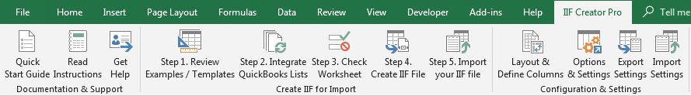
Part 2
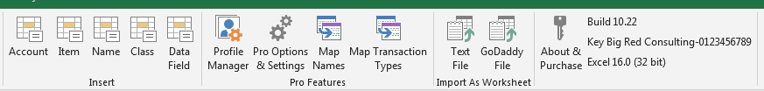
The ribbon menu is divided into several sections according to function. These sections are briefly described here and in more details in the following sections of the document:

Documentation
Use the options in this section to open the Quick Start Guide, this documentation file, and to request help. We strongly suggest reviewing this document to get started using the app.

Create IIF for import
Access the five overall steps to create an IIF file for import into QB.
Step 1. Review Examples/Templates
See how to lay out your data in one of the supported layout models. See the way to use accounts and the correct signs for amounts and quantities for all types of supported transactions. Even pull transactions directly from your company file to see how they look in Excel.
Step 2. Integrate QuickBooks Lists
When your worksheet is read and you’re about to error check it, first integrate with your QuickBooks company file. This process pulls copies of your lists into a cache for the IIF Creator to use. It uses the lists to make sure that:
- The IIF files you’ll create will not have conflicts with your company file.
- New list records you use in Excel are created with as much detail as possible as you import.
- Values from existing list records are added to your transactions much like when you enter transactions manually in QB.
Step 3. Check your worksheet
This step checks your worksheet for errors such as missing required columns, some incorrect accounting and backwards signs for amounts as well as other errors. It also finds new lists records for your review.
Step 4. Create IIF file
This final step creates the IIF file for import into QuickBooks. Specify your file name and a few other options as you create the file.
Step 5. Import your IIF file
Import your IIF file into QuickBooks. This step shows a dialog with the QB access point and the IIF file name to import.

Configuration and Settings
Use this section to customize the IIF Creator to match your worksheet data.
Layout & Define Columns
Select your worksheet layout style using this dialog. Also, ‘map’ your custom column titles to QuickBooks data fields and see both all the fields you can map (more common ones) and all of the less common fields available for use using fixed column titles.
Options & Settings
Set many options and defaults. When you set defaults, you don’t have to include as much information on your worksheets. For example, if your worksheet contains only checks, you can set the default transaction type to Checks and then omit the Type column.
Export Settings
Export all of your saved settings and preferences to a .DAT file. Use the file to share your settings with support when requested or import it on another machine to duplicate your current configuration.
Import Settings
Import a DAT file you’ve previously created to recreate your settings at the time the DAT file was created.

Insert
The Insert section helps you add list values from QuickBooks to your transactions without typing. This helps you use values that match QuickBooks existing lists and to insert data fields on the first row of your worksheet.

Pro Features (Pro only)
Profile Manager
Create and save Profiles that contain different settings and options as well as their own copies of your integrated lists. Useful if you use different worksheet layouts, want to work with different preferences, or you work with different company files.
Pro Options & Settings
Find options on this dialog windows that change how the IIF Creator behaves when you create new IIF files.
Map Names
Map names you use on your worksheet to existing names in QuickBooks
Map Transaction Types
Map transaction types you specify in the Type column to QuickBooks recognized transaction types.

Special Text Import options - Advanced
Import various known text file formats into Excel worksheets the IIF Creator can then work with.

File types include Credit Card, Checking, Savings, Amazon.com Detail Sales History File, Authorize.net, AmEx.com, Ecommerce Templates, Other (custom), and GoDaddy.

About
Use this section to enter your product keys and to review your current build number, your primary key, and your Excel version.

Recommended – How to get up to speed using the IIF Creator
- Review this documentation. Basic features are covered first in the document and then Advanced features at the end (many of which you won’t need.)
- Review the Examples/Templates. Review the three basic styles of transactions to determine what you’ll use: These are Multi-Row, Single Row, and Single Row Multiple Amounts.
- When reviewing examples, pay special attention to the Accounting. Many support requests are solved by fixing the accounting to match what you already do in QuickBooks. The examples show good accounting, but the accounts are generally not named the same as your accounts.
- Pull your data from QuickBooks for review. The IIF Creator will pull the last few days of details into Excel for your review in either the Multi-Row or Single row layouts. Access this feature from within the Example/Templates dialog window.
- Review a Journal report in QuickBooks. The Multi-Row layout is basically the same as a QuickBooks Journal report. Column titles from the Journal report will usually work with the IIF Creator by default.
- Trial Run: Follow these basic 1,2,3,4 steps as seen on the ribbon:
Step 1: Get a worksheet ready for import.
Include one or a few transactions on your worksheet.
Step 2: Integrate with your QuickBooks Company. Watch for errors. If there are errors, stop, review the help text on the message (if any) and follow the suggestions to fix errors.
Step 3: Check your worksheet using the Check Worksheet function. This process finds errors and shows you what will happen when you export. You’ll see the number of transactions and new list records that are round.
Step 4: Export to IIF. Pay attention to the success message to make sure it seems right. For example, is the correct number of transactions found?
Step 5: Import your IIF file into QuickBooks and check your results. Use transaction forms to open your transactions. Look at registers and reports to determine if all seems correct.
- Getting Help
  - If things don’t go as expected, try re-reviewing this doc and the examples.
  - If you receive import errors from QuickBooks, reintegrate and try again.
  - Contact us using the Get Help button or directly on our website and explain what is happening.
- Get into the details
This documentation includes many details that can help you get through difficult cases and to get the results you expect. Some tricky areas to review carefully if they apply to you are:
  - Sales Tax. If you have the sales tax feature on and want to import sales, you must deal with this, even if your sales aren’t taxable.
  - Accounting. Make sure you get it right. See the examples and your own Journal report. The order of accounts used in Excel matters for most transaction types.
    - For multi row transaction styles, the first row is a special row and the correct account type must be used. For example, for a check a bank account must be used and for an Invoice an Accounts Receivable account must be used.
    - For single row layouts, the two columns Account and Detail Account work the same way. The Account for a check must be a bank account, for example, and the Detail account usually isn’t a bank account, but instead an income or expense account.
  - Customize Explore the Customize options. Spend some time there, and refer to this documentation for explanation. You may well find something that makes your job much easier. The Customize options include features that let you change many column titles, set default values for, and change various behaviors. For example, you can:
    - See a full list of available fields.
    - Set default accounts and transaction types.
    - Set defaults for new name types and item types.
    - Force one customer for all sales.
    - Find existing names by account number, so you can use an account number in the Name field.

Terms & Concepts
- An IIF file is a special, highly structured file QuickBooks uses to import financial data including list records and transactions.
- Financial transactions are things like invoices and checks. Each check, for example is a transaction.
- Lists include your chart of accounts and names and new list records are included in the IIF file when needed. For example, if you use a new name on a transaction it is added to the IIF file.
- When your IIF file is imported into QuickBooks, transactions are added directly to your registers and ledgers with no need to accept or approve them.
- After import, the transactions behave just as if you’d entered them manually.
- When importing IIF files, QuickBooks expects most everything about each transaction to be specified in the file. This includes the dates, names, accounts, items, and amounts commonly used on financial transactions and also other data fields such as address fields on invoices and checks. When using the IIF Creator, you often don’t have to specify all of these data fields as it will fill in the details for you.

Worksheet Layout Instructions
Setting up data for export to QuickBooks from Excel is easy when compared to creating IIF files manually. The IIF Transaction Creator expects your data to be in one of several layout styles. If the data doesn’t follow one of these styles, it won’t be able to process it properly and won’t be able to create a valid IIF file from it.
In this document, references to “format” refer to the layout of your data on an Excel worksheet, not the Excel cell formats applied to the data. In most cases, you can use any font, underlining, cell formatting, or other Excel features to help you better view your data. Similarly, you can include formulas and other objects in your worksheets.
The IIF Transaction Creator reads your data from the rows and columns on your worksheet, where each column has a consistent meaning, and each row represents a transaction or part of a transaction. The two basic formats that the IIF Transaction Creator recognizes are a multi-row transaction and a single-row transaction.
QuickBooks, along with most other accounting systems, requires that each transaction be composed of balanced debits and credits, or signed amounts. Balanced means the sum of all the amounts for each transaction = 0.00. Each transaction must have at least two detail lines in order to be recorded. If you choose the single row layout the IIF Transaction Creator will create the detail that QuickBooks needs.
You may specify various defaults, such as the default transaction types, default name types, default accounts, and default dates. After setting defaults, in theory the simplest worksheet that can be used is a list of Amounts, each of which will become a transaction with the same accounts and date. However, that might not be very useful.
To augment the basic data on your worksheet you can either add columns and specify values or set defaults in the IIF Transaction Creator’s customization dialogs. For example, you can set the default Transaction Account to be “Wells Fargo Checking” for checks, and you can set the default transaction type to a “Check”.

Transaction Layout Rules
- The first row of the spreadsheet should contain column titles. You can use our default column titles, as described below, or you can customize the IIF Transaction Creator to recognize your titles.
- If your data doesn’t have a title row the IIF Transaction Creator can handle this case as well using the options in the Layout & Define Columns dialog.
- Columns can be in any order.
- Each transaction is made up of either a single Excel row or multiple rows, depending on the style you choose. The multiple row layouts support more columns and more complicated data.
- For the multi-row style, each transaction must be “in-balance”. This means that the sum of the amounts in the Amount column must be 0.00. This is another way of saying that debits must equal credits. If not, an adjusting entry will be added to make the transaction importable.
- Amounts should be specified in “dollars & cents”, E.G.”12.34”, and not with more detail (not like “12.345”). Fractions of cents will be rounded in the IIF file. Rounding may cause the transaction to be “out of balance” by a penny or more and when that happens an adjusting row is added for the difference. If you are calculating the Amount using a formula, formatting the cell to look like a currency is not enough. You must round the result using the ROUND worksheet function or other method.

Transaction Row Types
The IIF Transaction Creator’s different styles allow it to recognize several different row types.
For single-row transactions, there is only one row type, as each row represents a complete transaction.
For multi-row transaction styles, there are several types of rows. These include the “Transaction” or first row, and different types of “Detail” rows.
- The Transaction row is the first row of each transaction. The Account (or Transaction Account) on that row must match the transaction Type, and will sometimes dictate it’s type if you don’t specify it. For example, for an Invoice, the Account Type on the Transaction row must be an Accounts Receivable account.
- Detail rows follow the Transaction row. In multi-row mode, each transaction must have at least one detail row. Most detail rows contribute to the transaction total, except for Subtotals, which can be used on sales forms.
- There are several types of special detail rows:
  - Sales Tax. Sales tax rows can be used on Sales Transactions including Invoices, Credit Memos, and Sales Receipts. The tax row should be the last row of the transaction and is identified by using an existing Sales Tax Item in the Item column.
  - Sales Tax Groups. These special sub-types of the Sales Tax item can be used as well, just like a sales tax item. When you use a Sales Tax Group item, the IIF Transaction Creator will automatically include the details of the sales tax group in the IIF file.
  - Subtotals: Subtotals can also be used. Their amounts don’t contribute to the transaction total (as expected.) In order for the IIF Transaction Creator to recognize these special rows, you must use an existing Subtotal Item from QuickBooks.
  - Memos: For the multi-row layouts, include memo-only transaction rows by specifying a Memo / Description on the row without specifying an Amount or Account. For sales transactions you may include multi row memos by entering multi-row text in the cell. Use Alt-Enter in Excel to add a ‘new line’ to an Excel cell.

Transaction Layout Styles
Here are some examples of a check in different layout styles along with a description of how each works.

Multi-Row
When using the Multi-row is a style each transaction takes up at least two rows on your worksheet, where each row represents one accounting account and amount.
An example check:
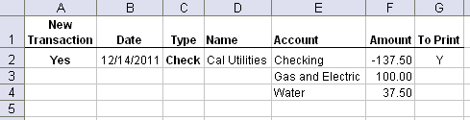
Here this check takes up three rows, where the first line uses the checking account name and the other two are the transaction detail rows. Note how the accounts are used and that the total of the Amounts = 0.00.
The first row of the check has a “Yes” value as that is the beginning of a new transaction. If there were a second check starting on row five, then the New Transaction column on row five would also contain a Yes value.

Multi-Row Detail lines only
This style is like the Multi-Row style, but no total row appears for the total transaction amount. When using this style, the IIF Creator will calculate the total for you based on the sum of the detail rows’ Amounts.
An example check:
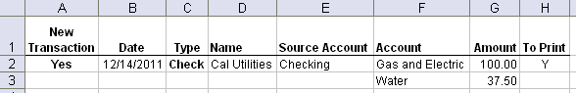
Note the example is much like the multi-row example, but there is no total row, and the Source Account/Transaction Account column appears, which holds the name of the bank account.

Single Row
This layout is simpler than the multi-row layouts, but is limited in that you can use only two accounts and one amount. It is for simpler data where each transaction only uses one detail account. For example, it can show a check written to the Utilities expense account, but without the detail seen above.
An example check:
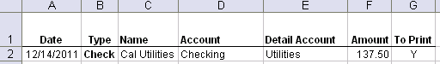
Note that there is both an Account and Detail Account column, one for each of the two accounts used. Also, the “New Transaction” column is not used because each new row starts a new transaction.

Single Row multiple Amount Columns
This layout also uses a single row on the worksheet for each transaction, but it allows you to include multiple amounts and accounts. It is the most complicated to set up but it works well for some data sources.
An example check:
Note that there are two amount columns and two account columns for the details, as well as the standard Account column.
To set up this type of layout, you must specify your amount and account columns on the Amounts tab of the Layout & Define Columns dialog.
How to configure the IIF Creator to expect multiple amount columns
To set the IIF Creator up for this type of layout, first go to Layout & Define columns and choose Custom Definitions. Next on the Layout tab, choose these options:
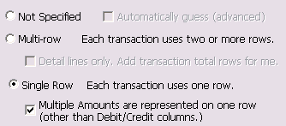
Next, click the Amounts tab and enter your column definitions as described below.
Configuring multiple Amount columns
This feature supports up to 10 columns using the Assistant, and you can optionally match its output and add additional columns manually.
To set up these columns, use the Assistant (recommended) or enter the multiple column titles manually in the text field on the Amounts tab in the Custom field Mapping dialog.
Columns are separated with commas and use an XML-like tag (<AmountCol>.) They can contain the column name, a default item name to use, and a default account name to use as well as other columns that such as an Account, Item, Rate, Quantity, and Description.
Amount Column Assistant
The Assistant can help you automatically configure your data and lets you pick other columns of data to be associated with each Amount column you define. It lets you easily set up multiple Amounts as well as an optional Item, Account, Description/Memo, Quantity, and Rate columns to go with each Amount. Note you can use the same columns over and over if desired.
To launch the Assistant, click the Assistant button on the Amounts tab of the Layout & Define Columns dialog window.
When you launch the assistant, you’ll see a grid of drop-down boxes that will contain all of the column titles in your worksheet. For each amount you want to specify, pick the column as well as any other columns you want to associate with that Amount. This example shows the grid completely filled out yours will likely look empty when you first launch the Assistant.
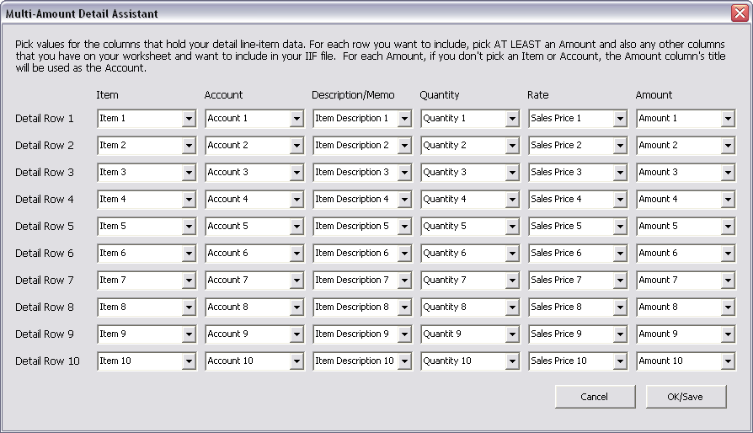
To specify a specific Item instead of an Item column, pick “Specify an Item” from a pick list in the Items column.
To specify a specific account instead of using an Account column, pick the “Specify an Account” option from a pick list in the Account column.
Press OK/Save when done and the results will be written to the Amounts tab of the Customize dialog.
Rules:
- If you specify only the Amount columns and no Account or Item columns, and you have no “Detail Account” column on your worksheet, and you have no default Detail Account in your settings, then the actual column title is used as the account.
- If you specify a default item or an item column, then the account from the item is used if the item is found based on your last integration. Otherwise, refer to rule #1.
- If you specify both an account and an item, then the account from the item is used if the item is found. In that case, refer to rule #1.
- You can over-specify Amount columns. Columns not found in your current worksheet will be ignored.
- You can define the columns in any order, regardless of how they appear on your worksheet. The order you use determines the order the amounts will appear in QuickBooks on your transactions.
- If you want to include sales tax it should be listed last in your Amount columns definitions, because it must appear last on sales transactions.
- The support label keywords are <AmountCol>, <ItemCol>, <AccountCol>, <DescCol>, <RateCol>, <QuantityCol>, <Item>, <Account>
- After using the Assistant, values use these keyword labels.
- The Assistant can be used to define up to 10 amounts. You can add more manually, but if you launch the Assistant again, they will be lost.

Custom Column Names
You may use the default column names, specified in the following pages and as seen on the example templates. You may also configure the IIF Transaction Creator to use your custom field names or no field names at all. This is useful when you can’t control the source of the data from another application, and you don’t want to manually reformat the worksheet for use with the IIF Transaction Creator with each new version of the data.
The Layout & Define Columns dialog lets you select which layout style is appropriate for your worksheet and also your custom column/field titles. To use this feature, choose Layout & Define Columns from the ribbon or menu:
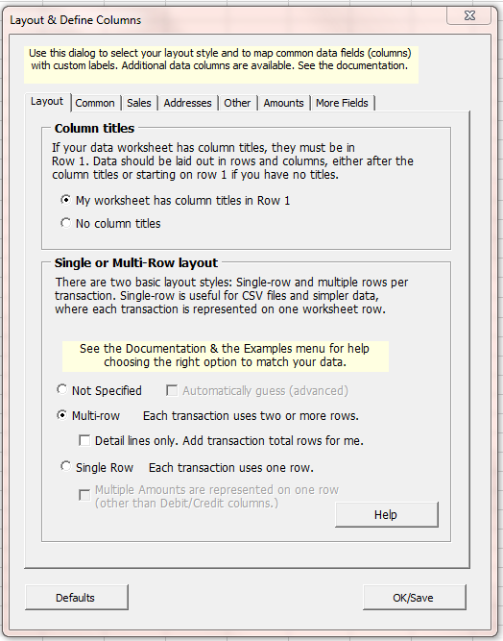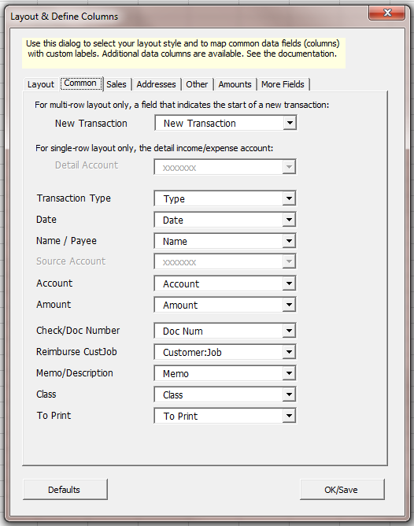
On the Layout tab you can:
Specify the single-row or multi-row option, and their sub-options and also whether or not your data has a title using row 1 of your worksheet.
On the rest of the tabs, you can:
Specify column titles or column letters (when you have no titles) for various data fields on your worksheet. The dialog first shows default names for each of the fields, and the pick lists for each field contain either column letters or the titles from your active worksheet. You can pick the same column for multiple data fields. This is useful where the same data should flow to multiple places in QuickBooks.

Other Options - Defaults
The IIF Transaction Creator also lets you set values instead of including values on your worksheet. These include defaults for transaction types, accounts, name types, item types, and more.
To access for the following groups of settings, choose Options & Settings from the ribbon or menu.
Default Name Types
You can specify the default name type for several different transaction types. We’ve included a custom option for each transaction type in QuickBooks that allows multiple name types.
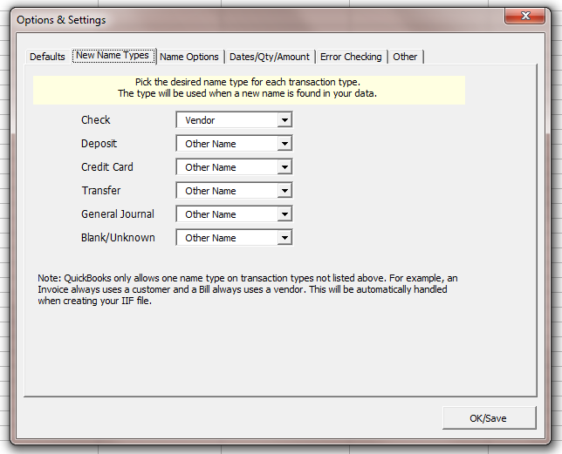
Default Transaction Types
You can specify two default transaction types, one for positive and one for negative transactions. In this context, negative means the first line of the transaction (usually the balance sheet detail line) is a credit or negative amount. For example, the first line is a credit to cash. Similarly, positive means a transaction with a debit first line, like an invoice, where the first line is a debit to your AR account.
Default Accounts
You can specify two default accounts. One for the transaction and one for the detail lines of the transaction. For example, if you are importing banking details (mostly checks), you could specify your bank account’s name for the transaction account.
Defaults for Sales Items
You can specify the default item type and sales tax item to use if the IIF Transaction Creator encounters new items (the items you use on invoices.)
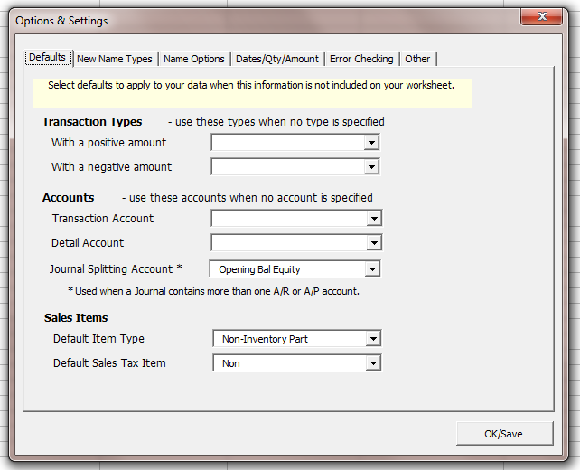
Color Coding Columns
To ensure that you understand which columns of data will be considered for inclusion in your IIF file and which are ignored, enable this option. When enabled, your column titles will be coded with either green (recognized) or yellow (ignored) based on the column titles and your settings. This will happen as you create an IIF file or when you error-check your worksheet.
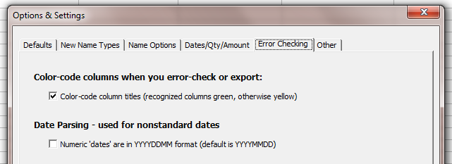
Note that this doesn’t mean the data in the column values will actually be used. For example, if you put “test” in a Date column, it will be ignored because it is not a date. Similarly, if you include a column that is inappropriate for the transaction type you’re exporting, it may not be included. For example, Checks do not have Terms in QuickBooks (bills and invoices do.)
IIF file Date Format
Older QuickBooks versions always expect the date to be in the mm/dd/yyyy format regardless of your system settings. Newer versions may use your system date format. If you’re having difficulty and the dates are importing ‘backwards’, you may need to set this option to dd/mm/yyyy.
Settings for Quantities and Amounts
The default behavior for sales item quantities is to export exactly what you put on your worksheet. However, QuickBooks expects negative quantities for sales, which is often awkward to set up on your worksheet. If this is the case, check this option and the Quantities will be reversed.
Similarly, it expects negative amounts for sales detail lines and you can reverse the sign of your Amounts if they are backwards using these setting.
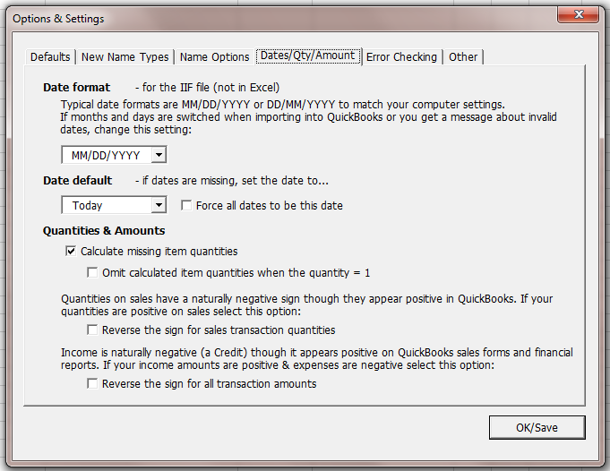
Name Matching Options
Names used in your worksheet are typically matched with existing names in QuickBooks based on the name itself. The name is the key value in QuickBooks. There are additional options available in the IIF Creator for name matching, including the use of the account number on the name and the use of address fields to keep ‘duplicate’ names separate. For example, “John Smith” in New York can be differentiated from “John Smith” in Los Angeles based on the address found on your worksheet:
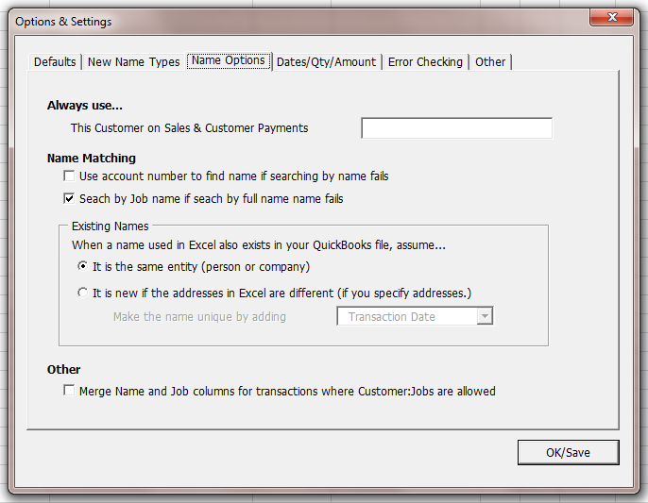

Transaction Types

Supported Transaction Types
The IIF Transaction Creator can help you import most transactions types. You may specify the transaction types on your worksheet in the Type column. If you don’t specify a type, then QuickBooks will pick one for you when importing, which may not be what you expect or want
If you do specify a type, then the IIF Transaction Creator will be able to better complete the transaction and fill in missing details when available based on your imported QuickBooks lists.
The following transaction types are supported:
Type | Description
Bill | A Vendor Bill. Imported into an Accounts Payable account
Credit | A Vendor Credit. Imported into an Accounts Payable account
Bill Pmt -Check | A payment for a bill. For most QuickBooks versions, is imported as a Check that reduces the Accounts Payable balance.
Check | A standard Check. Imported into a Bank account
Credit Card Charge | Imported into a Credit Card account
Credit Card Credit | Imported into a Credit Card account
Credit Memo | A Customer Credit Memo. Imported into an Accounts Receivable account
Deposit | A Bank Deposit. Imported into a Bank account.
Estimate | A Customer Estimate. Imported into the special Estimates account
General Journal | A Journal or General Journal transaction
Inventory Adjust | An Inventory Adjustment
Invoice | A Customer Invoice. Imported into an Accounts Receivable account
Item Receipt | A Vendor Item receipt is much like a Bill, but doesn’t impact the Vendor Balance until converted into a Bill
Payment | A Customer Payment on Account
Purchase Order | A Vendor Purchase Order. Imported into the special Purchase Orders account
Sales Receipt | A Customer Sales Receipt or cash sale. Imported into Undeposited Funds or a Bank account.
Sales Tax Payment | Like a Check, but pays Sales Tax due.
Stmt Charge | A Customer Statement Charge. Imported into an Accounts Receivable account.
Transfer | A Bank Transfer between accounts

Unsupported Transaction Types
Unfortunately, some transaction types can’t be imported into QuickBooks using its IIF import features. These transaction types include Paychecks & other payroll transactions as well as Sales Orders.

Common / Required Fields
This is a summary of the fields discussed above in the examples.
Column Title  [With Alternates] | Type | Comments | Summary or Detail?
New Transaction, NewTransaction, Trans Num, Trans No, Trans # | Any Value | Required for multi-row transactions.  Use a value on the first row of a transaction that is different from the preceding value and is not blank. “Y” is commonly used.  If you use the single-row layout, omit this field. | Summary
Name | Text | A name is required for many transaction types. Optional for others. To see if a name is required, create a transaction in QuickBooks of the desired type.  For checks, bills, and credit card charges, you can set the Name field to a Customer:Job in the detail lines of a transaction. This will charge the line item to that job for job-costing reports.  Instead of a single Name column, you may use the First Name and Last Name columns. | Both
First Name  Firstname, First | Text | The first name part of a name, if you have your names in two columns instead of one.  If used with the Name column, the value in the Name column is used for the transaction, and the First and Last name fields are used if adding the name to QuickBooks. | Both
Last Name  Lastname, Last | Text | The last name part of a name, if you have your names in two columns instead of one. | Both
Account | Text | An account from your Chart of Accounts. There are many rules around using the proper account type, especially for the first line of a transaction. Here are some of them, but this may not be a complete list: | Both
Account field Notes:
- A Bill’s first account must be an AP account
- An Invoice & Credit memo’s first account must be an AR account
- A Check’s first account must be a Bank account
- A Credit Card charge’s first Account must be a Credit Card account.
- You cannot have more than one AR or AP account on a transaction. For example, you can’t transfer money from AR to AP directly or between two different AR accounts.
- If you are using Items on sales forms (see optional fields below) and those items exist in your imported Lists (from QuickBooks) you can leave the Account blank and the IIF Transaction Creator will find the right account.
- You may specify a default Transaction Account and Detail Account in IIF Transaction Creator’s other settings dialog. If you do this, then you can optionally remove the Account column.
Amount | Number | A currency amount, rounded to the nearest hundredths of a unit. In the US this equates to dollars & cents.

Additional / Optional Fields
Columns such as the Amount must be included in your worksheet in order to import accounting transactions.
However, there are many more fields the IIF Transaction Creator will import with ease. The following sections describe this optional data.

Transaction Addresses – Special Handling
It is often useful to import addresses with your transactions. For example, you may want a mailing or shipping address imported on an Invoice so it can be printed after import. In order for the address on a check or a sales transaction (like an Invoice) to be imported, one of two things must be true:
- The name on the transaction must already exist in QuickBooks with an address and be integrated/known to the IIF Creator.
- An address is included on your worksheet. If you do this for a new name, the IIF Transaction Creator will add the address to both the transaction and the new name it creates in the IIF file.
Note that these options will work only when the IIF Transaction Creator knows what type of transaction it is dealing with.
To include the address on the spreadsheet, use the Address 1 – Address 5 fields or use Street and City, State, ZIP fields. For multi row styles, fill out address fields on the first row for most transactions or on the detail rows for deposits
If you have addresses in ‘blocks’ of text, then use these “Address” line fields. Here are some examples:
Address 1 | Address 2 | Address 3 | Address 4 | Address 5
Ecker Design | 123 Park Ave | Suite #27 | Palo Alto, CA 94052
Jones Wallpaper | 4566 Sunny Ave | Palo Alto, CA 94052
International Co. | 123 Amazon Street | Vancouver, BC A1A 3F3 | Canada
Notes:
- If you omit the Address 1 field, then the Name will automatically be used for the first line of the address.
- Follow a similar pattern for the Shipping address fields, which are Ship Address 1, Ship Address 2, Ship Address 3, Ship Address 4, and Ship Address 5.
If you have addresses in specific fields, you may use those instead. Here are some examples:
Street | Street 2 | City | State | ZIP | Country
123 Park Ave | Suite #27 | Palo Alto | CA | 94052
4566 Sunny Ave |  | Palo Alto | CA | 94052
123 Amazon Street |  | Vancouver | BC | A1A 3F3 | Canada
NOTES:
- When using this address layout, you may also include the “Address 1” column if you want a different value than the Name.
Full Address field list
Column Title | Alternate Titles
Address 1 | Addr1, Address1
Address 2 | Addr2, Address2
Address 3 | Addr3, Address3
Address 4 | Addr4, Address4
Address 5 | Addr5, Address5
Ship Address 1 | SAddr1, Ship Address1
Ship Address 2 | SAddr2, Ship Address2
Ship Address 3 | SAddr3, Ship Address3
Ship Address 4 | SAddr4, Ship Address4
Ship Address 5 | SAddr5, Ship Address5
-- OR --
Street | Street1, Street 1
Street 2 | Street2
City
State | Province
ZIP | Zip Code, Postal, Postal Code
Country

Ship Street | Ship Street1, Ship Street 1
Ship Street 2 | Ship Street2
Ship City
Ship State | Ship Province
Ship ZIP | Ship Zip Code, Ship Postal, Ship Postal Code
Ship Country

Optional Field List
There are many more fields you can add to your worksheet as columns. Many of the fields seen here are used only on sales forms and may not be visible in QuickBooks even if imported properly. To make them visible, use a different sales form template or create a custom template.
- Summary means the first row of a transaction in multi-row mode.
- Detail means everything but the first row.
Column Title  [with Alternates] | Data Type | Comments | Summary or Detail?
Type, TransType,  Trans Type | Text | The transaction type. You can omit this, but both the IIF Transaction Creator and QuickBooks import work better when you specify a Type: | Summary
Debit & Credit | Number | Can be used instead of the Amount column. | Both
Num, DocNum, Doc Num, Doc Number | Text | Document Number (e.g. the check number for checks, the invoice number for invoices and so on.)  Note that most versions of QuickBooks ignore this field when importing Sales Receipts. | Summary
PO Number, P. O. #, P.O.#, P.O. #, PONUMBER | Text | Used on Invoices and other sales forms. Also used for the Check Number on Sales Receipts (but not the DocNum for purchase order transactions.) | Summary
Check #, Check No, Check No., Check Number | Text | Used on Sales Receipts for the document number of the payment being received. | Summary
Memo, Description | Text | The "Description" on transaction lines. For single-row transactions, if the Memo is used, it is used on both the transaction and the detail lines, unless the Transaction Memo is also defined. | Both
Transaction Memo, Transaction Description | Text | The Memo. Use on the transaction source line only. Useful for single-row transactions and multi-row detail lines only transactions.
Ship Date | Date | Used on Invoices & other sales forms. | Summary
Deliv Date, Deliver Date | Date | Used on Invoices & other sales forms. | Summary
FOB | Text | Used on Invoices & other sales forms. | Summary
Ship Via, Via | Text | Used on Invoices & other sales forms, for the carrier. | Summary
Terms | Text | Used on Invoices & other sales forms. Does not set the due date. To set the due date, use the Due Date column. | Summary
Due Date | Date | Used on Invoices and bills and other “payable” transactions. | Summary
Billed Date | Date |  | Summary
Item | Text | Used on Invoices & other sales forms. | Detail
Class | Text |  | Both
Rep | Text | The Sales Rep full name (not the initials seen on an invoice.) | Summary
Clr, Cleared | Text | Is the transactions Reconciled?  Blank = not cleared  c or * or P = newly cleared  Y or R = cleared | Both, usually Summary
To Print, Print | Y/N | To Be Printed status. Setting to Y (meaning: “Needs to be printed”) makes the transaction ready to be printed after import. | Summary
To Email | Y/N | To Be Emailed status. | Summary
eMail | Text | Email address to use. Only used if the Name is created as a new name. Otherwise, QuickBooks uses the existing name’s email address (even if it is blank, which will result in an error.) | Summary
Payment Method | Text | The Payment Method used for Payments and Sales Receipts. | Summary
Quantity | Number | Quantity. If you use items, you probably want to use Qty as well. Purchases of items are a positive Qty and Sales are negative. | Detail
Sales Price | Number | Rate per item sold. Note that Rate * Qty should = Amount. If not, your imported QuickBooks data will be different than if you manually entered it, which can cause problems in reports. | Detail
Service Date | Text | The service date column available on Invoices and other sales forms. | Detail
Adj | Y/N | The General Journal “is adjusting” entry check-box | Summary
eMail, e Mail, email Address | Text | Email address for the Name | Summary
Fax | Text | Fax for the Name | Summary
Contact | Text | Primary Contact for the Name | Summary
Billable | Y/N | Sets the billable icon for checks, bills, and credit card charges. By default QB will make the item billable if it has a Customer:Job in the detail line of the transaction, and if it uses an allowed account for billable transactions (such as an expense account.) To make the item not-billable, set this value to N. | Detail
Customer Message | Text | The small field at the bottom of an invoice and other sales transactions (of the same name.) | Summary
Continued on next page…
Continued…
Column Title  [with Alternates] | Data Type | Comments | Summary or Detail?
Other | Text | Used on sales forms like invoices. Appears in the ‘fields’ area of the invoice above the table of sales detail. | Summary
Other 1, Other1, Custom 1 | Text | Used on sales forms like invoices. You can turn on this field in invoice customization. Appears in the detail area of an invoice or other sales form. | Detail
Other 2, Other2, Custom 2 | Text | Like Other 1. | Detail
Phone | Text | Customer phone number. | Summary
Phone2, Phone 2,  Alt Phone | Text | Customer phone number. | Summary
Contact | Text | Contact Name | Summary
Contact2, Contact 2,  Alt Contact | Text | Alternate Contact Name | Summary
Value Adjust, Value Adj | Y/N | For Inventory Adjustments. Enter either Y or N | Summary
Company Name, Co Name | Text | Company Name | Summary
Salutation | Text | The Name’s salutation (like Mr, Mrs., Sr, Jr.) | Summary
First Name, Firstname | Text | First Name | Summary
MI, INIT | Text | Middle Initial | Summary
Last Name, Lastname | Text | Last Name | Summary
Name Sub Type, Customer Type, Vendor Type | Text | The Name sub-type, such as Retail, Wholesale (or whatever your customer or vendor types are.) | Summary
Job Type | Text | The Job Type for Customers or Customer:Jobs | Summary
Debit | Number | Can be used instead of the Amount field, in conjunction with the Credit field. | Both
Credit | Number | Can be used instead of the Amount field, in conjunction with the Debit field above. | Both
Taxable | T/F or Y/N | Used to set the taxability of items on an invoice and other sales forms when used on Detail lines. When used on the Summary line, sets the taxability of the transaction (but you still need to set the detail lines to make them taxable.) | Both
Transaction Account, Source Account | Text | Used in the multi-row detail lines only style for the primary transaction account, such as AP for a Bill, AR for an Invoice or a bank account for a check or deposit. Used with the Account column.
Detail Account | Text | Used in the one-row style for the detail transaction account such as an expense for a check or bill or income for a deposit or invoice. Used with the Account column. | N/A
Vat Code | Text | Used for UK and some other international versions. See the section on VAT in this document. | Detail
Vat Rate | Number | Used for UK and some other international versions. See the section on VAT in this document. | Detail
Vat Amount | Number | Used for UK and some other international versions. See the section on VAT in this document. | Detail
GST Amount | Number | Used for QuickBooks Canada. See the section in this document for GST & PST. | Detail
PST Amount | Number | Used for QuickBooks Canada. See the section in this document for GST & PST. | Detail
Account Type | Text | Use account types as they appear on your Chart of Accounts in QuickBooks. | Both
Name Type | Text | Use Customer, Vendor, Other Name, or Employee. | Both
Item Type | Text | Use Item types as you see them on your Items list. | Detail

Sales Tax – Special Handling
The QuickBooks tax feature is different for US and international versions. Review the sections below for your country-specific QB version.

USA - Sales Tax
Use this section for Sales Tax in the US versions of QuickBooks.
Sales Tax area can be challenging for import. However, once it is set up correctly, it works quite well.
If you have sales tax turned on in QuickBooks, your sales-related transactions must include a sales tax item even if the item or items on the transaction are non-taxable. This is true for Invoices, Credit Memos, and Sales Receipts, and Estimates. Most other transactions in US QuickBooks do not use Sales Tax.
If your items are non-taxable, you don’t actually need to specify sales tax on your spreadsheet. Instead, the IIF Transaction Creator can automatically add a sales tax line as it is creating the IIF file.
However, it your sales are taxable, you need to specify the taxability and the sales tax item and amount, like this:
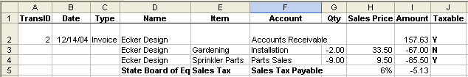
This example shows a single invoice with a mix of taxable and non-taxable items, and a sales tax detail row.
- Here, the “Sales Tax” item on row 5 must exist in QuickBooks before creating an IIF file. Because the item “Sales Tax” is a tax item, the IIF Transaction Creator will treat it in a special way in the IIF file in order to make the transaction importable.
- The “Y” on row 2 marks the entire Invoice as a Taxable transaction. This is important for QuickBooks Sales Tax reports. It implies that the customer is by default taxable (most are) but not necessarily that any tax will be charged on the transaction.
- The “N” on row 3 means that the Gardening line item is a non-taxable part of the transaction (even if it is taxable.)
- The “Y” on row 4 makes the sale of Sprinkler Parts taxable.
Notes:
- In the Taxable column, an empty value is the same as N or non-taxable.
- You may use T/F, True/False, Y/N or Yes/No as values for the Taxable column.
- The tax amount should be of the same sign as the amount being taxed. While it appears positive in QuickBooks on invoices, it will be negative on the worksheet for sales (and positive for credits.)

UK - Value Added Tax
Use this section for Tax in OLDER versions of QuickBooks for the UK – 2007 and older
Like Sales Tax, VAT can be particularly challenging for import. However, once it is set up correctly, using the IIF Transaction Creator can make it simple.
VAT is used on many transactions in QuickBooks UK. The worksheet format is different for VAT than for Sales Tax in the US. This is at least partially because a different VAT code can be associated with each line on a transaction.
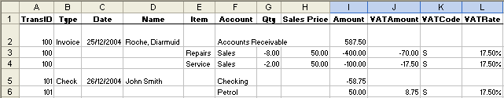
This example shows an Invoice and a Check.
- Here, the VAT Code is “S” for all lines, but it could be any of your VAT codes.
- Use only VAT codes already set up in QuickBooks.
- Here, the Amount on row 2 (the total amount of the invoice) is the sum of the Amounts & the VAT Amounts on rows 3 & 4 multiplied by -1.00. This keeps the transaction total “in-balance”, which is critical. The amount on row 5 is calculated similarly.
- Note that the first line of a transaction doesn’t have a VAT Code.
- The VAT Amount should be the same sign as the amount being taxed.
Use this section for Tax in NEWER versions of QuickBooks for the UK – 2008 and newer
Recent versions of QuickBooks for the UK have seen an overhaul in the way VAT is handled. Now VAT items are included on your items list, and there is also a VAT code list, available from the Lists menu. These two lists work together.
As a result of these changes, there is less flexibility when importing, and the data is laid out differently in Excel to model these changes:
Multi-row example:
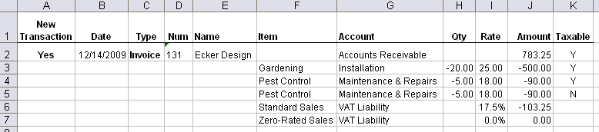
This example shows an Invoice.
- Note that now the VAT columns are omitted and replaced with a “Taxable” column and tax rows are added at the bottom of the invoices, similar to how the invoice now looks in QuickBooks.
- When importing, your default VAT codes are used for taxable and non-taxable sales, and your VAT items are used as specified on the worksheet (here “Standard Sales” and “Zero-Rated Sales”.)
- Be sure to use VAT Items that are already set up in QuickBooks.
- When exporting your lists to the IIF Transaction Creator, be sure to include your Items list (with VAT items set up) and your VAT Code list.
Single-row example:
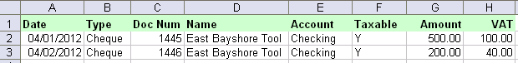
This single-row example shows two check (cheque) transactions with both VAT and the base expense amount. The check total for the first check is 600.00 and for the second is 240.00
- In order to find VAT, the IIF Transaction Creator looks for Items that are sales tax type items. These items can have any name, but should appear on your Items list in QuickBooks as a tax item.
- When you mark an item taxable, it will later get the default sales tax code for taxable activity during import.
- When you mark an item not taxable (N or blank), then it gets the default sales tax code for non-taxable activity during import.
- For single-row transactions as seen above, you must define multi-column amounts. For the example above, you’d put something like this in the multi-amount field on the Amounts tab in the Customize Columns dialog:
<Account>General Expenses<AmountCol>Amount,
<Item>VAT Tax<Account>VAT Liability<AmountCol>VAT
Or, if you use the Multi-Amount Detail Assistant, it would look like this for the example above:
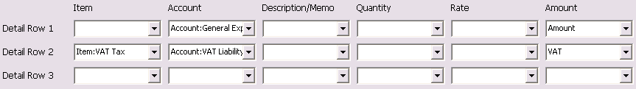
Note about defaults
Note that you can no longer import transactions and specify the exact VAT code that will be used. During import, the default codes from your VAT preferences are used. You can set these preferences in company preferences from the Edit menu in QuickBooks.

Canada - GST, PST/QST, or HST
QuickBooks for Canada – 2007 & older: Use this section for OLDER versions of QuickBooks
Like Sales Tax in US QuickBooks, GST & PST can be challenging for import. However, once it is set up correctly, using the IIF Transaction Creator can make it simple. GST can be used on many transactions in QuickBooks Canada. The worksheet format is similar to the format for Sales Tax in the US version:
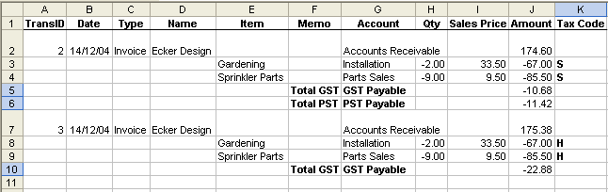
This example shows two invoices.
- In order to find your tax, the IIF Transaction Creator looks for keywords in the Memo & Account columns. The keywords are “Total GST”, “Total PST”, “GST Payable”, & “PST Payable”. These keywords cause the IIF Transaction Creator to create special GST and PST taxes in the IIF file.
- The first invoice in the example has both GST and PST on it, each at 7%, and one tax is calculated on the other.
- The second invoice shows only the GST code, which is suitable for Nova Scotia, New Brunswick, Newfoundland & Labrador where the unified HST is used but is tracked internally as GST in QuickBooks.
- The tax code should correspond to a tax code from your tax code list in QuickBooks.
- The Total GST and Total PST should be of the same sign as the line items being taxed.
- The amount(s) for GST and PST/QST on your worksheet needs to agree with the tax amounts QuickBooks would calculate, based on the tax rate(s) for the Tax Code used on the worksheet. Based on our testing, you may vary the amount by a few cents to account for rounding errors. If the amount is off by too much, you will get “transaction not in balance” and “invalid transaction” messages when importing.
QuickBooks for Canada – 2008 & newer: Use this section for NEW versions of QuickBooks
Newer versions of QuickBooks have changed the tax model to be more unified between Canada and the UK. Some specifics are different, and some control has been lost compared to older versions. In recent versions, specifying tax is much the same as in US versions, where each row on a transaction can be marked taxable or not, and the total tax or taxes are listed below the items being sold. As with the US versions, the Sales Tax items must first be set up in QuickBooks and then integrated. Don’t use new sales tax items when using the IIF Transaction Creator.
Multi-row example:
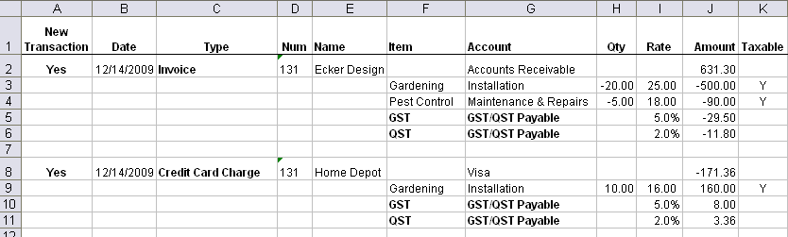
This multi-row example shows one invoice and a credit card charge with GST, QST. HST is similar but with a different label.
Single-row example:
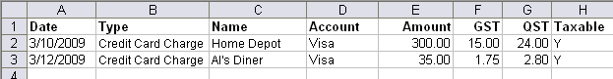
This single-row example shows two credit card charges with both GST and QST
- In order to find your tax, the IIF Transaction Creator looks for Items that are sales tax type items. These can have any name, but should appear on your Items list in QuickBooks as a sales tax item.
- When you mark an item taxable, it will later get the default sales tax code for taxable activity during import. When you mark an item not taxable (N or blank) then it gets the default sales tax code for non-taxable activity during import.
- You can create transactions with GST, with GST and PST/QST, or with HST (based on how the sales tax item is set up in QuickBooks.
- Sales transactions like invoices, sales receipts, and credit memos can include tax. Also, Purchase transactions like checks and bills and credit card charges can include tax.
- For single-row transactions as seen above, you must define multi-column amounts. For the example above, you’d put something like this in the multi-amount field on the Amounts tab in the Customize Columns dialog:
Amount<account>Sales Income, GST<item>GST (ITC), QST<item>QST (ON) on purchases
Or, if you use the Multi-Amount Detail Assistant, it will look like this to match the example above:
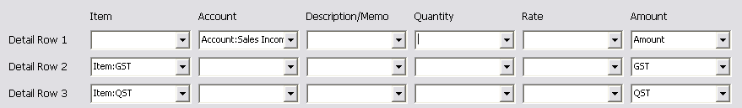
Note about defaults
Note you can’t import transactions and specify the exact sales tax code that will be used. During import, the default codes from your sales tax preferences are used. You can set these preferences in company preferences from the Edit menu in QuickBooks.

Inserting QuickBooks List Data
If you’re planning to enter data manually into Excel, you can use the Insert feature to enter key list data that matches the integrated QuickBooks lists.
Lists
We’ve added options to the ribbon for entering accounts, names, items, and classes. In order to use these options, you must have first integrated your lists. Once you’ve integrated, you can then pick options to paste into Excel cells from these lists.
If you want to manually enter data, we recommend that you first start with one of our examples. You can then remove columns you’re not interested in and add other columns as needed (see the complete list of columns in this document.) Then enter your own data into the appropriate cells.
To insert a value, click on the desired cell and then click one of the Insert buttons on the ribbon.
Fields
The last insert option allows you to insert fields using the default field titles. Click in an empty column on row 1 of your worksheet and then select this option.

Exporting your Worksheet & importing the IIF file into QuickBooks

Integrating your QuickBooks ‘Lists’
In order for the IIF Transaction Creator to create an IIF file that will work reliably with your QuickBooks Company it must first collect a copy of various lists in your file. We call this “integrating” with your file. Integration creates local copies of your lists for reference when creating an IIF file for import.
Integration is a critical step. Be sure to integrate regularly to avoid errors and other unexpected results during import.
There are two methods available to do this: For most versions of QuickBooks the one-step direct connection is available. For very old QuickBooks versions or when the direct connection won’t work, the IIF file method is also available.

Option 1: Integration using the Direct Connect method
This option is a one step process. Make sure the company file you’ll be importing into is open, and then choose the option to Integrate QuickBooks Lists. Choose the Direct Connect tab to complete the process.

Option 2: Integrating using an IIF list file
This option is a two-step process. First export from QuickBooks, then open the resulting lists file using the IIF Transaction Creator.
Note: It’s important to import all the requested lists into the IIF Transaction Creator at once. This is because when you import your lists IIF file, the results of the last import are deleted. So, if you integrate with a lists file with only the chart of accounts, then the IIF Creator will think your file has no names or items.
Exporting Lists from QuickBooks
To export your lists from QuickBooks, start at Utilities | Export | Lists to IIF files…
- Pick the Chart of Accounts, Customer, Vendor, Employee, Other Names, Class (optional), and Item lists. (For QuickBooks UK, be sure to pick your VAT Code List and note that Vendors are called “Suppliers.” For QuickBooks Canada, be sure to pick your Tax Code List.)
- The export dialog should look like this, with at least these lists selected:
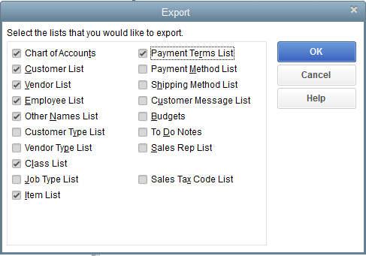
- Click OK and then enter a filename. You may want to change folder to one that is more convenient than the QuickBooks default. Be sure to note the folder location where the file is saved.
Opening your Lists using the IIF Transaction Creator
After creating the lists file, then open/integrate it with the IIF Transaction Creator. To do this, switch to Excel and choose Integrate QuickBooks Lists and then pick the file you just created from the IIF tab.

Creating an IIF file for Import into QuickBooks
After you’ve checked your worksheet, pick the option to export to an IIF file. This step creates an IIF file with your transactions. The export process offers several options:
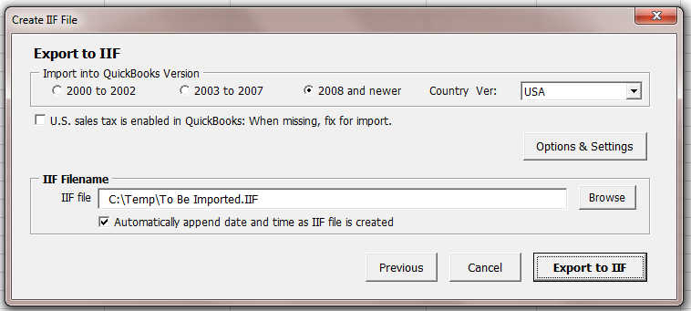

Importing your IIF file into QuickBooks
After you’ve created an IIF file, import it into QuickBooks. The import menu option is as shown:
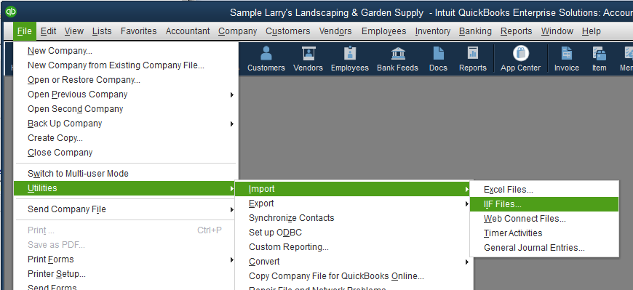
To import, pick the IIF Files option and then the file you created using the IIF Transaction Creator.
Older versions of QuickBooks have slightly different menu options for importing from IIF: To import using QuickBooks 2004 & 2005, choose File | Import | IIF files. For even older versions of QuickBooks, choose File | Utilities | Import.

Import Tips
- When you import transactions there is no ‘undo’. If the transactions are not as you expected, you can modify or delete them just as you might transactions that you enter manually. For this reason, we suggest starting small and checking your results.
Many things can be recorded that are valid and technically correct, are not actually what you wanted. So, it is important to check your results early in the process of using the IIF Creator.
- Timely integration with QuickBooks is very important and avoids many issues. The integration process pulls information about your company file and creates a cache of your lists including the Chart of Accounts and your various names lists.
- These integrated lists help the IIF Creator generate an IIF file that will reliably import into your QuickBooks company file. They are used, for example, to add new names and accounts to the IIF file.

Import Limitations
You can import most data into QuickBooks using IIF files, including new or updated list records (think Accounts, Customers, Vendors, Classes, and so on) and new transactions (Checks, Bills, Invoices, and so on).

QuickBooks does have some import limitations that may impact you, depending on what you’re importing.
Limitations include:
- While QuickBooks will import most transaction types, it will not import Sales Orders, Paychecks, other payroll transactions, or Bill Payments
  - Paychecks can be imported as checks (as long as you don’t want to use the built in payroll reports or forms.)
  - Bill Payments are imported as checks that pay down the AP balance.
- QuickBooks won’t import links between transactions, such as the link between an invoice and a payment. After import, payments can be edited to apply them to the desired invoices. Similarly, checks that pay bills can be applied to bills using the Pay Bills feature.
- QuickBooks won’t import custom field data on sales transactions or MPNs.
- QuickBooks must be in single user mode and you must be logged in as the Admin or the special Accountant user in order to import.

Common Questions
This section addresses FAQ’s not covered above.
Question: Why does the IIF Transaction Creator only create a few transactions?
Answer: It may be that you are in trial mode and the trial has expired. You can export up to 100 transactions in trial mode.
Question: Why do unwanted bank accounts get created when I import?
Answer: This can happen when you use new accounts on your transactions. When you use new accounts, the IIF Creator tries to guess a proper account type. For some transactions, the IIF Transaction Creator lets QuickBooks use the default account type, which is a bank account. In QuickBooks, you can change the bank account to most other types by editing it. You can use the “Account Type” column to force the account type you want.
Question: Why does a duplicate account get created when I import?
Answer: If the account’s name as entered in Excel a slightly different than the account in QuickBooks, a new one will get created. While case of your text doesn’t matter (“wells fargo”, “Wells Fargo”, and “WELLS FARGO” are all seen as the same thing), sometimes slight spelling variations aren’t noticed. Also, be sure that you don’t use both the account number and name. If you use account numbers on your Chart of Accounts, then you can use either the account number or the account name, but don’t use both.
Question: Can I specify more than one AR or AP account on a single transaction, like a Journal Entry?
Answer: You can’t with QuickBooks but you can with the IIF Transaction Creator for Journal entries. When you do this, the IIF Creator will automatically split up the Journal into multiple transactions for you so it can be imported.
Question: Why do I get the message that there is no information to convert to IIF?
Answer: This means the IIF Transaction Creator can’t find your data on the active worksheet, due to an incorrect layout on the spreadsheet. This, in turn, is usually caused by two things:
- First, your columns titles may not be in row 1 or may not be using the correct wrong key word titles. Note that field titles must be in row 1 and must use specific key words for the IIF Transaction Creator to find your data. If you don’t use the default column title you can use the Layout & Define Columns dialog to specify your own column titles for many common fields.
- Second, an Account column is required (unless you specify a default account.) Also, it must actually contain a value (except in cases where you are also using an existing sales item) for each row that will export. This is because QuickBooks requires an account for each row of data on a transaction.
To resolve this issue, review the examples/templates. If you make your data look like those examples, the IIF Transaction Creator will be able to locate your transactions.
Question: What happens when I reinstall the IIF Transaction Creator?
Answer: The IIF Transaction Creator is replaced by the installer. However, all of your custom settings and selections are retained. If you install a free update from our site, it will be available as soon as you start Excel.

Housekeeping - Installing & Purchasing the IIF Transaction Creator
This is an overview of various utility operations relating to using the IIF Transaction Creator.

Install the add-in
After running the installer, the installation is normally complete and there is nothing more to do.

Load the App as an Excel add-in
If for some reason the IIF Creator is not currently loaded, you may load it from within Excel manually. Once loaded, each time Excel starts the add-in will be available until you unload it. To load the add-in, first start Excel & make sure a workbook is open (one usually opens when you start Excel.)
Excel 2010 – 2016:
1. Select File, then Options from Excel's menu.
2. In the Options dialog, select Add-ins.
3. At the bottom of the add-ins pane, select Excel Add-ins and press Go.
4. When the Add-ins dialog opens, click Browse and navigate to the folder where you installed the add-in.
5. Select the *.xla file and then OK to close the dialogs.
Excel 2007:
1. Click the Microsoft Office Button and then click Excel Options.
2. Click Add-Ins and then in the Manage box select Excel Add-ins. Click Go.
3. In the Add-Ins available box, click Browse... and navigate to the folder where you installed this add-in.
4. Select the *.xla file & then OK to close the dialogs.
Excel 2000 to 2003:
1. In Excel choose Tools | Add-ins from Excel's menu.
2. Click Browse and then navigate to the folder to which you installed the add-in.
3. Select the *.xla file & Press OK to close the dialogs.
At this point, you should see this add-in listed in the Add-In dialog, with a checkmark next to it. Press OK to close the dialog, which will load the Add-In. Once it loads you’ll see a new ribbon tab or menu item in the Add-ins tab, or for older versions of Excel a menu to the right of Excel’s help menu.

Trial Period
The add-in will be in “trial” mode until you enter your primary product key. In trial mode, most features are available, but there are limitations to the number of transactions that can be exported.

Purchase & Enter your primary product key
To purchase the add-in, select About & Purchase from the custom menu in Excel. Click the Purchase button and you’ll be taken to our website to make your purchase. When you complete the purchase, we’ll send an email with your receipt and product key.
To enter your key, choose About & Purchase from the ribbon and then add the key.
Note: You may copy the key from the email and paste it into the add-key field: Use Ctrl-C (or right-click Copy) to copy the key & then paste it into the About & Purchase dialog using the shortcut key Ctrl-V.

Move the add-in to another computer
To move the add-in to another computer,
- Locate your product key code. If you don’t have a copy of the email, you can get the key from the About & Purchase dialog on the current computer.
- Install the add-in on the new computer.
- Enter your product key on the new computer in the About & Purchase dialog.

Advanced - Pro Features
Here’s an overview of the special Pro features unique to the IIF Transaction Creator Pro add-in, including the Profile Manager and special Pro options and settings.

Profiles & the Profile Manager
Profiles let you use the IIF Creator with multiple worksheet layouts and also with multiple QuickBooks company files without reentering settings. For example, if you work with two or more company files or two or more worksheet layout styles, you can save the settings for these cases as profiles, and then switch between them as needed.
When you create a Profile, all you need to do is give it a name and then switch to using it. Your settings are automatically remembered as you work with the add-in.
Here are instructions for using profiles:
- To create a new profile
  - Choose “Pro Features” and then “Profile Manager” from the IIF Creator’s menu.
  - Then click the Add New button and give your profile a name.
- To begin using a profile, click the OK/Save button with the desired profile selected.
- To delete a profile, select it and the click the Delete button.
As you switch profiles, the selected profile’s settings and integrated lists are reloaded, picking up where you left off when you last stopped using the profile. As a result, you do not need to reintegrate your lists each time you switch company files (if you work with more than one) unless the file has changed in the meantime. (See the section on integrating your lists for details regarding when to reintegrate.)

Mapping
Mapping helps you customize the IIF Creator Pro to match your worksheet data. You can map both names and transaction types. Mapping is similar to the Alias tool in QuickBooks' bank feed/online banking feature.
With a properly set up worksheet open (see the example templates and other instructions here to create your worksheet), access the mapping features by picking Customize and then Map Name or Map Transaction Types. Then follow the instructions to map your data.
Map Names used in Excel to the correct names in QuickBooks. E.g. "Target #123" to "Target" or "Fees" to "Wells Fargo". This feature includes wildcards for partial matches.
Map Transaction Types used in Excel to supported types. E.g. "Debit" to Check, "EFT" to Deposit, or "Statement" to Bill.

Other Pro Options
The Pro version of the IIF Creator also comes with additional settings and options.
There are several options, pictured here:
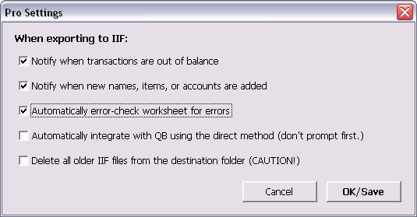
The first two options, the Notify options, provide extra confirmation regarding what is added to the IIF file. When transactions are out of balance, the IIF Creator will fix them silently, and with this option you are informed that this happened. Similarly, new names, items, and accounts are silently added to the IIF file, and this option lets you know when that happens.
The Automatically error-check worksheet for errors option runs the error checking routine as you export to an IIF file.
The automatically integrate option integrates with the destination QB file as you create an IIF file. This ensures that IIF file is created using the latest version of your lists.
Delete all older IIF files, should be used with caution. It removes all of the IIF files in the destination folder as you export, leaving only your new file in place. This can help avoid accidently re-importing older IIF files. Note that the deletion is final (files are not placed in the recycle bin.)

Advanced - Calculating unknown values – filling in the blanks
When you don’t have values for certain fields, the IIF Transaction Creator can fill in the blanks in several ways. First, if you use existing names or items, and don’t include certain details on your worksheet of data, the IIF Transaction Creator can fill in data based on the names or item from QuickBooks. Next, if you don’t know or don’t want to calculate certain amounts, the IIF Transaction Creator can calculate the amounts for you in many cases.

Including Missing Details
When you use Excel to import your transactions, you can omit some of the detail you want to see on the transaction once imported. The IIF Creator will fill in the details, including:

From Names | Address fields  Default sales tax item  Terms
Items | Account fields, as appropriate - the Purchase or Sales account.  Price/Rate  Memo/Description

Calculating Missing Amounts
One of the powerful features of the IIF Transaction Creator is its ability to automatically calculate the total and extended amounts for your transactions. If you know these amounts, then you don’t need this feature. However, if you care more about what you’re selling, and want to rely on QuickBooks rates and the IIF Transaction Creator to calculate the amounts for you, here are steps to do that. For this section, we’ll use an Invoice as an example, since sales transactions may be one of the most useful cases.
First, we’ll start our examples with a fully-calculated multi-row invoice, where all the amounts are included on the worksheet. Here you can see several attributes of the invoice. First, the extended Amounts for the Gardening and Pest Control amounts are calculated, though the Qty and Rates are also entered. Next, the sales tax is calculated. Finally, the total Amount of 635.73 is entered, though the other rows are also calculated:
Date | Type | Num | Name | Item | Account | Qty | Rate | Amount | Taxable
12/14/2009 | Invoice | 131 | Ecker Design |  | Accounts Receivable |  |  | 635.73 | Y
 |  |  |  | Gardening | Installation | -20.00 | 25.00 | -500.00 | Y
 |  |  |  | Pest Control | Maintenance & Repairs | -5.00 | 18.00 | -90.00 | Y
 |  |  |  | San Domingo | Sales Tax Payable |  | 7.75% | -45.73
Next, here is an example where some of the amounts are not filled in, but instead a “?” is entered, which tells the IIF Transaction Creator to calculate those amounts. Here, the sales tax and total invoice amount are both unknown. Note that in order for the IIF Transaction Creator to calculate the sales tax amount, the sales tax item must be imported from QuickBooks:
Date | Type | Num | Name | Item | Account | Qty | Rate | Amount | Taxable
12/14/2009 | Invoice | 131 | Ecker Design |  | Accounts Receivable |  |  | ? | Y
 |  |  |  | Gardening | Installation | -20.00 | 25.00 | -500.00 | Y
 |  |  |  | Pest Control | Maintenance & Repairs | -5.00 | 18.00 | -90.00 | Y
 |  |  |  | San Domingo | Sales Tax Payable |  | 7.75% | ?

Next, here is an example where all of the amounts are not filled in, but instead a “?” is entered. In this case, you can use new Items for both Gardening and Pest Control as the Qty and Rate is filled in on the worksheet:
Date | Type | Num | Name | Item | Account | Qty | Rate | Amount | Taxable
12/14/2009 | Invoice | 131 | Ecker Design |  | Accounts Receivable |  |  | ? | Y
 |  |  |  | Gardening | Installation | -20.00 | 25.00 | ? | Y
 |  |  |  | Pest Control | Maintenance & Repairs | -5.00 | 18.00 | ? | Y
 |  |  |  | San Domingo | Sales Tax Payable |  | 7.75% | ?
Next, here is a more extreme example where only the Qty’s are known. In this case the items Gardening and Pest Control must be set up in QuickBooks with a rate, or else the IIF Transaction Creator will calculate 0.00:
Date | Type | Num | Name | Item | Account | Qty | Rate | Amount | Taxable
12/14/2009 | Invoice | 131 | Ecker Design |  | Accounts Receivable |  |  | ? | Y
 |  |  |  | Gardening | Installation | -20.00 |  | ? | Y
 |  |  |  | Pest Control | Maintenance & Repairs | -5.00 |  | ? | Y
 |  |  |  | San Domingo | Sales Tax Payable |  |  | ?
If the Items Gardening, Pest Control, and San Domingo are set up in QuickBooks, all with the rates or sales prices seen in the first example above, then all of these invoices will produce the same output to QuickBooks.

Advanced - Text File Importing

Text, CSV, and Tab-delimited Files
If you are starting with a text file, the IIF creator can reduce the time it takes to prepare your data by using the Text File wizard. To use this wizard, start on the IIF Creator’s menu and pick Import and then Text File. You’ll see a dialog that looks like this:
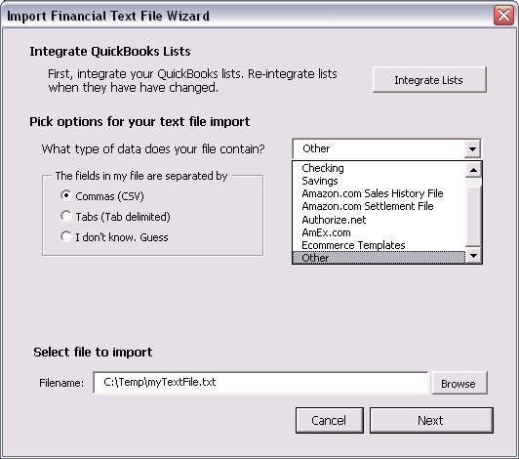
You have several options when importing a file, including picking the file delimiter, the account type, and the file name. Depending in your choices here, you’ll see other options as you continue the process. Follow the prompts to complete the process.

Amazon.com Detail Sales History File
A special implementation of the Import | Text File wizard lets you import Amazon.com history files. The data in the files is imported as Sales Receipts, Credits, Journals, and Checks, depending on the type of transaction.
An Amazon seller central account is required.
- Get the report: To download and use the correct Amazon.com file, follow these steps.
- First, log into your Amazon account.
- Pick Reports from the top menu, then Payments.
- Choose the Date Range Reports tab.
- Generate a new report, if needed.
- Click the Download button to download and save a report.
- Import it into Excel using the IIF Creator’s text import wizard and the Amazon.com Detail Sales History File option.
As you import, you’ll be asked for accounts and items as well as a few options. For best results, use accounts and items already set up in QB, which should appear on the lists. If not, integrate with your QuickBooks company file and then try again.
After you’ve imported the data, review the resulting worksheet to make sure the desired data is correct. Then continue the normal process to create an IIF file: Check the worksheet and then create an IIF file using the options on the IIF Creator’s menu or custom ribbon.

American Express History Files
To download the proper AmEx history file for use with the IIF Transaction Creator, complete the following steps:
- Log into your AmEx account online at www.americanexpress.com.
- Click My Account, and then Statements & Activity
- Choose the time period for transactions you want to download / import into QuickBooks.
- Click Download, as pictured below and then choose the options pictured (CSV and Include additional details.):
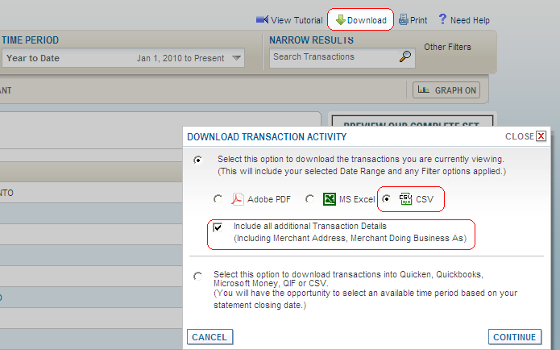
- Press Continue to download the file to your machine.
- Open the file using the Import | Text File option on the IIF Creator’s menu and then picking AmEx as the file type.
- Review the results, and then process the file as normal using the IIF Creator, checking the data and creating an IIF file from your worksheet.

Ecommerce Templates files
To download Ecommerce files, follow these steps:
- From the main Ecommerce Templates Admin page click the "view orders" link in the left-hand menu in the Store Admin section.
- Select a date range
- You can also filter the orders to review by status, for example Completed orders.
- Click the Search button.
- Choose the orders to include in your CSV file.
- Choose "Dump details to CSV file" from the pick list in the upper right of the page, and then click "Go" to begin the download.
Use the downloaded CSV file with the IIF Creator:
- Open the file using the Import | Text File option on the IIF Creator’s menu and then picking Ecommerce Templates as the file type.
- Select your PayPal account (should be a Bank account in QuickBooks) for any PayPal orders in your file. If you don’t have any PayPal orders, then you may pick any account.
- Review the results and then process the file as normal using the IIF Creator, checking the data and creating an IIF file from your worksheet.

GoDaddy Quick Shopping Cart (QSC) files
To use the IIF Creator with your GoDaddy shopping cart data, first export/download your QSC Shopping cart data using the Excel option. This will create an Excel workbook creating four worksheets. Use this file exactly as it is downloaded.
Once you have the file, then choose Import | GoDaddy File from the IIF Creator’s menu. You’ll see a dialog like this:
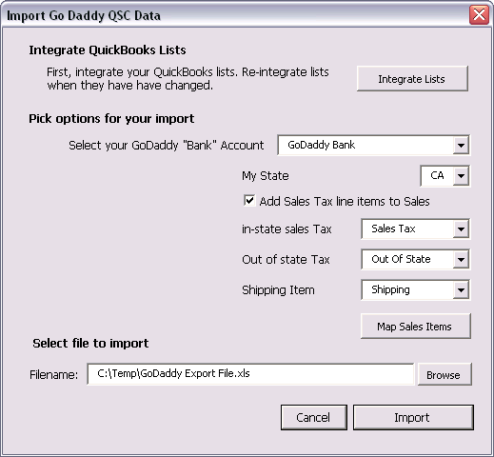
Use the GoDaddy file with the IIF Creator:
- Select your GoDaddy “Bank” account. This is where the resulting sales receipts will be recorded, and the balance of this account is the amount of Undeposited money in your GoDaddy account. You can also choose your Undeposited Funds account if you want the sales receipts to be recorded directly in that account.
- If you track sales tax in QuickBooks, select the Add Sales Tax option, your state, and the sales tax items to use in and out of state.
- Select the shipping item you’d like to use (there is no item in the GoDaddy file.)
- Optionally, you can map your GoDaddy cart items to your QuickBooks items using the Map Sales Items button.
- Use the Browse button to pick the GoDaddy XL file you downloaded.
- When you click Import the GoDaddy file will be processed into a worksheet that is ready for your review and ready to be converted to an IIF file using the standard IIF Creator features.

Advanced - Calling the IIF Transaction Creator with code
This section is intended for developers.
If you want to remotely access the IIF Transaction Creator with code in order to fully automate the creation of IIF files, this section applies to you.
There are several things you can do when you call the IIF Transaction Creator with code:
- Import lists from an IIF file or using direct connect
- Export IIF transactions to an IIF file.
- Import a settings file to configure the IIF Creator for your current worksheet.
Note that this is an incomplete interface. You can only call these functions and set a few options. Most options and configuration settings must be manually set up first. Then, once you have the import working smoothly, you can call the IIF Transaction Creator using the code examples below.

Connecting to Excel
In many cases, you’ll want to first start Excel on the machine and then connect to the running instance of Excel. This is particularly true with the IIF Transaction Creator as you’ll need to have Add-ins loaded when you call the IIF Transaction Creator’s functions. If you launch Excel with code, Add-ins don’t usually load.
Here’s a sample function you can use from another VB application to connect to Excel and launch code. If you are writing code in Excel, you don’t need to do this, but you can:
Notes:
In order to make this code work outside of Excel, you’ll need to create a Reference to Microsoft Excel.
  - In the VBA IDE, do this by choosing Tools | References.
  - In the VB 6.0 development environment choose Project | References.
Sub call_Export()
Dim runningXL As Excel.Application
Dim myResult As Variant

Set runningXL = GetObject(, "Excel.Application")

myResult = runningXL.Application.Run("'Transaction Creator for QB.xla'!export_To_IIF", "book5", "invoice", "C:\Temp\Test.iif")

MsgBox myResult(1) & vbCrLf & myResult(2) & vbCrLf & myResult(3)
End Sub

Exporting a worksheet to an IIF File
The function to export to an IIF file is called Export_To_IIF. It takes three string parameters:
- An open workbook Name
  - The workbook name may either be it’s full name like “C:\Temp\myname.xls” or just “myname.xls”
- The Worksheet Name (the name of the workbook tab your want to export.)
- The IIF File name to create
  - This may either be a fully qualified name like “C:\Temp\myfile.iif” or just “myfile.iif”.
  - If you do not use a fully qualified name, the file will be created in the current system directory.
Export_To_IIF returns a Variant Array of three values:
- A success Boolean value: True = the file was created, False = there was some issue
- A string value indicating success or failure. “OK” for success or a message indicating the issue.
- When a file is created, the file name of the file created.
  - The filename will always end with an IIF extension.
  - If you pass a file with another extension, “.iif” will be added to the filename
  - If an existing file of this name is present, it is overridden with the new data.
  - If you pass an empty string for the filename, the last known filename is used and returned.
VB Examples:
When calling Export_To_IIF from VB or VBA, you can use this VB syntax:
Application.Run "'[Filename]'! Export_To_IIF", "[Workbook Name]", "[Worksheet Name]", "[IIF File to Create]"
Or, for example:
Application.Run "'Transaction Creator for QB.xla'! Export_To_IIF", "book5.xls", "invoice", "C:\Temp\Test.iif"
If you want to pay attention to the return values of this function, use this VB syntax:
Dim successVals as variant
successVals = Application.Run ("'[Filename]'! Export_To_IIF", "[Workbook Name]", "[Worksheet Name]", "[IIF File to Create]")
Or, for example:
successVals = Application.Run( "'Transaction Creator for QB.xla'! Export_To_IIF", "book5.xls", "invoice", "C:\Temp\Test.iif")
OR:
Dim myResult As Variant
myResult = runningXL.Application.Run("'Transaction Creator for QB.xla'! Export_To_IIF", "book5.xls", "invoice", "C:\Temp\Test.iif")

Importing QuickBooks Lists – via IIF file
The function to import lists from QuickBooks is Import_Lists. It takes one string parameter, the IIF filename.
Import_Lists returns a Variant Array of three values:
- A success Boolean value: True = the file was imported False = there was some issue.
- A string value indicating success or failure. “OK” for success or a message indicating the issue.
- When a file is imported, the file name actually imported (which is probably the name you passed.)
Example:
Dim myResult As Variant
myResult = runningXL.Application.Run("'Transaction Creator for QB.xla'!Import_Lists", "C:\Temp\2008 Sample.IIF")

Integrating QuickBooks Lists – direct connect
The function to import lists from QuickBooks is Sync_Lists. It takes no parameters. It connects to QuickBooks and the currently open company file and pulls the lists it needs.
Sync_Lists returns a Variant Array of three values:
- A success Boolean value: True = the file was imported. False = there was some issue.
- A string value indicating success or failure. “OK” for success or a message indicating the issue.
- When a file is imported, the literal string "Automatic Sync"
Example:
Dim myResult As Variant
myResult = runningXL.Application.Run("'Transaction Creator for QB.xla'!Sync_Lists”)

Importing Application Settings
The function to import application settings from a file is importSettingsFile. It takes one string parameter, the settings file name. When you import settings, all of the saves IIF Transaction Creators settings are imported, which reconfigures the add-in with all of the various options and settings you can set using the user interface. Before importing a settings file, first created one form the last menu option on the IIF Creator’s menu.
ImportSettingsFile returns a Variant Array of three values:
- A success Boolean value: True = the file was imported False = there was some issue.
- A string value indicating success or failure. “OK” for success or a message indicating the issue.
- When a file is imported, the file name actually imported (which is probably the name you passed.)
Example:
Dim myResult As Variant
myResult = runningXL.Application.Run("'Transaction Creator for QB.xla'!ImportSettingsFile", "C:\Temp\QBIIFTX_Settings.dat")

Return the integrated Names List
The function to return the integrated Names list, pulled from QuickBooks is called getIntegratedNames. It takes two parameters. One parameter is for for the name types to return and the other for the two-dimensional string array of Names. The returned array’s first record contains the field names (rather like column titles in Excel) and the following records contain a list of names sorted by the NAME field.
The returned fields differ depending on the QuickBooks version used and if the user last used the IIF file method to get the lists or if they used the direct connect method. For the direct connect method of getting lists, you can safely return all name types in one array, and the values will be in the same columns. If the user used the IIF file method, you should get one name type at a time as the data returned will have a different number of columns and different data positions per name type.
The recognized types are “All”, “Employee”, “Customer”, “Vendor”, and “Other Name”. If you pass an empty string value then All name types are returned. To return more than one type, but not all, include multiple key words in the passed parameter, like “Customer Vendor” or “Other Name Employee”. You may use commas in the parameter for readability, like “Customer, Vendor, Employee”
Example:
Dim myResult() as string
runningXL.Application.Run "'Transaction Creator for QB.xla'!getIntegratedNames", “All”, myResult

