IIWC of PKBI
Program Book LMTV
2016


“From Central Java for Indonesia”
#EmpoweringCommunity

IIWC of PKBI
Indonesia International Work Camp of Perkumpulan Keluarga Berencana Indonesia
PKBI Jawa Tengah Building. 1st Floor. Room 105. Jalan Jembawan Raya No. 8 Semarang Central Java 50145 Telp: (+62) 24-7603-503 ext. 104 Fax +62247601989
Facebook: IIWC of PKBI
Twitter: @iiwc_indonesia
Youtube: IIWC of PKBI
Website: www.iiwc-pkbi.org
Project list of LMTV 2016
Contact Incoming Officer: Bi Aria (Mr)
E-mail: iiwc@pkbi.or.id | website: iiwc-pkbi.org
skype : IIWC_Indonesia
Table of Contents
What is IIWC of PKBI? 4
Vision and Missions 4
Vision: 4
Missions: 4
Values 4
Empowering Community 5
Our Team 6
General information for volunteers taking part in IIWC of PKBI Projects 7
Cancelation 7
Geography 7
Currency 8
Price List in Java Island 10
Basic Bahasa Indonesia 11
Daily Life 11
Moslem Pray Timing 13
Visa 13
CONTACTS 14
Long & Middle Term Volunteering 2016 15
The Aims 15
Working Days & Holiday 16
General Requirements 16
Financial Policy 16
Long & Middle Term Volunteering Project List (Duration: 2 - 12 Months) 18
Volunteer at PKBI Central Java Project 20
Mangkang Mangrove Conservation Project 23
Gedongsongo Heritage Village Project 25
Tegalrejo Red-District Shelter Project 27
Borobudur Temple Compound Project 29
Borobudur Village Heritage Project 31
Semarang Street Children Project 33
PIP – Semarang Urban Farming Project 35
Semoya Education Project 37
Disabled Children Shelter Project 39
Nuansa Mandiri Micro Credit Project 41

What is IIWC of PKBI?
Indonesian International Work Camp (IIWC) is a program that managed under PKBI (Perkumpulan Keluarga Berencana Indonesia) Jawa Tengah – Eng: Indonesia Planned Parenthood Association Central Java/IPPA Central Java- founded since 1998. IIWC of PKBI Jateng organized first workcamp cooperated with NICE Japan in Mijen Region, Semarang City. In the process, we engaged cooperations with local organizations and some volunteering organizations in global level. We started our volunteering activities while bringing tolerance in cultural diversity issue in the world.
IIWC of PKBI Jawa Tengah is recently growing and more strengthening as a pioneer in international volunteerism movement. We existed and actively involved in promoting global issue which is raised from local potentials. Not only for international but also empowering local volunteers.
This year, we are fully engage with our mother organization, PKBI to spread IVS movement to all over Indonesia. With the spirit of Volunteerism, Pioneers, Professionalism, and Independence, PKBI developed 26 branches all over Indonesia. Registered as a permanent member of International Planned Parenthoods Federation (IPPF), PKBI is involved in global movement as well. For the first step we open chance for your volunteer to participate our Work Camp in 8 provinces in 4 islands.
In line with Sustainable Development Goals/SDGs (Link: https://goo.gl/FucWoa) this year, we inspired to develop IIWC program with still related PKBI Jawa Tengah’s Visions and Missions. In the future, IIWC PKBI Jawa Tengah will still organized international volunteering program and more focus on community development for the people to have more control on themselves and better life quality.

Vision and Missions

Vision:
“Community empowerment, To Improve Quality of Life”

Missions:
- Community empowerment with maximizing local potentials
- Improving Youth involvement as a agent of changes toward society
- Spreading volunteerism spirit

Values
- Volunteerism
- Pioneering
- Independency
- Professionalism

Empowering Community

There are so many problems in a community that neither could be solved by the government nor by private sectors. As PKBI was established by the spirit of volunteerism, IIWC of PKBI believes that there are so many people that still have enthusiasm to make a change by their own strength in the community. Community only needs facilitators to dig out their potential and raise the spirit of volunteerism. This challenge inspired PKBI to develop a volunteerism platform to empower communities with groups or individuals with different background and culture but could still work together as a team. PKBI uses this tool to support local communities in order to reach family prosperity.
At least, 100 cadres work voluntary all over Indonesia with more than 500 youth volunteers have spirit to get involved in volunteering movement. Community Empowerment is the way to increase society ability on having their own control upon themselves. By this concept, as our base view on arranging the activities, IIWC of PKBI Jawa Tengah sees every community has potential to be developed as their strenght. By attendance of our volunteers in community, they will be a facilitator to dig deeper their potential and spreading the spirit of volunteerism.
In the other hand, IIWC PKBI Jawa Tengah Volunteers will perform in society as a group or individual who concern on tollerance beneth geographical distances, and cultural differences but they still could work together as a team. We use this tool to support our local partner to reach their aims.
We think that our activity is still relvant at the moment on the road to SDGs era in the near future. We believe, empowered communities will make big impact through society in local level at first, and by the time it will contribute widely in global level.
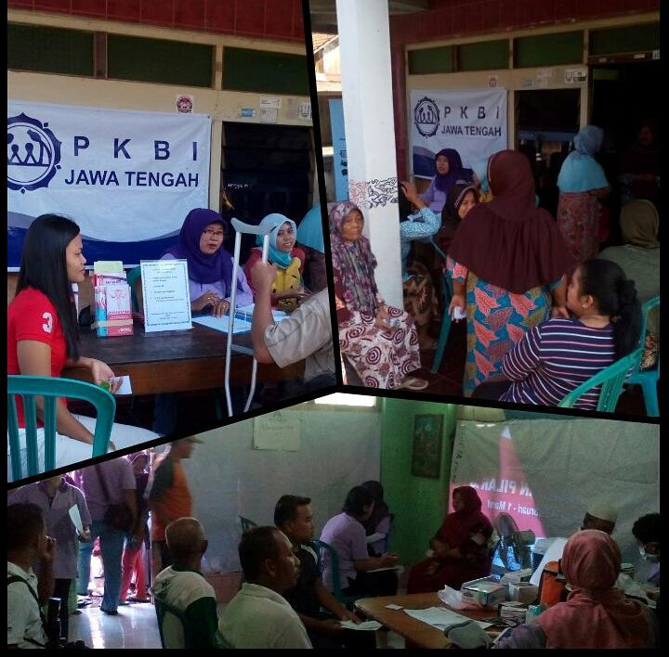

Our Team

PKBI Executive Director
Mrs. Lisa

Coordinator
Ms. Dania

Legal & Admin
Mr. Yoyon

Program Development
Mrs. Ifa
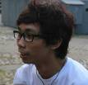
PR & Incoming Officer
Mr. Bi
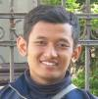
Project Development
Mr. Sany
PKBI Board Member
Outgoing Officer
Ms. Dania

Volunteers Mentors
Mr. Zulham & Mr. Wildan
Training Division
Mr. Yoyon
Notes:
Blue: Full-Paid
Green: Part-Time

General information for volunteers taking part in IIWC of PKBI Projects

Cancelation
Please inform to IIWC Indonesia trough iiwc@pkbi.or.id at least 30 Days before your work camp start. Cancelation it is really harm full to our project. Because, most of projects fund come from international participation fee. It also will affect to our cooperation with local partner. And it would be so be unfair if we keep your place blocked and therefore not giving a chance to other motivated volunteers who really willing to come to Indonesia.

Geography
Indonesia lies between latitudes 11°S and 6°N, and longitudes 95°E and 141°E. Due to this country located on equator line, Indonesia has a tropical climate with wet and dry seasons. Average annual rainfall in the lowlands varies from 1,780–3,175 millimeters (70–125 in), and up to 6,100 millimeters (240 in) in mountainous regions. Humidity is quite high, averaging about 80%. The average daily temperature range of Jakarta and another big city is 26–35 °C, and 18-25°C for the mountainous area.
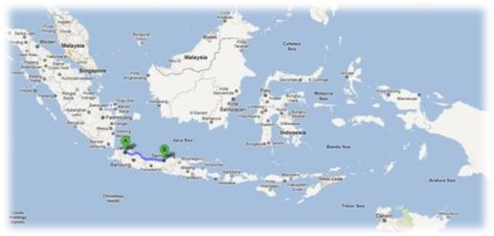

Jakarta (Capital City of Indonesia) Indonesian Flag (Merah Putih)


Semarang (Capital City of Central Java)
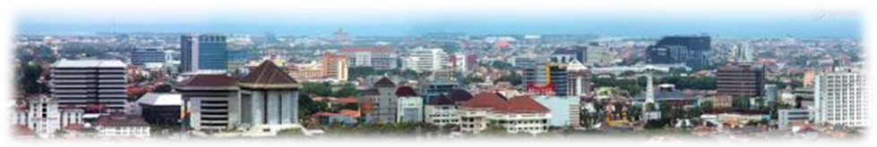

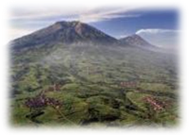

Mountainous Area in Java Island

Currency
The rupiah (Rp) is the official currency of Indonesia. Issued and controlled by the Bank of Indonesia, the ISO 4217 currency code for the Indonesian rupiah is IDR.

Image |  | Value | In Euro ( Oct 2015)
 |  | 100 IDR | 0.01
 |  | 500 IDR | 0.03
 |  | 1,000 IDR | 0.07
 |  | 1,000 IDR | 0.07
 |  | 2,000 IDR | 0.13
 |  | 5,000 IDR | 0.33333
 |  | 10,000 IDR | 0.66667
 |  | 20,000 IDR | 1.33333
 |  | 50,000 IDR | 3.32
 | 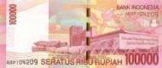 | 100,000 IDR | 6.64

Price List in Java Island
1 Package of Bread (10 slices) : 12,000 IDR
1 Liter or Milk : 14,000 IDR
1 Kilogram of Eggs : 15,500 IDR
1 Pieces of Instant Noodle : 1,800 – 2,300 IDR
1 Simple Mobile Phone : 150,000 IDR
1 SIM Card : 10,000 – 60,000 IDR
1 Internet Stick/USB Modem : 100,000 – 300,000 IDR
500 ml of Mineral Water : 3,000 IDR
Bananas /100gr : 1.375 IDR
1 Kilo of Mangoes : 14,000 – 18,000 IDR
1 Small Durian : 18,000 – 25,000 IDR
1 Huge Durian : 70,000 – 100,000 IDR
1 Plate of Nasi Goreng : 8,000 – 12,000 IDR (food stall), 18,000 – 25,000 IDR (restaurant)
1 Bowl of Meatballs : 8,000 – 10,000 IDR (food stall), 10,000 – 18,000 IDR (restaurant)
1 Bowl of Chicken Noodle : 6,000 – 7,000 IDR (food stall), 8,000 – 15,000 IDR (restaurant)
City Bus Fare : 3,500 IDR (Bus Rapid Transit)
1 coca cola 350 ml : 5,000 IDR
McDonald’s prices : http://menumcdonaldindonesia.com/
Economic City Bus : 2,000 IDR for 1-2 km. 3,000 IDRfor 3-5 km. 5,000 IDR >10km
Taxi : Approximately 15,000 IDR for 5km. 50,000 IDR for 15km.
Gasoline : Premium 7.400 IDR / liter , Pertalite 8.300 IDR / liter ,
Pertamax 9.000 IDR/liter

- Convenient stores such as Indomaret, Alfamaret, Circle K, 7Eleven are available everywhere in Java and Bali Island.
- ATM with Master Card, VISA, and Cirrus are available everywhere in main islands (Java, Bali, Lombok, Kalimantan, Sulawesi, and main cities in Papua)
- Credit Card is useable only in fancy restaurants and big supermarket (Hypermart, Carefour, Giant)
- Money Changer is available in airports and about 2-3 offices in big cities/ capital cities in Provincial level (Jakarta, Bandung, Semarang, Jogjakarta, Surabaya, dll)
- Traveler’s cheques can be cashed in international banks only (HSBC, CIMB, Standard Charter, etc)

Basic Bahasa Indonesia

Greetings and Introduction
Selamat Pagi Good Morning
Selamat Siang Good Afternoon
Selamat Sore Good Evening
Selamat Malam Good Night
Terima Kasih Thank you
Sama-sama You’re welcome
Sampai Jumpa See you again
Selamat tinggal Good Bye
Hallo, apa kabar? Hello, how are you
Nama saya Putri My name is Putri
Saya dari Indonesia I’m from Indonesia
Umur saya 22 tahun I’m 22 years old
Saya akan tinggal disini selama … bulan I’ll stay for … month
Saya akan tinggal disini sampai … I’ll stay until …
Hallo, siapa nama kamu/Anda? Hello, what’s your name?
Berapa umurmu? How old are you?

Daily Life

Electricity
Indonesia uses 220 Volt for its electricity. (Few years ago, the voltage was 110V. But then we switched to 220 Volts.) The voltage in many places is unstable. If you plan to bring computer, for example, you have to get a voltage stabilizer or a UPS.


Electricity Plug (F) in Indonesia Universal Plug F


Take a Bath (MANDI)
Bath tub and shower is not common in Indonesia. People normally just take the water from the water container using a dipper, called MANDI Mostly the toilet is integrated in one room (see picture).

Indonesian Bathroom with Indonesian Toilet Indonesian Bathroom with Western Toilet
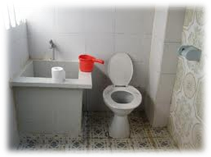
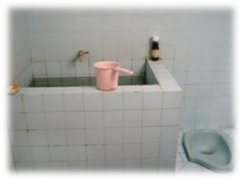

Meals

- Indonesian staple food is rice! It equals to bread or potato.
- Make sure you can or at least interested to adjust to rice, since you will be here for few weeks or even months
- Avoid chili or spicy food, because most non-indonesian can’t stand those

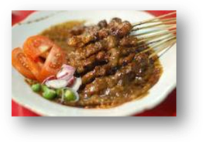

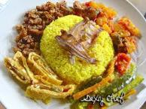
Sate Ayam / Chicken Satay Nasi Goreng / Fried rice Nasi Kuning / Yellow Rice
Bakso / Meatballs Mie Ayam / Chicken Noodle Gado-gado/Salad Ayam Penyet /

Fried Chicken With Chili




Moslem Pray Timing
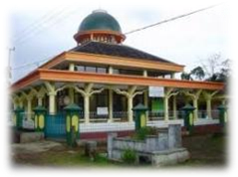
Muslims pray five formal prayers each day. The timings of these prayers are spaced fairly evenly throughout the day, so that one is constantly reminded of God and given opportunities to seek His guidance and forgiveness. You will hear the call to prayers (Azan) five times a day from the megaphone or loud speaker of Mosque for every praying time. Muslims observe the formal prayers at the following times:
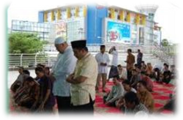
Fajr (pre-dawn): This prayer starts off the day with the remembrance of God; it is performed before sunrise. Azan between 03.30 – 05.00 am.
Dhuhr (noon): After the day's work has begun, one breaks shortly after noon to again remember God and seek His guidance. Azan between 11.45 am – 12.15 pm
'Asr (afternoon): In the late afternoon, people are usually busy wrapping up the day's work, getting kids home from school, etc. It is an important time to take a few minutes to remember God and the greater meaning of our lives. Azan between 3.00 – 3.30 pm
Maghrib (sunset): Just after the sun goes down, Muslims remember God again as the day begins to come to a close. Azan between 5.40 – 6.15 pm
'Isha (evening): Before retiring for the night, Muslims again take time to remember God's presence, guidance, mercy, and forgiveness. Azan between 6.50 – 7.15 pm

Visa

Recommended Visa for MTV Incoming Program (Duration Stay: 30 – 60 Days)
TYPES | DURATION | REMARKS
Visa On Arrival (Link: http://goo.gl/8LNC3z )  For more than 80 Countries | 30 Days | Cost US$ 25 - US$ 35 (Depend on Entry Airport)  Extendable 30 days

To stay up to 30 days, you may use recommended visa bellow. For those who want to stay up to 60 days, you should by Visa on Arrival, with one extend required in Indonesia.

Recommended Visa for LMTV Incoming Program (Duration Stay: 30 Days – 1 Year)
TYPES | DURATION | REMARKS
211 Visa (Link: http://goo.gl/8LNC3z )  You should Apply through Indonesian Embassy/Consulate in your country | 60 Days | Cost US$ 55  Extendable 4 times

To stay more than 30 days, you can apply for VISA Index 211 valid up to 60 days and extendable in any of Immigration offices in Indonesia. 211 Visa is not working visa, for tourism, family, social and cultural visit. Long And Middle Term volunteers are supposed to apply for this visa. For those who will stay up to 1 year, volunteer should renew their VISA once through Indonesian Embassy in country outside Indonesia (IIWC of PKBI team will recommend you some countries you able to apply during your stay).

Attention!
- For your visa renewal, IIWC will provide the volunteers with the invitation letter for visa
- Volunteers arrived should be reported to the authorizes with PKBI Director’s as guarantor

CONTACTS
Address:
IIWC of PKBI
Jl. Jembawan Raya No.8 Semarang, Jawa Tengah - INDONESIA
1st floor Building of PKBI Jawa Tengah Room 1.04.
Tel. +6224-7603503 LINE : iiwcpkbijateng
Fax. +6224-7601989 Whatsapp ; +62821-3466-4075
Website: www.iiwc-pkbi.org
Email:
- iiwc@pkbi.or.id (General/Placement)
- pr.iiwc@pkbi.or.id (Public Relations)
Staff Contact:
- Coordinator of IIWC
Dania Moehas iiwc@pkbi.or.id
- Finance & Admin
Ifa Rodja admin.iiwc@pkbi.or.id
- Public Relation & Placement
Bi aria pr.iiwc@pkbi.or,id

Long & Middle Term Volunteering 2016
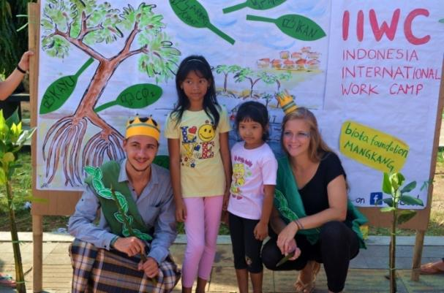
Long and Middle Term Volunteering is an international activity that deposits 2-5 month (middle term) or 6-12 (long term) with special theme for sustainable project. This activity is an individual project which each project contain 1 up to 3 volunteers. LMTV incoming program will support our mostly our regular activity in each project site. They will collaborate really close with local community as well as local volunteers (local Volunteers) to organize the project during their stay Indonesia.
Volunteer will stay either in rented volunteer house, or stay with a local family. This is aimed to collaborate with partners or local communities with the main purpose of exchanging experiences, culture, and mutual benefit between the relevant parties.

The Aims
- To exchange experience and culture, to provide opportunities for volunteers to connect with and learn from the community through enjoyment of local life and exchange.
- To promote lasting change with specialized and sustainable voluntary works that improve the community.
- Mutual benefit between the stakeholder, to empower not only the hosts, but also the local communities especially in depopulated areas.

Working Days & Holiday
- The volunteers work 5 days a week at least 25 hours.
- Saturday and Sunday are officially free, but there might be projects that have different free days. Volunteers can discuss together with the local partner for those days.
- The volunteers deserve to get 1 day off for each month
- For visa renewal (maximal 7 days), IIWC and local partner must know beforehand.
- If there will be a visit from your family or friends, please plan it according to the leave off days, your working schedule, meeting, middle and final evaluation seminar.
- In case that your guest would like to stay in your project site, please inform the local partner beforehand.

General Requirements
- Volunteers must be 18 years old or older
- Volunteers are keen on learning Indonesian language
- Volunteers have to be open minded toward local culture and custom
- Volunteers are obliged to stay during the whole length of the project
- Volunteers must bring their own personal medicine
- Volunteers will work 5 days a week, 5 - 8 hours a day. Saturday and Sunday are free days for volunteers, but there might be some project with different free days
- Volunteers have to be able to manage their own lodging whatever the type of the accommodation (Host Family, Boarding House, Dorm, Volunteer House)
- Required Language is English, but basic knowledge of Bahasa Indonesia will be necessary. We encourage the volunteer to learn Bahasa Indonesia in their home countries before departure.

Financial Policy
Participation fee is payable upon arrival, and each month should be paid on the first week of the month. It is around IDR 1,600,000 – IDR 3,100,000 (Approx. 106 Euros - 213 Euros) per month covering:
- Meals (Meals support provided IDR 900.000/month)
- Accommodation
- Management Fee
- Information and support in obtaining visa before arrival,
- Transportation from IIWC office to the project site when you starting your project, Orientation session, evaluation session, project coordination, & project supervising
- Project Material
Please note!
Volunteers should bear her/his personal expenses and bear health insurance by themselves. Fee for visa extension is IDR 400.000 for the first extension and IDR 350.000 for the second extension.
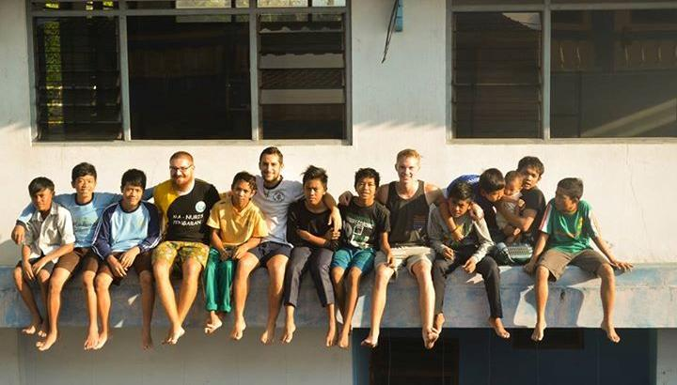

Long & Middle Term Volunteering Project List (Duration: 2 - 12 Months)
No | Code | Name | Location | Period | Type)* | Age | Vols | Fee (IDR)/Month
1 | LMTV – IIWC 1601 | Volunteer at PKBI Central Java Project | Semarang City, Central Java | Whole Year Except June 6th – July 6th | INTERN | 18+ | 2 | 2,700,000
2 | LMTV – IIWC 1602 | Mangkang Mangrove Conservation Project | Semarang City, Central Java | Whole Year Except June 6th – July 6th | ENVI, EDU | 18+ | 3 | 3,100,000
3 | LMTV – IIWC 1603 | Gedongsongo Heritage Village Project | Semarang Regency, Central Java | Whole Year Except June 6th – July 6th | HERI, EDU | 18+ | 1 | 3,100,000
4 | LMTV – IIWC 1604 | Tegalrejo Red-District Shelter Project | Semarang Regency, Central Java | Whole Year Except June 6th – July 6th | KIDS, EDU | 18+ | 3 | 3,100,000
5 | LMTV – IIWC 1605 | Borobudur Temple Compound Project | Magelang Regency, Central Java | Whole Year Except June 6th – July 6th | HERI, EDU | 18+ | 2 | 3,100,000
6 | LMTV – IIWC 1606 | Borobudur Village Heritage Project | Magelang Regency, Central Java | Whole Year Except June 6th – July 6th | HERI, CUL | 18+ | 2 | 3,100,000
7 | LMTV – IIWC 1607 | Semarang Street Children | Semarang City, Central Java | Whole Year Except June 6th – July 6th | KIDS, EDU | 18+ | 2 | 3,100,000
8 | LMTV – IIWC 1608 | PIP – Semarang Urban Farming Project | Semarang City, Central Java | Jan – Jun & Sept – Dec | ENVI, EDU | 18+ | 2 | 1,600,000
9 | LMTV – IIWC 1609 | Semoya Education Project | Sleman, Yogyakarta | Jan – Jun & Sept – Dec | KIDS, EDU | 18+ | 2 | 3,100,000
10 | LMTV – IIWC 1610 | Disabled Children Shelter Project | Semarang City, Central Java | Whole Year Except June 6th – July 6th | KIDS, EDU | 18+ | 2 | 3,100,000
11 | LMTV – IIWC 1611 | Nuansa Mandiri Micro Credit Project | Semarang City, Central Java | Whole Year Except June 6th – July 6th | SOC, EDU | 18+ | 1 | 3,100,000

Volunteer at PKBI Central Java Project

Code/Name | Location | Period | Type)* | Age | Vols
LMTV – IIWC 1601  Volunteer at PKBI Central Java Project | Semarang City, Central Java | Whole Year Except June 6th – July 6th | INTERN | 18+ | 2
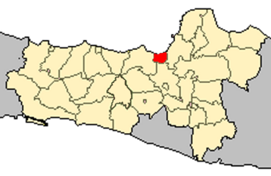
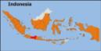

- Background: PKBI is mother organization of IIWC of PKBI. Perkumpulan Keluarga Berencana Indonesia (Indonesian Planned Parenthood Association – Eng) well known as PKBI is a pioneer of family planning movement in Indonesia since 1957, responding to the high death rate during birthing process at that year. PKBI believes that the prosperity of community should start by family. Family takes responsibility in 5 dimensions: Birth- Education- Health- Prosperity- and Future. As a non-profit organization, PKBI consistently engages in the field of family planning, population and Sexual and Reproductive health and rights (SRHR) for the needs of marginalized, social excluded and underserved groups. PKBI runs specific projects to fulfill sexual and reproductive health and rights through education, health services, empowerment of the community, and advocacy.

- Project
      - Youth Center Pilar PKBI Jawa Tengah
This Program had focus on giving education about Sexual and Reproductive Health and Youth Friendly Services. Youth Center Pilar consists of many volunteers ages 10-24 years old. Creativities, Highly Motivated, and interested in Sexual and Reproductive Health are the main requirement to involve at this program.
      - IIWC PKBI Jawa Tengah
Indonesia International Work Camp had focus on empowering community to make community have a better quality of life. The entire volunteer in IIWC PKBI Jawa Tengah will be involving in community issues.
      - Rumah Pintar Bangjo
Rumah Pintar Bangjo is educational shelter for marginalized kids living in Traditional Market of Semarang (Pasar Johar).
      - Sexual and Reproductive Health Clinics (Youth Friendly Services)
This clinics giving comprehensively sexual and reproductive health services, and mobile clinics for poor, marginalized, social excluded, and underserved people.

- Work: Volunteer will have one week preparation week to prepare workplan during their stay in Indonesia. IIWC 0f PKBI will assist them to allocate the activies baed onsince there are 4 different program that volunteers should be involved, we will explain each program:
1. Youth Center Pilar :
a. Education:
    - Give Sexual and Reproductive Health Information to school/university/kids
    - Peer Education discussion
    - Media handling : promote and educate teenagers about current issues that they can join
b. Service:
    - Counseling to local people
    - Mobile Clinic
    - Clinic for teenagers
- IIWC of PKBI:
  - Joining in IIWC PKBI event,
  - Project Visit
  - Media handling.
- Rumah Pintar Bangjo :
      - Study Group for early age kids and drop out kids
      - Library,
      - Skills Training for kids and the local people
      - Outing to the public library, museum, and other public place
      - Once a month health service
- Sexual and Reproductive Health Clinics:
  - Health promotion work

- Aims:
  - To give opportunity for volunteers learning about NGO’s work in Indonesia
  - To learn and promote about family planning issue in Indonesia
  - To support and enrich PKBI Central Java Programs

- Special remarks: Please be aware of Reproductive Health issues, bring some creative ideas for campaign, and be opening minded with all the cultural issues that related to health matters. You might be handling the website and media social as well.

- Location: at PKBI Building Jl.Jembawan Raya 8 - 12 Semarang , Central Java, Indonesia

- Accommodation: House Family, self cooking, and self management.

- Duration: at least 2 months

- Fee : IDR 2,700,000 per month (Approx. 180 Euro)

- Air port: Ahmad Yani Semarang Air port; Train Station : Tawang Semarang train station
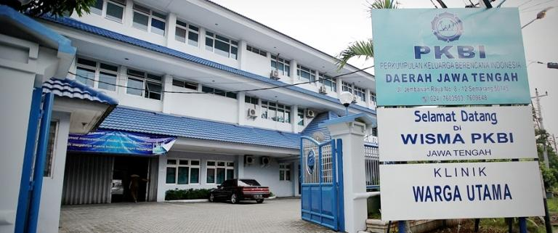
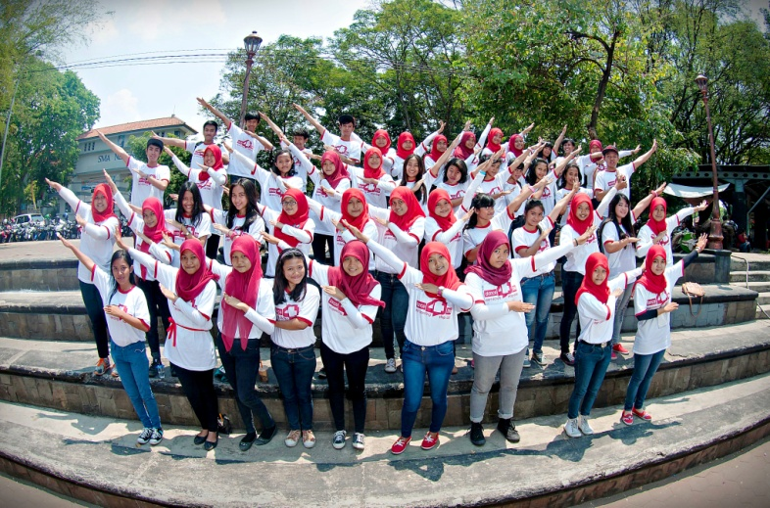

Mangkang Mangrove Conservation Project

Code/Name | Location | Period | Type)* | Age | Vols
LMTV – IIWC 1602  Mangkang Mangrove Conservation Project | Semarang City, Central Java | Whole Year Except June 6th – July 6th | ENVI, EDU | 18+ | 3
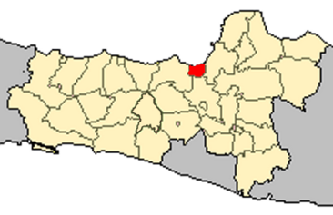
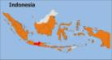




- Background: The project is answering the needs of preserving the coastal side of North Java Sea in Mangkang. This area is now in danger due to the abrasion of the sea, cutting mangrove by local factory and heavy force from the river flows. Before, many kinds of fish and shrimps are living there, but now since the condition of the mangrove forest is getting worse, it is quite difficult to find the species anymore. Fisherman also needs to go further to the ocean to fish and it means much work they need to do to earn money.

- Project: Mangkang is an area in the border of Semarang and located in coastal area but not in touristic part. There are 2 villages, Mangkang Wetan and Mangunharjo which separated by Street. Since 2007 IIWC cooperating with Lepas NGO and Bumi Lestari Mangrove Farmer Association plant mangroves in this area. Project start with workcamp and right now there are at least 4 workcamps in one year held in Mangkang. On 2010 IIWC start LMTV project at this area, and become pilot project for LMTV and STV work and support each other in one project site.

- Aims:
- To educate local people about the important of mangrove forest
- To educate local people about sustainable garbage management system
- To support youth empowerment program

- Work:
- Planting Mangrove at coastal/green belt in muddy habitat.
- Organizing socio cultural & environment educational activity with local youth,
- Campaign about environmental Issue,
- Promote Mangrove issue to some local school and university
- Promoting environment-friendly lifestyle by Reuse, Recycle, & Reduce

- Special Remarks: Very hot and less hygiene condition of poor coastal area. Be ready with sun block and sun burnt. Bring some ideas for environment education (especially about mangrove and how to take care of it) and Olympic Games for environment education for small children aged from 6-12 and adult. High Motivation, patient, prepares to work in slum area, prepare for muddy pond!!! Good physical endurance is a must!

- Accommodation: Volunteer will stay in IIWC Volunteer house inside the village

- Location: Mangunharjo village, Mangkang Wetan municipality, Semarang.

- Duration: at least 2 months

- Fee: IDR 3,100,000 per month (Approx. 213 Euro)

- Airport: Ahmad Yani International Airport Semarang, Tawang Train Station,
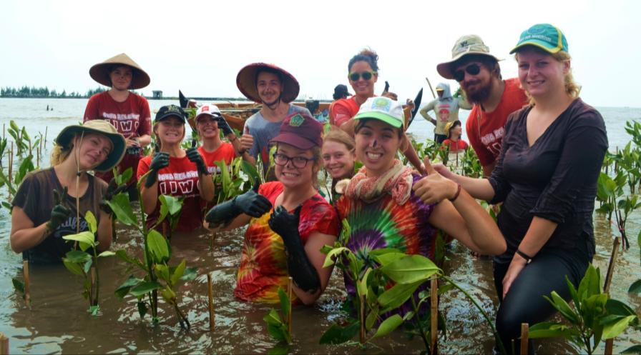

Gedongsongo Heritage Village Project

Code/Name | Location | Period | Type)* | Age | Vols
LMTV – IIWC 1603  Gedongsongo Heritage Village Project | Semarang Regency, Central Java | Whole Year Except June 6th – July 6th | HERI, EDU | 18+ | 1
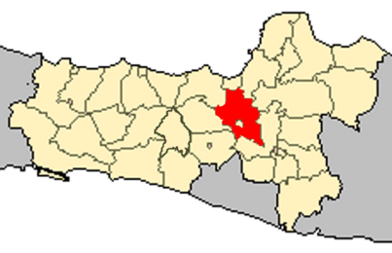
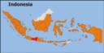


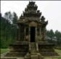

- Background: Gedongsongo is one of national heritage located in Central Java. There are 5 temples in the areas and the temples and became an attractive place for holiday, especially for regional tourist. This temple also surrounding by many intangible heritage such as dance, music, and festival that should support on the temple preservation matters. But still the environment awareness, socio economic background, sanitation and hygiene of the local people need to be improved. Most of the locals are earning money from the vegetables garden. The limitation of environmental friendly awareness from the local visitor as well as the sellers, this situation left many garbage in the temple area. The increasing number of visitor each year also contributed vandalism at the temple become one of the big problem on the heritage preservation issues.

- Project: Gedongsongo surrounding by villages which support on the existence of this historical sites. This place is growing one of popular tourist site in Semarang Regency. There are two most important aspects on heritage preservation issue on this place. First is tangible and intangible heritage such as building, dances, clothes, and soon. Second, is about society empowerment.

- Aims: To increase the awareness of the local people about garbage problem (especially non organic garbage), to support tangible and intangible heritage preservation program, cultural exchange with local people and educate student/local people to take care their environment, and self hygiene.

- Work: Volunteers will work daily with daily local activities (community service), environment awareness such as recycle garbage, organizing additional English lesson and school visit, and playing educative games with local children. Volunteers will also do the follow up activities of social empowerment program such as cultural exchange, health issue problem, socio cultural and economic aspect.

- Special remarks: please bring any necessary information about garbage recycle/upcycle. Be very creative for additional English lesson, games and other activities for the children. Usually on around October – March should be already rainy season. But, the weather becomes unpredictable now. So, do remember to bring sun block, rain coat and warm clothes to prevent very hot in the day time, rain during work and very cold at night.

- Accommodation: Host family, sleeping bag or and mattress needed, self cooking, and self managing.

- Location: Candi Village, Gedongsongo, Bandungan, Semarang Recency, Central Java Indonesia. The volunteers can see the breath taken view from the top of the hill in Gedongsongo. The air is so fresh and the nature is still so pure for a relaxing day. Click here to see the map.

- Duration: at least 2 months

- Fee: DR 3,100,000 per month (Approx. 213 Euro)

- Air port: Ahmad Yani Semarang Air port (SRG); Train Station: Tawang Main Train Station
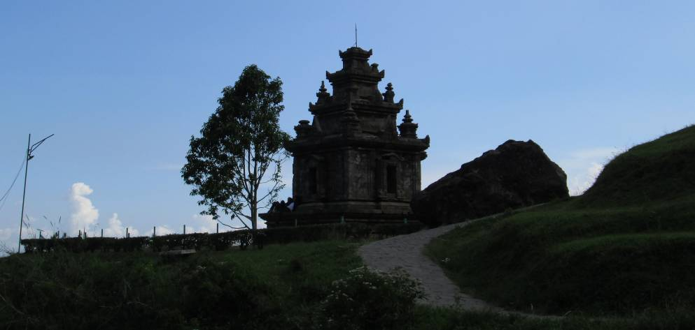

Tegalrejo Red-District Shelter Project

Code/Name | Location | Period | Type)* | Age | Vols
LMTV – IIWC 1604  Tegalrejo Red-District Shelter Project | Semarang Regency, Central Java | Whole Year Except June 6th – July 6th | KIDS, EDU | 18+ | 3
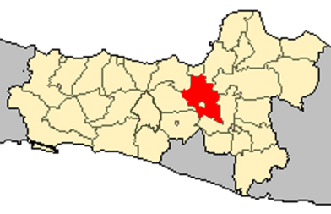
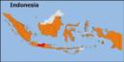



- Background: Vulnerable group especially less fortunate children in the city area and sub-urban area with various backgrounds is not yet holistically supported by the government or by other formal institutions in Indonesia. Children living in a prostitution area potentially experience daily lives with less non-formal educative interaction and space for playing with their peers. In Tegalrejo Prostitution area situated in Semarang region uptown the city live more than 25 children with this less advantage situation.

- Project: to facilitate children to play and learning activities in a positive way as mandated by children convention. We

- Aims:
- To assist children to learn their school subjects
- To give skill and arts knowledge to children
- To improve self confidence of children
- To motivate children on the importance of education

- Work: Main activities in shelter: Giving assistance to some school’s subjects, language skill, soft skill & hard skill, & organizing performance/expo/charity periodically. Additional Work: Class assisting or extraculiculer English at an Islamic elementary school nearby the shelter.
- Special remarks: be ready with many ideas for games and competition for children. Be open minded, and need to have lots love and cares to children , be ready as well that some children might be hyperactive.

- Accommodation: Tegalrejo Shelter/Rumah Belajar IIWC (minimum standard Javanese rent house); sleeping bag and mattress needed, self cooking

- Location: Tegalrejo sub-village, Jatijajar village, Semarang, Central Java Indonesia. Click here to see the map.

- Duration: at least 2 months

- Fee: IDR 3,100,000 per month (Approx. 213 Euro)

- Airport: Ahmad Yani Semarang airport (SRG); Train station: Tawang Main Train station

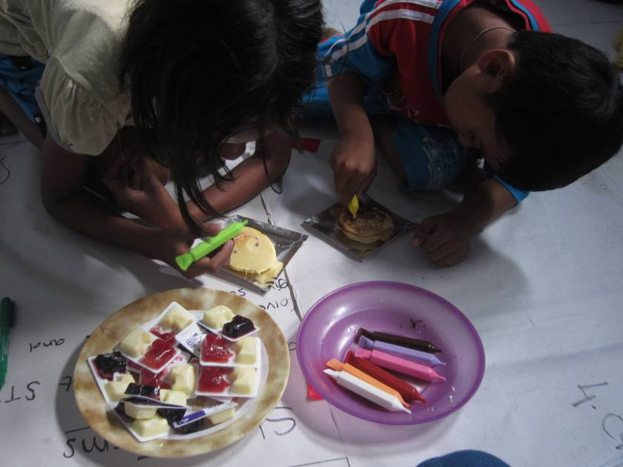

Borobudur Temple Compound Project

Code/Name | Location | Period | Type)* | Age | Vols
LMTV – IIWC 1605  Borobudur Temple Compound Project | Magelang Regency, Central Java | Whole Year Except June 6th – July 6th | HERI, EDU | 18+ | 1
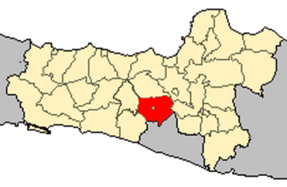
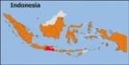

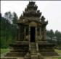

- Background: The world heritage volunteer program which is under the framework of the UNESCO World Heritage Education Program was officially launched in 2008. The activity initiated raising awareness about the necessity to protect, preserve and promote cultural and natural heritage in general and the inscribed or potential world heritage sites in particular. Volunteering program will support on Borobudur temple compound site preservation program through youth empowering.

- Project: Our heritage program is demonstrating the value of non-formal education as an approach to disseminate the values and expertise developed at the inter-governmental level to a large public and to young people in particular. The opportunities for a dynamic dialogue between the heritage and education expert involved in the promotion and protection of the sites and the volunteers and youth groups developing concrete world heritage projects to be carried out.

- The Aims :
- To increase the awareness among the youth in protecting, promoting and preserving the world heritage site in Indonesia generally, in Borobudur and Prambanan temple specifically.
- To Continue and sustain the previous activities in Borobudur and Prambanan temple by involving the young guardian network.
- To strengthen the cooperation among all stake holder involved.

- Work: Organizing school visit, together with local stakeholder, preparing the training for Youth Community, and training related to volunteer skill, Creating and distributing the educational material together with the senior high school students. Organizing campaign and direct outreach to the visitors of the temple for short discussion and raising awareness. Improving the English skill and business skill of local youth in UNESCO Gallery. This village has several potential local products such as pottery, pineapple and apple jam, organic snack, and batik.

- Accommodation: Boarding house in Indonesian family with simple bedding, shared kitchen and bathroom. Please note that Indonesian life style is very modest compared to European or American way.

- Special Remarks: Knowledge of history or world heritage site will be very helpful.

- Location: Borobudur Village (next to Borobudur temple), Borobudur municipality, Magelang regency, Central Java Indonesia.

- Airport: Ahmad Yani International Airport Semarang (SRG),Tawang Train Station, and Terboyo Bus Station

- Duration: At least 2 months

- Fee: IDR 3,100,000 per month (Approx. 213 Euro),
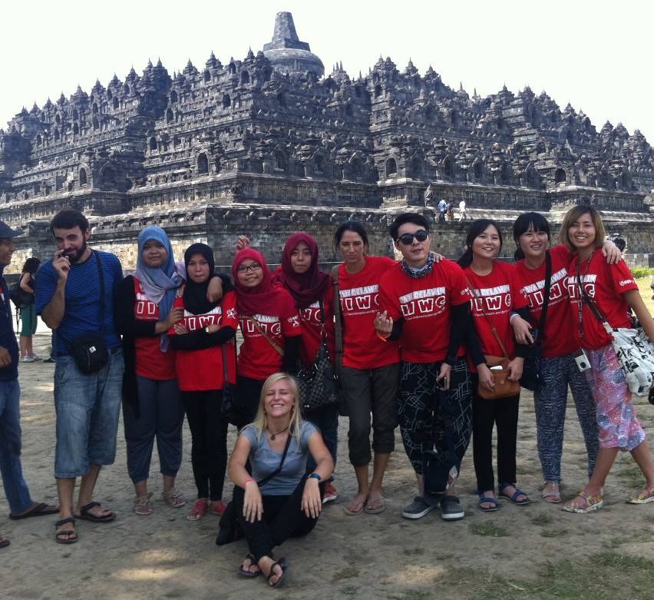

Borobudur Village Heritage Project

Code/Name | Location | Period | Type)* | Age | Vols
LMTV – IIWC 1606  Borobudur Village Heritage Project | Magelang Regency, Central Java | Whole Year Except June 6th – July 6th | HERI, CUL | 18+ | 1
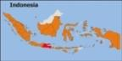

- Background: Borobudur Village Heritage Project located nearby the Borobudur Compound. The Borobudur Compounds is the greatest Buddhist temple in all over the world. Nominated as one of World Heritage List, The Borobudur Compounds has the most complete Buddhist relief as well. In a year, there are approximately 3.5 million people came to see and learn Borobudur Compound history and philosophy. This number are not as huge as number of people who interest in another cultural things in Borobudur Village. If we walk about 10 minutes from Borobudur Compounds we will find a peaceful place where Borobudur Village Heritage is preserved. Borobudur Village Heritage consists of Gamelan (Javanese traditional instrument) House, pottery Houses, Traditional food made of tofu, traditional oil refining, etc. There are Community Gallery of UNESCO to display all the traditional handmade of community.

- Project: Providing creative method to educate student and visitors of Borobudur Compound together with local volunteer who lived in Village. Cultural exchange for the local people and the volunteer would be nice collaboration to raising awareness of preserving heritage.

- Aims: Preserve Borobudur Village Heritage by inspiring local youth to love their village heritage.

- Work: Learning Borobudur Village Heritage, school visit to educate student about Borobudur Village Heritage, cleaning Borobudur Temple Compounds, creative campaign to raising awareness visitors to preserve Borobudur Temple Compounds.

- Special remarks: Very hot but sometimes rainy. Be ready with sun burnt and mosquitoes. Bring some ideas for creative campaign to preserve Borobudur Village Heritage, and your cultural learning spirit. You will amazed by the beautiful of the “sunrise and sunset” spot, fresh air from the field rice and hill, and the lovable society.

- Accommodation: Boarding house in Indonesian family with simple bedding, shared kitchen and bathroom. Please note that Indonesian life style is very modest compared to European or American way.

- Location: Borobudur Village (next to Borobudur temple), Borobudur municipality, Magelang regency, Central Java Indonesia.

- Airport: Ahmad Yani International Airport Semarang (SRG),Tawang Train Station, and Terboyo Bus Station

- Duration: At least 2 months

- Fee: IDR 3,100,000 per month (Approx. 213 Euro)
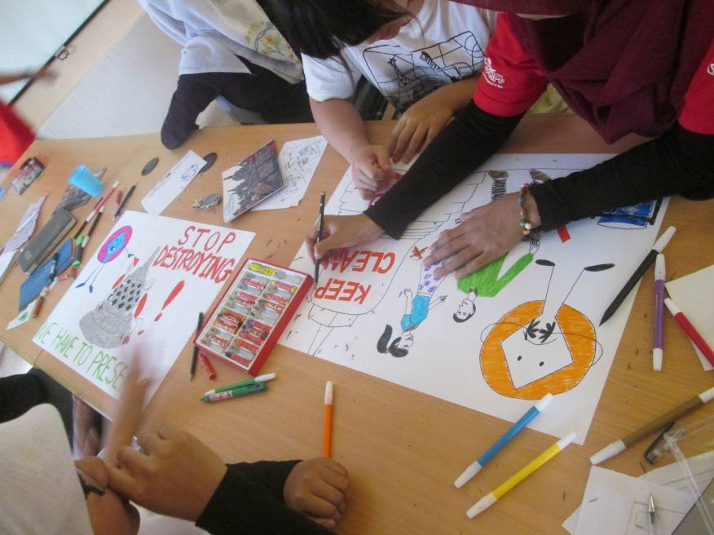

Semarang Street Children Project

Code/Name | Location | Period | Type)* | Age | Vols
LMTV – IIWC 1607  Semarang Street Children Project | Semarang City, Central Java | Whole Year Except June 6th – July 6th | KIDS, EDU | 18+ | < 12
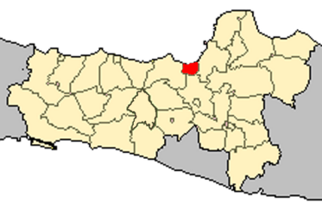
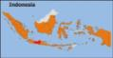

- Background: The workcamp will take place in Bangun Harjo village, which is located in Semarang City. This village is very close with Johar Market, the biggest traditional market in Semarang. Most of the local people there live in low economic standard. The condition of houses area is dirty and due to (penurunan tanah) issue in Semarang it can be flooded by sea water in daily basis even thou it is not regularly. In this less advantage condition the children living in this area make money in the street even some of them do not go to school. In cooperation with one local NGO name ASA Rumah Pintar Bangjo which has one shelter for the street children around Johar market IIWC would like to support the NGO’s activity through an international workcamp.

- Project: The project is mainly for supporting Rumpin Bangjo of PKBI Jawa Tengah program in educating children in Semarang slum Area.

- The aims of the camp are:
- To create educative games for the children so that it will give them more time for positive activities in their home instead of going to street.
- To create some activities dealing with personal hygiene for local children.
- To exchange the vision of each country’s living aspects, including education, culture, and way of life, especially which concerns to education and health
- To motivate the community (especially children in the area)

- Work: The main activities in Semarang Street Children Camp will deal with manual activities of teaching and playing with children such as making handicraft, necklace, or small something easy to get and possibly arts or music as well as collaborating with local people like sharing the culture. As a part of this project, school visit and university visit, we will visit some schools/university to campaign the street children project and cultural exchange. These activities really need strong motivation and physic.

- Special remarks: target groups are the children. Be ready with lots of ideas and loves for children.

- Accommodation: The volunteers will stay in Rumpin rented house together eith a local family with shared toilet and bathroom, sleeping bag and mattress needed, self cooking.

- Location: Semarang City, Central Java Indonesia. Click here to see the map.

- Duration: at least 2 months

- Fee : IDR 3,100,000 per month (Approx. 213 Euro)

- Airport: Ahmad Yani Semarang airport, Train Station: Tawang Semarang train station

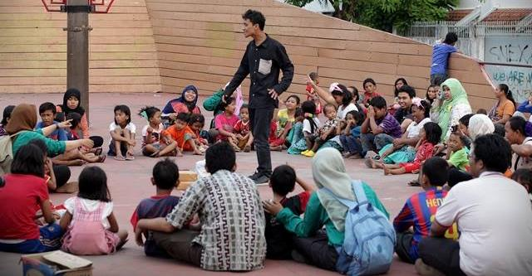

PIP – Semarang Urban Farming Project

Code/Name | Location | Period | Type)* | Age | Vols
LMTV – IIWC 1608  PIP – Semarang Urban Farming Project | Semarang City, Central Java | Jan – Jun & Sept – Dec | ENVI, EDU | 18+ | 2
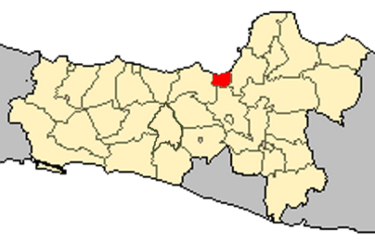
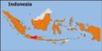

- Background: Semarang city is growing and becomes the 4th largest City in Indonesia. It has some slum area problem due the high of urbanization from sub urban city surround this city. GAMeS (Gerakan Ayo Menanam Sayur) ENG: Vegetable Planting Movement. Initiated a movement to optimize the usage of household waste and rising awareness toward society on environment protection in Semarang City. They face some problem o spread this spirit. For example lack of awareness on how important farming habit in urban live, and city live makes not so much time want to invest on participating the movement. But, for some couple years GAMeS engage cooperation with family empowerment program that most of the members are housewife in certain group. This group has the most possibility to join the movement. LMTV program in this project site have a partnership with PIP (Marine Academy). Your side-project will take place in PIP Semarang, the capital of Central Java. PIP Semarang is one of state education institution administered under the Human Resource Development Agency, Ministry of Transportation. It undertakes education and training to the potential young people graduates from senior high school to be Merchant Marine Officer and Port and Shipping management officer.

- Project: In GAMeS Central is Increase participation of urban communities to participate actively on farming movement to greening the city and farming in limited area. And your side project in PIP will about assisting the cadets and the lecturers with English conversation in daily life and classes.

- Aims:
- To increase of urban communities participation on Urban Farming Movement
- To realize Vegetables Community which we are going to propose to city governor as one sample to be implemented to other areas.
- To increase interest from urban communities on greening program of Semarang city and communities urban garbage management.

- Work: Morning Activity will take place in PIP Marine Academy from 9 am – 12 pm : Your main work in assisting the cadets and the lecturers with English conversation in daily life and classes. In GAMeS Center: Farming activities with urban communities, Verticultur tools making in GAMeS activity center, Life-in with local communities, Distributing 1000 vegetable seeds in city center during CFD (car free day/weekend), Edu-Farming program in some schools.

- Special remarks: You will participate in some local communities’ routines meeting or activities. There are living also many children surrounding your campsite, please be prepare some educative games, laugh and smiles.

- Accommodation: The accommodation will be in one guest house owned and located at the PIP area. You will have your own house with bathroom, air conditioner, fridge and gas stove. There will be small amount of pocket money allocated to support your daily transport in GAMeS Center project and meals. In this case your food will be prepared by the institution together with the cadets. You can join breakfast, lunch and dinner with them together in the hall so that better communication between you and the cadets can be built up.

- Location: Borobudur Timur Street RT 04 RW 08 Kelurahan Kembangarum Kecamatan Semarang Barat Kota Semarang

- Fee : IDR 1,600,000 per month (Approx. 106 Euros)

- Airport: Ahmad Yani Semarang airport, Train Station: Tawang Semarang train station
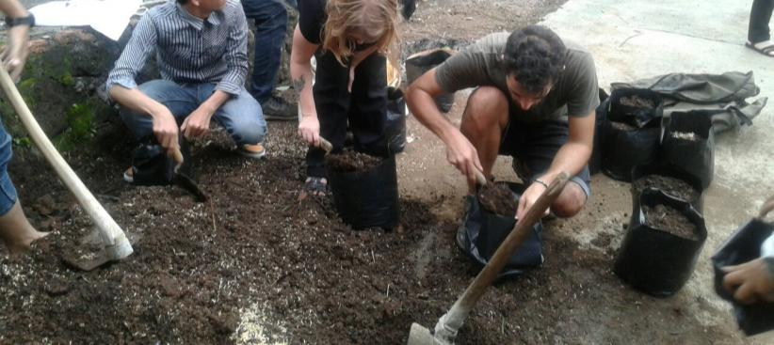

Semoya Education Project

Code/Name | Location | Period | Type)* | Age | Vols
LMTV – IIWC 1609  Semoya Education Project | Sleman, Yogyakarta | Jan – Jun & Sept – Dec | KIDS, EDU | 18+ | < 12
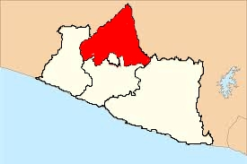

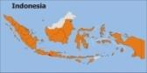

- Background: The first Workcamp in this area was taking place in 2008 while there was 2 years project called IIWC Cares Jogja after the earth quake in 2006. Recently one the school visited by the work camps name SD Muhamadiyah Semoya would like to have more IVS activity for the students there. The spirit and motivation brought by workcamp volunteers are expected to raise the motivation of the students to study more for their future.

- Project: SD Muhammadiyah Semoya Brebah (Muhammadiyah Semoya Brebah Elementary School) is a private Islamic elementary school. This school was one of school that visited by IIWC cares after earth quake in 2006. Some programs such as emergency workcamps, NVDA special camp, Notebook Action, donation for rebuilding one kindergarten, donation for sport facilities in primary school around this area had been done successfully. Recently, the school would like to have more International Voluntary Service (IVS) activity for the student there. The spirit and motivation brought by volunteers are expected to raise the motivation of the student to study more for their future. There is a need to have international experiences for the students as well as the teacher to build more their knowledge and soft skill in term of non-formal education approach combined with the formal education at school. At the same time, this project is also to offer the volunteers a chance to see the recovered area of which IIWC and some partners in the year of 2006-2008 did the post earth quake IVS action-The IIWC Cares Jogja as well as to share opportunity to the volunteers to experience local culture of Jogja which is not the touristic side.

- Work: Volunteer will assist English classes for 1st – 6th grade, non-formal English class for Teachers and staffs, culture exchange with the local people, help the work of local events, visiting kindergarten, and character building for the children. Volunteer can also help local people in their daily work in farm.

- Special Remarks: Good in English and want to learn Bahasa Indonesia, Has a letter of teaching of English is more preferable, cheerful, patient, self confidence builder and high motivation

- Accommodation: Host Family

- Location: Semoya Village, Brebah, Sleman Regency, Yogyakarta

- Starting Date: Period 1: January-May 2015, Periode 2: August-November 2015

- Duration: at least 2 months

- Fee : IDR 3,100,000 per month (Approx. 213 Euro)

- Terminal: Ahmad Yani Airport Semarang, Tawang Station Semarang

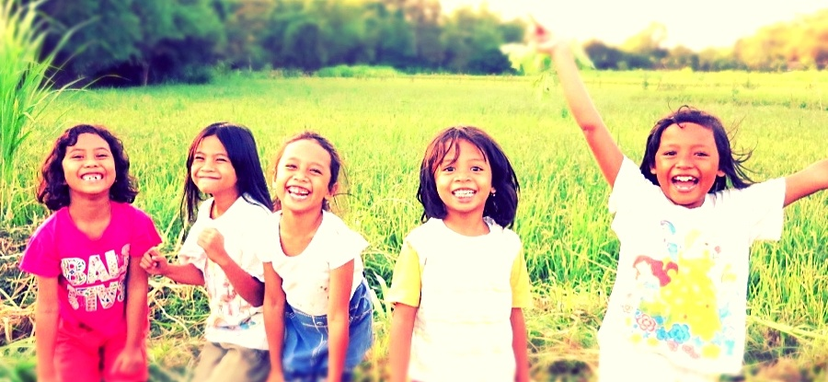
.

Disabled Children Shelter Project

Code/Name | Location | Period | Type)* | Age | Vols
LMTV – IIWC 1610  Disabled Children Shelter Project | Semarang City, Central Java | Whole Year Except June 6th – July 6th | KIDS, EDU | 18+ | < 12
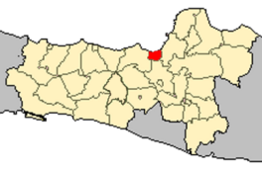
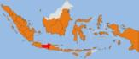

- Background: Since 1981 the institutes has also provided the education for the mentally retarded in the afternoon. The objectives of YPAC is to help the handicapped children who suffer from Poliomyelitis and Cerebral Palsy which includes their health, education and social welfare so they can stand on their own and they do not become the burden of the society. YPAC is located in the city center of Semarang, where you can find easily internet cafes, swimming pool and some universities and other public facilities.

- Project : Your project will take place in YPAC a school for disabled children in Semarang and there are 16 YPAC all over Indonesia. Initially it was intended to take care of the handicapped children suffering from poliomyelitis. But since 1969 YPAC has extended its services to children suffering from Cerebal Palsy. As a consequence, at this moment YPAC provides services for both types of handicap, e.g physiothheraphy for the physically handicapped and mental education for the mentally handicapped children. It has also facilities for other physical and mental retardation such as speech theraphy, occupational theraphy , music theraphy, etc.

- Work : [Working days : Monday – Friday] The work you will do in the YPAC will be depend on your skills and motivation in which part (kind of services you would like to choose ). If volunteer have a background of medical, they can help in medical services, teaching background in the educational services and other in other services togteher with the staff based on the project schedule of YPAC. Generally is helping the staff run their activities. But there are additional things that you can do there,the other idea are :
- Organizing and managing any activities or an additional English classes in the afternoon with the children who stay in the dormitory.
- Having club of activities (for example drama, music, drawing, etc) with the children in spare time
- Character building of the children by organizing outside activities in holiday for the children.
- Supporting the skill development of the children together with the staffs in the dormitory or school.

- Special remarks : The English level of the children is quite low, you have to be able to speak basic Indonesian. Politeness and kindness is highly required in this project

- Accommodation : Dormitory and Food are provided

- Location : Jalan KH. Ahmad Dahlan 4 Semarang Central Java Indonesia

- Duration : minimum 2 months

- Fee : IDR 3,100,000 per month (Approx. 213 Euro)

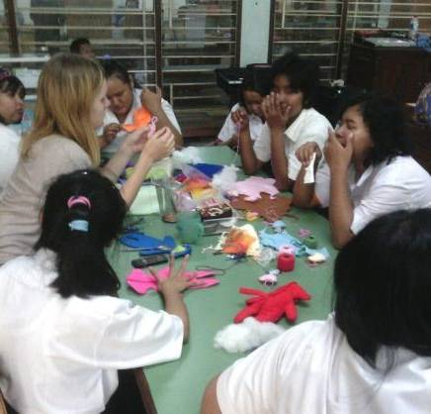
- Airport : Ahmad Yani Semarang International Airport, Tawang Train Station, and Terboyo Bus Station

Nuansa Mandiri Micro Credit Project

Code/Name | Location | Period | Type)* | Age | Vols
LMTV – IIWC 1611  Nuansa Mandiri Micro Credit Project | Semarang City, Central Java | Whole Year Except June 6th – July 6th | SOC, EDU | 18+ | 1
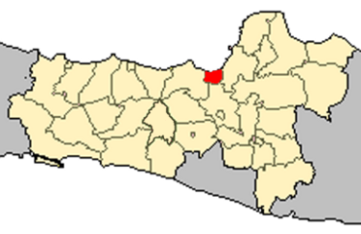

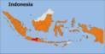

      - Background: Nuansa Mandiri is a women micro-credit association which would like to work together and self help through productive activities networking to support family income for economic stability, health and children education. Its founded at 2006 and has five main unit.

      - Project: There are: Micro-Credit Unit, Small Trade Business, Mentoring for Family Small Business, Mentoring on Productive Micro-Business and Resource for Women and Family Health especially for Women Reproduction Health and Family Planning.

      - Works : Volunteers will be assigned for: Helping administration for micro credit and collect money from Koperasi member in three traditional market during work days; Join and involve in Koperasi gathering, organizing skill development for Koperasi member, motivating the new target groups to be involved in the activities of Koperasi Perempuan, actively join in special event that joined by Koperasi, Public Relation things related to Koperasi and any other possibility activities during volunteers stay, & Having creative class with the local children, Organizing healthy dancing with local mother. Working days for the microcredit staffs mainly on Monday-Friday 9 am to 5 pm, but there will be some gathering held on weekend. Volunteer can discuss with the local partner for their daily schedule
      - Accommodation : Volunteers will stay at host family, you will get one room and share bathrooms and toilets with the other members. Meals provided or not by host family will be discussed in the On Arrival Training.

      - Special Remarks: You will work mostly with local mothers. Most of them could not speak English. Basic Indonesian language skill will be appreciated.

      - Location : Semarang City, Central Java.

      - Duration : Minimum 2 months, 4 months is preferable

- Fee : IDR 3,100,000 per month (Approx. 213 Euro)

      - Airport : Ahmad Yani Semarang International Airport, Tawang Train Station, and Terboyo Bus Station

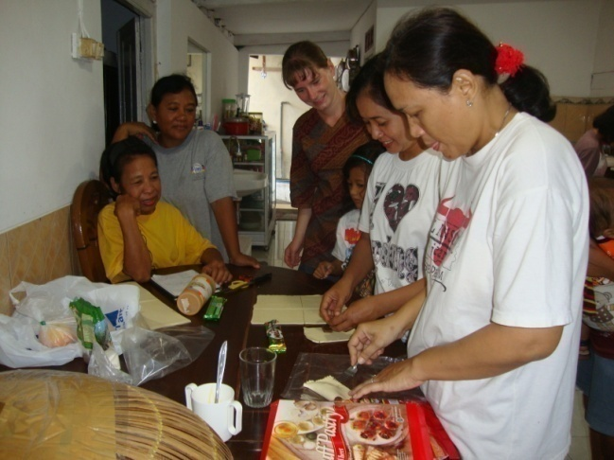

http://islam.about.com/cs/prayer/a/prayer_times.htm

