……...……………….
Prof Mati Kilp
Dean of the Faculty
of Mathematics and Computer Science

……...……………….
Prof Peeter Burk
Dean of the Faculty
of Physics and Chemistry

University of Tartu
Faculty of Mathematics and Computer Science
Faculty of Physics and Chemistry

REPORT OF SELF-EVALUATION
Accreditation of Curricula 2005

Programmes evaluated:

Bachelor in Engineering [Information Technology] 6464162
Master in Engineering [Information Technology] 7464162

Table of Contents
1. INTRODUCTION 7
1.1. A Brief History of the University of Tartu 7
1.2 The place of the University on the educational landscape of Estonia. The structure of the University 9
1.3 The Faculty of Mathematics and Computer Science 10
1.4 The Faculty of Physics and Chemistry 14
1.5 Principles and organisation of quality assurance at the University 16
1.6 Organisation of self-analysis 17
2. THE MISSION AND THE EDUCATIONAL POLICY 18
2.1. The mission of the University 18
2.2 Participation in the realisation of the education policy goals of the University 18
2.3. The study programmes assessed in the context of the educational policies of the University 20
3. DESCRIPTION OF THE STUDY PROGRAMMES 20
3.1. Normative documents 20
3.2. The study programmes: goals, entry requirements and completion 21
3.3. The general structure of study programmes and the tasks, weights, dynamics and development strategies of its parts (modules) 22
3.4. The expected activity of the graduates and the competences determining the content of the education 24
3.5. Strengths and weaknesses 24
3.6. The proportions and efficiency of auditory, practical and independent learning in the study program. Ways of realising creative and research-related objectives ..................................................................................24
3.7. The system of modifying and improving the study programme......................................................................25
4. THE STUDY PROCESS 25
4.1 The main teaching and learning methods applied and ways of their implementation 25
4.2. Organisation of the study process 25
4.3. Evaluation, ensuring of objectivity and analysis of study results 25
4.4. The checking and analysis of the study process and its level. Ensuring the uniformity of the actual study load. 26
4.5. Organisation of practice in the speciality and aspects of professional qualification. 27
5. STUDENTS 27
5.1. Admission 27
5.2. The level, counseling and career possibilities of students 28
5.3 Strengths and weaknesses 29
6. STUDY ENVIRONMENT 30
6.1. Study rooms 30
Digital Electronics Laboratory DIGILAB 38
6.2. Library 39
6.3. Service divisions and material resources 43
7. ACADEMIC AND SERVICE PERSONNEL 47
7.1. The sufficiency, qualification, suitability and compliance with the higher education standard of teachers 47
7.2. Selection, retraining and renewing of the teaching staff 51
7.3. Principles of distributing the workload of teachers and researchers and performance of additional administrative duties. 52
7.4. Research activity of staff 53
7.5. Auxiliary teaching staff 57
7.6. Conclusions 57
8. INTERNATIONAL CONTACTS AND QUALITY ASSURANCE 58
8.1. Cooperation in Estonia 59
8.2. International Cooperation 60
8.3. Quality Assurance 63

APPENDIX 1.2.1. The Structure of the University of Tartu …………………………………………………. 65

APPENDIX 1.3.1. Statutes of the Faculty of Mathematics and Computer …………………………………..... 66

APPENDIX 1.3.1.1. List of Staff of ICS …………………………….…………………………………………. 71
APPENDIX 1.3.2. Development plan for the Faculty of Mathematics and Computer Science 73
APPENDIX 1.3.3. The number of students at FMCS (31.12.2004) 77
APPENDIX 1.4.1. Statutes of the Faculty of Physics and Chemistry 78

APPENDIX 1.4.1.1. List of Staff of IEPT……………………………………………………………………….. 85

APPENDIX 1.4.2. Development plan for the Faculty of Physics and Chemistry …………………………….. 87

APPENDIX 1.4.2.1. Development plan and activity description of IEPT ………………………………….….. 91

APPENDIX 1.4.3. The number of students at FPC (01.03.2005) ………………………………………………. 96

APPENDIX 2.1.1. University of Tartu Strategic Plan 2008 ...………………………………………………… 98

APPENDIX 2.2.1. Textbooks published in 2002 – 2005 …………………………………………………….… 113

APPENDIX 3.3.1. Bachelor's Programme in Information Technology (3+2) …………………………….… 114

APPENDIX 3.3.1.2. List of Bachelor’s Theses 2005 …………………………………………………………. 135

APPENDIX 3.3.2.1. Master's Programme in Information Technology (3+2) ………………………………. 136

APPENDIX 3.3.2.2. List of Master’s Theses 2004-2005 …………………………………………………….... 153

APPENDIX 3.6.1. Quantitive Characteristics of Study Programmes ………………………………………....154

APPENDIX 4.3.1. Guidelines for Writing and Defending of Graduation Papers at FMCS and FPC ……. 155

APPENDIX 4.3.2. Regulations for Presentation of Graduation Papers at FMCS and FPC …………….... 159

APPENDIX 6.2.1. Periodicals on Computer Science and Information Technology at UT libraries……… 160

APPENDIX 7.1.1. Staff and subjects teached in curricula (2002-2004) ……………………………………. 163

APPENDIX 7.1.2. Short CV-s of Academic Staff of ICS …………………………………………………….. 166

APPENDIX 7.1.3. Short CV-s of Academic Staff of IEPT ………………………………………………….. 173

APPENDIX 7.4.1 Research grants of ICS in 2000-2004 ……………………………………………………. 178

APPENDIX 7.4.2. Research grants of IEPT in 2000–2004 ………………………………………………….. 180

APPENDIX 7.4.3. Publications of ICS 2000-2004 …………………………………………………………… 186

APPENDIX 7.4.4. Publications of IEPT 2000-2004 …………………………………………………………. 197

APPENDIX 7.4.5. Applied Research Projects for Estonia and International Projects ………………….. 203

APPENDIX 8.3.1. Abstract of student evaluations to the courses of ICS (academic year 2003/2004) ….. 205

APPENDIX 8.3.2. Abstract of student evaluations to the courses of IEPT (academic year 2003/2004) .... 209

1. INTRODUCTION

1.1. A Brief History of the University of Tartu

On 30 June 1632, King Gustav II Adolf of Sweden signed the Foundation Decree of Academia Dorpatensis, which enables us to mark the beginning of our university's history. The following stages can be observed in the history of the University of Tartu.

1632-1710 Academia Dorpatensis (Tartu University during the Swedish times)
* Academia Gustaviana 1632-1665
* Academia Gustavo-Carolina 1690-1710

The first students matriculated between 20-21 April 1632. The opening ceremony of Academia Dorpatensis (Academia Gustaviana) took place on 15 October in the same year. The academy in Tartu functioned with the faculties of Philosophy, Law, Theology and Medical, enjoying the privileges of the University of Uppsala. On account of the Russian-Swedish war the University of Tartu was transferred to Tallinn in 1656 and closed in 1665.
In 1690 Tartu became a university town again to host Academia Gustavo-Carolina. Shortly after that, however, the university was transferred from Tartu to Pärnu due to a coalition against Sweden and the Great Famine of 1695-1697. Opened in Pärnu on 28 August 1699, Academia Gustavo-Carolina was closed on 12 August 1710 because of the surrender of the Swedish army to the Russian forces during the Northern War.
1802-1918 Kaiserliche Universität zu Dorpat (The Imperial University of Tartu)
* Imperatorskij Jur'evskij Universitet 1893-1918
At the end of the 18th century the political and educational interests of the Russian central government and the Baltic-German elite coincided. On 21-22 April 1802 the university was reopened in Tartu as a provincial Baltic university depending upon the local knighthoods - it was titled Kaiserliche Universität zu Dorpat (also Imperatorskij Derptskij Universitet). The charter of 12 December 1802, endorsed by Czar Alexander I, gave the university the legal status of a Russian state university, with German as the language of instruction. In 1828-1838 future university professors in Russia were taught at the University of Tartu Professors’ Institute. In 1803 a lecturership of the Estonian language was established and in 1838 the Learned Estonian Society (Gelehrte Estnische Gesellschaft) was founded at the University.
Tartu University obtained the monopoly of higher education in the western provinces of the Russian Empire, forming close relationships with the Academy of Sciences in St. Petersburg in the east and with German universities in the west. During the russification campaign beginning in 1889 Tartu University was converted into Imperatorskij Jur'evskij Universitet, a traditional higher education establishment. In 1895, the Russian language was introduced as the language of instruction. In spite of great changes in the student body and the faculty, the University of Tartu in its capacity of a Russian university remained an international centre of science. What made University of Tartu unique throughout Russia was its role in educating distinguished scientists in every field of research and high-ranking officials for the Empire, especially in the fields of law and diplomacy.
In the turmoil of World War I the academic life of the University was interrupted by several stages of evacuation of its students, professors and property to Russia. In the spring of 1918 the Russian university was closed down and what is known as a voluntary departure of Russians opened up the path to a new provincial university to be launched by the German occupation forces – Landesuniversität in Dorpat, in the Baltic Duchy. Called Land University, it was opened on 15 September 1918. In a few months’ time, however, it was forced to close. On 27 November 1918 the commander of the military forces transferred the jurisdiction over the University of Tartu to a commission formed by the Provisional Government of Estonia.
Note: The dates until 1 February 1918 are given according to the old calendar.
1919-1940 Tartu University of the Republic of Estonia
Preparatory work for the opening of the university had already started in March 1918. The Head of the Commission formed by the Provisional Government of Estonia Peeter Põld was appointed the university’s curator (later a professor of pedagogy, the Pro-Rector and a doctor honoris causa). On 1 December 1919 the university opened its doors as Tartu University of the Republic of Estonia, with Estonian as the language of instruction, at which new subjects laying the foundation for the development and research of Estonian national culture were taught.
1940-1941 Tartu State University
In 1940/1941, the first academic year under Soviet rule, the students’ corporations and academic societies were closed and scientific contacts with West-European centres of research and universities were interrupted. The study programmes of Tartu University were replaced by those officially imposed in the Soviet Union: a course system was adopted and obligatory political subjects based on the new Marxist-Leninist ideology, including the history of the USSR, were introduced.
1942-1944 Tartu University of the Estonian Self-Government under Nazi German Rule (Ostland-Universität in Dorpat)
Ostland-Univesität in Dorpat was opened by the German occupation government, with Germany as its language of instruction. It was to serve the whole Baltic region. Taking into consideration the needs of the time, the University was opened as Tartu University of the Estonian Self-Government, with instruction in Estonian where the University Act of 1938 regulated the academic life. During the war the faculties of Medicine, Veterinary Medicine and Agriculture were given the priority status.
During World War II the university lost 22 buildings, a considerable amount of its property, the accommodations of its academic and administrative staff and its libraries.

1944-1989 Tartu State University
In the autumn of 1944 the incomplete structural reforms interrupted in the summer of 1941 were continued. The university was subordinated to the People’s Education Commissariat of the Estonian SSR (a ministry since 1946) and, beginning from 1946, to the Ministry of Higher Education of the Soviet Union.
Even in the 1960s the majority of the professors of Tartu State University belonged to the generation who had obtained their education at Tartu University in the Republic of Estonia and thus upheld the continuity of traditions in the processes of instruction and scientific research.
Since 1989 – The University of Tartu
The mentality and the positive attitudes of the students, the academic staff and researchers towards the Estonian national university had helped to preserve its atmosphere and restore Tartu University as the University of the Republic of Estonia. The years since 1989 have been ones of structural changes amid the restoration of the content of academic studies and of the old traditions, both having been considered to be of crucial importance. Intellectual freedom has been restored, Western-type systems of study and grading have been introduced, the standards for election to higher academic positions have been reviewed and contacts with European and other universities have been expanded, including an extensive student exchange programme. In 1996 the Open University was established to provide opportunities for life-long learning for all those interested in it without causing serious disruptions in their everyday lives.
On 19 June 1999 the Republic of Estonia signed the Bologna Declaration. The programme set out in the Declaration is based on a clearly defined goal: to create a European space for higher education in order to enhance the employability and mobility of citizens and increase the international competitiveness of European higher education. At the University it led to the adoption in 2001 of new study programmes, which in many fields distinguished undergraduate studies (3-year Bachelor’s programmes) and graduate studies (2-year Master’s programmes and 4-year Doctor’s programmes). These changes led to other ones in admission policies at several faculties in 2004.

1.2 The place of the University on the educational landscape of Estonia. The structure of the University

In Estonia, the system of higher education is run by the Ministry of Education and Research. General requirements for higher education are set by the Standards of Higher Education (1996). The provision of higher education is regulated by several laws (the Universities Act, the Private Schools Act, etc.). The University of Tartu (UT) is a legal person governed in its daily operations by the provisions of the University of Tartu Act, the Universities Act, the University of Tartu Statutes and other legislation.
The University comprises academic, administrative and support structures. Its structure as of 2004 is given in APPENDIX 1.2.1.

APPENDIX 1.2.1. The Structure of the University of Tartu

The Academic structure of the University consists of faculties and their subdivisions. Today, there are eleven faculties at the UT: Theology, Medicine, Biology and Geography, Philosophy, Physics and Chemistry, Exercise and Sports Sciences, Economics and Business Administration, Mathematics and Computer Science, Education, Social Sciences and Law. The constituent parts of a faculty are departments, institutes or other structural units in accordance with the statutes of the faculties. At the head of a faculty is the dean while the highest decision-making body is the council of the faculty. The teaching staff of the University involves 820 persons, among them 115 full-time professors, 208 associate professors (docents) and 490 lecturers and assistants.

In the academic year of 2003/2004 the student body of the University of Tartu comprised 17 261 students, of which 12 902 were taking bachelor and diploma courses. Female students made up nearly two thirds of the student body. The students pursuing a Master’s degree numbered 2 338 and those pursuing a Doctor’s degree 812. The student body included 376 foreign students coming from 32 countries.

1.3 The Faculty of Mathematics and Computer Science

The Faculty of Mathematics and Computer Science (FMCS) at the University of Tartu is the leading centre of teaching and research in mathematics in Estonia and one of the two centres of computer science in Estonia to be reckoned with, the other one being the Tallinn Technical University.
The Faculty is, in addition to that of the Tallinn Pedagogical University, the second one where teachers of informatics for schools are trained. The basic document for activities of FMCS is the Statutes of the Faculty given in APPENDIX 1.3.1.

APPENDIX 1.3.1. The Statutes of the Faculty of Mathematics and Computer Science

The Faculty’s 53 lecturer and 18 researcher positions are divided between four institutes:
- Institute of Computer Science
- Institute of Mathematical Statistics
- Institute of Pure Mathematics
- Institute of Applied Mathematics

General overview of the faculty

Number of students on December 31, 2004:
- Diploma studies - 22,
- Bachelor studies - 645
- Master studies - 108
- PhD studies - 48
- Teacher training - 11.
Floor space of the faculty building: 5255 m²
Number of academic staff on December 31, 2004: 71; from them 38 full-time.
The faculty consists of 4 institutes and 12 chairs.
Number of the curricula:
- Diploma studies - 2
- Bachelor studies - 7
- Master studies - 8
- Doctorate studies 3
Number of graduates in 2004:
- Diploma studies -14
- Bachelor studies - 54
- Master studies - 22
- Doctorate studies 4
There were 47 doctorate students on December 31, 2004.

Degree Programmes

The courses are organised on the basis of credit accumulation. One credit corresponds to 40 hours of work, at least half of which is constituted by independent work. While in full-time study, most students complete 40 credits a year.
Diploma courses (120 credits) - applied educational courses that, on average, last for 3 years. The students receive diplomas conferring a relevant qualification.
The requirement of UT for degrees can be found from the website
http://www.ut.ee/english/general/documents
Bachelor’s degree (the minimum requirement - 160 credits, from the academic year 2002/2003 120 credits) - study for the first academic level, with the average duration of 3 (3+2 study plan) - 4 years.
Master’s degree (80 credits) - study for the second academic level.
Students wishing to undertake a Master's programme must hold a Bachelor’s degree or an equivalent academic qualification. The programme lasts for 2 years.
Doctoral degree (PhD) (160 credits) - study for the highest academic degree. Students wishing to undertake a doctorate programme must hold a Master's degree or an equivalent academic qualification. The programme lasts at least for 4 years.

At the Faculty of Mathematics and Computer Science degrees are awarded in:
- Mathematics - Bachelor's, Master's and PhD levels
- Computer Science - Bachelor's, Master's and PhD levels
- Information Technology - Bachelor's and Master's levels
- Mathematical Statistics - Bachelor's, Master's and PhD levels
- Financial and Actuarial Mathematics - Master's level
- Applied Statistics - Master's level
- Exact Sciences – Bachelor's level

The Faculty of Mathematics and Computer Science has 667 undergraduate, 119 graduate and 48 post graduate students (31.12.2004). The main language of instruction is Estonian.

1.3.1 The Institute of Computer Science

Since 1993 the Faculty of Mathematics and Computer Science is divided into four institutes and one of them is the Institute of Computer Science (ICS). ICS plays a leading role in IT education offered at the University of Tartu. ICS is the curator of the speciality of Computer Science (Bachelor’s, Master’s and Doctoral studies). ICS and the Institute of Experimental Physics and Technology (IEPT), Faculty of Physics and Chemistry are the two main institutions responsible for Bachelor’s and Master’s programmes in Information Technology.

Total number of the teaching and research staff in ICS is 26, from them 5 people are working part-time. In the office of ICS 3 persons are employed. Detailed data about the staff is presented in APPENDIX 1.3.1.1.

APPENDIX 1.3.1.1. List of Staff of ICS (01.02.2005)

Development of the Institute is closely related to the development of other institutes of the Faculty following the plan of development of FMCS given in APPENDIX 1.3.1.2.

APPENDIX 1.3.2. Development Plan for the Faculty of Mathematics and Computer Science

Currently, the Institute of Computer Science has eight approved study programmes (see Table 1). Four of them (two Bachelor’s programmes in Computer Science; two Master’s programmes in Computer Science) are partly overlapping, since beginning from October 2001, the Faculty adopted new study programmes to meet the standards of the amended educational policies of the Republic. Instead of the old Diploma level Information Technology programme from the academic year 2002/2003 new Bachelor’s level programme in Information Technology was started.

Table 1. List of Study Programmes
Study Programme Title | Degree
Old study programmes
Computer Science  (Bachelor level, 4 years) | Baccalaureus scientiarum
Computer Science  (Master level, 2 years) | Magister scientiarum
Information Technology  (Diploma level, 3 years) | Diploma in Information technology
New study programmes
Computer Science  (Bachelor level, 3 years) | Bachelor of Science in Engineering,  BSc (Computer Science)
Computer Science  (Master level, 2 years) | Master of Science in Engineering,  MSc (Computer Science)
Information Technology  (Bachelor level, 3 years) | Bachelor of Science in Engineering,  BSc (Information technology)
Information Technology  (Master level, 2 years ) | Master of Science in Engineering,  MSc (Information Technology)
Other
Computer Science  (PhD level, 4 years) | Doctor Philosophiae

At the moment the students matriculated before the academic year of 2002/2003 continue according to old study programmes. The students matriculated from 2002/2003 onwards are studying according to new study programmes. Currently there are students studying according to all eight study programmes.
In APPENDIX 1.3.3 an overview of students of all specialities of FMCS is given.
APPENDIX 1.3.3. The number of students at FMCS (31.12.2004)

The following Table 2 specifies the students of ICS by sex and the programmes they are studying:
Table 2. List of students of ICS according to the study programmes (April 19, 2005)
Study programme | Number of students | Male / Female
Study programme | Number of students | M | F
Computer Science  (Bachelor level, 4 years) | 74 | 56 | 18
Computer Science  (Master level, 2 years) | 39 | 28 | 11
Information Technology  (Diploma level, 3 years) | 21 | 20 | 1
Computer Science  (Bachelor level, 3 years) | 177 | 130 | 47
Computer Science  (Master level, 2 years) | 6 | 6 | 0
Information Technology  (Bachelor level, 3 years) | 147 | 118 | 29
Information Technology  (Master level, 2 years ) | 5 | 3 | 2
Computer Science  (PhD level, 4 years) | 22 | 15 | 7

1.4 The Faculty of Physics and Chemistry

The Faculty of Physics and Chemistry (FPC) at the University of Tartu is the leading centre of teaching and research in Physics in Estonia and one of the two centres of Chemistry. The other one is the Tallinn Technical University.
FPC is the only institution in Estonia where specialists in Physics at all academic levels including the Doctor level are systematically prepared. Together with the Institute of Physics of the University of Tartu (IPUT) the Faculty is the main centre of Physics scientific research in Estonia and the most qualified specialists have assembled here. The basic document for activities of FPC is the Statutes of the Faculty given in APPENDIX 1.4.1.

APPENDIX 1.4.1. The Statutes of the Faculty of Physics and Chemistry

The Faculty’s elected 50 lecturer and 51 researcher positions are divided between two departments and seven institutes:
Department of Physics (28 lecturers and 15 researchers):
- Institute of Experimental Physics and Technology (code FKEF)
- Institute of Environmental Physics (code FKKF)
- Institute of Materials Science (code FKMF)
- Institute of Theoretical Physics (code FKTF)
Department of Chemistry (22 lecturers and 36 researchers):
- Institute of Physical Chemistry
- Institute of Chemical Physics
- Institute of Organic and Bioorganic Chemistry

General overview of the Faculty

Number of students on March 01, 2005:
- Diploma studies - 108,
- Bachelor studies - 695
- Master studies - 121
- PhD studies - 107
- Teacher training - 9.
Floor space of the faculty buildings:17600 m² (Physics building) + 5900 m² (Chemistry building) = 23 500 m². Floor space for teaching purposes is 6900 m² + 3500 m² = 10 400 m² respectively.
Number of academic staff on March 01, 2004: 127; from them 107 full-time.
The faculty consists of 2 departments, 7 institutes and 21 chairs.
Number of the curricula:
- Diploma studies - 4
- Bachelor studies - 9
- Master studies - 11
- Doctorate studies - 4
Number of graduates in 2004:
- Diploma studies -36
- Bachelor studies - 59
- Master studies - 38
- Doctorate studies 12
There were 95 doctorate students on March 01, 2005.
The Faculty of Physics and Chemistry has 803 undergraduate, 139 graduate and 107 post graduate students (01.03.2005). The main language of instruction is Estonian.

The main institution responsible for teaching of Information Technology (hardware stream) and subsequent research work in FPC is the Institute of Experimental Physics and Technology (IEPT). The roles of the Institutes are well described in the Statutes of the Faculty of Physics and Chemistry. Development of the Institute of Experimental Physics is closely related to the development of the whole Faculty following the development plan of FPC given in APPENDIX 1.4.2

APPENDIX 1.4.2. Development Plan for the Faculty of Physics and Chemistry

In APPENDIX 1.4.3 an overview of students of all specialities of FPC is given.

APPENDIX 1.4.3. The number of students at FPC (01.03.2005)

1.4.1 The Institute of Experimental Physics and Technology

The Institute of Experimental Physics and Technology was established at the turn of the academic year of 1992/93 predominantly on the basis of the former Chair of Experimental Physics. The Institute has three Chairs:
- Chair of Optics and Spectroscopy (Professor Jaak Aaviksoo, Rector of the UT)
- Chair of Applied Physics (Assoc. Prof. Kalev Tarkpea)
- Chair of Wave Optics (Professor and Academician Peeter Saari)

In 1993-1995 the Institute was headed by Prof.Lembit Pung, 1995-1998 – by Prof.Jaak Aaviksoo, 1998-2000 – by Prof. Lembit Pung again. Since 01.09.2000 Kalev Tarkpea is the Head of the Institute.
In 1998 Peeter Saari and Kalev Tarkpea started at the Institute with the new study programme Physical Technology of Information. In the year 2000 this programme was rearranged to the Information Technology (IT) study programme carried on in cooperation with the Faculty of Mathematics and Computer Science.
Nowadays the Institute of Experimental Physics and Technology (IEPT) plays a leading role in teaching of computer hardware and applied physics courses in UT. IEPT is responsible for the hardware stream of Bachelor’s and Master’s programmes in Information Technology. IEPT is also the curator of the Applied Physics programme (Master’s and Doctoral studies) at FPC including Plasma Physics, Measurement Technology, Medical Technology and Nanotechnology branches.
Total number of the staff of IEPT is 31, from them 11 full-time teachers and 6 researchers. The supporting personnel includes 14 people. Detailed data about the staff is presented in APPENDIX 1.4.1.1.

APPENDIX 1.4.1.1. List of Staff of IEPT (01.09.2005)

Development of the Institute is closely related to the development of other institutes of the Faculty of Physics and Chemistry following the plan of development of FPC given in APPENDIX 1.4.2.

1.5 Principles and organisation of quality assurance at the University

The University of Tartu regards the assurance of the quality of educational work as one of its strategic tasks. The development plan until 2008 emphasises that the University of Tartu assures a high level of education in all the forms of study by applying an integrated quality control system, offers new well-prepared courses, constantly updates the contents of the teaching materials, improves the study environment and employs modern methods of study. The university involves new target groups by creating flexible study opportunities for foreign students and students undertaking self-education in traditional and new forms of study.
Among other things, the development plan emphasises the need for introducing an integrated quality assurance system and, based on that, for compiling a quality assurance manual. In the evaluation of the work of the academic staff it is deemed necessary to give more consideration to the quality of the educational work, including student opinions on the subject courses.

By a decision of the University of Tartu Council on 27 October 2000 a document, “Foundations of the system of quality assurance in educational work at the University of Tartu”, was adopted. The document gives an overview of the principles of quality assurance in educational work in general, stating the most important activities based on which the quality of educational work is evaluated and the means used to assure the quality.

The process of study programme accreditation has started on a full scale. By now more than 130 study programmes at different stages of study have been accredited. In connection with the importance of the said process the UT Council considered it necessary for the results of accreditation to find more coverage and analysis inside the University. Based on the above the UT Council adopted a decision on 28 March 2003, “Accreditation of Study programmes at the University of Tartu”. The document envisages the setting up, in cooperation with the faculties, of sub-commissions of the Educational Commission in the fields of study (humaniora, socialia, medicina, realia) in order to analyse the annual accreditation results obtained from these fields and make improvements in the educational process, including the study programmes. Each commission also includes a representative of the students.

On a regular basis (each semester) an opinion poll, “Evaluation of the teaching and the subject courses”, is conducted among the students, on the basis of which a corresponding report will be prepared by the Educational and Student Department. How to apply better the results of the poll, however, needs to be specified in more detail to prevent the development of a potential attitude by the parties to consider the poll a mere formality.

In addition to the activities evaluating the quality of the educational work internally the University also considers it important to get feedback from its graduates and their employers. The Career Service conducts annual polls among the former students of the University who by the time of the poll have worked approximately six months. The graduates shall evaluate their initial copying at the labour market and the relevance and level of the knowledge and skills obtained from the University, and they are able to make suggestions on how to improve what has been done so far. The results of the poll are made available to both the faculties and the wider public (via the web).

The responsibility for cooperation with employers and for giving consideration to their suggestions and recommendations in the preparation and development of the study programmes lies with the faculties. On the University’s request, EMOR conducted a telephone poll among more than 500 employers in the spring of 2003. In the poll the employers were asked to evaluate the qualification of the University’s graduates and the study programmes. Without a doubt, employers need to be involved to a greater extent than before in the preparation of the study programmes, in particular in the widening of the practice possibilities but also in the conduction of the educational work in general. It is therefore necessary to do more thinking over how to enhance employers’ interest in the processes going on at universities.

Of decisive importance in the assurance of the quality of educational work is the academic level of the teachers. Academic positions are filled through competition and employment contracts are fixed-term contracts. After the end of the election term all the university teachers can take a so-called semester off, during which they maintain their salary while having no teaching duties. On a regular basis, refresher training is conducted for university teachers on the possibilities of using new teaching methods (incl. the web-based learning environment WebCT), and a methodology course “Teaching at a higher education establishment” has been launched on the initiative of the Faculty of Education.

The University considers the existence of a student counselling system a prerequisite to the assurance of the quality of educational work. A counselling service concerning the general organisation of the educational work and the related documentation is provided by the dean’s offices of all the faculties; the Department of Studies and Students has employed a student counsellor. Freshmen are supported by tutors (students of senior years). A career service has been established for career-related counselling of students, which, apart from counselling, offers relevant training to students and notifies them of job offers. From the autumn 2004 a psychologist is at the service of the students.

1.6 Organisation of self-analysis

To prepare the report, a commission comprising Head of ICS Docent Tiit Roosmaa, Professor Jüri Kiho, Professor Mare Koit, Docent Rein Prank and Professor Mati Tombak was formed at the Institute of Computer Science. Self-analysis was discussed on 16.06.2005 at a meeting of ICS. The parts of this report concerning the Faculty of Physics and Chemistry (FPC) and especially the IEPT are compiled by Kalev Tarkpea, Vice Dean of the FPC, Head of IEPT.

2. THE MISSION AND THE EDUCATIONAL POLICY

2.1. The mission of the University

The goal of the University, as defined in its Statutes, is to promote research and knowledge in all fields of its activities, to provide higher education based on professional research and academic study at all levels and to offer services in research, development and education.
The mission of the University of Tartu has been determined in the University of Tartu Strategic Plan, approved by the University Council on December 19, 2003 by the following statement: as a national university, taking together different science areas, the University of Tartu is to act as the guardian and advocate of a highly educated Estonia through internationally acclaimed research and the provision of research based higher education. Five specific „breakthrough“ areas are listed in this Plan for the development of the University between the years of 2003 and 2008: strengthening of the role of the national university, internationalisation, securing the continuity of top level national intelligentsia, harnessing to good effect the intellectual capital of the university, improving the quality of teaching and learning see APPENDIX 2.1.
APPENDIX 2.1.1. University of Tartu Strategic Plan 2008

2.2 Participation in the realisation of the education policy goals of the University

As the education policy goals of the University are currently the most adequately expressed in the University’s Strategic Plan (APPENDIX 2.1), the analysis of this section is presented from that very perspective. In general, it must be noted that the directions expressed in the Strategic Plan have a natural connection with the institutional developments of the both Faculties (FMCS and FPC).

The Development Plan of FMCS starting from 2002, and the subsequent Plan of FPC starting from 2000, referred to above in subsections 1.3 and 1.4, (APPENDIX 1.3.2) determine directions of development for ICS and IEPT, respectively.

The work being done at FMCS and FPC is in close correspondence with the key themes of the University’s Strategic Plan. First of all, the “breakthrough” areas:

Internationalisation and national education: an ellipse with two focuses. It means increased participation in international education and research programmes, such as the EU Framework Programmes, Socrates/Erasmus; bilateral institutional agreements between the University of Tartu and foreign institutions. The word “national” here means the development, popularisation and teaching and studying of the discipline in our native language, Estonian.

Many items of either theme have been specified in the Faculty’s development plan (see APPENDIX 1.3.2). Its items 2, 3 and 8 refer to international relations and to the development of mother-tongue education and research work; with regard to internationalisation see, in particular, point 13 in the Development plan in Appendix 1.3.2.

Harnessing to good effect the intellectual capital of the university. This is an area in which specific attention is paid to the University’s impact in Estonian society at large. From contributions of our Department we point out several projects and studies for different ministries and govermental bodies on environmental and applied physics problems.

Improving the quality of teaching and learning. Work in this area has been done in the following directions:
- Improvement of knowledge of the teaching staff
- Adjustment and revision of the study programmes
- Preparation of teaching materials
- Joint visits to lectures by colleagues
- Implementation of new teaching methods into the existing courses and introducing new courses
- Improvement of software and technological base for educational work.

Next, comments will be given one by one to characterize the indicated directions.

Teaching staff of ICS follows regular schedule of free from teaching semesters to raise the qualification. Most of the members of institute have used this time to work abroad and co-operate with foreign colleagues.

The revision of the new study programme on Bachelor’s level has largely been completed by now; the new study programmes on Master’s level continue to be adapted in the course of the work.

Within last four years a number of printed textbooks for compulsory courses have been published (see Appendix 2.2.1).

APPENDIX 2.2.1. Textbooks published in 2002 – 2005

2.3. The study programmes assessed in the context of the educational policies of the University

The Information Technology study programmes have been developed in a close cooperation of the Faculties (FMCS and FPC). For both, old and new study programmes, special commissions were formed which prepared the materials for all study programmes. If necessary, an additional commission will be appointed to examine the existing study programme and present amendment proposals.

The relationships of the study programmes assessed to the education policies of the University are vividly manifested by the example of the preparation of the new study programmes.

The cooperation was most important when designing the new curriculum. Because of module-structure, the contents of modules of the first years of Bachelor’s studies had to fit with other specialities as much as possible to guarantee maximal efficiency of teaching process. Before the work with designing Curricula started, teams of the University from different subject areas acquainted themselves with curricula in different European countries. The team on exact sciences included Vice-Dean of FMCS Tiit Roosmaa and Vice-Dean of FPC Kalev Tarkpea visited Dublin, Edinburgh, St. Andrews and Bergen Universities. The curricula were designed taking into account experience of several European countries following general guidelines of the University. In the curricula forming process the joint base module of two Faculties (FMCS and FPC) was fixed and after that modules inside the Faculty were formed. At this stage we followed the general policy of the University to have the Bachelor’s education as broad as possible and to have joint modules with other specialities.

3. DESCRIPTION OF THE STUDY PROGRAMMES
3.1. Normative documents and quantitative indicators

At the University of Tartu the design of study programmes has to conform to the rules laid down by several normative regulatory documents.
- Firstly, the study programmes must comply with the requirements laid down in the Standard of Higher Education adopted by the Government of Estonia on 13 August 2002 (decree No 258) (https://www.riigiteataja.ee/ert/ert.jsp);
- secondly, they shall agree with the Regulation of Studies of the University of Tartu adopted by the University’s Council on 30 April 2003 (regulation No 4) (http://www.ut.ee/livelink_files/1374177.htm);
- thirdly, they must conform to the Study Programmes Statutes passed by the University’s Council on 27 April 2001 (decision No 9) (http://www.ut.ee/livelink_files/1196936.htm).
- the doctoral programmes shall also be governed by the Statutes of Academic Degrees of the University of Tartu adopted on 29 January 1991
(http://www.ut.ee/livelink_files/1361030.htm).

All the study programmes provide the qualification meeting the requirements set by the Estonian Standard of Higher Education.

3.2. The study programmes: goals, entry requirements and completion

The main objectives of the old and the new study programmes do not differ substantially from each other: aim of the studies is to prepare qualified specialists.
The most important difference between the old and new study schemes is the following. In the old study system a graduate with the Bachelor’s degree was qualified for job as a medium level specialist and Master’s studies were exceptional and formed a preparatory stadium for PhD studies or were directed to educate high level professional specialists. In the new system education on Bachelor’s level gives wide platform for further studies and a graduate can not be considered as a specialist any more. It might be possible for Bachelor’s graduates from informatics to find a job as assistants in IT companies. Graduates on Master's level can be employed as specialists in informatics and information technology.
The formal requirements for entry to Bachelor’s level have not been changed. Results of state graduation exams from gymnasium determine the possibility to enter university studies. On Master’s level admission requirements have changed. In 4+2 system, results of studies on Bachelor’s level were the most important element for entrance combined with necessary minimal amount of passed courses. In the new 3+2 system necessary minimal amount of subjects on computer programming, software and hardware is needed and additionally admission exams are held.

The requirements for admission to the studies are presented in Table 3.

Table 3. Admission Criteria

Study programme | Admission criteria
Bachelor in Information Technology | Secondary school education from Estonia or its equivalent from abroad.
Master in Information Technology | Bachelor's degree or equivalent degree in a speciality the curriculum of which comprises prerequisite subjects (16 CP) in the following list:  - Algorithms and Data Structures (4 CP)  - Database Management Systems (2 CP)  - Object-Oriented Programming (4 CP)  - Computer Hardware I (2 CP)  - Electrical Measurements (2 CP)  - Principles of Telecommunications (2 CP)

The prerequisite to graduation is completion of the study programme. The requirements for graduation papers mainly concern the scope: Bachelor’s thesis 4 CP, Master’s thesis 20 CP.
Requirements for graduation papers and regulations of the defence at the both Faculties (FMCS and FPC) are given in APPENDIX 4.3.1.

3.3. The general structure of study programmes and the tasks, weights, dynamics and development strategies of its parts (modules)

3.3.1 The structure of the Bachelor study programme

The model for the present degree structure, adopted from the Bologna Declaration, consists of 3 years of Bachelor's level studies + 2 years of Master’s level + 4 years of PhD level. All studies on Bachelor’s and Master’s levels are combinations of smaller modules, the standard module size being 16 credits (+ 4 credit electives), some of which are mandatory, some to be chosen from a list of alternatives. Electives depend on the preference of each individual student. The Bachelor’s level has a mandatory module (16 credits) that is joint for both Faculties (FMCS and FPC). The total Bachelor’s study programme includes 120 credits and the Master’s programme 80 credits.

According to the Regulation of Studies of the University of Tartu (see Section 3.1), the Bachelor’s programme consists of the obligatory major subject and a minor subject, both of them can be obligatory prerequisites for continuous studies in the same field or in another field. To quote:
28. The major subject comprises two base modules, one narrow field and one speciality module and the Bachelor’s thesis or examination. The major subject is obligatory.
29. A prerequisite subject must be passed before starting the study of the respective subject or set of subjects.
- A minor subject is an integral set of subjects in the volume of at least 16 credits, which the student is entitled to select alongside with his/her major subject in accordance with the terms and conditions set out in the study programme. The minor subject comprises obligatory subjects and elective subjects.

The Bachelor's programme in Information Technology consists of two base modules (16 + 16 CP), one of which is joint for FMCS and FPC and the other one is joint with other specialties of the Faculty of Mathematics and Computer Science. The objective of the base module I is to provide a general introduction into the exact sciences. The base module II gives the basis in mathematics and computer science. The narrow field module I (16 CP) gives deeper knowledge in discrete mathematics and informatics necessary for presentation courses in speciality. The narrow field modules Hardware and Software and the subsequent speciality modules are optional. The Hardware modules will be normally chosen by the students of FPC and Software modules by the students of FMCS. These modules can be taken also from other study programmes. The speciality module I is compulsory for all students in Information Technology.

APPENDIX 3.3.1.1 Bachelor’s programme in Information Technology (3+2)
The graduation papers on Bachelor's level are written in different topics varying from theoretical software engineering to practical applications of ICT. The list on Bachelor's papers from the last three years are presented in APPENDIX 3.3.1.2.
APPENDIX 3.3.1.2. List of Bachelor's Theses 2002–2004

3.3.2. The structure of the Master programme

The Master programme consists of compulsory courses (40 CP) and gives to a student freedom for individual choice of courses in amount 8 CP from the list of elective Master's courses. The Programme includes optional subjects for 4 CP, practical work 8 CP, and Master thesis 20 CP.
APPENDIX 3.3.2.1. Master’s programme in Information Technology (3+2)
APPENDIX 3.3.2.2. List of Master's Theses 2002–2004
The structure of studies in Information Technology following the new study scheme
Master's Thesis (Information Technology)
20 CP
Bachelor's thesis 4CP
Elective Subjects
12 CP
Optional Subjects
8 CP

Elective
Subjects
8 CP

Master seminar
(comp)
4 CP

Consulting Methodology
(comp)
4 CP

Speciality Module
(comp)
32 CP

Practical Work
(comp)
8 CP

Optional
Subjects
4 CP

Speciality Module I
(compulsory)
16 CP
Speciality Module II
(Hardware or Software, elective) 16 CP

Narrow Field Module I
(compulsory)
16 CP
Narrow Field Module II
(Hardware or Software, elective) 16 CP

Field Specific (Common) Base Module
(compulsory)
16 CP
Curriculum Specific Base Module
(compulsory)
16 CP

3.4. The expected activity of the graduates and the competences determining the content of the education

The main consideration in the drawing up of the study programme was that the graduates would be able to find jobs in different organizations and enterprises. Then the pursuit is to provide the knowledge and skills required by an individual to be employed. The main employers are IT-companies, universities, ministries, banks, different state enterprises. Our graduates have no problems with finding jobs in their speciality. Demand for specialists in informatics and information technology in labour market is continuous. One of the main problems is that students become employed before graduation and have therefore on difficulties in finishing their studies.

3.5. Strengths and weaknesses

The strengths of the study programme are a clear structure and integration of subjects from different areas: computer science, mathematics, hardware, electronics and statistics..
Another strength is a wide range of choices: after Bachelor’s studies it is possible to continue on Master’s level not only inside but also outside of both Faculties (FMCS and FPC).
The academic career is not very popular among the IT graduates and it’s not easy to find good members of the teaching staff to run the study program. This is the main weakness of the study program.

3.6. The proportions and efficiency of auditory, practical and independent learning in the study program. Ways of realising creative and research-related objectives

At the Bachelor’s level the main emphasis lies on auditory work in order for the students to acquire the basic knowledge and methods. Tutorials and lectures are balanced as a rule fifty-fifty in the first two years. Big part of the practical work is done in computer classes. At the Master’s level greater emphasis is put on independent work as well as on study in the form of seminars. Research elements come in during first years through reports in several courses. From the third year of studies every student gets a supervisor who helps to start with research on the topic of Bachelor’s thesis and to continue later during his/her Master’s studies.

3.7. The system of modifying and improving the study programme

Modifications in the study programme will be introduced by the Councils of FMCS and FPC as appropriate. The study programme has been revised on April, 2004. The changes have been approved by the Councils of FMCS (23.04.2004) and FPC (28.04.2004, an additional change of the Master programme at 22.08.2005).
The list of existing elective courses and the list of new elective courses
(which will be added into curriculum) are discussed on meeting of the ICS
after each academic year.

4. THE STUDY PROCESS

4.1 The main teaching and learning methods applied and ways of their implementation

Typically the teaching is based on lecture courses with tutorials or computer classes with a final examination that the students are required to pass after attending the course in order to receive credits for their work. The examination is as a rule in the form of written exam. There are also seminar-type courses, starting on the Master’s level and independent studies and reading courses, particularly on the doctoral level. Group work is practiced in several Bachelor’s courses, particularly in homework. Later on, starting from Master’s level individual homework is dominating.

4.2. Organisation of the study process

Every student is expected to take enough courses supported each semester to obtain 20 credit points (one credit point equals 40 hours of study). The Bachelor’s students can take electives in all the departments of the University (in many cases after complying to necessary prerequisites). The information about the courses is available both on the Internet and in the form of a printed catalogue; in case of special or one-time courses advertisements are often put out and announcements made through the e-mail list of FMCS or FPC (sometimes there may be announcements in the newspaper Universitas Tartuensis).

4.3. Evaluation, ensuring of objectivity and analysis of study results

Most of the courses end with an exam and are graded on a scale from A to F. The students fill in a feedback (evaluation) form at the end of the course. All teachers get acquainted with the results of students’ evaluation. Generally the courses on ICS and IEPT have got high evaluation estimates from students, see APPENDIX 8.3.1. and 8.3.2. A grade can be appealed against to the Head of the Chair and further to the Dean. If necessary, the Dean will set up a commission to review the grade. So far, there has not been any serious complains from students to our teachers.

Vast majority of examinations are carried out in written form to ensure a more objective and uniform grading. If failed at an obligatory examination, the student has right to ask for an additional examination by a specially appointed commission. Results of the each examination session (twice a year) a summarized and reported by Assistant Dean to the Council of Faculty, discussed and analysed at council meetings. This has been especially important over the last few years (the crossover period from the 4-year to 3-year curriculum).

Requirements for graduation papers and procedure of their defence are fixed in the Guidelines for Writing and Defending Graduation Papers at the Faculty of Mathematics and Computer Science, approved by the Council of FMCS 21.01.2003. The document is given in APPENDIX 4.3.1. A subsequent document exists at the Faculty of Physics and Chemistry too.

APPENDIX 4.3.1. Guidelines for Writing and Defending Graduation Papers at the Faculty of Mathematics and Computer Science

Regulations for presentation of graduation papers at the both Faculties (FMCS and FPC) are given in APPENDIX 4.3.2.

APPENDIX 4.3.2. Regulations for Presentation of Graduation Papers at FMCS and FPC

4.4. The checking and analysis of the study process and its level. Ensuring the uniformity of the actual study load.

On Bachelor’s level the main problem is adaptation to the university life. In this reason the Dean’s office of FMCS has introduced a special lecture day to acquaint students with requirements of university studies. These lectures provided by Vice-Dean of the FMCS and by student-tutors. At the Faculty of Physics and Chemistry the special lecture course “Introduction to the Speciality” is introduced to acquaint students with requirements of university studies and to give a brief introduction to the speciality. The course ends with a written report. After each semester the results of the examination session are discussed on meetings of the ICS and IEPT. These results are discussed by the Councils of FMCS and FPC too. The study load can be spread uniformly over the study period, if students follow the suggested study schemes printed in the yearly issued brochures “Matemaatika-informaatikateaduskonna õppekavad” (Curricula of the Faculty of Mathematics and Computer Science) and “Füüsika-keemiateaduskonna õppekavad” (Curricula of the Faculty of Physics and Chemistry). Studies of Master's and PhD students are evaluated after each semester. All graduate students present reports about results of their studies.

4.5. Organisation of practice in the speciality and aspects of professional qualification.

Practice in the speciality (8 credit points) is included into Information Technology Master’s programme in new 3+2 system. As there is urgent need in the society for specialists in this area, it is not a big problem with finding the places of practice. Usually there is higher demand for specialists than we can offer and students can have a choice for the practice. The students of Computer Science and Information Technology often are employed already and they can imply the new knowledge into practice in their work-places. Contact person between firms and organizations and students is Professor of Software Systems at FMCS.

5. STUDENTS

5.1. Admission

The numbers of students entering studies at ICS and IEPT have varied from year to year but not in a large scale. The numerical description of admitted students is presented in Table 4. The only considerable difference from obvious trends is a large number of new Bachelor students in 2004. This is related to introducing the new system of admission described below.
Admission is done on the basis of the admission regulations, which are compiled separately for each academic year and are approved by the University of Tartu Council. Until 2004 the national examination grades for mathematics, foreign language and Estonian language were taken into account when selecting admitted number of students. The number of admissions to state-funded places was fixed (in Information Technology - 30 or later 25 places in both Faculties) but the self-paid place was guaranteed for all applicants having score 18 or more points of 40 (45%).
In 2004 an innovative approach was taken and the results of the national examinations for mathematics, foreign and Estonian languages formed the only basis for admission. The number of admissions was not fixed any more; all candidates obtaining the required score (28 of 40, or 70%) were admitted. The margin was based on admissions of previous years, however the number of students admitted was larger than expected. The admission margin for self-paid places was lower, 25 points of 40, or 62.5%.
According to the old (4+2) study scheme, Master’s students were admitted after ranking of candidates on the basis of their study results (average mark) on the previous level of studies. The algorithm for calculating average mark was approved by the Councils of FMCS or FPC, respectively. The total number of Master’s students admitted to state-funded places has been rather limited. Under the new study scheme (3+2), all candidates for a Master’s programme have to pass entrance examination in Informatics or Information Technology. So the admission to the 20 state-funded places in both Faculties was carried out in 2005. There are earlier also been several Master students who are paying themselves for their studies. The following Table 4 includes numbers of admitted students on all levels in last years. Also the numbers of graduates on all levels are given.

Table 4. Numbers of admitted students and graduates 2002-2005

Bachelor’s studies | 2002 | 2003 | 2004 | 2005
Information Technology at the Institute of Computer Science (FMCS)
Admitted | 25 | 41 | 123 | 51+6*
Graduated | 6 | 13 | 15 | 7
Information Technology at the Institute of Experimental Physics and Technology (FPC)
Admitted | 25 + 15* | 25 + 15* | 31 + 6* | 36 + 2*
Graduated | 5 | 16 | 14 | 30

Master’s studies
Information Technology at the Institute of Computer Science (FMCS)
Admitted |  |  |  | 12
Graduated |  |  | 1 | 2
Information Technology at the Institute of Experimental Physics and Technology (FPC)
Admitted | 2* | 5* | 4* | 20
Graduated | - | - | 2 | 6

* The number indicates the students who had entered on the self-paid positions.

As can be seen from Table 4, the graduation rate is relatively low. The numbers of graduates varies more than the corresponding numbers of admittance because of irregular academic leaves of students.

5.2. The level, counseling and career possibilities of students

Competition to state funded places on the Bachelor’s level is quite high. Competition on Master’s level in new (3+2) study system is moderate as a result of relatively small number of Bachelor's graduates. This is caused by the situation on the labour market. Most of the graduates of the Bachelor’s studies are already employed and so they are not very interested in the Master’s studies.

The proportion of females among the students admitted has decreased in the last years. The majority of those admitted are 17-19 years old. The admitted students come from all regions of Estonia; Southern Estonia is represented relatively more than Northern Estonia (taking into account the population). The quality of knowledge of those admitted has been different: the students who are paying themselves for the studies are weaker. Students graduated from elite gymnasiums in Tallinn and Tartu have much better knowledge and working skills than those coming from countryside.

Students are counselled by staff of the Dean’s Office and by tutors from among students. In Last year Bachelor’s students and graduate students are primarily counselled by supervisors. At the beginning of an academic year meetings introducing the Faculty and the organisation of studies to new students are held.

It was mentioned before, that there are no big problems with finding a job for a graduates. As the number of graduates is not very big, there is a lack of educated people in informatics/information technology in the country. Often students start to work before they have finished their studies. Unfortunately, this often results with breaking the studies or the study period tends to be longer than nominal study period..

5.3 Strengths and weaknesses
Strengths
- A strength of the admission regulations based on grades for national examinations is the fact that the candidates being interested in Information Technology will know very early that they are admitted. So they must not search for alternative possibilities.
- Another strength of the admission regulations is an even level and a higher-than-average scholastic proficiency of the candidates considering the high-school grades for national examinations.
- Significant increase of interest among the applicants in technology-related fields (instead of law or economics) compared with the years 1990-2000 (“the pendulum swings back”).
Weaknesses
- Weak public awareness in advantages of the Information Technology education offered by Tartu University. This education is considered by the young people as too theoretical.
- The big problem, especially on Master’s level has been inadequate financing of the studies from the side of state. Often students start to work before they have finished their studies and this results with breaking the studies.
Solutions
- More intensive explanatory work among the potential students, especially made by tutors (graduate and older undergraduate students). Subsequent project is already started and quite successfully.
- The modification of the admission's system in 2004 provides the Faculties with better possibilities to regulate the number of admissions on Bachelor’s level. On Master’s level there is a possibility to help students financially through grants from Estonian Science Foundation. So far a bigger part of the sum for stipends went to PhD students, now this money can be used for Master's students

6. STUDY ENVIRONMENT

6.1. Study rooms

6.1.1 The Faculty of Mathematics and Computer Science

During the whole period after establishment of ICS in 1991 the Institute has been situated in the University’s building at J. Liivi Street 2. In 2003 the new Faculty building was finished and all the Faculty has sufficient number of working places for staff and lecture rooms. The building at J. Liivi Street 2 has 5255 m² of floor space for teaching purposes.

Lecture Rooms:

Room 022 OHP, network connection, seating capacity: 12
Room 111 OHP, network connection, computer, video projector, seating capacity:156
Room 122 OHP, network connection, seating capacity: 66
Room 224 OHP, network connection, seating capacity: 20
Room 202 OHP, network connection, seating capacity: 48
Room 206 OHP, network connection, seating capacity: 48
Room 207 OHP, network connection, seating capacity: 40
Room 315 OHP, network connection, seating capacity: 40
Room 402 OHP, network connection, seating capacity: 42
Room 403 OHP, network connection, seating capacity: 56
Room 404 OHP, network connection, video projector, seating capacity: 70
Room 405 OHP, network connection, video projector, seating capacity: 96
Room 511 OHP, network connection, seating capacity: 20
Room 512 OHP, network connection, seating capacity: 20
Room 611 OHP, network connection, seating capacity: 20
Room 612 OHP, network connection, seating capacity: 20

Total seating capacity: 774
In addition, a large lecture room (amphitheatre) at Vanemuise Street 46 is used for courses with a big number of participants.
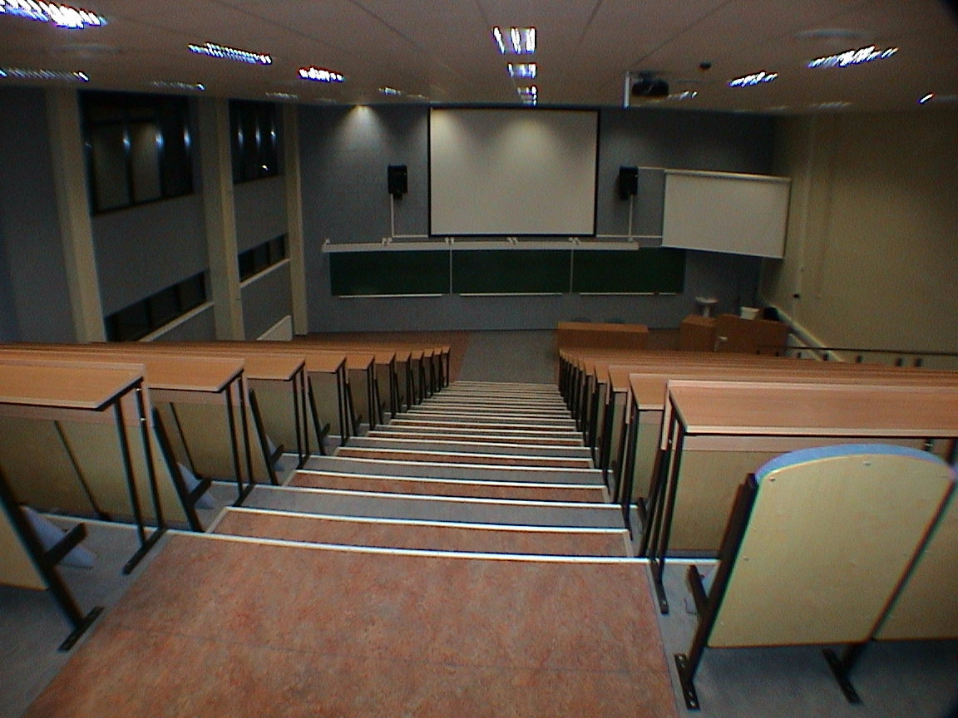
J. Liivi Street 2, Lecture-Room 111

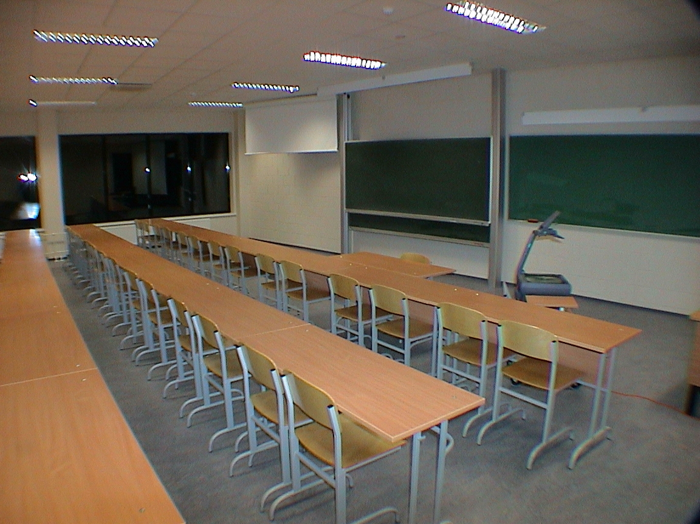
J. Liivi Street 2, Lecture-Room 405
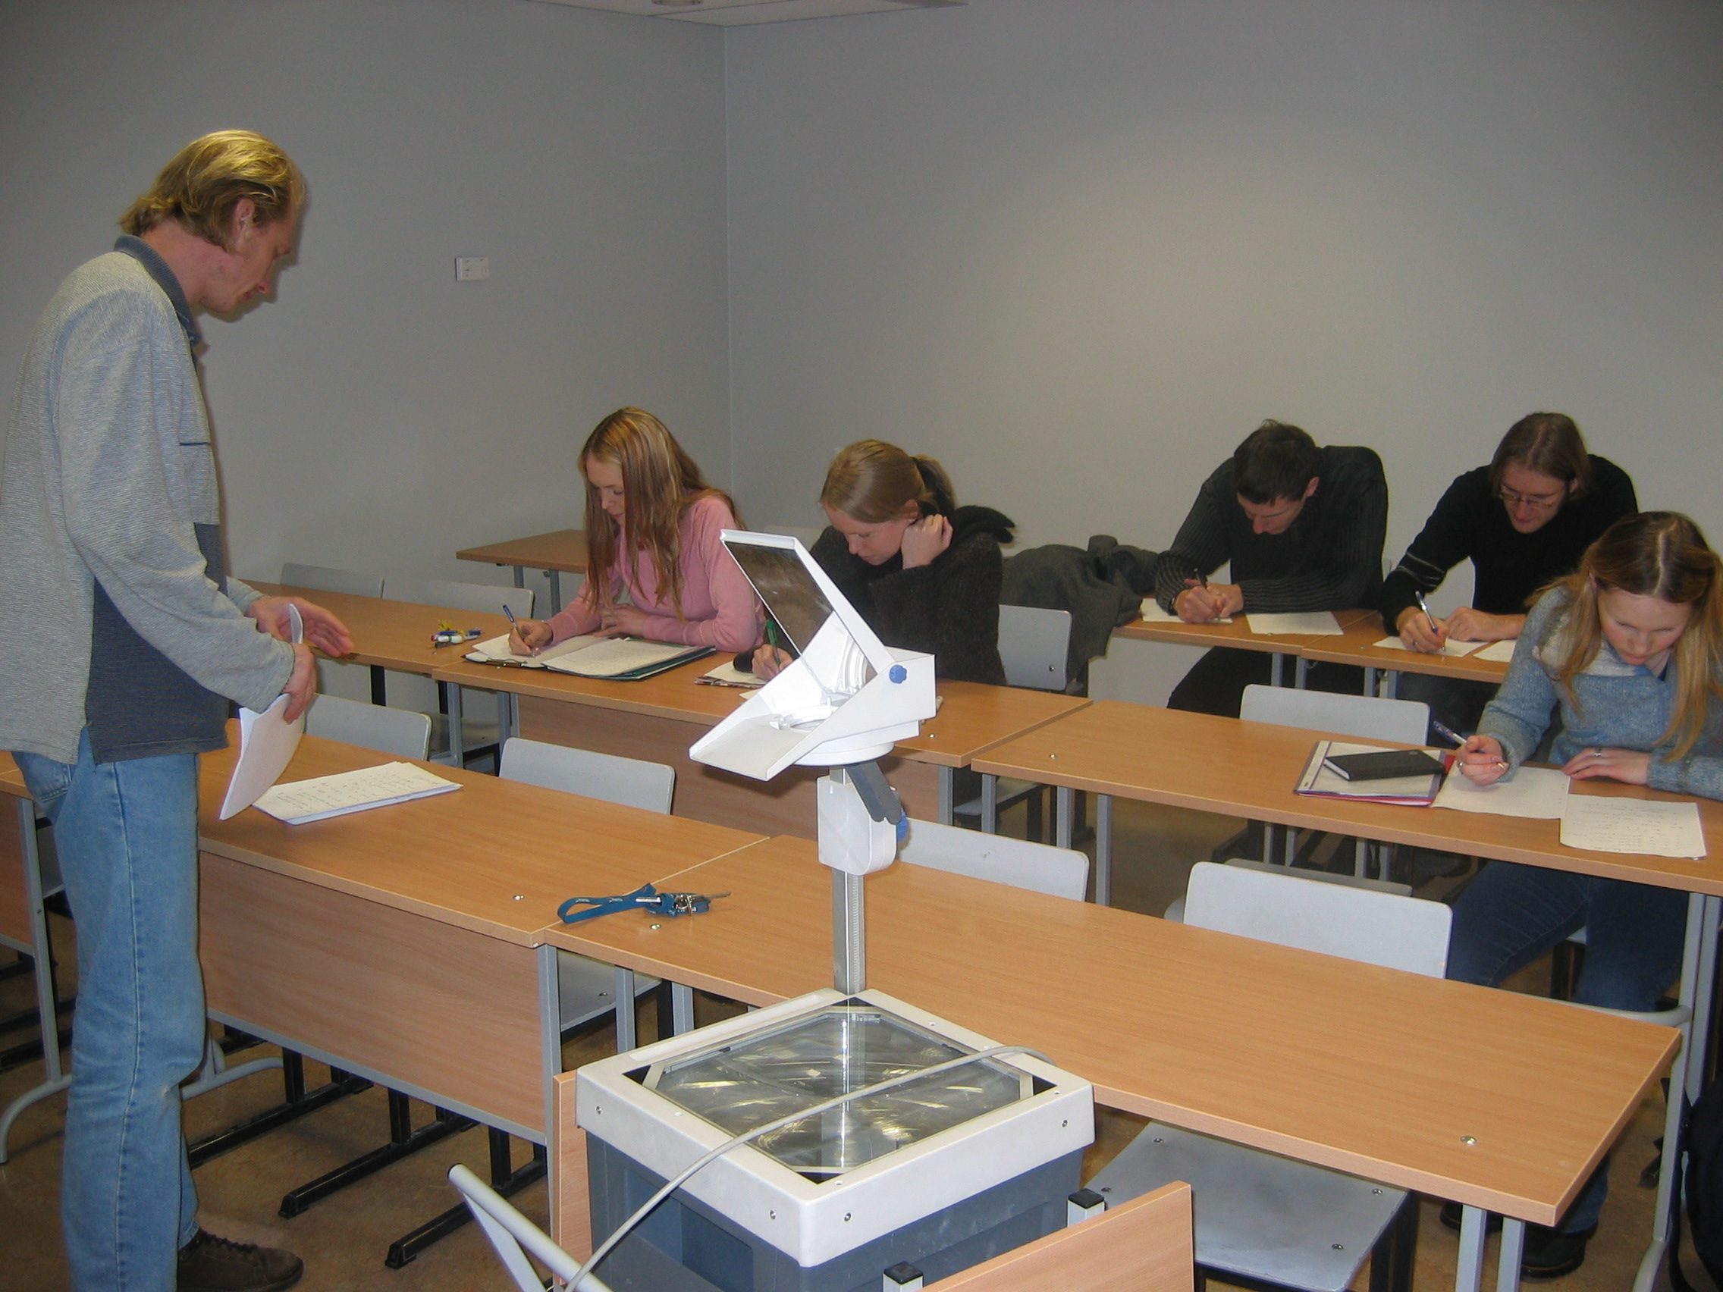

J. Liivi Street 2, Seminar Room 511

Laboratories and computer rooms:

Room 203 OHP, network connection, lecturer’s computer
work-places : 22; SUN BLADE 100 / SOLARIS 9
Room 311 OHP, network connection, video projector
work-places : 20; PC /Windows XP Pro
Room 003 OHP, network connection
work-places : 15; PC / Windows XP Pro
Room 004 OHP, network connection
work-places : 33; Pentium 100 / Windows 2003 TS
Room 205 OHP, network connection
work-places :19; PC/Pentium III / Linux

Total number of work-places: 109.

Room 123 CISCO Network Laboratory,
work-places : 11; PC / Windows XP Pro
Room 314 Multimedia Laboratory

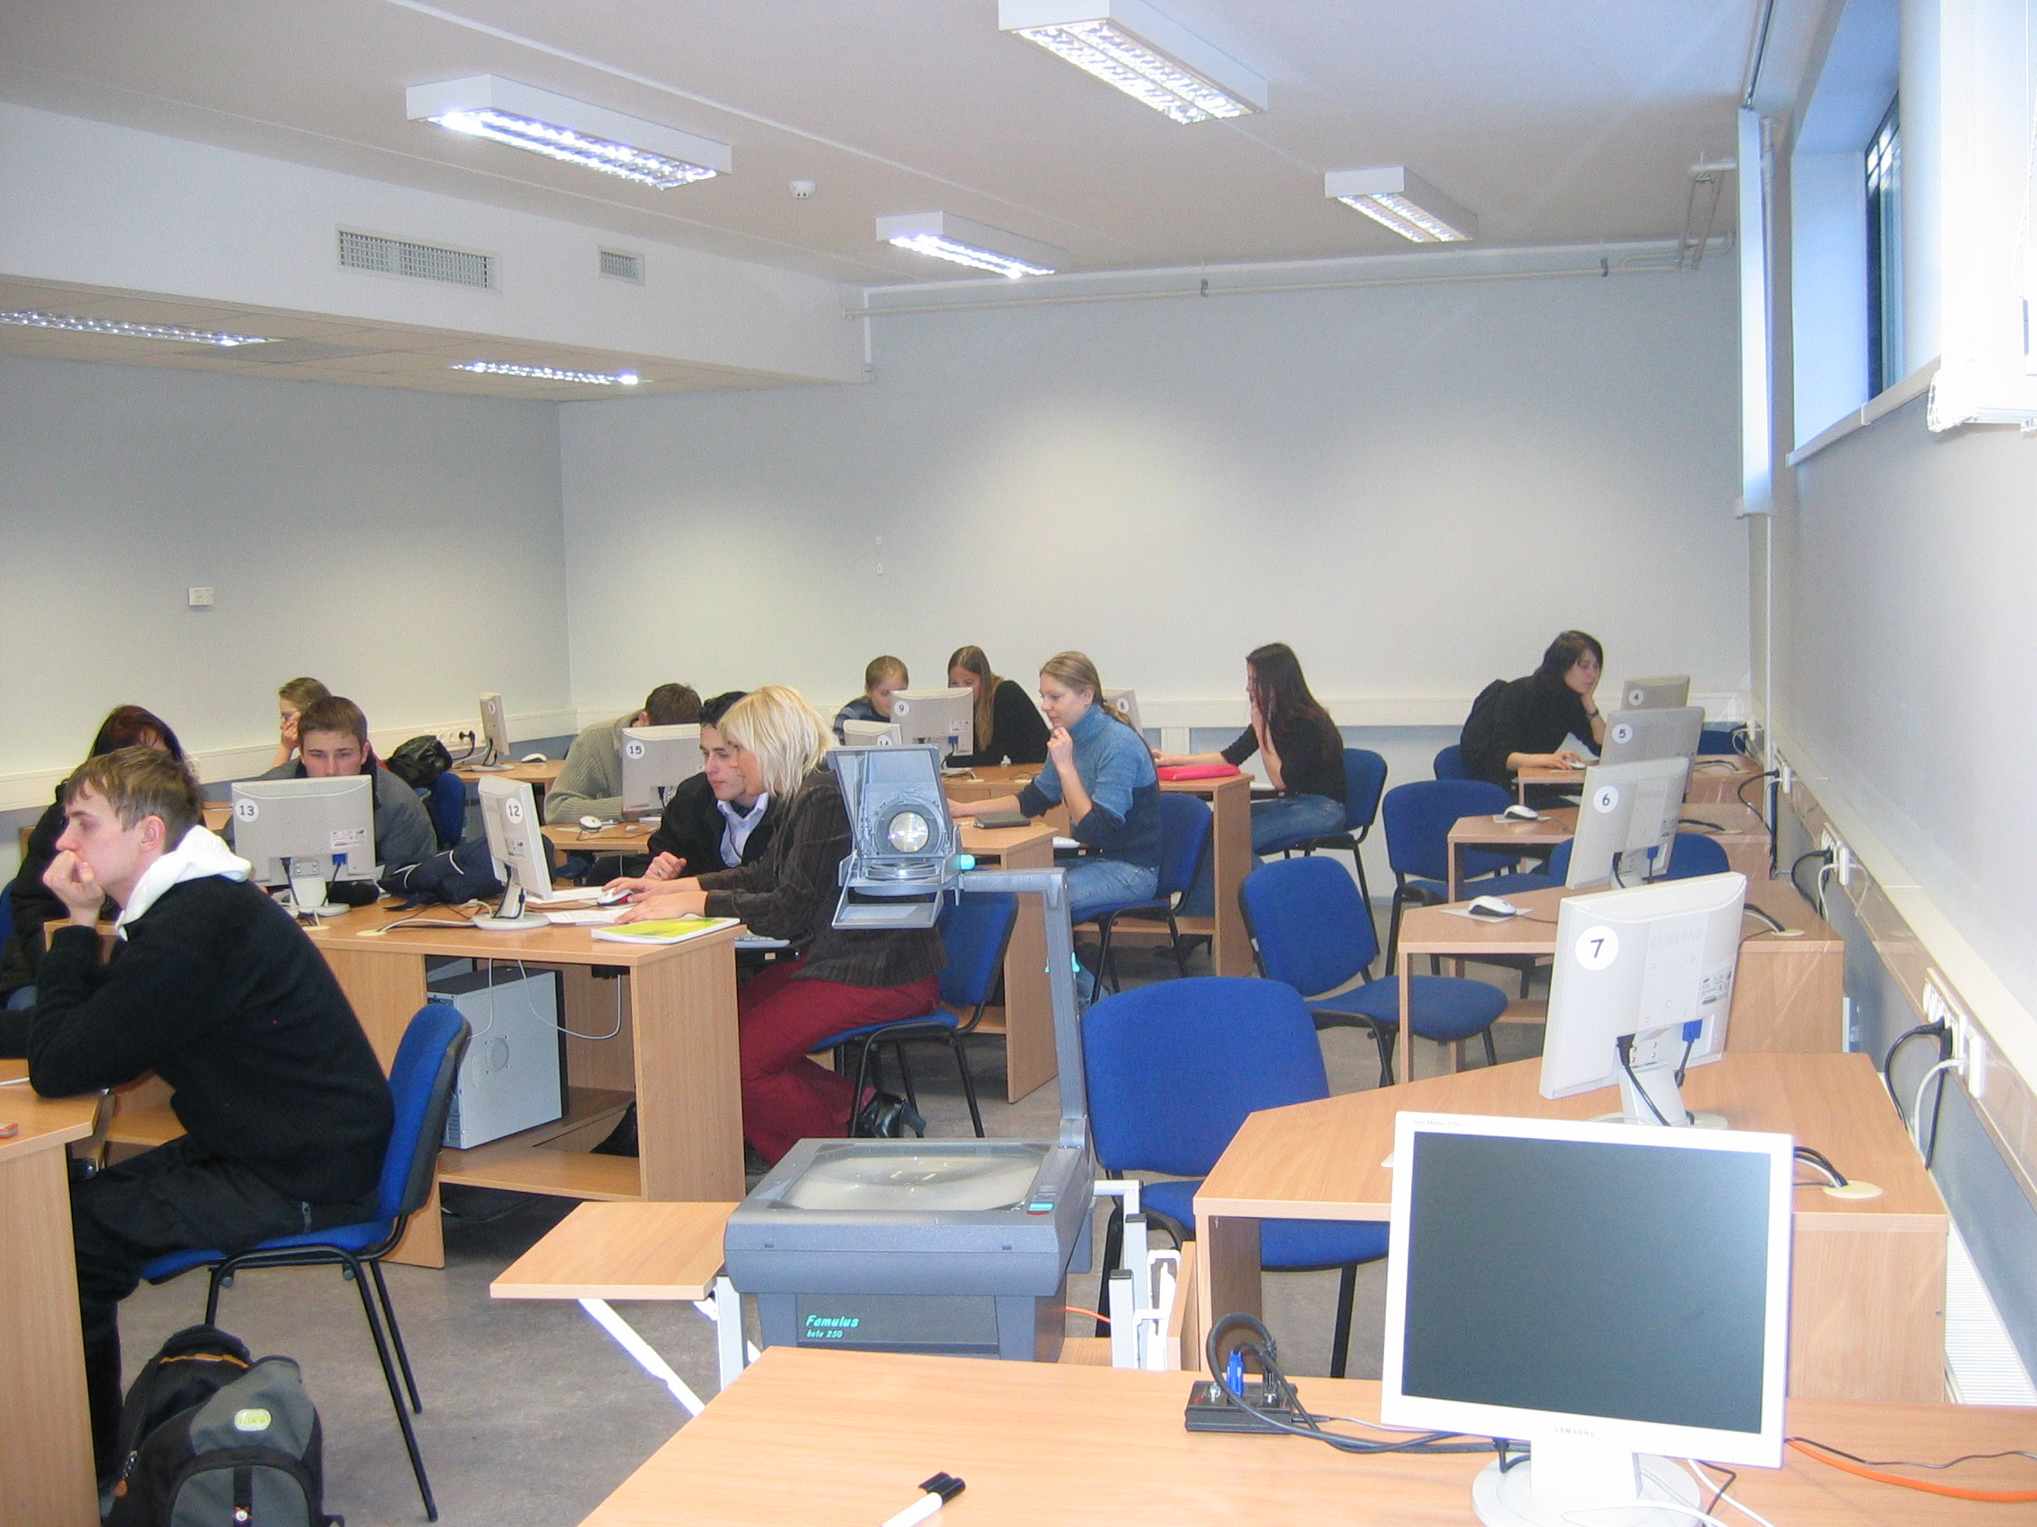

J. Liivi Street 2, Computer Room 003

6.1.2 The Faculty of Physics and Chemistry

At present, there is a sufficient number of lecture-rooms. The Physics building at Tähe Street 4 has 17 604 m² total floor space; 6902 m² of that floor space for teaching purposes. The lecture rooms are described in following Table 5.

Table 5. Lecture-rooms in FPC
Room | Seating capacity | OHP | Network connection | Computer | Supplementary devices
160 | 192 | + | + | + | video projector
170 | 102 | + | + | + | video projector
053 | 30
054 | 30
056 | 54 | + | WiFi
153 | 30
154 | 30
155 | 42
156 | 54 | + | WiFi |  | video projector
158 | 54 | + | WiFi
207 | 30 | + | + |  | video projector
253 | 30
256 | 54 | + | WiFi
258 | 54 | + | WiFi
405 | 30 | + | + |  | video projector
Total seating capacity: 816

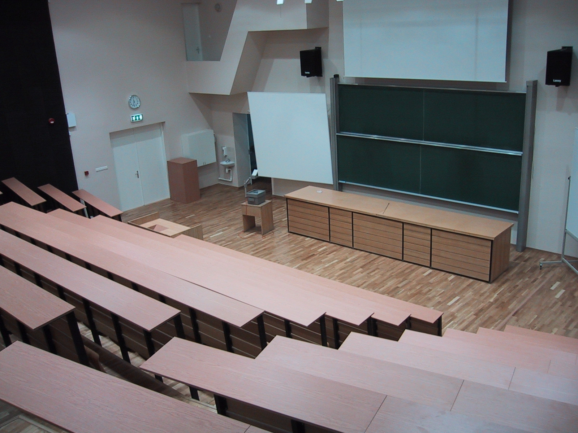
Tähe Street 4, Lecture-Room 160.

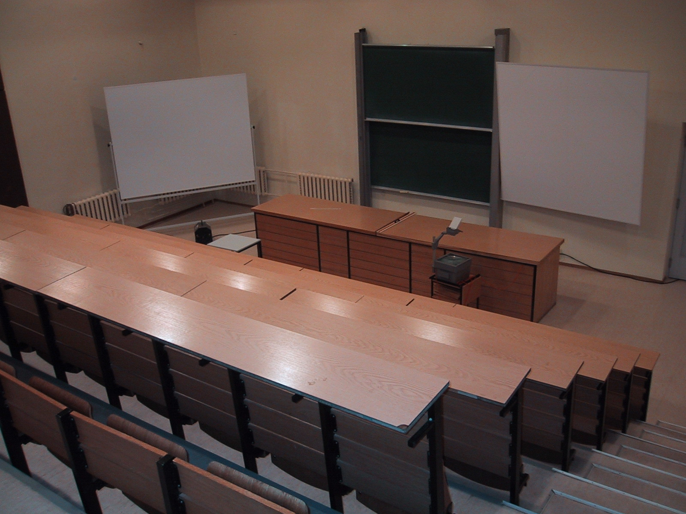
Tähe Street 4, Lecture-Room 170.

Computer-rooms:
Physics building (Tähe Street 4) has 2 computer rooms:

Computer-room 145
Computers: 18 PCs, Pentium IV 2.6 GHz, 512 MB RAM, nVidia FX5200, 40GB HDD, 1Gb LAN, ID card reader, CD/DVD reader, floppy.
Software: MS Windows XP Pro, MS Office 2000, MS Visual C++ 6.0, NetSupport School, Mathcad 2001i, MathLab7, Adobe Reader, AutoCad LT 2000i, R, Festart Dictionary, MikTEX, Idrisi Kilimanjaro, Gimp, OpenOffice.org, J2SDK, Turbo Pascal 7, SolidWorks etc.
In addition there is Linux (Fedora Core) installed into students computers.
Room has an OHP and lecturer's computer (the 19th one, Pentium 3.8GHz and WinXP Pro).

Computer-room 178
Computers: 16 PCs, Pentium III 450 MHz, 128 MB RAM, ATI Rage 98, 6GB HDD, 100 Mb LAN, CD-reader, floppy.
Software: MS Windows XP Pro, Mathcad 2001i, Adobe Reader, Gimp, OpenOffice.org, J2SDK, Turbo Pascal 7 etc.
Room has an OHP.

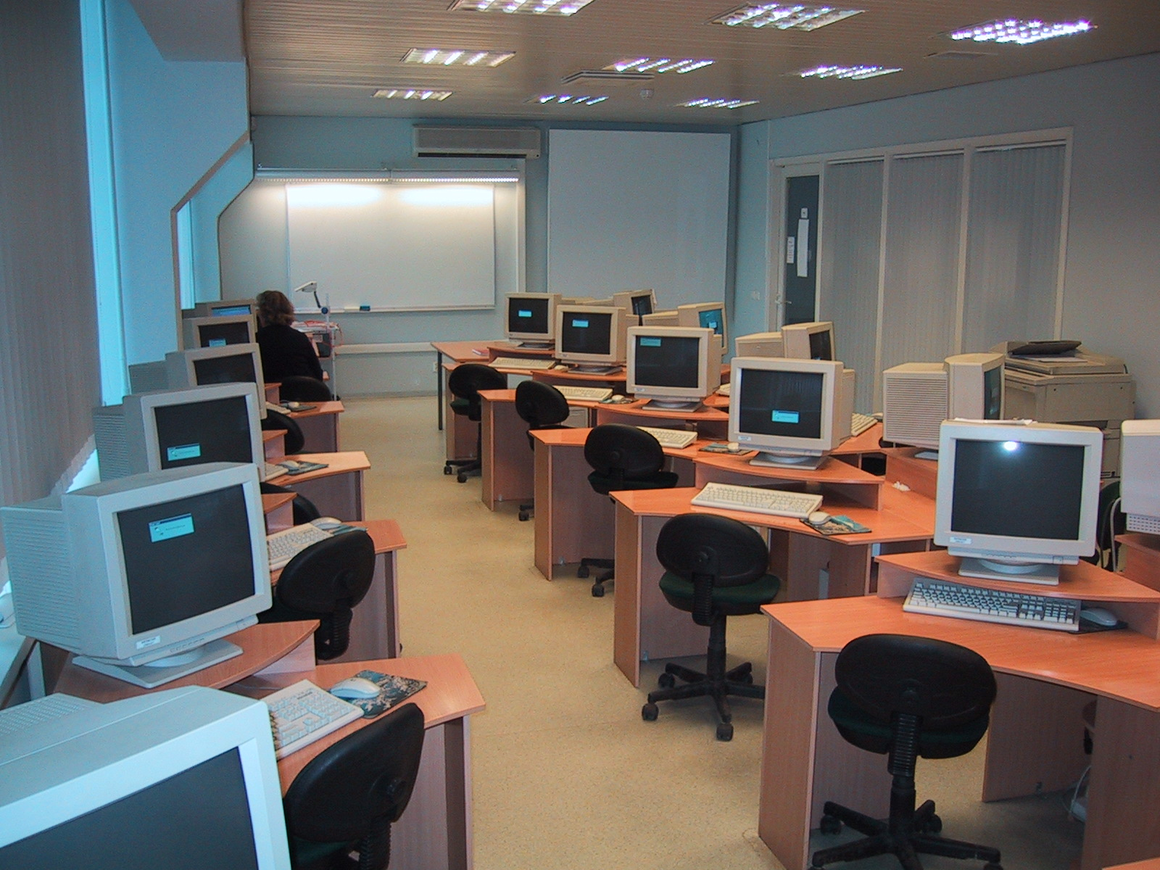
Tähe Street 4, Computer-Room 145.

Laboratory Rooms

The laboratory rooms are described in following Table 6.
Table 6. Laboratory rooms in IEPT
Room | Seating capacity | OHP | Network connection | Computers | Supplementary devices
021 | 12 | + |  | 6
179 | 12 |  | + | 12
210 | 16 |  | +
210A | 16 |  | + | 4
217 | 16 | + |  | 9 | 2 TVs
311,312 | 24 | + |  | 2
324,326, | 24 | + | + | 4
332,333 | 24 | + | + | 5
Total seating capacity: 144

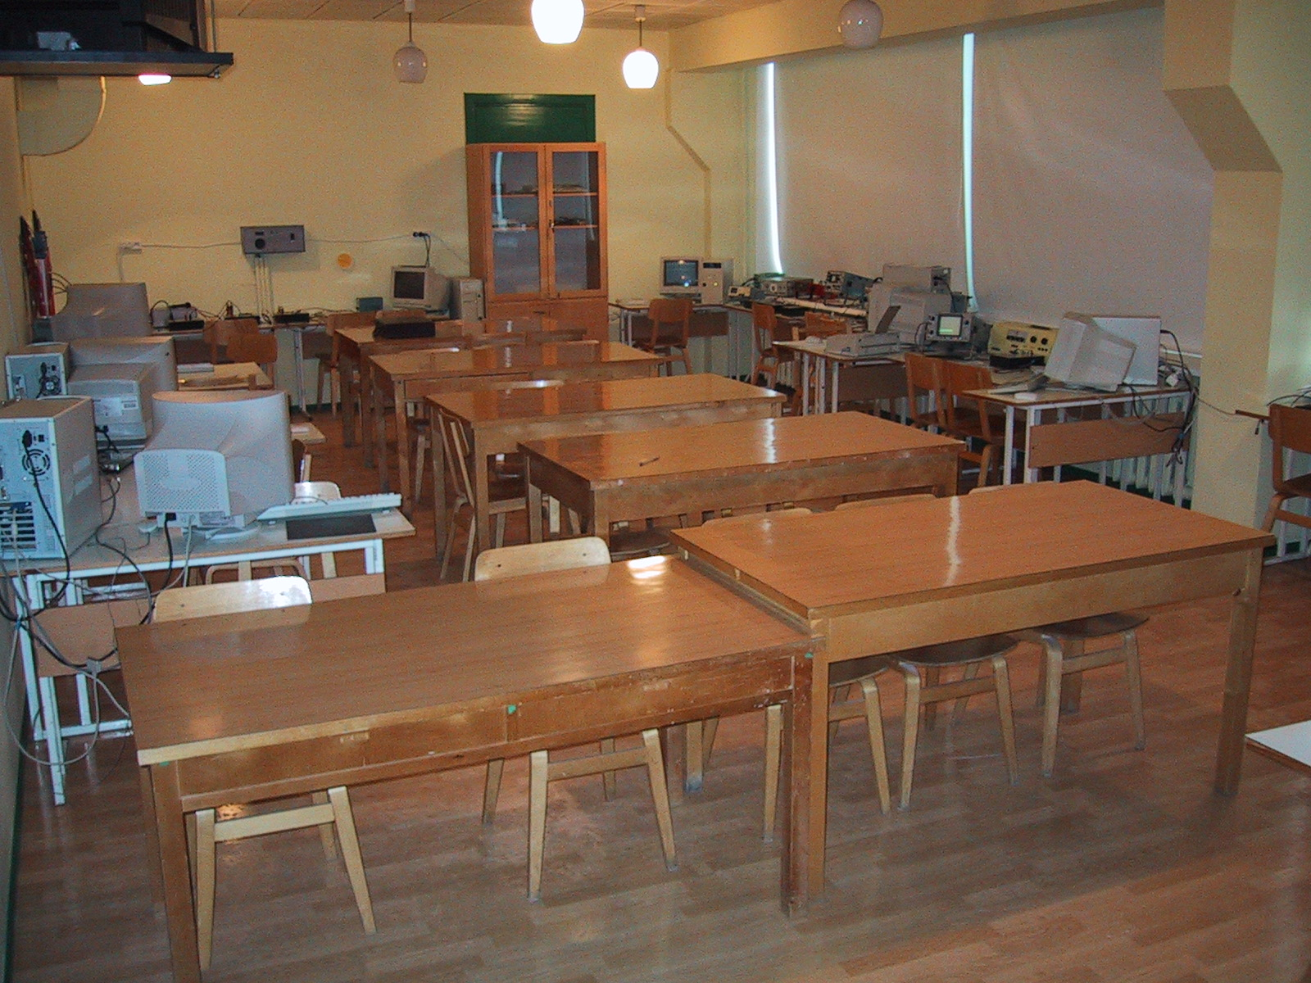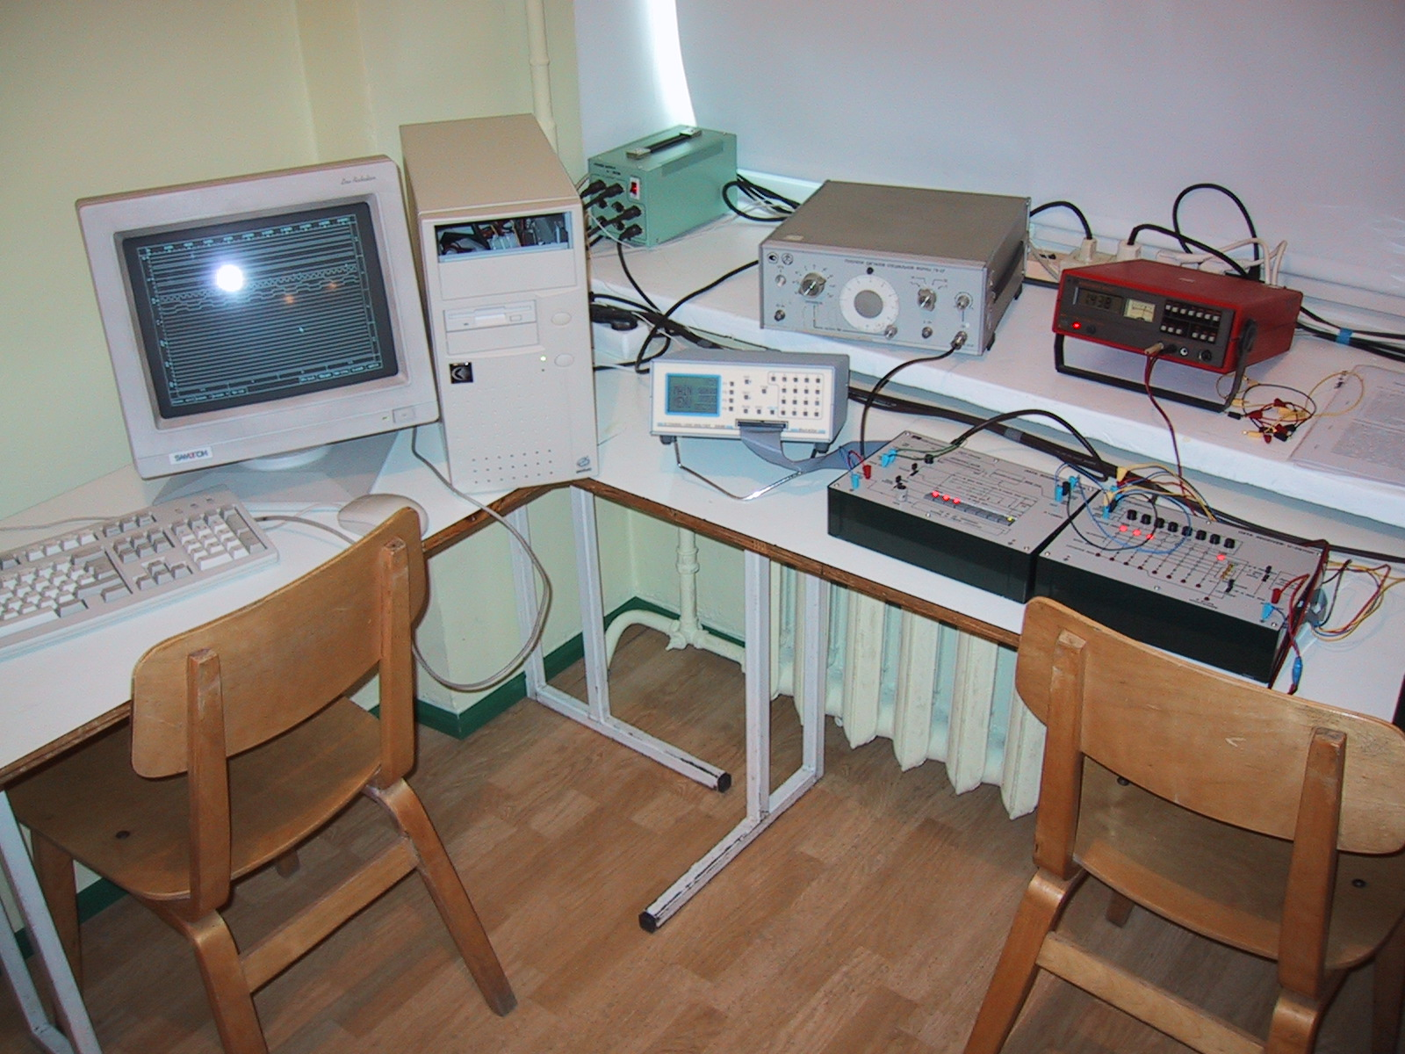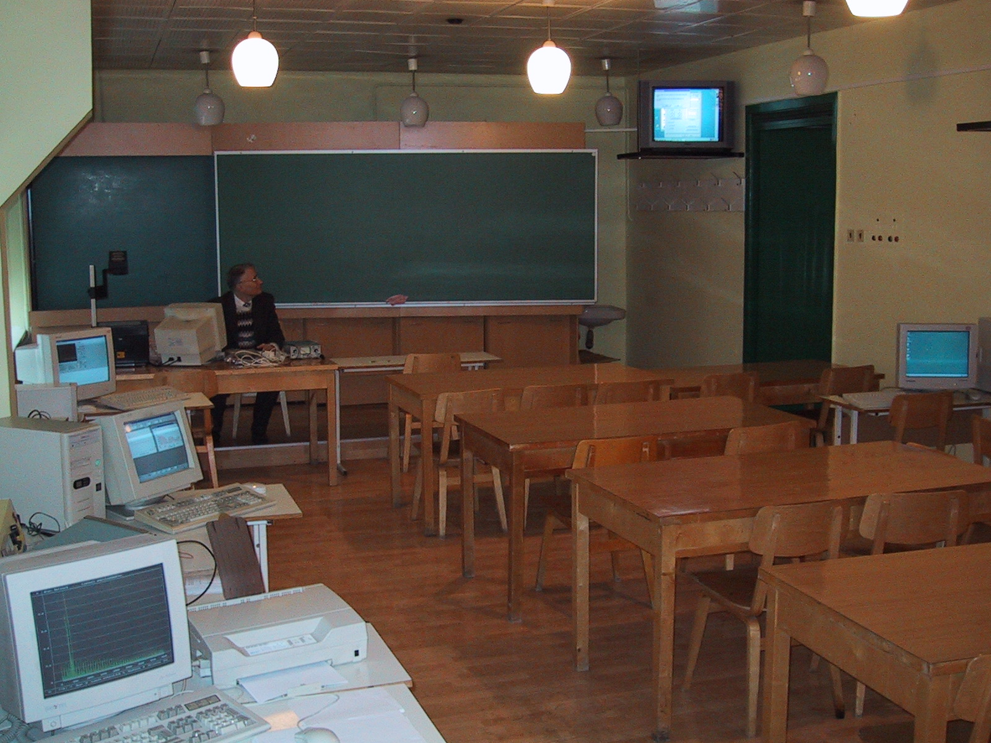
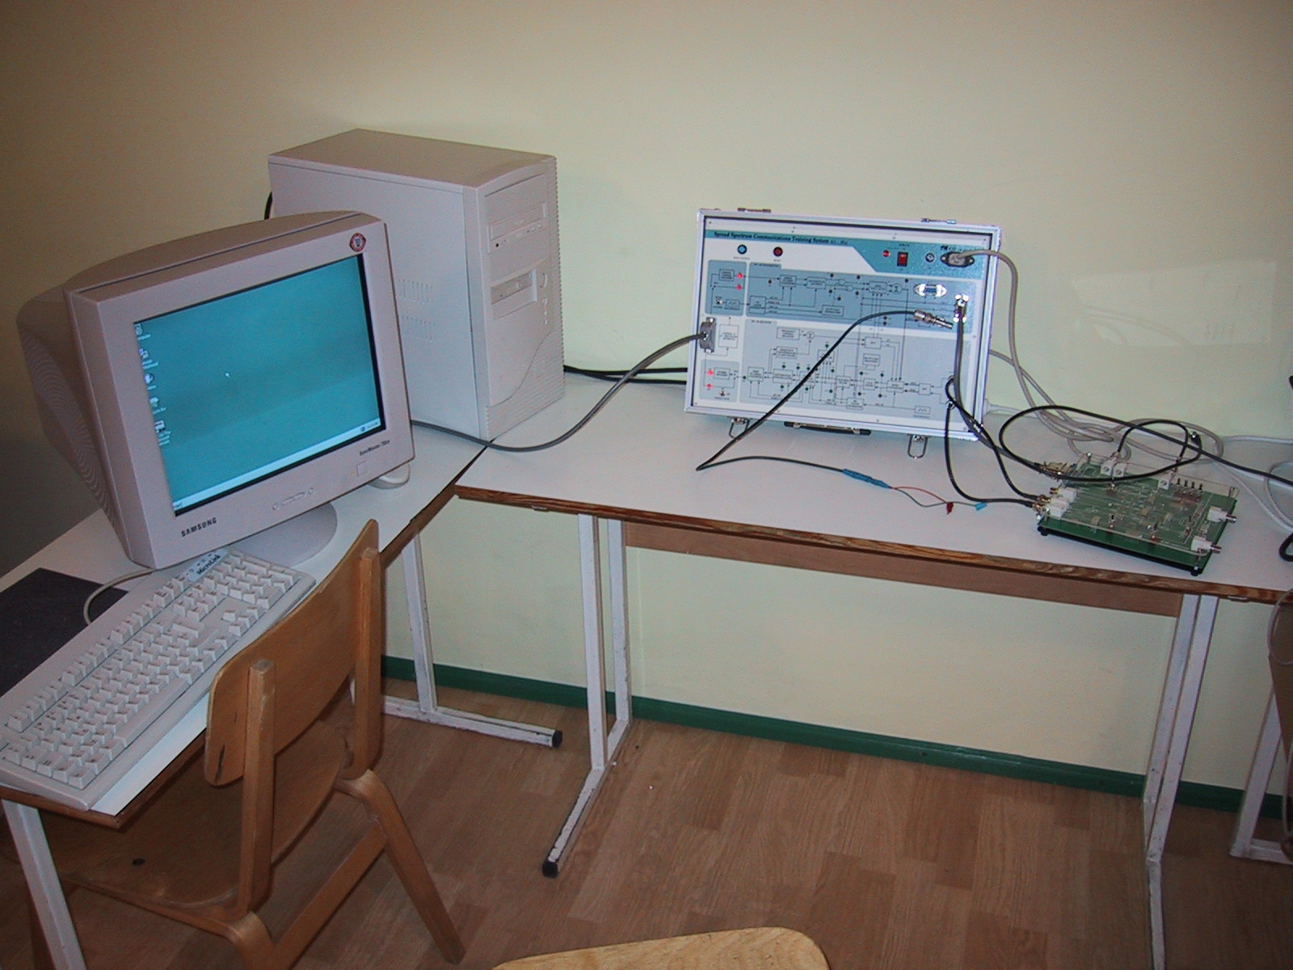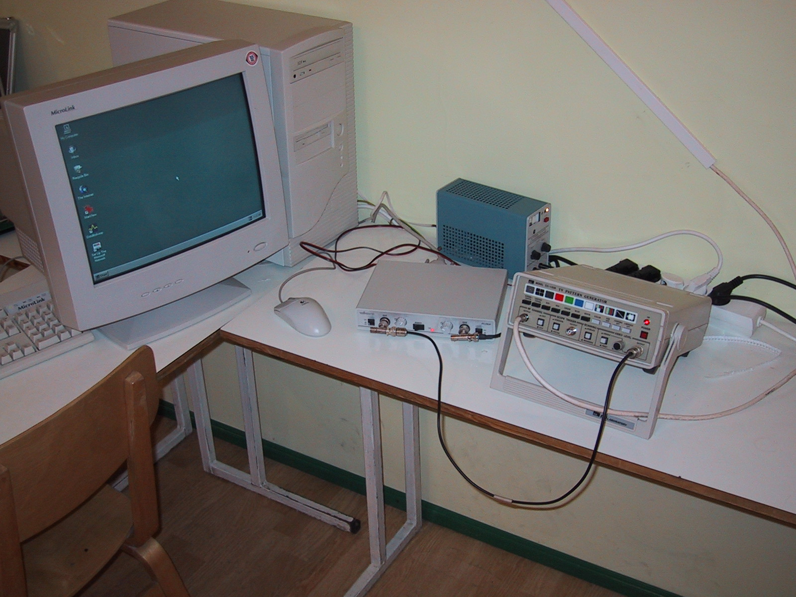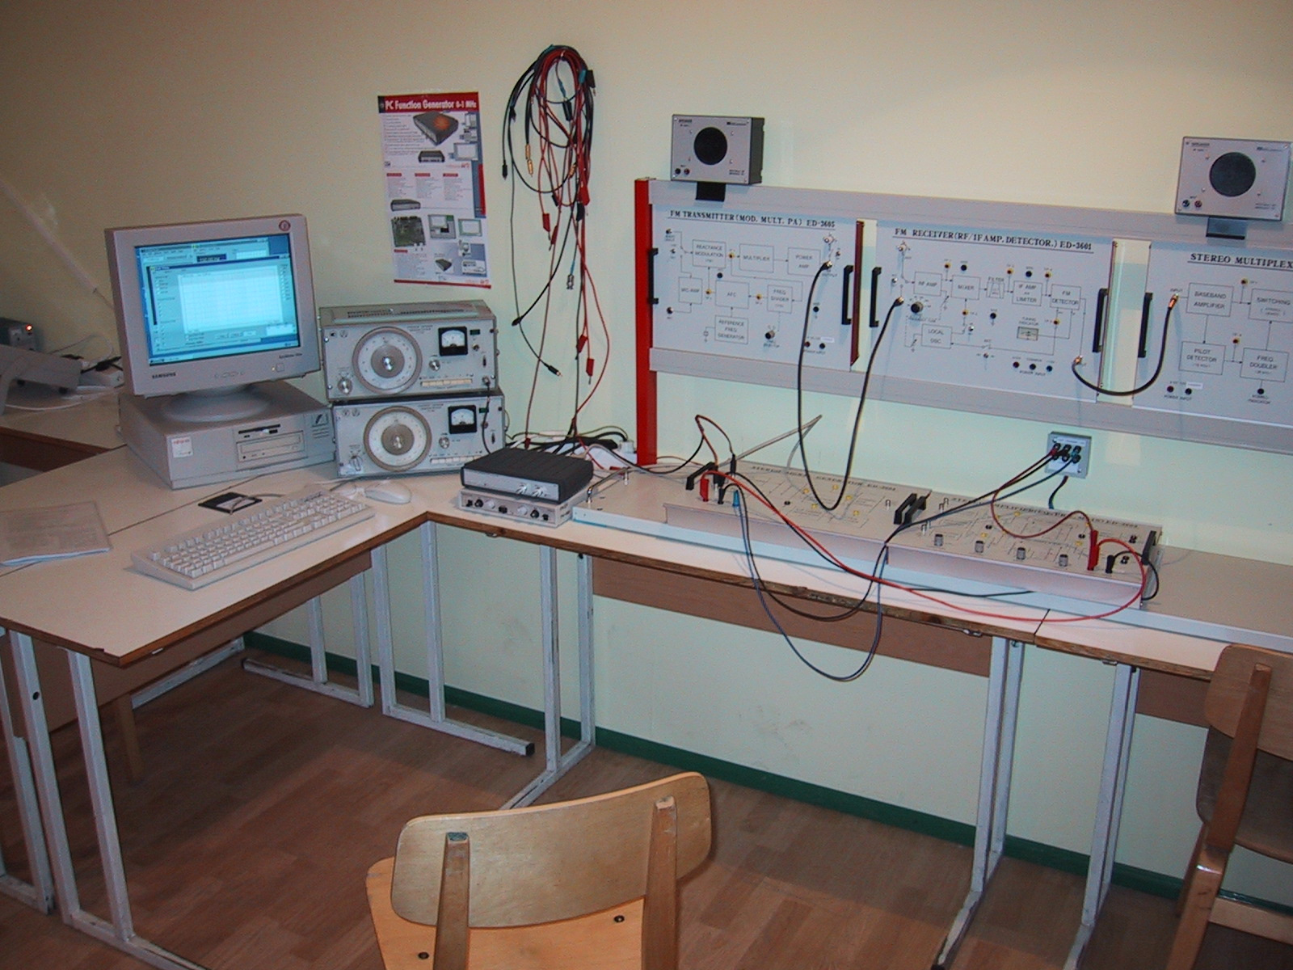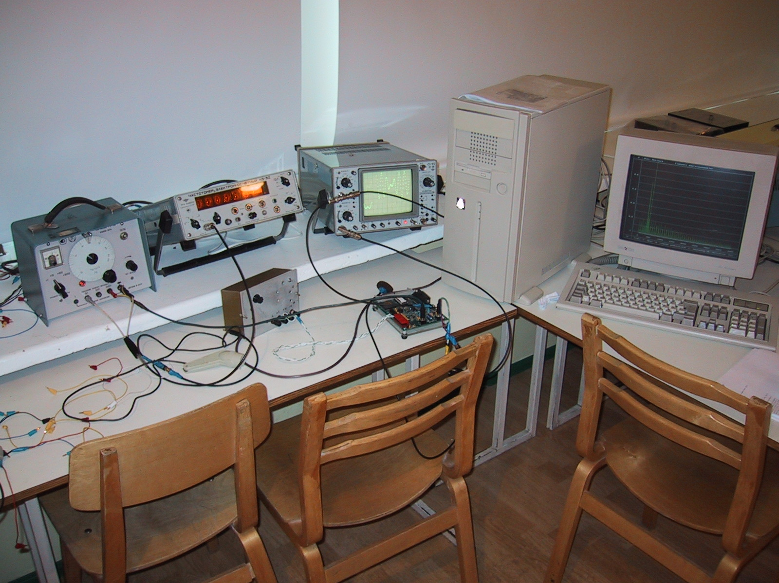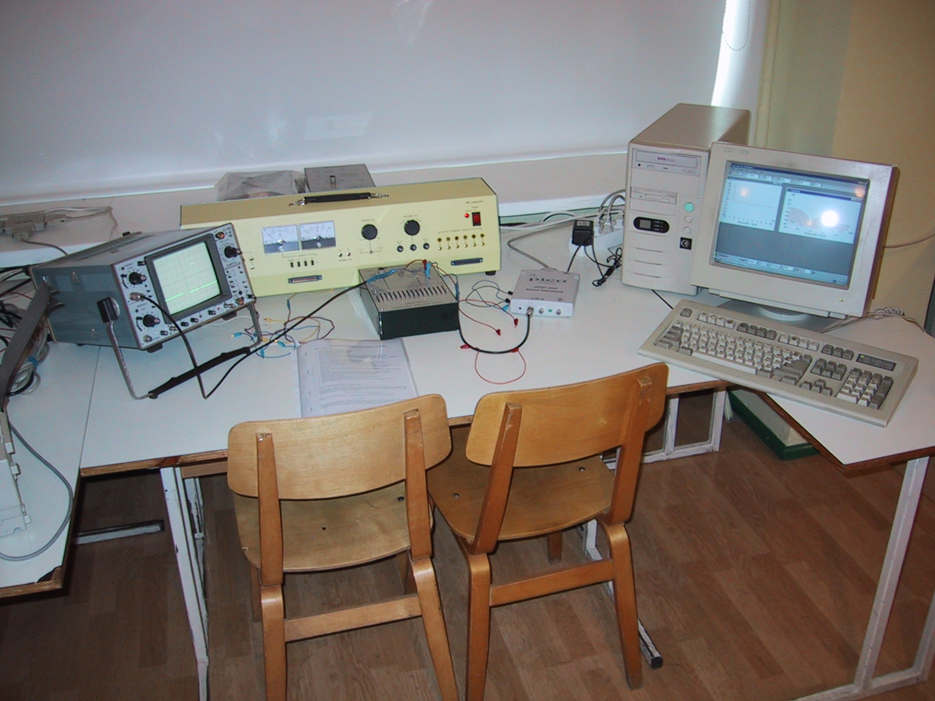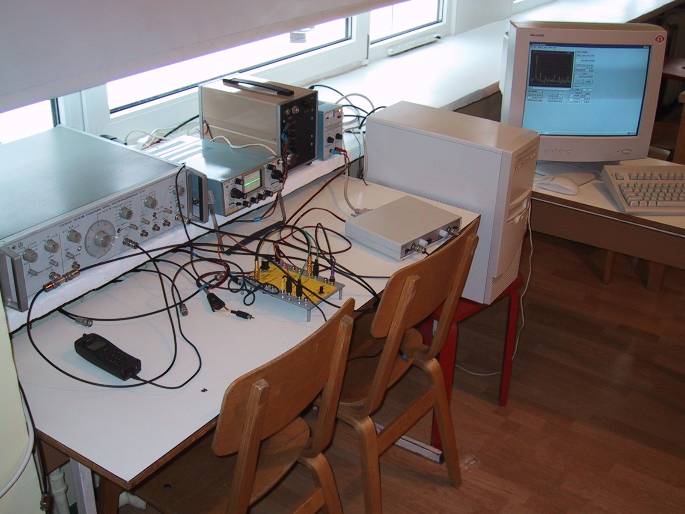
Tähe Street 4, Laboratory-Room 217 (telecommunication)

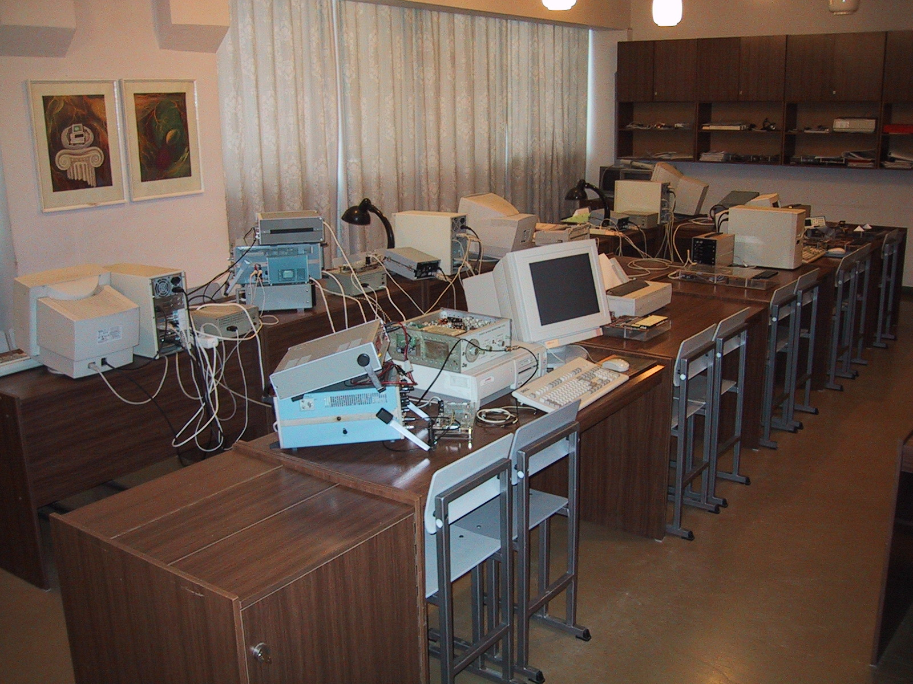
Tähe Street 4, Laboratory-Room 021 (microprocessors)

Special equipment:
To meet their special needs of the present curriculum, it is primarily important the purchase of the hardware products.
Each spring we rent from AS Microlink 12 new (last available model) personal computers (as components) for the practical works in course Computer Hardware Principles;
Hardware for the course Practical Works on Telecommunications. Namely: Training systems made by ED CO Laboratory (signal spectrum analysers, frequency modulators, multiplexers, demultiplexers, optical fiber sets, coders, decoders, Hamming error correctors); Training systems in telecommunications made by FACET® LabVolt, Garmin 101 GPS trainer, Velleman PC oscilloscopes and so on.
Hardware for the course Computer-aided Measurements; AD and DA converters, Tektronix digital oscilloscopes, logic analysers, computers.
Hardware for the course Practical Works on Microprocessors; Training kits based on Z80 microprocessors, logic analysers, oscilloscopes, computers.
Hardware for the courses Hardware Project and Robotex – DIGILAB

Digital Electronics Laboratory DIGILAB

DIGILAB was founded in 2004. The Estonian Information Technology Foundation was the major partner in funding.

The main goals of the lab are:
- To give postgraduted students opportunity make their project works, applied research projects and applied projects in state-of-art equipped electronics lab
- To increase ratio hands-on electronics and robotics projects in student courses.
- To encourage small enterprises to collaborate with student projects.

Current activities:
- There is a student robot contest Robotex where about 5 teams from UT participate. DIGILAB is the base for robot activities.
- Three undergraduate courses use digilab equipment for their hands-on project works.
- About 6 postgraduated students use lab for their project development
- We have 2 applied projects with partners from industry.

Usage in 2004-2005 period.

- About 50 students used the lab for their project works
- Average usage was about 80 human hours per week.

DIGILAB is equipped with:
- 3 workplaces for electronic work equipped with tools, materials and computers
- 1 workplace for Linux programming
- 1 workplace equipped with tools and accessories for mechanical work.
- State-of-art tools and equipment for digital electronics development and measurement.

Web page http://digi.physic.ut.ee (sorry, only in Estonian.)

Resources for further development.
The sufficient resource of space is available at Tähe Street 4 for further development.
One of the weaknesses is the unfinished process of equipping some lecture-rooms with computers and video projectors. The situation will be alleviated when a respective successful project is launched.
Computer room 178 is available for students only during lectures and seminars. It is decided that room 178 will be equipped with new PC-s. In this case the PII computers located there will be made available for students free-time use.

6.2. Library

The teachers and students of the Institute of Computer Science mostly use the University’s main library and the Faculty’s Library of the FMCS. The teachers and students of the Institute of Experimental Physics and Technology mostly use the University’s main library and the Physics Department’s library.

The stocks of the main library hold more than 65,000 titles (estimated by the Library number) of literature in mathematics, statistics and computer science. It is not possible to give exact figures since the grounds of classification are different and only relatively small part of literature in the Library is included into the electronic catalogue. In recent years, the open access stock has seen brisk growth, which has led to a considerable increase in its attendance. The University of Tartu Library receives a legal deposit copy of all the publications issued in Estonia.

The stocks of the Faculty’s library of FMCS hold more than 12,000 copies of library materials, mostly in mathematics, more than 5000 books and journals are available from open access stock. All the study material in Estonian is available in both, main library and the Faculty’s library. Both libraries make continuous efforts to order new text-books and study materials, the same time coordinating their activities. Big part of the literature in the Faculty’s library has been obtained through donations and personal contacts of teaching staff.

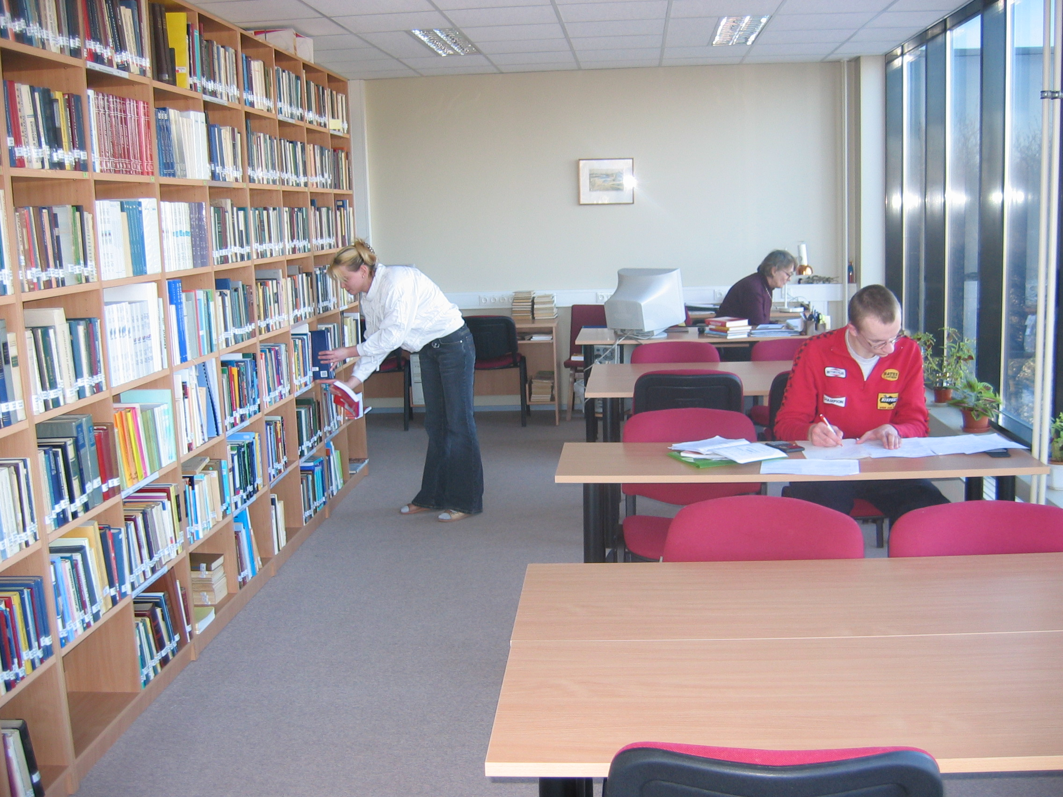

J. Liivi Street 2, Library of FMCS

The Physics Department's Library contains more than 11,500 titles of library materials. The size of collections is 19000, containing monographs, textbooks, reference books, periodicals from the end of the 18th century to the present day mainly in English, Russian, German and Estonian. The library consists of two parts:an open access stock with reading-room and a closed access stock The open access stock contains 5800 titles. The library has a small collection of electronic materials containing CD-ROMs and diskettes. The library materials can be borrowed and used in the reading-room. There are 1500 titles of former holds and 10000 titles from the post-war period. The great number of textbooks are donated. The acute shortage of space is a serious problem in the library.

Opportunities for using information networks:

In the Main library as a whole the situation substantially improved in the last academic year, since in the autumn a room was prepared for computer places and furnished with 36 decent computers. Apart from that the Faculty of Philosophy has a computer class with 6 computers. At the Physics Department’s library 2 computers are available in the vicinity of the open access stock of Physics. The Open University class at the Main Library holds about 15 computers. Similarly, computer use possibilities (4 computers) have improved at the European Documentation Centre of the Main Library.

The computer-based services currently available are: use of electronic catalogue, use of scientific databases and electronic journals at the University network, searching European Community materials, free search over the Internet, word processing, use of educational-information system and use of CD-ROM databases.
The University has access to 69 bibliographic and fulltext scientific databases incl. online
Databases. Through the University computer network
(http://www.utlib.ee/erialaportaal/index.php
the following databases of Computer Science literature are available:
- Blackwell Synergy
- Cambridge Journals Online
- Current Contents (ISI Web of Knowledge)
- EBSCO Academic Search Premiere
- INSPEC
- Kluwer Online
- ScienceDirect
- SpringerLink
- The Scientific & Technical Information Network (STN)

Textbooks: Within last five years 12 printed textbooks for compulsory courses have been published at ICS (see Appendix 2.2.1).

Periodicals

At least 11594 titles of fulltext journals (6000 per-reviewed) are available through the databases purchased by the library incl. 2464 journals titles in the field of Science: Physics 300 Journals, Astronomy – 39, Chemistry – 284, Mathematics and Computer Science 640 Journals. The most of subscribed journals are peer-reviewed. We can say that a wide variety of the world’s top journals are represented and the situation may be considered as satisfactory.

Electronic journals on the Main library Web by subject:
http://atoz.ebsco.com/Subjects.asp?id=1249&sid=29929109

The list of journals in informatics and information technology has become longer in last years. Big part of journals has been obtained through donations. University library gets the most important journals but the list is not long enough. There are many journals which are not available in Estonia and which are the key journals in our area of research. The Library of FMCS orders only few journals, the new issues from main library are on display for two weeks in the libraries of FMCS and Physics Department. The list of journals is given in Appendix 6.2.1.

APPENDIX 6.2.1. Periodicals on IT at UT libraries

Financing

The finances for foreign-language educational and scientific literature have been divided between faculties for four years. The amount of the funds depends on the percentage of the Faculty’s budget on the University’s budget.
- The allocations for 2001 were worth 842000.00 EEK, of which 659260.00 EEK were spent on journals in 2002.
- The funds in 2002 were worth 887640.00 EEK, of which 532042,00 EEK were spent on journals in 2003.
- The funds in 2003 were worth 917850.00 EEK, of which 549550.00 EEK were spent on journals in 2004.
- The funds in 2004 are 927850.00 EEK, of which 526328.00 EEK will be spent on journals in 2005 .

These sums enable only small purchases of literature corresponding to the primary educational needs, since the annual funding for one chair is just around 4000 EEK. Successful research work, however, requires at least ten times the funds since physical literature (particularly source publications) are expensive.

Budget of the main library for the Faculty of Mathematics and Computer Science is given in Table 7.

Table 7. Finances of the main library for FMCS

 | 2001 | 2002 | 2003 | 2004
Total for FMCS | 318 500 | 314 080 | 341 820 | 351 820
Journals | 229 353 | 224 470 | 212 095 | 158 319
books | 89 147 | 89 610 | 129 725 | 193 501

The library of FMCS has limited sources for literature, mostly new books and journals are bought for research grants. Approximate sum per year for books in computer science has been 50 thousand crowns.

Use
On account of the increase in the open access stock the use of physical books has clearly experienced a considerable rise; however, the library does not keep the corresponding statistics on a systematic basis.

With regard to the main library the attendance of the FPC students for instance is available by months for 2001-2005.
- In 2001 oct.-dec. there were 1881 visits
- in 2002 there were 9912 visits
- in 2003 there were 15261 visits
- in 2004 there were 17026 visits
- in 2005 jan.-march there were 3716 visits

In conclusion: the availability of scientific literature on computer science has much improved in recent years and can be considered satisfactory but far from being good. The small numbers of copies of textbooks must be considered as a disadvantage leading to long waiting lists for textbooks, which has an adverse effect on studies. The understocking is due to the unacceptably small acquisition budget of the University’s libraries.

Development prospects
Development is directly dependent on the state budget, in which the University of Tartu has so far been chronically underfunded. The present acquisition funds, while allowing ongoing obtainment of new literature as well as fresh initial information from electronic journals, are inadequate for the acquisition of more voluminous and more valuable reference books, source publications and other scientific information that is slower to fall out of date. As well, we cannot say that the stock is systematic – much has had to depend on the goodwill and taste of the donators.

6.3. Service divisions and material resources

6.3.1 The Institute of Computer Science

The Institute of Computer Science is an integral part of the Faculty of Mathematics and Computer Science and shares with other institutes all service possibilities of the new Faculty Building at J. Liivi Street 2. There is a cafeteria in the building and two recreation areas for students (on the first floor and the fourth floor).

The members of the Institute use also the possibilities provided for all the University’s students and employees by the infrastructures of the University as a whole as well as by those of downtown Tartu. Students use actively the Faculty’s library where is a reading room with computer facilities (4 computers).

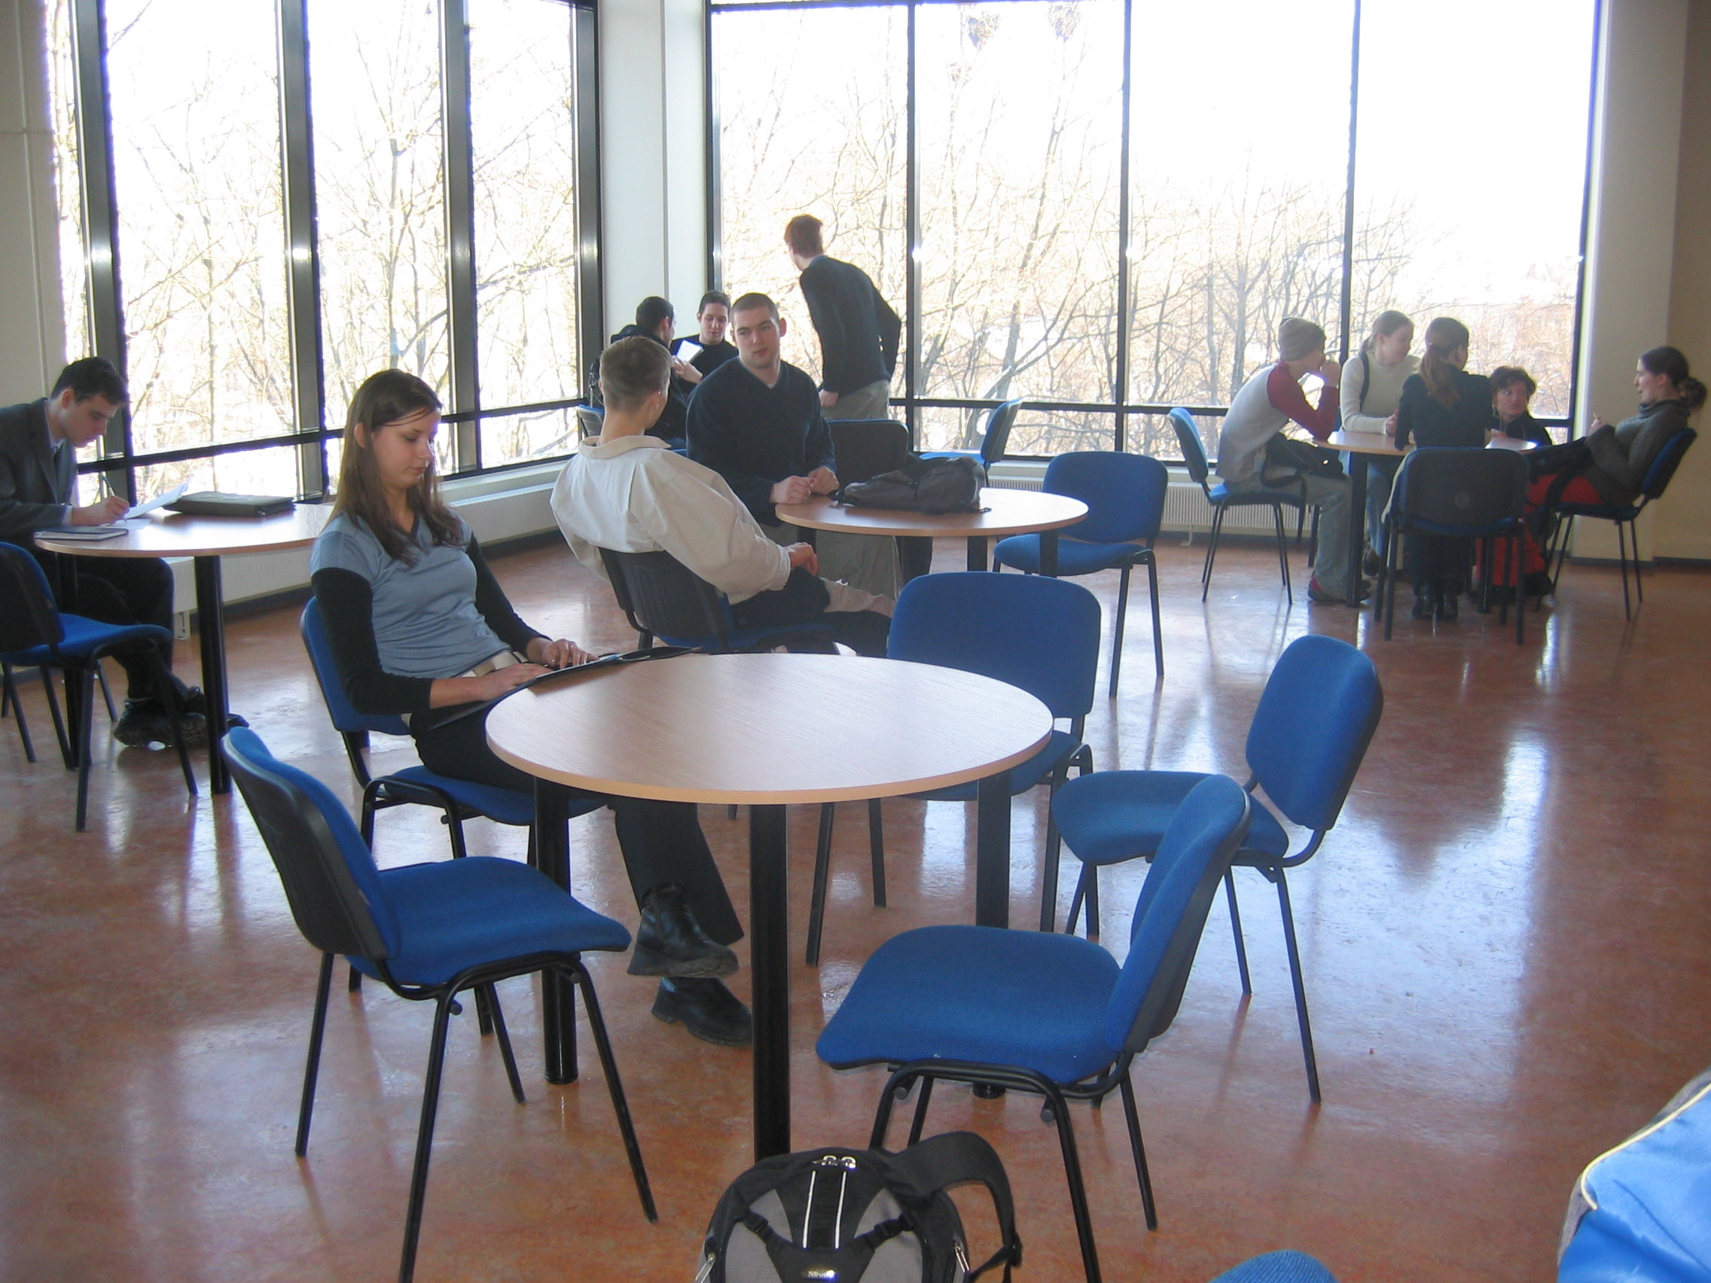

J.Liivi Street 2, Students recreation area, 4th floor

6.3.1.1. Infotechnological and office resources

The teaching staff is equipped with office space. ICS is situated on the third floor and PhD students have rooms in the ground floor of the Faculty building. Senior staff has single working rooms and lecturers and assistants work in double rooms. All staff is equipped with personal computers, also most PhD students have computerised working places. Institute has copy facilities. Institute has four portable computer projectors for teachers.

6.3.1.2. Financial resources

The Institute’s funds are formed from the following main sources:

A. Income from educational work.
B. Income from scientific research. This includes 4 sources:

(1) governmental targeted funding of research,
(2) grant funding from the Estonian Science Foundation,
(3) research and development contracts,
(4) targeted funding of doctoral students’ research.

Table 8. Incomes of the Institute of Computer Science (in thousands of EEK)

OPERATING INCOMES | 2001 | 2002 | 2003 | 2004
1. Income from tuition
1.1. Government-financed tuition | 4293,5 | 4687,1 | 4432,8 | 4777,2
1.2. Tuition fees from Open University | 939,6 | 783,7 | 893,9 | 900,0
1.3. Other fees | 0,0 | 2,7 | 36,6 | 37,0
2. Income from research activities
2.1. Target funding of research | 335,0 | 485,0 | 0,0 | 0,0
2.2. Estonian Science Foundation grants | 174,0 | 308,0 | 289,0 | 319,0
2.3. Research and development contracts | 330,9 | 2523,1 | 4809,6 | 3279,7
2.4. Target funding of PhD research | 260,7 | 231,0 | 234,5 | 96,0
3. Other income | 15,0 | 551,8 | 437,9 | 429,6
Total income
4. Overhead | 288,4 | 307,5 | 319,0 | 343,7
Net income | 6060,3 | 9278,9 | 10857,1 | 10074,4

A considerable growth of budgetary incomes can be observed throughout the period under study. Especially it can be seen in government-financed tuition. Under the title ”Target funding of research” we see the decrease. This does not mean that the research has stopped (see APPENDIX 7.4.4, for instance). At the moment the staff members are involved in several projects but leaders of the projects work somewhere else and the funding does not appear explicitly in our budget.

6.3.2 The Institute of Experimental Physics and Technology

The members of the Institute use also the possibilities provided for all the University’s students and employees by the infrastructures of the University as a whole as well as by those of downtown Tartu. There is a lunchroom in the Physics building and recreation areas for students.

6.3.2.1. Infotechnological and office resources

The teaching staff is well equipped with office space. Senior staff has single working rooms and lecturers and assistants work in double rooms. All staff is equipped with personal computers, also PhD students have computerised working places. Physics Department has copy facilities and makes it possible to use the copy machine for reduced price for students. Master students have also three working places with computers. The Institute has two portable computer projectors for teachers.

Department has bought for teaching and research purposes the package Mathcad, which is available for students in two computer classes in the building.. Hardware and software are countinuously renewed every year.

6.3.2.2. Financial resources

The funds are formed in the similar way as described above in the case of ICS.

Table 9. Incomes of the Institute of Experimental Physics and Technology (in thousands of EEK)

OPERATING INCOMES | 2001 | 2002 | 2003 | 2004
1. Government-financed tuition | 1891.0 | 2415.1 | 2387.4 | 2560.5
2. Incomes from research activities | 1611.0 | 1516.7 | 1511.1 | 1876.0
2.1. Target funding of research | 1165.0 | 1255.0 | 1205.0 | 1477.0
2.2. Estonian Science Foundation grants | 286.0 | 170.0 | 216.0 | 318.0
2.3. Target funding of PhD research | 160.0 | 91.7 | 90.0 | 81.0
Total income | 3502.0 | 3931.8 | 3898.4 | 4436.5
4. Overhead | - 46 | - 21 | - 32 | - 47
Net income | 3456.0 | 3910.8 | 3866.4 | 4389.5

No considerable change of total budgetary incomes can be observed throughout the period under study. We see a relatively small growth of incomes in the year 2004. Unfortunately, the incomes from government-financed tuition being largest part of incomes show no essential change in the last years according to the chronical underfunding of higher education of Estonia from the state budget.

6.3.2.3. Conclusion

The area of teaching rooms and their quality is sufficient to carry out the tasks of the programme, also the general teaching equipment such as computers and computer rooms, demonstrational equipment and specialized research equipment used for students’ work on their theses are satisfactory.

Im FPC an improvement is needed in the equipment of teaching laboratories. A number of specialized practical works have been specially designed or modified for the students, using to large extent of home-made equipment. However, the developing of laboratories with limited resources means making compromises between the fully-tailored labs and sharing them with other specialities.
Laboratory equipment for basic practical works is a major problem in FPC not only for the Information Technology curriculum but for the other close specialities (physics, materials science) at the Faculty as well as they share to a large extent the same resources.

7. ACADEMIC AND SERVICE PERSONNEL

7.1. The sufficiency, qualification, suitability and compliance with the higher education standard of teachers

7.1.1. Institute of Computer Science (ICS)

The Institute of Computer Science consists of four chairs:
- Chair of Cryptology,
- Chair of Language Technology
- Chair of Software Systems
- Chair of Theoretical Computer Science.

The head of the Chair of Cryptology is Prof. Ahto Buldas (PhD in Exact Sciences, Tallinn University of Technology) since the establishment of the Chair in autumn 2004. Prof. Helger Lipmaa joined the Chair in spring 2005. Assoc. Prof. Jan Willemson and Senior Scientist Peeter Laud have been involved in the Chair since its establishment.
The scientific interests of the Chair members vary from Foundations of Cryptography (Ahto Buldas) and Cryptographic Protocols (Helger Lipmaa) to Security Logics (Peeter Laud), Practice-Oriented Security and Game Theory (Jan Willemson). The teaching cources start from bachelor-level introductory cources on Combinatorics, Graph Theory and Introduction to Cryptography; and end with more dedicated subject-oriented courses like Cryptographic Protocols and Mathematical Foundations of Cryptography. Some more cources are planned to include in the curricula in order
to cover most of the necessary areas for the master- and doctoral students to start research in Cryptography and Information Security.

The head of the Chair of Language Technology since the establishment of the chair in 2001 is professor Mare Koit (Cand. Sc. from the Computing Centre of the Academy of Sciences of USSR, 1980; main research areas: natural language generation, dialogue processing).

At the chair there are

one Assoc. Prof.:
Tiit Roosmaa (Cand. Sc. from the Institute of Cybernetics the Estonian Academy of Sciences, 1987; main research areas: natural language understanding, automatic syntactic analysis of Estonian)

one lecturer:
Heli Uibo (M.Sc. from the University of Tartu, 1999; main research areas: computational models of Estonian morphology and syntax, treebanks)

two scientists:
Kaili Müürisep (Ph.D. from the University of Tartu, 2000; main research areas: formal grammar of Estonian, automatic summarization, treebanks)
Krista Strandson (M.A. from the University of Tartu, 2002; main research area: spoken Estonian)

Scientific research work is concentrated on the processing of written and Estonian (computational morphology, syntax and semantics) in co-operation with the department of Estonian and Finno-ugric linguistics.
Teaching work comprises all courses with code MTAT.06.nnn. A part of the courses belongs to the curriculum of computational linguistics (taught at the Faculty of Philosophy in co-operation with the department of Estonian and Finno-Ugric linguistics).

The head of the Chair of Software Systems since the establishment of the chair in 1992 is professor Jüri Kiho (Cand. Sc. from Moscow All-Union Research Institute for Scientific and Technical Information, 1973; main research areas: multi-editors, IT in organic chemistry).

At the chair there are

three Assoc. Professors, one of them - Jaak Vilo - on part-time (0.5) basis:
Helle Hein (Ph.D. from Tartu University, 1993; main research areas: theoretical mechanics)
Ain Isotamm (Cand. Sc. from Tallinn University of Technology, 1972; main research areas: compilers)
Jaak Vilo (Ph.D. from University of Helsinki, 2002; main research areas: bioinformatics, data mining)

three lecturers:
Eno Tõnisson (M.Sc. from University of Tartu, 1996; main research areas: computer-aided learning)
Anne Villems (M.Sc. from University of Tartu, 1996; main research areas: e-learning)
Vambola Leping (M.Sc. from University of Tartu, 1997; main research areas: IT control and synergy)

three assistants (two of them - Gunnar Nellis and Marina Issakova - on part-time (0.5) basis):
Ahti Peder (M.Sc. from University of Tartu, 2001; main research areas: combinatorics)
Gunnar Nellis (B.Sc. from University of Tartu, 2007; main research areas: multimedia)
Marina Issakova (M.Sc. from University of Tartu, 2003; main research areas: computer-aided learning)

Scientific research work is distributed in a wide spectrum.

Teaching work comprises all courses with code MTAT.03.nnn. The total number of yearly delivered courses is ~50. A number of them are taught by additionally employed specialists from outside the chair (incl. Master and PhD students at the institute).

The average age of the staff (01.09.2004) is 42 years.

The head of the Chair of Theoretical Computer Science is Professor Mati Tombak (Cand. Sc. from Leningrad University) since the establishment of the Chair in 1992.
At the chair there are :
one Assoc. Prof. - Rein Prank (Cand. Sc. from Moscow University)
2 senior scientists – Olga Sokratova and Varmo Vene (both PhD from University of Tartu),
one lecturer – Tõnu Tamme,
one assistant – Reimo Palm
One scientist – Härmel Nestra (all three have MSc degree from University of Tartu).
The teaching loading of the chair has been growing in last years due to increasing the number of students. Tutorials for compulsory barchelor level courses Elements of Discrete Mathematics and Introduction to Mathematical Logic are partly given by senior Master's students and PhD students, which is included as a practice into their individual study programmes.The teachers’ fields of education and research are suitable for the Chair and their qualification complies with the higher education standard.

The staff and the subjects in curricula of ICS teached by them are listed in APPENDIX 7.1.1.

APPENDIX 7.1.1. Staff and teached subjects in curricula

The list of short CV-s of the academic staff of ICS is presented in APPENDIX 7.1.2

APPENDIX 7.1.2. List of CV-s of the academic staff of ICS

7.1.2 Institute of Experimental Physics and Technology (IEPT)

There are 3 chairs at present:
- Optics and Spectroscopy – headed by Prof. Jaak Aaviksoo, Rector of the University of Tartu. His deputy is Assoc. Prof. Matti Laan;
- Applied Physics – headed by Assoc. Prof. Kalev Tarkpea;
- Wave Optics – headed by Prof. Peeter Saari.

The Head of the Institute is assoc.prof. Kalev Tarkpea. He is Assistant Dean of the Faculty of Physics and Chemistry also and acts in the Faculty as a curator of applied physics and information technology study programmes.

Chair of Optics and Spectroscopy
Teaching and research staff:
Professor Cand Sc Academician Jaak Aaviksoo
Assoc. Prof. Cand Sc Matti Laan
Lecturer PhD Toomas Plank
Senior scientist Cand Sc Märt Aints
Senior scientist Cand Sc Ants Haljaste
Scientist PhD Peeter Paris

Chair of Applied Physics
Teaching and research staff:
Assoc. Prof. PhD Alvo Aabloo
Assoc. Prof. Cand Sc Ando Ots
Assoc. Prof. Cand Sc Kalev Tarkpea
Assoc. Prof. Cand Sc Jüri Vedru
Assoc. Prof. Cand Sc Valeri Vassilchenko
Senior scientist PhD Kaupo Kukli
Senior scientist Cand Sc Viktor Seeman
0.25 senior scientist Dr.Habil. Arved Vain
Prof emer, senior scientist Dr.Sc Lembit Pung
Prof emer. Dr Sc. Ivar Jaek

Chair of Wave Optics
Teaching staff:
Professor Dr Sc Academician Peeter Saari
Lecturer PhD Hans Korge
Teaching assistant Lennart Neiman
Members of the subsequent scientific research group leaded by Prof Saari, namely scientist PhD Margus Rätsep and scientist PhD Kaido Reivelt are really the co-workers of the Institute of Physics, the big research unit outside of FPC.

The qualification and fields of education and research of the academic staff is suitable for the IEPT and complies with the higher education standard. All the members of the staff have the scientific degree corresponding to the Doctor Philosophiae (except for Lennart Neiman, who is teaching practical works on the Bachelor’s level only and is already preparing his MSc thesis). Some of them have the degree of Doctor of Science.

At present the Chair of Applied Physics is without a Professor in ordinary. The full Professor of Applied Physics will be elected when the financial situation of the Institute improves. The research staff of the Chair of Wave Optics is rather weakly connected with the main topics of research of the Institute. This situation shall improve if the more tight integration of physical institutions in Tartu will take place.

The list of short CV-s of the academic staff of IEPT is presented in APPENDIX 7.1.3

APPENDIX 7.1.3. List of CV-s of the academic staff of IEPT

7.2. Selection, retraining and renewing of the teaching staff

The procedure for the election of teachers and researchers has been established in the Statutes of the University of Tartu. The details of the respective requirements have been explained in the Requirements for Evaluation of Applicants for Teacher or Researcher Positions at the University of Tartu.

Elections for the teacher and researcher positions listed in Section 7.1 have proceeded according to the established procedure. The deadlines of and the terms and conditions of application for public competitions have been adhered to. By a decree of the UT Rector, expert commissions have been formed to evaluate candidates for the positions of Professor in ordinary. Most of their members have been leading foreign specialists in the corresponding fields of science. After that a recommendatory vote has been taken at the Faculty’s Council, evaluation of the candidates has been performed at the Academic Commission of the UT Council and elections have been held at the UT Council as a secret ballot.
The candidatures of Associate Professors, Lecturers, Assistants and Researchers are evaluated by a commission of experts formed by the Faculty’s Dean, and their election to office is performed by secret ballot at the Faculty’s Council for a 4- or 5- years period. All the teachers and researchers elected to office have complied with the required criteria. Supernumerary teachers are employed as required for the performance of particular educational duties by means of an employment or timeworker’s contract between the Dean and the employee.
For most positions (professors, associate professors, lecturers, assistants, researchers) just one candidate has applied. This is due to the scarcity in Estonia of specialists having corresponding qualification and experience. Also salary levels are not competitive with the corresponding positions in Europe and, therefore, not facilitating the employment of researchers from abroad. Researchers and teachers from elsewhere have not applied for, even though UT competitions are public and corresponding advertisements are also published on the UT’s English language homepage. However, during recent years there is a very positive trend that young Estonian scientists after obtaining their Ph.D. degree abroad or finishing Post Doctoral studies return to homeland.

Pursuant to Article 111 of the UT statutes and to the resultant legal provisions full-time teachers have the right to take one semester off from educational work in 5 years without forfeiting their salary. Semesters off shall be applied for at the Faculty’s Council according to a periodically reviewed schedule. Attempts are made to avoid prolonged gaps in the teaching of subjects of a particular field (for instance, regular mandatory subjects shall have been taught in advance if necessary).
In 2000–2004 the raising of one’s qualification during semesters off has taken place in the Institute of Computer Science as follows in Table 10. The teachers of the Institute of Experimental Physics and Technology have not used this right in last 5 years.

Table 10. Semesters off for self-education
Semester-off period | Person | Period for which a semester off was granted
Spring semester 1999/2000 | H.Hein | For 1995- 2000
Autumn semester 2000/2001 | M.Tombak | For 1995-2000
Autumn semester 2001/2002 | T.Tamme | For 1997-2001
Spring semester 2001/2002 | J.Kiho | For 1997-2002
Autumn semester 2002/2003 | M.Koit,  A.Villems | For 1997-2002  For 1998-2002
Autumn semester 2003/2004 | T.Roosmaa  R.Prank,  A.Peder | For 1997-2003  For 1997-2003  For 2001-2004
Spring semester 2003/2004 | E.Tõnisson,  H.Uibo | For 1999-2003  For 1999-2003
Autumn semester 2004/2005 | A.Isotamm | For 1999-2004

The procedure for the granting of semesters off from educational work has proved satisfactory. Their use by teachers to raise their qualification, primarily at foreign higher education establishments and scientific institutions, has been efficient.

7.3. Principles of distributing the workload of teachers and researchers and performance of additional administrative duties.

The general principles in the said field are regulated at the University of Tartu by the duty regulations for the academic personnel. The margins of the nominal workloads of teachers (4 auditory hours per week for a professor, 7 for an associate professor, 9 for a lecturer, 10 for an assistant, 14 for a teacher, 2 each for a senior researcher and a researcher) are attempted to be observed in the drawing up of semester timetables whenever possible. Other duties provided in the duty regulations for academic personnel are added taking into account actual workload of people involved (supervision, grants, contracts, etc.).

As the elected staff often has to teach more than is covered by the nominal teaching loading, several methods have been used to decrease the overloading of teaching. Firstly number of teaching hours for researchers has been increased up to half of the teaching loading of a lecturer, several subjects have been ordered from specialists outside the Department (PhD Peeter Kukk from Baltic Defence College, patent manager Sirje Kahu from Ustervall Ltd, for example). Also senior Master’s students and PhD students have been widely used for giving tutorials and computer classes for the first year students.

The administrative posts are Heads of the Institutes. Non-regular administrative duties are related to organizing conferencies and seminars where in most cases all the staff is involved.

7.4. Research activity of staff

By the UT normative regulatory documents presented in the appendices most of the teachers are under the obligations of doing scientific research and regular publishing in international peer-reviewed publications. A professor is obligated to scientific productivity at the international level during the 5-year term of office in the scope of at least one doctoral dissertation and a Assoc. Prof., senior scientist and scientist to productivity in the scope of at least 2/3 of a doctoral dissertation. (By the formal criteria one doctoral dissertation equals 3 international peer-reviewed scientific publications).
All teachers and researchers employed in corresponding positions have fulfilled and, for most of them, even overfulfilled the requirements.

7.4.1. Institute of Computer Science (ICS)

Research activities and topics of research of the members of ICS are characterised by the grants and research projects. Five members of the Institute are grantholders of grants from Estonian Science Foundations. I Short summaries of the grants are presented in APPENDIX 7.4.1

APPENDIX 7.4.1. Research grants of ICS in 2000-2004

Several young specialists have joined the Institute of Computer Science in recent years. From 1999 seven PhD dissertations have been defended by doctoral students of ICS, and six of them work now at the Institute: H. Lipmaa, K. Müürisep, V. Vene, O. Sokratova, P. Laud and J. Villemson. Additionally we have emloyed Ahto Buldas (PhD from Tallinn Technical University) and Jaak Vilo (PhD from Helsinki University) and seven members of junior staff: Eno Tõnisson, Ahti Peder, Gunnar Nellis, Marina Issakova, Reimo Palm, Härmel Nestra and Heli Uibo.

The publications of staff members of the Institute of Computer Science from last years are summarised in Table 11. The classification used follows the classification of publications of the Estonian Science Foundation:

CC | Scientific articles in Current Contents publications
A1A | Scientific articles in ISI Citation Indices and review journals
A1 | Scientific articles reviewed in major databases and review journals
A2 | Scientific articles in other foreign publications
A3 | Scientific articles in Estonian scientific publications
A4 | Popular scientific articles
R1 | Single publications from international scientific publishing houses
R2 | Other single publications published abroad
R3 | Single publications published in Estonia
R4 | University textbooks and other scientific single publications

Table 11. Publications of ICS relased in 2002-2004

Year | CC | A1A | A1 | A2 | A3 | A4 | R1 | R2 | R3 | R4 | Total
2002 | 2 | 2 | 8 | 18 | 4 | 2 | - | 2 | 5 | 2 | 45
2003 | 3 | 3 | 4 | 20 | 4 |  |  |  | 1 | 5 | 40
2004 | 1 | 7 | 20 | 10 | 8 | 4 |  |  |  | 4 | 54

A detailed list of publications by the staff is given in APPENDIX 7.4.3.

APPENDIX 7.4.3. Publications of ICS 2002-2004

The academic staff has been involved in domestic projects listed in APPENDIX 7.4.5.

APPENDIX 7.4.5. Applied research projects for Estonia 2002-2004

Table 12. Conferences in 2002-2004
Year | International conferences and seminars organised | Reports at  conferences/semoinars (teachers/researches) | Reports at  conferences/semoinars (students)
2002 | 5 | 24 | 5
2003 | 4 | 49 | 12
2004 | 7 | 29 | 13

7.4.2. Institute of Experimental Physics and Technology

The research at the Institute is carried out according to target-financed projects and grant projects. Projects PI-s have full rights of disposal the funds, thus they are administrators of scientific work. Head of the Institute acts as a coordinator of projects.

Main topics of research, year of last election and number of scientific publications of the members of IEPT are presented in Table 13.

Table 13. Publications and activity of academic staff of the Institute of Experimental Physics and Technology

Person and his main topics | Year of last election /total of publications /international-level publications in the last 5 years as of then
Professor Peeter Saari: investigation of limited-diffraction and localized light fields and femtosecond domain optics | 2002 / 216 / 14
Assoc. Prof. Alvo Aabloo: computer simulations of molecular dynamic processes, molecular modelling of electroactive polymer fillers | 2004 / 59 / 11
Assoc. Prof. Matti Laan: spectroscopic investigation of interactions between solid films, gas discharge plasma and radiation | 2003 / 87 / 9
Assoc. Prof. Ando Ots: analysis and modelling of thermostimulated charge transfer processes in wide-gap semiconductors | 2004 / 73 / 3
Assoc. Prof. Kalev Tarkpea: investigation of migration and recharging processes of lattice point defects in wide-gap semiconductors | 2003 / 51 / 3
Assoc. Prof. Valeri Vasilchenko: design of electroluminescent devices, optical paloedosimetric dating of the age of minerals | 2004 / 64 / 9
Assoc. Prof. Jüri Vedru: Foucault cardiography and its applications for discrimination and tracking of human heart motion | 2003 / 35 / 7
Lecturer Hans Korge: investigation of dynamics of gas discharge in the pure nitrogen and other molecular gases | 2003 / 24 / 0
Lecturer Toomas Plank: detection of electronegative gas impurities using corona discharge based detectors | 2002 / 18 / 5
Senior Scientist Mart Aints: physics and chemistry of low temperature gas discharge plasma and applications of the gas discharge | 2003 / 56 / 7
Senior Scientist Ants Haljaste: creation and dynamics of gas discharge, plasma diagnostics, applications of gas discharge plasma | 2004 / 57 / 6
Senior Scientist Kaupo Kukli: ALD synthesis and investigation of thin films containing high permittivity oxides | 2001 / 73 / 43
Senior Scientist Lembit Pung: synthesis and investigation of physical properties of wide-band-gap dielectric and optical materials | 2005 / 145/ 6
Senior Scientist Viktor Seeman: design and investigation of CaS and SrS based luminophors for thermoluminescence dosimetry | 2003 / 89 / 6
Senior Scientist Arved Vain: investigation of the biomechanics of skeletal muscles, design of myometers | 2001 / 224 / 12
Scientist Peeter Paris: investigation of high-frequency and capillary discharges in excimer mixtures, laser ablation | 2002 / 55 / 6

Research activities and topics of research of the members of IEPT are also characterised by the grants and research projects. Five members of the Institute are nowadays the grantholders of grants from Estonian Science Foundations. I Short summaries of the grants are presented in APPENDIX 7.4.2 The number of grants is given in Table 14.

Table 14. Grants of IEPT in last five years
Year | Target financing | ESF grants | Contractual works | Foreign Grants | Total
2001 | 2 | 4 |  |  | 6
2002 | 2 | 4 |  |  | 6
2003 | 2 | 4 |  |  | 6
2004 | 2 | 5 |  |  | 7
2005 | 2 | 5 |  |  | 7

APPENDIX 7.4.2. Research grants of IEPT in 2000-2004

The publications of staff members of the Institute of Experimental Physics and Technology from last years are summarised in Table 15. The classification used follows the classification of publications of the Estonian Science Foundation: mentioned above in desciption of the research acitvity of ICS.

Table 15. Publications of IEPT in last five years
Year | CC | A1A | A1 | A2 | A3 | A4 | R1 | R2 | R3 | R4 | MSc | PhD | Total
2000 | 15 | 5 |  | 3 |  | 2 |  |  |  |  | 6 | 1 | 32
2001 | 16 |  | 4 |  | 2 |  |  |  |  | 2 | 4 |  | 28
2002 | 12 |  | 6 | 2 | 4 |  |  |  |  | 2 | 5 | 2 | 33
2003 | 11 | 4 | 3 | 4 |  |  |  |  |  | 2 | 3 | 1 | 28
2004 | 23 | 1 | 4 | 2 | 1 |  |  |  |  |  | 4 | 2 | 37

APPENDIX 7.4.4. Publications of IEPT 2002-2004

Table 16. Conferences of IEPT in last five years

Year | International conferences and seminars organized | Reports at conferences (total)
2000 | 1 | 27
2001 | 1 | 11
2002 | 3 | 34
2003 | - | 16
2004 | - | 17

The results of scientific evaluations for the Institute of Experimental Physics and Technology carried out in 2001 were as follows:

Chair of Optics and Spectroscopy
The research activities of this group are considered as good and the overall capability as good. The implementation possibilities of the research in practical applications are excellent.

Chair of Applied Physics, the project Biomedical engineering and medical physics
The research activities are considered as good and the overall capability as good. The implementation opportunities of the results are excellent.

Chair of Applied Physics, the project Synthesis and physical properties of wide band-gap dielectric and optical materials
The research activity is evaluated as good and the overall capability as good. The implementation opportunities for the research results are excellent and highly relevant for the Estonian society.

7.5. Auxiliary teaching staff

Auxiliary teaching staff at the Faculty is composed of employees of the Institute’s Office. In 1998–2004 the technical personnel of the Institute’s Office has comprised 2 employees: Tiiu Tombak and Ülle Holm.
The duties of auxiliary teaching staff are established by a corresponding UT normative regulatory document. The technical personnel of the Institute’s Office is expert, competent and professional.
Auxiliary teaching staff at the Institute of Experimental Physics and Technology can be divided to all-institute staff and personnel more closely related to some one Chair.
All-institute support personnel consist of 4 persons. They are: an instrumental engineer Leo Visberg, chief engineer of study laboratories Helgi Oks, laboratory technicians Vaike Laan and Varpo Redi. Office staff consists of 2 persons: an information secretary Maive Ots and an administrator of web databases (including the examination results) Galina Posmetuhhova.
The members of the technical personnel of both Institutes receive periodic refresher training.

7.6. Conclusions

The strength of the programmes in Information Technology arises from synergy what has created from cooperation of software specialists graduated in Computer Science and hardware specialists graduated in Experimental Physics. The common study programme has essentially enlarged and deepened the collaboration between these partners (in particular, via joint supervising). The main weak side of the programmes is the small number of teachers graduated at technical universities. The lack of “engineering background” of teachers makes sometimes difficult to teach some technical subjects. The programmes also still need to develop their “industrial dimension” in order to respond more precisely to the demands of job market.

Strengths
- The teachers’ fields of education and research are predominantly suitable at all the chairs and their qualifications comply with the higher education standard.
- The number of teachers at most of the chairs is sufficient for normal educational activity.
- The filling of the positions of teachers and researchers is carried out pursuant to the procedure established and with full consideration given to the requirements set for the candidates.
- The system of teacher and researcher self-education functions satisfactorily.
- The Faculties pay attention to the problem of new-generation teaching staff. The doctoral studies program is functional and the defence of dissertations is on a level with the UT average.
- The level of scientific research (publishing, grant application, conference participation) is either internationally acceptable or wholly satisfactory with most of the teachers and researchers.

Weaknesses
- In some Chairs the number of associate professors is too large and the lecturers and assistants are absent.
- There is some lack of teachers for computer classes in tutorials of the first year courses in programming, discrete mathematics and computer hardware principles. Teaching load of PhD students becomes too high in some periods what disturbs their scientific work.
- Number of papers in leading journals in speciality could be bigger in the ICS.
- Foreign grants of both Institutes are very few in number.
- Due to the inadequate financing from the state budget the main scientific experimental equipment in IEPT is rather old-fashioned. Under this circumstance too large number of experimental studies are performed in the laboratories of cooperation partners abroad.
- Due to the abnormal age structure of the teachers the administrative and additional duties of younger members of the staff are too numerous in the IEPT.

Proposals for improving the situation
- Raising the efficiency of doctoral studies. One of the outcomes of this should be training of potential teachers.
- Improvement of the age structure of teachers by invitation of young colleagues to the teacher positions.
- Seeking more intensively for applied research projects in Estonia.
- Applying for more foreign grants and search for contractual works.

8. INTERNATIONAL CONTACTS AND QUALITY ASSURANCE

When speaking about the contacts with other institutions one must distinguish between, firstly, the types of institutions involved in the cooperation, and, secondly, the levels of cooperation. These distinctions are valid for both domestic and international cooperation.

By level, the cooperation contacts may be classified as
- cooperation based on institutional contracts, and
- cooperation based on individual contacts.

Among the institutions with which cooperation is done the following types must be distinguished:
- other educational establishments,
- academic organizations,
- structural units of the EU,
- non-governmental organizations,
- governmental institutions.

8.1. Cooperation in Estonia

8.1.1. Institute of Computer Science (ICS)

The Institute’s relations with other organizations are not officially regulated; cooperation with them is confined to contacts between individuals.
We have very good contacts with the academic staff of the Tallinn Technical University, especially with the Institute of Cybernetics, and Tallinn University.
Institute of Computer Science is a partner in the Centre for Dependable Computing, which is on of the centres of excellence in research in Estonia.
ISC have very close contacts with the Data Security Laboratory of Cybernetica AS. Based on the cooperation agreement concluded between the University of Tartu and Cybernetica AS, the Data Security Laboratory of Cybernetica AS, opened in January 1998 in Tartu, focuses both on the practical and academic side of data security development.
ICS has got lot of support from the Estonian Information Technology Foundation. Estonian Information Technology Foundation is a non-profit organisation founded by the Estonian Republic, Tartu University, Tallinn Technical University, Eesti Telekom and the Association of Estonian Information Technology and Telecommunications Companies. EITF's aims are to assist in preparation of the highly qualified IT specialists and to support information and communication technology-related development in Estonia. For these purposes the Foundation established and manages the Estonian IT College and adminsters the National Support Program for ICT in Higher Education "Tiger University."
One main channel of communication with possible employers is through Estonian Information Technology Society.

8.1.2. Institute of Experimental Physics and Technology (IEPT)

The main cooperation partner of IEPT is the Institute of Physics of Tartu University which formerly was a large research unit in the system of the Academy of Sciences of the Soviet Union. Cooperation between IEPT and the Institute of Physics is so intense and close that it is difficult to draw a line between these institutions. On the one hand, the staff and the students of the IEPT use the Institute of Physics as a research base, participating in the joint research projects and grants, one the other hand, the scientists of the Institute of Physics teach and supervise students at the IEPT.

Several private companies have been involved in the teaching process (KTK Canon Overall, Olerex, Tartu Technologies Ltd.) providing research topics related to their R&D and technological processes, supervision, materials samples, receiving students groups in order to introduce prospective working places. A fruitful collaboration with the Tallinn Technical University should be mentioned. In the field of materials-related research this is realized, first of all, within the frame of Estonian Centre of Excellence in Chemistry and Materials Science.

8.2. International Cooperation

8.2.1. Institute of Computer Science (ICS)

International Projects (2003-2005)

- A.Buldas
FP5 IST programme accompanying measures project. No. IST-2001-35174, An open source technology for data certification value-added services (OpenEvidence), Apr. 2002-Sept. 2003.
FP5 IST programme thematic network project No. IST-2001-39046, Roadmaps for European research on smartcard technologies (RESET), Sept. 2002-May 2003.

- V.Vene
Aug.2001 – July 2002 researcher at the Trieri University FP5 IST projekt Nr. IST-1999-20527 "Validation of critical software by abstract interpretation based static analysis" (DAEDALUS).

- PaNoLa – follow up project funded by NorFa. ( 2004-January 2005)
- Nordic Treebank Network, (April 2003- June 2005)

Creating network-based e-university model for the small countries in the context of e-learning in Europe" Socrates programme, Minerva1. (October 2003 - October 2005)

ECOLE, Comenius project, ( 2002-October 2004)

Visiting professors (2003-2005)

2005
- Professor Yorick Wilks, Sheffield University - "Human-Computer Dialogue Processing" February 21. - 25.
2004
- Prof. Dr. habil. Alexander Schill, Dresden University of Technology - "Mobile communication and mobile computing" September 29..- October 3.
- Acad., Dr. Sc. Vadim Stefanyuk, Institute for Information Transmission Problems, Moscow - "Lisp and Artificial Intelligence" September 20. - 30.
- PhD Graham Wilcocki, University of Helsinki - "XML-based Document Transformations" May 17. - 21.
- Professor Jan Sillitoe, Borås University- „Robotics“ March 8. - 19.
2003
- Dr. Luis Barbosa Uni. Minho (Portugal) - „Models of software Components“ December 6. - 15.
- Professor Peter Sander University of Nice - „WEB technologies“ November 17. - 21.
- Acad., Dr. Sc. Vadim Stefanyuk , Institute for Information Transmission Problems, Moscow - "Lisp, symbolic programming language. Concepts and applications." September 16. - 26.
- PhD Graham Wilcock, University of Helsinki - „XML-based Natural Language Generation“ May 5.-9.
- Professor Tatjana Gavrilova, Sankt–Petersburg Technical University - "Introduction to Knowledge Engineering" May 5.-6.
Individual Research Contacts

There are not bilateral contracts between ICS an other universities, but every member of our teaching or research staff have a lot of individual international contacts, and of course there exist a lot of contacts between research teams. For example ICS has good contacts with the following universities: University of Luebeck, Borås University, University of Helsinki and Helsinki Technical University, Stockholm University, University of Zuerich, University of Bath, University of Latvia, Vytautas Magnus University in Kaunas etc.

Membership of International Organizations

J.Kiho
Latvian Higher Education Quality Evaluation Centre, Evaluation Commissions.

R.Prank
AACE - Association for the Advancement of Computing Education.

T.Tamme
The Association for Logic Programming.

M.Tombak
European Association for Theoretical Computer Science liige.

A.Villems
ISAGA- International Simulation and Gaming Association, member of the board.
ESP - European Schools Project.

J.Villemson
IACRi (International Associacion for Cryptographic Research) ja BCS SGAI (British Computer Society Specialist Group of Artificial Intelligence).

P.Laud
European Association for Programming Languages and Systems (EAPLS).

T.Roosmaa, M.Koit, H. Uibo
Association for Computational Linguistics (ACL)

J.Vilo
Association of Computing Machinery (ACM) .
International Society for Computational Biology (ISCB)

8.2.2. Institute of Experimental Physics and Technology

International collaboration partners of IEPT, subsequent persons and experimental apparatus used in this cooperation are:
- Laboratory of Inorganic Chemistry, Department of Chemistry, (Assoc.Prof. M. Ritala, Prof. M. Leskelä) and Accelerator Laboratory, University of Helsinki (Mr. T. Sajavaara, Dr. E. Rauhala) Time-of-flight elastic recoil detection analysis (TOF-ERDA), using a SMV tandem accelerator EGP-10-II.
- Accelerator Laboratory, University of Helsinki (Mr. T. Sajavaara, Dr. E. Rauhala) Time-of-flight elastic recoil detection analysis (TOF-ERDA), using a SMV tandem accelerator EGP-10-II.
- Department of Materials Chemistry, The Ångström Laboratory, Uppsala University (Dr. J. Sundqvist, Dr. A. Hårsta), X-ray photoelectron spectrometry (XPS) using a Perkin Elmer PHI5500 equipment; X-ray fluorescence spectroscopy (XRFS) using a Spectro X-lab 2000 equipment; High-resolution scanning electron microscopy (SEM) using a Leo 1550 FEG equipment; X-ray diffractometry (XRD, Siemens D 5000) supplied with geometries enabling rocking-curve (ω) scans and ϕ-scans for studying epitaxial relationships.
- Department of Materials Science, Solid State Physics, The Ångström Laboratory, Uppsala University (Dr. M. Strømme) Temperature-dependent dielectric spectroscopy, determination of real and dimaginary parts of dielectric constants using a Novocontrol broadband dielectric converter with Solartron 1260 frequency response analyser.
- Group of laser spectroscopy, Uppsala University, Prof. Reinhold Hallin, investigation of capillary discharge in excimer mixtures.
- University of Greifswald, group of plasma chemistry, Prof. H. E. Wagner, Spectral characteristics of non-self-sustained discharge.
- Moscow State University, Faculty of Chemistry, Prof. K. Kozlov, Spectroscopic determination of electric field strength in plasmas.
- Norwegian University of Science and Technology, Physics department, Prof. R. S. Sigmond, Application of corona discharges.
- Institute of Geochemistry of Academy of Sciences of Russia, Moscow. (A. Lorenz) Irradiation of crystals with reactor neutrons.
- Studsvik Neutron Research Laboratory at Uppsala University, Nyköping, Sweden. (K. Sköld). Irradiation of crystals with reactor neutrons.
- University of Linköping, Department of Physics, Measurement Technology, Biology and Chemistry, Chemical Physics Group. (A. Lund). EPR measurements.
- Synchrotron Radiation Laboratory of Physics Department of Moscow University. (V. Mikhailin) Luminescence measurements.
- Institute of Physics and Technology, St. Petersburg. (P. Baranov) EPR measurements.

In the frame of co-operated research projects between IEPT and the Institute of Technology, University of Tartu, PhD-students from the Department of Materials Chemistry, Uppsala University, have carried out part of their research programme in the University of Tartu.
During last ten years the students from Uppsala University pass their laboratory course in wave optics at IEPT.

8.3. Quality Assurance

The quality assurance principles effective at the University of Tartu in general have been presented above in Section 1.4. The same principles are effective at the both Faculties (FMCS and FPC) including the both respective Institutes (ICS and IEPT). Let us recapitulate the main points.

- Systematically, study programme accreditations are carried out, their results are discussed in area commissions and the study programmes are amended according to the results. One of the stages of the process is under way herewith.

- On a regular basis (each semester) an opinion poll, “Evaluation of the teaching and the subject courses”, is conducted among the students, on the basis of which a corresponding report will be prepared by the Educational and Student Department. The results of the poll rank among the criteria influencing the likelihood of re-election of teachers; however, quite moderately. There is no formal mechanism for reckoning with these results.

APPENDIX 8.3.1. Abstract of student evaluations to the courses of the Institute of Computer Science (academic year 2003/2004)

APPENDIX 8.3.2. Abstract of student evaluations to the courses of the Institute of Experimental Physics and Technology (academic year 2003/2004)

- The Career Service conducts annual polls among the former students of the University who by the time of the poll have worked approximately six months. The former students shall evaluate their initial copying at the labour market and the relevance and level of the knowledge and skills obtained from the University, and they are able to make suggestions on how to improve what has been done so far. The results of the poll are made available to both the faculties and the wider public.
- Decisive in the assurance of the quality of educational work is the academic level of the teachers. Academic positions are filled through competition and the employment contracts are fixed-term contracts. The educational as well as research productivity requirements established for a position are strictly observed in the election process.

The above-listed measures constitute a general framework providing the leading persons of both Institutes (ICS and IEPT) with an overview of the relevance of their subjects as well as of the coping and competency of their graduates at the labour market. Owing to the small size of Estonia it is inevitable that the Institutes have contacts with the employers of their graduates, which provide additional data on the coping of individual graduates, naturally supplemented with general opinions from the employers. In broad terms such feedback allows control over and amendment of the quality of the educational work. Feedback from graduates and employers is realized also through professional societies where all groups: teachers, employers graduates and students are involved. At the same time one cannot be fully satisfied with the level of the feedback as it could be more intensive. Self-critically, let us mention the following:

- The scope of the accreditation process is very large, resulting in its conclusions being abstract; the Institutes still lack their own analysis mechanism and tradition of taking into account more specific results of accreditation.
- Although student polls are conducted at the end of the subject courses there is no clear mechanism for reckoning with these results; for the time being, the reckoning with the results of the polls in the teacher election procedure is a mere hope.
- Although competitions for teacher positions are carried out in strict compliance with the prescribed standard this is of no particular use for quality assurance as in most cases a teacher position is applied for by just one candidate whose election is only contingent on formal compliance with the standard.

The measures for surmounting these difficulties are derived directly from the difficulties themselves.

- We shall turn the results of the analysis of the accreditation process into a subject of meaningful analysis.
- A mechanism for reckoning with student opinions at the Faculties will be worked out.
- The Institutes shall undertake supplementary research on their graduates’ subsequent behavior at the labour market.
- Competitions for positions shall be turned into more meaningful contests between several candidates by international competition.

APPENDIX 1.2.1. The Structure of the University of Tartu

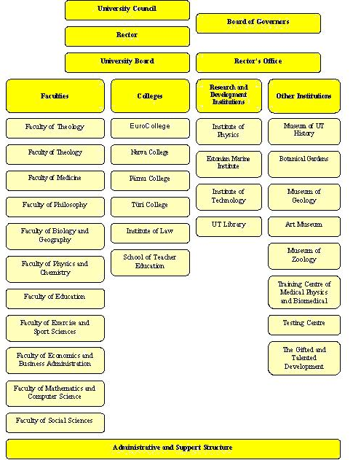

APPENDIX 1.3.1. Statutes of the Faculty of Mathematics and Computer Science
ADOPTED on 23 February 2001
Regulation No 5 of the Council
of the University of Tartu
(enforced on 27 April 2001)

AMENDED on 27 April 2001
Regulation No 10 of the Council
of the University of Tartu
(enforced on 27 April 2001)

STATUTES OF THE FACULTY OF MATHEMATICS AND COMPUTER SCIENCE

Adopted by the Council of the University of Tartu in conformity with the University Act`s Article 14,
Paragraph 3, Subparagraph 2 and the Statues of the University of Tartu Arcticle 10, Paragraph 18 and Arcticle 59.

I.General provisions

- The Faculty of Mathematics and Computer Science (the Faculty) is a unit of the academic structure of the University of Tartu (the University).
- The main task of the Faculty is to organise instruction, research and development in the field of Mathematics and Computer Science and to offer respective services.
- To fulfil its main task, the Faculty:
  - compiles curricula for the specialities taught at the Faculty and conducts instruction on the basis of the curricula;
  - organises research and development;
  - implements the Faculty`s plan of development;
  - educates teachers of Mathematics and Computer Science;
  - carries out continuing education in the Faculty`s specialities;
  - organises advisory and consultation activities in the Faculty`s specialities;
  - develops its infrastructure;
  - guarantees the continuity of the academic staff;
  - fulfils other tasks in the framework of the main task of the Faculty in conformity with the regulations adopted at the University.
- The activities of the Faculty are guided by the Statutes of the University, the Statutes of the Faculty, laws and other legal acts.
- The Faculty has its symbols approved by the University in the established procedure.

II. Management
II.1. The Council

- The highest decision-making body at the Faculty is the Council of the Faculty (the Council).
- Ex officio the Council consists of the dean, the assistant deans and heads of institutes. The other members of the Council are eight people elected by the ordinary full-time members of the teaching and research staff and four representatives of the student body while each institute must be represented by 1-3 elected members and each level of education must be represented by students. The chairman of the Council is the dean.
- The representatives of the teaching and research staff are elected for the term of two years, the students for one year.
- The dean announces the elections of the representatives of the teaching and research staff at least two weeks prior to the date of elections and announces the date for the nomination of candidates who may be proposed by the University rector, the dean, the heads of institutes, professors ordinary and holders of chairs.
- Elections are secret and take place at the election meeting held in May of the odd year. The election meeting has the power of judgement if more than a half of the members with the right to vote participate. Each member has eight votes. The election meeting is chaired by the dean. The election results are confirmed in the form of the list of priority on the basis of which the representatives of each institute are appointed. First, the candidate from each institute, having received the biggest number of votes, will be included in the Council. The remaining four seats are filled on the basis of the list of priority so that each institute might not have more than three representatives among the elected members of the Council.
If several candidates get an equal number of votes, as a result of the voting round, and on the basis of the priority list more persons are elected than there are vacancies in the Council, then the new voting round will be held between these people. If the new round does not give results, the membership to the Council will be received by casting lots.
- The Council approves of the procedure for electing student representatives.
- The membership of the Council of the Faculty is confirmed by the rector on the basis of the dean`s application. When the working agreement of a member of the Council terminates or it is abrogated, the rector, on the basis of the dean`s application, appoints a new member from the list of priority until the new elections. When presenting his or her application, the dean is guided by the rules established in Article 10 of the present document.
- The members of the Council assume office at the beginning of the academic year. The former body of the Council preserves its credentials until the new assumes its office.
- The Council, in conformity with its competence, adopts decisions which are signed by the chairman and the secretary of the meeting. If the secretary is not elected from the body of the members of the Council, the head of the dean`s office functions in the capacity of the secretary and participates in the Council meetings with the right to speak.
- Council meetings are convenied and chaired by the dean in whose absence he or she is replaced by an assistant dean. The dean is obligated to convenie the Council if at least half of its members so demand.
- The Council has the power of judgement if 2/3 of the members of the Council and the dean or the assistant dean in his or her absence participate in the meeting.
As decided by the chairman of the Council, people who are not members of the Council may participate with the right to speak but without the right to vote in its meetings dealing with the issues connected with these people.
- The decision of the Council is adopted when more than a half of the members of the Council present at the meeting vote for it. The decisions of the Council are obligatory on the members of the Faculty to be obeyed.
- The Council meetings are held as occasion requires but at least six times in the academic year.
- The Council:
  - discusses and makes decisions on the issues of instruction and research relevant to the main tasks of the Faculty;
  - adopts the Faculty's plan of development and presents it to the Council of the University for approval;
  - makes proposals to the Council of the University for changing the structure of the Faculty, for establishing and liquidating chairs;
  - elects members of the teaching and research staff of the Faculty with the exception of professors;
  - makes proposals to the Council of the University for electing professors;
  - decides to confer academic and applied degrees on the graduates in conformity with the established procedures at the university and the curricula approved by the Council of the University;
  - confirms the budgets and budget amendments for the dean`s office and institutes;
  - makes proposals to the Council of the University concerning the conditions and procedures of the admittance of students;
  - adopts the Faculty's curricula, the respective additions and amendments and presents them for approval to the Council of the University;
  - approves the curricula for MSc and PhD courses;
  - gives a hearing and approves the Faculty's annual account presented by the dean;
  - gives a hearing and assessment to the accounts of instruction and research presented by the heads of structural units, professors ordinary and holders of chairs;
  - in case of need forms permanent or temporary commissions from among its members to deal with the organisation of instruction and research and for working out solutions to particular problems;
  - expresses its position concerning the issues raised for dicussion by the rector, the dean, the Council of the University and the members of the Council of the Faculty;
  - makes decisions concerning other issues in its competence prescribed by the University Statutes or other legal acts.

II.2. The Dean
- The leader of the Faculty is the dean who is elected by the ordinary full-time members of the teaching and research staff of the Faculty and the members of the Council of the Faculty by secret ballot from among professors ordinary for the term of office of three years according to the procedures established by the Council of the University.

- If the candidates nominated to the post of the dean do not meet the requirements or the dean is not elected, the dean is appointed by the rector.
- One and the same person cannot be elected to the post of the dean for more than three terms of office in succession.
- The dean exercises administrative and disciplinary power on the basis of legal acts in the scope and manner established by the rector. In the limits of his or her competence the dean issues orders obligatory for fulfilment to the members of the Faculty.
- At least once a year the dean makes an account of the situation at the Faculty and his or her work to the Council of the Faculty. The basic points of the account are made known to the members of the Faculty.
- The dean is responsible for:
  - for the leadership in the Faculty, guarantees that he or she works in conformity with the University's Statutes, the present Faculty's Statutes, laws and other legal acts;
  - guaranteeing the fulfilment of the plan of development of the Faculty;
  - leading the Council of the Faculty;
  - exercising control over the work of the structural units of the Faculty;
  - representing the University in comformity with the rector's credentials;
  - the immatriculation, exmatriculation and and re-immatriculation issues of the students and solving respective problems;
  - approving the Faculty's timetable;
  - organising competitive elections to the posts of the members of the teaching staff, concluding working agreements, the abrogation, changing and terminating agreements;
  - obtaining confirmation of the rector to the lists of the members of the teaching and research staff of the Faculty;
25.10 making proposals to the Council of the Faculty concerning the confirmation and amendment of
the budgets of the structural units of the Faculty;
  - the right and purposeful use of the money allocated to the Faculty and other propeties;
  - the solution of the problems at the Faculty which do not belong to the competence of other officials.
26. The assistant deans are appointed and freed from office by the dean. The job description of assistant deans is provided in the official guidelines approved by the dean.
[ Enforced on 27 April 2001]
27. In the absence of the dean, an assistant dean or a head of the institute, on the basis of the dean`s application to the rector, fulfils his or her functions.
[Enforced on 27April 2001]

III. Structure
28. The Faculty consists of the following structural units:
28.1. The Institute of the Computer Science;
28.2. The Institute of Mathematical Statistics;
28.3. The Institute of Pure Mathematics;
28.4. The Institute of Applied Mathematics;
28.5. The Dean`s Office.
29. The work of the institute is lead by its head who is appointed to the post by the dean on the basis of the proposal made by the head of the institute in office for the term of three years from among professors ordinary or, as an exception, from among docents.
30. The head of the institute:
30.1 is the leader of the institute;
30.2 acts as a representative of the institute at the Faculty and outside it;
30.3 guarantees the fulfilment of the institute's budget and is responsible for the right and purposeful use of the money and other properties allocated to the institute;
  - coordinates instruction and the research in the respective field;
  - approves the subject programmes;
  - is accountable to the Council of the Faculty and the dean;
  - solves several problems in his competence.
31. The Council of the Faculty may establish the Council of the Institute determining the basic principles of its activity. The membership of the Council of the Institute is confirmed by the rector on the basis of the dean's proposal.
32. The dean's office is a structural unit of the Faculty which is responsible for managing the Faculty's affairs. The dean`s office is lead by the head of the dean's office.

IV. Membership
33. The membership of the Faculty consists of the academic staff working on the basis of working agreements and the students immatriculated to the specialities taught at the Faculty.

V. Financing
34. The Faculty`s budget is approved by the Council of the University.
35. The Council of the Faculty establishes the division of Faculty's budgetary resources between the dean's office and institutes. The Council of the Faculty has the right to make balanced amendments in the already confirmed Faculty budget in conformity with the procedures established at the University.
36. Financial resources are used in conformity with the rules and instructions regulating the University financing.

VI. Approval and amendment of the Statutes
37. The present statutes, the possible amendments and changes are approved by the Council of the University as proposed by the Council of the Faculty.

Volli Kalm Ivar-Igor Saarniit
Vice-Rector for Academic Affairs Academic secretary
(Acting as the rector)

APPENDIX 1.3.1.1. List of Staff of ICS

Name | Year of birth | Affiliation | Post | Year of election | Quali- fication | Working at UT from | Administrative responsibility
Tiit Roosmaa | 1955 | Associate Professor | 1.0 | 2004 | Cand. Sc. (Techn.) | 1978 | Head of ICS,  Vice Dean of FMCS  Member of the Council of FMCS
Tiiu Tombak | 1943 |  | 1.0 |  |  | 1975 | Senior-referent
Tiina Lasn | 1942 |  | 1.0 |  |  | 1967 | Senior-methodologist
Vesal Vojdani-Ghamsari | 1980 |  | 0.7 |  |  | 1994 | programmer
Ülle Holm | 1972 |  | 1.0 |  |  | 1995 | Secretary
Mati Tombak | 1942 | Professor | 1.0 | 2002 | Cand. Sc. (Math.) | 1975 | Member of the Council of FMCS
Ülo Kaasik | 1926 | Professor  Emeritus |  |  | Cand. Sc. (Math.) | 1953
Rein Prank | 1949 | Associate Professor | 1.0 | 2005 | Cand. Sc. (Math.) | 1973
Tõnu Tamme | 1958 | Lecturer | 1.0 | 2003 | M.Sc. (Comp.Sci.) | 1982
Reimo Palm | 1973 | Lecturer | 1.0 | 2003 | M.Sc. (Math.) | 1999
Olga Sokratova | 1971 | Senior Researcher | 1.0 | 2002 | PhD (Math) | 1998
Härmel Nestra | 1974 | Researcher | 1.0 | 2003 | M.Sc. (Comp. Sci.) | 2002
Jüri Kiho | 1941 | Professor | 1.0 | 2002 | Cand. Sc. (Techn.) | 1965 | Member of the Council of FMCS
Helle Hein | 1951 | Associate Professor | 1.0 | 2004 | PhD (Math.) | 1974
Ain Isotamm | 1942 | Associate Professor | 1.0 | 2002 | Cand.Sc. (Economics) | 1967
Varmo Vene | 1968 | Associate Professor | 1.0 | 2001 | PhD (Comp.Sci.) | 1994
Jaak Vilo | 1966 | Associate Professor | 0.5 | 2004 | PhD (Comp.Sci.) | 1994
Anne Villems | 1945 | Lecturer | 1.0 | 2004 | MSc (Comp.Sci.) | 2003
Vambola Leping | 1952 | Lecturer | 1.0 | 2005 | MSc (Comp.Sci.) | 1976
Eno Tõnisson | 1969 | Lecturer | 1.0 | 2001 | MSc (Math) | 1994
Marina Issakova | 1980 | Assistant | 1.0 | 2005 | MSc (Comp.Sci.) | 2004
Gunnar Nellis | 1974 | Assistant | 0.5 | 2004 | - | 2004
Ahti Peder | 1976 | Assistant | 1.0 | 2004 | MSc (Comp. Sci.) | 2001 | Member of the Council of FMCS
Mare Koit | 1945 | Professor | 1.0 | 2001 | Cand.Sc (Math..) | 1968 | Member of the Council of FMCS
Heli Uibo | 1971 | Lecturer | 1.0 | 2004 | MSc (Comp.Sci) | 1999
Kaili Müürisep | 1972 | Researcher | 1.0 | 2004 | PhD (Comp.Sci.) | 2000
Ahto Buldas | 1967 | Professor of Crypto-graphy | 0.5 | 2004 | PhD (Exact Sci..) | 2000
Helger Lipmaa | 1972 | Professor of Crypto-logy | 0.5 |  | PhD (Crypto-graphy) | 2000
Jan Villemson | 1974 | Associate Professor | 0.5 |  | PhD (Comp.Sci.) | 2000
Peeter Laud | 1977 | Senior researcher | 1.0 |  | PhD (Engineering Sci. | 2002
Eero Vainikko | 1963 | Professor | 0.5 | 2005 | PhD (Informatics) | 1998

APPENDIX 1.3.2. Development plan for the Faculty of Mathematics and Computer Science

DEVELOPMENT PLAN FOR THE FACULTY OF MATHEMATICS AND COMPUTER SCIENCE 2002-2005
Approved by the Academic Council of the University of Tartu
April 5, 2002

I. Introduction
1. Role of the Faculty of Mathematics and Computer Science. The Faculty of Mathematics and Computer Science (FMCS) is a centre of research and the research-based education in Estonia in computer science, mathematics and mathematical statistics The Faculty is responsible for the development of these areas in the country. In mathematics and mathematical statistics the leading specialists in Estonia are working at the Faculty while in computer science FMCS is one of the two main centres (beside the Tallinn Technical University). FMCS is one of the two faculties where teacher training is organized in mathematics and computer science supported by the research in this area. FMCS is oriented in its activites to the Nordic and West-European universities. Study programmes are designed and improved on the basis of experience, which has been obtained from cooperation with foreign colleagues, including experience from several international cooperation projects. All chairs of the Faculty have cooperation contacts with colleagues from European and North-American universities.
FMCS publishes a peer-reviewed journal with international Editorial Board Acta et Commentationes Universitatis Tartuensis de Mathematica, which is refereed by all main mathematical review journals.

2. Strategic strength of the Faculty, its weaknesses. First of all, the strategic strength of FMCS contains in the fact that the Faculty joins research and teaching of three closely related specialities. This makes it possible to read mathematically demanding and up-to-date courses for specialities of mathematical statistics and computer science and to use computers in teaching of all courses for all specialities. Good theoretical backround has been a guarantee for students to be able to continue successfully their graduate studies in other universities. Institutes of mathematical statistics and applied mathematics have been active in solving different practical problems, necessary for the society. It is wise to mention activities of the chair of didactics of mathematics in development of school programmes in mathematics and writing textbooks and instruction materials. Strength of the Faculty is based on the high qualification of teaching staff and researchers. Most of them take actively part in international scientific life, several of them on the top level. Four research awards of the Estonian Republic has been awarded to the members of the Faculty. In recent years international scientific publishers have published 2 monographs written by members of FMCS, several books are in preparation stadium. Results of research have been published in many prestigeous journals, members of Faculty have been referees of PhD theses in many countries, several of them belong to Editorial Boards of different journals. Faculty and its institutes have been organizers of several high level international conferencies.

Weaknesses of the Faculty are closely related to the strength of FMCS. High qualification of the members of the Faculty is in contradiction with the possibility to have optimal structure. Because of rapid growth of the number of students in computer science and infotechnology in last years, there exists a contradiction between number of students and number of teaching staff in different areas.
In research directions of FMCS certain inertia can be found. One can not be satisfied with the situation when several important and actual areas of mathematics are not developed in Estonia. Research in computer science is not enough effective and attractive for young people. There is not enough applied projects under research, the Faculty has not motivated its members to deal with practical problems of teaching and carring out research. Potential of FMCS has not found full use through Open university and continuing education. The most important problem is: how to guarantee to the students education where theory and applications would be in a reasonable balance and the applications would correspond to the expectations of the labour market. Solution of the problem will determine successfullness of the Faculty in the competition on the market of university education. FMCS will get new facilities with the new building. Much will depend on how successfully the Faculty is able to use this advantage.

II. Principles and Aims of the Development

3. Taking into account needs of the state and the society, which are emphasized in the order of study places by state, teaching and research in computer science and infotechnology are considered as the priority. High expectations and attention of the society to this area creates also new possibilities for other specialities of FMCS. The same time the Faculty still remains the main centre of research and teaching in mathematics and mathematical statistics; and will be an important centre of teacher training to educate gymnasium teachers on mathematics and informatics and to develope the related research in didactics of mathematics. In the area of computer science closer contacts with Tallinn Technical University have to be developed

4. As the faculty is following a new study scheme from academic year 2002/2003, we consider the education on Master level as an academic university education. The aim of Master studies is to give a solid university education, the same time following needs of the society. Bachelor studies form an important part of the Master education, thus giving a broad basement of education which includes also knowledge from applied areas. Having in mind enlargement of Master studies and need to arize its effectiveness, compulsory part is growing in new curriculum compared with the previous study scheme. Entering Master studies must be possible for all graduates on Bachelor level with necessary qualification.

5. Aim of Doctoral studies is to prepare computer scientists, mathematicians and statisticians, who are able to carry out research in their area. We emphasize that academic career is only one (but most important) future possibility for the graduates of PhD studies.

6. FMCS in cooperation with the Faculty of Education feels itself responsible for the level and contents of the teacher education in mathematics and computer science in Estonia. The aim of the Faculty is to prepare for Estonian schools teachers of mathematics and computer science who have deep knowledge and good skills in their area as well as in didactics and pedagogy. We assume that teachers of mathematics must be able to use computers in teaching, teachers of computer science must be able to support teachers of other topics in using computers.

7. It is planned to develope teacher training in the framework of continuing education. In cooperation with the distance learning centre of UT the Institute of Computer Science is implementing in the University methods of distance learning, based on infotechnology, guiding teaching staff of other specialities, if necessary, and carring out corresponding courses.

8. The aim of FMCS is to be an internationally recognized highly qualified centre of fundamental research in computer science, mathematics and mathematical statistics. More attention has to be paid to the application of professional skills and knowledge in Estonian society, to solve the problems from economy and research in other areas. To reach the goal closer contacts with possible partners have to be found. The Faculty has potential to participate in interdisciplinary projects to support mathematical, statistical or infotechnological sides of the projects.

9. Following from the text given above FMCS finds the most important strategic goals to be the following (in order of importance).
1) Construct a new building of the Faculty at J. Liivi 2 and renovate the previous part of the building.
2) Reach by modification of curricula and study process the situation when at least 75% of students will finish their Bachelor studies in nominal time.
3) Start with the project-based study system in specialities of computer science and infotechnology.
4) Reach the situation when study materials are for all compulsory courses available in electronic or in printed form.
5) Work out and apply in the Faculty a joint scheme of teacher training and continuing education.

III. Teaching and Research

10. Programmes of all courses will be re-examined because of switching over to the new study scheme. One aim is to modify the courses on Bachelor's level to fit better to the knowledge and abilities of the graduates from gymnasium. More emphasis has to be put to the disciplines related with applications. The same time theoretical courses will have the level and contents which guarantees good starting point for graduates at the labour market. The proportion of active forms of learning (tutorials, seminars, computer classes) will grow compared with the number of lectures. To diminish drop-out, the new study programmes include higher motivation and better control of continuous independent work of students. New progressive teaching methods based on infotechnology (interactive courses, simulation games) are implemented.
In Master studies stronger emphasis is put to broad general courses. In Master projects the topics with broad outlook are recommended. It is necessary to reach higher percentage of joint lectures and seminars on all levels of education.

11. The Institute of Computer Science will continue with professional courses for teachers of informatics, which enables to get a certificate of the teacher of informatics through the Open University. Teachers of mathematics will get schooling by moduli on computers, and special teaching software courses are held for teachers from areas different from mathematics. Because in many schools computer science is taught by teachers without special certificate, FMCS continues to carry out with courses through Open University to enable teachers to obtain profession of a teacher of informatics

12. Schooling in infotechnology will continue on different levels. With development of computer networks importance of methods and environments of distance learning is rapidly growing, what make it possible to take courses without leaving the office space. Distance learning is used for both, stationary studies and Open University courses.

13. Research is continuing in areas where high internationally recognized level has been achieved. This is also the main guarantee for successful graduate studies. International cooperation is enlarged through individual contact as well as in the framework of larger international projects. International conferences and seminars will be organized. Joint courses in English with universities from other countries will be held to support exchange of students between universities.

14. A programme for publishing study materials in Estonian will be worked out and implemented. In the programme need for study materials and its financial cover will be fixed. The most widely used study materials have to be made accessible to students in electronic form.

15. For development of the infotechnological basis of the Faculty computer classes will be enlarged and hardware and software will be continuously modernized. An auditorium for videoconferences will be equipped.

16. For development of new directions and areas of research as well as for implementing new courses talented young people are sent to the leading universities abroad to continue their studies. Special attention will be paid to the applied areas of computer science.

IV. Students and staff

17. System of curators will be introduced to help the first year students to follow better the studies and to give them „smooth landing“ in university life.

18. Optimal structure of the teaching staff will be figured out on the basis of the new study scheme. This will be followed every year as a basis to fix the regular staff of the faculty. The aim is to reach step by step the situation when number of teachers will correspond to the teaching loading in every institute and chair. This aim is taken into account when designing the yearly budget, the same time financing has to guarantee fulfilment of all tasks following from the curriculae.

19. It is necessary to increase the number of research positions for young talented people to have a resource for replacement of retired people.

Academician Jaak Aaviksoo  Rector, Professor | Ivar-Igor Saarniit  Academic secretary

APPENDIX 1.3.3. The number of students at FMCS (31.12.2004)

 | Year
Curriculum | 1. | 2. | 3. | 4. | Total
Bachelor's studies
6460101 Mathematics |  | 1 | 1 | 24 | 26
6460112 Mathematics | 109 | 24 | 12 |  | 145
6461101 Mathematical Statistics |  | 1 | 2 | 9 | 12
6461111 Mathematical Statistics | 26 | 16 | 12 |  | 54
6464120 Computer Science |  |  | 7 | 70 | 77
6464158 Computer Science | 81 | 61 | 37 |  | 179
6464162 Information Technology | 116 | 23 | 13 |  | 152
 | 332 | 126 | 84 | 103 | 645
Diploma studies
5464103 Information Technology |  | 2 | 17 |  | 19
5464115 Applied Computer Science |  |  | 3 |  | 3
 |  | 2 | 20 |  | 22
Master's studies
7460101 Mathematics | 10 | 11 |  |  | 21
7460111 Financial and Insurance Mathematics (professional degree) | 11 | 5 |  |  | 16
7461102 Mathematical Statistics | 4 | 8 |  |  | 12
7461110 Applied Statistics (professional degree) | 2 | 2 |  |  | 4
7461111 Mathematical Statistics | 1 |  |  |  | 1
7464110 Computer Science | 19 | 23 |  |  | 42
7464158 Computer Science | 6 | 1 |  |  | 7
7464162 Information Technology | 5 |  |  |  | 5
 | 58 | 50 |  |  | 108
Doctoral studies
8460101 Mathematics | 3 | 3 | 3 | 3 | 12
8461102 Mathematical Statistics | 5 | 2 | 3 | 4 | 14
8464110 Computer Science | 6 | 5 | 8 | 3 | 22
 | 14 | 10 | 14 | 10 | 48
Teacher training
7141041 Teacher of Computer Science for High School | 1 |  |  |  | 1
7141051 Teacher of Mathematics for High School | 10 |  |  |  | 10
 | 11 |  |  |  | 11
TOTAL | 415 | 188 | 118 | 113 | 834

APPENDIX 1.4.1. Statutes of the Faculty of Physics and Chemistry
ADOPTED by Regulation No. 11 of the Council of the University of Tartu on 27 April 2001 (effective as of 01.05.2001)

STATUTES OF THE FACULTY OF PHYSICS AND CHEMISTRY

Adopted by the Council of the University of Tartu on the basis of Section 14 Subsection 3 Clause 2 of the Universities Act and Section 10 Clause 18 and Section 59 of the Statutes of the University of Tartu.

I. General Provisions

- The Faculty of Psysics and Chemistry ( hereinafter : the Faculty ) is a unit of the academic structure of the University of Tartu ( hereinafter : the University ).
- The main function of the Faculty is to advance, in accordance with academic traditions, the development of physics and chemistry, provide up-to-date higher education, conduct postgraduate studies, organize refresher training and render socially relevant services based on educational and research activities.

To carry out its main function, the Faculty shall:

  - implement the development programme of the Faculty;
  - organize research and development activities;
  - draw up curricula of the specialities taught at the Faculty and conduct teaching based thereon;
  - ensure academic posterity for the Faculty.
  - conduct refresher training in the specialities taught at the Faculty;
  - conduct professional counselling and consultation activities;
  - advance the infrastructure of the Faculty;
  - fulfil other obligations pursuant to the procedures established by the University.

- The Faculty proceeds in its activities from the Statutes of the University, from its own Statutes, laws and other legal acts.
- The Faculty has its own system of symbols that is approved pursuant to the procedures established by the University.

II. Management.
II.1. The Council of the Faculty.
- The Council of the Faculty is the highest decision-making body of the Faculty.
- The Council of the Faculty consists ex officio of the Dean, Assistant Deans, heads of departments and institutes, and the directors of the institutions that are part of the Faculty. The representatives of students constitute at least 1\5 of the membership of the Council. The rest of the Council consists of ten members elected by regular full-time teaching staff and research staff of the Faculty. The chairman of the Council is the Dean.
- The representatives of the teaching staff and research staff shall be elected to the Council for two years, the representatives of the student body shall be elected for one year.
- The elections of the representatives of the teaching staff and research staff shall be announced by the Dean of the Faculty at least two weeks before the elections, notifying the deadline for the nomination of candidates. The candidates may be proposed by the Rector, the Dean , heads of departments and institutes, all regular full-time professors and heads of Chairs.
- The elections shall be secret and held at an election meeting organised in May of an odd year. An election meeting has a quorum if more than half of the members having the right to vote are present thereat. Each member has ten votes. The election meeting shall be chaired by the Dean. The election results shall be approved as a ranking. If in a ballot several candidates receive an equal number of votes, their standings in the ranking shall be formed by lot.
- The procedure for election to the council of representatives of students shall be approved by the Council.
- The membership of the Council shall be approved by the Rector on the proposal of the Dean. Upon termination or suspension of the employment contract of a member of the Council, the Rector shall appoint, on the proposal of the Dean, the first unelected candidate in the ranking as a member of the Council until the next election or resumption of the member whose employment contract was suspended, but for no longer than the next elections.
- New members of the Council assume office during the week before the beginning of the academic year. The powers of the previous membership stay in effect until the new membership assumes office.
- The Council shall pass decisions within the limits of its competency. The decisions shall be signed by the Chairman of the Council and the Secretary of the Council.
- The decisions of the Council are subject to execution by the members of the Faculty
- Meetings of the Council shall be held as necessary but at least six times per year.
- The meetings of the Council shall be convened and chaired by the Dean. The Chairman of the Council shall also convene the Council if requested by at least half of the members of the Council.
- The Council has a quorum if at least 2/3 of the members of the Council and the Dean are present at the meeting.
- The meeting may be attended with the right of speech but without the right of vote by the whole staff of the Faculty and other persons invited by the Chairman of the Council. The Council may declare a meeting closed.
- A decision of the Council is passed if more than half of the members present at the meeting vote for it.
- The Council shall:
20.1 discuss and decide issues concerning educational , research and development activities that arise from the main functions of the Faculty;
20.2 adopt the development plan of the Faculty and submit it to the Council of the University for approval;
20.3 make proposals to the the Council of the University for amending the structure of the University, and creating and terminating chairs;
20.4 make proposals for electing professors to the Council of the University;
20.5 elect the associate professors and senior researchers of the Faculty.
20.6 approve the budgets and budget amendments of the structural units of the Faculty;
20.7 make proposals to the Council of the University concerning the terms and conditions of and the procedure for the admission of students;
20.8 adopt the curricula of the Faculty and the improvements and amendments to be made therein, and submit them to the Council of the University for approval;
20.9 hear and approve annual reports presented by the Dean.
20.10 if necessary, set up from among its members standing and interim commissions to deal with issues pertaining to the organisation of educational and research work and to process individual problems;
20.11 form an opinion on issues raised by the Council of the University, the Rector, the Dean or the members of the Council of the Faculty;
20.12 decide other issues placed within its competency by the Statutes of the University or other legal acts.

II.2. Dean

- The work of the Faculty is directed by the Dean. The Dean is responsible for the development of the Faculty and an efficient fulfilment of its functions. The Dean shall be accountable to the Rector and the Council of the Faculty.
- The Dean shall be elected pursuant to the procedure established by the Council of the University from among professors in ordinary by regular full-time teachers and researchers and members of the Council by secret ballot for three years of office. If no candidates complying with the requirements are nominated for the position of the Dean or if the Dean fails to be elected, the Dean shall be appointed by the Rector.
- One and the same person shall not be elected to the position of the Dean for more than three successive terms of office.
- The Dean shall execute administrative and disciplinary authority at the Faculty based on legal acts to the extent and pursuant to the procedure established by the Rector. He issues orders within the limits of his competency. The orders are mandatory for the Faculty’s members.
- At least once per academic year the Dean shall report to the Council on the situation at the Faculty and on his work. The main standpoints of the report shall be disclosed to the membership of the Faculty.
- The competency of the Dean shall include:
26.1. managing the Faculty and guaranteeing that its activities comply with the Statutes of the University, the Statutes of the Faculty and the laws of the Republic of Estonia as well as with other legal acts;
26.2. ensuring that the development plan of the Faculty is realised;
26.3. managing the work of the Council;
26.4. checking the work of the structural units of the Faculty;
26.5. representing the University according to the powers received from the Rector;
26.6. resolving issues related to the matriculation, exmatriculation and re-matriculation of students;
26.7. approving the timetable of the Faculty;
26.8. holding elections of teachers and researchers pursuant to a competitive procedure and making proposals for concluding, suspending, amending and terminating employment contracts with the employees of the Faculty;
26.9. submitting memberships of teaching staff and research staff of the Faculty to the Rector for approval;
26.10. making proposals to the Council of the Faculty for approving and amending the budgets of the structural units of the Faculty;
26.11. assuming responsibility for lawful and appropriate use of money and other property allocated to the Faculty;
26.12. resolving issues concerning the Faculty, not falling within the competency of other bodies.
- The Dean may form a government for an operative management of the Faculty by establishing the basis and procedures for its activities.
- The Dean shall appoint and dismiss Assistant Deans. The duties of the Assistant Deans shall be established in the job descriptions, which shall be approved by the order of the Dean
- In the absence of the Dean, his duties are performed by the Assistant Dean, a head of department or institute by the order of the Rector on the proposal of the Dean.

III. Structure

30. The Faculty consists of the following structural units:

30.1. The Department of Physics which comprises:

30.1.1. The Institute of Experimental Physics and Technology;

30.1.2. The Institute of Materials Science;

30.1.3. The Institute of Environmental Physics;

30.1.4. The Institute of Theoretical Physics;

30.2. The Department of Chemistry which comprises:

30.2.1 The Institute of Physical Chemistry;

30.2.2. The Institute of Chemical Physics;

30.2.3 The Institute of Organic and Bioorganic Chemistry;
30.3. The Training Centre of Medical Physics and Biomedical Engineering;
30.4. The Dean’s Office.

III.1. Department
- Department is a structural unit of the Faculty that unites institutes that are close by speciality;
- The main duties of the Department are organising educational, research and development activities in its scientific sphere.
- To perform its main duties, the Department shall:

33.2 draw up curricula and conduct instruction on the basis of the curricula;

33.3 organize research and development activities;

33.4 carry out refresher training in its specialities;

33.5. conduct professional counselling and consultation activities;

33.6. ensure academic posterity for the department;

33.7. perform other functions pursuant to the procedure established at the University.

34. The Department is led by the head of department who is appointed by the Dean from among professors in ordinary for up to three years of office.
35. The Department Council is the highest collegial body of the Department.
36. The Chairman of the Department Council is the Head of the Department. The membership of the Council shall comprise ex officio the professors in ordinary of the Department, heads of the institutes and Assistant Deans appointed from among the staff of the department. Other members of the council and the Secretary of the council are appointed by the Head of the Department.
37. The membership of the Department Council is approved by the Rector on the proposal of the Head of the Department co-ordinated with the Dean
38. The Department Council shall pass decisions within the limits of its competency. The decisions shall be signed by the Head of the Department and the Secretary of the Council.
39. Meetings of the Department Council shall be held as necessary but at least six times per academic year.
40. The meetings of the Department Council shall be convened and chaired by the Head of the Department. The Head of the Department shall also convene the Department Council if requested by at least half of the members of the Department Council.
41. The Department Council has a quorum if at least 2/3 of the members of the Council . A decision of the Council is passed if more than half of the members present at the meeting vote for it.
42. The Dean has the right to suspend the decision of the Department Council and direct it for examination to the Council of the Faculty if the decision of the Department Council is not in conformity with the legal acts or interests of the Department. The decision of the Council of the Faculty is final.
43. The Department Council shall:
  - make proposals to the Council of the Faculty in all issues concerning its spheres of activity;
  - hear and approve the annual report of the Head of the Department;
  - elect the teachers, assistants and researchers of the Department;
  - submit the curricula and amendments of the curricula to the Faculty Council for approval;
  - approve the curricula for MSc and PhD courses
  - approve the subject programmes;
  - decide , pursuant to the procedures established by the University , awarding scientific and professional degrees on the basis of the curricula approved by the Council of the University.
  - approve the budget of the Department and submit it to the Council of the Faculty;
  - hear the reports of heads of institutes, professors in ordinary, and assess their work;
  - discuss the issues raised by the Faculty Council and heads of the institutes of the Department;

- The Head of Department shall:
  - be at the head of the Department;
  - direct the work of the Department Council;
  - solve issues concerning the Department that do not belong to the competency of other bodies.
  - In his absence, the Head of Department shall be substituted by one of the professors of the Department, appointed by the order of the Dean.

III.2. Institute

- The work of the Institute is managed by the Head of the Institute, appointed by the Dean from among the professors in ordinary of the Institute or ,exceptionally, from among the associate professors of the institute for three years of office.
- The Head of the Institute shall:
  - be at the head of the Institute;
  - act as the representative of the Institute at the Faculty and outside it;
  - guarantee the fulfilment of the budget of the Institute and be responsible for lawful and appropriate use of money and other property allocated to the Institute;
  - be accountable to the Council of the Faculty and the Dean;
  - solve other issues that fall within his competency.

  - The Institute may ask the Council of the Faculty to set up the Institute Council. The principles of its activities shall be approved by the Council of the Faculty.

III. Other structural units of the Faculty

- The Training Centre of Medical Physics and Biomedical Engineering is an institution of the University within the administration of the Faculty and its activities are based on the statutes approved by the Council of the University.
- The Dean’s Office is a structural unit of the Faculty that coordinates the work of other units and performs the tasks given by the Dean and the Council of the Faculty. The Dean’s Office is managed by the Head of the Dean’s Office.

IV. Membership

- The membership of the Faculty consists of the employees working on the basis of employment contracts and the students immatriculated to the specialities taught at the Faculty.

V. Financing

- The budget of the Faculty is approved by the Council of the University.
- The Faculty Council approves the distribution of the budgetary resources of the Faculty between the Dean's Office and the Institutes. The Council of the Faculty has the right to make balanced amendments to the bugdet of the Faculty, approved by the Council of the University.
- The financial means shall be used in accordance with the regulations governing the financing and targeted financing of the University.

VI. Approval and Amendment of the Statutes

- The Statutes of the Faculty and the improvements and amendments to be made therein shall be approved by the Council of the University on the proposal of the Council of the Faculty.
- The Statutes of the Faculty of Physics and Chemistry approved by the Council of the University of Tartu on 15.12.1995 shall be declared invalid.
- The present Statutes enter into force on May 1, 2001.

Academician Jaak Aaviksoo  Rector, Professor | Ivar-Igor Saarniit  Secretary of Academic Affairs

APPENDIX 1.4.1.1. List of Staff of IEPT

Name | Year of birth | Affiliation | Post | Year of election | Quali- fication | Working at UT from | Administrative responsibility
Kalev Tarkpea | 1958 | Associate Professor | 1.0 | 2003 | Cand. Sc. (Phys-Math) | 1980 | Head of IEPT,  Vice Dean of FPC  Member of the Council of FPC
Alvo Aabloo | 1965 | Associate Professor | 0.9 | 2004 | PhD (Physics) | 1989
Jaak Aaviksoo | 1954 | Full Professor | 1.0 | 1998 | Cand. Sc. (Phys-Math) | 1992
Märt Aints | 1944 | Senior Scientist | 1.0. | 2003 | Cand. Sc. (Phys-Math) | 1967
Tõnu Asu | 1944 |  | 1.0 |  |  | 1975 | Electronic engineer
Ants Haljaste | 1943 | Senior Scientist | 1.0 | 2004 | Cand. Sc. (Phys-Math) | 1967
Mart Kiisel | 1950 |  | 1.0 |  |  | 1986 | Senior engineer
Hans Korge | 1944 | Lecturer | 1.0 | 2003 | PhD (Physics) | 1968
Hando Kruuv | 1937 |  | 0.3 |  |  | 1969 | Technician
Kaupo Kukli | 1967 | Senior Scientist | 1.0 | 2001 | PhD (Physics) | 1999
Matti Laan | 1944 | Associate Professor | 1.0 | 2003 | Cand. Sc. (Phys-Math) | 1968 | Member of the Council of FPC
Vaike Laan | 1944 |  | 1.0 |  |  | 1969 | Technician
Lennart Neiman | 1944 | Assistant | 1.0 | 2003 |  | 1968
Helgi Oks | 1942 |  | 1.0 |  |  | 1965 | Senior engineer, Head of Teaching Labs
Ando Ots | 1941 | Associate Professor | 1.0 | 2005 | Cand. Sc. (Phys-Math) | 1966
Maive Ots | 1942 |  | 1.0 |  |  | 1973 | Secretary
Peeter Paris | 1953 | Scientist | 0.5 | 2005 | PhD (Physics) | 1976
Toomas Plank | 1971 | Lecturer | 1.0 | 2003 | PhD (Physics) | 1995
Väino Pool | 1958 |  | 0.25 |  |  | 1984 | Engineer
Galina Posmetuhhova | 1946 |  | 1.0 |  |  | 1969 | Engineer
Lembit Pung | 1935 | Senior Scientist | 1.0 | 2005 | Dr. Sci. (Phys-Math) | 1962
Ilmar Rammo | 1937 |  | 1.0 | 2003 | Cand. Sc. (Phys-Math) | 1987 | Specialist
Jüri Raud | 1972 |  | 1.0 |  | M.Sc. (Physics) | 2000 | Senior engineer
Varpo Redi | 1947 |  | 1.0 |  |  | 1969 | Technician
Helle Roos | 1949 |  | 1.0 |  |  | 1974 | Senior engineer
Peeter Saari | 1945 | Full Professor | 1.0 | 2002 | Dr. Sci. (Phys-Math) | 1994 | Member of the Council of FPC
Viktor Seeman | 1949 | Senior Scientist | 1.0 | 2003 | Cand. Sc. (Phys-Math) | 1971
Arved Vain | 1936 | Senior Scientist | 0.25 | 2005 | Dr.Habil. (Biology) | 1970
Valeri Vasilchenko | 1940 | Associate Professor | 1.0 | 2004 | Cand. Sc. (Phys-Math) | 1965
Jüri Vedru | 1948 | Associate Professor | 1.0 | 2003 | Cand. Sc. (Biology) | 1985
Leo Visberg | 1953 |  | 1.0 |  |  | 1971 | Mechanic engineer

APPENDIX 1.4.2. Development plan for the Faculty of Physics and Chemistry

Approved by the Council of the University of Tartu on 01.09.2000

Development plan for the Faculty of Physics and Chemistry of the University of Tartu

I. General Principles of Development
I.1. The goal of the activities of the Faculty of Physics and Chemistry of the University of Tartu (hereinafter: the Faculty ) is to advance, pursuant to academic traditions, the development of physics and chemistry, provide up-to-date higher education, organize supplementary training and render socially relevant services based on teaching and research activities
I.2. To accomplish this, the Faculty will rely upon its long-time traditions in research and education activities, and wide international relations of cooperation , being, alongside with the Institute of Physics of Tartu University and the Centre of Technology of the University of Tartu, the leading research and education centre in the domain of physics and chemistry in Estonia. The Faculty is developing cooperation with other Estonian research institutions that are similar in profile ( The Obsevatory of Tartu , the Institute of Chemical and Biological Physics ) and other institutions of higher education.
I.3. The Faculty will prepare highly educated and internationally competitive specialists in the fields and volume that are in accordance with the needs of Estonia. The tuition and research activities performed at the Faculty must be at the level acceptable by European universities.
I.4. The development of the Faculty will be open for new specialities, including those in interdisciplinary and technological spheres.
I.5. The Faculty will strengthen its position as the leading centre of training and refresher training of teachers of physics and chemistry, and the respective educational research in Estonia, and will be actively involved in the elaboration of the training system of teachers of natural sciences.
II. Structure of the Faculty
- In view of the further development of the Faculty, a structure of departments, with departments divided into institutes, would be the most efficient system. To coordinate the work of the institutes, inter-institutional work groups will be set up as necessary. There is likely to be a Department of Technologies based on the sciences of physics and chemistry, and other departments added to the Faculty. To develop the tuition and research activities performed at the Faculty, units ( centres ) supporting the integration of departments and specialities, e.g., the Centre of Education in Physics and Chemistry, a Centre of Infotechnology, etc. , will be established.
- The Centre of Education in Physics and Chemistry will be established within the administration of the Faculty to systematise the content and organisation of pedagogical training. Its competency would embrace pedagogical training in physics, chemistry and natural sciences, respective refresher training, development of physics and chemistry at secondary schools and corresponding research work as well as scientific-methodic curating of the supplementary training in physics and chemistry performed at the School of Exact Sciences and of contests in special subjects.
- The main function of the Centre of Infotechnology to be formed within the Faculty will be developing the infotechnological infrastructure of the Faculty in coordination with the development of the information system of the University of Tartu: administration and development of the computer classrooms and network of the Faculty, mutual coordination of the development and the curricula of infotechnology, counselling sub-units of the Faculty, etc.
- To guarantee up-to-date tuition and research activities, a unified Faculty Library will be established on the basis of the department libraries upon formation of a unified location of the Faculty.
III. Material Basis of and Organisation of Rooms at the Faculty
- The priority of the further development of the material basis of the Faculty will be the formation of a unified location of the Faculty at the beginning of Tähe Street. Up to the realisation of the strategic goal, the Department of Chemistry of the University of Tartu will continue its tuition, research and development activities in its current building.
- The core of the planned location of the Faculty is the Building of Physics of the University of Tartu which will be renovated in accordance with contemporary standards, guaranteeing conformity with requirements of environmental protection and work safety, and will be provided with fittings and equipment needed for contemporary tuition and research activities.
- To transfer the institutes of the Department of Chemistry to the location at Tähe Street, a new Building of Chemistry will be erected as an addition to the Building of Physics. The new building will be in conformity with requirements of environmental protection and work safety, and will be provided with fittings and equipment needed for contemporary tuition and research activities.
- To conduct general laboratory courses and lectures of bachelor students, a block of lecture rooms with modern support systems and equipment will be completed e.g., on the basis of the current D- wing of the building at Tähe 4.
- One of the priorities of the Faculty will be the elaboration of the modern instrumentarium needed for research and tuition activities.
- To guarantee up-to-date teaching of experimental and technological specialities, the material basis of the existing laboratories will be substantially improved and new specialised laboratories added.
IV. Main Directions in the Development of Tuition and Research Activities
- The Faculty considers it important to optimise the content of bachelor courses and to organise instruction at a contemporary technical and methodical level. To accomplish this, an analysis of the content of the bachelor courses will be performed in order to specify the basic set of knowledge and skills, the students should acquire in different specialities.
- The MSc and PhD programmes at the Faculty will be based on high-level research activities, and the instruction will be performed by researchers who are distintinguished in their specialities. The results of the MSc and PhD studies are taken into consideration upon determination of research directions.
- To enhance the economic effectiveness of tuition, the Faculty will unify the instruction of the basic courses of closely related specialities. The Faculty will aim at optimising the number of different basic tuition modules.
- The basic courses will be correlated with internationally recognized basic textbooks. The library of the Faculty will be provided with a sufficient number of copies of the textbooks to make them available to all students.
- The Faculty considers it expedient to differentiate the initial stage of bachelor studies on the basis of the level of the students. To decrease the heterogenuity of students, the Faculty will launch a speciality-based counselling system.
- If necessary, the Faculty will adopt a system of study cycles, in the case of which both semesters will be divided into two study cycles.
- The Faculty will increase application of novel infotechnological means in auditory and independent work of students, and stimulate the creation of a computer-based studying environment. The access of students to the computer network of the Faculty will be widened.
- To improve the tuition quality of all specialities, integration within the Faculty as well as with other faculties and institutions of the University of Tartu (above all, with the Faculty of Mathematics and Computer Science, the Faculty of Biology and Geography, the Faculty of Medicine of the University of Tartu and the Institute of Physics of the University of Tartu ).
- By a wider application of project-and-problem-oriented tuition methods , the ratio of lectures in auditory tuition will be decreased. More emphasis will be put on activating students and improving the results of independent work.
- Use of the scientific potential of the Institute of Physics and the Centre of Technology of the University of Tartu as well as that of the Observatory of Tartu in the MSc and PhD programmes at the Faculty will be continued and expanded.
- The enhance the efficiency of MSc and PhD programmes, the Faculty will strive for a reorganisation of the system of MSc and PhD studies at the University in the direction of flexibility, intensification of tuition and integration of different levels.
- The Faculty will promote successful participation on the international market of MSc and PhD studies to increase the number of foreign students participating in the MSc and PhD programmes at the Faculty.
- The Faculty will aim at making it possible for practicing teachers and specialists of applied higher education to get a master’s diploma on the basis of the subject courses of supplementary training.
- The Faculty aims at a flexible and operative development of research topics, proceeding from the changing directions of development in the world.
- In guaranteeing the development of the research activities, the Faculty regards it important to continue to apply for national and international grants and to participate more extensively in innovational and contractual projects.
- In financing the research and development activities of the Faculty, the orientation will be taken towards the expanding non-budgetary sources in Estonia and abroad. At the same time, the Faculty aims at coordinating the financing from the state budget with the results of research activities and MSc and PhD programmes.
- On the basis of the results of the research work, the Faculty will develop innovational and application activities, and will promote a more extensive use of the topics in MSc and PhD studies.
- The Faculty is ready to set up research and development laboratories and work groups for solving scientific-technological issues and performing application studies.
V. Students and Staff
- For admission of new students to bachelor courses, the Faculty will continue to use a system in which a certain level of the grades of state examinations will guarantee admission to the University.
- The Faculty will regard introducing its activities to the public as one of the most important directions of its development activities. The Faculty assumes that its whole staff and students would participate in it.
- As another important direction of its development activities, the Faculty sees its participation in the evolution of Estonian education policy. The Faculty ranks first in drawing up curricula of physics and chemistry for secondary schools, compiling textbooks and organising state examinations and supplementary training for teachers.
- Upon launching new technological specialities ( infotechnology, environmental technology and material science ) in full volume, the total number of students at the Faculty is predicted to reach a thousand.
- The increase of the volume and quality of the research and development activities at the Faculty prerequires an increase of the number of MSc and PhD students and a continuing improvement of the level of MSc and PhD programmes. Besides that, new possibilities for bachelor students to participate in the research activities, including those carried out at the institutions of the scientific cooperation partners of the Faculty , will be created.
- The Faculty will implement a system that guarantees a more extensive participation of students in instruction and counselling activities.

APPENDIX 1.4.2.1. Development plan and activity description of IEPT

DEVELOPMENT PLAN AND ACTIVITY DESCRIPTION OF THE INSTITUTE OF EXPERIMENTAL PHYSICS AND TECHNOLOGY
Approved
by the Council of the Faculty of Physics and Chemistry
28.04.2004

1. General principles

The Institute of Experimental Physics and Technology of the Department of Physics, Faculty of Physics and Chemistry, University of Tartu, consists of the following parts:
- The Chair of Optics and Spectrocsopy,
- The Chair of Applied Physics, and
- The Chair of Wave Optics.
All the Chairs are interrelated and work closely together.

2. History and position in the Estonian science

The Institute of Experimental Physics and Technology was established at 01.02.1993. At this time the Institute has four Chairs:
- Chair of Optics and Spectroscopy (Professor Jaak Aaviksoo)
- Chair of Applied Physics (Professor Lembit Pung)
- Chair of Solid State Physics (Professor Mart Elango)
- Chair of Technology (vacant)

In 1996 the new Institute of Material Science was opened at the Department of Physics and the Chair of Solid State Physics including the reseach groups of thin film technology and X-ray structural analysis were transferred to the new Institute. At present this groups are working as the parts of the Institute of Physics.
In 1997 the Chair of Technology was renamed to the Chair of Wave Optics. Dr.Sc. Acad. Peeter Saari was elected to this Chair. In 1998 Peeter Saari and Kalev Tarkpea were started with the development of the new study programme Physical Technology of Information. In the year 2000 this programme was rearranged to the Information Technology (IT) study programme carried on in cooperation with the Faculty of Mathematics and Computer Science.

The Institutes of Experimental Physics and Technology and the Institute of Materials Science are the two institutions in Estonia offering various doctoral programmes in experimental physics, while the undergraduate and master study programs exist at other institutions in Estonia as well. As the IEPT has to cover quite a wide field of research and postgraduate studies (gas discharges, thin film technology, thermoluminescence dosimetry, scientific instrumental engineering, biomedical engineering) we cooperate closely with the Institute of Physics of the University of Tartu (UoT), the Institute of Computer Science (Faculty of Mathematics and Computer Science, UoT) and with the Institute of Physiology (Faculty of Medicine, UoT) engaging their scientists as lecturers and supervisors. Help from these colleagues is very important, but the IEPT itself stays responsible for the scientific level of MSc and PhD programmes offered. The IEPT also has close cooperation and common research projects with the Institute of Chemical Physics (Department of Chemistry, UoT) and the Institute of Geology of Tallinn Technical University in the fields of dosimetry.

3. Teaching activities in the Institute of Experimental Physics and Technology (IEPT)

The Institute offers programmes at all the levels of study (Bachelor, Master, and Doctoral). The IEPT is almost completely responsible for the new (3+2) Master programme in Applied Physics. From the topics of Doctoral programme of Physics the IEPT covers the specialities of Optics and Spectroscopy (I) and Applied Physics (II).

The programme of activities of the scientific and teaching staff of the Institute, which has developed over years, includes lecture courses in basic disciplines of Physics and the compulsory, elective and optional courses courses for the students specializing in applied physics and information technology. The lecture courses of basic disciplines include:
- FKEF.02.001 Physical Concept of the World (by Kalev Tarkpea),
- FKEF.01.025 Optics (by Matti Laan),
- FKEF.02.004 Principles of Electronics (by Ando Ots),
- FKEF.02.126 Computational Physics I (by Alvo Aabloo),
- FKEF.04.007 Electricity and Magnetism (by Peeter Saari) and so on.
Most of them are complemented by practical work hours. A substantial part of the syllabus applied physics and information technology programmes belongs to the courses on Computer Electronics, Hardware Components, Computer Hardware Principles, Hardware Project, Project of Mechatronic Systems, Robotex 2004.
Although the three last mentioned highly project- and group-oriented courses (teached by Alvo Aabloo) form a significant part of the Information Technology (IT) study programme the students of Applied Physics enjoy them too.

Special lecture courses are delivered to the students, specializing in the Biomedical Engineering (Biomedical Instrumentation and Methods, Introduction to Medical Imaging, Radiations in Medicine, Medical Biomechanics, Fundamentals of Functional Anatomy and Biomechanics, Methods and Instrumentation for Medical Diagnostics and Therapy). These courses are teached by Jüri Vedru, Arved Vain and Kalle Kepler, Head of the Teaching and Research Centre of Biomedical Engineering.

Seminars in gas discharge physics, applied physics and information technology regularly take place at the IEPT. Our students and staff also participate in various seminars held at the Institute of Physics and Institute of Computer Science.

4. Scientific research in the Institute of Experimental Physics and Technology

The scientific research projects are very important for maintaining the high level of PhD and MSc programmes. In the process of organizing scientific degree programmes and supervising the progress of studies MSc and PhD students besides the lecturers and scientists of our Institute the researchers from the Institute of Physics and their complex of scientific laboratories are used continuously.

The main direction of the research of the Chair of Optics and Spectroscopy has been to clarify the formation mechanism of gas discharges and find out its new potential applications. The experiments are carried out at medium and near-atmospheric pressures in DC, pulsed and HF electric fields. The studies are carried out in molecular and noble gases as well as in their mixtures using electrical, optical and spectrosopical methods. The actual directions of the Chair are
- Study of photoionising radiation at near-atmospheric pressures.
- Study of emission mechanism of metal-dielectric structures into gas. The influence of thin layers of TiO₂, HfO₂ etc on the photoinduced emission is investigated.
- Study of conductivity mechanism of metal-dielectric-metal packets. The main attention is paid to the choice of precursor materials of dielectric allowing diminishing the leakage currents.
- Study of HF capillary discharge. The purpose of the study is clarifying how the trace gases influence the excitation/ionisation mechanism of He.
- Study of laser ablation. The aim of the research is finding the correlation between the electrical characteristics of the ablation and the spectrum of aerosol particles generated.
- Elaboration of methods allowing to determine the electric field strength on the basis of spectral measurements.
It should be pointed that all counted directions are linked and as a rule in parallel with experiments the computer modelling is carried out.

The main research field of the Chair of Applied Physics is more wide and covers the following topics:
- Deposition of breakdown-resistant atomic oxide layers with large dielectric permittivity (mainly Nb₂O₅, Ta₂O₅, TiO₂, ZrO₂, HfO₂ and multilayer structures based on them);
- Point defects, their migration and interaction in wide band gap luminophorous materials (CaS, SrS, ZnO), subsequent applications in thermoluminescence dosimetry;
- Medical engineering: myometric investigations of skeleton muscles, Foucault’ cardiography and tomography, non-invasive measurements of physical parameters of the human body;
- Instrumental engineering: improving the construction of scanning probe microscopes.
The main research direction of the chair of Wave Optics (prof. Peeter Saari) is the investigation of limited-diffraction and localized light fields and femtosecond domain optics, the research program is carried out at the Institute of Physics.

5. External contacts of the Institute of Experimental Physics and Technology (IEPT)

Cooperation between IEPT and the Institute of Physics is so intense and close that it is difficult to draw a line between these institutions. On the one hand, the staff and the students of the IEPT use the Institute of Physics as a research base, participating in the joint research projects and grants, one the other hand, the scientists of the Institute of Physics teach and supervise students at the IEPT.
During last ten years the students from Uppsala University pass their laboratory course in optics at IEPT.

Here are listed some collaboration partners of IEPT, subsequent persons and experimental apparatus used in this cooperation:
- Laboratory of Inorganic Chemistry, Department of Chemistry, University of Helsinki (Assoc.Prof. M. Ritala, Prof. M. Leskelä)
- Accelerator Laboratory, University of Helsinki (Mr. T. Sajavaara, Dr. E. Rauhala) Time-of-flight elastic recoil detection analysis (TOF-ERDA), using a SMV tandem accelerator EGP-10-II.
- Department of Materials Chemistry, The Ångström Laboratory, Uppsala University (Dr. J. Sundqvist, Dr. A. Hårsta), X-ray photoelectron spectrometry (XPS) using a Perkin Elmer PHI5500 equipment; X-ray fluorescence spectroscopy (XRFS) using a Spectro X-lab 2000 equipment; High-resolution scanning electron microscopy (SEM) using a Leo 1550 FEG equipment; X-ray diffractometry (XRD, Siemens D 5000) supplied with geometries enabling rocking-curve (ω) scans and ϕ-scans for studying epitaxial relationships.
- Department of Materials Science, Solid State Physics, The Ångström Laboratory, Uppsala University (Dr. M. Strømme) Temperature-dependent dielectric spectroscopy, determination of real and dimaginary parts of dielectric constants using a Novocontrol broadband dielectric converter with Solartron 1260 frequency response analyser.
- Group of laser spectroscopy, Uppsala University, Prof. Reinhold Hallin, investigation of capillary discharge in excimer mixtures.
- University of Greifswald, group of plasma chemistry, Prof. H. E. Wagner, Spectral characteristics of non-self-sustained discharge.
- Moscow State University, Faculty of Chemistry, Prof. K. Kozlov, Spectroscopic determination of electric field strength in plasmas.
- Norwegian University of Science and Technology, Physics department, Prof. R. S. Sigmond, Application of corona discharges.
- Institute of Geochemistry of Academy of Sciences of Russia, Moscow. (A. Lorenz) Irradiation of crystals with reactor neutrons.
- Studsvik Neutron Research Laboratory at Uppsala University, Nyköping, Sweden. (K. Sköld). Irradiation of crystals with reactor neutrons.
- University of Linköping, Department of Physics, Measurement Technology, Biology and Chemistry, Chemical Physics Group. (A. Lund). EPR measurements.
- Synchrotron Radiation Laboratory of Physics Department of Moscow University. (V. Mikhailin) Luminescence measurements.
- Institute of Physics and Technology, St. Petersburg. (P. Baranov) EPR measurements.

In the frame of co-operated research projects between IEPT and Centre of Technology, University of Tartu, PhD-students from the Department of Materials Chemistry, Uppsala University, have carried out part of their research programme in the University of Tartu.

6. Future plans

In soon future the Chair of Optics and Spectroscopy continues the research in above-counted directions. In the next four years three PhD students will finish their thesis and the group has two grants of Estonian Scientific Foundation dedicated to these topics.
Recently the quantitative model of electron emission of metal-dielectric structure has been set. This model demands further development. For this purpose the experiments in different gas mixtures are planned. The electrodes with different coating layers will be tested. The main idea of the planned experiments is finding the correlation between the photoinduced emission and the conductivity. The Chair foresees the application of coated electrodes as efficient emitters in gas discharge lasers. In the study of metal-dielectric packets the widening of characterisation methods is foreseen. As the first step the infrared Fourier spectroscopy will be involved.
The study of HF capillary discharge has in future two tasks. First, the main route of recombination will be clarified. Secondly, the possibilities of achievement of the inverse population in He/N₂ mixture will be studied.
The laser ablation studies will be directed to the modelling of the electron component of the laser-induced current. The experimental studies will deal with the detection of clusters and finding the correlation between the clusters and aerosol particles.
The spectral methods of the electric field strength determination will be applied to different gas mixtures and methods.

In the field of research of Applied Physics attention has to be paid on the decrease of the device dimensions, containing oxide functional layers, such as those providing charge storage and tuning in integrated capacitors and transistor gates. Adequate physical characterization of dielectric oxide layers with thickness in the order of 1-20 nm should be provided. Emphasis should be on the further development of overlayers usable in silicon based technology and growth of metal-oxide-silicon structures with minimal, i.e. of highest quality, interfaces. It is important to study the possibilities to grow compounds of the highest chemical stability, such as ZrO₂ or HfO₂, epitaxially, e.g. using the orientational effect of the substrate, on Si, thus minimizing the interface defect density. Another approach equally important is to specify the conditions enabling the growth of the same easily nucleating materials, e.g. ZrO₂ or HfO₂, in amorphous state, thus ensuring the highest average homogeneity without grain boundary defects.
The future plans also foresee deepening the collaboration with Centre of Technology, University of Tartu; The Ångström Laboratory, Uppsala University and Laboratory of Inorganic Chemistry, University of Helsinki. One can mention, for instance, the importance of the following research routes:
Continuation of the epitaxy studies, while besides the different XRD geometries also transmission electron microscopy (TEM) should be applied for monitoring the interface quality and phase transitions.
Dielectric spectroscopy should be applied on nanocrystalline and ultrathin oxide layers grown onto semiconducting (Si) substrates.
Theoretical calculations might be started in order to predict the peculiarities of dielectric response and spectrum of composite oxide layers or layers consisting of different crystallographic phases.
Different electrode materials, interface barriers created and influence of annealing environments and temperatures on the quality of dielectrics should be examined.
In the future, proper facilities for the dielectric characterization of nanostructures should be provided also at the University of Tartu.

APPENDIX 1.4.3. The number of students at FPC (01.03.2005)

Table 2. List of students according to the study programmes
Study programme | Number of students | Male / Female
Study programme | Number of students | M | F
Bachelor of Science in Physics  (old study programme) | 70 | 58 | 12
Bachelor in Natural Sciences [Physics] (new study programme) | 123 | 105 | 18
Physics Teachers Training (old study programme) | 3 | 2 | 1
Master of Science in Physics  (old study programme) | 49 | 33 | 16
Doctor of Philosophy in Physics  (old study programme) | 51 | 39 | 12
Bachelor of Science in Chemistry  (old study programme) | 45 | 22 | 23
Bachelor in Natural Sciences [Chemistry] (new study programme) | 130 | 52 | 78
Training of Teachers of Chemistry for Public Schools (old study programme) | 6 | 3 | 3
Master of Science in Chemistry  (old study programme) | 44 | 14 | 30
Doctor of Philosophy in Chemistry  (old study programme) | 44 | 28 | 16
Information Technology (diploma programme, old study programme) | 27 | 26 | 1
Bachelor in Engineering [Information Technology] (new study programme) | 106 | 100 | 6
Master in Engineering [Information Technology] (new study programme) | 9 | 9 | -
Bachelor of Science in Materials Science  (old study programme) | 34 | 25 | 9
Bachelor in Engineering [Materials Science] (new study programme) | 101 | 63 | 38
Bachelor of Science in Environmental Technology (old study programme) | 28 | 12 | 16
Bachelor in Natural Sciences [Environmental Technology] (new SP) | 58 | 21 | 37
Master of Science in Environmental Technology (old study programme) | 17 | 6 | 11
Doctor of Philosophy in Environmental Technology (old study programme) | 8 | 4 | 4
Master of Science in Molecular Technology (old study programme) | 2 | 1 | 1
Doctor of Philosophy in Molecular Technology (old study programme) | 4 | 3 | 1
Master in Natural Sciences [Preservation of Cultural Heritage] (old study programme) | 9 | 1 | 8
Science Teacher in Basic School (diploma programme, old study programme) | 81 | 15 | 66
Total | 1049 | 642 | 407

APPENDIX 2.1.1. University of Tartu Strategic Plan 2008

ADOPTED by the Council of the
University of Tartu Regulation no. 79 of
19 December 2003
(effective as of 20.12.2003)

UNIVERSITY OF TARTU STRATEGIC PLAN 2008 (A2008)

INTRODUCTION

The University of Tartu strategic plan 2008 (A2008) determines the role of the university in society, presents the “quantum leap domains” of its further development, goals and plans of action. A “quantum leap domain” is a sphere of activities where the academic and material potential of the university will be focused in order to guarantee the implementation of the mission and goals of the university.

The University of Tartu strategic plan 2008 (A2008) proceeds from the understanding that Estonia is a member of the European Union and a nation on the way towards a knowledge based society, and takes into consideration the strategic goals set in the major strategic documents, such as “Knowledge based Estonia”, “Sustainable Estonia 21” and “Estonian success 2014” as well as the criteria established in the public understanding agreement, the European Union Lisbon summit and the Bologna process documents.

I. STRATEGY

Mission
The University of Tartu is a national university uniting different branches of science.
The mission of the University of Tartu is to act as the guardian and advocate of a highly educated Estonia through internationally acclaimed research and the provision of research based higher education.
The mission of the University of Tartu shall be implemented in co-operation with domestic and foreign partners.

Vision
The University of Tartu is a research university of international repute and the centre of Estonian academic spirit, national culture, scientific language and high-technology innovation. The development of the university shall be implemented through advancing the five quantum leap domains.

Domain 1: Strengthening the role of the national university
The university sets the goal to further the development of research, tuition and study trends, instruction and publication in Estonian in all the branches of science as achievements in these domains will support our national identity in the general process of internationalisation. These will stress the consolidating role of the university as the guardian of national continuity.
The national university considers as of vital importance the research into the Estonian language, literature and history and appraises such aspects of Estonian nature, environment, society, economy and culture that through distinguishing and emphasizing the Estonian alma mater among the European and world universities will secure its international position. The national university shall pay special interest to medicine where the university, together with the University of Tartu Clinics, is responsible for the development of this domain in Estonia.
The role of the national university is to be defined in the National University Act.

Domain 2: Internationalisation
The University of Tartu shall be an international research university. Only with a strong international competitive edge in research and tuition can we secure the sustainable development of the university in the European research and higher education area, fostered by the participation of the university academic staff in international networks of co-operation. The University of Tartu shall establish new interdisciplinary centres of excellence and shall increase the number of research publications. At the same time, the university shall implement curricula in foreign languages and increase the number of both foreign academic staff and students.

Domain 3: Securing the continuity of top level national intelligentsia
The intelligentsia are the trustees of the national and the University of Tartu spirit.
The university sets the goal of guaranteeing the sustainability of the Estonian national intelligentsia. To attain this objective, the university shall prepare top level national intelligentsia by means of doctoral studies to guarantee the continuity of the research community as well as to meet the requirements of enterprises and the public sector, shall provide good working conditions for the reintegration of Estonian researchers and shall increase the ratio of staff with doctoral degrees among the academic staff.

Domain 4: Harnessing to good effect the intellectual capital of the university
The University of Tartu shall increase the intellectual capital through the transfer of knowledge and know-how as well as research and development activities, shall use it on a much wider scale in society, particularly in innovative production and knowledge-based politics, and will considerably increase the profit deriving from the implementation and protection of intellectual property.
The University of Tartu shall, in co-operation with other universities, state authorities, the City of Tartu and its enterprises, participate in the developmental activities of regional, national and international programmes and in solving practical problems.

Domain 5: Improving the quality of teaching and learning
The University of Tartu shall guarantee a high level of tuition in all study forms; shall implement a complex quality control system, shall elaborate new, well-prepared courses, shall continuously update the contents of study materials, shall improve the learning environment and implement modern teaching and learning methods. The university shall target new groups by creating flexible study opportunities for the international student body as well as for students of further education both in the traditional and new forms of tuition.
The University of Tartu shall proceed from this strategy in directing its further development and shall implement it jointly with its partners in Estonia, Europe and throughout the world, and shall provide simultaneously continuous feedback to its staff and stakeholders.

II. AREAS OF ACTIVITY

GENERALIA

To implement the strategy, the university strengthens strategic leadership carried out by the Council of the University. The links with society and the cooperation with the stakeholders are strengthened by the university primarily through its Board of Governors. Teacher training and propagation of research-based education are considered as extremely important. With the purpose of promoting partnership between faculties and managing the university’s strategic activities a permanent university strategy committee is to be established consisting of representatives of humaniora, socialia, realia et naturalia and medicina.

Humaniora’s major task is to promote the development of the national university with the native language as a means of instruction and research, and the development of research fields with Estonian themes and other humanities subjects, also to teach the Republic of Estonia how to become a learning society.

Socialia’s centre of activities is, beside international research, serving the society and the implementation of knowledge and innovation based policies.

Realia et naturalia and medicina have a great opportunity to lay the foundation for the science-consuming high technology production based on natural sciences and medicine, to guarantee technology transfer and development in entrepreneurship and medicine.

HUMANIORA

Humaniora is the field which embraces the major part of the activities of the Faculties of Philosophy, Theology, the School of Teacher Education of the Faculty of Education and a part of the Narva College. The humanities play a key role in the realization of the mission and the vision of the University of Tartu: developing internationally high level research and instruction, the university is at the same time the guardian and advocate of Estonian culture and national values, the promoter of higher education and research in Estonian. The humanities link Estonia with the European and, more widely, the world’s cultural context. The University of Tartu is willing to develop humaniora in cooperation and mutual dialogue with all the Estonian academic and cultural institutions. A specific feature of the field is the need to preserve sufficient diversity of research and instruction financed by the Republic of Estonia in the these specialities without which it is impossible to guarantee integral and sustainable development of the Estonian language and culture.

SOCIALIA

Socialia is the field which embraces the major part of activities of the Faculties of Economics and Business Administration, Law, Social Sciences, Education, the Institute of Law, the EuroCollege, the Pärnu College and partially the activities of the Faculty of Exercise and Sport Sciences and the Narva College. In counterbalance to the field’s dispersed character it is necessary to construct mechanisms which could integrate the field and accumulate the indispensable critical academic mass. It can be arrived at only in the case when the interdisciplinary character of social sciences is strengthened both within the field itself and also between the bordering sciences. The goal of the field is to contribute more considerably to the development of politics and society of the Republic of Estonia so that they might as a whole become knowledge based.

REALIA ET NATURALIA

Realia et naturalia is a field which embraces the major part of the activities of the Faculties of Mathematics and Computer Science, Biology and Geography, Physics and Chemistry, the Institute of Physics, the Marine Institute, the Institute of Technology and the Türi College, and partially the activities of the Faculties of Medicine and Education. The field is primarily aimed at increasing internationally top-level results of scientific research and training necessary specialists for the development of high technology with the purpose of raising the competitiveness of knowledge-based Estonia. The field’s strategic partners are Estonia’s major enterprises using contemporary technologies. Joint research programmes will be launched in partnership with them. To avoid the dispersion of the field, it is expedient to establish joint structures within the field.

MEDICINA

Medicina is the field which embraces the major part of the activities of the Faculty of Medicine and the Foundation University of Tartu Clinics, and partially the activities of the Faculties of Biology and Geography, Exercise and Sport Sciences and the Institute of Technology. Absolutely favourable conditions, unique for Estonia, have historically been created in Tartu to make it possible to further develop the academic clinical and biomedical environment which is worthy of both national and international recognition. The mission of the Faculty of Medicine is the creation and development of the medical environment, meeting the needs of contemporary medicine and societal development, which is necessary for teaching physicians and other medical specialists, for diverse research and strategic leadership in the field of Estonian medicine. The domestic partners of the University of Tartu in the field of medicina are the Estonian Agricultural University, the Estonian Biocentre, science-consuming biomedical enterprises and Estonian health care institutions.

III. ACTION PLANS

GENERALIA

Organisation
The general goals are the strengthening of cooperation between the university’s structural units – faculties, institutions and institutes, the increase of financial resources for research and instruction and the enhancement of cooperation with the university’s stakeholders.

- To work out the National University Act which provides the university’s tasks as a national university and a guarantor of the sustainability of national intelligentia, the principles of the university’s activities as a legal person in the public law and the principles of financing necessary for fulfilling its tasks which would guarantee the university’s development in conformity with the Strategic Plan. The Act also provides, in addition to this, the principles of financing of university museums, the library and the botanical gardens, and the role and the principles of financing of university clinics.
- To work out a programme for activities for internationalization, the implementation of which will be the priority activity of the Vice-Rector for Research. For the implementation of the programme, a department for promoting foreign relations shall be established.
- To work out a plan of activities for promoting research fields with Estonian themes at the university, the implementation of which will be the priority activity of the Vice-Rector of the national university.
- To strive for the launching of the state’s programme for the development of the Estonian language as a language science. To stimulate the writing of research papers and the preparation of study aids for higher education schools in Estonian giving special value to these activities when electing people to fill academic posts and employing them in other spheres of academic activity.
- To establish the role of university colleges as applied higher educational and regional development institutions and to provide the principles of their activity together with the Ministry of Education and Research.
- To strengthen cooperation with other research universities in order to establish joint structures and share resources.
- To enlarge the networks of partner organisations involving enterprises, non-governmental organisations, national and local governmental agencies on the basis of cooperation and partnership agreements.
- To perfect the division of tasks between the structural units involved in teacher training proceeding from the need to accumulate resources with the purpose of achieving the best results.
- To raise the status of the university library to the leading position in the consortium of scientific libraries ELNET and apply for the increase of financing for purchasing new acquisitions, thus reaching the level of financing comparable internationally.
- To strive for the launching of the state’s programme aimed at recognizing the value of the university’s heritage buildings and preserving them.
- To focus the attention of the University Publishing House/Publishers to publishing study literature in Estonian for all levels of education. Together with humaniora, to raise the level of scientific publications to an international standard.
- To introduce an integral quality assurance system and to publish a quality assurance handbook based on the system. To establish a quality control service. When assessing the quality of the academic staff, it is necessary to place more emphasis on the quality of instruction including the students’ feedback evaluation of the subject courses. To increase the students’ motivation and responsibility in the academic activities of the university.
- To reinforce systematically the information technology infrastructure of the university including students’ wider access to the use of computers.

Activities of research and development
The overall goal is internationalization – the increase of network-based research and creating the environment which supports the production of new knowledge and the implementation of innovative solutions in society: in entrepreneurship, public and non-profit sectors more than occurred in the past.
- To work out the university programme for research and development, taking into consideration the balance between research fields.
- To develop internationally competitive centres of excellence in research which are integrated with doctoral studies.
- To strengthen the organisational aspect of doctoral studies, to raise the degree of interest of supervisors and doctoral students, their responsibility to complete their studies within the nominal period, to enhance international cooperation in supervising doctoral theses.
- To develop the Institute of Technology into an all-Estonia technological development centre which will purposefully involve Estonian and especially foreign business partners. To establish a service for the protection and commercialization of intellectual property.
- To target the financing provided by the Estonian Science Foundation primarily for doctoral and post-doctoral research.

Instruction
The general goal is to improve the quality of instruction.

- To develop academic instruction proceeding from the needs of the Republic of Estonia and within the context of the European Higher Education Area.
- To appoint the Programme Board and the Programme Manager to each curriculum whose task is to organise instruction on the basis of this curriculum and the related developmental activities which involve, among other things, shaping of goals, employment opportunities and marketing conditions in conformity with the needs of society.
- To increase the proportions of independent study and the study based on specific teaching methodology – in general, to decrease the proportions of contact hours in the lecture room to 40% of the total amount of instruction.
- To run courses of higher school pedagogy enabling the junior teaching staff to fulfil their duties to the standards required by the university
- To enrich the opportunities for study in the continuing education system, including the Summer University, and to support the use of technology in different forms of instruction cooperating for this purpose with universities in the framework of the Estonian e-university.
- To launch training programmes for foreign students together with the accompanying marketing activities.
- To work out a programme for developing the facilities of the large lecture-rooms.
- To publish course books in Estonian for the general courses in specific fields.

Teaching staff and researchers
The goal is to guarantee academic sustainability which must be achieved employing the best Estonian and foreign researchers at the University of Tartu.

- To start the progressive transition to the model of individual academic careers.
- To raise the income level of the academic staff so that it conforms with the model 2-3-4 Estonian average salaries, and in the case of need to restructure instruction and research.
- To work out measures for making the academic career more attractive for junior researchers, including the measures needed for enhancing their motivation to choose a research career, in cooperation with the Ministry of Education and Research.
- To work out a programme for educating a new generation of the academic staff in all the faculties which will connect doctoral studies with the university’s academic sustainability.
- To introduce progressively the requirement that the individual should have academic experience of work at a foreign institution when elected to academic posts.
- To increase the proportion of the members of the academic staff from abroad and those teaching in English, supporting their involvement in the strategically important specialities, advertising the vacant posts of professors and docents in the foreign press. To facilitate learning the Estonian language by foreign members of the teaching staff.

Students
The general goal is to attract the best secondary school leavers to the University of Tartu where they can obtain the education which guarantees them success in life.

- To implement the same scheme based on firm admittance criteria for both fee- paying and non-fee-paying students
- To take into consideration the actual cost of instruction and the market demand in formulating the fee policy.

Serving society
The general goal is the implementation of the university’s intellectual capital in society.

- To better implement the university’s academic potential for guaranteeing balanced regional development cooperating for this purpose with local municipal governments and enterprises, both in the field of applied research and development and the field of continuing education. In order to strengthen the work of the structural units for regional cooperation and continuing education by involving more experts outside the university can participate as instructors in continuing education.
- To promote popularization of science supporting the activities of the Gifted and Talented Development Centre, Scientific Centre AHHAA, university museums and the Botanical Gardens.
- To strive for the adoption of new legal acts with the purpose of raising the value of the possession of an academic degree.
- To increase the role of the university as a counsellor and public opinion former for the parliament, the government, state agencies and the public sector.

HUMANIORA

Research and development activities
- To support these specialities in the sphere of internationalization which will be competitive in united Europe. In internationalizing research, the main stress must be laid on the cooperation with the research networks and programmes of the European Union.
- To participate actively in the cooperation with the European Science Foundation in compiling the European Citation Index in Humanities.
- To establish an interdisciplinary doctoral school in the field.

Instruction
- To preserve the existing Bachelor curricula and make them more interdisciplinary. To replace teacher-centred instruction with the learner-centred approach increasing the proportions of active learning and the students’ independent work.
- To encourage the specialities to invite guest lecturers, to actively support academic mobility and international contacts of students, degree students and members of the academic staff.
- To develop systemic continuing education designing curricula for the possible target groups of humaniora and to play an active part in the market of life-long learning and guaranteeing the instruction which conforms to the university’s role.
- To work out and launch three curricula for Master’s study to foreign students and at least three joint Master’s and doctoral curricula taught together with foreign universities.

Organisation
- To apply for the introduction of the state programme which will support the instruction and research in the specialities necessary for the preservation of national culture but which enrol a small number of students.
- To guarantee continuous enrichment of the Library of the University of Tartu with national and Estica/Baltica publications, to promote the acquisition of scientific literature in the field of humanities which was insufficiently acquired during the previous decades.
- To adopt a programme for distributing instruction space between different units in the building at Jakobi Street 2 when constructing premises for the Faculty of Philosophy, To plan the construction of buildings for the Faculty of Education, together with the School of Teacher Education, in Tähe Street.

MEDICINA
Research and development activities

- To develop two new national centres of excellence based on the structural units of the field.
- To join the international cooperation networks in the field and launch new joint research and development projects. To involve purposefully international biotechnological companies in research and development activities.
- To deepen cooperation with institutes and clinics with the purpose of investigating the basic, clinical, and social aspects of medical problems and implement research results in the Estonian health care system for promoting the population’s healthy ways of life.
- To develop research based on contemporary cell and molecular biology and biotechnology and information technology.
- To establish two schools for degree studies and design joint curricula in the field and between different fields for the degree studies.
- To encourage maximum cooperation between the structural units of the field dealing with biomedical research in exercise and sports sciences and to implement the results in the system of education and sports in Estonia.

Instruction
- To guarantee academic continuity of clinical specialities, it is necessary to improve the work and remuneration conditions of physician-lecturers so that their academic activities might be more appreciated.
- To establish a system of evaluation and assurance of the quality of instruction which will consider the specific features characteristic of the faculties.

Organisation
- To complete the construction of the first stage of the new complex of buildings for the University of Tartu Clinics in the Maarjamõisa medical campus with the purpose of raising clinical research and treatment of patients to a qualitatively new level.

REALIA ET NATURALIA
Research and development activities
- To achieve the situation where the national centres of excellence are included among the international network of centres of excellence.
- To involve the centres of excellence and the research institutes outside the faculties in conducting doctoral studies, to increase the scope and efficiency of doctoral studies.
- To establish inter-field curricula for PhD/MD studies.
- To consider further interdisciplinary cooperation, carrying out research, which is aimed at creating and implementing intellectual property as one of the main directions of the strategic development of the field.
- To consider the research and development programmes of the European Union as the main source of growth in this field.
- To consider the development of laboratory equipment and work space supply as vitally important.

Instruction
- To develop such academic potentials in sciences, natural sciences and medicine which would make the proportions in the number of students majoring in these specialities comparable with the respective indicators of recognised research universities.
- To further develop curricula in conformity with the European harmonisation programme for the corresponding specialities, to further develop interdisciplinary programmes taught in English with the aim of offering them on the international education market.

Organisation
- To develop the Institute of Technology, with the purpose of integrating research and development activities and technological innovation, to the level which would make it possible to cater for the needs of the faculties in carrying out technological development projects. This will enable it to fulfil the orders of companies for conducting applied research on their behalf, and promoting technological degree education. To make use of the field’s technological competence through technology competence centres.
- To build up and design the Natural Science Museum of the University of Tartu, a part of which would be the Botanical Gardens, the Museum of Zoology, the Museum of Geology and other interested structural units, thus making the museum a basic state institution, a depository, for preserving natural science collections.

SOCIALIA
Research and development activities

- To establish at least four research centres for social sciences including an interdisciplinary political science research centre, which would join all the higher level research efforts in the field of political sciences carried out at the Faculties of Law, Economics and Business Administration, Social Sciences, and a centre of entrepreneurship focusing its attention on research and advisory services in the field of economic management of enterprises. To strive for the participation of the centres in the national programme of centres of excellence.
- To achieve the situation that all the local social science periodicals are permanently represented at least in three international data bases.
- To raise the number of graduate students who annually complete doctoral studies to fifteen.

Instruction
- To design new interdisciplinary curricula for Master’s studies in the specialities of social sciences where there is a necessary competence and market demand.
- To increase the number of curricula and courses taught in foreign languages (especially in English) so that they would constitute 10% of all the curricula and courses in the field. To achieve the situation that foreign students would constitute at least 10% of the whole student body in the field.

Organisation

- To increase the necessary critical mass in social sciences for supporting curricula and the participation in international research programmes, creating the partner university networks with recognized research universities.

- To guarantee access to the most important social science data bases and scientific journals.

IV. THE IMPLEMENTATION OF THE STRATEGIC PLAN AND PRINCIPLES OF FINANCING

- The Strategic Plan of the university is a strategic document to which are added qualitative and quantitative indicators of development (Annex 1) and the investment requirements (Annex 2).
- On the basis of the Strategic Plan the university works out annual developmental tasks, the fulfilment of which is guaranteed by the university budget, at the same time bearing in mind fields, faculties and institutions.
- The Strategic Plan is discussed at the Council of the University each year.
- The Vice-Rector for Research makes a report about the fulfilment of the Strategic Plan, the amendments of the plan and the next year’s development tasks relying on the reports of the faculties and structural units.
- The university adopts a long-term investment plan for the fulfilment of the goals listed in the Strategic Plan.
- For the fulfilment of the Strategic Plan the university involves additional financial resources from the Estonian state budget and different programmes, from the structural funds of the European Union and other financial resources.
- The university works out and implements the system of performance related management which motivates the structural units and the employees to reach the goals provided in the Strategic Plan.

Annex

Annex 1
Indicators

The indicators represent numerical objectives that have been selected to monitor the changes taking place in the development of the university. They reflect the expected qualitative changes and set the target figures for the faculties and other structural units on which to base their own specified development goals.
The indicators reflect the vision for the year 2008 and achieving them would create a firm basis for the sustainable development of the university. At the same time the figures reflect the efficiency of the measures used as indicators as they will be based on the summary statistical data of the proceeding years and their changes will provide objective feedback in relation to the undergoing processes.

Indicator | Possible measurable indicators | Situation in 2002/2003 | Targeted objective by 2008
1. To educate 40-45% of the Bachelor and Master students in the public universities in Estonia | Ratios in different segments of higher education market (BA/BSc, MA/MSc, PhD) | 42% | 40-45%
2. To attract to the university the top majority of secondary school leavers with the best results in the state final exam | Minimum number of points required for admission;  State final exam results by subject
3. To increase the number of Master curricula in foreign languages to 15 | Number of curricula in foreign languages | 0 | 15
4. To raise the number of foreign students to 1000 | Number of foreign students | 376 | 1000
5. To bring the number of doctoral students who have completed their studies within the standard period of study up to 150 and their overall completion rate to 70% | Number of students who completed their studies in the standard period of study  Overall completion rates | 42  40% | 150  70%
6. To increase the number of publications cited in the Institute of Scientific Information (ISI) reference journals to at least 900 and the number of peer review articles in all subject fields to at least 1700 publications | Number of ISI citation publications,  Number of peer review publications | 2001 – 413  2001 – 950 | 900  1700
7. To increase the volume of international and industrial contracts to at least 150 million EEK | Overall volume of contracts | 61 million EEK | 150 million EEK
8. To develop 10 new inter- and multidisciplinary research centres of excellence | Number of centres of excellence | 6 | 16
9. To increase the income from protecting and implementing intellectual property rights to 20 million EEK | Income from IPR | 0,05 million EEK | 20 million EEK
10. To provide Estonian-language study materials for at least 30% of compulsory Bachelor level curricula subjects |  | Approx. 20% | 30%
11. To raise the number of the full-time academic staff and researchers with a PhD to 80% throughout the university | Ratio of academic personnel with PhD | 59% | 80%

Annex 2
Investment plan for the University of Tartu

The University of Tartu proceeds from the following premises in compiling its investment plan for the period 2004-2008:
- The total allocations from the university budget for capital investment until the year 2008 will be 240 million EEK;
- The national programme for heritage buildings may possibly provide investments up to 150 million EEK;
- 3From the structural funds it could be possible to finance investments up to 150 million EEK for the period 2004–2006 and up to 200 million EEK for the period 2007–2008;
- The reconstruction of rooms for the State Agency of Medicines financed by the Ministry of Social Affairs in the Nooruse St 1 building – 16 million EEK.
The total forecast of financing from different sources is approximately 750 million EEK.

Prioritised investments of the University of Tartu for the period 2004 –2008 (estimated cost at 2003 prices, million EEK)

Proceeding from the need to provide modern infrastructure and facilities for the UT centres of excellence (chemistry building, complex structure at Nooruse St 1), the prioritised strategic objects of this period shall be:
Chemistry building | 120
The complex structure at Nooruse St 1 (Institute of Pharmacy, Institute of Technology, State Agency of Medicines) | 77
Tiigi St 80 (Media building) | 50
Jakobi St 2 (building to be vacated) | 26
Jakobi St 5 (reconstruction of the building of the Faculty of Exercise and Sport Sciences) | 15
Sports building | 53
Ülikooli St 16 (von Bock building) | 17,8
Näituse St 13a study building | 7,5
Vanemuise St 46, central lecture hall | 5,1
Total approximately | 371,4

Information concerning the major investment requirements (estimated cost at 2003 prices, thousand EEK)
Jrk | Name and address | Total space in m² | Cost  2004-2008 | Remarks
1 | Faculty of Theology
2 | Faculty of Law
2.1 | Iuridicum 2, Näituse St 13a | 1471,3 | 7 000 | Vacant, ½ of the building currently unused
2.2 | Iuridicum, Näituse St 20 | 2100,2 | 500 | Car park
3 | Faculty of Medicine
3.1 | Vivarium building, Lunini St 4/16 |  | 12 000
3.1 | Institute of Pharmacy, Nooruse St1 |  |  | cf Institute of Technology, p 13.3
3.2 | Nooruse St 9 | 7124,2 | 6 000 | Roof, facade, windows, etc, refurbishing
4 | Faculty of Philosophy
4.1 | Ülikooli St 16 | 1429,0 | 17 800
4.2 | Küütri St 2 (English philology) | 1226,8 | 2 000 | Redecoration, transfer to central heating
4.3 | Language centre, Näituse St 2 | 1710,1 | 3 500 | Reconstruction of the basement, façade, car park
4.4 | Department of Arts, Lai St 34 | 1111,5  incl basement 370,0 | 3 000 | Reconstruction of the basement, façade, roof repairs
4.5 | UT main building, room 128 | 88,0 | 500 | Reconstruction
4.6 | Jakobi St 2 | 6516,6  excl main lecture hall  439,4 | 26 000 | When the new chemistry building is completed, this building will be transferred to the Faculty of Philosophy. Some rooms need partial, others full redecoration. The roof and half of the windows have already been replaced. The estimated cost of a renovated square metre of space is 4000 EEK
5 | Faculty of Biology and Geography
5.1 | Vanemuise St 46 | 6600,2  excl main lecture hall | 16 000 | Completing the recon-struction of the building (excl museums), facade, replacement of windows, reconstruction of the attic
5.2 | Main lecture hall, Vanemuise St 46 | 332,3 | 3 800 | Incl restoration of the furniture
5.3 | Institute of Botany and Ecology,  Lai St36 | 1382,2 | 22 000 | As an alternative, the estate on Oa St 4, 6, 6a can be reconstructed for use by the botanical gardens and the Faculty of Biology and Geography
6 | Faculty of Physics and Chemistry
6.1 | New chemistry building  a) a new building at Ravila St  b) a new extension to Tähe St 4 | 12000,0  8500,0 | 120 000 91 000
6.2 | Physics building, Tähe St 4 | 17607,2 | 12 000 | Reconstruction of the ventilation - 9 million EEK.  If the physics building is built either in Maarjamõisa or in Riia St then the present building at Tähe St 4 can be transferred to the Faculty of Education
7 | Faculty of Education
7.1 | Teacher Training School, Salme St 1a | 3637,6 | 5 000 | Ordinary repairs and redecoration
7.2 | Salme 1a | 3000,0 | 30 000 | Extension
7.3 | Purde St 27 | 4990,6 | 3 000 | Completing the building under construction (study facilities)
8 | Faculty of Exercise and Sport Sciences
8.1 | Jakobi St 5 | 1489,0  in addition the hall 371x 3=  1113,0 | 15 000 | 30% of rooms need re-decoration. Reconstruction of the sports hall for a 3-floor complex of laboratory and research facilities. Partial reconstruction of the basement.
8.2 | Lai St 37, car park | 791,0 | 500 | Building a car park
9 | Faculty of Economics and Business Administration
10 | Faculty of Mathematics and Computer Science
11 | Faculty of Social Sciences
11.1 | Media building, Tiigi St 78 | 4000,0 | 50 000 | Extension
11.2 | Tiigi St 78 | 4127,4 | 4 800 | Reconstruction of the basement, sewage pipelines
12 | Support structures
12.1 | UT main building, Ülikooli St 18 | 6184,2 | 15 000 | Repairs of the basement, completing the reconstruction of the façade and roof
12.2 | Administrative building, Ülikooli St 18a | 1626,0 | 6 500 | Basement, facade
12.3 | Archive, Jakobi St 1 | 1669,0 | 6 000 | Refurbishing the archive facilities, facade
12.4 | UT library, Struve St 1 | 27662,9 | 15 000 | Reconstruction of the ventilation system
12.5 | New palm house, Lai St 38 |  | 5 000 | Completing the works
12.6 | Botanical gardens, Lai St 38 |  | 2 200 | Renovation of the territory
12.7 | Developing the estate at Oa St 4, 6, 6a |  | 20 000 | Jointly with the building of the Faculty of Biology and Geography
12.8 | Sports complex, Ujula St 4 | 14890,0 | 53 000 | Reconstruction and a new extension
12.9 | UT residence, Vallikraavi St 25 | 470,8 | 5 200
13 | Technology park, institutes
13.1 | Marine Institute, Tallinn Mäealuse St 10a | 920,0 | 1 200 | Completing the building under construction
13.2 | Institute of Physics, Riia St 142 | 7353,8 | 5 000
13.3 | Institute of Technology, Nooruse St 1, incl Institute of Pharmacy | 7700,0 | 77 000 | State Agency of Medicines will move to Nooruse St 1. Dean’s Office will move from Veski St to Ravila St 19
14 | Other
14.1 | Ülikooli St 20 | 1279,7 | 2 500 | Facade
14.2 | Conservation of the ruins of the Dome Church |  | 3 000 | Completing the works
14.3 | Museum of History, Lossi St 25 | 3883,9 | 2 500 | Renovation of one of the halls, building the attic
14.4 | Observatory, Lossi St 40 | 1311,0 | 6 300
14.5 | Old Anatomical Theatre | 2156,5 | 22 000 | Renovation
14.6 | Academic club, Veski St 6 | 985,6 | 10 000
14.7 | Puiestee St 43 | 436,0 | 3 000
14.8 | Student club, Kalevi St 24 | 1501,6 | 30 000
Subtotal approximately 650 800

Investment requirements of Colleges (estimated cost at 2003 prices, thousand EEK)

15.1 | Narva College |  | 40 000 | Construction of a new building
15.2 | Türi College |  | 6 500 | Reconstruction of the present building, construction of the attic for the student dormitory
15.3 | Pärnu College |  | 20 800 | III stage of the building
Subtotal approximately 67 300

16. GRAND TOTAL UNIVERSITY approximately 750 million EEK

APPENDIX 2.2.1. Textbooks published in 2002 – 2005

Tamme, T., Tammet, T., Prank, R. Logic: from thinking to proving. Second edition. Tartu University Press. Tartu, 2002. 412 p.

Kiho, J. Java programming tutorial. Second edition. Tartu University Press. Tartu, 2002. 265 p.

Kiho J. Small Java-dictionary. Second edition. Tartu University Press, Tartu, 2002. 39 p.

Rammo I. Spectral devices. Tartu University Press. Tartu, 2002, 177 p.

Tarkpea K., Voolaid H. Handbook of Physics. Tallinn, Koolibri Publishers, 2002,144 p.

Palm, R. Elements of Discrete Mathematics. Tartu University Press. Tartu, 2003. 159 p.

Meho, I., Uibo, H., Jaeger, J., Kiho, J. Palm, R., Peder, A., Puus, U., Salumaa, P., Tõnisson, E. Programming Classes. Tartu University Press. Tartu, 2003. 44 p.

Kiho J. Algorithms and Data Structures. Third edition. Tartu University Press, Tartu, 2003. 147 p.

Tarkpea K. Electricity and Magnetism. Tallinn, Koolibri Publishers, 2003, 153 p.

Buldas, A., Laud, P., Villemson J. Graphs. Tartu University Press. Tartu, 2004. 92 p.

Palm, R., Prank, R. Introduction to Mathematical Logic. Tartu University Press. Tartu, 2004. 132 p.

Prank, R. Mathematical Logic and Algorithm Theory. Tartu University Press. Tartu, 2004
154 p.

Tamme, T. Logic programming techniques. Tartu University Press. Tartu, 2004 136 p.

Vainikko, E. Fortran95 and MPI, Tartu University Press. Tartu, 2004. 135 lp.

Kiho J. Algorithms and Data Structures. Exercises. Tartu University Press. Tartu, 2005. 31 p

APPENDIX 3.3.1. Bachelor's Programme in Information Technology (3+2)

Curriculum for undergraduate programme leading to bachelor degree IN Information technology (3+2)

Adopted by the Council of the Faculty of Mathematics and Computer Science at November 30, 2001  Adopted by the Council of the Faculty of Physics and Chemistry at December 3, 2001 | Approved by the Council of the University of Tartu  21 December 2001

Name of the Curriculum: | Information Technology
Academic area: | Exact Sciences

Name of the university:  The University of Tartu | Faculty: Faculty of Mathematics and Computer Science Faculty of Physics and Chemistry
Code: 6464162

Bachelor’s level
Total volume: 120 credit points
Nominal duration of the curriculum (years): 3
Date of accreditation:

Admission requirements
A certificate of secondary education of the Republic of Estonia or that of secondary education of an equivalent level of another country.

Short annotation of the curriculum.
The bachelor's programme in information technology provides the fundamentals of the classical branches of exact sciences and basic knowledge about computer software, information processing hardware and computer networks, real time systems, multimedia applications, computer electronics, and telecommunication; practical skills for work in the field of information and communication technology (ICT). A student can choose between the narrow fields of hardware (Faculty of Physics and Chemistry) or software (Faculty of Mathematics and Computer Science).

Objectives:
The Bachelor's programme in Information Technology provides applied training; completion of the curriculum enables graduates to conduct practical work in the field of ICT. Another purpose of the programme is to qualify the undergraduate student for Master-level studies in Information Technology

Documents issued: Bachelor’s diploma complete with a transcript of the subjects studied.

Degree awarded: Bachelor of Science in Engineering (Information Technology)

I STRUCTURE OF CURRICULUM

 | Credit points
Total of credit points | 120
Base studies | 32
Base module of the academic area of Exact Sciences | 16
Base module of the curriculum in Information Technology | 16
Narrow field modules (two modules to be chosen) | 32
Obligatory narrow field module in Information Technology | 16
Recommendable narrow field module in Hardware | 16
Recommendable narrow field module in Software | 16
Module of any other curriculum | 16
Speciality modules (two modules to be chosen) | 32
Obligatory speciality module in Information Technology | 16
Recommendable speciality module in Hardware | 16
Recommendable speciality module in Software | 16
Module of any other curriculum | 16
Elective Subjects (three modules, 4 credit points each, to be chosen) | 12
Optional Subjects | 8
Bachelor’s Thesis | 4

II LIST OF SUBJECTS AND MODULES

 | Credit points | Code | Credit or examination
Total of credit points | 120
Base studies | 32
Base module of the academic area (compulsory) | 16
Algebra and Geometry | 4 | MTPM.02.022 | E
Calculus I | 4 | MTPM.06.030 | E
Computer Programming | 4 | MTAT.03.100 | E
Physical Concept of the World | 4 | FKEF.02.001 | E
Base module in Information Technology (compulsory) | 16
Set Theory and Mathematical Logic | 2 | MTAT.05.089 | C
Calculus II | 2 | MTPM.06.031 | E
Electrical Measurements | 4 | FKEF.02.105 | C
Computer Hardware I | 4 | FKEF.02.093 | C
Data Analysis I | 4 | MTMS.01.069 | C
Object-oriented Programming | 4 | MTAT.03.130 | E

ANNOTATIONS OF SUBJECTS

1.1. Base module of the academic area (16 CP)
Algebra and Geometry
MTPM.02.022 (4 CP)
Aivo Parring, Viktor Abramov, Arne Kokk, Vladimir Kutšmei, Mart Abel, Valdis Laan, Lauri Tart, Nikita Salnikov, Olga Panova

Annotation:
This is an introductory course in the field of algebra and analytic geometry. The entire course consists of twenty lectures, ten of them are devoted to algebra and ten to analytic geometry. In the field of algebra the following topics are considered: 1) matrices, operations with matrices; 2) determinant of a matrix, Laplace theorem, reciprocal matrix; 3) vector space over the field of real numbers, subspace, basis, coordinates of a vector; 4) linear system of equations and their solutions Gauss-Jordan elimination, Cramer's ruie. In the field of analytic geometry we consider the following topics: 1) the operations with vector on a plane and in a three dimensional space such as scalar product, cross product, triple product; 2) equations of a straight line and a plane; 3) conics (ellipse, hyperbola, parabola) and surfaces of second order.

Literature
1.Kilp, M. (2005). Algebra I, Tartu.
2.Lumiste, Ü., Ariva, K. (1973). Analüütiline geomeetria. Tallinn.
3.Kaarli, K. (1981). Algebra praktikum (kujutused, maatriksid ja determinandid). Tartu.
4.Kaarli, K. (1986). Algebra praktikum (lineaarvõrrandisüsteemid). Tartu.
5.Tuulmets, L. Analüütilise geomeetria praktikum I, II, III.

Calculus I
MTPM.06.030 (4 CP)
Märt Põldvere, Leiki Loone, Virge Soomer, Urve Kangro, Rainis Haller, Natalja Saealle, Mart Abel, Vladimir Kutšmei, Kristel Mikkor, Evely Leetma, Anu Roos, Joosep Lippus, Margus Tõnnov, Annemai Mölder

Annotation:
Main topics of this introductory course include Limits, Differentiation, The Indefinite Integral, The Definite Integral, Techniques of Integration, L'Hospital's rules, Taylor's Formulae, Improper Integrals, Power Series.

Literature:
1.Kangro, G. (1982). Matemaatiline analüüs I. Valgus, Tallinn.
2.Reimers, E. (1988). Matemaatilise analüüsi praktikum I. Valgus, Tallinn.
3. Silverman, R.A. (1989). Essential Calculus with Applications. Dover Publications, Inc., New York.
4.Fichtengolz, G.M. (1999). Osnovy matematicheskogo analiza I. St. Peterburg (in Russian).

Computer Programming
MTAT.03.100 (4 CP)
Eno Tõnisson, Jüri Kiho, Heli Uibo, Helle Hein, Ahti Peder, Reimo Palm, Gunnar Nellis, Marina Issakova, Uuno Puus, Dmitri Lepp, Jaanus Jaeger, Margus Treumuth, Mart Anton, Deniss Sudak, Markko Abel, Ireen Meho, Jüri Harju

Annotation:
Introduction to computer programming on the basis of programming language Java.

Literature:
1. Kiho J.. Java programmeerimise aabits. TÜ, 2002, 265 lk.
2. Kiho J. Väike Java leksikon. TÜ, 2002, 39 lk.
3. Kiho J. Programmeerimise praktikumid. Algklassid, TÜ, 2003, 44 lk.
4. Lewis, J., Loftus W. Java Software Solutions. Addison-Wesley, 1998, 857 lk.
Physical Concept of the World
FKEF.02.001 (4 CP)
Kalev Tarkpea, Jaan Susi, Kari Hinnov

Annotation:
The main goal of the course is to provide a survey of the principles of contemporary physical concept of the world applying as examples the natural phenomena and physical properties of matter used in information technology. The application limits of various physical models are estimated, the physical terminology, measuring units and the main technical applications of physics are introduced. The principles of linear and rotational motion of the bodies, vibrations and waves, electromagnetic fields, optics and quantum mechanics are discussed in detail.

Literature:
1. Tarkpea, K., Voolaid, H. (2002). Handbook of Physics. Koolibri Publishers, Tallinn.
2. Lõhmus, J. Veskimäe, R. (2003). Universumi mikromaailm (Micro-World of the Universe)
3. Shu, Frank H. (1982). The Physical Universe. Univ.Science Books, Sausalito.
4. Halliday, D., Resnick, R., Walker, J. (1997). Fundamentals of Physics. Extended version. Wiley, New York.

1.2. Base module in Information Technology (16 CP)

Object-Oriented Programming
MTAT.03.130 (4 CP)
Ahti Peder, Helle Hein, Heli Uibo, Ivo Mägi, Oleg Mürk, Aleksei Nazarov, Igor Kuzmitšov, Andres Vilgota, Deniss Sudak, Anton Litvinenko

Annotation:
Paradigm of object oriented programming, including elements of network and parallel programming and implementation of classical data structures (trees, graphs, ...). Students have to implement a group project in Java

Literature:
1. Y.Daniel Liang. Introduction to Java Programming, 2005
2. B.Eckel. Thinking in Java (.html) (.zip)
3. M.T. Goodrich, R.Tamassia. Data Structures and Algorithms in Java. John Wiley & Sons, 1998
Set Theory and Mathematical Logic
MTRM.01.020(2 CP)
Peeter Oja, Uno Hämarik, Peep Miidla, Malle Fischer

Annotation:
Notion of a sets, operations with sets, functions relations, relations of equivalence and partitions to the classes, capacity of a set, ordered sets. Main notions of propositional calculus. Logically equivalent formulae. Disjunctive normal form of formulae.
Literature:
1. Oja, P. (2003). Hulgateooria. Tartu Ülikooli Kirjastus, Tartu.
Calculus II
MTPM.06.031 (4CP)
Märt Põldvere, Natalja Saealle, Enno Kolk, Urve Kangro, Leiki Loone, Maria Zeltser, Mart Abel, Annemai Mölder, Virge Soomer, Kristel Mikkor, Joosep Lippus, Darja Saveljeva, Rainis Haller

Annotation:
"Calculus II" deals with the following topics from theory of functions of several variables and from theory of functional series. Limits, continuity, partial derivates, directional derivate and gradient of functions of several variables. Differentiable functions of several variables, their total differential. Differentiation of functions of several variables. Implicit functions and their differentiation. Tangential plane and normal of a surface. Extremum of functions of several variables. Multiple (Riemann) integrals. Line and surface integrals. Functional and power series. Trigonometric Fourier series. Integrals that depend on parameter.

Literature:
1. G. Kangro, Matemaatiline analüüs II, Eesti Raamat, Tallinn, 1965 (teine, muudetud trükk, Valgus, Tallinn, 1968.).
2. E. Reimers, Matemaatilise analüüsi praktikum II, Valgus, Tallinn, 1988.
3. G.B. Thomas, R.L. Finney, M.D. Weier, F.R. Giordano, Thomas' Calculus, Boston. Addisson-Wesley, 2001.
4. R.A. Silverman, Essential Calculus with Applications, Dover Publications, Inc., New York, 1989.

Electrical Measurements
FKEF.02.105 (2 CP)
Toomas Plank, Hans Korge, Valeri Vassiltšenko, Lennart Neiman, Koit Mauring, Viktor Korrovits, Agu Anijalg, Aleksei Kotlov, Irina Kudrjavtseva, Rein Koch, Jüri Vedru

Annotation:
The lectures provide a survey of the principles and methods of electrical measurements, the treatment of results and evaluation of measurement uncertainty of direct and indirect measurements. In practical works, students obtain practical experience in using measurement devices and learn to express measurement results with measurement uncertainty. Further, they obtain additional knowledge about electricity. In seminars, the students learn to use the software package MathCAD for treatment of measurement results.

Literature:
1. T. Plank. Elektrimõõtmised. Loengukonspekt.
2. Riigi metroloogiakeskus. Mõõtemääramatuse väljendamise juhend. -Tartu, 1996, 152 lk.
3. R.Laaneots. Metroloogia. - Tln., TTÜ, 1994, 87 lk., il.
4. H.Tammet. Füüsika praktikum, Metroloogia. - Tln., Valgus, 1971, 240 lk.

Data Analysis I
MTMS.01.069 (2 CP)
Mare Vähi, Kristiina Rajaleid, Anu Roos, Natalja Jurevitš, Anne Selart, Tatjana Nahtman, Maiki Ilves

Annotation:
The main principles and methods of collecting, saving and checking data; primary data processing and analyzing; wording simple conclusions; and presenting and visualizing data are introduced.

Literature:
1. E.-M. Tiit, M.Möls. Rakendusstatistika algkursus.. Tartu, 1997
2. M.F. Triola. Elementary Statistics. 1989

Computer Hardware I
FKEF.02.128 (2 CP)
Toomas Plank, Urmas Tamm

Annotation:
Introductory lectures (24 hours) and laboratory works (16 hours) to computer sciences. Laboratory works are designed to practice PC assembling, software installation and system debugging methods.

Literature:
1. W. Buchanan, A. Wilson, Advancer PC Architecture, Addison-Wesley 2001.
2. B. M. Cook, N. H. White, Computer Peripherals, 2nd edition, Edward Arnold 1995.
3. M.M. Mano, Computer System Architecture, Prentice Hall 1993.
4. S. Mueller, Upgrading and repairing PCs, 16th edition, QUE 2005.
5. T. Shanley, D. Anderson, ISA System Architecture, 3rd edition, Addison-Wesley 1995..

II LIST OF SUBJECTS AND MODULES (continued)

 | Credit points | Code | Credit or examination
Narrow field modules | 32
Compulsory narrow field module in Information Technology | 16
Algorithms and Data Structures | 4 | MTAT.03.133 | E
Elements of Discrete Mathematics | 3 | MTAT.05.073 | E
Information Technology Standards | 1 | MTAT.03.092 | C
Network Technology I | 4 | MTAT.03.071 | E
Principles of Telecommunications | 2 | FKEF.02.080 | E
Real-Time Systems | 2 | FKEF.02.097 | E
Narrow field module in Hardware | 16
Electric Circuits | 2 | FKEF.02.122 | C
Principles of Electronics | 4 | FKEF.02.004 | E
Practical Course in Electronics | 2 | FKEF.02.036 | C
Microprocessors | 4 | FKEF.02.090 | E
Technical Graphics | 2 | FKEF.02.064 | E
Practical Works in Telecommunications | 2 | FKEF.02.081 | C
Narrow field module in Software | 16
Functional Programming Techniques | 2 | MTAT.05.047 | E
Workstations Software | 2 | MTAT.03.011 | C
Application Software | 3 | MTAT.03. | C
Logic Programming Techniques | 2 | MTAT.05.086 | C
Introduction to Mathematical Logic | 3 | MTAT.05.072 | E
Software Systems | 4 | MTAT.03.139 | E

ANNOTATIONS OF SUBJECTS

2.1. Information Technology compulsory narrow field module (16 CP)

Information Technology Standards
MTAT.03.092 (1 CP)
Uuno Puus

Annotation:
The course gives an overview of standards in IT, using standards in different areas in IT and of building standards. Students study standardisation process, standardisation organisations and more closer some interesting IT standards. As personal exercise students can to investigate some interesting problems related with IT standards.

Literature:
1. Blind, Knut (2004) The Economics of Standards – Theory, Evidence, Policy. Edward Elgar Publishing, Cheltenham, UK / Northampton, MA, USA.

Principles of Telecommunications
FKEF.02.080 (2 CP)
Ando Ots

Annotation:
Course includes the important aspects of transmission of signals as they relate to digital communications, describes different transmission and acquisition schemes for digital and analog signals.

Literature:
1. Gary M. Miller. Modern Electronic Communication, Prentice Hall, 1999.
2. Leon W. Couch. Digital and Analog Communication Systems, Prentice Hall, 2001.
3. Eugene Trundle. Newnes Guide to televisison and Video Technology, Oxford, 2001.
4. A.Ots. Telekommunikatsiooni aluste praktikumi tööjuhendid II, Tartu, 2004.

Algorithms and Data Structures
MTAT.03.133 (4 CP)
Peeter Laud, Ain Isotamm

Annotation:
Structure and correcness of algorithms. Their time-complexity. Data structures and their implementations. Sorting, string processing, tree and graph traversal, geometric algorithms.

Literature:
1. Kiho J. Algoritmid ja andmestruktuurid. TÜ, 2003, 146 lk.
2. T. H. Cormen, C. E. Leierson, L. Rivest. Introduction to Algorithms. (2nd ed.) MIT, 2001

Elements of Discrete Mathematics
MTAT.05.073 (3 CP)
Reimo Palm, Mati Tombak, Härmel Nestra, Ahti Peder, Jaak Simm, Tõnu Tamme, Jaak Pruulmann-Vengerfeldt

Annotation:
Basics of combinatorics. Binomial theorem. Recurrence equations. Graphs, trees, and digraphs. Relations. Operations with relations. Introduction into number theory. Linear congruences and congruence systems.

Literature:
1. Palm R. Diskreetse matemaatika elemendid, TÜ, 2003

Network Technology I
MTAT.03.171
Erkki Kukk

Annotation:
This course focuses on network terminology and protocols, local-area networks (LANs), wide-area networks (WANs), Open System Interconnection (OSI) models, cabling, cabling tools, routers, router programming, Ethernet, Internet Protocol (IP) addressing, and network standards.There is also initial router configuration, Cisco IOS Software management, outing protocol configuration, TCP/IP, and access control lists (ACLs). All materials are provided by Cisco Systems Inc.

Literature:
1. CCNA 1 and 2 Companion Guide (Cisco Networking Academy Program S.)

Real-Time Systems
FKEF.02.097 (2 CP)
Toivo Vajakas, Merik Meriste, Einar Roosileht

Annotation:
A real-time system as a symbiosis of several dynamic systems is discussed. Life cycle, functioning, management and description of features of the real-time system are introduced. The causes of problems arising by design and realization of time-determined computer systems are explained. Contemporary development trends of real-time software techniques (OMG and RT UML) are introduced.

Literarure:
1. P.A. Laplante Real-Time Systems Design and Analysis. IEEE, Wiley, 2004.
2. A.S.Tanenbaum, M van Steen: Distributed Systems, Prentice Hall, 2002

2.2. Hardware module (16 CP)

Practical Works on Telekommunications
FKEF.02.081 (2 CP)
Ando Ots

Annotation:
Practical works: Studying analog TV videosignal. Generation, transmission and receiving of stereosignal. Data transmission with optical fiber. Signal codierung and forward error correction by Hamming. FFT studying analog and digital signals. DFT speech analysis in digital phone system. PLL and quadrature demodulator signals studying.

Literature:
1. A. Ots. Telekommunikatsiooni aluste praktikumi tööjuhendid. Tartu, 2002.
2. G.M. Miller. Modern Electronic Communications. Prentice-Hall, 1998.

Technical Graphics
FKEF.02.064 (2 CP)
Peeter Kukk

Annotation:
Course of technical graphics in directed to students, who need practical experience how to draw on the paper or design in computer new devices for science or wide market. During the course students will be involved into the principles of classical engineering geometry, designing and drafting processes. They will also get an overview of selected ISO and ANSI standards needed for preparing production drawings. At the end of the course each student should draw an assembly drawing from detail consisting of three or five separate parts.

Principles of Electronics
FKEF.02.004 (4 CP)
Ando Ots, Valeri Vasilchenko

Annotation:
This course provides an introduction to principles of Electronics including following topics: Simple AC linear and passive circuits, bipolar and field effect transistors, single transistor circuits, operational amplifiers with and without negative feedback, operational amplifier applications. The principles and techniques of digital signal processing such as coding, modulation, data compression and forward error correction are discussed. Techniques needed for analog-digital and digital-analog signal conversions are introduced also.

Literature:
1. Smith. Electronics: Circuits and Devices, Third Edition. 1989.
2. Floyd. Electronic Devices, Second Edition. NY, 1984.
3. Horowitz, Hill. The Art of Electronics. Cambridge, 1989.
4. Lloyd R. Fortney. Principles of Electronics. NY, 1987.
5. A.Ots. Elektroonika praktikumi juhendid. Tartu, 1996.

Microprocessors
FKEF.02.090 (4 CP)
Alvo Aabloo, Mart Kiisel

Annotation:
The course gives detailed overview and practical knowledge about Zilog Z80 processor. During the course students will obtain knowledge about CPU specifications, internal architecture and programming in assembler. Overview about different CPU architectures and solutions is also part of the course. Practical lab on-hand exercise is necessary to perform. It’s the first introductory course where students have to develop software in hardware assembler.

Literature:
1. http://www.z80.info

Practical Course in Electronics
FKEF.02.036 (2 CP)
Mart Kiisel

Annotation:
The practical training hours are meant to develop the basic measurement skills in analog and digital circuits. Practical works deal with passiv filters, circuits on operational amplifiers, bipolar and FET transistors. This course includes various practical exercises in Electronics concerning following topics: RCL linear circuits and filters, bipolar transistor input-output characteristics and parameters, transistor analog signal amplifier, operational amplifier and its applications (summing and adding amplifier, integrator, Sallen and Key bandpass filter and others).

Literature:
1. Ots. Elektroonika praktikumi juhendid. Tartu, 1996.
2. Elektroonika 2000. Analoogelektroonika praktikumi juhendid. Tartu, 2000.
3. Horowitz, Hill. The Art of Electronics. Cambridge, 1989.

Electrical Circuits
FKEF.02.122 (2 CP)
Kalev Tarkpea

Annotation:
A supporting seminar course for the subject FKEF.02.004 Principles of Electronics. The classical network theorems (Thevenin’ and Norton), superposition principle, Kirchhoff’s rules, calculation of parameters of DC and AC circuits, design of magnetic circuits and transformers are introduced. Basic principles of semiconductor devices are also discussed shortly.

Literature:
1. C.R. Robertson. Fundamental Electrical and Electronic Principles. Newnes, 2000.
2. Kalev Tarkpea. Electricity and Magnetism. Koolibri Publishers, Tallinn, 2003.

2.3. Software module (16 CP)

Application Software (3 CP to be chosen)

Application Software: TeX
MTAT.03.017 (1CP)
Tõnu Tamme, Mati Tombak

Annotation:
Typesetting scientific documents and figures in LaTeX.

Literature:
1. Donald E. Knuth. The TeXbook. Addison-Wesley, 1984.
2. Helmut Kopka, Patrick W. Daly. A guide to LaTeX2e. Addison-Wesley, 1995.
3. Michel Goossens, Sebastian Rahtz, Frank Mittelbach. The LaTeX Graphics Companion: Illustrating Documents With TeX and Postscript (Tools and Techniques for Computer Typesetting Series). Addison-Wesley-Longman, 1997.
4. Lühike LaTeXiõpetus. 1994.

Application Software: Perl
MTAT.03.137 (2 CP)
Merle Sibola

Annotation:
An Overview of Perl: Variables, Operators and Control Structures; Regular Expression and Pattern Matching; Filehandles; Subroutines; Built-in Functions etc.

Literature:
1. http://www.perl.com/ (in English)
2. http://my.tele2.ee/trunin/ (in Russian)
3. Estonian courseware is available on WebCT

Application Software: INTERNET
MTAT.03.022 (1 CP)
Anne Villems

Annotation:
Aim of the course: student will become a knowledable Internet user. Course is e-course in WebCT environment. Themes: Distribusion and organisation of the Internet. History of the development of the Internet. How Internet work: addresses, ISO OSI model, routing, ports, client-server paradigm, names and DNS. Internet services: e-mail, lists, Usenet News, Ftp, www, Telnet - SSH, other services, Netiquette.

Literature:
1. T.Martens Interneti käsiraamat. ILO, 1996
2. How the Internet infrastructure works http://computer.howstuffworks.com/internet-infrastructure.htm
3. The animated Internet: http://www.learnthenet.com/english/animate/animate.htm

Application Software: Mathcad and StudyWorks (MathSoft)
MTRM.01.016 (2 CP)
Malle Fischer

Annotation:
Work environment of Mathcad. Overview of interval resources and applications of Mathcad.

Application Software: SQL
MTAT.03.030 (2 CP)
Asko Tiidumaa, Indrek Sander, Helle Hein

Annotation:
Principles of a relational database. SQL structure and syntax. Data Definition Language and Data Manipulating Language. Basic queries, filtering, grouping, aggregating. Views and menas of controlling user access to the data. Enforcing referential integrity.

Literature:
1. Ain Isotamm “Andmed, andmemudelid ja päringukeeled”, TÜ Kirjastus, 1996
2. Peter Gulutzan & Trudy Pelzer “SQL-99,Complete, Really”, Miller Freeman, 1999
3. Tarkvara käsiraamatud (Reference Guide)
4. Veebilehe www.piksel.ee/inc sektsioon SQL

Application Software: Access
MTAT.03.044 (1 CP)
Anu Roio, Rein-Alar Noorma

Annotation:
Review of the database MS Access. Creating the new database. Filtration. Sorting. Relationships. Queries. Forms. Reports.

Literature:
1. A. Barrows. Microsoft Access 2000 võhikutele
2. A. Mägi. Microsoft Access 97 käsiraamat
3. A. Linntam. Microsoft Access andmebaaside loomine

Application Software: SAS
MTMS.01.058 (1 CP)
Mare Vähi

Annotation:
An overview is given of the structure of SAS language, its main modules, its possibilities in working with data (DATA sentence, SQL, Access), and its most popular procedures (CONTENTS, PRINT, SOTR, etc).

Literature:
1. Parring, A.-M, Koskel, S., Vilismäe, J. (1993). Esmatutvustus SAS- süsteemiga, Tartu.

Computer Electronics
FKEF.02.095 (2 CP)
Ando Ots

Annotation:
Course is taught to software stream IT students. It includes an overview of principles and techniques PC and peripherial electronic devices. Data saving on magnetic, optical and magneto-optical types memory is described. Data compression and forward error correction principles, image data acquisition, computers and device interconnection techniques are discussed.

Literature:
1. Scott Mueller. Upgrading and Repairing PCs, 2002.
2. Horrovitz, Hill. Art of Electronics, 1989.
3. CD "KE kirjandus 2004" füüsikosakonna raamatukogus.

Functional Programming Techniques
MTAT.05.047 (2 CP)
Härmel Nestra, Varmo Vene

Annotation:
Basic constructions of functional languages - functions, referential transparency, recursion, types, polymorphism, higer-order functions, lazy and strict evaluation. Overview of a lazy purely functional language Haskell and basic programming techniques.

Literature:
1. S. Thompson. Haskell: The Craft of Functional Programming. 2nd ed. Addison-Wesley. 1999
2. P. Hudak. The Haskell School of Expression: Learning Functional Programming through Multimedia. Cambridge University Press, New York, 2000.
3. R. L. Page. Two Dozen Short Lessons in Haskell. Uni. of Oklahoma, 1997.
4. P. Hudak, J. Peterson, J. Fasel. A Gentle Introduction to Haskell. June 2000

Workstations Software
MTAT.03.011 (2 CP)
Marti Taremaa, Indrek Saar

Annotation:
Unix operating system, shell-programming, X-windows, application software on Unix workstations, Tcl/Tk programming.

Literature:
1. Effective awk Programming (3rd Ed), A.Robbins, 2001
2. Practical Programming in Tcl and Tk (4th Ed), 2003
3. A Practical Guide to UNIX System V, M.G Sobell, 1985

Logic Programming Techniques
MTAT.05.086 (2 CP)
Tõnu Tamme

Annotation:
Programming in Prolog: facts, rules and queries. Unification and resolution. Arithmetic and lists. Solving puzzles. Prolog's applications in artificial intelligence and linguistics.

Literature:
1. Tõnu Tamme. Prologi kursus lingvistidele. August 1998.
2. Tõnu Tamme, Tanel Tammet, Rein Prank. Loogika: mõtlemisest tõestamiseni. Tartu, 1997, 2002.
3. I. Bratko. Prolog programming for artificial intelligence. 3rd edition. Addison-Wesley, 2001.

Introduction to Mathematical Logic
MTAT.05.072 (3 CP)
Rein Prank, Reimo Palm, Sven Laur, Härmel Nestra, Vahur Vaiksaar

Annotation:
Propositional and predicate calculus. Axiomatic systems and formal proofs. Turing machines. Exercises are solved on computer.

Literature:
1. T.Tamme, T.Tammet, R.Prank. Loogika. Tartu Ülikooli Kirjastus, 1997.
2. R.Palm, R.Prank. Sissejuhatus matemaatilisse loogikasse. TÜ, 2004

Information Systems
MTAT.03.139 (4 CP)
Indrek Sander

Annotation:
Course will cover the stages of software developing. Main focus is in system analysis, requirement analysis, architectural desing and deployment. Practical skills for some modelling techniques are given (Use-case diagram, Data Flow Diagram, Business Process Diagram, Task Communication Diagram, Entity-Relationship Diagram, Database Schema Diagram). Rationale of methodological point of view is given. Other issues during IS development process are considered - planning, teaching, installing, choosing database software, evaluating user interface and proposals.

Literature:
1. Fitzgerald, G., Philippides, A., Probert, P. Information Systems Development, Maintance and Enchancement: Findings from a UK Study, International Journal of Information Management, 40 (2), 319- 329, 1999
2. Rolland, C. Goal Oriented Requirements Engineering, 11 International Conference on Information Systems Development, 2002
3. A. Isotamm Andmed, andmemudelid ja päringukeeled, Tartu Ülikooli Kirjastus, 1996
4. A. Isotamm Infosüsteemide projekteerimine, Tartu Ülikooli Kirjastus, 1998
5. .A. Perens “Projekti juhtimine”, Tallinn, 1999.

II LIST OF SUBJECTS AND MODULES (continued)

 | Credit points | Code | Credit or examination
Speciality modules | 32
Compulsory speciality module in Information Technology | 16
Project Management | 2 | MTAT.03.174 | E
Fundamentals of Signals and Systems I | 2 | FKEF.04.008 | E
Computer Security | 4 | MTAT.03.134 | E
Multimedia | 2 | MTAT.03.132 | C
Databases | 2 | MTAT.03.105 | E
Network Technology II | 4 | MTAT.03.172 | E
Recommendable speciality module in Hardware | 16
Computer-Aided Measurements | 2 | FKKF.03.036 | E
Computational Physics I | 2 | FKEF.02.126 | E
Computer Hardware II | 2 | FKEF.02.094 | E
Computer Components | 4 | FKEF.02.089 | E
Hardware Project | 4 | FKEF.02.099 | C
Quality Management | 2 | FKEF.02.052 | E
Recommendable speciality module in Software | 16
Software Engineering | 4 | MTAT.03.094 | E
System Administration | 3 | MTAT.03.087 | E
Web Information Systems | 3 | MTAT.03.136 | E
Operating Systems | 2 | MTAT.03.135 | E
Software Project | 4 | MTAT.03.138 | C
elective SUBJECTS  The subjects of one narrow field or speciality module (for one branch, Hardware or Software) serve as the recommendable elective subjects for another branch. | 12
optional SUBJECTS | 8
BACHELOR’S THESIS | 4

ANNOTATIONS OF SUBJECTS

3.1. Information Technology compulsory speciality module (16 CP)

Computer Security
MTAT.03.134 (4 CP)
Meelis Roos

Annotation:
The course gives an overvew of data security problems and a more closer study of the following subjects: access ontrol technologies, security architecture of UNIX and Windws NT Family, netwotk security (including firewalls and virtual private networks), applications of cryptography and secure programming.

Literature:
1. V.Hanson, A.Buldas, T.Martens, H.Lipmaa, A.Ansper, V.Tulit. Infosüsteemide turve 1: turvarisk. Küberneetika AS, Tallinn 1997
2. V.Hanson, A.Buldas, T.Martens, H.Lipmaa, A.Ansper, V.Tulit. Infosüsteemide turve 2: turbetehnoloogia. Küberneetika AS, Tallinn 1998
3. S.Garfinkel, G.Spafford.Practical UNIX \& Internet Security. 2nd ed. O’Reilly 1996
4. W. R. Cheswick and S. M. Bellovin. Firewalls and Internet Security.Addison-Wesley, 1994; http://www.wilyhacker.com/

Multimedia
MTAT.03.132 (2 CP)
Gunnar Nellis

Annotation:
The course gives fundamental concepts of the multimedia production. Have a look into text, graphics, sound, video making and editing and according software.

Literature:
1. Villamil-Casanova J, Molina L. An interactive guide to multimedia. Que E&T. 1996. 238 lk.
2. Vaughan T. Multimedia: Making it work. Osborne McGraw-Hill. 1998. 581 lk.
3. Steinmetz R, Nahrstedt K. Multimedia: Computing, communications and applications, Prentice-Hall, 1995.
4. Jakob Nielsen, Academic Press. Multimedia and Hypertext: The internet and beyond. 1995.
5. John F.Koegel Buford. Multimedia systems. ACM Press. 1994.
6. Mark Elsom-Cook. Principles of interactive multimedia. MCGRAW-HILL. 2000. 384 p.
7. Nigel Chapman and Jenny Chapman. Digital multimedia. Wiley. 2000.

Databases
MTAT.03.105 (2 CP)
Anne Villems

Annotation:
Overview of Database Management Systems (DBMS), their archtecture and tasks; Entity-Relationship (E-R) and relational data model; Normalisation, database languages, SQL; Physical level and indexes; Data recovery and security.

Literature:
1. J.Ullmann, J.Widom A First Course in Database Systems, Prentice-Hall, 1997.
2. J.Ullmann Principles of Database and Knowledge-Base Systems, Vol. I, II, 1989.

Network Technology II
MTAT.03.172 (4 CP)
Erkki Kukk, Erkki Laaneoks

Annotation:
This course focuses more in depth on LAN switches and WAN technologies. In practice we design many LAN and WAN implementations and have hands-on experience in configuring Cisco devices. All materials are provided by Cisco Systems Inc.

Literature:
1. CCNA 3 and 4: Companion Guide (Cisco Networking Academy Program S.)

Project Management
MTAT.03.174 (2 CP)
Neeme Vool

Annotation:
An overview of software project management is given. Beside theoretical aspects also certain practice-driven solutions are introduced. The students acquire modern concepts of software project management, appropriate techniques, knowledge and skills.

Literature:
1. Bennet, Warren Rost, Jr. Predicting software system development effort very early in the life-cycle using IDEF0 and IDEF1X models.
2. Randolph, Alan Checkered flag projects: 10 rules for creating and managing projects that win! Financial Times Prentice Hall.
3. Brooks, Frederick P., Jr. (Frederick Phillips) The mythical man-month: essays on software engineering Addison-Wesley.
4. Jacobson, Ivar The unified software development process Addison-Wesley.
5. Greenfield, Jack Software factories: assembling applications with patterns, models, frameworks, and tools. Wiley.

Fundamentals of Signals and Systems I
FKEF.04.008 (2 CP)
Peeter Saari

Annotation:
The basic concepts of general description of signals and systems - spectrum, impulse and frequency responses, modulation, feedback, filtering, etc. are introduced. The course relies on practical exercises and problem-solving with interactive Mathcad worksheets-simulators.

Literature:
1. H.P.Hsu, Schaum's outline of theory and problems of Signals and Systems, McGraw-Hill, New York [etc.], 1995
2. http://www.dspguide.com
3. A.V.Oppenheim, A.S. Willsky, and I.T.Young, "Signals and Systems", Prentice-Hall, USA, Englewood Cliffs, 1983.
4. H.Kwakernaak and R.Sivand, "Modern Signals and Systems, " Prentice-Hall, USA, Englewood Cliffs, 1990.
5. A.Mar (Ed.), Digital Signal Processing Applications, Prentice-Hall, USA, Englewood Cliffs, 1992.
6. S.L.Hahn, Hilbert Transforms in Signal Processing, Artech House, Boston - London, 1996.

3.2. Hardware speciality module (16 CP)

Computational Physics I
FKEF.02.126 (2 CP)
Alvo Aabloo

Annotation:
The course will give overview about some physical, chemical and biological processes solvable by computer modeling. Several computer modeling techniques like shooting method, DLA, etc are discussed. During the course students have to solve simple problems by programming and executing them on computer.

Computer Hardware Project
FKEF.02.099 (4 CP)
Alvo Aabloo

Annotation:
The course is about. MicroCHIP PIC CPU architecture, technical specifications and programming in assembler. Knowledges about specific technical details will be obtained during this course. The course has lectures and practical exercises in lecture room. The major part of the course is a project work. The student should plan and assemble hardware solution,develop software in assembler and make it work as independent device. The device developed during project work has to have some practical functionality and use external peripheral devices, like sensors, I/O devices, etc.

Computer Hardware II
FKEF.02.094 (2 CP)
Toomas Plank

Annotation:
Topics, explained concepts and ideas are: Electron key, logic gates, coders, decoders, multiplexers, adders. Flip-flops. S, R, D and T triggers, registers and counters. Microprocessors, their main components and functioning. CPU, control unit, clock, machine cycle, command cycle, registers, PC and addressing modes, SP and stack, interrupts and subroutines, buses, wait and hold. Instruction set, mnemonics, command formats, data transfer commands, arithmetic and logic operations, branch control commands, assembler, simple sample programs (multi-byte addition and subtraction, multiplication and division, binary and BCD data operations). Clock, timer and real time problems, serial and parallel ports, USB and Firewire, interrupt controller, DMA controller, chipsets. Computer memory, ROM, static and dynamic RAM , associative memory, cache, virtual memory. CISC and RISC processors.

Literature:
1. William Buchanan, Austin Wilson. Advanced PC Architecture. Addison-Wesley 2001
2. V. Carl Hamacher, Z.G.Vranesic, S.G. Zaky. Computer organization. McGraw-Hill, 1996

Hardware Components
FKEF.02.089 (4 CP)
Ergo Nõmmiste

Annotation:
The overview of "Intel" microprocessors and IBM PC computers in historical background, number systems and computer data formats. The microprocessor and its architecture, real and protected mode memory addressing, memory paging. Machine language and introduction to the instruction set. Interrupts, interfaces, I/O instructions, handshaking, interface wiring, I/O port decoding. Direct memory access (DMA) and DMA-controlled I/O, shared bus operation, disk memory system. Bus interfaces (ISA, EISA, VESA, PCI, AGP buses), the universal serial bus (USB), IDE (ATA) local bus

Literature:
1. http://www.fi.tartu.ee/loengumaterjalid/arvutikomponendid/loengumaterjalid.htm

Computer-aided Measurements
FKKF.03.036 (2 CP)
Uno Veismann, Aadu Mirme, Sander Mirme

Annotation:
The course presents principles of the integration of various electronic devices with computer, their operation and control. The focus is on organizing the co-operation between hardware (gauges, a computer) and software (a program) and on automation of data acquisition (automated retrieval and processing of data). The course is conducted in a form of design projects where student designs, performs and tests a computerised system. On the project the student writes a short report and presents that on the seminar of the course.

Quality Management
FKEF.02.052 (2 CP)
Olev Saks

Annotation:
The course presents: 1) principles and methods of the TQM (total quality management), based on the participation of all its members and aiming at long-term success through customer satisfaction; 2) the important legislation for the quality assurance, including the Metrology Act, the Conformity Assessment of products and services; 3) the principles of the standardisation, certification, accreditation; 4) the international organisations and institutions for quality (CGPM, CIPM, BIPM, EUROMET, ISO, IEC, OIML, EA, EOQ etc.); 5) the requirements for the expression of measurement results and of uncertainty in measurement.

Literature:
1. Mõõteseadus. RT I 1994, 71, 1224; RT I 1999, 14, 212. ja seda täiendavad õigusaktid
2. Tammet, H. Füüsika praktikum. Metroloogia. - Tln.: Valgus, 1971, 240 lk., il.
3. Laaneots, R. Mathiesen, O. Mõõtmise alused. - Tln.: TTÜ kirjastus, 2002, 206 lk., il.
4. Laaneots, R. Mõõtemääramatus. - Tln.: TTÜ kirjastus, 1995, 65 lk., il.
5. Guide to the Expression of Uncertainty in Measurement, First edition 1993, ISBN 92-7-10188-9, ISO: Switzerland, 101 p.
8. Accuracy Classes of Measuring Instruments, International Recommendation No. 4, OIML, 1979.
3.3. Software speciality module (16 CP)

Software Engineering
MTAT.03.094 (4 CP)
Jüri Kiho, Härmel Nestra

Annotation:
Paradigms of software development process, project management, system and requirements analysis, design, implementaton, testing, quality management and control.

Literature:
1. R. S. Pressman. Software Engineering: A Practitioner's Approach. European 3Rev.ed.McGraw-Hill, UK, 1994, 801 p.
2. I. Sommerville. Software Engineering. Addison-Wesley, 1992, 649 p.
3. R .Jürgenson, V. Vahe. Object-oriented approach to programming (in Estonian: Objektorienteeritud lähenemine programmeerimisele). TTÜ, 1999, 107 p.
4. H.-E. Eriksson, M. Penker. UML Toolkit. John Wiley & Sons, 1998, 397 p.
5. S.R.Schach. Object-Oriented and Classical Software Engineering.
McGraw-Hill, 2002, 628 p.
6. C. Ghezzi, M. Jazayeri, D. Mandrioli. Fundamentals of Software Engineering (2nd Edition), Prentice Hall, 2003, 604 p.
7. C. Larman. Applying UML and Patterns: An Introduction to Object-Oriented Analysis and Design and the Unified Process (2nd Edition), Prentice Hall, 2002, 627

System Administration
MTAT.03.087 (3 CP)
Marti Taremaa

Annotation:
Computer systems and system administration: basic concepts. Planning, developing, testing, deploying and maintenance of computer systems. Documenting, monitoring, helpdesk operations, problem solving and risk management from system administrator's point of view. Practical lab sessions go through basic stages of Linux-based system's lifecycle.

Literature:
1. The Practice of System and Network Administration", T. A. Limoncelli, C.Hogan, 2002
2. ICT Infrastructure Management, ITIL series, OGC, 2004
3. Security Management, ITIL series, OGC, J.A. Cazemier, P.L. Overbeek, L.M.C Peters, 2004
4. Essential System Administration (3rd Ed)", AE. Frisch, 2002

Web Information Systems
MTAT.03.136 (3 CP)
Aulis Sibola, Igor Kuzmitšov, Erki Hermann, Darja Kruševskaja, Janek Press

Annotation:
Web is introduced as information system. Multi-tier web information systems are being investigated; different technologies in web information systems will be introduced. In addition different XML technologies and their usability in web information system development are being introduced. As a result of practical group-work a web information system will be developed.

Literature:
1. A.Sibola. Veebiinfosüsteemid. Tartu.

Operating Systems
MTAT.03.135 (2 CP)
Kersti Taurus

Annotation:
This course will cover the key concepts in modern operating systems. Specific topics include: process management, memory management, file systems, protection and security, viruses, regular expressions.

Literature:
1. A. Silberschatz, P. B. Galvin, G. Gagne „Operating Systems Concepts“ 6th edition 2003
2. J.Vendelin „Operatsioonissüsteemid“ 2003
3. A. S. Tanenbaum “Modern Operating Systems” 2nd edition 2001

Software Project
MTAT.03.138 (4 CP)
Oleg Mürk, Ivo Mägi, Jüri Kiho

Annotation:
Software development in small groups.

Literature:
1. The Unified Software Development Process by Ivar Jacobson, Grady Booch, James Rumbaugh
2. Software Project Management: A Unified Framework by Walker Royce
3. UML Distilled: A Brief Guide to the Standard Object Modeling Language by Martin Fowler, Kendall Scott
4. PEOPLEWARE: Productive Projects and Teams, 2nd ed. by Tom DeMarco and Timothy Lister
5. Alistair Cockburn, Agile Software Development, Addison-Wesley, 2001. utlib, amazon.com
6. Kent Beck, Extreme Programming Explained: Embrace Change, Addison-Wesley, 1999. utlib, amazon.com
7. Jennifer Stapleton et al., DSDM: Business Focused Development, Addison Wesley Professional, 2003. utlib, amazon.com

APPENDIX 3.3.1.2. List of Bachelor’s Theses 2005
People admitted in 2002 and graduated 2005

Author of thesis | Title of thesis
Raivo Alla | The period of cardiographic signals as a continuous variable
Aleksandr Bogdanov | Atmospheric total ozone over Tallinn and Tartu. A satellite measurements database
Aleksei Bogdanov | Visualization of regional statistical data by means of SVG
Lidia Feklistova | The magnetic and optical information storage systems and their interfaces
Ants Isak | A RSS-technology to rely annotations
Indrek Jaal | The principles and optimization of the Town Hall square video security systems
Kristo Kõiv | College students` attitudes towards preferences of using of information and communication technology (ICT) in distance education
Kauri Kägo | Grid-jobs managing tool and its bioinformatic application example
Hannes Lehemets | Analysis of users interface languages
Kaja Liiv | Software used for microprocessors lab assignments in Windows operating system
Aleksei Mahhov | Automatic control system for a video camera
Kristo Nikkolo | Digital thermometer design
Andrei Porõvkin | Annotative articles, magazines and books catalogue
Anton Ragni | Using NI 6259 interface card in physical measurements
Kurmo Roosimäe | Computer controlled uninterruptible power supply
Margus Rosin | Tutorial for FPGA hardware PCI solution
Kerli Rungi | The survey of instant messengers
Aleksandr Savihhin | Information portal of the University of Tartu
Tanel Tetlov | Laboratory work for Computer Hardware course: Configuration of a WiFi router
Aleksander Tõnnisson | 3D functionality implementation with FPGA hardware
Hannes Vaher | An interface between personal computer and industrial devices
Aleksandr Vaskin | An interactive information kiosk system

APPENDIX 3.3.2.1. Master's Programme in Information Technology (3+2)
Curriculum for graduate programme leading to information technology master degree (3+2)

Adopted by the Council of the Faculty of Mathematics and Computer Science at November 30, 2001  Adopted by the Council of the Faculty of Physics and Chemistry at December 3, 2001 | Approved by the Council of the University of Tartu  21 December 2001

Name of the Curriculum: | Information Technology
Academic area: | Exact Sciences

Name of the university:  The University of Tartu | Faculty: Faculty of Mathematics and Computer Science Faculty of Physics and Chemistry
Code: 7464162

Master’s level
Total volume: 80 credit points
Nominal duration of the curriculum (years): 2

Admission requirements.
Bachelor's degree or equivalent degree in specialty the curriculum of which comprises prerequisite subjects (20 CP) in list I. An entrance examination must be passed.

Short annotation of the curriculum.
The master's programme in information technology provides profound knowledge about a specific field of information and communication technology (ICT) which enables a graduate to conduct development work in the field, qualifications to hold specialised consultations, and teamwork and project work skills. A student may choose between the narrow fields of hardware (Faculty of Physics and Chemistry) or software (Faculty of Mathematics and Computer Science).

Objectives:
The aim of master's programme in information technology is to train qualified specialists for the field of information and communication technology.

Documents issued: Master’s diploma complete with a transcript of the subjects studied.

Degree awarded: Master of Science in Engineering (Information Technology)
CURRICULUM FOR MASTER IN INFORMATION TECHNOLOGY

I PREREQUISITE SUBJECTS

 | Credit points | Code | Credit or examination
Total of credit points | 20
Algorithms and Data Structures | 4 | MTAT.03.133 | E
Databases | 2 | MTAT.03.105 | E
Object-oriented Programming | 4 | MTAT.03.130 | E
Computer Hardware Principles I | 2 | FKEF.02.093 | C
Electrical Measurements | 2 | FKEF.02.105 | C
Principles of Telecommunications | 2 | FKEF.02.080 | E

II GENERAL PROGRAMME

 | Credit or examination
Total of credit points | 80
Obligatory subjects of Master’s course | 32
Methods of counselling | 4
Elective subjects | 8
Optional subjects | 4
Seminar for Master students | 4
Speciality practical training | 8
Master’s thesis | 20

III LIST OF MODULES AND SUBJECTS FOR THE MASTER IN INFORMATION TECHNOLOGY CURRICULUM

 | Credit points | Code | Credit or examination
Total of credit points | 80
compulsoRY SUBJECTS OF MASTER’S COURSE (TO BE PASSED BY THE END OF THE COURSE) | 32
a) Software branch:
Software Engineering | 4 | MTAT.03.094 | E
Elements of Discrete Mathematics | 3 | MTAT.05.073 | E
Automata, Languages and Compilers | 4 | MTAT.05.085 | E
Functional Programming Techniques | 2 | MTAT.05.047 | E
Logic Programming Techniques | 2 | MTAT.05.086 | C
Information Systems | 4 | MTAT.03.139 | E
Operating Systems | 2 | MTAT.03.135 | E
System Administration | 3 | MTAT.03.087 | E
Information Technology Standards | 1 | MTAT.03.092 | C
Computer Security | 4 | MTAT.03.134 | E
Introduction to Mathematical Logic | 3 | MTAT.05.072 | E
b) Hardware branch:
Computational Physics II | 2 | FKEF.02.135 | E
Fundamentals of Signals and Systems II | 2 | FKEF.04.009 | E
Solid State Electronics | 3 | FKEF.02.017 | E
Applications of Solid State Electronics | 2 | FKEF.01.018 | E
Fundamentals of Quantum Computer and Cryptography | 2 | FKEF.04.011 | E
Numerical Modeling of Electric Fields | 2 | FKEF.01.039 | E
Magnetic Memory Materials | 2 | FKEF.02.100 | E
Optical Memory Materials | 2 | FKMF.01.112 | E
Applied Optics | 2 | FKEF.02.018 | E
Computer Components | 4 | FKEF.02.089 | E
Software Engineering | 4 | MTAT.03.094 | E
Computer Security | 4 | MTAT.03.134 | E
Information Technology Standards | 1 | MTAT.03.092 | C
SPECIALITY PRACTICAL TRAINING | 8
Practical Training in Information Technology | 8 | FKEF.02.108 | C
SEMINAR FOR MASTER STUDENTS | 4
Master Seminar on Information Technology | 4 | FKEF.02.104 | C
METHODICAL WORK | 4
Methodics of Consultative Work | 4 | FKMF.01.116 | C
or: Methodics of Consultative Work | 4 | MTAT.03.168 | C

ANNOTATIONS OF SUBJECTS

SOFTWARE BRANCH:

Software Engineering
MTAT.03.094 (4 CP)
Jüri Kiho, Härmel Nestra

Annotation:
Paradigmas of software development process, project management, system and requirements analysis, design, implementaton, testing, quality management and control.

Literature:
1. R. S. Pressman. Software Engineering: A Practitioner's Approach. McGraw-Hill, UK, 1994, 801 p.
2. I. Sommerville. Software Engineering. Addison-Wesley, 1992, 649 p.
3. R .Jürgenson, V. Vahe. Object-oriented approach to programming (in Estonian: Objektorienteeritud lähenemine programmeerimisele). TTÜ, 1999, 107 p.
4. H.-E. Eriksson, M. Penker. UML Toolkit. John Wiley & Sons, 1998, 397 p.
5. S.R.Schach. Object-Oriented and Classical Software Engineering.
McGraw-Hill, 2002, 628 p.
6. C. Ghezzi, M. Jazayeri, D. Mandrioli. Fundamentals of Software Engineering (2nd Edition), Prentice Hall, 2003, 604 p.
7. C. Larman. Applying UML and Patterns: An Introduction to Object-Oriented Analysis and Design and the Unified Process (2nd Edition), Prentice Hall, 2002, 627

Elements of Discrete Mathematics
MTAT.05.073 (3 CP)
Reimo Palm, Mati Tombak, Härmel Nestra, Ahti Peder, Jaak Simm, Tõnu Tamme, Jaak Pruulmann-Vengerfeldt

Annotation:
Basics of combinatorics. Binomial theorem. Recurrence equations. Graphs, trees, and digraphs. Relations. Operations with relations. Introduction into number theory. Linear congruences and congruence systems.

Literature:
1. Palm R. Diskreetse matemaatika elemendid, TÜ, 2003

Automata, Languages and Compilers
MTAT.05.085 (4 CP)
Ain Isotamm, Mati Tombak

Annotation:
In this course we are having deal with most applicable parts of Theory of formal languages: The final automata, regular languages, contaxt-free grammars, precedence mathods for parsing, and how to construct both compilers and interpreters.

Literature:
1. Alfred V. Aho, Jeffrey D. Ullman, The Theory of Parsing, Translation and Compiling

Functional Programming Techniques
MTAT.05.047 (2 CP)
Härmel Nestra, Varmo Vene

Annotation:
Basic constructions of functional languages - functions, referential transparency, recursion, types, polymorphism, higer-order functions, lazy and strict evaluation. Overview of a lazy purely functional language Haskell and basic programming techniques.

Literature:
1. S. Thompson. Haskell: The Craft of Functional Programming. 2nd ed. Addison-Wesley. 1999
2. P. Hudak. The Haskell School of Expression: Learning Functional Programming through Multimedia. Cambridge University Press, New York, 2000.
3. R. L. Page. Two Dozen Short Lessons in Haskell. Uni. of Oklahoma, 1997.
4. P. Hudak, J. Peterson, J. Fasel. A Gentle Introduction to Haskell. June 2000

Logic Programming Techniques
MTAT.05.046
Tõnu Tamme

Annotation:
Programming in Prolog: facts, rules and queries. Unification and resolution. Arithmetic and lists. Solving puzzles. Prolog's applications in artificial intelligence and linguistics.

Literature:
1. T.Tamme. Loogilise programmeerimise meetod. Tartu, 2003
2. T.Tamme. Prologi kursus lingvistidele. August 1998. (pdf)
3. T.Tamme, T. Tammet, Rein Prank. Loogika: mõtlemisest tõestamiseni. Tartu, 1997, 2002.
4. P. Blackburn, J. Bos, K.Striegnitz. Learn Prolog now! 2001. (html, ps, pdf)
5. I. Bratko. Prolog programming for artificial intelligence. 3rd edition. Addison-Wesley, 2001

Information Systems
MTAT.03.139 (4 CP)
Indrek Sander, Ain Isotamm

Annotation:
Course will cover the stages of software developing. Main focus is in system analysis, requirement analysis, architectural desing and deployment. Practical skills for some modelling techniques are given (Use-case diagram, Data Flow Diagram, Business Process Diagram, Task Communication Diagram, Entity-Relationship Diagram, Database Schema Diagram). Rationale of methodological point of view is given. Other issues during IS development process are considered - planning, teaching, installing, choosing database software, evaluating user interface and proposals.

Literature:
1. Fitzgerald, G., Philippides, A., Probert, P. Information Systems Development, Maintance and Enchancement: Findings from a UK Study, International Journal of Information Management, 40 (2), 319- 329, 1999
2. Rolland, C. Goal Oriented Requirements Engineering, 11 International Conference on Information Systems Development, 2002
3. A. Isotamm Andmed, andmemudelid ja päringukeeled, Tartu Ülikooli Kirjastus, 1996
4. A. Isotamm Infosüsteemide projekteerimine, Tartu Ülikooli Kirjastus, 1998
5. .A. Perens “Projekti juhtimine”, Tallinn, 1999.

Operating Systems
MTAT.03.135 (2 CP)
Kersti Taurus

Annotation:
This course will cover the key concepts in modern operating systems. Specific topics include: process management, memory management, file systems, protection and security, viruses, regular expressions.

Literature:
1. A. Silberschatz, P. B. Galvin, G. Gagne „Operating Systems Concepts“ 6th edition 2003
2. J.Vendelin „Operatsioonissüsteemid“ 2003
3. A. S. Tanenbaum “Modern Operating Systems” 2nd edition 2001

System Administration
MTAT.03.087 (3 CP)
Marti Taremaa, Eero Vainikko

Annotation:
Computer systems and system administration: basic concepts. Planning, developing, testing, deploying and maintenance of computer systems. Documenting, monitoring, helpdesk operations, problem solving and risk management from system administrator's point of view. Practical lab sessions go through basic stages of Linux-based system's lifecycle.

Literature:
1. The Practice of System and Network Administration", T. A. Limoncelli, C.Hogan, 2002
2. ICT Infrastructure Management, ITIL series, OGC, 2004
3. Security Management, ITIL series, OGC, J.A. Cazemier, P.L. Overbeek, L.M.C Peters, 2004
4. Essential System Administration (3rd Ed)", AE. Frisch, 2002

Information Technology Standards
MTAT.03.092 (1 CP)
Uuno Puus

Annotation:
The course gives an overview of standards in IT, using standards in different areas in IT and of building standards. Students study standardisation process, standardisation organisations and more closer some interesting IT standards. As personal exercise students can to investigate some interesting problems related with IT standards.

Literature:
1. Blind, Knut (2004) The Economics of Standards – Theory, Evidence, Policy. Edward Elgar Publishing, Cheltenham, UK / Northampton, MA, USA.

Computer Security
MTAT.03.134 (4 CP)
Meelis Roos, Ahto Buldas

Annotation:
The course gives an overvew of data security problems and a more closer study of the following subjects: access ontrol technologies, security architecture of UNIX and Windws NT Family, netwotk security (including firewalls and virtual private networks), applications of cryptography and secure programming.

Literature:
1. V.Hanson, A.Buldas, T.Martens, H.Lipmaa, A.Ansper, V.Tulit. Infosüsteemide turve 1: turvarisk. Küberneetika AS, Tallinn 1997
2. V.Hanson, A.Buldas, T.Martens, H.Lipmaa, A.Ansper, V.Tulit. Infosüsteemide turve 2: turbetehnoloogia. Küberneetika AS, Tallinn 1998
3. S.Garfinkel, G.Spafford.Practical UNIX \& Internet Security. 2nd ed. O’Reilly 1996
4. W. R. Cheswick and S. M. Bellovin. Firewalls and Internet Security.Addison-Wesley, 1994; http://www.wilyhacker.com/

Introduction to Mathematical Logic
MTAT.05.072 (3 CP)
Rein Prank, Reimo Palm, Sven Laur, Härmel Nestra, Vahur Vaiksaar

Annotation:
Propositional and predicate calculus. Axiomatic systems and formal proofs. Turing machines. Exercises are solved on computer.

Literature:
1. T.Tamme, T.Tammet, R.Prank. Loogika. Tartu Ülikooli Kirjastus, 1997.
2. R.Palm, R.Prank. Sissejuhatus matemaatilisse loogikasse. TÜ, 2004

HardWARE BRANCH:

Computational Physics II
FKEF.02.135 (2 CP)
Heiki Kasemägi

Annotation:
The course gives an overview about the principles on the Finite Element Method. The implementation of FEM on solving different problems in physics, chemistry and materials science are discussed. The students get aquainted themselves with differnet programs what implement FEM and performe computer experiments to solve realistic problems.

Literature:
1. William B. Bickford, "A First Course in the Finite Element Method", IRWIN 1990
2. Rober D. Cook, David S. Malkus, Michael E. Plesha, Rober J. Witt, "Contsepts and Applications of Finite Element Analysis", John Wiley & Sons LTD, 2002,
3. Niels Saabye Ottosen, Hans Peterson, "Introduction to the Finite Element Method", Prentice Hall International (UK) Ltd.,1992

Fundamentals of Signals and Systems II
FKEF.04.009 (2 CP)
Peeter Saari

Annotation:
The course is aimed at deepening of fundamentals of signal-processing, the focus being on methods of improving sensitivity and infotechnological effectiveness of signal detection and recording as well as on introducing recent developments in signal analysis techniques. The basic concepts of description of random functions, various noise and filter types are learned. Recording techniques for improving sensitivity and signal-to-noise ratio, like lock-in recording, etc., are analyzed from the point of view of their optimization. Introduced are time-frequency and multiscale representations of signals obtained via Wigner, Gabor, wavelet, etc., transformations. The course relies on practical exercises and problem-solving with interactive Mathcad worksheets-simulators.

Literature:
1. S.L.Hahn, "Hilbert Transforms in Signal Processing," Artech House, Boston - London, 1996.
2. J.-L. Starck, F. Murtagh, A. Bijaouhi, "Image Processing and Data Analysis - The Multiscale Approach," Cambridge Univ. Press, 2000.
3. N. Gershenfeld, "The Physics of Information Technology," Cambridge Univ. Press, 2000

Solid State Electronics
FKEF.02.017 (3 CP)
Kalev Tarkpea

Annotation:
The basic principles of solid state physics and their applications in information technology are introduced. The influence of valence electrons to the physical properties of solids in DC and AC processes are discussed. The course serves as an introduction to the physics of semiconductors, optoelectronics, magnetic and optical memory materials.

Literature:
1. Jiles,D. Introduction to the electronic properties of materials. Chapman&Hall, 1995.
2. Blakemore, J. Solid state physics, Wiley, 1988.
3. Grosse. P. Freie elektronen in Festkörpern. 1991.

Applications of Solid State Electronics
FKEF.01.018 (2 CP)
Ilmar Rammo

Annotation:
Review of the band theory of solids and the charge carrier distribution between energy levels of solids. The contact phenomena (contact of metal with semiconductor, p-n junctions, homo- and heterojunctions) and the physical working principles of the devices based on these phenomena (diode in stationary state and pulse operation, bipolar heterotransistor, field-effect transistor etc.). Functioning of the diodes used in the technology of ultra-high frequencies (Avalanche diodes, Gunn diodes). The lecture course is supplemented by practical work hours, including practical works of measuring the characteristics of semiconductors and parameters of semiconductor-based devices. The course is meant for Master Students of IT hardware branch.

Literature:
1. S. M. Sze. Physics of Semiconductor Devices. John Wiley & Sons,1981
2. T. S. Moss, G. J. Burrel, B. Ellis. Semiconductor Opto-Electronics. Butterworth & Co.Ltd 1973

Fundamentals of Quantum Computer and Quantum Cryptography
FKEF.04.011 (2 CP)
Peeter Saari

Annotation:
The aim of the course is to acquire an educational and psychological readiness for inevitable break of the hitherto progress line of the miniaturization of the computer hardware, which inevitably happens when the physical limits due to achieving of the quantum dimensions will be reached in the XXI century, and what has already happened in cryptography, since devices for quantum cryptography have been commercialized already in the beginning of the century. Introduced are the counterpart of the classical bit - the qubit, quantum registers and description and measurement of their states. Learning of the fundamentals of quantum information processing, the most essential algorithms and protocols is based on interactive Mathcad-worksheets that simulate the relevant quantum-mechanical relations.

Numerical Modeling of Electric Fields
FKEF.01.039 (2 CP)
Toomas Plank

Annotation:
The course provides a survey of the principles and methods of numerical analysis of electromagnetic fields. The course consists from lessons and practical works. The lessons talk about domain methods (finite difference method, finite element method) and boundary methods (charge simulation method, surface charge simulation method). In practical works, students obtain practical experience in using those methods for simulation of electromagnetic fields.

Magnetic Memory Materials
FKEF.02.100 (2 CP)
Kalev Tarkpea

Annotation: The formation of domain structure of ferromagnetic materials will be analyzed. Classification of magnetic materials by their parameters and applicational features is introduced. The materials used by design of magnetic and magneto-optical disks and basic principles of subsequent disk drives are discussed in detail.

Literature:
1. Robert C. O'Handley. Modern Magnetic Materials Principles and Applications. Wiley, 1999.
2. George W. Zobrist, Kanu G. Ashar. Magnetic Disk Drive Technology. Wiley – IEEE, 1996.
3. R.J. Gambino, T. Suzuki (editors). Magneto-Optical Recording Materials. Wiley – IEEE, 1999.

Optical Memory Materials
FKMF.01.112 (2 CP)
Ilmo Sildos, Martti Pärs

Annotation:
The purpose of the lecture course is to give an overview of the underlying physical principles of optical information storage systems. The most widespread materials and their preparation methods used in common data carrier media (MO, CD, DVD) will be considered.

Applied Optics
FKEF.02.018 (2 CP)
Ilmar Rammo

Annotation:
Fundamentals of the structure and functioning of optical systems. Detailed survey of the matrix method used for calculating the parameters of optical systems. Parameters describing real optical systems and methods for improving and optimising these parameters. Survey of optical systems used in contemporary practice (incl. CD and DVD players and optics of laser printers). A separate part of the lecture course deals with radiation receivers, including the detection and measuring of weak radiation fluxes.

Literature:
1. Guenther R.D. Modern Optics. - New York, 1990.
2. Instrumentation for engineers and scientists /John Turner and Martyn Hill, 1999, 192 p.
3. Rammo, Ilmar. Spectral devices. Tartu University Press. Tartu, 2002, 177 p.

Computer Components
FKEF.02.089 (4 CP)
Ergo Nõmmiste

Annotation:
The overview of "Intel" microprocessors and IBM PC computers in historical background, number systems and computer data formats. The microprocessor and its architecture, real and protected mode memory addressing, memory paging. Machine language and introduction to the instruction set. Interrupts, interfaces, I/O instructions, handshaking, interface wiring, I/O port decoding. Direct memory access (DMA) and DMA-controlled I/O, shared bus operation, disk memory system. Bus interfaces (ISA, EISA, VESA, PCI, AGP buses), the universal serial bus (USB), IDE (ATA) local bus.

Literature:
1. H.-P. Messmer, The Indispensable PC Hardware Book, Addison Wesley Longman, Essex, 1997.
2. B.B. Brey, The Intel Microprotsessors, Prentice-Hall International, London, 2000.
3. A. Pilgrim, Build Your Own Pentium III, The McGraw-Hill Companies, Inc., USA, 2000.

Methodics of Consultative Work
FKMF.01.116 (4 CP)
Henn Voolaid

Annotation:
The main goal is to form the skill of giving professional consultations and of introducing the goals of one's work for different level audiences.
The theoretical basis of general demands for teaching and public performance are introduced. Reports and team work are used as the methods of teaching.

ELECTIVE subjects to be chosen in the scope of 8 credit points as a minimum. In case some obligatory subjects have been passed by the student earlier, elective subjects must be chosen as their replacement. The obligatory subjects of one branch of Curriculum serve as the elective subjects for another branch. | 8
Programming Languages | 4 | MTAT.03.006 | E
Operating Systems Structures | 4 | MTAT.03.146 | E
Theory of Databases | 4 | MTAT.03.012 | E
Systems Modeling | 4 | MTAT.03.083 | E
Distrubuted Systems | 4 | MTAT.03.071 | E
Computer Graphics | 4 | MTAT.03.015 | E
Artificial Intelligence I | 4 | MTAT.06.008 | E
Artificial Intelligence II | 4 | MTAT.06.014 | E
Basics of Patents | 2 | FKMF.01.092 | E
Robotics | 4 | FKEF.02.134 | C
Image Information Processing | 3 | FKKF.03.050 | E
3D Virtual Modeling of Physical Experimental Equipment | 1 | FKMF.02.010 | C
Computer Simulations | 2 | FKMF.01.069 | C
Introduction to Electrical Engineering | 2 | FKEF.02.086 | E
Optoelectronic Devices | 2 | FKMF.01.043 | E
Technology of Electronic Devices | 1 | FKMF.01.044 | C
Practical Works on Telecommunications | 2 | FKEF.02.081 | C
OPTIONAL Subjects | 4
Master’s thesis | 20

ANNOTATIONS OF SUBJECTS

Programming Languages
MTAT.03.006 (4 CP)
Ain Isotamm

Annotation:
The topics of this course are the history and classification of programming languages, machine code, assembly language and the most essential aspects of imperative languages (data, memory, operators, syntax and translation etc)

Literature:
1. D. Friedman, M. Wand, C. Haynes Essentials of Programming Languages. MIT Press, 1992. (2ed, 2001)
2. A. Isotamm, Masinkood ja assembler, Tartu 1988
3. A. Isotamm, Makrokeel, Tartu 1988
4. Terrence W. Pratt, Programming Languages, Design and Implementation, University of Texas at Austin, 1975 (venekeelne tõlge T. Pratt, Jazyki programmirovanija: razrabotka i realizatsija, M. 1979)
5. L. B. Wilson, R. G. Clark, Comparative Programming Languages, 1988

Operating Systems Structures
MTAT.03.146 (4 CP)
Varmo Vene, Meelis Roos

Annotation:
The course gives an thorough overview about operarting system functions, structure and principles of operation. Most of the course is based on Unix-like operating systems but methods of other operating systems are also described. The subjects include I/O systems, hardware interfaces, storage systems, filesystem interfaces, filesystem implementation, process management, threads, process scheduling, synchronisation, deadlocks, memory management and virtual memory

Literature:
1. A. Silberschatz, P. B. Galvin, G. Gagne. Operating System Concepts. 6th ed. John Wiley & Sons. 2002
2. A. S. Tanenbaum. Modern Operating Systems. 2nd ed. Prentice Hall. 2001
3. G. Nutt. Operating Systems: A Modern Perspective. 3rd ed. Addison-Wesley. 2003

Theory of Databases
MTAT.03.012 (4 CP)
Anne Villems

Annotation:
Aims of the course: to be able to built a model of the well known part of the reality in E-R, UML and relational notation. Themes: Database system architecture, Entity-Relationship and UML tools, Relational model: relational languages, dependencies and normalization. Data protection (recovery, security, integrity), query optimization, missing information and null-values, physical level. Object-oriented (O-O) database model, Obeject-relational approach. Data warehouse, data maining.
Literature:
  - J.Ullmann, J.Widom A First Course in Database Systems, Prentice-Hall, 1997.
2. J.Ullmann Principles of Database and Knowledge-Base Systems, Vol. I, II, 1989.
3. R.Elmasri, S.Navathe Fundamentals of Database Systems, Addison-Wesley, 1994.
4. C.Date An Introduction to Database Systems, sixth edition Addison-Wesley 1995.
5. S.Abiteboul, et.al. Foundations of Databases, Addison-Wesley, 1995.

Systems Modelling
MTAT.03.083 (4 CP)
Toomas Saarsen, Jüri Kiho

Annotation:
System and model. Methods for system analysis, principal components. Project development, estimation of hazards and recources.

Computer Graphics
MTAT.03.015 (4 CP)
Konstantin Tretjak, Eero Vainikko

Methods and applications of computer graphics. Hardware, software and user interface aspects.

Artificial intelligence I
MTAT.06.008 (4 CP)
Mare Koit

Annotation:
Main kinds of artificial intelligence systems. Knowledge representation methods. Problem solving methods. Interaction. Machine learning.

Artificial Intelligence II
MTAT.06.014 (4 CP)
Tiit Roosmaa

This course is divided into four parts: First part offers an overview of the expert systems. Part II is about reasoning and planning and part III is about learning. Last part of the course is about intelligent agents.

Basics of Patents
FKMF.01.092 (2 CP)
Sirje Kahu

Annotation:
The objective of the course is to give the basic knowledge on protection of industrial property (inventions, trademarks) and technology transfer (licensing). As a result of passing the course the students obtain practical skills in conducting patent search in Internet. "Freedom to operate" and novelty searches will be discussed. The course focuses on practical aspects on intellectual property (incl copyright) in R&D and product development projects. The course gives also an overview of the state support schemes on technology development, including financing of patent searches and patenting. Required reading: Background Reading Material on Intellectual Property. World Intellectual Property Organization.

Robotics
FKEF.02.134 (4 CP)
Alvo Aabloo

Annotation:
It is a team work project. Each team should build a robot that performs the task defined by Robotex competition organizers. Each team should build a robot and participate in competition. It will include planning, project and develop hardware solution, develop and test software and make it work as fully functional mechatronical device. The team of students will be selected by lecturer so, that each team has some initial know-how about electronics, mechanics, programming and team work planning. Each team will also have dedicated supervisor

Image Information Processing
FKKF.03.050 (3 CP)
Aare Luts

Annotation:
This course provides an introduction to basic concepts and methodologies for digital image processing with an emphasis on the methods most used when studying the information within the images. As a result, the students should realize (and, preferably, develop) a number of working algorithms.

3D Virtual Modeling of Physical Experimental Equipment
FKMF.02.010 (1 CP)
Hugo Mändar

Annotation:
The course teaches computer program ACIS 3D Geometric Modeler (Spatial Inc.) for building three dimensional computer models of any physical equipment which can be used as visualization aids in presentations, lectures, manuals or reports. Students learn also programming language Scheme, which is used in ACIS for model building.

Computer Simulations
FKMF.01.069 (2 CP)
Jaak Kikas, Hele Siimon

Annotation:
The goal of the course is to give the audience an overview and some practical experience on possibilities of computer simulation for modelling and studies of various processes in nature and society. Computer simulations are widely used to model various processes in nature and society (molecular dynamics, phase transitions, growth and evolution, processes of propagation). Basics of numerical modelling and some particular algoritms are introduced. In the course of practical lessons students excercise numerical experiments on PCs. Students compose and present a simulation project. The course is designed for physics students, however, due to lack of compulsory courses is suitable for other specialities as well.

Introduction to Electrical Engineering
FKEF.02.086 (2 CP)
Hans Korge

Annotation:
The aim of the course is to familiarise students with the practical applications of the electromagnetic phenomena, especially with the DC, single-phase and three-phase AC sources and circuits, the construction and operation of the essential electrotechnical appliances (generators, motors, transformers, etc.), as well with the safety problems.

Literature:
1. R. Lahtmets. Elektrotehnika I. Alalisvool. Tallinn, 2002. 72 lk.
2. R. Lahtmets. Elektrotehnika II. Vahelduvvool. Tallinn, 2002. 68 lk.
3. R. Võrk, V. Mägi. Elektrotehnika. 2. ja 3. trükk. Tallinn, 1980 ja 1989. 392 lk.

Optoelectronic Devices
FKMF.01.043 (2 CP)
Jaan Aarik

Annotation:
The aim of the lecture is to give of a review of most important optoelectronic devices. The lecture explains operation principles of electroluminescence devices, light-emitting diodes, diode lasers, photoresistors, photodiodes, phototransistors, charge-coupling devices and some other optoelectronic devices. In addition, optoelectronic sensors and systems of optical communications will be described

Literature:
1. Verdeyen F. Laser electronics. Prentice-Hall, 1994
2. S. M. Sze. Physics of Semiconductor Devices. John Wiley & Sons,1981
3. T. S. Moss, G. J. Burrel, B. Ellis. Semiconductor Opto-Electronics. Butterworth & Co.Ltd 1973

Technology of Electronic Devices
FKMF.01.044 (2 CP)
Jaan Aarik

Annotation:
The aim of the lecture is to give of a review of contemporary methods for processing of electronic materials and fabrication of electronic and optoelectronic devices. Technologies for growing, doping, orientation, cutting and polishing of single crystals of semiconductor materials will be briefly reviewed. Methods for deposition, doping and annealing of thin solid films will be described and techniques for wet and dry etching as well as those for photo-, electron and X-ray lithography will be introduced. Some examples of complex processes allowing production of micro- and optoelectronic devices will be given.

Literature:
1. Nanoelectronics and Information Technology, Ed.: R. Waser, Wiley-VCH, Weinheim, 2003.
2. S. M. Sze. Physics of Semiconductor Devices. John Wiley & Sons,1981
3. T. S. Moss, G. J. Burrel, B. Ellis. Semiconductor Opto-Electronics. Butterworth & Co.Ltd 1973

Practical Works on Telecommunications
FKEF.02.081 (2 CP)
Ando Ots

Annotation:
This course includes practical exercises in Telecommunications concerning following topics:
Studying analog TV videosignal. Generation, transmission and receiving of stereosignal. Data transmission with optical fiber. Signal coding and forward error correction by Hamming. FFT studying analog and digital signals. DFT speech analysis in digital phone system. PLL and quadrature demodulator signals studying.

Literature:
1. Gary M. Miller. Modern Electronic Communication, Prentice Hall, 1999.
2. Leon W. Couch. Digital and Analog Communication Systems, Prentice Hall, 2001.
3. Eugene Trundle. Newnes Guide to televisison and Video Technology, Oxford, 2001.
4. A.Ots. Telekommunikatsiooni aluste praktikumi tööjuhendid II, Tartu, 2004.

APPENDIX 3.3.2.2. List of Master’s Theses 2004-2005

Author of thesis | Title of thesis
Kuldar Aas | Technologies of long-term preservation of digital datasets
Andero Belov | IPv6 firewall design solutions
Margus Jäger | Software design for calculation of uncertainty of pH measurement
Kaupo Komsaare | Automated data acquisition system for air ion spectrometrical facility at Tahkuse Air Monitoring Station
Allar Oja | Information technology equipment of modern cars
Kristjan Piir | Electronic music and sound synthesis applications
Henri Roostoja | Teaching database for South Prefecture of Estonian Police
Deniss Sudak | Design of universal dictionary editor
Laas Toom | Computer simulation of digital cosine transform processing of DVB video signal
Aleksandr Tcharnetski | Creation of e-learning course on web design in the WebCT environment

APPENDIX 3.6.1. Quantitive Characteristics of Study Programmes

Level of study | Bachelor’s | Master’s
Curriculum | Bachelor in Information Technology | Master in Information Technology
Total credits required | 120 | 80
Nominal duration (years) | 3 | 2
Degree | Bachelor in Engineering  (Information Technology) | Master in Engineering  (Information Technology)
Curriculum code | 6420307 | 7420308
Total of Compulsory Subjects  (CP and %) | 64 CP  55 % | 40 CP  77 %
Average scope of subjects (CP) | 3.2 | 2.8
Lectures (%) | 55 | 55
Seminars, practices (%) | 45 | 45
Elective and optional subjects (in CP and %) | 52 CP  45 % | 12 CP  23 %
Share of practical training | - | 10 %
Research papers (%) | 3.3 | 25
Examinations in compulsory subjects | 17 | 11.5
Of them written (%) | 100 | 100

APPENDIX 4.3.1. Guidelines for Writing and Defending of Graduation Papers at FMCS and FPC

GUIDELINES FOR WRITING AND DEFENDING OF GRADUATION THESES AT THE FACULTIES OF a) MATHEMATICS AND COMPUTER SCIENCE & b)PHYSICS AND CHEMISTRY

- Aims

With writing his or her graduation thesis (Bachelor, Master) the student demonstrates
- Purposeful use of knowledge in the speciality.
- How to present the research outcome in the speciality and write the thesis correctly and clearly.

- The theme and the supervisor

The supervisor of the graduation thesis may be a member of the university teaching or research staff. A person who does not work at the university but who meets all the requirements established for the member of the teaching or research staff can be also appointed a supervisor. If the supervisor of the graduation thesis does not work at the university, it is obligatory that the co-supervisor be appointed from among the members of the academic staff of the Faculty.

The supervisor of the graduation thesis takes care of the fact that the registered theme is of suitable scope and the degree of difficulty for a graduation thesis. The supervisor gives regular consultations to the student during research and writing the thesis.

- The graduation thesis

The author of the graduation thesis is the student who is defending it.

The content of the thesis may be:
- basis research;
- the solution of an applied task;
- a study aid, teaching material;
- a paper which consists of some components given above.

- Form of the graduation thesis

The graduation thesis is printed in a bound book form containing the following parts:
- the title page;
- the table of contents;
- the introduction (the introduction of the problem and an overview of the thesis);
- logically structured text;
- a summary in foreign language (predominantly English) including title;
- literature used;
- in the case of need one or more appendices (tables, the program, computer print-outs, a scientific article, a study aid, an account of the contract, etc.) added to the end of the thesis, as a separate volume, a database added to the main work, etc.

The graduation paper is printed on A4 format paper. The text must have margins on both sides, pages are numbered with the exception of the title page.

The summary of the thesis in Estonian is in English, German or French. The summary of the thesis in the foreign language is in Estonian. If the thesis is not written in English an additional summary in English is needed. The summary starts from the title of the thesis, in separate lines follow the author's name and the word “Summary“ in the respective language.

The literature used is presented in the alphabetical order or in the order of references. Only the sources referred to in the thesis are included in the list.

- Procedures prior to defence
- The Bachelor’s thesis must be presented into the Dean’s Office at the latest four days before the defence. The Master’s thesis and subsequent documents must be presented to the secretary of the Defence Commission before the declared time of meeting of the Commission. At this meeting the Commission allows the presented thesis to the defence. This meeting takes place at least two weeks before the defence. Bachelor’s thesis must be presented in two copies accompanied with the supervisor's written opinion. Master’s thesis must be presented in three copies accompanied with the supervisor's written opinion. The thesis written without the help of the supervisor must be presented to the Institute at the latest three weeks before defence.
- The Head of the Institute decides whether the thesis is allowed for defence or not. The Head of the Institute approves of the thesis with his (or her) signature on the title page and appoints at least one reviewer. If making a computer program is an essential part of the thesis, the reviewer must have an opportunity to get acquainted with functioning of the program.
- The author of the thesis, approved for defence, is allowed to defend it by the dean's order on condition he or she has fully satisfied the requirements of the academic curriculum.
- The student must have an opportunity to get acquainted with the reviewer's written opinion at least two days prior to defence.
- It is not allowed to make corrections or amendments in the thesis approved for defence. The author has the right to reclaim the thesis at the latest in the beginning of the defence board meeting and present the same or corrected thesis for approval before the new defence.

- Defence
- The defence boards for a speciality are formed by the Dean in his order for the duration of one academic year. The chairman of the board is a professor or a holder of the chair. The board, consisting at least of four members, may include ordinary members of the teaching and research staff. The dates of the defence board meetings are fixed at the beginning of each academic year. The defence board is competent to carry out the defence of graduation thesis if half of its members are present.
- In general both the supervisor of the thesis and the reviewer are present at defence. If the supervisor and/or the reviewer are absent from the defence meeting but they have presented a written opinion or a review with the proposal for the mark, the board can carry out the defence.
- The defence of the graduation thesis takes place in the form of a public academic discussion with the following points:
- the author's presentation (acquainting the audience with the tasks, solutions and research outcomes) and answers to short questions;
- the reviewer's speech and author's answers to reviewer's questions;
- the supervisor's speech;
- a general discussion (opinions of the people present with the exception of the author's, questions to the author, the supervisor and the reviewer, answers to the questions);
- the author's final speech (the author's thoughts, usually about the further development of the research subject, expression of gratitude, etc.);

The author is given 10-15 minutes for the introductory presentation, the board establishes the time limit at a particular meeting, the author is given up to one minute for the final speech.

- Assessment
- All the defended theses are given marks during the closed part of the defence board meeting in which also the supervisors and reviewers, the members of the Faculty Council have the right to participate. Only the members of the defence board take part in voting.
- When marking the thesis, the following aspects are taken into consideration
a) the value of the content, including
    - the degree of difficulty of the established task and the scope of work;
    - the degree of fulfilment of the established task;
    - originality of solution;
b) presentation of the written material, including
    - logical presentation and readability;
    - correct language use and the design of the thesis;
c) the author's performance during the defence meeting.

- The successfully defended thesis is given a positive mark and its author is testified as a university graduate.
- If the defence board considers that the thesis does not meet the establised requirements or the author cannot defend it, the thesis is given an unsatisfactory mark. In this case it is possible to defend the thesis for the second time after the improvement of the thesis or the author has to select a new theme and write a new thesis.

- Additional provisions
- The problems not regulated in the present guidelines are solved in conformity with the regulations of the organisation of instruction of the University of Tartu and the Faculty of Physics and Chemistry.
- The institutes and chairs may, depending on the specificity of the speciality, introduce additional requirements to the thesis which are in conformity with the present general guidelines and the student is notified in writing when the theme for the thesis is registered.
- The copyright problems connected with the thesis or its appendices are solved in the manner prescribed by law.
- The graduation theses are deposited at the chair or the institute.

Recommendations to the author of the graduation thesis

a) When writing the thesis, the author should consider his or her potential reader, a person who has had similar education in the speciality, for example, a fellow student. Taking this fact into account, it is necessary to pay due attention to the introduction of the research subject and the established task, explain the respective background, present the notions and the discussion with sufficient details. If the thesis is a review of the issues of the speciality which must give a complete overview of some problem, the author adds his or her discussion to the source matterials trying to make the difficult text of the authors of the source materials as intelligible as possible to the reader. In an applied research major attention is paid to the content and the mathematical task acquainting the reader with the used methods and the topical interpretation of the solutions. In the case of the thesis dealing with programming it is important to follow the documentation requirements of software. In presenting a study aid, the author of the thesis must take respective didactic principles into consideration.
b) In the graduation thesis it is necessary to delimit the author's contribution exactly drawing the reader's attention to it either in the introduction to the thesis or in the basic part of the text. In the remaining parts of the thesis the author refers to the used source materials if he or she does not deal with generally known notions and the results of the respective speciality.
- When writing the thesis, the author can be guided by formulation details of the scientific texts published by recognized publishing houses.
- In the summary the author presents a most profound but laconic overview of the thesis on one page. Special attention should be paid to the correctness of language use.
e) In the list of literature used each element is given sufficiently precicely giving, if possible
- the author(s);
- the title;
- the year of publication;
- the place of publication and the publishing house (the web material is supplied with the address and date);
- the title and the volume of a journal, a collection of articles;
- the number of pages in the book;
- the initial and end numbers of the pages of an article which has been printed on several pages.

APPENDIX 4.3.2. Regulations for Presentation of Graduation Papers at FMCS and FPC
The rules of presentation of PhD, MSc theses and the Master's projects for the defence to the Councils of Faculties of Mathematics & Computer Science and Physics & Chemistry

- Only the theses and projects belonging to the scientific competence of some Institute at the Faculties can be presented for defence.
- The PhD thesis is presented to the Dean of the Faculty for obtaining the PhD degree at the latest two weeks prior to the Faculty Council meeting in one copy with all the necessary accompanying documents.
- The MSc thesis and the Applied Master's project for obtaining respective degrees are presented to the secretary of the defence board at the latest three working days prior to the Faculty Council meeting in three book-form bound copies with necessary accompanying documents.
- The necessary documents for the presentation of the thesis are:

- an application to the Dean signed by the author with the indication of the speciality and the degree to be obtained;
- CV;
- a certificate issued by the Dean's Office to prove that the author has fully completed the academic curriculum;
- the opinion of the Institute to the scientific competence of which the thesis belongs;
- the supervisor's opinion (if the thesis has a supervisor).
- The Institute to the scientific competence of which the thesis belongs presents a list of possible opponents to the secretary of the defence board at the latest one working day prior to the meeting of the Faculty Council (the list contains each person's name, the scientific degree, place of work and contact address).
- Additional requirements
- an electronic information sheet in the required form (MS Word file) is forwarded to the secretary of the defence board on the following working day after the Faculty Council meeting;
- the agreement with the library to make PhD or MSc theses accessible in PDF must be concluded at the latest two weeks before the defence of the thesis;
- the completed PhD thesis must be sent to all the members of the Faculty Council at the latest two weeks before defence.

APPENDIX 6.2.1. Periodicals on Computer Science and Information Technology at UT libraries
MT indicates the library of FMCS and UT - stands for the main library of UT

A&A 1998 - UT
ACM computing surveys / Association for Computing Machinery 1971, 1973, 1979-81 MT
1983, 96-99 UT
ACM SIGPLAN notices / Association for Computing Machinery. Special Interest Group on Programming Languages 1991, 1993- UT
ACM transactions on database systems/Association for Computing Machinery 1994-997 UT
ACM transactions on graphics / Association for Computing Machinery 1987, 1996-98 UT
ACM transactions on graphics / Association for Computing Machinery 1976-85 MT
ACM transactions on programming languages and systems / Association for Computing Machinery 1996- UT
ACM transactions on software engineering and methodology / Association for Computing Machinery 1996- UT
Acta informatica 1996-97 UT
Acta mathematica et informatica Universitatis Ostraviensis / University of Ostrava. Faculty of science 1994-98, 2000 UT
Applied Linguistics 1994- UT
Arvutimaailm : AM 1993- UT
Arvutustehnika ja Andmetöötlus : A&A / 1987-97 UT
Bit : Computer science : Numerical mathematics 1978-82, 1990-92 UT
Byte : the magazin of technology integration 1992-98 UT
The computer journal / British Computer Society 1996-98 UT
Computational linguistics / Association for Computational Linguistics 1996-97, 2002- UT
Computer science journal of Moldova / Academy of Sciences of Moldova. Institute of Mathematics 1994-2003 UT
Computers and the humanities / official journal of the Association for Computers and the Humanities 1997, 2002- UT
Computing : archives for informatics and numerical computation 1998 UT
Computing reviews : review journal of the Association for Computing Machinery / Association for Computing Machinery 1993-94 UT
CSC news : information technology for science in Finland 1997- UT
CWI quarterly / Centrum voor Wiskunde en Informatica 1988-99 UT
Digital technical journal / Digital Equipment Corporation 91-94
ERCIM news / European Research Consortium for Informatics and Mathematics 1994, 1996-97 UT
EXE : arvutileht = Computer Magazine / MicroLink 1993-1995 UT
GMD-Spiegel : Informationen aus der wissenschaftlichen Arbeit der GMD- Forschungszentrum Informationstechnik 1994-95 UT
Hard'n'Soft : ежемесячный научно-популярный компьютерный журнал 1999-2003 UT
Human-computer interaction : a journal of theoretical, empirical and methodological issues of user science and of system design 1996-2000 UT
IBM journal of research and development / International Business Machines Corporation 1962-74, 1996-98 UT
IBM Nachrichten : das Magazin für Technologie und Lösungen 1990-95 UT
IEEE annals of the history of computing / IEEE Computer Society 1998 UT
IEEE concurrency / IEEE Computer Society 1998-2000 MT
IEEE concurrency / IEEE Computer Society 1997-2000 UT
IEEE design & test of computers / IEEE Computer Society, 1993-2000 UT
IEEE design & test of computers / IEEE Computer Society, 1998-1999 MT
IEEE expert : intelligent systems & their applications / IEEE Computer Society 1993-98 UT
IEEE multimedia / IEEE Computer Society 1998-2000 UT, MT
IEEE parallel & distributed technology : systems & applications / IEEE Computer Society 1993-96 UT
IEEE software / IEEE Computer Society 1993-2000 UT
1987-89, 1998-2000 MT
IEEE transactions on software engineering / Institute of Electrical and Electronics Engineers, IEEE Computer Society1993, 1996-99 UT
1975, 1978, 1980- 81 MT
IMA journal of mathematical control and information / Institute of Mathematics and its Applications 1996-98 UT
Information processing letters : devoted to the rapid publication of short contributions to information processing 1971-74, 1996-99 UT
Information Society news : news roundup from the European Commission's Information Society Project Office 1996-98 UT
International journal of corpus linguistics 2002- UT
International journal of micrographics and optical technology : including all aspects of electronic information transfer / Elsevier Science 1994-95 UT
IT professional / IEEE Computer Society 1999-2002 UT
Journal of chemical information and computer sciences / American Chemical Society 1993-2001 UT
Journal of computer and system sciences1972-74, 1996-98 UT
Journal of visual languages & computing 1996- UT
Log in : informatische Bildung und Computer in der Schule / Herausgeber Fachbereich Erziehungswissenschaft und Psychologie der Freien Universität Berlin 1998-2003 UT
Looking. Forward : the IEEE Computer Societ's student newsletter 1999 UT
Mathematical structures in computer science : a journal in the applications of categorical, algebraic and geometric methods in computer science1997 UT
Mikro PC 1995, 1997 UT
Parallel computing, 1996-98 UT
1987 MT
PC Magazin : Nachrichten, Lösungen, Trends 1995-96 UT
PC plus : the complete PC user’s magazine 1994-96 UT
PC pro : computing in the real world / Dennis Publishing 1995-96 UT
PC world / PC World Communications 1993-2000 UT
Proceedings of the IEEE / Institute of the Electrical and Electronics Engineers 1994-95 UT
Proceedings of the Romanian Academy. Series A, Mathematics, physics, technical sciences, information science 2000-04 UT
SIGCAT DISCourse : the professional journal of the special interest group on CD-ROM applications & technology / SIGCAT Foundation 1994-96 UT
SIGForth newsletter / Association for Computing Machinery 1993-94 UT
Software : concepts & tools 1994-95 UT
Software engineering journal : a joint publication of the Institution of Electrical Engineers and the British Computer Society 1994-96 UT
Software : practice & experience 1993-2002 UT
Theoretical computer science 1996-2001 UT
Tietokone : mikroalan erikoislehti 1995 UT
Tietotekniikan monistesarja = Data technology series 1995 UT
VLDB journal : the international journal on very large data bases / VLDB Endowment 1992-95 UT
Вестник Белорусского государственного университета : научно-теоретический журнал. Серия 1, Физика. Математика. Информатика 1999-2004 UT
Реферативный журнал. 59, Информатика. Отдельный выпуск / Всесоюзный институт научной и технической информации (ВИНИТИ), Государственный комитет СССР по науке и технике, Академия наук СССР 1964-90 UT

APPENDIX 7.1.1. Staff and subjects teached in curricula (2002-2004)

Lecturer | Acad.  Degree | Post | Code No |  | Title | CP
Chair of Theoretical Computer Science
Mati Tombak | Cand. Sc. | 1.0 | MTAT.05.077 |  | Structural complexity | 5
Mati Tombak | Cand. Sc. | 1.0 | MTAT.05.081 |  | Complexity theory | 4
Mati Tombak | Cand. Sc. | 1.0 | MTAT.05.091 |  | Master Seminar | 4
Mati Tombak | Cand. Sc. | 1.0 | MTAT.05.003 |  | Formal Languages | 4
Mati Tombak | Cand. Sc. | 1.0 | MTAT.05.094 |  | Binary Decision Diagrams | 5
Mati Tombak | Cand. Sc. | 1.0 | MTAT.05.048 |  | Automata and Formal Languages | 2
Rein Prank | Cand. Sc. | 1.0 | MTAT.05.065 |  | Discrete Mathematics | 3
Rein Prank | Cand. Sc. | 1.0 | MTAT.03.008 |  | CAL Software | 4
Rein Prank | Cand. Sc. | 1.0 | MTAT.03.060 |  | CAL Software | 3
Rein Prank | Cand. Sc. | 1.0 | MTAT.03.145 |  | Courseware seminar | 4
Rein Prank | Cand. Sc. | 1.0 | MTAT.03.176 |  | CAL Software Seminar | 4
Rein Prank | Cand. Sc. | 1.0 | MTAT.05.091 |  | Master Seminar | 4
Rein Prank | Cand. Sc. | 1.0 | MTAT.05.002 |  | Mathematical logic and algorithm theory | 4
Rein Prank | Cand. Sc. | 1.0 | MTAT.03.021 |  | Olympiads in Informatics | 3
Rein Prank | Cand. Sc. | 1.0 | MTAT.05.072 |  | Introduction to Mathematical Logic | 3
Rein Prank | Cand. Sc. | 1.0 | MTAT.05.023 |  | School Practice in Informatics | 4
Rein Prank | Cand. Sc. | 1.0 | MTAT.05.097 |  | Expression equivalence testing | 2
Tõnu Tamme | MSc. | 1.0 | MTAT.05.046 |  | Logic Programming Techniques | 1
Tõnu Tamme | MSc. | 1.0 | MTAT.05.012 |  | Logic Programming | 5
Tõnu Tamme | MSc. | 1.0 | MTAT.03.017 |  | Application Software: TeX | 1
Tõnu Tamme | MSc. | 1.0 | MTAT.05.018 |  | Logic I | 2
Tõnu Tamme | MSc. | 1.0 | MTAT.05.019 |  | Logic II | 4
Tõnu Tamme | MSc. | 1.0 | MTAT.05.054 |  | Logic (for postgraduated students) | 2,5
Tõnu Tamme | MSc. | 1.0 | MTAT.05.053 |  | Prolog for Linguists | 2
Tõnu Tamme | MSc. | 1.0 | MTAT.05.086 |  | Logic Programming Techniques | 2
Reimo Palm | MSc | 1.0 | MTAT.05.072 |  | Introduction to Mathematical Logic | 3
Reimo Palm | MSc | 1.0 | MTAT.05.073 |  | Elements of Discrete Mathematics | 3
Reimo Palm | MSc | 1.0 | MTAT.05.001 |  | Elements of mathematical logic | 3
Reimo Palm | MSc | 1.0 | MTAT.05.070 |  | Quantum Computing | 5
Härmel Nestra | MSc | 1.0 | MTAT.03.129 |  | Seminar on Programming Languages | 2
Härmel Nestra | MSc | 1.0 | MTAT.03.095 |  | Semantics of Programming Languages | 5
Härmel Nestra | MSc | 1.0 | MTAT.03.148 |  | Software Systems: testing | 2
Härmel Nestra | MSc | 1.0 | MTAT.03.094 |  | Software Engineering | 4
Härmel Nestra | MSc | 1.0 | MTAT.03.129 |  | Seminar on Programming Languages | 2
Härmel Nestra | MSc | 1.0 | MTAT.03.100 |  | Programming | 4
Chair of Software Systems
Jüri Kiho | Cand. Sc. | 1.0 | MTAT.03.089 | Software project |  | 2
Jüri Kiho | Cand. Sc. | 1.0 | MTAT.05.091 | Master Seminar |  | 4
Jüri Kiho | Cand. Sc. | 1.0 | MTAT.03.003 | Algorithms and Data Structures |  | 5
Jüri Kiho | Cand. Sc. | 1.0 | MTAT.03.094 | Software Engineering |  | 4
Jüri Kiho | Cand. Sc. | 1.0 | MTAT.03.100 | Programming |  | 4
Jüri Kiho | Cand. Sc. | 1.0 | MTAT.03.164 | XML-Based Data Handling |  | 5
Jüri Kiho | Cand. Sc. | 1.0 | MTAT.03.167 | Usability Testing |  | 4
Jüri Kiho | Cand. Sc. | 1.0 | MTAT.03.182 | Microcontrollers and IT applications in motorcars |  | 5
Helle Hein | PhD | 1.0 | MTAT.03.100 | Programming |  | 4
Helle Hein | PhD | 1.0 | MTAT.03.020 | Object Oriented Programming |  | 3
Ain Isotamm | Cand. Sc | 1.0 | MTAT.03.006 | Programming Languages |  | 4
Ain Isotamm | Cand. Sc | 1.0 | MTAT.05.066 | Compilers |  | 3
Ain Isotamm | Cand. Sc | 1.0 | MTAT.05.085 | Automata, Languages and Compilers |  | 4
Varmo Vene | PhD | 1.0 | MTAT.03.146 | Operating systems structures |  | 4
Varmo Vene | PhD | 1.0 | MTAT.03.013 | Functional Programming |  | 5
Varmo Vene | PhD | 1.0 | MTAT.05.047 | Functional Programming Techniques |  | 2
Varmo Vene | PhD | 1.0 | MTAT.05.092 | Categories in Computer Science |  | 2
Varmo Vene | PhD | 1.0 | MTAT.03.102 | Compiling Techniques |  | 5
Varmo Vene | PhD | 1.0 | MTAT.03.129 | Seminar on Programming Languages |  | 2
Varmo Vene | PhD | 1.0 | MTAT.03.146 | Operating Systems Structures |  | 4
Varmo Vene | PhD | 1.0 | MTAT.03.095 | Semantics of Programming Languages |  | 5
Jaak Vilo | PhD | 0.5 | MTAT.03.165 | Text Algorithms |  | 4
Jaak Vilo | PhD | 0.5 | MTAT.03.169 | Data Mining Research Seminar |  | 3
Jaak Vilo | PhD | 0.5 | MTAT.03.177 | Data Mining Problem-Oriented Seminar |  | 3
Jaak Vilo | PhD | 0.5 | MTAT.03.183 | Data Mining |  | 4
Jaak Vilo | PhD | 0.5 | MTAT.03.184 | Bioinformatics Seminar |  | 3
Anne Villems | MSc | 1.0 | MTAT.03.012 | Theory of Databases |  | 4
Anne Villems | MSc | 1.0 | MTAT.03.105 | Databases |  | 2
Anne Villems | MSc | 1.0 | MTAT.03.022 | Application Software: Internet |  | 1
Anne Villems | MSc | 1.0 | MTAT.03.019 | Didactics of Informatics |  | 2
Anne Villems | MSc | 1.0 | MTAT.05.093 | Seminar on Neural Networks |  | 2
Anne Villems | MSc | 1.0 | MTAT.03.027 | Campuswide Information System
Anne Villems | MSc | 1.0 | MTAT.03.029 | School Software |  | 2
Anne Villems | MSc | 1.0 | MTAT.03.054 | Pedagogy in Open Learning |  | 2
Anne Villems | MSc | 1.0 | MTAT.03.149 | Information Technology in School |  | 2
Anne Villems | MSc | 1.0 | MTAT.05.022 | School Practice in Informatics |  | 10
Anne Villems | MSc | 1.0 | MTAT.05.023 | School Practice in Informatics |  | 4
Eno Tõnisson | MSc | 1.0 | MTAT.03.009 | Introduction to Computer Applications |  | 2
Eno Tõnisson | MSc | 1.0 | MTAT.03.145 | Courseware seminar |  | 4
Eno Tõnisson | MSc | 1.0 | MTAT.03.143 | Computers in School Mathematics |  | 2
Eno Tõnisson | MSc | 1.0 | MTAT.03.009 | Introduction to Computer Applications |  | 2
Eno Tõnisson | MSc | 1.0 | MTAT.03.100 | Programming |  | 4
Eno Tõnisson | MSc | 1.0 | MTAT.03.173 | Didactics of Informatics (Practical Training) |  | 2
Eno Tõnisson | MSc | 1.0 | MTAT.03.176 | CAL Software Seminar |  | 4
Eno Tõnisson | MSc | 1.0 | MTAT.03.103 | Didactics of Informatics |  | 4
Marina Issakova | MSc | 1.0 | MTAT.03.100 | Programming |  | 4
Marina Issakova | MSc | 1.0 | MTAT.03.009 | Introduction to Computer Applications |  | 2
Gunnar Nellis | - | 1.0 | MTAT.03.073 | Multimedia Tools |  | 2
Ahti Peder | MSc | 1.0 | MTAT.03.020 | Object Oriented Programming |  | 3
Ahti Peder | MSc | 1.0 | MTAT.03.100 | Programming |  | 4
Chair of Language Technology
Mare Koit | Cand. Sc. | 1.0 | MTAT.06.001 |  | Introduction to Computational Linguistics | 3
 |  |  | MTAT.06.012 |  | Introduction to Computational Linguistics | 4
 |  |  | MTAT.06.008 |  | Artificial Intelligence I | 4
 |  |  | MTAT.06.005 |  | Computational Models in Language Understanding | 3
 |  |  | MTAT.06.010 |  | Mathematics for Computational Linguists II | 3
 |  |  | MTAT.06.002 |  | Proseminar in Computational Linguistics | 3
Tiit Roosmaa | Cand. Sc. | 1.0 | MTAT.03.033 |  | Programming Languages | 3
Tiit Roosmaa | Cand. Sc. | 1.0 | MTAT.06.003 |  | Language Technology | 1
Tiit Roosmaa | Cand. Sc. | 1.0 | MTAT.06.014 |  | Artificial Intelligence II | 4
Tiit Roosmaa | Cand. Sc. | 1.0 | MTAT.06.019 |  | Mathematics for Computational Linguists I | 4
Tiit Roosmaa | Cand. Sc. | 1.0 | MTAT.06.004 |  | Machine Translation | 4
Heli Uibo | MSc | 1.0 | MTAT.03.010 |  | Computer Handling | 2
Heli Uibo | MSc | 1.0 | MTAT.03.100 |  | Programming | 4
Chair of Cryptography
Ahto Buldas | PhD | 0.5 | MTAT.05.005 |  | Combinatorics | 4
Ahto Buldas | PhD | 0.5 | MTAT.05.069 |  | Graphs | 3
Ahto Buldas | PhD | 0.5 | MTAT.05.083 |  | Cryptology I | 4
Ahto Buldas | PhD | 0.5 | MTAT.05.084 |  | Cryptology II | 4
Ahto Buldas | PhD | 0.5 | MTAT.03.151 |  | Methods and Applications of Cryptology | 5
Ahto Buldas | PhD | 0.5 | MTAT.05.032 |  | Cryptographic Protocols | 5
Ahto Buldas | PhD | 0.5 | MTAT.05.039 |  | Applied Cryptography | 5
Jan Villemson | PhD | 0.5 | MTAT.05.013 |  | Game Theory | 2
Jan Villemson | PhD | 0.5 | MTAT.05.064 |  | Introduction to Cryptology | 2
Jan Villemson | PhD | 0.5 | MTAT.05.083 |  | Cryptology I | 4
Peeter Laud | PhD | 1.0 | MTAT.03.003 |  | Algorithms and Data Structures | 5
Peeter Laud | PhD | 1.0 | MTAT.03.003 |  | Algorithms and Data Structures | 4
Peeter Laud | PhD | 1.0 | MTAT.05.069 |  | Graphs | 3
Chair of Distributed Systems
Eero Vainikko | PhD | 1.0 | MTAT.03.028 |  | Parallel Computing | 5
 |  |  | MTAT.03.166 |  | Scientific Computing | 4
 |  |  | MTAT.03.179 |  | GRID systems | 2

APPENDIX 7.1.2. Short CV-s of Academic Staff of ICS

Name | Tiit Roosmaa
Year of Birth | 1955
Post; teaching load, elected in: | Associate Professor, full time  2004 re-elected
Academic degree; speciality; conferred in: | Cand. Sci in Technology. (PhD) 1987
Lenght of work at higher school (years): | 27
Additional assignments: | Vice Dean Faculty of Mathematics and Informatics, Head of ICS
Practical work experience in the speciality (years) | 27
Teaches curricular CPs: | 12
Presentations at international conferences in 2002-2004 | -
Publications in 2002-2004 | 4
Study aids in 2002-2004 | -

Name | Mati Tombak
Year of Birth | 1942
Post; teaching load, elected in: | Professor, full-time  2002 re-elected
Academic degree; speciality; conferred in: | Cand. Sci. in Math-Phys. (PhD) 1981
Lenght of work at higher school (years): | 38
Additional assignments:
Practical work experience in the speciality (years) | 38
Teaches curricular CPs: | 13
Presentations at int. conferences in 2002-2004 | 3
Publications in 2002-2004 | 3
Study aids in 2002-2004 | -

Name | Rein Prank
Year of Birth | 1949
Post; teaching load, elected in: | Associate Professor, full time  2004 re-elected
Academic degree; speciality; conferred in: | Cand. Sci. in Math-Phys. (PhD) 1982
Lenght of work at higher school (years): | 28
Additional assignments:
Practical work experience in the speciality (years) | 28
Teaches curricular CPs: | 20
Presentations at int. conferences in 2002-2004 | 3
Publications in 2002-2004 | 7
Study aids in 2002-2004 | 3

Name | Tõnu Tamme
Year of Birth | 1958
Post; teaching load, elected in: | Lecturer, full time 2003 re-elected
Academic degree; speciality; conferred in: | MSc in Comp. Sci., 1996
Lenght of work at higher school (years): | 23
Additional assignments: | -
Practical work experience in the speciality (years) | 23
Teaches curricular CPs: | 9
Presentation at int. conferences in 2002-2004 | -
Publications in 2002-2004 | 3
Study aids in 2002-2004 | 2

Name | Reimo Palm
Year of Birth | 1973
Post; teaching load, elected in: | Assistant, full time, 2003 elected
Academic degree; speciality; conferred in: | MSc in Math. 1996
Lenght of work at higher school (years): | 5
Additional assignments: | -
Practical work experience in the speciality (years) | 5
Teaches curricular CPs: | 14
Presentations at int. conferences in 2002-2004 | 1
Publications in 2002-2004 | 4
Study aids in 2002-2004 | 3

Name | Varmo Vene
Year of Birth | 1968
Post; teaching load, elected in: | Associate Professor full time,  2001 re-elected
Academic degree; speciality; conferred in: | PhD in Comp. Sci. 2000
Lenght of work at higher school (years): | 11
Additional assignments: | Coordinator of the Centre of Excellence on Dependeble Computing
Practical work experience in the speciality (years) | 11
Teaches curricular CPs: | 23
Presentations at int. conferences in 2002-2004 | 7
Publications in 2002-2004 | 5
Study aids in 2002-2004 | 1

Name | Härmel Nestra
Year of Birth | 1974
Post; teaching load, elected in: | Scientist, full-time, 2003 re-elected
Academic degree; speciality; conferred in: | MSc in Comp. Sci. 1998
Lenght of work at higher school (years): | 3
Additional assignments: | -
Practical work experience in the speciality (years) | 3
Teaches curricular CPs: | 28
Presentations at int. conferences in 2002-2004 | 1
Publications in 2002-2004 | 2
Study aids in 2002-2004 | -

Name | Jüri Kiho
Year of Birth | 1941
Post; teaching load, elected in: | Professor, full-time  2002 re-elected
Academic degree; speciality; conferred in: | Cand. Sci. in Technology 1973 (PhD)
Lenght of work at higher school (years): | 42
Additional assignments: | Holder of the Chair of Software Systems
Practical work experience in the speciality (years) | 42
Teaches curricular CPs: | 14
Presentations at international conferences in 2002-2004 | 2
Publications in 2002-2004 | 6
Study aids in 2002-2004 | 4

Name | Helle Hein
Year of Birth | 1951
Post; teaching load, elected in: | Associate Professor, full time  2004 re-elected
Academic degree; speciality; conferred in: | PhD in Math. 1993
Lenght of work at higher school (years): | 31
Additional assignments:
Practical work experience in the speciality (years) | 31
Teaches curricular CPs: | 4
Presentations at int. conferences in 2002-2004 | 3
Publications in 2002-2004 | 5
Study aids in 2002-2004 | -

Name | Jaak Vilo
Year of Birth | 1966
Post; teaching load, elected in: | Associate Professor, half time  2004 elected
Academic degree; speciality; conferred in: | PhD in Comp. Sci. 2002
Lenght of work at higher school (years): | 11
Additional assignments: | EMBL-MBI
Practical work experience in the speciality (years) | 14
Teaches curricular CPs: | 15
Presentations at int. conferences in 2002-2004 | 14
Publications in 2002-2004 | 10
Study aids in 2002-2004 | 3

Name | Ain Isotamm
Year of Birth | 1942
Post; teaching load, elected in: | Associate Professor, full time  2002 re-elected
Academic degree; speciality; conferred in: | Cand. Sc. in Economics (PhD) 1972
Lenght of work at higher school (years): | 38
Additional assignments:
Practical work experience in the speciality (years) | 38
Teaches curricular CPs: | 15
Presentations at int. conferences in 2002-2004 | -
Publications in 2002-2004 | -
Study aids in 2002-2004 | 11

Name | Anne Villems
Year of Birth | 1945
Post; teaching load, elected in: | Lecturer, full-time, 2004 re-elected
Academic degree; speciality; conferred in: | MSc in Comp.Sci. 1996
Lenght of work at higher school (years): | 34
Additional assignments: | Head of Informatics Board of Ministery of Science and Education
Practical work experience in the speciality (years) | 34
Teaches curricular CPs: | 34
Presentations at int. conferences in 2002-2004 | 10
Publications in 2002-2004 | 6
Study aids in 2002-2004 | 7

Name | Eno Tõnisson
Year of Birth | 1969
Post; teaching load, elected in: | Lecturer, full-time, 2001 re-elected
Academic degree; speciality; conferred in: | MSc in mathematics 1996
Lenght of work at higher school (years): | 10
Additional assignments: | -
Practical work experience in the speciality (years) | 10
Teaches curricular CPs: | 20
Presentations at int. conferences in 2002-2004 | 3
Publications in 2002-2004 | 8
Study aids in 2002-2004 | 1

Name | Ahti Peder
Year of Birth | 1976
Post; teaching load, elected in: | Assistant, full time, 2004 re-elected
Academic degree; speciality; conferred in: | MSc in Comp. Sci. 2001
Lenght of work at higher school (years): | 4
Additional assignments:
Practical work experience in the speciality (years) | 4
Teaches curricular CPs: | 15 (26)
Presentations at int. conferences in 2002-2004 | -
Publications in 2002-2004 | 2
Study aids in 2002-2004 | 1

Name | Gunnar Nellis
Year of Birth | 1974
Post; teaching load, elected in: | Assistant, half time, 2004 elected
Academic degree; speciality; conferred in: | -
Lenght of work at higher school (years): | 1
Additional assignments: | Holder of Multimedia Laboratory
Practical work experience in the speciality (years) | 1
Teaches curricular CPs: | 6
Presentations at int. conferences in 2002-2004 | -
Publications in 2002-2004 | -
Study aids in 2002-2004 | 1

Name | Marina Issakova
Year of Birth | 1980
Post; teaching load, elected in: | Assistant, full time, 2004 elected
Academic degree; speciality; conferred in: | MSc in Comp. Sci. 2003
Lenght of work at higher school (years): | 1
Additional assignments: | -
Practical work experience in the speciality (years) | 1
Teaches curricular CPs: | 8
Presentations at int. conferences in 2002-2004 | 2
Publications in 2002-2004 | 3
Study aids in 2002-2004 | -

Name | Mare Koit
Year of Birth | 1945
Post; teaching load, elected in: | Professor, full-time  2001 re-elected
Academic degree; speciality; conferred in: | Cand. Sc. in Math-Phys. (PhD) 1980
Lenght of work at higher school (years): | 36
Additional assignments:
Practical work experience in the speciality (years) | 36
Teaches curricular CPs: | 4
Presentations at int. conferences in 2002-2004 | 10
Publications in 2002-2004 | 24
Study aids in 2002-2004 | 1

Name | Heli Uibo
Year of Birth | 1971
Post; teaching load, elected in: | Lecturer, full time 2004 re-elected
Academic degree; speciality; conferred in: | MSc in Comp. Sci. 1999
Lenght of work at higher school (years): | 9
Additional assignments: | -
Practical work experience in the speciality (years) | 9
Teaches curricular CPs: | 10
Presentations at int. conferences in 2002-2004 | 4
Publications in 2002-2004 | 9
Study aids in 2002-2004 | 1

Name | Kaili Müürisep
Year of Birth | 1972
Post; teaching load, elected in: | Scientist, full time, 2004 re-elected
Academic degree; speciality; conferred in: | PhD in Comp. Sci. 2000
Lenght of work at higher school (years): | 5
Additional assignments: | -
Practical work experience in the speciality (years) | 5
Teaches curricular CPs: | -
Presentations at int. conferences in 2002-2004 | -
Publications in 2002-2004 | 5
Study aids in 2002-2004 | -

Name | Ahto Buldas
Year of Birth | 1967
Post; teaching load, elected in: | Professor, half time, 2004 elected
Academic degree; speciality; conferred in: | PhD in Exact Sci. 1999
Lenght of work at higher school (years): | 12
Additional assignments:
Practical work experience in the speciality (years) | 12
Teaches curricular CPs: | 8
Presentations at int. conferences in 2002-2004 | 1
Publications in2002- 2004 | 6
Study aids in 2002- 2004 | 1

Name | Helger Lipmaa
Year of Birth | 1972
Post; teaching load, elected in: | Professor, half time, 2005 elected
Academic degree; speciality; conferred in: | PhD in Cryptography; 1999
Lenght of work at higher school (years): | 10
Additional assignments: | -
Practical work experience in the speciality (years) | 10
Teaches curricular CPs: | 6
Presentations at int. conferences in 2002-2004 | 8
Publications in 2002-2004 | 14
Study aids in 2002-2004 | 1

Name | Jan Villemson
Year of Birth | 1974
Post; teaching load, elected in: | Associate Professor, half time, 2004 elected
Academic degree; speciality; conferred in: | PhD in Comp. Sci. 2002
Lenght of work at higher school (years): | 5
Additional assignments:
Practical work experience in the speciality (years) | 7
Teaches curricular CPs: | 6
Presentations at int. conferences in 2002-2004 | 6
Publications in 2002-2004 | 14
Study aids in 2002-2004 | 1

Name | Peeter Laud
Year of Birth | 1977
Post; teaching load, elected in: | Senior Scientist, 2004 re-elected
Academic degree; speciality; conferred in: | PhD; in Engineering; 2002
Lenght of work at higher school (years): | 3
Additional assignments: | Organising the seminar of the institute of CS
Practical work experience in the speciality (years) | 9
Teaches curricular CPs: | 8
Presentations at int. conferences in 2002-2004 | 5
Publications in 2002-2004 | 7
Study aids in2002- 2004 | 1

Name | Eero Vainikko
Year of Birth | 1963
Post; teaching load, elected in: | Professor, full-time, 2005 elected
Academic degree; speciality; conferred in: | PhD in informatics, 1997
Lenght of work at higher school (years): | 12
Additional assignments: | Representative of  University of Tartu at Estonian Grid Board
Practical work experience in the speciality (years) | 12
Teaches curricular CPs: | 13
Presentations at international conferences in 2002-2004 | 3
Publications in 2002-2004 | 4
Study aids in 2002- 2004 | 1

APPENDIX 7.1.3. Short CV-s of Academic Staff of IEPT

Name: Alvo Aabloo
Year of birth: 1965
Post; teaching load; elected in: Assoc. Prof; 0.9 ; 2004
Academic degree; speciality; conferred in: PhD; Physics; 1994
Length of work at higher schools (years): 10
Additional assignments:
Practical work experience in the speciality (years): 17
Teaches curricular CPs: 12
Presentations at international conferences in 2004: 10
Publications in 2004: 3
Study aids: 6

Name: Mart Aints
Year of birth: 1944
Post; teaching load; elected in: Senior Scientist; 1.0; 2004
Academic degree; speciality; conferred in: Cand.Sc.(PhD); Optics ;1988
Length of work at higher schools (years): 34
Additional assignments:
Practical work experience in the speciality (years): 34
Teaches curricular CPs: -
Presentations at international conferences in 2004:
Publications in 2004: 1
Study aids: 1

Name: Ants Haljaste
Year of birth: 1943
Post; teaching load; elected in: Senior Scientist; 1.0 ; 2004
Academic degree; speciality; conferred in: Cand.Sc.(Ph.D); Optics;1988
Length of work at higher schools (years): 38
Additional assignments:
Practical work experience in the speciality (years): 38
Teaches curricular CPs: -
Presentations at international conferences in 2004: 1
Publications in 2004:
Study aids:

Name: Hans Korge
Year of birth: 1944
Post; teaching load; elected in: Lecturer; 1.0; 2004
Academic degree; speciality; conferred in: Ph.D.; Physics; 1992
Length of work at higher schools (years): 37
Additional assignments:
Practical work experience in the speciality (years): 37
Teaches curricular CPs: 4
Presentations at international conferences in 2004:
Publications in 2004:
Study aids: 6

Name: Kaupo Kukli
Year of birth: 1967
Post; teaching load; elected in: Senior Scientist; 1.0; 2001
Academic degree; speciality; conferred in: PhD; Applied Physics; 1999
Length of work at higher schools (years): 10
Additional assignments:
Practical work experience in the speciality (years): 12
Teaches curricular CPs: 2
Presentations at international conferences in 2004: 2
Publications in 2004: 15
Study aids:

Name: Matti Laan
Year of birth: 1944
Post; teaching load; elected in: Assoc. Prof; 1.0; 2003
Academic degree; speciality; conferred in: Cand.Sc.(PhD); Phys-Math; 1980
Length of work at higher schools (years): 33
Additional assignments: Supervisor of the Gas Discharge Laboratory
Practical work experience in the speciality (years): 37
Teaches curricular CPs: 4
Presentations at international conferences in 2004: 1
Publications in 2004: 3
Study aids: 2

Name: Lennart Neiman
Year of birth: 1944
Post; teaching load; elected in: Teaching Assistant; 1.0; 2003
Academic degree; speciality; conferred in: Diplomed Physicist; 1967
Length of work at higher schools (years): 38
Additional assignments:
Practical work experience in the speciality (years): 35
Teaches curricular CPs: 2
Presentations at international conferences in 2004:
Publications in 2004:
Study aids:

Name: Ando Ots
Year of birth: 1941
Post; teaching load; elected in: Assoc.Prof; 1.0; 2004
Academic degree; speciality; conferred in: Cand.Sc.(PhD); Phys-Math; 1971
Length of work at higher schools (years): 39
Additional assignments:
Practical work experience in the speciality (years): 39
Teaches curricular CPs: 8
Presentations at international conferences in 2004:
Publications in 2004: 1
Study aids: 4

Name: Peeter Paris
Year of birth: 1953
Post; teaching load; elected in: Scientist; 1.0; 2002
Academic degree; speciality; conferred in: Ph.D.; Physics; 1994
Length of work at higher schools (years): 29
Additional assignments:
Practical work experience in the speciality (years): 29
Teaches curricular CPs: -
Presentations at international conferences in 2004:
Publications in 2004: 1
Study aids: 6

Name: Toomas Plank
Year of birth: 1971
Post; teaching load; elected in: Lecturer; 1.0; 2003
Academic degree; speciality; conferred in: Ph.D.; Physics; 2002
Length of work at higher schools (years): 9
Additional assignments: Member of the Council of TU Language Centre; Instructor in expeditions of Estonian GLOBE schools
Practical work experience in the speciality (years): 9
Teaches curricular CPs: 6
Presentations at international conferences in 2004:
Publications in 2004:
Study aids: 2

Name: Lembit Pung
Year of birth: 1935
Post; teaching load; elected in: Extraord. Senior Scientist; 1.0; 2005
Academic degree; speciality; conferred in: D.Sc.; Phys-Math; 1980
Length of work at higher schools (years): 40
Additional assignments:
Practical work experience in the speciality (years): 40
Teaches curricular CPs: -
Presentations at international conferences in 2004:
Publications in 2004: 3
Study aids: 4

Name: Peeter Saari
Year of birth: 1945
Post; teaching load; elected in: Full Professor; 1.0; 2002
Academic degree; speciality; conferred in: D.Sc.; Phys.-Math; 1980
Length of work at higher schools (years): 15
Additional assignments: Head of Laboratory, Institute of Physics; Head of Division of Astronomy and Physics, Estonian Acad. Sci.
Practical work experience in the speciality (years): 40
Teaches curricular CPs: 8
Presentations at international conferences in 2004: 1
Publications in 2004: 3
Study aids: 3

Name: Viktor Seeman
Year of birth: 1949
Post; teaching load; elected in: Senior Scientist; 1.0; 2004
Academic degree; speciality; conferred in: Cand.Sc.(PhD); Phys-Math;1985
Length of work at higher schools (years): 34
Additional assignments:
Practical work experience in the speciality (years): 34
Teaches curricular CPs: -
Presentations at international conferences in 2004:
Publications in 2004: 2
Study aids:

Name: Kalev Tarkpea
Year of birth: 1958
Post; teaching load; elected in: Assoc.Prof; 1.0; 2003
Academic degree; speciality; conferred in: Cand.Sc.(PhD); Phys-Math;1985
Length of work at higher schools (years): 25
Additional assignments: Head of the Inst of Exp Phys and Technol; Administrator of the Chair of Applied Phys.; Assistant Dean of the Faculty of Physics and Chemistry
Practical work experience in the speciality (years): 27
Teaches curricular CPs: 15
Presentations at international conferences in 2004:
Publications in 2004:
Study aids: 3

Name: Arved Vain
Year of birth: 1936
Post; teaching load; elected in: Senior Scientist; 0.25 ; 2001
Academic degree; speciality; conferred in: D.Sc.; Biomechanics; 1993
Length of work at higher schools (years): 40
Additional assignments:
Practical work experience in the speciality (years): 40
Teaches curricular CPs: -
Presentations at international conferences in 2004: 2
Publications in 2004: 2
Study aids:

Name: Valeri Vassilchenko
Year of birth: 1940
Post; teaching load; elected in: Assoc. Prof; 1.0 ; 2004
Academic degree; speciality; conferred in: Cand.Sc.(PhD); Phys-Math;1985
Length of work at higher schools (years): 42
Additional assignments
Practical work experience in the speciality (years): 42
Teaches curricular CPs: 2
Presentations at international conferences in 2004: 1
Publications in 2004: 1
Study aids:

Name: Jüri Vedru
Year of birth: 1948
Post; teaching load; elected in: Assoc. Prof; 1.0 ; 2003
Academic degree; speciality; conferred in: Cand.Sc.; Biology; 1988
Length of work at higher schools (years): 29
Additional assignments
Practical work experience in the speciality (years): 33
Teaches curricular CPs: -
Presentations at international conferences in 2004: 2
Publications in 2004: 1
Study aids:

APPENDIX 7.4.1 Research grants of ICS in 2000-2004

ESF grant No 4912
Polynomial Rewriting on Semirings and Applications to Automata Theory
Principal investigator Olga Sokratova
2001-2002

ESF grant No 5272
Theoretical Basis For Creating Intelligent Tutoring Software Using Computer Algebra Systems
Principal investigator Rein Prank
2002-2003

ESF grant No 5279
Semantic Based Program Analysis and Transformation
Principal investigators: Jaanus Pöial, Varmo Vene
Duration: 2002 - 2004

ESF grant No 5113
Time-Stamping Schemes: Security, Efficiency, and Availability
Principal investigator Ahto Buldas
2002-2003

ESF grant No 5568
Cryptographic methods to achieve soundness of database queries
Principal investigator Ahto Buldas
2003-2004

ESF grant 5870
Risk analysis based method for security assessment and its applications
Principal investigator Ahto Buldas
2004-2005

ESF grant No 4555
Modelling Estonian Dialogue on the Computer
Principal investigator Mare Koit
2001-2003

ESF grant No 5685
Modelling of Conversation Agent: Theoretical and Applied Problems of Estonian Dialogue Processing
Principal investigator Mare Koit
2004-2007

ESF grant No 4605
Development of Two-Level Morphology for Estonian and the Compilation of Lexicons for Automatic Progressing of Estonian
Principal investigator Tiit Roosmaa
2001-2003

ESF grant No 5722
Data Mining Methods and Applications
Principal investigator Jaak Vilo
2004-2006

APPENDIX 7.4.2. Research grants of IEPT in 2000–2004

Target-financed projects of the Institute of Experimental Physics and Technology

No | Topic name | Code | Responsible investigator | Years | Sum (EEK) | Chair
1 | Optics and spectroscopy | TFKEF0099 | M. Laan,  J. Aaviksoo | 1996-2000 | 2 392,000 | Optics and spectro-scopy
2 | Optical and spectroscopic investigation of interaction between solids, plasma and radiation | TFKEF1791 | J. Aaviksoo | 2001-2005 | 3 668,000 | Optics and spectro-scopy
3 | Applied and medical  physics | TFKEF0098 | L.Pung | 1997-2001 | 2 189,000 | Applied  Physics
4 | Synthesis and physical properties of wide-band-gap dielectric and optical materials | TFKEF2134 | L.Pung | 2002-2006 | 2 610,000 | Applied  Physics

Estonian Science Foundation grants

No | Topic name | Code | Responsible investigator | Years | Sum (EEK) | Chair
1 | High-frequency and capillary discharge in excimer mixtures | GFKEF3984 | M. Laan | 1999-2002 | 216,000 | Optics and spectroscopy
2 | Investigation of characteristics of photoionizing radiation of corona discharge | GFKEF4518 | M. Aints | 2001-2003 | 180,000 | Optics and spectroscopy
3 | The Eighth International Symposium on High Pressure, Low Temperature Plasma Chemistry (HAKONE VIII) | GFKEF5206 | A. Haljaste | 2002 | 30,000 | Optics and spectroscopy
4 | Investigation of optical and electrical characteristics of non self sustained discharge | GFKEF5675 | M. Aints | 2004-2006 | 126,000 | Optics and spectroscopy
5 | Laser ablation and aerosol particles | GFKEF5690 | M. Laan | 2004-2006 | 184,000 | Optics and spectroscopy
6 | Dielectric properties of nanocrystalline oxide films | GFKEF4205 | K.Kukli | 2000-2003 | 230,000 | Applied  Physics
7 | Development of multiple-inductor Foucault cardiography for discrimination and tracking of human heart motion | GFKEF5530 | J.Vedru | 2003-2005 | 219,000 | Applied  Physics

Reviews of projects (current projects only)

1. Target-financed project Optical and spectroscopic investigation of interaction between solids, plasma and radiation.
The target project for 2001 to 2005. Funding for 2005 is 870 000 EEK.

Personnel involved in project: 1 associate professor, 2 lecturers, 2 senior scientists, 1 scientist and 3 persons of technical staff, 3 PhD students and 2 MSc students.
The progress and realization of the project is coordinated by PI Prof.Jaak Aaviksoo and his deputy, associate professor Matti Laan.

Studies are carried out in 6 directions covered also by ESF grants.

Electric field determination in plasmas:
The ratio of intensities of the first negative system and the second positive system of nitrogen spectrum as a function of the electric field strength was experimentally determined in atmospheric-pressure air discharge. The results are used for determination of electric field strength in plasmas via spectroscopic measurements. The agreement about scientific co-operation between the Institute of Physics of the Ernst Moritz Arndt University of Greifswald (Germany) and the Faculty of Physics and Chemistry of the University of Tartu (Estonia) was signed on purpose to further development of optical and spectroscopic methods of investigation of chemical and physical processes in non-equilibrium plasmas.

Investigation of the photoionizing radiation of a corona discharge:
Yield of photoions produced by UV radiation of a positive point-to-plane corona was measured depending on air humidity and distance of spread of the radiation. We have refined the measuring system since it was first launched, and afterwards we could complete the measurements in air flow at the atmospheric pressure by adding new results that we obtained at lower pressures (20 Torr was the lowest pressure). The absorption coefficient of the corona radiation was calculated for air and water vapour on the basis of those measurements. Unlike the former data processing, the collisional quenching of excited states of oxygen and nitrogen was taken into account in final results. Our results are of interest for gas discharge physics, radiation chemistry and radiation technology.

Emission mechanism of thin films in gases:
A model, which describes the processes of initial stages of negative corona in air was composed. It was assumed that the emission is controlled by Fowler-Nordheim emission at the metal-dielectric interface and the reservoir of electrons at the dielectric-gas interface has a final capacitance. The results of the modelling correspond well with our previous experimental findings. The physical background of long-term memory effects was found. On the basis of the study PhD thesis “Low current mode of negative corona” by V. Repän was defended in 2004.
At the moment a more detailed study of photoinduced emission in N₂/O₂ mixtures is carried out. The purpose of the study is finding the correlation between the conductivity of TiO₂ layers and their electron emission. In experiments are used dielectric layers, which are prepared using different precursor materials.

Conduction mechanism of metal-dielectric-metal structures:
The aim of the study was the comparison of processes taking place in metal-dielectric-gas and metal-dielectric-metal structures. A method was elaborated which allows to study the memory effects of the conduction mechanism. It was found that in the case of Au/TiO₂/Ag packet the conduction is governed by the metal-dielectric interface and the current changes in the limits of five orders of magnitude follow Fowler-Nordheim type of dependence. Contrary, the conductivity of Mo/TiO₂/Al is the space charge limited one. The conductivity depends on TiO₂ precursor materials.

High frequency discharge:
Using methods of emission and absorption spectroscopy the excitation mechanism of the capillary discharge was studied. The main attention was paid to the region of the negative glow. It was found that in the case of high frequency discharge in He/Ar and He/N₂ mixtures the ionisation of He occurs due to the fast electrons. At medium pressures the conversion of He ions into molecular ions takes place. The dissociative recombination is the main reason of the population of excited states of He. The charge transfer as well as Penning reaction cause the population of B state of N₂⁺ ions.

Laser Ablation and Aerosol Particles:
Electrical characteristics of the preonset stage of laser ablation were studied. Using different configurations of electrodes was possible to determine the spatial regions where the charge carriers are created. It was found that that in the case of UV laser radiation the influence of the gas photoionisation is not negligible. The injection of charge particles from the target electrode is limited by the negative ion space charge. The processes were modelled and the results reflected properly the experimental findings.

Under this project 2 Ph. D. theses (T. Plank, 2002 and V. Repan, 2004) and 4 M.Sc. theses are defended.

2. Target-financed project Synthesis and physical properties of wide-band-gap dielectric and optical materials
The target project for 2002 to 2006. Funding for 2005 is 870 000 EEK.

Personnel, involved in investigations: 3 associate professors, 3 senior scientists and 2 persons of technical staff.
The progress and realization of the project is coordinated by PI Prof.emer. Lembit Pung and Head of the Institute Kalev Tarkpea.

Subject: Synthesis and physical properties of wide-band-gap dielectric and optical materials.
Aims: From the application point of view, the research is partially driven by the need for finding alternative dielectric materials which could be used in integrated capacitors and gate insulators in metal-oxide-semiconductor technology. In general, the aim is to replace the SiO₂, (most common material, but having a low permittivity). Upon the increase of capacitance, the thickness of SiO₂ will decrease below critical reliability limits and new technologies enabling the deposition of defect-free, high-permittivity materials are to be studied. Thus, a part of the work is concentrated on the investigation of new atomic layer deposition routes and the physical properties of resulting high-permittivity materials such as TiO₂, ZrO₂, HfO₂, Nb₂O₅ and Ta₂O₅ as well as their mixtures and solid solutions of arbitrary stoichiometry. Due to the fact that the properties may considerably depend on the synthesis route, the research work is strongly integrated with that carried out by the researchers in the partner chemistry laboratories.

Results: Within the project supported by Estonian Academy of Sciences “Synthesis and physical properties of wide-band gap dielectric and optical materials” several oxide layers (HfO₂, Al₂O₃ etc.) are synthesized by atomic layer deposition and measured in collaboration with other institutes at the University of Tartu as well as partner research groups at universities in Finland, Sweden and Spain. The work is aimed at the estimation of feasibility and viability of chemical routes to thin solid films using different metal precursors such as halides, iodides and alkylamides. The resulting films are characterized optically and structurally, whereas advanced compositional and dielectric spectroscopy analysis is organized at the partner laboratories. To date, the growing conditions of amorphous and crystalline Ta₂O₅, Nb₂O₅, HfO₂ and ZrO₂ layers have been specified. The influence of the exploitation of different halide and alkoxide zirconium precursors and their effect on the crystallinity of the resulting layers has been studied. It was found so far, that it is complicated to achieve surface-oriented growth on silicon for these materials even when the surface assists in the nucleation and further crystal growth. In the crystallized films, the crystallization results in better-defined bulk properties such as band-gap, for instance, but also few side effects appear, such as poorly controllable etching of the surface by reaction products, agglomeration and creation of voids. The reaction products and their effect on the growing surface were studied separately in real time.

A new synthesis route for oxide films has been developed. It is based on the “water-free hydrolysis” while halides of metals react with oxygen-containing precursors such as alkoxides via nucleophilic attack or breaking the bonds between oxygen and alkoxy ligands. Differently from the sol-gel deposition process, the resulting film, while obtained by atomic layer deposition, is dense amorphous oxide and contains relatively low amount of residues.
Main efforts have still been concentrated on the search and study of cation vacancies and V centres (a hole trapped on a sulphur ion near cation vacancy) in alkaline earth sulphides. Calcium and strontium sulphides are well known materials for a variety of luminophors. Both impurity defects (activators and coactivators) and also intrinsic lattice defects (cation and anion vacancies) influence the properties of CaS and SrS luminophors. However there were no reliable data on defects involving cation vacancies till recently. Lack of information on cation vacancies restrains essentially elaboration of new luminophors on the basis of alkaline earth sulphides. To overcome the problem we applied EPR method; measurements were carried out at low temperatures. As a result a family of V centres were found. Using data on V centres and cation vacancies obtained formation of complex Eu²⁺ luminescent centres were studied in luminophors CaS:Eu and SrS:Eu.

Estonian Science Foundation grants

1. Estonian Science foundation grant No. 5675
Code: GFKEF5675
Duration: 01.01.2004-31.12.2006
Funding: 126 000 EEK
Title: Investigation of optical and electrical characteristics of non-self-sustained discharge
PI: Mart Aints
Research staff: Ants Haljaste, Toomas Plank, Peeter Paris.
Keywords: non-self-sustained discharge, nitrogen spectrum
Abstract:
The gas medium (mixture of oxygen and nitrogen in different proportions, under near atmospheric pressure) is excited between parallel plate electrodes in DC electric field with strength lower than needed for the inception of the self sustained discharge. The seed electrons are generated with help of the photo effect irradiating the cathode by pulse laser or mercury lamp. The intensities of spectral bands of nitrogen are measured together with waveforms of the discharge current pulses. The main purpose is to measure the ratio of intensities of spectral bands of the 0-0 transitions of the second positive and the first negative systems of nitrogen, dependent on the electric field strength. The comparison of the results of measurement with theoretical calculations enables to make more exact values of coefficients of excitation and quenching of nitrogen states as well as rate coefficients of ionization processes depending on the electric field strength. The results are applicable in the plasma diagnostics for determination of the electric field strength via spectroscopic measurements, and for development of gas discharge based technologies.

2. Estonian Science foundation grant No. 5690
Code: GFKEF5690
Duration: 01.01.2004-31.12.2006
Funding: 184 000 EEK
Title: Laser ablation and aerosol particles
PI: Matti Laan
Research staff: Toomas Plank, Peeter Paris.
Keywords: ablation, aerosol
Abstract:
The main purposes of the project are: the study of the laser ablation near its threshold at atmospheric pressure in air and the investigation of the parametres of nanometer-size aerosol particles generated by laser ablation as a function of the target material and trace gases added to the ambient air.
There are only few studies dealing with laser ablation near its threshold in electronegative gases. At the same time near its threshold laser ablation creates particles of a narrow distribution function and the mean size of particles is easily changeable from few up to hundred nanometers. In this range of particle sizes is missing the common understanding of mechanisms, which cause the formation and growth of particles.
In the study electrical, optical and spectroscopic characteristics of the laser ablation are recorded for different target materials and radiation intensity; the humidity and concentrations of trace gases are changed; spectra of aerosol particles as a function of mentioned characteristics are recorded.
We expect the clarification of the chain of processes, which leads from the metal vapor produced by ablation to the recorded particle spectrum. It is assumed that this chain has much common with the particle evolution created by another means.
It is possible to apply the results of the study for calibration of aerosol spectrometers, for cleaning the environment from pollution and for laser-cleaning conservation works.

3. Estonian Science Foundation grant No. 5861
Duration: 2004-2007
Funding: Budget: 39 500 EEK per year
Title: Investigation of surface reactions during atomic layer deposition of oxide films
PI: Kaupo Kukli
Aims:
Within the project work according to the the Estonian Science Foundation Grant No. 5861 “Effect of surfaces and interfaces to the atomic layer deposition and properties of wide band gap oxide films”, the performance of metal oxides suitable for near-future microelectronic and sensoric applications have been investigated. In particular, the factors affecting the nucleation of thin oxide layers on noble metal and silicon surfaces and the electronic quality of the resulting films are of interest. The materials applicable in metal-oxide-semiconductor (MOS) devices as well as in metal-insulator-metal capacitive structures, under parallel investigation, comprise HfO₂, ZrO₂, TiO₂, SnO₂, Al₂O₃, which mostly can be regarded as high-permittivity (high-k) dielectrics. The influence of epitaxy, multiphase and nanocrystalline structure on the capacitance and conductivity of oxide thin films is an objective of the project..
Most important results of applied research (1999-2004)

During the recent years, atomic layer deposition (ALD) has gained considerable interest in the microlelectronic technology as a method enabling deposition of homogeneous conformal coatings in nanodimensions and at low temperatures. In industry, amorphous dielectrics belong to the favourable results as materials of the higher average structural homogeneity, especially in the cases when epitaxial growth can not be achieved. Such films usually possess relatively high resistivity because of the lack of grain boundary conduction mechanism and, simultaneously, permittivity comparable to that of polycrystalline structure of mixed phases. We have shown that in the case of proper choice of precusors and in a low temperature range (200-300 ºC) applied in ALD enable the growth of amorphous phase of most of the materials studied. The exploitation of single-crystalline Si substrates does not affect the nucleation considerably in the case of metal alkoxides. The exploitation of metal halides usually result in the crystal growth, but also, especially in the case of iodides. Contamination-free Ta₂O₅ and TiO₂ films were grown from respective iodides and hydrogen peroxide. ZrO₂ can not be grown in amorphous phase, similarly to TiO₂, but phases of relatively high density can be obtained, most easily from zirconium iodide and essentially in the films with thicknesses in nanometer range.
Mixtures of ZrO₂, Ta₂O₅, Al₂O₃ and Nb₂O₅ may demonstrate advanced dielectric properties compared to the binary compounds. Mixing low leakage and and highly polarizable oxides, such as Al₂O₃ and Ta₂O₅(Nb₂O₅) or depositing their multilayered structures with tailored resistivity and permittivity. The permittivity can be raised without dramatic increase in the dielectric loss and leakage current density. The combination of different compounds in the structures of variable stoichiometry can still allow the choice of the first layers in contact with silicon in accord with the stability diagrams.

APPENDIX 7.4.3. Publications of ICS 2000-2004

- Aabloo, A., Heero, K., Kruusmaa, M., Villemson, J. Robots Find a Better Way: A Learning Method for Mobile Robot Navigation in Partially Unknown Environemnts. In F.Groen, N. Amoto, A. Bonarini, E. Yoshida and B. Kröse, editors, Proceedings of the 8th Conference on Intelligent Autonomous Systems (IAS8), Amsterdam, The Netherlands, 2004. IOS Press. Available at http://home.cyber.ee/jan/02_Robots_Find_a_Better_Way.pdf.

- Abel, M., Kaasik, Ü. Matemaatika sõnaraamat.Tea.Tallinn.2002.390 lk.

- Ansper, A., Buldas, A., Freudenthal, M., Villemson, J. Scalable and Efficient PKI for Inter-Organizational Communication. Annual Computer Security Applications Conference ACSAC 2003.

- Asser, H., .Kaalep, H.-J., Linnas, S., Mikk, J., Muischnek, K., Songe, M., Uibo, H. Õpikute keerukuse analüüs arvutitel. Konverentsi "Toimiv keel II. Töid rakenduslingvistika alalt" Tallinna Pedagoogikaülikooli eesti filoloogia osakonna toimetised 3. TPÜ 2003, lk. 72-84.

- Baltic Way Mathematical Team Contest 1997-2001, Nummert, U., Villemson, J. (Eds.), Estonian Mathematical Society 2002, ISBN 9985-9235-9-6, 85 pp.

- Bick, E., Uibo, H., Müürisep, K. Arborest - a VISL-Style Treebank Derived from Estonian Constraint Grammar Corpus. Proceedings of the Third Workshop on Treebanks and Linguistic Theories (TLT 2004). Tübingen, Germany, Dec 10-11, 2004, pp. 1-14.

- Bick, E., Uibo, H., Müürisep, K. Arborest - a Growing Treebank of Estonian. NorFA yearbook 2004.

- Brazma, A., Parkinson, H., Sarkans, U., Shojatalab, M., Vilo, J., Abeygunawardena, N. Holloway, E. Kapushesky, M., Kemmeren, P., Lara, G. G., Oezcimen, A., Rocca-Serra, P., and Sansone, S. ArrayExpress - a public repository for microarray gene expression data at the EBI. Nucleic Acids Research, 2003, 31: 68-71.

- Buldas, A., Laud, P., Villemson, J. Graafid. Tartu Ülikooli Kirjastus, Tartu, 92lk.

- Buldas, A., Laud, P., Lipmaa H. Eliminating counterevidence with applications to accountable certificate management. Journal of Computer Security 10(3), pages 273-296, IOS Press. 2002.

- Buldas, A., Roos, M., Villemson, J. Undeniable replies for database queries, presented in Fifth International Baltic Conference on DB and IS, June 2002, Tallinn, Estonia. Proceedings of the Fifth International Baltic Conference, BalticDB&IS 2002.Edited by Hele-Mai Haav and Ahto Kalja.

- Buldas, A., Roos, M., Villemson, J. Undeniable database queries, in H-M. Haav, A. Kalja (Eds), Databases and Information Systems II, Selected Papers from the Fifth International Baltic Conference, BalticDB&IS 2002, Kluwer Academic Publishers, 2002, pp 43-55.

- Buldas, A., Saarepera, M. On Provably Secure Time-Stamping Schemes. In ASIACRYPT 2004, LNCS 3329, 2004, pp. 500-514.

- Capretta, V., Uustalu, T., Vene, V. Recursive coalgebras from comonads. In J. Adámek, S. Milius, eds., Proc. of 7th International Workshop on Coalgebraic Methods in Computer Science, CMCS'04 (Barcelona, Apr. 2004), Electronic Notes in Theoretical Computer Science, v. 106, pp. 43-61, Elsevier, 2004.

- Dowdall, J., Hess, M., Kahusk, N., Kaljurand, K., Koit, M., Rinaldi, F., Vider, K. Technical Terminology as a Critical Resource. Proc. LREC-2002, Las Palmas, 2002, Vol. VI, pp. 1897-1903.

- Dowdall, J., Rinaldi, F., Persidis, A., Kaljurand, K., Schneider, G., Hess, M. Terminology expansion and relation identification between genes and pathways. In Proc. Workshop on Terminology, Ontology and Knowledge Representation, Universite Jean Moulin, Lyon, 2004.

- Gerassimenko, O., Hennoste, T., Koit, M., Rääbis, A., Strandson, K., Valdisoo,M., Vutt, E. Annotated Dialogue Corpus as a Language Resource: An Experience of Building the Estonian Dialogue Corpus. The First Baltic Conference "Human Language Technologies. The Baltic Perspective". Commission of the Official Language at the Chancellery of the President of Latvia, Riga, 2004, 150-155.

- Gerassimenko, O., Hennoste, T., Koit, M., Rääbis, A. Other-initiated Self-Repairs in Estonian Information Dialogues: Solving Communication Problems in Cooperation. Proc. of 5th SIGdial Workshop on Discourse and Dialogue. Ed. by M. Strube and C. Sidner. Cambridge, MA, 2004, 39-42.

- Gerassimenko, O., Hennoste, T., Koit, M., Rääbis, A., Valdisoo, M. Dialoogiaktide klassifitseerimine: eestikeelsete infodialoogide analüüsi probleeme. 3. rakenduslingvistika konverents, teesid, Tallinn, 2004, 18-20 http://www.eki.ee/teesid.pdf

- Gerassimenko, O., Hennoste, T., Koit, M., Rääbis, A., Valdisoo, M. Developing a Typology of Dialogue Acts: Question - Answer Adjacency Pairs in Estonian Information Dialogues. Catalog'04. Proceedings of the 8th Workshop on the Semantics and pragmatics of Dialogue. Jonathan Ginzburg and Enric Vallduvi (eds). Barcelona, 2004, 150-151.

- Ghani, N., Uustalu, T., Vene, V. Build, augment and destroy, universally. In W.-N. Chin, ed., Proc. of 2nd Asian Symposium on Programming Languages and Systems, APLAS'04 (Taipei, Nov. 2004), Lecture Notes in Computer Science, v. 3302, pp. 327-347, Springer-Verlag, 2004.

- Ghani, N., Uustalu, T., Vene, V. Generalizing the augment combinator. In H.-W. Loidl, ed., Proc. of 5th Int. Symp. on Trends in Functional Programming, TFP'04 (München, Nov. 2004), pp. 65-76. Inst. für Informatik, Ludwig-Maximilians-Univ. München, 2004.

- Heero, K., Puus, U., Villemson, J. XML based document management in Estonian legislative system, presented in Fifth International Baltic Conference on DB and IS, June 2002, Tallinn, Estonia. Proceedings of the Fifth International Baltic Conference, BalticDB&IS 2002.Edited by Hele-Mai Haav and Ahto Kalja.

- Heero, K., Kruusmaa, M., Villemson, J. Path Selection for Mobile Robots in Dynamic Environments. European Conference on Mobile Robots 2003.

- Heiberg, S., Puus, U., Salumaa, P., Seeba, A.. Pair-Programming Effect on Developers Productivity, Proceedings of XP2003 (Springer LNCS 2675), pages 215 - 224, 2003.

- Hein, H., Lepik, Ü. On Stochastic Response of Nonlinear Oscillators, In Proceedings International Conference: Dynamical Systems and Applications, July 05-10, 2004, Antalya, Turkey, pp. 395-407.

- Hein, H. Vibrations of delaminated beams on elastic foundation. NSCM: Proceedings of 17th Nordic Seminar on Computational Mechanics, Stockholm, 2004, pp. 209-212.

- Hennoste T., Koit, M., Kullasaar, M., Rääbis, A., Vutt, E. Eesti dialoogikorpuse loomise probleemid. TÜ üldkeeleteaduse õppetooli toimetised 3. Tähendusepüüdja/ Catcher of the Meaning. Pühendusteos professor Haldur Õimu 60. sünnipäevaks 22. jaanuaril 2002. Toim. Renate Pajusalu & Tiit Hennoste. Tartu, 2002, lk 143-160.

- Hennoste, T., Koit, M., Strandson, K., Rääbis, A., Valdisoo, M., Vutt, E. Developing a Typology of Dialogue Acts: Some Boundary Problems. Proc. of the 4th SIGdial Workshop on Discourse and Dialogue, Sapporo , 5-6 July, 2003, pp 226-235.

- Hennoste, T., Koit, M., Strandson, K., Rääbis, A., Valdisoo, M., Vutt, E. Directives in Estonian Information Dialogues. Text, Speech and Dialogue. 6th International Conference TSD 2003. Ed. V. Matousek, P. Mautner. Springer, 2003, 406-411.

- Hennoste, T., Koit, M., Strandson, K., Rääbis, A., Valdisoo, M., Vutt E. Küsimuste ja direktiivide märgendamine eestikeelsetes infodialoogides. Toimiv keel II. Töid rakenduslingvistika alalt. Tallinna Pedagoogikaülikooli Eesti Filoloogia osakonna Toimetised 3, 138-154.

- Hennoste, T, Koit, M., Rääbis, A., Valdisoo, M. Developing a Dialogue Act Coding Scheme: An Experience of Annotating the Estonian Dialogue Corpus. LREC 2004 Satellite Workshop Compiling and Processing Spoken Language Corpora. Ed.Nelleke Oostdijk, Gjert Kristoffersen, Geoffrey Sampson. Lisboa, Portugal, 2004, 40-47.

- Hiie, A., Kaalep, H.-J., Linnas, S., Mikk, J., Muischnek, K., Songe, M., Uibo, H. Õpikute keerukuse analüüs arvutitel. Toimiv keel II. Töid rakenduslingvistika alalt. Tallinna Pedagoogikaülikooli eesti filoloogia osakonna toimetised nr.3. ISBN 9985-58-308-6. TPÜ Kirjastus, Tallinn, 2004, lk. 72-84.

- Hämarik, U., Palm, R. On choice of the stopping index in conjugate gradient type methods for solving ill-posed problems. In: 2nd International Conference 'Approximate Methods and Orthogonal Expansions, September 12-14, 2003, Kääriku, Estonia.

- Issakova, M., Lepp, D. A Training Program on Graphs of Standard Functions with Variable Coefficients. 6th International Conference on Technology in Mathematics Teaching. Volos-Greece, October 2003. 335-341.

- Issakova, M. Lepp, D. Rule dialogue in problem solving environment T-Algebra. TIME-2004 Conference Proceedings, Montreal, Canada, july 2004.

- Jutman, A., Peder, A., Raik, J., Tombak, M., Ubar, R. Structurally synthesized binary decision diagrams. Proceedings of 6th International Workshop on Boolean Problems, Freiberg, 2004, 271-278.

- Kaasik, Ü., Abel, M., Abel, E. Koolimatemaatika entsiklopeedia (vene keeles). Festart. Tallinn 2002.

- Kaasik. Ü. Matemaatikaleksikon. Kolmas, täiendatud trükk. AS Atlex, Tartu, 287 lk. 2003.

- Kahusk, N., Kaljurand, K. Semyhe tulemusi: kas tasub naise pärast WordNet ümber teha? Tartu Ülikooli üldkeeleteaduse õppetooli toimetised 3: Tähendusepüüdja/ Catcher of the Meaning, toim. Renate Pajusalu , Tiit Hennoste, Tartu Ülikooli kirjastus, Tartu, 2002, lk 185-195.

- Kaljurand, K., Rinaldi, F., Dowdall, J., Hess, M. Exploiting Language Resources for Semantic Web Annotations. In Proc LREC}-2004,Lisbon, Portugal, 2004, pp. 815-818.

- Kaljurand, K. Word Sense Disambiguation of Estonian with syntactic dependency relations and WordNet. In Proc. ESSLLI}-2004, Nancy, France, 2004, pp. 128-137.

- Kapushesky, M., Kemmeren, P., Culhane, A. C., Durinck, S., Ihmels, J., Körner, C., Kull, M., Torrente, A., Sarkans, U., Vilo, J. Brazma, A. Expression Profiler: next generation - an online platform for analysis of microarray data Nucleic Acids Research, 2004, Vol. 32, Web Server issue W465 W470 [NAR:Web] [PubMed:Abstract] [DOI:10.1093/nar/gkh470] [Local PDF copy].

- Kelarev, A., Sokratova O. An algorithm for languages recognized by graph algebras}, International Journal of Computer Mathematics, 12 (2002) 1317-1327.

- Kelarev, A., Sokratova, O. On congruences of automata defined by directed graphs, Theoretical Computer Science, 2003, Vol. 301, No. 1-3, 31-43, 13 lk

- Kelarev, A., Sokratova, O. On automata defined by directed graphs, Journal of Automata, Languages and Combinatorics, 2002.

- Kelarev, A., Sokratova, O. Directed Graphs and Syntactic Algebras of Tree Languages. Journal of Automata, Languages and Combinatorics.

- Kelarev, A., Miller, M., Sokratova, O. Languages recognized by two-sided automata of graphs, to appear in the Proceedings of the Estonian Academy of Science.

- Kelarev, A., Sokratova, O. Two algorithms for languages recognized by graph algebras, to apper in International Journal of Computer Mathematics, 79 (12): 1317-1327, 2002.

- Kiho, J. Java programmeerimise aabits. Teine, täiendatud trükk. Tartu Ülikooli kirjastus, 2002, 265 lk.

- Kiho, J. Väike Java leksikon Teine, täiendatud trükk. Tartu Ülikooli kirjastus, 2002, 39 lk.

- Kiho, J., Solopova, S. Heterogeneous File Projects in the Sketchy Modeling Environment. The Tenth Nordic Workshop on Programming and Software Development Tools and Techniques. IT-University, Copenhagen, August 18-20, 2002, pp. 71-79.

- Kiho, J. Algoritmid ja andmestruktuurid.Kolmas, parandatud trükk.Tartu Ülikooli Kirjastus, Tartu, 147 lk. 2003.

- Koit, M., Roosmaa, T., Õim, H. Teaching Computational Linguistics at the University of Tartu: Experience, Perspectives and Challenges. In Proceedings of the ACL Workshop on Effective Tools and Methodologies for Teaching NLP and CL. University of Pennsylvania, Philadelphia, 2002, pp 84-89.

- Koit, M. Suhtlusaktid ja suhtlusstrateegiad: eesti dialoogikorpuse analüüs (vene k). Proc. of Dialog-2004, International Conference Computational linguistics and intellectual technologies, M., Nauka, 2004, 329-334.

- Koit, M., Õim, H. Argumentation in the Agreement Negotiation Process: A Model that Involves Natural Reasoning. Proc. of the Workshop W12 on Computational Models of Natural Argument. 16th European Conference on Artificial Intelligence, Valencia, Spain, August 2004, 53-56.

- Kruusmaa, M., Villemson, J. Covering the Path Space: A Casebase Analysis for Mobile Robot Path Planning. The Twenty-second SGAI International Conference on Knowledge Based Systems and Applied Artificial Intelligence, December, 10.-12. 2002, Cambridge, UK.

- Kruusmaa, M., Villemson, J. Covering the path space: a casebase analysis for mobile robot path planning, in Knowledge Based Systems, Volume 16, Issues 5-6, Pages 235-242 (July 2003), Elsevier.

- Kullasaar, M, Vutt, E., Koit, M. Developing a Natural Language Dialogue System: Wizard of Oz Studies. Proc. First International IEEE Symposium 'Intelligent Systems', Varna, Bulgaria, September 10-12, 2002, volume I, pp. 202-207.

- Laud, P. Computationally Secure Information Flow. PhD thesis, Universität des Saarlandes, 2002.

- Laud, P. Encryption Cycles and Two Views of Cryptography. In NORDSEC 2002 - Proceedings of the 7th Nordic Workshop on Secure IT Systems (Karlstad University Studies 2002:31), pages 85-100, Karlstad, Sweden, November 7-8, 2002.

- Laud, P. Pseudorandom permutations and equivalence of formal expressions (abstract). In the 14th Nordic Workshop on Programming Theory, NWPT'02, pages 63-65, Tallinn, Estonia, November 20-22, 2002.

- Laud, P. Handling Encryption in an Analysis for Secure Information Flow. In Programming Languages and Systems, 12th European Symposium On Programming, ESOP 2003 Held as Part of the Joint European Conferences on Theory and Practice of Software, ETAPS 2003 Warsaw, Poland, April 7-11, 2003 Proceedings (LNCS 2618), pages 159-173, 2003.

- Laud. P. Improving the Gnutella protocol against poisoning (together with Meelis Roos and Jan Willemson). In proceedings of NORDSEC 2003, Gjovik, Norway, October 15-17, 2003.

- Laud, P. Handling Encryption in an Analysis for Secure Information Flow. To appear at ESOP 2003 - European Symposium on Programming, April 7-11, 2003, Warsaw, Poland.

- Laud, P., Corin, R. Sound Computational Interpretation of Formal Encryption with Composed Keys In Information Security and Cryptology - ICISC 2003, 6th International Conference, Seoul, Korea, November 2003, Revised Papers (LNCS 2971). . Springer-Verlag, 2004, pp. 55-66.

- Laud, P. Symmetric encryption in automatic analyses for confidentiality against active adversaries, in proceedings of 2004 IEEE Symposium on Security and Privacy, Oakland, CA, May 9-12, 2004. pp.71-85

- Lepp, D. Program for exercises on operations with polynomials. 6th International Conference on Technology in Mathematics Teaching. Volos-Greece, October 2003. 365-369

- Meho, I., Uibo, H., Jaeger, J., Kiho, J., Palm, R., Peder, A., Puus, U., Salumaa, P. Tõnisson, E. . Programmeerimise praktikumid. Algklassid. TÜ Kirjastus. Tartu 2003, 44 lk.

- Müürisep, K. Eesti keele süntaksianalüsaatori märgenditest. Toimiv keel. II : töid rakenduslingvistika alalt. Tallinna Pedagoogikaülikooli eesti filoloogia osakonna toimetised 3. Tallinna Pedagoogikaülikool, Eesti Keele Instituut ; koostaja H. Metslang; toim. M. Sepper, J. Lepasaar. Tallinn : Tallinna Pedagoogikaülikooli Kirjastus, 2004, lk 207-217.

- Müürisep, K., Puolakainen, T., Muischnek, K., Koit, M., Roosmaa, T., Uibo,H. A New Language for Constraint Grammar: Estonian. InternationalConference Recent Advances in Natural Language Processing. Proceedings.Borovets, Bulgaria, 10-12 September 2003, lk 304-310.

- Nestra, H. A Framework for Studying Substitution. Acta Cybernetica 15 (2002), University of Szeged, Szeged, Hungary, pp 633-652

- Nestra, H. Transfinite Corecursion. Proceedings of the 16th Nordic Workshop on Programming Theory, P.Pettersson and Wang Y. (eds), Uppsala University Technical report, October 2004, pp 30-32.

- Otto, F., Sokratova, O. Reduction relations for monoid semirings - JOURNAL OF SYMBOLIC COMPUTATION, 2004, Vol. 37, No. 3, 343-376, 34 lk

- Palm, R. Diskreetse matemaatika elemendid. Tartu ülikool, arvutiteaduse instituut. Tartu, 2003, 159 lk.

- Palm, V., Kiho, J., Jalas, A., Tenno, T., Palm, N. Computerized Database on Chemical Reactivity (Rate and Equilibrium Constants) and Concerted Software for Retrieval, Processing, and Prognosis of Data. International conference on Education and Information Systems: Technologies and Applications (EISTA'04). July 21-25, 2004, Orlando, Florida, USA. Proceedings, Vol. II, 190-195

- Palm, R.. Diskreetse matemaatika elemendid. Tartu Ülikooli Kirjastus, Tartu, 159.

- Palm, R., Prank, R. Sissejuhatus matemaatilisse loogikasse.ISBN 9985-56-867-2. TÜ Kirjastus, Tartu, 2004, 132 lk.

- Pouliquen, B., Steinberger, R., Ignat, C., Käsper, E., Temnikova, I. Multilingual and Cross-lingual News Topic Tracking. In: Proceedings of the 20th International Conference on Computational Linguistics (CoLing'2004), Vol. II, pages 959-965. Geneva, Switzerland, 23-27 August 2004.

- Prank, R., Tõnisson, E. Computers in School Mathematics - A Pilot Course for School Teachers of Mathematics in Estonia. Technology in Mathematics Teaching. Proceedings of the ICTMT5 (Klagenfurt). Plenary Lectures and Strands. Schriftenreihe Didaktik der Mathematik, vol. 25. öbv & hpt, Vienna 2002.

- Prank, R. Using Computerised Tests as Support for Tutorial-Type Learning in Logic. Proceedings of the Second International Conference on the Teaching of Mathematics, 1-6 July 2002, Hersonissos, Crete. CD-publication. John Wiley & Sons, Inc. Publishers. 9 p.

- Prank, R., Issakova, M., Lepp, D., Tõnisson, E. T-algebra - äpiprogramm pähikooli algebraülesannete lahendamise õppimiseks. Matemaatikaõpetajate päevade artiklitekogumik Koolimatemaatika XXXI. Tartu 2004. lk. 78-84.

- Prank, R. Matemaatiline loogika ja algoritmiteooria. ISBN 9985-56-868-0, TÜ Kirjastus, Tartu, 2004, 154 lk.

- Prank, R., Vaiksaar, V. Expression manipulation environment for exercises and assessment. 6th International Conference on Technology in Mathematics Teaching. Volos-Greece, October 2003. 342-348.

- Press, J. Hardware image filtering on desktop computers. GraphiCon 2004 Conference Proceedings. OOO MAKS Press. Vene Föderatsioon, Moskva, 2004, lk. 170-173.

- Puus, U., Seeba, A., Salumaa, P., Heiberg, S. Analyzing Pair-Programmer's Satisfaction with the Method, the Result, and the Partner, Proceedings of the 5th International Conference Extreme Programming and Agile Processes in Software Engineering, XP2004, Garmisch-Partenkirchen, June 2004.

- Pöial, J. Stack Effect Calculus with Typed Wildcards, Polymorphism and Inheritance. In Proc. 18-th EuroForth Conference, Sept. 6-8, TU Wien, Vienna, Austria, pp. 38, 2002.

- Pöial, J. Program Analysis for Stack Based Languages. Proc. 19th EuroForth Conference, 17th - 19th October 2003, Royal Hotel, Ross-on-Wye, UK, p. 9 - 13.

- Pöial, J. Implementation of Directed Multigraphs in Java. In Proc. PPPJ03, 2nd International Conf. on the Principles and Practice of Programming in Java, June 16-18, Kilkenny, Ireland, 2003, 163.

- Rinaldi, F., Dowdall, J. Hess, M., Kaljurand, K., Koit, M., Kahusk, N. Vider, K. Terminology as Knowledge in Answer Extraction. TKE-2002, Nancy, France, 2002, pp. 107-112.

- Rinaldi, F., Dowdall, J., Hess, M., Kaljurand, K., Karlsson, M. The role of technical Terminology in Question Answering TIA-2003 Strasbourg, France

- Rinaldi, F., Dowdall, J., Hess, M., Mollá, D., Schwitter, R., Kaljurand, K.. Knowledge-Based Question Answering KES-2003 Knowledge-Based Intelligent Information & Engineering Systems Oxford

- Rinaldi, F., Dowdall, J., Hess, M., Kaljurand, K.. Persidis, A. jt. An opportunity for ISO TC37 SC4? ACL-2003 workshop on Linguistic Annotation Sapporo

- Rinaldi, F., Dowdall, J., Kaljurand, K., Hess, M., Mollá, D. Exploiting Paraphrases in a Question Answering System ACL-2003 workshop on paraphrasing (IWP2003) Sapporo

- Rinaldi, F., Kaljurand, K., Dowdall J., Hess, M. Breaking the Deadlock On The Move to Meaningful Internet Systems 2003: CoopIS, DOA, and ODBASE Catania, Sicily, Italy 876-888.

- Rinaldi, F., Schneider, G., Kaljurand, K., Dowdall, J., Persidis, A. O.Konstanti. Mining relations in the GENIA corpus. In Proc Second European Workshop on Data Mining and Text Mining for Bioinformatics in conjunction with ECML, Pisa, Italy, 2004, pp. 61-68.

- Schneider, G., Rinaldi, F., Kaljurand, K., Hess, M. Steps towards a GENIA Dependency Treebank. In Proc. Treebanks and Linguistic Theories {TLT). Tübingen, Germany, 2004, pp. 137-148.

- Roos, M., Villemson, J., Laud, P.. Improving the Gnutella protocol against poisoning. Nordic Workshop on Secure IT Systems NordSec 2003.

- Roosmaa, T., Koit, M., Muischnek, K., Müürisep, K., Puolakainen, T., Uibo,H. Eesti keele arvutigrammatika: mis on tehtud ja kuidas edasi? - Keel ja Kirjandus 3/2003, lk. 192-209.

- Seidl, H., Vene, V., Müller-Olm, M. Interprocedural Invariants. Trierer Forschungsberichte Mathematik / Informatik, 2002:10, Universität Trier, 21 p., 2002.

- Seidl, H., Vene, V., Müller-Olm, M. Global invariants for analysing multi-threaded applications. Proc. of Estonian Academy of Sciences: Phys., Math., v. 52, n. 4, pp. 413-436, 2003.

- Seidl, H., Vene, V., Müller-Olm, M. Towards a practical analyzer for multi-threaded C (abstract). In the 14th Nordic Workshop on Programming Theory, NWPT'02, pp 90-92, Tallinn, Estonia, November 20-22, 2002.

- Simm, J. Ontology View on Intelligent Systems, Proceedings of IEEE, Bulgaria, Varna, 2004. pp. 480-484.

- Sokratova, O. On semimodules over commutative, additively idempotent semirings, Semigroup Forum 64(1) (2002) 1-11.

- Sokratova, O. Projective semimodules Algebra Universalis, 2002, Vol. 48, No. 4, pp.389-398,

- Sokratova, O. Automata in autonomous varieties of algebras. to appear in the Proceedings of the Thematic Term on Automata, Languages and Semigroups, Coimbra, Portugal, 2002.

- Tamme, T. Matemaatika tehnilised piirid. Kogumikus: Mart Jaanson, Monika Kaldalu, Janika Päll (toim.).Techne. Scripta Musicalia, 2002, lk. 135-138.

- Tamme,T., Tammet, T., Prank, R. Loogika: mõtlemisest tõestamiseni. Teine trükk. Tartu Ülikooli Kirjastus, 2002. (x+412 lk.)

- Tamme, T. Loogilise programmeerimise meetod. ISBN 9985-56-819-2. TÜ Kirjastus, Tartu, 2004, 136 lk.

- Tombak, M. Logical method in Combinatorial counting. Proc. IPSI-2003, 4 pp. CD-publication.

- Tooding, L.-M., Villems, A. "9.klassi infotehnoloogia katseline tasemetöö", kogumikus "Üleriigilised tasemetööd 2004", lk. 117-127, Tallinn 2004

- Tõnisson, E. Checking the Equivalence of Expressions in Computer Algebra Systems - Application Possibilities in Mathematics Education. Proceedings of the Second International Conference on Teaching of Mathematics (at the undergraduate level). John Wiley & Sons, Inc. Publishers, 2002. In CD pap356.pdf

- Tõnisson, E. Expression Equivalence Checking in Computer Algebra Systems. Technology in Mathematics Teaching. Proceedings of the ICTMT5 (Klagenfurt). Plenary Lectures and Strands. Schriftenreihe Didaktik der Mathematik, vol. 25. öbv & hpt, Vienna 2002.

- Tõnisson, E. Equivalence of Equations and Computer Algebra Systems. Vienna International Symposium on Integrating Technology into Mathematics Education (VISIT-ME-2002). bk teachware Series "Support in Learning".

- Tõnisson E.. The Correctness, Completeness and Compactness Standards of Computer Algebra Systems and of School Mathematics. Proceedings of Montreal International Symposium Technology and its Integration in Mathematics Education (TIME-2004). bk teachware Series "Support in Learning" 2004. CD.

- Tõnisson, E. Mõned võimlaused arvuti kasutamiseks matemaatikaõppes. Kogumik Matemaatika õpetamisest koolis. Riiklik Eksami- ja Kvalifikatsioonikeskus. Tallinn, 2004. lk 143-150.

- Ubar, R., Vassiljeva, T., Raik, J., Jutman, A., Tombak, M., Peder, A. Optimization of structurally synthesized BDD-s Proceedings of the 4th IASTED International Conference on Modelling, Simulation and Optimization MSO 2004, 234-240.

- Uibo, H. Experimental Two-Level Morphology of Estonian. In: LREC 2002. Proceedings of the third International Conference on Language Resources and Evaluation. Las Palmas de Gran Canaria, Spain, May 29-31, 2002. Volume III, Pp. 1012 - 1015.

- Uibo, H.. Syntactically annotated corpora of Estonian. In: The First Baltic Conference "Human Language Technology - the Baltic Perspective", Riga, Latvia, April 21-22, 2004, pp. 45-48.

- Uustalu, T., Vene, V. Least and greatest fixed-points in intuitionistic natural deduction. Theoretical Computer Science, 272(1-2):315-339, 2002.

- Uustalu, T., Vene, V. The dual of substitution is redecoration. In K Hammond, S Curtis, eds, Trends in Functional Programming 3, pp 99-110. Intellect, Bristol / Portland, OR, 2002.

- Uustalu, T., Vene, V. Upwards accumulations and comonad structure (abstract). In the 14th Nordic Workshop on Programming Theory, NWPT'02, pp 95-96, Tallinn, Estonia, November 20-22, 2002.

- Uustalu, T., Vene, V. An alternative characterization of complete iterativeness (extended abstract). In Z. Ésik, I. Walukiewicz, ed., Proc. of Int. Wksh. on Fixed Points in Computer Science, FICS'03 (Warsaw, Apr. 2003), pp. 81-83. Warsaw Univ., 2003.

- Uustalu, T., Vene, V. Signals and Comonads. In P.Pettersson, W.Yi, eds, Proc. of 16th Nordic Workshop on Programming Theory, NWPT'04 (Uppsala, Sweden, 6-8 Oct 2004), pp. 9-10, Uppsala Univ., 2004.

- Valdisoo, M., Vutt, E., Koit, M. Ob odnom podhode k razrabotke intellektualnoi dialogovoi sistemõ. KII' 2002. Trudõ konferentsi, I, Moskva: Fizmatlit, 2002, 389-397.

- Valdisoo, M., Vutt, E. "Võlur Ozi" tehnika ja eesti keeles suhtlev arvuti. A&A, 5, 2002, lk 63-67.

- Valdisoo, M., Vutt, E., Koit, M.. On a method for designing a dialogue system and the experience of its application. J.Comput Syst. Sci Int-Engl. TR 42(3): 456 . 464, May-Jun 2003.

- Valdisoo, M., Vutt, E., Koit, M. Ühest dialoogsüsteemi projekteerimise meetodist ja selle rakendamise kogemusest (vene keeles). Teorija i Sistemy Upravlenija, N3, 2003, st. 149-157.

- Villems, A., Tooding, L.-M., Rämson, A.-L. "9.klassi informaatika katseline tasemetöö", kogumikus: Üleriigilised tasemetööd 2002,REKK, Tallinn, lk.180-193. ISSN 1406-7986.

- Villems, A. Kaugkoolitus õpetajakoolituses - tugevused ja nõrkused lk.31.-35. Kogumikus "Õpetajakoolitus kui kvaliteetse täiskasvanukoolituse alus. Eesti Vabaharidusliit, 2003.

- Villems, A., Muuli, V. From national projects to international ones with the help of Ecole" 4 lk. Kogumikus "E-Learning in Science and Environmental Education, Tartu 2003.

- Villems, A., Tooding, L.-M., Rämson, A.-L. 9.klassi tasmetöö informaatikas, REKK'i kogumik "Tasemetööd 2003", lk.117-122.

- Villems, A., Talviste, K., Saadjärv, R. [PA-49] The Knowledgopol project: a tool for making knowledge act Proceedings of the ISAGA-SAGSAGA 2004, Munich, CD*

- Villemson, J. Size-efficient interval time stamps, PhD thesis, Tartu 2002.

- Villemson, J., Zolk I. Võrratused. Tartu Ülikool. Täppisteaduste Kool, 2003, ISBN 9985-4-0303-7, 98 pp.

- Villemson, J., Björnsson, Y. Six wins hex tournament, in ICGA Journal, Vol. 27, No. 3, September 2004, pg 180.

- Vilo, J., Kapushesky, M., Kemmeren, P., Sarkans, U., Brazma, A: Expression Profiler. In Parmigiani,G., Garrett,E.S., Irizarry,R. and Zeger,S.L. (eds), The Analysis of Gene Expression Data: Methods and Software, Springer Verlag, 2003, New York, NY.

- Volk, M., Gustafson-Capková, S., Hagstrand, D., Uibo, H. Teaching Treebanking. NorFA yearbook 2004.

- Zaitseva, J., Villemson, J., Pöial, J. Tutorial Environment for Cryptographic Protocols. Nordic Workshop on Secure IT Systems NordSec 2003.

APPENDIX 7.4.4. Publications of IEPT 2000-2004

- Aarik J., Aidla A., Uustare T., Kukli K., Sammelselg V., Ritala M., Leskelä M. Atomic layer deposition of TiO₂ films from TiI₄ and H₂O. Applied Surface Science, 2002, 193, 277-286.
- Aarik J., Bichevin V., Jõgi I., Käämbre H., Laan M., Sammelselg V. Fowler-Nordheim tunneling in Au-TiO₂-Ag film structures. Central European Journal of Physics , 2004, 2, No.1, 147-159 (CEJP 2, No. 1, pp.147-159, 2004).
- Aarik J., Bichevin V., Käämbre H.,Jõgi I., Laan M., Sammelselg V. Fowler- Nordheim tunnelling in metal-oxide-metal systems. Central European Journal of Physics, 2004, 2, No. 1, 147-159.
- Aarik J., Mändar H., Kirm M., Pung L. Optical characterization of HfO₂ thin films grown by atomic layer deposition. Thin Solid Films, 2004, 466, 41-47.
- Aarik J., Sundqvist J., Aidla A., Jun Lu, Sajavaara T., Kukli K., Hårsta A. Hafnium tetraiodide and oxygen as precursors for atomic layer deposition of hafnium oxide thin films, Thin Solid Films, 2002, 418, 69-72.
- Aints M., Haljaste A. and Roots L. Photoionizing radiation of positive corona in moist air. Proc. VIII Int. Symp. High Pressure Low Temp. Plasma Chem, Tartu, Estonia, Tartu University Press, 2002, 2, 282-285.
- Anton M., Punning A., Aabloo A., Listak M., Kruusmaa M. Towards a Diomimetic EAP Robot. Proc. of Toward Autonomous Robotic Syste ,(TAROS’04) 6-8 Sept. 2004, Colchester, UK.
- Danilkin M. I., Kerikmäe M.P., Klimonsky S.O., Kuznetsov V.D., Makarov E.E., Permyakov Ju.V., Primenko A.E., Seeman V.O. Energy transfer and storage mechanisms in infrared- sensitive storage phosphor SrS:Eu,Sm. Nuclear Instruments and Methods in Physics Research, Section A: Accelerators, Spectrometers, Detectors and Associated Equipment, 2005, 537, Issues 1-2, 89-92.
- Dueñas S., Castán H., Barbolla J., Kukli K., Ritala M., Leskelä M. Conductance transient, capacitance–voltage and deep-level transient spectroscopy characterization of atomic layer deposited hafnium and zirconium oxide thin films. Solid-State Electronics , 2003, 47,1623-1629.
- Dueñas S., Castán H., García H., Barbolla J., Kukli K., Aarik J. Effect of Growth Temperature and Postmetallization Annealing on the Interface and Dielectric Quality of Atomic Layer Deposited HfO₂ on p and n Silicon. Journal of Applied Physics, 2004, 96, 1365-1372.
- Dueñas S., Castán H., García H., Barbolla J., Kukli K., Aarik J., Aidla A. The electrical-interface quality of as- grown atomic-layer-deposited disordered HfO on p- and n-type silicon. Semiconductor Science and Technology, 2004, 19, 1141-1148.
- Dueñas S., Castán H., García H., Barbolla J., Kukli K., Ritala M., Leskelä M. On the interface quality of MIS structures fabricated from Atomic Layer Deposition of HfO₂, Ta₂O₅ and Nb₂O₅-Ta₂O₅-Nb₂O₅ dielectric thin films. Materials Research Society Proceedings, 2003, 786, E3.18-E3.28.
- Dueñas S., Castán H., García H., Barbolla J., Kukli K., Ritala M., Leskelä M. On the interface quality of MIS structures fabricated from Atomic Layer Deposition of HfO₂, Ta₂O₅ and Nb₂O₅-Ta₂O₅-Nb₂O₅ dielectric thin films. Materials Research Society Symposia Proceedings, 2004, 786, 147-152.
- Harjunmaa A., Sajavaara T., Arstila K., Kukli K., Keinonen J. Thin Film Nanolaminate Analysis by Simultaneous Heavy Ion Recoil and X-ray Spectrometry. Nuclear Instruments and Methods in Physics Research B: Beam Interactions with Materials and Atoms, 2004, 219-220, 773-777.
- Heero, K., Willemson J., Aabloo A., Kruusmaa M. Robots Find a Better Way: A Learning Method for Mobile Robot Navigation in Partially Unknown Environments. Proc. of the 8th Conf. on Intelligent Autonomous Systems (IAS-8) 2004, 559-566.
- Jaek I. V., Vasilchenko V. P. Use of secondary phosphorescence for determing an absorbed dose in dosimetric luminophors. Journal of Applied Spectroscopy, 2002, 69, 2, 310-314.
- Jones A. C., Aspinall H. C., Chalker P. R., Potter R J., Kukli K., Rahtu A., Ritala M., Leskelä M. Some Recent Developments in the MOCVD and ALD of High-k Dielectric Oxides. Journal of Materials Chemistry, 2004, 14, 3101-3112.
- Jonsson A-K., Niklasson G.-A., Ritala M., Leskelä M., Kukli K. Dielectric Permittivity and Intercalation Parameters of Li Ion Intercalated Atomic Layer Deposited ZrO₂. Journal of the Electrochemical Societ, 2004, 151, F54-F58.
- Jõgi J., Aarik J., Bichevin V., Käämbre H., Laan M., Sammelselg V. Fowler–Nordheim tunnelling in TiO₂ films grown by atomic layer deposition on gold substrates. Proceedings of the Estonian Acad. Sci. Phys. Math. /TA toimetised/, 2004, 53, 4, 226-236.
- Kasemägi H., Klintenberg M., Aabloo A., Thomas J. O. Molecular dynamics simulation of the effect of nanoparticle fillers on ion motion in a polymer host. Solid state Ionics, 2004, 168, 3-4, 249-254.
- Kukli K. Atomic layer deposition chemistry, mechanisms and related physical properties of high-permittivity dielectric oxides. Extended Abstracts of International Workshop on Gate Insulator 2003 (IWGI 2003), Abstract No. Hik2_1, pp. 106-111.
- Kukli K., Aarik J., Ritala M., Uustare T., Sajavaara T., Lu J., Sundqvist J., Aidla A., Pung L., Hårsta A., Leskelä M. Effect of Selected Atomic Layer Deposition Parameters on the Structure and Dielectric Properties of Hafnium Oxide Films. Journal of Applied Physics, 2004, 96, 5298-5307.
- Kukli K., Ritala M., Aarik J., Uustare T., Leskelä M. Influence of growth temperature on properties of zirconium dioxide films grown by atomic layer deposition, Journal of Applied Physics, 2002, 92, 1833-1840.
- Kukli K., Ritala M., Leskelä M., Sajavaara T., Keinonen J., Gilmer D. C., Hedge R., Rai R., Prabhu L. Atomic layer deposition of HfO₂ thin films and nanolayered HfO₂-Al₂O₃-Nb₂O₅ dielectrics. Journal of Materials Science: Materials in Electronics, 2003, 14, 361-367.
- Kukli K., Ritala M., Leskelä M., Sajavaara T., Keinonen J., Gilmer D. C., Tobin P. J. Hafnium Silicon OxideFilms Prepared by Atomic Layer Deposition. Materials Science Engineering B, 2004, 109, 2-5.
- Kukli K., Ritala M., Leskelä M., Sajavaara T., Keinonen J., Hegde R. I., Gilmer D. G., Tobin P. J. Properties of Oxide Film Atomic Layer Deposited from Tetraethoxy Silane, Hafnium Halides, and Water. Journal of the Electrochemical Society, 2004, 151, F98-F104.
- Kukli K., Ritala M., Leskelä M., Sajavaara T., Keinonen J., Jones A. C., Roberts J. L. Atomic layer deposition of hafnium dioxide films from 1-methoxy-2-methyl-2-propanolate complex of hafnium. Chemistry of Materials, 2003, 15, 1722-1727.
- Kukli K., Ritala M., Leskelä M., Sajavaara T., Keinonen J., Jones A. C., Roberts J. L. Atomic layer deposition of hafnium dioxide films using hafnium bis(2-butanolate) bis(1-methoxy-2-methyl-2-propanolate) and water. Chemical Vapor Deposition (Advanced Materials CVD), 2003, 9, 315-320.
- Kukli K., Ritala M., Leskelä M., Sajavaara T., Keinonen J., Jones A. C., Neil L., Tobin L. Atomic Layer Deposition of Hafnium Dioxide Films from Hafnium Hydroxylamide and Water. Chemical Vapor Deposition, 2004, 10, 91-96.
- Kukli K., Ritala M., Lu J., Hårsta A., Leskelä M. Properties of HfO₂ Thin Films Grown by Atomic Layer Deposition from Hafnium Tetrakis(ethylmethylamide) and Water. Journal of the Electrochemical Society, 2004, 151, F189-F193.
- Kukli K., Ritala M., Pilvi T., Sajavaara T., Leskelä M., Jones A. C., Aspinall H. C., Gilmer D. C., Tobin P. J. Evaluation of a Praseodymium Precursor for Atomic Layer Deposition of Oxide Dielectric Films. Chemistry of Materials, 2004, 16, 5162-5168.
- Kukli K., Ritala M., Sajavaara T., Keinonen J., Leskelä M. Atomic layer deposition of hafnium dioxide films frowm hafnium tetrakis(ethylmethylamide) and water. Chemical Vapor Deposition, 2002, 8, 199-204.
- Kukli K., Ritala M., Sundqvist J., Aarik J., Lu J., Sajavaara T., Leskelä M., Hårsta A. Properties of hafnium oxide films grown by atomic layer deposition from hafnium tetraiodide and oxygen, Journal of Applied Physics, 2002, 92, 5698-5703.
- Kukli K., Ritala M., Uustare T., Aarik J., Forsgren K., Sajavaara T., Leskelä M., Hårsta A. Influence of thickness and growth temperature on the properties of zirconium oxide films grown by atomic layer deposition on silicon, Thin Solid Films, 2002, 410, 53-60.
- Laan M. and Raud J. HF Capillary discharge: Distribution of radiation along electrodes. Proc. VIII Int. Symp. High Pressure Low Temp. Plasma Chem., Tartu, Estonia, Tartu University Press, 2002, 2, 286-290.
- Laan M., Aarik J., Josepson R., Repän V. Low Current Mode of Negative Corona: Mechanism of Electron Emission. Journal of Physics D: Applied Physics, IOP Publishing LTD, England, 2003, 36, No. 21, 2667-2672.
- Malchenko S., Vedru J. Model of Heart Shape Cyclic Variation for Foucault Cardiography Simulations. Int. Journal of Bioelectromagnetism, 2003, 5, No. 1, 318-319.
- Moldkov A., Jaek I., Vasilchenko V. Anomalous fading of IR-stimulated luminescence from feldspars: preliminary results of the search. 8th International Conference “Metods of Absolute Chronology” Book of Abstracts, 2004, 110-111.
- Niinistö J., Putkonen M., Niinistö L., Kukli K., Ritala M., Leskelä M. Structural and dielectric properties of thin ZrO₂ films on silicon grown by atomic layer deposition from cyclopentadienyl precursor. Journal of Applied Physics, 2004, 95, 84-91.
- Niinistö J., Putkonen M., Niinistö L., Kukli K., Ritala M., Leskelä M. Structural and Dielectric Properties of Thin ZrO₂ Films on Silicon Grown by Atomic Layer Deposition from Cyclopentadienyl Precursor. Journal of Applied Physics, 2004, 95, 84-91.
- Paris P., Aints M., Laan M., Valk F. Measurement of intensity ratio of nitrogen bands as a function of field strength, J. Phys. D: Appl. Phys, 2004, 37, No. 8, 1179-1184.
- Paris P., Laan M. and Valtna H. Laser ablation and aerosol particles. Proc. VIII Int. Symp. High Pressure Low Temp. Plasma Chem., Tartu, Estonia, Tartu University Press, 2002, 2, 405-409.
- Paris P., Laan M., Mirme A., Tamm E. Measuring, creation and rise of nanoparticles. Proceedings of Estonian Physical Society, 2001, Tartu, , 2002, 78-87.
- Plank T., Aints M. and Haljaste A. Initiation probability of burst pulses. Proc. VIII Int. Symp. High Pressure Low Temp. Plasma Chem., Tartu, Estonia, Tartu University Press, 2002, 1, 83-87.
- Punning A., Anton M., Kruusmaa M., Aabloo A. A Biologically Inspired Ray-like Underwater Robot with Electroactive Polymer Pectoral Fins. Mechatronics and Robotics (MechRob’04), (13-15 Sept. 2004, Aachen, Vol. 2, 241-245.
- Putkonen M., Niinistö J., Kukli K., Sajavaara T., Karppinen M., Yamauchi H., Niinistö L. ZrO₂ thin films grown on silicon substrates by atomic layer deposition with Cp₂Zr(CH₃)₂ and water as precursors. Chemical Vapor Deposition (Advanced Materials CVD), 2003, 9, 315-320.
- Rammo I. Spectral devices. Tartu University Press. Tartu, 2002, 177 p.
- Reivelt K. and Saari P. Experimental demonstration of realizability of optical focus wave modes. Phys. Rev. E, 2002, 66, No. 5, 056611.
- Reivelt K. and Saari P. Optically realizable localized wave solutions of the homogeneous scalar wave equation. Phys. Rev. E, 2002, 65, No. 4, 046622.
- Reivelt K. and Saari P. Self-reconstruction of three-dimensional images by pulsed wave fields. In: Biannual Report 2000/2001, Füüsika Instituut, 2002, pp. 34-37.
- Reivelt K. and Saari P. Localized wave solutions of the scalar homogeneous wave equation and their optical implementation. arXiv/physics/0309079, 2003, pp. 0309079.
- Reivelt K. and Saari P. Experimental demonstration of realizability of optical focus wave modes. In: Selected Papers VIII, ICO Topical Meeting on Polarization Optics, June 30 – July 3, 2003, Polvijärvi, Finland, University of Joensuu, Department of Optics, 2003, pp. 72-73.
- Reivelt K., Saari P. The Bessel-Gauss pulse as an appropriate mathematical model for optically realizable localized waves. Opt. Lett. 2004, 29, No. 11, 1176-1178.
- Repän V., Laan M. and Plank T. Electric field modeling for point-plane gap. Proc. VIII Int. Symp. High Pressure Low Temp. Plasma Chem., Tartu, Estonia, Tartu University Press, 2002, 1, 134-138.
- Saari P. Evolution of near-cycle pulses in focused optical beams. Laser Physics, 2002, 12, No. 4, 812-817.
- Saari P. Localized waves and relativity. Extended abstracts of Intern. Conf. PIERS´04, University of Roma, 2004.
- Saari P. Design of ultrashort localized pulsed wavefields. In: Selected Papers VIII, ICO Topical Meeting on Polarization Optics, June 30 – July 3, 2003, Polvijärvi, Finland, University of Joensuu, Department of Optics, 2003, pp. 50-51.
- Saari P. Localized waves in femtosecond optics. In: Proceedings of Summer School on Ultrafast Photonics, St.-Andrews Univ., Scotland, 2003, pp. 100-120.
- Saari P. Relativistic Doppler effect, aberration and Gouy effect on localized waves. Atti della Fondazione Giorgio Ronchi, Special Issue on "Anomalies and Strange Behavior in Physics: Challenging the Conventional", 2003, 58, No. 6, 729-754.
- Saari P. Relativistically boosted localized waves. Abstracts of 12th Intern. Laser Physics Workshop, Hamburg, Germany, August 25-29, Hamburg University, 2003, pp. 66.
- Saari P., Reivelt K. Generation and classification of localized waves by Lorentz transformations in Fourier space. Phys. Rev. E, 2004, 69, No. 3, 036612-12.
- Schuisky M., Kukli K., Aarik J., Lu J., Hårsta A. Epitaxial growth of TiO₂ films in a hydroxyl-free atomic layer deposition process. Journal of Crystal Growth, 2002, 235, 293-299.
- Seeman V., Danilkin M., Must M., Ots A., Pung L. V centres in plastically deformed SrS. Physica Status Solidi (b), 2003, 238, 1, 102- 109.
- Seeman V., Danilkin M., Ots A., Pedak E., Pung L., Pärnoja E. EPR of [LI]⁰, [Na]⁰, and [K]⁰ centres in SrS and CaS polycrystals. Physica Status Solidi (b), 2004, 241, No 1, 170- 174.
- Seeman V., Danilkin M., Ots A., Pedak E., Pung L., Pärnoja E. EPR of [LI]⁰, [Na]⁰, and [K]⁰ centres in SrS and CaS polycrystals. Physica Status Solidi (b), 2004, 241, No. 1, 170-174.
- Skaburskas K., Vedru J. Origination of Foucault Cardiogram by Impedance Redistribution: Transfer Coefficient Approach. Int. Journal of Bioelectromagnetism, 2003, 5, No. 1, 32-33.
- Sundqvist J., Hårsta A., Aarik J., Kukli K. and Aidla A. Atomic layer deposition of polycrystalline HfO₂ films by the HfI₄–O₂ precursor combination. Thin Solid Films, 2003, 427,147-151.
- Tarkpea K., Voolaid H. Handbook of Physics. Tallinn, Koolibri Publishers, 2002,144 p.
- Tarkpea K. Electricity and Magnetism. Tallinn, Koolibri Publishers, 2003, 153 p.
- Tehver M., Vainikko E., Skaburskas K., Vedru J. Remote access and scheduling for parallel applications on distributed systems. Computation Science – Proc. ICCS 2002 Int. Conf., Amsterdam, The Netherlands, April 21-24, 2002, Part 1, pp. 633-642.
- Toomla T., Vain A., Kahn H. Skeletilihaste funktsionaalse seisundi võrdlev analüüs müomeetrilisel meetodil. Konverents “Teadus, sport ja meditsiin”, Ettekanded. 2004, lk. 94-96.
- Ushakov S. V., Navrotsky A., Yang Y, Stemmer S., Kukli K., Ritala M., Leskelä M, Fejes P., Demkov A., Wang C., Nguyen B-Y., Triyoso D., Tobin P. Crystallization in hafnia- and zirconia-based systems. Physica Status Solidi (b), 2004, 241, 2268-2278.
- Vain A. On Methodology for analysing sports technigues. Acta Academiae Olympiquae Estoniae, 2003, 11, No. 1, 23-30.
- Vain A. Recording Mechanical Oscillation in Soft Biological Tissue. European patent nr. 089728. May 06, 2002. Hamburg.
- Vain A. Role of Skeletal Muscle Tone and Elasticity in the Workability Restoration of Male Cross-Country Skiers. Acta Academiae Olympique Estoniae, 2002, 10, 1, 95-108.
- Vain A. Skeletilihaste ületreenituse seisundi hindamisest vastupidavusaladel. In: Konverents „Teadus, Sport ja Meditsiin“. Ettekanded. Tartu, 2002, 131.
- Vain A., Kums T. Criteria for preventing overtraining of the musculoskeletal system of gymnasts. Biology of Sport, 2002, 19, 4, 329-345.
- Vedru J. Foucault principle based inductive measurement of bioimpedance variation. Proc. XII Intern. Conf. on Electrical Bioimpedance & V Electrical Impedance Tomography, Gdansk, Poland. 2004, Vol. 1, 305-308.
- Veldi M., Vasar V., Hion T., Vain A., Kull M. Myotonometry demonstrates changes of lingual musculature in obstructive sleep apnoea. Eur. Arch. Otorhinolaryngol., 2002, 259, 108-112.
- Veldi M., Vasar V., Hion T., Vain A., Kull M. Myotonometry demonstrates changes in soft palate and genioglossal muscle. Sleep medicine, 2003, 4, Suppl. 1, 1:S49.
- Veldi M., Vasar V., Vain A., Kull M. Obstructive sleep apnea and ageing: Myotonometry demonstrates changes in the soft palate and Tongue while awake. Pathophysiology, 2004, 11, 159-165.
- Öpik V., Timpmann S., Karelson K., Vain A. Monitoring of the training of Triathletes – a longitudinal case study. Acta Academiae Olympiquae Estoniae, 2003, 11, No. 1, 70-84.
APPENDIX 7.4.5. Applied Research Projects for Estonia and International Projects

Ministry of Education and Research of the Estonian Republic, state program „Estonian and national culture“

a) project
Syntactically analysed and disambiguated text corpus
Team leader Tiit Roosmaa
2002- 2003

b) project
„Building of annetated dialogue corpus based on the corpus of spoken Estonian“
Team leader Mare Koit
2002

c) project „Dialogue corpus as a basis of Estonian user interface“
Team leader Mare Koit
2003

Ministry of Education and Research of the Estonian Republic, state program „Estonian national memory"
a) projekt
Information dialogue with computer in Estonia
Team leader Mare Koit
2004-2008

b) project
Language software based on syntactic analysis and language resourses needed for its development
Team leader Tiit Roosmaa
2004-2008

Tiger Leap Foundation

a) project „School software project T-algebra“
Team leader: Rein Prank
2004-2005

b) project „Scool software for graphs of functions“
Team leader Rein Prank
2002

Centre of Dependable Computing

a) Croup Mathematical Foundations and Programming Languages

Representative of UT: Varmo Vene

Participants: Varmo Vene, Peeter Laud, Jaanus Pöial

b) Croup Design and Testing of Digital Systems
Group leader Raimund Ubar (Tallinn Technical University)
Participants:. Mati Tombak, Ahti Peder

International projects
Sokrates program
Project Socrates Comenius 3 - European Collaborating Learning Network (ECOLE-NETWORK
Project leader Henk Sligte
Participant Anne Villems
2001-2004

Project Minerva UNIVe
Program Staff training
Project leader Anne Villems
2002-2005

Project Accessibility of information; exchange of study materials and courses
Co-leader Karin Ruul
2003-2004

EC Copernicus project: TELRI II
Trans European Language Resources Infrastructure
Representative of UT T.Roosmaa.
1999-2002

APPENDIX 8.3.1. Abstract of student evaluations to the courses of ICS (academic year 2003/2004)

 |  | No | %
For me the subject is | obligatory | 94 | 48
For me the subject is | elective | 92 | 47
For me the subject is | optional | 11 | 6
Total |  | 197 | 100%

 |  | No | %
I have attended…  lectures/seminars | very few | 8 | 4
I have attended…  lectures/seminars | half | 24 | 12
I have attended…  lectures/seminars | most | 84 | 42
I have attended…  lectures/seminars | all | 82 | 41
Total |  | 189 | 100%

 |  | No | %
My interest in the course is | great | 46 | 23
My interest in the course is | rather great | 109 | 55
My interest in the course is | rather small | 38 | 19
My interest in the course is | small | 7 | 4
Total |  | 200 | 100%

 |  | No | %
For me the subject is | easy | 44 | 22
For me the subject is | feasible | 112 | 56
For me the subject is | difficult | 39 | 19
For me the subject is | very difficult | 6 | 3
Total |  | 202 | 100%

 |  | No | %
The lecturer presents the subject clearly and systematically | always | 71 | 35
The lecturer presents the subject clearly and systematically | mostly | 96 | 48
The lecturer presents the subject clearly and systematically | sometimes | 31 | 15
The lecturer presents the subject clearly and systematically | rarely | 4 | 2
Total |  | 202 | 100%

 |  | No | %
The lecturer relates the subject with other subjects and practical life | always | 47 | 24
 | mostly | 70 | 35
 | sometimes | 57 | 29
 | rarely | 26 | 13
Total |  | 200 | 100%

 |  | No | %
During the course the lecturer treated the students fairly and impartially | always | 154 | 77
 | mostly | 41 | 20
 | sometimes | 4 | 2
 | rarely | 2 | 1
Total |  | 201 | 100%

 |  | No | %
Cooperation of the lecturer with the students outside of class was | very good | 77 | 38
 | good | 78 | 39
 | satisfactory | 17 | 8
 | unsatisfactory | 1 | 0
 | I had no need of that | 29 | 14
Total |  | 202 | 100%

 |  | No | %
The lecturer encouraged active participation of the students during the course | always | 86 | 43
 | mostly | 77 | 39
 | sometimes | 25 | 13
 | rarely | 11 | 6
Total |  | 199 | 100%

 |  | No | %
The illustrative materials used were informative and helped to acquire the subject | always | 61 | 30
 | mostly | 106 | 52
 | sometimes | 25 | 12
 | rarely | 3 | 1
 | illustrative materials were not used | 7 | 3
Total |  | 202 | 100%

 |  | No | %
The syllabus of the subject was available | on registration | 56 | 28
The syllabus of the subject was available | during the course | 110 | 55
The syllabus of the subject was available | was not available | 2 | 1
The syllabus of the subject was available | I was not interested | 31 | 16
Total |  | 199 | 100%

 |  | No | %
At the start of the course the objectives of the course were for me | absolutely clear | 46 | 23
 | rather clear | 112 | 55
 | rather unclear | 37 | 18
 | unclear | 7 | 3
Total |  | 202 | 100%

 |  | No | %
At the start of the course the tasks and requirements related to independent work were for me | exactly known | 48 | 24
 | generally known | 98 | 49
 | partially known | 27 | 14
 | not known | 26 | 13
Total |  | 199 | 100%

 |  | No | %
At the start of course the requirements and grading criteria were for me | exactly known | 73 | 36
 | generally known | 83 | 41
 | partially known | 29 | 14
 | not known | 16 | 8
Total |  | 201 | 100%

The materials necessary for the course were available for me | always | 124 | 61
The materials necessary for the course were available for me | mostly | 52 | 26
The materials necessary for the course were available for me | partially | 13 | 6
The materials necessary for the course were available for me | not at all | 2 | 1
The materials necessary for the course were available for me | not interested | 11 | 5
Total |  | 202 | 100%

The materials necessary for the course I got from… | University library | 20 | 10
The materials necessary for the course I got from… | faculty/speciality library | 17 | 9
The materials necessary for the course I got from… | other libraries | 4 | 2
The materials necessary for the course I got from… | Internet | 176 | 91
The materials necessary for the course I got from… | distributed by the lecturer | 17 | 9
The materials necessary for the course I got from… | elsewhere | 26 | 13
Total |  | 193 | 100%
As this question implied multiple answers then the total number/percentage points at the number or percentage of persons who answered to the questions

 |  | No | %
The credit points awarded for the course correspond to the volume of work necessary for passing | false, too many credits | 4 | 2
 | correct | 162 | 81
 | false, too little credits | 34 | 17
Total |  | 200 | 100%

 |  | No | %
In sum, I find that the course was | successful | 87 | 43
In sum, I find that the course was | rather successful | 89 | 44
In sum, I find that the course was | rather unsuccessful | 18 | 9
In sum, I find that the course was | unsuccessful | 7 | 3
Total |  | 201 | 100%

APPENDIX 8.3.2. Abstract of student evaluations to the courses of IEPT (academic year 2003/2004)

 |  | No | %
For me the subject is | obligatory | 377 | 93%
For me the subject is | elective | 21 | 5%
For me the subject is | optional | 9 | 2%
Total |  | 407 | 100%

 |  | No | %
I have attended…  lectures/seminars | very few | 13 | 3%
I have attended…  lectures/seminars | half | 44 | 11%
I have attended…  lectures/seminars | most | 202 | 50%
I have attended…  lectures/seminars | all | 148 | 36%
Total |  | 407 | 100%

 |  | No | %
My interest in the course is | great | 81 | 20%
My interest in the course is | rather great | 201 | 49%
My interest in the course is | rather small | 102 | 25%
My interest in the course is | small | 27 | 7%
Total |  | 411 | 100%

 |  | No | %
For me the subject is | easy | 9 | 2%
For me the subject is | feasible | 212 | 52%
For me the subject is | difficult | 150 | 37%
For me the subject is | very difficult | 39 | 10%
Total |  | 410 | 100%

 |  | No | %
The lecturer presents the subject clearly and systematically | always | 183 | 45%
The lecturer presents the subject clearly and systematically | mostly | 186 | 45%
The lecturer presents the subject clearly and systematically | sometimes | 34 | 8%
The lecturer presents the subject clearly and systematically | rarely | 8 | 2%
Total |  | 411 | 100%

 |  | No | %
The lecturer relates the subject with other subjects and practical life | always | 140 | 34%
 | mostly | 189 | 46%
 | sometimes | 67 | 16%
 | rarely | 13 | 3%
Total |  | 409 | 100%

During the course the lecturer treated the students fairly and impartially | always | 261 | 64%
 | mostly | 123 | 30%
 | sometimes | 20 | 5%
 | rarely | 4 | 1%
Total |  | 408 | 100%

 |  | No | %
Cooperation of the lecturer with the students outside of class was | very good | 165 | 41%
 | good | 154 | 38%
 | satisfactory | 39 | 10%
 | unsatisfactory | 4 | 1%
 | I had no need of that | 45 | 11%
Total |  | 407 | 100%

 |  | No | %
The lecturer encouraged active participation of the students during the course | always | 138 | 34%
 | mostly | 157 | 38%
 | sometimes | 84 | 21%
 | rarely | 30 | 7%
Total |  | 409 | 100%

 |  | No | %
The illustrative materials used were informative and helped to acquire the subject | always | 213 | 53%
 | mostly | 158 | 39%
 | sometimes | 20 | 5%
 | rarely | 8 | 2%
 | illustrative materials were not used | 6 | 1%
Total |  | 405 | 100%

 |  | No | %
The syllabus of the subject was available | on registration | 150 | 36%
The syllabus of the subject was available | during the course | 216 | 53%
The syllabus of the subject was available | was not available | 7 | 2%
The syllabus of the subject was available | I was not interested | 38 | 9%
Total |  | 411 | 100%

 |  | No | %
At the start of the course the objectives of the course were for me | absolutely clear | 124 | 30%
 | rather clear | 219 | 53%
 | rather unclear | 59 | 14%
 | unclear | 10 | 2%
Total |  | 412 | 100%

 |  | No | %
At the start of the course the tasks and requirements related to independent work were for me | exactly known | 85 | 21%
 | generally known | 190 | 46%
 | partially known | 93 | 23%
 | not known | 41 | 10%
Total |  | 409 | 100%

 |  | No | %
At the start of course the requirements and grading criteria were for me | exactly known | 147 | 36%
 | generally known | 174 | 43%
 | partially known | 59 | 15%
 | not known | 26 | 6%
Total |  | 406 | 100%

 |  | No | %
The materials necessary for the course were available for me | always | 221 | 54%
The materials necessary for the course were available for me | mostly | 127 | 31%
The materials necessary for the course were available for me | partially | 42 | 10%
The materials necessary for the course were available for me | not at all | 9 | 2%
The materials necessary for the course were available for me | not interested | 8 | 2%
Total |  | 407 | 100%

The materials necessary for the course I got from… | University library | 144 | 35%
The materials necessary for the course I got from… | faculty/speciality library | 101 | 25%
The materials necessary for the course I got from… | other libraries | 38 | 9%
The materials necessary for the course I got from… | Internet | 286 | 70%
The materials necessary for the course I got from… | distributed by the lecturer | 242 | 59%
The materials necessary for the course I got from… | elsewhere | 68 | 17%
Total |  | 408 | 100%
As this question implied multiple answers then the total number/percentage points at the number or percentage of persons who answered to the questions

 |  | No | %
The credit points awarded for the course correspond to the volume of work necessary for passing | false, too many credits | 1 | 0%
 | correct | 318 | 78%
 | false, too little credits | 89 | 22%
Total |  | 408 | 100%

 |  | No | %
In sum, I find that the course was | successful | 161 | 39%
In sum, I find that the course was | rather successful | 199 | 49%
In sum, I find that the course was | rather unsuccessful | 33 | 8%
In sum, I find that the course was | unsuccessful | 16 | 4%
Total |  | 409 | 100%

