ABSTRACT
Rahal, Imad Mohamad, Ph.D. Department of Computer Science, College of Science and Mathematics, North Dakota State University, February 2005. A Vertical Extensible Framework for the Scalable Mining of Association Rules. Major Professor: Dr. William Perrizo.

The huge volumes of data amassing in application areas such as bioinformatics, agriculture, medicine, supermarkets, banks, networks, and the like has motivated a universal solicitation for data-mining techniques capable of analyzing such data and dealing with its volumes. The work in this dissertation focuses on one type of data-mining tasks, namely, the task of association rule mining which discovers association relations among items in datasets matching user-defined measures of interests. The most computationally intensive component of this discovery process is the extraction of groups of items known as frequent itemsets. We propose an efficient vertical framework for representing data and mining frequent itemsets that is based on the P-tree technology along with other AI techniques such as set-enumeration trees and tabu search. The efficiency of the framework is demonstrated experimentally. With an ultimate aim of being capable of handling the rising needs of many applications such as precision agriculture, we extend the proposed framework to produced rules in situations where the ubiquitous support pruning is not sought. In the context of citations graphs, we propose another extension of the framework, capable of operating in a divide-and-conquer parallelized fashion, to discover patterns among subject matters that reveal subject-matter extension and evolution. A final extension of the framework develops an interactive incremental parallel model which focuses on analyzing genome annotation data for association rules potentially useful in the annotation of new genes or missing values and the validation of old annotations, in addition to other potential uses such as the extension of relations represented in the Gene Ontology.
CHAPTER 1: INTRODUCTION

The huge volumes of data being generated in numerous application areas such as bioinformatics, agriculture, medicine, business, networks, and the like have motivated a universal solicitation for techniques capable of analyzing such data by directly dealing with its volumes in the analysis process and not by circumventing it. Data mining stepped into the picture as a highly potent process capable of discovering and extracting important and useful knowledge and information from huge volumes of raw data. Many people view data mining as a research area that forms the intersection among a number of popular research areas such as databases, information retrieval, machine learning, artificial intelligence, statistics and the like. Data mining itself is a broad research area easily decomposable into a number of more specific research sub-areas one of which is association rule mining.
Association rule mining is the data-mining process for finding association rules in datasets matching user-defined measures of interest such as support and confidence. Usually, association rule mining proceeds by mining all frequent itemsets, which is popular for being very computationally intensive, followed by a rule-extraction phase where rules are then derived from the frequent itemsets in a straight forward manner. In general, mining all frequent itemsets has only become feasible after the renowned observation of the downward closure (or anti-monotonicity or Apriori) property of support which has proved to effectively prune the search space in numerous scenarios. Chapter 2 presents data mining and association rule mining in more details along with a number of state-of-the-art and very popular association rule mining approaches.
A large number of papers have addressed the problem of association rule mining but not that many have focused on scalability over very large datasets (i.e. when datasets contain a very large number of records or transactions). In Chapter 4, we propose a new vertical framework for representing data and mining frequent itemsets (and association rules, eventually) that is based on the P-tree technology, for which we dedicate the whole of Chapter 3, in order to achieve faster processing over vertically-structured and compressed data, set enumeration trees for fast itemset enumeration, and an adapted form of tabu search – very popular in AI – for better space pruning. Experimental results presented hereinafter show big improvements for our approach over large datasets when compared to other contemporary approaches in the literature. The scalability of the proposed approach is also addressed.
In general terms, association rule mining is only efficiently applicable in scenarios where the huge space of frequent itemsets could be reduced from 2^{I} (where ^{I} is the number of items) by the using the Apriori property of support which observes that no itemset can be frequent unless all of its subsets are. In practice, however, we are witnessing many real-life scenarios where high support is not necessarily of interest to users either because it is too low to be used as a basis for pruning or because it is difficult to estimate an optimal value for it. In such situations, mining for specific associations rules such as fixed-consequent confident rules might be favored. However, this clearly introduces a rule-space explosion problem because the Apriori property is no longer utilized to prune the potentially huge itemset space. Focusing only on rules with minimal antecedents might help alleviate the rule-space explosion problem because only a subset of the rules is to be produced.
The need for fixed consequent association rule mining is becoming more evident in a number of applications ranging from market basket research to precision agriculture. Highly confident rules are desired in all situations; however, support thresholds fluctuate with the applications and the datasets under study as we shall show in more details later on. In Chapter 5 of this dissertation, we take the initiative of presenting an algorithm, which is an adaptation of that produced in Chapter 4, for producing minimal confident rules in the context of fixed-consequent association rule mining that relieves users from the burden of specifying minimum support thresholds while still providing highest-support rules thus making it applicable to all types of support environments. We show that the proposed framework is efficient and can be easily expanded by adding new pruning conditions pertaining to specific situations.
Graphs are increasingly becoming a vital source of information within which a great deal of semantics is embedded. As the sizes of graphs increase, the ability of arriving at the embedded semantics becomes more difficult. One type of important hidden semantics is that which is embedded in the edges of directed graphs such as citation graphs.
Chapter 6 attempts to understand temporal aspects in publication trends through citation graphs by identifying patterns in the subject matters of scientific publications using an efficient vertical association rule mining model. Such patterns, when mined from narrow domains, can elucidate important characteristics such as subject-matter extension and/or evolution. We contrast our work with previous work in graph mining, citation mining, and web-structure mining, propose an efficient vertical data representation model, introduce a new subjective-interestingness measure for evaluating patterns which favors those patterns that signify strong associations between properties of publications written at different points in time, and present and experimentally analyze an efficient algorithm that utilizes and extends the algorithm presented in Chapter 4 to operate in a divide-and-conquer parallelized mode for the sole purpose of discovering the rules of interest.
In the areas of bioinformatics and molecular biology, data is currently being generated at relatively very high speeds resulting in a gradual shift of research focus towards data analysis which is a characteristic of the post-genomic era we are currently witnessing. Preliminary “in-silico” studies – i.e. the analysis of biological data using silicon chips or computers – have portrayed data-mining tools as highly potent for analyzing bioinformatics data. In Chapter 7, just before wrapping up the main contributions of this dissertation in Chapter 8, we extend the work presented in Chapters 4 and 6 in order to analyze genome annotation data by discovering rules capable of yielding deeper insights into such data. In the literature, association rule mining has been noted for producing a large number of rules which could be highly overwhelming for biological researchers. We show how the proposed extension is capable of using domain knowledge in the form of queries in order to efficiently, incrementally and interactively mine only the subset of the associations that are of interest to the biological researcher.

CHAPTER 2: ASSOCIATION RULE MINING

- Data Mining
Data mining as a research area has been mainly motivated by the availability of huge amounts of data and a universal need for uncovering any embedded “interesting” information and knowledge that might play a useful role in decision-making processes. It has been noted in the literature that data mining forms the next step in the evolutionary path of information technology which first started with data collection through file systems (1960s and before), followed by data management through databases (1970s to 1980 early) and finally data analysis and understanding (late 1980s to present).
Formally speaking, data mining is the process of extracting useful knowledge from large volumes of data (i.e. the process of mining knowledge from data). Data mining is sometimes erroneously treated synonymously to the broader process of knowledge and data discovery (KDD), which is certainly not the case; in reality, data mining is only one phase in the KDD process which, in turn, is a multi-phased iterative process whose phases are briefly outlined next: (1) cleaning and integration of various databases and flat files into a common data repository, (2) selection and transformation of relevant data into suitable forms, (3) data mining of interesting patterns from the data, (4) pattern evaluation to identify the interesting patterns based on some predefined measures (this step can be carried out interactively), and, finally, (5) knowledge presentation to communicate the mined knowledge and information to the user mostly through visualization techniques which provide better view.s This process can be repeated as needed until the user is satisfied with the results. As we can see, data mining compromises only one step in the KDD process.
A point that needs to be emphasized is that, by definition, data mining applications are expected to deal with large volumes of data; otherwise, they should be more accurately classified as machine learning or statistical systems. In other words, data mining applications must be scalable to large datasets.
Data mining has matured to become a broad science composed of a number of finer tasks. In general terms, any data-mining task can be classified into one of two broad categories: descriptive and predictive. The former category provides general characteristics of the data while the later focuses on inference values for unknown data based on the current (and known) data (the process is sometimes referred to as prediction). Next, we briefly outline a number of popular data-mining tasks adapted from [37].
Characterization is the process of summarizing the general characteristics and features of a specific class of data (usually referred to as the target class) where the related data is usually collected through database queries. As an example, one might be interested in characterizing the products in a store whose sales have decreased by 50% over a certain period of time. There maybe some common characteristics to all those items which we would like to uncover.
Discrimination is very similar to characterization in that it reveals the characteristics of a target class; however, here we are interested in those characteristics in comparison with those pertaining to one or more other contrasting classes. The target and contrasting classes are specified by the user and their data is retrieved from the database before the discrimination process starts. As an example, a user might want to discriminate between the characteristics of the products in a store whose sales have increased by 10% over a certain period of time this year and the products whose sales have increased by 10% over the same period of time last year.
Classification is process of using a training dataset with known class labels to come up with a model (or function) that predicts the unknown class label of new samples. Classification is very similar to regression from statistics except that the later is mostly applicable to continuous data while the former focuses more on categorical data. Oddly enough, many a times, books refer to both as classification which is certainly not the case. An example of classification can be found in the banking industry where customer characteristics like age, annual income, marital status, and the like are integrated in credit-approval applications such as predicting the possibility of approving loan applications (the loan application status is the class label in this case). In an initial step, a dataset containing a certain number of customers with known class labels is used to create a classifier which can then be used to predict the class label of new applications.
Clustering is process of grouping data objects into cluster such that intra-cluster similarity is maximized while inter-cluster similarity is minimized. In other words, objects within the same cluster are very similar and objects in different clusters are not. An application for clustering would be to cluster the customers of some enterprise with the hope of finding homogeneous groups that could serve as marketing campaign targets.
Through clustering, we can find groups of objects that behave similarly, which is a desired target in many applications; however, sometimes, we are only interested in those objects that lie scattered around without behaving similarly to any pattern existing in the data. Those objects are known as outliers as they do not adhere to the patterns defined by the rest of the objects in the dataset and the process of the detecting them is referred to as outlier detection. Outlier detection is usually desired in applications where abnormal behavior is of interest such as intrusion detection in networks or fraud detection in credit cards. Data cleaning is another important process that calls for outlier detection for the purpose of detecting noise and errors in datasets and eventually removing them.
Roughly speaking, association rule mining – the focus of our work in this dissertation and for which we dedicate the remaining of this chapter – is the process of discovering association rules among attribute values that exist frequently in a given set of data. A good example application for association rule mining is market basket research where users are usually interested in mining associations between items in a store by analyzing the daily transactions. An example of a rule might be cheese➔bread meaning that customers buying cheese are very likely to buy cheese during the same visit to the store; this will give a strong indicator to place bread next to cheese.
- Association Rule Mining
Since its introduction in 1993 by Agrawal et al. [1] [2], association rule mining has continuously received a great deal of attention from the Database research community. Formally speaking, Association Rule Mining (ARM) is the data-mining process of finding interesting associations and/or correlation relationships among large sets of data items. The original motivation for searching for association rules comes from the need to analyze the so-called supermarket transaction data in what is known as Market Basket Research (MBR) where analysts are interested in examining customer behavior in terms of the purchased products.
In many supermarkets, data are collected using bar-code scanners at checkout. Such market-basket databases consist of a large number of transaction records. In addition to the transaction identifier, each record lists all items bought by a customer during a single visit to the store. Knowledge workers are interested in finding out what groups of items are constantly purchased together. Such knowledge could be useful in many business decision-making processes such as adjusting store layouts (placing products optimally with respect to each other), running promotions, designing catalogs, and identifying potential customer segments as targets for marketing campaigns.
Association rules provide information in the form of "if-then" statements. These rules are computed from the data, and, unlike the rules of logic, they are probabilistic in nature. In association analysis, the antecedent (the "if" part of the rule) and the consequent (the "then" part) are sets of items referred to as itemsets that are disjoint (i.e. do not have any item in common). In addition to the antecedent and the consequent, an association rule usually has interesting measures that express degrees of certainty/uncertainty in the rule.
Two ubiquitously used measures are the support and confidence. The support of an itemset is the number of transactions that include all items in the itemset. The support of an association rule is then simply the support of the union of the items in the antecedent and the consequent. It is can either be expressed as an absolute number or as a percentage out of the total number of transactions in the database. In statistical terms, this measure expresses the statistical significance of the rule.
The confidence of an association is defined as the ratio of the number of transactions containing all the items in the antecedent as well as the consequent of the rule (i.e. the support of the rule) over the number of transactions that include all items in the antecedent alone (i.e. the support of the antecedent). Statistically, this measure expresses the statistical strength of the rule. Another way to think of support is that it is the probability that a randomly selected transaction from the database will contain all items in the antecedent and the consequent, whereas the confidence is the conditional probability that a randomly selected transaction will include all the items in the consequent given that the transaction includes all the items in the antecedent.
For example, if a database has 100,000 transactions out of which 2,000 include both items A and B and 800 of these include item C, then the association rule "if A and B are purchased then C is also purchased in the same visit to the store" has a support of 800 transactions (alternatively 0.8% = 800/100000) and a confidence of 40% (=800/2000).
- Formal Problem Statement
Formally, let I be a set of items defining the item space. A set of items S = {i₁, …, i_{k}} belonging to I is referred to an itemset, or a k-itemset if S contains k items. Any transaction over I is defined as a couple T = (tid, ilist) with tid being the transaction identifier and ilist an itemset over I. A transaction T = (tid, ilist) is said to support an itemset S in I, if S is a subset of ilist. A transaction database D over I is defined as a set of transactions over I.
For every itemset, S, the support of S in D adds the number of transaction identifiers of all transactions in D that support S (i.e. contain S in their ilists): support(S, D) = |{tid | (tid, ilist) in D, S in I}|. An itemset is called frequent if its support is greater than or equal to a given absolute minimal support threshold, minsupp, where 0 <= minsupp <= |D|. When working with support as a fraction (i.e. absolute support divided by |D|) or percentage instead of absolute support, we use a relative minimal support threshold, relative_minsupp, defined over [0, 1] or [0, 100], respectively. An itemset which is not known to be frequent or non-frequent is referred to as a candidate frequent itemset.
Generally speaking, ARM is defined as a two-step process: (1) finding all frequent patterns which occur at least as frequently as a pre-determined minimum support threshold and (2) generating strong association rules from the frequent patterns which must satisfy the minimum confidence threshold. Nevertheless, few contemporary ARM approaches do not adhere to this two-step process format.
- Itemset Mining
Given a set of items I, a transaction database D over I, and a minimal support threshold minsupp, we are asked to find the collection of frequent itemsets in D with respect to minsupp. In practice, we are not only interested in the set of frequent itemsets, but also in the actual supports of those itemsets.
- Rule Generation
The support of an association rule A➔C in D, support(A➔C, D), is the support of A union C in D. An association rule is called frequent if its support exceeds the given minsupp. The confidence of an association rule A➔C in D, confidence(A➔C, D), is the conditional probability of having C contained in a transaction, given that A is contained in that transaction: confidence(A➔C, D) := P(C |A) = support(A ➔C, D) / support(A, D).
A rule is called confident if its confidence exceeds a given minimal confidence threshold minconf, where 0 <= minconf <= 1. Given a set of items I, a transaction database D over I, a set of frequent itemsets, and a minimal confidence threshold minconf, we are asked to generate the collection of strong rules (i.e. frequent and confident) in D with respect to minsupp and minconf.
- An Illustrative Example
Table 1 shows an example database D of transactions defined over the item space I = {bread, cheese, cola, milk}. Table 2 generates all the itemsets in D with their respective supports. All itemsets in italics are frequent with respect to minsupp of 1. Table 3 shows all rules generated from the frequent itemsets and italicizes the strong rules with respect to minconf of 0.55. Note that frequent 1-itemsets are not considered in the rule-generation process as they do not generate any strong rules because they contain singleton items.

- An example transaction database D
tid | ilist
100 | {cheese, cola, milk}
101 | {cheese, milk}
102 | {bread, cola}
103 | {bread, cheese}

- All itemsets in D with their support values
Itemset | Support
{} | 4
{bread} | 2
{cheese} | 3
{cola} | 2
{milk} | 2
{bread, cheese} | 1
{bread, cola} | 1
{bread, milk} | 0
{cheese, cola} | 1
{cheese, milk} | 2
{cola, milk} | 1
{bread, cheese, cola} | 0
{bread, cheese, milk} | 0
{bread, cola, milk} | 0
{cheese, cola, milk} | 1
{bread, cheese, cola, milk} | 0
- All association rules in D with their support and confidence values
Itemset | Support | Confidence
{bread}➔{cheese} | 1 | 0.5
{cheese}➔{bread} | 1 | 0.33
{bread}➔{cola} | 1 | 0.5
{cola}➔{bread} | 1 | 0.5
{cheese}➔{cola} | 1 | 0.33
{cola}➔{cheese} | 1 | 0.5
{cheese}➔{milk} | 2 | 0.66
{milk}➔{cheese} | 2 | 1
{cola}➔{milk} | 1 | 0.5
{milk}➔{cola} | 1 | 0.5
{cheese, cola}➔{milk} | 1 | 1
{cheese, milk}➔{cola} | 1 | 0.5
{cola, milk}➔{cheese} | 1 | 1
{cheese}➔{cola, milk} | 1 | 0.33
{cola}➔{cheese, milk} | 1 | 0.5
{milk}➔{cola, cheese} | 1 | 0.5

- Pruning the Search Space
The task of discovering all frequent itemsets is known to be the most computationally intensive step among the two. For this reason, the bulk of the work in this dissertation is directed towards the generation of frequent itemsets only. The search space of itemsets is exponential in the number of items occurring in the database. Thus, the main reason for utilizing the minimum support threshold is to limit the selected subspace to a reasonable one. This is referred to as the curse of high dimensionality in the data mining literature. Another curse, known as the curse of high cardinality occurs in ARM – and data mining in general – applications when the mined databases are massive, containing millions of transactions, making support counting a computationally expensive operation.
For an item space I, the search space of itemsets has a cardinality of exactly 2^{|I|} (i.e. there exists 2^{|I|} different itemsets with sizes ranging from 1 to |I|. If given a large enough I (which is usually the case in MBR for example), then simply using the naive approach of generating and counting the supports of all itemsets over the database would not be feasible. Searching in such a huge space requires the generation of a large number of candidate frequent itemsets and the counting of their respective supports. As a result, it is of vital prominence to generate as few candidate frequent itemsets as possible. Ideally, we only need to generate and count the frequent itemsets; however, such a situation is still impossible to this date [32]. To prune the space, almost all ARM algorithms utilize the downward closure of support property proposed by Agrawal et al. in 1993 [1]. This property states that if an itemset is frequent then all of subset itemsets should also frequent; put differently, no itemset can be frequent unless all of its subset itemsets are frequent. According to this property, support is monotone decreasing or anti-monotone with respect to itemset extension.
This property could be demonstrated in Table 2 where all itemsets have supports less than or equal to the supports of their subset itemsets. For example, support({bread, cheese, cola, milk}) = 0 <= support({cheese, cola, milk})=1 and <= support({bread, cola, milk})=0 and <= support({bread, cheese, milk})=0 … and support({bread})=2 and <= support({})=4.
An important property employed during the rule-generation process is the confidence anti-monotonicity property which states that confidence is monotone decreasing or anti-monotone with respect to the extension of the consequent of a rule. Given a rule R, if a single item is removed from the antecedent of R to be included in the consequent of, then the resulting antecedent would be a subset of the initial one which results in a potential increase in its support and, in turn, a potential decrease in the new rule’s confidence (recall that the confidence of a rule is the support of the rule divided by the support of the antecedent). Thus, we could conclude that, if a certain consequent of an association rule over an itemset I causes the rule to be non-confident, all of the consequent’s superset itemsets must result in non-confident rules.
The applicability of this property is evident in Table 3 where all rules containing the some items have a confidence that potentially decreases as the antecedent shrinks or increases as it grows. For example, confidence({cheese, cola})➔{milk})=1 >= confidence({cheese}➔{cola, milk})=0.33 and >= confidence({cola}➔{cheese, milk})=0.5 and >= confidence({milk}➔{cheese, cola})=0.5.
- Frequent Itemset-Mining Algorithms
In this section, we present a brief survey of three contemporary popular approaches for mining frequent itemsets. The formal descriptions of the algorithms that appear in this section and in the following one have been adapted from [32]. Note that optimized versions of those approaches have been employed later on in some of our experimental analysis studies.
- The APRIORI Algorithm
In general, two categories of frequent itemset mining approaches exist: (1) those that generate candidate itemsets and then test their support and (2) those that directly arrive at the frequent itemsets without generating candidate frequent itemsets usually by processing an in-memory version of the database which is usually stored in special data structures to efficiently facilitate this. Perhaps the most popular approach for (1) is the original APRIORI algorithm [1] proposed by Agrawal et al. which marks the birth of ARM (and of the whole research area known today as data mining).

Algorithm: APRIORI

Input: D, minsupp
Output: Frequent itemsets with respect to D and minsupp
Method:
1:C₁:= {{i} | i Є I}
2:k:= 1
3:while C_{k} ≠ {} do
4:// Compute support for all candidate k-itemsets
5:for all transactions (tid, ilist) in D do
6:for all candidate itemsets I in C_{I} do
7:if I Є ilist
8:I.support ++
9:end if
10:end for
11:end for
12:// Extract all frequent itemsets
13:F_{k}:= { I | I.support >= minsupp}
14:// Generate new candidate itemsets
15:for all (I, J in F_{k}, I[i] = J[i], 1 <= i <= k-1, and I[k] < J[k]) do
16: New_I:= I U {J[k]}
17: if (∀ Sub_I in I where |Sub_I| = k:
Sub_I is in F_{k}) then
18: C_{k+1}:= C_{k+1} U New_I
19: end if
20: end for
21: k++
22: end while

- APRIORI frequent itemset-mining algorithm.

APRIORI works in a level-by-level bread-first fashion generating frequent (k+1)-itemsets from frequent k-itemsets in a three-step process: (i) join any two k-itemsets sharing the first “k-1” items, (ii) prune all those (k+1)-itemsets that have at least one infrequent subset, and (iii) scan the database to count the support of all (k+1)-itemsets that survived step (ii). APRIORI-based approaches usually require one scan of the database for every processed level. In other words, if the largest frequent itemset produced is of size x, then the algorithm requires x scans of the database. A formal description is depicted in Figure 1.
As shown in the figure, the algorithm works in a level-by-level fashion. For every level k, the algorithm joins all the frequent itemsets from the previous level sharing all but the last item to produce the candidate frequent k-itemsets. This step is referred to as the join step and is directly followed by a prune step which eliminates any candidate frequent k-itemset having at least one non-frequent (k-1)-itemsets (i.e. all (k-1)-itemset subsets must be in the set of frequent (k-1)-itemsets) by utilizing the downward closure of support property. The algorithm finally proceeds to count the supports of those itemsets that have survived the pruning step in order to find the frequent k-itemsets.
A large number of optimizations have been proposed in the literature for this algorithm. Most of those variations deal with steps (ii) to assuage the cost of searching for all subsets of a candidate frequent itemset usually by storing frequent itemsets in special data structures such as hash trees [2] in order to reduce the number of produced candidate frequent itemsets that have to be tested, and step (iii) to efficiently compute the supports of the those candidates frequent itemsets. We briefly outline a number of the useful ideas adapted from [37] (Chapter 6) that have been utilized in various APRIORI optimizations.
Transaction reduction (reducing the number of transactions scanned in future iterations): A transaction that does not contain any frequent k-itemsets cannot contain any frequent (k+1)-itemsets. As a result, after generating the frequent k-itemsets, we need not consider any transaction that does not support at least one frequent k-itemset further in subsequent scans of D for s-itemsets where s > k.
Partitioning (partitioning the data to find candidate itemsets) [16]: Using this approach we only need two database scans to generate all frequent itemsets. First, we divide D, into n non-overlapping partitions such that each can easily fit into memory. The minimum support threshold for itemsets in each partition (referred to local support threshold) is minsuppxN/|D| (where N is the number of transactions in that partition). All the local frequent itemsets within every partition are found. For each generated itemset, we record the tids of the transactions containing the items in the itemset. As a result, we could find the local frequent itemsets in just one database scan. Local frequent itemsets may not be frequent with respect to the entire database, D; however, any frequent itemset in D must occur as a local frequent itemset in at least one partition [37] (Chapter 6). Therefore we could use the local frequent itemsets as candidates with respect to D. We scan D to get the support of all candidate itemsets (which have been generated using the partitions) over D. Partition size and number of partitions are set so that each partition can fit into main memory and therefore be read only once in each phase.
Sampling [84]: This is a statistical-based approach that abides by the principle of using a representative sample (usually randomly selected) whose size is much smaller than the total population and work with that whenever we can not deal with the whole population. The completeness of approaches using this idea is questionable and in reality depends on how “representative” is the chosen sample. In short, we select a sample S form D and generate all frequent itemsets in S usually using a lower support threshold than minsupp and assume that the resulting set of frequent itemsets contains all the frequent itemsets in D. Some approaches that follow this idea claim the ability to mine all the frequent itemsets (i.e. they operate over S but yet they do not skip any frequent itemsets in D) using S.
Dynamic itemset counting (adding candidate itemsets at different points during a scan) [16]: APRIORI determines new candidate itemsets only immediately prior to every complete database scan. Here, itemsets are dynamically added and deleted as transactions are read. It relies on the fact that, in order for an itemset to be frequent, all of its subset itemsets must also be frequent; so, we only need to examine those itemsets whose subsets are all frequent. To do that dynamically, we first start by partitioning the database into blocks marked by start points, and then add candidate frequent itemsets at any start point. This approach has been modeled in analogy to the way in which trains work. First, we assume that there is a station every M transactions. The passengers in this analogy are itemsets. Itemsets can get on at any stop as long as they get off at the same stop in the next pass around the database. Only itemsets currently on the train are counted when they occur in transactions. At the very beginning, we start counting 1-itemsets; at the first station, we start counting some of the 2-itemsets; at the second station, we can start counting 3-itemsets as well as any 2-itemsets that can be counted and so on. The algorithm stops after every M transactions to add more itemsets. This has the advantage of being able to add new candidate frequent itemsets if all of their subsets are estimated to be frequent thus resulting in fewer database scans.
Using hash trees [2]: In order to efficiently find all k-subsets of a candidate frequent itemset, all frequent k-itemsets are stored in a hash table. Candidate frequent itemsets are stored in a hash-tree. A node of the hash-tree either contains a list of itemsets (a leaf node) or a hash table (an interior node). In an interior node, each bucket of the hash table points to another node. The root of the hash-tree is defined to be at depth 1. An interior node at depth d points to nodes at depth d + 1. Itemsets are stored as leaves. When we add a k-itemset I during the candidate generation process, we start from the root and go down the tree until we reach a leaf node. At an interior node at depth d, we decide which branch to follow by applying a hash function to the d^{th} item of I denoted as I[d], and following the pointer in the corresponding bucket. All nodes are initially created as leaf nodes. When the number of itemsets in a leaf node at depth d exceeds a specified threshold, the leaf node is converted into an interior node, only if k > d. In order to find the candidate-frequent itemsets that are contained in a transaction, T, we start from the root node. If we are at a leaf node, we find which of the itemsets in the leaf are contained in T and increment their support. If we are at an interior node and we have reached it by hashing the item i, then we hash on every item that comes after i in T and recursively apply this procedure to the node in the corresponding bucket. For the root node, we hash on every item in T.
- The ECLAT Algorithm
Another popular approach that falls in the same category as APRIORI is ECLAT [95]. ECLAT is a divide-and-conquer approach that uses a vertical data layout and parallel processing to optimize the depth-first generation of frequent itemsets. Indeed, ECLAT is considered the first algorithm to generate frequent itemsets in depth-first order. The database is scanned once but a vertical version of it is required to be memory resident during processing. It does not fully exploit the downward closure property of support as it does not utilize step (ii) of APRIORI, the pruning step; it generates a candidate (k+1)-itemset if two of its k-subsets are frequent resulting in a larger number of candidates compared to APRIORI [33]. Nonetheless, it was shown experimentally in [95] to outperform other contemporary approaches including APRIORI itself; this can be attributed mostly to its fast counting of supports of candidate frequent itemsets.

Algorithm: ECLAT

Input: D, minsupp, I subset of I
Output: Frequent itemsets with prefix I with respect to D and minsupp
Method:
1:F[I]:= {}
2:for all i Є I occurring in D do
3:F[I] := F[I] U {I U {i}}
4:// Create D^{i}
5:D^{i}:= {}
6:for all j Є I occurring in D such that j>i do
7:C:= support({i,j})
8:if |C| >= minsupp
9:D^{i}:= D^{i} U{(j,C)}
10:end if
11:end for
12:// Depth-first recursion
13:Compute F[I U{i}] (D^{i}, minsupp)
14:F[I]:= F[I] U {I U {i}}
15:end for

- ECLAT frequent itemset-mining algorithm.

Figure 2 shows the formal description of the ECLAT algorithm. Instead of generating all the frequent itemsets at certain level, the algorithm recursively generates all frequent itemsets that share a common prefix while using only a selected smaller subset of the database to utilize efficiently in support counting. This characteristic of the algorithm enables the frequent-itemset generation to be performed in parallel if desired.
[94] proposes the use of diffsets to efficiently compute the supports of candidate frequent itemsets which optimizes the ECLAT approach further. At any level, instead of storing the transactions containing every item, diffsets are utilized to store only the differences among those sets. The resulting approach is referred to as dECLAT.
- The FP GROWTH Algorithm
In the second category where no candidate frequent itemsets are generated, perhaps the most popular approach is FP GROWTH [38]. FP GROWTH views transactions as ordered strings of items and proceeds by storing all transactions in a trie data structure creating a compressed in-memory version of the database, known as a Frequent Pattern tree (FP-tree) [38], and then traverses the tree to derive all frequent itemsets in a depth-first manner.
The FP-tree representation of the data is vertical and horizontal simultaneously in the sense that it provides a fast means to count the transactions containing a certain item and to find the items in a certain transaction. Compression in this representation is best achieved by sorting the items of the transactions using some predefined order so as to maximize item overlap among transactions. The tree has a null root and one child for every different initial item in the transactions of the database. Any transaction that starts with an item that is not currently a child of the root results in creating a new child node labeled with that item; otherwise, the counter of the child containing the item is incremented by one. This logic is continued for all nodes other than the root which finally results in the creation of a complete FP-tree.
After creating the FP-tree, no database scans are needed. This approach does not exploit the downward closure property of support. As noted in [32], the processing logic of FP GROWTH is highly similar to that of ECLAT. The two approaches only differ in how they store their in-memory database representations and how they count the support of itemsets. It is also worth mentioning that the compression gain using FP-trees is not always as high as desired which gives ECLAT an edge over FP GROWTH in numerous situations.

Algorithm: FP Growth

Input: D, minsupp, I subset of I
Output: Frequent itemsets with prefix I with respect to D and minsupp
Method:
1:F[I]:= {}
2:for all i Є I occurring in D do
3:F[I]:= F[I] U {I U {i}}
4:// Create D^{i}
5:D^{i}:= {}
6:H:= {}
7:for all j Є I occurring in D such that j>i do
8:C:= support(I U {i,j})
9:if |C| >= minsupp
10:H:= H U {j}
11:end if
12:end for
13:for all (tid, X) Є D with i Є X do
14:D^{i}:= D^{i} U{(tid, X ∩ H) }
15:end for
// Depth-first recursion
16:Compute F[I U{i}] (D^{i}, minsupp)
17:F[I]:= F[I] U {I U {i}}
18:end for

- FP GROWTH frequent itemset-mining alg.

Figure 3 shows the formal description of the FP GROWTH algorithm. After creating the FP-tree the algorithm operates recursively, like ECLAT, by mining the set of all frequent itemsets sharing a common prefix. For every such set, only the relevant transactions are employed in counting the supports of the itemsets.

A number of optimizations have also been proposed herein for the original approach presented in [38] such as [65] which uses a more compressed version of the trie data structure – known as Patricia trie [54] – to represent the database of transactions. In general, experiments have shown that approaches in this category outperform the previous ones when the database is relatively small so as to fit in memory and fairly dense where maximal frequent itemsets are large in terms of number of items (a maximal frequent itemset is a frequent itemset such that none of its supersets is also frequent).
- Rule-Generation Algorithm
Albeit the work in this dissertation focuses mainly on the task of mining frequent itemsets rather than the complete ARM process because of the inherent computational cost of such a task, for matters of completeness, we include the formal description of the algorithm employed in generating strong association rules from the frequent itemsets in Figure 4. This algorithm could be used over on any set of frequent itemsets regardless of the algorithm employed in its generation. It is worth noting that this algorithm is unanimously described as “straight forward” in the ARM literature.
The first step in this algorithm is to generate the frequent itemsets using any of the previous algorithms. The algorithm then loops through the generated frequent itemsets of size 2 or more and generates the strong rules from each itemset using the aforementioned confidence anti-monotonicity property. To do this, the algorithm starts by putting all the items of the frequent itemset in the antecedent, and at every step, generates a new potential rule by moving one item from the antecedent to the consequent. Once a non-confident rule is encountered, the processing of the current frequent itemset halts because any further expansion of the consequent would generate only non-confident rules as stated in the confidence anti-monotonicity property.

Algorithm: Association Rule Generation

Input: D, minsupp, minconf
Output: Rules with respect to D, minsupp, and minconf
Method:
1:F:= Compute Frequent Itemsets (D, minsupp)
2:R:= {}
3:for all I in F do
4:R:= R U I ➔ {}
5:C₁:= {{i} | i Є I}
6:k:= 1
7:while C_{k} ≠ {} do
8:// Extract all consequents of confident association rules
9:H_{k}:= {X in C_{k} | confidence ((I excluding X) ➔ X) >= minconf}
10:// Generate new candidate consequents
11: for all (X, Y in H_{k}, X[i] = Y[i] for 1 <= i <= k-1 and X[k]<Y[k]) do
12:New_I:= X U {Y[k]}
13:if (∀ J in New_I, |J| = k: J Є H_{k}) then
14:C_{k+1}:= C_{k+1} U New_I
15:end if
16: end for
17: k++
18: end while
19: R:= R U{I excluding X ➔ X | X Є H₁ U H₂ … U H_{k}}
20: end for

- Rule-generation algorithm.

CHAPTER 3: DATA REP. USING P-TREES

- Representations for Transactional Data
Almost all data in ARM applications comes in the form of transactional data which is also the format used for MBR data discussed in the previous chapter. Transactional data comes in two different – yet semantically equivalent – representations: (1) the list representation in which every transaction either records a list of items associated with its tid or (2) the binary representation in which every transaction either records a value of 1 to denote the presence of the corresponding item in the transaction or a 0 to denote its absence. Figure 5 depicts an example transactional dataset typically used in ARM applications and which demonstrates the semantic equivalence between the two representations.
One problematic characteristic of the list representation is that it violates the first normal form principle (1NF) in database normalization [73] (Chapter 19). The reason for this being that the ilist attribute contains repeating groups. To resolve the issue, we could replace the ilist attribute by an item attribute and use the combination of (tid, item) as a key in the resulting normalized relation. The only problem with this solution is that it tends to create relations that are too deep (i.e. containing too many records) yet not very wide (i.e. containing too few attributes) especially in situations where the original number of transactions is already large enough.
The binary representation provides another solution to this problem which tries to strike a balance between the relation’s width and height. It resolves this issue by replacing the ilist attribute with one attribute per item in the item space as shown in the lower part of Figure 5.

tidBeets OnionsSaltSugarTomatoesT₁11011T₂00011T₃01000T₄11000T₅10000T₆01000T₇00010T₈00100T₉11110
tidilistT₁{Beets, Onions, Sugar, Tomatoes}T₂{ Salt, Sugar}T₃{Onions}T₄{Beets, Onions}T₅{Beets}T₆{Onions}T₇{Sugar}T₈{Salt}T₉{ Beets, Onions, Salt, Sugar}

- List, binary representations for transaction data

All the representations discussed thus far are horizontal in the sense that the main entity of storage and access is the transaction or the record. By closely examining the binary representation, one notices that it could be expressed vertically by considering each item rather than each transaction as the main entity of focus. In reality, this representation is referred to as the vertical data representation which – in its original format – represents every item as a vertical binary list of items containing a 1 for every transaction that includes the item and a 0 otherwise. This could be noticed from the lower part of Figure 5 by examining the relation vertically rather than horizontally.
- The P-tree Technology
For several decades and especially with the preeminence of the relational database model, data has almost always been organized into horizontal record structures and then processed vertically in what is known as vertical scanning of files of horizontal records. This has made good sense in situations where the requested result is itself a set of horizontal records such as in database querying. In data mining, we are typically interested in collective data properties that can be expressed very briefly. Therefore, we argue that in data mining, the case for vertical scanning of horizontal records is not strongly supported.
Col 1 Col 2
0 1
0 1
0 1
0 1
1 0
0 0
1 1
1 1
a) A 2-column table

The concept of vertical partitioning for relations has already been studied within the context of both centralized and distributed database systems. The vertical decomposition of a relation permits a number of transactions to execute concurrently. It is a good strategy when a small numbers of columns are retrieved by most queries. [21] proposes an attribute-level Decomposition Storage Model called DSM, similar to earlier models in the literature like the Attribute Transposed File l (ATF) model [8], for storing each column of a relational table in a separate table. DSM has been shown to perform surprisingly well. [91] presents the Bit Transposed File (BTF) model that takes advantage of encoding attribute values using a small number of bits in order to reduce the storage space in a vertically decomposed context. In addition, a number of purely vertical models for various data-mining processes have been proposed in the literature such as for frequent itemset mining [78] [95], text categorization [68], OLAP and data warehouses [89], and generic data mining [76], all of which have noted and demonstrated the advantages of vertically structuring and processing data in data-mining applications.
The work in this dissertation is based on a vertical and efficient data structure, the P-tree (Predicate or Peano tree), for storing and processing data. P-trees are tree-like data structures that store relational data in a loss-less compressed column-wise format by encoding each attribute in bits, grouping together all attribute bits for the different records at every bit position, and representing each bit group by a P-tree. P-trees provide a lot of information and are structured to facilitate fast data-mining processes as discussed in details in [24] and [62]. This aspect is greatly appreciated when dealing with vast volumes of raw data as is the case in most data-mining applications.
P-trees can be utilized for binary data as well as categorical and numeric data stored in relational format; however, in this dissertation, we will limit ourselves to the former format only as this happens to be the format of the transactional data we are dealing with. The reader is advised that data partitioning here is attribute- (or column-) based and not row-based as is the case in the ubiquitous relational data representation.
To create P-trees from binary data, we store all bit values in each binary attribute for all the transactions separately. In other words, we group all bits, for all transactions t in the table, in each binary attribute, separately. Each such group of bits is called a bit group. Figure 6 shows the process of creating P-trees from a binary relational table. Part b) of the figure shows the creation of two bit groups, one for each attribute in a). Parts c) and d) show the resulting P-trees, P₁ and P₂ of the bit groups in b). P₁ and P₂ are constructed by recursively partitioning the bit groups into halves.

c) P₁

3(0)
3
0
1
2
1 0
6
2
4
0
2
d) P₂
b) The resulting
bit groups

0
0
0
0
1
0
1
1
1
1
1
1
0
0
1
1

- Construction of basic P-trees.

Each P-tree records the total number of 1s in the corresponding bit group on the root level. The second level in the tree gives the number of 1s in each of the halves of the bit group. The first node from the left on the second level gives the number of 1s in the first half of the bit group; similarly, the second node gives the number of 1s in the second half of the bit group. This logic is continued throughout the tree with each node giving the number of 1s in either the first or the second half (depending on whether it is the left or right node) of the bit group represented by the parent node. For example, in part d) of Figure 6, the root of P₂ is 6, which is the 1-bit count of the entire bit group. The second level of P₂ contains the 1-bit counts of the two halves separately, 4 and 2. Since the first half contains only 1s, it is considered pure (referred to as a pure-1 node) and thus need not be partitioned further. This aspect is referred to as P-tree compression and is one of the most important characteristics of the P-tree technology (the reader is referred to [24] and [62] for more details on this issue). Similarly, nodes representing halves containing only 0s, like the left node on the third level of the tree in d), are considered pure-0 nodes and are not partitioned further. The right half, 2, is pure-1 and accordingly need not be partitioned further.
For efficiency purposes, we do not directly store the basic P-trees as shown in Figure 6; instead, we use a variant of the P-tree, called Pure-1 tree (P1-tree for short). P1-trees contain nodes labeled with either a 0 or 1. A node in a P1-tree is a labeled with a 1 if and only if the corresponding bit group it represents is made up entirely of 1s (i.e. it is pure-1). Nodes labeled with a 0 can be either pure-0 nodes or mixed (i.e. neither pure-0 nor pure-1). Note that we can easily differentiate between pure-0 nodes and mixed nodes by the fact that pure-0 zero nodes have no children (i.e. they are leaf nodes). Parts a) and b) of Figure 7 show the P1-trees corresponding to the P-trees in Figure 6.
P1-trees are manipulated using operations such as NOT, AND, OR, and ROOTCOUNT (the count of the number of 1s in the bit group represented by the tree) in order to process and query the underlying data. These operations are very fast as demonstrated in [24] and [62]. The NOT operation is a straightforward swap of every pure node. Pure-1 nodes become pure-0 nodes and vice versa; while, mixed nodes stay as they are. The AND operation logically ANDs the nodes at the same position in the operand trees while the OR operation ORs them. Note that ANDing a pure-0 node with anything else results in a pure-0 node, and ORing a pure-1 node with anything results in a pure-1 node. These observations are exploited to achieve faster P-tree ANDing and ORing. Parts c) and d) in Figure 7 depict the AND and OR results of P₁ and P₂ shown in parts a) and b), respectively.
Using P-trees, we can compute the support of an itemset in a fast and efficient manner without any database scans. Each item i will be represented by a P-tree, P_{i}; to get the support of an item, we issue a ROOTCOUNT operation on the P-tree of that item. To get the support of an itemset containing more than one item, we AND the P-trees of the items in the itemset and then issue a ROOTCOUNT operation on the result. For example, to compute the support of itemset {1, 4, 9}, we execute the following operation ROOTCOUNT(P₁ AND P₄ AND P₉). The confidence is a ratio between the supports of two itemsets, so it could also be computed quickly and efficiently in a similar manner.
a) P₁
0
0
0
0
1
1 0
0
0
1
0
1
b) P₂

c) P₁ AND P₂
0
0
0
0
1
0
0
1
0
1

d) P₁ OR P₂

- Pure-1 trees.

CHAPTER 4: A SCALABLE VERTICAL MODEL FOR MINING ASSOCIATION RULES

- Introduction
ARM is the data-mining process for finding all association rules in datasets matching user-defined measures of interest such as support and confidence. Usually, ARM proceeds by mining all frequent itemsets – a step known to be very computationally intensive – from which rules are then derived in a straight forward manner. In general, mining all frequent itemsets prunes the space by using the downward closure (or anti-monotonicity or Apriori) property of support which states that no itemset can be frequent unless all of its subsets are frequent. A large number of papers have addressed the problem of ARM but not many of them have focused on scalability over very large datasets (i.e. when datasets contain a very large number of transactions). In this chapter, we propose a new model for representing data and mining frequent itemsets that is based on the P-tree technology for compression and faster processing over vertically structured data, set-enumeration trees for fast itemset enumeration, and an adapted form of Tabu search for better space pruning. Experimental results presented hereinafter show big improvements for our approach over large datasets when compared to other contemporary approaches in the literature.
The approach presented herein belongs to the first category of ARM approaches which generates candidate frequent itemsets and tests them much like the way APRIORI works. It exploits the efficient, non-redundant enumeration of set-enumeration trees guided by taboo lists, and data compression along with fast vertical logical operations of the P-tree technology. As we demonstrate later in this chapter, the approach is specifically targeted for very large datasets. To that end, we provide a detailed experimental analysis study that investigates our performance over various datasets with different characteristics and shows how we outperform other contemporary approaches such as APRIORI, ECLAT and FP GROWTH – we consider this list to be relatively exhaustive as we believe that almost all other popular approaches for mining frequent itemsets have extended from one of those approaches in one way or another – over very large datasets.
This chapter is organized as follows: In Section 4.2 set-enumeration trees, which are the fundamental building components of our approach, are introduced. In Section 4.3, we propose our new approach for mining frequent itemsets along with an illustrative example. Section 4.4 discusses details about the implementation devised for this work in addition to a comprehensive performance analysis study. We finally conclude this chapter with some closing remarks and our future direction in Section 4.5 while some acknowledgments appear in Section 4.6.
- Set-Enumeration Trees
Our approach is based on a well-known structure for enumerating sets that supports complete and non-redundant search of an item space, namely, the Set-Enumeration (SE) tree proposed in [72]. The SE tree framework provides a scheme for enumerating all possible subsets of an itemset without redundancy by imposing an ordering on the given set of items, and for presenting them graphically in a tree structure thus shifting the problem from a random subset search problem to an organized tree search problem.

{a} (1)
{b} (2)
{c} (3)
{a, b} (4)
{a, c} (5)
{b, c} (6)
{a, b, c} (7)
{} (0)

- The SE tree enumerating all the subsets of set I.
To understand how SE trees accomplish the task at hand, consider the following finite set of items I = {b, a, c}. For the purpose of enumeration, we will use the alphabetic order as the imposed order on set I; thus, the ordered list of items then becomes I = {a, b, c}. The SE tree enumeration of all the possible subsets of I is shown in Figure 8. The figure shows all the possible subsets of I each with a corresponding number shown between brackets indicating its generation order (assuming breadth-first traversal of the tree). First, we generate the empty subset which is the root of the SE tree. Next, generate subset {a}, then {b}, etc (note, we could have started with c or b instead but we decided to use the alphabet order as the imposed order). As we shall demonstrate later in this chapter, the structure of the SE tree provides a framework facilitating easy augmentation of pruning conditions along the branches of the tree thus giving us the capability of reducing the itemset space using support pruning techniques.
- The Proposed Approach
- The New ARM Algorithm
In this section, we discuss the underlying tree structure of our algorithm which greatly resembles the SE tree presented before with some branches terminating pre-maturely. Each node in the tree represents a frequent itemset.
Algorithm: Optimized ARM

Input: D, ordered list of items I, minsupp
Output: Frequent itemsets wrt D, minsupp
Method:
1:// Create the root node of the tree which is empty 2:(null) and insert it in the tree root:= new tree node insert(root, tree)
4:for all i Є I do
5// Create new node with label i n:= new node(i)
7:if support(i) < minsupp delete n
9:else
10:// Insert n under the root (left to right)
insert(n, tree) // Processing nodes in DF order
13: for all nodes n’ to the left of n do
14:// The label of new_n represents the itemset
generated by the union of the items in n and n’
new_n:= new node (label(n) U label(n’))
16: if support(new_n)<minsupp
17:delete new_n
18:halt processing under n’
19: else
2//Insert new_n in position where n’ exists under
its parent node insert(new_n, tree)
23:end if end for end if end for

- The proposed ARM algorithm.
Our algorithm utilizes the downward closure of support to prune the SE tree. Every time it generates a new candidate frequent itemset, I, at some node, n, it computes support(I). If support(I) is greater than or equal to minsupp, then it inserts node n in the tree. The algorithm is formally outlined in Figure 9.
First, we have to assume some predefined order among the items in our dataset. We ignore all items that are infrequent with respect to minsupp. Using this order, we start adding the items to the tree under the root. After adding an item I to the tree, we join I with all itemsets, X, that exist in the tree to the left of I by traversing them in depth-first (DF) order. Any union between item I and itemset X that produces an infrequent itemset results in terminating the processing under X because nodes under X are supersets of X and thus are bound to produce infrequent itemsets when joined with I. On the other hand, any union that produces a frequent itemset results in a new node inserted under I labeled with the union. Insertion of new frequent itemsets under I preserves the order of the X nodes that exist to the left of I.
- An Illustrative Example
Perhaps walking through an example would help better illustrate the idea. Figure 10 below depicts the tree generated for an example dataset with five items {1, 2, 3, 4, 5} each represented by a P-tree as shown in the figure. Each node shows the itemset it represents (between curly braces) along with the support of the itemset (the number on the right). The tree shows all frequent itemsets for minsupp of 3.
To build the tree, we insert the first item, 1, which has a support value of 3 under the root. Since there are no other frequent itemsets in the tree at this point, we quit the processing for this node and move to item 2 which is also frequent with support(2) = 7. After inserting {2} under the root, we start joining 2 with all frequent itemsets to its left. {1} is the only frequent itemset in this case so we form a new itemset {1,2} but the support of this node is 1 which is less than minsupp; accordingly, we disregard itemset {1,2}. After that comes 3 with support of 4; so, we insert it next to {2} under the root. 3 is first joined with {1} to form the {1,3} with support 3. {1,3} is inserted under {3}. Similarly, 3 is joined with {2} to form {2,3} which is also frequent and thus is inserted under {3} to the right of {1,3} just like {2} is to the right of {1} (i.e. the order of the nodes is preserved). Similarly we process the last two items in our list, namely, items 4, 5.

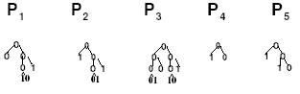
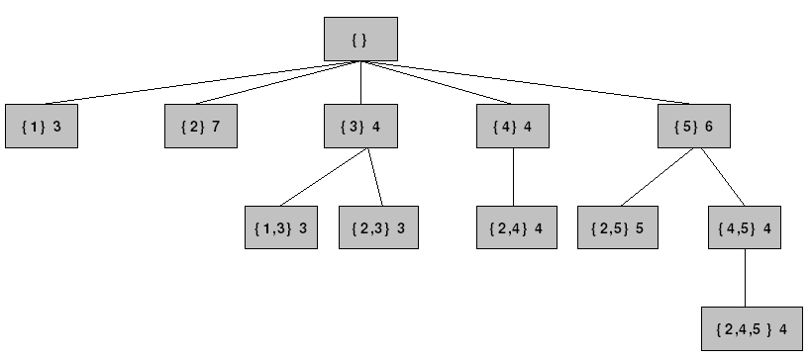
- SE tree for dataset {1, 2, 3, 4, 5}.
- Taboo Lists
Going back to Figure 10, suppose we are currently working with node {5}. During the processing span of {5}, it must be joined with nodes {2} and {2,4} and in this order because both of them are frequent itemsets lying to its left. If {2,5} happens to be infrequent then so will {2,4,5} because it is a superset of {2,4}; as a result, our approach so far would generate and test candidates frequent itemset like {2,4,5} that could be eliminated by prior knowledge about infrequent subsets such as {2,5}, in this case.
To remedy the problem, we associate a temporary taboo list (TL) with every item, I, under processing where we save all the nodes that have produced infrequent itemsets when joined with I. Going back to the previous scenario, if {2,5} is infrequent then we append {2} to the taboo list of item 5 (TL₅ for short). In later steps, before computing the support of any new candidate itemset, X, containing item 5, we check if any subset of X is in TL₅. If so, we simply discard X. This may seem unfeasible at first glance; however, an efficient implementation based on logical operations has been devised as we shall discuss in more details in the following section.
It is worth mentioning that our traversal through the itemset space using taboo lists is very similar to a popular approach used in the AI literature and known as tabu search [30]. The idea of tabu search is to traverse the space in a more effective manner by avoiding moves that result in revisiting points in the space previously visited whose outcome are known not to be acceptable (hence the name "tabu”). The fact that the union of I and X produces an infrequent itemset implies that future joins of I with any superset of X will produce an infrequent itemset; a scenario similar in essence to revisiting a point in the search space whose outcome is known to be unsatisfactory and which could have been circumvented by putting the point on a tabu list. Because of the difference in context and problem definition, we refer to our lists as taboo lists instead of tabu lists.
- Implementation & Performance Analysis
- Implementation
For every new item, I, we create a new node under the root and test for candidate frequent itemsets by joining I with all nodes lying to its left in DF order. The actual node creation order in the tree is the lexicographic subset ordering of the items in the given item list. For example, the node creation order for the set {1,2,3} would be: {1}, {2}, {1,2}, {3}, {1,3}, {2,3}, {1,2,3}. This ensures that every itemset has all its subsets generated prior to its generation.
For every item, I, we maintain a TL_{I} which stores the itemsets whose supports, when joined with I, are known to be less than minsupp and thus the itemsets formed by joining I with any of their supersets are known beforehand to be infrequent so their support values need not be computed. In our implementation, each TL_{I} can be maintained as a P-tree having a size equal to the number of nodes to the left of I (i.e. all nodes that need to be joined with I). A value of 1 is used for nodes which, when joined with I, result in an infrequent itemset. The remaining TL_{I} entries will be 0s. For example, for the set of items {1,2,3,4}, suppose that the nodes created so far in the tree are: {1}, {2}, {1,2} ,{3}, {1,3}, {2,3}, {1,2,3}. For item 4, we initialize a TL₄ to have seven entries (because we have 7 frequent itemsets so far) all containing 0s initially. If the union of item 4 with node {2} results in an infrequent itemset, then the second entry in TL₄ which corresponds to itemset {2} is flagged with a 1, and so are all other entries containing item 2 (i.e. entries {1,2}, {2,3} and {1,2,3}).
But how can we “efficiently” locate all other entries containing item 2? In order to be able to answer this question, an extra step needs to be performed. We maintain, for every item, an index list which is a binary list that has a value of 1 for every position in list of frequent itemsets (i.e. node-creation order traversal of nodes in the SE tree) that this item exists in. Note that index lists can be maintained as P-trees (referred to as an index P-trees). For our last example, item 1 will have the following index list: 1, 0, 1, 0, 1, 0, 1; indicating that by viewing the nodes of the SE tree in node creation order, item 1 occurs in node positions 1, 3, 5 and 7. Every new node added to the tree results in the expansion of all index lists by either a 1, if the corresponding item is in the new node added, or a 0, otherwise. The TL of the current item is also expanded by a 0 so as to maintain a length equal to that of the index lists in order to facilitate logical operations as we describe next.
Going back to the previous scenario where joining {4} with node {2} results in an infrequent itemset and thus node {2} need to be added to TL₄, we simply OR the index list of item 2 with TL₄. In general, if we want to add node {x, y,…,z} to a taboo list, say TL_{I}, we AND the index lists for all items in the node (i.e. AND index lists of x with that of y … with that of z). The resulting list will contain a 1 for the occurrence of any superset of itemset {x, y,…,z} including itself. Then, we OR the resulting index list with TL_{I} which results in appending node {x, y,…,z} to TL_{I}.
Ideally, we maintain all taboo lists and index lists as P-trees as this results in faster logical operations in addition to compression when possible. An extra advantage for using P-trees to encode taboo lists is the capability of speeding up node traversal especially in cases where there are many consecutive 1s. For example, suppose the entries in a taboo list are: 1111 0011. Figure 11 below shows the corresponding P-tree of the given taboo list.
1 0
0 1
0

- The resulting taboo list in P-tree format.

In this example, instead of going through the first four nodes sequentially and then skipping them afterwards because they are flagged, using a P-tree to represent the taboo list, we can directly skip the first 4 entries because they form a pure-1 node on 2nd level of the P-tree. However, due to the cost of maintaining P-trees in dynamic environments, the work in this dissertation does not use P-trees to encode taboo lists and index lists.
By using the proposed approach, one could indirectly eliminate the need for the two steps needed by APRIORI to generate candidate frequent itemsets, namely, the join and prune steps. To recap, APRIORI joins any two k-itemsets sharing the first “k-1” items in the join step and prunes all those (k+1)-itemsets that have at least one infrequent subset in the prune step. In general, pruning can be accomplished either by searching, which entails a processing-time overhead, or by using complicated data structures to store frequent itemsets like hash trees as suggested in [2], which might incur an overhead due to their maintenance and searching especially when they exhibit poor cache locality [95]. By using taboo lists in our approach, we combine those two steps into one step because we only form a candidate frequent itemset if and only if all subsets of that itemset are known to be frequent. In other words, the pruning is integrated into the join step.
Finally, we would like to make the point that the collection of index lists are an exact replica of the tree except for being in binary (i.e. each item involved in the corresponding itemset has a 1 in its index list); consequently, for better space utilization we need not store the tree. All frequent itemsets can be found in the index lists. However, this additional advantage has not been utilized in the implementation devised for this work. In addition, each TL is only maintained for the processing span of the corresponding item after which it is discarded; during that time, it could be stored as a P-tree and, thus, could be compressed when possible. As a result, we have no extra storage overhead other than the temporary taboo lists each lasting for the duration of the processing of the corresponding item.
- Performance Analysis
To analyze the performance of the proposed approach, we develop an implementation for the work suggested herein using P-trees (called PTREE SE) and compare it with four popular state-of-the-art frequent itemset-mining approaches: FP-GROWTH (FPG) [38], APRIORI [1] [2], Depth-First APRIORI (DFA) [47] and ECLAT [95]. We have chosen FPG because it utilizes a compressed data representation model that can be viewed as vertical and horizontal simultaneously [33]. APRIORI and DFA are both APRIORI-based implementations with the former using a bread-first traversal of the itemset space and the latter a depth-first traversal. The vertical data representation of ECLAT along with being the first approach to successfully perform depth-first-based frequent itemset discovery [33] made it a very attractive comparison target.
The data mining community has prominently noted the importance of the availability of implementation benchmarks due to the high dependence of experimental comparison results on the implementations used; as a result, for the approaches we compare with, we use publicly available implementations renowned for their speed. FPG and APRIORI have been downloaded from [31] after being used as benchmarks in the Frequent Itemset Mining Implementations competition [27], while ECLAT and DFA have been from the Frequent Itemset Mining Implementations Repository [27] after participating in the competition. We use Borgelt’s implementation [14] of ECLAT and Kosters’s implementation of DFA [47]. All implementations are coded in C++ and tested on an Intel Pentium-4 2.4GHz processor workstation with 2GB RAM running Debian Linux. In all experiments, we focus on mining all frequent itemsets only without rule generation.
The experiments presented herein are designed to follow formal experimental design methodologies. In particular, we make use of the 2^{k} factorial experimental design methodology [51] where the considered input factors are the number of transactions in the dataset (cardinality), the number of items (dimensionality) in the dataset, the density of the dataset, the type of the dataset (i.e. real or synthetic), and the minimum support threshold specified. The only response of interest is the execution time for mining all frequent itemsets. Our design methodology requires us to choose two opposite values for each of the k factors and then scrutinize the responses at all possible 2^{k} factor-level combinations each referred to as a design point.
Applying this design in its present form would be intractable because of inherent problems related to some of the chosen factors; consequently, we use a variant of this design that is tailored for our context. For example, to probe the effect of the cardinality factor, we had to generate synthetic datasets using IBM’s Quest synthetic data generator [39] because, to the best of our knowledge, such large datasets are not publicly available. Most real datasets are classified as small in cardinality according to our criteria. Due to those reasons, we use real-life datasets, when available, to represent design points; otherwise, synthetic datasets are to be created for those design points having no matching real-life datasets. As a result of the real-life dataset rarity, we ignore the effects of the type factor in our experimental study.
Another problem is related to the minimum support threshold. Due to the difficulty of choosing only two levels for support and the imperative need to study the behavior of the compared approaches over many support levels, we limit ourselves to using only the cardinality, dimensionality and density factors to generate design points. For every generated design point, we probe the behavior of the compared implementations over the corresponding dataset by varying the support threshold and going to low but manageable values.

Choosing levels for the selected factors could become a very complicated task due to its subjective nature. The levels chosen for the cardinality factor are “large” and “small” taking one million transactions as the cutoff (i.e. datasets with less than 1 million transactions are relatively small while those with less than 1 million are relatively large). For the dimensionality factor, we have “high” and “low” levels where high dimensionality exceeds 250 items. The levels for the density factor are “dense” and “sparse”. We take “sparse” to mean few items (out of the total number of items in our item space) in most transactions of the dataset so we set the threshold for this factor at 0.05 meaning that the average number of items per transaction in “sparse” datasets should not exceed 5% of the total number of items in the dataset. Considering all factor-level combinations would amount to eight (2³) resulting design points each represented by a dataset as shown in Table 4 where ITMs is the number of items in the dataset, AVG is the average number of items per transaction, TRANs is the total number of transactions, and DESC is the “factor-level” combination description for each of the datasets. We have strived to choose datasets that highly reflect the corresponding design points according to their given descriptions.
The large datasets, “Synthetic Dataset 1” through “Synthetic Dataset 4”, in addition to “Synthetic Dataset 5” have been synthetically generated using IBM’s synthetic data generator. While generating those datasets, we only set the number of transactions, number of items, and average number of items per transaction and used default values for the rest of the variables. The “BMS-POS”, “Accidents” [35] and “Chess” datasets are real-life datasets downloaded from the Frequent Itemset Mining Implementations Repository [27].

- Datasets descriptions.
 | ITMs | AVG | TRANs | DESC
Synthetic Dataset 1 | 500 | 10 | 5 mil | Large High Sparse
Synthetic Dataset 2 | 500 | 100 | 5 mil | Large High Dense
Synthetic Dataset 3 | 200 | 10 | 10 mil | Large Low Sparse
Synthetic Dataset 4 | 100 | 10 | 20 mil | Large Low Dense
BMS-POS | 1657 | 7.5 | 515597 | Small High Sparse
Accidents | 468 | 33.3 | 340183 | Small High Dense
Synthetic Dataset 5 | 100 | 3 | 346421 | Small Low Sparse
Chess | 75 | 37 | 3196 | Small Low Dense
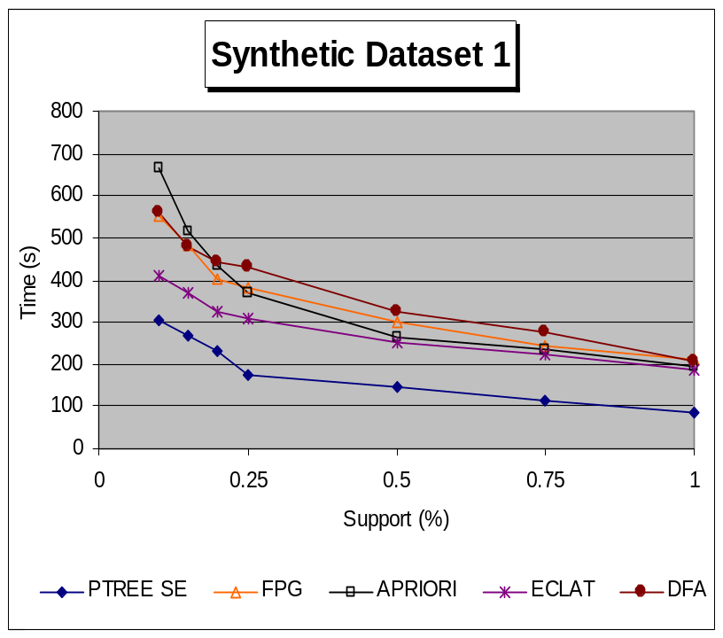

- Performance comparison results over “Synthetic Dataset 1”.
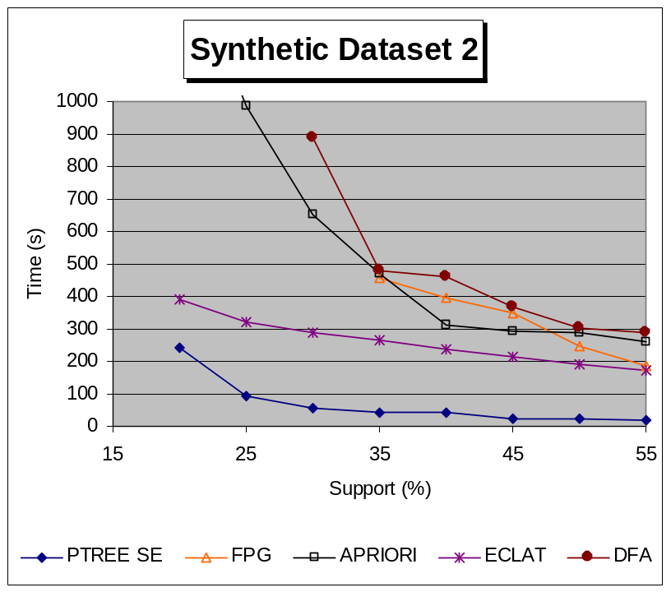
- Performance comparison results over “Synthetic Dataset 2”.
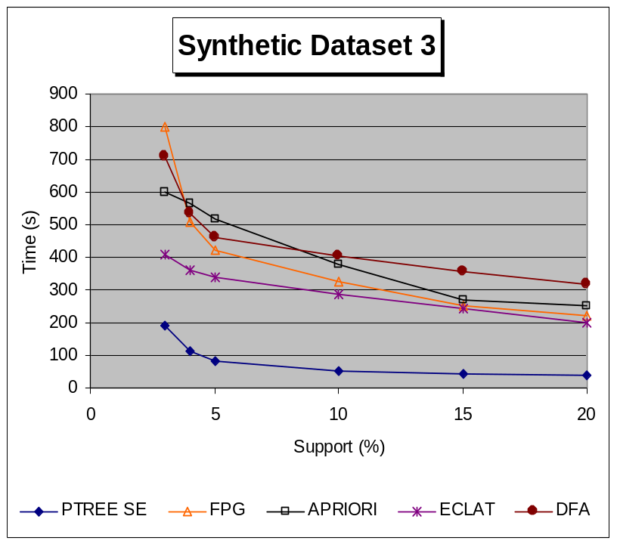
- Performance comparison results over “Synthetic Dataset 3”.

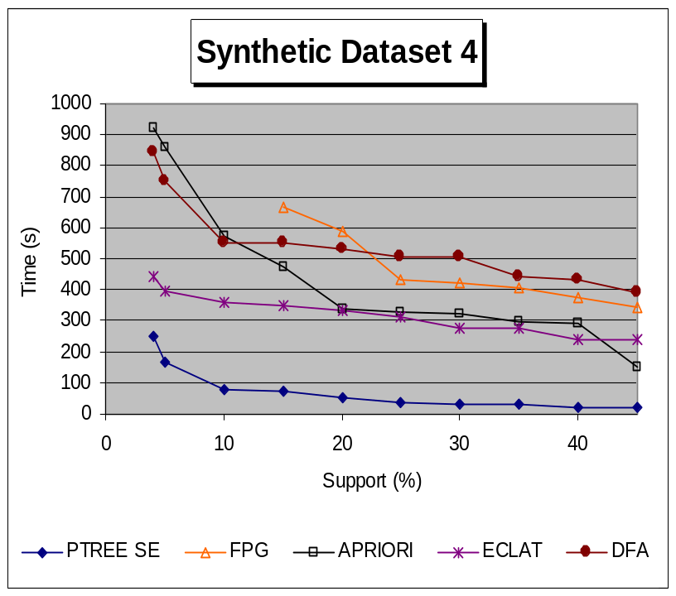
- Performance comparison results over “Synthetic Dataset 4”.
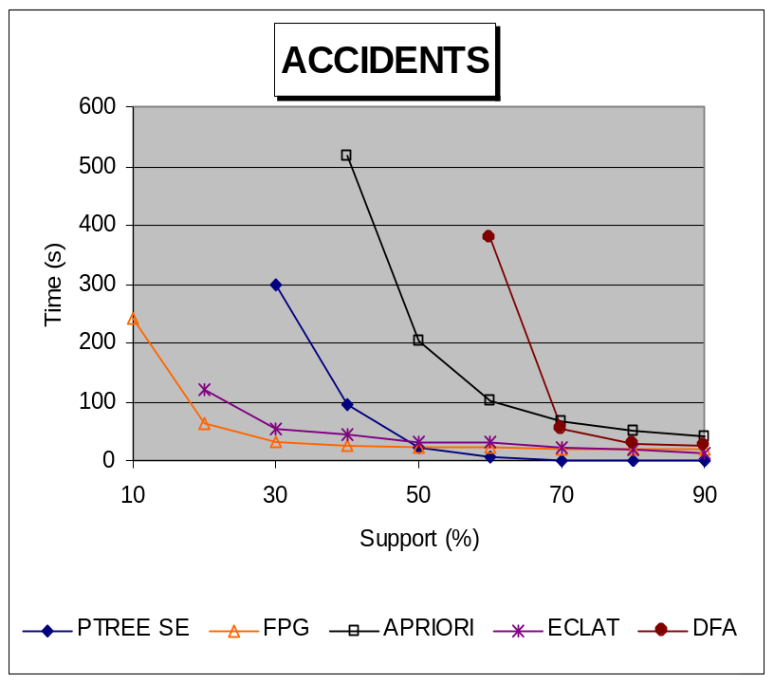
- Performance comparison results over “Accidents”.

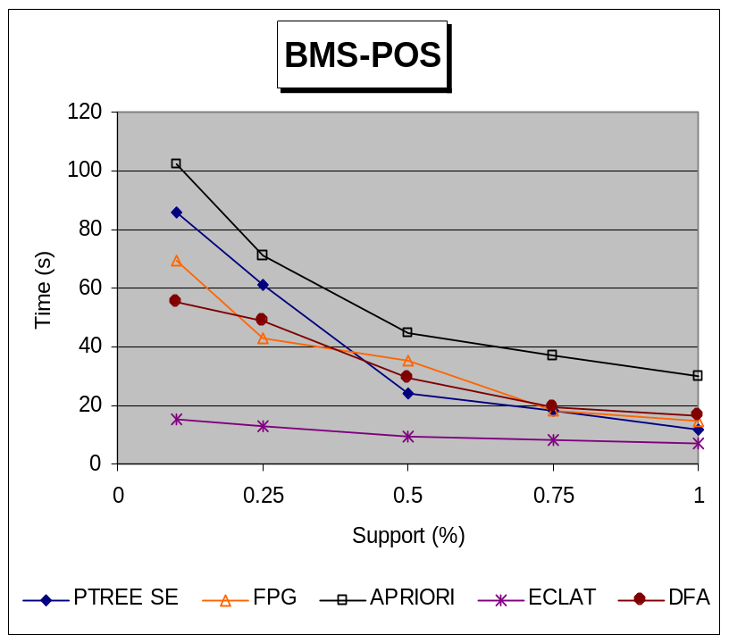
- Performance comparison results over “BMS-POS”.
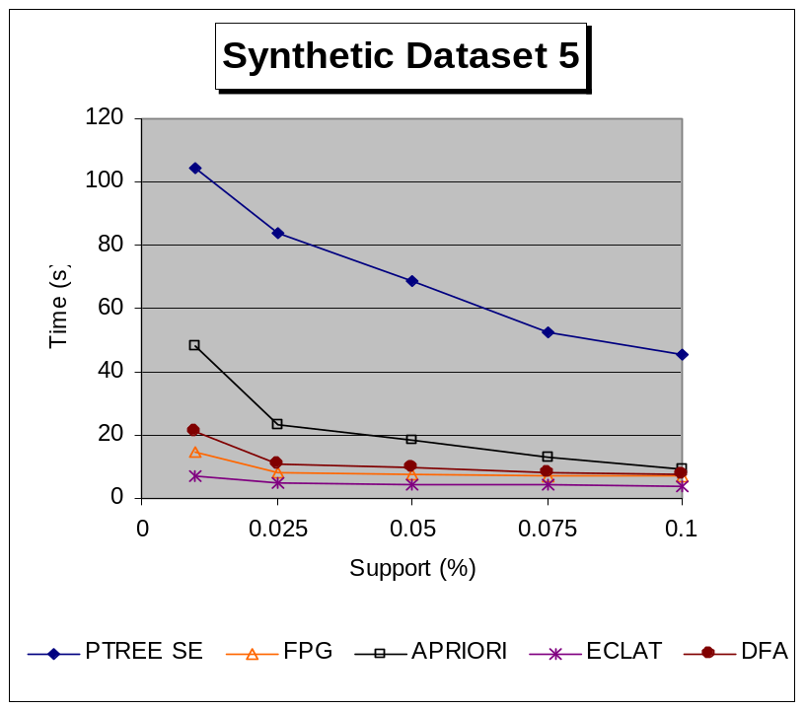
- Performance comparison results over “Synthetic Dataset 5”.

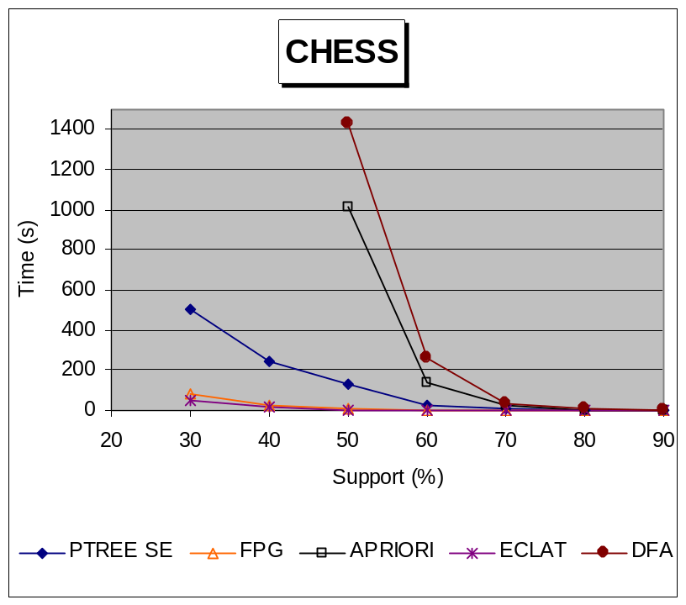
- Performance analysis results over “Chess”.
Figure 12 through Figure 19 show the performance graphs for all approaches at various support thresholds on each design-point dataset. The reader is advised that curves terminating prematurely (e.g. FPG in Figure 13 terminates at 35% support while other curves show results at 30% support and less) imply that the corresponding approach took too much time before finishing that it had to be terminated manually.
As is evident from the figures, our P-tree-based approach demonstrates superior results against contemporary approaches over all large datasets showing improvements close to one order of magnitude especially over “Synthetic Dataset 2” and “Synthetic Dataset 4” in Figure 13 and Figure 15, respectively.
Efficacy over large datasets can be mainly attributed to our vertical data processing; a claim which can be justified by referring back to the figures where ECLAT, which also uses pure vertical data processing, shows the best performance among the selected contemporary approaches over all large datasets. Our improvements over ECLAT can be accredited to the utilized SE-tree-based enumeration which is complemented by taboo lists and a compressed data representation model through P-trees. In addition, ECLAT forms a candidate frequent itemset based on only two frequent subsets (i.e. it does not fully utilize the downward closure of support property [32]); utilizing taboo lists has completely eradicated this problem in our approach where only candidate frequent itemsets all of whose subsets are frequent itemsets are generated.
Results on the smaller datasets are not nearly as encouraging suggesting that our performance improves by increasing the level of the cardinality factor; an observation which we find to be very reasonable because our approach uses compressed data structures to vertically process requests for discovering frequent itemsets. Another possible justification for our performance degradation over small datasets is not being able to amortize the cost of loading and processing datasets P-trees (in addition to taboo lists and index lists) over small datasets where compression does not prove to be very effective.
A more subtle justification for this difference in execution time between large and small datasets could be derived by recalling how our approach works in terms of data processing; it performs precautionary logical operations on taboo lists and index lists in order to eliminate unnecessary operations on P-trees (i.e. counting support only when needed). This implicitly assumes that the precautionary operations are cheaper than then P-tree data operations. Since both types of operations are mostly logical ANDing operations, the dominant factor here is the size of the operands being ANDed (assuming they are compressing somehow similarly). For the precautionary operations, the operands have the same size as the number of produced frequent itemsets while for the data P-trees, this would be the size of the dataset. It is very clear that when the data cardinality is high enough (where the number of transaction is much higher than the number of produced frequent itemsets which does not exceed the thousands for our large datasets), the cost of ANDing data P-trees exceeds that of the precautionary operations; thus, by eliminating the unnecessary data P-trees operations over the large datasets, we would be saving a lot on execution time. On the other hand, for the considered smaller datasets, the number of frequent itemsets is very large compared to the number of the transactions in the corresponding dataset such that not only do the savings resulting from eliminating unnecessary data P-trees operations by operating on taboo lists and index lists diminishes drastically, but also an extra processing cost is incurred.
Our experiments do not highlight any effects resulting from the dimensionality factor over low to “relatively” high dimensional datasets. After careful consideration, we have been able to realize that the effect and controllability of the dimensionality factor are rather dubious because the actual effect on the time response is largely controlled by the number of frequent 1-itemsets which, in turn, depends on the support, density, and cardinality factors making it extremely difficult to control. Note that in sone situations, the number of frequent 1-itemsets could be very small albeit the total number of items is extremely large.
In regard to our last factor, the density factor, we find our results to be largely comparable over most datasets regardless of the density of the data. However, it is worth mentioning that, over small datasets, results seem to be more encouraging over denser datasets where PTREE SE ranks third after ECLAT and FPG on both datasets (“Accidents” and “Chess” in Figure 16 and Figure 18, respectively). Over sparser small datasets, the performance degrades noticeably for PTREE SE especially on “Synthetic Dataset 5” as shown in Figure 17. Note that using P-trees, we can compress very sparse as well as very dense datasets because of the large numbers of consecutive 0s and 1s, respectively; so, it could be the case that P-tree compression is playing a more vital role over denser datasets. The density factor does not show evident effects on large datasets.
Our experimental analysis section has also exposed some known characteristics for the contemporary approaches we are comparing with. For example, the performance of FPG improved drastically over smaller datasets which could be justified by the fact that FPG creates an in-memory version of the dataset and then traverses this version to derive all frequent itemsets. As aforementioned, this is highly feasible when the dataset is relatively small so as to fit in memory, and fairly dense where the FP-tree compresses (after ordering all items in transactions so as to increase the transaction overlap). Thus, it is very intuitive to expect performance degradations over larger datasets especially when the compression of the FP-tree is not very effective. For dense datasets, we only notice improvements for FPG over ECLAT on small datasets where FPG outperforms ELCAT on “Accidents” for the only time in our experiments and shows very close performance on “Chess”.
Better results for the horizontal APRIORI-based approaches (APRIORI and DFA) are observed over sparse datasets regardless of the cardinality and dimensionality factors. We view this observation as very reasonable due to the fact that APRIORI-based approaches operate in a generate-and-test fashion which, consequently, makes their performance degrade tremendously as the number of generated candidate frequent itemsets to be tested increases dramatically which is really the case over dense datasets. Though not evident in the graphs, PTREE SE (and even ELCAT) is expected to have exhibited a similar performance behavior as it also generates candidate frequent itemsets and then tests for their support. It is highly possible that our expected performance degradations over denser small datasets have been circumvented by the vertical data processing, compression, and effective itemset enumeration.
To assess the scalability of the compared approaches, we develop a synthetic dataset with 500 items, an average of 100 items per transaction and one million transactions. We then generate two datasets from this dataset by first doubling the size and then quadrupling it thus generating a total of three datasets each with 500 items and an average of 100 itemsets per transaction but with different cardinalities: one-million, two-million, and four-million transactions, respectively. The rationale for generating different datasets by expanding available ones is to be able to vary the dataset size without changing any of the other dataset inherent characteristics; in other words, even though the datasets have different sizes, they all produce the same frequent itemsets at the same support thresholds (given in percentage) because the only difference between them is being generated by duplicating the transactions a fixed number of times. Accordingly, by fixing the support level and probing the performance of the compared approaches at different dataset sizes, we can isolate and understand the effect of increasing the cardinality on the overall performance of the approaches and, thus, their scalability. Figure 20 and Figure 21 below show the scalability comparison analysis for all approaches over the aforementioned datasets at two different support threshold values, 40% and 30%, respectively. Note that over the 4-million transactions dataset in Figure 21, FPG had to be terminated manually after exceeding 2500 seconds in execution time.

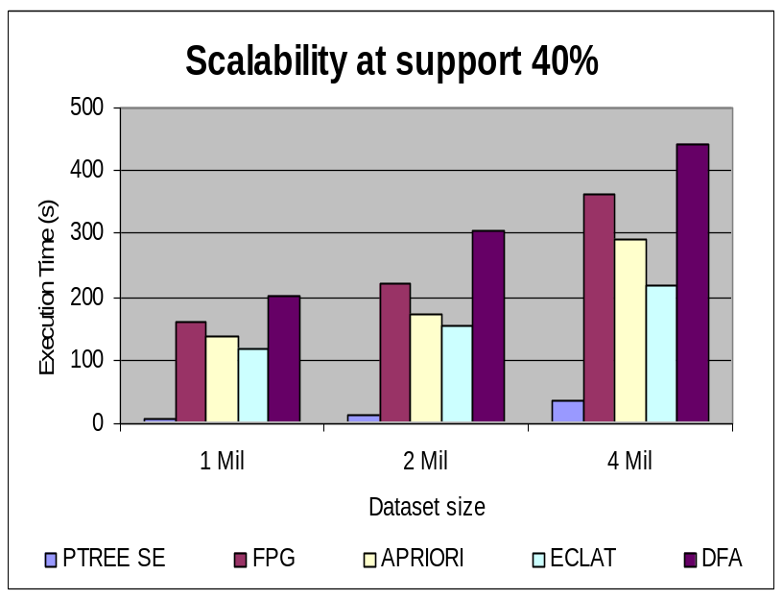
- Scalability analysis results at 40% support.
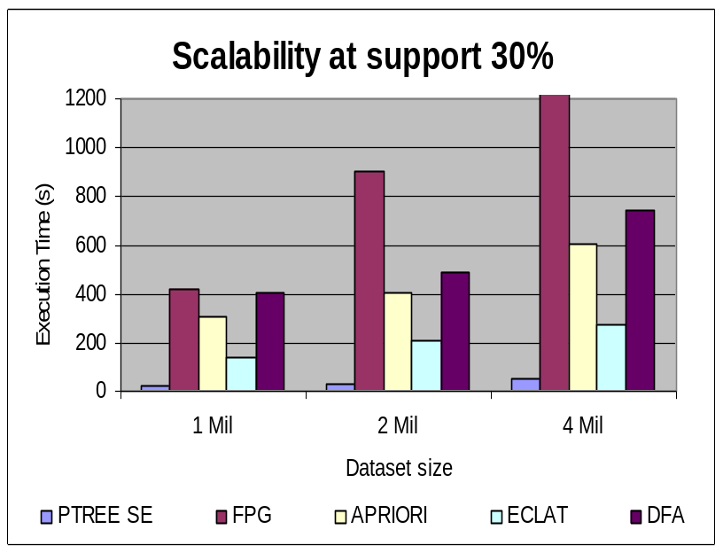
- Scalability analysis results at 30% support.

As evident from the graphs, our approach shows the best scalability, by far, among all approaches at both support thresholds. Results for ECLAT are also notable which, again, suggests vertical data processing to be the main reason for this dominance in scalability results. FPG and DFA show the worst scalability performance results. These observation convey yet another important characteristic of P-trees (and of most vertical data structures) showing how applications based on these structures are not affected much by cardinality increase; a behavior generally lacking in most horizontal approaches. Additionally, this scalability reemphasizes a point we have been made previously while attempting to justify the drastic change in the performance of our approach over large and small datasets; from the figures, we see that as the number of transactions increase (with the number of frequent itemsets kept constant), the savings in time become much more evident suggesting that now the P-tree data operations are becoming much more expensive than the precautionary operations as we increase the size of the dataset. We end this section by emphasizing an important point regarding the implementations used to compare our approach with other contemporary approaches. As discussed previously, these implementations have been selected for inclusion in our study because they are publicly available and relatively fast compared to other implementations for the same approaches; nevertheless, we do realize that they might not have been optimized uniformly which could have affected their resulting performance in our experimental analysis.
- Conclusion
In this chapter, we have shown how to efficiently produce candidate frequent itemsets whose subsets are all frequent itemsets without much memory and time overhead using SE tree enumeration and taboo lists. To improve the efficiency of the frequent itemset-mining process further, we utilize a Boolean vertical data-representation model complemented by compressed data structures, P-trees, resulting in very fast itemset-intersection operations. Note that all of the P-tree-based operations needed to accomplish the task at hand, such as ANDing and ROOTCOUNTing, are performed on the vertically compressed P-trees without the need for any decompression.
We have proposed a framework utilizing a number of techniques with the objective of efficiently extracting frequent itemsets and eventually association rules. The conducted experiments indicate the cardinality factor to be the most effective on performance. Our approach performs best when applied over very large datasets where multiple scans of the database or even an uncompressed in-memory version of the database are very prohibitive. Less evident has been the effect of the density factor over small datasets. In addition, further experimentation has demonstrated the scalable nature of our approach and of vertical approaches, in general, as opposed to other horizontal approaches.
Future direction in this area includes devising additional optimization techniques to integrate into our approach in order to improve the performance over small to mid-sized datasets where our approach did not demonstrate highly comparable results. We would also like to extend the proposed framework to efficiently handle situations where users do not wish to utilize the downward closure of support by focusing on confidence pruning only in their quest for association rules such as in precision agriculture and medical research. We plan to apply the proposed approach over pertinent datasets mainly in the areas of web-structure mining and bioinformatics with the hope of furthering our understanding of its practicality in real-life problems. In addition, not much research has focused on updating datasets represented using P-trees in dynamic environments; so we would like to analyze this factor in practice especially over real-life datasets.
- Acknowledgements
We would like to thank all the people who publicly provided the implementations used in our experimental analysis study. In addition, special thanks go to the organizers of the Frequent Itemset Mining Implementation Repository for their continued efforts to collect and provide association rule-mining datasets and implementations. Finally, we thank the researchers at IBM Almaden for publicly providing the code for the Quest synthetic data generator.

CHAPTER 5: MINING CONFIDENT MINIMAL RULES WITH FIXED-CONSEQUENTS

- Introduction
ARM is considered one of the most important applications, by far, to ever emanate from the data mining community. As previously mentioned, it was initially proposed by Agrawal et al. in 1993 [1] for market basket data in what is known MBR. MBR data is usually in the form of transactions each containing a list of items bought by a customer during a single visit to a store. An association rule of the form X➔Y relates two sets of items, X and Y, where the underpinning relation follows the direction of the arrow (from X to Y) and is then described as “customers who buy X are very likely to buy Y”. The degree of likeliness of an association rule is determined by external measures associated with it such as the ubiquitous support and confidence measures. The originally proposed goal for association rule mining has been to find all the rules with support and confidence surpassing some minimal user-specified thresholds.
Few works in the literature have noted a notorious problem in association rule mining that relates to the overwhelming number of produced rules. A number of approaches such as [9] and [46] [39] use additional parameters to code the user’s rule preferences in an attempt to reduce the total number of produced rules. Some of the suggested parameters in the literature include lift [9], conviction [9] [83] and reliability [3]. (it is worth noting that the naming used for those parameters is not standard). A point made against those measures is that, while they attempt to capture user preferences more fully, they obviously overburden the user with more parameter tuning.
Other algorithms take a different approach for coding user preferences by requiring the rules to have special formats through the integration of itemset constraints [10]. One popular form of itemset constraints is the consequent constraint where all produced rules are required to have the consequent specified by the user. Numerous applications exist for fixed-consequent ARM such as in MBR where one is interested in finding which items are sold with a specific set of items of interest for the purpose of running promotions on it; nowadays, the need for fixed consequent ARM is becoming even more evident. Though such constrained rules can always be obtained by using the original ARM scheme proposed by Agrawal et al. followed by the application of a “post-ARM” processing/cleaning step to retain only those rules that have the specified itemset as consequents, we believe that, since users are generally not interested in the rest of the rules, it would not be optimal (and reasonable) to burden them with additional processing time for generating uninteresting rules that will eventually be removed during the “post-ARM” step.
After motivating the need for our work, we propose an approach for mining minimal confident rules in the context of fixed-consequent ARM which relieves the user from the burden of specifying a minimum support threshold. Highly confident rules are desired in all situations; however, support thresholds fluctuate with the applications and the datasets under study, as we shall discuss more thoroughly later on, which makes confidence a better target of focus than support. The algorithm presented herein uses a similar framework – based on set enumeration trees, taboo search and P-trees – to the one in the previous chapter that is tailored for a totally different context. We empirically demonstrate that the suggested framework is efficient and can easily be expanded by adding new pruning conditions pertaining to specific situations.
This chapter is organized as follows: In Section 5.2, we introduce the notion of fixed-consequent, confidence-based ARM and motivate its need. In Section 5.3, we present the proposed algorithm along with an illustrative example. Section 5.4 discusses details about the implementation devised for this work in relation to the work discussed in previous chapter. Sections 5.5 and 5.6 provide the proof of completeness for the proposed algorithm in addition to a performance analysis study, respectively. We finally end this chapter with some concluding remarks in Section .
- Towards Mining Confident, Minimal, Fixed-Consequent Rules
- Fixed-Consequent ARM
As mentioned in our introduction, using MBR, some stores may want to find all the rules that have a certain item (or set of items) as a consequent for the purpose of running promotions on this (those) specific item(s). In this context, a rule of the form X➔Y, where X and Y are itemsets and Y is user specified, can inform the business analyst that since people that buy X are also inclined to buy Y, then, in order to promote the sales of Y, we can run promotions on Y that also include X.
Perhaps the use of fixed-consequent ARM is more evidently needed in the context of precision agriculture. Agricultural data is usually described by visible reflectance bands (Blue, Green and Red), infrared reflectance bands (e.g., NIR, MIR1, MIR2 and TIR) and possibly some other bands of data gathered from ground sensors such as yield quantity, yield quality, and soil attributes like moisture and nitrate levels. For simplicity and without loss of generality, we consider the following relation, R, as a prototypic relation for this type of data: R (Red, Green, Blue, NIR, …, Yield quality). In this context, analysts are usually interested in finding high yield quality given other properties like Red, Green, Blue, etc…; as a result, using high yield quality as our fixed consequent, we get rules describing the best reflectance band combinations that produce high yield [25]. Some applications in medical research investigate patient records to analyze the characteristics that lead to the death of patients (or the existence of chronic diseases); such a task can be accomplished in a similar manner.
- Confidence-Based ARM
We take confidence-based ARM to mean that users only specify the confidence threshold of interest. In general, users are always interested in high-confidence rules. The higher the confidence of a rule, the lower the error rate of generalizing it over the dataset. A rule with a confidence of 95% tells us that we are tolerating an error rate of 5% when we assume the validity of the corresponding rule. We believe it should be totally up to the user to specify the error rate that can be tolerated.
In spite of the fact that we are always interested in rules with high confidence values, we argue that support fluctuates depending on the application at hand and the dataset under analysis. In some datasets, high support values are always desired. This is the case for MBR data because store managers always like to see high support values for their rules. However, it does not have to be the case for other datasets. Considering our medical research example again, let us suppose that we have a large database of patient records. We are interested in finding what combinations of attributes stored in those records imply the death of the patient. Ideally, we would require our ARM application to detect such rules early on so that we could attempt to diagnose the problem – if any – before the support of those rules increases in the database. Similar considerations apply to fraud and copy detection.
In [20], Cohen et al. motivates the need for low-support, high-confidence rules by observing that usually high support rules are obvious and well-known unlike low-support ones which provide “interesting” insights into the data. Example applications for low-support high-confidence ARM mentioned in [20] include copy detection [79] (for identifying similar documents) and collaborative filtering (for making recommendations to users based on their behavioral similarity to others) [88].
We have devised our algorithm to generate the highest support rules that match the users’ specified minimum thresholds without having users to specify any support threshold. By doing so, we would reduce the number of parameters supplied on behalf of users thus relieving them from the burden of determining an optimal value for the support threshold in order to produce meaningful and interesting rules.
- Rule Minimality Property
We assume that the minimum confidence threshold c (which is usually high) provided by the user represents her threshold of interest; as a result, any two rules having confidence values exceeding c, where the antecedent of one of them is a superset of the antecedent of the other, are to a great extent equally interesting to the user. Support comes into the picture to tip the scales in the direction of the rule with higher support. For example, suppose we generate two rules, R1 and R2, with confidence values greater than the confidence threshold where R1 is “formula milk” ➔ “diapers” and R2 is “formula milk”, “baby shampoo” ➔ “diapers”. R1 and R2 are considered very equally interesting to the user, and thus we select only the one with higher support and prune the other. Since R2’s antecedent is a superset of R1’s, then R1’s support is surely higher than or equal to R2’s. A more contextual justification for our choice would be by arguing that since the user knows that “formula milk” ➔ “diapers” from R1 no new knowledge is given by R2:“formula milk”, “baby shampoo” ➔ “diapers”. In this context, we refer to R1 as a minimal rule and R2 as non-minimal. Producing minimal rules can be viewed as an extension over previous approaches in the literature such as [20] and [28] which restrict their work to rules of item pairs only (i.e. one item in the antecedent and one item is the consequent).

Definition 4.1: (Non-Minimal Rules) Formally speaking, a rule, R, is said to be non-minimal, if there exists at least one other rule, S, such that both rules have confidence values greater than the minimum confidence threshold, have the same consequent, and the antecedent of R is a superset of that of S.

The work in [7], [11] and [57] support our claim regarding the importance of minimal rules. [7] uses the notion of non-redundant or minimal rules to refer to rules with the smallest possible antecedents and largest possible consequents. This matches our rule minimality definition – Definition 4.1 – to a large extent since we also require the antecedent to be as small as possible; however, we relax the requirement on the consequent because we are dealing with fixed consequents. [11] emphasizes the importance of “small” rules in the context of genome analysis while [57] extends it to medical data.
- The Proposed Rule-Generation Algorithm
- Pruning
After the user specifies a minimum confidence threshold, minconf, and a consequent itemset, C, our algorithm proceeds by the creating an SE-tree structure. Every node in the tree represents the antecedent itemset of the rule I➔C. Whenever we create a new node, n, in the tree and label it with an itemset, I, we apply the pruning conditions listed next to check whether we can terminate the processing at n pre-maturely thus reducing the space. By terminating a node, we stop further processing at that node and no longer list any itemsets under it. We exploit the following three pruning conditions: (1) Zero-confidence pruning: if the confidence(I➔C) = 0, then terminate n, (2) one-support pruning: if the support(I➔C) = 1, then terminate n, and (3) minimality pruning: if the confidence(I➔C) >= minconf, then terminate n
Zero-confidence pruning is a simple and straight forward pruning condition based on the observation that if the support of a certain itemset, I, is zero then every superset of I has a zero support; as a result, any rule formed by replacing the antecedent of a rule having a zero confidence by a superset of that antecedent will also have a zero confidence. To justify that, suppose a rule I➔C has a support of zero (i.e. support(I U C) = 0); as a result, the confidence of I➔C is also zero (recall that confidence(I➔C) = support(I➔C) / support(I)). Suppose that I’ is a superset of I; we know that support of (I’ U C) is zero since (I’ U C) is a superset of (I U C). As a result, support of (I’➔C) is zero and thus confidence(I’➔C) is also zero. In short, if we know that a rule I ➔C has a zero confidence, then there is no need to process the supersets, I’, of I and compute the confidence values of the rules I’➔C.
Rules with support of 1 are based on a single sample from the database and thus are not rules per se. In addition, if the support of any rule I➔C is 1, then any non-minimal rule formed from this rule can not have a support greater than 1. In practice we can easily combine the previous two pruning conditions by pruning a node if its support is less than or equal to 1; this is because the confidence of a rule is equal to zero if and only if its support is equal to zero. Hereinafter, we shall refer to those two pruning conditions combined as the support-less-than-two pruning.
The minimality pruning condition is based on our previous discussion for the need to remove non-minimal rules. Once we generate a rule R: I➔C with confidence value exceeding minconf, we terminate the node, n, that generated R because all successor nodes of n may only generate non-minimal rules of R according to our definition of minimality. It should be clear to the reader how flexible this framework is in terms of allowing other pruning conditions that pertain to special situations to be easily added to our set of conditions and tested in a similar manner. Each pruning condition, when satisfied results, in pre-mature node termination.
Our algorithm employs the two pruning conditions, support-less-than-two pruning and minimality pruning, to prune the SE tree. Every time we generate a new itemset, I, at some node, n, one of the following three scenarios may transpire: (1) support(I➔C) < 2: we terminate n, (2) confidence(I➔C) Є (0, minconf), exclusively: we continue processing without terminating n, and (3) confidence (I➔C) >= minconf: we terminate n and output I➔C as a rule.
The formal algorithm is depicted in Figure 22. Note that the algorithm is complete in terms of producing all confident minimal rules; the formal proof is presented later in Section 5.5.

Algorithm: Confident, Minimal, Fixed-Consequent ARM

Input: D, ordered list of items I, fixed consequent C minconf
Output: Confident, Minimal, Fixed-Consequent rules with respect to D, minconf, and C
Method:
1:// Create the root node of the tree which is empty (null) and insert it in the tree
2:root:= new tree node
3:insert(root, tree)
4:for all i Є I do
5:// Create a new node with label i
6:n:= new node(i)
7:// Insert n under the root (right to left)
8:insert(n, tree)
9:RECURSIVE:
10:if support(I➔C) < 2
11:terminate n
12:else
13:if confidence(I➔C) >= minconf
14:terminate n
15:add(I➔C,RULES)
16:else
17:if confidence(I➔C) Є (0, minconf)
18:// Processing the nodes in DF
19:for all nodes n’ to the right of n do
20:// The label of new_n represents the rule whose
antecedent is the n U n’ new_n:= new node(label(n) U
label(n’)) insert(new_n, tree)
23:goto RECURSIVE
24:end for
25:end if
end if
26:end if
27:end for

- The proposed rule-generation algorithm.

- An Illustrative Example
Let us assume we are considering the following item space I = {1, 2, 8, 7, 6, 5, 4, 3, 9, 10, 11}. The first step in our algorithm is to assume some order on the items in I. In our example, suppose we exploit the decreasing order of the item index as our order; the ordered list of items in I then becomes {1, 2, 8, 7, 6, 5, 4, 3, 9, 10, 11}.

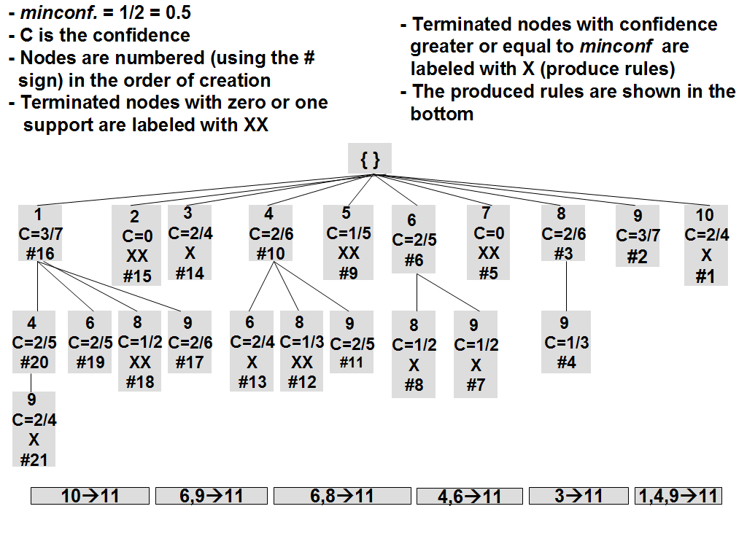
- The resulting tree for our example dataset.

Item 11 is selected as the fixed consequent and minconf is set at 1/2. In addition to showing the node labels along with the corresponding confidence values, the tree depicted in Figure 23 shows the order of node creation (the number following the # sign in each node). The first node to be created is 10. Testing the confidence of the rule 10➔11 we get a confidence of 2/4 which is equal to minconf; thus, we output 10➔11 as our first rule (rules are shown in the bottom of the figure in order of discovery too) and we terminate this node as instructed in the algorithm. Then we move to 9, the second item is our list, and insert a node labeled with it to the left of the first node 10. Confidence(9➔11)=3/7 < minconf; thus, we leave node 9 un-terminated. There are no un-terminated nodes to the right of node 9, so we move to item 8 and create a node under the root labeled with 8. Confidence(8➔11)=2/6 < minconf and the un-terminated node on highest level in the tree that is furthest to the right of 8 is 9 (the only one in this case) ; thus, we insert under 8 a node labeled 9 (this node represents itemset {8,9}). Confidence(8,9➔11)=1/3 < minconf and there are no more un-terminated nodes; thus, we move to the next item in our list and create a node under the root labeled with 7. Since Support(7➔11)=0, we terminate this node and create a new node labeled with the next item in the list, item 6. Confidence(6➔11)=2/5 < minconf and the un-terminated node on highest level in the tree that is furthest to the right of 6 is 9; thus, we insert under 6 a node labeled 9 (this node represents itemset {6,9}) and test for confidence(6,9➔11) which turns out to be equal to minconf. As a result, we output 6,9➔11 as our second rule, terminate this node, stop processing under 9, and move to the closest un-terminated sibling of 9. The first sibling (the only one in this case) is node 8 and this node also gives a rule with support(6,8➔11)=1. Again, we terminate this node, stop processing under 8 (we do not need to try the node labeled 9 under node 8), and move to the closest un-terminated sibling of 8 which does not exist; thus, we move on to item 5 in our list. Similarly we proceed to create the rest of the tree depicted in Figure 23.
- Ensuring Rule Minimality
Suppose in Figure 23 we are currently working with node 1. Under this node, nodes 9 and node 8,9 will be considered because both of them are un-terminated nodes on its right. A possible scenario would be for both rules, 1,9→11 and 1,8,9→11, to succeed thus we end up generating a non-minimal rule, 1,8,9→11 in this case.
Another scenario we need to consider is when rule 1,9→11 has support 0 or 1, then there is no need to try rule 1,8,9→11 because its support is also going to be 0 or 1. In this scenario, our algorithm won’t produce undesired rules but will test for rules whose outcome is known beforehand which is undesirable because this involves performing extra time-consuming yet unneeded operations.
If we view the antecedent of any rule that violates a pruning condition as an infrequent itemset (in essence, both violate pruning conditions: rule minimality or support-less-than-two in the former case and downward closure of support in the latter), then we could attempt the same solution as in the previous chapter where we utilize taboo lists and index list to ensure that we never generate a frequent itemset in case any of its subset itemsets is infrequent. For this reason, we omit repeating the solution here again.
- Proof of Completeness
It now remains to prove that our algorithm is guaranteed to produce all confident minimal rules. We use the “proof by contra-positive” logic to arrive at the conclusion that, because of the way our algorithm is formulated, we can not skip any confident minimal rule. To do that, let us assume that there is a confident minimal rule R: B➔C that we have missed. We can rewrite R as b_{l},b_{m},...b_{r},b_{s}➔C where each b_{i} is an item in the itemset, B, and by default b_{l} is the current item under consideration. Going back to the algorithm, we realize that rule antecedents are formed by successively appending new items, one at a time, to an itemset until a rule forms. For example, in Figure 23, the last rule 1,4,9➔11 formed by first trying 9➔11 (the node representing this rule was the 2nd node to be created in the tree), then 4, 9➔11 (the node representing this rule was the 11th node to be created in the tree) until we finally arrive at the successful rule 1,4,9➔11 (the node representing this rule was the 21st node to be created in the tree). Applying this logic to B➔C we infer that the antecedent, B, formed by appending b_{s} (the first item in itemset B) to b_{l},b_{m},...,b_{r}. Let us consider for the moment the two rules: R1: b_{m},...,b_{r},b_{s}➔C and R2:b_{l}➔C. It suffices to deal with R1 and R2 only because the same logic provided here can be applied to R2 recursively. Since we are assuming B➔C to be a confident minimal rule, then we know that neither R1 nor R2 have support values equal to 0 or 1 (otherwise B➔C would also have a support of 0 or 1 and thus can not be a confident rule). This proves that both R1 and R2 have support values greater than one which takes care of the support-less-than-two pruning condition. It remains to deal with the minimality pruning condition. Let us look at the following two scenarios: (1) Both rules, R1 and R2, have confidence values below minconf (but above zero) and (2) at least one of the rules has a confidence value above minconf.
Recall that B→C is assumed to be minimal so we know none of its subsets has been added to the taboo list of item b_{l}. Assuming scenario (1) takes place, we arrive at a contradiction since both R1 and R2 have confidence values between zero and minconf and thus non of the pruning conditions is met; as a result, because of the way the tree subset enumerator works, we should have created a node labeled b_{l},b_{m},...,b_{r},b_{s} under the node labeled b_{l} and tested for the validity of the rule B➔C. On the other hand, if we assume that scenario (2) occurs then one of the two nodes representing the antecedents of R1 and R2 (depending on which of R1 or R2 has a confidence value above minconf) has met the minimality pruning condition and should have been terminated before the creation of the node representing the rule B➔C; thus, scenario (2) also results in a contradiction because we are assuming B➔C to be minimal.
- Performance Analysis
To the best of our knowledge, no previous work has attempted to mine the type of rules we are considering. Nevertheless, we find [10] to be particularly interesting as it proposes an algorithm, called Dense-Miner, which is capable of mining association rules with fixed consequents at very low support thresholds. For the lack of a better benchmark, we compare our approach with Dense-Miner; however, we have to emphasize that a number of fundamental differences exist between the two approaches which we briefly outline next: (1) Dense-Miner mines all association rules while we only mine minimal, confident rules, and (2) Dense-Miner uses support as a pruning mechanism while this is not the case in our work (in reality we also use support pruning, but, in our case, the support threshold is always set at 2 as an absolute threshold). As for rule overlap between the two approaches, all rules produced by our approach that have support higher than the minimum support threshold used for Dense-Miner will be produced by Dense-Miner also.

 | Transactions | Items | Items per transaction
Connect-4 | 67557 | 129 | 43
PUMSB | 49046 | 7117 | 74
- Datasets descriptions

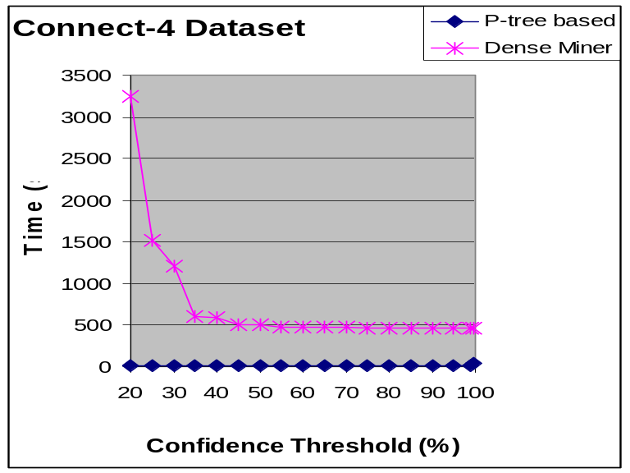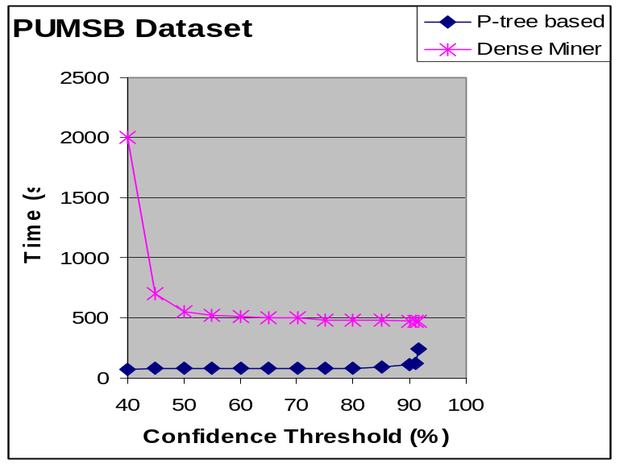
- Speed comparison.

All experiments have been conducted on a P-II 400 with 128 SDRAM running Red hat Linux 9.1. C++ has been used for coding. We experiment on two real-life dense datasets, Connect-4 and PUMSB, which are available at the UCI Machine Learning Repository [87]. Those datasets have been used for experimental analysis in [10]. All results shown for [10] have been taken from their work.
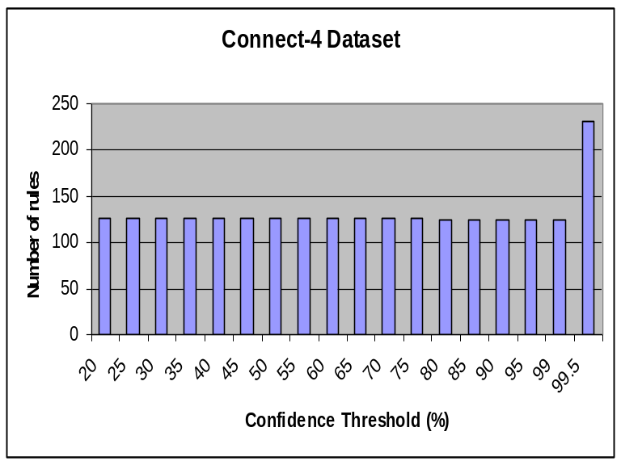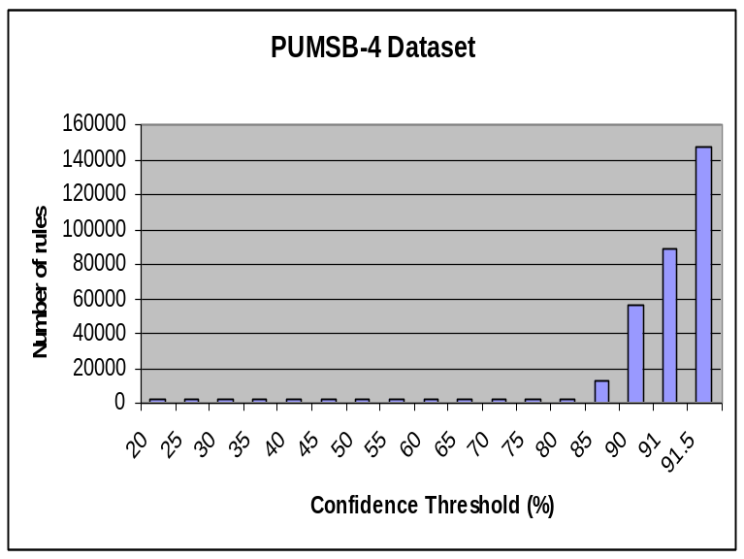
- Number of rules produced.

Table 5 briefly describes the two datasets by listing the number of transactions, items, and items per transaction for each dataset. Figure 24 shows the total execution time (in seconds) needed to mine rules at different confidence thresholds by our approach (P-tree based) and Dense-Miner. As aforementioned, Dense-Miner mines all rules using support pruning. It uses a variant of support referred to as coverage and defines the minimum coverage threshold to be the minimum support divided by the support of the fixed consequent. Results for Dense-Miner are observed with minimum coverage threshold fixed at 1% and 5%, respectively.
Our approach, on the other hand, mines only minimal rules without using any support pruning. It is very clear from the figure that users interested in minimal rules without support would prefer our approach as the time needed is many orders of magnitude less than that of Dense-Miner. The user might notice from both parts of Figure 24 how the two approaches differ in the way they produce the rules. Dense-Miner takes more time at lower confidence while our approach takes more time at higher confidence thresholds. This is mainly because our approach mines minimal rules using only confidence pruning; as a result, the higher the confidence threshold, the more difficult it would be to get confident rules high in the SE tree and the deeper the SE tree grows thus requiring more time to traverse in subsequent iterations. Dense-Miner, on the other hand, mines all rules and it is very logical to have more rules satisfying lower confidence thresholds (and vice versa) which obviously requires more time to mine.

The number of rules produced by Dense-Miner ranges from around 500,000 rules to less than 10 rules over both datasets. Figure 25 shows the number of rules produced by our approach over the two datasets at the different confidence thresholds. The same discussion presented in the previous paragraph applies here regarding the larger (smaller) number of rules produced at higher (lower) confidence thresholds.

- Conclusion
In this chapter we have proposed a framework based on SE-trees, taboo lists and the P-tree technology for extracting minimal, confident rules using fixed-consequent ARM. The proposed methodology relieves the user from the burden of specifying a minimum support threshold by extracting the highest support rules that satisfy user confidence threshold. Although, to the best of our knowledge, no previous work has attempted to mine minimal, confident rules with fixed consequents, we provide a comparison analysis study showing how well we compare to other close approaches in the literature.
In terms of limitations, we acknowledge that our approach suffers in situations where the desired minimal rules lie deep in the tree because a large number of nodes and levels need to be traversed then. A future direction in this area targets finding heuristic measures for estimating the probability of rule availability along certain branches and quitting early in cases where such probability is low. Another potential suggestion would be to employee fixed n-ply searches by only going down the tree a fixed number of levels, or iterative deepening where the number of considered levels increases as we progress.

CHAPTER 6: EXPLOITING EDGES SEMANTICS IN CITATION GRAPH DATA USING AN EFFICIENT VERTICAL ASSOCIATION RULE MINING MODEL

- Introduction
Graphs are increasingly becoming a vital source of information within which a great deal of semantics is embedded. As the size of available graphs increases, the ability of arriving at the embedded semantics grows into a more difficult problem. One form of important hidden semantics is that which is embedded in the edges of directed graphs. Citation graphs serve as a good example in this context. This chapter attempts to understand temporal aspects in publication trends through citation graphs by identifying patterns in subject matters of scientific publications using an efficient vertical association rule mining model. Such patterns can (1) indicate the original subject matters that lead into or participate in the development of other target subject matters later in time (subject matter extensions), (2) highlight the evolution of subject matters, and (3) give insights on the potential effects of current research on future research.
From a data mining perspective, this chapter attempts a special kind of ARM. The standard ARM, when applied to scientific publications, would consider each publication as a transaction. A transaction includes a variable number of items drawn from a predefined item space. Traditionally, ARM has been applied to shopping carts or market baskets that contain combinations of items simultaneously bought from a store. The item space is the set of all items that are for sale in a store under study. Borrowing this concept over to the publications context, the presence of a property, such as a subject matter, could be viewed as an item.
We view the set of all subject matters present in the publications represented by the citation graph under consideration as a well-defined item space where a certain publication can have more than one subject matter. The user is advised that we have used the terms “property”, “subject” and “subject matter” interchangeably hereinafter. So far, since all properties relate to a single publication without any knowledge of the citation graph, applying ARM could only highlight which subject matters are most commonly covered in conjunction with which others. To learn more about the history of publications or their future impacts, we have to relate their properties to the properties of publications that are citing them.
We highlight how our work is different than previous work in graph mining, citation mining, and web-structure mining, propose an efficient vertical data representation model, introduce a new subjective interestingness measure for evaluating patterns with a special focus on those patterns that signify strong associations between properties of cited publications and citing publications (referred to as citee and citer publications hereinafter, respectively), and present an efficient parallelized divide-and-conquer algorithm for the purpose of discovering the rules of interest with detailed analysis.
This chapter is organized as follows: In Sections 6.2 and 6.3, we give an overview on the current research literature in web-structure mining, citation mining and graph mining, and show how our work is fundamentally different. Section 6.4 presents the adopted data representation model for citation graph data. In Section 6.5 we introduce a new subjective interestingness measure and compare it to other measures in the literature; we also present the notions of intra- and inter-node rules. Section 6.6 gives a detailed description of our algorithm followed by a performance analysis study in Section 6.7and an investigation of the results in Section 6.8. Finally, Section 6.9 concludes this work with potential future extensions.
- Web-Structure and Citation Mining
Our work is similar in essence to other research in the broad areas of citation mining and web-structure mining. The area of citation analysis has been studied in information retrieval (IR) for many purposes one of which is discovering influential journals by giving journals “influence weights” [26] based on the number of influential journals citing them. Web-structure mining (a.k.a. web-link mining) borrows this idea over to the newer context of the World Wide Web. Formally, web-structure mining is the process of discovering influential and “authoritative” pages over the Web. Two types of web pages can be distinguished: authorities and hubs. Authorities are web pages that are linked to by many other pages because they contain important information; while, hubs are web pages that contain links to many authorities on some subject. [45] proposes an approach for analyzing the link structure of the World Wide Web and finding information of “high-quality” in response to broad-topic search queries which can have thousands of potentially relevant web-page matches. In order to provide effective searching for users, only the subset of authoritative pages on the topics of interest is returned. [18] discusses a newer approach for the same purpose that is mainly based on [45].
[48] introduces the novel concept of citation mining which combines citation bibliometrics and text mining. Their work focuses on analyzing and documenting the impacts of research on the development of real-life applications, technology, and other research over time along with the pathways through which this can be achieved; in addition, it attempts to recognize and highlight the different characteristics relating to the user population. In other words, the work studies the different impacts of research along with the impacted population. They represent the studied research by publications indexed by the Science Citation Index database and the user population by other publications in the database citing the studied research publications as well as their future extensions. Citation bibliometrics [58] is utilized to highlight the characteristics of the impacted user population by analyzing the user publications. The text-mining [68] component of their approach analyzes the relations among technical areas in the population publications and between them and other areas in research publications using intelligent and feasible text mining.
Research in citation analysis and web-structure mining such as [45] and [18] has focused primarily on discerning entities such as journals, papers or web pages that are deemed influential or authoritative on certain topics of interest. In contrast, our work has a totally different entity of focus, the publication subject matter, which could be viewed as the query input in web-structure mining applications. In addition, our work differs from [48] and other citation-mining research in that we attempt to discover research trends by understanding the semantics hidden in the edges of citation-graph data. Those edges are used to relate publications, represented by their corresponding subject matters, where the edge direction embodies a time element.
We adopt a new approach that uses a popular data-mining application to arrive at rules associating subject matters of publications written at different points in time. The objective of our study is to discover rules capable of uncovering subject matter extensions (what subject matters did it extend from?) and evolution (what subject matters are impacted by it?) over time as well as providing a “potential” framework for predicting future subject matters that could be affected by current research, when applicable. As we discuss in more details later on, a vertical data representation model is employed to enable the possible analysis of huge citation graphs where other approaches might fail. We also propose a new interestingness measure to guide us through the enormous rule space in the quest for the subset of interesting rules.
- Graph Mining
A particular interest in graph data is that of interactions. Many objects in the world have special interaction relationships where objects influence one another. One area in which interactions are involved is the study of proteomics in biology [67]. Most work in cells is not isolated; rather, it is done by interacting proteins. Past techniques in protein interactions include binary networks [4], Bayesian networks [67], and support vector machines [17]; nevertheless, there is still a room – and need – for the application of a wide range of graph-based techniques.
In association rule mining of graph data, the idea of what constitutes a transaction and what defines the support of an itemset depends on the graph model. In some instances, a transaction can be viewed as an individual graph and the support of an itemset (which is a sub-transaction or a sub-graph) is based on the number of transactions (or graphs) in the graph database [41] supporting the itemset. The task of finding frequent patterns can then be represented as frequent sub-graph or sub-transaction searching. Searching occurs by comparing sub-graphs to check for similarity, a problem defined as the sub-graph isomorphism problem which is known to be NP-complete [41]. To alleviate the complexity of matching sub-graphs, various heuristics and methods are utilized. Common among these is a form of canonical labeling which allows the label codes attached to graph nodes or edges to be compared rather than the actual graph structures taking invariably much less time [41]; however, methods that use these labeling techniques suffer when the data has too few unique labels. Two popular algorithms for frequent itemset generation applied to graph data are summarized next. Other algorithms can be found in [53] and [93].
APRIORI-based Graph Mining (AGM) [41] mines association rules from frequent substructures or sub-graphs. In AGM, graphs take the shape of adjacency matrices. Canonical matrix coding is used in order to alleviate the isomorphism problem. Candidate generation occurs when two sub-graph matrices share all but the last column. These two matrices are joined to form the next level candidate which has all the common columns in addition to the differing ones. This is in direct comparison to the way itemsets are joined in typical APRIORI-based algorithms. After generating a candidate sub-graph, the graph set is then scanned to determine the support of that sub-graph.
The Frequent Sub-Graph algorithm (FSG) [50] is another algorithm based on APRIORI. FSG’s approach seeks to limit the space by only considering connected sub-graphs. A sparse graph representation is used to reduce storage and computational costs. As with AGM, FSG adds one edge at a time during candidate generation. However, it has been noted more prominently that each join for a candidate does not necessarily result in a single candidate as is the case in classical ARM.
All previous work on graph mining focused on the discovery of patterns within the graph structure. Node information played a secondary role, if any, in the process. Our approach, on the other hand, is centered on the data available in the graph nodes. The graph structure is exclusively used to relate the information among nodes that are connected by citation edges. Some previous work in bioinformatics has used a similar approach but with a main focus on biological aspects [59] [66]. In addition, because we are dealing with citation data, only directed graph (digraph) structures are considered in our work where nodes represent publications and edges represent citation relationships. Even though such graphs are viewed as acyclic, in practice, they might contain cycles due to factors such as “preprints” and “self-citations”. Research on association rule mining of graph data has considered more general and even more complicated graph structures such as hyper-graphs.

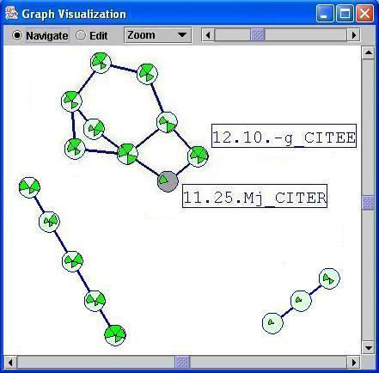
- An example citation graph.

The set of citer-citee relationships is usually embodied in a citation graph. For every citation, we have a directed edge connecting the citer to the citee. Figure 26 depicts part of a citation graph drawn using a modified version of the TouchGraph software [85]. The figure shows three disconnected components. In the larger component, a publication having a property 12.10.-g and another publication having a property 11.25.Mj are involved in a citation relationship where the latter publication cites the former (in the figure, citation relations go from lower to higher nodes).
- Data Representation
We utilize a path-based approach to represent graph data in tabular or relational format where we consider every path in the graph as a transaction. In the simplest version, we can limit ourselves to paths of length one which means that every edge will result in a single transaction. Such transactions contain information on both of their participating nodes. The corresponding ARM problem can then be phrased in terms of the relation that results from twice joining the relation containing the node data of the citation graph with the edge relation. If the frequency of a particular property is evaluated on this joined table, the result would differ from the frequency in the original relation containing only the node data. It is important to recognize that the concept of a frequent itemset will depend on the length of the path used as a transaction (recall that we can represent paths of length L as transactions instead of limiting ourselves to only edges of length one). Note that there is a lot of redundancy in the resulting relation since the information from a particular node will be repeated once for every incoming and outgoing edge. For example, suppose that each publication has n properties, P₁ to P_{n}, where each property value can be either 1 or 0 denoting the existence or absence of that property in the corresponding publication, respectively. Table 6 depicts the framework discussed in this section which we utilize to represent a citation graph as a table of transactions. The first half in this table would constitute the citee set and the second one the citer set. The first row shows a publication with visible properties P₁ and P₂ being cited by a publication with property P₂.
Citee
Citer
P₁
P₂
...
P_{n}
P₁
P₂
….…

P_{n}
….

1

….

0

0

1

0
1

….

0

….

0

0

0

0
1

….

1

….

1

1

1

1
0

….

0

….

0

1

0

1
0

- Framework for representing graph edges as transactions

As we shall describe later, we utilize a bitmap-based vertical model to represent the data shown in Table 6. Unlike [94], which also uses bitmaps to encode the existence or absence of properties, our model employs P-trees for the purpose of achieving bit-based compression and faster processing operations. Compression is exploited to help assuage problems when the number of edges in the graph (i.e. transactions in our model) grows enormously especially in cases where the data is sparse. The reader is referred to Chapter 3 for more details on how compression is achieved using P-trees.

In the context of macromolecule substructure discovery, [61] models paths in three-dimensional coordinate graphs, where nodes represent atoms and edges represent chemical bonds, as transactions similar to the way we model graph edges. Because macromolecules can have a large number of atoms, their corresponding graphs tend to have a massive number of paths represented as transactions which can clearly become infeasible. The authors also emphasize that the expected number of atoms in interesting patterns is at least five but is usually more than that. As a result, they propose an interesting and intuitive approach to reduce the large number of transactions by pruning all atom-pair interactions whose length (i.e. distance between the two interacting atoms) is above a certain user-defined threshold. They justify this step by the fact that the distance between two interacting atoms is inversely proportional to the strength of the chemical bond between them. In our case, the data represents citations and is limited to paths of length one (i.e. to edges only). The efficiency degradation resulting from the increase in the number of transactions can be circumvented by using compression as we empirically demonstrate in our experiments over large datasets. In cases where compression does not prove to be very effective, we suggest utilizing temporal constraints on the data by limiting the nodes in the graph, which represent publications, to those published between certain dates and ignoring all other nodes along with their incoming and outgoing edges. Other suggestions include limiting the edges in the graph only to those involving nodes relating to specific subjects of interest. Due to time and space limitations, this chapter does not attempt to analyze the effects of those suggestions; such analysis is to be considered in future extensions of our work.
- Rule “Interestingness” Measure
- On “Interestingness” Measures
A number of studies in the literature have analyzed the notion of interestingness in data mining. In general, interestingness measures of patterns can fall in one of two classes: objective measures and subjective measures [60] [80] [81]. Objective interestingness measures are data centric in the sense that they define the interestingness of a pattern in terms of the data used in the mining process. They also depend on the structure of the patterns. For example, the two most heavily used objective measures in ARM are support and confidence. Due to the many complexities arising in the pattern discovery process, objective measures usually discover a large number of patterns and thus fall short of their purpose especially when the notion of interestingness depends on additional factors such as the decision maker. A number of subjective measures have been proposed for the latter scenario. In general, subjective measures endeavor to generate a smaller, tailored set of patterns that is potentially more interesting and useful to the pattern examiner.
As discussed in [81], subjective measures depend on two main factors to discover patterns, namely, actionability and unexpectedness. Actionability states that a pattern is considered interesting to the examiner if it calls for action on his or her behalf. Unexpectedness focuses more on the surprising factor of the pattern with respect to the examiner; i.e., to what degree does the pattern surprise the examiner. In order for the unexpectedness factor to be integrated into a subjective measure, a system of beliefs [81] must be defined first. Such a system would define the standard knowledge expected by the examiner. The discovery process then captures all deviations from such standards as unexpected and thus as interesting to the examiner. In general terms, beliefs can be of two types: hard and soft. Hard beliefs represent knowledge that the examiner is not willing to change even in the light of newly discovered contradictory evidence; the validity of the discovered patterns and sometimes the original data are questioned instead. On the other hand, soft beliefs could be changed by the examiner when that is suggested by newly discovered patterns. A user-defined measure of strength, referred to as degree of belief, is usually associated with every belief in the system. A number of subjective interestingness measures for association rules are presented next.
[64] uses a probabilistic approach to discover unexpected rules in the form of “rule-pairs”. Their work is domain independent in that it requires no prior knowledge in the form of beliefs against which the unexpectedness factor is measured.
[52] proposes the use of synthetic comparison between rules and beliefs (which are also represented as rules) to arrive at interesting rules. A rule R is considered to be different from a belief B if R and B have similar consequents but very dissimilar antecedents or vice versa. In this context, their distance-based similarity is based on the synthetic structures of rules and beliefs.
[81] defines the interestingness of a pattern by the degree with which it “shakes” the belief system. Their work emphasizes the importance of rule actionability along with the complexity associated with formulating and integrating it into the discovery process. To alleviate this problem, they assume that most actionable rules are unexpected and use rule unexpectedness as the focal point in their interestingness measure. A number of approaches have been suggested to define the degrees of beliefs such as the frequency approach which is limited to beliefs in the form of rules and the conditional approach which can be applied to more general forms of beliefs and thus is chosen by the authors. Their work can be applied in dynamic environments where the data changes often thus affecting the degrees of beliefs and, consequently, the outcome of the interesting patterns.
[82] defines a subjective interestingness measure for the analysis of healthcare insurance claims. The main concern here is to find “deviations from the norms” which can call for corrective actions to reinstate them back to the standard. The actions are pre-defined by domain experts for each class of deviations which clearly is only feasible for very domain-specific applications.
[60] associates a degree with every belief in the system where beliefs are coded as rules. Degrees of beliefs are defined by the examiner and can be updated using a “revision procedure”. As in [81], they focus on the unexpectedness factor of interestingness and define a rule R to be unexpected with respect to a belief B if: (1) the antecedents of R and B are logically contradicting, and (2) the number of tuples intersecting R and B (i.e. the subset of tuples where the antecedents of R and B are both true) is “statistically” large. In order to arrive at the subset of interesting rules, the authors assume the validity of what they refer to as the “monotonicity of beliefs” which states that if a belief holds on some data with some degree then it must also hold on large subsets of that data.
- Intra- And Inter-Node Rules
To define our interestingness measure, we introduce the concept of inter- and intra-node rules. Intra-node rules relate properties within publications of the same category.

Definition 6.1: (Intra-Node Rule) An intra-node rule is a rule whose antecedent and consequent are properties drawn from either the citer or the citee set of publications but not from both simultaneously, support is greater than the minimum support threshold, and confidence is greater than the minimum confidence threshold.

In general, intra-node rules could be derived without knowledge of the graph. Those rules would, however, differ from rules that are derived in the path-based setting described previously, namely, inter-node rules.
Inter-node rules depend fundamentally on the knowledge derived from the graph structure. Here, a rule might have its antecedent drawn from the citer set, while, its consequent from the citee and vice versa. Different formats of rules could be derived in this manner, but we limit ourselves to only one form in which the antecedent is drawn from the citee while the consequent is drawn from the citer. As we discuss later, this format of rules can give insights into research publication trends by associating properties of publications written at different points in time.

Definition 6.2: (Inter-Node Rule) An inter-node rule is a rule whose antecedent is drawn from the citee set of publications, consequent is drawn from the citer set of publications, support is greater than the minimum support threshold, and confidence is greater than the confidence of the corresponding intra-node rule (which is defined next).

Definition 6.3: (Corresponding Intra-Node Rule) The corresponding intra-node rule of an inter-node rule is a “potential” rule having the same antecedent as the inter-node rule (drawn from the citee set of publications), a consequent whose properties are the same as those in the consequent of the inter-node rule but drawn from the citee set of publications, and a confidence greater than the minimum confidence threshold.

Rules could simply be derived by using the minimum support and confidence thresholds; however, since it is very difficult to estimate a minimum threshold for confidence that would yield interesting rules, we consider an inter-node R to be of interest if there exists a corresponding intra-node rule, R’, such that the confidence of R is larger than or equal to confidence of R’. As described in Definition 6.3, R’ has the same antecedent as R (drawn for the citee set of publications) along with a consequent having the same properties drawn from the citer set of publications for R and from the citee set of publications for R’. Note that in Definition 6.3 we say that a corresponding intra-node rule is a “potential” rule to emphasize that we are not interested in its support; we just use its confidence – which should be greater than the minimum specified threshold – for testing the inter-node rule at hand. As an example, consider an inter-node rule, R: Citee_Prop₁ → Citer_Prop₆, Citer_Prop₉. This rule associates property 1 from the citee set with the combination of properties 6 and 9 from the citer set. The corresponding intra-node rule, R’, would then be Citee_Prop₁ → Citee_Prop₆, Citee_Prop₉. This kind of information tells us that inter-node properties are exhibiting associations stronger than corresponding intra-node ones which deserves attention. As a result, the reader is advised that the notion of the constant ubiquitously-known confidence threshold is not directly utilized in our work; we substitute it with a tailored form derived for each rule dynamically and separately from the confidence of the corresponding intra-node rule.
To a domain expert in the publications field, we expect most of the rules to be semantically interpretable; however, surprises may arise. We consider those as a form of unexpected knowledge that could be potentially interesting. From a data-mining perspective, inter-node rules provide valuable knowledge embodied in associations between earlier work represented by citee properties and later work represented by the citer properties. Given a subject S of interest, the derived associations can be used to show S’s future subject extensions (i.e. what subjects have directly or indirectly extended from S). This is could be done by matching S against the antecedents of the rules and viewing the subjects in the consequents as extensions of S. A rule such as R: Subject_X_Citee → Subject_Y_Citer says that a considerable number of publications with subject matter Y cite publications with subject matter X which could indicate that Y has extended of X. A more concrete example would be a rule stating that subject “databases” implies subject “data mining” since the latter is an extension of or a development from the former.
Another use of such associations is highlighting the evolution of subjects which can be viewed as the opposite of the first use. By matching a subject of interest, S, against the consequents of the rules, we can view the subjects in the antecedents as the original subjects from where S extended or derived. The rationale for this is that publications, written later in time, usually, follow the trend of citing the original and seminal publications that started a certain research direction. As an example, almost all work on “association rule mining” usually cites Agrawal’s et al. original ARM work [1] [2] implying that their application areas could be viewed as extensions of the market basket research (MBR) model. This is particularly true for this chapter where we model citation graph data as MBR transactions to enable the application of ARM; as a result, we can view MBR as an original subject which we (and many others) have extended.
A third use can be to predict the “potential” impact that current publications might have on future publications. We do realize that this last use might not be applicable all the time; nevertheless, it might provide valuable knowledge when it does apply. For example, a rule such as R: Subject_X_Citee → Subject_Y_Citer, Subject_Z_Citer might tell us that having a set of publications, S, involving subject matter X implies that future publications involving subject matters Y and Z might cite S with a certain support (R’s support) and confidence. Looking at the same issue from a different angle, using inter-node rules such as R may help us in determining what future publication subject matters might get affected by current publication subject matters. For example, from R, we can conclude that it is probable for current publications with subject matters X to be cited by future publications with subject matters Y and Z; thus, we can say that subject matter X will have an effect on subject matters Y and Z. Notice that, from this last observation, we might also be able to gain more insight on future subjects given current ones. In short, we envision the usefulness of such inter-node rules as they present associations between the properties of two sets of publications written at different points in time (the citee set and the citer set) that are more confident than similar associations between properties of the same set of publications.
As we have established thus far, we are primarily interested in associations among properties of citee publications and citer publications that are stronger than similar associations among properties drawn from citee publications alone. In a sense, our work is similar to [64] in that we too discover specific pairs of rules, where each pair is composed of an inter-node rule along with its corresponding intra-node rule, and use the conditional probability of those rules to decide upon the interestingness of the inter-node rule. Another similarity with [64] is that we do not utilize a user-define system of beliefs like other work on subjective interestingness measures such as [52] [60] [81] and [82]; the corresponding intra-node rules are used to set the norms. Any inter-node rule that deviates from this norm by having a confidence greater than the confidence of its corresponding intra-node rule is unexpected and thus interesting. The rationale for this is based on our belief that, in general, one usually expects intra-node properties to exhibit the strongest associations because their nodes play the same role in the graph which happens to be the citee role in this work as we are only focusing on citee intra-node rules. If we consider for a moment the derived relation resulting from our data representation, we can quickly realize that in order for an intra-node rule to a have a high confidence value, the subjects participating in the rule consequent must exist together with those in the antecedent part quite often; for that to happen, those subjects must coexist together in the same publications. In view of the fact that we are more interested in understanding subject matter evolution, extension and potential predictivity, the temporal element plays a crucial role in our notion of interestingness which coexisting subject matters simply do not satisfy. As a result, we view inter-node rules that are not stronger than their corresponding intra-node rules as non-interesting.
In order for a statistically large number of publications P_{Citer} with a certain subject matter S_{Citer} to cite a set of publications P_{Citee} involving a subject matter S_{Citee} where S_{Citer} is not prominently spread in P_{Citee}, S_{Citer,} in its current form, ought to be rather newer than S_{Citee} which explains its scarcity in P_{Citee}. For example, a large number of publications on “data mining” cite the “machine learning” literature which is an older subject matter forming one of the roots of “data mining”. Inter-node associations adhering to this justification can clearly highlight subject evolution as well as future extensions as discussed previously.
Sometimes, S_{Citee} and S_{Citer} could be disciplinary unrelated subjects and associations can be of interdisciplinary value. An example would be the “Nash Equilibrium” work that the well-known Dr. John Nash did at Princeton University in area of game theory in 1950 which awarded him the Nobel Prize in economics in 1994. Almost all economics literature on equilibrium cites Nash’s work or its extensions even though economics and game theory are disciplinary unrelated fields of research.
Another scenario could occur when S_{Citer} is older than S_{Citee} but became a “hot” research subject only after the introduction of S_{Citee}. In the event that this is true, a justification for the observed citation phenomenon could be that research in S_{Citee} has lead to important advancements or findings with high applicability to S_{Citer}. Biological research started way before the introduction of computers; however, due to the advancements in the fields of data mining and machine learning, a large number of publications on biology, especially those focusing on the “in-silico” analysis (i.e. through the use of computers) of biological data [67], cite the newer data mining and machine learning literatures.
The above discussion elucidates that our subjective interestingness measure discovers unexpected rules capable of highlighting subject matter extensions and evolution which also could give insights on the potential effects of current research on future research where applicable. We focus largely on the unexpectedness factor of interestingness simply because, at this stage, we are interested in understanding the semantics embedded in citation graphs. This is in direct comparison with [81] which also limits the definition of interestingness to the unexpectedness factor but only because the actionability factor is hard to formulate and integrate into the discovery process as suggested.
- Mining Citation Graph Mining Data
The P-tree-based ARM algorithm devised for this work is a variant of the one we have presented in Chapter 4. It has been used to analyze a subset of the dataset available for the KDD Cup 2003 competition [43], a knowledge discovery and data mining competition held in conjunction with the ninth annual ACM SIGKDD Conference. The subset of data under consideration deals with citation graphs and publication subject matters represented by PACS numbers (Physics and Astronomy Classification Scheme).
PACS numbers are numbers used to represent subject matters of publications in the Physics domain. The total number of PACS numbers available in the given dataset is 828. We have 828 citee PACS numbers and 828 citer PACS numbers amounting to a total of 1656 attributes or columns used in the derived table. We have used item indexes 1 to 828 for citee attributes and 829 to 1656 for citer properties.
The total number of transactions (i.e. edges) considered is 1448 out of a possible 352,807 edges in the original dataset. The reason for this reduction is that we have selected only the subset of publications participating in the citation graph (i.e. nodes in it) and having PACS numbers. Each transaction records the item indexes of the PACS numbers existing in its participating nodes. The same file could also be represented in binary where attribute values record the existence or absence of the corresponding PACS number in the participating nodes of every edge. In our case, we utilize the latter format to help expedite the process of creating P-trees.
After representing the data vertically using P-trees, we divide the ARM task into four steps, the first two of which are done in parallel. First, we mine all frequent itemsets from the citee part of the dataset. Those itemsets satisfy the minimum specified support threshold, minsupp (i.e. have support greater that or equal to minsupp). Second, we mine all frequent itemsets from the citer part. Each of those two sets of frequent itemsets is mined using the vertical ARM algorithm that was introduced in Chapter 4 (depicted in Figure 9).

Algorithm: Graph-based ARM

Input: Citee part of D, citee ordered list of items, citer part of D, citer ordered list of items, minsupp, minconf
Output: All inter-node, intra-node combinations such that the confidence(inter-node) >= confidence(intra-node) >= miniconf and support(inter-node) >= minsupp
Method:
1:// Mine frequent itemsets from the citee part using the “Optimized ARM” algorithm depicted in Figure 9 in Chapter 4
2:F₁:= “Optimized ARM”(citee part of D, citee ordered list of items, minsupp)
3:// Mine frequent itemsets from the citer part using the “Optimized ARM” algorithm depicted in Figure 9 in Chapter 4
4:F₂:= “Optimized ARM”(citer part of D, citer ordered list of items, minsupp)
5:// Join F₁ and F₂ to produce all frequent itemsets using the “JOIN” algorithm depicted in Figure 28 in this chapter
6:F:= “Join”(F₁,F₂, minsupp)
7:// Mine inter-node rules using the “Inter-node Rule Mining” algorithm depicted in Figure 29 in this chapter
8:RULES:= “Inter-node Rule Mining”(F, minconf)

- An proposed graph-base ARM.

Note that representing data in P-tree format has the advantage of speeding up the frequent itemset-mining process because, after creating the P-trees which could be done offline, no database scans are ever needed [24] [62], just logical operations on compressed bitmaps. To get the support of an itemset containing items X and Y, all we have to do is to AND P_{X} and P_{Y} and issue a ROOTCOUNT operation on the resulting tree (cheaper than a database scan [24] [62]). Additionally, as in [78], we take advantage of our vertical data representation to utilize memory efficiently by only materializing the P-trees related to the part of the dataset we are dealing with. Even while mining each part separately, all P-trees for non-frequent itemsets are unloaded from memory as they will not be of any use later on, resulting in better overall memory utilization. In addition, the two steps we have described so far are independent thus giving us the ability to perform them asynchronously (i.e. they could be done in parallel [78]) resulting in more execution-time gains. The formal description of the algorithm is depicted in Figure 27.
After mining all the frequent itemsets in both parts of the dataset, we perform a join step on the results. The reason for this is the format of the desired inter-node rules; each rule must have its antecedent drawn from the citee part while its consequent from the citer part. By definition, the support of the rule must be greater than or equal to minsupp (i.e. the support of the union of the antecedent and consequent must be greater than or equal to minsupp and so must be the support of each considered separately). Thus, instead of mining all frequent itemsets across all of the dataset which could result in an exponential increase in the number of itemsets that must be generated and tested (because of doubling the item space) and then pruning all itemsets that do not contain items from both parts of the dataset, we perform a divide-and-conquer approach by mining, in parallel, each part separately. Figure 28 shows the logic for the join algorithm.

Algorithm: Join

Input: D, frequent itemsets F₁, frequent itemsets F₂, minsupp
Output: Set of all frequent itemsets with respect to D and minsupp
Method:
1:if empty(F1) or empty(F2)
2:return
3:end if
4:F:= {}
5:// Join all frequent itemsets
6:for all i Є F₁ do
7:// Size of taboo list of i is equal to size(F)
8:if (size(i)==1)
9:TL_{i}:= (0, size(F))
10:else
11:for all k subsets of i: size(k)=size(i)-1 do
12:TL_{i}:= TL_{i} OR TL_{k}
13:end for
14:for all j Є F₂ do
15:// Check to see if the support test is needed
16:if (TL_{i}[position of j]==0)
17:if support(i U j) >= minsupp
18:F:= F U {i U j}
19:else
20:for all k Є F₂: j is a subset of k do
21:// Insert k into i's taboo list so as not to join it with i
22:TL_{i}[position of k]:=1
23:end for
20:end if
21:end for
22:end for

- The join algorithm.

The join step is modeled after our initially proposed vertical ARM algorithm in Chapter 4 and takes advantage of the downward closure property of support with respect to itemset size by utilizing taboo lists. We initialize the set of joined frequent itemsets to be empty at first (line 4) and then insert in it all frequent itemsets that result from joining every frequent itemsets in one of the joined sets with all frequent itemsets in the other set using taboo lists to reduce the itemset space similar to what we have done previously. Note that here, in addition to providing the two sets of frequent itemsets as input, the algorithm expects the final set of index lists for each of the two joined sets – even though this is not explicitly stated in the algorithm – in order to be able to use taboo lists.
In comparison with the way we have used utilized taboo lists so far, the join step uses a taboo list for every frequent itemset in one of the set of frequent items being joined. This has not been case previously because we used one taboo list for every item only (or frequent 1-itemset) and not for every frequent itemset.
Another difference is that here, taboo lists are fixed in size and do not grow as has been the case so far. The reason for this lies in the way we are joining the two sets of frequent sets; we are taking one frequent itemset from one of the sets, F₁, and joining it with all frequent itemsets in the other set, F₂. The size of the taboo list for each frequent itemset in F₁ is equal to the size of frequent itemsets in F₂. Consequently, in the join step, it is much easier to use P-trees to represent taboo lists and index lists as they are static.
A third difference is that the join algorithm, in its current form, utilizes the downward closure property of support only partially because whatever we do for frequent k-itemsets is not reflected on the frequent (k+1)-itemsets being joined. We could alleviate this problem simply by maintaining the taboo lists of all frequent k-itemsets being joined throughout the join phase. Recall that the taboo lists are initialized to contain all zeros at first. This would still hold for frequent 1-itemsets; however, for frequent k-itemsets for k>1, we initialize their taboo lists to be the ORing of the taboo lists of all of their frequent (k-1)-itemsets subsets. This ensures that all itemsets I₁, in one part of the dataset, whose join has failed with any itemset I₂, from the second part of the dataset, are not joined with any supersets of I₂ because supersets of I₂ will get a copy of I₂’s taboo list. In essence, this can be viewed as a space versus time issue. Storing all taboo lists for the whole duration of the join step will surely save more time because it ensures 100% utilization of the downward closure property of support; meanwhile, not doing so would save memory space at the expense of time. In our experiments, we show that by using the latter approach only, the time savings are already significant.
At this point, we have all frequent itemsets containing both citee and citer parts. Each itemset produces only one rule because all of its citee items should reside in the antecedent while the citer items in the consequent. As a result, producing rules is fast and requires almost no processing (i.e. no enumeration of the different rules that could be derived from an itemset) other than the confidence test.

Algorithm: Inter-node Rule Mining

Input: Frequent itemsets F, minconf
Output: All inter-node, intra-node combinations such that the confidence(inter-node) >= confidence(intra-node) >= miniconf
Method:
1:for all {i U j} Є F: i is from citee and j is from citer do
2:R:= i➔j
3:// Set R’ to be the corresponding rule of R
4:R’:= i➔j’
5:if confidence(R)>= confidence(R’) >= minconf
6:RULES:= RULES U (R, confidence(R), R’)
7:end if
8:end for

- Inter-node rule mining.
The fourth and last step is to produce the inter-node rules. To do that, we have to compare the confidence of every inter-node rule with the confidence of its corresponding intra-node rule (which in turn must satisfy minconf) and mark all the inter-node rules that match this criterion. As mentioned previously, we do not care for the support of the corresponding intra-node rules; we just use their confidence for testing purposes. Figure 29 depicts the process of mining inter-node rules from frequent itemsets.
As before, computing the confidence of a rule is rather straight forward because of P-trees; the confidence of a rule is equal to the ROOTCOUNT of the P-tree representing the itemset in the rule antecedent union the rule consequent divided by the ROOTCOUNT of the P-tree representing the antecedent. Each such inter-node rule provides us with valuable information as it associates subject matters of publications written at different points in time.
- Performance Analysis
To the best of our knowledge, there exist no benchmarks or previous work attempting to discover similar rules from citation graphs as we are doing here. To give the reader a clearer view of the efficiency of the proposed approach, we have developed an implementation for the work suggested herein using P-trees (called PARM) and compared its performance with the fast implementations of the four contemporary association rule mining approaches which we have used in our experimental analysis in Chapter 4, namely, FP GROWTH (FPG), APRIORI, Depth-First APRIORI (DFA), and ECLAT. In addition, in order to understand the effectiveness of the proposed divide-and-conquer parallelized methodology, we also compare with our ARM approach proposed in Chapter 4 (called WHOLE-PARM) which we describe herein as holistic in the sense that it performs ARM over the whole dataset. To recapitulate, PARM divides the problem of mining frequent itemsets into two smaller and independent steps which are then carried out in parallel and joined later on while WHOLE-PARM performs this step over the whole dataset just like the rest of the approaches we are comparing with.
All implementations used herein are coded in C++ and executed on an Intel Pentium-4 2.4GHz processor workstation with 2GB RAM running Debian Linux. In all experiments, we focus on mining all the frequent itemsets only by varying the minimum support threshold.

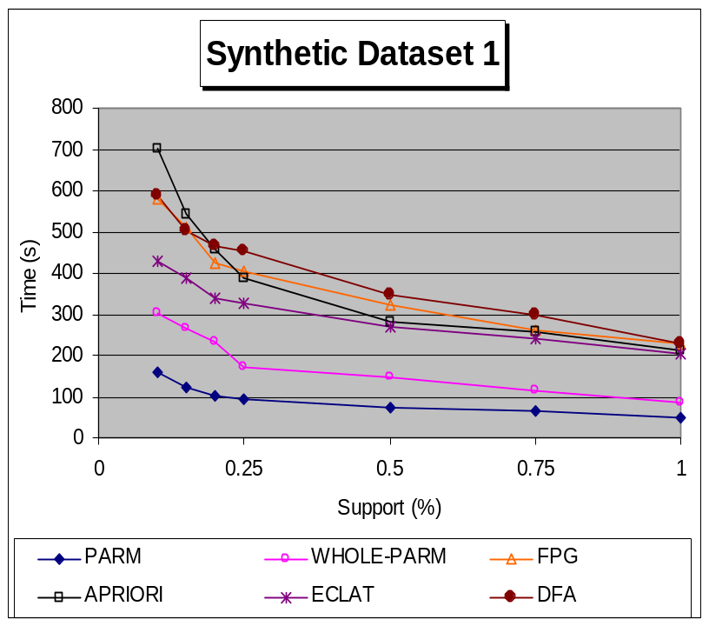
- Performance analysis results over “Synthetic Dataset 1”.

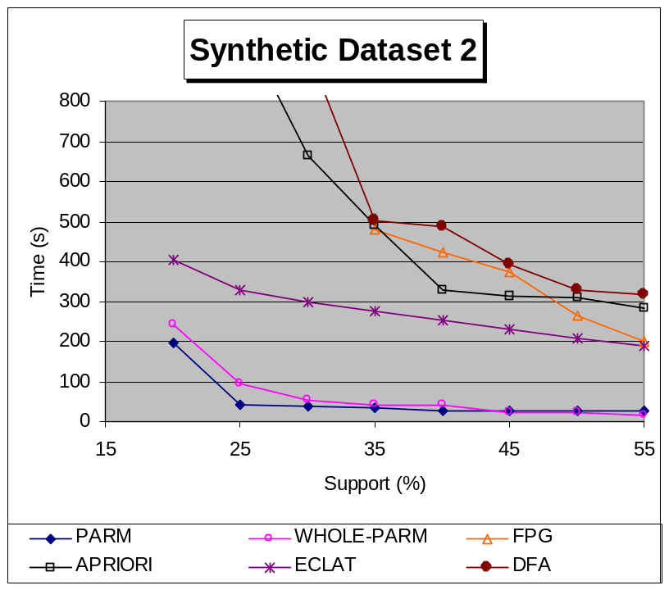
- Performance analysis results over “Synthetic Dataset 2”.

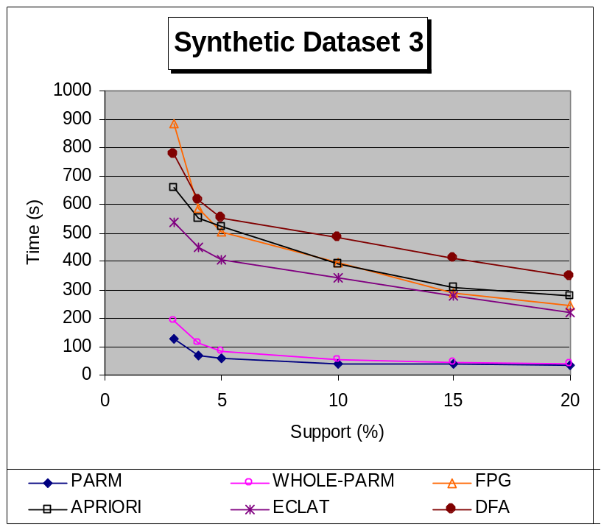

- Performance analysis results over “Synthetic Dataset 3”.

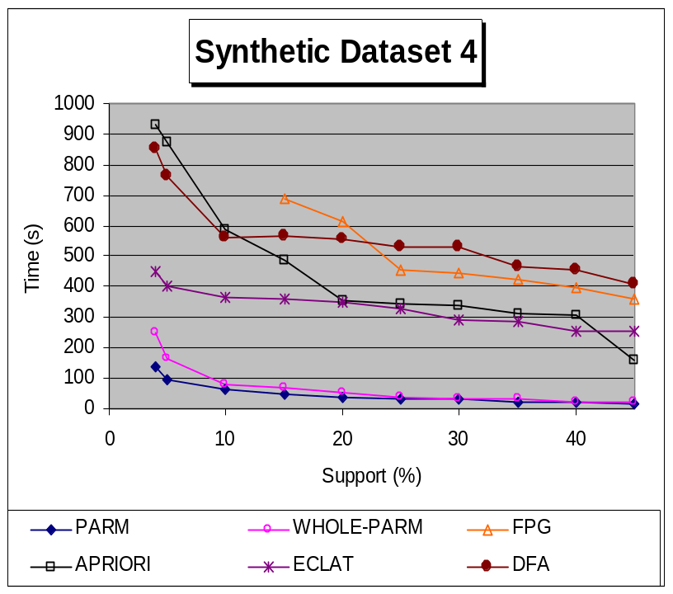

- Performance analysis results over “Synthetic Dataset 4”.

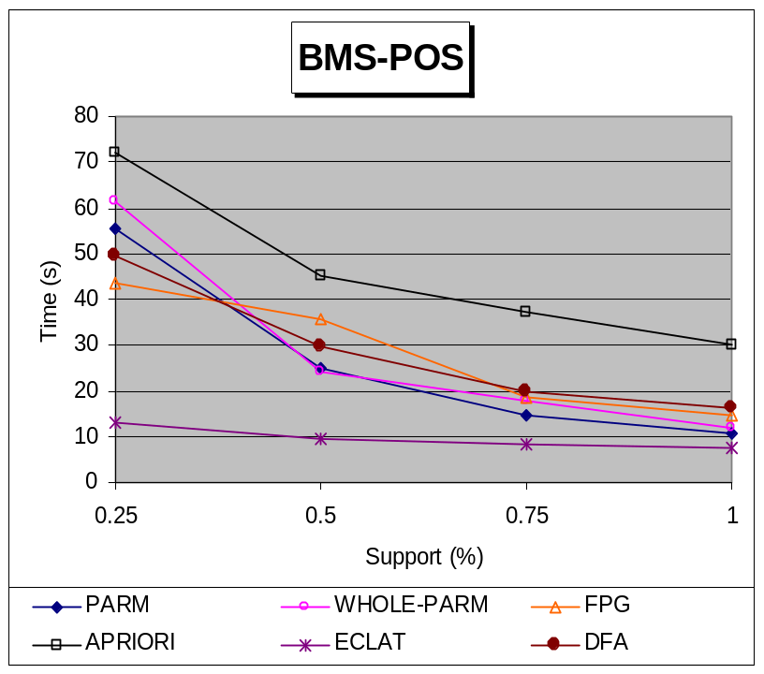

- Performance analysis results over “BMS-POS”.

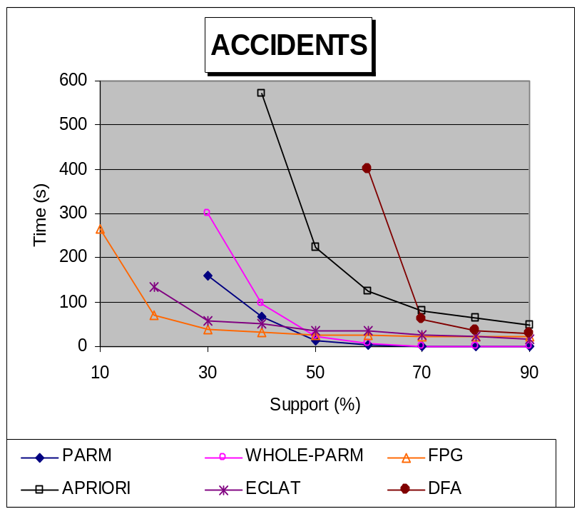

- Performance analysis results over “Accidents”.

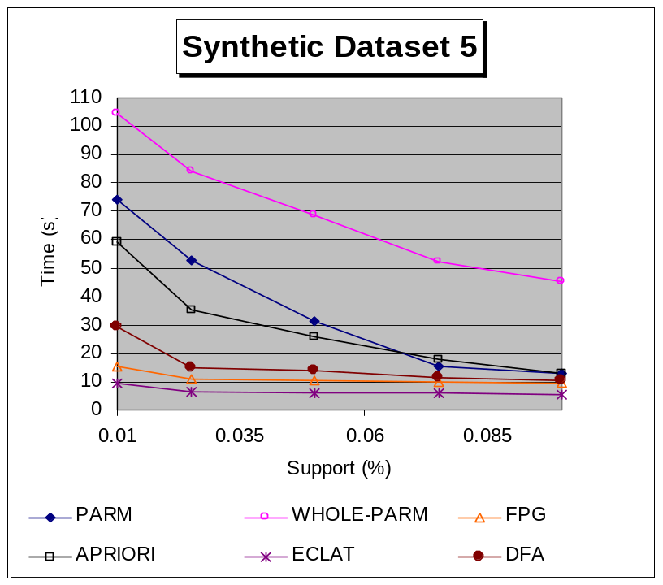

- Performance analysis results over “Synthetic Dataset 5”.

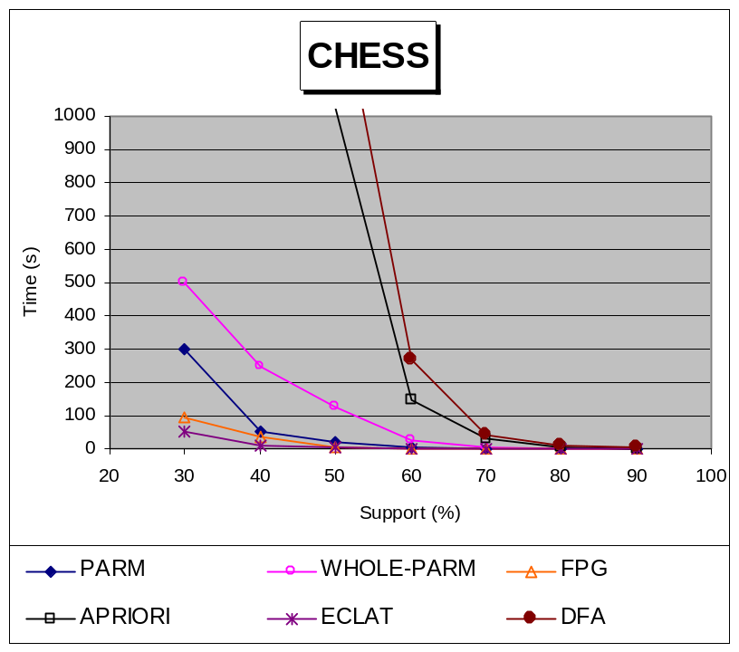

- Performance analysis results over “Chess”.

The focal point in this experiment is to illuminate the effectiveness of the proposed approach in comparison with other approaches that are capable of producing the same output. As a result, we focus mainly on the performance of the mining the frequent itemsets utilizing our parallel divide-and-conquer methodology. In addition to using the implementations from Chapter 4, we also follow the same formal experimental design methodology, namely the 2^{k} factorial experimental design, proposed in Chapter 4 and experiment on the same design points. For PARM, we have divided the number of items in half and assumed one portion to contain the first half of the items and the second half to contain the second half. We assume parallel processing, so we only include the time needed to mine the frequent itemsets from the more time-demanding portion in addition to the cost of joining the results (we are only computing the time to mine all frequent itemsets without rule production).
Figure 30 through Figure 37 show performance results for the all approaches at various support thresholds on the given design points each represented by a corresponding dataset. Results are very consistent with those presented in Chapter 4; the two P-tree-based approaches (i.e. PARM and WHOLE-PARM) demonstrate better results than all included contemporary approaches over all large datasets but somehow poorer results on the smaller datasets. As a result, no further comparison analysis with the contemporary approaches is given here; we now focus on comparing PARM with WHOLE-PARM.
Even though it is evident in the comparison analysis figures that PARM and WHOLE-PARM exhibit highly similar performance characteristics, the execution-time curves for PARM are always below those of WHOLE-PARM suggesting that the former always requires less time to finish that the latter. This is comes at no surprise – and is in fact an expected result – because PARM simply divides the first step in WHOLE-PARM into two independent portions that it performs in parallel; thus, only the time for the more time-consuming portion, in addition to the join, is included in the execution time of PARM. In certain situations where any of the two mined portions produces no frequent itemsets (finding no frequent 1-itemsets is enough), we get the benefit of being able to terminate the execution early on without the need of continuing the mining of the second portion (and surely without doing any join). Holistic approaches such as WHOLE-PARM would not be able to make this decision until after having performed ARM over all the dataset and discovered that there are no frequent itemsets containing items from both portions of the dataset. In addition to the parallel processing, PARM introduces another advantage over WHOLE-PARM by using only static data structures (taboo lists and index lists) in its join step unlike WHOLE-PARM which utilizes dynamic structures that continuously need to be resized throughout the ARM process.
We now turn our attention exclusively to analyzing the gap in the execution time between PARM and WHOLE-PARM on the selected design points. Optimally, the best performance attained by PARM would be achieved when the division of the first step is done in such a way that both resulting portions require approximately the same amount of execution time; i.e. the time to mine the frequent itemsets in each portion is approximately the same, and, as a result, the number of frequent itemsets is approximately the same since the latter is directly proportional to (and in fact controls the) former. In this case, the portion requiring the most time is in fact minimal. Any division other than that is not optimal. If we take the extreme case where the frequent itemsets reside in one portion then PARM simply reduces to exactly WHOLE-PARM.
From the above discussion, we conclude that it is highly probable for the datasets over which there exists a small gap in the execution time between PARM and WHOLE-PARM to have been divided in such a skewed way that most of the frequent itemsets have fallen in one portion; as result, the performance of PARM has approached that of WHOLE-PARM. This could be assumed to hold over datasets “Synthetic Dataset 2”, “Synthetic Dataset 3”, “BMS-POS” and “Synthetic Dataset 4”where the difference in execution time between PARM and WHOLE-PARM is not very significant unlike datasets “Synthetic Dataset 1”, “Synthetic Dataset 4” and “Accidents” where PARM reduces the execution time into around half that of WHOLE-PARM. Another justification could be related to the fact that WHOLE-PARM fully utilizes the downward closure of support property while the current implementation of PARM only partially utilizes this property in the join step (but fully in the two initial steps performed in parallel). Dataset “Chess” shows large time savings for PARM (about 200 seconds); however, relatively speaking, the required execution time of PARM is still more than half of what is required by WHOLE-PARM.
- Result Analysis
We have run our algorithm several times on the dataset described in Section 6.6 using different support threshold values and noting the impact on the number of produced intra- and inter-node rules. Minconf has been set to zero. Figure 38 depicts a graphical representation of the number of intra- and inter-node rules produced versus the support value chosen. The figure also depicts a table showing the exact measures in both cases.

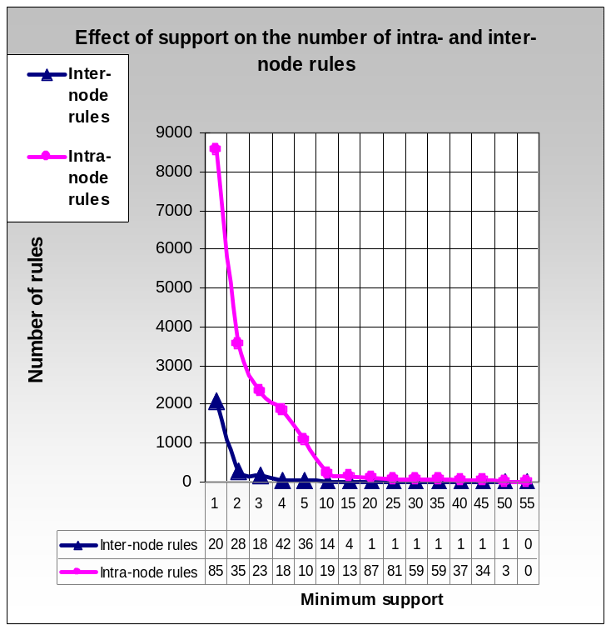
- Effect of support on the number of intra- and inter-node rules.

Although the number of intra-node rules is, in most cases, larger than that of the inter-node rules, it is interesting that whenever we have intra-node rules, at least one inter-node rule shows. Another noteworthy observation is that, in the absolute support range of [20, 50], only one inter-node rules shows.
The rule is 11.30.Pb_CITEE → 11.30.Er_CITER,11.27. + d_CITER (conf>=0.294798,supp=94/1448); it associates the 11.20.Pb citee PACS number with the 11.30.Er and 11.27.+d citer PACS numbers with a confidence of approximately 29.5% and a support of 6.5%. This rule has the highest support among all inter-node rules produced by our ARM algorithm. Note that no rule, neither intra-node nor inter-node, is produced when the absolute support exceeds 55.
Confidence values for inter-node rules fluctuate between 0.004 and 1 (i.e. from 0.4% to 100%). The following rule has a confidence of 100% and is worth mentioning: 11.20.Dj_2_CITEE → 03.65.Db_2_CITER, 03.80.+r_2_CITER (conf=100%, supp=0.35%).
Support =20/1448 to Support =50/1448 (~1.38% to 3.45%)

11.30.Pb_CITEE->11.30.Er_CITER,11.27.+d_CITER (conf>=0.294798,supp=94/1448)
Support =15/1448 (~1%)

11.30.Rd_CITEE--> 12.39.Fe_CITER,12.38.Lg_CITER
(conf>=0.25,supp=15/1448)

12.38.Lg_CITEE-->11.30.Rd_CITER,12.39.Fe_CITER (conf>=0.267857supp=16/1448)

12.10.-g_CITEE-->04.50.+h_CITER,11.25.Mj_CITER (conf>=0.475,supp=20/1448)

11.30.Pb_CITEE-->11.30.Er_CITER,11.27.+d_CITER (conf>=0.294798,supp=94/1448)

- Subset of the set of rules generated using different supported values.

Support =20/1448 to Support =50/1448 (~1.38% to 3.45%)

“Supersymmetry”-->”Charge conjugation, parity, time reversal, and other discrete symmetries”, “Extended classical solutions; cosmic strings, domain walls, texture” (conf=>0.294798,supp=51/1448)

Support =15/1448 (~1%)

“Chiral symmetries” --> “Chiral Lagrangians”, “Other nonperturbative calculations” (conf=>0.25, supp=15/1448)

“Other nonperturbative calculations”--> “Chiral symmetries”, “Chiral Lagrangians” (conf=>0.267857, supp=15/1448)

“Unified field theories and models” -->”Gravity in more than four dimensions, Kaluza-Klein theory, unified field theories; alternative theories of gravity”, “Compactification and four-dimensional models” (conf=>0.475, supp=19/1448)

“Supersymmetry”-->”Charge conjugation, parity, time reversal, and other discrete symmetries”, “Extended classical solutions; cosmic strings, domain walls, texture” (conf=>0.294798, supp=51/1448)

- Rules after replacing PACS numbers with their definitions.

Figure 39 shows some of the inter-rules that we have produced at different support values. We include them herein for completeness. PACS numbers drawn from the citee set of publications and the citer set of publications are appended by _CITEE and _CITER, respectively.
In order to understand the semantics of the produced rules, we have consulted the description of the PACS numbers available at American Institute of Physics (AIP) [5]. This description associates every PACS number with its corresponding subject matter. For example, the rule the following inter-node rule:
11.30.Rd_CITEE→12.39.Fe_CITER, 12.38.Lg_CITER (conf>=0.25, supp=15/1448), can now be equivalently rewritten as:
“Chiral symmetries” --> “Chiral Lagrangians”, “Other nonperturbative calculations” (conf=>0.25, supp=15/1448).
According to our analysis, subject matter “Chiral symmetries” has an impact on subject matters “Chiral Lagrangians” and “Other nonperturbative calculations”, where the latter subject matters have extended somehow from the former. Figure 40 lists rules from Figure 39 with the PACS numbers replaced by their semantic equivalents from AIP.
With the assistance of experts in Physics, we have been able to analyze and evaluate some of the discovered rules. One of the observations we have found is that most of the rules have older and more general antecedents (citee part) than consequents (citer part) possibly indicating that physics researchers tend to cite the entire history of development of a subject matter, going back several decades if necessary, thereby, connoting that older and more general subjects are more likely to be cited more often with time. It is clear that old and general subject matters form the ground for most research subject matters that come later thus supporting our claims regarding the ability of the discovered rules to highlight subject matter extensions and evolution over time. For example, in the rule "Supersymmetry" →"Charge conjugation, parity, time reversal, and other discrete symmetries", "Extended classical solutions; cosmic strings, domain walls, texture", the antecedent is very fundamental, general, and rather old, and, indeed, all the consequent subject matters can be viewed as extensions from it.
Some of the rules require further investigation; however, for the most part, it could be confirmed that, in fact, consequent subject matters of the rules have extended, in some form, from antecedent subject matters. For example, the rule “Chiral symmetries” --> “Chiral Lagrangians”, “Other nonperturbative calculations” holds as it is known that, in general, symmetries are fundamental properties of a system and Lagrangians are used to calculate system behavior based on its symmetries making them a valid extension. In other words, symmetries form the theory which has been extended by the application of predicting behavior, namely, Lagrangians. In addition, Lagrangians is one type of non-perturbative calculations which explains the remaining part of the rule.
In addition, forming chains of rules by matching the antecedent of one rule with the consequent of another, could enable us to look many hops backwards in subject evolution (or forward in subject extensions) and to understand how subjects form and what their future impacts are. Thus, albeit we have focused so far only on direct citations by limiting ourselves to the use of single-edge paths as the transactions in our data model, we still have the potential capability of gaining deeper insights on subject evolution and extensions, and future impacts by forming rule chains. This aspects still requires further investigation. All of these observations fit, to a large extent, our motivation for the format of the desired rules, subjective notion of interestingness, and claims regarding their usability.
- Conclusion
We have proposed an efficient vertical association rule mining model for representing citation graph data and generating rules capable of associating research subjects of publications written at different points in time. Patterns of interest could reveal the original subject matters from which other subject matters of interest might have been extended later in time, the evolution of subject matters, and the potential effects of current research on future research. We hope to have initiated a novel research direction which will lead to better understanding of how we ought to understand citation graph data.
In our citation data analysis, we have exploited the time factor embedded in the directionality of the edges in the citation graph in an efficient manner. An edge from node X to node in Y in a citation graph implies that publication X cites publication Y and, more importantly, that Y was written before X (ignoring factors such as “preprints” and “self-citations”). The time factor is perhaps one of the main reasons we have restricted our analysis to citation graph data; nevertheless, we believe our techniques could be generalized to other application domains.
A future direction in this area would be to analyze different types of directed graphs with the aim of exploiting factors other than the time factor. We plan to study the efficacy of the previously suggested temporal and subject constraints in reducing the number of considered graph edges by focusing only on the nodes (along with their incoming or outgoing edges) satisfying a given set of constraints. In addition, we would like to analyze the usefulness of the concepts presented herein when applied to other potential domains such citation mining and web-structure mining.
We have been able to extend the efficient vertical ARM model proposed in Chapter 4 to handle situations where one is interested in a specific rule format (in our case, the format is to have citee subjects in the antecedent and citer subjects in the consequent of all produced rules). Those rules have the potential capability of elucidating temporal aspects in publication trends as embedded in citation graphs by identifying specific patterns in the subjects of scientific publications. Carefully-designed experiments have shown clear and decisive enhancements of the divide-and-conquer parallel extension over the original holistic vertical ARM model of Chapter 4. Additionally, the experiments have shown large time improvements for our approach when compared to other optimized implementations for cotemporary approaches especially on very large datasets.

CHAPTER 7: INCREMENTAL INTERACTIVE MINING OF CONSTRAINED ASSOCIATION RULES FROM BIOLOGICAL ANNOTATION DATA WITH NOMINAL FEATURES

- Introduction
Data arising from genomic and proteomic experiments is amassing at high speeds resulting in the accumulation of huge amounts of raw data; consequently, the need for analyzing such biological data – the understanding of which is still lagging way behind – has been prominently solicited in the post-genomic era we are currently witnessing. During the past decade, data mining has emerged as a new research area bringing together researchers from various disciplinary fields with a prime emphasis on the need to extract important and interesting knowledge from vast amounts of accumulated data. Because of the overlap in aims, recent “in-silico” studies have revealed bioinformatics as a great potential application area for data mining.
In this chapter, we attempt to analyze annotated genome data by applying a very central data-mining technique known as association rule mining with the aim of discovering rules capable of yielding deeper insights into this type of data. In the literature, association rule mining has been noted for producing a large number of rules which could be highly overwhelming for biological researchers. We propose a new technique capable of using domain knowledge in the form of queries in order to efficiently mine only the subset of the associations that are of interest to researcher in an incremental and interactive mode.
Understanding biological data and unraveling hidden patterns in it pose many challenges for biological community and require intelligent data-mining and analysis techniques. Of highest prominence for data analysis of biological systems are the following considerations: (1) understanding the complexity and the nature of processes involved in generating biological data, (2) highlighting the fuzziness characteristic and intractability of biological data, and (3) removing partiality and fallacy in data along with reducing the effects of noise and creeping errors.
From its dawn, data mining has attempted to unravel valuable knowledge embedded in huge amounts of data. Its achievements in numerous applications have shown potential success in a very large number of domain areas including bioinformatics. The target of the work presented herein fits the description of the second and third important consideration for biological data analysis (i.e. (2) and (3) above); in particular, we utilize ARM to help highlight the intractability of biological data by interactively studying the associations among the feature values used to describe the genes or proteins under study. The derived rules can also be used to detect annotation errors.
Each feature can be seen as a multi-valued attribute of nominal nature; i.e., it can take a number of different discrete values which are usually unordered. For example, the gene-function feature is coded in discrete values describing the function of the corresponding genes such as “amino acid metabolism”, “biosynthesis of serine”, or “fermentation”. Note that continuous features can always be discretized and processed in a similar manner.
A number of studies in the literature have attempted non-interactive analysis over different types of biological data such as micro-array gene expression data and SAGE data. We are only aware of one study that discovers rules from genome annotation data.
We study the effects of applying an adapted form of ARM over the Saccharomyces cerevisiae (a.k.a. S. cerevisiae or yeast) genome annotation data to detect associations among values of the different features used to describe the genes in the genome. Instead of overflowing biologists with all rules that match the specified minimum support and confidence thresholds, our approach gives users the flexibility of using domain knowledge to specify the general format of the desired rules and to select the features among which associations need to be uncovered. This process could be repeated interactively and incrementally by building up on previously mined results. The ultimate aim of our work is to efficiently give biological researchers more control in their quest for association rules of interest through the enormous rule space.
This chapter is organized as follows. In Section 7.2 we give a brief introduction on the yeast genome. Section 7.3 provides a literature review on the application of association rule mining on various types of biological data. Section 7.4 highlights the major contributions of our work and how it differs from previous work in this area. Sections 7.5 and 7.6 propose our data representation model along with our incremental and interactive approach, respectively. In Sections 7.7 and 7.8, we provide and analyze some performance results and attempt to make biological significance from the mined rules, respectively. Finally, Section 7.9 concludes this work with potential future direction in this area.
- The Yeast Genome Data
Highly desirable characteristics of yeast such as easy, inexpensive and rapid cultivation complemented with an extensive genetic and biochemical knowledge accumulated over years of research have rendered this organism a model organism for research purposes. Yeast is viewed as a highly appropriate setting for the study of basic biological processes that are pertinent to other larger eukaryotes such as humans. Efforts for understanding the yeast genome began as early as 1950s. During the early 1980s, a physical map of the yeast genome was created which paved the way to the Saccharomyces Genome Project (1989-1996). This project led to the discovery of more than 6000 DNA (ORFs) available in the yeast genome. Years after their noted discovery, the functions of about a third of those ORFs have not yet been exposed which initiated the Saccharomyces Genome Deletion Project [6] [75] with the ultimate objective of shedding light on unknown ORF functions through phenotypic analysis of mutant strains.
Our initial encounter with the yeast genome data was as part of the KDD CUP 2002 competition [42] held in conjunction with the 8th ACM International Conference on Knowledge Discovery and Data Mining. The competition subsumed two tasks, the second of which focused on devising models characterizing the behavior of the different yeast genes in some unknown experimental context [22].
A number of comprehensive genome databases such as the Munich Information center for Protein Sequences (MIPS) [56] provide several catalogues of information on different organism genomes including yeast. The yeast genome under study subsumes 6374 genes each annotated with descriptive features describing the respective protein encoded by each gene. The descriptive features include function, phenotype, complexes, localization, protein class, pathways, enzyme catalogues (EC), and interactions. Most of the descriptive feature values are divided into classes which in turn could be further subdivided into subclasses yielding a hierarchy of levels. The gene annotation data we have used has been was extracted mainly from MIPS database. After extraction, the data was the formatted for the task at hand as we shall describe more later. The following briefly describes each of the considered descriptive features.
Function: The functions of a gene are the jobs that its encoded protein does or the "abilities" that it has. These may include transporting substances around, binding to substances, holding substances together and changing one substance into another. We can also note that each entry may have multiple functions.
Phenotype: Phenotype characterizes the "outward, physical manifestation" of the organism. These are the physical parts, the sum of the atoms, molecules, macromolecules, cells, structures, metabolism, energy utilization, tissues, organs, reflexes and behaviors; anything that is part of the observable structure, function or behavior of a living organism. This feature attribute represents the phenotype of the protein encoded by each gene.
Complexes: This feature gives the protein complex to which every protein encoded by each gene belongs.
Localization: Localization is the process that leads to the specific localization of proteins to regions of cells. This feature attribute represents the localization of the protein encoded by corresponding gene.
Protein Class: The data used here represents the protein classes of the protein encoded by each gene.
Pathways: Proteins participate in different regulatory (bio-chemical) pathways. This feature attribute describes the corresponding pathways that are encoded by the corresponding gene.
Enzyme Class (EC): This attribute describes the enzyme encoded by each gene. Enzymes are used to catalyze (speed up) chemical reactions in the cells.
Interactions: This attribute describes the genes whose encoded proteins physically interact with each other.
- Literature Review
Since the early 2000s, a number of papers have addressed and noted the importance of analyzing biological data through the application of ARM. Early work on the analysis of microarray gene expression data [36] appeared in 2001. Over the last decade, the microarray method [63] has successfully become a major source for understanding and discovering gene regulation patterns. In a nutshell, it provides the capability of monitoring the behavior of huge numbers of genes on a single microarray DNA chip with the aim of profiling gene expressions under various environmental conditions and factors. The resulting gene expression data involve a huge number of attributes, which are the genes, and rows, which are treatments that numerically measure the expression levels of genes under the considered conditions and factors.
[49] presents a study of how to represent microarray data in MBR format. To this end, they propose two formats: gene table and treatment table. In the former format, genes form the rows of the relation and treatments form the columns. This format is typically useful for clustering and classification purposes. The treatment table format is just the opposite of the former format where treatments form the rows of the relation and genes form the columns. The latter format is typical for ARM analysis to identify sets of regulated genes. Their approach utilizes a vertical data structure to represent data and expedite the process of mining rules using the popular APRIORI algorithm; however, no results are reported in their work. [12] and [23] show different attempts to mine association rules from yeast and tumor cells, respectively, using the APRIORI algorithm with no modifications or improvements. Both studies provide biological analysis and interpretations for the discovered rules.
[86] notes a major problem, not previously addressed, when applying ARM on microarray gene expression data. It pertains to the large number of genes (items) observed on such datasets which could reach as high as tens of thousands resulting in potentially long execution time and the discovery of an overwhelming number of rules [86]. They propose a post-mining analysis phase which enables biologists to evaluate the discovered rules using a number of “rule evaluation operators” and “data inspection operators”. No suggestions for optimizing the mining process are given.
[40] proposes an ARM approach for mining associations among motifs existing in the promoter regions of genes from C. elegans and C. briggsae. The importance of motifs is largely due to the fact that they include transcriptional control information which could be used to predict expressions in different cell types. They introduce an algorithm that is capable of integrating the distance between motifs into the discovered rules.
The work in [44] studies the effects of using various quality measures for association rules. It uses a “multi-criteria” genetic algorithm in an attempt to alleviate the combinatorial problem of ARM. No information on the organism studied is provided in the work.
The Serial Analysis of Gene Expression (SAGE) technique [77] is used for the quantitative profiling of gene expression data. Genes are represented by tags, describing their transcription product, which are then counted to produce a quantified representation of the genes’ expression levels. Tags are nucleotide sequences of predefined length (usually 10). [11] discusses ARM as a complementary technique to clustering capable of resolving some of the latter’s problems by allowing genes to belong to more than one cluster (every rule is viewed as a cluster) and highlighting the relationship among genes within the same cluster (rule directionality from the antecedent to the consequent). Their study uses different data normalization techniques to Booleanize SAGE data derived from human cells and analyzes the effects on the rule-discovery process. The algorithm utilized is based on the notion of free-sets [15] to efficiently produce frequent itemsets and represent them in a condensed way.
[74] uses simple association rules to shed light on clusters derived through clustering analysis of child meningitis data. The examples (usually symptoms describing patients) are first clustered and then their membership in the clusters is described by association rules. Rules that are not pertinent to their analysis and do not reveal important information are eliminated.
We are only aware of one study, [19], attempting to analyze yeast genome annotation data using ARM. They have collected annotation information on each gene in the genome from various public sources over the Internet and compiled a relational table describing different gene features such as primary structure information and homologous proteins. They built a system called PolyFARM (Poly-machine First Order Association Rule Miner) using the Haskell language, a declarative programming language that uses the Inductive Logic Programming (ILP) technology [55] [92] to mine first order association rules (i.e. association rules derived from relational data and expressed in first order predicate logic) in a distributed fashion over a Beowulf cluster making optimal use of the available hardware resources.
- Contributions
While most previous ARM approaches analyze different formats of gene expression data, we perform ARM over relational gene annotation data with descriptive features similar in format to the data used in [19]. We focus on the yeast genome as a study organism. In our data, genes can be viewed as the transactions in the MBR context where feature values are the items.
Unlike all previous approaches, we propose to optimize the rule-discovery process by giving biologists the flexibility of incorporating domain knowledge, in the form of desired rule formats and features of interest, into the rule-discovery process. We believe that providing such knowledge would be highly effective in focusing the rule discovery on the user’s interests thus reducing the overwhelming number of rules produced and the high cost associated with mining them. By focusing on specific features and rule formats, we are capable of accomplishing this reduction in the number of rules during the mining process as opposed to other techniques such as [86] which mines all the matching rules and then, in a post-mining phase, attempts to return only the rule subset of interest. In other words, our approach does not burden the user with extra processing time for mining additional rules that are probably not of interest to the user.
One argument that could be made against this contribution of ours is that if biologists know, beforehand, the subset of interesting features, then they can use other approaches like [19] and restrict the ARM process only to those features. In our defense, we argue that, by definition, data mining is the process of discovering hidden and previously unknown knowledge from huge amounts of data and so it would extremely difficult for anyone to decide upon this knowledge beforehand; however, we believe that domain experts, such as biologists in our context, can provide important domain knowledge capable of guiding and focusing the mining process at different points in time. By applying other ARM approaches on pre-selected features, biologists would risk having to redo the whole process from the get-go using different features until satisfaction is attained (or until they give up).
Our approach, on the other hand, follows a divide-and-conquer methodology – very similar to that presented in the previous chapter – that proceeds by performing a number of independent steps – possibly in parallel – in order to arrive at a middle stage which builds up with time to form a common ground for future attempts to incorporate domain knowledge. In other words, for all subsequent mining requests, our approach first tries to backtrack to the middle stage and use any results that are pertinent to new the request, thus saving on execution time, when possible, by not repeating tasks already done, and then proceeds to building the final result for the current request and saving it in the middle stage. We describe the process of being able to pose new requests based on old ones as interactive mining and that of being able to use old results to satisfy new requests as incremental mining. Following our discussion from the previous chapter, approaching the problem with a divide-and-conquer methodology enables us to achieve a number of tasks in parallel which other holistic approaches still need to process sequentially, as we shall elaborate later.
In the general context of ARM, [34] presents a very similar approach for incrementally mining rules in an interactive mode. This paper attempts to mine association rules satisfying Boolean conditions on items (i.e. inclusions and exclusions constraints) called queries posed by users during mining sessions (i.e. sequences of queries) with the ultimate aim of incorporating the work into data mining query languages. There are a number of distinctions that render our approach different from theirs work most of which are related to the biological context we are dealing with here. First, they focus on Boolean items as entities in the constraint-specification process while we focus on the whole feature, which could be composed of hundreds and even thousands of values or items, for specifying constraints, mining rules and reusing old results because a feature is the entity that makes sense biologically; in addition, it would be infeasible for biologists to specify inclusion and exclusion constraints on features with a large number of items. In essence, our focus is on the biological features which form the upper level in a concept hierarchy [37] (Chapter 4) having the feature values (or items) at the lowest level.
Second, their rule constraints specify the items that need or need not be present in the mined results regardless of other items; i.e., the discovered rules can contain other items not specified by the rule in the rule constraint. Our approach on the other hand takes a more biologically-oriented perspective by only allowing rules to include values from the specified features. To understand the rationale for this, consider when biologists are interested in examining the effect of a set of features on another set, all rules that include values from additional features (i.e. other than the ones specified in the query) cannot serve the examination purpose set by the biologists because they involve new uncontrollable factors.
A typical use of the discovered association rules is to highlight patterns of interaction among features of interest. Selected rules of interest can always be validated experimentally. Strong associations among feature values can also be useful in annotating other genes in the genome by predicting their unknown feature values such as their function. For example, a strong rule PHENOTYPE_X, LOCALIZATION_Y ➔ FUNCTION_Z says that it is probable for a gene with phenotype value X and localization Y whose function is unknown to have Z as a function. The task of annotating gene by biologists is not easy and straightforward as many people think. Association rules can greatly aid in this respect by being used as classification rules that give the biologist an additional accuracy estimate (i.e. the confidence measure) unlike other classification techniques that do not provide such measurements.
However, a more important usage of such rules would to be to aid in detecting wrong annotations especially those derived using BLAST searches [13] which focus on gene homology to annotate genes. BLAST is a popular computer program capable of finding gene sequences similar (or homologous) to a given gene sequence (or set of gene sequences). Roughly speaking, two gene sequences are considered homologous if they match over 75% of their sequences while this is true for protein sequences if they match over just 25% of their sequences. Biologists admit that a lot of errors and inconsistencies have crept into the process of annotating genes which we ought to detect especially by utilizing "in-silico" analysis. Strong association rules among gene annotations come in handy in such situations.
We believe that the derived frequent itemsets could also be useful in understanding how genes group in clustering analysis. For example, to gain more intuition into why two genes, gene_A and gene_B, cluster together we could examine the frequent itemsets and identify those that apply to the gene_A and gene_B, simultaneously, in order to understand the intuition behind their clustering.
A broader goal for the discovered “intra-organism” rules (i.e. discovered from a single organism) is to be able to generalize them, if possible, into “inter-organism” rules (i.e. valid across multiple organisms) with certain support and confidence values. Such associations can elucidate important relations and/or dependencies among gene features independent of any organism which would assist in validating future gene annotations which we aim to pursue this goal as a future direction.
The last motivation for “inter-organism” association rules is their use in expanding the Gene Ontology (GO) [29]. The GO relates all the terms – each specified as a node – used to describe genes and proteins in a massive yet controlled ontology. So far, only two types of relations exist between GO nodes: isa and part-of. When traversed, isa relations between nodes indicate more specificity (or generality if traversed backwards); while, part-of relations relate parts to their wholes. Currently, only terms from three organisms have been included in the GO: yeast, mouse and flybase (Drosophila). Semantically, the GO is divided into three disconnected sub-ontologies for molecular function, biological process and cellular localization.
Isa and part-of relations can be described as intentional relationships in database terminology which means that they always hold in reality (even though they might not hold on all organisms) like functional dependencies [73] (Chapter 19) hold on the database schema even if none of the tuples currently in the database supports them. Strong “inter-organism” association rules can potentially give us extentional relationships that are derived from data rather than the schema. We believe these relations might be worthwhile in expanding the GO to capture higher levels of information. Nevertheless, these claims require further investigation.
- Data Representation
Some of the extracted features have values arranged into hierarchies. For example, the broad function “metabolism” subsumes finer values such as “amino acid metabolism” which in turn subsumes “assimilation of ammonia, metabolism of the glutamate group”.

- Nominal values for all features
Feature | Total Values
pathway | 80
EC | 622
complexes | 316
function | 259
localization | 43
protein class | 191
phenotype | 181
interactions | 6347

For every feature, we have collected all possible values and considered each as a separate entity represented by a bit vector containing a 1 for every gene having/satisfying the feature value and a 0 otherwise. Table 7 lists the total number of distinct nominal values for each feature. We have a total of 8039 feature values or items and 6374 genes or transactions. For optimization purposes, we use the P-tree technology for implementing our work as in the previous chapters. Each feature value will be represented by a P-tree instead of a bit vector.
- Mining The Genome
To give biologists more control over the rule-discovery process, we propose a means for interactively performing this process by integrating domain knowledge in the form of desired rule formats and features of interest. This integration is intended to speed up the mining process by (1) focusing on the selected subset of the data only instead of the whole dataset and (2) reusing old results in answering new mining requests. Biologists can examine the returned results and issue additional requests as needed which will benefit, when possible, from the results mined so far.
For the utilized yeast dataset, performing holistic ARM – i.e. over all the item space like our proposed approach in Chapter 4 – over the 8039 items might result in high execution time due to the huge number of potential frequent itemsets (2⁸⁰³⁹) each producing zero or more rules. In situations where biologists might be willing and even interested in performing their analysis interactively in stages, this undesired situation can be circumvented. Suppose a biologist is first interested in investigating the effect of a subset of the features over another subset such as the effect of phenotype on function; the rule format that needs to be specified in this case would be: phenotype → function. Our approach would then proceed by mining the frequent itemsets from the phenotype feature values and the function feature values separately (i.e. produce two independent sets of frequent itemsets). To produce rules of the form phenotype → function, each frequent itemset must subsume items from phenotype and function; as a result, we perform a join on the two sets of frequent itemsets and produce a new set containing all frequent itemsets combining the two features. We then derive rules adhering to the user-define format in a straight forward fashion. Note that each frequent itemset can potentially produce only one rule as will become clearer later. It should be clear to the reader that this approach is a generalization of the one we have presented in the previous chapter in that the features subsumed in the antecedents and consequents of the rules can change dynamically. All subsequent analytical stages including phenotype and/or function would benefit from the frequent itemsets mined in this stage as we shall describe in detail later in this section.
After representing the data vertically using P-trees, we divide the ARM process into four steps. (Step 1) First, for every feature specified in the initial rule format, we mine all frequent itemsets from its items separately. Because of their independence, mining the features involved in this step can be performed asynchronously as in the previous chapter. All itemsets produced from every feature must satisfy the minimum specified support threshold, minsupp (i.e. have support greater that or equal to minsupp).
Again, to mine the frequent itemsets from a set of items, we utilize the approach proposed in Chapter 4. This approach returns all frequent itemsets in an SE tree where each node in the tree is a frequent itemset. Using the SE tree, we can easily navigate through all frequent itemsets and locate the supersets of a given itemset.
(Step 2) After separately mining all the frequent itemsets from the items of all selected features, we perform a join step as in previous chapter. Recall that every produced rule must conform to the specified rule format and thus must contain items from all the selected features. By definition, the support of a rule must be greater than or equal to minsupp; i.e., the support of the union of the items from the selected features must be greater than or equal to minsupp (and, consequently, so must be the support of the items of each feature taken separately). So far, we have performed our divide-and-conquer approach by mining frequent itemsets from each part of the rule separately and then joining the results in a straight forward way. Performing this step would result in an SE tree containing all frequent itemsets including items from all selected features.
Each set of frequent itemsets is represented by an SE tree and their join requires taking all combinations of nodes from both trees. Figure 41 depict possible SE trees for function and phenotype features. Recall that the join step takes advantage of the down closure property of support with respect to itemset size which states that any itemset must have support greater than or equal to the support of any of its supersets and thus no itemset can be frequent unless all of its subsets are also frequent. Going back to the phenotype→function example, suppose that the result of joining two nodes, one from the SE tree of each feature, representing frequent itemsets I_{phenotype} and I_{function} is a non-frequent itemset, then there is no need to join I_{phenotype} or any of its supersets (which are the children nodes of the I_{phenotype} in the phenotype SE tree) with I_{function} or any of its supersets (which are the children nodes of the I_{function} in the function SE tree). As noted in previous chapters, some supersets of an itemset might not be directly reachable from it; consequently, to achieve better performance results, we use the join function from Chapter 6 which utilizes taboo lists and index lists to maintain all itemsets whose supports, when joined with a node I under consideration, are less than minsupp and thus the supports of their supersets when joined with I need not be computed.
Transcription

Metabolism
Ø
Energy
Metabolism
b)
a)
Ø
Cell cycle defects
Sensitivity to antibiotics
Stress response defects
Cell cycle defects

Stress response defects

- Example function and phenotype SE trees.

At the root level of an SE tree, there is usually the empty set. Below the root, single frequent items are usually listed. For example, in Figure 41 a), we have {“cell cycle defects”}, {“stress response defects”}, and {“sensitivity to antibiotics”} as frequent 1-itemsets on the first level of the tree. The second level contains frequent 2-itemsets such as {“stress response defects”, “cell cycle defects”} under the first-level node {“stress response defects”}. Each node in the tree adds a single item to the itemset in its parent node. Note that, for space purposes, we use this additional item to label the corresponding node; i.e., the node {“stress response defects”, “cell cycle defects”} under node {“stress response defects”} is labeled with {“cell cycle defects”} only.
For more than two trees, we join every two of them independently until we produce one final SE tree. Note that this approach gives great flexibility in working in parallel and produces more intermediate results that could be utilized by future requests.
(Step 3) The third step would be to produce the rules. Each itemset might produce only one rule because all the items from every feature should reside in the position specified by the user for the respective feature in the rule. In the phenotype→function example, all items belonging to phenotype should reside in the antecedent of all derived rules while items belonging to function should reside in the consequent. Again, producing rules here is fast and requires almost no processing other than the confidence test.
(Step 4) After the user examines the returned rules, s/he may wish to issue new requests on the dataset by specifying different rule formats. This can be viewed as the start of the interactive mode. If the new request involves features that have already been included in previous requests, our approach would incrementally build on the results obtained so far to answer the new request. For example, suppose that the user submits localization→function as the new desired format; in this case, there would be no need to re-mine the frequent itemsets from function because they had already been mined in previous requests. All that needs to be done now is to mine frequent itemsets from localization and join them with function as in Step 2 above. Another example would be if the new request involves both phenotype and function such as in localization, phenotype→function; in this case, we could utilize the all frequent itemsets from the first request and join them with those derived from localization. In cases where new requests do not involve features used in previous ones, this process needs to be started from Step 1. The formal description of our approach is given in Figure 42 and Figure 43.
Algorithm: Rule Mining

Input: Frequent itemsets F,query, minconf
Output: All all rules with respect to D, F, and minconf
Method:
1:for all {i U j} Є F: Feature(i)Є Antecedent(query) and Feature(j)Є Consequent(query) do
2:R:= i➔j
3:if confidence(R)>= >= minconf
4:RULES:= RULES U (R, confidence(R))
5:end if
6:end for

- Rule mining.

We would like to emphasize a highly significant point in regard to maintaining results from previous requests. [34] has shown that, for a limited number of successive requests, the approach of incrementally deriving results is better than other approaches such as (1) mining the whole dataset and then post-processing the rules to derive results for all future requests (known as the “post-processing” approach [34]) and (2) mining only the requested parts of the dataset but repeating this process over for all subsequent requests (known as the “integrated” approach [34]). As a result, we believe that the reuse practice in our incremental approach should not entail extra overhead for a limited number of subsequent requests.

Algorithm: Incremental Interactive ARM

Input: Features of D in request, request, minsupp, minconf
Output: SE for frequent itemsets with respect to request, D, and minsupp, all rules with respect to D, minsupp, and minconf
Method:
1:// Mine frequent itemsets for all features in the request for which we found no saved SE tree result. Use the algorithm depicted in Figure 9 in Chapter 4
2:for all features F Є request: not SE(F) Є SE_Base do
3:Insert(SE(F), SE_Base)
4:end for
5:// Get the maximally useful SE trees (i.e. that contain frequent itemsets for largest number of features in the request) saved in the current session
6:matches:= SE_base(request)
7:// Join all returned SE trees to produce all frequent itemsets SE tree using the “Join” algorithm depicted in Figure 28 in Chapter 6.
8:for all SE_{i,} SE_{j} Є matches do
9:Remove(SE_{i},matches)
10:Remove(SE_{j},matches)
11:SE_Join:= “Join”(SE_{i}, SE_{j}, minsupp)
12:Insert(SE_{i},matches)
13:Insert(SE_{i},SE_Join)
14:end for
15:// for loop exits when matches has 1 SE tree only
16:F:= Pop(matches)
17:// Mine rules using the “Rule Mining” algorithm depicted in Figure 42 in this chapter
18:RULES:= “Rule Mining”(F, request, minconf)
19:// Get a new request from user and call this procedure
20:“Incremental Interactive ARM”(request, minsupp, minconf)

- Constrained interactive incremental mining of association rules.

- Comparison Analysis
To give the reader a flavor of the improvements resulting from using an incremental mining approach, we have developed an implementation in C++ for our work and compared it with the post-processing approach on an Intel Pentium-4 2.4GHz processor workstation with 2GB RAM running Debian Linux.
For our work, we compute the total time for answering 5, 10, 15, 20 and 25 consecutive requests or queries each containing up to 3 features and using at least one feature from a previous query. The results are shown in Figure 44. We set the minimum confidence threshold to 90% and varied the minimum support threshold between 20% and 0.05%. We do not assume parallel operation; i.e. mining the frequent itemsets from the different features in the specified query is not performed in parallel even though it is possible as in the previous chapter. Note that for the post-processing approach (we used our implementation from Chapter 4), we only include the time needed to mine the whole dataset (i.e. we do not consider the time needed to scan the resulting set of rules for the subset of interest).
The figure clearly highlights the gain achieved by using the proposed approach. The post-processing shows more 620 seconds at 5.9% support threshold while our approach is able to go as low as 0.05% using only around 410 seconds. The figure also demonstrates the previously mentioned concerns regarding the performance degradations as the number of queries increases. This is reflected by the big increase in execution time when we go from 5 queries to 25 queries especially at low support thresholds.
In addition to the savings in execution time, Figure 44 shows that by using our approach, biologists could go to very low support thresholds and mine frequent itemsets (and eventually rules) that would go undetected in the post-processing approach. This is shown more clearly in Figure 45 where our approach is able to mine thousands of frequent itemsets that are unfeasible to mine using the post-processing approach.
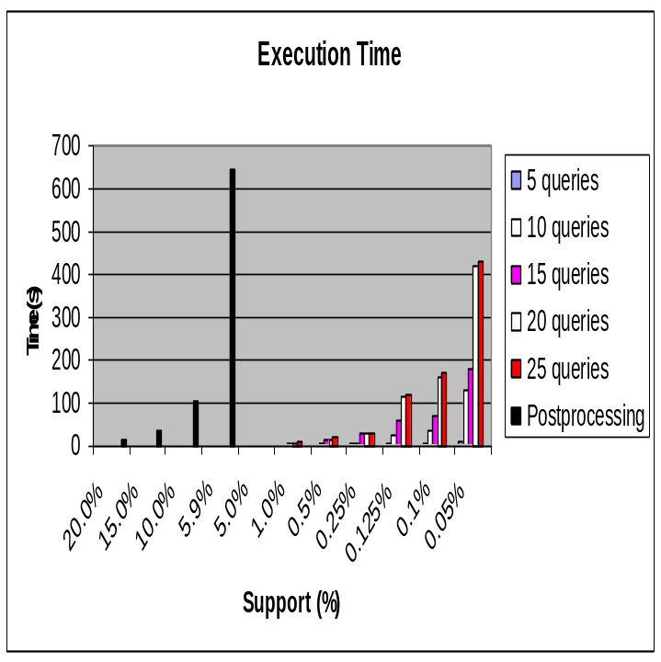
- Execution time.

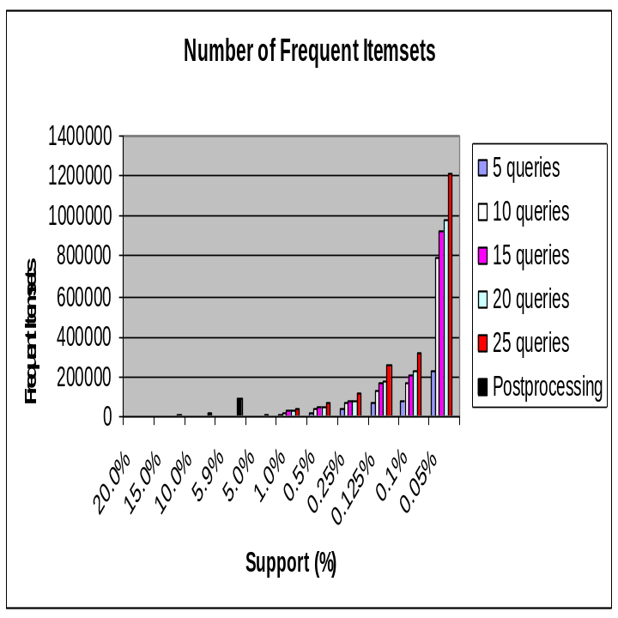
- Number of frequent itemsets generated.
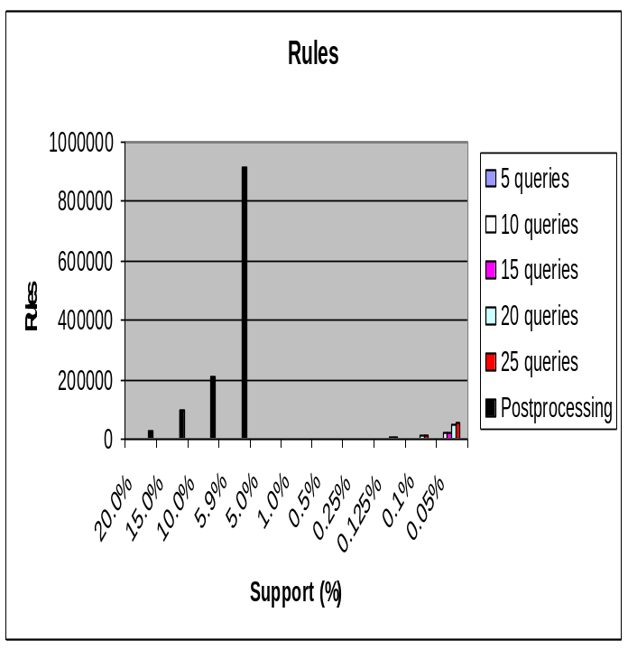
- Number of rules generated.

Figure 46 illustrates yet another important characteristic of our incremental and interactive mining approach which is the ability to focus the search and the returned results only on the desired features. The post-processing approach returned slightly less than a million rules at support 5.9% most of which are irrelevant to the queries we have selected. As a matter of fact, we noticed that for our queries, interesting rules stared to show at support 0.5%. For higher support, only uninteresting and evident rules appeared.
- Biological Significance of the Results
In our experimental analysis, we have derived a set of rules with very high confidence (minimum confidence threshold set to 90%). A large proportion of the rules were quite evident and uninteresting in the sense that they provided only common knowledge. For example, the following rule had a support of 1.15% and a confidence of 90.12%: complex = cytoplasmic ribosomal large subunit ➔ localization = cytoplasm.
Of special interest to us has been a subset of the rules explaining aspects pertinent to the yeast eukaryotic initiation factor 2B (eIF2B). eIF2B has been well defined and characterized in yeast and mammals but not in other eukaryotes [90]. Our results have associated the yeast eIF2B factor with specific molecular interactions within the cellular complex. One relevant aspect that we have inferred concerning this factor is that it is involved in ribosome biogenesis. In yeast, the eIF2B factor mediates the exchange of a series of proteins bound to the initiation of translation which is performed by ribosomes. Several researchers have demonstrated that eIF2B factor is a key regulatory step for the control of translation initiation; in specific, it catalyzes a vital regulatory step in the initiation of the translation of mRNA.
The computational analysis we have reported in this chapter has generated a set of associations part of which has been previously reported in the literature. This observation validates the significance of association rule mining in the investigation of genome annotation data and the robustness of our approach in analyzing it. Our results so far can be described as “generally encouraging”; however, further investigation is still needed to gain deeper insights into the results and to clarify other pertinent aspects.
- Conclusion
In this chapter, we report a novel computational approach which generalizes that of Chapter 6 targeted for the analysis of the yeast genome annotation data. Our approach optimizes the rule-discovery process by pursuing an interactive, incremental approach which enables parallel operations and the reuse of previously mined results, and gives biologists the flexibility of incorporating domain knowledge, in the form of desired rule formats thus aiding in focusing their analysis on specific features of interest. For a limited number of consecutive queries, our approach has experimentally demonstrated better performance results than the post-processing approach. In addition, we are able to discover rules that go undetected due to infeasibility in other approaches.
A shortcoming of this work in its current version is that it assumes that all queries in the same session use the same minimum support threshold, minsupp, because this is a precondition for subsequent queries to be able to utilize results (i.e. SE trees) containing frequent itemsets from previous queries in the same session. Should minsupp change, the frequent itemsets for all features in the new query might need to be recomputed from scratch. We are currently considering possibilities in which we would still be able to partially utilize the results when minsupp changes; in case minsupp increases, we can make a pass through the utilized SE trees in order to eliminate all those frequent itemsets that no longer satisfy the new threshold. On the other hand, if minsupp decreases, then the problem becomes much more complicated. This is certainly one of our future extensions of this work.
Our experimental results have demonstrated the potential ability of this work to mines frequent itemsets at very low support thresholds, much lower than what holistic approaches could handle. Consequently, one reasonable suggestion to alleviate the shortcoming discussed in the previous paragraph is to set minsupp at a very low value such that there would be no need to change it for consequent session queries.
Another future direction in this area is to extend the features in our analyzed data to include other important features such as secondary protein structures. We also aim to pursue similar analysis over different genomes such as the human genome. As aforementioned in this chapter, a broader goal for extending our analysis to different genomes is the discovery of “inter-organism” association rules that are valid across organisms rather than on a single organism – or at least assess their availability – in order to describe important dependencies among gene feature values independent of any organism which can also be potentially highly useful in the expansion of the considered relations in the GO.

CHAPTER 8: CONCLUSION

We have started this dissertation with a chapter introducing the area of association rule mining and surveying a number of its most popular and successful approaches which have been utilized in some of our experimental studies. At the heart of our work, we have proposed a vertically structured framework for representing and analyzing data capable of efficiently producing candidate frequent itemsets whose subsets are all assured to be frequent itemsets without much memory or time overhead using set-enumeration trees and an adapted form of tabu search from AI, namely, taboo search. To improve the efficiency of the frequent itemset-mining process further, we have utilized a bit-based vertical data-representation model complemented by compressed data structures, P-trees, resulting in very fast processing operations performable on the vertically compressed P-trees themselves without the need for any decompression.
The presented empirical studies have indicated the cardinality factor to be the most effective on performance. Our approach performs best when applied over very large datasets where multiple scans of the database or even an uncompressed in-memory version of the database are very prohibitive. In addition, further experimentation has demonstrated the scalable nature of our approach and of vertical approaches, in general, as opposed to other horizontal approaches.
Our main future direction in this area includes devising additional optimization techniques to integrate into our approach in order to improve the performance over small to mid-sized datasets where our approach did not demonstrate highly comparable results. We also plan to apply the proposed approach over pertinent real-life datasets that are of dynamic nature; as not much research has focused on updating datasets represented using P-trees in dynamic environments.
We have extended the proposed a framework to enable it to extract minimal, confident rules using fixed-consequent ARM. The main benefit of this extension is to relieve the user from the burden of specifying a minimum support threshold by extracting the highest support rules that satisfy the specified confidence threshold. Albeit, to the best of our knowledge, no previous work has attempted to mine minimal, confident rules with fixed consequents, we provide a comparison analysis study showing how well we compare to other close approaches in the literature.
One observed limitation of this first extension includes performance degradations in situations where the desired rules lie deep in the tree because a large number of nodes and levels in the SE tree need to be traversed then. As a result, one of our future directions targets finding heuristic measures for estimating the probability of rule availability along certain branches and quitting early in cases where such probability is low. Another potential suggestion would be to employee fixed n-ply searches by only going down the tree a fixed number of levels, or iterative deepening where the number of considered levels increases as we progress.
Another extension of our framework has been proposed for representing citation-graph data and generating rules capable of associating research subject matters of publications written at different points in time. As we have shown in Chapter 6, interesting patterns could potentially reveal subject matter extensions and evolution along with a rough idea regarding the effects of current research on future research. We believe our work is novel in this area and highly hope to have initiated a novel research direction which would lead to better understanding of how we ought to understand citation graph data.
In a nutshell, what we have done is to extend our ARM framework to handle situations where one is interested in specific rule formats such as “citee subject matters ➔ citer subject matters” in our case. After suggesting a new subjectiveness “interestingness” measure, we have shown the potential capability for those rules to elucidate embedded temporal aspects in publications participating in citation graphs. Our experimental analysis, mostly a repetition of that used for our vertical framework in Chapter 4, have shown possible improvement scenarios for the proposed divide-and-conquer parallel extension over holistic ARM approaches including our vertical framework of Chapter 4.
In our citation data analysis, we have exploited the time factor embedded in the directionality of citation-graph edges in an efficient manner. Recall that an edge from node X to node in Y in a citation graph implies that publication X cites publication Y and, more importantly, that Y was written before X. The time factor is perhaps one of the main reasons we have restricted our analysis to citation graph data; nevertheless, we believe our techniques could be generalized to other application domains.
As a result, a future direction in this area would be to analyze different types of directed graphs with the aim of exploiting factors other than the time factor. We also plan to study the efficacy of using temporal and subject constraints in reducing the number of considered graph edges by focusing only on the nodes (along with their incoming or outgoing edges) satisfying a given set of constraints. In addition, we would like to analyze the usefulness of the concepts presented herein when applied to other popular domains such citation mining and web-structure mining.
Chapter 7 takes our framework one further step by proposing a new computational ARM approach, which generalizes that proposed for mining citation graphs in Chapter 6, targeted for the analysis of the yeast genome annotation data. This last extension optimizes the rule-discovery process by pursuing an interactive and incremental approach which enables parallel operations and the reuse of previously mined results provided that the same minsupp is used, and gives biologists the flexibility of incorporating domain knowledge, in the form of desired rule formats thus directly aiding in focusing their analysis on specific features of interest. For a limited number of consecutive queries, our approach has experimentally demonstrated better execution results than post-processing approaches represented by our original ARM framework. In addition, we show our ability to discover rules that go undetected due to infeasibility in other approaches.
One future direction we would like to pursue is to extend the features in the analyzed data to include other important features such as secondary protein structures. We also aim to apply similar analysis over different genomes such as the human genome. As discussed earlier in this dissertation, a broader goal for extending our analysis to different genomes is the discovery of “inter-organism” association rules that are valid across organisms rather than on a single organism in order to describe biologically significant dependencies among gene feature values independent of any organism which can eventually be used as a base for expanding the considered relations in the GO.

REFERENCES
- Agrawal, R, T Imielinski, and A Swami (1993). Mining association rules between sets of items in large databases. In Proc. ACM Inter. Conf. Management of Data (SIGMOD), P Buneman and S Jajodia (eds.), pp. 207-216. Washington D.C.: ACM Press 1993.
- Agrawal, R and R Srikant (1994). Fast algorithms for mining association rules. In Proc. 20th Very Large Databases (VLDB) Conf., JB Bocca, M Jarke, and C Zaniolo (eds.), pp. 487-499. Santiago: Morgan Kaufmann.
- Ahmed, K, N El-Makky, and Y Taha (2000). A note on ‘Beyond Market Baskets: Generalizing association rules to correlations’. In ACM SIGKDD Explorations, 1(2), 46-48.
- Akutsu, T, S Miyano, and S Kuhara (1999). Identification of genetic networks from a small number of gene expression patterns under the Boolean network model. In Proc. Pacific Symposium on Biocomputing, pp. 17-28.
- American Institute of Physics. http://www.aip.org [24 June 2004].
- Astromoff, A, E Winzeler, D Shoemaker, K Anderson, C Pai, K Davis, G Yen, and R Davis (1998). The Saccharomyces deletion project - functional analysis of the yeast genome. Yeast Genetics and Molecular Biology Meeting, College Park, Maryland, August 1998.
- Bastide, Y, N Pasquier, R Taouil, G Stumme, and L Lakhal (2000). Mining Minimal Non-Redundant Association Rules using Frequent Closed Item sets. In Proc. 1st Inter. Conf. on Computational Logic.
- Batory, DS (1979). On Searching Transposed Files. ACM Transactions on Database Systems (TODS), 4(4), 531-544.
- Bayardo, R and R Agrawal (1999). Mining the most interesting rules. In Proc 5th ACM Inter Conf. on Knowledge Discovery and Data Mining (SIGKDD), pp. 145-154. San Diego: ACM 1999.
- Bayardo, R, R Agrawal, and D Gunopulos (1999). Constraint-Based Rule Mining in Large, Dense Databases. In Proc. 15th Inter. Conf. on Data Engineering (ICDE), pp. 188-197. Sydney: IEEE Computer Society Press.
- Becquet, C, S Blachon, B Jeudy, JF Boulicaut, and O Grandrillon (2002). Strong-association-rule mining for large-scale gene expression data analysis: a case on human SAGE data. Genome Biology, 3(12), 1-16.
- Berrar, D, W Dubitzky, M Granzow, and R Eils (2001). Analysis of Gene Expression and Drug Activity Data by Knowledge-based Association Mining. In Proc. Critical Assessment of Techniques for Microarray Data Analysis Techniques, pp. 23-28.
- BLAST the Human Genome. http://www.ncbi.nlm.nih.gov/genome/seq/ HsBlast.html [30 December 2004].
- Borgelt, C (2003). Efficient Implementations of Apriori and Eclat. In Proc. IEEE ICDM 1st Inter. Workshop Frequent Item Set Mining Implementations (FIMI), B Geothals and M Zaki (eds.), http://sunsite.informatik.rwth-aachen.de/Publications/CEUR-WS//Vol-90/ [6 June 2004]. CEUR Workshop Proceedings.
- Boulicaut, JF, A Bykowski, and C Rigotti (2003). Free-sets: a condensed representation of Boolean data for frequency query approximation. Data Mining and Knowledge Journal, 7(1), 5-22.
- Brin, S, R Motwani, JD Ullman, and STsur (1997). Dynamic itemset counting and implication rules for market basket data. In Proc. ACM Int. Conf. Management of Data (SIGMOD). J Peckham (ed.), pp. 255-264. Tucson: ACM Press 1997.
- Brown, M, WN Grundy, D Lin, N Cristianini, CW Sugnet, TS Furey, M Ares Jr., and D Haussler (2000). Knowledge-based analysis of microarray gene expression data by using support vector machines. Genetics, D Botstein (ed.), 97(1), 262-267.
- Chakrabarti, S, BE Dom, D Gibson, J Kleinberg, R Kumar, P Raghavan, S Rajagopalan, and A Tomkins (1999). Mining the Link Structure of the World Wide Web. IEEE Computer, 32(8), 60-67.
- Clare, A and RD King (2003). Data mining the yeast genome in a lazy functional language. In Proc. Inter. Symposium on Practical Aspects of Declarative Languages.
- Cohen, E, M Datar, S Fujiwara, A Gionis, P Indyk, R Motwani, JD Ullman, and C Yang (2001). Finding interesting associations without support pruning. IEEE Transactions on Knowledge and Data Engineering (TKDE), 13(1), 64-78.
- Copeland, GP and S Khoshafian (1985). A Decomposition Storage Model. . In Proc. ACM Inter. Conf. Management of Data (SIGMOD), SB Navathe (ed.), pp. 268-279. Austin: ACM Press.
- Craven, M (2002). The Genomics of a Signaling Pathway. ACM SIGKDD Explorations, 4(2), 97-98.
- Creighton, C and S Hanash (2003). Mining Gene Expression Databases for Association Rules. Bioinformatics, 19(1), 79-86.
- Ding, Q, M Khan, A Roy, and W Perrizo (2002). The p-tree algebra. In Proc. 17th ACM Symposium Applied Computing (SAC), B Panda (ed.), pp. 413-417. Madrid: ACM 2002.
- Ding, Q and W Perrizo (2002). Association Rule Mining on Remotely Sensed Images Using P-trees. In Proc. 6th Pacific-Asia Conf. on Knowledge Discovery and Data Mining (PAKDD), MS Cheng, PS Yu, and B Liu (eds.), pp. 66-79. Taipei: Springer-Verlag.
- Egghe, L and R Rousseau (1990). Introduction to informetrics. Quantitative methods in library, documentation and information science. Amsterdam: Elsevier.
- Frequent Itemset Mining Implementations Repository (2003). http://fimi.cs.helsinki.fi [1 June 2004].
- Fujiwara, S, JD Ullman, and R Motwani (2000). Dynamic Miss-Counting Algorithms: Finding Implications and Similarity Rules with Confidence Pruning. In Proc. 16th Inter. Conf. on Data Engineering (ICDE), pp. 501-511. San Diego: IEEE Computer Society 2000.
- Gene Ontology Consortium. http://www.geneontology.org/ [30 December 2004].
- Glover, F (1994). Tabu Search for Nonlinear and Parametric Optimization (with Links to Genetic Algorithms). Discrete Applied Mathematics, 49 (1-3), 231-255.
- Goethals, B. http://www.cs.helsinki.fi/u/goethals [2 March 2004].
- Goethals, B (2003). Survey on Frequent Pattern Mining. http://www.cs.helsinki.fi /u/goethals [30 December 2004].
- Goethals, B (2004). Memory issues in frequent itemset mining. In Proc. 19th ACM Symposium on Applied Computing (SAC), H Haddad, A Omicini, RL Wainwright, and LM Liebrock (eds.), pp. 530-534. Nicosia: ACM 2004.
- Geothals, B and JVD Bussche (2000). Interactive Constrained Association Rule Mining. In Proc. 2nd Inter. Conf. on Data Warehousing and Knowledge Discovery (DaWak), volume 1874 of Lecture Notes in Computer Science. London: Springer.
- Geurts, K, G Wets, T Brijs, and K Vanhoof (2003). Profiling High Frequency Accident Locations Using Association Rules. In Proc 82nd Annual Meeting of the Transportation Research Board. Washington D.C.
- Haeseleer, PD, S Liand, and R Somogyi (1999). Gene Expression Analysis and Modeling. In Proc. Pacific Symposium on Biocomputing.
- Han, J and M Kamber (2001). Data Mining: Concepts and Techniques. San Diego: Morgan Kaufmann.
- Han, J, J Pei, and Y Yin (2000). Mining Frequent Patterns without Candidate Generation. In Proc. ACM Inter. Conf. Management of Data (SIGMOD), W Chen, JF Naughton, and PA Bernstein (eds.), pp. 1-12. Dallas: ACM 2000.
- IBM Quest synthetic data generator. http://www.almaden.ibm.com/software/quest/Resources/ datasets/syndata.html [7 April 2004].
- Icev, A, C Ruiz, and EF Ryder (2003), Distance-Enhanced Association Rules fro Gene Expression. In Proc 9th ACM SIGKDD Workshop on Data Mining in Bioinformatics (BIOKDD), MJ Zaki, JTL Wang, and H Toivonen (eds.), pp. 34-40.
- Inokuchi, A, T Washio, and H Motoda (2000). An apriori-based algorithm for mining frequent substructures from graph data. In Proc. European Conference on Principles and Practice of Knowledge Discovery in Databases (PKDD), DA Zighed, HJ Komorowski, and JM Zytkow (eds.), pp. 13-23. Lyon: Springer 2000.
- KDD Cup Competition (2002). The 8th ACM Inter. Conf. on Knowledge Discovery and Data Mining (SIGKDD). http://www.biostat.wisc.edu/~craven/kddcup/ [20 December 2004].
- KDD Cup Competition (2003). The 9th ACM Inter. Conf. on Knowledge Discovery and Data Mining (SIGKDD). http://www.cs.cornell.edu/ projects/kddcup/ [30 December 2004].
- Khabzaoui, M, C Dhaenens, and EG Talbi (2004). Association Rule Discovery fro DNA Microarray Data. In Proc. SIAM SDM Bioinformatics Workshop, pp. 63-71. Orlando: SIAM 2004.
- Kleinberg, JM (1998). Authoritative Sources in a Hyperlinked Environment. In Proc. ACM-SIAM Symposium on Discrete Algorithms (SODA), pp. 668-677. San Francisco: ACM Press 1998.
- Klemettinen, M, H Mannila, P Ronkainen, H Toivonen, and A Verkamo (1999). Finding interesting rules from large sets of discovered association rules. In Proc 8th ACM Inter. Conf. on Information and Knowledge Management (CIKM), pp. 401-407. Kansas City: ACM 1999.
- Kosters, WA and W Pijls (2003). APRIORI, A Depth First Implementation. In Proc. IEEE ICDM 1st Inter. Workshop Frequent Item Set Mining Implementations (FIMI), B Geothals and M Zaki (eds.), http://sunsite.informatik.rwth-aachen.de/Publications/CEUR-WS//Vol-90/ [6 June 2004]. CEUR Workshop Proceedings.
- Kostoff, RN, JA del Rio, JA Humenik, LEO Garcia, and LAM Ramirez (2001). Citation Mining: integrating text mining and bibliometrics for research user profiling. Journal of the American Society for Information Science and Technology, 52(13).
- Kotala, P, P Zhou, S Mudivarthy, W Perrizo, and E Deckard (2001). Gene Expression Profiling of DNA Microarray Data using Peano Count Trees. Online Proc 1st annual Virtual Conference on Genomics and Bioinformatics (VCGB). http://midas-10.cs.ndsu.nodak.edu/bio [1 October 2003].
- Kuramochi, M and G Karypis (2002). An efficient algorithm for discovering frequent subgraphs. Technical Report 02-026, University of Minnesota, Department of Computer Science. http://www.users.cs.umn.edu/~karypis/publications/Papers/ PDF/fsg2.pdf [20 February 2004].
- Law, A and W Kelton (2000). Simulation Modeling and Analysis. Singapore: McGraw-Hill.
- Liu, B and W Hsu (1996). Post-Analysis of Learned Rules. In Proc. AAAI National Conference on Artificial Intelligence, pp. 828-834, Portland: AAAI Press.
- Matsuda, T, H Motoda, T Yoshida, and T Washio (2002). Mining patterns from structured data by beam-wise graph-based induction. In Proc. 5th Inter. Conf. on Discovery Science, pp. 422-429. London: Springer-Verlag.
- Morrison, DR (1968). Practical Algorithm To Retrieve Information Coded in Alphanumeric. Journal of the ACM (JACM), 15(4), 514-534.
- Muggleton, S (1992). Inductive Logic Programming. Academic Press.
- Munich Information center for Protein Sequences (MIPS). http://mips.gsf.de/ [2 August 2004].
- Ordonez, C, C Santana, and LD Braal (1999). Discovering Interesting Association Rules in Medical Data. In Proc. IEEE Advances in Digital Libraries Conference. Baltimore: IEEE Computer Society Press.
- Osareh, F (1996). Bibliometrics, Citation Analysis and Co-Citation Analysis: A Review of Literature I. Libri 46 (4), 149-158.
- Oyama, T, K Kitano, K Satou, and T Ito (2000). Mining association rules related to protein-protein interactions. http://citeseer.nj.nec.com/459605.html [30 December2004].
- Padmanabhan, B and A Tuzhilin (1999). Unexpectedness as a Measure of Interestingness in Knowledge Discovery. Decision Support Systems, 27(3).
- Parthasarathy, S and M Coatney (2002). Efficient Discovery of Common Substructures in Macromolecules. In Proc. 2nd IEEE Inter. Conf. on Data Mining (ICDM), pp. 362-369. Maebashi City: IEEE Computer Society.
- Perrizo, W (2001). Peano count tree technology lab notes. Technical Report NDSU-CS-TR-01, North Dakota State University, Computer Science Department. http://www.cs.ndsu.nodak.edu/~perrizo/classes/785/pct.html [18 January 2003].
- Pevsner, PA, Y Lysov, KR Khrapko, A Belyavsky, and A Mirzabekov (1991). Improved Chips for Sequencing by Hybridization. Journal of Biomolecular Structure and Dynamics, 9(2), 399-410.
- Piatetsky-Shapiro, G and CJ Matheus (1994).The Interestingness of Deviations. In Proc. AAAI Workshop on Knowledge Discovery in Databases, pp. 25-36. Seattle: AAAI Press.
- Pietracaprina, A and D Zandolin (2003). Mining Frequent Itemsets using Patricia Tries. In Proc. IEEE ICDM 1st Inter. Workshop Frequent Item Set Mining Implementations (FIMI), B Geothals and M Zaki (eds.). http://sunsite.informatik.rwth-aachen.de/Publications/CEUR-WS//Vol-90/ [6 June 2004]. CEUR Workshop Proceedings.
- Pipenbacker, P, A Schliep, S Schneckener, A Schönhuth, D Schomburg, and R Schrader (2002). ProClust: Improved clustering of protein sequences with an extended graph-based approach. Bioinformatics, 18(90002), 182-191.
- Pray, L (2003). Unraveling Protein-Protein Interactions. The Scientist, 17(2). http://www.the-scientist.com/yr2003/jan/lcprofile1_030127.html [30 December 2004].
- Rahal, I and W Perrizo (2004). An optimized Approach for KNN Text Categorization using P-tees. In Proc. 19th ACM Symposium on Applied Computing (SAC), H Haddad, A Omicini, RL Wainwright, and LM Liebrock (eds.), pp. 613-617. Nicosia: ACM 2004.
- Rahal, I, D Ren, A Perera, H Najadat, W Perrizo, R Rahhal, and W Valdivia. Incremental Interactive Mining of Constrained Association Rules from Biological Annotation Data with Nominal Features. To appear in Proc. 20th ACM Symposium on Applied Computing (SAC).
- Rahal, I, D Ren, and W Perrizo (2004). A Scalable Vertical Model for Mining Association Rules. Journal of Information & Knowledge Management (JIKM), 3(4), 317-329. Singapore: iKMS & World Scientific Publishing Co.
- Rahal, I, D Ren, W Wu, and W Perrizo. Mining Confident Minimal Rules with Fixed-Consequents. In Proc. IEEE Inter. Conf. on Tools with Artificial Intelligence (ICTAI), pp. 6-13.
- Raymon, R (1993). An SE-tree based Characterization of the Induction Problem. In Proc. 10th Inter. Conf. on Machine Learning (ICML), pp. 268-275. Amherst: Morgan Kaufmann.
- Ramakrishnan, R and J Gehrke (2003). Database Management Systems. New York: McGraw-Hill.
- Robardet, C, B Cre’milleux, and JF Boulicaut (2002). Characterization of unsupervised clusters with the simplest association rules: application for child meningitis. In Proc. ECAI Workshop on Intelligent Data Analysis in Medicine and Pharmacology (IDAMAP), pp. 61-65.
- The Saccharomyces Genome Deletion Project. http://www-sequence.stanford.edu/group/yeast_deletion_project [2 August 2004].
- Serazi, M, A Perera, Q Ding, V Malakhov, I Rahal, F Pan, D Ren, W Wu, and W Perrizo (2004). DataMIME™. In Proc. ACM Inter. Conf. Management of Data (SIGMOD), G Weikum, AC König, and S Deßloch (eds.), pp. 923-924. Paris: ACM 2004.
- Serial Analysis of Gene Expression (SAGE). http://www.ncbi.nlm.nih.gov/SAGE/ [12 July 2004].
- Shenoy, P, JR Haristsa, S Sudatsham, G Bhalotia, M Baqa, and D Shah (2000). Turbo-charging vertical mining of large databases. In Proc. ACM Inter. Conf. Management of Data (SIGMOD), W Chen, JF Naughton, and PA Bernstein (eds.), pp. 22-29. Dallas: ACM 2000.
- Shivakumar, N and HG Molina (1996). Building a Scalable and Accurate Copy Detection Mechanism. In Proc. Inter. Conf. on the Theory and Practice of Digital Libraries.
- Silberschatz, A and A Tuzhilin (1995). On Subjective Measures of Interestingness in Knowledge Discovery. In Proc. 1st ACM Inter. Conf on Knowledge Discovery and Data Mining (SIGKDD), UM Fayyad and R Uthurusamy (eds.), pp.275-281. Montreal: AAAI Press
- Silberschatz, A and A Tuzhilin (1996). What Makes Patterns Interesting in Knowledge Discovery Systems. IEEE Transactions on Knowledge and Data Engineering (TKDE) special issue on Data Mining, 8(6), 970-974.
- Suzuki, E (1997). Autonomous Discovery of Reliable Exception Rules. In Proc. 3rd ACM Inter. Conf. on Knowledge Discovery and Data Mining (SIGKDD), D Heckerman, H Mannila, and D Pregibon (eds.), pp. 259-262. Newport Beach: AAAI Press.
- Tan, PN and V Kumar (2000). Interestingness Measures for Association Patterns: A Perspective. In Proc. 6th ACM SIGKDD Workshop on Post-processing in Machine Learning and Data Mining. Boston: ACM Press.
- Toivonen, H (1996). Sampling Large Databases for Association Rules. In Proc. 22th Very Large Databases (VLDB) Conf., TM Vijayaraman, AP Buchmann, C Mohan, and NL Sarda (eds.), p.134-145. Bombay: Morgan Kaufmann.
- TouchGraph LLC. http://www.touchgraph.com [24 November 2004].
- Tuzhilin, A and G Adomavicius (2002). Handling Very Large Numbers of Association Rules in the Analysis of Microarray Data. In Proc. 8th ACM Inter. Conf. on Knowledge Discovery and Data Mining (SIGKDD), pp.396-404. Edmonton: ACM 2002.
- UCI Machine Learning Repository. http://www.ics.uci.edu/~mlearn/ MLRepository.html [30 December 2004].
- Varian, HR and P Resnick (1997). Recommender Systems - Introduction to the Special Section. Communications of the ACM (CACM) special issue on recommender systems, 40(3), 56-58.
- Wang, B, F Pan, D Ren, Y Cui, Q Ding, and W Perrizo (2003). Efficient OLAP operations for spatial using Peano trees. In Proc. ACM SIGMOD Workshop on Data Mining and Knowledge Discovery (DMKD), MJ Zaki and CC Aggrawal (eds.), pp. 28-34. San Diego: ACM 2003.
- Williams, DD, GD Pavitt, and CG Proud (2001). Characterization of the initiation factor eIF2B and its regulation in Drosophila melanogaster. Journal of Biological Chemistry, 276(6), 3733-3742.
- Wong, HKT, HF Liu, F Olken, D Rotem, and L Wong (1995). Bit Transposed Files. In Proc. 21st Very Large Databases (VLDB) Conf., A Pirotte and Y Vassiliou (eds.), pp. 448-457. Zurich: Morgan Kaufmann.
- Wrobel, S and S Dzeroski (1995). The ILP description learning problem. Towards a general model-level definition of data mining in ILP. In Proc FGML Annual Workshop of the GI Special Interest Group Machine Learning (GI FG 1.1.3).
- Yan, X and J Han (2002). gSpan: Graph-Based Substructure Pattern Mining. In Proc. IEEE Inter. Conf. on Data Mining (ICDM), pp. 721-724. Maebashi City: IEEE Computer Society.
- Zaki, MJ and K Gouda (2003). Fast Vertical Mining Using Diffsets. In Proc. 9th ACM Inter. Conf. on Knowledge Discovery and Data Mining (SIGKDD), L Getoor, TE Senator, P Domingos, and C Faloutsos (eds.), pp. 326-335. Washington D.C.: ACM 2003.
- Zaki, MJ, S Parthasarathy, M Ogihara, and W Li (1997). New Algorithms for Fast Discovery of Association Rules. In Proc. 3rd Inter. Conf. on Knowledge Discovery and Data Mining (SIGKDD), D Heckerman, H Mannila, and D Pregibon (eds.), pp. 283-286. Newport Beach: AAAI Press.

This chapter is a modified version of a paper [70] which has appeared with the same title in the Journal of Information & Knowledge Management (December 2004) by World Scientific.
This chapter is a modified version of a paper [71] which has appeared with the same title in the proceedings of the IEEE International Conference on Tools with Artificial Intelligence (Boca Raton, Florida), November 2004.
This chapter is a modified version of a paper with the same title which is currently under second review for inclusion in the Knowledge and Information Systems (KAIS) international journal by Springer-Verlag.
A database providing access to a very large number of bibliographies, abstracts, and references found in more 3500 journals over more than 100 disciplines.
Those properties are subject codes drawn from the Physics and Astronomy Classification Scheme (PACS) numbers used in the physics domain. More on this issue is coming later on in this chapter.
Recall that the purpose of data mining is to discover useful and comprehensible knowledge from huge amounts of data.
In reality, data mining as a research area can be viewed as a combination of a number of areas such as databases, information retrieval, machine learning, artificial intelligence, statistics and the like.
This chapter is a modified version of a paper [69] which will appear with the same title in proceedings of the ACM Symposium on Applied Computing (SAC) (Santa Fe, New Mexico), March 2005.

