
Individual support packages for people with a disability
Handbook
November 2017

If you would like to receive this publication in another format:

Department of Health and Human Services
– Individual support packages
< http://services.dhhs.vic.gov.au/individual-support-package>

1300 650 172 (local call within Victoria, except mobile phones)

disability.services@dhs.vic.gov.au

If you are deaf, or have a hearing impairment or speech impairment, contact us through the National Relay Service.
TTY users
Tel: (03) 13 3677 then ask for 1300 650 172
Speak and Listen users
Tel: 1300 555 727 then ask for 1300 650 172
Unless indicated otherwise, this work is made available under the terms of the Creative Commons Attribution 4.0 Australia licence. The licence DOES NOT apply to any software, artistic works, images, photographs or branding, including the Victorian Coat of Arms, the Victorian Government logo and any Victorian Government departmental logos.
To view a copy of this licence, visit <creativecommons.org/licenses/by/3.0/au>
It is a condition of this Creative Commons Attribution 4.0 Licence that you must give credit to the original author who is the State of Victoria.
Authorised and published by the Victorian Government, 1 Treasury Place, Melbourne.
ISBN 978-0-7311-7173-6 (online PDF/Word)
November 2017
Contents
1 Introduction 7
1.1 Who is this handbook for? 7
1.2 What is in this handbook? 7
1.3 What is an individual support package? 9
1.4 The main steps for an individual support package 11
2 Getting started 13
2.1 Offer of an individual support package 13
2.2 Notional allocation 14
2.3 Accepting the offer 14
2.4 What to expect from your facilitator 15
2.5 Things to think about when planning for your ongoing supports 16
2.6 Support while you wait for your package 19
3 Funding guidelines 20
3.1 Funding principles 20
3.2 How the funding principles work 22
3.3 What can be purchased? 23
3.4 Who can supports be purchased from? 23
3.5 Choosing service providers 27
3.6 When you cannot choose your own provider 28
3.7 What services cost 29
3.8 Ongoing and one-off funding 33
3.9 Time period for funding 33
3.10 Sharing support delivery 33
3.11 Supports that all people pay for themselves 34
3.12 Questions for non-registered personal support providers 37
4 Funding administration arrangements 38
4.1 Introduction 38
4.2 Direct payments 38
4.3 Financial intermediary service 39
4.4 Registered disability service provider 40
4.5 Which funding administration arrangement should you choose? 42
5 Your funding plan 45
5.1 Planning and the funding approval process 45
5.2 Putting your funding plan into action 50
5.3 Changes to supports 56
5.4 Funding acquittal 59
5.5 Financial reviews 60
5.6 Unspent funds 60
5.7 Reviewing your supports and individual support package 62
5.8 Support coordination 63
6 Rights and responsibilities 66
6.1 Your rights 66
6.2 Privacy 66
6.3 Your responsibilities 68
6.4 Advocacy 70
6.5 Making a complaint 71
7 Day services 74
7.1 What are day services? 74
7.2 Things you need to think about if choosing to use day services 75
7.3 Being flexible 78
7.4 Non-attendance at your day service 80
7.5 Reporting by your day service 84
8 Direct payments 85
8.1 Who can use direct payments? 85
8.2 What support is available to me as a direct payments user? 85
8.3 Do direct payments affect my income? 86
8.4 Getting started with direct payments 87
8.5 Changing to direct payments 88
8.6 Managing direct payments 89
8.7 Your responsibilities for direct payments 95
9 Direct employment 96
9.1 What is direct employment? 96
9.2 Who can use direct employment? 97
9.3 What information about direct employment is available? 97
9.4 What you need to do to be a direct employer 98
9.5 Bank account 98
9.6 Employing family members 99
10 Financial intermediary service 100
10.1 What is a financial intermediary service? 100
10.2 Is there any financial impact on me if I use the financial intermediary? 101
10.3 Who can use the financial intermediary service? 101
10.4 What support is available to me to find out more? 102
10.5 Getting started with the financial intermediary 102
10.6 Managing your responsibilities with the financial intermediary service 102
10.7 Acquittal 103
10.8 Temporarily stopping or ending financial intermediary services 103
10.9 What if I have a question or problem with payments or reports? 104
11 For more information 105
11.1 What do the words mean? 105
11.2 Contact Disability Services Intake and Response 110
11.3 Disability Services policies and guidelines 111
11.4 Relevant laws 111
Appendix: Figure descriptions 112


Cover image: Artwork by Hanna Wilkinson, one of the winners
of the 2012 VALID annual ‘Having a Say Conference’ Art Competition (Conference Theme: ‘My Life My Way’)

Introduction

Who is this handbook for?
This handbook is for you if:
- you are a person with a disability, or
- you are a nominated person or other supporter with responsibilities for developing or managing an individual support package, and
- you have an existing individual support package that is due for review, or
- you are planning for an individual support package.
The handbook is also useful for other supporters who are helping you with your individual support package.

Important note
This handbook does not apply to funding you have received, or may receive, from the National Disability Insurance Scheme for individualised supports. If you are in this situation please contact the National Disability Insurance Authority for more information.
National Disability Insurance Scheme website
<http://www.ndis.gov.au>

What is in this handbook?
The handbook has information about:
- individual support packages
- what individual support package funding can be used for
- service providers
- how funds can be managed
- your responsibilities if you receive an individual support package
- the meanings of important words used in this handbook (see Section 11:1).
It has information and questions you can ask service providers before you decide what services you need.
It also tells you who you can talk to if you have a problem.

Not sure what a word or a term means?
This handbook uses lots of different words and terms. These words are made bold in the handbook and you can find their meaning in Section 11:1.
For more information
The information in this handbook is based on the individual support package guidelines that departmental staff and facilitators use.
Individual Support Package guidelines and information page on the Service Providers website < http://providers.dhhs.vic.gov.au/individual-support-package>

What is an individual support package?
An individual support package is funding paid by the department to help a person pay for supports that will meet their disability support goals and needs.
An individual support package lets the person be in control of working out what supports they need, on the condition they meet the funding guidelines and departmental approval of a funding plan.
The person can also be in control of how those supports are provided. The person can decide who will provide the supports and how and when the supports should be provided.
In some cases an individual support package may buy supports for family or carers so they can continue caring for the person. An individual support package can be used to buy group support such as a place in a day service.
All of this means the person can choose the supports they need that will best help them to achieve their goals and live the way they want.
For children with a disability, supports to meet their needs are based on the best interests of the child and, where possible, strengthen and build the capacity of the family to care for them.
Supports for people with a disability who are parents take into consideration the impact of their disability on parenting.
The supports that a person buys with their individual support package should be things that are not already available from family and friends or from their community.
Supports can be flexible – this means that the person can change supports or the service provider if they want to.
An individual support package is ‘attached’ to the person. This means that the person can change the type of supports or service provider if their needs change.

The main steps for an individual support package
The following outline shows the main steps and timeline of an individual support package.
Figure 1A: The main steps for an individual support package (steps 1–5)
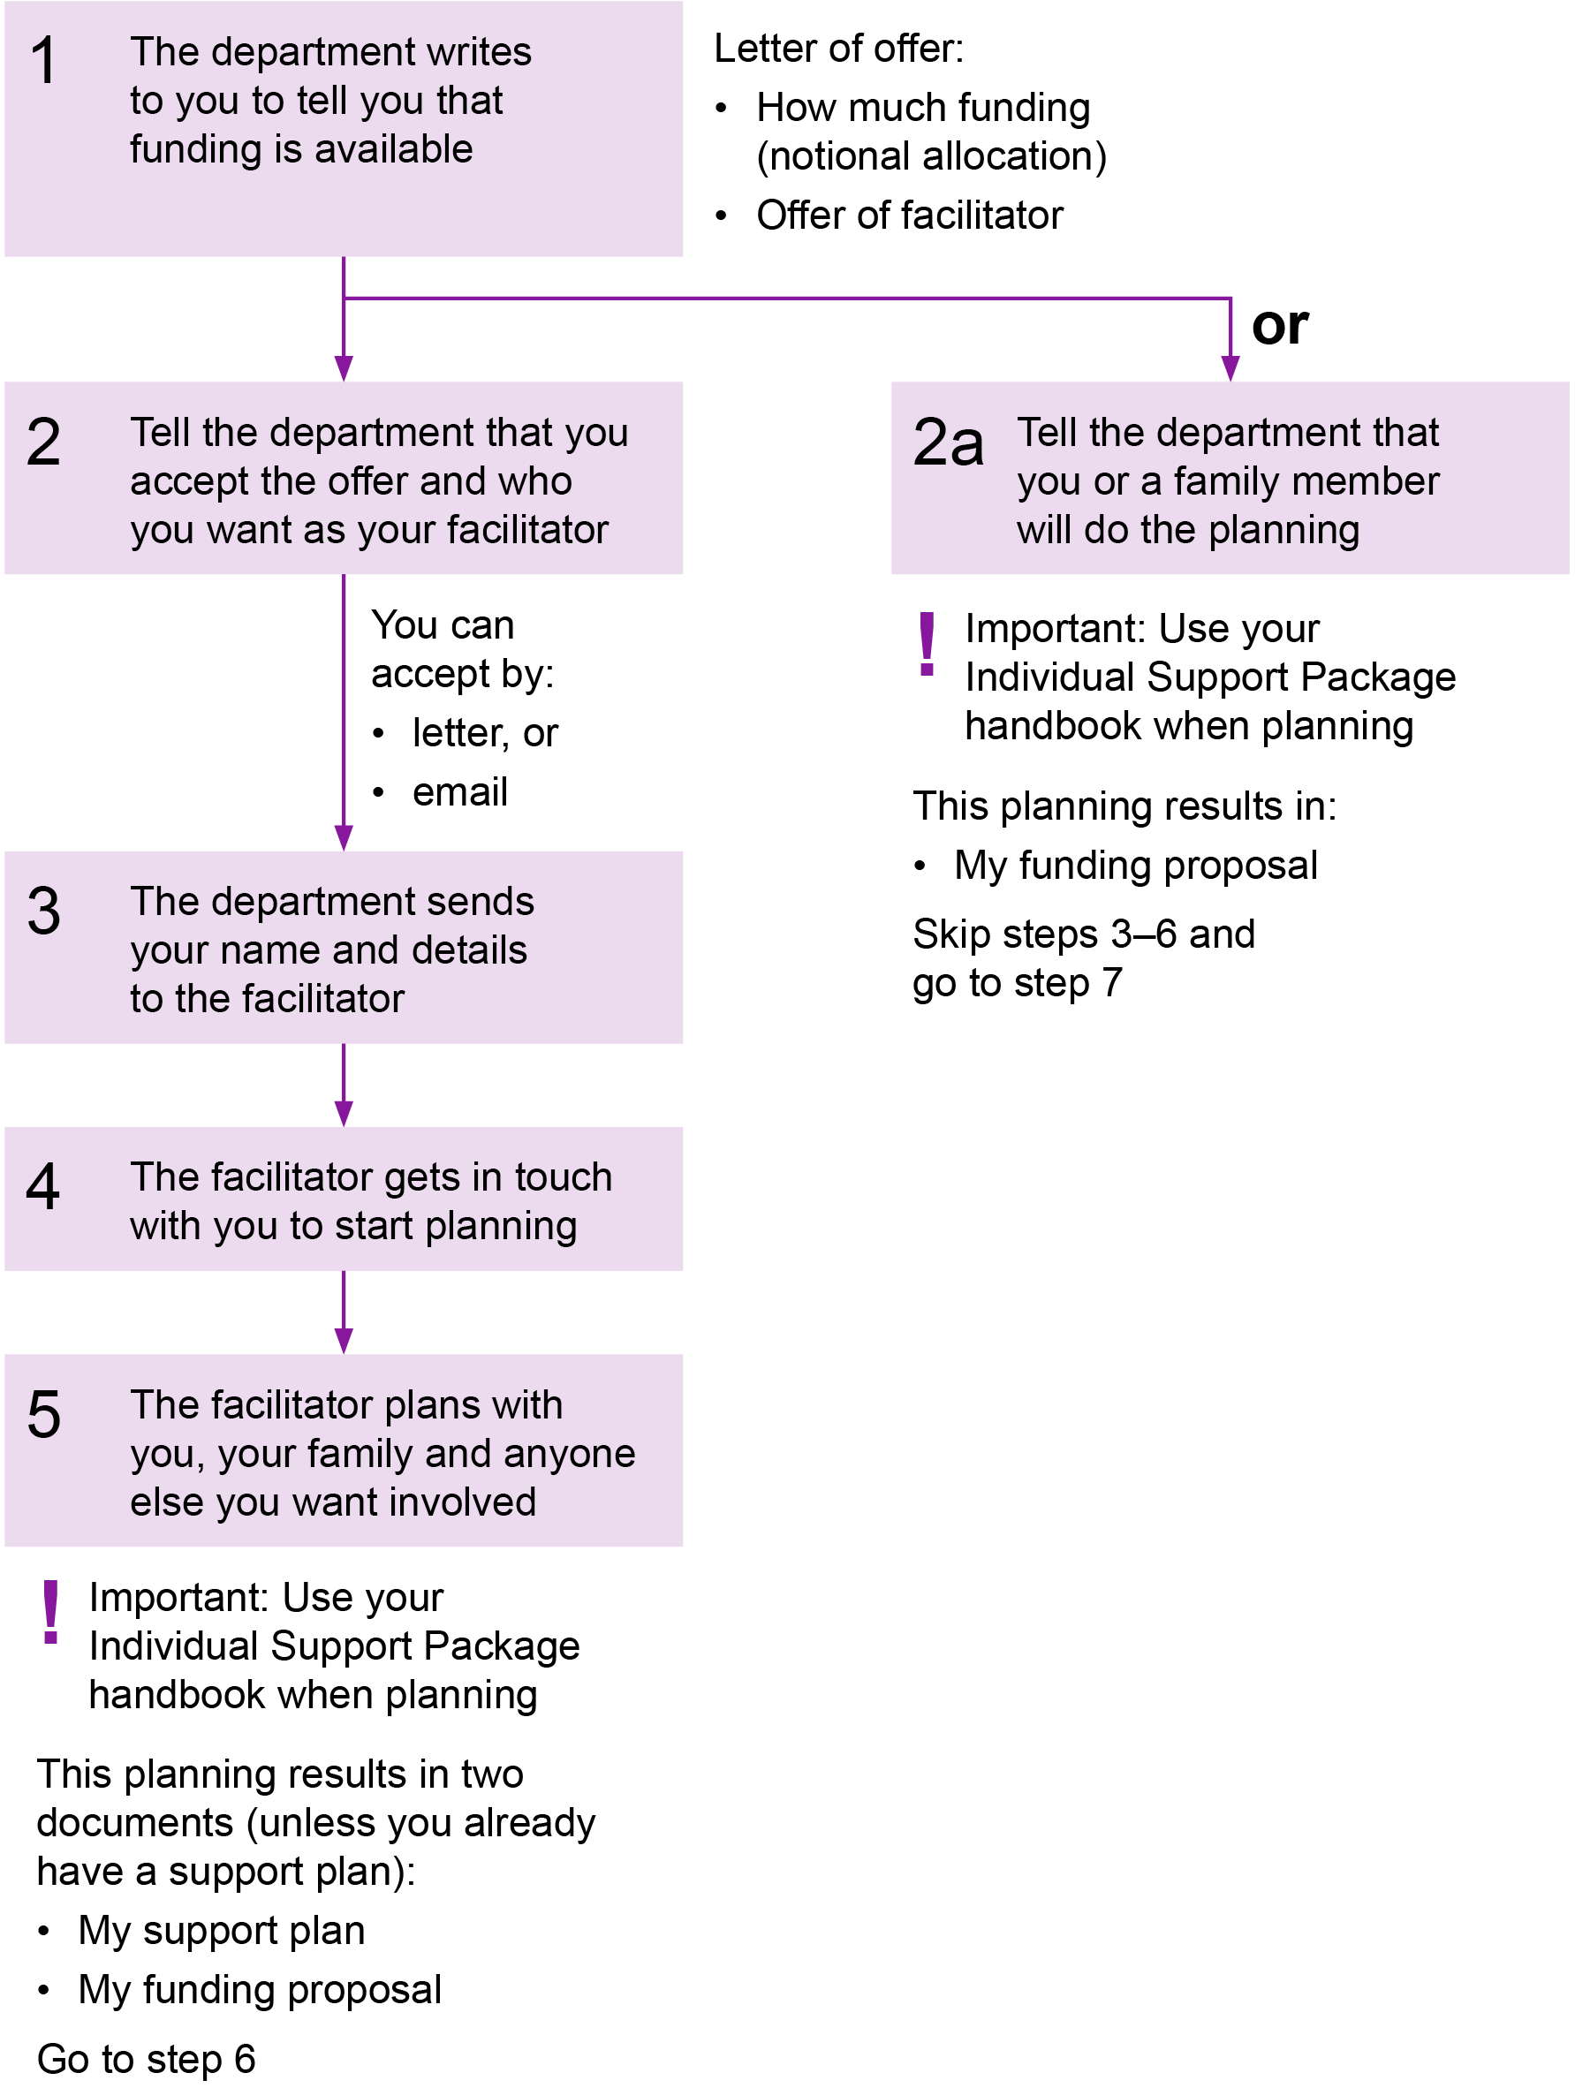
Figure 1B: The main steps for an individual support package (steps 6–11)
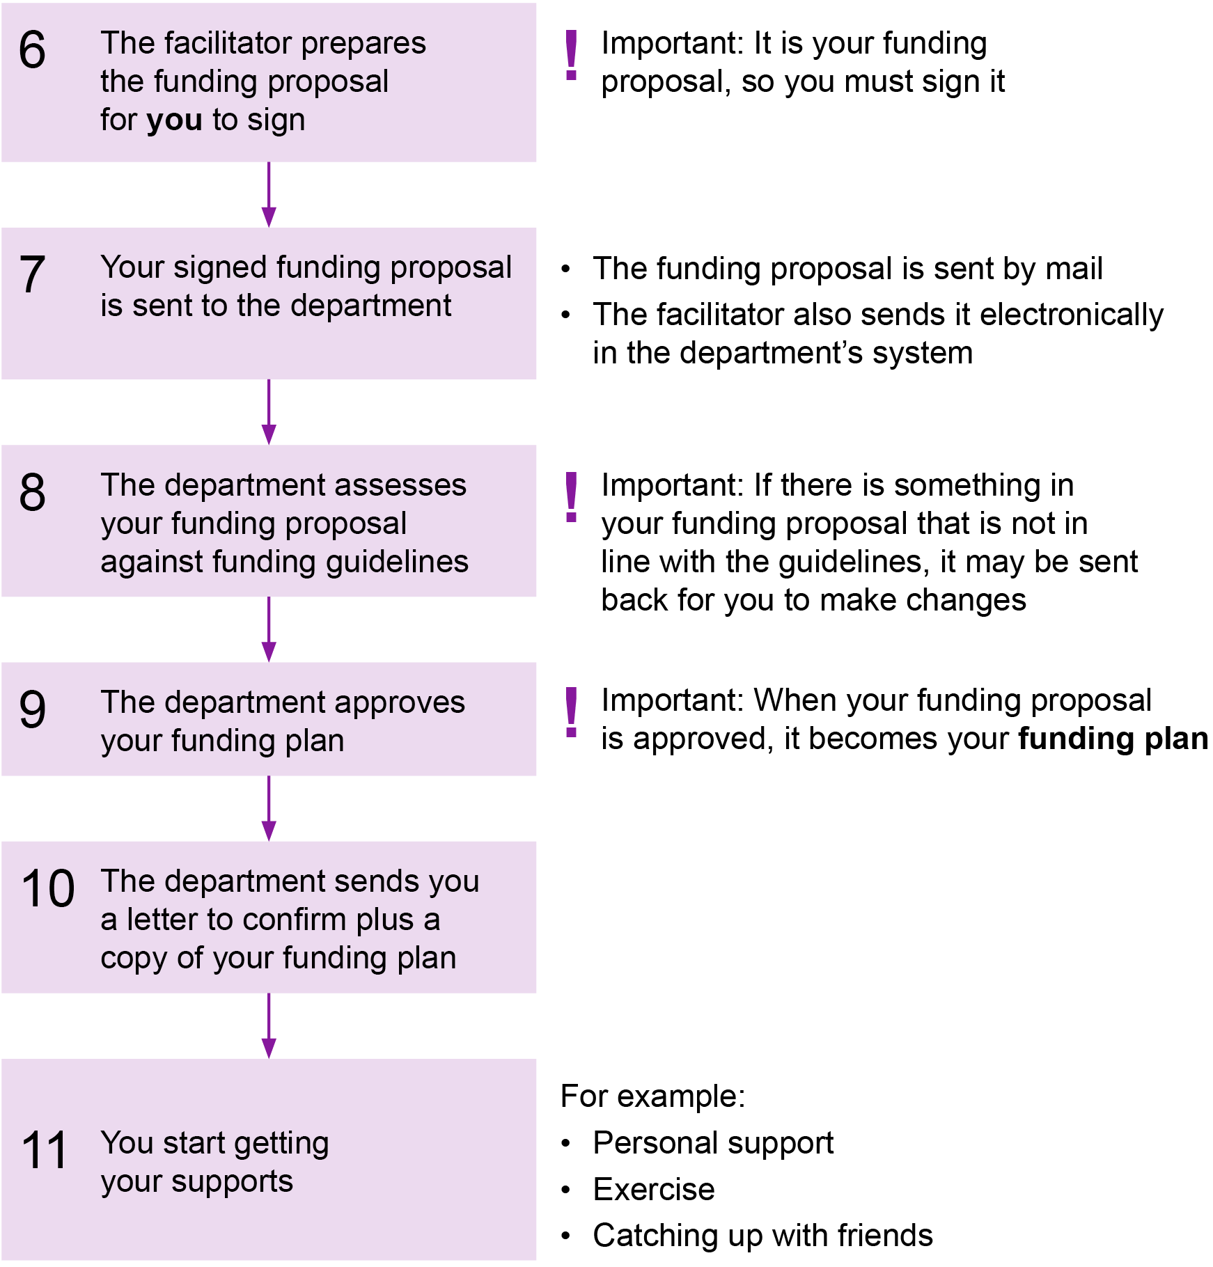
Description of Figure 1A and Figure 1B

Getting started

Offer of an individual support package
The Disability Support Register (DSR) is a database of all the people who need funding. The department uses the DSR to decide when a person will get access to an individual support package. People whose needs are more urgent will usually get access to funding before someone with less urgent needs.
If you meet the criteria for an individual support package, the department will contact you to let you know. The department will follow up this contact with a formal letter to confirm the offer.
This letter will also tell you what organisations in your area can help you to do detailed planning. This planning will look at what supports you need at the moment, who will provide the supports and how much they will cost.
To do the planning you can:
- do it yourself
- you can ask a family member, friend or other supporter to help
- use a facilitator, or
- you can ask your case manager (if you already have one).
Your family, friends or other supporters can help you make all of these decisions if you want them to.
The letter will also tell you that if you want to use a facilitator you will need to provide written consent for your personal information to be given to the facilitator.
A facilitator will only get information about you that is necessary for them to help plan for your individual support package.

Notional allocation
When you made your application to the DSR, the department will have allocated you a DSR band level. A DSR band level has a funding range linked to it. This range is the amount of departmental funding that will cover your ongoing support needs.
This range is also called your notional allocation.
This information is given to you so that you and your facilitator know how much money you might be able to have allocated to you. This makes it easier for you to plan for supports.
For example, if your notional allocation is $10,000 to $15,000, you can work out the best supports for you within that amount.
If your needs have changed a lot since you put in your DSR application, you or your facilitator can ask the department to approve a higher amount of funding.
The department will tell you if the increased funding will be approved or may ask you to do another DSR application.

Accepting the offer
To accept the offer of an individual support package, you must tell the department in writing. The department will give you an acceptance form to fill in, sign and return.
The letter of acceptance includes boxes you can tick to:
- accept (or decline) the offer
- ask for a facilitator
- name your preferred facilitator organisation or give permission for the department to choose one for you.
By signing the letter, you are providing consent for your information to be given to the facilitator if you have chosen to use one.
Once you have sent the letter of acceptance back to the department, the department will pass on your details to your preferred facilitator. The facilitator must get in touch with you within two weeks to start the planning.

What to expect from your facilitator
The most important thing to remember when working with your facilitator is that their job is to help you get the best possible results from your individual support package.
In doing this job, you can expect your facilitator to:
- explain to you, right from the start, what their role is and how they can help you
- know about you and your disability support needs when they meet you the first time
- be able to understand how you communicate your thoughts
- listen to and respect your ideas, values, preferences, cultural background and chosen lifestyle
- let you direct the planning as much as you are able to
- not impose their own ideas or values on your decisions
- listen to and respect the views of the important people in your life, such as your family, but also help you to manage situations if others have different views about what you should buy with your package
- know what supports and services are available in your community
- help you to get detailed information, in a format you understand, from potential service providers about the services they offer and what they might cost
- tell you about your rights and how you can make a complaint about a service
- have an in-depth knowledge of the individual support package guidelines and processes
- be able to explain to you the funding administration arrangement options
- be there to support you, if you want them to, to put your funding plan into action.
At the end of your time with the facilitator it is hoped that you will:
- feel more informed and empowered to make your own decisions
- be able to exercise more control over your support arrangements
- be able to use more informal, community-based and generic supports
- know how to deal with issues or problems as they come up.

Things to think about when planning for your ongoing supports
Whether you are doing the planning by yourself, with the help of supporters or with a facilitator, there are a number of things to think about.
You should start with:
- What are your goals?
- How would you like to achieve your goals?
If you are using a facilitator or disability service provider to help with planning, they will be able to help you work out your current goals are and tell you about the services in your area that can help you meet those goals.
You might want to talk to your family or friends and work out who will do what.
You might also want to talk to someone who has already been through planning or reviewing their individual support package. They might be able to give you some ideas and confidence about what you can do. This is called peer support – see ‘Peer support’ on page 17.

Things to think about

What supports did you ask for when your DSR request was made?
- Do you still need the same supports?
- Has something changed in your life that means you might need different supports?

What services do you need?
- Do you know what is available or suitable for your needs?
- Do you have some ideas but want to talk them over with the facilitator or disability service provider?
- Are there people in your life who could provide some support free of charge?

Who will provide the services?
- Do you know any service providers that you want to use?
- Are there any service providers that have been recommended to you?
- Are there any service providers you don’t want to use?
- Have you received information, in a format you can understand, about the services being offered and what they might cost?

How will you pay for the supports?
- What level of control and responsibility do you want when it comes to paying for your supports?
- Do you want to pay for your supports directly from your individual support package or do you want someone else, such as your facilitator, to manage this?

How will your plan work?
- Who will make contact with the suppliers or service provider(s) so you can start using the services?
- Who will make sure the support happens when and how you want it to?
- Who will follow up if something goes wrong?

How will the funding be monitored and accounted for?
- Who is going to receive reports about how much funding has been spent on your behalf or how much is left?

What will happen if you want to change your supports?
- Who do you need to ask?

Peer support
Through personal experiences with their individual support package, many people with a disability and their carers develop expertise in:
- making choices and taking control of their supports
- knowing where to find information and get answers
- getting good value for money from their individual support package
- developing processes and systems to manage their funds
- employing support workers who best meet your needs.
Your facilitator or the department may be able to help you find people who have planned or reviewed their individual support package and who have ideas and experience to share. This is called providing peer support.
Alternatively, the department’s website has a listing of current groups, events and websites.

For more information

Peer support page on the Services website < http://services.dhhs.vic.gov.au/peer-support>
Go to: For Individuals > Disability > Self-Directed Support > scroll down to ‘Peer support’

Support while you wait for your package
Planning for your individual support package may take some time. You and/or your facilitator may need time to explore all the options and find the service providers.
Usually, supports cannot start until your individual support package has been approved. You may, however, need some help in the short term.
This may include situations such as:
- your support arrangements are complex to set up
- services are not yet ready to provide the support(s) you need
- support is required immediately
- your arrangements might need to change soon.
In the above situations the department may be able to give you some funds for interim support.
A request for interim support may be made by you, your family or carer(s), or your facilitator.
A person from the department will consider your request for interim support based on your notional allocation and the individual support package funding guidelines.
Interim support will only be given for a certain period of time and for a specific purpose.
For more information
If you are not sure what some of the words mean in this handbook, go to Section 11.1: What do the words mean?

Funding guidelines

Funding principles
- Your individual support package funding must be used to buy supports that are directly related to your disability needs and to achieve the goals in your support plan. These goals might include:
    - moving to independent living
    - staying within your family environment
    - living independently
    - enabling family or carers to receive support so they can continue their caring role
    - providing support if you are a parent with a disability so you can meet your parental responsibilities and keep your family together
    - having better health and wellbeing
    - improving your skills and capabilities
    - having more opportunities to go out and meet friends or go to social events
    - having more opportunities to get out and about in the community
    - participating in education or further training
      - improving your employment opportunities.
- Your funding is not income for you (like money you might get from work or a pension).
- Your funding can only be used when you have tried, but cannot get, informal supports or community services to meet your disability support needs.
- Your funding cannot be used to pay for supports that are paid for by other local, state or Commonwealth government programs. However, you can use your funding to contribute towards the cost of these supports if you need to.
- Your funding should be used to buy services or other things that are the best value for you. Best value means it is right for you but may not be the cheapest or the most expensive.
- Your funding must not be used to pay for things that any other community member would normally pay for themselves unless at least one of the following circumstances applies:
    - your disability prevents you from accessing the service or item in the same way as the rest of the community
    - there is a benefit, supported by professional medical evidence, to your health, wellbeing or fitness that would otherwise be unavailable
    - without funding the item or service you would not be able to get the same result that the community access or participation would usually make possible
    - funding an item or service may prevent a crisis or undesirable outcome for you
    - you are experiencing financial hardship
or
    - funding a service or item is more cost-effective and provides a better alternative to a higher cost, more intensive or restrictive support (for example, supported accommodation) that you would require if the service or item is not approved.

For more information, about Supports that all people pay for themselves go to Section 3.11, later in this chapter.
- Your funding cannot be used for a prohibited purpose. A prohibited purpose includes:
    - anything that is against the law
    - gambling
    - directly employing staff – unless you have departmental approval
    - setting up or using a business that you own or part own (or that you have shares in) to employ people, or
    - buying supports or services from a company (or other legal entity) in which you have a financial interest (including as a director or shareholder).

How the funding principles work
Figure 2: How the funding principles work
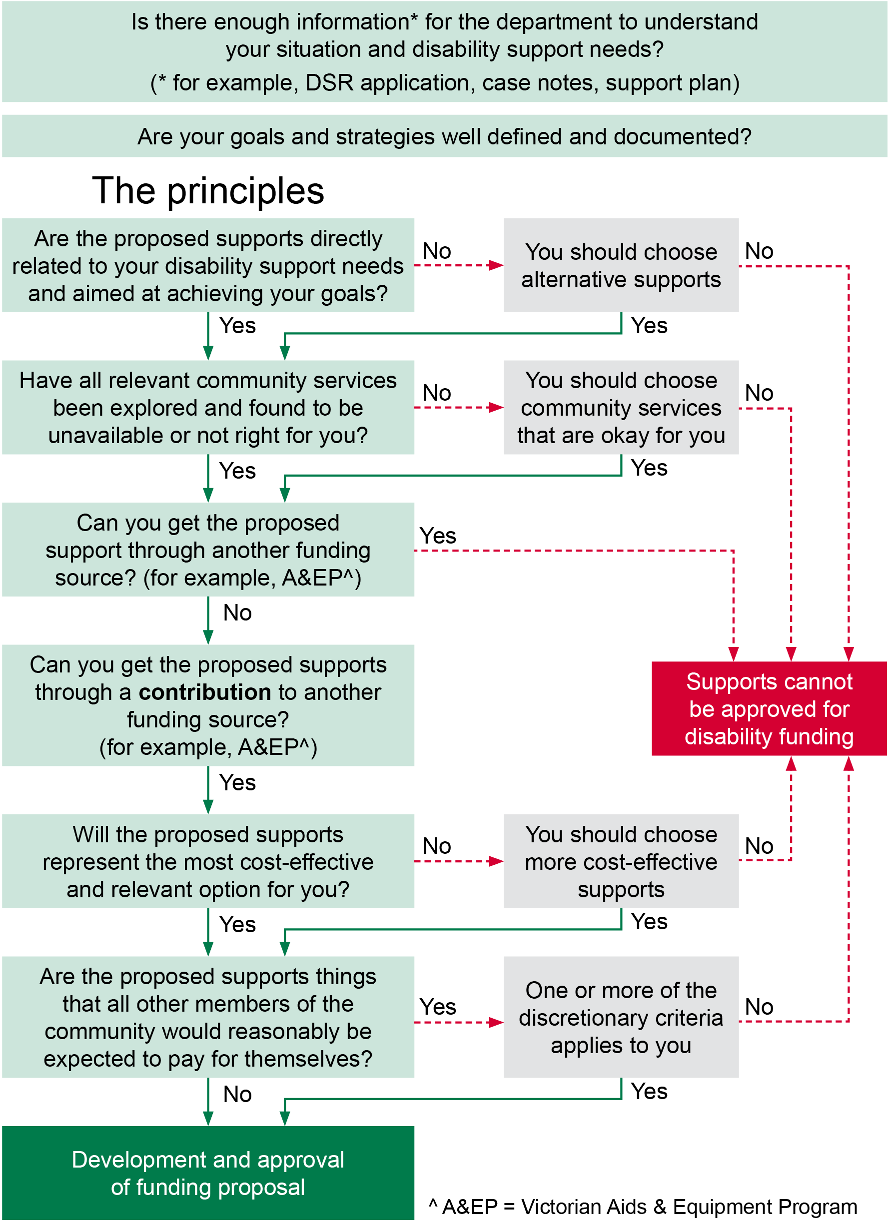
Description of Figure 2

What can be purchased?
There is no ‘list’ of things that can or can’t be paid for with your individual support package. The types of supports that can be purchased must be considered within the funding principles* (see Section 3.1) and will depend on your disability needs.

Who can supports be purchased from?
Support can be purchased from the following types of providers:
- registered disability service providers
- providers of personal support – not registered as disability service providers
- providers of generic community services
- providers of commercial goods and services.

Day services
You may want to use all or part of your individual support package funding to purchase support from a day service provider. Day services are available to adults only.
All the information in this handbook applies if you use a day service. There are some extra things that you might need to think about if you use a day service. These are explained in Chapter 7 of this handbook.

Where can I get more information about day services?
More detailed information about day services is available in Chapter 7 of this handbook.

Registered disability service providers
Some organisations that provide disability services are registered by the department under the Disability Act 2006. To be registered, the service provider has to show the department that they can provide a service for people with a disability and meet the requirements of the Disability Act.
The Disability Act says that registered service providers have to:
- give people information about their services, including the cost
- have a complaints process (this must include advice that people can make a complaint to the Disability Service Commissioner)
- meet the standards for disability services in Victoria.
Registered providers may also need to:
- pass safety screening checks (police checks and Working with Children checks where appropriate)
- show they are financially responsible
- have processes in place to comply with the Occupational Health and Safety Act 2004
- have WorkSafe insurance cover
- comply with the department’s incident reporting procedures
- have other appropriate insurance.
Who are the registered disability service providers?
There is a list of registered disability services providers on the Registration requirements for disability services providers on the Service Providers website.

Registration requirements for disability service providers <http://providers.dhhs.vic.gov.au/registration-requirements-disability-service-providers>

Providers of personal support – not registered
There are providers of personal support that are not registered under the Act. You can choose one of these organisations but you need to know that:
- they do not need to comply with the Disability Act, such as meeting the disability standards
- you cannot make a complaint to the Disability Services Commissioner about their services
- they are not monitored by the department.
Note: The Disability Services Commissioner may be able to deal with complaints about some non-registered providers, such as the statewide financial intermediary service or the Aids and Equipment program.

Providers of generic community services
Generic community services may be the most appropriate provider of the supports you need. Generic community services (or ‘generic supports’) include supports that many community members use, such as dental services, therapy and recreation. These services are not covered by the Disability Act.
In some instances, these services will be monitored by a relevant professional association or a statutory body that can hear complaints.

Providers of commercial goods and services
Commercial goods and services are things that all members of the community buy or use. This includes providers of services such as home help.
If you would like to use a commercial service you should get information from them before making your decision.
These providers are not covered by the Disability Act. If you have any concerns about a community service provider or want to make a complaint about them, you can contact Consumer Affairs Victoria to help you.
For more information
Consumer Affairs Victoria
Consumer Affairs Victoria website <http://www.consumer.vic.gov.au>

1300 55 81 81

Email Consumer Affairs Victoria <consumer@justice.vic.gov.au>

Family members
You may use a family member as a paid provider of personal support, but there are two conditions:
- they cannot be living in the same house as you
- they must be employed by a service provider (unless you have departmental approval for direct employment – see Chapter 9 of this handbook for more information about direct employment).
Circumstances that might mean you could use a family member as your paid carer include:
- you live in a rural or remote area, so it is hard to find a professional carer close to home
- you have religious or cultural reasons
- you have complex medical needs, or
- you have strong personal views about privacy and dignity.
Your family member must be prepared to do what all other employees of that service provider do. For example, they must pass a safety check (a police check and Working with Children check if you are under 18 years old).
You must be the person to ask to use a family member as your paid carer; they cannot ask you. You need to be sure that you will still be in control of the support you receive.
Some things you need to think about include:
- having a contract with the family member as your service provider
- having an independent person to mediate if there is any disagreement
- having a plan for your family member to take a break from supporting you from time to time
- thinking about emergency or back-up support arrangements in case your family member is not able to provide support (for example, if they are sick).
The arrangement should be regularly monitored to make sure it continues to be in your best interests.

Choosing service providers
Choosing service providers is both your decision and your responsibility. Your facilitator can help you to get information to make decisions about which supports to use and who can provide them.
Some of the questions you should ask or be helped to ask of any service provider are:
- What type of supports can you provide?
- Will my support staff be trained to use the health-related equipment I need?
- What training will you provide so that my support staff can deal with emergency situations such as equipment failure?
- Will other workers be available when the usual worker calls in sick? What will you do to ensure the replacement worker is trained to use my health-related equipment?
- What are the costs of the support?
- Are there any conditions related to providing the support? (This might include the limited hours or days that you can access support.)
- Do you have adequate insurance arrangements, for example in case a worker is injured while at my home?
- Do you have a complaints process that I can understand and feel confident about?
If you want to use a provider for personal support that is not registered, you need to state confirm that you understand what it means for you. You will also need to take responsibility for making sure they provide high-quality services in the way that you expect.
There are some extra questions you should ask if you want to use a provider of personal support that is not registered. You should only decide to use such an organisation if you are happy with the answers they give you.
If you have any concerns about a service provider that is not registered under the Act and want to make a complaint about them, you can contact Consumer Affairs Victoria to help you (see Chapter 6: Rights and responsibilities for details).
What are the questions to ask service providers that are not registered?
A checklist of the questions to ask is included in Section 3.12 of this chapter.

When you cannot choose your own provider
A facilitator or a departmental worker may disagree with your decision to use a provider of personal support that is not registered if it is felt that due to your:
- level of support need and/or reduced capacity to make decisions and lack of a support network, or
- need for specialist supports (for example, you show behaviours of concern or have a health condition that requires specific care or procedures including emergency care).
In either of these situations you will be required to use registered providers of personal support.
If you would like to use your individual support package funding to buy a place in a shared supported accommodation service, this will also have to be from a registered disability service provider.

What services cost
Disability service providers that have a service agreement with the department are funded in unit prices. The cost of the services you need will generally be based on these unit prices.
Sometimes they might charge you more than the unit price. This might be because specific skills or expertise are needed to meet your needs. The disability service provider must provide you with information about their price and why it is different from the unit price.
If you think a higher price is unfair or you don’t have enough funding to pay for it, you may need to find another service provider.
What are the unit prices?
The unit prices can change quite often because of things like the cost of living going up or to cover pay rises for staff. To check the most up-to-date unit prices for supports people buy with individual support package funding, check the department’s Policy and Funding guidelines.
https://www.dhhs.vic.gov.au/policy-and-funding-guidelines
If you do not have access to the internet, ask your facilitator or the department for a copy of the latest prices.

Other service providers
All other services work out their price based on their business needs.
You should find out how much the service costs and make a decision about whether it is ‘best value’ for you before you decide to use the service.

How is the total cost worked out?
When you know what the price is for a service, you need to multiply this by the amount of the service you need over the year.
For example, let’s say that you need personal support and the service provider has agreed to provide it to you for $38.00 per hour. You need two hours of support each day (including weekends) for 52 weeks in the year.
This will result in the following calculation:
$38.00 × 2 hours × 7 days × 52 weeks = $27,664 per year
You may also want to have some funding set aside for when something happens that you didn’t expect.
This may be for things like:
- going to social events where you might need more than your usual support, or
- if you get sick and need more personal support at home.
This may mean that you include an additional line in your funding proposal such as:
$38.00 × 2 hours × 20 days = $1,520
Your facilitator or disability service provider can help with these calculations.
If you purchase a day service, the price will generally be for a year rather than an hourly rate. How much you will pay will be based on an assessment of your support needs and how often you will attend.
For example, a full year might cost $17,667 per year. If you will only be using the service four days a week, you will pay 0.8 of the yearly rate, which is $14,134.

Goods and services tax (GST)
When costing your funding proposal, any GST that is in the price needs to be shown separately. You should find this out by asking the service provider if their price includes GST.
The department will pay the GST amount in addition to the funding you are allocated for supports.
You and/or your facilitator simply need to ask the service provider a couple of questions and use their answers to cost your funding proposal.
Neither you or your facilitator needs to be GST experts – it is the service provider’s responsibility to know and give you the correct answer.
GST can be:
- included in the quoted price (‘inc’)
- charged on top of the quoted price (‘exc’)
- not applicable (‘free’).
The questions you need to ask and the possible responses you might get are shown in the following figure.
The figure uses the same example as above of personal support at $38.00 per hour.
Figure 3: GST questions and answers
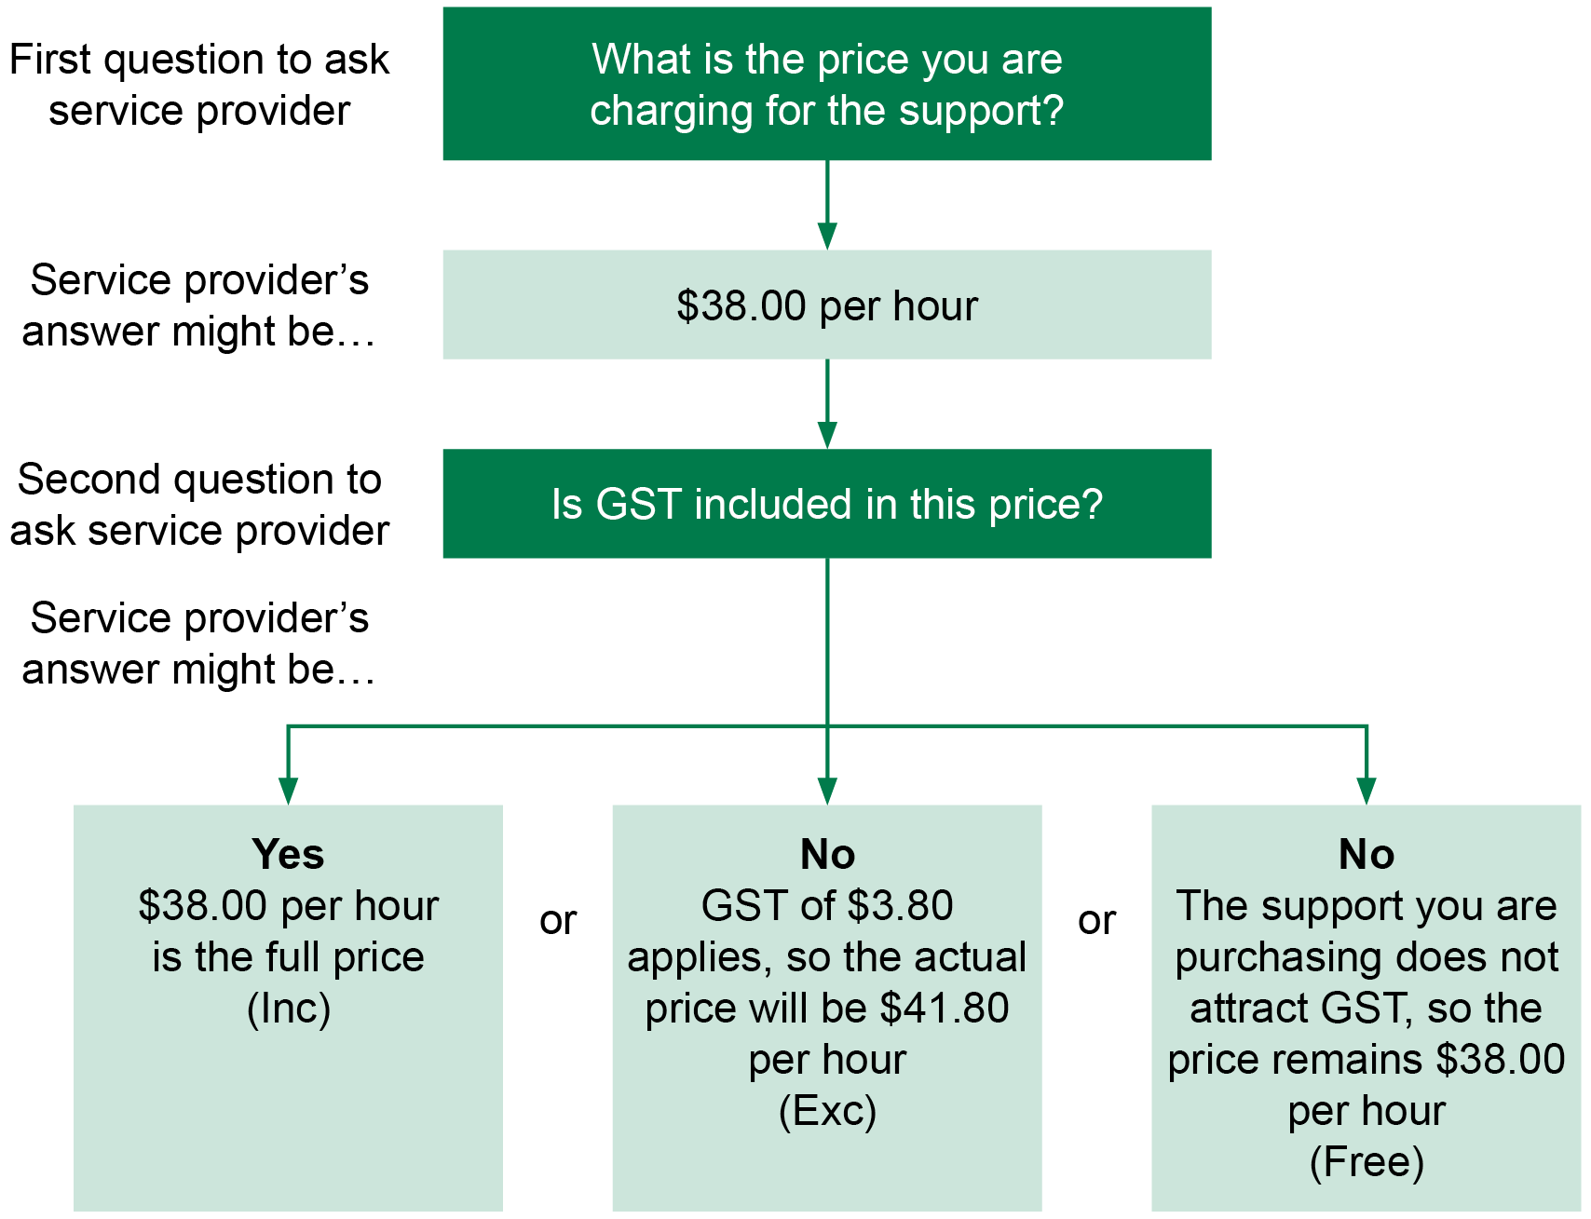
Description of Figure 3

Ongoing and one-off funding
Individual support packages are for funding to meet ongoing disability support needs.
For most people this will be for things like personal support in the home or to get out and about in the community.
Supports that happen only for a short time, but are needed often, are also counted as ongoing. For example, two weeks’ respite every three months should be included as ongoing funding.
One-off funding will usually be used to buy extra things you might need, such as equipment. This often occurs in the first year of your individual support package where, for example, you need equipment to help establish an independent living arrangement.
Only ongoing funding is counted against your notional allocation.

Time period for funding
Because you have ongoing disability support needs, you will continue to receive funding until you no longer need it. This does not necessarily mean that the amount of funding will stay the same forever.
When your support plan is reviewed (at least every three years), you can receive help to work out whether the supports you’ve been getting are still right for you. If your situation changes over time, there may need to be a change to your funding plan.

Sharing support delivery
Sharing support delivery means that two or more people use some or all of their individual support package funding to buy support from the same service provider(s).
You can share support delivery with a friend, or someone else you know, if you want to.
There are some things that you should think about before you decide to share. These things include:
- Who will make sure the supports are delivered?
- Will sharing affect the level or quality of support that you receive?
- What will happen to the support(s) if one of you wants to stop sharing?
You may want to have an agreement with the people you share with about the above issues, including what will happen if there are any changes.
Your facilitator may help you find out the answers to these questions before you make a decision to share supports with other people.
If you decide to share supports, you will still need to make sure you meet your responsibilities described in this handbook.

Supports that all people pay for themselves

What types of support are we talking about?
The items or supports that all members of the community have to pay for include, but are not limited to:
- electricity, gas, telephone and internet costs
- general household fittings, furniture and white goods
- standard electrical goods and consumer products
- food, groceries and other household goods
- rent or rental assistance
- fees and memberships (such as for day services, respite, school or gym)
- aids and equipment subsidy top-up
- vehicle purchases, modifications or maintenance
- house and contents insurance, vehicle and life insurance
- tickets to movies, shows or sporting events
- holidays
- petrol
- tram, train, bus or taxi fares
- health and pharmaceutical items
- complementary therapies (for example, Chinese herbal medicine)
- payment for sexual services.

What evidence might be needed?
You can only buy one or more of these items from your individual support package if the purchase is related to your disability support needs and goals, and that all options for getting the supports through another source or funding have been thought about.
To help the department understand why you need to use your funding to buy any of these types of support you should be able to say that:
- you have a clear need for the item or service
- you would not be able to achieve your goal(s) without the item or service
- you have no family member(s) or others living nearby who could provide or assist with services
- you or your family cannot afford to buy the item or make a contribution (see below for more information)
- community supports are unavailable or inappropriate
- there are geographical issues that would stop you from getting community, social or recreational activities, or essential support needs
- all other funding sources (for example, charities) have been explored and found to be not available or appropriate
- you have used other funding sources, but these have now been used to their maximum and/or you are no longer ‘eligible’
- providing the support through another support type or disability funded service would be more expensive and less beneficial to you.

Financial hardship
Many people with a disability rely on the Disability Support Pension as their main or only source of income. Many people will also face significant costs associated with having a disability. This can include costs such as higher-than-average transport costs, continence aids and so on.
The combination of these factors may mean that you are experiencing financial hardship and want to purchase items from your individual support package that other people in the community would be expected to buy from their own money.
Before buying supports from individual support package funding because of financial hardship, you should try to work out if you could change your income or what you spend. For example, have you explored all possible funding support from other places such as Centrelink? Can a family member buy it on your behalf?
It is your or your nominated person’s responsibility to look into this before asking the department to fund the support. It is also your or your nominated person, guardian or administrator’s responsibility to provide proof that you are experiencing financial hardship.
You might need to show the department information such as your what you earn, how much you spend (and on what), any assets you have and the reasons why paying for supports would create financial hardship.

Questions for non-registered personal support providers
If you are thinking about purchasing services from a non-registered support provider, here are some questions you could ask them first.
Tick the box when you get an answer you are happy with.
Are you considering or would you consider registering as a disability service provider under the Disability Act in order to provide disability services?
Are you a legal entity, such as a company or incorporated body?
Do you do pre-employment safety screening (police checks, Working with Children checks) of staff and volunteers?
Can you make sure that workers will be able to deliver the service I want at the times I want?
Will I be able to have a say in who my workers are?
Do your workers do regular training and will you be able to provide training specific to my support needs?
Will my support workers be trained to use the health-related equipment I need?
Will other workers be available when the usual worker calls in sick and what process will you have in place to ensure they are trained to use my health-related equipment?
Are there any occupational health and safety issues we need to discuss?
Do you have public liability insurance and WorkSafe insurance in case something happens to a worker in my home?
How do you make sure you provide a good service?
How do I complain if I need to?
How much is the service going to cost?
If there are any other questions you want to ask, you might like to attach another piece of paper

Funding administration arrangements

Introduction
At the planning stage, or when you have a review of your individual support package, you need to think about how you want the funding for your supports to be managed. This is known as funding administration.
The different funding administration arrangements you can have are:
- direct payments
- a financial intermediary
- a disability service provider
You may also use a combination of these arrangements.

Direct payments
Direct payments is where you and/or a nominated person receive the funding directly from the department and pay for services and supports to meet the goals in your funding plan.
You must open a bank account that is only to be used for direct payments. The department then transfers the individual support package funds as outlined in a payment schedule to the bank account. You and/or your family must sign a direct payments deed (‘deed’) with the department and meet your responsibilities as described in the deed and this handbook.
These responsibilities include:
- negotiating and arranging the services and supports
- checking the quality of the supports you receive
- checking that the invoices from your service providers are correct (this means that you received the supports stated in the invoice and that the cost of the supports is what you expect to pay)
- paying the invoices and keeping receipts
- providing records to the department when requested.
Direct payments give you maximum control over your funding.

Direct employment
People who are approved to use the direct payments option may also decide that they would like to directly employ their support workers.
This must only happen after you have obtained all the relevant information about being an employer, put in an application for direct employment and had it approved by the department.

Where can I get more information about direct payments and direct employment?
More detailed information about direct payments and direct employment is available in Chapter 8 and Chapter 9 of this handbook.

Financial intermediary service
A financial intermediary service is responsible for making payments on your behalf. The financial intermediary service will:
- hold your individual support package funding and pay the invoices for the supports you receive
- keep records for you and give you regular reports on what you have spent.
The financial intermediary will also provide the department with regular records of your use of the funding. This enables the department to see whether or not your funding plan is working for you.
When you use the financial intermediary service you will be responsible for:
- negotiating and arranging the services and supports
- checking the quality of the supports you receive
- checking that the invoices from your service providers are correct (this means that you received the supports stated in the invoice and that the cost of the supports is what you expect to pay)
- authorising each invoice to say it is okay to pay and sending it to the financial intermediary service for payment without delay
- only sending invoices to the financial intermediary service that relate to your funding plan.
The financial intermediary arrangement gives you flexibility, choice and control over your expenditure, but you do not have to hold the funding or pay the invoices.
Where can I get more information about the financial intermediary service?
More detailed information about the financial intermediary service is available in Chapter 10 of this handbook.

Registered disability service provider
This is where the department transfers your individual support package funding straight to your disability service provider(s).
Under this arrangement the disability service provider:
- delivers the services and maintains records of your funding
- may also arrange to buy other services or supports in your funding plan (if this happens you should be involved in deciding who will provide those services)
- will tell you what has been spent if they are buying other supports on your behalf.
In this arrangement, you have only limited responsibility for the funding.
You can, however, change service provider under the conditions shown in Section 5.3: Changes to supports.
The disability service provider is responsible for telling the department about how they have spent the funding and showing that they have provided the services to you.
The disability service provider arrangement works best where all or a large part of your supports will be provided by one disability service provider.
Can I have more than one funding administration arrangement?
Yes. A combination of the above arrangements may work best if, for example, your individual support package includes buying a place in a group program, such as a day service, and the rest is a made up of a number of other small services or items.

Which funding administration arrangement should you choose?
The figure below will help you decide which funding administration arrangement is best for you.
Figure 4: Which funding administration arrangement should you choose?
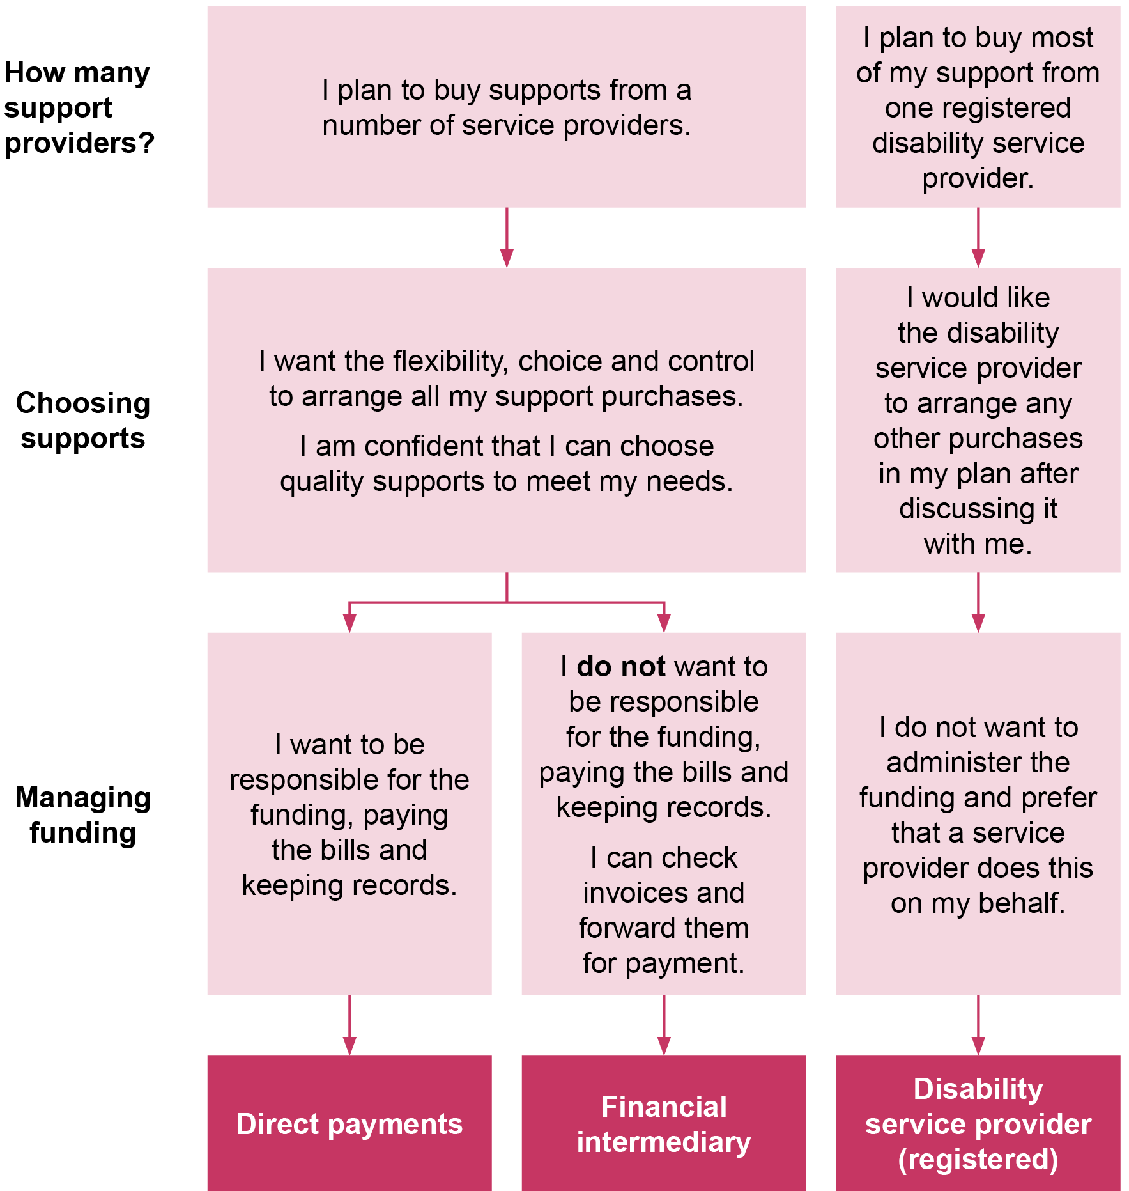
Description of Figure 4

What if you don’t choose the best option for your situation?
After you have worked through the questions above, your facilitator or the department may feel that your choice of funding administration arrangement is not the best option for you.
If this is the case, you might need to agree to having someone help you or to have more regular checking in about how you are going.
The department may not allow you to use direct payments or the financial intermediary service if:
- you or your nominated person do not seem to understand the funding plan, the direct payments deed or the choices you need to make, or
- the arrangement will place you, your nominated person or others at risk, for example, of your funding being spent on the wrong things.
If you choose to buy all your support from an unregistered service provider, you must use the financial intermediary as your funding administration option. This is because the department is unable to make payments to an organisation that does not have a funding agreement with the department. The service provider will give you invoices that you need to check, sign if they are okay and send to the financial intermediary for payment.

Other things to think about with funding administration
When deciding on a funding administration arrangement, you and/or your nominated person must say that you accept the terms and conditions that go with the arrangement.
If you choose to use a financial intermediary or disability service provider you will need to provide your consent for them to be given information about your funding plan so they can provide the funding administration arrangement.
Where the terms and conditions associated with the funding administration arrangement are not met you will be provided with information and support to fulfil your responsibilities.
Where the terms and conditions are consistently not met, the department may help you to move to another funding administration arrangement or ask you to repay the funds.

If you are not sure what some of the words mean in this handbook, go to Section 11.1: What do the words mean?

Your funding plan

Planning and the funding approval process

Support plan
The Disability Act says that you must have a support plan if you receive an ongoing disability support. An individual support package is an ongoing disability support.
The support plan is about your life and what you need and want to achieve. The support plan outlines your goals and the strategies and resources required to achieve those goals. This should involve looking at how you can do things in your local community or receive help from family, friends or others.
There might, however, be some things you can only achieve with funding from the department. This is where a funding proposal needs to be developed. The funding proposal relates to your goals and needs but looks at details of what it will cost to help you.
The Disability Act says that your support plan must be reviewed at least every three years. Each of these reviews will require you to do a new funding proposal at the same time.
The Disability Act also says that you can ask the department or a disability service provider to help you develop your support plan.
The support plan can be in the format you like best.
Even though you have a support plan, it is a good idea to have an agreement with each of your service providers. An agreement can set out things like:
- what supports you need from the provider
- what you want to achieve
- which worker(s) will provide the support
- when they will provide the support
- what you can do if a worker calls in sick.

Funding proposal
The funding proposal is used for:
- getting approval of your funding
- telling the department which funding administration arrangement(s) you have chosen
- giving information to the funding administrator(s) about how your funding is to be spent
- showing that you accept the conditions and responsibilities that go with receiving an individual support package.
While your support plan can be unique to you, there is a consistent format that must be used for the funding proposal.
The funding proposal must be in this format so that:
- everyone can understand the process for getting final approval of funding allocation
- departmental delegates are provided with consistent information
- consistent data is gathered for reporting purposes.

Who can fill in a funding proposal?
The funding proposal can be filled in by:
- you
- a supporter chosen by you
- a worker who already has a relationship with you (for example, your case manager)
- a facilitator chosen by you
- a facilitator allocated by the department if you don’t want to choose.

How can you fill in your funding proposal?
The funding proposal can be filled in one of three ways:
- paper version – for people with a disability or supporters who want to hand write the funding proposal
- home computer version – for people with a disability, supporters or facilitators who will type the funding proposal onto their computer
- electronic version – for facilitators who will work with you to develop your funding proposal.
The paper and home computer versions are available from departmental offices at your request.
If you ask for one of these versions, you will also be given a guide to help you fill in the form.
Most facilitators will work with the electronic version. This version uses the department’s Client Relationship Information System (CRIS) and Client Relationship Information System for Service Providers (CRISSP).
Whichever version you use, the printed first page will look like the below.
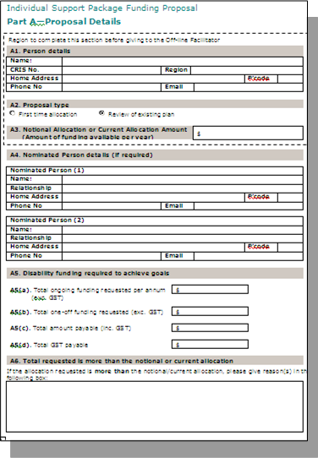

Acknowledging the conditions of funding
You must sign your funding proposal no matter who fills it in.
This is so you can show that you understand the conditions of receiving the funding allocation.
The conditions include saying that:
- you will spend the funds within your goals
- you will check reports about your expenditure
- you will meet the responsibilities of the funding administration arrangement(s) you have chosen.
Your signature also tells the department that you have been involved in, and agree with, the contents of the funding proposal.
If you are not able to sign, someone else may sign on your behalf.
Someone who can sign on your behalf could be:
- a nominated person
- two nominated people (for example, your two parents).
If you are 16 years old or over, you and a nominated person may both sign the funding proposal.
If you choose to have a nominated person sign on your behalf, they must:
- involve you in decisions about your support and in all relevant decisions
- talk to you about how you want to use and manage the funds
- operate in your best interests.
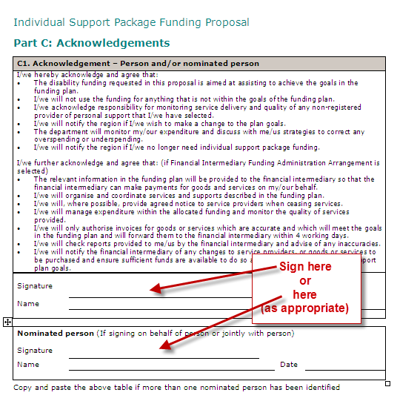

For more information
Go to Chapter 6: Rights and responsibilities.

Approval
Because the individual support package is government money that is being allocated to you, it must be approved by someone authorised to approve an individual support package. This person works for the department and is called a departmental delegate.
There are three things that the departmental delegate must know when considering your funding proposal for approval:
- Is the funding requested within the notional allocation or, if not, has a good reason been provided?
- Do the supports requested comply with the funding guidelines?
(see Chapter 3)
- Is the funding administration arrangement(s) appropriate for you?
(see Chapter 4)
- Is the review period appropriate for you?

Putting your funding plan into action

From funding proposal to funding plan
Once the funding proposal is approved it becomes your funding plan. You and/or your nominated person will be provided with a copy of your funding plan. Once you have this you can start putting your plan into action.
You will also be told in writing that your funding has been approved.
The information on the funding schedule (which is part of your funding plan) will also be given to any organisations that you nominated to administer your funding. This is so they can make the payments on your behalf.

Implementing your funding plan
When you are told that your funding plan is approved, you can make arrangements to receive the supports in your plan and work out how to pay for them.
How you do this will depend on what funding administration arrangement(s) you have chosen.
The following figures show the key things that need to happen for:
- direct payments
- the financial intermediary
- disability service provider.
If you have more than one funding administration arrangement, you will need to look at more than one figure.

Implementing an individual support package funding plan, by funding administration arrangement
Figure 5: Steps for funding administration by direct payments
The following steps 12–17 follow on from the main steps (1–11) for an individual support package (see Section 1.4).
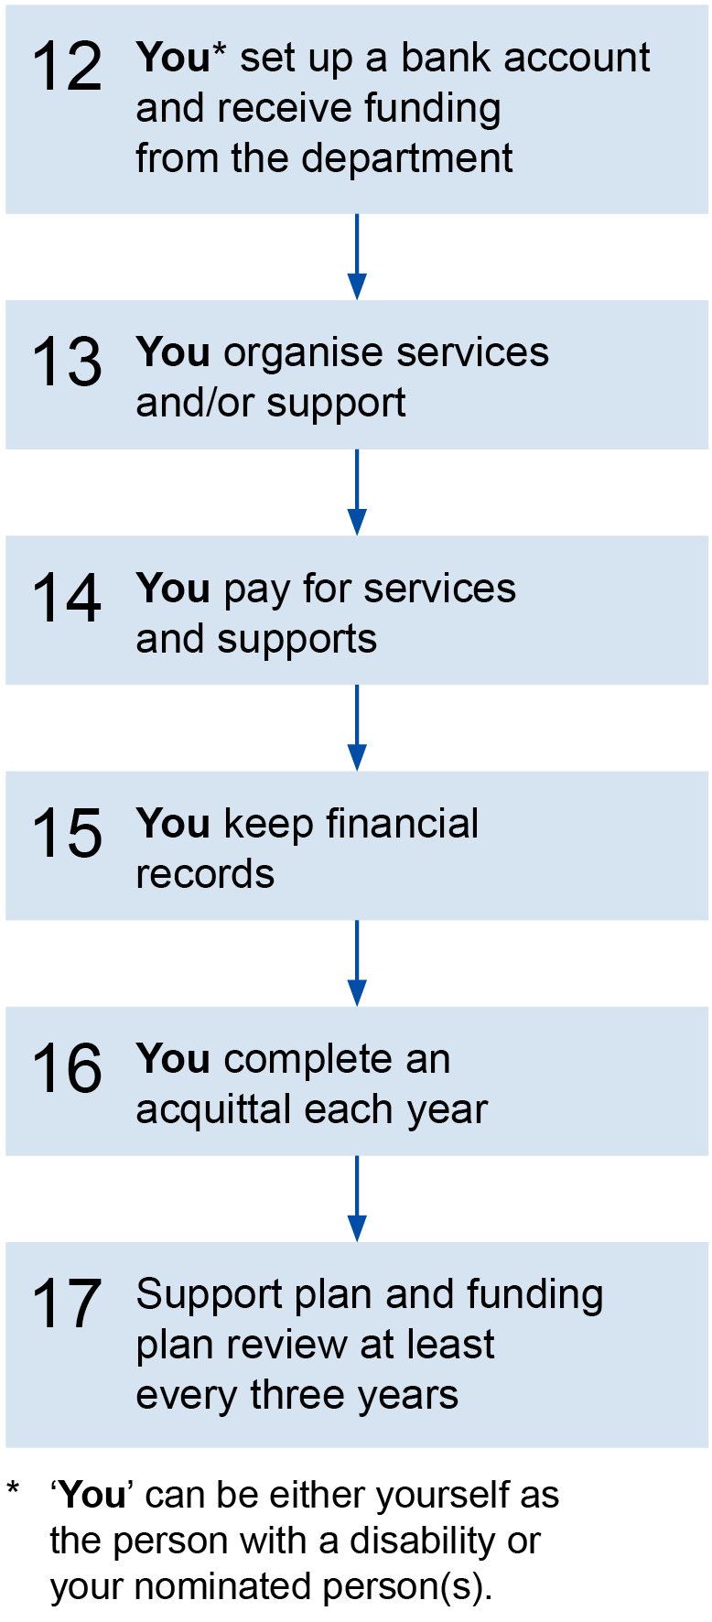
Description of Figure 5
Figure 6: Steps for funding administration by financial intermediary
The following steps 12–17 follow on from the main steps (1–11) for an individual support package (see Section 1.4).
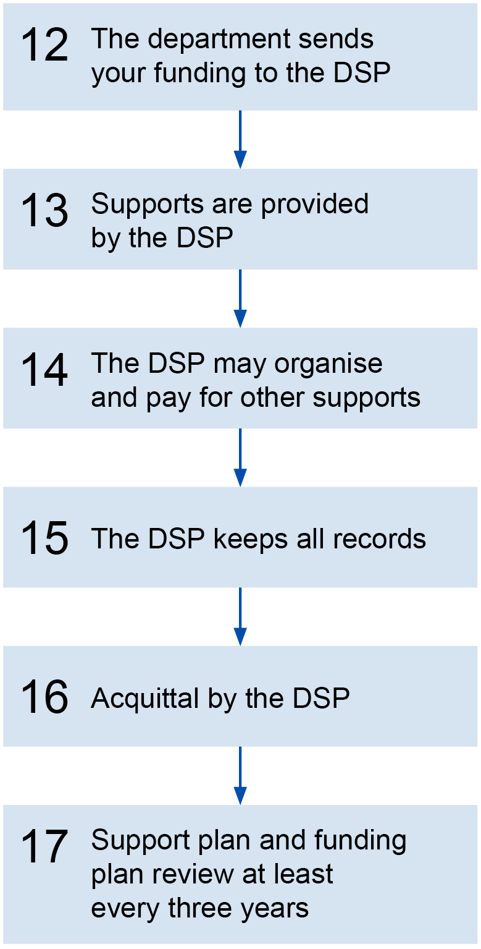
Description of Figure 6
Figure 7: Steps for funding administration by disability service provider
The following steps 12–17 follow on from the main steps (1–11) for an individual support package (see Section 1.4).
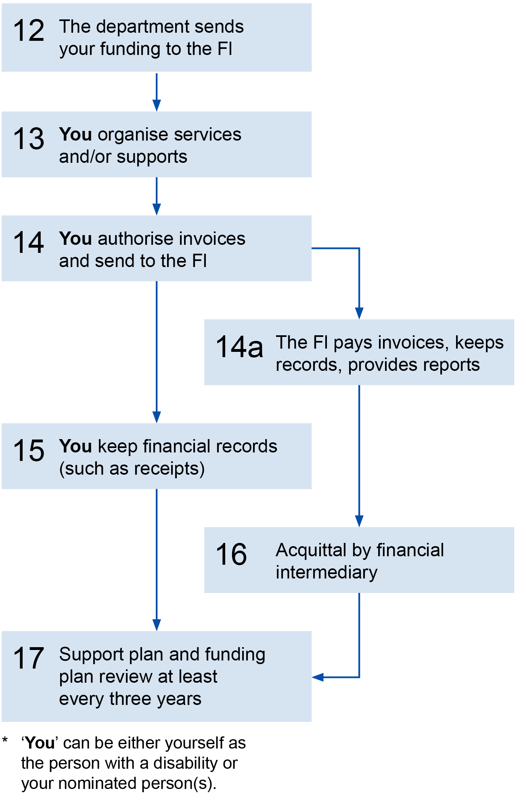
Description of Figure 7

Getting help with implementing your funding plan
Your funding plan will say who will implement and monitor your package. This could be you, a supporter or your facilitator.
It is part of your facilitator’s role to give you some help, if you want them to, after your funding plan is approved. This is to make sure:
- the supports start
- that you and your supporters (if relevant) are aware of your responsibilities
- that you and your supporters know who to contact if you need more help or would like to request a review.
Your facilitator may be able to help you every once and a while throughout the period of the plan.

Support coordination
If you don’t have many supporters available, have difficulty negotiating with service providers or have complex needs, you may need someone else to help you coordinate your supports. This is called support coordination and, if you need it, it should be included in your funding plan.
Support coordination should be tailored to your needs. It can range from contact every once in a while to regular monitoring and help with managing your supports.

Where can I get more information about support coordination?
More information about support coordination can be found at Section 5.8 at the end of this chapter.

Changes to supports
You can make changes to your individual support package at any time as long as they are within your funding allocation.
You can change, without needing to ask the department for approval, from:
- one service provider to another
- one type of support to another.
If you are using the financial intermediary service, you will need to tell them about the change so they can expect invoices from a new provider.
Any changes must be in line with the funding guidelines in this handbook.

Changes that you need to tell the department about
You must tell the department that you want to make a change if:
- you have chosen a new goal for your support plan
- your needs have increased and you need more funding
- your funding administration arrangement changes
- your nominated person changes.
The department will tell you what needs to happen next.
Important information
With these types of changes, the department will usually ask you to review your support plan and funding plan. Depending on your current funding administration arrangement, there may be other things you need to do.

What you must do
When making any changes, you must:
- tell your service provider(s) that you want to stop receiving support from them (this is called ‘giving notice’ – see below)
- talk to the new service provider(s) about starting the new support
- tell your funding administrator of the change
- tell the department if your supports are funded through a disability service provider.

Giving notice
The period of notice you need to give will usually be what the service provider has asked you to give. For registered disability service providers the period of notice is usually two months. This may be different if you have agreed on another period with the service provider.
You may give a very short period of notice if the service has not been meeting your needs. For example, you may want to change quickly if the service provider has been regularly failing to provide you with the service.
Can I get help if I want to give short notice?
Yes. You can ask someone to help you raise your concerns and provide the notice. This might be a family member, friend, advocate, facilitator or case manager.
Information about advocates is included in Chapter 6: Rights and responsibilities of this handbook.

Changes that indicate you will need more funding
If your disability support needs have changed and you think you need more funding, the department might ask you to do two things:
- have a review of your support plan and funding plan
- put in a new application to the Disability Support Register for the new funding amount.

Emergency support
Sometimes you can have unexpected changes in your life and need more support than what is available in your funding allocation.
You and your supporters should try to sort out other ways of meeting this increased need.
If you can’t sort it out, you can contact your local Intake and Response Team for advice. They may be able to arrange some emergency funding for supports that may help with meeting your increased needs.
The department will tell you how long this funding will last.

Moving within Victoria
Your individual support package is allocated to you, no matter where you live in Victoria. This means that you can move within Victoria and the funding moves with you.
If you want to move from one place to another, you need to tell the department. If you are moving a long way, it may mean that you need to make changes to your funding plan or your funding administration arrangement. The departmental office staff will tell you what needs to be done.
You will also need to talk to each of your service providers to work out whether they work in your new area or if you have to change to a new provider.

Moving into or out of Victoria
There is an agreement between all states and territories in Australia that any person who gets individually attached funding can ask for 12 months of funding to be transferred to the new state or territory where they are moving to.

Arriving in Victoria
If you have come to Victoria from another state with individually attached funding, this is considered to be an individual support package. This means that you can use the funds in line with this handbook.
Staff from the department where you are going to live will help you with a planning process and, if your needs are ongoing, do a funding proposal.
The department will help you to make sure that supports are in place at the end of the 12-month period so that your support continues without a break.

Leaving Victoria
If you want to move to another state or territory, you need to tell the department that you will be moving.
When you leave Victoria, your individual support package arrangements will stop.
The department will, however, talk to the government in your new state or territory to tell them how much funding you will have for the next 12 months and send this funding to them.
The department cannot put conditions on the transferred funds. Your new package will be managed according to the policies of the state or territory you are moving to.

Funding acquittal
At the end of each financial year, you will need to let the department know how your package was spent for that year. This is called a funding acquittal. How this will be done depends on your funding administration arrangement. If you use a financial intermediary or a disability service provider, they will do the acquittal. If you use direct payments you will need to do the acquittal yourself. A financial year is from 1 July until 30 June.
If you use a disability service provider, the department may contact you to confirm that you have received the services listed in your funding plan.
The purpose of an acquittal is to check how your funding is going. This is done by looking at how much funding you have received from the department against how much has been spent. The acquittal may show that you have some funds that have not been spent as planned. This is called unspent funds.

Financial reviews
Depending on your funding administration arrangement, the department may ask to review your individual support package in consultation with you. This might be just a regular check to see how you are going, or it might be because something seems unusual.
You must take part in a review if the department asks you to.

Unspent funds
Where the acquittal shows that there are unspent funds, $1,500 or five per cent of your yearly allocation (whichever is more) may be carried forward into the next financial year.
How do I know whether $1,500 is more or less than five per cent?
If your annual allocation is up to $30,000 a year, the carry forward will be $1,500. If your allocation is more than $30,000 a year the carry forward will be five per cent of your allocation.
The carried forward amount will be added to your annual allocation for the following year.
You may spend the carried forward funds on any supports you want or need within the funding guidelines and your goals.
The carried forward funds must be spent by the end of the next financial year.
If the acquittal at the end of the next financial year shows that you have unspent funds again, the department may suggest a review of your support plan and funding plan.
What if I have received the service but have not yet received the invoice?
Acquittal will usually be done in early October of the next financial year to allow time for all outstanding payments to be made. Services that have not been paid for by the start of the acquittal process will not be included in the acquittal and will need to be paid for out of the next financial year’s allocation.

What happens if the unspent funds are more than $1,500 or five per cent?
Any unspent funds over the limits will be returned to the department. If you are a direct payments user, you must return the unspent funds within 14 days of being asked to do so. In exceptional circumstances, the department may let you carry forward these funds as well.

Day services and unspent funds
The above instructions about unspent funds do not apply if you have purchased a place in a day service.
This is because the unit price for a day service place is based on a year’s service. If you are unable to attend for a period of time, the yearly unit price continues to apply.

Reviewing your supports and individual support package
When developing your funding proposal, your facilitator will talk to you about when your supports should be reviewed. They will also talk to you about who will do the review with you.
The Disability Act says that your support plan must be reviewed at least every three years. There may be reasons why an earlier review would be better.
These include where you:
- are approaching a big change in your life, such as moving from education to employment
- have a progressive condition or your health is unstable
- are a younger person with a disability living in residential aged care
- are expecting changes in your family situation
- often have a large amount of unspent funds
- have behaviours of concern.
You or your supporter can request a review at any time if:
- you want to change your goals
- the plan or parts of the plan are not meeting your needs
- there are unexpected changes in your circumstances.
The department might also start a review if there is significant over or under spending or something else unusual. You must take part in any reviews that the department has.
A review involves looking at how your supports and funding are working for you. Some of the things to think about are:
- Have your goals been met?
- Are the strategies outlined in the plan working and are they still relevant? Do they need to be changed?
- Are the chosen supports effectively meeting your goals?
- Has your funding been spent in the way you expected?
- Has the funding administration arrangement met your needs?

How reviews are conducted
How your review is conducted will depend on your circumstances. At a minimum, someone from the department (or day service provider if relevant) will contact you to ask how things are going and whether you want to make any changes.
If everything is going well and you don’t want to change your goals or supports, the department will send you a new funding plan to sign to confirm the new dates and your agreement.
If you want to make a lot of small changes or one big change (such as changing the funding administration arrangement), the department may ask you to participate in a more detailed review of your funding proposal.
If you are not sure what some of the words mean in this handbook, go to Section 11.1: What do the words mean?

Support coordination
Support coordination can be very helpful because it helps to make sure supports are right for achieving a person’s goals.

What is support coordination?
Support coordination is:
- help from an independent person to manage and keep an eye on your support arrangements
- set up to meet your needs – this might mean you are in regular contact or only every now and then
- assessed at every support plan/funding plan review.

What does a support coordinator do?
A support coordinator can:
- make arrangements with support providers about
    - when you attend a service and for how long
    - what you will do when you go to the service
- follow up any concerns you have with your providers
- help you to check invoices to make sure you are paying the right amount for the right services
- help you to get out and about in the community by
    - setting up arrangements with individuals and organisations
    - helping you to communicate with others
    - helping you to build ongoing relationships
- help you to learn how to manage your supports yourself.

When support coordination may be required
Support coordination is a good idea if you don’t have as much support from family, friends or others, or if you:
- have a limited capacity to deal or negotiate with the service sector
- need to coordinate a lot of providers
- need to organise many community activities and help with transport
- need extra help to manage your financial administration option.

Requirements for purchasing support coordination
- If you need support coordination, it should be included in your Disability Support Register application and/or funding plan and form part of your funding allocation.
- Support coordination must not be purchased from an organisation that is providing any other service for you unless:
    - you have a strong wish to use someone from the same service provider because, for example, you have an established, trusting relationship with the person or organisation
    - there is limited or no choice of alternative providers – for example, in rural areas.
Important note
If you would like to use an organisation for support coordination that is also providing you with other support, the department can help you make sure they keep the two things separate.
This is to make sure that if you are not happy with the quality of the service, the support coordinator will be able to talk about your issues with their own employer.

What evidence might be needed?
When deciding about support coordination, you should think about the following questions and be able to provide answers if the department asks about it:
- Do you have a clear need for support coordination?
- How will support coordination help you achieve your goals?
- What are the things that will stop you from achieving your goals without support coordination?
- Do you have any family member(s) or others living nearby who could provide support coordination?
- Can you show that not funding support coordination will cause issues such as:
    - inefficient use of your funding
    - potential for your services to fail
    - extra costs to fix problems

Rights and responsibilities

Your rights
Your rights in accessing disability services are described in the Disability Act.
As a person who has applied for an individual support package, you have the right to:
- expect your request for support to be treated fairly and equitably
- have choice and flexibility
- be involved in decisions as much as you can
- have support to make decisions if you want
- expect quality service delivery
- make changes to your supports if required
- have access to complaints processes.
Your rights as a member of the community are outlined in other laws such as the Charter of Human Rights and Responsibilities Act 2006, the Equal Opportunity Act 2010 and the Commonwealth Disability Discrimination Act 1992.

Privacy
If you ask for or receive support from the department, the department will need to collect and record some information about you. The department will use or give out this information as part of working out whether you can receive support, how much support you need, how it might be provided, and to provide support to you in line with your support plan.
The department may need to give some or all of this information to other disability service providers so that they can support you in line with your support plan.
You will be asked to give this information to the department. You will also be asked to agree to the department getting this information from other people, such as your family, and for it to be shared with other disability service providers.
If you decide not to give the above information to the department or not to agree to the department getting it on your behalf:
- the department may not be able to work out whether you can receive support, how much support you need, and how support may be provided
- the department and other service providers may not be able to provide support to you.
The department will not use or give out the information for any reason other than the reason given to you (unless there is another legal reason that the department has to give out your information).
The type of information the department will need includes:
- personal information such as your name, address, age and gender
- health information such as the disabilities or impairments you may have and your medical and other needs
- any feedback you give the department.
The department will store the information it collects about you safely and make sure that no one else can access or use it.
The department will keep the information for as long as required under the Public Records Act 1973, and make that information available to you if you ask for it (subject to any relevant law). You have the right to ask the department to correct any information if you think it is not right.
You can contact the department at any time if you would like to:
- see your information
- correct any of your information
- get a written copy of the department’s privacy statement and any other related documents.

Your responsibilities
You have a number of responsibilities if you receive an individual support package. As part of developing the funding proposal, the facilitator will help you work out whether you will take on these responsibilities or whether there is someone you would like to nominate to do it on your behalf.

Acknowledge the conditions of your funding
When you receive an individual support package from the department there are some conditions about the funding that you are responsible for. Your facilitator will ask you (and your nominated person if you have one) if you agree to these conditions.
You will need to sign the funding proposal to say that you agree with the conditions.
The funding proposal comes with conditions. Everyone who gets an individual support package must sign that they agree with these conditions. Each funding administration arrangement has extra conditions.

Monitor your funding plan
The purpose of monitoring is to make sure that the things you hope to achieve out of your funding plan are being addressed and the supports continue to meet your needs and goals.
If your goals and needs are not being met, monitoring will let the department know, and a review of your support plan and funding plan can begin to fix this.

Financial monitoring
The responsibilities for financial monitoring depend on how the funding is being administered.
Where your package is allocated directly to a disability service provider, the service provider is responsible for the funding and monitoring the services on your behalf.
Where your individual support package is managed by a financial intermediary service, the financial intermediary records your expenditure and provides you with reports so you can see how much has been spent and how much is left.
The financial intermediary will also provide regular reports to the department about your funds so they can help if things are not going according to plan.
If there are concerns about your expenditure, the department may ask someone (this might be your facilitator) to talk to you about it and see what can be done to fix the problem.
If you are using direct payments, you are responsible for monitoring your funding.

Keep records of expenditure
Whichever funding administration arrangement you are using, you should keep a copy of all receipts, invoices and other papers you receive.
Keeping these will help if someone has a question about a payment or you disagree with a report you receive from your disability service provider or financial intermediary service.

Provide a safe environment for staff to work in
If support workers are going to come into your home to support you, you need to make sure that the environment is safe for them.
There are things you can do such as making sure there’s nothing the worker can trip over or slip on.
There are other things that you will need to work through with the service provider. For example, if you need help with showering, you and the service provider should check your bathroom to make sure the worker can provide the help you need.
It is important that you discuss your support needs and home environment with your service provider(s) before agreeing to use the service provider.

Tell the department when a package is no longer needed
You may no longer need access to ongoing support for a variety of reasons. This might be because you can get your supports from somewhere else.
When this happens, you must tell the department within 14 days of making this decision and give the date that you want the services to stop.
The department will then tell the service provider or financial intermediary to stop payments other than for services already provided.
If you are using direct payments, the department will ask you to return any unspent funds. You must return the unspent funds within 14 days of the department asking you to do so.
You should also stop direct debits you have set up or any other regular purchasing arrangements. If providers of these arrangements want you to give notice or ask for a cancellation fee that you think is unfair, Consumer Affairs Victoria may be able to help you or the Disability Services Commissioner if the provider is a registered disability service provider.

Advocacy
Advocacy is about making sure that you have the same rights as others in the community. An advocate is a person who can help you to make decisions that affect your life and stand by you when you have a complaint.
You might need an advocate because:
- you think you are not being listened to
- you think your beliefs and feelings are not being respected
- you don’t fully understand what your rights are
- you find it hard to make decisions
- you need help in meeting your responsibilities.

How do I get more information about advocacy and who might be able to help me?

Disability Advocacy and shelf help page of our Service Providers website < http://providers.dhhs.vic.gov.au/disability-advocacy-and-self-help >

1800 783 783 or TTY: 1800 008 149

Making a complaint
If you are not happy with a service or part of a service you receive, you should talk to the service provider to try and fix the problem.
It the problem is not fixed or you are not happy about how the service provider is treating your complaint, you can complain to an independent person or organisation.
There will be different ways to complain depending on the type of service.

Registered disability service providers
Registered disability service providers are required by the Disability Act to have a complaints procedure.
The Disability Act says that the service provider must explain the procedure to you in a way that you are able to understand. Supports provided by the department are subject to the Disability Services complaints policy.

Disability Services Complaints policy
Complaints and review page of our Services website < http://services.dhhs.vic.gov.au/complaints-and-review >
Contact your departmental office
(If you don’t know the number, call 1800 783 783
or

TTY 1800 008 149)
You can complain to the Disability Services Commissioner if you believe the service provider has not properly investigated or acted upon your complaint.
Disability Services Commissioner
Disability Services Commissioner website <http://www.odsc.vic.gov.au>
1800 677 342 (free call)
TTY 1300 726 563

(refer to the online complaints form on the website)

Other providers of personal care support
Other providers of personal care support are not covered by the Disability Act, so you will not be able to ask the Disability Services Commissioner to investigate your complaint. You should ask the provider to explain their complaints procedure to you.
If you need independent advice and help about making a complaint about a service, contact Consumer Affairs Victoria.

Community services
Goods or services that you buy from community services are not covered by the Disability Act.
If you need independent advice and help about making a complaint about a service, contact Consumer Affairs Victoria.
Consumer Affairs Victoria
Consumer Affairs Victoria website <http://www.consumer.vic.gov.au>
1300 55 81 81
TTY: 133 677 then ask for 1300 55 81 81
Email Consumer Affaris Victoria <consumer@justice.vic.gov.au>

Interpreter Service 131 450.

Day services
This chapter provides more information for people who are considering using some or all of their individual support package to purchase day services. See Section 3.4 also.

What are day services?
Day services are a type of support organised or provided directly by disability services providers. They can help you to:
- be involved in your community
- become more independent
- do things you want to do.
Day services usually involve activities in a range of lifestyle areas, including daily living, developing work skills, community participation and recreation.
These activities can be during the day, in the evening or on weekends depending on the ability of the day service to provide staff and other resources.
Specific activities are worked out with you and your supporters to make sure they best meet your needs and preferences.
Day services can be for small groups, larger groups or tailored to your specific needs
Day services activities might be:
- provided directly by a day services provider – either in a building operated by that provider or somewhere in the community with staff support
- organised and supported by a day service provider but delivered by someone else (like a swimming program at a local pool).

Things you need to think about if choosing to use day services

Support plan
As mentioned in Section 5.1, the Disability Act says if you get an ongoing disability service you must have a support plan. A day service is an ongoing disability support.
If you do not already have a support plan when you start at your day service, the day service must help you develop one within 60 days.

Using two (or more) day services
You can choose to use your individual support package funding to buy supports from more than one day service. For example, you might choose more than one day service because they offer different programs or activities that will help you meet your goals.

Price for day services
The price for day services is based on attending the service as part of a group for 30 hours a week, 46 weeks of the year.
This usually means you will attend for six hours a day, Monday to Friday. However, this may be different if you and your day service provider have agreed on something that suits you better. For example, you may choose to pay for a staff member to support only you. This is usually more expensive and might mean you receive less than 30 hours’ support a week.
The unit price includes components for salaries, allowances, WorkCover and superannuation.
Unit prices also cover long service leave, recreation and sick leave, roster backfill, public holidays, annual leave loading, employment safety screening, a contribution to the cost of providing transport support and administrative costs.
If you want to go to a group activity in a day service part time, you will only be charged for the days you agree to attend.

Fees
Some day services might charge a general service fee on top of the unit price to help cover costs of delivering the service.
If the day service charges a fee, they must tell you why. This information must be in a format you understand.
The service provider should have this information on their website or give it you to when you are working out which services you want to use.
The information must include:
- the amount of the fee
- why the fee is being charged
- what the fee covers
- whether the fee includes costs associated with activities (such as brushes and paints for art classes) or if these will be paid separately
- whether the fee is charged once or regularly
- how and when to pay the fee
- how they will tell you if the fee changes
- if there is a fine for not paying, or paying late
- the process and contact details if you have trouble paying the fees.
Note: Depending on the activities you want to do, you may need to pay for some additional things such as:
- entry fees to places you might visit
- the extra costs of activities you want to do, such as paints and brushes.
- In this situation, you will make the payment directly to the provider of the activity.
Some things to remember about fees:
- You must pay your fees. Fees are things that all people in the community would be expected to pay. When planning your activities and managing your personal income, remember to consider any possible fees you will have to pay.
- You cannot use your individual support package to pay for fees. Your individual funding package must be used to pay for supports related to your disability. This means you will need to pay for fees with your own money, such as your disability pension or wages.
- You can talk to someone if you have a problem paying your fees. If you are having problems paying your fees you may be able to get help by having the fees reduced or removed altogether. Talk to your day service provider and departmental office about what options are open to you.

Activities costs
Some of the activities you choose may have additional costs such as needing to buy brushes and paints for art classes.
The day service must tell you if these costs are covered by your fees described above or whether you have to pay the extra costs directly to the provider of the activity.
It is expected that the amount you pay for activities will be different from other people because you might choose different activities.

Transport
In some cases, day services will be able to provide transport to get you to and from the service. If you use their transport, the day service may ask you to pay a contribution towards the cost.
Your contribution should not be more than the amount you can receive from the Mobility Allowance from Centrelink.

For more information

Australian Government Department of Human Services https://www.humanservices.gov.au/individuals/services/centrelink/mobility-allowance
Go to: Centrelink > People with disability > Payments for people living with illness, injury or disability > Mobility Allowance

Being flexible
You may decide that you want to use your individual support package to buy supports that are much more flexible than what you currently have. This might mean doing things in the evening or on weekends. It might mean doing things like going to the swimming pool or doing classes to help build your independent living skills.
If you want to make changes, talk to your day service provider. They will help you to do things you want to do within the funding in your individual support package and to meet the goals in your support plan.
If you want to make a lot of changes, the day service provider may ask the departmental office to help you with planning for the changes.

What you need to think about
Before you take steps to change your day service provider or supports, there are a few things you should think about:
- Can your current service provider help? Don’t assume your day service provider can’t meet your needs. Talk to them about what you want and about ways that they might be able to support you. If there is something at your current day service you are unhappy about, let them know.
- Make sure that your chosen service provider can support you. Before you make plans to leave make sure you have somewhere to go. You may like a different provider, but they may not be able to support you at the time you want them to. Where you live and availability of transport may also limit choices available to you. Make sure that what you want is available and can meet your needs.
- You need to give your current provider two months’ notice. This notice period gives you and your provider time to prepare for the change. Your provider may tell you that they don’t need two months’ notice and you may agree on a shorter notice period.
- Your support plan may need to change. If you go to other day service(s) you will need to have a support plan for your new service(s). This might mean you have more than one plan or, if the service providers are able to work together with you, you could have one updated plan for both services.
- You may need a new funding administrator. If you use your funding at two (or more) services you may need to decide who you want to be your funding administrator. You can choose to have more than one provider to manage your funding but you will need to agree on this with both day service providers. It is important to check if your provider charges a fee for this. If you do need to change your funding administrator you can talk to your departmental office about what options are open to you.

Reviewing your support plan
If you want to change your supports, the best place to start is with your support plan. You can ask for your support plan to be reviewed at any time.
You might want to think about the following:
- Is the information in your support plan correct and up to date?
- Are you happy with the goals in your support plan?
- Are you happy that the activities that you do help you to meet your goals?
- Are there things that you are interested in that aren’t currently available at your day service?
If you have questions about any of these things, you should talk to your day service about how they can support you to explore different ideas and activities. You can ask a family member or carer to help you. You can then work together to put these in your support plan and start making changes.

If your needs change temporarily
Sometimes your support needs can change for a short time. For example, if you have been sick you might need some time to get well again. This might mean you need a little more support than normal to do your usual activities.
If you do need more support for a while, talk to your day service provider about what this means for your activities. If you only need to make small changes your day service provider should be able to work with you to rearrange things so you can do your activities, or do something else you want to do until things get back to normal for you.
If your increased support needs are likely to last a while, your funding might not be enough for your day service provider to support you. In this situation you might need to apply for additional funding. If this happens, your day service provider will help you talk to the department about how to apply for temporary additional funding.

If your needs change permanently
If your needs change permanently, you might need more funding so your day service can continue to support you in the same way.
If there’s been a change in your needs you can talk to your day service provider or departmental office about applying for a permanent increase in funding. This will generally mean you will need to lodge an application on the Disability Support Register.
Remember, not everyone can get more funding. It depends on your level of need compared with other people’s level of need. If the review of your support needs results in no change or increase to your funding, you can talk to your day service provider or your supporters about how to make your current funding work better for you.

Non-attendance at your day service
Sometimes you might not be able to attend the day service. Sometimes this may be your choice, while other times it may be out of your control. What you or the day service provider need to do in these situations will vary.

Taking time off
You may need to take time off from your day service. This might be because you are going on holiday or because you are sick. Whatever your reasons for taking time off, remember:
- Let your day service provider know. If you know you are going to be away, tell your day service provider as soon as possible so they can plan for you being away. Give them the dates you will be on holiday or your hospital appointment if you have one.
- Keep everyone updated. If you need some time off unexpectedly, let your day service provider know as soon as you can. If you are sick you may need someone to contact your day service for you. You and/or your supporters should discuss with your provider about how long you might need to be away and about keeping them informed about when you might come back. You may also need to tell the department if you are going to be away a long time.
- There may be different ways your provider can support you. If you need a longer period of leave or time at home, talk to your day service provider about different ways they can support you. These might be in your home or in a convenient place in your community.
- Your provider may not be able to offer you a place when you get back. Depending on circumstances, your day service provider may need to change things while you are away. Talk with them and/or your departmental office before you make any decision to leave.

Taking time off and your individual support package funding
- As mentioned in Section 7.2 above, the unit price for day services is based on attendance for a whole year (less official leave periods). This means that if you don’t attend for a day or two, your funding needs to remain with the day service provider.
- This is because the day service provider has to continue operating the service, such as paying workers, for all other service users.
- If, however, you need to take a longer period of time off, you will need to talk to your day service provider and the departmental office about supports you will need while away from the service and how this will be funded.

Infectious medical conditions
Some medical conditions can be passed on to other people and make them sick too. This can create problems where people meet together.
If you have an infection or a disease that can be passed on to other people it might not be appropriate for you to go to your day service until you are better.
With some infectious diseases, your doctor will tell you that you must tell any services you attend, including day services, that you have the disease. Your day services provider will then work with you to find out if there is a way for you to be able to do your activities without putting other people at risk.
In extreme situations, your day service provider may tell you they cannot support you until you are better or until there is no more risk to other people.
If this happens your provider should give you a letter explaining how long you need to stay away and the requirements for you returning (for example, a medical certificate saying that the condition is no longer contagious).

Temporary leave of absence
In some cases a day service may ask you to take a leave of absence from the service. This means you might not attend the service or participate in activities for a short period of time.
This could be because your support needs have changed so much that the day service provider is worried about your safety and wellbeing or safety and wellbeing of other people.
Before giving you notice of a leave of absence the day service provider must:
- explain their reason for the leave of absence with you and your supporters in person
- tell you the reason why they can’t support you in a letter written in language or a format that suits you
- talk about what your options are, including what might be done to make sure you can return as soon as possible
- talk to the departmental office and explain why they think they can’t support you at the moment
- talk about what this means for your funding and the options open to you.
Day service providers should make every effort to help you through this process.
If you disagree with a decision to ask you to take leave of absence, you can discuss this with the day service provider and your departmental office.

Being asked to leave the service
If, after working through all the steps about leave of absence, the day service provider does not believe they can continue to support you, they may give you notice to leave the service permanently.

If your day service is closed
Sometimes day services have to close because things happen that they cannot control. This might be because of a flood or a fire, or some other reason.
Your day service will support you in different ways depending on when, why and how long they will be closed.
- If your day service needs to close while you are there. If there is an accident or an emergency that means your day service has to close, day service staff will help you to make other arrangements. They might arrange for you to go home or to another safe place for a while. They will make sure you are safe, and that there are people to support you. They will also tell you and other people who need to know when they will be open again.
- If your day service needs to close because of risk. Sometimes the weather can make it unsafe for a day service to open, especially in areas where there is a risk of floods or bushfire. If the Country Fire Authority calls a Code Red Day your day service may not be allowed to open by law. You should speak to your day service about what happens on Code Red Days so that you stay safe, especially if you live in an isolated place.
- If your day service needs to close for a long time. Sometimes day services may need to close for a long time – for example, if there is a flood or the building is damaged and it will take some time to fix it. If this happens your day service should let you and your family or carers know in a letter. The letter should tell you how long the service will be closed and what other arrangements are being put in place to support you during the closure.

Reporting by your day service
As your funding administrator, your day service provider uses your funding to pay for the costs of providing group activities. If you pay an amount for the whole year to attend the day service, the provider is not required to keep detailed reports about your individual support package.
If the day service provider makes payments for other supports on your behalf, they must keep records of this and make them available to you.
For example, if you choose to go to a day service three days per week instead of five, and spend the other two days at home, the day service will tell you how much money you have left from your package after the three days at the day service. Then you can work out how you want to use the remaining funding for other supports.
If you are not sure what some of the words mean in this handbook, go to Section 11.1: What do the words mean?

Direct payments
This chapter provides more information for people who are considering choosing direct payments for part or all of their individual support package. See Section 4.2.
In this chapter, a reference to ‘you’ includes a reference to the person with a disability and if the direct payments user is different, the direct payments user.

Who can use direct payments?
People who have an individual support package can use direct payments. The person who signs the direct payments agreement with the department can be:
- a person with a disability (adult)
- a person with a disability (adult) and a nominated person
- a parent of a child with a disability, guardian, administrator or legal attorney of the person with a disability or other nominated person
- two nominated people, such as the parents of a person with a disability
- a person with a disability aged 16–17 years and his or her parent or legal guardian.
The department will not allow someone to use direct payments if the person does not seem to understand their funding plan, the direct payments deed or the choices they face when they are supported to understand these.

What support is available to me as a direct payments user?
If you need help with direct payments you can:
- talk to your facilitator or case manager
- ask about talking to an experienced direct payments user who has agreed to talking with you
- contact the direct payments contact officer.

Do direct payments affect my income?
No. Direct payments do not affect your income.

Taxation
The Australian Taxation Office (ATO) has issued a class ruling, CR 2009/50: Income tax: Department of Human Services (Vic) Disability Support Direct Payment Project. The class ruling states that direct payments are not considered assessable income under section 6-5 of the Income Tax Assessment Act 1997. This includes interest earned on the bank account you open for direct payments.
The ruling also states that:
- you cannot claim a tax deduction for goods or services purchased with direct payments
- you cannot claim a rebate on medical expenses paid for with direct payments.
When completing your tax return you are not required to provide the details of the bank account you use for direct payments. If you are questioned by the ATO about the bank account, refer them to the class ruling CR 2009/50.

Centrelink
Centrelink does not regard direct payments as income for people who receive Centrelink entitlements.
If you receive Centrelink payments or are applying for Centrelink payments, the department can give you with a letter that provides the necessary details about direct payments.

Getting started with direct payments
Before you can start direct payments you will need to:
- have read the handbook and this chapter in particular
- submitted an individual support package funding proposal with direct payments as a funding administration option
- receive approval from the department to be a direct payments user
- open a bank account that is only to be used for direct payments (see below for more information)
- complete a bank account form at the bank and ask them to stamp and sign it
- sign two copies of the direct payments deed (see below for more information)
- return the completed bank account form and two signed copies of the deed to the direct payments contact officer.

Important note
When your funding plan with direct payments is approved, the department will give you the bank account form and direct payments deed for you to fill in.

Direct payments bank account
Under a direct payment arrangement, the department makes monthly payments into a bank account that you set up and from which you can make payments for your supports.
This bank account must be in the name of the direct payments user(s) who sign the deed.
You should talk to your bank about what features the account provides, but it must not:
- have a credit card attached to it
- have an overdraft facility
- be linked to any other bank account.

What about bank fees and interest?
You are responsible for paying any bank fees that may apply to your bank account. Any interest earned on the bank account will become part of your direct payments funds, which you may only use for the goals in your funding plan.

Direct payments deed
The direct payments deed outlines the legal roles and responsibilities of the department and direct payment user(s). The deed should be read, understood and signed by the individual support package recipient and/or their nominated person(s).
Everyone who signs the deed must comply with all the requirements outlined in this handbook and the deed.
You will be asked to sign two copies of the deed and the department will also sign these two copies. The department will keep one copy and return the other copy to you for your records.

Changing to direct payments
It is important that you talk to your service provider(s) about the change. Talk to the service providers about what you want, how much services will cost, when you will be invoiced and how you will pay the invoices. When you use direct payments, you will be responsible for monitoring the quality of the supports and services you purchase with direct payments funding. If you plan to change service providers, you will need to provide the agreed length of notice to existing service providers.
If you are currently using the financial intermediary or a disability service provider and want to change to direct payments, you will need to have a review of your support plan and funding plan.
Once the department has approved your new funding plan with direct payments, your current funding administrator will be given two months’ notice (unless otherwise agreed). This means that your funding plan for direct payments may not start until the beginning of the third month after telling the funding administrator.
Your current funding will have a plan end date, which will be the day before you start on direct payments. Please ensure you send all invoices with service dates up to your plan end date to the financial intermediary for payment before starting on direct payments.
Note: After you have started on direct payments, the department will ask the disability service provider or financial intermediary to identify any unspent funds they were holding on your behalf. The unspent funds will be included in the calculation of carry forward that is done at the end of the next financial acquittal.

Managing direct payments

Transfer of direct payments funds into your bank account
Provided that all of the steps set out in ‘Getting started on direct payments’ have been completed, the direct payments funds will be transferred into your bank account according to the payment schedule in your funding plan. This will happen by the first Thursday of each month. Usually payments will be made as 12 equal monthly payments in advance. If you need to have the payments made in another way, you will need to explain why and have this detailed in your funding proposal.
Each time direct payments funding is transferred to the bank account you will receive a ‘remittance advice’ from the department. This advice tells you that the funds have been transferred.
You will be told about any changes to the payment schedule.

Using cash
Unless otherwise agreed and approved in your funding plan, there is a limit of $100 cash per month that can be taken out from your bank account either at an ATM, over the bank counter or via an EFTPOS cash withdrawal.
You must keep a record (a cash log) of all cash that you withdraw and spend from your bank account, and of the things you buy with that cash. Copies of a cash log are included in the records folder. You can download additional copies from the department’s website.
You must keep receipts for cash purchases of $20 or more in the records folder. The maximum amount of direct payments funding you can spend without receipts must not be more than $300 in a 12-month period. The first 12-month period will start on the first day of your funding plan.
For more information
Download additional copies of the direct payments cash log from:

Direct payment page of our Services website < http://services.dhhs.vic.gov.au/direct-payments >

Record keeping
When using direct payments it is important to keep good records of how the direct payments funds are used. You must keep all records for seven years. This responsibility continues after the direct payment deed ends.
The records you need to keep are:
- the funding plan and any changes to the funding plan that the department has approved
- receipts and invoices
- bank statements for the bank account
- copies of direct debit authorisations
- cheque butts
- cash log.
Make sure you file invoices and receipts regularly in the records folder. This will make it easier for you to budget the direct payments funding and will help you to prepare for a financial review (see Financial review on page 91 for more information).

Records folder
To help you keep your records in one place, the department will give you a records folder. The records folder is a two-ring binder with tabs where you can keep things like:
- your copy of this handbook
- your funding plan
- your direct payments deed
- any letters to or from the department
- cash logs
- cash receipts
- copies of invoices
- bank statements.

Contact with the direct payments contact officer
You will be contacted by the direct payments contact officer after three months experience of direct payments to ask how direct payments are working for you. If you are having difficulties managing direct payments, the direct payments contact officer will offer information and short-term support. If necessary, this might lead to a financial review (see Financial review on page 91).

Acquittal
After the end of each financial year (a financial year ends on 30 June) the department will give you an acquittal form. You use this form to fill in how much of your direct payments funding has been spent during the year.
You will then need to sign the form and return it to the department.
If your acquittal shows that there are unspent funds over the limits set out in Secton 5.6, the department will send you an invoice and request that you make a payment by cheque or direct debit.
The department may also ask you to complete and sign an acquittal at any other time. This might include when the direct payments deed has ended and you have not signed a new direct payments deed or you have decided to no longer use direct payments.

Financial review
The department may conduct a financial review of your direct payments funds.
At a financial review the department will ask to see your records:
- to match what you have spent against your funding plan
- to see how you are managing your direct payments funds.
You must take part in the financial review and answer all of the department’s questions. This will help make sure you are getting the right support you need.

If you are having difficulties
You must contact the direct payments contact officer if:
- you are having difficulty finding services
- you are having difficulty keeping track of your funding and managing the responsibilities of direct payments.
You can request:
- short-term support to manage direct payments
- a temporary stop to direct payments because of illness, change in family circumstances or other factors
- an end to direct payments if you are unable to manage.
If you decide to end direct payments you must tell the direct payments contact officer in writing. If direct payments are stopped temporarily or ended, the department will help you to make alternative arrangements if you still need disability supports.

Temporarily stopping or ending direct payments
If the department believes that you are using the direct payment funds incorrectly or inappropriately it can temporarily stop or end direct payments. This includes circumstances such as:
- you use direct payments funds to pay for the direct employment of a worker without prior written permission from the department
- you use direct payments for setting up or using a company that you have a financial interest in to employ workers (see Section 3.1)
- you use direct payments for purchasing supports and services from a company that you have a financial interest in (including as a director or shareholder)
- you use the direct payments funds for gambling or anything that is against the law
- you do not use the direct payments funds for meeting the goals in your funding plan
- you do not keep the records described in this chapter, or you do not provide records when the department asks for them
- your ability to manage direct payments is temporarily or permanently affected
- you do not repay an overpayment or any direct payments funds the department requests you to do so, or
- you do not comply with the direct payments deed or this handbook.
The department will also end direct payments if you move interstate.
If direct payments are ended, the direct payments deed automatically ends on the same day.
If direct payments are ended you must:
- complete an acquittal
- pay any remaining invoices
- repay all other direct payments funds that you have in the bank account to the department
- repay any direct payments funds that were spent for purposes other than the goals of your funding plan or in line with the funding principles.

Recouping funding
The department may request that you repay funding if it becomes apparent that:
- the department has made an overpayment for any reason
- you have used direct payments funding for purposes other than the goals of your funding plan or in line with the funding principles, or
- you are ending direct payments
- the department is ending direct payments.
If the department asks you to repay the funding, you must do so within 14 days of the request.

Closing your bank account
If direct payments are temporarily stopped, you should keep the bank account open in case direct payments start up again.
If you decide to stop direct payments or the department decides to end direct payments, you may choose to close the bank account.
You can close the bank account only after you have:
- paid any outstanding invoices
- completed an acquittal
- returned any unspent direct payments funds to the department.
Information about closing the bank account can be provided to you by your bank.

Your responsibilities for direct payments
As a direct payments user you are required to:
- keep records of all direct payments for seven years (this continues after the direct payments deed ends)
- not spend more than $100 in cash per month (unless another amount is agreed) and keep a cash log
- complete an acquittal at the end of a full financial year on direct payments or at other times if the department asks you to
- return direct payments funding within 14 days of being asked to by the department (the department will only request repayments for reasons set out in this handbook)
- comply with the requirements set out in this handbook and the direct payments agreement
- provide a safe environment for other people to work in when a service is provided in your home. It is in your interests to have public liability insurance. If you have a home insurance policy this will usually include public liability insurance cover; however, you need to check with your insurer about your exact coverage.

Direct employment
This chapter provides more information for people who have or will have direct payments and who are also considering applying for approval to directly employ their own support workers. See Section 4.2.
In this chapter, where appropriate, a reference to ‘you’ includes a reference to the person with a disability and, if the direct payments user is different, the direct payments user.

What is direct employment?
Direct employment is where you or a person nominated by you have an individual support package administered through direct payments and you directly employ your support worker(s).
Under direct employment you are able to:
- choose the support workers who will best meet your needs
- negotiate salary and hours of work directly with each support worker
- tell the support worker what work you want them to do and how they should do that work
- negotiate directly with the support worker any changes to hours of duty or the services to be provided
- address and manage any concerns with performance/behaviour directly with the support worker.
You are also responsible for ensuring that you comply with all legal, financial and human resources obligations that are associated with being an employer.
You will also need to maintain records for anyone you employ about things such as the days and hours worked, salary and superannuation paid, tax withheld from the salaries and leave that is owning to them.

Who can use direct employment?
You can chose to use direct employment if:
- you are approved to use the direct payments funding administration option
- you have read and understood this handbook and the ‘Direct employment resource guide’
- you are willing to do the job of a direct employer as outlined in this chapter
- you have signed and given the department an application for direct employment and it has been approved
- you sign a direct employment agreement.

What information about direct employment is available?
The department has developed a number of resources to help you to get more detail about direct employment and to decide whether you want to apply for direct employment.
- These resources are:
- Direct employment information sheet
- Direct employment frequently asked questions
- Direct employment insurance information sheet
- Direct employment resource guide.
You can ask your local departmental office or individual support package facilitator for copies of these documents.
They are also available on the department’s website.

Important information
The ‘Direct employment resource guide’ has information about the things you need to know to be an employer. You need to read and understand the resource guide before putting in an application.

What you need to do to be a direct employer
Once you have been approved as a direct employer, and put into place all the requirements outlined in the ‘Direct employment resource guide’, you must undertake the following:
- sign the direct employment agreement and give it to the department
- complete, sign and return to the department the VMIA Insurance Application forms
- ensure you have the right amount of household public liability insurance cover
- ensure you have WorkSafe insurance (if WorkSafe says you need it)
- conduct a Working with Children check (if you are under the age of 18). You must also conduct a Working with Children check if there is likely to be people under 18 at the location for delivery of services, on a regular or occasional basis.
- comply with your Pay As You Go taxation obligations (you can speak with the ATO about this)
- comply with any superannuation requirements
- check, to the best of your ability, that your home is a safe workplace.

Bank account
Depending on how you employ your workers, you may need to set aside some money each year to pay for future payments such as annual leave and leave loading.
The funding you set aside will need to be part of your annual acquittal but will not be included in your unspent funds.
To make it easier to work out how much you have set aside, you might want to open a bank account that is separate from, but linked to, your direct payments bank account. You can then transfer some money into that account from your direct payments bank account.
You do not need to give the department any details about the separate bank account. The department can, however, ask to look at the account’s bank statements if your direct payments are part of a financial review.
Both the original direct payments bank account and the direct employment entitlements bank account must be kept separate from any other bank accounts in your name. The direct employment entitlements bank account must not have an overdraft facility.

Employing family members
All the requirements for employing family members are outlined in Section 3.4. The one exception to the requirements for direct employment is that a family member employed by you does not need to be employed by a service provider.
This is because you are the employer and you will take care of all the employment responsibilities (that a service provider would otherwise do on your behalf).
If you are not sure what some of the words mean in this handbook, go to Section 11.1: What do the words mean?

Financial intermediary service

What is a financial intermediary service?
A financial intermediary service is responsible for making payments on your behalf. The financial intermediary service:
- pays the invoices for the supports you receive once they have checked the information is correct
- keeps records for you and gives you regular reports on what you have spent
- reimburses you for items listed in your funding plan that can’t be purchased with an invoice
- makes other arrangements, if necessary, to pay service providers who do not issue invoices
- tells you and the department if invoices or reimbursement requests do not meet the required criteria or if your individual support package funds are overspent
- provides regular financial reports to the department.

Who is the financial intermediary?
At the time of publication of this handbook, the financial intermediary service is provided by MOIRA FI. For more information:

MOIRA FI website
<http://www.moirafi.org.au>

1800 044 214 (freecall)

Is there any financial impact on me if I use the financial intermediary?
No. There is no impact on your funding allocation if you use the financial intermediary service.

Is there a cost to me if I use the financial intermediary service?
No. There is no cost to service users. The department pays the financial intermediary directly to deliver the service.

Goods and services tax (GST)
Depending on what supports and services you want to buy, you may be charged GST by the service provider. This needs to be shown on your funding plan. If you have to pay GST, the department will pay it in addition to your funding allocation.

Centrelink
Centrelink does not regard funds that are managed through the financial intermediary service as income for people who receive Centrelink entitlements.

Who can use the financial intermediary service?
People who have an individual support package can use the financial intermediary. The person can be:
- a person with a disability (adult)
- a person with a disability (adult) and a nominated person (also known as an ‘invoicing authority’)
- a parent of a child with a disability, guardian, administrator or legal attorney of the person with a disability or other nominated person.

What support is available to me to find out more?
If you need help with understanding what the financial intermediary service does you can:
- talk to your facilitator or case manager
- ask about talking to an experienced financial intermediary service user who has agreed to talk with you
- talk to the financial intermediary service.

Getting started with the financial intermediary
Before you can start with the financial intermediary you will need to:
- have read the handbook and this chapter in particular
- hand in an individual support package funding proposal to the department with financial intermediary as a funding administration option
- receive approval from the department to use the financial intermediary service.
The department will then let the financial intermediary service know that you would like to begin with them on a date that is convenient to you.

Managing your responsibilities with the financial intermediary service
For the financial intermediary service to make payments on your behalf, you will need to:
- organise your supports and services
- ensure that those supports and services are in line with the goals in your funding plan
- authorise or sign off any invoices received from service providers and return those invoices to the financial intermediary service
- monitor your spending as you go using the monthly statements you will receive from the financial intermediary service
- keep some records (even though the financial intermediary service is responsible for keeping most records on your behalf). The records you need to keep are:
    - your funding plan and any changes to the funding plan that have been approved by the department
    - receipts or other documents that relate to requests for reimbursement.

Acquittal
You will not need to do an acquittal if you use the financial intermediary service. They will do it for you. The financial intermediary will also tell you if you have any funds that can be carried forward or that need to be given back to the department.

For more information
For more information about acquittal and unspent funds, go to Section 5.4: Funding acquittal and Section 5.6: Unspent funds.

Temporarily stopping or ending financial intermediary services
The department can temporarily stop or end financial intermediary services if you:
- buy supports or services from a company that you have a financial interest in (including as a director or shareholder)
- you use your individual support package funds for gambling or anything that is against the law
- you do not use the individual support package funds for meeting the goals in your funding plan
- your ability to organise supports and/or authorise invoices is temporarily or permanently affected
- you do not repay an overpayment of funds if the department requests you to.
In these circumstances the department will work with you to explore options about other ways to manage your individual support package funding.
The department will end financial intermediary service payments if you move interstate.

What if I have a question or problem with payments or reports?
As a first step, you should raise your issue with the financial intermediary. The financial intermediary service will provide you with information about who to contact if you have any concerns with their service.
If you are not satisfied with their response, you can contact the department.

For more information

What do the words mean?
The meanings of important words used in this handbook are set out below.
Words | Meaning
advocate | A person who can help you to make decisions that affect your life and stand by you when you have a complaint.
best value | A service that is just right for you but may not be the cheapest or the most expensive.
carer | A person who provides unpaid care and support to a family member or friend who has a disability.
case manager | A person who provides a service for people with a disability in complex situations and who require intensive help to identify issues, plan and implement solutions and strategies.
cash log | A cash log is a record of all cash that you withdraw and spend from your bank account, and of the things you buy with that cash.
community services | Services or supports within local communities. Examples include health services, education, transport and home cleaning.
day services | Day services typically involve activities in a range of lifestyle areas, including daily living, developing skills to help get a job, community participation and recreation. Specific activities are developed with you and your supporters to make sure they best meet your needs and preferences.
day services provider | A community service organisation that provides day services under the Disability Act and is registered on the register of disability service providers.
delegate (departmental delegate) | A Department of Health and Human Services staff member who can approve the use of government funding up to certain limits.
department | The Department of Health and Human Services
direct employment | Where you or a person nominated by you have an individual support package administered through direct payments and you directly employ your support worker(s).
direct payments | Funding provided by the department directly to a person with a disability or their nominated person to purchase supports in line with the goals of their funding plan.
direct payments contact officer | A person employed by the department who can offer you short term support with your direct payments. The contact officer will contact you after three months experience of direct payments to ask how direct payments are working for you. If you are having difficulties managing direct payments, the direct payments contact officer will offer information and short-term support.
direct payments deed | The deed of agreement signed by the department and the direct payments user that contains the obligations of the department and the direct payments user about direct payments.
direct payments user | The person who signs the direct payments deed with the department. This may be the person with a disability who is the subject of an individual support package or someone else who assists the person.
Disability Act 2006 (the Disability Act) | The Victorian law that says how people with a disability should be supported.
disability service provider | A person or organisation (for example, a community service organisation) that provides disability services under the Disability Act and is registered on the register of disability service providers. The department is also a disability service provider.
disability support | Supports that specifically meet the needs and goals of a person with a disability.
Disability Support Register (DSR) | The system used by the department to record a person’s current need for ongoing disability support. The DSR provides a clear and accurate picture of the support that is currently required so that when resources become available, they can be allocated in a fair and efficient way.
facilitator | Someone who does planning with people with a disability with a particular focus on developing funding proposals.  They may also help with:  - developing a person’s support plan  - initial implementation of a person’s funding plan.
financial intermediary (service) | An organisation engaged by the department that holds funds and makes payments on behalf of the person with a disability or nominated person in accordance with their funding plan. It also keeps records of each person’s funding and reports expenditure to the person and to the department.
financial review | A review of your individual support package conducted by the department and in consultation with you. This will involve reviewing your financial records to match what you have spent against your funding plan; and to see how you are managing your direct payment funds.
funding | The amount of money the department allocates to a person that is used to purchase a range of supports as set out in an approved funding plan.
funding administration | How your funding for your supports is managed. The different funding administration arrangements may be direct payments, a financial intermediary, a disability service provide or a combination of these arrangements.
funding administrator | The individual or organisation who administers your funding for your supports. You may have more than one funding administrator.
funding plan | Once a departmental delegate approves a funding proposal (see next entry), it can be referred to as a person’s funding plan.
funding proposal | A document that outlines the individual support package funding and supports requested to meet a person’s disability support needs.
generic supports | Supports that many community members use, such as dental services, therapy and recreation. These services are not covered by the Disability Act.
individual support package | The name given to the funding that the department allocates to a person to purchase a range of supports as set out in an approved funding plan.
informal support | The type of support that people get from family members or other supporters (not from paid carers).
interim support | Following the allocation of an individual support package and before approval of the funding proposal a short period of support may be granted. This support is time limited and aligned with a person’s agreed funding plan.
leave of absence | A short period of time during which a person might not attend the service or participate in activities.
nominated person | A family member, carer, friend or other supporter nominated by the person with a disability to assist with making choices about what supports they require and who will provide them. The nominated person may help to arrange the supports and manage the funding administration arrangement.
notional funding allocation/notional allocation | The amount of money that was calculated at the time of lodging a person’s request for disability funded support on the Disability Support Register or as amended following a review. By being aware of the available resources, people can better plan for the most cost effective supports they need.
peer support | When people share what they have learned from their experiences with someone on a similar journey. Peer support can include informal conversations between peers, through to formal programs that might involve trained and paid peer support workers. It can take place in person, or over the telephone or the internet; between two people, a small group or within a large group.
person | The person with a disability who is the subject of the individual support package.  The term also includes people at different life stages such as childhood, adolescence and adulthood and acknowledges the varying needs and involvement of family and carers.
personal support | A service for people to assist with activities they are unable to complete for themselves because of their disability. Personal support may be provided for daily in-home activities or to access community activities and services.
prohibited purpose | Funding cannot be used for a prohibited purpose including:  - anything that is against the law  - gambling  - directly employing staff – unless you have departmental approval  - setting up or using a business that you own or part own (or that you have shares in) to employ people, or  - buying supports or services from a company (or other legal entity) in which you have a financial interest (including as a director or shareholder).
records folder | To help you keep your records in one place, the department will give you a records folder. The records folder is a two-ring binder with tabs where you can keep things like your copy of the handbook, your funding plan, cash logs, any letters to or from the department, our direct payments deed.
support coordination | A service that can be purchased as part of a person’s plan, to coordinate and monitor their support arrangements.
support coordinator | The person employed to coordinate and monitor your support arrangements. Support coordination is:  - help from an independent person to manage and keep an eye on your support arrangements  - set up to meet your needs – this might mean you are in regular contact or only every now and then  - assessed at every support plan/funding plan review.
support plan | A support plan is a requirement of the Disability Act where a person is receiving an ongoing disability service. A support plan documents the goals of the person with a disability and describes how the support from the disability service provider is intended to address their goals.
supporter(s) | A term used throughout these guidelines to refer to family members, friends, carers and informal advocates who are working with the person to determine the content of their individual support package and its implementation, and to help them achieve their goals. The term excludes paid carers and service providers.
supports | A term used throughout these guidelines to refer to the services, goods and/or activities that may be purchased through an individual support package.
unit prices | The hourly or yearly rate charged by disability service providers that have a service agreement with the department. The cost of services will generally be based on these unit prices.

Contact Disability Services Intake and Response
For direct connection to your local departmental office, call 1800 783 783 or TTY 1800 008 149.

Disability Services policies and guidelines
- Disability Services access policy
- Disability Services planning policy
- Disability Services planning resource kit and implementation guide
- Disability Services Disability Support Register (DSR) registration guidelines
- Disability Services undue financial hardship guidelines

How can I get a copy?

Individual Support Package page on our Services website < http://services.dhhs.vic.gov.au/individual-support-package>

1300 650 172 (local call fee within Australia,
except mobile phones)

TTY: (03) 9096 0133 (if you are deaf or have a hearing, speech or communication impairment)

Email Disability Services
<disability.services@dhs.vic.gov.au>

Relevant laws
- About the Disability Act 2006 Easy read
< http://services.dhhs.vic.gov.au/disability-act-2006>
- Brief guide to the Commonwealth Disability Discrimination Act 1992
<http://www.hreoc.gov.au/disability_rights/dda_guide/dda_guide.htm>
- For more information about the Charter for Human Rights and Responsibilities Act 2006, visit the Victorian Equal Opportunity and Human Rights Commission website <http://www.humanrightscommission.vic.gov.au>

Appendix: Figure descriptions

Figure 1A and Figure 1B: The main steps for an individual support package
- The department writes to you to tell you that funding is available
Letter of offer:
        - How much funding (notional allocation)
        - Offer of facilitator
- Tell the department that you accept the offer and who you want as your facilitator
        - Letter of acceptance (or email)
        - Go to step 3
OR
2a Tell the department that you or a family member will do the planning:
        - Important! Use your Individual Support Package handbook when planning
        - My funding proposal
        - Go to step 7
- The department sends your name and details to the facilitator
- The facilitator gets in touch with you to start planning
- The facilitator plans with you, your family and anyone else you want involved
        - Important! Use your individual support package handbook when planning
This planning results in two documents (unless you already have a support plan)
        - My support plan:
        - My funding proposal
- The facilitator prepares the funding proposal for you to sign
        - Important! It is your funding proposal, so you must sign it
- Your signed funding proposal is sent to the department
        - The funding proposal is sent by mail
        - The facilitator also sends it electronically in the department's system
- The department assesses your funding proposal against funding guidelines
        - Important! If there is something in your funding proposal that is not in line with the guidelines, it may be sent back for you to make changes
- The department approves your funding plan
        - Important! When your funding proposal is approved, it becomes your funding plan
- The department sends you a letter to confirm plus a copy of your funding plan
        - Letter of approval
        - My funding plan
- You start getting your supports
For example:
        - Personal support
        - Exercise
        - Catching up with friends
Return to text following Figure 1B

Figure 2: How the funding principles work
A flow chart of the funding principles presented as a sequence of questions. The flow chart outlines the principles that must be fulfilled prior to the development and approval of a funding proposal. The flow chart also shows that if the principles cannot be fulfilled at any point in the sequence, then supports cannot be approved for disability funding.
There are two initial questions: Is there enough information (for example, DSR application, case notes, support plan) for the department to understand your situation and disability support needs? Are your goals and strategies well defined and documented?
Following these two questions, the sequence of questions related to the principles begins.
Are the proposed supports directly related to your disability support needs and aimed at achieving your goals? If Yes, proceed to the next principle. If No, you should choose alternative supports. If you do that, proceed to the next principle. If not, supports cannot be approved.
Have all relevant community services been explored and found to be unavailable or not right for you? If Yes, proceed to the next principle. If No, you should choose community services that are okay for you. If you do that, proceed to the next principle. If not, supports cannot be approved.
Can you get the proposed support through another funding source (for example, Victorian Aids & Equipment Program)? If No, proceed to the next principle. If Yes, supports cannot be approved.
Can you get the proposed supports through a contribution to another funding source (for example, Victorian Aids & Equipment Program)? If Yes, proceed to the next principle.
Will the proposed supports represent the most cost-effective and relevant option for you? If Yes, proceed to the next principle. If No, you should choose more cost-effective supports. If you do that, proceed to the next principle. If not, supports cannot be approved.
Are the proposed supports things that all other members of the community would reasonably be expected to pay for themselves? If No, you have fulfillled all the principles and can proceed to the development and approval of funding proposal. If Yes, do one or more of the discretionary criteria applies to you? If Yes, you can proceed to the development and approval of funding proposal. If No, supports cannot be approved.
Return to text following Figure 2

Figure 3: GST questions and answers
Question | Answer
First question to ask service provider:  What is the price you are charging for the support? | Service provider's answer might be:  $38.00 per hour
Second question to ask service provider:  Is GST included in this price? | Service provider's answer might be:  - Yes – $38.00 per hour is the full price (Inc)  or  - No – GST of $3.80 applies, so the actual price will be $41.80 per hour (Exc)  or  - No – The support you are purchasing does not attract GST, so the price remains $38.00 per hour (Free)
Return to text following Figure 3

Figure 4: Which funding administration arrangement should you choose?
Question | Direct payments | Financial intermediary | Disability service provider (registered)
How many support providers? | I plan to buy supports from a number of service providers. | The same as for ‘Direct payments’ | I plan to buy most of my support from one registered disability service provider.
Choosing supports | I want the flexibility, choice and control to arrange all my support purchases.  I am confident that I can choose quality supports to meet my needs. | The same as for ‘Direct payments’ | I would like the disability service provider to arrange any other purchases in my plan after discussing it with me.
Managing funding | I want to be responsible for the funding, paying the bills and keeping records. | I do not want to be responsible for the funding, paying the bills and keeping records.  I can check invoices and forward them for payment. | I do not want to administer the funding and prefer that a service provider does this on my behalf.
Return to text following Figure 4

Figure 5: Steps for funding administration by direct payments
The following steps 12–17 follow on from the main steps (1–11) for an individual support package (see Section 1.4):
12 You set up a bank account and receive funding from the department
13 You organise services and/or support
14 You pay for services and supports
15 You keep financial records
16 You complete an acquittal each year
17 Support plan and funding plan review at least every three years
Return to text following Figure 5

Figure 6: Steps for funding administration by financial intermediary
The following steps 12–17 follow on from the main steps (1–11) for an individual support package (see Section 1.4):
12 The department sends your funding to the Fl
13 You organise services and/or supports
14 You authorise invoices and send to the Fl
14a The Fl pays invoices, keeps records, provides reports
15 You keep financial records (such as receipts)
16 Acquittal by financial intermediary
17 Support plan and funding plan review at least every three years
Return to text following Figure 6

Figure 7: Steps for funding administration by disability service provider (DSP)
The following steps 12–17 follow on from the main steps (1–11) for an individual support package (see Section 1.4):
12 The department sends your funding to the DSP
13 Supports are provided by the DSP
14 The DSP may organise and pay for other supports
15 The DSP keeps all records
16 Acquittal by the DSP
17 Support plan and funding plan review at least every three years
Return to text following Figure 7

Your funding will be adjusted each year to cover increases in the cost of living and pay rises.
If you use your funding to purchase a place in a day service at a support needs assessment (SNA) unit price, this will be GST free because the department pays the GST to the service provider. If you choose to use your day service funding to purchase other supports, you must remain within the SNA allocation. This means that, if you wish to purchase supports that include GST, they will need to make adjustments to other supports to remain within the SNA allocation.
‘You’ can be either yourself as the person with a disability or your nominated person(s).
‘You’ can be either yourself as the person with a disability or your nominated person(s).

