Topaz Installation & Setup of Topaz T-S261-HSB Device for use with Prelude Software

Minimum Requirements
SBClient Obtainable from Activant Solutions
Windows 2000/XP/Vista PC with network connectivity to Activant Prelude Database
1 Free Serial or USB Port on Workstation

Microsoft .NET 1.1 Framework From Microsoft
Also available on this Disk “dotnetfx.exe”
Or Refer to the ReadMe.DOC for instructions on allowing registry entries by NON-Admin Users of Windows PC

Installation procedure

- Unpack your Topaz unit and attach it to PC
  - (see Topaz Installation & Operations Guide) Only Serial or USB connection is required for Topaz to Function with Activant Prelude application.
- Install Topaz Driver Software
  - Execute TOPAZ\SignPlus.exe
  - follow onscreen instructions.
- Install Prelude Topaz Interface
  - Run Setup.exe
Follow on Screen Instructions.
Prelude Application Administrator should have Setup the appropriate settings inside prelude to allow this device to function. (see Prelude Documentation )

Verify Software is functioning from Prelude Software

Prelude Topaz Setup Steps.
- Verify that you are on or above version 19.5 , if you are not at this minimum release please contact Prelude Development to have Patches installed for Topaz Device.
- Create Unix User that will be used for Topaz Device to connect into Prelude. This user will be like any other Unix user Created for Normal Prelude operations, however you are NOT required to Create a Prelude/System Builder User for this.
Write down id Created Below.. Suggested User “topazSign”
Unix User_______________ Unix Password assigned _____________
- 1 Time Setup for Assign settings to Options Parameters for Topaz Devices from Prelude Menus Systems – System Parameters – Maintenance – Options Parameters – General Parameters. You should see a screen similar to this. 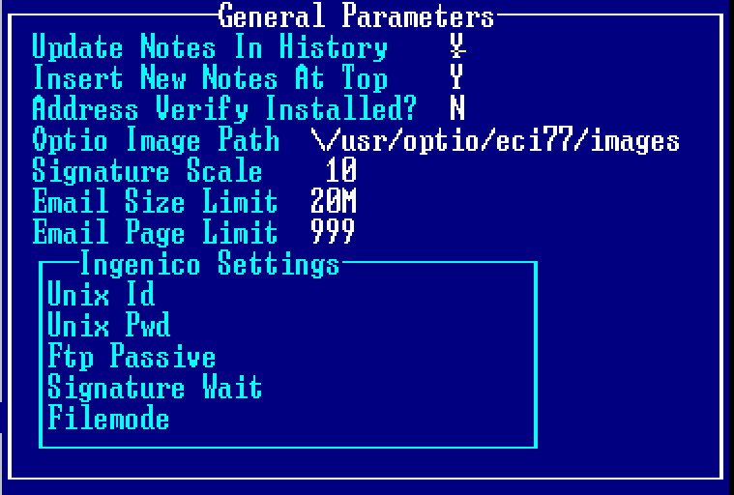
- You must fill in the Optio Image Path and it should be the location of Optio Images folder on Unix System. Typically this is \/usr/optio/eci77/images

Hit F5 For Topaz Flags answer the following prompts
- Enter the Unix Id and unix Password from Step 2 above.
- Depending on your system setup you may have to set the FTP Passive flag to “Y”, this setting will be determined when you run the Test function
- Signature Wait flag is used to have Windows Pop-up Application wait until User closes it after capturing signature.
- Filemode Flag, is used for Citrix and other thin client environments which do not allow arguments to be passed at Execution command in Windows.

- This must be checked for EACH user that will use Topaz Device Check Users Location Profile that is defined on the User Record. From Prelude Menus Systems – System Parameters – Maintenance -- User Identification Maintenance. Look at the Location Profile
Write Location Profile Here _________
- In Startup Parameter Maintenance -
From Prelude Menus Systems – System Parameters – Maintenance -- Order Processing Controls – Startup Parameter Maintenance
enter the Location profile from Above Step 4
- Hit F6 Key for Retail Setup and in the Swipe/ Sign Capture line enter the Word :”TOPAZ”
- Save the F6 Screen and the Startup Parameters screen…
- You can Test The Ingenico Device basic usage by running the Command /TOPAZ.CONTROL which should activate the device and allow you to swipe and sign and return statuses of Mode X done…

Area’s of Prelude that support the Ingenico Device are.
Sales Order entry with 05 Order type Completion Screen with credit card payment Types

Retail cash Sales Entry with Completion Screen and Credit card Payment Types

Signature capture Sales Order Entry & Retail cash Sales Entry F10 Additional Options Signature capture.

Note Modifications to Forms Printing may be required to print the signature on The physical Receipts or Documents.

All Signatures are stored in “tif” format for Optio Printing, use of non optio rendered form will NOT print a signature.

