 | ТМ ® | 

DETECTOR PRITECTION LINEAR
OF PERIMETERS

" Prizma -1/300TM " | ОМLD. 08.001-15
" Prizma -1/500TM " | ОМLD. 08.001-15
ТU 4372-006-44873746-02
Manufacturer: SMC «Omega-microdesign»
CONFORMITY CERTIFICATES
№ РОСС RU. ОС03.В01452
№ ССКБ RU.OC01.H00027

INSTALLATION AND OPERATION MANUAL
ОМLD. 08. 001 РЭ

Russia

CONTENS
1. INTRODUCTION 3
2. PURPOSE 3
3. TECHNICAL DATA 3
4. INSTALLATION AND OPERATION INSTRUCTIONS 5
5. CONTENTS OF DELIVERY 8
6. DESIGN AND OPERATION OF DETECTOR 8
6.1 Work principle 8
6.2 The description of a design of blocks 9
6.2.1 General information 9
6.2.2 The description of a design of blocks 9
6.2.3 Synchronizing the units в 11
6.2.4 Cables (cords) for connection of units 12
7. MARKING AND SEALING 13
8. BOXING AND PACKAGE 13
9. SAFETY PRECAUTIONS 13
10. ORDER OF INSTALLATION 13
10.1 Requirements to preparation of the site and location of the detector’s units 13
10.2 Installing on a barrier or wall 15
10.3 Installing on special posts ST-1 16
10.4 Installing on a support (pole or pipe) 17
10.5 Installing along barriers and walls 18
10.6 Connecting the units 18
10.7 Connecting the connection cable 18
11. SETTING UP THE DETECTOR 20
11.1 Setting up the detector 20
11.2 Aligning the detector 20
11.3 Testing synchronization 21
11.4 Selection of the threshold changing mode 22
11.5 TRAINING of the detector. 22
11.6 Testing safe operation 23
11.7 COMPLEMENTARY TRAINING of the detector. 23
11.8 Manual threshold changing. 23

12. MAINTENANCE SCHEDULE……………………………………………………..24
13. SERVICE OF THE CONTROLLABLE BOUNDARY 26
14. STORAGE AND TRANSPORTATION RULES 26
15. TROUBLESHOOTING 26

1. INTRODUCTION
1.1 The following definitions and abbreviations are used for the purposes of this manual:
Detector “Prizma-1/300TM” , “Prizma-1/500TM” RU – a receiver unit; TU – a transmitter
unit; SU – a sensor unit; UW – the SU’s upper wire; LW – the SU’s lower wire; SA – sensitivity
area; DA – detection area; IPK – installation parts kit; WMA – the SU’s wire mounting attachments;
CIU – control and indicating unit.
1.3. Some definitions:
Sensitivity area (SA) is a confined spatial ellipsoid of revolution with its longer axis coaxial to a nominal line that connects the transmitter and the sensor unit of the detector. The cross-sectional dimensions of the detection area are limited by the 5th Fresnel zone and various surfaces located closer to the axis than the 5th zone.
Detection area (DA) is a part of the sensitivity area of similar shape located inside the sensitivity area and which can be concurrent with the latter in case of significant sensitivity increase. When sensitivity decreases the DA’s cross-section decreases as well, where its length does not change and is defined by a distance between the TU and the RU.

2. PURPOSE
2. The detector is designed to form and monitor an extended spatial DA with turns and various heights, and to generate an alarm signal in case of intruder detection in the DA.
2.2. The DA is an ellipsoid of revolution with its longer axis coaxial to a nominal line that connects the transmitter and the sensor unit of the device
2.3 Depending on application the DA can be formed:
а) Along the top part of an obstacle;
б) Along an obstacle cloth (a building wall) for the approach control;
в) Along an earth surface on open sites of a boundary.
2.4 If necessary it is possible to add a controllable zone with physical obstacles (a barbed wire, tape АКLor other)
2.5 Detector it is intended for teamwork with the equipment fixing change of size of resistance of a target control chain (in the person on duty rezhi ow has resistance of the resistor included consistently with any of vyvo-dov of "dry" contact group of target relay RU).

3. TECHNICAL DATA
3.1 The detector maintains continuous round the clock operation.
3.2 The detector is capable of operating with a DA from
Prizma -1/300TM | From 25 to 300 m
Prizma -1/500TM | From 75 to 500 m
Length of the DA is determined as a distance between the transmitter and the sensor unit (from minimum to maximum).
3.3 The detector is capable of generating an ALARM signal in the monitoring circuit with lasting from
2 to 5 sec. An ALARM signal is generated through a change of the monitoring output circuit resistance
from less than 35Ohms to more than 1000kΩ, or through “interruption” of an external control resistor Rtr
positioned into terminals at the face plate of the RU. Upon the change of the monitoring output circuit
resistance the voltage must not exceed 38V, and the current must be limited at a level of no more than
100mA. It is possible to connect control indicators on the face panel of the RU, which will be used when
making adjustments.
3.4 The detector is capable of generating an ALARM signal to access
- attempt to controls and indication a receiver unit
- At switching-off of pressure of a food (Formation of a continuous signal ALARM without control indication).

3.5 . The detector is capable of safe operation in temperate or cold climate (Temperate and Cold Climate (UHL) construction, category 1 under GOST 15150-69, yet in the temperature range from minus 50°C to plus 50°C).
- exposure to UHF emission in the range from 150 to 175MHz with power of up to 50W at a distance no less than 5m;
- moving of vehicles not within the sensitive area;
- exposure to electromagnetic noise under GOST R 50009-00 (voltage pulses in power supply circuits, electrostatic discharges, etc.).
3.6 The detector provides working capacity at:
- Speeds of a wind to 30 m/s
- Influence of deposits in the form of a rain to 30 mm/hour or snow to 10 mm/hour (in recalculation on water);
- Influence of solar radiation and overheat of cases no more +110°С;
- To height of roughnesses no more + 0,3 m on a piece of a controllable site in places of an adjunction of a sensitive zone to an earth surface;
- To height of a snow cover to 0,5 m (at moving possibility on height RU and TU the cover height can be more on moving size on height);
- To height of a grassy cover to 0,3 m;
- Moving to a zone of detection of small subjects or animals with the linear sizes no more than 0,2 m
- Influence of VHF of radiation in a range of 150-175 MHz capacity to 50 Vt on distance not less than 5 m;
- Journey out of a sensitive zone of vehicles;
- Influence of electromagnetic hindrances in accordance with GOST Р 50009-00 (impulses naprjazhe-nija in feed circuits, electrostatic categories, etc.).
3.7 Power supplies detector are carried out a source of a direct current with but-minalnym value of pressure 24В at admissible side-altars of change from 10 In to 36 Century
3.8 The maximum current consumed detectors on a chain of a direct current, does not exceed 25 мА, and the maximum capacity does not exceed 0,25 Vt
3.9 The detector the ALARM about-dolzhitelnostju 3 … 5 seconds the Signal ALARM provides delivery in a control chain of a signal is formed by change conducted-ranks resistance of a target control chain from value less than 35 Ohm to znache-nija more than 1000 clod (disconnection of "dry" contact group of the target relay). At measurement of size of resistance of a target control chain, pressure should not exceed 38 In, and the current should be limited at level no more than 100 мА. On control panel BPRM there are the light-emitting diodes, allowing to observe signa-ly both thresholds, and buttons for installation of thresholds that provides convenience at on-building.
3.10 The detector has possibility of the remote control of working capacity. The signal of the remote control should be formed by giving on wires of recreation centre RU of pressure of a food range detector during time not less than 0,3 with. In reply to giving of a signal of a recreation centre detector makes self-checking and, in case of serviceability, forms a signal ALARM.
3.11 Service life of the detector units and the fiberglass WMAs will not be less than 10 years.
3.12. The detector does not contain precious metals.
4. INSTALLATION AND OPERATION INSTRUCTIONS
4.1 The detector is located at the guarded perimeter – outdoors or indoors.
4. . TU “1” (see Fig.4.1) and RU “1” are placed facing each other so that the DA guards the monitored sector. DA “2” is an ellipsoid of revolution with its longer axis coaxial to a nominal line “3” that connects the centers of the RU and TU “1” installed at a height “H” from the ground surface at a distance “L” from each other. Note. Except where specifically indicated, all distances herein shall be specified in meters
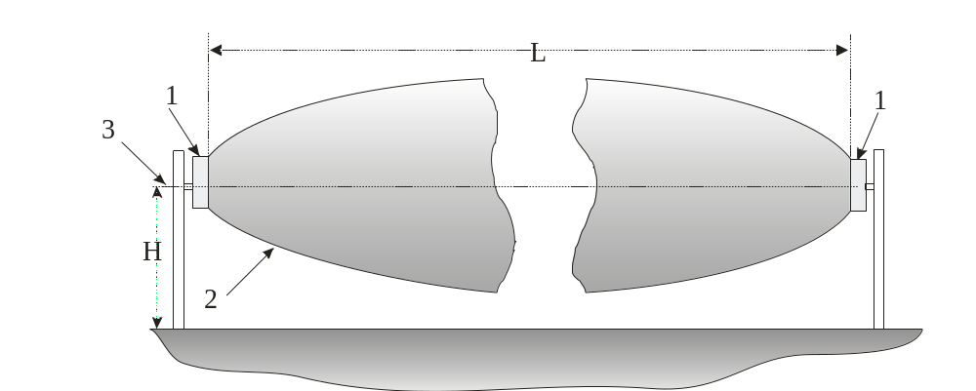
Fig. 4.1
4.3 The TU and RU are placed at a selected height (0.8 to 1.2 m is recommended) from the ground surface.
4.4 Width of the sensitivity are depends on the distance between the TU and RU and is determined by an approximate diagram shown in Fig. 4.2.
The diagram shows:
L – distance between the TU and RU (X-axis); r(L) – distance from the nominal line that connects the centers of the RU and TU to the sensitivity area limit in the middle of the guarded sector (half width of the sensitivity area).
Note: Width of the DA (moment of operation) depends on the thresholds set and can be narrower as compared to that shown in Fig. 4.2.
4.5 Selecting a height of placement, note that when approaching the TU (RU) along the axis the DA “separates” from the ground as shown in Fig. 4.1, 4.3. Fig. 4.3 shows how the distance “r(A)” from the lower limit of the SA to the ground surface depends on approaching the TU (RU) to a distance “A”. The calculation assumes that | 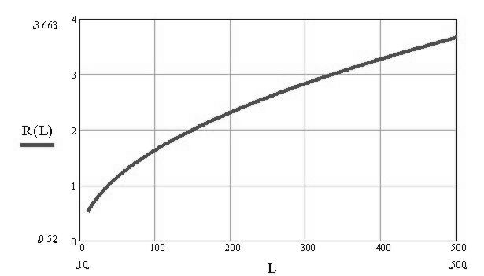  Fig. 4.2
the centers of units are at a height of 0.9m from the ground surface and the surface itself is plane at the specified distance from the units. At a zero distance from these units the DA width is equal to the width of the units. With other height of units placement a liner correction must be made for the height change, i.e. the “A” axis to be moved up is the height is smaller and down if the height is larger.  4.6 . If located along |  | 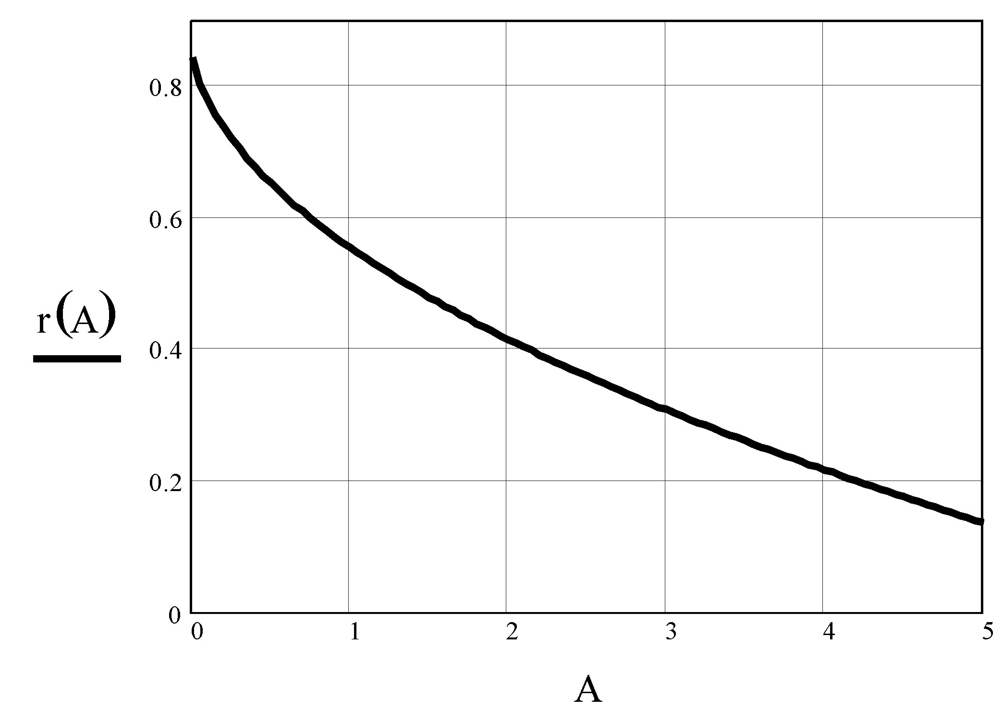 Fig. 4.3
walls, barriers or other structures (excluding radioparent) the DA must not touch their surfaces. Fig. 4.4 shows cross-sections (relative to axis “1”) of DA at various distances from the units (TU or RU) located at a height “H”: “2” – in the middle of a long guarded sector; “3” – at a distance of 2 to 3m from the units; “4” – close to the units. Distance “B” from the units to a structure must not be less than a half width of the DA in the middle of the sector.  4.7 Proximity of the DA “axis” to conducting (non- |  |  | 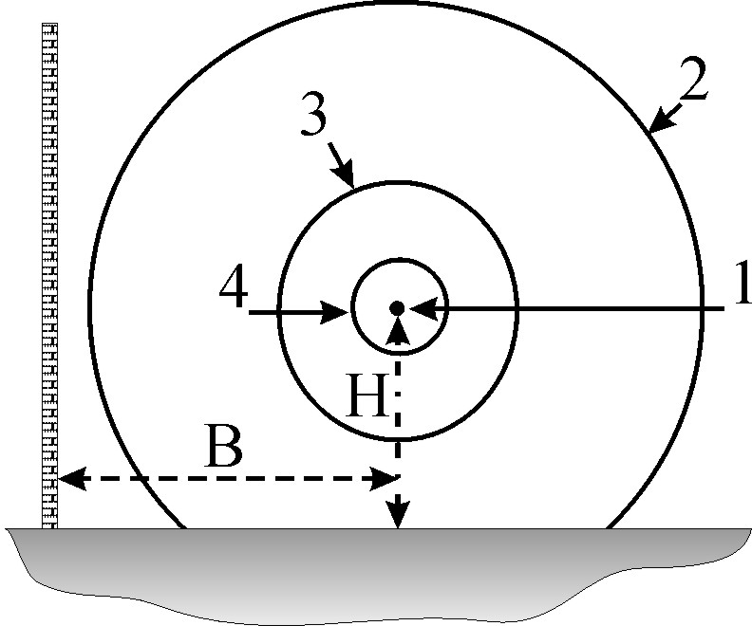 Fig. 4.4
radioparent) barriers to a distance smaller than half width of the DA may lead to interference of the radio signal, and with swinging barrier or change in reflecting properties it may lead to significant fluctuations of the level of signal being received that is to s significant reduction of the signal/noise ratio. Therefore, when designing and installing the width of the sensitivity area must be taken into account (see diagram in Fig. 4.2).
4.8 It should be noted that a portion of the guarded sector of the DA is an ellipsoid of revolution truncated by the ground surface (see Fig.4.4, zone “2”). However (see section 4.4), when approaching the TU (RU) the DA “separates” from the ground and is necessary to cover the created “passages” by means of either the DA of a contiguous sector as shown in Fig. 4.5 (top view) and 4.6 (side view), or using physical obstacles (barriers, barbed wire or other). Fig. 4.5, 4.7,…4.9 show the TU as “1” and the RU as “2”.

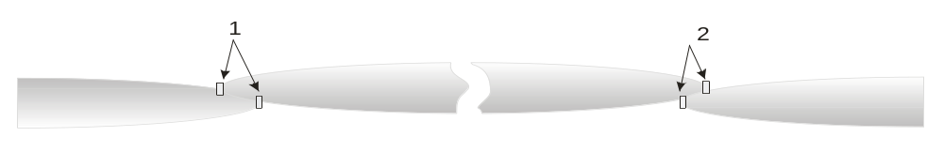 Fig. 4.5
4.9 The length of a guarded perimeter must not exceed 300 m and shall not be less than 25 m for “Prizma-1/300TM”, and must not exceed 500 m and shall not be less than 75 m for “Prizma-1/500TM”.
4.10 When installing several serial detectors at the perimeter their spatial separation (to eliminate interaction) and overlapping of detection areas (to eliminate passages “authorized by error”) must be ensured. Fig. 4.5 and 4.6 show a variant of spatial separation. Elimination of interaction of adjacent detectors can be ensured: by units of the same designation (TU or RU) installed adjacently and by spatial | 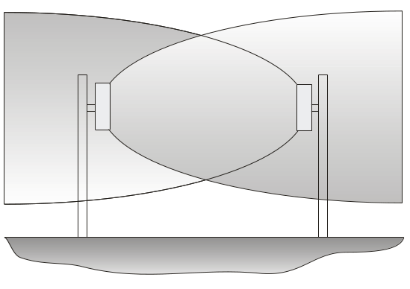 Fig. 4.6
Lateral displacement of the axes of their Das to eliminated the screening effect (shadowing) of the units on each other.  4.11 If units with different designation (RU and TU) of the adjacent sectors are installed close to and facing each other, a switching out of the RU is possible due to a possibility of its “exposure” by the TU of the adjacent sector. To resolve the conflict in case of close installation of units with deferent designations at the adjacent sectors ensure that their DAs do not cross.  4.12 Overlapping of DAs when installed at a place with turns of the guarded perimeter, for example, as conventionally shown in Fig. 4.7 is | 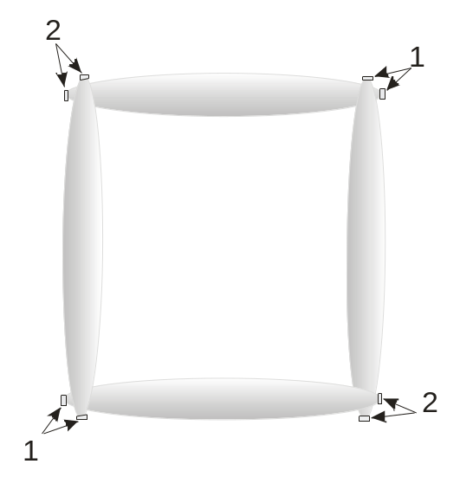 Fig. 4.7
obtained using the same method (see section 4.10).  4.13 When installing detectors along barriers the following must be determined: are the radio waves emitted by the TU capable of reaching the RU having been reflected from the barrier. If they are, rotate the DA axes as shown in Fig. 4.8. Angle of rotation to be calculated taking into account the widening of the DA (see diagram in Fig. 4.2) so that the DA does not touch the barrier (even barriers radioparent in dry weather are capable of reflecting radio waves after rain). |  | 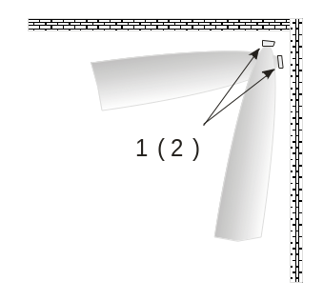 Fig. 4.8
4.14 When a detector is placed in the upper part of the barrier (almost the “canopy-type” version), take the influence of reflected waves into account in the same manner as in section 4.13. Select a height of placement of the units above the barrier so that the waves reflected from the barrier do not project onto the radioparent surface of the RU. In such case for installation use special KVZ-holders available in the content of delivery. Fig. 4.9 (same as in Fig. 4.4 with the same designations) sows approximate DA cross-sections for the “canopy-type” version. |  |  | 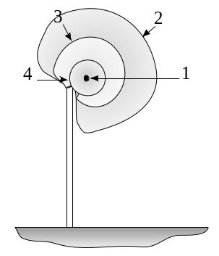 Fig. 4.9

5. CONTENTS OF DELIVERY
5.1 Contents of delivery for a detector and IPK to be chosen from tables corresponding to the packages.
Package No.1 (The Units)
Name | Quantity
a transmitter unit (TU) | 1 p.
a receiver unit (RU) | 1 p/
Knot of fastening of blocks UZK | 2 p.*
Passport | 1 b.
Data card | 1 b.
The operation manual | 1 b.
*Note: Contents of delivery and mounting versions of the units to be specified when ordering a detector for specific sector of the perimeter.
UZK-1 to attach TU and RU to barriers or walls of buildings, to poles or pipes;
2) UZK-2 to attach TU and RU on columns or pipes;
3) UZK -22 - to attach two TU and RU on columns or pipes;
Package No.2 KVZ-1 – a holder to attach TU and RU to upper parts of barriers, walls of buildings or roofs
Package No. 3 (Mounting boxes)
1) BD-00 (BD-02) – to connect two TUs of the adjacent sectors.
2) BM-00 (BM-02) – to connect two RUs of the adjacent sectors.
Package No. 4(Rack for fastening of two blocks of adjacent sites)
ST-1 | A post 1.4m high to install one or two TUs (RUs)
OST-1/0.5 (/0.8;/1)** | A support 0.5 (0.8; 1.0) m to fix the ST-1, installed into the ground
UK-ST1 | Mounting attachment for TU (RU) on ST-1 post
UK2-ST1 | Mounting attachment for TU (RU) on ST-1 post
KSST-1 | A box to connect one or two TUs (RUs)  To be built-in to the upper part of ST-1 post

**Notes. The supports are available in three modifications differing in depth of installation into the ground: 0.5m, 0.8m, and 1.0m (chosen based on required stability of an ST-1 in specific ground). To eliminate swinging of cables inside metallic hoses, two optional clamps to fix the cables to the post can be included into the contents of delivery

6. DESIGN AND OPERATION OF DETECTOR

6.1 Work principle
6.1.1 The detector’s principle of operation is based on detecting a trespasser by an induced change of parameters of the electromagnetic field between a TU and a SU along a two-wire SU. At that the
TU and RU units are connected to the opposite ends of the twowire SU.

6.2 The description of a design of blocks

6.2.1 General information
The transmitter unit (TU) and receiver unit (RU) have similar construction. A subunit including printed circuit boards and modules is installed inside a metal case with radioparent face plate. A cord for external attachments and connections is lead out from the lower part of the case. For protection of the cord from atmospheric conditions it is enclosed in a metallic hose. The backside of the units accommodates structural elements for fixing and alignment. | 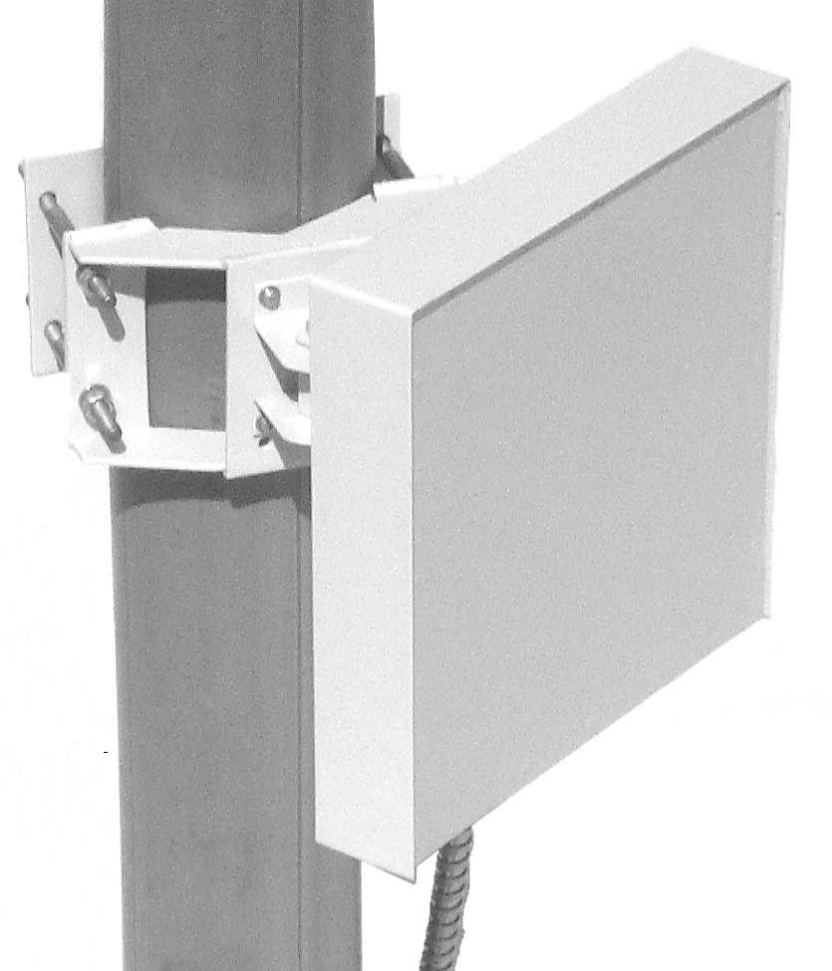 Fig. 6.1
Overall dimensions of the units without the attachment fittings: 205×205×45mm. The back wall accommodates an antennae module and electronic blocks on printed circuit boards. The from part of the case accommodates a radioparent windows of fiberglass. On the outer side of the RU (TU) back wall a fixing and alignment device (UZK) is attached. Under the UZK there is a sleeve for leading in the cable and fixing the metallic hose. The construction of a RU differs from that of a TU in that the back

side has holes with protruding indicators 1 “Л” (left), “-” (middle) and “П” (right) with control buttons 2 with the same designations located under them. The indicators and the buttons are protected from exposure by a special cover fixed by means of two thin shank coarse thread screws. Between the middle indicator and button there is a hole for an IR cover position sensor (opened/closed). | 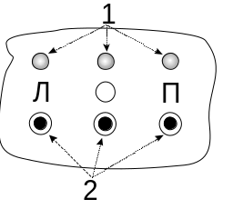 Fig. 6.2

6.2.2 Controls and indicators
Designations of the controls and indicators, modes of indication, and other information is given in Fig. 6.2 and in tables 6.1…6.6.
Table 6.1 Indication modes representation.
No. | Designation of indicator | “Л” |  | “-”(C, middle, M) |  | “П”
No. | Designation of indication mode | Green | Red | Green | Red | Green | Red
1 | Main | 4-bit signal |  | 3-bit signal |  | 2-bit signal | Alarm
2 | Indication of sensor’s signal | 4-bit signal | ∗ | 3-bit signal |  | 2-bit signal
3 | Indication of sensor signal with double (“×2”) rise | 3-bit signal |  | 2-bit signal | ∗ | 1-bit signal
4 | Indication of factory preset thresholds and synchronization quality activation | Factory present on |  | 1-bit |  | 0-bit | ⊕
5 | Indication of sensor’s threshold | ∗ | 4-bit threshold |  | 3-bit threshold |  | 2-bit threshold
6 | Indication of threshold with double (“×2”) rise |  | 3-bit threshold | ∗ | 2-bit threshold |  | 1-bit threshold
7 | Indication of threshold with ×4 rise |  | 2-bit threshold |  | 1-bit threshold | ∗ | 0-bit threshold

Note. The “*” sign indicates an “on” condition of an indicator corresponding to the number and designation of an indication mode. 4…0-bit: binary bits of a signal value indicated; 4-bit is the high (4th) bit,… 0-bit is the low (0) bit. When the green and red colours of the same indicator are simultaneously on its colour will change into the orange. Exception: when the regular mode is indicated by the ALARM indicator and the values of the signal that caused the alarm switch alternatively. In this manual abbreviated designations of indicator colours may be used, for example, “Lr” for left red or “Rg” for right green, etc.
Table 6.2 Changing the indication modes.
Action | “Л” | “C” | “П”
Increase of indication mode number | Single short depression (1 sec)
Decrease of indication mode number |  |  | Single short depression (1 sec)

Тable 6.3 Alignment mode
Action | “Л” | “C” | “П”
Switching alignment mode on |  | Pressing and holding until three green indicators turn on in the indication mode “1”
Switching alignment mode off |  | Repeat pressing and holding until three green indicators turn on

Тable 6.4 Semi-automating threshold setting mode.
Action | “Л” | “C” | “П”
Switching complementary training mode on (with storing previous values) |  | Pressing and holding until three red indicators turn on in the indication mode “2”
Switching retraining mode on (without storing previous values) |  | Pressing and holding until three red indicators turn on in the indication mode “3”
Setting a moment of operation |  |  | Pressing and holding until Rr or Rg indicator turns on
Storing the selected threshold and switching the auxiliary threshold setting mode off |  | Repeat pressing and holding until three red indicators turn on in the indication mode “2” (“3”)
Exit without storing the selected threshold and switching the auxiliary threshold setting mode off | Pressing and holding until three green indicators turn on in the indication mode “2, 3”

Тable 6.5 Manual threshold changing mode
Action | “Л” | “C” | “П”
Switching manual threshold changing mode on |  | Pressing and holding until three green indicators turn on in the indication mode “5…7”
Threshold increasing | Single short depression (1 sec)
Threshold decreasing |  |  | Single short depression (1 sec)
Storing the selected threshold and switching the manual threshold changing mode off |  | Repeat pressing and holding until three green indicators turn on
Exit without storing the selected threshold and switching the manual threshold changing mode off | Pressing and holding until three green indicators turn on

Тable 6.6 Resetting
Action | “Л” | “C” | “П”
Resetting in any indication mode | Pressing and holding until three green indicators turn on in the indication mode “2, 3”

6.2.3. Synchronizing the units
6.2.3.1. The Rr indicator is continuously on (*) in the TU/RU sector synchronizing mode, in the 4th indication mode (Table 6.7). Green indicators represent: “Lg” – (☼) switching on/(-) switching off of factory preset thresholds; “Mg” and “Rg” – quality of synchronization (communication between TU and RU) by radio beam; at that the “П” (right) indicator may be on and of orange colour.
Тable 6.7
Designation  of indicator | “Л” |  | “-”(“C”, middle, M) |  | “П”
Designation  of indicator | Green | Red | Green | Red | Green | Red
Indication of mode 4 | ☼/(-) | - | 1-bit | - | 0-bit | ∗

In this mode the TU emits r.f. pulses towards the RU, and the RU determines their position in time to pass only these pulses into the “time gates” for further processing and decision making. Time diagram in Fig. 6.3 visualizes the above. Noise 1 cannot pass into the time gates and is “not let” for further processing.
БПРД
БПРМ
На обр.
1
Fig. 6.3
Synchronization quality is determined from Table 6.8
Synchronization quality | Value | “Mg” | “Rg”
Good | 3 | * | *
Satisfactory | 2 | * | -
Bad | 1 | - | *
No synchronization | 0 | - | -

6.2.4 Cables (cords) for connection of units
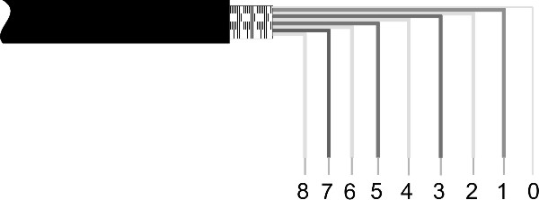
6.2.4.1 RU cable is connected to external devices (connection box, etc.) by means of a built-in shielded eight-wire cable (EKS-GVPVE-5e-4×2×0.52). by means of a built-in shielded eight-wire cable (EKS-GVPVE-5e-4×2×0.52 The cable has four twisted pairs and an uninsulated wire connected with the shielding band. Purpose of the conducting wires of the cable is according to Table 6.9.
Таble 6.9
Pair No. | Cable marking | Conductor color | Purpose
1 | “1” or “+” | orange | +Usuppl
1 | “2” or “-” | white | - Usuppl
2 | “3” or “DK” | brown | Remote control: pulse with an amplitude of 7…36V, length of 0.3…3 s
2 | “4” or “DK” | white
3 | “5” or “ZP” | blue | Resetting to factory preset thresholds
3 | “6” or “-” | white | - Usuppl
4 | “7” or “R” | green | Output relay contacts:  NC – monitoring mode, NO - alarm
4 | “8” or “R” | white | Output relay contacts:  NC – monitoring mode, NO - alarm
Shield wire |  | Connecting the case with the earthing terminal
Note. No marking of cable is allowed.
6.2.4.2 TU cable is connected to external devices (connection box, etc.) by means of a built-in shielded four-wire cable (EKS-GVPVE-5e-2×2×0.52). The cable has two twisted pairs and an uninsulated wire connected with the shielding band. Purpose of the conducting wires of the cable is according to Table 6.10.
Таble 6.10
Pair No. | Conductor color | Purpose
1, 2 | color | + Uпит
1, 2 | white | - Uпит
Shield wire |  | Connecting the case with the earthing terminal
Notes:
1) Usage of a two-wire cable is allowed; at that the coloured wire is for the positive terminal of a power supply unit being connected.
2) Lengthening (extension) and shortening of the TU and RU cables is allowed. Lengthening must be done using a cable of the same type observing the colours and matching the pairs in a twisted pair. It is required to connect and insulate the wires, to restore the continuous shielding and protective cover (sheath).
3) It is allowed to restore the cable sheath using a shrink conduit. After shortening of the metallic hose restore its regular shape, especially at the lead-in portions (at ends). If necessary, replace the metallic hose by a similar in size.

7. MARKING AND SEALING
7.1 The detector’s units bear the following:
a manufacturer’s trademark; product code; year of manufacture.
7.2 One of the screws for fixing the panel to the detector’s RU box is placed into a suitable cup being sealed by the QC representative.
8. BOXING AND PACKAGE
8.1 Transportation boxes will have the handling marks as follows:
HANDLE WITH CARE, FRAGILE, KEEP DRY, TOP, DO NOT TURN OVER.
8.2 The transportation boxes will have a QC stamp by the manufacturer.
8.2 Transportation box has a brand of factory of the manufacturer

9. SAFETY PRECAUTIONS
9.1 Maintenance of the detector must be carried out by personnel with strong skills in its operation and having a permission to work with electrical devices with voltage of up to 1000V.
9.2 It is necessary to remember that negligence in use of the detector and violation of the
requirements of the present manual may cause failure of the detector.
9.3. It is strictly prohibited to apply voltage higher than 36V to the RU and TU cord wires.

10. ORDER OF INSTALLATION
10.1 Requirements to preparation of the site and location of the detector’s units
10.1.1 The sector between the unit’s TU and RU must satisfy the following requirement: a) surface of the sector must be leveled with a tolerance of ±0.3m at the portion of the perimeter where the detection area touches the ground surface. With larger positive differences the upper edges of obstacles can form rather powerful secondary sources of radio waves or completely screen the RU from TU (where there is no line of sight), where in case of a reduced signal the signal/noise ratio decreases accordingly that may lead to a decrease of the interval between false alarms. Fig. 10.1 represents a case where the height of an obstacle reaches the height of a nominal axis drawn through the centers of the TU and RU. It can be seen how the detection area is distorted and possibilities of its uncontrolled crossing arise for the “two-double” position; at that any changes of the upper surface (edge) of the obstacle significantly change the amplitude of the legitimate signal (the surface properties and properties of the secondary source of emission change).
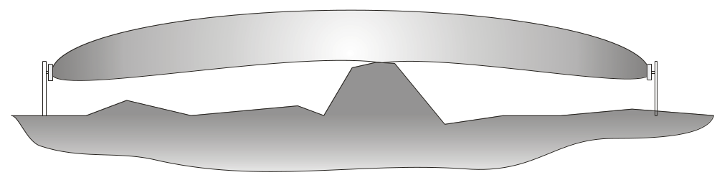
Fig. 10.1
b) within the sensitivity area (see Fig. 4.2, 4.4) there must be no objects (bushes and other vegetation hither than 0.3m, branches of trees, wickets, gates, etc.) swinging under action of meteorological factors;
c) a width of the restricted area must be selected based on the width of the detection area (see section 4.4). Smaller width of the restricted area is allowed. At that the amplitude of the signal detected during the alignments may significantly decrease. In such case it is required to change the spatial location of the RUs (TUs). For example, if fixed on supports (poles or pipes), rotate the UZK around the support so that the RU (TU) moves against the wall or fence by 70…100mm; at that a direction of the unit towards the opposite unit must be selected to maximize the amplitude of the signal at the RU. In some cases, where it is not possible to obtain an acceptable increase of the signal amplitude, the detector’s noise immunity may decrease that can be determined during a test run or experimental operation;
d) presence of detached still objects is allowed within the detector’s DA (poles, tree-trunks without lower branches, etc.) at a distance of 0.5m from the axis that connects the TU and RU;
e) the height of grass cover within the DA must not exceed 0.3m;
f) the height of snow cover must not exceed 0.5m.
Note. If height of the snow cover exceeds 0.5m, adjust the height of the RU (TU) so that the distance from the axis that connects centers of the units to the snow surface is no less than 0.3…0.4m.
10.1.2 Determine probable location of the DA and that of the units.
10.1.3 Choose a place and way of attaching the units, the suitable attachments and other auxiliary holders and materials
10.1.4 If the metallic hose is planned to be located in the ground, it must be protected from corrosion.
Note. The RU and TU cables have outdoor design and do not require any protection except for protection from mechanical damage. However, the metallic hose, besides its being a mechanical means of protection, functions as a cable shield and earthing for the metal cases of the TU and RU.

10.2 Installing on a barrier or wall
10.2.1 A variant for mounting the units on a wall 1 (barrier) is shown in Fig.10.2. The units are placed at a height less than 0.8…0.9m above the averaged ground, floor or soil surface. First of all, marking to fix a holder 2 is made (UZK-1). Centers of the holes are in the corners of a nominal 80×60 rectangle.
Using screws 3 with spring washers and nuts attach the TU (RU) to holder 2. Drill suitable holes in wall 1 and using screws or bolts with suitable washers fix the RU (TU) to the barrier. If the TU and RU have to be located above a barrier or a building wall it is possible to use special holders 1 (see Fig.10.3) from the contents of delivery. | 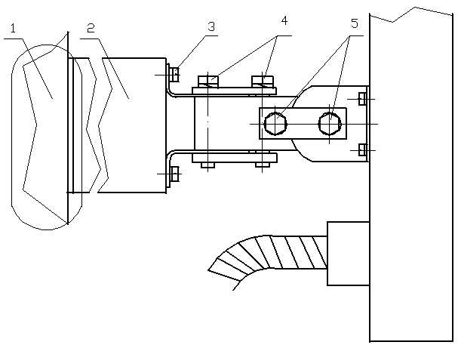  Fig. 10.2
At that centers of holes are located in the corners of a nominal 80×80 square. At that it is allowed that two RU or TU units are installed on one holder for adjacent sectors. The united are fixed to the holder by means of screws 3 with washers 2. Eliminate possible interaction of adjacent sectors, when the TU of one sector is directed towards the RU of another sector.  10.2.2 . Determine a location for fixing the RU (TU) on a wall or surface of a barrier, do marking, drilling and other required steps.  Note. It is required to observe safety rules during installation works. Outdoor areas and premises with conducting floor are referred to the specifically dangerous category where any kind of “double” insulation of tools will not ensure safety of the works!!! |  | 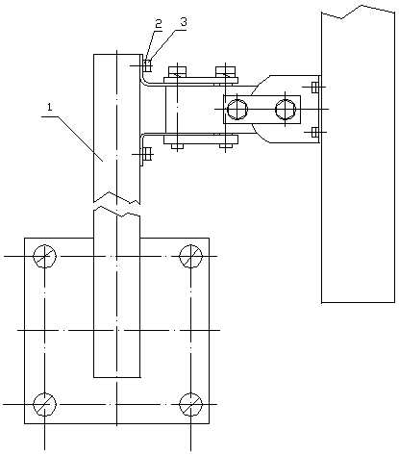  Fig. 10.3
10.2.3 UZK-1 ensures rotation to an azimuth (in horizontal plane) within 150⁰ (-75⁰…+75⁰) and at an elevation (in vertical plane) within 150⁰ (-75⁰…+75⁰).
10.2.4 To make alignment at an azimuth loosen bolts 4 (Fig. 10.2) to be able to rotate the units applying a low force. Rotate the RU (TU) towards the opposite TU (RU) of the same sector. Tighten bolts 4 to straighten the spring washers.
Note: 1. The maximum on the diagram is concurrent with the normal (perpendicular) to the plane of the radioparent window.
2. For this work use a spanner with S=10 and a screwdriver with the blade 0.8mm thick for screw 5 (М4×10).
10.2.5 For visual alignment to an elevation (see Fig.10.2) loosen bolts 5 to be able to rotate the unit applying a low force. Rotate the RU (TU) towards the opposite unit. Tighten bolts 5 to straighten the spring washers.
10.2. After the visual alignment do a fine alignment using the indicators on the RU in the “Alignment” mode (see section 11.2).

10.3 Installing on special posts ST-1

10.3.1 Mark the locations for installation of ST-1 posts and laying of all outer cables for connection of the detectors’ units 10.3.2 On the marked locations dig holes with dimensions 400×400×600 (400×400×800 or 400×400×1100) in the ground depending on the selected variant OST-1 (/0.5, /0.8, /1).  10.3.3 Plumb the OST-1 posts into the holes, leaving the portion with attachments above the ground, then fill the holes |  |  |  | 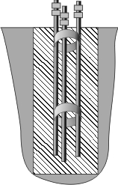  Fig.10.4
with concrete or mortar as per Fig.10.4.  10.3.4 After setting of the mortar lead cable 1 (Fig. 10.5) for connecting with concentrator or CIU through the lower hole of post 2 and lead it out through the upper hole; fix the posts to the supports using nuts as per Fig. 10.5. Using nuts and a plumb adjust the vertical position of the posts and tighten the nuts.  Note. If an armoured cable or a cable with thick sheath is used that prevents leading the cables through a post from TU (RU) 3, remove the armour or make the sheath thinner above portion “Б”(Fig. 10.5) to ensure unobstructed leading the cables through the post.  10.3.5 . Install UK-ST1 (UK2-ST1) holders onto the posts in the locations of TUs (RUs) as shown in Fig.10.5.  10.3.6 . Using screws fix TUs (RUs) 3 to the holders.  10.3.7 Lead the cables in metallic hoses from TU (RU) 3 through the nearest holes in the posts and lead them out through the upper hole of the post, allowing for possible necessity of free movement of TU (RU) along the post in case snow cover exceeds the limit, etc. |  | 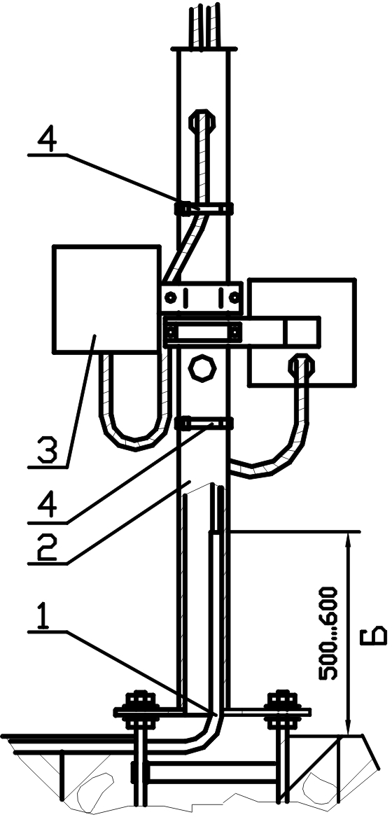  Fig.10.5
10.3.8 Lead the cables into the KSST-1 connection box as per sections 10.3.9 …10.3.14.  10.3.9 Lead cables 1 (Fig. 10.6) in metallic hoses through the holes of the cable lead-ins 2 and lead the prepared ends 3 of cables to terminals “ИЗВ1” (DET1) or “ИЗВ2” (DET2) for further connection.  10.3.10 Drive screw 4 several turns out to fully release the lead-in hole. Lead metallic hose 1 into the lead-in hole and holding it tight from inside tighten screw 4.  10.3.11 To lead two cables in metallic hoses repeat steps in section 10.3.10 for the second cable. |  | 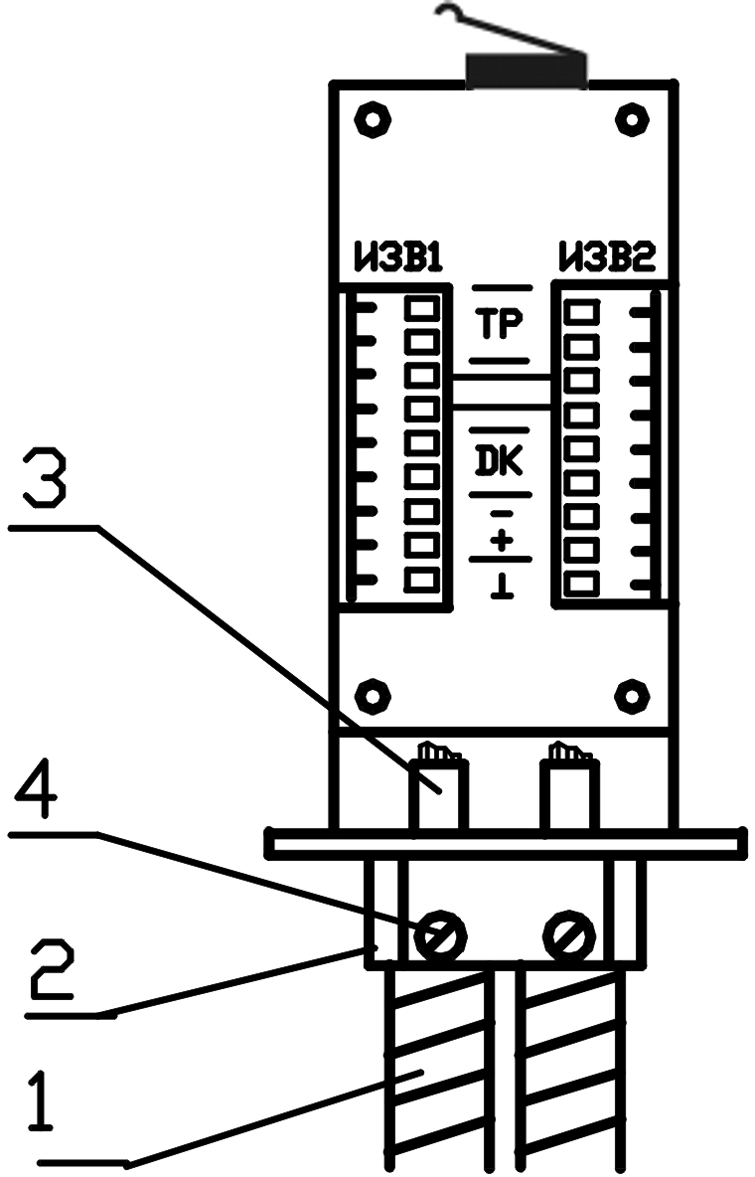  Fig.10.6
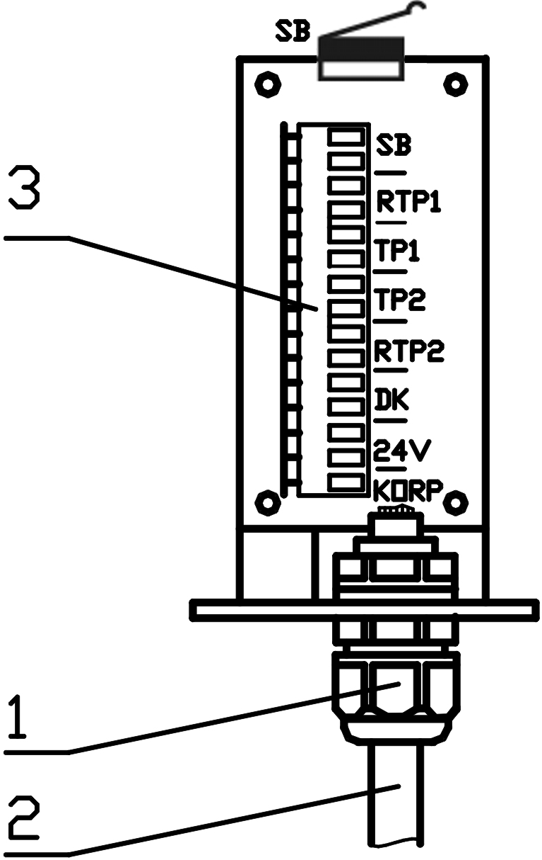  Fig.10.7 | Undo pressure nut 1 several turns (Fig. 10.7) to release the cable lead-in hole.  10.3.13. Lead cable 2 through the lead-in hole and lead the prepared ends of cable 2 to terminals 3 for further connection.  10.3.14. By means of pressure nut 1 (Fig.1 10.7) securely fix cable 2.  10.3.15. Install KSST-1 onto the upper part of the post and fix using screws 1 (Fig. 10.8). |  | 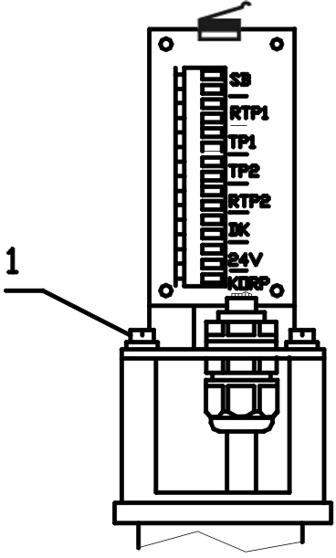  Fig.10.8
10.3.16 To eliminate swinging of cables inside metallic hoses under wind use clamps 4 (Fig. 10.5) from the contents of delivery to attach the outer portions of cables to the post at the lengths from the units to the holes in the posts.

10.4 Installing on a support (pole or pipe)
10.4.1 Choose or install a support to fix the units to it (a pole or pipe with Ø100 to 160mm). If the chosen support is of rectangular or other cross-section order with the unit or make special clamps. When installing note the characteristics of soil and ensure stability and durability of the structure being made with possible partial concreting of a support placed into the soil.
10.4.2 . Using studs, nuts and washers install the UZK-2 clamps onto the support to fix one TU (RU) or UZK-22 two fix a pair of TUs (RUs). The UZK clamps accommodate devices for fixing and alignment with the RU (TU). Height of installation is based on operational and tactical considerations and specific conditions. The approximate installation height is 0.8…0.9m from the averaged ground (floor) surface to the lower part of the RU (TU).

10.5 Installing along barriers and walls
10.5.1 When installing along surfaces of barriers (building walls) consider the requirements in section 4.13.
10.5.2 Two variants are possible for attaching the units: a) on supports as per section 10.4; b) one of the units of the sector is installed directly onto surface of a barrier (wall), and the second is installed on a support.
10.5.3 Prepare and install the units as per sections 10.2 and 10.4.

10.6 Connecting the units
10.6.1 Connect the conducting wires of the detector cables..
10.6.2 Connect TU cables to “ИЗВ1” (DET1) (“БПРМ1” (RU1), “БПРД1” (TU1)) and/or “ИЗВ2” (DET2) (“БПРМ2” (RU2), “БПРД2” (TU2)) terminals in accordance with the marking on the chassis of KSST-1 (BM-00, BD-00 or other) and Table 10.1.
Тable 10.1
Pair No. | Marking of KSST-1 (BM-00, BD-00, BM-02, BD-02) | Conductor color | Purpose
1, 2 | “1” | coloured | +Usuppl
1, 2 | “2” | white | - Usuppl
Shield wire “0” |  | Connecting with the earthing terminal
10.6.3 Connect RU cables to “ИЗВ1” (DET1) (“БПРМ1” (RU1)) and/or “ИЗВ2” (DET2) (“БПРМ2” (RU2)) terminals in accordance with the marking on the chassis of KSST-1 (BM-00, BD-00 or other) and Table 10.2.
Тable 10.2
Pair No. | Chassis marking | Conductor color | Purpose
1 | “1” | orange | +Usuppl
1 | “2” | white | - Usuppl
2 | “3” | brown | Remote control:
2 | “4” | white | Remote control:
3 | “1” / “2” | blue | Resetting to/Turning off factory preset thresholds
3 | “2” | white | - Usuppl
4 | “7” | green | Output relay contacts:  NC – monitoring mode, NO - alarm
4 | “8” | white | Output relay contacts:  NC – monitoring mode, NO - alarm
Shield wire “0” |  | Connecting with the case and the earthing terminal

10.7 Connecting the connection cable
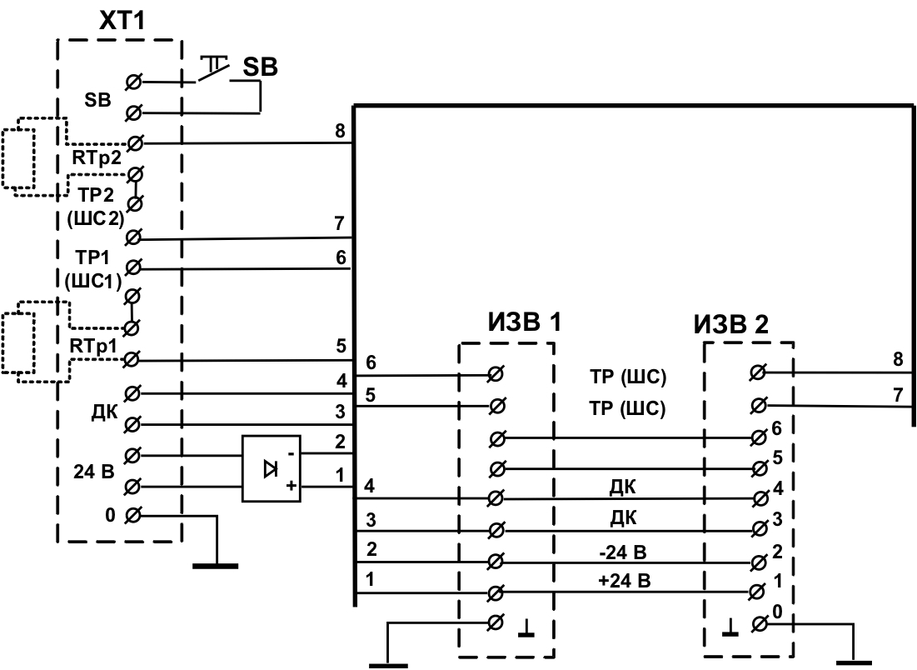
10.7.1 Connecting the connection cable to KSST-1, BM-00, BM-02
Fig.10.9

10.7.1.1 Connect the wires of the connection cable (with CIU or concentrator) to contacts of the terminals on the back of the chassis in accordance with the electrical diagram of the project (see Fig.10.7, Fig.10.9). Place control resistors into “RТР1” and “RТР2” terminals. Connect the pairs of the control wires from CIU to “ТР1” and “ТР2” (ШС1 and ШС2) terminals. If the ALARM circuit is monitored at ТР1(2) terminals without an external resistor (a jumper in the RТР terminals) it is necessary to limit the current to a value not exceeding 100mA (a current limiter can be installed instead of the jumper in the RТР terminals). The “alarm signal” generated by the tamper button “SB” can be combined with one of the “alarm signals”, for example “TP1”, for which purpose the corresponding pair of control wires from the CIU shall be connected to the two terminals “ТР1” and “SB”, where a jumper shall be installed onto the other “ТР1” and “SB” terminals. Connect the pair of 24V wires from the power supply unit to the two “24В” terminals. Connect the pair of “ДК” wires from the button and the relay of the remote control to the two “ДК” terminals.
Notes. 1) To connect the wires of the cable press the lever of a contact, insert the exposed end of a conductor into the opened hole of the contact and release the lever; 2) Install a terminal resistor into the RТР terminals as required for the control and indicating unit and carry out measurements at the “ТР” terminals, where the RТР value will be determined by the resistance required to maintain the MONITORING MODE of the CIU.
10.7.1.2. Carefully pack the cables in KSST-1 (BM-00 and other), close cover 1 (Fig. 10.10), fix it using screws 2 and seal (for KSST-1).  *Note. Before connecting the blue wire of the RU cable it is required to decide on the way of setting the detector’s sensitivity. When using the factory preset thresholds connect the blue wire to the “+” of the power supply; for the manual threshold setting mode or the training mode connect the blue wire to the “-”of the power supply.. | 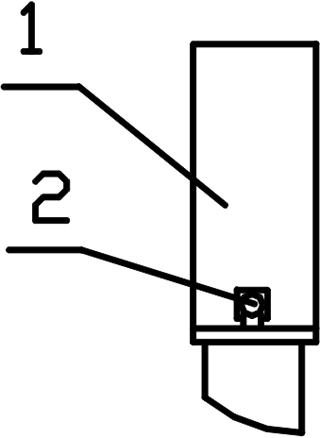  Fig.10.10

10.7.2 Connecting the connection cable to KSST-1, BM-00, BM-02-02

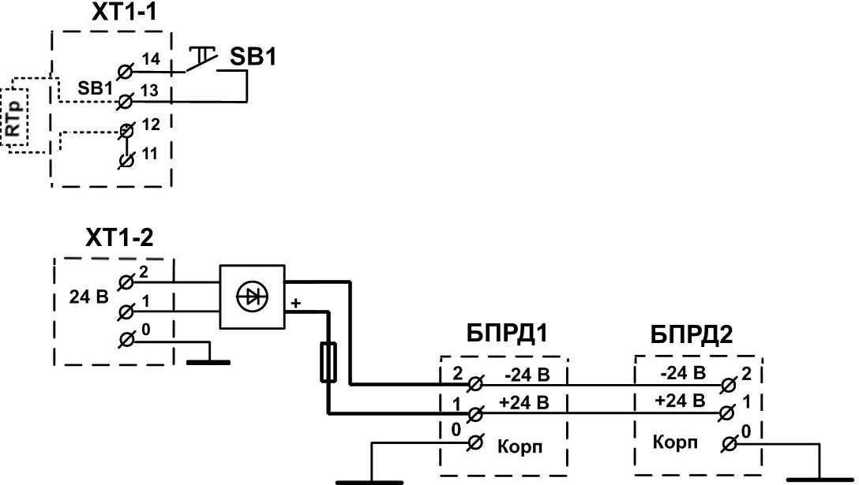

Fig. 10.11
10.7.2. . Connect the wires of the connection cable (with CIU or concentrator) to contacts of the “ХТ1” terminals (see Fig.10.11). Place control resistor (RTp) into terminals 12 and 13. Connect the pair of control wires from CIU to terminals 11 and 14. If the ALARM circuit is monitored at terminal 11 without an external resistor (a jumper in terminals 12 and 13) it is necessary to limit the current to a value not exceeding 100mA (a current limiter can be installed instead of the jumper in terminals 12 and 13). Connect the pair of 24V wires from the power supply unit to the two “24В” terminals.
10.7.2.2 Carefully pack the cables in BD-00, BD-02, close cover 1 (Fig. 10.10), fix it using screws 2.
Note. Connecting the TU connection cable to KSST-1,(BM-00 and other) is possible. In such case install the jumper into the second and third XT1 terminals shown in Fig.10.9 (count from the upper terminal ). Connect the pair of control wires from CIU to the 1st and 5th terminals. Connect the pair of 24V wires from the power supply unit to the two “24В” terminals. Close the cover of KSST-1,(BM-00 and other).

11. SETTING UP THE DETECTOR
11.1 Setting up the detector is done by two operators, who have permissions to work with electrical
devices with voltage of up to 1000V.11.
11.2 Setting up shall be carried out after installation of the RUs and TUs on a solid bearing surface (a wall, a fence, a console, a pole, an earthrod, etc.), attaching and connecting the SU’s wires, earthing and external synchronization, laying and connecting the power supply and alarm cables.
11.1.3. To prepare the detector for operation do the following:
1) carry out alignment; 2) test synchronization quality;
3) set a threshold in a selected mode; 4) test safe operation; 5) if necessary, correct the threshold value using the manual threshold change mode and retest safe operation.

11.2 Aligning the detector
11.2.1 The operators will stand outside the DA, one at the RU and the other at the TU, in order to ensure ease of aligning the units, monitoring of the indicators and control using the buttons.
11.2.2. Unscrew the two thin shank coarse thread screws, remove the protective cover from the back side of the RU and do visual alignment, for which purpose turn the TU and RU so that their front surfaces are perpendicular to the nominal axis that connects centers of the units.
11.2.3. Switch the units alignment mode (Table 6.3), for which purpose while in mode 1 (when the indicators are off, or the “Mg” or “Mr” indicator is on) press and hold button “C” (middle, M) until three green indicators are on, then release the button.
11.2.4. Carry out fine alignment, for which purpose slightly change the vertical and horizontal angles of the TU and RU until the maximum reading appears at indicators “Lr”, “Mr”, and “Rr”. For an open sector a maximum reading converted into a distance in accordance with Tables 11.1 and 11.2 will show an approximate distance between the TU and RU. In fact, changing the spatial and angular locations of the RU and TU achieve indication of a smallest possible distance (maximum possible amplitude of the signal received by the RU from the TU). A situation when none of the red indicators is on shows that the signal is out of the dynamic range. If the “Mg” indicator is on, the signal exceeds the maximum and the distance between the TU and RU must be increased. If the “Rg” indicator is on, the signal is below the limit and the distance between the TU and RU must be decreased.

Тable 11.1
Indicator |  | Лr | Сr | Пr | Лr |  | Сr | Пr | Лr |  | Сr | Пr | Лr |  | Сr | Пr | Лr |  | Сr | Пr | Лr |  | Сr | П  r
Indicator on |  | 1 | 1 | 1 | 1 |  | 1 | 0 | 1 |  | 0 | 1 | 1 |  | 0 | 0 | 0 |  | 1 | 1 | 0 |  | 1 | 0
Sector length | <50m |  |  |  |  | 50…100m |  |  |  | 100…150m |  |  |  | 150…200m |  |  |  | 200…250m |  |  |  | >250m
Тable 11.2
Indicator | Лr | Сr | Пr | Лr | Сr | Пr | Лr | Сr | Пr | Лr | Сr | Пr | Лr | Сr | Пr | Лr | Сr | П  r
Indicator on | 1 | 1 | 1 | 1 | 1 | 0 | 1 | 0 | 1 | 1 | 0 | 0 | 0 | 1 | 1 | 0 | 1 | 0
Sector length | <75m |  |  | 75…175m |  |  | 175…260m |  |  | 260…340m |  |  | 340…425m |  |  | >425m
Note. “1” – indicator is on, “0” – indicator is off.
11.2.5. Having completed the alignment tighten all the screw connections of UZK until the spring washers are straight. Press and hold the “C” button until three green indicators turn on. As soon as the button is released the “Lg” indicator will go on for a short time, and all the indicators must turn off.

11.3. Testing synchronization
11.3.1. The operator at the RU must switch the synchronization mode on (see Table 6.4), for which purpose he will intermittently press the “Л” (left) button three times to switch the indication mode No.4 on (“Rr” indicator is on) and then press and hold the “C” (middle) button until the three red indicators are on, then releasing the button. In this mode the “Rr” indicator must be continuously on (*) (Table 6.8), and the “Mg” and “Rg” indicators must be persistently on indicating good synchronization (communication between TU and RU) by radio beam; at that the “Rr” indicator will be on and of orange colour.

11.4. Selection of the threshold changing mode
11.4.1. Select the threshold changing mode:
a) resetting to factory preset thresholds;
b) semi-automatic (TRAINING or COMPLEMENTARY TRAINING mode);
c) manual will variable accuracy (ROUGH, MEDIUM, FINE).
11.4.2. When connecting the blue wire of the RU to “+” of power supply the factory preset thresholds mode is switched on. In the indication mode No.4 the “Rr” and “Lg” indicators are on. At that the “Rr” indicates that the indication mode No.4 is on, and the “Lg” indicates that the factory preset thresholds are switched on.
Note. Other modes of threshold changing can be switched on only after disconnecting the blue wire of the RU from “+” of power supply.
11.4.3. TRAINING should be carried out if a threshold for a given perimeter is set for the first time or when it is necessary to reduce (make coarse) the detector’s sensitivity.
11.4.4. COMPLEMENTARY TRAINING is done if the detector does not always operate when the DA is crossed and it is necessary to increase the detector’s sensitivity.
11.4.5. Where it is necessary to adjust (slightly increase or decrease) sensitivity of the detector or to set a certain threshold value, manual threshold changing has to be done.

11.5. TRAINING of the detector
11.5.1. The operator should move away from the TU to a distance of 3m towards the RU and 2m from the nominal axis of the guarded sector of the perimeter.
11.5.2. The operator at the RU must switch the semi-automatic threshold setting mode on (see Table 6.4), for which purpose he will press the “Л” (left) button twice for a short time to switch the indication mode No.4 on (“Mr” indicator is on) and then press and hold the “C” (middle) button until the three green indicators are on, then releasing the button.
11.5.3. The operator at the perimeter should cross it in “all the way” posture; as soon as he reaches the center line, the operator at the RU will press the “П” (right) button and release it when the “П…” (right + colour) indicator turns on (the “Rg” indicator indicated acceptance of the threshold, the “Rr” indicator indicated denial of the threshold acceptance due to its proximity to the noise signal); the operator at the perimeter should leave the guarded area.
11.5.4. Repeat steps in section 11.5.3 at different sectors of the perimeter in “all the way”, “two-double”, “on haunches” postures, where the operator must completely cross the DA. The operator will move away from the center line to a distance larger than a half of the DA width acting based on the information in section 4.
11.5.5. When the threshold setting is complete*, press and hold the “C” (middle) button until the three red indicators turn on. As soon as the button is released the “Lg” indicator will go on for a short time, and all the indicators must turn off.
*Note. If for any reason saving of the training settings (the thresholds selected) is not required, press and hold the “Л” (left) button until three red indicators are on. As soon as the button is released the “Lg” indicator will go on for a short time, and all the indicators must turn off.
The detector is now operating in the monitoring mode.

11.6. Testing safe operation
11.6.1 The operator at the perimeter will cross it at random locations and in various postures (“all the way”, “two-double”, “on haunches”), where the operator must cross the DA.
11.6.2. The operator at the RU will observe generation of ALARM signals and record amplitudes of the signals causing the ALARM to operate. In mode 1 the signal amplitudes will not be completely indicated (high bits only). To be able to observe the small amplitude signals in more detail use the indication mode 3 without indication of ALARM signals (see Table 6.1).
11.6.3. Table 11.3 shows how the signal values are indicated in the indication modes 1…3. Where: 0-bit is the low (0) bit of the binary code, 4-bit is the high bit, and “Indic.” is for indicator.
11.6.4. When the smallest signal amplitude causing the ALARM to operate significantly exceeds the threshold value it is recommended to increase the threshold value in the manual change mode (section 11.8).

Таble 11.3
Mode  of indication | Signal amplitude value in numerical code
Mode  of indication | 4-bit | 3-bit | 2-bit | 1-bit | 0-bit
Mode No.1 | “Lg” indic. | “Mg” indic. | “Rg” indic.
Mode No.2 | “Lg” indic. | “Mg” indic. | “Rg” indic.
Mode No.3 |  | “Lg” indic. | “Mg” indic. | “Rg” indic.

11.7. COMPLEMENTARY TRAINING of the detector
11.7.1. Complete steps in section 11.5.1.
11.5.2. The operator at the RU must switch the semi-automatic threshold setting mode on (see Table 6.4), for which purpose he will press the “Л” (left) button for a short time to switch the indication mode No.2 on (“Lr” indicator is on) and then press and hold the “C” (middle) button until the three red indicators are on.
11.7.3. Complete steps in sections 11.5.3 through 11.5.5.
1.7.3. Complete steps in sections 11.5.3 through 11.5.5.

11.8. Manual threshold changing
11.8.1. Select the manual threshold changing mode.
The detector features three modes of manual threshold changing: 1) coarse; 2) medium; 3) fine. Selection of the accuracy of threshold changing is a requirement. Switch the manual threshold changing mode (see Table 6.5), for which purpose by pressing the “Л” (left) button for a short time switch the required indication mode:
No.5 (coarse threshold changing mode: the “Lg” indicator is on),
No.6 (medium threshold changing mode: the “Mg” indicator is on),
No.7 (fine threshold changing mode: the “Rg” indicator is on).
Then press and hold the “C” (middle) button until three green indicators turn on.
11.8.2. Table 11.4 shows how the signal values are indicated in the indication modes 5…7. Where: 0-bit is the low (0) bit of the binary code, 4-bit is the high bit, and “Indic.” is for indicator.
Таble 11.4
Modes of indication | Threshold amplitude value in numerical code
Modes of indication | 4-bit | 3-bit | 2-bit | 1-bit | 0-bit
Mode No.5 | “Lr” indic. | “Mr” indic. | “Rr” indic.
Mode No.6 |  | “Lr” indic. | “Mr” indic. | “Rr” indic.
Mode No.7 |  |  | “Lr” indic. | “Mr” indic. | “Rr” indic.
Notes: Not all bits of threshold values are shown by the indicators. A single depression of a button will change a threshold value depending on the indication mode. When in mode 5 each depression will change the value of the 1st bit, therefore, depending on a state of the bit the low visible bit (2nd bit) will change after the first or second depression of button (“П” (right) or “Л” (left)). Indication in mode 5 is the same as in the alarm mode. Between operations of the “Rr” indicator green indicators operate to represent high bits of the signal (causing the ALARM). This is useful when selection and manually setting thresholds. When in mode 6 each depression will change the value of the ¼ of the 1st bit, therefore, depending on a state of the bit the low visible bit (1st bit) will change after the first or fourth depression of button. When in mode 7 each depression will change the value of the ¼ of the 0 bit, therefore, depending on a state of the bit the low visible bit (0 bit) will change after the first or fourth depression of button. In should be noted that a threshold will change after each depression of button, at that not only visible (high) bits always change.
ATTENTION! Setting small threshold values may cause false operations!
11.8.3. To increase a threshold value intermittently press the “П” (right) button.
11.8.4. To decrease a threshold value intermittently press the “Л” (left) button. Take the notes in section 11.8.2 into account.
11.8.5. When the threshold setting is complete*, press and hold the “C” (middle) button until the three green indicators turn on. As soon as the button is released the “Lg” indicator will go on for a short time, and all the indicators must turn off.
*Note. If for any reason saving of the changed threshold value is not required, press and hold the “Л” (left) button until three green indicators are on. As soon as the button is released the “Lg” indicator will go on for a short time, and all the indicators must turn off.
The detector is now operating in the monitoring mode.

12. MAINTENANCE SCHEDULE
12.1 General provisions
12.1.1 The present maintenance schedule is the main document that defines types, content, intervals
and technique of the scheduled works on the detector.
12.1.2 Maintenance will mean measures to control health of the detector and maintain it in good order.
12.1.3 Timely and complete maintenance during operation is one of the basic requirements in
supporting the good working condition of the detector.
12.1.4 Maintenance of the detector provides for a scheduled completion of a package of preventive
works comprising the following routines:
18
Routine 1 – daily maintenance;
Routine 2 – monthly maintenance;
Routine 3 – semiannual maintenance.
12.2. List of maintenance operations
12.2.1 Routine 1:
visual inspection of detector;
functional test of detector.
12.2.2 Routine 2:
visual inspection of detector;
functional test of detector;
checking of lubricant at hardware of detector units;
inspection of fastening of SU elements;
inspection of service documentation.
12.2.3 Routine 3:
visual inspection of detector;
functional test of detector;
checking lubricant at hardware of detector units;
inspection of SU elements fastening;
inspection of service documentation;
inspection of SU wires and connector cables condition.
12.3 Procedure of maintenance operations.
12.3.1 Visual inspection of detector.
12.3.1.1 During visual inspection check for:
tightness of unit box covers;
damage of paint or corrosion marks;
tears and cuts on SU wires and connector cables;
wire slacks of more than 50 mm;
icing on SU wires;
security of attachment of detector units.
12.3.2 Functional test of detector.
12.3.2.1 The operators will stand within a line of sight, one at RU and the other at SU.
12.3.2.2 The operator at SU will make attempts to cross the guarded perimeter at various locations of
the perimeter. After each pass the operator will monitor generation of an alarm signal. Repeat the
attempts in 2 to 3 minutes. In the alarm mode indicator 4 on the face panel of the RU is on.
12.3.3 Checking lubricant at hardware of detector units.
12.3.3.1 Check presence of lubricant at pins and nuts, by which means the detector’s SU units and
holders are attached. Is necessary, apply lubricant coat (type K-17, CIATIM-201, petroleum jelly).
12.3.4 Inspection of SU elements fastening .
12.3.4.1 Check fastening of holders, tighten securely if necessary.
12.3.4.2 Check attachment of wires to dielectric consoles, tighten if necessary.
12.3.5 Inspection of service documentation.
12.3.5.1 Check availability of the manual.
12.3.6 Inspection of SU wires and connector cables condition.
12.3.6.1 Turn the power supply off.
12.3.6.2 Disconnect all wires from detector units.
12.3.6.3 Wash with ethyl alcohol (GOST 18300-87) in accordance with the standing application rates.
12.3.6.4 Using a megohmmeter with working voltage of up to 500V measure a resistance between the
conductors and resistance to earthrod. The resistance must not be less than 0.5 MOhm.
12.3.6.5 Connect all cables and wires to detector units according to the electrical diagram and close
the units.
12.4 The following is required to carry out the scheduled work: multimeter C4313 or other device
with equal or better characteristics; a megohmmeter with working voltage of up to 500V; screw drivers;
spanner 7811-0457 GOST 2839-80; combination pliers; wire cutters; a ladder; a 500 gr hammer; a brazing torch; entrenching tools; rag; lubricant

13. SERVICE OF THE CONTROLLABLE BOUNDARY

13.1. The perimeter must be serviced by personnel instructed on the safety regulation.
13.2. In winter, summer and autumn seasons it is necessary to maintain the height of the grass and bushes cover within the DA of no more than 0.3m (by cutting or other method).
13.3. During seasons when the snow cover thickness changes it is necessary to shovel the snow or change the height of RU and TU. After changing the detector height it is required to carry out its alignment and setting of thresholds using the above technique.

14. STORAGE AND TRANSPORTATION RULES
14.1 A detector shall be stored in a manufacturer’s package in accordance with storage conditions
clause 3 (a non heated storage facility) GOST 15150-69.
“Machines, devices and mechanical articles. Constructions for various climatic conditions.
Categories, operating, storage and transportation conditions related to action of climatic environmental
factors in absence of corrodent vapors”.
14.2 Transportation of detectors in the manufacture’s package must be conducted in a pressure
compartment of an aircraft, in railway box wagons or containers without a limitation of distance, in road
vehicles on unpaved roads at a speed of 40 km/hr to a distance of 1000 km.

Note. When transporting by railway low-tonnage shipment must be used.

15. TROUBLESHOOTING
Description and characteristics of fault | Possible reason | Remedy
1. ALARM signal is continuously generated
1.1. None of the indicators of the RU panel is on | a) No power supply voltage | a) Restore the power supply
1.2. The “Mr” (in mode 1) or the “Rg” (in alignment mode) indicator on the RU panel is on | a) No power supply voltage at TU | a) Restore the power supply to TU
 | b) total sector length exceeds maximum allowed | b) change the length accordingly
 | c) alignment disturbed | c) carry out alignment
1.4. The “Mg” (in mode 1 or in alignment mode) indicator on the RU panel is on | a) Sector length less than 25m | a) change the length accordingly
2. Frequent false operations | a) high-noise condition due to violation of section 10.1 | a) Follow steps in section 10.1
2. Frequent false operations | b) too high sensitivity of detector | b) Adjust sensitivity as per sections 11.5, 11.7 or 11.8
2. Frequent false operations | c) exposure of RU by the signal from the TU of the adjacent sector | c) eliminate the exposure
2. Frequent false operations | d) the sensitivity area is crossed by animals | d) stop passage of animals or decrease sensitivity
3. Detector not always generates an ALARM signal when perimeter is crossed | a) too low sensitivity of detector | a) Adjust sensitivity as per sections 11.5, 11.7 or 11.8

 | User's box 3322, Glavpochtamt, Penza, Russia, 440000  E.mail: info@TSO-perimetr.ru | +7(841-2) 54-12-68  +7(495) 764-18-26 | 

