\

(1) Focus of your portfolio: The goal of SED 514 is to equip teachers with technical and pedagogical skills to enhance teaching and learning. You will prepare a 514-portfolio (electronic or paper) of your work, illustrating how computer technologies can be used to improve the teaching and learning of a particular unit within your discipline. By the time you are done with this class, you will have collected and developed resources that will benefit you and your students. Please note that many of the activities in this portfolio may be also used as artifacts for your professional teaching portfolio (PDP) .

- Complete the title page of the portfolio that includes you’re a photograph of you, your name, school, subject taught, and topic for portfolio.
- Identify the subject and topic for which your 514-portfolio will be developed. Briefly describe the significance of this topic with respect to your curriculum.

Name | Subject taught | topic(s) for portfolio
Mario Flores | Algebra 1 A & B  Algebra 2 A & B  Geometry  Pre-Calculus | Algebra 1 B:  Unit 3:  Students will be able to multiply, divide, and raise a power to a power using exponents. Students will be able to add, subtract, multiply, and divide polynomials. Students will learn how to factor special product and common factors. Also, students will learn to factor trinomials and solve polynomial equations by factoring.  1) Systems of Equations  2) Exponents and Polynomials  3) Polynomials and Factoring  4) Quadratic Equations  5) Rational Expressions and  6) Exponents  7) Multiplying and Dividing Monomials  8) Polynomials  9) Addition of Polynomials  10) Subtraction of Polynomials  11) Multiplication of Binomials  12) Multiplying Polynomials  13) Factoring Polynomials  14) Differences of two Squares  15) Trinomials  16) Factoring x^2 + bx + c  17) Factoring ax^2 + bx + c  18) Factoring by Grouping  Unit 4:  Students will be able to solve quadratic equations, use the quadratic formula, rational, and radical equations. Students will be able to add, subtract, multiply, and divide rational expressions. Students will learn how to divide polynomials, simplify complex rational expressions  And prove theorems.  19) Introduction to Quadratic Equations  20) Solving Quadratic Equations  21) Solving by Completing the Square  22) Quadratic Formula  23) Simplifying Rational Expressions  24) Multiplying Rational Expressions  25) Dividing Rational Expressions  26) Addition and Subtraction:  Like and Unlike Denominators  27) Solving Rational Equations

(2) Documenting your work with screen capture: Screen capture programs allow the user to take pictures of anything on their screen and save them as graphics files. Download a screen capture program for your home computer and use it to take pictures of items required in this portfolio.

- Demonstrate competency with a screen-capture utility by inserting a .jpg file of keyboard shortcuts, contextual help menu, of the operating system you are using. Note that virtually all programs and operating systems have help menus and keyboard shorcuts. Consult these electronic help menus when you need to know how to perform a particular operation.

(3) Backing-up and transporting your files: Always backup your files!!! You can: (a) save them on USB drive or portable hard drive, (b) upload (ftp) them to your CSUN account (uDrive), (c) move them to an Internet hard drive, or (d) send them as attached files accompanying email messages. Do one of the following:

- Save your work to your uDrive. The uDrive is an extra storage area that provides additional disk space for campus users who wish to store their desktop files and folders on a remote server. Include a screen capture.

- Develop an Internet hard drive using the Yahoo briefcase or similar resource. You can send your files to your Internet hard drive and then retrieve them at home or school. Include a screen capture.

(4) Learning about your students. Most secondary school teachers must learn the names of 150-200 students at the beginning of each academic year. This formidable task is made much easier using a photographic seating chart. *TPE-tip Teachers may use photographic seating charts, combined with student information surveys to learn about their students early in the semester (TPE 8). Make certain to check with your school regarding policies for photographing students.

- Use a digital camera to make a seating chart for one of the classes you teach or for this class at CSUN.

(5) Searching / Identifying Plagiarism. The ease of information access can accelerate the learning process, but it can also be counter-productive by facilitating plagiarism. Discuss the importance of intellectual honesty with your students and illustrate how you can easily identify work plaigiarized from sites on the Internet.

- Using an advanced search engine with Boolean search features (such as Altavista), find text from one of your students or from a website related to your field that appears to be plagiarized. Copy and paste the text and the URLs of both pieces in question. Alternatively, you may wish to use an online plagiarism detection service such as tunitin.com

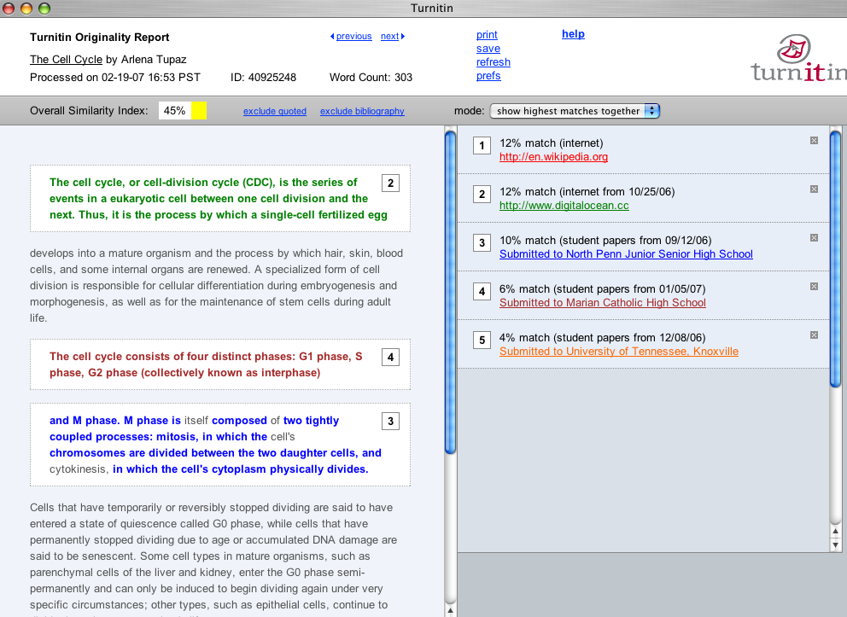
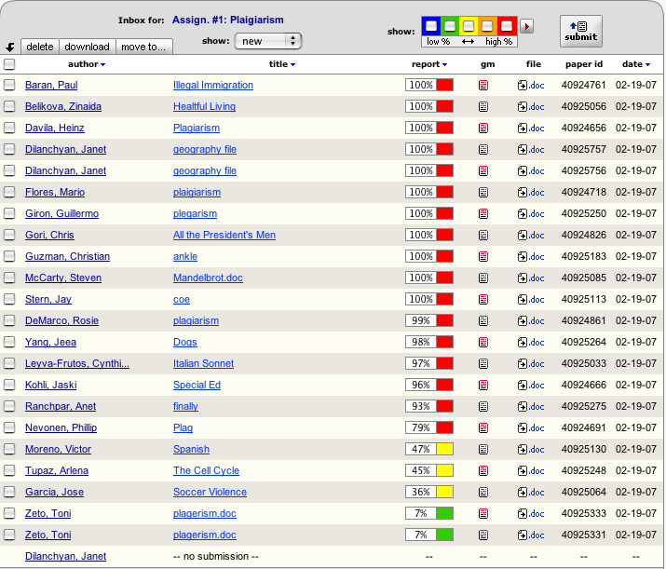

(6) History of computers / graphic search engines. Answer the following questions using information from technology education websites or other online resources. Make certain that all information is in your own words. No credit can be given for information that is identical to that of another student or a web page.

- Contributors to the development of the computer: Select five individuals who have made significant contributions to the development of the computer. List the contribution(s) of each individual and briefly describe its importance. See technology education websites. Use a graphic search engine to find pictures of each.

- Computer Generations: Computer historians have classified computers into "generations" in an effort to identify the major technological advances upon which the computers are built. Briefly identify the major features of each of the first five generations of computers. See technology education websites. Use a graphic search engine to find pictures of each.

Photo | Contributions to the development of computer
Herman Hollerith | Mr. Hollerith created the first “adding and sorting machine” and he found the “Tabulating and Recording Company” which later became one of the most popular and successful compute companies in the world. That company is now IBM.
Ralph Baer | He invented the first video game. Ralph Baer is the father of a very famous game call Pong. His invention change the way the world view games and created a whole new industry. His invention transformed the arcade games into computers and consoles video games industry.
Claude Shannon | Claude Shannon developed a theory called “The mathematical Theory of Communication” this theory help engineers to code data. Engineers used the data to check for “accuracy after transmission between computers”.
Thomas Kurtz and John Kemeny | Thomas Kurtz and John Kemeny develop Basic code. They worked together to created the first basic program, which started the beginning for computer programming.
Steve Jobs | Co-founder of apple computers.

gen-eration | Photo of key component | Features
First |  | Williams-Kilburn tube was the first system that allows data storage. “The Williams tube or (more accurately) the Williams-Kilburn tube (after Freddie Williams and coworker Tom Kilburn), developed about 1946 or 1947, was a cathode ray tube used to electronically store binary data.  Williams Tube  When a dot is drawn on a cathode ray tube, the visible spot lasts for a time (called "persistence") that depends on the type of phosphor used in the tube”  Computers memory system was called Drum Memory: created to load the computer programs. “Drum memory was an early form of computer memory that was widely used in the 1950s and into the 1960s, invented by Gustav Tauschek in 1932 in Austria. For many machines, a drum formed the main working memory of the machine, with data and programs being loaded on to or off the drum using media such as paper tape or punch cards”.
Second |  | The first integrated circuit. This was the first system that incorporated resistors and capacitors with semiconductor materials.
Third |  | Hard disk gave computers better storage system. It would allowed companies to create accessible memory for users.
Fourth |  | Microprocessor allowed faster computing that ever before.
Fifth |  | Netscape started the internet revolutionized the world’s communication system.

(7) Making computers accessible to students: Given the importance of computers in business and society, it is important that we provide students who have special needs access via specialized software and hardware. Describe three data input or output devices, or three OS or software options that may be used to make computers more accessible to students with specific physical handicaps. *TPE-tip If you have students with special needs in your class, you may wish to develop lesson plans illustrating how you have made your curriculum accessible to them using adaptive hardware and/or software. (TPE4)

- Experiment with the universal access features associated with your computer's operating system and research third-party hardware and software solutions for those with special needs. Describe three hardware or software solutions and explain how they may help students with specific special needs.
I can use flash screen in order to help all students regardless of hearing capabilities. For example, students with regular hearing capabilities are able to hear a beeping noise made by the computer. Students who are hard of hearing will benefit from this program because, instead of hearing a beeping noise, they will see a flash on the computer screen.

Cursor size can improve performance for students with difficulties seeing the mouse cursor on the screen. For example, students taking a short quiz, practice test, chapter review, online searching or simply working on the computer can benefit from this program.


Voice over can be use in order to help all students regardless of reading, motor skill, etc. capabilities (many other ways as well). For example, ELL (English Language Learner) students who are having difficulty understanding by reading text directions, but they understand verbal directions can benefit from this program. Also, ELL students can potentially learn how to pronounce new words.

(8) Computer knowledge. Teachers should be conversant with computer terminology and concepts that pertain to the use of technology in their classrooms.

- Review the list of computer terms and concepts for educators and then take this online quiz. Retake the quiz until you understand the terms and concepts and score 90% or better. Include a screen shot of your first and final test results. *TPE-tip If you have access to an online test-generation system such as WebCT, Blackboard, or Quizmaker, you may wish to develop online self-quizes for your students. (TPE2, TPE3)

