Spectrum
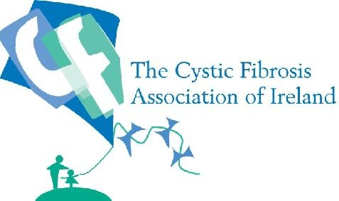

E-Bulletin from Cystic Fibrosis Association of Ireland
Issue 4, October 2009

Dear all,

Welcome to the October issue of Spectrum. We are continuing to send a hard copy to all until we transfer over to our new database next month, so apologies for the duplication and please bear with us over the next while as we try to update all our data. We would greatly appreciate if everyone could return the attached contact details form, and if we can send you an e-version of the bulletin in future, it will mean that you are saving the Association vital funds.

As we head into the winter months, we would like to remind everyone who usually receives the seasonal flu vaccine to do so as normal. We are also continuing to seek clarification and on the roll-out of the vaccination programme for the H1N1 Virus (swine flu), which is due to commence on the 19th October. We will circulate more information as soon as it becomes public.

We have also highlighted the need for a ‘family rate’ to significantly reduce the cost for those families with a PWCF that want to have their whole family vaccinated against the H1N1 virus. We are awaiting a response from the HSE on this issue.

It has been a very busy period and we are pleased to highlight some good news as well as the many challenges that face us in the next few months. In this issue of Spectrum, we are also delighted to add some photos from some recent events including:

- The hand over of the three dedicated rooms for adults with CF in Galway University Hospital after many years of campaigning and fundraising by the Galway Branch of CFAI. A fantastic achievement and one which will make a big difference for many years to come.

- Three CFAI branches, Tipperary Limerick and Clare have come together in an exciting and innovative new partnership ‘TLC4CF’ to help improve services in Limerick Hospital. TLC4CF had 2 launches in September in Limerick and Ennis that not only attracted more than a couple of hundred people, but also all the local T.D.s, and well known sports stars.

We also very much welcome the decision by the HSE to publish the report ‘Services for People with Cystic Fibrosis in Ireland’ next week. This report, which sets out the HSE strategy for CF Centres in Ireland, has been heavily influenced by the Pollock Report into CF Services in Ireland which was commissioned by the CFAI. The report will in effect provide a blueprint for CF services in Ireland for many years to come, but much remains to be done to ensure its full implementation.

The CFAI is holding a series of regional meetings over the next few months to increase participation in the work of the Association, to outline our plans and to hear your views. The first regional meeting is the North East which will be held in Kells, County Meath on 15th October. Everyone in the north-east region is welcome.
A major seminar organised by CFAI will focus on the need for a lung-transplant and organ donation policy framework in Ireland will be held on November 5th in Dublin in the Morrison Hotel. The seminar and a new television series focussing on people with CF awaiting or in receipt of lung transplants will be aired around this time. These two initiatives will highlight the first EU CF Week (www.cfweek.eu) which takes place from the 9th -15th November. We will be circulating more information on recent EU developments in the near futures and how these impact on Ireland.

We would like to once again thank everyone for their immense efforts in fundraising in recent months, which is reflected in better services around the country such as the new adult facilities in Galway featured in this newsletter. We hope to announce further developments around the country over the next few months to give everyone a good sense about the impact of their fundraising. We will be acknowledging and thanking some of the largest donations in an initiative just before Christmas, details to follow.

Philip Watt CEO CFAI
Editor of Spectrum: Máirín O Shea

- Key Developments

Swine Flu Update The HSE and IMO have agreed that the vaccine will be made available from 19th October, and we have been assured that PWCF will be amongst the ‘at risk’ groups identified for first receipt of the vaccine. According to the Irish Times, up to 112,000 doses of licensed swine flu vaccine are expected to be delivered here this week and GPs are to be paid €10 for each of the two swine flu doses administered to each patient. The HSE is hoping it will know which GPs are willing to take part in the programme by this weekend.
We have also highlighted the need for a ‘family rate’ for the families of people with CF to ensure that vaccination costs are kept to a minimum. A bulletin will be circulated by CFAI as soon as we have information.

Dedicated facilities open for adults with CF in University Hospital Galway
Following years of negotiation and fund raising, three fully fitted rooms dedicated to adults with CF were opened on 30th September 2009 in University Hospital Galway.

The three rooms, which are located on the ground floor of the main hospital in St. Anthony's Ward, have been carefully designed and completed to a high specification to provide adults with CF the best quality accommodation available. The key features include an en suite with shower and toilet, electric bed with over-bed trunking, desk and study area, high quality positive pressure air conditioning, broadband access both cable and WiFi, and TV with built in DVD to ensure that the possibility of boredom setting is cut to the minimum.

The project was promoted by the Galway Branch of CFAI who also set up locally registered charity, Galway CF Hospital Project, to focus on localfundraising and undertake the necessary work. Galway CF Hospital Project contracted a qualified building contractor, Carey Developments Ltd. to complete the extension and refurbishment work. The specifications for the rooms were drawn up under the supervision of HSE West who also supervised the construction. The refurbishment work was completed on schedule at the end of August. Following this, HSE West underwent the process of completing the commissioning of the accommodation, including certifying the air conditioning and ensuring compliance with infection control in all matters.
At the opening of the rooms, Chairman of Galway CF, Jarlath Feeney paid tribute to all the people who had helped raised the funds required to pay for the works, to the CFAI for their funding support, to the builders, Carey Developments Ltd., to the HSE West and in particular it’s retiring Hospital GM, Brigid Howley and a special tribute to his fellow committee members, Mary Lane Heneghan, Martin Kelly and Marie Brennan, for their dedication in seeing the project through to completion.
"This is a very positive day for adults with CF in the West. Now, at least, they have a place to go in Galway when they need to be in hospital. A place that meets all the requirements of people with CF" said Jarlath at the opening. The total cost of the project was €350,000; €180,000 of which was funded by CFAI and the balance of funds being raised locally.

Philip Watt, CEO of CFAI, said ‘The new facility in Galway is a good example of what can be done when key stakeholders get together and work in partnership. CFAI is proud to be associated with this development and wishes to acknowledge the immense work of Mary Lane Heneghan, Jarlath Feeney and all those involved in the Galway branch of CFAI and the Galway Hospital Project and the staff and management of Galway University Hospital who made this progress possible.

The next project in hand for the Galway Branch is the completion of a properly certified and resourced lung function lab. The branch hopes to have this project completed within six months.

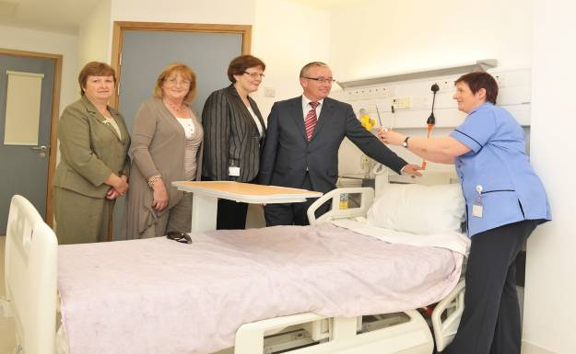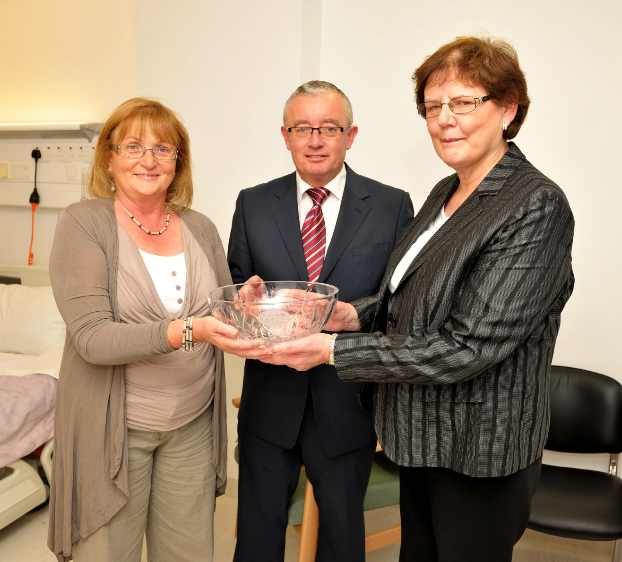
Pictured at the opening of the dedicated Cystic Fibrosis rooms in University Hospital Galway on Wednesday 30 September 2009 were; Marie Brennan, Secretary Galway CF, Mary Lane Heneghan, Galway CF, Brigid Howley, General Manager Galway Hospitals, Jarlath Feeney Chairman Galway CF and Michele Feeney Assistant Ward Sister, St. Anthony's Ward UHG.
Galway CFAI Branch committee members, Mary Lane Heneghan and Jarlath Feeney make a presentation to Brigid Howley, General Manager, Galway Hospitals in recognition of her support of CF services in Galway on the occasion of her retirement from her post of General Manager on 30 September 2009.

Launch of TLC4CF Galway CFAI Branch

Launch of TLC4CF
TLC4CF (Tipperary, Limerick, Clare for Cystic Fibrosis) is a fundraising initiative formed by the Tipperary, Limerick and Clare branches of the Cystic Fibrosis Association of Ireland (CFAI) to help improve services, facilities and in turn improve lives for all people living with Cystic Fibrosis in the Mid West Region.
TLC4CF was officially launched in both Limerick and Clare in the last month. The Limerick launch took place on Monday 28th September at the Savoy Hotel, with over 150 guests in attendance and supported by Munster Rugby Players, Alan Quinlan, John Lacey and Marcus Horan. The Clare launch was attended by John Minogue, Manager of Clare of All Ireland winning U21 hurling team, on Friday 2nd October in The Queens Hotel, Ennis, with over 250 guests in attendance. These included the winning all Ireland Clare hurling U21 squad and, members of the winning all Ireland Ladies Football team. Also lending their support were all of four Clare T.D’s, Junior Minister Tony Killeen, Pat Breen, Timmy Dooley and Joe Carey.

TLC4CF have a number of targets to reach over the next few years:
· To improve existing inadequate facilities for PWCF attending the Mid Western Regional
Hospital (MWRH), Limerick, which services Tipperary, Limerick and Clare (as well as
some patients from Kerry)
· To construct a specialised CF out-patients unit with 5 treatment rooms
· To provide a dedicated CF in-patient unit with 9 ensuite rooms this would
dramatically reduce the risk of CF patients acquiring life threatening cross infections
· To lobby for the recommended number of staff to care for PWCF
· To bring CF treatment at MWRH to European standards
· To increase general awareness in the region for CF and the issues surrounding the
condition
· To create awareness about Genetic Screening to possible carriers of the Gene
This capital project will cost in the region of €3.5 million, and TLC4CF are appealing to organisations, schools, businesses, clubs and individuals to organise fund raising events or make donations to raise vital funds for this worthy cause.

Speaking at the launch, Katie Drennan, a 19 year old Cystic Fibrosis Sufferer said: “I have to travel to Dublin for some of my treatment and this puts extra stress on me when I am unwell having to travel such a long distance and be away from family and friends for such a long time. I am a second year student at the University of Limerick and I should be able to get the correct standard of care and treatment in Limerick, but I can’t. At present the facilities we have in the Mid West for people with CF are totally inadequate and we are launching TLC4CF to address this. There is a dedicated CF team at the MWR Hospital, but they are totally overloaded and are working under severe pressure with inadequate facilities. This is putting our lives at serious risk and we cannot stand by and wait any longer for the facilities to improve. Many CF sufferers like me have to undergo a strict regime of physiotherapy airway clearance, nebulised antibiotics and various drugs twice daily to stay well. Through TLC4CF, people in the region can help us raise vital funds which will directly improve the lives of so many people like me in the Mid West who are fighting a daily battle with Cystic Fibrosis.”

Dr. Michael Mahony, Pediatric Consultant at Mid Western Regional Hospital stated at the launch “There is an urgent need for improved Cystic Fibrosis facilities in the Mid West region so that patients can be segregated with the risk of cross infection greatly reduced. These facilities which TLC4CF are fundraising for will help improve the quality of care, the ease of access of care, and provide resources that will allow patients to be treated in isolation. This can only translate into better long term outcomes for people with this potentially life threatening disease.”

Also present at the launch was Philip Watt, CEO of CFAI. Speaking about TLC4CF, Philip said “CFAI welcomes this initiative and look forward to working with TLC4CF to provide improved facilities for PWCF in the Mid West Region.”
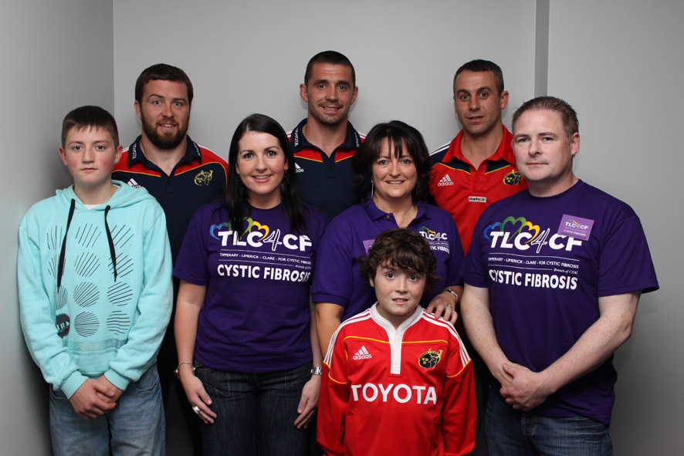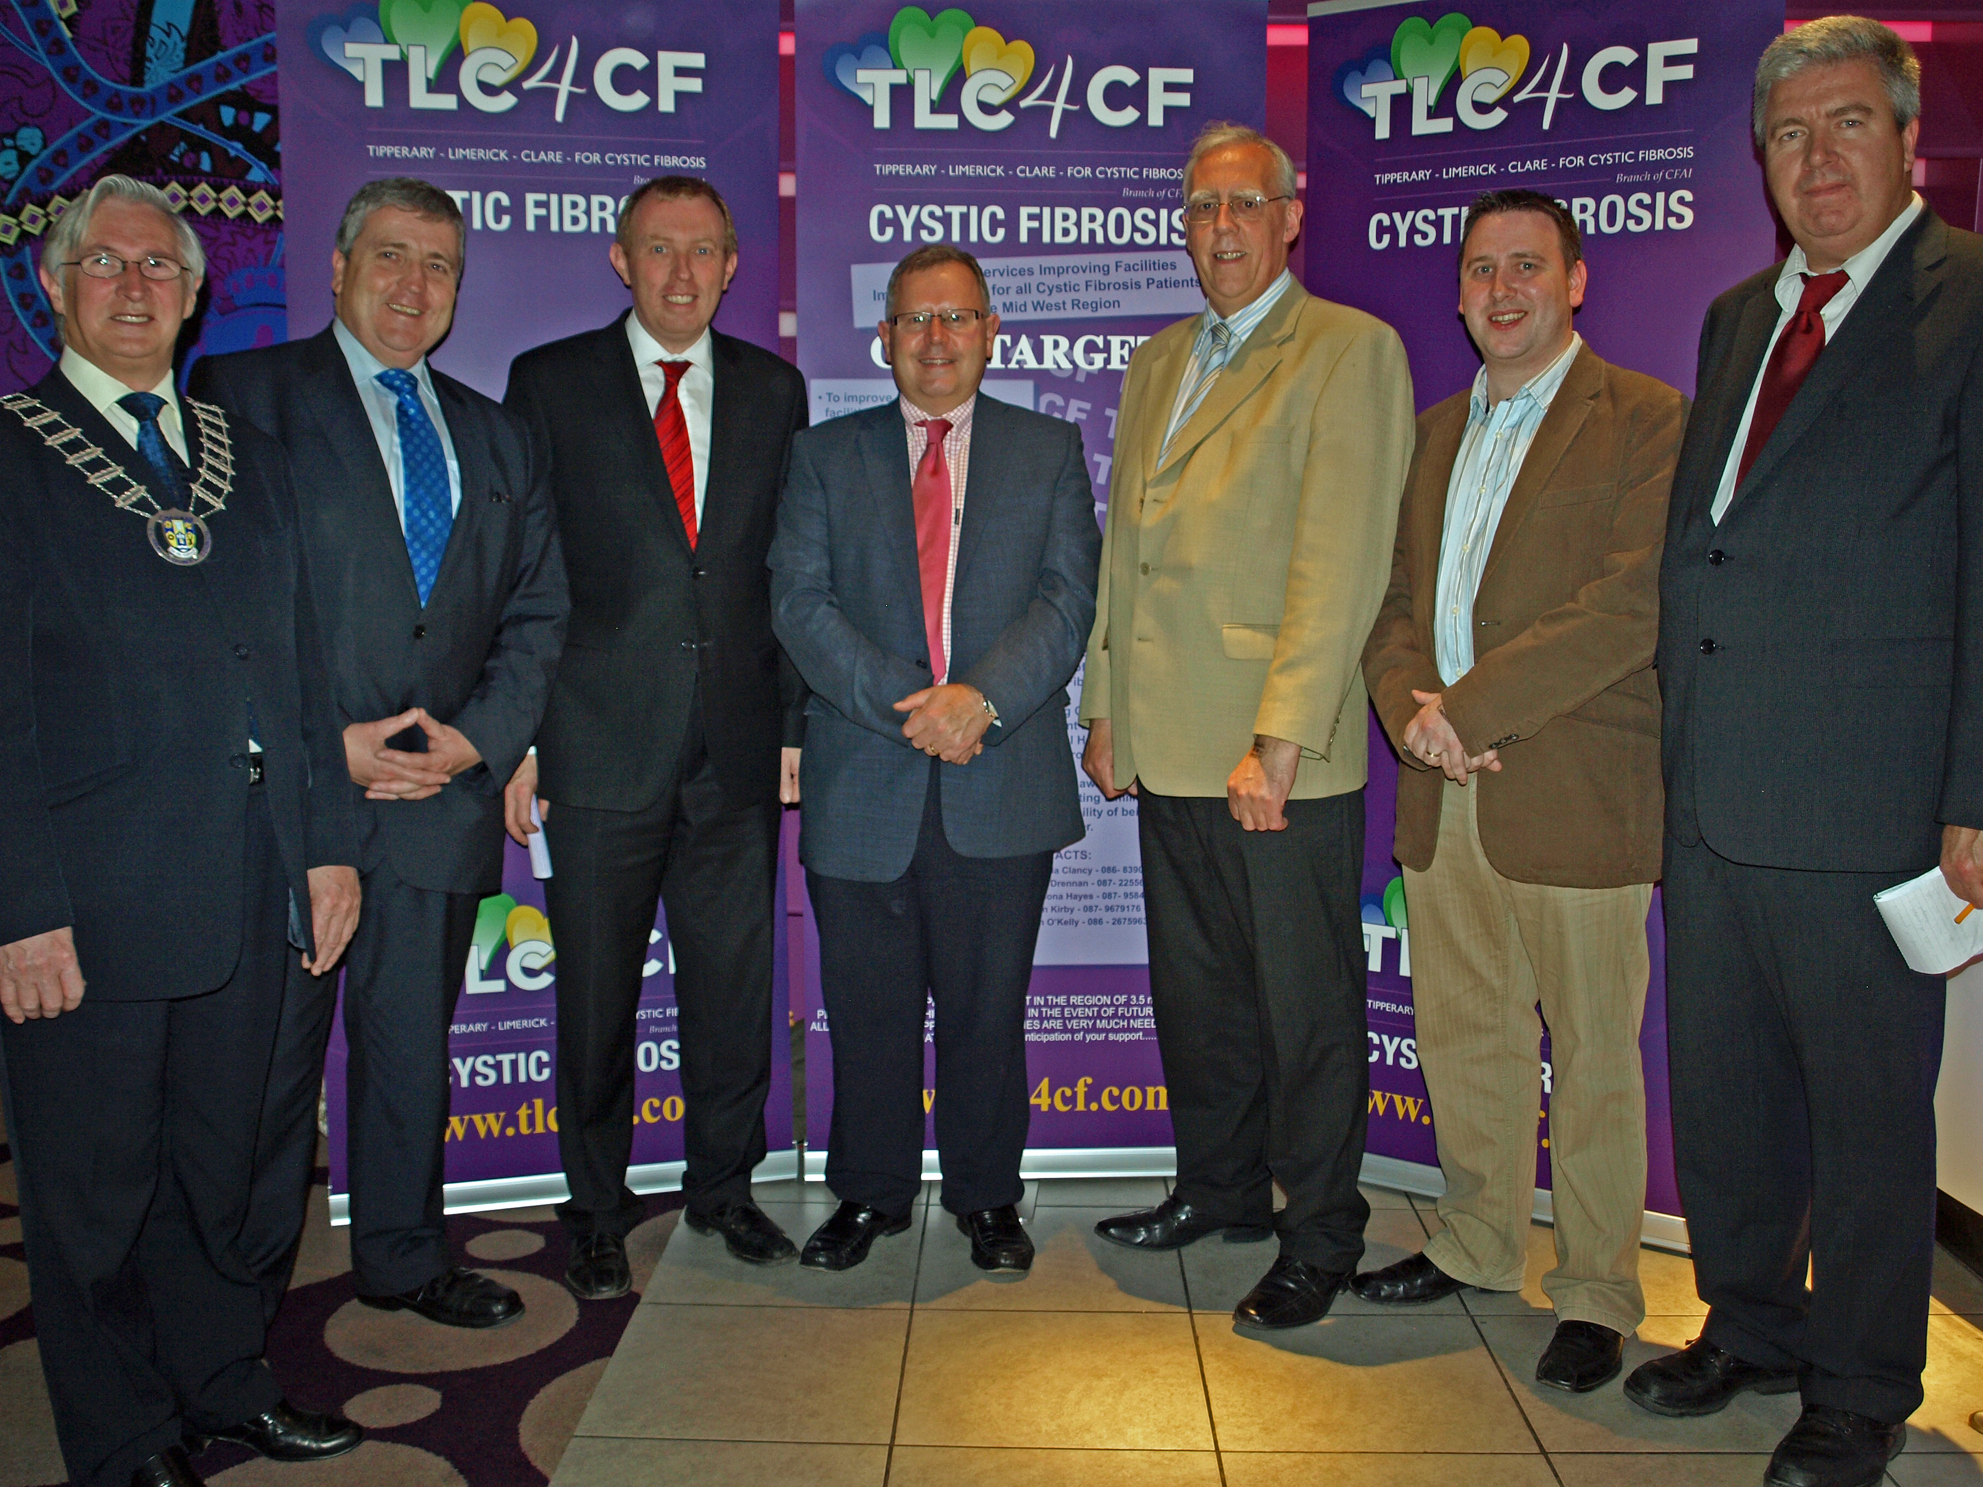
Marcus Horan, Alan Quinlan, John Lacey, Eoin Clancy, Orla Flannagan, Marcella Clancy, Kenneth Flannagan, Cillian Clancy
Deputy Mayor of Clare Michael Begley, Pat Breen TD, Timmy Dooley TD, Dr. Michael Mahony, Tony Killeen TD, Joe Carey TD and Philip Watt CF House CEO

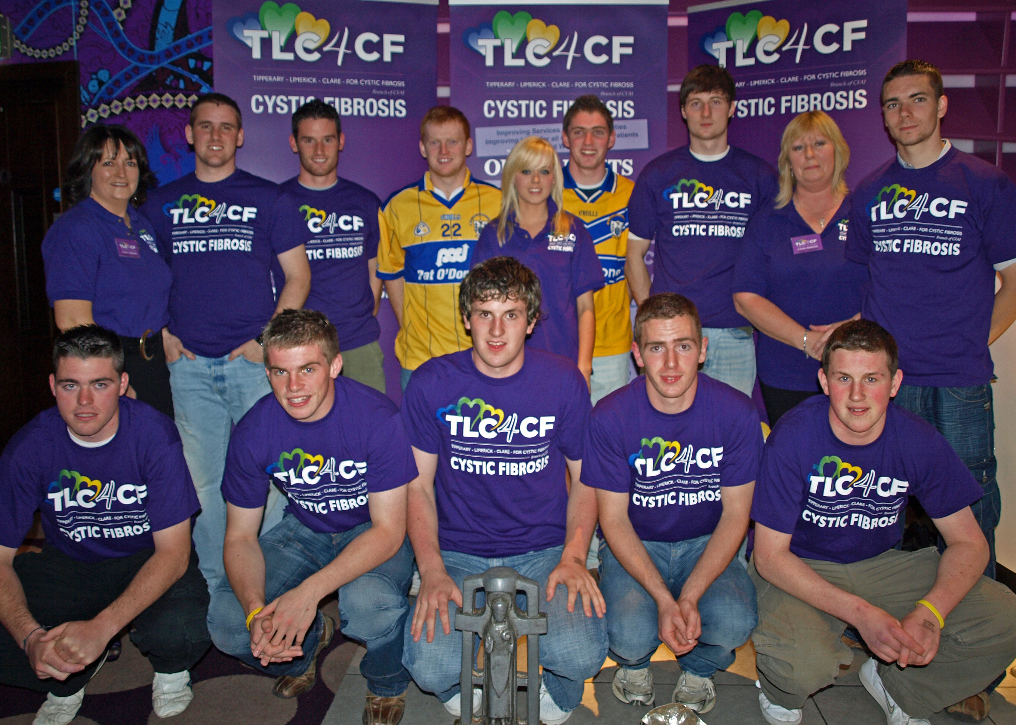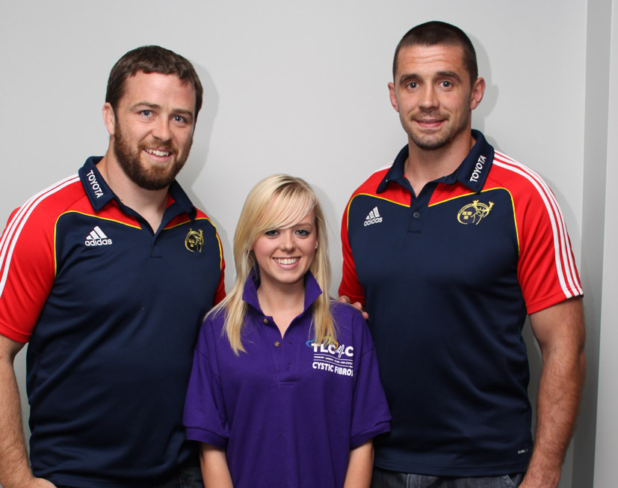
Marcella Clancy, Katie & Linda Drennan and members of the All Ireland Clare U21 winning hurling team.

Marcus Horan, Katie Drennan, Alan Quinlan

For further information on TLC4CF or to receive a fundraising pack please call one of the below, or email info@tlc4cf.com. Information and a downloadable information pack can also be found on www.tlc4cf.com.
Tipperary: Caitriona Hayes: caitriona@tlc4cf.com
Limerick: Owen Kirby: owen@tlc4cf.com
Limerick: Liam O'Kelly: liam@tlc4cf.com
Clare: Marcella Clancy marcella@tlc4cf.com
Clare: Linda Drennan linda@tlc4cf.com

Regional Meetings beginning The first of CFAI’s regional meetings, ‘A Time for Change: Towards better services for people with Cystic Fibrosis in Ireland’, will be taking place in the North-Eastern region on the evening of Thursday 15th October at the Headfort Arms Hotel, Kells, Co. Meath. This meeting is open to everyone concerned about CF in the North-East area, including Meath, Cavan, Louth, Monaghan and neighbouring counties. The meeting will take place between 6pm and 8.30pm and will focus on - Improving services in your local CF centre - The transplant issue - How we can work together as a National Association To register, please contact Eufemia Solinas in CF House, 01 4962433 or email info@cfireland.ie

The Commission on Taxation Report – Concern at potential impacts on the CF Community

The CFAI will be making representations to the Government on possible impacts on the CF Community arising from the Report of the Commission on Taxation. With many thanks to David Fitzgerald, CFAI NEC member who researched this issue and provided the following analysis. If you wish to read the Commission on Taxation Report it is available at http://www.commissionontaxation.ie/.

The Commission on Taxation report makes a number of recommendations which, if implemented, may have an impact on the Cystic Fibrosis community. This article reviews each such recommendation and comments on the implications of each one. It should be noted that recommendations 1, 4 and 5 below have the greatest capacity to have negative impact on the CF Association/ people with CF and/or their families.

1. Recommendation:

As a general rule, all social welfare payments should be subject to taxation.

• There should be no change in the taxation status of maternity benefit, adoptive benefit and health and safety benefit.
• Specific exemptions from income tax should be introduced for Family Income Supplement,
the Domiciliary Care Allowance and the Respite Care Grant.

Comment: If implemented this recommendation would have the effect of taxing all Social Welfare payments except the exclusions outlined above. A key implication here would be the taxing of disability payments

2. Recommendation:

Medical insurance relief should be continued on a more limited basis.
Comment: This could adversely affect those with CF as it would, in effect render medical insurance more expensive.
3. Recommendation:

Relief for health expenses should continue at the standard rate.
Comment: This preserves the status quo, although the status quo is very new; health expense relief having been reduce from marginal to standard rate tax in 2009.
4. Recommendation:

When direct expenditure support at the appropriate level is in place, the incapacitated child tax credit should be discontinued.

Comment: This is a significant proposal as it would have the effect of reducing a parent’s net income by €3,660. The “sweetener” is that it should not be introduced until direct expenditure support at the appropriate level is in place.
The problem with this is that the “appropriate level” will be determined by the Minister for Health, Department Officials or the HSE (or a combination of all three). Their idea of “appropriate level” may differ from ours.
There is a distinct possibility that the tax credit would be removed, and a promise to put “appropriate expenditure” would be made. Experience has taught that such promises be treated with the greatest scepticism.

5. Recommendation

The allowance for employing a carer for an incapacitated individual should continue. However, the rate of relief should be the same as that available under health expenses relief.

Comment: This can effectively reduce the allowance by about 50%. It may prove a very onerous measure for some.

6. Recommendation

The threshold on the eligibility of individual donations to charities and approved bodies to attract tax relief should be reduced from €250 to €100.

Comment: This is a good proposal as it may encourage more individuals to contribute to organisations such as CFAI. Even if did not, more contributors would get tax relief on their donations.

7. Recommendation

The relief for individuals donating to charities should be at the standard rate in all cases.

Comment: This is rather like giving with one hand and taking away with the other. This effectively reduces charities incomes.

8. Recommendation

An upper limit of €500,000 per person on the annual value of donations which may attract tax relief is recommended.

Comment: This would mean that a charity receiving a donation from a wealthy person would be likely to have the donation curtailed. This is not in the interest of charities.

9. Recommendation

The self-employed should be treated in the same way as PAYE earners under the scheme with the tax relief being paid to the charity or approved body.

Comment: This is a technical measure which has no material consequence.

10. Recommendation
In relation to donations from companies, the amount that would attract tax relief should be the same as for individuals, i.e. a maximum of €500,000 per annum. The rate of tax relief on corporate donations should be the corporate tax rate and, as with donations from individuals, the tax relief should be paid to the charity or approved body.
Comment: Largely technical measures which will have no material impact of themselves (except for the reprise of the €500,000 cap.
Summary
Recommendations 1, 4 and 5 above have the greatest capacity to impact on the CF Association or people with CF and / or their families.

Disability Federation and the upcoming Budget
As concern about impending cuts in social spending in the upcoming budget mounts, the Disability Federation of Ireland (of which CFAI is a member) have prepared a submission to Government. John Dolan, CEO recently gave the following statement in conjunction with this: “While the voluntary disability sector appreciates that the Government faces restricted options for Budget 2010, the situation can never justify imposing costs on the most vulnerable who themselves have no room for manoeuvre. We want to work with Government and other stakeholders to maximise the value gained from public resources. At the same time, we need a reaffirmation in Budget 2010 from Government that it is not cutting loose from the National Disability Strategy now that times are hard. Now more than ever Government must keep faith with the disabled people of Ireland, and show how it will protect the NDS.

Budget 2010 must design any spending cuts so as to protect people with disabilities. Voluntary disability organisations, who continue to provide key health and personal social services, and who have vigorously minimised their costs, need to see the Budget focus on four key areas:

- Protection of funding for disability-specific services and facilities;
- Maintenance of adequate income, especially given the on-going extra costs imposed by a disability
- Continued improvement in access for people with disabilities to mainstream public services
- Recognition, in terms of funding and participation in decision-making, of the role of voluntary disability organisations in achieving social inclusion for people with disabilities.

The DFI Pre-Budget Launch takes place on Thursday 8th October and we will keep members updated on developments.

- Awareness

CFAI at Electric Picnic 2009
The Electric Picnic was held in Stradbally on the weekend of the 4th 5th & 6th of September where the CFAI had an awareness stand for the weekend manned by a team of 20 volunteers. The aim of the CFAI stand was to increase awareness to the general public as will as collect data on the level of public knowledge of CF in Ireland. The stand helped raise funds for the “Buy a Brick” campaign. Data was also collected in the form of a questionnaire from over the 3 days. The stand was an excellent chance to meet the public and to answer some of the many questions public has about CF. Over 600 donor cards where give out to the public and a number large number of people expressed an interest in fundraising of CF in the future as will as singing up to CFAI newsletter. The CFAI would like to thank all who help over the weekend by giving their time as volunteers and to all how attended the stand, a special word of thanks to the organizers of the Electric Picnic for allowing us to having the stand.

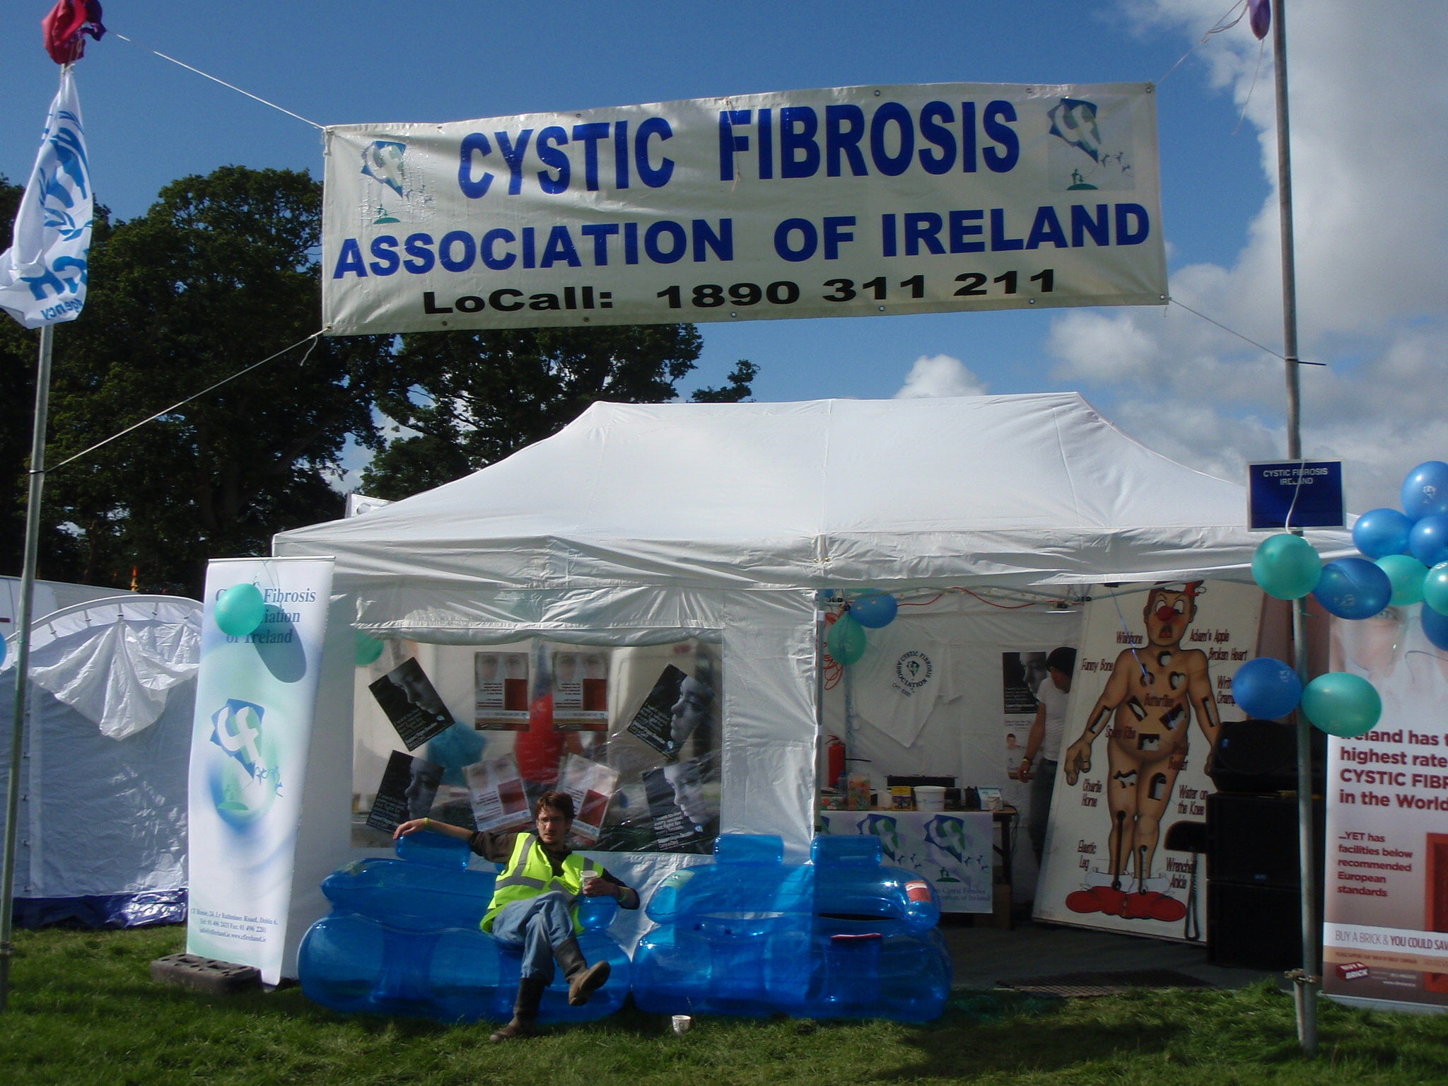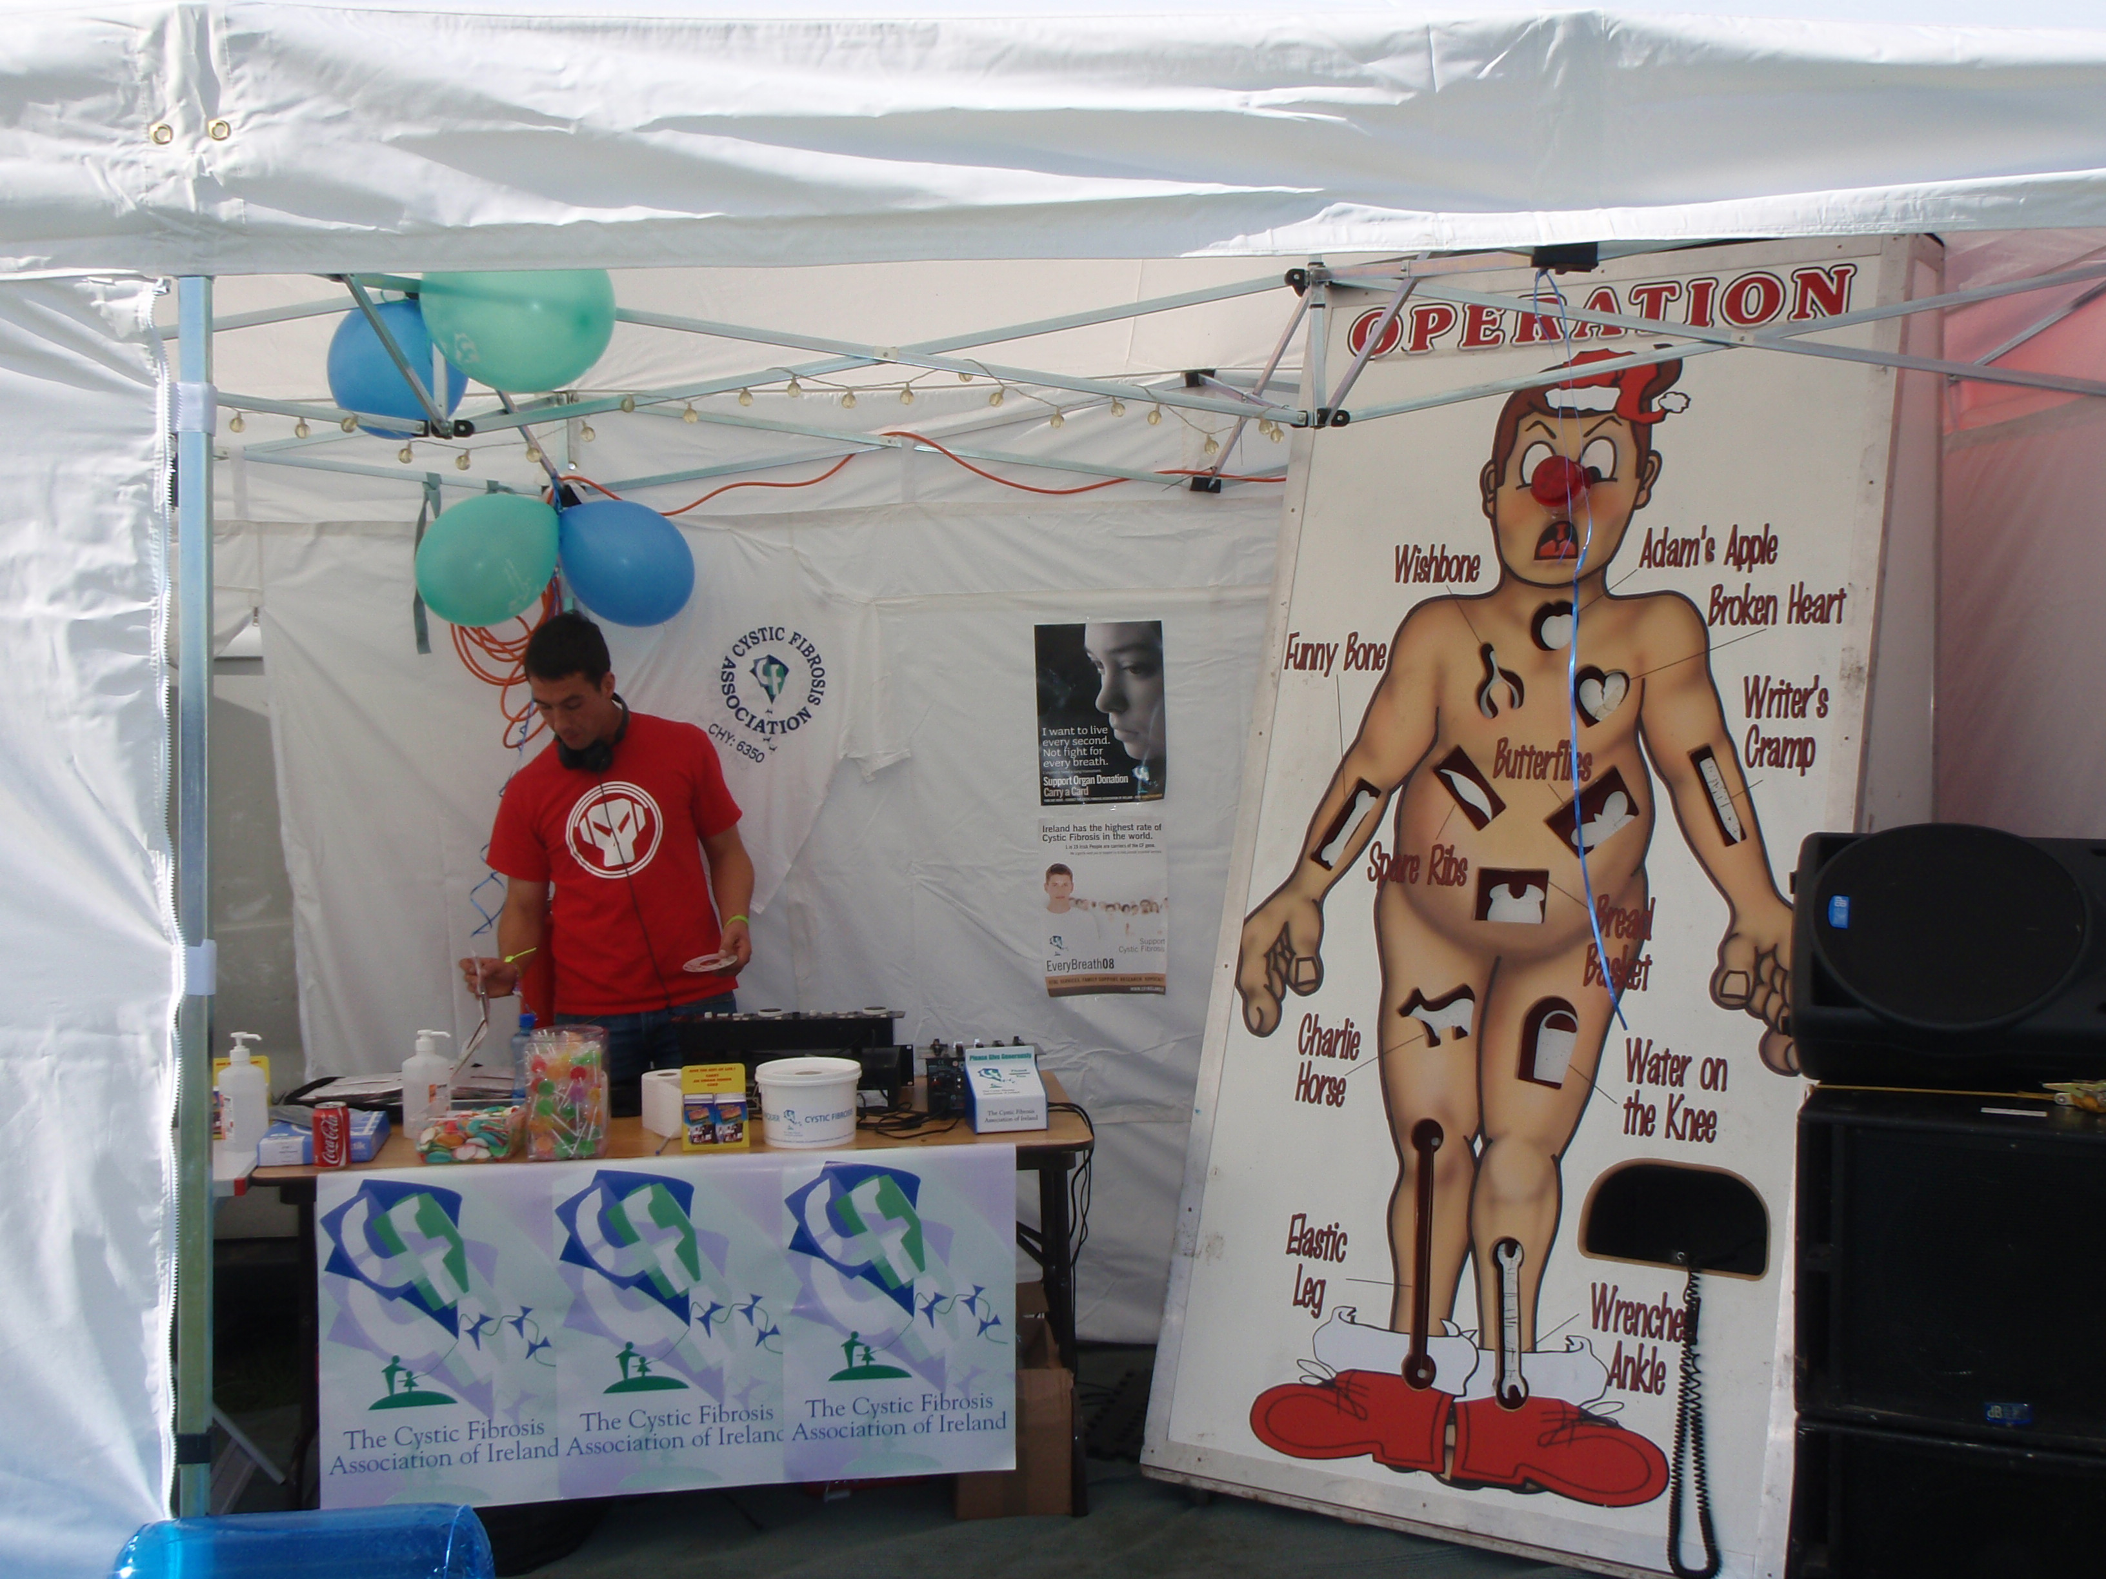
Visitors to the tent enjoyed the DJ’s tunes and the Giant Operation game which demonstrated the effects of CF on the different parts of the body

Tomás Thompson, CF Advocate, outside the CFAI awareness tent
Breaking New Ground at the National Ploughing Championships Well done to Paul Minchin from Co. Carlow, a PWCF who received Ireland’s first ever double lung transplant in 2007, and recently represented his county at the National Ploughing Championships.
- Fundraising
Fundraising income continues to hold its own, but with anecdotal evidence of a drop in income across the sector, we watch with bated breath, and appeal to our supporters to continue to fundraise for CFAI to allow us provide services and facilities for the CF community nationally.

IPPA ‘Happy Faces’ Charity of the Year
We have been successful in our bid to become 'charity of the year' for the Irish Professional Photographer's Association. This will focus primarily on IPPA ‘Happy Faces Day' in April 2010 and the IPPA Calendar for 2010. The IPPA formally announced this at their annual conference in Ballymascanlon Hotel, Dundalk on Sunday 4th Oct. Caroline Heffernan and Martin Cahill addressed the conference on the nature of CF and the need to maximise fundraising from this partnership. A meeting with the IPPA, Fuzion PR, Phillip Watt and Martin Cahill takes place on Thursday 8th Oct, after which all will be circulated with proposed details for promoting this event.

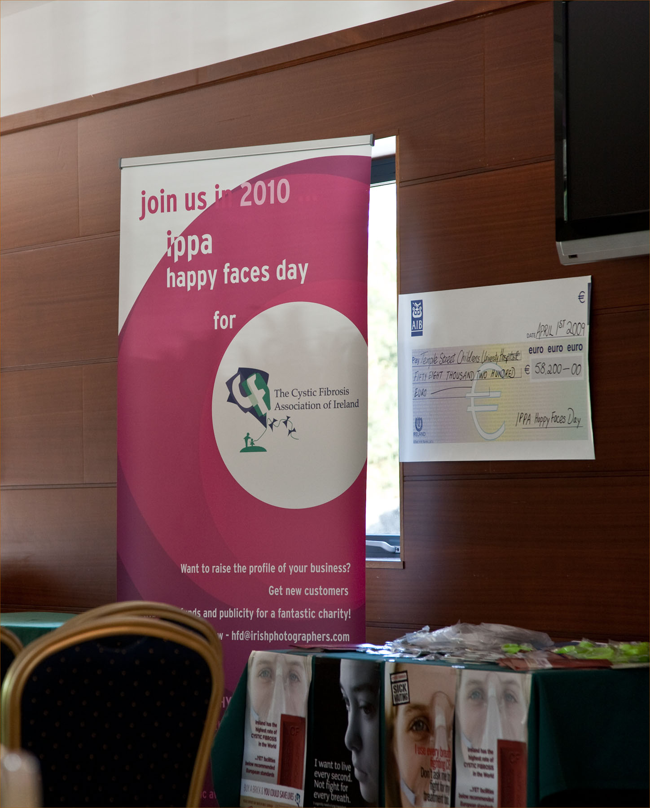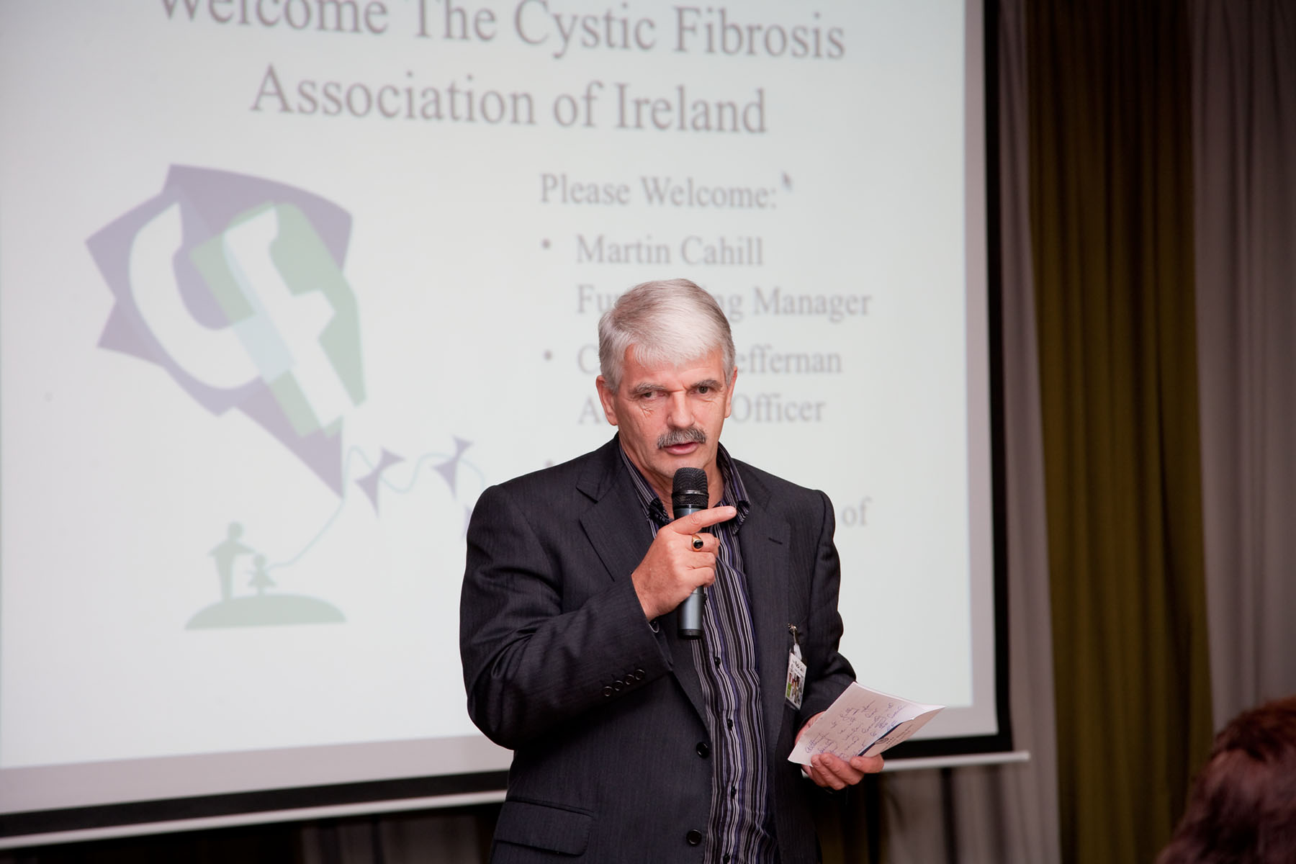
IPPA Campaign and donation
Martin Cahill, Fundraising Manager speaking at the event

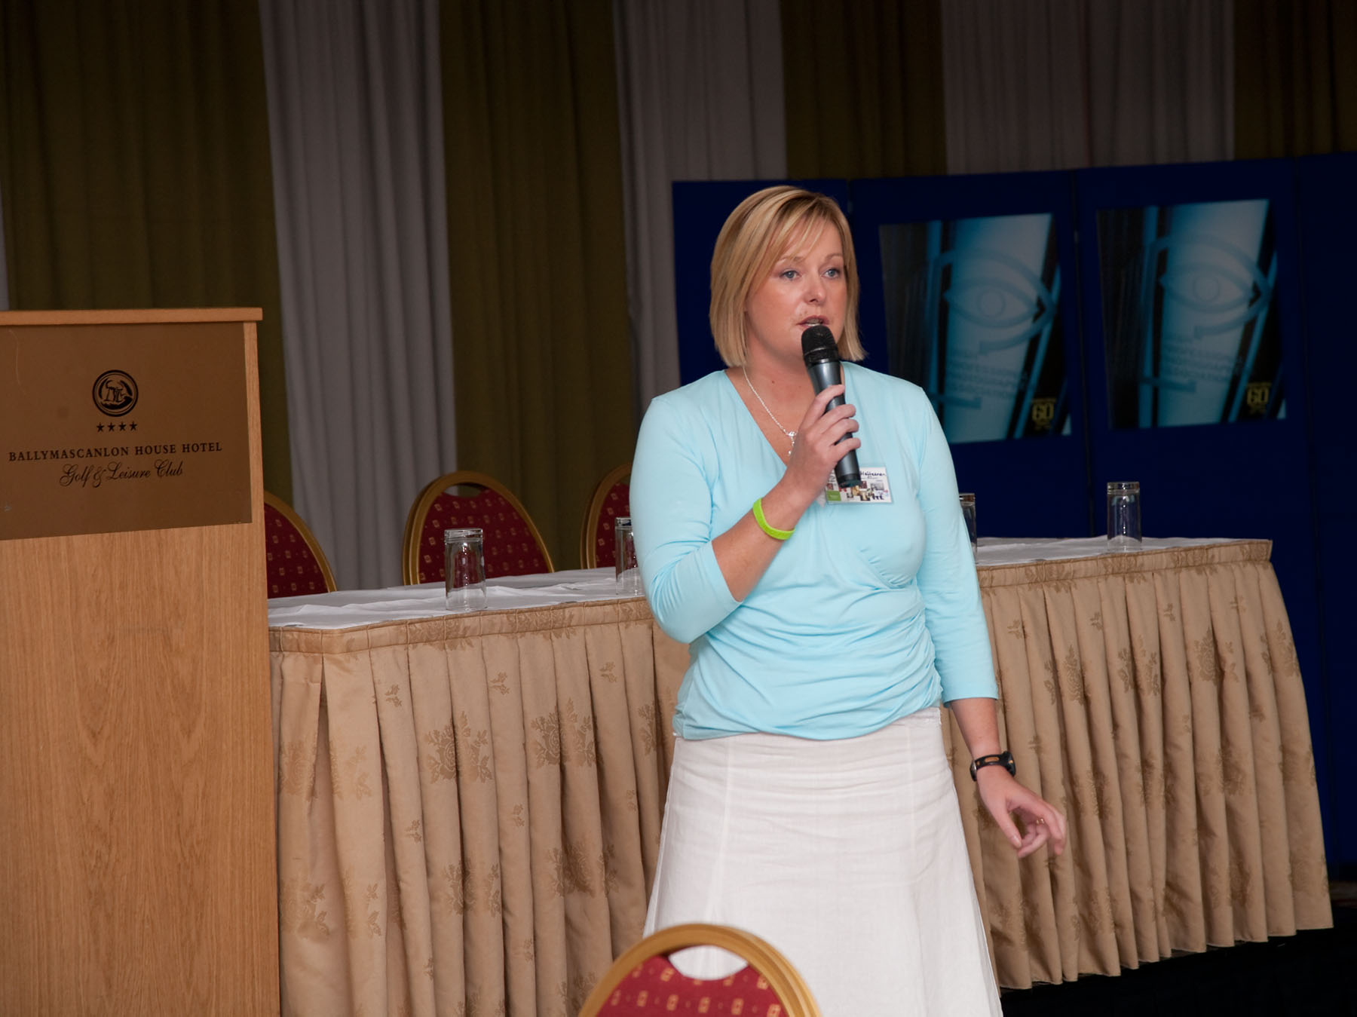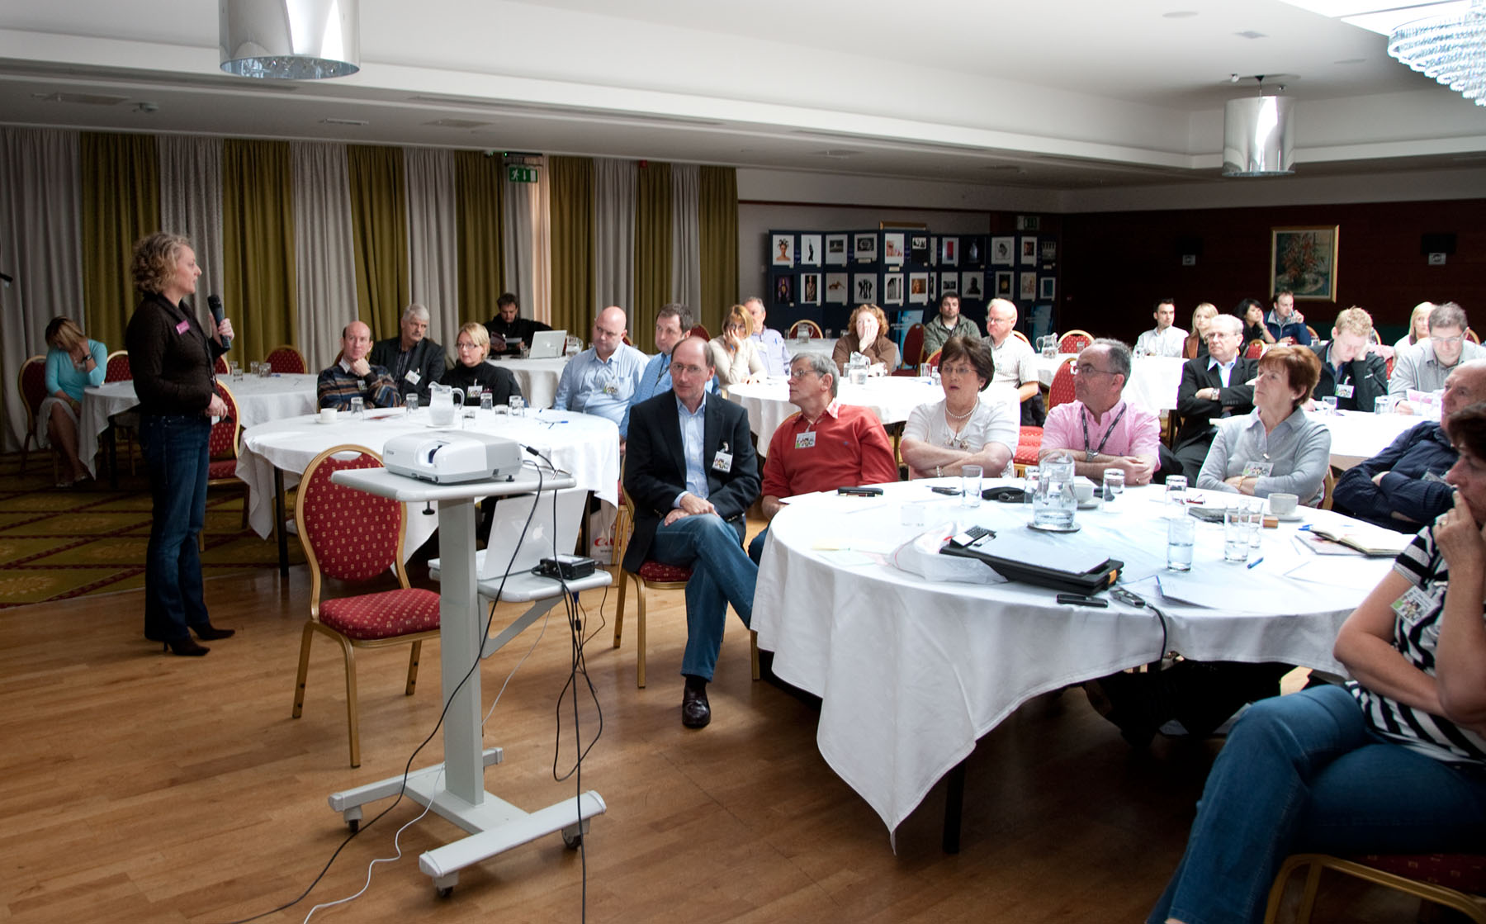
Caroline Heffernan, CF Advocate speaking also
IPPA members at the Conference

Galway Cycle ‘09
Each year a group of students from National University of Maynooth, (NUIM) organise and complete a cycle event from Maynooth to Galway and back in aid of a chosen charity. Selection is by presentation by shortlisted charities followed by student’s union committee vote.
CFAI were chosen as beneficiaries in 2009 and the event raised in the region of €80,000. President of the committee Eimear Ryan (Ph D student) very capably marshalled her colleagues, support crew, cyclists and collectors to produce and fantastic, accident-free event. Weather was the usual mixed bag, 60+ cyclists completed the event, and a whopping €16,000 was collected on the streets of Galway on the Saturday. Martin Cahill and Caroline Heffernan addressed the group at a function in the Quays, Galway. Many thanks are due to a lot of people, too numerous to mention here. The overall team effort was amazing to witness.
As a thank-you gesture, and by way of recognition CFAI have nominated the Cycle Committee in a category of the National Fundraising Awards. Although not shortlisted, the group are longlisted with 42 other fundraisers out of 73 entrants.

Lugathon 2009
The CF Lugathon took place on Saturday 12th September and a group of approximately 50 walkers with varying experience undertook the challenge. The weather was excellent and an enjoyable day was had by all. Some CF parents and PWCF participated, and Lee Harnett, PWCF aged 12, was the third person to reach the summit, leaving mum Caroline way behind. Dave Crowley probably would have been first to the top, but he arrived at the starting point after everyone had departed! Lee Harnett, PWCF mentioned above, has been chosen by Make-a-Wish Foundation to travel to the Philadelphia to meet his skateboarding hero, Bam Margera. Enjoy the trip Lee.

The Lakes 10k
Saturday, 19th September, Lorna Brennan and friends organised the Lakes 10k around the beautiful Blessington Lakes. This was the first of a proposed annual event and you can check their dedicated website www.lakeshoreriders.com. Tomas Thompson made a great impression at the event disseminating information about the nature of CF. 500 runners/walkers/joggers took part, and the event was a resonding success. Jordan Kidd, PWCF aged 8 , was the mascot for the event, travelling in dad David’s sidecar to lead the runners out to the starting point. A social evening in Avon Ri Lakeside Resort Hotel was characterised by the showing of some 900 photos of the day’s events and a few thank-you speeches. Special acknowledgement of the efforts and organising skills of Shane, Lorna and Sharon in organising the whole event, and of course the Kidd family and friends who assisted.

Troops ‘Everest Climb Challenge’ for Cystic Fibrosis September 2nd & 3rd, 2009
On the 2nd and 3rd of September the 4th Field Artillery Regiment based at Columb Barracks, Mullingar, and 100 Battalion, based at Camp Ciara in Chad, undertook a climb, equivalent to the height of Mount Everest, in aid of Cystic Fibrosis Association of Ireland (CFAI). Teams of five ascended climbing walls at both Columb Barracks and Camp Ciara continuously over the two days, gaining a height of 8,848 metres. Teams from the local community will also took part. Ian Taylor, the youngest Irish man to reach the summit of Mount Everest participated to launch this unique event. Before the event, he said “This challenge will involve team work and stamina, and even though the teams will be in two very different locations, we will be working together to raise vital funds for CFAI.”

Race around Ireland
Team Tailteann members Noel Tonge, Eoin Ryan, Jack Lynch and Brian Heffernan undertook the cycling Race Around Ireland challenge event, a non-stop 4 Day event, raising considerable funds to date for Cystic Fibrosis. The team came third in the team section of the challenge, completing the event in relays with each team member only getting about 3 hours sleep over the 4 days. The event proved to be a tough one and each team member cycled 70 miles long stages in 4-hour shifts. Special mention of the hard work of the support crew, Neil O’Brien, Ciara Ryan, Orla Ryan, Jim Gilmartin and Brendan Tonge, without whose assistance and encouragement the team could not have not survived the challenge. We offer our heartiest congratulations to Team Tailteann on their success in the event.

The Racecourse Challenge for Cystic Fibrosis
Parent of a Cystic Fibrosis sufferer, Antony Lewis-Crosby, is setting out on a unique marathon project to visit every one of the 87 racecourses in Ireland, England, Scotland and Wales in alphabetical order to raise money in Ireland for the Buy a Brick campaign to support the development of adult CF services in the Republic’s hospitals. There are 26 racecourses in Ireland and the whole project will take 5 years. 23rd August was the launch date for the Irish part of the project with the race meeting at Ballinrobe and it continued at Bellewstown on 26th August; and Clonmel on 3rd September (which was postponed to 29th October). Funds will be raised through betting on every race on the day and also where possible through collections among the crowd. CF supporters are invited to join Antony and his family at the meetings. Join him and his wife Carol one hour before racing starts for instructions. Antony is determined that everyone will have a good day out as well as raising money for such an important cause. The whole project has the full support of the CF Association of Ireland and the Cystic Fibrosis Trust in the UK. On 10th August a website will be launched with news about the challenge and the dates for the race meetings in 2009 and 2010: www.racecoursechallenge.org
If you would like to join Antony at any of these race meetings please contact Martin Cahill or Grainne Kennedy at the Cystic Fibrosis Association of Ireland on 01 4962433 or Antony direct on 00447767771135. Entry to some race meetings may be complimentary.

Mizen to Malin and Malin to Mizen Walks
A reception was held in CF House to acknowledge the contribution of all participants in both above events, which were articulated in a previous issue of Spectrum. Considerable funds were raised for CF through these events. The TCD/UCD group who walked northwards regaled the gathering with stories of injuries, fatigue, rain and a lot of funny incidents en route, but the overall evidence of the generosity of local people along the way was particularly heartening. Emmet Ryan, whose self-dubbed title is that of ‘Ireland’s answer to Forrest Gump’ lost two stone on the southward journey, but didn’t admit to losing his way at any time. Logically, if Emmet undertakes the challenge over a period of 4 more years, he will be only half the man he was at the start of this year’s effort (as per Martin Cahill!). Both events raised considerable awareness of CF in local communities, while generating much needed funds also.

New York City Marathon 2009
With our highest number of participants to date at 23 this year, the group met for an orientation evening in Dublin on 30th September. Gerard Fay, well-known marathon man, of whom more is written elsewhere in this bulletin, addressed the group, dispensing advice about clothing, blister plasters (Emmet Ryan please note!) and the nature of the 26.2 km course and his contribution was much appreciated by all.

Dublin City Marathon
We have a considerable number of participants running for CF again this year, and many thanks and best wishes to those competing. Both Cork and Limerick Womens Mini-marathons were very well supported this year by CF fundraisers locally. Congratulations to all who participated.

Gerard Fay’s 8 Marathons in 8 Days followed by New York Marathon for CFAI
On the week of the 19th to the 26th of October Drogheda man Gerard Fay will undertake a challenge of running / walking the Dublin Marathon Course 8 times, finishing with the Marathon itself on the 26th of October, in aid of the Cystic Fibrosis Association of Ireland. The challenge will cover a distance of 210 miles (336km) and is being done to raise awareness of Cystic Fibrosis, and to raise vital funds for the 8 Centres of Excellence around the country as well as research. However, once the Dublin marathon is completed it does not stop there as 6 days later he will go on to do the New York Marathon.
Gerard has completed many challenges over the years for CF and has completed 56 marathons to date, over 25 half marathons and numerous smaller races as well as a walk from Dublin to Cavan and Drogheda to Galway. Also in August this year he did a 24 hour walk and completed 95 miles over the 24 hours.
Two years ago, Gerard Fay, who is Chairman of the North Eastern branch of Cystic Fibrosis Association of Ireland set himself a target to personally raise €100,000 for CFAI. Over the past two years Gerard has raised €70,000 and hopes to raise a further €30,000 by the CFAI Annual Conference which is being held in Kilkenny next April, which he will walk to as part of his fundraising mission. To find out more on how to get involved, or to donate contact Gerard on (087) 2398881 or visit www.mycharity.ie/event/gerard_fays_event.

There are numerous fundraising events taking place around the country, many under the auspices of the branch network. These events raise much needed funds for the Association to allow us to provide the services to the CF community which CFAI is mandated to do. Such events are also important in raising and increasing awareness of CF in the community at large, an important factor in fundraising. Remember, as an independent body, CFAI does not receive any government funding and is totally dependent on voluntary fundraising and donations to provide those services. Branches are welcome to supply details of upcoming events for inclusion in the Spectrum e-bulletin.
- Upcoming Events:
PWCF Christmas Party
This year the PWCF Christmas party will take place in Athlone on the 28th November (venue to be confirmed). Cross-infection guidelines apply. If interested, please contact Caroline (CF Advocate) on 087 9323933 by 14th October.
- Media
‘Alex – A Passion for Life’ October 8th, Channel 4, 9pm This Thursday night Channel 4 are showing their follow-up Cutting Edge documentary on Alex Stobbs, a talented PWCF who studied music at Cambridge. This programme follows Alex as he pursues his dream of conducting Bach’s Magnificat orchestra. ‘A Passion for Living; the amazing story of a boy who makes every day matter’ autobiography written by Alexander Stobbs is also available, published by Hodder and priced at €18.99.
Reader’s response ‘Living Life on a Roller Coaster’
Written by Helen Little, reviewed by Caroline Heffernan
In this book we follow the lives of Helen, Emma and Luke, all on the same road but with very different twists, turns and obstacles in their paths. Emma and Luke have CF and share what it is like doing the many treatments needed by people with Cystic Fibrosis (PWCF). Helen shares honestly of the daily challenges in bringing up her children with medical needs. Their story shows the diversity of CF as Emma’s health deteriorates much quicker than Luke’s, resulting in the need for a transplant. Helen remains strong giving Emma 24 hour care when needed and also encourages Luke to remain strong, active and continue with treatments. On Emma’s birthday an early evening phone call brings the good news of a set of lungs available for her. Everything speeds up from this point to get them over to Newcastle for the transplant.
Back home, six weeks later, life post-transplant is very different. Emma has been trained to administer her new medications, to understand and guage her body’s responses to the medication and watch for rejection. Luke, having managed his care quite adequately while Helen and Emma were in England, was also managing his treatments. Helen talks about the family’s readjustments post-transplant. Reading this book opened my eyes as to how life as a parent to a PWCF is challenging. As a PWCF it gave me an insight into the emotional difficulties faced when having to make the decision to transplant and the procedures involved in transplantation. It is an emotional read, but proves that together we can conquer life with CF.
Have your say - Invitation for PWCF contributions to new booklets CFAI is currently finalising its new Employment Booklet and also its School & CF booklet. We really want to illustrate the day to day issues and feelings of PWCF in these settings, so if you are a PWCF who has anything to say about your time in school or on the road to employment, please do drop us a line with your views, and we would be delighted to include them in the booklets. Testimonials will be kept anonymous so you can be as open as you like about the highs and lows. Submissions can be anything from a couple of sentences to as long as necessary.
CFAI Christmas Cards This year CFAI is using the same stock as last year, in order to utilise the remaining stored supplies. There is opportunity to choose from one of the four categories (Children, Contemporary, Religious, Traditional) and cost per pack is € 5 plus postage, which must be paid in advance. For more details or to place an order, please contact Eufemia Solinas at CF House (01 4962433) or email info@cfireland.ie. Branch Christmas card orders can also be made by contacting All Print & Design, but you will need to place your order immediately (Tel: 01 8786035, email: sales@allprint.ie)
- Publications / Research
Advances in gene isolation An Irish research team at University College Dublin’s medical school and the Children’s Research Centre in Crumlin, have discovered a gene variant that makes people with CF five times more likely to develop liver cirrhosis and other liver complications than patients who carry the normal version of the gene. About 5% of CF patients develop liver disease that is so severe they require a liver transplant, so researchers are very excited about the discovery, which could lead to earlier detection and diagnosis of CF liver disease, with better treatment options.
- Opportunities
An open door Doorway to Life (Abode) is now accepting applications for its Independent Living Programme
This programme is designed for people with physical and sensory disabilities who have a genuine interest in exploring independent living skills. A FAS training grant is payable while taking part in this scheme. Accommodation is available at the centre for those who do not live within commuting distance. For further information, contact Clodagh or Barbara at Doorway to Life, Mahon, Cork. Telephone: 021 4357606 Email: info@doorwaytolife.com

For the Creative Spirits
An information and advice day for the Irish Arts & Disability Awards 2009 is taking place on Wednesday 14 October 2009 11am – 2pm. The Arts & Disability Awards Ireland is a bursary programme for individual disabled artists living in N. Ireland & Republic of Ireland working in all art forms. The venue is Fire Station Artists’ Studios, 9-11 Lower Buckingham Street, Dublin 1 and this is a free event, with lunch provided. Please confirm your attendance and any other requirements by 7th Oct, Tel: (ROI 048) (UK 028) 9023 9450 or email gillian@adf.

Get up and Go
Blanchardstown Centre for Independent Living are hosting a Seminar ‘Transport for people with a disability’ on Thursday 15th of October 2009 from 7- 9pm at Cross Care Centre, Main Street Blanchardstown Village, Dublin 15. What you will find out:
- How to go about learning to drive
- What your entitlements are when buying a car
- Where to go to get your car adapted
- The different modes of Public Transport – Irish Ferries, Dublin Bus, Bus Eireann, Irish
Rail, Luas, Taxi Regulator, Airports.
- The support services available when using public Transport & flying
Refreshments will be served on the day, and it will provide an opportunity for people with a disability to meet with each other and discover all the options around transport.
If you would like attend on the night or if you require transport to get to the seminar please contact: Micheline Clancy on 01-8270609 or E-mail: bcil@dublincil.org.

Taking Heart
The Take Heart Initiative is a series of interactive workshops run by ACCORD to help people:
- Deal with the personal consequences of unemployment
- Identify & Build inner resources
- Move forward together with family, friends & significant others
The next workshop will take place next Monday night, 12th October, at the Clarion Hotel in the IFSC, 7–9pm. All welcome, admission free. Booking advisable on 01-5053112 or info@accord.ie

If there is any item that you would like to submit for inclusion in the next e-bulletin, please send it to moshea@cfireland.ie

