Sacred Heart & Holy Rosary Parish “A Tithing Parish” Dover, New Jersey
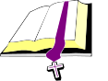  Daily Scriptures &  Eucharists  July 7-14, 2019  Fourteenth Sunday in Ordinary Time  Is 66: 10-14c; Gal 6: 14-18; Lk 10: 1-12, 17-20  5:00 pm Vigil- Josephine Arico  8:00 am Linda Toohey &  Eric Bentrovato  10:00 am For the People  11:30 am Pablo E. Cantera  7:00 pm Special Intention of Anna B. Kavaliauskas  Monday  Gn 28:10-22a; Mt 9:18-26  7:00 pm Bernard Covalesky, Sr.  Tuesday – St. Augustine Zhao Rong, Priest & Companions, Martyrs  Gn 32:23-33; Mt 9:32-38  8:30 am John F. Stevens  Wednesday  Gn 41:55-57, 42:5-7a, 17-24a; Mt 10:1-7  8:30 am John Lose &  Martha Lose  Thursday – St. Benedict, Abbot  Gn 44:18-21, 23b-29, 45:1-5; Mt 10:7-15  8:30 am Linda Toohey  Friday  Gn 46:1-7, 28-30; Mt 10:16-23  8:30 am Florence Swan &  Agnes Barlak  Saturday – St. Henry  Gn 49:29-32, 50:15-26a; Mt 10:24-33  8:30 am Special Intention of Anna B. Kavaliauskas  Fifteenth Sunday in Ordinary Time  Dt. 30: 10-14; Col 1:15-20; Lk 10: 25-37  5:00 pm Vigil- Camila &  Freddy Nieves  8:00 am Linda Toohey  10:00 am The Mizzoni Family & Efren Dumo  11:30 am For the People  7:00 pm Joyce Doll   | Memorial Candles for This Week  Sacred Heart of Jesus Candle: Ed Rudnicki rq. Marie Richards | WELCOME…………  To all our visitors this weekend.  Welcome All Senior Citizens:  ALL SENIORS 55 and over: JOIN THE SACRED HEART LEISURE CLUB.  We invite all senior citizens to be part of this enjoyable group of people to socialize and engage in a very vital part of our church.  We have various informative speakers, we enjoy a Christmas and Spri ng Luncheon along with other entertaining events throughout the year.  Our meetings are held the second and fourth Tuesday of each month at 11:30 am with coffee/cake in the Sacred Heart Rectory Meeting Room.  Hoping to see you all at our next meeting! Yearly dues are $15.00 (used for donations to our church at Christmas & Easter). Interested? Please call President Joann Caruso at 973-586-4248.  New Parishioners  Sacred Heart Parish welcomes new parishioners to register at any time. Registration forms can be found on the heaters of the church or you may feel free to stop by the parish offices from 9:30 am to 4:30 pm, Monday to Friday. Questions? You can reach the parish secretary, Patty Hyle @ 973-366-0060. (Registration forms are also available on our website www.sacredheart-dover.com.)  Summer Meals & Recreation  When school lets out, hunger sets in for far too many New Jersey children. To combat summertime hunger, St. John’s Episcopal Church is teaming up with Dover community organizations to serve up summer meals and recreational activities to children.  This free program will run from June 25 to August 16, Mondays through Fridays, from 1 pm. to 3 pm at St. John’s, 11 Bergen Street, Dover. There is no fee, but registration is required. See more information on the following page.  Upcoming Events: Craft and Vendor Fair  St. Cecilia Church Hall, 70 Church Street, Rockaway, NJ 07866  Saturday, November 2, 2019 from 9:00 am - 2:00 pm.  Post Abortion Announcement  An “Entering Canaan” Day of Prayer and Healing for men who have lost a child to abortion will take place Saturday, July 13, 2019, at Our Lady of New York Convent in the Bronx. The day will be directed by Rev. Mariusz Koch, CFR and is hosted by Lumina/Hope & Healing after Abortion. For further information, or confidential reservations call: 877-586-4621, or email at lumina@postabortionhelp.org Come and experience the mercy of God!  “God’s Plan for Giving.....Tithing A Way of Life”  Collection for June 30, 2019    WILL BE PUBLISHED IN JULY 14TH BULLETIN
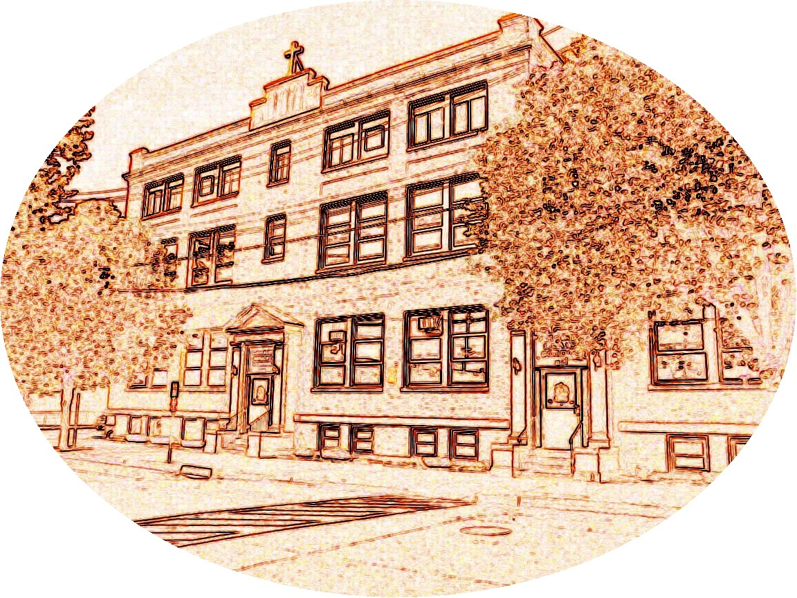    This Week in Our Parish July  CHRISTMAS DECORATIONS  It has been the custom here at Sacred Heart Parish to memorialize loved ones at Christmas time through a donation toward the flowers and greenery that decorate our Church during this holy season. A list of all intentions will be available at Christmas. We ask that your intention be printed below.  IN MEMORY OF/SPECIAL INTENTION OF:  DONATED BY:  TUESDAY – July 9  11:30 am Leisure Club Meeting – Rectory  Basement  SATURDAY – July 13  9:00 am Confessions – Church  Parish & Community Bulletin Board:  Baptism Prep. Class  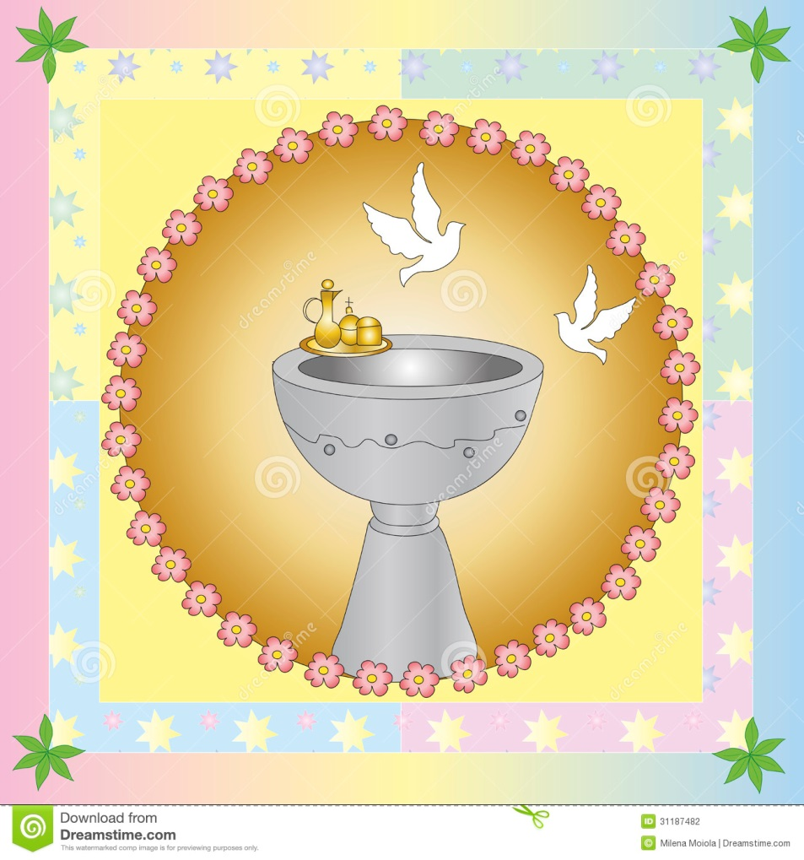  The great sacrament of Baptism makes us a child of God, welcomes us into the Kingdom of Heaven and enables us to avoid evil, among other things. What a great gift. In order to partake of this Sacrament a parent must be a parishioner and attend a preparation class. Class is offered once a month, on the 3rd Thursday. Registration is required to take the class. Please call:  GALE COLUCCI @ 973-476-3906.  Early Bird Registration  Register NOW for Religious Education!  We now have Pre K Classes for ages  3,4, and 5 year olds!    Register now for a reduced registration fee of $50.00! This fee will remain until MAY 31ST. Beginning June 1st the registration fee will be the usual of $65.00!  See Registration form contained in our bulletin this week.  Questions? Contact Lisa Masone at the Parish Offices. 973-366-0060 or  coordreled@sacredheart-dover.com  Volunteers Needed!  If you would like to become a Catechist Sub-Teacher or Aide for the 2019-2020 Religious Education program please contact Lisa 973-366-0060.  Protecting God’s Children  “If any person may have been abused by any priest, they should immediately contact their local County Prosecutor’s Office and the Diocese’s Victims Assistance Coordinator: Dr. Ken McNiel at 973-879-1489. You may also be in touch with either of the Diocesan Response Officers: Rev. Msgr. James T. Mahoney, Vicar General and Moderator of the Curia, 973-777-8818 Ext. 205 or Sister Joan Daniel Healy, S.C.C., Chancellor/Delegate for Religious, 973-777-8818 Ext. 248.  The entire text of the Policy of the Diocese of Paterson in Response to Complaints of Sexual Abuse is available on the diocesan Web site: www.patersondiocese.org  Fourteenth Sunday in Ordinary Time  First Reading: Isaiah 66:10-14c  Isaiah instructs the people of Jerusalem to rejoice, because God would restore her prosperity. The people will better understand God's power through their homeland's restoration.  Second Reading: Galatians 6:14-18  Paul describes the sign of the cross of Jesus as all that is significant. Following the old laws is unimportant. Instead, being baptized in Christ and adhering to his ideals is what matters most.  Gospel: Luke 10:1-12, 17-20  Jesus sent forth seventy-two disciples to preach his good news, telling them "the harvest is rich, but the workers few." He also gave them detailed instructions on how to act towards the people. Jesus then reminded them not to be happy because of their power over evil, but to rejoice in the salvation they would achieve.    Are You a Devotional Candle Lighter?  If you light a candle for a loved one once a week or more often, may we offer you another way of honoring that individual? In our Crucifix Chapel (as you enter church, on your right you will see the Crucifix) we have devotional candles, that, once lighted, burn continually for one year. Below each candle is a plaque with a person or family imprinted on it, including the name of the person offering the candle. Each candle burns at a cost of $100.00 per year. Interested? Contact Patty at the Parish Offices, 973-366-0060.  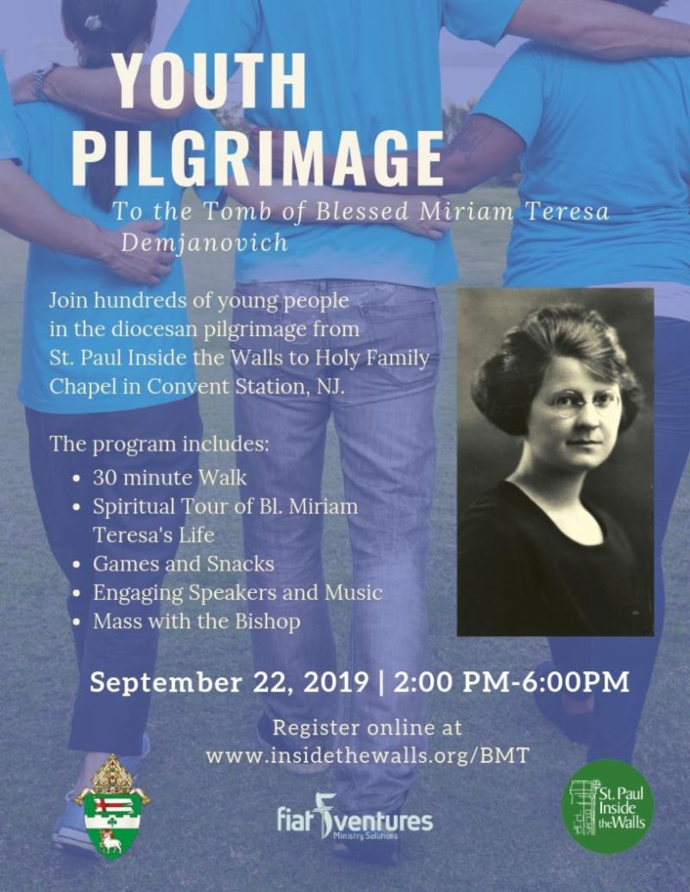 |  |  | - - | Weekly Reflections  “HIS WORD TODAY” by Rev. William J. Reilly  Fourteenth Sunday in Ordinary Time  July 7, 2019  “At that time the Lord appointed seventy-two others whom he sent ahead of him in pairs to every town and place he intended to visit. He said to them ‘the harvest is abundant, but the laborers are few; so ask the master of the harvest to send out laborers into his harvest. Go on your way; behold, I am sending you like lambs among wolves.”  Imagine being one of those sent. Who is your companion, as you go to bring the message of Jesus to someone else. Is your partner the talkative type, allowing you to remain present, but quiet? To whom will you go, either knocking on a door, stopping by a hospital bed, saying hello to someone in the laundromat? Isn’t it interesting to wrestle with the answers?  Well, you are one of the lucky ones, not among the seventy-two, but among all the baptized to work in bringing in the harvest. If someone doesn’t do his or her part, the harvest fails, dies, or simply rots. It is out there and the Lord needs people to follow His call as priests and deacons, as religious and committed lay workers, as missionary disciples. The good thing is, we do not do it alone but the Lord accompanies you.  There is work to be done and I heard that He is asking you to do it. Talk to someone about it today and fulfill your potential  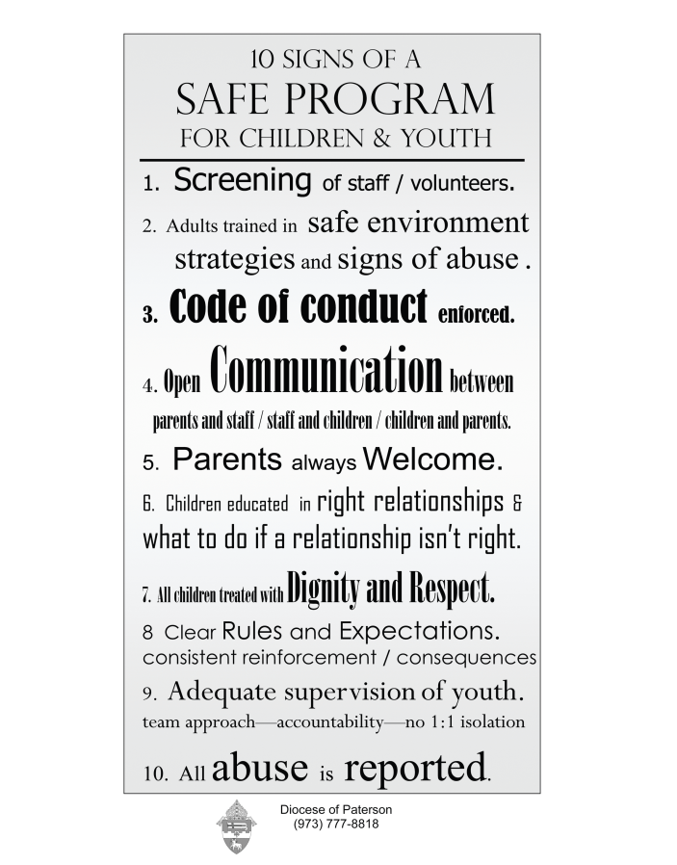  On Line Giving is Now Available  Sacred Heart Church offers Online Giving, an additional option for giving to the Church.  BENEFITS TO YOU  - Set up your contributions  - Change your Contributions at any time  - No need to write checks  - Contributions are scheduled; no need to make up missed contributions  - If you prefer, a credit or debit card can be used as well  Online Giving is not meant to replace the traditional Sunday Offertory Collection; it is meant to enhance it. Many parishioners would rather have the option of giving without writing a check or remembering to bring the check and envelope to church each week. It also gives you the opportunity to contribute to first and/or second collections even if you are out of town, etc.  Please consider this option or continue to use the offertory envelopes you currently receive. If you do not get envelopes but wish to, contact the Parish Office at 973-366-0060.  For more information or to sign up for Online Giving, call the Parish Office (973-366-0060) or email phyle@sacredheart-dover.com. Someone will contact you and help you get started.  "Eucharistic Reparation"  Please join us for "A Weekend of Eucharistic Reparation", Celebrating the Sense of the Sacred, from July 11 to 14, in honor of the 102nd Anniversary of the apparitions at Fatima. Come before the Blessed Sacrament as we pray the Rosary each hour, celebrate Holy Mass, and join in round-the-clock Eucharistic Adoration.  Take a break from the hectic days of summer, and come to the beautiful Blue Army Shrine of Our Lady of Fatima in Washington, NJ. Families, groups, ministries, and individuals are invited and encouraged to participate! Please say "YES", and give this special gift to our Blessed Mother! Visit our website: www.bluearmy.com. For more information, please call 908-689-1700 x 224 or 908-652-1153 or email: dorothyc@bluearmy.com.  The Mystery of the Eucharist  We will be publishing Bishop Serratelli”s Pastoral Letter of Corpus Christi on “The Eucharist: The Gift of Life” in each Bulletin for the next few weeks. If you will contact the parish office and request a copy, we will be happy to grant your request.  Please enjoy the second instalment in today’s bulletin.


