Sacred Heart & Holy Rosary Parish “A Tithing Parish” Dover, New Jersey
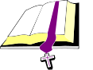  Daily Scriptures &  Eucharists  June 23-30, 2019  The Most Holy Body & Blood of Christ  Gn 14: 18-20; 1 Cor 11: 23-26; Lk 9: 11b-17  5:00 pm Vigil- For the People  8:00 am Rocco Rosica & The Cicchetti Family  10:00 am Rita Murray &  Herminio Agront  11:30 am The Mizzoni Family & Camila & Freddy Nieves  7:00 pm James Quigley  Monday - The Nativity of St. John the Baptist  Is 49:1-6; Acts 13:22-26; Lk 1:57-66, 80  7:00 pm Msgr. Barretta  Tuesday  Gn 13:2, 5-18; Mt 7:6, 12-14  8:30 am Sp. Int. Anna B. Kavaliauska  Wednesday  Gn 15:1-12, 17-18; Mt 7:15-20  8:30 am Joseph McCusker &  Herminio Agront  Thursday – St. Cyril of  Alexandria, Bishop & Doctor of  the Church  Gn 16:1-12, 15-16 or 16:6b-12, 15-16;  Mt 7:21-29  8:30 am James Fortner  Friday - The Most Sacred Heart  of Jesus  Ez 34:11-16; Rom 5:5b-11; Lk 15:3-7  8:30 am Adolfo Monsalve &  Lucila Monsalve  Saturday – Sts. Peter & Paul, Apostles  Acts 12:1-11; 2 Tm 4:6-8, 17-18; Mt 16:13-19  8:30 am Bernard Covalesky, Sr.  Thirteenth Sunday in Ordinary Time  Gn 14: 18-20; 1 Cor 11: 23-26; Lk 9: 11b-17  5:00 pm Vigil- Eric Bentrovato & Linda Toohey  8:00 am For the People  10:00 am Virginia Dickerson &  Jim Quigley  11:30 am The McGuinness Family  7:00 pm Frank & Concetta Negri & Sam Porfido | Memorial Candles for This Week  Sacred Heart of Jesus Candle: Frances Ferrara rq. Ruth & Family | WELCOME…………  To all our visitors this weekend.  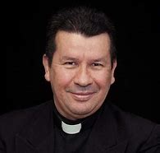  Coffee And….  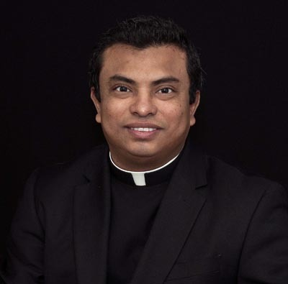  Please join the entire Parish as we officially welcome our new priests with coffee and a goodie after the 8:00, 10:30, 11:30 am and 1:30pm Masses, in the Rectory Basement. Rev. Rubén D. Castillo Rev. Manuel Guevara Membreño Parochial Vicar  Administrator  Corpus Christi Collection  This weekend, the Feast of Corpus Christi, Saturday/Sunday, June 22nd -23rd, 2019, Please bring with you: Jello; Pudding or Instant Oatmeal. Cash/Check donations will also be accepted made payable to Catholic Charities or online at www.ccpaterson.org/corpus. Thank you for helping those in need in our Diocesan communities of Morris, Passaic and Sussex Counties.  Summer Meals & Recreation  When school lets out, hunger sets in for far too many New Jersey children. To combat summertime hunger, St. John’s Episcopal Church is teaming up with Dover community organizations to serve up summer meals and recreational activities to children.  This free program will run from June 25 to August 16, Mondays through Fridays, from 1 pm. to 3 pm at St. John’s, 11 Bergen Street, Dover. There is no fee, but registration is required. See more information on the following page.  New Parishioners  Sacred Heart Parish welcomes new parishioners to register at any time. Registration forms can be found on the heaters of the church or you may feel free to stop by the parish offices from 9:30 am to 4:30 pm, Monday to Friday. Questions? You can reach the parish secretary, Patty Hyle @ 973-366-0060. (Registration forms are also available on our website www.sacredheart-dover.com.)  Enjoy Grocery Shopping?  Visiting Nurse Association of Northern New Jersey’s House Calls for Groceries (HCG) program provides grocery shopping assistance on a weekly or biweekly basis to homebound residents in Morris County. Once matched, volunteers contact the HCG client to schedule a mutually convenient time to grocery shop. Volunteers visit the client’s home to pick up the shopping list, and payment for the groceries. Then, the volunteer will shop at a local grocery store, deliver the groceries to the client’s home and assist with putting items away. This is a great opportunity for professionals, retirees and students who are looking for ways to create meaningful relationships with neighbors. For more information, please contact Rachel Enderle, Volunteer Coordinator, at 973-451-4128 or renderle@vnannj.org  “God’s Plan for Giving.....Tithing A Way of Life”  Collection for June 16, 2019    $9,154.00
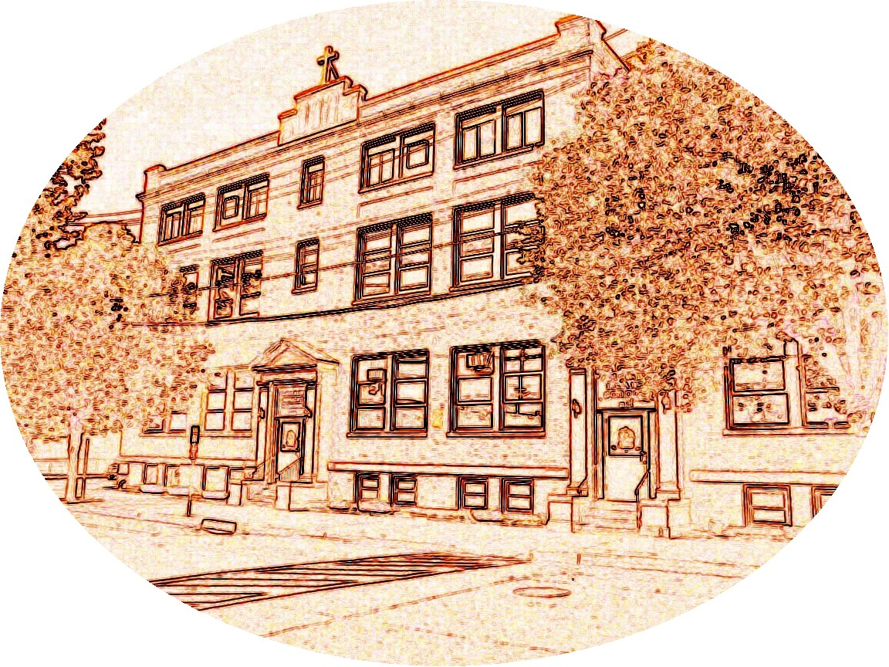    This Week in Our Parish June  CHRISTMAS DECORATIONS  It has been the custom here at Sacred Heart Parish to memorialize loved ones at Christmas time through a donation toward the flowers and greenery that decorate our Church during this holy season. A list of all intentions will be available at Christmas. We ask that your intention be printed below.  IN MEMORY OF/SPECIAL INTENTION OF:  DONATED BY:  TUESDAY – June 25  11:30 am Leisure Club Meeting – Rectory  Basement  SATURDAY – June 29  9:00 am Confessions – Church  SUNDAY – June 30  Meet & Greet our new priests after 8:00, 10:00, & 11:30 am Masses and after 1:30 pm – Rectory Basement  Parish & Community Bulletin Board:  Baptism Prep. Class  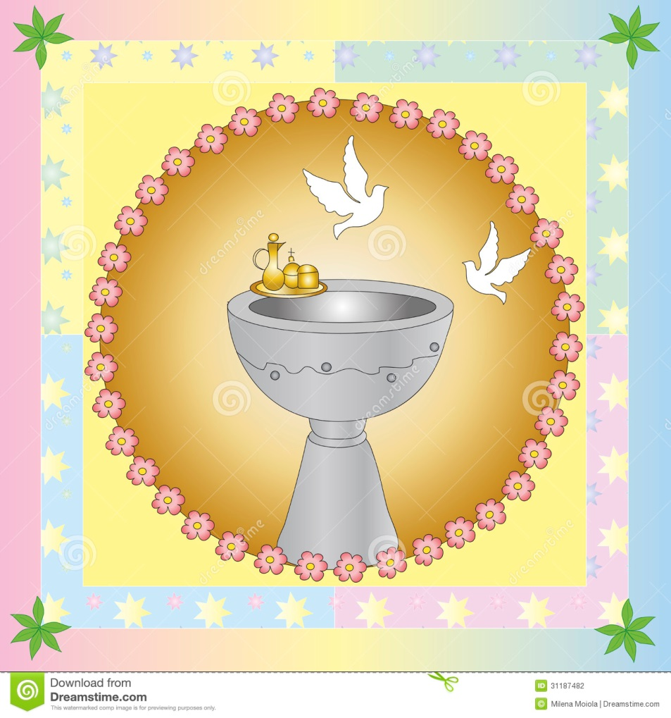  The great sacrament of Baptism makes us a child of God, welcomes us into the Kingdom of Heaven and enables us to avoid evil, among other things. What a great gift. In order to partake of this Sacrament a parent must be a parishioner and attend a preparation class. Class is offered once a month, on the 3rd Thursday. Registration is required to take the class. Please call:  GALE COLUCCI @ 973-476-3906.  Early Bird Registration  Register NOW for Religious Education!  We now have Pre K Classes for ages  3,4, and 5 year olds!    Register now for a reduced registration fee of $50.00! This fee will remain until MAY 31ST. Beginning June 1st the registration fee will be the usual of $65.00!  See Registration form contained in our bulletin this week.  Questions? Contact Lisa Masone at the Parish Offices. 973-366-0060 or  coordreled@sacredheart-dover.com  Volunteers Needed!  If you would like to become a Catechist Sub-Teacher or Aide for the 2019-2020 Religious Education program please contact Lisa 973-366-0060.  Protecting God’s Children  “If any person may have been abused by any priest, they should immediately contact their local County Prosecutor’s Office and the Diocese’s Victims Assistance Coordinator: Dr. Ken McNiel at 973-879-1489. You may also be in touch with either of the Diocesan Response Officers: Rev. Msgr. James T. Mahoney, Vicar General and Moderator of the Curia, 973-777-8818 Ext. 205 or Sister Joan Daniel Healy, S.C.C., Chancellor/Delegate for Religious, 973-777-8818 Ext. 248.  The entire text of the Policy of the Diocese of Paterson in Response to Complaints of Sexual Abuse is available on the diocesan Web site: www.patersondiocese.org  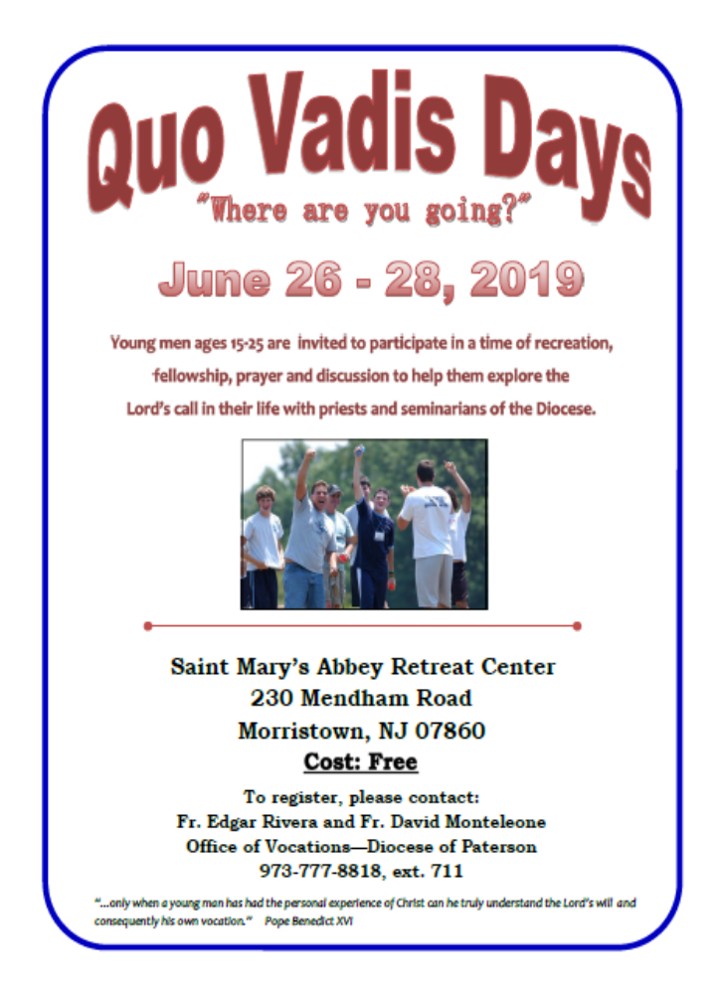  The Most Holy Body & Blood of Christ  First Reading: Genesis 14:18-20  Melchizedek, a priest of God, prayed that Abram would be blessed by God. He also praised God for delivering Abram's foes into his hands.  Second Reading: 1 Corinthians 11:23-26  Paul describes Jesus' actions during the last supper. Jesus broke bread and said it was his body given for us, asking that we do the same in remembrance of him. He then passed the cup and called it his blood. Jesus then asked us to break bread in this manner to remember his death until he returns.  Gospel: Luke 9:11b-17  Jesus spoke to a large crowd when his disciples asked that he dismiss the people to give them a chance to find food and lodging. Jesus asked the disciples to give the crowd something to eat, but they had only five loaves of bread and two fish. Jesus then blessed and distributed the food, which fed about 5,000 people. Twelve baskets were then collected from what was left over.    Are You a Devotional Candle Lighter?  If you light a candle for a loved one once a week or more often, may we offer you another way of honoring that individual? In our Crucifix Chapel (as you enter church, on your right you will see the Crucifix) we have devotional candles, that, once lighted, burn continually for one year. Below each candle is a plaque with a person or family imprinted on it, including the name of the person offering the candle. Each candle burns at a cost of $100.00 per year. Interested? Contact Patty at the Parish Offices, 973-366-0060.  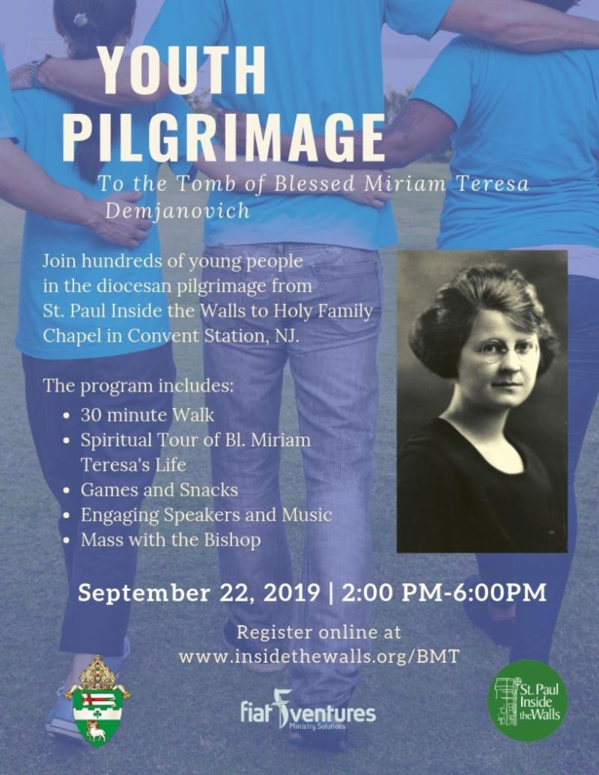 |  |  | - - | Weekly Reflections  “HIS WORD TODAY” by Rev. William J. Reilly  The Most Holy Body and Blood of Christ  (Corpus Christi)  June 23, 2019  “Brothers and sisters: I received from the Lord what I also handed on to you, that the Lord Jesus, on the night he was handed over, took bread, and, after he had given thanks, broke it and said ‘This is my body that is for you. Do this in remembrance of me.”  Words so familiar, accompanied by the gestures of looking up, thanking, breaking and giving. Every Eucharist the words of Paul, and of Jesus at the last supper echo in our ears.  We might be surprised to know that Paul’s teaching of the Corinthians, predates the last supper accounts in the gospels. It was already known, repeated and celebrated. How interesting, we call that a ‘tradition’, a handing over. Paul uses the word twice in a different way. He hands the story to his disciples, and describes the handing over of Jesus for the passion.  The great gift of the Eucharist brings us together with the Lord, forming a relationship with Him, making us one with each other and permits us to acknowledge a living Presence among us. At every mass, in every tabernacle, the Lord is present to be praised, adored, and loved with grateful affection.  Remember the person who met Philip and said ‘Sir, we would like to see Jesus?’  He is here.  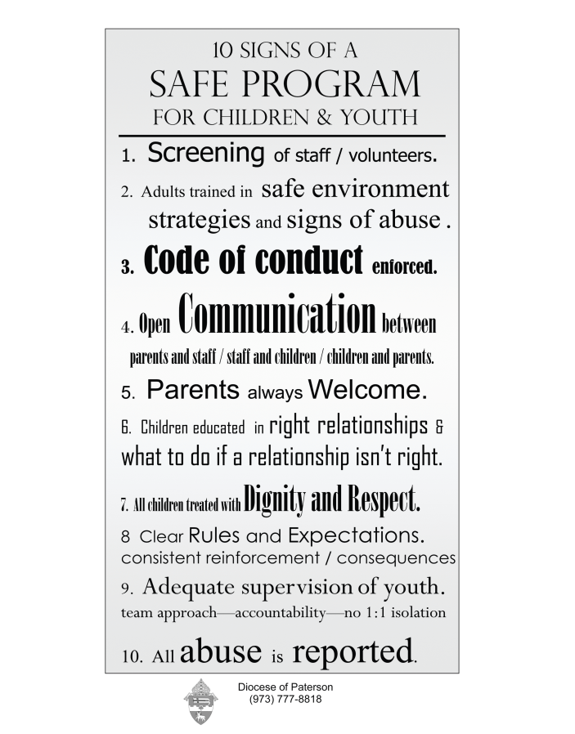  On Line Giving is Now Available  Sacred Heart Church offers Online Giving, an additional option for giving to the Church.  BENEFITS TO YOU  - Set up your contributions  - Change your Contributions at any time  - No need to write checks  - Contributions are scheduled; no need to make up missed contributions  - If you prefer, a credit or debit card can be used as well  Online Giving is not meant to replace the traditional Sunday Offertory Collection; it is meant to enhance it. Many parishioners would rather have the option of giving without writing a check or remembering to bring the check and envelope to church each week. It also gives you the opportunity to contribute to first and/or second collections even if you are out of town, etc.  Please consider this option or continue to use the offertory envelopes you currently receive. If you do not get envelopes but wish to, contact the Parish Office at 973-366-0060.  For more information or to sign up for Online Giving, call the Parish Office (973-366-0060) or email phyle@sacredheart-dover.com. Someone will contact you and help you get started.

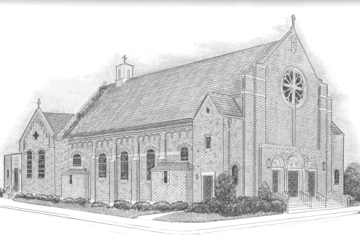
GRADES K-9 CCD Grade _________________
* EARLY BIRD SPECIAL*

$50.00 FROM NOW UNTIL MAY 31, 2019
(REGULARLY $65.00)

SACRED HEART & HOLY ROSARY PARISH - DOVER, NJ
RELIGIOUS EDUCATION REGISTRATION
SCHOOLYEAR 2018 – 2019 973-366-0060

coordreled@sacredheart-dover.com

STUDENT'S NAME: (FIRST MIDDLE LAST) _____________________________________________________________________

STUDENT'S AGE: ___________ GRADE IN SCHOOL (Sept-2019):__________

CHILDS DATE OF BIRTH ___________________

HOME ADDRESS: ______________________________________________________________________

CITY/TOWN_____________________________ STATE: ________ ZIP: ___________________

HOME PHONE:_____________MOTHER:____________FATHER:_________________

EMERGENCY CONTACT NAME: ________________________PHONE NUMBER: _________________

FATHER’S FIRST & LAST NAME: _______________________________________________________

MOTHER'S FIRST & MAIDEN NAME: __________________________________________________

PARENT’S EMAIL ADDRESS: MOTHER: ____________________FATHER:_____________________

CHILD'S PLACE & DATE OF BIRTH: ___________________________________________________

CHURCH OF BAPTISM, DATE & LOCATION _____________________________________________________________________________

BAPTISMAL CERTIFICATE SUBMITTED? _____YES ____ NO

SACRAMENTS RECEIVED: FIRST EUCHARIST: _____YES ____NO CONFIRMATION: _____YES ______NO

PRIOR GRADES of RELIGIOUS EDUCATION: ___________________________________________

NAME and LOCATION of RELIGIOUS EDUCATION SCHOOL: _____________________________________________________________
STUDENT'S SPECIAL NEEDS: _________________________________________________________

STUDENT'S ALLERGIES: _____________________________________________________________

PARISH IN WHICH FAMILY IS REGISTERED: __________________________________________

FOR PARENTS AND GUARDIANS PLEASE SELECT ALL THAY APPLY:

__ I AM INTERESTED IN BECOMING CERTIFIED CATECHIST

__ I AM INTERESTED IN BEING CATECHETICAL AID __ I AM INTERESTED IN VOLUNTEERING

Office use only: Amount of payment: _______________ Date of payment: _______________

Check Number: _______________ Cash: _______________ Number of children________

