Modeling Mental States in Agent-Oriented Requirements Engineering

Alexei Lapouchnian¹ and Yves Lespérance²
¹Department of Computer Science, University of Toronto, Canada, alexei@cs.toronto.edu
²Department of Computer Science, York University, Toronto, Canada, lesperan@cs.yorku.ca

Abstract

Recently, Goal-Oriented Requirements Engineering (GORE), where stakeholder goals are identified, analyzed/decomposed and then assigned to software components or actors in the environment, and Agent-Oriented Software Engineering (AOSE), where goals are objectives that agents strive to achieve, have been gaining popularity. Their reliance on goals makes GORE and AOSE a good match. While goal-oriented RE approaches generally include formal components that allow for rigorous analysis of system properties, they do not support reasoning about the goals and knowledge of agents. This paper presents an agent-oriented requirements engineering approach that combines informal i* models with formal specifications in the CASL language through the use of Intentional Annotated Strategic Rationale diagrams. In the resulting framework agent goals and knowledge are represented as their mental states, which allows for the formal analysis of, among other things, agent interactions and incomplete knowledge. CASL models can also serve as high-level specifications for multiagent systems.

1. Introduction

Modern software systems are becoming increasingly complex, with lots of complex interactions. The recent popularity of electronic commerce, web services, and peer-to-peer applications confirms the need for software engineering methods for constructing applications that are open, distributed, and adaptable to change. This is why many researchers and practitioners are looking at agent technology as a basis for distributed applications.
Agents are active, social, and adaptable software system entities situated in some environment and capable of autonomous execution of actions in order to achieve their set objectives [21]. Furthermore, most problems are too complex to be solved by just one agent — one must create a multiagent system (MAS) with several agents having to work together to achieve their objectives and ultimately deliver the desired application. Therefore, adopting the agent-oriented approach to software engineering means that the problem is decomposed into multiple, autonomous, interacting agents, each with a particular objective. Agents in MAS frequently represent individuals, companies, etc. This means that there is an “underlying organizational context” [7] in MAS. Like humans, agents need to coordinate their activities, cooperate, request help from others, etc., often through negotiation. Unlike in object-oriented or component-based systems, interactions in multiagent systems occur through high-level agent communication languages, so interactions are mostly viewed not at the syntactic level, but “at the knowledge level, in terms of goal delegation, etc.” [7].
In requirements engineering, goal-oriented approaches (e.g, KAOS [3]) have become prominent. In Goal-Oriented Requirements Engineering (GORE) high-level stakeholder objectives are identified as goals and later refined into fine-grained requirements assignable to agents in the system-to-be or in its environment. Their reliance on goals makes goal-oriented requirements engineering methods and agent-oriented software engineering a great match. Agent-oriented analysis is central to requirements engineering since the assignment of responsibilities for goals and constraints among components in the software-to-be and agents in the environment is the main outcome of the RE process [19]. Therefore, it is natural to use a goal-oriented requirements engineering approach when developing MAS. With GORE, it is easy to make the transition from the requirements to the high-level MAS specifications. For example, strategic relationships among agents will become high-level patterns of inter-agent communication.
In the above context, while it is possible to informally analyze small systems, formal analysis is needed for any realistically-sized system to determine whether such distributed requirements imposed on each agent in MAS are correctly decomposed from the stakeholder goals, consistent and, if properly met, achieve the system’s overall objectives. Thus, the aim of this work is to devise an agent-oriented requirements engineering approach with a formal component that supports reasoning about agents’ goals (and knowledge), thus allowing for rigorous formal analysis of the requirements expressed as the objectives of the agents in MAS.
In our approach we integrate the i* goal-oriented modeling framework [22] with CASL [15], a formal agent-oriented programming language supporting the formal modeling of agent mental states. This gives the modeler the flexibility and intuitiveness of the i* notation as well as the powerful formal analysis capability of CASL. To bridge the gap between informal i* diagrams and formal CASL specifications we propose an intermediate notation that can be easily obtained from i* models and then mapped into CASL. With our i*-CASL-based approach, a CASL model can be used both as a requirements analysis tool and as a formal high-level specification for a multiagent system that satisfies the requirements. This model can be formally analyzed using the CASLve [16] tool or other tools and the results can be fed back into the requirements model.

[Benefits of formally modeling goals and knowledge]
[Criticize KAOS and other approaches where goals are just objectives. need to be assigned to agents. to deal with goal delegation, need to model differences in agents’ goals and negotiation. Similarly for modeling knowledge exchange]

The rest of the paper is organized as follows: Section 2 briefly describes the concepts of i* and CASL; Section 3 discusses our approach in detail and presents a case study; Section 4 presents a further discussion of the approach, while Section

2. Background

2.1. The i* framework

i* [22] is an agent-oriented modeling framework that can be used for requirements engineering, business process reengineering, etc. i* centers on the notion of intentional actor and intentional dependency. The actors are described in their organizational setting and have attributes such as goals, abilities, beliefs, and commitments. In i*, an actor can use opportunities to depend on other actors for the achievement of goals, the execution of tasks, or the acquisitions of resources, which it cannot achieve, execute, and obtain by itself, or not as cheaply, efficiently, etc. At the same time, the actor becomes vulnerable if other actors do not deliver. i* actors are strategic in the sense that they are concerned with the achievement of their objectives and strive to find a balance between their opportunities and vulnerabilities. Similarly, dependencies in i* are intentional since they appear as a result of actors pursuing their goals. In i*, actors represent stakeholders (with stakeholders’ goals being the actors’ objectives) as well as the agents of the system-to-be.
The framework has two main components: the Strategic Dependency (SD) model and the Strategic Rationale (SR) model. The former describes the external relationships among actors, while the latter focuses on the reasoning each actor goes through regarding its relationships with other actors. In SD models (see Figure 2), nodes represent actors. Actors are divided into agents (concrete physical actors, systems, or humans), roles (typically a function in an organization), and positions (groups of roles usually played by one actor). Directed links in SD diagrams represent dependencies among actors. Depending actors are called dependers and depended actors are called dependees. There can be four types of dependencies based on what is being delegated – a goal, a task, a resource, or a softgoal. Goal dependencies give the dependee the freedom to achieve the delegated goal as it sees fit; task dependencies require that the dependee execute a specific task; physical or information resources are provided by the dependees of resource dependencies; a softgoal dependency specifies that the depender needs the achievement of a softgoal – a quality goal. Softgoals are related to non-functional requirements [2]. They do not have a clear-cut satisfaction conditions and have solutions that are “good enough”. Finding such solutions is called satisficing.
SD models capture the intentionality of a process, what is important to its participants, while abstracting over all other details. SD models can be used to model the existing processes in an organization, their rationale, and the goals of the stakeholders. The analysis of SD models helps in the identification of the organization’s need for a new system. SD models can also model the system-to-be in its organizational environment. Here, they are used to understand how the network of intentional dependencies can be reorganized with the introduction of a new system. However, SD models do not support the modeling finer details of organizational processes and the process of suggesting and analyzing process alternatives. SR models are used to address these concerns.
SR models (see Figure 3) are used to explore the rationale behind the processes in organizations from the point of view of participating actors. The models allow for deeper understanding of what each actor needs and how its needs can be met. SR models also enable the analyst to assess possible alternatives in the definition of actor processes to better address their concerns. To define an actor process one can use four types of nodes – goals, tasks, softgoals, and resources – and three types of links – means-ends links, softgoal contribution links, and task decompositions. Means-ends links specify alternative ways to achieve goals; task decomposition links connect tasks with components (simpler tasks, goals, or resources) needed for their execution. Softgoals are used to evaluate alternatives with the help of softgoal contribution links that specify how (positively or negatively) each alternative contributes to their satisficing. [!!!TROPOS]

2.2. CASL

The Cognitive Agents Specification Language (CASL) [15] is a formal specification language that combines theories of action [12] and mental states [13] expressed in situation calculus [10] with ConGolog [4], a concurrent, non-deterministic agent-oriented programming language with a formal semantics. CASL uses special predicates to formally express agents’ knowledge and goals; communicative actions are used for inter-agent communication and ConGolog is then employed to specify the behaviour of agents. This combination produces a very expressive language that supports high-level reasoning about the agents’ mental states. The logical foundations of CASL allow it to be used to specify and analyze a wide variety of MAS. For example, it can support non-deterministic systems and systems with incompletely specified initial state.
CASL specifications consist of two parts: the model of the domain and its dynamics (the declarative part) and the specification of the agents’ behaviour (the procedural part). The domain is modeled in terms of the following entities:
- Agents. These are agents in the system and its environment.
- Primitive actions. All changes in the domain are due to primitive actions being executed by agents. For example, the action bookRoom(agt,meetingID, date,room) books a room for a meeting.
- Situations. A situation, a state of the domain that results from the execution of a sequence of actions. There is a set of initial situations (with no predecessor) corresponding to the ways agents think the world might be like initially.
- Fluents. These are the predicates and functions that change from situation to situation. For example, we use the fluent Room(meetingID,date,room,s), where s is a situation parameter, to model the fact that a room is booked on some day for some meeting. In this paper, we will mostly omit situation parameters in code samples for brevity.
To specify the dynamics of an application domain, we use these types of axioms:
- Action precondition axioms that describe under which conditions actions can be performed.
- Successor state axioms, which specify how primitive actions affect fluents. They were introduced in [12] and provide a solution to the frame problem.
- Initial state axioms, which describe the initial state of the domain and the initial mental states of the agents.
- Other axioms. These include unique name axioms for actions and domain independent foundational axioms.
Agent’s behaviour is specified using a rich high-level programming language with procedure declarations, loops, conditionals, nondeterminism, concurrency, interrupts [4]. A special predicate Do(Program,s,s′) holds if Program successfully terminates in situation s′ after starting in s.
CASL supports formal modeling of agents’ goals and knowledge. The formal representation for both goals and knowledge is based on a possible worlds semantics incorporated into the situation calculus, where situations are used as possible worlds [11][13]. CASL uses accessibility relations K and W to model what an agent knows and what it wants respectively. K(agt,s′,s) holds if the situation s′ is compatible with what the agent agt knows in situation s, i.e., in situation s, the agent thinks that it might be in the situation s′. In this case, the situation s′ is called K-accessible. Intuitively, if an agent does not know the value of some formula φ, it thinks that in some possible worlds it might be true and in some – false. An agent knows some formula φ if φ is true in all K-accessible situations: Know(agt,φ,s)=∀s′(K(agt,s,s′) ⊃ φ[s′]). Additionally, KWhether(agt,φ,s) indicates that an agent knows whether φ holds or not and KRef(agt,θ,s) specifies that an agent knows the value of θ. Constraints on the K relation ensure positive and negative introspection (i.e., agents know whether they know something) and guarantee that what is knows is true. Communicative actions such as inform, informWhether, and informRef are used for exchanging information among agents. The precondition for inform actions ensures that no false information is transmitted. The changes to the mental states of agents due to communicative and other actions are specified by the successor state axiom for the K relation. The axiom presented in [14] makes sure that agents are aware of the execution of each action. Many modifications to the K relation are possible (for example, to handle encrypted messages [15] or to provide belief revision [17]).
The accessibility relation W(agt,s′,s) holds if in situation s an agent considers that everything that it wants to be true actually holds in s′, which is called W-accessible. We use the formula Goal(agt,ψ,s) to indicate that in situation s the agent agt has the goal that ψ holds. The definition of Goal says that ψ must be true in all W-accessible situations that have K-accessible situation in their past. This ensures that while agents may want something they know is impossible to obtain, the goals of agents must be consistent with what they currently know. In our approach, we mostly use achievement goals that specify the desired states of the world. We use the formula Goal(agt,Eventually(ψ)) (we omit the situation parameters here) to state that agt has the goal that ψ is eventually true. The dynamics of the W relation are specified, as usual, by a successor state axiom. It guarantees that agents do not acquire conflicting goals. The request and cancelRequest actions are used by agents to request services of other agents and cancel their requests respectively. Requests are used to establish intentional dependencies among actors.
The acquisition of knowledge and goals by agents is automatic – there is no need to monitor for and process messages procedurally.

3. The i*-CASL notation and methodology

3.1. A motivating example

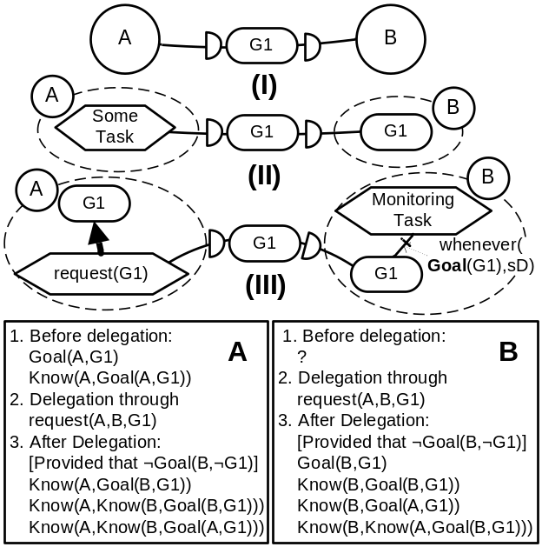
Figure 1. A motivating example

Suppose, that we are employing a Tropos-like agent-oriented RE methodology to model a simple goal delegation involving two agents. Figure 1 models a situation where agent A delegates the goal G1 to another agent B. In the SD notation (I), we see the agents and the intentional dependency labeled G1. In a more detailed SR notation (II), we see that G1 is needed for executing SomeTask and that G1 is acquired by B through a goal dependency. In the even more detailed Intentional Annotated SR (iASR) notation proposed here (III), we see that agent A has the goal G1 and the task request(G1) is a means for achieving it. This task delegates G1 to agent B where an interrupt running inside MonitoringTask monitors for the acquisition of instances of G1. However, we would also like to be able to analyze this interaction and predict how it will affect the intentions and the knowledge of these agents. Using the approach proposed in this paper, one can create a formal model based on the iASR diagram in Figure 1, analyze it, and conclude that, for example, before the goal delegation, agent A has the goal G1 and knows about this fact. After the delegation (and provided that B did not have a conflicting goal), A knows that B acquired the goal, that B knows that it has the goal, and that B knows that A has the same goal, etc. Similarly, for the agent B based on the model in Figure 1 we cannot say what its mental state was before the goal delegation. However, after the request from A we know that it has the goal G1 and knows about it, etc. Agent B also knows how it acquired the goal G1 and thus will be able to trace its intention to achieve G1 to agent A.
[???? – where should we go with this ????]

3.2. The case study

To illustrate the methodology for the combined use of i* and CASL we chose a variation of the Meeting Scheduler, which has become a popular exemplar problem in Requirements Engineering (e.g., [18]). In the context of the i* modeling framework the process was first analyzed in [22]. The initial requirements for the process were stated as “For each meeting request, to determine a meeting date and location so that most of the intended participants will be able to effectively participate”. We introduce a number of modifications to the meeting scheduling process to make our models more manageable and to better illustrate our methodology. For example, we take the length of meetings to be the whole day. A meeting can be successfully scheduled if for all the intended participants there is a date (among the dates suggested by the initiator) that fits in their schedule and there is an available room on that date. The model can be easily changed to handle many meetings per day. We also assume that in the environment of the system-to-be there is a legacy software system called the Meeting Room Booking System (MRBS) that handles the booking of meeting rooms.
We first briefly present the SD and SR diagrams developed during the early and late requirements analysis and then explain how the SR models can be enriched and mapped into CASL specifications for formal analysis.

3.3. Developing initial i* models

In the early requirements phase, we analyze the organizational environment of the system-to-be. Here, we follow the Tropos approach and use SD diagrams to model the stakeholders, their goals, and their intentional dependencies.
During the late requirements stage the system is brought into its environment. SD models developed at this stage facilitate the understanding of how the system can help in achieving stakeholder goals, how intentional dependencies can be reconfigured with the introduction of the system-to-be, and what responsibilities can be delegated to the system.

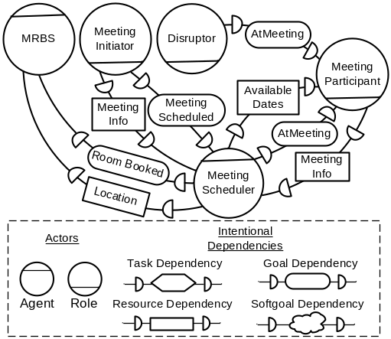
Figure 2. Meeting Scheduler in its environment

Figure 2 is a detailed SD diagram that shows the computerized Meeting Scheduler (MS) agent in its environment. Here, Meeting Initiator (MI), which is a role, depends on MS for scheduling meetings and for being informed about the meeting details. MS, it turn, depends on Meeting Participant (MP) for attending meetings and for providing his/her available dates to it. MS uses the booking system to find and book available rooms for meetings. The Disruptor actor represents outside actors that change participants’ schedules, thus making the system more dynamic.
[ONLY IF NOT IN THE i* SECTION] SR diagrams are used to analyze goals, plans, and dependencies from the point of view of individual actors. Process alternatives, which are modeled using means-ends links, can be modeled and analyzed using quality criteria represented by softgoals. For example, Meeting Initiator can use the old manual way of scheduling meetings or it can use the automated Meeting Scheduler agent. These alternatives have different contributions to softgoals such as Convenience. In the SR model for Meeting Initiator (see Figure 3), we assume that the softgoal analysis was performed and the automated scheduling option was chosen.

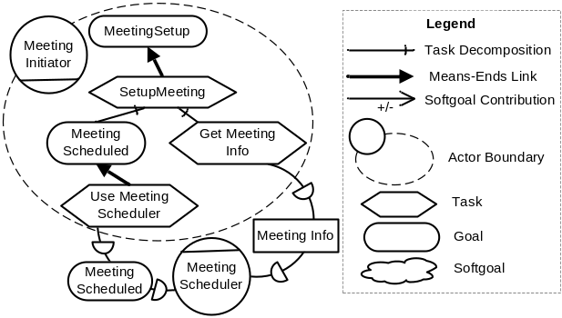
Figure 3. SR model for Meeting Initiator

3.4. Increasing Precision with iASR Models

Our goal is to tightly associate i* models with formal specifications in CASL. The standard SR diagrams are geared for informal analysis and can be quite ambiguous. For example, they do not provide any information on whether the subtasks in task decompositions are supposed to be executed sequentially or concurrently and whether all the subtasks are executed unconditionally or not. CASL, on the other hand, is a precise language. To handle this precision mismatch we propose Intentional Annotated SR (iASR) models that help in bridging the gap between SR models and CASL specifications.
The starting point for developing an iASR diagram for an actor is the regular SR diagram for that actor. It then can be appropriately modified/enriched, thus becoming an iASR model every element of which can be easily mapped into CASL.

3.4.1. Annotations. The main tool that we use for disambiguating SR models and for increasing their level of precision is annotations. We revised the list of annotations originally used in the i*-ConGolog approach [20]. Annotations are textual constraints on iASR models and can be of three types: composition, link, and applicability conditions. Composition annotations (specified by σ in Figure 4) are applied to task decompositions and specify how the subtasks/subgoals are to be combined to execute the supertask. Four types of composition are allowed: sequence (“;”), concurrency (“||”), prioritized concurrency (“>>”), and alternative (“|”). The default composition annotation is sequence (for means-ends links, the default annotation is alternative). These annotations are applied to subtasks/subgoals from left to right. E.g., in Figure 4, if the ”>>” annotation is applied, n₁ has the highest priority, while n_{k} has the lowest. The choice of composition annotations is based on the ways actions and procedures can be composed together in CASL.

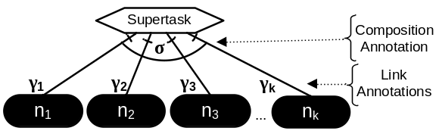
Figure 4. Composition and link annotations

Link annotations (γ_{i} in Figure 4) are applied to subtasks/subgoals (n_{i}) and specify how/under which condition they are supposed to be achieved/executed. There are six types of link annotations (corresponding to CASL operators): while loop, for loop, condition, the pick annotation (π(varList,cond)), which non-deterministically picks values for the variables from the list that satisfy the condition, the interrupt (whenever(varList,cond, cancelCond)) that fires whenever there is a binding for the variables in the list that satisfies the condition unless the cancellation condition is true, and the guard, that blocks the execution until a certain condition is true. The absence of a link annotation on a particular decomposition link indicates the absence of any conditions on the subgoal/subtask.
The third annotation type is the applicability condition (ac(cond)). It applies to means-ends links that model goal achievement alternatives and specifies under which condition the corresponding alternatives are applicable. For example, the analyst may specify that phoning participants to notify them of the meeting details is applicable only to important participants, while the email option is applicable for every participant.
We note that annotations allow analysts to model the domain more carefully and to capture data and control dependencies and other details.

3.4.2. Softgoals. Our approach does not provide tools for formal analysis of quality concerns. Therefore, softgoals are used as criteria for evaluating process alternatives and then are removed prior to the development of iASR models. We assume that only interesting alternatives are kept in the models postponing the selection until runtime. Alternatively, softgoals can be operationalized or metricized, thus becoming hard goals.

3.4.3. Handling goals in iASR models. As previously discussed, CASL agents have two components: the procedural specification of their behaviour and the declarative specification of their mental state. iASR diagrams model agent processes and therefore can be used to represent the procedural component of CASL agents. Thus, the presence of a goal node in an iASR diagram indicates that the agent is aware of the goal being in its mental state and is prepared to deliberate about whether and how to achieve it. For the agent to modify its behaviour in response to the changes to its mental state, it must synchronize its procedural and declarative components (see Figure 5A). Agent mental states usually change as a result of communication such as goal delegation and data exchange. Mental state changes are automatic and are based on the successor state axioms for the K and W relations. However, for the behaviour of an agent to reflect these updates, the procedural component of the agent must be made aware of the changes. The usual way to do it is to use interrupts or guards with their conditions being the presence of certain goals or knowledge in the mental state of the agent. There must be a program (represented by a task node) where the guard/interrupt can be placed (Figure 5B). Thus, in iASR diagrams, the parent of a goal node must be a task node.
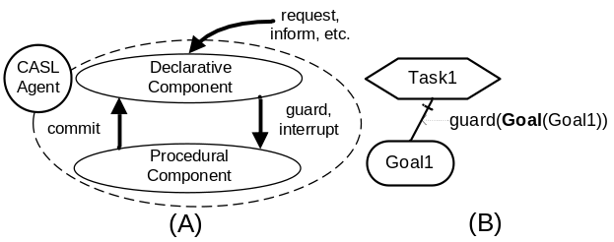
Figure 5. Synchronizing procedural and declarative components of CASL specifications

In CASL, as it is described in [15], only communication actions have effects on the mental state of the agents. We, on the other hand, would like to get the flexibility of having agents change their mental state on their own by executing the action commit(agent,φ), where φ is a formula that the agent wants to hold. Thus, in CASL and in iASR diagrams all agent goals must be either acquired from intentional dependencies or by using the commit action.
By making the agent acquire a goal by itself the modeler makes sure that the agent’s mental state reflects the fact that multiple alternatives exist in particular places in the model of the agent’s behaviour. Moreover, the presence of a goal node suggests that the designer envisions new possibilities of achieving the goal. This way the agents would be able to reason about various alternatives available to them or come up with new ways to achieve the goals. Self-acquired goals add flexibility to the system models by preserving the variability in the way goals can be achieved in the corresponding formal specifications and the modelers will not have to operationalize the goals early.
Since all agent goals must either come from other agents or self-acquired, a goal refinement pattern where a means to achieve some goal G1 (which can be acquired repeatedly since the interrupt annotation is used) is another goal G2 (Figure 6A) (or a set of goals) must be transformed into a pattern where G2 is self-acquired by the agent (Figure 6B). The means to achieve G1 in Figure 6B is a task that self-acquires the goal G2 using the commit action. Once the goal is in the mental state of the agent, the guard condition on the goal node G2 becomes true and the agent can start achieving it as appropriate. AND and OR goal decompositions can be similarly transformed into the proper iASR patterns. These transformations can be performed automatically during the generation of CASL specifications from iASR models so as to keep the models simpler. [AND-refinement]
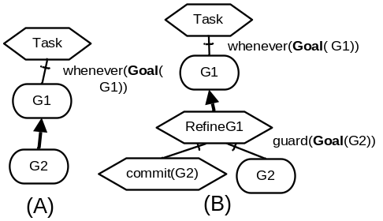
Figure 6. A goal refinement pattern in iASR
models

3.4.4. Adding agent interaction details. i* usually abstracts from modeling the details of agent interactions. CASL, on the other hand, models all the details of inter-agent communication: requests for services or information, the selection of the course of action upon the receipt of the information, etc. Because of the importance of agent interactions in MAS, in order to formally verify multiagent system specifications in CASL, all aspects of agent interaction must be provided in the corresponding iASR models. This includes the tasks that request services or information from the agents in the system, the tasks that provide the information or inform about the success or failure in providing the service, etc. The communication links are assumed to be reliable, so there is no need to model communication failure handling.
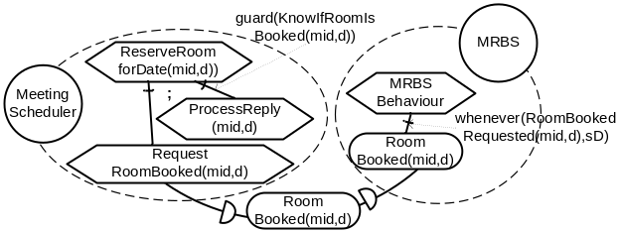
Figure 7. Adding agent interaction details

Figure 7 illustrates how an intentional goal dependency RoomBooked (see Figure 2) can be modeled in an iASR model. Here, mid stands for “meeting ID”, a unique meeting identifier. In this model fragment, the MS agent has a task that requests the booking of a room for a meeting while the task that ProcessReply is executed only after the scheduler knows whether the MRBS was able to book a room. Furthermore, the MRBS agent has the RoomBooked goal, which is accompanied by the interrupts that fires whenever an instance of the goal is acquired.
Similar agent interaction details have to be provided for the task dependencies. Also, while at a high level we use resource dependencies as a separate dependency type, at an iASR level we can model them more precisely through either goal or task dependencies depending on the level or freedom the requesting agent gives the resource provider in the way it delivers the resource. For example, the requesting agent can simply ask for a resource without worrying how it is provided. This corresponds to a goal dependency. On the other hand, the agent may instruct the provider on how exactly to deliver the resource, which is modeled by a task dependency. This applies to all dependencies including the information ones.
Figure 8 presents a fragment of the iASR model for Meeting Scheduler agent. It shows the process of achieving the goal of scheduling meetings. The model has one self-acquired goal AvailableDatesKnown (it is the goal of collecting available meeting slots from participants). The goal is acquired for flexibility since there are many ways to gather this information, while only one alternative is fully explored. The model accounts for the possibility of meeting slots being occupied by external activities during the scheduling process. So, there is a possibility of someone declining to meet on a previously available date. The model also supports concurrent scheduling of many meetings by implementing a locking mechanism to avoid trying to booking several meetings in the same time slot. [More on the example – managing schedule through goals???]
[in the meeting scheduling case study we decided not to maintain schedules for meeting participants explicitly. Instead, we relied on the presence of AtMeeting(p,mid,d,s) goals in their mental states as an indication of the participants’ intention to attend certain meetings on certain dates. With the axioms presented in Section 6.7.1.4 (and also assuming that agents do not drop their commitments), the consistency of participants’ schedules can be easily maintained since the meeting requests conflicting with already adopted AtMeeting goals are automatically rejected. Present axioms used for schedule consistency???]
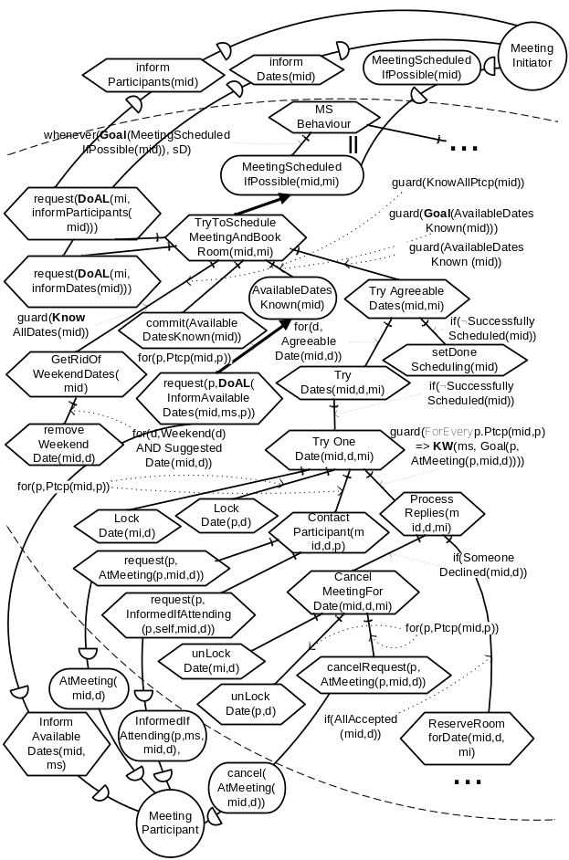
Figure 8. Fragment of the iASR model for
Meeting Scheduler

[DO WE SPECIFICALLY TALK ABOUT KNOWLEDGE??? The ability to refer to agent’s knowledge – formulas/conditions can refer to knowledge, incomplete knowledge]

3.5. Mapping iASR diagrams into CASL

Once all the necessary details have been introduced into an iASR diagram, it can be mapped into the corresponding CASL model. This model provides the formal semantics for the otherwise informal i* model, thus making the iASR model amenable to formal analysis.
The modeler defines a mapping m that maps every element (except for intentional dependencies) of an iASR model into CASL. Specifically, agents are mapped into CASL procedures that specify their behaviour; roles and positions are mapped into similar procedures with an unbound agent parameter so that they can be used by compatible CASL agents; leaf-level task nodes are mapped into CASL procedures or primitive actions; composition and link annotations are mapped into the corresponding CASL operators, while conditions present in the annotations will map into defined fluents with the same name in CASL. Task decomposition is automatically mapped into a CASL procedure that reflects the structure of the decomposition and all the annotations. The mapping process for each actor starts at the root of the iASR decomposition tree and terminates when all leaf nodes are processed. [GENERIC TASK MAPPING!!!]

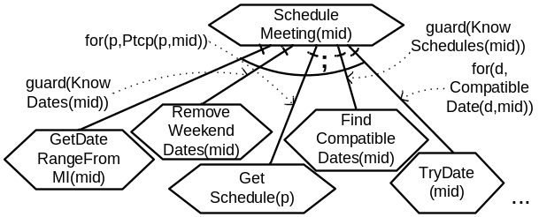
Figure 9. Example iASR task decomposition

Figure 9 shows how a Meeting Scheduler’s task of scheduling meetings can be decomposed. This task will be mapped into the CASL procedure with the following body (it contains parts still to be mapped into CASL):
proc ScheduleMeeting(mid)
m(GetDateRangeFromMI(mid));
guard m(KnowDates(mid)) do
m(RemoveWeekendDates(mid))
endGuard;
for p: m(Ptcp(mid)) do
m(GetSchedule(p))
endFor;
guard m(KnowSchedules(mid)) do
m(FindCompatibleDates(mid))
endGuard;
for d: m(CompatibleDate(d,mid)) do
m(TryDate(mid))
endFor;
…
endProc
In our approach, an iASR goal node is mapped into a CASL formula, which is the formal definition for the goal, and an achievement procedure, which encodes the how the goal can be achieved and is based on the means-ends decomposition for the goal in the iASR diagram: m(ASRGoal) => <GoalFormula , AchieveProc>. The constraint on the achievement procedure is quite weak and states that there must be a case that the achievement procedure actually achieves its goal: ∃s,s′.Do(AchieveProc,s,s′) ∧ GoalFormula[s′]
E.g., a formal definition for ScheduleMeeting(mid,s) could be: ∃d[AgreeableDate( mid,date,s) ∧ AllAccepted(mid,date,s) ∧ RoomBooked(mid,date,s)]. It says that there must be a date agreeable for everybody on which all participants agreed to meet and on which a room was booked. However, initial formal goal definitions are often too ideal and the goal cannot always be achieved. Such goals must be deidealized [18]. In order to weaken the goal appropriately, one needs to know under what circumstances the goal cannot be achieved. Thus, an analyst must have an insight into the way the goal is achieved before deidealizing it. Modeling an achievement process for a goal using iASR diagrams is a great way to understand how that goal can be denied and thus iASR models can be used to come up with a correct formal definition for the goal. For example, it is not always possible to schedule a meeting. Here is one way to weaken the goal ScheduleMeeting:

MeetingScheduledIfPossible(mid,s)=
//1. The meeting has been successfully scheduled
SuccessfullyScheduled(mid,s) ∨
//2. No agreeable dates
∀d[IsDate(d) ⊃ ¬AgreeableDate(mid,d,s)] ∨
//3. Some participants cannot attend on all potential dates
∀d[AgreeableDate(mid,d,s)⊃SomeoneDeclined(mid,d,s)] ∨
//4. No rooms available
∀d[SuggestedDate(mid,d,s)⊃[AllAccepted( mid,d,s)⊃¬RoomBooked(mid,date,s)]]

The achievement procedures for goals are automatically constructed based on the modeled means for achieving them, and the associated annotations including the applicability conditions. By default, alternative composition annotation is used, which means that some applicable alternative will be nondeterministically selected. Other alternatives are also possible. For example, it is possible to try all appropriate alternatives concurrently or try each alternative in sequence until the goal is achieved. This is a designer preference. Figure 10 shows a generic goal decomposition with the generated achievement procedure. Note that the applicability conditions (φ_{i}) map into guard operators to prevent the execution of unwanted alternatives.
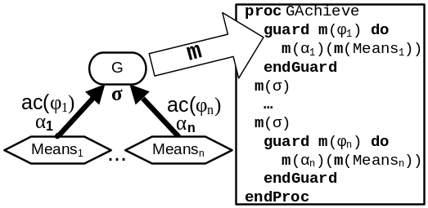
Figure 10. Creating achievement procedures

Intentional dependencies are not mapped into CASL per se – they are implicitly established by the agent interactions. iASR tasks requesting help from agents will generally be mapped into actions of the type request(FromAgt,ToAgt,Eventually(φ)) for achievement goals φ. We add a special abbreviation DoAL(δ,s,s′) (Do At Least) to be used when establishing task dependencies. It stands for Do(δ||(πa.a)*, s,s′), which means that program δ must be executed, but the requested agent has the flexibility to execute any other activity concurrently. Thus, to request and agent to execute a certain known procedure, the depender must request it with: request(FromAgt,ToAgt,DoAL( SomeProcedure)).
In order for an intentional dependency to be established, we also need a commitment from a dependee agent to act on requests from the depender. Thus, the dependee must monitor its mental state for newly acquired goals. Here is an interrupt that is used by Meeting Participant to check for a request for the list of its available dates:
<mid: Goal(mp,DoAL(InformAvailableDates(
mid,MS),now,then) ∧
Know(mp,¬∃s,s′(s ≤ s′ ≤ now ∧
DoAL(InformAvailableDates(mid,MS),s,s′)))→
InformAvailableDates(mid,MS)
until SystemDone>
Here, if MP has the goal to execute the procedure InformAvailableDates and knows that it has not yet executed it for this request, the agent sends the available dates. The cancellation condition SystemDone indicates that MS always monitors for this goal. Requesting agents use similar interrupt/guard mechanism to monitor for requested information or confirmations.

3.6. Formal verification

Once an iASR model is mapped into the corresponding CASL specification, it is ready to be formally analyzed. Coupled with the appropriate tools, CASL provides powerful facilities for the formal analysis of its specifications. One such tool, CASLve [16], is a theorem prover-based verification environment for CASL. CASLve provides a library of proof methods for proving various types of results. One can use CASLve to prove properties such as liveness, safety, and termination. Both global and agent-specific properties can be verified as well as agent interaction protocols, goal decompositions, and goal achievability. In addition to physical executability of agent programs, epistemic feasibility [9] of agent plans – whether agents have enough knowledge to successfully execute their processes – can be verified. [MORE? Subjective execution??]
Other avenues could be explored as well, for instance, simulation and model checking. However, most tools based on these techniques work with much less expressive languages than CASL. Therefore, CASL specifications must be simplified before these methods can be used on them. For example, mental states would have to be operationalized and an approach would have to be found to deal with incomplete information in CASL specifications. One straightforward possibility that is not, however, advisable since it requires, for instance, the removal of goals and knowledge from the formal model is ConGolog simulation. This path was explored in [20].
If expected properties of the system are not entailed by the CASL model, it means that the model is incorrect and needs to be fixed. The source of an error found during verification can usually be traced to a portion of the CASL code and to a part of its iASR model. Because of the tight mapping between iASR models and CASL specifications, their synchronization is straightforward and can easily be automated.

4. Discussion

[Traceability] TODO
[Automated Mapping] TODO
The basic successor state axiom describing the dynamics of the K relation for knowledge accepts new information without regard for who the sender of that information is. This may not be acceptable for all domains. In [8] we provided a simple way of handling trust, an increasingly important issue in MAS, in CASL. A Trusts relationship, with which agents could specify whom they trust for particular type of information, was introduced allowing agents to accept information from trusted sources only. Likewise, the Serves relation could be used to specify which goals and from whom the agents will acquire when requested, and which requests will be denied.
We use the version of CASL where the precondition for the inform action requires that the information being sent be known to be true to the sending agent: Poss(inform(sender,receiver,φ),s) ≡ Know(sender,φ,s). This prevents agents from transmitting false information. The removal of this restriction allows the modeling of systems where agents are not always truthful. This can be useful when dealing with security and privacy requirements. Similarly, the precondition of the request action makes sure that when requesting services from other agents, the sender does not itself have goals that conflict with the request. Relaxing this constraint also allows for the possibility of modeling malicious agents.
[Hard to guarantee that a procedure achieves goal in MAS – too many potential obstacles]

5. Related Work

In our approach, we produce CASL specifications from i* models for formal analysis and verification. This approach is similar to the Tropos framework in that it is agent-oriented and is rooted in the RE concepts. Our approach is not the first attempt to provide formal semantics for i* models. For example, Formal Tropos [5][6], which is part of the Tropos framework, supports formal verification of i* models through model checking. Also, in the i*-ConGolog approach [20], on which our method is based, SR models are associated with formal ConGolog programs for simulation and verification. In these methods, goals of the agents are abstracted out of formal specifications. This is done due to the fact that the formal components of these approaches (the model checker input language and ConGolog respectively) do not support reasoning about agent goals. Reasoning about agent knowledge is not supported either. However, most of the interactions among agents involve knowledge exchange and goal delegation since multiagent systems are developed as social structures. Thus, complementing informal modeling techniques such as i* with formal analysis of agent goals and knowledge is very important in the design of multiagent systems. We propose a framework where goals are not removed from the agent specifications, but are added to the agents’ mental states, thus allowing agents to reason about their objectives. Information exchanges among agents are also formalized as mental state changes in CASL specifications. In our approach, goals are not system-wide properties, but belong to concrete agents. The same applies to knowledge. This subjective point of view provides opportunity for new types of formal analysis on CASL specifications.
[KAOS, Albert II ????] Our stuff – formal modeling of goals and knowledge and CASL specs can serve a high-level design for the MAS. Also – agent interactions can be analyzed at a semantic level.

6. Conclusion

7. References

- J. Castro, M. Kolp and J. Mylopoulos. Towards Requirements-Driven Information Systems Engineering: The Tropos Project. Information Systems, 27(6):365-389, 2002.
- L.K. Chung, B.A. Nixon, E. Yu and J. Mylopoulos. Non-Functional Requirements in Software Engineering. Kluwer, 2000.
- A. Dardenne, A. van Lamsweerde and S. Fickas. Goal-Directed Requirements Acquisitions. Science of Computer Programming, 20:3-50, 1993.
- G. De Giacomo, Y. Lespérance and H. Levesque. ConGolog, A Concurrent Programming Language Based on the Situation Calculus. Artificial Intelligence, 121:109-169, 2000.
- A. Fuxman, L. Liu, M. Pistore, M. Roveri and J. Mylopoulos. Specifying and Analyzing Early Requirements: Some Experimental Results. Proc. RE-03, Sep. 8-12, 2003, Monterey Bay, California, USA.
- A. Fuxman, M. Pistore, J. Mylopoulos and P. Traverso. Model Checking Early Requirements Specifications in Tropos. Proc. RE'01, Toronto, Canada, August 27-31, 2001.
- N.R. Jennings. Agent-Oriented Software Engineering. In Proc. MAAMAW-99, Valencia, Spain, 1999, pp. 1-7.
- A. Lapouchnian. Modeling Mental States in Requirements Engineering - An Agent-Oriented Framework Based on i* and CASL. M.Sc. Thesis. Department of Computer Science, York University, Toronto, 2004.
- Y. Lespérance. On the Epistemic Feasibility of Plans in Multiagent Systems Specifications. In J.J.C. Meyer and M. Tambe, Eds., Proc. ATAL-2001, Revised papers, pp. 69-85, LNAI 2333, Springer, 2002.
- J. McCarthy and P. Hayes. Some Philosophical Problems From the Standpoint of Artificial Intelligence. In B.Meltzer and D. Michie, Eds., Machine Intelligence, Volume 4, pp. 463-502, Edinburgh University Press, 1969.
- R.C. Moore. A Formal Theory of Knowledge and Action. In J.R. Hobbs and R.C. Moore, Eds., Formal Theories of the Common Sense World, pp. 319-358, Ablex Publishing, 1985.
- R. Reiter. The Frame Problem in the Situation Calculus: A Simple Solution (Sometimes) and a Completeness Result for Goal Regression. In V. Lifschitz, Ed. Artificial Intelligence and Mathematical Theory of Computation: Papers in Honor of John McCarthy, pp. 359-380, Academic Press, 1991.
- R.B. Scherl and H. Levesque. The Frame Problem and Knowledge-producing actions. In Proc. Eleventh National Conference on Artificial Intelligence, Washington, DC, July, 1993, pp. 689-695.
- S. Shapiro, Y. Lespérance and H. Levesque. Specifying Communicative Multi-Agent Systems. In W. Wobcke, M. Pagnucco and C. Zhang, Eds., Agents and Multi-Agent Systems - Formalisms, Methodologies, and Applications, pp. 1-14, Springer, 1998.
- S. Shapiro and Y. Lespérance. Modeling Multiagent Systems with the Cognitive Agents Specification Language - A Feature Interaction Resolution Application. In C. Castelfranchi and Y. Lespérance, Eds., Intelligent Agents Volume VII – Proc. ATAL-2000, pp. 244-259, LNAI 1986, Springer, 2001.
- S. Shapiro, Y. Lespérance and H. Levesque. The Cognitive Agents Specification Language and Verification Environment for Multiagent Systems. In C. Castelfranchi and W.L. Johnson Eds., Proc. AAMAS’02, Bologna, Italy, July 15-19, 2002, ACM Press.
- S. Shapiro, M. Pagnucco, Y. Lespérance and H. Levesque. Iterated Belief Change in the Situation Calculus. In A.G. Cohn, F. Giunchiglia and B. Selman, Eds., Proc. KR-2000, pp. 527-538, Morgan Kaufmann, 2000.
- A. van Lamsweerde, R. Darimont and P. Massonet. Goal-Directed Elaboration of Requirements for a Meeting Scheduler: Problems and Lessons Learnt. Proc. RE'95, York, UK, 1995.
- A. van Lamsweerde. Requirements Engineering in the Year 00: A Research Perspective. Proc. ICSE’00, Limerick, Ireland, June, 2000.
- X. Wang and Y. Lespérance. Agent-Oriented Requirements Engineering Using ConGolog and i*. In G. Wagner, K. Karlapalem, Y. Lespérance and E. Yu Eds., Proc. AOIS-01, 2001, pp. 59-78, iCue Publishing, Berlin.
- M. Wooldridge. Agent-Based Software Engineering. IEE Proceedings on Software Engineering, 144(1):26-37, 1997.
- E. Yu. Towards modeling and reasoning support for early requirements engineering. In Proc. RE’97, Annapolis, USA, pp. 226–235. IEEE Computer Society, 1997.

