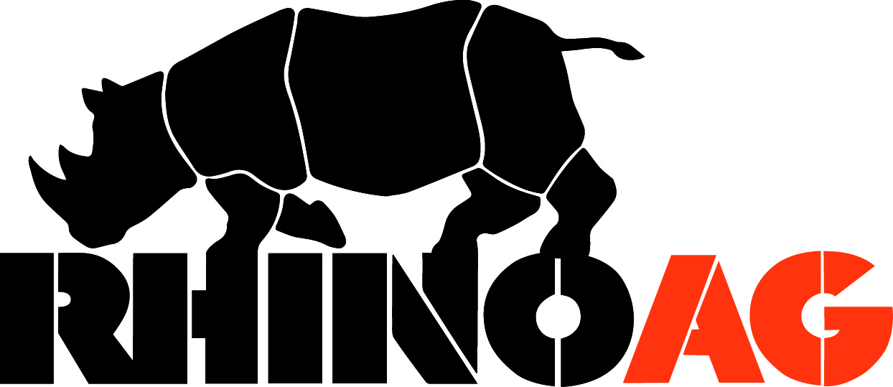

TERMS & CONDITIONS
PARTS SALES

Effective January 1, 2019

RhinoAg, Inc. is a registered trademark of Alamo Group Inc.

TABLE OF CONTENTS

Parts Policy pg. 3

Special Programs pg. 3

Terms & Discounts – Parts pg. 4

RhinoAG Parts Stock Order Program pg. 5

Parts Warranty pg. 5

Dealer Error Parts Return Policy pg. 6

Shipped Wrong by Customer Service or

Shipped in Error by the Warehouse pg. 7

Freight Claim Policy pg. 8

Freight Fuel Surcharge pg. 8

Quarterly Parts Return Program pg. 9

Quarterly Parts Return Calendar pg.10

Termination pg.11

TermSync pg.12
Company Information pg.14

DEALER PARTS POLICY

TO ENSURE PROMPT HANDLING

Please include the following information with every parts order:

- Include correct customer account number. The customer account number may be found on all RhinoAG invoices and previous packing slips.
- If a purchase order number is required with your parts order, include this number with the order. If no purchase order is required, give the name of the person ordering the parts.
- If you have a preferred mode of transportation (i.e., UPS, CF, etc.) specify at the time of order. Please be advised that this may delay the shipment of your parts order if the carrier is not on a scheduled pick-up from our facilities. From time to time for special programs RhinoAG reserves the right to restrict shipments to certain carriers.
- Orders printed to the warehouse after 2:00 pm CST are not guaranteed to ship out the same day. This includes expedited shipments such as Next Day Air, 2nd Day Air or 3rd Day Air.
- Backorders - any part not available when an order is shipped will be placed on backorder, and will automatically ship within 24 hours of receipt of the needed parts as the original order requested. Example – UPS Ground or Next Day Air, etc.
- Most repair parts will be painted black unless otherwise communicated to customer service by phone.
- Parts that are special order “ON DEMAND”- dealers have until the next business day to cancel. Dealers will have to accept the order after this time has expired. The part will be non-returnable.
- Orders that have an incorrect address will be subject to an address correction fee.

SPECIAL PROGRAM OR STOCK ORDERS

- Stock Orders must be entered online at www.rhinoparts.com to be eligible for the “Weekly Stock Order Program”. Stock Orders will be shipped at company convenience.
- Special Program Stock Orders – From time to time, RhinoAG may announce special stock order programs for which you should allow extra time for shipment dependent upon credit approval. DO NOT use special programs for emergency orders.

TERMS & DISCOUNTS – PARTS

Standard Discounts

Online Orders

25% Trade Discount
3% Discounts for all orders received via E-Commerce only
5% Additional Cash Discount (If paid by 10th of the month following the date of
invoice)

Phone/Fax Orders

25% Trade Discount
5% Additional Cash Discount (If paid by 10th of the month following the date of
invoice)

Dealers must be in good credit standing to earn standard discounts.

- No Additional Discount will be allowed if invoices are past due. Invoices are due on the 10th of the month following the date of the invoice. If invoice is not paid within invoice terms, freight allowance will be invoiced to the dealer.
- Stock Order Program – Special Stock Order programs will be announced periodically. Freight, discounts, terms, etc. will be included in the announcement of each specific program.
- Phone or fax orders - $30 dealer net minimum.
- E-Commerce Orders (www.rhinoparts.com)- No minimum order
- Cash in Advance – Dealers may be set up as Cash in Advance if current dealer financial conditions dictate and at the sole discretion of RhinoAG. Shipments will be made once payment is received.
- Standard freight charges apply.

RHINOAG PARTS
STOCK ORDER PROGRAM

Standard Discounts

Online Orders

25% Trade Discount
3% Discounts for all orders received via E-Commerce only
7% Additional Cash Discount (If paid by 10th of the month following the date of
invoice)

Dealers must be a qualified RhinoAG dealer and not retail credit card.

A RhinoAG Parts Dealer is allowed to place regular stock orders under the following terms:

- ORDER PERIOD: Orders may be placed multiple times each week. All orders must be placed via E-Commerce at www.rhinoparts.com by selecting the “Stocking” tab.
- TERMS: Payment is due the 10th of the month following invoice date to be eligible for the cash discount.
- MINIMUM ORDER: $1000.00 dollars or more at Dealer List Prices. No line minimum required.
- TERMS CODE: 103
- FREIGHT: Freight will be prepaid Continental U.S ONLY. Canada, Alaska, Hawaii will have to contact customer service. If invoice is not paid within terms, freight allowance will be billed to the dealer. If parts are returned on a stock order and it drops below the minimum dollar amount of $1000.00 then freight will be charged back.
- ORDERS: Must be sent to dealership placing stock order. No direct shipments.

PARTS WARRANTY

- RhinoAG warrants new replacement parts against defects in materials or workmanship for 90 days from dealer invoice date to the customer for the part(s).
- Freight – Normal ground freight to obtain warranty parts from RhinoAG is claimable on all failures occurring during the standard warranty period.

DEALER ERROR PARTS RETURN POLICY

- Dealer must submit all returns within 30 days from date of invoice at www.rhinoparts.com under “RMA” tab.
- RESTOCK FEES WILL BE WAIVED FOR DEALER ERRORS (Except for Quarterly Returns). Parts ordered within the last 30 days are eligible for return, except special Order “On Demand” parts which are non-returnable at any time. You may contact customer service to verify if a part is returnable or you may access the price file located on Ecommerce at www.rhinoparts.com. On the price file the saleable code of D designates an “On Demand” part. Once approved dealer will receive a Return Material Authorization. Parts will not be accepted without approved Returned Material Authorization.
- Returned parts must be in new and resalable condition and properly identified with the RhinoAG part number.
- RhinoAG, Inc reserves the right to refuse or charge handling fees for parts which are not in a saleable condition, in original packaging, or unidentified.
- The return authorization issued by RhinoAG is valid for 60 days unless otherwise stated. Any material received after this period will be subject to cancellation and/or rejection.
- All parts must be genuine RhinoAG Parts in unused condition originally purchased by the Dealer as service parts on parts invoices.
- Returned parts are to be shipped freight prepaid by the Dealer to address shown on authorization. Additional freight and handling charge may apply if shipment is to be forwarded to another location.
- All parts are subject to final acceptance by RhinoAG before credit is issued. Damaged, un-identifiable, or otherwise rejected or unacceptable parts will be held for 10 days after the Dealer has been notified of the rejection. If the Dealer requests the rejected parts to be returned, freight will be billed to the dealer; otherwise, parts will be discarded.
- Parts which have been superseded or are denoted non-returnable are not eligible for return.
- Dealer Net is defined as list price less trade discounts at the time of return.
- The Dealer will bear the transportation costs of any error for orders received via telephone or E-Commerce.
- Unacceptable parts will be held for 10 days after dealer notification, after which the parts will be scrapped. Parts returned to the dealers will be at the dealer’s expense and a 15% handling fee will be charged.

SHIPPED WRONG BY CUSTOMER SERVICE OR SHIPPED IN ERROR BY THE WAREHOUSE

- The Dealer must request an RMA within 30 days of invoice date.

- The parts are not to be returned until the Return Material Authorization is received by the Dealer. Parts returned without an RMA will not be accepted.

- The authorized parts and a copy of the Return Material Authorization are to be shipped freight prepaid to the address shown on the authorization, which can be found from the RMA tab on the website, www.rhinoparts.com, then print the RMA. Additional freight and handling charge may apply if shipment is to be forwarded to another location.

- Credit for freight charges prepaid by the Dealer will be allowed in the case of a RhinoAG error when noted.

- Credit for authorized returned parts, due to a RhinoAG Parts error, will be issued to the Dealer’s account at Dealer Net less additional discounts.

- Unacceptable parts will be held for 10 days after dealer notification, after which the parts will be scrapped. Parts returned to the dealers will be at dealer’s expense and a 15% handling fee will be charged.

FREIGHT CLAIM POLICY

- Dealer is responsible for inspecting any package delivered by a motor freight company (i.e. UPS, FedEx Freight, XPO, R&L, etc.) at time of delivery, in order to be eligible to file a claim on a shortage or damaged part from that motor freight company.

- RhinoAG customer service must be notified within 24 hours or the next business day of receipt of damaged and or shorted part.

- The Bill of Lading MUST be noted with the damage/shortage and pictures provided reflecting the packaging and part damages.

- The Bill of Lading MUST be signed off by the delivering service for verification that the delivering service is aware of the damage/shortage.

- The Dealer is to make sure the delivering service inspects the package prior to notifying RhinoAG customer service.

- The Freight Claim will be filed by RhinoAG customer service when notified by the dealer.

- The dealer is to retain the damaged package until RhinoAG customer service provides instructions on returning or discarding.

Claims will be denied if shortage or damage is not reported within the specified time frame and/or documentation is not provided.

FREIGHT FUEL SURCHARGE

The company reserves to the right to implement “Fuel Surcharges” for parts, should this become necessary. The company will also remove the “Fuel Surcharge” at its discretion, as this is monitored on a routine basis. The “Fuel Surcharge” portion will be charged for all orders, even those that receive free freight.

QUARTERLY PARTS RETURN PROGRAM

RhinoAG will accept, once each quarter, the return of current, returnable, service parts from active RhinoAG Parts dealers under the following conditions:

- A Dealer may return up to 15% of the prior calendar year’s parts shipments for the corresponding quarter. (see example below)
 | 2018 Sales net | 2019 allowed net amount (15% of 2018 sales)
Q1 | $12,000 | $1,800
Q2 | $25,000 | $3,750
Q3 | $37,000 | $5,550
Q4 | $26,000 | $3,900
- Requests can be submitted on Ecommerce (www.rhinoparts.com) under Surplus Parts Return tab. The list must be received prior to the 15th day of the second month of the current quarter (February, May, August, or November) without exception. (See next page for calendar.)
- No safety items intended as protection for the operator or bystanders and sold as standard equipment will be accepted on surplus returns. This includes driveline shields, safety chains, deflectors, or any other items deemed as safety related. No part that has limited storage life or is otherwise subject to deterioration, such as rubber items, gaskets, or lubricants will be accepted on quarterly returns.
- Return authorization will be issued for acceptable parts on the Return Material Authorization form which must be received by the Dealer before return shipment is made.
- Parts are to be properly identified with the RhinoAG part number, carefully packed with a copy of the Return Material Authorization enclosed, and shipped freight prepaid to the address shown on the Authorization prior to the 15th day of the last month of the current quarter (March, June, September, or December).
- Credit will be issued for acceptable parts to the Dealer’s account at current Dealer List prices less a 35% discount and less a 15% handling charge, unless otherwise noted. Additional charges may be applied for parts returned unidentified, not in the original packaging, original condition or not listed on authorization.
- For listing of returnable parts, please visit www.rhinoparts.com and look for the Excel price file under “What’s New”.

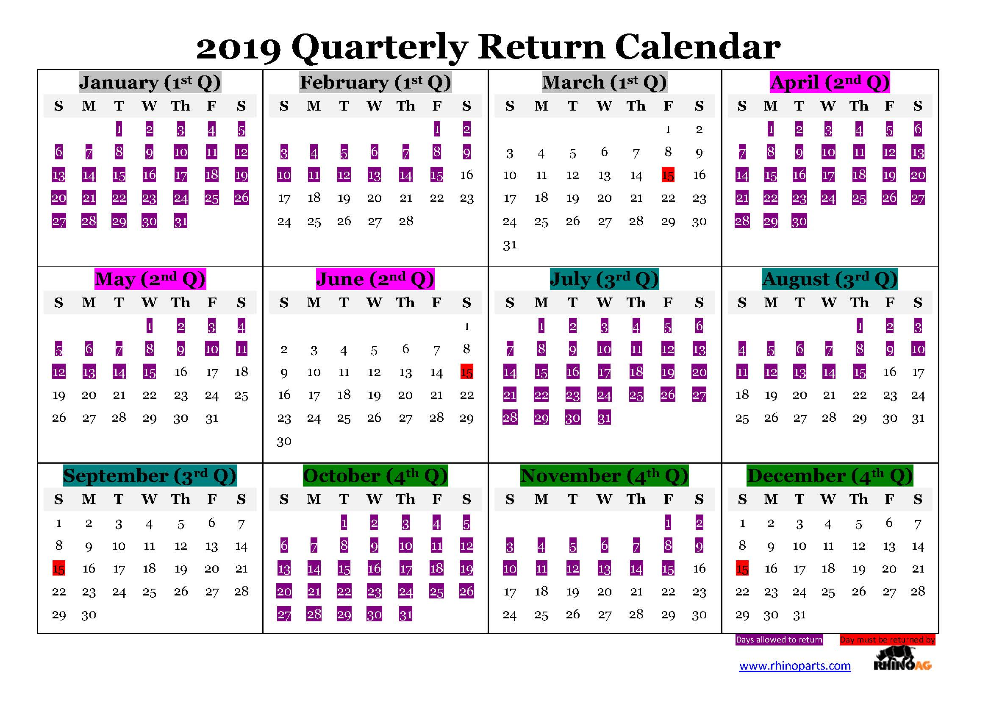

TERMINATION

In the event that the Dealer Agreement between RhinoAG and the Dealer is terminated by either party, RhinoAG agrees to repurchase service parts under the following conditions:

- Upon receipt of the Return Material Authorization, parts are to be properly identified with the RhinoAG part number, carefully packed with a copy of the termination authorization. Freight must be prepaid or as determined by the state buy back laws.
- Unacceptable or unauthorized parts will be held for 10 days after the Dealer has been notified of the rejection. If the Dealer requests that the rejected parts be returned, the dealer will be responsible for return freight charges; otherwise, parts will be discarded.
- Credit for acceptable parts will be issued to the Dealer’s account at current Dealer Net prices, less additional discounts, and less a 20% handling charge, or as determined by state laws.

The Terms and Conditions set out herein are subject to any and all applicable state laws.

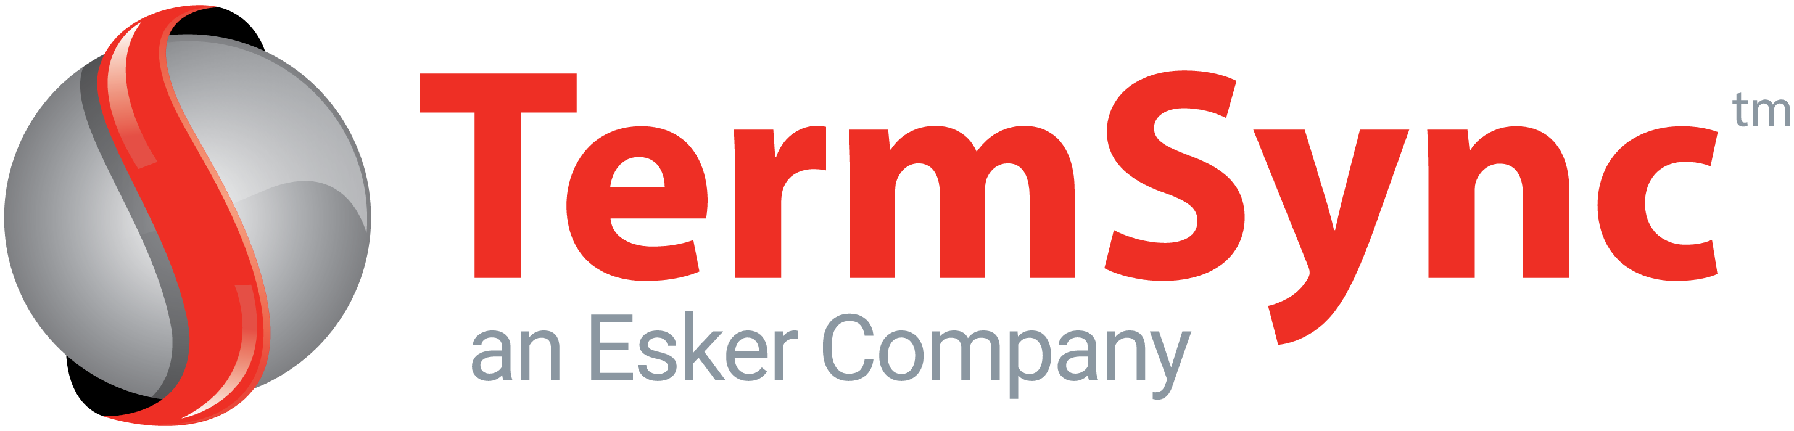

RHINOAG is now working with TermSync to help streamline communications

RhinoAG is pleased to announce a new partnership with TermSync, Inc., an online payment service, to provide tools to easily manage and process RhinoAG payables. The TermSync system provides a secure internet portal and friendly reminders to help reduce the cost of managing AP.

How It Works
You will soon begin receiving weekly reminder emails from TermSync when invoices are coming due. A link in each reminder will take you directly into your RhinoAG account. From there, you can manage your account with functions including:

- Make an electronic payment | - Apply credits to invoices
- View/Print copies of invoices (PDF) | - Send a message or ask a question

This service is provided by RhinoAG and is completely FREE to you and does not require you to change your current payables process.

How to Get Started
An account has already been setup for you in TermSync. You will soon receive an email from TermSync from which you can, at your convenience, follow the steps below:

(1) Follow the link “View Full Message Thread”,
(2) **Login using your email address (the one that receives this letter),
(3) Complete the banking information by checking an invoice and clicking “Schedule Payment”
(4) Begin managing your RhinoAG account.

**Most internet browsers are supported. If using Internet Explorer, please upgrade to 11 or greater.

The email address this message was sent to is what we currently have on file as the accounts payable contact. If this is correct, no further action is required. If the contact information needs to be changed, or added to, please reply to this email with the name(s) and email address(es).

Also, the reminder emails will come from termsync@termsync.com on behalf of RhinoAG and its parent company Alamo Group. Please ensure these emails do not get placed in a spam folder as this will be our way of contacting you with payment reminders.

RhinoAG hopes this new service will be helpful and convenient. Please let us know if you have any questions.
Thank you
Dee Ehlers and Laura Hazen
RHINOAG Credit Department

RHINOAG

1020 S. Sangamon Ave.
Gibson City, IL 60936

WWW.RHINOAG.COM

Phone: 800-221-2855
Parts: 800-446-5158
Fax: 800-782-0126

parts@rhinoag.com



