
Crafting your 2019
financial game plan
January

Financial New Year’s resolutions are one of the most common as nearly one-third of Americans plan to make one in 2019 according to a Fidelity survey. While wishing to strengthen your financial situation in the new year is a good first step, actually following through on this can be difficult. Everyone’s situation is unique, but let’s take a look at a few of the top areas to address when crafting your 2019 financial game plan.
Reevaluate your savings strategy
The start of the new year is a great time to take a step back and reevaluate your current savings strategy. First, consider looking into your retirement savings options. If you have not already, maximize the match your employer offers for 401(k) contributions. One in five workers are not contributing enough to get the full match from their employer according to research from benefits administrator Alight Solutions.
Additionally, consider sitting down with your financial advisor if your goals or needs have changed recently. Perhaps you have a new child on the way and want to begin an education savings plan, or maybe you have set a resolution to make a big purchase in the new year. Whatever your new goal may be, being prepared for the financial commitment ahead of time will be a big help in achieving it.
Learn and build your credit score
Your credit score is a constantly evolving number that banks and other lenders use to decide whether to approve you for a loan or line of credit. If you do not know your current score, it can be easily checked for free on a number of sites such as annualcreditreport.com or creditkarma.com. Checking your score on these sites does not hurt your score since it is a soft inquiry. A hard inquiry, on the other hand, is done by banks or lenders when you apply for a new loan or credit card. Too many hard inquiries in a short period of time can have a negative impact on your score.

Once you know your current score, there are many different actions you can take to improve it. The most impactful however is to improve your credit utilization ratio, which is the amount of credit you are currently using comparative to your available line of credit. For example, if you have a $1,000 line of credit and just made a $900 credit card purchase, this will likely have a negative impact on your score the longer it remains at this high ratio. Paying off current credit amounts not only helps reduce this ratio but can help you save money lost on accumulating interest charges. Consider consulting your advisor on additional tips to improve your score and pay back debt.
Identify areas to cut back
Perhaps the simplest financial goal you can make for the new year is to reduce spending on non-essential purchases. One of the most popular ways Americans are cutting monthly costs is by getting rid of traditional cable. Though streaming services like Netflix and Hulu are far from brand new offerings, the content they offer is eliminating the need for many consumers to continue spending on cable TV. This results in cord-cutters saving an average of $85 per month even including the amounts spent on internet and streaming services according to Fortune.
In 2019, do not underestimate the savings that can be had in other purchase areas like restaurants and entertainment. Forbes contributor Priceonomics found that it is almost five times more expensive to order delivery from a restaurant than to cook at home. Of course, completely ditching all restaurant and entertainment expenses is not a realistic goal, but saving money on these occasions is still possible. Before planning a night out or heading to a restaurant, scan coupons sites such as Groupon and RetailMeNot for deals.

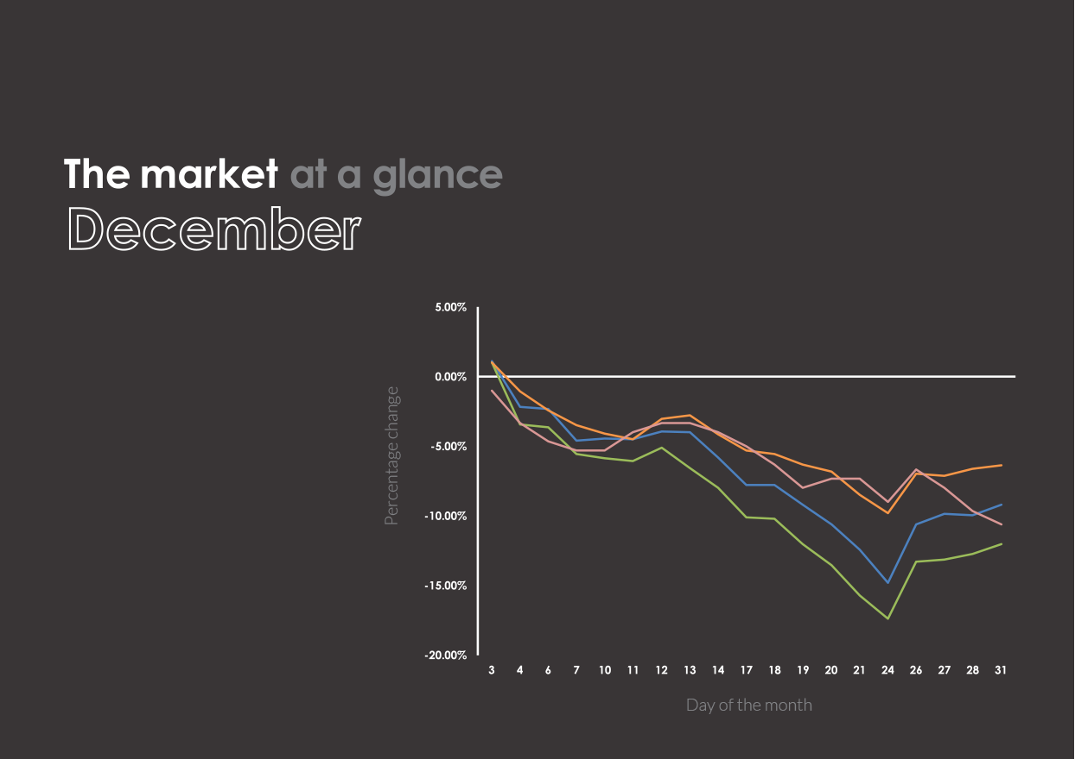




- The Dow Jones Industrial Average dropped 653 points on Christmas Eve breaking 1918’s record for the
worst-ever Christmas Eve trading day. Despite the fall, the Dow soared back two days later with a rise
of 1,086 points, the largest daily point gain in its history.
U.S. Large Cap
(S&P 500)
2,506.85 (-9.18%)
U.S. Mid/Small
(Russell 2000)
1,348.56 (-12.05%)
International Large
(NYSE International 100)
4,890.29 (-6.35%)
U.S. Treasuries
(U.S. 10-year Treasury yield rate)
2.69 (-10.63%)
The market in action
Past performance is no guarantee of future results. Indices are unmanaged and cannot be invested into directly.
- The stock of pharmaceutical and consumer goods manufacturer Johnson & Johnson fell 10 percent after losing a bid to overturn a jury verdict that awarded nearly $4.7 billion to consumers impacted by asbestos found in its baby powder products. Documents used in the case revealed that the company had known of the contamination for decades.
- Department store J. C. Penny saw its stock fall to 97 cents per share in late December marking the company’s worst day of trading since first being listed on the NYSE in 1929. The company closed 138 stores across the U.S. in 2017 and has not been profitable since 2010.
- Shares of Deere & Company, who owns the agricultural equipment brand John Deere, rose four percent after news that China will agree to purchase a “substantial” amount of agricultural product from the U.S. in the future. In November, China had imported zero soybeans from the U.S. in response to recent trade tariffs.

Biggest retirement saving mistakes
to avoid at each life stage

According to Northwestern Mutual’s 2018 Planning & Progress Study, a shocking 21 percent of Americans have nothing at all saved for the future, and 78 percent say they are extremely or somewhat concerned about not having enough set aside for retirement.
Everyone’s path to retirement is different, but there are general rules that can help guide your savings strategy over time. Here are retirement tips for each stage of your life:
Your 20s: Not taking the advantage of time
Fresh into your new job out of college in your 20s is an exciting time and can set the foundation for a successful financial future. The biggest mistake to avoid during this time is not getting started early and missing out on the most powerful retirement savings factor out there: time.
Recency bias can push young savers to dedicate more than is required to student loans lessening the ability to compound savings. It may be natural to think of retirement as a lower priority since it is decades away compared to student loans, both can be done at the same time.
Be sure to understand how your employer’s match works and maximize this if possible. Even if you have doubts about your current job in the long-term, most retirement savings can be transferred to your next employer or an individual retirement account should you choose to switch jobs.
Your 30s: Getting housed in
Life changing events such as marriage and children will likely start coming into play during this time. As these events occur, some savers may find themselves buying
a house too early.
While you should not feel pressure to stay cramped-up in a small apartment, be sure look at your first home purchase from all angles. Buying a home too small for your growing family might not work for your needs years down the road. Spending lavishly on a big home might seem sensible now, but consider what happens in the event of a move or job transition.
Your 40s: Shifting your focus
Your early years are considered the accumulation phase but do not think that your 40s are a time to neglect retirement contributions. By this time, there are may be many different areas that need financial attention in your life. How much should you be setting aside for your child’s education? Should you use that new bonus for a home remodel?
Questions during this time can get complex and it is important to prioritize what saving areas need the most attention. Now is a good time to consult with a financial advisor to break down these various areas and your goals for each.
Your 50s: Inaccurate assumptions
By your 50s, you likely have a clearer picture of what your savings situation looks like and can begin preparing for when you want to retire and the expenses you expect to have.
Too often, savers underestimate what they will need throughout retirement. According to a recent study featured in Wealth Professional, 15 percent of retirees globally do not have enough income to live comfortably and another 43 percent say they could have used a little more income after retiring.
Similar to your 40s, these decisions of when to retire and how much will be needed can be complex to navigate. With the help of your financial advisor, consider all of the factors that may be in play. These can include upcoming healthcare costs, what happens in the case of an underperforming market, and other scenarios.

