University of Oklahoma

Graduate College

DISGUST AS A CONCEPTUAL FOUNDATION FOR ART APPRECIATION IN THE COMMUNITY COLLEGE: A THOUGHT EXPERIMENT IN PRACTICE

A Dissertation

submitted to the Graduate Faculty

in partial fulfillment of the requirements for the

Degree of

DOCTOR OF PHILOSOPHY

By

CATHERINE JOHNSTON
Norman, Oklahoma
2018

DISGUST AS A CONCEPTUAL FOUNDATION FOR ART APPRECIATION IN THE COMMUNITY COLLEGE: A THOUGHT EXPERIMENT IN PRACTICE

A Dissertation approved for the
DEPARTMENT OF EDUCATIONAL LEADERSHIP AND POLICY STUDIES

By

Dr. Susan Laird, Co-Chair

Dr. Juanita Vargas, Co-Chair

______________________________
Dr. Joan Smith

______________________________
Dr. Amy Bradshaw

______________________________
Dr. Kristen Hextrum

© Copyright by catherine johnston 2018
All Rights Reserved.
DEDICATION
To Cam. Always, Always.

ACKNOWLEDGEMENTS
I want to thank my husband, Cam, who has loved and supported me on this long academic journey. I want to thank my children, Becca, Stephen, Keifer, Greg, James, and Andrew; as well as my daughter-in-law, McKensey, and my grandsons, Rhett and Rowdy, for keeping me grounded and reminding me what really matters. I also wish to thank my mother, father, and siblings, for among their gifts to me was Alice. I want to express my appreciation for the support of my aunt and extended families.
I am so grateful to have my sisters of the heart, Julie, Kendra, and Diane. Words cannot adequately express to my sisters how much I love, value, and appreciate their humor, encouragement, feedback, and commiseration. I want to thank my friend, Darby, who has always believed in me, provided her expert “Darbyvision,” and has supported me even when I wavered. I am thankful for my friends, Lisa, Pia, Sharon, Janet, Alexa, and Deby, who were always there with words of encouragement.
I am fortunate to have a great committee. I have had the tremendous support of my co-chairs, Dr. Susan Laird (Educational Studies) and Dr. Juanita Vargas (Adult and Higher Education), who have taught, advised, supported, and guided my dialogue with aesthetic disgust and the re-visioning of art appreciation. In addition, Dr. Joan Smith (Educational Studies) and Dr. Amy Bradshaw (Instructional Psychology and Technology), who were insightful teachers and mentors. Finally, Dr. Kristen Hextrum (Adult and Higher Education), although invited late, was willing to go through the looking glass with me.

Table of Contents
ACKNOWLEDGEMENTS iv
Table of Contents v
LIST OF TABLES viii
LIST OF FIGURES ix
THROUGH THE LOOKING GLASS & WHAT [I] FOUND THERE—CARROLL 1
INTRODUCTION 1
CHAPTER 1 6
Into the Garden of Live Flowers: The Evolution of the Metacognition of an Artist/Educator in a Community College 6
First Day 7
Learning Teaching Theory 18
Understanding Context 26
A Single Road with Two Finger Posts, One Destination 30
Disgust Not Beauty As A Central Theme For A Dissertation 37
CHAPTER 2 43
Wool and Water: Beauty and Art Appreciation in Context 43
Art Appreciation: Denotation and Connotations 44
The Denotation of Art 44
Appreciation as Aesthetic Beauty, Delight, and Disgust 45
Connotations of Art Appreciation 47
Art Appreciation Serves Higher Purposes 47
Art Appreciation Serves a Practical Purpose 48
Art Appreciation Serves Silent Partners 49
Art as Language 51
Purposeful Looking and Seeing 55
Community Colleges: A Brief History 64
Community College: Challenges in Navigating the Terms and Terrain 67
CHAPTER 3 72
Feathers and Crabs: Critical Aesthetic Pedagogy-Disgust, Engagement, and Community, The Re-Visioning of Art Appreciation 72
Looking Glass: Looking In 73
Looking Glass: Gazing Back 75
Mitigated Looking Within an Art Encounter 82
Art Encounters: Seeing Is Not Enough 85
Looking Glass: Easing the Divides 89
Building Trusting Encounters 93
Looking to Blooms 95
Contrariwise: Disgust, Not Beauty, As Central Theme 100
Remaining Disinterested in the Face of Disgust 101
Savoring Different Kinds of Disgust 104
Disgust or Difficult Beauty 111
Educating with Disgust 115
CHAPTER 4 118
Time to Talk of Many Things: Critical Aesthetic Pedagogy: The Thought Experiment 118
Art Appreciation Terrain 119
Shoes: Course Terrain 122
Ships: Learning Experience 129
Sealing-Wax: Active Learning 134
Cabbages: Student Selected Active Learning Assignment 136
Kings: Cooperative Learning 138
Sea Is Boiling Hot: Disgust, Anger, and Critical Thinking 141
Pigs Have Wings: Student Learning Opportunities 143
CHAPTER 5 148
Art Appreciation Re-Visioned: Who Dreamed It?: Implications for Practice, Disgust or Difficult Beauty, and Considerations for Another Day 148
REFERENCES 158
APPENDIX A: PARTICIPANT CONSENT FORM FOR OBSERVATIONS, INFORMATION RELEASE, AND INTERVIEWS 172
APPENDIX B: PRE-COURSE SURVEY 174
APPENDIX C: COURSE SYLLABUS 182
APPENDIX D: STUDENT RESEARCH ASSIGNMENT 196
APPENDIX E: VISUAL ANALYSIS DESCRIPTION AND GRADING RUBRIC 205
APPENDIX F: EXIT-COURSE SURVEY 212

LIST OF TABLES
Table 1. Student Definitions of Aesthetic Beauty and Aesthetic Disgust 131

LIST OF FIGURES
Figure 1. Catherine Johnston. Flowers Teach Alice a Lesson. Digital. 2017 6
Figure 2. Catherine Johnston, Frankenbanana (2016-recreation of 1978 work). Banana, blue dye, thread. 14
Figure 3. Pietro Perugino Umbrian, The Crucifixion with the Virgin, Saint John, Saint Jerome, and Saint Mary Magdalene [middle panel] 22
Figure 4. Carlo Crivelli, The Crucifixion. c. 1487, Tempera on panel. 22
Figure 5. Joan Miró, Femme, 1934 25
Figure 6. Catherine Johnston. Altered Context. Digital Image 26
Figure 7. Photograph No. Nwdns-245-Ms-2238l (Lee Russell) 27
Figure 8. Ken and Tyler, l985© Robert Mapplethorpe Foundation. 28
Figure 9. Michelangelo Merisi da Caravaggio. Judith Beheading Holofernes. Oil on canvas. 33
Figure 10. Artemisia Gentileschi. Judith Beheading Holofernes. Oil on Canvas 34
Figure 11. Catherine Johnston. White Queen. 2017 Digital Image 43
Figure 12. Catherine Johnston. Meal Shared. 2016 Digital Image. 53
Figure 13. Catherine Johnston. Just Look at Them 2016. Digital Image 55
Figure 14. Photograph No. 111-SC- 204811 (T4c. Sam Gilbert) 56
Figure 15. Photograph No. 111-SC-203464 (Pfc. W. Chichersky) 57
Figure 16. Figure 16. Carrie Mae Weems, LOOKING INTO THE MIRROR, THE BLACK WOMAN ASKED, "MIRROR, MIRROR ON THE WALL, WHO'S THE FINEST OF THEM ALL?" THE MIRROR SAYS, "SNOW WHITE, YOU BLACK BITCH, AND DON'T YOU FORGET IT!!!" 61
Figure 17. Catherine Johnston. White Queen in Sheep Guise is Truthful. 2017. Digital Image. 72
Figure 18. Albrecht Dürer, Draughtsman Making a Perspective Drawing of a Reclining Woman, 1600. Woodcut. Gift of Henry Walters, 1917. 73
Figure 19. Shawn Heinrichs. Tung Kang, Taiwan from 2011. Used by Permission of the Artist. 82
Figure 20. Michelangelo Merisi da Caravaggio. The Incredulity of Saint Thomas. Oil on Canvas. 1601-1602. 85
Figure 21. Patricia Piccinini. Doubting Thomas. Silicone, Fiberglass, human hair, clothing, chair. 2008. 86
Figure 22. Raphael (Raffaello Sanzio da Urbino). School of Athens (Detail). Fresco. 1511 89
Figure 23. Patricia Piccinini. Young Family. 2002. Silicone, polyurethane, leather, plywood, human hair. 80 x150 x110 cm. 92
Figure 24. Leonardo Da Vinci. Madonna of the Rocks. 1483-1486. 92
Figure 25. Patricia Piccinini. Undivided. 2004. Silicone, human hair, flannelette, 101 x 74 x0127 cm. 93
Figure 26. Patricia Piccinini. Undivided (Detail). 94
Figure 27. Patricia Piccinini. Eulogy. 2011. Silicone. Fiberglass, human hair, clothing. 11 x 65 x 60 cm. 96
Figure 28. Patricia Piccinini. Eulogy (Detail). 96
Figure 29. Patricia Piccinini. Newborn. Silicone, fiberglass, human hair, clothing, 110 x 65 x 60 cm. 98
Figure 30. Nan (one month after being battered) 1984 Nan Goldin 101
Figure 31. Mary Cassatt. Lydia (At the Theatre) 1879. Pastel. 103
Figure 32. Peter Claesz. Vanitas Still Life. 1628. Oil on Wood. Rogers Fund, 1949. 106
Figure 33. Cindy Wright. Baconcube. 2010. Oil on linen, 49 ¼” x 55. 106
Figure 34. Victoria Reynolds. Cream Cascade. Oil on panel. 24” x 18” 108
Figure 35. Victoria Reynolds. Fat Mouth. 2008. 16” x 18” 109
Figure 36. Fernando Botero: Abu Ghraib 60, 2005: oil on canvas; 51-5/8 x 62-1/4 in. 111
Figure 37. Jenny Saville, Reflective Flesh, 2002 – 2003, Oil on canvas. 115
Figure 38. Claes Oldenburg, (1976). Clothespin, Core-Ten and stainless steel, 45' x 6' 3 3/4" x 4'. 116
Figure 39. Catherine Johnston. Alice and the White Knight. 2017 Digital Image. 119
Figure 40. Art Class on Wheels. 2015. Digital Image. 128
Figure 41. Student Notebook Covers. 2015. Digital Image. 129
Figure 42. Student Potato Stamps. 2015. Digital Image. 134
Figure 43. Student Drawings. 2015. Digital Image. 135
Figure 44. Student Mask. 2015. Digital Image. 137
Figure 45. Gustav Klimt. The Virgin. 1913. Oil on canvas. 137
Figure 46. Student Art History Class Creation. 2015. Accordion-Fold Box. 139
Figure 47. Student Notebook Entry: Visual Vocabulary. 2015. Digital Image. 144
Figure 48. Catherine Johnston. Queen Alice. 2017. Digital Image. 149
Figure 49. Catherine Johnston. Improvisation: Queens, Girls, Alice, and Mirrors. 2018. Digital Image. 157

ABSTRACT
Reflecting on the history of art appreciation and viewing its current context within a community college, as a general education course that largely perpetuates cultural miseducation (Martin 2011) through preservation of the Western canon, this dissertation is a theoretical inquiry into the re-visioning of the art appreciation curriculum. In community college (and perhaps elsewhere), conceptually grounding art appreciation curriculum in “aesthetic disgust,”(Korsmeyer 2011) or “difficult beauty,” (Bosanquet 1923) with pedagogical creativity can yield deeper, livelier critical student engagement and (transformative) learning than a traditional conceptual grounding in beauty.
A core construct the study identifies is the centrality of beauty within art appreciation (Plato 380 B.C.E.; Burke 1757; Kant 1790). The context and setting for this study is a community college art appreciation course. It identifies student populations, the culture and the forces acting upon community colleges that affect who does (and does not) succeed there; the role of art appreciation as general education courses in community colleges. This inquiry showed that art appreciation serves often as a cultural foundation for ideas of beauty (Plato 380 B.C.E.; Burke 1757; Kant 1790) and as seen through the male gaze (Berger 1972; Benjamin 2007; Mulvey 1975). This curriculum re-visioning provided a practical framework for incorporating critical aesthetic pedagogy (Medina), cooperative learning, (Johnson and Johnson 2009), encounters of aesthetic disgust and difficult beauty (Bosanquet, 1923; Korsmeyer, 2011; Martin, 2011, Haraway, 2008) and the centrality of these concepts to art appreciation with studio experience. In this qualitative study, student selected course content led art appreciation topical classroom conversations and multiple measures were used to determine student engagement/learning.

THROUGH THE LOOKING GLASS & WHAT [I] FOUND THERE—CARROLL

INTRODUCTION
YKCOWREBBAJ

sevot yhtils eht dna,gillirb sawT’
ebaw eht ni elbmig dna eryg diD
,sevogorob eht erew ysmim llA
.ebargtuo shtar emom eht dnA

She puzzled over this for some time, but at last a bright thought struck her. ‘Why, it’s a Looking-glass book, of course!

Alice adventures chronicle her efforts to make sense of her queerly connected and constantly changing experiences. Capriciously, the blame for entering the looking glass is assigned to the actions of a kitten. Once inside, Alice engages in literary and verbal exchanges with those she meets along the way, among the most mystifying poems to Alice is the Jabberwocky. Humpty Dumpty explains to Alice many words used are portmanteaus or a blend of two words. Portmanteaus are neither compounds nor contractions. As I look back in order to build the context for ideas I now hold, a descriptive word for the educational adventures that have shaped my metacognition is the portmanteau for cognition and odyssey, cognidyssey.
The teacher I am and the new conceptual foundation of curriculum I propose to re-vision are the result of my more than 30-year cognidyssey. A human life is but series of experiences, seemingly random and even mundane. When I consider which experiences intertwine to set the course for my life’s odyssey, these three come to mind. First, I both struggled and loved books and reading. Despite being diagnosed in elementary school as dyslexic, I read for my love of tales like those that had me escaping down rabbit holes with Alice. I was too young to know that Alice was to become my Beatrice. Second, the wordplay of story books contrasted starkly with my strict religious family that held the bible was literally true except when it was metaphoric, and evil was everywhere and not metaphoric. Finally, I loved being at school, I was anonymous and the space seemed to be generally safe (literally free of evil). The curriculum was plentiful (both covert and overt) and many teachers were nurturing. When I was not in school, I was pretending to be in school, fabricating lessons, and grading those lessons. I wanted to become a teacher.
When I peer into my looking glass, I imagine it is like the one in Through the Looking Glass & What Alice Found There. The woman looking back at me confirms the reality that I have become a teacher. My story begins in Chapter 1 and chronicles the act of going through the looking glass learning from Alice’s experience in the looking glass terrain. There seeing and understanding what is seen are not one in the same. Sociologist Parker Palmer (2007) describes how a teacher’s subject can find them. In my case, my subject matter became clear to me in my painting epiphany; the key in the lock turned and I understood how to accomplish in paint what I saw. This revelation is much like my experience when reading ceased to be a wrestling match with letters and transition to entrances to other worlds crafted by words.
Chapter 1 places the artist/educator in context. I utilized Arthur Bochner’s (2014) Coming to Narrative: A Personal History of Paradigm Change in the Human Sciences, as the model to map personal history as the student of art, artist, teacher of art appreciation, and educational experiences. This chapter an account of pedagogical transitions accounts pedagogical transitions over time and illuminates the initial source of fascination with aesthetic disgust (Korsmeyer 2011).
Chapter 2 is an overview of the various transitions and purposes from the origins of the study of art appreciation, to the curriculum, textbooks, and pedagogy of art appreciation used today. Art appreciation conceptually grounded in beauty is miseducative especially but not only in the community college. The chapter also provides an overview of the American community college (its strength and its challenges) and attendant student populations; the culture and the forces acting upon and within community colleges effects who does (and does not) succeed there; the role of general education in community colleges; and the art appreciation course within this context.
Chapter 3 outlines the foundation for the re-visioning of art appreciation curriculum's conceptual foundation in disgust rather than beauty and explains how the objectives of art appreciation could become a context in which students come together to communicate through and about art. The chapter also outlines the philosophical foundation for the dissertation thesis, in community colleges, conceptually grounding art appreciation curriculum in “aesthetic disgust, ” (Carolyn Korsmeyer) or “difficult beauty,” (Bosanquet) with pedagogical creativity can yield deeper, livelier critical student engagement and (transformative) learning than a traditional conceptual grounding in beauty, of prompting engagement, deepening the conversation about art, and inviting the examination of social constructs of the artists’ worlds. A thought experiment enacting teaching art appreciation grounded in aesthetic disgust with a studio experience provides experiential implications to the theoretical.
Chapter 4 describes the art appreciation thought experiment. I describe my re-visioning of an art appreciation curriculum and the theoretical framework developed by Yolanda Medina called Critical Aesthetic Pedagogy. I describe the course structure and the importance of a cooperative learning classroom (Johnson Johnson, 2009). I describe student discourse on aesthetic beauty and disgust, provide student examples, and share observations about visual encounters in small group and class culture over the course of the semester.
Chapter 5 includes reflections on my preconceptions concerning aesthetic disgust and its centrality to the re-visioning of art appreciation in the studio experience. I provide the advantages and limitations of critical aesthetic pedagogy within a community college and its applicability to other subjects. Moreover, I briefly address potential challenges to course re-visioning in the form of course standardization trends in a climate of fiscal accountability and heavy reliance on adjunct instructors.

CHAPTER 1

Into the Garden of Live Flowers: The Evolution of the Metacognition of an Artist/Educator in a Community College
In the terrain inside the looking glass, Alice is surprised to find the flowers can talk. She never actually thought to speak to a flower before. The flowers, in turn, school Alice about making assumptions about them. The flowers explain to Alice that it is the conditions in which flowers grow that silence them in outside the looking glass. Alice’s assumptions about what she thinks she knows are challenged.
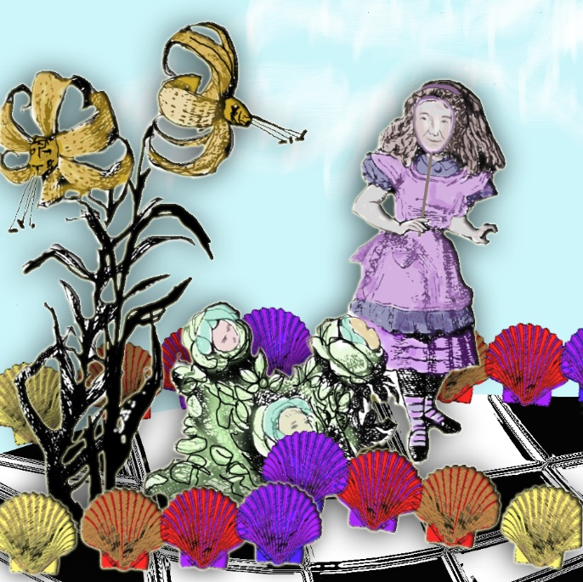
Figure 1. Catherine Johnston. Flowers Teach Alice a Lesson. Digital. 2017

First Day
My first day in my first position to teach art appreciation at a community college, I was pregnant with my oldest son. For me, the significant appeal of this educational environment was its open admissions. My academic qualifications for this adjunct position included an MA from a private, non-profit, liberal, and historically black Roman Catholic university and a BFA from a private, non-profit art college. The community college provided me a syllabus, a textbook, a classroom with desks in rows, a teacher’s desk, and a roster with 35 names. As I faced this new class, I asked myself, beyond a comprehensive art curriculum art I lived at one institution and the educational theories I read about at another, exactly what did I know about teaching art appreciation? I began developing my own curriculum and pedagogy from my “what not to do list if I ever got to be a teacher” list. Looking ahead to what my class could look like, I knew I wanted a positive learning experience, one that valued students and their abilities. As the class took shape, I could see I was guided by love of subject (Palmer), and simply, the Golden Rule.
When I scrutinize my years as an undergraduate, the prevailing pedagogies were experimental and experiential. There was an attempt on the part of my nationally and internationally esteemed art college instructors to exorcise what educational philosopher John Dewey called the, “enemies of the aesthetic.” Dewey explains, these" …are neither the practical nor the intellectual. They are the humdrum." The consistent lapping of normal experience becomes a rhythm that lulls. Somewhere along in a life of looking, seeing, and interpreting an image-driven world, some fill up and others empty their eyes. Either response to experience may result in a kind of blindness and a creative inertia. In retrospect I may take issue with the price paid for the wake-up call, all students were either actively engaged or they could not keep up and dropped out.
The art college I attended was open admission. We went to school 5 days a week and at least 8 hours a day. There was room for nothing else. Completing assignments filled my life. I felt that what I knew about art prior to coming to college was meaningless in this broader, theory-rich context. The complete art education enculturation was experiential learning. Educational theorist David Kolb explains the experiential learning theory is based upon the work of Dewey and psychologist Kurt Lewin. “Learning is defined as ‘the process whereby knowledge is created through the transformation of experience.’(Chapter 2, pg.49) Knowledge results from the combination of grasping and transforming experience.” Of the 6 propositions of experiential learning, one of the most apt was, “Conflict, differences, and disagreements are what drive the learning process.” Resolution, reflection, and strategizing became a means of a negotiating a path for self-preservation; learning seemed like a by-product.
As the college wholly owned my life, the best of those years was the effect this experience had on my thinking skills. In my first-year class design class, we were asked to bring an object to class. Over the term, we made studies of that object through drawings, recreated our object in 3-dimensions in paper to various scales, transformed our object into a mode of transportation, an object of worship, a piece of furniture, and the transfigurations went on and on. I am reminded of Sir Ken Robinson’s Changing Educational Paradigm (2011). Robinson references a longitudinal study in Breakpoint and Beyond that measures divergent thinking. Participants were challenged to create an exhaustive list of uses for a paperclip. Robinson reveals that the study used kindergarten children and nearly all children began at the genius level, but, over the next ten years, this collective tendency toward divergent thinking and imagination dropped significantly. Robinson attributes this drop in divergent thinking to common education, educating for a single right answer, to standardized testing, to a breakdown in learning, and assessing of the individual. Cooperation and conversations during the learning process, while exciting, makes it difficult to determine who should “get credit” for the learning and not. While I learned to function in public school, selecting a right answer was seldom apparent to me. For me, a true/false was an unreal and unsatisfying binary selection process, I needed: “the answer is true because …” or “the answer is false because….” This kind of assessment was never afforded to me. But art school required a new kind of nonbinary response.
I believe our design instructor (purposely or not) was conceptually awakening the child who could produce a myriad of ideas based on a single “paperclip.” He began with a few nudges and the ideas snowballed. My original object was a brass crab ashtray. Eventually, I created an overstuffed crab chair and my most abstracted piece was a series of environmental drawings of crabs. I used flour as a drawing medium. I transformed small ponds in a park by utilizing their shape to form the crab bodies and the flour to draw their appendages. To preserve these conceptual crabs for class, I documented through photography.
My only point of comparison for art college was high school. I had the sporadic interactions with an overworked high school art instructor for my final two years. Nearly all of his instruction was provided through kinesthetic demonstrations. He focused on technical skills, never on aesthetics or art history. His classroom was positive, filled with quiet conversations, and active students. I always focused on my work. It was during my senior year, that the instructor actually began speaking to me. I decided I would go to art college. An urban high school, my singular designated visit with the guidance counselor was disappointing. With a reading disability and my SAT scores in his hand, I was told I was not college material and that I should think about beauty school or landscape gardening. Even though I was discouraged, I sat on the floor of his office and looked through his bookcase of college catalogs until I found an art college catalog.
I think the art college catalog was its own kind of fairy tale. The glossy pages promising access to a creative terrain where I could learn to create anything. As entering freshman, we experienced what I call the culling of the weak through a Darwinian “survival of the fittest” pedagogy. For instructors, it was common practice to have students hang homework on the wall at the start of class and then critique it, either as a group or singularly. I remember one class in which the instructor simply said it was all [insert bad word] take it down and left. The college was a world unto itself, complete with its own language. I recall another critique addressing drawings made on the school grounds. The images hung on the wall and the instructor posed the question, which work do you like? There was an extended silence. The instructor smiled like a Cheshire Cat as her wild curls bounced around her round face. She turned in slow circle, her toothy smile fixed upon her face waiting patiently for one of us to break. Finally, one older woman chose one. Calmly, almost purring, the instructor asked the student why she liked that one. The student answered, “Because it looked like a tree.” I watched the instructor’s face. I became afraid. Her eyes narrowed and her smile grew even wider. Surely, this was a scene from Alice’s Adventures in Wonderland, in reality, the malevolence of what followed “darkened the woods” of our classroom in a much more frightening way. It was a kind of madness to take this abuse. Alice’s experiences in Wonderland seemed less story-like:
But I don't want to go among mad people,' Alice remarked.
`Oh, you can't help that,' said the Cat: `we're all mad here. I'm mad. You're mad.'
`How do you know I'm mad?' said Alice.
`You must be,' said the Cat, `or you wouldn't have come here.'
Yet the critique moved forward as this brave student was eviscerated and the instructor moved on to others. Her appetite was great and many of us left in tears before that class was over.
I believe art critiques were meant to be positive, constructive, and to force us to reflect and be able to articulate our decision-making process. We were called to explain every mark we made, to justify why we chose particular materials, as well as to communicate ideas and defend their validity (Kolb 194.). However, these critiques were more often lessons in self-defense. Helpful feedback was not the rule, more the exception. Another proposition of experiential learning is that “All learning is relearning.” The instructors assumed their role was to challenge and scrutinize our ideas about art and art-making in order to advance our aesthetic decision making (Kolb 194). The challenge, however, served more often to generate feelings of being diminished, humiliated, or the day’s abject lesson. For me, a bit of survival was discovered in my psychology class and my love for fairy tales. Moreover, I learned to present my work without revealing fear and to always be prepared to articulate “the why.”
As a result of my interest in fairytales, I read the works of Freudian Bruno Bettelheim and Jungian Maria Louise Van Franz and I reread the tales. I saw elaborate symbolic layering, preexisting within stories. I used layering, privately translating this notion to hiding my personal content in plain sight to limit heartache. I began to externalize a protection method for my art. I created fabric paintings over oil paintings that I felt were valuable, but instructors felt were not. Naively, I believed that the hidden content was my voice and external imagery, nothing more than a diversionary tactic. I made small openings in the new fabric coverings for the original paintings to see out. In the activity of binding my wounds and those of my art and voice, this protective layer was praised by my instructors. My answers to critique questions were worthy of discourse in Wonderland. For all my queer talk, I was rewarded with praise and good marks. After creating through a fictional artist self, I wondered what authentic art self would emerge after this test of endurance. Would the educative practices of this college be considered “ordinary practices” in the art world? Was there even an art world? According to the late philosopher, social activist, Maxine Greene (1995), “The art world is a constructed world, and therefore we must remember to view it as contingent and open to critique. There is a standing challenge in Greene’s words that I return to again and again.
Our non-studio classes included a core of traditional college curriculum: literature, composition, psychology, anthropology and of course, art history. The traditional coursework was taught by instructors or recent graduates from an Ivy League university within proximity of the college. These instructors were accustomed to working with art students. These patient instructors held high standards yet provided lots of support and multiple means of learning the academic content. I enjoyed the non-studio classes, they were engaging and instructors expected creative responses. Unaware, I was challenging social norms in my psychology class. Some of the “treats” I brought to my instructor included blown eggs and filled with colored jellos and various foods dyed alien colors. My personal favorite was a banana transformation. I peeled a banana, dyed it blue, and stitched it back into its peel. Having read Mary Shelley in another class, I saw it as my “reanimation” and a visual enhancement and challenge to the ordinary.
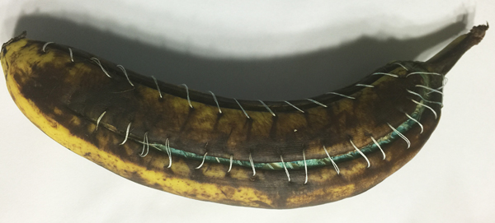
Figure 2. Catherine Johnston, Frankenbanana (2016-recreation of 1978 work). Banana, blue dye, thread.
Art history classes were held at 7:30 AM in an auditorium style room. Our class viewed slide after slide for an hour and half, a couple times a week. For tests, we went to a slide window and memorized the following: Who made the image, the date, time period, why it was important, and so on. This was the standard test format. Our textbook was the 6th edition of Gardner’s Art through the Ages (1975). This large red tome has two female artists illustrated in its nine hundred and five pages, Käthe Kollwitz (1919) and Bridget Riley (1964). If one’s view of art world is predicated upon this text, art originates in human artifacts by male artists. This art world comes into its own as Western culture develops from Greco-Roman traditions to Art of the 20th century. The art of Japan, India, China, Meso-America, Central Andes, North American Indians, African and Oceanic peoples are covered in just over a hundred pages. For art students as well as future art instructors, the importance of the canon and the relegation of women and the non-Western world to a nearly a footnote of importance is pushed forward for another generation. At 20 years old, I was troubled by the arrangement of the textbook---where were all the women? Our class was ethnically diverse with both male and female students. While most of our studio instructors were male, there were females. What was meant by their absence in this book that was to contextualize my understanding of where art was now and how it came to be this way?
As developing artists, Art history was meant to be our foundation for creative inspiration. German philosopher Immanuel Kant might have questioned if we were artists at all. Conceptually, Kant would be at odds with my Darwinian perspective on the college. His ideas do not seem open to a nature vs nurture argument on artistic potential. In The Critique of Judgement, Kant maintained, genius is “innate” to the artist and cannot be taught (Kant 2352). Classmates with innate talent graduated with apparent ease, but others (like me) succeeded through tenacity and effort. Psychologist Wendy Johnson (2013) writes nature or nurture is old and overly simplistic dichotomy. There is evidence that genius or greatness is tied to our knowledge of “genetic mechanisms” and the three decades of data on “…the roles of motivation and deliberate practice in the manifestation of excellent performance” (10).
The Experience Producing Drive (EPD), is a theory that holds, “…natural selection operates most directly on those genetic aspects of complex organisms that are manifestations of the organism's active agency”, (11) and a person’s capacity to locate themselves in conditions where they will best thrive. Key to EPD is that genes have an impact on behaviors “through their control of motivations and preferences that drive that acquisition of experience as well as emotional and physiological responses.” (11) Moreover, the implications of EPD suggest there is little difference in ability potential between those with innate talents and those without. (13). Johnson raises this important question, “What would the truth of EDP theory imply we should do as a society to encourage and develop excellent performance?” (13) What might teaching look like in an active encouraging environment founded on the premise that all students had a potential for greatness?
Innately great and not, after 4 years of total commitment to this college environment, I was presented a blue diploma. A hand printed document on hand-made paper that indicated a small number of the original class of more than a hundred and twenty students had earned a degree. Many years passed and I thought my perceptions of art college were just that, my perceptions. Bochner indicates that my perceptions or knowledge are based on my positionality. I learned my perceptions were more an objective reality. The art college alumni formed a Facebook page. The first two years of posts read like a survivors’ support group:
[She] hated my work, she made fun of it when we did critiques, no joke...she was not into flowers and happy things. I was not "bizarre" enough for her. Thank goodness for [teacher name], he gave me so much confidence and always said very positive things.
I think it was very interesting that it was VERY obvious when a teacher didn’t like you or your work (only in Art School) I got no support from [Teachers A and B], but [Teachers C and D] totally had my back.
[This teacher] told me to drop out. Real supportive.
I was full of self-doubt; the competitive nature of the college (among other factors) kept us divided and unaware that we had common experiences. Would knowing have changed anything? I don’t know. Palmer offers this advice, “…Re-membering involves putting ourselves back together, recovering identity and integrity, reclaiming the wholeness of our lives.”In these experiences, I was forgetting who I was and my agency. I did not want students to feel as if they walked into a forest that robbed them of their identity. I knew that as a teacher, I did not want my students to feel as I had and I believe critiques could have value. I would just have to establish guidelines for conversations and create a comfortable environment for these exchanges to occur.

Learning Teaching Theory
Curiously, I learned in my first graduate degree in curriculum and instruction, “it was as folke dooe, and not as folke say” type educational experience. All content was dispensed to students through lecture. Regardless of pedagogical theory, the delivery method was always lecture. I would sit quietly taking copious notes and try to imagine what the practice of these theories (Erik Erikson-psychosocial development, Benjamin Bloom-mastery learning, Jean Piaget and Jerone Bruner-cognitive development, Dewey and Maria Montessori-constructivism, B. F. Skinner-behaviorist, Kolb-experiential learning, and Lev Vygotsky-activity theory) might look like if we learned them as they might be actualized in a classroom. Curiouser and curiouser, if the pedagogy was not working, how would I know how to adapt? Or which theory might suit the current situation better? Could one really know/understand pedagogical theory in isolation from both subject matter and students?
Reflecting on this cognitive dissonance, my teaching principles now included love of subject, creating a positive learning environment, and, I determined, finding a way to connect students with course content through means other than lecture. I wanted them to learn to create as well as learn about the creative process. Seeing a demonstration of something was clearer to me than written or oral instruction. For me, invariably my response to written instructions would lead to an interpretation the instructor never intended. I was not aware I was trying to support various learning preferences, I was trying to promote understanding from many directions.
Open Access: What Does That Mean?
Even though community colleges don’t require special admission criteria for their doors to be open to those who want to attend, the college experience can be a disorienting one. Some of the students I met at the community college where I first taught art appreciation had learning disabilities as I did or were told that they were not college material. Dewey writes, “The nature of experience is determined by the essential conditions of life.” For community college students, more often than not, life is a juggling act of many elements, just one of which is their education. Increasingly more stratified along social class lines, community colleges serve students with lower socioeconomic status, many of whom are also members of a large subset of students who are the first of their family to attend college. Almost two-thirds of these students will require developmental coursework in order to prepare them to take college level courses. The community college campus and its operational jargon seem alien, even overwhelming, and in order to foster student agency there needs to be a translating, welcoming educative message. After my college experiences, I could see how in a community college environment, I had potential to create student-centered, success-oriented class rich with fun and fascinating things about art.
In my first art appreciation classes, I assigned 25 percent of my grades to assessment of vocabulary and textbook content. The rest was assigned to activities going on in the classroom. I included some basic drawing exercises, simple color mixing, relief printmaking, and a small-scale photorealism work. These creative exercises accomplished a variety of objectives: they provided concrete examples of design concepts such as gestural or implied lines; they helped to dispel ideas that abstract imagery was easy or created by artists without skill; and, they reminded students of the wonder and delight in creating. I also had students journal about their art experiences and include questions and creative ideas. I eliminated the use of journals after 3 years. My journal instructions and/or student inclinations seemed to encourage oversharing of personal information rather than writing about art or aesthetics.
I was not one who found great value in memorization tests often favored by art history courses. I worked with the vocabulary of the discipline and the analysis of works of art. Dewey described art as "prefigured in the very process of living" Thus through the medium of art, our experiences may, in part, be understood. I believed that through analysis, rather than the testing traditional to the discipline, I would have student engaging in the art world while still learning formal verbiage and context.
I wanted students to be able to not only look at art, but really see it, and provide an analysis based on collected visual evidence. Thus, a significant portion of a student grade was derived from an art analysis essay. I liken this activity to unpacking a work of art. I wanted students to see the individual parts of the whole artwork, and then repacking the content in order to determine how the content supports their ideas about the meaning of the work of art. To help students understand how the individual elements of a work influence the meaning of the whole, my first art pieces seemed alike.

Figure 3. Pietro Perugino Umbrian, The Crucifixion with the Virgin, Saint John, Saint Jerome, and Saint Mary Magdalene [middle panel]
c. 1482/1485. oil on panel transferred to canvas
middle panel: 101.5 x 56.5 cm (39 15/16 x 22 1/4 in.) framed: 134 x 165.1 x 7.3 cm (52 3/4 x 65 x 2 7/8 in.)
Andrew W. Mellon Collection. 1937.1.27.b


Figure 4. Carlo Crivelli, The Crucifixion. c. 1487, Tempera on panel.
75 x 55.2 cm (29 1/2 x 21 3/4 in.); image (arched): 74 x 55.2 cm (29 1/8 x 21 3/4 in.)
Wirt D. Walker Fund. 1929.862. The Art Institute of Chicago

A comparison I use is Pietro Perugino’s (1481/1485) The Crucifixion [middle panel] (Figure 3.) and Carlo Crivelli’s (1487) The Crucifixion (Figure 4.). Both images contain the same three figures: Christ, Mary Magdalene, and John, the beloved. Both images have the figures placed in a triangular composition with Christ’s head forming the peak and his two companions complete the other two base points of the triangle. While Perugino provides evidence that the image depicts death, the viewer is not compelled to linger on the feelings of pain, grief, or torture of the event, but more likely to contemplate the triumph over death theme that is woven into the scene. The saturated red of John’s wrap draws the viewer to look at his serene viewing of Christ’s peaceful sacrifice. Christ’s gently cast down face directs the viewer to observe the quiet prayers of Mary. The softly rounded rocks of the hills, trees, greenery, placid lake and sky all add to the warm and inviting nature of the scene. This moment of sacrifice is an eternal reminder of the promise of resurrection.
Crivelli’s work directs the viewer’s eye in much the same way, but his palette is a complementary one. The smooth folds of John’s red robes in Perugino’s work are replaced with stiff, angular folds of a red-violet, almost the color of blood, contrasted with a green. This harsh angularity is repeated throughout Mary’s garments and is mirrored in the creation of the rocky terrain. The green of Mary’s robes is modified with red, this, too, adds to the visual tension. The ground is hard and life seems to struggle to find purchase even in the tiniest amounts among the crevices of this unwelcoming place. The anguished faces of Mary and John both look to the broken angular lines of the body of Christ. Blood runs from his wounds, down his body, and seems to emerge under a skull that rests at the foot of the cross. Even the sky, heavy with coming darkness, reveals to the viewer the enormity of consequences of the death of Christ.
For guidance and in an effort to demystify the grading process, I provide students with a rubric. We would go through these two works in this manner: First, we would describe all the content items without using references to color or emotive terms. Second, we would describe all the colors of those items with as much specificity as we could. Third, we would describe the structure of the work. This included the technique, the use of repeated shapes or elements, and how the artist directed the viewer to look at the work and what devices they used to do this. Finally, we would describe what the work meant to them and utilize what elements from each of the previous three sections supported this idea. They were required to use information from each of the three previous sections to support their ideas. Using this format, we approached these two works systematically. The chalkboard would be covered with notes. Discussions would be lively.
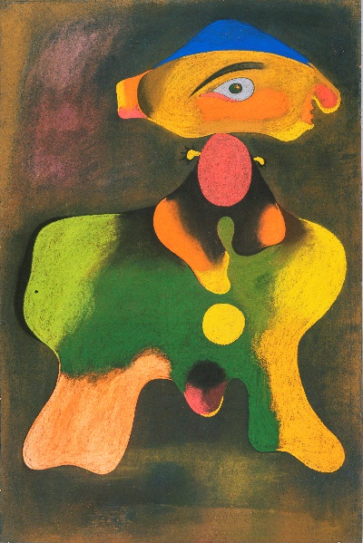
Figure 5. Joan Miró, Femme, 1934
Pastel, graphite, and scoring or scratching on artist's sandpaper with prepared surface
42 1/8 x 28 1/8 inches (107 x 71.4 cm)
© Artists Rights Society (ARS), New York / ADAGP, Paris
The Louise and Walter Arensberg Collection, 1950
http://www.philamuseum.org/collections/permanent/51065.html

I would also select a more abstract work that the majority of the students either did not like or felt had nothing to say to them. This pastel work by Joan Miro (1934) titled Femme (Figure 5.) is the kind of image I would select. Before we would begin, I would ask a series of questions concerning sensorial experiences. She has a large ear, a large eye, a large nose, a tiny mouth, two tiny arm/hands extending from her “body.” If one attaches purpose and size to importance and meaning, then this woman should or has little to say and is not one to embrace or be embraced. Further, upon closer inspection of her hands, the fingers are tiny triangles. These do not suggest soft touches but look more like reptile would touch or scratch. This woman comes replete with a red, ready and round womb atop her pelvis bone shaped body. The interior of which holds a phallus shape, an egg, and a gumball machine exit chute. After the board was again filled with ideas about the work, students were able to see the framework for paper. The discovery was that sometimes writing on a paper on a work of art that provoked a strong response, even a negative one, could be the source of a powerful paper. After the group practice, students would select their own works to unpacking and analyze.

Understanding Context
As students learn about the unpacking progress, it is important to have them reflect upon the context of the images. One could imagine a story to match the image of the young woman sitting in front of the window (Figure 6.), however, if the she is shown within the totality of the image (Figure 7.), the context shifts perhaps changing her story, tone, and meaning of the image.
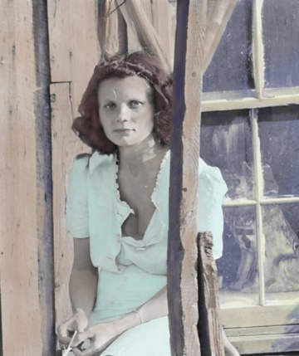
Figure 6. Catherine Johnston. Altered Context. Digital Image
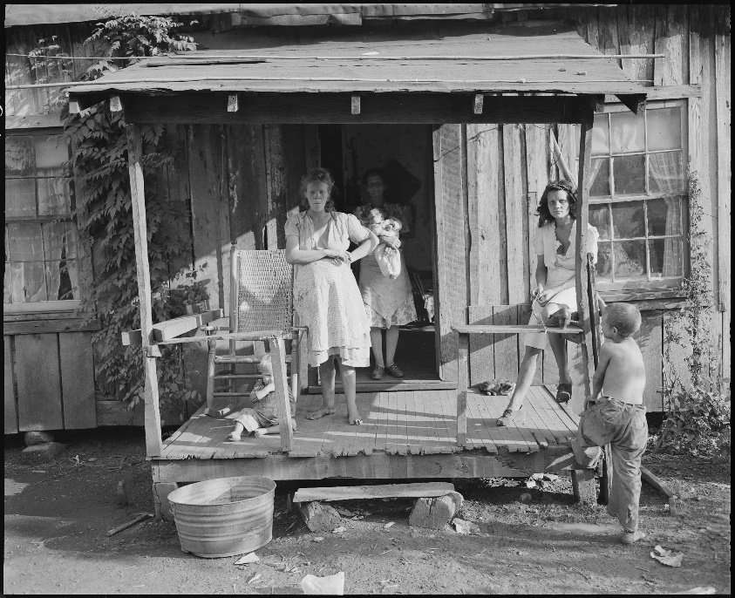
Figure 7. Photograph No. Nwdns-245-Ms-2238l (Lee Russell)
“Miners' Wives and Children on the Front Porch on a Typical, Fifty Year Old House. Kentucky Straight Creek Coal Company, Belva Mine, Abandoned After Explosion [In] Dec. 1945, Four Mile, Bell County, Kentucky” September 4, 1945; National Archives and Records.
Dewey suggested "in order to perceive aesthetically, he [/she] must remake his [/her] experiences so they can enter integrally into a new pattern." Not all art is easy and comfortable to observe. If morality is social and is thus defined by society, then how are students to remake their experience?
Dewey describes the process of parents reinforcing acceptable behaviors and actions of children and the application of consequences to actions that are in opposition to the family, culture or society. As we mature into adulthood, "our thoughts of our own actions are saturated with the ideas that others entertain about them, ideas which have been expressed not only in explicit instruction but still more effectively in reaction to our acts." The community becomes a we into which a member is part of the collective whole. As part of the we the individual must continue to reflect.
As Dewey moved from personal to social morality, he devoted a small section to those he says "are in possession of codes and principles" that will ultimately settle all matters of right and wrong for everyone and for all times. Dewey cautioned against this path, saying this way leads to intolerance.
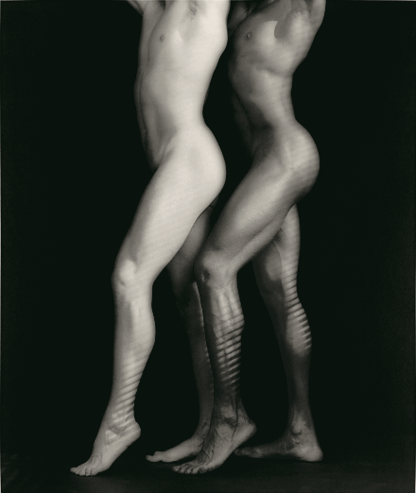
Figure 8. Ken and Tyler, l985© Robert Mapplethorpe Foundation.
Figure 8.
Used by Permission.
Consider the photographic image of Ken and Tyler (Figure 8) by Robert Mapplethorpe. Mapplethorpe died in 1989 from an AIDS-related disease. An exhibition of his life’s work entitled, The Perfect Moment was arranged into a traveling exhibit. When his work reached Cincinnati in March of 1990, curator Dennis Barrie faced obscenity charges (later dismissed). While the city was conservative, the museum board was fully behind the exhibition and made this one concession, to view this show, you had to be an adult and pay an admission. During the same time, in any place in America that sold Mademoiselle and other glamour magazines, Calvin Klein continued to launch visually and sexually enticing images to promote his Obsession cologne. Visually, Mapplethorpe’s work and the Calvin Klein advertisements share stylistic similarities, the context and content separate the two compositions. A Klein’s powerful marketing campaign and heteronormative content provides context and open access to an image that may have been difficult for some viewers yet, will not be challenged as obscene. Art, art’s intent, business, and profit seem to be regulated by different codes.
In addition to issues with moral content, sometimes students choose minimalist content, as a way to cut down the complexity of the assignment; however, when asked their selection they most often have trouble articulating clear ideas with supporting evidence. I suggest students choose a work which they feel passionately about (positive or negative) rather than a work of tepid interest. Above all I wanted students to find works of art that spoke to them. This paper and skill set was important to me and therefore, received the highest point value. Students were permitted to revise the papers for improvement as well as higher grades.
As students selected a work for unpacking, common discussion questions included: what about the artist’s intent and the viewers’ ideas? Could one argue an image or sculpture meant more than one thing? How does the title, artist’s personal history, or time period influence meaning? Through the use of the rubric, the class could determine that there were some theories about an image or sculpture for which there was no supporting evidence. If, as Dewey writes, creating a work of art involves the successful unification of the visual elements, the medium, and the artist's intent, then artists having reached significance are able to convey experience from their own lives into the context of a created form.

A Single Road with Two Finger Posts, One Destination
After 5 years of walking the adjunct road I was still a happy teacher. My classes were always full and I loved working with the community college student population. I knew if I wanted to get a full-time teaching position, I would have to return to a university for a second masters, this time a terminal degree, a masters of fine art (MFA). I was accepted into a three-year program at a public, state’s flagship research university. For my program, most graduate assistants (GA) were drawing instructors, but my appointment was to teach art appreciation. I was also solely responsible for every aspect of the class. This GA position allowed me to keep teaching art appreciation with a different student population.
My studio classes included painting and printmaking. The summation of the 3-year MFA program resulted in a cohesive body of work for a thesis exhibition. In the time between my bachelors and the start of my MFA, the art history classes revealed that the terrain of the art world had and was changing. The university art historian was a feminist and the work of female painters such as Judith Leyster, Artemisia Gentileschi, and Elisabetta Sirani work were no longer obscured by their male canon contemporaries, Frans Hals, Caravaggio, and Guido Reni. I wrote my first feminist art history paper and was entranced with these new artists whose work I could now study.
My MFA program was better at preparing graduates for life after degree completion than either of my other degrees. My teachers did talk to us about how to apply for work. In my search for employment, I applied to over a hundred teaching and gallery positions, making the short list five times before I was hired by a rural community college in the Midwest. I had no concept of small town and rural. I was the art department. Arriving the weekend before school started, I taught clay, drawing, painting, humanities, and art appreciation. I was also expected to advise students, run the art gallery, be on committees, and generally participate in college life. I learned if you did not do something, whatever that something was, the something did not get done. So, the list of things to do to get students involved in art just kept getting longer: one gallery, a second was added, an annual arts festival, grant-writing for the art gallery and arts festival; club co-sponsorships with the theatre students, theatre set flat painting, T-shirt and program covers for the plays, art field trips to museums, and mural painting.
The second mural was the idea of the local historical society. I did not want to design a block long, two-story image. I imagined endless meetings with people arguing over the significance of one thing or another. I said I would paint the mural, if they could find someone to design it. I believed with community of only two thousand people the odds of finding another willing artist well, pigs would fly first. Several months passed and the ladies returned to see me with a design, and my summer calendar was filled with mural painting and the distant sounds of snuffling and wings.
In art appreciation, my class enrollment limit was set at 40 and sometimes hit 50 or more. Trying to build a safe collaborative environment in which students would be willing to share their ideas in front of that many students was not always easy. Keeping everyone engaged was even more challenging. After many years of teaching art appreciation in a community college, revising as I reflected on my teaching, about what worked and what did not, I began to notice a theme in imagery that seemed to engage and capture students’ attention. If students expect anything from an art appreciation class, they imagine they will learn about famous works in art history. These works would be classical in subject: art with aesthetic beauty.
I have observed that while students have their expectations satisfied by seeing images like Leonardo Da Vinci’s Mona Lisa or Rembrandt’s Nightwatch, images that seem to hold student attention and spark imaginative thoughts included images like Francisco de Goya’s Saturn devouring his Son and Hieronymus Bosch’s Garden of Earthly Delights. Goya’s image depicts a grizzly scene of a god eating his children to avoid the fulfilment of his destiny. Student interest in Bosch’s work offer more clues to ponder. The image contains three panels. One depicts the Garden of Eden with Adam and Eve, the largest central panel depicts the garden of earthly delights, and the last panel depicts damnation. In class discussions about the work, the serenity of the Garden of Eden was not the panel that held fascination for students, it was discussing the activities of condemned figures. Over the years as my art appreciation curriculum evolved, I began collecting images that provoked strong responses, in particular, responses of disgust, images with aesthetic disgust. Moreover, I had also observed that the film industry found fiscal success in the release of endless sequels of horror films, all variations on a theme.
I began presenting works I learned about in graduate school. For example, I would show the same subject as presented by male and female artists. We would compare and contrast the works and discuss the merits of each. I found that there were more than a hundred images of Judith beheading Holofernes. For a grisly subject, the variety of renderings ranged from the bloodless to the blood-soaked.
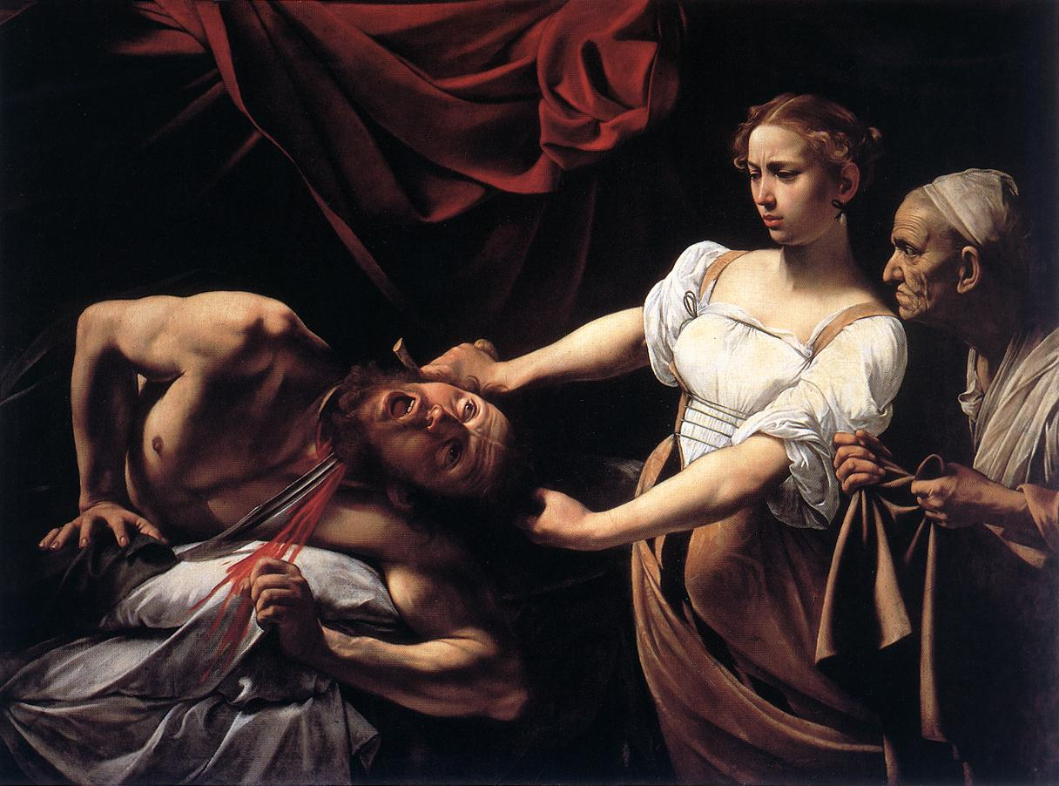
Figure 9. Michelangelo Merisi da Caravaggio. Judith Beheading Holofernes. Oil on canvas.
1598-1599.http://www.barberinicorsini.org/ 
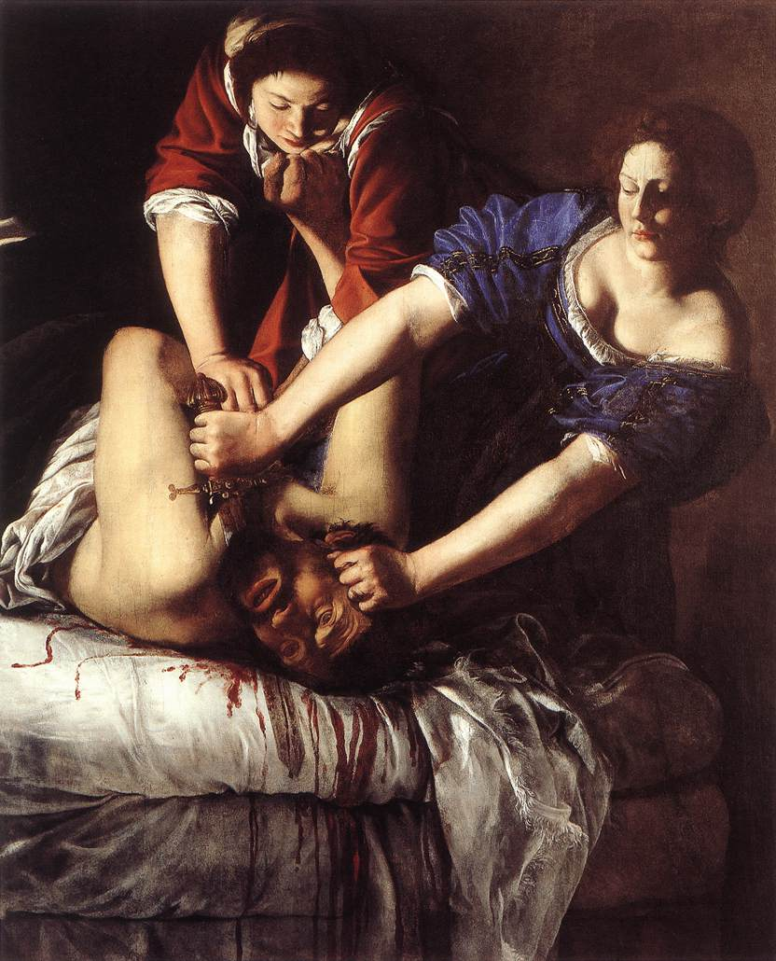
Figure 10. Artemisia Gentileschi. Judith Beheading Holofernes. Oil on Canvas
https://www.uffizi.it/?en.
My favorites to compare were those of Michelangelo Merisi da Caravaggio (Figure. 9) to Artemisia Gentileschi (Figure. 10). Contemporaries, the strong common characteristics present in both make the works easily identifiable as Baroque, but the artist’s intent, meaning, personal history of the artists within the time period are used in vastly different ways. Routinely, I would bring the class through an analysis rubric so they could see that meaning is linked to content, color, and how the artist has engaged the viewer. I would ask questions like this: Which woman is disgusted by her task? Considering the objective is to cut a large knife through a neck bone, who is going to be more successful and why? How is meaning changed in a vertical versus horizontal composition? Discussions were never dull. There is always discovery for the class at the juncture of understanding such things as how gender and life experience impact how artists envision a scene and how gender roles of that time and culture may differ.
Teaching students how to find a way to articulate their insights and conversations with art is vital. This develops by providing clear guidelines for deconstruction and construction writing, encouraging the use of the writing lab, and by being open to a revision policy which permits students to revise papers to improve grades. If the grade is what motivated a student, then I would provide an avenue for students to improve writing skills and earn the grade they wanted. My history instructed me to work for multi-modal teaching methodologies for multi-modal learners. I learned the art of improvisation as expressed by educator Alfonso Montuori, who writes, “[It] is my belief that there is an important and potentially fruitful connection between improvisation and the lived experience of complexity, and that improvisation and creativity are capacities we would do well to develop in an increasingly unpredictable, complex, and at times chaotic existence.” With experience, I continue to evolve as an instructor. I believe education is meant to promote personal growth, to expand understanding, to satisfy curiosity, to provide training, and to liberate. Education cannot help but alter the individual engaged in learning and individuals may change society as it can be changed.
Even with the increased class size, I continued to incorporate six to ten sessions of creative exercises within a semester art appreciation. The most repeated phrase of the first class drawing exercise is I can only draw stick figures. Upon finding out students can do draw more than that, most students want to be a master artist within the semester. There is time for quiet discussion when students are creating and for a larger class, these exercises became more important for building a classroom community. To help student understand artists, creative thinking, and how the arts enrich our lives, I also tried having the students read a couple of short stories, Nathanial Hawthorne’s The Artist of the Beautiful and Ray Bradbury’s A Season of Calm Weather. At the heart of Hawthorne’s short story is the watchmaker’s apprentice struggle for the legitimacy of fine art in a utilitarian (crafts) world. I used this story as an opportunity to have conversations about the importance of general education course work. Bradbury’s little gem is about a couple on seaside holiday near Pablo Picasso’s residence. Although George wants to buy a piece by Picasso, he knows, because his wife does not share his appreciation/love of the artist’s work, this will not happen. Late one afternoon, George is on the beach with one older man deeply absorbed in drawing in the sand. Drawing complete, the men acknowledge each other and George is left with an incredible intangible gift of an enormous Picasso. I used this story to discuss the differences in the use of the word value; conceptual and performance art; the creative process; and ideas about owning art.
As the instructor of art, in addition to my teaching responsibilities, I was responsible for two small art galleries. I kept the galleries full year-round of the work by students, regional, national, and international artists. Over my years at the college, we added an arts festival including demonstrations. To provide as many different kinds of experiences with art for students living in a rural area, twice a year, another faculty member and I took students on a day long trip to see major works of art in situ. For many students, this was their first experience in a museum and even their first trip out of their state. After nearly 14 years, I took an administrative position in curriculum and assessment at a large urban community college.

Disgust Not Beauty As A Central Theme For A Dissertation
I was encouraged to return to graduate school by my supervisor. I began my coursework and consideration for my dissertation topic. Among my ideas was a re-visioning of the curriculum of art appreciation. The extended legacy and power of the textbook was a lesson I re-learned in one of my classes. In the history of higher education, a classmate and I were to present on the pre-civil war section of our textbook, American Higher Education: A History written by professor of higher education Christopher Lucas (2006). As I read the chapters, what struck me was that the content of the text preserved history like a dandelion seed (regardless of the author’s perspective and even bias) and would extend a legacy that would cling and be carried forward into the future. To illustrate this, among the sources used by the author was Thomas Woody’s (1929) A History of Women’s Education in the United States. Lucas speculates about the opposition to the education of women, their intellectual inabilities to do serious scholarship, as well as the prevailing opinion that advanced education was simply beyond abilities of females. Moreover, Lucas describes other random paternalistic practices that marginalized women. What Lucas could have focused on was how women challenged educational barriers, instances of female leadership, and examples of the struggles and desires of women to be educated, rather than documenting the prevailing prejudices that oppressed and kept women (as well as those of color) from equal access to the education white men were afforded. The textbook perspective seems to preserve an unhealthy nostalgia. Philosopher George Santayana’s “Those who fail to learn from history are doomed to repeat it” speaks to this reality.
Today, more than 98 million girls around the world are without access to an education. The need for initiatives like those of Michelle Obama’s Let Girls Learn, the persistent low numbers of women in leadership roles, and the constancy of the pay gap in America suggest learning from the past is not happening. What we teach matters and the how history is written matters. As a graduate student, I read some of the primary sources for the textbooks and considered the intent of the content; this was not something I knew to do as an undergraduate.
In my experience as an instructor, textbooks and their content have a certain authority of truth, making challenging the veracity of the textbook difficult for students. I recall having one edition of a humanities’ textbook in which Shakespeare lived for well over a hundred years. As a result of having to direct student attention to this typographical error, I theorize students generally accept the textbook content whether they agree with it or not and as factual.
As I consider re-visioning, I want to challenge students to become actively engaged with their academic content and to understand course outcomes, rather than accepting what is presented to them passively. Freshmen taking general education courses are making all kinds of transitions as they are learning college culture. Moreover, George Kuh (2008) writes that students will be more successful in college and life if high-impact practices are aligned with essential learning outcomes. These outcomes include the study of human culture and environment, intellectual and practical skills, and active involvement with issues of personal and social responsibility. An open classroom environment creates the space for students to come together
Educational psychologist David Johnson and curriculum and instruction professor Roger Johnson explain that cooperative learning is the instructional use of small groups so that students work together to maximize their own and each other’s learning. Cooperative learning is predicated on the development of relationships within the classroom. This learning environment takes time, commitment, and a willingness to value the importance of each individual's unique history and abilities. In a cooperative learning experience, there is an expectation of shared responsibility for learning. Education happens with students rather than to students suggests the instructor’s view of the student’s capacity as knowers. This distinction in pedagogical practice requires something from everyone. Changes like this in a re-visioning of art appreciation would change everything. These ideas become the genesis of a thought experiment.
Why does one experiment? The answer, of course, is to learn, uncover, discover, or rediscover something about teaching and learning. Internet browsers like Google have ushered in an age of asking and receiving answers for any question. While a search query may yield millions of documents and a query can be refined to ensure the results answer the research question, documents cannot replace classroom experience or contemplative thinking about how the instructor, students, content, and classroom actually come together. Philosopher Catherine Elgin writes, “[Though experiments are] not actual, an often not even possible, experiments. They are imaginative exercises designed to disclose what would happen if certain, perhaps unrealized, conditions were met” (Elgin 2014, 226). She goes on to describe them as “imaginative exercises” that can be envisioned without being enacted and are created “within a context of background assumptions” (238). The assumptions, ideas, theoretical ideas for which and from which the thought experiment are fashioned, may or may not result in some kind of evidence, useful or not. Would a thought experiment re-visioning a curriculum that utilizes at its heart, images considered disgusting that speak to the strong emotions such as, anger, betrayal, fear, death, and grief rather than images of beauty produce interesting results?
I can see my intrigue with images of aesthetic disgust has existed as an interwoven thread of an idea. This interest in aesthetic disgust is illustrated in my collection of over a hundred versions of Judith beheading Holofernes. I pepper images that are visually disgusting amid the traditional canon for flavor. When I reflected on the question, “Why I did I use a particular set of images to teach art appreciation?” a germ of an idea for a thought experiment began to take root. What if I re-visioned art appreciation? What would happen if I took the course emphasis off the associated textbook curriculum and opened the course content to the investigation and discovery of the denotation and annotation of the words art and appreciation. What would happen if students help guide the course? What would happen if I taught an art appreciation class in a community college with disgust as its conceptual foundation, not beauty? If the purpose of the class was to learn to appreciate art, why does an introductory art class designed as a general education course need to learn a particular set of images? If students selected the art to meet course learning objectives with guidance of the instructor, how would the change impact student learning, student engagement, and the classroom community? Would this sort of change be impossible? Yes! Change is indeed possible. The art world slowly opens to include more women. Alice reminds me that the introduction of coffee to Europeans began a love affair with Satan’s drink, that is until Pope Clement VIII deemed it a “truly Christian beverage.” Familiarity can make the strange taste good and one small change in perception can affect the views of countless others.

CHAPTER 2

Wool and Water: Beauty and Art Appreciation in Context
The Queen was amazed that Alice’s memory only worked backward, further, that Alice was unable to believe impossible things. Contrariwise, the Queen’s memory was fluid and for her, she “believed as many as 6 impossible things before breakfast.” While, Alice is startled by the Queen’s transition into a sheep, she maintains her conversation demonstrating Alice’s resiliency and capacity in the face of challenges to her schema.
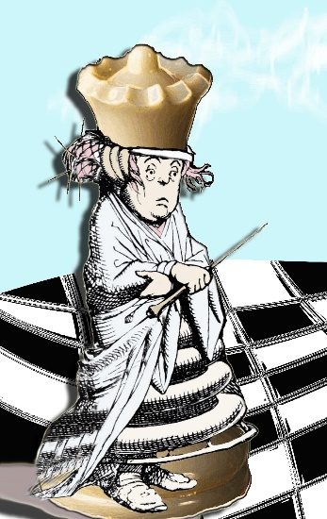
Figure 11. Catherine Johnston. White Queen. 2017 Digital Image

Art Appreciation: Denotation and Connotations
As a visual language, art is able to communicate beyond the culture where the work originated. As Dewey explains, language "…ceases to be communication until variations of understanding can be translated, through the meanings of words, into a meaning that it is the same to both parties." When the word “art” is coupled with “appreciation,” connections are made through context, time, story, and tone over-layering and complicating the understanding of their meaning(s). Further, art appreciation has been heavily tasked throughout history: it has served to refine a person’s character; to provide moral education; to train the aesthetic palette of future consumers of art; to provide a positive type of leisure in life; to teach the principles of design and color as a means of critical analysis; and to provide access to an art history. Under the weight of the ambitious task of teaching the vocabulary of art, all the art mediums, and all of art’s history from recorded time to this moment within a semester, the words art and appreciation continue to slip away, unclearly defined (if defined at all).

The Denotation of Art
The Oxford dictionary defines art as
The expression or application of human creative skill and imagination, typically in a visual form such as painting or sculpture, producing works to be appreciated primarily for their beauty or emotional power.
Originally art was simply ‘skill at doing something.’ Its use in the modern sense dates from the early 17th century. The word comes from Latin ars, from a base which meant ‘to put together, join, or fit’.
Art’s meaning for individuals is derived from varying experiences with art (formal and informal, familial, or cultural, and educational). For many, defining art is not unlike Justice Stewart’s famous statement on obscenity: “I know it when I see it.” The clarity of an answer to the question “what is art?” is further complicated by the fact that this skill has been practiced (some would argue) by monkeys and elephants. Like a masterpiece drawn in sand at low tide, a definition of art is only temporal at best. Art does not conform to a central core, a universal ideal, or a singular purpose (Weitz 1956, 27-35; Dickie 1969, 253-256; Carney1982, 85-92; Osborne 1984, 9-20; Efland 2004, 234-251). Art is used to communicate ideas and ideals, to document history, to represent beauty as well as disgust; art is often seen as a commodity or reduced to its elements, principles, and mediums; and, art is viewed as a tool of the powerful as well as a vehicle for liberation.

Appreciation as Aesthetic Beauty, Delight, and Disgust
For Kant (1790), aesthetic judgement is “simply” reflective (715), and in order to know feelings connected to an art object, the viewer must exercise disinterested judgement. Kant writes, “Taste is the faculty of estimating an object or a mode of representation by a means of a delight or aversion apart from any interest. The object of such a delight is called beautiful.” Like art and appreciation, beauty is a word with layered meaning. And what of images that are ugly? Kant argues, “One kind of ugliness alone is incapable of being represented conformably to nature without destroying all aesthetic delight, and consequently artistic beauty, namely, that which excites disgust.” Kant’s perspective suggests a disgusting image forfeits its further consideration as an object of art, as a thing of beauty.
Kant’s ideas of delight and aversion are foundational for British philosopher Bernard Bosanquet. He argues in the Three Lectures on Aesthetic (1915), that there are two kinds of beauty: easy and difficult (85). Easy beauty is “recognizable” as beauty. Bosanquet maintains difficult beauty is “repellent” to some, and appears in three cases: “intricacy, tension, and width”. These forms of beauty challenge the viewer in unconventional ways and images may overwhelm and disturb. Bosanquet suggests ugliness can be attributed to difficult beauty and/or “weakness” or lack of education/effort in the viewer (95).
Bosanquet’s concept of easy and difficult beauty asks the viewer to examine the very foundation of their culturally constructed views. Philosopher Carolyn Korsmeyer (2011) inserts disgust as another kind of beauty. She suggests in her book, Savoring Disgust: The Foul & the Fair in Aesthetics, images of disgust not only ask for a response but also present a challenge to “beauty” (173). Aesthetic beauty is often used as a tool to sort the desirable from the undesirable, with the undesirable is often viewed as something to be avoided. Korsmeyer defines aesthetic disgust as, “A response that, no matter how unpleasant, can rivet attention to the point where one actually may be said to savor the feeling.” Korsmeyer further suggests that the disgusting still finds purchase by “sidling up alongside things that are nobly and perfectly formed, including those things that are otherwise painful.”

Connotations of Art Appreciation

Art Appreciation Serves Higher Purposes
Arthur Efland’s (1990) A History of Art Education reveals that the visual arts was not a university program of study until Felix Slade, successful lawyer and art collector, endowed three chairs at Oxford, Cambridge, and London in 1868. The ideas of John Ruskin, Oxford’s first chair, had a significant impact on American art education, even when those ideas were not well received in his own country (Efland, 63). The writings of Ruskin combined with German idealism form the basis of William T. Harris’ premise that art serves a higher purpose (Efland, 130). As United States Commissioner of Education, Harris argues the arts “preserve” for humanity the “precious moments of elevated insight if those seers who are, next to religious seers, the greatest teachers of the human race.” Additionally, Harris, among others, advocated for the study of art to refine the character of men and women as well as to provide a means of moral training (Jansen 1991, 17-28; Harris 1897, 261-275). The first instances of this type of art appreciation within higher education curriculum appear in the college catalogs as early the 1870s (Jansen, 18). Women could graduate from elite colleges with “artificial grace” and “superficial knowledge” of the arts (Curti 1959, 175). Over the next thirty years, art education curriculum in the form of art history, theory of art, and/or as art and design was added to the upper level course offerings in the catalogs of colleges and universities such as Vassar, Syracuse, Yale, and William and Mary (Jansen, 22-24).

Art Appreciation Serves a Practical Purpose
At the turn of the century, more general art courses emerged as curriculum in teacher preparation programs (Jansen, 42). New textbooks written at this time (Dow 1899; Poore 1903) reveal a pedagogical certainty the authors possess an expertise of the artists’ world and that students should come learn about art from the experts. Many believe that teaching with these types of texts will lead to an understanding of the elements and principles of art, ultimately enabling students to see, understand, and even appreciate art (Jansen, 77). According to Charles Jansen (1991), Harvard was the first university to combine elements and principles of art with practical application of those principles. Although Harvard eventually dropped this version of the course, other colleges and universities began to add similar courses (80). Charles Bennett (1923), educator and champion of the manual arts, who authored Art Training for Life and Industry, argues “Appreciation of art is not the same as knowledge of art. It is not something that can be absorbed from books, or even from teachers; it is something that must be gained through experience… even to be personally acquainted with artists and with the character of their works, is not to appreciate art.” Bennett’s text stresses the importance of practical application of conceptual knowledge (35). For him, practical application includes such media as landscaping, advertising and fiber works (30-35). Bennett maintains that a broad range of artistic media could be taught experientially to students of all ages (22) and art could serve a practical application in everyday living. This utility of art leads to consideration of art as commodity as well. Art appreciation, then, becomes a means to educate American consumers (Jansen, 184). While art was viewed as increasing satisfaction in leisure, the growth and popularity of these classes continued. By 1941, “all women’s colleges, half the men’s colleges, and two-thirds of the co-educational institutions offered art courses (Efland, 219).”

Art Appreciation Serves Silent Partners
Textbooks represent a sizeable market within the publishing industry (Apple 2013, 1410). Even as new authors write textbooks, authors of existing textbooks retire, and, as pedagogy changes with time and cultural development in the late-modern era, the strength and control of textbooks has continued to grow. University of Wisconsin Professor Michael Apple’s book, Teacher & Texts: A Political Economy of Class and Gender Relations in Education, reveals the implications of what he calls “the political economy of the textbook.” This industry makes a significant amount of money and has become increasing consolidated. Three-quarters of all textbooks come from only ten publishers (1466). Apple reveals, “Only three out of every ten books are marginally profitable…” While censorship seems like a reason to keep textbooks written in a particular ideological voice, Apple suggests that profitability is the primary driver of textbook change. Diane Ravitch’s book, The Language Police: How Pressure Groups Restrict What Students Learn (2003) is disturbing. She writes that she inadvertently has discovered, “an elaborate, well-established protocol of beneficent censorship, quietly endorsed and broadly implemented by textbook publishers, testing agencies, professional associations, states, and the federal government.” Ravitch was able to obtain publisher writing guidelines. She writes that publishers seek to eliminate controversy through image and word selection and even how history is presented. For some textbooks, the authors may have been scholars, but subsequent editions were updated by corporate employees and some books were completely created this way. The survey textbooks are created and packaged with instructions and activities to make them “teacher proof.” The textbook contains the curriculum for an art appreciation course. An instructor is presented with the challenge to cover all of the various media included in what might “define art,” as well as all of the color and design principles to provide students with the language of the arts.” Additionally, in order to provide context for the evaluation of art, the curriculum also includes all of the history of art from cave to present (Western perspective) plus a couple non-Western chapters. Within art appreciation textbooks, the printing of images and the acquisition of the rights to reproduce those images comes at a cost. Wholesale change of imagery could mean significant investment of new dollars without guarantee of return on investment. Thus, it seems fiscal concerns will continue to perpetuate some images/artists being included while excluding others.

Art as Language
…Photography is not practiced by most people as an art. It is mainly a social rite, a defense against anxiety, and a tool of power.
—Susan Sontag, On Photography, 1977

Mandarin Chinese is the most commonly spoken language worldwide; however, there is another language that has managed to slide into global prominence with such subtlety that many seem unaware of it or its significance: the language of images. Image as a language is not a new concept. Paintings (and other art forms) have long been used to communicate such things such as religious dogma, rules for living, and political messages. Artists in the Western tradition were able live and even thrive because of the support of wealthy/powerful patrons. The growth of personal images began to accelerate with the start of the development of the photographic medium. While artists still painted and relied on commissions of patrons, more images could be captured by a person with a tool (camera), and the photographer may (or may not) consider herself or himself an artist. Eastman Kodak “Brownie” simplified the complexity of imaging making with a camera to the press of a button. Priced at one dollar, the “Brownie” sold a hundred thousand units in 1900. Printing photographs on paper once required a skilled person trained to use equipment in dark room work. For many years, “this democratic media” was not truly affordable to all as printing images remained costly. As the professional printing labs were replaced by machines monitored by minimally trained people, both cost and quality of printing were reduced. Currently, many people take digital pictures, print sparingly, and keep digital albums. Photography has become a series of digital images that need never printed nor touched, only seen. While over two billion Facebook users upload 350 million pictures every day, another 700 million appear and disappear within 10 seconds through Snapchat. Facebook has more than 250 billion images stored by their millions of users. Instagram, an online photo-sharing application has 700 million users. Digital image sharing is woven as intricately as words as a means of transmitting, touching, and connecting with others. Digital imagery is a common tongue.
People of nearly all ages, near and far, “speak” this visual language. Digital images are also the by-product of sightless aperture of tools which once learned can capture pieces of anything, of anyone. Much like the spoken vernacular, image sharing allows others to view the chronicles of another’s days and nights in a fluid stream of color and variety. Moreover, the camera itself has been “demystified,” made affordable, and has been integrated into phones. Over the last 40 years, the refinement of digital cameras, lenses, and options for image manipulation have expanded exponentially.
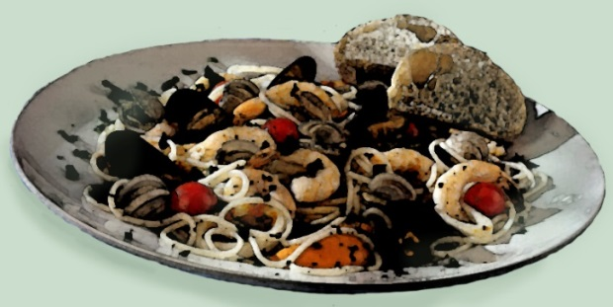
Figure 12. Catherine Johnston. Meal Shared. 2016 Digital Image.
Online documentation of meals shared (Figure 12), baby’s firsts, and the “artfully” transformed join to form a digital sea of the good, bad, beautiful, the disgusting, and everything in between. At the core of the unfettered barrage of digital imagery may be that everyone and no one is an artist. Images can reveal truths, make lies truth or suggest truths and lies. Fake news mimics so seamlessly real news, that fabrications such as pizzagate impact on real people. Social media rapidly distributes fake news, photo manipulations, and memes everywhere and all the time. Without the artist consent, Matt Furie’s Pepe the Frog was repurposed and turned into symbols of hate. Even knowing images can be false, one’s eyes tend to believe what he or she sees—even more than one believes what he or she reads or hears. Unlike verbal language, visual language is often neglected in the public-school curriculum. Without instruct instruction on visual language, how then will students develop their ability to select, use, create, understand, and/or critique imagery in a meaningful way? How will students learn to look more carefully and really see? There is an expectation that high school graduates will have achieved standards in the areas of mathematics, science, history, and English. In four years, theoretically, this curriculum will provide graduates the education they will need to make them good citizens and community members, as well as prepare them to work or meet the academic challenges of college. And when it does not? What then? In practice, many high school graduates enter college without the requisite skills to be successful. A student’s socio-economic status (SES) plays a significant role in student success. Low-income students may dream of college, but a real or perceived lack of preparation (Aikens and Barbarin, 2008) and actual college enrollment numbers reveal a different educational picture.

Purposeful Looking and Seeing
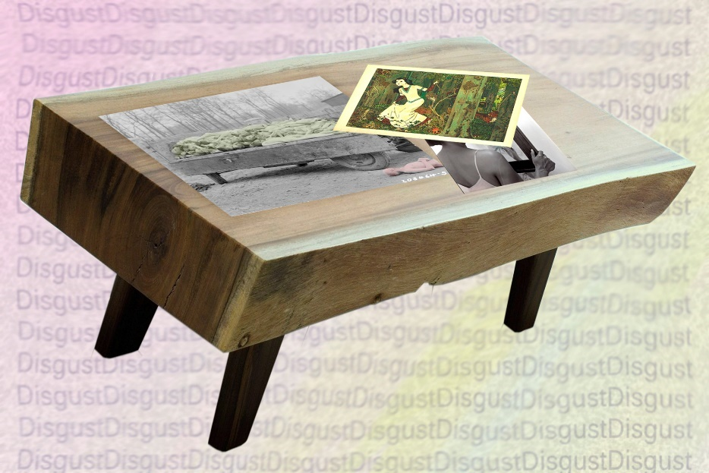
Figure 13. Catherine Johnston. Just Look at Them 2016. Digital Image
What does one do when educational concerns such as college preparedness are so tightly woven into complex patterns of American culture and not given to simple solutions? Community colleges across America are challenged with this difficult question: how does one undo the academic achievement gap between those with privilege, opportunity, and access and those without? This question to challenge is not unlike one posed in author Virginia Woof’s Three Guinea: “How in your opinion are we to prevent war?” Woolf begins her address to this question by directing the reader’s attention to photographs on a table. She might argue these photographs are visual truths rather than merely images recorded in light and shade.
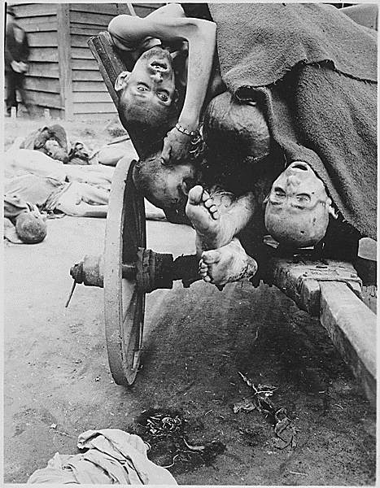
Figure 14. Photograph No. 111-SC- 204811 (T4c. Sam Gilbert)
“Some of the bodies being removed by German civilians for decent burial at Gusen Concentration Camp, Muhlhausen, near Linz, Austria. Men were worked in nearby stone quarries until too weak for more, then killed,” May 12, 1945; National Archives and Records.
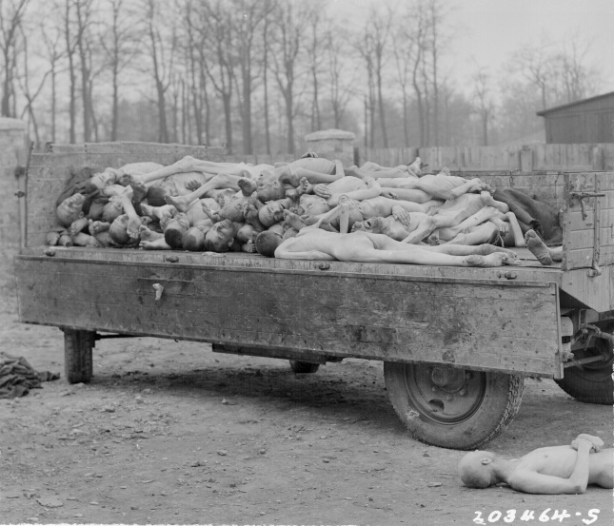
Figure 15. Photograph No. 111-SC-203464 (Pfc. W. Chichersky)
“A truck load of bodies of prisoners of the Nazis, in the Buchenwald concentration camp at Weimar, Germany,” April 14, 1945; National Archives and Records.
These photographs are not easy to look at: “they are photographs of dead bodies for the most part…of what might be a man’s body or a woman’s; [and] those certainly are dead children.” What do these images convey about those captured in that moment, those who captured that moment, and those who created the circumstances of that moment? For Woolf, these images speak of war, of horror and disgust.
In On Photography, Susan Sontag refers to Plato's Cave referencing humankind's continued propensity to choose looking at images of some kind of truth, rather than walking out into daylight and seeing. According to Sontag, when photography was still young, photographers like Mathew Brady, Dorothea Lange, Margaret Bourke-White, and Walker Evans brought to the eyes of those trying to live in peaceful, ignorant bliss the war dead and the faces of the migrant workers. As with Realism in painting, these photographic images spoke to the nobility and suffering of the common person. Bourke-White says, "One photograph might lie, but a group of pictures can't" A group of pictures tell a particular kind of truth within a context. A stream of images becomes a kind of visual indoctrination, while not an approved teaching mechanism (Martin 2002, 59) it is an effective one. John Berger writes, “The way we see things is affected by what we know and what we believe,” Thus, raising the importance of visual analysis in and about imagery.
Are there examples of images of power or lack thereof that demand engagement, even if only momentarily, that might be placed alongside of Woolf’s images on the imagined table? What might these images look like? Consider that there are indeed pernicious images that are meant to perpetuate racism and class. These images can serve to mis-educate and retain current cultural constructs. For some viewers, they are as comfortable as skin and for others, the visual message loops filling them with negativity and hopelessness. Call to your visual memory for the image of Disney’s Snow White and add it to Woolf’s table. Snow White’s name reveals her skin color and the popular princess tale follows Western cultural norms; she is destined (regardless of adversity) because of her race-normed beauty and goodness to have a happily-ever-after hetero future. In Educational Metamorphoses, philosopher Jane Roland Martin lists many examples of "educational agents (school, home, religious institutions, among others)." Images, film, sculpture, and hosts of other art forms are also educative. These agents may actually communicate mis-educative messages. Rather than conveying cultural heritage and wealth, their embedded curriculum may support classism, xenophobia, racism, sexual orientation discrimination, and misogyny. How can an image hold so much power? Berger argued that, “Every image embodies a way of seeing. Even a photograph. Gaze now upon, the addition of another image (Figure 16.) of woman gazing in a mirror by Carrie Mae Weems called Mirror/Mirror (1987). The artist has selected a signature moment in course the tale of Snow White. Not only does it embody a way of seeing, but the literal content of viewer and mirror evokes various ideas and multiple possible contexts and further, numerous implications about this moment can be drawn from the history of mirrors. Snow White never wonders about her beauty, this is a question asked by her stepmother, the queen. If the image follows the Snow-White storyline, the woman is the queen. While the queen almost has her face against the mirror, her eyes are averted from the other woman reflected back at her. The queen has flawless skin, physical strength, and beauty which are emphasized by the simplicity of her attire. Only the head and shoulders of the woman are visible in the mirror. She seems to be wrapped in a gauzy material creating the illusion that only her face and one of her hands are solid. The mirror woman’s lips are parted as if speaking and her semi closed eyes look steadily if not, coldly, at the queen. Her slender hand is lifted to reveal she is wearing a bezel set ring and on the tips of fingers rests the irregularly shaped glittering star end of the classic fairy godmother’s wand. Weems merges the prophetic (presumably) neutral voice of the mirror with that of ideas commonly associated with fairy godmothers. The former describes a truth teller who will speak without regard for how lives are impacted by revelations, and the latter, a woman who provides assistance to those who are good and true, helping them rise above their life’s trials. In Mirror/Mirror: A History of the Human Love Affair with Reflection, Mark Pendergrast writes, “Mirrors are meaningless until someone looks into them. Thus, a history of the mirror is really the history of looking, and what we perceive in these magical surfaces can tell us a great deal about ourselves—whence we have come, what we imagine, how we think and what we yearn for.” Mirrors are used to see the beautiful; to twist and distort appearances; to see inaccessible views; to confirm the splendor of the wealthy; and to hold magic that can both see and tell secrets. Weems’s use of mirror as symbol taps into the mirror’s rich history. The title of the work provides more context for understanding the layers of meaning. The queen, a black woman, asks of the mirror, “Who is the finest of them all?” In reply, the Mirror Says, "Snow White, You Black Bitch, and Don't You Forget It!!!” Is Weems’ mirror refuting the queen’s beauty? The mirror’s words in tandem with a fairy godmother wand, suggests the mirror may not play a neutral role in this Snow-White tale. The queen never was nor would ever be “the finest of them all” in this tale.
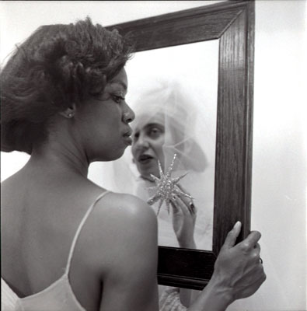
Figure 16. Figure 16. Carrie Mae Weems, LOOKING INTO THE MIRROR, THE BLACK WOMAN ASKED, "MIRROR, MIRROR ON THE WALL, WHO'S THE FINEST OF THEM ALL?" THE MIRROR SAYS, "SNOW WHITE, YOU BLACK BITCH, AND DON'T YOU FORGET IT!!!"
Photograph.1987 Used by Permission of the Artist
http://carriemaeweems.net/galleries/aint-jokin.html
Weems’ image (Figure 16) begins with a familiar invitation in its fairy tale litany of mirror, mirror on the wall…and ends with an unexpected challenge to reveal a variety of truths to the one who looks and sees. In an interview with bell hooks, Weems describes watching Hollywood movies with white subjects that fashion a cultural landscape to inhabit. She is mystified by those who view her created cultural landscape using her subjects and her experience. The same thing does not happen as with white subjects. Weems says, “Folks refuse to identify with concerns black people express which take us beyond race into previously undocumented emotional realms.” bell hooks adds, “This piece places that sense of fixed location, because the meaning depends on the direction from which you gaze at the piece.” Sometimes, there is an expectation that a work of art should have a true meaning and artist’s intent. This universal truth is lost at the juncture between creation and viewer. Feminist Rosi Braidotti writes:
…women may have common situations and experiences, but they are not, in any way, the same. In this respect, the idea of the politics of location is very important. This idea, developed into a theory of recognition of the multiple differences that exist among women, stresses the importance of rejecting global statements about all women and of attempting instead to be as aware as possible of the place from which one is speaking.
Or the place from which one is looking. Weems’ image is about the gaze, gazing, reflections, beauty, the American class system, gender, and race all framed within and before a looking glass. Add Weems’ image to the Woolf’s table knowing that life experiences of the viewer may draw the variety of messages from the image. Both Weems’ Mirror/Mirror and Woolf’s images of war grapple with difficult questions. They have the power and potential to engage the viewer in conversation, challenge currently held beliefs or ideals, and even to promote change. Mirror/Mirror is significant because the viewer’s eye is able to witness Weems “cultural terrain.”
Like Weems, Woolf wrote of a cultural terrain. This terrain depicts barriers of class and gender as well as the divide in opportunities afforded educated men and the daughters of educated men. She begins by trying to explain why communication is a challenge between men and women. Woolf writes, “…birth is mixed, classes still remain fixed” and while each has makes living, Woolf wonders if there is reason to speak across the terrain concerning the things which divide men and women. Educated men, she writes, crossed a bridge each day, ascending pulpits, practicing things that maintain life stations. Woolf describes an image of their clothing as “splendid,” military-like, and ritual-driven attire. Surely, in a fairy tale world, the educated men would vie for the fairest in the land. The work and worth of daughters of educated men and has previously been valued a portion of man’s purse, she could expect little, and struggled to make a living wage. Woolf suggested an educational solution for the daughters of educated men and others who had been excluded. Rather than recreating an old model, one that excludes, Woolf proposes one that is innovative and experimental, the poor college. Teachers at the poor college should be “good livers” as well as “good thinkers.” Woolf writes, “[At poor colleges there] would be none of the barriers of wealth and ceremony, of advertisement and competition which now make the old and rich universities …cities of strife.” The community college is markedly similar to much of Woolf’s vision for the poor college, a college not actualized in her experience. The shared ideals include providing open access to students, as well as curriculum including medicine (nursing), mathematics, music, painting, and literature, all subjects that can be taught as Woolf suggests cheaply.”

Community Colleges: A Brief History
In 1901, the President of the University of Chicago, William Rainey Harper, and the Superintendent of Joliet High School, J. Stanley Brown, collaborated in the formation of Joliet Junior College. Joliet's open enrollment and free (or low) tuition offered teacher training, programs designed to put students directly in the workforce, and general education coursework. Under Harper's leadership the University divided the first two years into the “Academic College” and the last two in the “University College.” Harper held that the real work of the university was in the second college. Joliet Junior College could serve students in those first two years with proper instruction, and those prepared for the "University College" could transfer. If the second two years of a college education contain the significant courses, what is communicated to faculty who teach and students who enroll in courses in those first two years? The mission of community colleges remains a constant after more than a hundred years: to provide open access to educational opportunities to under-served populations throughout America. The development of the community college made selective admission policies of four-year colleges and universities seem less like barriers to educational access because of the transfer system.
Even though community colleges are educating nearly half of all college students, these colleges are often seen as bottom tier institutions. Professor of education Rebecca Cox writes, “Over half of all black students and two-thirds of Latino college students are enrolled in community colleges.” According to Allie Bidwell, the impact of economic disparity on the pursuit of a college degree is documented in National Clearing House data. Students from low-income high schools enroll at four-year schools at a rate of 30 percent, compared to seniors in higher income high schools with enrollments of 38 percent to 48 percent. However, the data are reversed for enrollment in community colleges. More than 44 percent of graduating seniors from lower income high schools are far more likely to go to a community college while their graduating peers from higher income schools comprise enrollments between 30 and 37 percent. According to Complete College America, nearly 2 million entering freshmen will be placed in non-credit courses to address academic deficiencies. Over 50 percent of African-Americans and 45 percent of Hispanic students will be placed in developmental courses. Only 14 percent of African-Americans and nearly 24 percent of Hispanic students successfully complete their developmental coursework and their college level course work in two years. Most students work part or full-time, attend college part-time, and require closer to six years to complete a two-year degree. Nearly 60 percent of community college students are women, many single mothers. Students often attend community colleges because of the location, the affordability, and the programming offered. Hopes and dreams for better tomorrows often become thin in the light of weak academic preparedness. The struggle to balance work, children, and school with limited support and guidance causes many students to give up and quit attending school.

Community College: Challenges in Navigating the Terms and Terrain
President Truman’s Commission on Higher Education for Democracy reviewed the educational landscape in 1947 and sought to refine the responsibilities of colleges and universities. The Commission’s findings, The Truman Report, cited a lack of educational access for people of lower socio-economic means, people of color, people without academic preparation, and women. Further, the report went on to expand the role of the community college as the cultural center of its community. The Truman report outlined what the common educational experience should be for all people.
General education should give to the student the values, attitudes, knowledge, and skills that will equip him [or her] to live rightly and well in a free society…It should therefore embrace ethical values, scientific generalizations, and aesthetic conceptions, as well as an understanding of the purposes and character of the political, economic, and social institutions that [people] have devised…They are means to a more abundant personal life and a stronger, freer social order... General education seeks to extend to all [people] the benefits of an education that liberates.
Community colleges have incorporated the Truman reports’ vision of general education as essential to foundational education.
All degree-seeking students will find their way into general education coursework, and nearly sixty percent of the first two years of a transfer degree are comprised of general education courses. After completing coursework, the expectation is that students will have internalized general education competencies woven throughout the curriculum. General education curriculum includes composition and communication; government and history; mathematics and science; and social science and humanities. These courses serve as the foundation for transfer degrees like those Woolf identifies such as, mathematics, music, art, and literature as well as terminal degrees that lead directly to employment such as the nursing or computer programming.
The vernacular used by members of the academic community is most often not the same as the vernacular the students. There is no magic decoder ring passed out to students as they enter college. Students must navigate online student portals to enroll/change enrollment or even find their grades. This portal may or may not be the same as the online learning management system that contains course content for face-to-face and online courses. Students are directed to pay bills at bursar or to see the registrar. The teacher in the classroom is an instructor or a professor. The instructor hands out a syllabus and explains this document is a contract of educational expectations. The institution loads the syllabus with so many policies and procedures, the course specific content becomes obscured. The perspective of what is important within a syllabus is predicated on whether you are the student, instructor, or administrator. Moreover, the syllabus, viewed by many as a contract, and the use of language to compose the syllabus and the function of syllabi within a course is a common discussion among faculty (Zamudio-Suaréz 2016, Gannon 2016).
Navigating the college landscape without help is not unlike acting in a play without stage directions. About forty percent of community college students are the first in their family to attend college. There may be no one in the wings with prompts providing them positive encouragement or correct information about how to simply be in college.
U. S. government statistics cited in the American Association of University Women’s (AAUW) 2001 publication ¡Sí, Se Puede! Yes, We Can: Latinas in School, indicate the Hispanic population in the United States was estimated to be 39.3 million, with expected growth to 80.7 million by the year 2050. This number is significantly short of recent census data. According to the US Census (last update September 19, 2012), the Hispanic population in 2010 was 50.5 million and the projected figure for the year 2050 is 132.8 million. The AAUW reports Hispanics have higher high school dropout rates; they are labeled with learning disabilities in greater numbers than white students; and Hispanic students are more often not pursuing or placed on a college bound curriculum track. In response, the AAUW study introduces the concept of possible selves: one’s ability to imagine one’s self as a different self, including how people think about themselves, their prospects, and their possible futures. The concept of possible selves has broader application. In order for any student to be successful, she or he must be able to envision another version of themselves, a possible self, and be able to give this alternative enough detailed reality that the student can see the path from possible self to what might become an actual self.
Envisioning new possible selves becomes the process of deconstructing those barriers constructed from and through a variety of educative, cultural, and social experiences and fashioning alternative means of moving forward in new ways. The read through between students and college personnel is not an easy one. Each person has expectations, agendas, and experiences. The start of a new semester may be more like a theatre production in which all members of the class (instructor included) has a variety of scripts at play. Instructors assume similarity between their own scripts and those of their students. Students often do not understand why an instructor is not following the same script the rest of the students are following. Once instructors and students become aware of the differences in their scripts and expectations, the window of student success has diminished for those who are slow to learn their classroom script or even notice they have the wrong ones. In The College Fear Factor: How Students and Professors Misunderstand One Another, Cox writes that nationally, community colleges describe/market themselves on a continuum from extensions of high schools to two-year schools with strong academic reputations. Further complicating expectations, Cox argues, are the many goals students have for being in a community college class. Creating successful environments to accommodate the diverse needs of students who come from a broad range of reasons is of vital importance. Art appreciation conceptually grounded in beauty is miseducative especially but not only in the community college. Perhaps art appreciation curriculum could be conceptually grounded in aesthetic disgust. This adds to the impetus to re-vision curriculum that promotes student engagement with meaningful and culturally relevant content.
Alice understood the need to create positive and nurturing experiences and be part of the creation process. She found herself on a train without a ticket. Alice was uncomfortable because everyone around her had a ticket, passengers spoke in chorus, and all seemed to understand the process. Everyone but Alice. A tiny voice near her head began to talk to her. When the source of the voice is revealed, he looks to Alice like a giant gnat. He translates some of the differences of “how things are” on this side of the looking glass. Alice has to stretch her ideas to include all that she has seen and heard.

CHAPTER 3

Feathers and Crabs: Critical Aesthetic Pedagogy-Disgust, Engagement, and Community, The Re-Visioning of Art Appreciation
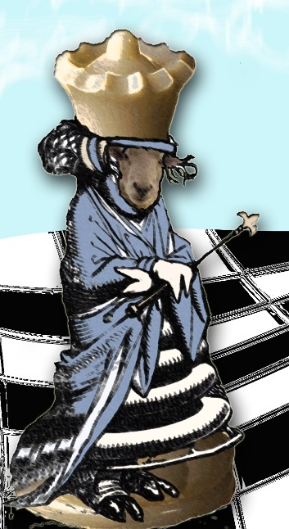
Figure 17. Catherine Johnston. White Queen in Sheep Guise is Truthful. 2017. Digital Image.
‘Can you row?’ the Sheep asked, handing her a pair of knitting-needles as she spoke.
‘Yes, a little—but not on land—and not with needles—’
Alice was beginning to say, when suddenly the needles turned into oars in her hands…
‘Feather! Feather!’ the Sheep cried again, taking more needles. ‘You’ll be catching a crab directly.’
…‘A dear little crab!’ thought Alice. ‘I should like that.’
‘Didn’t you hear me say “Feather”?’ the Sheep cried angrily, taking up quite a bunch of needles.
‘Indeed I did,’ said Alice: ‘you’ve said it very often—and very loud. Please, where are the crabs?’
‘In the water, of course!’ said the Sheep, sticking some of the needles into her hair, as her hands were full. ‘Feather, I say!’
‘Why do you say “feather” so often?’ Alice asked at last, rather vexed. ‘I’m not a bird!’
‘You are,’ said the Sheep: ‘you’re a little goose.’
The shop where Alice and the Queen have just browsed in transitions to a boat gliding upon a river. Alice accepts the incongruity of the present to the recent past because she must. However, in contrast to typical Looking-Glass conversations that are riddled with word play, the Queen’s directions to Alice are real commands used in rowing. The Queen’s directions are educative, however, if Alice does not understand the words in their intended context, then Alice learns nothing.

Looking Glass: Looking In
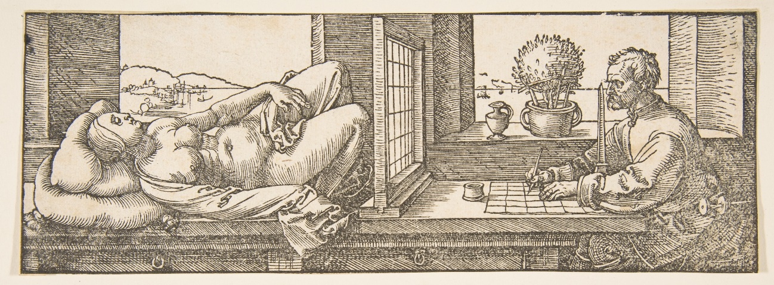
Figure 18. Albrecht Dürer, Draughtsman Making a Perspective Drawing of a Reclining Woman, 1600. Woodcut. Gift of Henry Walters, 1917.
http://www.metmuseum.org/art/collection/search/366555,

Korsmeyer asks the viewer to think, “…How complex is the phenomenon of “looking” as it operates in a picture like this—not only how we the spectators regard it but also how viewing perspectives are represented within the painting.” (location 1107-18)
In Art as Experience, Dewey began his description of experience as "things happen," and so they do. From birth, a person grows, transforms, is shaped and reshaped—a metamorphosis occurs. Some changes are "quantum" and are marked by rapid change and others come almost without notice like the erasure of a stone-carved face exposed to the relentless pitting of sand carried by winds. The ordinariness of experience as a constant is contrasted with aesthetic experience. As Greene explained, “Most people, in fact, are likely to go on in that [unaware] fashion, unless—or until— ‘one day the why arises,’ [or] as Albert Camus puts it, ‘and everything begins in that weariness…’” The process of reexamining complacent understanding and rebuilding with feelings—those that ache and others that thrill—will require "taking in" what is there to move into an esthetic experience.
Dewey compared the connection of emotion with an esthetic experience to a play. “It attends the development of a plot; and a plot requires a stage, a space, wherein to develop and time in which to unfold. Experience is emotional but there are no separate things called emotions in it.” A completed work of art is imbued with that “play.” As the artist raises a brush to fill the canvas and the viewer leans in for a closer look, the play begins.
In The Accidental Tourist , we see the “play” in Pulitzer prize winning author for fiction Anne Tyler's character, Macon, had honed his travel so as to minimize external cultural contact. His very nature is revealed in his suitcase and his packing—and unpacking— process. For Macon, his dis-engagement with experience is how to leave without leaving, how to see without seeing, how to interact without being changed by interactions. Macon’s creation was his suitcase, literally and figuratively. Dewey states, "Works of art, like words, are literally pregnant with meaning. To see Macon’s suitcase was to see into Macon. Aesthetic meaning, uniting the visual elements, and the "magic" of the artist's ability to marry these in that perfect expression, is the essence of what Dewey called "Art as Experience.” If the visual embodiment of experience is viewed as a suitcase to be unpacked, then those who explore its contents will learn something about art—about themselves, the process and the experience or not (and this too reveals something).

Looking Glass: Gazing Back
Once “we” have met, we can never be “the same” again. Propelled by the tasty but risky obligation of curiosity among companion species, once we know, we cannot not know. If we know well, searching with fingery eyes, we care. That is how responsibility grows. –Donna Haraway from When Species Meet
Classrooms are the meeting places for students and teachers. The arrangement of furniture, construction of syllabus, selection of text, and the meeting of people all fashion the educational experience. When the structure of a class has the instructor at the front of the room, education most often happens to students. Educative experiences in which teachers deliver content to students foster student passivity. In this view of the education process, Brazilian educator Paulo Freire (1970) explains, student minds are as empty bank vaults and teachers possess the currency (knowledge). This thinking comprises a dominant educational pedagogy which functions as both method of content delivery and means of classroom management. Freire argues educational practices transfer knowledge through infusing information into students. This body of information is constructed to maintain a banking model. A change in educational practices must occur in order to provide students the opportunity to develop a vision of their individual potential. For Freire, when the oppressed are able to “see” oppression, the struggle (and the educational experience) is transformed into a quest for freedom. With the realization of the interwoven relationship of the oppressed and the oppressor, the oppressed enter unfamiliar terrain to begin the struggle “to regain their lost humanity.” Freire writes, “…oppression is domesticating.” This waking perception of themselves and their condition of subordination is the point of reflection. Freedom and liberty are achieved through collaborative actions of people in a dialogue of life-affirming possibilities: “The oppressed suffer the duality which has established itself in their innermost being. They discover that without this freedom they cannot exist authentically.”
Education for freedom and liberation provides a new forum for “posing” a conversation about people and their connections. Education for freedom transforms and validates the dialectical process of “becoming.” Dialogue makes visible the contradictions within familiar patterns of authority, the duality of oppressed and internalized oppressing voices understood through education. True education is not given to students; rather it is a result of the connections made between students. Many students entering from the K-12 system bring personal views of themselves based on their individual performances on high stakes tests such as the End of Instruction (EOI). For over a hundred years, the College Entrance Examination Boards (commonly referred to as the SAT) have constructed standardized tests to identify deserving students ready to attend college. In 1959, a second standardized test, commonly called the American College Testing (ACT), was introduced as a means to better gauge a student’s ability by measuring students’ “practical knowledge rather than cognitive reasoning.”
According to recent research by the University of Illinois, the grade point average of the first semester was the better predictor whether the student will graduate from college. Regardless of the entrance test, placement scores can become a barrier to those unaccustomed to high stakes testing or simply don’t test well. Placed in college courses, new students and returning students find themselves in classes where teaching styles may differ from class to class. The instructor may also have different expectations for different students within her/his own classroom, and there also can be (presumably) objective tests determine student success. For many students, these sorts of objective, qualitative and quantitative measurements of knowledge and thinking skills impinge on self-worth and cloud their ability to know. These tests also train students to think there is a right or best answer among wrong or less wrong ones. Standardized assessments are intended to document the filling of students’ minds, but the data drawn from over a billion dollars spent on testing does not consider economic and cultural differences within student populations. The power and knowledge acquisition control rests within the hands of the instructor, and a student’s responsibility for his/her learning is passive (Parsons and Blocker 1997).
Arlo Kempf (2016) contends while no one would argue against teachers being held to high standards, there is no proof that standardized testing makes teachers more responsible or makes schools more fiscally responsible. Moreover, if standardization does anything, it “opens the door for more teacher-proof teaching (regimented curriculum, assessment, delivery, and reporting);” it discredits teaching and learning not captured by standardized tests; and it creates a vulnerability for students who have test challenges as well as how these scores impact teachers, administrators, and schools.. Dispensing educational content via lecture is a long tradition. Large institutions have class sizes in the hundreds, making the use of lecture defendable. However, “[r]esearch shows students retain around 10 percent of lecture material” (Sousa 2011, 100). This teaching style compounds problems for students who are self-identified or institutionally identified as not college-ready. These students may feel they cannot be educated. Students are frequently accustomed to relying on others (friends, internet, parents) for their “claims to know.”
The passivity/broken sense of students as knowers is further compounded by the alien nature of college and the academic demands they are not prepared to meet. The text, Student Success in College: Creating Conditions that Matter (2005) details effective practices that have made a real difference for diverse learners. Some of these practices include active engagement, collaborative learning, and group work. With active participation, where there is an expectation of shared responsibility for learning, education happens with students. Educating with rather than to students suggests the instructor’s view of the student’s capacity as knowers. This distinction in pedagogical practice requires something from everyone. Students are not passive recipients of this knowledge and instructors are not center stage. Moving away from passive leaning, students and the instructor move into problem-posing education. Freire writes, “Students, as they are increasingly posed with problems relating to themselves in the world and with the world, will feel increasingly challenged and obliged to respond to that challenge.”
Instructors choosing to work collaboratively with students will have to abandon the total lecture mode as sole method of delivery of class content. How the instructor positions himself or herself as keeper of the course content knowledge or co-investigator determines whether students learn to trust their knowledge claims from real world experience and their “subjective certainties.” Cooperative learning aligns well with philosopher Lorraine Code’s “mitigated relativism.” Instructors are still responsible for established course content, but also “capable of taking into account” other perspectives. Collaborative learning creates a middle ground for students and the instructor to meet around common course content. Within collaborative learning, students have an opportunity to flourish and invest in the construction of their educational experiences.
Similarly, Martin’s theory of education as encounter does not place limits on the learners or on where education takes place. Thus, students come to college, she argues, bringing both abilities and cultural stock. On the individual level, small and large changes happen both in and out of educational settings that can influence learning and the learner. When an individual’s abilities and capacities are “yoked and unyoked” to cultural stock, the result is “items of stock being reinterpreted, refigured, reconstructed and even rejected.” How stock is coupled with capacities informs an individual’s changes. New stock is always being created. Martin’s model entrusts instructors with enacting educative practices with “care, concern, and connection”. The students gather, and each one brings their own composition or “living legacies,” as Martin called them. Students, instructors, and the art itself set the stage for an art encounter.

Mitigated Looking Within an Art Encounter
In an art appreciation class, an image and students in a classroom intersect in an aesthetic encounter. The artist’s experience is conveyed by her or her agent in the form of one particular photographic representation, and students draw their ideas from a composite of past and present experiences.

Figure 19. Shawn Heinrichs. Tung Kang, Taiwan from 2011. Used by Permission of the Artist.
http://journal.bluespheremedia.com/.
Each student looks and sees an image. Consider this image (Figure 19): Sitting on pails in vividly contrasting, brilliant colored clothes, women work to provide for their families. One can only imagine the strength of the smells and the impact of the shark fins, their flesh, fluids, and water on their exposed skin. This assessment might be a literal first look at the image. However, there could be multiple ways to look at this image. Example 1: The viewer might raise questions, such as, “Could this be a very good day, one in which the women will take home food and lots of money?” Example 2: The viewer might be drawn in by its aesthetic power, rhythms, repeated shapes, contrast of colors, and warmth against the coolness. Example 3: The viewer might see only horror and disgust in the destruction of animals as well as experience a visceral impact upon viewing such a scene. Example 4: The viewer may share, identify, or comprehend the cultural perspective or context of a woman, a mother living in Taiwan.
Each example of how one might look at this image represents a truth and some truths may conflict. This conflict of truths necessitates classroom focus on a pluralist analysis of differences, while still maintaining a “commitment revealing interconnections.” Whether the intent of the photographer was to expose something tragic or finding something beautiful and even noble, the image challenges what is known about what is seen. Code wrote, “The power of stereotypes and ideologies is implicated in the myriad micro-practices that are constitutive of more formal, institutional power structures.” Within these power structures, large and small (as in those within a classroom), students and instructors will have to practice seeing through a multiplicity of experiences present and develop skills to recognize simultaneous points of view of the same image.
Greene bluntly stated, “The art world is a constructed world.” This art world seems neatly constructed in art appreciation textbooks. The art world is a man’s world. Highlighting artists to watch in magazines Artforum and ArtReview, women are only featured in 13 to 15% of the total number of artists included. Tragically, like the pay gap, this disparity continues. While there are exceptions, major museums like the Whitney, exhibit women in less than 20% of their total exhibition schedule. To maintain such a world, any new voices, any dissent, must be ignored or put down. Change is slow in coming. Reconciling multiple truths, “connections and openings” within the existing framework of knowledge about art, requires what Donna Haraway calls “situated knowledge.”
Unpacking art and images is about seeing, and in seeing, there is a knowing that was not there before. Students can experience this same understanding/misunderstanding within themselves and in the classroom community. Women often don’t know they are underrepresented in art galleries or see their own potential. Code speaks directly to women who make up sixty percent of the student population and the challenges they face. She writes, “Women do not simply don a stereotype as they might a costume or a role: this is not a matter of superficial overlay. They are encoded by, marked with stereotypes, from earliest infancy.” If women are viewing the world through their internalized sense of personal value as stereotypes, how will they be able to see themselves or others as unique individuals? Community college students are learning to negotiate these institutional ways of knowing as well. Through mitigated looking, the understanding of the image is altered, and through this collaborative learning experience, the student as knower builds her or his own agency.

Art Encounters: Seeing Is Not Enough
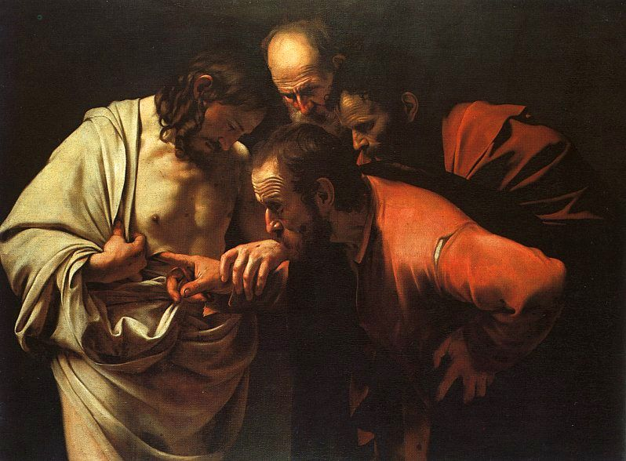
Figure 20. Michelangelo Merisi da Caravaggio. The Incredulity of Saint Thomas. Oil on Canvas. 1601-1602.
http://www.potsdam-park-sanssouci.de/picture-gallery.html;

Without actually sticking his fingers into the wound of Christ, Thomas could not believe his eyes. Similarly, community college students are often reticent participants in a classroom and may need to be encouraged to become active participants in their own educational experience. Within aesthetic education, there is formal vocabulary, criteria for evaluation, and methods and specific distances deemed “correct” by various art experts for viewing art. Although there is cross-over, differences, and variations between experts, the significant writers of the discipline are men. Aesthetic distance has historically been considered requisite for viewing and objectively evaluating art, thus, literally and figuratively widening the unseen gulf between students and the art itself. While this distance can contribute to understanding, it is only one access point to art appreciation. Dewey wrote that art was part of the very fabric of living. This idea suggests that in addition to art as encounter, students will rediscover in the encounter something that preexists within themselves. Students can build and further develop and challenge knowledge of art from their classroom experience.
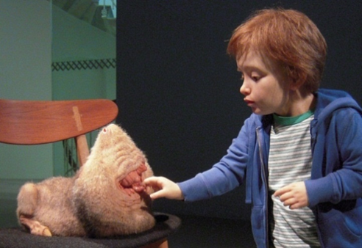
Figure 21. Patricia Piccinini. Doubting Thomas. Silicone, Fiberglass, human hair, clothing, chair. 2008.
https://www.patriciapiccinini.net/103/26. By Permission of the Artist
Consider Patricia Piccinini’s Doubting Thomas (Figure 21). Like Caravaggio, Thomas’ fingers probe into an opening; however, unlike the Thomas of Caravaggio’s work, Piccinini’s Thomas is a child, and the viewer is left to fear or wonder about exactly what is the child placing his fingers into. The sculpture conveys that it is not enough to know with the eyes. This creature has a realness to it, and the child wants to know it through his other senses. Code offers some insights for understanding the role subjectivity plays in the manner students construct knowledge. The knower, she argues, is situated in time and in a particular place, and this acts as the frame of reference for experience. People with children and those without may react differently according to their experiences. This frame of reference is further refined by “specific social and linguistic contexts, which include racial, ethnic, political, class, age, religious, and other identifications.” A parent might wonder, where is the guardian of the child?
Another way student understanding is mitigated is by the student’s ability for imaginative interpretations. Receptivity to a given subject is often governed by individual aesthetic tastes or even passionate obsessions to certain subjects. These perceptions then influence how the student as knower constructs knowledge about the subject. A student wishes she could be in on the adventure and be dreaming up the context for such a situation to occur. The student and instructor approach art from their respective situated knowledge. In a collaborative learning experience, the combined educative work to learn from Piccinini’s work and its creator dispels what Code called “…the knower as a solitary truth seeker” and replaces this with “knowers as social beings and of knowledge seeking as a communal, dialogic activity…”
Central to Piccinini’s work is the idea of encounter of beings. Her interest in ecology and biotechnology guides her creative process. Writing about Piccinini’s creations, Haraway shifts the focus from value-laden speculations about the creature’s nature to wonder, “What do they contribute to the flourishing and health of the land and its critters (naturalcultural in that sense)?” In Piccinini’s images there is an acceptance of the mutability of life, the consequences (and unintended consequences) of science for good and for ill, and an opening to another terrain. Her concerns speak to the weighty objectivity of science and value of scientific supported ways of knowing. Piccinini wrote, “I am particularly fascinated by the unexpected consequences, the stuff we don't want but must somehow accommodate. There is no question as to whether there will be undesired outcomes; my interest is in whether we will be able to love them." Therefore Piccinini creates in the hope that when humanity creates monsters (as it continues to explore biotechnology), it will also learn to love what it creates. Piccinini’s created worlds rely on those who encounter her works to be able to construct meaning conducive to bringing about positive relationships with the encountered.

Looking Glass: Easing the Divides
Art is separated from the mass of people not only by the distance established when art is located in a “preserve” of some kind but also by the distance created by commodification, be esotericism, by false claims of realism, by artificial mystifications that excluded women, people of color, and the poor. (Maxine Greene, 147)
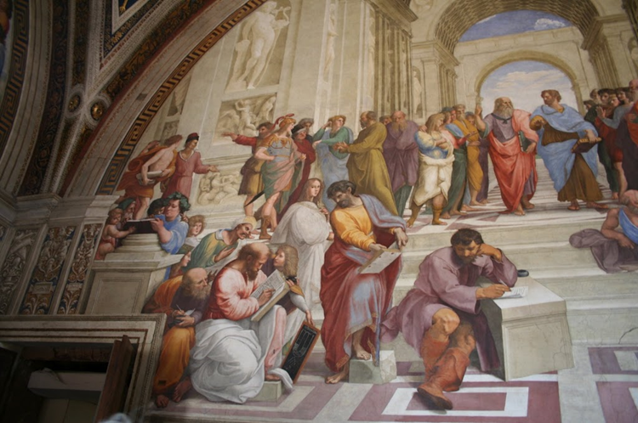
Figure 22. Raphael (Raffaello Sanzio da Urbino). School of Athens (Detail). Fresco. 1511
http://www.museivaticani.va/content/museivaticani/en.html/
Community colleges provide access to art education to diverse populations, often those the farthest removed from the art “preserves.” Jennifer González wrote, “Nearly half of all minority undergraduates attend a community college,…and the U.S. Census projects that minority populations are growing.” A commonly included image in art education texts is Raphael’s School of Athens (Figure 22). This work provides a beautiful illustration of Renaissance art and the exclusivity of a type of education and philosophical thought that may seem as alien to community college students as Piccinini’s images.
Over the history of Western art, the canon has been defined largely by men like those regally robed figures in School of Athens. Code wrote…” It is tempting to cling to the conviction…[that] publicly agreed-on procedures is the only route to clarity and certainty in knowledge…Abandoning that route admits ambiguity and tentativeness into both process and product—a reckless, dizzying prospect. If education is truly to be emancipatory, then it must respect active knowers weighing their educational experiences, participating in fashioning their own complex structure of “conceptual, political, and ‘knowledge accumulation’ factors [that ultimately] produces the conditions that make knowledge possible.”
In application to aesthetic education, Code’s foray into “displacing entrenched thought structures” might be founded first in educating by honoring difference. Within a classroom, this would mean a curriculum which would permit critique of “received knowledge” and values the experience of the knowers present. Consider philosopher George Dickies’ Institutional Theory of the art world—there is the artist, the art/artifact, the viewer, art as medium, and art as part of a continuum. All parts fit into an overall institutionalized whole. Code would probably agree as the Western canon perpetuates the patriarchy, it also reinforces social class distinctions, and further, simply reduces art to a commodity, an art object to be bought and sold. On the surface, there is nothing wrong with the parts of Dickies’ theory. The theory becomes problematic when art education serves up fixed thoughts and packaged “certainty of knowledge,” and then, unaltered, the students carry forth these same thoughts and knowledge out of the classroom.
.
Figure 23. Patricia Piccinini. Young Family. 2002. Silicone, polyurethane, leather, plywood, human hair. 80 x150 x110 cm.
https://www.patriciapiccinini.net/151/26 By Permission of the Artist.
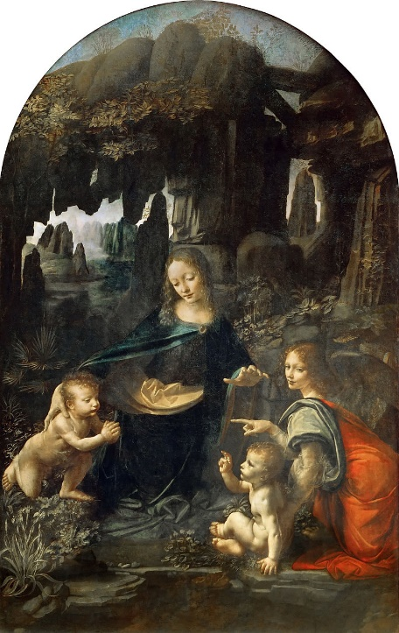
Figure 24. Leonardo Da Vinci. Madonna of the Rocks. 1483-1486.
Oil on canvas. 78.3 x 48. Louvre.
Re-visioning art appreciation may disturb the canon. Could one leave out Leonardo Da Vinci’s Madonna of the Rocks (Figure. 24) in favor of Piccinini's sculpture of Young Family (Figure. 23). Could the Mother in the Young Family be communicating ideas about mothering, nurturing, and concern for the future of the young, not completely dissimilar to those of mother in Da Vinci’s work?

Building Trusting Encounters
Art speaks for the artist; art is like the narrator speaking for another. The art narrates the artist’s life and the viewer can only know that artist through the narration and in relation with each individual’s lived situation. Ponder Piccinini’s constructed world of Undivided from 2004.

Figure 25. Patricia Piccinini. Undivided. 2004. Silicone, human hair, flannelette, 101 x 74 x0127 cm.
https://www.patriciapiccinini.net/65/62. By Permission of the Artist.

Figure 26. Patricia Piccinini. Undivided (Detail).
In a life-size bedroom, a child sleeps spooned with “an adult Surrogate for the Northern Hairy-nosed Wombat.” (Figure 25) The covers are kicked aside and the child’s teddy bear found its resting spot on the floor. The scene is of peaceful vulnerability for the sleepers. A look at the detail reveals small pouches on the back of the sleeping Surrogate, each containing baby wombats in varying stages of maturity. One baby even looks ready to emerge and explore the room the sleeping pair share. Piccinini guides the viewer’s understanding by entitling the work, Undivided (Figure 26). Clearly, while the encounter depicts differences, the image is one of trusting relationships.
Iris Marion Young describes ethical encounters with others as one of “asymmetrical reciprocity.” When students and their instructors meet and communicate with open honesty, there still must be that acknowledgement of difference. Each member of the classroom, suggests Young, “drag[s] behind them shadows and histories, scars and traces, that do not present in our communication. One of the powerful strengths of Piccinini’s work is her ability to conjure an “other.” Viewers encounter these others and are then challenged to reflect. Although a class is replete with diversity, when faced with Piccinini’s creatures, the students and teacher experience inter-conductivity. When this interconnection between students is examined, students should see how their responses, behaviors, and concerns for the quality of her or his work impact all members of the classroom community. Each member’s participation in the educative process is valued. Martin describes students’ ultimate exchange in the educative process as a gift. The beneficiaries from collaborative educational exchanges find their own educational agency as they in turn enrich the lives of those giving and passing on the gifts.

Looking to Blooms
The collaborative learning environment permits the opportunity for students to build from their lived experience. In this sharing space, there is understanding. Martin calls this the “change process” as students encounter and engage in something new.

Figure 27. Patricia Piccinini. Eulogy. 2011. Silicone. Fiberglass, human hair, clothing. 11 x 65 x 60 cm.
https://www.patriciapiccinini.net/68/26. By Permission of the Artist.
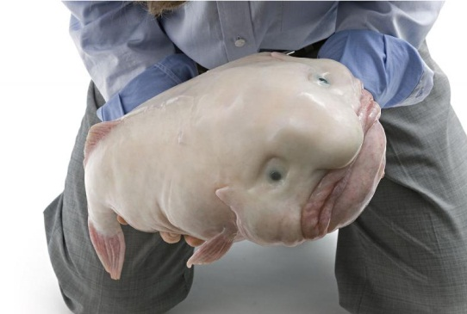
Figure 28. Patricia Piccinini. Eulogy (Detail).
Imagine community college students and teachers encountering Piccinini’s Eulogy (Figure. 27). Guided by the revised version of educational psychologist Benjamin Bloom’s taxonomy, students could be asked to recall and list (remembering) what they know about Eulogy (Figure. 28). It is likely that the associations will vary and may include fishing and funerals. The question may be asked, is this a real fish? Yes, it is a blobfish. A member of the class, via phone or laptop, could read aloud the description (understanding). This boneless, gelatinous fish lives at depths of two or three thousand feet hovering just above the sea floor. With the information at hand, the question could be asked, why would the artist entitle the work Eulogy? (Applying) Inedible, these creatures are caught by trawlers and discarded, and now face extinction. Piccinini’s efforts to raise awareness point to a basic problem with the Save the Blobfish campaign: the creature simply lacks visual appeal. Students could then be asked about the visual appeal of the blobfish. This squishy, translucent, viscous, and unnatural fishlike otherness both draws the viewer’s eye and may make the stomach pitch. Piccinini feared their form would supersede normal calls of the activists and perhaps may even doom the blobfish in the end. Students could be asked to examine the role appearance plays in preservation efforts (analyzing). Building from what they know (remembering), students could move through the cognitive levels with Bloom and find something new (creating). Similarly, Martin suggests through the course of “yoking together” each student’s abilities and cultural stock, there is learning, and in the classroom, students may learn to reclaim abilities and cultural stock and builds from there. Thus, she argues, “The change in that individual’s end state is, in turn, what has been learned.”

Figure 29. Patricia Piccinini. Newborn. Silicone, fiberglass, human hair, clothing, 110 x 65 x 60 cm.
https://www.patriciapiccinini.net/109/26. By Permission of the Artist.
Community colleges classes are often comprised primarily of women, many of whom have children. Most students attend college part-time while working full-time. Students must negotiate through campus culture and use the jargon of the domain. Inadvertently (or purposefully), educators can become a cultural liability to students, if instructors fail to consider the value the experience of our knowers. For example, Piccinini’s Newborn (Figure 29.) would not be quite like other babies. There are those who would call for the child to be raised and those who would call this child abhorrent. There may be an inclination to focus on difference and how figures are othered or mutant. However, in a world of standardized tests, trend setters, and multi-million-dollar campaigns designed to ensure the populous knows what products are best, those who don’t measure up on tests, the mutants, the myriads of othered others, must wrestle to know their worth and recognize their capacities. Pedagogically, students can be made to feel othered, and without support, the educational landscape can be a strange and unwelcoming place. This makes it is imperative to translate a welcoming message through Martin’s care, concern, and connection in order to foster student agency. This again is where educating for and with aesthetic disgust is both important and significant. The unfamiliar and different offer vast opportunities for students to create new relationships and expand their understanding of the world around them.
For some members of the class, the significance of the encounter will be greatly affected by the creation of an environment where difference is valued and being open-minded is prized. “Imagination, [according to Greene], may be our primary means of forming an understanding of what goes on under the heading of “reality”; imagination may be responsible for the very texture of our experience. Art can offer the opportunity to grow and discover through these encounters.
Students can truly be the beneficiary of Code’s “open middle ground where an inquirer can take a position, a standpoint, within a forest of absolutes.” Too often classrooms are filled with students who occupy space together but little else. When students and instructors share in the responsibility for the learning experience, a collaborative learning environment can grow. Participants recognize the value of the experiences they possess and how this understanding is mitigated to encompass various perspectives. Using the theory of education as encounter, students and their instructors gather to study art. Respecting the capacities and cultural stock each student brings, a collaborative learning experience can be developed. This learning environment takes time, commitment, and a willingness to value the importance of each individual's unique history and abilities. The knowing of another will change in how each one responds to another in the classroom. Students engaged in collaborative classes are more likely to recognize their responsibility with their collaborative partners; collaborations turn strangers into friends. For first generation community college students, being viewed as seekers of knowledge worthy of having the support of peers and instructors is important validation. Transferring the problematic social significance of othering art works from Piccinini’s art challenges the viewer even as her imagination fashions new worlds. She takes on problematic social significance of othering but Piccinini’s imagery is also worth the encounter.

Contrariwise: Disgust, Not Beauty, As Central Theme
Students encounter visual images at every turn of their daily lives. Literary critic Roland Barthes wondered, “How can we look without seeing? One might say that the photograph separates attention from perception and yields up only the former…” Students live in and through social media; they are saturated with imagery as never before. Berger (1975) suggested, “We are now so accustomed to being addressed by these images we scarcely notice their total impact.” The democratic medium of photography has blinded the eyes of all to images except those works documenting human atrocities, argued Sontag. So how does an instructor make art appreciation meaningful and relevant? In order to see difference in all of this sameness, infused difference via images of aesthetic disgust may provide that contrast to make visible that which could enrich art appreciation curriculum in ways exanimations of aesthetic beauty alone could not.

Remaining Disinterested in the Face of Disgust
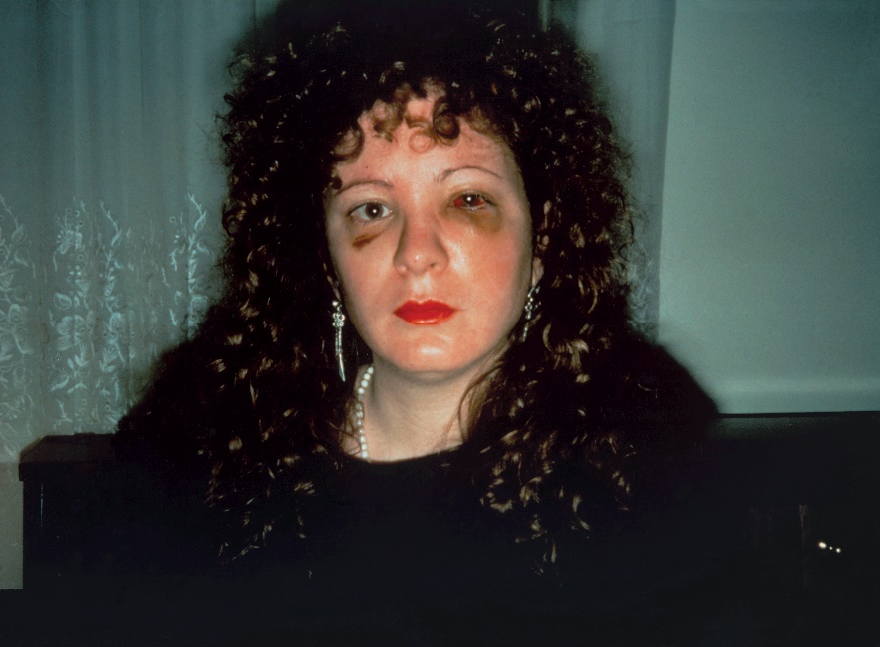
Figure 30. Nan (one month after being battered) 1984 Nan Goldin
©Nan Goldin, Courtesy Matthew Marks Gallery
Red lipstick, jewelry, and “done-up” to go out, Nan (Figure. 30) faces the viewer. The mottled bruises and the warmth of her flesh against its complementary cool color produce an arresting image of a woman. Nan’s eyes demand attention. What is the prerequisite for the appreciation of this work of art? Is it possible for the viewer to objectively or “impartially” look at this work? According to theorists of arts and aesthetic education Michael Parsons and Gene Blocker, this objectivity is called aesthetic “disinterest.” They suggested that with art, the reason for looking is “…simply the pleasure of looking at them [art objects]. That is, we look at these “for their own sake.” This is what “disinterested” means, that we are personally unmotivated by any personal interest in the outcome. Our attention is only on the qualities of the object….” Although this aesthetic “disinterest” had fallen out of favor, Parsons and Blocker still maintained, “…The less experience one has with art in general the more personal motive hinders one’s aesthetic response.” Emotions cloud one’s ability to look at the actual characteristics of the work itself.
Dewey suggested there was a disconnect in this objective viewing. This disconnect presupposes that there is an agreed upon set of standards and that these standards will likely be drawn from social norms or through the societal elite. He argued in opposition to Parsons and Blocker, saying it is in error to say the painting itself is lovely; rather, the loveliness comes from the experience within, from the viewer as he or she looks at the painting.
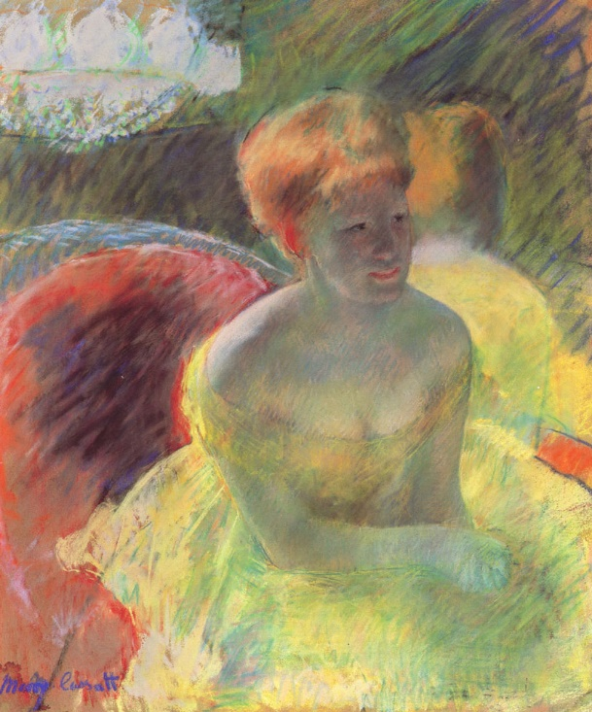
Figure 31. Mary Cassatt. Lydia (At the Theatre) 1879. Pastel.
The practice of disinterest, or what Dewey called “the submission to convention in practice and intellectual procedure,” seems to be in opposition to aesthetics. Examine the image of Nan Goldin’s Nan and then Mary Cassatt’s Lydia (Figure. 31). Are both women examples of aesthetic beauty? The answer is maybe yes, but for different reasons. Lydia is fine example by American Impressionism painter from the canon of those significant artworks that define Western art history. Nan is not. Nan’s color scheme is complementary like Lydia’s; however, the effect is not to charge the image with warmth and/or energy; it is, instead, to press discord, dissonance and disharmony. Nan is an example that sits right on that edge between aesthetic beauty and aesthetic disgust.
Korsmeyer defined aesthetic disgust as “A response that, no matter how unpleasant, can rivet attention to the point where one actually may be said to savor the feeling.” . My fondness of the foul and fair, pushes me to amend professor of education Deanne Bogdan’s “shiver” and “shimmer” by adding the term, shudder. Bogdan assigns the term shiver to describe the state of person experiencing “the ‘fingers-up-and down-the spine’ sensation often experienced” in aesthetic experience. Shimmer is this and more “are non-hierarchical, coterminous, and recursive, together represent an active form of meditation-in-relation.” And what if the experience is one of horror or disgust? Is a shiver of pleasure the best way the articulate the experience? The visceral nature of disgust, extreme pain, or horror seems more akin to a shudder than that of a shiver of pleasure experience. Shiver or shudder, both have powerful aesthetic educational potential to unpack.

Savoring Different Kinds of Disgust
Korsmeyer further suggested that there are two basic types of disgust: the visceral (or contact with repugnant) and the moral (or pertaining to transgressions against social norms). These two forms of disgust become linguistically intertwined. She argued, “Disgust is an affective response that can be mustered to patrol social boundaries and norms—for instance, to reinforce proscriptions on what should be eaten or on sexual behavior.” Disgust seems to be an innate part of the human experience, but what people find disgusting is often culturally created. Through intentional cognitive manipulation or through a strict physiological reaction, images of disgust illicit responses from the viewer. Disgust embraces rotting foods or flesh, bodily fluids, and the gradual decline of the body into dust, only to prick at the edges and senses of the body. These pricks invite a need to recoil, induce feelings of revulsion, fill the nose with putrid smells, and conjure ideas of things that emit squishy and oozing matter.
Korsmeyer distilled disgusting eating into six categories, which were then divided into one of two groups. Group one contains foods a person found disgusting and also foods that one could eat in small amounts, but when eaten in excess, move the food from good to gross. Group two contains foods that are considered too strange (as in eating a tick) or not strange enough (as in eating another person). Also, in this group would be eating things that are alive or looked too much like they are living or eating something that have been dead too long and are rotting. Moreover, food is prepared with violence—killing, chopping, skinning, burning and other such actions. Some stages of food produce less than pleasant intermediate tastes and smells—fermentation and spoilage.
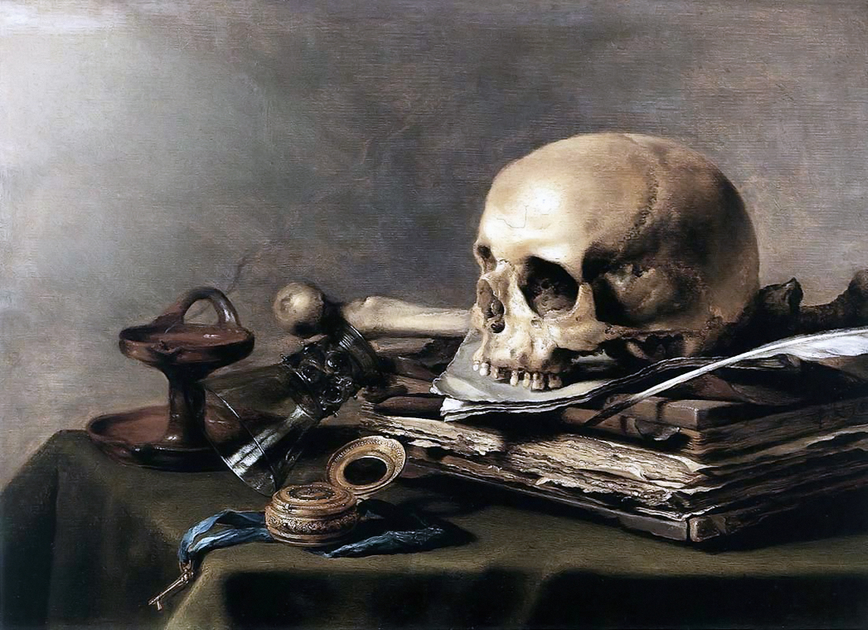
Figure 32. Peter Claesz. Vanitas Still Life. 1628. Oil on Wood. Rogers Fund, 1949.
https://www.metmuseum.org/art/collection/search/435904,

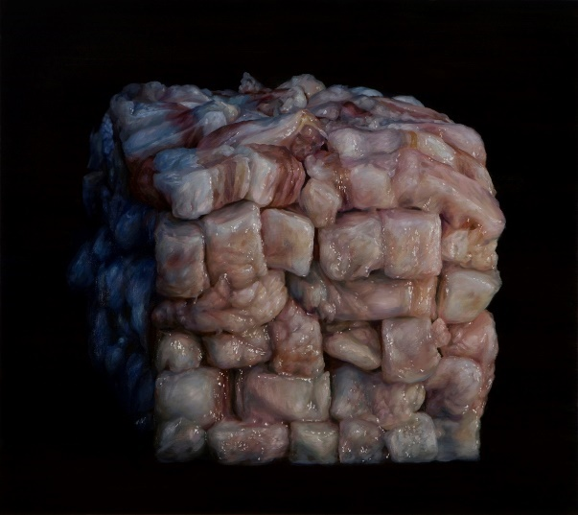
Figure 33. Cindy Wright. Baconcube. 2010. Oil on linen, 49 ¼” x 55.
http://www.cindywright.org/dt001011.html. By Permission of the Artist.
The inspiration for Cindy Wright’s painting, Baconcube (Figure. 33) is derivative of her fascination with Baroque vanitas paintings like the one painted by Peter Claesz (Figure. 32). Vanitas imagery are filled with symbols of the transient and fragile nature of a human life. Artists of the vanitas genre includes such items as candles, drinking glasses half-full (or half-empty), luscious fruits, exotic flowers, meats, books, musical instruments, hour glasses, and human skulls, and other bones. The cups and dishes are almost always depicted precariously balanced or on the edge of tipping or crashing to the ground. Included items like sheet music or gold frequently symbolize the rewards of intellectual or fiscal pursuits, which are then topped with bones to indicate these items remain with the living rather than the dead. The fruits and meats are most often rendered on the edge of rotting and the flowers are drooped with blooms past the prime of perfection. Claesz’s Vanita contains a skull’s unseeing eyes which warn the viewer that all is vanity.
Wright takes one aspect of the vanitas and painted stacked, slick pieces of raw flesh. The viewer knows from experience that meat does not last long in this state. Wright’s work more than doubles the size of the Claesz work, which made the appearance of the meat more imposing. Even though one could not taste, feel, or smell these works, the image calls to those senses. Wright’s images of meat do not easily permit a disinterested contemplation of their subject matter; rather, a variety of physiological responses occur in answer to the painted image. Her art at a certain distance is work of trompe l’oiel; yet, up-close, the work surfaces take on abstract qualities that lose the clear “meat statement” of what could be seen as the “intended” viewing distance.
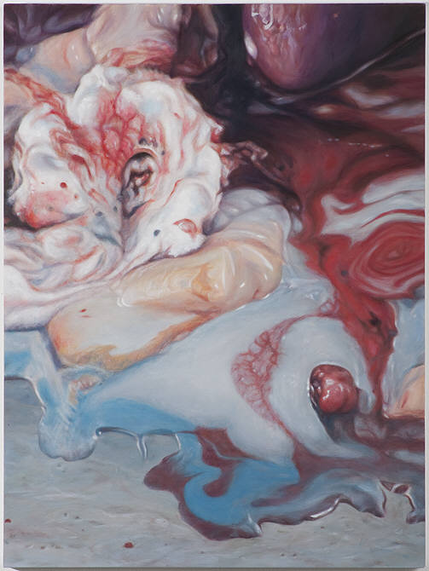
Figure 34. Victoria Reynolds. Cream Cascade. Oil on panel. 24” x 18”
Collection of the Artist. By Permission of the Artist.
Victoria Reynolds is another artist that draws inspiration from the Baroque vanitas and painted meat. Her painting, Cream Cascade (Figure. 34), works rather like the reverse of Wright’s Baconcube (Figure 33). What the viewer sees at first blush is a rich creamy swirling substance pooled around small, more solid, masses; this perhaps is the thick ooze of what might have been a melted sundae. The cream advances from the top of the canvas, melts towards the viewer, and leaves only a small area open, and this is in danger of being submerged. This slow progression of ooze might trigger a cloying sensation, but if the viewer studies the masses more closely, the cream is revealed to be the viscous matter of internal parts of an animal. Culture contributes to how the viewer responds to images, and Reynolds as artist was both a part of culture as well as one who shapes, pushes, and entwines with culture. Reynolds’ conversation with those who process animals for food lead her to discover a shared beauty where others might have only seen the viscous surfaces of slain creatures. Aesthetic disgust, according to Korsmeyer, “profoundly recognizes—intimately and personally—that it is our mortal nature to die and to rot. Acquiescing to this terrible truth and finding beauty in the overall pattern gives it shape is both an artistic and a philosophical accomplishment.”
Reynolds’ work also employs the use of elaborate framing. These ornate frames seem to signify that this painting is an important painting found on the walls of important people.
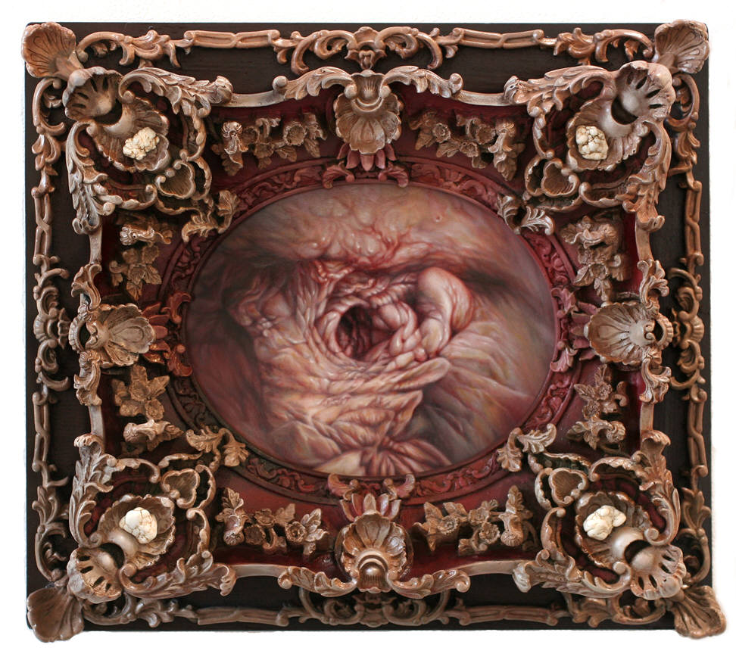
Figure 35. Victoria Reynolds. Fat Mouth. 2008. 16” x 18”
Collection of Blaine Halvorson, CA. By Permission of the Artist.
At the center of Reynolds’ Fat Mouth (Figure. 35) is a fleshy orifice which is ringed with folds of irregularly bundled pale pink fibers. The painted portion of this intimately small work is surrounded by a Baroque frame of high relief decorative shape that undulates but is clearly made from wood. The exploited contrast of the highly decorative wood frame against the more simplified patterns of the meaty opening summons the viewer’s attention and sets the stage for consideration of this grisly composition. The orifice looks like it is trapped beneath the frame and leads the viewer to wonder, is it living or rotten? If you stuck your finger into it, would it snap shut? Fat Mouth takes its genesis from characteristic Baroque theatrical excess and paintings that reflects the brevity of life (the Vanitas). The removal of traditional still life objects (i.e., candles, flowers, or skulls) dislocates much of the embedded cultural symbolism allowing for new conversations on the vanitas to be formed. Reynolds’s might disgust; however, her images capture what could be seen as a temporal beauty amid the fragility of the flesh.

Disgust or Difficult Beauty
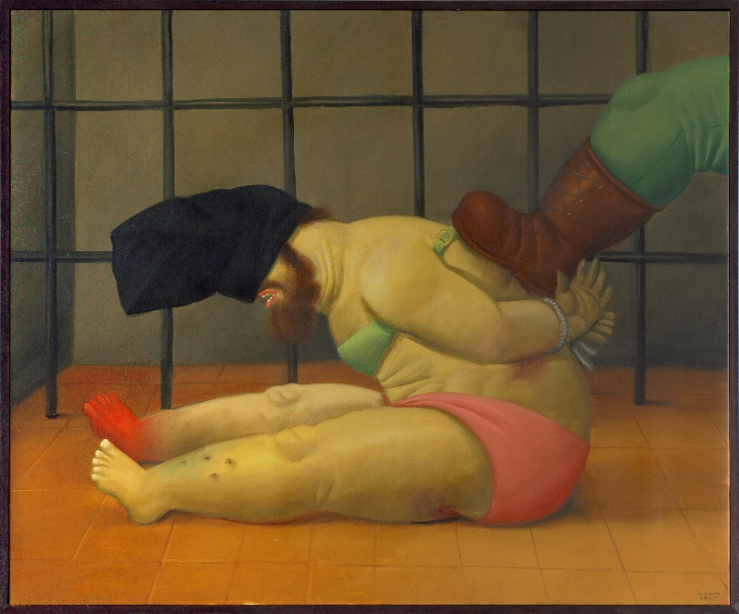
Figure 36. Fernando Botero: Abu Ghraib 60, 2005: oil on canvas; 51-5/8 x 62-1/4 in.
University of California, Berkeley Art Museum and Pacific Film Archive, Gift of the artist. 2009.12.32
© Regents of the University of California
There is nothing fragile about Fernando Botero’s (Figure. 36) depictions of the human form. His stocky bodies are well-known in the art world, yet his artist merit is sometimes dismissed as “light weight” because of his commercial appeal. The creation of a series of works based on the photographs of the Abu Ghraib prison abuse and torture brought new attention to Botero’s work. The photographs as horrific as they were, documented the scene. According to philosopher Arthur Danto, Botero’s work “…By contrast, establish[ed] a visceral sense of identification with the victims, whose suffering we are compelled to internalize and make vicariously our own.” Botero has refused to sell the works and is not seeking profit from them; rather, he is using his visual voice and aesthetic disgust to keep the horrific nature of these events awake in the public eye.
Kant maintained, “It is the disposition of soul evoked by a particular representation engaging the attention of the reflective judgement, and not the object, that is to be called sublime.” Although Botero’s work is one of aesthetic disgust, it also provokes and invokes reflection on the sublime. Botero’s work seems to demand a response from the viewer. The response to the sublime is not tepid. Edmond Burke stated:
…the great power of the sublime, that far from being produced by them, it anticipates our reasonings, and hurries us on by an irresistible force. Astonishment, as I have said, is the effect of the sublime in its highest degree…No passion so effectually robs the mind of all its power of acting and reasoning as fear. For fear being an apprehension of pain or death, it operates in a manner that resembles actual pain. Whatever therefore is terrible, with regard to sight, is sublime too…
The tormented, bound figure of the Abu Ghraib prisoner is astonishing. How can it be that humans act so inhumanly? Burke describes the idea of sublime. Burke’s words seem to suggest the artist has drawn on universal and often secret, unvoiced fears of viewer vulnerability. The viewer’s aesthetic disgust makes room for a discussion over the misery, pain, and an uncertain future of the bound man. Aesthetic disgust and the pleasure of looking but not experiencing exist, co-mingled. In his Three Lectures on Aesthetic, Bosanquet wrote that there were two “classes” of beauty, easy and difficult.
The richly saturated colors of Botero’s rounded figures possess elements of simple or “straightforward pleasure,” but the prisoner’s body, naked except for underwear and a woman’s bra, as well as the burn marks, discolored hands and foot move the image into the second class because difficult beauty can trigger visual resistance, which can translate into something repulsive or to be rejected. Hidden from the viewer’s direct gaze are the eyes of the prisoner and the identity of the tormentor. The room is bereft of any elements of comfort, showing only floor and bars. Of the 11-key people identified in this atrocity, only 6 served any time for their crimes. Most of those in higher command were censured in some way, but no prison time. Botero’s work has a political/social agenda and in these instances of aesthetic disgust tread the line between Korsmeyer’s categories: visceral and moral disgust.
Images of aesthetic disgust ask for a response and can be viewed as a challenge to “beauty.” Kant maintained,
One kind of ugliness alone is incapable of being represented conformably to nature without destroying all aesthetic delight, and consequently artistic beauty, namely, that which excites disgust. For, as in this strange sensation, which depends purely on the imagination, the object is represented as insisting, as it were, upon our enjoying it, while we still set our face against it, the artificial representation of the object is no longer distinguishable from the nature of the object itself in our sensation, and so it cannot possibly be regarded as beautiful.
Kant’s perspective suggests a disgusting image forfeits further consideration as art, as a thing of beauty. Yet as Korsmeyer suggested, the disgusting still finds purchase by “sidling up alongside things that are nobly and perfectly formed, including those things that are otherwise painful.” Images that provoke feelings of disgust are wedded with images that demand to be seen and their message received. Through acts of cruelty, Botero painted a horrific event in a way that enticed the eye, it is incompatible with natural beauty. Yet, one cannot help but find Botero’s image both horrifying and beautiful.
Korsmeyer argued disgust is redefined by people and changes as people change. If one eats too many cookies, what was wonderful now becomes an object of disgust. Disgust involves a reaction to and a shrinking from the object of disgust. Somewhere in the “second curious look,” Korsmeyer maintained, is the window of discovery and an aversion initiates reflection.” In the reflection and with this reflection is the understanding that the disgust is not just for the “sheer arousal” alone, but rather, as philosopher Aurel Kolnai, explained ‘the object of disgust is prone to be connected with something which is concealed, secretive, multilayered, uncanny, sinister, as well as something which is shameless, obtrusive, and alluring.’

Educating with Disgust
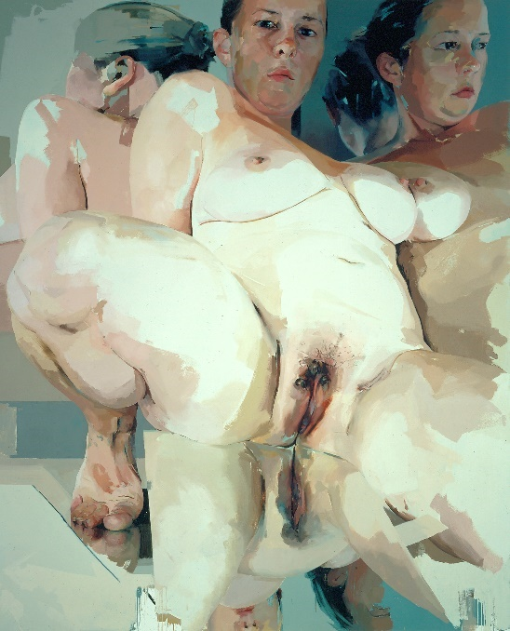
Figure 37. Jenny Saville, Reflective Flesh, 2002 – 2003, Oil on canvas.
120 1/8 x 96 1/16 x inches, 305.1 x 244 cm
©Jenny Saville 2017. Courtesy of the Artist and Gagosian.

Also captivated by flesh is artist Jenny Saville (Figure. 37) Her 10-foot by 8-foot canvases of women challenge the point of view of the onlooker. She maintains, “Beauty is always associated with the male fantasy of what the female body is. I don’t think there is anything wrong with beauty…if there is a wart or a scar, this can be beautiful in a sense, when you paint it…Individual things are seeping out, leaking out. Saville presses against the “disinterested” looking, thrusts the viewer in a confrontation with traditions of classical Western beauty, and forces the examination of the human form as it defies accepted norms. Korsmeyer suggested that Saville’s exploration of the body and the power of disgust places her work on a knife’s edge of altering or defying conventional beauty, leading to a deep aesthetic experience. Through the size of the canvas and scale of the form, Saville places the viewer in the position to look at the female form from a ground up perspective.
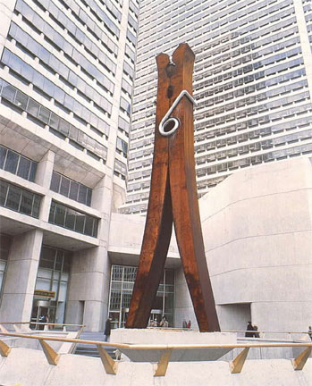
Figure 38. Claes Oldenburg, (1976). Clothespin, Core-Ten and stainless steel, 45' x 6' 3 3/4" x 4'.
Central Square Plaza, Fifteenth and Market Streets, Philadelphia. © 2006 Claes Oldenburg and Coosje van Bruggen.
Similarly, exploring the visual concepts of scale is Claes Oldenburg in a work called Clothespin. Like Reflective Flesh, the sculpture shifts the viewer’s perception by a radical explosion of size and medium, making a small object of domestic chores into a monument. The use of Oldenburg’s work within an art appreciation class to explore the Pop Art movement and the visual concepts of scale, perspective, and place may indeed provide a rich learning lesson, but consider what could be added through aesthetic disgust. The exploration of scale, perspective, and even place could begin with Saville’s work. The content of Saville’s work also opens the way to explore women’s issues and ideas held about women’s bodies. This visual investigation might become a feminist discussion reviewing cultural ideals or distortions. The discussion might be about changes in views on women in the context of time, according to gender, or how the art and artists are shaped by the “male” gaze or “female” gaze.
In her desire to reach her goal and change, Alice forgets her identity. When she emerges from the woods into the open, her memory returns. To reach her goal, Alice seeks the advice of twin boys, Tweedledum and Tweedledee. Their response to Alice’s question, “Would you tell me which road leads out of the wood?” is answered with recitation of The Walrus and the Carpenter. The poem analysis discussion following the recitation somehow results in Alice dressing them for “battle.” Alice briefly assumes the gendered role before breaking free and moving along. This is not unlike addressing interesting works of the canon. Oldenburg’s work has significance. When the Oldenburg work is analyzed within the context of a feminist issue prompted by aesthetic disgust, the analysis and perspectives about the Clothespin may change, grow, and/or evolve; thus, laying the groundwork for the necessity of the thought experiment and ultimately, the curriculum re-visioning.
.

CHAPTER 4

Time to Talk of Many Things: Critical Aesthetic Pedagogy: The Thought Experiment
Alice, as pawn, follows a white knight. He and his horse are laden with things, all devices of own creation. His inventions go awry, but with each stumble, the unintended consequence results in a new invention. Governed by rules of chess, the knight’s move permits Alice’s final move to the 8th square to become queen. The crowning of Alice and her surprise is a result of cognitive discord. While she explores the looking glass world, she is unsure if what she knows still holds true. New students may share this same cognitive discord and further, instructors who are inventive may discover unintended consequences as they try to make changes to the classroom environment, curriculum, and pedagogy. From cognitive discord to aesthetic disgust, for some is visiting the alien world of the looking glass terrain. Care, connections, and concern seem essential elements for any successful transition.
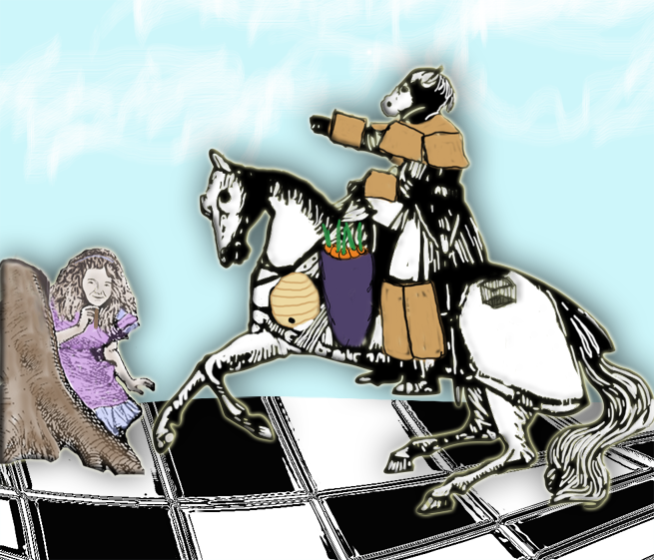
Figure 39. Catherine Johnston. Alice and the White Knight. 2017 Digital Image.

Art Appreciation Terrain
Art Appreciation instructors teaching the same course are most often required to meet the learning objectives and use the same textbooks. Professors Lenetta Choate and Marybelle Keim (1997) surveyed community colleges in Illinois to learn what was being taught in art appreciation, who was teaching the courses, and what kind of resources were being utilized. Choate and Keim received 29 community college respondents.What they found was most of the instructors had educational attainment of a master’s degree and had been teaching for at least 10 years. Most of the colleges relied on overheads, slide projectors, film projectors, tape or disk players and half had computers. Nearly all the colleges offered art history and art appreciation. “Eighty-six percent (n=25) of the instructors used lecture.” The remainder incorporated lecture and discussion or lecture and demonstration or hands-on. The art periods emphasized were largely Western, the named artist did not include any women, and most the weighted assessment was a major test. If this survey was replicated today, responses would most likely reveal that there are multimedia units with Internet access in each classroom.
One of the popular art appreciation textbooks listed by the respondents, Living with Art, was in use during my thought experiment. According to Charles Jansen (1991), Rita Gilbert, the original author, was an associate professor at North Texas State University. When the textbook went to the 6th edition, Mark Getlein took over authorship. According to the publisher’s website, Getlein was attending or going to attend Julliard School, but became enamored with the idea of becoming a textbook writer/editor. Each edition gives thanks to a host of company contributors and college and university faculty reviewers. Instructors must trust the publisher, that those who author the textbooks, have the educational background to do so. Each edition brings some changes, but the overall structure remains visible. Of particular interest to this research is the section on Art and Beauty.
In Gilbert’s editions, this section begins with what she believes is a common assumption, “all art should be beautiful,” but today there is ugly art. She steps the reader through a discussion about the nature of beauty, artist intent, and point of view. Gilbert pairs Ivan Albright’s Into the World Came a Soul Called Ida and Edmund Burke’s essay on The Sublime and the Beautiful to open students to “delightful horrors” and wonderfully powerful works. She writes, “The observer of art should be open to the widest possible range of experience. Art that momentarily pleases the eye offers only one level of experience. Art that touches the intellect and the emotions beings far greater satisfaction.”
In contrast, this section in Getlein’s edition begins with, “Beauty is deeply linked to our thinking about art.” He uses the word aesthetics as referring to the common belief that art is supposed to be beautiful and raises the suggestion that being “beautiful” is art’s purpose. Getlein discusses the 18th century practice of disinterested consideration of works of art. He alludes to theorists, but he does not name any nor are any cited in the notes for the chapter. He writes that art can produce a range of emotions, pleasant and not. “The common thread is that in each case we find the experience to be valuable for its own sake…Beauty remains a mysterious concept, something that everyone senses, many disagree about, and no one has yet defined.”
The title of the textbook is Living with Art and instead, Getlein’s reductionist treatment of the concept of beauty contributes to art as a preserve (Greene), a divide, or island that a person can cross or visit.

Shoes: Course Terrain
Walking into my classroom on the first day of class, I looked at the faces of those who have enrolled in my section of art appreciation. Some students have academic experience and others are brand new to the college. When I explained that in addition to being an administrator for the college, an artist, and an instructor for the class, I was also a student just like they were, I had the classes’ complete attention. I explained that I wanted to do something new with the curriculum. I needed their help to see if my thought experiment could be more than an experiment. There was a feeling of curiosity, some concern, and a connection that we were about to begin something together.
The experiment I proposed was a studio experience approach to art appreciation. This serves to move students away from their passive position in the classroom. Learning encounters (Martin) can evoke cognitive dissonance in students accustomed to having information poured into them. Professor Yolanda Medina (2012) outlines the three essential elements of critical aesthetic pedagogy: creating a safe, welcoming environment where students feel comfortable sharing their experiences and the cultural capital they bring; eliminating the “banking” teacher-student exchange and moving to “problem posing” conversations between teacher and among students about content; and encouraging students to examine how experiences (of all kinds) shape who they are and impact how they negotiate the world in which they live (Medina, 28 Freire, 81).
Medina defines an aesthetic experience in this way, “[T]he relationship created in the space between an observer and a work of art, and the way this artwork affects this observer. It is a moment of perception…when we are fully aware and full awakened by the artwork in front of us.” She utilizes dance professor Susan Stinson’s (1985) three ways to consider the aesthetic experience to guide her curriculum. In the first level, beauty is intrinsic in the artwork. To understand art, you must have special knowledge. This level does not freely invite students to offer ideas about art, rather, it suggests that the instructor or some other expert must be consulted to validate ideas resulting by interaction with the art. The second way to view the aesthetic dimension is to place focus on the experience of the viewer and what he or she bring to the art rather than art itself. The final way to look at the aesthetic dimension is the artwork becomes a vehicle through which the student can see a view of the world, perhaps a different view of the world. Through this perspective art becomes a point of connection to feel empathy and compassion towards they seen.
From Stinson, Medina derives two essential concepts for success for critical aesthetic pedagogy, “…imagination illuminates the path towards possibilities” and “…compassion gives us the desire to embark on the path to change.” Thus, the curriculum for art appreciation can serve an important role in the lives of community college students. The art appreciation classroom becomes place for possible selves and to engage with other students in a respectful safe environment. Student -selected and culturally relevant imagery requires power sharing and a willingness for the instructor to take the position of a teacher-student as well as class participants to take on the role of student-teachers/co-mentors.
The students who became my teachers in this thought experiment came rich with cultural diversity. Of my original 23 students, 22 signed agreements (see Appendix A) to be participants. The majority of the students were taking the class to fulfill a requirement, but a lot of students selected the class specifically having an interest in art. There was a decidedly feminine presence, with more than 3 times the number of women than men. The student majors were evenly divided between the hard and soft sciences. Two students failed because they quit coming to class and all attempts to contact them on my part were unsuccessful.
The classroom was set-up for cooperative learning. There were 7 large tables, each with 4 seats. At the back of the classroom were 4 computers stations. The room was equipped with open Wi-Fi, a projection unit, a smart board, and a 5th computer station linked to the projection unit. To determine who would sit together, I had the students take the VARK questionnaire and email me their results. The VARK questionnaires were developed by Dr. Neil Fleming to determine learning preferences—V-visual, A-aural, R-read/write, and K-kinesthetic. While students may desire their learning experiences in a particular modality, most students are multi-modal. I wanted to ensure students with singular learning preferences were distributed across the groups.
Students were aware from the first day that this section of art appreciation would be different from other sections being offered. As we went over the syllabus (Appendix C), I provided the students with the standard art appreciation course description:
Course Description: The study of art from a variety of different backgrounds and cultures as both product and process. Aesthetic judgement making in evaluation of art from different times and places is stressed. Periods of art history with relevant concepts and terminology are included.
We read through the course description for the section as I re-visioned it:
Expanded Course Description: This course is designed for students as an exploration of art. Students will fashion working definitions of art, art appreciation, aesthetic beauty and the rarely discussed related term aesthetic disgust. Students will examine the established context and vocabulary of art in order to analyze imagery and reconstruct content for relevant meaning. In addition, to make conceptual aspects of the artistic/creative process more tangible, students will also engage in active learning exercises.
In addition to course description modifications, I expanded the learning objectives and course competencies. The first three re from the original syllabus:
Students will be introduced to the vocabulary and philosophy of art and aesthetics; Students will explore the relationship between the arts, culture, and the history of ideas; and Students will apply to the skills of visual literacy and critical thinking in written form.
These learning objectives were written to the lower levels of Bloom’s Taxonomy. To those three, I added:
Students will demonstrate unpacking art; Students will reconstruct unpacked art content; and Students will construct personally relevant meaning from art content.
These learning objectives expected students to move through all 6 levels of Blooms in the course of a semester.
Student learning was documented through both group and individual work. Assignments were creative assignments (mask making, drawing, and printmaking), a student research project concerning the American flag in art, daily group work, a group presentation, and a visual analysis essay. Students were given pre-and post-survey (Appendices B and F) comprised of largely opened questions on art, the ideas about art appreciation, beauty and aesthetic disgust, class expectations, and what they would include in an art appreciation class.
In order to align this section of art appreciation with the other sections, I utilized the following chapter headings as a framework: “Living with Art?”; “What is Art?; “Themes of Art”; “Visual Elements”; Principles of Design”; “Drawing”; “Painting”; “Prints”; “Camera and Computer Arts”; “Graphic Design”; “Sculpture and Installation”; and Architecture.” Chapters 15 through 23 covered the entire history of art from the ancient world to the today. Students would be selecting from remaining chapters to find a creative way to document their findings and share them in a class presentation. Lectures were brief and meant to provide information for the subject to be covered. Lectures were not closed to questions. Some lectures were derived from class conversation in the previous section. At the close of the mini lecture (15 minutes or less), I would propose a prompt for table discussion. The tables would be asked to formulate a table answer with image illustrations to support their answer as well as the source of the imagery. Students would work these out in their notebooks. Resources at hand were their textbook, phones, laptops (if they had one), and four computers in the back of the room. These answers would need to be emailed to me or put in the Learning Management System (LMS) dropbox before the next class. I would assemble the answers, add information that I thought might be beneficial to a separate slide, and upload the PowerPoint for the class to the LMS. This presentation would be the first item on the next classes’ agenda and each table would be responsible for explaining their resolution for the prompt.

Figure 40. Art Class on Wheels. 2015. Digital Image.
During the second class, I assigned student tables and gave out table tents for each student to put their names on and to decorate as they wished. A bag of art supplies was issued to each table. The bags contained scissors for each member, crayons, markers, glue sticks, white, and tacky glue. I had to devise a way to make my class supplies portable (Figure. 40). Each table was given a spiral-bound drawing notebook (Figure. 41) and a sheet of paper. They were asked to cut the paper in some way and give a section to each person in their group. On the paper each person should draw something that meant something to them or said something about themselves. Each table completed their mini drawing and reassembled them to form the cover for their table’s notebook.
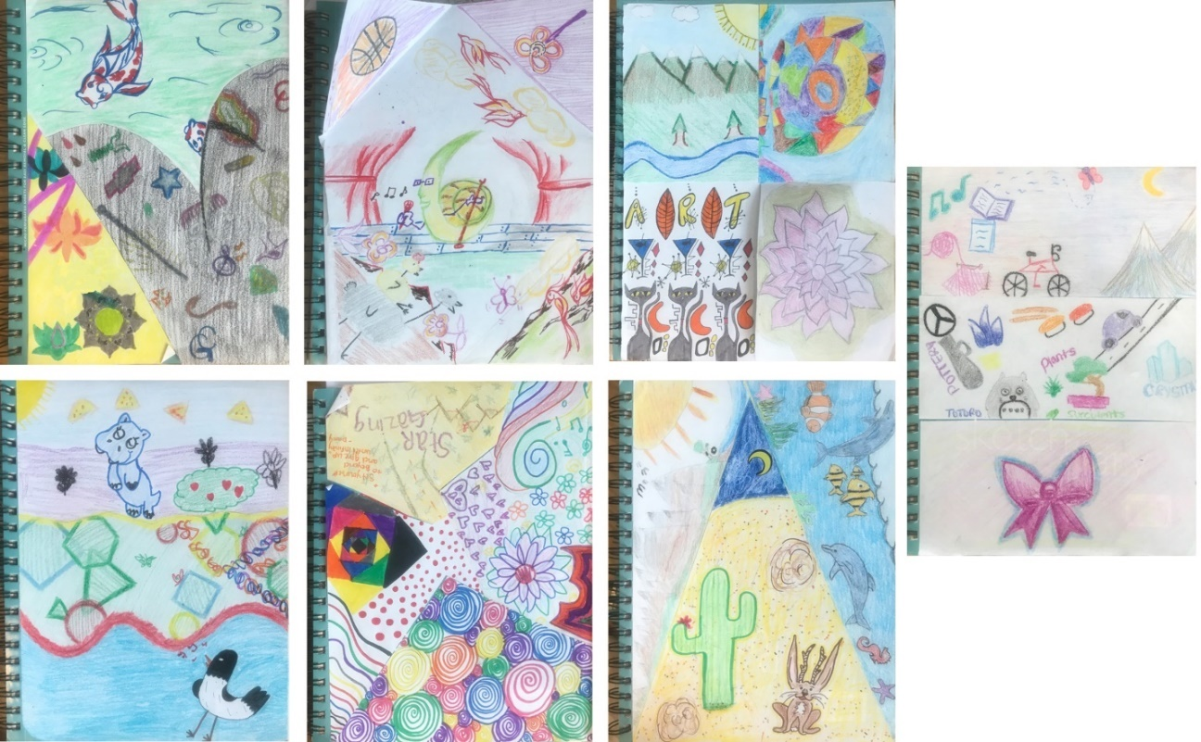
Figure 41. Student Notebook Covers. 2015. Digital Image.
These notebooks were used by each table to take notes and collect useful vocabulary, plan submissions for their group’s contributions for class assignments, and to plan group projects. After a couple of class periods, I was able to identify which book went to which table by the drawings on the cover. Each person’s personality, likes, and drawing style began to emerge linking their drawing with their face and name.

Ships: Learning Experience
To set sail, I introduced students to the term aesthetic disgust. However, at the beginning, Bosanquet’s term “difficult beauty” was easier for students to understand. Students determined quickly whether something was beautiful or not. Seeing difficult beauty is the transformative aesthetic learning moment when looking at a challenging work of art. During group work, as the students were selecting work to illustrate their definitions, one student told the others he thought there might not be anything different between aesthetic disgust and aesthetic beauty. Further, he thought that beauty did not have to begin as beauty, but might begin as something not beautiful, disgusting, or ugly, until you understand the work. This aligned with Roger Fry’s (1912) The Grafton Gallery: An Apololgia. Fry writes about a common complaint that today’s artists focus on the “ugly instead of consoling us with beauty.” He goes on to remind readers that familiarity lends the viewer easy access to the work’s unifying elements, and that “we find ugly those works in which we still perceive the unity only by an effort.”
Another table went to the Internet and found the German word “Ekel” (or Eckel) and utilized an excerpt from Winfried Menninghaus’ Disgust: Theory and History of a Strong Sensation (2003) and included this portion, “… that you are not so delicate as to shy away from such an examination. Therefore, I shall venture, indeed, on a closer consideration of the nature of Eckel….” “To be Eckel” denoted both that which repels and the (too) ticklish, (too) delicate sensibility, which (too) easily allows itself to be repelled by something.” The students were drawn to this definition of disgust, because it described their experience looking at disgusting things. While students were more comfortable with the verbiage of difficult beauty, it was the contrast between their definitions of aesthetic beauty and aesthetic disgust (Table 1.) I found interesting.
Aesthetic Beauty | Aesthetic Disgust
A set of standards or principles defining the concept of Beauty | A set of standards or principles defining concepts of Disgust (the opposite of beauty)
The Appreciation of art. | Disapproval of beauty
Anything that is physically and visually pleasing. | Something that is visually unpleasing to the naked eye, but can be pleasing when faced with the organization of the process.
Is very appealing to the eye and is attractive to the viewer and usually creates a positive response | Is not appealing to the eye and can cause the viewer to feel uncomfortable
Philosophical art emphasizing physical beauty creation/appreciation. | Mixing of grotesque and beauty in art. i.e. beautiful meaning but disgusting portrayals.
Something that provokes positive and pleasant emotions to the viewer. | Something promotes negative vibes to the viewer and also provokes thought.
Can be construed as pleasing or appealing to the eye. Sometimes art is thought to have aesthetic beauty if it is simple, uses pure colors, symmetrical | Art that can create emotions like sadness, horror, awe, and a full range of other emotions.
Table 1. Student Definitions of Aesthetic Beauty and Aesthetic Disgust
Students associated beauty with pleasing to the eye and positive responses. To illustrate their definition of aesthetic beauty, students included some of the following images, Monet’s Water Lilies, Thomas Cole’s The Oxbow, Albert Bierstadt’s The Rocky Mountain, Landers Peak, a Christian Dior advertisement, Katsushika Hokusai’s The Great Wave off Kangawa, and a graphic design image of a young woman with an Escher butterfly-like design.
Students defining aesthetic disgust had a much broader range of answers. While student responses to beauty were pleasant, pleasing, and positive, student responses associated aesthetic disgust included a wide range of emotions. They were able to find works that satisfied their definitions. Student selected works to aesthetic disgust included Goya’s Saturn Devouring one of his Children, Méret Oppenheim’s Luncheon in Fur, Annie Sprinkle’s Pees’ on Earth, a painting of oysters on the half shell (artist unknown), Xu Zhen’s Fearless, and an image of a woman’s face dissolving into a skull (artist unknown).
Some students seemed more challenged to keep the aesthetic with the word disgust when I asked them to generate and illustrate their own list of examples of “core disgust” (those examples that illicit a visceral response) and “moral disgust” (abhorrent behaviors outside social norms). Each table was to have a general discussion about what should be placed on each list and then which art images best illustrate those they wished to highlight in the subsequent PowerPoint. In seeking examples of core disgust, the majority of students were completely wrapped up in finding images of gross pictures (examples-mucus, dirty toilet, infected flesh) rather than finding viscerally charged works of art. In contrast, more students were able select works of art to illustrate moral disgust (examples-Rubin’s Massacre of the Innocents, Joanne Ju’s Put it Back, and Afke Golsteijn and Floris Bakker’s Death by Party).
Another interesting observation was that students were clear that cultural context changes their disgust factor, as did the intent and motive in moral disgust examples. An example given by a student was that randomly stepping on a bug by chance is simply an accident. However, purposely stepping on a bug with a motive to smash it is disgusting. A cultural reverence for all life forms, made any act to destroy life, disgusting.
Art, for students, in the third phase of Stinson’s model promoted feeling emotion and expressing compassion and empathy for both animals and people. Their engagement with art was further demonstrated with their brief writing selections for The Gender Ad Project and in the images, student selected to analyze. Whether it is aesthetic disgust, difficult beauty, or ugly, art works with complex content represented a challenge and conversation, and the students excelled at meeting that challenge. A final example of student capacity for empathy and perceptiveness can be seen in this group’s selection of the work Francesca Woodman’s photography. They wrote:
She photographs women in dark[,] decrepit environments. All of her photos are black and white[,] and that adds to the intensity. The figures look ghostly and yet ethereal. We think Woodman’s [sic] is trying to convey messages of women who are abused, or have gone through some troubles in their lives, or even death. The women look like they are in pain from their morose facial expressions and crouched body positions. The themes in her photographs are death, pain, suffering, and possibly insanity. We think the dark and light contrast of [sic]adds to the eerie nature. we think if the photos were in color the effect would change. Our thoughts on beauty have not changed because we like creepy things. We find her photographs haunting and stunning.
While the language of disgust can in and of itself provoke a visceral reaction, difficult beauty provides clarity and an opening into complex works of art, even phantasmagorical ones.

Sealing-Wax: Active Learning
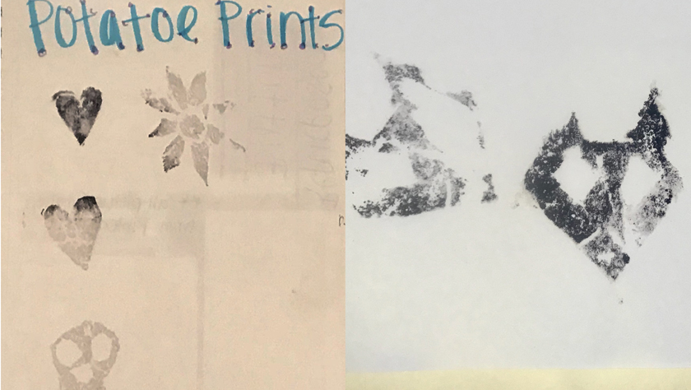
Figure 42. Student Potato Stamps. 2015. Digital Image.
Getting your hands sticky can trigger a disgust reaction in some people. However, I was fortunate not to have anyone with too strong an aversion to stickiness. Students had in a previous class been presented with a mini-talk on printmaking. This talk was very brief and very basic from wax seal impressions, grave rubbing, to making a list of four categories: screen printing, lithography, woodcuts, and metal engraving. These four main groups had subcategories and each group selected a printmaking type and was responsible for providing images and technical information for the following class.
After the class discussion of those selected images and the methodologies, I distributed potatoes, butter knifes, and ink pads. I noted a student carving out his initials (Figure. 42). I reminded the class at large that this was just like a wood cut or linocut and would print the image backwards. There was more than one sigh and some more potatoes distributed. Students had to be reminded when class time was over and more than one student wrote that they thought that the concrete exercise of an abstract idea—the hands-on, creative exercise—was helpful in their understanding of the printmaking process. Students also spent time doing contour drawing using paper bags and their shoes as subjects (Figure. 43). Students also did blind contours and one or two more extended drawings.
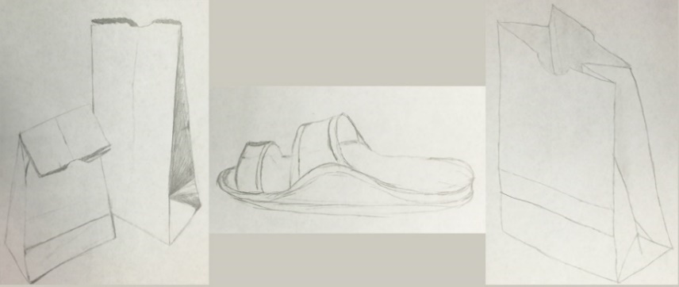
Figure 43. Student Drawings. 2015. Digital Image.
They did very well, and the class was engaged in the assignment. One student did caricature of all his classmates. The class wanted to do art every class. I had one open creative assignment left to determine.

Cabbages: Student Selected Active Learning Assignment
My head was not empty as a cabbage, in truth, I wanted students to be able to have input in the type of the creative assignment. Unfortunately, this freedom had to have limits. Students had little or no budget and there was a time constraint. In order to determine an open active learning assignment, I asked students what project they would like to do. The list was extensive and impressive. They wanted to work with glass, to design clothes, to do more printmaking, to do something three-dimensional, to do something architectural, to create a mask, and so on. The assignment that could be completed within my budget and their timeline on their wish list was the mask assignment. Students were provided with a mask and items such as decorative papers, glues, glitter, feathers, buttons, strings. I asked them to select an artist they liked and either replicate an aspect of a work on the mask or do something in the style of the artist (Figure. 44). This student had a fondness for the artist, Gustav Klimt, drawing their inspiration from the work, The Virgin (Figure. 45).
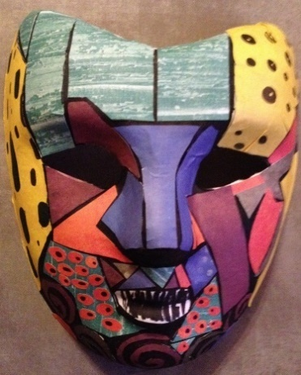
Figure 44. Student Mask. 2015. Digital Image.
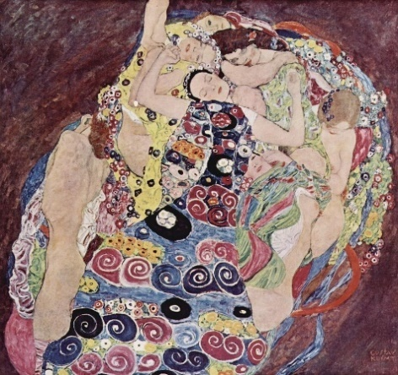
Figure 45. Gustav Klimt. The Virgin. 1913. Oil on canvas.
National Gallery in Prague.
Normally, Students work in their groups, but they do wander to other tables to exchange supplies and to discuss what their peers are doing. The students were able to talk both about their artist and the work they have selected, pointing out the elements in the artwork and how they translated them to their mask. I heard more than once that covering the mask was harder than they imagined. Translating even a simple image and retaining the artist’s look took effort, and the effort took time.

Kings: Cooperative Learning
The last group assignment was a presentation of their creative art history project. I passed the crown to the students to present various aspects of art history to their fellow classmates. They had a signup sheet posted and updated in the LMS. Each table group of students discussed among themselves and determined what part of art history interested them. The only restriction I placed in topic selection was that it could not duplicate something already chosen. We discussed academic sources and the importance of citing 5 academic sources. Each group was to present their selected art history topic through a creative presentation.
In the syllabus, I had provided ideas to get their thinking started, but what they could do for a creative presentation was open-ended. The class ended with two groups creating time capsules, two groups constructing art boxes (one had a diorama aspect), one group created binder presentation, another created a match game, and one created a fold-out puzzle-like box (Figure.46).
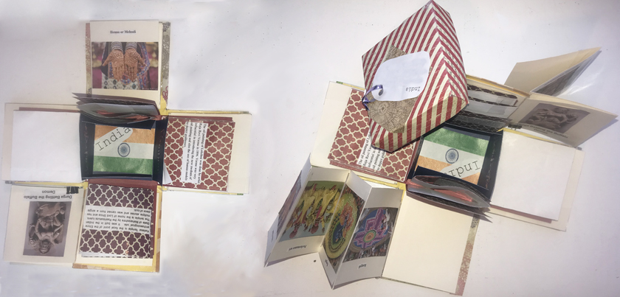
Figure 46. Student Art History Class Creation. 2015. Accordion-Fold Box.
While the students reviewed each student group, I reviewed each student in the group individually. Some students voiced concern how the effort (or lack thereof) of individual group members would impact presentation grades. I moved from table to table every class period, watched interactions, noted attendance, and addressed issues as I saw them. This attention to student interaction is integral to cooperative learning. Johnson, Johnson, and Smith (2014) explain that cooperation happens when five conditions are present. Cooperative learning as a pedagogy has been the subject of over 305 research studies. Cooperative learning is not simply students sitting together. First, and at the heart of cooperative learning, is positive interdependence. Positive interdependence means all members of the group are necessary for the group to be successful. The second condition is each student being individually accountable to meeting their role in the group and ensuring the group is successful. The third element is promotive interaction. This condition develops as the members assist each other, as class members encourage one another, and as they discuss class concepts. The fourth element is appropriate use social skills. Some students have group skills and other have to learn to share, cooperate, and value the other members. The final element is group processing. This means to examine how learning is occurring in each group, by each member, and to determine what changes could improve the student learning experience.
Cooperative learning builds classroom community, but not all groups in the study worked in complete harmony. Most students chose to work performance issues out among themselves. With one exception (a brother and a sister), the students were all strangers when they met, and some became friends when class ended. When asked where a group member could be, the members knew the situation of the missing member. While the classroom was generally humming with discussion, students were rarely doing things that were not class-related. Whereas one of the complaints voiced by many instructors is the inappropriate use of cellphones in the classroom, cell phone use was classroom appropriate. For example, during art appreciation, class assignments required independent and interdependent research. Students utilized their textbooks, the classroom computers, and their cellphones to complete their assignments. Student phones were in view and in use. As I moved from table-to-table, students would ask me to look at their phone screen as a means of providing context for their questions or to affirm their understanding how they were fulfilling the assignment.

Sea Is Boiling Hot: Disgust, Anger, and Critical Thinking
There is some research examining the connection between disgust and boiling hot tempers. A particularly volatile subject is the American flag in art. Those artists who have risen to the public eye are often considered infamous rather than famous. Despite the nationalistic trend to wear flag apparel and utilize flag picnic accoutrements, the treatment of the flag in art brings about a powerful disgust reaction in people. The student research project I assigned was based on one developed by a colleague. Students were presented with a handout with three examples of an artist’s use of the flag in their art (Appendix D). All the information for how to complete the assignment was detailed in the handout. In preparation for the assignment, the students were shown the artwork and given personal and cultural background information for each of the artists. I also had a government professor come to my class to provide a historical context in his discussion of the flag, law, and free speech.
The students were to interview at least 5 people and provided a form for recording the raw data. They were to collect some demographic data, then present each art work recording the participant’s reaction and comments. Their final question was to ask each participant whether they thought there were laws to restrict treatment of the flag. If the participant answered “yes,” then the students asked follow-up questions about the specific dictates of the laws. The students were to compile the data, noting gender and education differences for their participants, and conclude with how their personal feelings about the works compared to those of the participants interviewed. These are excerpts from a couple student summaries:
I learned many things from conducting this poll. Firstly, I learned that people found this poll to be very in-depth and that it required intense, heavy thought on deep subject matters. I readily agreed with them and thanked them for participating, because I would also have found it difficult to answer these questions if asked to participate in a survey. Second, I learned that there is a diverse group of individuals, and that art is open to interpretation to the viewer. Though each of these pictures provided a diverse range of responses, I was interested to see overlapping answers. For example, I thought that the first person who saw Pickled Flags as being a depiction of the commercialization of America had a very unique and different opinion of my own. You can imagine that I was surprised to see this being the most common answer for that picture. I also learned that it was important that we had the chance to form our own opinions in class before conducting the poll, because I found it hard to remember my initial response and opinions to the art after I had interviewed ten people. …I felt that this was a great assignment because I generally feel that people are very patriotic or very apathetic or neutral with their patriotism, and it was interesting to see responses in regards to artwork that depicts the symbol of our country in different lights, and how each individual responded differently to the meaning of these images.

From conducting these interviews, I learned that when talking about political issues, you should be prepared to not like the views of those you care about. While I agree with some things said about certain things, there were moments where I just cringed internally.
When the assignment was completed, most students found the prevailing attitudes to the works were negative. In addition, most of those interviewed believed that there are laws in place to ensure that the flag was protected. Most of the students demonstrated an adequate or better ability to compile the raw data. Looking at gender, age, and educational attainment for differences and similarities in respondent answers required instructor assistance for some students while others took to the work easily.
A second assignment that brought some heated responses from students was from their perusal of the Gender Ads Project. The potency of visual media in our culture cannot be denied. Cultural anthropologist Scott Lucas’ website of over 3000 images grew out of a gender class he was teaching. In their response papers, it was clear students are very much aware of the fact they are being manipulated by advertisements on an almost daily basis. I found most male and female students responded similarly to the gender ads. Despite this awareness, many wrote how they struggled with their self-image, and while logically they knew perfection was impossible and unreal, they still were not entirely happy with their physical appearances.

Pigs Have Wings: Student Learning Opportunities
Conceptually a class without tests seemed as likely as pigs flying, but I was telling the truth when I announced this in class on the first day. The issue some students failed to grasp was just because I was not testing did not mean their learning was not being assessed. Each assignment students were given was aligned with one of the course competencies. Their group work developed a visual vocabulary and understanding of the visual elements.
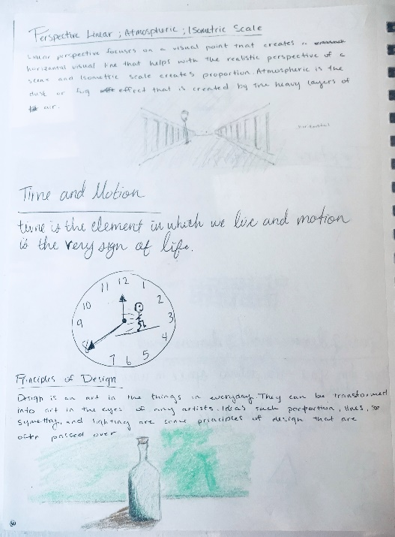
Figure 47. Student Notebook Entry: Visual Vocabulary. 2015. Digital Image.
Each student demonstrated his or her competency through the final visual analysis assignment (Appendix E). This assignment required students to demonstrate critical thinking, the ability to unpack art, and to reconstruct art content in order to develop and articulate a statement of the personally relevant meaning of specific works of art.
Student analysis essays showcased whether the student learned to look purposefully. The students were given a grading rubric. This was the same rubric they used to guide the analysis paper the students had written collaboratively. As a class, we first unpacked a work of art together. Then, each group unpacked a work and sent it to me, and I provided specific feedback. Finally, each student selected a work for visual analysis and sent me his or her choice. If a student’s selected work was so complex as to make the analysis unwieldy, I discussed options with the student, such as focusing the analysis on a portion of the larger work. At times, I offered suggestions for other similar but less complex works of art for the assignment. Overall, I offered advice but approved all choices. The art students selected were evenly split between contemporary works and those made before1970. The selections were also evenly split between works that were examples of easy beauty and those that were difficult beauty. Students took care to choose works that meant something to them. Most of their selections reflected the person I had grown to know. I was surprised by one young woman whose examples all semester had been experimental, when she selected a pastoral scene. A student’s excerpt written about Marianne Stokes’ Death and the Maiden (1908) reveals the use of structure, color, placement, symbolism to construct the meaning for her:
It could be a representation of life and death. The clean white night gown that the girl is wearing in contrast to the black robe that the angel of death is wearing could represent purity, innocence, and good health. In contrast, the angel is in all black and her skin is a putrid color. She represents death and the things unknown. The red blanket in-between them could be a representation of either life or death. Red could represent life, passion, love, lust, creativity, and vitality. It could also represent death, violence, anger, hatred, sickness, or blood. The fact that the girl is clutching the blanket so desperately tells me that she is trying to hold onto life. She is not ready to let go.
I provided feedback to students on the grading rubric. The comments on the paper and notations on the rubric were detailed such that a student would know exactly where they had missed points and why. If I had significant concerns, I wrote a note asking to meet with the student privately. Students were permitted to revise their papers following the rubric and my feedback. Most students took advantage of the revision opportunity. The most frequent issue was failure to include something required by the rubric.
I was sad to see the end of the semester arrive. Students in their pre- and post-class surveys revealed that their ideas about what art appreciation is remained similar but with some expansion to include statements such as, “What is the artist’s overall goal?” and the activity of determining “If art is esthetically pleasing or disgusting.” Half of the students’ answers to creating their own art appreciation class changed as well. Some would add a lot more studio time, music and dancing, museum trips, and more international experiences. Largely their expectations about what happens in art appreciation class remained unchanged.
In the pre-course survey, students were presented with Hieronymus Bosch’s Garden of Earthly Delights (1495-1505). They were to select one panel as a writing prompt. Students were to include whether it was beautiful or not. As I expected, more students chose the Last Judgement panel than the other two panels. They used phrases like “strangely beautiful” and “surreal.” In the post-class survey, I presented them with Patricia Piccinini’s Newborn (2010) (Figure 29.), and the majority of the students thought the work was either beautiful or an example of difficult beauty. I had a personally problematic response to the answer given by a physical therapy major who found the child repulsive. I thought this was a disturbing answer for one bound for the medical profession. Another student who was repulsed saw this child as an offspring of incest. The moral dimension of aesthetic disgust disturbs profoundly.
Student evaluations of the instructor and class indicated that my class rated our section higher than other sections. In the comment section, students wrote the following about the source materials: “The material used allowed me to have access to images and information at any time;” “The book served as a good reference for many assignments;” “We rarely used the book, which was very expensive.” These statements reveal more about which sources students utilized. Student comments about student learning included answers such as this one: “What contributed most to my learning was the mixture of lecture and interactive activities and assignments. We not only had typical lecture, but we got to actually practice some of the techniques we were learning about. For example, when we studied print making, we got make our own prints”; “The short talks”; “The group activities and cooperative learning”; and “Teacher interaction with students.” Under the recommendations for course improvements section, there was only one suggestion among positive comments. This student writes that “it would better if students had the option to work in teams, or independently. Some of us prefer to work alone sometimes.” These comments are always food for thought for the next time.
There will be a next time, and to be committed to improvement, self-reflection is required. My thought experiment was a departure from what students were expecting. Cooperative learning was new to most and aesthetic disgust was an alien concept. Fear of the unfamiliar and discomfort can create a cognitive discord that may be detrimental to the classroom culture. Students understood Bosanquet’s concept of beauty and difficult beauty. Beauty was easy to see or took work to find. Students considering aesthetic disgust, often ignore the word aesthetic and retain only the word disgust. Some students enjoy disgust and others, not so much. Binding the two words for students worked better after they understood difficult beauty. My ease with aesthetic disgust caused me to forget I needed to begin with Blooms. Alice unpacks her experience through the looking glass with her sister. She did not want to forget. Like Alice, I do not want to forget my experiences. Like Alice, I love adventures in learning.

CHAPTER 5

Art Appreciation Re-Visioned: Who Dreamed It?: Implications for Practice, Disgust or Difficult Beauty, and Considerations for Another Day
The soft purring of a kitten brings Alice full circle. She asks, “Now, Kitty, let’s consider who it was that dreamed it all.” Alice’s walk through the mirror was her own re-visioning. She could be compassionate, heartless, a queen, or even a king. Helene Cixous (1976) contends, “Woman must write her self,” and through expressions of creativity, a woman might actively craft herself within the context of the world and ultimately her own story. This re-visioning of art appreciation has been one of looking inward and of discovering new insights as Alice did as she traversed strange but familiar terrain. These reflections develop one’s character, change the way one reads a story, develops curriculum, understands what learning means, and directs the future.

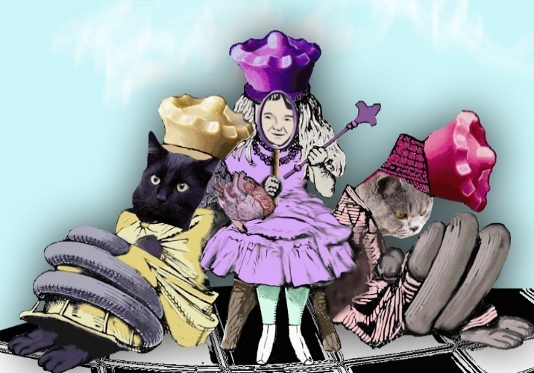
Figure 48. Catherine Johnston. Queen Alice. 2017. Digital Image.

As with any cognidyssey and arriving at the final chapter, one cannot help but see strengths, weakness, and my preconceptions concerning aesthetic disgust as a conceptual foundation for re-visioning of art appreciation in the community college. Adrienne Rich defined revisioning as follows, “Re-vision--the act of looking back, of seeing with fresh eyes, of entering an old text from a new critical direction--is for us more than a chapter in cultural history: it is an act of survival. Until we can understand the assumptions in which we are drenched we cannot know ourselves.” Rich’s voice tells me while I am moving forward in my new creations, I am still comprised of all the characters and experiences I have met thus far. Awareness of my past, choices and patterns of behavior allows me the option to change my present. I identify with Maxine Greene’s inability to “bracket out [her] biography and [her] experiences of embeddedness in an untidy, intersubjective world.” Moreover, I understand Greene displeasure at being demeaned for being “‘too’ literary to do philosophy.”
I have been told I could have been so much more than a community college instructor, as if community colleges were not real colleges and then, deciding to work in curriculum in a PhD program rather than a specific discipline or at least leadership, was at best a gendered choice. Do not misunderstand, I had choices. I had the opportunity to move into university teaching but I love and believe in the community college mission. As an instructor, your teaching is the center of your work. Thus, how the teaching and curriculum work for students is vital to student success. Re-visioning a course in toto takes time, and this thought experiment provided an invaluable opportunity to actualize some of my theorizing.
Teaching art appreciation for so many years, one can see the obvious changes in the technology available in the classroom and in the student population community college classrooms. While my personal educational experiences have been many, the textbooks choices used for art appreciation have only expanded a little and those editions change slowly. The expectations for what should be covered seems slow in changing. I find this curious. When I asked faculty in the arts, why do freshmen need to know about specific artists such as Picasso or Rembrandt in an art appreciation class? Without exception, they looked at me as if I am crazy. I pressed further and asked what it meant to appreciate art and how knowing any particular artist improved a student’s ability to appreciate art.
This was the point in my conversations with faculty that curriculum certainty was gone. My conversations with student participants revealed a different understanding about course content. When asked about the meaning of art appreciation in the course title, only three students referenced famous painting or history in their description. The rest of the students used phrases such as, to understand; to be able to be in the discussion of a piece [art]; to know why we have [art] and how [art] benefits us; and to see art in new way and to challenge your perceptions of art. The divide in what faculty think students should know and what students think the class will be about brings me back to the fundamental questions—what does it mean to appreciate art and how does one teach that? I am convinced in this introductory-level class and for the student population of this digital world, attempting to cover centuries of art history absorbs too much course time and distracts from the overarching goal of student engagement with art. While the term aesthetic disgust seemed to cause many students to lose focus; conceptually, Bosanquet’s difficult beauty opened and expanded conversations to fundamentally, the same ideas and complex and meaningful subjects. When the students have the impetus to drive imagery for the class to discuss, the onus for engagement/learning does not fall on the instructor. With my re-visioning, I am “…no longer merely the-one-who-teaches, but one who is [being] taught in a dialogue with the students, who in turn while being taught also teaches.”
I believe this re-visioning works for me (and could work for other general education courses) because I taught the course with complete autonomy. Common course textbooks tend to dictate content, especially with the use of adjuncts. One of the elements that shapes art appreciation courses is the instructor. Community colleges continue to hire a significant number of adjunct instructors. The academic backgrounds of instructors could include such degrees as art education, art history, arts, fine arts, or even graphic/digital media. Traditionally, this has allowed the course to flex a small amount because course learning outcomes and competences are written fairly broadly. If the method of determining whether course outcomes and competences are met is also open, then courses would have a vibrancy of the experience of the various instructor/student engagements with the course material. If, however, course homogenization is important across all sections, then success becomes narrowly defined and course conformity is inevitable.
In Critical Pedagogy, Joe Kincheloe (2008) explains how important it is for administrators to support scholar teachers. Teachers must be researchers within their field of teaching and talking about their teaching and their research. With heavy teaching loads, multiple courses, and other responsibilities, Kincheloe warns against the deskilling of many faculty, which results in the heavy dependence on textbooks to guide/inform and the push to standardize curriculum and instruction. Recently, a national accrediting agency (the Higher Learning Commission) denied Scottsdale Community College’s request to add a new online program. Ashley Smith (2017) explains the denial was a result of multiple factors, but among them was the inconsistent faculty online training, multiple learning management systems, and significant disparity in course success rates between online and face-to-face sections of the same class. Implicit in Smith’s article is a push toward standardization.
When innovation is suspect and success is thought to be achieved through standardization, is the window for re-visioning curriculum still open? Yes, I will believe in the window, even when I see evidence to the contrary. I want to believe in the enchanted, the creative, and the innovative. Alice says, “Do you know, I always thought Unicorns were fabulous monsters, too! I never saw one alive before!’
‘Well, now that we have seen each other,’ said the Unicorn, ‘if you’ll believe in me, I’ll believe in you.” (Carroll 247).
On a national level, there is discussion concerning the need for general education courses to be part of curriculum coherence within the student’s degree. Loni Pazich (2017) informs readers that students are overwhelmed and confused by the proliferation of countless course options that may or may not be right for their degree plan. Moreover, Pazich, Montas, and Mintz (2017) argue what students need is a “…structured liberal learning that provides a firm grounding in the ethical, historical, cross-cultural and policy issues relevant not only to their professional aspirations but also to their lives.” Discussion over curricular coherence is hardly a new conversation. Another dimension is added by Complete College America (CCA). In their 2016 publication, New Rules: Detailed Policy Language, CCA provides detailed policy language for those within the Alliance of States concerning structured paths and non-traditional students. If over 60 percent of students are part-time and non-traditional, then this policy guidance suggests students be given less choices in order to create a focused path to graduation. College success is equivalent to degree completion, is it not? Or perhaps success is good grades, completing a semester, student academic self-efficacy, acquisition of life skills (critical thinking, writing, communication, etc.), and/or timely graduation? Moreover, determining the nature of success is dependent upon the perspective of students, faculty, institutions, and external stakeholders.
A fiscal perspective on higher education directs the attention to the trillion-dollar student loan debt, to the statistic that less than 40% of first time, full-time students graduate with their associates from their original college, and to the fact that the federal investment in education is close to 160 billion dollars. As higher education is required to be transparent in its practices and accountable for dollars spent, a pragmatic aim is ensuring success drives decisions. My re-visioning or the works of others that bloom outside the bounds of “art” in the garden of art appreciation, beauty, and aesthetics are at risk of being plucked out for at least two related reasons. First, pragmatically, courses that transfer within a state or across the nation arguably should have the similar course content. Course transfer is critically important when so many students transfer. According to the data collected by the National Student Clearinghouse Research (2016) one-third of all students entering college for the first time transferred at least once, and many more than once. Therefore, in regards to course transfer, I cannot help but wonder how would my re-visioning be received? Transfer raises these questions: who sets the content, what will the sameness look like, how this should be measured, and who should validate the course? These are questions that cannot begin to be addressed here.
Second, the use of multiple faculty including adjuncts (with varying degrees of integration into the college culture) having earned a range of degrees colleges may choose to examine the various approaches to course content, raise questions on course inconsistency, course rigor, textbook choice, and textbook use (or lack thereof). Even with these negatives, I will continue to press for innovation and creativity even in a time that favors standardization. Anthropologist Mary Catherine Bateson writes about composing a life, “In a society like our own, we make a sharp contrast between creativity and standardization…” Bateson explains that these are different times, our lives must change. She describes her interest in improvisation and whether it is music, meal preparation, or art, with creativity there can be new compositions, flavors, and discoveries. Art appreciation with re-visioning, is not just mine but is in concert with the interests, enthusiasm, experiences shared and exchanged with students have the power to fashion something new, engaging, and unique each time. I believe to make education relevant and thus, develop curriculum in which students are more successful, we must honor student knowledge and the cultural capital they bring to the classroom. This will require improvisation. We need to look in and look out and be ready to step out bravely to create something new.
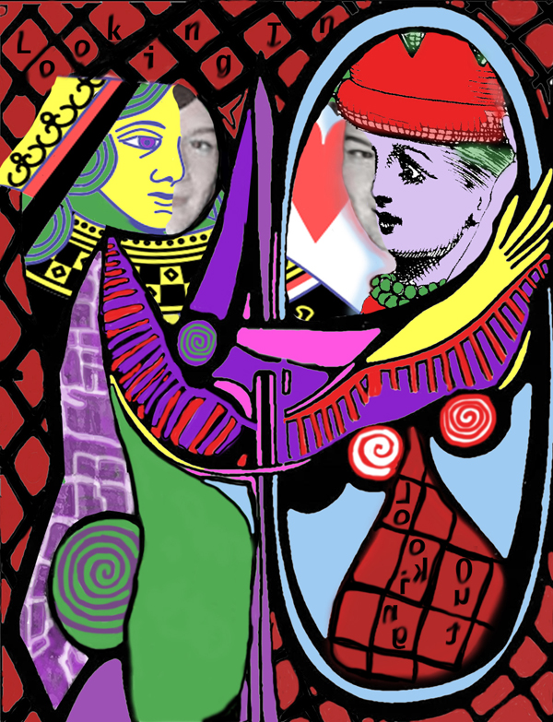
Figure 49. Catherine Johnston. Improvisation: Queens, Girls, Alice, and Mirrors. 2018. Digital Image.
Still she haunts me, phantomwise,
Alice moving under skies
Never seen by waking eyes.

REFERENCES
Achieving the Dream. College Readiness. Focus-Area/college-readiness http://achievingthedream.org/focus-areas/college-readiness. 2016.
Agee, James and Walker Evans. Let Us Now Praise Famous Men. New York: Ballentine Books, 1960.
Apple, Michael. Teachers and Texts: A Political Economy of Class and Gender Relations in Education. New York: Routledge Taylor & Francis Group, 2013. Kindle Edition.
Aikens, N. L., and O. Barbarin. “Socioeconomic Differences in Reading Trajectories: The Contribution of Family, Neighborhood, and School Contexts.” Journal of Educational Psychology,100: 2 (2008): 235-251.
Allan, Elizabeth G.. “I hate Group Work!”: Addressing Students’ Concerns About Small-Group Learning”. InSight: A Journal of Scholarly Teaching. (2016): 81-89.
American Association of Community Colleges. “About Colleges.” 2017. http://www.aacc.nche.edu/AboutCC/Documents/AACCFactSheetsR2.pdf.
____ “Community Colleges Past to Present.” 2016. http://www.aacc.nche.edu/ABOUTCC/HISTORY/Pages/pasttopresent.aspx.
Armstrong, Patricia. “Bloom’s Taxonomy” The Center for Teaching and Learning: Vanderbilt University. 2017. https://cft.vanderbilt.edu/guides-sub-pages/blooms-taxonomy/#2001.
Balolong, Francis. "Facebook Photo Library Now has 250 Billion User Photos." Social Barrel, (2014) http://socialbarrel.com/facebook-photo-library-now-250-billion-user-photos/53315/.
Bateson, Mary Catherine. Composing a Life. New York: Grove Press, 1989.
Bathes, Roland. Camera Lucida: Reflections on Photography. New York: Hill and Wang, 1980.
Bennett, Charles. Art Training for Life and Industry, Peoria, Ill.: The Manual arts press 1923; Google, 2013, http://hdl.handle.net/2027/uc1.$b124216.
Bennett, William. To Reclaim a Legacy: A Report on the Humanities in Higher Education, Washington, DC: National Endowment for the Humanities, 1984.
Benjamin, Walter. “The Work of Art in the Age of Mechanical Reproduction.” Illuminations. New York: Schocken Books, 2007.
Berger, John. Ways of Seeing. London: British Broadcasting Corporation and Penguin Books, 1972.
Bidwell, Allie. “Income Disparity Affects How Soon Students Enroll in College.” U.S. News and World Report. 2013. http://www.usnews.com/news/articles/2013/10/16/income-disparity-affects-how-soon-students-enroll-in-college
Blackburn, Robert M. and Jarman, Jennifer. “Changing Inequalities in Access to British Universities,” Oxford Review of Education 19 (2). (1993): 197-215. http://www.jstor.org/stable/1050816.
Boal, Augusto. Games for Actors and Non-Actors. New York: Routledge, 1992.
Boal, Augusto & McBride, Charles A. Theatre of the Oppressed. Theatre Communications Group, 2013.
Bochner, Arthur P. Coming to Narrative: A Personal History of Paradigm Change in the Human Sciences. New York: Routledge, 2014. Kindle Edition.
Bogdan, Deanne. “The Shiver-Shimmer Factor: Musical Spirituality, Emotion, and Education.” Philosophy of Music Education Review 18:3, (2010): 111-129.
Bosanquet, Bernard. Three Lectures on Aesthetic. London: McMillan and CO., Limited, 1923.
Bosch, Hieronymus. The Garden of Earthly Delights. 1495-1505. Oil on Panel. 220 cm x 390 cm. https://www.museodelprado.es/. .
Botero, Fernando. Abu Ghraib 60. 2005. oil on canvas; 51-5/8 x 62-1/4 in. University of California, Berkeley Art Museum and Pacific Film Archive, Gift of the artist. 2009.12.32. © Regents of the University of California.
British Rowing. Glossary of Rowing Terms. (2017). https://www.britishrowing.org/knowledge/online-learning/techniques-and-training/glossary/
Brown, James R. “Explaining, Seeing, and Understanding in Thought Experiments.” Perspectives on Science 22: 3, (2014): 357-376.
Brown, Jessie, Kurzweil, Martin and Pritchett, Wendell. "Quality Assurance in U.S. Higher Education: The Current Landscape and Principles for Reform." Ithaka S+R. 2017. https://doi.org/10.18665/sr.303620.
Brown, John S., Collins, Allan, and Duguid, Paul. “Situated Cognition and the Culture of Learning,” Educational Researcher, 18, 1 Jan-Feb 1989.
Burke, Edmund. The Works of the Right Honourable Edmund Burke, Vol. I. (of 12), 1757 http://www.gutenberg.org/cache/epub/15043/pg15043.txt
Bush, Carney, James D. “What Is a Work of Art?” Journal of Aesthetic Education 16, no. 3, 1982: 85-92, http://www.jstor.org/stable/3332195.
Bush, Grace. “25 years Later: Cincinnati and the Obscenity Trial over Mapplethorpe Art.” The Washington Post. https://www.washingtonpost.com/entertainment/museums/25-years-later-cincinnati-and-the-obscenity-trial-over-mapplethorpe-art/2015/10/22/07c6aba2-6dcb-11e5-9bfe-e59f5e244f92_story.html?utm_term=.8526817a3cd8
Braidotti, Rosi. Nomadic Subjects: Embodiment and Sexual Difference in Contemporary Feminist Theory, 2nd ed. New York: Columbia University Press, 2011, Kindle Edition.
Carroll, Lewis. Alice in Wonderland and Through the Looking Glass. USA: Grosset & Dunlap, 1989.
Cassatt, Mary. Lydia Leaning on Her Arms, Seated in a Loge. 1879. Pastel. .
Chakraborty, Sarbani. "Deskilling of the Teaching Profession." Sociology of Education: An A-to-Z Guide, edited by James Ainsworth, 184-186. Thousand Oaks, CA: SAGE Publications, Inc., 2013. doi: 10.4135/9781452276151.n106.
Chingos, Matthew M. “Strength in Numbers: State Spending on K-12 Assessment Systems.” Brown Center on Education Policy: Brookings Institute, (2012.) https://www.brookings.edu/wp-content/uploads/2016/06/11_assessment_chingos_final_new.pdf.
Choate, Lenetta K. and Keim, Marybelle C. “Art Appreciation Courses in Illinois Community Colleges.” Community College Journal of Research and Practice 21, no.3, (1997):319-330, DOI: 10.1080/1066892970210305
Peter Claesz. Vanitas Still Life. 1628. Oil on Wood. Rogers Fund, 1949. https://www.metmuseum.org/art/collection/search/435904, .
Cixous, Helene. “The Laugh of the Medusa.” Signs 1, 4 (1976): 875-893.
CNN Library. “Iraq Prison Abuse Scandal Fast Facts.” 2017. http://www.cnn.com/2013/10/30/world/meast/iraq-prison-abuse-scandal-fast-facts/index.html
Code, Lorraine. What Can She Know, London: Cornell University Press, 1991.
Cohen, Arthur, M, Florence B. Brawer, and Carrie B. Kisker. The American Community College, 6th ed., San Francisco, CA: The Jossey-Bass, 2014. Kindle Edition
College Board. “About Us.” College Board. 2017. http://about.collegeboard.org/history
Complete College America. “CCA New Rules—Detailed Policy Language.” Complete College America. 2016. https://boardofed.idaho.gov/resources/cca-new-rules-detailed-policy-language/.
___. “Far too Many Students Start in Remediation.” Complete College America. 2017 http://completecollege.org/spanningthedivide/#far-too-many-students-start-in-remediation-1-10-17.
Cook, Bryan and Natalie Pullaro. College Graduation Rates: Behind the Numbers. (2010) http://www.acenet.edu/news-room/Pages/College-Graduation-Rates-Behind-the-Numbers-.aspx.
Cox, Rebecca. The College Fear Factor. Cambridge, Massachusetts, Harvard University Press, 2009.
Crivelli, Carlo. The Crucifixion. c. 1487, Tempera on panel. 75 x 55.2 cm (29 1/2 x 21 3/4 in.); image (arched): 74 x 55.2 cm (29 1/8 x 21 3/4 in.) Wirt D. Walker Fund. 1929.862. The Art Institute of Chicago.
Curti, Merle. The Social Ideas of American Educators: With New Chapter on the Last Twenty-Five Years. Paterson, New Jersey: Pageant Books, Inc., 1959.
Da Caravaggio, Michelangelo Merisi. The Incredulity of Saint Thomas. Oil on Canvas. 1601-1602.http://www.potsdam-park-sanssouci.de/picture-gallery.html; .
___. Judith Beheading Holofernes. 1598-1599. Oil on canvas. http://www.barberinicorsini.org/. .
Da Vinci, Leonardo. Madonna of the Rocks. 1483-1486. Oil on canvas. 78.3 x 48. Louvre. .
Danto, Arthur. “The Body in Pain.” The Nation. (2006) http://www.thenation.com/article/body-pain
Daws, Jack. Pickled Flags. 2001 Mixed Media. Image Courtesy of Greg Kucera Gallery, INC. 212 Third Ave South-Seattle, WA 98104
De la Croix, Horst and Tansey, Richard. Gardner’s Art Through the Ages, 6th Ed. New York: Harcourt Brace Jovanovich, INC.
Dewey, John. Art as Experience. New York: Perigree, 1958.
___. Democracy and Education. An Introduction to the Philosophy of Education. New York: Free Press, 1916.
___. Experience and Education. New York: Touchstone, 1938.
___. Moral Writings of Dewey. Amherst, New York: Prometheus Books, 1994
Dickie, George. “Defining Art.” American Philosophical Quarterly 6, no. 3 (1969): 253-256, http://www.jstor.org/stable/20009315 .
Dow, Arthur Wesley. Composition: A Series of Exercises in Art Structures for the use of Students and Teachers. Garden City: New York, Doubleday, Page and Company, 1914. eBook, 2014.
Dürer, Albrecht. Draughtsman Making a Perspective Drawing of a Reclining Woman, 1600. Woodcut. Gift of Henry Walters, 1917. http://www.metmuseum.org/art/collection/search/366555,
Efland, Arthur D. A History of Art Education: Intellectual and Social Currents in Teaching the Visual Arts. New York: Teachers College Press, 1990.
___. “The Entwined Nature of the Aesthetic: A Discourse on Visual Culture.” Studies in Art Education 45, no. 3 (2004): 234-251, http://www.jstor.org/stable/1320971 .
Elgin, Catherine Z. “Fiction as Thought Experiment.” Perspectives on Science 22, 2 (2014): 221-241.
Evans, Jonathan. The NSFW History of Calvin Klein’s Provocative Ads. Esquire. 2018. http://www.esquire.com/style/news/g2841/nsfw-history-calvin-klein-advertising/.
Facebook, "Company information: Our Mission." Last modified 08 28, 2017. Accessed August 28, 2017. http://newsroom.fb.com/company-info/.
Fleming, Neil. D. and Charles C. Bonwell. “Introduction to VARK.” (2017) http://vark-learn.com/the-vark-questionnaire/.
Forrest, Sharita. “First-Semester GPA a Better Predictor of College Success than ACT Score.” Illinois New Bureau. 2016. https://news.illinois.edu/blog/view/6367/320538
Frank, Priscilla. « The Late Photographer Francesca Woodman Used Ghosts to Tell Her Story.” Huffington Post. (2015) https://www.huffingtonpost.com/entry/francesca-woodman-photos_us_562eb3efe4b0c66bae59359f
Franklin Institute: History of Science and Technology. “The Kodak Brownie.” (2012) http://learn.fi.edu/learn/sci-tech/kodak-brownie/kodak-brownie.php.
Freire, Paolo. Pedagogy of the Oppressed. New York: Continuum, 2007.
Geno, Mike. Jelly. Oil on wood. 8 x 8. Personal Collection.
Gentileschi, Artemisia. Judith Beheading Holofernes. 1614-1620. Oil on Canvas. https://www.uffizi.it/?en.
Getlein, Mark. Living with Art. 10th ed. New York: McGraw Hill, 2013.
Gilbert, Rita. Living with Art. 2nd ed. New York: Alfred A. Knopf Inc. 1985.
Ginorio, Angela and Michelle Huston. ¡Sí, Se Puede! Yes, We Can: Latinas in School. New York: American Association of University Women Educational Foundation, 2001.
Golden, Nan. Nan (one month after being battered) 1984 Nan Goldin. ©Nan Goldin, Courtesy Matthew Marks Gallery.
González, Jennifer. “Education for All? 2-Year Colleges Struggle to Preserve Their Mission.” Chronicle of Higher Education. (2012) http://chronicle.com.librarynt.occc.edu/article/2-Year-Colleges-Fight-to-Save/131608/.
Goodchild, F., H. S. Wechsler, and Association for the Study of Higher Education, “Report of the President's Commission on Higher Education, 1947,” The History of Higher Education, Needham Heights, MA: Simon & Schuster Custom Publ. 1997, 758-772, http://faculty.washington.edu/joyann/EDLPS531/President-s_Commission.pdf.
Greene, Maxine. "Art and Imagination: Reclaiming the Sense of Possibility." Phi Delta Kappan. 76.5 (1995): 378-82. ERIC. EBSCO. Web. 28 Aug. 2011.
___. Landscapes of Learning. New York: Teachers College Press, 1978.
___. Releasing the Imagination: Essays on Education, the Arts, and Social Change. San Francisco, CA: Jossey-Bass, 1995.
Grimm, Jacob and Grimm, Wilhelm. “Snow-White and the Seven Dwarfs” in The Grimm’s Fairy Tales, http://www.pitt.edu/~dash/type0709.html#snowwhite.
Gross, David and Brandon Griggs. "Snapchat CEO 'mortified' by leaked e-mails." CNN Tech Last modified May 29, 2014. Accessed August 24, 2014. http://www.cnn.com/2014/05/29/tech/mobile/spiegel-snapchat-leaked-e-mails/.
Haraway, Donna. When Species Meet. Minneapolis: University of Minnesota Press, 2008.
___. “(tender) Creature Exhibition catalogue. Artium.” Speculative Fabulations, for Technoculture's Generations: Taking Care of Unexpected Country. 2007. http://www.patriciapiccinini.net/writing/30/444/56#.
Heinrichs, Shawn. Tung Kang, Taiwan. 2011. Personal Collection. http://journal.bluespheremedia.com/.
Higgins, Chris. “Educational Aesthetics,” The Handbook of Research in the Social Foundations of Education. New York: Rutledge, 2011, 131-152.
Hill, Catherine. “Barriers and Bias: The Status of Women in Leadership.” AAUW report. 2016. http://www.aauw.org/resource/barriers-and-bias/.
Holmgrem, David. “Lindquist, Everet Franklin” The Biographical Dictionary of Iowa. The University of Iowa Press, 2009.
hooks, bell. Art on My Mind: Visual Politics. New York: The New Press, 1995.
Irwin, Rita L. and Alex de Cosson. A/R/tography: Rendering Self Through Art-Based Living Inquiry. Vancouver, Canada: Pacific Educational Press, 2004.
Jansen, Charles “Scenarios of Art Appreciation: An Analysis of Text.” PhD diss., University of George, 1991.
Johnson, D. Kent and James L Ratcliff. “Creating coherence: The unfinished agenda.” New Directions for Higher Education. 125, 2004, 85-95.
Johnson, David W. and Frank P. Johnson. Joining Together: Group Theory and Group Skills, 10th Ed. Columbus, Ohio: Pearson, 2009.
Johnson, D. W., R. T. Johnson, and K.A. Smith. “Cooperative Learning: Improving University Instruction by Basing Practice on Validated Theory.” Journal on Excellence in College Teaching, 2014. 25,3&4, 81-118
Johnson, Wendy. “Greatness as a Manifestation of Experience-Producing Drives” in The Complexity of Greatness: Beyond Talent or Practice. 3-16. Edited by Scott Barry Kaufman, New York: Oxford Press, 2013.
Johnston, Catherine. Alice and the White Knight. 2017 Digital Image. ©Catherine Johnston. Personal Collection.
___. Altered Context. 2017. Digital Image. Personal Collection.
___. Art Class on Wheels. 2015. Digital Image. Personal Collection.
___. Flowers Teach Alice a Lesson. 2017. Digital Image. ©Catherine Johnston. Personal Collection.
___. Frankenbanana. 2016-recreation of 1978 work. ©Catherine Johnston. Banana, blue dye, thread.
___. Improvisation: Queens, Girls, Alice, and Mirrors. 2018. Digital Image. ©Catherine Johnston. Personal Collection.
___. Just Look at Them. 2016. Digital Image. Personal Collection.
___. Meal Shared. 2016 Digital Image. Personal Collection.
___. Queen Alice. 2017. Digital Image. ©Catherine Johnston. Personal Collection.
___. White Queen. 2017 Digital Image. ©Catherine Johnston. Personal Collection.
___. White Queen in Sheep Guise is Truthful. 2017. Digital Image. ©Catherine Johnston. Personal Collection.
Kant, Immanuel. The Critique of Judgement. Digiread.com, 1790, Kindle Edition, 2006.
Kempf, Arlo. The Pedagogy of Standardized Testing: The Radical Impacts of Educational Standardization in the US and Canada. New York: Palgrave Macmillan, 2016.
Kincheloe, Joe L. Critical Pedagogy Primer. New York: Peter Lang, 2008.
Klimt, Gustav. The Virgin. 1913. Oil on canvas. National Gallery in Prague.
Kolnai, Aurel. On Disgust. Chicago: Open Court, 2004.
Kolb, Alice Y and David A. Kolb. “Learning Styles and Learning Spaces: Enhancing Experiential Learning in Higher Education”. Academy of Management Learning & Education 4,2 2005, 193-212.
Kolb, David. Experiential Learning: Experience as the Source of Learning and Development 2nd Ed. Upper Saddle River, New Jersey: Pearson Education Inc., 2015.
Korsmeyer, Carolyn. Gender and Aesthetics: An Introduction. London: Routledge, 2004. Kindle Edition.
___. Savoring Disgust: The Foul and the Fair in Aesthetics. New York: Oxford University Press, 2011.
Kuh, George D. High-Impact Educational Practices: What They are, Who has Access to the Them, and Why They Matter. Washington, D.C: AAC&U, 2008.
Laird, Susan. “Aesthetics and Education,” Handbook of Educational Theories, edited by Shirley Jackson and Barbara Thayer-Bacon. 43-56. Charlotte, North Carolina: Information Age Publishing, Inc., 2013.
Land, George and Beth Jarman. Breakpoint and Beyond: Mastering the Future Today, USA: Harper Business, 1992.
Lather, Patti. Getting Smart: Feminist Research and Pedagogy with/in the Postmodern. New York: Routledge, 1991.
Laurillard, Diane. Rethinking University Teaching: A Conversation, E-Version: Taylor & Francis e-Library, 2002.
Let Girls Learn. “About,” https://letgirlslearn.gov/about/. 235-251. http://search.proquest.com/docview/614480803?accountid=12964.
Levin, John S. and Susan T Kater (eds). Understanding Community Colleges. New York: Routledge, 2013.
Leavy, Patricia. Method Meets Art, 2nd Ed. New York: The Guilford Press. Kindle Edition
Lucas, Christopher J. American Higher Education: A History, 2nd Ed. New York: Palgrave Macmillan, 2006.
Lucas, Scott. A. The Gender Ads Project. 2015. http://www.genderads.com/.
Manjoo, Farhad. “Why Instagram is Becoming Facebook’s Next Facebook.” The New York Times. 2017. https://www.nytimes.com/2017/04/26/technology/why-instagram-is-becoming-facebooks-next-facebook.html
Mapplethorpe, Robert. Ken and Tyler. © Robert Mapplethorpe Foundation
Martin, Jane Roland. Coming of Age in Academe. New York: Routledge, 2000.
___. Cultural Miseducation: In Search of a Democratic Solution. New York: Teachers College Press, 2002.
___. Educational Metamorphoses: Philosophical Reflections on Identity and Culture. Lanham, Maryland: Bowman & Littlefield Publishers, Inc., 2007.
___. Education Reconfigured: Culture, Encounter and Change, New York: Routledge, 2011.
Medina, Yolanda. Critical Aesthetic Pedagogy: Towards a Theory of Self and Social Empowerment, New York: Peter Lang, 2012.
Menninghaus, Winfried. Disgust: Theory and History of a Strong Sensation. Albany: New York: State University of New York Press, 2003.
Miller, Kevin. The Simple Truth about the Gender Pay Gap. AAUW report, 2017. https://www.aauw.org/resource/the-simple-truth-about-the-gender-pay-gap/
Miller, William Ian. The Anatomy of Disgust. Cambridge, Massachusetts: Harvard University Press, 1997.
Miro, Joan, Femme, 1934. Pastel, graphite, and scoring or scratching on artist's sandpaper with prepared surface. 42 1/8 x 28 1/8 inches. © Artists Rights Society (ARS), New York / ADAGP, Paris. The Louise and Walter Arensberg Collection, 1950. http://www.philamuseum.org/collections/permanent/51065.html.
Montuori, Alfonso. “The Complexity of Improvisation and the Improvisation of Complexity: Social Science, Art and Creativity.” Human Relations 15,2: 237-255.
Morris, Weitz. “The Role of Theory in Aesthetics.” The Journal of Aesthetics and Art Criticism 15, no.1 (1956): 27-35, http://www.jstor.org/stable/427491.
Mulvey, Laura. “Visual Pleasure and Narrative Cinema.” Screen 16, no. 3: pp. 6-18, 1975. http://www.jahsonic.com/VPNC.html
National Archives and Records. Photograph No. Nwdns-245-Ms-2238l (Lee Russell), “Miners' Wives and Children on the Front Porch on a Typical, Fifty Year Old House. Kentucky Straight Creek Coal Company, Belva Mine, Abandoned After Explosion [In] Dec. 1945, Four Mile, Bell County, Kentucky” September 4, 1945.
___. Photograph No. 111-SC-203464 (Pfc. W. Chichersky). “A truck load of bodies of prisoners of the Nazis, in the Buchenwald concentration camp at Weimar, Germany,” April 14, 1945.
___. Photograph No. 111-SC- 204811 (T4c. Sam Gilbert). “Some of the bodies being removed by German civilians for decent burial at Gusen Concentration Camp, Muhlhausen, near Linz, Austria. Men were worked in nearby stone quarries until too weak for more, then killed,” May 12, 1945.
National Education Association. Journal of Proceedings and Addresses. 1897; Google, 2007., https://books.google.com/books/reader?id=bnwBAAAAYAAJ&num=19&printsec=frontcover&output=reader&pg=GBS.PA268.
National Center for Educational Statistics. “Immediate College Enrollment Rate.” 2017. https://nces.ed.gov/programs/coe/indicator_cpa.asp.
National Student Clearinghouse Research Center. “Transfer & Mobility: A National View of Student Movement in Postsecondary Institutions, Fall 2008 Cohort”. 2015. P.8, https://nscresearchcenter.org/wp-content/uploads/SignatureReport9.pdf.
Obama White House Archives. “Fact Sheet: Let Girls Learn-A Comprehensive Investment in Adolescent Girls Education.” https://obamawhitehouse.archives.gov/the-press-office/2016/10/11/fact-sheet-let-girls-learn-comprehensive-investment-adolescent-girls.
Oldenburg, Claes. Clothespin. 1976. Core-Ten and stainless steel, 45' x 6' 3 3/4" x 4'. Central Square Plaza, Fifteenth and Market Streets, Philadelphia. © 2006 Claes Oldenburg and Coosje van Bruggen.
Osborne, Harold. “The Language Metaphor in Art.” Journal of Aesthetic Education 18, no. 1, (1984): 9-20, http://www.jstor.org/stable/3332568.
Palmer, Parker J. The Courage to Teach: Exploring the Inner Landscape of a Teachers Life, 10th Anniversary Edition, San Francisco, CA: John Wiley& Sons, 2007. Kindle Edition.
Parsons, Michael J. and Gene H. Blocker. Aesthetics and Education: Discipline in Art Education: Contexts of Understanding. Chicago: University of Illinois Press, 1993.
Pazich, Loni Bardolino. “A Call for Curricular Coherence.” Inside Higher Ed. 2017, https://www.insidehighered.com/views/2017/09/18/overcoming-obstacles-curricular-coherence-essay#.WeD-4K1YO2Q.link.
Pazich, Loni Bordoloi, Roosevelt Montas, and Steve Mintz. “Getting to the Core of it.” Inside Higher Ed. 2017, https://www.insidehighered.com/views/2017/01/26/disparate-institutions-find-common-core-curriculum-reaps-significant-benefits-essay#.Wc5NGY-DMeA.link.
Pendergrast, Mark. Mirror/Mirror: A History of the Human Love Affair with Reflection. New York: Basic Books, 2003, Kindle Edition.
___. Uncommon Grounds: The History of Coffee and How It Transformed Our World. New York: Basic Books, 2010, Kindle Edition.
Perugino, Pietro The Crucifixion with the Virgin, Saint John, Saint Jerome, and Saint Mary Magdalene [middle panel] c. 1482/1485. oil on panel transferred to canvas: 101.5 x 56.5 cm (39 15/16 x 22 1/4 in.) framed: 134 x 165.1 x 7.3 cm (52 3/4 x 65 x 2 7/8 in.) Andrew W. Mellon Collection. 1937.1.27.b
Piccinini, Patricia. Doubting Thomas. 2008. Silicone, Fiberglass, human hair, clothing, chair. Personal Collection of the Artist.
___. Eulogy. 2011. Silicone. Fiberglass, human hair, clothing. 11 x 65 x 60 cm. Personal Collection of the Artist.
___. In Another Life catalogue. Wellington City Gallery, Wellington, NZ. 2006. http://www.patriciapiccinini.net/writing/28/444/56.
___. Newborn. Silicone, fiberglass, human hair, clothing, 110 x 65 x 60 cm. Personal Collection of the Artist.
___. Undivided. 2004. Silicone, human hair, flannelette, 101 x 74 x0127 cm. Personal Collection of the Artist.
___. Young Family. 2002. Silicone, polyurethane, leather, plywood, human hair. 80 x150 x110 cm. Personal Collection of the Artist.
Poore, H.R. Pictorial Composition and the Critical Judgement of Pictures: A Handbook for Students and Lovers of Art. New York: G.P. Putnam’s Sons, 1903, eBook, 2008.
Raphael (Raffaello Sanzio da Urbino). School of Athens (Detail). 1511. Fresco. http://www.museivaticani.va/content/museivaticani/en.html/..
Ravitch, Diane. The Language Police: How Pressure Groups Restrict What Students Learn. New York: Vintage Books, 2002, Kindle Edition.
Reinhart, Mark, Holly Edwards, and Erina Duganne. Beautiful Suffering: Photography and the Traffic in Pain. Chicago: University of Chicago Press, 2007.
Reynolds, Victoria. Cream Cascade. 2011. Oil on Panel. 24” x 18”. Photo: Brian Forrest. Personal Collection.
___. Fat Mouth. 2008. 16” x 18”. oil on panel with painted frame, collection of Blaine Halvorson, CA.
___. Kiss the Fat. 2005. Oil on Panel. oil on panel with painted frame, 17 x 14 1/4 inches overall, Collection of Tony Lydgate, HI.
Rich, Adrienne. “When We Dead Awaken: Writing as Re-Vision.” College English Teacher 34.1 1972.
Ringgold, Faith. American Collection #6: The Flag is Bleeding #2. 1997. Acrylic on canvas. 77 x 81. Private Collection.
Robinson, Ken. “Changing Educational Paradigms.” Ted Talks, October 2010. https://www.ted.com/talks/ken_robinson_changing_education_paradigms.
Saltz, Jerry. “Where the Girls Aren’t.” Village Voice. 2006. http://www.villagevoice.com/2006-09-19/art/where-the-girls-aren-t/.
Saville, Jenny. Reflective Flesh, 2002 – 2003, Oil on canvas.120 1/8 x 96 1/16 x inches, 305.1 x 244 cm. ©Jenny Saville 2017. Courtesy of the Artist and Gagosian.
Scholder, Fritz. American Portrait with Flag, 1979. Courtesy of American Museum of Western Art-The Anschutz Collection/Photo courtesy William J. O'Connor I© Estate of Fritz Scholder.
Smith, Ashley. “Standardization in Online Education.” Inside Higher Ed. September 14, 2017 https://www.insidehighered.com/news/2017/09/15/accreditor-denies-arizona-community-colleges-bid-expand-online#.WeD8_PFM8Bk.link.
Smith, Noel. "Economic Inequality and Poverty: Where Do We Go from Here?" International Journal of Sociology and Social Policy 30, no. ¾, 2010, 127-39.
Smith, Peter. The History of American Art Education. Westport, Connecticut: Greenwood Press, 1996.
St. Rose, Andresse and Catherine Hill. “Women in Community Colleges: Access to Success.” AAUW Report. 2013. https://www.aauw.org/files/2013/05/women-in-community-colleges.pdf.
Sontag, Susan. On Photography. New York: Picador, 1977.
___. Regarding the Pain of Others. New York: Picador, 1933.
Sousa, David A. How the Brain Learns, 4th ed. Thousand Oaks, CA: Corwin: A Sage Company, 2011. Kindle Edition.
Steinberg, Shirley. Critical Qualitative Research. New York: Peter Lang Publishing, 2012.
Sterling, Richard E. Joliet Junior College 1901 to 2001: A Pictorial History of America’s Oldest Public Community College. St. Louis, MO: G. Bradley Publishing, Inc., 2001.
Stinson, Susan. “Curriculum and the Morality of Aesthetics,” Journal of Curriculum Theorizing 6, no. 3 (1985): 66-83.
Student Work. Student Art History Class Creation. 2015. Accordion-Fold Box. Personal Collection.
___. Student Drawings. 2015. Digital Image. Personal Collection.
___. Student Mask. 2015. Digital Image. Personal Collection.
___. Student Notebook Covers. 2015. Digital Image. Personal Collection.
___. Student Notebook Entry: Visual Vocabulary. 2015. Digital Image. Personal Collection.
___. Student Potato Stamps. 2015. Digital Image. Personal Collection.
Tatarkiewicz, Wladysaw. “What is Art? The Problem of Definition Today,” British Journal of Aesthetics11, no. 2 (1971): 134-153.
United States Census Bureau. “Profile America Facts.” http://www.census.gov/newsroom/releases/archives/facts_for_features_special_ededitio/cb11-ff18.html.
Weems, Carrie Mae. LOOKING INTO THE MIRROR, THE BLACK WOMAN ASKED, "MIRROR, MIRROR ON THE WALL, WHO'S THE FINEST OF THEM ALL?" THE MIRROR SAYS, "SNOW WHITE, YOU BLACK BITCH, AND DON'T YOU FORGET IT!!!" 1987. Photograph. Used by Permission of the Artist. http://carriemaeweems.net/galleries/aint-jokin.html.
White, Hayden, “The Value of Narrativity in the Representation of Reality,” Critical Inquiry 7, 1 (1980): 5-27). Accesses http://www.jstor.org/stable/1343174
Woody, Thomas. A History of Women’s Education in the United States. New York: The Science Press, 1929.
Woolf, Virginia. Three Guineas. New York: Harcourt Brace Jovanovich Publishers, 1938.
Wright, Cindy. Baconcube. 2010. Oil on linen, 49 ¼” x 55”. http://www.cindywright.org/dt001011.html. Personal Collection.
Young, Iris Marion. Intersecting Voices: Dilemmas of Gender, Political Philosophical, and Policy. Princeton. New Jersey: Princeton University Press. 1997.
Zamani-Gallaher, Eboni M., Jaime Lester, Debra D. Bragg, and Linda S. Hagedorn, (Eds.) Ashe Reader Series on Community Colleges, 4th edition. Boston, PA: Pearson Learning Solutions, 2014.
Zamudio-Suaréz, Fernanda "Professors Bury Hidden Gems in Syllabi to Spur Students' Interest." Chronicle of Higher Education, September 09, 2016.

APPENDIX A: PARTICIPANT CONSENT FORM FOR OBSERVATIONS, INFORMATION RELEASE, AND INTERVIEWS
Re-Creating Art Appreciation through the Critical Aesthetics of Disgust

The purpose of the study:
The purpose of this research is to find out how people react to the aesthetic of disgust. This is not an experiment. Art appreciation textbooks dictate a curriculum. This curriculum perpetuates an existing aesthetic distance between students and a Eurocentric predefined concept of the “beautiful.” I agree to the following during Fall 2015.

If you agree to be in this research, your pre- and post-test, essays, group work, drawings, attendance, rate of participation, and reflections will become part of the data set for the studio research on the efficacy of disgust to an art appreciation curriculum.
I understand that:

1. Participation is strictly voluntary. I can refuse to answer any questions that I do not wish to answer.
2. The information gathered will not affect grades or any other evaluations.
3. The information gathered will be confidential. Student names or any other identifying factors will be removed from any report or publication of the data or results.
4. I may opt out as a participant at any time and for any reason with no repercussions, but I understand I still must complete all assignments for a grade.
5. Participation in this study will not directly provide any benefits to me. Declining participation in this study will not cause adverse actions to be taken against me or my grades.
6. I understand there will be audio or video tapes recorded in the classes but the files will be destroyed within two years of the study or upon completion of the dissertation.
7. I understand my instructor will not know who is participating in this research until after the grades are turned in.

I understand that this research study has been reviewed and approved by the Institutional Review at an institution. For research-related problems or questions regarding subjects' rights, I can contact the Institutional Review Board through Dr. Janet C. Perry, Director of Institutional Effectiveness, Office at 405-682-1611 or jcperry@XXXX.edu. For research-related problems or questions regarding the study, I can contact Catherine Johnston, OU graduate student and principle investigator, at 405-682-1611 or cjohnston@XXXX.edu. For other questions or concerns about research, contact Dr. Juanita Vargas at 405-325-4202 or jgvargas@ou.edu.

You can also contact the University–Campus Institutional Review Board (OU-NC IRB) at 405-
325-8110 or irb@ou.edu if you have questions about your rights as a research participant, concerns, or complaints about the research and wish to talk to someone other than the researcher(s) or if you cannot reach the researcher(s).

I have read the consent form above and understand the explanation provided to me. I have had all my questions answered to my satisfaction.

By checking the box, I indicate I agree to participate in this study. ☐

I do NOT wish to participate in this study I understand no adverse actions will be taken against me or my grades if I choose this option. I will still participate in all the same tests, assignments, and other classroom activities as the rest of the class.

By checking the box, I indicate I do NOT wish to participate in this study. ☐

By sending an email to Dr. Janet C. Perry at jcperry@xxxx.edu with my name and the statement I Agree, I am agreeing to participate in this research.
IRB NUMBER: 5827

IRB APPROVAL DATE: 09/16/2015

APPENDIX B: PRE-COURSE SURVEY
Exactly, What is Art Appreciation?
Demographics
Name
Gender | Male [ ] Female [ ]
[ ] Freshmen  [ ] Sophomore |  | My major is_______________________________________
Describe your last experience with art
I am taking this class because
Brainstorm things you think can be called art. Include specific examples if you know any.

What do you think the word appreciation means in the course title: What is Art Appreciation?
The textbook for this class reads as follows: “Beauty is deeply linked to our thinking about art. Aesthetics, the branch of philosophy that studies art, also studies the nature of beauty.” The author goes on to suggest many believe the purpose of art is beauty. What do you think? Could there be another purpose?

*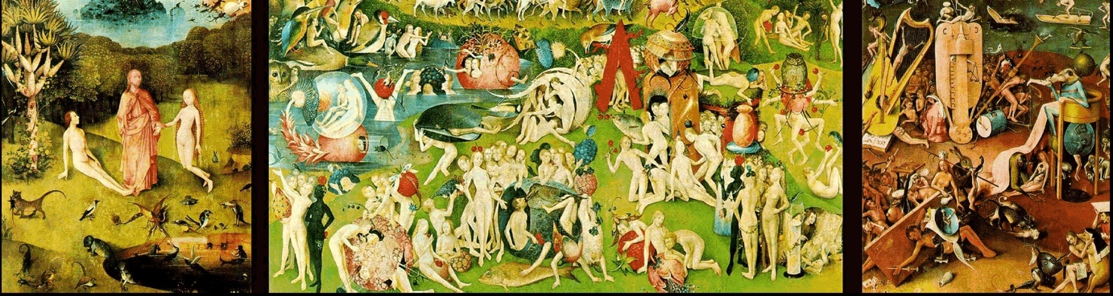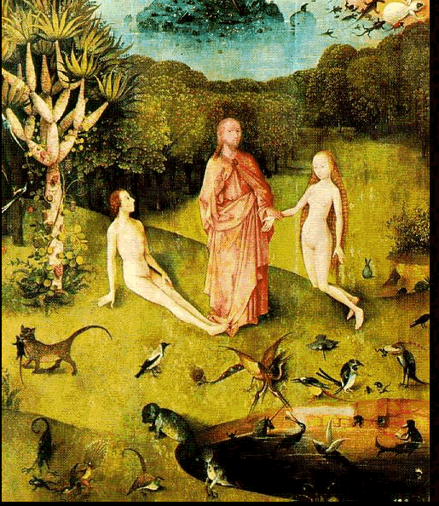A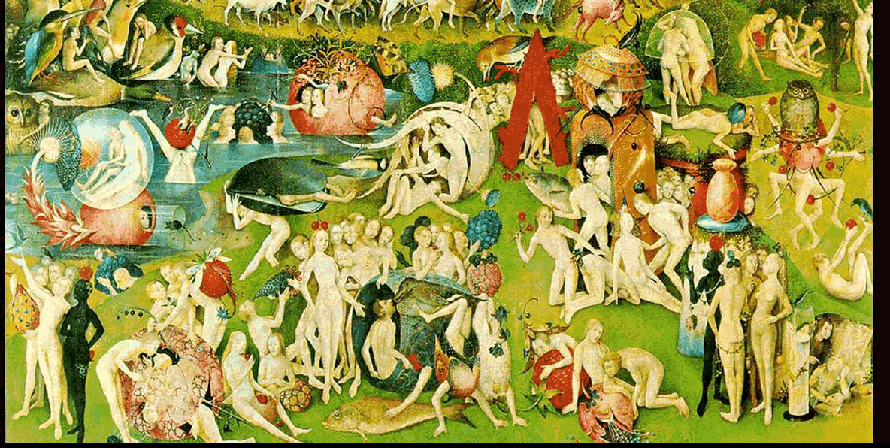B

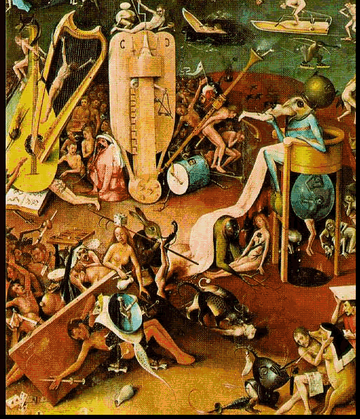C
The first image is segment of a complex piece with multiple parts. A, B. and C are details within those segments. Look at each detail (A, B, or C). First, indicate whether the detail is beautiful to you and why or why not. Then, select one detail (A, B, or C) you think would inspire you to create a story or start a class discussion. Explain your selection.

Anything that is not disgusting can be considered art according to some experts. Can something disgusting be disgusting be art? Why or why not? In your opinion.

When I think of an art appreciation class I imagine I am going to do: (describe your vision)
If I were to create my own art appreciation class I would: (describe your vision)
**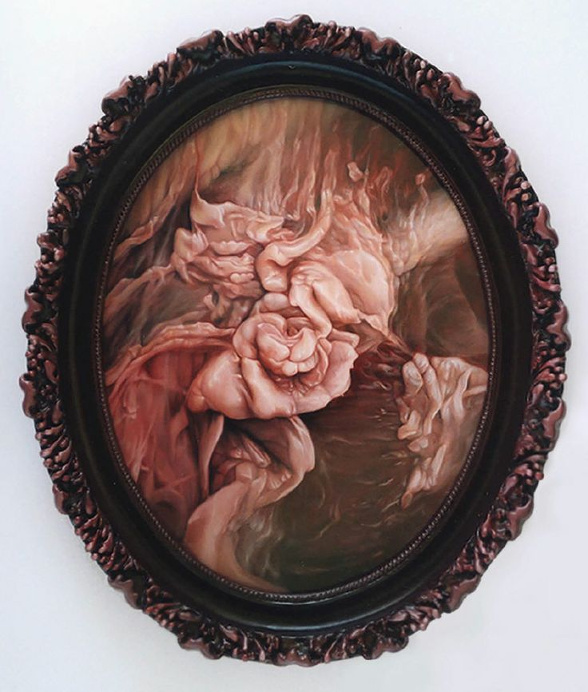
Describe this art work?

* Hieronymus Bosch, The Garden of Earthly Delights. 1495-1505. Oil on Panel. 220 cm x 390 cm. https://www.museodelprado.es/. .
**Victoria Reynolds. Kiss the Fat. 2005. Oil on Panel. By Permission of the Artist.

APPENDIX C: COURSE SYLLABUS
Course Syllabus
Art 1053 Art Appreciation

Instructor Information:
Catherine Johnston
E-Mail: email address
Office Phone Number:
Office Hours: 10-11 a.m. Monday and Wednesday and by appointment
Office Location:

Section Information:
Number: ART 1053 TR01F
Location:
Days: Mondays and Wednesdays
Time: 11:00 a.m. -12:20 p.m.

Course Description: The study of art from a variety of different backgrounds and cultures as both product and process. Aesthetic judgement making in evaluation of art from different times and places is stressed. Periods of art history with relevant concepts and terminology are included.
Expanded Course Description: This course is designed for students as an exploration of art. Students will fashion working definitions of art, art appreciation, aesthetic beauty and the rarely discussed related term aesthetic disgust. Students will examine the established context and vocabulary of art in order to analyze imagery and reconstruct content for relevant meaning. In addition, to make conceptual aspects of the artistic/creative process more tangible, students will also engage in active learning exercises.

Course Credits: 3 semester credit hours

Course Prerequisites: ENGL 0203, adequate placement score, or by meeting determined placement measures

Required Text and Material: Living with Art by Mark Getlein, 10th Edition. Published by McGraw/Hill. ISBN 978-0-07-337925-8

Learning Objectives and Course Competencies:
- Students will be introduced to the vocabulary and philosophy of art and aesthetics.
- Students will explore the relationship between the arts, culture, and the history of ideas.
- Students will apply to the skills of visual literacy and critical thinking in written form.
- Students will demonstrate unpacking art.
- Students will reconstruct unpacked art content.
- Students will construct personally relevant meaning from art content.
In addition to general course competencies, this course will also:
- Provide students with appropriate terminology for analyzing works of art in various genres.
- Familiarize students with artworks representing two- and three-dimensional media (drawing, painting, photographs, sculpture, crafts, and architecture).
- Include classic artworks as well as non-traditional art (comics, crafts, etc.) to demonstrate the range of what “art” is.
- Assist students in improving skills of visual literacy and writing.
- Provide a brief survey of art history.
- Include motifs and ideas from non-Western traditions to provide multicultural perspectives.

This course is designed for individual creative application, small group collaborative work, and larger group discussion. Students are expected to do the following: attend class, choose topics/images that align with their personal interests, participate in class projects, present material that engage their classmates, and to be respectful of others. All major group work will be done during the designated class time.

Method of Evaluation and Grading:

Group Work
Class Participation (10@16) | 160 points
Group Projects Moodle uploads (4 @20) | 80 points
Group Presentation | 150 points
Individual Student Work
Flag Project | 200 points
Visual Analysis Paper | 300 points
Active Exercises (3 @ 20) | 60 points
Genderad Exercise | 50 points
Total | 1000 points

Grading Scale:
A 900 points and above
B 800-899 points
C 700-799 points
D 600-699 points
F 599 points and below

Class Overview:

Class Participation (Attendance Policy) - 160 points
This course is designed for individual creative application, small group collaborative work, and larger group discussion. Students are expected to do the following; attend class, choose topics/images that align with their personal interests, participate in class projects, present material that engage their classmates, and to be respectful of others. These points are earned through active attendance. Missed class participation points cannot be made up.

American Flag as Art - 200 points
This project explores perceptions of the American flag and its use in visual art. Images of the art works for this project are included on the page below.
- Poll at least five people - family, friends, acquaintances or strangers (but not fellow classmates). Record their age, gender, and highest level of education received. Assure them their information will remain anonymous. Choose people of various ages who you think will be willing and thoughtful – and who might have a view different from your own!
- Show them the three art images that incorporate the American flag.
- Ask your participants what they think the meaning is of each work of art shown.
- Is the image perceived more “positive” or more “negative” in a patriotic sense? Why?
- Record their responses.
- Next, ask your participants if they think there are laws in place that restrict what a person can and cannot do with the American flag (in the making of art or anything else). If they believe laws exist – ask them what the laws are.
- After all surveys have been made, summarize your findings in a follow-up report. In addition to the report, you must separately submit the raw data (actual information obtained from interviewees). Make sure the report is thorough and accurately reflects the information you collected from your participants.

Analysis Paper - 300 points
Select an image for analysis and submit the image for approval.
Paper Format:
Section 1: Visual Analysis
Section 1A (literal description): Give a visual inventory of the work. Make sure that given a series of similar works that I could tell which work you have chosen. Be systematic. For example, describe in detail the style of hair, shape of the face, type of tree, quantity, placement and so on. Subtle details make meaning. No colors or emotive terms should be used. For example, she has brown hair, only describes the color, not the length, style or type of hair. She could have anything from a mohawk to an afro.
Section 1B (color description): Give a visual inventory of the colors of a work. Tell what colors you see and where they are located. Be as specific as possible. For example, “The bench top is powder blue with a navy blue back.” Remember the colors should be written in paragraph form rather than a list.
Section 1C: (structure, pattern and technique):
Structure: Tell me what you see first, second, third, fourth and so on as well as why you saw it in that order. For example, I see his hat first because it's the lightest color in the work and the hat contrasts with the dark colors around. It is also centrally located. Continue to tell what you see next and why your eye moved in that order until you have included all significant visual details in the work.
Pattern: Are there any repeated shapes? If so, what are they? Does the eye flow in any particular geometric shape?
Technique: Is the work done in a realistic manner? In what sense isn't it realistic? Can you see the strokes? Do they go in any particular pattern? Are the colors evenly applied, modeled naturally, and so on?

Section 2: Reconstruction for Meaning
Section 2A: Support your ideas by providing evidence from sections 1 A through 1C. What does the piece mean and what visual proofs do you have that support your ideas? Begin with the first section and tell what literal information supports your ideas. Then explain why the color choices support your ideas. Finally describe how the eye flow, patterns and technique support your ideas.
Section 2B: Describe cultural contexts from which ideas of disgust are derived. Korsmeyer suggests that there are two basic types of disgust: the visceral (or contact with repugnant) and the moral (or pertaining to transgressions against social norms). Which form is this work? What evidence supports this? Why?

Section 3: Reflection

Section 3A: Write your definition of aesthetic beauty. Has your understanding of beauty changed? If so, how? If not, why not?

Section 3B Write your definition of aesthetic disgust. Has your understanding of disgust changed? If so, how? If not, why not?

Section 3 C Does understanding the meaning and its cultural context change your affinity with your selected work? Why or why not.

Section 3 D Is your selected work, an example of aesthetic beauty or aesthetic disgust, explain.

Students who have their papers reviewed by the Communication lab should bring the assignment format and grading rubric. A reviewed draft signed by the Communication Lab can be submitted with your final paper for an additional 30 points added to the paper grade. Papers that deviate from the assigned format will require revision to receive a passing grade.
Group Projects Moodle Uploads - 80 points
Small groups are given a topic to consider and information to gather. The group has one week to submit as a group, the response to the classroom prompt. These submissions will be reviewed in the next class. Late submissions will not receive credit.

Active Exercises - 60 points
These are hands-on exercises designed to give the student experience with the application of concepts learned in class. Students are graded based upon effort and attitude, not on artistic merit.

Genderad Exercise - 50 points
Visit the Genderads project at: http://www.genderads.com/styled-7/photos-4/ and review images under rolesI>normalized. Consider what these images say about women, men, and their body images.
Find an ad whose message has a personal impact on you or someone you know. In a paragraph of at least 300 words, explain the literal content (what is the ad trying to sell), the subtext (what other messages is the viewer supposed to receive), your response to the ad, and the implications of the ad for you or for someone else. Could this industry be changed? If so, how? If not, how can those who see these images undo, challenge, or push back against their effects? In your response, make sure you include a link to the ad you have chosen.
Group Presentation *- 150 points
From Chapters 15-20 in your textbook, select one chapter to use as the content starting point for your group presentation. Create one of the following to present your chosen time period or propose something not listed for instructor approval:
Time capsule
Create a time capsule. Choose a time range, an area of the world, and fill container with art and influences of that era. Be ready to discuss your contents.

Series of Matchbox Foldouts
Create a series of mini foldout matchbooks representing a particular aspect of the time period you selected. Include relevant events that shaped the art you have chosen to for your flipbook minis.
Facebook Page

Create a Facebook Page for your chosen time period.

Art Box
Create an art box. The box may contain art, become a diorama, or used as a framework to display the works.

Informative Card Game
Create an informational card game or board game. The objective of which would be for the players to learn about the information you have researched and assembled to share with the class.

Movie
Create a movie.
There will some time to work on these in class. Students will be expected to present their creations to their classmates and engage in a question and answer period.

*(students were presented with examples of each these and encouraged to think of other ideas, images were removed because permissions were not acquired)

Late Work Policy: All assignments are due on the assigned date by 5 p.m. Assignments may be, and are encouraged to be, turned in early. All assignments not turned in on the due date may be turned in within one week with a one grade penalty (all “A” work will only be able to achieve a “B”, etc.).

In case of extreme extenuating circumstances beyond the student’s control (hospitalization, death in the family, etc.), verifiable written documentation must be submitted to the instructor.

Email Address Use
Students use their college email account to send emails to the instructor, while instructors use their college email account to send emails to students. It is not acceptable to use a non-college email account to send or receive emails for this course. Forwarding your college email to another email address occurs at your own risk as these email messages may be lost. [This is optional, but is highly recommended. Feel free to reword.]

College Academic Policies were given to students, but are not included in this document

Course Schedule
Class Week | Date | Activity | Assignment | Due Dates
1 | Aug 17 | To be covered in class:  - Go over syllabus, informed consent, and course expectations.  - VARK | Pre-course Assessment (turn in)  Informed consent  Mini Talk | Aug 17
 | Aug 19 | Chapter 1  What Artist Do?  - Create places for some human purpose  - Create extraordinary versions of ordinary objects  - Record and commemorate  - Tangible forms to the unknown  - Tangible forms to feelings and Ideas  - Refresh our visions and help us see the world in new ways | Who is an artist?  What makes an artist an artist?  What is the role of the artist in society?  Has this role changed? Why or why not.  Is this role valued? Why or why not. | Aug 19
2 | Aug 24 | Form groups  - Group introductions  - Mini Talk  Week Two: Chapter Two: What is Art?  To be covered in class:  - Group question: What is art? Is there anything that is not art? List examples.
 | Aug 26 | - The question of beauty  - Create preliminary definitions of art, art appreciation, aesthetic beauty, and aesthetic disgust. Examples if possible (turn in) | Group Assignment One: Assign one per group; upload to Moodle visual examples and explanation/rationale; and complete prior to week three (#1) | Due by Aug31
3 | Aug 31 | Chapter Three: Themes of Art  To be covered in class: Patrons of the Arts, themes and the artist  - Review art definitions  - Mini talk  - Drawing exercise (#a) | Drawing exercise
 | Sept 2 | Group Assignment -Assign one per group; upload to Moodle visual examples and explanation/rationale; and complete prior to week four (#2)  Themes  - Sacred Realm  - Politics and the Social Order  - Stories and Histories  - The Natural World  - Looking Outward: the Here and Now  - Looking Inward: the Human Experience  - Invention and Fantasy  - Art and Artist | Group Assignment Two: Assign one per group; upload to Moodle visual examples and explanation/rationale; and complete prior to week four (#2) | Due by Sept 9
4 | Labor Day-no class
 | Sept 9 | To be covered in class:  - Review Moodle uploads on themes, examples, and rationale  - Application of elements in context of art  - Visual Elements  - Line  - Contour/outline  - Direction/Movement  - Shape and Mass  - Light  - Color  - Texture and Pattern  - Space 2 dimensional/3 dimensional  - Perspective Linear; Atmospheric; Isometric Scale  - Time and Motion  Group work on analysis
5 | Sept 14 | Chapter Five: Principles of Design  - Design Principles  - Unity and Variety  - Balance –Symmetrical/Asymmetrical/Radial  - Emphasis and Subordination  - Scale and Proportion  - Rhythm  Mini Talk  Group work on analysis
 | Sept 16 | Assign one per group; upload to Moodle visual examples and explanation/rationale; and complete prior to week six (#3)  Group work on analysis | Group Assignment Three: Assign one per group; upload to Moodle visual examples and explanation/rationale; and complete prior to week six (3) | Due by Sept 6
6 | Sept 21 | Chapter Six: Drawing, Chapter 7: Painting, and Chapter 11: Sculpture and Installation  Surfaces/Support/Ground or Primer/Pigment/Binder  Graphic, Metalpoint, Charcoal, Crayon, Pastel, Chalk, Pen, Ink, Wash, Collage, Fresco, Tempera, Oil, Watercolor, Gouache, Acrylic, Mosaic, Tapestry, Mixed Media  In the round, Relief, Modeling, Carving, Casting, Assembling, Earthworks/Installations  Mini Talk  Review Moodle uploads on themes, examples, and rationale
 | Sept 23 | Printmaking exercise (#b)  Selection for Analysis Due | Printmaking exercise  Analysis selection | Printmaking exercise/Analysis selection due Sept 23
7 | Sept 28 | Chapter 8: Prints and Chapter 9: Camera and Computer Arts and Chapter 10: Graphic Design  Matrix/Edition  Relief/Woodcut/LinoCut /Wood engraving  Intaglio/Engraving/Drypoint/Mezzotint/Etching/Photogravure  Lithography/Planographic  Screenprinting/Silkscreen/Serigraphy  Monotype  Inkjet  Photography/Film/Video/Internet  Signs and Symbols Typography Layout Word and Image Motion and Interactivity Graphic Design and Art
 | Sept 30 | Introduce the genderads project.  Review images under objects>normalized.  What do these images say about women, men, body images?  http://www.genderads.com/styled-7/photos-4/ | Find area of the gender ad that has a personal impact on you or someone you know. Explain the literal content (what is the ad trying to sell), what is the subtext (what other messages is the viewer supposed to receive), explain your response to the ad, and the implications of the ad for you or someone else. Could this industry be changed? If so, how? If not, how can those who see these images undo, challenge, or push back against it effects? In your response, make sure you include a link to the ad you have chosen. | Genderad assignment Due Oct 5
8 | Oct 5 | Chapter 12 Arts of Ritual and Daily Life and Chapter 13 Architecture  Clay/Ceramics, Glass. Metal, Wood, Fiber, Ivory. Jade, Lacquer  Art, Craft, Design  Load-bearing Construction/ Post and Lintel, Round/Pointed Arch and Vault, Cast Iron Construction, Balloon-Frame Construction, Steel-Frame Construction, Suspension and Cable-Stayed Structures, Reinforced Concrete, Geodesic Domes, Digital Design and Fabrication, Fabric Architecture, Sustainability Architecture
 | Oct 7 | The Art of Disgust  Group work. Create working definitions of beauty and disgust. Construct the contextual source(s) of these definitions. Identify examples of beauty/disgust in cultural contexts. Carolyn Korsmeyer suggests that there are two basic types of disgust: the visceral (or contact with repugnant) and the moral (or pertaining to transgressions against social norms). upload to Moodle definitions, an example of each type, describe how they are exemplify both art and disgust; and complete prior to week 9. (#4) | Group Assignment Four: Assign one per group; upload to Moodle visual examples and explanation/rationale; and complete prior to week nine (4) | Due by Oct 12
9 | Oct 12 | Chapter 14: Ancient Mediterranean Worlds  The Oldest Art? Is it art?  Drawing exercise (#c) |  | Drawing C due Oct 12
 | Oct 14 | Flags and Art—Ms. Darby Johnsen
10 | Oct 19 | Flags, Art, and Politics—Mr. Nate Vanden Brook
 | Oct 21 | Collect compile and complete flag research assignment |  | Flag Assignment due Oct 26
11 | Oct 26 | Journals
 | Oct 28 | Chapter 15 Christianity and the Formation of Europe Chapter and 16: The Renaissance  Mini talk  Group work
12 | Nov 2 | Chapter 17: The 17th and 18th Centuries  Mini talk  Group work |  | Analysis Paper due  Nov 2
 | Nov 4 | Chapter 18: Arts of Islam and of Africa  Group 1 Presentation |  | Turn in
13 | Nov 9 | Group 2 Presentation  Group Review |  | Turn in
 | Nov 11 | Chapter 19 Arts of East Asia: India, China  Group 3 Presentation  Group Review |  | Turn in
14 | Nov 16 | Group 4 Presentation  Group Review |  | Turn in
 | Nov 18 | Chapter 20: Arts of the Pacific and of the Americas  Group 5 Presentation  Group Review |  | Turn in
 | Nov 23 | Chapter 21: The Modern World: 1800-1945  Mini talk  Drawing 4 |  | Turn in
15 | Nov 30 | Group 6 Presentation  Group Review |  | Turn in
 | Dec 2 | Review preliminary definitions of art, art appreciation, aesthetic beauty, and aesthetic disgust, and examples. Given course experience, refine definitions, and include examples. |  | Turn in
16 | Dec 7 | Chapter 22: From Modern to Post Modern and Chapter 23 Opening Up to the World
 | Dec 9 | Mini Talk  Bring post 1945 examples of interest that are not in the textbook.  Post Course Assessment

APPENDIX D: STUDENT RESEARCH ASSIGNMENT
Art Appreciation
The American Flag in Art
This project explores perceptions of the American flag and its use in visual art. Images of the art works for this project are included on the following page. (This assignment was created by and adapted with permission from a wonderful artist, educator, and friend.)

Poll at least five people - family, friends, acquaintances or strangers (but not fellow classmates). Record their age, gender, and highest level of education received. Assure them their information will remain anonymous. Choose people of various ages who you think will be willing and thoughtful – and who might have a view different from your own!

- Show them the three art images that incorporate the American flag.

- Ask your participants what they think the meaning is of each work of art shown.
- Is the image perceived more “positive” or more “negative” in a patriotic sense? Why?
- Record their responses.

- Next, ask your participants if they think there are laws in place that restrict what a person can and cannot do with the American flag (in the making of art or anything else). If they believe laws exist – ask them what the laws are.

- After all surveys have been completed, summarize your findings in a follow-up report. In addition to the report, you must separately submit the raw data (actual information obtained from interviewees). Make sure the report is thorough and accurately reflects the information you collected from your participants

Post Data Collection Report:
In essay form:

- Number of male and female participants in your poll. Did you notice any differences in the responses of male vs. female or their willingness to participate in the project?
- Age range of each gender group and your analysis of differences in the responses based on age.
- Range of education for each gender group and your analysis of differences based on educational level.
- Opinions and comments from participants for art work #1 (summarize from the raw data)
- Opinions and comments from participants for art work #2 (summarize from the raw data)
- Opinions and comments from participants for art work #3 (summarize from the raw data)

For items 4, 5, and 6 be sure to note how many participants considered each artwork positive and how many considered each work negative.

- Summarized results from participants concerning the American flag and the law.
- Write your personal observations on the assignment itself. What did you learn from your interviews? How were the five participants’ perceptions of the art works and their meanings different from your own ideas? Be specific with your answers.

1.
American Collection #6: The Flag is Bleeding #2, 1997
acrylic on canvas
77 x 81
Private Collection
Faith Ringgold (By Permission of the Artist)

2.

Jack Daws
Pickled Flags 2001 Mixed Media
Image Courtesy of Greg Kucera Gallery, INC.
212 Third Ave South-Seattle, WA 98104

3.
Fritz Scholder. American Portrait with Flag,1979. (Courtesy of American Museum of Western Art-The Anschutz Collection/Photo courtesy William J. O'Connor I© Estate of Fritz Scholder)

Data Sheet
Participant 1 | Age |  | Gender |  | Highest Level of Education
 |  |  | P or N | Laws? | Comments
Image 1
Image 2
Image 3
Participant 2 | Age |  | Gender |  | Highest Level of Education
 |  |  | P or N | Laws? | Comments
Image 1
Image 2
Image 3
Participant 3 | Age |  | Gender |  | Highest Level of Education
 |  |  | P or N | Laws? | Comments
Image 1
Image 2
Image 3
Participant 4 | Age |  | Gender |  | Highest Level of Education
 |  |  | P or N | Laws? | Comments
Image 1
Image 2
Image 3
Participant 5 | Age |  | Gender |  | Highest Level of Education
 |  |  | P or N | Laws? | Comments
Image 1
Image 2
Image 3
Participant 6 | Age |  | Gender |  | Highest Level of Education
 |  |  | P or N | Laws? | Comments
Image 1
Image 2
Image 3

APPENDIX E: VISUAL ANALYSIS DESCRIPTION AND GRADING RUBRIC
Section 1: Visual Analysis
Section 1A (literal description): Give a visual inventory of the work. Make sure that given a series of similar works that I could tell which work you have chosen. Be systematic. For example, describe in detail the style of hair, shape of the face, type of tree, quantity, placement and so on. Subtle details make meaning. No colors or emotive terms should be used. For example, she has brown hair, only describes the color, not the length, style or type of hair. She could have anything from a mohawk to an afro.
Section 1B (color description): Give a visual inventory of the colors of a work. Tell what colors you see and where they are located. Be as specific as possible. For example, “The bench top is powder blue with a navy blue back.” Remember the colors should be written in paragraph form rather than a list.
Section 1C: (structure, pattern and technique):
Structure: Tell me what you see first, second, third, fourth and so on as well as why you saw it in that order. For example, I see his hat first because it's the lightest color in the work and the hat contrasts with the dark colors around. It is also centrally located. Continue to tell what you see next and why your eye moved in that order until you have included all significant visual details in the work.
Pattern: Are there any repeated shapes? If so, what are they? Does the eye flow in any particular geometric shape?
Technique: Is the work done in a realistic manner? In what sense isn't it realistic? Can you see the strokes? Do they go in any particular pattern? Are the colors evenly applied, modeled naturally, and so on?
Section 2: Reconstruction for Meaning
Section 2A: Support your ideas by providing evidence from sections 1 A through 1C. What does the piece mean and what visual proofs do you have that support your ideas? Begin with the first section and tell what literal information supports your ideas. Then explain why the color choices support your ideas. Finally describe how the eye flow, patterns and technique support your ideas.

Section 1 Visual Analysis |  |  |  | Point Earned
 | 40-31 | 25-30 | 0-24
Literal Description | Well-defined description of all significant aspects/items/objects of the artwork. Does not include the use of color or emotive terms. | Description of artwork is relatively complete. Color or emotive terms may or may not be used. | Superficially inventories the artwork. May contain color or emotive terms in place of descriptive terms. Significant elements are absent
 | 30-24 | 20-23 | 0-19
Color Description | The colors of all significant aspects/items/objects of the artwork have been described. Does not include the use of emotive terms | Description of colors used in the artwork is relatively complete. Emotive terms may or may not be used. | Superficially inventories the colors in the artwork. May contain emotive terms in place of descriptive terms. Significant color descriptions are absent
 | 30-24 | 20-23 | 0-19
Structure/Pattern/Technique | The third section contains completed and thorough descriptions of structure, patterns, and technique. | The third section contains the descriptions of structure, patterns, and technique. One of the three may be missing or poorly completed or all may be included but not thoroughly. | The third section minimally completed. Some or all components are incomplete.
 | Total possible (100)
Reconstruction
 | 40-31 | 25-30 | 0-24
Supported from literal description | The idea /meaning of the work is well-supported by content from the literal description (no color terms are used). Many details are used. | The idea /meaning of the work is adequately supported by content from the literal description, there may be the use of color terms. | The idea /meaning of the work is vaguely supported or is not supported by specific content from the literal description. Color terms may be used.
 | 30-24 | 20-23 | 0-19
Support from color description | The idea /meaning of the work is well-supported by color description. Many specific details are used. | The idea /meaning of the work is basically supported by color description. There may be details but they may not be specific. | The idea /meaning of the work is vaguely or not supported by the color description. There may be no details.
 | 30-24 | 20-23 | 0-19
Support from structure/pattern/technique | The idea /meaning of the work is well-supported by the completed and thorough descriptions of structure, patterns, and technique. | The idea /meaning of the work is somewhat supported by the completed and basic descriptions of structure, patterns, and technique. One of the three may be missing or vague. | The idea /meaning of the work vaguely supported. One or more of the areas may be missing. There are few (if any) specific supporting details.
 | Total possible (100)
Reflection
Choose A or B | 25-21 | 20-18 | 0-17
A. Is your work an example of aesthetic disgust?  Describe cultural context and which type disgust (moral or visceral) and why you believe this to be true | Student has selected A or B and answered the prompts thoroughly as it applies to their chosen essay. | Student has selected either A or B and they have answered the prompts adequately but without detail, or one prompt well and not the other. | Student has selected either A or B and they have failed to address both parts. Answer is vague and lacks support and explanation.
B. Is your work an example of aesthetic beauty?
Describe cultural context and for defining this as beautiful and why you believe this to be true
Answer A AND B | 25-21 | 20-18 | 0-17
Write your definition of aesthetic beauty. Has your understanding of beauty changed? If so, how? If not, why not? | Student has written two detailed definitions and provided reflective answers on changes about those definitions. | Student has written two definitions. One of the two may better be detailed than the other. The reflective answers on changes about those definitions may address one of the answers but not both or could address both but only basically. | Student has failed to write one of the two definitions; or included two definitions but both are so vague it is unclear what the definitions are for, and they have provided little or no reflective answers on changes about those definitions.
Write your definition of aesthetic disgust. Has your understanding of disgust changed? If so, how? If not, why not?
 | Total possible (50)
Mechanics
 | 50-41 | 35-40 | 0-34
 | Student has followed all directions AND has spell checked, reviewed, revised, corrected and turned in college level work. | Student has followed most of the directions AND has made some attempt to spell check, review, revise, correct, and turn in college level work but there are some errors. | Student has not followed all directions AND has many numerous errors in the writing process.
 | Total possible (50)
Total

Students who have their papers reviewed by the Communication lab should bring the assignment format and grading rubric. A reviewed draft signed by the Communication Lab can be submitted with your final paper for an additional 30 points added to the paper grade. Papers that deviate from the assigned format will require revision to receive a passing grade.

APPENDIX F: EXIT-COURSE SURVEY
Exit-Course Survey
Exactly, What is Art Appreciation?
Demographics
Name
Gender | Male [ ] Female [ ]
[ ] Freshmen  [ ] Sophomore |  | My major is______________________________________
Describe your last experience with art
I am taking this class because
Brainstorm things you think can be called art. Include specific examples if you know any.
What do you think the word appreciation means in the course title: What is Art Appreciation?

The textbook for this class reads as follows: “Beauty is deeply linked to our thinking about art. Aesthetics, the branch of philosophy that studies art, also studies the nature of beauty.” The author goes on to suggest many believe the purpose of art is beauty. What do you think? Could there be another purpose?

*
Give this work your own title:
Is this a work that draws you in or repels you? Explain your answer.

What question would you ask the artist?

Why would this be important to know?

**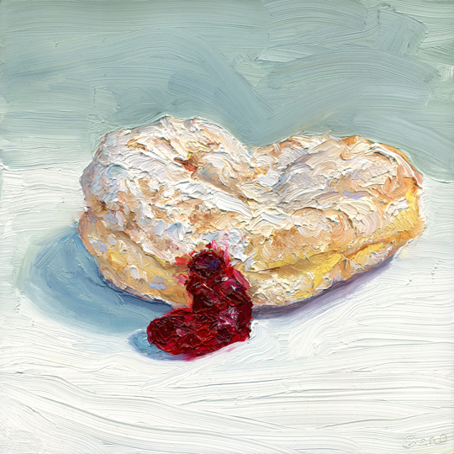
Describe your initial ideas/feelings about this work:

Is this a work of aesthetic beauty or disgust (difficult beauty)? Explain your answer.

What do you think the artist was trying to communicate? What makes you think this?
Anything that is not disgusting can be considered art according to some experts. Can something disgusting be disgusting be art? Why or why not? In your opinion.
When I think of an art appreciation class I imagine I am going to do: (describe your vision).
If I were to create my own art appreciation class I would: (describe your vision)

* Patricia Piccinini, Newborn. Silicone, fiberglass, human hair, clothing, 110 x 65 x 60 cm. By Permission of the Artist.
** Mike Geno, Jelly. Oil on wood. 8 x 8. By Permission of the Artist.

Carolyn Korsmeyer, Savoring Disgust: The Foul and the Fair in Aesthetics (New York: Oxford University Press, 2011).
Bernard Bosanquet, Three Lectures on Aesthetic (London: McMillan and Co., Limited, 1923).
Yolanda Medina, Critical Aesthetic Pedagogy: Towards a Theory of Self and Social Empowerment (New York: Peter Lang, 2012).
Lewis Carroll, Alice in Wonderland and Through the Looking Glass. (USA: Grosset & Dunlap, [1872] 1989), 159.
In chapter 6, Humpty Dumpty explains to Alice a poem she has tried to read but struggles to understand. Many of the words in the poem are portmanteaus or a blend of wo words. Portmanteaus are neither compounds nor contractions. The portmanteau for cognition and odyssey is cognidyssey, the adventures that shape my metacognition.
Beatrice is one of Dante’s guides in Dante Alighieri’s Divine Comedy (1308-1320). I found her ability to cope in any environment very comforting. Wonderland and the looking glass worlds were constantly changing and making how to respond to the local social cues confusing. Alice was curious and this made her adventurous, even brave. I admired Alice’s adaptability and her kindness. She seemed like a friend on which you could rely.
When I write free of evil, I mean to being free or safe from Satan. Growing up, the world was filled with evil and Satan lurked everywhere trying to tempt or do evil. School seemed like a safe refuge; a place to hide among other children.
Lewis Carroll’s (1872) second novel.
Parker J. Palmer, Courage to Teach: Exploring the Inner Landscape of a Teachers Life, 10th Anniversary Edition (San Francisco, CA: John Wiley& Sons, 2007, Kindle Edition), Location 215.
The definition for aesthetic disgust that resonates with me was written by Carolyn Korsmeyer (2011) in Savoring Disgust: The Foul and the Fair in Aesthetics. She writes, “Aesthetic disgust is a response that, no matter how unpleasant, can rivet attention to the point where one actually may be said to savor the feel (3).
Bernard Bosanquet, Three Lectures on Aesthetic (London: McMillan and Co., Limited, 1923), 85.
Carroll, Through the Looking Glass & What Alice Found There, 163.
Most of this chapter is devoted to challenging Alice’s preconceived ideas about flowers. I immediately thought about my students in my first class. I believe that self-reflection on ideas held is so important. While your eyes tell you things, what you see is seldom the whole story or sometimes not even the truth. Carroll, Through the Looking Glass & What Alice Found There, 163-168.
Palmer, The Courage to Teach: Exploring the Inner Landscape of a Teachers Life, 10th Anniversary Edition, 514.
John Dewey. Art as Experience (New York: Perigree, 1980) 40.
Ibid, 40.
I believe some people’s eye reach a metaphoric saturation point. Susan D. Moeller’s (1999), Compassion Fatigue: How the Media Sell Disease, Famine, War, and Death lays out a compelling argument for the contribution of the news reporting/media in the emotional numbing of vast numbers of America’s population. The old news story phase, “if it bleeds it leads,” pulls at the heart strings until the individual feels overwhelmed and helpless to stop the tragedy and withdraws or escapes. Escape can look like empty eyes, but there are those who simply don’t see past their own concerns.
David A. Kolb Experiential Learning: Experience as the Source of Learning and Development, 2nd Ed. (Upper Saddle, New Jersey: Pearson Education, INC, 2015) 51.
Alice Y Kolb and David A. Kolb, “Learning Styles and Learning Spaces: Enhancing Experiential Learning in Higher Education”. Academy of Management Learning & Education 4,2: (2005) 194.
Ken Robinson. “Changing Educational Paradigms.” Ted Talks, October 2010. https://www.ted.com/talks/ken_robinson_changing_education_paradigms.
George Land and Beth Jarman, Breakpoint and Beyond: Mastering the Future Today (USA: HarperBusiness,1992), 153.
The longitudinal study followed 1600 children beginning in kindergarten for 15 years.
David Kolb, Experiential Learning: Experience as the Source of Learning and Development 2nd Ed. (Upper Saddle River, New Jersey: Pearson Education Inc., 2015) 194.
John S Brown, Allan Collins, and Paul Duguid, “Situated Cognition and the Culture of Learning,” Educational Researcher, 18, 1 Jan-Feb 1989, 7 (32-42).
Maxine Greene, Releasing the Imagination: Essays on Education, the Arts, and Social Change (San Francisco, CA: Jossey-Bass, 1995) 136.
Horst de la Croix and Richard Tansey, Gardner’s Art Through the Ages (6th Ed) (New York: Harcourt Brace Jovanovich, INC., 1975).
Käthe Kollwitz (1919) Memorial to Karl Liebknecht, Woodcut, in Horst de la Croix and Richard Tansey, Gardner’s Art Through the Ages (6th Ed) (New York: Harcourt Brace Jovanovich, INC., 1975), 726.
Bridget Riley (1964) Current. Synthetic-resin paint on composition board approx. 53 3/8” x 58 7/8”, in Horst de la Croix and Richard Tansey, Gardner’s Art Through the Ages (6th Ed) (New York: Harcourt Brace Jovanovich, INC., 1975), 777.
Immanuel Kant The Critique of Judgement (Translated James Creed Meredith. 1790) Kindle, Location, 2352.
Wendy Johnson, “Greatness as a Manifestation of Experience-Producing Drives” from The Complexity of Greatness: Beyond Talent or Practice. Scott Barry Kaufman ed (New York: Oxford Press, 2013), 10-11.
Arthur P. Bochner, Coming to Narrative: A Personal History of Paradigm Change in the Human Sciences (New York: Routledge, 2014, Kindle Edition), 1956.
May 20, 2011- Facebook posts by alumni of a private art college the south in the 80’s. Discussions concerned common learning experiences while in school together.
Palmer. The Courage to Teach: Exploring the Inner Landscape of a Teachers Life, 10th Anniversary Edition, 438.
Carroll, Through the Looking Glass & What Alice Found There, 187.
John Haywood. A Dialogue Conteinyng the Nomber in Effect of all the Prouerbes in the Englishe Tongue Compacte in a Matter Concernyng Two Maner of Mariages (CC1.0, http://name.umdl.umich.edu/A03168.0001.00, 1546) Part 2, chapter 1.
Carroll, Through the Looking Glass & What Alice Found There, 11.
Neil. D. Fleming and Charles C. Bonwell, “Introduction to VARK,” 2017. http://vark-learn.com/the-vark-questionnaire/.
John Dewey, Art as Experience, 13.
According to the latest American Association of Community Colleges’ Fact Sheet 36% of the student population are the first generation to attend college. The actual number of first generation students on a campus varies by location. http://www.aacc.nche.edu/AboutCC/Documents/AACCFactSheetsR2.pdf
Achieving the Dream.org, “College Readiness,” Focus-Area/college-readiness http://achievingthedream.org/focus-areas/college-readiness.
Dewey, Art as Experience, 34.
Dewey, Art as Experience, 138.
John Dewey, The Nature or Moral Philosophy in the Moral Writings of John Dewey (Amherst, NY: Prometheus Books, 1994, Kindle Edition), 3594-3605.
Ibid, location 3605-12.
Ibid, location 3711-18.
Grace Bush, “25 years Later: Cincinnati and the Obscenity Trial over Mapplethorpe Art,” The Washington Post, October 2015, https://www.washingtonpost.com/entertainment/museums/25-years-later-cincinnati-and-the-obscenity-trial-over-mapplethorpe-art/2015/10/22/07c6aba2-6dcb-11e5-9bfe-e59f5e244f92_story.html?utm_term=.8526817a3cd8.
I contacted Calvin Klein’s protocol for use of a particular image from 1990 on multiple occasions and received no reply. The image I wished to use was very similar to the one I selected from the Mapplethorpe exhibit. I am including a link to the advertising history and a clear comparison can be drawn from the campaign at the time and points to distinct homoerotic cultural bias. Jonathan Evans, “The NSFW History of Calvin Klein’s Provocative Ads,” Esquire. 2018. http://www.esquire.com/style/news/g2841/nsfw-history-calvin-klein-advertising/.
Bachelors-1977-1981.
Start of second of MFA-1991.
Alfred Montuori, “The Complexity of Improvisation and the Improvisation of Complexity: Social Science, Art and Creativity,” Human Relations, 26,2 (2003): 238
Oxford Dictionary defines conceptual art as, “Art in which the idea presented by the artist is considered more important than the finished product, if there is one.” From http://www.oxforddictionaries.com/us/definition/american_english/conceptual-art.
Oxford Dictionary defines performance art as, “An art form that combines visual art with dramatic performance.” From http://www.oxforddictionaries.com/us/definition/american_english/performance-art?q=performance+art.
Christopher J Lucas, American Higher Education: A History, 2nd Ed. (New York: Palgrave Macmillan, 2006), 103-139.
Thomas Woody, A History of Women’s Education in the United States (New York: The Science Press, 1929).
Lucas, American Higher Education: A History, 2nd Ed., 122.
Ibid, 162.
Obama White House, “Archives. Fact Sheet: Let Girls Learn-A Comprehensive Investment in Adolescent Girls Education,” https://obamawhitehouse.archives.gov/the-press-office/2016/10/11/fact-sheet-let-girls-learn-comprehensive-investment-adolescent-girls.
Let Girls Learn, “About,” https://letgirlslearn.gov/about/.
Catherine Hill, “Barriers and Bias: The Status of Women in Leadership,” AAUW Report. 2016. http://www.aauw.org/resource/barriers-and-bias/.
Kevin Miller, “The Simple Truth about the Gender Pay Gap,” AAUW Report, 2017. https://www.aauw.org/resource/the-simple-truth-about-the-gender-pay-gap/.
George D. Kuh, High-Impact Educational Practices: What They are, Who has Access to the Them, and Why They Matter (AAC&U, Washington, D.C.,2008) 16.
David A. Johnson and Roger T. Johnson, “An Overview of Cooperative Learning” 2008, http://www.co-operation.org/what-is-cooperative-learning/
Institutional commitment would include: the availability of rooms that permit dialogue, rather than lecture and reasonable class sizes of 30 or smaller. Fiscal benefit: student retention cost is less than recruitment cost.
Catherine Z. Elgin, “Fiction as Thought Experiment,” Perspectives on Science, 22 (2), 2014, 226.
Mark Pendergrast, Uncommon Grounds: The History of Coffee and How It Transformed Our World (New York: Basic Books, 2010, Kindle Edition) 8.
The chapter called Wool and Water is a challenge to Alice’s thinking. Unpacking art and appreciation is to discover a universe of possibilities. Wool as a material is quite miraculous in that it is both able to keep a person warm or cool. Queen as sheep never drops a stitch as she knits an ironic twist of wool and words. Alice has to run and stay alert to keep up. Carroll, Through the Looking Glass & What Alice Found There, 207.
Carroll, Through the Looking Glass & What Alice Found There, 213.
Carroll, Through the Looking Glass & What Alice Found There, 209-214.
Dewey, John, The Moral Writings of John Dewey, 3337.
Oxforddictionaries.com, “Art,” accessed April 26, 2015, http://www.oxforddictionaries.com/definition/english/art.
Jacobellis V. Ohio., 378 U.S. 184 (1964). http://www.Acluohio.Org/Archives/Cases/Jacobellis-V-Ohio.
Immanuel Kant, The Critique of Judgement. (Amazon Digital Services, Inc., 2012, Kindle Edition), 737.
Kant, The Critique of Judgement, 2431.
Bernard Bosanquet, Three Lectures on Aesthetic (London: McMillan and Co., Limited, 1923), 85.
Ibid, 87.
Carolyn Korsmeyer, Savoring Disgust: The Foul and the Fair in Aesthetics (New York: Oxford University Press, 2011), 3.
Korsmeyer, Savoring Disgust: The Foul and the Fair in Aesthetics. 46.
David M. Wilson, “Slade, Felix (1788–1868)”, Oxford Dictionary of National Biography, Oxford University Press, 2004; online ed, Oct 2007, http://www.oxforddnb.com/view/article/25704, accessed 5 June 2015.
Arthur D. Efland, A History of Art Education: Intellectual and Social Currents in Teaching the Visual Arts (New York: Teachers College Press, 1990). 63.
National Education Association. Journal of Proceedings and Addresses. (1897; Google, 2007), https://books.google.com/books/reader?id=bnwBAAAAYAAJ&num=19&printsec=frontcover&output=reader&pg=GBS.PA268, 268.
Charles Jansen, “Scenarios of Art Appreciation: An Analysis of Text” (PhD diss., University of George, 1991), 80.
Charles Bennett, Art Training for Life and Industry, (1923; Google, 2013), http://hdl.handle.net/2027/uc1.$b124216, 10.
Michael Apple, Teachers and Texts: A political Economy of Class and Gender Relations in Education, (New York: Routledge Taylor & Francis Group, 2013, Kindle Edition), 1429.
Ibid, Kindle location1484.
Ibid.
Diane Ravitch. The Language Police: How Pressure Groups Restrict What Students Learn (New York: Vintage Books, 2002, Kindle Edition,), 2.
The Language Police simply stunned me. At the close, Rativch provide a series of examples. This is just one; Another testing expert told me about a bias review committee in Ohio that dropped the famous Sojourner Truth speech, "Ain't I a Woman?" on the grounds that it would give an "unfair advantage" to inner-city children over children in affluent suburbs, because it is more often assigned in the former than in the latter. It was removed at the urging of a private school representative. Location. 3090
Ibid, 129.
Mandarin Chinese is the first language for nearly one billion people. http://www.nationsonline.org/oneworld/most_spoken_languages.htm
The Franklin Institute: History of Science and Technology, (2012) “The Kodak Brownie”. http://learn.fi.edu/learn/sci-tech/kodak-brownie/kodak-brownie.php
Facebook, "Company information: Our Mission." Last modified 08 28, 2017. Accessed August 28, 2017. http://newsroom.fb.com/company-info/.
Gross, David, and Griggs Brandon. CNN Tech, "Snapchat CEO 'mortified' by leaked e-mails." Last modified May 29, 2014. Accessed August 24, 2014. http://www.cnn.com/2014/05/29/tech/mobile/spiegel-snapchat-leaked-e-mails/.
Francis, Balolong. "Facebook Photo Library Now has 250 Billion User Photos," Social Barrel, Last modified 9 17, 2013. Accessed August 24, 2014. http://socialbarrel.com/facebook-photo-library-now-250-billion-user-photos/53315/.
Farhad Manjoo. “Why Instagram is Becoming Facebook’s Next Facebook,” 2017, https://www.nytimes.com/2017/04/26/technology/why-instagram-is-becoming-facebooks-next-facebook.html.
Andrew Briener, “Pizzagate, explained: Everything you wanted to know about the Comet Ping Pong pizzeria conspiracy theory but are too affair to search for on Reddit,” Salon, 2016.
Paul Mihailidis and Samantha Viotty, “Spreadable Spectacle in Digital Culture: Civic Expression, Fake News, and the Role of Media Literacies in “Post-Fact Society,” American Behavioral Scientist, 61,4, 2017: 441-454.
Matt Furie, http://mattfurie.com/.
A Midwest state curriculum currently requires one unit of Fine Arts or Speech. Fine Art is defined as Music, Art, or Drama. Approximately, 10% of all parents have elected for their children to opt out of college-prep curriculum. http://sde.ok.gov/sde/newsblog/2011-11-28/state-supt-janet-barresi-sees-increase-number-freshmen-opting-take-college-prep;/.
N. L. Aikens & O. Barbarin, “Socioeconomic differences in reading trajectories: The contribution of family, neighborhood, and school contexts,” Journal of Educational Psychology, 100(2), (2008): 235-251, http://search.proquest.com/docview/614480803?accountid=12964.
Spanning the Divide. Close to two million beginning college students require remediation. The data from Complete College America reports that this number represents 42% of all students. Troublesome is that of those students needing remediation, is the disproportionally high number of low-income and students of color (African Americans 56% and Hispanic 45%). See complete report here: http://completecollege.org/spanningthedivide/#far-too-many-students-start-in-remediation.
Virginia Woolf, Three Guineas (New York: Harcourt Brace Jovanovich Publishers, 1938), 3.
Ibid, 10-11.
Susan Sontag, On Photography (New York: Picador, 1977), 3.
James Agee and Walker Evans, Let Us Now Praise Famous Men (New York: Ballentine Books, 1960), 413.
Jane Roland Martin, Cultural Miseducation: In Search of a Democratic Solution (New York: Teachers College Press, 2002) 59.
John Berger, Ways of Seeing (London: British Broadcasting Corporation, 1972) 8.
Jane Roland Martin, Educational Metamorphoses: Philosophical Reflections on Identity and Culture, (Maryland: Bowman & Littlefield Publishers, INC., 2007), 49.
Ibid, 10.
Jacob and Wilhelm Grimm, “Snow-White and the Seven Dwarfs” in The Grimm’s Fairy Tales http://www.pitt.edu/~dash/type0709.html#snowwhite.
Mark Pendergrast. Mirror/Mirror: A History of the Human Love Affair with Reflection (New York: Basic Books, 2003, Kindle Edition), 48.
Ibid.
bell hooks, Art on My Mind: Visual Politics (New York: New Press 1995), 76.
Ibid.
Ibid, 84.
Rosi Braidotti. Nomadic Subjects: Embodiment and Sexual Difference in Contemporary Feminist Theory, 2nd ed. (New York: Columbia University Press, 2011, Kindle Edition), 3003.
These are but three examples of how art and artists are impacting the world: https://www.weforum.org/agenda/2017/01/how-can-artists-lead-dramatic-social-change/ http://www.thescarproject.org/ http://nirajgera.com/sacred-transformations-acid-attack-survivors-photography/
bell hooks, Art on My Mind: Visual Politics, 76.
Woolf, Three Guineas, 3
Ibid.
Woolf, Three Guineas, 69.
Ibid, 19.
Ibid, 53.
Ibid, 34.
Ibid.
Ibid.
Ibid.
When Woolf was writing Three Guineas, higher education was accessible primarily to men and to men of the highest class in society. With the passage of free compulsory secondary education act in 1944, entrance standards to universities increased. According to an article by Robert Blackburn and Jennifer Jarman, less than .5% of women entered universities and after World War II, men from working background accounted for less than 2% (197-198). Robert M. Blackburn and Jennifer Jarman. “Changing Inequalities in Access to British Universities” in Oxford Review of Education 19 (2). 1993. 197-215 http://www.jstor.org/stable/1050816
Woolf, Three Guineas, 34.
Richard E. Sterling, Joliet Junior College 1901 to 2001: A Pictorial History of America’s Oldest Public Community College (St. Louis, MO: G. Bradley Publishing, Inc., 2001), 7.
American Association of Community Colleges. “Community Colleges Past to Present,” http://www.aacc.nche.edu/ABOUTCC/HISTORY/Pages/pasttopresent.aspx
Rebecca Cox, The College Fear Factor, (Cambridge, Massachusetts, Harvard University Press, 2009), 4.
Allie Bidwell, “Income Disparity Affects How Soon Students Enroll in College,” U.S. News, http://www.usnews.com/news/articles/2013/10/16/income-disparity-affects-how-soon-students-enroll-in-college.
Complete College America, “Corequisite Remediation: Spanning the Completion Divide,” http://completecollege.org/spanningthedivide/#far-too-many-students-start-in-remediation-1-10-17.
Cox, The College Fear Factor, 8.
According to the 2013 Women in Community College report, in contrast to the annual cost of $8655 for tuition and fees charged by public four institutions, attending full time at a public community college on average is $ 3131. Nearly 80 percent of Pell grant recipients earned $30000 or less. Also, more than a third of Pell recipients have the status of independent with dependent children. See the complete report here: Andresse St. Rose and Catherine Hill, “Women in Community Colleges: Access to Success,” AAUW Report. 2013. https://www.aauw.org/files/2013/05/women-in-community-colleges.pdf.
F. Goodchild and H. S. Wechsler & Association for the Study of Higher Education, “Report of the President's Commission on Higher Education, 1947,” The history of higher education, (Needham Heights, MA: Simon & Schuster Custom Publ. 1997), 758-772, http://faculty.washington.edu/joyann/EDLPS531/President-s_Commission.pdf.
Fernanda Zamudio-Suaréz, "Professors Bury Hidden Gems in Syllabi to Spur Students' Interest," Chronicle of Higher Education, September 09. 2016:10.
American Association of Community Colleges, “Fast Facts Factsheet,” 2016, http://www.aacc.nche.edu/AboutCC/Pages/fastfactsfactsheet.aspx.
Angela Ginorio and Michelle Huston, ¡Sí, Se Puede! Yes, We Can, (Washington, DC: American Association of University Women Educational Foundation, 2001), vii.
United States Census Bureau, “Profile America Facts,” http://www.census.gov/newsroom/releases/archives/facts_for_features_special_editions/cb11-ff18.html
Angela Ginorio and Michelle Huston, ¡Sí, Se Puede! Yes, We Can, 3.
Ibid, 4.
Ibid.
Ibid, x.
Cox, The College Fear Factor, 15-16.
Carroll, Through the Looking Glass & What Alice Found There, 177-185.
Carroll, Through the Looking Glass & What Alice Found There, 217-219.
Carroll, Through the Looking Glass & What Alice Found There,216
Carroll, Through the Looking Glass & What Alice Found There, 216.
Carrol does not tell the reader, that the Queen giving Alice actual rowing commands. To catch a crab is when there is a rowing error and the oar is “caught”. The error can sometimes be corrected or could result in rower being thrown from the boat. To Feather is to place the oars parallel to the water. Source: British Rowing, “Glossary of Rowing Terms,” 2017. https://www.britishrowing.org/knowledge/onlinelearning/techniques-and-training/glossary/.
Carol Korsmeyer, Gender and Aesthetics: An Introduction (New York: Routledge, 2004, Kindle Edition), 1107-18.
John Dewey, Art as Experience, 40.
Martin, Educational Metamorphoses: Philosophical Reflections on Identity and Culture, 12.
Maxine Greene, Landscapes of Learning (New York: Teachers College Press, 1978) 42-52.
Ibid, 41.
Ibid, 42.
Anne Tyler, The Accidental Tourist (New York: The Random House Publishing Group, 2007).
Ibid, 118.
Ibid
Donna Haraway, When Species Meet (Minneapolis: University of Minnesota Press, 2008), 287.
Freire, Pedagogy of the Oppressed, 44.
Ibid, 51.
Ibid, 48.
Ibid, 85.
College Board, “About Us” 2017. http://about.collegeboard.org/history.
David Holmgrem, “Lindquist, Everet Franklin” The Biographical Dictionary of Iowa. The University of Iowa Press, 2009.
Ibid.
The study included the academic achievement of nearly two thousand University of Illinois students over a period of 6 years. Factors examined in the study in addition to the student’s G.P.A were their ACT scores, family socioeconomic status, gender, race, major, and academic unit. Sharita Forrest (2016) First-Semester GPA a Better Predictor of College Success than ACT Score, https://news.illinois.edu/blog/view/6367/320538
According to a Matthew Chingos’ 2012 Brookings report on state spending on assessment, 1.7 billion dollars are spent annually on primary contracts. His report outlines the benefits of states utilizing the same company to bring the testing costs down. He is clear that the elimination of testing does not provide a revenue source to increase teacher wages. The report does not how the tests might improve schools or student learning, but it does indicate teachers are evaluated based on testing results. See full report here: https://www.brookings.edu/wp-content/uploads/2016/06/11_assessment_chingos_final_new.pdf.
Arlo Kempf, The Pedagogy of Standardized Testing: The Radical Impacts of Educational Standardization in the US and Canada, (New York: Palgrave Macmillan, 2016). 24.
Ibid, 25
Diane Laurillard, Rethinking University Teaching: A Conversation (E-Version: Taylor & Francis e-Library, 2002), 93.
David A. Sousa, How the Brain Learns, 4th Ed. (Thousand Oaks, CA: Corwin: A Sage Company, 2011) 100. Kindle Edition.
Code, What Can She Know, 182.
Institutional commitment would include: the availability of rooms that permit dialogue, rather than lecture and reasonable class sizes of 30 or smaller. Fiscal benefit: student retention cost is less than recruitment cost.
Freire, Pedagogy of the Oppressed, 81.
Code, What Can She Know, 250.
Code ’s mitigated relativism “is constrained by objectivity and a commitment to realism, but capable to taking into account subjectivity, accountability, and a range of perspectives seriously into account by refusing the tyranny of ideal objectivity universality, and gender-neutrality.” (251) The latter have been central to the propagation and maintenance of the oppression of women.
Ibid, 251.
Martin uses cultural stock rather than capital to indicate what a student brings to their educational encounter through location, culture and history. Martin, Education Reconfigured: Culture, Encounter and Change.
Martin uses the word yoked to describe the binding of the various parts of constructed knowledge.
Martin, Education Reconfigured: Culture, Encounter and Change, 23.
Martin, Education Reconfigured: Culture, Encounter and Change, 41.
Ibid, 200.
Code, What Can She Know, 263.
Ibid.
Greene, Releasing the Imagination: Essays on Education, the Arts, and Social Change, 136.
Jerry Saltz, “Where the Girls Aren’t,” 2006, http://www.villagevoice.com/2006-09-19/art/where-the-girls-aren-t/.
Haraway, When Species Meet, 287.
Code, What Can She Know, 190.
Dewey, Art as Experience, 24.
Code, What Can She Know, 46.
Ibid.
Ibid, 123.
Haraway, When Species Meet, 288.
Patricia Piccinini, “Another Life” catalogue, Wellington City Gallery, Wellington, NZ, 2006, http://www.patriciapiccinini.net/writing/28/444/56.
American Association of Community Colleges, “About College, “http://www.aacc.nche.edu/AboutCC/Documents/AACCFactSheetsR2.pdf. Data from the Association of American Community Colleges.
Jennifer González, “Education for All? 2-Year Colleges Struggle to Preserve Their Mission,” The Chronicle of Higher Education, 2012, http://chronicle.com.librarynt.occc.edu/article/2-Year-Colleges-Fight-to-Save/131608/.
Although commonly covered in classroom lectures as a depiction of the greatest of Western male minds, this work contains one figure whose gender has been debated. The discussion revolves around Raphael’s desire to include Hypatia of Alexandria. The identity of the figure is still discussed. This is an interesting article from the mathematics department of Baylor University. https://www.baylor.edu/math/news.php?action=story&story=55045.
Code, What Can She Know, 263-264.
Code, What Can She Know, 57.
Green, Releasing the Imagination: Essays on Education, the Arts, and Social Change, 140.
Korsmeyer, Gender and Aesthetics: An Introduction, 2248-70.
Code, What Can She Know, 264.
An application of Greene’s ideas about teaching for openings from Green, Releasing the Imagination: Essays on Education, the Arts, and Social Change.
Greene, Releasing the Imagination: Essays on Education, the Arts, and Social Change, 117.
Donna Haraway, “(tender) Creature Exhibition catalogue. Artium,” Speculative Fabulations, for Technoculture's Generations: Taking Care of Unexpected Country, (2007), http://www.patriciapiccinini.net/writing/30/444/56#.
Iris Marion Young, Intersecting Voices: Dilemmas of Gender, Political Philosophical, and Policy (Princeton, New Jersey: Princeton University Press. 1997), 53.
Thought drawn from Code’s ecological model.
Bloom’s taxonomy refers to classification of the thinking and learning skills/abilities of students. The first one was created in 1956 and later revised in 2001. Each layer of the triangular model builds on the previous layer and increases in complexity. The first level is remembering, second is understanding, third is applying, fourth is analyzing, fifth is evaluating, and the sixth is creating. These cognitive levels were changed from nouns to verbs and the highest form of cognitive ability was changed from evaluation to creating. https://cft.vanderbilt.edu/guides-sub-pages/blooms-taxonomy/#2001
Martin, Education Reconfigured: Culture, Encounter, and Change, 19.
Ibid, 107.
Martin, Educational Metamorphoses: Philosophical Reflections on Identity and Culture, 39.
Greene, Releasing the Imagination: Essays on Education, the Arts, and Social Change, 133 &138.
Code, What Can She Know, 317.
Roland Bathes, Camera Lucida: Reflections on Photography (New York: Hill and Wang, 1980), 111.
Sontag, On Photography, 21.
Michael J. Parsons and H. Gene, Aesthetics and Education: Discipline in Art Education: Contexts of Understanding (Chicago: University of Illinois Press, 1993), 53-54.
Ibid, 28.
Ibid.
Dewey, Art as Experience, 250.
Ibid, 40.
Carolyn Korsmeyer, Savoring Disgust: The Foul and the Fair in Aesthetics, 3.
Deane Bogdan, “The Shiver-Shimmer Factor: Musical Spirituality, Emotion, and Education, Philosophy of Music Education Review 18,2 (2010): 116.
Ibid, 124.
Korsmeyer, Savoring Disgust: The Foul and the Fair in Aesthetics,4.
Ibid, 5.
Ibid, 63.
Ibid, 63-64.
Trompe l'oeil, “Visual illusion in art, especially as used to trick the eye into perceiving a painted detail as a three-dimensional object,” https://en.oxforddictionaries.com/definition/us/trompe_l'oeil.
Ibid, 178.
This is especially true for those who frequent museums. Reynolds’ choices of frames are Baroque, Rococo, Romantic, or some other ornate and often gold-leaf style.
Baroque art looked different as interpreted by different cultures and artists, but core common characteristics included the use of contrast (light, materials, and colors), dramatic or purposeful movement, asymmetry, appeal to strong emotions, visual and actual depth, and sometimes grand scale.
Arthur Danto, “The Body in Pain,” The Nation, 2006, http://www.thenation.com/article/body-pain
Kant, The Critique of Judgement, SS 25.
Edmund Burk, Of the Passion Caused by the Sublime, 1904-1914, http://academic.brooklyn.cuny.edu/english/melani/gothic/burke2.html, Part II section I and Section II.
Bernard Bosanquet, Three Lectures on Aesthetics. Lecture III, 1915, http://books.google.com/ebooks/reader?id=6K8zAQAAIAAJ&printsec=frontcover&output=reader&pg=GBS.PR8, 76-116.
CNN Library, “Iraq Prison Abuse Scandal Fast Facts,” April 2017, http://www.cnn.com/2013/10/30/world/meast/iraq-prison-abuse-scandal-fast-facts/index.html.
Kant, The Critique of Judgement, SS 48.
Korsmeyer, Savoring Disgust: The Foul and the Fair in Aesthetics, 46.
Ibid, 120.
Aurel Kolnai, On Disgust (Chicago: Open Court, 2004), 47.
Korsmeyer, Savoring Disgust: The Foul and the Fair in Aesthetics, 103.
Ibid.
Carroll, Through the Looking Glass & What Alice Found There 186-188.
Carroll, Through the Looking Glass & What Alice Found There, 191.
In chapter 4, Tweedledee recites to Alice the longest poem he knows, The Walrus and the Carpenter. The poem describes a walk taken by a Walrus and a Carpenter in the company of oysters they will end up eating. At the point in the poem when the relationship changes among the companions, Carroll writes, "The time has come," the Walrus said, "To talk of many things: Of shoes--and ships--and sealing-wax-- Of cabbages--and kings-- And why the sea is boiling hot-- And whether pigs have wings." In the poem, the Walrus and Carpenter clearly are in the position of power over the unsuspecting oysters. Carroll’s curious word choices make both clear and veiled references to the upper class and royalty, ending the section with questions about the possibility of the impossible.
Martin, Educational Metamorphoses: Philosophical Reflections on Identity and Culture, 39.
Lenetta K. Choate and Marybelle C. Keim. “Art Appreciation Courses in Illinois Community College,” Community College Journal of Research and Practice,1997, 21:3, 319-330.
Choate and Keim’s research began with a summary of the research that had been before. Some of those studies included, the Center for the Study of Community Colleges looked at profile of humanities instructors and student enrollment habits in art classes (Brawer 1976; Cohen 1988). Jansen (1971) researched the art programs in randomly selected 2 and 4-year colleges in the central part of America. Dent (1971) surveyed community college instructors in Illinois. Pages 319-320.
Choate and Keim received 36 responses, but only 29 of them had art appreciation classes. Their response rate was 69 percent. Page 322.
Ibid, 324.
Ibid, 325.
Ibid, 327.
Charles Jansen, Scenarios of Art Appreciation: An Analysis of Text. PhD diss., (University of George, 199)1, 254.
Looking into background of authors of popular textbooks often results in a brief biography that shows up on book sellers websites. When Rita Gilbert presumably retired, Mark Getlein took over authorship. Some of Gilberts verbiage remains even in the most current edition.
McGraw Hill, “About the Author: Mark Getlein” Higher Education, https://www.mheducation.com/highered/product/1259822494.authorbio.html.
Rita Gilbert, Living with Art. 2nd ed. (New York: Alfred A. Knopf Inc. 1985), 38.
Ibid, 39.
Mark Getlein, Living with Art. 10th ed. (New York: McGraw Hill, 2013), 25.
Ibid, 28.
Shoes is the first of seven seemingly nonsensical topics listed by the Walrus. Without feet, shoes are not relevant to the Walrus’ oyster audience in the literal sense, but shoes may represent a choice made to travel or having the means and ability to travel.
Yolanda Medina, Critical Aesthetic Pedagogy: Towards Theory of Self and Social Empowermen, (New York: Peter Lang Publishing, Inc., 2012), 44.
Susan W. Stinson, “Curriculum and the Morality of Aesthetics,” Journal of Curriculum Theorizing, 1985, 74.
Ibid, 77.
Ibid, 78-79.
Medina, Critical Aesthetic Pedagogy: Towards Theory of Self and Social Empowerment, 42.
Ibid, 43.
Neil D. Fleming and Charles C. Bonwell, “Introduction to VARK,” 2017. http://vark-learn.com/the-vark-questionnaire/.
Ships is the second of seven topics listed by the Walrus to his oyster audience. Similar to shoes, ships represent the ability to move and travel, but in an elevated manner. The captain of the ship sets the course and has a certain amount of control over his/her destination and those who travel with them. A captain may or may not share the sailing of their ship.
Winifred Menninghaus, Disgust: Theory and History of a Strong Sensation (Albany: NY: State University of New York Press, 2003), 25.
Priscilla Frank, “The Late Photographer Francesca Woodman Used Ghosts to Tell Her Story,” Huffington Post, 2015, https://www.huffingtonpost.com/entry/francesca-woodman-photos_us_562eb3efe4b0c66bae59359f.
Sealing-Wax is the third of the seven topics listed by the Walrus for his oyster audience. While not popular now in a digital age, in my youth, I sent my letters sealed with wax. I had a variety of seals. Seals were once the way that documents were kept private and secret. Sealing-Wax is another symbol for control of information.
Cabbages is the fourth of the seven topics the Walrus lists to his oyster audience. The origins of the word cabbage can be tied to “head,” but it is also an old term used by tailors. Tailors would lay out a garment to be cut out and “cabbage” the unused portion for themselves. A cabbage head may be unwise, but to cabbage fabric was the means for a tailor to thrive. Perspective changes understanding.
Kings is the fifth topic the Walrus listed to his oyster audience. The word king is gendered and charged with power. The Walrus has been very clever with his power and hides his true purpose until it is too late for the oysters to make a different choice. In education, assigning grades places power in the hands of the instructor. The power structure in teaching and learning can be an open one.
Elizabeth G. Allan. “‘I hate Group Work!’: Addressing Students’ Concerns About Small-Group Learning,” InSight: A Journal of Scholarly Teaching (2016):81.
D. W. Johnson, R. T. Johnson, and K.A. Smith, “Cooperative Learning: Improving University Instruction by Basing Practice on Validated Theory.” Journal on Excellence in College Teaching, 25, 3 – 4(2014): 93-94.
Sea is Boiling Hot is the sixth topic listed for the Walrus’ oyster audience. A pot of salt water brought to a boil could be viewed as a small sea. The danger for the oysters is real. There is danger when people forget their humanity; when we are whipped into an angry sea, boiling hot and spill over.
Teaching critical thinking is vital. For more, see: J. Simpson, S. Carter, S. H. Anthony, and P. G. Overton, “Is disgust a homogeneous emotion?” Motivation and Emotion, 30, 1 (2006): 31-41, doi:http://dx.doi.org.ezproxy.lib.ou.edu/10.1007/s11031-006-9005-1.
Some of the most famous examples would include: Dread Scott http://www.dreadscott.net/works/what-is-the-proper-way-to-display-a-us-flag/; Faith Ringgold was arrested as part of the Judson 3 for her work, The Flag is Bleeding; Jasper Johns, Three flags; Fritz Scholder, American Portrait; and Jack Daws, Pickled Flags.
In the numerous flag art essays, I reviewed, anger and disgust seem to be linked. Flag art is linked with nationalism, patriotism, free speech, and anger. From data gathered, free speech is not often understood from a legal point of view. Having factual information in the discussion about art that can figuratively and literally be incendiary is vital to ensuring a “free” or open discussion about volatile art.
Scott Lucas, “The Gender Ads Project” 2015 http://www.genderads.com/.
The adynaton, pigs have wings is the seventh and final topic listed by the Walrus for his oyster audience. Impossible things are the stuff of dreams and the hopes for better tomorrows. In Wonderland, an infant transformed into a pig (Carroll, Alice in Wonderland, 62), thus to believe a pig could fly is not too impossible. For the oysters, their fate was sealed, but for students, the course re-visioning is ripe with possibilities.
Musée d’Orsay Marianne Stokes. Death and the Maid.1908. https://tinyurl.com/y77vxng3.
Carroll, Through the Looking Glass & What Alice Found There, 294.
Helene Cixous, “The Laugh of the Medusa,” Signs, 1, 4, 1976: 876.
Adrienne Rich, “When We Dead Awaken: Writing as Re-Vision,” College English Teacher, 34.1, (1972): 18.
Greene, Releasing the Imagination: Essays on Education, the Arts, and Social Change, 113.
Data provided by the National Center for Educational Statistic student enrollment in college upon high school graduation by race: 2015 2000 Asian 87% 74% Black 56% 56% Hispanic 67% 49% White 70% 65% https://nces.ed.gov/programs/coe/indicator_cpa.asp.
Freire, Pedagogy of the Oppressed, 80.
Adjunct qualifications are regulated by national accreditation standards. In at least two large regions, they should hold a masters with 18 credit hours in the subject area. There are some instances where exceptions are made for experience or other certifying credentials. South Association of Colleges and Schools (SACCOS) http://www.sacscoc.org/pdf/081705/faculty%20credentials.pdf; Higher Learning Commission (HLC) http://download.hlcommission.org/FacultyGuidelines_2016_OPB.pdf.
Joe L. Kincheloe, Critical Pedagogy Primer (New York: Peter Lang, 2008), 18-19.
Ashley Smith, “Standardization in Online Education,” Inside Higher Ed, September 14, 2017 https://www.insidehighered.com/news/2017/09/15/accreditor-denies-arizona-community-colleges-bid-expand-online#.WeD8_PFM8Bk.
D. Kent Johnson and James L. Ratcliff, “Creating coherence: The unfinished agenda,” New Directions for Higher Education, 125 (2004): 85-95.
Loni Bordoloni Pazich, “A call for Curricular Coherence,” Inside Higher Ed, 2017 https://www.insidehighered.com/views/2017/09/18/overcoming-obstacles-curricular-coherence-essay#.WeD-4K1YO2Q.
Loni Bordoloi Pazich, Roosevelt Montas, and Steve Mintz, “Getting to the Core of it” Inside Higher Ed, 2017, https://www.insidehighered.com/views/2017/01/26/disparate-institutions-find-common-core-curriculum-reaps-significant-benefits-essay#.Wc5NGY-DMeA.
A 2016 report from the Association of American Colleges and Universities had over 300 chief academic officers (or someone appointed) respond to a survey about general education design, learning outcomes, and teaching approaches. Fifty-eight percent indicated that their general education requirements were well or fairly integrated in with their programs’ curriculum. This number was up from the last time the survey was completed in 2008 when the response was 48. Recent Trends in General Education Design, Learning Outcomes, and Teaching Approaches: Key Findings from a Survey among Administrators at AAC&U Member Institutions Hart Research Associates https://www.aacu.org/sites/default/files/files/LEAP/2015_Survey_Report2_GEtrends.pdf.
Complete College America, “New Rules-Detailed Policy Language,” Complete College America, 2016, https://boardofed.idaho.gov/resources/cca-new-rules-detailed-policy-language/.
American Association of Community Colleges. About Colleges. http://www.aacc.nche.edu/AboutCC/Pages/fastfactsfactsheet.aspx
The IPEDS criteria used to evaluate all institutions regardless of Carnegie classification. While this criterion is changing, the use of IPEDs data alone to determine student success for community colleges “represent 25 percent and 30 percent” of those attending. Bryan Cook and Natalie Pullaro, 2010 College Graduation Rates: Behind the Numbers. http://www.acenet.edu/news-room/Pages/College-Graduation-Rates-Behind-the-Numbers-.aspx
Brown, Jessie, Martin Kurzweil, and Wendell Pritchett, “Quality Assurance in U.S. Higher Education: The Current Landscape and Principles for Reform,” Ithaka S+R., 2017. https://doi.org/10.18665/sr.303620.
National Student Clearinghouse Research Center, “Transfer & Mobility: A National View of Student Movement in Postsecondary Institutions,” Fall 2008 Cohort. https://nscresearchcenter.org/wp-content/uploads/SignatureReport9.pdf, P.8.
Mary Catherine Bateson, Composing a Life (New York: Grove Press, 1989), 2-3.
Carroll, Through the Looking Glass & What Alice Found There, 295.
Carolyn Korsmeyer, (2011). Savoring Disgust: The Foul and the Fair in Aesthetics. New York: Oxford University Press, 4.

