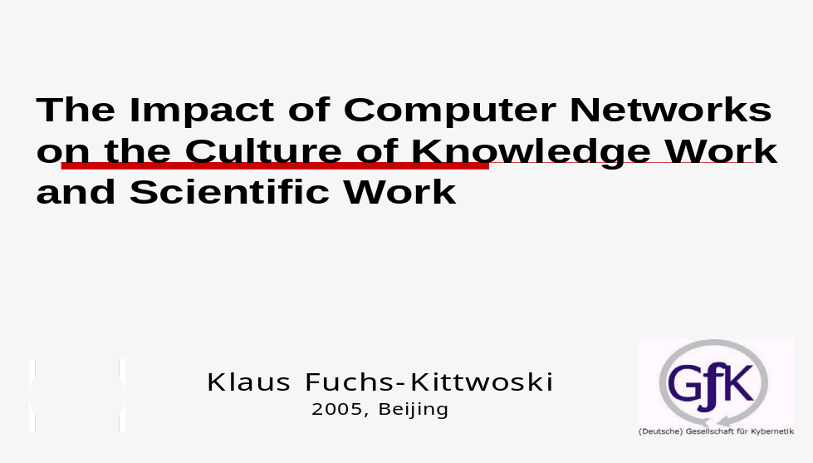

K. FUCHS-KITTOWSKI
University of Applied Sciences Berlin and Society of Science Research, Berlin (Germany)
The Impact of Computer Networks on the Culture of Knowledge Work and Scientific Work
To reach a higher productivity of knowledge, work is a main task of the 21st century, just as increasing productivity of manual work was in the 20th century. Applying and renewing existing knowledge and creating new knowledge characterize knowledge work. For the creation of new knowledge, social interaction is needed. Local and international networks (the Internet) provide support for social interaction, the technical and organizational basis for a higher productivity and creativity and will enable a new culture of knowledge work and scientific work.
The support of knowledge-intensive work processes and knowledge management in knowledge-intensive organizations by modern information and communication technologies has become an important topic in informatics. The vision is: a ICT-support of cooperation, of knowledge provision and generation helps to develop creative-learning organizations , , and that could be the basis for an information- and communication society for all, or even, with the „information centers” and „centers of thought” or knowledge communities connected with the nets, the basis for the development of the Noosphere in the sense of Teilhard de Chardin and Vladimir I. Vernadsky´ , if one also takes the local and global social structures of the human society into account.
This paper will discuss concepts of information and communication-support for knowledge-intensive work processes and will show the impact of computer networks on the culture of knowledge and scientific work.
The paper will describe the vision of the „Noosphere” of Pierre Teilhard de Chardin and V.I. Vernadsky in the perspective of information and of world-wide communication. The Noosphere vision will be presented critically from the viewpoint of present-day insights in natural science and the worldwide networking of scientists, according to the vision of J.C.R. Licklider and the vision of „Netizens” of M. and R. Hauben. It will advocate that the development of a Nooshere can be supported by the networking and globalization of information and communication techniques. The Noosphere is the sphere of human mind and work, but it should not be identified with the modern technological trend. We speak not only about the technological systems themselves, but also about organizational forms connected with them. Teilhard de Chardin and V.I. Vernadsky saw burgeoning forms of such a development in the emerging international scientific community. Now we see such burgeoning cells in the creation of „information centers” or „centers of knowledge” in connection with the development of international computer networks. On the basis of an intensive networking of interaction of human beings - an information society for all - can emerge, whose way of value creation is based on developing the creativity of human beings, on the development of their intelligence and on a deeper understanding of their conditions as human beings.
1. Development of Modern Information and Communication Technology (ICT)
“Euch haben sie das Netz ums Haupt geworfen” („The net they now have thrown around your head”.) This statement by Friedrich Schiller in „Wilhelm Tell“ characterizes the present-day situation of informatics in science and the economy. The drama about Tell is giving it another meaning, though.
Hardly any innovation of recent years deserves such great attention as the development of the Internet. For it affects not only the development of modern Information and Communication Technologies. The point is rather the development of a future information society’s infrastructure for all.
In the late 60s of the past century, the US military have created the so-called ARPAnet that connected the military computers with one another. In the early 80s the research institutions also used the network to an ever-increasing extent. The network’s operation was handed over to the National Science Foundation of the USA. This also allowed other countries to connect to the network step by step.

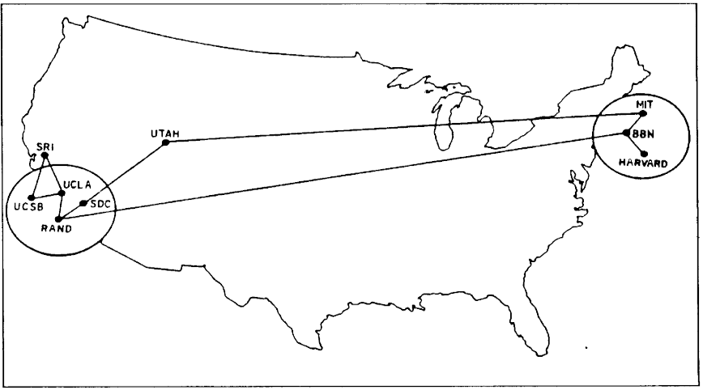

Figure 1: ARPANET, see Hauben, M. / Hauben, R. Netizens – On the History and Impact of Usenet and the Internet
On the International Forum On Information and Documentation in 1978 M. Dobrov, Randollph and Rauch jointly working together at the International Institute of Systems Analysis (IASA), presented in their paper on „International Networks for International Team Research” a diagram which illustrated a digital networking between the USA, Austria, the People’s Republic of Poland, and the USSR (Figure 2 see also).
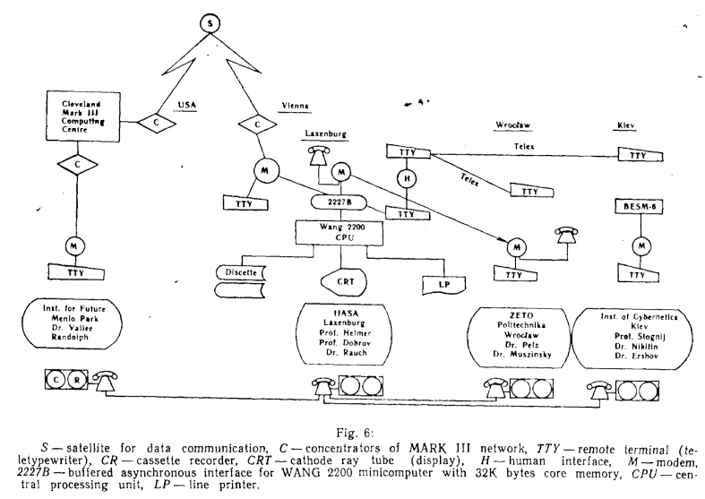
Figure 2: Diagramm from M. Dobrow et al, showing a temporal network connecting scientists in USA, Austria, Polen and in the USSR
At that time the author took part in further elaborating and developing this approach on intellectual lines, by active participation at the conference on Data Communications and further workshops. Further meetings, e.g. in Budapest and our cooperation at an appropriate main line of research at the GDR’s Academy of Science also pursued this aim.
With G. M. Dobrov we worked on the orgware concept, . Now he and the project manager of network development at IIASA in particular had asked me to take part in elaborating a study to consider the „cross-boundary data exchange“. Today, cross-boundary data exchange is almost a matter of fact in the world that has grown more closely together. In those days, however, a cross-boundary data exchange still constituted a problem even for the western countries. For instance, this was due to different prices, as well as to different hardware and software. Above all the salient point for us was to cross beyond the Iron Curtain.
The political division of the world at those times does not turn up in the sketch outlined by Dobrov.
Thus only literature search was left over for the first attempts at a data flow ”crossing beyond the Iron Curtain”. As Figure 2 indicates, the GDR did not take part in this attempt at that time. The disputes about the GDR’s participation in this network development and utilization is also mentioned elsewhere , . When we with P. T. Kirstein in the international institute for applied system analysis (IASA)., in the middle of the cold war, thought about whether one could at least use the ARPA-NET for search and exchange of medical literature, because the net already then had a knot near London, with a possible connection to the British Medical Library to the MEDLARS system, immediately were disciplinary rebukes on the two sides.
At that time the network was mainly subordinated to the military, so that both sides revoked any attempts at a data flow going beyond the Iron Curtain.
Today we discuss through the concepts Internet, Information Highway or Cyberspace the infrastructure of a global information society for all. At the beginning this notion existed only in a very simple form as the ARPA-network for military purposes. It is only a short while ago that it began to be used for transferring knowledge in modern science. Without this information one can hardly appreciate what has been achieved since then.
2. New Forms of Communication to Support International Collective Research
2.1. International Networks for International Team Research
The Internet has brought about such a new quality of direc communication mediated by technology that is not obtained by printing.
At the same time, it becomes clear that scientific communication is bound to bring about a demand for scientific information. To meet this demand is considered as solving the problem of scientific information.
Thus M. Bonitz writes (as comment to the IIASA-article of G. M. Dobrow and his colleguages: „We have to consider that mankind’s major existential problems require the entire potential of science for their solution. However, science can only completely unfold its productive force when supported by an adequate system of scientific communication. These premises entail the urgent efforts to cope with the problem of scientific Information.“
He continues:
„Moreover, such problems are characterized by the following fact: They do not stop at boundaries between countries. In addition, the recommendations worked out by scientists can become fully effective only if applied on an international scale” .
The culture in scientific activity at the Universities and institutions of higher education and other research centers is inconceivable today without the Internet. It allows a rapid exchange of documented knowledge, between scientists and gives access to a seemingly infinite global information supply. The access time to it is within the range of a few seconds. Indeed the boundaries between countries and continents disappear. This is a revolutionary change whose importance we can only appreciate by comparing the present-day situation with the one in former times.
The informatics expert Tim Berners-Lee developed the World Wide Web (WWW) at the Geneva-based High Energy Research Center CERN in 1991 for information exchange between scientists. At the High Energy Research Center CERN another project is advanced today. The researchers together with computer companies like IBM and Hewlett-Packert build at a global meta-network of computers – the Grid. This could lead to a technology which fundamentally changes the world again.
Despite world-wide communication, human relations can become impoverished, personal talks between human beings can become limited. To counteract this tendency, of course it is necessary to improve the technological infrastructure and to transfer documented knowledge on a massive scale. But at the same time it is necessary to achieve a two-fold objective. We must also succeed in reinforcing the communication between human beings and the conditions for creativity to produce new knowledge.
2.2. Information centers/ Thinking center – centers of Knowledge – of Thought
For the development of the modern digital nets the leading vision for research was: a technical net by which the people can cooperate internationally. This was carried by basic scientific visions for a new way of computer use. As shown by R. Hauben this basic ideas go back to discussions in the circle around Norbert Wiener at the MIT. These visions lead once to the understanding of the computer as a medium and on the other hand to the thought of a combination of the special abilities of the computer with the special abilities of man, as was expressed by J.C.R. Licklider and also by G. Klaus already early by the concept of “Man Computer Symbiosis”. (see also, )
The technocratic thinking of many computer scientists (so at that time also in the GDR) contributes to staying behind in the end. Many computer scientists have difficulties especially with regard to the social aspect of computer science. In our book: „Informatics and Automation“ the thesis, that problem solution processes aren't generally automatic, plays a large role. Therefore a combination of man and computer can or must be supported by different dialogue forms: direct dialog and indirect dialog via an information center, because man/computer communication is a meaningful combination of syntactic (machine) and semantic (human) information processing. A reviewer of our book wrote that our strategy of the information center clearly shows how strongly the authors would underestimate the forthcoming performances of the Artificial Intelligence (AI) research. To our satisfaction we experienced exactly the opposite reaction at the IIASA conference, one of the first public meetings for the development the ARPA-Net. Davis, the developer of the packet switching, jumped up and cried out: „You are right! If the technical net stands once, then the net of the information centers will be the real net.” This different reception of our concept was based on the fact (as we know today) that the net development under J.C.R. Licklider backed the consideration of man and machine having things in common and significant differences, so a sensible man-computer interaction (symbiosis) is needed. As a prerequisite for this man-computer symbiosis Licklider also saw (of course we didn't know that at this time) the so-called „Thinking center“.
We wrote: “By appropriate organizational measures, it is therefore possible to obtain dynamic forms of linking human and machine-operated information processing without having to develop completely new foundations in programming technology. In this respect, the setting up of an information center, by which a special form of man/computer communication is carried out, plays an important role. This will be presented in greater detail.”
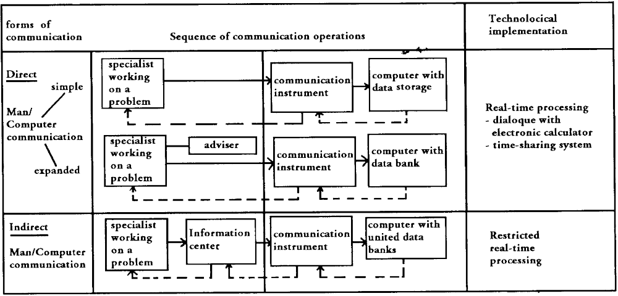
Figure 3: Man/Computer communication: direct (on-line) dialog operation and indirect via an Information Center
Man/Computer Communication: A Problem of Linking Semantic and Syntactic Information Processing. In: IIASA Workshop, 1975
The basic ideas of the development of networks had their origin, also in progressive socio-political conceptions of a scientific community communicating via technical nets. The Internet and its forerunners ARPA-Net, USE-Net ( see M. and R. Hauben) evolved in a cultural context that was shaped by communities of designers and users whose members were scientists and engineers. Raymund Werle writes: Their enthusiasm for untrammeled exploration and experimentation fused with the political milieu of antiauthoritarian spirit of the „computer hacker“ communities that emerged on the nascent electronic networks. The technical design of the initial Internet embedded, reflected and reinforced elements of this culture, which changed in correspondence with technical changes.
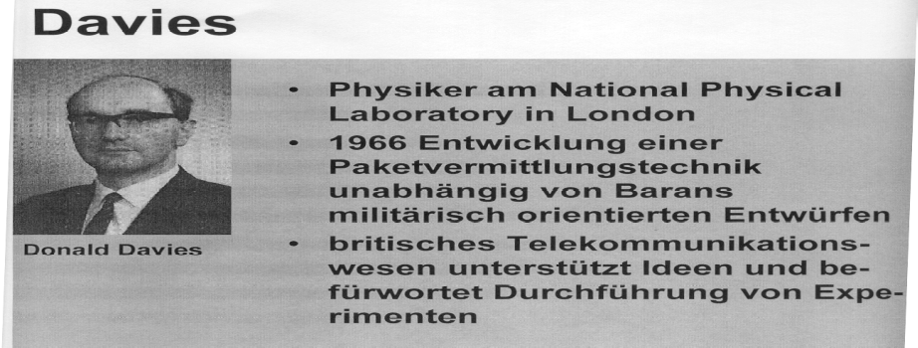
So we learn the necessity of the inclusion of humanistic thinking in the design process of modern information- and communication technologies and their application, the integration of social research and planning strategies into the planning of science and technology also from the failure of the GDR and its obvious technological delay. But, when today the Internet overcomes national borders and makes
Fugure 4: Donald Davis
international online communication possible also researchers in the GDR and other Estern Europen Researcher and specially also the work in IIASA , contributed to this development.

2.3. Creative learning enterprises
The information processing approach [cf. Simon 1997], which arose with the Cybernetics (I order) and to a large extent is represented in computer science and cognitive science, especially in artificial intelligence research, has led to an understanding of the enterprise organization alone as an information processing system. However, on the basis of somewhat deeper considerations of information and organization theory, we – on the contrary – advance the thesis that in the process of self organization of living and social systems information comes into existence, and is not merely processed after having been introduced from external sources [Fuchs-Kittowski et al. 1998a]. This is a finding that is currently advocated particularly as the result of concepts developed in Japan and the USA about knowledge management and learning enterprise organizations [e.g. Krogh et al. 2000, Fuchs-Kittowski, F. et al.].
Because of the increasing possibilities regarding the development of the individuality and creativity of people in and outside of the organization, as well as because of the expanded possibilities for the transmission of social tradition (through objectification and reification of the knowledge in work organization, tools, software and parts of the business culture), enterprises, too, are now on the way to develop creative learning organizations.
This means that, on the basis of an intense interrelation with their environment, the use of internal and external information sources, they are internally increasingly able to create new information and values in the development (self-organizing) of social organization and new knowledge for new actions. [F.-Fuchs-Kittowski, K. Fuchs-Kittowski ]

2. 4. Internet and Culture: The Dynamics of Interdependence
The technical ease with which the Internet's reach can be extended into many diverse cultural settings has provided incentives and exerted pressures towards cultural change, and it has triggered - as a counter-reaction - efforts to control the use of and the content which is communicated via the net. The resulting dynamics unfolded as a consequence of the interdependence of technical and cultural elements. The cultural effects are manifold: rather than a uniform mega trend we observe cultural globalization, cultural globalization and fragmentation and also cultural convergence.
2. 5. Human Rights and Human Risks in the Global information Society
There are serious risks implied within the innovation for our global information society. These risks especially refer to human equality and solidarity, security and liberty. The global electronic networks may also lead towards a global risk society. The fundamental question therefore is: Can the global information society secure the fundamental individual, social and international human rights?
We will argue here, that - focusing an the technical innovations themselves -, even the identification of the global technical net with the Noospheer Vision of Teilhard de Chardin, will lead into this dangerous direction. Instead, we should deal with the inadequate policies of the technological development, with inadequate social structures. We should realize that the real chances of electronic networks are connected with the possibilities for a new culture of work, knowledge work and scientific work, in the possibility to overcome the great global risk, which lies in the limited human capacity to deal with future problems in a rational way (Hamelink, Cees), but which certainly lies in social structures where the power can be used for egoistic goals of individuals or social groups.

3. Computer supported Knowledge Work: A Problem of Linking, Syntactic and Semantic Information Processing
3.1. Information- and Communication- oriented approach to knowledge management for knowledge intensive work processes
The support of knowledge-intensive work processes and knowledge management in knowledge-intensive organizations by modern information and communication technologies has become an important topic in informatics. The vision is: a ICT-support of cooperation, of knowledge provision and generation helps to develop creative-learning organizations, and that could be the basis for an information- and communication society for all, or even, with the „information centers” and „centers of thought” or knowledge communities connected with the nets, the basis for the development of the Noosphere in the sense of Teilhard de Chardin and Vladimir I. Vernadsky, if one also takes the local and global social structures of the human society into account.
We proceed from the assumption that the scope for setting up new organizational structures has increased decisively with the recent development in modern information and communication technologies, especially with the global electronic networks – the Internet. Due to their ability to overcome the restrictions of time and space network systems promise to enable new types of work, a new culture of knowledge work and scientific work. However empirical research has shown that at the present time the potential of the systems for new forms of work an organization are not being sufficiently exploited and that in practice the use of these technologies is accompanied by significant difficulties.
Computerized information systems to support knowledge management often neglect the social surroundings of information / knowledge generation and also value forming in the work practice. From the point of view of the cultural-historical activity theory, C. Clases and T. Wehner have pointed out that we have to look at the processes of knowledge generation as „a process imbedded in socially distributed activities that are constantly reproduced and transformed in an between specific communities of practices.” Therefore we will concentrate on the knowledge-intensive work processes itself, as the basis, so that knowledge will not become an isolated entity, abstracted from its practical use. .

All this clearly shows: Knowledge is not fixed once and for all the time. We have to take into account the diversity of meanings across the distributed activity systems and we have also to take into account the forming of new meanings on the basis of new experiences. Last not least we have to take into account the different forms of existents of information and knowledge on different levels in the organization: coded knowledge – Information and not coded knowledge – meanings, thoughts, and ideals - on the level of the individual, on the level of the group and on the level of the organization as a whole.
Special importance for the computer support of knowledge-intensive work processes and scientific work has the cultural-historical tradition in activity theory (Vygotsky, 1962, Leotjev, Engeström 1987, Hacker, Raeithel, 1995, Wehner u.a.). On this basis it is possible to understand, that knowledge is not only stored in books or data banks, but it is handed down (inherited) also by the existing division of labor, the work organization, and the tools used in the work process (so also by the software tools) and the culture of an organization.
As we have already said, just this embodied, contextual, socially distributed and social process-related the classical knowledge management usually neglects character of knowledge and cognition.
With the box (in the figure 5) „Knowledge nets for the cooperative knowledge production”, we specially want to stress the point that knowledge as a process and product of a social process is embedded in distributed social activities, that knowledge is generation in cooperation, in a work community.

Figure 5: Provision and generation of Knowledge in knowledge intensive work processes
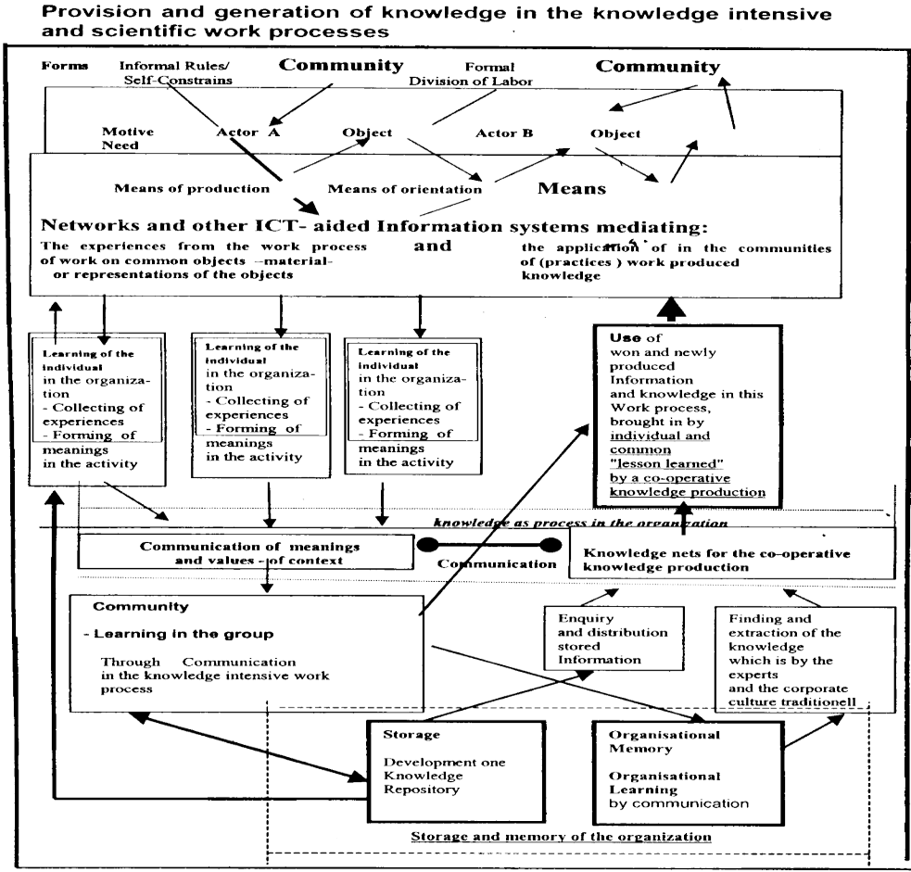
The proposed fundamental difference between syntactic and semantic information processing, the difference between store and memory, the difference between information processing and information generation of forming meanings, is also fundamental for the two views in knowledge management: The differences and the interrelations must be understood for bridging the theoretical gap between the information-oriented and the communication-oriented approach.
Knowledge management strategies can be divided in information-oriented and communication / personal-oriented views. New concepts try to bridge the two and consider at least instruments from the other approaches. For the integration of both views a theoretical gap has to be bridged. Also here the activity theory is needed, because on its basis it becomes possible to introduce a special communication-oriented strategy. The socialization strategy: oriented to knowledge nets for the co-operative knowledge production (box see Frank Fuchs-Kittowski).
The current support for knowledge work by modern information and communication technologies shows deficiencies. The solutions now available support the provision of existing knowledge from an „Organizational Memory Information System” or call on existing expert knowledge, or they support conditions of creating knowledge - the communication between knowledge workers - in decentralized and self-organized virtual knowledge communities. This is why an integration of the information-oriented and the communication- oriented approaches seems necessary to sufficiently support knowledge work (see Frank Fuchs-Kittowski).
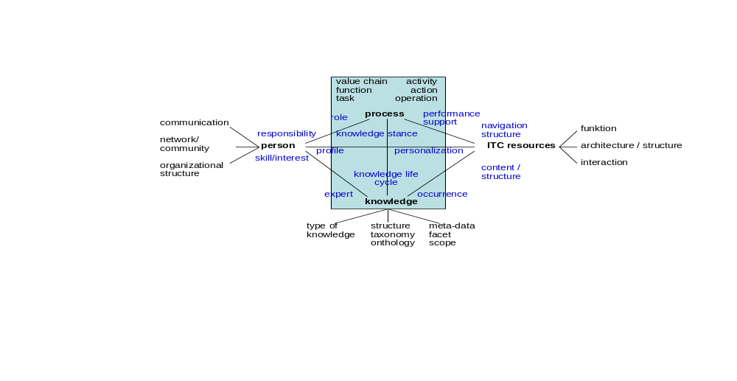Figure 6: Perspectives for modeling in knowledge management based on Maie, from Händrich and Maier
As T. Händrich and R. Maier could demonstrate, it becomes necessary to relate functions from process models to actions from activity theory.
Our position is: Man-Computer-Communication is a linking of semantic and syntactic information processing. So the information-oriented or technology-oriented approach will dominate as soon as the semantic information processing can be reduced to syntactic information processing. But this is only possible if the semantic of the information can be totally mapped on syntax-strictures (data) and the activities and actions can all be fulfilled by formalized operations (algorithms).
But knowledge-intensive work process and still more a scientific work process is characterized by a knowledge-gab. It is a problem-solving process. A problem-solving process is due to the knowledge-gab not generally to be formalized and thus also not generally automating. In the case of the creative aspects of the knowledge intensive work processes and the scientific work – in the case of cooperative knowledge production the communication-oriented (personal-oriented and social-oriented) approach has therefore to be dominant. An integration of both approaches seems to be sensible, because the knowledge intensive work process and the scientific work process need both, the provision and the generation of knowledge. The knowledge-intensive and scientific work processes are different mixtures of routine work and creative work, work and creative work that can be formalized.
3.2 Knowledge-intensive work processes for creative learning organizations
The knowledge-intensive work processes requires new cooperative, self-organizing forms for work, organization and learning that support creativity and can be supported by information and communication systems (in particular tele-cooperation systems. [ Fuchs-Kittowski & E. Vogel 2001],[F. Fuchs-Kittowski 2001, K. Fuchs-Kittowski et al. 1999a]..
Knowledge-intensive processes are characterized that not all knowledge relevant to the situation is available (knowledge gap); rather, it must be gained or created by the persons involved during the course of the process. In other words, it must evolve from the scratch (closing the knowledge gap). Such processes are characteristic in that they are not continuously algorithm able and to be formalized. Furthermore, such processes contain partial tasks that are new and occur only within these processes. Methods and tools, e.g. software tools and data, coming from a potential of methods and tools, e.g. method and data banks, must be provided in order to work on these tasks.
Complex, knowledge-intensive processes, especially problem-solving processes, require that the design and control of the cooperative work process are left to the participating individuals, who thus need to coordinate regarding cooperating participants, activities and responsibilities. This way, self-organized, dynamic (competence) networks are created in accordance with the requirements of a specific problem or process. The concept of self-organization promises autonomy for those people in the work process.
This is counteracted by an extraneous organization (external determination), which is based on the determination of a process in advance (predefined sequence of activities) and leads to rigidly automated systems, which can be reduced by flexibility. In the reality of social organizations, permanent change between extraneous- and self-organization takes place. This permanent change should be taken into account when designing and using systems for computer support of knowledge-intensive processes.
Rigid structures should be avoided when using computers in complex, self-organizing social systems. Instead a flexible and dynamic support of information and communication processes should be aspired to. The permanent linking of syntactic (computer-based) and semantic (human) information processing and, simultaneously, the constant changing from an already organized system (function system) to a self-organizing system (action system) is necessary.
Therefore, it is only possible to undertake a rough pre-structuring of the processes that can be structured in advance. Tasks and activities within the pre-structured processes are not determined by the system or pre-defined. Instead, control of the work processes remains with the cooperating persons. Coordination amongst participants follows in accordance with the specific situation. Through dynamic selection of suitable cooperation partners and the possibility of including further partners if necessary, problem- and context-related knowledge and problem solution networks can evolve dynamically.

3.3. Man/computer communication – an information center can be useful
Semantic information processing is the combination of meanings of information to form new meanings. It is typical of man's intellectual information processing to be concentrated upon the contents. The structural processes which are underlying the meaning of words and sentences are carried out by man unconsciously. By making man continually aware .of the structural processes, his creative thinking would be interrupted and troubled. Hence, semantic information processing is immediate processing of semantic statement contents.
Syntactic information processing is a transformation of the structure of information carriers. On the basis of unique rules between information carriers and their meanings, new meanings are ascribed to them. The contents of semantic statements are processed by the mediation of structural transformations.
Man/computer communication is to be considered from two interrelated aspects. On the one hand, it is a mere instrument to rationalize human information-processing operations. On the other hand, it is more and more becoming an integral part of the intellectual process of work performed by man. As a mere instrument, computer application is limited to supplying and using models. These models are representing the continually repeated tasks that can, therefore, be put into a scheme. These tasks can temporarily be separated from the problem processing and solving process of man engaged in creative activities from his semantic information processing. But we have also to consider the possibility of solving, with the help of the computer, the tasks which are not continuously repeated, which are relatively unique and occur unforeseeably in human problem processing and solving (nonschematic tasks) which are worth being automated.
Then the dynamical transitions between emerging new tasks and their solution by computer must be mastered. An application always means to link syntactic and semantic information-processing operations.
For knowledge workers, for people working on problems, we must aim at designing possibili- ties for ITC-aplications allowing a very simple transition to machine readable formulation of a task.. Knowledge workers, people working on problems requires often very detailed special knowledge in the field of computer technology and of modeling processes. Above all, there occur non schematic tasks. But the necessity of immediate action and decision is not typical of the creative problem-solving process in knowledge work or scientific work.. Therefore, it is not necessary to build only direct man/computer systems with real time processing. To give aid to the process of working on problems and solving them, especially for management staff of higher levels, and other knowlege workers indirect man/computer communication is by fare a more advantageous solution. In indirect communication, a special process of work is switched in between the syntactic and the semantic information-processing operations. This process of work comprises the fact process to be modeled until the formulation of a machine-intelligible data processing task, including cooperation of the user with the modeler (problem analyst, ) on the semantic level. So, the function of mediating is carried out by a special organizational component of man/computer communication that is often called an information center / ore thinking center.

4. Scientific Research, Scientific Information And The Search In The Internet
4.1. Information Search on the Internet and Grid-Computing
At the beginning of the new century and millennium we are also on the threshold from an industrial society to an information and knowledge-based society. Modern communication networks with multimedia terminals constitute the technological infrastructure for such a development. Terms like Information Highway, Cyber-Space or Hyperspace were coined for this infrastructure. Multiple and controversial are the expectations and apprehensions connected with this technological development. They stem forth from the ambivalent repercussions of modern Information and Communication Technologies.
The new applications are aimed at improving the quality of life for the individual and at increasing the effectiveness and efficiency of business processes. Tele-working, shopping by telecommunication, online-databases, and interactive entertainment by telecommunication are essentially changing our way of life and work.
One problem that will doubtlessly confront us, and encumbers us considerably even today is the deluge of information. On the one hand, we suffer from an overabundant supply of information. We are lacking necessary mechanisms to filter the information between important and unimportant pieces of information. On the other hand, we are often unable to retrieve a certain information item in a purposeful manner. The problem of information retrieval will occupy us to a much greater extent in the future. We need powerful navigation tools for effective surfing in the flood of data. The development of the World Wide Web was an important step, but not the solution. Rather was it the real beginning of the problem. In particular, it is necessary to solve the following technical problems:
- Rapid communication networks are needed to transfer the big quantities of data,
- Powerful computers are needed to process and distribute the data,
- Efficient software is needed to cope with the complex distributed environment and to facilitate access for the Internet user,
- In particular, new methods for the search and evaluation of the information are needed in the Internet.
- At this also possibilities of the website evaluation, the assessment of the information contents by the user.
The informatics expert Tim Berners-Lee developed the World Wide Web (WWW) at the Geneva-based High Energy Research Center CERN in 1991 for information exchange between scientists.
The World Wide Web in the Internet allows access to multimedia documents. Therefore and in this context: Communication is not limited to the transfer of texts, but voice and video information items are also transmitted. The web allows simple text formatting and to embed graphics, as well as to refer (by hyperlink) to documents located on any server in the Internet.
The language for marking, HTML (Hypertext Markup Language) and the new Internet-Protocol, HTTP (Hypertext Transfer Protocol) emerged.
Because of its hypertext character the entire project was called the World Wide Web.

The informatics expert Tim Berners-Lee developed the World Wide Web (WWW) at the Geneva-based High Energy Research Center CERN in 1991 for information exchange between scientists. At the High Energy Research Center CERN another project is advanced today. The researchers together with computer companies like IBM and Hewlett-Packert build at a global meta-network of computers – the Grid. This could lead to a technology which fundamentally changes the world again.
Only with the Grid the particle physicists have the chance to evaluate the data volume of the “ Large Hadron Collider” (LHC). The LHC-Computing Grid will provide researcher all the world with computer powers to evaluate the LHC experiments.
The Grid shall make it possible that scientists of the whole world access the data and can evaluate them together. This shall not be carried out via a new Internet but by expansion of the efficiency of the existing net.
The Web, developed by Tim Berners-Lee in CERN is a platform for the exchange of information, the Grid shall make the exchange of computer resources possible. The vision is, that the users then takes up the resources if he really needs it.
Today, considerations are already advanced how far the Grid topic can gain meaning for the IT applications in modern enterprises in future.
Informatic, being more than a purely mathematical and technical discipline, involves analysis of the general structure of spheres to which automatic information processing can be applied as well as the conditions by which the hard and software systems at one's disposal can be used to the best advantage. We view this sphere of informatics as a form of organizing information processing, beginning with a scientific analysis of the interrelations between semantic and syntactic {human or mechanical) information processing from which general principles for the design of information systems can be derived. We speak of organizing information processing as the special topic. drsiciplene of infomatics. The new book from B. Page “Organisation of software aplication” also follows this idea that informatics involves the analysis of the general structure of spheres to which automatic information processing can be applied.

4.2. Information Search Based on Specific Databanks (in the Internet) and the Life Sciences
Biochemistry and molecular biology are increasingly interpenetrated and constitute a joint scientific discipline, Databanks and other tools of Information Technology have highlighted the interdisciplinary and cross-area character of biochemical and molecular biological research. In this manner, fundamental discoveries are no longer reserved to the specialists. This idea is evidenced by the recent discovery of a new group of anti-inflammatory drugs.
This example stems from a special area in biochemistry – the eicosanoid research. It demonstrates, how by including certain modern databanks new insights were obtained that would have been impossible with traditional approaches of research. Such an example is the discovery of cyclooxygenase-2 as a prerequisite for developing a new group of drugs.
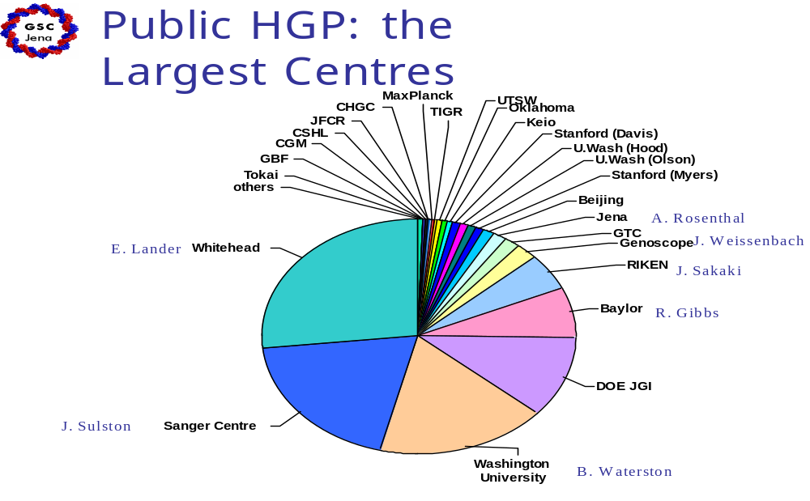
If we speak of information search based on specific databanks, then the medical literature search system PubMed deserves to be highlighted. It has allowed the medical biochemist to handle the tremendous and ever increasing flood of literature in a purposeful way. By skillfully choosing suitable keywords it is possible to filter out the relevant sources at low cost fast and to a great extent completely. Thus it is also considerably easier for a scientist through reading to familiarize himself rapidly with new fields that he has not dealt with at all before.
Figure 7: The largest research centres of the public Human Genom Project (HPG)
4.2.1. Bio-chemical molecular biological research and the development
particularly efficient information- and communication technologies
The deciphering (decoding) of the humane genome is one of the great research performances of the sciences of our days. Efficient research groups of the USA, Great Britain, France, Japan and Germany were involved in the deciphering (decoding) of the humane genome. But also high performance computer like Deep Blue and now "Blue Gene" are necessary.
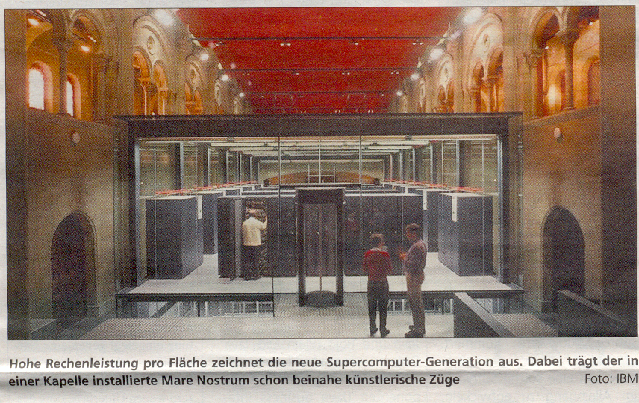
The scientific value of the humane genome project is discussed controversially at present. The assessments move of the comparison with the landing of the first person on the moon up to the consideration as a pure prestige object whose financial and personnel effort wouldn't stand in proportion to the achieve information- and communication results. Each of the two sides might be right in certain regard. Of course is the deciphering of the human genome an important milestone in the bio-medical research, which would not have been possible for without the revolution in the information- and communication technologie.

On the other hand, the importance of this performance may not be overrated. With the solution of a problem in the scientific research new problems arise, and limits are recognized simultaneously. Dealing with the now known structure of the human genome holds a number of obstacles in itself. There is a not to underestimate individual variability of the base-sequence of which isn't always easily recognizable whether it has pathological consequences or not. Another difficulty lies in

Figure 9: The new Supercomputer Generation: "Blue Gene"
the fact that the genes can contain both: amino acid encoding and not encoding areas (promoters, introns and other not translated regions) and it is not distinguished straight away between encoding and not encoding regions.
On the other hand, the optimists say: between encoding and not encoding sequences can easily be distinguished. One therefore knows certainly that more than 90% or even 95% of the 3 bn constituents or the complete sequence encodes for no protein and doesn't contain any signal for transcription and translation movement either and has possibly only the significance of a stock loft for nucleotides. Here so, the divergence between gene availability and gene expression is seen less problematically.
The analysis of the gene sequences of a healthy person and a person or embryo who will suffer immediately or later from genetically caused disorders, has led to the possibility and will lead to further possibilities that e.g. one can assess by using prenatal DNA diagnostics whether the child will be ill or healthy with regard to this disorder.
In future, sequence comparisons will allow a prognosis about the life expectancy or the risk for certain disorders beyond the frames of hereditary diseases. Another example for the usefulness is the comparison of DNA sequences in human materials at the site of crime with those of suspicious persons to identify the offender.
So important the knowledge of the structure of a gene is, it is aim of the molecular biologist, to predict from the structure of the gene the structure of the gene product – the protein.
But, from the base sequence merely the primary structure is derivable, i.e. the sequence of amino acids. The functional qualities of a protein, however, are determined by its three-dimensional structure. Only this knowledge allows us to gain insights into their modes of action. Due to thermodynamic driving forces the spatial structure of a protein is determined by its primary structure; in the process of the cotranslational folding of the peptide chain the energetically most favorable conformational state is formed. However: this alone is not enough, one knows today that special convolution proteins (chaperones) are involved in it too.
It has been intensively tried for approx. 30 years to predict the spatial structure of proteins correctly, however, with moderate success. Only the revolution in the information technology can help to achieve a breakthrough in the future also here. At present is worked with the new development high performance computer "Blue Gene", for the prediction of the protein conformation.

Blue Gene puts everything previous in computer technology with regard to its efficiency into the shade. 500 times, this computer works 1000 times faster than Deep Blue, the computer which in 1997defeated the chess world's champion Gary Kasparov.

4.2.2. Decoding of the humane genome and computerized storage and
evaluation of the biological information from the genome analysis
Bio-chemical research which doesn't make use also of molecular-biological techniques is unthinkable today. On the other hand is with the identification and clearing up of gene structures at the same time also to clear up the mode of action of the gene products, i.e. the corresponding proteins. However, the latter is subject of the traditional biochemistry. Beyond these considerations, it seems meaningful today to talk about a common subject discipline of the biochemistry and molecular biology.
With the growing mutual penetration of biochemistry and molecular biology the importance of databases gained considerably in the biochemical research.
With which gigantic information mass one has to work here, gets clear for example with the humane genome project.
The data published in Nature show, that man has hardly more as 30,000 genes.

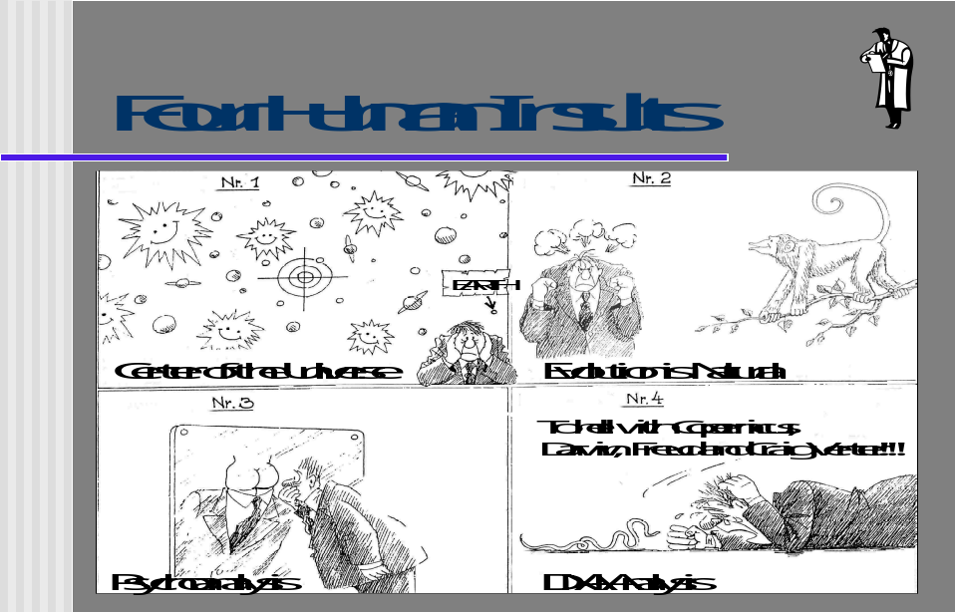
Figure 10: The four insults

The deciphering of the human genome has been advanced enormously within the last few years and has opened a new door of the biological age. By permanent improvement in the techniques of sequencing the price could be lowered from $ 2 per base to $ 0.3 per base within 3 years.
The information quantity rate was increased more than was foresaw in the foresight, so that the project could already be completed in 2001. On the 16th of February 2001 The International Human Genome Sequencing Consortium published the main results in Nature. At this time the largest portion of the genome, 90%, was decoded in the meantime, there still was an uncertainty for 10%. This very exact and almost complete sequence was already exposed due to the high pressure on researchers results expected to 2003.
Here we have a very new situation in science. The results could not have been published in a journal. One would need many (40 and more) edition of the scientific journal Nature to publish all the sequences. Because of this situation these results only exists on the computers.

A malice of this enormous information mass consists that a very large portion of the genome apparently doesn't reach the expression and we therefore don't know the functions of these sequence sections.
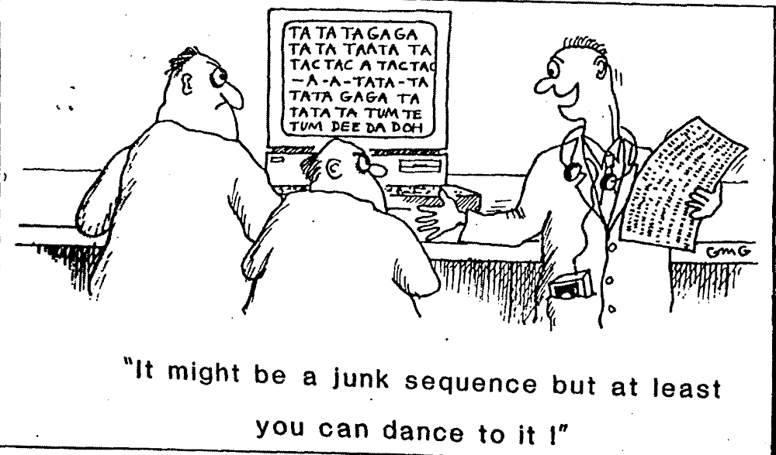
Figure 11: "It might be junk sequence but at leases you can dance to it"

Among those genes reaching expression are primarily of interest for the medical research this one whose failure or change leads to diseases. With the methods of modern genetic engineering hereditary diseases being valid till now as incurable can namely be treated successfully in the perspective. Approx. 500 to 1000 of such "illness genes" are merely known to man till now. From this results that the medicine oriented biochemist is confronted with an enormous surplus of information, from which he must filter out selectively the information relevant for him. This is hardly possible without today's means of the information and communication technology. Specially the Internet, high speed computers, various databases as well as software packages which connect the data with each other.
A comparison of the base sequences of genes, gene sections, transcription products or polypeptide chains with the sequences of well-known genes or gene products, stored in databases, makes it possible, to find out whether they are already known and then to assign them correspondingly.
If it turns out, that it is an until now unknown gene or gene product, is it of interest for the biochemist, for which already known gene similarities exists. From this important conclusions can be drawn with regard to the evolution of the genes and their relationships.
Figure 11: Human Sequenzes in Gen Banks
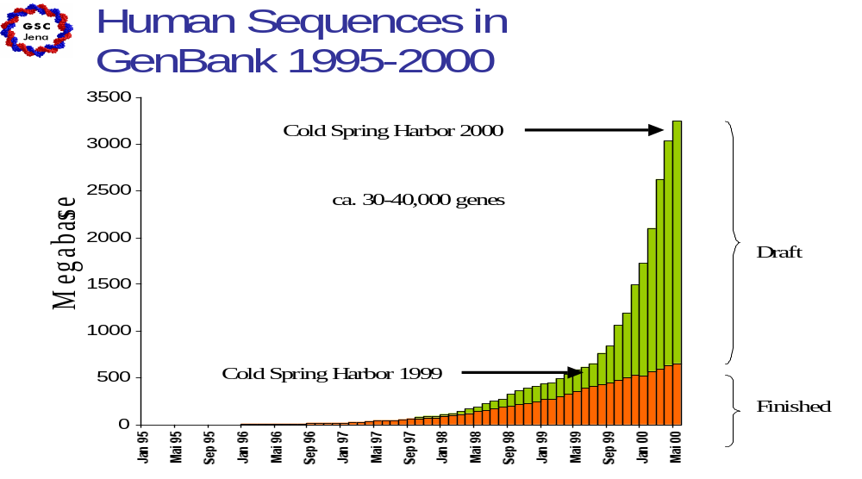
In the scheme:" Science as Information system and knowledge creating Organiz tion" attention is drawn to the importance of computer application for the genome sequencing as well as to the use of data banks for the comparison of base sequences or amino acid sequences with in data banks stored sequences of known gene or gene products (cf. box of experiment evaluation, comparison and databases.)
The special significance of modern information- and communication technologies for the biochemical/ molecular biological research process is highlighted and introduced into the culture of the scientific work process as a whole.
4.2. The scientific research process as information and communication
process and knowledge generating organization

The figure shows the scientific research process as a process of information and communication and his embedding in the social organization of science (the laboratory, the scientific facilities) as well as its support by information and communication technologies.
In addition to this decisive trend of development, there is another aspect which, in our opinion, seems to be of growing significance, namely, the integration of these highly efficient soft and hardware systems into the scientific work process as an complex information processing and of problem solving by man. This integration is not restricted to the mastering and application of predetermined models and partial models, but, also encompass the process of dealing with new data processing tasks arising directly from data processing during work. Thus, the essential basis for this is given in the formulation of tasks . for data processing consisting of the transition from semantic to syntactic information processing.
When we characterize the scientific work process by the creation of new working hypotheses and speak about the necessary Knowledge areas, the Framework for the classification of the data, we speak also about of this transition from semantic to syntactic information processing. This also includes the creation of tasks and programs for use in processing. Opening completely new fields of application with dynamic phases of intersection of semantic and syntactic information processing.
Thince this is an issue which should not be considered a problem of the user alone, this leads also hear, to the necessity of a center of thinking or information center. .

Figure 12:
Structure of the experimental research process

Knowledge areas
- Research organization
e.g. biochemical lab
- background issues
- Framework for the
classification of
the data and information
Conceptions

Centers of Thinking
-reference framework

Information center
3
Experiment
- design
and
Research object

Nature

4

Control

1
6 17
Output
experimental
Proto-Data
Sequence- analysis

5
creation of new working hypotheses

2 10

10 8
2 9
hypothesis
assessment

7
Background Information

internal models

Information potential

at

Techniques
Method
Theories etc.

Molecular structures
on ' databases
Experiment
- evaluation
and
the data reduction process
- Data processing

Exchange of ideas
- scientific-technical
conversations to the
data's interpretation

12

Comparison of base- or
amino acid sequences,
genes, gene sections, or transcription products such as polypeptides
with the corresponding data
stored in data banks

13 14 15 11

13 14 15

16
Knowledge-co-production on the basis of
Telecooperation systems
Inquiry in the Internet - in the global network of computers
by a direct and/ or indirect dialog via information centers

This scheme illustrates/depicts the experimental research process in natural sciences. It shows the relations between the area (the world) of experimentally won data (facts) and the scientific description of the world.
The arrows show the direction of the determination.
If the science system were represented exhaustingly with arrow 1 and 2, the description of the world would be, obviously according to a simple reflection, determined by the examination object alone.

With the overcoming of the naive realism, which insinuates in the end that one includes the world just like it is. It got clear that one must take into account the activity of the cognitive subject. This means the conclusion that scientific results find their scientific explanation in the process producing them.
Data cannot be used uncritically for hypothesis formation and confirmation or falsification. Because before the data are interpretable and reducible and can be relied on as empirical proof, practical methods, like experiment design and control, replication, scientific argumentation and critics, are used, as essential part of the scientific method. (arrow 1)
Another step is still taken, however, now. It is clarified with the scheme that a scientific cognition doesn't represent only a result of individual analyses and insights into complex connections but also has to be taken into account how scientific knowledge is generated in a social process in a scientific community.
The knowledge production produces knowledge products. These knowledge products can be seen no longer only with respect to the examination object "nature". Knowledge products must also be seen in reference to their Production process. So the scientific activity, the research culture, learns greater interest. The examination object (the object) from nature is confronted with certain organization conditions in the laboratory (arrow 3).
It is an important difference whether e.g. field research carried out according to agricultural science or whether this is taken off in a laboratory work at the biotechnology. This leads to a rise of the power of the researcher opposite the examination object. The factors like: the availability of methods and equipment, the faster accessibility (provision) of knowledge, for faster execution of the processes of examination as well as repeatability and control possibilities, play an important role of (arrow 4).

The fast provision of techniques, methods, theories and an background knowledge by online databases becomes for the experimentally working researcher an important support of his work. The provided knowledge potential can particularly support the creation of new working hypotheses (arrow 5), which then form the prerequisite for fundamentally new experimental enquiry’s to nature (arrow 6).
Basis for the hypothesis assessment and the creation of new hypotheses is the experiment evaluation which is carried out especially in the scientific conversation in the laboratory or other scientific institutions. (arrows 7).
Positively weighted hypotheses are taken into the information potential and are made available when required. (arrows 8)
In the scientific dialog the data are interpreted, the hypotheses and Theory forming is carried out. (arrow 9).
So the real knowledge production is a knowledge co. construction. In a scientific community, in an experimentally working laboratory in a corresponding conversation the culture of scientific work develops.
So we have also here the combination of a syntactic and semantic information processing as it appears in every knowledge transfer cycle. The interplay between the instrumental forms of syntactic information processing and communication with the human forms interaction in the scientific work process (research behavior) must be examined and worked out.
The embedding of the instrumental information and communication systems in the social organization of science is necessary, because only the social organization, the scientific conversations in the laboratory, in the scientific community, can deliver the reference framework for the classification and interpretation of the data and information (arrow 10).

A modern bio-chemical and molecular-biological research is without the application of more and more efficient information and communication technology unthinkable. As seen in connection with the deciphering of the human genome, further requirements to increase the efficiency of the computers and communication nets come from this research.
Needed are high performance computer like “Deep Blue” and "Blue Gene" and also grid computing will develop !. (See arrow 11).
Here particularly for the reduction of time for the genome sequencing and for the possibility of the comparison of molecular structures, is necessary a fast and secure access to Information in the data basis or to knowledge in the heads of experts or in the scientific organization as a whole. ( 12).
Today the application of modern information and communication technologies in the research process stand in a close connection with use of telecooperation systems to support cooperative scientific work (knowledge- co- production) relatively independent from room and time as well as with the use of the Internet for the provision of scientific information. (see arrow cf. 14 and 15).

A naive realistic cognition position is hardly represented in today's science philosophy.. It is regarded as an overcome position. Modern cognition positions, like the hypothetical realism of the “evolutionary cognition theory” or a “constructive realism”, like represented here, are recognizing the active, constructive performance of the cognitive subject. With this, however, we must not follow certain exaggerations in science sociology, after which the scientific results would be negotiated in the social organization of science, like in politics. Scientific results are not object of democratic decision finding.
Important and right is, however, that the meanings of our concepts with which we approach our objects of research, with which we search after literature in online databases, arise in a social process, in the scientific community.
With arrow 16 we stressed therefore again, with respect to the enquiry in the Internet, that the social organization, the competent community of work, the scientific community, give the framework for the classification and interpretation of the data.
No Information system is able by itself to provide this (cover) reference framework.
The Reference framework can only be given by active members of the communities of work, by the information centers or centers of thinking (see arrow 17).
According to Teilhard de Chardin and V.I. Vernadski an active scientific community , could form a nucleus for an emerging noosphere.

In the ordinary opinion of science the nature is respected as something untouched (objective) and the science is seen as a test to win a literal description of this world (by protocol sentences). This conception of science corresponds to the ideas of a naive realism which starts out from a reflective relation between the world and its scientific description.
Such a position implies that the research technology as well as other intellectual conditions represent certain conditions of the research, which can be beneficial for the extraction of knowledge, but don't influence the knowledge contents.
In reality there isn't any cognition, no scientific contents, which isn't determined by the social form of the research behavior fundamentally.
What we describe as "actual" and "true" this isn't only determined by the object of the research alone, but also by the theoretical strategies, by the examination methods of the research object. Our knowledge is a construction over the world. So the cognition of nature is a theoretical inferring from the data’s to the underlying laws of nature. Therefore we deal with a culturally produced World. The existence of a reality existing before and independently of man isn't denied with that. However, it is made clear that we don't have any admission to it, outside scientific methods of the knowledge production.
5. knowledge networking via databanks – a new typ of scientific work

5.1. knowledge networking via databanks

Before the present revolution of Information Technology, new discoveries were reserved to specialists working in one field for years and often for decades. In contrast, today it has become possible to make fundamental discoveries for scientists who had originally been active in a completely different field. At first sight, this development seems paradoxical in view of the ever-increasing knowledge and continued specialization of biochemical-molecular research. It is branching out into ever more special disciplines.
This contradiction can be solved by knowledge networking via databanks.
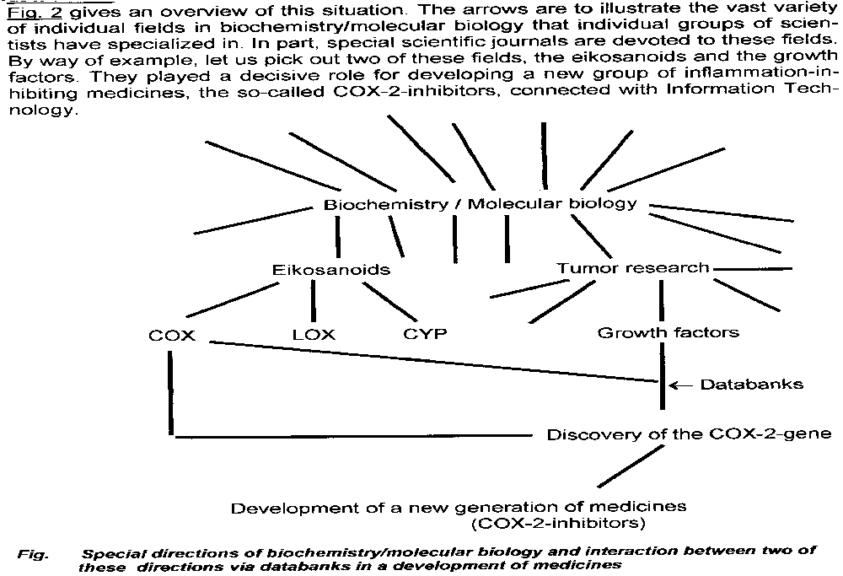

Figure 13: Special reseach directions integrated via databanks (Tankred Schewe 2002, p. 207)
A now well known example is the interaction between two directions of bio-medical research via databanks in the development of Cox-2-inhibitors.
Eicosanoids are oxygenation products of polyunsaturated fatty acids with 20 carbon atoms, especially of arachidonic acid. Longest known eicosanoids are the prostaglandins. However, they occur not only in the seminal fluid where they had been detected for the first time, but are widely spread in the organism. At low concentrations they fulfill a multitude of biological regulatory functions. Besides prostaglandins, several further groups of biologically active eicosanoids are known today. They differ with regard to their pathway of biochemical formation. According to the nature of the enzyme of fatty acid oxygenation, we distinguish three major groups of eicosanoids, the cyclooxygenase products (COX), the lipoxygenase products (LOX) and the cytochrome P-450-products (CYP). The eicosanoids have aroused particular interest in medical research. Apart from their beneficial physiological functions, they also play an adverse mediator role for pathological processes in inflammation, asthma, and other disorders.
The eicosanoid specialists were successfully seeking for ”2nd- generation NSAID” devoid of side effects. However, for a long time their efforts were in vain. The decisive impetus for the break-through came oddly enough from a completely different field of research.
Employing common methods of molecular biology, the researchers around Harvey Herschman isolated one of these transcription products and determined its base sequence. This product was compared with those sequences of known genes that were stored in databanks. It turned out that the protein encoded by this gene had been unknown until that time. However, it was strikingly similar with another already known protein, the cyclooxygenase (COX). After receiving this information from a databank, the team leader had to look up in a textbook of biochemistry what cyclooxygenase really meant and what functions it had.. He admitted this fact in a lecture that he delivered in the University Clinics of Berlin-Steglitz in 1997. His laboratory’s subsequent investigations uncovered that the new protein was in fact a special variant of cyclooxygenase that is also inhibited by all NSAID’s that were known at that time.
Then the first publications about the new observations appeared (Kujubu/
Fletcher/Varnum/ Lim/Herschman 1991; Fletcher/Kujubu/Perrin/Herschman 1992). Immediately after that, eicosanoid specialists started a real run on the new enzyme. Almost overnight Herschman himself had become a pioneer of eicosanoid research.
Despite the difficulties with the Cox 2 – inhibitors , fatally for everyone suffering from rheumatism, arthritis etc., the discovery of the Cox 2 revolutionized the Eikosanoid research. Today we know that the Development of Cox 2-Inhibitoren as a “new generation of medicines” was not so successful as one thought in the beginning. But of course the conclusions we derive from this example for an emerging new typ of scientific work in the view of informatics and of information science are still correct and not influenced by this development.

  - The Emergence of Information - the Problematic of the Various Language Games

The outlined example from the eicosanoid research provides evidence for the following situation. Scientists come closer together through networking by Information Technology the continually growing information abundance. This happens despite the advancing necessary sub-specialization’s. This closer coming together is to be seen in regional and special scientific terms. Thus the Information Technology makes a significant contribution to enhance the interdisciplinary character of the biologicalbiochemical-molecular biological research process.
However, this example also permits to elucidate the "target-group problematic" derived from the various "language games" in the meaning of Ludwig von Wittgenstein.
For instance, let us consider a biochemist searching for literature on the therapeutic utilization of COX-2 (Cyclooxygenase-2). As was described already, he can find the literature items via various descriptors. However, the meaning of the indexes and of the search terms can have emerged in different "language games". In many cases, the terms that the author used when writing the original text had a meaning that emerged in a certain societal field.. This field differs in many cases from the societal field that determines the meaning of the terms assumed for indexing. In their turn, the meanings of the terms for the person searching for literature will be different. Notably this person will in most cases live and work in still another societal field. To start with, let us recognize that the meanings of societal information are formed in a societal process. Then it becomes clear that it is impossible to determine them in the same manner for everybody and unambiguously in areas of syntax.

Medicament

Biochemistry COX-2

Rheum

A Venn- Diagram about the Search for Documents that are Characterized by Four Different Indexing Terms (Figure 14 )

In modern bibliographical information retrieval systems quite often you have many millions of documents in a databank, and these documents are available on a worldwide scale. Usually each database is specialized in a particular field of knowledge, as e.g. in medical abstracts. The documents are elaborated, indexed, and stored by professionals, so that professional librarians and information scientists can retrieve them.
However, let us assume that we want to use such a system without being a biochemist/ molecular biologist or a librarian scientist and we want to learn something about the therapeutic utilization of Cox-2 (Cyclooxygenase-2). Then we can find the literature via different descriptors (see Figure 3).

The meaning of the words is different that are used first by the author, second by the indexer and later by the searcher or data bank user.
This fact points out the importance of semantic feedback operations, as they become possible in an extended or multiplied knowledge transfer cycle,.
Moreover, this fact indicates a principal difficulty of automated search systems that can bring about literature retrieval only on the basis of syntactic structures.
Hence it is important not only to provide the information items or their carriers, but also to describe for whom they are meant.
But on the other hand it is also important that the users of the search services can also indicate their personal user profile in a search query. However, at present in most cases, this does not apply to most search services in the Internet. The person-related criteria (e.g. to which interest group the user belongs) are changed at a slow pace only. Therefore the search service can also take them into account (cf. K. Nawrocki)
Let us suppose that we speak about information search operations on the basis of specific databanks, as here about the medical literature search system PubMed. Then we may assume at first that all three persons: the author, indexer and searcher, are specialists in the same scientific field. In such a situation the problem of different semantics is not bound to arise due to the similar "language games". However, let us take another point of departure, as our example indicates. The utilization of modern Information and Communication Technologies substantially promotes the interdisciinterdisciplinary character of the biochemical-molecular biological research process. Therefore, it is necessary to bear in mind also here the fact of different language games.
This means in particular to consider the following insight. The information processing approach (paradigm) developed from cognition sciences cannot take into account the emergence of meanings. This is due to the fact that this approach always presupposes information as given. Only with the theory ofself- self-organization was this viewpoint also taken into account. That theory was connected with the concept of information emergence or with the formation of meanings. M. Eigen was the first to develop this approach in his theory about the emergence of life.
Now speaking about the possibilities and limits of literature search based on specific databanks we ought to learn from the self-organization theory of life. The salient point is that those meanings of concepts that are relevant here are also not set out in advance, but they emerge in a social process of self-organization. This approach will compel to include Man in the search and evaluation process.

- Semantic Feedback Relations as a Basis for Self-Organization of Document- Disseminating Information Systems

The search for information is an ever-recurring demand of each Internet user. Therefore it is amazing that to date we have been forced to work with search services that are obsolete in their concept. Namely they do not allow the user to evaluate the quality of documents. The users have put up with the previous search services, but hardly anybody is really satisfied with the time-consuming search operations.
A vast array of technical possibilities is available on the Internet. For instance, individual users can establish direct contact with the provider of information or documents (the mediator). They can by themselves intervene into the process of service provision, e.g. in the software development or elaboration of documents. Thus they can become co-producers of their own knowledge. In such a situation it is unacceptable that an Internet user cannot learn from the experience of other Internet users until today.

Users:
- Scientists
- Artists
- Jurists
- Journalists
- Management
- Legislators
- Citizens for information and entertainment

Formation of mea-nings
by:
- Scientists
- Artists
- Jurists
- Journalists

Wiss

1

5
3

Search by search engines:
- Retrieval-
- Selection-
- Presentation systeme
Evaluation Submitting
Program
Qualitative Evaluation
by User groups, with Consideration of Forming of semantic in a social process.
process.

4
Registration
by:
- Registering,
- Classification
- Indexing

4
5
Man as a Mediator: Information center
- Information Broker
- Librarians
- Possibility for evaluation by the
system designers and users
Stored documents:
- Knowledge as complex data structures
- Expertise findings on paper, magnetic tape,
video or disk etc.

2

A Document-Disseminating Information System as a Self-Organizing System (Figure 15)
Amended Diagram according to: S∅ren Brier, Royal School of Librarianship, Denmark. In: The Usefulness of Cybersemiotics in Dealing with Problems of Knowledge Organization and Document Mediating Systems, Cybernetica 4, 1996

Therefore we take a diagram originally elaborated by S∅ren Brier. He drew it up to make clear the necessary semantic feedback processes, but we add to it in particular a feedback loop of user evaluation.
The possibilities for interaction of the Internet allowed increasingly customized supplies and the formation of large communities. For instance, scientific communities emerged to solve a specific problem. This situation also leads to the formation of information communities. Now this allows the emergence of services different from the conventional search services. The novel services are consistently transferring to the competent end user or user groups the production of information and in particular the evaluation of its quality. As compared with the conventional catalogues, here each Internet user receives a possibility to evaluate the found web page. He can even maintain by himself single web pages in the system. This proves to be an important way to improve the quality of information by services on the Internet and intranet as well.
The diagram illustrates a document-disseminating information system as a self-organizing system by means of semantic feedback relations. The non-dotted arrows illustrate the document transportation. The dotted arrows illustrate the feedback relations in the form of negative or positive evaluation of the document contents or of the system’s performance.
- It refers to the possibility of direct interaction by the circulation of documents between the producer and user. In particular, scientists do this when they dispatch off prints. In Knowledge Co-Construction producer groups are also formed in the scientific community.
- It refers to the possibility of a librarian’s direct access to a document collection.
In the case of an appropriate specialization, e.g. as a biochemist / molecular
biologist who continuously attends the current specialist conferences, he is
suited to the language game of the biochemist/molecular biologist as a
producer and user.
- It refers to the end user’s access via an online system.
Here, however, the described difficulties occur in regard to the mostly differing
utilization of concept meanings in the organization of science.

- This refers to the possibilities of Man, of the librarian or information broker as a mediator of the collection or also as a system designer to support the electronic search by improving the systems. Here it is possible to improve the global quest by search engines, such as systems for retrieval, selection and presentation, in particular by a purposeful specialization of the data / knowledge bases.
- With the Plug-in or the Evaluation Submitting Program we introduce a fur
- ther feedback relation, the evaluation by the competent user or user groups. In our view, this feedback loop is particularly important in semantic and syntactic
terms (S. Brier had indeed implied it in 3 and 4, but not taken it sufficiently into
account). This aspect is particularly important in the search for scientific
literature, when asking for medical documents. But it also acquires a general
importance for the normal user with regard to the rubbish in the Internet.

Of course, the other inserted dotted lines that represent semantic feedback relations are also used to evaluate the quality of the documents. However, we want to indicate a special channel here, in order to draw attention to a relatively new development. The evaluation of information retrieval in the Internet attracts an ever-increasing attention.
The possibilities of interactions on the basis of the internet, a stronger personalizing of offers as well as the creation of lager communities e.g. scientific communities for solving special problem, leads to this, that also information-communities are formed. This makes the creation of services possible, which in difference to the until now known retrieval (tracing) services, shift consequently the information extraction and particularly the assessment of their quality to the competent final user or user groups. In comparison with the known catalogs every internet user gets the possibility to judge the web site found and to care for single web sites in the system. This proves to be an important way to the improvement of the information quality of tracing services of the internet and of intranets.
Here we referred e.g. to the online advisory service in the electronic commerce ,
In connection with the Internet customer advisory service via the internet we have always more frequent, simultaneous also the possibility, that enterprises learn from the customers. To exploit this potential of the World Wide Web is it necessary to use the possibilities of mutual communication.
Opinions of the customers are caught up with, book reviews (e.g. Amazon.de). The customers can read the assessment and form such a judgement of their own.
Ciao, as the biggest consumer portal of the world collects experience reports on products and services.
- Numeric average assessment (e.g. eBaay.de).
- Average customer assessment (Amazon, Moviefinder, eBay feedback profiles).
Similar as in the case of the text comments customers judge here other products represented in form of numeric evaluation scales (most) for 1-5. These opinions are summarized to average values.
The preferred evaluation method is at present the manual evaluation by experts, and in this respect, the qualification of these experts becomes the main problem. The other problem is the overwhelming abundance of documents in the Internet. Even many experts cannot completely evaluate this abundance. Hence from the very beginning, it is necessary to limit the quantity of documents to be evaluated.
The manual evaluation by the competent user or user groups signifies that a user has the possibility to subjectively evaluate a document. To forestall a dominant position of a user’s subjective views, it is necessary to form a mean value for the evaluation by all users. As K. Nawrocki has worked out this manner of procedure has an advantage that the burden of a few experts is distributed to thousands of end users. A possible drawback is trustworthiness as opposed to the evaluation by one expert. It is possible to defuse the problem of trustworthiness by increased user transparence. Specialist groups will be formed in the field of science, in particular in medicine for instance. As is generally the case in scientific life, it is necessary to solve any occurring conflicts by an increasing transparence, improved collegiality and enhanced internationality.

6.2. Man as a Mediator: Information center
- Information Broker, Librarians, Systems analysists

With regard to the trends of development we have outlined here, we have gained experience in the establishment of information systems that has induced us to devote the same degree of attention to the trend toward more efficient man/computer systems with special organizational components. like an Information center.
Man/computer systems are complex information systems of purposeful interrelated syntactic and semantic processes of information processing. Therefore, they require detailed knowledge of the rationale of the transition from the semantic to the syntactic phase and vice versa. To leave these problems untouched would mean an even greater limitation of the range of application and the social effectivity of computer systems. In turn, the gap between theory and practice of mental work and analysis of social systems, which is already evident .will deepen even more.

A special task in the design of information systems is to consider how the advantages and the special performance of specifically human, semantic information processing can be linked with the performance of syntactic information processing (structure-processing automats) so as to form a high performance overall system.
So also for Licklider: “It seems reasonable to envision, for a time 10 or 15 years hence, a "thinking center that will incorporate the functions of present-day libraries together with anticipated advances in information storage and retrieval and the symbiotic functions”.
Man/computer systems are complex information systems of purposeful interrelated syntactic and semantic processes of information processing. Therefore, they require detailed knowledge of the rationale of the transition from the semantic to the syntactic phase and vice versa.

8. Thinking about social development and the worldwide communication perspective.
8.1 The Noosphere Vision of Pierre Teilhard de Chardin and Vladimir I. Vernadsky in the Perspective of World-Wide Communication
The noosphere vision of the two great natural scientists and thinkers Teilhard de Chardin and V. I. Vernadsky is to presented critically. Their basic ideas have to be discussed from the viewpoint of present-day insights in natural science and of the world-wide information and communication technology. To date very little has become known about their mutual influence on each other. It is advocated that the development of a noosphere can be supported by the networking and globalization of information and communication techniques. The noosphere is a sphere of human mind and of work, but it must not be identified with the modern technological trend that is changing all sectors of our life. A reference should be made to Teilhard de Chardin's warnings against individualism, nationalism and racism, as well as fascism and Stalinism as seductive erroneous developments. The fundamentally teleological vision of T. de Chardin has to be contrasted with the idea of creativity in nature and in man. Delimiting conditions, such as structure, information, and at the level of society, the free will of man who has become aware of himself-humanistic values, are considered. All of them operate to limit the number of possibilities for development that are derived from the creativity of nature and man. Thus, new possibilities for development emerge at a higher level. The utilization of technology must be really oriented to human beings among human beings. Only with a strong internal determination of the social processes by understanding the genuine existence of man as man will it be possible to master the ambivalence of the technological effects and to come closer towards a society with deepened human information and communication.
8.2. Thinking about Real Development
Developmental thinking, which means, understanding the world as a developmental process, existed already with the ancient Greeks. It was always in the focus of debates in terms of world-outlook , , , . Since developmental thinking in the field of social sciences has been discredited by the collapse of the former socialist countries, it is important to make clear that the modern development conception does not leave any room for a „natural subject that is still to determine the course of history“, for an inevitable sequence of five types of societal formations that takes place with necessity . Such a mechanistic sequence had already been questioned by breaking a strict causality as was brought about by quantum physics, by overcoming the mechanistic conception of determinism. We have different possibilities of further social development.
Above all today, in view of a growing nationalism, we ought to keep in mind the warnings of Teilhard de Chardin against this aberration and we should clearly remind of his fundamental rejection of racism. He calls racism „the doctrine of progress by isolation“, a teaching that captivates wide sections of mankind at present. He warns against the idea of selection and choosing of races, and emphasizes „The racial doctrine flatters collective egoism which is more vivid and noble, but also more sensitive than any individual pride...“ [1, p. 230] „Isolation of an individual - or isolation of a group. Two different forms of the same tactics; each of them can at a first glance legitimize itself as a credible extrapolation of those methods that have been followed by life on the way up to us.“ ...[1, p. 230]. If today we read the book of Daniel Goldhagen: „Hitler's Willing Executioners“ it becomes obvious how important and exceptional these statements were, when the book „Man in Cosmos“ was written between 1938 and 1940. For his development, man requires humanity, solidarity. Here, too, we ought not to discard the warnings of Teilhard de Chardin against totalitarianism. What he clearly means here is Stalinism, when Teilhard de Chardin wrote between 1938 and 1940, „instead of a hope for abrupt awakening of consciousness, the mechanization, which as it seems, inevitably stems from totalitarianism...“ [1, p. 250]. He asks then, „Is the modern principle of totality not so monstrous, because it is probably the distortion of a marvelous thought and approaches truth quite closely“ ...[1, p. 250].
In agreement with the „evolutionary stage conception of information“ it becomes therefore clear that the level of self-awareness can only develop within the framework of the „consciousness of society“ level. The emergence of personality presupposes a certain development of social life of human beings, of social consciousness and of society , , .(see figure )
Hence, we see what a force is inherent and belongs to the noosphere vision of Teilhard de Chardin. Whether one follows it in all consistency or critically faces it on natural scientific, philosophical, or theological grounds, this vision leads us beyond individualism, beyond collective egoism, warns us against a too rapid mechanization of the social sphere by totalitarianism and points to an internal community and solidarity.

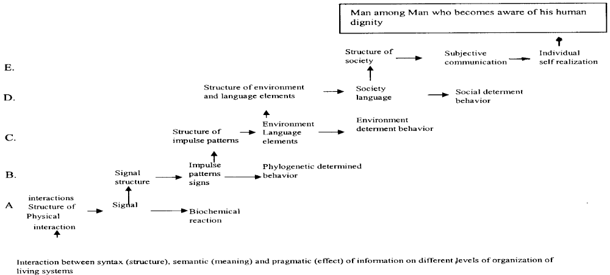
Figure 16: evolutionary concept of information – development of generation, preservation and use of information from the molecular level up to the level of self consciousness - the level of values.
The isolation of the individual and of the group, thus the strongest factor of ramification, is bridged by the social dimension. The world becomes ever smaller (with a view to the living conditions} owing to the new means of communication. The vision of Teilhard de Chardin’s world-wide communication is therefore a profound and stimulating view, if one does not take it as „a proof for faith and if one has not become insensitive to the horrors of this world and to the ambivalence of scientific and technological advance owing to the optimistic predetermination of his teleological that is target-determined conception.
Hence, present-day developmental thinking is based on the developmental thinking of the 18th and 19th centuries and despite this, it is essentially different from it. Present-day theory of science and philosophy is increasingly influenced by the insights of the physics of self-organization, so that one can really speak about a recovery of developmental thinking. In few of the many distortions that have been experienced by developmental thinking, this is a genuine new gain. The new gain of modern developmental thinking also includes the conception of information. Only by including the evolution of informational processes does it become possible at all to overcome the reduction of mind to matter and also the dualism of mind and matter.
Here we must represent the evolution of information and of the exchange of information in the meaning of the „evolutionary stage conception of information“ developed by us, as an evolution of the levels of organic/human and social communication processes. This evolution has hardly been investigated to date. However, the self-organization of information in biological and social systems is our central issue for understanding the essence of information and the role of informatics, as well as of the computer scientist in contemporary society .The last mentioned stage of evolution: the development of information and communication, of the information exchange between human beings and social organizations (development of the communication of knowledge, development of societal and of self- awareness, of social and individual values) allows to elaborate the societal, social, and individual aspect in the development of man and to regard it in interconnection with the development of modern information and communication technologies (see figure 16).
It is possible to formulate the following hypothesis: On the basis of an intensive networking of interactions of human beings among one another and supported by world-wide socio-technological information and communication systems, a communication society can emerge whose way of value creation is based on deploying the creativity of human beings, on the evolution of their intelligence and on a deeper understanding of their condition as human beings.
Ethical values are rooted in empathy that has „its real depth and width only, if it is directed not only to man, but to all living beings,“ „in the deep respect for life,“ as was pointed out above all by A. Schweitzer, in his Nobel Peace Prize speech in Oslo, 1954 . A. Schweitzer emphasizes the deep respect for all life, but as a doctor he must distinguish between deep respect for man and the living blade of grass or for the dangerous parasite. So the ethical principle of the “deep respect for life” includes (leads us to) the human dignity as the highest ethical value.
8. 3. Development of a World-Embracing, Technologically Supported Communication of Human Beings among Human Beings
According to Teilhard de Chardin, the noosphere presents itself as a noogenesis, as a process of mental growth. The fundamental law that dominates evolution is the law of a growing complexity and of increasing consciousness. If, based on the stability of the laws of nature, one applies this law also to the future, and then the result is that also within mankind we can note a growth in complexity and in consciousness. This process of psychogenesis, which could be shown for the past, will continue to deploy itself also in the future. Now this compels us to put the question, whether there are indeed such symptoms of an increasing unification. There we see to our surprise that in fact under the influence of technology, of the modern means of transport and of communication, under the impact of a globalization of the economy, mankind more and more develops in the direction of a unity that it had not known in its past until today. With man, the course of evolution suddenly seems to change and instead of pressing for a greater differentiation it leads on the contrary to an even greater unity and concentration. The development of modem information and communication technologies has a great share in this development. It is obvious that the globalization of markets, the internationalization of trade and of industry lead to increasingly intensive contacts and to a growing cooperation between human beings of all continents.

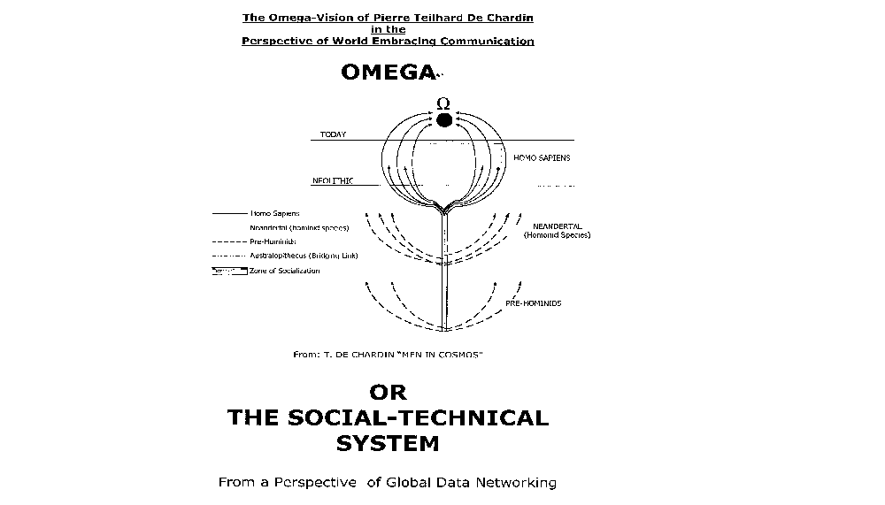
Figure 17: The Omega Vision (according to the drawing of T. de Chardin p. ) in the perspective of world-wide communication – the development of global digital networks as social-technical systems
These contacts and this co-operation can be supported by modern information and communication technologies. But one can also oppose this development, but one will soon be forced to recognize it. Apart from this coming closer together of the people of the world, at the same time, the construction of an internal organization takes place. Contemporary mankind aspires to carry out a process of organization and of socialization. Not only do the various cultures fertilize one another. Beyond the borders of the previous national states, races and languages, common efforts develop in the field of science, of the arts, and of ethics. In all these fields we are witnessing an increasingly closer co-operation, such a concentration of all forces that was unprecedented in the past. Teilhard de Chardin and V. I. Vernadsky both agreed in the statement that this phenomenon could most clearly be recognized in the field of the exploration of nature. In this field, joint thinking and research have developed allover the world. Of course, one can ask oneself today, how, in view of World War I and above all also of World War II, of the extermination camps, such as Auschwitz and others, one could cling to this vision of mankind growing closer together. But on the other hand we have to see, that in order not to be destroyed in one's own human dignity when faced with such a situation, one had substantially to strengthen one's belief in a positive development of mankind. Thus Teilhard de Chardin writes, „man must believe more strongly in mankind than in himself, or else he must despair“ . This also applies today.
An attentive examination of mankind's present situation against the background of the previous evolution shows us that in many fields we can note a closer coming together and increasing agreement. The consciousness about our common „space-ship earth,“ the growing world population, the more frequent contacts between human beings under the influence of globalization in industry and trade, the mutual interpenetration of cultures, and the support of these processes by modern information and communication technologies, by the emerging of the global telecommunication and tele-cooperation systems - all this seems to indicate that indeed the cosmic organization process can continue itself in the mankind of today. In this respect, we do not speak about the technological systems themselves , but about certain organizational forms connected with them , Just as Teilhard de Chardin and V. I. Vernadsky saw burgeoning forms of such a development in the emerging international scientific community, so one could assume also as such burgeoning cells the creation of „information centers“ in connection with the development of international computer net- works. At an early date we drew the attention to the necessity of creating such information centers within the context of the development of international telecommunication and tele-cooperation.,
Today, by means of an office computer or of a personal computer on one's desk, from one's own living room, via the telephone net- work or via satellite, one can be connected with the whole world. Personally one can get .access to the libraries of the world and thus to the knowledge of the world, or one can take part in (tele)-conferences in other countries without being obliged to go there. Is this not indeed a part of noogenesis, the mental growth process as Teilhard de Chardin has imagined it? The new expansive information technological complexes bring about a new social situation, which is expressed above all in an explosion of human labor in space and time. As is generally known, the universal agent of the industrial revolution of the past century was the steam engine. It replaced muscular force and allowed a concentration of great masses of people in the urban areas. The universal agent of large-scale industry in our days is the microprocessor. It allows the mechanization of mental work and decentralization, as well as a global and local networking.
For instance, satellite offices are not an organizational form of office work already existing previously, but a socio-technological innovation that requires a responsible introduction in professional, social, and ethical terms, and thus a prudent initiative. This leads to the circle of problems covering socio-technological systems and socio- technological information systems design. Hence, tele-working is a socio- technological innovation ,.
It is the challenge of informatics as a science to make a contribution towards the achievement of this development. ,,, At the same time, however, the fact is becoming compellingly clear that it is this very development which must undertake the further human formation of society, the establishment of appropriate social structures which make possible the unfolding of humanity by true interpersonal communication and vice versa.
By means of telecommunication nets and services it became possible to govern the rapidly growing international companies. The question arises as to whether this globalization promises more wealth and prosperity , better chances not only for the industrialized countries but for all other countries as well, or will it switch on a slow down spiral at which no country can win and all will lose, does it attack democracy and welfare .
Are there interconnections or, even, is there agreement with the noosphere vision of Teilhard de Chardin and of Vernadsky? Or must the question be put in an alternative manner: „Noosphere - omega or the socio-technological system?“ Are both of them mutually excluding targets? . Probably, in our consideration we will not arrive at an either, or, but also not at a both, and, but rather at a neither, nor . Neither will the socio-technological system - for instance, the world-wide web - in itself alone be a satisfactory target, and even the meaning of historical development, nor will viewing a growing complexity, in the meaning of a growing psychic life of the universe according to Teilhard de Chardin open our eyes to the difficulties, to the evil in this world, but something third will emerge in connection with the technological basis and its human integration into a society in which man can be a human being among human beings.
Already Vernadsky had modified his conception originally adopted from Teilhard de Chardin on the development of the noosphere- as a sphere of mind and of work. In a case of neither, nor one will have to attribute a great importance to the socio-technological systems, to worldwide communication between human beings, in the meaning of the vision of Teilhard de Chardin. In fact, the need for an ultimate unity and meaning is revealed to us only from the existence of man in his social world, in the cosmos. It is our example of the satellite office that shows us this point, and therefore the socio-technological system must be evaluated in its turn. In this form, a group of people works in a joint office near their homes. Hence, here it would be possible to assume that there could come about a higher form of socialization. In contrast, the variant of isolated tele-working, which is also called electronic outwork, will offer no great chance for personal development. A communication society can emerge .
For Vernadsky, too, the deployment of the noosphere is supported by a wide-ranging deployment of modern sciences. According to our view, however, it is necessary to add against this science and technology optimism that has been carried to the absolute: that the „absolute“ aspect of research becomes questionable, however, if research itself is carried to the absolute in its cognitive possibilities and is „projected into an unlimited sphere“, if feasibility values are not imposed to ensure a humane application of research results. „The main conception to be promoted is social responsibility,“ Berleur says. So we have discussed the scientific and social implications, as well as a number of ethical problems in connection with the deciphering of th human genome.
The creativity in nature ,, and in man and the delimiting conditions, such as structure, information, and at the level of society, the free will of man who has become aware of himself - humanist values, are the basis of evolution. These conditions operate to limit the number of possibilities for development that are derived from the creativity of nature and man. Thus, new possibilities for development emerge at a higher level. The utilization of technology must be really oriented to human beings among human beings. Only with a strong internal determination of the social processes by understanding the genuine existence as man will it be possible to master the ambivalence of its effects and to come closer towards a society with deepened human information and communication.
Now, these limitations must be imposed by understanding human dignity, namely on the basis of deploying human culture and civilization and collective reason, so that we should not do whatever we can, like animals. By limiting the developmental possibilities of human society that are still possible at a lower stage of social development, by imposing a stronger internal determination, new possibilities for evolution are opened up. As we have tried to describe, a higher developmental stage of human living together can be supported by scientific and technological means, especially also by modern information and communication networks. These information and communication technologies are an intensive expression of an objectification of human mind. But technological development cannot in itself be the factor determining the internal determination of social development.
A creative man among human beings who has really become aware of his human dignity is and continues to be such a factor of internal determination by which really new possibilities can be opened up for a humane living together. Hence, these are human beings that are able to carry out genuine human communication between human beings. This will be a rewarding vision for the future social development.

Frank Fuchs-Kittowski, Klaus Fuchs-Kittowski, Kurt Sandkuhl, The use of synchronous tele-cooperation to design virtual, creative organizations: Conclusions based on empirical research. In: IFIP 98, World Computer Congress, Dateien\725.hm
Fuchs-Kittowski, K., Fuchs-Kittowski, F., Quality of working life, Knowledge-intensive work and creative learning organizations – Information processing paradigm versus self-organization theory. In: IFIP World Computer Congress, Montreal 2002,
Piere Teilhard De Chardin, Der Mensch im Kosmos, C.H. Beck´schen Verlagsbuchhandlung Verlag München, 1959
Vladinir I. Vernadskij, Der Mensch in der Biosphäre – Zur Naturgeschichte der Vernunft, (W. Hofkirchner Hrsg.), Peter Lang Verlag, Frankfurt a.M., 1997
Fuchs-Kittowski, K., Krüger, P. The Noosphere Vision of Pierre Teilhard de Chardin and Vladimir I. Vernadsky in the Perspective of Information and of World-Wide Communi cation. In: W. Hofkirchner (Editor): World Future, 1997, Vo. 50 pp.757-784
Friedrich Schiller, Wilhelm Tell. In: Schillers Werke. Weimar: Volksverlag, 1958. S. 452
Geihs, K. Chancen und Risiken von Kommunikationsnetzen. In: Neue Wege des Informationsmanagements in Banken – Chancen und Risiken von Kommunikationsnetzen – Internes Knowledge-Management, Neuntes Symposium des Informationsrings Kreditwirtschaft e.V., ik report, Band 9. Frankfurt am Main, Zürich 1996, S. 25
Hauben, M. , Hauben, R. , Netizens – On the History and Impact of Usenet and the Internet. Los Alamitos, California, Washington, Brussels, Tokyo: IEEE Computer Society Press, S. 117
Gnnadij M. Dobrov, Robert H. Randolph, W.D, Rauch, International Networks for International Team Research. In: International Forum On Information and Documentation, International Federation For Documentation, 1978, vol. 3, No, 3
M. Bonitz, Wissenschaftliche Forschung und wissenschaftliche Information, Akademie Verlag, Berlin, 1981, p. 47
Fuchs-Kittowski, K. Lemgo, K., Schuster, U., Wenzlaff, B., Man / Computer Communication: A Problem of Linking Semantic and Syntactic Information Processing. In: Workshop on Data Communications. International Institute for Applied Systems Analysis 2361 Laxenburg, Austria, September 15-19, 1975, CP-76-9.S. 169-188
Dobrov, G.M., Organisationstechnologie als Gegenstand der Systemanalyse. Teil 1: Grundsatzfragen und Teil 2: Aspekte und Ebenen der Organisationstechnologie. In: Wissenschaftliche Zeitschrift der Humboldt-Universität zu Berlin, Mathematisch-Naturwissenschaftliche Reihe, (Berlin). 5 (1979), S. 613-622 und 675-684
Fuchs-Kittowski, K., Wechselbeziehungen zwischen Automat und Gesellschaft – zu Strategien des Einsatzes der automatisierten Informationsverarbeitung als Rationalisierungs- und Erkenntnismittel. In: Wissenschaftliche Zeitschrift der Humboldt-Universität zu Berlin, Mathematisch-Naturwissenschaftliche Reihe, (Berlin). 5 (1979), S. 707 – 718
Klaus Fuchs-Kittowski, Die digitalen Medien und die Zukunft der Kultur wissenschaftlicher Tätigkeit. In: Wissenschaft und Digitale Bibliothek: Wissenschaftsforschung, Jahrbuch für Wissenschaftsforschung, Berlin 1998. Hrsg. V. K. Fuchs-Kittowski, H. Laitko, H. Parthey, W. Umstätter, Berlin: Gesellschaft für Wissenschaftsforschung 2000, S. 9-66
K. Fuchs-Kittowski, Grundlinien des Einsatzes der Informations und Kommunikationstechnologien in der DDR – Wechsel der Sichtweisen zu einer am Menschen orientierten Informationssystemgestaltung, In: Informatik in der DDR – eine Bilanz, Symposium vom 7. Bis 9 Oktober 2004 an der Technischen Universität Chemnitz, in prin Springer-Verlag, 2005
R. Hauben, The Vision of Computer Networking Communication and ist Influence on East-West Relations and the GDR. In: Informatik in der DDR – eine Bilanz, Symposium vom 7. Bis 9 Oktober 2004 an der Technischen Universität Chemnitz, in prin Springer-Verlag, 2005
Kirstein, P. K. and Kenney, S. B., The Uses of the ARPA Network via the University College London Node, - In: Workshop On Data Communications, September 15-19, 1975, International Institute for Applied Systems Analysis 2361, Austria, 1975
M. Bonitz, Wissenschaftliche Forschung und wissenschaftliche Information, Akademie Verlag, Berlin, 1981, S. 143- 144
R. Hauben, Creating the Vision for the Internet, From the Wiener Circles to Licklider and ARPA`s Information Processing Techniques Office (IPO). In: K. Fuchs-Kittowski, S. Piotrowski (Rditors): Kybernetik und Intersisziplinarität – Georg Klaus zum 90. Geburtstag, Abhandlungen der Leibniz-Sozietät, trafo verlag, Berlin, 2oo4
J.C.R. Licklider, R. Taylor, The Computer as a Communication Device, Science and Technology: For the Technical Men in Managemnent 76 (Aoril 1968): 21-31. Reprinted in Memoriam: J.C.R. Licklider: 1915-1990. 21-41. Palo Alto, Calif. Digital Systems Research Center, 1990. (URL http.//memex.org/lick.html
J.C.R. Licklider Man-Computer Symbiosis. IRE Transaction on Human Factors in Electronics HFE-1 (March 1960): 4-11. Reprinted In Memoriam: J.C.R. Licklider: 1915-1990. 1-19. Palo Alto, Calif. Digital Systems Research Center, 1990. (URL http.//memex.org/lick.html
G. Klaus, Zur Soziologie der Mensch-Maschine-Symbiose” – Eine kybernetische Betrachtung. In: Deutsche Zeitschrift für Philosophie. Heft 10, 1962: 885-902
H. Liebscher, Georg Klaus, Georg Klaus zu philosophischen Problemen der Mathematik und Kybernetik, Berlin, 1982
K. Fuchs-Kittowski, Kybernetik, Informatik und Philosophie – Zum philosophischen Denken von Georg Klaus: Im Spannungsfeld zwischen formalem Modell und nicht formaler Wirklichkeit. In: : K. Fuchs-Kittowski, S. Piotrowski (Rditors): Kybernetik und Intersisziplinarität – Georg Klaus zum 90. Geburtstag, Abhandlungen der Leibniz-Sozietät, trafo verlag, Berlin, 2oo
Zemanek, Heinz, Weltmacht Computer - Weltreich der Information, Bechtle Verlag, Esslingen, München, 1991
Fuchs-Kittowski, Klaus, Kaiser, Horst, Tschirchwitz, Reiner, Wenzlaff, Bodo: Informatik und Automatisierung – Theorie und Praxis der Struktur und Organisation der Informationsverarbeitung, Akademie-Verlag, Berlin, 1976
J.C.R. Licklider Man-Computer Symbiosis. IRE Transaction on Human Factors in Electronics HFE-1 (March 1960): 4-11. Reprinted In Memoriam: J.C.R. Licklider: 1915-1990. 1-19. Palo Alto, Calif. Digital Systems Research Center, 1990. (URL http.//memex.org/lick.html
It seems reasonable to envision, for a time 10 or 15 years hence, a "thinking center" thatwill incorporate the functions of present-day libraries together with anticipated advances in information storage and retrieval and the symbiotic functions suggested earlier in this paper. The picture readily enlarges itself into a network of such centers, connected to one another by wide-band communication lines and to individual users by leased-wire services. In such a system, the speed of the computers would be balanced, and the cost of the gigantic memories and the sophisticated programs would be divided by the number of users. J.C.R. Licklider Man-Computer Symbiosis. ebenda
K. Fuchs-Kittowski, K. Lemgo, U. Schuster, B. Wenzlaff, Man/Computer Communication: A Problem of Linking Semantic and Syntactic Information Processing. In: IIASA Workshop on Data Communication, September 15-19, 1975, International Institute for Applied Systems Analysis 2361 Laxebburg, Austria
ebenda
M. Hauben, R. Hauben, Netizens – On the History and Impact ofUsenet andthe Internet, IEE Computer Society Press, Los Alamitos, Califormia, Washington, Brussel, Tokyo, 1997
R. Werle, Internet and Culture: The Dynamics of Interdependence. In: G. Banse, A. Grunwald, M. Rader (eds.): Inovation for an e-Society – Challenges for Technology Assesment, edition sigma, Berlin 2002
D. Carl, W. Dames, D. Hammer, V. Heymer, G. Hofmann, H.W. Meier, C. Sattler, I. Wende, The System Concept of the Computer Network DELTA. In: N. Inose ( Editor): Evolution Computer Communications Proceedings of the 4th International Conference on Computer Communication, North-Holland, 1978, Amsterdam
A. Butrimenko, J.H. Sexton, V. Dashko, IASA Data Communication Network. In: IIASA Workshop on Data Communication, September 15-19, 1975, International Institute for Applied Systems Analysis 2361 Laxebburg, Austria
A. Butrimenko, Computer Networking for Scientific Collaboration: The IIASA Case, Euro IFIP 1979, p 383
Fuchs-Kittowski, F. Fuchs-Kittowski, K., Sandkuhl, K. The use of synchronus telecooperation to design virtual, creativ organisations: Conclusions based on empirical research. In: the global information society on the way to the next millennium, IFIP World Computer Congress ’98, CD-Rom Edition of the Austrian Computer Society
Fuchs-Kittowski, F., Fuchs-Kittowski, K. Knowledge-intensive work processes for creativ learning organisations. In: Institut für Technikfolgenabschätzung und Systemanalyse and VDI/VDE-Technologiezentrum Informationstechnik (Editors): Innovation for an e-Society. Challenges for Technology Assessment, 17-19 October, Berlin, Congress Pre-prints, CD-Rom Edition, Teltow 2001
R. Werle, Internet and Culture: The Dynamics of Interdependence. In: G. Banse, A. Grunwald, M. Rader (eds.): Inovation for an e-Society – Challenges for Technology Assesment, edition sigma, Berlin 2002
C. Hamelink, Risks in the Global e-Society. In: G. Banse, A. Grunwald, M. Rader (eds.): Inovation for an e-Society – Challenges for Technology Assesment, edition sigma, Berlin 2002
Frank Fuchs-Kittowski, Klaus Fuchs-Kittowski, Kurt Sandkuhl, The use of synchronous tele-cooperation to design virtual, creative organizations: Conclusions based on empirical research. In: IFIP 98, World Computer Congress, Dateien\725.hm
Fuchs-Kittowski, K., Fuchs-Kittowski, F., Quality of working life, Knowledge-intensive work and creative learning organizations – Information processing paradigm versus self-organization theory. In: IFIP World Computer Congress, Montreal 2002,
Fuchs-Kittowski, K., Krüger, P. The Noosphere Vision of Pierre Teilhard de Chardin and Vladimir I. Vernadsky in the Perspective of Information and of World-Wide Communication. In: W. Hofkirchner (Editor): World Future, 1997, Vo. 50 pp.757-784
Clases C., Wehner, T., Cooperation, knowledge production and system design. In: Bonnie Nardi, David Redmiles (Editors): Computer-Supported Cooperative Work: The Journal of Collaborative Computing, Special Issue of CSCW and activity theory and design
K, Fuchs-Kittowski, Information – Neither Matter nor Mind – on the Essence and on the Evolutionary Stage Concept of Information. In: W. Hofkirchner (Editor): Goren Breach Science Publisher, 1997
Frank Fuchs-Kittowski. Wissens.Ko-Produktion und dynamische Netze: Kooperative Wissenserzeugung und – nutzung in wissensintensiven Geschäftsprozessen. In: H. J. Müller, A. Abecker, H. Maus, and K. Hinkelmann (editors): Geschäftsprozessorientiertes Wissensmanagement: Von der Strategie zum Contend. Proceedings of the Workshop at WM`20012, Baden-Baden, Germany, 14-16 March 2001, Kaiserslautern, Germany, 2001. Deutsches Forschungszentrum für Künstliche Intelligenz
T. Händrich, R. Maier, Modeling Knowledge Work,
Marcus Michalewicz, Die Bedeutung der Grid-Thematik für die IT-Landschaft moderner Unternehmen. In: Datenbank Spektrum, Zeitschrift für Datenbanktechnologie, Heft 12, 2005, S. 31-43
Schewe, T. Neue Horizonte der biochemisch-molekularbiologischen Forschung im Lichte der Revolution der Informationstechnologie zur Jahrhundertwende. In: Stufen zur Informationsgesellschaft für alle. Festschrift zum 65. Geburtstag von Klaus Fuchs-Kittowski. Hrsg. V. Chr. Floyd, W. Hofkirchner, C. Fuchs, Frankfurt a.M. Peter Lang Verlag 2002
Fuchs-Kittowski, K. Rosenthal, A., Rosenthal, A., Die Entschlüsselung des Humangenoms – ambivalente Auswirkungen auf Gesellschaft und Wissenschaft. In: Erwägen, Wissen, Ethik (EWE), Heft 2, 2005
The DNA sequence of human chromosome 21. Nature, 4o5, 311 (2000)
This description is taken from Tankred Schewe, Neue Horizonte der biochemisch-molekularbiologischen Forschung im Lichte der Revolution der Informationstechnologien zur Jahrtausendwende.In: Christiane Floyd, Cristian Fuchs, , Wolfgang Hofkirchner (Hrsg.): Stufen zur Ibnformationsgesellschaft, Festschrift zum 65. Geburtstag von Klaus Fuchs-Kittowski, Peter Lng Verlag, Frankfurt a.M., Berlin, Wien, 2002
Kujubu, D.A., Fletcher, B.S., Lim, R.W., Herschman, H.R., TIS10, a phorbolester/cyclooxygenase homologue. In: Journal of Biological Chemestry 266 (1991), Heft 20. S. 12866-12872.
Fletcher, B.S., Kujubu, D.A., Perrin, D.M., Herschman, H.R., Structure of the mitogen-inducible TIS10 gene and demonstration that the TIS10-encodet protein is a functional prostagladin G/H synthase. In: Journal of Biological Chemestry 267 (1992) Heft 7, S. 4338-4344.
J Assoc Physicians India. 2005 Mar;53:200-4. COX-2 selective nonsteroidal anti-inflammatory drugs: current status. Mahajan A, Sharma R. Rheumatology Clinic, Postgraduate Department of Medicine, Government Medical College, Jammu.
Fuchs-Kittowski, F. , Vogel, E., Kooperative Online-Beratung im Electronic Commerce: Der COCo-Ansatz zur kooperativen Wissenserzeugung. In: Mensch & Computer. Hrsg. V. H. Oberquelle, R. Oppermann, J. Krause, Teubner Verlag, Leipzig, Wiesbaden, 2001
Fuchs-Kittowski, K. , Wissens-Ko-Produktion: Verarbeitung, Verteilung und Entstehung von Informationen in kreativ lernenden Organisationen. In: Stufen zur Informationsgesellschaft für alle. Festschrift zum 65. Geburtstag von Klaus Fuchs-Kittowski, Hrsg. Chr. Floyd, W. Hofkirchner, C. Fuchs, Peter Lang Verlag, Frankfurt a.M., Berlin, New York, Wien, 2002, S. 59 - 125
Nawrocki, K., Bewertung der Informationsrecherche im Internet und Vorstellung eines neuen Ansatzes, Dipomarbeit, FHTW Berlin, 21.2.2001
Fuchs-Kittowski, K.; Information – Neither Matter nor Mind: On the Essence and on the Evolutionary Stage Conception of Information – In: The Quest For A Unified Theory of Information. Hrsg. W. Hofkirchner. World Futures General Evolution Studies. Volume 13, Gordon and Breach Publisher, Australia, Canada, Amsterdam, 1994, S. 331 – 350
Fuchs-Kittowski, K., Rosenthal, H.A., Selbstorganisation, Information und Evolution – Zur Kreativität der lebenden Natur. In: Information und Selbstorganisation – Annäherung an eine vereinheitlichte Theorie der Information. Hrsg. V. N. Fenzl, W. Hofkirchner, G. Stockinger. Studien-Verlag, Wien, 1998, S. 141-188
Brier, S., What is a `Possible Ontological and Epistemological Framework for a True Universal `Information Science?` The Suggestion of a Cybersemiotics. In: The Quest For A Unified Theory of Information. Hrsg. W. Hofkirchner. World Futures General Evolution Studies. Volume 13, Gordon and Breach Publisher, Australia, Canada, Amsterdam, 1994, S. 79 – 99.
Fuchs-Kittowski, K., Heinrich, L.,J., Rolf, A., Information entsteht in Organisationen – in kreativen Unternehmen: Wissenschaftstheoretische und methodologische Konsequenzen für die Wirtschaftsinformatik. In: Wirtschaftsinformatik und Wissenschaftstrheorie – Bestandsaufnahme und Perspektiven. Hrsg. V. J. Berker, W. König, R. Schütte, O. Wendt, S. Zelewski, Betriebswirtschaftlicher Verlag Dr. Th. Gabler GmbH, Wiesbaden, 1999, S. 329-361
Fuchs-Kittowski, F., Online-Beratung im Electronic Commerce – Kundenberatung über das Internet. Frauenhofer Institut für Software- und Systemtechnik (ISST), http:isst.fhg.de/ffuchs/, 2. November 2000
Fuchs-Kittowski, F., Kooperative Wissenserzeugung und –nutzung in wissensintensiven Geschäftsprozessen. In: Professionelles Wissensmanagement – Erfahrungen und Visionen. Hrsg. V. H-P. Schnurr, S. Staab, R. Studer, G. Stumme, Y. Sure, Shaker Verlag, Aachen, 2001
Klaus Nawrocki, Bewertung der Informationsrecherche im Internet und Vorstellung eines neuen Ansatzes, Dipomarbeit, FHTW Berlin, 21.2.2001
ebenda
This part of the article is based on the joint publication with P. Krüger: The Noosphere Vision of Pierre Teilhard de Chardin and Vladimir I. Vernadsky in the Perspective of Information and of World-Wide Communication. In: W. Hofkirchner (Editor): The Quest for A Unified Theory of Information. World Futures General Evolution Studies Vol. 13, Gordon and Breach Publishers, Amsterdam, 1999
W. Ebeling, Strukturbildung bei irreversiblen Prozessen – Eine Einführung in die Theorie dissioativer Strukturen, BSB B.G. Teubner Verlagsgesellschaft, 1976
K. Fuchs-Kittowski, H.A. Rosenthal und S. Rosenthal, Zu den modernen genetischen Technologien und dem Verhältnis von Wissenschaft und Ethik, , Wahrheit und Wert , Rationalität und Humanismus. In: E. Geissler, W. Scheler (Hrsg.): Genetic engineering und der Mensch, VII. Kühlungsborner Kolloquium, Akademie-Verlag, Berlin, 1981
R. Feistel, Ritualisation und Selbstorganisation der Information
W. Umstätter, Die Wissenschaftlichkeit im Darwinismus, Biologie heute, Nr. 381, 1990
W. Hofkirchner, Zwischen Chaos und Versklavung – Die Entgrenzung der Naturwissenschaften und die Mauer im Kopf. In: Fortschrittliche Wissenschaft, 37, 1993, S. 718
D. J. Goldhagen, Hitlers willige Vollstrecker, Ganz gewöhnliche Deutsche und der Holocaust, Siedler Verlag, 1996
K. Fuchs-Kittowski, Reflection on the Essence of Information. In: C. Floyd, H. Züllighofen, R. Budde, R. Keil-Slawik (Editors): Software development and Reality Construction, Springer Verlag, Berlin, Heidelberg, New York, 1992.
K. Fuchs-Kittowski, Theorie der Informatik im Spannungsfeld zwischen formalem Modell und nicht formaler Welt. In: W. Coy et al. (Hrsg.): Sichtweisen der Informatik, Vieweg, Braunschweig1992
K. Fuchs-Kittowski, Die Psychologie benötigt eine weder dualistische noch reduktionistische Lösung des Geist-Gehirn-Problems. In: Ethik und Sozialwissenschaften, Streitforum für Erwägungskultur, Westdeutscher Verlag, EnS 6, Heft 1
K. Fuchs-Kittowski, Reflection on the Essence of Information. In: C. Floyd, H. Züllighofen, R. Budde, R. Keil-Slawik (Editors): Software development and Reality Construction, Springer Verlag, Berlin, Heidelberg, New York, 1992.
A. Schweitzer, Das Problem Des Friedens In Der Heutigen Welt, Verlag C. H. Beck Nobel Peace Prize acceptance speech in Oslo, November 4, 1954
Teilhard de Chardin, Der Mensch im Kosmos
T. Stonier: The Emerging Global Brain. In: W. Hofkirchner (Editor): The Quest for A Unified Theory of Information. World Futures General Evolution Studies Vol. 13, Gordon and Breach Publishers, Amsterdam, 1999
W. Hofkirchner, Ein neues Weltbild für eine neue Weltordnung – Reflexion über Selbstorganisation der Menschheit. In: W. Hofkirchner (Hrsg.): Weltbild Weltordnung – Perspektiven für eine zerbrechliche und endliche Erde, agenda global Verlag, Münster, 1994
P. Fleißner, W. Hofkirchner: Emergent information. Towards a unified information theory, In: Bio Systems, Journal of Biological and Information Processing Science, Elsevier, Amsterdam, 1996
K. Brunnstein, Perspectives of the Vulnerability of IT-based Society: In: Proceedings of IFIP 12th World Computer Congress, Madrid, Spain, Volume II, pp. 588-592
Fuchs-Kittowski, K. Lemgo, K., Schuster, U., Wenzlaff, B., Man / Computer Communication: A Problem of Linking Semantic and Syntactic Information Processing. In: Workshop on Data Communications. International Institute for Applied Systems Analysis 2361 Laxenburg, Austria, September 15-19, 1975, CP-76-9, S. 169-188
G. Wersig, Organisations-Kommunikation: Die Kunst ein Chaos zu organisieren, FBO-Fachverlag für Büro- und Organisationstechnik, Baden-Baden, 1989
E. Ulich, Arbeits- und organisationspsychologische Aspekt, In: H. Balzer et. Al. (Hrsg.): Einfürhrung in die Software-Ergonomie, de Gruyter, Berlin, 1988.
E. Ulich, Arbeitspsychologie, Verlag der Fachvereine, Zürich / C.E. Poeschel Verlag, Stuttgart, 1992
A. Rolf, A. Moeller, Sustainable Development: Gestaltungsaufgabe der Informatik, In: Informatikspektrum 19: 206-2013 (1996) Springer Verlag, 1996
K. Sandkul, H. Weber (Hrsg.): Telekooperationssysteme in dezentraler Organisation, Tagungsband zum Workshop der GI Fachgruppe 5.5.1, Berlin, 1996
K. Fuchs-Kittowski, H. Junker, Zukünftiger Erwartungen an den Gestalter moderner Informationstechnologien, InfoTech, Jg. 5, Heft 4 Dez 93-Febr.94.
K. Kornwachs, Information und Kommunikation – Zur menschengerechten Technikgestaltung, Springer-Verlag, Berlin, 1993
T. Necker, Opening Address to the 13th IFIP-Computer Worldcongress, Hamburg, Germany. In: Informatik Spektrum, Band 17, Heft 6, Springer-Verlag, 1994
H.-P. Martin, H. Schumann; Die Globalisierungsfalle – Der Angriff auf Demokratie und Wohlstand, Rowohlt, Reinbeck bei Hamburg, 1996
This question has been put forward in a seminar held at the Evangelical Academy Müllheim (Germany) under the leadership of H. J. Fischbeck. See also Figur from him for the invitation to this seminar.
Weizenbaum contra Haefner (M. Haller Hrsg.): Sind Computer Die Besseren Menschen?, pendo-verlag, Zürich, 1990
M. Roth, Information und Kommunikationsgesellschaft,VHW-Mitteilungen, 1995
J. Berleur, Risks and Vulnerability in an Information and Artificial Society. In Procceedings of the IFIP 12th World Computer Congress, Madrid, Spain, Volume 11, pp. 309-310
K. Fuchs-Kittowski, H.A. Rosenthal, A. Rosenthal, Die Entschlüsselung des Humangenoms – ambivalente Auswirkungen auf die Gesellschaft und Wissenschaft. In: Erwägen Wissen Ethik (Deliberation Knowledge Ethics) Jg. 16/2005 Heft 2, Lucius
Walter M. Elsasser: Kreativität als Eigenschaft Molekularer Systeme, Department of Earth and Planetary Sciences, The Johns Hopkins University, Baltimore, USA, January 1986
K. Fuchs-Kittowski, H.A. Rosenthal, Selbstorganisation, Information und Evolution – Zur Kreativität der belebten Natur. In: N. Fenzl, W. Hofkirchner, G. Stockinger, Information und Selbstorganisation- Annäherung an eine vereinheitlichte Theorie der Information, Studien Verlag, Innsbruck-Wien, 1989
Fuchs-Kittowski, K., Schewe, T., Informationsverarbeitung, -recherche und -erzeugung–erzeugung in den Biowissenschaften. In: H. Parthey, G. Spur (Hrsg.): Wissenschaft und Innovation, Wissenschaftsforschung Jahrbuch 2001, Gesellschafts für Wissenschaftsforschung, Berlin, S. 185-220

