Gasoline Sweeper Manual

Model: □ GS80V-C SWEEPER GS80V-CE SWEEPER
□ GS100V-C SWEEPER □ GS100V-CE SWEEPER
□ GS80V-BS750EX SWEEPER □ GS100V-BS750EX SWEEPER

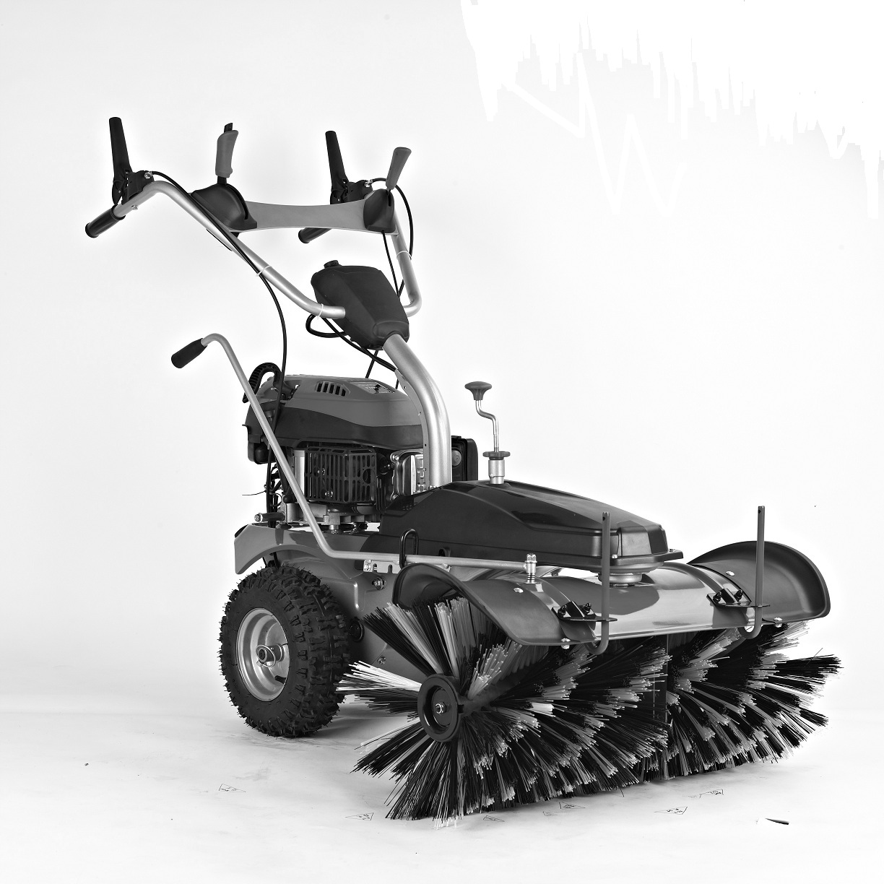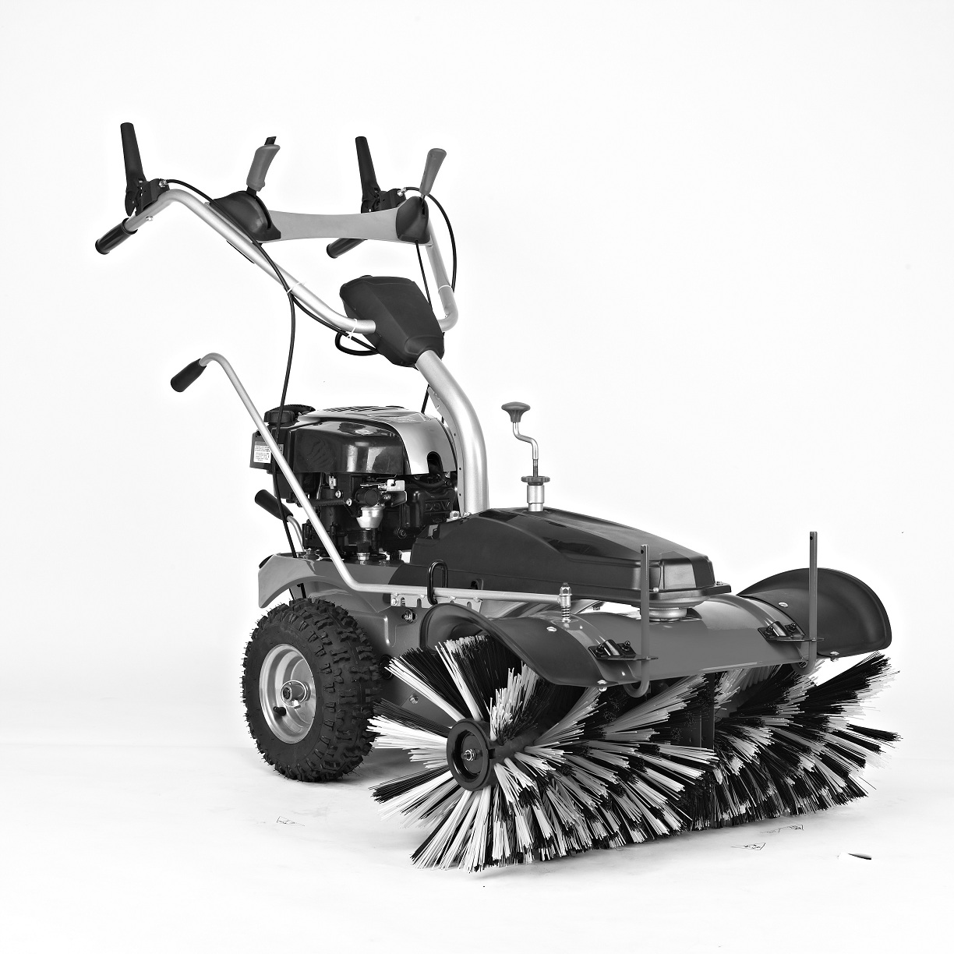




CAUTION: Read and follow all Safety Rules and Instructions before operating this equipment

Thank you for choosing our Gasoline Sweeper.
To ensure that you get the best results from your Gasoline Sweeper please read all of these safety and operating instructions carefully before using this product.
TABLE OF CONTENTS

1. Safety Message……………….....……………..…………......2
2. Product specifications……………….....……………..……...5
3. Assembly……………………......……………..……….….…...6
4. Before Operation……………………………………………….8
5. Operation……………….....…………………………….……...9
6. Maintenance and storage……………….....………………..13

1. Safety messages
Your safety and the safety of others are very important. We have provided important safety messages in this manual and on the machine. This information alerts you to potential hazards that could hurt you or others. Please read these messages carefully.
Of course, it is not practical or possible to warn you about all the hazards associated with operating or maintaining a machine. You must use your own good judgment.
SYMBOLS
The following symbols appear on the machine. They are there to remind you of the care and attention required in use. This is what the symbols mean:

Warning.


Read and understand the owner’s manual before using this machine.


Keep hands out of discharge chute.

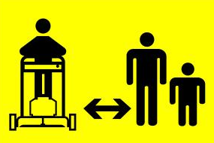
Keep bystanders at a safe distance from the machine.


Never point the discharge chute towards bystanders.


Disconnect the spark plug wire, and consult technical literature before performing repairs or maintenance.


Risk of burns.


Use hearing protection.

General Conditions Of Use

- Do not put hands or feet near or under rotating parts.
- Read this manual carefully. Make sure that you are familiar with the different controls, settings and handles of the equipment.
- Know how to stop the unit and ensure that you are familiar with emergency stop.
- Never allow children or people unfamiliar with these instructions to use the machine. Note, that local regulations can restrict the age of the operator.
- If you feel unwell, tired or have consumed alcohol or drugs, do not operate the machine.
- Always inspect the machine before usage. Ensure that no parts are worn or damaged.
- Replace worn out or damaged elements and bolts in sets to preserve balance.
- The operator of the machine is responsible for people’s safety.
- Never use the machine near children or animals.
- The operator of the machine is held liable for any accidents or hazards to other people and their property.
- Thoroughly inspect the area, where the equipment is to be used, if necessary remove any foreign objects.
- Do not refuel gasoline indoors or while the engine is running.
- Spilled gasoline is extremely flammable, never refuel while the engine is still hot.
- Wipe off any spilled gasoline before starting the engine. It may cause a fire or explosion!
- Beware of hazards, while working on difficult soil hence; extremely stony or hard soil.
- Boots with non-slip soles with steel jacket is required. Avoid loose-fitting clothes.

Using Instructions

- Always start the engine from safety zone.
- Do not leave the safety zone while operating the machine, if it is necessary to leave the safety zone, turn off the engine before leaving the zone.
- After striking a foreign object, stop the engine immediately, remove the spark plug cap and inspect the machine thoroughly for damage. Repair the damage before continuing
- If the machine should start to vibrate abnormally, stop the engine and check immediately for the cause. Vibration is generally a warning of damage.
- Always disengage the levers, turn off the engine, and remove the spark plug, when the unit is left unattended.
- Always turn off the engine and ensure that all moving parts have come to a complete stop before making any repairs, adjustments, or inspections.
- Exercise extreme caution when operating on slopes.
- Never operate the machine at a fast pace.
- Do not overload machine capacity by attempting to work at too fast a rate.
- Do not carry passengers.
- Pay attention, while the machine is in reverse.
- Never allow any bystanders in front of unit.
- Always disengage the rotary brush, if not in use.
- Only operate the machine at daylight or in fully illuminated areas
- Ensure a stable foothold and always keep a firm hold on the handles. Always walk, never run.
- Do not operate the equiment when barefoot or wearing sandals.
- Exercise extreme caution when changing direction on slopes
- By rear tillers, ensure that the blades are protected by safety shield, only the part of the blades that works into the soil must be free.
- Never attempt to make any adjustments, while the engine is running.
- Use extreme caution when reversing or pulling the machine backwards
- Never operate the engine indoor or in areas with low ventilation. The exhaustion from the engine contains carbon monoxide. Failure to observe could result in permanent injury or death.

Gasoline Safety

- Keep gasoline in a jerry can specially made for this purpose.
- Fill up the tank with a funnel, do the operation outside. Do not smoke. Do not use mobile phone.
- Fill up with gasoline and oil before staring the engine. Never open the cap of the fuel tank to add gasoline while the engine is running or still hot.
- Do not start the engine if there is some gasoline spread around, take the machine away from the one where gasoline have been split and avoid any contact from a hot source as long as the split gasoline is completely evaporated.
- Tighten the fuel tank cap and close tightly the jerry can cap.

2. Product Specifications
Engine model Y173V/ B&S750EX
Petrol engine 3.6kW /2.7kW
Engine speed 3000/min
Working width 80cm / 100cm
Broom speed 180 rev./min------350 rev./min
Guaranteed Sound Power Level 98dB(A)

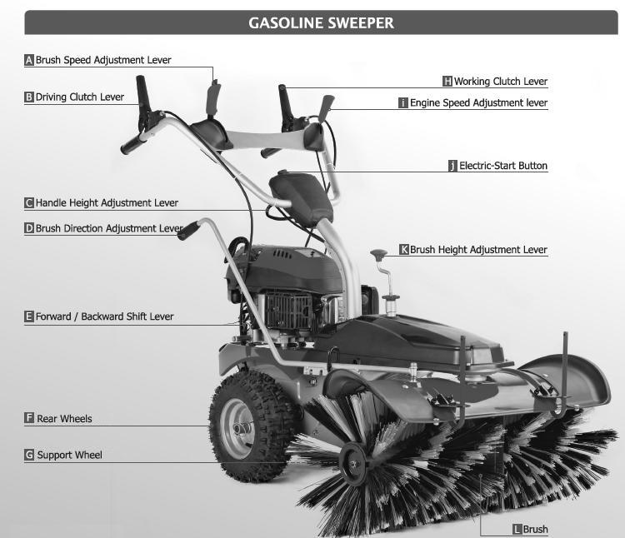
* Optional Parts:
Collection Box Snow Scraper
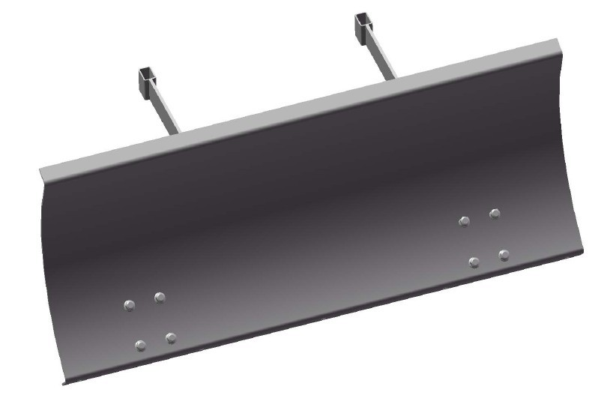
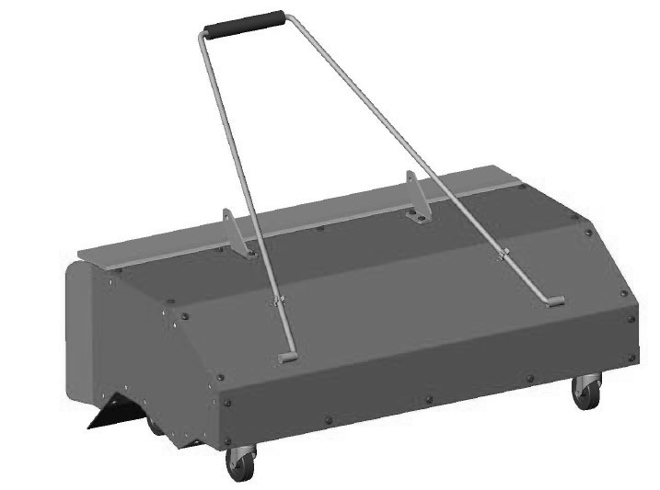

3. Assembly
Unpacking
Remove machine from carton and check thoroughly for additional loose parts. The sweeper is almost ready assembled from the factory. Only a few items remain to be assembled.

Handle Setup
Install the handle bar to handle fixing plate with nuts.
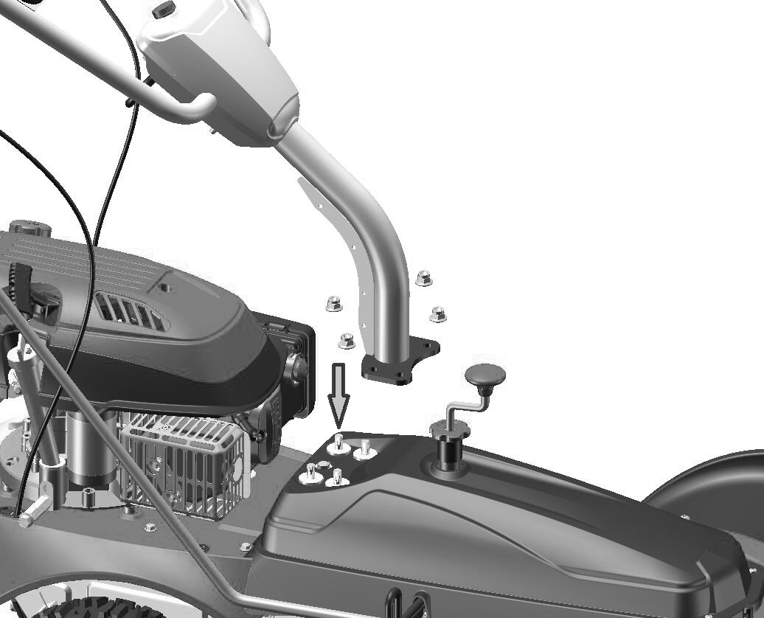

Handle Bar

Nut

Handle Fixing Plate

Brush Steering Lever Setup
Take out brush steering lever from carton, and install the lever with spring, washer and nut.
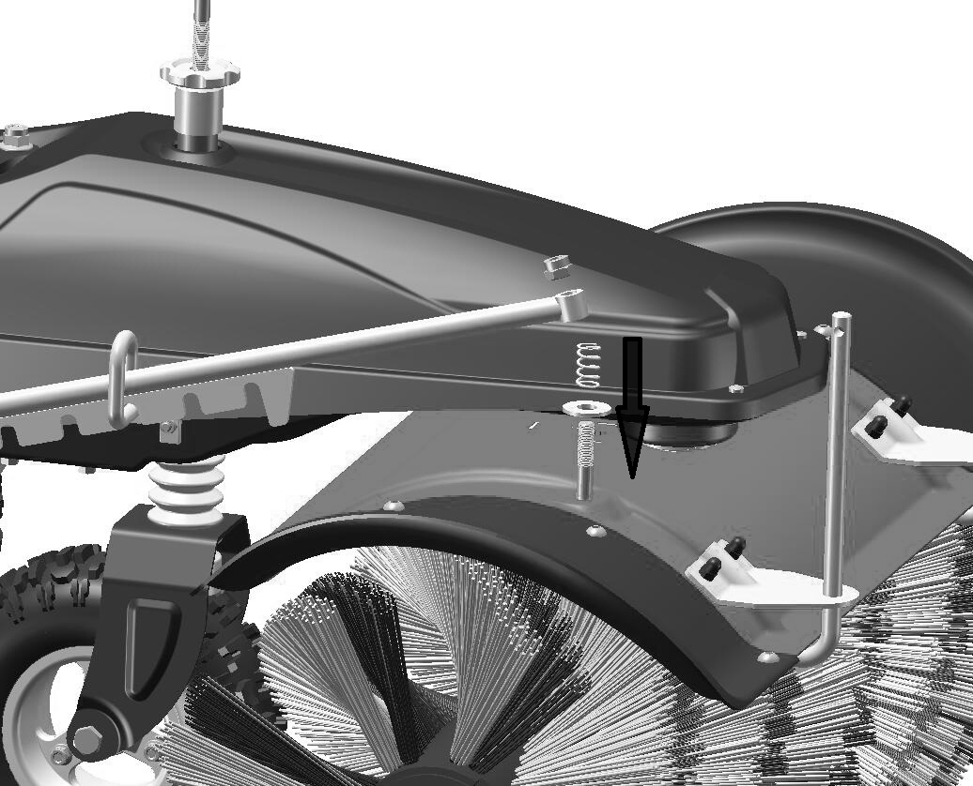
Nut
Brush Steering Lever
Spring
Washer

Shift Lever Setup
Install shift lever with Bolts and Nuts.
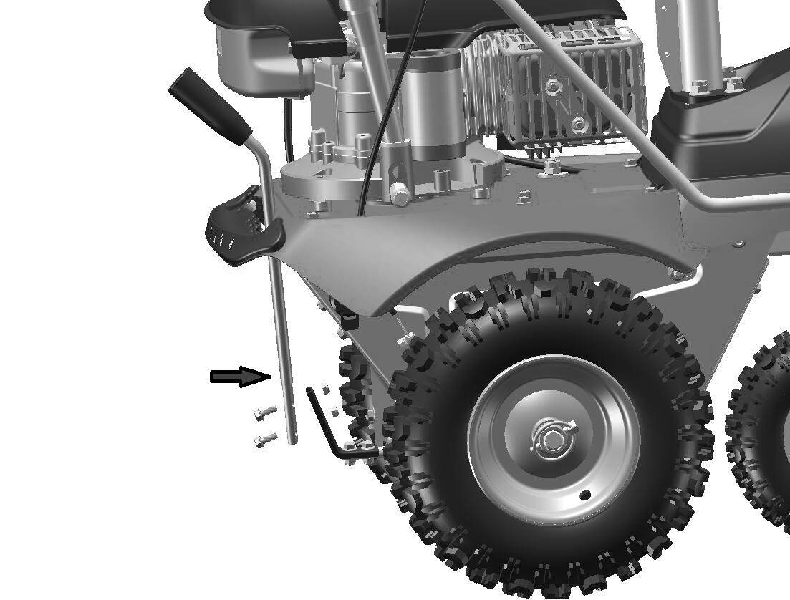

Shift Lever

Brush Setup
Install the brush on each side following the figure.

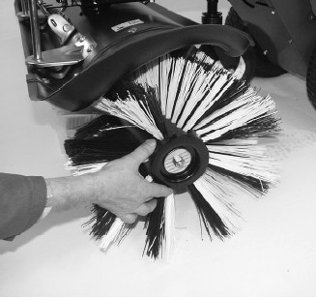
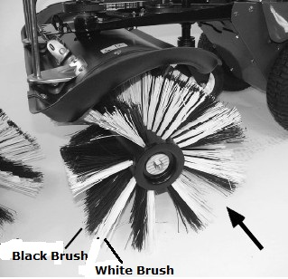
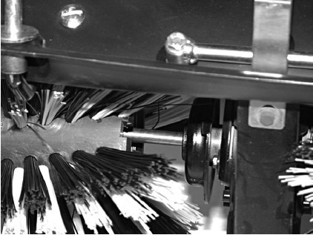

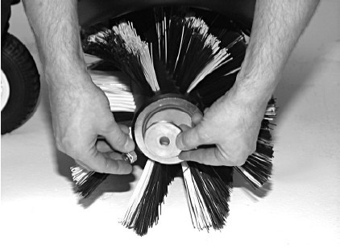
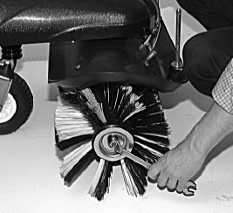

4. Before Operation
Engine Oil
The mower is shipped without oil in the engine.
A bottle of oil is included in the box with your mower. Add the entire contents of the oil bottle into the oil filler opening.
All engines are run at the factory prior to packaging. Most of the oil is removed prior to shipment; however, some oil remains in the engine. The amount of oil left in the engine varies.
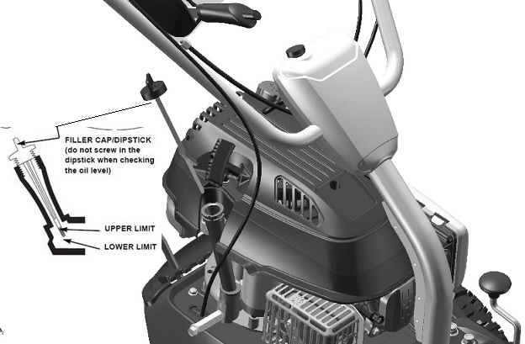
Add enough oil to bring the oil level between the upper and lower limit marks on the dipstick as shown. Do not overfill engine with oil.
FUEL
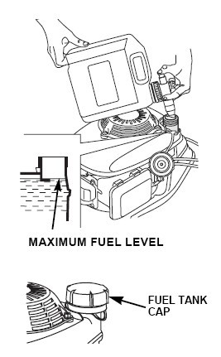
NOTICE: Engine delivered without gasoline, refuel 1.0 liter of before starting the engine.
- Remove the filler cap
- Add fuel to the bottom of the fuel level limit in the neck of the fuel tank. Do not overfill. Wipe up spilled fuel before starting the engine.
- Tighten the fuel tank cap


Gasoline is extremely flammable, and gasoline vapor can explode, causing serious injury or death. Use extreme care when handling gasoline. Keep out of reach of children.
Refuel in a well-ventilated area with the engine stopped. Do not smoke or allow flames or sparks in the area where the engine is refueled or where gasoline is stored. Avoid repeated or prolonged contact with skin or breathing of vapor.
After refueling, tighten the fuel tank cap securely. If any fuel was spilled, make sure the area is dry before starting the engine.

Charge The Battery (only for Electric start)
Charge the battery before use. Before the electric start function is used, the battery must be charged for 5 hours. Put the charger plug into the hole in the battery and connect the charger to a power supply.
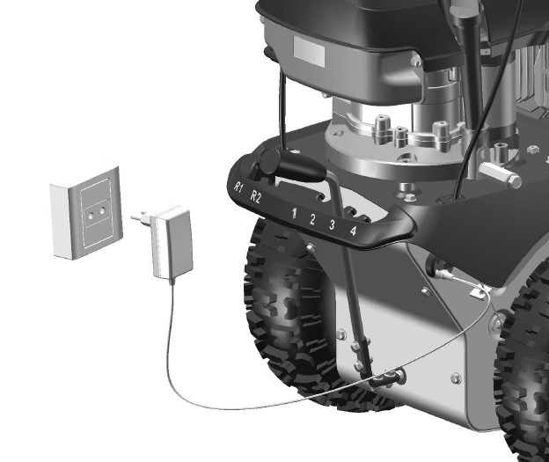

4. Operation
 Read the instruction manual for the engine,before use
Before using the machine, remove all foreign objects from the vicinity. Stones,glass,branches and similar items can damage the sweeping machine.Also check that all bolts are tightened.
Control oil level before starting the engine. See attached guide.

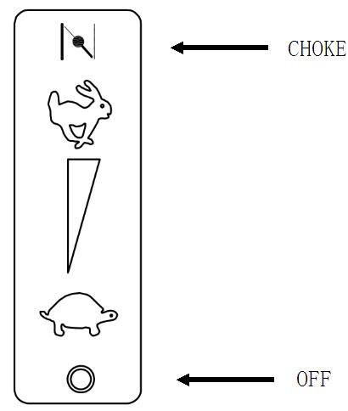
Start The Engine By Recoil Starter:
1. Push the engine speed adjustment lever to the “CHOKE” position.
2. In cold condition, it’s necessary to push the primer button on the air filter before pulling the starter handle.
- Pull the recoil starter gently until you feel resistance in the rope. Then pull quickly and energetic. Do not at any time let go of the recoil starter but glide it gently back and pull again.
- Turn the engine speed adjustment lever to “start”posotion.
- Regulate the lever until the engine is runing smoothly.

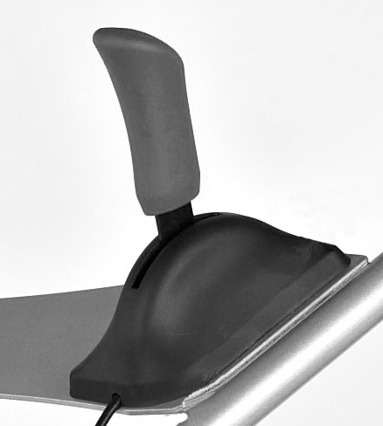
Engine Speed Adjustment Lever

Start The Engine By Electric Starter:
1. Push the engine speed adjustment lever to the “CHOKE” position.
2. In cold condition, it’s necessary to push the primer button on the air filter before starting the engine
3. Turn the engine speed adjustment lever to “start” position.
4. Turn clockwise the start-key until the engine start.
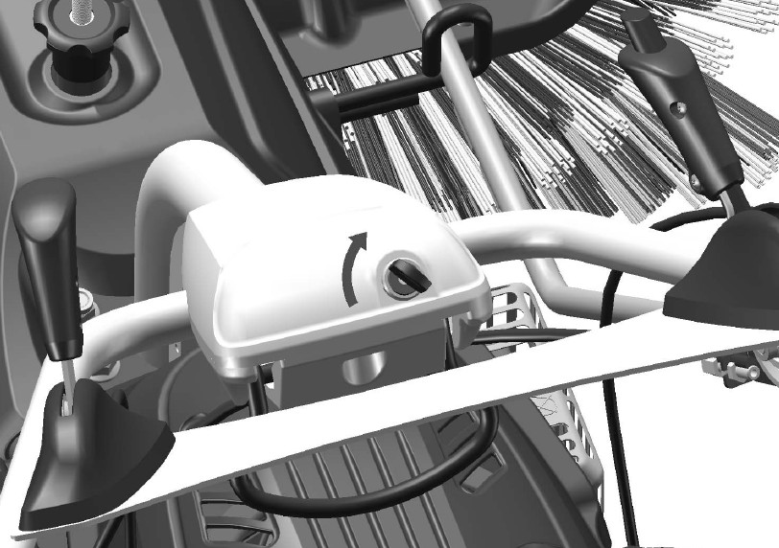
5. Regulate the lever until the engine is running smoothly.
Height adjustment of handle
There are 3 gears to adjust the height of handle. Adjust the handle such that the working height is comfortable.
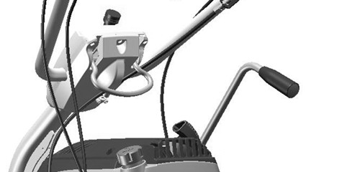

Height adjustment of handle

Brush height adjustment lever
Knob B
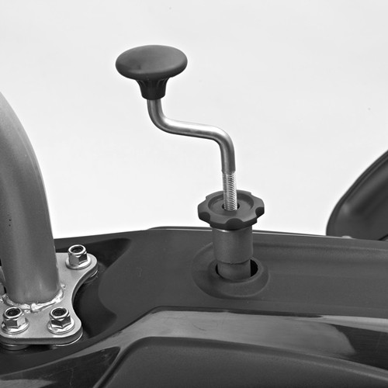
When the brush becomes worn, it might be necessary to adjust the proximity of brushes to the working surface.
Knob A

- Move the knob A upward.
- Adjust the knob B upward or downward to Remove or add the distance between brush and land.
3. Fasten the knob A

Angle adjustment of brush
There are 5 gears to adjust the angle, the brush can be pivoted 25 degrees to eighter side. This is done by pushing the swing handle down, turing the brush and releases the handle so the detent clicks into place.

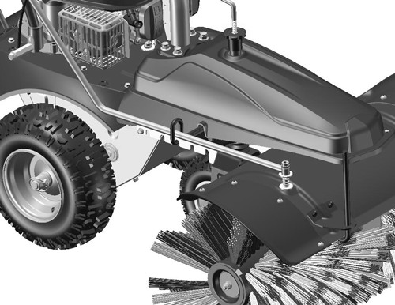

Angle adjustment of brush

Activation For Working of Bush
Press down the Bush Working clutch lever (Left side of handle) to activate the bush working .Once released the lever and the brush will stop.

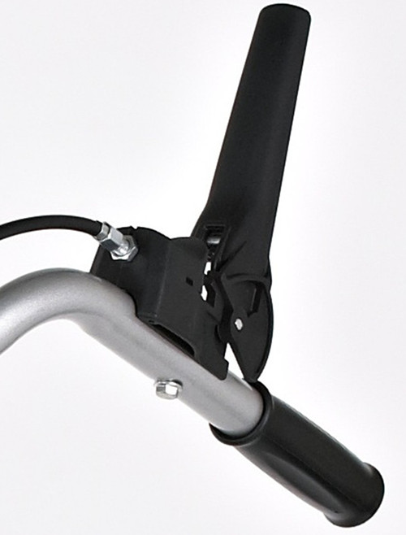
Bush Working clutch lever

Brush Speed Adjustment lever
Push the lever to speed up the bush. If you want to reduce the speed of Bush, press down the button and pull the lever. Adjust speed of Brush as your requirement.
Button
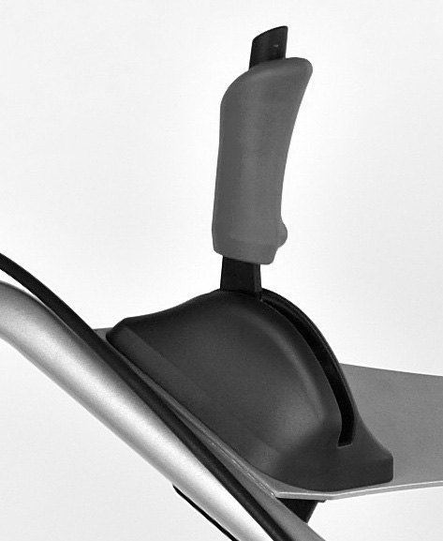

Brush Speed Adjustment lever

Activation For Driving
Press down the driving clutch lever (Right side of handle) to activate the machine driving.
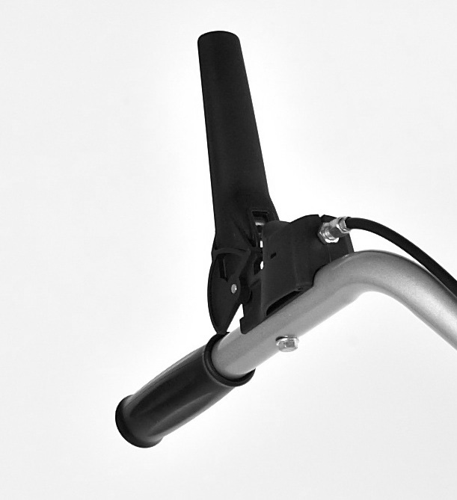
Driving Clutch Lever

Forward/Backward Shift Lever
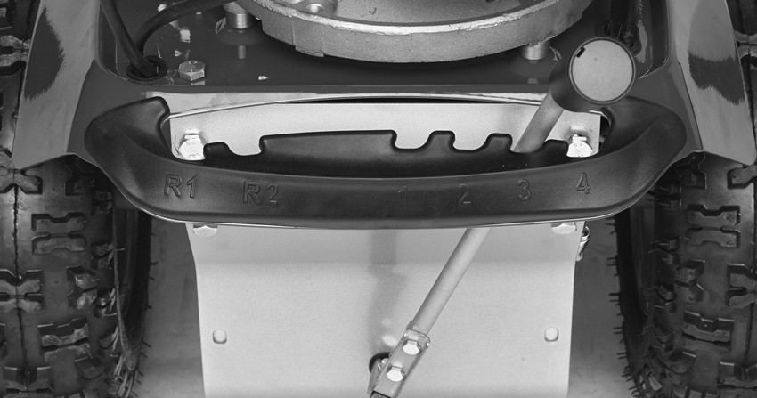
There are 4 gears to forward, and there are 2 gears to backward. Swing the control lever to adjust the driving speed after stopping the driving.
Note: please release the driving clutch lever while adjusting the lever. If you adjust the lever when the sweeper is moving, it can damage the gearbox of machine.

Stop the engine:
1. Released the brush and drive clutch lever.
2. Turn the engine speed adjustment lever to “OFF” position.

- Maintenance and storage
Engine Maintenance

Check Engine Oil Level
Check the engine oil level with the engine stopped and the mower.
- Remove the oil filler cap, and wipe the dipstick clean.
- Insert the dipstick into the oil filler neck, but do not screw it in.
- Check the oil level shown on the dipstick. If near the lower, fill to the upper level with the oil. Do not overfill.
- Screw in the filler cap securely.

NOTICE: Running the engine with a low oil level will cause engine damage.
Change Engine Oil
Drain the used oil while the engine is warm. Warm oil drains quickly and completely.
- Wipe the oil filler area clean, then remove the oil filler cap/dipstick.
- Place a suitable container next to the mower to catch the used oil, then tilt the mower on its right side. The used oil will drain through the filler neck. Allow the oil to drain completely.
Please dispose of used motor oil and the containers in a manner that is compatible with the environment. We suggest you take it in a sealed container to your local recycling center or service station for reclamation. Do not throw it in the trash, pour it on the ground, or pour it down a drain.
- Fill with the recommended oil. Do not overfill. Allow a couple of minutes for the oil to settle in the engine, then measure the oil level.
Air Cleaner Service
NOTICE: Operating the engine without an air cleaner, or with a damaged air cleaner, will allow dirt to enter the engine, causing rapid engine wear.
- Press down on the cover tabs and remove the cover.
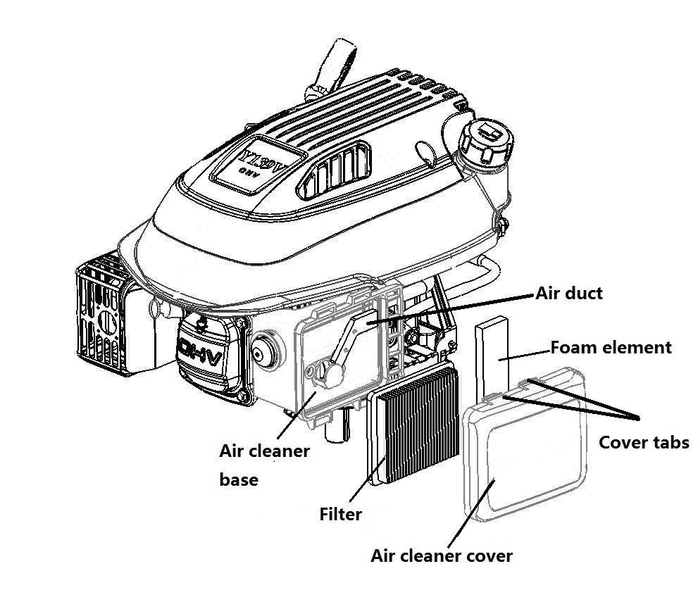
- Remove the filter from the air cleaner base..

- Inspect the filter and foam element, and replace it if damaged.

- Clean the filter by tapping it several times on a hard surface to remove dirt, or blow compressed air through the air filter from the inside. Never try to brush off dirt; brushing will force dirt into the fibers.

- Wipe dirt from the inside of the air cleaner base and cover, using a moist rag. Be careful to prevent dirt from entering the air duct that leads to the carburetor.
- Reinstall the filter and cover.

Spark Plug Service
For good performance, the spark plug must be properly gapped and free of deposits.
- Disconnect the spark plug cap and remove any dirt from around the spark plug area.
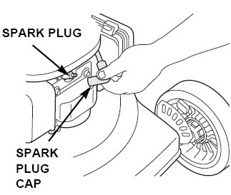

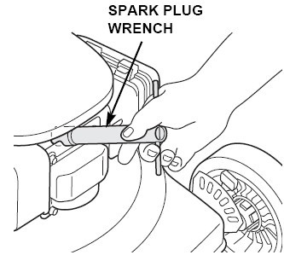

- Remove the spark plug with a spark plug wrench.

- Inspect the spark plug. Replace it if the electrodes are worn, or if the insulator is cracked or chipped.

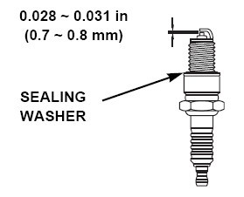
- Measure the spark plug electrode gap with a suitable gauge. The gap should be 0.028 ~ 0.031 in (0.7 ~ 0.8mm). Correct the gap, if necessary, by carefully bending the side electrode with a suitable tool.

- Install the spark plug carefully, by hand, to avoid cross-threading.

- Install the spark plug cap on the spark plug.

NOTICE: A loose spark plug can overheat and damage the engine. Over tightening the spark plug can damage the threads in the cylinder head.

Problem solution:
The engine won’t start:
1. Check sparkplug.
2. Check that the spark plug cap is fitted correctly.
- Check if the motor is equipped with an ignition switch. (It must be activated)
- Check if the motor is equipped with a fuel valve. (It must be activated)

The engine runs unevenly:
- Check that the choke has been released.
- Check fuel for impurities.

If the brush will not run:
- Check that the clutch is adjusted correctly.
- Check that the belt is tight.

If the machine will not run:
- Check that the clutch is adjusted correctly.
- Check the belt.

If the machine does not sweep effectively:
- Check the distance between the brush and working surface.

Caution:
The engine shall be stoped when carrying out maintenance and cleaning operations, when changing tools and when being transported by means other than under its own power.
Check regularly that all bolts and nuts are tightened. Retighten if necessary.
The engine must be completely cooled before storing indoors or covered.
Maintain or replace safety and instruction labels, as necessary.
Only use orginal spare parts or accessories. If ont orginal parts or accessories is used, the liability is no longer applied.

