Middle East – North Africa
(MENA)
Business Unit

Partitioned Neutral Zone
(PNZ)

Saudi Arabian Texaco
(SAT)
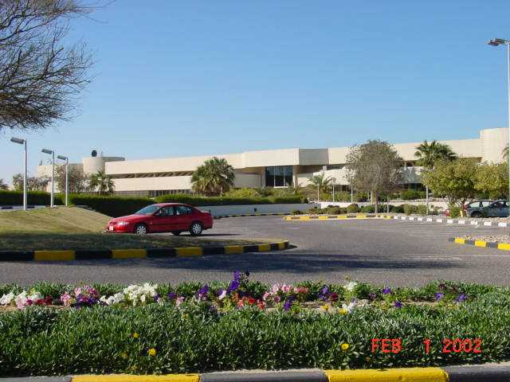
Orientation
Saudi Arabian Texaco – Main Administration Building – Mina Saud
"What would I have known or written had I been a quiet, mercantile politician or a lord in waiting? A person must travel, and turmoil, or there is no existence.”
Lord Byron

Expatriate assignments can be immensely gratifying experiences. Before committing to an expatriate assignment, however, we must examine the motivation that leads any of us to consider international employment. For some, it may be a promotion, the challenge of a new position or the chance for travel. Still others may be interested in increased financial incentives, the adventure of daily life in an international location or gaining a global perspective for themselves and their families.

As in any move, even one across town, there are adjustments to be made. Becoming expatriates can magnify these adjustments. The rich opportunities an expatriate assignment brings are not without frustrations, trade-offs and challenges. For a family, it is important that everyone be committed to the experience and prepared to adapt to a completely new environment.

Camp residents and management have developed the following guide. We hope you will find it useful.
TABLE OF CONTENTS

SECTION NO. | CONTENTS | PAGE NO.
I | Before Moving | 2
 | - Checklist | 2
 | - Passports | 6
 | - Photographs | 6
 | - Medical and School Records | 7
 | - Household Inventory | 8
 | - Planning Your Shipment | 9
 | - List of Children's Items | 10
 | - Global Assignment Center | 12
 | - Computer Information | 13
 | - Staying in touch | 14
II | The Trip to Kuwait | 15
III | Upon your Arrival | 16
IV | Background information | 17
 | - Housing and Household | 17
 | - Grocery Shopping and the Camp Commissary | 22
 | - Medical Care | 23
 | - General | 23
 | - Medical Procedures | 24
 | - School Medical Procedures | 24
 | - Civil ID Medical Procedures | 25
 | - Transportation | 27
 | - Recreation and Entertainment | 28
 | - Reading Material | 29
 | - Communications | 30
 | - Mailings | 30
 | - Telephone Calls | 31
 | - Computer Services | 31
 | - Pets | 32
 | - Clothing | 33
 | - Banking and Bills | 35
 | - Drivers License | 36
 | - Schools | 37
 | - Religion | 43
V | Background on Culture | 44
 | - A Muslim’s View of Islam | 44
 | - A Ramadhan Reminder | 47
VI | Miscellaneous Attachments | 48
 | - SAT TIL Human Resources information | 49

BEFORE MOVING

Checklist

The checklist below is designed to capture the majority of issues and action items necessary for completion prior to your move overseas. Other activities, such as arranging family physicals, housing assistance, moving contractor, etc., will be arranged through the Global Assignments Center (Page 13).

Household

- Prepare a complete inventory of items you will store, those in your air and sea shipments, and those in your accompanying baggage. Leave a copy with someone back home.

- Make a list of items to purchase before you leave.

Postal

- Buy two one-hundred stamp rolls of U.S. postage.

- Send change of address cards as follows :
Your Name
ChevronTexaco - Kuwait Pouch
P. O. Box 5095
Bellaire, Tx.77402-5095.

- Send friends and family a flyer with your new address and telephone number. Include specific information on how to mail letters and packages. Mention what NOT to send through the mail, such as clothing, culturally offensive material, food, household items, jewelry, medication, toys, etc.

Medical

- Complete all required exams and immunizations.

- Request copies of any pertinent medical records, X-rays and prescriptions. Be certain prescriptions are legible and in English generic terms (no brand names). Specific brands may be different in Kuwait.

- Request a record of your blood type.

- Bring a copy of your eyeglass prescription and an extra pair of glasses. If you wear contacts, bring enough lens supplies to last the first few months.

- Complete all dental work and bring records.

- If you take medicine regularly, it is strongly advised that you bring a year's supply with a prescription. You may wish to check availability of prescriptions in the local market through SAT’s Medical Department.

Other

- Make a complete list of addresses to take with you. Include all business contacts (i.e., bank, lawyer, accountant, family doctor), social contacts, friends and family. Remember to include phone and fax numbers.

- Determine the fastest way to contact key relatives and the fastest way for them to reach you in case of emergency.

- Take your local phone book with you.

- Check the airlines’ policy on excess baggage.

- Arrange for automatic deposits for paychecks.

- Set up service for your bank and credit cards through the Internet if possible

- Are there any on-going expenses for which you can arrange automatic deductions from a bank account?

- Update your will. If you don't have one, make one!

- Consider obtaining a safe deposit box to store valuables, and other important documents (i.e. inventories, wills, trust deeds, etc.).

- Find out about absentee voting.

- School records for children as well as standardized test results should be brought with you.

- Check with the airlines to see which health certificates you may need for animals you want to transport. Ensure your pet has an up-to-date rabies vaccination. A Kuwaiti import permit is required as well. See section on Pets (Pg. 26). Notify HR and/or SAT well in advance in order to secure domestic pet import permit. Please note that Muslims consider dogs unclean and that strict pet control rules are in place. You should consider this when making decision about bring your pet.

- You must appoint a legal guardian for any minor children staying Stateside.

- You may need to "break" residency in certain high tax states to avoid taxation. Consult a tax expert for advice.

- Be sure property and liability policies are up-to-date.

- Authentication of your marriage by the U.S. State Department – Please contact CTOP HR or SAT for instructions on how to obtain authentication.

Items to carry with you on your person

- Passport.

- U.S. currency.

- 200 Kuwait Dinars (exchange at your local bank or airport).

- Traveler's checks.

- Credit card(s).

- Company identification.

- Driver's license, local or international.

- Copy of visa for Kuwait.

Items to carry with you in your carry-on baggage

- Copies of passport information pages and visas for all family members.

- Medical records.

- Children's school records.

- Immunization records.

- Power of attorney, if you need one.

- Will.

- Insurance records.

- Names, addresses and phone numbers of important contacts in the U.S. and in Kuwait.

- Other original documents (i.e., birth certificates, marriage license, etc.).

- Copies of the last three years' federal & state income tax returns.

- Important jewelry (or wear it).

Items to leave with a trusted person in the U.S.

- Copies of passport pages.

- Copies of the last three year's income tax forms.

- Access to a safety deposit box (if applicable).

- Power of attorney (if applicable).

- Last will and testament.

Items you may want to purchase before you leave

- Additional clothing/shoes/tennis shoes.

- School uniforms.

- Beach items.

- Paperback books.

- Music/computer CDs.

- Luggage

- Children's toys.

Many of these items are available in Kuwait, however, selection may be limited and in some case prices can be high in comparison to the United States.
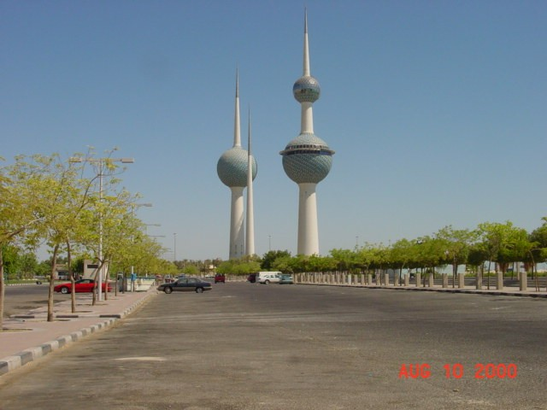
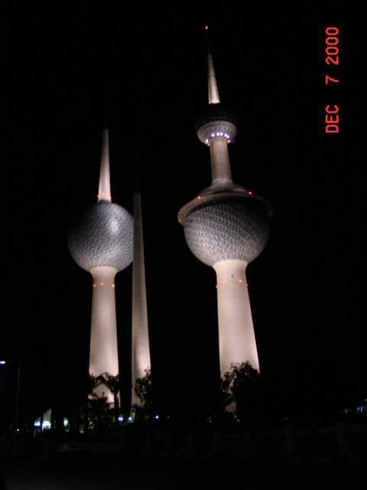
Kuwaiti Towers - Kuwait City – taken from Chili’s parking lot

Passports

The first step in an overseas move should be to secure passports for each family member. The passport application can usually be obtained at the main post office in your city. They can also tell you where to go to begin the application process. It may take about 4-6 weeks before you receive your passport. Sign it when you receive it. Parents may sign the passports for small children. For American citizens, either the father or mother can sign the passport. Some mothers sign it since the child may travel more with the mother. After you have the passport number, the company can begin the necessary visa applications.

If any member of the family is not a US citizen, you will need to check on visa requirements for him or her. For instance, although visas are not required for US citizens throughout most of Europe, they are required for citizens of countries in SE Asia, Africa and South America. This can be a concern should you wish to visit European countries during your overseas travels.

The passport numbers and copies of the information pages will be needed for school applications and other registrations. It is a good idea to leave a copy of the same page with a trusted individual in the US. You should also carry a copy of the information pages and a copy of your visa with you in Kuwait, since there are periodic security checkpoints. Keep them in your purse, briefcase, or school backpack. Later in the process, you will receive a Kuwait Civil ID card. This should be kept with you when you travel around Kuwait.

Photographs

The following quantities and sizes of passport photographs should be obtained for each family member (non-polaroid):

20 of 4 x 6 cm (face size 1½”)
10 of 3 x 4 cm (face size 1”)

Additionally, adult members of the family will need six (6) 2 X 3 cm for securing a Kuwait driver’s license.

Ensure that all photos show full face (passport type) in color, and are not glossy finish. The matte finish is preferred by the various Kuwait agencies. Additionally, bring the negative as more prints may be needed during your overseas assignment.

Non-polaroid passport photographs are becoming more difficult and more expensive to obtain in the U.S. Therefore, you may want to wait and obtain the needed photographs in Kuwait as they are easily obtained and reasonably priced.

Medical and School Records

Begin to gather medical and school records. ChevronTexaco will provide information on medical requirements in your offer; and the forms and instructions for obtaining a complete pre-departure medical exam and history. This is needed for the employee and each family member moving overseas.

Immunization requirements should be checked with your Doctor or ChevronTexaco’s Medical Department. If you are receiving the typhoid immunization, ask the doctor about the tablets which are taken over a 7-day period. For most people, they are more tolerable than the injection as far as side effects go, and they protect for 5 years. The tablets are not widely available, so you may have to call several pharmacies to see which one can locate them through their supplier.

The company can forward the application packets for the American School of Kuwait prior to arrival although this can be handled when you arrive as well. Fill in as much information as possible, although some of it will obviously not be available--such as residency visa numbers. A copy of the application should be faxed or sent to SAT to ensure enrollment at school. Keep the originals in your possession until you actually go to the school with your child. One form will need to be filled out in Arabic--this will be done by SAT personnel once you arrive in Kuwait. The front page of the medical form for school should be filled out with as much information as you know—but don’t worry if you need to leave things blank.

Gather names, addresses, phone numbers, and fax numbers for all pediatricians, dentists, and other medical doctors. You may want to contact them to explain that you will be moving overseas, but will be returning each summer for checkups and do not want your records categorized as inactive. You should update their files with any insurance changes that will take place as a result of your transfer.

Children under 12 may receive polio vaccine, MMR, BCG (TB vaccine), and meningitis immunizations as part of their residency visa process. It will not matter if they had these immunizations before they came, they may still get them. You may want to discuss this with your doctor to be reassured that additional dosages of these vaccines will not be harmful. Children under two usually don’t need the BCG immunization.

Although hepatitis B vaccinations are not required for Kuwait, you may travel during vacations or school trips to areas where it would be prudent to be immunized. Therefore you should take this series if possible. If you do not have time to complete the three immunizations, consult your doctor about the advantages/disadvantages of starting the series in the US and finishing in Kuwait. The series is available in Kuwait, but the immunization clinics often don’t recognize the paperwork that says you have had the first and/or second immunization. They begin the process as if it were the first immunization. You may want to ask your personal physician’s advice on whether the dosage is the same for all three immunizations.

Hepatitis A vaccinations are generally recommended as well. Check with the Company Medical Department for their most recent suggestions. You should also check your tetanus vaccination record to ensure continued protection.

Household Inventory

It is a good idea to make an inventory record of personal belongings before leaving your current assignment. It may be best to list different destinations (e.g. “storage”, “shipment”, “take in luggage”, and “store with family”) on various forms and list items on the appropriate form. This should minimize “decisions” when the packers are there --a time when you don’t need more decisions.

Keep a video inventory, still photos, and inventory sheets in a safe place, or better still, two separate places.
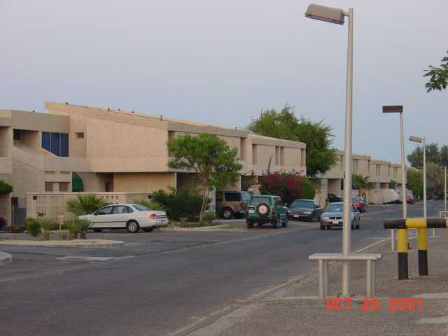
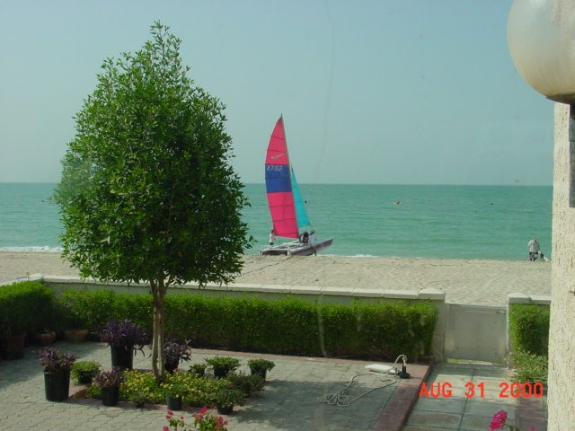
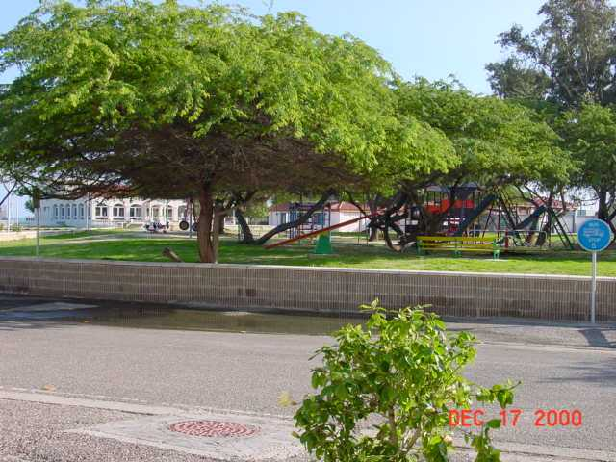
Row of villas at Mina Saud camp – North side
Sail boat behind villas at Mina Saud camp
North Park at Mina Saud camp
Planning Your Shipment

Try to use one room for sea shipment, another for air, etc. Begin to pack the carry-on items early so the movers won’t inadvertently pack them. Read the “Know Before You Go” booklet published by the US Customs offices. Make sure and check air and sea shipment allowances (weight limits) when planning what you will ship.

If you are planning to fly directly to Kuwait without a stopover, you may want to take the maximum allowable number of suitcases on the plane as checked baggage. This way you will have more items on hand when you arrive in Kuwait. However, if you are planning a stopover, consider taking a lesser amount of luggage and shipping most of your belongings. Consider that you will have to take the luggage on subways, trains, or taxis; carry it through airports; and keep it in hotel rooms that are often limited in space.

If you are moving during August--June, bring several sets of school clothes, backpacks, and school supplies in your checked baggage in case your shipment is delayed. Uniforms are required at the American School of Kuwait. Please refer to the “Schools” write-up in Section IV of this Manual.

Consider how the shipments are made and stored. Many items arrive quite dusty and may not arrive at your house in the boxes they were shipped in. When the boxes arrive in Customs, the contents are often dumped out and then put back into boxes haphazardly. Clothes may arrive dusty and wrinkled, and you may want to wash kitchen items and bedding. Overall, most things arrive in good shape with minimal damage or confiscation at Customs.

Please do not bring food! It can slow your shipment’s release from Customs, and inspectors may open containers for testing, and then you may worry about contamination.

You may want to bring video cassettes, non-prescription and prescription drugs, audio cassettes, and books in your checked baggage since these are often held at Customs if they arrive in shipments. Any drugs should be clearly marked and in original containers.

Suggested items to ship:

- Bookcases, underbed boxes
- Computers
- Bikes
- Sports equipment (tennis, golf, snorkeling, basketballs)
- Tools, tool boxes
- Sheets and pillows
- Towels/beach towels
- Beach chairs, snorkel equipment, umbrellas
- Table linen/placemats
- China (optional - entertaining is informal)
- Cold weather clothes
- Videos (PG and G, no sexual content)
- Hobby materials
- Pots, pans, kitchen utensils, cookbooks
- Decorative items
- Garden equipment
- Card table(s) and chairs
- Grill (available in Kuwait, but may be more expensive)
- Christmas decorations and artificial tree

Buy in Kuwait:

- Television (US uses NTSC system--Kuwait uses the PAL system)
- VCR/DVD (Same as above)
- Small appliances
- Microwave
Note : Your NTSC video cassettes will only function when you purchase a multi-
system VCR.

Do not bring alcohol, pork products, video tapes or printed material that may be outside local norms, heirlooms and antiques.

Refer to section headed Housing and Household for further information.

List of Children's Items to bring

Beach Equipment: Boogie boards, rafts, floaties, beach umbrellas, chairs, goggles, snorkles and fins are definites.

Any Nintendo, Play Station type equipment is recommended. (multi-system TV and VCR’s are available in Kuwait) Bring lots of games!

Computer games and computer educational programs are musts. Encarta or similar CD-based encyclopedias are most helpful with school work for third grade on.

Bikes, skateboards, rollerblades, etc. are recommended. Outdoor recreational equipment such as basketballs, soccer balls, badminton, etc. are used throughout the year.

Tennis is available as are tennis lessons. Therefore rackets and balls should be brought if this is an interest.

Children’s videos (i.e., Disney) are acceptable. The videos may be confiscated for two to three weeks for censorship viewing purposes; however, all will be returned.

Children’s books are also acceptable.

Stocking up at Toys R Us for generic boys/girls birthday gifts is helpful. Children are invited frequently to birthday parties and toy selection in Kuwait City is not always up to US standards.

Portable CD players and cassette players are appropriate. Some popular CDs can be found in Kuwait City, but are behind the current sounds in the States. CDs can be carried in.

Boy Scout and Girl Scout gear should be purchased in the States (i.e., uniforms, handbooks, projects). Badges are earned and awarded by the various scouting programs either in camp or with the school.

Sunvisors and at least 2 or 3 swim suits are recommended as well as multiple wet shoes for the entire family. Wet shoes are generally worn at all times on the beach and in the ocean to avoid stepping on coral or sea urchins.

School uniforms and school supplies are easier to obtain in the States. Generally, notebook paper, blank drawing paper, markers, highlighters, red pens, pencils, etc. Bring such supplies in your suitcase if coming during the school year. Calculators are a must for 5th grade onwards, as well math/science calculators for junior high and high school students.

For hobbies your child has, bring items with you.

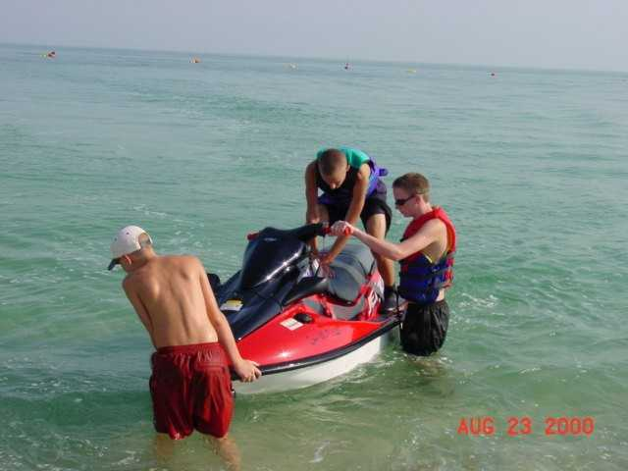
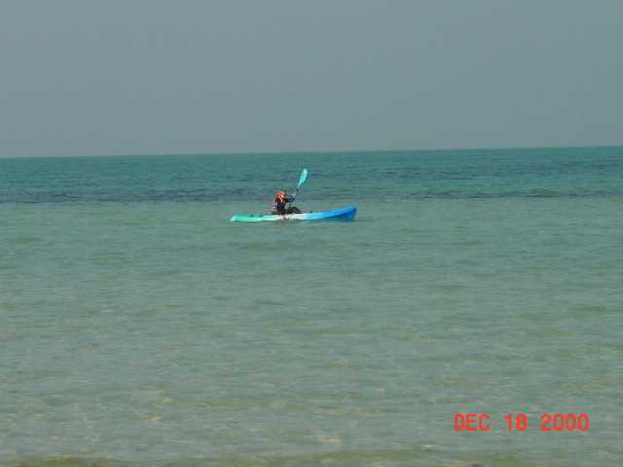
Musical instruments may come in handy as there are several classes available at the school as well as piano lessons available at times privately in camp.

Expatriate Counselor

The HR Expatriate Counselor handles all administration related to human resources policies and programs for all phases of the expatriation and repatriation processes, as well as being the expatriates' contact regarding HR questions and problems which expatriate employees may have.

Note: Please clarify your vacation status, as your unused vacation will need to be used in the year of your transfer if possible. If operating conditions prevent you from taking your full vacation entitlement in the year of your transfer to or from international service, management may grant pay in lieu of any vacation remaining at the end of the year. This applies only to the year of transfer, and payment is based on your rate of pay, base salary plus location premium (subject to monthly salary maximum), in effect when payment is made. Please plan this out with your new supervisor as soon as it is practical to discuss it.

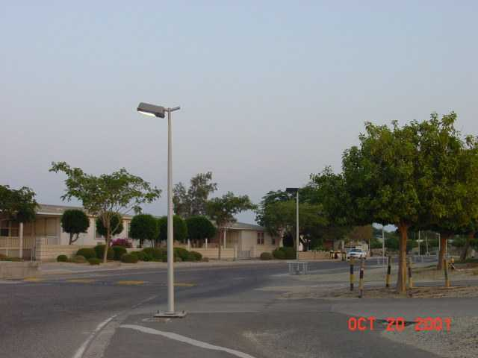
Interior – modular homes – Mina Saud camp
Computer Information

The following recommendations regarding business and personal computers have been developed to help make your transfer easier.

1. Please notify ITD or ISSC personnel, both in Kuwait and at your current location, when you are planning to leave your current location and the date you plan on arriving in Kuwait.

2. Request assistance from your local computer help department to:

a) Transfer required files (including all E-Mail files) to a ZIP disk or a CD-ROM.

b) Request a TEXUSGC NT login script, if you don't already have one.

c) Have your Exchange Mail Box moved from your site to the PNZ server, after you have left the office for good, and before coming to Kuwait. (Note - clean out your mailbox as much as possible before transferring it.)

d) Make sure your identifiers on the Mail account have changes so that PNZ personnel can administer the account.

e) Don't have your account deleted in your old office until you are in Kuwait and are sure you have everything you need.

3. Do not bother with 110 Volt Surge Suppressers. They do not seem to hold up well in Kuwait.

5. Do investigate your hardware to make sure that it can run on 240 Volt 50 Cycle systems. If not, get good transformers, preferably a combination stabilizer/transformer. This will help protect your equipment from power fluctuations by putting out a constant voltage (look for the gauge on the front showing output voltage.) If you cannot find transformers in the US, they are readily available in Kuwait.

6. If you have 110 Volt equipment that you plan to use, bring extension cords, since 110 Volt extension cords are not available in Kuwait.

If you have any questions, or require additional information, please contact the SAT Information Technology Division in Mina Saud at 965-395-0444 ext. 625 or the Joint Operations Information Technology Division in Wafra at 965-381-2637.
Staying in touch

We strongly recommend you send a flyer to your family and friends, giving them mail and telephone details. An example is shown below.

John and Jane Smith

Mail

Please send all "flat" mail (letters, envelopes, cards) to the following address. U.S. postage is all that's required (from the U.S.):

Mr/Mrs John/Jane Smith
C/O ChevronTexaco - Kuwait Pouch
P. O. Box 5095
Bellaire, Tx.77402-5095

Packages need to be accompanied by a customs form, and should be mailed to the following address :

Mr/Mrs John/Jane Smith
Saudi Arabian Texaco
P. O. Box 6
Al-Zour (Mina Saud) 66051 Kuwait

Telephone (from the U.S.)

Home : 011 965 xxx xxxx
Office: 011 965 xxx xxxx

(Note: 965 is the country code for Kuwait).

THE TRIP TO KUWAIT

Many people break up the trip to Kuwait by spending time in London, Amsterdam, Paris, Frankfurt, etc. enroute to moving there. This can be a good time for a short break before you begin your new life in Kuwait. It also gives your body time to adjust to the new time zones.

KLM Airlines goes through Amsterdam, British Air through London and Lufthansa goes through Frankfurt. Current frequent flyer programs combine British Air/American and KLM/Northwest Airlines.

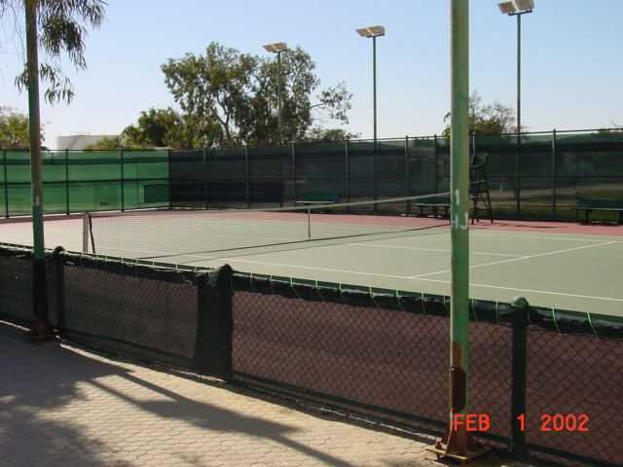
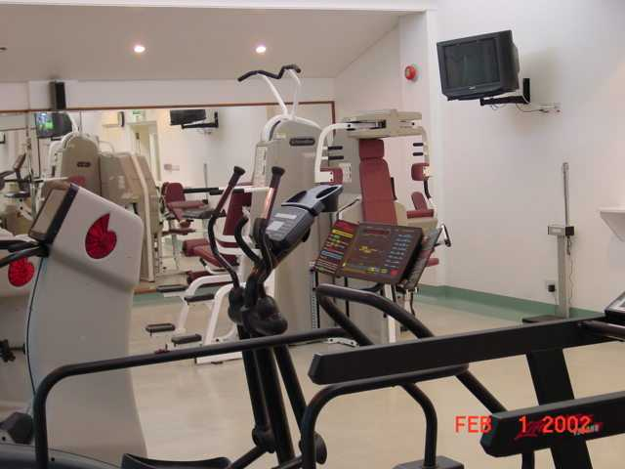
There are baggage limitations for overseas flights. You can bring two suitcases that weigh no more than 70 pounds each. The first suitcase can be no larger than 62 inches, adding together the length, width, and depth dimensions. The second suitcase can be no larger than 55 inches (L+W+D) in Coach, or 62 inches in Business Class. You are allowed one carry-on piece of baggage in addition to your purse or briefcase. The carry-on can be no larger than 45 inches (L+W+D). Please check with your airline to get the latest restrictions on luggage for the class of service that you will fly.

You are allowed to bring along 56 lbs. of excess baggage per person, but before leaving, please confirm that the airline will charge you on a "straight through" basis, rather than for each flight segment, as the difference can amount to thousands of dollars.

If you are purchasing luggage, you may want to consider pieces that nest, or fit inside of each other. This will also be helpful with storage of your luggage during the year since it won’t take up as much valuable storage space. Most people suggest buying relatively inexpensive luggage as even expensive luggage will show wear quickly with the numerous flights you will be making in the next few years. Expensive luggage may also target your bags for theft.

Tennis courts at Mina Saud camp
Exercise facility at Mina Saud camp

UPON YOUR ARRIVAL

- Make a copy of the first two pages of your passport and a copy of your Kuwait visa and carry them with you at all times. Be sure to do this for all family members. You should also keep an extra copy of this information in a safe place.

- If you have not already done so, obtain color photographs for family members as detailed in Section I of this Manual. This service is available in Fahaheel and Kuwait City.

- As soon as possible, talk to the Government and Public Relations Department and begin obtaining your Civil ID, and Residency Visa for all family members, driver’s licenses for yourself and your spouse (if desired) and appropriate school documents. You are responsible for informing the Government and Public Relations Department prior to the expiration of these documents.

- Once you have a Residency Visa, the law requires that you obtain a Kuwait driver’s license in order to drive in Kuwait.

- You should register each member of your family at your Embassy as soon as possible. Be sure to take your passport and two color photos with you when you register. Registration cards are available in the SAT Mina Saud Administration Building.

Check List

- Copies of passport/visa

- Photos

- Residency Visa

- Civil ID

- Give school records to school

- Driver’s License

- Register at Embassy
BACKGROUND INFORMATION

Housing And Household

All expat employees and their families are housed in the Mina Saud Camp. Camp Housing is a mix of villas (3 bedroom condominiums), individual houses and bachelors quarters. In addition, there are individual guest rooms, located near the Administration Building. New arrivals are housed in individual houses or bachelor quarters as appropriate. As people are transferred in and out, different units become available and are considered for occupancy as they become available.

The electrical power supply in Kuwait is 240V, 50 cycles. American appliances like mixers, bread makers and sewing machines work in Kuwait, but they may be sluggish if/when they are returned to use in the States. This is because converters adjust voltage, not cycles, so appliances may age faster. American 110 volt heating element appliances, such as toasters, waffle irons, clothing irons, etc., will not last long under 50 cycle power, and it is suggested to leave these items behind.

A vacuum cleaner is supplied by the company; however it may not be the same standard as you are used to, so you may want to consider taking your own. An ironing board is supplied, but you will need an iron. You can bring your US iron, but remember, it may not last long.

Most homes seem cozier with scatter rugs or Persian rugs. These are available in Kuwait and may be one of the first souvenirs you pick up. You may want to bring bathroom rugs. Bring pictures for the walls and a folding card table. Lamps are supplied with the houses, and additional lamps can be bought locally.

There are small patios and yards. Bring a rake, small pruning scissors, hoe and shovel since you may want to plant some flowers or shrubs. Many houses have trees and shrubs already. Any yards with grass will be mowed by the company. Many residents also hire a gardener. A patio table, 4 chairs, and a chaise lounge are provided, but you may want to consider additional inexpensive patio chairs and beach chairs for company or large families.

The bathrooms require more consideration. Unlike in the US, there are no plug-ins in the bathrooms for curling irons, blow dryers, etc. There is one shaver type outlet 110/220-240V. You may consider buying a multiple plug electrical strip and extension cord. In the villas, the main floor bathroom is good-sized. The children’s bath upstairs is small.

The dining table is 42” x 76” and has one 42” x 18” leaf, which can be inserted to make a 42” x 94” table. There are 8 chairs with the dining table.

Furniture you might want to bring could include a bookcase, a computer stand or table, and possibly two comfortable La-Z-Boy type chairs for watching TV.

Stereo equipment can be brought from the US and used with adapters/converters. Bring your cassette tapes and CDs. People suggest buying televisions and VCRs in Kuwait. Multi-systems are available in Kuwait with PAL, MESECAM, and NTSC. English programming is available 24 hours a day in camp. There is CNN, BBC, MTV, Star TV, Discovery, ESPN, Orbit News and Super Movies, all in English, broadcast all day.

There are two telephones provided in each residence. You can purchase additional phones in Kuwait or bring them from the US and use an adapter. Some people have brought their cordless phones, but adapters, etc. are a bit of a hassle and you may just want to plan to get extra phones when needed in Kuwait.

Most household items can be purchased in Kuwait. There is an Ace Hardware in the city and a True Value Hardware. There is an A to Z store which is like a small K Mart (without the clothes/shoes departments) and an IKEA which has furniture and housewares. There are numerous souks or shops for household goods.
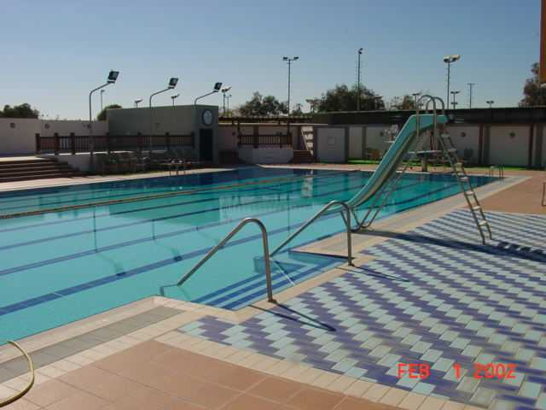
Swimming pool complex at Mina Saud camp
The following items/appliances are available for your use prior to the arrival of your shipment.

Appliances/Furniture  - Coffee Pot  - Alarm Clock for bedroom  - Toaster  - TV  - VCR  Available Upon Request  - High Chair  - Crib  - Crib Sheets  Kitchen  - Frying pans, 1sm, 1 lg  - Pots, 3 sizes  - Mixing bowls, 2 sizes  - Serving bowls, 2  - 6 plates  - 6 coffee cups/mugs  - Peeler  - 12 water/tea glasses  - 6 cereal bowls  - Cooking spatula  - 6 salad plates  - Sharp knives, 1 lg.  - 6 sets eating utensils  - 3 serving spoons  - Can opener  - Tongs  - Hot pads  - Cookie sheet  - Baking dishes (Pyrex) 2 sizes  - Juice pitcher  - Storage containers for leftovers  - Salt/pepper shakers  - Kitchen trash can  - Rags  - Dishtowels  - Broom  - Dustpan  - Mop  - Bucket  - Placemats or tablecloth | Consumables (2 - 3 days supply)  - Toilet paper  - Coffee filters  - Paper towels  - Paper napkins  - Liquid dish soap  - Dishwashing powder  - Cleansing powder  - Salt and pepper  - Sponges  - Pot scrubber  - Bath soap  Bath/Bedrooms  - 6 Bath towels  - 6 Hand towels  - 6 Wash Cloths  - Trash cans - 1 each bath  - 6 pillows  - 1 Set King sheets and pillow cases  - 4 Sets Twin sheets and pillow cases  - Bed spreads, 4 Twin and 1 King  - Blankets, 1 King, 4 Twin 1 Paring  Miscellaneous  - Pencils  - Pens  - Scratch paper  - Clothes Hangers  Items you may keep until you leave Kuwait  - 2 Keys to Villa  - Step stool  - 2 Yard hoses  - Vacuum  - Outdoor Garbage Can  - 2 Phones
The following furnishings are supplied by the Company and can be used during your entire assignment in Kuwait.

Living Room
1 |  | Each |  | Coffee Table
1 |  | Each |  | Coffee Table
3 |  | Each |  | End Table
1 |  | Set |  | Suite one love divan (two seaters) and one couch (3 seater)
2 |  | Each |  | Table Lamp
Dining Room
1 |  | Each |  | Buffet
1 |  | Each |  | Table
8 |  | Each |  | Chair with seat and back cushions
Master Bedroom
1 |  | Each |  | Bed, King size, complete with box mattress, spring mattress and head board
2 |  | Each |  | Bedside table
2 |  | Each |  | Bedside Lamp
1 |  | Each |  | Chest-of-drawers
1 |  | Each |  | Upholstered chair
Children Bedrooms (2)
4 |  | Each |  | Bed, single (twin), with box mattress, spring mattress and headboard
2 |  | Each |  | Bedside Lamp
2 |  | Each |  | Bedside table
1 |  | Each |  | Desk
1 |  | Each |  | Chair
Kitchen
1 |  | Each |  | Refrigerator
1 |  | Each |  | Tumble dryer (fully automatic)
1 |  | Each |  | Washing Machine (fully automatic)
1 |  | Each |  | Double Oven unit
1 |  | Each |  | Hot plate unit (4 burner)
1 |  | Each |  | Dishwasher

Others
1 |  | Each |  | Vacuum cleaner, Hoover
1 |  | Set |  | Window Drapes
1 |  | Set |  | Carpet, wall-to-wall
1 |  | Set |  | Miscellaneous, consists of two shower curtains, one ironing board and one step stool
Note : All furnishings are matching sets.

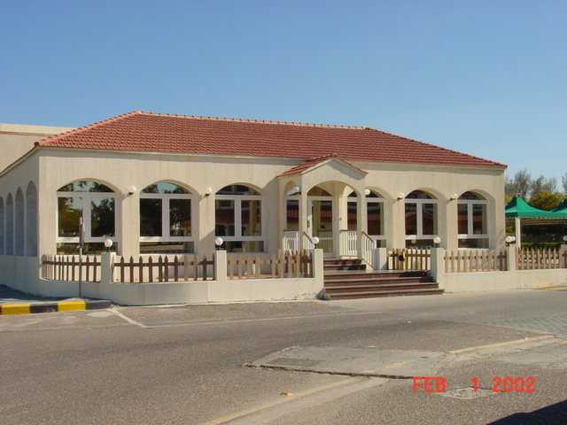
Community building at Mina Saud camp
Grocery Shopping and the Camp Commissary

The Camp Commissary contains both a variety of foodstuffs and kitchenware. Detergents and cleaning agents, as well as dry and canned foods are available. Frozen meats and cheeses are available. A good selection of kitchenware is available for purchase. Pots, pans, cooking utensils, dishes, glassware, and plastic containers are always in stock. Toiletries such as soaps, razors, toothpaste, etc. are sold. The selection of foods is limited, and most camp residents prefer to shop in the larger stores in or around Kuwait City.

The Khiran Center, located in Mina Al-Zour Village, stocks many American canned goods, cereals, fresh milk, eggs, bread, and fresh fruits/vegetables. It also sells frozen meats, ice cream, household, some hardware and marine items, and a few appliances. It is a very nice store and is convenient. The Transportation Department will provide a car and driver upon request to go to the Khiran Center.

For major grocery shopping trips, including fresh meats and bakery items, there are “Sultan Center” stores at various places throughout Kuwait. The largest one is in Salmiya, one hour from camp. The nearest ones are in Fahaheel and Ahmadi, about 40 minutes from camp. They are similar in style to chains like American Kroger, Albertson, or Safeway stores with lots of produce, small appliances, general groceries, personal care items, film drops, dry-cleaning drops, etc. They carry just about everything you would find in the US with many American brands available. Some brands of grocery items are available on a sporadic basis, but the stores are generally well stocked, clean and pleasant to shop in. The Sultan Centers accept credit cards for purchases, and do not charge extra to use them.

There are good fish markets in Fahaheel and Kuwait City. They may also sell live chickens, turkey, and produce. Each area of Kuwait City also has a co-op, which is a concentration of stores centered around a grocery store, similar to a Sultan Center, but smaller, and often cheaper in price. The co-op area will also have a bank, restaurants such as Kentucky Fried Chicken, Baskin Robbins Ice Cream, and Pizza Hut, hair salons, book stores, etc. In some areas, these are more Arabic-speaking, but it is still possible to transact business here as many of the employees in stores also speak English.

You will want to bring or purchase a cooler to transport frozen/refrigerated goods from the store back to camp.

Medical Care

General

There is a Saudi Arabian Texaco hospital right outside of the camp gate. Since the invasion, it is actually more of a clinic as there are no hospital beds except for normal obstetrical deliveries. There are doctors that rotate between the camp and Texaco field clinics. There are two dentists, a pediatrician, lab doctor, X-ray, pharmacy and a female OB/GYN at the camp hospital. A dermatologist comes to the camp hospital once a week for appointments. Most care and medicines are free. You must start at this SAT clinic before going into Kuwait City for anything, since they need to give you a referral for a particular place or doctor. The Chief Medical officer must authorize services provided and/or paid for by SAT. Please note, while medical facilities and care is generally good in Kuwait, the practices and norms are not necessarily to Western standards. You should consider this when contemplating elective surgical procedures, pregnancy, etc.

You will want to bring some type of medical care guide, or encyclopedia CD-ROM with you. Two recommended books are Merck’s Manual (a physician’s guide to symptoms and treatments) and H. Winter Griffith’s “Complete Guide to Prescription and Non-Prescription Drugs.” You will want to know the generic names of medicines you use, since brand names are different overseas. Medicines such as aspirin, ibuprofen, benilyn, cough syrups, antihistamines, etc. are available at the pharmacy at no cost.

There are several American/British doctors and dentists at clinics in the city to whom you may be referred. The cost for these physicians is about the same as in the US and you can submit claims to your insurance just as you would in the States. The cost for medicines at a pharmacy in the city is comparable to the US, but you should know the generic compound name. Many drugs, which are prescription drugs in the States, are available without a prescription in Kuwait. Vitamin and mineral supplements are generally not available, even at pharmacies. Rubbing alcohol for first aid purposes is not available in liquid form (except in a liniment smelling compound) but is for sale in foil wrapped towellettes.

If you have prescription drugs from the States, bring a year’s supply and get a copy of the prescription in generic terms to facilitates customs inspection. You can also bring your own aspirin, cough syrups, etc., but keep everything in their original containers and put it in your luggage. (It will probably be confiscated in your shipments.) The drug Ritalin is difficult to get in Kuwait, but using the proper procedures, there is one place to obtain it.

Some people do not like the BCG vaccination because it remains tender for several months. It will ooze and scab over several times, sometimes for up to 3 months, and leaves a scar. The school nurse recommends swimming in the gulf or applying salt water several times a day and then drying the area with a hair dryer to heal it quickly.

If you are unfamiliar with a BCG vaccination, which protects against TB, you may want to discuss it with your doctor before leaving the US. The BCG is normally required for children 2 – 12 years-old to get their Kuwait residency visa. The BCG is also normally required for all children to attend school in Kuwait. Normally, children under 2 will not be required to get a BCG. With some polite but firm effort you can usually persuade the authorities to not have your children vaccinated with the BCG, in which case they will be required to have a TB intradural (skin) test every 6 months.

Once a person is given the BCG vaccine, any future TB intradural test would show positive. This requires that all future TB screening be done by an alternative method, such as X-rays.

Adults and children over 12 are required to have a chest X-ray to screen for TB. The lines at the government clinic may be long and clean.

If you have documentation from the US, which states your blood type, bring a copy. (Also for each child). This will eliminate one test since the SAT lab can use it to fill in a blood type form for Kuwait. Blood will be drawn to test for other diseases.

Bring your immunization records with you so you can keep it updated as you receive immunizations. Authorities and medical personnel will generally ignore any of this information. You do not need to have the official International Health Card to record immunizations. Most states have an immunization record card that each child receives when they begin immunizations.

Medical Procedures

Medical procedures are governmental requirements for living and working in Kuwait. The procedures can be divided into two areas:
- medical procedures for dependent children for school admission
- medical procedures for securing work permits, Civil ID’s and Drivers license

School Medical Procedures

This is a government required mandate for all school age children. It mainly consists of a TB screening and subsequent inoculation. Paperwork required:

- 2 (3 X 4 cm) photographs
- A copy of each child’s birth certificate
- A copy of each child’s passport (information pages only)
- A copy of the father and mothers passport (information pages only)
- A copy of all immunization certificates
- A copy of blood typing (see Blood typing at end of this document)
- Copy school registration form and letter from school requesting the school medical procedures
- Should the employee have been working in Kuwait prior to the arrival of the family and already holds a Civil ID Card, a Copy of this Civil ID card must be provided per child

The children must be taken to a government clinic on Mondays only. (This is the only day these school medical procedures can be initiated). At that time, all of the above documentation will be turned in to the desk/nurse. The children will have a nominal physical exam by a doctor, which consists of listening to heart, questions by doctor to parent of allergies, etc. The child will also receive an interdural TB skin test (an injection under the skin).

The child must return on Wednesday (48 hours later) to the same clinic for the TB skin test to be read. At that time, a pink card more commonly known as the BCG card will be given to the parent noting the results of the TB skin test. Also at that time, either a BCG shot will be administered and noted on the pink card or the parent requests a TB skin test every 6 months in lieu of the BCG inoculation. The every six month procedure will be the same (i.e. Skin test on Monday, read on Wednesday).

The parent will leave the clinic with both a pink card (BCG card) and either a yellow or green health card. Both of these are to be taken to the school nurse for their files. (Should you elect the 6 month frequency TB test, the school nurse will return the pink card to you for this procedure. Once completed, you are to give the school the pink card again).

This procedure should be completed within the first week of being in Kuwait for the child’s attendance at the school to be legal. However, the school will generally allow the child to attend while these procedures are being taken care of.

The SAT Clinic was recently approved for administering school TB tests. Please check with the Chief Medical Officer for the current procedure if you prefer your child to be tested at the SAT clinic. There are other clinics where these procedures can be completed as well. Your mentor will so advise you.

Civil ID Medical Procedures

These procedures are mandatory for all adults and their dependents. While some of the documentation obtained for a school procedure can be provided for the Civil ID procedure, the majority of procedures must be done at the Fahaheel Clinic.

Children under 12 will be required to show proof of the BCG process (so take a copy of the pink card) and will be required to get a Meningitis injection if school aged. No blood test for communicable diseases or X-ray will be required.

Children over 12 will be required to receive a Meningitis injection, a blood test and a chest X-ray.

Adults, both male and female, will each have a blood test for communicable diseases and a chest x-ray. It is recommended that you take your own Band-Aids for the blood test as none are provided. It is recommended that the ladies wear a cotton white T-shirt with no undergarments under a jacket. By wearing the cotton T-shirt, no change is necessary, simply remove the jacket, get the x-ray and be done.

It is best to arrive at the clinic between 9:00 a.m. and 9:30 a.m. The paperwork required is as follows
- Passport Photos (take at least 4 each)
- Passports of each person as well as at least 2 copies of each passport.
- Copy of Husbands Civil ID and Residency Page in passport.
- Copy of immunization records
- Copies of blood type records for each person in family

To avoid a further blood test, should your blood type already be known and is documented on personal medical records or immunization cards you should do the following:

- Go to the Texaco Clinic and request blood typing. (Take your blood type documentation with you)
- It is recommended that the Husband do this. It is not necessary for the children to be present if documentation exists of their blood type. However, the father needs to bring this documentation with him to the clinic)
- The doctor will provide laboratory request forms for the lab at Texaco Clinic to do the blood typing
- The lab technician will then transfer the blood type onto the forms from your medical documentation. The original of these forms will go to GPR. The carbon copy you keep and present to the school clinic and Fahaheel clinic for their various procedures

Should you not have any medical documentation, then you will have to get a blood test at the Texaco Clinic. The same procedure applies.

Transportation

The camp is approximately one hour from Kuwait City. The children ride in Suburbans or buses to school. The drivers stay in town during the school day and have cellular phones for emergency contacts. A parent may ride the bus, if there is room, to go to the school to volunteer. Transportation is available by appointment to allow participation in extracurricular activities like basketball, swimming, and yearbook. Bus/car Transportation with driver is also available for PTA meetings, school programs, and after-school activities. There are approximately 40 students attending the American School of Kuwait, so several buses are currently assigned. Students leave camp about 6:00 a.m. and return about 3:45 p.m. Seat belt use is mandatory.

Each family can request a private car and driver once every two weeks. Typically, several employee spouses may wish to go together to the city, so you can usually “pool” with someone and go into the city when you want to go. Spouses are not allowed to use or drive SAT or JO (Wafra) assigned vehicles inside or outside camp.

There is a shopping bus that goes into town twice a week, so many people do their grocery shopping then. Buses are also frequently made available for additional cultural activities, American Women’s League meetings, and organized trips to stores, such as Ace Hardware or a shopping center at Christmas.

Women are allowed to drive in Kuwait and many own vehicles and drive. The speed limit is 120 km/hr (75 mph), but most drivers in Kuwait seem to drive much faster than that. Additionally, driving skills and behaviors of the local population are different than what you may be used to. Defensive driving, extra care and caution while driving is essential.

Bikes, walking, and gasoline-powered golf carts are good ways to get around camp. The streets are all paved and there are many children riding bikes.

Recreation And Entertainment

English television programming is available 24 hours a day at camp. There are CNN, BBC, Star TV, Orbit News, the American channel, ESPN, and a Movie channel. Videotapes can be rented or bought, but buying is more reasonable since it’s a long way to drive back to town just to return a tape after 2 days. Videos cost about 3 KD ($10) to buy. They are copies, so the picture may be of poor quality. Videotapes are censored in Kuwait.

There are three lighted tennis courts and a practice court at camp. A tennis instructor is on staff and offers lessons and tournaments. There is a new swimming pool and recreational complex (with stairmaster, treadmill, weight equipment), sauna and steam room for camp residents. There are two large playgrounds with soccer nets, swings, merry-go-round, slides, teeter-totters and benches (and lots of sand to play in!). A new playground was added in 1994. (A basketball court is available in camp.) Right outside the compound is a non-senior staff recreation center--basketball, indoor tennis, football, shuffleboard, and a large gymnasium.

Many people snorkel, swim, fish, etc., in the Gulf “right in their own backyard.” Some have small boats or inflatable rafts or water toys. There are no “segregated beaches” for males/females at the camp. Every villa backyard is on the beach and everyone plays/swims there. Bikinis are not appropriate in this culture, but modest tank type swimsuits for females are acceptable. Some camp families have sailboats or motorboats. Bring water shoes (several pairs for each child), beach chairs, beach umbrellas, and snorkel equipment.

Spouses participate in bridge, stitch and mahjongg groups, and families can belong to a “Beachcombers” group. Beachcombers has a game night twice a month where they play Bingo, etc. They also organize dinners to Kuwait restaurants, family outings to places like the ice skating rink, theater productions, or Show Biz Pizza.

Arabic and English lessons are available at the camp as interest demands.

There is a golf course at the camp that families can join. It is also open to memberships for others outside the camp in Kuwait. (There are two other golf courses in Kuwait.) They generally have some type of tournament each Friday, and offer a lunch afterward to members and their families by reservation. Many families have golf carts, since it is really too hot and tiring to walk in the summer.

Boys and girls can join Little League Baseball or T-Ball teams in Kuwait. The season runs from October through March with several breaks for holidays. Private music lessons are offered at the camp by professional musicians brought out from the city. Adults and children may receive instruction in virtually any instrument. We recently purchased a piano, which is available to all camp residents.

Reading Material

The school libraries seem to be more than adequate for the children, and a camp library has recently been opened. The Company owns an encyclopedia set and subscribes to several magazines, which can be checked out.

There is a good family bookstore in Salmiya that stocks typical American and British children’s books. If you bring books from the States, bring paperbacks as they do not weigh as much in your shipment. Most people trade books. Remember that books may be censored in your shipment. The Kuwait Bookstore in the Al-Muthanna Complex has a fine selection of reading material including periodicals. You can receive magazine subscriptions through the pouch mail.

There are several English language magazines and newspapers on the stands and available in camp. English language daily newspapers like the Arab Times and the Kuwait Times are locally available, and the USA Today is available in Kuwait City.

Communications

Mailings

Camp residents recommend buying 2 rolls of US stamps with which to mail letters, which are sent to Texas through the SAT office pouch. If you run out, you can have a friend send some of the adhesive-backed stamp sheets in a flat envelope. For letters and magazines (DO NOT SEND PACKAGES), the address is:

{Employee name}
C/o ChevronTexaco Kuwait Pouch
P. O. Box 5095
Bellaire, Tx. 77402-5095

Some companies do not seem to be able to get an address with 4 lines into their computer, so magazines and bills may be delayed when they leave out the Texaco--Kuwait line. (The Bellaire personnel have to search for the correct pouch to put it in, and it may end up back at your previous US assignment location during the several months it takes to get your address changed on all ChevronTexaco records). To circumvent this problem, we recommending sending a change of address with the employee name and the word “Kuwait” on the first line, followed by the rest of the Bellaire address:

John Doe – Kuwait or Doe – Kuwait

Manila envelopes and packages may be sent to the following address. International postage is required, and a customs form listing contents will be required:

{Employee Name}
Saudi Arabian Texaco
P. O. Box 6
Al Zour (Mina Saud), Kuwait 66051

Pouch mail will come to the camp mail room, and will take about a week from the US. Pouch mail arrives twice a week, and mail can be sent from camp twice a week. The system is not fool-proof, but it does enable friends and family to use US postage with a reasonable delivery time.

You may want to write a letter to your credit card companies, physicians, churches, and social/professional organizations explaining your move overseas and that you will continue to be using the US mail to communicate. It is very helpful to keep a large file of phone numbers, addresses, fax numbers, and E-mail addresses of anyone and everyone you know.

Telephone Calls

Telephone calls are quite normal except that only one person can speak at a time--no cutting in or speaking on top of another person or interrupting, as we tend to do in the States. Voice quality is generally good, with a slight delay. (Remember, Kuwait time is 9 hours later than US Central Standard Time, 8 hours later than Central Daylight Time.) It costs approximately $2 per minute to call the US from camp. To call Kuwait from the US costs less than $1 per minute (AT&T TrueWorld plan is $0.67/minute on weekends from the US to Kuwait). So for some family members, it might be reasonable to give them money and have them call Kuwait at a set time periodically if you have frequent phone conversations.

It is not possible to dial a toll free 800 number from Kuwait at this time. Please try to get as many “long distance” non-toll free numbers for credit card companies, mortgage companies etc. before coming to Kuwait.

Computer Services

Computer service is currently available to camp residents through SAT’s Information Technology Division, although you may choose to subscribe to one of several local Internet providers. Fixed value Internet and International calling cards are available at many places in Kuwait. Many people find these cards not only convenient, but also very efficient and reliable for Internet service and for International calls.

Pets

Pets are allowed in camp, but pets brought from out of Kuwait may be subject to quarantine depending on what city you connect through (i.e., London requires quarantine, Paris and Amsterdam do not). People tend to have small house dogs, because it gets too warm in the summer for pets to be outdoors and their feet could even burn in the hot sand. Please note, Muslims consider dogs to be unclean. As such, your responsibility to maintain control of your dog is extremely important in a camp environment. Extra care should also be exercised in cleaning up after any pet. There are a number of cats in the camp. You should consider the availability of pet care while you are away on vacation or home leave before deciding to own a pet in Kuwait.

Many families have brought their pets from the US. Some have used a pet travel service from Houston (see below) that takes care of all arrangements for the pet to get it into the country. KLM Airlines is apparently set up for transporting pets and has excellent facilities in Amsterdam for boarding, exercising, and caring for pets between flights. British Air in London has similar facilities.

It can be a time consuming process for obtaining forms and registrations to get the animal out of Customs once it arrives in the country. Some people have their pet arrive a few weeks after they do, because they do not want to spend another 3 hours at the airport after arrival in Kuwait, and it allows the family to vacation enroute to Kuwait. You should anticipate an expense of $1000 to fly the pet to Kuwait and get it registered and released from Customs.

Importing pets to Kuwait requires the following :
- Health certificate from your local veterinarian.
- Up to date rabies vaccination.
- An approved import permit from the Kuwait Ministry of Agriculture. Contact your mentor family in SAT to process the permit well in advance of your move.

Veterinary care is available both in Kuwait City and Fahaheel.

The American Women’s League has an interest group that rescues abused and neglected animals and finds good homes for those pets. It would be a good place to begin the search for a dog if you desire a pet but do not wish to bring a pet overseas.

Pet transportation or information can be obtained from :
Belieben Kennel Service
Jane Edwards
P. O. Box 60804 AMF
Houston, Tx. 77205-0804
Tel : 713-466-1378
Fax: 713-466-5527

Clothing

Standard American dress seems appropriate in Kuwait. Women at the camp generally dress as they would in the US for similar occasions. People tend to wear what they want, some get more dressed up than others and no one seems concerned. We do ask that no one wear shorts to the business office during working hours.

People do get a little more dressed up when going into the city. Dockers and pants are the norm for everyday wear in the winter months of November through February. Tank tops, sleeveless blouses, and midriff-baring shirts are not acceptable. Muslim influence would suggest modesty in all clothing, so tightfitting clothes would be inappropriate. Jackets or blazers would “hide” some of the form fitting shirts, pants, etc.

The coffee party held to welcome a new spouse to camp is much like an American coffee party as far as clothing goes--nice dresses and pants. It seems casual, comfortable clothes, slightly on the dressy side, are common. At American Women’s League meetings, the ladies wear everything from nice pants/blazers to business suits. Skirts and dresses are more common than pants.

Clothing is expensive in Kuwait, and the colors and fabrics are not usually to Western preferences. Therefore, it is recommended that you buy your clothing in the US prior to coming or on home leave in order to get the best value in price and quality.

Cotton clothing is more appropriate in the heat of Kuwait than polyester, as well as material that does not wrinkle too much. Tennis shoes or comfortable walking shoes are a must. The beach is hard to walk on with simple slip-on shoes--the sand comes into your shoes from all sides. In the city, you will do a lot of walking, so consider your feet. They may also swell from the heat, so allow for this.

The men dress in nice casual clothes at the office at camp. Men’s clothing is similar to nice golf attire--Dockers and button polo shirts are acceptable. However, business dress should also be brought to Kuwait. There will be many teas, coffees, and dinners when visitors come from New York, or new people arrive in camp. Men may need several suits and dressier shirts for these visitors and SPE or other technical functions.

Comfortable clothing for tennis and golf will be needed if you intend to participate. Something more modest than the typical tennis skirt would be in order for women. Cotton fabric is a must!

Lined windbreakers, blazers, and light sweaters are needed for the winter months. Some of the women also wear scarves when they go outside because it can get very windy. Children usually will need a heavy weight windbreaker or sweatshirt for winter, since they play outside at recess at school. It is also cool on the bus in the mornings in the winter, and can be cool in the classroom if the air-conditioning is too high.

There are good tailors in Kuwait City. You buy the material and take it to the tailor along with a picture of the outfit you want made (or bring an outfit you want to use as an example). The tailors do not need patterns and are reasonably priced. To help with style ideas, you may want to bring a Penney’s catalog or stop by a fabric store in the States several months before you leave and request a pattern book. The fabric store will take your name and number and call you when the book is outdated for you to come pick it up. There are many fabric stores throughout Kuwait where you can buy fabric. Zippers and buttons are also available, but patterns are scarce. The Burda pattern magazine is sold here, but you must trace the pattern pieces from one multi-sized conglomeration of pieces, so you may want to bring your favorite patterns if you intend to sew yourself.

Banking and Bills

You must have a bank account in the U.S., and it is a good idea to have the name of a banking officer with whom you can communicate by telephone (or fax) when necessary. Paychecks will be set up for automatic deposit to that U.S. account. You can write checks for cash to SAT in the business office. There is a limit on the amount of cash you can receive in a specific period of time (KD 300 or $1000 per day). People generally carry a lot of cash in Kuwait. Visa and MasterCard are accepted at bigger stores, but you may have to pay an additional surcharge if you use them at smaller shops. The Sultan Center grocery store accepts Visa, MasterCard and American Express. Due to currency fluctuations, your bill may reflect a slightly different amount charged in U.S. dollars than you thought, due to posting dates.

Some people have a trusted friend/relative in the US handle payments for all charge cards/bills. Other people run a line of credit on their charge cards since the mail system may not get the bill or get the payment to the proper parties on time. They mail a sum, say $1000, to the charge company and keep track of their expenditures for the month. Then they send a check in for the approximate amount of the anticipated new bill so that it should arrive before the due date. Differences are made up on the next bill, but a large sum of credit should be maintained to allow for late or lost mail. Losing the interest on $1000 may be better than paying the finance charges due to a late payment if you use the charge card frequently.

It is useful to set up banking and credit card administration and payment through the Internet. You cannot access the credit card companies’ toll-free 800 numbers in Kuwait therefore alternative phone numbers are needed to contact companies by telephone. Most credit card companies have collect numbers that can be called internationally. Check the back of the card for telephone numbers.

Some businesses accept U.S. dollars and the SAT business office can provide large bills of US dollars. This is often desirable when you travel and will be exchanging money into another foreign currency.

Driver’s License

The company provides assistance to obtain a driver’s license in Kuwait. A spouse may also choose to obtain a driver’s license, even if you have no immediate plans to drive. You may end up purchasing a car in a few months and you will already have your license.

Before leaving the States, check your driver’s license for its renewal date. You may want to change your address to a parent’s or someone else’s, so you will be assured of having an address in the state you have your license from. Since the post office will only forward mail for 1 year, you will want to have an address at the driver’s license bureau where you can receive a renewal notice. You may also want to check on the procedure for renewal--whether a picture will be needed, an eye test, or whatever. You may want to ask if there is an allowance for being out of the country when it is time to renew your license or if you can get a copy of the renewal form before you leave the US. You will want to keep a valid U.S. drivers license while you are overseas since you will need it to rent a car when you return on home leave, use it when you write a check for identification, and won’t have to take the driving portion of a driver’s license test when you repatriate.

You may also find it useful to obtain an International Driver’s license. These are valid for up to one year and can be obtained at most AAA offices.

Schools

Note - As of January 1, 1997, SAT requires the children of all U.S. Expatriate new arrivals to attend the American School of Kuwait (ASK), (elementary, middle and high school). Children attending kindergarten can only attend ASK. SAT will pay for one year of pre-school (the year preceding elementary school).

The American School of Kuwait (ASK):
P. O. Box 6735 Hawalli
32042 Hawalli, Kuwait (Arabian Gulf)

Phone: (965) 266-4341
Fax: (965) 265-0438

Home page: http://www.ask.edu.kw
E-mail: ask@ask.edu.kw

Superintendent: Dr. Andy Page-Smith

The School opened in 1964. Enrollment is 1304 students in CDC-12. The student body is 48% Kuwaiti, 29% American, and 23% are from 40 other nationalities. There are 9-week grading periods, and an 'A' is between 90% - 100%. During Ramadhan, school hours are 9 - 2:30. There is no hot lunch program, although some lunch items are available for students daily. The variety and quantity varies. Many students bring a lunch box and eat at their desk before or after going out to recess. If you are moving during the school year, plan on bringing in your luggage (or air shipment) insulated lunch boxes. Small insulated thermos bottles and lunch box-size refreezable ice blocks are recommended as well.

Hours: CDC (Nursery) 7:30 - 10:30 am or 11:30 am - 2:30 pm
or 7:30 - 1:30 pm

KGIA 7:30 - 10:40 am
or 11:20 am - 2:30 pm

KGII 7:30 am - 1:00 pm

Gr. 1 - 12 7:30 am - 2:30 pm

Uniform: Navy slacks, skirts, white shirts with collar (no logos or monogram), navy
sweaters or blazers; PE - navy, black or white shorts, white plain shirt.
At least 1 pair of black shoes and 1 pair of tennis shoes (for P.E.) Boys
can wear navy shorts to school. Girls cannot wear shorts at school
except during P.E. Girl’s skirts have to be below knee line at least.

Notes from the American School Of Kuwait (ASK)--Elementary

At ASK, children work more on social/vocabulary skills in the early elementary/kindergarten classes, although academics are certainly covered-- just not “hurried.” This is partly a result of the many different cultures and language backgrounds of the children. By grade 4, your child will be challenged and perhaps doing more advanced work than their US counterparts. In the past, children could not be advanced to a higher grade than their age/previous grade would indicate. Therefore, even if your child was placed in the same grade as would have been assigned in the US, but you felt the curriculum was a repeat of the previous year, you could not request placement in the next grade level.

Students begin daily Arabic as a Foreign Language (AFL) in grade I. All students take AFL and enroll whenever they get to school. If you move mid-year, your child will be placed with classmates who have probably been in class since August, so they may need some extra encouragement. Although it may seem impossible, the children struggle through and can either retake beginning Arabic the next year or move on. In most cases, the Arabic classes do not advance too quickly during the year.

The after-school activities program is for children in grades 1-5. Classes begin in October and run for 6 week sessions through May. You may take up to four classes per 6 week period (one class per afternoon) if there is a vacancy. Typical offerings are basketball, soccer, gymnastics, knitting, travel club, computer, piano/keyboards, and table tennis. There is also an elementary swim team that meets after school 3 afternoons per week, and runs for the semester. Transportation is provided by Texaco for these after-school activities, leaving ASK at 4:00 p.m.

For Physical Education (PE), you may want to buy several packets of white Hanes T Shirts (no pocket or collar for PE) for both boys and girls. Navy blue knit elastic waist shorts (often available at athletic supply/uniform stores) and navy jogging pants/sweatshirts for winter PE days should be purchased as well. Children wear a wide variety of shoe types, most common being the tennis/athletic shoes children would wear in the US. This is true for PE and non-PE days. If girls wear skirts or jumpers to school, they must wear navy shorts underneath. Navy blue clothing may be purchased at JC Penney's or Lands End. The school does not provide for purchase.

School supply lists are sent home on the first day of school, although some teachers send a supply list on the last day of school the previous year. Color crayons and index cards are difficult to find in Kuwait. You may want to bring a selection of school supplies to get started. "Neat" notebooks are preferred to spiral bound notebooks (Size A4).

The library has a wide variety of children’s books and magazines and is very spacious and modern. The school moved to it's present location in 8/94.

The school uses the 1993 HBJ Treasury of Literature program for reading and language arts. This program employs a multifaceted approach to reading instruction. Many skills are taught through the use of real children's literature. The program is a complete language program, which includes writing, grammar and spelling. A new math program was adopted in the 1997-98 school year.

Enrollment for younger children is limited to 10 - 25 students per class. Upper grade enrollment is limited to 25 students per class. In Grades 1 - 5, teachers are helped by a half time assistant. Full time assistants are employed in the CDC, KGI and KG2 programs. There are four classes per grade level, except for KGI and KGII, which have two and three classes respectively.

All grades are self-contained, heterogeneous groupings, except grade five where instruction is departmentalized. That is, each teacher takes responsibility for a different subject area and children move from teacher to teacher. However, the school is evaluating this practice and may return to self contained fifth grades.

Notes from the American School of Kuwait (ASK)--Middle

There are 30 full time teaching staff who work solely in the Middle School (MS). Class sizes for core subjects average at 24 students and for elective subjects average 14 per class. Middle School consists of the 6th, 7th and 8th Grades.

The MS has a full time Counselor who takes an active role in student progress as do Grade Coordinators at each 3 Grade levels.

Parent involvement is encouraged and a meeting with a child’s teacher is easily organized, readily accepted and appreciated.

The school year is divided into quarters with a report card being issued at the conclusion of each quarter. A progress report is also issued to all students midway through each quarter.

All MS students are involved in compulsory quarterly courses including Computer, Health, Music Appreciation, Art, Reading, Geography and Intro. To Foreign Languages. (Computer is not offered before Grade 7).

Electives available for a semester or all year include Band, Choir, Media Studies, Speech & Drama, Principles of Technology, French, Spanish, Yearbook, Computer Programming and Computer Multimedia. Art courses include Ceramics and Pottery. There are various instrument training classes as well which are included in Band.

All MS students must study Arabic or Arabic as a Foreign Language.

The MS runs an alternating day block schedule. Students have eight, 88 minute periods over 2 days. Each student is assigned to an advisor / advisee group (similar to a homeroom), which meets for 15 minutes every morning.

“Neat” A4 size notebooks (as opposed to spiral notebooks) are required for most classes.

An extensive after-school activity program has been established, with activities ranging from Chess Club and Jazz Band to Basketball and Roller Hockey.

Notes from the American School of Kuwait (ASK)--High

The high school operates on a 6 day rotational class schedule, so classes do not meet daily. Some extended periods are built into this rotation, which allows for some longer periods for science labs, etc. The majority of students find this schedule appealing; enjoying the flexibility and free time built in. There is not a bell system to alert students when classes begin or end - it is the student’s responsibility to be at class on time.

There are intramural and extracurricular competitive teams in everything from soccer to basketball to swimming to badminton, and academic teams for Model UN, debate, drama, chess, math, etc. Competitive meets are held in places such as Cairo, Dubai, Bahrain, Kuwait, etc. Parents pay for the out of country transportation to these events and students often are housed with families in the host city. You may want to consider immunizations such as cholera or hepatitis B (which are not required in Kuwait) if your child may be traveling to other countries.

"Neat" A4 size notebooks (as opposed to spiral notebooks) are required for most classes.

ASK offers Advanced Placement (AP) courses for grades 11 and 12 and PSAT at grade 10. It offers foreign languages in French and Spanish. For French, it has a 5-year program, and Spanish is a 3-year program.

Exams are taken before Christmas break. Seniors (High School Students) are not required to take AFL.

There is no segregation of classes (except for PE) as might be anticipated in a Muslim country. It is very much like a US high school of comparable size, except for the variety of nationalities present. Typical school activities such as school dances, prom, drama productions and student council are all available.

A "bubble" houses the pool and gym. It has a swimming pool, basketball courts, and a multi-purpose floor. Tennis courts have also been set up inside.

The American School of Kuwait Information Sheet

Private, non-profit, comprehensive, college-preparatory, co-educational, day school.

Language of instruction: English. Other languages taught : Arabic, French, Spanish.

Enrollment: PK-12 : 1304 students - The student body is 48% Kuwaiti, 29% American, and 23% are from 40 other nationalities.

Curriculum: American, designed and implemented to prepare students for American colleges and universities.

Admission requirements: English competence and excellent scholastic records : Math/English admission test.

Student/Teacher ratio: High School, 12:1; Middle School 13:1; Elementary 15:1.

Accreditation : Middle States Association of Colleges and Schools.

Calendar: Two semesters; August - December, January - June.

Students: Dependents of businessmen, diplomats, professors, merchants, doctors, engineers in various industries.

Transcripts of Student Records

- Official copies available only to educational institutions authorized by parents or students.

- Unofficial copies available to students and parents.

- AFL = Arabic as a Foreign Language; ESL = English as a Foreign Language.

- Math I = first half of Algebra I; Math II = second half of Algebra I; Math III = Basic Geometry; Math IV = basic course covering the major topics of Algebra II.

- AP Courses offered: Biology, Calculus AB, Chemistry, Computer Science A, Economics, English Literature, European History, French Language, French Literature, Physics B, Spanish Language, History of Art, U.S. History.

- Credit is awarded and entered on transcript with semester grade at end of each semester.

- One-half unit of credit is awarded for successful completion of courses that meet five times per week for one semester (75 or more clock hours).

- One-fourth unit of credit is awarded for successful completion of a course that meets two or three times per week for one semester (30 or more clock hours).

- Copies of previous school records, when available, accompany transcript.

Graduation Requirements

- Successful completion of 8 semesters of study beyond eighth grade

- 25 units of credit including 4 English, 3 Social Studies, 3 Math, 3 Science, 2 Language, 2 Physical Education, 1 Fine Arts, 5 Computer Science.

- All students’ grades 1 - 11 whose first language is not Arabic are required to study Arabic as a Foreign Language each semester.

- All students’ grades 1 - 12 whose first language is Arabic are required to study Arabic each semester.

- Muslim students are required to study Islam each semester.

College Admission Tests 1995-96

- SAT: 89 of the 101 seniors in the class of 1995/96 tested : Verbal Mean: 510; Mathematical Mean: 650; Highest Score: 1450.

- TOEFL Mean: 620.

- ACT: 10 students in the class of 1996 tested:

AP Examinations: 60 tests taken. Number of tests taken in parentheses followed by number of scores 3 or above: Calculus (32) 7; English Literature (36) 16; Biology (13) 9; U.S. History (33) 19; Chemistry (23) 1; Spanish (2) 1; Physics (16) 7; French Language (7) 1; Spanish Literature (1) 1.

For additional information on ASK, please visit:

http://www.ask.edu.kw

Religion

There is an Episcopalian Church of the Jerusalem and Middle East Diocese in Ahmadi, about 30 minutes from camp. It is very British and meets on Sunday evenings. It is a small church with stained glass, organ, choir, and a room to the side for Sunday School. There is a mix of nationalities in attendance. Dress varies from casual/jeans to suits.

The Catholic Church in Ahmadi meets on Friday mornings.

In Kuwait City, there are both Catholic and Evangelical/Protestant churches that meet on Friday (the official day off for government offices) and for Sunday services.

The chapel at Camp Doha Army base is also available for worship although it is 1 1/2 hours away.

There is a small branch of the Church of Jesus Christ of Latter Day Saints that meet in the city on Fridays for regular worship services.

Some families meet together in camp and have gatherings to worship and fellowship on Fridays and throughout the week.

Bibles are sold in bookshops throughout Kuwait. There doesn’t seem to be a problem with Customs in bringing your personal Bibles and study materials in your shipment or carry on baggage.
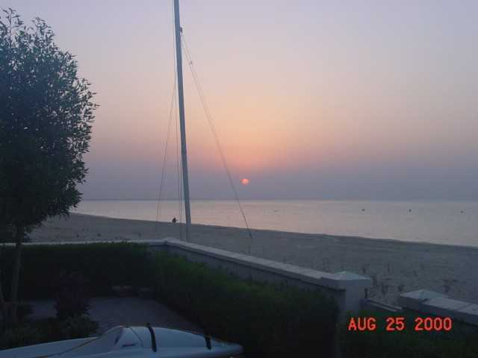
Sunset – taken from back yard – north side villa

BACKGROUND ON CULTURE

A Muslim’s View Of Islam

Islam and Muslims

The Arabic word “Islam” means peace, submission and obedience. The religion of Islam is the complete acceptance of the teachings and guidance of God as revealed to Prophet Mohammed (PBUH). A Muslim is one who believes in God and strives for total reorganization of his life according to His revealed guidance and the sayings of the Prophet. He also works for building human society on the same basis. “Muhammadanism” is a misnomer for Islam and offends its very spirit. The word “Allah” is the proper name of God in Arabic. It is a unique term because it has no plural or feminine gender.

Continuity of Message

Islam is not a new religion. It is, in essence, the same message and guidance which Allah revealed to all Prophets:

“Say, we believe in Allah and that which has been revealed to us, and that which was revealed to Abraham and Ishmael and Isaac and Jacob and the tribes and that which was given to Moses and Jesus and to other Prophets, from their Lord. We make no distinction between any of them, and to Him we submit.” (Qura’n 3:83)
The message, which was revealed to Prophet Mohammed (PBUH), is Islam in its comprehensive, complete and final form.

The Five Pillars of Islam

There are five pillars of Islam:

- The declaration of faith: To bear witness that there is none worthy of worship except Allah, and that Mohammed is His messenger to all human beings till the Day of Judgment. The Prophethood of Mohammed obliges Muslims to follow his exemplary life as a model.

- Prayers: Daily prayers are offered five times a day as a duty towards Allah. They strengthen and enliven the belief in Allah and inspire man to a higher morality. They purify the heart and prevent temptation towards wrong-doings and evils.

- Fasting the month of Ramadhan: Muslims during the month of Ramadhan not only abstain from food, drink and sexual intercourse from dawn to sunset, but also from evil intentions and desires. This teaches love, sincerity and devotion. It develops a sound social conscience, patience, unselfishness and will-power.

- Zakat: To pay annually 2.5% of one’s net savings over the past year is a religious duty, and a purifying sum to be spent on poorer sections of the community.

- Pilgrimage to Makkah: It is to be performed once in a lifetime, if one can afford it financially and physically.

Besides these pillars, every action, which is done with the awareness that it fulfills the will of Allah, is also considered an act of worship.

Islam enjoins faith in the Oneness and Sovereignty of Allah, which makes man aware of the meaningfulness of the Universe and of his place in it. This belief frees him from all fears and superstitions by making him conscious of the presence of the Almighty Allah and of man’s obligations towards Him. This faith must be expressed and tested in action. Faith alone is not enough. Belief in one God requires that we look upon all humanity as one family under the universal Omnipotence of God - the Creator and Nourisher of all. Islam rejects the idea of a chosen people, making faith in God and good action the only way to heaven. Thus, a direct relationship is established with God, without any intercessor.

Man: The Free Agent

Man is the highest creation of God. He is equipped with the highest of potentialities. He is left relatively free in his action and choice. God has shown him the right path, and the life of Prophet Mohammed provides a perfect example. Man's success and salvation lies in following both. Islam teaches the sanctity of the human personality and confers equal rights upon all without any distinction of race, sex or color.

The law of God, enunciated in the Qura'n and exemplified in the life of the Prophet, is supreme in all cases. It applies equally to the highest and the lowest, the prince and the peasant, the ruler and the ruled.

Qura’n and Hadith

The Qura'n is the last revealed word of God and the basic source of Islamic teachings and laws. The Qura'n deals with the bases of creeds, morality, history of humanity, worship, knowledge, wisdom, God-man relationship, and human relationships in all aspects. Comprehensive teachings on which can be built sound systems of social justice, economics, politics, legislation, jurisprudence, law and international relations are important contents of the Holy Qura'n.

Mohammed (PBUH) himself was an unlettered man who could not read or write. Yet, the Holy Qura'n was committed to memory and writing by his followers, under His supervision, during his lifetime. The original and complete text of the Qura'n is available to everybody in Arabic, the language in which it was revealed.

Translations of the meaning into many languages are widely used. Hadith, the teachings, sayings and actions of Prophet Mohammed, meticulously reported and collected by his devoted companions, explain and elaborate the Qura'nic verses.

Concept of Worship

Islam does not teach or accept mere ritualism. It emphasizes intention and action. To worship God is to know Him and love Him, to act upon His law in every aspect of life, to enjoin goodness and forbid wrong-doing and oppression, to practice charity and justice and to serve Him by serving mankind. The Qura'n presents this concept in the following sublime manner:
"It is not righteousness that you turn your faces to the East or the West, but righteous is he who believes in God and the Last Day and the Angels and the Book and the Prophets: and gives his wealth of love of Him to kinsfolk and to orphans and the needy and the wayfarer and to those who ask, and to set slaves free: and observes proper worship and pays the Zakat. And those who keep their treaty, when they make one, and the patient in tribulation and adversity and time of stress: such are those who are sincere. Such are the Godfearing." (Qura'n 2:177)

Islamic Way of Life

Islam provides definite guidelines for all people to follow in all walks of life. The guidance it gives is comprehensive and includes the social, economic, political, moral and spiritual aspects of life. The Qura'n reminds man of the purpose of his life on earth, of his duties and obligations towards himself, his kith and kin, his community, his fellow human beings and his Creator. Man is given fundamental guidelines about a purposeful life and then he is left with the challenge of human existence before him so that he might put these high ideals into practice. In Islam, man's life is a holistic, integrated unit and not a collection of fragmented, competitive parts. The sacred and secular are not separate parts of man: they are united in the nature of being human.

Historical Perspective

Mohammed (PBUH) was born in the year 570 A.D. in the city of Makkah in Arabia. He came of a noble family: he received the first revelation at the age of forty. As soon as he started preaching Islam, he and his followers were persecuted and had to face severe hardships. He was, therefore, commanded by God to migrate to Madinah, another city in Arabia. During a short span of 23 years, he completed his mission of prophethood and died at the age of 63. He led a perfect life and set an example for all human beings as his life was the embodiment of the Qura'nic teachings.
Islam’s Rational Appeal

Islam in its clear and direct way of expressing truth has a tremendous amount of appeal for any seeker of knowledge. It is a solution for all the problems of life. It is a guide towards a better and complete life glorifying, in all its phases, God, the Almighty Creator and the Merciful Nourisher.

A Ramadhan Reminder

Ramadhan is one of the five pillars of Islam, and is taken very seriously by our Muslim neighbors and coworkers. It occurs at a different time each year, as the Islamic calendar is based on the lunar calendar. (The lunar calendar has 12 months’, each 29 or 30 days long. The start of a new month depends on when the new moon is sighted.) Because the Islamic calendar is shorter by 10 or 11 days than the western calendar, Ramadhan arrives 10 or 11 days “earlier” each year.

The office hours will change as will the school hours for the children. It is against the law to eat, drink, smoke, or chew gum during the hours between dawn and dusk. (It should be noted that daylight begins when one can distinguish the difference between a white and a black thread. It is, therefore, a different time than sunrise.) If one is traveling in a car, for example, it is strictly forbidden to eat, drink, smoke or so much as chew gum. People have been sent to jail in Kuwait for eating or drinking in public during Ramadhan.

There will not be food or drink available for consumption during these hours. Many of the grocery stores will be open for business as usual, however. The Sultan Center will be open 24 hours a day. Other businesses may open a little later than usual and will not reopen at 4 P.M. Instead, they may reopen as late as 7:30 or 8:00 P.M. and then stay open until 11:00 P.M. or later. This will vary from day to day and from store to store.

Restaurants will be closed, there will be no water at the tennis courts, and so forth, between dawn and dusk.

At about the midpoint of Ramadhan there is a tradition referred to as Gergayon. The children in Mina Saud will celebrate the tradition by walking from door to door greeting their neighbors, after dark. It is customary to hand out candy/sweets.

ISLAM IS NOT JUST A PART OF OUR MUSLIM NEIGHBORS' LIVES;
IT IS THE WAY OF LIFE IN SAUDI ARABIA AND KUWAIT.

