What Makes a Good Practise for Competition
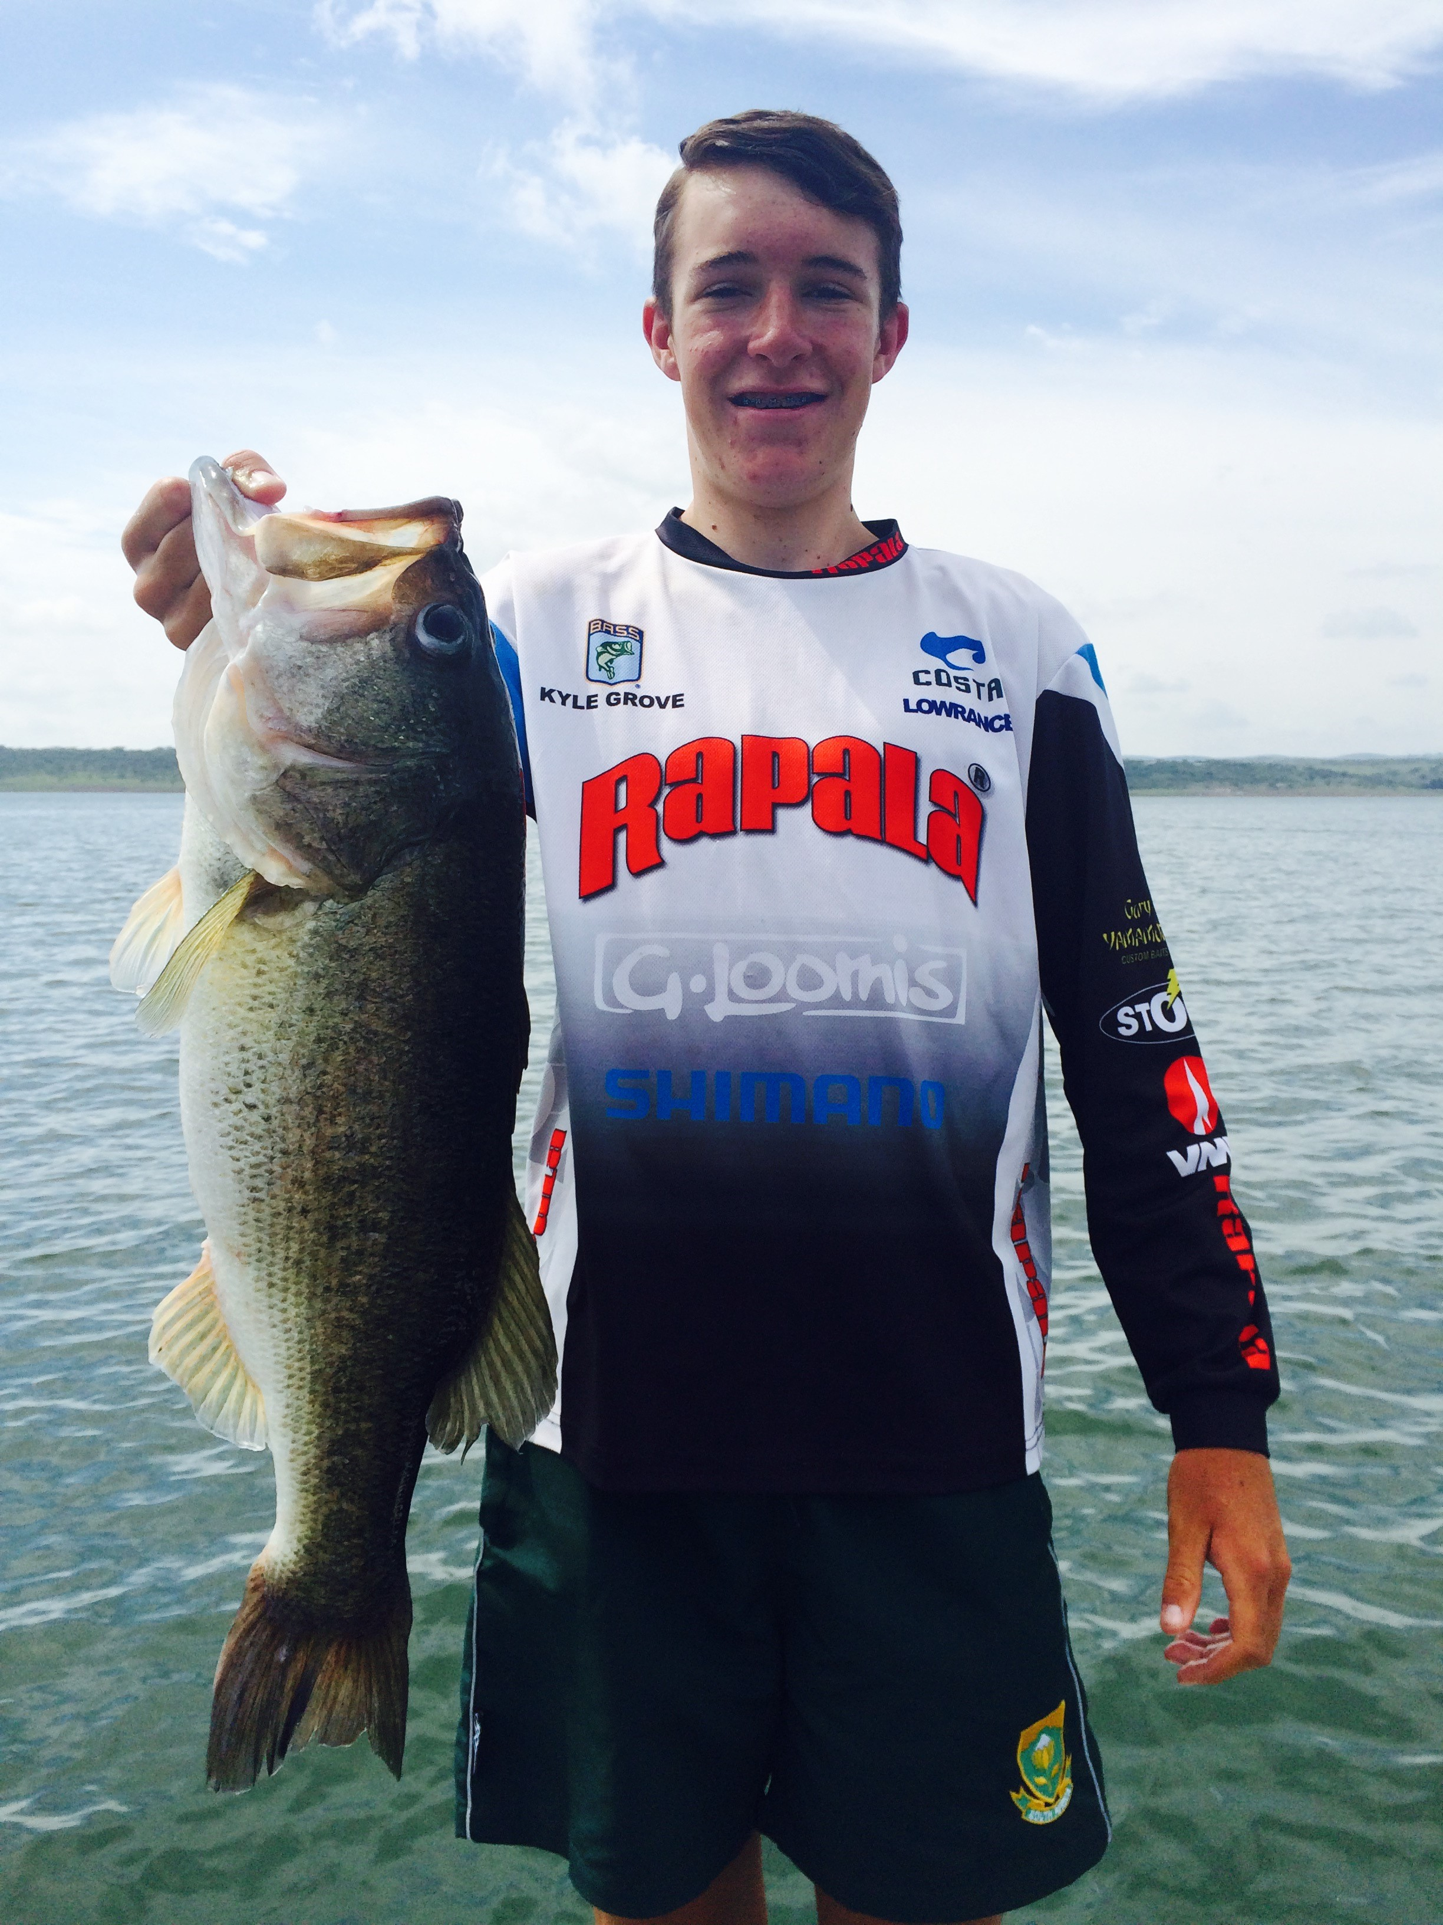

Practising for a competition means to practise the venue where the competition will be hosted .( in short a lot of time spend on the water ).Locating a few spots and finding the right baits that the fish want to eat.

A few key tips for a good practise.

- Ensure that you have enough spots which have the ability to produce fish for the duration of the competition.
- Try to locate at least a limit spot where you can quickly get limit ,as well as a spot where you might get a few kickers.
- Sometimes the small fish don’t eat what the big fish eat ,so finding out what both big fish and keeper size fish eat can be challenging but crucial.
- Also know the where about of the fish during the course of the day ,some spots are a hit in the mornings and some might only come on later during the day.

- When the fish are located in different spots during practise ,don’t catch them all ,just catch some to determine the fish size.

If you practise using these tips you can be sure to have a good competition.

