CALL FOR TENDERS

LITBS N°9132785

LONG-TERM AGREEMENT FOR THE PRINTING WORKS

The United Nations Fund in Guinea-Bissau undertakes this call for tenders for establishing long-term agreements (LTA) for the achievement of printing works

The tenders, in sealed envelopes, could be sent to the following address:

United Nations Children’s Fund (UNICEF)
Guinea-Bissau
United Nations Building
P.O. Box 464 – Bissau 1034
Only Logistics and Supply Section

IMPORTANT – ESSENTIAL INFORMATION

The LITB reference N°91132785 must absolutely appear on the envelope that contains the tender.

The forms should be used to reply to this Call for Tenders. It is possible to include separately any additional detail if deemed necessary.

The tenders with the mention "LITB Printing works” should be sent by DHL to the Supplies Section, United Nations Building – P.O. Box 464 – Bissau 1034 to Bissau, at the latest by 30 July 2017 at 5 pm. The tenders received after this date will note be considered. The Tenders may be dropped off at the box provided for to that effect, which is at the UNICEF reception.

The tenders received after the established date and time will be invalidated.

This Call for Tenders is an international Open Call. The File of Call for Tenders is available on the web site of UNICEF

It is important to read all the provisions of this document to ensure the best understanding of the conditions required by UNICEF and be able to present a complete tender compliant with ALL THE DOCUMENTS REQUIRED. Note that the lack of compliance will invalidate any tender.

THIS CALL FOR TENDERS NOTICE WAS:

Prepared by:

_________________________________________
Dexter Cooper, Supply Officer

Approved by:

_____________________________________
Kabirou Gbadamassi, Supply & Logistics Specialist

TENDER FORM

The TENDER FORM should be filled out, signed, and returned to UNICEF. In order to be valid, the tender should be presented, following the instructions contained in this CT.

TERMS AND CONDITIONS OF THE AGREEMENT

Any agreement/order form resulting from this Call for Tenders and the LTA will contain the UNICEF General Conditions enclosed, as well as any other Term and Specific Condition detailed in this CT.

The Undersigned, who have read the General Conditions of the Call for Tenders number LITB N° 9132785 set out in the document enclosed, propose to provide the services according to the Terms and Conditions set out in the document.

Signature and stamp: ________________________________

Date: ________________________________

Name and Title: ________________________________

Company: ________________________________

Mailing Address: ________________________________

Tel/Mobile No: ________________________________

E-mail: ________________________________

Validity period of the Tender: 3 (three) month from the presentation of the tender at the UNICEF Bamako office

Tender currency: XOF (FCFA)

Taking into consideration the UNICEF Payment Terms set out in this document, please indicate the discount offered in accordance with the payment period:

Payment within 10 days: _____%, within 15 days: _____%, within 20 days: _____%, within 30 days: _____%

Any other commercial discount proposed: ___________________________________________

ANNEX I

1.0 RULES AND PROCEDURES

1.1 ORGANISATIONAL FRAMEWORK

UNICEF is the Agency of the United Nations mandated for promoting children’s rights, ensure them their elementary rights and offer them development opportunities. Within the framework of its mission, UNICEF fights for the establishment of the child’s rights as an international standard of behaviour regarding children. The UNICEF role is to mobilise the political wills and the material resources in order to help the countries to ensure the implementation of the slogan “children first”. UNICEF is committed to the special protection of the most vulnerable children.

UNICEF carries out its mandate through its head office located at New York, 8 regional offices and 125 country offices all around the world. UNICEF has also a research centre in Florence, a base of supply operations in Copenhagen and offices in Tokyo and Brussels. The 37 UNICEF national committees mobilise resources and ensure the advocacy for the mission and the organisation mandate.

1.2 SUBJECT OF THIS CONSULTATION

This Call for Tenders (CT) aims to identify a provider who will be qualified to undertake printing works of different supports related to the new 2016-2020 cooperation programme, within the framework of a long-term agreement. The services include:

- Printing of the designed supports
- Delivery all the way to Guinea-Bissau

This Call for Tenders constitutes one and single batch.

UNICEF has no obligation to order a minimal quantity of services to the provider, following the long-term agreement (LTA) which may arise from this CT.

UNICEF will not be liable for any expenses when no services provision was provided within the framework of this Agreement/LTA.

This Agreement/LTA will be signed for a two-year period that is renewable for one year, depending on the provider performance. The prices will have to be set throughout the validity period of the LTA.

The Agreement is not exclusive. UNICEF has the right to obtain the same services or similar ones from other Contractors, as it sees fit.

Request of additional information:

Any request for clarification and further information concerning this CT will have to be addressed in writing to the persons below within 8 days before the deadline of the tenders’ presentation:

- Kabirou Gbadamassi, Supply and Logistics specialist (kgbadamassi@unicef.org)
- Jones Mpakateni, Communication for Development Specialist, (jmpakateni@unicef.org)

The replies to the written requests will be sent in writing to all the companies that have confirmed their intention to present a tender, without, however, identifying the origin of the request.

UNICEF will make an effort to quickly reply to the requests made, knowing, however, that any late reply on its part will not oblige it to extend the deadline for the presentation of the offers, except if UNICEF considers that such derogation is justified and necessary.

1.3 Reply format

The tendering company should give enough information for each section of this CT, in order that the evaluation team of UNICEF becomes able to make a correct and fair evaluation of the company.

Presentation of the tenders

ATTENTION: There must be no financial information in the technical proposal. In case of non-compliance with this instruction, the tender will be systematically rejected. The separation of the envelope with the “technical proposal” from the envelope with the “financial proposal” should be properly respected. In case of non-compliance, the tender will be rejected and will not be considered.

The Tenderers will have to send their tenders by DHL to the address:
Supplies Section, UNICEF, Guinea-Bissau - United Nations Building, Bissau 1034.
The Tenders may also be dropped off in the box provided for this purpose that is at the UNICEF reception.

The Tenderers will have to send their Tenders in duplicate copies (an original one and a copy) in an external envelope and two internal envelopes.

The internal envelopes will have to be denominated:

- Technical Proposal
- Financial Proposal

The internal envelopes will also have to mention the name and the address of the Tenderer and the UNICEF reference – LITB N°9132785

The only mention on the external envelope will have to be: UNICEF – LITB – GUINEA-BISSAU N°9132785.

The technical proposal will be subjected to a document different from the one of the financial proposal.

Closing date for the submitting the tenders: At the latest by 30 July 2017, at 5 pm (Bissau time).
Any tender received after the indicated date and time will be not considered.
No tender can be modified after the established date and time for the tenders’ submission.

Withdrawal of tenders

Before the deadline, the tenderers may withdraw their tender after written notice received by UNICEF.

- The e-mail of the withdrawal will have to indicate ITB – N°9132785
- The e-mail will have to mention “WITHDRAWAL”
- The e-mail will be addressed to kgbadamassi@unicef.org

1.4 OPENING AND EVALUATION OF THE TENDERS

The opening of the closed envelopes will be made in public session as mentioned above. The internal committee for opening the tenders will proceed to the analysis of the technical and financial proposals. The tenders considered non-acceptable will be eliminated. The tenders that will not be in accordance with the terms and conditions of this consultation, including those containing uncomplete information will be disqualified.

The evaluation of the tenders will be done in three phases:

- Compliance check of the administrative documents: trade register, documents proving the payment of the social contributions and taxes, etc.
- Evaluation of the technical proposal: the analysis of the technical references of the tenderers, the certificates of proper execution, and the qualifications competences of the staff proposed for the provision of the service, as well as the evaluation of the provided samples.
- Evaluation of the financial proposal: only the financial proposals of the tenderers qualified at the level of the technical evaluation will be analysed. As a rule, the selection will be made on the company that submits a tender, which is technically, and financially the best one.

The opening date of the technical proposals is established on 31 July 2017 at 10 am at UNICEF Bissau.

A technical commission composed of two persons, including one who is external to the purchase process, will check the presentation of the tenders in accordance with the requirements of the above point 1.3.

Clarifications of the tenders
The clarifications request about a tender and the reply that is provided will be made by e-mail and no changes to the sum or the content of the tender is sought, except if that is necessary for confirming the correction of calculation errors found by UNICEF at the moment of the tenders’ evaluation.

Subcontracting
The Tenderers will have to indicate clearly in their Tenders the services that will be subcontracted to another company. A Technical Proposal, as described below, has to be tendered for all the subcontractors and will be considered as an integral part of the tender.

UNICEF rights
UNICEF reserves the right to accept or refuse any tender, whatsoever. UNICEF reserves the right to cancel the request procedure of the Tender and to exclude all the tenders, at any moment before the attribution of the markets, without claiming any liability from the tenderer(s) concerned and without being obliged to inform the tenderer(s) affected by the reasons of its decision.

UNICEF will not be held responsible for the expenses that the tenderers have incurred for preparing their replies to the Tender Request.

UNICEF reserves the right to attribute the markets to one or several companies.

UNICEF property
For this CT, the requests of additional information, as well as the replies and the tenders sent are considered as UNICEF property. All the material submitted in response to this CT will remain to UNICEF. All the tenders that have not been selected from the technical analysis will be destroyed by UNICEF after a 6-month period as from the opening of the technical envelopes.

Tender languages
English, Portuguese, or French are the only languages that are accepted for this CT.

Information property
The information that the Tenderers consider as being their intellectual property will have to be labelled clearly as “intellectual property” by the side of the text concerned. UNICEF will process this information in an appropriate manner.

Evaluation of the technical and financial proposals

For the technical proposal, the specifications mentioned in this CT will have to be taken into account. It will include:

- Trade register or the statutes of the company;
- Document proving the payment of the social contributions;
- Document proving the payment of the taxes;
- Technical references of the tenderers (list of the tenderer customers for similar works);
- Copies of supports achieved for the appreciation of the quality;
- The list and qualification of the staff (attach the résumés).

The price should not be mentioned in the technical proposal

Financial proposal

The financial proposal will include:

- The Submission form duly signed and sealed;
- The board of the expenses duly filled out, dated, signed, and sealed.

The prices will be quoted in Francs CFA, Euro or US Dollars
The tenders will be evaluated according to the following selection criteria:

CATEGORY | SCORE
- Technical evaluation criteria
- Technical references of the tenderer concerning services with the same relevance or nature achieved along the last two years, accompanied with certificates of good execution | 20
- The list of the staff and qualifications (attach résumés) | 15
- Realistic delivery time | 10
- Quality of the copies received (English, Portuguese or French) | 10
- Presentation of the tender:  Summary  Layout  Cover  Clarity and readability | 1  1  1  2
TOTAL TECHNICAL SCORE (minimum score required: 40 pts) | 60
- Financial evaluation criteria
- The lowest financial proposal | 40
TOTAL FINANCIAL SCORE | 40
TOTAL TECHNICAL AND FINANCIAL SCORES | 100

The financial proposal that is the lowest in economic terms with the better commercial conditions receives 30 points. The other financial proposals receive a score, which is determined according to the following formula: 30 x FIP / PR, in which the FIP represents the sum of the lowest financial proposal and PR represents the sum of the financial proposal concerned. The Fs financial score is determined as follows: for the tender of a tenderer (x), whose tender is (PR), the score (Fs) is calculated as follows: Sc = 30 x FIP/PR.

The long-term agreement will be attributed to the tenderer who has:

- Obtained the technical score of 40 points or more;
- The best total price for the 47 items (total rendered to Bissau).

The evaluated and compared tenders are then presented to the Contract Review Committee of UNICEF Guinea-Bissau (CRC).

The renderer who had offered the best financial proposal and obtained the score of 40 points or more on the technical evaluation will be proposed to a long-term agreement corresponding to his/her tender.

1.5 Signature of the long-term agreement (LTA)

UNICEF Bissau will send to the Market Contractor a Long-Term Agreement in accordance with the model in force in UNICEF. Within fifteen (15) days after its reception, the Market Contractor will sign and return to UNICEF Guinea-Bissau the Long-Term Agreement.

1.6 Corruption or fraudulent acts
If there are irrefutable evidences that lead to believe that the Company had indulged in corruption or fraudulent acts during the attribution or execution of the Market, UNICEF Guinea-Bissau may, within fifteen (15) days after notifying it, terminate the Agreement and the provisions of the following paragraphs are applicable as of right.

For the purposes of this paragraph, the following terms are defined as follows:
- Someone is guilty of “corruption” when offering, giving, requesting or accepting any advantage in order to influence the execution of a Market, and
- Someone, who is involved in “fraudulent acts” and misrepresents or distort facts in order to influence the attribution or execution of a Market in a detrimental manner to UNICEF Guinea-Bissau. “Fraudulent acts” include in particular any arrangement or collusive act of the Tenderers (before or after the assignment of the Tender) that aim to artificially maintain the tenders prices at levels not corresponding to those resulting from the game of a free and open competition, and deprive UNICEF Guinea-Bissau of the advantages of the latter.

UNICEF Guinea-Bissau will reject an attribution tender if it is found that the Assignee proposed is guilty of corruption or is involved in fraudulent acts for the attribution of this Market.

UNICEF Guinea-Bissau will exclude a Company indefinitely or for determined period from any attribution of Markets under its liability, if it is established at any moment that the Company is involved in corruption or fraudulent acts in order to obtain or during the execution of a Market under its liability.

1.7 Payment schedule
The payments will be done only with the acceptance by UNICEF of the achieved works, in compliance with the phases contractually defined. The payment terms are 30 days-net after the receipt of the invoice accompanied by the order form and the delivery notes duly signed. The payment will be done by bank transfer in the invoice currency (CFA; Euro or $).

1.8 Copyrights, patents and other exclusive rights
The intellectual property and the other property rights, among them the patents, copyrights and trademarks, concerning the products, documents or other materials that have a direct link with the agreement issued from the LTA or products, prepared and gathered for the purposes of the agreement remain as UNICEF property. On UNICEF request, the company is under the obligation to take the necessary actions, establish, sign, and validate any requested document and generally to give its support in order to obtain and transfer to UNICEF such rights, in accordance to the applicable law.

1.8 Confidential nature of the documents and information
Any document, drawing, plan and report, map, photo, mosaic, recommendation, evaluation and other data prepared or received by the Company for the purposes of the Agreement are UNICEF property. They have to be processed as confidential documents that will be given only to the qualified employees of UNICEF after the achievement of the works established in the agreement.

The Company must not reveal in any circumstance to a particular person, government or other authority different from UNICEF, the information that it has, due to its collaboration with UNICEF, and that had not been given.

ANNEX II: CONTRACTUAL PROVISIONS

1. LONG-TERM AGREEMENT

1.1 UNICEF wishes to establish (a) non-exclusive Long-Term agreement(s) ("LTA") for the purchase of the services listed, according to the needs during the aforementioned LTA. One of the provision of this Agreement states that UNICEF will not have the obligation of any purchase, any minimum quantity, of its services. UNICEF will not be responsible for any expense in the eventual case of not doing a purchase within the framework of the LTA(s) established.
1.2 The services purchases will be done by means of agreement(s) issued by UNICEF, in accordance with the Terms and Conditions of the LTA(s) established.

2. TERM
2.1 This LTA will be valid for an initial period of 24 months, with the possibility of a renewal for an additional period of up to 12 months in case of satisfactory performance.

3. PRICES AND DISCOUNTS
3.1 The tenderers have to present prices discounts according to the forms of the financial proposal in FCFA, Euro or US Dollar.

3.2 The tenderers are requested to indicate:

a) the discount(s) approved for a quickest payment than the standard term of UNICEF.
b) any other commercial discount(s).

3.3 Besides the proposed discounts, the prices given by the tenderers will constitute the maximum ceiling prices that will remain fixed for a period of 24 months from the beginning of the LTA.

3.4 since the renderer had the possibility to give commercials discounts to UNICEF, the unit prices will be reduced for specific agreements.

4. CERTIFICATION OF THE MOST FAVOURABLE PRICE

4.1 By submitting this tender, the tenderer certifies that UNICEF, for the Long-Term Agreements/Contracts resulting from this tender request, is not invoiced more than other customers for a similar service in similar circumstances are.

5. TERMS OF DELIVERY OR INCOTERMS
CIF

6. DELIVERIES
The terms of the LTA are prices presented to Bissau, Guinea-Bissau. s

7. TENDERING PROCEDURES

7.1 The Long-Term Agreement(s) will be attributed to the tenderer(s) that had obtained the highest combined technical and financial score and whose tender is compliant with all the Instructions, Terms and Specific Notes, and the Terms and General Conditions contained in the tender request, provided that the tender is reasonable and of interest to UNICEF for accepting it.

7.2 For this tender request, the evaluation criteria are those established in the technical criteria Board and the price level.

8. SAMPLES
The provider will provide samples of previous works according to the UNICEF request.

9. STANDARD PACKAGES REQUESTED
Not applicable

10. PACKING LIST
Not applicable

11. HAZARDOUS MATERIALS
Not applicable

12. STATEMENTS OF THE TENDERER

12.1 The tenderer states and ensures that:

- He/she has the staff, the experience, the qualifications, the premises, the financial resources and all the other competences and resources for complying with his/her obligations, respecting all the LTA or contract resulting from this tender request;
- He/she had not conclude and will not conclude any agreement or arrangement that restricts or limit the UNICEF rights under any LTA or contract resulting from this tender request.

13. COUNTRY OF ORIGIN
Not applicable

14. DAMAGES AND INTERESTS

14.1 For significant delays of Reports production that had not been previously negotiated, UNICEF has the right to claim damages and interests to the tenderer concerned, and deduce 0.5% from the value of the contract per additional day of delay, up to a maximum of 10% of the contract value. The payment or the deduction of these damages and interests will not free the tenderer from any obligation or liability resulting from a LTA or contract.

15. UNETHICAL BEHAVIOUR

15.1 UNICEF applies strictly a zero tolerance policy concerning the acts that are non-professional or fraudulent and the lack of ethics of the tenderers. Consequently, any registered tenderer that give evidence of achieving unethical, non-professional or fraudulent acts will be suspended and prohibited to continue business relationships with UNICEF.

16. CORRUPTED AND FRAUDULENT PRACTICES
16.1 UNICEF requires that all the tenderers associated to this tender request respect the highest ethical standards in the course of the procurement and the execution of the services. For applying this policy, UNICEF defines as follows the terms mentioned for the purposes of this provision:

- The corruption practices imply to propose, give, receive or request anything having a value for influencing the action of a public agent in the procurement process or in the execution of a contract, and
- A fraudulent practice implies an inaccurate representation of the facts in order to influence the procurement process or the execution of a contract to the customer detriment. It includes collusive practice between tenderers (before or after the submission of the tenders), aiming to establish the tenders prices at levels that are artificially not competitive and deprive the customer from the advantages of a free and open competition.

UNICEF will reject an attribution tender if there are evidences that the selected provider/contractor has been involved in corrupted or fraudulent practices in order to obtain or the execution of a finance contract by UNICEF.

17. NO ADVANTAGES GRANTING TO THE EMPLOYEES

17.1 The tenderer grants that no UNICEF or United Nations employee has received or will have a proposal of any direct or indirect advantage from the tenderer resulting from this Call for Tenders or the attribution of it. The Tenderer takes into consideration that the breach of this provision constitutes a breach of an essential condition of the Call for Tenders.

18. GUIDELINES CONCERNING PRESENTS AND HOSPITALITY

18.1 The tenderers should not give presents, nor invitations to the staff members of UNICEF. The leisure travels with a sportive and cultural objective, the theme parks, or the offer of holidays, transportation, or the invitations to extravagant lunches and dinners are prohibited.

19. DISCLOSURE OF SANCTIONS OR TEMPORARY SUSPENSION

19.1 Only suppliers who are considered responsible or are conditionally responsible are qualified to receive contracts from UNICEF and/or to reply to tenders requests of UNICEF. In order to be considered a responsible supplier with whom UNICEF has business relationships, a supplier must not be suspended nor prohibited, nor in any other way identified as a no.

ANNEX III

Technical specifications of the items

LIST OF POSSIBLE COMMUNICATION ITEMS FOR UNICEF GUINEA-BISSAU

Item no | Specifications techniques
1 | 2 panel folder with 2 pockets  - Fits A4 documents  - 2 sided  - 350 g. + matt lamination & spot UV  - spine  - creased & folded  - 4 colours throughout  - correlate books inside  full set of irises, colour proofs and mock-ups
2 | 48 p. book  - A4 format (210 x 297 mm)  - 4 colours throughout  - 4 p. cover (inside & out)  - 44 p. inside  - 350 g cover w/ matt UV lamination  - Perfect binding  - Inside pages: 130 g. w/ mat finish on all pages  full set of irises, colour proofs and mock-ups
3 | 64 p. book  - Format A4 (210 x 297 mm)  - 4 colours throughout  - 4 p. cover (inside & out)  - 60 p. inside  - Perfect bind  - 350 g cover w/ matt UV lamination  - Inside pages: 130 g. w/ mat finish on all pages  full set of irises, colour proofs and mock-ups
4 | 80 p. book  - Format A4 (210 x 297 mm)  - 4 colours throughout  - 4 p. cover (inside & out)  - 76 p. inside  - Perfect bind  - 350 g cover w/ matt UV lamination  - Inside pages: 130 g. w/ mat finish on all pages  full set of irises, colour proofs and mock-ups
5 | 96 p. book  - Format A4 (210 x 297mm)  - 4 colours throughout  - 4 p. cover (inside & out)  - 92 p. inside  - Perfect bind  - 350 g cover w/ matt UV lamination  - Inside pages: 130 g. w/ mat finish on all pages  full set of irises, colour proofs and mock-ups
6 | 80 p. book  - 240 x 290 mm landscape  - 4 colours throughout  - 4 p. cover (inside & out)  - 76 p. inside  - 350 g cover w/ matt UV lamination  - Inside pages: 130 g. w/ mat finish on all pages  full set of irises, colour proofs and mock-ups
7 | CO Country brochures  240 x 240 mm  52 p. (48 p. + 4 p. cover)  Perfect bound  300 g. cover + mat lamination + spot UV  Inside pages 135 g. + lacquer on all pages  full set of colour proofs and mock ups
8 | Reports  - A4 (210 x 297 mm)  - portrait  - perfect find  - 4 colours  - 4 p. cover (inside & out)  - 300 g cover w/ matt UV lamination  - Inside pages: 115 g. w/ mat finish on all pages  - full set of irises, colour proofs and mock-ups
9 | 3 Pager briefs  - A4  - 3 panels, 2 creases (630 x 297 mm opened, 210 x 297 mm closed)  - 4 colours  - 300 g. paper, matt lamination throughout
10 | A3 posters  A3 format, 1 sided  297×420 mm  175 g.  4 colours one sided
11 | A2 posters  A3 format, 1 sided  420 x 594 mm  175 g.  4 colours one sided
12 | 3 fold flyers  210 x 300 mm  170 g.  2 creases and fold  4 colours  Mat lamination  full set of colour proofs and mock ups
13 | A5 flyers  A5  4 colours  Machine varnish  170 g.  
14 | CD Rom  Copy & design CD rom + mass duplication up to 600 MB data
15 | CD cover  -120 mm x 120 mm  -4 colours single sided  -135 g, cut to size & glued to CD rom
16 | A3 Wall calendar folded in 2 to fit into press kit (format A4 folded in 2)  - 24 p. calendar (12 p. folded in 2) + 4 p. cover  - format 210 x 290 mm closed, 290 x 420 mm opened  - 4 colours  - 135 g matte inside w. matte machine varnish + cover 320 g with matte UV varnish  stitched bound + hole to hold calendar
17 | A3 Wall calendar  - A3 Wall Calendar (297 x 420)  - 2 p. cover 250 g.(1 leaf)+ matt U.V. varnish  - 28 inside pages (14 leaves), 170 g + matt inside pages  - spiral bound + hanger  - full set of irises, colour proofs & mock ups  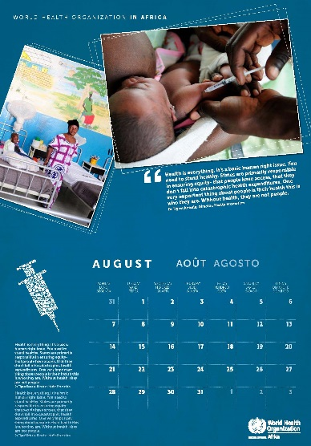
18 | A2 Wall calendar  - A2 Wall Calendar (420 x 594 mm)  - 2 p. cover 250 g.(1 leaf)+ matt U.V. varnish  - 28 inside pages (14 leaves), 170 g + matt inside pages  - spiral bound + hanger  full set of irises, colour proofs & mock ups
19 | Desk Calendar  - 24 p. desk calendar + 2 page cover  - 210 x 145 cm  - Stand foil calendar w/ cardboard  - printed 4 colours  - paper stock: 250 g  - spiral bound  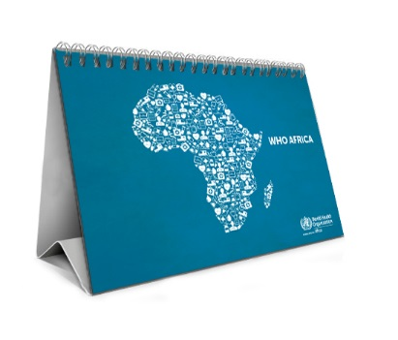  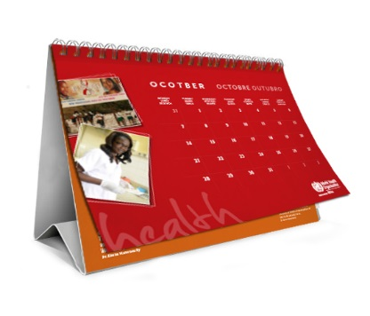
20 | Agenda  - 156 p. organiser including 4 p. cover  - 210 x 150 mm  - 350 g. cover + matt UV lamination  - 110 g. inside pages  - 4 colours  spiral bound
21 | Padded agenda + pen  -156 p. agenda 140 x 200 mm with padded cover customized  -branded cover w/ WHO logo  -branded pen with 1 colour artwork printed  -1 week on 2 pages  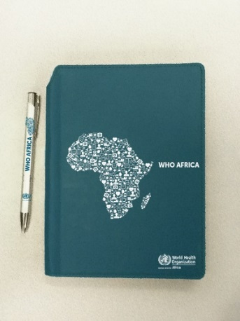
22 | Small stickers  - round sticker/ die cut  - diameter: 10 cm  4 colours, 1 sided
23 | Larger stickers  - round sticker/ die cut  - diameter: 20 cm  - 4 colours, 1 sided  
24 | Postcards/greeting cards  - Standard postcards (150 x 100 mm)  - 4 colours  - 2-sided  - uncoated paper  350 g
25 | Factsheets  A4 factsheets  -A4 portrait 210 x 297 mm  -4/4 colours  -250 g. matt machine varnish  -2 sided  -full set of irises, colour proofs and mock-ups  -factsheets collated in folder
26 | Adult t-shirts  100% cotton  160 g.  4 colour logo printed in the front  Sizes S, M, L  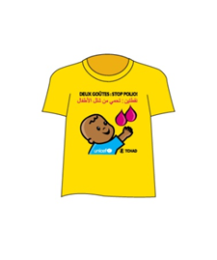  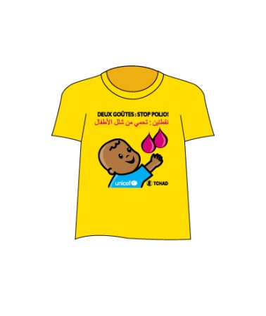
27 | Children t-shirts  100% cotton  160 g.  4 colour logo printed in the front  Mix sizes 6, 8, & 14 y.  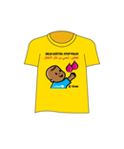
28 | Onesies  Onesie (baby body suit)  100% cotton  Short sleeve  Size 3-6 months  White w/ 4 colour logo printed on it  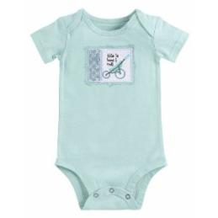
29 | Newborn hoodies  New born hats  (0-6 months)  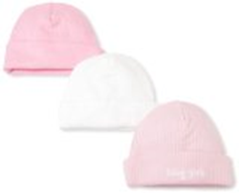
30 | Baby swaddling/receiving blanket  100% cotton  80 cm x 80 cm  
31 | Hats  Standard yellow caps  4 colour artwork printed on it  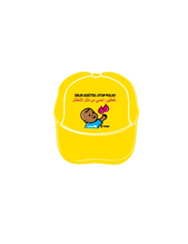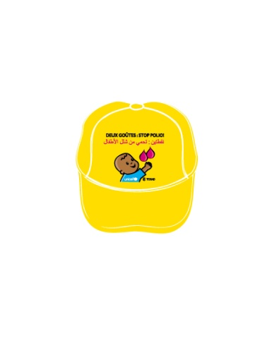
32 | Tote  Non woven tote  4 colour logo print on cover  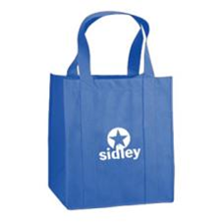
33 | Awareness bracelets  Plastic bracelet w/ logo/ message printed on it  
34 | Mouse pads  20 cm diameter  Round/ Square or rectangle  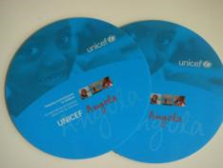
35 | Drawstring bag packs  Custom made drawstring  polyester  4 colour logo on front  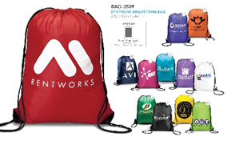
36 | Car sticker (long)  Long sticker  4 colours  100 x 28 cm  Printed on PVC  
37 | Car sticker (short)  Short sticker  4 colours  65 x 28 cm  Printed on PVC  
38 | Pop up tents  3 x 3 m aluminium tent + 2 lateral prints  Each Kit Includes:  -Pop Up Frame 30 mm  -1 Ceiling  -1 Lateral  -1 front  -2 lateral half height  -2 Telescopic bars  -Transport Bag  -Stakes for Fixing  Ceiling and laterals are 100% polyester w/ 200 gr./ sq. meter, water proof and fire retardant treatment (M2)
39 | Roll up banners  Elite retractable Banner Stands with carrying case x2  850 mm x 2m  Base  Poles  Bag to carry stands  Original design  4 colour artwork printed 1 side  Set of 2 stand  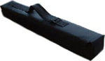
40 | Flags  Large flags  artwork 4 colours  48 cm x 48 cm  Flag with 4 holes to hang with a string  On polypropylene 0.4 mm  Printed 2 sides
41 | Desk flag  Small desk flags  15 cm x 10 cm  -process on polyester cloth  -plastic pole + base  -4 colour artwork printed on it
42 | Blank note book  A5 portrait  -4 p. cover w/ 4 colour logo printed on it  -spiral bound  -4 colours, 250 g plastic cover  -inside: 90 g, blank pages, woodf ree paper  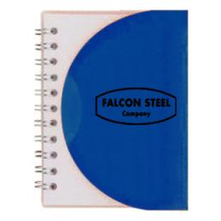
43 | Photo enlargements mounted on foam core, small enlargements (60 x 90 cm)  -format: 60 x 90 cm  -Forex (white) board applied with high resolution digital printing + glue little hanger on back, ready to hang  -4 colours  -Matte lamination  -Single side artwork
44 | Photo enlargements mounted on foam core, medium enlargements (80 x 120 cm)  -format: 80 x 120 cm  -Forex (white) board applied with high resolution digital printing + glue little hanger on back, ready to hang  -4 colours  -Matte lamination  -Single side artwork
45 | Photo enlargements mounted on foam core, large enlargements (120 x 180cm)  -format: 120 x 180 cm  -Forex (white) board applied with high resolution digital printing + glue little hanger on back, ready to hang  -4 colours  -Matte lamination  -Single side artwork
46 | Branded pens  -blue or black ink  -4 colour artwork printed on it  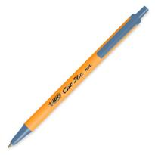
47 | Branded USB keys  -Flat branded UBS keys (credit card like)  -2 GB capacity  -4 colour artwork printed on it  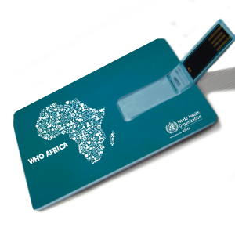  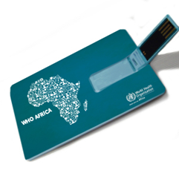
48 | Leaflet Size: A4 ; Sheet 1  Paper: 150 gsm art paper  Binding: Two Fold/Three Fold  Printing: both sides, Color: Full (4) color  Design, Layout
49 | Leaflet Size: A5 ; Sheet 1  Paper: 150 gsm art paper  Binding: Two Fold/Three Fold  Printing: both sides, Color: Full (4) color  Design, Layout
50 | Poster: Size: A1  Paper: 250 gsm art paper  Printing: One side, Color: Full (4) color  Design, Layout
51 | Poster: Size: A2  Paper: 250 gsm art paper  Printing: One side, Color: Full (4) color  Design, Layout
52 | Poster: Size: A3  Paper: 250 gsm art paper  Printing: One side, Color: Full (4) color  Design, Layout
53 | Flyer/Leaflet: Size: A4  Paper: 150gsm art paper  Printing: One side, Color: Full (4) color  Binding: Single leaf  Design, Layout
54 | Flyer/Leaflet: Size: A5  Paper: 150gsm art paper  Printing: One side, Color: Full (4) color  Binding: Single leaf  Design, Layout
55 | Flyer/Leaflet: Size: A4  Paper: 80gsm art paper  Printing: One side, Color: Full (4) color  Binding: Single leaf  Design, Layout
56 | Leaflet: Size: A5  Paper: 80gsm art paper  Printing: One side, Color: Full (4) color  Binding: Single leaf  Design, Layout
57 | Information/Fact Sheet: Size: A3  Paper: 150gsm art paper  Printing: Two sides, Color: Full (4) color  Binding: Single leaf, one or two fold  Design, Layout
58 | Information/Fact Sheet: Size: A4  Paper: 150gsm art paper  Printing: Two sides, Color: Full (4) color  Binding: Single leaf, one or two fold  Design, Layout

ANNEX IV - UNICEF GENERAL TERMS AND CONDITIONS

- ACKNOWLEDGMENT COPY

Signing and returning the acknowledgment copy of a contract issued by UNICEF or beginning work under that contract shall constitute acceptance of a binding agreement between UNICEF and the Contractor.

- DELIVERY DATE

Delivery Date to be understood as the time the contract work is completed at the location indicated under Delivery Terms.

3. PAYMENT TERMS

- UNICEF shall, unless otherwise specified in the contract, make payment within 30 days of receipt of the Contractor's invoice which is issued only upon UNICEF’s acceptance of the work specified in the contract.
- Payment against the invoice referred to above will reflect any discount shown under the payment terms provided payment is made within the period shown in the payment terms of the contract.
- The prices shown in the contract cannot be increased except by express written agreement by UNICEF.

4 LIMITATION OF EXPENDITURE

No increase in the total liability to UNICEF or in the price of the work resulting from design changes, modifications, or interpretations of the statement of work will be authorized or paid to the contractor unless such changes have been approved by the contracting authority through an amendment to this contract prior to incorporation in the work.

5. TAX EXEMPTION

Section 7 of the Convention on the Privileges and Immunities of the United Nations provides, inter alia, that the UN, including its subsidiary organs, is exempt from all direct taxes and is exempt from customs duties in respect of articles imported or exported for its official use. Accordingly, the Vendor authorizes UNICEF to deduct from the Vendor's invoice any amount representing such taxes or duties charged by the Vendor to UNICEF. Payment of such corrected invoice amount shall constitute full payment by UNICEF. In the event any taxing authority refuses to recognize the UN exemption from such taxes, the Vendor shall immediately consult with UNICEF to determine a mutually acceptable procedure.
Accordingly, the Contractor authorizes UNICEF to deduct from the Contractor’s invoice any amount representing such taxes, duties, or charges, unless the Contractor has consulted with UNICEF before the payment thereof and UNICEF has, in each instance, specifically authorized the Contractor to pay such taxes, duties or charges under protest. In that event, the Contractor shall provide UNICEF with written evidence that payment of such taxes, duties or charges has been made and appropriately authorized.

6. LEGAL STATUS.

The Contractor shall be considered as having the legal status of an independent contractor vis-à-vis UNICEF. The Contractor’s personnel and sub-contractors shall not be considered in any respect as being the employees or agents of UNICEF.

7. CONTRACTOR’S RESPONSIBILITY FOR EMPLOYEES

The Contractor shall be responsible for the professional and technical competence of its employees and will select, for work under this Contract, reliable individuals who will perform effectively in the implementation of the Contract, respect the local customs and conform to a high standard of moral and ethical conduct.

8. INDEMNIFICATION

The Contractor shall indemnify, hold and save harmless and defend, at its own expense, UNICEF, its officials, agents, servants and employees, from and against all suits, claims, demands and liability of any nature or kind, including their costs and expenses, arising out of the acts or omissions of the Contractor or its employees or sub-contractors in the performance of this Contract. This provision shall extend, inter alia, to claims and liability in the nature of workmen’s compensation, product liability and liability arising out of the use of patented inventions or devices, copyrighted material or other intellectual property by the Contractor, its employees, officers, agents, servants or sub-contractors. The obligations under this Article do not lapse upon termination of this Contract.

9. INSURANCE AND LIABILITIES TO THIRD PARTIES

(a) The Contractor shall provide and thereafter maintain insurance against all risks in respect of its property and any equipment used for the execution of this Contract.

(b) The Contractor shall provide and thereafter maintain all appropriate workmen’s compensation and liability insurance, or its equivalent, with respect to its employees to cover claims for death, bodily injury or damage to property arising from the execution of this Contract. The Contractor represents that the liability insurance includes sub-contractors.

(c) The Contractor shall also provide and thereafter maintain liability insurance in an adequate amount to cover third party claims for death or bodily injury, or loss of or damage to property, arising from or in connection with the provision of work under this Contract or the operation of any vehicles, boats, airplanes or other equipment owned or leased by the Contractor or its agents, servants, employees or sub-contractors performing work or services in connection with this Contract.

(d) Except for the workmen’s compensation insurance, the insurance policies under this Article shall:

(i) name UNICEF as additional insured;

(ii) include a waiver of subrogation of the Contractor’s rights to the insurance carrier against UNICEF;

(iii) provide that UNICEF shall receive thirty (30) days written notice from the insurers prior to any cancellation or change of coverage.

(e) The Contractor shall, upon request, provide UNICEF with satisfactory evidence of the insurance required under this Article.

10. SOURCE OF INSTRUCTIONS

The Contractor shall neither seek nor accept instructions from any authority external to UNICEF in connection with the performance of its services under this Contract. The Contractor shall refrain from any action which may adversely affect UNICEF or the United Nations and shall fulfil its commitments with the fullest regard to the interests of UNICEF.

11. ENCUMBRANCES/LIENS

The Contractor shall not cause or permit any lien, attachment or other encumbrance by any person to be placed on file or to remain on file in any public office or on file with UNICEF against any monies due or to become due for any work done or materials furnished under this Contract, or by reason of any other claim or demand against the Contractor.

12. TITLE TO EQUIPMENT

Title to any equipment and supplies which may be furnished by UNICEF shall rest with UNICEF and any such equipment shall be returned to UNICEF at the conclusion of this Contract or when no longer needed by the Contractor. Such equipment when returned to UNICEF shall be in the same condition as when delivered to the Contractor, subject to normal wear and tear.

13. COPYRIGHT, PATENTS AND OTHER PROPRIETARY RIGHTS

UNICEF shall be entitled to all intellectual property and other proprietary rights including but not limited to patents, copyrights and trademarks, with regard to documents and other materials which bear a direct relation to or are prepared or collected in consequence or in the course of the execution of this contract. At UNICEF's request, the Contractor shall take all necessary steps, execute all necessary documents and generally assist in securing such proprietary rights and transferring them to the UNICEF in compliance with the requirements of the applicable law.

14. CONFIDENTIAL NATURE OF DOCUMENTS

(a) All maps, drawings, photographs, mosaics, plans, reports, recommendations, estimates, documents and all other data compiled by or received by the Contractor under this Contract shall be the property of UNICEF, shall be treated as confidential and shall be delivered only to the UN authorized officials on completion of work under this Contract.

(b) The Contractor may not communicate any time to any other person, Government or authority external to UNICEF, any information known to it by reason of its association with UNICEF which has not been made public except with the authorization of the UNICEF; nor shall the Contractor at any time use such information to private advantage. These obligations do not lapse upon termination of this Contract with UNICEF.

15. FORCE MAJEURE; OTHER CHANGES IN CONDITIONS

(a) In the event of and as soon as possible after the occurrence of any cause constituting force majeure, the Contractor shall give notice and full particulars in writing to UNICEF of such occurrence or change if the Contractor is thereby rendered unable, wholly or in part, to perform its obligations and meet its responsibilities under this Contract. The Contractor shall also notify UNICEF of any other changes in conditions or the occurrence of any event which interferes or threatens to interfere with its performance of the Contract. On receipt of the notice required under this Article, UNICEF shall take such action as, in its sole discretion, it considers to be appropriate or necessary in the circumstances, including the granting to the Contractor of a reasonable extension of time in which to perform its obligations under the Contract.

(b) If the Contractor is rendered permanently unable, wholly, or in part, by reason of force majeure to perform its obligations and meet its responsibilities under this Contract, UNICEF shall have the right to suspend or terminate this Contract on the same terms and conditions as are provided for in Article 14, “Termination”, except that the period of notice shall be seven (7) days instead of thirty (30) days.

(c) Force majeure as used in this Article means acts of God, war (whether declared or not), invasion, revolution, insurrection or other acts of a similar nature or force.

16. TERMINATION

If the Contractor fails to deliver any or all of the deliverables within the time period(s) specified in the contract, or fails to perform any of the terms, conditions, or obligations of the contract, or should the Contractor be adjudged bankrupt, or be liquidated or become insolvent, or should the contractor make an assignment for the benefit of its creditors, or should a Receiver be appointed on account of the insolvency of the contractor, UNICEF may, without prejudice to any other right or remedy it may have under the terms of these conditions, terminate the Contract, forthwith, in whole or in part, upon thirty (30) days notice to the Contractor.

UNICEF reserves the right to terminate without cause this Contract at any time upon thirty (30) days prior written notice to the Contractor, in which case UNICEF shall reimburse the Contractor for all reasonable costs incurred by the Contractor prior to receipt of the notice of termination.

In the event of any termination no payment shall be due from UNICEF to the Contractor except for work and services satisfactorily performed in conformity with the express terms of this contract.

Upon the giving of such notice, the Contractor shall have no claim for any further payment, but shall remain liable to UNICEF for reasonable loss or damage which may be suffered by UNICEF for reason of the default. The Contractor shall not be liable for any loss or damage if the failure to perform the contract arises out of force majeure.

Upon termination of the contract, UNICEF may require the contractor to deliver any finished work which has not been delivered and accepted, prior to such termination and any materials or work-in-process related specifically to this contract. Subject to the deduction of any claim UNICEF may have arising out of this contract or termination, UNICEF will pay the value of all such finished work delivered and accepted by UNICEF.

The initiation of arbitral proceedings in accordance with Article 22 “Settlement of Disputes” below shall not be deemed a termination of this Contract.

17. SUB-CONTRACTING

In the event the Contractor requires the services of subcontractors, the Contractor shall obtain the prior written approval and clearance of UNICEF for all sub-contractors. The approval of UNICEF of a sub-contractor shall not relieve the Contractor of any of its obligations under this Contract. The terms of any sub-contract shall be subject to and in conformity with the provisions of this Contract.

18. ASSIGNMENT AND INSOLVENCY

1. The Contractor shall not, except after obtaining the written consent of UNICEF, assign, transfer, pledge or make other dispositions of the Contract, or any part thereof, of the Contractor's rights or obligations under the Contract.

2. Should the Contractor become insolvent or should control of the Contractor change by virtue of insolvency, UNICEF may, without prejudice to any other rights or remedies, terminate the Contract by giving the Contractor written notice of termination.

19. USE OF UNITED NATIONS AND UNICEF NAME AND EMBLEM

The Contractor shall not use the name, emblem or official seal of the United Nations or UNICEF or any abbreviation of these names for any purpose.

20. OFFICIALS NOT TO BENEFIT

The Contractor warrants that no official of UNICEF or the United Nations has received or will be offered by the Contractor any direct or indirect benefit arising from this Contract or the award thereof. The Contractor agrees that breach of this provision is a breach of an essential term of the Contract.

21. PROHIBITION ON ADVERTISING

The Contractor shall not advertise or otherwise make public that the Vendor is furnishing goods or services to UNICEF without specific permission of UNICEF.

22. SETTLEMENT OF DISPUTES

Amicable Settlement

The Parties shall use their best efforts to settle amicably any dispute, controversy or claim arising out of, or relating to this Contract or the breach, termination or invalidity thereof. Where the parties wish to seek such an amicable settlement through conciliation, the conciliation shall take place in accordance with the UNCITRAL Conciliation Rules then obtaining, or according to such other procedure as may be agreed between the parties.

Arbitration

Any dispute, controversy or claim between the Parties arising out of this Contract or the breach, termination or invalidity thereof, unless settled amicably under the preceding paragraph of this Article within sixty (60) days after receipt by one Party or the other Party’s request for such amicable settlement, shall be referred by either Party to arbitration in accordance with the UNCITRAL Arbitration Rules then obtaining. The arbitral tribunal shall have no authority to award punitive damages. In addition, the arbitral tribunal shall have no authority to award interest in excess of six percent (6%) and any such interest shall be simple interest only. The Parties shall be bound by any arbitration award rendered as a result of such arbitration as the final adjudication of any such controversy, claim or dispute.

23. PRIVILEGES AND IMMUNITIES

The privileges and immunities of the UN, including its subsidiary organs, are not waived.

24. CHILD LABOUR

UNICEF fully subscribes to the Convention on the Rights of the Child and draws the attention of potential suppliers to Article 32 of the Convention which inter alia requires that a child shall be protected from performing any work that is likely to be hazardous or to interfere with the child's education, or to be harmful to the child's health or physical, mental, spiritual, moral or social development.

25. ANTI-PERSONNEL MINES

UNICEF supports an international ban on the manufacture of anti-personnel mines. Anti-personnel mines have killed and maimed thousands of people, of whom a large proportion are children and women. Anti-personnel mines present a serious obstacle to the return of populations displaced from their residences by fighting around their villages and homes. UNICEF has, therefore, decided not to purchase products from companies that sell or manufacture anti-personnel mines or their components.

26. AUTHORITY TO MODIFY

No modification or change in this Contract, no waiver of any of its provisions or any additional contractual relationship of any kind with the Contractor shall be valid and enforceable against UNICEF unless provided by an amendment to this Contract signed by the authorized official of UNICEF.

27. REPLACEMENT OF PERSONNEL

UNICEF reserves the right to request the Contractor to replace the assigned personnel if they are not performing to a level that UNICEF considers satisfactory. After written notification, the Contractor will provide curriculum vitae of appropriate candidates within three (3) working days for UNICEF review and approval. The Contractor must replace the unsatisfactory personnel within seven (7) working days of UNICEF’s selection.

If one or more key personnel become unavailable, for any reason, for work under the contract, the Contractor shall (i) notify the project authority at least fourteen (14) days in advance, and (ii) obtain the project authority’s approval prior to making any substitution of key personnel. Key personnel are designated as follows:

(a) Personnel identified in the proposal as key individuals (as a minimum, partners, managers, senior auditors) to be assigned for participation in the performance of the contract.

(b) Personnel whose resumes were submitted with the proposal; and

(c) Individuals who are designated as key personnel by agreement of the Contractor and UNICEF during negotiations.

In notifying the project authority, the Contractor shall provide an explanation of circumstances necessitating the proposed replacement(s) and submit justification and qualification of replacement personnel in sufficient detail to permit evaluation of the impact on the engagement.

Acceptance of a replacement person by the project authority shall not relieve the Contractor from responsibility for failure to meet the requirements of the contract.

