WELCOME TO
LET'S CAMP S'MORE

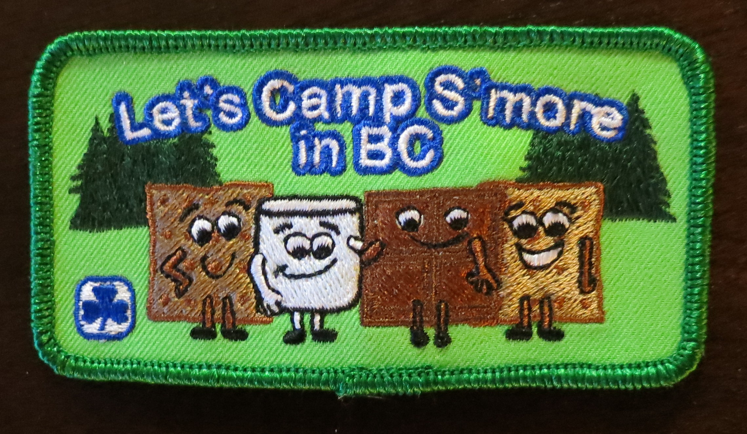

The Let's Camp S'more program objective is to introduce and teach basic camping skills to newer guides and their guiders, to help to motivate them to want to camp in tents, and to increase their interest to camp more often while having fun in a camping environment. Basic camping skills include activities such as outdoor cooking, fire building, tent care, shelter and tarp erecting, trail marking, dish washing, basic compass, bedroll and gear packing, outdoor dressing, kit list developing, and running Guides Own. Please note, these activities are suggestions. Not all activities must be done.

The primary objective of this camp is to give Guides a chance to sleep in a tent for the first time and learn how to help in the preparation and cooking of their food. Please give them the opportunity to work on these skills and just step in to assist where necessary. Too this end, we are making this a very simple camp where patrols will have lots of time to set up their tents and cook and clean up after their meals.

In this package you will find the program outline with a round robin of camping skills, games and crafts. As well, there are menu and recipe suggestions, and a kit list. As mentioned, this camp is very basic. If your campers are more experienced, you can introduce more or different activities to build on the skills they already have. Plan your camp to suit your girls and your available time. Pick those activities that work the best for you and your girls and remember to be flexible. Adapt this package to have fun learning the basic camping skills to keep you and your girls happy in learning to camp in a tent setting.

Remember to use the most current Safe Guide forms, available from the website. Your Camping, and Program Advisers and your local trainers are there to help you with planning any part of your camp or if you have any questions or concerns.

There is an interactive crest order form available on the web site at www.bc-girlguides.org. The crests are $1.00 each for units in BC.

An evaluation form has been included for you to complete after your camp and the BC Camping Committee would greatly appreciate hearing from you. Your suggestions and comments are very useful in the creation of future camp packages. We love receiving pictures, so please send some of those along too!

The most important thing is flexibility and adapting this package to work for your camp. Please use your wonderful creativity as required! Most of all have fun at camp!

BC Camping Committee

Created 2013

If you received this resource as a printed copy please check the BC Girl Guide website to ensure it is the most recent version. This copy was revised in December, 2013.

Let's Camp S'more
CONTENTS

Welcome – from BC Camping Committee page 1
Contents 2
Core Staff, Team, Patrol Guider & Camping Com. Responsibilities 3
Suggested Time Line 4
Program Guideline 5
Program Activities & Details 7
Menu & Recipes 13
Kit List 14
Crest and Dippy Bag Orders 15

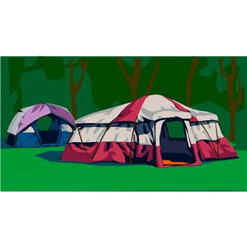
Organizational Responsibilities

THE AREA CORE STAFF:

The team (Hostess Committee) should consist of a Responsible Guider, Substitute Responsible Guider, First-aider, Quarter Master (QM), and Program Leaders (these can include experienced Guiders and Rangers). Team size will vary depending upon the number of participants.

THE TEAM'S RESPONSIBILITY:
- Book the appropriate campsite – with at least 1 night of residential sleeping and a large enough outdoor area for all planned activities
- Coordinate finances, and developing a budget to include accommodation, food, program, LCS dippy bags and crest costs (the standard LCS bags and crests)
- Advertise in your area and neighbouring areas
- Put together the core staff team
- Use the OAL Go Camping document (available at https://www.girlguides.ca ) when planning your event. Be certain all Safe Guide requirements are met and all forms are submitted to a Yellow Activity Assessor for assessment
- Communicate with Patrol Guiders by providing the kit list, travel directions, camp expectations and evaluations
- Assign sleeping arrangements
- Develop and plan program to encourage mingling between patrols, as each group can learn something from each other.
- Send payment and order form for LCS dippy bags and crests to the Provincial office, at least four weeks prior to event
- Enjoy the camp weekend

THE PATROL GUIDER'S RESPONSIBILITY:

- Responsible for their patrol girls

- Participate in all programs and activities provided by Hostess Committee

- Help where ever needed

- Ensure all forms are submitted to event Responsible Guider on time

- Follow requested directions, and bring kit list equipment to camp

- Provide evaluation to Responsible Guider at end of event

- Have fun!

THE BC CAMPING COMMITTEE'S RESPONSIBILITY:

- Provide Let’s Camp S’more information packet

- Provide direction and/or assistance as required

- Provide dippy bags and crests for purchase

SUGGESTED TIMELINE

14 Weeks Prior

- Discuss with your area, and receive approval from your councils to proceed

- Book tentative campsite

12 Weeks Prior

- Build your Core Staff Team

- Prepare the prospectus and application forms

10 Weeks Prior

- Advertise the event. Provide reasonable time to receive applications back from interested Patrol Guiders

6 weeks prior

- Receive applications, health forms, and camp fees from Patrol Guiders
- Hold camp planning session with Core Staff Team. Plan program based on numbers attending

4 Weeks prior

- Communicate with Patrol Guiders attending by giving them the kit lists and any specific information related to the site. e.g., map with directions, arrival time, bedding needs for campsite, and/or program supplies for their patrol
- Provide all Safe Guide forms to Patrol Guiders to complete and request an emergency contact list
- Send all health forms to First-aid Guider, and note any food concerns to QM

- Send registration form and dippy bag order to BC Camping Committee

2 weeks prior:

- Complete all Safe Guide forms, submit SG3 to an appropriate Activity Assessor
- Notify Commissioner and Camp Adviser of event

- Forward emergency contact list to home contact person
- Prepare welcome kits for patrols. Should include the program schedule, activity sign-up sheet, program itinerary, campfire, etc.

Camp Weekend:

  - Have Fun at Camp, one S’more Time!!

week After Camp:

- Make sure all expenses are paid out, and finalize expense reports. Supply finance and program summary to your Area Council

PROGRAM GUIDELINE

FRIDAY EVENING
6:00 - 7:00 Arrive
check in
take gear to rooms
camp boundaries, rules, fire drill, patrol duties

7:45 Welcome, housekeeping rules
8:00: Craft stations (20 minute/station)
- light tea lights
- frying pan
- bedroll hat craft
- name tags for dish bags

9:30 pm – Mug up and get ready for bed – Guider meeting while girls have mug up.

10:30 pm – Quiet time

SATURDAY
7:00 am - Rise and shine, get washed up etc.

8:00 am – Breakfast

9:00 am – Fire drill

9:10 am – Flags and announcements

9:30 - 11:45am – Round Robin sessions (30 minutes/station)
- camp kitchens and washing dishes
- stoves and lanterns
- putting up tents and pop ups
- If you have groups already in tents they will do bingo and compass drawing for two sessions

10:30 – 10:45 am – snack

10:45 am – 11:45 am – Round Robin continued

Noon – Bring tote to kitchen for lunch and snack supplies, prepare lunch, and clean up

2:00 pm – 2nd Round Robin sessions ( 15 minutes/station)
- camp etiquette
- progression of Guiding skills
- camp fire
- packing for camp

3:00 pm – snack

3:15 pm – Barnyard Bedlam (camp organizers lead game while the Patrol Guiders get a break), setting up gear in tents

5:00 pm – Bring tote to kitchen for supper fixings, prepare supper, clean up

7:30 pm – Campfire

8:30 pm – Mug up followed by bathroom time and in to tents.

10:00 pm – Quiet time

SUNDAY

7:30 am – Bring mug to kitchen for hot chocolate and fill tote with breakfast supplies. Cook breakfast and clean up patrol dishes.

9:00 – 9:45am - Pack up patrol gear and complete evaluations

9:45 - Closing



PROGRAM ACTIVITIES

Choose your activities to suit the need and experience of your campers. The following is suitable for girls and guiders new to camping.

FRIDAY ROUND ROBIN SESSIONS - 20 minute stations

Tea Lights - at this station girls practice lighting tea lights in preparation of lighting camp stoves and lanterns.
Bedroll Hat Craft - see blow
Frying Pan Hat Craft - see below
Name Tags - Supply each girl with a dippy bag. These can be stuffed with duct tape, a compass, a flashlight and a small first aid kit or other such camping items available from local Dollar stores. Supply each girl with a 2"x 3" piece of fun foam and have them decorate this with their names and, if using, their patrol design. Attach these to their dippy bags for easy identification.

SATURDAY AM ROUND ROBIN SESSIONS - 30 minute stations

Camp kitchens/Washing Dishes - Have each patrol bring their camp kitchens with them to this station. Go through each making suggestions of how they can be improved. Also, go over the 3 dish pan method of washing dishes. (See below)

Stoves and Lanterns - Go over the basic parts of the stoves and lanterns. Attach the propane and check for leaks with soapy water. Practice lighting each.

Putting up Tents and Pop-ups - Each patrol with the help of one experienced Guider will put up their tent and pop-up. Be sure that all girls are involved in the activity, and not merely watching the Guider do this activity. The girls will place their gear in the tents once the tents and pop-ups are erected.

Bingo/Compass Drawing - if you have a group of more experienced girls who have come into camp early they may want to spent 2 nights in their tents. They would have set up their tents prior to this Round Robin session. If this is the case, they can do this session in place of the "Putting up Tents and Pop-up" session. (See Bingo card and Compass drawing grids below)

SATURDAY PM ROUND ROBIN SESSIONS - 15 minute sessions

Camp Etiquette - Information to cover: leave no trace camping, considerate tent life, don't pick or damage any of the natural surroundings, respect for wildlife and don't feed any of the animals, respect camp quiet times, keep your campsite neat, keep your gear neat and your designated area, store food in the proper way, do your share of the camp chores.

Progression of Camping Skills - available from bc-girlguides.org > camping resources. This session can be run as a "Red light/green light" game. A Leader calls out the Girl Guide camping skills. If the girls have completed them they go forward and if they haven't they go back. Remember to make all games fun!

Camp Fire - go over the planning of a campfire, get suggestions of what songs they would like to sing later in the evening.

Packing for Camp - suggest what should be on the kit list and how to pack

ACTIVITIES, CRAFTS & GAMES

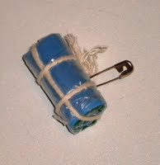
Bedroll Camp Hat Craft
Supplies
- blue fun foam - 5x11 cm
- green felt - 10x10 cm
- plastic sandwich bags, split at the seams to become 2 squares
- string
To Do
- lay out plastic "groundsheet"
- place your blue foam "mattress" in the centre
- fold a piece of felt in half (sleeping bag) and place on foam
- make a packers knot in one end of your string so you are ready to tie your bedroll when rolled
- fold groundsheet over the top of the sleeping bag and then into the centre from both sides
- starting from the top, tightly roll the bag making sure to keep the sides of the ground sheet tucked in as you roll
- when you get to the bottom use a V-fold to tuck in the end of the ground sheet so no loose ends are showing.
- secure the bedroll with your string by following the directions from "How to Make a Bedroll"

Frying Pan Hat Craft
Supplies
- small pieces of brown, white and yellow felt
- piece of black pipe cleaner
- bottle cap or film canister lid
To Do
- cut bacon (brown) and eggs (white and yellow yolks) from the felt
- glue them to the inside of the lid
- glue the pipe cleaner to the edge of the lid to form the frying pan handle

Washing Dishes The Girl Guide Way
- begin with 3 washing basins
- place hot soapy water in the first, warm rinse water in the second and cool bleach water in the third
  - don't have water so hot it will burn the girls and use a very small amount of bleach 1/2 cap
- once the dishes are washed, rinsed and bleached, place them in the dippy bags and hang them from a line
- to clean the basins, dump the soap water basin into the grey water pit. Then dump the rinse water into the wash basin and then dump it into the pit. Lastly dump the bleach water into the rinse basin and then into the wash basin and then into the pit. This way all basins will have been bleached.
- place the basins upside down, slightly stacked to air dry
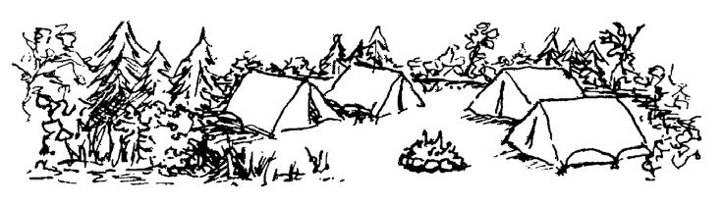
B | I | N | G | o
Lady bug | Heart shaped rock | An acorn or other nut | Tracks | Spider web
An edible plant | butterfly | ants | A birds nest | A berry or a plant that will have berries
A feather | Clover | FREE | A Robin | Pine cone
Mushroom | Scat | seeds | Yellow flower | Spider
Bird song | Signs of a squirrel feast | An insect other than an ant | An insect home | Moss covered rock

Nature Bingo - This is just one example of what can be included in your bingo card.

Compass Drawings
Equipment: (for each girl)
Pencil, graph paper, list of directions
How to Play:
- Use a pencil to "connect the dots" on a sheet of graph paper following the directions and distances given.
- One step equals one space.
- Completing the directions will create a picture

Graph Paper Trefoil
Start near the middle of the page, at least 5 squares from the bottom.

1. Go North-West 1 step
2. Go North 2 steps
3. Go East 2 steps
4. Go South-East 1 step
5. Go East 2 steps
6. Go North 3 steps
7. Go West 1 step
8. Go South-West 1 step
9. Go West 2 steps
10. Go North-West 1 step
11. Go North 3 steps
12. Go North-East 1 step
13. Go East 2 steps
14. Go North-West1 step
15. Go North 1 step
16. Go North-East 2 steps
17. Go East 3 steps
18. Go South-East 2 steps
19. Go South 1 step
20. Go South-West 1 step
21. Go East 2 steps
22. Go South-East 1 step
23. Go South 3 steps
24. Go South-West 1 step
25. Go West 2 steps
26. Go North-West 1 step
27. Go West 1 step
28. Go South 3 steps
29. Go East 2 steps
30. Go North-East 1 step
31. Go East 2 steps
32. Go South 2 steps
33. Go South-West 1 step
34. Go West 8 steps

Graph Paper Maple Leaf
Start near the bottom center of the page.

1. Go North 7 steps
2. Go East 6 steps
3. Go North-West 1 step
4. Go North-East 4 steps
5. Go West 1 step
6. Go North 2 steps
7. Go West 2 steps
8. Go North 1 step
9. Go South-West 4 steps
10. Go North 8 steps
11. Go South-West 1 step
12. Go North-West 2 steps
13. Go South-West 2 steps
14. Go North-West 1 step
15. Go South 8 steps
16. Go North-West 4 steps
17. Go South 1 step
18. Go West 2 steps
19. Go South 2 steps
20. Go West 1 step
21. Go South-East 4 steps
22. Go South-West 1 step
23. Go East 6 steps
24. Go South 7 steps

Graph Paper Toadstool
Start at least six squares from the left side of the page.

1. Go North 4 steps
2. Go West 2 steps
3. Go South-West 1 step
4. Go West 1 step
5. Go North-West 1 step
6. Go North 2 steps
7. Go North-East 3 steps
8. Go East 6 steps
9. Go South-East 3 steps
10. Go South 2 steps
11. Go South-West 1 step
12. Go West 1 step
13. Go North-West 1 step
14. Go West 2 steps
15. Go South 4 steps
16. Go West 2 steps

BEDROLLS One example of how to make a bedroll

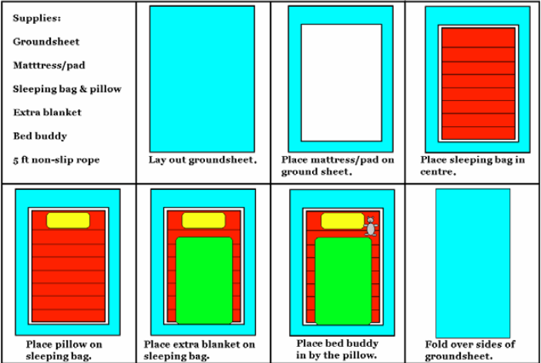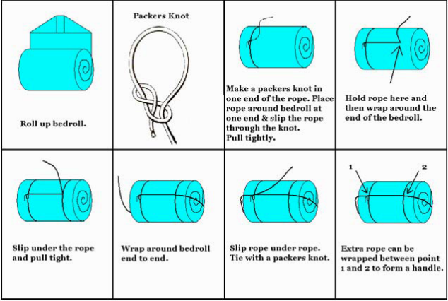

Background
Although the art of tying bedding rolls has been around for a very long time, the information is not passed on, rather re-learnt by each new generation. The armed forces teach recruits this valuable life skill, but opportunities for civilians are limited.
When Lord Robert Baden-Powell wrote "Scouting for Boys" in 1908, his ideas included camping activities. Similar ideals were adopted when Lady Olave Baden-Powell introduced the Guiding movement for girls.
Unfortunately, although each boy and girl who goes to scout or guide camp should be taught how to tie a bedding roll, very few of them retain this information. This leaves modern scout and guide leaders in a sticky spot. If you are new to leading a scout or guide unit on camp, the sources for you to gather this information are scant and incomplete. Our quest for this information has led us to create this instruction for you. It may not be textbook, but it works.
Why bother?
If you are asking this question, you have never had to go to camp in the rain! A properly tied bedding roll will keep all your bedding dry, even surviving being dropped in water. At camp a dry night’s sleep is a valuable commodity.
If your sleeping bag has no stuff sack, you roll it as tightly as you can, starting at the foot, and tie it with the attached ties. Some people sew on pieces of elastic and just slip them over the rolled bag.
What do you need?
Ground Sheet - 6’(180cm) x 4’(120cm) Camping Mat Blankets – to act as insulation to keep you warm Sleeping Bag Pillow Night Clothes Strong cord or rope - 3-4 metres long (12’ minimum), ¼” thick minimum
A friend

Ground Sheet
A ground sheet is any kind of waterproof material. You can buy rubber or heavy gauge plastic or an old shower curtain. It should be a little longer and wider than your unrolled (but zipped up) sleeping bag.
The ground sheet is laid on the ground to protect your sleeping bag, pad and you from ground moisture.
When your sleeping bag is rolled or in its stuff sack, you make it waterproof by wrapping the ground sheet around it and tying it with a rope as illustrated. If you do this properly, your bedroll will remain dry even if out in the rain or if dumped in the river from a canoe. The rope should be sturdy, with the ends whipped.

BARNYARD BEDLAM
Spread a large number of acorns (or similar item) over the playing area.
Each patrol is assigned an animal and they pick a farmer.
Patrols go in search of the nuts. When they find one, they stand next to it making the appropriate noise (mooing, clucking, etc.) until the farmer comes to them.
Sometimes there may be multiple "animals" at the same nut at any given time.
The nuts can be counted and a winner declared but forgoing a count and awarding everyone a treat is a great way to encourage great "camping spirit"

LOVE TO CAMP - to be read and repeated line by line at camp closing

To be in the great outdoors

mountains, lakes, trees.

Learning how to survive

cooking over a fire; putting up a tent.

Sitting around the campfire

sharing songs and stories

with my sisters in Guiding - -- - - -

love to camp

MENU/RECIPES

Always remember all allergies and special dietary needs that you have in your group.

Depending on the skills and experience of your campers more of the cooking can be done by patrols. Lunch could be cooked on propane stoves or on buddy burners. However, remember patrol cooking does take more time than having a camp cook. Remember the focus of this camp is for girls and Guiders to learn the basics of tent camping. More complex skills can be learned at a later camp.

Friday night mug up:
Meat, cheese, crackers, chocolate milk or milk

Saturday breakfast:
Pancakes, sausages, syrup and fruit

Snack:
Apple & water

Lunch:
Chicken noodle soup, grilled cheese sandwiches, veggies and dip, water

Snack:
Granola bar and juice box

Dinner:
Fixings to make chicken fajitas or quesadillas (tortillas, cooked chicken, cheese, veggies, and salsa) worms in dirt in a cone (cone, marshmallow for bottom, chocolate pudding, crushed cookies, cream, gummy worm) and a drink

Mug up: hot apple juice, S’more bag (cereal)

Sunday breakfast:
Hot choc with whipped cream in kitchen. Make egg mcmuffins with scrambled egg, ham, cheese and English muffins, instant oatmeal, juice. We will cook breakfast for them if the weather isn’t nice.

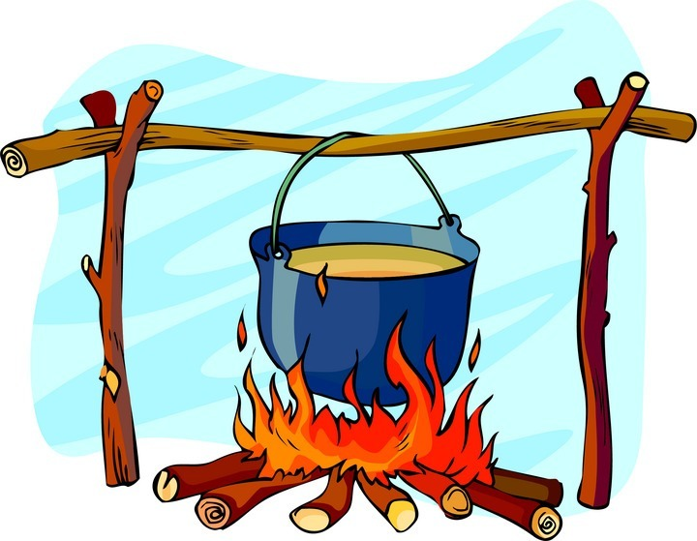

Participant Kit List
Everyone should always wear uniform to and from camps.
Please keep in mind that items may need to be added or deleted depending on the time of year and whether you are indoors or out!
Remember to LABEL everything clearly in case it gets misplaced. If it’s irreplaceable please leave it at home. Bring two pieces of luggage only: a bedroll and a small duffle bag that the girl can carry (No garbage bags). Your daughter should help pack her gear or she will not know where to find things while at camp.

Clothing
• warm pyjamas (a tracksuit works well)
• pants (1 pair) (NO blue jeans)
• t-shirts (2)
• sweatshirt or pullover (1) (not the one to sleep in)
• socks (3)
• extra socks to wear to bed (1)
• underwear (3)
• sturdy shoes for walking/hiking (NO open-toed shoes)
• warm jacket with hood
• raingear (MUST) including boots
• camp hat (MUST)
• plastic bag for dirty laundry
• inside shoes or slippers (must have hard soles)
• toque and gloves or mitts
Gear
• sleeping bag (suitable for time of year)
Note: theme-styled bags tend to be thin and do not provide adequate insulation.
• extra blanket
• sleeping mat—closed-cell foam or self-inflating thermal mat (Blow-up air mattresses are not suitable or reliable.)
• ground sheet (an old shower curtain, piece of tarp or any kind of plastic big enough for the sleeping mat to fit on)
• small pillow (optional)
• sleeping buddy (small, optional)
Dishes
• Unbreakable plate, mug, cup, bowl, fork, knife and spoon in a mesh bag (because the dishes hang to drip dry)
• Label all dishes and cutlery with the girl’s name or initials using nail polish or permanent marker. Tape will fall off when the dishes are washed. Make sure the permanent marker is actually permanent!
Personal Items
These may be packed in an ice cream bucket with name in permanent marker – no tape!
• hand towel, face cloth, soap, tooth brush and paste, etc.
• hair brush and ties (long hair must be tied back at all times)
• small package of tissues
• water bottle
Miscellaneous
• camera • whistle
• personal first aid kit • sunscreen (no spray)
• bug lotion (no spray) • sit-upon or folding camp chair
• water bottle
• flashlight with new batteries, plus a spare set (in a labeled zip lock bag)
Medications: To be given to the first aider upon arrival at camp.
Place all medications (prescription and over-the-counter) in a zip-lock plastic bag clearly labeled with the girl’s name.
All medication (prescription and over the counter) must be in the original container and clearly labeled with dispensing instructions.
Please leave at home:
- all sleeveless tops (spaghetti-strap tops, tank tops, etc.)
- all open-toed shoes
- all electronic devices, including cell phones
CREST ORDERS:

Let's Camp S'more crests ($1.00 or $1.50 for non BC units) and dippy bags ($4.00) can be ordered from the BC Girl Guides website. Crests and dippy bags can be provided in advance, but please allow four weeks for delivery.

To place an order:
- include a check made out to BC Girl Guides - BC Council and mail the check and order form to: Crest Requests
Girl Guides of Canada - BC Council
1476 W 8th Ave.
Vancouver, BC V6H 1E1.
- email the completed crest order to officeclerk@bc-girlguides.org and then phone 604-714-6636 extension 123 or toll free 1-800-565-8111 (during office hours) and give your order information to pay by credit card.



