chapter
1

Managing Effectively in a Changing World

CHAPTER CONTENTS

Learning Objectives 3

Key Student Questions 3

Class Roadmap 4

Key Terms Presented in This Chapter 7

Sustainability Box 8

Prep Cards 9

Lecturettes 12

Additional Discussion Quesions 16

Examples 20

Expanded PowerPoint Slide Show 22

Supplemental Features 27

Young Manager Clips 27

Manager’s Hot Seat 27

Self-Assessment 27

Test Your Knowledge 27

(c) 2016 by McGraw-Hill Education. This is proprietary material solely for authorized instructor use. Not authorized for sale or distribution in any manner. This document may not be copied, scanned, duplicated, forwarded, distributed, or posted on a website, in whole or part.

LEARNING OBJECTIVES

LO1 Describe the four functions of management.
LO2 Understand what managers at different organizational levels do.
LO3 Define the skills needed to be an effective manager.
LO4 Summarize the major challenges facing managers today.
LO5 Recognize how successful managers achieve competitive advantage.

KEY STUDENT QUESTIONS

Students typically enroll in an introductory management course with two primary questions:

⬧
1. “What makes a “good” manager?”
2. “How can I apply the material we learn in this class to my daily life?”

How you answer these questions depends on your teaching style and the tone you want to set for the class.
- To increase class involvement, ask two or three students to describe the best managers they have ever known. Capture what the students say, and then ask the class to tell you what similarities and differences they hear in the stories. Link the similarities to the skills needed for planning, organizing, leading and controlling, and then discuss the differences in terms of leadership style and the flexibility leaders need to react differently to different situations. It is important to let students know that there is not single set of guidelines to become a “good” manager. The best managers are the ones who have a wide range of skills which they apply differently in different situations. Then ask students to describe situations they have encountered recently where they needed to use planning, organizing, leading and/or controlling. Based on the discussion, help students to see that the best way for them to apply the material is to think about how to use each concept in their own lives. One useful analogy here is to compare technical, interpersonal, and conceptual skills to different types of tools - not every tool is right for every person, and not every tool is right for every task, but the more tools you have in a toolbox, the more likely it is that you will be able to get the job done effectively.

- To maintain more control over the class, start the class by saying “This is your first day as a manager.” Explain that whenever anyone creates a “to do” list they are planning, whenever anyone tries to persuade someone else to do something they are leading, whenever anyone checks to see if they have enough money in their checking account to take a vacation they are organizing, and whenever anyone balances a checkbook they are controlling. Go on to explain that just as people have different styles of writing “to do” lists and managing their money, managers use different styles of management, but that certain key skills have emerged, and that the purpose of the class is to help students learn those skills.

Teaching Tip
The first day of class sets the tone for the rest of the quarter. If at all possible, I try to do three things on the first day of class:
1) go over the class syllabus (which helps the students understand my expectations for the class);
2) find out from the students what their expectations are for the class (I record these, and at the end of the term ask students if they have been met); and
3) cover some introductory material from Chapter 1 of the text (usually managerial skills, levels of management, etc.) By starting to lecture and discuss material on the first day of class, you convey your excitement about the subject matter, and you help your students become more excited about it, too.

CLASS ROADMAP

LO1 - The Four Functions of Management

Management is the process of working with people and resources to accomplish organizational goals.

1.1 Planning helps you deliver value
- Planning is specifying the goals to be achieved and deciding in advance the appropriate actions taken to achieve those goals.
- Planning activities include analyzing current situations, anticipating the future, determining objectives, deciding in what types of activities the company will engage, choosing corporate and business strategies, and determining the resources needed to achieve the organization’s goals.
- Delivering strategic value is a process in which people throughout the organization use their brains and the brains of customers, suppliers, and other stakeholders to identify opportunities to create, seize, strengthen, and sustain competitive advantage.
1.2 Organizing resources achieves goals
- Organizing is assembling and coordinating the human, financial, physical, informational, and other resources needed to achieve goals.
- Activities include attracting people to the organization, specifying job responsibilities, grouping jobs into work units, marshalling and allocating resources, and creating conditions so that people and things work together to achieve maximum success.

1.3 Leading mobilizes your people
- Leading is stimulating people to be high performers.
- Directing, motivating, and communicating with employees, individually and in groups.
1.4 Controlling means learning and changing
- Controlling monitors progress and implements necessary changes.
- Makes sure that goals are met.

1.5 Managing requires all four functions
- Most managers have to perform all four management functions more or less simultaneously.

LO2 – Four Different Levels of Managers

2.1 Top managers strategize and lead
- Top-level managers are senior executives of an organization and are responsible for its overall management.
- Referred to as strategic mangers, focus on long-term issues and emphasize the survival, growth, and overall effectiveness of the organization.
- The chief executive officer (CEO) is one type of top-level manager.

2.2 Middle managers bring strategies to life
- Middle-level managers are located in the organization’s hierarchy below top-level management and above frontline managers.
- Called tactical managers, they are responsible for translating the general goals and plans developed by strategic managers into more specific objectives and activities.
- An administrative controller who bridges the gap between higher and lower levels.

2.3 Frontline managers are the vital link to employees
- Frontline managers are operational managers are lower-level managers who supervise the
operations of the organization.
- They successfully implement operations in support of company strategy.
- Team leaders are expected to help their teams achieve important projects and assignments.

2.4 Team leaders facilitate team effectiveness
- Team leaders engage in a variety of behaviors to achieve team effectiveness.
- Team leaders are more like project facilitators or coaches.

2.5 Three roles that all managers perform
- Interpersonal roles: Leader, Liason, Figurehead
- Informational roles: Monitor, Disseminator, Spokesperson
- Decisional roles: Entrepreneur, Distrubance handler, Negotiator

LO3 – Managers Need Three Broad Skills

3.1 Technical skills
- A technical skill is the ability to perform a specialized task that involves a certain method or process.
a. Specific abilities that result from knowledge, information, practice, and aptitude.

3.2 Conceptual and decisional skills
1. Conceptual and decision skills involve the manager’s ability to identify and resolve problems for the benefit of the organization and everyone concerned.

3.3 Interpersonal and communication skills
1. Interpersonal and communication skills influence the manager’s ability to work well with
people.
- These skills are often called people skills or soft skills.
- Emotional intelligence involves a managers’ ability to understand themselves, manage themselves, and deal with others.

LO4 – Major Challenges Facing Managers

4.1 Business operates on a global scale
- Globalization means that talent can come from anywhere.
- Top CEOs know that the change from a local to a global marketplace is gaining momentum, and irreversible.
- Ideally, transnational companies have managers who specialize not only in particular businesses and functions, but also particular countries.

4.2 Technology is continuously advancing
- The Internet changes the way management thinks and acts.
- The percentage of trade that takes place on the Net is small, but it is growing, as is the number of Internet users worldwide.
- Social Capital is goodwill stemming from your social relationships

4.3 Knowledge is a critical resource
- Knowledge management is the set of practices aimed at discovering and harnessing an organization’s intellectual resources.
- Knowledge management is about finding, unlocking, sharing, and altogether capitalizing on the most precious resources of an organization: People’s expertise
- Skills
- Wisdom
- Relationships

4.4 Collaboration boosts performance
- Effective collaboration requires productive communications between different departments, divisions, or other subunits of the organization.
- Companies today also must motivate and capitalize on the ideas of people outside the traditional company boundaries.
- Involving the customer more in company decisions.
- Get customers to think creatively and talk with one another online to come up with new product and service ideas.

4.5 Diversity needs to be leveraged
- Diversity in the labor force is becoming greater and greater.
- Managers need to leverage the strengths of diverse employees.

LO5 – Sources of Competitive Advantage

  - Transformational industries, such as industries centered around the Internet today and the car 100 years ago, show us that the key to having a competitive advantage is being able to sustain that advantage over time.

5.1 Innovation keeps you ahead of competitors
- Innovation is the introduction of new goods and services.
2. Innovation comes from people; it must be a strategic goal; and it must be managed properly.
5.2 Quality must continuously improve
- Quality is the excellence of a product, including its attractiveness, lack of defects, reliability, and long-term dependability.
2. Quality can be measured in terms of performance, various service dimensions, reliability (failure or breakdowns), conformance to standards, durability, serviceability, and aesthetics.

5.3 Services must meet customers’ changing needs
    - Service means giving customers what they want or need, when they want it.
    - An important dimension of service quality is making it easy and enjoyable for customers to experience a service or to buy and use products.

5.4 Do it better and faster
- Speed involves rapid execution, response, and delivery of results. It often separates the winners from the losers.
- For some companies, speed has become a strategic imperative.

5.5 Low costs help increase your sales
- Cost Competitiveness means keeping costs low enough so the company can realize profits and price its products (goods or services) at levels that are attractive to consumers.
- Managing your costs and keeping them down require being efficient.
- Costs that need to be managed carefully
Raw material
Equipment
Capital
Manufacturing
Marketing
Delivery
Labor
- Because the cost of customer acquisitions is so high, the Internet is a great way to communicate with customers but a terrible way to get new customers.
5.6 The best managers deliver all five advantages
- The best managers and companies don’t pay attention to just one competitive advantage - they deliver all five of them.

KEY TERMS PRESENTED IN THIS CHAPTER

Conceptual and decision skills Skills pertaining to the ability to identify and resolve problems for the benefit of the organization and its members.
Controlling The management function of monitoring performance and making needed changes.
Cost competitiveness Keeping costs low to achieve profits and be able to offer prices that are attractive to consumers.
Emotional intelligence The skills of understanding yourself, managing yourself, and dealing effectively with others.
Frontline managers Lower-level managers who supervise the operational activities of the organization.
Innovation The introduction of new goods and services.
Interpersonal and communication skills People skills; the ability to lead, motivate, and communicate effectively with others.
Knowledge management Practices aimed at discovering and harnessing an organization’s intellectual resources.
Leading The management function that involves the manager’s efforts to stimulate high performance by employees.
Management The process of working with people and resources to accomplish organizational goals.
Middle-level managers Managers located in the middle layers of the organizational hierarchy, reporting to top-level executives.
Organizing The management function of assembling and coordinating human, financial, physical, informational, and other resources needed to achieve goals.
Planning The management function of systematically making decisions about the goals and activities that an individual, a group, a work unit, or the overall organization will pursue.
Quality The excellence of your product (goods or services).
Service the speed and dependability with which an organization delivers what customers want.
Social capital Goodwill stemming from your social relationships.
Speed Fast and timely execution, response, and delivery of results.
Team Leaders Employees who are responsible for facilitating successful team performance.
Technical skill The ability to perform a specialized task involving a particular method or process.
Top-level managers Senior executives responsible for the overall management and effectiveness of the organization.

SUSTAINABILITY BOX

Indra Nooyi of PepsiCo Pushes for Sustainable, “Healthier” Growth

PepsiCo is known for Doritos, Cheetos and Mountain Dew, but the CEO, Indra Nooyi, is pushing for “delivering sustainable growth by investing in a healthier future for people and our planet.” Nooyi has started a sustainability initiative called “Performance with Purpose”.” The two components of PepsiCo’s sustainability strategy include:
1) Human Sustainability – Encouraging people to live balanced lives
2) Environmental Sustainability – In 2010, PepsiCo launched a recycling partnership with 3 com panies to increase container recycling to 50% by 2018.

DISCUSSION QUESTIONS & SUGGESTED ANSWERS

1) Indra Nooyi, as CEO of PepsiCo, faces some unique challenges as she advocates a dual-focus strategy for her company. Describe your reaction to her dual-focus strategy and whether you think it will help PepsiCo succeed in the future.

As more and more companies are becoming sensitive to environmental sustainability, it will be important for companies to stay successful and continue to be successful in the future. Although it may not be viewed as profitable, it will enhance the overall corporate image and reputation of the company which is built over a period of time. Sometimes you have to have a dual-focus as prescribed by Nooyi.

2) To what degree do you think a “Perfor- mance with Purpose” strategy would be applicable to other organizations (using examples)? How could leaders of other organizations modify the strategy so it would fit their particular organizational cultures and industries?

Every organization has the ability to develop and implement a sustainability strat egy. Take a look at what other companies are doing to get some ideas.
Cisco – Reduced employee travel and office space by enabling virtual workforce and telecommuting
Intel – Rigorously addresses renewables, energy savings and LEED certification.
AMD – Carbon footprint certification
Sabre – Initiated sustainability goals as part of management objectives

PREP CARDS

DISCUSSION QUESTIONS

- Look at the bar chart on page 9. By a show of hands, how many of you would say that you relate positively to your current (or previous) boss? Why or why not? What could your boss do to improve the way he or she relates to you?

Answers will vary but if consistent with the general working population, the majority of the class might raise their hands. Students will still have a variety of recommendations about how this relationship could improve, though, including recommendations for communication and feedback on performance.

- While frontline managers have direct managerial control over their employees, team leaders do not have direct control over team members. What strategies can team leaders use to direct team members to achieve organizational objectives?

Answers will vary but students might discuss how team leaders can make sure the team has a shared vision of their goals, objectives, and expectations for members.

GROUP CHALLENGE: “Moms and Dads as Managers”

Divide the class into groups of three to five students and ask them to brainstorm about the following questions:
- How does a parent perform the function of planning?

Examples will likely include activities related to preparing children for various stages of education, from kindergarten through college. For example, making decisions about school placement and ongoing educational activities to ensure success.

- How does a parent perform the function of organizing?

Examples here might include parents’ employment, budgeting, mortgage or rental payments, hiring of babysitters or tutors, etc.

- How does a parent perform the function of leading?

Answers may vary more here based on parenting styles but will highlight activities related to directing, motivating and communicating with family members.

- How does a parent perform the function of controlling?
Students might mention disciplinary aspects of parenting or various safeguards and probationary periods encountered throughout childhood.

ACTIVITIES

The Holland Code test is based on the idea that peoples’ personalities are reflected in their occupational choice. The self-assessment consists of 48 example tasks that students have to rate by how much they would enjoy performing each. Upon completion, students receive their RIASEC marker, a three-letter code representing the top three domains of endeavor that appeal to them. Holland Codes are frequently used in career counseling. This free self-assessment is available at: http://personality-testing.info/tests/RIASEC.php. Upon completion of the self-assessment, students should submit a brief report evaluating their results and answering the following questions:

1. What were your top three domains of endeavor? Explain each one briefly.
2. Do you agree or disagree with the results of this self-assessment? Why?
3. Do you think a self-assessment like this would be helpful to you in choosing a career? Why or why not?

Students generally find this exercise to be consistent with their views of their own career interests and find that the assessment is helpful in allowing them to consider additional career options that they may have overlooked. However, students will also note that changing majors or career trajectories at this point in their educational process can also pose many challenges.

CHAPTER VIDEOS

• Redbox - Run time: 10:47
Redbox was created to fill a customer need in the marketplace -- renting low-cost movies in a convenient location. It is now America's No. 1 choice for movie rentals and has over 27,800 kiosks across the country dispensing DVDs, Blu-ray, and video games. Located conveniently in over 400 retail partnerships, customers can rent a DVD for only $1 per day. Redbox has responded to the challenges of continuously advancing technology by allowing customers to view kiosks' inventory and reserve items online, and search Redbox's database for the closest kiosk that has a desired item in stock. A diverse workforce is important to Redbox to help it better understand its customers and address its customers' wants and needs.

Follow-Up Questions:
- One source of competitive advantage is to be able to meet customers' changing needs. Explain how Redbox has been able to do this.

Redbox allows customers to purchase low-cost movies at a convenient location.

- How has the collaboration between McDonald's and Redbox benefited both companies?

McDonalds’ dinner business was slow and installing Redbox video kiosks helped increase business during slow periods. Redbox customers also must return the next day to return the movie, increasing the likelihood of more business at McDonalds. Redbox benefitted by placing their kiosks in high traffic areas.

3. In what ways has Redbox used technology to improve the services it offers to customers?
Customers can use their phones or the internet to find kiosk locations, find movies, check inventory of the movies, and purchase rentals.

- Explain how Redbox leverages its diverse workforce.
Employee diversity allows for a better understanding of Redbox’s customer base.

- Zappos.com -- Run Time: 12:36
Purchased in 2009 by Amazon.com, Zappos has been allowed to continue to operate as it had prior to the acquisition. The company's ten core values are based on pursuing growth and learning, and passion and determination. All decisions are based on these core values. The company is organized into teams that transcend the work environment, and 20% of the team's time must be spent outside of the work environment. Relationship-building helps drive a management approach that focuses on the primary goal of the company -- to provide the best possible experience for the customer.

Follow-Up Questions:
- What are the characteristics that are valued by Zappos in terms of management and leadership?

Employees who are drivers and will follow projects through from beginning to end. Micromanagers are not appropriate in Zappos’ corporate culture.

- How does Zappos incorporate its core values into the management function of organizing?

Zappos organizes their company around its 10 core values to ensure that the right management team is in place and empowered to make decisions.

3. Explain the role of teams and teamwork at Zappos.

Zappos focuses on managing tasks, not people. Employees are required to spend 20% of their time outside the office with their team.

- How has the leadership style at Zappos contributed to the success of the company?

Zappos values leaders who empower their coworkers. This translates to their high customer service ratings.

LECTURETTES

LECTURETTE 1.1: An Analysis of United States vs. Japanese Management

Research conducted in comparing American style management vs. the Japanese style of management shows that they are clearly separate from one another.

As an example the cofounder of Honda Motor Company, T. Fujisawa, observed that, “Japanese and American managers are 95 % the same and differ in all important aspects.” On one hand, managers must cope with the same challenges and opportunities-irrespective of whether they are operating in Tokyo or Los Angeles. However, in five critical areas, the business environment is very different.

NATIONAL CULTURE

The American worker usually perceives the job-even a good job-as primarily a means to an end: a source of funds through which one enjoys life off the job. The worker in America discovers that American individualistic values run contrary to the corporate workgroup. The “Go west, young man” worker mobility work ethic in America limits company loyalty and long-term employment commitments on the part of the employee.

However, the Japanese culture places extraordinary pressures on one’s obligations-especially those from above. Obligations are inherited at birth and enlarged through education and career. They result in fierce loyalty to one’s employer and one’s country. As a nation, the Japanese enjoy an amazing consensus of purpose and are highly disciplined to fulfill these obligations. In Japan, it is said that the job is society, and society is the job. Every Japanese person who joins a company shares equally in it. His or her friends work for the same company.

THE WORKFORCE

Japanese workers work together for good of the organization, avoiding individual recognition in favor of group, corporate, and national accomplishments. The American worker is an individual who looks out for number one.
Japanese workers perceive an overall duty to work long hours, shun vacations, and commit themselves completely to their work, giving Japan its long history of being called the most goal-oriented country in the world. Apathy on the part of American workers is an increasingly challenging problem. The lack of worker loyalty and work orientation is evidenced by the fact that the average tenure of any United States job is only 4.2 years, whereas the Japanese see the commitment lasting a lifetime.

Competition among employees is a long-standing American tradition and is seen as one way to keep workers sharp and hard working. Little concern is expressed for the fact that this emphasis on competition can undermine worker cooperation and employee morale. The Japanese see such competition as a negative work factor, and research has shown that Japanese worker performance deteriorates under competitive environments.

MANAGEMENT STYLE

The American management style tends to impose control through explicit and formal rules and regulations that are documented in corporate standard operating manuals. Japanese management control is more subtle, implicit, and informal. Japanese control stems from a set of corporate values that are expressed by management until a corporate culture becomes clearly understood by all employees so that it directs their every behavior. In most American companies, management fosters an “inspect to quality” philosophy that focuses on evaluation of a task after it is complete. Japanese management nurtures a “work to quality” culture that creates quality in the work process, as it is being done.

The American executive places fundamental priority on organizational efficiency, while the Japanese executive is dedicated to “Wa” or the achievement of peace and harmony, without which the firm will fail.

The CEO in a Japanese firm is a true representative of that organization and its values. Japanese CEOs receive only a fraction of the compensation given to American CEOs, although the Japanese traditionally work longer hours. Stock options, a popular form of extra compensation for American executives, are not available to Japanese executives. When a firm does poorly, the CEO typically resigns in disgrace. CEOs in failing American firms give themselves huge salary increases. Most Japanese managers at all levels of the firm, work 12-hour days, six days a week. American executives believe in their own individualism and do not see themselves as required to carry the image of the firm as a personal obligation.

SUPERIOR-SUBORDINATE RELATIONSHIPS

There is a clear superior-subordinate relationship in American companies, and this relationship is often shallow and short-term. The Japanese have a very different philosophy reflected in the saying that “It’s the superior’s job to help the subordinate learn the job.” In Japan, there is a mentor-protégé relationship that is almost Godfather-like: a relationship that is both functional and emotional. The Japanese superior assumes the corporate lifetime commitment and accepts the responsibility in a holistic manner (i.e., a responsibility for all aspects of the subordinate’s life for a lifetime). Such an approach would not be possible in the United States since workers would strongly resent any efforts on the part of a superior to meddle in their private lives.

The acceptance of women in the managerial ranks of American companies is well accepted. However, in Japan, management is not viewed as a legitimate position for women. In fact, working beyond the marrying age is not an acceptable activity for women. Japanese management has yet to accept the rights of the working-woman.

DECISION MAKING

In an individualistic society such as the United States, it is not surprising that there is a tradition that an American manager is skilled at making decisions alone. Seeking advice is often viewed as leaning on others and a definite sign of weakness. Japanese companies, however, often use a group participative process by which everybody has a right and an obligation to contribute. Once a decision is reached, all proceed to implement it-even managers who did not agree with it.
Americans admire decisions that are fast and specific. The Japanese dislike decisions in general and will delay them as long as possible. They accept ambiguity as a way of life and work with it until a decision becomes absolutely necessary. They prefer to agree to proceed in a general direction, gathering more information as they go, changing that general direction as necessary, and making a decision at the last moment. As a result, Japanese decisions tend to be based on a maximum of information and tend to be of high quality.

LECTURETTE 1.2: An Examination of Managerial Roles

An increasing awareness of the management application has resulted in a significant change in the day-to-day work activities that are inherently a part of this dynamic process.

THE TASKS OF A PRACTICING MANAGER

Extensive studies in the duties and managerial activities have been done by
Henry Mintzberg, Morgan McCall, Ann Morrison, Robert Hannan and others. A summary of their findings is presented below.

- The managerial workday is long. Managers work long, long hours. The higher one goes up the managerial hierarchy, the longer the working hours.

- Managers are busy and work at a hectic, unrelenting pace. They begin to work the very moment they walk into the workplace and continue working, without relief, until they leave many hours later. Managers cannot afford the luxury of leisurely coffee breaks-they drink their coffee during endless meetings. They do not enjoy a relaxed lunch - lunch is skipped unless it is used to entertain a client or to orchestrate a group decision. In either case, the meal is secondary to the work that is accomplished during the meal.

- The manager’s day is fragmented. A manager has so many work demands that there is little time to spend on any one activity. Therefore, the workday is fragmented with hundreds of brief episodes, few of which are brought to closure. Interruptions and discontinuity is commonplace. American executives tend to spend less than nine minutes on any one issue or activity. This pressure often extends throughout an organization. For example, a study found that U.S. foremen engage in an average of 583 separate activities over an eight-hour work shift-an average of one every 48 seconds.

- The manager’s work is varied. Managers are involved in a wide variety of activities. They must deal with telephone calls, meetings (both scheduled and unscheduled), tours, visits, appearances, speech-making, negotiations, grievance hearings, performance reviews, scheduling, controlling, and interacting with all kinds of people, and dealing with all kinds of paperwork. All these activities deal with all the functional areas within the firm.

- Managers stay close to home. Managers can be called “homebodies” because they spend the great bulk of their time engaged in activities within their own organization. However, as managers progress upward in the company hierarchy, increasingly more time is spent outside their own work area and outside the firm itself.

- Verbal activities dominate the manager’s time. In two British studies, managers were found to spend 66 and 80 percent of their time in verbal communications. Another study found that U.S. CEOs spend 78 percent of their time in verbal communication activities. In fact, most managers prefer verbal communications to paperwork.

- Managers use many contacts and tend to network. Because of their high-level involvement in verbal communication, managers tend to have contacts with many people. The incessant parade of telephone calls, interpersonal sessions, and meetings result in an almost continuous exchange of information with a growing number of people. This need to exchange voluminous information has led many managers to develop a set of cooperative relationships with certain people whose assistance is often needed.

- A manager tends to develop an individual “art of management.” Management is rapidly developing the qualities that may someday qualify it as a science. However, in the meantime, managers must develop personal procedures, techniques, and styles that can help them plan, schedule, organize, control, and otherwise deal with the many fragmented tasks with which managers must cope every workday. Managers are forced to use intuition and judgment as the core of most decisions. As such, management becomes an art as developed and conducted by the individual manager.

- Managers are proactive planners. Typically, managers find too little time for adequate planning. This is a proverbial “catch 22” situation as many of the fragmented activities that disrupt the manager’s day result from an inherent lack of planning. Consequently, the manager becomes a reflective planner, constantly reacting to the work environment.

- Information is the core of management. Since managers spend most of their workday collecting, assimilating, analyzing, and disseminating information, information is at the heart of the managerial process. Information management may then become the major key to managerial success.

- Managers do not practice time management. Managers are seldom aware of the way they spend their time. They typically overestimate the amount of time they spend on reading, writing, production work, and just thinking. They tend to underestimate the time they spend in informal interactions and meetings-especially unscheduled meetings. Thus, it is clear that most managers are not expert at managing their time.

- Managers lose their rights. As a manager, you may lose your right to:
- Lose your temper.
- Be one of the gang.
- Bring your personal problems to work.
- Vent your frustrations and express all your opinions at work.
- Resist change.
- Pass the buck.
- Get even.
- Play favorites.
- Put your own interests first.
- Ask others to do what you wouldn’t do.
- Expect to be immediately recognized and rewarded for doing a good job.

THE ROLES A MANAGER MUST PERFORM

Mintzberg and others have identified ten major roles that managers must fulfill:

- Interpersonal roles
- Figurehead – Entails symbolic duties associated with the formal organization.
- Leader – Creates and nurtures relationships with subordinates.
- Liaison – Builds informational networks of contacts outside the workplace.
- Informational roles
- Monitor – Seeks appropriate information from both internal and external sources.
- Disseminator – Transmits information within the organization.
- Spokesperson – Addresses the transmission of information to outsiders.
- Decisional roles
- Entrepreneur – initiates and encourages change, creativity, and innovation.
- Disturbance Handler – Initiates the corrective action needed to deal with important, unexpected difficulties.
- Resource Allocator – Distributes organizational resources (funds, equipment, time, human resources, and etcetera).
- Negotiator – Serves as the organization’s chief negotiator in the manager’s areas of responsibility.

ADDITIONAL DISCUSSION QUESTIONS

1. Identify and describe a great manager. What makes him or her stand out from the crowd?
Students—especially those with very limited work experience—may find this a difficult question to answer especially since the word “great” is highly subjective. However, it can be answered at three levels.
Those students who have worked for one or more organizations will be able to identify an individual who seemed to be a better manager than others will. They will probably mention his or her ability to communicate clearly, willingness to support and aid subordinates, and skill in providing motivation and leadership, etc.

The question can also be answered in terms of business executives who are featured in magazines or appear on television. These managers stand out from the crowd because of their visions for the organization or their successes in either building up or turning around a business. These are (or have potential to be) successful managers.

In addition, this question can be addressed at the family level. A student’s parents, for example, may be great managers as they balance a number of different time-consuming activities despite ongoing problems and pressures.

There are a number of issues that can be raised in connection with this question. For example, are successful business executives always-great managers? Are great managers always successful? Are great managers always the types of individuals for whom a student would want to work?
2. Have you ever seen or worked for an ineffective manager? Describe the causes and the consequences of the ineffectiveness.
Different students will have different levels of experience. However, most will have worked on a committee or as a member of a group and will thus have had some experience in an ineffective situation.

Inefficiency results from a wide range of factors including lack of clarity and vision, failure to communicate effectively, poor organization, lack of leadership and motivation, lack of feedback, etc. In essence, it results from weaknesses in one of the four functional areas of management—planning, organizing, leading, and controlling.

3. Describe, in as much detail as possible, how the Internet and globalization affect your daily life.
The use of the Internet has become a part of everyone’s daily life. Increased information is now made available to benefit everyone that would use the Internet. The Internet allows a person to attend classes online, obtain their college degree, buy a car, send flowers or a card, and buy groceries and medications without leaving the privacy of their home. One can benefit by utilizing the Internet globally because it is possible to buy goods and services from around the globe in today’s market driven economy. Interaction among individuals can transcend around the globe via Internet technology. In the age of information systems an individual can access data that was previously not available in the last decade.

4. Identify some examples of how different organizations collaborate “across boundaries.”
Different organizations manage their resources across boundaries to build upon customer needs. Some examples would include customers now doing some of the work that used to be done by employees, such as filling their own gas tanks, pouring their own soft drinks in restaurants, using ATMs, using self-check out lanes, and printing boarding passes on their home printers. In addition, 20% of workers around the world today telecommute frequently, and approximately 10% work from home every day. These numbers are higher in the Middle East, Latin America, and Asia, with over 50% of workers in India and 30% in Mexico working from home. This trend allows employees to connect with customers and coworkers around the clock.

5. Name a great organization. How do you think management contributes to making it great?
Students may name organizations they have worked for or are familiar with by reputation. A great organization is one that gains competitive advantage by employing management practices that satisfy both internal and external stakeholders. Great organizations focus on cost competitiveness, quality, speed, and innovation. Cost competitiveness means pricing goods or services so that they are attractive to customers, and ensuring that they add more value than the competitors. Quality refers to the excellence of the product or service and is more important than ever as customers’ expectations for high quality and value increase. Speed can be a critical factor in separating a great company from a good company. An organization that can deliver its goods or services quickly can increase customer loyalty and beat competitors to market with new products. Most great organizations are leaders in innovation whether it is in the creation of new products and services or in continually improving internal processes that reduce costs, improve quality or increase speed. Great organizations also focus on continuous improvement and beating themselves rather than their competitors. Truly great companies are always asking the question, “How can we improve ourselves?”

6. Name an ineffective organization. What can management do to improve it?
Students may name organizations they have worked for in the past or troubled organizations in the news media. An ineffective organization is one that has no clear sense of direction and is not structured in an appropriate manner. The leadership is weak and the control processes are poor. As a result, the organization does not effectively utilize its resources, and often the decisions and actions facing the organization are allowed to slide.

Management can improve their planning application utilizing a bottom up approach or self managed teams. Increased communication to formulate a vision to permit every employee to be a part of a participatory approach.

7. Give examples you have seen of firms that are outstanding and weak on each of the four pillars of competitive advantage. Why do you choose the firms you do?
The four pillars of competitive advantage are cost, quality, speed, and innovation; and students should be able to identify firms that are strong and weak in each of the areas. It is important that students recognize that firms often succeed by offering a combination of these pillars of competitive advantage. For example, a man can buy a suit off the peg at a local store at a very reasonable price. Its quality, however, may not be outstanding. By contrast, there are tailors in each of the major cities that offer top quality products but at a very high price, and it may take them weeks to complete a single suit. In Hong Kong, by contrast, you can have a suit made overnight. The quality can be quite good, and the price can be quite high. To a large degree, however, they are competing on the basis of speed.

Students select or choose the firms based on their exposure, experience, or insight they may have in the firms operation. Student’s culture and value systems will differentiate thus highlighting different frames of reference.

8. Describe your use of the four management functions in the management of your daily life.
Most students are aware of the importance of planning in managing their daily lives, particularly if students are attending school, working full-or part-time and involved in home and community activities. Planning allows students to analyze their different roles (such as student, co-worker, parent, etc.) and set goals and prioritize their daily activities. Students will also often find themselves organizing the activities of others both at home and at school, such as fellow students, co-workers, service personnel and family members. Many students will also play a role in leading and motivating others. They may have taken the lead on a group project, volunteered to coach soccer or have been selected to chair a committee. In terms of controlling, students are likely to review plans and schedules for various projects and assignments, and balancing recreational activities with their studies. In addition, many students review their long-term goals, such as earning a degree or learning to speak Spanish.

9. Discuss the importance of technical, conceptual, and interpersonal skills at school and in jobs you have held.

At school, students have to be able to handle the technical aspects of each course - a break-even analysis in marketing, a cash flow problem in finance, a linear programming problem in operations research, etc. However, they do not go through the program in a vacuum. They also have to have the interpersonal and communicational skills that allow them to work with other members of a team or group. Being able to communicate effectively with the instructor is another key still that they have to master. Conceptual skills are vitally important to top management because they must make decisions that will impact the whole organization. Exactly the same skills are needed when working in a business or organization. Working at the local McDonalds’s requires that students be able to technically handle the day-to-day tasks. Furthermore, they have to be able to interact and communicate with not only their peers and the manager but also the customers. The reputation of the franchise is, in large part, dependent on the image they (and others) project to customers.

10. What are your strengths and weaknesses as you contemplate your career? How do they correlate to the skills and behaviors identified in the chapter?
Students should be able to list at least three or four major strengths and weaknesses vis-à-vis their future careers and the instructor might then ask them to evaluate these strengths and weaknesses specifically against the four managerial functions-planning, organizing, leading, and control.

11. Devise a plan for developing yourself and making yourself attractive to potential employers. How would you go about improving your managerial skills?

The instructor can help the student through this exercise by giving a personal example: showing how he or she has used each of the eight pieces of advice to better position his or her career and other interests. The recommended method of improving managerial skills is through education and personal experiences. Recognizing the skills is important to seek retraining and recognizing the skills required to be an effective manager. Technical or problem solving skills is developing the product knowledge and the ability to listen, observe, and diagnose problem/opportunities. Conceptual and decision skills pertain to the ability to identify and resolve problems for the benefit of the organization and its members. Interpersonal and communication skills are people skills; the ability to lead, motivate, and communicate effectively with others.

12. Consider the managers and companies discussed in the chapter. Have they been in the news lately, and what is the latest? If their image, performance, or fortunes have gone up or down, what has changed to affect how they fared?

Many of the organizations listed in the chapter will have suffered setbacks or improved their status by the time the students read the text. Setbacks are typically caused by changes in market conditions, mismanagement, or unwise use of resources (for example, overexpansion.) Improvements can be tied to the four drivers of competitive advantage - innovation, speed, quality, and cost, as well as customer service and effective management.

- Who are Business Week’s most recent “Best and Worst Managers” and why were they selected?

Students’ answers will vary according to year.

- Look at the bar chart on page 00. By a show of hands, how many of you would say that you relate positively to your current (or previous) boss? Why or why not? What could your boss do to improve the way he or she relates to you?

Students will likely mention suggested imrpvements in managers’ communication styles, whether it be increased interaction with one’s supervisor, more two-way communication, and more regular feedback or praise for employee performance.

- While frontline managers have direct managerial control over their employees, team leaders do not have direct control over team members. What strategies can team leaders use to direct team members to achieve organizational objectives?

Students’ answers may vary but will likely focus on specific sugggestions team leaders related to accountability, improving team cohesiveness, and ensuring team members share the same perceptions of the teams goals and objectives.

EXAMPLES

Example 1.1 – Technological Change: Social media has revolutionalized the way businesses interact with their customers. A recent study found that 80% of survey rspondents believe CEO involvement in social media is crucial to the success of the business. However, many CEOs still prefer to network in person. Managers today must find a balance between both forms of interaction, which each have their unique benefits.. CEOs need not devote all their time to monitoring social networking sites, but it is important to recognize the value that can come from gathering statistics on information such as the number of customer complaints on Twitter or the most-liked posts on Facebook.

Example 1.2 - Innovation: As noted above, email retention is of major concern to managers today. Accordingly, numerous companies have taken advantage of this opportunity to offer both email management systems and consulting about appropriate e-mail retention. Cataphora is one such company. Its customers rely on it not only to retain emails, but to provide software and hardware that can help to recreate discussions, even when they are held across multiple different systems..

Example 1.3 - Leading: Are “Generation Y” employees really that much different in their motivational needs than baby boomers or generation X employees? Andrea S. Hershatter, the director of the undergraduate business program at Emory University, thinks so. She believes that Gen Y employees need more direction from their employers because they dislike ambiguity and risk. At the same time, she says “…they feel entitled to have others support them in their efforts to accomplish and achieve.”

Example 1.4 – Top-level managers: It used to be that top-level management was the purview of white males. But times are changing, and even though minorities and women still face glass ceilings, they are also breaking through to the executive suite. Consider Indra Nooyi, the 51-year-old CEO of PepsiCo. In 2006 and 2007, Fortune Magazine named her the most powerful woman in the U.S. business. Nooyi, a former consultant, leads by reinvention, and says, “The minute you’ve developed a new business model, it’s extinct, because somebody is going to copy it.”

Example 1.5 – Interpersonal and communication skills: PricewaterhouseCoopers releases an annual report on “Annual and Long-Term Incentives”. The report covers the ways in which top companies reward their employees. Interestingly enough, the 2007 report shows that companies are moving away from incentives based only on financial measures, and are now rewarding top executives on things like people management skills as well. This shows the importance of interpersonal and communication skills for the practicing manager.

Example 1.6 – Survive and Thrive: In his book The One Thing You Need To Know…About Great Managing, Great Leading, and Sustained Individual Success, Marcus Buckingham discusses what leaders of companies such as Walgreens and Best Buy have to say about the art of leadership. He outlines six core concepts that help people become great leaders: 1) Leaders rally people toward a better future; 2) Leaders use their clarity about the future to turn anxiety into confidence; 3) Leaders know who they serve; 4) Leaders know why they are going to win; 5) Leaders identify one key measure to use as a “core score”; and 6) Leaders act - they do things that are both symbolic and systemic. For example, one of Rudy Giuliani’s first actions as the mayor of New York was to rid the streets of “squeegee men” who demanded money for cleaning windshields. His actions were symbolic - intended to tell New Yorkers that Giuliani was serious when he talked about a better quality of life for them.

EXPANDED POWERPOINT SLIDE SHOW
EXPANDED POWERPOINT SLIDE SHOW
EXPANDED POWERPOINT SLIDE SHOW

These expanded PowerPoint slides can be used to supplement the lecture material.

  Expanded PowerPoint Slide 1  Chapter Title | 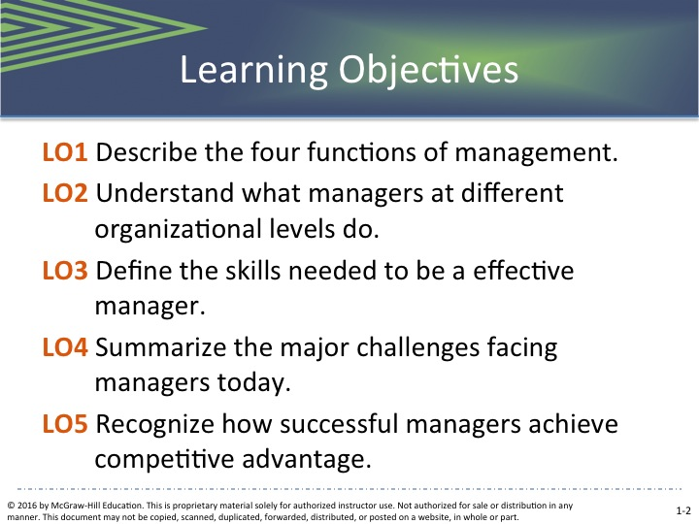  Expanded PowerPoint Slide 2  Learning Objectives: LO1 – LO5 | 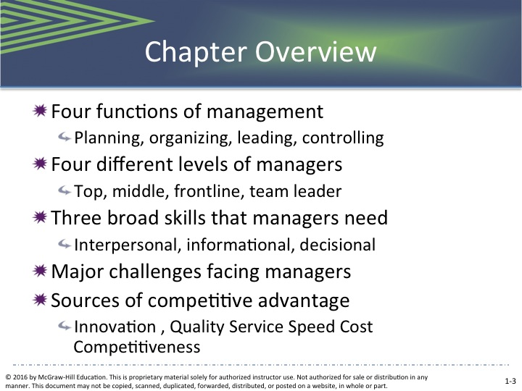Expanded PowerPoint Slide 3  4 Chapter Overview
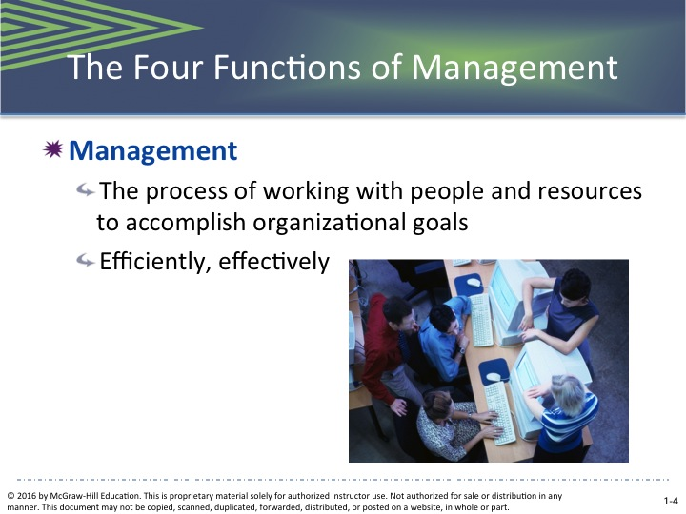  Expanded PowerPoint Slide 4  4 Functions of Management | 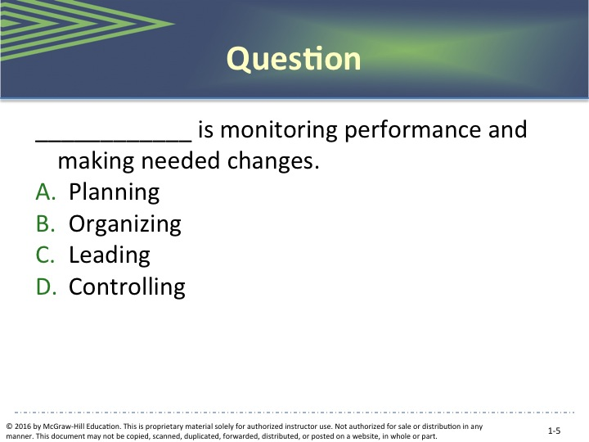  Expanded PowerPoint Slide 5  Question | 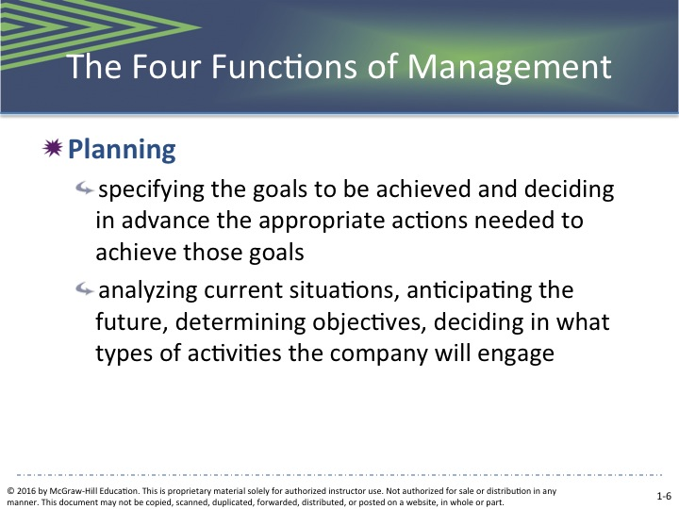  Expanded PowerPoint Slide 6  4 Functions: Planning
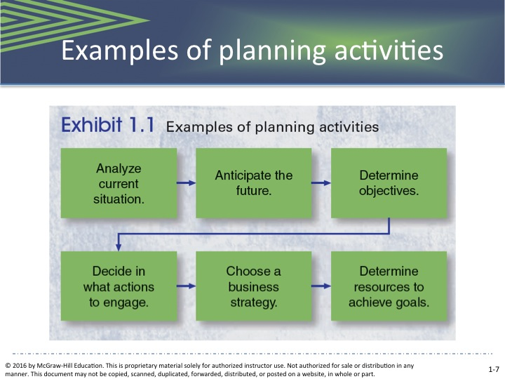  Expanded PowerPoint Slide 7  Examples of planning | 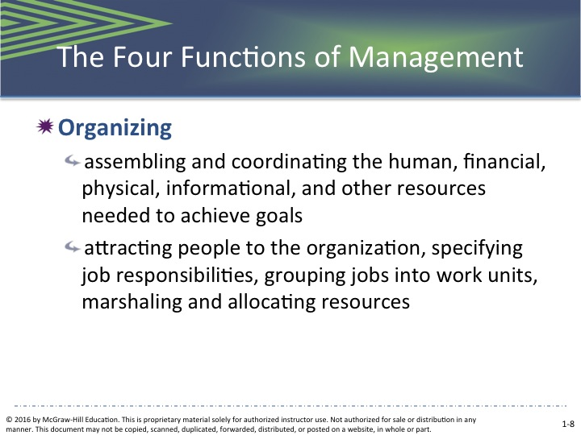  Expanded PowerPoint Slide 8  4 Functions: Organizing | 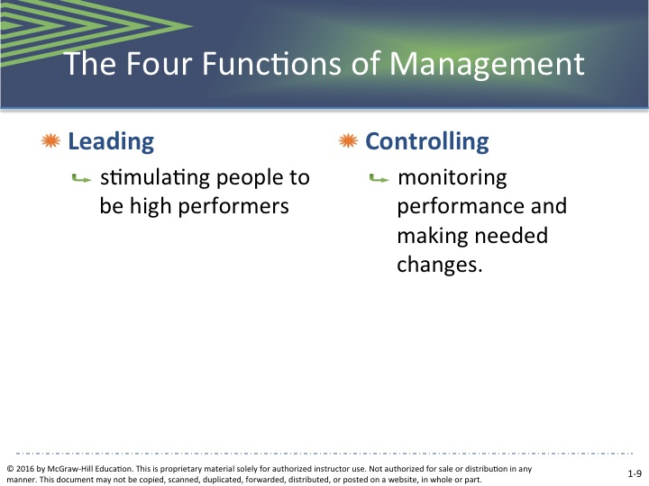Expanded PowerPoint Slide 9  4 Functions: Leading & Controlling

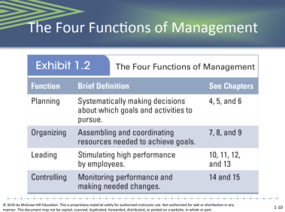  Expanded PowerPoint Slide 10  4 Functions of Management | 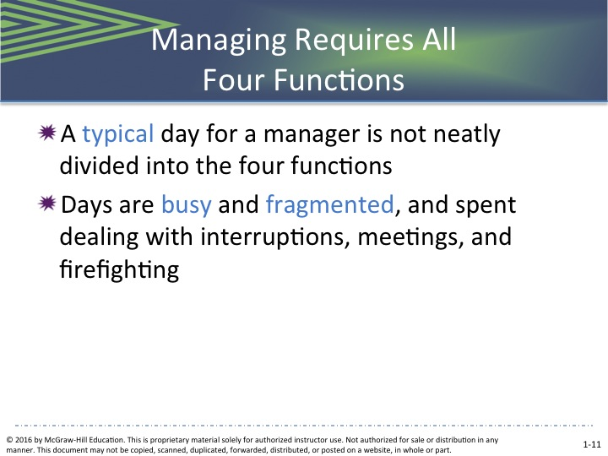  Expanded PowerPoint Slide 11  Managing Requires All 4 Functions |  | 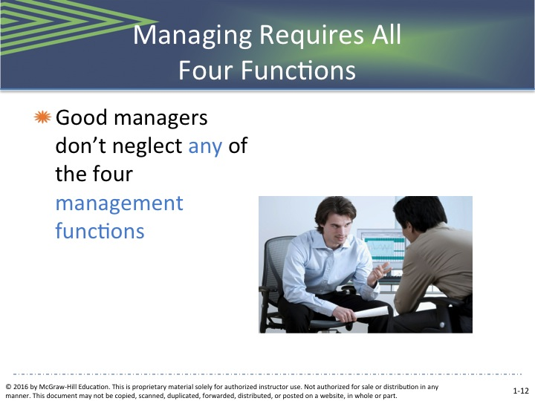Expanded PowerPoint Slide 12  Managing Requires All 4 Funtions
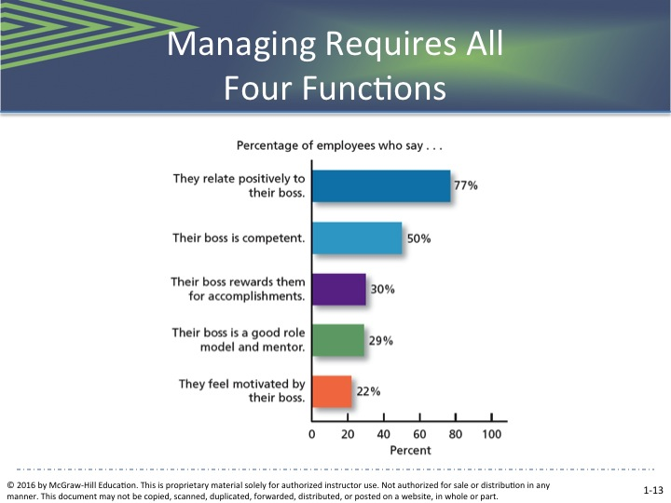  Expanded PowerPoint Slide 13  Managing Requires All 4 Functions |  | 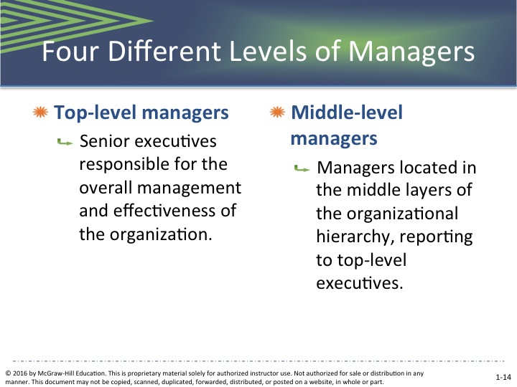  Expanded PowerPoint Slide 14  4 Different Levels | 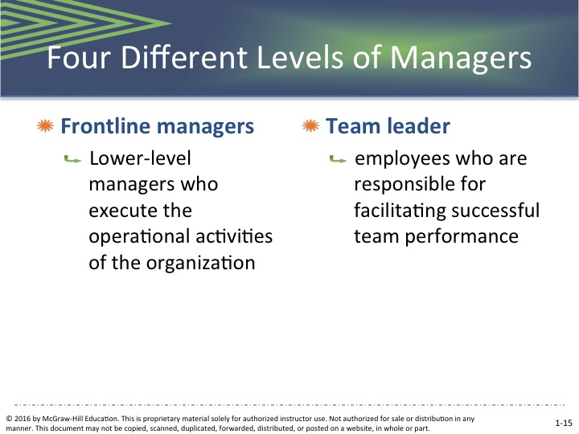Expanded PowerPoint Slide 15  4 Different Levels
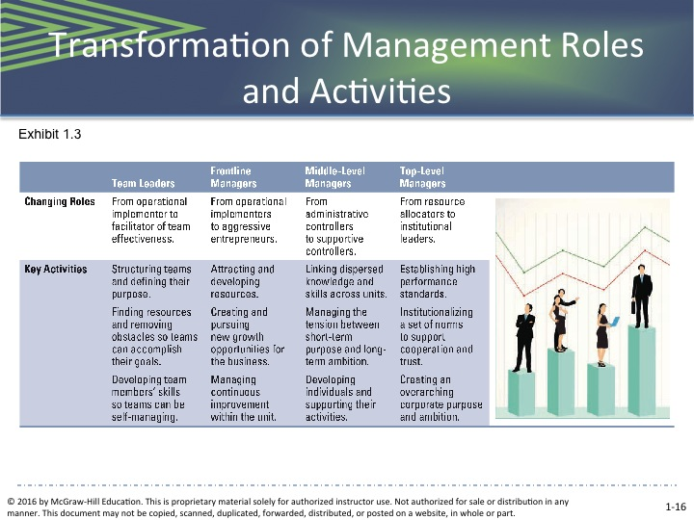  Expanded PowerPoint Slide 16  Transformation of Management Roles & Activities |  | 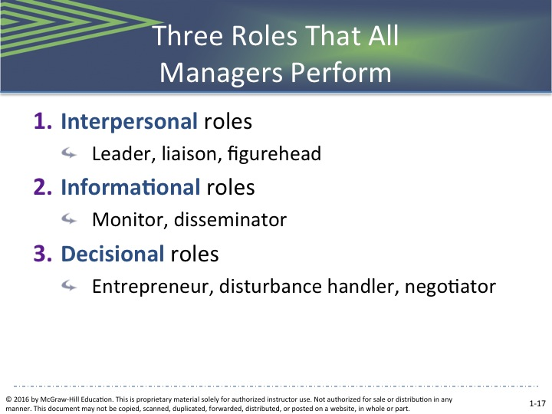  Expanded PowerPoint Slide 17  3 Roles All Managers Must Perform | 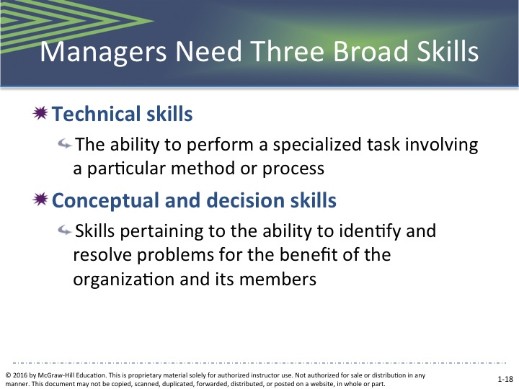  Expanded PowerPoint Slide 18  3 Broad Skills of Managers

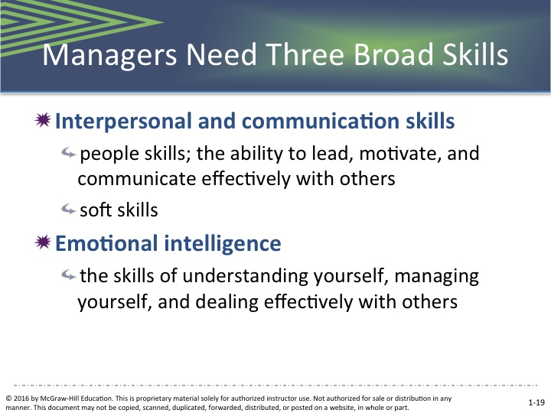  Expanded PowerPoint Slide 19  3 Broad Skills of Managers | 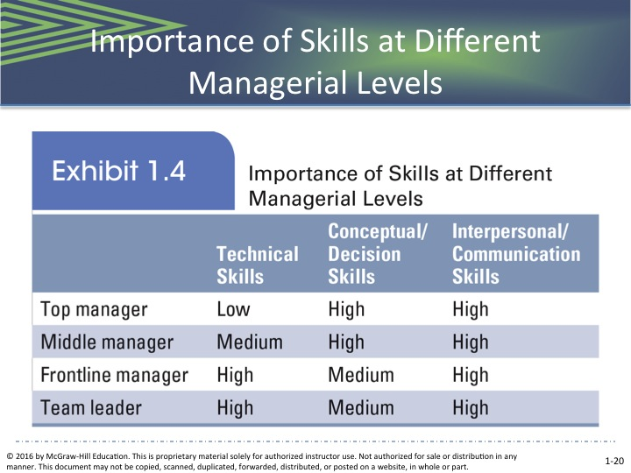  Expanded PowerPoint Slide 20  Importance of Skills at Different Levels | 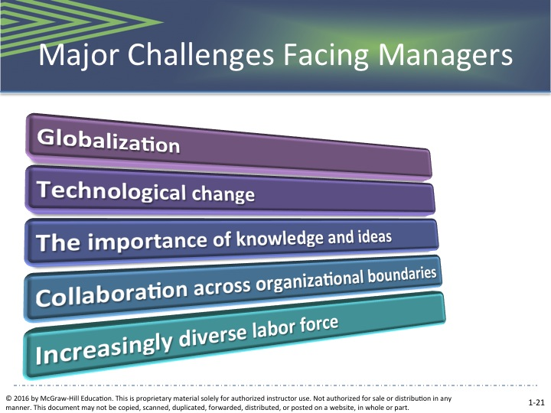Expanded PowerPoint Slide 21  Major Challenges Facing Managers
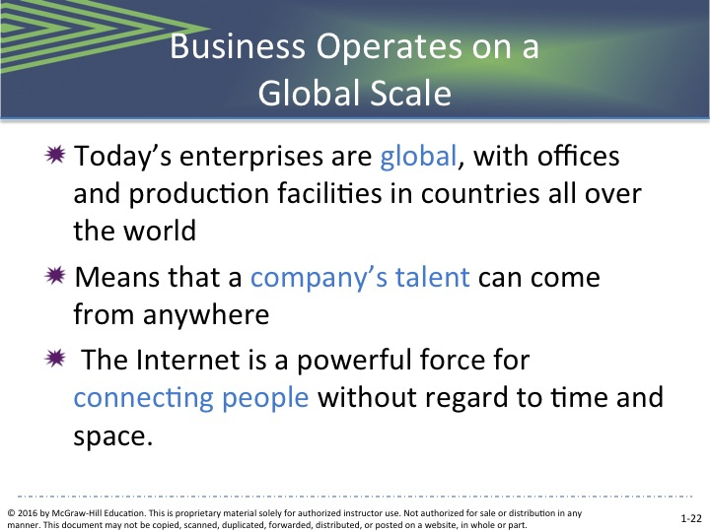  Expanded PowerPoint Slide 22  Business Operates on a Global Scale | 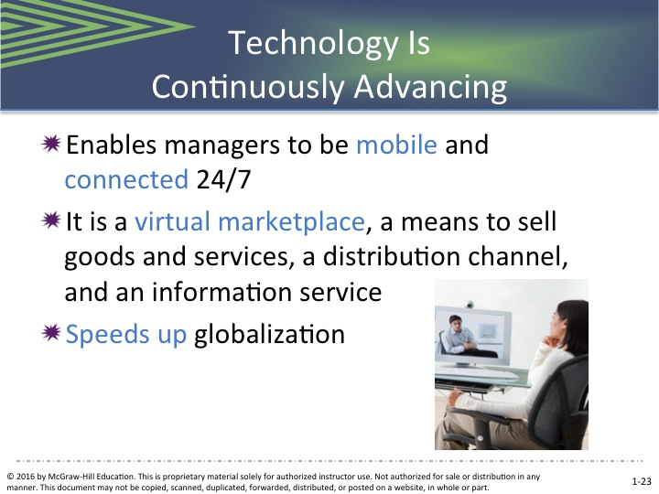  Expanded PowerPoint Slide 23  Technology is Continuously Advancing | 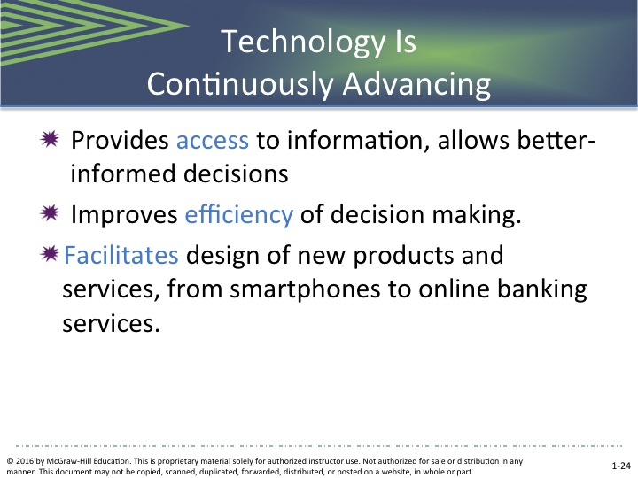  Expanded PowerPoint Slide 24  Technology is Continuously Advancing
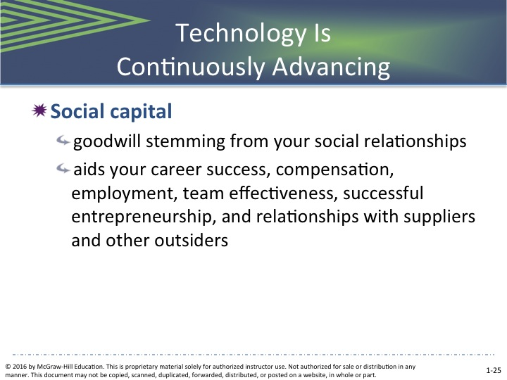  Expanded PowerPoint Slide 25  Technology is Continuously Advancing | 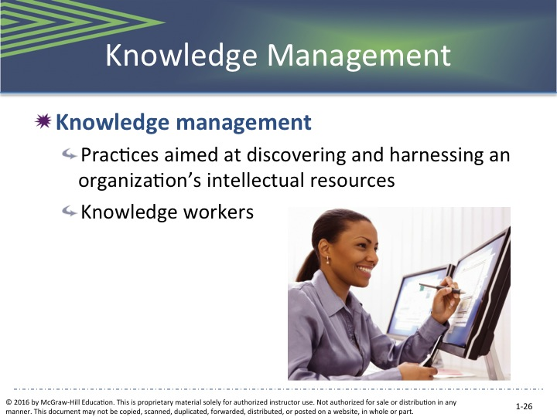  Expanded PowerPoint Slide 26  Knowledge Management | 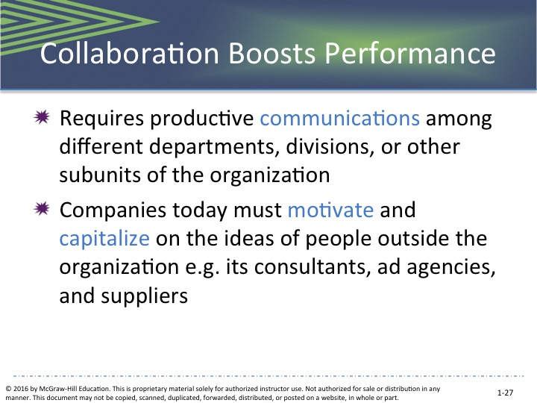Expanded PowerPoint Slide 27  Collaboration Boosts Performance

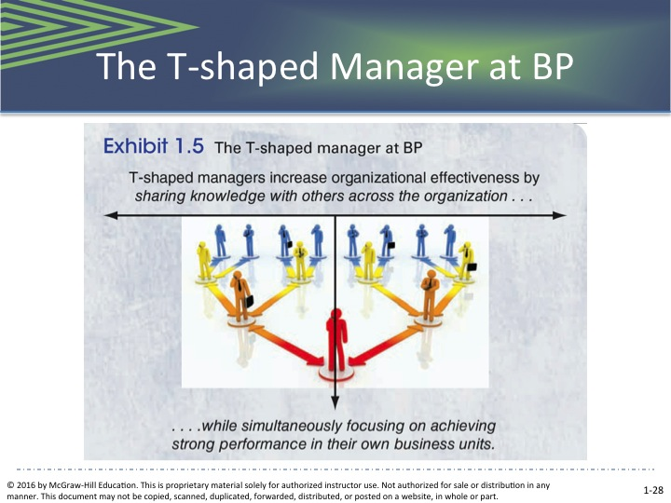  Expanded PowerPoint Slide 28  The T-Shaped Manager at BP | 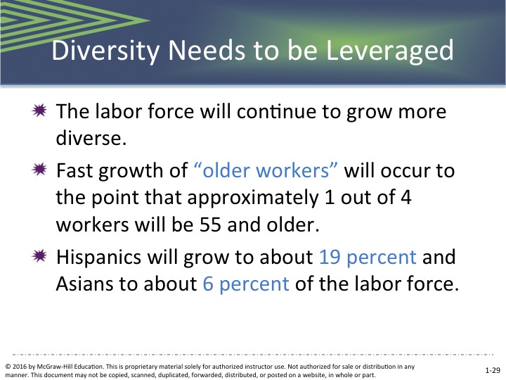  Expanded PowerPoint Slide 29  Diversity to be Leveraged | 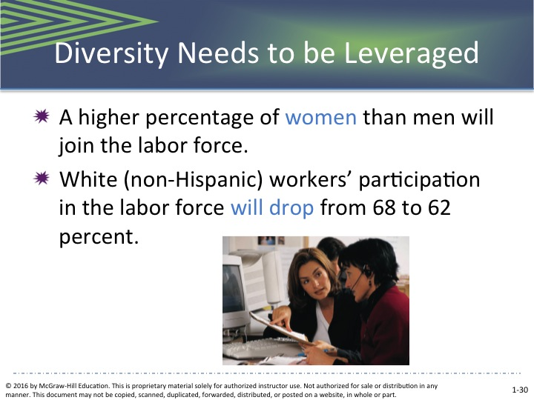  Expanded PowerPoint Slide 30  Diversity Needs to be Leveraged
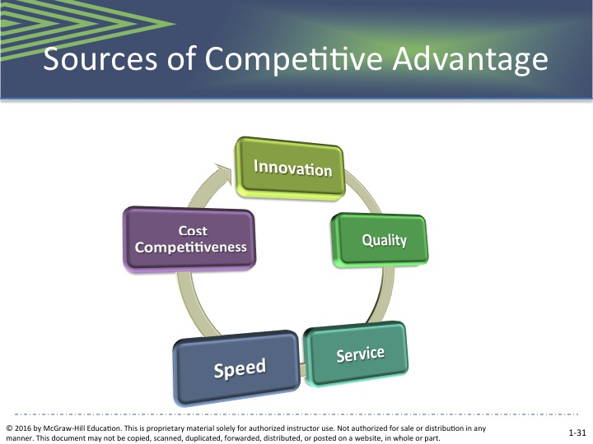  Expanded PowerPoint Slide 31  Sources of Competitive Advantage | 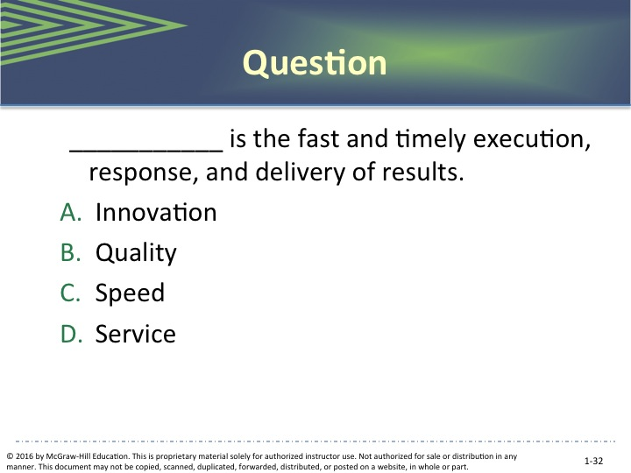  Expanded PowerPoint Slide 32  Question | 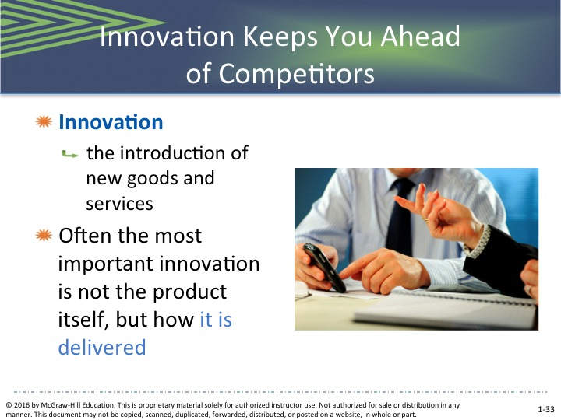Expanded PowerPoint Slide 33  Innovation Keeps You Ahead of Competitors
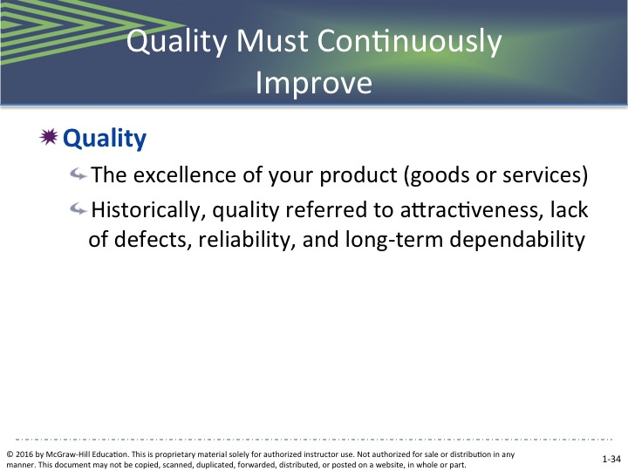  Expanded PowerPoint Slide 34  Quality Must Continuously Improve | 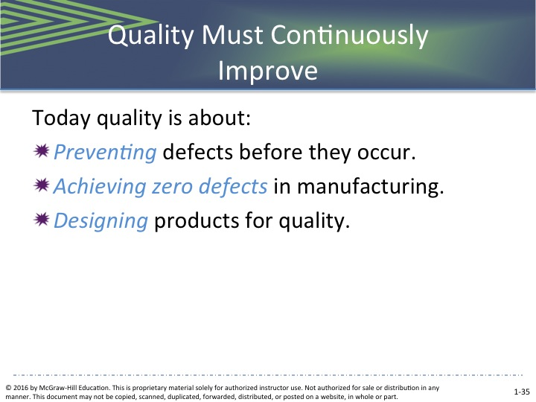  Expanded PowerPoint Slide 35  Quality Must Continuously Improve | 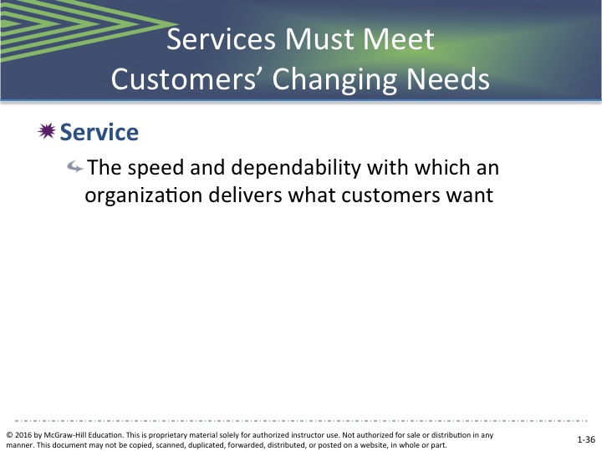  Expanded PowerPoint Slide 36  Services Must Meet Customer’s Changing Needs

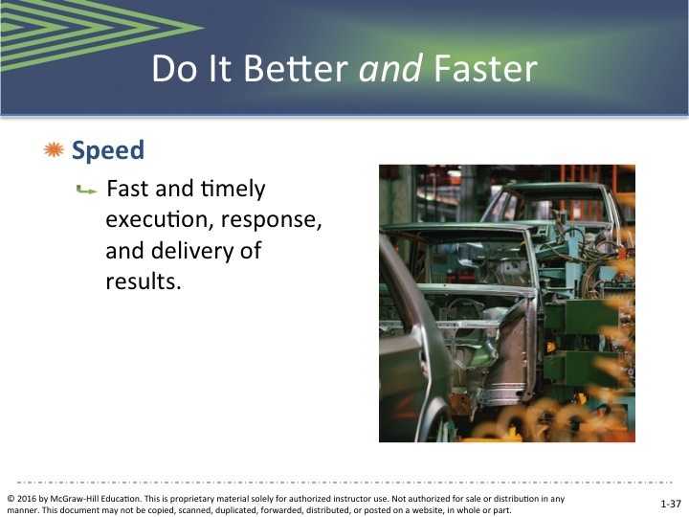  Expanded PowerPoint Slide 37  Do It Better and Faster | 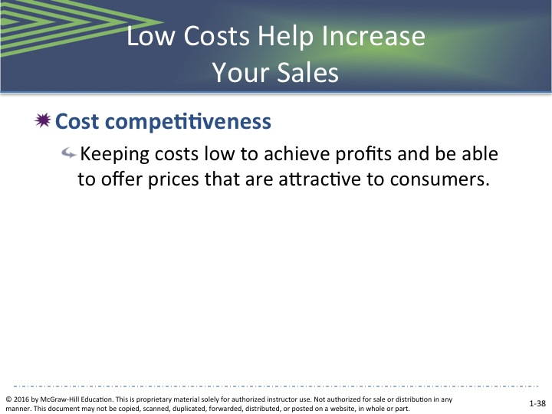  eXPANDED POWERPOINT SLIDE 38  Low Costs Help Increase Your Sales | 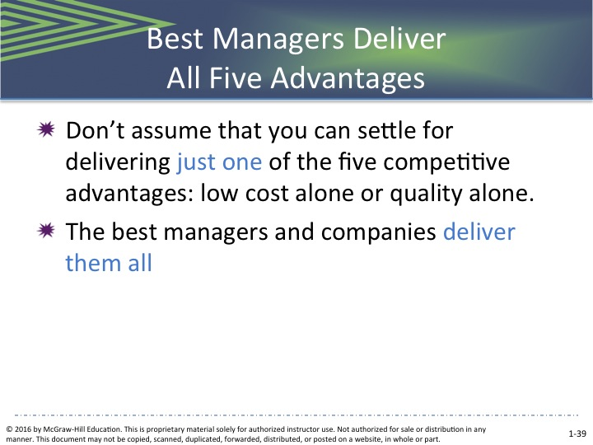  Expanded Powerpoint slide 39  All Five Advantages
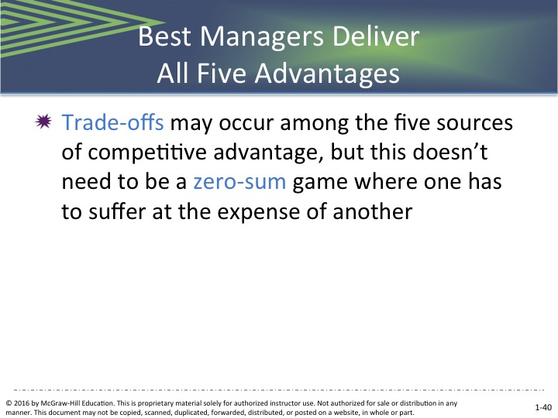  Expanded Powerpoint slide 40  All Five Advantages | 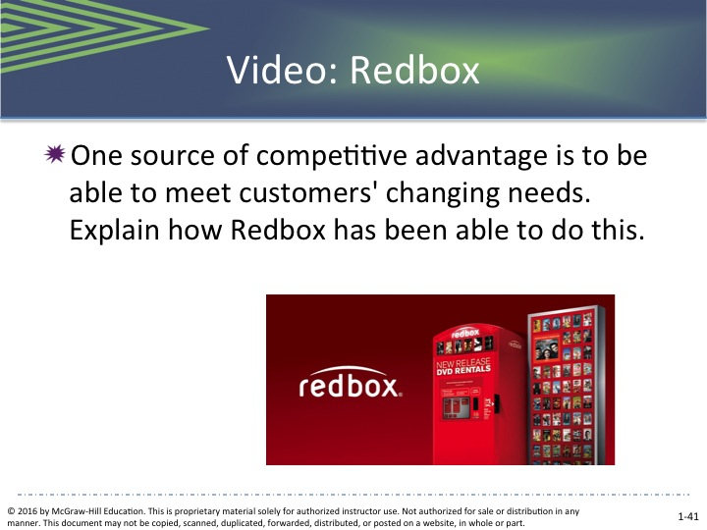  Expanded PowerPoint Slide 37  Video: Redbox | 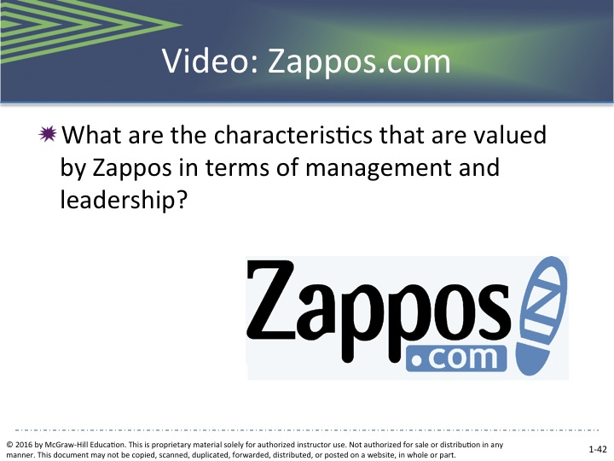  eXPANDED POWERPOINT SLIDE 38  Video: Zappos.com

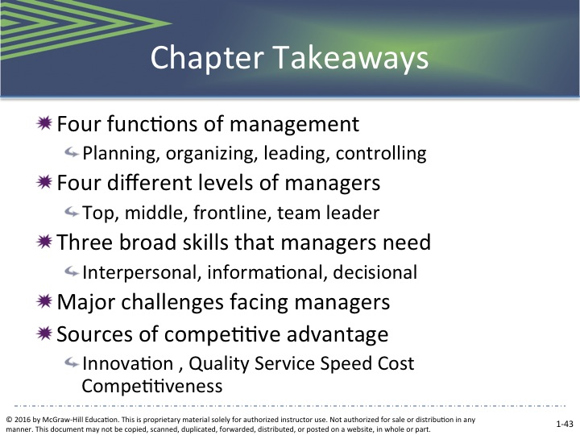
Expanded Powerpoint slide 40
Chapter Takeaways

SUPPLEMENTAL FEATURES

Go to Connect ® for M Management to access additional Resources.

YOUNG MANAGER CLIPS

- Michael Kettner, Bar Manager

MANAGER’S HOT SEAT (MHS)

- Project Management: Steering the Committee
Self-Assessment

- There are no self assessments for this chapter
TEST YOUR KNOWLEDGE

- Managerial Functions

? Adapted from Gene Burton, “Japan vs. United States: A Comparison of Corporate Environments and Characteristics,” Human Systems Management 8, No. 2, 1989, 167-173; Graef Crystal, “The Great CEO Pay Sweepstakes,” Fortune, June 18, 1990, 94-102; Boyle DeMente, The Japanese Way of Doing Things (Englewood Cliffs, NJ: Prentice-Hall, Inc., 1981); Robert Doctor, “Asian and American CEOs: A Comparative Study,” Organizational Dynamics, Winter 1990, 45-46; Frank Gibney, Japan: The Fragile Super Power (New York: W.W. Norton and Co., Inc., 1979); Andrew Tanzer and Ruth Simon, “Why Japan Loves Robots and We Don’t” Forbes, April 1990, 148-153.
? Adapted from Earnest Archer, “Things You Lose the Right To Do When You Become a Manager,” Supervisory Management, July 1990, 8-9; K. Bartol and D. Martin, Management (New York: McGraw-Hill, 1991), 10-14; Robert Guest, “Of Time and the Foreman,” Personnel, May 1956, 478; R. Kreitner, Management, 5th ed. (Boston: Houghton-Mifflin, 1992), 18-20; M. McCall, A. Morrison, and R. Hannan, Studies of Managerial Work: Results and Methods (Greensboro, NC: Center for Creative Leadership, 1978), 6-18; Henry Mintzberg, “The Manager’s Job: Folklore and Fact,” Harvard Business Review, March/April 1990, 57-69; Henry Mintzberg, The Nature of Managerial Work (New York: Harper and Row, 1980).
Hendricks, Drew. “Three Ways Social Media is Driving a Business Revolution” Forbes. 2/25/2014 www.forbes.com
Julien, Janelle. “The Retention Game”. AIIM E-DOC, Sept/Oct 2006, Vol. 20, Issue 5, pp. 29-31. and Catphora website: http://www.cataphora.com/.
Gerdes, Lindsey, “What’s Different About the Ys”. Business Week, 9/24/2007, Iss. 4051, pg 56.
Benner, Katie; Levenson, Eugenia; Arora, Rupali; and Kaufman, Susan M. “50 Most Powerful Women in the U.S.” Fortune, 10/15/2007, Vol. 156, Issue 7, pp 42-43.
Phillips, Lucy. “It Starts to Add Up.” People Management. 9/6/2007, Vol. 13, Issue 18, pg. 17.
Breen, B., “The Clear Leader”, Fast Company, March 2005, pp. 65-67.

