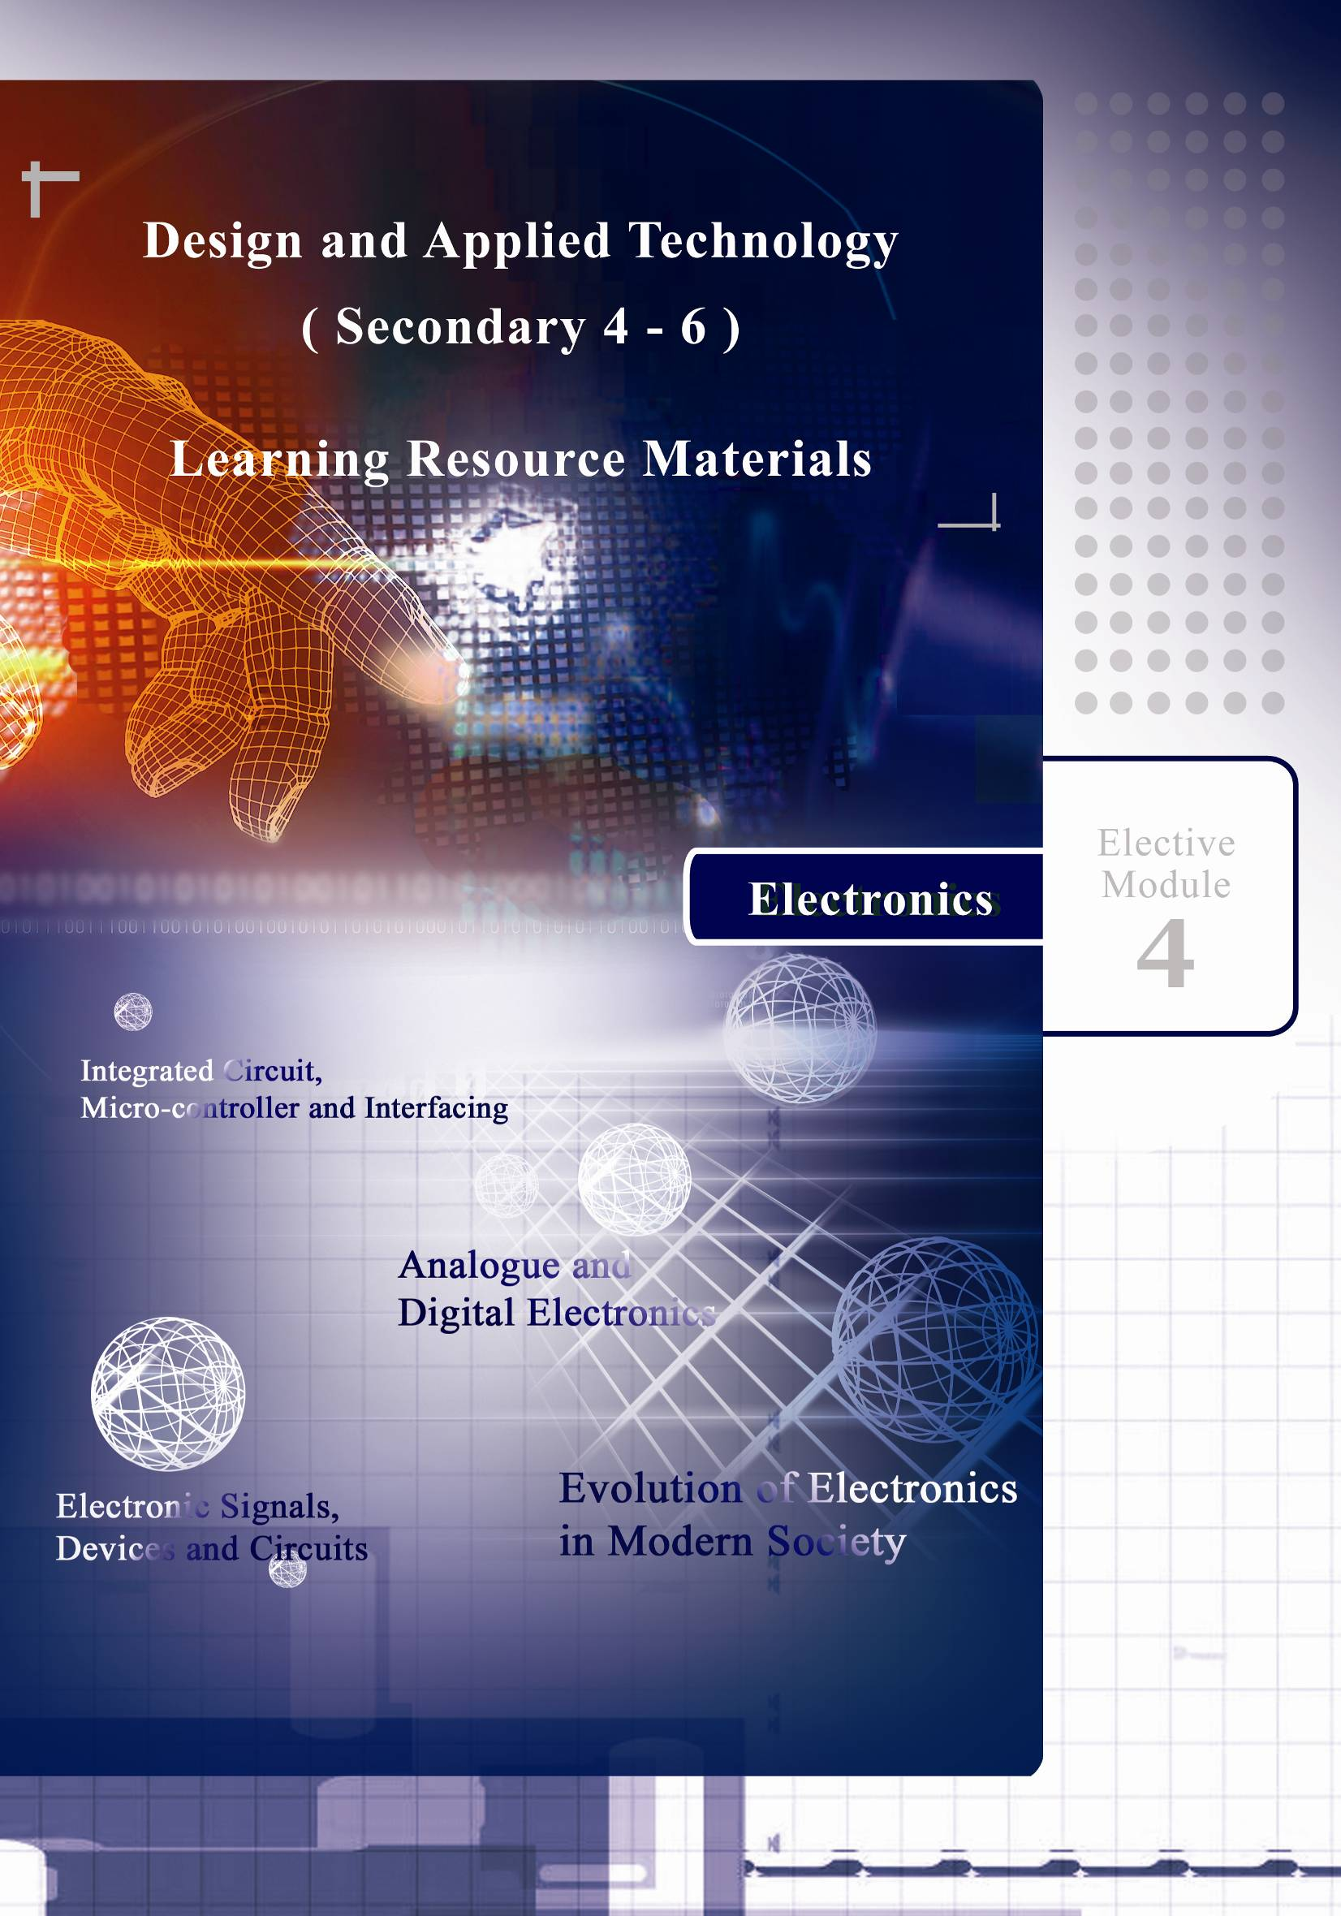

Design and Applied Technology
(Secondary 4 – 6)

Elective Module 4
Electronics

[Learning Resource Materials]

Resource Materials Series
In Support of the Design and Applied Technology Curriculum
(S4 – 6)

Technology Education Section Developed by
Curriculum Development Institute Institute of Professional Education
Education Bureau And Knowledge (PEAK)
The Government of the HKSAR Vocational Training Council
Technology Education Section

Curriculum Development Institute
Education Bureau
The Government of the Hong Kong Special Administrative Region
Room W101, 1/F, West Block, Kowloon Tong Education Service Centre,
19 Suffolk Road, Kowloon Tong, Hong Kong

Reprinted with minor amendments 2010

Project Advisor:  Dr. Chiu Ping Kuen, Peter  Authors:  Mr. Chiu Yat Ming, Michael  Mr. Yung Wai Shun, Wilson  Project Co-ordinators:  Mr. Li Yat Chuen  Mr. Tsang Siu Wah | (Head, Department of Electronic & Information Engineering, IVE/Shatin)  (Lecturer, Department of Electronic & Information Engineering, IVE/Shatin)  (Lecturer, Department of Electronic & Information Engineering, IVE/Shatin)  (Senior Training Consultant, PEAK/VTC)  (Training Consultant, PEAK/VTC)

The copyright of the materials in this package, other than those listed in the Acknowledgements section and the photographs mentioned there, belongs to the Education Bureau of
the Government of the Hong Kong Special Administrative Region.

© Copyright 2009

Duplication of materials in this package other than those listed in the Acknowledgements section may be used freely for non-profit making educational purposes only. In all cases, proper acknowledgements should be made. Otherwise, all rights are reserved, and no part of these materials may be reproduced, stored in a retrieval system or transmitted in any form or by any means without the prior permission of the Education Bureau of
the Government of the Hong Kong Special Administrative Region.
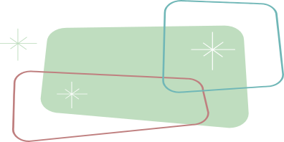
PREFACE

A set of curriculum resource materials is developed by the Technology Education Section of Curriculum Development Institute, Education Bureau for the implementation of the Design and Applied Technology (Secondary 4-6) curriculum in schools.

The aim of the resource materials is to provide information on the Compulsory and Elective Part of the DAT (Secondary 4-6) to support the implementation of the curriculum. The resource materials consist of teacher’s guides and student’s learning resource materials of each Strand and Module of the DAT (Secondary 4-6) arranged in eight folders.

All comments and suggestions related to the resource materials may be sent to:

Chief Curriculum Development Officer (Technology Education)
Technology Education Section
Curriculum Development Institute
Education Bureau
Room W101, West Block, 19 Suffolk Road
Kowloon Tong
Hong Kong

CONTENTS
Introduction
Chapter 1 – Electronic Signals, Devices and Circuits | 1
1.1 Electronic Components and Circuits | 2
1.2 Ohm’s Law and Its Application | 11
1.3 Digital and Analogue Signals | 22
1.4 Logic Circuits | 24
Chapter 2 – Analogue and Digital Electronics | 34
2.1 System Electronics | 35
2.2 Op-Amp operation | 37
2.3 Latch Circuit | 42
2.4 Memory and Counter | 45
Chapter 3 – Integrated Circuit, Micro-controller and Interfacing | 51
3.1 Types of Integrated Circuit | 52
3.2 Programmable Systems | 61
3.3 Micro-controller Basics | 67
Chapter 4 – Evolution of Electronics in Modern Society | 84
4.1 Miniaturisation of Electronic Products | 85
4.2 Impact of Converging Technologies | 89
4.3 Impact of Emerging Technologies | 92
Theme-based Learning Tasks | 95
- Laboratory 1: LED Blinker – Multi-vibrator | 95
- Laboratory 2: Photo-resistor and Applications | 100
- Design Project: Open Day Electronic Game Competition | 105
- Case Study: Smart Card | 108
Assessment Tasks | 110
- Quiz 1 - Electronic Signals, Devices and Circuits | 110
- Quiz 2 - Analogue and Digital Electronics | 113
- Quiz 3 - Integrated Circuit, Micro-controller and Interfacing | 116
- Quiz 4 - Evolution of Electronics in Modern Society | 122
Useful Websites | 124
References | 126
Glossary of Terms | 127
Acknowledgements | 131

INTRODUCTION

The objective of this module is to enable students to explore the design of electronic circuits, mainly in the area of electronic control and electronic products. In particular, the resource materials support students to explore:

(a) why certain technologies are used, and the way they are operated
(b) the principles that underlie technological developments
(c) the components of a system and how they function in practice
(d) the impact of technological processes and progresses

Integration of theory and practice is the key learning and teaching strategy. Students are encouraged to explore the integration of theory and practices, and examine the effects of technology on society and the environment. In connection to this, the following learning activities are also included in the resource materials:
- Design project
- Case study
- Exploration activities such as experiments, stop and think.

Students are also encouraged to interrelate their understanding of this module with other optional modules in the DAT curriculum so that they could develop their capability in solving design and technological problems with wider perspectives.
CHAPTER 1 - ELECTRONIC SIGNAL, DEVICE AND CIRCUIT

This chapter covers the following topics:

  - Electronic Components and Circuits
  - Ohm’s Law and Its Application
  - Digital and Analogue Signals
  - Logic Circuit

These topics include learning materials and activities that facilitate students to:

- Define electric current, resistance, potential difference and transducer
- Describe the functions of commonly used electronic components
- Calculate the current throughout voltage across resistors in series and parallel circuits by using Ohm’s Law
- Calculate power consumption of electronic systems (Power = Voltage x Current)
- Explain the difference between direct and alternating current signal
- Explain how a potential divider works
- Explain the difference between a digital and an analogue signal
- Understand the use of truth table and Boolean expressions
- Analyze electronic logic design problems and use circuits with appropriate logic gates to solve problem
- State the use of a transistor as a driver and a switch.
1.1 ELECTRONIC COMPONENTS AND CIRCUITS

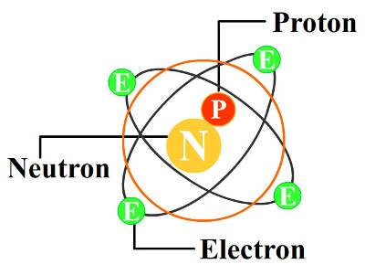
The basic understanding of the fundamental concepts of voltage and current requires a degree of familiarity with the atom and its structure. The simplest of all atoms is the hydrogen atom, made up of two basic particles, the proton and the electron.

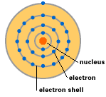
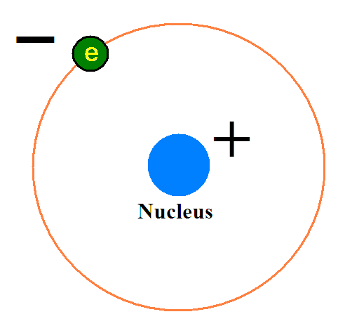

Hydrogen atom Copper atom

Copper is the most commonly used conducting metal in electrical or electronics industry. It has 29 electrons that orbit around the nucleus in four electron shells. An electron is a negatively charged particle in an atom. In conductive materials, electrons can jump from atom to atom. To start the electrons jumping, there need to be an imbalanced situation, in which more electrons would be at one end of the conductor than the other.

There is a flow of charges when there is a force pushing it, which is the electric current. In the case of electric current, this force is known as voltage. Voltage makes it possible for charge to move. In a similar way, water can flow through a pipe when there is a difference in water pressure.

The definition of Electric Current is simply the flow of “Holes” (positive charges) or the flow of Electrons (negative charges).

1.1.1 Electronic Components

Resistor
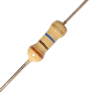
A resistor is a two-terminal electrical or electronic component that resists an electric current by producing a voltage drop between its terminals.

Potentiometer
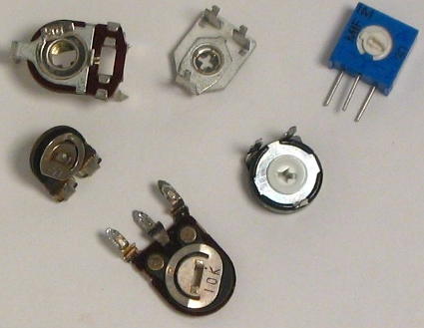
A potentiometer is a variable resistor that can be used as a voltage divider. One of the most common uses for potentiometers is as audio control devices.

Thermistor

A thermistor is a type of resistor used to measure temperature changes, relying on the change in its resistance with changing temperature. One of the most common uses for thermistor is as CPU temperature monitoring system.
85°c

Light-Dependent-Resistor
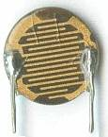
A Light-Dependent-Resistor (LDR) or photoresistor is an electronic component which resistance decreases with increasing light intensity. One of the most common uses for LDR is as automatic on/off street lamp.

Capacitor

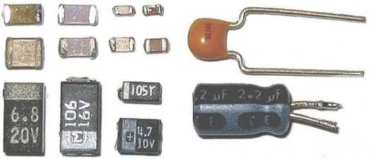
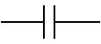
A capacitor can store energy between a pair of closely spaced metal plates. When current is applied to the capacitor, electric charges will be built up on each plate.

Diode
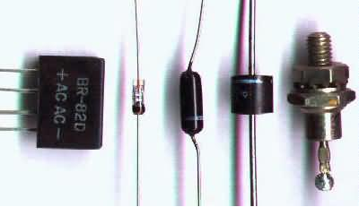
A diode restricts the current flow direction, and allows to flow in one direction, but blocks in the opposite direction.

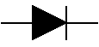

LED

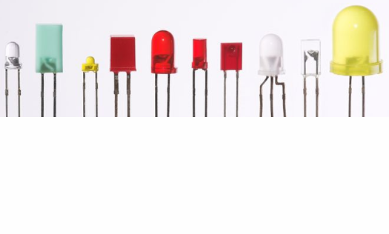
Light Emitting Diode (LED) lights up when a forward current passes through it. It is also a kind of diode.
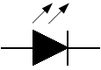

Transistor

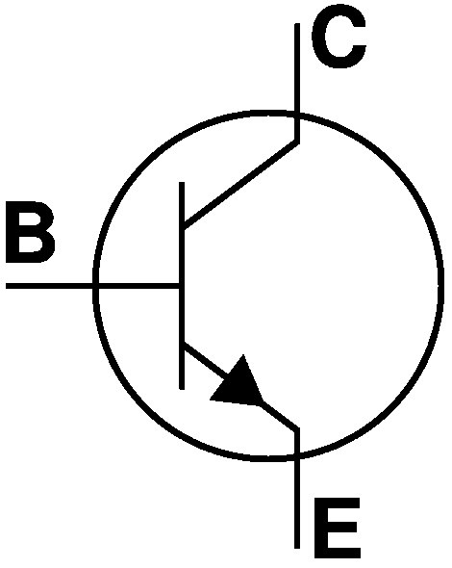
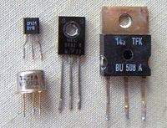
A transistor is a semiconductor device, commonly used as an amplifier or an electrically controlled switch.

Speaker
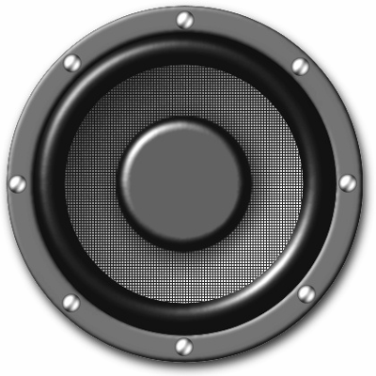
A speaker is an electro-acoustic transducer that converts electrical signals into sounds that are loud enough to be heard at a distance.

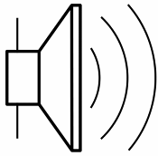

Buzzer
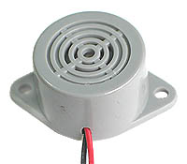
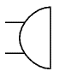
Generally, a buzzer is like a speaker and produced sound by electro-acoustic signals. The only different is buzzer is made of pizeo-electric which is voltage-driven, while speaker is made of coil which is current-driven device.

Microphone

A microphone is an acoustic-to-electric transducer that converts sound into an electrical signal. Microphones are used in many applications such as telephones and karaoke.



Integrated Circuit
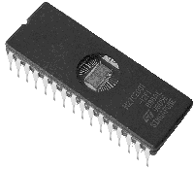
An integrated circuit is a miniaturized electronic circuit that has been manufactured in the surface of a thin substrate of semiconductor material.
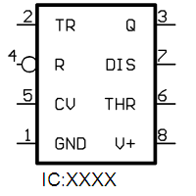

Fuse
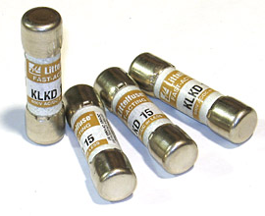
Fuse is a device used in electrical systems to protect against over current.

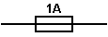

Switch
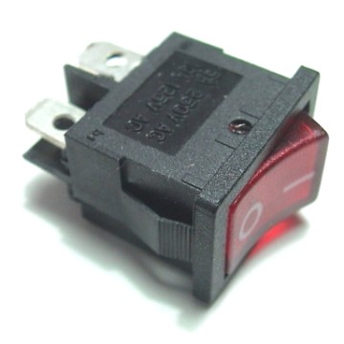
Switch is an on-off device which allows current to flow only when it is in the closed (on) position. For example, it is used as a lamp switch.

Relay
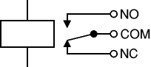
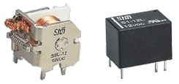
Relay is an electrically operated switch, for example, a 12V battery circuit connected to the coil can switch a 220V AC mains circuit. Normally it is used for isolation.

Transformer
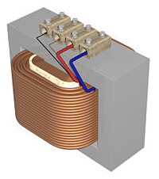
A transformer only allows an alternating voltage to be stepped up or stepped down. It is made of two windings coupled together with transformer core. Typically, primary winding is referred to input side, and secondary winding for output.
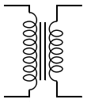

Nowadays, NDS-Lite is the most famous handheld game device. This is an electronic device. It includes electronic components, colour LCD display and speaker, etc. After removing the case, you will notice that the device is made up of a number of components, as shown in the following pictures:
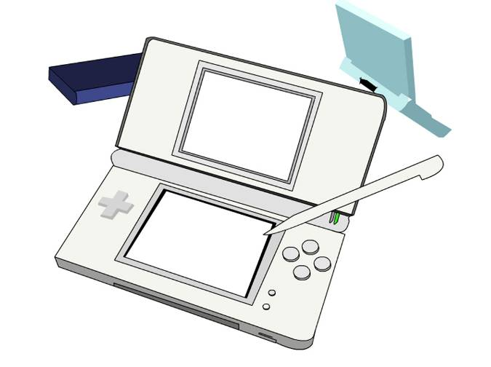
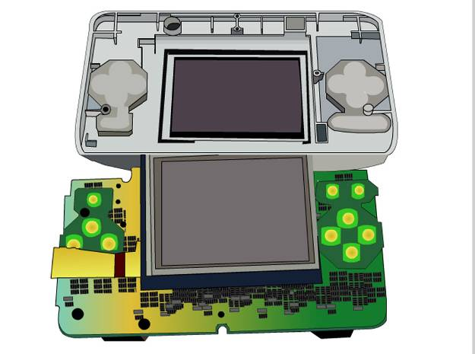

STOP AND THINK
- Why are we interested in NDS-Lite?
- How many types of electronic components are inside NDS-Lite?
- What is the input control? How many types of input elements of NDS-Lite are there?
What is the output of the NDS-Lite Game console?

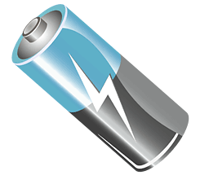
1.1.2 Voltage

What is Voltage? You can see that any circuit must have at least one voltage source. In fact, voltage should be more correctly called "potential difference". It is actually the Electro Motive Force in electricity (EMF) and the potential difference which are responsible for the pushing and pulling of electrons or electric current through a circuit.

To produce a drift of electrons along a conducting wire, it is necessary to have a difference of potential between the two ends of the wire.
1.1.3 Current

What is Current?
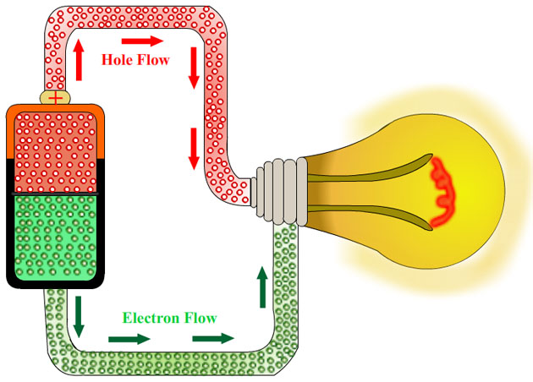
A flow of electrons forced into motion by voltage is known as current. The atoms in good conductors such as copper wire have one or more free electrons in the outer shell constantly flying off. Electrons from other nearby atoms will fill in the holes. There are billions of electrons moving aimlessly in all directions, all the time in conductors.

The amount of current in a circuit is measured in amperes (amps). Smaller units used in electronics are mA (1 / 1,000th of an ampere) and μA (1 / 1,000,000th of an ampere).

The quantity of electrons used in determining an ampere is called "coulomb" and one ampere is one coulomb per second. This is the unit of measuring electrical quantity or charge.

1.1.4 Resistance
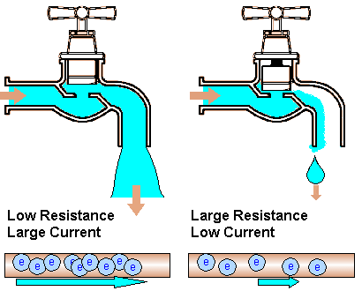
What is Resistance?

In the previous topic ‘Current’, we learnt that certain materials such as copper have many free electrons. Other materials have fewer free electrons and some substances such as glass, rubber, mica have practically no free electron movement therefore making them good insulators. Between the extremes of good conductors such as silver, copper and good insulators such as glass and rubber, there are other conductors of reduced conducting ability. They "resist" the flow of electrons hence called ‘resistance’.
1.1.5 Colour coding

As it is difficult to read the resistance value from the surface of the resistor, a resistor colour coding system is employed and applies to all kind of axial lead resistors such as carbon film, metal oxide film, fusible, precision metal film, and wire-wound oxide.

The first three bands close to one end of the resistor are used to determine the resistance. The fourth band represents the tolerance of the resistor. Generally, the colors of the first two bands represent the numerical value of the resistor. The third band represents the power-of-10 multiplier.
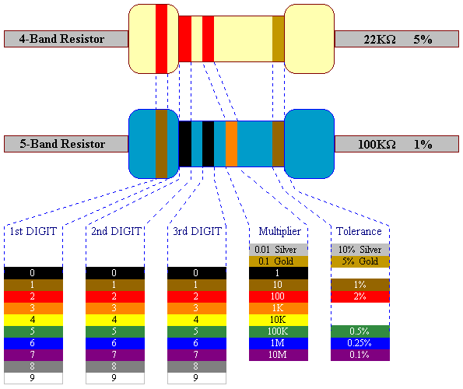
- The first two bands represent the first and second digits respectively.
- The third band determines the power-of-ten multiplier for the first two digits.
- The fourth band is the manufacturer’s tolerance, which is an indication of the precision by which the resistor was made.

1.1.6 A Simple Circuit
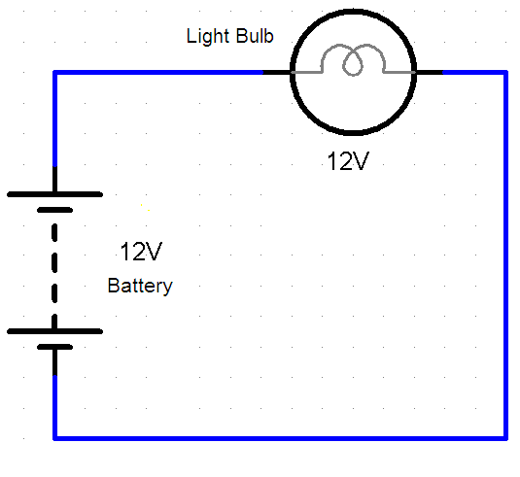
A simple circuit contains three parts:
- A source of electrical potential difference or voltage (such as a battery).
- A conductive path which allows the movement of charges (such as copper wire).
- An electrical resistance which can be loosely defined as any object that uses electricity to do work (such as a light bulb).

After studying the basic components and some electronic theories, now you have the basic knowledge on circuit, and also the ability to design a circuit like below.

STOP AND THINK
- This is a lamp switch circuit. Why is it using two switches, SW1 and SW2?
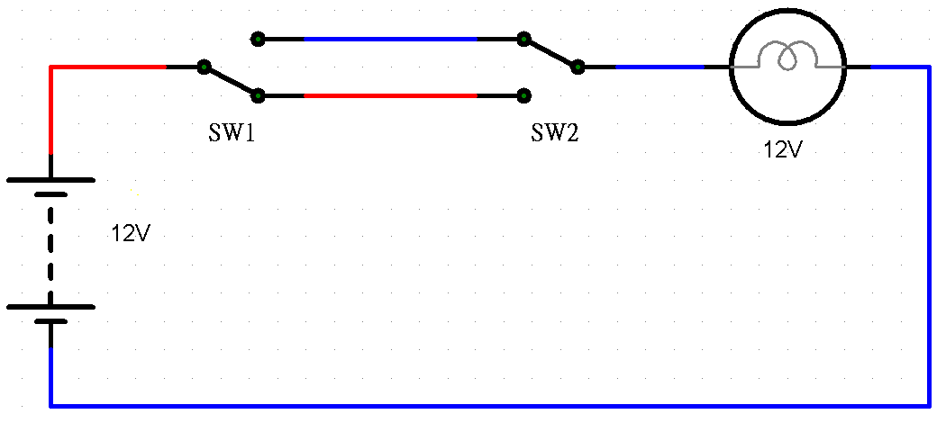
Where can you find this kind of circuit?
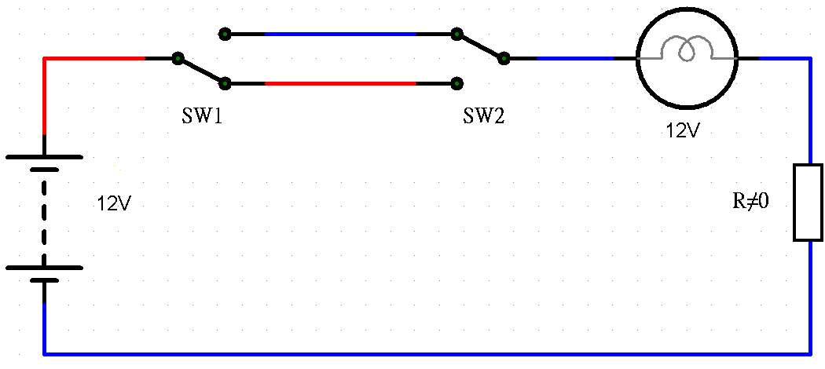
If the above circuit adds a resistor in series, what will happen to the light bulb?

1.2 OHM’S LAW AND ITS APPLICATION


In order to make meaningful statements about quantities in circuits, we need to describe their quantities and below are the standard units of measurement for electrical current, voltage, and resistance.

 | Symbol | Unit of measurement | Unit Abbreviation
Voltage | V | Volt | V
Current | I | Ampere | A
Resistance | R | Ohm | Ω
These units and symbols for electrical quantities are very important as we begin to explore the relationships between them in circuits. Firstly, the relationship between current, voltage, and resistance is called Ohm's Law, which was discovered by Georg Simon Ohm.
Ohm's principal discovery was that the amount of electric current through a metal conductor in a circuit is directly proportional to the voltage across it. Ohm expressed his discovery in the form of a simple equation, describing how voltage, current, and resistance interrelated, this equation is:
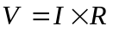
In this algebraic expression, voltage (V) is equal to current (I) multiplied by resistance (R). Using algebraic techniques, we can manipulate this equation into two variations, solving for I and R respectively:
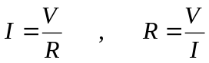

1.2.1 Relationship between Voltage, Current and Resistance
Let's see how these equations might work to help us analyze simple circuits:
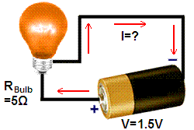

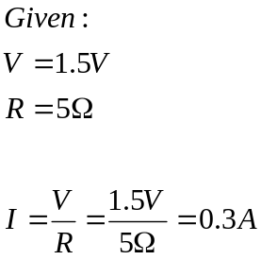
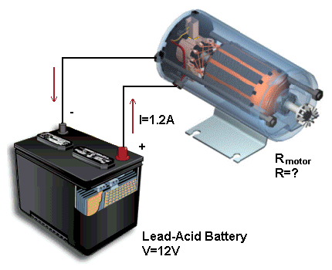
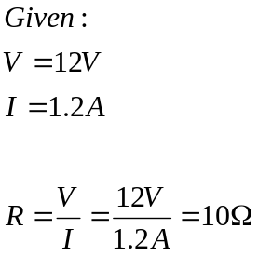
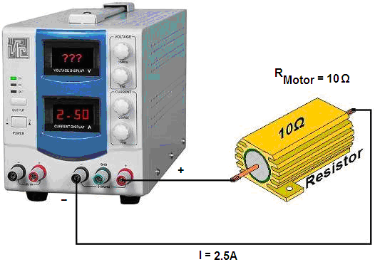

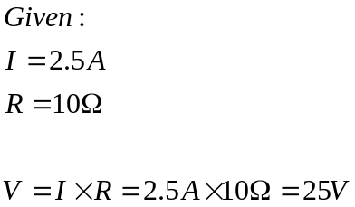

- Voltage measured in volts, symbolized by the letters "V".
- Current measured in amps, symbolized by the letter "I".
- Resistance measured in ohms, symbolized by the letter "R".
- Ohm's Law: V = IR ; I = V/R ; R = V/I

1.2.2 Electric Power
In general, electric power can be simpilty call as power, it is used to indicate how much energy is being consumed. To determine the power in an electric circuit, simply multiply the voltage in "volts" by the current in "amps", the result of power in "watts”.
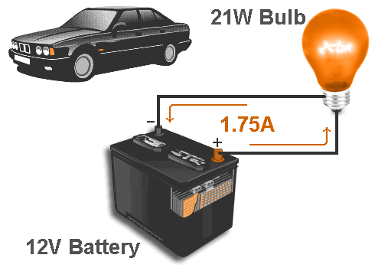
In the circuit shown, we know we have a car battery with voltage of 12 volts and lamp current measured as 1.75A, then we get the power of the light bulb as 21W.
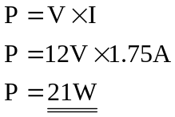
However, these power equations are commonly associated with the Ohm's Law equations relating voltage, current, and resistance (V=IR; I=V/R ; and R=V/I), then:
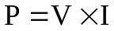 or 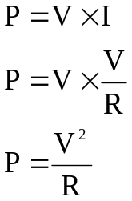 or 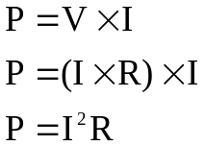
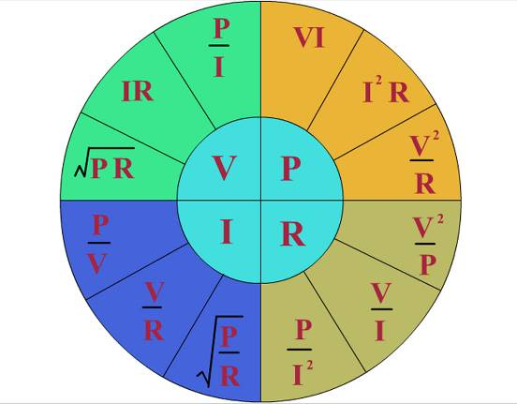
For the above power equation, we can find the bulb resistance by:

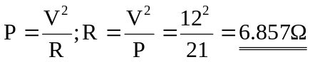

1.2.3 Series and Parallel Circuit

Usually, we find circuits where more than two elements are connected together. There are two distinct ways in which components can be connected together, which are series connection and parallel connection.

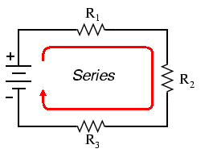
Series Circuit:

There are three resistors R1, R2, and R3 which are connected together in the form of series connection. All components are connected end-to-end and the characteristic of a series circuit is that there is only one path for current flow.

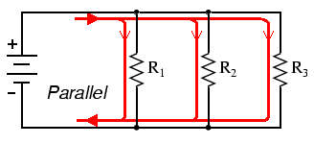
Parallel Circuit:
Again, there are three resistors R1, R2, and R3, but this time they form more than one continuous path for current flow. Each individual path through R1, R2, and R3 is called a branch. All components are connected across each other, forming exactly two sets of electrically common points. The characteristic of a parallel circuit is that all components are connected between the same set of electrically common points.

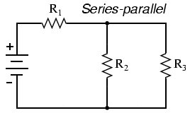
Series-Parallel Circuit:
Also, the circuits can be a combination of series and parallel. In this configuration, R2 and R3 are in parallel with each other, while R1 is in series with the parallel combination of R2 and R3.

1.2.4 Calculation of Series and Parallel Circuits

The effect of connecting resistors in series is to increase the resistance between a and b. In fact, the total resistance is determined by finding the sum of the resistance levels of the three resistors, that is RT = R1 + R2 + R3.
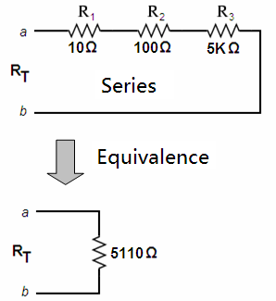

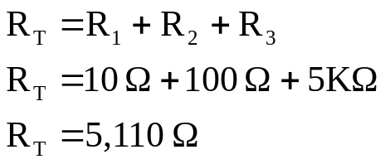

In general, the total resistance of a series configuration is the sum of the resistance levels. The more resistors are connected in series, the greater the final resistance is achieved.

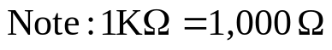
Unlike series configuration, the total resistance in parallel configuration is always less than the value of the smallest resistor.

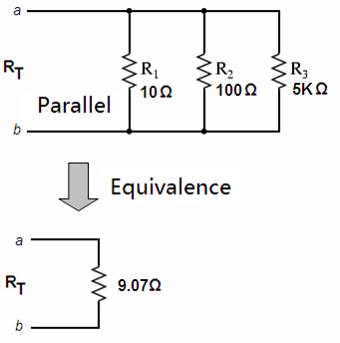
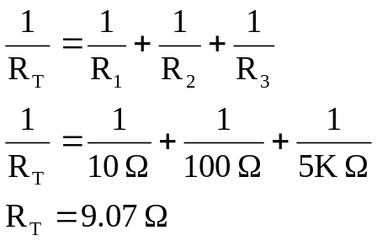

If the smallest resistor of a parallel combination is much smaller than the other parallel resistors, the total resistance will be very close to the smallest resistor value.

In general, the total resistance of a parallel configuration is the reciprocal of the sum of the reciprocal of each resistance levels. The more resistors are connected in parallel, the smaller the final resistance is achieved.

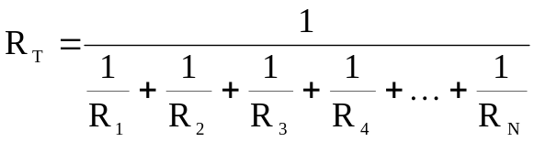
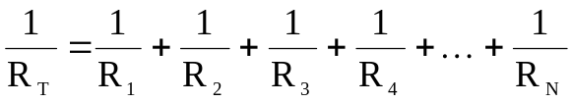

Or

1.2.5 Voltage Division and Current Division

Voltage Division

The ratio of individual resistance to total resistance is the same as the ratio of individual voltage drop to total supply voltage in a voltage divider circuit. This is known as the voltage divider formula, and it is a short-cut method for determining voltage drop in a series circuit without going through the current calculations of Ohm's Law.

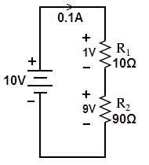
- The voltage across series of resistive elements will be divided in a ration of the magnitude of the resistance levels.
- In a series resistive circuit, the larger the resistance, the more of the applied voltage it will capture.
- The ratio of the voltage across series resistors will be the same as the ratio of their resistance levels.

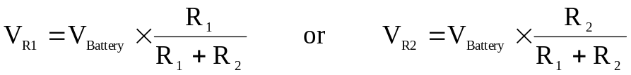

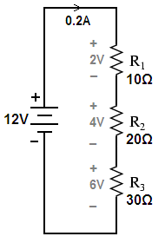
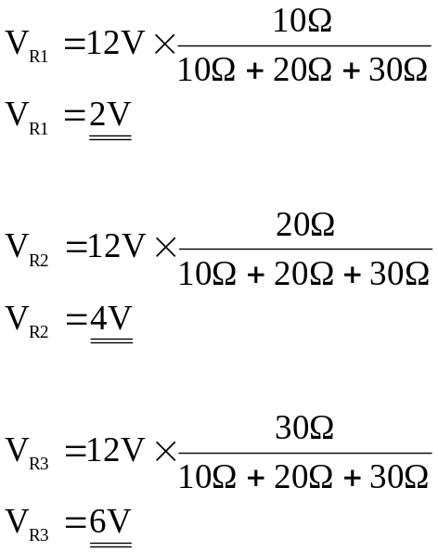
One of the devices frequently used as a voltage-dividing component is the potentiometer, which is a resistor with a movable element positioned by a manual knob or lever. The movable element, typically called a wiper, makes contact with a resistive strip of material at any point selected by the manual control:
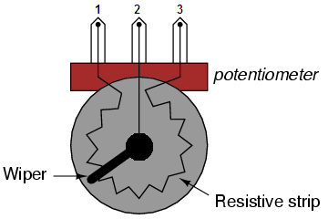
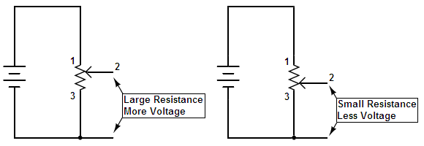
Just like the fixed voltage divider, the potentiometer's voltage division ratio is strictly a function of resistance. A potentiometer functions as a variable voltage divider where the voltage division ratio is set by wiper position. This application of the potentiometer is a very useful means of obtaining a variable voltage from a fixed-voltage source such as a battery.
Current Division

The current entering parallel resistive elements will split into branches currents. If equal resistors are connected in parallel, then the current through each branch will be the same. By definition, the ratio of total resistance to individual resistance is the same ratio as individual branch current to total current. This is known as the current divider formula.
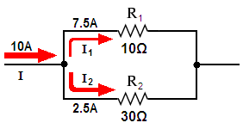
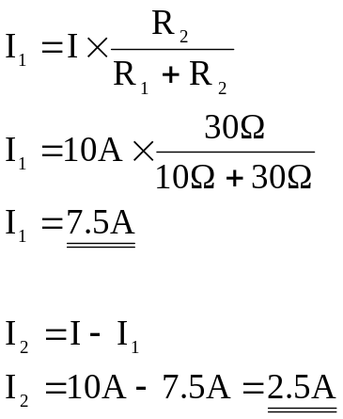

So, the sum of current entering a node is equal to the sum of current leaving the node. In general, the formula of current divider can be expressed as shown below.

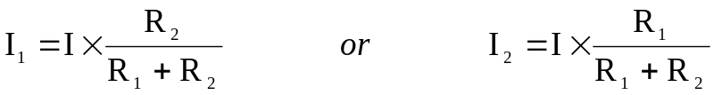

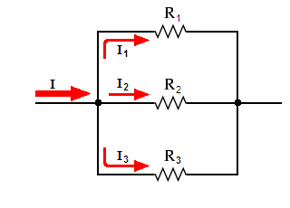
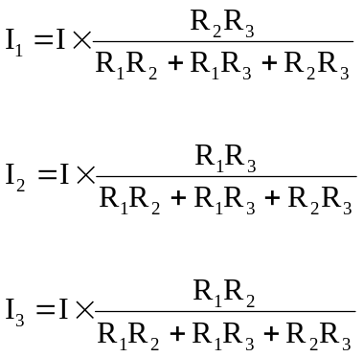

1.2.6 Alternating Current (AC) and Direct Current (DC)

Electricity can flow either in alternating current (AC) mode or direct current (DC) mode. However, the difference between AC and DC has to do with the direction in which the electrons flow. In DC, the electrons flow steadily in a single direction, while in AC, electrons keep switching directions, current flows forward and backward alternatively.
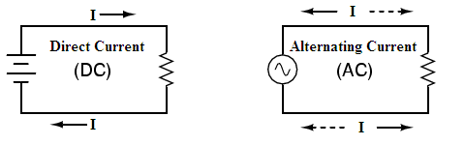

A Direct Current (DC) supply, stays at a fixed or regulated voltage all of the time, like the voltage from a battery. A DC supply is needed by most circuits as a constant reference voltage.
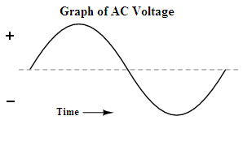
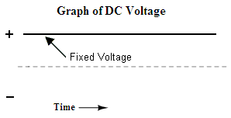
Basically for AC, when an alternator produces AC voltage, the polarity switches in positive and negative and repeats. By graphical description, the waveform is traced from an alternator and it takes on a distinct shape, which known as sine wave.

When the waveform begins to repeat itself, it is exactly one cycle of that wave. In measurement, this is often called the period of a wave. The period of a cycle in degrees is always 360,
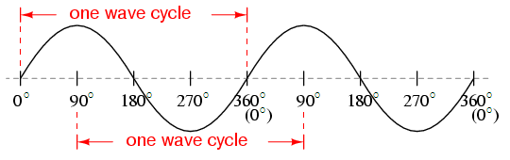
A more popular measure for describing the alternating voltage or current wave is called frequency. The unit for frequency is Hertz (Hz), which represents the number of wave cycles completed during one second of time.
Period and frequency are mathematical reciprocals of one another. That is, if a wave has a period of 0.1 second, its frequency will be 10 Hz, or 10 cycles per second.
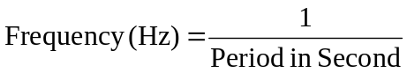

Below are different types of periodical waveforms that change the polarity between positive and negative in time, which include sine, square, triangle, or saw-tooth voltage or current waveforms. In general, any wave shape bearing close resemblance to a perfect sine wave is called sinusoidal, anything different being labeled as non-sinusoidal.
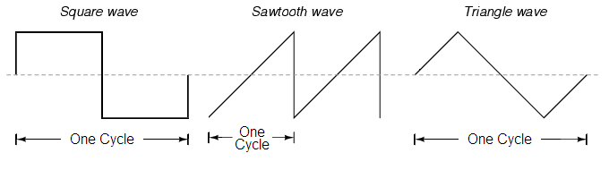

1.3 DIGITAL AND ANALOGUE SIGNALS

Analogue signals:

Analogue signals are used in traditional electronic devices. An example of an analogue signal is the loud-speaker of a stereo system. When the volume is turned up, the sound increases slowly and constantly.
Other examples of analogue systems include: Light Dimmer Control. You may try to think of something else in analogue signal.
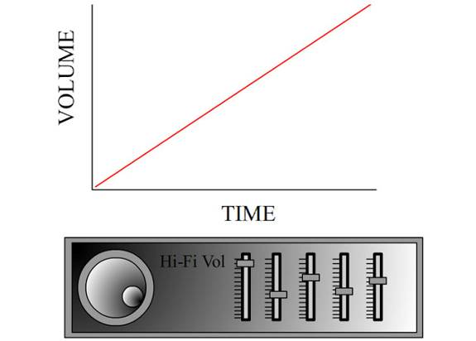

Digital signals:

Modern electronic products such as computers and mobile phones depend on digital signals. However, a good example of digital signal is Morse code. The signal is sent as a series of ‘on’ and ‘off’ pulses. The signal is either present or it is not. Morse code was introduced in 1837 by Samuel Morse as a method of communication.
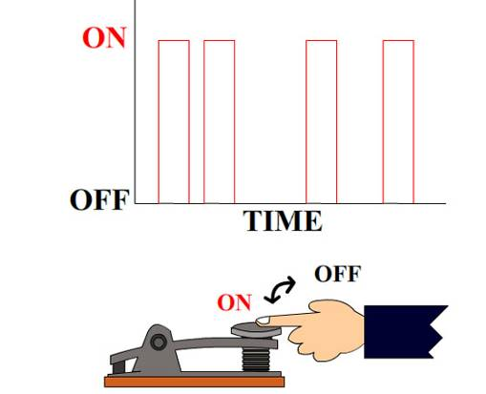

Both analogue and digital devices can be used as sensors. A thermostat inside an oven is analogue as resistance changes with temperature, where a micro-switch is digital, as it is ‘on’ or ‘off’.

Computers are digital devices and the various electronic parts communicate using 1’s and 0’s.
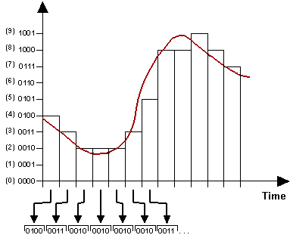
1 = ON
0 = OFF
For more easy understanding, analogue signals are continuous where digital signals are discrete. Analogue signals are continuously varying where digital signals are based on 0 and 1, or as often described as on and off.

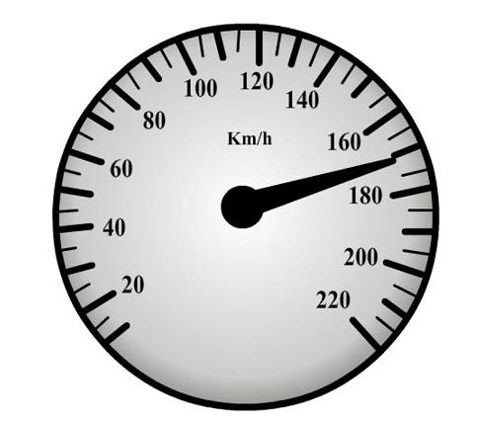
As an analogy, consider a light switch that is either on or off (digital), and a dimmer switch that allows you to vary the light in different degrees of brightness (analogue). As another analogy, consider a speedometer in which the pointer is turning clockwise as increasing in speed.

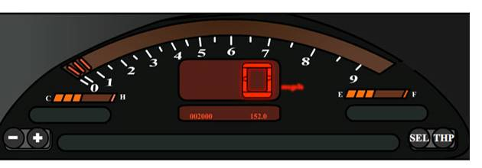
Where in digital world, they change the analogue signal into digital, and sometimes, it manipulates the retrieved datum and turns devices on and off to represent the corresponding reading.
  - LOGIC CIRCUITS

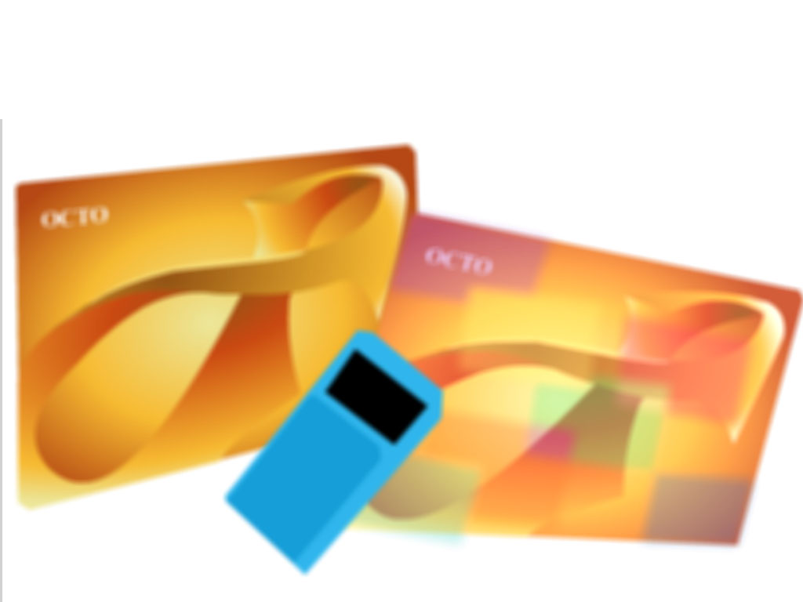
Octopus, everybody knows what it is in Hong Kong. The Octopus Card works on an add-value mechanism. Every time you travel with the Octopus Card, money value will be deducted from it automatically. When the value in your card becomes negative, you can simply add value by paying money. The Octopus Card can be used on trains, buses, minibuses, trams or ferries, etc. You can also use it to buy anything at 24 hours convenience stores or fast food shops, etc

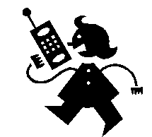
Mobile phone is another essential electronics tool around us everyday. In early 90’s, mobile phone is using analogue technology, but now, almost all handheld devices utilize digital technology. Current mobile phones can support many additional services such as SMS for text messaging, email, packet switching for access to the Internet, and MMS for sending and receiving photos and video.

STOP AND THINK
  - What are inside the Octopus?
  - Why can it store money value inside?
  - Why mobile phone being digitized for the last 10 years?
  - List out the devices which are related to ‘digital’ everyday.

Before we study the microprocessor or memory, we need to understand the basic building block of the digital world. Although microprocessor is powerful, in fact, they are mainly built from the first beginning - the Logic Gates.
Logic gate is a circuit that performs a logic function on a number of input binary signals. The logic gate is the basic building block from which many different kinds of logic circuit can be constructed. The signals at the input and output terminals of a gate are either at a LOW or HIGH level, sometimes called 0 or 1.

Consider the following diagrams:
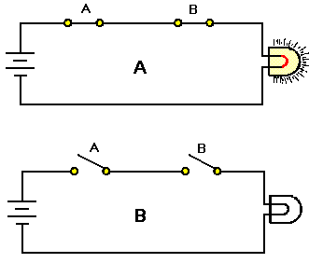
We can demonstrate the operation of the AND gate with a simple circuit that has two switches connected in series as shown. You can see that both switches are closed at the same time to light the lamp (view A). Any other combination of switch positions (view B) would result in an open circuit, either one of the switch is opened, the lamp would not be lighted.

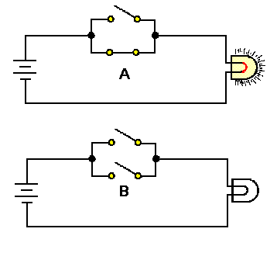
Now we demonstrate the OR gate, two switches are placed in parallel. If either or both of the switches are closed (view A), the lamp will light. The only time the lamp will not light up is when both switches are open (view B).

There are various types of logic gates in which they can be interconnected to perform different logic functions. The types of gate to be considered are the AND, OR, NOT, NAND, NOR, EX-OR, and EX-NOR gates.

Logic functions are defined by a truth table. This is a table which listed all the possible combinations of the input variables applied to a gate. Each variable can only be at either logic 0 or logic 1. Also, the output is generally labeled as F.

NOT logic functions:
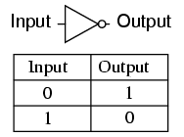
The gate shown here is known as an inverter, or NOT gate, because it outputs the exact opposite digital signal as what is input.

BUFFER logic functions:
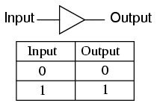
If two inverter gates are connected together so that the output of one feeds into the input of another, the two inversion functions would "cancel" each other out, so that there would be no inversion from input to final output.

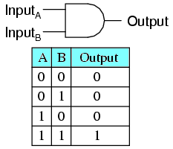
AND logic functions:

One of the gates is AND gate, so-called because the output of this gate will be "high" (1) if and only if all inputs are "high" (1). If any input(s) are "low" (0), the output is guaranteed to be in a "low" state as well.

With the 2-input AND gate subjected to all possibilities of input logic levels, a LED provides an indication of the output logic level.

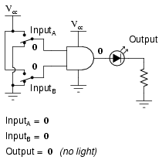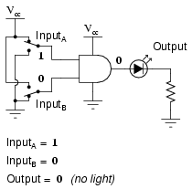
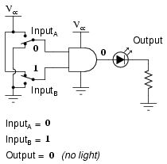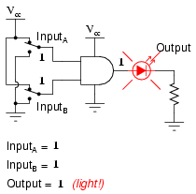

OR logic functions:
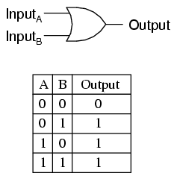
The next gate to be investigated is OR gate, so-called because the output of this gate will be "high" (1) if any of the inputs are high. The output of an OR gate goes "low" (0) if all inputs are low.
With the 2-inputs experiencing to all possible logic levels, a LED provides visual indication of the gate's output logic level.

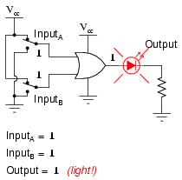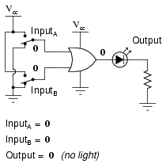

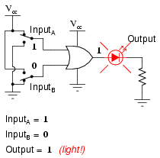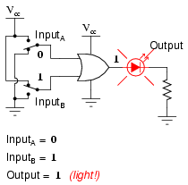

NAND logic functions:
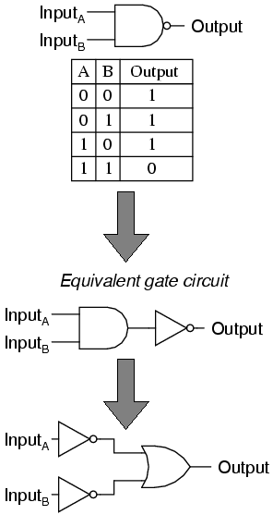
Another logic gate which basically formed by an AND gate and a NOT gate (inverter) is called NAND gate. The word "NAND" is a contraction of the words NOT and AND. Essentially, a NAND gate behaves the same as an AND gate with a NOT (inverter) gate connected to the output terminal. The truth table for a NAND gate is opposite as an AND gate.

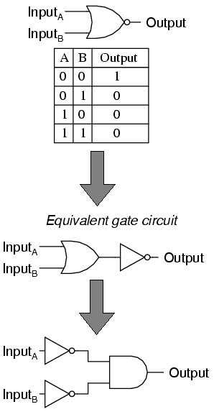
NOR logic functions:

As expected, the NOR gate is an OR gate with its inverted output, just like a NAND gate is an AND gate with an inverted output.

For NOR gates, the output goes "low" (0) if any of the inputs are made "high" (1). The output is high only when all inputs are low.

XOR logic functions:
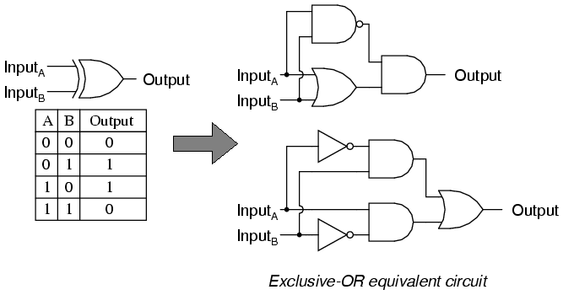

Exclusive-OR gates output a "high" (1) logic level if the inputs are at different logic levels, either 0 and 1 or 1 and 0. Conversely, they output a "low" (0) if the inputs are at the same logic levels.
Exclusive-OR gates are very useful for circuits where two or more binary numbers are to be compared bit-for-bit, and also for error detection (parity check) and code conversion.
XNOR logic functions:

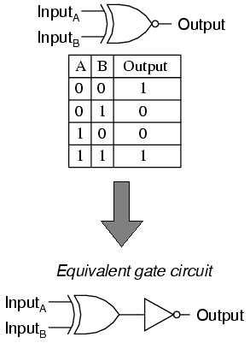
Finally it comes the Exclusive-NOR gate, otherwise known as the XNOR gate. It is equivalent to an Exclusive-OR gate with an inverted output. The truth table for this gate is exactly opposite to the Exclusive-OR gate.
As indicated by the truth table, the purpose of an Exclusive-NOR gate is to output a "high" (1) logic level whenever both inputs are at the same logic levels (either 00 or 11).

To summarize, there are eight basic logic blocks in the digital world.

a. NOT  F  F  F  F  F  F  F  F  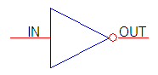 | b. Buffer  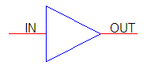 | c. AND  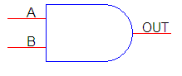 | d. OR  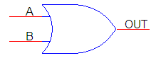
F = IN | F = IN | F = A · B | F = A + B
  IN | F
  0 | 1
  1 | 0
  IN | F
  0 | 0
  1 | 1
  A | B | F
  0 | 0 | 0
  0 | 1 | 0
  1 | 0 | 0
  1 | 1 | 1
  A | B | F
  0 | 0 | 0
  0 | 1 | 1
  1 | 0 | 1
  1 | 1 | 1
e. NAND  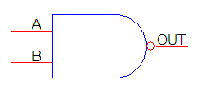 | f. NOR  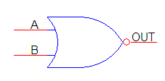 | g. EX-OR  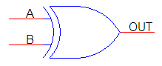 | h. EX-NOR  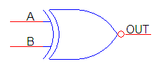
F = A · B | F = A + B | F = A · B + A · B | F = A · B + A · B
  A | B | F
  0 | 0 | 1
  0 | 1 | 1
  1 | 0 | 1
  1 | 1 | 0
  A | B | F
  0 | 0 | 1
  0 | 1 | 0
  1 | 0 | 0
  1 | 1 | 0
  A | B | F
  0 | 0 | 0
  0 | 1 | 1
  1 | 0 | 1
  1 | 1 | 0
  A | B | F
  0 | 0 | 1
  0 | 1 | 0
  1 | 0 | 0
  1 | 1 | 1

1.4.1 Boolean Algebra

It is possible to reduce a number of logic gates in a logic circuit, and then fewer gates will be achieved to implement the design. When a combinational circuit is to be designed to solve a logic problem, a Boolean equation with truth table describing the required circuit operation may be produced.

Simplification of a Boolean equation may be carried out by using either the rule of Boolean algebra or a mapping method. Boolean equations can be rearranged in either the product-of-sum (POS) or the sum-of-product (SOP). Where POS expression is in the form of F = (A+B)(C+D) and SOP expression is in the form of F = (AB)+(CD).

Logic Rules

Boolean algebra uses some of the same rules as ordinary algebra. In addition there are a number of logic rules which allow variables to be combined or eliminated to give a simpler version of an equation. These logic rules are:

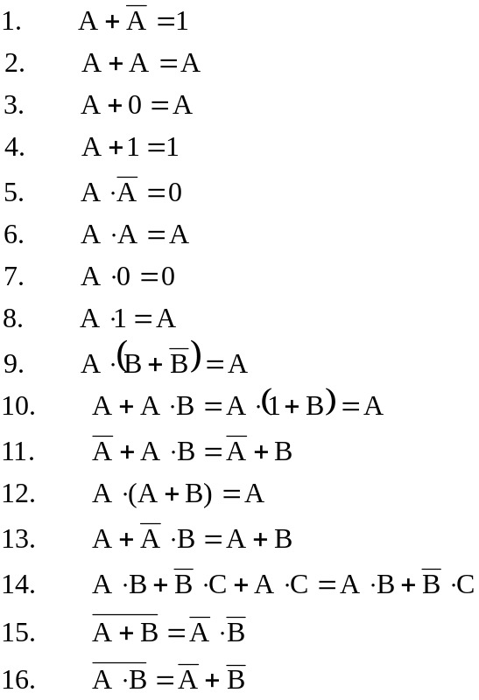

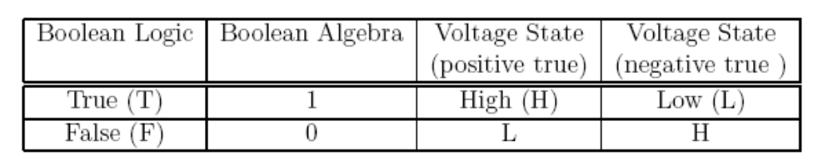

Example 1: Simplify F = B (A + C) + C.

Solution: F = AB + BC + C
F = AB + C (1 + B)
F = AB + C

Example 2: Simplify F = (A + B) BC + A

Solution: F = ABC + BC + A
F = A (1 + BC) + BC
F = A + BC

Example 3: Simplify 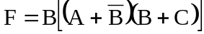
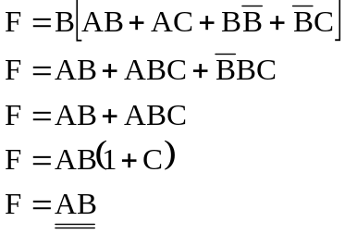
Solution:

CHAPTER 2 ANALOGUE AND DIGITAL ELECTRONICS

This chapter covers the following topics:

2.1 System Electronics
2.2 Op-amp Operation
2.3 Latch Circuit
2.4 Memory and Counter

These topics include learning materials and activities that facilitate students to:

- Explain how a systems approach (I-P-O) can be applied to the design of electronic circuit
- State the characteristics of an ideal op-amp
- Describe how an inverting and a non-inverting op-amp operate, and their practical use
- Explain the need for memory in a logic system
- Understand the use of a D-type flip-flop as a basic type of memory
- Utilize simple analogue and digital circuits
2.1 SYSTEM ELECTRONICS

Closed System:

When designing a control system, it is a good practice to consider it as a number of stages. For example, a drilling machine can be looked upon as the following.

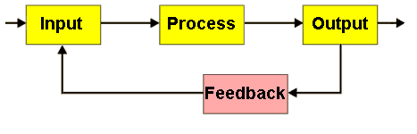

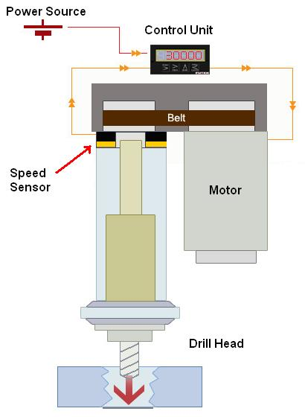
This is an example of a closed-loop system. It is a drilling machine with speed control, which can maintain the speed of the drill when it’s under a heavy load.

There is a sensor device, which detect the speed of the drill head. If the speed is different to the set speed, the control unit will adjust the power of the motor such that it can increase or decrease the speed.

Open System

A system that does not have feedback is an open system. An open system normally works once and then stops. A good example is shown below. A digital camera is used to take a photograph, which is then transferred to the computer where processing of the picture takes place and finally a printout is produced. This is an open system because there is no feedback and no attempt is made to improve the picture.

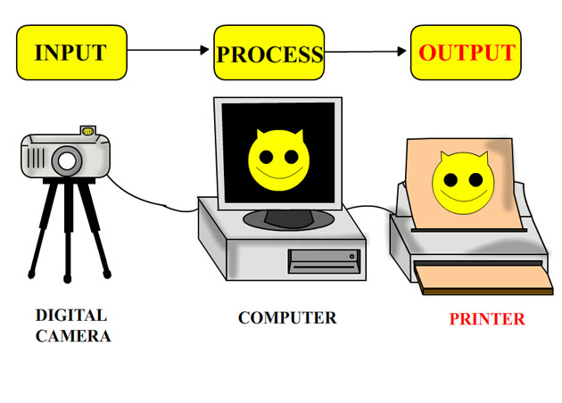
STOP AND THINK
The person taking the picture decides to improve the final printout, using graphics software. He prints out the photograph several times and alters the photo with the software. Is the system still an open system or has it now changed to a closed system with feedback?

2.2 OPERATIONAL-AMPLIFIER

Operational Amplifiers (also known as Op-Amps) are used in a range of circuits. They are generally used to amplify a weak electrical current in a circuit. Radios, stereo systems, headphones, TVs and many other electrical products include an operational amplifier as a component in many of their circuits.

For example, the circuit below is a part of an alarm circuit. When the circuit detects any alternation in light intensity by the light sensor, it sends a signal to trigger the relay and turn on the alarm system which sounds the siren. Without the operational amplifier, the signal would be too weak. The operational amplifier amplifies the signal such that it is strong enough to sound the siren. Sensors often need operational amplifiers in order for them to work properly.
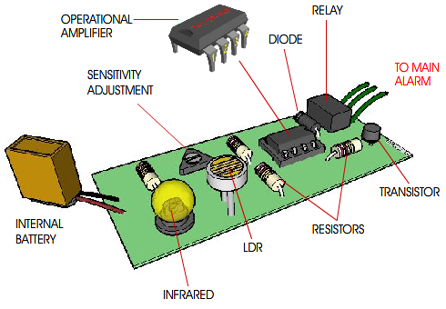
STOP AND THINK
Try to make a list of other electrical products that have operational amplifiers as a component in circuits.

The operational amplifier is the most useful single device in analogue electronic circuitry. With the use of different combination of external components, it can be made to perform a wide variety of analogue signal processing tasks.

8 not connected
7 +V
6output
5 offset null
offset null1
inverting input2
non-inverting input3
-V4
+
–

DEFINITION
Characteristics of an ideal operational amplifier:
- Infinite voltage gain
- Infinite input impedance
- Zero output impedance
- Infinite bandwidth
- Zero input offset voltage
- A control network that sets the amount of feedback (e.g. resistors)

The basic operation of an operational amplifier is shown in the following diagram. Please see the different between VR1 and the output of the operational amplifier.
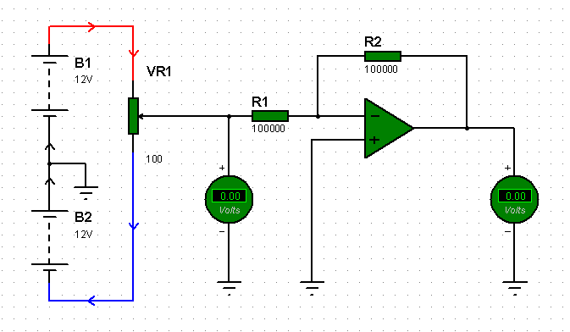
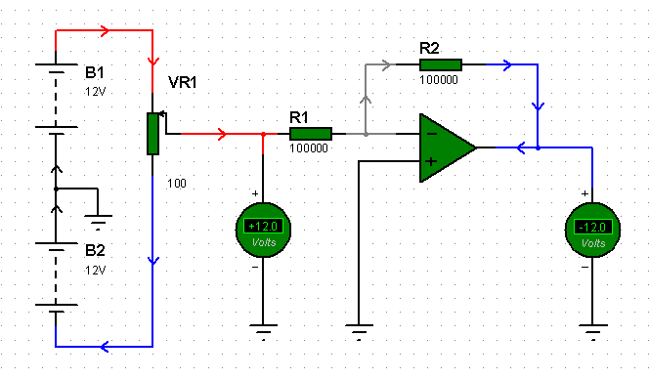

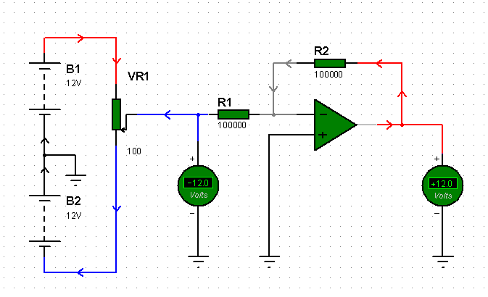

2.2.1 Inverting Amplifier

The closed loop gain of the inverting amplifier is equal to the ratio of R_{f (}feedback resistor) over R_{i} (input resistor). This transfer function describes accurately the output signal as long as the closed loop gain is much smaller than the open loop gain.
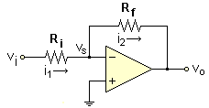
The basic circuit of the inverting amplifier is shown.

The transfer function is derived as follows: Considering the arbitrary current directions we have:
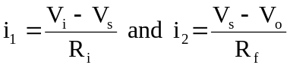

The non-inverting input (+) is connected directly to ground, then V_{s} = V- = 0 V, therefore:
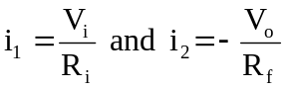

Since there is no current flow to any input, which is the infinite input impedance defined before, hence
i₁ = i₂

Therefore, the transfer function of the inverting amplifier is
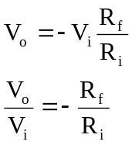
Then 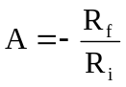, where A is the gain.

2.2.2 Non-inverting Amplifier

The non-inverting op-amp has the input signal connected to its non-inverting input, thus its input source sees as infinite impedance. There is no input offset voltage because V_{E} is equal to zero.

The voltage divider rule is used with V_{OUT} being the input to the voltage divider, and V_{IN} being the output of the voltage divider. Since no current can flow into either op amp lead, use of the voltage divider rule is allowed.
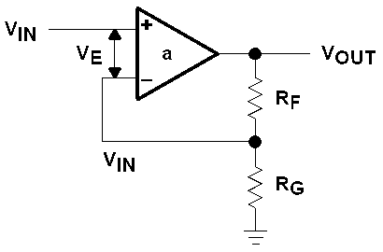
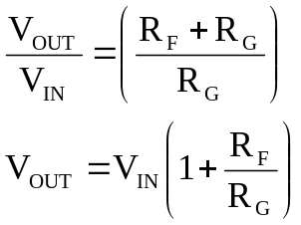
When V_{OUT} = 1, the circuit becomes a unity gain buffer. R_{G} is usually deleted to achieve the same results. Some operational amplifiers are self-destructive when R_{F} is left out of the circuit, so R_{F} is used in many buffer designs.

When R_{F} is included in a buffer circuit, its function is to protect the inverting input from an over voltage. R_{F} can never be left out of the circuit in a current feedback amplifier design because R_{F} determines stability in current feedback amplifiers.

2.2.3 Negative Feedback
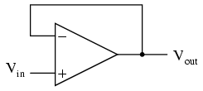
If we connect the output of an operational amplifier to its inverting input (-), and apply a voltage signal to the non-inverting input (+), we find that the output voltage of the operational amplifier closely follows that input voltage.

As V_{in} increases, V_{out} will increase in accordance with the differential gain. However, as V_{out} increases, that output voltage is fed back to the inverting input, thereby acting to decrease the voltage differential between inputs, which acts to bring the output down.
Taking the operational amplifier’s output voltage and coupling it to the inverting input is a technique known as negative feedback, and it is the key to having a self-stabilizing system. This stability gives the operational amplifier to work in its linear mode, as opposed to merely being saturated fully "on" or "off" as it was when used as a comparator, with no feedback at all.
As we've seen, negative feedback is useful when applied to operational amplifiers. It allows creating all these practical circuits, being able to precisely set gains, rates, and other significant parameters with just a few changes of resistor values. Negative feedback makes all these circuits stable and self-correcting.

The basic principle of negative feedback is that the output tends to drive in a direction that creates a condition of equilibrium or balance. In an operational amplifier circuit with no feedback, there is no corrective mechanism, and the output voltage will saturate with the tiniest amount of differential voltage applied between the inputs. The result is a comparator.

2.2.4 Positive Feedback

The use of positive feedback which results in a feedback amplifier having closed-loop gain greater than 1, it results in operations as an oscillator circuit. An oscillator circuit then provides a varying output signal. There is a sinusoidal oscillator if the output signal varies in sinusoidal. If the output voltage rises quickly to one voltage level and later drops quickly to another voltage level, generally it is a pulse or square wave oscillator.
If the gain is smaller than 1, the oscillations die out after a few cycles, and if the gain is greater than 1, the oscillator drives itself into saturation and cutoff clipping, which is limited by the supply voltage. Where V_{f} is the feedback voltage, A_{v} is the voltage gain, and α_{f} is the feedback attenuation. See the result below.

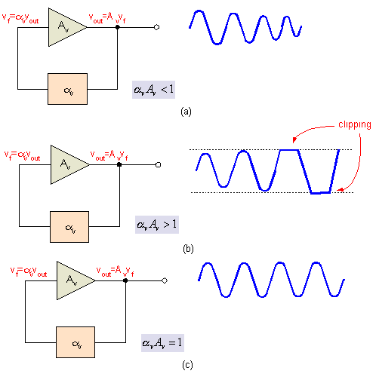

2.3 LATCH CIRCUIT

In electronics, a latch is a data storage system used to store information in sequential logic systems. One latch can store one bit of information.

There are several types of basic latch, which include Set-Reset (SR) Latch, and D-Latch.

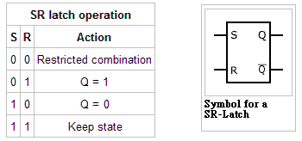
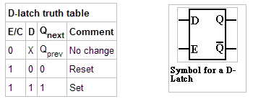
Most of the Flip-Flop circuit can be built by either two NAND gates or two NOR gates, which is called a NAND gate latch or NOR gate latch respectively The two NAND gates are cross-coupled so that the output of NAND-1 is connected to one of the input of NAND-2, and vice versa.

For NAND gate latch, there are two inputs including SET and RESET, and the gate outputs normally labeled as Q and , while the NOR gate latch is in same configuration but using NOR gates instead of NAND gates.
Q
1

2
SET

RESET
Q

Operation of NAND Latch:

- SET = RESET = 0. This condition tries to set and clear the latch at the same time, and it produces Q = = 1. If the inputs are returned to 1 simultaneously, the resulting state is unpredictable. This input condition should not be used.
Q
- SET = 0, RESET = 1. This will always cause the output to go to the Q = 1 state, where it will remain even after SET returns HIGH. This is called “setting” the latch.
- SET = 1, RESET = 0. This will always produce the Q = 0 state, where the output will remain even after RESET returns HIGH. This is called “clearing” or “resetting” the latch.
- SET = RESET = 1. This condition is the normal resting state, and it has no effect on the output state. The Q and outputs will remain in whatever state they were in prior to this input condition.
Q

For D-latch, it contains the NAND latch and the steering NAND gates 1 and 2. The common input to the steering gates is called an “enable” input (normally abbreviated as “EN”) rather than a clock input because its effect on the Q and outputs is not restricted to occurring only on its transitions.
Q
1

2
Q

SET

RESET
D

EN

Operation of D-Latch:

- When EN is HIGH, the D input will produce a LOW at either the SET or the RESET inputs of the NAND latch to cause Q to become the same level as D. If D changes while EN is HIGH, Q will follow the changes exactly. In other words, while EN = 1, the Q output will look exactly like D. In this mode, the D latch is said to be transparent.
- When EN goes LOW, the D input is inhibited from affecting the NAND latch because the outputs of both steering gates will be held HIGH. Thus the Q and
Q
outputs will stay at whatever level they had just before EN went LOW. In other words, the outputs are latched to their current level and cannot change while EN is LOW even if D changes.

2.4 MEMORY AND COUNTER

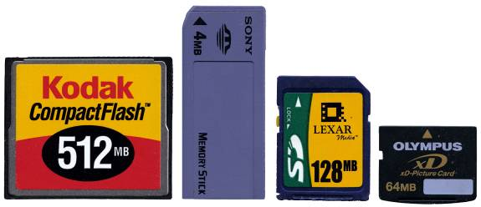
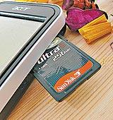
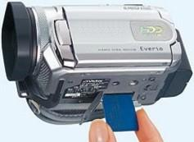
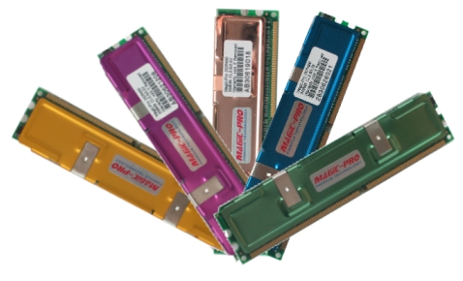
2.4.1 Memory

STOP AND THINK
- What is the function of memory?
- Why memory is necessary in computer systems?
- How many types of memory do you have encountered in daily life?

Memory is a very important part of digital systems. Its availability in digital computers allows for storing programs and data. Furthermore, it is important for temporary storage of the output produced by a combinational circuit for use at a later time in the operation of digital system.

The basic memory element is latch. And there are two basic types of memory: ROM and RAM.

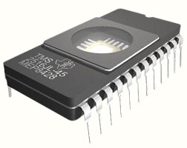
ROM - Read-Only Memory: data is pre-recorded for read only which cannot be removed. ROM is non-volatile and it retains its contents regardless the computer is on or off. Most personal computers contain a small amount of ROM that stores critical programs such as the program that boots the computer. In addition, ROMs are used in calculators and peripheral devices such as printers, whose fonts are often stored in ROMs.

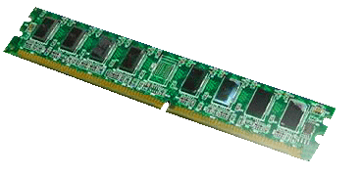
RAM - Random Access Memory: whose contents can be accessed with read, write or remove. Its data will lose when there is no power supply on it. RAM is usually used for primary storage in computers to hold active information such as data and programs. Common forms of RAM are: SRAM (Static RAM) and DRAM (Dynamic RAM).

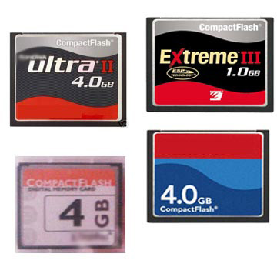
Flash memory is non-volatile computer memory that can be electrically erased and reprogrammed. It is a technology that is primarily used in memory cards, USB flash drives, which are used for general storage and transfer of data between computers and other digital products. It is a specific type of EEPROM that is erased and programmed in large blocks. Examples of applications include PDAs (Personal Data Assistant) and laptop computers, digital audio players, digital cameras and mobile phones.

2.4.2 Counter

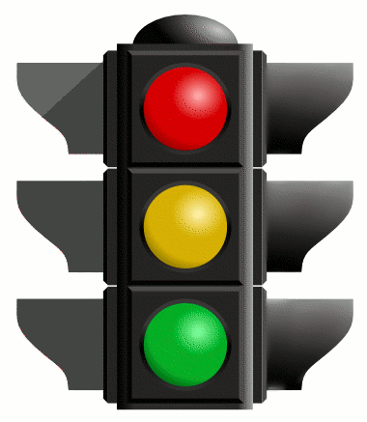
A traffic light is a signalling device indicating which specific movement to drive or walk. Now let us design a simple traffic light by using a “counter” to do the similar thing. As you all know, the sequence of the traffic light in Hong Kong is Red→ Red and Amber → Green → Amber → Red repeatedly like the table below.

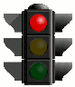
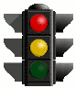
Counter Output | LEDs on/off sequence
Counter Output | Red | Amber | Green
Q₀
Q₁
Q₂
Q₃
Q₄
Q₅
Q₆
Q₇
Q₈
Q₉

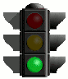
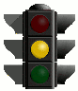

The counter advances as the clock input becomes high. Each output Q₀ ~ Q₉ goes high in turn as counting advances.

Q₀ → Q₁ → Q₂ → Q₃ → Q₄ → Q₅ → Q₆ → Q₇ → Q₈ → Q₉

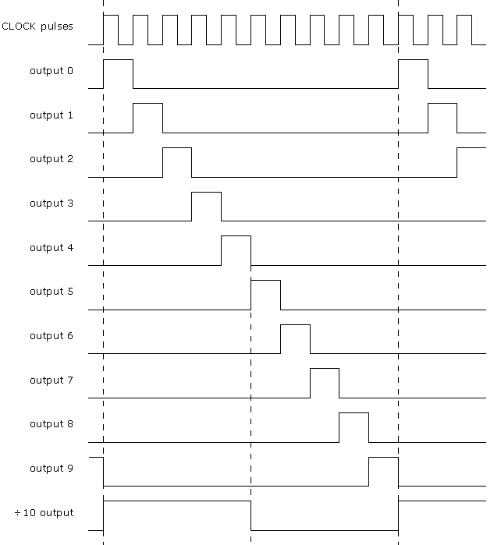

For the counter advance, it requires clock signal for triggering. Using 555 a stable circuit provides clock pulses for the 4017 counter which has ten outputs (Q0 to Q9). Each output becomes high in turn as the clock pulses are received.

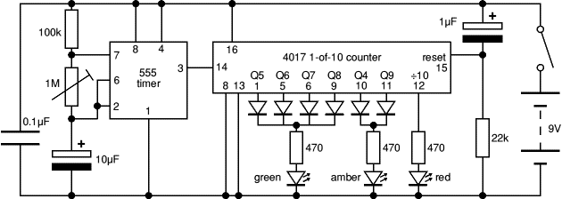

STOP AND THINK
- Why are some diodes required in the counter output?
- How to increase the brightness of the LEDs?
- How to decrease the clock speed? Which components determine the frequency?

What is inside the counter?

In fact, the counter combines with several discrete J-K flip-flops. J-K flip-flops have the ability to "toggle" their output state at the command of a clock pulse when both J and K inputs are made "high" (1):
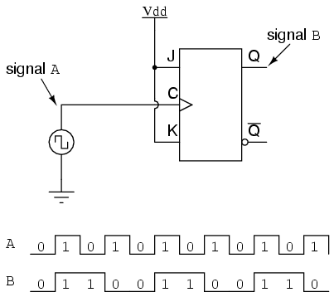

Starting with four J-K flip-flops connected in such a way to always be in the "toggle" mode, we need to determine how to connect the clock inputs in such a way so that each succeeding bit toggles when the bit before it transitions from 1 to 0. The Q outputs of each flip-flop will serve as the respective binary bits of the final, four-bit count.

If we used flip-flops with negative-edge triggering, we could simply connect the clock input of each flip-flop to the Q output of the flip-flop before it, so that when the bit before it changes from a 1 to a 0, the "falling edge" of that signal would "clock" the next flip-flop to toggle the next bit:
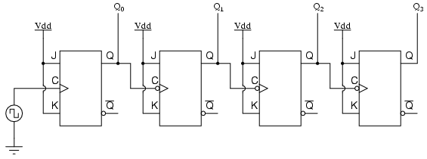
+ve Trigger -ve Trigger

This circuit would yield the following output waveforms, when "clocked" by a repetitive source of pulses from an oscillator:

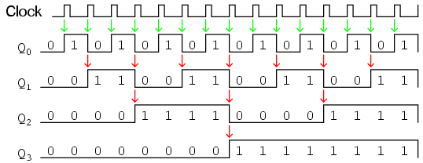

STOP AND THINK
For the decade counter in the previous, a decoder is required to decode the binary pattern into sequential bit. Try to guess what are the minimal J-K flip-flops in the 4017 decade counter?

CHAPTER 3 INTEGRATED CIRCUIT, MICROCONTROLLER AND INTERFACING

This chapter covers the following topics:

3.1 Types of Integrated Circuit (IC)
3.2 Programmable Systems
3.3 Micro-controller Basics

These topics include learning materials and activities that facilitate students to:

- identify the common types of IC being used in electronics products
- understand the use of a micro-controller
- describe, with the use of a simplified block diagram, the different parts of a micro-controller and a micro-controller system
- recognize that a ‘bus’ is a link that transports information within a digital system;
- explain the advantages and disadvantages of software-controlled systems compared to hard-wired systems
- apply simple interfacing circuits for micro-controller based system

3.1 TYPES OF Integrated Circuit

3.1.1 Invention of Integrated Circuit

Before the invention of integrated circuit, electronic products were commonly made of vacuum tube. Due to the size of vacuum tube, the size of electronic product can be very large if it was of certain complexity e.g. computer of 40s is typically in the size of a room. Later, transistor was invented. As transistor has smaller size, it soon replaced vacuum tubes used in almost every electronic product. However, new electronic product ideas e.g. calculator, keep occur that make people still consider transistor was not small enough and want even better way to make electronic circuit smaller. The problem was solved by two engineers, whose names are Jack Kilby and Robert Noyce in the period from 1958 to 1959. The interesting point here is that they were working on the solution to the problem of how to make more with less independently and unaware of the activities of each other. They both came up with the same solution – put the whole circuit i.e. transistors, wires, everything in one silicon chip. This is what we called integrated circuit. Jack Kilby was an engineer working for Texas Instruments in 1958. Robert Noyce was a research engineer co-founded the Fairchild Semiconductor Corporation in 1957 and the Fairchild Semiconductor Corporation later announced the first commercially available integrated circuits in 1961. In 1968, Robert Noyce co-founded Intel, the company invented microprocessor, which is now being used in every desktop computer.

HIGHLIGHT
An integrated circuit (IC) is a semiconductor wafer on which thousands or millions of tiny components, including resistors, capacitors, and transistors are fabricated.

Nowadays, we can prepare in a computer called workstation the circuit diagram to be put into an IC.

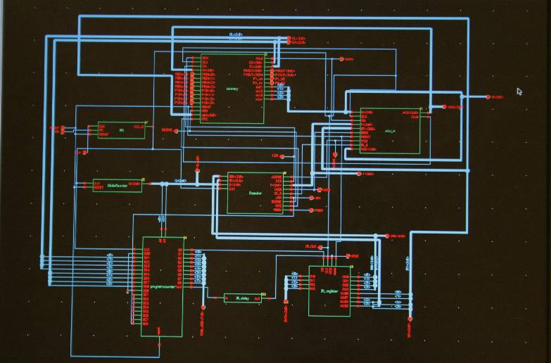

The workstation can help to design the layout, which is a representation of the integrated circuit in term of planar patterns of metal, oxide or semiconductor layers that make up the components of the integrated circuit.
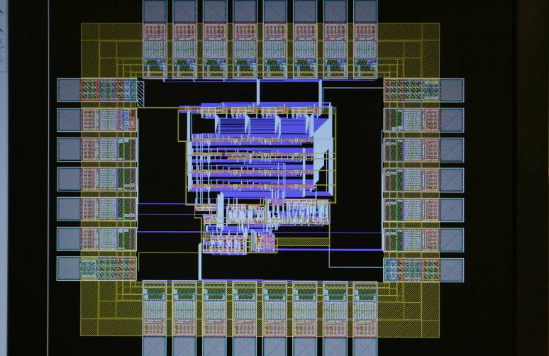

After the integrated circuit is fabricated and tested. Each good die, at which the circuit has been fabricated, will then be attached to an IC package and then welded to the pads inside the package using very fine aluminium (or gold) wires.
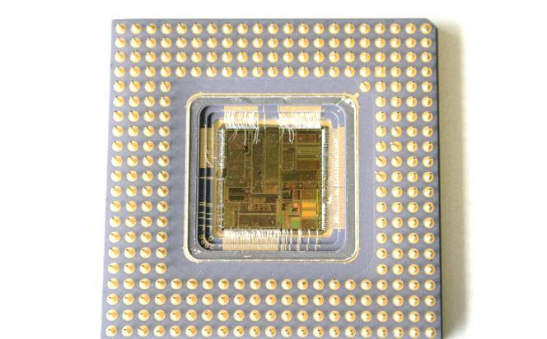

An integrated circuit is a whole circuit fabricated in one chip.

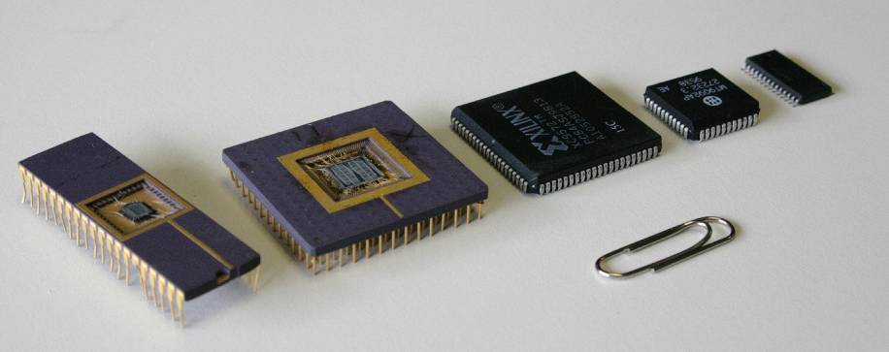

The appearance of integrated circuit in different types of packages

Since its invention, ICs
- have made possible the development of many new products, including personal digital assistant (PDA) and personal computers (PC) and video game consoles.
- have been used to improve the design of many existing products, including televisions, radios, and high-fidelity equipment.

ICs are
- considered as one of the most important innovations of mankind
- used in almost all modern products.

STOP AND THINK
How Do We Live Differently without Integrated Circuit?

- Consider the electronic products that you used today, which of them come with integrated circuit?
- Identify which of them would not exist if integrated circuit has not been invented.
- Hence, comment on how our daily life would be affected if integrated circuits have not been invented.

3.1.2 Different Types of Integrated Circuit

(1) Categorize Integrated Circuit by Function

The tiny components in an IC can be:

- connected together as a circuit when fabricate the IC to perform a function
- not connected together as a circuit when fabricate the IC to perform any useful function. In such case, the function of the IC can be defined (or programmed) after it is fabricated (see section 3.2 programmable system for details.)

We can find commercially available ICs that are fabricated to perform the following functions:

- Logic Gates
There are ICs that contain logic gate circuit such as AND (e.g. 7408 is Quad 2-Input AND Gates), OR (e.g. 7432 is Quad 2-Input OR Gate), NAND (e.g. 7400 is Quad 2-Input NAND Gate). (see Chapter 2 for details of logic gate)
- Operational Amplifiers
For example, 741 is a family of general purpose operational amplifier IC. (see Chapter 2 for details of operational amplifier.)
- Timers
These are circuits that help keep track of time. (see Chapter 2 for explanation of counter) 555 is one of the most popular timer IC, which allow user to operate in one of the following modes, which differ by what help is available to keep track of time:
- Monostable mode: the 555 functions as a "one-shot", which is a pulse that exists once for a short period of time
- Free Running mode: the 555 operates as an oscillator, which periodically expresses timing instances.
- Bistable mode: the 555 can operate be in either one of its two stable states.
- Analogue Switches
These ICs behave like a relay but are implemented using a transistor rather than moving parts (e.g. 4016 is a quad bilateral switch). Compared to a relay, it allows much smaller current passing through and also does not provide electrical isolation of relay. (see Chapter 1 for details)
- Memories
ICs used to store information e.g. RAM and ROM (see Chapter 2.4 for details).
- Micro-controller
ICs contain a miniaturized computer in it. We will discuss it in greater detail next section (section 3.3). Examples include 8051, PIC and ARM.

STOP AND THINK
Search on the Internet to find:
- datasheet of the IC with the above mentioned part numbers (e.g. 741, 555) and application circuit diagram examples.
- more functions that can be found in commercially available ICs.

(2) Categorize Integrated Circuit by Complexity
As technology advances, people become manageable to put more and more electronic components into one chip. The complexities or levels of integration (they both refer to the number of electronic components per chip) are often used to categorize ICs. Following table summarizes different levels of integration:

Categorization of IC by Complexity

Types | Stand For | Electronic Components Per Chip | Examples
SSI | small-scale integration | ≤ 100 | Logic gates
MSI | medium-scale integration | 100 to 3,000 | Counter
LSI | large-scale integration | 3,000 to 100,000 | A/D, D/A
VLSI | very large-scale integration | 100,000 to 1,000,000 | Micro-controller
ULSI | ultra large-scale integration | > 1 million | Pentium, Pentium Dual Core

The term ULSI was proposed for chips of complexity more than 1 million of components but people often use the term VLSI to cover ULSI as well.

(3) Categorize Integrated Circuit by Package

After the integrated circuit is fabricated and tested. Each good die, at which the circuit has been fabricated, will then be assembled inside an IC package before it is sold. The package prevents the die from damaging by external force or moisture, and it also prevents the silicon chip from erosion by various sources of chemicals. There are two main types of IC packages:

Through Hole Package
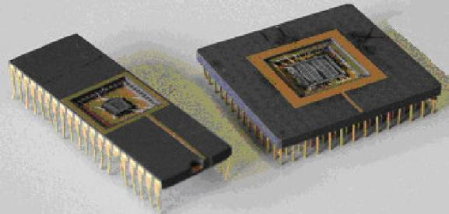

Figure 3.3 – Examples of Through Hole Package

Pins on through hole package allow us to insert into holes drilled in printed circuit board (PCB) and then soldered to pads on the opposite side of the PCB. Inserting into holes and soldering to pads provide stronger mechanical bonds make through hole package than surface mount package does. However, the additional drilling translates into higher production cost and less routing area for signal traces.

- Surface Mount Package

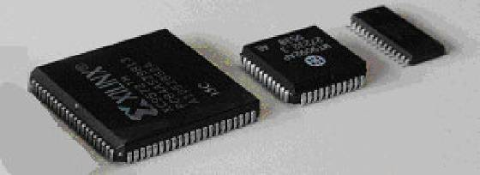

Figure 3.4 – Examples of Surface Mount Package

There is no or smaller lead on the surface mount packages so that it
- is usually smaller than its through hole package counterpart.
- can be directly attached to pads on the surface of PCB and hence save space (and effort) to drill hole in PCB
- does not require to drill holes on PCB and can be mounted on both sides of the PCB.

As a result, it allows us to produce PCB with much higher circuit densities. Nowadays, surface mount package is used in majority of electronic products and has largely replaced its through hole package counterpart.

(4) Categorize Integrated Circuit by Signal it Process

ICs can also be categorized as either analog (linear), digital or mixed signal (both analog and digital on the same chip) according to the types of signal they are designed to process. More specifically:
- Digital IC operates at only a few defined logic levels or states, typically only two different states called LOW and HIGH. Logic gates, flip-flops, memories and

micro-controller are common digital ICs. (see Chapter 2 for explanation of Digital)
- Analog IC has continuously variable output that is a linear function of the input signal level. Operational amplifier and sensors are two common analog ICs. (see Chapter 2 for explanation of Analog)

Many logic families were originally produced and commercially available as individual discrete component and each component contains one or few related basic logical functions such as NAND gates or latch. These discrete components could then be used as "building-blocks" to create systems by interconnecting a number of them together as an electronic product. As technology advances, we can now produce higher level of integration IC such as micro-controller or other more complex function. After their invention, some of the logic families became also used as the “building blocks” to implement logic functions within these highly integrated IC. We will explain the characteristics of TTL and CMOS in the following few paragraphs.

At first, we will discuss the Transistor––Transistor Logic (TTL). As implied by its name, TTL is a family of logic devices in which all logic circuits are constructed by using of transistors and resistors only, including such as logic gates, counter, latch, memory. The study of the internal circuit design of TTL is beyond the scope of the electronic elective of DAT. However, it is beneficial for us to learn the following characteristics of TTL logic as mentioned below:

- Power Supply
Common TTL circuits require a power supply of 5V to operate properly.

- Input Voltage
The voltage of an input signal has to be within a range in order it can be recognised by an TTL input as logic LOW or logic HIGH.

 | Logic LOW | Logic HIGH
Voltage Range | 0 V to 0.8 V | 2.0 V to 5 V
 | (above the ground) | (above the ground)

- Input Current

A small amount of current must be drawn from a TTL input to ensure proper logic levels (Note that the direction of current flow is different for logic LOW and logic HIGH). The total current drawn must be within the capacities of the preceding stage, which limits the number of nodes that can be connected to an TTL output.

 | Logic LOW | Logic HIGH
Input Current | < 1.6mA | > 0.04 mA
 | (flowing out from an | (flowing into an TTL
 | TTL input) | input)

- Output Current
When an TTL output is operating properly,
  - if it is in logic HIGH state, the output should be able to output up to 0.4mA current and yet still able to maintain at least 2.4 V above the ground.
  - if it is in logic LOW state, the output should be able to sink up to 16mA current and yet still able to maintain not more than 0.4 V above the ground.

- Output Voltage
When an TTL is operating properly, its output signal should be within a range as specified by the table below. However, if an TTL output is connected to nodes that take current exceeds its output current limit, the output voltage would also go outside the voltage range specified by the table below.

 | Logic LOW | Logic HIGH
Voltage Range | 0 V to 0.4 V | 2.4 V to 5 V
 | (above the ground) | (above the ground)

TTL circuits are one type of commonly used IC. As a result, signal inputs and outputs of other IC and electronic equipments are often specified as "TTL" inputs or outputs to stress that they are compatibility with their voltage and current levels.

Followings are some important characteristics of Complementary Metal–oxide–semiconductor (CMOS) devices:

      - high noise immunity (i.e. the ability that the device is able to operate properly without being affected by unwanted signals);
      - low power consumption but increase with switching frequency (i.e. frequency at which logic state is changed between HIGH and LOW);
      - allows a high density of logic functions on a chip;
      - widely used in highly complex digital ICs (e.g. microprocessor and microcontroller), analog circuits (e.g. image sensor, operational amplifier, RF applications) and mixed-signal application (e.g. analog digital converter).

STOP AND THINK
What Are the Usages of Different ICs?

- Find a daily electronic product and disassemble it (e.g. Soy bean miller in the diagram below or a Wiimote for the PlayStation)
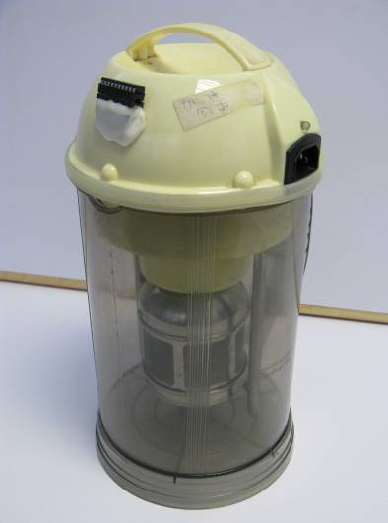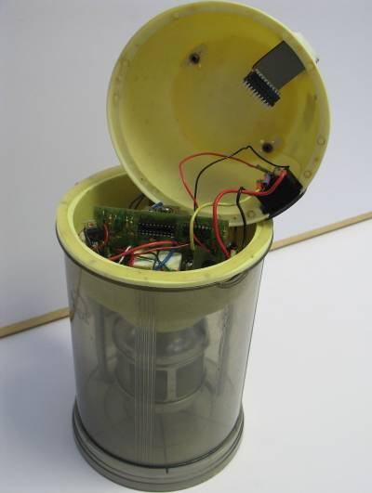

- Select three ICs that you consider as one of the common types of IC being used in other electronic products.
- For IC that you selected, try to identify what type(s) it is. You may assign more than one type to each IC. [Note: you may search the Internet for data sheet to describe the function and the characteristics for the IC you selected.].
- Guess which type of IC is the most commonly listed by your classmates. Then, guess what its usage is.

3.2 PROGRAMMABLE SYSTEMS

3.2.1 Programmable Logic Devices

After the invention of integrated circuit, people manage to invent a lot of new electronic product based on it. To design a new electronic product, electronic engineer prepares conceptual circuit design based on the expected functionality of the electronic product. Then, conceptual circuit design can be tested to determine whether it performs the function as expected. A traditional way is to test a conceptual circuit design is to build the circuit and then test its functionality. We will keep modify the design of the circuit and test it until it works as expected. However, this is a fairly difficult way of build a circuit, particular if the circuit consists of more than a dozen of component. Further, there are many opportunities for mistakes to create a large number of interconnecting wires and modify the interconnection. The purpose of inventing programmable logic device is to help dramatically reducing the number of interconnecting wires and make changes to the design of an electronic circuit easier.

Ordinary electronic circuit implements a predefined set of functions. We refer this kind of logic circuit as "hard-wired" because the logic circuits can only be wired together to perform a single task only. In order to make the circuit to perform a different task, it is necessary to change the circuitry and hence the wiring of the circuit. A programmable logic device or PLD is an electronic component used to build logic circuits. Unlike a logic gate, which has a fixed function, a PLD has an undefined function at the time of manufacture. Before the PLD can be used in a circuit, it must be programmed to define the exact function for it to perform. Programming of a PLD can usually be carried out in an equipment in a much easier way that changing the wiring of a hard-wired circuit. Afterward, to make the circuit to perform a different task, we may simply program the device once more (i.e. reprogram the device) to define another function for the PLD to perform.

(1) Programmable Logic Array

We will describe programmable logic arrays or PLA as an example of programmable logic devices and use it to explain how programming can be done.

The function of PLA is to allow designers to implement Boolean functions. Each PLA consists of an array of logic gates and a number of programmable interconnections between the logic gates. Following diagram illustrates a simple three inputs (X₂, X_{1,}
X₀) two outputs (Y₁, Y₀) PLA before it is programmed.

X₂
X₁
X₀
Y₁
Y₀
•
•
•

Before a PLA is programmed, there is no electrical connection between any of its vertical wire and horizontal wire. We will use the following example to illustrate how interconnections can be specified when we implement a Boolean equation using PLA.

Example: By using the three inputs two outputs PLA, design a logic circuit that implements a Boolean equation specified by the following truth table:

X₂ | X₁ | X₀ | S
0 | 0 | 0 | 0
0 | 0 | 1 | 1
0 | 1 | 0 | 1
0 | 1 | 1 | 0
1 | 0 | 0 | 1
1 | 0 | 1 | 0
1 | 1 | 0 | 0
1 | 1 | 1 | 1
Solution:
Before we illustrate how the interconnections can be specified in order to implement a Boolean equation, let’s study the construction of the first part of the PLA. It can be easily understood that if the top wires correspond to X₂, X₁ and X₀, then the wires just below correspond to their negation, 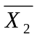, 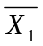, 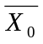. That is,

X₂
X₁
X₀
X₂
X₁
X₀
•
•
•

Next, let’s study the construction of the rest of the PLA.
X₂
X₁
X₀

A number of black dots have been added to represent where interconnections should be made. In effect, "programming" a PLA means specifying where to put these black dots. Here, after added the black dots, the output of the AND gates correspond to

The first AND gate (on the left) is: 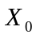
The second AND gate (from the left) is: 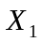
The third AND gate (from the left) is:
The fourth AND gate (from the left) is: 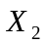.

Next, let’s add OR gates using horizontal wires to connect all the above four gates together.

X₂
X₁
X₀
S

Exercise: By using the three inputs two outputs PLA, design a logic circuit that implements a Boolean equation specified by the following truth table:

X₂ | X₁ | X₀ | C
0 | 0 | 0 | 0
0 | 0 | 1 | 0
0 | 1 | 0 | 0
0 | 1 | 1 | 1
1 | 0 | 0 | 0
1 | 0 | 1 | 1
1 | 1 | 0 | 1
1 | 1 | 1 | 1

Example: By using the three inputs two outputs PLA, design a 3-bit full-adder, which takes three bits, B₀, B₁ and B₂, and adds them to produce a SUM and a CARRY output. Note: you may refer to the following truth table for the exact function of a full-adder:

B₂ | B₁ | B₀ | CARRY | SUM
0 | 0 | 0 | 0 | 0
0 | 0 | 1 | 0 | 1
0 | 1 | 0 | 0 | 1
0 | 1 | 1 | 1 | 0
1 | 0 | 0 | 0 | 1
1 | 0 | 1 | 1 | 0
1 | 1 | 0 | 1 | 0
1 | 1 | 1 | 1 | 1

Solution: We may note from the above truth table that we have already used the 3 Input 2 Output PLA implemented the required Boolean equations. Hence, we may program the PLA and put it in the circuit represented by the following diagram:
10KΩ
3 Input
2 Output PLA
5V
5V
10KΩ
10KΩ
470Ω
470Ω
B₂
B₁
B₀
CARRY
SUM
You may consider the above illustrates the design of a very simple computer, which display the result of adding three bits input on the two LEDs. In reality, we might use programmable logic devices with a few thousand gates or even much more to design a complicated IC, say a computer on a chip or namely micro-controller.

3.2.2 Micro-controller as A Multi-purpose Programmable Integrated Circuit

Micro-controllers are another type of programmable IC. Like programmable logic device, micro-controller they can be programmed to perform different functions. Micro-controller does this by defining a set of subtasks, or instructions that controls how it works, and then letting users write programs from these instructions. Details about micro-controller will be given in next section (section 3.3).
3.3 MICRO-CONTROLLER BASICS

3.3.1 Use of a Micro-controller

A micro-controller is a kind of miniaturized computer fabricated in one chip. It is found in all kinds of electronic products used in daily life. Some of these examples are shown below.
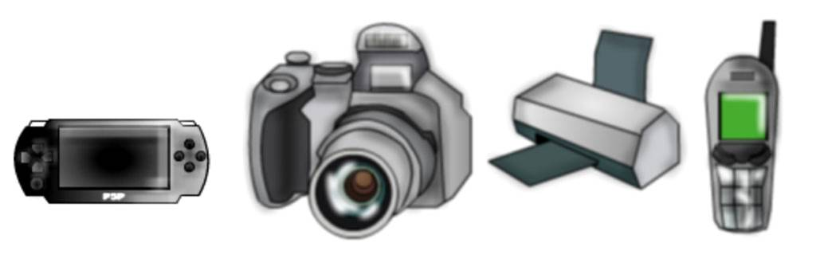
Examples of Electronic Products Used in Daily Life
that Incorporate Micro-controllers

HIGHLIGHT
What is Micro-controller?

A micro-controller (or MCU) is an integrated circuit that includes circuitry sufficient to act self-sufficiently and cost-effectiveness as a miniaturized computer. Unlike a general-purpose computer, a micro-controller is usually for a dedicated task e.g. to control a particular system.

STOP AND THINK
How Many Micro-controllers Do You Use Today?

- Try to make a list and count how many devices with micro-controllers you interact in a typical day.
- Select one device out of your list and describe what this device does. Suggest what the micro-controller in this device does.

3.3.2 Similar Parts in Micro-controller System and Personal Computer
A micro-controller is a computer-on-a-chip. So, what a computer has? All computers, including personal computer, mainframe computer or a micro-controller, have several things in common:
- The computer has a CPU (central processing unit) to execute programs. If you are sitting at a personal computer to browse the Internet, the CPU in your computer is executing a program that implements the Web browser to display web pages.
- The CPU loads the program from somewhere. On your personal computer, the browser program is loaded from secondary memory e.g. hard disk.
- The computer has some primary memory e.g. RAM where it can store the program that a computer is executing
- The computer has some input and output devices so it can communicate with people and external world while it is executing program. On your personal computer, the keyboard and mouse are input devices and the monitor and printer are output devices.

Following diagram shows an exploded view of a modern personal computer.
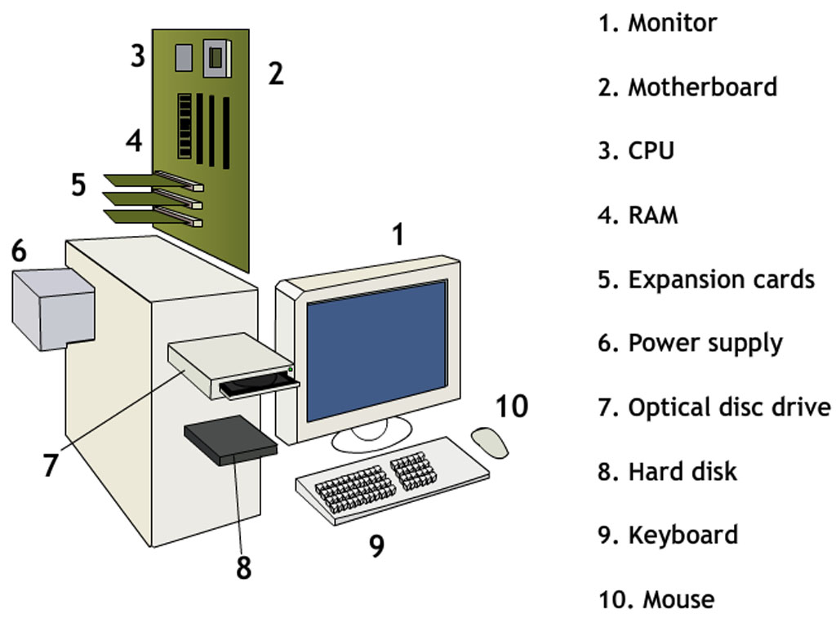

STOP AND THINK
- Which part(s) of a personal computer corresponds to CPU, memory, input and output?
- Which part(s) of human body corresponds to the four components of a computer, namely to CPU, memory, input and output?

    - Transporting Information within a Computer System

The following block diagram illustrates the essential parts of different types of computers such as personal computer, mainframe computer or a micro-controller. The rectangle in dotted line surrounds the parts that usually integrate inside a micro-controller.

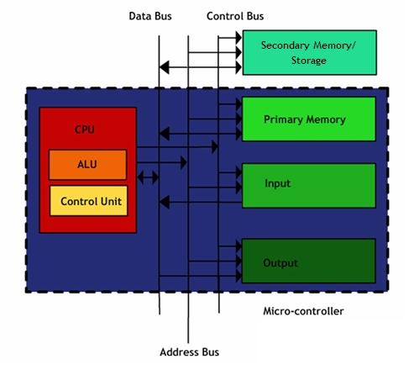
Block diagram representing the essential parts of a micro-controller.

Central Processing Unit (CPU)
- Consist of two parts, Control Unit and Arithmetic / Logic Unit (ALU)
- Control Unit interprets and executes a list of instructions which comprise the program
- The list of operation that performs the desired task is called a program
- The computer operates on a list of instructions, which are stored in primary memory and executed in a sequential manner.
- Arithmetic / Logic Unit executes arithmetic and logical operations required in the execution of a program.

Primary Memory
- High speed semiconductor memory used to store the program and also any data values which are associated with the program.
- Directly addressed by the microprocessor and the two principal types are read-only memory (ROM) and read/write memory (RAM)
- ROM is used only for permanent programs and unchanging data storage
- RAM (Random Access Memory) is used to stored programs and data that can change during the execution of the programs

Secondary Memory/ Storage
- The desired data stored must be copied to the primary memory before the CPU can access and process the information
- Also called mass-storage devices. Example includes hard disk and DVD-ROM. They usually have large storage capacities at a relatively low cost

Input/ Output (I/O) Unit
- Contains the interface circuits needed to allow the I/O devices to properly communicate with the computer
- Examples of input devices are keyboard, image scanner, mouse ...
- Examples of output devices are printer, plotter, monitor ...

The Bus System
- Information is passed between the various units of a computer via a communication subsystem called a bus
- In practice a computer bus is divided into three groups of signals:

The data bus
- A set of wires along which data is transferred between units
- Signals are bi-directional, since data can flow into or out of the CPU
The address bus
- A set of wires along which is sent the binary code (the address) that identifies the memory location to be used
- Addresses can only be issued by the CPU, so it is uni-directional
The control bus
- A collection of special signals that co-ordinates the activities of the various units
- Each type of CPU has its own particular set of signals
- 8-bit CPU has 8-bit data bus and usually has 16-bit address bus, which allows it to address 64 Kbytes (2¹⁶) memory locations

    - Programming a Micro-controller

(1) What is Computer Program?
To illustrate what computer program is, let’s consider a hypothetical micro-controller that has been incorporated in a programmable robot (a dog). Followings are the instructions that the micro-controller is able to execute:

Instructions | Meaning
Forward | Move forward one step
Backward | Move backward one step
Turn | Turn left by 90 degree
Now the dog is placed in the following maze:
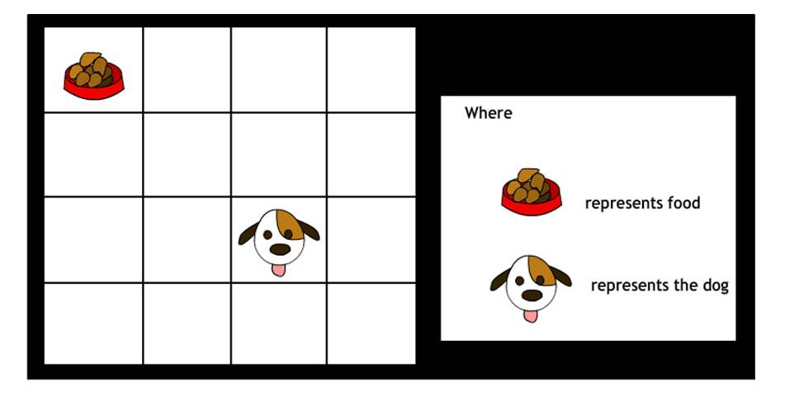

If the micro-controller inside the dog executed the following program, it will control the dog walking from its current position to the food:
Forward
Forward
Turn
Turn
Turn
Forward
Forward

HIGHLIGHT
What is Computer Program?

A computer program is a collection of instructions that describes a task, or a set of tasks, to be carried out by a computer. A computer program is loaded into memory and then executed instruction by instruction, until termination.
(2) Decision Making Instruction
Suppose the dog now locates in a more complicated maze as shown below:
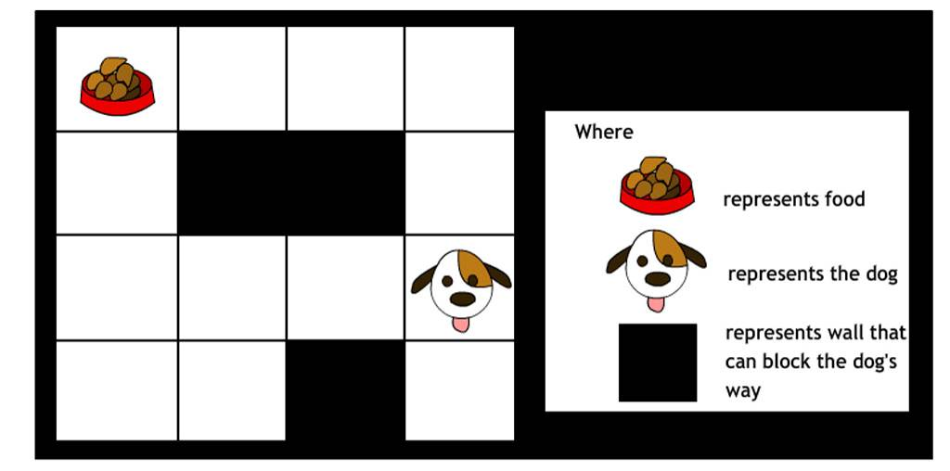
STOP AND THINK
Can the dog still reach the food if it is controlled by the same program?

We feel the dog is not smart enough. So, we change its hardware design so that it is able to check whether its way ahead is blocked (by a wall) or not and it has now one more instruction (see below) that can be used in its program.

Instructions | Meaning
Forward | Move forward one step
Backward | Move backward one step
Turn | Turn left by 90 degree
Wall? | To check whether the way ahead is blocked or not.

“Wall?” belongs to one type of instruction called decision making. It allows the computer to decide which way it should go next.

STOP AND THINK
Assuming the dog can only know by using the “Wall?” Instruction whether its way ahead is blocked by wall or not, develop a program to control the dog to walk from its current position to the food.

3.3.5 Simple Interfacing
In previous section, we compared human body with computer and learnt that various parts of human body can correspond to the four components of a computer, namely CPU, memory, input and output. As human being can communicate with each other, it would be interesting to learn that how a micro-controller-based system can communicate with each other or human being. In this section, we will use some simple examples to illustrate how a micro-controlled based system can be designed to speak and hear with each other or human being.
(1) How can a Micro-controller System Speak?
Human being can speak. How does a micro-controller based system speak to us?

Example: Lighting an LED On and Off (Digital Output)
Following diagram shows a digital output circuit in which a micro-controller uses an output pin to light an LED on and off.
From a micro-controller output pin
220Ω

Following is the pseudo code describing what we are going to do in our program to turn the LED on and off every third of a second.

Loop
Set an Output Pin to High
Wait for 1/3 second
Set an Output Pin to Low
Wait for 1/3 second
End loop

Depending on the need of the micro-controller-based system, we could attach a suitable message to the ON state and OFF state of the LED. For example, in a traffic light system, we have attached the message of stop to the ON state of the red light and the message of go to the ON state of the green light so that the traffic light system continue telling pedestrian when they are supposed to stop and when it is suitable time to go.

The pattern of ON and OFF state, how many LEDs are needed and how they are organized (for example, in term of a LED matrix, 7 segment LED) would certainly depend on the requirements of particular applications of the micro-controller-based system. Furthermore, for certain applications, the message may better be expressed using other components e.g. LCD.
(2) How can a Micro-controller System Hear?
Human being can hear. How does a micro-controller based system hear from us?

Example: Sensing a Button On or Off (Digital Input)
To connect a digital input to a micro-controller, you need three connections: a connection to power on the one side of the switch, a connection to your micro-controller on the other side of the switch, and a connection to ground. You can see from the following schematic that, if the switch is closed, the micro-controller’s input is connected to +5V (or High), and if the switch is open, it is not.
To a micro-controller input pin
10kΩ
+5V

Following is the pseudo code describing what we are going to do in our program to make the micro-controller read the switch:

Loop
Check if the pin is Low or High
If the pin is High
Do something
End if
End loop

Similar to the case of speaking, we could attach a suitable message to the OPEN state and CLOSE state of a switch. The pattern of OPEN state and CLOSE state (e.g. Morse coding or coding system using in nowadays advance wireless global communication system such as 3G mobile network), how many bits are needed and how they are organized (e.g. series or parallel) would certainly depend on the requirements of particular applications of the micro-controller-based system. Furthermore, for certain applications, the message may better be collected using other components e.g. photo sensor, charge coupled device (CCD) found in digital camera.

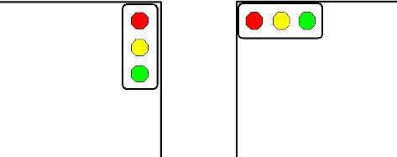
Example: Traffic Light Controller

Following diagram represents a road junction with two traffic lights, one for horizontal traffic direction and the other for the vertical traffic direction.

Following diagrams shows an interfacing circuit that use output pin P13, P14, P15, P3, P4 and P5 to control the traffic lights. Note that we use LED to represent the traffic light (what are the differences from a real traffic light in terms of the characteristics and requirements to the interfacing circuit?)

Vertical Traffic Light | Horizontal Traffic Light
220Ω | 220Ω
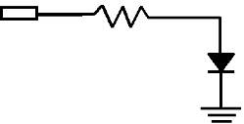  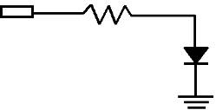  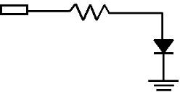  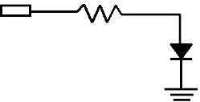  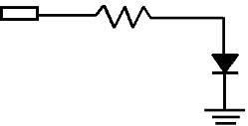  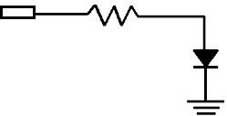  P13 | P3
green | green
220Ω | 220Ω
P14 | P4
yellow | yellow

220Ω | 220Ω
P15 | P5
red | red

Following program allows the vertical traffic to flow for 30 second before turning to 10 second yellow and followed by a 40 second red. When the vertical traffic is red, the horizontal traffic is set to green for 30 seconds and yellow for 10 seconds, then red for 40 seconds. [Note that we need to make sure not both red lights turn on for the same time.]

Loop

Set the Output Pin 13 to HIGH
Set the Output Pin 5 to HIGH Wait for 30 second

Set the Output Pin 13 to LOW
Set the Output Pin 14 to HIGH Wait for 10 second

Set the Output Pin 14 to LOW
Set the Output Pin 5 to LOW
Set the Output Pin 15 to HIGH
Set the Output Pin 3 to HIGH Wait for 30 second

Set the Output Pin 3 to LOW
Set the Output Pin 4 to HIGH Wait for 10 second
Set the Output Pin 4 to LOW
Set the Output Pin 15 to LOW

End loop

Example: Sensor Based Traffic Light Controller

Some traffic light controllers have sensors under the pavement that detect whether or not a car is waiting at a red light. We will modify the traffic light controller so that the vertical traffic see a green light all the time until the sensor (simulated by a switch connected to input pin P8) detect a HIGH. At that time, we will start the sequence of light to let traffic go through the horizontal direction.

Loop

Set the Output Pin 13 to HIGH
Set the Output Pin 5 to HIGH
If (P8 = 1) Then

Wait for 30 second

Set the Output Pin 13 to LOW
Set the Output Pin 14 to HIGH Wait for 10 second

Set the Output Pin 15 to HIGH
Set the Output Pin 3 to HIGH Wait for 30 second

Set the Output Pin 3 to LOW
Set the Output Pin 4 to HIGH Wait for 10 second

Set the Output Pin 4 to LOW
Set the Output Pin 15 to LOW

END IF
End loop

(3) Peripheral

A peripheral (e.g. joysticks, printers and scanners) is a piece of hardware that can be added to a micro-controller-based system in order to expand its abilities. It is typically connected to a micro-controller through some form of bus like USB.

The devices that make up the input and output units are called peripherals because they are external to the rest of the micro-controller. The most important aspect of peripherals is interfacing. The objective of micro-controller interfacing is to make sure digital information transmission can be carried out between a micro-controller and its peripherals in a compatible way. However, many input and output devices are not directly compatible with micro-controller because of difference in characteristics like operating speed or signal level. Interfacing these input and output devices to a micro-controller requires special interface circuit to translate these characteristics so that they can correctly communicate with the micro-controller. For example, many other digital output devices, from a motor to solenoids will need more voltage and current than a typical micro-controller’s output pin can supply. Following examples show some special interface circuits to translate the difference in voltage and current level between these devices and a micro-controller.

Example 1: Interfacing to speaker
8Ω  1kΩ  +5V  From a Micro-controller Output pin | Interfacing a speaker to micro-controller

A speaker require amount of current that the output pin of a typical micro-controller is not able to supply. In the above example, a transistor act like a switch. When a high logic level is placed at the output pin of the micro-controller, a small current supplied from the output pin and flow into the ground through the transistor. At the same time, the transistor will allow a larger current flowing from the +5V to the ground through the speaker and the transistor. Refer chapter 1 for details in using transistor as a switch.

Example 2: Interfacing to relay
1kΩ
+7 to 15Vdc
From a Micro-controller Output pin
To ac device

Interfacing a relay to micro-controller

Some devices operate with ac power and are not directly compatible to the electrical characteristics of micro-controller output pin. It is also not possible to simple use a transistor as a switch in the much the same way we did in last example for speaker. Example of such device includes a light bulb, a door opener (e.g. a device controlled by a combinational door lock at the main entrance of a building). For this device, we may make use of a relay. The above circuit illustrates how to interface such device to a micro-controller output pin via a relay and transistor. When a high logic level is placed at the output pin of the micro-controller, a small current supplied from the output pin and flow into the ground through the transistor. At the same time, the transistor will allow a larger current flowing from the +7 to 15Vdc to the ground through the coil of a relay and the transistor. When a sufficiently large current is flowing through the coil of the relay, it allows an ac current flow through the door opener. Refer chapter 1 for details of relay.

Interfacing input and output devices to a micro-controller could require more than simply translating the signal levels. In some cases, special software is required to communicate with the Input and Output device via the special interface circuit.

Example 3: Interfacing to a 3x4 keypad
The following circuit illustrates how to interface a 3x4 keypad to a micro-controller. In order to find out which key is pressed, software is required to be developed to sequentially check each column of keys in turn for whether there is any key in this column is being pressed. To check one column of key, the software place a logic high in the correspond output pin and logic low to the other output pin (e.g. to check the column with key “1”, “4”, “7” and “*”, a logic high is placed in output pin 1 and logic lows are placed in output pin 2 and output pin 3), then the software check the logic level of all four input pins. A logic high in a particular input pin means the corresponding key is being pressed.

1
2
3
4
5
6
7
8
9
*
0
#
10kΩ
10kΩ
10kΩ
Micro-controller Input Pin 1
Micro-controller Input Pin 2
Micro-controller Input Pin 3
Micro-controller Input Pin 4
Micro-controller Output Pin 1
Micro-controller Output Pin 2
Micro-controller Output Pin 3

3.3.6 An Example of Commercial Micro-controller

In this section, we are going to introduce a particular class of micro-controllers that are available with BASIC interpreter firmware. Micro-controllers were originally programmed only with instructions that are represented by their native language of 0 and 1, called machine language. Due to its difficulty to read and understand by human being, assembly language and later high-level programming languages, including C and Basic are invented. The high-level programming languages were originally invented as general purpose languages, and later also made available for micro-controller after enhanced to better support their unique characteristics.

In light of the existence of a range of programming tools and environment, which can range from drag and drop kind of visual programming to assembly language, it is suggested that, for HKDSE level, one of Basic version available for micro-controller adopted as a compromise between programmability and ease of use. With this assumption in mind, we are going to discuss one of the commercially available micro-controller with BASIC interpreter, which are available in a number of microcontrollers, including 8051, Z8, ARM, Amtel and PIC.

The BASIC Stamp is a micro-controller with a BASIC interpreter called PBASIC built into ROM. It is made by Parallax, Inc. and has been quite popular with electronics hobbyists since the early 1990s. The BASIC Stamp is in fact a small PCB that contains the following essential elements of a micro-controller, including CPU, memory (EEPROM), 16 input and output (I/O) pins. It was originally built around the Microchip 16C57 micro-controller (and now also available in other micro-controller e.g. ARM). 16C57 2Kbyte EEPROM holds the executable program and any data. Its32 bytes of RAM serve as variable space and I/O pin interface for the BASIC program. [Note: PBASIC is not the only choice. There is other BASIC interpreter for micro-controller e.g. BasicX, PicBasic Pro. The differences between them are not too great that migration from one BASIC variant to another variant is possible without too much additional learning and change of program.]

Most programming environments have a text editor with a few extra features, such as a code checker, or a tool to link the editor to the BASIC interpreter is available. When it is used, we may edit the BASIC program in the text editor available in the programming environment and then download BASIC program to the BASIC Stamp, which interpret the program, store in the onboard memory for later execution. The program remains staying at the memory until it is erased and reprogrammed even when the power is removed.

About the 16C57, it is one member of the PIC (programmable interface controllers) micro-controller family. PICs are made by Microchip and are some of the most popular micro-controllers, which has varieties with
- 8-bit, 16-bit and 32-bit data width.
- different number of input/output pins;
- capable of only digital input and output or capable of doing analog input and output;
- different kind of built-in peripherals e.g. whether it has built in analog-to-digital converters and built in serial ports;
- varying clock speeds and amounts of RAM;
- different programming methods including through window on the top of the
- chip to expose to UV light in order to erase them for reuse and flash-programmable, which is programmed and erased using just electrical signals from a PC.

Following shows some project developed by hobbyist:

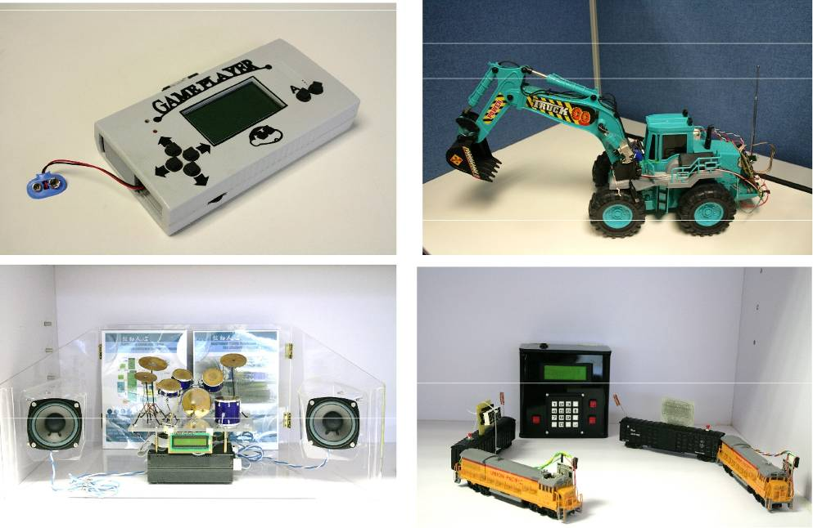

(1) Summary of Instructions
Following summarize the instructions of Basic Stamp that will be used in this resource package:

Instructions | Meaning
high | set an I/O pin high
input | set the direction of an I/O pin to input
low | set an I/O pin low
output | set the direction of an I/O pin to output
for...next | execute the instruction(s) between “for” and “next” for a number of times. The instruction(s) is represented as “…” here.
if...then | decision
end | finish the execution of a program
pause | delay for the specified time
debug | send a debugging string to the display on the desktop computer

(2) Simple Digital Output

Following table shows the PBASIC implementation of the pseudo code that we introduced in our “Lighting an LED On and Off (Digital Output)” example.

Pseudo Code | PBASIC
Loop | DO
Set the Output Pin to High | HIGH x
Wait for 1/3 second | PAUSE 333
Set an Output Pin to Low | LOW x
Wait for 1/3 second | PAUSE 333
End loop | LOOP

(3) Simple Digital Input

Following table shows the PBASIC implementation of the pseudo code that we introduced in our “Sensing a Switch Open or Close (Digital Input)” example.

Pseudo Code | PBASIC
Loop | DO
Check if the pin is LOW or HIGH | IF (IN x = 1) THEN
If the pin is HIGH | Do something
Do something | ENDIF
End if | LOOP
End loop

CHAPTER 4 – EVOLUTION OF ELECTRONICS IN MODERN SOCIETY

The objective of this chapter is to guide student to explore the evolution of electronics in the past decades. This chapter contains topics on:

4.1 Miniaturization of Electronic Products
4.2 Impact of Emerging and Converging Technologies

These topics include learning materials and activities that facilitate students to:

- state the impact of the miniaturization of electronic products on society
- state the impact of emerging and converging electronic products in society

4.1 Miniaturization of Electronic Products

The trend of miniaturization in electronic product has been there since the early day. You may notice of its existence from a number of every day electronic products e.g. mobile phones, PDA and sub-notebook computers, camcorders, smart card etc. In fact, the trend of miniaturization will continue in the foreseeable future.

The advancement in IC design technology as well as innovations in packaging technology are both critical to miniaturizing electronic products. We will discuss each of them in the following two sections.

4.1.1 Advance in IC Design Technology

In 1965, Gordon Moore, another founder of Intel, invented what we later call Moore’s Law to predict the growth of IC complexity based on his observation. Moore's law states that the number of transistors on an integrated circuit doubles every 18 to 24 months. It has held remarkably well over three decades of semiconductor device production.

HIGHLIGHT
The Moore’s Law

The number of transistors that can be built in one chip doubles every 18 months.

Following graphs shows the numbers of components people begin manage to put into a chip versus year.
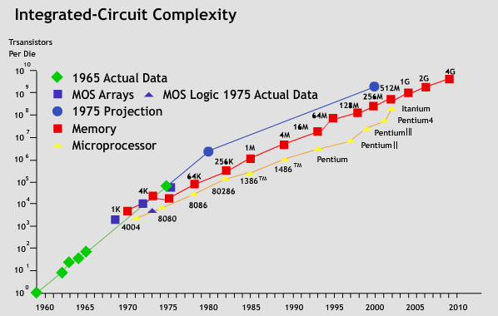
The Growth of Integrated Circuit Complexity

The trend of increasing more and more transistors can be put in one integrated circuit results in the following three phenomena:

The trend of increasing more and more transistors can be put in one integrated circuit results in the following three phenomena:

- Miniaturization of Electronic Products
As we put more transistors in an integrated circuit of the same area, we reduce the size of each integrated circuit and hence reduce the physical size of electronic product.
- IC with same functionality but more power
Another possibility is to use the additional transistors to design a more powerful IC e.g. faster CPU, or more than one CPU per chip i.e. multi-core CPU, chip-level multiprocessor.
- IC that integrated more functionality
We can use the additional transistors to add more functions a chip e.g. add multimedia capability, Internet connectivity. [The latter two phenomena also help give rise to convergence to be discussed in next section.]

4.1.2 Advance in Manufacturing Technology

Besides advance in IC design technology, innovations in packaging technology also contribute to the trend in the miniaturization of electronic products. In this section, we will discuss a number of techniques developed to reduce the amount of space wasted in traditional
IC package.
Surface-Mount Devices. We discussed in chapter 3 that surface mount packages allows us to produce PCB with much higher circuit densities because it

- is usually smaller than its through hole package counterpart.
- unlike through hole package, was designed to attach directly to pads on the surface of PCB and hence it save the space (and effort) require to drill hole in PCB
- can also be mounted on both sides of a PCB because no hole is required to drill on PCB.

Miniaturization processes

To achieve even higher degree of miniaturization, the chip-on-board (COB) process was invented to attach unpackaged IC chips directly to a PCB with the chip facing away from the PCB. Then, fine wires are using to bond the die pads onto the PCB pads. The chip-on-chip (COC) process further improves the space utilization by putting a smaller chip on top of a COB chip. Flip Chip further improve the space utilization by attaching the chips face down on the PCB to eliminate the need to bond wires between the chips and the PCB. Multichip Modules (MCM) is another approach to miniaturization in which multiple ICs, dies in form of COB, COC or flip-chip or other modules are interconnected in an IC package that it can then be used as a single IC.

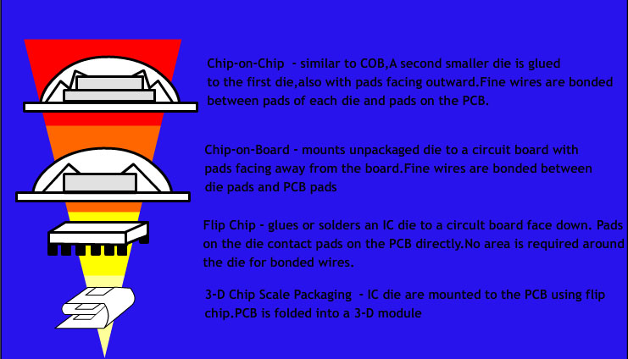

Chip-on-chip – similar to COB, A second smaller die is glues to the first die, also with pads facing outward. Fine wires are bonded between pads of each die and pads on the PCB.

Chip-on-Board – mounts unpackaged die to a circuit board with pads facing away from the board. Fine wires are bonded between die pads and PCB pads.

Flip Chip – glues or solders an IC die to a circuit board face down. Pads on the die contact pads on the PCB directly. No area is required around the die for bonded wires.

3-D Chip Scale Packaging – IC dies are mounted to the PCB using flip chip. PCB is folded into a 3-D module.

Miniaturization processes

4.1.3 Miniaturized Electronic Products

Miniaturized electronics bring us to radically rethink the possible new applications of electronics. For example, because so much of the body's operation is electrical in nature, including nervous response, sensory input, and muscle control. They are all likely application areas for miniaturized electronics. As a result, many new treatments and health aids are now under development to take advantage of miniaturized electronic devices. You may find two such examples in below:

Artificial Vision. We can now implant a small semiconductor wafer in the back of the eye to function as an artificial retina. When light hit the wafer, it causes electrical stimuli is generated. The electrical stimuli are then applied to the optic nerve and restore some degree of vision.

Hearing Aids. In cases traditional hearing-aid technology is ineffective; we can now install part of the equipment inside our ear to deliver electrical stimulation directly to auditory nerves in the cochlea (inner ear) in response to external sounds. Another part of the equipment is installed behind the ear to pick out sound and transmit to the part inside the ear through a wired connection.

STOP AND THINK
- Try to think another example of electronic product that could not exist before miniaturization technologies
- Then, try to guess or conduct research to find out which miniaturization technologies make the electronic product happen.

4.2 Impact of Converging Technologies

4.2. 1 What is convergence?

As mentioned in last section, when we are able to put more and more transistor in one integrated circuit, we can integrate more functionality into one integrated circuit. More specially, the functions traditionally belong to different product could become able to be put in one integrated.

Convergence is combining two or more previously separate area of business to create something new, which can be a new product or service, a new alliance, a new value chain structure, or a new economic model that generates greater value for the business and its customers. Depending on where it takes place, there are different types of convergence, including media, connectivity and device. Following sections will explain each of them.

4.2.2 Different Types of Convergence

(1) Media Convergence

In the past, information has been represented in various physical forms or media: words on paper; images on canvas; and even computer programs on punch cards. We considered different types of information were expressed in different media and handled with different devices.

As technology advance, more and more types of information keep converted into zeros and ones representation including photographs; email; music; games; radio and television; movies; news; phone calls. Every day, we continue to hear new development in which more media are moved from analog to digital domain. Following table show a history of which product moves from the analog domain to digital domain.
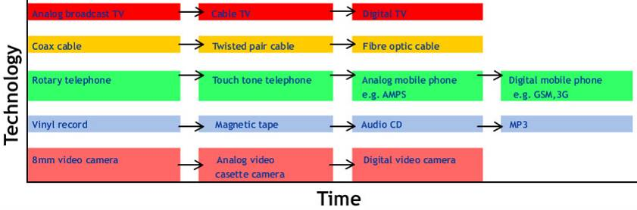

Representing all information in the as a string of zeros and ones has significant implication. This allows all forms of information, from words and numbers to music, pictures, movies and more, to be manipulated by the same means including the same devices, technologies and networks. Digitization is considered as the root of convergence. Without it, convergence could never happen.

HIGHLIGHT
Convergence of Media

Digitization results in more and more types of information can now be represented in the same abstract form and manipulated by a common means.

(2) Connectivity Convergence

  - Growth in Connectivity
The accuracy of Moore’s Law predict the complexity of IC make people interest to explore similar laws at other areas of electronics. In the telecommunication world, people found that the wired-line, nomadic, and wireless technologies improve their speed in a manner similar to Moore's Law. The speed of telecommunication networks (in bits per second) can be illustrated by the following graph.

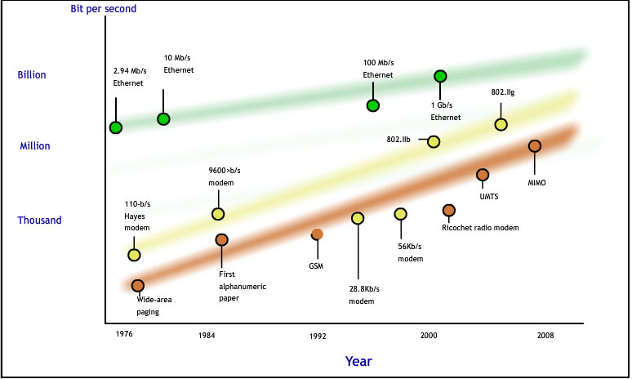
The Growth in Connectivity
(b) Everything get connected
As the networks are becoming faster and faster, it became being used in every where i.e. pervasive, for both wired and wireless formats. In developed countries, 60 percent of all homes are connected to the Internet. At the same time, mobile networks now cover almost every location in most cities. As networks are becoming increasingly pervasive, products are now designed with built in connectivity to bring us a wide range of product and service possibilities, from networked games to online music stores. In the coming future, there will be growing number of convergent consumer electronic devices with connectivity (broadband or wireless) emerge, including game consoles, Internet radios, educational toys, and health monitors with each of them deliver more value to their customer than their standalone counter-part do.
(3) Device Convergence
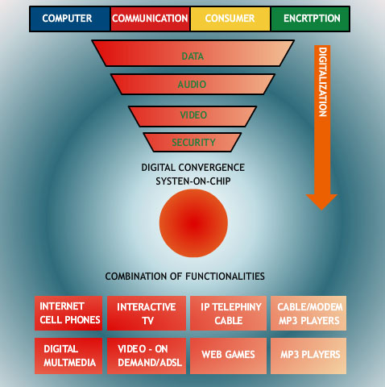

As we are able to integrate more transistors into one IC, we can use the additional transistors to add more functions into the same IC (in additional making it more powerful). Typical example is IC for building our handheld wireless devices such as mobile phone. We could say add new multimedia functions and multiple RF technologies into our handheld wireless devices. This is just one example of communications, computing and consumer electronics converge into a single electronic device. These trends are also bringing companies formerly target for separate market to compete with each other, e.g. handset vendors and operators to compete digital cameras, music players, PCs and even TV set. To summarize, the consumer now has a new dimension of choice, a choice between one-function devices (which is specialized or more powerful in handling such one function) and multi-functional devices (which has the capability of doing more than one function).

STOP AND THINK
What Multi-functional Devices Are More Useful?
Do you consider a phone with camera or a phone with PDA more useful? Why?

  - Impact of Emerging Technologies

As the technology advance, it can be anticipated that the trend of miniaturization and convergence to continue in foreseeable future. Besides this, what are the new technologies and products are emerging? What possible impact these emerging technologies will bring to the society? In this section, we are going to explore the possibilities.

4.3.1 Emerging Technologies
In this section, we are going to briefly discuss a number of emerging technologies, which has various degrees of novelty and closeness to market.

Radio-Frequency Identification (RFID)

The RFID technology was devised for automatic identification of object. A key component of the RFID technology is a device called RFID tag, which idea come from microchips used to tag both wild animals and pets. An RFID tag can be put in an object and then read from several meters beyond the line of sight of RFID reader. Two types of RFID tags are commercially available, namely the active tag and the passive tag. The active RFID tag consists of an IC and an antenna. The IC stores and processes information, which can be received and transmitted as radio frequency (RF) signal via its antenna. The passive RFID is chipless (i.e. does not have an IC) and are thinner than a sheet of paper. It can be printed directly onto an object for identification purpose. Passive RFID has an advantage of lower cost.

RFID applications include
- help keep track of goods in inventory tracking and management, supply chain management (http://www.ti.com/rfid/shtml/apps-supply.shtml), manufacturing process, automatic routing of goods
- asset tracking by librarian, ticket agent or health-care professional etc - http://www.ti.com/rfid/shtml/apps-asset-tracking.shtml
- control access to buildings and networks.
- Contactless payment - http://www.ti.com/rfid/shtml/apps-contactless.shtml

Near Field Communications (NFCs)

NFC is wireless two-way communication technology based on RFID. It enables devices of less than 10 cm apart to exchange information. Besides communicate wirelessly with other NFC devices, it is able to communicate with existing RFID infrastructures as well as contactless smart infrastructure including smart card and reader. Further, it is able to work on device not powered by a battery e.g. smart poster. Unlike Bluetooth, NFC devices establish connection faster (0.1 sec vs. 6 sec) but have a shorter communication range (10 cm vs 10m) and lower data transfer rate (424 kbit/s vs 721 kbit/s). NFC is primarily aimed for mobile phone. Applications including mobile ticketing in public transports, mobile payment as a credit card, smart poster using mobile phone to read RFID tags on the poster, electronic ticketing, and electronic key.

Smart Dust

Smart Dust is a compelling example of miniaturization. It is a tiny wireless micro-electromechanical device, which include sensors that can detect light, temperature, acceleration, air pressure or vibration; micro-controller; wireless communications ability and a power supply. They could automatically create networks between themselves and the Internet. Since they are as tiny as dust particles, they can be spread throughout buildings or the atmosphere to collect data that their sensors are capable to detect. Their applications include:
- entertainment devices that can communicate with handheld computer for games and other forms of entertainment e.g. user attach the sensors to his or her fingers to "sculpt" 3D shapes in virtual clay visible on the device's screen. The same idea could be applied to playing piano or communicating in sign language. (source: http://newearthsummit.org/forum/index.php?topic=376.0)
- inform of disasters, such as earthquakes.
- military applications in which they perform as sensors to track enemy movements.
- medical fields in which a hundred of these sensors are scattered around a hospital to track patient movements.
- climate control for building e.g. each room in a building is installed with hundreds or thousands of light or temperature sensing smart dusts, which are linked to a central computer to give engineers idea on how energy is used and how it can be saved.

These areas of applications expand as people able to create smaller and smaller smart dust; say from dimensions in millimeter to micrometer level, or even down to nanotechnology level. In some research, devices may be created at less that 100nm in size; so small that inter-atomic interactions and quantum mechanical properties need to be studied extensively.
THEME-BASED LEARNING TASKS

Laboratory 1: LED Blinker – Multivibrator

Objectives :
1. Let student use power supply and oscilloscope;
2. Understanding a multivibrator working principle;
3. Use of breadboard for testing circuit;
4. Practice soldering techniques on universal PCB.
Setup & Tools:

- Solder Iron;
- Breadboard;
- Universal PCB;
- Power Supply;
- Oscilloscope.

- Introduction

A multivibrator is an electronic circuit used to implement a variety of simple two-state systems such as oscillators, timers and flip-flops. The most common form is the astable or oscillating type, which generates a square wave.

In its simplest form the multivibrator circuit consists of two cross-coupled transistors. Using resistor-capacitor networks within the circuit to define the time periods of the unstable states, the various types may be implemented. Multivibrators find applications in a variety of systems where square waves or timed intervals are required.

- Part Lists and Circuit Schematic

Item | Quantity
LED (Red): 5mm (D1, D2) | 2
Transistor: 9014 (Q1, Q2) | 2
Resistor: 330Ω (R1,R4) | 2
22kΩ (R2,R3) | 2
Capacitor: 10μF (C1, C2) | 2
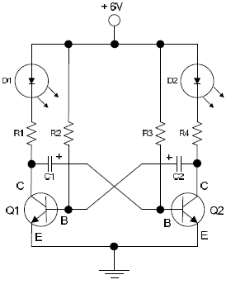
- Use of Breadboard

To build our lab, we will use a breadboard like the one shown below.

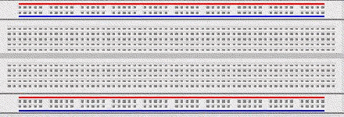

The breadboard has many strips of metal (copper usually) which run underneath the board. The metal strips are laid out as shown below.

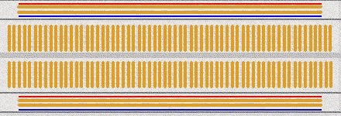

When using the breadboard, the legs of components are placed in the holes. Each hole is connected to one of the metal strips running underneath the hole.

Each strip forms a node. A node is a point in a circuit where two components are connected.

Connections between different components are formed by putting their legs in a common node. On the breadboard, a node is the row of holes that are connected by the strip of metal underneath.

The long top and bottom row of holes are usually used for power supply connections. The row with the blue strip is used for the negative voltage (usually ground) and the row with the red strip is used for the positive voltage.

Example
A series connection of 2 resistors on a breadboard looks like the picture below on the left and a parallel connection of 2 resistors looks like the picture below on the right.
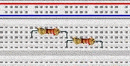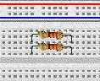

- Circuit Description

The circuit keeps one transistor switched on and the other switched off. Initially, Q1 is switched on and Q2 is switched off.

  - Q1 holds the bottom of R1 (and the left side of C1) near ground (0V).
  - The right side of C1 (and the base of Q2) is being charged by R2 from below ground to 0.6V.
  - R3 is pulling the base of Q1 up, but its base-emitter diode prevents the voltage from rising above 0.6V.
  - R4 is charging the right side of Q4 up to the power supply voltage (+V). Because R4 is less than R2, C2 charges faster than C1.
  - When the base of Q2 reaches 0.6V, Q2 turns on, and the following positive feedback loop occurs.
  - Q2 abruptly pulls the right side of C2 down to near 0V.
  - Because the voltage across a capacitor cannot suddenly change, this causes the left side of C2 to suddenly fall to almost -V, well below 0V.
  - Q1 switches off due to the sudden disappearance of its base voltage.
  - R1 and R2 work to pull both ends of C1 toward +V, completing Q2's turn on. The process is stopped by the B-E diode of Q2, which will not let the right side of C1 rise very far.
  - This now takes to another state, the mirror image of the initial state, where Q1 is switched off and Q2 is switched on. Then R1 rapidly pulls C1's left side toward +V, while R3 more slowly pulls C2's left side toward +0.6V. When C2's left side reaches 0.6V, the cycle repeats.

- Procedure

  - Construct the LED blinker circuit in the breadboard, using scrappy connecting wire if necessary;
  - Adjust the power supply for 6V output, limit the current (100mA) to protect the circuit;
  - Connect the power supply output into your testing circuit;
  - Check the LEDs flash working properly, the LED will flash alternatively;
  - Using oscilloscope to see the waveform generated by this multivibrator;
  - Change with different value of R2, R3, C1 and C2, see what happen to the LEDs; and
  - Solder the component on a Prototype/Universal PCB.

- Summary of Work Done

- Observation

Using Oscilloscope, try to find out the waveform from LEDs. Draw the waveforms and measure the flashing frequency.

- Discussion

How to increase the flash rate? (i.e. increasing it frequency)

What happen if C1 is different to C2?

~End~

Note: Write clearly and show all steps. Attach additional A4 size paper, if space provided is insufficient.
Laboratory 2 – Photo-resistor and Applications

Title : Photo-resistor in RC

Objectives : 1. Use of measuring equipment, e.g. Power Supply and Multimeter;
2. Understanding a Light-Dependent-Resistor working principle;
3. Use of breadboard for testing circuit; and
4. Practice soldering techniques on universal PCB.

Setup & Tools:
- Solder Iron
- Breadboard
- Universal PCB
- Analog Multimeter
- Digital Multimeter
- Power Supply

- Introduction
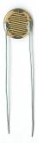
A photo-resistor is an electronic component whose resistance decreases with increasing incident light intensity. It can also be referred to as a light-dependent resistor (LDR), or photoconductor.

A photo-resistor is made of a high-resistance semiconductor. If light falling on the device is of high enough frequency, photons absorbed by the semiconductor give bound electrons enough energy to jump into the conduction band. The resulting free electron (and its hole partner) conduct electricity, thereby lowering resistance.

A photo-resistor is simply a resistor whose resistance depends on the amount of light incident upon it. They are used to make light-sensitive switching devices. Photo-resistors are often made from cadmium sulfide (CdS). The resistance of a CdS photo-resistor varies inversely to the amount of light incident upon it. In other words, its resistance will be high in the dark and low in the light.

The LED behaves like an ordinary diode except that when it is forward biased, it emits light. The LED’s forward voltage drop is higher than an ordinary diode. Typical LED’s require 5 to 15mA to reach full brightness, but are not designed to handle more than about 20 mA of current (though some can handle upwards of 80 mA or more). You will therefore always need to provide a resistor in series with an LED to limit the current to about 20 mA or less, or else you will burn it out. Also, don’t make the mistake of trying to substitute an LED where a standard diode is called for! Look at the schematic diagram to see which kind of component is needed.

- Components

Item | Quantity |  | Item | Quantity
220Ω Resistor | 1 |  | LED (Red 5mm) | 1
470Ω Resistor | 1 |  | 9014 Transistor | 1
10KΩ Resistor | 1 |  | Photo-resistor | 1
22KΩ Resistor | 1 |  | Breadboard | 1

- Procedure

1. Measure the photo-resistor’s resistance in the ambient lighting of the lab. Once this is recorded, repeat the measurement.
2. To verify the behavior of the LED, construct the circuit shown in Figure 1, and vary the supply voltage between 1 to 5 volts at 1-volt increments. At each voltage, measure the voltage across the LED and the 470Ω resistor and enter the values into the following table. The LED current can be calculated by applying Ohm’s law across the resistor. A similar table should be entered into the lab report with all voltage values and comments. Remember I=V/R for current.
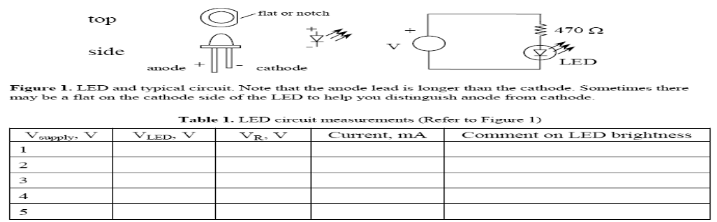
Figure 2 shows a simple ‘light-controlled-LED’. The circuit should turn-off the LED as the photo resistor is covered. Based on the information obtained in Table 1, what is a good supply voltage to use? (Hint: V should be high enough so that enough current flows through the LED when the photo resistor has low resistance, and yet should be low enough so that the current is not enough to turn on the LED when the photo resistor has high resistance.) Build the circuit and check its function.
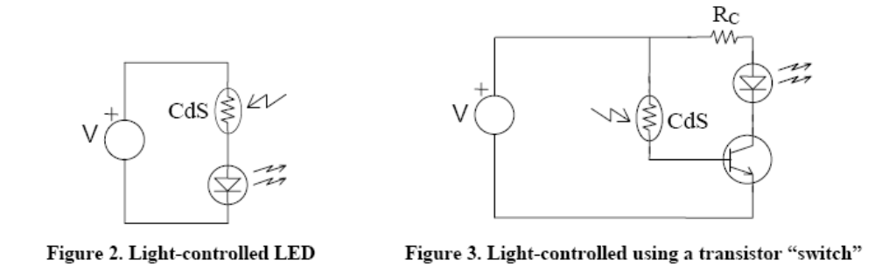

The Light-Controlled Switch Using a Transistor
A transistor can be added to the light-controlled-switch circuit to improve its sensitivity and to eliminate the ‘half-on-half-off’ state of the LED. A rudimentary circuit to do so is shown above in Figure 3. Here the photo-resistor controls the transistor’s base current, which is then amplified by the transistor. The collector current of the transistor, in turn, controls the LED.
Unfortunately, this circuit may not function properly, because when the photo-resistor is in the dark state, (and the LED is supposed to be turned off), the base current may be large enough that the LED may stay lit. Figure 4 shows an improved circuit. This is the circuit that you will build and experiment with next.
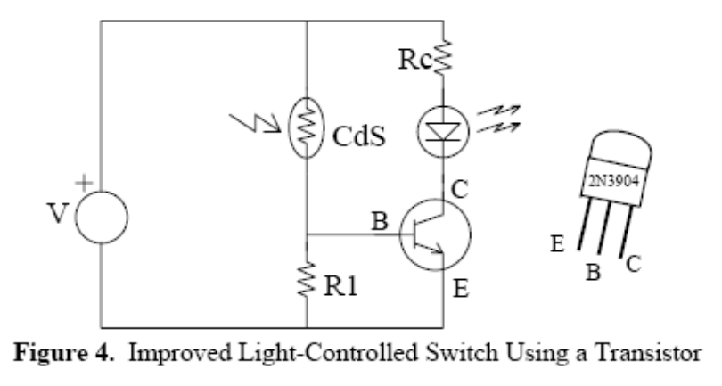
With a properly selected resistor R1, the voltage at the base of the transistor in the dark state is less than 0.7 V, and therefore the transistor is in the cut-off state. As the photo-resistor’s resistance decreases (as the result of an increase in light intensity), the base voltage increases. Once the base voltage reaches 0.7 V, the base current starts to flow, and any further decrease in the photo-resistor’s resistance causes an increase of base current. This base current increment will be amplified by the current gain of the transistor.

- Summary of Work Done

- Discussion
How to improve the change-state response? Please draw it. (e.g. Darlington, Relay....)

If two LEDs are connected in parallel, using one or two resistor(s) to improve better equal brightness? Also draw the circuit with resistor(s) value.

~End~
Note: Write clearly and show all steps. Attach additional A4 size paper, if space provided is insufficient.
Design Project: Open Day Electronic Game Competition (for Chapter 3)

Design Brief

Your school principal / DAT teacher has asked you to design and develop a micro-controller based electronic game to participate in an electronic game competition at the coming school Open Day. Students could use breadboard to develop these electronic games.
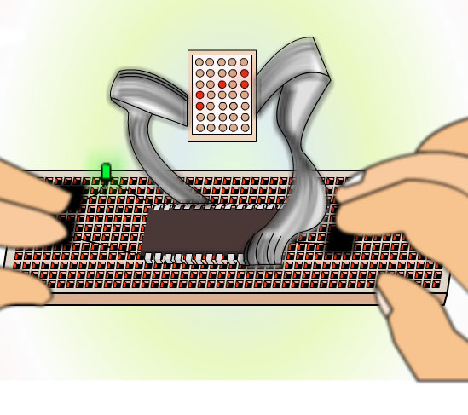
Such open-day electronic game will be used to demonstrate your learning. The game will also be evaluated by visitors, who act as judge of competition when visit the DAT room. Students are divided into groups and work cooperatively in the following activities:

Design Considerations

While you are required to pay attention to whether your electronic game is fun to play, but it must be kept simple and should fit into the available resource, including
- Available budget
- Available time
- Available hardware resource (e.g. memory size, number of input and output pins) of the micro-controller development kit available from your school.
Before you can start your design work, you need to know what components and micro-controller based system development equipment are available.

- Proposal and Discussion

The class is divided into teams to brainstorm on game idea for developing electronic game for exhibiting at school open day. Suggested steps are as follows:

- each group member write your ideas down
- prepare a block diagram of electronic game to illustrate what input and output devices are required
- decide which is the best proposal with your group member and/ or DAT teacher

- Planning

Once your group decided on the best proposal and it has also been accepted by your DAT teacher, your group could then develop a more detailed planning on your design project to outline the:
- objectives
- design specifications
- budget
- timeline

First, you need to draw up a list of design specifications for your electronic game. Such list should contain
- a description on what your game will be
- how it is played
- the key features of your game
- key components and technologies required to implement your game
- any special resource requirements in order to implement your game

A timeline for task completion is developed, working backwards from the deadline set for exhibition, and tasks are allocated to specific individuals or groups.

The students obtain quotations for the components required for implementing the electronic game, and formulate an appropriate budget plan.

III. Implementation
The students monitor progress against the timeline and budget for developing your game. The timeline and a running sheet of expenditure is put on a classroom wall, to keep all members aware of it.

IV. Testing and Debugging
Testing is very important when developing an electronic product with quantity. You need to check your prototype very carefully for any problem, bug or user friendliness. You are suggested to invite classmate, who are not familiar with your game, to test and try out your game. Some problems may not be identified by yourselves because you are so familiar how to play your game and would not try out some odd scenario. Fix or improve the design of your game once problem are identified. Write the problem found and any improvement.

V. Evaluation
After the game has been completed, the class evaluates the outcomes of the project against the objectives that were set in the planning stage, and this should include the result of competition and feedback from visitors at the open day. There are also a number of things to consider when evaluating the success of your work. Please make your evaluation. Here are some questions to help you evaluate your work:
- Was the game successful? Was it what you intended to?
- Does the game meet the requirements of the brief and your specification?
- What do you estimate the cost to make?
- How much would it cost to make ten as opposed to just one?
- Check your game against the competition by comparing quality, interesting, unique features, etc.
Case Study: Smart Card – Evolution of Electronics in Modern Society

1. Overall Expectation

Students living in a technological advanced society like Hong Kong are expected to develop a macroscopic view in issues such as “the impact of technology on society”, “ethical and legal issues”, “business issues” and “the impact of emerging technologies” in an integral approach and from multiple perspectives. In addition, the learning experience provided by this case study enables students to develop critical thinking skills. They will experience the complexity of the real world by taking into consideration of societal, economical, legal and technological factors in problem-solving and decision–making. This case study is targeted for the students of S4 or above who are studying the NSS DAT curriculum. The major focus of this case is about the impact of smart card in the society.

2. Expected Learning Outcomes

Students should be able to:
- Have a better understanding of the ethical and legal issues in Hong Kong.
- Develop skills in analysing and interpreting real world data.
- Understand the basic principles underlying the smart card.
- Investigate and evaluate an interesting application of smart card from societal, technological, legal and business perspectives.
- Propose new applications and consider its feasibility.
- Present their views, ideas and research findings in various ways, including written report, verbal presentation and open debate.

3. Background

A smart card a pocket-sized card embedded with integrated circuits which can process information. There are two types of smart card, namely memory card and microprocessor card. Memory contains only non-volatile memory storage components, and perhaps some security logic. Microprocessor card contain volatile memory and microprocessor components. Smart cards provide a means of effecting business transactions in a flexible, secure way with minimal human intervention. There are already many area of smart card applications; including: Credit card, ATM card, SIM card for mobile phone, access control, public transportation, digital identification card, school application. Each of them brings us positive effect to the quality of our daily living. However, like other innovation, they are not without shortcoming.
In this case study, students are required to work in groups cooperatively to study an existing or potential new area of daily life, which is affected by the use of smart card.
Each member of the group is assigned different tasks for which they are responsible.

4. Activities

Students are divided into groups and work cooperatively in the following activities:

A) Research Proposal

Students are required to prepare a proposal to state:
- topic of area on
- how our school life is/can be affected by the introduction of smart card application?
- how smart card can be used to save the trouble of keeping patient record?
- their selection of research methods to gather information. It can be
- Internet search to find out what types of smart cards are available, whether there are similar applications
- Reading and analysis the product / application manual.
- observation exercise, in-depth interviewing and role-playing to establish what users really want from a smart card application, the situation of their daily life before and after the introduction of the smart card application

- Data Collection

At this stage, students carry out in groups to collect data specified in their proposal.

- Analysis

Students are required to critically analyze their finding. Suggested discussion questions include
- how the designers chose to meet users’ needs and what constraints they faced;
- discuss how smart card is used in this application to enhance the quality of our daily life.
- the pros and cons of the smart card application with regard to their influences on daily life.

- Presentation

Students are required to present their findings and analysis in the group through presentations, debates or other forms of dialogue.
ASSESSMENT TASKS

Quiz 1: Electronic Signals, Devices and Circuits (short questions)

Answer 10 questions only, each carry 10 marks.

Q1. What is a LED?

_________________________________________________________________________________________________________________________________________________________________________________________________________________________________
Q2. Label the leads of transistor below, and write down what is the transistor type.

Q3. Connecting a lead from the negative to the positive of a battery will produce:

_________________________________________________________________________________________________________________________________________________________________________________________________________________________________
Q4. If two resistors are placed in series, the final resistance is:

_________________________________________________________________________________________________________________________________________________________________________________________________________________________________
Q5. If a small value of capacitance is connected in parallel with a large value capacitance, the total capacitance will be:

_________________________________________________________________________________________________________________________________________________________________________________________________________________________________
Q6. If a 12v light bulb consumes 4A current, what is the power of the light bulb in watt?

_________________________________________________________________________________________________________________________________________________________________________________________________________________________________
Q7. A 100nF capacitor in parallel with 10nF produces:

_________________________________________________________________________________________________________________________________________________________________________________________________________________________________
Q8. A resistor with colour bands: red-red-red-gold, has the value:

_________________________________________________________________________________________________________________________________________________________________________________________________________________________________
Q9. A 10kΩ resistor in parallel with 10kΩ produces:

_________________________________________________________________________________________________________________________________________________________________________________________________________________________________
Q10. A red-red-red-gold resistor in series with an orange-orange-orange-gold resistor produces:

_________________________________________________________________________________________________________________________________________________________________________________________________________________________________
Q11. To obtain a higher value of resistance, resistors are connected in:

_________________________________________________________________________________________________________________________________________________________________________________________________________________________________

Q12. If a 10k resistor is placed across a 10v supply, the current will be:

_________________________________________________________________________________________________________________________________________________________________________________________________________________________________
Q13. Which of the following LED is correctly connected, A, B, C or D? State your reason.
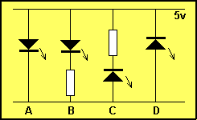

_________________________________________________________________________________________________________________________________________________________________________________________________________________________________
Q14. What are the functions of a transistor?

_________________________________________________________________________________________________________________________________________________________________________________________________________________________________

Quiz 2: Analogue and Digital Electronics (long questions)

Instruction:
- Please write down your answer in the boxes.
- There are 5 questions. Answer ALL questions.
- The duration of the test is 1 hour.

- Complete the truth table of the gates listed below: (28 Marks)

a. AND | b. NAND | c. OR | d. NOR
  A | B | OUT
  0 | 0
  0 | 1
  1 | 0
  1 | 1
  A | B | OUT
  0 | 0
  0 | 1
  1 | 0
  1 | 1
  A | B | OUT
  0 | 0
  0 | 1
  1 | 0
  1 | 1
  A | B | OUT
  0 | 0
  0 | 1
  1 | 0
  1 | 1
e. EX-OR | f. EX-NOR | g. NOT | h. Buffer
  A | B | OUT
  0 | 0
  0 | 1
  1 | 0
  1 | 1
  A | B | OUT
  0 | 0
  0 | 1
  1 | 0
  1 | 1
  IN | OUT
  0
  1
  IN | OUT
  0
  1

- Write down the truth table of the following logic circuit. (24 Marks)

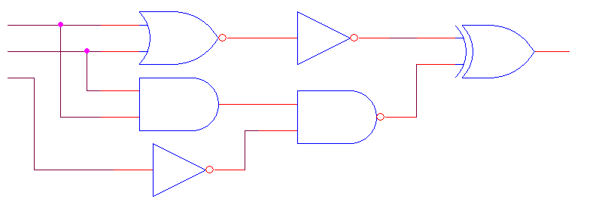
A
B
C
OUT

A | B | C | OUT
0 | 0 | 0
0 | 0 | 1
0 | 1 | 0
0 | 1 | 1
1 | 0 | 0
1 | 0 | 1
1 | 1 | 0
1 | 1 | 1

Answer Q3~Q5 with the same circuit below.

- Write the sequence of traffic light shown in the 4017 circuit. (30 Marks)
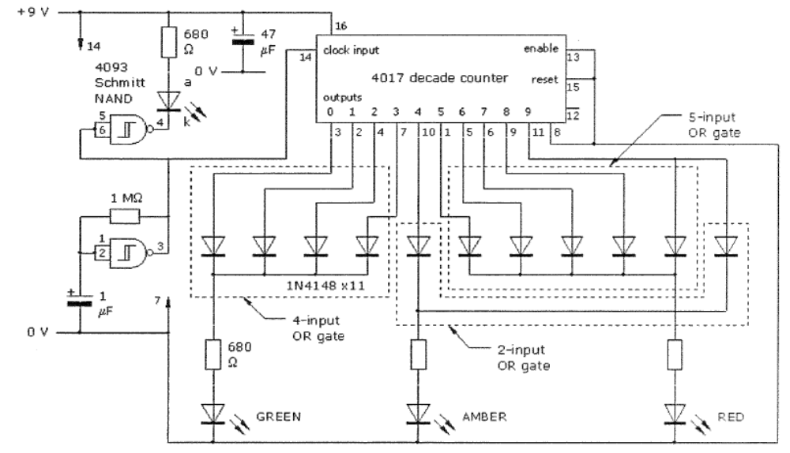
Sequence Step | Red | Amber | Green
0
1
2
3
4
5
6
7
8
9

- If pin 14 of the 4017 decade counter has been broken, what happen to the traffic light? (8 Marks)

- Which component(s) determine the speed of the traffic light? (10 Marks)
Quiz 3: Integrated Circuit, Micro-controller and Interfacing

Instruction:

- Please write down your answer in the space provided.
- Answer ALL questions.
- The duration of the test is 1 hour.
Short Questions (50%)

Q1. Is microprocessor a functional block that can be found in a micro-controller? Provide reason(s) to support your answer. (5 marks)

Q2. Is digital camera consists of a micro-controller? Provide reason(s) to support your answer. (10 marks)

Q3. Suggest why the mouse of a Personal Computer is an input device. (5 marks)

Q4. In the process of downloading a web page from the Internet and then displaying on monitor screen, different parts of your personal computer will be involved in handling the “0” and “1” representing the web page. Suggest how RAM in the motherboard is involved in the process. (5 marks)

Q5. Do the following statements correctly describe the characteristic of computer programs? Provide reason(s) to support your answer. (5 marks)
a) Instructions are executed by a computer sequentially.
b) Computer program has to be loaded into memory before it is being executed.

Q6. What is(are) the advantage(s) of using IC in electronic products? (5 marks)

Q7. a) f P13 in the following circuit High, will the LED on or off? (5 marks)

P13
470Ω

b) If the button is pressed, will P3 of the following circuit High or Low?

P3
10kΩ
+5V
220Ω

Q8. State whether the LED will be ON or OFF for the following cases: (10 marks)

No. | Circuit Diagram | Status of output Pin  (if any) | Answer:  ON / OFF
a. |  | None
b. |  | None
c. |  | P14 = High
d. | EMBED PBrush 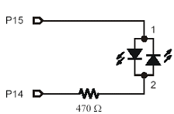 | P15 = High  P14 = High

Long Questions (50%)
Q1.
a) Draw the schematic that include the following resisters and LED circuit connect to the four output pins, P0, P1, P2 and P3 of a micro-controller. (15 marks)
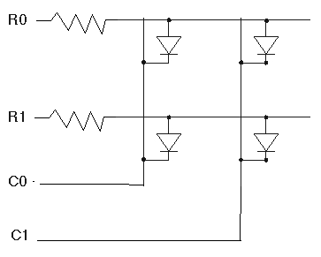

b) Write a pseudo code for a program to make all LEDs flash on and off, the LEDs should light up four times per second.

Q2. a) Connect the following circuit diagram such that P15 controls the RED LED and P14 controls the GREEN LED. In addition, when P13 is HIGH, both LED will be off.
Micro-controller
P13
P14
P15
470Ω
470Ω
RED
GREEN

- Write a pseudo code for a program to complete the following task:
  - RED LED on for 250ms then off
  - GREEN LED on for 250ms then off
  - RED and GREEN LED on for 250ms then off
  - Restart again (20 marks)

Q3. Discuss the similarity of library with computer in term of which part of a library corresponds to the four components of a computer, namely to CPU, memory, input and output. (15 marks)

Quiz 4: Evolution of Electronics in Modern Society

Instruction:
- Please write down your answer in the space provided.
- Answer ALL questions.
- The duration of the test is 1 hour.
Short Questions (40%)
Q1. With the help of an example, explain the Moore’s Law. (10 marks)

Q2. Is digitalization a direct result or indirect result of Moore’s Law? Provide reason(s) to support your answer. (10marks)

Q3. .State one of the three principal factors which driving the phenomenon of convergence. With the help of an example, explain why it can be considered as one of the driving factors. (10 marks)

Q4. Is smartphone a convergence product? Provide reason(s) to support your answer. (10 marks)
(A smartphone is a mobile phone with advanced capabilities beyond a typical mobile phone, often with Personal Computer-like functionality such as e-mail and Internet capability)

Long Questions (60%)
Q1. Nowadays, we find more and more products are moved to the digital domain. Discuss whether the phenomenon is driven by technology or needs of human being. (30 marks)

Q2. If you are to design a new phone, what new function you suggest to include in the phone? Why do you think people will like your new phone? (30 marks)

Useful Websites

CHAPTER 1 – ELECTRONIC SIGNALS, DEVICES AND CIRCUITS

Ohm's Law | http://www.kpsec.freeuk.com/ohmslaw.htm  http://www.twysted-pair.com/ohms.htm  http://en.wikipedia.org/wiki/Ohm's_law  http://en.wikibooks.org/wiki/Electronics/Ohm's_Law

CHAPTER 2 – ANALOGUE AND DIGITAL ELECTRONICS

NAND Gate and Latch | http://hyperphysics.phy-astr.gsu.edu/hbase/electronic/nandlatch.html
Latch | http://en.wikipedia.org/wiki/Latch_(electronic)
Operational Amplifier | http://www.analyzethat.net/65_operational_amplifiers.php
Operational Amplifier | http://en.wikipedia.org/wiki/Operational_amplifier
Circuit symbol | http://www.kpsec.freeuk.com/symbol.htm
Digital | http://en.wikipedia.org/wiki/Digital
Logic Circuit | http://www.technologystudent.com/elec1/dig2.htm
How Flash Memory Works | http://electronics.howstuffworks.com/flash-memory.htm

CHAPTER 3 – INTEGRATED CIRCUIT, MICROCONTROLLER AND INTERFACING

Building Skyscrapers on a Wafer | http://www97.intel.com/discover/JourneyInside/TJI_Microprocessors_lesson6/default.aspx
How Micro-controllers Work? | http://electronics.howstuffworks.com/microcontroller1.htm
How Microprocessors Work? | http://www.intel.com/education/mpworks/index.htm
Microprocessor | http://en.wikipedia.org/wiki/Microprocessor
How Motherboards Work? | http://computer.howstuffworks.com/motherboard.htm
TI Interactive Timeline | http://www.ti.com/corp/docs/company/history/interactivetimeline.shtml
Intel Innovation in Education - The Journey Inside | http://www97.intel.com/discover/JourneyInside/TJI_Overview/default.aspx

CHAPTER 4 – EVOLUTION OF ELECTRONICS IN MODERN SOCIETY

Ethical Implications of Emerging Technologies: A Survey | http://unesdoc.unesco.org/images/0014/001499/149992E.pdf
The trillion dollar Challenge Principles for profitable convergence | http://www.deloitte.com/dtt/cda/doc/content/The%20trillion%20dollar%20challenge_FINAL.pdf

References

Al Williams (2002). Microcontroller Projects Using the Basic Stamp. CMP Books.
Crowe and Barrie (1998). Introduction to digital electronics. London: Arnold.
Dan O’Sullivan and Tom Igoe (2004). Physical Computing Sensing and Controlling the Physical World with Computers. Thomson Course Technology PTR.
F. Floyd (2004). Electronics fundamentals: Circuits, Devices, and Applications. Upper Saddle River N.J. : Pearson/ Prentice Hall.
Gregg Wyant and Tucker Hammerstrom (1994). How Microprocessors Work. Ziff-Davis Press.
Ian Hickman (1990). Analog Electronics. Oxford: Newnes.
J. Reid, K. Dueck (2008). Introduction to Digital Electronics. New York: Thomson Delmar Learning.
Jerry C. Whitaker (2005). The Electronics Handbook. FL: CRC Press.
Nancy Cox, Charles T. Manley, Jr., Francis E. Chea (1995). LAN Times Guide to
Multimedia Networking. Osborne McGraw-Hill.
Roger Bridgman (1993). Electronics. New York: Dorling Kindersley.
Roger Tokheim (2008). Digital Electronics: Principles and Applications. McGraw- Hill Education.
Stephen L. Herman (2007). Electronics for Electricians. NY: Thomson Delmar Learning.

GLOSSARY OF TERMS

Term | Descriptions
AC | An alternating current (AC) is an electrical current whose magnitude and direction vary cyclically with time
Atom | The smallest particle of an element that can combine with similar particles of other elements to form the molecule of a compound. Atoms commonly consist of electrons (negatively charged particles) revolving around a positively charged nucleus containing protons, neutrons and other particles.
Boolean | Boolean algebra is an algebraic structure (a collection of elements and operations on them obeying defining axioms) that captures essential properties of both set operations and logic operations
Chip | A chip, also known as an integrated circuit or microchip, is a semiconductor wafer on which thousands or millions of tiny resistors, capacitors, and transistors are fabricated.
Comparator | Comparator is a device which compares two voltages or currents and switches its output to indicate which is larger. More generally, the term is also used to refer to a device that compares two items of data.
Convergence | The phenomenon that two or more previously discrete lines of business are combining to create new product or service, alliance, value chain structure or economic model.
Coulomb | Coulomb is the amount of electric charge transported by a current of 1 ampere in 1 second.
CPU | It is the brains of a computer. It is where most calculation and decision making process take place.
Current | The amount of electric current (measured in amperes) through some surface, e.g., a section through a copper conductor, is defined as the amount of electric charge (measured in coulombs) flowing through that surface over time.
DC | Direct current or continuous current is the constant flow of electric charge.
Device Convergence | The trend that the three worlds of communications, computing and consumer electronics come together in a single device.
Digitization | The phenomenon that more and more types of information can now be represented as zeros and ones.
Electric Charge | The potential of electrons or protons to attract each other.
Electron | Any of the negatively charged particles that form a part of all atoms.
EMF | Electromotive force is a term means charges “Q” pass across an electric device, and gains energy, the net EMF for that device is the energy gained per unit charge. This has units of volts (V), or Newton-meter/coulomb (N-m/C).
Fabricate | To process semiconductor for making integrated circuit.
Feedback | Feedback is a process whereby some proportion of the output signal of a system is passed back into the input. This is often used to control the dynamic behavior of the system.
Frequency | Frequency is the measurement of the number of occurrences of a repeated event per unit of time.
Hertz | The hertz (symbol “Hz”) is the SI unit of frequency.
Holes | An electron hole is the conceptual and mathematical opposite of an electron. The concept describes the lack of an electron.
Integrated Circuit | An integrated circuit, also known as a chip or microchip, is a semiconductor wafer on which thousands or millions of tiny resistors, capacitors, and transistors are fabricated.
Interfacing | Transmitting digital information between a micro-controller and its peripherals in a compatible way.
Mica | The mica group of sheet silicate minerals includes several closely related materials having highly perfect basal cleavage.
Microchip | A microchip, also known as an integrated circuit or chip, is a semiconductor wafer on which thousands or millions of tiny resistors, capacitors, and transistors are fabricated.
Micro-controller | An integrated circuit that includes circuitry sufficient for it to act self-sufficiently and cost-effectiveness as a miniaturized computer. Unlike a general-purpose computer, a micro-controller is usually for a dedicated task e.g. to control a particular system.
MMS | Multimedia Messaging Service (MMS) is a standard for telephony messaging systems that allows sending messages that include multimedia objects (images, audio, video, rich text) and not just text as in Short Message Service (SMS).
Moore’s Law | An empirical law proposed by Gordon Moore. The law predicts the number of transistors that can be built in one chip doubles every 18 months.
Morse code | Morse code is a method for transmitting telegraphic information, using standardized sequences of short and long elements to represent the letters, numerals, punctuation and special characters of a message.
Neutron | The neutron is a subatomic particle with no net electric charge.
Octopus | The Octopus card is a rechargeable contactless stored value smart card used to transfer electronic payments in online or offline systems in Hong Kong.
Open Loop | An open loop controller, also called a non-feedback controller, is a type of controller which computes its input into a system using only the current state and its model of the system.
Parallel | A parallel circuit is a different path for current through each of its components. A parallel circuit provides the same voltage across all its components.
PDA | A Personal digital assistant, abbreviated PDA, is a specification for a handheld-sized computer that runs a specific version of the Windows CE operating system.
Period | An interval of time which is measured between a start point and an end point and generally repeats, in a cycle with the end point of one period being the start point of the next.
Potential Difference | The potential difference is a quantity related to the amount of energy that would be required to move an object from one place to another against various types of forces.
Proton | The proton is a subatomic particle with an electric charge of one positive fundamental unit.
Pseudo code | It consists of a collection of short, English phrases used to describe specific tasks to be performed by a computer program.
Peripheral | Computer hardware for expanding the capability of a computer.
Program | A collection of instructions that describes a task, or a set of tasks, to be carried out by a computer.
RAM | Random access memory is a type of data storage used in computers. RAM is a volatile memory as the information or instructions stored in it will be lost if the power is switched off.
ROM | Read-only memory is a class of storage media used in computers and other electronic devices. Because data stored in ROM cannot be easily modified, it is mainly used as firmware.
Series | The current that flows in a series circuit has to flow through every component in the circuit. Therefore, all components in a series connection carry the same current.
Sine wave | The sine wave or sinusoid is a function that occurs often in mathematics, physics, signal processing, electrical engineering, and many other fields.
SMS | The Short Message Service (SMS), often called text messaging, is a means of sending short messages to and from mobile phones.
Voltage | Voltage sometimes called electric potential or electrical tension, which is the difference of electrical potential between two points of an electrical or electronic circuit.
Wafer | A thin slice of semiconducting material on which miniaturised circuits are built.
Watt | The watt (symbol “W”) is the SI derived unit of power, equal to one joule of energy per second.

ACKNOWLEDGEMENTS

Every effort has been made to trace the copyright for the photographs and images as needed. We apologize for any accidental infringement and shall be pleased to come to a suitable arrangement with the rightful owner if such accidental infringement occurs.

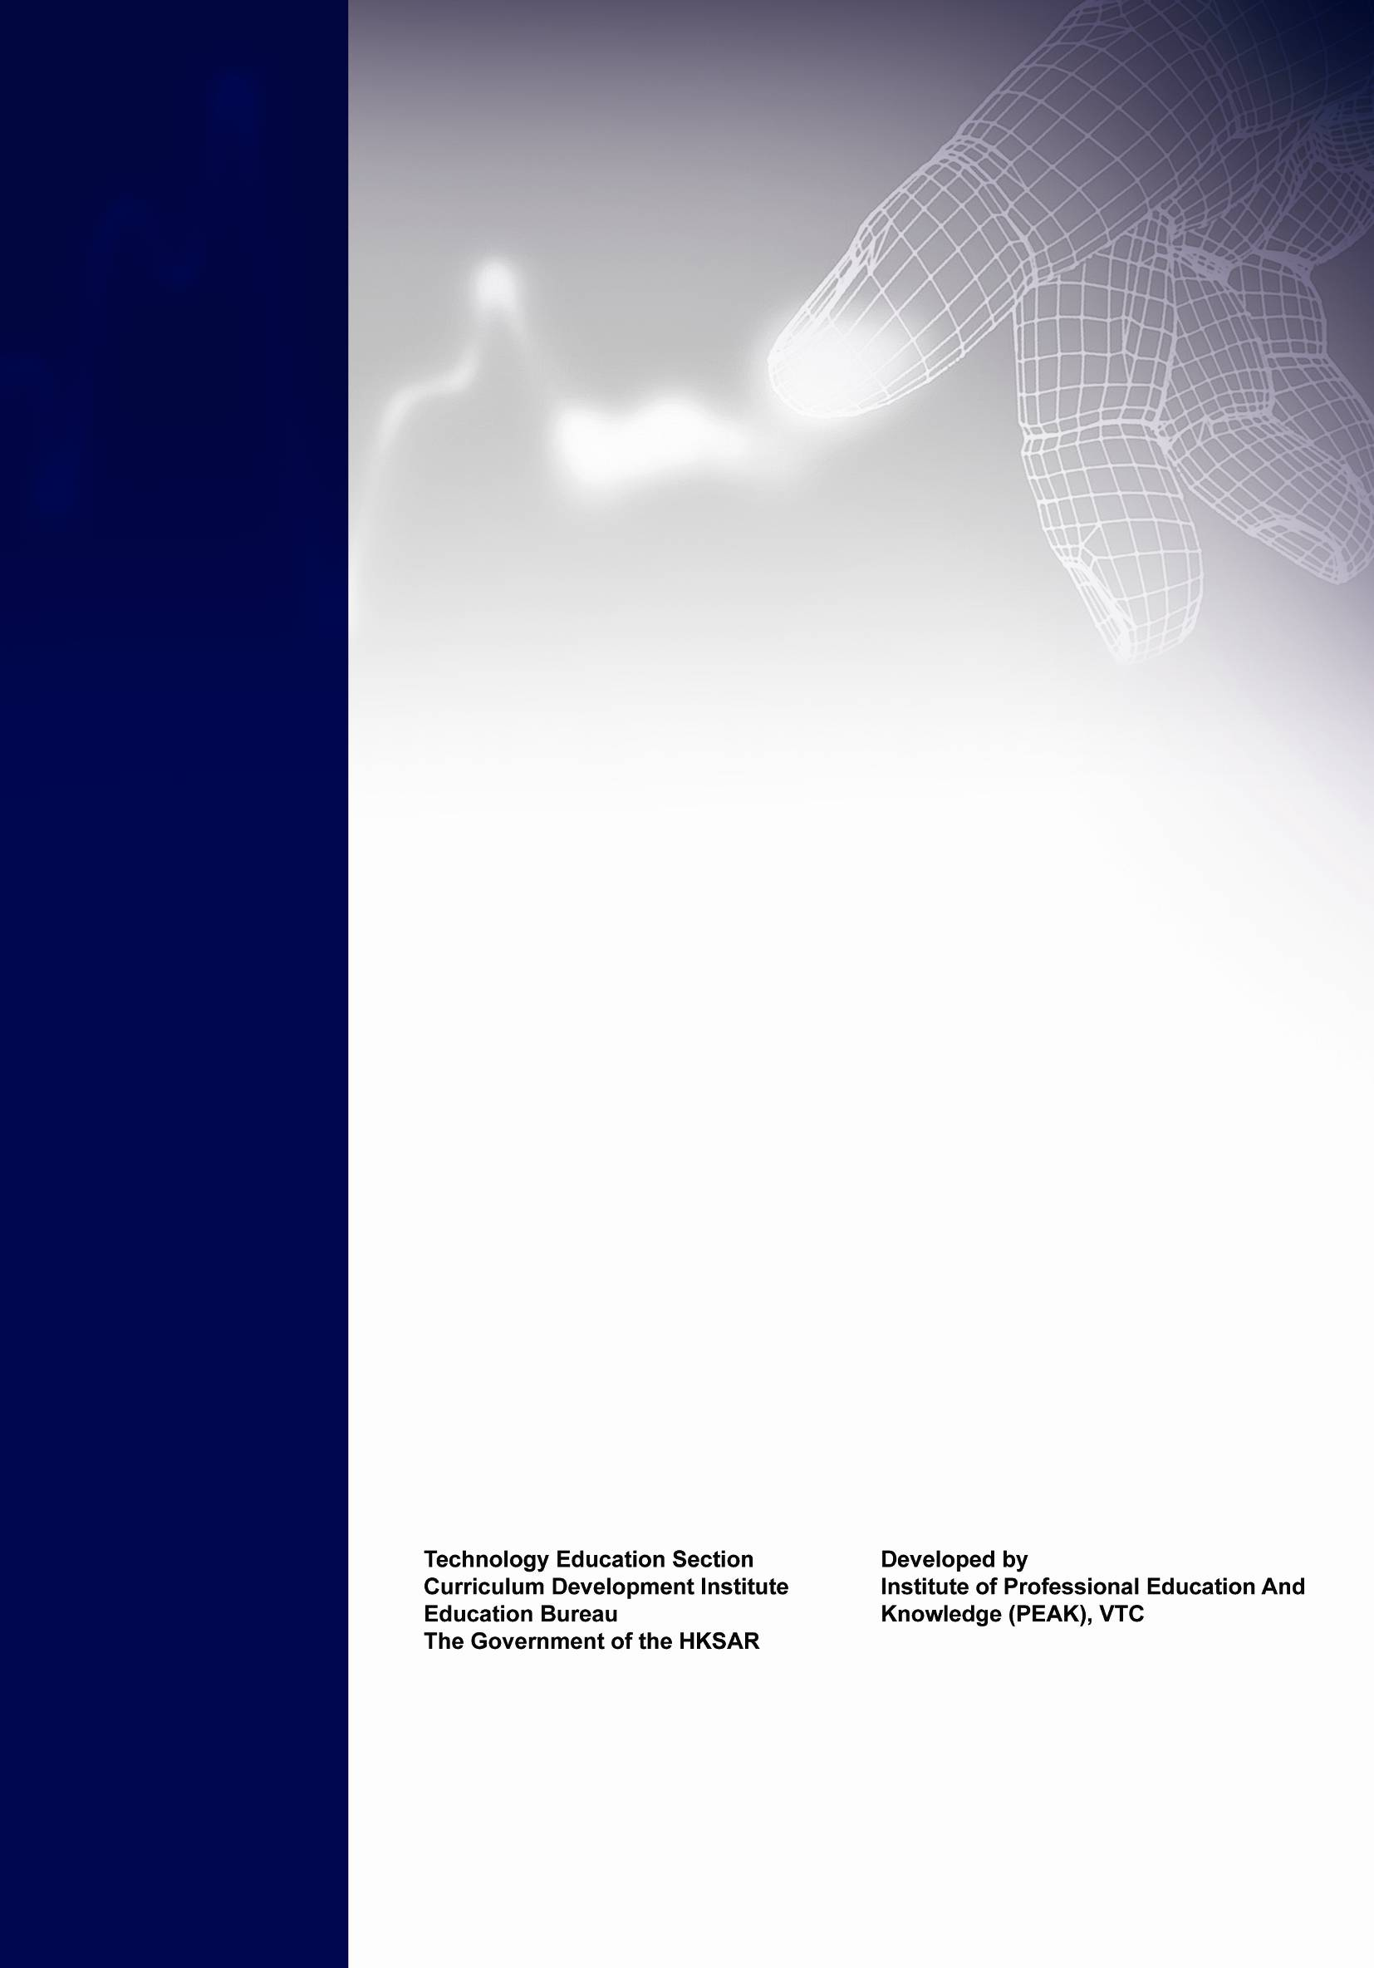
Technology Education Section Developed by
Curriculum Development Institute Institute of Professional Education
Education Bureau And Knowledge (PEAK)
The Government of the HKSAR Vocational Training Council

BASIC is an acronym for Beginner's All-purpose Symbolic Instruction Code

