PARTS LIST

MICROWAVE OVEN

220V 50Hz

TECHNICAL DATA

Model reference MG1770M

Functions Grill
Oven type WD700J-917
Colour White
Cavity Volume 17liter

Supply voltage 220V 50Hz
Frequency 2450 MHz±50 MHz

Rated Power Consumption(after 15mins.)
Microwave 1080W±10%
Microwave output 700W
Grill 1000W+5/-10%

Rated current(after 15mins.)
Microwave 5.10A±10%
Grill 4.40A+5/-10%

Safety devices
Thermal protector for magnetron /cavity fire open at 120ºC
Fuse Ceramic type 8A
Primary interlock switch
Second interlock switch
Monitor interlock switch

Control Manual

Unit dimensions 458 x 375 x296
Oven cavity size 320 x 288 x 183
Net Weight 15.5Kg

Power cord length 1200mm
Plug EURO

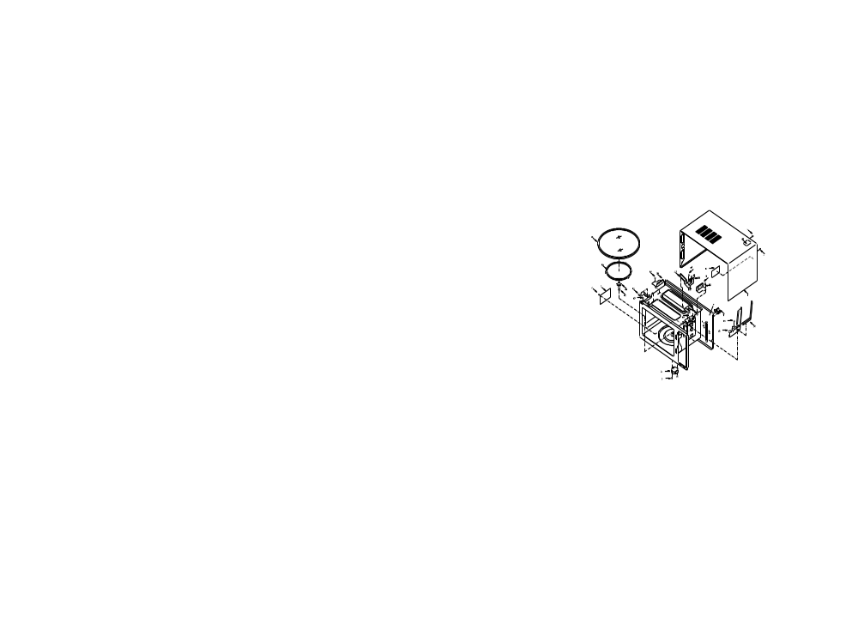

Supplier | Jens Parts No | Code | Pos.No | Order Part No | Description | O’ty
JENS | A04 |  | 1 |  | Cabinet | 1
JENS | B04 |  | 2 |  | Special Screw | 1
JENS | B05 |  | 3 |  | Screw | 5
JENS | A30 |  | 4 |  | Wire Buckle | 1
JENS | A02 |  | 5 |  | Grill Cavity | 1
JENS | W02 |  | 6 |  | Gear Motor | 1
JENS | B02 |  | 7 |  | Screw | 1
JENS | B08 |  | 8 |  | Screw | 1
JENS | A37 |  | 9 |  | Splash-Proof board | 1
JENS | A36 |  | 10 |  | Special Washer | 1
JENS | A35 |  | 11 |  | Turntable Shaft | 1
JENS | A33 |  | 12 |  | Roller | 1
JENS | A32 |  | 13 |  | Glass Tray | 1
JENS | W17 |  | 14 |  | Thermostat,120ºC | 1
JENS | B07 |  | 15 |  | Screw | 1
JENS | A38 |  | 16 |  | Up Bearing | 1
JENS | B01 |  | 17 |  | Screw | 1
JENS | A31 |  | 18 |  | Insulated Film | 1
JENS | B03 |  | 19 |  | Screw | 4
JENS | W24 |  | 20 |  | Heater | 2
JENS | A43 |  | 21 |  | Heater Support | 2
JENS | B2 |  | 22 |  | Screw | 3
JENS | A42 |  | 23 |  | Thermostat Support | 1
JENS | A49 |  | 24 |  | Warning Label | 1
JENS | A41 |  | 25 |  | Small Sponge Gasket | 1
JENS | A45 |  | 26 |  | Prevent Wind Board | 1

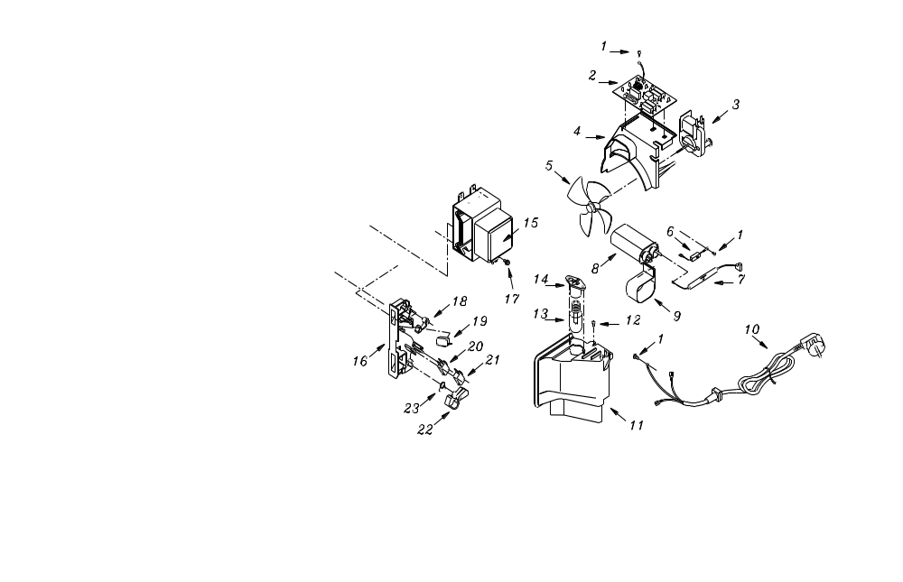

Supplier | Jens Part No | Code | Pos.No | Order Part No. | Description | O’ty
JENS | B04 |  | 1 |  | Special Screw | 2
JENS | W23 |  | 2 |  | Noise Filter | 1
JENS | W13 |  | 3 |  | Blower Motor | 1
JENS | A27 |  | 4 |  | Space Partition | 1
JENS | A28 |  | 5 |  | Fan | 1
JENS | W11 |  | 6 |  | Diode Ass’y | 1
JENS | W12 |  | 7 |  | HV Fuse | 1
JENS | W10 |  | 8 |  | Capacitor 0.92uF | 1
JENS | A29 |  | 9 |  | Capacitor Band | 1
JENS | W20 |  | 10 |  | Power supply Cord | 1
JENS | A26 |  | 11 |  | Duct | 1
JENS | B05 |  | 12 |  | Special Screw | 1
JENS | W08 |  | 13 |  | Lamp | 1
JENS | W09 |  | 14 |  | Lamp Socket | 1
JENS | W01 |  | 15 |  | Magnetron | 1
JENS | A21 |  | 16 |  | Switch Holder | 1
JENS | B01 |  | 17 |  | Special Screw | 4
JENS | A24 |  | 18 |  | Small Revolving Arm | 1
JENS | W04 |  | 19 |  | Primary Interlock Switch | 1
JENS | W05 |  | 20 |  | Door Sensing Switch | 1
JENS | W04 |  | 21 |  | Interlock Monitor Switch | 1
JENS | A22 |  | 22 |  | Big Revolving Arm | 1
JENS | A25 |  | 23 |  | Returning Spring | 1

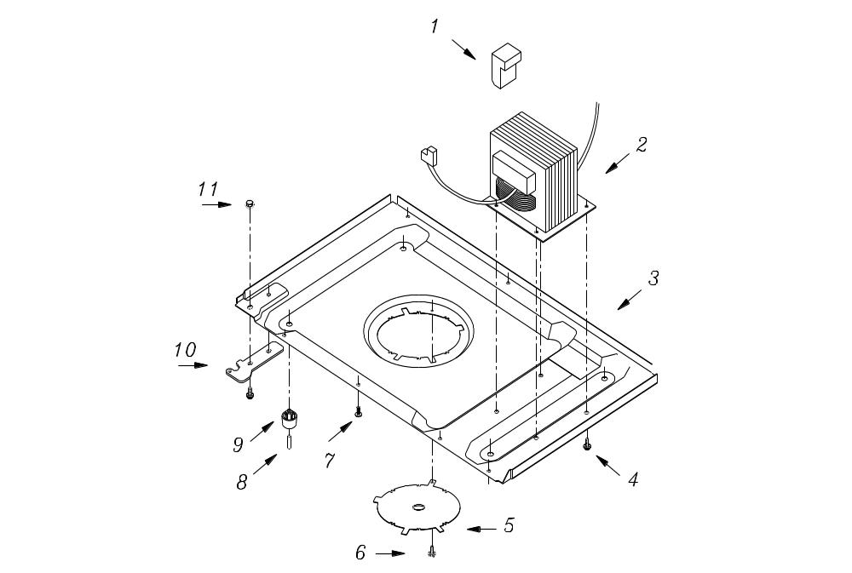

Supplier | Jens Part No | Code | Pos.No | Order Part No. | Description | O’ty
JENS | A20 |  | 1 |  | Quake-Proof Cushion | 1
JENS | W02 |  | 2 |  | Transformer | 1
JENS | A15 |  | 3 |  | Base Board | 1
JENS | B01 |  | 4 |  | Special Screw | 4
JENS | A19 |  | 5 |  | Gear Motor Cover | 1
JENS | B03 |  | 6 |  | Special Screw | 1
JENS | B03 |  | 7 |  | Special Screw | 7
JENS | A18 |  | 8 |  | Pin | 4
JENS | A17 |  | 9 |  | Oven leg | 4
JENS | A16 |  | 10 |  | Bottom Hinge | 1
JENS | B09 |  | 11 |  | Nut | 1

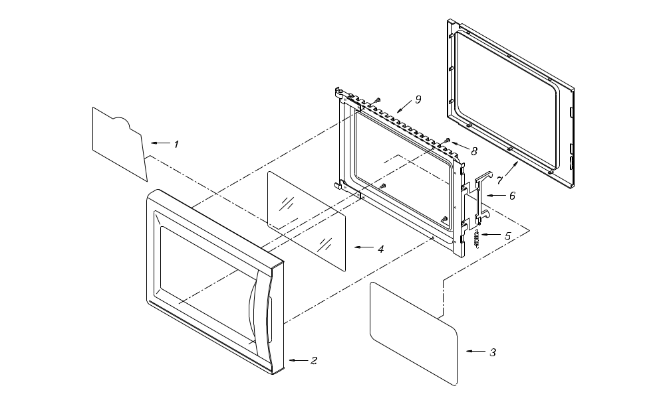

Supplier | Jens Part No | Code | Pos.No | Order Part No | Description | O’ty
JENS | A43 |  | 1 |  | Front nameplate | 1
JENS | A05 |  | 2 |  | Door Cover | 1
JENS | A09 |  | 3 |  | Protection Film | 1
JENS | A06 |  | 4 |  | Window Board | 1
JENS | A08 |  | 5 |  | Spring | 1
JENS | A07 |  | 6 |  | Door latch | 1
JENS | A10 |  | 7 |  | Choke Dielectric | 1
JENS | B07 |  | 8 |  | Screw | 4
JENS | A03 |  | 9 |  | Door Assembly Complete | 1

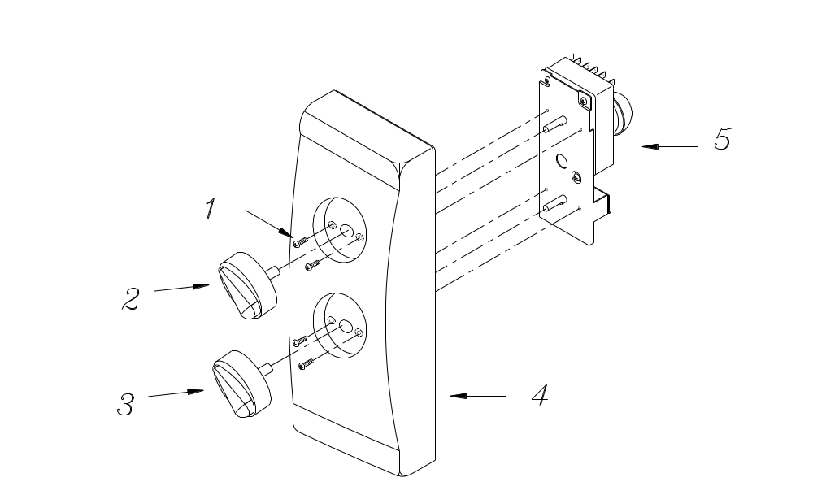

Supplier | Jens Part No | Code | Pos.No | Order Part No | Description | Q’ty
JENS | B02 |  | 1 |  | Screw | 4
JENS | A12 |  | 2 |  | Time knob | 1
JENS | A12 |  | 3 |  | Power knob | 1
JENS | A11 |  | 4 |  | Control Frame | 1
JENS | W16 |  | 5 |  | Timer | 1

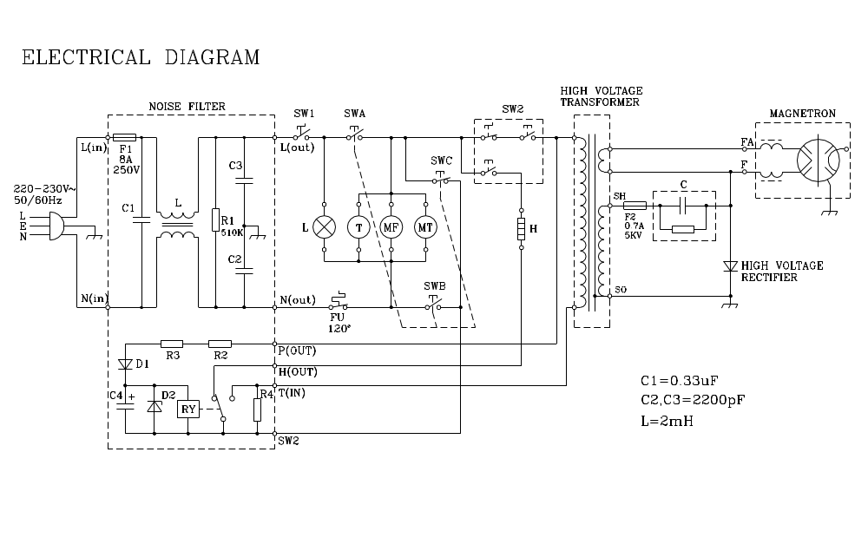
SW1: TIME CONTROL SWITCH
SW2: POWER CONTROL SWITCH

SWA: THE PRIMARY INTERLOCK SWITCH

SWB: THE SECOND INTERLOCK SWITCH
SWC: THE MONITOR INTERLOCK SWITCH
L: OVEN LAMP
T: TIMER MOTOR
MF: FAN MOTOR
MT: TRAY MOTOR
H: HEATER
FU1,FU2: THERMOSTAT
F1,F2: FUSE

