Ministry of Education and Science of the Russian Federation
Russian Engineering Union
Interregional Union of Scientific and Engineering Public Organizations
Peter the Great Saint Petersburg Polytechnic University



5th International Scientific and Practical Conference
MODERN MECHANICAL ENGINEERING: SCIENCE AND EDUCATION - 2016
(MMESE-2016)

30 June – 01 July 2016

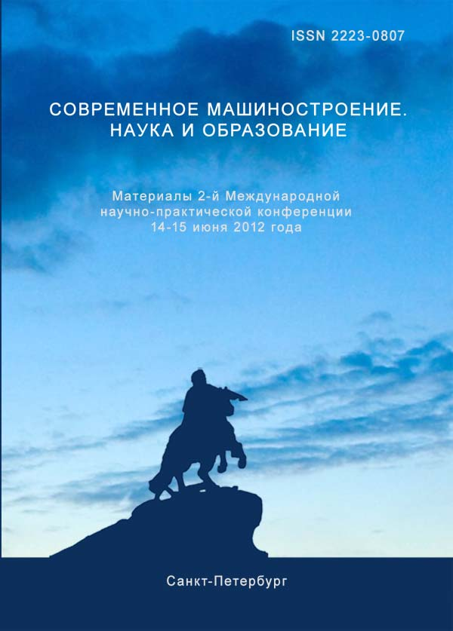 | 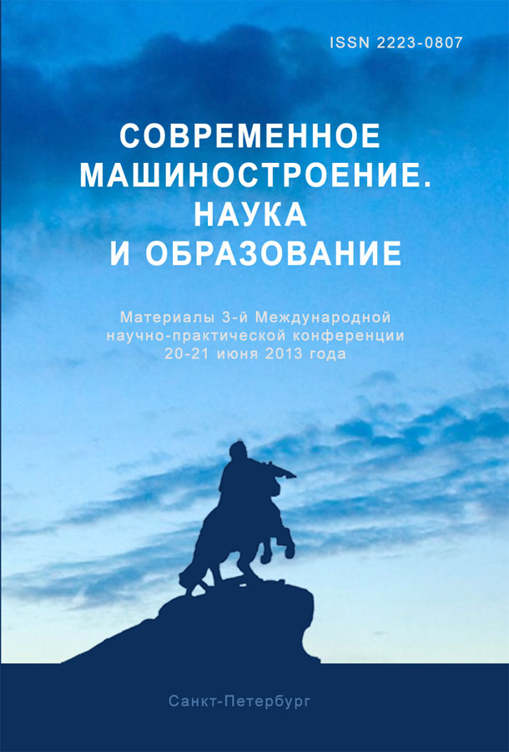 | 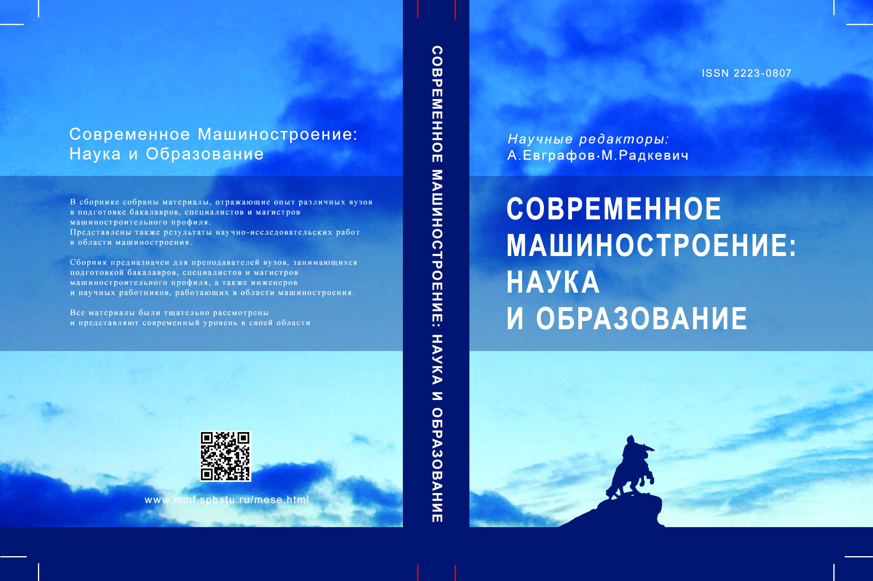 | 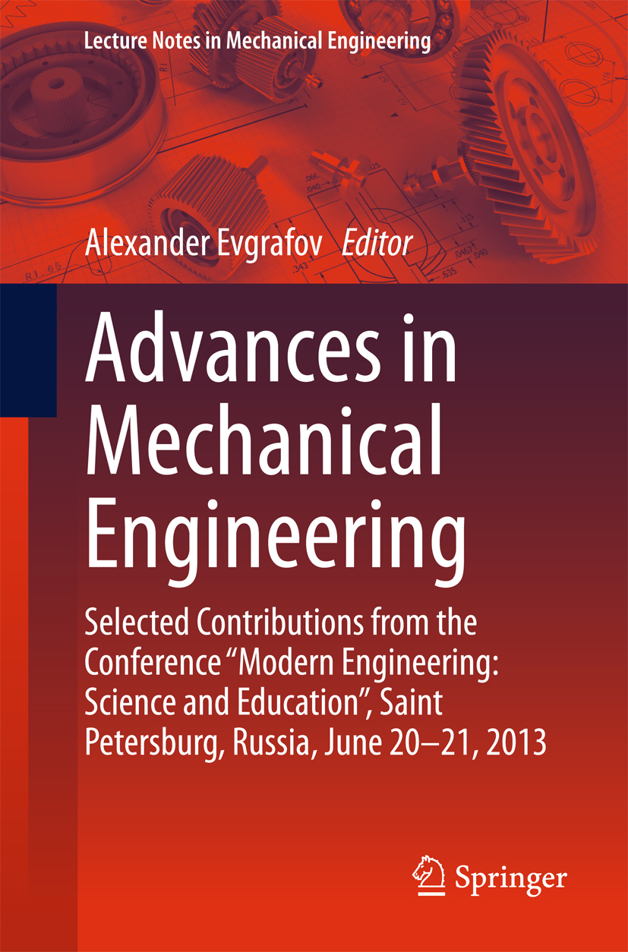 | 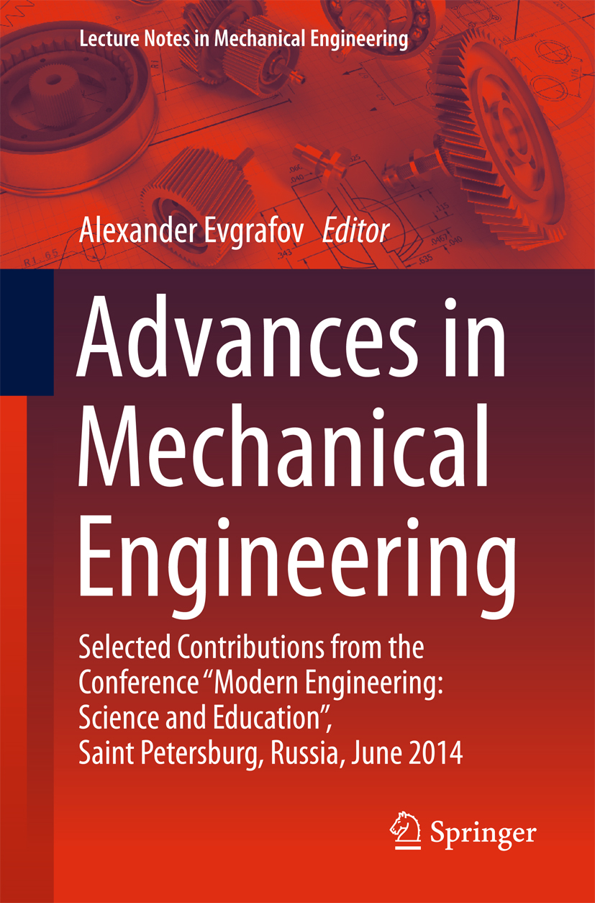

Saint- Petersburg
Russia

Program Committee
Chairman
• Prof. A.A. Popovich- SpbPU, St. Petersburg
Co-Chairman
• Prof. AN Evgrafov- SPbPU, St. Petersburg
Program Committee Members
• Prof. M.M.Radkevich- SPbPU, St. Petersburg
• Prof. M.S. Bundur- SPbPU, St. Petersburg
• Prof. M.S. Kokorin- SPbPU, St. Petersburg
• Prof. V.I.Karazin- SPbPU, St. Petersburg
• Prof. K.P.Manzhula- SPbPU, St. Petersburg
• Prof. M.A.Skotnikova- SPbPU, St. Petersburg
• Prof. A.V.Priemyshev- SPbPU, St. Petersburg
• Prof. A.N.Volkov- SPbPU, St. Petersburg

Organizing Committee
Chairman
• Prof. A.N. Evgrafov- SPbPU, St. Petersburg

Organizing Committee Members
- Prof. Jaroslav Raychik – Head of Department "Technology of building processes and materials." Częstochowa University of Technology, Poland
- Prof. Ramasubbu Sunder - Director Research, Bangalore Integrated System Solutions (P) Ltd
- Assoc.Prof. Nikolai Kazakov - Technical University, Faculty of Machine Building, Sofia, Bulgaria
- Prof. Vladimir Puhliy, Polytechnic Institute of the Sevastopol State University

Secretariat of SPbPU:
A. L. Smirnova
L. M. Papina
Ye. K. Protasova
R. F. Grigoryeva
B. Yu. Shtreker

Purpose of the conference - to discuss topical subjects of mechanical engineering, analysis and synthesis of the application results of innovative technologies in teaching engineering disciplines.

Topics
• Teaching Technologies
• Machine Mechanics
• Details of mechanisms. Designing, modeling and reliability of tribosystems
• Technology of structural materials and material science
• Implementation of international network of master program within the framework of the TEMPUS project
• Transport and technology systems
•Machine tool building
• Problems of practice-oriented training for the machine building
• Mechatronics and Robotics

The Conference working languages are Russian and English.

Important dates
- 15.04.2016 – deadline for full papers submission
- 29.04.2016 – deadline for information of papers acceptance

Publication
The Conference Proceedings will be presented on the USB flash drive.
Hard copy of Proceedings will be available upon prior request at the Organizing Committee for an additional fee (1400 rub.)
You can place an advertisement in the Conference Proceedings . The cost of 1400 printed characters is 15000 rub.

Proceedings of the Conference (paper and electronic versions) will be published by the decision of the Program Committee of the conference.
Proceedings are also included in the Russian Science Citation Index RISC.
Papers of the Proceedings will be assigned a DOI (digital object identifier).

Rules for abstracts and report (paper)
All papers must be prepared in strict accordance with the template (see http://www.mmf.spbstu.ru/mese/regulations.html)

Structure of submitted materials
Initials and surname of author (authors);
Title of the report;
Information about the author (s): name, patronymic, surname, academic degree, place of work, country, city, e-mail or contact telephone;
Abstract and key words;
Summary report;
List of references;
Text of the report:
- abstract describing of the problem and possible application of the results obtained
- formalized statement of the problem, the proposed method to solve it, difference
and advantage , examples confirming the efficiency and effectiveness of the
proposed solutions;
- discussion of the results obtained;
Literature
Information about the author (s): name, patronymic, surname, place of work,
abstract and key words and references.
Name of the text file with paper and registration form (marked Reg) must contain the name and initials of the first author. If several papers, the name of the text file must have number of the paper.

For example: ivanov_ak_1.doc and ivanov_ak-reg.doc.

Address to send paper(s): tmm-russia@mail.ru , Alexander Evgrafov

Venue
5th International Scientific and Practical Conference MMESE-2016
will be held on 30 June – 01 July 2016 in Peter the Great St. Petersburg Polytechnic University (Main Education Building).
Address: ul. Politekhnicheskaya 29 (Metro station "Politekhnicheskaya").
University website: http://www.spbstu.ru

Conditions of participation in the conference
In addition to participating in plenary and breakout sessions, Conference participants can enjoy a bus tour around St. Petersburg (evening of June 30), as well as an excursion to one of the suburbs of St. Petersburg (July 1).
These activities are carried out exclusively on request and at an additional cost.

Registration fee includes: 1 coffee break, 1 lunch, participant folder with handouts and conference proceedings on the USB-flash drive.

Registration fee does not include: a bus tour of St. Petersburg , excursion to one of the suburbs of St. Petersburg and a hard copy of the Conference Proceedings.

To participate in the Conference:

send the completed registration form (Attachement1) to the email address: expert1@spbstu.ru File name with a registration form must include the name and initials of the participant. For example: ivanov_ak_reg.
Accommodation
Hotel accommodation is paid by the conference participants.
1. Hotel "Sputnik" *** (Prosp. Morisa Toreza 36, Metro station “ Ploschad‘ Мuzhestva“)
2.University Hotels**
-Lesnoy prospekt 65-67, Metro station “Lesnaya“
-Grazhdanskiy prospekt 28, Metro station “Akademicheskaya“.

All the recommended hotels are within 20-30 minutes of walk from the University
NB: Hotel reservation is carried out through the Organizing Committee of the Conference. The Organizing Committee has arranged special (discounted) prices, and guarantees a proper accommodation for the Conference participants.

Registration fee
Registration fee in euro, including 18% VAT

Participants – 250 euro

PhD Students and Students – 120 euro

You can pay by bank transfer or by credit card at registration .
Participants wishing to pay by a bank must cover transaction charges.

Payment methods

Intermediary bank:

SWIFT:

Beneficiary’ s bank: Bank «Saint-Petersburg» PJSC

64A Maloohtinsky Prospect, St. Petersburg 195112,

Russian Federation

SWIFT: JSBSRU2P

Beneficiary: account 40503978490550200001

Peter the Great St. Petersburg Polytechnic University (SPbPU),

29, Polytechnicheskaja str, St Petersburg,

Russian Federation

Please, write your name and the conference name (MMESE-2016)

Example: John Brown, MMESE-2016

Contact Information

Organizing Committee of the Peter the Great St. Petersburg Polytechnic University, Politekhnicheskaya str., 29, 1 education building, room. 42
195251, St. Petersburg, Russian Federation

Alla Smirnova

Tel / fax: +7 (812) 297 20 88

Lidia Papina

Tel/fax: +7(812) 552 85 34

E-mail: expert1@spbstu.ru

Abstracts/papers
Alexander Evgrafov
Tel/Fax: +7(812) 297 48 45
E-mail: tmm-russia@mail.ru
Chair”Theory of Mechanisms and Machines”
Conference website: http://www.mmf.spbstu.ru/mese.html
Registration Form

Title: Mr  Mrs  Ms  Prof  Dr 
Last Name ________________________
First Name ________________________
Other Names ______________________
Dates of birth______________________
Place of birth_______________________
Citizenship________________________
Passport number____________________
Date of issue______________________
Date of expiry______________________
Country of permanent residence________
Place of visa issuing_________________
Place of work:
Organization_______________________
Address___________________________
Position___________________________
E-mail____________________________
Fax______________________________
Phone_____________________________
Accompanying person, if any___________

Date of arrival_______________________
Date of departure____________________
Please note!
Copy of the first page of your passport sent by fax or by e-mail is required for issuing an official invitation (visa support). Visa support letter (official invitation) will be sent to you within 2 months (for EU members within 2 weeks).
Accommodation needed:  Yes  No
Booking the hotel:
 Hotel “Sputnik”
-  single room
-  double room
Address: Hotel “Sputnik”- Prosp. M.Toreza 36; metro station “Ploshchad’ Muzhestva”
2.University Hotels**:
 Lesnoy prospekt 65, Metro station “Lesnaya“
 single room
 double room

 Grazhdanskiy prospekt 28, Metro station Akademicheskaya.
 single room
 double room

Date and Place_______________
Signature ___________________

