

CUA40211
Certificate IV in Dance Teaching & Management

Module Four – Part 1 – Quality Teaching

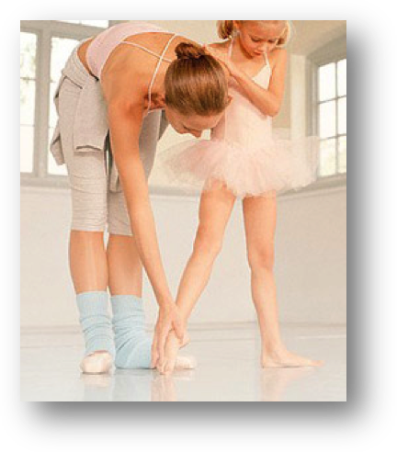

Contents

SISCCRO302A Apply Legal And Ethical Instructional Skills 5
Legal and ethical responsibilities for Dance Teachers 5
CUADTM401A Plan And Organise Dance Classes 7
1. The Teaching/ Learning Process 7
2. Understanding the Dance Teacher 8
2.1. Teacher Competencies 8
2.2. Dance Teaching Philosophies 9
Dance School Policy 11
3. Understanding the Learner 13
Physical Development 18
Psychosocial Development 20
Personality 21
Psychological Issues 23
Substance Abuse 25
Blooms Cognitive Domains And Taxonomies 27
3.2. How Students Learn Movement 30
3.3. Selection, Sequencing And Presentation Of Content For The Learner 33
Sequencing 34
Presentation 35
Imagery 35
The Importance of Play 37
3.4. Motivation 38
4 Learning Environment 42
4.2. Inclusive Environment 44
Cultural Differences 44
Disabilities 47
Equal Opportunities 47
Communicating Instructions 49
Feedback 49
Guided Manipulation 52
Negative Feedback 53
Alternative Ways to Give Feedback 53
Questioning 54
4.4. Managing the dance classroom 54
Pacing and Time Management 56
5. Planning & Evaluation 63
The Teacher 64
The Student 64
Program Content 65
Performances 65
Enrichment 66
5.2. Program Planning 71
Lesson Plan Evaluation Criteria 76
Sample Lesson Plans 77
Lesson Plan One: 78
Lesson Plan Two: 82
Alternative Sample Scaffold Templates for Lesson Plans 90
Self-Evaluation: 93
Lesson Observation Format 94
References 95
Activities: Planning, Learning And Teaching 98
Introductory Activity 98
Understanding the Dance Teacher Activities 99
Activity One: 99
Activity Two: 100
Activity Three 101
Activity Four: 102
Activity Five: 103
Understanding the Learner Activities 104
Activity One: 104
Activity Two: 107
Activity Three: 108
Activity Four: 109
Activity Five: 111
Activity Six: 112
Activity Seven: 113
Activity Eight: 114
Learning Environment 115
Activity One: 115
Activity Two: 116
Activity Three: 116
Activity Four: 117
Activity Five 117
Activity Six: 118
Activity Seven: 119
Activity Eight: 119
Activity Nine: 120
Activity Ten: 120
Activity Eleven 121
Planning and Evaluation 122
Activity One: 122
Activity Two: 123
Activity Three: 124
Activity Four: 125
Self-Evaluation: 125
Activity Five: 126
Activity Six: 127
Activity Seven: 128
Activity Eight: 129
Task: 129

SISCCRO302A Apply Legal and Ethical Instructional Skills

Legal and ethical responsibilities for Dance Teachers

Dance Teachers have a Duty of Care for their students, staff and parents or carers. By following these guidelines the safety of all participants will be increased and the risk of negligence reduced.

- Activities and Sessions must be adequately planned
When sessions are not prepared there is a higher risk of impaired learning and injury may result especially where new skills are being taught. Appropriate progressions in teaching these skills at appropriate skill levels are essential especially in potentially dangerous skills.

- A safe environment is imperative
Both the facilities and equipment being used must be safe. A safe environment is free from discrimination, harassment and abuse. If sessions are being conducted outdoors such as at an event then adverse weather conditions must be taken into account.

- Treatment
All participants should be treated fairly, with respect and dignity regardless of gender, race, and place of origin, athletic potential, colour, sexual orientation, religion, political beliefs, socio-economic status and other conditions.

- Physical contact
Ensuring any physical contact with a dancer is appropriate to the situation and necessary for the dancer’s skill development. Also being acutely aware of the power the dance teacher has and the trust the dancers put in them. Avoid any situations with participants that could be construed as compromising, inappropriate or intimate.

- Child protection
Is the understanding and action of complying with the state child protection requirements.

- Professional Development
Maintaining and improving teaching skills and qualifications through development, training and education opportunities.

- Dancers should not be expected to perform if injured or incapacitated Pressure to perform with an injury may result in negative physical and psychological consequences.

- Aims
Developing the participant’s skills, knowledge and experiences and ensuring they provide all participants equal time, attention and opportunities whenever possible. Providing feedback to players and other participants in a manner sensitive to their needs and avoiding overly negative feedback.

  - Performing within own limitations
Dancers should not perform activities beyond their own physical limitations.

  - Supervision
All activities must have adequate supervision to ensure the practice environment is as safe as possible.

  - Dance Teachers should know first aid
A current knowledge of the basic emergency procedures including STOP (Stop, Talk, Observe, Prevent further injury) and RICE (Rest, Ice, Compression, Elevation) procedures for managing injuries should be updated regularly. There should be a written emergency plan appropriate medical assistance readily available.

  - Clear rules for general conduct both before during and after dance sessions.
Injuries may result when conduct at practice venues is unstructured such as in waiting times. Clear written rules should be developed and understood by all participants for general conduct and behaviour.

  - Records
Accurate records should be maintained in all cases of injury including relevant general and medical information and progress reports. Accident reports should be made as soon as possible after an injury occurs.

(Adopted from R. Martens [1990] Successful Coaching, Champaign, III: Leisure Press)
And http://www.ausport.gov.au/Rights/Responsibilities-coaches

CUADTM401A Plan and Organise Dance Classes

Introduction:
These information pages hope to introduce dance teachers to basic principles of teaching and learning, based on knowledge of child development, so that they may reflect upon and improve their repertoire of skills.

1. The Teaching/ Learning Process

There are three stages involved with teaching and learning:

- Planning
- Implementation
- Evaluation

Each stage directly affects the other stages, and the process can be represented as a cycle.
Encompassing the Teaching Learning process is knowledge of the teacher and the learner.
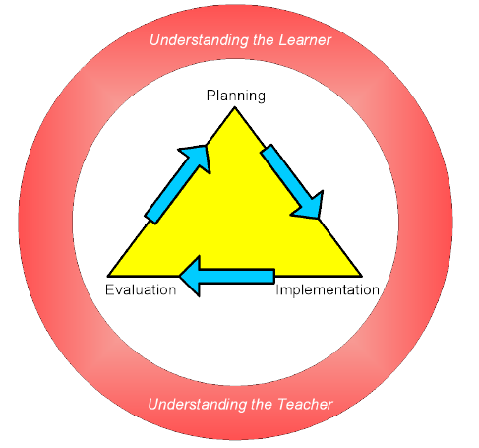

2. Understanding the Dance Teacher

By the end of this section students will:

- Have an understanding of positive role models and associated teaching styles
and competencies;
- Develop an awareness of teaching philosophies

2.1. Teacher Competencies

To be an effective dance teacher and establish a professional dance teaching business, teachers need to establish a good understanding of core teacher competencies.

The following outlines five core ideals for teacher competency in Dance, as described by Hanna (1999:76-77):

Show commitment to students and their learning
Dance teaching should be based on observation, knowledge and respect of students’ interests, abilities, skills, knowledge, family circumstances and peer relationships. Teachers should be punctual, reliable and well organised when teaching dance classes.

Develop a strong knowledge base of dance and dance teaching
Teachers should understand all aspects of what they are teaching and how to teach it to students.
This includes the following two aspects;

- Have a strong understanding of dance technique
- Have some knowledge of how students develop and learn

Manage and monitor student learning.
Teachers need to engage students using effective teaching methods, resources and motivation and employ methods to assess the students learning and evaluate their progress.

Evaluate your dance teaching
Teachers need to be able to review and self-evaluate dance teachings practices – and learn from experiences. This may include seeking advice from other dance teachers, feedback from students, researching (and adapting to) new findings, ideas and theories.

Participate in learning communities
Dance teachers should contribute to ATOD syllabus updates, recommend changes and attend syllabus updates and information sessions. Teachers should actively seek out professional development to improve their dance teaching.

2.2. Dance Teaching Philosophies

Paramount to beginning teaching in any form is the establishment of a personal teaching philosophy - a rationale upon which all teaching and learning experiences are based.
Dance teachers develop their teaching philosophy based on:

- Their beliefs about teaching and learning;
- Their experience and expertise;
- Their personality;
- The level of service they wish to provide

A dance teacher’s personal philosophy may also be influenced by the organisation they may work for or the particular syllabus they teach.

Your philosophical approach to teaching is an evolving process and will change as your knowledge of teaching expands and your experience grows.

Philosophy Categories

Smith & Autard (1994) have identified three distinct categories of dance teaching philosophies:

Professional
Under this category, a dance teacher aims to produce highly skilled technical dancers in preparation for a career in dance and performance. This is typically instructional based, where the teacher directs and controls disciplined dancers.

Educational
This category aims to develop dancer’s creative, expressive and social skills.
Under this category, a dance teacher aims to instil a sense of dance appreciation for dancers, rather than training them for a career in dance. The teacher employs open-ended, non-instructive methods of teaching under this category, encouraging dancer creativity and problem solving.

Mid-Way
Utilising elements from the Professional and Educational model, this category encourages artistic education, performance education and an appreciation of dance (cultural education).

The following table provides a comparison of these philosophies:

 | Professional | Educational | Mid-Way
Objective | Career in Dance | Education and Appreciation of dance | Creating, Performing and Appreciating dance
Approach | Product | Process | Product and Process
Education | Knowledge of technical syllabi and theatre dance | Imagination, creativity, individuality | Using technical and Creative knowledge
Teaching Style | Instructional – teacher as expert, pupil as apprentice | Non-instructional - encourages creativity, individuality and problem solving | Combines the use of Instructional and Non Instructional

The guiding philosophy of the ATOD Ltd is to promote and advance the art of dance and the caring and careful training of dance students, catering for both students learning for pleasure and those aspiring to professional careers in dance. Following this general philosophy it is expected that most ATOD teachers will follow the midway model.

Aims and General Objectives

Every dance teacher needs to develop a personal set of aims and general objectives based upon their teaching philosophy. These aims and general objectives provide a basis for their planning and programming, as well as providing parents with an overview of the services offered and the style in which these services will be provided.

Dance School Policy

The dance teacher’s philosophy and aims and objectives, once decided, will form the basis of the Dance School Policy. This policy should describe the overall direction of the teaching learning program and may include:

• Name of School
• Address of venue
• Contact details
• Aims & objectives
• Staff details
• Styles offered
• Enrolment details
• Safety considerations
• Teaching methods
• Fee structure
• Community involvement
• Facilities such as parking, preparation room, parents waiting room
• Pick up and drop off procedures
• Timetable
• Uniform & grooming requirements

2.3. Teaching Styles

Teaching styles are the various methods the teacher uses to instruct the students and are guided by the teacher’s personal philosophy. According to Kassing & Jay (2003:59-63), styles range from teacher-oriented to student-oriented learning situations, as illustrated in the diagram below:

Teaching Styles
Student-centered
Command Practice Reciprocal Self-check Inclusive Guided Discovery Divergent

In teacher-centred teaching styles, the teacher is the central focus and source of learning. In student-centred teaching styles the student initiates and takes responsibility for their learning while the teacher acts as a mentor during the learning process.

- Command Style
This is the most commonly used teaching style. The teacher plans and prepares for the class, demonstrates the exercises, and corrects the dancers’ execution.
The teacher makes all decisions in regards to the subject matter, class etiquette, discipline and motivation.

- Practice Style
This style is less teacher-centred than the command style, but is often used in conjunction with the command style. The teacher will allocate time for students to practice an exercise during the class.

- Reciprocal Style
This style is based on the use of an observer and a performer, and can also be referred to as “peer teaching”. Firstly, the teacher creates the criteria for executing exercises, which may be presented in the form of a checklist. Secondly, the students are grouped into pairs. The observer watches the performer execute the combination – and evaluates the performer against the criteria checklist. Thirdly, the observer discusses their observations in a constructive manner with the performer. Finally, the observer and performer reverse roles.

- Self-Check Style
This style involves the teacher developing a checklist of criteria the dancer can use as a self-evaluation tool. During the self-check, the dancer observes their execution of the movement/step/combination using the criteria checklist.

- Inclusive Style
This style allows the student to make a choice on how they will challenge their abilities, based on different options presented to them by the teacher. This style allows dancers to adjust their levels of performance, depending if they wish to challenge themselves or not.

- Guided Discovery Style
This student-centred style involves the teacher questioning students to develop their convergent thinking skills. In convergent thinking, the student is guided by the teachers questioning to finding an answer to the question asked. These types of questions require the student to analyse their movements and then add this information to their personal checklist.

- Divergent Style
This style promotes problem solving in the students. The teacher will present a problem to the students, provide a structure and boundaries for solving the problem, and ask the students to solve the problem. As long as the students work within the structure and boundaries of the problem, they will achieve success. This teaching style is basic to teaching creative movement, improvisation, and choreography.

A dance teacher’s style of teaching is as individual as their philosophy. Many teachers will not follow the one style but will employ many different styles dependent upon which is the best style suited to teach differing knowledge and skills. Employing a variety of teaching styles also keeps the learning interesting and engaging for the students.

3. Understanding the Learner

By the end of this section students will:

- Be able to identify stages of development and preferred learning styles;
- Be able to select, sequence and present content for the learner.

Knowledge of how students develop and learn is essential to any dance teacher and will have many implications for teacher expectations and teaching strategies employed. A dance teacher needs a thorough knowledge of:

• Development Stages (Physical, Psychosocial and Cognitive)
• How students learn movement (Perceiving, Thinking and Doing)
• Different Learning Styles
• Motor Learning Stages (Attempt, Correct and Perfect)
• Selection, Sequencing and Presentation of Content for the Learner
• Motivation

3.1. Development Stages

As a dance teacher, it is important to understand the stages of Physical, Cognitive and Psychosocial development so that students are provided with the most effective way of learning suited to their individual needs.

In the following tables Kassing and Jay (2003: 92-94) summarise the distinguishing characteristics of different age groups that are of consideration to dance teachers. It describes how each age group learns, what they need to have to learn effectively, what they best relate to, their motor skills, typical dance activities and dance forms.

Distinguishing characteristics of 3 to 5 year olds:

Learn by | Need to have | Relate to | Motor skills | Dance activities
• Imitation  • Following  • Leading  • Manipulating  • Watching and listening  • Exploring and discovering the elements of dance  • Using senses (touch, taste, hear, see, feel)  • Practicing respect for property and equipment | • Structure in the class  • Repeated practice with following instructions  • Repetition of the activity  • Praise (positive reinforcement)  • Smiles  • Short activities balanced with rest periods  • Gross motor activity 9arms and legs)  • Class work as a group | • Lively music  • Stories and tales  • Bright colours  • Familiar objects  • People and occupations  • Animals  • Machines  • Songs  • Chant songs  • Fantasy  • Pretending  • Props, ribbons, scarves etc. | • Loco motor movements; walk, run, jump and gallop  • Non loco motor movements; bend, stretch, twist, turn, jump in place, fall | • Body awareness  • Spatial awareness  • Discovery and exploration dances  • Dance making (know that there is a beginning, middle, and an end)

Distinguishing characteristics of 6 to 8 year olds:

Learn by | Need to have | Relate to | Motor skills | Dance activities
• Imitation  • Watching  • Listening  • Exploring (elements of dance)  • Creating (improvising and short dance making)  • Working as a group, later in partners  • Problem solving through group activities in which children take turns | • Short activities  • Rest periods  • Vigorous activities (gross motor)  • Body awareness  • Personal space  • Instructions for 3-4 steps  • Adult attention and approval  • Structure  • Prop manipulation  • Repetition  • New challenges  • Short skill practice  • Self-discipline  • Cooperation | • Animal movements activities  • Modes of transportation  • Environments: zoo, farm, forest, jungle  • Variety of music  • Self-expression  • Movement exploration using dance vocabulary  • Performing steps  • Props | • Horizontal and vertical jumps  • Hop  • Slide  • Skip  • Gallop  • Leap  • Directional movements and steps  • Physical fitness (leg strength, flexibility and abdominal strength) | • Non Loco motor  • Loco motor  • Body awareness  • Spatial awareness  • Use of space  • Quality of movement  • Relationship of body to other objects  • Dance making  • Dance performing  • Dance appreciation

Distinguishing characteristics of 9 to 14 year olds

Learn by | Need to have | Relate to | Motor skills | Dance activities
• Exploring• Movement-language connections  • Executing  • Performing  • Creating  • Observing | • Peer activities  • Listening and observation skills to contribute to activities  • Interest in tops  • Action, enthusiasm, and opportunities to participate full  • Emotional outcomes met or will not participate  • Respect, fairness, and understanding of responsibility to feel mature  • Praise and reinforcement  • Problem-solving situations | • Variety of learning activities  • Motivation to learn  • Dance making  • Developing and practising skills and steps  • Variety of music and props  • Personal appearance  • Peers | • Loco motor  • Non loco motor  • Training concepts, conditioning  • Develop upper-body strength  • Agility, balance, and speed | • Performing steps, dance patterns, and combinations  • Dance making in small groups  • Choreography (teacher and student)  • Performing dances  • Dance class for fun, enjoyment, personal development, or enrichment  • Dance as a career  • Dance as education  • Interest in attending performances and learning about dance  • Dance appreciation

Distinguishing characteristics of 15 to 18 year olds

Learn by | Need to have | Relate to | Motor skills | Dance activities
• Observing  • Exploring  • Improvising  • Creating dances  • Executing and performing  • Discussing, evaluating, and developing aesthetics | • Skills and creative problem solving situations  • Emotional support  •Accommodation for differences in maturity and development  • Structure in class  •Encouragement  and positive feedback  • A part in decision making | • Social activities  • Activities that motivate them  • Peers more than teachers  • Music  • Topics/issues important to them as  individuals or as a group | • Loco motor  • Non loco motor  • Training concepts, conditioning  • Develop upper-body strength  • Agility, balance, and speed | • Perfecting steps, dance patterns, and combinations  • Participate in group activities  • Dance making in groups  •Choreography (teacher and student)  • Performing dances  • Dance class for fun, enjoyment, personal development, or enrichment  • Dance as a career  • Dance as education

Physical Development

“Physical development includes the growth of the body and its organs during childhood, the appearance of physical signs of aging during adulthood and the gains and losses in motor abilities that occur over the years.”
(Sigelman & Shaffer, 1995)

Two major influences play a part in the physical development of an individual:

• Genetics (what we inherited from our parents and family)
• Environment (the external forces that impact our lives)

With consideration of these major influences, the following outlines the significant changes in physical development through the lifespan of an individual. Possible teaching strategies for each stage of physical development have also been included. Many of these strategies, however, are not restricted to the one stage; instead, they can be common to all:

Stage | Age | Physical characteristics | Teaching Strategies
Pre School | 3 – 8 years | • Children at this age are extremely active. Involvement in activity is important; they may experience difficulty standing still for long periods.  • Gross motor skills are more developed than their fine motor skills (small hand movements, hand-eye coordination)  •Bodies are flexible and resilient, yet their bone growth is not yet complete (their bodies cannot stand heavy pressure)  •Children become more confident as their fine motor skills develop, but they may not understand their physical limitations.  •Significant percentage of students may experience reduced hearing due to build-up of fluid in the narrow tubes running from their ears (a consideration when giving instructions to children).  •Right or left-handedness is established. | • Lessons should be activity based  • Use alternate sides  •Plan for a variety of activities  • Progress quickly from one activity to the next  • Gross motor movements should form the basis and lead to simple fine motor activities  • Show caution with stretching exercises  • Play games such as Simon Says, Freeze, and Follow the Leader to develop the ability to stand still and follow directions
Middle Age Adult |  | • Some middle aged adults may experience a reduced ability to see and hear.  • Reduction in muscle strength-resulting in deterioration and stiffening of joints.  •For students that are returning to dance after a number of years, it is important to remind them they will need to pace their training to suit their physical needs. | • Lessons should include thorough body stretching activities, such as warm up and warm down  • Structure programs to ensure exercises requiring strength and flexibility are given adequate preparation  •Well defined emergency plan  • Trained in CPR  • Use alternate sides
Older Adult |  | •Older adults benefit from regular exercise. However, exercise of an inappropriate type, duration, intensity, frequency and progression can trigger a cardiovascular accident or serious musculoskeletal injury. | •Programs should be suited to the individuals needs  • Teachers should ensure students are able to recognise (and adjust own program accordingly) when experiencing signs of physical stress  •Well defined emergency plan  • Trained in CPR  • Provide alternative exercises  • Use alternate sides

Psychosocial Development

“Psychosocial development refers to changes in personal and interpersonal phenomena such as motives and emotions, personality traits, interpersonal skills and relationships, and roles played within the family and the larger society.” (Sigelman & Shaffer, 1995)

In considering psychosocial development, as described above, it is influenced by two important factors: 1. Personality and 2. Psychological Issues (such as self-esteem, self-image and physiological stress).

Personality

Personality is the organised combination of attributes, motives, values and behaviours unique to each individual. Carl Erikson, a Neo-Freudian theorist, believed that social and cultural influences are critical to shaping personality.

Eriksson defined eight stages of psychosocial development, as it relates to personality:

Stage | Age | Description | Teaching Strategies
Trust versus Mistrust | Birth – 1 yr. | Infants learn to trust their care-givers to meet their needs. Responsive parenting during this stage is critical. | • Praise and support  • Smiles  •Responsive support
Autonomy versus Shame & Doubt | 1-3 yrs. | Children learn to be autonomous – asserting their will and doing things for themselves, or they will doubt their own abilities. | • Encouragement  • Allow time for children to express their ideas  •Encourage approximations
Initiative versus  Guilty | 3-6 yrs. | Children learn to develop initiative by experimenting and exploring. If this is discouraged they will feel guilty about showing initiative. Children are concerned with them but must learn not to impinge on the rights of others. They express their emotions openly. | •Encourage approximations  • Allow children to make choices  • Play down any bursts of anger  •Try not to respond to a child angrily  • Provide understanding and limit setting not punishment  • Use students to demonstrate “good work” for the group  •Ensure all children succeed in an activity
Industry versus Inferiority | 6-12 yrs. | Children need to attain feelings of accomplishment and competence, be praised for trying and helped to persevere (or they will feel inferior and lack confidence in their ability). They are sensitive to criticism, have difficulty with failure and are generally eager to please the teacher. They are becoming sensitive to others but may be prone to teasing without realising how hurtful it can be. | • Praise (including praise for trying)  • Encouragement to persevere  •Play down comparisons  • Be aware of teasing and insist on respectful interactions between students  • Use students to demonstrate “good work” for the group  •Corrections should be worded in a positive way
Identity versus Role Confusion | 12-20 yrs. | Adolescents are concerned about what type of person they are becoming and need to develop a sense of self, integrating the various roles they undertake in different situations They are heavily concerned with their peer group and what others think of them. Peer group pressure may replace eagerness to please the teacher. Identity conflicts can cause stress and turmoil. | • Promote positive body images  • Be aware of signs of psychological issues such as eating disorders, depression etc.  •Help learners evaluate which movement, music, design etc. best meet expressive needs.  • Challenge learners’ ideas constructively  • Provide group corrections  •Make individual corrections in a private manner
Intimacy versus Isolation | 20-40 yrs. | Young adults seek to form an intimate relationship (or shared identity) with another person – but may fear intimacy or may not want to give up their independence. Loneliness and isolation may result. | • Encourage students to share problems and discuss solutions as a group  • Coordinate social events
Generativity versus Stagnation | 40- 65 yrs. | Adults must feel that they are producing something of value- something that will outlive them – either by successfully raising their children or by contributing to society through their work. Otherwise, they may feel stagnant and self-centred. | •Encourage social discussions about family, friends and work  •Coordinate social events including family and friends  •Organise community performances  •Encourage involvement in the dance community
Integrity versus Despair | 65 yrs. + | Older adults must come to view their lives in a meaningful way, in order to face death without worries and regrets. | •Encourage social discussions about family and friends  •Coordinate social events including family and friends  •Encourage involvement in the dance community

Psychological Issues

There are many psychological issues facing the dance student today.

These include:

• Self Esteem
• Eating Disorders and Nutrition
• Substance abuse
• Physiological Stress (including performance anxiety)

Self Esteem

Self-esteem is a person’s overall evaluation of their worth as a person. It develops as children compare themselves with others and as they receive feedback on their competence from those around them, including parents, peers and teachers.

It is important that teachers consider in advance how dance activities and our actions can impact our students’ self-esteem. Teachers need to encourage students to believe in their own abilities, therefore building their self-confidence (a student’s belief in how they can learn and execute a skill). This is often critical to a student’s ability to perform. For example, if a student believes they are a great dancer, then this will lead into a great performance. On the other side of this self-confidence spectrum, if a student believes they are an awful dancer, a poor performance will result.

Many strategies to promote a high self-esteem are discussed in the section titled ‘Learning Conditions’.

Eating Disorders and Nutrition

As an art form, dance seems to highly value a particular body shape for it’s’ ability to create the most aesthetically pleasing line. Warren (1989:64-65) describes the ideal body structure and proportions for classical ballet dancers, stating that it is ‘never acceptable to be overweight, awkward, extremely ‘turned in’ or inflexible, or to possess certain exaggerated physical characteristics that do not conform to the traditional classical look, and that often ‘auditioning dancers are simply asked to stand in a line, and first eliminations are made based solely upon the look of their bodies’.

Schnitt & Schnitt (1991) discuss how pressures for thinness in dancers can be extreme, especially in settings where competition is high for performance slots or for teacher approval.

These pressures may be teacher-driven, profession-driven, peer-driven or self-driven. Due to these pressures anorexia nervosa and bulimia may be more frequent in dancers than the general public. Anorexia is characterised by a dramatic weight loss brought about by malnutrition. Bulimia is binge eating; the rapid, secretive and uncontrolled ingestion of large quantities or food, often followed by vomiting and/or the use of laxatives.

Arnheim (1991) lists the following signs to look for in a dancer with an eating disorder:

• Social isolation and withdrawal from friends and family
• A lack of confidence in dance abilities
• Ritualistic eating behaviour (e.g. organising food on a plate)
• An obsession with counting calories
• An obsession with constantly exercising, especially just before a meal
• An obsession with weighing self
• A constant overestimation of body size
• Patterns of leaving the table directly after eating to go to the restroom
• Problems relating to eating disorders (e.g. malnutrition, menstrual irregularities, or chronic fatigue)

Chelmar & Fitt (1990) recommend using concern and caution when approaching a student suspected of having an eating disorder. Consultation with an Eating Disorders Professional beforehand on how to approach the situation is essential, as confrontations can do more harm than good if handled improperly.

Dance teachers need to exercise extreme caution when commenting on any aspect of a student’s physique, especially body weight. An understanding of the different body types, as described by Fitt (1988) is also necessary for teachers to assist in setting realistic expectations and to design programs which are based upon each individual’s physiology and structure, movement capacities and limitations and conditioning needs. Teachers also need to be advocates of healthy eating programs and be able to assist students with information on nutrition for the dancer. Further details on Nutrition are discussed in the Safe Dance module.

Substance Abuse

Substance abuse can take the form of:

• Alcohol
• Nicotine (cigarettes)
• Laxatives
• Drugs such as cocaine, marijuana, ecstasy etc.

Reasons for substance abuse include:

• Peer pressure
• Experimenting with adult behaviour
• Stress reduction
• Anti-anxiety or temporary anti-depressant effects
• Recreation
• Boredom
• Feelings of lack of control

Dance teachers need to be positive role models for a healthy lifestyle, and be aware of severe personality changes caused by substance abuse. Where necessary, teachers should consult with the responsible caregiver.

Physiological Stress

A moderate amount of physiological stress may be useful to the dancer when harnessed to improve the quality of their technique and performance. However, if expected levels of stress inhibit adequate performance, teachers need to assist with strategies to control anxiety.
Hanna (1999) states that a stressor for one person may not cause stress for another.
Although this selectivity is not entirely understood, an individual’s personality, cultural attitudes and prior experience dealing with pressure make all the difference.

Teachers need to be aware that dance does induce stress (even though it can be beneficial).
Some signs of excessive stress on a student can be obvious to a dance teacher: icy hands in a hot room, blushing, trembling, shortness of breath, tears and other emotional outbursts, nervousness, increased perspiration, extra trips to the bathroom, palpitating heart, muscular tension, faintness, back strain, depression, anxiety, difficulty in swallowing, headaches, loss of appetite, intestinal and eating disorders, insomnia, feelings of frustration and resentment.

Ways of alleviating physiological stress and performance anxiety include:

• Eliminate incorrect teaching – ensure adequate preparation and correct technique
• Set realistic expectations – expectations need to vary based on individuals’ ability
• Professional counselling
• Relaxation techniques such as deep breathing
• Visualisation – using imagery to prepare for execution
• Talking and writing about students’ concerns
• Relevant articles on bulletin boards and newsletters

Hanna also states that dance may be a means of dealing with the symptoms of stress (but not the actual causes). Coping with stress through dance may relax the dancer sufficiently to allow him or her on resolving stressors in their lives.

Cognitive Development

“Cognitive Development involves changes in mental processes involved in perception, language use, learning and thought”.
(Sigelman & Shaffer, 1995)

Dance Teachers need to consider their students’ understanding of the world and consider ways to ensure the content chosen is at a level the students are able to understand and is delivered in a way to assist the students to make connections with their current knowledge.

Piaget’s Cognitive Stages
An important psychologist in cognitive development, Jean Piaget, suggests that children build cognitive (thinking) structures for understanding and responding to their experiences of the world. His model identifies four cognitive stages of students.

In considering Piaget’s stages, dance teachers should be aware that a student’s ability to apply the various stages’ skills will vary depending on the cognitive domain in which they are operating (i.e. depending on levels of interest). Also, Piaget’s theory is biased toward a western perspective on thinking as it values the logical and scientific approaches to thinking.

The following table, summarised from QUT (1999) describes Piaget’s four stages of cognitive development and teaching strategies:

Stage | Age | Physical characteristics | Teaching Strategies
Sensory-motor | 0-2 yrs. | Young children experience the world through their senses. They believe that objects are permanent (and still exist when they can no longer see them); they initiate goal-directed actions, and know how to prolong interesting experiences. | Use concrete materials (use physical objects for stimulation). Use visual aids.
Pre-operational | 2-7 yrs. | Children are ego-centric and make judgements around their own experiences. They may make up magical explanations when problem solving. They mime or pretend actions (such as combing their hair). They have a limited understanding of concepts required for “logical” thought. | Keep using concrete materials. Keep using visual aids. Keep instructions brief, using gestures, to highlight intent. Focus on one aspect of a situation at a time.
Concrete Operational | 7-11 yrs. | Children gradually develop the ability to solve problems logically by making rules based upon their own experiences. However, they still have trouble grasping hypothetical ideas and future possibilities – their logic is restricted to their immediate concrete experience. Students are less ego-centric and more aware of others. | Keep using concrete materials. Keep using visual aids. Use familiar examples to go from simple steps to complex steps. Get students to analyse (practically) their problems and activities.
Formal Operational | 11+ yrs. | Adolescents should fully develop the ability to think logically and abstractly but may not always use it. This stage involves abstract and rational thinking. Students reason from general principles to specific actions. | Keep using concrete operational materials. Provide opportunities for student to hypothesise (ask questions). Provide opportunities for students to inquire. Use activities that are highly relevant to students’ interests.

Blooms Cognitive Domains and Taxonomies

Another important theorist in cognitive development was Benjamin Bloom (1956). Bloom developed Cognitive Domains and associated taxonomies that explain cognitive, affective and psychomotor development of individuals. These domains are an important consideration for dance teachers, as they demonstrate in the dance class, teachers are not just teaching the body to move – they also impact cognitive and affective development.

Bloom explains the cognitive domain as dealing mainly with mental or intellectual abilities.
The affective domain focuses on the attitudes, values, interests and feelings of individuals.
The psychomotor domain incorporates all observable voluntary human motion (explained in further detail below).

Psychomotor Domains

Anita Harrow (1972) created a hierarchical classification of psychomotor behaviours incorporating the lowest level of observable human motion to the highest level. Her model is designed to help dance teachers (and other educators) to clarify and categorise movement experiences.

Harrow’s model is summarised by QUT (1999) in the following table. Her model presents definitions and examples of the different classification levels, including reflex movement, basic-fundamental movements, perceptual abilities, physical abilities, skilled movements and non-discursive communication.

Levels | Definitions | Behaviour Activity
Reflex Movements | Actions elicited without conscious volition in response to some stimuli. | Flexion, extension, stretch, postural adjustments.
Basic Fundamental Movements | Inherent movement patterns which are formed from a combining of reflex movements and are the basis for complex skilled movement | Walking, running, jumping, sliding, hipping, rolling, climbing, pushing, pulling, twisting, gripping, manipulating. Grasping finger movements.
Perceptual Abilities | Interpretation of stimuli from various modalities providing data for the learner to make adjustments his/her environment | The outcomes of perceptual abilities are observable in all purposeful movement. Examples: Auditory (following verbal instructions), Visual (dodging a moving ball), Kinaesthetic 9making bodily adjustments in a handstand to maintain balance, Tactile (determining texture through touch), Coordinated (jump rope, punting, catching).
Physical Abilities | Functional characteristics of organic vigour, which are essential to the development of highly skilled movement. | All activities, which require strenuous effort for long periods of time – i.e. distance, running, distance swimming. All activities, which require muscular exertion – i.e. weight lifting, wrestling.  All activities, which require wide range of motion at hip joints – i.e. touching toes, back bend ballet exercises. All activities, which require quick precise movements – i.e. shuttle run, typing etc.
Skilled Movements | A degree of efficiency when performing complex movement tasks which are based upon inherent movement patterns. | All skilled activities, which build upon the inherent loco motor and manipulative movement patterns of classification. These activities are obvious in sports, recreation, dance, and fine arts areas.
Non-discursive communication | Communication through bodily movements ranging from facial expressions through sophisticated choreographies. | Body postures, gestures, facial expressions, all efficiently executed skilled dance movements and choreographies.

3.2. How Students Learn Movement

Understanding how students learn movement and dance is central to teaching. Gray (1989) describes a human information processing system that has been adapted to create the following Learning Model with three stages:

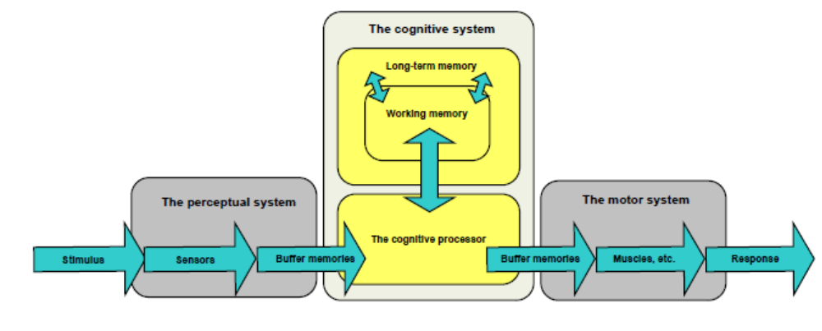

Stage 1 - Perceiving
A student’s perceptual system consists of stimulation to human sensors – such as eyes, ears, muscles and skin – and briefly storing this incoming information into “buffer” memories while waiting processing.

Stage 2 - Thinking
As these sensors store information into the buffer memories, the cognitive or “thinking” system proceeds to organise and process the information. Once processed, these perceptions are transferred to the motor subsystem.

Stage 3 - Doing
After the information is transferred to the motor system, appropriate actions are initiated. The motor processes implement muscle activity, which results in observable dance movements and postures.

Preferred Learning Styles

According to Kassing & Jay (2003), within each stage of the Learning Model, students will use three senses during dance class while learning:

- Visual
Visual learners are those learners who need to ‘see’ to understand. Visual learning of dance often involves watching the teacher and replicating the movements. Other ways of visual learning include visual displays (videos/dvds, posters, images, maps, handouts, charts, graphs, flip cards, overheads)

- Auditory/Verbal
Auditory learners have an attachment to music theory and styles; they remember music and attach the movement to the music. This type of learner learns through techniques such as instructions, question and answer sessions, using a variety of tone and pitch while speaking, rhymes and cues. These learners like to say the steps as they do them.

- Kinaesthetic
The most effective way to learn something is to learn “by doing”. Dancers often have a kinaesthetic repertory of works in their memory. Kinaesthetic learners learn best through hands-on experience, demonstrating or teaching others and team activities.

All students will have a preferred learning style. It may be visual, verbal, and kinaesthetic or a combination of these learning styles. It is important that teachers use all three cueing systems when presenting content to cater for the needs of all of the students in the class.

Motor Learning

Motor Learning is the process of improving the smoothness and accuracy of movements.
Kassing & Jay (2003) state that it involves practice or experiences which causes changes in the central nervous system, that permanently alter a students learning capacity and performance of skilled dance movements.

Kimmerle & Cote-Laurence (2003) describe motor learning as having three distinct stages through which the teacher guides students – Attempt, Correct, and Perfect. The following table outlines each of these three stages of motor learning, how students learn within each stage, and strategies for teachers to maximise the success of using each stage:

 | Learning Implications | Teaching Strategies
Attempt | This stage represents the learner’s first exposure to the new skill.  In this stage, the student:  Picks up relevant cues from the teacher,  Forms a mental image of the skill required,  Retrieves or constructs a motor plan of the skill,  Executes the skill. | Teaching the simplest elements of the dance form vocabulary and having students perform the exercises and steps at a basic skill level.  Using different techniques to motivate students.  Providing clear and unambiguous instructions.  Allowing students to observe and then attempt a step, explaining the movement clearly by breaking it up into parts.  Providing regular feedback and corrections.
Correct | This stage covers the practice time needed for the learner to self-monitor the execution of the skill. Constant guidance at this level of learning is detrimental to long term retention. Instead, students learn how to perform self-checks to become responsible for their learning and perfecting of their performance.  During this stage, the student:  Monitors their performance externally and internally  Assesses and reprograms their motor plan  Attempts the corrected skill | Once exercises and steps have been learned ensure a reviewing process  Varying these exercises and steps according to time and space  Using prescriptive feedback  Refraining from giving too much feedback and guidance  Using random practice (new combinations using the step)  Encouraging students to mentally practice the execution of steps and combinations  Selecting imagery to heighten performance and artistry
Perfect | This final stage allows the student to execute the skill with minimal conscious attention. The teacher uses minimal cues or demonstrations to encourage the students to be responsible for learning and perfecting their performance.  In this stage the student will:  Practice with ongoing monitoring,  Revise their performance,  Produce a skilled action,  Combine the skill with other skills, music and people. | The teacher’s role in this stage is to guide the student’s mental and psychological skills while encouraging a positive attitude and confidence in their dancing abilities.  Practicing combinations automatically to reduce the influence of outside stimuli or attention demands.  Helping students learn by demonstrating the entire dance, then teaching each step of the dance separately. Together with the students, the teacher will then put the steps together in sequential order so that they are prepared to execute the entire dance.  Applying imagery, mental practice and other psychological techniques.  Promoting personal excellence, positive attitude, confidence and self-talk.

3.3. Selection, Sequencing and Presentation of Content for the Learner

The selection, sequencing and presentation of content will play a key role in assisting students’ understanding and minimising behaviour management problems.

Selection

When selecting content there are two main factors to consider:

- Is the level of the content developmentally appropriate? Do the students have the necessary cognitive skills to understand the content, the physical ability to perform the content, and the psychological readiness to learn the content?
- Is the content engaging? Will the students find the content interesting and be motivated to learn? Does the content challenge the students yet be achievable?

Sequencing

Correct sequencing of the content is essential to ensure optimum learning.
The content must follow a logical progression and gradually build the knowledge skills and attitudes required. New work should build upon concepts and skills that are already established. Links need to be made between new learning and prior learning to facilitate efficient learning.

Programs and lessons should follow a structured progression of tasks and activities, and consider the use of graduated workload, such as:

• Frequency
This refers to how often the dance classes and/or rehearsals occur.

• Intensity
This refers to how physically demanding or difficult a class and/or rehearsal is.

• Time
This refers to how long an exercise lasts.

Geeves (1990) states “the tenet of ‘start slowly and progress gradually’ with each new dance class is the responsibility of both the teacher and the dance student. No matter how empathetic or talented, the teacher is unable to experience pain or emotion for a student. The individual student should be aware of his/her level of tolerance and never work through pain, fatigue, illness or injury.”

Other strategies for sequencing content include:

• Simple to complex
Steps are taught in order of difficulty. For example, a single time step would be taught before a double and a jump from 2 feet would be taught before a hop.

• Part- whole
The teacher breaks a step down into basic elements, teaching each element separately to the students, then assisting the students to join the whole step. For example the teacher would teach the students the elements of a time step separately (shuffles- hops- step- tap steps) and culminate by putting the steps together shuffle, hop, step, tap step, step. When teaching a pirouette the teacher would teach the students to releve first, followed by use of the arms, followed by how to ‘spot’, culminating with adding these skills together.

• Whole- part- whole
This is a variation of part - whole where the teacher would demonstrate or perform the whole step first for the students before breaking it into parts.

• Chunking
This requires the teacher to break the step into ‘chunks’ or groups of basic elements, which are taught separately then added together once learnt.

• Whole to part
This involves the teacher teaching the whole step first in a general manner then breaking it down into parts. For example a teacher may teach a port de bras in its entirety then break down each section for technical analysis.

• Add-on
This method is commonly used to teach dances and long combinations or enchainment’s. The teacher would teach the first step and the students would practise, the teacher would then teach the 2nd step and the students would practice the 2 steps together, the teacher would teach the 3rd step and then the students would practice the 3 steps together etc.

Presentation

The presentation of the content must be undertaken in a way that is engaging, motivating and assists students in their understanding. The use of imagery to assist students’ understanding and the use of play are valuable teaching strategies to explore in this section.

Imagery

Using mental imagery is a teaching strategy to assist students to better understand postural alignment, technique and artistry/presentation, and generate the corresponding kinaesthetic responses in the body to make this movements/correction possible. Imaging prompts messages from the central nervous system to produce change in muscle action.

Imagery used in dance classes can be categorised in two types:

• Indirect
Indirect imagery uses the image as a metaphor. For example for students experiencing difficulty with turns could be asked to visualise a spinning top and relate this to the way they are turning, or students experiencing difficulty with pelvic alignment may be asked to imagine their pelvis is a bowl of water which will spill if the bowl is tipped either forwards or backwards.

• Direct
Direct imagery involves imagining and mentally rehearsing a particular movement or sequence. Mental rehearsal may be just as beneficial as physical rehearsal. The nervous dancer may mentally run through the steps of their routine in their mind’s eye before they enter the stage. When focusing on turnout the teacher may instruct the class to visualise the leg rotating in the hip socket.

Overby (1991/2) indicates mental imagery is used by dancers:

- To practice a well-learned skill or choreography for a performance
- Who are injured or sick
- To build self-confidence

Imagery may also be internal focussing on what you would see or feel when you are performing the movement, or external which would involve what the movement would look like if you were watching it performed on television.

Overby (1991/92) describes the use of the kinaesthetic and visual senses to classify imagery. Kinaesthetic images involve imagining what a movement feels like whereas visual imagery involves imagining what a movement looks like. Franklin (1996:49) further explores the use of the senses adding image categories such as tactile (touch), proprioceptive (body position), olfactory (smell), auditory (hearing) and gustatory (taste) For those teachers further interested in imagery Franklin (1996) provides several practical examples of the relationship between imagery and alignment, and dance imagery related to technique and performance, and gives guidelines for students and teachers for using imagery.

The Importance of Play

Children love to play, and it is an important aspect of their physical, psychosocial and cognitive development, especially in the early childhood years.

Santrock (1997), quoted in QUT (1999) has described the various types of play that children are involved in. These include sensorimotor/practice play, pretence/symbolic play, social play, constructive play and games. The following table describes these types of play and suggests teaching strategies for each stage:

Type of Play | Description | Teaching Strategies
Sensorimotor/Practice | Involves the repetition of behaviours when new skills are being learnt | Focus on gross motor movement. Repeat movements so children become familiar.
Pretence/  Symbolic | Make-believe play appears around 18 months and reaches a peak at 4-5 years old (then gradually declines) | Use characters to help with learning new movements. Tell stories and get children to participate.
Social | Involves social interaction with peers including sociodramatic play and rough-and-tumble play. This play increases dramatically around pre-school years. | Use groups and pairs.
Constructive | Occurs when children engage in self-regulated creation or construction of a product or a problem solution. | Get children to create their own movements.
Games | Games are activities engaged in for pleasure that include rules and often competition. | For younger student, focus on simple games using groups. For older students, use complex games (can also introduce winners etc.).

3.4. Motivation

An important aspect to understanding the learner is consideration of the motivational needs of students. Motivation involves the ability to initiate and persist at a task. Teachers need to create a learning environment that motivates students to learn, stimulating their independent thinking and action.

Taylor & Taylor (1995) describe the traditional motivational characteristics of a highly motivated student as “having a high level of energy. They are typically enthusiastic about class and rehearsal, and have a keen interest in learning new ways to improve. They are often the first dancers to arrive and the last to leave, they expend 100% effort, and they spend extra time learning new skills or rehearsing a role.”

When considering the motivational needs to students, it is important for teachers to be aware that not all students are motivated by the same things and that a student’s personality often influences how they may be motivated and if they “seem” motivated. That is, a teacher should not assume that students without some of the traditional motivational characteristics, as described above, are not motivated.

Taylor & Taylor describe the following Performance formula which describes how increased motivation results in expending more time and effort in physical, technical, and mental training.

Motivation + (Ability – Task Difficulty) = Performance

Gray (1989) describes three factors that influence motivation in students:

- Arousal. Often specific to the individual student and task being learnt, arousal levels can also be tied to the student’s emotional and physical state. Often, too much or too little tension will adversely affect the student’s motivation to learn. Performance anxiety frequently creates inhibitions and mistakes, and for this reason non-threatening environments are suggested for the dance class that provides opportunities to involve all children.

- Interest. Dance students learn efficiently and effectively while they have a purpose and interest in what they are learning. Individualising learning and personal responsibility for learning usually increases students’ interest in dancing, and can be maintained by the teacher’s enthusiasm in class and by the introduction of new and challenging material.

- Goal Orientation. Students should set goals and work towards these goals, while clearly understanding the teacher’s expectations. It is important for students to participate in setting their goals and understanding why the goal is important, as they are more apt to understand it and be more motivated to achieve it. Goals should be specific and attainable within a distinct time frame.

In consideration of the factors that influence motivation, dance teachers can apply the following teacher strategies to influence motivation of their students, as described by Taylor & Taylor (1995):

• Setting Goals
This is an action of collaborating with your students to set short-term and long-term goals. Goals should be challenging but realistic and attainable.

• Training with a Regular Partner
Pair students with a regular training partner with similar ability and goals and a compatible training regimen.

• Dancer Role Models
Help students decide what dancer they aspire to be like as a role model.

• Motivational Cues.
Use motivational key words, phases or photographs/images of favourite dancers and performances.

• Daily Dance Diary
Have students use a dance diary as a means of identifying areas of improvement. By keeping a regular record of their dance-related activities, dancers learn about their current level of performance, how close they are to attaining their goals, and what progress they’ve made toward the goal.

• Motivational Dance Imagery
Encourage students to imagine them performing successfully, therefore inspiring them to practice more diligently and perform harder.

• Two Daily Questions
Remind students of why they are working so hard and what they need to do to reach their goals. To assist with this process, encourage students to ask themselves two questions every day, for example “what can I do today to become the best dancer I can be?” and “did I do everything possible today to become the best dancer I can be”.

4 Learning Environments

By the end of this section students will:

1. Develop an awareness of learning conditions
2. Apply appropriate use of physical contact and corrective techniques
3. Demonstrate appropriate and fair selection procedures
4. Devise methods of self-expression and creativity
5. Demonstrate positive communication skills
6. Develop behaviour management strategies
7. Have an awareness of inclusive learning environment

Having a positive learning environment is conducive to student learning, as well as assisting the dance teacher by creating an effective teaching atmosphere. To create a positive learning environment, dance teachers need to consider:

• Learning Conditions
• Inclusive Environments
• Positive communication and feedback
• Expectations and Behaviour Management Strategies

4.1. Learning Conditions

Brian Cambourne (1988) examined the way children learn to speak and devised a number of conditions necessary for language learning. These conditions may also be adapted to learning dance.

The following outlines these conditions, and explores some dance teaching strategies:

Condition | Description | Teaching Strategies
Immersion | Just as meaningful language surrounds children from the day they are born, the art of dance should also surround children (to motivate and encourage them to learn dance) | Display posters and images on walls.  Have libraries of dance books and videos/dvds.  Use consistent music.  Organise group bookings to dance performances.
Demonstrations | Demonstration is an important learning condition of dance. This includes physical demonstration (for visual learners) as well as verbal descriptions (for auditory learners). Teachers should ensure that all demonstrations are designed to impart technically correct knowledge, with emphasis on correct body alignment and mechanics for safe dance practice. | Physically demonstrate steps. Use older students to demonstrate.  Manipulate students.  Verbally describe steps.  Show videos/dvds.
Employment/  Practice | Children learning to speak are constantly given chances to practise and use language in meaningful situations. Learning to dance also requires constant practice. Teachers should provide a variety of practice situations and ensure use of alternate sides to cater for all learners. | Include practice and rehearsal opportunities.  Promote performance opportunities.  Use motivational and musical cues to encourage students to practice regularly.
Expectations | Teacher expectation plays a role in how students learn, i.e. their expectations can have a subtle influence on what the student expects of themselves. To ensure effective expectations are defined, dance teachers should focus on what is possible in the short term, set achievable targets which still challenge student, and encourage and support their efforts to attain them.  Teachers need to foster a “can do” attitude. Students need to see themselves as successful learners. | Speak honestly to students/parents about what they want to achieve, and what the teacher expects they may achieve.  Review short-term goals regularly.  Help students reach decisions about their dance goals.
Responsibility | Students need to take responsibility for learning dance. Using the Goal Orientation approach (Gray 1989), students feel responsibility for their dance learning due to their participation in setting the goal (they are therefore more apt to understand it and be more motivated to achieve it). Using the Problem Solving approach, students are not taught what to learn, but how to learn, always with the support of their teacher until it is no longer required. | Encourage students to define goals.  Ask open ended questions which require effort and thought on the part of the student (i.e. “why did you fall backward in your pirouette?”)  Encourage students to help others learn.  Ask students to complete a learning log or dance journal
Approximations | Dance students need to be rewarded and recognised for their efforts. In order to feel capable, students need to learn that mistakes are ok – by talking about mistakes and minimising the effort of making a mistake. Students should be aware that mistakes are part of the learning process. | Provide constructive criticism if students make mistakes. Encourage students to learn from their mistakes and improve. Notice improvements and efforts by students, communicate this to the students.  Build confidence in students by focusing on their successes, acknowledging the difficulty of a task and providing encouragement.
Feedback | When learning, feedback from others is essential for motivation, correction or reinforcement. Teachers should provide positive feedback for effort and improvement, not just correction of faults. Teachers should be aware that feedback can be stated in a way that is either positive and rewarding or negative and discouraging. Distribution of feedback is very important. Teachers should ensure that their position in the room or the position of the students in the room is modified throughout the lesson to provide an even distribution of feedback. (e.g. rotate the lines of the students after each step) | Provide positive and encouraging feedback to all students.  Provide one student with positive feedback to achieve a class correction.  Provide positive comments to the group.  Ask students to demonstrate a particular step or sequence.  Use mirrors for students to use to gain feedback.  Encourage students to provide positive comments on each other.  Use applause, stars, stickers and rewards.  Rotate students to ensure the teacher is able to view all students equally, and from different angles.

4.2. Inclusive Environment

To provide an inclusive environment, teachers need to understand value and cater for individual differences, and aim to address barriers that limit participation, and endeavour to create equal opportunities for all students. Physical, cognitive and psychosocial differences and relevant teaching strategies are discussed in the section titled “Understanding the Learner”.

Other issues relevant to creating an inclusive environment include the following:

• Cultural Differences
• Disabilities
• Equal Opportunities

Cultural Differences

Every student when they enter the classroom will bring a unique set of beliefs and behaviours, which reflect the values of their parents, their upbringing and their community. An effective teacher needs to be aware of the cultural differences between students, and modify the delivery of content to suit all students. For example, some cultures may find it offensive to be physically touched during a class, while others may find direct eye contact to be disrespectful, so that when the teacher is talking to them they will look at the floor rather than the teacher.

Kassing & Jay (2003) have devised a table of cultural considerations that highlight the differences between the Anglo-American perspective and other culturally different perspectives.

Cultural Aspect | Anglo-American Perspective | Culturally different perspectives
Family Name | • Father’s surname usually used | •Father’s and Mother’s surnames are used  •Family name may be written first, followed by the given name
Family | •Nuclear families  •Marriage contract can be terminated  •Smaller families  •Partnership status  •Child centered | •Extended families  •Variety of family arrangements  •Child subordinate to parents  •Older children care for younger children  •Authority delegated by maleness and age
Social Distance | •Moderate distance for conversation  •Value own space | •Close distance for conversation  •Close physical contact welcomed
Age Orientation | •Youth oriented  •Young people think independently and make decisions | •Elders respected  •Tradition important
Education | •Universal  •Formal and technical  •Social mobility and security  •Pragmatic  •Stress on verbal fluency and application to life  •Teacher is an authority figure or surrogate parent  •Emphasis on evaluation | •High aspiration  •Ability to feel comfortable in main stream society  •Obstacle course to be surmounted  •Learning and doing integrated  •Stress affected and psycho motor skills
Individuality | •Individual shapes own destiny  •Self-reliance important  •Hero is a person of action  •Self-disciplined | •Anonymity  •Accepts group sanctions  •Dependent on others – family and peers  •Humility valued
Work Achievement | •Material and spiritual acquisitions  •Money is symbol for success, intelligence and power | •Work to satisfy present need and physical survival  •Follow ways of parents  •Share group spirit of achievement  •Cooperative  •Acceptance of the status quo  •Manual labour respected
Time | •Time consciousness  •Governed by clock and calendar  •Like routines  •Future oriented  •Value efficiency and speed | •Concerned with joys of the present  •Little concept of wasting time  •People control time  •People are more important than time
Touching | •Acceptable in some situations | •May be a sign of acceptance in some groups; may be offensive for religious reasons or others
Smiling | •Shows pleasure and acceptance  •Sign of disrespect if one smiles when being reprimanded | •Use to hide embarrassment, to show respect  •Used to act as an interruption in conversation
Eye Contact | •Shows interest in what is being heard  •Shows honesty and respect | •May be indirect in conversation  •Indirect eye contact is a sign of respect
Work Habits | •Independence preferable to dependence  •Competitive | •Dependences sometimes acceptable  •Cooperation preferred to competition  •Hard work valued
Teacher Role | •Respected | •Highly respected  •Honoured
Teaching Strategies | •Teacher-directed lessons are familiar | •Teacher-directed activities are familiar  •Lecture method commonly used
Noise Tolerance | •Silence preferred to noise | •Noise tolerance high  •Noise shows enthusiasm  •Noise preferable to silence
Waiting in Turn | •Not waiting for turn in line and in conversation is considered impolite | •May not form an orderly line  •Getting service by getting the attention of the clerk may be acceptable  •Interrupting in conversation may show enthusiasm and interest  •Waiting may also show respect
Use of Language | •Language used for direct communication | •Language may be used to express feelings
Work Achievement | •Material and spiritual acquisitions  •Money is symbol for success, intelligence and power | •Work to satisfy present need and physical survival  •Follow ways of parents  •Share group spirit of achievement  •Cooperative  •Acceptance of the status quo  •Manual labour respected
Time | •Time consciousness  •Governed by clock and calendar  •Like routines  •Future oriented  •Value efficiency and speed | •Concerned with joys of the present  •Little concept of wasting time  •People control time  •People are more important than time  •
Use of Language | •Concise and clear  •Linear organisation | •Language may be used to show status within a group  •Organisation may be non-linear, circular or zigzag in nature
Listening Style | •Listen to one person at a time | •Capable of listening to more than one person at a time, even while talking
Discipline | •Consequences should fit the misconduct  •Punishment is logical | •Punishment may be effective  •Punishment may involve shaming  •Punishment may cause loss of face

Disabilities

When catering for students with a disability, Buck (1998) suggests the teacher requires an awareness of the specific disability, and then examines the dance curriculum to determine which activities are appropriate and meet the needs of the student. Adaptations to the curriculum may need to be made to the physical environment, objectives, strategies, equipment and assessment. The teacher needs to decide upon the level of support required, and make the appropriate arrangements. Other students in the class should be prepared for the participation of a student with a disability, and be aware of how they can support this student.

Equal Opportunities

In working to provide a supportive environment for all students, teachers need to be aware not to treat some students more favourably than others. Feedback needs to be distributed equally. Teachers need to be aware of positive and negative feelings that may develop towards students and take steps to ensure that all students, not just the ‘teachers favourites’, receive encouragement and feedback. Evaluation and assessment should be undertaken in an unbiased manner.
Individual students should be assessed objectively against clearly stated criteria and that to demonstrate objective assessment the teacher must:

• Base any reporting system (written or oral) on the clearly stated criteria made known to students prior to assessment

• Give regular (e.g. daily) verbal feedback in class

• Use constructive criticism language in assessment, by providing positive encouragement (e.g. ‘‘You’re getting there'/'Almost got it') along with specifics of what student has achieved/ done well, and objective assessments of any movements which need correction

• Where available, use external standards (e.g. if students undertake external exams) as an independent yardstick

• Where possible teachers should endeavour to avoid comparison between students, however when students are auditioning or competing for a special opportunity such as a solo performance or a position in a troupe, teachers need procedures in place to ensure fair selection. To demonstrate appropriate and fair selection procedures the teacher must ensure:

• Assessment is relevant to the student’s ability, age, and fitness (i.e. is not beyond level of competency)

• All assessment measures (e.g. practical demonstrations, theory questions) are clearly understood by all participants prior to assessment

• Confidentiality is maintained, and sensitive issues dealt with privately. The studio or school's policy on all performance opportunities needs to be clearly articulated with the teacher ensuring that no guarantees are made or implied regarding performance casting.

4.3. Positive Communication and Feedback

Effective, positive communication is an important aspect of providing a positive learning environment for students. As well as clearly communicating dance instructions, dance teachers need to be able to communicate important issues affecting the class or students, motivate students to be responsible and responsive dancers, and provide positive and rewarding feedback. The style of language used to communicate should vary according the age and stage of development of students. For example, the explanation of “turnout” would be vastly different when communicating to a pre-school group or mature-age students.

Often, communication is influenced by our manner of delivery (i.e. tone of voice, body stance and gestures). Dance teachers should consider that keeping their manner confident, informative, clear, and supportive encourages a positive learning environment.

Effective communication is a complicated skill to achieve, and is based on a number of skills, such as:

• Friendliness, smiling and speaking gently.
• Positive Attitude. Look for solutions rather than dwell on problems.
• Listening. Value and respect the opinions of others.
• Compliment genuinely. Acknowledge student improvement and effort.
• Attentiveness. Displaying interest in class activities; speaking frequently with students.
• Reinforcement. Show continual support and encouragement.
• Approachable. Be continually willing to help and be approachable to students.
• Vocal skills (Including useful tone of voice, body stance and gestures) To prevent vocal injury, teachers need to use natural pitch, visual gestures, take sufficient water breaks, avoid grunting and harsh speaking, breathe deeply focusing on abdominal muscles, use microphone speaking in normal voice, face the class with good posture.

Communicating Instructions

Providing a class with clear instructions is essential to dance teaching. Dance teachers must explain content and activities using clear instructions, explanations and demonstrations.

Instructions may be given using the following instructional methods and examples:

• Verbal
Using counts, descriptive words, and terminology

• Non-verbal
Eye contact, pauses in verbal communication and body language

• Audio-Visual
Sound effects (whistles, bells, claps) and imagery

• Written Forms
Signs and black/white boards

Importantly, instructions need to provide clear and specific directions that break down information in a logical way.

Feedback

As stated as a consideration for Learning Conditions, feedback plays an important part of the communication and interaction between student and dance teacher. All feedback should be used as a basis to set future goals and promote improvement. Feedback should be seen as an opportunity for improvement, needs to be clear and specific, focusing on the change required. Effective feedback is part of the strategies the teacher uses in presenting the class content. According to Kassing & Jay (1999), the three main types of feedback are verbal, nonverbal and guided manipulation. All three types of feedback should be positive and motivating, engaging the students in the learning process. Teachers can also use negative feedback, described below, but this type should be used sparingly.

Verbal Feedback - like verbal instructions, consists of the teacher’s statements and vocal inflections to the students. This type of feedback provides a dancer with constructive criticism and praise for performance efforts. Dance teachers should focus on the performance work of the student (and their improvements) rather than on comments that could have the effect of personally downgrading or humiliating a student.

Some teaching strategies and examples that can be employed to provide positive verbal feedback include:

• Acknowledgement
Gives the dancer information about their performance in a positive way - i.e. “You did a single pirouette without losing your balance, now try a double.”

• Prescriptive Feedback
Directs the dancer to perform correctly, i.e. “Remember to keep your shoulders and hips square at the start of your pirouette”.

• Corrective Feedback
Indicates the error that the student made and presents a solution to correct it, i.e. “You are having trouble executing your pirouette because your weight is shifted back during your releve”.

According to Schlaich & DuPont (1993) corrections can be:

• Physical
Involves dealing with the correct use of the body

• Facilitating
Designed to make movement easier

• Rhythmic
Dealing with counts and music

• Qualitative
Use to improve movement aesthetics

• Pinpointing
Choose students who are executing the step correctly to demonstrate for the group, and then explain the technical merits.

Nonverbal Feedback - often involves the body language of the teacher. It can be a facial expression, gesture, nod, look or eye contact with the students (and their surrounds). A teacher’s body language can provide a whole range of information to the students.

Marsh (1996), as quoted in QUT (1999: 103-104) suggested a number of ‘Dos and Don’ts’ for verbal feedback which should be considered by teachers as teaching strategies:

Do:

• Eye Contact
When speaking to students, keep regular eye contact with all students.

• Scan Students
Frequently scan all students while talking.

• Positive Body Language
Use a number of positive expressions and gestures.

• Body Direction
Direct your body to specific students that are being addressed

• Move Around
Move systematically to students in different locations in the room.

Don’t:

• Look away
When you are talking to students.

• Adopt ‘sloppy’ positions
In the room, for example sitting on tables, leaning on walls or doors when speaking. Teach students from a single location.

Nonverbal feedback often involves demonstrations, such as the teacher demonstrating a movement, using other students to demonstrate, using mirrors and asking students to observe their movements.

Guided Manipulation

Guided manipulation involves the teacher’s physical handling of a student’s body or body parts to guide them through the movement of a step. Dance is physical in nature, so guided manipulation to achieve and feel the correct movement is an important type of feedback in the dance classroom. This type of feedback is most effective in one-on-one lessons. Teachers should always inform students if they are about to use guided manipulation, ensuring that the students feel comfortable.

Negative Feedback

Negative feedback points out the student’s attitude or action that must be changed. This type of feedback should be used sparingly and should only be used as a last resort – as the negative feedback could influence the student’s confidence. If negative feedback is necessary, dance teachers should consider saying it to the class in general, or to the person in private.

Alternative Ways to Give Feedback

• Group Correction - Give the corrections to the whole group, even though not all
students require each correction you give.

• Questioning - Ask questions of the group rather that stating the correction yourself, even though as a teacher you are fully aware of the correction needed.

• Praise One Student - Make corrections through recognising and praising the work of one student.

• Quiet Praise - Adolescents may prefer feedback to be given in a quiet and individual manner, and not a loud in front of their peers.

• Student Demonstration - Ask one of the students to demonstrate a step in front of the class.

• Use of Mirrors - Mirrors are a good way for students to gain feedback without a word being spoken.

• Peer Feedback - Students are also able to comment on another’s performance (comments should always be positive).

• Rewards - Stars, stickers, applause.

• Contrasting Right and Wrong - The teacher can demonstrate an incorrect technique and students give corrections. Alternatively, the teacher can demonstrate both the correct and incorrect technique and students choose the technique to use.

• Isolating the Trouble Area - For example, having the students practice only the arm movements, and limit the movement, to make it easier for students to concentrate on the correction.

Questioning

Questioning is another important technique to encourage students to take responsibility for their learning. Questioning can challenge and simulate thoughts and evoke feelings in students and teachers alike.
QUT (1999: 111-112) state reasons for asking questions could include:

• Focusing attention
• Encouraging interest
• Stimulating activity
• Checking for understanding
• Assessing progress

Types of questions that dance teachers can use include:

• Direct - Aimed at one person to check understanding
• Indirect - Presented to an entire group, to check for group understanding
• Closed - Requires a limited response
• Open - Requires more information from the students, often stimulating a group discussion

Some factors to consider in asking a “good question” include:

• Reason for the question
• Focus (avoid asking two questions in one)
• Clarity (do students understand the question?)
• Maintains student engagement
• Stimulates thoughts
• Uses the appropriate question type
• Allow sufficient waiting time
• Distribution of questions around the class

4.4. Managing the dance classroom

Is to manage a dance class effectively, and provide an effective learning environment for students, teachers must decide on a number of classroom issues before beginning teaching.
These issues will be guided by the teachers’ philosophy and style of teaching. Classroom management issues include setting classroom expectations and establishing effective behaviour management strategies, as well as planning for the organisation of the dance class through managing time and movement all with regard to classroom safety.

Pacing and Time Management

The speed at which the lesson progresses from one activity to the next to allow all the work to be covered is known as pacing. When delivering content, pacing is an important skill for the teacher so that students do not become bored and lose motivation for learning, or stand still for too long so that their muscles are no longer warm for safe dance practice. Pacing will vary depending upon the age and stage of the learners development, along with the technical level of difficulty associated with the step. Skrinar and Moses (1988: 291) discuss how excessive talking can lead to poor time management and be counterproductive to learning movement.

Teachers need to:

• Be punctual when starting and finishing classes
• Allocate approximate time frames to each teaching activity and monitor time throughout
the lesson (keeping in mind that lesson plans may need to change as the lesson
progresses)
• Develop the ability to deliver feedback and corrections whilst teaching to the music
• Establish routines for classroom movement so that students are able to move quickly and safely within the dance space from one formation or place to another. E.g. moving from the barre to the centre, swapping lines after each step to provide an even distribution of feedback, or procedures for having a time efficient drink break.

Classroom Expectations

An important aspect of providing an effective learning environment for students is by setting dance classroom expectations that mirror expected professional dance conduct. These “ground rules” are clearly communicated by the teacher to the students; these rules help the teacher attend more to dance teaching and instruction rather than to behaviour management. Once these expectations have been set in place, and students understand the teacher’s expectations and their responsibilities, many behaviour management issues will already be overcome.

According to Rodgers (1989), to define classroom expectations, teachers need to consider the Rights, Rules and Responsibilities of their students and themselves. In any dance school, all students in the dance class have a right to learn dance, and be provided with a learning environment that is safe, supportive, respectful and equal. Rights and Responsibilities are considered as being inseparable and are therefore dealt with as “two sides of the one coin”.

For example, students have a right to be heard, yet have a corresponding responsibility to listen. Responsibilities can be defined as the obligations that a person holds to oneself, to others and to the community. Rules provide the framework of desirable behaviour in the dance classroom. Rules need to be established on an agreed basis and applied within a context of consistency and fairness; rules protect Rights and invoke Responsibilities (Rodgers, 1989).

Some Rights, Rules and Responsibilities that can apply to all dance schools include:

Rights | Rules | Responsibilities
Safety  Affirm the right of all dance school members to feel safe. | Everyone will work and play safely | Students and teachers are responsible for working and playing safely.
Respect  All students have the right to be respected and treated fairly. | Everyone will respect each other and treat others fairly. Students will respect those in authority. | Students and teachers are responsible for respecting others and treating them fairly (and respecting those in authority).
Protection of Property  All students have the right to expect that all property and the environment will be treated with care. | Everyone will care for property and the environment. | Students and teachers are responsible for caring for property and the environment.
Work Ethic  Teachers have the right to teach and learners have the right to learn | Everyone will be focused – both teachers and learners. Students and teachers will attend dance lessons prepared, on time and ready to learn. | Students and teachers are responsible for being a focused learner or teacher.
Communication  All students and teachers have the right to meaningful and regular communication about dance education | Everyone will communicate regularly and meaningfully about dance education, where appropriate. | Students will listen to teachers about dance education, and will communicate this information to others where appropriate. Teachers will ensure all dance education is disseminated to all students regularly and meaningfully.

These rules listed above are very broad and may need some clarification for the students to understand them fully.
For example, one important ground rule for teachers to set could relate to the attire of their students. Teachers should be specific about the type of attire students should wear to class, and their grooming requirements. For safe dance practice students should remove jewellery, tie back hair, wear appropriate footwear only – not socks.

Teachers should be mindful, however, that a teachers own choice of dance attire and grooming habits speaks loudly to their commitment and regard to their profession (often students will mimic that of the teacher).

Other rules could include:

• Only one person will speak at a time when operating as a whole class
• Students should follow the instructions of the teacher at all times
• Students should only touch another student when instructed to do so
• Students will only touch or operate the sound equipment when asked
• All students will do their best
• All equipment e.g. Balls, scarves, musical instruments will be packed away neatly at the completion of each activity
• No person will speak in a derogatory manner about others

Negotiation - A Strategy For Student Ownership

In the establishment of rules, teachers could ask the class to identify which rules they think are necessary in a dance class. All students’ suggestions are then listed on a whiteboard. The teacher assists the students to group the rules under the general categories. E.g. Respect, Care for property, Safety (care for people), Learning, Communication.
From this the students will have a deeper understanding of the rules and would hopefully be more inclined to follow them as they have chosen the rules themselves, and not had them imposed upon them by the teacher.

4.5. Behavioural Management

Teachers should consider that although defining and communicating the Rights, Rules and Responsibilities within their classroom, some students will challenge this. Therefore, the teachers expectations concerning accountability need to be directly connected to the rules defined, and the consequences for breaking rules need to be both obvious and understood by all students.

Rogers (1989), states that all rules occur within relationships. Behaviour is relational. While rules can provide acceptable limits to unacceptable behaviour, as well as focusing on the behaviour, they cannot create the behaviour. Rules can give some protection for rights, but they cannot guarantee rights. Human fallibility, human ignorance and wilful wrongdoing will always compete with what the school community says is right. At the very least, rules give a yardstick within which ‘the right’ can be explained and enforced, but responsibility will always need to be taught, supported and encouraged”.

According to Sleishman (2005), managing student behaviour - based on the rights, rules and responsibilities defined by the teacher – can be done by using two behavioural management techniques: Routines and Responses.

Routines

Routines are those activities that students participate in on a regular, ongoing basis (and that the students are familiar with). Routines often express well-mannered behaviours, time markers during the class duration, stretching and warming down times, ways of entering and leaving the classroom, and transitions and preparations between dance exercises and steps.

For example, a teacher may have a routine for a jazz class where the first 10 minutes of the class involves the students’ stretching, followed by 30 minutes of practical exercises or syllabus work, followed by 10 minutes of warming down, finalised by a 5 minute question and answer session (where all students sit in front of the teacher at the front of the room). The teacher routinely executes the jazz class using this format, and expects all students to understand and follow the routine.

Whatever the routines a teacher wishes to use, they should be explicitly stated and understood by all students. Clarifying these conventions to new and experienced students improves the effectiveness and quality of the learning environment. However, Sleishman (2005) considers that teachers should not have “too many routines, but enough to promote and ensure good organisation and responsible behaviour.”

Responses

Students’ behaviour can result in either Positive or Negative Consequences, as explained in detail below.

• Positive Consequences
• New skills being learnt
• Class motivation
• Classroom atmosphere is harmonious
• Increase in student self-image
• Feelings of success and achievement

• Negative Consequences.
• New skills are not being learnt
• Class motivation is low
• Classroom atmosphere is discordant
• Decrease in student self-image
• Feelings of failure

In order to bring about these consequences, teachers can respond to student behaviour in ways that can foster positive or negative consequences. Responses to appropriate behaviour include:

• Positive feedback (verbal or non-verbal) to individuals or to the class
• Token rewards, such as stars, stickers and lollies

Rogers (1989) outlined some responses to inappropriate behaviour.
The following list has been adapted from this information:

• Waiting in silence - The teacher refrains from speaking/teaching until the inappropriate behaviour is stopped. The music may also need to be turned off to cause this effect.

• Rule reminder - The teacher reminds the students of the rule that is being broken, for example “remember that only one person speaks at a time”.

• Tactical ignoring - Recognising students that are giving appropriate behaviour while ignoring students that are not. For example, “Emily’s feet are in the perfect position to start the step”.

• Time out - The teacher asks the student to step to the side of the classroom, away from the group, for a brief period of time. E.g. one minute.

• Taking the student aside - The teacher takes the student aside for a private conversation while the group is doing something else or the teacher asks to see the student privately on completion of the class.

• Exit procedures - In extreme cases of inappropriate behaviour, the teacher may have procedures in place for the disruptive student to exit the classroom. Teachers need to consider their duty of care when organising these procedures.

• Losing privileges - Used by the teacher when the student/s are being irresponsible. A suitable warning as to the loss of privileges will be given to students displaying inappropriate behaviour. For example, “We will not practice our ball dance today if everyone continues to talk while others are talking”.

• Nonverbal messages/feedback - The teacher uses a range of non-verbal feedback to remind students of inappropriate behaviour without distracting from the class activity too much. E.g. holding up a stop finger to students that are trying to talk over another student already speaking.

• Questioning - For example, “How’s it going, any problems?” or “What are you doing?” or “What should you be doing?”

• Distractions and diversions - The teacher attempts to distract the students from their disruptive behaviour by: -
- Asking for assistance.
- Moving within close proximity.
- Changing the activity.

• Use of humour - The teacher defuses the situation with a witty and appropriate comment.

• Broken record - The teacher continues to repeat the instruction until it is followed, and ignores student inappropriate responses.

• Conferencing with parents - The teacher will organise a time to discuss the students behaviour with the parents. Parents may also be invited to observe the dance class.

• Friend separation - The teacher re-locates students in the dance classroom who are displaying inappropriate behaviour, away from their friend or dance partner who is also participating in the inappropriate behaviour. For example, “Anne and Belinda, I will separate the two of you if you continue to talk to each other while I am teaching”.

5. Planning & Evaluation

By the end of this section students will:

1. Demonstrate effective lesson planning
2. be able to utilise a range of teaching strategies in lesson planning
3. be able to devise suitable methods for student and program evaluation
4. Develop and implement self-evaluation strategies
5. Develop an awareness of available resources
6. Demonstrate objective assessment

Effective classroom management and organisation are only available through careful planning. Beginning teachers especially, need to fully detail their planning to ensure they have considered all necessary aspects. Thorough planning and evaluation make it possible for all teachers to monitor, examine and improve their teaching practice continually. Planning takes place in two forms:

• Program Planning
This type of planning provides a general overview. Timeframes for programs may vary. Some teachers prefer to organise their planning on a yearly basis, others plan in terms or semesters for example most schools have four terms per year. Other teachers prefer to plan by units which are generally based around a theme or organising idea. For example, preparations for concerts/exams are common organising ideas, while a series of lessons may also be based around an “Under the Sea” theme.

• Lesson Planning
This type of planning is specific to a single lesson or class. Several lessons around a common organising idea or theme make up a program.

5.1. Program Planning Considerations

The following section outlines the Program Planning considerations of the Teacher and the Student.

The Teacher

When beginning program planning teachers must firstly consider their dance teaching philosophy and their general aims and objectives as established in the section titled “Understanding the teacher”.

The Student

An examination of the needs of the students should also be undertaken.
The following factors about the students must be considered:

• Age, gender and stage of development
Physical, psychosocial and cognitive stages of development and implications for teaching were discussed in the section titled “Understanding the Learner”.

• Prior learning and level of skill
Note: Where possible students should be placed with others of a similar age and skill level.

• Aspirations
Is the student learning for fun? Does the student aspire to be a professional dancer/teacher?

• Time Available
How often does the student wish to attend lessons? Educational commitments – Will educational commitments restrict the amount of time available for dance? Other extra-curricular commitments - Are there times/days the student is unable to attend classes/performances due to other extra-curricular activities?

• Special Needs
Does the student have a disability or a particular medical condition? Are there cultural and language backgrounds to consider?

Program Content

Content can be organised in many forms such as:

Examination Syllabi

ATOD Ltd has a comprehensive, examination syllabi which is available in the styles of ballet, jazz, tap, street beat, and hip hop, contemporary and national character. The benefits of using the ATOD Ltd. syllabi include;

• The steps are graded and follow a logical sequence, with more advanced grades building upon knowledge and strengths gained in earlier grades
• The choice of music and movement is appropriate to the style of dance
• The choreography of the dances may be undertaken by the teacher so that the selection of music and movement can be adjusted to better meet the needs of the student
• Unseen work is gradually incorporated at appropriate age and skill levels
• Examinations provide the teacher and student with valuable objective feedback on progress
• The syllabus music and movement is continually reviewed and upgraded to match safe dance practice and current trends

Performances

The ATOD Ltd. provides opportunities for performance through:

• State Competitions
• State and Australasian Scholarships • Combined Concerts
• Other performance opportunities could include:
• Eisteddfods – solo and group
• Community performances e.g. school fetes etc.
• Annual dance school concerts
• Semi-professional performances e.g. fashion parades, children’s shows, promotional
work etc.

Enrichment

While examination and performance work is enjoyable and enriching, it is also worthwhile for teachers to conduct or recommend open or free syllabi classes for enrichment or refinement.
Providing the students with opportunities to choreograph either individually or in a group will also extend the student’s abilities and provide experience with different knowledge, skills, processes and values. ATOD Ltd provides opportunities for enrichment through:

• Workshops
• Summer Schools
• Dance Camps
• National Conferences

The Physical Environment

Factors to consider include:

• Appropriate space for the size of the class and type of movement
• Adequate ventilation
• Toilet facilities
• Suitable non-slip flooring such as soft wood, sprung wooden, tarkett and sprung parkett. Concrete is unsuitable and may cause injuries
• Space clean and clear of obstacles especially electrical cords
• Barres and mirrors attached firmly to walls. Barres must be of an appropriate height for the students
• Adequate lighting
• Temperature conducive to dancing
• Appropriate ceiling height – Steps of large elevation and partnering classes incorporating lifts will need extra vertical space to ensure safe dance practice

Resources Available

Technology
• Videotaping of students
• Using TV/DVD/video as an instructional aid
• Using a CD-ROM or the Internet as an instructional aid

Personnel
• Regular teachers
• Guest teachers/choreographers
• Assistant/Trainee teachers
• Demonstrators

Other
• White board
• Skeleton
• Music and sound equipment
• Posters
• Books
• Syllabi documents
• Scarves, musical instruments, props etc.

Teachers need to ensure that the resources chosen are age and stage appropriate for the students. For example when selecting music, teachers should consider:

• Tempo - Younger students will require slower pieces of music for the more difficult steps. A fast tempo may also make it difficult for students to recall the step sequence effectively

• Style - Is the style of music appropriate for the age group?

• Language Content - Many popular pieces of music may be unsuitable for a children’s class due to the level of explicit language

Evaluation and Assessment

Effective evaluation and assessment is the process of obtaining feedback and using this feedback to improve teaching practices.

Evaluation is therefore necessary to:

1. To determine if the objectives have been achieved
2. To provide assistance with future planning.

The assessment process is depicted in the following flow chart (Australian National Training Authority (1999).
PLAN | - ASSESSMENT IS REQUESTED  - EVIDENCE REQUIRED IS IDENTIFIED  - ASSESSMENT METHODS & TOOLS ARE ESTABLISHED  - ASSESSMENT PROCEDURE IS TRIALLED
CONDUCT | - THE CANDIDATE IS BRIEFED ON THE ASSESSMENT  - ASSESSMENT IS ORGANISED  - EVIDENCE IS GATHERED  - ASSESSMENT DECISION IS MADE  - ASSESSMENT IS DOCUMENTED  - FEEDBACK IS GIVEN TO CANDIDATE
REVIEW | - ASSESSMENT IS REPORTED TO RELEVANT PEOPLE  - ASSESSMENT PROCEDURE IS REVIEWED  - ASSESSMENT DECISIONS ARE CHECKED  - REVIEW FINDINGS ARE REPORTED AND CHANGES MADE

Evaluation includes:

Student evaluation - generally focuses upon the student’s achievement of the objectives and assists the student to participate when setting future goals and objectives. Students’ self-assessment is also an important strategy.

Teacher evaluation - should examine the teaching methodology used and the teacher’s ability to facilitate the achievement of the objectives. Self-assessment is the main form of teacher evaluation. Assistance from examiners and other teachers is a valuable source for teacher evaluation. Students are also a wonderful source of information for teacher assessment. After evaluation has taken place, a plan needs to be put into action to improve teaching practices.

Program Evaluation is dependent upon the student’s achievement of the objectives and the teacher’s assessment of the teaching methods used. It should directly influence the planning of the next program.
Questions to consider may include:

• Were students’ needs adequately assessed and catered for?
• Was the content suitable to the needs of the students?
• Were the resources used adequate to assist the students in achieving the objectives?
• What other resources may be suitable?
• Did the planned program adequately meet the needs of the students?
• Are there any other ways to organise the program to make it more efficient for the teacher without sacrificing students’ achievements?
• Was the program achievable for the teacher without creating undue stress?
• Are the participants, parents, students and teachers satisfied with the program?
• Were the teaching methods appropriate?
• Were the developmental stages catered for and learning conditions satisfied?
• Were the reporting procedures adequate to meet the needs of the parents and
students?
• Were the methods of assessment appropriate to evaluate the attainment of objectives?

Evaluation may be undertaken by:

1. The teacher
2. The student
3. An external assessment procedure

Evaluation may be:

1. Informal
2. Formal

Strategies for obtaining or providing feedback for evaluation include:

• Verbal feedback, e.g. general discussion or interview
• Students’ non-verbal behaviours
• Regular structured opportunities for student feedback
• External feedback, e.g. examination results, examiner comments sheets, performance results, eisteddfods and competition/scholarship results
• Peer assessment
• Written test
• Questionnaire
• Survey (refer to Dance Event Survey – Appendix Four)
• Diary/Journal
• Profile (refer to Performance Profile – Appendix Three)
• Checklist (refer to checklists in Lesson Plan Three – Appendix Nine)
• Progress report (refer to Student Evaluation Report – Appendix Five)
• Audition
• Video and analysis
• Observation sheets (refer Lesson Observation format – Appendix Two)

5.2. Program Planning

Once the teacher has a full understanding of the individual’s needs, they must compare these with the level of service they can provide and recommend a program suited to the needs of the student. The program should include the following factors:

• Aims and general objectives
• Frequency and duration of lessons
• Class size – group and/or private lessons
• Average age of students in classes
• Content including
- Grade level of class, indicating general technical content
- Performance opportunities
- Participation in various levels of competition
- Examination suitability
• Resources
• Program evaluation

5.3. Lesson Planning

Most lessons will follow a similar sequence or routine.
The common elements of a lesson are:

• Warm up and introduction
• Teaching strategies/activities which include input, guided practice and independent practice
• Cool down and evaluation

Lesson plans will also follow this sequence; however there are several other details which need to be included. The following table shows a list of elements to include in a lesson plan and considerations for the teacher.

Lesson Plan Elements | Examples | Considerations
Title  List the main focus of the lesson | • Bronze Star Exam Dance  •Technical relating to turnout  •New Step: Pas de Bourees
Duration and Time Allocation  At the beginning of the plan indicate how long the lesson will take overall.  Then give a time allocation to each section and teaching strategy of the lesson plan. | Duration: 60 minutes  Time Allocation:  15 mins Warm up  5 mins Introduction  10 mins Revision of Prior Learning  5 mins Execution of new step at barre  5 mins Execution of new step in centre  5 mins Individual practice and feedback  5 mins Fund dance enchainment  10 mins Cool down and evaluation | Issues relating to pacing of the lesson are paramount. Ensure you have included enough content and variety in the lesson plan to match the amount of time taken for the lesson.
Age and Grade Level  Indicate the grade level at which the lesson is aimed and the age of the students | Silver Medal Ballet – students 10 years of age  Bronze Star Jazz – Adult learners | The teaching strategies and choice of content and resources you use in your lesson plan will be dependent upon the grade level and the student’s age and stage of physical, psychosocial and cognitive development
Specific objectives  Start with the stem statement “At the end of this lesson students should be able to”  Follow with the specific knowledge, processes, attitudes and skills the students should achieve starting with a verb such as: identify, extend, describe, perform, recognise, apply, interpret, choreograph and create.  Outcomes are similar to objectives but state skills or competencies the students should achieve in an explicit way. | Specific Objective  By the end of the lesson students should be able to perform ‘developpe jump’ from Silver Star using correct safe dance technique.  Outcome:  Students perform a single time step identifying components and counts. | Evaluation of achievement of specific objectives and outcomes needs to take place at the end of the lesson. Specific objectives and outcomes should be stated in a way to make their attainment explicit and observable. Try not to include the word ‘teach’. Do not choose a verb so ambiguous that you will not be able to accurately evaluate it.
Warm Up  List a detailed description of exercises and gentle stretches to prepare the body for increased exertion and reduce the potential risk of injury. | Refer to Notes in Safe Dance for Warm up. | The warm up needs to begin with a cardiovascular (huff ‘n’ puff) component, vigorous enough to cause perspiration.  It is important that the movement is continuous and progresses from on the spot with body part movement, to small skips and jumps or movements specific to the technique required in the lesson.  A set of stretches appropriate to the content of the lesson should follow. Stretches should be well detailed so that their safe dance practice can be assessed.
Introduction  This section must be able to help students understand what they are doing, why they are doing it and motivate them to want to do it. | Show a DVD/picture of a step to be taught.  Demonstrate the step in a spectacular fashion.  Explain why a particular aspect of technique is so important. Ask students to self-evaluate a DVD/Video of their own dancing practice and set goals and recommendations for improvement. List the sequence of activities on a whiteboard and tick them off as accomplished. | Try to make this part as interesting as possible to involve the students as much as possible.
Content  The subject matter and technical details should be listed. | • Pirouettes- strong preparation and releve with correct pirouette placement, use of arms and head  • Elevation – developpe jump from Silver Star – posture, using the knees when leaping and landing, arm placement, leg extension  • Tarantella – Italian dance performed with a tambourine and use of skirt  • Time Step – components: shuffle, hop, step, tap step, step  Counts: 8&1, 2&3&, 4&5, 6&7&,  Technique: ankle action on shuffle and tap step, accent the hop, use of arms | Content must be appropriate to the developmental stage of the students, engaging and sequenced correctly.  Ensure links are made with prior acknowledge.
Safe Dance  List safe dance procedures related to the safe operation of the lesson | • Ensure students align the knees over the toes when bending  • Remind students to wait for their turn when choosing an instrument | Some notes will relate to the particular type of technique required to complete a movement. Other notes will relate to classroom organisation and rules to ensure safety. Many of these notes will relate to the technical content section of the lesson plan. Ensure to give alternatives for potentially risky movements, and use safe ways to extend student’s physical capabilities.
Teaching strategies  List ( in point form if possible) the actual teaching strategies used to give input and facilitate guided and independent practice | Refer to sample lesson plans at the end of this text. | Instructions  Questioning techniques  Feedback  Variety, practice  Allowance for different types of learners  Appropriate to age and stage of development  Graduated workload  Use of imagery
Resources  List all resources used in the lesson | Whiteboard & Markers  CD Player, IPod, MP3, MP4 etc.  CD – Classical Hits  Scarves  Video Camera  TV | Having resources listed enables the teacher to be well prepared for the lesson. Valuable learning time and motivation is wasted if the teacher needs to search for resources during the lesson.
Class Organisation  Types of grouping-  Indicate whether the class is working as a whole group, in small groups, with a partner or individually.  Spatial organisation –  Indicate whether students are on the barre, in the centre, in lines, travelling from corner to corner, in a circle etc. | • Instruct students to sit on the floor  • Move students into the centre facing the mirrors in lines  • Direct students to find a partner and discuss  • Students execute the step one at a time from the corner  • Ensure students rotate lines after each step | For smooth and safe movement and beneficial student interaction remember to establish routines so that students have an understanding of the rules and expectations in the different settings.
Cool Down  The reverse process of warm up.  List all activities and stretches designed to take precautions to reduce post exercise muscle soreness. | Refer to Safe Dance notes | As most injuries are to the lower back, ankles and knees, these areas will require particular attention in the cool down.
Evaluation | Refer to lesson plans which follow this text. | Evaluation must relate to the specific objectives/outcomes stated at the beginning of the lesson plan. The students’ progress, the teacher’s performance and the program need to be evaluated. Evaluation must be used to improve the success of future lessons.

Each teacher will develop a preferred format to use when writing lesson plans. The following scaffolds provide sample lesson plans displaying different formats that you may wish to adopt. Regardless of which format you choose or design, you need to ensure that the elements listed above are included in some way. Use the Lesson Plan Evaluation Criteria to assist with the evaluation of lesson plans.

Lesson Plan Evaluation Criteria

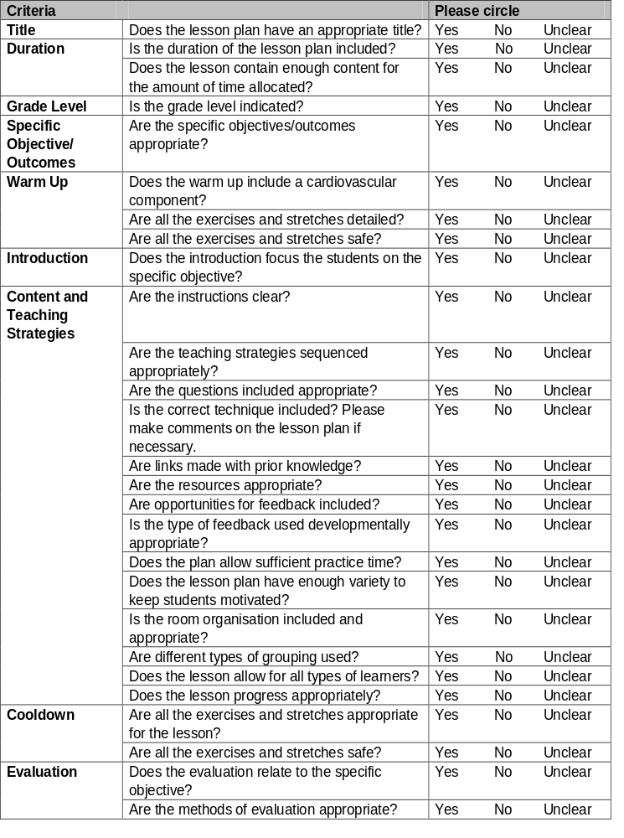

Sample Lesson Plans
Lesson Plan One: 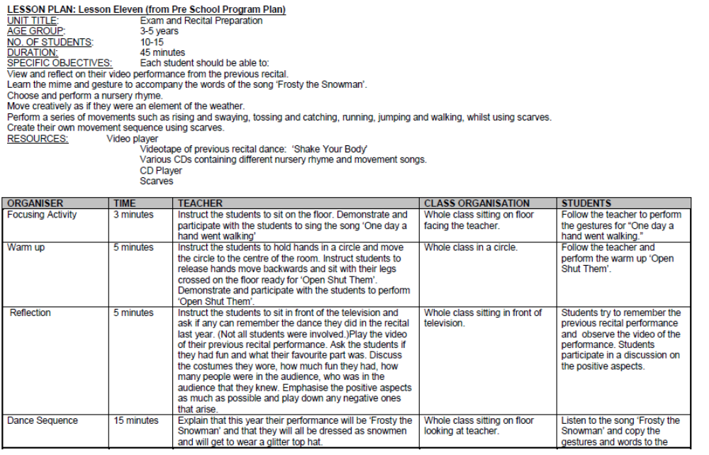
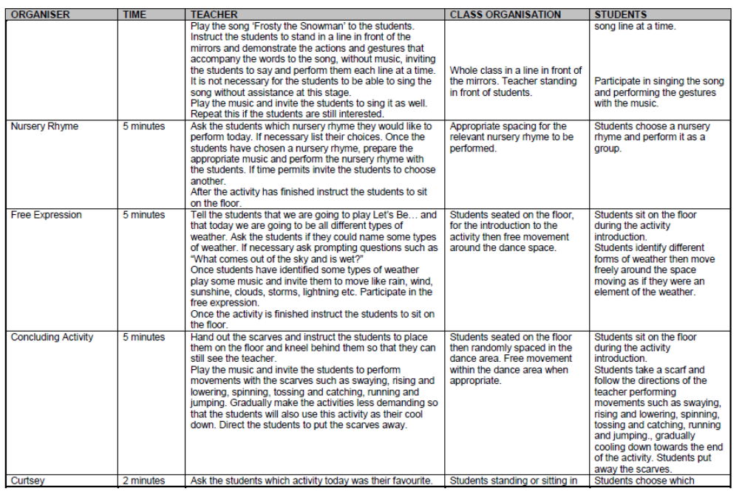
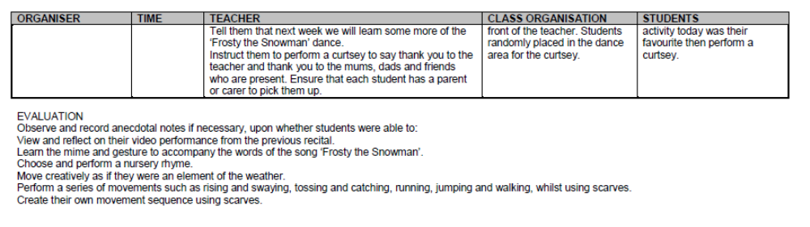

Lesson Plan Two:

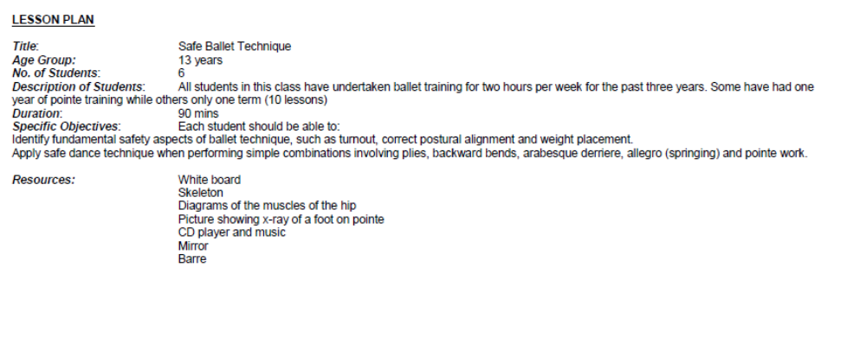
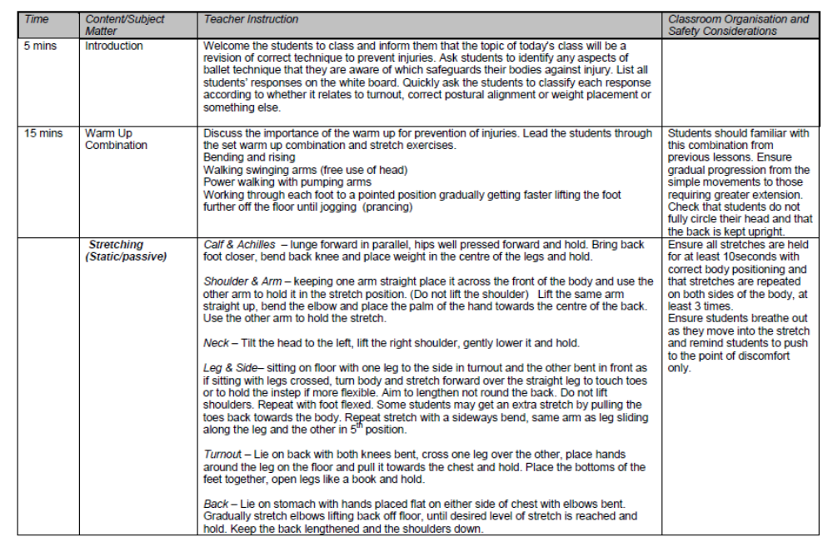

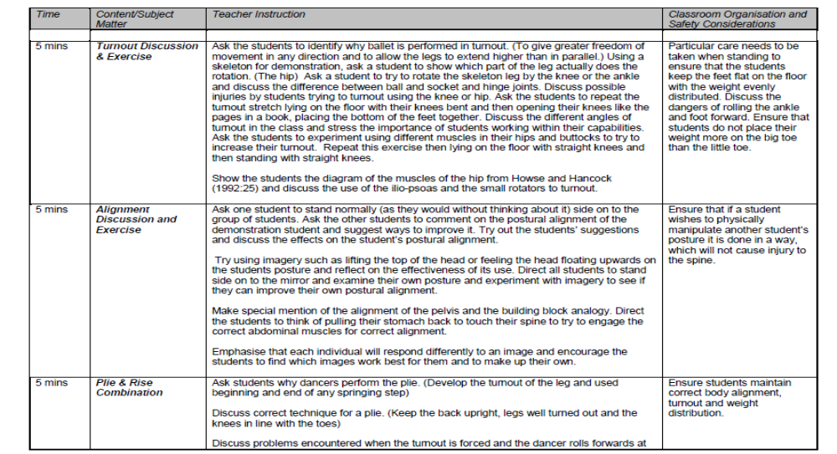

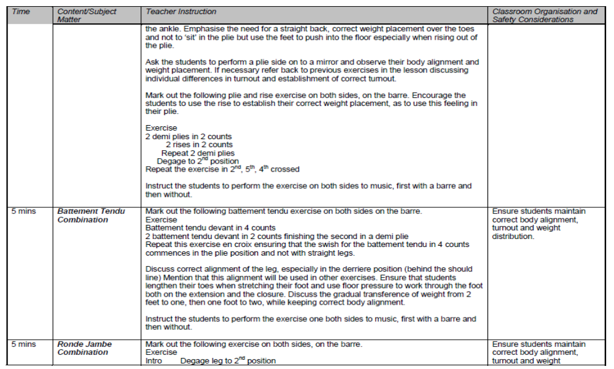
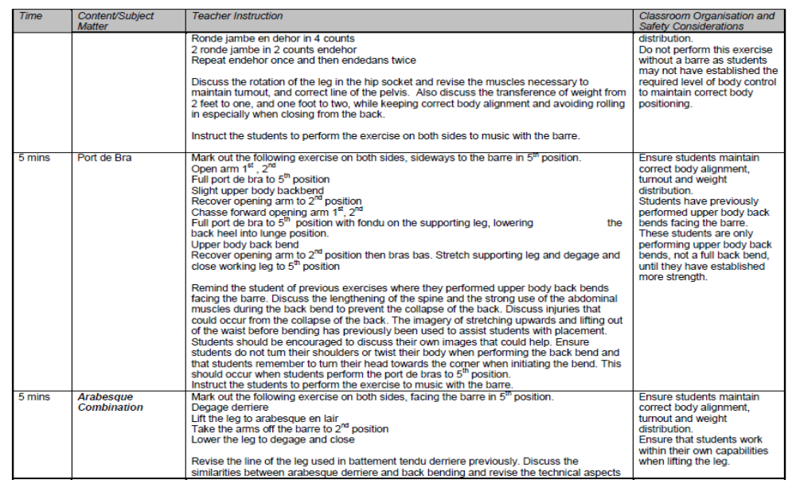
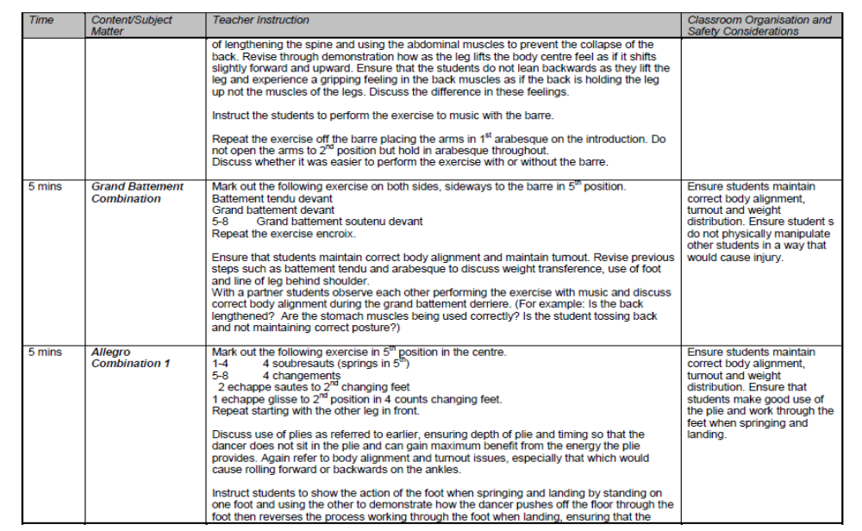

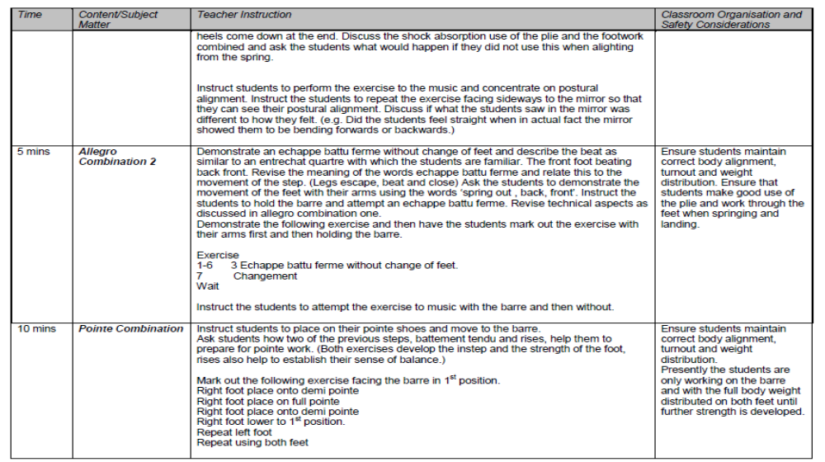
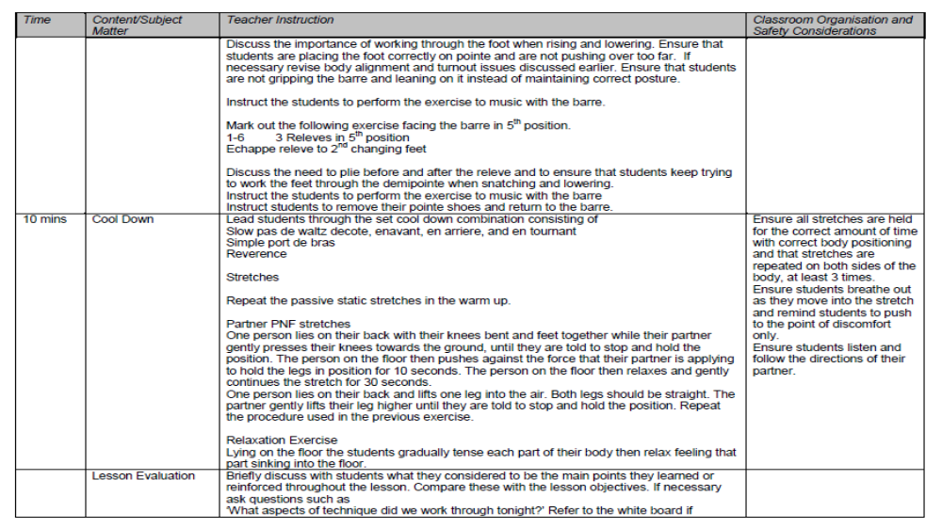

Alternative Sample Scaffold Templates for Lesson Plans
Grade: |  |  |  | Genre: |  | Age:
Lesson Duration:
Focus: Objective/Outcome:
By the completion of the lesson the students should have:
Program | Time Allocated | Specific Parts of Activity | Focus |  | Teaching Techniques |  | Safe Dance Considerations and Specific Comments
Warm-up |  | Cardiovascular Warm-Up
Intro
Barre
Centre
Cool Down

Evaluation from Teacher/ Mentor:

Evaluation from Student:
Grade: |  |  |  | Genre: |  | Age:
Lesson Duration:
Focus: Objective/Outcome:
By the completion of the lesson the students should have:
Program | Time Allocated | Specific Parts of Activity | Focus |  | Teaching Techniques |  | Safe Dance Considerations and Specific Comments
Warm-up |  | Cardiovascular Warm-Up
Intro
Barre
Centre
Cool Down

Evaluation from Teacher:
Student:

- Dance Style: (Classical Ballet, Jazz Moves, Hip Hop, Contemporary etc.)
- Topic: (Focus for the lesson)
- Grade/Level and age of students: (grade or level of the class and the age of the students attending the class)
- Students Attending: (however many students are attending the lesson)
- Lesson Duration: (how long the lesson runs)
- General Aim / Goal for the lesson: Students should be able to
- Prerequisite knowledge: (What they already know)

Learning Outcomes  (what the students should be able to achieve in that section of the lesson) | Time | Teaching / Learning Strategies  (including questions) | Organisation  (sitting, standing at the barre, in the centre) | Resources  (DVD, posters, props etc.) | Assessment Strategies  (Observing, surveys, feedback forms etc.)
Orientating Phase
(Beginning)
• Students should be able to
Enhancing Phase
(Middle)
• Students should be able to
Synthesising Phase
(End)
• Students should be able to

Self-Evaluation:

- What went well?
- What could be done differently next time?
- How can I use the feedback to assist me for the next lesson?

Lesson Observation Format

A Teacher or Mentor may use this template to record observations of your teaching methodology and strategies for feedback for quality teaching and learning.

Dance Lesson Observation Sheet
Lesson Plan
Warm Up
Sequence of Activities
Cool Down
Communication
Language Use
Enthusiasm
Supportiveness
Teaching Strategies
Clear Instruction
Demonstration
Checking for Understanding
Feedback
Classroom Management
Time
Setting
Student Behaviour

References

Arnheim, D. (1991). Dance Injuries: Their Prevention and Care, 3rd edition. Princeton, NJ.: Princeton Book
Company.

Australian Dance Council (Ausdance). (1998). The Interim National Competencies for Dance Teachers, http://www.ausdance.org.au/outside/interest/competency/index.html 24/10/2005.

Australian National Training Authority (1999). Training Package for Assessment and Workplace Training – BSZ401A Plan Assessment. Melbourne: ANTA.

Bloom, B. (1984). The 2 Sigma Problem: The Search for Methods of Group Instruction as Effective as One-
to-One Tutoring. Educational Researcher 13, 6, 4-16.

Buck, R. (1998). Everyone can dance – Inclusive Dance Strategies for Years 1-10. Brisbane: Education Queensland.

Cambourne, B. (1998). The Whole Story: Natural Learning and the Acquisition of Literacy in the Classroom.
Ontario, Canada: Scholastic-TAB Publications, Ltd.

Chelmar, R. & Fitt, S. (1990) Diet – A Complete Guide to Nutrition and Weight Control. Princeton, NJ.:
Princeton Book Company.

Fitt, S. (1988). Dance Kinesiology. New York: Schirmer Books.

Franklin, E. (1996). Dynamic Alignment Through Imagery. Champaign, IL.: Human Kinetics.

Geeves, T. (1990). Safe Dance Project Report. Canberra: Australian Dance Council – Ausdance.

Gray, J. A. (1989). Dance Instruction – Science Applied to the Art of Movement. Champaign, IL.: Human
Kinetics.

Hanna, J.L. (1999). Partnering Dance and Education – Intelligent Moves for Changing Times. Champaign, IL.: Human Kinetics.

Kassing G. & Jay, D. (2003). Dance Teaching Methods and Curriculum Design – Comprehensive K-12 Dance Education. Champaign, IL.: Human Kinetics.

Kimmerle, M & Cote-Laurence, P. (2003). Teaching Dance Skills Developmental Approach. New Jersey: J. Michael Ryan Publishing Inc.

Overby, L. (1991/92). “Principles of Motor Learning Applied to the Teaching of Dance Technique”, Kinesiology and Medicine for Dance, Vol 14, No. 1, Fall/Winter.

Queensland University of Technology (QUT). (1999). Dance Teaching Methodology: Study Guide.
Brisbane: QUT.

Rogers, W. A. (1989). Making a discipline plan. Melbourne, Vic: Nelson.

Schlaich, J & DuPont, B. (1993). The Art of Teaching Dance Technique. Reston, Virginia: American Alliance for Health, Physical Education, Recreation and Dance.

Schnitt, J & Schnitt, D. (1991). “Psychological Issues in the Clinical Approach to Dancers”. In Sataloff, R.

Brandfinbrener, A & Lederman, R. (eds.) Textbook of Performing Arts Medicine. New York: Raven Press Ltd.

Sigelman, C.K & Shaffer, D.R. (1995). Lifespan Human Development. California: Brooks/Cole:.

Skrinar, M. & Moses, N. (1998). “Who’s Teaching the Dance Class?” in Clarkson, P. & Skrinar, M (eds.) Science of Dance Training. Champaign, IL.: Human Kinetics.

Sleishman, P. (2005). Practically Speaking – The 5R Framework: Building Relationships and Managing Behaviour. Special Education Perspectives, Volume 14, Number 1, pp. 13–27

Smith-Autard, J. (1994). The Art of Dance in Education. London: A&C Black Ltd.

Taylor, J. & Taylor, C. (1995) The Psychology of Dance. Champaign, IL.: Human Kinetics.

Warren, G.W. (1999). Classical Ballet Technique. Florida: University of South Florida Press.

Activities: Planning, Learning and Teaching

Use the text to assist you in completing the following activities:

Introductory Activity

Read section 1 Introduction – the Teaching Learning Process - and complete the following table by placing a tick in the appropriate column to categorise these teaching skills as Planning, Implementation or Evaluation.

Teaching skill | Planning | Implementation | Evaluation
Identify aims and objectives
Give clear instructions to the class
Being punctual
Design the physical environment
Observe students in class and complete checklist of skills
Invite peer/mentor to observe teaching and provide feedback
Communicating classroom rules and routines to students
Complete diary/journal, noting successful teaching strategies
Choose resources
Ensure safe dance practice is followed during the execution of steps
Determine prior learning and level of skill
Discuss student progress with parents
Select content
Review examination results
Establish friendly rapport with students and parents

Understanding the Dance Teacher Activities

Read section 2 - Understanding the Dance Teacher - and complete the following activities:

Activity One:

Complete the following table by evaluating your development regarding the listed teacher competencies.

Competency | Not yet competent | Working towards competency | Competent | Highly Competent | Comments
Show commitment to students and their learning | ◻ | ◻ | ◻ | ◻
Develop a strong knowledge base of dance and dance teaching | ◻ | ◻ | ◻ | ◻
Manage and monitor student learning | ◻ | ◻ | ◻ | ◻
Evaluate your dance teaching. | ◻ | ◻ | ◻ | ◻
Participate in learning communities. | ◻ | ◻ | ◻ | ◻

Activity Two:

Use your results from completing the above activity to set goals for your professional development as a dance teacher. Consider what you would like to gain, and ways you could improve your teaching skills, by completing this module.

Activity Three:

Identify the dance teaching philosophy category your philosophy of dance best suits, and write a brief explanation.

Professional | Educational | Mid-way
◻ | ◻ | ◻

Explanation:

Activity Four:

Categorise the statements listed below as either

- Aims and General Objectives; or
- Specific Objectives/Outcomes.

Statement | Aims and General Objectives | Specific Objectives/Outcomes
Develop a love and appreciation of dance
Apply safe dance technique when performing pointe work
Instil an understanding of dance technique
Develop positive personality traits, such as self-discipline, commitment, persistence and confidence.
Choreograph a jazz dance suitable for performing in Gold Star Jazz B examination
Provide specific training to undertake examinations and gain qualifications in dance
Work within a group to ensure exact arm placement for a performance routine

Activity Five:

Describe which of these teaching styles you have used or observed, and provide examples:

Teaching Style | Example
Command Style
Practice Style
Reciprocal Style
Self-Check
Inclusive
Guided Discovery
Divergent

Understanding the Learner Activities

Read section 3 - Understanding the Learner - and complete the following activities:

Activity One:

Complete the following table by ticking the stage most appropriate for these teaching implications. Many of these ideas are not restricted to one age group but may be common to more than one.

Teaching Implication | Early childhood | Middle childhood | Adolescence | Middle Age Adult | Older Adult
Develop a deeper awareness of how the body works and its movement capabilities
Promote positive body images
Show caution with stretching exercises
Develop a greater awareness of dance technique and its expressive value
Use peer tutoring and increase activities which involve working with others
Promote a healthy lifestyle through a good diet
Lessons should be activity based
Lessons should progress quickly from one activity to the next
Offer opportunities for students to view each other’s work and comment positively
Increase learner’s knowledge of anatomy
Structure programs to ensure exercises requiring strength and flexibility are given adequate preparation
Teachers should ensure students are able to recognise (and adjust own program accordingly) when experiencing signs of physical stress
Frequently praise and recognise children’s’ efforts
Always supervise stretching activities
Use concrete materials and visual aids
Be aware of eating disorders, substance abuse and other factors leading to an emotional imbalance and a greater risk of teenage suicide

Activity Two:

Choose one of the psychological issues facing the dancer today, research an article and attach to this page. Complete a short summary of the article.

- Psychological issues can include:
- Self esteem
- Eating disorders and nutrition
- Substance Abuse
- Physiological stress (and performance anxiety)

Attach:

Summary:

Activity Three:

Label the diagram below with the three stages of learning movement according to the human information processing system. Also, draw a line from the example to the appropriate stage.

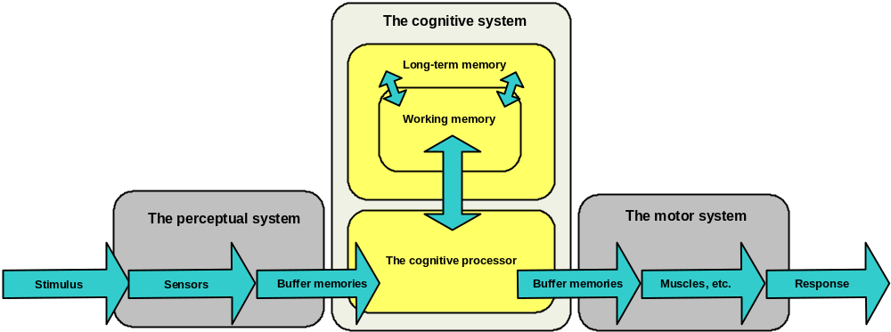

 | #
Perceiving | →? | 1. Attempt to execute the time step
Thinking | →? | 2. Watch the teacher demonstrate the time step
Doing | →? | 3. Think about the components and counts of the time step

Activity Four:

Find your preferred learning style by circling the appropriate response. The column with the most responses indicates your preferred learning style.

 | Visual | Auditory | Kinaesthetic
When you spell do you … | Try to see the word | Use the phonetic response | Write it to find if it feels right
When you concentrate do you … | See vivid detailed pictures | Think in sounds | Have few images and those that you do have involve movement
When you concentrate do you … | Get distracted by untidiness | Get distracted by noise or sounds | Get distracted by movements
When you are angry do you … | Become silent and seethe | Express it in an outburst | Storm off, grit your teeth and clench your fists
When you forget something do you … | Forget names but remember faces | Forget faces but remember names | Remember best what you do
When you contact people on business do you … | Write an email or letter | Prefer the telephone | Talk it out face to face, or whilst walking or during another activity
When you are relaxing do you … | Prefer to watch TV or read or see a play | Prefer to listen to the radio or play music | Prefer to play games or sport
When you enjoy the arts do you … | Like paintings | Like music | Like dancing
When you reward someone do you … | Write remarks of praise on their work or in a note | Give them oral praise | Give them a pat on the back
When you try to interpret someone’s mood do you … | Primarily look at facial expression | Listen for the tone of voice | Watch their body movements
When you are reading do you … | Like descriptive scenes that you visualise | Enjoy dialogue and conversation and hearing the characters | Prefer action stories or are not a keen reader
When you learn do you … | Like posters, diagrams, slides and demonstrations | Like verbal instructions, talks and lectures | Prefer direct involvement, activity and role playing
When you are inactive do you … | Look around, doodle or watch something | Talk to yourself or other people | Fidget
When you are talking do you … | Talk sparingly and don’t listen for too long | Enjoy listening but are impatient to talk | Gesture a lot and use expressive movement
Total:

Activity Five:

Determine the teaching sequence for the following steps in order of complexity
(Simple=1 to complex=5/6):

Example One – Leaping

◻ Grande Jete Entourntant or Turning Leap
◻ Jump from two feet
◻ Split Leap or Grande Jete
◻ Jumping from one foot to the other foot
◻ Hopping

Example Two – Turning

◻ Turning using two feet (on the spot)
◻ Releve (or snatch) in pirouette position (no turning)
◻ Multiple Turns
◻ Single Turn with use of arm and head
◻ Three step spin
◻ Use of head (spotting technique)

Activity Six:

Match the following imagery descriptions, often used by teachers, to assist with describing dance technique.

Imagery Description | # | Dance Technique
Zipping up a pair of jeans | →? | 1. alignment of the spine
String attached to top of head with body dangling | →? | 2. postural alignment
Building Blocks stacked on top of one another | →? | 3. aligning pelvis correctly
Snow Man melting | →? | 4. pirouettes and turning
Feet piercing the sand | →? | 5. performing a series of travelling leaps (leading from one step to the next)
Spinning top | →? | 6. elbow placement when arms in 2nd position
Skipping stones across the water | →? | 7. relaxing
Buoy floating on the water | →? | 8. lowering through the feet after executing a jump or leap

Activity Seven:

Think of an example for each type of Play.

Type of Play | Example
Sensorimotor/Practice
Pretence/Symbolic
Social
Constructive
Games

Activity Eight:

Use the following Technical Profile for yourself or for your dance. Use these results to create three goals for your next term at your dance studio.

Label each section of the profile with the technical skills that are important for your dance performance. Indicate how you currently perceive yourself on the 1 to 10 scale, for each factor, by drawing a line at that level and shading in the area below it. A score below 7 indicates an area in need of further development. Use this profile as a basis for setting or determining goals.

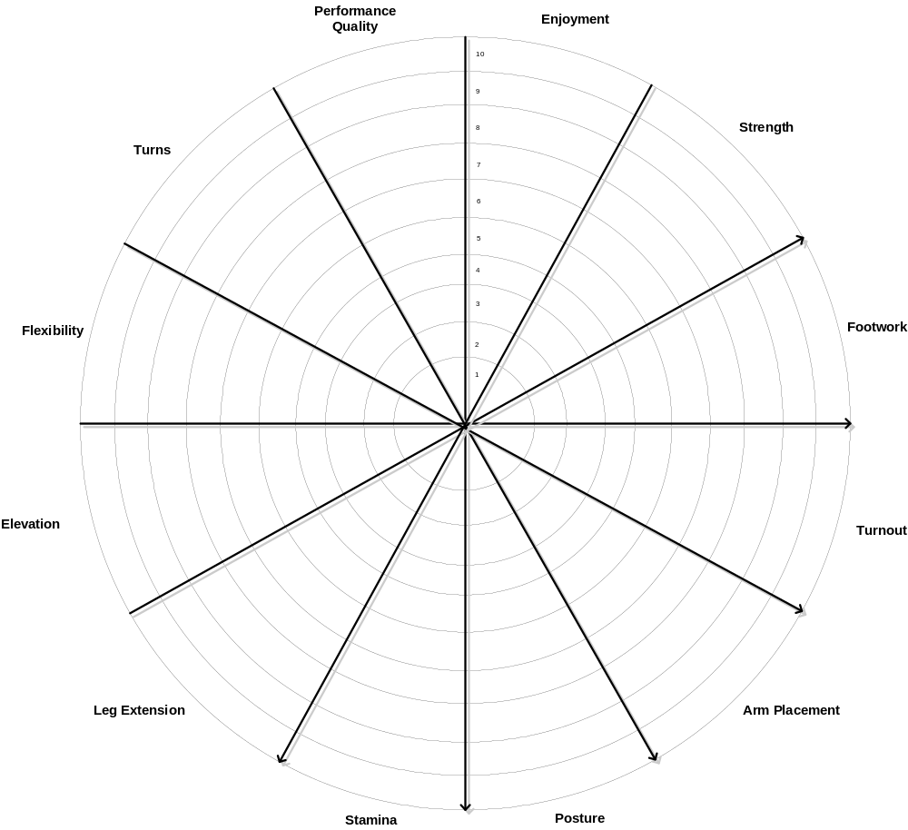

The diagram is adapted from Taylor, J. & Taylor, C (1995). Psychology of Dance. Champaign IL: Human Kinetics.

Learning Environment

Read section 4 – Learning Environment - and complete the following activities:

Activity One:

Describe your ultimate dance studio to promote the learning condition of Immersion. Include a floor plan, details of the resources you would use, and other teaching strategies to assist with Immersion. Explain why you have decided to include these strategies.

Activity Two:

Choose a step from Bronze Medal, and describe how you will demonstrate it to cater for all types of learners.
List below the technical information you will emphasis during the demonstration.

Name of step (include grade or level):
Technical Information | Type of Learner
<Technical information relating to step> | Visual | Auditory/Verbal | Kinaesthetic

Activity Three:

Imagine you have broken your leg and are unable to give a physical demonstration. List alternative ways of demonstrating movement in the space below:

Activity Four:

Devise a game you could utilise to make ‘repeated practice’ of a step more enjoyable for students.

Activity Five

Choose the teacher under which you think you have experienced the most improvement. Think about the types of expectations this teacher has had on your development as a dancer. Briefly reflect upon these expectations and their effect on your abilities as a dancer.

Activity Six:

Use the table below to identify Open Ended Questions, which assist in promoting greater responsibility on the part of your students.

Question | Open Ended?
Why did you fall backwards in your turn?
Are your arms placed in third position?
Were your feet stretched during that jump?
How do you think Susan could improve her leap?
How do you think we should start our dance for maximum impact?
Did you all use your head and facial expressions on that step?
Can you think of any ways to control your arms when you spring?
How should the knees be at the end of a jump?
Try working with a partner to improve your isolations.

Activity Seven:

Rephrase each of these negative statements in a positive way. The first statement has been rephrased as an example for you.

Negative Feedback | Positive Feedback
“You are not trying hard enough. You’ll never be able to get that step.”
“You keep falling over in your turns because you never keep you balance.”
“The line of your arms is ugly because you keep lifting your shoulders.”
“Can’t you spring any higher?”

Activity Eight:

Apart from verbal feedback, describe one other form of feedback you have used, and comment on its success:

Activity Nine:

Think about a student with a disability or culturally different background that you have encountered. Describe the ways in which the program has been modified to cater for individual differences and provide an inclusive environment.

Activity Ten:

Fill in the time allocations for this one-hour lesson for the introduction of a new step/combination:

Time allocation | Activity Description
 | Warm Up
 | Introduction (with video demonstration) Stretching can continue during introduction
 | Revision of prior learning through discussion and enchainment using similar steps
 | Lead students through technical execution of the step at the barre.
 | Lead students through technical execution of the step in the centre
 | Allow time for students to practice new step individually or with a partner. Walk around the room giving individual feedback.
 | Fun dance enchainment of extremely simple steps including new step at finish
 | Cool down and stretches in circle on floor. Discussion of new step to ascertain which students have a good grasp of technical aspects. Students to rate themselves on a scale of 1 to 5 as to how confident they feel with the new step or write about it in their dance diary.

Activity Eleven

Choose a genre from Bronze Medal. Identify the age of the students. Considering the Rights and Responsibilities involved, design five rules for classroom behaviour appropriate to your classroom. List your reason for their inclusion, along with your responses for appropriate and inappropriate behaviour to these rules.

5 commonly used rules are described below.

Rule | Reasons/Rationale | Responses to Appropriate Behaviour | Responses to Inappropriate Behaviour

Planning and Evaluation

Read section 5 – Planning and Evaluation - and complete the following activities:

Activity One:

Design a format for Lesson Planning which you would like to adopt. Attach your lesson plan format here.

Activity Two:

Complete a minimum of three practice Lesson Plans using your format.
You may wish to complete more than three Lesson Plans during your training.
Record these or attach in the space below.

Activity Three:

Evaluate one of your lesson plans using the Lesson Plan Evaluation Criteria provided below.

Activity Four:

Self-Evaluation:

Use the Lesson Observation Format below to self-evaluate your planning and teaching. If possible, video tape the lesson that you will evaluate.

Dance Lesson Observation Sheet
Lesson Plan
- Warm up
- Sequence of activities
- Cool down
Communication
- Language Use
- Enthusiasm
- Supportiveness

Teaching Strategies
- Clear instruction
- Demonstration
- Checking for understanding
- Feedback
Classroom Management
- Time
- Setting
- Student Behaviour

Activity Five:

Write a lesson plan (or use one the Lesson Plans from the above activity). Conduct the lesson in front of your teacher/mentor, or video tape the lesson and provide it to your teacher/mentor, for the completion of the Lesson Observation Format

Teachers will complete this section by writing a Lesson Plan and having a mentor evaluate the plan and the execution of it. The mentor should complete the dance observation sheet.

Dance Lesson Observation Sheet
Lesson Plan
- Warm up
- Sequence of activities
- Cool down
Communication
- Language Use
- Enthusiasm
- Supportiveness

Teaching Strategies
- Clear instruction
- Demonstration
- Checking for understanding
- Feedback

Classroom Management
- Time
- Setting
- Student Behaviour

Activity Six:

Complete the following table by re-evaluating your development regarding the listed teacher competencies.

Competency | Not yet competent | Working towards competency | Competent | Highly Competent |  | Comments
Show commitment to students and their learning | ◻ | ◻ | ◻ | ◻
Develop a strong knowledge base of dance and dance teaching | ◻ | ◻ | ◻ | ◻
Manage and monitor student learning | ◻ | ◻ | ◻ | ◻
Evaluate your dance teaching. | ◻ | ◻ | ◻ | ◻
Participate in learning communities. | ◻ | ◻ | ◻ | ◻

Activity Seven:

Reflect upon your teaching skills and describe any changes to your teaching skills on completion of this Workbook.

Activity Eight:

Task:

On completion of this workbook (which is to be submitted with this task or handed to the examiner with lesson plan prior to examination) you may submit a video/DVD of your teaching or request an examination session with an assessor to demonstrate your practical teaching skills.
The session will be approximately 45 minutes (either by video submission or face to face demonstration). A further 15 mins is allocated for the Evaluation by interview.

Lesson Plan
Part A: Written Component To Be:-

- SENT WITH VIDEO/DVD FOR SUBMISSION
- or
- HAND ONE COPY TO THE ASSESSOR PRIOR TO ENTRY OF EXAMINATION ROOM AND KEEP ONE COPY FOR PERSONAL USE DURING EXAMINATION
- Design a lesson plan using the format that you have practised.
- Grade level is for Bronze Medal and age of candidates is your choice and must be nominated in the lesson plan.
- 3- 5 students should be taught in this class
- Outline a rationale for the students selected indicating their ability and specific needs.
- Duration of the lesson should be approximately 30-45 minutes including the component of specific warm up. ( A general warm up must be completed prior to videotaping or starting examination but must be included in the written lesson plan)
- Focus for the lesson should be a technical aspect (such as elevation or turning specific to the genre chosen) which will be explored through the development of skills and steps – not the whole syllabus.

Part B: Video/Dvd Submission or Practical Examination

- Select and organise an appropriate venue/learning environment for conduction of the lesson plan as described in PART A.
- Ensure that all resources are prepared and organised.
- Conduct and video the lesson you have prepared (including both students and teacher) ensuring that suitable modifications are undertaken throughout the lesson to cater for situations that may arise.

Part C: Evaluation

- FOR SUBMISSION BY VIDEO/DVD
- Write a self – evaluation containing the following details after viewing your video lesson.
- Lesson Plan : Warm-up, Sequence of Activities, Cool Down
- Communication: Language Use, Enthusiasm, Supportiveness
- Teaching Strategies: Clear Instruction, Demonstration, Checking for Understanding, Feedback
- Classroom Management: Time, Setting, Student Behaviour
- FOR PRACTICAL EXAMINATION THE EVALUATION WILL TAKE THE FORM OF AN INTERVIEW WITH THE ASSESSOR FOLLOWING THE SESSION

