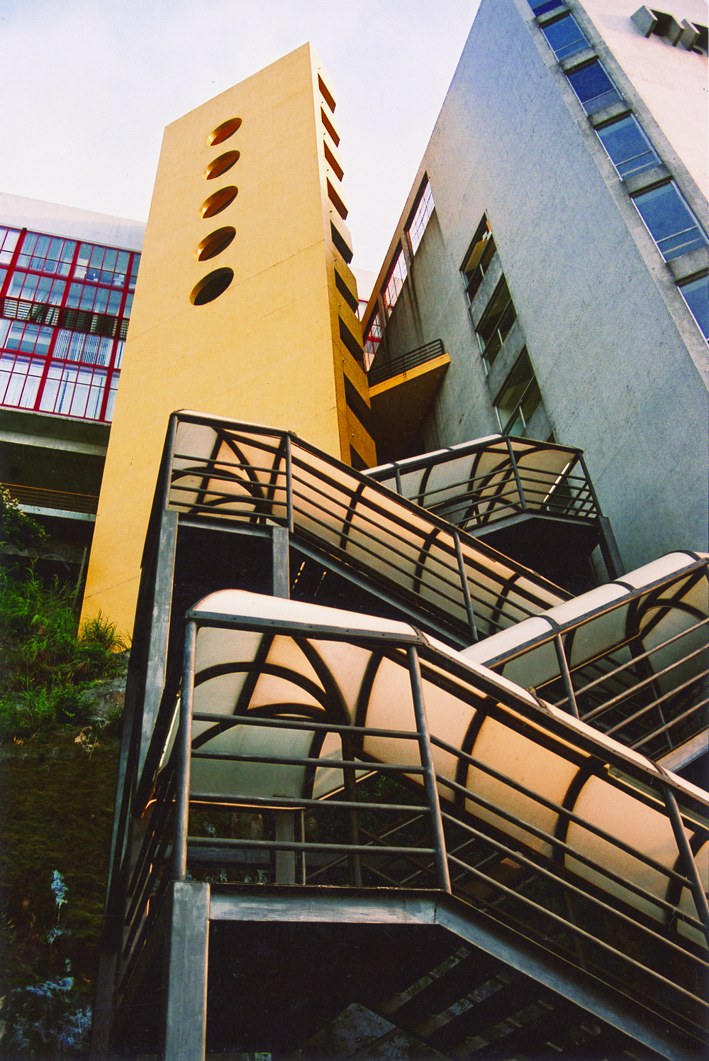

Special Features 2
University of Macau 3
Department of Economics 4
M. Soc. Sc. in Economics 6
Ph. D. in Economics 11
Library Facilities 12
E-Campus 12
Academic Staff 13
Selected Staff Publications 15
Financial Issues 17
Studying and Living in Macau 17
Contact Information 19

Contents
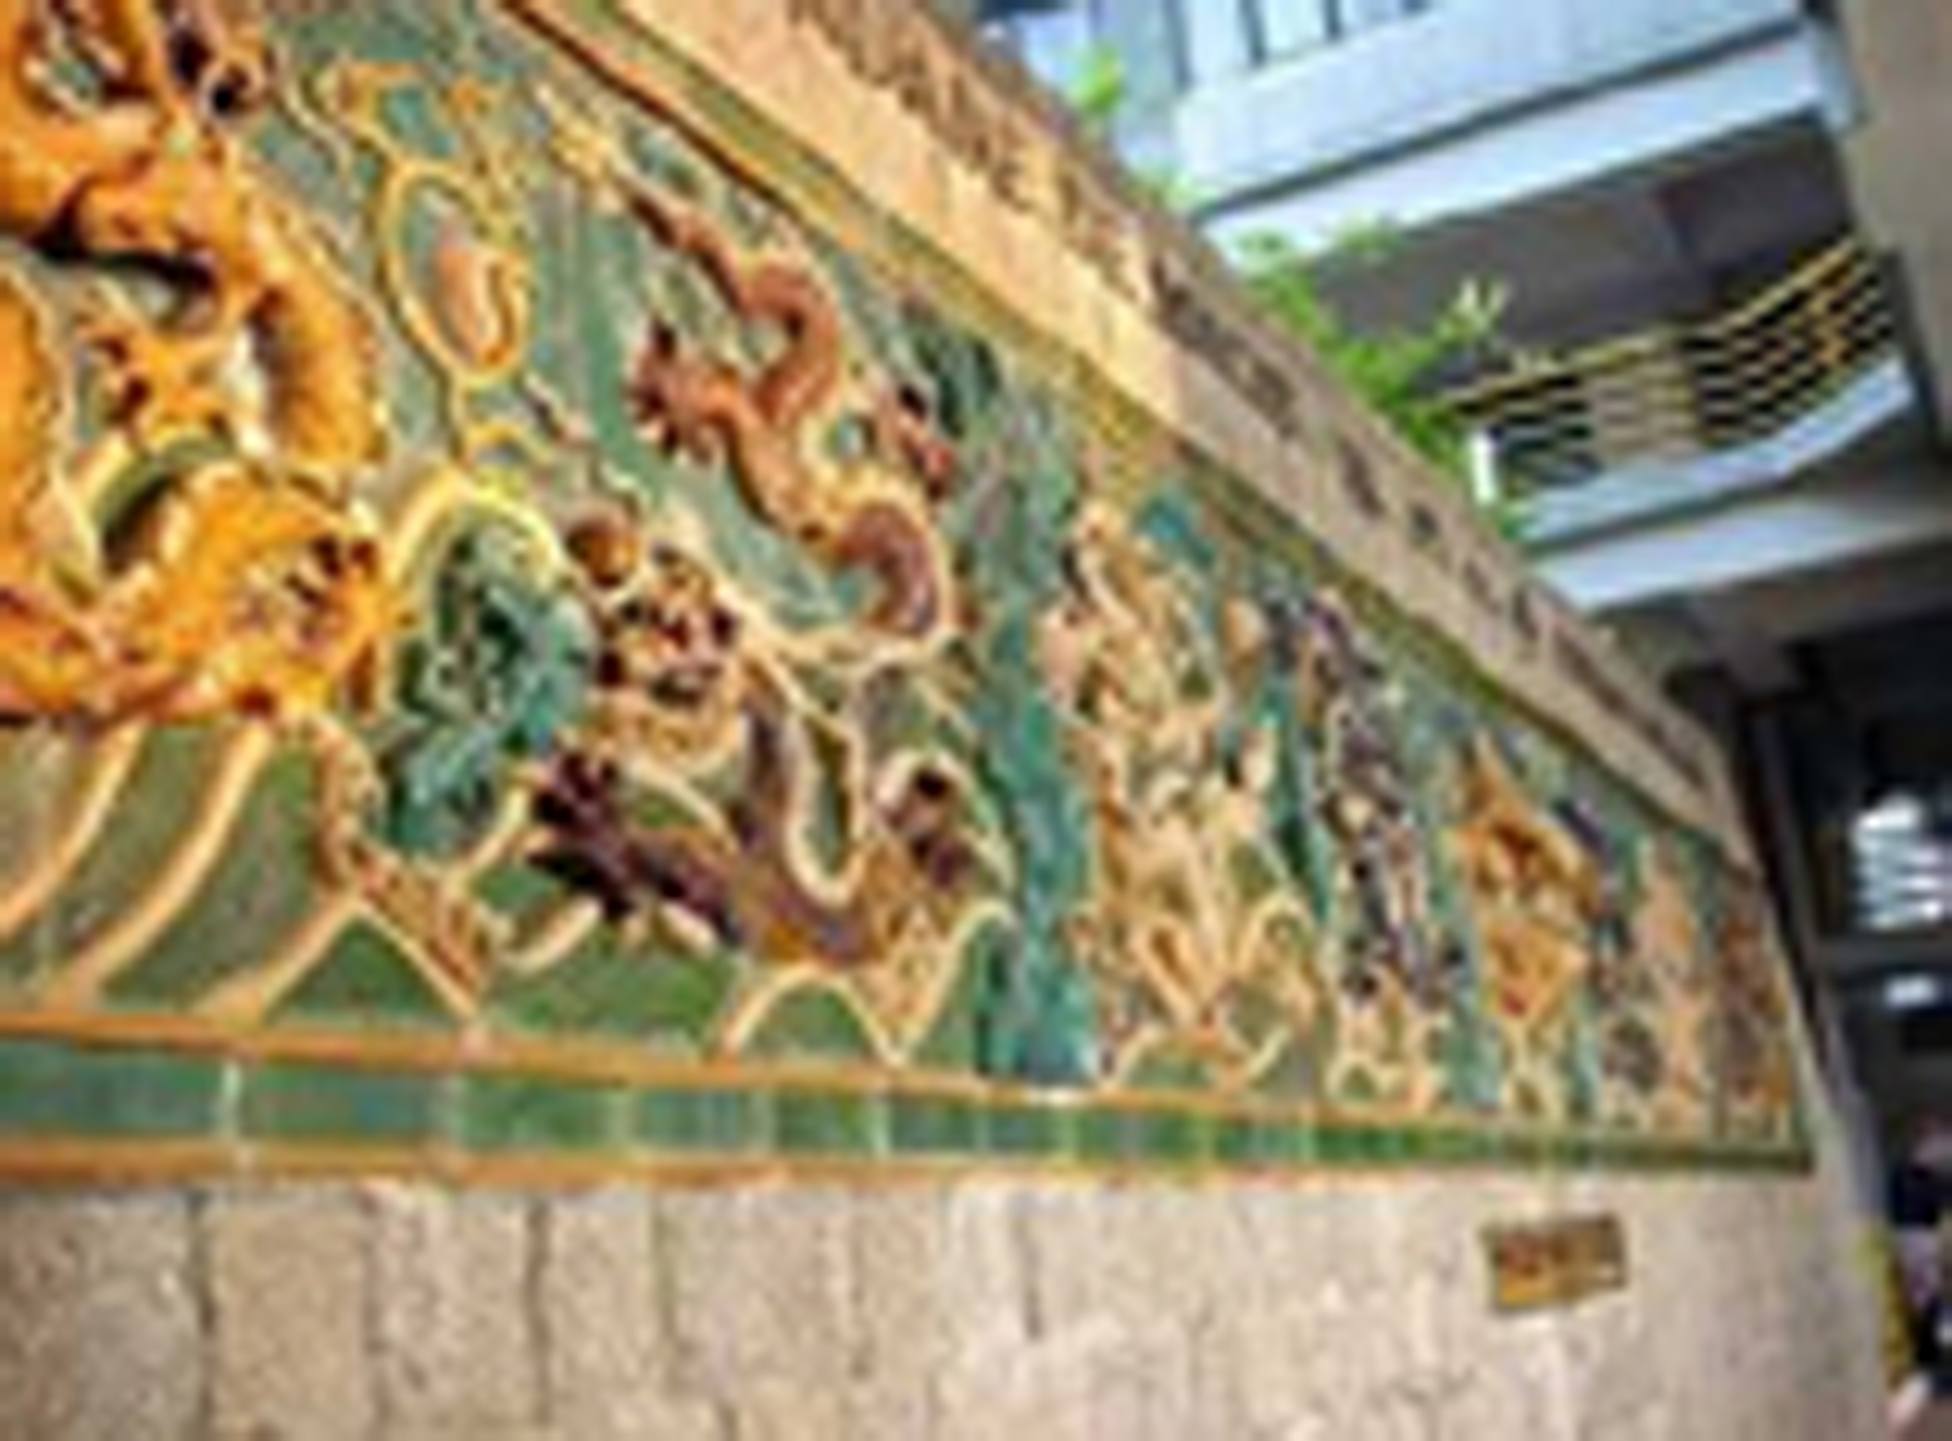
Special Features

- All courses are taught in small seminar groups and small lectures, giving close attention to the academic progress of each student.

- Our economists are experienced in teaching, research and practice in the field of economics.

- The degree attracts students from local and other regions, and our environment is one that favourable for exchanges both on economics idea and cultural experience among students.

- Students are encouraged to attend the Workshop on Economics, a long-established forum for idea exchange in our Department, in order to come into contact with sizeable academics and research students, working on a variety of fields of economic inquiry.

- High-quality IT computing facilities are available to all graduate students of economics, providing full access to the software and hardware commonly used by professional economists.

- Our Library is particularly well-endowed with e-based research journals – more than 130 economic journals with full text available to our students. Academic reference support is improving. The UM Library has 3,600 books on economics. More than 300 printed- / e- journals with full-text are available for conducting research and supporting teaching up to postgraduate level.

- The Centre of Macao Studies and the Social Science Research Center on Contemporary China are two specialized research centers where research on the economies of Macao and China is concentrated.

- Scholarship may be offered to outstanding students.
2
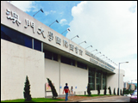
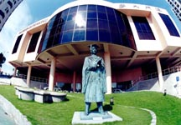

University of Macau (UM)

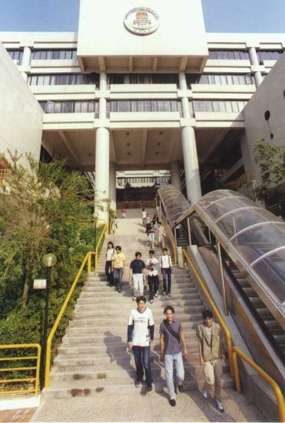
The UM is a public institution of higher learning dedicated to the creation, transmission and diffusion of culture, science and technology. Two decades earlier, in March 1981, the University of East Asia (U.E.A.) had been founded as a private institution with the support of the government of Macao, which gave land in lease for the campus on Taipa Island. In February 1988 the Macao government took over the University through the Macao Foundation. Since then, the commitment to high-quality education, including training local people, has been intensified.

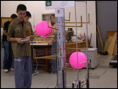

The University’s campus overlooks the Pearl River estuary and commands impressive views of the Macao Peninsula, China, and the South China Sea. Its buildings are laid out in such a way that the residential, teaching and administrative facilities are linked by walkways and staircases and form an integrated whole.

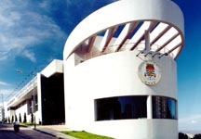
Currently, basic academic activities of the University are organized into five faculties, namely Faculty of Business Administration, Faculty of Education, Faculty of Law, Faculty of Social Sciences and Humanities, and Faculty of Science and Technology. The total student population is about 6,600 in 2008/09 while academic staff amounts about 400.

3

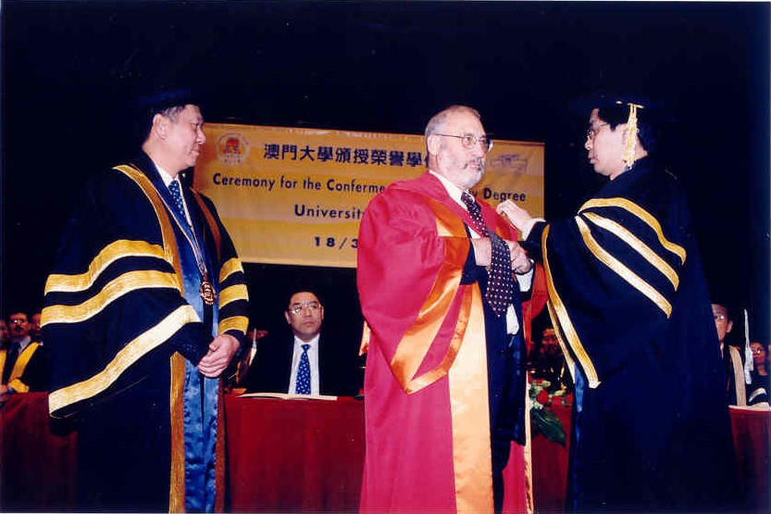

Department of Economics

The study of economics at UM, leading to the award of Bachelor of Social Sciences, started in 1981 when the discipline was part of the Faculty of Social Sciences of the ex- University of East Asia. The Economics Programme was formed in 1993 as a unit of the combined Faculty of Social Sciences and Humanities (FSH). In 2002, the Department of Social Sciences was created inside FSH and the Economics Programme is under this new departmental structure. In 2006, the Department of Economics was created within the Faculty of Social Sciences and Humanities.

With the resumption and expansion of the FSH Economics Programme, areas such as economic research (especially those dealing with the local economy), conferences / seminars and publications (including the currently well-established Workshop on Economics and the Social Science Roundtable) have been strengthened.

To celebrate the 20th anniversary of our University, the Economics Programme had the honour to invite Joseph Stiglitz, 2001 Nobel Laureate in Economics, to deliver a public lecture titled “Lessons from the Financial Crisis in Asia” under our Distinguished Lecture Series. Stiglitz made his first public lecture in Asia after receiving the Nobel Prize and received the honorary degree of Doctor of Social Sciences conferred by our University. His lecture attracted an audience of more than 1,200 - attending at four venues with the aid of simultaneous broadcasting - and was one of the successful academic events of the last decade in Macao.

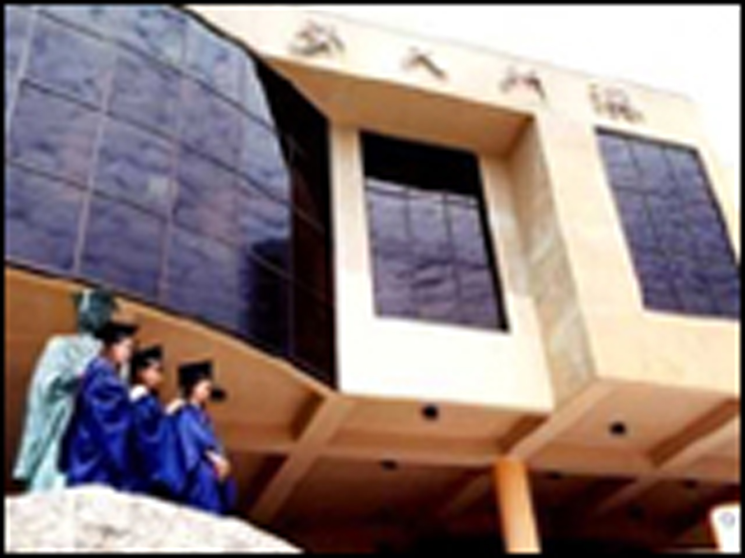
In 2005, a university-level appointment was made to Sir James A. Mirrlees, 1996 Nobel Laureate in Economics, as Distinguished Professor of Economics. His role is mainly to improve the research capacity of economics in UM.

4

Our Department held an International Symposium on Chinese Economic Growth: Causes, Prospects and Its Implications for Macao on the 2nd and 3rd March 2007. This Symposium had the objective of further understanding China’s recent economic success, particularly the issues related to the sources of growth; and was organized in three parts: distinguished lecture, paper presentation, and a Macao roundtable. Two Nobel laureates and six economists presented their research papers.

The International Conference on Economic Integration in the Greater China Region, organized by the Department of Economics and Social Science Research Centre on Contemporary China, FSH, UM, and the Chinese Economists Society (CES), was held at the University of Macau on 29th-30th March, 2009. Sir James Mirrlees, the 1996 Nobel Laureate, besides six outstanding economists from Mainland China, Hong Kong, Macao and Taiwan were invited to deliver keynote speeches. The conference provided an excellent opportunity for scholars from all over the world to present their researches on the sources of economic growth in the Greater China Region, especially the influence of the global financial crisis on sustainable economic growth. There were more than 100 people participated in the conference. Participants were mainly from the US, Canada, Europe and the cross-strait regions. Over 40 papers were presented during the conference, in addition to 2 roundtable discussion panels. Selected papers are chosen for the special issue of the Journal of the Asia Pacific Economy to be published in late 2010

Our more than 400 strong graduates are now active across the globe in a wide variety of positions: many are now successfully engaged in education, private industry, and public services pursuits – here in Macao, of course, but also across Asia, Europe an North America.

M.Soc.Sc. in Economics
Objectives

- To provide high-quality academic education and training in the field of economics
- To enable the application of economic principles to the design and analysis of economic policy
- To teach the advanced economic theory and technical skills that enable students to progress to the Ph. D programme
- To produce quality graduates with the analytical expertise that will enable them to function more effectively as economists, policy makers, researchers and educators

General

The Masters of Social Sciences in Economics is a full-time programme over a period of two years. It is based on both coursework and dissertation. In the first year, students are required to take eight courses, of which four are compulsory, and of which the remaining four are chosen from a list of elective courses. The four compulsory courses cover microeconomic and macroeconomic theories, quantitative and research methods. The other elective courses are chosen from various standard sub-fields in economics.

In the second year, upon successful completion of all courses requirements, students are required to write a dissertation. The dissertation is a demonstration of the student’s ability to conduct independent research.

Academic performance is reviewed by our teaching staff on a regular basis. Emphasis is placed on the maintenance of normal academic progress. Withdrawal from the course may be imposed on students who fail to comply with the degree requirements.

Admissions

Applicants are expected to have an undergraduate degree in Economics from an accredited university, preferably a good honour or its equivalent.

Those with a good undergraduate degree but without previous training in economics, may be offered a place with added requirement of completing certain economics courses at undergraduate level.

Applicants are required to prove English proficiency, such as TOFEL (minimum score of 550) and/or IELTS (minimum score of 6.0).

If you are unsure whether your qualifications are at the right level, complete an application form (downloadable from our Registry’s website) with your academic transcript. Individual cases will be considered on their own merit.

Degree Structure

First year / First semester:
Four Compulsory Courses:

- Microeconomic Theory | - Macroeconomic Theory
- Methods of Economic Research | - Econometric Analysis I

First year / Second semester:
Four Elective Courses from the following choices (subject to availability):

- International Trade and Finance | - Development Economics
- Public Economics | - Labour Economics
- Industrial Organization | - Monetary Economics
- The Chinese Economy | - Econometric Analysis II
- Advanced Topics in Economic Theory
- Regional Economies (Asia-Pacific / European Monetary Union)

Second year / First and Second semesters:
- Dissertation
7
Course Structure

MSEC100 Microeconomic Theory （微觀經濟理論）
Methodological foundations of microeconomics. Theories of production and individual choice. Aspects of decision theory under certainty, risk and uncertainty. Introduction to game theory under complete and incomplete information, with applications to oligopoly. Perfect competition as a limiting case. General competitive equilibrium: existence and Pareto efficiency. Private information in markets. Basic auction theory. General theory of markets with adverse selection. Contract design in the context of moral hazard problems.

MSEC101 Macroeconomic Theory（宏觀經濟理論）
Intertemporal allocation and dynamic optimisation. Neoclassical growth theory: Solow and Cass–Koopmans models. Endogenous growth theory: learning by doing, human capital, growth through new products, the Schumpeterian approach. Short-run fluctuations in a monetary economy: Keynesian models, imperfect information, staggered contracts, menu costs. Monetary models with optimizing agents. Inflation and monetary policy. Money in the open economy; economics of exchange rates.

MSEC102 Methods of Economic Research（經濟研究方法）
Develops research ability of students through intensive discussion for preparing dissertation, individual and group research projects. Critical appraisal of modern economic research. Main techniques of empirical investigation and key issues in applying and testing theoretical models.

MSEC103 Econometric Analysis I（計量經濟分析I）
Review of conditional distributions, expectation, regression and principles of inference. Linear regression models, ordinary and generalized least squares, heteroscedasticity. Non-linear least squares. Hypothesis testing and confidence intervals. Maximum likelihood estimation and testing. Introduction to models and methods for discrete and censored data. Simultaneity, exogeneity, instrumental variables methods. Dynamic models: autoregressive and moving average processes, vector autoregressions. Causality, stationarity, unit root tests, and cointegration. Introduction to panel data methods and models.

MSEC110 International Trade and Finance（國際貿易與金融）
Applications of basic trade theory to real-world economic problems.
Neoclassical trade theory of pattern of trade and gains from trade, strategic trade theory under imperfectly competitive markets, labour migration and capacity mobility, market distortions and commercial policies, dynamic trade theory and economic growth. Adjustment in international exchange markets, balance of payments, and international monetary system. Application of recent theoretical analysis on macroeconomic fluctuations and growth within an open economy context.

MSEC111 Development Economics（發展經濟學）
Applies economic theories to economic growth and development. Meaning of development, economic growth, population and migration, capital flows, foreign aid, stabilization and adjustment. Income distribution, poverty, hunger, household behavior, agriculture, rural credit markets, institutions and the problem of corruption. Models of growth and migration, modernization, technological change. Static and dynamic model of political economy.

MSEC112 Public Economics（公共經濟學）
Measurements of changes in welfare; economy-wide incidence of taxes; taxation, risk-taking, and investments; corporate taxation; effects of taxation on financial markets; taxation of goods and services; taxation of income; taxation and savings; positive problems of redistribution; and tax arbitrage, tax avoidance, tax evasion, and the underground economy. Applied capital theory for public-sector investment decisions; social opportunity cost of capital, labor, and foreign exchange; social cost of unemployment; welfare cost of the inflation tax; issues of exchange rate policy.

MSEC113 Labour Economics（勞動經濟學）
Neoclassical analysis of labour market and its institutions. Topics on labour demand, labour supply, compensating wage differentials, human capital theory, discrimination and earnings differentials. Theories of wage and wage determination. Worker motivation and behaviour. Recent developments in the distribution of wage and salary income and in key institutions and organizational structures. Education and training: earnings functions, effects of school quality. Unemployment, search and turnover.

MSEC114 Industrial Organization（產業組織）
Structure, behavior, and performance of firms and their interactions on social welfare, production and other economic decisions under various forms of market structures. Organization of the firm, monopoly, oligopoly, price discrimination, auctions. Economic and social regulation, deregulation and privatization, patent, anti-trust. Principal agent theory, vertical and horizontal integration, contracts, firms’ behavior under monopoly and oligopoly, government regulations.

MSEC115 Monetary Economics（貨幣經濟學）
Survey of monetary and financial economics with an emphasis on macroeconomic elements. Models and theories of money and financial intermediation. Standard methods of introducing money into the neoclassical growth framework, overlapping generations models, and search-theoretical foundations for money.

MSEC116 The Chinese Economy（中國經濟）
Applies economic analysis to the study of Chinese economy. Sectoral contribution to the growth of total output. Formation of the development strategies before and after the economic reform. Evaluation of various macroeconomic policies after the 1980s; and China’s integration with the global economy.

MSEC117 Regional Economies (Asia-Pacific / European Monetary Union)
（區域經濟－亞太地區 / 歐洲貨幣聯盟）
Advanced economic analysis of the growing Asia-Pacific economies and the expanding European monetary union. Major issues such as economic liberalization and restructuring, regional integration and globalization. In-depth reading and individual research for selected regions.

MSEC118 Econometric Analysis II（計量經濟學II）
Study of econometric techniques using time series and spatially dependent cross section data. Generalized method of moments estimation, spatial dependence modeling, vector autoregression models. Applications of these techniques in finance, macroeconomics, marketing, industrial organization, development, and other fields as well. Empirical processes and asymptotic theory, nonparametric and semiparametric estimation, unit roots and cointegration, continuous time econometrics.

MSEC119 Advanced Topics in Economic Theory（高階經濟理論專題）
Topics on some frontier issues in economic theory. Macroeconomics: optimal fiscal and monetary policy, time inconsistency and incentive incompatibility of optimal policy, redistribution and political economics, real business cycle models, new Keynesian models, endogenous growth, recursive methods and robust control; Microeconomics: bounded rationality and complexity, evolution and learning, advanced game theory (in particular dynamic games), social learning, evolutionary/learning game theory and evolutionary financial economics. Papers on current topics of research in economic theory, mathematical economics, finance, and mathematical problems of interest to economists.
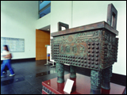
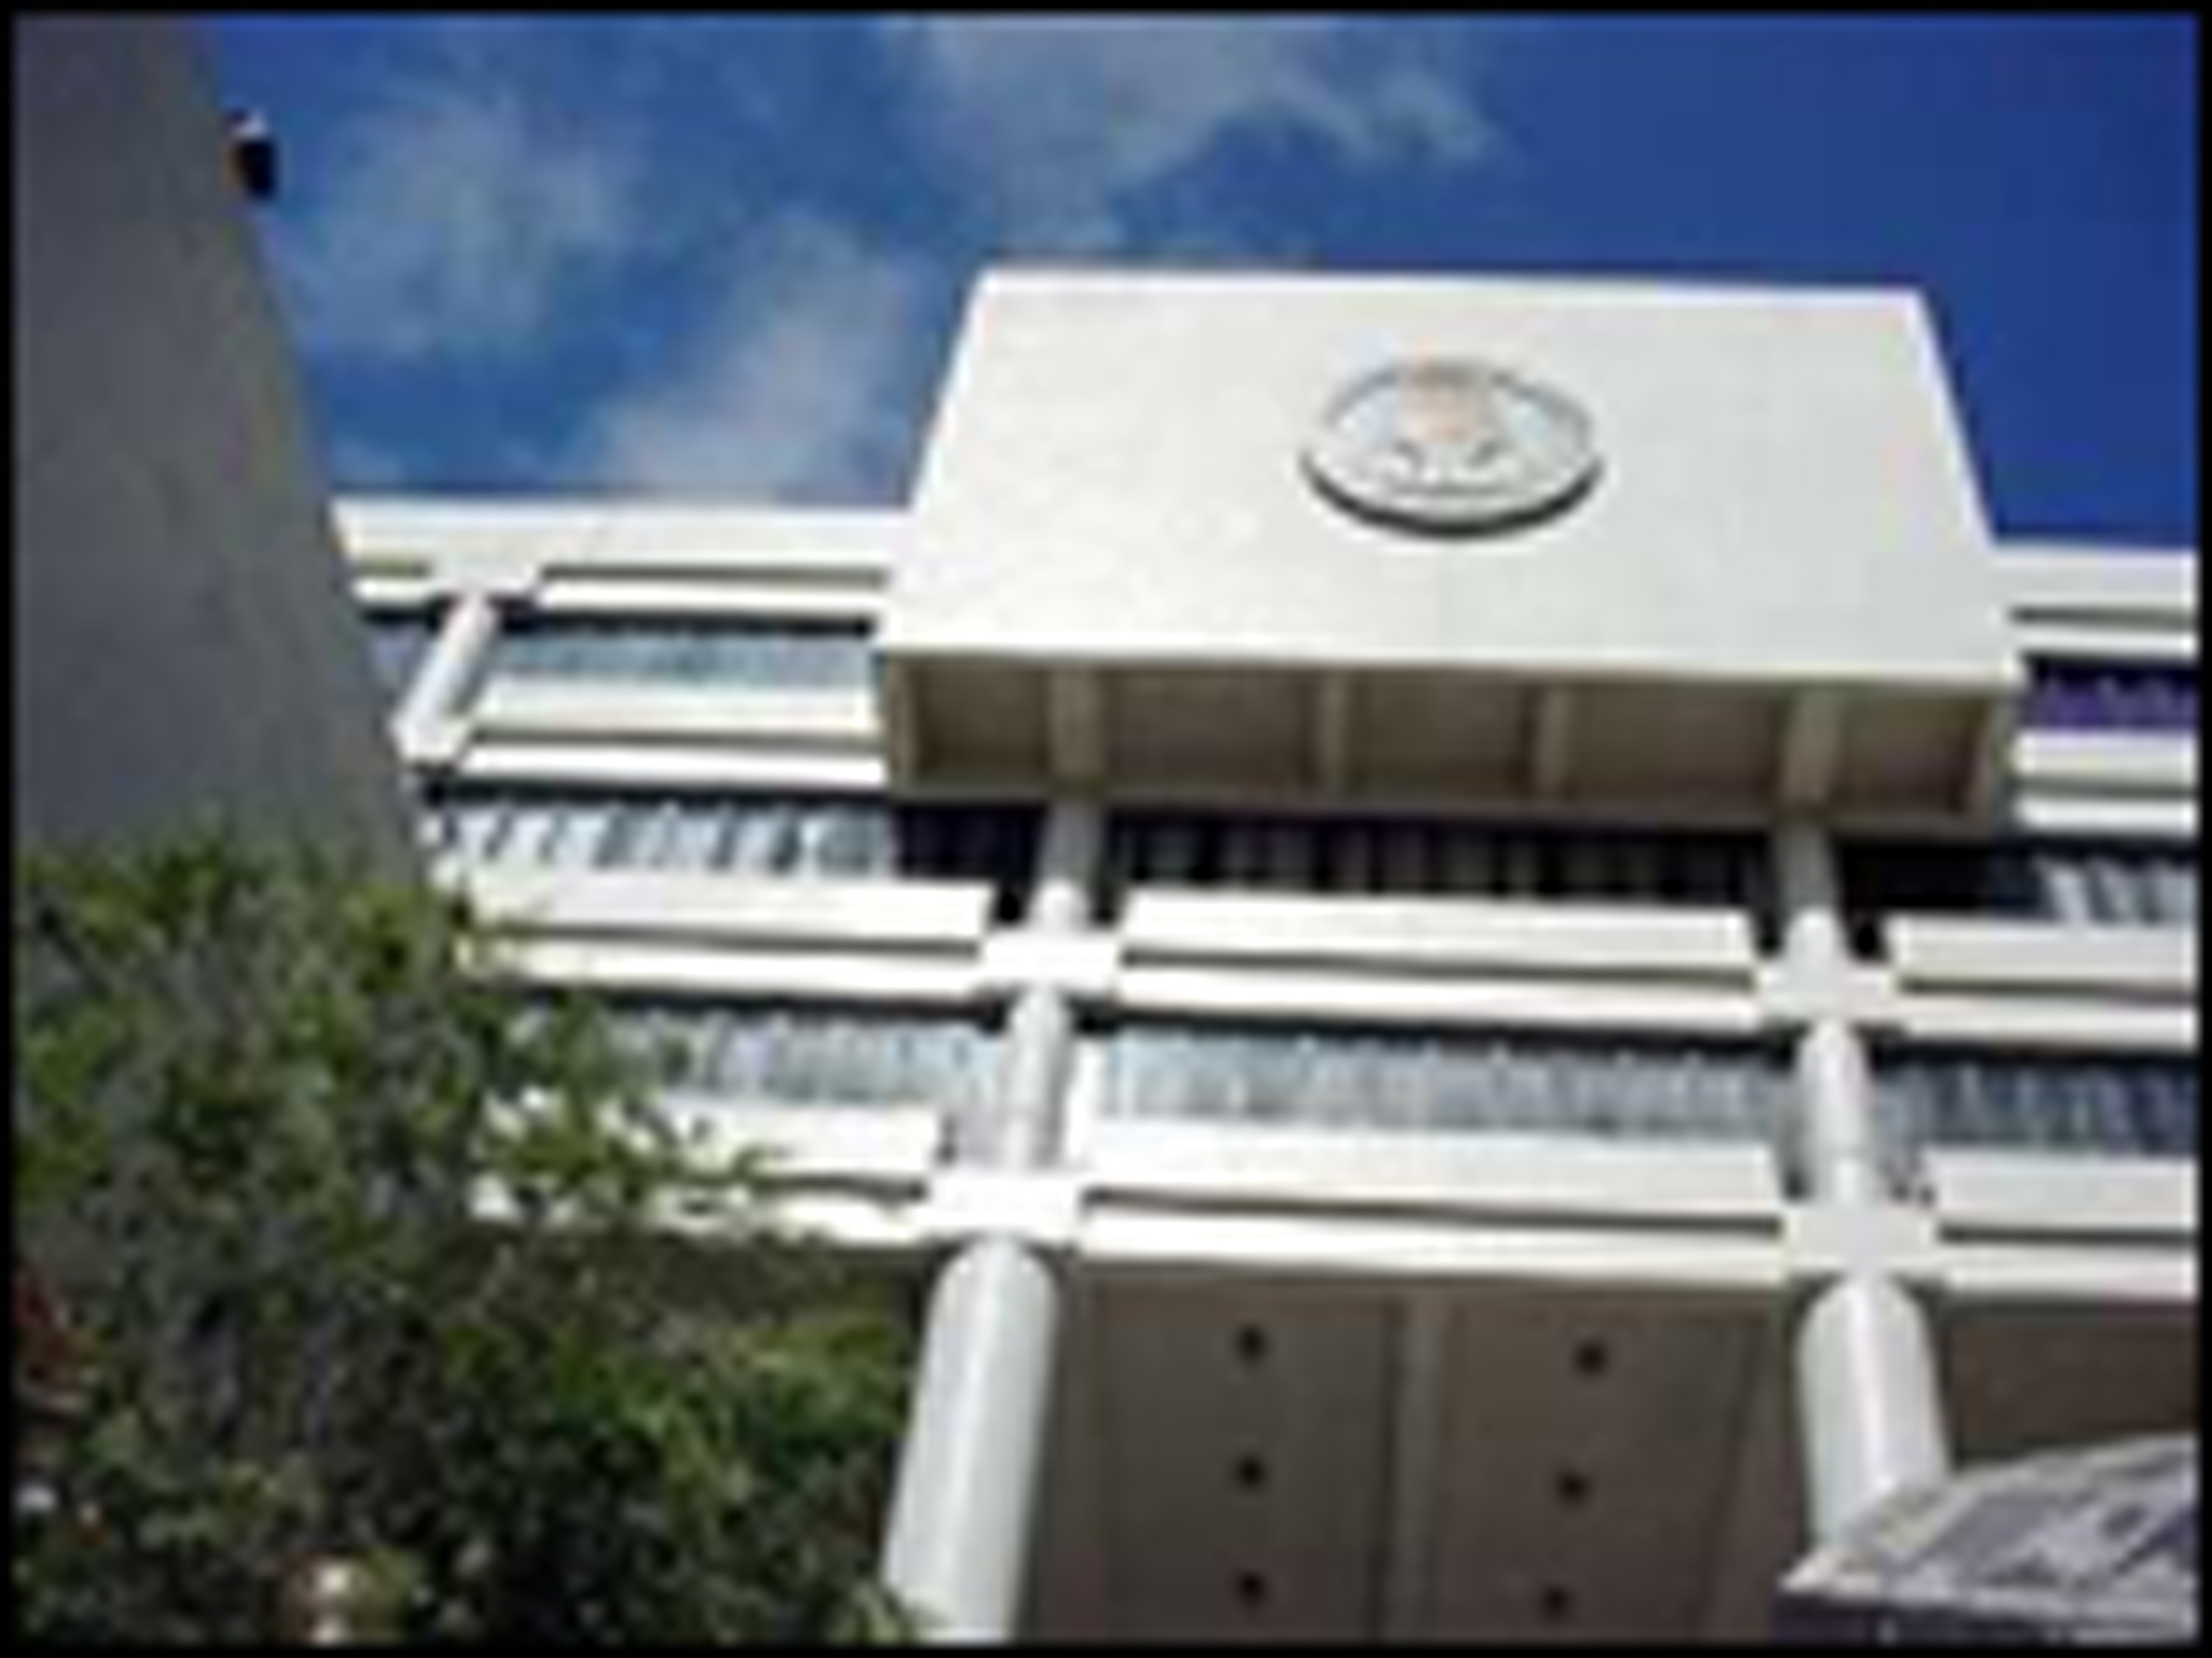

Ph.D. in Economics

Objectives

- To provide high-quality academic education and training in the field of economics at the doctoral level
- To prepare students in teaching and research for position of responsibility in government, research organizations, and in the business world
- To strengthen teaching and research within the University, in areas related to economic science, an endeavour which ultimately benefits to the Macao society

Admissions

This is a research degree by dissertation. Applicants are expected to have a masters degree in Economics from an accredited university, or its equivalent.

Applicants are required to prove English proficiency, such as TOFEL (minimum score of 550) and/or IELTS (minimum score of 6.0).

If you are unsure whether your qualifications are at the right level, complete an application form (downloadable from our Registry’s website) with your academic transcript. Individual cases will be considered on their own merit. Alternatively, you may want to contact one of our academic staff members for discussion of possible thesis topic before submitting your application.

Thesis Topic Areas
- The Chinese economy (including Macao) | - Public Economics
- Development Economics | - Welfare Economics
- Microeconomics
11
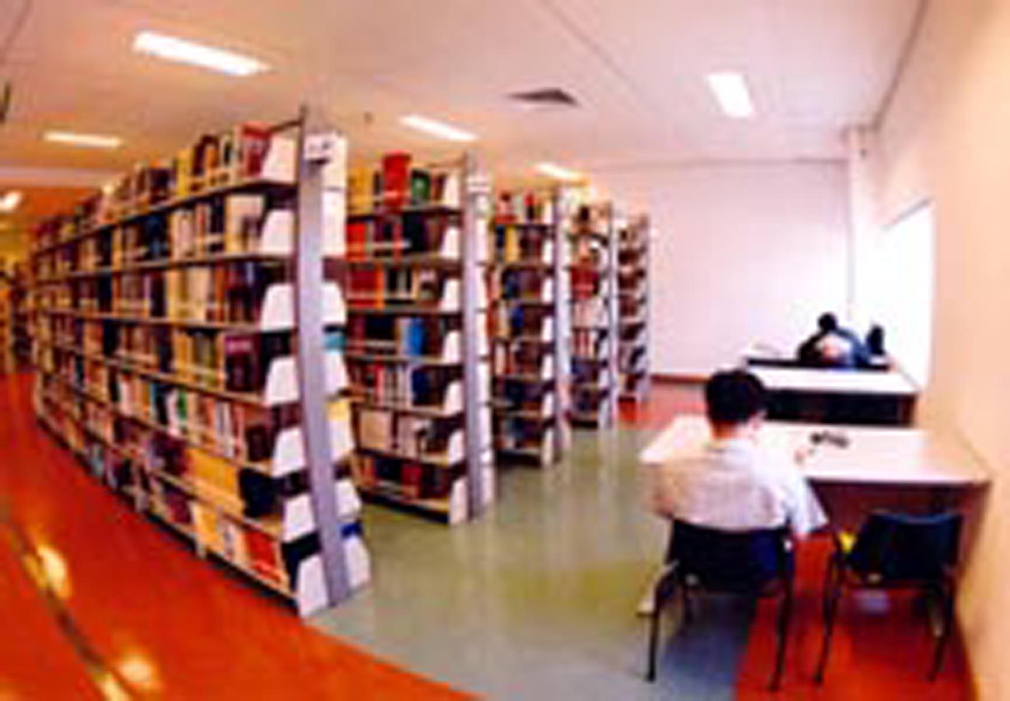
Library Facilities

The new University of Macau International Library is located at an independent building, a five-minute walk from the main campus. It has a working space area of 15,000 m². With a seating capacity of 400, the Library has a stock of more than 200,000 volumes (approximately 5,000 on economics), and receives 1,200 periodicals, other audio-visual materials, maps, microforms, newspapers, and other special materials. A special feature of our Library is a rich and up-to-date collection of official publication from ten international organizations (UN, ILO, WB, WTO, WFP, APEC, ADB, NATO, UNRISD, and EU), through the establishment of the International Document Centre. In recent years, significant progress has been made on the provision of electronic databases, which greatly enhances the research capacity to our academic staff and research students. Amongst the inclusion of these databases related to economics is JStor, ScienceDirect, EconLit, EBSCO, and the Blackwell Publishers’ Humanities and Social Science Collection.
E-campus
There are over 1700 personal computers, and over 100 workstations and servers in the University of Macau. More than 500 computers that are mainly used by the students are located in the computer rooms and laboratories at all the Faculties. The computer rooms are open for 24 hours a day, 7 days a week, and provide Internet connection free of charge. In 2002, the Macao's first remote mirroring storage area network was built in the UM, and it is also the first establishment to use the same class in South-east Asia.

In order to facilitate the development of the multimedia applications for teaching purposes, the UM has established the multimedia supporting center. The LCD projectors, audio and video equipment are also equipped in most of the classrooms. Moreover, the WebCT system -- the on-line education platform, the Optical Mark Recognition, the Video Conference system and the Streaming Video system are setup to carve the new epic of academic exchange and teaching mode.

The Net-Wireless service has covered most areas of the UM campus including hostels, so that our staff and students can connect to the campus network and the Internet at their convenience. Every year the UM has arranged for the promotion of notebook computer and the loan of wireless network card for students. In 2004, our wireless network has started the pilot run on the IEEE 802.11g industry standard with a high-speed of 54Mbps. Furthermore, there are about 270 dial-up connections for students to access the campus network and the Internet at home or from the hostels that are out of campus. SUN and PC are the two major OS adopted in our University. Standard software and special econometrics packages (such as SPSS, SAS, EViews, STATA and Limdep) are available to our research students.
12
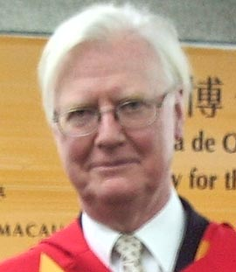 | Mirrlees, James A. (University-Level Appointment)  Distinguished Professor of Economics  Ph. D. in Economics, University of Cambridge  (Taxation, Growth, Microeconomics)
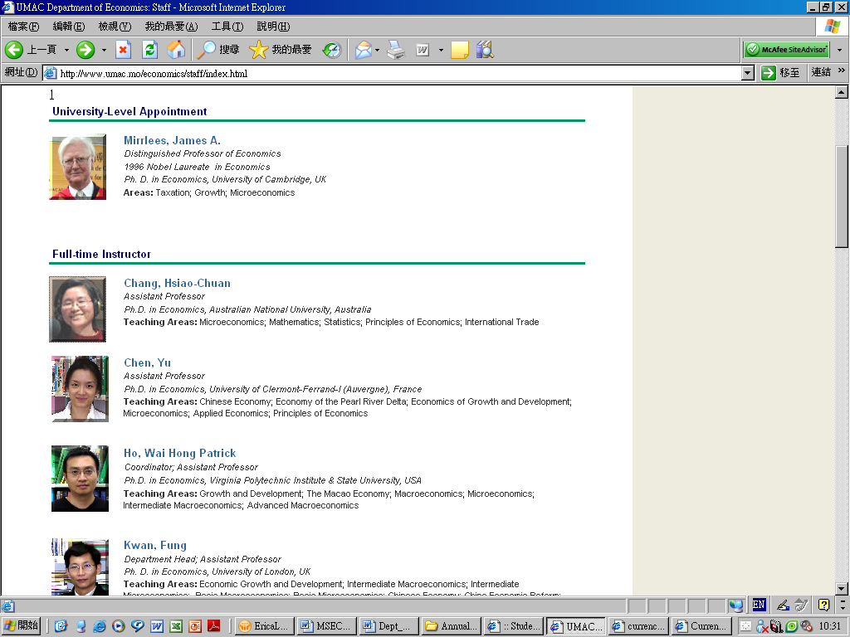 | Chang, Hsiao-Chuan  Assistant Professor  Ph.D. in Economics, Australian National University, Australia  (Microeconomics; Mathematics, Statistics, Principles of Economics, International Trade)
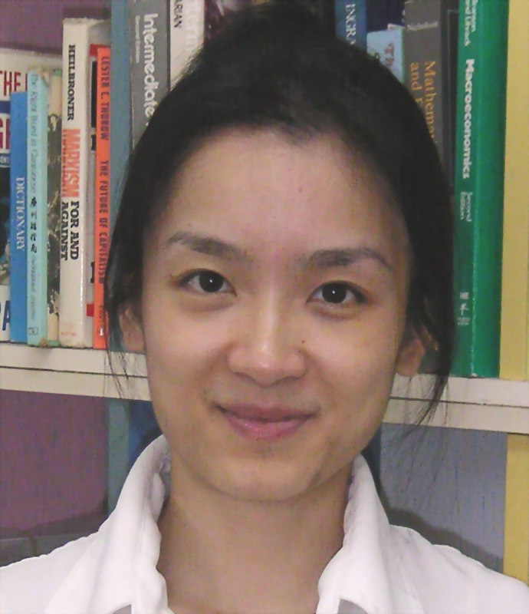 | Chen, Yu  Assistant Professor  Ph.D. in Economics, University of Clermont-Ferrand-I (Auvergne), France  (Chinese Economy; Microeconomics; Economics of Development)
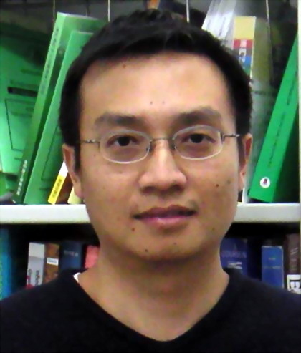 | Ho, Wai Hong Patrick (Coordinator of Undergraduate Programme)  Associate Professor  Ph.D. in Economics, Virginia Polytechnic Institute & State University, USA  (Public economics, Economic growth of East Asian countries, Financial intermediation)
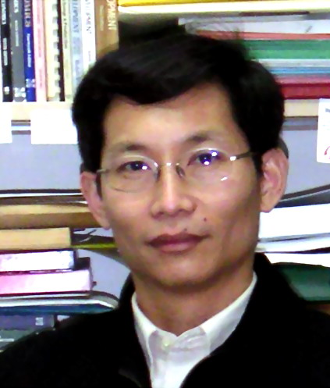 | Kwan, Fung (Department Head; Coordinator of Postgraduate Programme)  Assistant Professor  Ph. D. in Economics, University of London, UK  (Chinese economy, Economic development, macroeconomics, Macao economy)
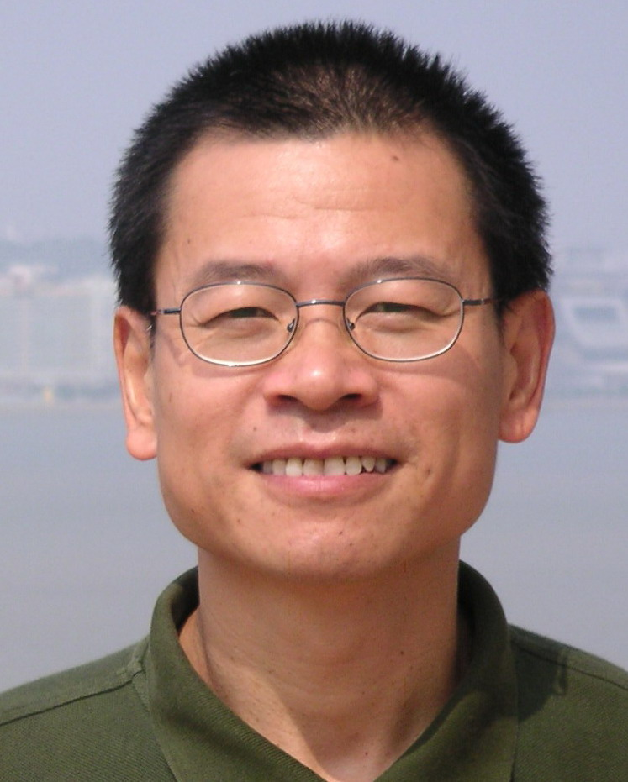 | Liu, Chun Wah  Assistant Professor  Ph. D. in Economics, University of Wisconsin - Madison, USA  (Comparative economics, Information economy, Industrial economics and Institutional economics)
 | 13
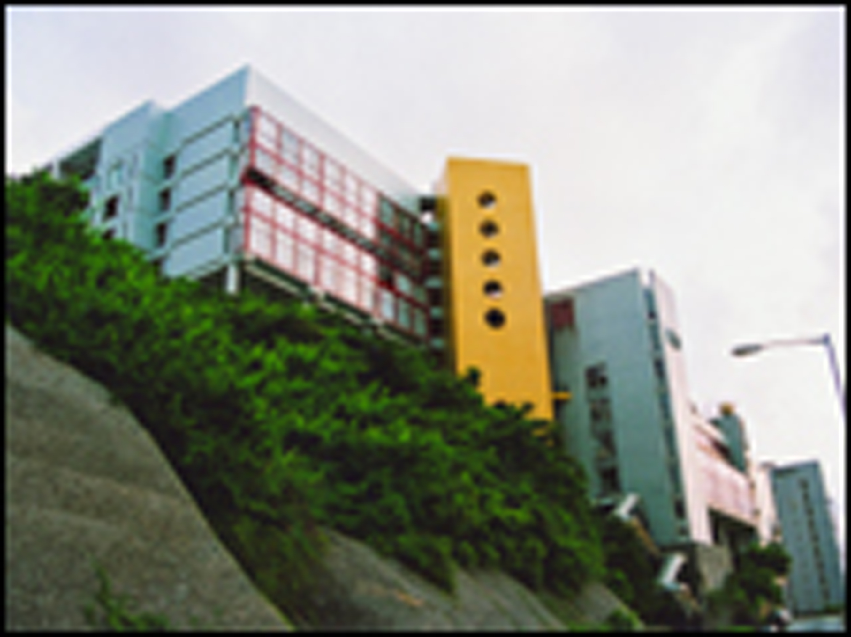
Academic Staff
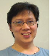 | Porapakkarm Ponpopje  Assistant Professor  Ph. D. in Economics, University of Virginia, USA  (Macroeconomics, Money and Banking, Statistics)
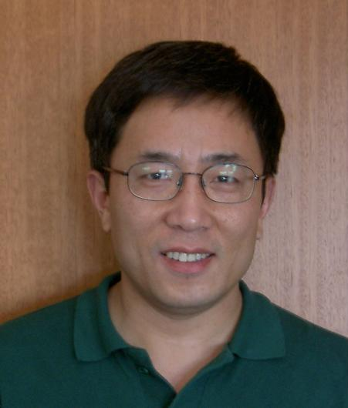 | SUN, Guang-zhen  Associate Professor  Ph.D. in Economics, Monash University, Australia  (Microeconomics, Mathematical Economics, Social Choice and Public Choice, History and Economic Thought)
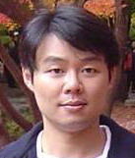 | Wong, Ka Kei Gary  Associate Professor  Ph.D. in Econometrics, Monash University, Australia  (Applied econometrics, Microeconomics, Mathematical Economics)
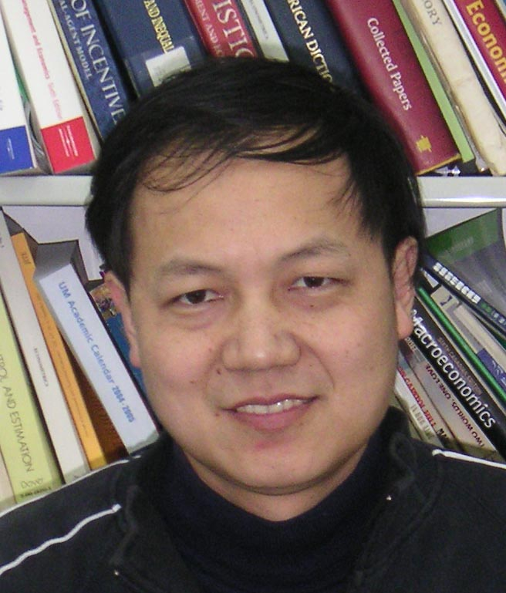 | Zheng, Mingli  Associate Professor  Ph.D. in Mathematics, Huazhong University of Science and Technology, China  Ph.D. in Economics, University of Toronto, Canada  (Applied econometrics, Applied microeconomics, Industrial organization, Law and economics)

14
Selected Staff publications

- Chang, Hsiao-chuan. (2007) “Budget Balance and Trade Balance: Kin or Strangers. A Case Study of Taiwan”, Oxford Journal, 6 (1) 75-81.

- Chen, Yu (2008). "Opening-up or Institutional Development? Evidence from China". International Economic Journal, 22 (4) 419-430.

- Chen, Yu. (2009) "What Do We Need Besides Trade?" Journal of Chinese Economic and Business Studies, 7 (1) 17-30.

- Ho, Wai Hong Patrick. (2005). "Public Capital, Asymmetric Information and Economic Growth" with Yong Wang, Canadian Journal of Economics, 38(1), 57 - 80.

- Ho, Wai Hong Patrick & Yong Wang (2007) "Factor Income Taxation and Growth under Asymmetric Information", Journal of Public Economics, 91(3-4), 775 - 789.

- Kwan, Fung (2009) “Agricultural Labour and the Incidence of Surplus Labour: Experience from China During Reform”, Journal of Chinese Economic and Business Studies. 7 (3), 341-361.

- Sun, Guang-Zhen (2009), “The Age-Dependent Value of Time: A Lifecycle Analysis”, Journal of Economics , 97(3), 233-250.

- Wong Ka Kei Gary and H J Park (2007), “The Use of Conditional Cost Function to Generate Estimable Mixed Demand Systems”, American Journal of Agricultural Economics, 89 273-286.

- Wong Ka Kei Gary and K R McLaren (2005), “Specification and Estimation of Inverse Demand Systems: A Distance Function Approach”, American Journal of Agricultural Economics, 87, 823-834.
15
- Zheng, Mingli (2005) “Rational Legal Decision-Making, Value Judgment and Efficient Precaution in Tort Law,” Journal of Institutional and Theoretical Economics, 161(3), 411-427.

- Zheng, Mingli (2006) “Bidding Behavior in Competing Auctions: Evidence from eBay,” European Economic Review, 50(2), 307-322.

16

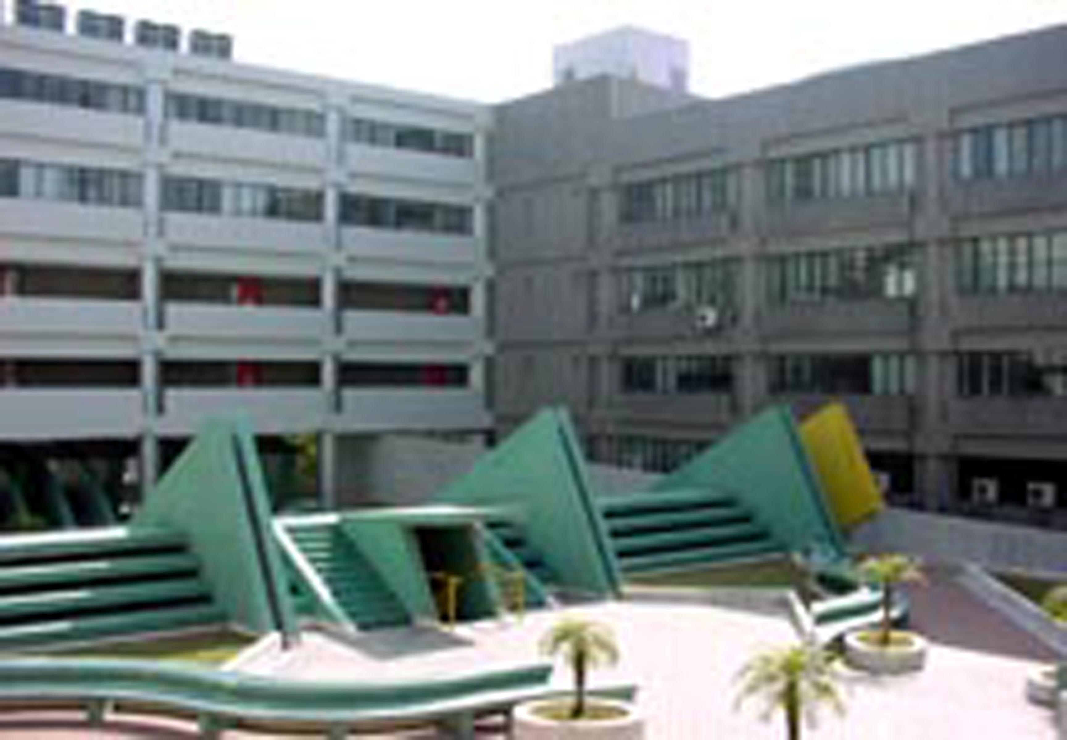
Financial Issues

The scheme of tuition fees for 2010-2011 is as follows:

For students of M.Soc.Sc. from Macao, Hong Kong, China mainland and Taiwan – MOP61,600 (for 2 academic years); For students from other countries – MOP76,800. For Ph.D. students from Macao, Hong Kong, China mainland and Taiwan, MOP75,600 (for 3 academic years); Other students – MOP94,500.

Fees are for the whole programme. Additional fees are required for those who need extra period to complete the whole programme.

A number of graduate assistantships and studentships are available to candidates with excellent academic record. Remunerations varies (MOP9,000 and MOP7,500 to for the current students). There are also limited scholarships for local and international students. Please contact our Student Office for details.
Email: so.enquiry@umac.mo;
URL: http://www.umac.mo/so/index.html

Studying and Living in Macao

The University offers accommodation for non-local students. There are three types of on-campus hostels: single room, double room and shared room, the monthly charges are MOP2,000 (around USD251), MOP1,200 (around USD150) and MOP800 (around USD100). The monthly charges for off-campus hostels are MOP700 (around USD88) per person.

Students have access to the University’s own medical service, which is further supported by the local KiangWu Hospital and the government hospital - Hospital Centre S. Januario.
17

The cost of living in Macao is relatively lower than the neighbouring regions. It is estimated that a monthly minimum of MOP2,800 (around USD350) covers meal, transportation and other basic living expenses.

The official currency in Macao is MOP.

HKD1 = MOP1.03
USD1 = MOP8.03
ECU1 = MOP9.4

Macao’s climate is warm and humid with a fairly wide variation in temperature over the year. From June to September, the temperature can rise to over 30ºC while it can drop to below 10ºC from November to February. The average temperature rarely drops below 14ºC. Macao’s weather is also influenced by tropical cyclones from the South Pacific Ocean during the typhoon season.

International students must obtain a visa in order to study in Macao. The Macao Immigration Department issues student visas to full-time student enrolling in the university. After the student arrives in Macao and completes the registration in the university, he/she should submit the testimonial and a copy of his/her identification/travel document to the Foreigners Subdivision of the Macao Immigration Department. For application charges, please contact Macao Immigration Department or refer to the following URL:
http://www.fsm.gov.mo/psp/sm/epromise_sm.htm
Detailed portrait of the Macao city is available at this URL: http://www.cityguide.gov.mo

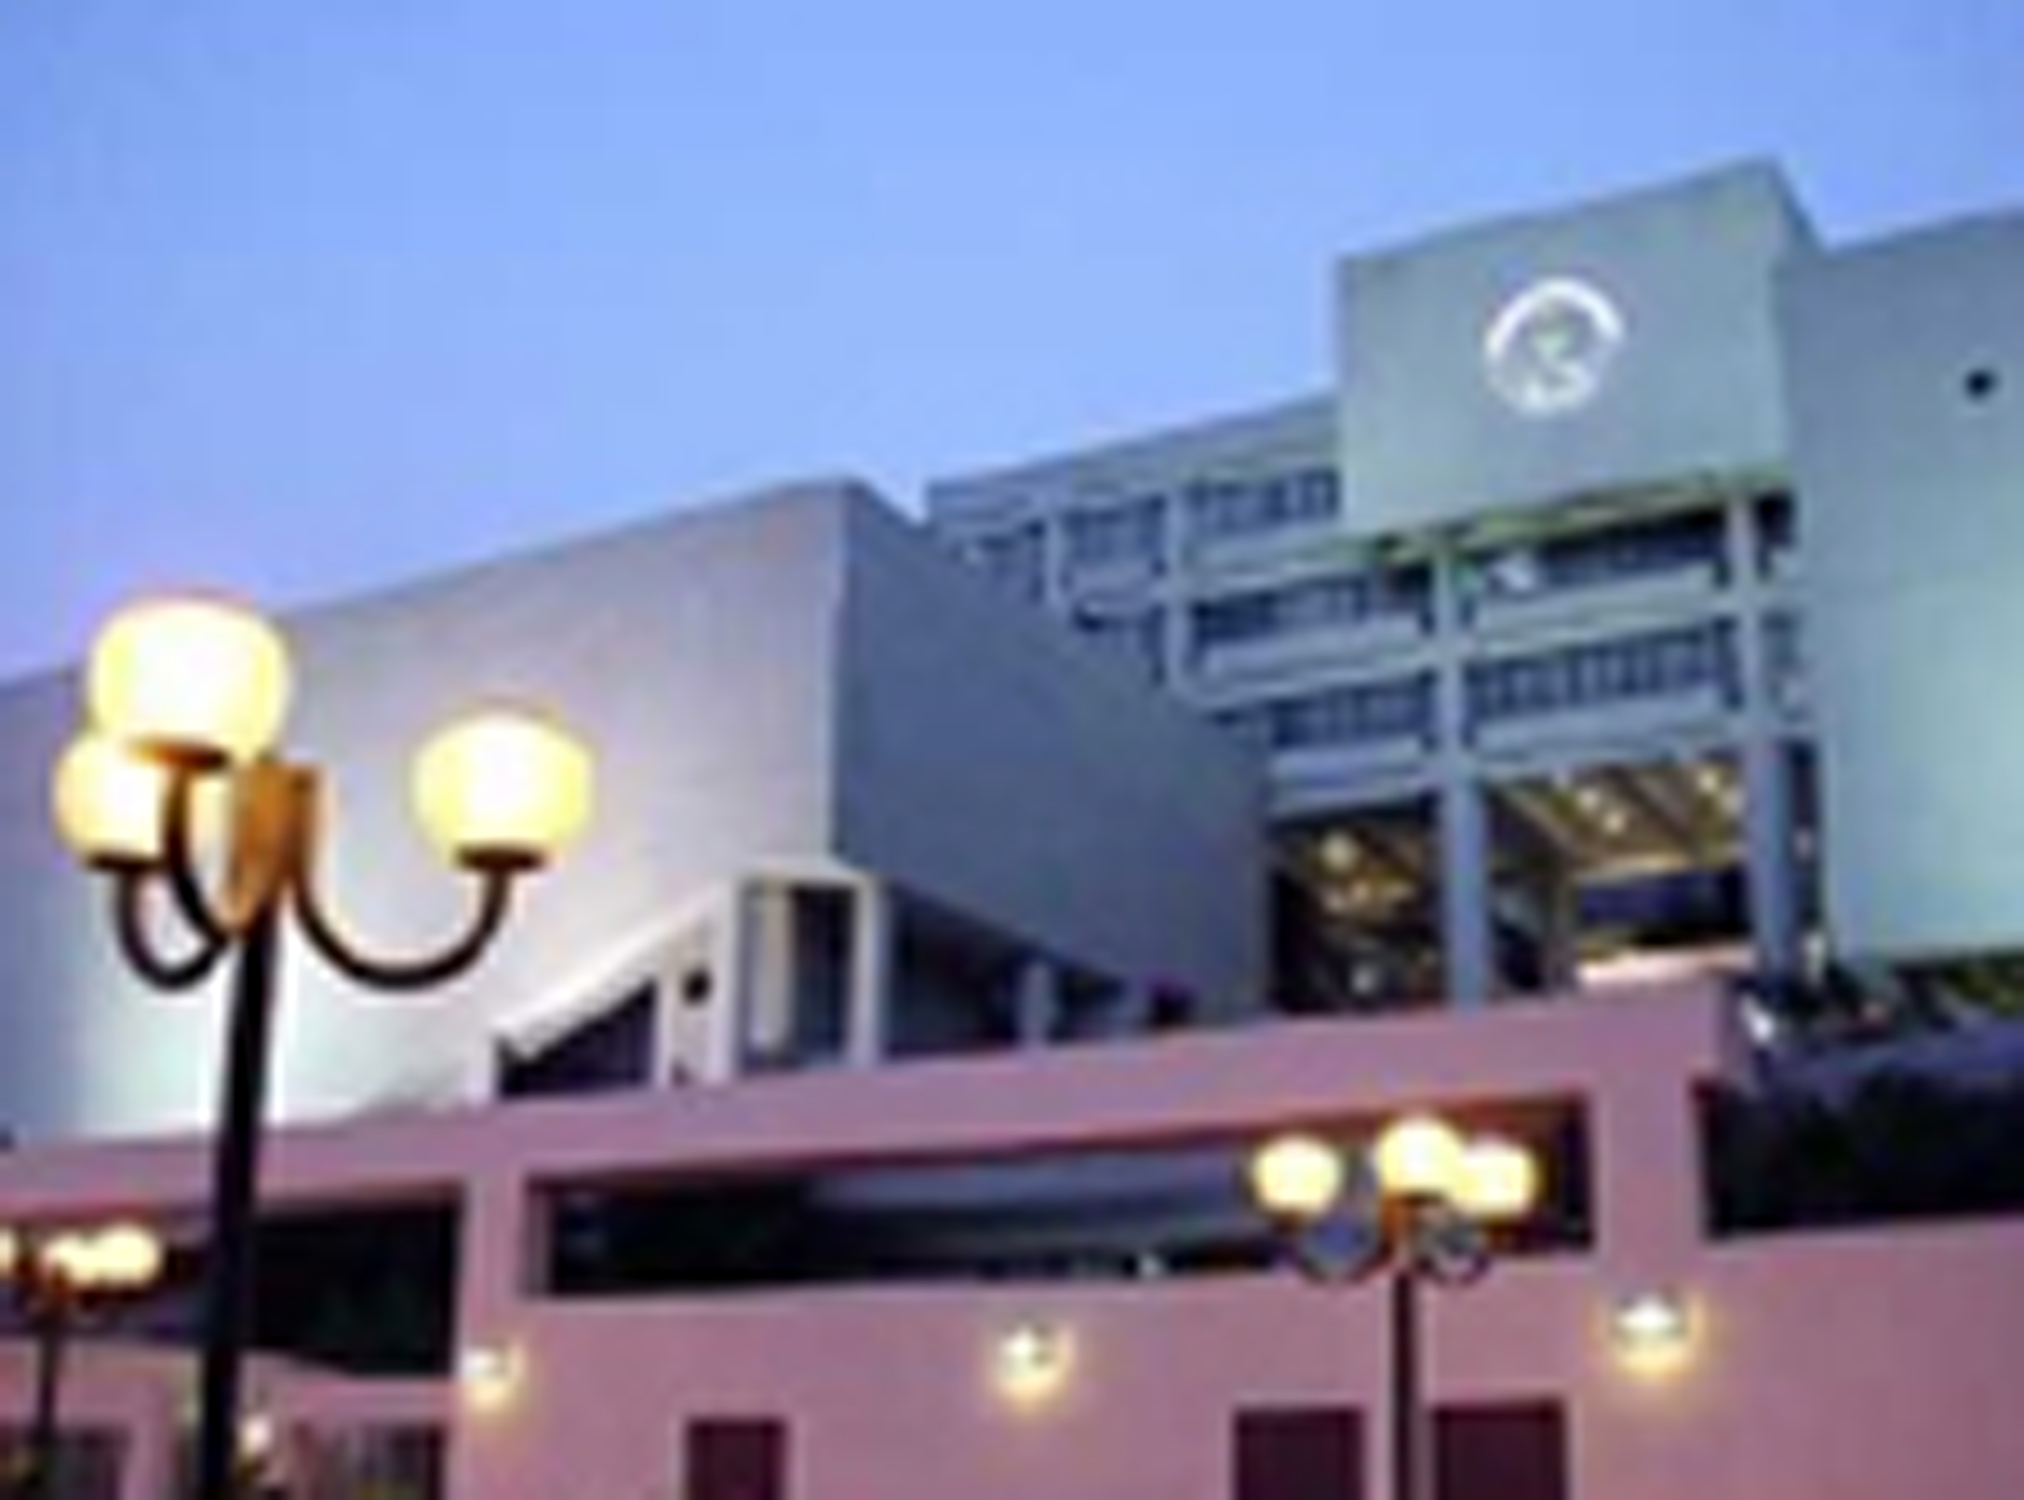

18
Contact Information

Department of Economics
Faculty of Social Sciences and Humanities
University of Macau
Room TM2A, Tai Fung Building
Taipa, Macao SAR
China

Telephone: 853-83974274

Telefax: 853-28838312

Email: econ@umac.mo

Economics Programme’s URL:
http://www.umac.mo/economics

Application Form and related materials are downloadable from our Registry’s URL: http://www.umac.mo/reg/

Application Deadline (for M.Soc.Sc. in Economics):

Local applications: March, 2010

Other applications: March, 2010

Application Deadline (for Ph.D. in Economics):
Please contact the Graduate School for details.
Tel: 853-83974849/4850
Email: gradschool@umac.mo,
Address: Room A105 of 1st floor of Administrative Building

******************************************************
Every effort has been made to ensure that information presented in this prospectus is correct at the time of publication. However, all information is subject to change. 27th January 2010

