Phone: +44 (0) 1937 844 800 ¦ E-mail: orders@mtalearning.com

MTa’s innovative and engaging learning materials are used in over 100 countries and enable facilitators to deliver high impact training in 1000s of the world’s most demanding businesses and organisations.
To order your MTa materials please call, e-mail or purchase online at www.mtalearning.com.
If you would like to discuss your requirements in more detail we would delighted to help, simply call or e-mail.
MTa Insights™ |  | Shorter Activities + Leadership Activities
Complete MTa Insights  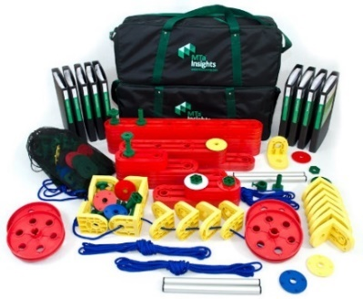 | 1 x set of MTa Insight components (2 holdalls)  All 53 MTa Insight activities in 9 volumes:  - Team Working Level 1  - Team Working Level 2  - Communication  - Problem Solving  - Business Priorities  - Performing for Excellence  - Leadership 1  - Leadership 2 (Cable and Hoist)  - Leadership 3 (Maxi Market and Waste Away) |  | Code | Price
 |  |  | INS-CO | $2625
 | The Complete MTa Insights in Arabic |  | INS-AR | $2625
MTa Insights Expansion Pack | Expand the MTa Insights for use with up to 16 additional participants  - 1 x set of MTa Insights components (2 holdalls)  - Only available to purchasers of an MTa Insights |  | INS-EX | $1215
MTa Insights App Upgrade | Get access to your MTa Insights on your tablet |  | INS-APP | $262.50

MTa Academy |  | See www.mtalearning.com for dates
MTa® Facilitator Masterclass | A two day workshop designed to help you discover the principles behind world class experiential learning  * Early Bird price |  | Code | Price
MTa® Facilitator Masterclass |  |  | DEM-MC | £795*  £895
The Art of Facilitation | Over two days, Martin founder of MTa, will help you develop your skills as a facilitator of experiential learning |  | DEM-AF | £1195
MTa® Experience Workshop | This one day workshop is an interactive and energetic introduction to MTa’s tools |  | DEM-FW | £95

MTa Team Kit™ | Team Development
Complete MTa Team Kit  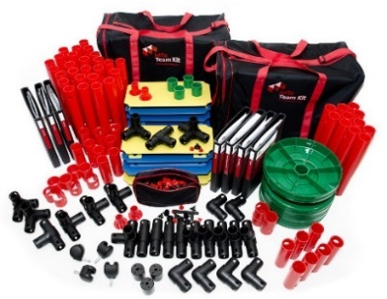 |  | 1 x Set of MTa Team Kit components (2 holdalls)  plus the activity manuals:  - Over the Bridge  - Trailer  - Rectangle  - Digital Display  - The Frame  - Tower  - 10 Short Activities | Code | Price
 |  |  | KIT-C | $2015
 |  | The Complete MTa Team Kit in Arabic | KIT-AR | $2015
MTa Team Kit Expansion Pack |  | Expand the MTa Team Kit for use with upto 12 additional participants  - 1 x set of MTa Team Kit components (2 holdalls)  - Only available to purchasers of an MTa Team Kit | KIT-A | $1215
MTa Team Kit App Upgrade |  | Get access to your MTa Team Kit on your tablet | KIT-APP | $199.50

MTa Mini™ |  | Table Top Activities
MTa Mini Complete  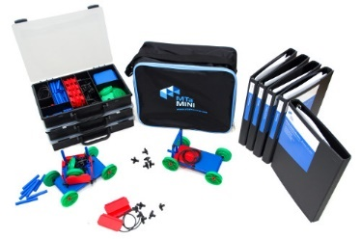 | Save $235 with the MTa Mini Complete  1 x set of MTa Mini components (3 trays), plus:  - 5 x Mini Crossing Boundaries activities  - 4 x Mini Essentials activities |  | Code | Price
 |  |  | MIN-C | $1215
MTa Mini Crossing Boundaries | 1 x set of MTa Mini components (3 trays), plus the activity manuals:  - Carts and Horses  - Promises Promises  - Words, Names and Numbers  - Transport & The Rig |  | MIN-CB | $890
MTa Mini Essentials | 1 x set of MTa Mini components, plus the activities:  - Within Four Walls  - Gantry  - Helipads  - Handcuffed |  | MIN-E | $560
MTa Mini Expansion Pack | Expand the MTa Mini for use with up to 15 additional participants  - 1 x set of MTa Mini Components (3 trays)  - Only available to purchasers of an MTa Mini |  | MIN-A | $325
MTa Mini App Upgrade | Get access to your MTa Mini on your tablet |  | MIN-APP | $99.50

MTa KanDo-Lean™ |  | Lean Processing
MTa KanDo Lean  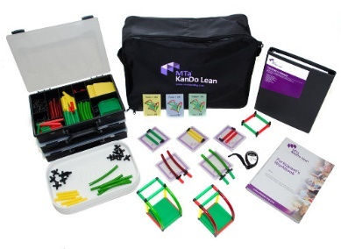 | 1 x set of MTa KanDo Lean components, plus:  - Comprehensive Facilitators’ guide  - 16 x participant workbooks |  | Code | Price
 |  |  | KAN-S | $1215
Additional Workbooks | - Pack of 16 additional workbooks |  | KAN-BM | $75
MTa KanDo Lean App Upgrade | Get access to your MTa KanDo Lean on your tablet |  | KAN-APP | $79.50

MTa Select™ |  | Assessment
MTa Select  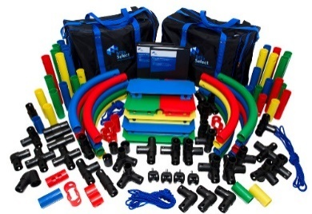 | 1 x set of MTa Select components, plus:  - Assessors’ guide  - 8 x Assessment Activities  - Assessors working documents  - example assessment programmes |  | Code | Price
 |  |  | SEL-S | $1525
MTa KanDo Lean App Upgrade | Get access to your MTa KanDo Lean on your tablet |  | KAN-APP | $154.50

MTa Coaching Skills™ |  | Coaching Skills
MTa Coaching Skills  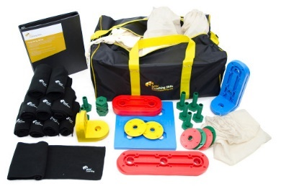 | 1 x set of MTa Coaching Skills components, plus:  - Coaching Skills Facilitators’ Guide (2 x ½ day workshop programme with all supporting materials) |  | Code | Price
 |  |  | COA-S | $755
MTa Coaching Skills Expansion Pack | Expand MTa Coaching Skills for use with larger groups:  - 1 x set of Coaching Skills components |  | COA-A | $545
MTa Coaching Skills App Upgrade | Get access to your MTa Coaching Skills on your tablet |  | COA-APP | $79.50

MTa New Dimensions™ |  | Cooperation and Collaboration
MTa New Dimensions  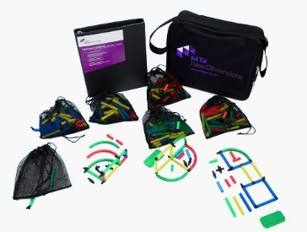 | - 1 x set of MTa New Dimensions components  - Comprehensive Facilitators’ guide |  | Code | Price
 |  |  | DIM-S | $555
MTa New Dimensions App Upgrade | Get access to your MTa New Dimensions on your tablet |  | DIM-APP | $79.50

MTa PASS™ |  | Activities for Young People
MTa PASS Classroom Pack  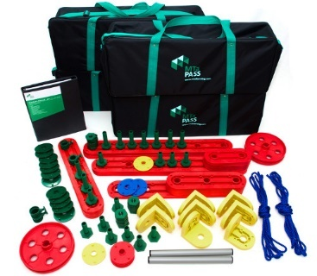 | 2 x sets of MTa PASS components (4 holdalls), plus  - 17 x activities in a comprehensive teachers’ manual |  | Code | Price
 |  |  | PAS-CP | $1375
MTa PASS | 1 x set of MTa PASS components (2 holdalls), plus:  - 17 x activities in a comprehensive teachers’ manual |  | PAS-S | $795
MTa PASS App Upgrade | Get access to your MTa PASS on your tablet |  | PAS-APP | $79.50

The Culprit™ |  | Giving and Receiving Feedback
The Culprit  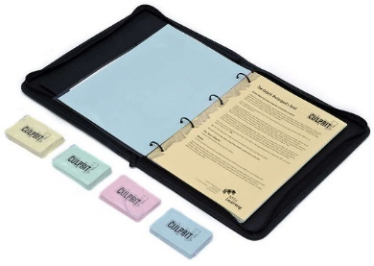 | - Culprit Materials  - Comprehensive Facilitators’ guide  - Supporting Documentation |  | Code | Price
 |  |  | CUL-S | $330

MTa Helium Stick ™ |  | Basic Team Skills
MTa Helium Stick  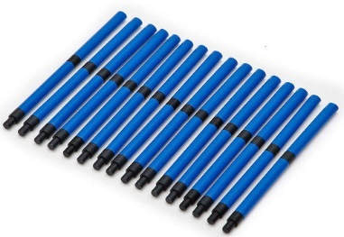 | - 1 x set of MTa Helium Stick components  - Facilitators notes  - Participants’ briefs and review sheets |  | Code | Price
 |  |  | MAG-S | $75

 | ① Invoice Details | ② Delivery Details if Different
Name
Job Title
Organisation
Address Line 1
Address Line 2
City
Postcode or ZIP
Country
E-mail
Work Tel Number
Mobile Tel Number

Product Name | Product Code | Quantity | Cost | Total Cost

① Sub Total | _________
② Add Post and Packaging  UK $18.00 ¦ EU 7% ¦ Non EU 12% ¦ N. America & M. East 15% ¦ World 18% | _________
Total | _________

Payment Details
❑ Credit Card
❑ Mastercard  Visa  AMEX  Delta  Maestro
Card Number |  | 3 Digit Security Code (AMEX 4) |  | Expiry Date __ /__
Card Holders Name and Address

❑ BACS and Wire Transfers: Banking details will be sent with order confirmation
❑ Purchase Order Number ______________________

