Managing Your Enrollment
Table of Contents
Managing Your Enrollment Overview 1
Course Materials Overview 1
Important General Information 1
Your Role in the Enrollment Process 2
Consent 3
Enrollment Capacity 6
Modify Combined Section Enrollment Capacity 9
Identify Combined Sections: Primary & Capacity 13
Wait List 16
Activating the Wait List Using Update Sections of a Class 16
Managing the Wait List 18
Viewing Wait List by Student 21
Wait List Audit 22
Wait List Audit Field Descriptions 23
Class Permissions 25
Class Permissions Page 25
Student Specific Permissions 29
General Permissions 32
Permission to Drop Bundled Co-Requisite Course 34
Session Dates and Deadlines 36
Enter Textbooks 38
Textbook Report: View Missing or Not Displayed Textbooks 39
Instructor Provided Content Entry 40
Class Roster 41
Class Meeting Information: Maintain Schedule of Classes 47
Instructor Schedule 50
Class Associations: View Units, Honors, Graded & Optional Component 53
View Course Requisites 57
Enrollment Requisite Summary Detail 59
Course Catalog 61
Student Services Center 65
Enrollment Detail & Grid 66
Student Enrollment History 69
Placement Test Scores 74
Term Credit Override 75
Service Indicators 77
Student Groups 80
Course Change Request Form 83
PDF Schedule of Classes Report 84
Running a PDF Schedule of Classes Report 84
Sample PDF Schedule of Classes 86
Curricular Enrollment Report 87
All Course Report 89
Data Center 91

Managing Your Enrollment Overview

Course Materials Overview
In this manual you will learn how to do the following in regards to managing your enrollment, including preparing for the enrollment period, responding to student questions during the enrollment period, and managing student changes following the enrollment period:
- Give Permissions for Courses
- Change Enrollment & Wait List Capacity
- View/Change Consent
- View a Class Roster
- Utilize system to troubleshoot and resolve student enrollment problems

Important General Information

Student Specific Permissions versus General Permissions
Student Specific Permissions | Strictly associated with a specific student. The student name and/or ID must be obtained to enter this student’s permission into the system.  Note: All classes are automatically indicated as Student Specific Permissions.
General Permissions | Set up and assigned to any student. However, there is no tracking to verify which and to whom General Permission numbers have been assigned. General Permission numbers may get lost or used by the incorrect person; therefore, it is recommended to keep a written log that tells to whom each number is issued or use the Permissions |Comments| tab.
Tip: You can view class permissions for any course in any department.
See Accessing Class Permissions section.

The Enrollment Help Line
If you have student enrollment questions, you can call the enrollment help line at 262-0920.
If you have course enrollment / setup questions, call Curricular Service at 262-6345

Your Role in the Enrollment Process
Essentially, your role in the Enrollment Process is to simplify the enrollment process for students and then to trouble shoot when necessary.
There are steps that you and the Curricular Representatives in your department may take to create this simplicity in advance of Enrollment. But, of course, there will always be difficulties for some students, which you will need to explain or solve. And finally, after Enrollment, there will be ongoing changes to make. This chart displays the full process of preparing for Enrollment. The elements covered in this training of Managing Your Enrollment are noted.

Set Up Schedule of Classes
Courses, Sections, Enrollment Packaging, Instructors, Enrollment Capacities, Variable Units, Honors, Topics, Consent, Requisites
Proof, Finalize, & Distribute Schedule of Classes
Advance Preparation for Enrollment
Covered in this Course:
Managing Your Enrollment
Enrollment & Wait List Capacities,
Combined Section Enrollment & Wait List Capacities, Consent
Enrollment Period
Trouble Shooting & Problem Solving Enrollment System,
Class Information (capacities, consent)
Student Information (permissions)
Post Enrollment Changes

Tips: Reference the Class Search (online Schedule of Classes) through this path:
>Self Service >Class Search >Class Search (displays 4 most recently published terms)
-or- >Curriculum Management >Schedule of Classes >Class Search History (all terms)
This view reflects real-time updated information.
To view Enrollment ‘Key Deadlines’ for Fall and Spring Term, reference the sidebar here:
http://registrar.wisc.edu/

Consent
Change the Consent indicator when needed for the full course or specific sections.
Valid Values for Consent are:
- D Department Consent Required Permission required to enroll
- I Instructor Consent Required Permission required to enroll
- N No Special Consent Required Anyone can enroll if requisites met
Note: Add Consent term rolls from the previous like semester.
Be sure to verify the Add Consent field is set to what you really want it to be: N, I, or D.

Updating Consent
Step | Action | Result
 | Select from your Main Menu:  >Curriculum Management  >Schedule of Classes  >Update Sections of a Class | The Find page displays.
 | Use the Find page to locate the desired course.  Search by:  -Term  -Subject Area & Catalog Nbr | 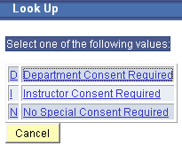  The specified course displays on Update Sections of a Class page.
 | 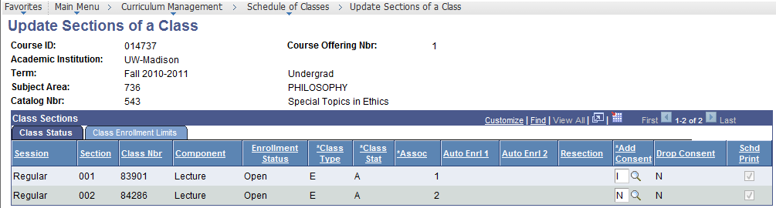
 | If needed, select |Class Status| page tab. | The Class Status page displays.
 | If needed, change the Consent field of section(s) to:  N No Special Consent Required  I Instructor Consent Required  D Department Consent Req’d  No one can enroll unless they get a permission  Anyone can enroll; but, there might be requisites | Consent displays the value you select.
 | Select [Save]. | Any changes made will be saved.

Update Sections of a Class: Class Status Page Field Descriptions
The table below describes the fields found on the Update Sections of a Class, Class Status page:
Field | Description
Course ID | A unique number assigned by the system when a course is first added to the Course Catalog.
Academic Institution | This field always displays UW-Madison.
Term | A four-digit code representing century, year, and semester.  Semesters are as follows: Fall=2, Spring=4, Summer=6.  e.g. 1192=Fall 2018-2019, 1194=Spring 2018-2019.
Subject Area | The Academic Department. It is usually a three-digit number.
Catalog Nbr | The course number in a Subject Area as described in the Course Catalog.
Course Offering Nbr | Each course will have a Course Offering Number. Each member within a Crosslisted group has a different Course Offering Number.
Class Status
Session | Represents the length and weeks a class meets. Regular sessions of full Fall and Spring terms are coded as A1. Courses meeting less than the full semester and summer term have a 3-letter code representing the Begin week, Span, and weeks of Instruction.
Section | Every class is identified with a 3 digit Class Section number.
Class Nbr | A unique 5-digit number assigned to each section.  This number can be used for student enrollment.
Component | Identifies the type of instruction for a class; examples include Lecture, Discussion, Lab, Seminar, etc.  Each course can have up to three types of instruction.
Enrollment Status | The enrollment status of this section. Values are:  Open  Closed
Class Type | Values are:  ‘N’ Non-enrollment section  ’E’ Enrollment section
Class Stat | Values are:  ‘A’ Active Section  ‘X’ Cancelled Section
Assoc | Association numbers match ‘Enrollment’ section numbers.  All ‘Non-Enrollment’ sections are Association number 9999.
Auto Enrl 1 | Used if 2 different types of Components and auto enrollment is desired.  Auto Enroll is placed on the enrollment section.  All sections in an auto enroll must be in the same Associated Class or one section must be a ‘9999’ Associated Class.  The student will be enrolled in both sections.
Auto Enrl 2 | Used if 3 different types of Components and auto enrollment is desired.  Auto Enroll must be placed on the enrollment section.  All sections in an auto enroll must be in the same Associated Class or one section must be a ‘9999’ Associated Class.  The Higher auto enroll section number is in this field.  The student will be enrolled in all three sections.
Resection | UW-Madison does not use this field.
Add Consent | Values are:  ‘D’ for Department Consent Required  ‘I’ for Instructor Consent Required  ‘N’ for No Consent Required  Note: If course Component type is IND and the  Catalog Nbr is <=699, Add Consent must be D or I.
Drop Consent | The value will always be N for Non Consent.  UW-Madison does not use this field.
Schd Print | If box is checked, section will display in Class Search.

Enrollment Capacity
Class Enrollment Limits may be changed or viewed in Update Sections of a Class.
You may also see how many students have currently enrolled.

Special Notes on Enrollment Capacity
- When you change enrollment capacity or wait list capacity, make sure that all impacted components of the Enrollment Group are changed (e.g. Discussion and Lecture).
- If this is a Combined Section, each department must change their enrollment to match the combined sections enrollment capacity & wait list capacity.
- The Combined Section link will display on the Class Enrollment Limits page if a section is combined. The Combined Section link will show the combined sections enrollment capacity and the current enrollment for each member of the crosslist or meets-with groups.
To change the enrollment capacity for a combined section, see ‘Modify Combined Section Enrollment Capacity’.
- When changing enrollment capacity, do not change enrollment capacity beyond what the facility can accommodate. You can see the capacity of the facility on the Maintain Schedule of Classes, Meetings page. (Go here: >Curriculum Management >Schedule of Classes >Maintain Schedule of Classes |Meetings|)

Updating the Enrollment Capacity
Step | Action | Result
 | Select from your Main Menu:  >Curriculum Management  >Schedule of Classes  >Update Sections of a Class | The Find page displays.
 | Use the Find page to locate the desired course.  Search by:  -Term  -Subject Area & Catalog Nbr | The specified course displays on Update Sections of a Class page.
 | 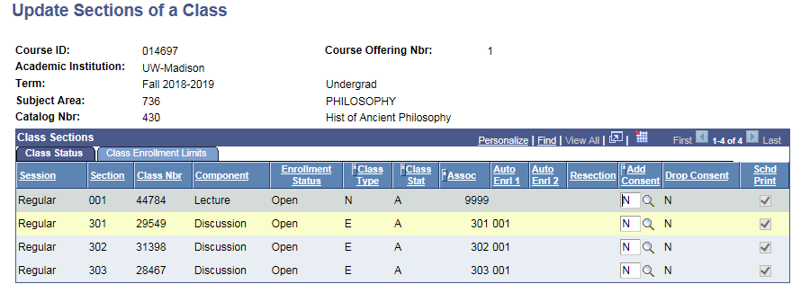
 | Select |Class Enrollment Limits| page tab. | The enrollment capacity number displays for all the sections.
 | 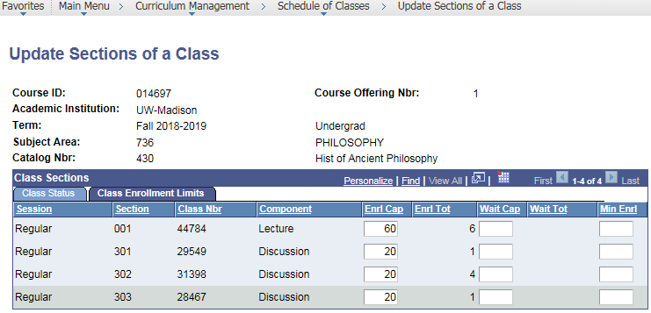
 | Locate the Enrl Cap for the appropriate section and  enter the new enrollment capacity.  Tips:  Remember to change all impacted enrollment package components (e.g. Disc & Lec).  To change the enrollment capacity for a combined section, see ‘Modify Combined Section Enrollment Capacity’.  To utilize the wait list feature, see ‘Wait List’. | The new enrollment capacity number displays for the section.  Tip: Before changing the capacity, consider the room capacity, TA Contracts, and if this is a combined section. (See Special Notes.)  If canceling a section/course, drop the Enrl Cap & Wait Cap to zero immediately and contact your department’s curricular rep.  Note: UW Madison does not use the Min Enrl field.
 | Select [Save]. | Any changes made will be saved.

Class Enrollment Limits Page Field Descriptions
The table below describes the fields found on the Update Sections of a Class, Class Enrollment page:
Field | Description
Course ID | A unique number assigned by the system when a course is first added to the Course Catalog.
Academic Institution | This field always displays UW-Madison.
Term | A four-digit code representing century, year, and semester.  Semesters are as follows: Fall=2, Spring=4, Summer=6.  e.g. 1192=Fall 2018-2019, 1194=Spring 2018-2019.
Subject Area | Identifies the Academic Department. It is usually a three-digit numeric value.
Catalog Nbr | The course number in a Subject Area as described in the Course Catalog.
Course Offering Nbr | Each course will have a Course Offering Number. Each member within a Crosslisted group has a different Course Offering Number.
Class Enrollment Limits
Session | Represents the length and weeks a class meets. Regular sessions of full Fall and Spring terms are coded as A1. Courses meeting less than the full semester and summer term have a 3-letter code representing the Begin week, Span, and weeks of Instruction.
Section | Every class is identified with a 3 digit Class Section number assigned by the user.
Class Nbr | A unique 5-digit number assigned to each section. This number can be used for student enrollment.
Component | Identifies the type of instruction for a class; examples include Lecture, Discussion, Lab, Seminar, etc.  Each course can have up to three types of instruction.
Enrl Cap | The enrollment capacity for this section.
Enrl Tot | Number of students currently enrolled.
Wait Cap | The wait list capacity for this section. See ‘Wait List’.
Wait Tot | Number of students currently on wait list.
Min Enrl | UW-Madison does not use this field.
Combined Section | This link only displays on combined sections.  Select Combined Section to see Combined Sections detail. Use [Return] to get back to the Update Sections of a Class page.  Note: For more detail, see the Combined Sections chapter of this manual.

Modify Combined Section Enrollment Capacity
The Update Sections of a Class Combined Section link will allow you to do the following:
- Identify the primary and secondary members of a combined sections course.
- Identify and change the combined enrollment and wait list capacity for the combined sections.
- Identify requested room capacity for the combined sections.
- View enrollment and wait list totals for the course and for each member of the group.
- Primary Department Enrollment Representative: You MUST enter the combined Enrollment & Wait List Capacity here; This is the ONLY place where this can be changed.

Combined Sections Special Notes
- The Combined Sections description will begin with any of these codes:
XL | Crosslisted | XM | Crosslisted & Meets With
MW | Meets With | SL | Section Level Meets With

- The Combined Sections ID # can be found on the >Curriculum Management >Schedule of Classes >Update Sections of a Class, on the |Class Enrollment Limits| page tab, and then select Combined Section link.

- The Combined Sections ID Description provides the following information:
Combined Sections Code, Primary Department, Catalog Nbr., Session Code, and Section Nbr. (e.g. XL ZOOLOGY 151 A1 609)

- The combined Enrollment Capacity ‘term rolls’ from the previous like semester.

- The Enrollment Capacity set on the Combined Section Detail page is what the Enrollment System uses for the section’s enrollment capacity.

- The Primary Department is responsible for updating combined Enrollment & Wait List Capacity. Failing to monitor this field will result in enrollment problems for students.

- The Combined Section link provides information about class sections that are crosslisted and/or meets with. To view which departments are members of a crosslisted group, use this menu path: >Curriculum Management >Course Catalog >Course Catalog, |Catalog Data| page, Course Offerings box.

Updating Combined Section Enrollment Capacity
Step | Action | Result
 | Select from your Main Menu:  >Curriculum Management  >Schedule of Classes  >Update Sections of a Class | The Find page displays.
 | Use the Find page to locate the desired course. | The Update Sections of a Class page displays.
 | Select |Class Enrollment Limits| page tab.  (This is where you change your department’s enrollment cap!) | The Class Enrollment Limits page displays.  Note: For more detail, see the Class Enrollment Limits Page Fields Descriptions section of this manual.
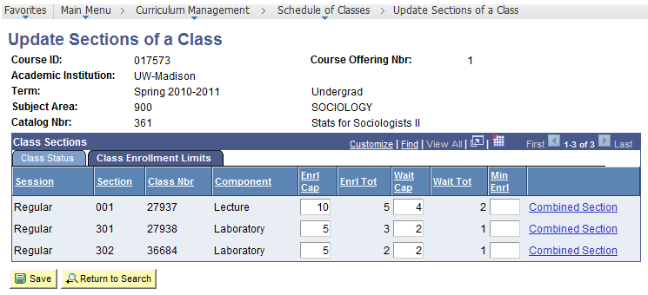
Select to see ‘true’ combined section enrollment & to change combined section enrollment capacity & wait list capacity.
Your Department’s Enrollment ONLY!
 | Select a Combined Section link. | Combined Section Detail page displays.
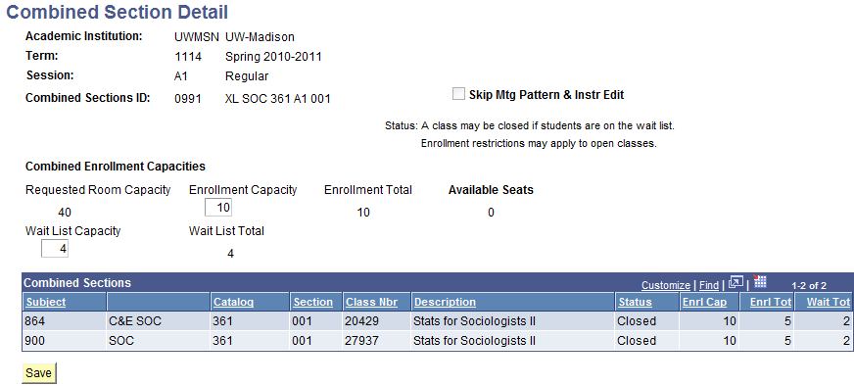
The numbers in these fields should all match.
Primary Sets
 | Update Enrollment Capacity  and, if using, Wait List Capacity. | New capacity displays.
 | Select [Save].
Select [Return] and, if needed, update your department’s Enrl Cap on the
Update Sections of a Class page and select [Save]. Then advise the other subject(s) to change their Enrl Cap on the Update Sections of a Class page and select [Save].
 | Go back and follow Step 4 through Step 8 for every Combined Section.

Combined Sections Detail Page Field Descriptions
The table below describes the fields found on the Combined Sections Detail page:
Field | Description
Academic Institution | This field always displays UW-Madison.
Term | A four-digit code representing century, year, and semester.  Semesters are as follows: Fall=2, Spring=4, Summer=6.  e.g. 1192=Fall 2018-2019, 1194=Spring 2018-2019.
Session | Represents the length and weeks a class meets. Regular sessions of full Fall and Spring terms are coded as A1. Courses meeting less than the full semester and summer term have a 3-letter code representing the Begin week, Span, and weeks of Instruction.
Combined Sections ID | The Combined Sections ID Description provides the following information: Sections Combined Code, Primary Department, Catalog Nbr., Session Code, and Section Nbr.  (e.g., XL MATH 240 A1 001)
Skip Mtg Pattern & Instr Edit | UW-Madison does not use this field.
Combined Enrollment Capacities
Requested Room Capacity | The projected classroom capacity for this section.
Enrollment Capacity | Enter COMBINED enrollment capacity for this section.  Note: The Enrollment Capacity should equal Enrl Cap for ALL subjects.
Enrollment Total | Number of students currently enrolled.
Available Seats | Number of seats left based on combined section enrollment capacity and the total enrollment to date.
Wait List Capacity | Enter COMBINED wait list capacity for this section.
Wait List Total | Number of students currently on the wait list.  Tip: Should match Wait Cap on Update Sections of a Class.
Combined Sections
Subject | Identifies the Academic Department. It is usually a three-digit numeric value with the subject’s name displaying to the right.
Catalog | The course number in a Subject Area as described in the Course Catalog.
Section | Every class is identified with a 3 digit Class Section number assigned by the user.
Class Nbr | A unique 5-digit number assigned to each section. This number can be used for student enrollment.
Description | Title of course.
Status | The status of the section: ‘Open’ or ‘Closed’.
Enrl Cap | The enrollment capacity for that section’s Class Nbr.
Enrl Tot | The total number of students enrolled through that particular section’s Class Nbr.
Wait Tot | The total number of students on the wait list through for that particular section’s Class Nbr.

Identify Combined Sections: Primary & Capacity
Step | Action | Result
 | Select from your Main Menu:  >Curriculum Management  >Combined Sections  >Identify Combined Section | The Find page displays.
 | Use the Find page to locate the desired subject area.  - Search by Term.  - Search by Combined Sections ID # if known.  - If Combined Sections ID # is unknown, fill in Description with the combined sections code (XL, MW, XM, SL) followed by a space and the short description for the primary department in ALL upper case letters  (e.g. XL MATH.) or change Description filter to ‘Contains’ and type your department’s short description in ALL CAPS. | The Identify Combined Sections page displays.  Tip: The Combined Sections ID # can be found on the >Curriculum Management >Schedule of Classes >Update Sections of a Class, on the |Class Enrollment Limits| page, and then select Combined Section link.  The Combined Sections ID Description provides the following information:  Sections Combined Code, Primary Department, Catalog Nbr., Session Code, and Section Nbr. (e.g., XL MATH 240 A1 001)  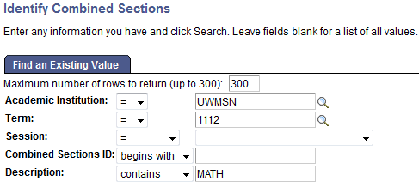  Enter one or the other
 | 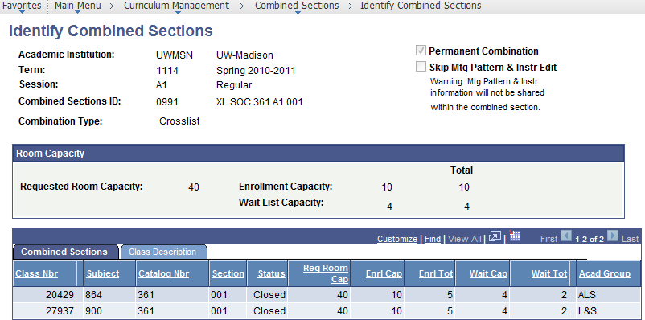

Identify Combined Sections Page Field Descriptions
The table below describes the fields found on the Identify Combined Sections page:
Field | Description
Academic Institution | This field always displays UW-Madison.
Term | A four-digit code representing century, year, and semester.  Semesters are as follows: Fall=2, Spring=4, Summer=6.  e.g. 1192=Fall 2018-2019, 1194=Spring 2018-2019.
Session | Represents the length and weeks a class meets. Regular sessions of full Fall and Spring terms are coded as A1. Courses meeting less than the full semester and summer term have a 3-letter code representing the Begin week, Span, and weeks of Instruction.
Combined Sections ID | The Combined Sections ID Description provides the following information: Sections Combined Code, Primary Department, Catalog Nbr., Session Code, and Section Nbr.  (e.g., XL MATH 240 A1 001)
Combination Type | Indicates the type of combined section: Crosslist, Meets With, Crosslist & Meets With, and Section Level Meets With.
Permanent Combination | All crosslist and some meets with combinations are permanent, and are indicated as such with a check in the box.
Skip Mtg Pattern & Instr Edit | UW-Madison does not use this field.
Combined Capacities
Requested Room Capacity | The projected classroom capacity for this section.
Enrollment Capacity | The COMBINED enrollment capacity for this section.  Note: The Enrollment Capacity should equal Enrl Cap for ALL sections.
Wait List Capacity | The COMBINED wait list capacity for this section.
Total | Number of students currently enrolled.  Number of students currently on the wait list.
Combined Sections Tab
Class Nbr | A unique 5-digit number assigned to each section. This number can be used for student enrollment.
Subject | Identifies the Academic Department. It is usually a three-digit numeric value.
Catalog Nbr | The course number in a Subject Area as described in the Course Catalog.
Section | Every class is identified with a 3 digit Class Section number assigned by the user.
Status | Indicates if the section is ‘Open’ or ‘Closed’.
Req Room Cap | Indicates the requested room size for this section.
Enrl Cap | The enrollment capacity for this section’s Class Nbr.
Enrl Tot | Number of students currently enrolled through each Class Nbr.
Wait Cap | The wait list capacity for this sections’ Class Nbr.
Wait Tot | Number of students currently on each Class Nbr’s wait list.
Acad Group | Identifies a school or college within the university.
Class Description Tab
Class Nbr | A unique 5-digit number assigned to each section. This number can be used for student enrollment.
Subject | Identifies the Academic Department. It is usually a three-digit numeric value.
Catalog Nbr | The course number in a Subject Area as described in the Course Catalog.
Section | Every class is identified with a 3 digit Class Section number assigned by the user.
Description | Title of course.

Wait List
You can set up sections of a course to create enrollment wait lists to the size you specify; you then monitor and determine who can enroll. Note: Wait Cap & Wait List Capacity do NOT term roll.
- When you add or change the Wait Capacity, make sure that all impacted components of the enrollment package are changed (e.g. Discussion, Lab and Lecture).
- If this is a Combined Section, each department must change their Wait Cap to match the combined sections Wait List Capacity.
- Students can only get on an open wait list until the session’s add deadline date.

Activating the Wait List Using Update Sections of a Class
Step | Action | Result
 | Select from your Main Menu:  >Curriculum Management  >Schedule of Classes  >Update Sections of a Class | The Find page displays.
 | Use the Find page to locate the desired course.  Search by: Term, Subject Area,  & Catalog Nbr | The course displays on Update Sections of a Class page.
 | Select |Class Enrollment Limits| page tab. | The capacities display for all sections.  Tip: Combined Sections may look open from this page; verify available seats by selecting  each section’s Combined Section link.
 | Locate the Wait Cap for the appropriate section(s) and  enter the wait list capacity.  Make sure that all impacted components of the enrollment package are changed  (e.g. Disc and Lecture). | The new wait capacity number displays for the section(s).  Tip: To stop further wait listing,  decrease the Wait Cap.  Note: If there is a Wait Cap, once the Enrl Cap is met, the Wait Tot will display the number of students on the wait list.  The wait list is available to students until the session’s add deadline date.
 | Select [Save]. | Any changes made are saved.
 | If this is a combined section,  a) Select Combined Section  link for the impacted section.  b) Change the Wait List Capacity  to match section’s Wait Cap.  c) Select [Save].  d) Select [Return].  e) Go back and follow Step 6 a-d  for every Combined Section  with a wait list. | Combined Section Detail page displays.  Tip: Primary Dept: Notify secondary subject(s) to update Wait Cap  on ‘Update Sections of a Class’ page.
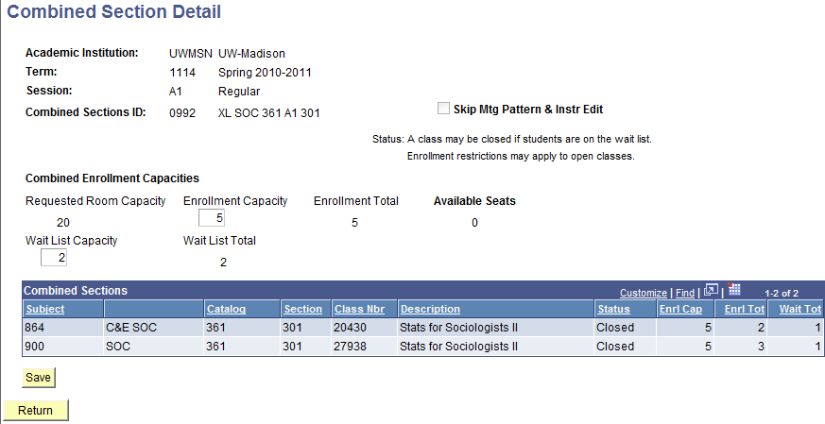
Tip: To assist with managing combined section wait lists, use this page: >Curriculum Management >Combined Sections >Identify Combined Sections. Search using Term, and for the Description, change search parameter to ‘contains’ and enter the subject’s short description in ALL CAPS. See Combined Sections ID, e.g. SOC.
Remember to review each section to see if there really are seats available.

Managing the Wait List
Step | Action | Result
 | Select from your Main Menu:  >Curriculum Management  >Wait List  >Manage Wait List | The Find page displays.
 | Use the Find page to locate the desired course.  Search by: Term & Subject Area | The specified Subject’s Courses with activated wait lists display.  Note: Combined Seats Available displays a number if this course is combined.  - A negative Seats Available indicates over enrolled.
 | 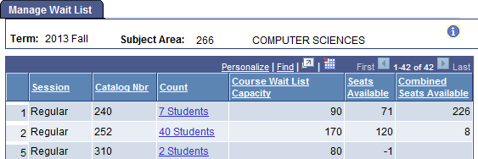
 | If a student is on a wait list,  Count is an active link;  Select Count for specific course wait list you want to review. | The Wait List Manager displays.  Note: Combined sections display  all subject’s wait lists.
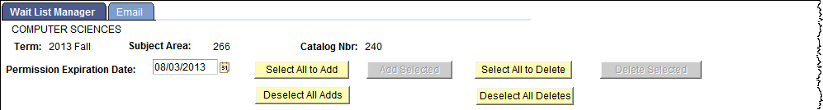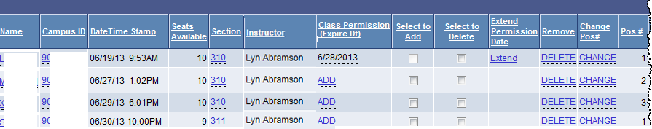
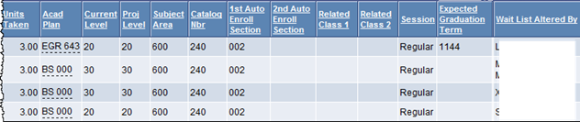

Depending on what you want to do, follow the steps below: * Access based on security
If you want to: | Then follow these steps for that student:
Give student permission to enroll*   Note: Permission Expiration Date defaults to 2 days from now & reverts back to this  if you Change or Delete  or leave the page. | a. If a different Permission Expiration Date is desired, enter new date.  b. Based on your needs, do one of the following:  - To allow one student to enroll,  select their ADD link.  - To allow multiple students to enroll,  check their Select to Add box and then  select [Add Selected].  - To allow all students to enroll,  select [Select All to Add] and then  select [Add Selected].  c. Select [Yes] to ‘Are you sure’ message.  d. Automatically the student is granted a permission that expires as indicated and a comment is added. The student is notified via email to enroll and you are emailed a copy.
Extend an expired  permission*   Note: The Extend Permission Date column and Extend link will only display if a previously granted wait list permission expired. | - If a different Permission Expiration Date is desired, enter new date.  - Select Extend.  - Select [Yes] to ‘Are you sure’ message.  d. Automatically the student’s original permission is extended to expire as indicated and a new comment is added. The student is notified via email to enroll and you are emailed a copy.
Delete student from wait list* | a. Based on your needs, do one of the following:  - To remove one student,  select their DELETE link.  - To remove multiple students,  check their Select to Delete box and then select [Delete Selected].  - To remove all students,  select [Select All to Delete] and then  select [Delete Selected].  b. Select [Yes] to ‘Are you sure’ message.  c. The student and you receive an email.  Note: If error regarding a hold displays,  contact Curricular Services to delete.
Change student’s wait list position BY SECTION* | a. Select CHANGE.  b. Type New Student Position number.  c. Select [Change Order].
View all student’s wait listed classes | a. Select Name.  b. Close View Wait List by Student when done.
View classes student already enrolled in* | a. Select Campus ID.  Tip: Look for Status of ‘Enrolled’.  b. Close Enrollment Detail when done.
View Class Detail | a. Select Section.  b. Select Return to Wait List Manager when done.
View student’s major(s)* | a. Select Acad Plan.  b. Close Academic Program Summary when done.
View wait listed student’s Email address | Select Email tab.
View Wait List Audit page | a. Select [Wait List Audit] button.  b. Close Wait List Audit when done.

Viewing Wait List by Student
You can view all the classes on a student’s wait list by term.
Step | Action | Result
 | Select from your Main Menu:  >Curriculum Management  >Wait List  >View Wait List by Student | The Find page displays.
 | Use the Find page to locate the desired student. | The View Wait List By Student page displays.
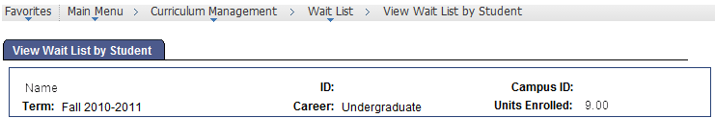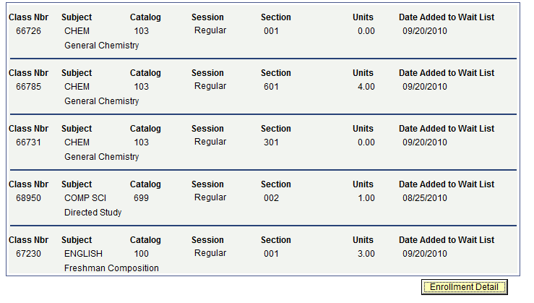
Note:
- All of the student’s wait listed classes display here. (Maximum is 3 sections.)
- All class components of the enrollment package display.
- The current number of units a student is already enrolled in displays in Units Enrolled.
- Select [Enrollment Detail] button to quickly jump to the Enrollment Detail page where you can see what the student has enrolled in, dropped, and wait listed. *

Wait List Audit
You can view a wait list audit report to assist you in managing your wait list more effectively. This page is dynamic and will reflect point-in-time data based on enrollment activity.
Step | Action | Result
 | Select from your Main Menu:  >Curriculum Management  >Wait List  >Wait List Audit | The Find page displays.
 | Use the Find page to locate the desired course. | The Wait List Audit page displays with only enrollment sections that involve the wait list.
 | 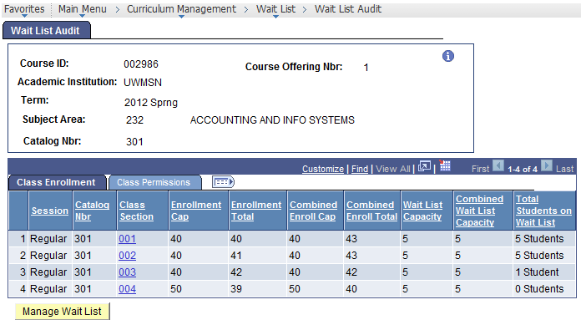
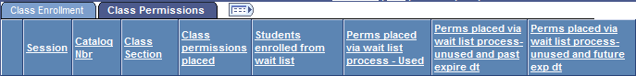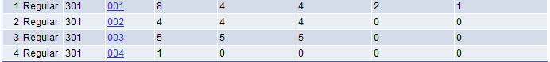
Tips: If Class Section displays as a blue link, then this is a Combined Section
& the |Class Permissions| totals reflect only this subject’s permissions.
 | Select Show All button. | Information from both tabs display on one page.  Use this information to assist your decision making.
 | If desired, select [Manage Wait List] to open that course’s waitlist detail. | Wait List Manager opens in a new window, press [Enter] and manage as you desire.  Close window when done.

Wait List Audit Field Descriptions
The table below describes the fields found on the Wait List Audit Page:
Field | Description
Class Enrollment
This page gives you enrollment and wait list capacities as well as combined enrollment and combined wait list capacities. This page includes the total number of students on the wait list for a given section of the class.
Session | Represents the length and weeks a class meets. Regular is the standard full Fall and Spring semester. Courses meeting less than the full semester and summer term have a 3-letter code representing the Begin week, Span, and weeks of Instruction.
Catalog Nbr | Course number in a Subject Area as described in the Course Catalog.
Class Section | Three-digit section number.  Tip: If Class Section displays as a blue link, then this is a Combined Section. Select section link to view Combined Section Detail page.
Enrollment Cap* | Subject’s enrollment capacity for this section.
Enrollment Total* | Subject’s number of students currently enrolled.
Combined Enroll Cap | Combined enrollment capacity for this section.
Combined Enroll Total | Number of students currently enrolled through this combined section.
Wait List Capacity* | Subject’s wait list capacity for this section.
Combined Wait List Capacity | Combined wait list capacity for this section.
Total Students On Wait List | Total number of students currently on this section’s wait list.  Note: Each term the Office of the Registrar clears all students from all wait lists, once this is done, this column will reflect ‘0’; all other column data will remain.
[Manage Wait List] | Opens Wait List Manager in a new window. Press [Enter].  Manage as you desire. Close window when done.

* If combined, this field displays only that subject’s totals.

Field | Description
Class Permissions
This page gives you information related to the number of class permissions placed.
The numbers on this page reflect only those permissions placed under your department.
Session | Represents the length and weeks a class meets.
Catalog Nbr | Course number in a Subject Area as described in the Course Catalog.
Class Section | Three-digit section number.  Tip: If Class Section displays as a blue link, then this is a Combined Section. Select section link to view Combined Section Detail page.
Class permissions placed | Total number of permissions granted on the Class Permissions page for this subject and this section. Counts all Status types.
Students enrolled from wait list | Total number of students who were on the wait list and are currently enrolled for this subject and this section.
Perms placed via wait list process – Used | Number of ‘Used’ permissions placed via the wait list ‘add’ process for this subject and this section.
Perms placed via wait list process – unused and past expire dt | Number of ‘Not Used’ permissions placed via the wait list ‘add’ process that have expired for this subject and this section.
Perms placed via wait list process – unused and future exp dt | Number of ‘Not Used’ permissions placed via the wait list ‘add’ process that are still eligible to be used (not expired) for this subject and this section.
[Manage Wait List] | Opens Wait List Manager in a new window. Press [Enter].  Manage as you desire. Close window when done.

Tip: If the last three columns (Perms placed via wait list process…) do not add up to the
‘Class permissions placed’, manual permissions have been granted as well.
Verify the status of those Class Permissions here: (if you have access)
>Curriculum Management >Schedule of Classes >Class Permissions

Class Permissions

Class Permissions Page
The Class Permissions page provides you the opportunity to give a student the ability to enroll for a certain section of a course as well as set/change an expiration date for their enrollment in that section. You can even specify under what conditions the permissions can be used. You may also remove a student’s unused permission from a class section.
Follow this menu path:
>Curriculum Management >Schedule of Classes >Class Permissions
The Class Permissions page looks like this:
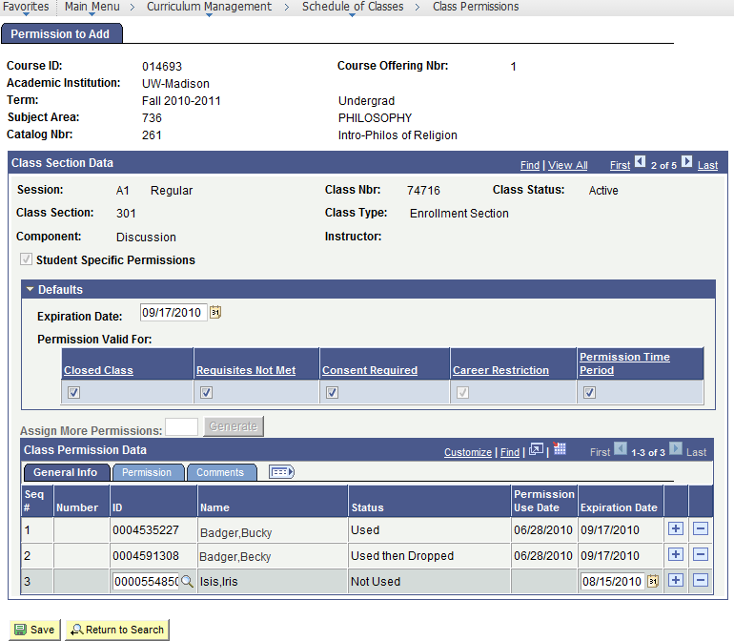

Class Permissions Field Descriptions
The table below describes the fields and buttons found on the Class Permissions page:
Field | Description
Course ID | A unique number assigned by the system when a course is first added to the Course Catalog.
Course Offering Nbr | Each course will have a Course Offering Number. Each member within a Crosslisted group has a different Course Offering Number.
Academic Institution | This field always displays UW-Madison.
Term | A four-digit code representing century, year, and semester.  Semesters are as follows: Fall=2, Spring=4, Summer=6.  e.g. 1192=Fall 2018-2019, 1194=Spring 2018-2019.
Subject Area | Identifies the Academic Department, usually a three-digit numeric value.
Catalog Nbr | The course number in a Subject Area as described in the Course Catalog.
Session | Represents the length and weeks a class meets. Regular sessions of full Fall and Spring terms are coded as A1. Courses meeting less than the full semester and summer term have a 3-letter code representing the Begin week, Span, and weeks of Instruction.
Class Nbr | A unique 5-digit number assigned to each section. This number can be used for student enrollment.  Tip: Give the Student the Class Nbr to make enrolling easier.
Class Status | Status of course is ‘Active’ or ‘Cancelled Section’.  Note: Only add student permissions to an ‘Active’ section.
Class Section | Every class is identified with a Class Section number assigned by the user. Course structure supports three types of instruction. The following ranges are used to assign section numbers:  - 001-299 Primary component type; usually lecture or seminar.  - 301-599 Second component type; usually discussion or laboratory.  - 601-899 Third component type, usually laboratory or discussion.
Class Type | Identifies if this section is a ‘Non-Enrollment Section’ or ‘Enrollment Section’.  Note: Only add class permissions to an ‘Enrollment Section’.
Component | Identifies the type of instruction for a class; typically Lecture, Discussion, Lab, Seminar, etc.
Instructor | Instructor of this section.
Student Specific Permissions | Automatically checked on an ‘Enrollment Section’ because Student Specific Permissions is the default permission mode.  Your department’s curricular services representative can change this.
 | Select to open the Session Dates and Deadlines page in a new window.
Defaults
Expiration Date | The date defaults to the add deadline for the session of that section.  Note: The defaults Expiration Date can be changed temporarily to drive the Expiration Date when adding new permissions; Once you leave the page, this field will revert back to the default date.
Permission Valid For: | The default is that a permission is valid for all conditions; meaning, the student will get into the class section no matter what. You can specify only under what condition(s) the student can use their permission.  ☑Closed Class  ☑Requisites Not Met  ☑Consent Required  ☑ Permission Time Period – KEEP CHECKED AT ALL TIMES
Assign More Permissions  [Generate]  (Set All Permissions to Issued) | Active and used when course is set up as unchecked/non ‘Student Specific Permissions’.  Type in the number of permissions you would like created and select [Generate].  Check if you want to mark all ‘general’ permissions as issued.  Note: Students can use the general number even if not ‘issued’.
Class Permission Data – General Info Tab
Seq # | Automatic numbering sequences as students are added to the list.
Number | If a general permission, the enrollment number to use.
ID | The EMPL ID of the student who was given permission to add this section.  Tip: If you do not know the student’s Empl ID, you can use the magnifying glass look up to search by the student’s Campus ID.
Name | The name of the student who was given permission to add this section.
(Issued) | Check to indicate general permission issued.
(Issued By) | The Id of the person who checked ‘Issued’ on the general permission.
(Issued Date) | The date the general permission was checked as ‘Issued’.
Status | Values include: Not Used, Used, Used but Waitlisted, Used then Dropped.
Permissions Use Date | The date the student used this class permission number to enroll.
Expiration Date | The date through which the student’s permission is valid.  After that day, their permission to enroll into this section expires.  You can change the Expiration Date here if needed.  Tip: Give the student a short enrollment period to use this permission.  To view Enrollment Deadlines for all terms, select [Dates and Deadlines] button or reference this page: >Records and Enrollment >Dates & Deadlines >Session Dates and Deadlines.  Note: When placing class permissions between a session’s ‘add’ deadline and the ‘drop’ deadline, you will need to change the Expire Dt to allow enrollment.  If a student needs permission to enroll in a section after the  drop deadline, the student needs to go to their Student Center and complete the Course Change Request to request a late add:  http://registrar.wisc.edu/course_change_request.htm
Class Permission Data – Permission Tab
☑ Checkboxes | You can specify only under what condition(s) this specific student can use their permission. Uncheck to turn off.  ☑Closed Class  ☑Requisites Not Met  ☑Consent Required  ☑ Permission Time Period – KEEP CHECKED AT ALL TIMES
Class Permission Data – Comments Tab
Comments | An optional free-form text field with a limit of 50 characters only seen on this page. Permissions granted through the Manage Wait list process, have this comment ‘Added via wait list process –‘id.
Class Permission Data – Show Tab
Show All Columns  Show Tabs | A toggle tab. Select [Show all Columns] to view all fields on one tab.  Select Show Tabs to return to multi-tab view.
Buttons
[+] | Select to Add a new student specific permission.
[-] | Select to Delete the permission to the left of this button.  Note: You cannot delete a ‘Used’ Permission.
[Save] | Select to Save all the additions, changes, and deletions you have made to this course.

Student Specific Permissions
A Student Specific Permission is strictly associated with a specific student to enroll in a specific course section. You will need the student’s Campus ID to enter the student’s permission.
If you are between the add deadline and the drop deadline, you will also need to change the permission’s expiration date. The drop deadline is the latest expiration date you can grant.
The student will still need to enroll in this course section. You have merely given them permission to enroll.
Student Specific Permissions are usually used for the following types of courses:
- Independent Study | - Closed Sections
- Directed Study | - Requisites Not Met
- Research Courses | - Wait List

Tips for Using Student Specific Permissions
- All classes default to Student Specific Permissions.
- Permissions should only be entered on an Active, Enrollment section.
- Members of combined sections must set up their own permissions.
- The Expiration Date defaults to the add deadline of the session.
- Permissions granted using the Manage Wait List process are automatically added here.
- Once a student uses the permission, it may not be deleted and the expiration date cannot be changed.
- You can view class permissions for any course in any department.
- Give the Student the Class Nbr to make enrolling easier.
- Once a student enrolls using the permission, they may drop and re-enroll through the Expiration Date.
- Section Changes:
For students already enrolled in a course, departments should enter class permissions for students requesting a section change. If the Add Deadline has passed, the student’s Expiration Date will need to be adjusted. The student can then use the ‘Swap’ feature through Web Enrollment to complete the section change. Using class permissions to accomplish section changes will be available through the Drop Deadline of the session the course is offered.

Student Specific Permissions can:
- Override Course Requisites
- Override Instructor or Department Consent
- Override Class Enrollment Limits
- Override Room Capacity
Note: Be sure the room can accommodate the total number of students.

Granting Student Specific Permissions
To give a student permission to enroll in a course section, follow the steps below:
Step | Action | Result
 | Select from your Main Menu:  >Curriculum Management  >Schedule of Classes  >Class Permissions | The Find page displays.
 | Use the Find page to locate the course you want to give the student permission to enroll in.  Search by:  -Term  -Subject Area & Catalog Nbr | The specified course displays on the Class Permissions page.
 | On |Permissions to Add|, find the ‘Active’, ‘Enrollment Section’  in which the student wants permission to enroll. | The correct enrollment section displays.  Tip: Use View All to see all sections; This makes it easier to scroll and find the specific enrollment section.
 | Verify that the Student Specific Permissions box is checked. | If the Student Specific Permissions box is not checked, this may be a general permission.
 | 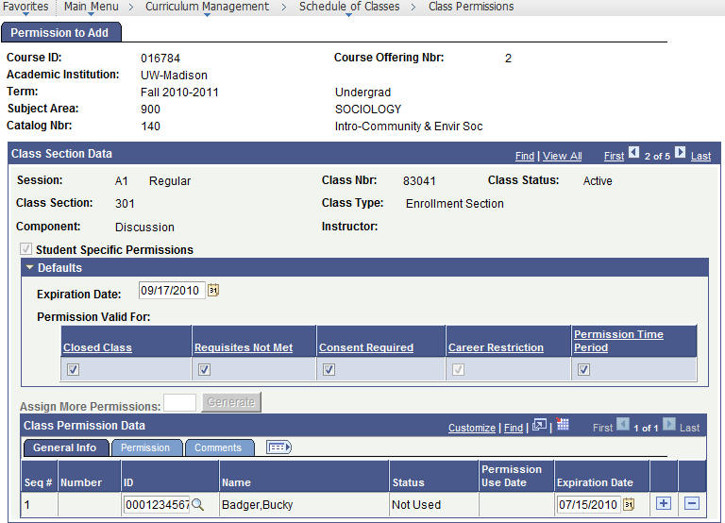
 | If desired, change any Defaults for new permission rows. | e.g. Expiration Date, Permissions Valid For
 | If ID field is filled in, select last [+] Add row. | A new blank row displays.
 | Select blank ID field’s magnifying glass look up. | Look Up ID box displays.
 | Enter student’s Campus ID. | Campus ID displays.
 | Select [Look Up]. | Search Results that match the look up criteria display.
 | Select student from search results. | ID and name of selected student displays.
 | If needed, change Expiration Date to the date through which student can use this permission. | Tips: Select [Dates and Deadlines]; latest expiration date is Drop Class Deadline.  View “Class Permissions Field Descriptions” section for more detail.
 | If you need to change the permission’s use conditions,  select |Permission| tab, and check the conditions when the permission can be used. | Allowed permission conditions are checked.  Reminders:  - Always keep ‘Permission Time Period’ checked.  - Keeping all items checked indicates the student’s permission can be used to enroll no matter what.
 | 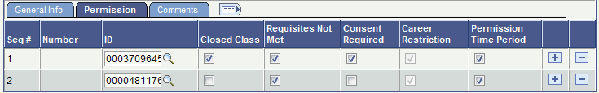
 | If you want to add comments to an individual’s permission, select |Comments| tab, and type Comments. | Comments display.  Note: Permissions granted through the Manage Wait list process, have this comment  “Added via wait list process -” id.
 | 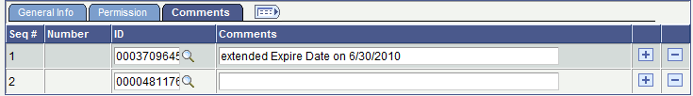
 | Select [Save]. | The student’s permission to enroll in this course section saves.

Tips: The student still needs to enroll in this course section.
You have merely given them permission to enroll.
When you notify the student to enroll, give them the Class Nbr to make enrolling easier.
Once a student enrolls using the permission, they may drop and re-enroll through their Expiration Date.

General Permissions
General Permissions may be set up and assigned to any section of a course. However, there is no tracking to verify which and to whom General Permission numbers have been assigned. General Permission numbers may get lost or used by the incorrect person; therefore, it is recommended that, when setting up General Permission numbers, you keep a written log that tells to whom each number is issued or use the Permissions |Comments| tab.
All classes are automatically indicated as Student Specific Permissions. To turn Student Specific Permissions off, contact your department Curricular Representative.

Tips for Using General Permissions
- Permissions should only be entered on an Active, Enrollment section.
- Members of combined sections must set up their own permissions.
- Permissions may override Enrollment Capacity, Requisites, and/or Consent.
- The student still needs to enroll in this course section.
You have merely given them permission to enroll.
- Once a student uses the permission, it may not be re-used even if expiration date has not been reached.
- Once a student uses the permission, it may not be deleted.
- Once a student uses the permission, the Expiration Date cannot be changed.

Assigning General Permissions
To create and view general permission numbers, follow the steps below:
Step | Action | Result
 | Select from your Main Menu:  >Curriculum Management  >Schedule of Classes  >Class Permissions | The Find page displays.
 | Use the Find page to locate the desired course.  Search by:  -Term  -Subject Area & Catalog Nbr | The specified course displays on the Class Permissions page.
 | Find the ‘Active’,  ‘Enrollment Section’ for which you want to assign permissions. | The correct enrollment section displays.  Tip: Use View All to see all sections.
 | Verify the Student Specific Permissions field is NOT checked & the section has an active field for Assign More Permissions. | If not, contact your Office of the Registrar’s Curricular Services Representative to uncheck ‘Student Specific Permissions’.
 | Change any of the Defaults. | Example: Expiration Date, Permissions Valid for:
 | Enter the number of permissions needed in the Assign More Permissions field. | The number of permission numbers requested displays.
 | 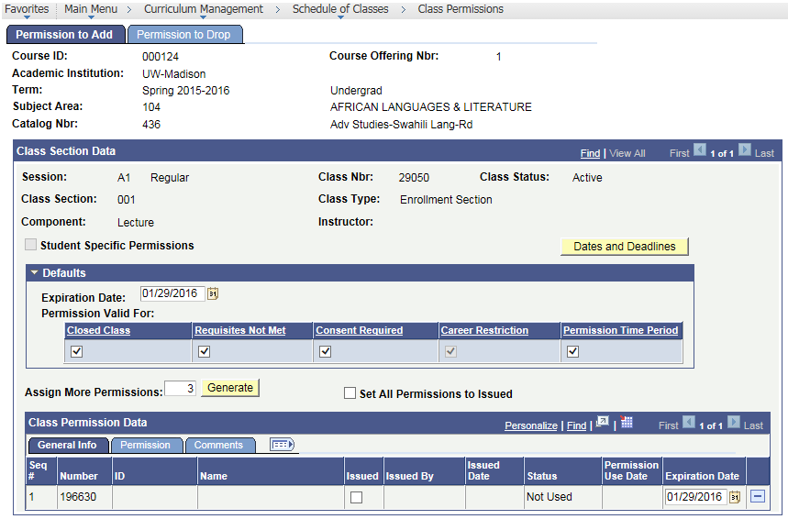
 | If you want to mark all permissions granted as ‘issued’, check ‘Set All Permissions to Issued’. | ‘Set All Permissions to Issued’ is checked.  Note: A student can use a permission even if it is  not ‘issued’.
 | Select [Generate]. | The number of permission numbers requested display as ‘Not Used’.  As these numbers are given to students, keep a record of which have been assigned. This could be done on the ‘Comments’ tab.  When a student uses the permission number, the page displays the name and ID of the student using the permission number and the status changes to ‘Used’.
 | Modify any of the other page tabs. | Updated information displays in fields.
 | Select [Save]. | The new general permissions are saved.

Next: Give the student the Class Nbr AND class permission Number to make enrolling in this section possible.
During Step 1 of the enrollment process, the student will be required to enter a ‘Permission Nbr’ in the Class Preferences area.

Permission to Drop Bundled Co-Requisite Course
You will only use this page to grant a student permission to drop a course that is part of a bundled set of co-requisite courses, like FIGs (first year interest groups) through the drop deadline of the session the course is offered.
When NOT to use | A student can drop a ‘standard’ course using their student center through the drop deadline of the session the course is offered; after the drop deadline, the student should contact their current academic dean’s office.
To grant a permission to drop a course section, follow the steps below:
Step | Action | Result
 | Select from your Main Menu:  >Curriculum Management  >Schedule of Classes  >Class Permissions | The Find page displays.
 | Use the Find page to locate the course you need to give the student permission to drop.  Search by:  -Term  -Subject Area & Catalog Nbr | The specified course displays on the Class Permissions page.
 | Select |Permissions to Drop| tab. | The Permission to Drop page displays.
 | Find the ‘Active’, ‘Enrollment Section’ in which the student wants permission to drop. | The correct enrollment section displays.  Tip: Use View All to see all sections.
 | 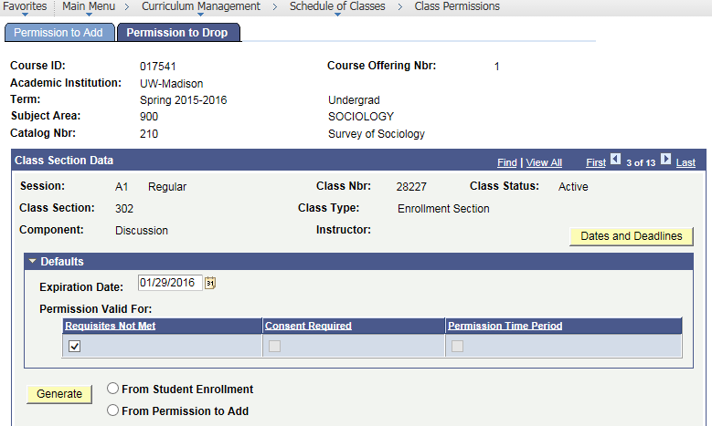
 | If desired, change Default Expiration Date for new rows. | Defaults Expiration Date changes.
 | 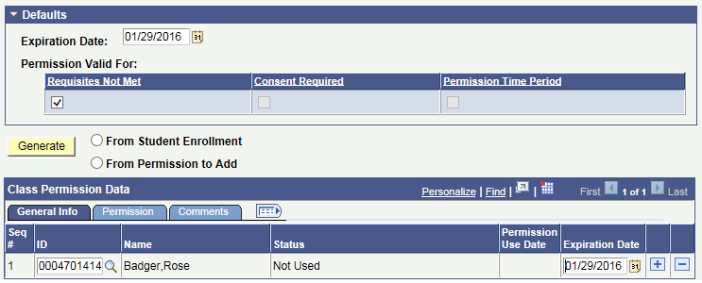
Depending on who you want to grant drop permission to, follow the proper steps below:
To select: | Then follow these steps:
A specific student | a. If ID field is filled in, select last [+].  b. Select blank ID field’s magnifying glass look up.  c. Enter student’s Campus ID  d. Select Look Up.  e. Select student from search results.
All enrolled students | a. Select From Student Enrollment.  b. Select [Generate].  c. If you want to remove any of the students,  select their [-] Delete button.
All students granted permission | a. Select From Permission to Add.  b. Select [Generate].  c. If you want to remove any of the students, select their [-] Delete button.

 | If needed, change Expiration Date to the date through which student can use this permission. | Tip: Select [Dates and Deadlines]; latest expiration date is Drop Class Deadline.
 | If you want to add comments to an individual’s permission, select |Comments| tab, and type Comments. | Comments display.
 | Select [Save]. | The student’s permission to drop this section saves.

Session Dates and Deadlines
This page provides information about the term and session parameters; such as description, category, session code, beginning and ending dates, and weeks of instruction and key deadlines.

Accessing Session Dates and Deadlines
To access Session Dates and Deadlines, follow the steps below:
Step | Action | Result
 | Select from your Main Menu:  >Records and Enrollment  >Date and Deadlines  >Session Dates & Deadlines | The Find page displays.
 | Use the Find page to locate the desired term.  Search by:  - Academic Career  - Term  - Session | The Session Dates and Deadlines page displays for the Session you selected.
 | 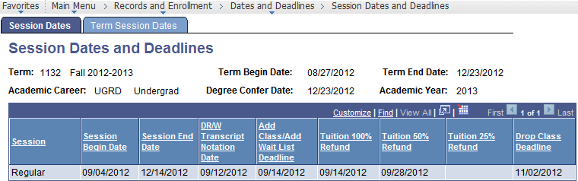
 | Select |Term Session Dates| tab. | All the sessions for the term display.
 | 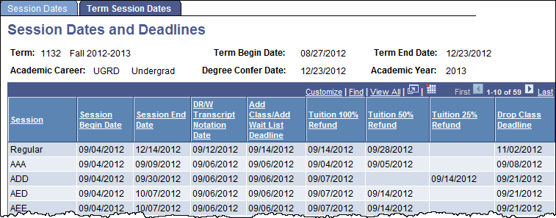

Session Dates and Deadlines Page Field Descriptions
The table below describes the fields found on Session Dates and Deadlines page:
Field | Description
Term | A four-digit code representing century, year, and semester.  Semesters are as follows: Fall=2, Spring=4, Summer=6.  e.g. 1192=Fall 2018-2019, 1194=Spring 2018-2019.
Term Begin Date | The beginning date of the term. This is NOT the first day of class.
Term End Date | The end date of the term. This is NOT the same as the last day of class.
Academic Career | The different calendar dates by career: Undergrad, Grad, Medical, etc.
Degree Confer Date | Official Graduation day used when posting degrees for term.
Academic Year | Academic year of term.
Session | Represents the length and weeks a class meets. Regular sessions of full Fall and Spring terms are coded as A1. Courses meeting less than the full semester and summer term have a 3-letter code representing the Begin week, Span, and weeks of Instruction.  - B = The week the class begins meeting.  - S = The number of weeks the class spans.  - I = The number of weeks of instruction during that span.  For example, the DHE session begins in the 4th week of the full semester (D), spans 8 weeks (H), and has 5 weeks of instruction (E).
Session Begin Date | First day of session code.
Session End Date | Last day of session code.
DR/W Transcript Notation Date | Last day to Drop Courses or Withdraw from University without DR or W grade notation on Transcript.
Add Class/Add Wait List Deadline | Last day to Add Courses without Departmental approval and last day to get on available wait lists.
Tuition 100% Refund | Last day for 100% tuition adjustment on dropped classes. If blank, the tuition adjustment calendar for the term/session has not been created yet.
Tuition 50% Refund | Last day for 50% tuition adjustment on dropped classes. If blank, the tuition adjustment calendar for the term/session has not been created yet.
Tuition 25% Refund | Last day for 25% tuition adjustment on dropped classes. If blank, the tuition adjustment calendar for the term/session has not been created yet.
Drop Class Deadline | Last day to Drop Courses.

Enter Textbooks
In order to add, change, or display textbooks on a class section, follow the steps below:
Step | Action
 | Select from menu >Curriculum Management >Textbook Entry >Enter Textbook Information
 | Find the specific section of the course that needs textbooks added or edited.
 | If textbooks are already displaying and you want to edit, select [Edit].
If the textbooks page is empty, you can copy all textbook information from another class section into this empty section by following the steps below:
- Select [Copy From Another Class].
- Find the course you want to copy from using Term, Subject Area, Catalog Nbr., Class Sect
 | If no textbooks, check ✓ ‘Select to indicate...no textbooks’(autosaves);Click [Return to Search]
Enter or edit textbook information as desired:
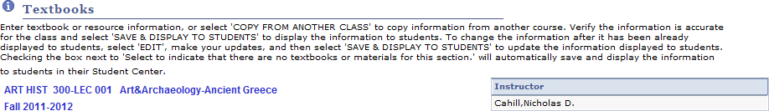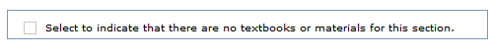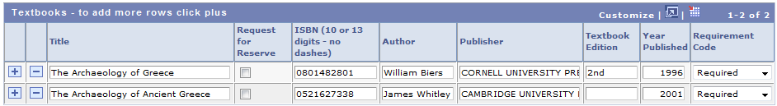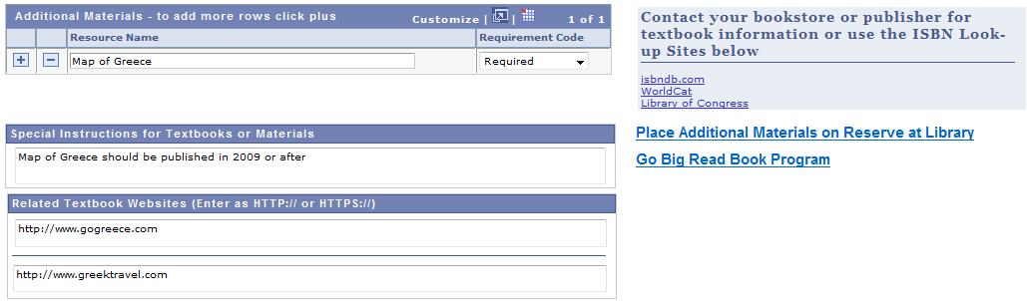
Saves and displays all textbook information in Class Search and to enrolled students in their Student Center. (step 8)
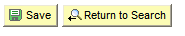
Tips: To add a new row, select [+]. To delete a row, select [-].
For assistance: select ‘i'; email textbook@em.wisc.edu; call 262-0920 or 2-6345.
Contact your bookstore regarding textbook editions, desk copies or order quantities.
 | If not ready to display textbooks to students, select [Save] to save entered textbook information.
 | If ready to display textbooks to students, select [Save & Display To Students].

Textbook Report: View Missing or Not Displayed Textbooks
To quickly audit which courses and/or sections in your subject have missing or partially entered textbook information, you can run the Missing Textbook Report on a term-by-term basis.
This report identifies textbooks as missing from a section if:
- No textbook information was entered, -or-
(Tip: If a section will not have any textbook information, on the Enter Textbooks page,
check ‘☑ Select to indicate…no textbooks…’; thereby, removing section from report.)
- Textbook information was entered but only saved.
(Tip: On the Enter Textbooks page, select [Save & Display to Students];
thereby, removing section from report.)
To run the Missing Textbook Report, do the following:
Step | Action | Result
 | Select from your main menu:  >Curriculum Management  >Textbook Entry  >Missing Textbook Report | The Find page displays.
 | Use the Find page to search by Term and Subject Area numbers. | The Missing Textbook Report page displays.
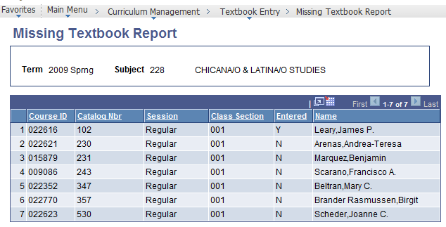
Tips:
- Entered ‘N’ means no textbook information entered.
- Entered ‘Y’ means textbook information entered & saved but NOT displayed.
- Only the first component type displays (sections numbered 001-299).
- To change sort order, select desired underlined heading.
- For assistance: email textbook@em.wisc.edu, call 262-0920 or 262-6345.
- Reference instructions for Entering Textbooks here:
Faculty: https://learn.sis.wisc.edu/training/uploads/textbooksfc.doc
SIS: https://learn.sis.wisc.edu/training/uploads/textbookssis.doc

Instructor Provided Content Entry
In order to add, change, or display actual course content for a class section, follow the steps below:
Step | Action
 | Navigate to >Curriculum Management >Textbook Entry >Instructor Provided Content.
 | Find the specific section of the course that you want to add or edit instructor provided content.
 | If content is already displaying to students, and you want to edit, select [Edit].
If the content page is empty, you can copy all instructor provided content from another class section into this empty section by following the steps below:
- Select [Copy From Another Class].
- Find the course you want to copy from using Term, Subject Area, Catalog Nbr., Class Sect
Enter or edit content information as desired:
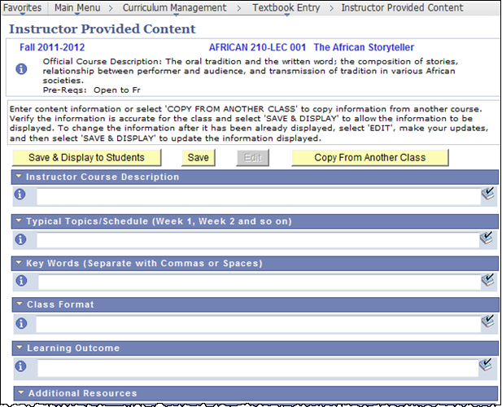
Tips: For assistance on expected content and usage of each field, select ‘i’ button.
To spell check, select each book with check button.
 | If not ready to display content to students, select [Save] to save entered information.
 | If ready to display content to students, select [Save & Display to Students].
 | To enter content for a different class section, select [Return to Class Selection].

Class Roster
Use to view students who are Enrolled, Dropped, or Waiting for a specific course section.
Note: Class rosters can also be seen and/or printed from the Query Library
as well as when an instructor signs onto My UW Madison.
Step | Action | Result
 | Select from your Main Menu:  >Curriculum Management  >Class Roster  >e-Class Roster | The Find page displays.
 | Use the Find page to locate the desired course.  Search by:  -Term  -Subject Area & Catalog Nbr  -AND Class Section  OR  -Term & Class Number | The specified course displays on the Class Roster page with Enrolled Students displayed.  Note: Student Enrollment Status defaults to ‘Enrolled’.  If this is a combined section, the class roster displays ALL students enrolled; not just students enrolled through your department.
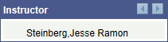
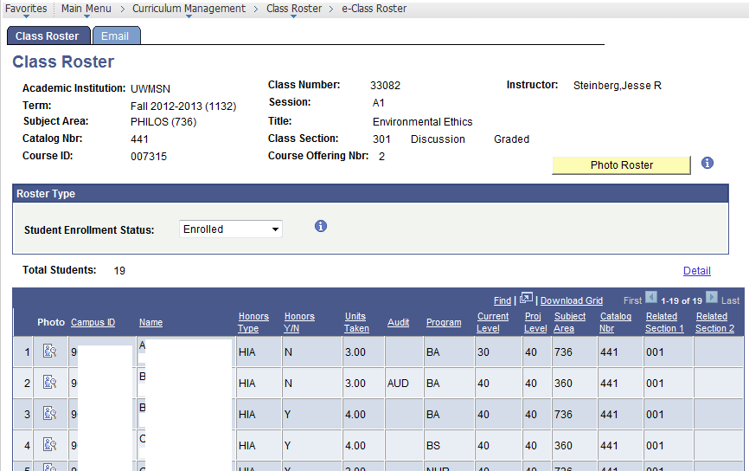
 | If you want to export your roster to a spreadsheet, select Download Grid. | Another browser window displays and a File Download dialog box will display, select ‘Open’.
 | If you want to view the Photo Class Roster, select [Photo Roster]  . | Another browser window displays; sign on with your netid & password; on the File Download dialog box, select [Open]; Photo Roster of enrolled students displays; Close window when done.
 | View the roster or emails by the desired Student Enrollment Status.  - Dropped (as of 1st class day)  - Enrolled  - Waiting (displays in alpha order) | Note: When you select a different Student Enrollment Status from the drop-down list, the view changes automatically.  Tips: ‘Waiting’ displays students in ALPHA order, NOT in their priority order. Use |Email| tab to see Date Added to wait list.  See Appendix for Class Roster Access Tips.
 | 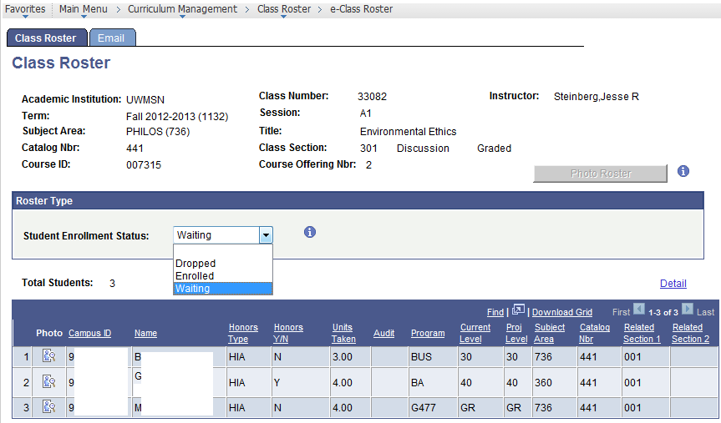
 | If you want Wait List assistance, select ‘i’ icon, next to Student Enrollment Status. | An Enrollment Wait List help window opens.  Close window when done.
 | If you want field assistance,  select upper ‘i’ icon, . | The Class Roster Help Index window opens.  Close window when done.  Continues on next page…
 | If you want to see the students’ email addresses, select |Email| page tab. | The class roster displays with the email addresses showing.  Note: Instructors can create an Email Distribution list through DoIT that is automatically kept up to date using the Enable and ModifyYour Class List.  Once the list is created, a Send Email link will display as well as the classlist email address.
 | 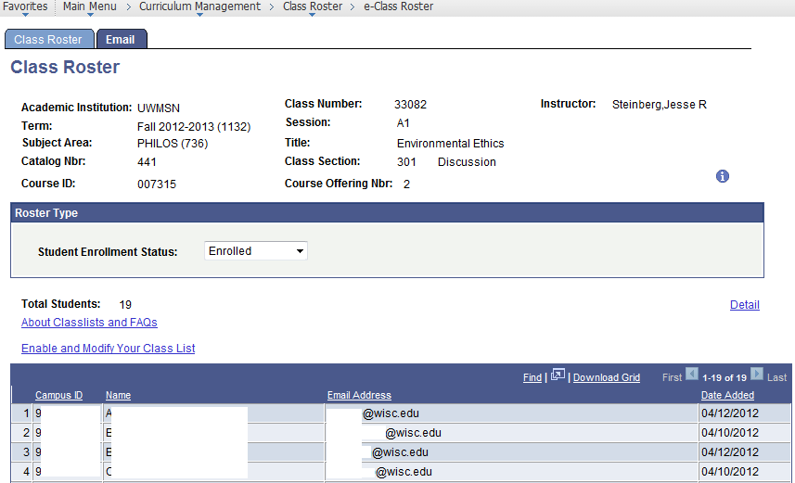
 | If you want to view the Class Detail, select Detail link and then select [Return to Class Roster] when you are done. | The Class Detail window displays.  Continues on next page…
 | 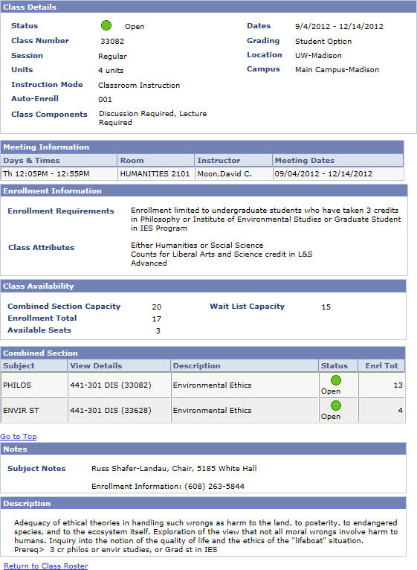

Class Roster Page Field Descriptions
The table below describes the fields found on the Class Roster Page:
Field | Description
Academic Institution | This field always displays UWMSN for UW-Madison.
Term | A four-digit code representing century, year, and semester.  Semesters are as follows: Fall=2, Spring=4, Summer=6.  e.g. 1192=Fall 2018-2019, 1194=Spring 2018-2019.
Subject Area | Identifies an instructional unit that has a discrete grouping of courses. It is usually a three-digit numeric value.
Catalog Nbr | The course number in a Subject Area as described in the Course Catalog.
Course ID | A unique number assigned by the system when a course is first added to the Course Catalog.
Class Number | A unique 5-digit number assigned by the system. This number can be used for student enrollment.
Session | Represents the length and weeks a class meets. Regular sessions of full Fall and Spring terms are coded as A1. Courses meeting less than the full semester and summer term have a 3-letter code representing the Begin week, Span, and weeks of Instruction.
Title | The course title.
Class Section | Displays section number and component type (e.g., lecture, lab), and if it’s the Graded or Non-Graded Component.
Course Offering Nbr | Each course has a Course Offering Number.  Each member within a Crosslisted group has a different Course Offering Number.
Instructor | Instructor’s preferred name if provided, otherwise primary name.
 | Select to view Photo Roster of enrolled students for this section.
 | Opens a help window. Close window when done.
Student Enrollment Status | Defaults to ‘Enrolled’. You can also display ‘Dropped’ and ‘Waiting’.  Note: The information related to ‘dropped’ students only appears for students who have dropped a section once the first day of the session occurs.  The ‘Waiting’ list displays in alpha order, not priority order.  If helpful, the Email page tab displays Date Added.
Total Students | Number of students enrolled, dropped, or waiting for this section.
Detail | Select Detail to see Class Detail page.
Download Grid | Select Download Grid link to open the class roster in a spreadsheet.  Note: See Appendix for Class Roster Access Tips.
Photo | Select icon to view this student’s campus ID photograph.
Campus ID | Campus ID of student.
Name | Student’s preferred name if provided, otherwise primary name.
Honors Type | Indicates whether section is offered for Honors (HON, HOP, or HIA).
Honors Y/N | Displays ‘Y’ or ‘N’ if student chose to take honors class for honors.
Units Taken | Number of credits student enrolled for.
Audit | Displays ‘AUD’ if the student is auditing the course.  A blank audit field means the student is not auditing the section.
Program | Academic Program of student.
Current Level | Current academic level of student.
Proj Level | Projected academic level of student.
Subject Area | Identifies the Academic Department through which the student enrolled.
Catalog Nbr | The course number through which the student enrolled.
Date Dropped | The Date Dropped is the date the student dropped this section; this will only display once the first day of the session occurs.  Note: This field only appears when Student Enrollment Status of ‘Dropped’ is selected.
Related Section 1 | Information displays if multi-component course. Currently, these fields display only non-auto enroll components or optional components.
Related Section 2 | Information displays if multi-component course. Currently, these fields display only non-auto enroll components or optional components.

Class Meeting Information: Maintain Schedule of Classes
To view course meeting information for a specific term, follow the steps below:

Accessing and Viewing Class Meetings Information
Step | Action | Result
 | Select from your Main Menu:  >Curriculum Management  >Schedule of Classes  >Maintain Schedule of Classes | The Find page displays.
 | Use the Find page to locate the desired course.  Search by:  -Term  -Subject Area  -or- Subject Area & Catalog Nbr | Maintain Schedule of Classes displays.
 | Select |Meetings| page tab. | The Meetings page displays.  Tip: Select View All to find the appropriate section.
 | 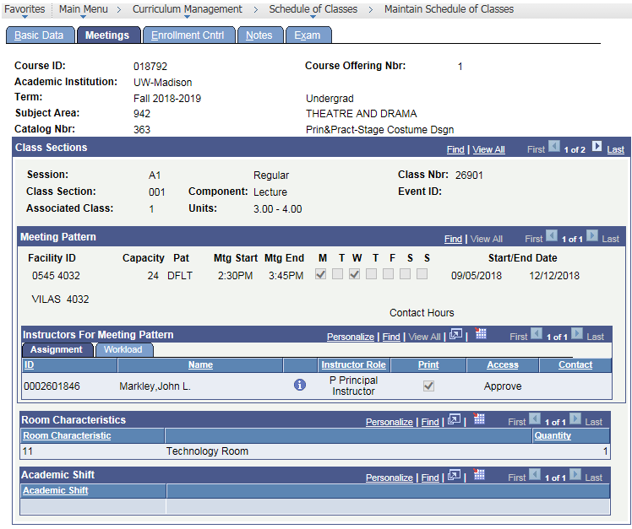

Meetings Page Field Descriptions
The table below describes the fields and links found on the Meetings page:
Field | Description
Course ID | A unique number assigned by the system when a course is first added to the Course Catalog.
Academic Institution | This field always displays UW-Madison.
Term | A four-digit code representing century, year, and semester.  Semesters are as follows: Fall=2, Spring=4, Summer=6.  e.g. 1192=Fall 2018-2019, 1194=Spring 2018-2019.
Subject Area | Identifies the Academic Department. It is usually a three-digit #.
Catalog Nbr | The course number in a Subject Area as described Course Catalog.
Course Offering Nbr | Each course will have a Course Offering Number. Each member within a Cross-listed group has a different Course Offering Nbr.
Class Sections
Session | Represents the length and weeks a class meets. Regular sessions of full Fall and Spring terms are coded as A1. Courses meeting less than the full semester and summer term have a 3-letter code representing the Begin week, Span, and weeks of Instruction.
Class Section | Every class is identified with a 3 digit Class Section number assigned by the user.
Component | Identifies the type of instruction for a class; examples include Lecture, Discussion, Lab, Seminar, etc.  Each course can have up to three types of instruction.
Class Nbr | A unique 5-digit number assigned to each section. This number can be used for student enrollment.
Event ID | Automatically generated by the system.
Associated Class | Association numbers match ‘Enrollment’ section numbers.  All ‘Non-Enrollment’ sections are Association number 9999.
Units | The number of units or credits for which this section is being offered. If applicable, this may display a range of units.
Meeting Pattern
Facility ID | A 10-character field. The first five characters define the building/wing code. The last five digits define the room number. Typically, only two groups of four numbers display.
Capacity | The seating capacity for the room displayed in Facility ID field.
Pattern | Codes that indicate the day(s) of the week the class meets and the default length of class.
Mtg Start | The time the class begins.
Mtg End | The time the class ends.
M T W T F S S | The days of the week that the class meets are checked.
Start/End Date | Start and end date for the session. Session dates display here if the class meets less than the whole semester.
Topic Id | UW-Madison does not use this field.
Free Format Topic | UW-Madison does not use this field.
Print Topic on Transcript | UW-Madison does not use this field.
Contact Hours | UW-Madison does not use this option.
Combined Sections | This only displays on combined sections.  Note: Go to >Curriculum Management >Schedule of Classes >Update Sections of a Class, |Class Enrollment Limits| page to see Combined Sections detail.
Instructors for Meeting Pattern
ID | The system ID for an instructor.
Name | Instructor’s name displays after their ID is identified.
Instructor Role | UW-Madison does not use this field.
Print | UW-Madison does not use this field.
Access | Level of grading rights: Approve, Grade, No Access.  When there are multiple instructors for a section, the instructor identified as Grade access will print on the grade roster.
Contact | UW-Madison does not use this field.
Room Characteristics
Room Characteristic | Indicates special room characteristics (i.e., Tech, Moveable Seating, etc.) requested.
Quantity | The desired quantity of the room characteristic (i.e., 2 screens).
Academic Shift
Academic Shift | UW-Madison does not use this field.

Instructor Schedule
This page provides information regarding an Instructor’s Schedule and which sections of a course an instructor is teaching. If a student knows they are studying independently with a specific instructor, use this page to view which section the instructor is teaching. This schedule includes only course scheduling.

Accessing Instructor Schedule
Step | Action | Result
 | Select from your Main Menu:  >Curriculum Management  >Instructor/Advisor Information  >Instructor Schedule | The Find page displays.
 | Search by Term and instructor Last Name and First Name. | Instructor Schedule page displays.  Tip: Contact Curricular Services if you are not finding a specific instructor.
 | 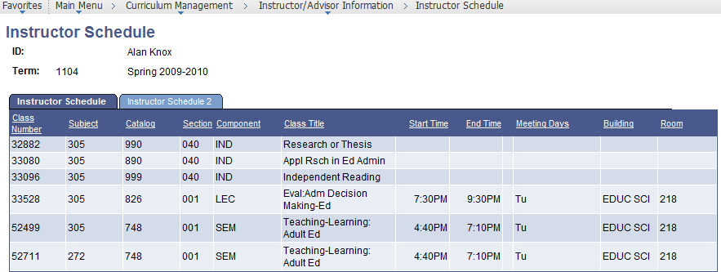
 | To see more details, select |Instructor Schedule 2| page tab. | Instructor Schedule 2 page displays.
 | 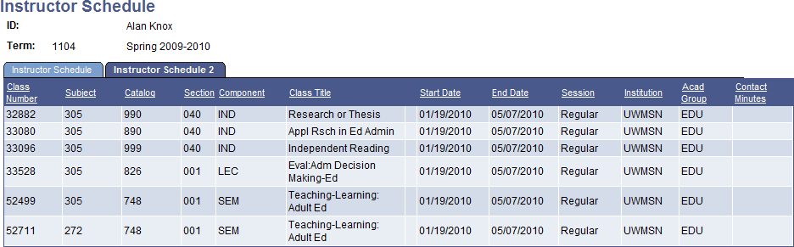

Instructor Schedule Page Field Descriptions
The table below describes the fields and links found on the Instructor Schedule page:
Field |  | Description
(Instructor Name) |  | The instructor’s full name.
ID |  | Instructor’s Empl ID number generated by the student system. It is a unique identifier for the instructor and will never be changed throughout the individual’s relationship with the University. This is not the same as Campus ID.
Term |  | A four-digit code representing century, year, and semester.  Semesters are as follows: Fall=2, Spring=4, Summer=6.  e.g. 1192=Fall 2018-2019, 1194=Spring 2018-2019.
Instructor Schedule
Class Number |  | A unique 5-digit number assigned by the system. This number can be used for student enrollment.
Subject |  | Identifies the Academic Department. It is usually a three-digit numeric value.
Catalog |  | The course number in a Subject Area as described in the Course Catalog.
Section |  | Every class is identified with a 3 digit Class Section number assigned by the user.
Component |  | Identifies the type of instruction established for the course; examples include Lecture, Discussion, Lab, Seminar, etc.  Each course can have up to three types of instruction.
Class Title |  | Title of class.
Start Time |  | The time the section starts.
End Time |  | The time the section ends.
Meeting Days |  | The days the section meets.
Building |  | The building name.
Room |  | The room number.
Instructor Schedule 2
ID (Instructor Name) | The instructor’s ID and full name.
Term | A four-digit code representing century, year, and semester.  Semesters are as follows: Fall=2, Spring=4, Summer=6.  e.g. 1192=Fall 2018-2019, 1194=Spring 2018-2019.
ID | Instructor’s Empl ID number generated by the system. It is a unique identifier for the instructor and will never be changed throughout the individual’s relationship with the University. This is not the same as Campus ID.
Class Number | A unique 5-digit number assigned by the system. This number can be used for student enrollment.
Subject | Identifies the Academic Department. It is usually a three-digit numeric value.
Catalog | The course number in a Subject Area as described in the Course Catalog.
Section | Every class is identified with a 3 digit Class Section number assigned by the user.
Component | Identifies the type of instruction established for the course; examples include Lecture, Discussion, Lab, Seminar, etc.  Each course can have up to three types of instruction.
Class Title | Title of class.
Start Date | Start date for the session.
End Date | End date for the session.
Session | Represents the length and weeks a class meets. Regular sessions of full Fall and Spring terms are coded as A1. Courses meeting less than the full semester and summer term have a 3-letter code representing the Begin week, Span, and weeks of Instruction.
Institution | This field always displays UWMSN for UW-Madison.
Acad Group | Identifies a school or college within the university.
Contact Minutes | UW-Madison does not use this field.

Class Associations: View Units, Honors, Graded & Optional Component
The Adjust Class Associations pages provide information regarding enrollment packages, credits, components, requisites, and honors for any given term. What distinguishes this component from others is it provides information by association instead of by class section or course.
Class Associations allow you to view:
- Specific credits/units for a class section for a specific term
- Grading basis
- Graded components
- Requirement Designation (honors)
- Class components for each association
- Optional and required components
- Final exam flag
- Requisites at catalog and/or association level

Class Association Tips
- When courses have variable credits and multiple sections, such as a Topics course, each section can have a different requisite, honors designation, and number of credits/units.
- While Course Catalog Data shows the range of variable units, Class Association shows the exact number of units for each section for a specific term.
- Associations are groups of sections that comprise an enrollment package within a course. Each class association can have different requisites, honors, and credits (i.e., one section for Honors only or First Year Students only).

Accessing and Viewing Class Associations
Step | Action | Result
 | Select from your Main Menu:  >Curriculum Management  >Schedule of Classes  >Adjust Class Associations | The Find page displays.
 | Use the Find page to locate the desired course.  Search by:  -Term  -Subject Area  -or- Subject Area & Catalog Nbr | The Class Associations page displays.  Tip: Use View All to find the correct Associated Class.  Associations of ‘9999’ do not display.  Note: You can view the Minimum and Maximum Units on this page.
 | 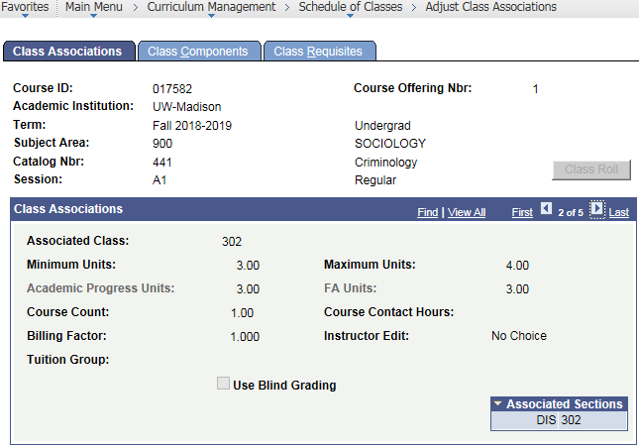
 | Select |Class Components| page tab. | The Class Components page displays.
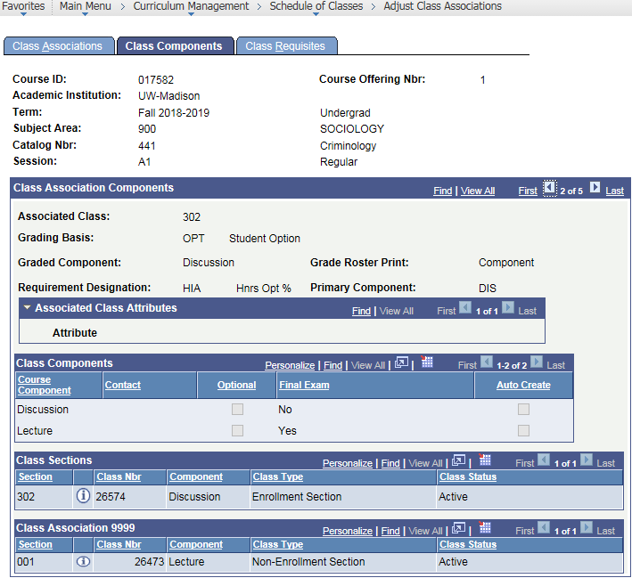

HON Honors
HON Honors
 | Select |Class Requisites| page tab. | The Class Requisites page displays.  Note: Catalog and Class Association Requisites are listed here.  See also next section, View Course Requisites.
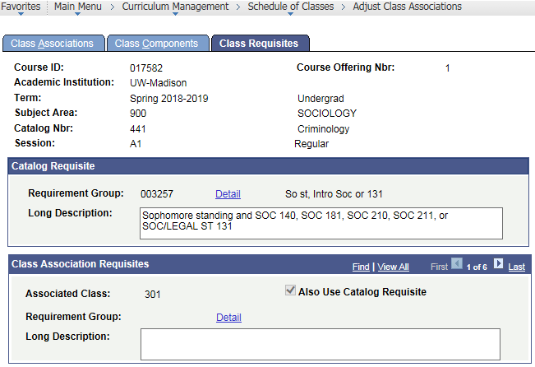
If checked, enrollment system enforces catalog requisites (above) AND Class Association Requisites (below).

If unchecked, only the lower Class Association Requisites is enforced. (uncommon)

Note: To view field descriptions of Class Associations,
reference the Curricular and Enrollment Inquiry manual
under the chapter entitled ‘Class Associations’.

View Course Requisites
You can view what requisites are placed on a particular course, at the catalog level and the class association level. This shows you what the enrollment system is enforcing when students enroll.

Viewing Course Requisites through Class Associations
Step | Action | Result
 | Select from your Main Menu:  >Curriculum Management  >Schedule of Classes  >Adjust Class Associations | The Find page displays.
 | Use the Find page to locate the desired course.  Search by:  -Term  -Subject Area  -or- Subject Area & Catalog Nbr | The Adjust Class Associations page displays.
 | Select |Class Requisites| page tab. | The Class Requisites page displays.  Note: Catalog and Class Association Requisites are listed on this page.
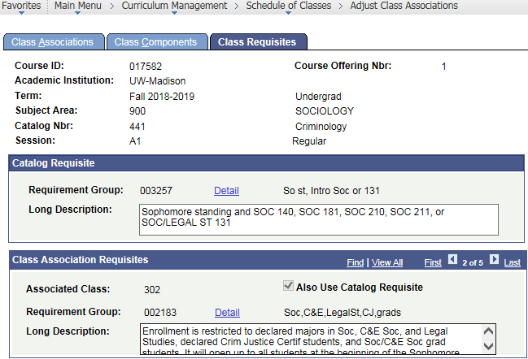
Catalog Requisite also enforced
IF checked,
 | If desired, select Detail to see the full detail of the requisite. | The Requirement Group Summary page displays.  Tip: Select [Cancel] when done viewing.  Note: View this section of the manual for more details: Requirement Group Summary Page Field Descriptions.
 | 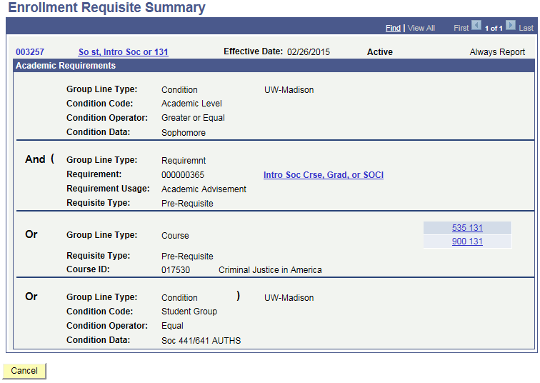

Enrollment Requisite Summary Detail
When a Requisite Group is made up of academic requirements, you can view the specifcations behind the requisite.

Accessing and Viewing the Enrollment Requisite Summary
Step | Action | Result
 | Select from your Main Menu:  >Curriculum Management  >Enrollment Requirements  >Enrollment Requisite Summary | The Find page displays.
 | Use the Find page to locate the desired course.  Search by:  -Requirement Group #, if known  -or-  -Academic Group  -Subject Area  -Catalog Number | The Enrollment Requisite Summary page displays.  Tip: Select [Search] to see all requirement groups.
 | 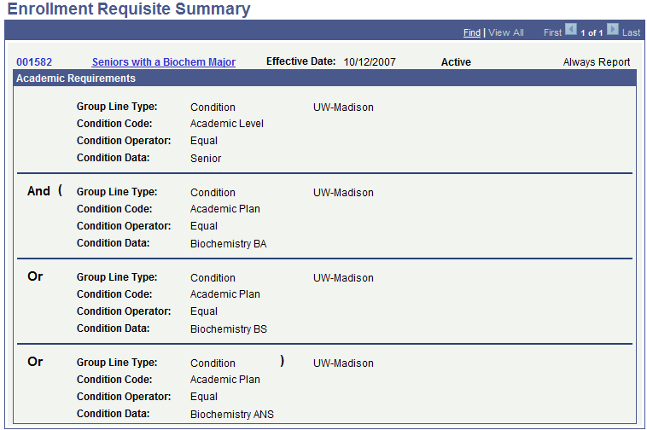
 | Select requirement group name link by the Requirement Group number. | Requirement Group Summary Description page displays.
 | 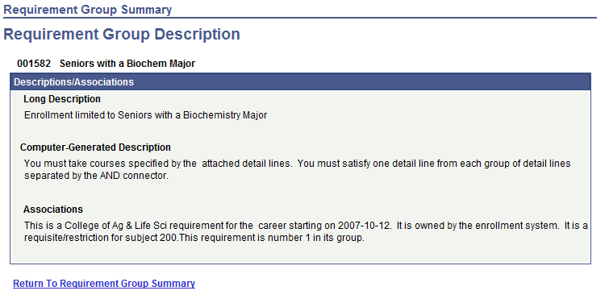
 | Select Return to Requirement Group Summary. | The Enrollment Requisite Summary page displays.

Requirement Group Summary Page Field Descriptions
The table below describes the fields found on the Requirement Group Summary page:
Field | Description
Requirement group number | Six digit number assigned by system when requirement group was created.
Requirement group name | Link to view Requirement Group Description.
Effective Date | Effective date given when requirement group was created.
Status | Indicates whether requirement group is ‘Active’ or Inactive’.
Always Report | UW-Madison does not use this field.
Group Line Type | Indicates if requirement group was created as ‘Condition, ‘Course’, ‘Requirement’, or ‘Wild Card Course’.
Next fields… | The next fields displayed depend on the Group Line Type.

Course Catalog
The Course Catalog displays all the courses that have been approved by Divisional Committees to be offered at the University of Wisconsin – Madison. All Course Catalog pages provide historical information, including courses that are no longer available to be taught (inactive courses). Data displayed on these pages define the parameters of these courses.
Curricular Services maintains the Course Catalog; therefore, they are the only group that can update course catalog data.
Use the Course Catalog to find out the following:
- The short and long titles for a course
- If a course is approved for variable units
- If a course may be repeated for credit
- If instructor consent is required for enrollment*
- How the course is graded
- Information regarding the components of a course *
- If a final exam is required for the course*
- The course description and any approved requisites, and catalog enforced requisites
- Honors information about the course *
- Course attributes
- Topics for the course
* These fields may be overridden on a specific Class Association for a particular term.

Accessing the Course Catalog
Step | Action | Result
 | Select from your Main Menu:  >Curriculum Management  >Course Catalog  >Course Catalog | The Find page displays.
 | Use the Find page to locate the desired course.  Search by:  -Subject Area  -or-  -Subject Area and Catalog Number | The Course Catalog page displays.  Search Tip:  To access all the courses within the department, enter Subject Area code. To narrow the search to a specific course, also enter Catalog Number.  The search only displays 300 results; therefore, if your department has more than 300 rows, you may need to use a wildcard search. Example: To see all 400 level classes, enter ‘4##’ in Catalog Nbr.
 | 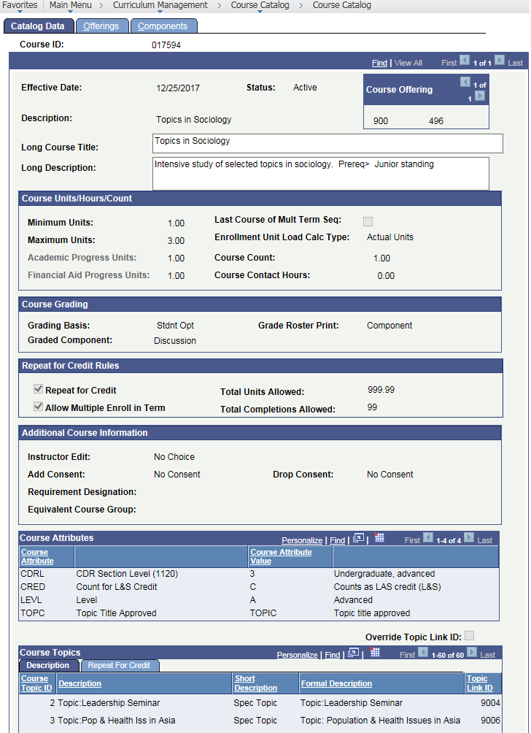
 | Select |Offerings| page tab to display its contents. | The Offerings page displays.
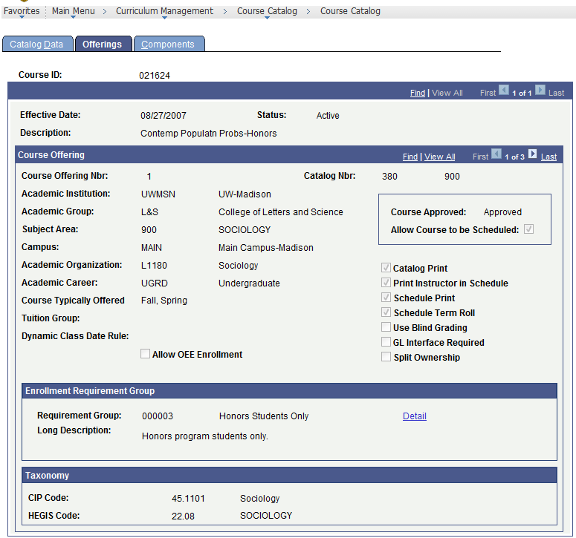

Continues on next page…
 | Select |Components| page tab to display its contents. | The Components page displays.
 | 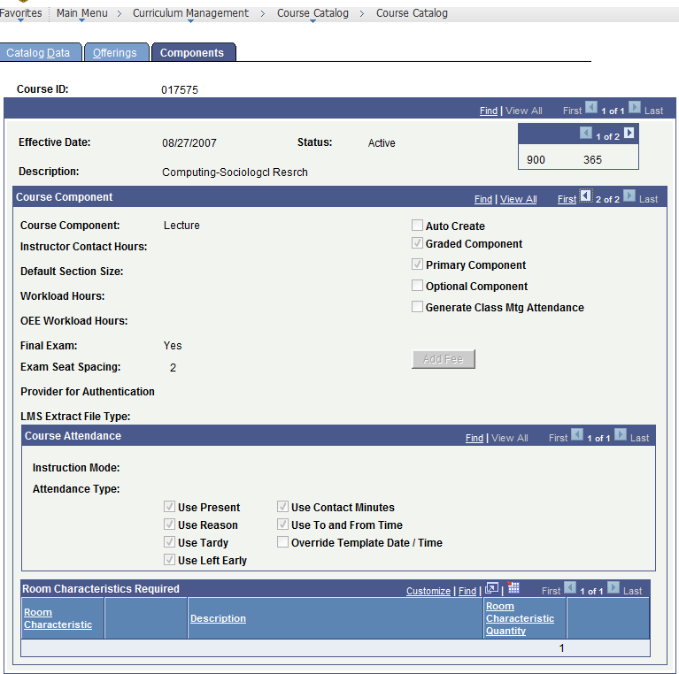

Note: To view field descriptions of the Course Catalog, reference the Curricular and Enrollment Inquiry manual under the chapter entitled ‘Course Catalog’.

Student Services Center
The Student Services Center is a view of what the student sees in their Student Center.
To view the Student Services Center in the student information system, follow the steps below:
Step | Action | Result
 | Select from your Main Menu:  >Campus Community  >Student Services Center | The Find page displays.
 | Use the Find page to locate the desired student. | The Student Services Center displays.
 | 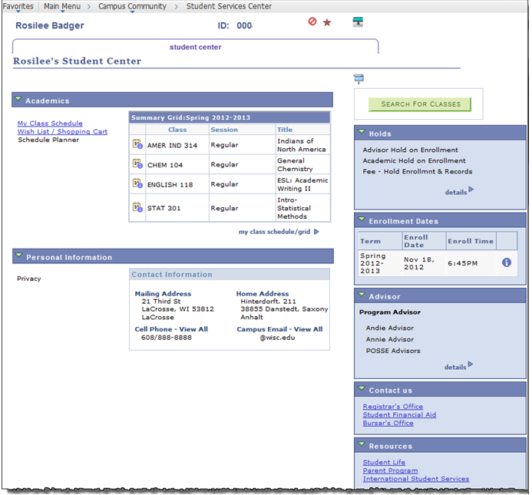
Select any desired links, icons, or ;
then when done, select [Cancel] or close extra window.
Tip: Select Wish List / Shopping Cart to view by term the courses this student has
indicated an interest in enrolling for as well as their actual class schedule.

Enrollment Detail & Grid

Purpose and Path
This page provides detailed information about a student’s enrollment for a specific term.
Follow this menu path:
>Records and Enrollment >Student Academic Information >Enrollment Detail

Enrollment Detail Page and Field Descriptions
The Enrollment Detail page looks like this:
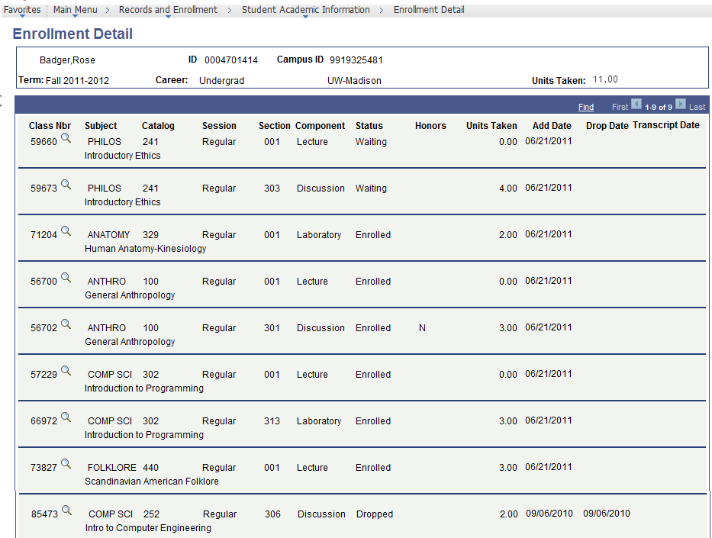
Important Page Information and Reminders
- If a student is on any Wait List, those classes display first, followed by enrolled sections.
If a student has dropped any sections as of the first day of class, dropped sections display last.
- If Session displays something other than “regular” for a fall or spring term, it means this is a modular course.
- This page displays only one term at a time. The easiest way to view a different term for the same student is to use [Return to Search], or if shown, use the [Previous in List] or [Next in List] button.
Field | Description
Term | The term in which the student is/was enrolled.
Career | All students belong to an academic career: Undergraduate, Graduate, Law, Medical, Pharmacy, Vetmed, or Univ Specials Students.
Units Taken | Number of credits student is enrolled in for the selected term.
Class Nbr | A unique 5-digit number assigned to each section. This number can be used for student enrollment.
Look Up | When selected, the look up will display more detail about the time and location of the course as shown below:  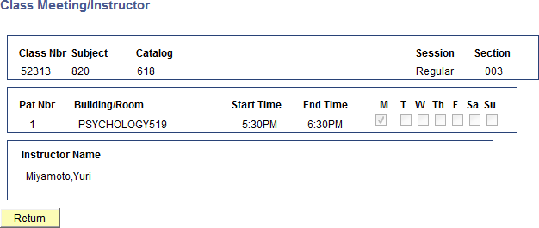  Note: To exit the Class Meeting/Instructor page, select [Return].
Subject | The department the student enrolled under.
Catalog | Course number (e.g. Math 111).
Session | Session in which the course was taken.
Section | The specific section number student enrolled in.
Component | The type of section (e.g. lecture, discussion, seminar, lab, etc.)
Status | Displays ‘Waiting’ if student on wait list for this section.  Displays ‘Enrolled’ if student taking this section.  Displays ‘Dropped’ if student is no longer taking this section.
Honors | For non-honors sections, this field displays as blank.  For honors sections, this field displays as a ‘Y’ for Yes if the student is taking the section for ‘Honors’ and as an ‘N’ for No if the student is not taking the section for honors.
Units Taken | The number of credits for that course.
Add Date | Date student enrolled in course.
Drop Date | Date student dropped course.
Transcript Date | Date of drop if different than Drop Date to be reflected on transcript.
Grid | When selected, the student’s Enrolled course grid for that particular term will display in a new window as shown below.  To change Display Options, select desired display options and select [refresh grid].  To exit, close the window when done viewing.
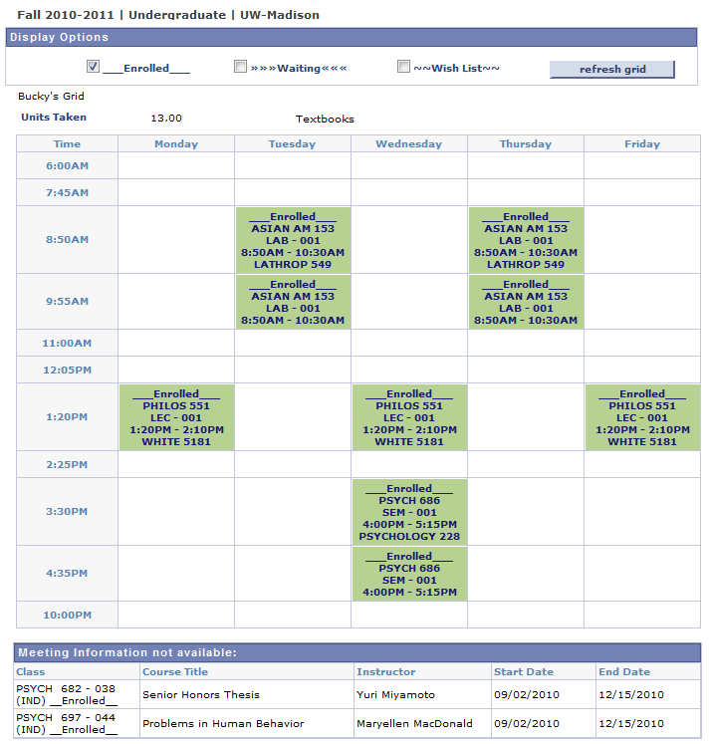

Student Enrollment History
The Student Enrollment History page is used primarily by Dean’s Offices to:
- Verify that a student had been enrolled or attempted to enroll in a specific course or to determine that a student dropped a course in error and needs to be re-enrolled.
- Verify if and when a Course Change Request was processed by the Registrar’s Office.
- Verify actual enrollment activity attempts, helpful in special circumstances.
- Verify error message student received when attempting enrollment activity.

Viewing Student Enrollment History
To view a Student’s Enrollment History, follow the steps below:
Step | Action | Result
 | Select from your Main Menu:  >Records and Enrollment  >Student Academic Information  >Student Enrollment History | The Enrollment Trail page displays.
 | 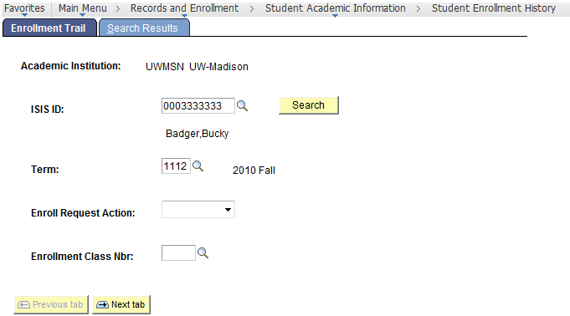
 | Use the SIS ID magnifying glass look up to locate the student’s ID.  Look up and select the student. | The student’s SIS ID appears on the Enrollment Trail page.
 | Enter Term. | Term number displays.
 | If you wish to limit your search to a specific type of enrollment action, select desired Enroll Request Action from the list. | Enroll Request Nbr. field is filled in.  Example: If you only want to see a student’s adds for a term, select ENROLL action.
 | If you wish to focus on the action of a specific enrollment component, enter Enrollment Class Nbr. | Enrollment Class Nbr. field is filled in.  Tip: If the Class Nbr is unknown, use the magnifying glass look up to find the number.
 | Select [Search]. | The Search Results page displays if there is a match.
 | 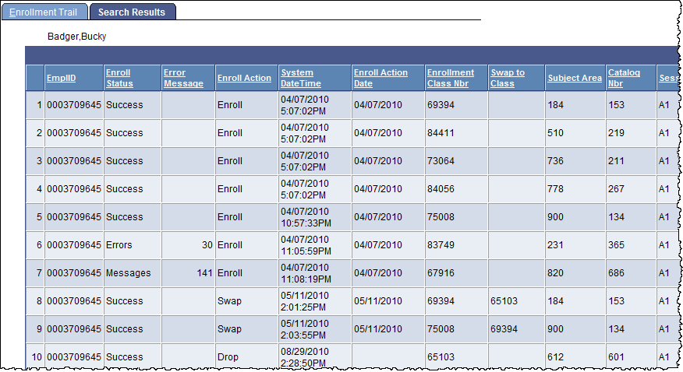
 | Use the Vertical and Horizontal scroll bars to view all student enrollment history fields. | Note: The rows display in ascending  System Date Time order; you can sort the columns differently, by selecting the desired column heading.  Reference Student Enrollment History Field Descriptions for full description of these columns.
 | If you are unsure of what the columns or error messages mean, select button at the top of the page. | Web page displays with summary of column codes.  Note: See all Enrollment Error Messages here: http://kb.wisc.edu/helpdesk/page.php?id=19277.

Student Enrollment History Search Results Field Descriptions
The table below describes the fields found on the Student Enrollment History Page:
Field | Description
 | Displays web page of student enrollment messages.
Empl ID (SIS ID) | Number generated by the system. It is a unique identifier for a student and will never be changed throughout the individual’s relationship with the University. This is not the same as Campus ID.
Enroll Status | Indicates the result of the enrollment action.  Success  Errors  Messages (success)  Pending (transaction saved but not submitted)  (Dates & times aren’t displayed when action is pending.)
Error Message | The first error message number received while trying to enroll.  Tip: Select to see error message descriptions.
Enroll Action | Indicates the type of action taken.  Enroll Enroll – WL (wait list)  Drop Drop - WL  Swap Swap - WL  Norm Maint (honors/credits) Chg WL Pos  Change Grade Remove Grade Add Grade
System Date Time | Identifies the date and time that the action was taken in the system.
Enroll Action Date | Will generally match the System Date Time unless it is changed for the express purpose of adjusting the student’s record such as a “backdate”. This field may be blank if the Office of the Registrar staff enters no date.
Enrollment Class Nbr | A unique 5-digit number assigned to each section. This number can be used for student enrollment.  ***Please Note: Currently class sections are not displayed through this page; i.e. lectures, discussions, etc. To reference the class sections that correspond to the Enrollment Class Number in your results, see >Curriculum Management >Schedule of Classes >Update Sections of a Class |Class Enrollment Limits|.
Swap to Class | Enrollment class number swapping into.
Subject Area | Identifies the Academic Department. It is usually a three-digit numeric value.
Catalog Nbr | The course number in a Subject Area as described in the Course Catalog.
Session | Session of enrollment number.
Related Class 1 & 2 | Currently, these fields display only non-auto enroll components or optional components. Future adjustments to this page may allow for all related components, such as those that are auto-enrolled, to be viewed.
Grading Basis | ADM = Administrative Grading  AUD = Audit  CNC = Credit/No Credit  GRD = Graded  NCA = No Credit Associated  NON = Non-graded Component  NUM = Numerical Grading  PF = Pass/Fail  PRG = Progress, 1st in sequence  SUS = Satisfactory/Unsatisfactory  WDR = Withdrawal-Retroactive
Units Taken | The number of credits/units which the student is enrolled.
Honors | HON = Honors Only Courses  HOP = Accelerated Honors  HIA = Honors Optional  Blank = no honors is offered
Honors Option | Y = Yes  N = No  Blank = no honors option is offered
Enroll Reason | Reason codes that correspond to Enrollment Actions indicating the reason for the action. This field is not populated if the action is taken through the enrollment system. Actions processed via course change requests often have reasons.  ADD = Administrative Add  DEAN = Dean’s Action Credit Override  SDRP = Student Drop  HNRS = Add Honors  SECT = Section Change  NHNR = Delete Honors  UNIT = Unit Change  OVR = Unit Override  GBAS = Grade Basis Change  CAR = Career Change  LATE = Late Add/Drop  ADRP = Administrative Drop  CNCL = Cancel Enrollment  WDRW= Withdrew
Enroll Source | SE = Self-Service (web enrollment)  E = Enrollment Engine  QE = Quick Enroll (Office of the Registrar)  CC = Cancelled Section Engine  WD = Withdraw Engine
Student’s Academic Career | UGRD = Undergraduate  GRAD = Graduate  VMED = Veterinary Medicine  PHAR = Pharmacy  LAW = Law  MED = Medicine  USPC = University Special Student
User ID | Displays the student’s OPERID.  You may notice some other ID codes, some examples:  IVR001 = Touchtone Enrollment System  WEB001= Web Enrollment System  Any other code will represent the ID of the person responsible for executing the action.

Placement Test Scores
Use the Placement Test Scores to view Test Scores for ACT, SAT, AP, TOEFL, and UW System Placement, such as English and Math placement and Foreign Language.
Step | Action | Result
 | Select from your Main Menu:  >Records and Enrollment  >Student Academic Information  >Placement Test Scores | The Find page displays.
 | Use the Find page to locate the desired students.  Search by:  - Last Name & First Name  -or- -Campus ID  -or- National ID (Soc.Sec. No.) | All test score information for the specified student displays on the Placement Test Scores page.  Note: The default of this page is to display  ALL test summaries.
 | 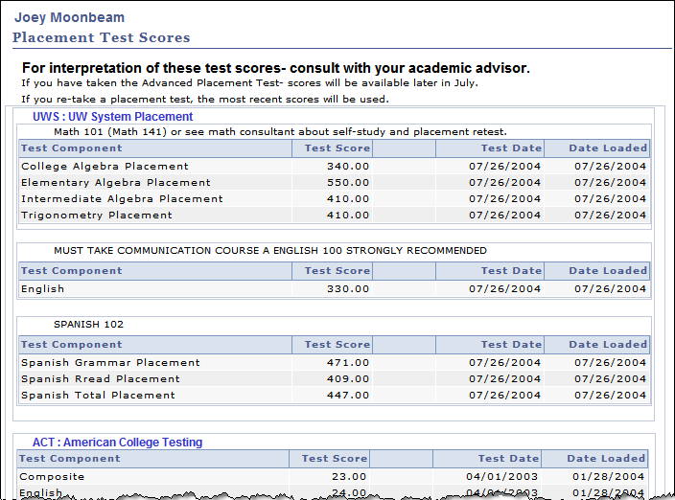

Term Credit Override
Various offices have the ability to override a student’s pre-established maximum enrollment limits per term. You can view if a student has been given override permission as well as a minimum credit load on the Term Credit Override page.

Accessing Term Credit Override
To access the Term Credit Override page, follow the steps below:
Step | Action | Result
 | Select from your Main Menu:  >Records and Enrollment  >Dean/Dept Processing  >Term Credit Override | The Find page displays.
 | Use the Find page to locate the student. | The Term Credit Override page displays.  Note: You can view the number of units (credits) the student is allowed to take (maximum and/or minimum).
 | 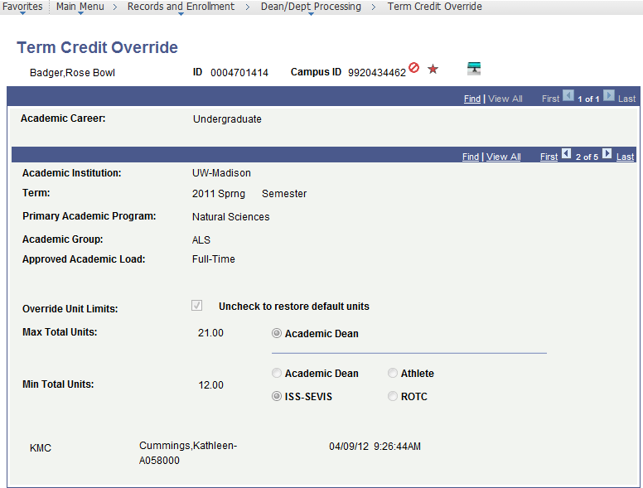

Term Credit Override Page Field Descriptions
The table below describes the fields found on the Term Credit Override page:
Field | Description
Name | Student’s name (last name, first name).
ID | Number generated by the system. It is a unique identifier for a student and will remain the same throughout the individual’s relationship with the University. This is different than the Campus ID.
Campus ID | Ten-digit number assigned to student upon first contact with UW-Madison.
Academic Career | All students belong to an academic career: Undergraduate, Graduate, Law, Medical, Pharmacy, Vetmed, or Univ Specials Students.
Academic Institution | This field always displays UW-Madison.
Term | A four-digit code representing century, year, and semester.  Semesters are as follows: Fall=2, Spring=4, Summer=6.  e.g. 1192=Fall 2018-2019, 1194=Spring 2018-2019.
Primary Academic Program | Student’s primary academic program for this term.
Academic Group | Academic Group of student’s academic program.
Approved Academic Load | Academic load approved for this term (e.g., full-time, part-time).
Override Unit Limits | If unchecked, the student has not been given permission to override credit load.  If checked, the student has been given permission to override credit load. See fields below for unit load approved.
Max Total Units | Maximum number of credits a student can enroll in.
Min Total Units | Minimum number of credits a student must be enrolled in.
Authorizing Offices | The office that last authorized the override is selected.  e.g. Academic Dean, Athlete, ISS-SEVIS, ROTC

Service Indicators
To see if a student has any enrollment holds, access the Manage Service Indicators page.
Step | Action | Result
 | Select from your Main Menu:  >Campus Community  >Service Indicators  >Person  >Manage Service Indicators | The Find page displays.
 | Use the Find page to locate the student. | The Manage Service Indicators page displays.
 | 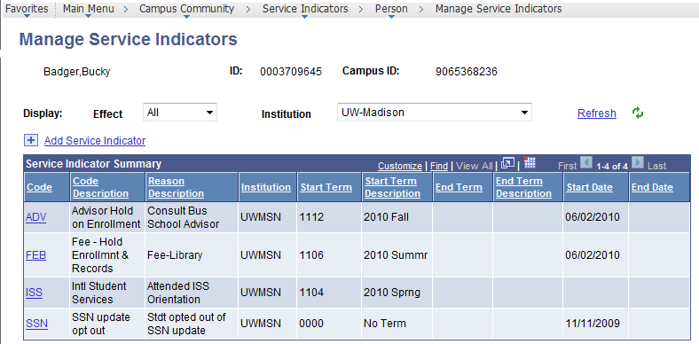
 | Select Code for the service indicator you want to view. | The View Service Indicator page displays.  Tip: The Services Impacted area of this page show services that can be impacted, including enrollment, records, etc.
 | When done viewing,  select [Cancel]. | Continues on Next Page…
 | 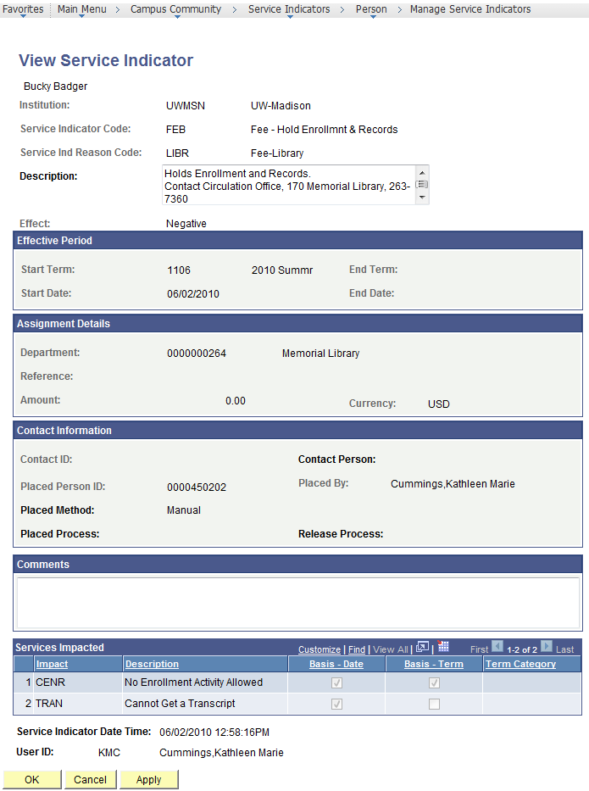

Service Indicator Field Descriptions
The table below describes the fields and buttons found on the Service Indicator page:
Field or Button | Description
Institution | ‘UWMSN’ for UW Madison.
Service Indicator Code | Type of service indicator placed on the student (e.g. advisor, fee)
Service Ind Reason Code | A further explanation of the service indicator.  For Fee and Advisor service indicators, the reason identifies the office requesting placement of the service indicator.
Description | Additional information usually indicating who to contact and impact on student based on Service Indicator Reason Code.
Effect | Impact service indicator has on student, ‘Negative’ or ‘Positive’.
Start Term | Term in which the service indicator is activated.  If only Start Term is entered, and the Services Impacted include enrollment, the student will not be able to add, drop, or swap from the specified Start Term or any future term until service indicator is released.
End Term | Term in which the service indicator is de-activated.  A blank End Term will prevent enrollment activity from the Start Term through all future terms
Start Date | Date the service indicator will take effect.  The Start Date determines when the student will begin to see the service indicator in My UW Madison.
End Date | Date the service indicator will no longer take effect.
Department | The Department responsible for the service indicator.
Reference | Optional free-form text field to provide further detail.
Amount | Dollar amount of the fine(s). $0.00 Service indicators hold services.
Currency | Currency in which the fee amount should be paid.
Contact ID/Person | Optional person to contact.
Placed Person/ID | Person who placed the service indicator.
Placed Method | How the service indicator was placed on this record, manual or batch.
Placed Process | If placed by a process, name of the process
Comments | An optional memo field available for further explanation.
Services Impacted | List of services this service indicator impacts, e.g. enrollment, transcript.
User ID | The User ID and name of the person who last updated the service indicator.

Student Groups

Student Groups
This page provides the ability to view if a student is in any student groups (e.g. honors program, certificate programs, math placement group). Student groups are usually used with course requisites.
Follow this menu path:
>Records and Enrollment >Career and Program Information >Student Groups
The Student Groups page looks like this:
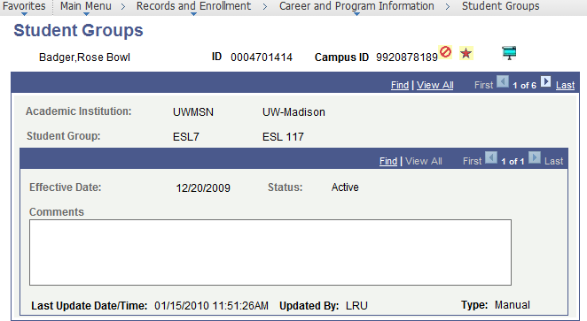
Field | Description
Academic Institution | ‘UWMSN’ for UW-Madison.
Student Group | Description of the student group (e.g. Study Abroad).
Effective Date | Date on which the student was eligible.
Status | Status is either ‘Active’ or ‘Inactive’.
Comments | Comments, if any.
Last Updated… | Last Date, Time, User ID, and Type of update made.

View Student Groups by Student
To view all students in a particular student group, follow the steps below:
Step | Action |  | Result
 | Select from your Main Menu:  >Records and Enrollment  >Career and Program Information  >View Student Groups by Student |  | The Find page displays.
 | Use the Find page to locate the Student Group you want to view. |  | The View Student Groups by Student page displays.
 | If desired,  change Select Effective Dates. |  | All rows for student inactive, active, future dated  Most Current (Any Status) row inactive, active  Most Current Active as of today  Most Current Inactive as of today
 | If a more limited list is desired, select Range Selection and fill in additional fields. |  | Additional fields display to narrow your list.
 | Select [Get Results]. |  | The results display on the  View Student Groups by Student page.
 | 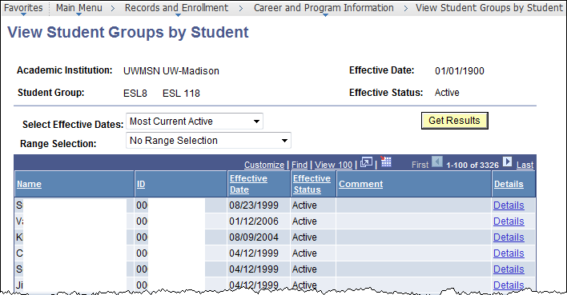
 | View the student group members. | -
 | If you want to view the student’s details, select Details and then select [Cancel] when done. | Student Groups page displays.

Appendix
Managing Your Enrollment

Course Change Request Form
Online Course Change Requests are used to request a change to a course after the deadline has passed for the following activities. Instructor, Department and/or Dean’s approval is required for the request to be processed.
- Add a Class
- Drop a Class
- Change Section
- Add/Remove Honors
- Change Credit
- Change Optional Section
Online Course Change Requests are also used to request the following activities:
- Add/Remove Audit
- Add/Remove Pass Fail

Students access the Course Change Request form through the Student Center in My UW Madison (http://my.wisc.edu) by selecting the Course Change Request link on the ‘term information’ subtab within Course Enrollment.

Tips: View ‘Enrollment Deadlines - Permissions & Procedures’ here: http://registrar.wisc.edu
This will give you deadlines for various enrollment activities and indicate when a course change request form is necessary and when students should complete the activity via their Student Center.

Additional forms for student can be found on the Registrar’s website under Students: http://registrar.wisc.edu/

PDF Schedule of Classes Report
You can run reports to view or print your Schedule of Classes. Utilize this report to view a subject and all courses being offered during a term with the following details: contact info, catalog number and name, approved requisites, class number, credits, component type, section number, start and end time, meeting days, place, instructor, online indicator, honors type, exam date and time, auto enroll and footnotes. There are two report views:
- Sorted By Course (Best for Fall & Spring term) template name = U_CU_PDFTT_1
- Sorted by Session Code (Best for Summer term) template name = U_CU_PDFTT_2

Running a PDF Schedule of Classes Report
Step | Action | Result
 | Select from your Main Menu:  >Reporting Tools  >BI Publisher  >Query Report Viewer | Query Report Viewer page displays.
 | Select [Search]. | Search Results display.
 | 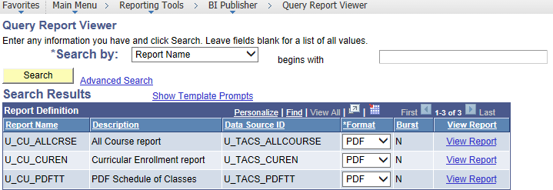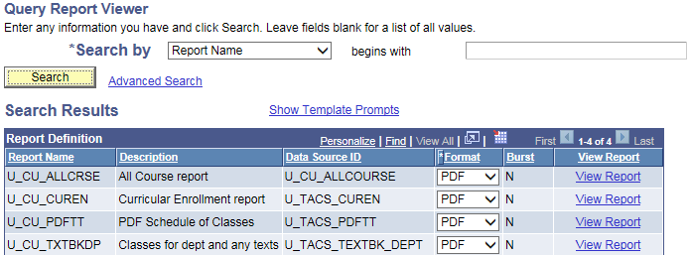
 | Select Show Template Prompts. | Expanded Template Search Results display.
 | 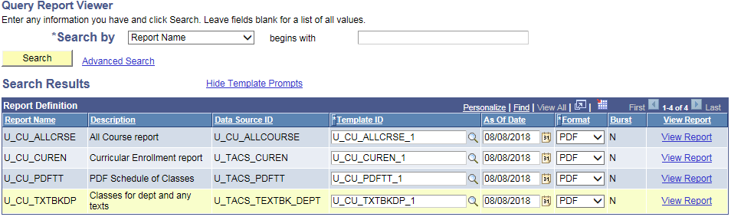
 | If needed, you can select a different Template ID for the  PDF Schedule of Classes using the lookup:  U_CU_PDFTT_1 = Course # sort  U_CU_PDFTT_2 = Session sort | Selected Template ID displays. (Keep Format PDF)  Tip: To view other Template IDs, select PDF Schedule of Classes Template ID magnifying glass lookup button; select [Look Up]; selected desired Template ID.
 | For the PDF Schedule of Classes, select View Report. | Blank U_TACS_PDFTT page displays.
 | Fill in all three fields:  Term, Academic Group, Subject | The fields display filled in as entered.
 | 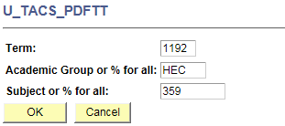
 | Select [OK]. | The report displays in a new browser window.  Close report window when done.

Sample PDF Schedule of Classes
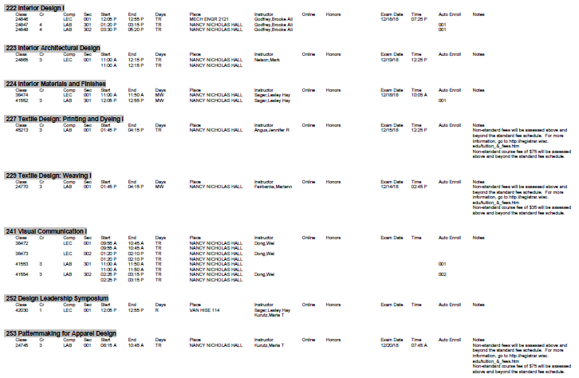

Curricular Enrollment Report
The Curricular Enrollment Report displays real-time course data for a specific term including enrollment, wait list, and combined capacity information in an easy to view, share, and print format.

Running a Curricular Enrollment Report
Step | Action | Result
 | Select from your Main Menu:  >Reporting Tools  >BI Publisher  >Query Report Viewer | Query Report Viewer page displays.
 | Select [Search]. | Search Results display.
 | For Curricular Enrollment report, select View Report. | Blank U_TACS_CUREN page displays.
 | Fill in all three fields:  Term, Academic Group, Subject  If you want to omit IND sections, check the box. | The fields display filled in as entered.
 | 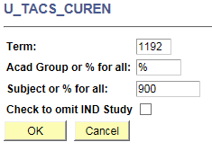
 | Select [OK]. | The report displays in a new browser window.  Close report window when done.

Sample Curricular Enrollment Report
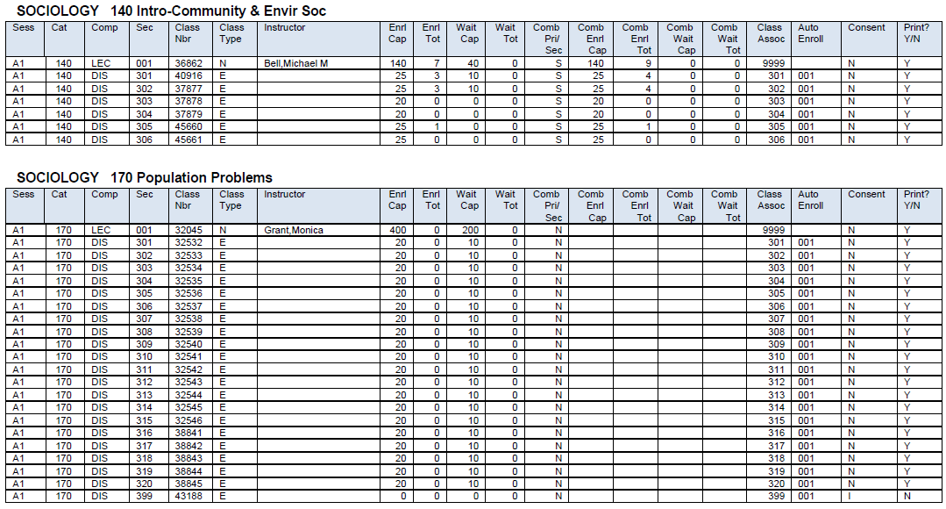

All Course Report
The All Course Report displays all courses available to offer through your subject based on the Effective Date you use. This is an ideal way to view approved requisites.

Running an All Course Report
Step | Action | Result
 | Select from your Main Menu:  >Reporting Tools  >BI Publisher  >Query Report Viewer | Query Report Viewer page displays.
 | Select [Search]. | Search Results display.
 | 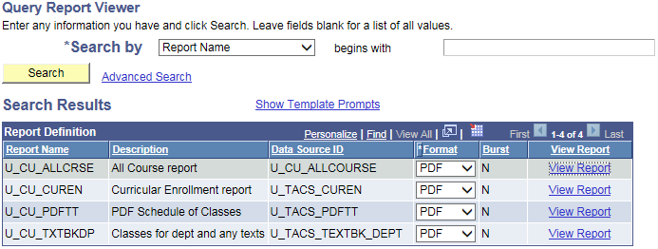
 | For All Course report,  select View Report. | Blank U_TACS_ALLCOURSE page displays.
 | Fill in all three fields:  Effective Date, From Subject Area #, To Subject Area # | The fields display filled in as entered.  Tip: It’s best to use Term Begin Date for Effective Date. See >Records and Enrollment >Dates and Deadlines >Sessions Dates and Deadlines.
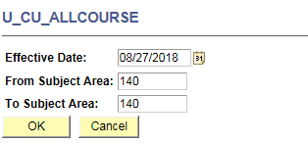
Effective Date Tip:
Course Catalog changes are usually Effective Dated the first day of the term.
 | Select [OK]. | The report displays in a new browser window.  Close report window when done.

Sample All Course Report
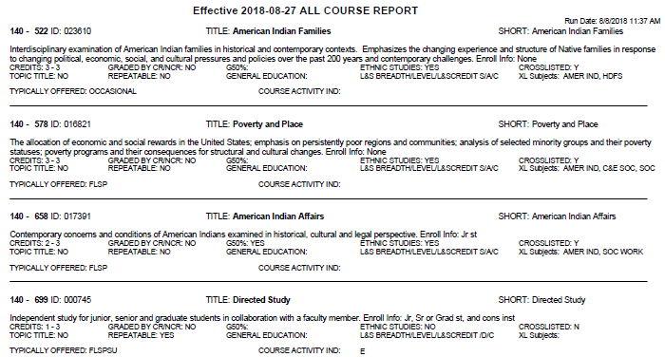

Data Center
To run a report to find a list of courses or course and section-level data using the Data Center, follow the steps below:
Step | Action | Result
 | Select from your Main Menu:  >Reporting Tools  >Data Center | The Data Center displays.
 | Select |Courses| tab. | Courses tab selected  Note: The default active page is Students.
 | Enter desired report criteria.  Tips:  - Must enter at least 1 field in the top section.  - Section data (bottom section) is not required. However, if you enter criteria in the bottom section you must enter term criteria. | Fields display criteria entered.  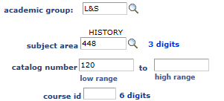
 | Select [SEARCH]. | Results display at bottom of page.
 | View report results at bottom of page, by selecting Tabs or Show all columns button . | Your report displays within a consistent template of tabs & columns depending on whether you are searching on course-level criteriaa only or including section-level criteria.  Tip: Select column headings to sort differently.
 | Course level criteria only:
 | Course and section-level critieria:
 | If you want to Download to Excel, select . | The full results will appear in an Excel document.
 | To run another report:  - Select [CLEAR].  - Go back to Step 3. | [CLEAR] will erase all previous criteria; however, results will display until another search is run.

