Marine Baseline Study on the Potential Impacts of a Seawater Intake Structure and a Brine Disposal System for a Proposed Desalination Plant North of Swakopmund

Prepared for

Namibia Water Corporation (NamWater)

Prepared by

Nina Steffani

On behalf of
Pisces Environmental Services (Pty) Ltd

December 2008



Contact Details:

Nina Steffani, Marine Environmental Consultant
21 Skippers End, Zeekoevlei 7941, South Africa, Email: ninasteffani@telkomsa.net

Andrea Pulfrich, Pisces Environmental Services
PO Box 31228, Tokai 7966, South Africa, E-mail: apulfrich@pisces.co.za
ABBREVIATIONS, UNITS AND GLOSSARY

Abbreviations
ANZECC Australian and New Zealand Environment and Conservation Council
BCF Bioconcentration Factor
CCC Criteria Continuous Concentration
CCME Canadian Council of Ministers of the Environment
CD Chart Datum
CIP Clean in Place
CITES Convention on International Trade in Endangered Species
CMC Criteria Maximum Concentration
CMS Convention on Migratory Species
CSIR Council for Scientific and Industrial Research
DSP diarrehetic shellfish poisoning
DWAF Department of Water Affairs and Forestry
E East
EC₅₀ median effective concentration
EDTA Ethylenediaminetetraacetic acid
EIA Environmental Impact Assessment
ESE East-Southeast
HAB Harmful Algal Blooms
HSDB Hazardous Substances Data Bank
IUCN International Union for Conservation of Nature
LC₅₀ median lethal concentration
M&CM Marine and Coastal Management
MPA Marine Protected Area
NaOCl Sodium Hypochlorite
NNW North-Northwest
NOEC no observed effect concentration
NPA National Ports Authority
NSF National Sanitation Foundation
NW Northwest
PIM Particulate Inorganic Matter
PNEC predicted no effect concentrations
POM Particulate Organic Matter
ppm parts per million
ppt parts per thousand
PSP paralytic shellfish poisoning
RO Reverse Osmosis
RSA DWAF Republic of South Africa, Department of Water Affairs and Forestry
RSA Republic of South Africa
SACW South Atlantic Central Water
SE Southeast
SLS Sodium lauryl sulphate
SSE South-Southeast
SSW South-Southwest
STPP Sodium tripolyphosphate
SW Southwest
SWRO Seawater Reverse Osmosis
TOC Total Organic Carbon
TRC Total Residual Chlorine
TSP Trisodium phosphate
TSPM Total Suspended Particulate Matter
US-EPA United States Environmental Protection Agency
WSW West-Southwest

Units used in the report
µg. ℓ⁻¹ micrograms per litre
cm centimetres
cm. s⁻¹ centimetres per second
g. kg⁻¹ grams per kilogram
g C. m⁻² .day⁻¹ grams Carbon per square metre per day
gfd gallons per square foot per day
h hours
ha hectares
kg kilogram
km kilometres
km² square kilometres
m metres
m. s⁻¹ metres per second
mm millimetres
m² square metres
m³. day⁻¹ cubic metres per day
m³. hr⁻¹ cubic metres per hour
m³. s⁻¹ cubic metres per second
m³ .yr⁻¹ cubic metres per year
m.s⁻¹ metres per second
mg. ℓ⁻¹. milligrams per litre
ng. ℓ⁻¹ nanograms per litre
mg Chl a .m⁻³ milligrams Chlorophyll a per cubic metre
psu practical salinity units which in the normal oceanic salinity ranges are the same as ⁰/₀₀
s seconds
tons. hr⁻¹ tons per hour
tons. km⁻² tons per square kilometre
% percentage
~ approximately
< less than
> greater than
°C degrees centigrade
Glossary
Acute toxicity Rapid adverse effect (e.g. death) caused by a substance in a living organism. Can be used to define either the exposure or the response to an exposure (effect).
Benthic Referring to organisms living in or on the sediments of aquatic habitats (lakes, rivers, ponds, etc.).
Benthos The sum total of organisms living in, or on, the sediments of aquatic habitats.
Benthic organisms Organisms living in or on sediments of aquatic habitats
Biodiversity The variety of life forms, including the plants, animals and micro-organisms, the genes they contain and the ecosystems and ecological processes of which they are a part.
Biomass The living weight of a plant or animal population, usually expressed on a unit area basis.
Biota The sum total of the living organisms of any designated area.
Bivalve A mollusk with a hinged double shell.
Community structure All the types of taxa present in a community and their relative abundance.
Community An assemblage of organisms characterized by a distinctive combination of species occupying a common environment and interacting with one another.
Effluent A complex waste material (e.g. liquid industrial discharge or sewage) that may be discharged into the environment.
Epifauna Organisms, which live at or on the sediment surface being either attached (sessile) or capable of movement.
Ecosystem A community of plants, animals and organisms interacting with each other and with the non-living (physical and chemical) components of their environment
Guideline trigger values These are the concentrations (or loads) of the key performance indicators measured for the ecosystem, below which there exists a low risk that adverse biological (ecological) effects will occur. They indicate a risk of impact if exceeded and should ‘trigger’ some action, either further ecosystem specific investigations or implementation of management/remedial actions.
Habitat The place where a population (e.g. animal, plant, micro-organism) lives and its surroundings, both living and non-living.
Infauna Animals of any size living within the sediment. They move freely through interstitial spaces between sedimentary particles or they build burrows or tubes.
Macrofauna Animals >1 mm.
Macrophyte A member of the macroscopic plant life of an area, especially of a body of water; large aquatic plant.
Meiofauna Animals <1 mm.
Mariculture Cultivation of marine plants and animals in natural and artificial environments
Marine discharge Discharging wastewater to the marine environment either to an estuary or the surf zone or through a marine outfall (i.e. to the offshore marine environment)
Marine environment Marine environment includes estuaries, coastal marine and near-shore zones, and open-ocean-deep-sea regions.
Pollution The introduction of unwanted components into waters, air or soil, usually as result of human activity; e.g. hot water in rivers, sewage in the sea, oil on land.
Population Population is defined as the total number of individuals of the species or taxon.
Dilution The reduction in concentration of a substance due to mixing with water
Dissolved oxygen (DO) Oxygen dissolved in a liquid, the solubility depending upon temperature, partial pressure and salinity, expressed in milligrams/litre or millilitres/litre
Effluent Liquid fraction after a treatment process (i.e. preliminary, primary, secondary or tertiary) in a wastewater treatment works
Environmental impact A positive or negative environmental change (biophysical, social and/or economic) caused by human action
Environmental quality objective A statement of the quality requirement for a body of water to be suitable for a particular use (also referred to as Resource Quality Objective)
Recruitment The replenishment or addition of individuals of an animal or plant population through reproduction, dispersion and migration.
Sediment Unconsolidated mineral and organic particulate material that settles to the bottom of aquatic environment.
Species A group of organisms that resemble each other to a greater degree than members of other groups and that form a reproductively isolated group that will not produce viable offspring if bred with members of another group.
Sludge Residual sludge, whether treated or untreated, from urban wastewater treatment plants
Subtidal The zone below the low-tide level, i.e. it is never exposed at low tide
Surf zone Also referred to as the ‘breaker zone’ where water depths are less than half the wavelength of the incoming waves with the result that the orbital pattern of the waves collapses and breakers are formed
Suspended material Total mass of material suspended in a given volume of water, measured in mg/l.
Suspended matter Suspended material.
Suspended sediment Unconsolidated mineral and organic particulate material that is suspended in a given volume of water, measured in mg.l⁻¹.
Tainting This refers to the tainting of seafood products as a result of the presence of objectionable chemical constituents which may greatly influence the quality and market price of cultured products.
Taxon (Taxa) Any group of organisms considered to be sufficiently distinct from other such groups to be treated as a separate unit (e.g. species, genera, families).
Toxicity The inherent potential or capacity of a material to cause adverse effects in a living organism.
Turbidity Measure of the light-scattering properties of a volume of water, usually measured in nephelometric turbidity units.
Vulnerable A taxon is vulnerable when it is not Critically Endangered or Endangered but is facing a high risk of extinction in the wild in the medium-term future.

TABLE OF CONTENTS

1 GENERAL INTRODUCTION 9
1.1 Scope of Work 9
1.2 Benthic Marine Baseline Survey 11
1.3 Structure of the Report 12
1.4 Approach to the Study 12
1.5 Limitations and Assumptions 13
2 REGULATORY SETTING 14
2.1.1 Legislative and Permitting Requirements 15
2.1.2 International Standards and Guidelines 15
2.2 Water Quality Guidelines 17
3 PROJECT DESCRIPTION: PRE-FEASIBILITY PHASE 20
3.1 Seawater Intake Structure 22
3.2 Reverse Osmosis Plant 24
3.3 Brine Effluent 25
3.4 Construction Activities in the Marine Environment 25
4 ENVIRONMENTAL DESCRIPTION 27
4.1 Physical Environment 28
4.1.1 Sediments and Topography 28
4.1.2 Climate 30
4.1.3 Winds 31
4.1.4 Waves 32
4.1.5 Tides 34
4.1.6 Coastal Currents 34
4.1.7 Surf-zone Currents 34
4.1.8 Upwelling 35
4.1.9 Water Masses and Temperature 37
4.1.10 Turbidity 38
4.1.11 Organic Inputs 39
4.1.12 Low Oxygen Events 40
4.1.13 Sulphur Eruptions 41
4.2 Biological Environment 43
4.2.1 Sandy Substrate Habitats and Biota 43
4.2.2 Rocky Habitats and Biota 46
4.2.3 Pelagic Communities 48
4.2.3.1 Plankton 48
4.2.3.2 Fish 49
4.2.3.3 Marine Mammals 50
4.2.3.4 Turtles 50
4.2.4 Birds 51
4.2.5 Beneficial Uses 52
4.2.5.1 Conservation Areas 52
4.2.5.2 Recreational Areas 55
4.2.5.3 Mariculture Areas 55
4.2.5.4 Industrial Uses 56
4.2.5.5 Commercial and Recreational Fisheries 58
4.2.6 Existing Environmental Impacts 60
4.2.7 Potentially Threatened Habitats 64
5 SOURCES OF POTENTIAL ENVIRONMENTAL IMPACT 65
5.1 Identification of Key Issues 65
5.2 Intake and Discharge Structures 66
5.2.1 Construction of Intake and Discharge Structures 66
5.2.2 Blasting 70
5.2.3 Permanent Discharge and Intake Structures 75
5.3 RO Plant Effluents 77
5.3.1 Salinity 78
5.3.2 Temperature 80
5.3.3 Dissolved Oxygen 82
5.3.4 Biocides 84
5.3.5 Co-discharged Waste Water Constituents 87
5.4 Options for Feedwater Intake and Brine Discharge 91
5.4.1 Intake Structures 92
5.4.1.1 Conventional direct (open water) intake structures 93
5.4.2 Discharge Alternatives 98
5.4.3 “No-development” Alternative 99
6 CONCLUSIONS AND RECOMMENDATIONS 101
6.1 Recommendations for further Studies 102
6.2 Monitoring 104
6.3 Environmental Acceptability 104
7 REFERENCES 106

List of Figures

Figure 1: Location of proposed NamWater desalination plant north of Swakopmund and approximate positions of the Uranium Mine Developments in the region and the Wlotzkasbaken desalination plant. 21
Figure 2: Conceptual layout of the intake and discharge options. 22
Figure 3: Schematic illustration of the conceptual layout of the proposed desalination plant. 23
Figure 4: Conceptual design of the intake onshore channel with breakwater, stilling basin, and onshore pump station (Alternative 2). 24
Figure 5: Basic process flow diagram for the RO Desalination Plant. 25
Figure 6: Map of the coastal zone between Walvis Bay and Henties Bay, and the study area for the proposed RO plant (blue rectangle). 28
Figure 7: Photos of the study area from top left to bottom right: South end of study area looking north, middle of study area showing beach berm, car tracks on beach, north end of study area and gravel beds at northern end. 29
Figure 8: Sub-bottom profiling colour map of the seabed offshore of the study area. 30
Figure 9: Seabed sediments in the study area. 31
Figure 10: Swakopmund Seasonal Wind Roses. 34
Figure 11: Map of the Namibian coastline showing the positions of the upwelling cells and the formation zones of low oxygen water. Place names mentioned in the text are also indicated. 37
Figure 12: Seawater temperatures at Swakopmund recorded between 1988 and 1998. 38
Figure 13: Satellite image showing dust plumes being blown offshore from the Namibia coast (Image source: www.intute.ac.uk). 40
Figure 14: ‘Walk-outs’ and mass mortalities of rock lobsters at the central Namibian coast (image source: www.nacoma.org.na). 42
Figure 15: Satellite image showing discoloured water offshore the Namib Desert resulting from a nearshore sulphur eruption (satellite image source: www.intute.ac.uk). Inset shows a photograph taken from shore at Sylvia Hill, north of Lüderitz, during such an event in March 2002 (photograph by J. Kemper, MFMR, Lüderitz). 43
Figure 16: Rocky outcrop in the study area backed by sandy beach (top), and large Perna perna (bottom left) and a diversity of red foliose algae (bottom right) low at the shore. 48
Figure 17: Dead Leatherback Turtle washed up at a beach north of Swakopmund, March 2008. 52
Figure 18: Project - environment interaction points, illustrating the distribution of existing industries and other users in the coastal region around the study area (red rectangle). 55
Figure 19: Beaches in the study area are heavily impacted by 4x4 traffic. 62
Figure 20: The area is popular with rock- and surf-anglers, and target species such as silver kob are now considered to be over-exploited (Photo: P. Tarr, from Molloy & Reinikainen 2003). 63
Figure 21: Flow-scheme of a SWRO system showing the conventional pretreatment and chemical dosage steps (green) and the different waste and side streams (the broken lines showing intermittent flows) (after UNEP 2008). 89
Figure 22: Overview of different marine intake systems for supply of feedwater to Reverse Osmosis Desalination Plants (adapted from Pankrantz 2008). 94
Figure 23: Examples of open intake basin with breakwater (left, image source: UNEP 2008) and traditional open channel seawater intake (right, image source Pankratz 2008). 94
Figure 24: Schemtaic diagrams of a Vertical Beach Well (left) and a Horizontal Collector Well or ‘Ranney’ Collector (right). (Image source: UNEP 2008). 97
Figure 25: Schematic of the Horizontal Drilled Drains (HDD) (source: Neodren system by Catalana de Perforacions). 97
Figure 26: Sketch of synthetic infiltration gallery (after Jones 2008). 99

List of Tables

Table 1: Relevant acts and the regulations for industrial activities in and adjacent to Namibian waters. 15
Table 2: Water quality guidelines for the discharge of a high-salinity brine into the marine environment. 19
Table 3: Monthly climate statistics for Swakopmund. 32
Table 4: Tide statistics for Walvis Bay from the SA Tide Tables (SAN 2007). All levels are referenced to Chart Datum. 35
Table 5: Expected composition and flow of the brine discharge (Turgis 2008). 64

GENERAL INTRODUCTION
To provide for the large volumes of potable water required in the medium term by the fast growing Uranium Mining Industry, the Namibia Water Corporation (NamWater) intends to establish a Reverse Osmosis Desalination Plant (RO Plant) with an output capacity of 25 Mm³/annum just north of Swakopmund, on Namibia’s central coast. Associated with the plant will be a Sea Water Intake structure of ~65 Mm³/annum (~170 000 m³/day) complete with a brine disposal system (~90 000 m³/day).

With respect to the proposed project, and in line with Namibia’s Environmental Assessment Policy (1994) and the provisions contained in the Environmental Management Act (2007), NamWater requires the compilation of an Environmental Impact Assessment (EIA). As an important input into this EIA, NamWater has asked the CSIR for their consultancy services to conduct marine and geophysical surveys and to compile a Marine Specialist and Geophysical Marine Report. CSIR in turn has appointed Pisces Environmental Services (Pisces) to provide the biological marine studies and the Marine Specialist Report.

Scope of Work
NamWater requires the compilation of a Marine Specialist Report based on required marine surveys and studies. Ultimately, the Marine Specialist Report shall provide input to a project-specific EIA, and shall further contribute to the marine component of an Environmental Management Plan (EMP), which will be submitted to the Ministry of Environment and Tourism with an application for environmental clearance.

Following the Scope of Work specified by NamWater, there are two components to the marine study:
• The compilation of a Marine Specialist Report.
• A marine biological survey of the nearshore marine environment in the vicinity of the proposed desalination plant to establish baseline conditions (diversity and abundance of existing communities) before the commencement of construction of, and subsequent brine discharge from, the proposed desalination plant. The results of this survey will be compiled in a separate report and will provide input into the Marine Specialist Report. This survey will also provide the baseline for a monitoring study assessing the impacts of the brine disposal on the benthic marine environment. (It has to be noted that the biological survey can only be conducted once the final plant design and location has been decided on).

Infrastructures associated with the proposed desalination plant that may have an effect on the marine environment are:
• the seawater intake structure of ~170 000 m³/day (including pipelines and associated structures below the high water mark), and
• the disposal system discharging ~90 000 m³/day of high salinity brine (including pipelines and associated structures below the high water mark).

At this early planning phase of the project (pre-feasibility phase), detailed engineering and design plans for these infrastructures are not yet in place. Similarly, the exact locations of the intake and discharge structures have not yet been finalised.

A phased approach is thus adopted in which the CSIR team assists the engineering team in designing the sea water and brine disposal structures, as well as assisting with the decision regarding their location. The first phase is thus an Environmental Screening Study (part of the pre-feasibility phase) with the primary aims being to gather baseline information to inform the design, and to evaluate impacts and alternatives at a high level in order to screen out potential fatal flaws at an early stage of the design process. The Environmental Screening Study it thus the first step in an iterative process whereby the project design is conceptualised, evaluated and then prepared in more detail during the feasibility phase of the project.

In line with this phased approach detailed above it was thus decided to first compile a Marine Baseline Study (this report) that forms part of the Environmental Screening Process and shall contribute to it through the identification of the environmental issues relating to the proposed sea water intake and brine disposal project, consultations with key stakeholders and careful consideration of recommendations of practical and effective measures to reduce undesirable impacts upon the environment to acceptable levels, and to enhance positive impacts. If fatal flaws are identified, this will be pointed out as early as possible in the process. If viable alternatives exist, these will be raised with NamWater.

The purpose of this Marine Baseline Study is thus to:
provide marine biological baseline information during the preliminary design phase, in order to guide the conceptual design process, and to
identify environmental risks and significant impacts (potential fatal flaws) due to the proposed project, together with recommendations of practical measures which can be incorporated into the early design and planning of the project that will result either in the avoidance of potentially significant negative environmental impacts or their mitigation to the extent that residual effects fall within acceptable limits; and enhancement of positive aspects of the project.

Detailed Terms of Reference for the Marine Baseline Study are:
To describe the baseline marine biology in the project area, emphasising, but not limited to, sensitive and threatened habitats, and threatened or rare marine fauna and flora. All pertinent characteristics of the marine environment will be described including amongst others the following components:
  - Marine Baseline Conditions
  - Bathymetric information of the area
  - Waves, Tides and Currents
  - Surf-zone Currents and Processes
  - Upwelling
  - Water Chemistry
  - Nutrients
  - Turbidity
  - Organic Inputs
  - Low Oxygen Events
  - Sulphur Eruptions
  - Sandy Substrate Habitats and Biota
  - Rocky Habitats and Biota
  - Pelagic Communities, including plankton, fish, marine mammals, and turtles
  - Birds;
To describe the impacts generally associated with the development of a RO desalination plant on the marine biology of the project area during the construction and operational phases of the desalination plant (Note: the baseline study will NOT contain an assessment of the impacts due to the lack of a detailed project design).

Ultimately, the information gathered during this baseline study will feed into the Marine Specialist Report that forms part of the full EIA conducted during the Feasibility Phase (second phase of the project). A project specific marine environmental impact assessment can only be confidently conducted if all plant specifications (e.g. effluent discharge volumes and constituents, and final location and design of intake and discharge structures) have been finalised, relevant survey results are available and the model results of the discharge footprint have been provided. This detailed assessment of marine biology impacts for the pipeline component of the project will be provided in the Marine Specialist Report. The Marine Specialist Report will incorporate the information contained in the Marine Baseline Study. Based on the same reasoning as outlined above, the biological benthic baseline survey (field survey to establish the biological baseline conditions in the vicinity of the plant) can only be conducted when the exact locations of the intake and discharge structures are known. Results of the field survey will provide further input into the Marine Specialist Report and the project specific impact assessment.

Benthic Marine Baseline Survey
The hypersaline effluents from desalination plants inevitably affect the communities of the receiving environment in some way, which translates into the need for a suitable monitoring programme to investigate the extent and magnitude of this impact. At the start of a monitoring programme is the baseline survey to determine the natural state of the potentially affected communities prior to the impact occurring, in other words before the construction and operation of the desalination plant. In the original proposal to NamWater, a benthic baseline survey of the soft bottom infaunal macro-invertebrates (macrofauna) was thus recommended. Macrofauna live on or in the superficial sediments of the sea floor, usually to a depth of ~30 cm. These organisms are a major food source for fish and other benthic predators, and play a key role in remineralisation and flux of organic matter deposited in the sea floor. Benthic macrofauna is commonly used as biological indicator because as a group they are relatively sedentary and reflect the quality of their immediate environment, have relatively long life spans and their responses integrate water and sediment quality changes over time. Obviously, such a survey requires that the seafloor is sandy as this is the natural habitat of these organisms. Ideally, the study area around the brine outlet point should thus consist of unconsolidated sediments of at least 50-cm thickness. At the time of the proposal-writing, there was no detailed knowledge of the physical marine environment around the brine discharge point. A bathymetry survey conducted by R. Vonk from the CSIR in October 2008, however, established that the seafloor at the proposed discharge point in 3 m water depth is primarily rocky with a thin veneer of sediment at places. Thicker sediment patches only occur in deeper (10 m) waters. This eliminates the option of a benthic macrofaunal survey. It is thus suggested to conduct a preliminary diving survey to determine firstly the type of saefloor, i.e. whether the seafloor is permanently exposed rocky reef or whether the rocky outcrops are intermittently covered by sand, and secondly what type of community is inhabiting the seafloor around the outlet point. The outcome of this survey will give a better idea of the type of monitoring programme suitable for this project. It is planned to conduct the diving survey in January/February 2009.

Structure of the Report
This report describes the biological baseline conditions of the affected area and explains the effects on the marine environment (i.e. the coastal zone below the high water mark) of the construction and operation of the proposed RO Desalination Plant and their context.

Chapter 1, this chapter, provides a general introduction to the proposed project, and outlines the Scope of Work, the report structure, and the approach to the study.

Chapter 2 details the regulatory requirements, as well as other guidelines that are applicable to the marine aspects of the desalination plant project.

Chapter 3 gives an overview of the proposed RO Plant, providing a conceptual design of the project and proposed intake and discharge structures. Construction and operational activities that will affect the marine and coastal environment are described.

Chapter 4 describes the receiving marine biophysical environment that could be affected by the Desalination Plant. Existing impacts on the marine environment are discussed and sensitive and/or potentially threatened habitats or species are identified.

Chapter 5 describes key issues and sources of potential environmental impact that are identified during the environmental screening process for the proposed Desalination Plant and summarised in terms of the construction, operation and decommissioning phase.

Chapter 6 introduces various design options for intake and discharge structures, provides a summary of the main issues and discusses on a general level the environmental acceptability of the project and alternative design options.

Chapter 7 provides a full listing of all information sources and literature cited in this document.

Approach to the Study
This marine baseline study comprises a description of the receiving environment and identifies and describes key issues and sources of potential ecological impacts in the marine environment due to the proposed desalination plant. As determined by the terms of reference, this study has adopted a ‘desktop’ approach utilising existing information. Consequently, the description of the natural baseline environment in the vicinity of the proposed desalination plant is based on a review and collation of existing information and data from the scientific literature, internal reports, and previous environmental impact assessments for various developments in the region. The information for the identification of potential impacts related to the seawater intake and brine discharge was drawn from various scientific publications as well as information sourced from the Internet. The sources consulted are listed in the Reference chapter.

Limitations and Assumptions
The following are the limitations of the study:
- Currently the project is in the pre-feasibility phase, which is the conceptual phase where different design options are compared and evaluated. The description of the key issues and impacts is therefore generic in nature.
- The description of the baseline environment is using a desk-top approach. Results from the benthic field survey will only be available at a later stage when the design is finalized, and will therefore only be incorporated in the final Marine Specialist Study in the EIA phase.
- Potential changes in the marine environment such as sea level rise and/or increases in the severity and frequency of storms related to climate change are not included in the terms of reference and therefore not dealt with in this report. Such scenarios are difficult to assess due to the uncertainties surrounding climate change. Should evidence of such changes become available, the development and management plans for the desalination plant should be re-examined to include the impacts of these anticipated macroscale changes.

REGULATORY SETTING
The Republic of Namibia follows an Environmental Assessment Policy that aims to achieve and maintain sustainable development, particularly the wise utilisation of natural resources and the responsible management of the biophysical environment. Accordingly, there are several regulatory requirements, at international, national and regional level, to which the proposed NamWater desalination project will have to conform. These are briefly outlined below and summarised in Table 1.

Table 1: Relevant acts and the regulations for industrial activities in and adjacent to Namibian waters.

Law/Ordinance | Applicability
Article 95 (1) of the Constitution of the Republic of Namibia (1990) | - Preservation of Namibia’s ecosystems, essential ecological processes and biological diversity  - Sustainable use of natural resources
Environmental Assessment Policy of 1995 | - Prescribes Environmental Impact Assessments for any developments with potential negative impacts on the environment.
Environmental Management and Assessment Bill (2003) | - establishes principles for environmental management and promoting integrated environmental management
Sea Birds and Seals Protection Act 46 of 1973 | - No disturbance of seabirds and seals
Seashore Ordinance 37 of 1958 | - Removal of living and non-living resources from seashore or seabed and depositing of rubbish within 3 nautical miles of the shore
Sea Fisheries Act 29 of 1992 | - Dumping at sea  - Discharge of wastes in marine reserves  - Disturbance of rock lobsters, marine invertebrates or aquatic plants  - Prohibited areas for catching/disturbing fish, aquatic plants or disturbing/damaging seabed
Nature Conservation Ordinance 4 of 1975 | - Protection of various species
Marine Resources Act 27 of 2000 (and accompanying regulations) | - Discharges into the sea
Convention of Biological Diversity | - Protection of various species
Atmospheric Pollution Prevention Ordinance No. 11 of 1976 | - Pollution prevention
Hazardous Substances Ordinance 14 of 1974, and amendments | - Pollution prevention
Petroleum Products and Energy amendment Act of 2000 | - Disposal of used oil
Territorial Sea and Exclusive Economic Zone of Namibia Act 3 of 1990 | - Exploitation of natural resources in the EEZ
Draft Pollution Control and Waste Management Bill (1999) | - Protection for particular species, resources or components of the environment
Water Resources Management Act 24 of 2004 | - Water related pollution and abstraction
SADC Protocol on Shared Water Systems | - Water related pollution and abstraction
National Monuments Act 28 of 1969 | - Disturbance of shipwrecks, archaeological and cultural sites
United Nations Law of the Sea Convention of 1982 | - Marine pollution from seabed activities and land-based sources

Legislative and Permitting Requirements
Following the Environmental Assessment Policy of 1995, an environmental clearance certificate is required from the Directorate of Environmental Affairs (DEA) prior to commencement of operations for the desalination plant project. This Policy stipulates that an Environmental Impact Assessment is required for any policy, programme or project with potential negative impacts on the environment, whether initiated by Government or private sector.

Under Namibian legislation both the abstraction and discharge of water from and into the sea requires a permit under Sections 32 and 56 of the Water Resources Management Act (No. 24 of 2004), respectively. This Act is based on the National Water Policy (Ministry of Agriculture, Water and Rural Development 2000). The effluent water discharged (and potential associated co-discharges) from the proposed RO plant is classified as “industrial effluent” and thus requires a license under the Act. A combined licence to abstract and use water and to discharge effluent is covered under Section 38 of the Act. Licenses are provided through the Ministry of Agriculture, Water Affairs and Forestry (MAWF).

The Ministry of Environment and Tourism (MET) is the custodian of Namibia’s natural environment and discharges this duty via environmental regulations. The MET is thus the lead agent for EIAs; however licensing of water abstraction, use and disposal is only considered once an EIA acceptable to MAWF has been submitted and a Record of Decision has been handed down.

A draft version of the Pollution Control and Waste Management Bill (1999) has amalgamated a variety of Acts and Ordinances that provide protection for particular species, resources or components of the environment. These include, but are not limited to, the Nature Conservation Ordinance No.4 of 1975, the Sea Fisheries Act 29 of 1992, the Sea Birds and Seals Protection Act 46 of 1973, Seashore Ordinance No. 37 of 1958, Hazardous Substances Ordinance No. 14 of 1974 and amendments, and the Atmospheric Pollution Prevention Ordinance No. 11 of 1976. All construction, disturbance, effluent and pollution resulting from the RO Plant project will be required to be in strict accordance with the regulations outlined in the Pollution Control and Waste Management Bill.

International Standards and Guidelines
In addition to the regional, national and international legislative requirements, there are international standards, protocols and guidelines that are applicable for a desalination plant project:
In August 2007, the Department of Water Affairs & Forestry (DWAF 2007) of South Africa published the “Guidelines for the evaluation of possible environmental impacts during the development of seawater desalination processes”. This document gives general guidance on the assessment procedure, lists possible environmental impacts which can be expected during implementation of seawater desalination, and provides recommendations for specialist and monitoring studies.
The International Finance Corporation, a member of the World Bank Group, has developed operational policies (IFC 1998) that, inter alia, require that an impact assessment is undertaken within the country’s overall policy framework and national legislation, as well as international treaties, and that natural and social aspects are to be considered in an integrated way. IFC has further published Environmental, Health, and Safety Guidelines (known as the 'EHS Guidelines') containing guidelines and standards applicable to projects discharging industrial wastewater (IFC 2007). The EHS Guidelines contain the performance levels and measures that are normally acceptable to IFC and are generally considered to be achievable in new facilities at reasonable costs by existing technology. The EHS Guidelines are technical reference documents with general and industry-specific examples of Good International Industry Practice (GIIP), as defined in IFC's Performance Standard 3 on Pollution Prevention and Abatement (IFC 2006). This Performance Standard has the objective to avoid and minimize adverse impacts on human health and the environment by avoiding or minimizing pollution from project activities. It outlines a project approach to pollution prevention and abatement in line with internationally disseminated pollution prevention and control technologies and practices. In addition, Performance Standard 3 promotes the private sector’s ability to integrate such technologies and practices as far as their use is technically and financially feasible and cost-effective in the context of a project that relies on commercially available skills and resources.
Other guidance documents are those by the California Coastal Commission (Seawater Desalination and the California Coastal Act, 2004), the United Nations Environmental Programme (UNEP 2008) and the World Health Organisation (WHO, 2008) that include international best practices and principles such as the precautionary approach and describe how design and construction approaches can mitigate likely impacts.
The Rio Declaration on Environment and Development (1992), which calls for use of EIA as an instrument of national decision making (Principle 17). Moreover, it establishes important principles for sustainable development that should be reflected in EIAs, such as the application of the precautionary principle (Principle 15, whereby, where there is uncertainty in the nature and severity of a potential impact, conservative assumptions are made with respect to the significance and potential severity of the impact being assessed).

As signatory to the Convention of Biological Diversity and Convention to Combat Desertification, Namibia is committed to the preservation of rare and endemic species, and to provide protection for ecosystems and natural life-support processes within the country’s boundaries. As a signatory of the United Nations Law of the Sea Convention of 1982, Namibia is required to adopt legislation to reduce marine pollution from seabed activities in the Exclusive Economic Zone (EEZ) and on the continental shelf, and from land-based sources.

Water Quality Guidelines
The Water Resources Management Act does not contain any target values for water quality. These will form part of the regulations associated with the new Water Act and will be implemented at a future date. As far as can be established, South Africa is the only southern African country that currently has an official set of water quality guidelines for coastal marine waters. In terms of policy, legislation and practice South Africa’s operational policy for the disposal of land-derived wastewater to the marine environment (DWAF 2004 a-c) is thus of relevance. Specifically, environmental quality objectives need to be set for the marine environment, based on the requirements of the site-specific marine ecosystems, as well as other designated beneficial uses (both existing and future) of the receiving environment. The identification and mapping of marine ecosystems and the beneficial uses of the receiving marine environment provide a sound basis from which to derive site-specific environmental quality objectives (Taljaard et al., 2006). To ensure that environmental quality objectives are practical and effective management tools, they need to be set in terms of measurable target values, or ranges for specific water column and sediment parameters, or in terms of the abundance and diversity of biotic components. The South African Water Quality Guidelines for Coastal Marine Waters (DWAF, 1995) provide recommended target values (as opposed to standards) for a range of substances, but these are not exhaustive. Therefore, in setting site-specific environmental quality objectives, the information contained in the DWAF guideline document is supported by additional information obtained from published literature and best available international guidelines (e.g. ANZECC, 2000; World Bank, 1998). Recommended target values are also reviewed and summarized in the Benguela Current Large Marine Ecosystem (BCLME) document on water quality guidelines for the BCLME region (CSIR 2006). Recommended target values are provided in Table 2.

Table 2: Water quality guidelines for the discharge of a high-salinity brine into the marine environment.
VARIABLE | SOUTH AFRICA  (DWAF 1995) | AUSTRALIA/NEW ZEALAND  (ANZECC 2000) | WORLD BANK ª  (World Bank 1998)
Zone of impact / mixing zone | To be kept to a minimum, the acceptable dimensions of this zone informed by the EIA and requirements of licensing authorities, based on scientific evidence. |  | 100 m radius from point of discharge for temperature
Temperature | The maximum acceptable variation in ambient temperature is ± 1°C | Where an appropriate reference system is available, and there are sufficient resources to collect the necessary information for the reference system, the median (or mean) temperature should lie within the range defined by the 20%ile and 80%ile of the seasonal distribution of the ambient temperature for the reference system. | < 3°C above ambient at the edge of the zone where initial mixing and dilution take place. Where the zone is not defined, use 100 meters from the point of discharge when there are no sensitive aquatic ecosystems within this distance.
Salinity^{b} | 33 – 36 psu | Low-risk trigger concentrations for salinity are that the median (or mean) salinity should lie within the 20%ile and 80%ile of the ambient salinity distribution in the reference system(s). The old salinity guideline (ANZECC 1992) was that the salinity change should be <5% of the ambient salinity. | -
Total residual Chlorine | No guideline, however deleterious effects recorded for concentrations as low as 2 – 20 μg. ℓ⁻¹. A conservative trigger value is <2 μg.ℓ⁻¹. | 3 µg Cl. ℓ⁻¹ measured as total residual chlorine (low reliability trigger value at 95% protection level, to be used only as an indicative interim working level) (ANZECC 2000)^{c} | 0.2 mg. ℓ⁻¹ at the point of discharge prior to dilution
Dissolved oxygen | For the west coast, the dissolved oxygen should not fall below 10 % of the established natural variation. For the south and east coasts the dissolved oxygen should not fall below 5 mg/ℓ (99 % of the time) and below 6 mg/ℓ (95 % of the time) | Where an appropriate reference system is available, and there are sufficient resources to collect the necessary information for the reference system, the median lowest diurnal DO concentration for the period for DO should be >20%ile of the ambient dissolved oxygen concentration in the reference system(s) distribution. The trigger value should be obtained during low flow and high temperature periods when DO concentrations are likely to be at their lowest. | -
Nutrients | Waters should not contain concentrations of dissolved nutrients that are capable of causing excessive or nuisance growth of algae or other aquatic plants or reducing dissolved oxygen concentrations below the target range indicated for dissolved oxygen (see above) | Default trigger values of  PO₄-P: 100 µg. ℓ⁻¹  NO_{x}-N: 50 µg. ℓ⁻¹  NH₄⁺-N: 50 µg. ℓ⁻¹  for the low rainfall southern Australian region (Table 3.3.8 in ANZECC 2000)
Chromium | 8 μg. ℓ⁻¹ (as total Cr) | Marine moderate reliability trigger value for chromium (III) of 10 μg. ℓ⁻¹ with 95% protection  Marine high reliability trigger value for chromium (VI) of 4.4 μg. ℓ⁻¹ at 95% protection. | 0.5 mg. ℓ⁻¹ (total Cr) for effluents from thermal power plants
Iron |  | Insufficient data to derive a reliable trigger value. The current Canadian guideline level is 300 μg. ℓ⁻¹ | 1.0 mg. ℓ⁻¹ for effluents from thermal power plants
Molybdenum |  | Insufficient data to derive a marine trigger value for molybdenum. A low reliability trigger value of 23 μg. ℓ⁻¹ was adopted to be used as indicative interim working levels.
Nickel | 25 μg. ℓ⁻¹ (as total Ni) | 7 μg. ℓ⁻¹ at a 99% protection level is recommended for slightly-moderately disturbed marine systems.
ª The World Bank guidelines are based on maximum permissible concentrations at the point of discharge and do not explicitly take into account the receiving environment, i.e. no cognisance is taken of the fact of the differences in transport and fate of pollutants between, for example, a surf-zone, estuary or coastal embayment with poor flushing characteristics and an open and exposed coastline. It is for this reason that we include in this study other generally accepted Water Quality guidelines that take the nature of the receiving environment into account.
^{b} The ANZECC (2000) Water Quality guideline for salinity is less stringent than, but roughly approximates, the South African Water Quality guideline that requires that salinity should remain within the range of 33 psu to 36 psu.
^{c} In case of chlorine “shocking”, which involves using high chlorine levels for a few seconds rather than a continuous low-level release, the target value is a maximum value of 2 mg. ℓ⁻¹ for up to 2 hours, not to be repeated more frequently than once in 24 hours, with a 24-hour average of 0.2 mg. ℓ⁻¹ (The same limits would apply to bromine and fluorine.).

PROJECT DESCRIPTION: PRE-FEASIBILITY PHASE
- The site for the proposed desalination plant is on the northern outskirts of the Swakopmund municipal area (Figure 1). During October 2008, a marine geophysical survey was conducted for an area extending 4 km northwards from the saltworks and 2 km out the sea. This survey led to the identification of two potential locations for the intake structure, in the central portion of the study area in the vicinity of Mile 6 (Figure 2). The anticipated life-span of the desalination plant is a minimum of 20 years, with provisions to expand and renew equipment as and where it is needed.

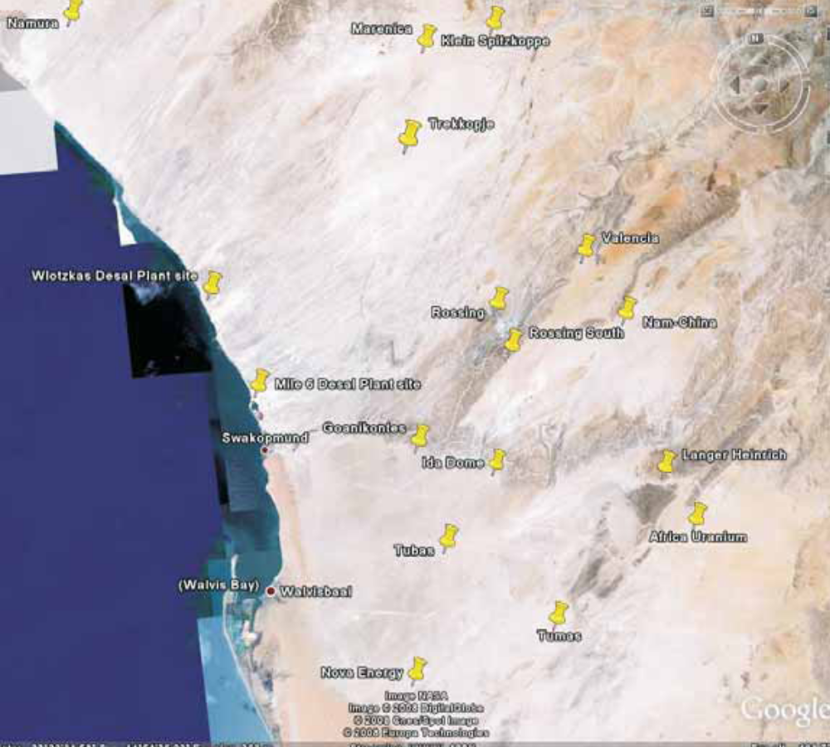

Figure 1: Location of proposed NamWater desalination plant north of Swakopmund and approximate positions of the Uranium Mine Developments in the region and the Wlotzkasbaken desalination plant.

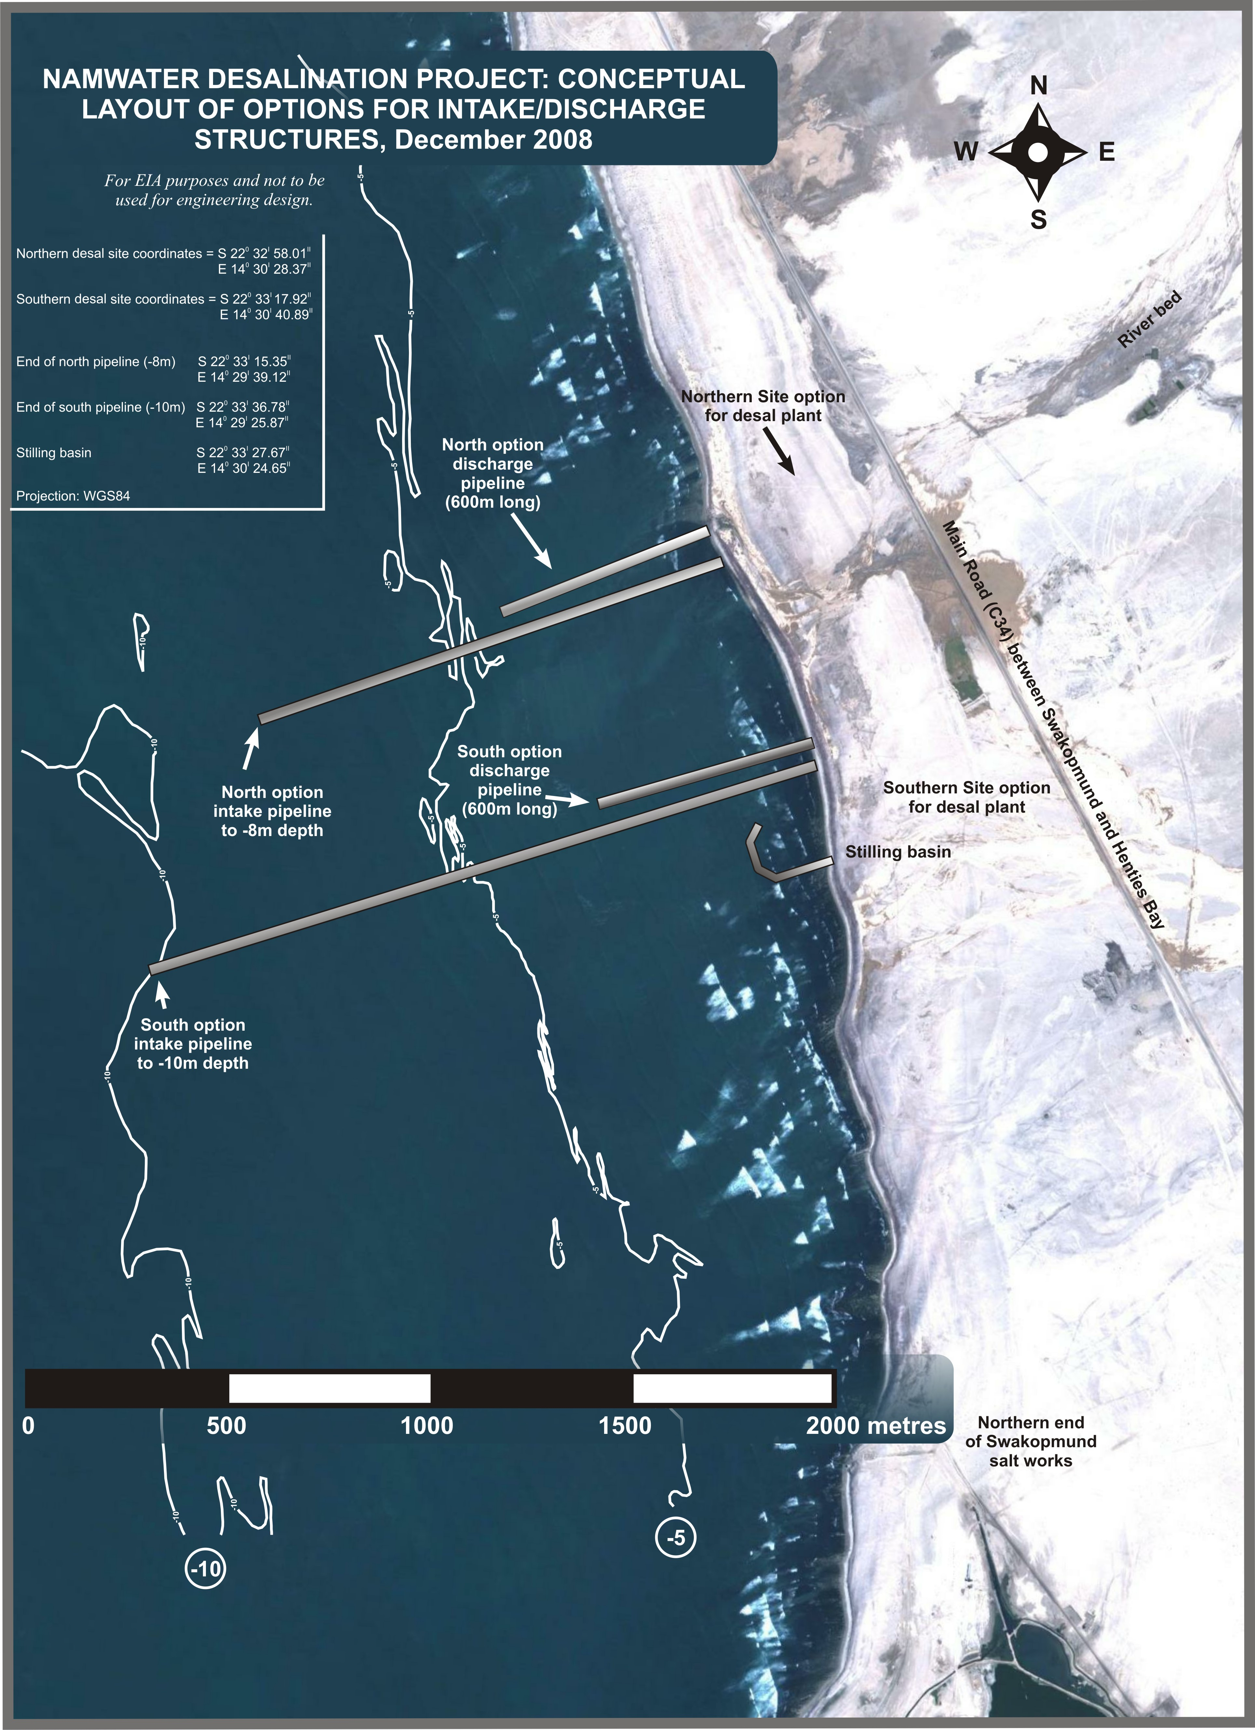

Figure 2: Conceptual layout of the intake and discharge options.

- The facility will consist of the following principle components:
- A seawater abstraction and brine disposal facility.
- A desalination plant located on land.
- A permanent transfer pipeline through which process water will be pumped to NamWater’s distribution facilities.

- This Marine Baseline Study will deal with the first of these components only.

- The key components of the project are presented in Figure 3 and described below.

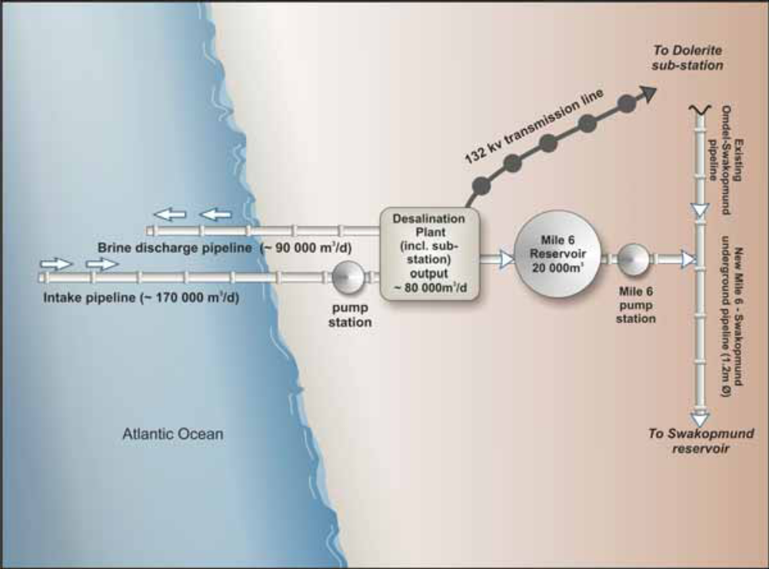

Figure 3: Schematic illustration of the conceptual layout of the proposed desalination plant.

Seawater Intake Structure
In the current pre-feasiblity phase of the project two alternative design options for the intake structures are being considered.

Alternative 1 is a submerged inlet structure that is situated approximately 800 m to 1500 m offshore. There are two location alternatives for the pipelines, a North and a South option in 8 m and 10 m water depth, respectively (Figure 3). Two submerged cement coated and cathodic protected steel pipes are connecting the inlet structure to the onshore intake pump station. The pipelines will be trenched through the surf zone (in sandy gully preferably). Beyond the surf zone the pipeline will be placed on the seabed, and weighted with ‘concrete coats’. On the shore, the pipeline will run underground into the pump station. A caisson will be placed offshore at the inlet with the top of the caisson protruding about 5 m above the seabed so that sea water will be abstracted from approximately mid-depth between the surface and the seabed to minimize the amount of sediment in the intake water (also called feed water).

Alternative 2 would involve the construction of breakwaters extending out to sea, in order to create an open water stilling basin of approximately 3 m water depth below mean seawater level (MSL), with an open channel connecting the stilling basin with the intake pump station (Figure 4). The intake is likely to have travelling screens to reduce the effect of entrainment, and the intake of sediments.

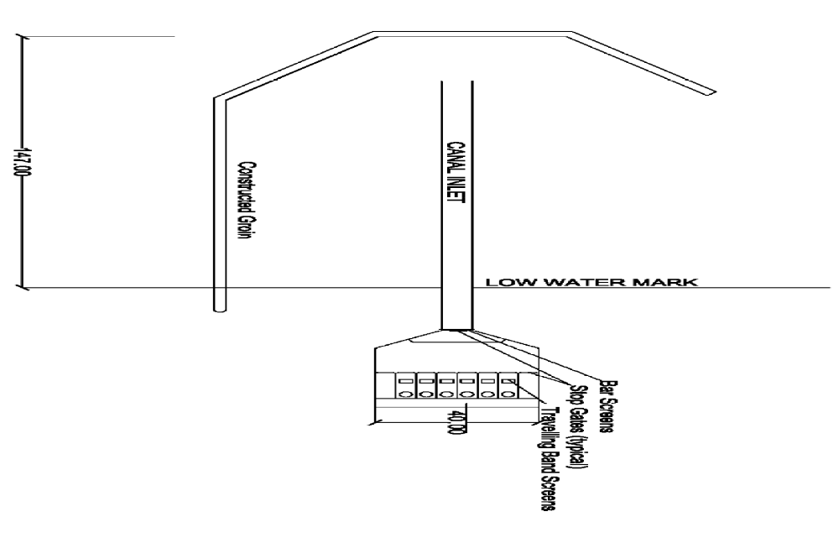

Figure 4: Conceptual design of the intake onshore channel with breakwater, stilling basin, and onshore pump station (Alternative 2).

For both options, the intake pump station will be located close to the shore, with the pumps being protected by a screen system. The feed water will be transferred from the pump station to the desalination plant through a transfer pipeline. A ‘pigging’ system for regular maintenance cleaning of the seawater supply lines (both intake and discharge pipes) will be installed. This involves the use of a ‘pig’ (bullet-shaped device with bristles), which is introduced into the pipeline to mechanically clean out the structure.

Reverse Osmosis Plant
The current design is for a Reverse Osmosis (RO) Desalination Plant with a 90 Mm³/annum intake, approximately 25 Mm³/annum output, and 35 Mm³/annum of brine to be discharged back into the sea. The engineering technologies to be applied will consist of screening, Dissolved Air Flotation (DAF), flocculation, ultra filtration, cartridge filtration, reverse osmosis and post treatment (Figure 5). Approximately 60% of the sea water abstracted will be returned to the sea as brine.
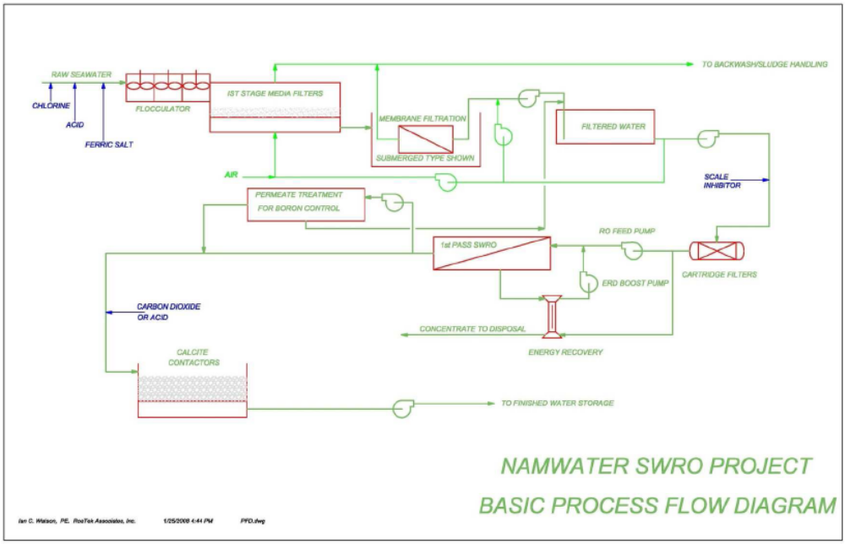

Figure 5: Basic process flow diagram for the RO Desalination Plant.

The plant will be connected to the national grid via 132 kV 44 km long transmission line from the existing Dolerite sub-station to plant and will source approximately 20MW of power for the operational phase. A reservoir at Mile 6 will be constructed at ground level with a water storage capacity of 20 Megalitres, and a pump station that can pump 4000m /hr from the desalination plant. A new pipeline will be build from the plant to Swakopmund that will link with the existing Omdel-Swakopmund pipeline and will then run towards the existing Swakopmund Reservoir.

Construction is planned to commence in mid- 2009 with a construction phase of a maximum of 24 months. An area of 400 m x 250 m is required for construction and lay-down (i.e. storage of equipment). During operation, with inclusion of the sub-station, the footprint will be 200 m x 250 m.

Brine Effluent
About 60% of the seawater abstracted will be returned to the sea as brine. A brine disposal system returns the brine from the desalination plant back to the sea via a pipeline of approximately 600 m length, either at the North or the South option (Figure 3). The brine will have approximately double the salinity of seawater. The discharge point will be located in such a manner as to avoid re-circulation of the brine back into the intake system.

Currently, no specification on potential chemicals and co-substances discharged with the brine are available. It is, however, likely that the use of a biocide is required to inhibit biological growth in the pipelines and on the screens. If sodium hypochlorite is used, this needs to be neutralised before the feed water enters the RO membranes as the chlorine damages the membranes. In addition, the RO membranes need to be cleaned (CIP = Clean in Place) at certain intervals. Depending on the quality of the feed water, this is typically undertaken at intervals of three to six months. The chemicals used are mainly weak acids and detergents. Further chemicals are often added to improve the cleaning process, such as detergents, oxidants, complexing agents or biocides for membrane disinfection. It is proposed that the CIP rinse water will be kept on drying beds and disposed of to an accredited landfill site. No solids will be disposed off to sea from the desalination plant.

Construction Activities in the Marine Environment
- Construction activities associated with the development of the RO Plant will be focussed in four main areas:
- submerged intake (Alternative 1) and discharge pipelines; or
- breakwater and stilling basin for intake (Alternative 2) and discharge pipelines;
- the transfer pipelines to and from the desalination plant area; and
- the desalination plant.

This Marine Baseline Study will concentrate with the first two areas only.

Alternative 1: The intake and outfall points of the RO Plant pipelines will be located 800 to 1500 m and 600 m offshore in water depth of 10 m and 8 m, respectively. The concrete intake structure will have a caisson at the pipeline inlet with top of the caisson approx 5m above the seabed. Beyond the surf zone the pipeline will be placed on the seabed. On shore, the pipeline will run underground into the pump station. Individual pipeline sections of 10-24 m will be fabricated by the supplier and transported to the site where the pipelines will cross the surf-zone. They will subsequently be butt-welded together into long strings. This will require a sufficiently large and relatively flat onshore area where the pipes can be stockpiled and prepared. Concrete weight collars will be placed around the strings to provide stability on the seabed. The pipe sections will be dragged down the shore by dozer and capped at either end before being floated out to sea by means of a tug. The air is released from the pipe, and as it fills with water it sinks to the bottom. The different strings making up the total pipeline are placed one behind the other and connected by means of spool pieces. This is usually undertaken by commercial divers.

Where they cross the surf-zone, the pipelines will be buried to a depth below the seasonal beach and nearshore erosion level to avoid damage by wave forces in the surf-zone. To achieve this, a temporary jetty will be constructed to provide a stable platform from which a trench can be excavated. Excavation to a suitable depth to accommodate the pipeline will require blasting. The trench will be protected from infilling by wave action by rows of sheetpiles. The pipes are then placed in the trench and subsequently buried by earth-moving machinery. Excavated material will be disposed of into the surf-zone down-current of the construction site. Further offshore, the pipes are left lying on the seabed, and with time will settle into the sandy substrate.

Alternative 2: In case of alternative 2, a J-shaped breakwater with a stilling basin will be constructed at approximate to 10 m water depth. The excavated trench for the open channel will coincide with the corridor that leads to the -10 m contour nearest to shore. The base of the canal intake corridor will be at 3 m below Mean Sea Level (MSL). At this point, no further construction details are available.

- Rock blasting will be necessary during the routing and laying of the intake and discharge pipelines or the construction of the open channel connecting the stilling basin to the intake pump station. All blasting activities will be conducted in accordance with recognised standards and safety requirements. The number of blasts will be restricted to the absolute minimum required, and will most likely consist of smaller, quick succession blasts directed into the rock using a time-delay detonation. Only one blast per day will be undertaken.

ENVIRONMENTAL DESCRIPTION
This environmental description encompasses the coastal zone and shallow nearshore waters (< 40 m depth) extending from Walvis Bay north to Henties Bay (Figure 6). Some of the data presented are, however, more regional in nature, e.g. the wind and wave climate, nearshore currents, etc. The purpose of this environmental description is to provide the baseline environmental context within which the RO desalination plant project proposed by NamWater will take place.

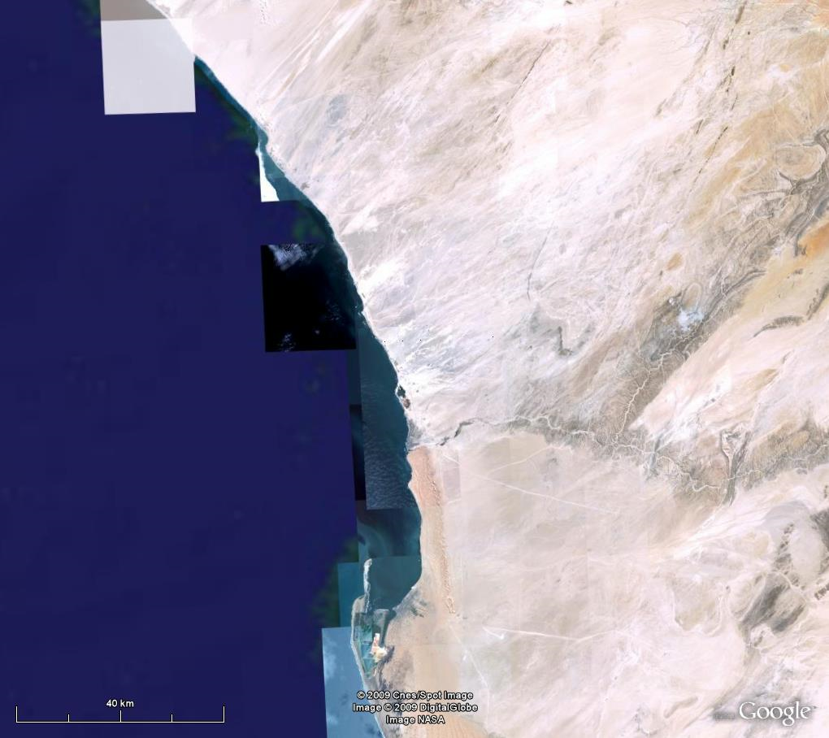

Hentis Bay

Swakopmund

Walvis Bay

Figure 6: Map of the coastal zone between Walvis Bay and Henties Bay, and the study area for the proposed RO plant (blue rectangle).

Physical Environment

Sediments and Topography
The coastal strip around Swakopmund is covered by a 2-3 m thick layer of very loose, medium to fine graned sea sand, which stretches ~200 m inland. Only in the vicinity of Henties Bay the shore is backed by low sandy cliffs. The surficial deposits of the Namib group are underlain by Gneissitic/Schist rock of the Swakop group and Damara sequence. The residual gneiss, which form a layer of between 0.6 - 1.8 m thick, are underlain by gneiss bedrock. A groundwater study undertaken for another proposed desalination plant project at Wlotzkasbaken, ca. 30 km north of Swakopmund, detected no freshwater table at the beach, although seawater penetrated inland to at least 500 m from the high water mark at a depth of 1.5 m (The Soil Engineer 2007).

In the intertidal and low-shore areas sediments become coarser and are generally dominated by moderately to well-sorted gravelly sand and fine sandy gravels with mean particle sizes of 600-1700 μm. Along much of the coastline, there is a prominent berm on the upper beach (Figure 7). A dried-up catchment run-off channel reaches down to the coast in the middle of the study area. Anecdotal evidence suggest that during flash floods the river can swell to 100 m wide, but that such floods only happen every 20 to 30 years (J. de Kock, Civil Constuction Division, NamWater). The northern end of the study area is characterised by extensive gravel beds (Figure 7).

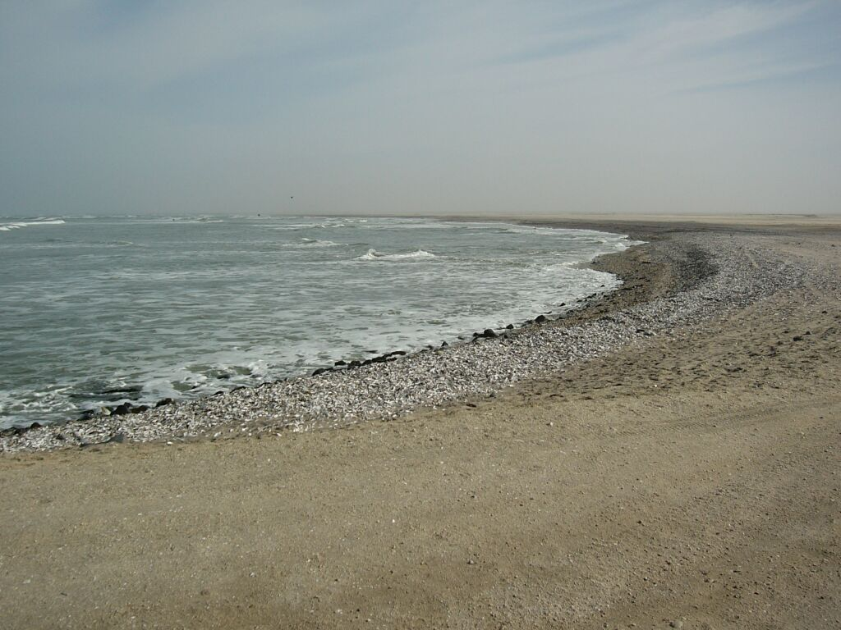
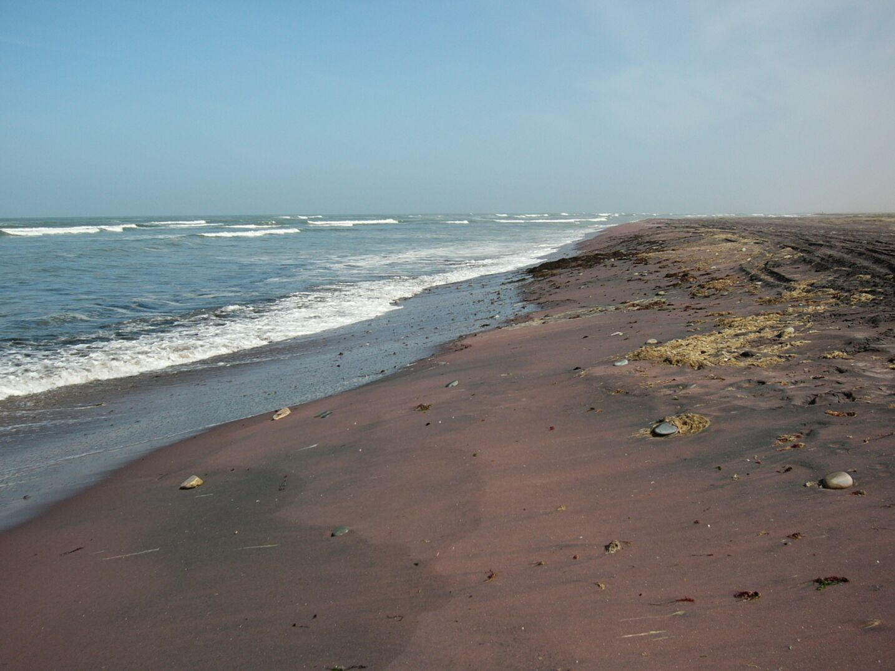
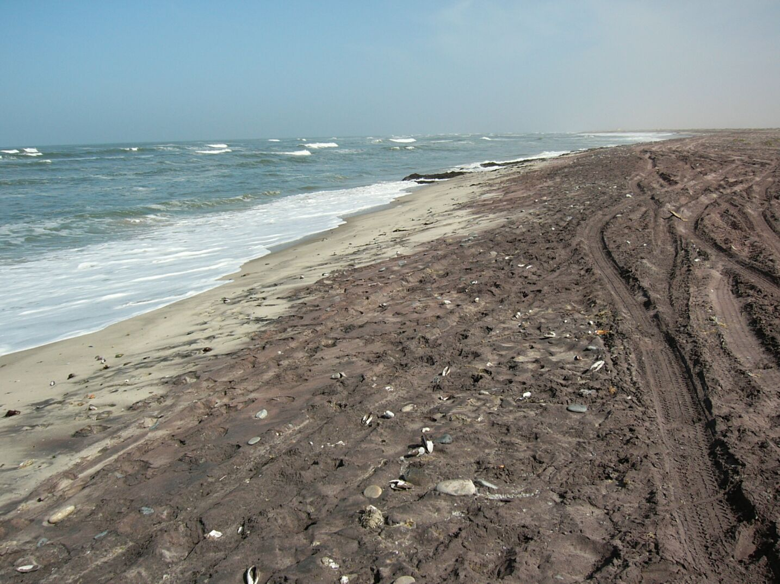
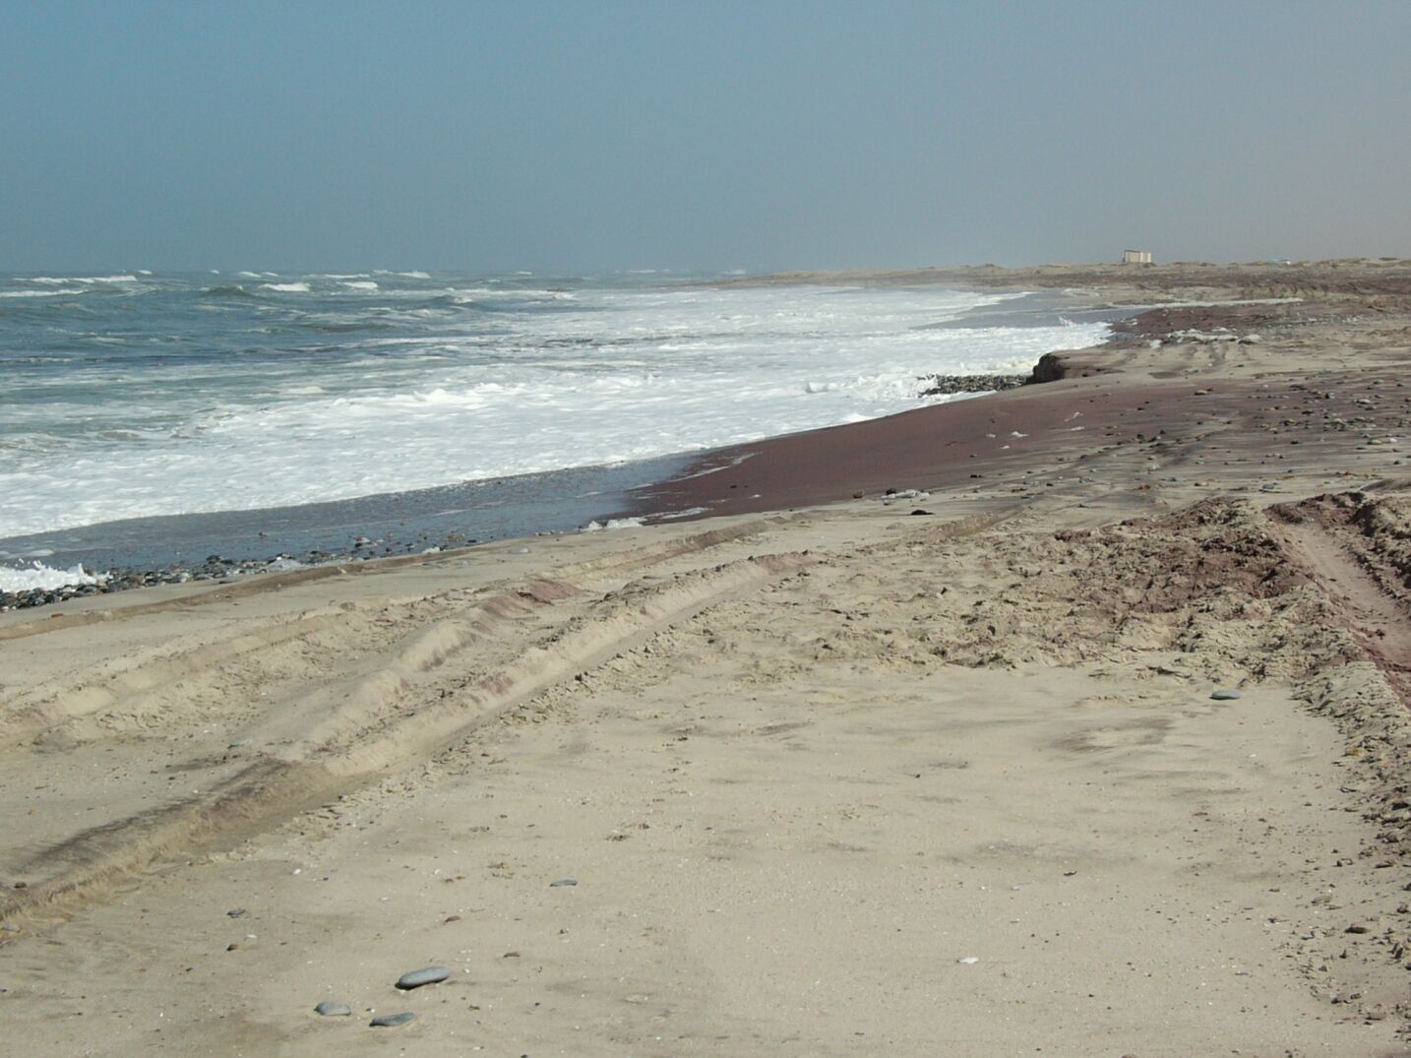

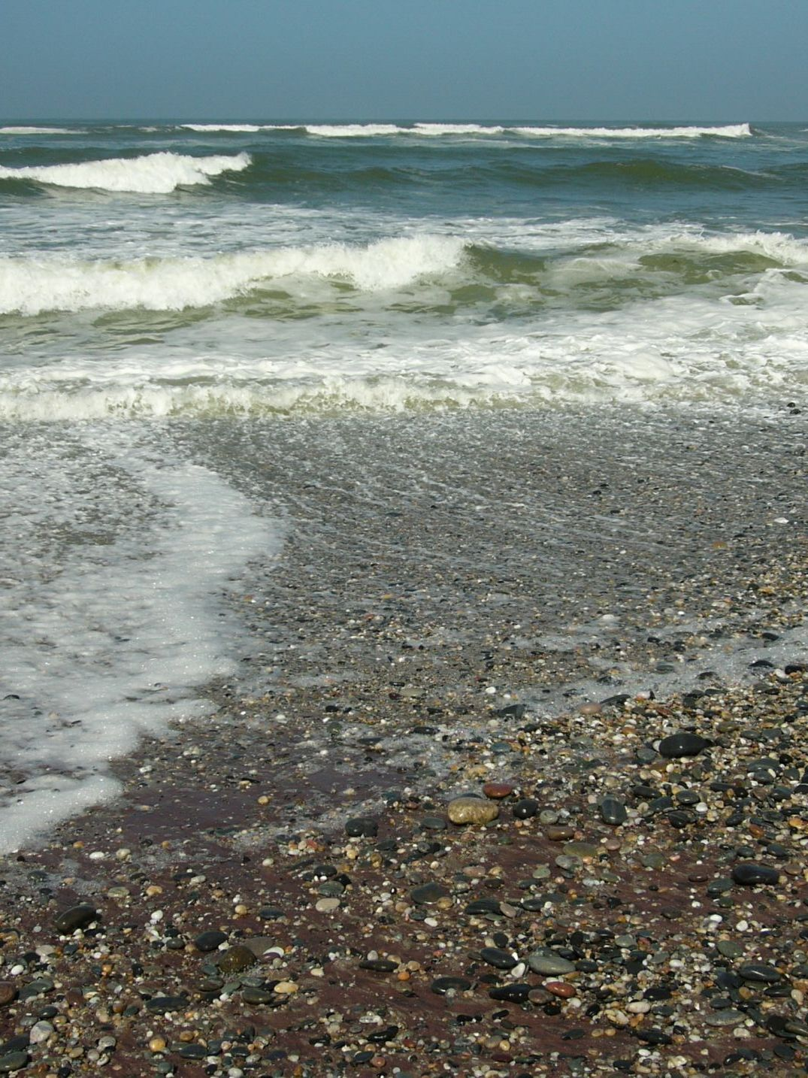

Figure 7: Photos of the study area from top left to bottom right: South end of study area looking north, middle of study area showing beach berm, car tracks on beach, north end of study area and gravel beds at northern end.
From the berm, the beach slopes steeply to the low water mark. At 1-2 m depth the slope flattens and the sand is replaced by gently sloping, low-relief rocky seabed. This extends ~400 m offshore to about the 5 m depth contour. Between the 5 m and 10 m depth contours, the seabed is characterised by low-relief rock outcrops interspersed by depressions of fine to medium sand (Figure 4.2). The sandy areas, which have a maximum thickness of 2.6 m, are underlain by bedrock. Seaward of the 10 m depth contour the seabed is dominated by a gently sloping flat featureless sandy area (CSIR 2007).

Figure 8: Sub-bottom profiling colour map of the seabed offshore of the study area.
Further offshore to beyond the 100-m depth contour, the seabed is dominated by a tongue of sandy mud, which extends from south of Sandwich Harbour to the north past Henties Bay (Figure 9). These biogenic muds are the main determinants of the formation of low-oxygen waters and sulphur eruptions off central Namibia (see below).

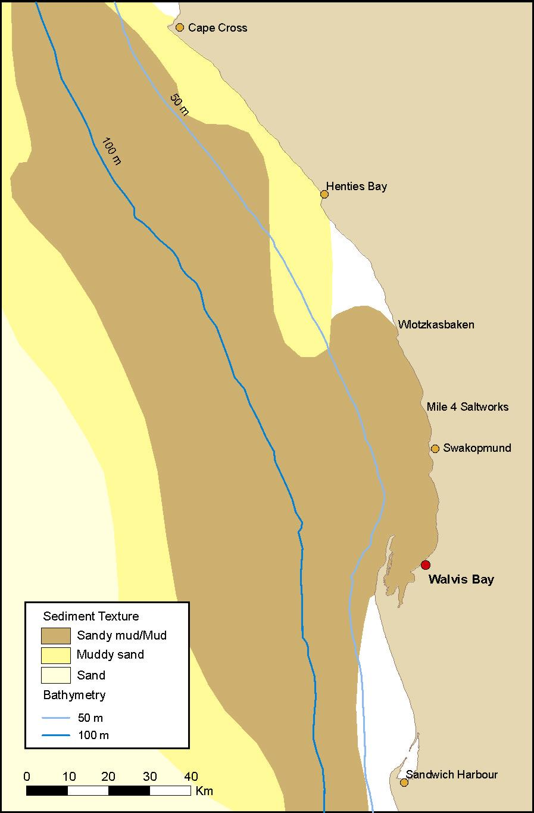

Figure 9: Seabed sediments in the study area.

Climate
The extremely arid climate of the Namib Desert is controlled by the interacting effects of the South Atlantic Subtropical Anticyclone (SAA), the divergent south-easterly trade winds, the cold water Benguela upwelling system and the desert’s location on the rainshadow side of southern Africa (Van Zinderen Bakker 1975). Consequently there is a steep climatic gradient from the cool, often foggy, coastal belt dominated by southerly winds to the warm dry interior from which it is separated by the Great Escarpment. The harsh aridity of the Namib coastline contrasts with the rich productive marine environment offshore. Heavy rainfall in the interior of the country rarely reaches the sea, although water trapped underground in large aquifers may reach the coastline. There are no perennial westward-flowing rivers in the study area. All seasonal or ephemeral rivers lie between the border to Angola and Walvis Bay and may occasionally reach the sea when they flood after heavy inland rains.

Fog is the most distinctive feature of the coastal climate of the Namib. It is usually considered to be a hazard since it impairs visibility but it is a significant source of moisture for desert animals and plants. Fog occurs on average 150 days per year, being most frequent during the months of April through August. Average precipitation per annum along the coastal region between Walvis Bay and Henties Bay is <15 mm. Coastal temperatures average around 15°C, gradually increasing inland (Barnard 1998). In winter, maximum diurnal shifts in temperature can occur caused by the hot easterly ‘Berg’ winds which blow off the desert. During such occasions temperatures up to 30°C are not uncommon. Detailed monthly climate statistics for Swakopmund are provided in Table 3.

Table 3: Monthly climate statistics for Swakopmund.
Month | Temperature (°C)  Average Daily Max/Min | Rainfall  (in mm) | Relative Humidity  (%)
January | 23/15 | 0 | 73
February | 23/16 | 5 | 73
March | 23/15 | 8 | 73
April | 24/13 | 3 | 66
May | 23/11 | 3 | 68
June | 23/09 | 0 | 64
July | 21/08 | 0 | 65
August | 20/08 | 3 | 73
September | 19/09 | 0 | 69
October | 19/11 | 0 | 69
November | 22/12 | 0 | 71
December | 23/14 | 0 | 72

Winds
The atmospheric features and processes active on the West Coast of southern Africa have been described by Nelson & Hutchings (1983), Kamstra (1985), Shannon (1985), Shannon & Nelson (1996), and Shannon & O’Toole (1998). The description below is summarised from these authors.

The area under consideration falls within the Benguela region. Winds at the sea surface are seasonally modulated and significantly influence the oceanography of the Benguela region. The winds in the system are vigorous with gale force winds occurring in all seasons, but being most frequent in spring. The prevailing winds are controlled by the south Atlantic subtropical anticyclone, the seasonal atmospheric pressure field over the subcontinent, and the eastward moving mid-latitude cyclones south of the southern African subcontinent. The south Atlantic anticyclone is a perennial feature that forms part of the discontinuous belt of high-pressure systems, which encircle the subtropical southern hemisphere. It undergoes seasonal variations in that it is strongest in the austral summer when it also attains its southernmost extension lying southwest and south of the subcontinent. In contrast, the mid-latitude cyclones passing south of the subcontinent result in a short-term cyclicity of wind events.

The arid coastal plain of the southern African West Coast acts as a thermal barrier to cross-flow thereby topographically steering the winds along the coast. This induces the characteristically moderate to strong south-westerly (SW) winds in the region. Available wind data indicate that winds from the West-South-Westerly direction dominate the wind pattern in the area, with wind speeds reaching up to 10 m. s⁻¹. These winds bring cool, moist air into the coastal region, and play an important role in the loss of sediment from beaches. These strong equatorwards winds are interrupted by the passing of coastal lows with which are associated periods of calm or north or northwest wind conditions. These northerlies occur throughout the year, but are more frequent in spring and summer.

During autumn and winter, the south Atlantic anticyclone weakens and migrates north-westwards causing catabatic, or easterly ‘berg’ winds. These powerful offshore winds can exceed 50 km. h⁻¹, producing sandstorms that considerably reduce visibility at sea and on land. Although they occur intermittently for about a week at a time, they have a strong effect on the coastal temperatures, which often exceed 30°C during ‘berg’ wind periods (Shannon & O’Toole 1998). Seasonal wind roses for Swakopmund are illustrated in Figure 10.

Waves
The central Namibian coastline is influenced by major swells generated in the roaring forties, as well as significant sea waves generated locally by the persistent south-westerly winds. Apart from Walvis Bay and Swakopmund, wave shelter in the form of west to north-facing embayments, and coast lying in the lee of headlands are extremely limited.

No measured wave data are available for the Swakopmund - Henties Bay area. However, data collected by Voluntary Observing Ships indicate that the largest waves recorded along the southern African West Coast originate from the S-SW sectors and may attain 4-6 m. Storms occur frequently with significant wave heights over 3 m occurring 10% of the time. Waves are concentrated in a fairly narrow directional band with 75% of waves moving in the SSW direction sector, whilst 17% are in the SW sector, and 7% occur from the south. There is no strong seasonal variation in the wave regime except for slight increases in swell from WSW-W direction in winter.

Wave heights in the range of 1.5 m to 2.5 m occur most frequently, with a mean wave height of 2.14 m and mean wave periods in the range of 8 s to 13 s. Longer period swells with mean periods of 11 s to 15 s and generated by mid-latitude cyclones occur about 30% of the time. Wind-induced waves on the other hand have shorter wave periods (~8 seconds), are generally steeper than swell waves.

Daily wave height measurements from a wave recorder stationed off Port Nolloth indicate an ‘event’ scale distribution of wave heights, with large wave events persisting for a maximum of 7 days, but 3-5 day periods being more common.

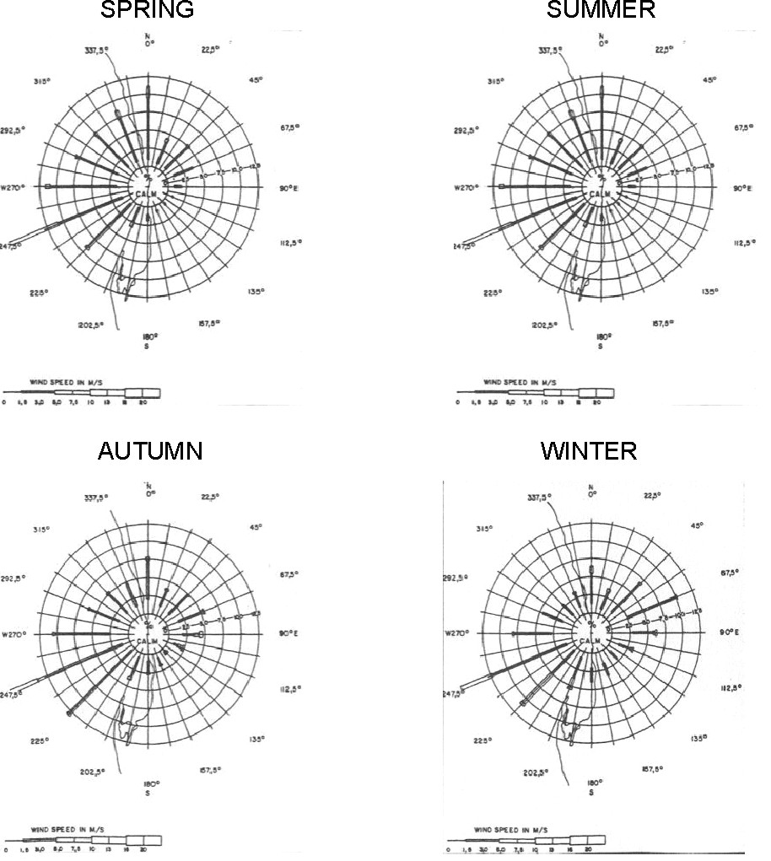

Figure 10: Swakopmund Seasonal Wind Roses.

Tides
In common with the rest of the southern African coast, tides in the study area are regular and semi-diurnal. The maximum tidal variation is approximately 2 m, with a typical tidal variation of ~1 m. Variations of the absolute water level as a result of meteorological conditions such as wind and waves can however occur adjacent to the shoreline and differences of up to 0.5 m in level from the tidal predictions are not uncommon. Tidal currents are minimal with measurements of 0.1 m.s⁻¹ reported at Walvis Bay. Table 4 lists mean tidal levels for Walvis Bay.

Table 4: Tide statistics for Walvis Bay from the SA Tide Tables (SAN 2007). All levels are referenced to Chart Datum.
Description |  | Level in m
Highest Astronomical Tide | HAT | +1.97
Mean High Water of Spring Tide | MHWS | +1.69
Mean High Water of Neap Tide | MHWN | +1.29
Mean Level | ML | +0.98
Mean Sea Level | MSL | +0.966
Mean Low Water of Neap Tide | MLWN | +0.67
Mean Low Water of Spring Tide | MLWS | +0.27
Lowest Astronomical Tide | LAT | 0.00

Coastal Currents
Current velocities in continental shelf areas of the Benguela region range generally between 10 – 30 cm.s⁻¹ (Boyd & Oberholster 1994). The flows are predominantly wind-forced, barotropic and fluctuate between poleward and equatorward flow (Shillington et al. 1990; Nelson & Hutchings 1983). Fluctuation periods of these flows are 3 - 10 days, although the long-term mean current residual is in an approximate NW (alongshore) direction. Currents in the nearshore environment along the coastline of the study area have not been well studied, but some surface-current measurements were done at Swakopmund between 1971 and 1972 (CSIR 2005). Surface currents in the area appear to be quite variable, with flows primarily <30 cm.s⁻¹ and an average velocity of 14 cm.s⁻¹. Current speeds in reverse flows observed between Walvis Bay and Henties Bay range between 2 - 17 cm.s⁻¹. Near bottom shelf flow is mainly poleward (Nelson 1989) with low velocities of typically 5 cm.s⁻¹.

Surf-zone Currents
Typically wave-driven flows dominate in the surf-zone (characteristically 150 m to 250 m wide), with the influence of waves on currents extending out to the base of the wave effect (~40 m; Rogers 1979). The influence of wave-driven flows extends beyond the surf-zone in the form of rip currents. Longshore currents are driven by the momentum flux of shoaling waves approaching the shoreline at an angle, while cross-shelf currents are driven by the shoaling waves. The magnitude of these currents is determined primarily by wave height, wave period, angle of incidence of the wave at the coast and bathymetry. Surf-zone currents have the ability to transport unconsolidated sediments along the coast in the northward littoral drift.

Nearshore velocities have not been reported and are difficult to estimate because of acceleration features such as surf-zone rips and sandbanks. However, computational model estimates using nearshore profiles and wave conditions representative of this coastal region suggest time-averaged northerly longshore flows which have a cross-shore mean of between 0.2 to 0.5 m.s⁻¹. Instantaneous measurements of cross-shore averaged longshore velocities are often much larger. Surf-zone-averaged longshore velocities in other exposed coastal regions commonly peak at between 1.0 m.s⁻¹ to 1.5 m.s⁻¹, with extremes exceeding 2 m.s⁻¹ for high wave conditions (CSIR 1993, 2002). The southerly longshore flows are considered to remain below 0.5 m.s⁻¹.

Upwelling
The major feature of the Benguela system is upwelling and the consequent high nutrient supply to surface waters leads to high biological production and large fish stocks. The prevailing longshore, equatorward winds move nearshore surface water northwards and offshore. To balance the displaced water, cold, deeper water wells up inshore. Although the rate and intensity of upwelling fluctuates with seasonal variations in wind patterns, the most intense upwelling tends to occur where the shelf is narrowest and the wind strongest. The largest and most intense upwelling cell is in the vicinity of Lüderitz, and upwelling can occur there throughout the year (Figure 11). Off northern and central Namibia, several secondary upwelling cells occur. Upwelling in these cells is perennial, with a late winter maximum (Shannon 1985).

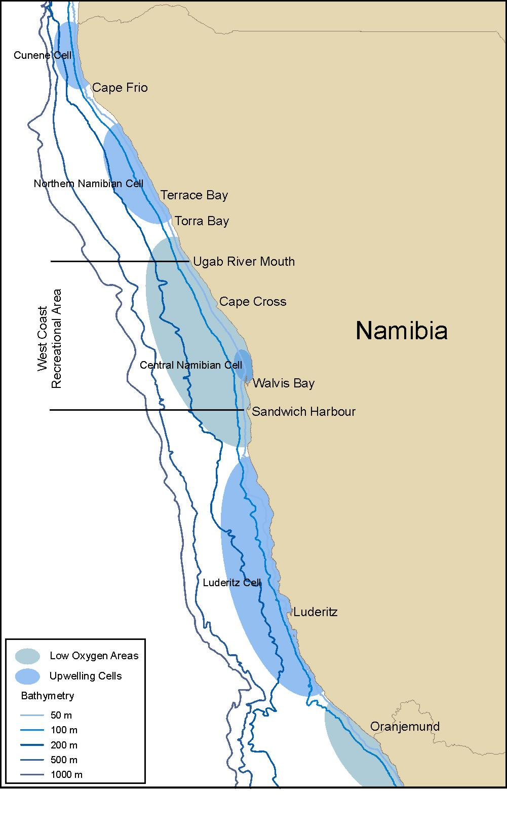

Figure 11: Map of the Namibian coastline showing the positions of the upwelling cells and the formation zones of low oxygen water. Place names mentioned in the text are also indicated.

Water Masses and Temperature
South Atlantic Central Water (SACW) comprises the bulk of the seawater in the study area, either in its pure form in the deeper regions, or mixed with previously upwelled water of the same origin on the continental shelf (Nelson & Hutchings 1983). Salinities range between 34.5‰ and 35.5‰ (Shannon 1985). Data recorded over a ten year period at Swakopmund (1988 – 1998) show that seawater temperatures vary between 10°C and 23°C, averaging 14.9°C. They show a strong seasonality with lowest temperatures occurring during winter when upwelling is at a maximum (Figure 12).

During the non-upwelling season in summer, daily seawater temperature fluctuations of several degrees are common along the central Namibian nearshore coast. It appears that the thermal regime of the surf-zone is controlled by the locally-forced Ekman offshore transport, which leads the associated temperature fluctuations by one day (Bartholomae & Hagen 2007). This time-lag suggests the existence of a persistent recirculation cell in nearshore waters in this region.

The continental shelf waters of the Benguela system are characterised by low oxygen concentrations, especially on the bottom. SACW itself has depressed oxygen concentrations (~80% saturation value), but lower oxygen concentrations (<40% saturation) frequently occur (Visser 1969; Bailey et al. 1985; Chapman & Shannon 1985).

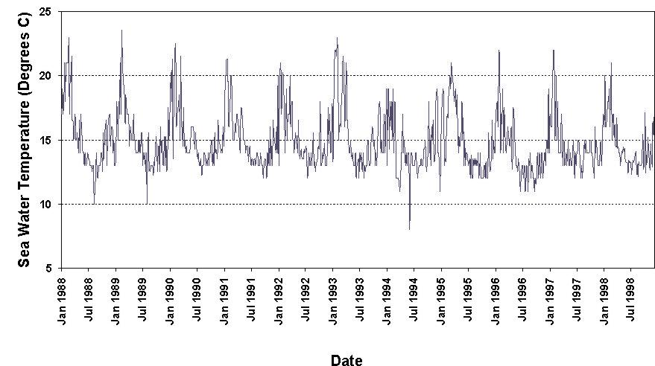

Figure 12: Seawater temperatures at Swakopmund recorded between 1988 and 1998.

Nutrient concentrations of upwelled water of the Benguela system attain 20 µm nitrate-nitrogen, 1.5 µm phosphate and 15-20 µm silicate, indicating nutrient enrichment (Chapman & Shannon 1985). This is mediated by nutrient regeneration from biogenic material in the sediments (Bailey et al. 1985). Modification of these peak concentrations depends upon phytoplankton uptake which varies according to phytoplankton biomass and production rate. The range of nutrient concentrations can thus be large but, in general, concentrations are high.

Turbidity
Turbidity is a measure of the degree to which the water looses its transparency due to the presence of suspended particulate matter. Total Suspended Particulate Matter (TSPM) is typically divided into Particulate Organic Matter (POM) and Particulate Inorganic Matter (PIM), the ratios between them varying considerably. The POM usually consists of detritus, bacteria, phytoplankton and zooplankton, and serves as a source of food for filter-feeders. Seasonal microphyte production associated with upwelling events will play an important role in determining the concentrations of POM in coastal waters. PIM, on the other hand, is primarily of geological origin consisting of fine sands, silts and clays. PIM loading in nearshore waters is strongly related to natural inputs from rivers or from ‘berg’ wind events, or through resuspension of material on the seabed.

Concentrations of suspended particulate matter in shallow coastal waters can vary both spatially and temporally, typically ranging from a few mg.ℓ⁻¹ to several tens of mg.ℓ⁻¹ (Bricelj & Malouf 1984; Berg & Newell 1986; Fegley et al. 1992). Field measurements of TSPM and PIM concentrations in the Benguela current system have indicated that outside of major flood events, background concentrations of coastal and continental shelf suspended sediments are generally <12 mg.ℓ⁻¹, showing significant long-shore variation (Zoutendyk 1992, 1995). Considerably higher concentrations of PIM have, however, been reported from southern African west coast waters under stronger wave conditions associated with high tides and storms, or under flood conditions.

The major source of turbidity in the swell-influenced nearshore areas off Namibia is the redistribution of fine inner shelf sediments by long-period Southern Ocean swells. The current velocities typical of the Benguela (10-30 cm. s⁻¹) are capable of resuspending and transporting considerable quantities of sediment equatorwards. Under relatively calm wind conditions, however, much of the suspended fraction (silt and clay) that remains in suspension for longer periods becomes entrained in the slow poleward undercurrent (Shillington et al. 1990; Rogers & Bremner 1991).

Superimposed on the suspended fine fraction, is the northward littoral drift of coarser bedload sediments, parallel to the coastline. This northward, nearshore transport is generated by the predominantly southwesterly swell and wind-induced waves. Longshore sediment transport, however, varies considerably in the shore-perpendicular dimension. Sediment transport in the surf-zone is much higher than at depth, due to high turbulence and convective flows associated with breaking waves, which suspend and mobilise sediment (Smith & Mocke 2002).

On the inner and middle continental shelf, the ambient currents are insufficient to transport coarse sediments, and resuspension and shoreward movement of these by wave-induced currents occur primarily under storm conditions (see also Drake et al. 1985; Ward 1985).

The powerful easterly ‘berg’ winds occurring along the Namibian coastline in autumn and winter also play a significant role in sediment input into the coastal marine environment (Figure 13), potentially contributing the same order of magnitude of sediment input as the annual estimated input of sediment by the Orange River (Zoutendyk 1992; Shannon & O’Toole 1998; Lane & Carter 1999). For example, for a single ‘berg’-wind event it was estimated that 50 million tons of dust were blown into the sea by extensive sandstorms along much of the coast from Cape Frio, Namibia in the north to Kleinzee, South Africa in the south (Shannon & Anderson 1982) with transport of the sediments up to 150 km offshore.

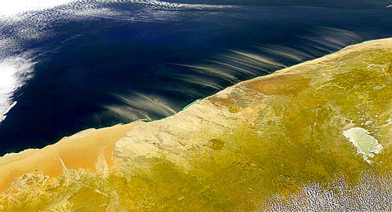

Figure 13: Satellite image showing dust plumes being blown offshore from the Namibia coast (Image source: www.intute.ac.uk).

Organic Inputs
The Benguela upwelling region is an area of particularly high natural productivity, with extremely high seasonal production of phytoplankton and zooplankton. These plankton blooms in turn serve as the basis for a rich food chain up through pelagic baitfish (anchovy, pilchard, round-herring and others), to predatory fish (snoek), mammals (primarily seals and dolphins) and seabirds (jackass penguins, cormorants, pelicans, terns and others). All of these species are subject to natural mortality, and a proportion of the annual production of all these trophic levels, particularly the plankton communities, die naturally and sink to the seabed.

Balanced multispecies ecosystem models have estimated that during the 1990s the Benguela region supported biomasses of 76.9 tons/km² of phytoplankton and 31.5 tons/km² of zooplankton alone (Shannon et al. 2003). Thirty six percent of the phytoplankton and 5% of the zooplankton are estimated to be lost to the seabed annually. This natural annual input of millions of tons of organic material onto the seabed off the southern African west coast has a substantial effect on the ecosystems of the Benguela region. It provides most of the food requirements of the particulate and filter-feeding benthic communities that inhabit the sandy-muds of this area, and results in the high organic content of the muds in the region. As most of the organic detritus is not directly consumed, it enters the seabed decomposition cycle, resulting in subsequent depletion of oxygen in deeper waters overlying these muds and the generation of hydrogen sulphide and sulphur eruptions along the coast.

An associated phenomenon ubiquitous to the Benguela system are red tides (dinoflagellate and/or ciliate blooms) (see Shannon & Pillar 1985; Pitcher 1998). Also referred to as Harmful Algal Blooms (HABs), these red tides can reach very large proportions, with sometimes spectacular effects. Toxic dinoflagellate species can cause extensive mortalities of fish and shellfish through direct poisoning, while degradation of organic-rich material derived from both toxic and non-toxic blooms results in oxygen depletion of subsurface water. Periodic low oxygen events associated with massive algal blooms in the nearshore can have catastrophic effects on the biota (see below).

Low Oxygen Events
The low oxygen concentrations are attributed to nutrient remineralisation in the bottom waters of the system (Chapman & Shannon 1985). The absolute rate of this is dependent upon the net organic material build-up in the sediments, with the carbon rich mud deposits playing an important role. As the mud on the shelf is distributed in discrete patches (Figure 4.3), there are corresponding preferential areas for the formation of oxygen-poor water, the main one being off central Namibia (Chapman & Shannon 1985) (see Figure 11). The distribution of oxygen-poor water is subject to short (daily) and medium term (seasonal) variability in the volumes of oxygen depleted water that develop (De Decker 1970; Bailey & Chapman 1991). Subsequent upwelling processes can move this low-oxygen water up onto the inner shelf, and into nearshore waters, often with devastating effects on marine communities.

Oxygen deficient water can affect the marine biota at two levels. It can have sub-lethal effects, such as reduced growth and feeding, and increased intermoult period in the rock-lobster population (Beyers et al. 1994). The oxygen-depleted subsurface waters characteristic of the southern and central Namibian shelf are an important factor determining the distribution of rock lobster in the area. During the summer months of upwelling, lobsters show a seasonal inshore migration (Pollock & Shannon 1987), and during periods of low oxygen become concentrated in shallower, better-oxygenated nearshore waters.

On a larger scale, periodic low oxygen events in the nearshore region can have catastrophic effects on the marine communities. Low-oxygen events associated with massive algal blooms can lead to large-scale stranding of rock lobsters, and mass mortalities of other marine biota and fish (Newman & Pollock 1974; Matthews & Pitcher 1996; Pitcher 1998; Cockroft et al. 2000). Very recently, in March 2008 a series of red tide blooms of the dinoflagellate Ceratium Furca occurred along the central Namibian coast. The blooms developed during a time where high temperatures combined with a lack of wind, which is believed to be at the root of the red tide blooms. Algal blooms usually occur during summer-autumn (February to April) but can also develop in winter during the ‘bergwind periods’, when similar warm windless conditions occur for extended periods. The blooms from March 2008 were non-toxic but the eventual die-off and bacterial decomposition of the bloom reduced oxygen concentrations in the water column which caused rock lobster walk-outs and other fish mortalities on several occasions in March 2008 (www.nacoma.org.na, Figure 14).

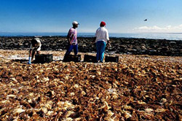

Figure 14: ‘Walk-outs’ and mass mortalities of rock lobsters at the central Namibian coast (image source: www.nacoma.org.na).

Sulphur Eruptions
Closely associated with seafloor hypoxia, particularly off central Namibia between Cape Cross and Conception Bay, is the generation of toxic hydrogen sulphide and methane within the organically-rich, anoxic muds following decay of expansive algal blooms. Under conditions of severe oxygen depletion, hydrogen sulphide (H₂S) gas is formed by anaerobic bacteria in anoxic seabed muds (Brüchert et al. 2003). This is periodically released from the muds as ‘sulphur eruptions’, causing upwelling of anoxic water and formation of surface slicks of sulphur discoloured water (Emeis et al. 2004), and even the temporary formation of floating mud islands (Waldron 1901). Such eruptions are accompanied by a characteristic pungent smell along the coast and the sea takes on a lime green colour (Figure 15). These eruptions strip dissolved oxygen from the surrounding water column. Such complex chemical and biological processes are often associated with the occurrence of harmful algal blooms, causing large-scale mortalities to fish and crustaceans (see above).

Sulphur eruptions have been known to occur off the Namibian coast for centuries (Waldron 1901), and the biota in the area are likely to be naturally adapted to such pulsed events, and to subsequent hypoxia. However, satellite remote sensing has recently shown that eruptions occur more frequently, are more extensive and of longer duration than previously suspected, and that resultant hypoxic conditions last longer than thought (Weeks et al. 2004).

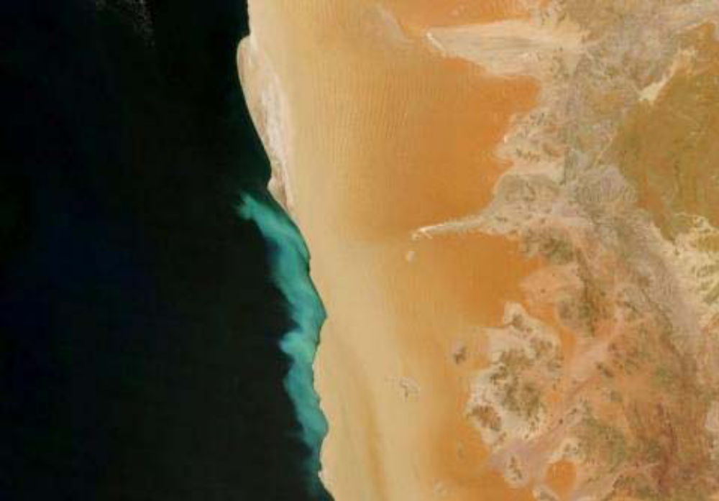
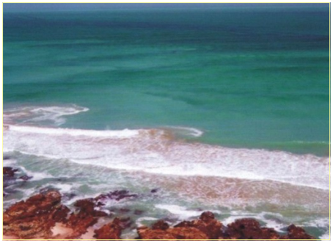

Figure 15: Satellite image showing discoloured water offshore the Namib Desert resulting from a nearshore sulphur eruption (satellite image source: www.intute.ac.uk). Inset shows a photograph taken from shore at Sylvia Hill, north of Lüderitz, during such an event in March 2002 (photograph by J. Kemper, MFMR, Lüderitz).

Recently, the role of micro-organisms in the detoxification of sulphidic water was investigated by a collaborative group of German and Namibian scientists (http://www.mpi-bremen.de/Projekte_9.html; http://idw-online.de/pages/de/news292832). During a research cruise in January 2004, they hit upon a sulphidic water mass off the coast off Namibia covering 7,000 km² of coastal seafloor. The surface waters, however, were well oxygenated. In the presence of oxygen, sulphide is oxidized and transformed into nontoxic forms of sulphur. Surprisingly, though, there was an intermediate layer in the water column, which contained neither hydrogen sulphide nor oxygen. Further investigation indicated that sulphide diffusing upwards from the anoxic bottom water is consumed by autotrophic denitrifying bacteria below the oxic zone. The intermediate water layer is the habitat of detoxifying microorganisms, which by using nitrate transform sulphide into finely dispersed particles of sulphur that are nontoxic. Thus, the microorganisms create a buffer zone between the toxic deep water and the oxygenated surface waters. These results, however, also suggest that animals living on or near the seafloor in coastal waters may be affected by sulphur eruptions more often than previously thought. Up to now, sulphidic water masses were monitored with the help of satellites, taking pictures of the sea surface while orbiting the earth, as they show up as whitish/turquoise discolorations of surface water (Figure 15). However, many of these sulphidic events may go unnoticed by satellite because bacteria consume the hydrogen sulphide before it reaches the surface.

Biological Environment
Biogeographically the central Namibian coastline falls into the warm-temperate Namib Province which extends northwards from Lüderitz into southern Angola (Emanuel et al. 1992). The coastal, wind-induced upwelling characterising the Namibian coastline, is the principle physical process which shapes the marine ecology of the central Benguela region.

The coastline of central Namibia is dominated by sandy beaches, with rocky habitats being represented only by occasional small rocky outcrops. Consequently, marine ecosystems along the coast comprise a limited range of habitats that include:
- sandy intertidal and subtidal substrates,
- intertidal rocky shores and subtidal reefs,
- the water body.
The benthic communities within these habitats are generally ubiquitous throughout the southern African West Coast region, being particular only to substratum type, wave exposure and/or depth zone. They consist of many hundreds of species, often displaying considerable temporal and spatial variability. The biological communities ‘typical’ of each of these habitats are described briefly below, focussing both on dominant, commercially important and conspicuous species, as well as potentially threatened or sensitive species, which may be affected by the proposed project.

Sandy Substrate Habitats and Biota
The benthic biota of soft bottom substrates constitutes invertebrates that live on (epifauna), or burrow within (infauna), the sediments, and are generally divided into megafauna (animals >10 mm), macrofauna (>1 mm) and meiofauna (<1 mm).

Intertidal Sandy Beaches
Sandy beaches are one of the most dynamic coastal environments. The composition of their faunal communities is largely dependent on the interaction of wave energy, beach slope and sand particle size, which is called beach morphodynamics. Three morphodynamic beach types are described: dissipative, reflective and intermediate beaches (McLachlan et al. 1993). Generally, dissipative beaches are relatively wide and flat with fine sands and high wave energy. Waves start to break far from the shore in a series of spilling breakers that ‘dissipate’ their energy along a broad surf-zone. This generates slow swashes with long periods, resulting in less turbulent conditions on the gently sloping beach face. These beaches usually harbour the richest intertidal faunal communities. Reflective beaches have low wave energy, and are coarse grained (>500 µm sand) with narrow and steep intertidal beach faces. The relative absence of a surf-zone causes the waves to break directly on the shore causing a high turnover of sand. The result is depauperate faunal communities. Intermediate beach conditions exist between these extremes and have a very variable species composition (McLachlan et al. 1993; Jaramillo et al. 1995). This variability is mainly attributable to the amount and quality of food available. Beaches with a high input of e.g. kelp wrack have a rich and diverse drift-line fauna, which is sparse or absent on beaches lacking a drift-line (Branch & Griffiths 1988; Field & Griffiths 1991).

In the area between Walvis Bay and the Kunene River, beaches make up 44 % of the coastline (Bally et al. 1984). A number of studies have been conducted on sandy beaches in central Namibia, including Sandwich Harbour (Stuart 1975; Kensley & Penrith 1977), the Paaltjies (McLachlan 1985) and Langstrand (McLachlan 1985, 1986; Donn & Cockcroft 1989), beaches near Walvis Bay and Cape Cross (Donn & Cockcroft 1989), and very recently a beach survey was conducted near Wlotzkasbaken as part of the baseline study for the RO desalination plant for the Trekkopje Uranium Project (Pulfrich 2007). A further study by Tarr et al. (1985) investigated the ecology of three beaches further north on the Skeleton Coast. The results of these studies are summarised below.

Most beaches on the central Namibian coastline are open ocean beaches receiving continuous wave action. They are classified as exposed to very exposed on the 20-point exposure rating scale (McLachlan 1980), and intermediate to reflective and composed of well-sorted medium to coarse sands. The beaches tend to be characterised by well-developed berms (see Figure 7), and are well-drained and oxygenated.

Numerous methods of classifying beach zonation have been proposed, based either on physical or biological criteria. The general scheme proposed by Branch & Griffiths (1988) is used below, supplemented by data from central Namibian beach studies (Stuart 1975; Kensley & Penrith 1977; McLachlan 1985, 1986; Donn 1986; Donn & Cockcroft 1989).

Supralittoral zone - The supralittoral zone is situated above the high water spring (HWS) tide level, and receives water input only from large waves at spring high tides or through sea spray. The supralittoral is characterised by a mixture of air breathing terrestrial and semi-terrestrial fauna, often associated with and feeding on kelp deposited near or on the driftline. Terrestrial species include a diverse array of beetles and arachnids and some oligochaetes, while semi-terrestrial fauna include the oniscid isopod Tylos granulatus, and the talitrid amphipod (Amphipoda, Crustacea) Talorchestia quadrispinosa. Community composition depends on the nature and extent of wrack, in addition to the physical factors structuring beach communities, as described above.

Midlittoral zone - The intertidal zone, also termed the mid-littoral zone, has a vertical range of about 2 m. This mid-shore region is characterised by the cirolanid isopods Pontogeloides latipes, Eurydice (longicornis=) kensleyi, and Excirolana natalensis, the deposit-feeding polychaete Scolelepis squamata (Polychaeta) and various species of the polychaete genus Lumbrineris, and the amphipods of the families Lysianassidae and Phoxocephalidae. In some areas, juvenile and adult sand mussels Donax serra (Bivalvia, Mollusca) may also be present in considerable numbers.

Inner turbulent zone - The inner turbulent zone extends from the low water spring tide level to about -2 m depth, and is characterised by highly motile specie. The bentho-planktic mysids Gastrosaccus namibensis and G. psammodytes (Mysidacea, Crustacea), the ribbon worm Cerebratulus fuscus (Nemertea) and the cumacean Cumopsis robusta (Cumacea) are typical of this zone, although they generally extend partially into the midlittoral above. In areas where a suitable swash climate exists, the gastropod Bullia digitalis (Gastropoda, Mollusca) may also be present in considerable numbers.

Transition zone - The transition zone spans approximately 2-3 m depth and marks the area to which the break point might move during storms. Extreme turbulence is experienced in this zone, and as a consequence this zone typically harbours the lowest diversity on sandy beaches. Typical fauna of this zone include the polychaetes Nephtys hombergi, Diopatra neopolitana and Glycera convoluta, nemertean worms, amphipods such as Urothoe elegans and Mandibulophoxus stimpsoni, and the isopods Cirolana hirtipes and Eurydice (longicornis=) kensleyi.

Outer turbulent zone - Below 3 m depth extends the outer turbulent zone, where turbulence is significantly decreased and which is marked by a sudden increase in species diversity and biomass. In addition to the polychaetes found in the transition zone, other polychaetes in this zone include Diopatra neopolitana and Glycera convoluta. The abundance of nemertean worms increases significantly from that in the transition zone. Amphipods such as Urothoe elegans and Mandibulophoxux stimpsoni are also more abundant, as are the isopods Cirolana hirtipes and Pontogeloides latipes, the mysid G. namibensis, the decapods Diogenes extricatus and Ogyrides saldanhae, and the three spot swimming crab Ovalipes punctatus, as well as the gastropods Bullia laevissima and Natica forata.

The surf-zone in the study area is rich in phytoplankton (primarily dinoflagellates and diatoms) and zooplankton, and particulate organic matter is commonly deposited on the beaches as foam and scum. The organic matter, both in suspension and deposited on the sand, is thought to represent the main food input into these beaches, thereby accounting for the dominance of filter-feeders in the macrofaunal biomass (McLachlan 1985).

Most of the macrofaunal species recorded from beaches in central Namibia are ubiquitous throughout the biogeographic province, and no rare or endangered species are known. The invertebrate communities are similar to those recorded from beaches in southern Namibia (McLachlan & De Ruyck 1993; Nel et al. 1997; Meyer et al. 1998; Clark & Nel 2002; Clark et al. 2004; Pulfrich 2004a; Clark et al. 2005, 2006; Pulfrich & Atkinson 2007). The beaches are characterised by a relatively depauparate invertebrate fauna, both with regard to species diversity and biomass, which is typical of high-energy west coast beaches.

Subtidal Sandy Habitats
The structure and composition of benthic soft bottom communities is primarily a function of water depth and sediment grain size, but other factors such as current velocity, organic content, and food abundance also play a role (Snelgrove & Butman 1994; Flach & Thomsen 1998; Ellingsen 2002).

There is a noticeable scarcity of published information on the subtidal soft sediment biota, the only reference sourced being that of Donn & Cockcroft (1989) at Langstrand who investigated macrofauna to 5 m depth (see description for outer-turbulent zone above). In general, almost no scientific work on subtidal benthic communities has been done in the vicinity of the study area, or within the general region (J. Basson, MFMR, pers. comm.), and no further information could be obtained.

Rocky Habitats and Biota

Intertidal Rocky Shores
The central and northern coasts of Namibia are bounded to the east by the Namib Desert and are characterised primarily by gravel plains and shifting dunes. In common with most semi-exposed to exposed coastlines on the southern African west coast, the rocky shores that occur in the region are strongly influenced by sediments, and include considerable amounts of sand intermixed with the benthic biota. This intertidal mixture of rock and sand is referred to as a mixed shore, and constitutes 40 % of the coastline between the Kunene River and Walvis Bay (Bally et al. 1984). In the study area, mixed shores are limited to very few small low-shore outcrops that are exposed only at low water spring, which alternate with long stretches of sandy beaches.

Typically, the intertidal area of rocky shores can be divided into different zones according to height on the shore. Each zone is distinguishable by its different biological communities, which is largely a result of the different exposure times to air. The level of wave action is particularly important on the low shore. Generally, biomass is greater on exposed shores, which are dominated by filter-feeders. Sheltered shores support lower biomass, and algae form a large portion of this biomass (McQuaid & Branch 1984; McQuaid et al. 1985).

Mixed shores incorporate elements of the trophic structures of both rocky and sandy shores. As fluctuations in the degree of sand coverage are common (often adopting a seasonal affect), the fauna and flora of mixed shores are generally impoverished when compared to more homogenous shores. The macrobenthos is characterized by sand-tolerant species whose lower limits on the shore are determined by their abilities to withstand physical smothering by sand (Daly & Mathieson 1977; Dethier 1984; van Tamelen 1996).

The published data on rocky intertidal biota is restricted to the areas south of Lüderitz (Penrith & Kensley 1970a; Pulfrich et al. 2003a, 2003b; Pulfrich 2004b, 2005, 2006, 2007; Clark et al. 2004, 2005, 2006; Pulfrich & Atkinson 2007), and north of Rocky Point (Penrith & Kensley 1970b; Kensley & Penrith 1980). The information sourced from these publications, is complemented by unpublished data on rocky biota in the Wlotzkasbaken area supplied by MFMR (B. Currie, MFMR, unpublished data), and visual observations by the author of this report.

Typical species in the high shore include the tiny snail Afrolittorina knysnaensis, the false limpet Siphonaria capensis, the limpet Scutellastra granularis, and the barnacle Chthamalus dentatus. Further down the shore the mytilid mussels, Semimytilus algosus, Choromytilus meridionalis, and Perna perna occur (Figure 16). The invasive alien Mediterranean mussel Mytilus galloprovincialis is also present. Foliose algae are represented primarily by the red algae Caulacanthus ustulatus, Ceramium spp. and Plocamium spp. and the green alga Ulva spp. (N. Steffani, pers. obs.). The species encountered at the rocky outcrops in the study area were similar to those recorded from rocky intertidal areas in southern Namibia, and further to the north (see references above).

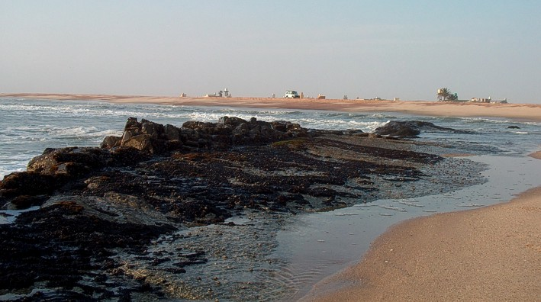

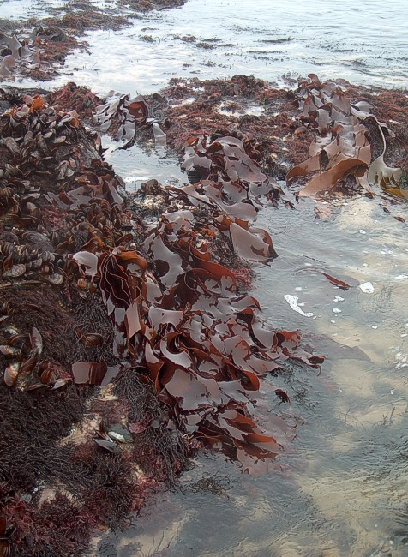
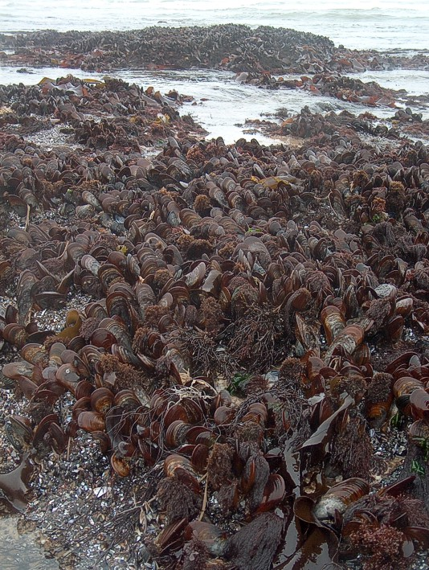

Figure 16: Rocky outcrop in the study area backed by sandy beach (top), and large Perna perna (bottom left) and a diversity of red foliose algae (bottom right) low at the shore.
As part of a natural sedimentary cycle on the Namibian coastline, these outcrops are subject to gradual accumulation of sand deposits during summer, and subsequent beach erosion during winter.

Although not directly harbouring any rare faunal or floral species, rocky intertidal shores are food-rich habitats for seabirds and wetland birds, attracting higher numbers of birds than the surrounding sandy beaches. Rocky intertidal fauna most sensitive to disturbance are the large limpet species. They tend to be the first ones eliminated by disturbance and the last to recover because of possible narrow tolerance limits to changes in environmental conditions. They act as keystone species on rocky shore, controlling the abundance of foliose algae and hence many other species (Branch 1981).

Rocky Subtidal Reefs
Reports on the benthic biota of nearshore reefs are restricted primarily to research undertaken in the vicinity of Lüderitz (Beyers 1979; Tomalin 1995; Pulfrich 1998; Pulfrich & Penney 1998, 1999, 2001), and information on rocky subtidal habitats in central Namibia is lacking. No scientific surveys have been undertaken of rocky subtidal habitats in the study area, and no information exists on the faunal and floral communities (J. Basson, MFMR, pers. com.).

A hydrographical and geophysical survey conducted in the area (CSIR 2008) indicates that the area is characterised by gently sloping, low-relief rock outcrops intersected by sandy gullies and depressions. The flat and featureless nature of the reefs suggests that they may intermittently be covered by a veneer of unconsolidated sediments. Although kelp occurs sparsely for up to 100 m offshore, the benthic communities inhabiting these reefs can be expected to be dominated by sand-tolerant and deposit feeding species. More information on the benthic communities in the study area will be available once the field survey has been conducted.

Pelagic Communities
The pelagic communities are typically divided into plankton and fish, and their main predators, marine mammals (seals, dolphins and whales) and turtles.

Plankton
Plankton is particularly abundant in the shelf waters off Namibia, being associated with the upwelling characteristic of the area. Plankton range from single-celled bacteria to jellyfish of 2-m diameter, and include bacterio-plankton, phytoplankton, zooplankton, and ichthyoplankton.

Off the Namibian coastline, phytoplankton are the principle primary producers with mean annual productivity being comparatively high at 2 g C. m⁻². day⁻¹. The phytoplankton is dominated by diatoms, which are adapted to the turbulent sea conditions. Diatom blooms occur after upwelling events, whereas dinoflagellates are more common in blooms that occur during quiescent periods, since they can grow rapidly at low nutrient concentrations (Barnard 1998). A study on phytoplankton in the surf zone off two beaches in the Walvis Bay and Cape Cross area showed relatively low primary production values of only 10-20 mg C. m⁻². day⁻¹ compared to those from oceanic waters. This was attributed to the high turbidity in this environment (McLachlan 1986). In the surf-zone, diatoms and dinoflagellates are nearly equally important members of the phytoplankton, and some silicoflagellates are also present. Charateristic species belong to the genus Gymnodinium, Peridinium, Navicula, and Thalassiosira (McLachlan 1986).

Namibian zooplankton has a relatively low diversity. Samples collected over a full seasonal cycle (February to December) along a 10 to 90-nautical-miles transect offshore Walvis Bay showed that the mesozooplankton (<2mm body width) community included egg, larval, juvenile and adult stages of copepods, cladocerans, euphausiids, decapods, chaetognaths, hydromedusae and salps, as well as protozoans and meroplankton larvae (Hansen et al. 2005). Copepods are the most dominant group making up 70–85% of the zooplankton. The four dominant calanoid copepod species, in order of abundance, are M. lucens, C. carinatus, R. nasutus and Centropages spp. During the period of intense upwelling, the two herbivorous species, C. carinatus and R. nasutus, increase in abundance inshore, leading to a shift in dominance from C. carinatus to M. lucens with increasing distance offshore. Seasonal patterns in copepod abundance, with low numbers during autumn (March–June) and increasing considerably during winter/early summer (July–December), appear to be linked to the period of strongest coastal upwelling in the northern Benguela (May–December), allowing a time lag of about 3–8 weeks, which is required for copepods to respond and build up large populations (Hansen et al. 2005). This suggest close coupling between hydrography, phytoplankton and zooplankton. Timonin et al. (1992) described three phases of the upwelling cycle (quiescent, active and relaxed upwelling) in the northern Benguela, each one characterised by specific patterns of zooplankton abundance, taxonomic composition and inshore-offshore distribution. It seems that zooplankton biomass closely follows the changes in upwelling intensity and phytoplankton standing crop. Consistently higher biomass of zooplankton occurs offshore to the west and northwest of Walvis Bay (Barnard 1998).

Ichthyoplankton constitutes the eggs and larvae of fish. As the preferred spawning grounds of numerous commercially exploited fish species are located off central and northern Namibia, their eggs and larvae form an important contribution to the ichthyoplankton in the region.

Fish
Small pelagic species that may occur in the area include the sardine/pilchard (Sardinops sagax), juvenile horse mackerel (Sadinops ocellatus), anchovy (Engraulis capensis), and round herring (Etrumeus whiteheadi). Although these species generally occur within the 200 m contour, they may often be found very close inshore, just beyond the surf-zone. The Namibian pelagic stock is currently considered to be in a critical condition due to a combination of over-fishing and unfavourable environmental conditions as a result of Benguela Niños.

Linefish species common off the central Namibian coastline include snoek (Thyrsites atun), silver kob (Argyrosomus inodorus), West Coast Steenbras (Lithognathus aureti), blacktail (Diplodus sargus), white stumpnose (Rhabdosargus globiceps), Hottentot (Pachymetopon blochii) and galjoen (Dichistius capensis). Dusky kob (Argyrosomus coronus) also occurs off northern Namibia.

The surf-zone and outer turbulent zone habitats of sandy beaches are considered to be important nursery habitats for marine fishes (Modde 1980; Lasiak 1981; Kinoshita & Fujita 1988; Clark et al. 1994). However, the composition and abundance of the individual assemblages seems to be heavily dependent on wave exposure (Blaber & Blaber 1980; Potter et al. 1990; Clark 1997a, b). Surf-zone fish communities off the coast of southern Namibia have been studied by Clark et al. (1998) and Meyer et al. (1998), who reported only five species occurring off exposed and very exposed beaches, these being harders (Liza richardsonii), white stumpnose (Rhabdosargus globiceps), False Bay klipfish (Clinus latipennis), Super klipvis (C. superciliosus) and galjoen (Dichistius capensis). From the surf-zone off Langstrand beach near Walvis Bay, McLachlan (1986) recorded galjoen (Dichistius capensis), West Coast steenbras (Lithognathus aureti), flathead mullet (Mugil cephalus), and southern mullet (Liza richardsoni). Off Cape Cross only two species were recorded, these being sandsharks (Rhinobatos annulatus) and West Coast steenbras.

Marine Mammals
Marine mammals occurring off the central Namibian coastline include 35 species of whales and dolphins, including the endemic Heaviside’s Dolphin (Cephalorhynchus heavisidii), and the Cape fur seal (Arctocephalus pusillus pusillus). In central Namibia, Cape fur seals occur at two main breeding sites on the mainland and on nearshore islands and reefs. The mainland colony at Cape Cross is currently the largest in Namibia with an estimated 157 000 (Hampton 2003). Unpublished data from the Marine and Coastal Management (MCM, South Africa) even suggest a number of 187 000 (Mecenero et al. 2006). A further colony of ~9 600 individuals exists on Hollamsbird Island south of Sandwich Harbour. The colony at Pelican Point is primarily a haul-out site.

There is a controlled annual quota, determined by government policy, for the harvesting of Cape fur seals on the Namibian coastline. The Total Allowable Catch (TAC) currently stands at 60 000 pups and 5 000 bulls, distributed among four licence holders. The seals are exploited mainly for their pelts (pups), blubber and genitalia (bulls). The pups are clubbed and the adults shot. These harvesting practices have raised concern among environmental and animal welfare organisations (Molloy & Reinikainen 2003).

Turtles
Five of the eight species of turtle worldwide occur off Namibia (Bianchi et al. 1999). Turtles that are occasionally sighted in the study area, include the Leatherback Turtle (Dermochelys coriacea), the largest living marine reptile. Leatherback Turtles are known to frequent the cold southern ocean and are often recorded off the southern African west coast. Although they tend to avoid nearshore areas, they may be encountered in Walvis Bay and off Swakopmund between October and April when prevailing north wind conditions result in elevated seawater temperatures. Observations of Green (Chelonia mydas), Loggerhead (Caretta caretta), Hawksbill (Eretmochelys imbricata) and Olive Ridley (Lepidochelys olivacea) turtles in the area are rare.

Leatherback turtles have washed up in significant numbers on the central Namibian shore lately. During the past two to three years 200 to 300 dead turtles were found (www.nacoma.org.na). Leatherbacks feed on jellyfish and are known to have mistaken plastic bags, raw plastic pellets, plastic and styrofoam, tar balls and balloons for their natural food. Ingesting this debris can obstruct the gut, lead to absorption of toxins and reduce the absorption of nutrients from their real food. The turtles also get entangled in the gill nets of fishing boats or trapped by trawls, traps and pots, longlines and dredges, and then drown. Leatherback Turtles are listed as Critically Endangered (facing an extremely high risk of extinction in the wild in the immediate future) worldwide by the International Union for Conservation of Nature (IUCN) and are in the highest categories in terms of need for conservation in CITES (Convention on International Trade in Endangered Species), and CMS (Convention on Migratory Species). Although Namibia is not a signatory of CMS, Namibia has endorsed and signed a CMS International Memorandum of Understanding specific to the conservation of marine turtles. Namibia is thus committed to conserve these species at an international level.

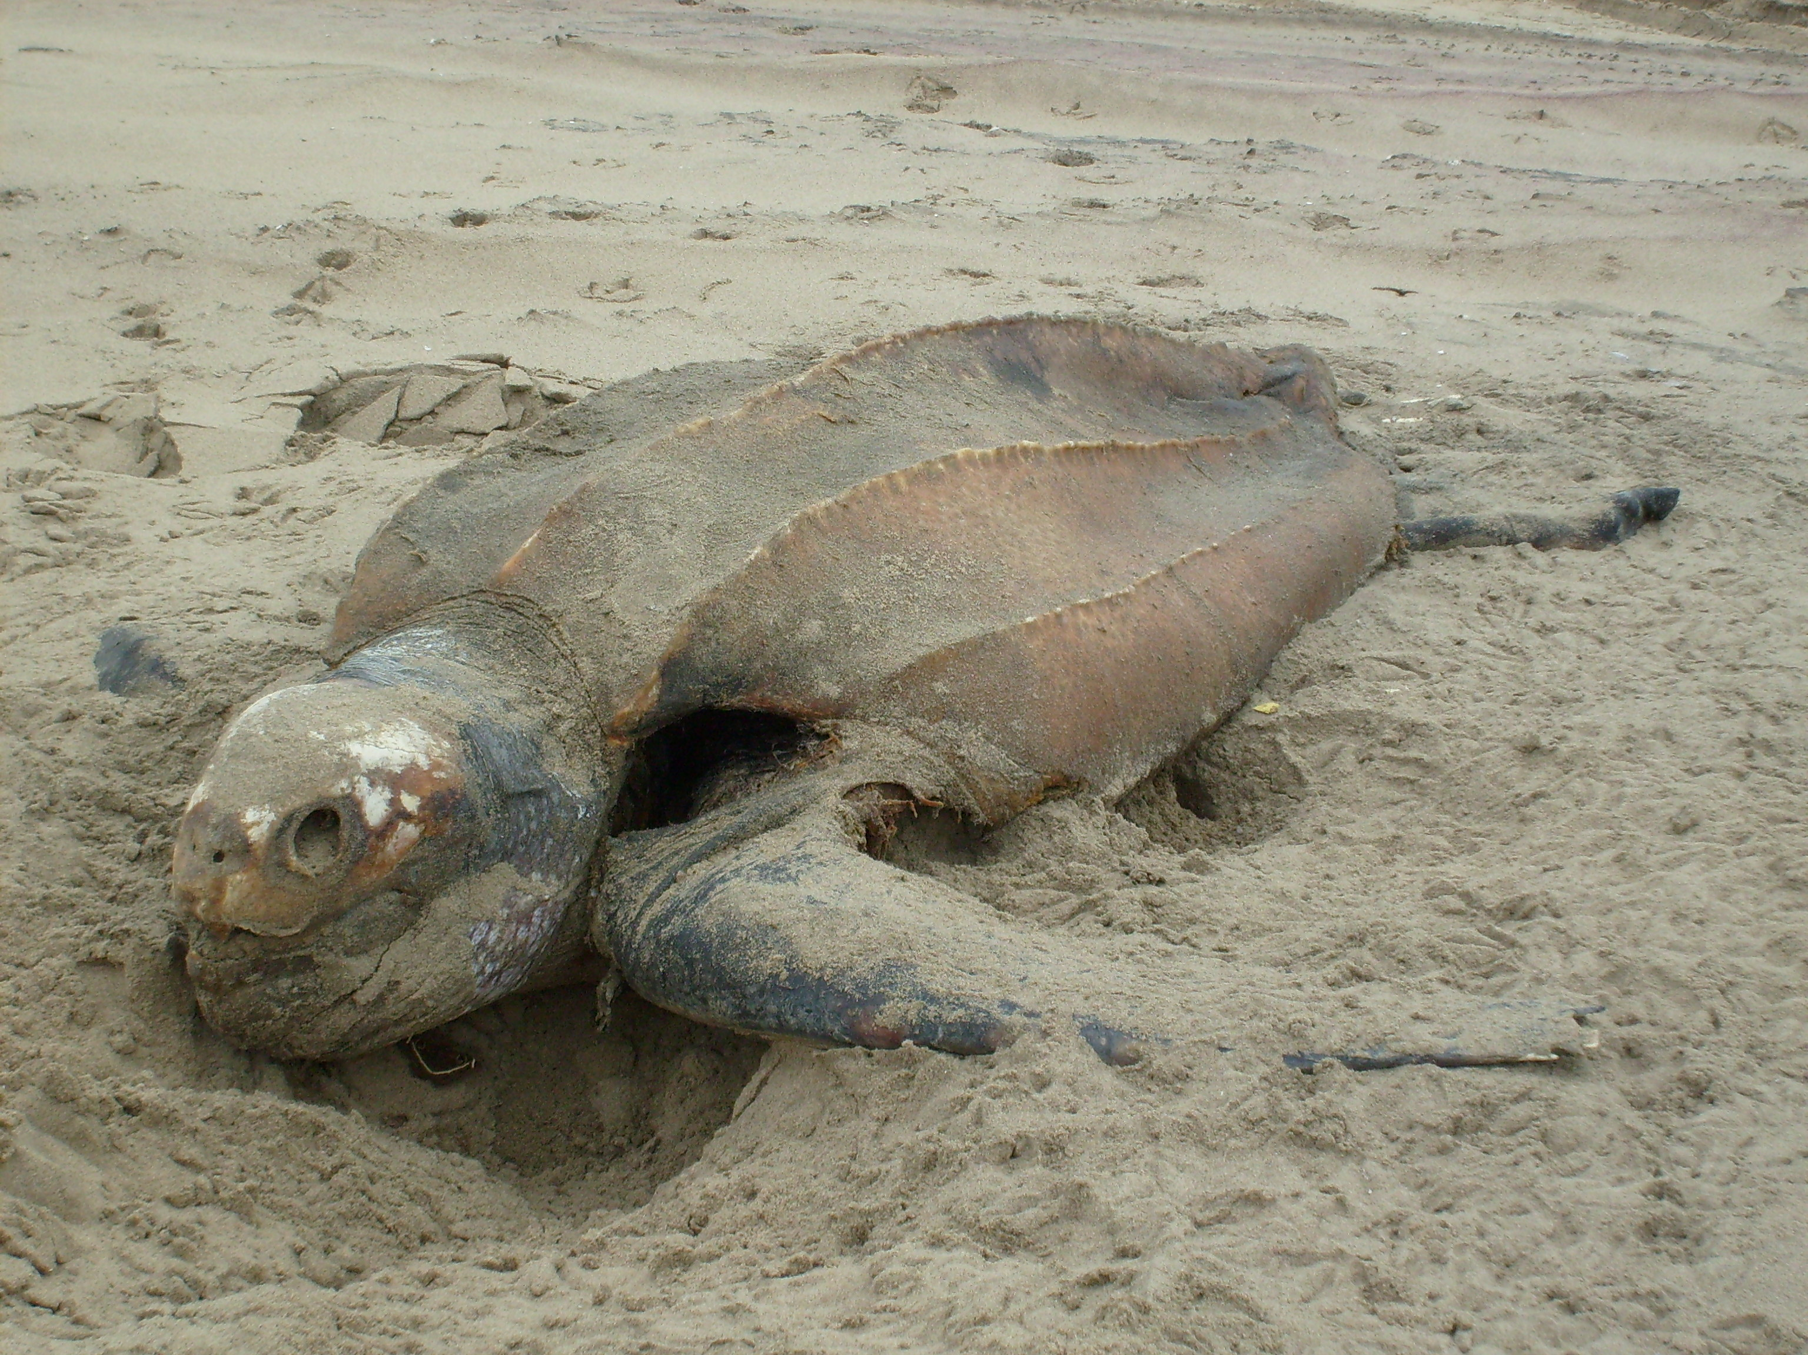

Figure 17: Dead Leatherback Turtle washed up at a beach north of Swakopmund, March 2008.

Birds
Coastal seabirds resident in central Namibia include the Cape gannet (Morus capensis), the Cape cormorant (Phalacocorax capensis) and the African penguin (Spheniscus demersus). All of these species breed on nearshore islands, as well as on the man-made guano platforms in Walvis Bay, Swakopmund and Cape Cross. Birds reported from the 30 km stretch of coast between Walvis Bay and Swakopmund include African Black Oystercatcher (Haematopus moquini), Kelp Gull (Larus dominicanus), Cape cormorant, Turnstone (Arenaria interpres), Curlew Sandpiper (Calidris ferruginea), Grey plover (Pluvialis squatarola), Swift Tern (Sterna bergii) and Common Tern (Sterna hirundo) (Simmons et al. 1999). In their study of beaches on the skeleton coast, Tarr et al. (1985) report a diversity of shorebirds including Turnstone, Sanderling (Calidris alba), Curlew Sandpiper, Whitefronted Plover (Charadrius marginatus), Kelp Gull and Grey plover. In the vicinity of Walvis Bay bird numbers were estimated at 50-100 km⁻¹, the majority being Palearctic migrants (McLachlan 1985), whereas Tarr et al. (1985) report numbers of 28 km⁻¹ as far north as Rocky Point. The 30 km long shoreline between Walvis Bay and Swakopmund has the highest linear count of birds in southern Africa at ~450 birds. km⁻¹ with totals exceeding 13 000 shorebirds of 31 species, most of which are Palearctic migrants (Simmons et al. 1999; Molloy & Reinikainen 2003; http://www.ramsar.org/profile/profiles_namibia .htm). Individual 10 km sections, which include the rocky shores between Caution Reef and Swakopmund peak even higher at 770 birds/km.

Of particular importance in the area is the Damara tern, which breeds in shallow scrapes on the gravel plains near the coast during the summer months. The 30 km stretch of beach between Walvis Bay and Swakopmund, particularly the area around Caution Reef, supports the densest known colony of breeding Damara terns. Densities within a 2 km² study area have exceeded 120 nesting pairs, or 60 pairs/km² (Simmons et al. 1999). The breeding areas are cordoned off to beach traffic (Molloy & Reinikainen 2003).

Beneficial Uses
Beneficial uses of the coastal marine waters of Namibia can be subdivided into three categories:
- Recreational use;
- Mariculture use (including collection of seafood for human consumption); and
- Industrial uses (e.g. intake of cooling water for Power Plants, intake of feed-water for Desalination plants, and water for fish processing, and/or mariculture, guano harvesting, salt production).

The project-environment interaction points are summarised in Figure 18 and described in more detail below.

Conservation Areas
Numerous conservation areas exist along the coastline of Central Namibia, although none fall within the study area. However, for the sake of completion, they are briefly summarised below.

The Skeleton Coast National Park is located to the north of the study area. It extends 500 km from the Ugab River in the south to the Kunene River in the north, covering a total land-area of approximately 16 400 km². The coastline is characterised by many shipwrecks, dense coastal fogs and cold onshore winds. The general public has access only to the southern section between the Ugab and Hoanib rivers, staying at Terrace Bay and Torra Bay. Although open all year to linefish boats, Torra Bay and Terrace Bay are partly closed or restricted to rock- and surf-anglers. There is a seal colony at Cape Frio. The northern section of the Skeleton Coast Park is a tourism concession area and restricted to fly-in safaris only. The park is managed as a wilderness area by the Ministry of Environment and Tourism (MET) due to its ecological sensitivity.

The Cape Cross Seal Reserve is situated approximately 130 km north of Swakopmund. With a surrounding area of 60 km², the Cape Cross Seal Reserve was proclaimed in 1968 to protect the largest of the 23 breeding colonies of Cape fur seals along the southern African West Coast. During the November/ December breeding season as many as 340 000 adults may gather at Cape Cross at one time. A small lichen reserve is also located in the area, and emergent offshore reefs which serve as seabird nesting areas are also protected.

Sandwich Harbour, located 55 km south of Walvis Bay, is one of Namibia’s four proclaimed RAMSAR sites and one of southern Africa’s richest coastal wetlands. The area consists of two distinct parts: a northern, saltmarsh and adjoining intertidal sand flat which supports typical emergent vegetation, and a southern area of mudflats and raised shingle bars under tidal influence. The area supports an extremely rich avifauna including eight endangered species among the large numbers of waders, terns, pelicans and flamingos. Bird numbers are reported to reach 175 000, with Palearctic waders reaching densities of 7000 birds per km². Several archaeological sites dating back 1000 years also exist within the area (Barnard 1998).

Walvis Bay lagoon is the largest single area of shallow sheltered water along the Namibian coastline. The tidal inlet consists of adjacent intertidal areas, Pelican Point, mudflats exposed at low tide, and sandbars serving as roosting and feeding sites for resident and migratory birds. The wetland consists of natural areas of the lagoon and the Walvis Bay saltworks (Barnard 1998). The site supports up to 250 000 individuals of wetland birds, some species such as flamingos occurring in impressive numbers. Eleven endangered bird species are regularly observed (http://www.ramsar.org/ profile/ profiles_namibia. htm).

Currently there are no marine protected areas (MPAs) in Namibia. The Directorate of Resource Management (DRM) within the Ministry of Fisheries and Marine Resources (MFMR), however, mandated the identification of MPAs in Namibia, with the purpose of protecting important spawning and nursery grounds for fish and other marine resources (such as rock lobster), as well as sensitive ecosystems and breeding areas for seabirds and marine mammals. Resulting from extensive consultation with various stakeholders (including the mining, fishing and tourism industries, and the public sector), environmental and legal specialists and scientists the development of a multi-zoned marine protected area (MPA) along the Namibian coast is recommended (Currie et al. 2008). The proposed MPA area comprises a coastal strip in the south-west of Namibia’s marine waters, extending from Hollamsbird Island (24º38’S), the northernmost island, in Meob Bay, to 72 km south of Sinclair Island (27º40’S) at Chamais Bay (27º55’S) in the south, spanning approximately three degrees of latitude and an average width of 30 kms.

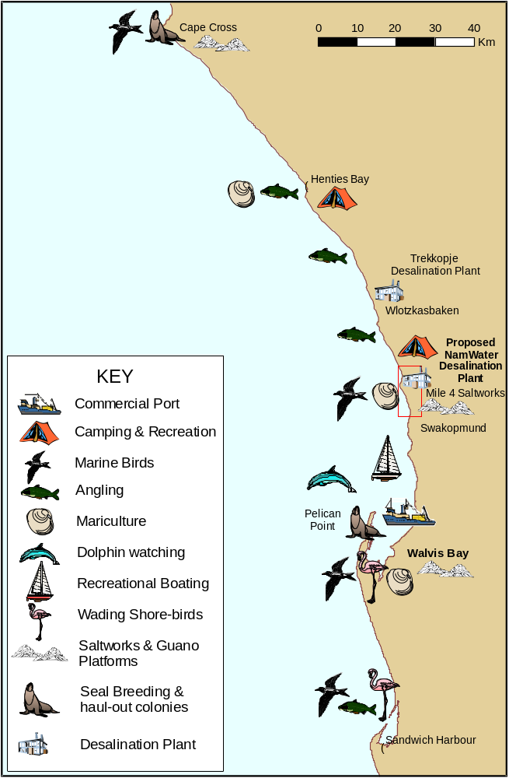

Figure 18: Project - environment interaction points, illustrating the distribution of existing industries and other users in the coastal region around the study area (red rectangle).

Recreational Areas
The study area falls within the West Coast Recreation Area, which stretches from Swakopmund 200 km northwards to the Ugab River. The area is renowned for its excellent angling potential, and visited annually by thousands of fishermen. Popular angling spots along the coast have been identified and named by dedicated anglers to indicate their distance from Swakopmund (e.g. Mile 14, Mile 72 and Mile 108, at which campsites are located). A particular environmental feature along this stretch of coastline are the extensive lichen fields which stretch northwards from Wlotzkasbaken. These are threatened by uncontrolled off-road driving.

Mariculture Areas
Mariculture activities in the vicinity of the study area are conducted at an increasing scale in Walvis Bay. At present, there are over 20 companies engaged in cultivation of Pacific oyster (Crassostrea gigas) and European flat oyster (Ostrea edulis) in the bay. Oyster spat is imported from Chile and South Africa, and are cultivated in baskets suspended near the surface. The oysters require periodical sorting over the 6 to 10 month growth period, before being exported primarily to South Africa, Europe, Hong Kong and Singapore. Oyster cultivation is also conducted in the feed-water ponds of the Walvis Bay and Swakopmund salt works. The oysters are grown out in trays and mesh bags suspended from ropes or wooden structures within the ponds (Maurihungirire & Griffin 1998; http://www.keetmanshoop.com/oysters.htm; http://www.ncp.co.za/WalvisHomeProducts Oysters.asp). In 2007, the industry exported oysters worth about N$35 million.

One of the greatest threats to Namibia’s small oyster industry are red tide events, which became evident during a recent bloom in March 2008. The algal bloom coupled with unusually high water temperatues (up to 25 degrees) and the release of sulphide into the sea, reduced the oxygen in the bay to near zero. This resulted in huge losses with an estimated 10 million oysters - 80 to 90 per cent of the stock - being destroyed and a delay in foreign market expansion by probably up to a year. Previous red tides occurred in June 2006 and December 2005, but the 2008 event was more severe. The oyster farming industry is currently investigating ways to reduce the effects from any future algal bloom events. ‘Toughening’ oysters (e.g. taking the oysters out of the water so that they can adapt to surviving out of water or with little oxygen) and/or genetically modifying them to cope with harsh climatic and ocean conditions are some of the measures that may become important features in local oyster production (http://allafrica.com news from 28 April 2008, http://africasciencenews.org news from 28 March 2008).

In 1999 experimental cultivation of the invasive alien mussel Mytilus galloprovincialis was undertaken at Pelican Point in Walvis Bay. The project was unsuccessful, however, due to the natural takeover by Perna perna and Semimytilus algosus (Molloy & Reinikainen 2003). The Henties Bay Marine and Coastal Resources Research Centre is a multidisciplinary research project of the University of Namibia. The main aim of the centre is to promote sustainable and responsible utilization of Namibia's coastal resources for the benefit of all Namibians. Research conducted at the centre towards developing the fisheries and agriculture sectors complements what is done by the Ministries of Fisheries and Marine Resources. It includes the mariculture of algae (primarily Gracilaria gracilis) and White Mussel (Donax serra), as well as various finfish species (Blacktail, Diplodus sargus capensis and Silver Kob, Argyrosomus inodorus) (http://www.dlist-benguela.org/Hotspots/ Hotspots/Erongo_Region). Some experiments are also being undertaken with South African abalone (Haliotis midae), and scallops.

Industrial Uses
Reverse Osmosis Desalination Plant near Wlotzkasbaken
The construction of a desalination plant near Wlotzkasbaken some 30 km north of Swakopmund is currently underway to supply water to the Trekkopje UraMin mine. An extensive public participation and EIA process was conducted for this project (Turgis 2008). The Trekkopje Uranium Project, developed by UraMin Namibia (Pty) Ltd., is a low-grade, shallow uranium deposit some 65 km north-east of Swakopmund and is expected to operate for more than 10 years. The mine will require 15 million m³ of water per year for heap leaching of uranium, with additional capacity for other users. This water is to be sourced from a Reverse Osmosis desalination plant located in an abandoned borrow pit 3.5 km north of Wlotzkasbaken. The desalination plant will constitute nine independent, parallel reverse osmosis modules, each with a nominal capacity of 282 m³/h at 11°C and 292 m³/h at 15°C. The annual net production of treated water from this desalination plant will be 20 Mm³/annum (54 794 m³/day), with an associated sea water abstraction rate of 48 309 179 m³/annum (139 300 m³/day). The actual daily average flow achieved is, however, dependant on the sea water temperature and plant availability. Consequently, the plant is designed for a maximum production in excess of the specified 20 million m³ per year. A water recovery of 46% will be achieved, meaning that 46% of the sea water is converted into treated water, while the remaining 54% of this sea water is returned to the sea. The average brine volume which will be returned to the sea is 84 931 m³/day. The intake system is, however, designed to draw in a sea water volume of 15,076 m³/hr, which caters for the possible future water demand of 45 Mm³/year. The plant is to be built in a modular fashion, to allow for future expansion, to meet other commercial and industrial needs.

The overall project infrastructure consists of:
two x 1,200 mm high density polyethylene (HDPE) or carbon steel intake pipes, with suitable corrosion protection
a sea water intake structure, 5m x 10m x 1.5m high on the sea bed
320 m long x 5 m wide x 1.5 m deep trench in the sea bed rock, through the surf zone
400 m long temporary jetty, which is 8m wide, constructed of concrete
a 1,000 mm HDPE or steel brine discharge pipe, 600 m long
sea water intake sump & transfer pump buried in the beach, with a building housing the transformer and switchgear for power supply to the sea water intake pumps
one 1,200 mm diameter glass fibre reinforced (GRP) sea water transfer pipe will be used from the inlet sump to the desalination plant
one 1,000 mm diameter GRP pipe will be used for the brine return from the desalination plant to the sea outfall pipeline
a chlorine dosing system to control marine growth
a desalination process plant,
intermediate water storage at the desalination plant,
treated water transfer pipeline to the mine, and
a terminal water storage reservoir at the uranium mining site at Trekkopje.

Construction started in early 2008, and a timeframe of ten months has been allowed for the commissioning of the desalination plant and pipelines. The construction period for pipeline installation is anticipated to take 12 months (Turgis 2008).

Saltworks at Mile 4
Namibia is the largest salt producer in sub-saharan Africa. Salt is the most important non-metallic minerals mined in Namibia, with the bulk of the salt output coming from the seawater evaporation pans at Walvis Bay and Swakopmund. The Swakopmund-based Salt Company (Pty) Ltd produces around 120 000 tons of edible salt annually (http://www.saltco.com/index.html). The saltworks are situated about 7 km (4 miles) north of Swakopmund, off Route 76 to Terrace Bay. Production of the concentrated brine at the saltpan, known as Panther Beacon, began in 1933, but by 1952 the salt source was exhausted. Seawater has since been pumped into open evaporation and concentration ponds from which crystallized salt is removed with mechanical scrapers. The pans are shallow and of varying salinity. Apart from a few halophytes, the saltworks are devoid of vegetation.

The aquatic portion of the Swakopmund saltworks, which encompasses 400 ha, has been registered as a private nature reserve. The shallow expanses of water created to permit evaporation in the salt-producing process are ideal feeding grounds for thousands of wetland birds, such as Greater and Lesser flamingos. Damara terns breed on the surrounding desert plains and bring their young to the salt-works. Other visitors are the rare Great crested grebe and a large colony of Cape cormorants. A large wooden commercial guano platform covering 31,000 m² has been built in one of the northern pans. The guano platform has supported up to 700,000 Cape Cormorants in the past, and an average of 45,000 birds has been supported in recent years. Breeding species include Damara Tern and Chestnut-banded Plover. The value of these commercial saltpans as habitat for waders and others birds is obvious from biannual wetland counts (up to 93,000 birds of ca. 35 species at any one time) and the breeding of terns, cormorants and plovers in and around the saltworks (BirdLife International 2008 BirdLife's online World Bird Database: the site for bird conservation. Version 2.1. Cambridge, UK: BirdLife International. Available: http://www.birdlife.org (accessed 24/11/2008)).

The Walvis Bay Salt Refiners in Walvis Bay produce primarily chemical grade salt. The Walvis Bay salt field operation, is one of the largest wind and solar evaporation facilities in Africa, processing 24 million tons of sea water each year to produce more than 400 000 tons of high-quality salt. The majority of the country's coarse salt production, is exported in bulk to South Africa where it is used by the chlor-alkali industry for production of chlorine and caustic soda. Some bulk salt is shipped to West Africa and Norway for the fishing industry. Bagged salt is exported to various markets, including South Africa, for use as an animal feed supplement, in sugar refining and as a feedstock for refined table salt (http://www.ncp.co.za/WalvisHomeCompany.asp). Nutrients found in the ponds sustain a variety of wetland birds such as flamingoes and other waders. Up to 120 000 birds at a time have been viewed at the salt field and more than 60 different species have been identified.

Guano is rich in Nitrogen (14-16%), Phosphorus (9%) and Potassium (3%), and consequently is valuable as an agricultural fertilizer. The man-made guano platforms at Walvis Bay, Swakopmund and Cape Cross are unique in the world, and guano has been scraped annually from them since the 1930s. The wooden platform between Swakopmund and Walvis Bay is located ~200 m offshore and has an area of 1.7 ha. A further two platforms of 4 ha each have been erected at the salt pans north of Swakopmund (see above) and at Cape Cross. The platforms currently produce about 2 500 tons of guano per season. Due to the absence of sand on the platforms, the guano is of a very high quality, fetching about N$ 700 per ton. It is reaped every 12-18 month after the end of the main summer breeding season (http://www.traveltonamibia.com/ guano.htm).

Commercial and Recreational Fisheries
Pelagic and Demersal Fishery
The sardine Sardinops sagax and hake Merluccius spp. have formed the basis of the Namibian pelagic and demersal fishing industry for the past five decades. The northern Benguela has experienced large fluctuations in fish stocks and sardine stocks in particular have decreased markedly from several million tons in the 1950s and 1960s to a few hundred thousand tons in recent years. Currently, the sardine industry relies heavily on the variable annual recruitment of sardine for its catches, making them susceptible to environmental impacts such as for example Benguela Niño events (Bartholomae & van der Plas 2007). The pelagic fishery is carried out by a fleet of entirely Namibian-owned steel and wooden-hulled purse-seining vessels, which operate out of Walvis Bay. The fishing extends from mid-February till the end of August, depending on when the quotas are filled. The fleet consists of ~30 registered vessels ranging in length from 21 - 49 m, although in recent years less than half have been operational due to the severely depleted pelagic resource. Principally sardine is targeted for canning, whilst by-catch species are used for fish-meal and oil production. The fishery is entirely industrialised, with the smaller vessels concentrating on catches for fish meal, whilst the larger vessels concentrate on sardines for canning. The catches are brought back from as far afield as the Kunene River for processing at the reduction plants and canneries in Walvis Bay. Although primarily working further offshore, the purse-seiners may operate inshore to depths of 10 m (Hampton 2003).

The Namibian demersal fishery is concentrated on the edge of the continental shelf, as a minimum trawl depth of 200 m has been set in order to protect the juvenile stocks. Interaction with the project is thus not expected.

Linefish Fishery
The cold, nutrient-rich Benguela upwelling system is characterised by a relatively low species diversity but high production and species abundance, which forms the basis for the Namibian linefish fishery. This fishery consists of three sectors: the recreational shore-angling sector, the commercial lineboat sector, and the commercial and recreational skiboat sector that all target specific, but sometimes overlapping, species (Holtzhausen et al. 2001).

Recreational Angling
The Namibian coast has a high reputation as an angling destination, and was once legendary for the large catches made regularly by recreational anglers. However, over the last two decades the average catches have decreased considerably, although only anecdotal evidence exists for the good catches made prior to the 1990s (Holtzhausen & Kirchner 2001).

Most angling is done from the shore, primarily from the beach but also off rocks. Some angling is also done from skiboats offshore beyond the surf-zone. Kirchner et al. (2000) reported that the recreational angling community is made up of three distinct segments: coastal Namibian residents (15%), inland Namibian residents (38%), and South African visitors (46%). Recreational shore-angling in Namibia is restricted to approximately one-quarter of the coastline, stretching from Sandwich Harbour, south of Walvis Bay, to the mouth of the Ugab River in the north. Over 90% of shore-angling takes place in the West Coast Recreational Area, primarily in the vicinity of the coastal towns Walvis Bay, Swakopmund and Henties Bay. The study area is thus heavily utilised by the angling community. Some limited angling also takes place farther north, at Terrace Bay and Torra Bay in the Skeleton Coast Park, and in the south towards Lüderitz, as well as near Oranjemund.

Anglers target a variety of different species. The most important species is silver kob (Argyrosomus inodorus) constituting about 70% of all the recreational shore angling catches in Namibia (Kirchner et al. 2000). Other targeted species include dusky kob (A. coronus), West Coast steenbras (Lithognathus aureti), galjoen (Dichistius capensis) and blacktail (Diplodus sargus). To a much lesser extent, sharks, including the copper shark (Carcharhinus brachyurus), the spotted gulley shark (Triakis megalopterus) and the smoothhound (Mustelus mustelus), are targeted (Zeybrandt & Barnes 2001). Catches are made all year round, but are higher in summer.

Commercial line-fishery
The angling resource is shared with a commercial linefishery, which operates from Walvis Bay in inshore waters. Commercial linefishing is carried out by skiboats as well as by larger vessels. It is limited to vessels having a government permit, but permits are freely available and the number of registered permit-holders in the sector has more than doubled in the past decade. In 2002, there were seven skiboat operators and 13 larger vessels registered as permit-holders, although some had ceased fishing operations (Stage & Kirchner 2005).

Similar to the shore-anglers, the commercial linefishery targets silver kob and West Coast steenbras, but also seasonally seeks snoek (Thyrsites atun). Although recreational shore-anglers and the commercial linefishery catch kob in roughly equal numbers (Kirchner & Beyer 1999), the kob caught by anglers are on average younger and smaller than those caught by the commercial linefisheries, leading to a total lower catch mass than that landed by commercial linefishers (Stage & Kirchner 2005). There is concern that fish stocks cannot support the current fishing pressure and that linefishing is becoming unprofitable. Increasingly, commercial vessels are now catching sharks (Stage & Kirchner 2005), which were previously caught mostly by skiboat anglers (Holtzhausen et al. 2001). Between April and August the boats primarily operate in the area between the Ugab River and Rocky Point, to the north of the study area, although they may occasionally also visit the area between Walvis Bay and Ugab River. During early summer, the fleet target the inshore areas off Walvis Bay for Snoek (Holtzhausen & Kirchner 1998).

Fish stocks and in particular silver kob have become heavily exploited in Namibian waters, and there is concern that the species is being depleted (Holtzhausen et al. 2001; Kirchner 2001). In 2001, the bag limit for recreational anglers was thus reduced from 30 to 10 fish per day and a fishing licence fee of N$14 per month has been levied (Stage & Kirchner 2005). In addition, a size limit for kob has been introduced stipulating that any kob <40 cm must be released and only two kob >70 cm per angling day are permitted. There have also been discussions to introduce restrictions for the commercial linefisheries such as reducing the number of permit-holders, or introducing size limits, total allowable catches and/or closed seasons (Holtzhausen et al. 2001; Kirchner 2001). However, thus far the commercial sector of the linefishery is not subject to any restrictions apart from the permit requirement (Stage & Kirchner 2005).

Studies investigating the benefits of the linefishery to the Namibian economy have shown that in total the linefishery contributed approximately N$35 million to Namibia’s Gross Domestic Product GDP in 1996/1997 of which N$29.7 million was direct expenditure by recreational shore-anglers (Kirchner et al. 2000). Using multiplier effects (economic benefits that go beyond direct income generated through fisheries), it appears that the economic benefits are greatest in recreational angling, less in commercial fishing by large vessels, and least in commercial skiboat fishing (Zeybrandt & Barnes 2001; Barnes et al. 2004; Stage & Kirchner 2005) suggesting that further catch restrictions would do less harm to the economy if applied to the commercial linefishing sector rather than to recreational angling (Stage & Kirchner 2005).

Existing Environmental Impacts

Traffic on Beaches
The West Coast Recreation Area between Swakopmund and Henties Bay is used extensively by recreational rock- and surf anglers, who visit the coast during the summer holiday period (December/January). Between January and April the majority of visitors are from South Africa, who visit the area only to fish. These anglers travel both on the coastal salt road as well as on the beach (Figure 19). Rock Bay (Mile 17), about 4.5 km south of Wlotzkasbaken is also popular with fishermen for launching small inflateables and skiboats to target fishing sites beyond the surf-zone.

Various studies have been undertaken that show the effects of human-induced disturbances in the form of vehicle traffic on physical characteristics of the beaches, and on the faunal populations inhabiting them (Defeo & Alava 1995; Alonso et al. 2002; Borges et al. 2002; Gomez-Pina et al. 2002). Shearing and compression as a result of vehicle passage in soft sand can extend to depths of 20 cm. As most of the macrofaunal species occur in the top 10-cm layer of sand, compaction of these sediments due to vehicular traffic on beaches can result in significant reduction in macrofaunal abundance. While sensitivity to compaction varies between species, results have indicated that at upper levels of the beach, as few as 17 passes can damage up to 10% of the supralittoral fauna, with some species suffering mortalities of up to 98% (van der Merwe & van der Merwe 1991). The tendency for drivers to follow the same tracks accentuates this. Tyre ruts are also capable of trapping certain species (e.g. giant isopods, ghost crabs, and the chicks of certain shorebirds that nest on the upper beach), which are then subsequently run over by following traffic (van der Merwe & van der Merwe 1991; Brown 2000; amongst others). Although birds can get used to vehicles passing very close by, disturbed birds can be flushed from their nests resulting in decreased breeding success. Beach traffic can also be a constant disturbance to resting flocks at high tide, or to flocks feeding in the swash zone at low tide (van der Merwe & van der Merwe 1991).

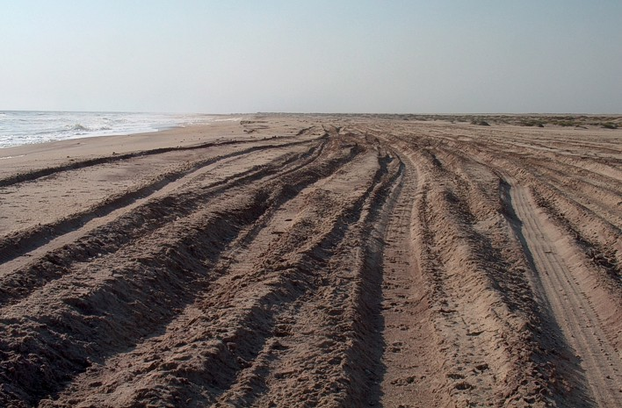

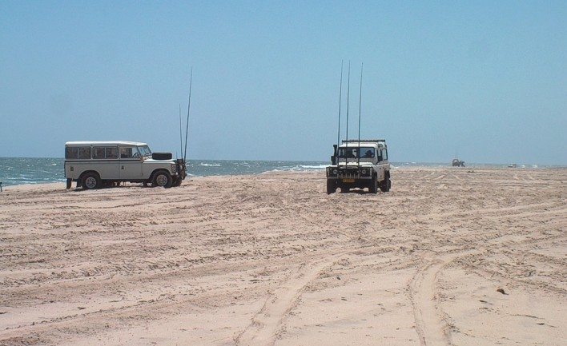

Figure 19: Beaches in the study area are heavily impacted by 4x4 traffic.

Rock- and Surf-Angling
The central Namibian coast between Swakopmund and Henties Bay was once legendary for the large catches regularly made by recreational anglers visiting the area specifically to fish (Figure 20). Over the past two decades, however, average catches have decreased considerably (Holtzhausen & Kirchner 2001), and species specifically targeted by anglers (e.g. silver kob) are now considered to be over-exploited (Holtzhausen et al. 2001; Kirchner 2001).

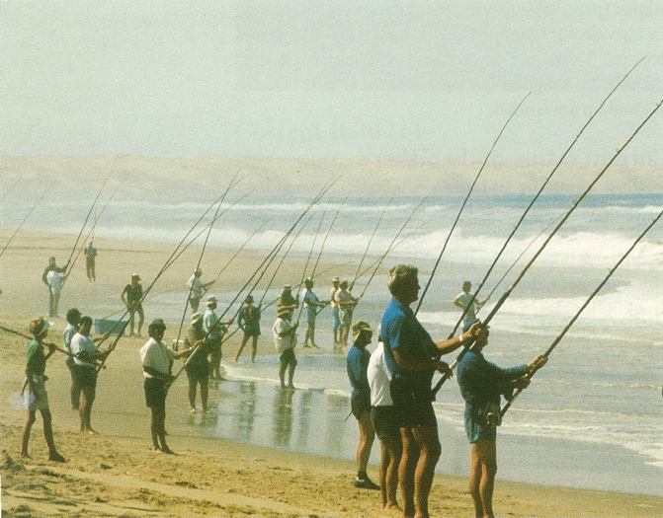

Figure 20: The area is popular with rock- and surf-anglers, and target species such as silver kob are now considered to be over-exploited (Photo: P. Tarr, from Molloy & Reinikainen 2003).

Construction and Operation of the Trekkopje Reverse Osmosis Desalination Plant near Wlotzkasbaken
The construction activities for intake and discharge structures for the Trekkopje RO Desalination plant at the beach are localised and confined to within a hundred metres but will result in the loss of the biota associated with the disturbed beach sediments. Provided physical changes to beach morphology are kept to a minimum, biological recovery of disturbed areas is, however, expected to occur within 2-5 years (Pulfrich & Steffani 2007). Similary, the loss of subtidal substratum as a result of the intake and pipeline installation will be temporary, as the structures will provide an alternative substratum for colonizing communities.

During the operational life time of the plant, a high-salinity brine will be more or less continuously discharged at a volume of ~85 000 m³/day. This might increase with an expansion of the plant. The reject brine will be discharged back into the sea at 6 m water depth through a 600-m long single discharge pipeline with 27 diffusers, 150 mm in diameter and spaced 3 m apart. Chlorine will be used to reduce biofouling of the pipelines, which will also be pigged periodically to clear any macro-fouling of the lines. The chlorine will be neutralized with sodium metabisulphite (SMBS). Table 5 lists the expected compositon of the brine effluent and the typical cleaning reagents and pre-treatment chemicals to be used. The maximum expected volume of cleaning chemicals is 53 m³, to be discharged into a volume of 8 x 3,773 m³ providing a 190 times dilution.

Table 5: Expected composition and flow of the brine discharge (Turgis 2008).
Description | Units | Quantity
Feed-water Intake | m^{3.} h⁻¹ | 6181
Average brine production | m³. h⁻¹ | 3085
Co-discharges (UF Backwash and CIP rinse water) | m³. h⁻¹ | 634
Discharge velocity | m. s⁻¹ | 0.64  1.28
Salinity | mg. ℓ⁻¹  psu | 67 468  67.5
ΔT | °C | <1
pH |  | 7.3 – 8.2
Antiscalant Vitec SR | mg. ℓ⁻¹ | 4.3
Chlorine | mg. ℓ⁻¹ | <1
Sodium tripolyphosphate (STPP) | mg. ℓ⁻¹ | 7.29
Trisodium phosphate (TSP) | mg. ℓ⁻¹ | 7.29
Ethylenediaminetetraacetic Acid (EDTA) | mg. ℓ⁻¹ | 7.29
Sulphuric acid (H₂SO₄) | mg. ℓ⁻¹ | 0.58
Hydrochloric Acid (HCl) | mg. ℓ⁻¹ | 0.01
Coagulant: Ferric Chloride (FeCl₃) | mg. ℓ⁻¹ | 8
Phosphoric Acid (H₃PO₄) | mg. ℓ⁻¹ | 0.01

A CORMIX model was used to predict the brine footprint around the outlet (Turgis 2008). The brine effluent is anticipated to have a temperature of 15ºC (i.e. no temperature elevation above the ambient seawater temperature of 15ºC), a salinity of 67.5 psu and a density of 1046 kg/m³ with an effluent flow of 2 300 m³/hr (0.64 m³/s). Future flows of 4 600 m³/hr (1.28 m³/s) were also modelled. The brine is negatively buoyant and will tend to sink towards the seabed. To ensure optimum dilution in the near-field the port is configured to discharge at an angle of 60º above horizontal, at a depth of 6 m. For the salinity, a dilution of 25 times is required to reduce the brine concentration to the required 36 psu or less.

The largest predicted brine footprint for the initial design flows would occur when the effluent is discharged into an ambient current of 0.5 m/s through diffuser ports of 0.15 m diameter. The required dilutions under this scenario would be achieved within 17 m of the end of the discharge pipeline. Under future design flows, this footprint would extend to within 26 m of the end of the discharge pipeline. It was, however, noted that an assumption for the model is that the effluent is mixed throughout the water column and is thus continually diluted by “clean” water, under all environmental conditions. Plume behaviour under occasions of calm sea conditions and/or strong horizontal flows have not been considered, and the model results are therefore not necessarily conservative. Although it is anticipated that the footprint of the brine (and any associated pollutants) is likely to be modest, there does exist a degree of uncertainty as to the extent of the potential ‘worst-case’ scenario footprint of the effluent discharge (Pulfrich & Steffani 2007).

The intake structure is fitted with a screen with water velocities at the opening of 0.09 m/s, reducing the effect of impingement. The abstraction of the feed water will, however, result in the entrainment of plankton.

Potentially Threatened Habitats
Taking into account the waste-water characteristics of the proposed discharge from the RO plant, potential impacts are most likely to target important marine ecosystems and beneficial uses that rely on the health of marine organisms and plants, such as recreational angling and future marine aquaculture activities. Certain areas of special interest potentially to be impacted by discharges from the RO Plant into the marine environment were identified. These specific areas include:
- The natural intertidal and shallow subtidal environments adjacent to the discharge;
- Recreational rock- and surf-angling; and
- Proposed mariculture activities.

SOURCES OF POTENTIAL ENVIRONMENTAL IMPACT
In the course of the environmental screening process for the proposed RO Plant, key issues were identified relating to potential impacts on the marine environment. These are briefly summarised below in terms of the construction, operation and decommissioning phase, and then discussed in more detail later in this section.

Identification of Key Issues
Construction Phase
The potential impacts associated with the construction of feed-water intake and brine discharge structures into the marine environment are related to:
- Onshore construction (human activity, air, noise and vibration pollution, dust, blasting and piling driving, disturbance of coastal flora and fauna) (to be dealt with by others);
- Alternative 1: Construction and installation of an offshore pipeline intake and discharge (construction site, pipe lay-down areas, and trenching in the marine environment, vehicular traffic on the beach and consequent disturbance of intertidal and subtidal biota); and
- Alternative 2: Construction and installation of a breakwater with stilling basin and an open channel to the onshore pump station situated above the high water mark, and associated pipelines leading to and from the plant (construction site, lay-down areas, and trenching in the marine environment, vehicular traffic on the beach and consequent disturbance of intertidal and subtidal biota).

The RO Plant including the pump station will be constructed a set-back distance from the existing shoreline. Consequently, issues associated with the location of the plant and pump station, and the associated pipelines leading to and from these constructions are not deemed to be of relevance to the marine environment, and will be dealt with by another specialist study. However, infrastructure extending into the sea will require removal of seabed material (blasting, piling driving and increased turbidity) and seabed preparation, and will consequently impact on intertidal and shallow subtidal biota.

Operational Phase
The key issues and major potential impacts are mostly associated with the operational phase. The key issues related to the presence of pipeline infrastructure and brine discharges into the marine environment are:
- altered flows at the intake and discharge resulting in ecological impacts (Alternative 1) (e.g. entrainment and impingement of biota at the intake, flow distortion/changes at the discharge, and affects on natural sediment dynamics);
- altered hydrographical conditions due to the breakwater extending through the surf zone and beyond resulting in ecological impacts (Alternative 2) (e.g. effects on natural sediment dynamics, disrupting alongshore movement off juvenile fish and recruits, breakwater may cause sand build-up and dredging may be required in future);
- the effect of elevated salinities in the brine water discharged;
- the effect of the discharged effluent potentially having a higher temperature than the receiving environment;
- biocidal action of residual chlorine in the effluent;
- the effects of co-discharged constituents in the waste-water;
- the removal of particulate matter from the water column where it is a significant food source, as well as changes in phytoplankton production due to changes in nutrients, water column structure and mixing processes; and
- direct changes in dissolved oxygen content due to the difference between the ambient dissolved oxygen concentrations and those in the discharged effluent, and indirect changes in dissolved oxygen content of the water column and sediments due to changes in phytoplankton production as a result of nutrient input.

Additional engineering design considerations, not strictly constituting issues to be considered within this marine specialist study, include the following:
- structural integrity of the intake and outfall pipelines or the breakwater (e.g. related to shoreline movement);
- potential impacts associated with the momentum transfer from the discharge and/or the discharge structure itself;
- potential re-circulation of brine effluents;
- pipeline maintenance and replacement requirements; and
- water quality of feed-waters that should include consideration of possible deteriorating water quality (particularly sediments that may be stirred up during storms, or large-scale hypoxia or sulphur eruptions in bottom waters), that may require specific mitigation measures or planned flexibility in the operations of the RO Plant.

Decommissioning Phase
The minimum anticipated life of the RO plant is approximately 20 years. The individual RO modules will be replaced as and when required during this period. No decommissioning procedures or restoration plans have been compiled at this stage, as it is envisaged that the plant will be refurbished rather than decommissioned after the anticipated 20 year lifespan. The potential impacts during the de-commissioning phase are expected to be minimal in comparison to those occurring during the operational phase, and no key issues related to the marine environment are identified at this stage. As full decommissioning will require a separate EIA, potential issues related to this phase will not be dealt with further in this report.

Intake and Discharge Structures

Construction of Intake and Discharge Structures
The use of intake and discharge pipelines (Alternative 1) in the engineering designs for the RO Plant will involve considerable disturbance of the high-shore, intertidal and shallow subtidal beach habitats during the construction and installation process. To avoid exposure on the beach and nearshore area, the pipeline will be buried below the seabed. This will require excavation of beach sediments and blasting of bedrock. Entrenchment of the pipeline through the surf-zone will require the construction of a temporary jetty to provide a stable work platform from which a trench can be excavated.

Similary, the installation of the breakwater with stilling basin and the open channel through the beach (Alternative 2), would involve extensive disturbance of the shallow subtidal and intertidal beach habitats during the construction phase. The construction will involve considerable excavation activities in the surf zone, as well as on the beach all the way up to the high water mark. Rock blasting will be necessary to remove existing bedrock to the required depth.

Pipeline launching and entrenchment or channel excavation will involve extensive traffic on the beach by heavy vehicles and machinery, as well as the potential for hydrocarbon spills. Dune vegetation and associated fauna at the excavation sites will almost certainly be entirely eliminated, and beach macrofauna and avifauna severely disturbed. Although the activities on the intertidal beach will be localised and confined to within a hundred metres of the construction site, the beach sediments will be completely turned over in the process and the associated macrofauna will almost certainly be entirely eliminated. In case of Alternative 2, the beach area excavated for the open channel will be permanently lost. Any shorebirds feeding and/or roosting in the area will also be disturbed and displaced for the duration of construction activities. The invertebrate macrofaunal species inhabiting these beaches are all important components of the detritus / beach-cast seaweed-based food chains, being mostly scavengers, particulate organic matter and filter-feeders (Brown & McLachlan 1994). As such, they assimilate food sources available from the detritus accumulations typical of this coast and, in turn, become prey for surf-zone fishes and migratory shorebirds that feed on the beach slope and in the swash zone. By providing energy input to higher trophic levels, they are all important in nearshore nutrient cycling, and the reduction or loss of these assemblages may therefore have cascade effects through the coastal ecosystem (Dugan et al. 2003).

Trench excavation through the surf-zone will necessitate the removal of large volumes of beach sand and disposing of it down-current of the construction site. It will most likely also involve blasting a channel into the underlying bedrock of a few hundred metres length through the surf-zone. Soft-bottom benthic species live either on the seafloor (epifauna), or in the surficial layers (approximately the top 30 cm) of the sediment (infauna). Obviously, the physical removal of sediments or bedrock in the trench will result in the total destruction of the associated benthic biota. Mobile organisms such as fish and marine mammals, on the other hand, are capable of avoiding the construction area and should therefore not be significantly affected by the excavation activities (unless blasting is involved, see below).

Excavating operations will also result in increased suspended sediments in the water column and physical smothering of macrofauna by the discarded sediments. Increased suspended sediments in the surf-zone and nearshore can potentially affect light penetration and thus phytoplankton productivity and algal growth, and loads the water with inorganic suspended particles, which may affect the feeding and absorption efficiency of filter-feeders. The impact of the sediment plume, however, is expected to be relatively localised and of short duration (only for the duration of the trench excavation. Re-deposition of settling sediments may affect benthic communities. Settling rates depend on the type of sediment; as larger the gran size as faster the settling rate. Rapid deposition of material from the water column and direct deposition of excavated sands on adjacent areas of seabed will have more of an impact on the benthic community due to smothering effects, than gradual sedimentation to which benthic organisms are adapted and able to respond. However, this response depends to a large extent on the nature of the receiving community as some mobile benthic animals inhabiting soft-sediments are capable of migrating vertically through more than 30 cm of deposited sediment (Maurer et al. 1979, 1981a,b, 1982; Newell et al. 1998; Ellis 2000). In contrast, sedentary communities could potentially be adversely affected by both rapid and gradual deposition of sediment. Filter-feeders are generally more sensitive to suspended solids than deposit-feeders, since heavy sedimentation may clog the gills. However, research on filter-feeders living in coastal waters showed that bivalves in particular are highly adaptable, and can maintain their feeding activity over a wide range of inorganic particulate loads (Iglesias et al. 1996; Navarro et al. 1996). Suspended sediment effects on juvenile and adult bivalves occur mainly at the sublethal level with the predominant response being reduced filter-feeding efficiencies at concentrations of about 100 mg.ℓ⁻¹. Lethal effects are seen at much higher concentrations (>7°000 mg.ℓ⁻¹), and after long (3 weeks) exposures (Clarke & Wilber 2000). For bivalve egg stages, critical suspended sediment concentration range from 188 mg.ℓ⁻¹ for oysters to 1 000 mg.ℓ⁻¹ for burrowing clams and larval stages show no effects at suspended sediment concentrations <750 mg.ℓ⁻¹ (Clarke & Wilber 2000). Crustaceans also appear resistant to lethal effects with 25% mortality rate reported at 10 000 mg.ℓ⁻¹ for >240 hour exposures (Clarke & Wilber 2000). Impacts on highly mobile invertebrates and fish are likely to be negligible since they can move away from areas subject to re-deposition.

As part of a natural sedimentary cycle, the Namibian coastline is subject to gradual accumulation of sand deposits during summer, and subsequent beach erosion during winter. The biota of rocky intertidal and subtidal habitats in the wave-dominated nearshore areas are thus likely to be well adapted to periodic sand deposition and resuspension. The effects of elevated levels of particulate inorganic matter and depositions of sediment have been well studied, and are known to have marked, but relatively predictable effects in determining the composition and ecology of intertidal and shallow subtidal benthic reef communities (Zoutendyk & Duvenage 1989). In the highly turbulent near-bottom flows, the abrasive action of sand particles in suspension can cause scouring, which may result in the removal of whole organisms or their parts (D’Antonio 1986; Slattery & Bockus 1997; Van Tamelen 1996; Day et al. 2000).

It has been postulated by many authors that the distribution and diversity of temperate reef algal communities is coupled to fluctuations in sediment levels (Littler et al. 1983; Stewart 1983; D’Antonio 1986; Schiel & Foster 1986; Santos 1993 amongst others), as well as other environmental variables such as depth (light), substrate topography, wave exposure, consumption by grazers and interspecific competition. Engledow & Bolton (1994) ascertained that the diversity of intertidal seaweeds in Namibia is strongly affected by sedimentation if the level of deposition rises above 5.6 kg of sediment/m² (equivalent to a 5.6-mm layer of sand). Sand inundation was found to directly affect species diversity by favouring a few sand-tolerant species, thereby controlling dominance by a single species (Daly & Mathieson 1977; Devinny & Volse 1978; Airoldi et al. 1995; Airoldi & Cinelli 1997; Airoldi & Virgilio 1998). For example, a number of southern African west-coast species are adapted to sand and may dominate the midlittoral region of sand-influenced rocky shores. Aeodes orbitosa, Ulva sp. and several species of Gymnogongrus have crustose holdfasts and tetrasporophytes, and are able to survive sand burial for several months (Trowbridge 1996; Stegenga et al. 1997). Alternatively, sediment-induced disturbance can lead to the co-existence of a diverse mosaic of sediment tolerant and sediment intolerant competitors for space (Littler 1980; Littler & Littler 1981; Seapy & Littler 1982; Littler et al. 1983; McQuaid & Dower 1990). In sediment influenced areas, species richness therefore appears to be controlled by the frequency, nature and scale of disturbance of the system by sedimentation (McQuaid & Dower 1990; Dethier 1984).

Macroalgae (including kelp) seem to be more extensively impacted by prolonged sediment smothering than by short-term deep sand burial (Marszalek 1981; Rogers 1990; Airoldi et al. 1996), and only in extreme conditions of sand movement may thalli be broken by abrasion or killed by prolonged burial (Daly & Mathieson 1977).

The amount of suspended sediment in water and the deposition rate thereof are also major physical factors limiting the distribution and abundance of benthic invertebrates. Shifting sediments and frequent sand inundation can have a significant effect on the species diversity and community structure of intertidal and subtidal macrobenthic assemblages by removing grazers (Littler et al. 1983; D’Antonio 1986; Branch et al. 1990; Marshall & McQuaid 1989; Marshall & McQuaid 1993; Pulfrich et al. 2003a, 2003b), predators (Robles 1982), and either promoting or inhibiting the establishment of competitively dominant species (Berry 1982; Taylor & Littler 1982).

Adult population are likely to survive severe siltation, especially in areas of moderate to high water movement, by resistance to burial (Taylor & Littler 1982; Littler et al. 1983), emigration to adjacent non-inundated areas (Littler et al. 1983), or adjustment of filtration rates (Griffiths & Griffiths 1987; Hawkins et al. 1999). Increased sedimentation may, however, affect the recruitment success of macrobenthic species by smothering the substrate and thereby reducing settlement stimuli and food supply for juveniles (Eggleston 1972).

Some of the effects of sedimentation are indirect, however. Patellid limpets are intolerant of inundation (Marshall & McQuaid 1993), and their depletion in areas of inundation leads to a proliferation of algae. Reductions of the densities of grazers, with concomitant dominance by foliose algae, often typify rocky-shore communities disturbed by sediments (Littler & Murray 1975; Hawkins & Hartnoll 1983, Littler et al. 1983; Hockey & Bosman 1986; Eekhout et al. 1992; Pulfrich et al. 2003a; Pulfrich et al. 2003b). Inundation by sand may also promote siphonariid limpets, because they are not only tolerant of sand but inferior competitors with patellids (Marshall & McQuaid 1989; Branch et al. 1990).

Once the pipeline has been laid or the breakwater build and sufficient sediments have accumulated, the affected seabed areas will with time be recolonised by benthic macrofauna. The ecological recovery of the disturbed seafloor is generally defined as the establishment of a successional community of species, which progresses towards a community that is similar in species composition, population density and biomass to that previously present (Ellis 1996). The rate of recovery (recolonisation) depends largely on the type of community that inhabits the re-depositing sediments, the extent to which the community is naturally adapted to high levels of sediment disturbances, the sediment character (grain size) and physical factors such as depth and exposure (waves, currents) (Newell et al. 1998; Herrmann et al. 1999). Recolonisation can take place by passive translocation of animals during storms or sediment infilling from areas adjacent to the trenching site, active immigration of mobile species, and immigration and settlement of pelagic larvae and juveniles (Hall 1994; Kenny & Rees 1994, 1996; Herrmann et al. 1999; Ellis 2000). Usually, undisturbed sediments adjacent to the impacted site provide an important source of colonising species enabling faster recovery (van Moorsel 1993, 1994; Cheshire & Miller 1999).

In general, communities of short-lived species and/or species with a high reproduction rate (opportunists) may recover more rapidly than communities of slow growing, long-lived species. Opportunists are usually small, mobile, highly reproductive and fast growing species and are the early colonisers. Sediments in the nearshore wave-base regime, which are subjected to frequent disturbances, are typically inhabited by these opportunistic species (Newell et al. 1998). Recolonisation will start rapidly after cessation of trenching, and species numbers may recover within short periods (weeks). Opportunistic species may already attain increased densities within months after sediment removal. Long-lived species like molluscs and echinoderms, however, need longer to re-establish the natural age and size structure of the population. Biomass therefore often remains reduced for several years (Kenny & Rees 1994, 1996).

Provided the construction activities are all conducted concurrently, the duration of the disturbance should be limited to a year. Studies on the disturbance of beach macrofauna communities on the West Coast by beach mining activities have ascertained that, provided physical changes to beach morphology are kept to a minimum, and sediment characteristics on the beach are not severely altered, biological ‘recovery’ of disturbed areas will occur within 2-5 years (Nel et al. 2003; Pulfrich et al. 2004). Disturbed subtidal communities within the wave base (<40 m water depth) might recover even faster (Newell et al. 1998).

Blasting
Trenching of the pipeline or construction of the breakwater and open channel are likely to require blasting as the sand cover on the beach is thinning out into the surf-zone. Effects of underwater blasting on marine organisms have received extensive coverage in the formal peer-reviewed scientific literature, as well as in various assessments for seismic surveys, underwater construction and weapons testing. The following impact description is based on two relatively recent reviews on the subject provided in Lewis (1996) and Keevin & Hempen (1997).

Explosives generate chemical energy, which is released as physical, thermal, and gaseous products. The most important of these for marine organisms is the physical component which, as a shock wave, passes into the surrounding medium. Depending on the blasting practice, some of the energy may escape into the water column, and it is this shock wave that is the primary cause of damage to aquatic life at, or some distance from the shot point. Thermal energy dissipation, in contrast, is generally limited to the immediate vicinity (<10 m) of the exploding material, and in shallow water gaseous products produce minor shock wave amplitudes.

The nature of the shock wave generated by the blast depends on the type of explosive used. Relatively low energy explosives such as black powder are slow burning and produce a shock wave with a shallow rise height. Dynamite and other high explosives have a rapid detonation velocity and produce a more abrupt shock wave. Consequently, high explosives have more dramatic effects on marine organisms.

Two damage zones are associated with an underwater explosion:
- an immediate kill zone of relatively limited extent, but within which all animals are susceptible to damage through disruption of their body tissues by the pressure wave generated by the explosion, and
- a more extensive remote damage zone in which damage is caused by negative pressure pulses, generated when the compression wave is reflected from an air-water interface. The negative pulses act on gas bodies within the organism inducing injuries such as haemorrhaging and contrusions of the gastro-intestinal tract (mammals and birds) or rupture of swimbladders in fish.

Keevin & Hempen (1997) and Lewis (1996) provide information on blast-effects on a variety of shallow water (<10 m) organisms. Below follows a summary of these effects focussing on the marine macrophytic algae, major invertebrate macrofaunal taxa, fish, turtles and marine mammals that may occur in the blast area off the RO plant site.

Macrophytes
Smith (1996) measured blast effects on three species of algae, and found that both physical and physiological damage can occur within 10.5 m of a 2 kg explosive charge. Mortality (=biomass loss) was limited to within 8.5 m whilst depressions in photosynthetic rates post-blast occurred at all distances observed; 2.5 m – 10.5 m from the blast. This indicates that any disruptions to algal beds through blasting would be limited to the immediate vicinity of the charges.

Invertebrates
Due to the lack of gas bodies, marine invertebrates appear to be relatively immune to blast effects in terms of obvious injury or mortalities. Keevin & Hempen (1997) reported that oysters (Ostrea virginica) exposed to a 136.1 kg charge of TNT (high explosive) in open water had 100% survival at distances ranging from 7.6 - 122 m from the blast. Crabs (Callinectes sapidus) also showed high survival rates when exposed to a 90.7 kg open water charge, with mortalities ranging from 28% 15.2 m from the blast, to 11% at a distance of 75 m. At 110 m from the charge crab mortalities were zero. In a study by CSIR (1997) in Saldanha Bay, mud prawns (Upogebia capensis) suspended in perforated, thin walled plastic bags at 0.5 m, 30 m, 70 m and 120 m from six short interval (millisecond) 22.5 kg high explosive blasts in stemmed shot holes, showed no mortalities, and were actively swimming immediately after the blasts. In contrast, Keevin & Hempen (1997) reported 55% mortality in crabs exposed within 38 m - 15 m to a 13.6 kg blast in open water. Sublethal injuries in crabs, including carapace rupture, have been observed within metres to similarly moderately sized blasts (Keevin & Hempen 1997). This suggests that the blast-effects on invertebrates are likely to remain confined to the construction area and minimal far-field effects are likely to occur.

Fish
The swim bladder in fish is the organ most frequently damaged by shock (pressure) waves generated by underwater explosions (Lewis 1996, and authors cited therein). Post-mortem examinations of fish killed by underwater explosions generally show traumatic rupture of swim bladders and associated damage to adjacent organs including kidney, liver and spleen (Keevin & Hempen 1997). Further evidence of the role of the swim bladder in blast trauma is offered by the different apparent sensitivities to underwater explosions of physoclistous and physostomus fish species. The former have their swim bladder attached to the circulatory system and it consequently responds slowly to pressure changes, whereas the latter have the swim bladder ducted to the oesophagus with a relatively rapid pressure equalization response. Consequently physoclistic fish species, such as white bass (Morone chrysops) appear to be more sensitive to blasts than physostomus species such as trout (Salmo sp). Further factors moderating susceptibility to mortality and injury due to blast effects include body shape and overall size. In general thick bodied cylindrical fish, e.g. Sphyraena spp. (barracuda), are less susceptible to injury than more laterally compressed species such as Sparidae (Fitch & Young 1948). Furthermore, Yelverton et al. (1975) found that higher shock wave intensity was required to kill larger than smaller fish of the same species.

Fish species that do not posses swim bladders (e.g. sharks and rays, some bony fish such as sea chub Girella spp, scorpion fish Scorpaena and Scorpaenicthys sp., and soles such as Trinectes sp.) appear to be largely immune to underwater explosions. For example, Goertner et al. (1994) found that Trinectes were not killed beyond a distance of 1 m from an open water charge of 4.5 kg of the high explosive pentolite.

Hill (1978) has developed equations predicting lethal ranges and safe distances for fish exposed to open water explosions. Input information for these includes:
- Typical size (weight) of the fish species likely to be exposed to the charges
- Depth of the target fish in the water column
- Depth of the detonation, and
- Weight of the charge.
Keevin & Hempen (1997) provide nomograms based on Hill's (1978) equations for estimating ranges from these variables. Following Hill's (1978) recommendations ranges calculated from the nomograms should be doubled to account for possible energy focusing effects of shallow water. Given the fact that surf-zone and nearshore species along the central Namibian coastline are widely distributed, the probability of the blasting programme having a measurable effect at the population level on fish in the study area is judged to be unlikely and therefore of low impact.

Based on exposures of anchovy eggs and larvae to a small charge size of 50 g TNT, Kostyuchenko (1973) concluded that fish eggs and pre-air bladder inflation fish larvae suffer pathological injury from underwater explosions, but effect ranges appear to be relatively small (< 20 m). The 'Guidelines for the use of explosives in Canadian Fisheries waters' (Wright, cited in Keevin & Hempen 1997) utilise a wider range of data and define a peak particle velocity of 13 mm.s⁻¹ as the critical threshold. These data allow the calculation of setback distances for fish spawning areas according to the regression equation:
Setback distance (m) = 1.806 (charge wt in kg) + 34.61

It is assumed that fish eggs and larvae will be widely distributed along the central Namibian coastline. Given the small area in which effects would possibly be generated, the probability of the proposed blasting programme having a measurable effect on fish eggs and larvae in the study area is unlikely.

Birds
Information on the effects of underwater blasting on swimming and diving birds is limited to experiments on ducks (Lewis 1996). Mortality occurred primarily within the immediate vicinity (< 10 m) of the blast, as a result of extensive pulmonary haemorrhaging and ruptured livers, kidneys, airsacs and eardrums. Birds beyond 20 m from the blast were largely uninjured. Lewis (1996) presents underwater blast criteria for birds on and beneath the water surface, from which safe and lethal ranges can be estimated.

In the case of underwater explosions, shock waves above the water surface are considered highly unlikely (O’Keeffe & Young 1984), and impacts on shore-birds can therefore be expected to be insignificant. Blasting on the shoreline, however, are likely to result in flight responses in nesting birds (Wambach et al. 2001), and resting or feeding flocks on the shore. Various studies have indicated that birds habituate to noise and human-induced disturbance, including shots (http://www.tc.gc.ca/CivilAviation/ publications/tp13029/ Auditory/menu.htm), recordings of propane exploders (Spanier 1980), and aircraft noise (Bradley et al. 1990). Given the small area in which effects would possibly be generated, the probability of the proposed blasting programme having a measurable effect on birds in the study area is unlikely.

Turtles
A number of studies have demonstrated that sea turtles are killed and injured by underwater explosions (Duronslet et al. 1986; Gitschlag 1990; Gitschlag & Herozeg 1994; Gitschlag & Renaud 1989; Klima et al. 1988; O'Keeffe & Young 1984). Experiments undertaken to document the effects of underwater explosions on sea turtles, found that animals placed at intervals between 200-900 m from an explosive removal of an oil platform suffered averted cloaca and vasodilation, and in extreme cases lost consciousness, and if left in the water may have drowned. Carapace fractures in Loggerhead turtles which surfaced within minutes of a detonation have also been reported, as have extensive internal damage, particularly to the lungs.

Young (1991) developed the following equation to estimate sea turtle safe ranges, but as there has been no study establishing the relationship between underwater explosive pressures and mortality, this should be used for preliminary planning purposes only.
R = 222 W^{1/3}
Where R = range in m and W = charge weight in kg.

There are no data on non-lethal damage from underwater explosions or delayed mortality, both of which may have a greater impact on sea turtle populations than immediate death from explosions.

Although occurring in the study area, turtles are infrequent visitors in the shallow nearshore regions. It is recommended that the area around the blasting area be searched before blasting commences, and to postpone blasting if a sea turtle is spotted. Given the small area in which effects would possibly be generated, the probability of the proposed blasting programme having a measurable effect on turtles in the study area is unlikely if the above recommendation is adhered to.

Marine Mammals
Similar to fish, injuries to mammals generated by underwater explosions are primarily trauma of various levels to organs containing gas, such as lungs, ears, and the intestinal tract. Empirical evidence on seals suggests that close proximity to charges can result in mortality, with observations of seals being killed by an 11.4 kg dynamite charge exploded 23 m away (Hanson 1954, cited in Keevin & Hempen 1997). Empirical observations on blast effects on other mammals have allowed the formulation of quantitative relationships between explosive charge size and safe distances. Keevin & Hempen (1997) provide such relationships derived from Young (1991) and Hill (1978). Using three input variables, namely depth of the target animal, depth of detonation and weight of the charge, the safe distances from the predicted maximum charges can be estimated in terms of seal mortality and sub-lethal injury. Note that seals outside of the lethal range but within zero effect range limit may suffer blast injuries such as lung haemorrhaging or ear drum rupture (Hill 1978). However, animals are expected to recover unaided; i.e. no human intervention should be required.

Given the relatively small lethal range and the generally low numbers of seals in the study area relative to the overall population size any population level mortality effects, or injuries that may be caused are judged to be insignificant.

Although occurring in the study area, whales and dolphins are infrequent visitors in the shallow nearshore regions, being more common further offshore. Because of their large sizes the risk of pathological injuries that may be caused by the proposed blasting appears to be constrained because of limited effect ranges. Young (1991) gives the following safe ranges for dolphins and whales, the equations indicating a reduction in sensitivity to underwater explosions with increasing size:
Juvenile dolphin R = 576 W ^{0.28}
Dolphin R = 434 W ^{0.28}
6m Whale R = 327 W ^{0.28}
Where R = range in m and W = charge weight in kg.

Due to the limited effect ranges and the distributions of whales and dolphins in the region any effects of the proposed blasting programme at the respective population levels are considered to be insignificant. Although not directly specified under Namibian environmental laws, disturbance of whales should be avoided. If whales are present in the blast area, disturbance cannot be ruled out. Consequently mitigation of the possible disturbance effect is required. It is recommended to visually search the area around the blasting area before blasting commences and to postpone the blasting should a whale be spotted.

Permanent Discharge and Intake Structures
Installation of Structures
Installation of the intake structure and pipeline or of the breakwater will effectively eliminate any (sandy of rocky) biota in the structural footprint, and reduce the area of seabed available for colonisation by marine benthic communities. The loss of substratum as a result of the intake and pipeline or breakwater installation will, however, be temporary, as the structures themselves will provide an alternative substratum for colonising communities. Assuming that the hydrographical conditions around the structures will not be significantly different to those on the seabed, a similar community to the one on the rocky seabed can be expected to develop. Should the pipeline, however, be located primarily on unconsolidated sediments, biota developing on the structures will be significantly different from the original soft sediment macrobenthic communities. These structures are likely to be left in place on the seabed beyond decommissioning of the plant, and their impacts will thus extend to the post-closure phase.

The composition of the fouling community on artificial structures depends on the age (length of time immersed in water) and the composition of the substratum, and usually differs from the communities of nearby natural rocky reefs (Connell & Glasby 1999; Connell 2001). Colonization of hard substratum goes through successional stages (Connell & Slayter 1977). Early successional communities are characterized by opportunistic algae (e.g. Ulva sp., Enteromorpha sp.). These are eventually displaced by slower growing, long-lived species such as mussels, sponges and/or coralline algae, and mobile organisms, such as urchins and lobsters, which feed on the fouling community. With time, a consistent increase in biomass, cover and number of species can usually be observed (Bombace et al. 1994; Relini et al. 1994; Connell & Glasby 1999). Depending on the supply of larvae and the success of recruitment, the colonization process can take up to several years. For example, a community colonizing concrete blocks in the Mediterranean was found to still be changing after five years with large algae and sponges in particular increasing in abundance (Relini et al. 1994). Other artificial reef communities, on the other hand, were reported to reach similar numbers of species (but not densities and biomass) to those at nearby artificial reefs within eight months (Hueckel et al. 1989).

In case of breakwater construction, changes in alongshore sediment transport and subsequent erosion and/or sand accumulation is possible. Furthermore alongshore movement of juvenile or adult fish inhabiting the surf-zone will be hindered. In case of extensive sand build-up at the breakwater, dredging may be required. Dredging will result in elimination of the associated macrofauna and suspended sediment plumes (see section 5.2.1 above for more detail of such impacts).

Impingement and Entrainment
Intake of water directly from the ocean, be it through the submerged intake structure at the end of the intake pipeline or via the stilling basin with a channel to the pump station, will result in loss of marine species as a result of impingement and entrainment. Impingement refers to injury or mortality of larger organisms (e.g. fish, jellyfish, turtles) that collide with and are trapped by intake screens, whereas entrainment refers to smaller organisms that slip through the screens and are taken into the plant with the feed water. Impingement mortality is typically due to suffocation, starvation, or exhaustion due to being pinned up against the intake screens or from the physical force of jets of water used to clear screens of debris. The significance of impingement is related primarily to the location of the intake structure and is a function of intake velocity. The use of velocity caps, which are structures that fit over the intake several feet away from the opening, will reduce and change the direction of the intake water velocity, allowing fish and other mobile species to react more quickly to the velocity change and escape the intake system.

While using screens and velocity caps reduces the impingement caused by open water intakes, entrainment effects are likely to remain, as most of the entrained organisms are too small to be screened out without significantly reducing the intake water volume. Entrained material includes holoplanktic organisms (permanent members of the plankton, such as copepods, diatoms and bacteria) and meroplanktic organisms (temporary members of the plankton, such as juvenile shrimps and the planktonic eggs and larvae of invertebrates and fish). Most studies relating to entrainment have been undertaken in association with the effects of power plant once-through cooling systems. In these systems, entrained organisms are killed or injured due to high pressures or temperatures. In the case of RO desalination plants, mortality and injury occurs when water is forced against the filters or membranes. While some studies suggest 100% mortality of entrained organisms in power plant cooling systems (California Coastal Commission 2004), other results suggest that the majority of organisms survive passage through such systems, with mortalities ranging from 10 - 20% (Bamber & Seaby 2004). These authors noted, however, that survival rates are species-specific and that generalisations from the responses of one species to those of another are invalid. Compared to once-through cooling systems, it is likely that mortality rates in RO plants are 100% since the seawater is forced, at high pressure, through filters or membranes to remove particles, including the small organisms that are taken in with the feed-water. Furthermore, the feed water will be treated with a biocide specifically designed to eliminate and kill entrained biota. The significance of entrainment is related both to the location of the intake, as well as the overall volume of feed-water required.

The mortality caused by entrainment may affect the productivity of coastal ecosystems, but effects are difficult to quantify (UNEP 2008, WHO 2007). Although plankton organisms show temporal and spatial variations in species abundance, diversity and productivity, it can be assumed that the common native species will be prevalent in coastal surface areas. Furthermore, plankton species have rapid reproductive cycles. Due to these circumstances it seems unlikely that the operation of a single desalination facility will have a substantial negative effect on the ability of plankton organisms to sustain their populations. The entrainment of eggs and larvae from common invertebrate and fish species will also unlikely adversely affect the ability of these species to reproduce successfully. The reproduction strategy of these species is to produce a large number of eggs and larvae, of which only a small percentage reaches maturity due to natural mortality (such as starvation of larvae or failure to settle in a suitable location). For example, an entrainment study for a RO Pilot Plant in San Francisco Bay has shown that the estimated effects of fish larvae entrainment were minimal and indicated little potential for population-level effects (Tenera Environmental 2007).

The question is if entrainment causes a significant additional source of mortality which may have a substantial negative effect on the ability of a species to sustain its population, i.e. cumulative effects such as the existence of nearby other desalination plants (the Trekkopje desalination plant is 30 km further north). While it is relatively simple to quantify the levels of entrainment for a specific project, it is very difficult and complex to estimate the actual ecosystem impacts, especially when cumulative effects with other projects may occur.

An issue of potential concern in large-volume intakes, such as that proposed for this project, is the removal of particulate matter from the water column, where it is a significant source of food for surf-zone and nearshore communities. This is unlikely to be of significance in the study area, as the surf-zone is particularly productive, and particulate organic matter frequently accumulates on the beach as foam and scum.

Algal blooms negatively impact source water quality and may result in elevated organics in the source water and accelerated biofouling of RO installations. Red tide algal blooms may result in the release of algal toxins of small molecular weight, such as domoic acid and saxitoxin, which may impact product water quality, however, these are well removed by desalination treatment. In order to minimize the entrance of algal material in the open intake, the source water intake structure should be at least 5 meters under the ocean surface and the intake designed so the water entrance velocity is less than 0.2 m/s (UNEP 2008). The low entrance velocity would also allow minimizing entrainment of marine organisms with the collected source water.

Flow Distortion
The potential of scouring of sediment around the discharge outlet is a serious design issue for an effluent system discharging into a shallow receiving water body (Carter & van Ballegooyen 1998).

The location of a discharge or intake pipeline on the shoreline, or even the shore-crossing of the pipeline may distort sediment transport pathways in the nearshore environment (and may even extend to the distortion of aeolian sand transport pathways if the infrastructure associated with the discharge is located in, or extends through, the mid- and upper shore) and consequently will alter the natural environment to some degree. This should be limited as the pipeline will be trenched through the shore-crossing. Accretion or erosion of the shoreline may, however, occur as a result of natural sediment dynamics and seasonal sand movements. Damage or dysfunction of the intake/discharge structures may thus occur if these considerations are not included in the engineering designs.

RO Plant Effluents
The effluent water discharged from the desalination plant will constitute a high-salinity brine (approximately double that of the ambient seawater) that has been treated with a biocide, and which contains other chemical residuals from RO membrane cleaning processes. Under current design specifications, the feed-waters will be drawn from ~5 m below the sea surface. At this depth the water column is expected to be well mixed, and no thermocline would be expected. Although piping of water prior to it entering the RO plant may potentially result in a slight elevation in temperature, this increase is assumed to be negligible. For the sake of completion, a discussion on effects of increased temperature is included though.

Salinity
All marine organisms have a range of tolerance to salinity, which is related to their ability to regulate the osmotic balance of their individual cells and organs to maintain positive turgor pressure. Aquatic organisms are commonly classified in relation to their range of tolerance as stenohaline (able to adapt to only a narrow range of salinities) or euryhaline (able to adapt to a wide salinity range), with most organisms being stenohaline.

Salinity changes may affect aquatic organisms in two ways:
- direct toxicity through physiological changes (particularly osmoregulation), and
- indirectly by modifying the species distribution.

Salinity changes can also cause changes to water column structure (e.g. stratification) and water chemistry (e.g. dissolved oxygen saturation and turbidity). For example, fluctuation in the salinity regime has the potential to influence dissolved oxygen concentrations, and changes in the stratification could result in changes in the distribution of organisms in the water column and sediments. Behavioural responses to changes in salinity regime can include avoidance by mobile animals, such as fish and macro-crustaceans, by moving away from adverse salinity and avoidance by sessile animals by reducing contact with the water by closing shells or by retreating deeper into sediments.

However, in marine ecosystems adverse effects or changes in species distribution are anticipated more from a reduction rather than an increase in salinity (ANZECC 2000). Very little information exists on the effect of an increase in salinity on organisms in coastal marine systems, most studies being done either on effects of a decline in salinity due to an influx of freshwater, or on salinity fluctuations in estuarine environments, where most of the fauna can be expected to be of the euryhaline type.

Sub-lethal effects of changed salinity regimes (or salinity stress) can include modification of metabolic rate, change in activity patterns or alteration of growth rates (McLusky 1981). The limited data available include a reported tolerance of adults of the mussel Mytilus edulis of up to 60 psu (Barnabe 1989), and successful fertilization (Clark 1992) and development (Bayne 1965) of its larvae at a salinity of up to 40 psu. The alga Gracilaria verrucosa can tolerate salinity ranges from 9-45 psu (Engledow & Bolton 1992). The shrimp Penaeus indicus was capable of tolerating a salinity range of 1 to 75 psu if allowed an acclimation time of around 48 hours (McClurg 1974), the oyster Crassostrea gigas tolerated salinities as high as 44 psu (King 1977), and the shrimp Penaeus monodon survived in 40 psu saline water (Kungvankij et al. 1986a, b, cited in DWAF 1995). Chen et al. (1992) reported a higher moulting frequency in juveniles of the prawn Penaeus chinensis at a salinity of 40 psu. Lethal effects were reported for seagrass species: for example, salinities of 50 psu caused 100% mortality of the Mediterranean seagrass Posidonia oceanica, 50% mortality at 45 psu, and 27% at 40 psu. Salinity concentrations above 40 psu also stunted plant growth and no-growth occurred at levels exceeding 48 psu (Latorre 2005). The high saline concentration can also lead to an increase of water turbidity, which is likely to reduce light penetration, an effect that might disrupt photosynthetic processes (Miri & Chouikhi 2005). The increased salt concentration can reduce the production of plankton, particularly of invertebrate and fish larvae (Miri & Chouikhi 2005). One of the main factors of a change in salinity is its influence on osmoregulation, which in turn affects uptake rates of chemical or toxins. In a review on the effects of multiple stressors on aquatic organisms Heugens et al. (2001) summarize that in general metal toxicity increases with decreasing salinity, while the toxicity of organophosphate insecticides increases with increasing salinity. For other chemicals no clear relationship between toxicity and salinity was observed. Some evidence, however, also exists for an increase in uptake of certain trace metals with an increase in salinity (Roast et al. 2002; Rainbow & Black 2002).

Very few ecological studies have been undertaken to examine the effects of high salinity discharges from desalination plants on the receiving communities. One example is a study on the macrobenthic community inhabiting the sandy substratum off the coast of Blanes in Spain (Raventos et al. 2006). The brine discharge from the desalination plant was approximately 33 700 m³/day, nearly a third of that considered for the Swakopmund RO Plant. Visual census of the macrobenthic communities were carried out at two control (away from the discharge outlet) and one impacted (at the discharge outlet) location several times before and after the plant began operating. No significant variations attributable to the brine discharges from the desalination plant were found. This was partly attributed to the high natural variability that is a characteristic feature of seabeds of this type, and also to the rapid dilution of the hypersaline brine upon leaving the discharge pipe. Other studies, however, indicated that brine discharges have led to reductions in ﬁsh populations, and to die-offs of plankton and coral in the Red Sea (Mabrook 1994), and to mortalities in mangrove and marine angiosperms in the Ras Hanjurah lagoon in the United Arab Emirates (Vries et al. 1997). Salinity increases near the outfall of a SWRO plant on Cyprus were reported to be responsible for a decline of macroalgae forests, and echinoderm species vanished from the discharge site (Argyrou 1999 cited in UNEP 2008).

The South African Water Quality guidelines (DWAF 1995) set an upper target value for salinity of 36 psu. The paucity of information on the effects of increased salinity on marine organisms makes an assessment of the high salinity plume difficult. However, this guideline seems sufficiently conservative to suggest that no adverse effects should occur for salinity <36 psu. At levels exceeding 40 psu, however, significant effects are expected, including possible disruptions to molluscan bivalves (e.g. mussels/oysters/clams) and crustacean (and possibly fish) recruitment as salinities >40 psu may affect larval survival (e.g. Bayne 1965; Clarke 1992). This applies particularly to the larval stages of fishes and benthic organisms in the area, which are likely to be damaged or suffer mortality due to osmotic effects, particularly if the encounter with the discharge effluent is sudden.

Use of a multi-port diffuser system at the end of the discharge pipeline should ensure that the effluent is sufficiently dispersed throughout the water column under most sea conditions. Under cases of extreme calm, however, the brine may sink to the bottom due to its greater density, thereby primarily affecting the bottom third of the water column and potentially pooling in seabed depressions.

Temperature
An increase in temperature of the feed-water during its progress through the RO plant is not expected and consequently the discharged effluent will have the same temperature as the ambient intake waters. The discharge through a diffuser should ensure that the effluent is suitably mixed throughout the water column, but in cases of limited water movement, as can be expected during very calm weather periods, the high density brine can be expected to sink to the bottom. Should stratification of the water column have occurred (which is considered unlikely, however, in the shallow, turbulent nearshore areas), temperature of the brine may be warmer than that of the ambient water at depth. Although temperature changes as a result of the discharge are not expected, they are described below for the sake of completion.

Bamber (1995) defined four categories for direct effects of thermal discharges on marine organisms:
- Increases in mean temperature
- Increases in absolute temperature
- High short term fluctuations in temperature
- Thermal barriers

Increased mean temperature
Changes in water temperature can have a substantial impact on aquatic organisms and ecosystems, with the effects being separated into two groups:
- influences on the physiology of the biota (e.g. growth and metabolism, reproduction timing and success, mobility and migration patterns, and production); and
- influences on ecosystem functioning (e.g. through altered oxygen solubility).
The impacts of increased temperature has been reviewed in a number of studies along the West Coast of South Africa (e.g. Luger et al. 1997; van Ballegooyen & Luger 1999; van Ballegooyen et al. 2004, 2005). A synthesis of these findings is given below.

Most reports on adverse effects of changes in seawater temperature on southern African West Coast species are for intertidal (e.g. the white mussel Donax serra) or rocky bottom species (e.g. abalone Haliotis midae, kelp Laminaria pallida, mytilid mussels, Cape rock lobster Jasus lalandii). Cook (1978) specifically studied the effect of thermal pollution on the commercially important rock lobster Jasus lalandii, and found that adult rock lobster appeared reasonably tolerant of increased temperature of +6°C and even showed an increase in growth rate. The effect on the reproductive cycle of the adult lobster female was, however, more serious as the egg incubation period shortened and considerably fewer larvae survived through the various developmental stages at +6°C above ambient temperature. Zoutendyk (1989) also reported a reduction in respiration rate of adult J. lalandii at elevated temperatures.

Other reported effects include an increase in biomass of shallow water hake Merluccious capensis and West Coast sole Austroglossus microlepis at 18°C (MacPherson & Gordoa 1992) but no influence of temperatures of <17.5°C on chub-mackerel Scomber japonicus (Villacastin-Herroro et al. 1992). In contrast, 18°C is the lower lethal limit reported for larvae and eggs of galjoen Distichius capensis (Van der Lingen 1994).

Internationally, a large number of studies have investigated the effects of heated effluent from coastal power stations on the open coast. These concluded that at elevated temperatures of <5°C above ambient seawater temperature, little or no effects on species abundances and distribution patterns were discernable (van Ballegooyen et al. 2005). On a physiological level, however, some adverse effects were observed, mainly in the development of eggs and larvae (e.g. Cook, 1978, Sandstrom et al. 1997; Luksiene et al. 2000). Other effects observed include alterations in the photosynthesis behaviour of algal assemblages (Martinez-Arroyo et al. 2000), decreases in the duration of larval development (e.g. barnacle larvae, Thiyagarajan et al. 2003), and suppressed growth in the post-larvae of the spiny lobster Panulirus argus due to prolonged intermoulting periods and reduced size increments with each moult (Lellis & Russel 1990). For a temperature increase of approximately 5°C an increased photosynthetic rate and biological community metabolism (Q10 ~ 2.5) is reported (Parsons et al. 1977).

The South African Water Quality Guidelines recommend that the maximum acceptable variation in ambient temperature should not exceed 1°C, which is an extremely conservative value in view of the negligible effects of thermal plumes on benthic assemblages reported elsewhere for a ΔT of +5°C or less.

All benthic species have preferred temperature ranges and it is reasonable to expect that those closest to their upper limits (i.e. boreal as opposed to temperate) would be negatively affected by an increase in mean temperature. The sessile biota in the Benguela region are, however, naturally exposed to wide temperature ranges due to surface heating and rapid vertical mixing of the water column and intrusions of cold bottom shelf water into the system. It can thus be assumed that the biota in these waters are relatively robust and well-adapted to substantial natural variations in temperature.

The application of the ANZECC water quality guideline (that requires that the median temperature in the environment with an operational discharge should not lie outside the 20 an 80 percentile temperature values for a reference location or ambient temperatures observed prior to the construction and operation of the proposed discharge), is more appropriate to the high temperature variability conditions in the bottom waters of the study area. As temperature differences between the brine and receiving waters are expected to be <1°C, there is compliance with these guidelines, as well as with the South African Water Quality Guidelines.

Increased absolute temperature
The maximum observed sea surface temperature in the region typically is <22°C. Strong wind events are likely to mix surface the water column to such an extent that the bottom waters usually have similar water temperatures to the surface waters. The discharged brine will not be heated above this naturally occurring maximum temperature and therefore an increase in absolute temperature is not expected and is not further assessed here.

Short term fluctuations in temperature and thermal barriers
Temperature fluctuations are typically caused by variability in flow or circulation driven by frequently reversing winds or tidal streams. For example, Bamber (1995) described faunal impoverishment in a tidal canal receiving hot water effluent where the temperature variability was ~12°C over each tidal cycle. As noted above, the bottom waters in the area may vary rapidly in temperature, and the ecological effects of potential brine-induced changes in temperature are therefore not further assessed.

For thermal barriers to be effective in limiting or altering marine organism migration paths they need to be persistent over time and cover a large cross-sectional area of the water body. The predictions for the brine plume distributions indicate that neither condition will be met in the study area. Over and above this there are no known migration pathways in the system. This effect can therefore be considered insignificant.

Dissolved Oxygen
Dissolved oxygen (DO) is an essential requirement for most heterotrophic marine life. Its natural levels in seawater are largely governed by local temperature and salinity regimes, as well as organic content. Coastal upwelling regions are frequently exposed to hypoxic conditions owing to extremely high primary production and subsequent oxidative degeneration of organic matter. Along the southern African west coast, low-oxygen waters are a feature of the Benguela system.

Hypoxic water (<2 ml O₂. ℓ⁻¹) has the potential to cause mass mortalities of benthos and fish (Diaz & Rosenberg 1995). Marine organisms respond to hypoxia by first attempting to maintain oxygen delivery (e.g. increases in respiration rate, number of red blood cells, or oxygen binding capacity of haemoglobin), then by conserving energy (e.g. metabolic depression, down regulation of protein synthesis and down regulation/modification of certain regulatory enzymes), and upon exposure to prolonged hypoxia, organisms eventually resort to anaerobic respiration (Wu 2002). Hypoxia reduces growth and feeding, which may eventually affect individual fitness. The effects of hypoxia on reproduction and development of marine animals remains almost unknown. Many fish and marine organisms can detect, and actively avoid hypoxia (e.g. rock lobster “walk-outs”). Some macrobenthos may leave their burrows and move to the sediment surface during hypoxic conditions, rendering them more vulnerable to predation. Hypoxia may eliminate sensitive species, thereby causing changes in species composition of benthic, fish and phytoplankton communities. Decreases in species diversity and species richness are well documented, and changes in trophodynamics and functional groups have also been reported. Under hypoxic conditions, there is a general tendency for suspension feeders to be replaced by deposit feeders, demersal fish by pelagic fish and macrobenthos by meiobenthos (see Wu 2002 for references). Further anaerobic degradation of organic matter by sulphate-reducing bacteria may additionally result in the production of hydrogen sulphide, which is detrimental to marine organisms (Brüchert et al. 2003).

Because oxygen is a gas, its solubility in seawater is dependent on salinity and temperature, whereby temperature is the more significant factor. Increases in temperature and/or salinity result in a decline of dissolved oxygen levels. The temperature in the effluent is not significantly elevated in relation to the intake water temperature, and a reduction in dissolved oxygen is thus only expected as a result of the elevated salinity of the brine. For example, saturation levels of dissolved oxygen in seawater decrease with rising salinity from 5.69 ml/ℓ at 15˚C and 35 psu, to 4.54 ml/ℓ at for example 67.5 psu (DWAF 1995), not taking into account any biological use of oxygen due to respiration, oxidation and degradation. In summer months the surface water can reach temperatures of 23°C, and the saturation level of DO in the brine at this temperature would decline from 4.91 ml/ℓ at 35 psu to 3.97 ml/ℓ at 67.5 psu. These approximate calculations for an example brine of 67.5 psu translate into a 19-20% reduction of DO in the brine. The South African Water Quality Guidelines for Coastal Marine Waters (DWAF 1995) state that for the west coast, the dissolved oxygen should not fall below 10% of the established natural variation. A potential difference in DO concentration of 20% is within the natural variability range of the waters in the Benguela, and the potential for a reduction in dissolved oxygen levels will also drastically reduce within a few meters of the outlet as the receiving water body is very shallow and therefore likely to be well mixed.

Near-bottom waters on the central Namibian coast are often characterised by hypoxic conditions as a result of decomposition of organic matter and low-oxygen water generation processes. A decrease in DO levels in the discharged brine is thus not of great concern. Cumulative effects may occur though during such low oxygen events but compared to the potentially large footprint of the natural hypoxic water masses, the footprint of the effluent itself will be minimal.

A critical factor that needs to be observed is that oxygen depletion in the brine might also occur through the addition of sodium metabisulfite, an oxygen scavenger, which is commonly used as a neutralizing agent for chlorine (Lattemann & Höpner 2003) (see below). In this case, aeration of the effluent is recommended prior to discharge. If this is indeed undertaken, the brine may in fact have a higher DO concentration than the receiving water body during natural low oxygen events.

As discussed above, the expected changes in dissolved oxygen are associated with both direct changes in dissolved oxygen content due to the difference between the ambient dissolved oxygen concentrations and those in the effluent being discharged. However, indirect changes in dissolved oxygen content of the water column and sediments due to changes in hydrodynamic and ecosystem functioning in the area are also possible. For example, oxygen concentrations may change (particularly in the bottom waters and in the sediments) due to changes in phytoplankton production as a result of changes in nutrient dynamics (both in terms of changes in nutrient inflows and vertical mixing of nutrients) and subsequent deposition of organic matter.

Several of the scale control additives typically used in RO plant operations have the potential to act as nutrients for plants (e.g. sodium tripolyphosphate and trisodium phosphate). In principle the phosphate can act as a plant nutrient and thus increase algal growth (Lattemann & Höpner 2003), however, phosphate generally is not limiting in marine environments, unless there are significant inputs of nitrogen (nitrates, ammonia), which is the limiting nutrient in such systems.

Biocides
Chlorination of the intake water is undertaken to ensure that the pumping systems (e.g. intake pipe and RO membranes) are maintained free of biofouling organisms. For example, larvae of sessile organisms (e.g. mussels, barnacles) can grow in the intake pipe, and impede the intake flow of the feed-water. Biofouling by algae, fungi and bacteria can rapidly lead to the formation and accumulation of slimes and biofilms, which can increase pumping costs and can lead to the proliferation of sulphate reducing bacteria. This can ultimately result in the production of hydrogen sulphide causing metallic corrosion problems.

There are two main groups of biocides: the oxidising biocides and the non-oxidising biocides. The classification is based on the mode of biocidal action against biological material. Oxidising biocides include chlorine and bromine-based compounds and are non-selective with respect to the organisms they kill. Non-oxidising biocides are more selective, in that they may be more effective against one type of micro-organisms than another. A large variety of active ingredients are used as non-oxidising biocides, including quaternary ammonium compounds, isothiazolones, halogenated bisphenols, thiocarbamates, as well as others.

The chemistry associated with seawater chlorination when using chlorine-based products is complex and only a few of the reactions are given below, summarized from ANZECC (2000), Lattemann & Höpner (2003) and UNEP (2008). Chlorine does not persist for extended periods in water but is very reactive. Its by-products, however, can persist for longer. The addition of sodium hypochlorite to seawater results in the formation of hypochlorous acid:

NaOCl + H₂O → HOCl + Na⁺ + OH⁻

Hypochlorous acid is a weak acid, and will undergo partial dissociation as follows:

HOCl → H⁺ + OCl⁻

In waters of pH between 6 and 9, both hypochlorous acid and hypochlorite ions will be present; the proportion of each species depending on the pH and temperature of the water. Hypochlorous acid is significantly more effective as a biocide than the hypochlorite ion.

Seawater chlorination differs greatly from that of fresh water primarily due to the high bromide concentration of seawater (average bromide concentration in seawater is 67 mg/ℓ). In the presence of bromide, chlorine instantaneously oxidises bromide to form hypobromous acid:

HOCl + Br⁻ → HOBr + Cl⁻⁻

Hypobromous acid is also an effective biocide. It is worth noting that, for a given pH value, the proportion of hypobromous acid relative to hypobromite is significantly greater than the corresponding values for the hypochlorous acid - hypochlorite system. Thus, for example, at pH 8 (the pH of seawater), hypobromous acid represents 83% of the bromine species present, compared with hypochlorous acid at 28%. Hypobromous acid can also disproportionate into bromide and bromate which is accelerated by sunlight.

Naturally occurring organic substances (e.g. ammonia) contribute to a major part of oxidant consumption, i.e. chlorine reacts readily with nitrogenous substances (e.g. ammonia) to form N-chlorinated compounds, which constitute the combined chlorine. These compounds are more persistent than the free chlorine. The reaction of hypochlorous acid with ammonia results in the formation of chloramines. The formation of chloramine species is dependent on pH, temperature, contact time and the relative concentrations of chlorine and ammonia. Essentially, any free chlorine will be converted to monochloramine at pH 7 to 8 when the ratio of chlorine to ammonia is equimolar (5:1 by weight) or less. At higher chlorine to ammonia ratios, or lower pH values, dichloramine and trichloramine will be formed. When ammonia is present, the competing reactions of chlorine with bromide and ammonia are likely to result in the rapid formation of both monochloramine and hypobromous acid. In coastal seawater, ammonia concentrations are usually lower (typically less than 28 µg N.ℓ⁻¹) and therefore hypobromous acid is the main species. However, when ammonia increases, bromamines (tri-and di-bromamines) may be formed. These bromamines are highly oxidising species and disappear rapidly to form organic bromamines. Chlorine can also react with nitrogen-containing organic compounds, such as amino acids to form organic chloramines. Little is known about the biocidal properties of these compounds.

In natural waters, chlorine can undergo a range of reactions in addition to those discussed above. It will react with inorganic constituents of water such as iron (II), manganese (II), nitrite and sulphide.

The reaction of chlorine with organic constituents in aqueous solution can be grouped into several types:

(a) Oxidation,
where chlorine is reduced to chloride ion, e.g. RCHO + HOCl → RCOOH + H⁺ + Cl⁻

(b) Addition,
to unsaturated double bonds, e.g. RC = CR' + HOCl → RCOHCClR'

(c) Substitution,
to form N-chlorinated compounds, e.g. RNH₂ + HOCl → RNHCl + H₂O
or C-chlorinated compounds, e.g. RCOCH₃ + 3HOCl → RCOOH + CHCl₃ + 2H₂O

Chlorine substitution reactions can lead to the formation of halogenated compounds, such as chloroform (e.g. reaction c), and, where HOBr is present, mixed halogenated and brominated organic compounds. Although such reactions are significant in terms of the resultant halogenated by-products, it has been estimated that only a few percent of the applied chlorine ends up as halogenated organic products. Chlorine is a powerful oxidant, and a significant proportion of the applied chlorine is likely to be consumed in reactions such as (a), leading to the formation of non-halogenated organic products, with chlorine being reduced to chloride.

A number of other source water characteristics are likely to have an impact on the concentrations of organic by-products present in brine water discharges: natural organic matter in water is the major precursor of halogenated organic by-products, and hence the organic content of the source water (often measured as total organic carbon, TOC) may affect the concentration of by-products formed. In general, the higher the organic content of the source water, the higher the potential for by-product formation. The ammonia concentration is likely to affect the extent of by-product formation, through reaction with chlorine to form chloramines. Although seawater generally contains low concentrations of ammonia than freshwater, under certain conditions (dependent on chlorine dose: ammonia nitrogen concentration) it can compete with bromide for the available chlorine to form monochloramine. In addition, hypobromous acid can react with ammonia to form bromamines. Although the sequence of reactions is complex, it is likely that the reaction of either hypochlorous or hypobromous acid with ammonia to form halamines will reduce organic by-product formation during the chlorination of seawater. The pH of the incoming feed-water water could also affect the nature of the by-products formed. In general, while variations in pH are likely to affect the concentrations of individual by-products, the overall quantity formed is likely to remain relatively constant.

The presence of certain pollutants in source waters could lead to an increase in the levels of certain halogenated organics. The presence of phenol, for example, can lead to the formation of chlorophenols, some of which can taint fish flesh at concentrations as low as 0.001 mg/ℓ (DWAF 1995).

Paradoxically, chlorine chemistry thus establishes that no free chlorine is found in chlorinated seawater where bromide oxidation is instantaneous and quantitative. However, the chlorinated compounds, which constitute the combined chlorine, are far more persistent than the free chlorine. After seawater chlorination, the sum of free chlorine and combined chlorine is referred to as total residual chlorine (TRC).

Marine organisms are extremely sensitive to residual chlorine, making it a prime choice as a biocide to prevent the fouling of marine water intakes. Many of the chlorinated and halogenated by-products that are formed during seawater chlorination (see above) are also carcinogenic or otherwise harmful to aquatic life (Einav et al. 2002, Lattemann & Höpner 2003). Values listed in the South African Marine Water Quality Guideline (DWAF 1995) show that 1500 µg.ℓ⁻¹ is lethal to some phytoplankton species, 820 µg.ℓ⁻¹ induced 50% mortality for a copepod and 50% mortality rates are observed for some fish and crustacean species at values exceeding 100 µg.ℓ⁻¹ (see also ANZECC 2000). The lowest values at which lethal effects are reported are 10 – 180 µg.ℓ⁻¹ for the larvae of a rotifer, followed by 23 µg.ℓ⁻¹ for oyster larvae (Crassostrea virginica). Sublethal effects include valve closure of mussels at values <300 µg.ℓ⁻¹ and inhibition of fertilisation of some urchins, echiuroids, and annelids at 50 µg.ℓ⁻¹. Eppley et al. (1976) showed irreversible reductions in phytoplankton production, but no change in either plankton biomass or species structure at chlorine concentrations greater than 10 µg.ℓ⁻¹. Bolsch & Hallegraeff (1993) showed that chlorine at 50 µg.ℓ⁻¹ decreased germination rates in the dinoflaggelate Gymnodinium catenatum by 50% whereas there was no discernable effect at 10 µg.ℓ⁻¹. This indicated that particularly the larval stages of some species may be vulnerable to chlorine pollution. The minimum impact concentrations reported in the South African water quality guidelines are in the range 2 to 20 µg.ℓ⁻¹ at which fertilisation success in echinoderm (e.g. sea urchin) eggs is reduced by approximately 50% after 5 minute exposures.

The World Bank Guidelines recommend a target concentration of 0.2 mg/ℓ (200 µg/ℓ) at the point of discharge prior to dilution, whereas the ANZECC (2000) guidelines suggest a more conservative value of 3 µg Cl/ℓ measured as total residual chlorine. Considering the relatively close proximity of commercial and recreational fisheries, it is important, to ensure that the residual chlorine concentration in the discharged purge water are specifically reduced to a level below that which may have lethal or sublethal effects on the biota, particularly the larval stages. Consequently, it is recommended that a conservative target value be adopted (e.g. 3 µg Cl/ℓ). To ensure that biocide concentrations comply with the relevant water quality guidelines, active minimisation of chlorine effects through de-chlorination with, for example sodium metabisulfite, is therefore an essential mitigation measure to ensure that biocide concentrations in the discharge do not exceed the No Observed Effect Concentration (NOEC).

The use of sodium metabisulfite as a neutralizing agent for chlorine is, however, associated with oxygen depletion in the effluent, as the substance is an oxygen. Aeration of the effluent, prior to discharge is strongly recommended as an additional mitigation measure, particularly as the area is known to naturally experience fairly regular oxygen deficits.

Co-discharged Waste Water Constituents
At this phase of the project, no details are available for the need, specifications and volumes of cleaning chemicals that may be used during the pretreatment and CIP (cleaning in place) phases of the RO plant operation, and that may be co-discharged with the brine effluent. This section thus describes the use and effects of cleaning chemicals that are used conventionally in RO plants with an open water intake structures (Figure 21). It can generally be said that a sub-surface intake design will reduce the need for and volume of any of these cleaning agents considerably.

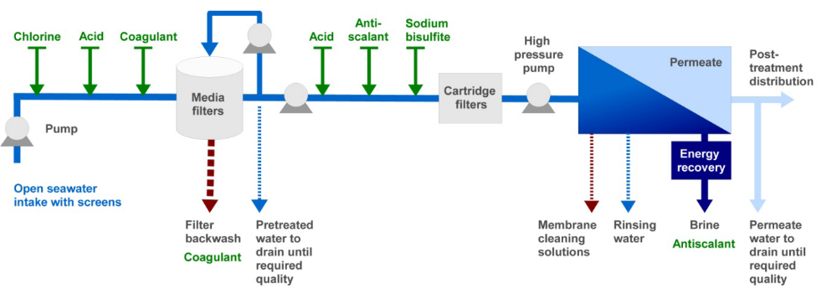

Figure 21: Flow-scheme of a SWRO system showing the conventional pretreatment and chemical dosage steps (green) and the different waste and side streams (the broken lines showing intermittent flows) (after UNEP 2008).

Coagulants like ferric chloride (FeCl₃) are used as part of the pre-treatment process to cause particles in feed-water to form larger masses that can be more easily removed with filters before the water passes through to the RO membranes. Dosing of sulfuric acid to establish slightly acidic pH values and addition of coagulant aids such as polyelectrolytes can enhance the coagulation process. Polyelectrolytes are organic substances with high molecular masses (like polyacrylamide) that help to bridge particles together. The dosage of coagulants and coagulant aids is normally correlated to the amount of suspended material in the intake water. It can range between < 1 and 30 mg/l for coagulants and between 0.2 and 4 mg/l for polyelectrolytes. The particulate material is retained when the seawater passes through the filter beds. The filters are backwashed on a period basis (few times every day), using filtered seawater or permeate water, in order to clean the filters from the particulate material, producing a sludge that contains mainly sediments and organic matter, and filter coagulant chemicals. The backwash water can either be discharged into the sea, or may be treated and the sludge disposed in a landfill. Acute toxic effects of the sludge when co-discharged to the sea are generally not expected, but some evidence suggests that chronic effects could occur (Sotero-Santos et al. 2007, e.g. reduction of fecundity in Daphnia). However, ferric chloride may cause a discoloration of the receiving water, and the sludge discharge may lead to increases in turbidity and suspended matter. There is also concern that the discharge of ferric coagulants may cause a discoloration of sandy beaches when dispersed by currents (UNEP 2008). Impacts such as reduced primary production or burial of sessile organisms by increased turbidity in the discharge may thus occur (Sotero-Santos et al. 2007, Lattemann & Höpner 2003). Such indirect effects are difficult to quantify, but as a pro-active measure it is recommended that particles are removed before discharge of the sludge.

Scaling on inside tubes or on RO membranes impairs plant performance. Anti-scalants are commonly added to the feed-water in RO plants to prevent scale formation. The main representatives of anti-scalants are organic, carboxylic-rich polymers such as polyacrylic acid and polymaleic acid. Acids and polyphosphates are still in use at a limited scale but on the retreat as they can cause eutrophication through formation of algal blooms and macroalgae (DWAF 2007). Phosphonate and organic polymer antiscalants have a low toxicity to aquatic invertebrate and fish species, but some substances exhibit an increased toxicity to algae (see UNEP 2008 for reference). The typical antiscalant dosing rate in desalination plants (1–2 mg/l), however, is a factor of 10 lower than the level at which a chronic effect was observed (20 mg/l), and it is 10–5,000 times lower than the concentrations at which acutely toxic effects were observed. Due to the antiscalants capability of binding nutrienst they may, however, interfere with the natural processes of dissolved metals in seawater following discharge (see UNEP 2008 for reference). Some of these metals may be relevant micronutrients for marine algae.

Polyphosphate antiscalants are easily hydrolysed to orthophosphate, which is an essential nutrient for primary producers. The use of polyphosphates may cause a nutrient surplus and an increase in primary production in the discharge site, which may lead to oxygen depletion when the organic material decays. Eutrophication was reported at the outlets of some larger thermal desalination plants that used polyphosphates for scale control (Shams et al. 1994).

Despite feedwater pretreatment, fouling occurs inside the plant, necessitating periodic plant cleaning. In RO plants, membranes may become fouled by biofilms, accumulation of suspended matter and scale deposits. Initial fouling can be detected by monitoring salt passage, permeate flux and membrane pressure, and needs to be cleaned off periodically to avoid irreversible membrane damage. The cleaning intervals (CIP) of RO membranes are typically three to six months depending on the quality of the plant's feed-water (Einav et al. 2002). The chemicals used are mainly weak acids and detergents. Alkaline cleaning solutions (pH 11-12) are used for removal of silt deposits and biofilms, whereas acidified solutions (pH 2-3) remove metal oxides and scales. Further chemicals are often added to improve the cleaning process, such as detergents, oxidants, complexing agents or biocides for membrane disinfection. These additional chemicals are usually generic types or special brands recommended by the membrane manufacturers. Common cleaning chemicals include Sulphuric acid, Ethylenediaminetetraacetic acid (EDTA), Sodium tripolyphosphate (STPP), and Trisodium phosphate (TSP). Below follows a short summary of the environmental fates and effects of these chemicals.

Sulphuric acid (H₂SO₄) is used for pH adjustment in the desalination process to reduce the pH for the acid wash cycle. It is a strong mineral acid that dissociates readily in water to sulphate ions and hydrated protons, and is totally miscible with water. At environmentally relevant concentrations, sulphuric acid is practically totally dissociated, sulphate is at natural concentrations and any possible effects are due to acidification. This total ionisation will imply also that sulphuric acid, itself, will not adsorb on particulate matters or surfaces and will not accumulate in living tissues (http://www.chem.unep.ch/irptc/sids/oecdsids/7664939.pdf). Sulphuric acid can be acutely toxic to aquatic life via reduction of water pH. Most aquatic species do not tolerate pH lower than 5.5 for any extended period. No guideline values are available for this substance but No Observed Effect Concentration (NOEC) values were developed from chronic toxicity tests on freshwater organisms and range from 0.058 mg/ℓ for fish populations to 0.13 mg/ℓ for phytoplankton and zooplankton populations, respectively (http://www.chem.unep.ch /irptc/sids/oecdsids/7664939.pdf). As seawater is highly buffered, the limited sulphuric acid discharges are not expected to have significant impacts in the marine environment.

EDTA is an aminopolycarboxylic salt that is used as a chelating agent to bind or capture trace amounts of iron, copper, manganese, calcium and other metals. In water treatment systems, EDTA is used to control water hardness and scale-forming calcium and magnesium ions to prevent scale formation. Because of the ubiquitous presence of metal ions, it has to be assumed that EDTA is always emitted as a metal complex, although it cannot be predicted which metal will be bound. EDTA will biodegrade very slowly under ambient environmental conditions but does photodegrade. EDTA is not expected to bioaccumulate in aquatic organisms, adsorb to suspended solids or sediments or volatilize from water surfaces (European Union Risk Assessment Report 2004). Toxicity tests on aquatic organisms have shown that adverse effects occur only at higher concentrations (the lowest concentrations at which an adverse effect was recorded is 22 mg.ℓ⁻¹) (European Union Risk Assessment Report 2004). On the other hand, if trace elements like Fe, Co, Mn, and Zn are low in the natural environment, an increased availability of essential nutrients caused by the complexing agent EDTA is able to stimulate algal growth. Heavy metal ions in the water are complexed by free EDTA, and a comparison of the toxicity of those compared to the respective uncomplexed metals and free EDTA have shown a reduction in toxicity by a factor of 17 to 17000 (Sorvari & Sillanpää 1996). Experiments (albeit with significantly higher trace metal concentrations than are typically observed in the environment) indicate that EDTA decreases the accumulation of metals such as Cd, Pb and Cu, however the absorption of Hg by mussels is seemingly promoted through complexation with EDTA (Gutiérrez-Galindo 1981, as cited in the European Union Risk Assessment Report, 2004). Potential promotion of the accumulation of metals in sediments is unlikely to be a concern as in high concentrations EDTA prevents the adsorption of heavy metals onto sediments and even can remobilise metals from highly loaded sediments (European Union Risk Assessment Report 2004). Within the framework of marine risk assessment, the European Union has published a risk assessment report in which a Predicted No Effect Concentration (PNEC) of 0.64 mg/ℓ was calculated (European Union Risk Assessment Report 2004).

Sodium tripolyphosphate (STPP, Na₅P₃O₁₀) is the sodium salt of triphosphoric acid, and is a typical ingredient of household cleaning products, and is thus present in domestic waste waters. STPP is an inorganic substance that when in contact with water (waste-water or natural aquatic environment) is progressively hydrolysed by biochemical activity, finally to orthophosphate. Acute aquatic ecotoxicity studies have shown that STPP has a very low toxicity to aquatic organisms (all EC/LC₅₀ are above 100 mg/ℓ) and is thus not considered as environmental risk (HERA, 2003). The final hydrolysis product of STPP, orthophosphate, however, can lead to eutrophication of surface waters due to nutrient enrichment. However, phosphate as a nutrient is not limiting in marine environments unless there are significant inputs of nitrogen (nitrates, ammonia), which is the limiting nutrient in the marine environment. In addition to the hydrolysis into orthophosphate, STPP can, depending on the presence of cationic ions, precipitate in the form of insoluble calcium, magnesium or other metal complex species (HERA 2003).

Trisodium phosphate (TSP) (Na₃PO₄) is a highly water-soluble cleaning agent. When dissolved in water it has an alkaline pH. The phosphate can act as a plant nutrient, and can thus increase algal growth, however, as noted above, phosphate as a nutrient is not limiting in marine environments unless there are signifcant inputs of nitrogen.

After the cleaning process is complete and the cleaning agents have been circulated through the membranes, the membranes are rinsed with product water several times. In many cases, the residual membrane cleaning solution and also the first rinse which contains most of the constituents from cleaning are neutralized and diverted to a sanitary sewer for processing. It is possible that the cleaning wastes are either discharged by direct blow-down immediately after cleaning, or by storage and continuous blending into the waste stream. Alternatively, it is injected by continuous flow of small quantities into the brine and discharged into the sea in the effluent (Einav et al. 2002). Neutralization of extremely alkaline or acidic solutions (e.g. sulphuric acid) and treatment of additional cleaning agents is recommended before discharge to the ocean to remove any potential toxicity (http://www.paua.de/Impacts.htm). Seawater is however highly buffered, and has a strong neutralising effect on acids.

In summary, the toxicity of the various chemicals used in the pre-treatment and CIP process (aside from biocides) is relatively low, and none of the products are listed as tainting substances (DWAF 1995). Of more concern is the potential increase in turbidity (Backwash-sludge), the change in pH (sulphuric acid), and the potential for eutrophication (e.g. STPP, TSP).

The waste brine often contains low amounts of heavy metals that pass into solution when the plant’s interior surfaces corrode. In RO plants, non-metal equipment and stainless steels are typically used. The RO brine may therefore contain traces of iron, nickel, chromium and molybdenum, but contamination levels are generally low (Hashim & Hajjaj 2005; http://www.paua.de/Impacts.htm). Heavy metals tend to enrich in suspended material and finally in sediments, so that areas of restricted water exchange and soft bottom habitats impacted by the discharge could be affected by heavy metal accumulation. Many benthic invertebrates feed on this suspended or deposited material, with the risk that metals are enriched in their bodies and passed on to higher trophic levels. At this stage, no assessment of the potential concentration of heavy metals can be provided, as it is an incidental by-product of RO plant processes. It is therefore recommended that limits are established for heavy metal concentrations in the brine discharges, and the brine regularly monitored to avoid exceedance of these limits.

Options for Feedwater Intake and Brine Discharge
- The number and size of seawater reverse osmosis desalination (SWRO) plants, as well as, the environmental awareness related to such projects is increasing, resulting in increased emphasis on intake (and outfall) design and economics. Intake (and outfall) can be the ‘fatal flaw issue’ of new seawater desalination facilities. But whereas for the design and the manufacturing of the desalination unit itself well known and approved technical solutions are available, the intake and the pre-treatment of the seawater, as well as, the discharge of the brine have to be adapted to the specific conditions at the construction site of each plant. These can differ in a wide range, as beside the influences determining the raw water quality, also items like the geological situation and details related with infrastructure or logistic are usually very different and have to be considered consequently during design, construction and operation of a desalination plant.

This section presents current design alternatives for intake and discharge structures.

Intake Structures
- The extraction of seawater to feed a reverse osmosis system is critical with regards to limitation of suspended solids, variation of seawater temperature, contamination by pollutants and particularly oil, as well as, marine biological matter. These factors, individually and/or together, present a great challenge for the pre-treatment of the feedwater for the RO process with regards to performance and operational costs. Experience has shown that the pre-treatment is the most critical area of a seawater RO desalination plant, and that long-term successful plant operation is greatly influenced by the combination of pre-treatment and intake method. The design, modelling, monitoring, and permitting activities that surround the intake method, may thus represent as much as 10% to 30 % of the capital cost of the entire facility. In the long term, a good intake design will not only protect downstream equipment and reduce environmental impact on aquatic life, but it will enhance process performance and reduce pre-treatment system capital and operating costs as well.

The targets for an ideal intake system are:
Avoid suspended organic matter (solids, colloids, etc),
Avoid dissolved organic matter (grease, oil, etc),
Avoid biological activity (algae, plancton, etc),
Avoid dissolved heavy metals and scaling compounds,
Keep permanent physiochemical characteristics (temperature, salinity),
Maintain constant feed flow (not decreasing in time),
Flexibility to adjust the sea water flow to the required feed water flow to the RO trains (RO plants are modular installations), and
Environmental friendly, avoiding negative impacts on the environment (sea and coast).

In addition, the intake should be as close as possible to the site of the desalination plant to optimize energy consumption.

- Various intake alternatives exist for the supply of seawater to a RO Plant, largely grouped into direct (open water) and indirect (water filtered through seabed) intakes (Figure 22). These are described briefly below:

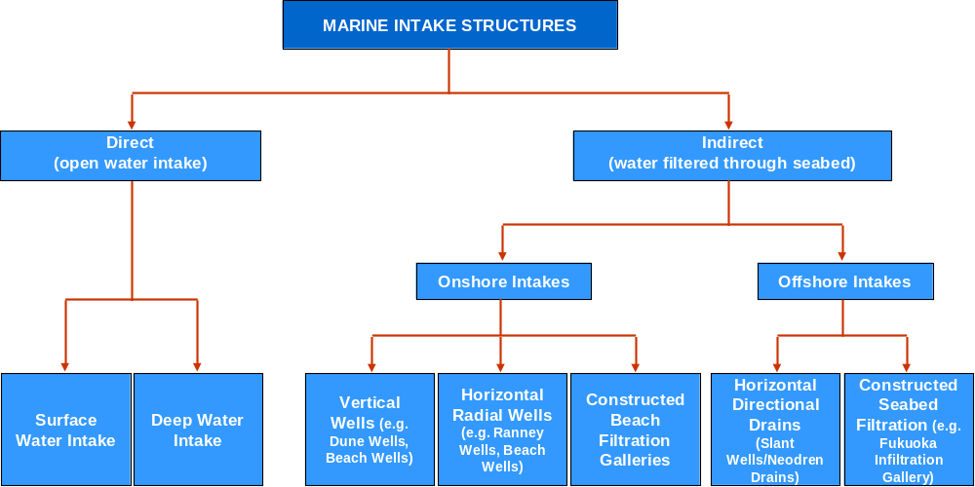

Figure 22: Overview of different marine intake systems for supply of feedwater to Reverse Osmosis Desalination Plants (adapted from Pankrantz 2008).

Conventional direct (open water) intake structures
The conventional method of intake is the open intake of seawater by active or passive screens of different kind. Open ocean intakes are suitable for all sizes of seawater desalination plants, but are typically more economical for plants of production capacity higher than 20,000 m³/day. Surface intakes can be as simple as dredged channels through a nearshore region to draw in seawater. This kind of intake system is usually made of a conveying concrete channel and/or a breakwater basin with simple and/or complex mechanical screening systems at the intake (Figure 23).
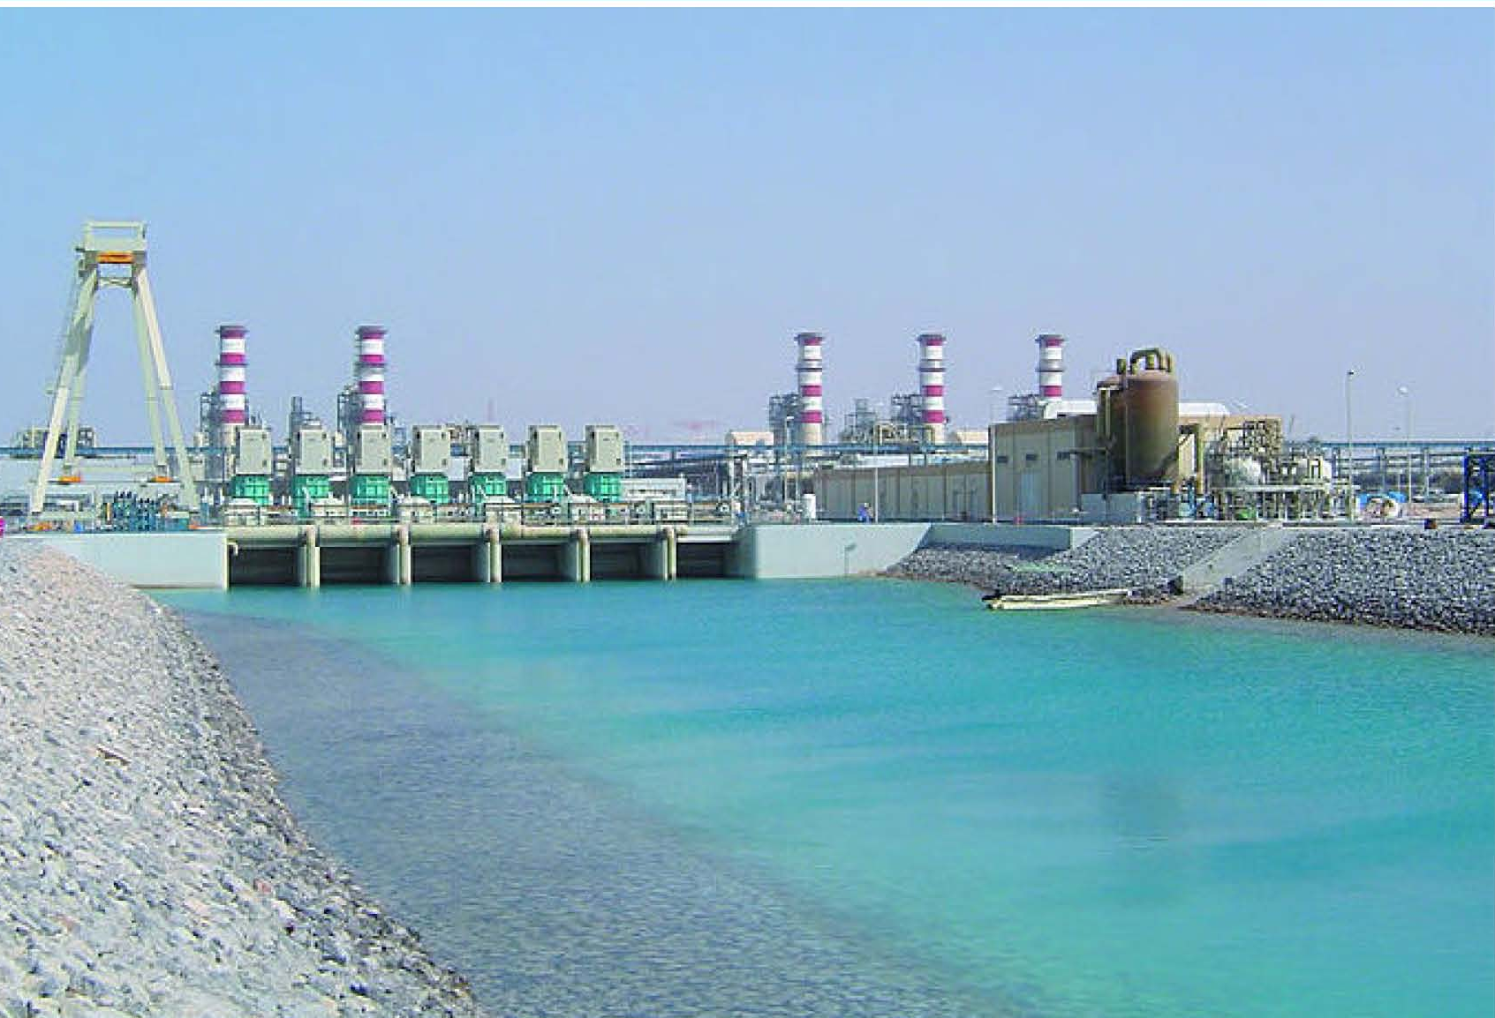
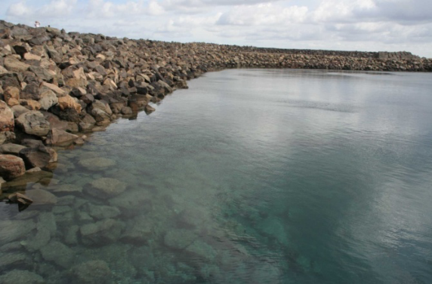

Figure 23: Examples of open intake basin with breakwater (left, image source: UNEP 2008) and traditional open channel seawater intake (right, image source Pankratz 2008).

The size of the screening system depends on the quantity and type of the suspended matter present in the water. Surface intakes work with an acceptable degree of performance when small loads of debris are present, but become ineffective when the water gets saturated with large loads of debris and sediments. This type of intake usually provides a low quality feed water resulting in operational issues. The open channel type of intake used to be the most common, but is going under a phase-out on a global scale in favor of the more advanced and effective offshore systems (Peters & Pintó 2008).

Deep water intakes are the most common intakes for existing RO plants, especially for larger ones. The construction of a classic open intake involves long submarine pipelines installed on the ocean floor with up to few hundred or even thousand metres of length from the shore into the offshore area, or intake wells with pumps in deeper water and pipelines installed on a jetty.

The main concern when designing an open water intake is to prevent marine life and other debris from entering the desalination system, not only because of the impact on marine life, but also because it can foul the desalination membranes. The three main technologies currently used to address these concerns associated with direct sweater extraction are listed below.

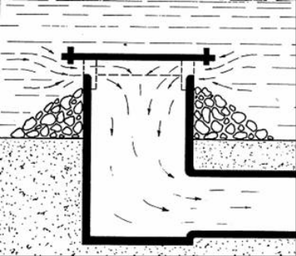
Velocity Caps
Velocity caps minimize the velocity at the intake to prevent impingement. A velocity cap consists of a cover placed over a vertical terminal of an offshore intake pipe. The aim of the cover is to convert vertical flow surrounding the intake pipe to horizontal flow. Fish avoid rapid changes to horizontal flow and velocity cap intakes may thus provide 80 to 90 per cent reduction in fish impingement. However, velocity caps do not reduce the entrainment of eggs and larvae.

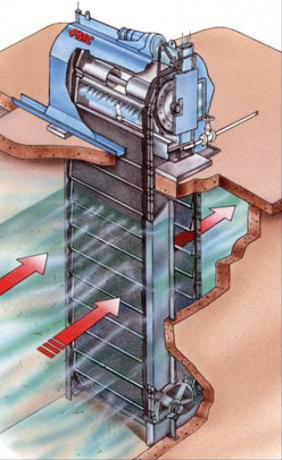
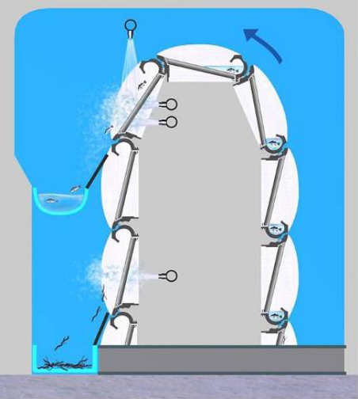
Travelling Water Screens
Travelling screens are equipped with revolving wire mesh panels that rotate through the water and are cleaned by a high-pressure water spray. These technologies are designed to prevent debris from entering the system rather than to minimise impingement and entrainment.

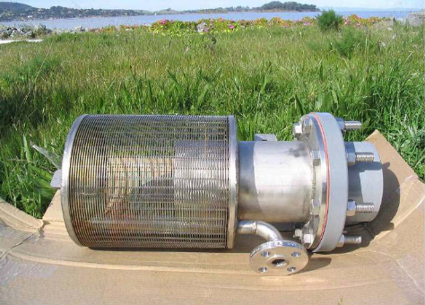
Vertical and Cylindrical Wedgewire Screens (Passive Screens)
Recent advances in offshore intake screens include Cylindrical Wedgewire Screens, also known as Passive Screens, which avoid high levels of impingement and entrainment. These are designed to enable large water intakes at low velocity and physical exclusion of marine biota with screen mesh sizes ranging from 0.5-10 mm. Passive Screens have a proven ability to reduce impingement and entrainment. Their effectiveness is related to their slot width and low through velocity. It has been demonstrated that 1 mm openings are highly effective for larval exclusion and to reduce entrainment (Pankratz 2004).

Without periodical cleaning of the screens, the slot-holes would block within a relatively short period of time, thus increasing the velocity and energy requirements of the intake waters. To protect the intake from large debris, piled structures can be constructed around single intakes. Depending on final design, some form of air or water blasting may be periodically used to assist in screen maintenance. An air blasting system can be installed through pipes placed in the intake screen system. Providing several separate risers would also reduce the risk of total blockage.

Although the intake of floating matter and debris is avoided with deep water intakes, the feed water abstraced with such direct intake systems is subject to marine biological activity and suspended matter, which needs to be removed or reduced by the pre-treatment. The pre-treatment of the seawater for classic open intake methods ranges - behind the screening and sand trap - from single & double stage multimedia filtration and combination with clarification, coagulation or dissolved air flotation to ultrafiltration (Gare 2002, Vedavyasan 2007). All filtration processes will give rise to a waste stream containing the filtered solids and any coagulant used. For example, media filters can generate a wastewater volume of between 3-5% of their treated water throughput. If this water cannot be returned to the feed water source (typically the case if a coagulant has been added), the derived sludge must be dewatered either by settlement or by some mechanical process. To eliminate biological growth in the system, chlorination is widely used, which needs to be neutralized to avoid damage to the RO membranes (Gare 2002, Lattemann & Höpner 2003).

- Indirect seawater intake
- The most well known indirect intake system is the seawater intake beach well which is either a vertical or a horizontal source water collector that is typically located in close vicinity to the sea (Figure 24). The seawater is collected in conventional wells and pumped to the plant, or it is collected in horizontal well screens that are connected to a vertical well with an integrated pump and a pump house on the beach, like the ‘Ranney’ system. Another subsurface intake is an infiltration gallery that consist of perforated pipes arranged in a radial pattern in the saturated sand onshore. These systems are used to tap into the on-shore coastal aquifer. The seawater collected is pretreated via slow filtration through the subsurface seabed formations in the area of source water extraction.

Vertical intake wells are usually less costly than horizontal wells; however their productivity is relatively small and they are therefore only suitable for smaller plants (<4 000 m³/day), unless a large number of beach wells, occupying a considerable stretch along the beach, are constructed. Even horizontal wells or infiltration galleries are only suitable for RO plants with a capacity of <40 000 m³/day (Voutchkov 2005).

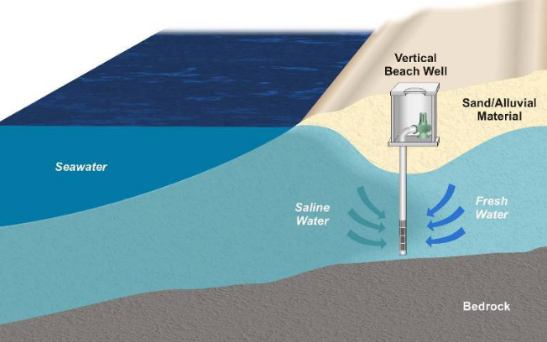
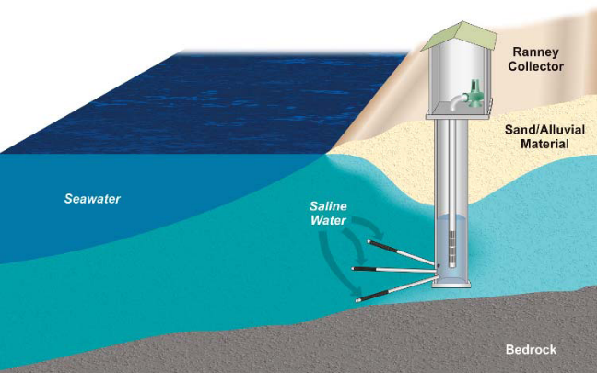

Figure 24: Schemtaic diagrams of a Vertical Beach Well (left) and a Horizontal Collector Well or ‘Ranney’ Collector (right). (Image source: UNEP 2008).

A more recent development in intake design options are horizontally drilled drains (HDD) in the offshore marine sediments that are more suitable for larger RO plants (Peters et al. 2007; Peters & Pintó 2008). Currently, the largest one using this system is the RO desalination plant in San Pedro del Pinatar with 172,800 m³/d (Peters et al. 2007). An array of perforated drain pipes are installed in bore holes, drilled with horizontal directional drilling (HDD) method in the stratum below the seabed. The HDD collector wells consist of relatively shallow blank well casing with one or more horizontal perforated screens bored under an angle (typically inclined at 15 to 20 degrees) and extending from the surface entry point underground past the mean tide line at a minimum depth below the sea floor of 5 to 10 meters.
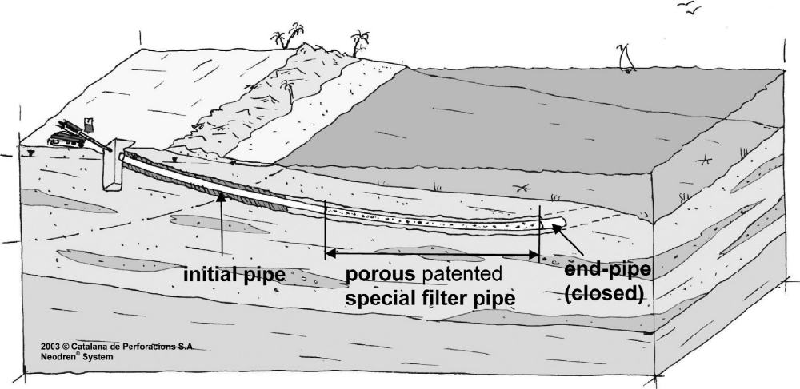

Figure 25: Schematic of the Horizontal Drilled Drains (HDD) (source: Neodren system by Catalana de Perforacions).
Similar to beach well and infiltration galleries, the seawater is extracted indirectly through the sub-seabed area that is acting as a natural filter. The risk of impacts on groundwater resource is, however, reduced because the seawater is extracted off-shore and with very low velocity. Another advantage is that during construction and installation activities the impact on the environment is reduced as the working area is limited to two points; one onshore behind the beach area or further away from the coast line for the drilling rig and peripheral machinery, and one offshore at the end of the drains at the seabed (Peters et al. 2008). Permanent structures are also reduced as most of the pipeline is underground.

- Designed with appropriate intake velocities and installed at the proper depth within the substrate, sub-surface intakes can operate with negligible impingement and entrainment effects on local marine life. A further operational advantage is that the natural filtering effects of the beach sediments ensure that the feed-water is comparatively clean and free of fine particulate material, thereby reducing operating costs by reducing the necessity for the use of pre-treatment substances (California Water Desalination Task Force 2003a; Campbell & Jones 2005; WHO 2007). In areas where quality of the feed water may be an issue as a result of high turbidity, productivity or the occurrence of harmful algal blooms (HABs) or sulphide eruptions (e.g. the study area), these intake options as a pre-treatment strategy are thus attractive.

- The problem with these conventional indirect schemes is that they are limited by the site-specific hydrogeological characteristics. The factors that define site suitability are the transmissivity/productivity of the seashore’s geological formations, the thickness of the beach deposits and the existence of nearby fresh water source aquifers, which could be negatively impacted by the beach well operations or could have a measurable effect on beach well water quality. The geological conditions that favour the construction of beach well intakes are permeable sand formations whose transmissivity exceeds 1000 m³/day/m, and whose depth extends to 15 m or more (Voutchkov 2005). Even the off-shore directionally drilled perforated drain pipes (HDD) are limited by the permeability and porosity of the overlying soil (Peters et al. 2007).

Given the limitations of existing sub-surface intake systems, a conceptual design of a synthetic permeable system has recently been developed that would not be reliant on local geological characteristics but has the same advantages of pre-filtered feed water as conventional sub-surface intakes (Jones 2008). The synthetic infiltration gallery comprises a subterranean reservoir installed at a sheltered location, a borehole created by directional drilling, and a pipe or series of pipes extending from the reservoir into the open ocean (Figure 26). The terminal end of the intake is overlain with marine mattresses with filtration media sachets. The intake receives water infiltrated through these sachets. The offshore filter media is designed to foster an environment for microbial communities to effectively remove biologically available nutrients such as phosphorus and nitrogen compounds as well as assimilated organic carbon. In addition, the system removes undesirable suspended particles to produce a feed water supply independent of surrounding geology.

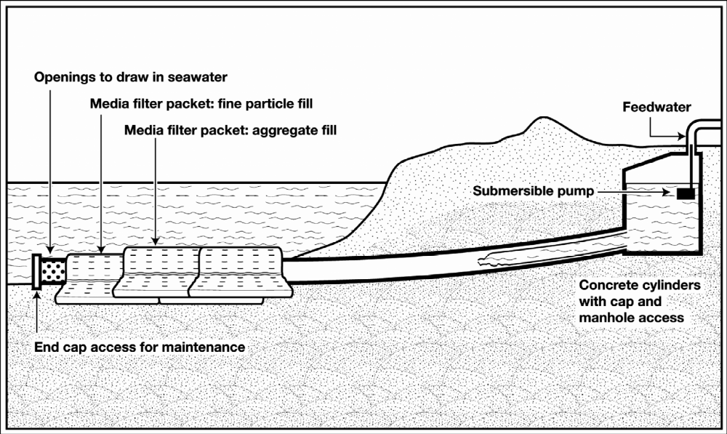

Figure 26: Sketch of synthetic infiltration gallery (after Jones 2008).

Discharge Alternatives
Various discharge alternatives exist for the disposal of effluent from the RO Plant, namely single-point or diffuser effluent pipelines, beach discharge wells, open-channel surf-zone discharges, and evaporation ponds.

The most widely used method of concentrate disposal is discharge via a single open outfall or a diffuser system into the sea. Two key options are available to accelerate concentrate mixing from an ocean outfall discharge: i) to rely on the naturally occurring mixing capacity of the tidal (surf) zone, or ii) to discharge the concentrate beyond the tidal zone and to install diffusers at the end of the discharge outfall in order to improve mixing. Although the tidal zone carries a significant amount of turbulent energy and usually provides much better mixing than the end-of-pipe type of diffuser outfall system, this zone has a limited capacity to transport the saline discharge load to the open ocean. If the mass of the saline discharge exceeds the threshold of the tidal zone’s salinity load transport capacity, the excess salinity would begin to accumulate in the tidal zone and could ultimately result in a long-term salinity increment in this zone beyond the level of tolerance of the aquatic life (WHO 2007). This salinity threshold mixing/transport capacity of the tidal zone can be determined using hydrodynamic modelling. Typically, ocean outfalls for large seawater desalination plants extend beyond the tidal zone, and are equipped with diffusers in order to provide the mixing necessary to prevent the heavy saline discharge plume to accumulate at the ocean bottom in the immediate vicinity of the discharge. This option is the proposed option for this project.

Disposal of brine through beach discharge wells involves the construction of beach wells on or just off a beach. The concentrate is discharged through the well, and mixing with ocean water takes place within the sands prior to the concentrate reaching the sediment/water interface. Any water with higher than ambient salinity would then be subject to mixing within the surf zone of the beach (California Water Desalination Task Force 2003b). Currently, few desalination plants internationally are using this option of a high-saline brine discharge (one example is the Marina Coast Water District plant in the Monterey Bay Area, California, California Water Desalination Task Force 2003b), and there are no studies available that have investigated the effects of this type of discharge on the marine environment. Also, similar to the intake via beach wells, this option is only suitable for smaller plants.

An open-channel surf-zone discharge is usually designed such that the discharge occurs just above the high water mark with the brine flowing down an open concrete channel into the active surf-zone. As the beaches in the area of the proposed intake and discharge structures for the RO Plant are actively used by rock- and surf-anglers, who often travel along the coast on the beach, such a discharge option would not be appropriate. Not only would it have substantially higher aesthetic impacts than a buried pipeline, but would pose an obstruction to vehicular traffic on the beach.

The use of evaporation ponds for the disposal of reject brine from desalination plants, is a particularly attractive alternative in arid and semi-arid areas, both from an economic and environmental perspective. Evaporation ponds have long been used for salt production in many parts of the world, and recently this option for disposal of reject brine has been implemented at numerous inland plants in the Gulf States (Ahmed et al. 2000; Mohamed et al. 2005). This disposal option is, however, practical only for relatively small volume discharges, as the land area required to receive brine volumes of the magnitude proposed for the NamWater RO Plant would be extensive. Alternativley, the brine could be discharged to the existing saltworks north of Swakopmund. The brine, however, would most likely need pre-treatment as the salt produced by the saltworks is destined for human consumption. Secondly, the brine supply is likely to greatly exceed the intake capacity of the saltworks.

Alternative disposal methods on land will be investigated by the on-land team during the EIA (feasibility) phase of the project and will be reported on elsewhere.

“No-development” Alternative
Various alternatives were considered by NamWater for supplying the large volumes of water required by the Uranium Mining Industry. The possible alternatives investigated included the use of groundwater and surface water, or construction of a desalination plant. As natural groundwater and surface water supplies are insufficient to meet the requirements of the mine, these fresh water sources were not considered as feasible options.

The “no-development” alternative for the Desalination Plant therefore implies that further development of the Uranium Mining Industry may not proceed, and the proposed taxes and other direct financial and economic benefits of the industry will not be realised. The “no-development” option is from a marine perspective undeniably the preferred alternative, as all impacts associated with beach disturbance and effluent discharge will no longer be an issue. This, however, needs to be weighed up against the potential positive socio-economic impacts undoubtedly associated both with the RO Plant project itself, as well as the Uranium Mining Industry development.

CONCLUSIONS AND RECOMMENDATIONS
The main marine impacts associated with the proposed RO Desalination Plant north of Swakopmund are related to the construction of the intake and outfall structures during the construction phase, and the permanent structures (primarily the breakwater basin in Alternative 2) and the intake of feed water from, and consequent discharge of a high-salinity brine back into the ocean during the operational phase.

Construction Phase
The installation of the intake and discharge structures will result in considerable disturbance of the high-shore, intertidal and shallow subtidal habitats at the construction site. The construction will involve considerable excavation activities in the surf zone and beyond, as well as on the beach. Pipeline launching and entrenchment or channel excavation will involve extensive traffic on the beach by heavy vehicles and machinery, as well as the potential for hydrocarbon spills. Although the activities on the intertidal beach will be localised and confined to within a hundred metres of the construction site, the beach sediments will be completely turned over in the process and the associated macrofauna will almost certainly be entirely eliminated. In case of Alternative 2, the beach area excavated for the open channel will be permanently lost. Rock blasting will be necessary to remove existing bedrock to the required depth. Trench excavation through the surf-zone will necessitate the removal of large volumes of beach sand and disposing of it down-current of the construction site. It will most likely also involve blasting a channel into the underlying bedrock of a few hundred metres length through the surf-zone. Obviously, the physical removal of sediments or bedrock in the trench will result in the total destruction of the associated sessile benthic biota. Excavating operations will also result in increased suspended sediments in the water column and physical smothering of macrofauna by the discarded sediments.

Operational Phase
The key potential impacts are mostly associated with the operational phase. The permanent installation of intake and discharge structures may alter current flows and affect natural sediment dynamics. In case of Alternative 2, the breakwater may cause erosion and/or sand accumulation that in turn may necessitate dredging works.

The open water intake structure proposed for this project will result in impingement and entrainment of biota. Whereas careful designing of the intake with appropriate screening systems can reduce impingement substantially, the entrainment effect will not be eliminated. Entrainment of biological matter and suspended matter in turn will require substantial pre-treatment of the feed water which has environmental as well as operational cost consequences for the RO plant.

The need for pre-treatment of the feed water will also result in the use of chlorination to prevent biofouling of the pipelines and screens, and the use of other cleaning materials, which will be co-discrahged with the reject brine. Impacts associated with the brine discharge thus include:
the effect of elevated salinities in the brine water;
the effect of the effluent potentially having a higher temperature than the receiving environment;
biocidal action of residual chlorine in the effluent;
the effects of co-discharged constituents in the waste-water;
the removal of particulate matter from the water column where it is a significant food source, as well as changes in phytoplankton production due to changes in nutrients, water column structure and mixing processes; and
direct changes in dissolved oxygen content due to the difference between the ambient dissolved oxygen concentrations and those in the discharged effluent (especially if sodium bisulfate is used to neutralize residual chlorine), and indirect changes in dissolved oxygen content of the water column and sediments due to changes in phytoplankton production as a result of nutrient input.

At this stage of the project, detailed engineering designs and specifications for the construction of the intake and discharge structures are not available, nor are the brine effluent characteristics known. The impacts discussed are thus those generally associated with large RO Desalination plants elsewhere in the world, and applicable to this environment. The impact list may thus not be complete, but will be re-evaluated during the EIA phase of the project when design details are finalized.

Recommendations for further Studies
The experience of existing operational RO plants and the considerable research in the field of desalination techniques has shown that careful planning and design of the plant is vital for a successful long-term plant operation (Campbell & Jones 2005, WHO 2007, UNEP 2008). From a systems engineering perspective, three criteria drive the design of a seawater reverse osmosis plant, namely, quality of feed water, reverse osmosis membrane specification, and water quality of permeate (Jones 2008). From a marine environmental perspective, the first - the quality of the feed water - is a critical issue as the quality is largely determined by the type of intake system used. As the first step in the pre-treatment process, the type of intake used will affect a range of source water quality parameters and will ultimately impact the performance of downstream treatment facilities. In the end, the intake technology will determine the magnitude of impingement and entrainment effects as well as the level of chemical pollution co-discharged with the brine. A good intake design would thus not only protect downstream equipment and enhance process performance and reduce pre-treatment system capital and operating costs, but it would reduce environmental impact on aquatic life as well. In modern RO desalination plant projects, the design, modelling, monitoring, and permitting activities that surround them, may represent as much as 10% to 30 % of the capital cost of the entire facility (WHO 2007).

Many recent studies and reviews have thus emphasized that the intake structure is a key component in RO plants, and advocate, where possible, the use of sub-surface intakes (Lattemann & Höpner 2003, WHO 2007, Peters et al. 2007, Peters & Pintó 2008, National Water Comission 2008, Pankratz 2008). Sub-surface intakes have the advantage over open water intakes that the overlaying sediment acts as a natural filter and can significantly reduce the intake of biological and suspended material.

At present, two alternative intake design options are considered: an open water intake in 8 or 10 m water depth via a 800 m to 1500 m long pipeline, or the construction of a breakwater basin with conveying channel. Both are open water intakes, necessitating the need for extensive pre-treatment. Pre-treatment and screen maintainance is likely to be higher for Alternative 2 (breakwater basin) as this is a surface water intake. As described in an earlier section above, the feasibility of sub-surface intakes depends on local geological conditions, and from the preliminary information available it seems that the study area will not have the right conditions. However, the appraisal of alternatives is a vital component of environmental screening and impact assessment processes (WHO 2007, UNEP 2008), and it is thus strongly recommended to include a study on the feasibility of sub-surface intake options, especially those that involve synthetic or engineered filtration systems. Such a study as part of the EIA is also recommended by international guidelines such as those published by the World Health Organization (WHO 2007) and United Nations Environment Programme (UNEP 2008).

These guidelines (WHO 2007, UNEP 2008) further recommend a study on the chemical and physical properties of the raw water, preferably before the desalination plant is designed and built. A thorough raw water characterization at the proposed intake site must include an evaluation of physical, microbial and chemical characteristics, meteorological and oceanographic data, and aquatic biology. Seasonal variations should also be taken into account. The study should consider all constituents that may impact plant operation and process performance including water temperature, total dissolved solids (TDS), total suspended solids (TSS), membrane scaling compounds (calcium, silica, magnesium, barium, etc.) and total organic carbon (TOC). While many of these data are currently available (and presented in this report), the detailed chemical composition of the source water in the study area is not known.

In case of an open water intake, an entrainment study is further recommended. Ideally, this should be done as a pilot project for a pilot plant (Seawater desalination and the California Coastal Act 2004). The most common recognized study for determining entrainment effects of open ocean water intakes is known as the “316(b)” study, named after a section of US EPA federal Clean Water Act (US EPA 1977, Seawater desalination and the California Coastal Act 2004). The protocol for this study was designed to evaluate the impacts of once-through cooling systems used by thermal power plants but can also be used for desalination intakes. Basically, the study requires sampling at various depth of the water column over the course of a year at both the intake site and a control site to identify the types and concentrations of species that would be entrained. The study then uses any of several models to determine what effect the entrainment has on adult fish population or broader marine community of the source water. This study should also take into consideration the potential cumulative effect of the sea water intake from the Trekkopje RO plant.

To quantify the full impact of the brine discharge on the marine environment, all affected habitats and/or communities should be monitored before and during the discharge. However, prior research has indicated that this is impractical, impossible or simply unnecessary. Monitoring should rather focus on what are likely to be the most sensitive, significantly affected and/or representative species, communities or resources. The proposed discharge area includes two principal kinds of habitat - subtidal unconsolidated sediments and reefs, and intertidal sandy beaches. In both cases a suite of standard, and widely accepted techniques have been developed for the monitoring of invertebrate communities associated with these habitats, and it is proposed that these be adopted for monitoring studies to assess the disturbances associated both with the pipeline construction as well as with the brine discharge. Previous studies have shown that fish, birds and other vertebrates are usually not significantly affected by discharges, as they are highly mobile and are easily able to avoid the brine plume. Monitoring of these populations is therefore considered unnecessary. A monitoring program of sandy intertidal beaches is in place for the Trekkopje RO plant near Wlotzkasbaken, which is currently under construction. It is suggested that the results of this monitoring program (if shared) will also inform on the extent and magnitude of the construction impacts for the NamWater desalination plant. It is thus recommended to concentrate effort on the design and implementation of a subtidal monitoring program. A first preliminary benthic subtidal survey around the proposed outfall site will be conducted in January/February 2009.

Monitoring
Monitoring plays a key role in ensuring that plant operations function as intended and achieve the provision of safe drinking water with minimal environmental impacts. It includes validation, operational monitoring, verification and surveillance. Validation is the process of obtaining evidence that control measures are capable of operating as required, in other words it should confirm that specific pieces of equipment achieve accepted performance standards. Operational monitoring is the planned series of observations or measurements undertaken to assess the ongoing performance of individual control measures in preventing, eliminating or reducing hazards. Operational monitoring will normally be based on simple and rapid procedures such as measurement of turbidity and chlorine residuals or inspection of distribution system integrity. Verification provides assurance that a system as a whole is providing safe water while surveillance reviews compliance with identified guidelines standards and regulations.

There are a number of operational monitoring programmes that need to be established for the operational phase of the project. These are, however, not part of this baseline study but will be provided in the Environmental Management Plan as part of the EIA process.

Environmental Acceptability
From a coastal and marine environmental perspective, the proposed intake/discharge site cannot be considered particularly “pristine”. The stretch of coastline is already heavily impacted by regular vehicular traffic and seasonally high visitor numbers who utilize the area primarily for rock- and surf-angling and coastal recreation. Macrofaunal communities inhabiting the beach are therefore relatively depauperate and on some beaches show signs of moderate disturbance. No unique or new species were found on any of the beaches sampled in the vicinity of the study area (Pulfrich 2007b), and the species assemblages were typical of high-energy, exposed southern African West Coast beaches. None of the species encountered are currently classified as rare or endangered.

Construction activities as part of the proposed development will severely impact the beach and nearshore habitats and their associated communities. However, provided construction activities are not phased over an extended period, the beach is not repeatedly disturbed through persistent activities and suitable post-construction rehabilitation measures are adopted, the macrofaunal communities are likely to recover in the medium-term (i.e. over a period of years). The macrofaunal populations of these beaches are highly variable, on both spatial and temporal scales, and subject to dramatic natural fluctuations, particularly as a result of episodic disturbances such as unusual storms, and low oxygen events. As a consequence, the macrofauna are considered to be relatively resilient, being well-adapted to the dynamic environment, and capable of keeping pace with rapid beach changes (McLachlan & De Ruyck 1993). The highly localised, yet significant impacts over the short term thus need to be weighed up against the long-term benefits of the desalination plant.

Prior to the subtidal marine benthic survey planned for January/February 2009, little can be said about the nearshore subtidal communities. However, it is expected that the seabed will consist of bedrock covered with a thin veneer of sediments that is likely to show strong temporal and spatial variation due to the exposed nature of the coast and the high sediment transport. Benthic communities are thus likely to be impoverished as on the one hand the sand movement over the rocky substrate will smother and/or abrase rocky communities, while the fluctuation in sand cover and thickness will limit the potential for an established sandy bottom community. It is expected that the benthic communities in the study area will consist of a mixture of a few rocky and sandy substrate species that are adapted to frequent disturbance.

During the operational phase, entrainment of marine biota with the abstracted raw sea water (feed water) will occur. Furthermore, a high-salinity brine potentially containing biocides and other cleaning chemicals will be continuously discharged. It is particularly important that the development of a coherent density flow of brine along the seabed is avoided by ensuring as complete mixing throughout the full extent of the water column as is possible at the point of discharge. Consequently, the effluent will be discharged through a multi-port diffuser positioned in an area of relatively high wave conditions and increased current, and where regular mixing of the water column can be expected as a result of the exposed nature of the coastline. However, an accurate assessment of the mixing capacity of the effluent plume can only be done once the brine characteristics are known and results from a hydrodynamic modelling exercise are available. Important is that potential cumulative effects resulting from the close vicinity to the Trekkopje RO desalination plant are taken into consideration. In the end, the careful consideration of available technologies and processes for the RO plant is the key issue in the plant design that will allow the selection of the least environmentally damaging option for feed-water treatment and cleaning of plant components, thereby reducing discharges of hazardous components into the environment.

REFERENCES
Ahmed, M., Shayya W.H., Hoey, D., Mahendran, A., Morris, R. & J. Al-Handaly (2000). Use of evaporation ponds for brine disposal in desalination plants. Desalination, 130: 155-168.
Airoldi, L. & F. Cinelli (1997). Effects of sedimentation on subtidal macroalgal assemblages: an experimental study from a Mediterranean rocky shore. Journal of Experimental Marine Biology & Ecology, 215: 269-288.
Airoldi, L. & M. Virgilio (1998). Responses of turf-forming algae to spatial variations in the deposition of sediments. Marine Ecology Progress Series, 165: 271-282.
Airoldi, L., Fabiano, M. & F. Cinelli (1996). Sediment deposition and movement over a turf assemblage in a shallow rocky coastal area of the Ligurian Sea. Marine Ecology Progress Series, 133(1-3): 241-25.
Airoldi, L., Rindi, F. & F. Cinelli (1995). Structure, seasonal dynamics and reproductive phenology of a filamentous turf assemblage on a sediment influenced, rocky subtidal shore. Botanica Marina, 38(3): 227-237.
Alonso, J., Alcantara-Carrio & J. Cabrera (2002). Tourist resorts and their impact on beach erosion at Sotavento Beaches, Fuerteventura, Spain. Journal of Coastal Research, 36:1-7.
ANZECC (1992). Australian water quality guidelines for fresh and marine waters. National Water Quality Management Strategy Paper No 4, Australian and New Zealand Environment and Conservation Council, Canberra.
ANZECC (2000). Australian and New Zealand guidelines for fresh and marine water quality. Volume 2, Aquatic ecosystems. National water quality management strategy; no.4. Australian and New Zealand Environment and Conservation Council, Agriculture and Resource Management Council of Australia and New Zealand ,Canberra Australia. ISBN 0 642 19562 5 (www.deh.gov.au/water/quality/nwqms/introduction/).
Bailey G.W. & P. Chapman (1991). Chemical and physical oceanography. In: Short-term variability during an Anchor Station Study in the southern Benguela Upwelling system. Progress in Oceanography, 28: 9-37.
Bailey, G.W., Beyers, C.J. De B. & S.R. Lipschitz (1985). Seasonal variation of oxygen deficiency in waters off southern South West Africa in 1975 and 1976 and its relation to catchability and distribution of the Cape rock-lobster Jasus lalandii. South African Journal of Marine Science, 3: 197-214.
Bally, R., McQuaid, C.D. & A. C. Brown (1984). Shores of mixed sand and rock: an unexplored marine ecosystem. South African Journal of Science, 80: 500-503.
Bamber, R.N. & R.M.H. Seaby (2004). The effects of power station entrainment passage on three species of marine planktonic crustacean, Acartia tonsa (Copepoda), Crangon crangon (Decapoda) and Homarus gammarus (Decapoda). Marine Environmental Research, 57: 281 –294.
Bamber, R.N. (1995). The influence of rising background temperature on the effects of marine thermal effluents. Journal of Thermal Biology, 20(1/2): 105-110.
Barnabe, G. (1989). Aquaculture. Volume 1. New York, Ellis Horwood. 528 pp.
Barnard, P. (ed.) (1998). Biological diversity in Namibia - a country study. Namibian National Biodiversity Task Force, Windhoek.
Barnes, J.I., Zeybrandt, F., Kirchner, C.H., Sakko, A.L. & J. Macgregor (2004) Economic valuation of the recreational shore fishery: a comparison of techniques. In: Sumaila, U.R., Steinshamn, S.I., Skogen, M.D. & D. Boyer (Eds). Ecological, Economic and Social Aspects of Namibian Fisheries. Delft; Eburon Academic Publishers: 215–230.
Bartholomae, C.H. & A.K. van der Plas (2007). Towards the development of environmental indices for the Namibian shelf, with particular reference to fisheries management. African Journal of Marine Science, 29: 25-35.
Bartholomae, C.H. & E. Hagen (2007). Short-term variability in alongshore winds and temperature off Swakopmund, Namibia, during a non-upwelling event in 1998–1999. African Journal of Marine Science, 29: 141-145.
Bayne, B.L. (1965). Growth and delay of metamorphosis of larvae of Mytilus edulis L. Ophelia, 2: 1-47.
Berg, J.A. & R.I.E. Newell (1986). Temporal and spatial variations in the composition of seston available to the suspension-feeder Crassostrea virginica. Estuarine & Coastal Shelf Science, 23: 375–386.
Berry, P.F. (1982). Biomass and density of detritivores on a rocky littoral reef on the Natal coast, with an estimate of population production for the ascidian, Pyura stolonifera. Investigational Reports of the Oceanographic Research Institute, 53: 1-12.
Beyers C.J. De B. (1979). Stock assessment and some morphometric and biological characteristics of the rock-lobster Jasus lalandii on Marshall Rocks, its main commercial fishing area off South West Africa, 1971-1974. Investigational Report of the Sea Fisheries Branch, South Africa 117: 1-26.
Beyers, C.J. De B., C.G. Wilke & P.C. Goosen (1994). The effects of oxygen deficiency on growth, intermoult period, mortality and ingestion rates of aquarium-held juvenile rock lobster Jasus lalandii. South African Journal of Marine Science, 14: 79-88.
Bianchi, G., Carpenter, K.E., Roux, J.-P., Molloy, F.J., Boyer, D. & H.J. Boyer (1999). FAO species identification guide for fishery purposes. Field guide to the Living Marine Resources of Namibia, 256pp.
Blaber, S.J.M. & T.G. Blaber (1980). Factors affecting the distribution of juvenile estuarine and inshore fish. Journal of Fish Biology, 17: 143-162.
Bolsch,, C.J. & G.M. Hallegraeff (1993). Chemical and physical treatment options to kill toxic dinoflagellate cysts in ship’s ballast water. Journal of Marine Environmental Engineering, 1: 23-29.
Bombace, G., Fabi, G., Fiorentini, L. & S. Speranza (1994). Analysis of the efficacy of artificial reefs located in five different areas of the Adriatic Sea. Bulletin of Marine Science, 55: 559-580.
Borges, P. Andrade, C. & M.C. Freitas (2002). Dune, bluff and beach erosion due to exhaustive sand mining – the case of Santa Barbara Beach, Sao Miguel (Azores, Portugal). Journal of Coastal Research, 36: 89-95.
Boyd, A.J. & G.P.J. Oberholster (1994). Currents off the west and south coasts of South Africa. S. Afr. Shipping News and Fish. Ind. Rev., 49: 26-28.
Bradley, F., Book, C. & A.E. Bowles (1990). Effects of Low-Altitude Aircraft Overflights on Domestic Turkey Poults. Bbn Systems and Technologies Corp Canoga Park CA, Final Report (http://stinet.dtic.mil).
Branch, G.M. & C.L. Griffiths (1988). The Benguela ecosystem part V: the coastal zone. Oceanography & Marine Biology: An Annual Review, 26, 395-486.
Branch, G.M. (1981). The biology of limpets: physical factors, energy flow and ecological interactions. Oceanography & Marine Biology: An Annual Review, 19: 235-380.
Branch, G.M., Eekhout, S. & A.L. Bosman (1990). Short-term effects of the 1988 Orange River floods on the inter-tidal rocky-shore communities of the open coast. Transactions of the Royal Society of South Africa, 47: 331-354.
Bricelj, V.M. & R.E. Malouf (1984). Influence of algal and suspended sediment concentrations on the feeding physiology of the hard clam Mercenaria mercenaria. Marine Biology, 84: 155–165.
Brown, A. (2000). Is the sandy beach isopod Tylos granulatus an endangered species? South African Journal of Science, 96: 466.
Brown, A.C. & A. McLachlan (1990). Ecology of sandy shores, pp. 1-328 Amsterdam, Elsevier.
Brüchert, V., Barker Jǿrgensen, B., Neumann, K., Riechmann, D., Schlösser M. & H. Schulz (2003). Regulation of bacterial sulfate reduction and hydrogen sulfide fluxes in the central Namibian coastal upwelling zone. Geochim. Cosmochim. Acta, 67(23): 4505-4518.
California Coastal Commission (2004). Sea water desalination and the California coastal Act. March 2004. (Source: http://www.coastal.ca.gov.)
California Water Desalination Task Force (2003a) Issue paper on beach wells. Draft Document. (http://www.owue.water.ca.gov/recycle/desal/desal.cfm).
California Water Desalination Task Force (2003b). Issue paper on concentrate management associated with desalination facilities. Draft Document. August 2003.
Campbell, R.L. & A.T. Jones (2005). Appropriate disposal of effluent from coastal desalination facilities. Desalination, 182: 365-372.
Capuzzo, J.M., Davidson, J.A., Lawrence, S.A and M. Libni (1977). The differential effects of free and combined chlorine on juvenile marine fish. Estuar. Coastal Mar. Sci. 5:733-741.
Carter, R.A. & R.C. van Ballegooyen (1998). Preliminary Kudu Power Plant environmental assessment: the discharge of hot water effluent into the marine environment, CSIR Report ENV/S-C 98017, 43pp.
Chapman, P. & L.V. Shannon (1985). The Benguela Ecosystem. Part II. Chemistry and related processes. Oceanography & Marine Biology: An Annual Review, 23: 183-251.
Chen, J.C., Lin, M.N., Lin, J.L. & Y.Y. Ting (1992). Effect of salinity on growth of Penaeus chinensis juvelines. Comp. Biochem. Physiol., 1024(2): 343-346.
Cheshire, A.C. & D.J. Miller (1999). The impact of sand dredging on benthic community structure at Pt Stanvac Dredge Site 4: Final report on the results of surveys 1992 to 1999. Department of Environmental Biology, University of Adelaide.
Clark, B.M. & R. Nel (2002). Baseline survey of sandy beaches in Mining Area 1. Unpublished Report, NAMDEB Diamond Corporation.
Clark, B.M. (1997a). Variation in surf zone fish community structure across a wave exposure gradient. Estuarine & Coastal Shelf Science, 44: 659-674.
Clark, B.M. (1997b). Dynamics and Utilisation of Surf Zone Habitats by Fish in the South-Western Cape, South Africa. Unpublished PhD Thesis, University of Cape Town.
Clark, B.M., Atkinson, L.J. & A. Pulfrich (2005). Sandy Beach and Rocky Intertidal Monitoring Studies in the Bogenfels Mining Licence Area, Namibia. Monitoring Report 2005. Report to NAMDEB Diamond Corporation (Pty) Ltd., Oranjemund, Namibia.
Clark, B.M., Atkinson, L.J., Steffani, N. & A. Pulfrich (2004). Sandy Beach and Rocky Intertidal Baseline Monitoring Studies in the Bogenfels Mining Licence Area, Namibia. Monitoring Report 2004. Report to NAMDEB Diamond Corporation (Pty) Ltd., Oranjemund, Namibia.
Clark, B.M., Bennett, B.A. & S.J. Lamberth (1994). A comparison of the ichthyofauna of two estuaries and their adjacent surf-zones, with an assessment of the effects of beach-seining on the nursery function of estuaries for fish. South African Journal of Marine Science, 14: 121-131.
Clark, B.M., Pulfrich, A. & L.J. Atkinson (2006). Sandy Beach and Rocky Intertidal Monitoring Studies in the Bogenfels Mining Licence Area, Namibia. Monitoring Report 2006. Report to NAMDEB Diamond Corporation (Pty) Ltd., Oranjemund, Namibia. 133pp.
Clark, B.M., Smith, C.E. & W.F. Meyer (1998). Ecological effects of fine tailings disposal and marine diamond pumping operations on surf zone fish assemblages near Lüderitz, Namibia. AEC Unpublished Report. 46pp.
Clark, J.V. (1992). Physiological responses of adult Penaeus semisulcatus (de Haan) to changes in salinity. Comp. Biochem. Physiol. A., 101(1): 117-119.
Clarke, D.G. & D.H. Wilber (2000). Assessment of potential impacts of dredging operations due to sediment resuspension. DOER Technical Notes Collection (ERDC TN-DOER-E9), U.S. Army Engineer Research and Development Centre, Vicksburg, MS. www.wes.army/mil/ el/dots/doer.
Cockroft, A.C., Schoeman, D.S., Pitcher, G.C., Bailey, G.W. & D.L. Van Zyl (2000). A mass stranding or “walkout” of West Coast rock lobster Jasus lalandii in Elands Bay, South Africa: causes, results and implications. In: Von Kaupel Klein, J.C. & F.R. Schram (Eds), The Biodiversity Crises and Crustacea. Crustacean Issues, 11: 673-688.
Connell, S.D. & R.O. Slatyer (1977). Mechanisms of succession in natural communities and their role on community stability and organisation. American Naturalist, 111: 1119-1144.
Connell, S.D. & T.M. Glasby (1999). Do urban structures influence local abundance and diversity of subtidal epibiota? A case study from Sydney Harbour. Marine Environmental Research, 47: 373-387.
Connell, S.D. (2001). Urban structures as marine habitats: an experimental comparison of the composition and abundance of subtidal epibiota among pilings, pontoons and rocky reefs. Marine Environmental Research, 52: 115-125.
Cook, P.A. (1978). A prediction of some possible effects of thermal pollution on marine organisms on the west coast of South Africa, with particular reference to the rock lobster, Jasus lalandii. Transactions of the Royal Society of South Africa, 43(2): 107-118.
CSIR (1993). Physical impacts of the disposal of dredger spoil at Richards Bay. CSIR Report EMAS-C93028,.67pp + App.
CSIR (1997). Saldanha Bay general cargo quay dredging: Effects of underwater blasting on benthic invertebrates and fish. CSIR Report ENV/C 97055. 6pp.
CSIR (2002). A decision support tool: Operational time for the Namdeb inshore mining project. CSIR Report ENV-S-C 2002-120.
CSIR (2005). Sedimentation of the Small-Craft Harbour at Swakopmund. CSIR Report ENV-S-C 2005-004, submitted to Desert Child and Windhoek Consulting Engineers, April 2005.
CSIR (2006). The development of a common set of water and sediment quality guidelines for the coastal zone of the BCLME. CSIR Report No CSIR/NRE/ECO/ER/2006/0011/C, prepared for the Benguela Current Large Marine Ecosystem Programme, January 2006.
CSIR (2007). Hydrographical, Geophysical, Sidescan Sonar Survey in Wlotzkasbaken/Rock Bay, Namibia. Prepared for Keyplan (Pty) Ltd, CSIR Report CSIR/BE/IE/IR/2007/0013/B, 11pp.
Currie H, Grobler K, Kemper J (2008) Concept note, background document and management prosposal for the declaration of Marine Protected Areas on and around the Namibian offshore islands and adjacent coastal areas. Draft 4., Prepared by Feike Natural Resource Management advisors for the Ministry of Fisheries and Marine Resources, NACOMA - Namibian Coast Conservation & Management Project and World Wide Fund For Nature. pp. 119 + Appendices.
D’Antonio, C.M.D. (1986). Role of sand in the domination of hard substrata by the intertidal alga Rhodomela larix. Marine Ecology Progress Series, 27: 263-275.
Daly, M.A. & A.C. Mathieson (1977). The effects of sand movements on intertidal seaweeds and selected invertebrates at Bound Rock, New Hampshire. Marine Biology, 43: 45-55.
Day, E.G., Branch, G.M. & C. Viljoen (2000). How costly is molluscan shell erosion ? A comparison of two patellid limpets with contrasting shell structures. Journal of Experimental Marine Biology & Ecology, 243: 185-208.
De Decker, A.H. (1970). Notes on an oxygen-depleted subsurface current off the west coast of South Africa. Investigational Report: Division of Sea Fisheries, South Africa, 84, 24 pp.
Defeo, O. & A. De Alava (1995). Effects of human activities on long-term trends in sandy beach populations: wedge clam Donax hanleyanus in Uruguay. Marine Ecology Progress Series, 123: 73-82.
Department of Water Affairs And Forestry (DWAF) (1995). South African water quality guidelines for coastal marine waters. Volume 1. Natural Environment. Volume 2. Recreation. Volume 3. Industrial use. Volume 4. Mariculture. Pretoria.
Department of Water Affairs And Forestry (DWAF) (2004a). Operational policy for the disposal of land-derived water containing waste to the marine environment of South Africa, Water Quality Management Series Sub-Series No. MS 13.2, Edition 1. Pretoria
Department of Water Affairs And Forestry (DWAF) (2004b). Operational Policy for the disposal of land-derived water containing waste to the marine environment of South Africa: Guidance on Implementation, Water Quality Management Series Sub-Series No. MS 13.3, Edition 1. Pretoria
Department of Water Affairs And Forestry (DWAF) (2004c). Operational policy for the disposal of land-derived water containing waste to the marine environment of South Africa: Appendices. Water Quality Management Series Sub-Series No. MS 13.4, Edition 1. Pretoria.
Department of Water Affairs And Forestry (DWAF) (2007) Guidelines for the Evaluation of possible Environmental Impacts during the Development of Seawater Desalination Processes. August 2007, Project No. 337/2006, Pretoria.
Dethier, M.N. (1984). Disturbance and recovery in intertidal pools: maintenance of mosaic patterns. Ecological Monographs, 54: 99-118
Devinny, J.S. & L.A. Volse (1978). Effects of sediments on the development of Macrocystis pyrifera gametophytes. Marine Biology, 48: 343-348.
Diaz, R.L. & R. Rosenberg (1995). Marine benthic hypoxia: a review of its ecological effects and the behavioural responses of benthic macrofauna. Oceanography & Marine Biology: An Annual Review, 33: 245-303.
Donn, T.E. & A.C. Cockcroft (1989). Macrofaunal community structure and zonation of two sandy beaches on the central Namib coast, South West Africa/Namibia. Madoqua, 16: 129-135.
Donn, T.E. (1986). Intertidal Macrofauna. In: McLachlan, A. (ed.). Ecological surveys of sandy beaches on the Namib coast. Unpublished ICR Report no. 13.
Drake, D.E., Cacchione, D.A. & H.A. Karl (1985). Bottom currents and sediment transport on San Pedro Shelf, California. Journal of Sedimentary Petrology, 55: 15-28.
Drewitt, A.L. & R.H.W. Langston (2006). Assessing the impacts of wind farms on birds, Ibis, 148: 29–42.
Dugan J.E., Hubbard, D.M., McCrary, M.D. & M.O. Pierson (2003). The response of macrofauna communities and shorebirds to macrophyte wrack subsidies on exposed sandy beaches of southern California. Estuarine, Coastal and Shelf Science, 58S: 133-148.
Duronslet, M.J., Caillouet, C.W., Manzella, S., Indelicato, K.W., Fontaine, C.T., Revera, D.B., Williams, T. & D. Boss (1986). The effects of an underwater explosion on the sea turtles Lepidochelys kempi and Caretta caretta with observations of effects on other marine organisms. Unpublished report submitted to National Marine Fisheries Service Biological Laboratory, Galveston, Texas.
Eekhout, S., Raubenheimer, C.M., Branch, G.M., Bosman, A.L. & M.O. Bergh (1992). A holistic approach to the exploitation of intertidal stocks: limpets as a case study. South African Journal of Marine Science, 12: 1017-1029.
Eggleston, D. (1972). Factors influencing the distribution of sub-littoral ectoprocts of the south of the Isle of Man (Irish Sea). Journal of Natural History, 6: 247-260.
Einav, R., Harussi, K. & D. Perry (2002). The footprint of the desalination processes on the environment. Desalination, 152: 141-154.
Ellingsen, K.E. (2002). Soft-sediment benthic biodiversity on the continental shelf in relation to environmental variability. Marine Ecology Progress Series, 232: 15-27.
Ellis, D.V. (1996). Practical mitigation of the environmental effect of offshore mining. Offshore Technology Conference, Houston Texas, 6-9 May 1996.
Ellis, D.V. (2000). Effect of mine tailings on the biodiversity of the sea bed: example of the Island Copper Mine, Canada. In: Sheppard, C.R.C. (ed.). Seas at the Millennium: An Environmental Evaluation. Volume III, Global Issues and Processes. Pergamon, Elsevier Science, Amsterdam, Lausanne.
Emanuel, B.P., Bustamante, R.H., Branch, G.M., Eekhout, S. & F.J. Odendaal (1992). A zoogeographic and functional approach to the selection of marine reserves on the west coast of South Africa. South African Journal of Marine Science, 12: 341-354.
Emeis, K.-C., Brüchert, V., Currie, B., Endler, R., Ferdelman, T., Kiessling, A., Leipe, T., Noli-Peard, K., Struck, U. & T. Vogt (2004). Shallow gas in shelf sediments of the Namibian coastal upwelling ecosystem. Continental Shelf Research, 24: 627-642.
Engledow, H.R. & J.I. Bolton (1992). Environmental tolerances in culture and agar content of Gracilaria verrucosa (Hudson) Papenfus (Rhodophyta, Gigartinales) from Saldanha Bay. South African Journal of Botany, 58(4): 263-267.
Engledow, H.R. & J.J. Bolton (1994). Seaweed alpha-diversity within the lower eulittoral zone in Namibia: The effects of wave action, sand inundation, mussels and limpets. Botanica Marina, 37: 267-276.
Eppley, R.W., Renger E.H. & P.M. Williams (1976). Chlorine reactions with seawater constituents and inhibition of photosynthesis of natural marine phytoplankton. Estuarine and Coastal Marine Science, 7: 291-301.
European Union Risk Assessment Report (2004). Edetic Acid (EDTA). CAS No: 60-00-4. EINECS No: 200-449-4. Risk Assessment Vol. 49. Final Report, 2004. http://ecb.jrc.it/documents/Existing-Chemicals/RISK_ASSESSMENT/ REPORT/edtareport061 .pdf
Fegley, S.R., Macdonald, B.A. & T.R. Jacobsen (1992). Short-term variation in the quantity and quality of seston available to benthic suspension feeders. Estuarine & Coastal Shelf Science, 34: 393–412.
Field, J.G. & C.L. Griffiths (1991). Littoral and sublittoral ecosystems of southern Africa. In: A.C. Mathieson & P.H. Nienhuis (eds). Ecosystems of the World 24. Intertidal and Littoral Ecosystems, Elsevier Science Publishers, Amsterdam.
Findlay, K.P. 1996. The impact of diamond mining noise on marine mammal fauna off southern Namibia. In: Environmental Evaluation Unit Report, Impacts of deep sea diamond mining, in the Atlantic 1 mining licence area in Namibia, on the natural systems of the marine environment. EEU Unpublished Report No. 11/96/158.
Fitch, J.E. & P.H. Young (1948). Use and effect of explosives in California waters. California Fish and Game, 34: 53-70.
Flach, E. & L. Thomsen (1998). Do physical and chemical factors structure the macrobenthic community at a continental slope in the NE Atlantic? Hydrobiologia, 375/376: 265-285.
Gare S (2002) RO Systems: the importance of pre-treatment. Filtration + Separation, January/February 2002:22-27.
Gitschlag, G.R. & B.A. Herczeg (1994). Sea turtle observations at explosive removals of energy structures. Marine Fisheries Review, 56: 1-8.
Gitschlag, G.R. & M. Renaud (1989). Sea turtles and the explosive removal of offshore oil and gas structures. In: Eckert, S.A., Eckert, K.L. & T.H. Richardson (Eds). Proceedings of the 9th Annual Workshop on Sea Turtle Conservation and Biology, NOAA Technical Memorandum NMFS-SEFC-232, pp. 67-68
Gitschlag, G.R. (1990). Sea turtle monitoring at offshore oil and gas platforms. In: Richardson, T.H., Richardson, J.I. & M. Donnelly (Eds). Proceedings of the 10th Annual Workshop on Sea Turtle Biology and Conservation. NOAA Technical Memorandum NMFS-SEFC-278. pp. 223-246.
Goertner, J.F., Wiley, M.L., Young, G.A. & W.W. McDonald (1994). Effects of underwater explosions on fish without swimbladders. Technical Report NSWC TR 88-114. Naval Surface Warfare Center, Dahlgren Division, White Oak Detachment Silver Spring, MD.
Gomez-Pina, G. Munoz-Perez, J. Ramirez, J.L. & C. Ley (2002). Sand dune management problems and techniques, Spain. Journal of Coastal Research, 36: 325-332.
Griffiths, C.L. & R.J. Griffiths, 1987. Bivalvia. pp 1-88. In: Pandian, T.J. & F.J. Vernberg (ed.) Animal Energetics, Academic Press, New York, NY.
Hall, S.J. (1994). Physical disturbance and marine communities: life in unconsolidated sediments. Oceanography & Marine Biology: An Annual Review, 32: 179-239.
Hampton, I. (2003). Harvesting the Sea. In: Molloy, F. & T. Reinikainen (Eds) (2003). Namibia`s Marine Environment. Directorate of Environmental Affairs, Ministry of Environment & Tourism, Namibia, 31-69.
Hansen FC, Cloete RR, Verheye HM (2005) Seasonal and spatial variability of dominant copepods along a transect off Walvis Bay (23ºS), Namibia. African Journal of Marine Science 27:55-63.
Hashim, A. & M. Hajjaj (2005). Impact of desalination plants fluid effluents on the integrity of seawater, with the Arabian Gulf in perspective. Desalination, 182: 373-393.
Hawkins, A.J.S., James, M.R., Hickman, R.W., Hatton, S. & M. Weatherhead (1999). Modelling of suspension-feeding and growth in the green-lipped mussel Perna canaliculus exposed to natural and experimental variations of seston availability in the Marlborough Sounds, New Zealand. Marine Ecology Progress Series, 191: 217-232.
Hawkins, S.J. & R.G. Hartnoll (1983). Grazing of intertidal algae by marine invertebrates. Oceanography & Marine Biology: An Annual Review, 21: 195-282.
HERA (2003). Human & Environmental Risk Assessment on ingredients of European household cleaning products. Sodium Tripolyphosphate (STPP) CAS: 7758-29-4. Draft June 2003. (http://www.heraproject.com).
Herrmann, C., Krause, J. Chr., Tsoupikova, N. & K. Hansen (1999). Marine Sediment extraction in the Baltic Sea. Status Report. Baltic Sea Environment Proceedings, No. 76. 29 pp.
Heugens, E.H.W., Hendriks, A.J, Dekker, T., Van Straalen N.M & W. Admiraal (2001). A review of the effects of multiple stressors on aquatic organisms and analysis of uncertainty factors for use in risk assessment. Crit. Rev. Toxicol., 31(3): 247-284.
Hill, S.H. (1978). A guide to the effects of underwater shock waves on Arctic marine mammals and fish. Pacific Marine Science Report 78-26. Institute of Ocean Sciences, Patricia Bay, Sidney, B.C. 50 p.
Hockey, P.A.R. & A.L. Bosman (1986). Man as an intertidal predator in Transkei: disturbance, community convergence and management of a natural food resource. Oikos, 46: 3-14.
Hoepner, T. & S. Lattemann (2002). Chemical impacts from seawater desalination plants - a case study of the northern Red Sea. Desalination, 152: 133-140.
Holtzhausen, J.A. & C.H. Kirchner (2001). An assessment of the current status and potential yield of Namibia's northern West Coast steenbras Lithognathus aureti population. South African Journal of Marine Science, 23: 157-168.
Holtzhausen, J.A., Kirchner, C.H. & S.F. Voges (2001). Observations on the linefish resources of Namibia, 1999-2000, with special reference to West Coast steenbras and silver kob. South African Journal of Marine Science, 23: 135-144.
Hueckel, G.J., Buckley, R.M. & B.L. Benson (1989). Mitigating rocky habitat loss using artificial reefs. Bulletin of Marine Science, 44: 913-922.
IFC (2006) Performance Standards on Social and Environmental Sustainability. April 30, 2006. Available online: http://www.ifc.org/ifcext/sustainability.nsf/Content/PerformanceStandards.
IFC (2007) Environmental, Health, and Safety (EHS) Guidelines. April 30, 2007. Available online: http://www.ifc.org/ifcext/sustainability.nsf/Content/EnvironmentalGuidelines
Iglesias, J.I.P., Urrutia, M.B., Navarro, E., Alvarez-Jorna, P., Larretxea, X., Bougrier, S. & M. Heral (1996). Variability of feeding processes in the cockle Cerastoderma edule (L.) in response to changes in seston concentration and composition. Journal of Experimental Marine Biology & Ecology, 197: 121-143.
International Finance Corporation (1998). Procedure for the Environmental and Social Review of Projects (version dated December 1998 available from www.ifc.org, at http://ifcln1.ifc.org/ifcext/enviro.nsf/Content/ESRP%5C$FILE%5CEnv&SocReviewProc.pdf.
Jaramillo, E., McLachlan A. & J. Dugan (1995). Total sample area and estimates of species richness in exposed sandy beaches. Marine Ecology Progress Series, 119, 311-314.
Jones, A.T. (2008). Can we reposition the preferred geological conditions necessary for an infiltration gallery? The development of a synthetic infiltration gallery. Desalination 221:598-601
Kamstra (1985). Environmental features of the southern Benguela with special reference to the wind stress. In: South African Ocean Colour and Upwelling Experiment. Shannon L.V. (Ed.), Sea Fisheries Research Institute, Cape Town, p13-27.
Keevin, T.M. & G.L. Hempen (1997). The environmental effects of underwater explosions with methods to mitigate impacts. U.S. Army Corps of Engineers St. Louis District 1222 Spruce Street St. Louis, Missouri 63103-2833.
Kenny, A.J. & Rees H.L. (1994). The effects of marine gravel extraction on the macrobenthos: Early post-dredging recolonisation. Marine Pollution Bulletin, 28: 442-447.
Kenny, A.J. & Rees H.L. (1996). The effects of marine gravel extraction on the macrobenthos: Results 2 years post-dredging. Marine Pollution Bulletin, 32: 615-622.
Kensley, B.F. & M.J. Penrith (1977). Biological survey of Sandvis 1, introduction and faunal list. Madoqua, 10(3): 181-190.
Kensley, B.F. & M.J. Penrith (1980). The constitution of the fauna of rocky intertidal shores of South West Africa. Part III: The north coast from False Cape Frio to the Kunene River. Cimbebasia Series A, 5(4): 201-214.
Keyplan (Pty) Ltd (2007). URAMIN NAMIBIA (Pty) Ltd, Trekkopje Uranium Mine: 20,000,000 m³/year Desalination Plant. Process description for EIA Report. T565.
King, M.G. (1977). Cultivation of the Pacific oyster, Crassostrea gigas, in a non-tidal hypersaline pond. Aquaculture, 11: 123-136.
Kinoshita, I. & S. Fujita (1988). Larvae and juveniles of blue drum, Nibea mitsukurii, occurring in the surf zone of Tosa Bay, Japan. Japanese Journal of Ichthyology, 35: 25-30.
Kirchner, C.H. & J.E. Beyer (1999). Estimation of total catch of silver kob Argyrosomus inodorus by recreational shore-anglers in Namibia using a roving-roving creel survey. South African Journal of Marine Science, 21: 191–199.
Kirchner, C.H. (2001). Fisheries regulations based on yield per recruit analysis for the linefish silver kob Argyrosomus inodorus in Namibian waters. Fisheries Research, 52: 155–167.
Kirchner, C.H., Sakko, A. & J.I. Barnes (2000). Estimation of the economic value of the Namibian recreational rock-and-surf fishery. South African Journal of Marine Science, 22: 17-25.
Klima, E.F., Gitschlag, G.R. & M.L. Renaud (1988). Impacts of the explosive removal of offshore petroleum platforms on sea turtles and dolphins. Marine Fisheries Review, 50: 33-42.
Kostyuchenko, L.P. (1973). Effects of elastic waves generated in marine seismic prospecting on fish eggs in the Black Sea. Hydrobiological Journal, 9: 45-48.
Kukert, H. (1991). In situ experiments on the response of deep sea macrofauna to burial disturbance. Pacific Science, 45: 95.
Lane, S.B. & R.A. Carter (1999). Generic Environmental Management Programme for Marine Diamond MIning off the West Coast of South Africa. Marine Diamond Mines Association, Cape Town, South Africa. 6 Volumes.
Lasiak, T.A. (1981). Nursery grounds of juvenile teleosts: evidence from surf zone of King's beach, Port Elizabeth. South African Journal of Science, 77: 388-390.
Latorre, M. (2005). Environmental impact of brine disposal on Posidonia seagrasses. Desalination, 182: 517-524.
Lattemann S, Höpner T (2003) Seawater desalination: Impacts of brine and chemical discharge on the marine environment, Vol. Balaban Desalintation Publications, Italy. pp. 142 + Appendices.
Lellis, W.A. & J.A. Russell (1990). Effect of temperature on survival, growth and feed intake of postlarval spiny lobster. Aquaculture, 90(1): 1-9.
Lewis, J.A. (1996). Effects of underwater explosions on life in the sea. Ship Structures and Materials Division, Aeronautical and Maritime Research Laboratory. Document # DSTO-GD-O080. 38pp.
Littler, M. M. & D.S. Littler (1981). Intertidal macrophyte communities from Pacific Baja California and the upper Gulf of California: relatively constant vs. environmentally fluctuating systems. Marine Ecology Progress Series, 4: 145-158.
Littler, M.M. (1980). The effects of recurrent sedimentation on rocky intertidal macrophytes. Journal of Phycology, 16: 26.
Littler, M.M., Martz, D.R. & D.S. Littler (1983). Effects of recurrent sand deposition on rocky intertidal organisms: importance of substrate heterogeneity in a fluctuating environment. Marine Ecology Progress Series, 11: 129-139.
Littler, M.N. & S.N. Murray (1975). Impact of sewage on the distribution, abundance and community structure of rocky intertidal macro-organisms. Marine Biology, 30: 277-291.
Luger, S., van Ballegooyen, R.C. & R. Carter (1997). Possible use of seawater cooling by Saldanha Steel: Three dimensional modelling of the thermal plume and assessment of ecological impacts. CSIR Report ENV/S-C97058, 66p + figures.
Luksiene, D., Sandstrom, O., Lounasheimo, L. & J. Andersson (2000). The effects of thermal effluent exposure on the gametogenesis of female fish. Journal of Fish Biology, 56(1): 37-50.
Maartens, L. (2004). Participation in Leg 3 of the Alexander von Humboldt – Angola - Benguela (AHAB) - Expedition in the Benguela Current and tropical waters off Angola: 16 to 29 February 2004. De Beers Marine: Namibia Internal Report, 10 pp.
Mabrook, B. (1994). Environmental impact of waste brine disposal of desalination plants, Red Sea, Egypt. Desalination, 97: 453-465.
MacPherson, E. and A. Gordoa (1992). Trends in the demersal fish community off Namibia from 1983 to 1990. South African Journal of Marine Science, 12: 635-649.
Marshall, D.J. & C.D. McQuaid (1989). The influence of respiratory responses on the tolerance to sand inundation of the limpets Patella granularis L (Prosobranchia) and Siphonaria capensis Q et G. (Pulmonata). Journal of Experimental Marine Biology & Ecology, 128: 191-201.
Marshall, D.J. & C.D. McQuaid (1993). Differential physiological and behavioural responses of the intertidal mussels, Choromytilus meridionalis (Kr.) and Perna perna L., to exposure to hypoxia and air: a basis for spatial separation. Journal of Experimental Marine Biology & Ecology, 171: 225-237.
Marszalek, D.S. (1981). Impact of dredging on a subtropical reef community, Southeast Florida, USA. Proceedings of the 4th International Coral Reefs Congress, 1: 147-153.
Martinez-Arroyo, A., Abundes, S., Gonzalez, M.E. & I. Rosas (2000). On the influence of hot-water discharges on phytoplankton communities from a coastal zone of the Gulf of Mexico. Water, Air, and Soil Pollution, 119(1-4): 209-230.
Matthews, S.G. & G.C. Pitcher (1996). Worst recorded marine mortality on the South African coast. In: Harmful and Toxic Algal Blooms. Eds. Yasumoto, T, Oshima, Y., Fukuyo, Y. Intergovernmental Oceanographic Commission of UNESCO, pp 89-92.
Maurer, D., Keck, R.T., Tinsmann, J.C. & W.A. Leathem (1981a). Vertical migration and mortality of benthos in dredged material: Part I - Mollusca. Marine Environmental Research, 4: 299-319.
Maurer, D., Keck, R.T., Tinsmann, J.C. & W.A. Leathem (1981b). Vertical migration and mortality of benthos in dredged material: Part II - Crustacea. Marine Environmental Research, 5: 301-317.
Maurer, D., Keck, R.T., Tinsmann, J.C. and W.A. Leathem (1982). Vertical migration and mortality of benthos in dredged material: Part III - Polychaeta. Marine Environmental Research 6:49-68.
Maurer, D.L., Leathem, W., Kinner, P. & J. Tinsman (1979). Seasonal fluctuations in coastal benthic invertebrate assemblages. Estuarine & Coastal Shelf Science, 8: 181-193.
Maurihungirire, M. & K. Griffin (1998). Mariculture- a Namibian Perpective. Namibia Brief, 20: 134-135.
McClurg, T.P. (1974). Studies on some environmental requirements of Penaeus indicus M. EDW. Twenty-ninth Steering Committee Meeting on Marine Disposal of Effluents. CSIR, NIWR, 79pp.
McLachlan A (1986) Ecological surveys of sandy beaches on the Namib coast. Report No. 13, Institute for Coastal Research, University of Port Elizabeth, Port Elizabeth, 135 pp.
McLachlan, A. & A. De Ruyck, 1993. Survey of sandy beaches in Diamond Area 1. A report to Consolidated Diamond Mines, Oranjemund, Namibia.
McLachlan, A. (1980). The definition of sandy beaches in relation to exposure: a simple rating system. South African Journal of Science, 76: 137-139.
McLachlan, A. (1985). The ecology of two sandy beaches near Walvis Bay, Madoqua, 14(2): 155-163.
McLachlan, A., Jaramillo, E., Donn, T.E. & F. Wessels (1993). Sandy beach macrofauna communities and their control by the physical environment: a geographical comparison. Journal of coastal Research, Special Issue, 15: 27-38.
McLusky, D. S. (1981). The estuarine ecosystem. Blackie & Son, Glasgow, 150pp.
McQuaid, C.D. & DOWER, K.M. (1990). Enhancement of habitat heterogeneity and species richness on rocky shores inundated by sand. Oecologia, 84: 142-144.
McQuaid, C.D. & G.M. Branch (1984). Influence of sea temperature, substratum and wave exposure on rocky intertidal communities: an analysis of faunal and floral biomass. Marine Ecology Progress Series, 19: 145-151.
McQuaid, C.D., Branch, G.M. & A.A. Crowe (1985). Biotic and abiotic influences on rocky intertidal biomass and richness in the southern Benguela region. South African Journal of Zoology, 20: 115-122.
Mecenero, S., Roux, J.-P., Underhill, L.G. & M.N. Bester (2006). Diet of Cape fur seals Arctocephalus pusillus pusillus at three mainland breeding colonies in Namibia. 1. Spatial variation. African Journal of Marine Science, 28: 57-71.
Meyer, W.F., Ewart-Smith, C., Nel, R. & B.M. Clark (1998). Ecological impact of beach diamond mining on beach, rocky intertidal and surf zone biological communities in the Sperrgebiet, Namibia. Phase 1 – baseline surveys. AEC Unpublished Report. 77 pp.
Ministry of Agriculture, Water and Rural Development (2000) National Water Policy White Paper, Republic of Namibia.
Miri, R. & A. Chouikhi (2005). Ecotoxicological marine impacts from seawater desalination plants. Desalination, 182: 403-410.
Modde, T. (1980). Growth and residency of juvenile fishes within a surf zone habitat in the Gulf of Mexico. Gulf Research Reports, 6: 377-385.
Mohamed, A.M.O., Maraqa, M. & J. Al Handhaly (2005). Impact of land disposal of reject brine from desalination plants on soil and groundwater. Desalination, 182: 411-433.
Molloy, F. & T. Reinikainen (Eds) (2003). Namibia`s Marine Environment. Directorate of Environmental Affairs, Ministry of Environment & Tourism, Namibia, 160 pp.
National Water Commission (2008). Emerging Trends in Desalination: A Review. November 2008. Waterlines Report Series No 9, October 2008, UNESCO Centre for Membrane Science and Technology. University of New South Wales.
Navarro, E., Iglesias, J.I.P., Camacho, P.A. & U. Labarta (1996). The effects of diets of phytoplankton and suspended bottom material on feeding and absorption of raft mussels (Mytilus galloprovincialis Lmk). Journal of Experimental Marine Biology & Ecology, 198: 175-189.
Nel, P., Pulfrich, A. & A.J. Penney (2003). Impacts of beach mining operations on sandy beach macrofaunal communities on the beaches of Geelwal Karoo, Report by Pisces Environmental Services (Pty) Ltd prepared for Trans Hex Operations (Pty) Ltd, Cape Town.
Nel, R., Ewart-Smith, C., Meyer, W.F. & B.M. Clark (1997). Macrofauna baseline study of three pocket-beaches in the Sperrgebiet, Namibia. AEC Unpublished Report. 23pp.
Nelson, G. & L. Hutchings (1983). The Benguela Upwelling area. Prog. Oceanogr., 12, 333-356.
Nelson, G. (1989). Poleward motion in the Benguela area. In: Poleward Flows along Eastern Ocean Boundaries. Neshyba et al. (eds) New York; Springer: 110-130 (Coastal and Estuarine Studies 34).
Newell, R.C., Seiderer, L.J. & D.R. Hitchcock (1998). The impact of dredging works in coastal waters: a review of the sensitivity to disturbance and subsequent recovery of biological resources on the seabed. Oceanography and Marine Biology: an Annual Review, 36: 127-178.
Newman, G.G. & D.E. Pollock (1971). Biology and migration of rock lobster Jasus lalandii and their effect on availability at Elands Bay, South Africa. Investigational Report: Division of Sea Fisheries, South Africa, 94: 1-24.
O’Keeffe, D.J. & G.A. Young (1984). Handbook on the environmental effects of underwater explosions (Technical Report NSWC TR 83-240). Silver Spring, MD: Naval Surface Weapons Centre.
OECD (Organisation for Economic Co-operation and Development) (1997). Screening Information Data Set: (SIDS) Initial Assessment Profile: Sodium Dodecyl Sulfate. http://www.chem.unep.ch/irptc/sids/OECDSIDS/151213.htm
Pankratz, T. (2000). An Overview of Seawater Intake Facilities for Seawater Desalination. Englewood, CA: CH2 MHill, Inc.
Pankratz, T. (2008). Global Overview of Seawater Desalination Intake Issues. Presentation given at Alden Desalination Intake Solutions Workshop Holden, Massachusetts – 16 October 2008.
Parsons, T.R., Takahashi, M. & B. Hargrave (1977). Biological Oceanographic Processes. Pergamon Press, New York: 332pp.
Penrith, M.-L. & B.F. Kensley (1970a). The constitution of the intertidal fauna of rocky shores of South West Africa. Part I. Lüderitzbucht. Cimbebasia Series A, 1(9): 191-239.
Penrith, M.-L. & B.F. Kensley (1970b). The constitution of the fauna of rocky intertidal shores of South West Africa. Part II. Rocky Point. Cimbebasia Series A, 1(10): 243-268.
Peters T, Pintó D (2008) Seawater intake and pre-treatment/brine discharge - environmental issues. Desalination 221:576-584
Peters T, Pintó D (2008) Seawater intake and pre-treatment/brine discharge - environmental issues. Desalination 221:576-584.
Peters, T., Pintó, D. & E. Pintó (2007). Improved seawater intake and pre-treatment system based on Neodren technology. Desalination 203:134-140.
Pitcher, G.C. (1998). Harmful algal blooms of the Benguela Current. IOC, World Bank and Sea Fisheries Research Institute Publication. 20 pp.
Pollock, D.E. & L.V. Shannon (1987). Response of rock-lobster populations in the Benguela ecosystem to environmental change – a hypothesis. South African Journal of Marine Science, 5: 887-899.
Potter, I.C., Beckley, L.E., Whitfield, A.K. & R.C.J. Lenanton (1990). Comparisons between the roles played by estuaries in the life cycles of fishes in temperate Western Australia and southern Africa. Environmental Biology of Fishes, 28: 143-178.
Pulfrich, A. & A.J. Penney (1998). Assessment of the impact of diver-operated nearshore diamond mining on marine benthic communities in the Zweispitz area, Namibia. Report to NAMDEB Diamond Corporation (Pty) Ltd, 33pp.
Pulfrich, A. & A.J. Penney (1999). Assessment of the impact of diver-operated nearshore diamond mining on marine benthic communities near Lüderitz, Namibia. Final Report to NAMDEB Diamond Corporation (Pty) Ltd, 33pp.
Pulfrich, A. & A.J. Penney (2001). Assessment of the impact of diver-operated nearshore diamond mining on marine benthic communities near Lüderitz, Namibia. Phase III. Report to NAMDEB Diamond Corporation (Pty) Ltd, 50pp.
Pulfrich, A. & L.J. Atkinson (2007). Monitoring environmental effects of sediment discharges from the Marine Dredging Treatment Plant on sandy beach and rocky intertidal biota in Mining Area 1, Namibia. Prepared for NAMDEB Diamond Corporation (Pty) Ltd., Oranjemund, Namibia, 85pp.
Pulfrich, A. & N. Steffani (2007) Environmental impact assessment: Proposed Trekkopje Reverse Osmosis Plant. Marine Ecological Aspects. Prepared by Pisces Environmental Services for Turgis Consulting (Pty) Ltd., pp. 119 + Appendices.
Pulfrich, A. (1998). Assessment of the impact of diver-operated nearshore diamond mining on marine benthic communities in the Kerbe Huk area, Namibia. Report to NAMDEB Diamond Corporation (Pty) Ltd, 29pp.
Pulfrich, A. (2004a). Baseline Survey of Sandy Beach Macrofaunal Communities at Elizabeth Bay: Beach Monitoring Report – 2004. Prepared for NAMDEB Diamond Corporation (Pty) Ltd., Oranjemund, Namibia, on behalf of CSIR Environmentek, 53pp.
Pulfrich, A. (2005). Survey of intertidal and subtidal rocky shore communities at Elizabeth Bay: Intertidal and subtidal monitoring report – 2005. Report to NAMDEB Diamond Corporation (Pty) Ltd., Oranjemund, Namiba, 39 pp.
Pulfrich, A. (2006). Survey of intertidal and subtidal rocky shore communities at Elizabeth Bay: Intertidal and subtidal monitoring report – 2006. Report to NAMDEB Diamond Corporation (Pty) Ltd., Oranjemund, Namibia, 52 pp.
Pulfrich, A. (2007a). Survey of intertidal and subtidal rocky shore communities at Elizabeth Bay: Intertidal and subtidal monitoring report – 2007. Report to NAMDEB Diamond Corporation (Pty) Ltd., Oranjemund, Namibia, 64 pp.
Pulfrich, A. (2007b) Intertidal sandy beach communities at Wlotzkasbaken, Namibia. Trekkopje desalination plant: baseline monitoring report. Prepared by Pisces Environmental Services for Turgis Consulting (Pty) Ltd, pp. 38 + Appendix.
Pulfrich, A., 2004b. Baseline survey of intertidal and subtidal rocky shore communities at Elizabeth Bay: Intertidal and subtidal monitoring report – 2004. Prepared for NAMDEB Diamond Corporation (Pty) Ltd., Oranjemund, Namibia, on behalf of CSIR Environmentek, 36 pp.
Pulfrich, A., Nel, P. & A.J. Penney (2004). Impacts of beach mining operations on sandy beach macrofaunal communities on the beaches of Geelwal Karoo. 2004 Beach Survey, Report by Pisces Environmental Services (Pty) Ltd prepared for Trans Hex Operations (Pty) Ltd, Cape Town.
Pulfrich, A., Parkins, C.A. & G.M. Branch (2003a). The effects of shore-based diamond-diving on intertidal and subtidal biological communities and rock lobsters in southern Namibia. Aquatic Conservation: Marine & Freshwater Ecosystems, 13: 257-278.
Pulfrich, A., Parkins, C.A., Branch, G.M., Bustamante, R.H. & C.R. Velásques (2003b). The effects of sediment deposits from Namibian diamond mines on intertidal and subtidal reefs and rock-lobster populations. Aquatic Conservation: Marine & Freshwater Ecosystems, 13: 233-255.
Rainbow, P.S., & W.H. Black (2002). Effects of changes in salinity and osmolality on the rate of uptake of zinc by three crabs of different ecologies. Marine Ecology Progress Series, 244: 205-217.
Raventos, N., Macpherson, E. & A. Garcıa-Rubies (2006). Effect of brine discharge from a desalination plant on macrobenthic communities in the NW Mediterranean. Marine Environmental Research, 62: 1-14.
Relini, G., Zamboni, N., Tixi, F. & G. Torchia (1994). Patterns of sessile macrobenthos community development on an artificial reef in the Gulf of Genoa (northwestern Mediterranean). Bulletin of Marine Science, 55: 745-771.
Roast, S.D., Rainbow, P.S., Smith, B.D., Nimmo, M. & M.B. Jones (2002). Trace metal uptake by the Chinese mitten crab Eriocheir sinensis: the role of osmoregulation. Marine Environmental Research, 53: 453-464.
Robinson, T.B., Griffiths, C.L., Branch, G.M. and A. Govender (2007a). The invasion and subsequent die-off of Mytilus galloprovincialis in Langebaan Lagoon, South Africa: effects on natural communities. Marine Biology in press.
Robles, C. (1982). Distribution and predation in an assemblage of herbivorous diptera and algae on rocky shores. Oecologia, 54: 23-31.
Rogers, C.S. (1990). Responses of coral reefs and reef organisms to sedimentation. Marine Ecology Progress Series, 62: 185-202.
Rogers, J. & J.M. Bremner (1991). The Benguela Ecosystem. Part VII. Marine-geological aspects. Oceanography & Marine Biology: An Annual Review, 29: 1-85.
Rogers, J. (1979). Dispersal of sediments from the Orange River along the Namibian desert coast. S. Afr. J. Sci., 75(12), p567.
SAN (South African Navy) (2007). South African Tide Tables, Hydrographer, South African Navy, Private Bag X1, Tokai 7966, 260 pp
Sandstrom, O., Abrahamsson, I., Andersson, J. & M. Vetemaa (1997). Temperature effects on spawning and egg development in Eurasian perch. Journal of Fish Biology, 51(5): 1015-1024.
Santos, C. (1993). A multivariate study of biotic and abiotic relationships in a subtidal algal stand. Marine Ecology Progress Series, 94: 181-190.
Schiel, D.R. & M.S. Foster (1986). The structure of subtidal algal stands in temperate waters. Oceanography & Marine Biology: An Annual Review, 24: 265-307.
Schratzberger, M., Rees, H.L. & S.E. Boyd (2000). Effects of simulated deposition of dredged material on structure of nematode assemblages – the role of burial. Marine Biology, 136: 519-530.
Seapy, R.R. & M.M. Littler, 1982. Population and species diversity fluctuations in a rocky intertidal community relative to severe aerial exposure and sediment burial. Mar. Biol., 71: 87-96.
Seawater desalination and the California Coastal Act, March 2004. www.coastal.ca.gov/energy/14a-3-2004-desalination.pdf.
Shams El Din, A.M., S. Aziz, and B. Makkawi (1994) Electricity and water production in the Emirate of Abu Dhabi and its impact on the environment, Desalination 97: 373-388.
Shannon L.V. & S. Pillar (1985). The Benguela Ecosystem III. Plankton. Oceanography & Marine Biology: An Annual Review, 24: 65-170.
Shannon, L.J., C.L. Moloney, A. Jarre & J.G. Field (2003). Trophic flows in the southern Benguela during the 1980s and 1990s. Journal of Marine Systems, 39: 83 - 116.
Shannon, L.V. & F.P. Anderson (1982). Application of satellite ocean colour imagery in the study of the Benguela Current system. South African Journal of Photogrammetry, Remote Sensing and Cartography, 13(3): 153-169.
Shannon, L.V. & G. Nelson (1996). The Benguela: Large scale features and processes and system variability. In: The South Atlantic: Present and Past Circulation. Wefer, G., Berger, W.H., Siedler, G. & D.J. Wells (eds.). Berlin; Springer: 163-210.
Shannon, L.V. & M.J. O’Toole, 1998. BCLME Thematic Report 2: Integrated overview of the oceanography and environmental variability of the Benguela Current region. Unpublished Report, 58pp.
Shannon, L.V. (1985). The Benguela Ecosystem. Part 1: Evolution of the Benguela physical features and processes. Oceanogr. Mar. Biol. Ann. Rev., 23, 105-182.
Shillington, F.A., Peterson, W.T., Hutchings, L., Probyn, T.A., Waldron, H.N. & J.J. Agenbag (1990). A cool upwelling filament off Namibia, South West Africa: Preliminary measurements of physical and biological properties. Deep-Sea Res., 37 (11A): 1753-1772.
Simmons, R.E., Barnes, K.N. Jarvis, A.M. & A. Robertson (1999). Important Bird Areas in Namibia. Research Discussion Paper No. 31. DEA of MET, 68pp.
Slattery, M. & D. Bockus (1997). Sedimentation in McMurdo Sound, Antarctica: A disturbance mechanism for benthic invertebrates. Polar Biology, 18(3): 172-179.
Smith, G.G & G.P. Mocke (2002). Interaction between breaking/broken waves and infragravity-scale phenomena to control sediment sediment suspension and transport in the surf zone. Marine Geology, 187: 320-345.
Smith, M. (1996). Effects of underwater explosions on aquatic vegetation, submerged and emergent. Report Submitted to the U.S. Army Corops of Engineers, Project #DACW43-96-P1584. Southern Illinois University, Edwardsville, IL.
Snelgrove, P.V.R. & C.A. Butman (1994). Animal-sediment relationships revisited: cause versus effect. Oceanography & Marine Biology: An Annual Review, 32: 111-177.
Sorvari, J. & M. Sillanpää (1996). Influence of metal complex formation on heavy metal and free EDTA and DTPA acute toxicity determined by Daphnia magna. Chemoshere, 33(6): 119-127.
Sotero-Santos, B., Rocha, O. & J. Povinelli (2007). Toxicity of ferric chloride sludge to aquatic organisms. Chemosphere, 68(4): 628-636.
Spanier, E. (1980). The use of distress calls to repel night herons (Nycticorax nycticorax) from fish ponds. Journal of Applied Ecology, 17: 287–294.
Stage, J. & C.H. Kirchner (2005). An economic comparison of the commercial and recreational linefisheries in Namibia. African Journal of Marine Science, 27: 577-584.
Stegenga, H., Bolton, J.J. & R.J. Anderson (1997). Seaweeds of the South African West Coast. Contributions from the Bolus Herbarium, No. 18. Creda Press, Cape Town. 655 pp.
Stenton-Dozey, J.M.E. & A.C. Brown (1994). Exposure of the sandy-beach bivalve Donax serra Röding to a heated and chlorinated effluent II. Effects of chlorine on burrowing and survival. Journal of Shellfish Research, 13: 451-454.
Stewart, J.G. (1983). Fluctuations in the quantity of sediments trapped among algal thalli on intertidal rock platforms in Southern California. Journal of Experimental Marine Biology & Ecology, 73: 205-211.
Stewart-Oaten, A. & W.W. Murdoch (1986). Environmental impact assessment: "Pseudoreplication" in time? Ecology, 67:929-940.
Stuart, C.T. (1975). Marine fauna collected at Sandwich Harbour, Namibia Desert Park, South West Africa. Madoqua Series II, 4: 101-102.
Summer, W, Schmidt, O. & W. Zhang (1994). Buoyant surface discharges analysed by the expert system CORMIX and compared with Delft Hydraulics Laboratory data under varying flow conditions. Hydroinformatics ‘94 Conf. Proc., Balkema, Rotterdam.
Taljaard, S., Monteiro, P.M.S. & W.A.M. Botes (2006). A structured ecosystem-scale approach to marine water quality management. Water SA 32: 535-542.
Tarr, J.G., Griffiths, C.L. & R. Bally (1985). The ecology of three sandy beaches on the Skeleton Coast of South West Africa, Madoqua, 14(3): 295-304.
Taylor, P.R. & M.M. Littler (1982). The roles of compensatory mortality, physical disturbance, and substrate retention in the development and organization of a sand-influenced, rocky-intertidal community. Ecology, 63: 135-146.
Tenera Environmental (2007) Appendix C. Marin Municipal Water District Desalination Facility Intake Effects. http://www.cityofmillvalley.org/Index.aspx?page=842
The Soil Engineer (2007). Geotechnical report for the proposed Uramin Water Project in Wlotzkas Baken. Prepared for Bicon, 16pp.
Thiyagarajan, V., Harder, T. & P.-Y. Qian (2003). Combined effects of temperature and salinity on larval development and attachment of the subtidal barnacle Balanus trigonus Darwin. Journal of Experimental Marine Biology & Ecology, 287: 223-236.
Timonin, A.G., Arashkevich, E.G., Drits, A.V. and T. N. Semenova (1992) Zooplankton dynamics in the northern Benguela ecosystem, with special reference to the copepod Calanoides carinatus. In Benguela Trophic Functioning. Payne, A. I. L., Brink, K. H., Mann, K. H. and R. Hilborn (Eds). S. Afr. J. mar. Sci. 12: 545–560.
Tomalin, B.J. (1995). Specialist study on impacts of diamond mining on rock-lobster populations and the fishery. In: CSIR 1996. Environmental Impact Assessment for marine diamond mining in the Namibian Islands concession, Council for Scientific and Industrial Research Report EMAS-C96023. 33pp.
Trowbridge, C.D. (1996). Demography and phenology of the intertidal green alga Codium setchellii: the enigma of local scarcity on sand-influenced rocky shores. Marine Biology, 127: 341-351.
Turgis Consulting (Pty) Ltd (2008) Report of the Environmental and Social Impact Assessment Trekkopje Desalination Project, Erongo Region, Namibia. Prepared by Turgis Consulting (Pty) Ltd for UraMin Namibia (Pty) Ltd. Final Draft January 2008. pp. 275 + Appendices.
Underwood, A.J. (1992). Beyond BACI: the detection of environmental impact on populations in the real but variable world. Journal of Experimental Marine Biology and Ecology, 161: 145-178.
Underwood, A.J. (1993). The mechanics of spatially replicated sampling programmes to detect environmental impacts in a variable world. Australian Journal of Ecology, 18: 99 - 116.
Underwood, A.J. (1994). On beyond BACI: sampling designs that might reliably detect environmental disturbances. Ecological Applications, 4: 3-15.
Underwood, A.J. (1996). Detection, interpretation, prediction and management of environmental disturbances: some roles for experimental marine ecology. J. Exp. Mar. Biol. Ecol., 200: 1-27.
UNEP (2008) Desalination Resource and Guidance Manual for Environmental Impact Assessments. United Nations Environment Programme, Regional Office for West Asia, Manama, and World Health Organization, Regional Office for the Eastern Mediterranean, Cairo.
US EPA (1977). Guidance for evaluating the adverse imapcts of cooling water intake structures on the aquatic environment: Section 316(b) P.L. 92-500.
Van Ballegooyen, R.C. & S.A. Luger (1999). Assessment of a potential thermal discharge in a coastal embayment using a three dimensional hydrodynamic model. In: Fifth International Conference on Coastal and Port Engineering in Developing Countries: Proceedings of the COPEDEC V, Cape Town, April 1999, (ed. G.P. Mocke), Volume 3: 2018-2027.
Van Ballegooyen, R.C., Pulfrich, A., Penney, A. & N. Steffani (2005). Kudu Power Plant Environmental Impact Assessment: Assessment of a proposed cooling water discharge into the marine environment at a location near Uubvley. CSIR Report ENV-S-C 2005-054, 141pp.
Van Ballegooyen, R.C., Steffani, C.N. & P.D. Morant (2004). Kudu Power Plant Environmental Impact Assessment: Assessment of a proposed cooling water discharge into the marine environment. CSIR Report ENV-S-C 2004-086, 62pp+ 22 pp. Appendix.
Van der Lingen, C.D. (1994). Aspects of the early life history of Galjoen Dichistius capensis. South African Journal of Marine Science, 14: 37-45.
Van Der Merwe, D. & D. Van Der Merwe (1991). Effects of off-road vehicles on the macrofauna of a sandy beach. South African Journal of Science, 87: 210-213.
van Moorsel, G.W.N.M. (1993). Long-term recovery of geomorphology and population development of large molluscs after gravel extraction at the Klaverbank (North Sea). Rapport Bureau Waardenburg bv, Culemborg, The Netherlands.
van Moorsel, G.W.N.M. (1994). The Klaver Bank (North Sea), geomorphology, macrobenthic ecology and the effect of gravel extraction. Rapport Bureau Waardenburg and North Sea Directorate (DNZ), Ministry of Transport, Public Works & Water Management, The Netherlands.
Van Tamelen, P.G. (1996). Algal zonation in tidepools: experimental evaluation of the roles of physical disturbance, herbivory and competition. Journal of Experimental Marine Biology & Ecology, 201: 197-231.
Van Zinderen Bakker, E.M. (1975). The origin and palaeoenvironment of the Namib Desert biome. J. Biogeography 2: 65-73.
Vedavyasan, C.V. (2007). Pretreatment trends - an overview. Desalination 203:296-299.
Villacastin-Herroro, C.A., Crawford, R.J.M, & J.G. Field (1992). Statistical correlations between purse-seine catches of chub-mackerel off South Africa and select environmental parameters. South African Journal of Marine Science, 12: 157-165.
Visser, G.A. (1969). Analysis of Atlantic waters off the coast of southern Africa. Investigational Report Division of Sea Fisheries, South Africa, 75: 26 pp.
Voutchkov, N. (2005). SWRO desalination process: on the beach - seawater intakes. Filtration + Separation October 2005, p 24-27
Vries, M.B., Delvigne, G.A.L. & R.A.H. Thabet (1997). Relocation of desalination plant ’s outfall in the U.A.E in order to minimise environmental damage. Madrid: I.D.A.World Congress on Desalination and Water Reuse.
Waldron, F.W. (1901). On the appearance and disappearance of a mud island at Walfish Bay. Transactions of the South African Philosophical Society, 11(1): 185-194.
Wambach, D.A., Traxler, M.A. & K.W. Eakin (2001). Montana Department of Transportation - a fine feathered friend. In: Irwin, C.L., Garrett, P. & K.P. McDermott (Eds). Proceedings of the 2001 International Conference on Ecology and Transportation, Center for Transportation and the Environment, North Carolina State University, Raleigh, NC: pp. 546-548. (Abstract)
Ward, L.G., 1985. The influence of wind waves and tidal currents on sediment resuspension in Middle Chesapeake Bay. Geo-Marine Letters, 5: 1-75.
Weeks, S.J., Currie, B., Bakun, A., Peard, K.R. (2004). Hydrogen sulphide eruptions in the Atlantic Ocean off southern Africa: implications of a new view based on SeaWiFS satellite imagery. Deep-Sea Research I, 51:153-172.
White, G.C. (1986). Handbook of chlorination. 2nd edition, New York: Van Nostrand Reinhold Company Inc.
WHO (2007) Desalination for Safe Water Supply. Guidance for the Health and Environmental Aspects Applicable to Desalination. Public Health and the Environment. World Health Organization. Geneva 2007. http://www.who.int/water_sanitation_health/gdwqrevision/desalination.pdf.
World Bank (1998). Pollution Prevention and Abatement Handbook. Thermal Power: Guidelines for New Plants. WORLD BANK GROUP, p413-426.
WSP Coastal Africa (Pty) Ltd. (2007). Trekkopje Uranium Mine Marine Intake Works and Brine Discharge for Desalination Plant at Wlotzkasbaken, Namibia: Preliminary Design. Report No. WSP/CO/206819E/4/May 2007, 39pp.
Wu, R.S.S. (2002). Hypoxia: from molecular responses to ecosystem responses. Marine Pollution Bulletin, 45: 35-45.
Yelverton, J.T ., Richmond, D.R., Hicks, W., Sanders, K. & E.R. Fletcher (1975). The relationship between fish size and their response to underwater blast. Topical Report DNA 3677T. Defense Nuclear Agency, Department of Defense, Washington, D.C.
Young, G. A. (1991). Concise methods for predicting the effects of underwater explosions on marine life. NAVSWC NO 91-220. Naval Surface Warfare Center. Silver Spring, Maryland.
Zeybrandt, F. & J.I. Barnes (2001). Economic characteristics of demand in Namibia's marine recreational shore fishery. South African Journal of Marine Science, 23: 145-156.
Zoutendyk, P. & I.R. Duvenage (1989). Composition and biological implications of a nepheloid layer over the inner Agulhas Bank near Mossel Bay, South Africa. Transactions of the Royal Society of South Africa, 47: 187-197.
Zoutendyk, P. (1989). Oxygen consumption by the Cape rock lobster, Jasus lalandii. South African Journal of Marine Science, 8: 219-230.
Zoutendyk, P. (1992). Turbid water in the Elizabeth Bay region: A review of the relevant literature. CSIR Report EMAS-I 92004.
Zoutendyk, P. (1995). Turbid water literature review: a supplement to the 1992 Elizabeth Bay Study. CSIR Report EMAS-I 95008.

