1.Title / Content Area: | National Forest Speed Dating! | 
2. Developed by: | Melissa Cohen
3. Grade Level: | 11th/12th grade
4. Essential Question: | How can we compare the National Forests within the United States?
5. Contextual Paragraph | This 2-hour lesson, spread over 2 days, is intended for students in urban schools who have no real connection with nature. It’s intended to introduce the students to the National Forests and the concept of what is contained within a National Forest

6. Resource Set
Teton National Forest, Wyoming | Willamette National Forest,  Oregon | Dixie National Forest,  Utah | Inyo National Forest,  California | Monongahela National Forest,  West Virginia
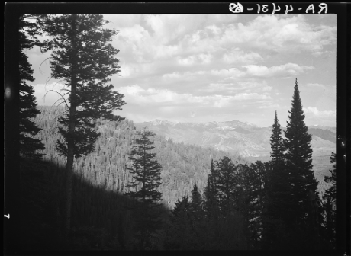 | 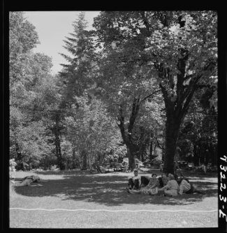 | 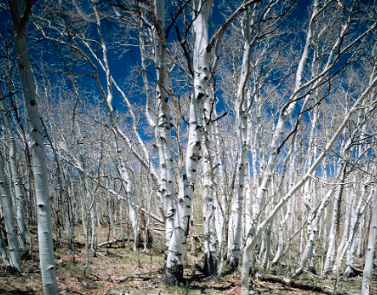 | 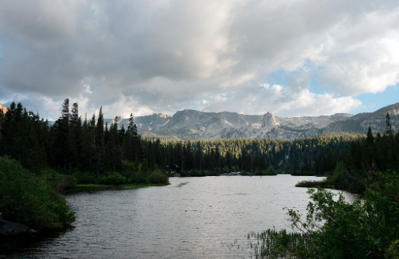 | 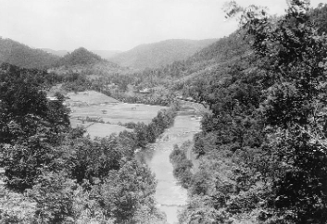
https://www.loc.gov/item/fsa1998019189/PP/ | https://www.loc.gov/item/fsa2000050088/PP/ | https://www.loc.gov/item/2011630963/ | https://www.loc.gov/item/2013633092/ | https://www.loc.gov/item/fsa1998018738/PP/

Custer National Forest, Montana | White Mountains National Forest,  New Hampshire | Montezuma National Forest,  Colorado | Chugach National Forest,  Alaska | Apache National Forest, Arizona
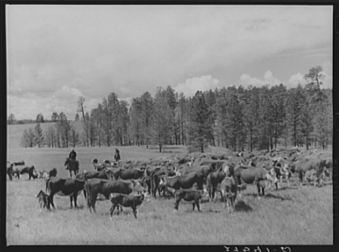 | 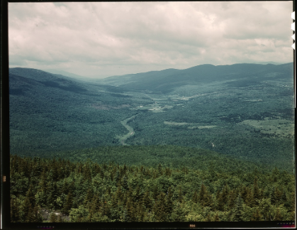 | 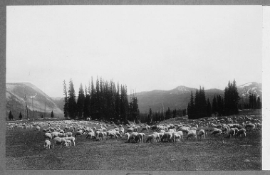 | 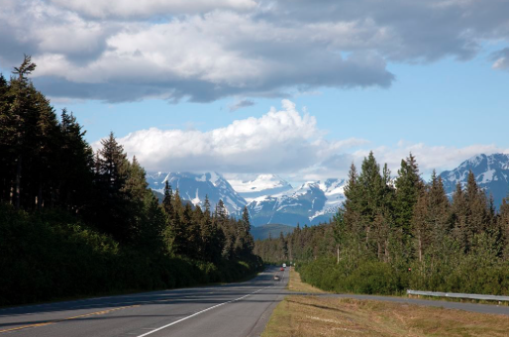 | 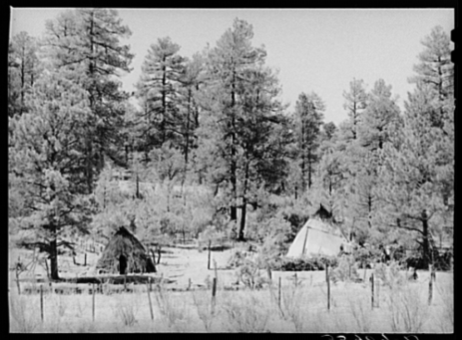
https://www.loc.gov/item/fsa2000008936/PP/ | https://www.loc.gov/item/fsa1992001255/PP/ | https://www.loc.gov/item/fsa1998018737/PP/ | https://www.loc.gov/item/2010630954/ | https://www.loc.gov/item/fsa2000017197/PP/

Phase II
Foundations Annotations
7. Curriculum Connections

8. Curriculum Standards

CCSS.ELA-LITERACY.RH.11-12.1
Cite specific textual evidence to support analysis of primary and secondary sources, connecting insights gained from specific details to an understanding of the text as a whole.
CCSS.ELA-LITERACY.RH.11-12.2
Determine the central ideas or information of a primary or secondary source; provide an accurate summary that makes clear the relationships among the key details and ideas.
CCSS.ELA-LITERACY.RH.11-12.7
Integrate and evaluate multiple sources of information presented in diverse formats and media (e.g., visually, quantitatively, as well as in words) in order to address a question or solve a problem.
CCSS.ELA-LITERACY.RH.11-12.9
Integrate information from diverse sources, both primary and secondary, into a coherent understanding of an idea or event, noting discrepancies among sources.
9. Content & Thinking Objectives

Use Evidence Analysis Window Frame-glennwiebe.org 2017 ESSDACK

10. Inquiry Activities & Strategies

Day 1: Students will be given instructions (below) and spend the class period researching their forest and creating the associated materials/props for the speed dating.
Day 2:
- Teacher will arrange tables so that the “speed daters” face one another.
- Each dater will have 2 minutes to talk about their forest while the other student takes notes. After both have had their 2 minutes, they will have one minute to ask questions of one another.
- Teacher will then say “rotate” and students will move one seat down – this rotation can be done in many different ways, all depending on the amount of students participating.
Putting down a nice tablecloth, adding tea lights, bringing Hershey’s chocolate kisses, turning down the lights, and playing some calm café music is highly recommended to set the mood. ☺

11. Assessment Strategies

During both days, teacher will be walking the room, listening for questions/connections, noting student activity, and listening for student understanding of analysis. Teacher will also be listening for and asking students questions.
Day 1: HW/Assessment – student will collect all information on their National Forest that they need for the speed
Day 2: After the Speed Dating, students will write a reflection essay on their experience. They will answer the following questions in paragraph form.
- Which forest did your forest most connect with and why?
- Which forest did your forest least connected with and why?

Other Resources
12. Web Resources

http://www.foresthistory.org/ASPNET/Publications/region/1/flathead/chap7.htm

13. Secondary Sources

14. Print and Other Media Resources

S is for S’mores, A Camping Alphabet written by Helen Foster James and Illustrated by Lita Judge (Sleeping Bear Press)
Thomas Jefferson Builds a Library by Barb Rosenstock




National Forest Service Speed Dating!
You will be assuming the character of a National Forest. Your task is to research your forest and create a Speed Dating Profile Form” which summarizes the basic information about your forest. In addition to the profile form, you will provide a “nameplate” that identifies you (and any information you wish to share) and a “business card” that you will give to your “birth date” during the Speed Dating Activity. You will also need to bring a “prop” that helps your “date” identified you—something that has to do with your individual forest (be creative!).
During the speed dating, you will speed date with other forests in the National Forest Service. Your goal is to figure out who you “match” with and who you may not “match” with – forests you can relate to, forests who have similarities to your forest in any category you may wish to deem significant (location, size, types of trees, types of animals found, etc.).
You will have a 4-5 minute “meet and greet” during which you will share your story and to listen to the story of the forest with whom you are paired. Therefore, you should have a 2-minute soliloquy prepared about yourself ready to present. It will be your task to learn about the forests you have “met” and take notes on their stories. At my signal, both people seated at the desks will move.
You have the choice of what types of research you’d like to use – credible online resources, textbook, your notes, etc., but you will have to hand in a bibliography, in proper format, at the time of the Speed Dating Event.
You will need to make a business card for your forest with your information on it. You can find templates on Google Docs or online. You should print 8 cards – you can do them all on 1 sheet and cut them up. You can use normal paper for this – no need to go crazy here. Your card should have your name, your forest, and any other information/graphics you feel appropriate.

You must also have a map of your National Forest. The map must show the location of the forest within the United States but can also show the features of the forest.

Rules for the speed dating:
- Be ready and prepared! Know who you are!
- Be in character the whole time.
- Have your nameplate, business cards, and notes with you for the duration of the activity.
- Ask questions - give answers - participate!
- Get to know the other forest.
- Complete the notes chart with information on the people you meet.
- Learn something - find your “match” (es)
- HAVE FUN!

What am I grading?
- Your Speed Dating Profile Form (I will give you these)
- Your business cards (you will print 1 page – 8 cards)
- Your bibliography
- Your map
- Your prop/dress/creativity
- Your communication during the event
- Your ability to stay in character during the event
- Your completed National Forest Information Chart (you will complete this during the event)

VERY IMPORTANT – Picking Your National Forest:
Students may pick any National Forest in the United States. Once you pick your forest, you must email me the name of the forest. Only one National Forest will be allowed per state, so if you want to get a particular National Forest, you need to be quick! The first person to email me the National Forest will get it and that state will be off limits to any other student. NOTE: Be sure that it’s a NATIONAL Park.

Speed Dating Profile Form

Forest’s Name: _______________________________

Where is your forest located? ___________________________________

What issue(s), if any were associated with making the Forest? _____________________________________

Year your forest was added to the National Forest Service: ____________________________________

How did the people living around your forest effect the creation of your forest as part of the NFS? ____________
____________________________________________________________________________________________
____________________________________________________________________________________________

What is the most important problem facing your forest and how would you fix it? __________________________
________________________________________________________________________________________________________________________________________________________________________________________

Accomplishments:

What effect did you have (short and long term)? ____________________________________________________
________________________________________________________________________________________________________________________________________________________________________________________

Who were your colleagues/friends? ______________________________________________________________
________________________________________________________________________________________________________________________________________________________________________________________

What obstacles/challenges/ “haters” did you face? How did you deal with them? __________________________
________________________________________________________________________________________________________________________________________________________________________________________

NATIONAL FOREST INFORMATION CHART
As you “date” forests, take notes about them in the space provided.

NFS Research Project Rubric

Name: __________ National Forest: __________________________

 | Points Possible | Points Earned
Participation in Speed Dating Event – stayed in character, asked appropriate questions, answered all questions asked, took good notes | 20
Speed Dating Profile Form – all questions fully answered | 15
Business Cards & Map – professionally done, attractive, and has name, location, and other appropriate information | 5
Nameplate is provided and complete. | 5
Notes page – completed with appropriate data | 5
Extra Credit – Creativity or Other Work Above and Beyond the Task | Up to 10 points
TOTAL | 50

ARS Component Guide
Phase I Components
- Title / Content Area: Provide the title of the ARS. If the title doesn’t explicitly denote the sets theme, please also provide a content area (e.g. Environment, Government, Immigration, War/Military, Women’s History, etc.).
- Developed by: Provide your name and any other contributors to the ARS.
- Grade Level: Provide the grade level(s) for which the set is to be taught.
- Essential Question: Provide an essential question that encompasses the set theme and that could be used as a launching point for use in the classroom.
- Contextual Paragraph for Resource Set: Provide a short paragraph explaining the resource set and describing the context in which the set is to be used
- Resource Set: Provide titles, context, thumbnails and addresses for specific resources. It isn’t necessary to provide a thumbnail for all resources (e.g. audio and video files). Important: Be sure to use a permanent URL and check your hyperlinks for all resources.

Phase II Components
- Curriculum Standards: Provide local, state or national standards that could be addressed through the use of the ARS and subsequent activities

- Curriculum Connections: Provide other curriculum areas to which this set of resources could be applied

- Content & Thinking Objectives: Provide objectives to be met through the use of the ARS and subsequent activities

- Inquiry Activities & Strategies: Provide specific strategies and learning activities which the ARS will be used to support

- Assessment Strategies: Provide assessment methods which will be used to demonstrate student learning after the use of the ARS and subsequent activities

Other Resources
- Secondary Sources: Provide any secondary sources that could be used to supplement the ARS

- Web Resources: Provide links to any additional web resources that could be used to supplement the ARS

- Print and Other Media Resources: Provide other resources that could be used to supplement the ARS

