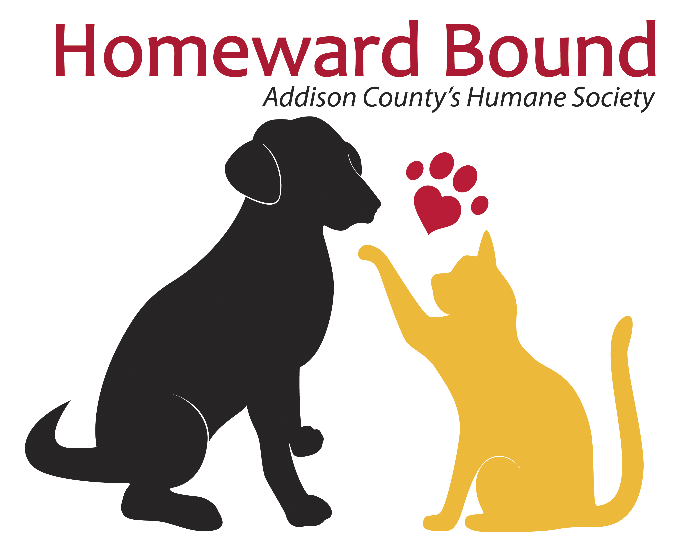
Membership Enrollment Form

_____________________________________________________________
Your Name Telephone Number

_____________________________________________________________
Mailing Address Town State/Zip

Email Address: _________________________________________________

Membership Level (check one)

[ ] Single $25.00 [ ] Junior (under 16) $10.00

[ ] Family $40.00 [ ] Senior (over 55) $10.00

I would like to make an additional donation of $__________________

$10 equals one case of canned kitten food or 10 cardboard carriers for cats
$25 equals 20 pounds of dry cat or dog food
$50 equals one bottle of antibiotics or 1 cat spay or neuter
$75 equals 1 dog spay or neuter or 200 pounds of cat litter
$100 equals 25 microchips
$250 equals 5 feral cats sterilized and rabies vaccinated
$500 or more means an enduring investment in the future of Addison County animals

Total Amount Enclosed $_____________

Payment Information: [ ] Check Enclosed [ ] VISA/MasterCard

Card Number: ________________________________________________

Expiration Date: ___________________ Security Code: _______________

Mail form to Homeward Bound at 236 Boardman Street, Middlebury, VT 05753
or call 802-388-1100 to order by credit card over the phone.

