Supplement to Network Edge Orienting:

NEO software and LEO scoring: simulation of multiple SNP phenotypes and robustness of detection

Jason E. Aten
21 August 2007

Abstract:

Here we provide R code that illustrates the NEO software's performance on simulated data for the robustness analysis.

library(GeneCycle) #for pcor.shrink to compute conditioning on all remaining vars
library(GeneNet) #for pcor.shrink to compute conditioning on all remaining vars
library(ggm) # for pcor to compute conditioning on individual variables k
library(e1071) # for impute: to handle NA in the data by filling in the median
library(sem) # for RAM model format 'mod' and Maximum likelihood indices of fit.
library(MASS) #
library(gplots)

# change this to the path to your working directory
setwd("C:/good”)

# load the NEO software, change this to the path to where you saved neo.txt
source("C:/good/neo.txt")

# overall plan:
# compare single marker analysis, which is LEO.NB.MAX
# to LEO.NB.ALL to LEO.NB.FOR,
# find the appropriate thresholds.

# first some functions to help with robustness ploting

############################################

# helper function for robustness.plot
if(exists("get.ylim") ) rm(get.ylim);
get.ylim = function(the.data) {
x=data.frame(the.data)
b.to.a.greedysnp.leo.nb.for = anac(x$LEO.NB.FOR)
b.to.a.greedysnp.leo.nb.all = anac(x$LEO.NB.ALL)
b.to.a.greedysnp.leo.nb.max = anac(x$SIMPLE.MAX.MAX)

ylim.max = max(c(b.to.a.greedysnp.leo.nb.for, b.to.a.greedysnp.leo.nb.all, b.to.a.greedysnp.leo.nb.max),na.rm=T)
ylim.min= min(c(b.to.a.greedysnp.leo.nb.for, b.to.a.greedysnp.leo.nb.all, b.to.a.greedysnp.leo.nb.max),na.rm=T)
c(ylim.min, ylim.max)
}

# window opening helper function for robustness.plot
# open a window for plotting, on windows, mac, or unix
if (exists("cross.platform.windows")) { rm(cross.platform.windows) }
cross.platform.windows=function() {
if (.Platform$OS.type == "windows") {
return(windows());
}
if (has.name("pkgType",.Platform)) {
if (.Platform$pkgType == "mac.binary") {
return(quartz());
}
}
return(X11());
}

# robustness.plot(): plot the Robustness studies.
if(exists("robustness.plot") ) rm(robustness.plot);
robustness.plot = function(the.data, do.postscript=FALSE, file.name = "postscriptfile.ps", ylim=get.ylim(the.data), main="LEO.NB Robustness Study", xlab="Number of SNPs", ylab="LEO.NB", threshold1 = 0.3, threshold2 = 0.75, new.window=FALSE, legend.pos =c(NA,NA)) {

if (do.postscript) {
postscript(file=file.name, horizontal=FALSE) # optional output to Postscript file
} else {
if (new.window) cross.platform.windows()
}

x=data.frame(the.data)

b.to.a.greedysnp.leo.nb.for = anac(x$LEO.NB.FOR)
b.to.a.greedysnp.leo.nb.all = anac(x$LEO.NB.ALL)
b.to.a.greedysnp.leo.nb.max = anac(x$SIMPLE.MAX.MAX)

ylim[2] = max(ylim[2],1.5+max(threshold1,threshold2)) # make space for the dashed threshold lines

device.num = plot(1:length(b.to.a.greedysnp.leo.nb.for),b.to.a.greedysnp.leo.nb.for,type="l",ylab=ylab,xlab=xlab,ylim=ylim,cex.lab=1.5, main=main,cex.main=1.5)
points(1:length(b.to.a.greedysnp.leo.nb.for),b.to.a.greedysnp.leo.nb.for,pch=21,bg="red",cex=1.5)

lines(1:length(b.to.a.greedysnp.leo.nb.max),b.to.a.greedysnp.leo.nb.max)
points(1:length(b.to.a.greedysnp.leo.nb.max),b.to.a.greedysnp.leo.nb.max,pch=23,cex=1.5,bg="blue") # diamond

lines(1:length(b.to.a.greedysnp.leo.nb.all),b.to.a.greedysnp.leo.nb.all)
points(1:length(b.to.a.greedysnp.leo.nb.all),b.to.a.greedysnp.leo.nb.all,pch=22,cex=1.5,bg="yellow") # square

abline(h=threshold1, lty=2) # LEO.NB.ALL threshold
abline(h=threshold2,lty=2) # LEO.NB.FOR threshold

manual.legend = !is.na(legend.pos[1])

if (!do.postscript & manual.legend) {
print("pick legend location now and press left button once. Then press right button and choose stop.")
a=locator()

legend(a[1],a[2], c("LEO.NB.FOR", "LEO.NB.ALL", "MAX.vs.MAX"), cex=1.2, pch=c(21,22,23),pt.bg=c("red","yellow","blue"))
}

if (!manual.legend) {
legend(legend.pos[1],legend.pos[2], c("LEO.NB.FOR", "LEO.NB.ALL", "MAX.vs.MAX"), cex=1.2, pch=c(21,22,23),pt.bg=c("red","yellow","blue"))
}

if (do.postscript) dev.off() # if you started with pdf(), postscript() or bmp() earlier

invisible(device.num)
}

# plot the robustness plots for LEO.NB scores
par(mfrow=c(4,2))

robustness.plot(r$greedy.Insig1.Mvd,main="Insig1 to Mvd: Greedy SNPs")
robustness.plot(r$fwd.Insig1.Mvd,main="Insig1 to Mvd: Forward SNPs")

robustness.plot(r$greedy.Insig1.Sqle,main="Insig1 to Sqle : Greedy SNPs ")
robustness.plot(r$fwd.Insig1.Sqle,main="Insig1 to Sqle : Forward SNPs ")

robustness.plot(r$greedy.Insig1.Dhcr7,main="Insig1 to Dhcr7: Greedy SNPs")
robustness.plot(r$fwd.Insig1.Dhcr7,main="Insig1 to Dhcr7: Forward SNPs")

robustness.plot(r$greedy.Insig1.Fdft1,main="Insig1 to Fdft1: Greedy SNPs")
robustness.plot(r$fwd.Insig1.Fdft1,main="Insig1 to Fdft1: Forward SNPs")

# plot just FOR and ALL plus put in vertical lines indicating where the threshold crossing occurs.
if(exists("robustness.plot.mounier") ) rm(robustness.plot.mounier);
robustness.plot.mounier = function(the.data, reverse.direction=FALSE , do.postscript=FALSE, file.name = "postscriptfile.ps", ylim=get.ylim(the.data,reverse.direction ), main="LEO.NB Robustness Study", xlab="Number of SNPs", ylab="LEO.NB", threshold1 = 0.3, threshold2 = 0.75, new.window=FALSE, legend.pos =c(NA,NA),fwd.and.greedy.snps=F) {

if (do.postscript ) {
postscript(file=file.name, horizontal=FALSE) # optional output to Postscript file
} else {
if (new.window) cross.platform.windows()
}

x=data.frame(the.data)

if (reverse.direction) {
score.for = anac(x$LEO.NB.FOR.1)
score.all = anac(x$LEO.NB.ALL.1)
score.max = anac(x$SIMPLE.MAX.MAX.1)
} else {
score.for = anac(x$LEO.NB.FOR)
score.all = anac(x$LEO.NB.ALL)
score.max = anac(x$SIMPLE.MAX.MAX)
}

ylim[2] = max(ylim[2],1.5+max(threshold1,threshold2))
# make space for the dashed threshold lines

x.points = 1:length(score.for)
mplier = 1
if (fwd.and.greedy.snps) {
x.points = 2* x.points
mplier = 2
}

device.num = plot(x.points,score.for,type="l",ylab=ylab,xlab=xlab,ylim=ylim, cex.lab=1.5, main=main,cex.main=1.5)
points(x.points,score.for,pch=21,bg="red",cex=1.5)

#lines(x.points,score.max)
#points(x.points,score.max,pch=23,cex=1.5,bg="blue") # diamond

lines(x.points,score.all)
points(x.points,score.all,pch=22,cex=1.5,bg="yellow") # square

abline(h=threshold1, lty=2) # LEO.NB.ALL threshold
abline(h=threshold2,lty=3) # LEO.NB.FOR threshold

# label the threshold lines with smaller versions of the score to which they correspond
# every 4-th point or so
skippy=seq(3,length(score.all)*mplier,4*mplier)
points(skippy,rep(threshold2, length(skippy)),pch=22,cex=2) # ALL
points(skippy,rep(threshold1, length(skippy)),pch=21,cex=2) # FOR

w=which(score.all<threshold2)
first.th.dip=w[1]
x=x.points[first.th.dip]
lines(x=c(x,x),y=c(ylim[1]-100,threshold2),lwd=2)

w2=which(score.for<threshold1)
first.th.dip2=w2[1]
x2=x.points[first.th.dip2]

if (!is.na(w[1]) && !is.na(w2[1]) && w[1]==w2[1]) {x2=x2+0.2}

lines(x=c(x2,x2),y=c(ylim[1]-100,threshold1),lwd=2,lty=2)

manual.legend = !is.na(legend.pos[1])

if (!do.postscript & !manual.legend) {
print("pick legend location now and press left button once. Then press right button and choose stop.")
a=locator()

legend(a[1],a[2], c("LEO.NB.FOR", "LEO.NB.ALL"), cex=1.2, pch=c(21,22),pt.bg=c("red","yellow"))
}

if (manual.legend) {
legend( legend.pos[1],legend.pos[2], c("LEO.NB.FOR", "LEO.NB.ALL"), cex=0.6, pch=c(21,22),pt.bg=c("red","yellow"))
}

if (do.postscript) dev.off() # if you started with pdf(), postscript() or bmp() earlier

invisible(device.num)
}

# Start of new analysis

# Generate simulated data, calling test.robust as follows:
# actually we submitted this to the Sun Grid Engine on the calypso.genetics.ucla.edu
# cluster as follows
# Notice that the first study is just 1 SNP into B, and 100 noise SNPs.
(in the shell, mkdir /home/jaten/dev/peculiar/monte.carlo.robustness)
first so that the directory exists

source("neo.txt")
setwd("/home/jaten/dev/peculiar/monte.carlo.robustness")
job.list=list("test.robust","test.robust","test.robust")
submit.to.sge(job.list)
#your job-array 351660.1-3:1 ("neo.sge.2.qsub.me.sh") has been submitted
getwd()
#[1] "/home/jaten/dev/peculiar/monte.carlo.robustness"

# where the test.robust function notes the SGE_TASK_ID environment variable,
# and correspondingly changes its behavior to run the Greedy, Forward, and ForwardAndGreedy
# versions of NEOrobustness().

# Notice there is no A SNPs here.

test.robust=function() {

num.reps=100

sge.task = get.sge.task()

set.seed(sge.task * 101)
r=list()

r$forward.null = list()
r$greedy.null = list()
r$greedy.and.forward.null = list()

r$forward.50.causal = list()
r$greedy.50.causal = list()
r$greedy.and.forward.50.causal = list()

r$forward.100.causal = list()
r$greedy.100.causal = list()
r$greedy.and.forward.100.causal = list()

for (k in 1:num.reps) {

# Several key parameters are
restricted.heritability.a = .4
restricted.heritability.b = .4
observed.a.b.correlation = .3
topK = 20

dat=neo.monte.carlo.data(do.a.snp=0,do.b.snp=1, percent.causal.signal=1, noise.a.snp=50, noise.b.snp=50, nearby.a.snps=0, nearby.b.snps=0, restricted.heritability.a = restricted.heritability.a, restricted.heritability.b = restricted.heritability.b, observed.a.b.correlation = observed.a.b.correlation, percentage.range.for.neighbor.cor = c(.40,.70))

b=ncol(dat)
a=b-1

datSNP =dat[,-c(a,b)]
datExpr=dat[, c(a,b)]

if (sge.task==1) r$greedy.100.causal[[k]] = NEOrobustness( datSNP, datExpr, TopGreedy=1:topK, TopForward=rep(1,topK), no.log.quiet=TRUE)
if (sge.task==2) r$forward.100.causal[[k]] = NEOrobustness(datSNP, datExpr, TopGreedy=rep(1,topK), TopForward=1:topK, no.log.quiet=TRUE)
if (sge.task==3) r$greedy.and.forward.100.causal[[k]] = NEOrobustness(datSNP, datExpr, TopForward=1:topK, TopGreedy=1:topK, no.log.quiet=TRUE)

print(paste(sep="","Done with k=",k," of out ",num.reps," at ",date()))

sge.task = get.sge.task()

the.file=gsub(":",".",gsub(" ","_",paste(sep="","r.test.robust.task",sge.task,".results.",k,".",date(),".rdat")))
save(r,file=the.file)

} # end for num.reps

r
}

# let us repeat the same thing but this time with a single A snp as well.
# Same function just the dat= call line changes to, in the new function test.robust.1a.1b():

dat=neo.monte.carlo.data(do.a.snp=1,do.b.snp=1, percent.causal.signal=1, noise.a.snp=50, noise.b.snp=50, nearby.a.snps=0, nearby.b.snps=0, restricted.heritability.a = restricted.heritability.a, restricted.heritability.b = restricted.heritability.b, observed.a.b.correlation = observed.a.b.correlation, percentage.range.for.neighbor.cor = c(.40,.70))

setwd("/home/jaten/dev/peculiar/mc.robust.1a.1b")
job.list=list("test.robust.1a.1b","test.robust.1a.1b","test.robust.1a.1b")
submit.to.sge(job.list)
# your job-array 351661.1-3:1 ("neo.sge.2.qsub.me.sh") has been submitted

###############################################

# Same function just the dat= call line changes to, in the new function test.robust.0a.1b.5causal():

dat=neo.monte.carlo.data(do.a.snp=0,do.b.snp=1, percent.causal.signal=.5, noise.a.snp=50, noise.b.snp=50, nearby.a.snps=0, nearby.b.snps=0, restricted.heritability.a = restricted.heritability.a, restricted.heritability.b = restricted.heritability.b, observed.a.b.correlation = observed.a.b.correlation, percentage.range.for.neighbor.cor = c(.40,.70))

dir.create("/home/jaten/dev/peculiar/mc.robust.0a.1b.5causal")
setwd("/home/jaten/dev/peculiar/mc.robust.0a.1b.5causal")
job.list=list("test.robust.0a.1b.5causal","test.robust.0a.1b.5causal","test.robust.0a.1b.5causal")
submit.to.sge(job.list)
# your job-array 351662.1-3:1 ("neo.sge.2.qsub.me.sh") has been submitted

# 36 hours later…jobs run in parallel… task2 has finished. a=load("/home/jaten/dev/peculiar/mc.robust.0a.1b.5causal/r.test.robust.task2.results.100.Sun_Aug_12_16.05.02_2007.rdat")
# task2 : gives r$forward.100.causal

# but task 1 stopped after 14 samples...bummer.
#a=load("/home/jaten/dev/peculiar/mc.robust.0a.1b.5causal/r.test.robust.task2.results.100.Sun_Aug_12_16.05.02_2007.rdat")
# log file says:
Warning: cannot open file '/no.neo.log.html.logs.multione.leo/B.to.A.html', reason 'No such file or directory'
Error in file(file.path, "wt") : unable to open connection
Execution halted
[jaten@calypso ~/dev/peculiar/mc.robust.0a.1b.5causal]$
# so the logging, which should have been off anyhow, was messing us up here;
# probably a race condition with the 3 processes writing to the same file at once.
# Done: fixed this; neo.txt, new revision: 1.275; now logging is truly off
# when pm$no.log=TRUE.
# Fortunately none of the others hit this race condition, so
# we only need to re-run mc.robust.0a.1b.5causal : task 1

# test.robust.0a.1b.5causal.task1.only = function() we want
dir.create("/home/jaten/dev/peculiar/mc.robust.0a.1b.5causal.task1.greedy.only")
setwd("/home/jaten/dev/peculiar/mc.robust.0a.1b.5causal.task1.greedy.only")
job.list=list("test.robust.0a.1b.5causal.task1.only")
submit.to.sge(job.list)
# your job 351691 ("neo.sge.2.qsub.me.sh") has been submitted

# task 3 finshed all 100
a=load("/home/jaten/dev/peculiar/mc.robust.0a.1b.5causal/r.test.robust.task3.results.100.Sun_Aug_12_13.23.41_2007.rdat")
r$greedy.and.forward.100.causal

##################################################################

# Same function just the dat= call line changes to, in the new function test.robust.1a.1b.5causal():

dat=neo.monte.carlo.data(do.a.snp=1,do.b.snp=1, percent.causal.signal=.5, noise.a.snp=50, noise.b.snp=50, nearby.a.snps=0, nearby.b.snps=0, restricted.heritability.a = restricted.heritability.a, restricted.heritability.b = restricted.heritability.b, observed.a.b.correlation = observed.a.b.correlation, percentage.range.for.neighbor.cor = c(.40,.70))

dir.create("/home/jaten/dev/peculiar/mc.robust.1a.1b.5causal")
setwd("/home/jaten/dev/peculiar/mc.robust.1a.1b.5causal")
job.list=list("test.robust.1a.1b.5causal","test.robust.1a.1b.5causal","test.robust.1a.1b.5causal")
submit.to.sge(job.list)
# your job-array 351663.1-3:1 ("neo.sge.2.qsub.me.sh") has been submitted

# and for 0 causal signal, test.robust.1a.1b.0causal()

dat=neo.monte.carlo.data(do.a.snp=1,do.b.snp=1, percent.causal.signal=0, noise.a.snp=50, noise.b.snp=50, nearby.a.snps=0, nearby.b.snps=0, restricted.heritability.a = restricted.heritability.a, restricted.heritability.b = restricted.heritability.b, observed.a.b.correlation = observed.a.b.correlation, percentage.range.for.neighbor.cor = c(.40,.70))

dir.create("/home/jaten/dev/peculiar/mc.robust.1a.1b.0causal")
setwd("/home/jaten/dev/peculiar/mc.robust.1a.1b.0causal")
job.list=list("test.robust.1a.1b.0causal","test.robust.1a.1b.0causal","test.robust.1a.1b.0causal")
submit.to.sge(job.list)
# and
submit.to.sge(job.list,assigned.task=1) # re-run just task 1, which failed
# the first time with:
#
#Warning: cannot open file '/no.neo.log.html.logs.all.zeo/A.to.B.html', reason #'Cannot allocate memory'
#Error in file(file.path, "wt") : unable to open connection
#Execution halted

# and for 0 causal signal, test.robust.0a.1b.0causal()

dat=neo.monte.carlo.data(do.a.snp=0,do.b.snp=1, percent.causal.signal=0, noise.a.snp=50, noise.b.snp=50, nearby.a.snps=0, nearby.b.snps=0, restricted.heritability.a = restricted.heritability.a, restricted.heritability.b = restricted.heritability.b, observed.a.b.correlation = observed.a.b.correlation, percentage.range.for.neighbor.cor = c(.40,.70))

dir.create("/home/jaten/dev/peculiar/mc.robust.0a.1b.0causal")
setwd("/home/jaten/dev/peculiar/mc.robust.0a.1b.0causal")
job.list=list("test.robust.0a.1b.0causal","test.robust.0a.1b.0causal","test.robust.0a.1b.0causal")
submit.to.sge(job.list)
# your job-array 351665.1-3:1 ("neo.sge.2.qsub.me.sh") has been submitted

# and now for 4 SNP trait, same levels of heritability and such….with and without A SNPs

test.robust.1a.4b.4causal.4an.4bn = function(…)…
dat=neo.monte.carlo.data(do.a.snp=1,do.b.snp=4, percent.causal.signal=1, noise.a.snp=50, noise.b.snp=50, nearby.a.snps=4, nearby.b.snps=4, restricted.heritability.a = restricted.heritability.a, restricted.heritability.b = restricted.heritability.b, observed.a.b.correlation = observed.a.b.correlation, percentage.range.for.neighbor.cor = c(.40,.70))

dir.create("/home/jaten/dev/peculiar/mc.robust.1a.4b.4causal.4an.4bn")
setwd("/home/jaten/dev/peculiar/mc.robust.1a.4b.4causal.4an.4bn")
job.list=list("test.robust.1a.4b.4causal.4an.4bn"," test.robust.1a.4b.4causal.4an.4bn","test.robust.1a.4b.4causal.4an.4bn")
submit.to.sge(job.list)
# your job-array 351688.1-3:1 ("neo.sge.2.qsub.me.sh") has been submitted

submit.to.sge(job.list,assigned.task=3) # re-run just task 3, which failed
# because of a typo (highlighted item in list above was mis-spelled, now fixed)
# your job-array 351787.3-3:1 ("neo.sge.2.qsub.me.sh") has been submitted

# and version without A SNPs.

test.robust.0a.4b.4causal.4an.4bn=function(…)…
dat=neo.monte.carlo.data(do.a.snp=0, do.b.snp=4, percent.causal.signal=1, noise.a.snp=50, noise.b.snp=50, nearby.a.snps=4, nearby.b.snps=4, restricted.heritability.a = restricted.heritability.a, restricted.heritability.b = restricted.heritability.b, observed.a.b.correlation = observed.a.b.correlation, percentage.range.for.neighbor.cor = c(.40,.70))

dir.create("/home/jaten/dev/peculiar/mc.robust.0a.4b.4causal.4an.4bn")
setwd("/home/jaten/dev/peculiar/mc.robust.0a.4b.4causal.4an.4bn")
job.list=list("test.robust.0a.4b.4causal.4an.4bn","test.robust.0a.4b.4causal.4an.4bn","test.robust.0a.4b.4causal.4an.4bn")
submit.to.sge(job.list)
# your job-array 351689.1-3:1 ("neo.sge.2.qsub.me.sh") has been submitted

submit.to.sge(job.list,assigned.task=3) # re-run just task 3
# your job-array 351788.3-3:1 ("neo.sge.2.qsub.me.sh") has been submitted

###################

# Next to do is, read in the data, summarize the 100 simulations, and plot each of these 6 basic scenarios….
# as in boxplots . # We did 6 scenarios: causal signal at 0, 50% and 100%. And SNPs just into B,
# or into both A and B. For each of these 6 scenarios, we have Greedy, Forward, and ForwardAndGreedy
# SNP selection out to 20 SNPs (most of which will be noise after the first SNPs). And then we have
# LEO.NB.FOR, LEO.NB.ALL, and LEO.NB.MAX to plot.

# Now look at the effect of the Neighboring nearby weaker SNPs, where they are at .4 to .7 correlated with the original signal SNPs.

dat=neo.monte.carlo.data(do.a.snp=1,do.b.snp=1, percent.causal.signal=1, noise.a.snp=50, noise.b.snp=50, nearby.a.snps=4, nearby.b.snps=4, restricted.heritability.a = restricted.heritability.a, restricted.heritability.b = restricted.heritability.b, observed.a.b.correlation = observed.a.b.correlation, percentage.range.for.neighbor.cor = c(.40,.70))

dir.create("/home/jaten/dev/peculiar/mc.robust.1a.1b.1causal.4an.4bn")
setwd("/home/jaten/dev/peculiar/mc.robust.1a.1b.1causal.4an.4bn")
job.list=list("test.robust.1a.1b.1causal.4an.4bn","test.robust.1a.1b.1causal.4an.4bn","test.robust.1a.1b.1causal.4an.4bn")
submit.to.sge(job.list)
# your job-array 351666.1-3:1 ("neo.sge.2.qsub.me.sh") has been submitted

# (also run this same job at home, but with seed: set.seed(554324). The run at home is
# in hopes of getting it all finished sooner.
# dir.create("mc.robust.1a.1b.1causal.4an.4bn")
getwd()
#[1] "f:/good"
setwd("f:/good/mc.robust.1a.1b.1causal.4an.4bn/")
source("../neo.txt")
> test.robust()
[1] "Progress through the NEOrobustness loop: done with 1 out of 20 at Sat Aug 11 04:43:37 2007"
[1] "Progress through the NEOrobustness loop: done with 2 out of 20 at Sat Aug 11 04:43:50 2007"
[1] "Progress through the NEOrobustness loop: done with 3 out of 20 at Sat Aug 11 04:44:04 2007"
[1] "Progress through the NEOrobustness loop: done with 4 out of 20 at Sat Aug 11 04:44:20 2007"
[1] "Progress through the NEOrobustness loop: done with 5 out of 20 at Sat Aug 11 04:44:36 2007"
[1] "Progress through the NEOrobustness loop: done with 6 out of 20 at Sat Aug 11 04:45:04 2007"
[1] "Progress through the NEOrobustness loop: done with 7 out of 20 at Sat Aug 11 04:45:42 2007"
[1] "Progress through the NEOrobustness loop: done with 8 out of 20 at Sat Aug 11 04:46:43 2007"
…

#where test.robust has been linearized for non-cluster work:
test.robust
function() {

num.reps=100

sge.task = get.sge.task()

set.seed(554324)
r=list()

r$forward.null = list()
r$greedy.null = list()
r$greedy.and.forward.null = list()

r$forward.50.causal = list()
r$greedy.50.causal = list()
r$greedy.and.forward.50.causal = list()

r$forward.100.causal = list()
r$greedy.100.causal = list()
r$greedy.and.forward.100.causal = list()

for (k in 1:num.reps) {

restricted.heritability.a = .4
restricted.heritability.b = .4
observed.a.b.correlation = .3
topK = 20

# dat=neo.monte.carlo.data(do.a.snp=1,do.b.snp=1, percent.causal.signal=0, noise.a.snp=50, noise.b.snp=50, nearby.a.snps=4, nearby.b.snps=4, restricted.heritability.a = restricted.heritability.a, restricted.heritability.b = restricted.heritability.b, observed.a.b.correlation = observed.a.b.correlation, percentage.range.for.neighbor.cor = c(.40,.70))
#
# b=ncol(dat)
# a=b-1
#
# datSNP =dat[,-c(a,b)]
# datExpr=dat[, c(a,b)]

## r$greedy.null[[k]] = NEOrobustness( datSNP, datExpr, TopGreedy=1:topK, TopForward=rep(1,topK), no.log.quiet=TRUE)
## r$forward.null[[k]] = NEOrobustness(datSNP, datExpr, TopGreedy=rep(1,topK), TopForward=1:topK, no.log.quiet=TRUE)
## r$greedy.and.forward.null[[k]] = NEOrobustness(datSNP, datExpr, TopForward=1:topK, TopGreedy=1:topK, no.log.quiet=TRUE)
##
## dat=neo.monte.carlo.data(do.a.snp=4,do.b.snp=4, percent.causal.signal=0.5, noise.a.snp=50, noise.b.snp=50, nearby.a.snps=0, nearby.b.snps=0, restricted.heritability.a = restricted.heritability.a, restricted.heritability.b = restricted.heritability.b, observed.a.b.correlation = observed.a.b.correlation, percentage.range.for.neighbor.cor = c(.40,.70))

## datSNP =dat[,-c(a,b)]
## datExpr=dat[, c(a,b)]
##
## r$greedy.50.causal[[k]] = NEOrobustness( datSNP, datExpr, TopGreedy=1:topK, TopForward=rep(1,topK), no.log.quiet=TRUE)
## r$forward.50.causal[[k]] = NEOrobustness(datSNP, datExpr, TopGreedy=rep(1,topK), TopForward=1:topK, no.log.quiet=TRUE)
## r$greedy.and.forward.50.causal[[k]] = NEOrobustness(datSNP, datExpr, TopForward=1:topK, TopGreedy=1:topK, no.log.quiet=TRUE)

dat=neo.monte.carlo.data(do.a.snp=1,do.b.snp=1, percent.causal.signal=1, noise.a.snp=50, noise.b.snp=50, nearby.a.snps=4, nearby.b.snps=4, restricted.heritability.a = restricted.heritability.a, restricted.heritability.b = restricted.heritability.b, observed.a.b.correlation = observed.a.b.correlation, percentage.range.for.neighbor.cor = c(.40,.70))

b=ncol(dat)
a=b-1

datSNP =dat[,-c(a,b)]
datExpr=dat[, c(a,b)]

#if (sge.task==1) r$greedy.100.causal[[k]] = NEOrobustness( datSNP, datExpr, TopGreedy=1:topK, TopForward=rep(1,topK), no.log.quiet=TRUE)
#if (sge.task==2) r$forward.100.causal[[k]] = NEOrobustness(datSNP, datExpr, TopGreedy=rep(1,topK), TopForward=1:topK, no.log.quiet=TRUE)
#if (sge.task==3) r$greedy.and.forward.100.causal[[k]] = NEOrobustness(datSNP, datExpr, TopForward=1:topK, TopGreedy=1:topK, no.log.quiet=TRUE)

r$greedy.100.causal[[k]] = NEOrobustness( datSNP, datExpr, TopGreedy=1:topK, TopForward=rep(1,topK), no.log.quiet=TRUE)
r$forward.100.causal[[k]] = NEOrobustness(datSNP, datExpr, TopGreedy=rep(1,topK), TopForward=1:topK, no.log.quiet=TRUE)
r$greedy.and.forward.100.causal[[k]] = NEOrobustness(datSNP, datExpr, TopForward=1:topK, TopGreedy=1:topK, no.log.quiet=TRUE)

# just do topK snps...
# r$greedy.100.causal[[k]] = NEOrobustness( datSNP, datExpr, TopGreedy=topK, TopForward=1, no.log.quiet=TRUE)
# r$forward.100.causal[[k]] = NEOrobustness(datSNP, datExpr, TopGreedy=1, TopForward=topK, no.log.quiet=TRUE)
# r$greedy.and.forward.100.causal[[k]] = NEOrobustness(datSNP, datExpr, TopForward=topK, TopGreedy=topK, no.log.quiet=TRUE)

print(paste(sep="","Done with k=",k," of out ",num.reps," at ",date()))

sge.task = get.sge.task()

the.file=gsub(":",".",gsub(" ","_",paste(sep="","r.test.robust.task",sge.task,".results.",k,".",date(),".rdat")))
save(r,file=the.file)

} # end for num.reps

r
}

# Summarize our directories; should be done in about 60 hours or so, maybe 30 hours
# if more CPUs free up.
[jaten@calypso ~/dev/peculiar]$ ls -alFt|head -20
total 124672
drwxr-xr-x 2 jaten hguser 4096 Aug 11 03:48 mc.robust.1a.1b.1causal.4an.4bn/
drwxr-xr-x 9 jaten hguser 4096 Aug 11 03:48 monte.carlo.robustness/
drwxr-xr-x 9 jaten hguser 4096 Aug 11 03:47 mc.robust.1a.1b/
drwxr-xr-x 9 jaten hguser 4096 Aug 11 03:47 mc.robust.1a.1b.5causal/
drwxr-xr-x 9 jaten hguser 4096 Aug 11 03:47 mc.robust.1a.1b.0causal/
drwxr-xr-x 9 jaten hguser 4096 Aug 11 03:46 mc.robust.0a.1b.5causal/
drwxr-xr-x 9 jaten hguser 4096 Aug 11 03:39 mc.robust.0a.1b.0causal/
…
-rwxr-xr-x 1 jaten hguser 545335 Aug 11 03:47 neo.txt*
…
[jaten@calypso ~/dev/peculiar]$ qstat
job-ID prior name user state submit/start at queue master ja-task-ID
---------------------------------------------------------------------------------------------
351618 -1 beast.aiv. msuchard r 08/08/2007 17:09:55 biomath02. MASTER
350213 -1 whap.6676 malarcon r 05/29/2007 08:58:44 biomath03. MASTER
351664 0 neo.sge.2. jaten r 08/11/2007 03:35:47 biomath03. MASTER 2
351612 -1 beast.aiv. msuchard r 08/08/2007 17:08:23 biomath04. MASTER
351664 0 neo.sge.2. jaten r 08/11/2007 03:35:47 biomath04. MASTER 3
350214 -1 whap.6699 malarcon r 05/29/2007 08:59:14 biomath05. MASTER
351662 0 neo.sge.2. jaten r 08/11/2007 03:29:12 cpu02.q MASTER 1
351638 -1 mis.16.sh. daphnawv r 08/09/2007 15:28:55 cpu03.q MASTER
351594 -1 sim.22615 twu r 08/07/2007 20:32:02 cpu05.q MASTER
351664 0 neo.sge.2. jaten r 08/11/2007 03:35:46 cpu06.q MASTER 1
351613 -1 beast.aiv. msuchard r 08/08/2007 17:09:40 cpu07.q MASTER
351665 0 neo.sge.2. jaten r 08/11/2007 03:38:48 cpu07.q MASTER 1
351619 -1 beast.aiv. msuchard r 08/08/2007 17:09:55 cpu08.q MASTER
351620 -1 beast.aiv. msuchard r 08/08/2007 17:09:55 cpu09.q MASTER
351661 0 neo.sge.2. jaten r 08/11/2007 03:12:18 cpu10.q MASTER 2
351662 0 neo.sge.2. jaten r 08/11/2007 03:29:13 cpu10.q MASTER 2
350215 -1 whap.6722 malarcon r 05/29/2007 08:59:29 cpu11.q MASTER
351663 0 neo.sge.2. jaten r 08/11/2007 03:29:44 cpu11.q MASTER 3
351661 0 neo.sge.2. jaten r 08/11/2007 03:12:18 cpu12.q MASTER 1
351661 0 neo.sge.2. jaten r 08/11/2007 03:12:18 cpu12.q MASTER 3
351660 0 neo.sge.2. jaten r 08/11/2007 03:00:02 cpu13.q MASTER 2
351663 0 neo.sge.2. jaten r 08/11/2007 03:29:44 cpu13.q MASTER 1
351660 0 neo.sge.2. jaten r 08/11/2007 03:00:02 cpu14.q MASTER 3
351663 0 neo.sge.2. jaten r 08/11/2007 03:29:44 cpu14.q MASTER 2
351660 0 neo.sge.2. jaten r 08/11/2007 03:00:02 cpu15.q MASTER 1
351662 0 neo.sge.2. jaten r 08/11/2007 03:29:13 cpu15.q MASTER 3
351665 0 neo.sge.2. jaten qw 08/11/2007 03:38:48 2,3
351666 0 neo.sge.2. jaten qw 08/11/2007 03:48:44 1-3:1
[jaten@calypso ~/dev/peculiar]$

# We have 5 jobs waiting for CPUs.

# Gathering and plotting the results

# Analysis/plotting helper function: factor to numeric

# helper function to convert from factors to numeric via character--affected by options(digits = 4); getOptions("digits") to check.
if(exists("anac") ) rm(anac);
anac=function(x) as.numeric(as.character(x))

# Gather the data

# gather the robustness results

setwd("f:/good/mc.robust.1a.1b.1causal.4an.4bn/")

# helper function to convert from factors to numeric via character--affected by options(digits = 4); getOptions("digits") to check.
if(exists("anac") ) rm(anac);
anac=function(x) as.numeric(as.character(x))

dr=dir()
mine=grep("r.test.robust",dr,fixed=T)

num.frames = length(mine)

# assemble a data frame for each statistic that you want
# n=1:20 snps across the top
# and repetitions down the rows

# here we do LEO.NB.FOR, and then all the other stats too.

blank.frame = matrix(nrow=num.frames, ncol=20)
colnames(blank.frame) = paste(sep="","snp.count.",1:20)
rownames(blank.frame) = paste(sep="","rep.",1:num.frames)

the.frames = list()

the.frames$my.LEO.NB.FOR.snp.gr = blank.frame
the.frames$my.LEO.NB.FOR.snp.fw = blank.frame
the.frames$my.LEO.NB.FOR.snp.fg = blank.frame

the.frames$my.LEO.NB.MAX.snp.fw = blank.frame
the.frames$my.LEO.NB.MAX.snp.gr = blank.frame
the.frames$my.LEO.NB.MAX.snp.fg = blank.frame

the.frames$my.LEO.NB.ALL.snp.fw = blank.frame
the.frames$my.LEO.NB.ALL.snp.gr = blank.frame
the.frames$my.LEO.NB.ALL.snp.fg = blank.frame

the.frames$my.SIMPLE.MAX.MAX.snp.fw = blank.frame
the.frames$my.SIMPLE.MAX.MAX.snp.gr = blank.frame
the.frames$my.SIMPLE.MAX.MAX.snp.fg = blank.frame

the.frames$my.LEO.MULTIONE.NB.snp.fw = blank.frame
the.frames$my.LEO.MULTIONE.NB.snp.gr = blank.frame
the.frames$my.LEO.MULTIONE.NB.snp.fg = blank.frame

## the.frames$my.zeo.for.snp.fw = blank.frame
## the.frames$my.zeo.for.snp.gr = blank.frame
## the.frames$my.zeo.for.snp.fg = blank.frame

## the.frames$my.zeo.max.snp.fw = blank.frame
## the.frames$my.zeo.max.snp.gr = blank.frame
## the.frames$my.zeo.max.snp.fg = blank.frame

## the.frames$my.zeo.all.snp.fw = blank.frame
## the.frames$my.zeo.all.snp.gr = blank.frame
## the.frames$my.zeo.all.snp.fg = blank.frame

# last one has the accumulated data
a=load(“”]) # load once, has each seperate sim in the lists.

for (i in 1:num.frames) {

df.fw=data.frame(r$forward.100.causal[[i]])
df.gr=data.frame(r$greedy.100.causal[[i]])
df.fg=data.frame(r$greedy.and.forward.100.causal[[i]])

the.frames$my.LEO.NB.FOR.snp.fw[i,]=anac(df.fw$LEO.NB.FOR)
the.frames$my.LEO.NB.FOR.snp.gr[i,]=anac(df.gr$LEO.NB.FOR)
the.frames$my.LEO.NB.FOR.snp.fg[i,]=anac(df.fg$LEO.NB.FOR)

the.frames$my.LEO.NB.MAX.snp.fw[i,]=anac(df.fw$LEO.NB.MAX)
the.frames$my.LEO.NB.MAX.snp.gr[i,]=anac(df.gr$LEO.NB.MAX)
the.frames$my.LEO.NB.MAX.snp.fg[i,]=anac(df.fg$LEO.NB.MAX)

the.frames$my.LEO.NB.ALL.snp.fw[i,]=anac(df.fw$LEO.NB.ALL)
the.frames$my.LEO.NB.ALL.snp.gr[i,]=anac(df.gr$LEO.NB.ALL)
the.frames$my.LEO.NB.ALL.snp.fg[i,]=anac(df.fg$LEO.NB.ALL)

the.frames$my.SIMPLE.MAX.MAX.snp.fw[i,]=anac(df.fw$SIMPLE.MAX.MAX)
the.frames$my.SIMPLE.MAX.MAX.snp.gr[i,]=anac(df.gr$SIMPLE.MAX.MAX)
the.frames$my.SIMPLE.MAX.MAX.snp.fg[i,]=anac(df.fg$SIMPLE.MAX.MAX)

the.frames$my.LEO.MULTIONE.NB.snp.fw[i,]=anac(df.fw$LEO.MULTIONE.NB)
the.frames$my.LEO.MULTIONE.NB.snp.gr[i,]=anac(df.gr$LEO.MULTIONE.NB)
the.frames$my.LEO.MULTIONE.NB.snp.fg[i,]=anac(df.fg$LEO.MULTIONE.NB)

## the.frames$my.zeo.for.snp.fw[i,]=anac(df.fw$zeo.for)
## the.frames$my.zeo.for.snp.gr[i,]=anac(df.gr$zeo.for)
## the.frames$my.zeo.for.snp.fg[i,]=anac(df.fg$zeo.for)

## the.frames$my.zeo.max.snp.fw[i,]=anac(df.fw$zeo.max)
## the.frames$my.zeo.max.snp.gr[i,]=anac(df.gr$zeo.max)
## the.frames$my.zeo.max.snp.fg[i,]=anac(df.fg$zeo.max)

## the.frames$my.zeo.all.snp.fw[i,]=anac(df.fw$zeo.all)
## the.frames$my.zeo.all.snp.gr[i,]=anac(df.gr$zeo.all)
## the.frames$my.zeo.all.snp.fg[i,]=anac(df.fg$zeo.all)

}

# Now generating the statistics to plot

# OLD function, not used here (yet), but some ideas from it might be useful:

if(exists("power.graph") ) rm(power.graph);
power.graph=function(ha,hb,scores424,do.postscript=FALSE,do.labels=TRUE,...) {

# pick out an ha and hb level with w.
if (do.postscript) {
psfile=paste(sep="","power.plot.ha",round(ha,2),".hb",round(hb,2),"..rhoab.vs.leo.i.ps");
postscript(file=psfile,horizontal=FALSE)
} else {
# windows()
}

w=which(scores424$ha==ha & scores424$hb==hb)

u8=unique(scores424[w,1:8])
num.reps = length(w)/nrow(u8); # automatically determine num.reps, rather than assume 50
num.grp = nrow(u8)

#plot(scores424$rho.ab[w], scores424$rmsea.f2.M.M1M2.BtoA[w])

leo.i = (scores424$chiprob.f2.M.M1M2hidden.con[w] - scores424$chiprob.f2.M.M1M2.BtoA[w])

# split leo.i scores by the different parameter variations
#bplist=split(leo.i,scores424$rho.ab[w])
bplist=split(leo.i,scores424$splitter[w])

group.firsts= seq(1,length(w),num.reps)

bps=rep(NA,length(bplist));
rhos=rep(NA,length(bplist));
for (i in 1:length(bplist)) {
bps[i]=boxplot.stats(bplist[[i]])$stats[3]
rhos[i]=scores424$rho.ab[w[group.firsts[i]]]
}

scale.factor=num.grp / max(rhos)

# manually split out the levels, so we can be sure the
# split is correct (not combining close or duplicated rho levels), and
# then label the split groups correctly with their rho.ab.level, rhos.
man.split=split(leo.i,scores424$splitter[w])
names(man.split)=as.character(rhos)

if (do.labels) {
# boxplot(leo.i ~ scores424$rho.ab[w],notch=F,ylab="LEO.I for MA,MB model",xlab=paste(sep="","Horizontal axis: observed rho(A,B) = gamma^2 + omega. hA=",round(ha,2),", hB=",round(hb,2),". Dashed lines at LEO.I=2"),col="yellow",at=rhos*scale.factor,main="Monte Carlo study: detecting causal influence under partial\nconfounding: 0%, 17%, 33%, 50%, 67%, 83%, 100% causal",sub="Group labels show (omega/rho(A,B)) or percent true causal influence. Boxes for 50 replicates at N=200.")#,at=1:length(unique(scores424$percent.max.omega))-.2,boxwex=.25,ylim=c(-.15,.7))

boxplot(man.split,notch=F,ylab="LEO.I for MA,MB model",xlab=paste(sep="","Horizontal axis: observed rho(A,B) = gamma^2 + omega. hA=",round(ha,2),", hB=",round(hb,2),". Dashed lines at LEO.I=2"),col="yellow",at=rhos*scale.factor,main="Monte Carlo study: detecting causal influence under partial\nconfounding: 0%, 17%, 33%, 50%, 67%, 83%, 100% causal",sub="Group labels show (omega/rho(A,B)) or percent true causal influence. Boxes for 50 replicates at N=200.",...)#,at=1:length(unique(scores424$percent.max.omega))-.2,boxwex=.25)

} else {
boxplot(man.split,notch=F,col="yellow",at=rhos*scale.factor,ylab="LEO.I for MA, MB model",sub=paste(sep="","Observed correlation(A,B)\nhA=",ha,", hB=",hb),...)#,at=1:length(unique(scores424$percent.max.omega))-.2,boxwex=.25,ylim=c(-20,20))
}

# hit the center of the boxplots like this:
points(x=rhos*scale.factor,y=bps,pch=19,col="red")

# connect the centers that have the same percent.max.omega

# split by groups that have the same percent.max.omega
percent.omega.groups = split(w,scores424$percent.max.omega[w])
ngroup = length(percent.omega.groups)

# get the labels for the groups
pog.nm=as.character(round(as.numeric(names(percent.omega.groups)),2))

# omit last group: only 1 point
for (j in 1:ngroup) {

w.grp=percent.omega.groups[[j]]

leo.i.grp = (scores424$chiprob.f2.M.M1M2hidden.con[w.grp] - scores424$chiprob.f2.M.M1M2.BtoA[w.grp])

rhos.grp=sort(unique(scores424$rho.ab[w.grp]))

bplist.grp=split(leo.i.grp,scores424$rho.ab[w.grp])
bps.grp=rep(NA,length(bplist.grp));

bn = names(bplist.grp)

for (i in 1:length(bplist.grp)) {
bps.grp[i]=boxplot.stats(bplist.grp[[i]])$stats[3]
}

# take the max point in the first group as the reference location to label above
bps.grp.top=max(bplist.grp[[1]])
text(x=rhos.grp[1]*scale.factor,y=bps.grp.top+2,labels=pog.nm[j])

# if (j != ngroup) { # don't plot lines for last group of singleton point.
lines(x=rhos.grp*scale.factor,y=bps.grp)
# }
} # end j

abline(a=2,b=0,lty=2)
#abline(v=.3*scale.factor,lty=3)

if (do.postscript) {
dev.off();
system(paste(sep="","ps2pdf ",psfile),wait=T);
system(paste(sep="","chmod +x ",paste(sep="",substr(psfile,1,(nchar(psfile,type="chars")-3)),".pdf")),wait=F);
}
invisible(0)
} # end power.graph

#And now plotting – THESE ARE PRELIMINARY 7 DATA POINT PLOTS, NOT THE FULL 100 REPETITIONS! – SEE LATER ON FOR THOSE!!!

library(gplots) # for barplot2

# how to extract the medians if need be:
bps=rep(NA,length(bplist));
for (i in 1:length(bplist)) {
bps[i]=boxplot.stats(bplist[[i]])$stats[3]
}

if (exists(“rbp”)) rm(rbp)
rbp=function(x,stat.name,th,...) {

dv=boxplot(split(x,1:ncol(x)),notch=F,ylab=stat.name,col="orange",cex.lab = 1.5, cex.names =1.5, cex.axis=1.5, ...)

abline(h=th, lty=2) # show our favorite LEO.NB.FOR significance threshold

invisible(dv)
}

rbp(the.frames$my.LEO.NB.FOR.snp.gr,”LEO.NB.FOR”,.3, xlab="Number of Greedy SNPs assigned per node")
rbp(the.frames$my.LEO.NB.FOR.snp.fw,”LEO.NB.FOR”,.3, xlab="Number of Forward SNPs assigned per node")
rbp(the.frames$my.LEO.NB.FOR.snp.fg,”LEO.NB.FOR”,.3, xlab="Forward & Greedy SNPs per node")

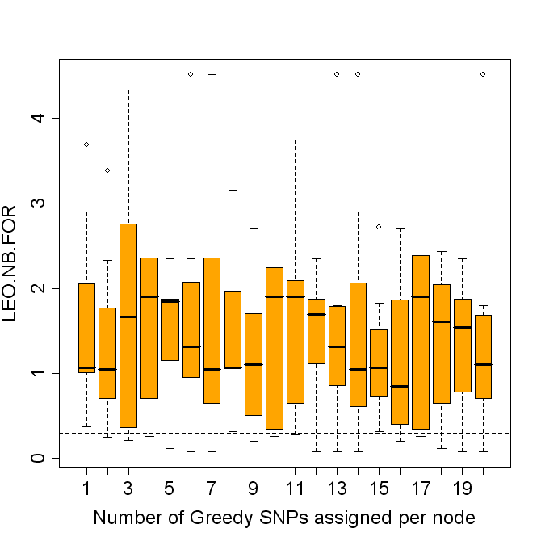
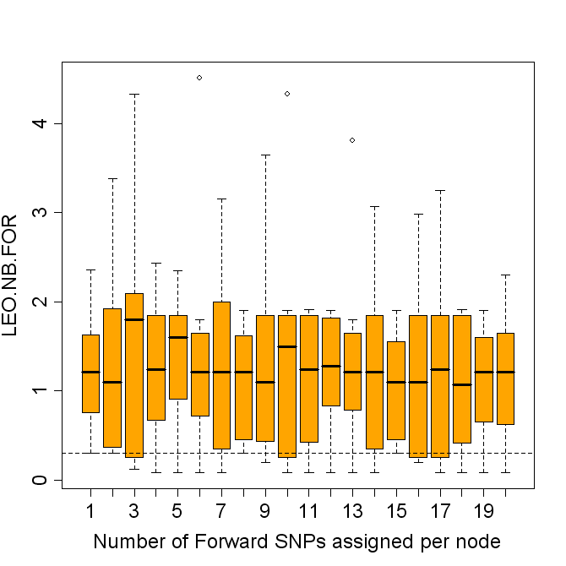

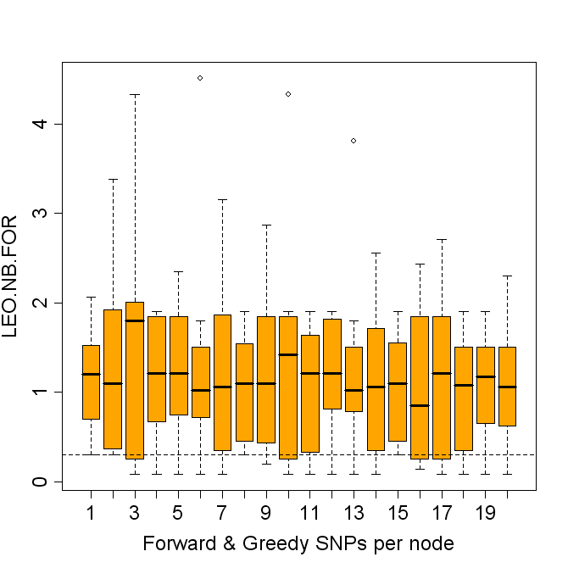
rbp(the.frames$my.LEO.NB.ALL.snp.gr,”LEO.NB.ALL”,.75, xlab="Number of Greedy SNPs assigned per node",ylim=c(0,4))
rbp(the.frames$my.LEO.NB.ALL.snp.fw,”LEO.NB.ALL”,.75, xlab="Number of Forward SNPs assigned per node",ylim=c(0,4))
rbp(the.frames$my.LEO.NB.ALL.snp.fg,”LEO.NB.ALL”,.75, xlab="Forward & Greedy SNPs per node",ylim=c(0,4))

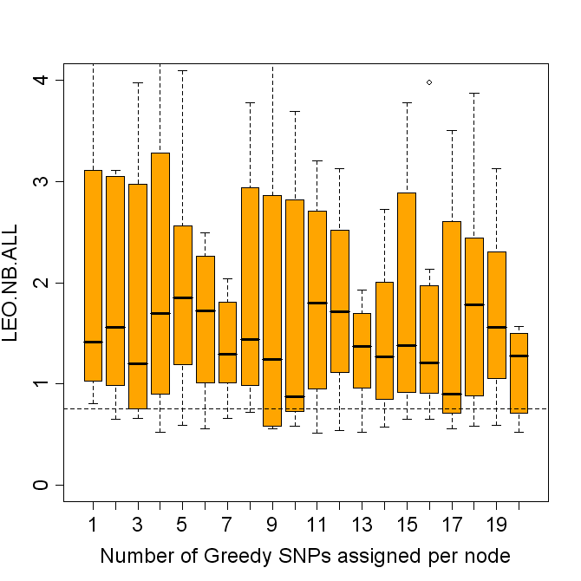

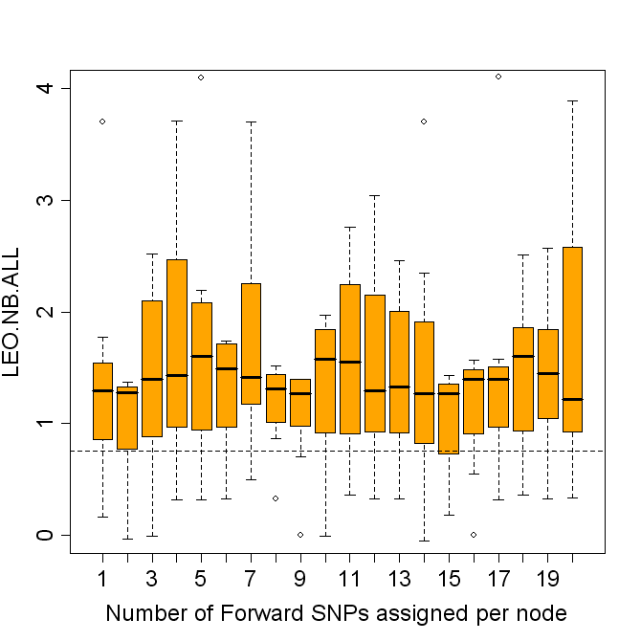

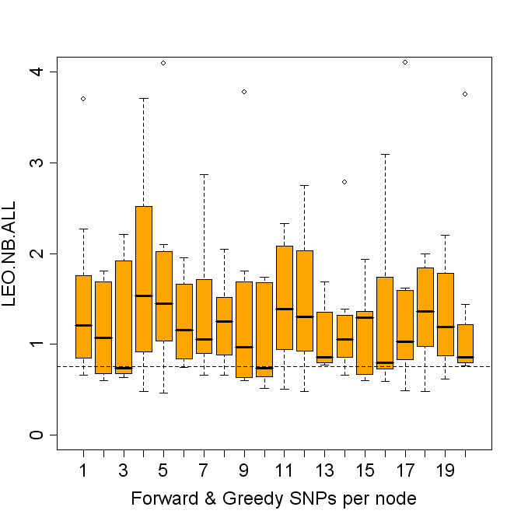

rbp(the.frames$my.LEO.MULTIONE.NB.snp.gr,”LEO.MULTIONE.NB”,.3, xlab="Number of Greedy SNPs assigned per node",ylim=c(0,4))

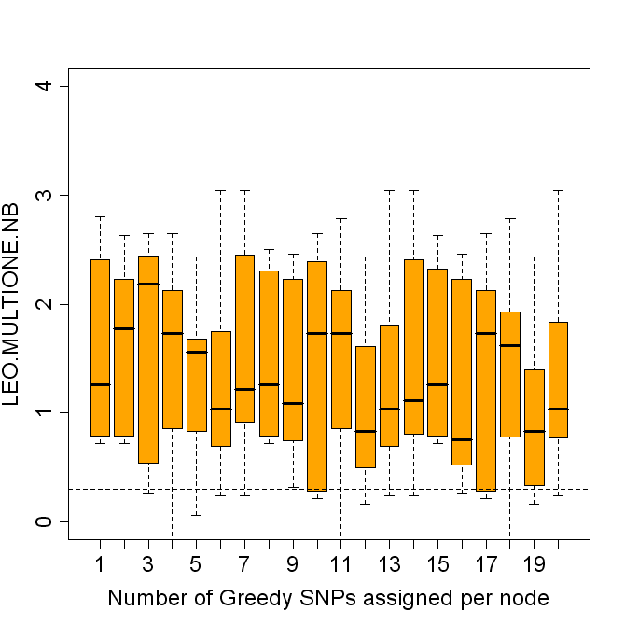
rbp(the.frames$my.LEO.MULTIONE.NB.snp.fw,”LEO.MULTIONE.NB”,.3, xlab="Number of Forward SNPs assigned per node",ylim=c(0,4))

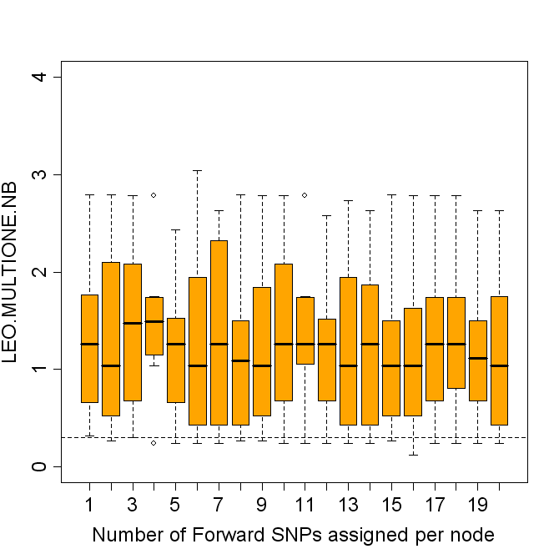

rbp(the.frames$my.LEO.MULTIONE.NB.snp.fg,”LEO.MULTIONE.NB”,.3, xlab="Forward & Greedy SNPs per node",ylim=c(0,4))

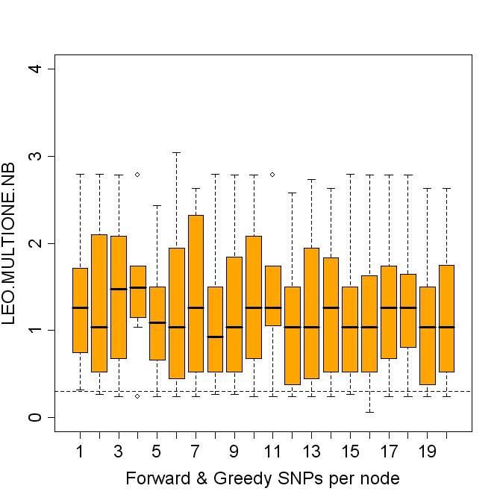

# these with 10 samples:
load("r.test.robust.task1.results.10.Sat_Aug_11_17.57.11_2007.rdat")
# then do the same as above to get variable “r” into the.frames

rbp(the.frames$my.LEO.NB.MAX.snp.fg,”LEO.NB.MAX”,.75, xlab="Forward & Greedy SNPs per node",ylim=c(0,4))
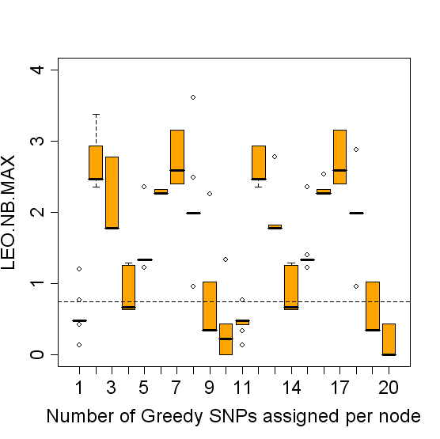

rbp(the.frames$my.LEO.NB.MAX.snp.fw,”LEO.NB.MAX”,.75, xlab="Number of Forward SNPs assigned per node",ylim=c(0,4))
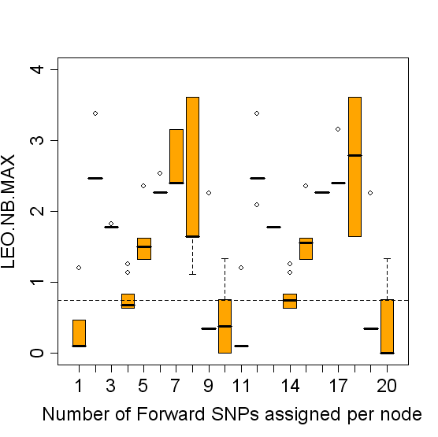

rbp(the.frames$my.LEO.NB.MAX.snp.gr,”LEO.NB.MAX”,.75, xlab="Number of Greedy SNPs assigned per node",ylim=c(0,4))

# The best single marker model is high variable in performance and depends a lot on SNP selection.

##### now some data from the null hypothesis—useful for setting thresholds
# here we have 1 A SNP, and 1 B SNP and 100 noise SNPs, and 0 causal signal but
# the same heritabilities and observed A-B correlation, after 42 simulations
load(“mc.robust.1a.1b.0causal/r.test.robust.task3.results.42.Sat_Aug_11_17.32.37_2007.rdat”)
num.frames=42
the.frames=list()
blank.frame = matrix(nrow=num.frames, ncol=20)
colnames(blank.frame) = paste(sep="","snp.count.",1:20)
rownames(blank.frame) = paste(sep="","rep.",1:num.frames)

the.frames = list()

the.frames$my.LEO.NB.FOR.snp.fg = blank.frame
the.frames$my.LEO.NB.MAX.snp.fg = blank.frame
the.frames$my.LEO.NB.ALL.snp.fg = blank.frame
the.frames$my.SIMPLE.MAX.MAX.snp.fg = blank.frame
the.frames$my.LEO.MULTIONE.NB.snp.fg = blank.frame

for (i in 1:num.frames) {

df.fg=data.frame(r$greedy.and.forward.100.causal[[i]])

the.frames$my.LEO.NB.FOR.snp.fg[i,]=anac(df.fg$LEO.NB.FOR)
the.frames$my.LEO.NB.MAX.snp.fg[i,]=anac(df.fg$LEO.NB.MAX)
the.frames$my.LEO.NB.ALL.snp.fg[i,]=anac(df.fg$LEO.NB.ALL)
the.frames$my.SIMPLE.MAX.MAX.snp.fg[i,]=anac(df.fg$SIMPLE.MAX.MAX)
the.frames$my.LEO.MULTIONE.NB.snp.fg[i,]=anac(df.fg$LEO.MULTIONE.NB)
}

rbp2=function(x,stat.name,th,...) {

dv=boxplot(split(x,1:ncol(x)),notch=F,ylab=stat.name,cex.lab = 1.5, cex.names =1.5, cex.axis=1.5, ...)

abline(h=th, lty=2) # show our favorite LEO.NB.FOR significance threshold

invisible(dv)
}

rbp2(the.frames$my.LEO.NB.FOR.snp.fg,”LEO.NB.FOR”,.3, xlab="Forward & Greedy SNPs per node",col=”purple”,ylim=c(-4,1))
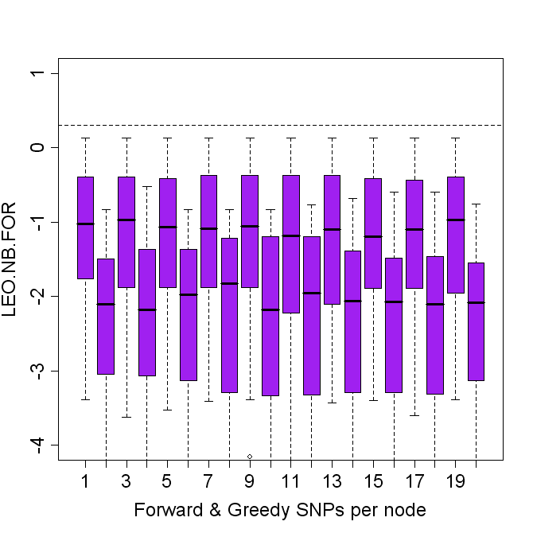
# clearly well below our 0.3 threshold under the null distribution

rbp2(the.frames$my.LEO.NB.ALL.snp.fg,”LEO.NB.ALL”,th=.75, xlab="Forward & Greedy SNPs per node",col=”purple”,ylim=c(-4,4))

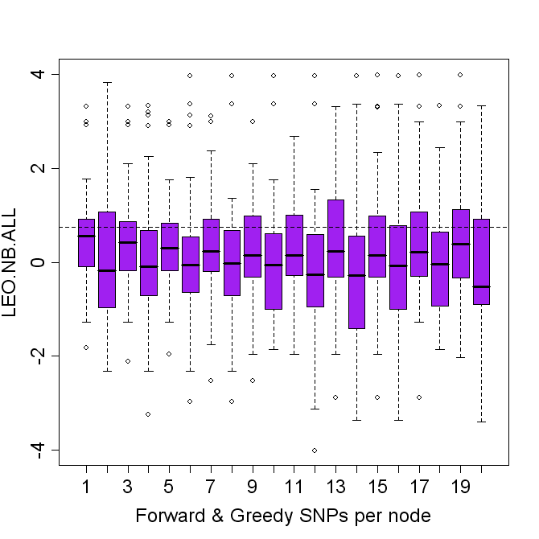

rbp2(the.frames$my.LEO.MULTIONE.NB.snp.fg,”LEO.MULTIONE.NB”,th=.3, xlab="Forward & Greedy SNPs per node",col=”purple”,ylim=c(-8,4))

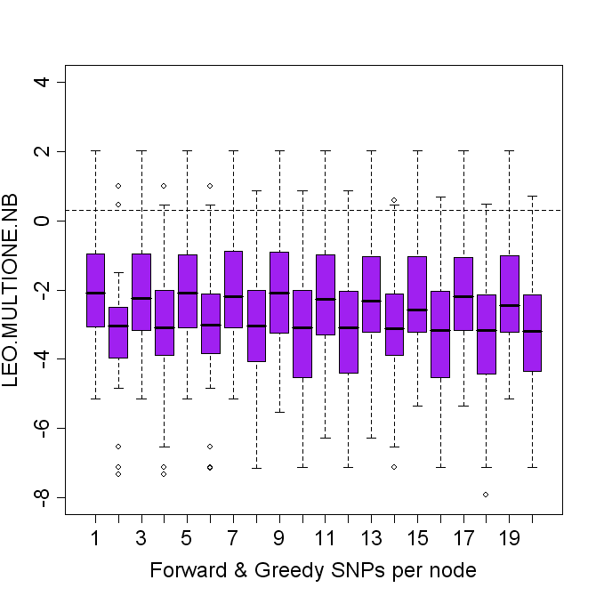

rbp2(the.frames$my.LEO.NB.MAX.snp.fg,”LEO.NB.MAX”,th=.75, xlab="Forward & Greedy SNPs per node",col=”purple”,ylim=c(-8,4))

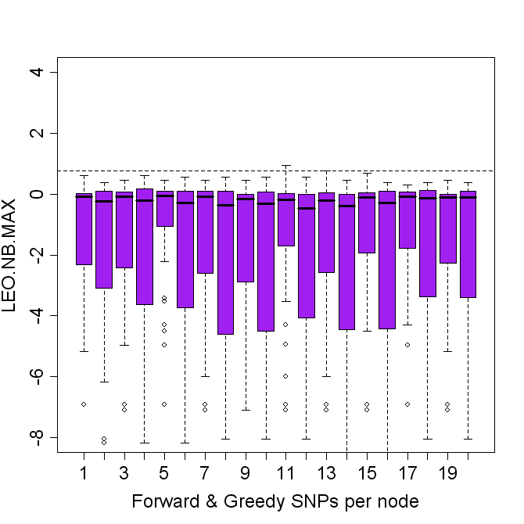

##################################################
########## now process the actual 100 samples data
[jaten@calypso ~/dev/peculiar]$ find . -name '*.100.*' –print
# monte.carlo.robustness is same as: 0a.1b.no.neighbors.1causal
./monte.carlo.robustness/r.test.robust.task3.results.100.Sun_Aug_12_05.28.02_2007.rdat
./monte.carlo.robustness/r.test.robust.task2.results.100.Sun_Aug_12_10.06.59_2007.rdat
./monte.carlo.robustness/r.test.robust.task1.results.100.Sun_Aug_12_14.56.15_2007.rdat

./mc.robust.1a.1b/r.test.robust.task3.results.100.Sun_Aug_12_03.30.12_2007.rdat
./mc.robust.1a.1b/r.test.robust.task1.results.100.Sun_Aug_12_06.02.53_2007.rdat
./mc.robust.1a.1b/r.test.robust.task2.results.100.Sun_Aug_12_14.38.15_2007.rdat

./mc.robust.0a.1b.5causal/r.test.robust.task3.results.100.Sun_Aug_12_13.23.41_2007.rdat
./mc.robust.0a.1b.5causal/r.test.robust.task2.results.100.Sun_Aug_12_16.05.02_2007.rdat

./mc.robust.1a.1b.5causal/r.test.robust.task3.results.100.Sun_Aug_12_07.16.37_2007.rdat
./mc.robust.1a.1b.5causal/r.test.robust.task2.results.100.Sun_Aug_12_08.03.22_2007.rdat
./mc.robust.1a.1b.5causal/r.test.robust.task1.results.100.Sun_Aug_12_11.35.58_2007.rdat

./mc.robust.1a.1b.0causal/r.test.robust.task3.results.100.Sun_Aug_12_13.12.29_2007.rdat
./mc.robust.1a.1b.0causal/r.test.robust.task2.results.100.Sun_Aug_12_14.26.48_2007.rdat

./mc.robust.0a.1b.0causal/r.test.robust.task2.results.100.Sun_Aug_12_11.58.00_2007.rdat
./mc.robust.0a.1b.0causal/r.test.robust.task1.results.99.Mon_Aug_13_05.14.33_2007.rdat
./mc.robust.0a.1b.0causal/r.test.robust.task3.results.94.Mon_Aug_13_05.12.56_2007.rdat
# done

##########################

rbp=function(x,stat.name,th,...) {

dv=boxplot(split(x,1:ncol(x)),notch=F,ylab=stat.name,col="orange",cex.lab = 1.5, cex.names =1.5, cex.axis=1.5, ...)

abline(h=th, lty=2) # show our favorite LEO.NB.FOR significance threshold

invisible(dv)
}

# first one, same as
a=load(“monte.carlo.robustness/r.test.robust.task3.results.100.Sun_Aug_12_05.28.02_2007.rdat”)

get.frames = function(rlist) {
num.frames = length(rlist)
blank.frame = matrix(nrow=num.frames, ncol=20)
colnames(blank.frame) = paste(sep="","snp.count.",1:20)
rownames(blank.frame) = paste(sep="","rep.",1:num.frames)

the.frames = list()

the.frames$my.LEO.NB.FOR.snp = blank.frame
the.frames$my.LEO.NB.MAX.snp = blank.frame
the.frames$my.LEO.NB.ALL.snp = blank.frame
the.frames$my.SIMPLE.MAX.MAX.snp = blank.frame
the.frames$my.LEO.MULTIONE.NB.snp = blank.frame

for (i in 1:num.frames) {

df=data.frame(rlist[[i]])

the.frames$my.LEO.NB.FOR.snp[i,]=anac(df$LEO.NB.FOR)
the.frames$my.LEO.NB.MAX.snp[i,]=anac(df$LEO.NB.MAX)
the.frames$my.LEO.NB.ALL.snp[i,]=anac(df$LEO.NB.ALL)
the.frames$my.SIMPLE.MAX.MAX.snp[i,]=anac(df$SIMPLE.MAX.MAX)
the.frames$my.LEO.MULTIONE.NB.snp[i,]=anac(df$LEO.MULTIONE.NB)

}
the.frames
}
the.frames = get.frames(r$greedy.and.forward.100.causal)

rbp2=function(x,stat.name,th,...) {

dv=boxplot(split(x,1:ncol(x)),notch=F,ylab=stat.name,cex.lab = 1.5, cex.names =1.5, cex.axis=1.5, ...)

abline(h=th, lty=2) # show our favorite LEO.NB.FOR significance threshold

invisible(dv)
}

# yellow denotes the finished 100 repetition samples…
rbp2(the.frames$my.LEO.NB.FOR.snp,”LEO.NB.FOR”,.3, xlab="Forward & Greedy SNPs per node",col=”yellow”)
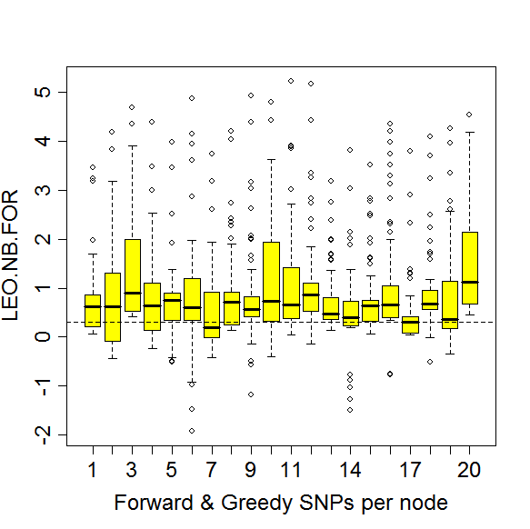

rbp2(the.frames$my.LEO.NB.MAX.snp,”LEO.NB.MAX”,.3, xlab="Forward & Greedy SNPs per node",col=”yellow”)
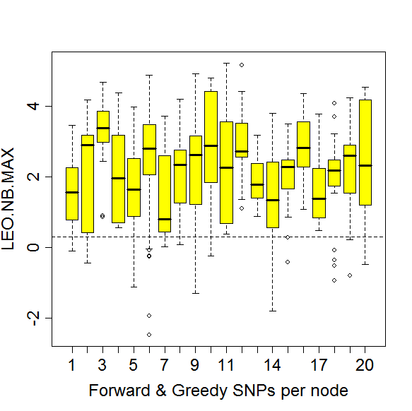
rbp2(the.frames$my.LEO.NB.ALL.snp,”LEO.NB.ALL”,.75, xlab="Forward & Greedy SNPs per node",col=”yellow”)
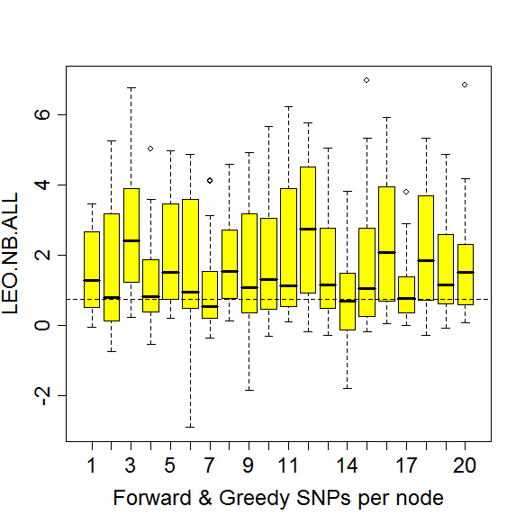

rbp2(the.frames$my.LEO.MULTIONE.NB.snp,”LEO.MULTIONE.NB”,.75, xlab="Forward & Greedy SNPs per node",col=”yellow”)
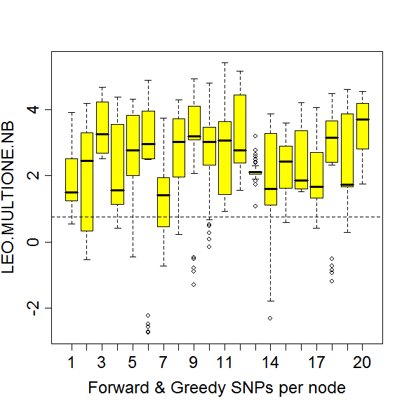
rbp2(the.frames$my.SIMPLE.MAX.MAX.snp,”SIMPLE.MAX.MAX”,.75, xlab="Forward & Greedy SNPs per node",col=”yellow”)
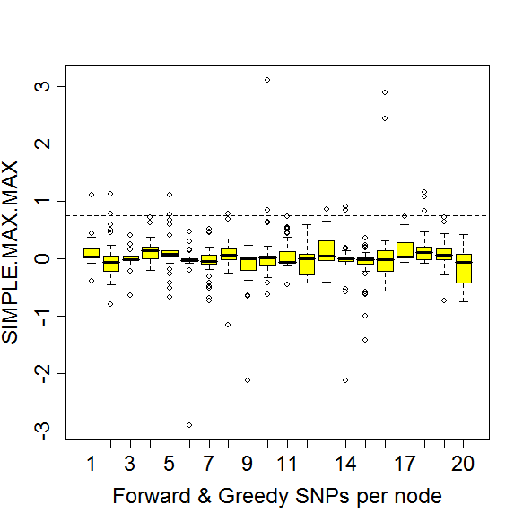

###########################

[jaten@calypso ~/dev/peculiar]$ find . -name '*.100.*' –print
# monte.carlo.robustness is same as: 0a.1b.no.neighbors.1causal
#bash-3.2$ ln -s monte.carlo.robustness mc.robust.0a.1b.no.neighbors.1causal
#bash-3.2$ pwd
#/home/jaten/dev/peculiar

# these 3 replaced by more descriptive following 3:
#./monte.carlo.robustness/r.test.robust.task3.results.100.Sun_Aug_12_05.28.02_2007.rdat
#./monte.carlo.robustness/r.test.robust.task2.results.100.Sun_Aug_12_10.06.59_2007.rdat
#./monte.carlo.robustness/r.test.robust.task1.results.100.Sun_Aug_12_14.56.15_2007.rdat

./mc.robust.0a.1b.no.neighbors.1causal/r.test.robust.task1.results.100.Sun_Aug_12_14.56.15_2007.rdat
./mc.robust.0a.1b.no.neighbors.1causal/r.test.robust.task2.results.100.Sun_Aug_12_10.06.59_2007.rdat
./mc.robust.0a.1b.no.neighbors.1causal/r.test.robust.task3.results.100.Sun_Aug_12_05.28.02_2007.rdat

./mc.robust.1a.1b/r.test.robust.task3.results.100.Sun_Aug_12_03.30.12_2007.rdat
./mc.robust.1a.1b/r.test.robust.task1.results.100.Sun_Aug_12_06.02.53_2007.rdat
./mc.robust.1a.1b/r.test.robust.task2.results.100.Sun_Aug_12_14.38.15_2007.rdat

./mc.robust.0a.1b.5causal/r.test.robust.task3.results.100.Sun_Aug_12_13.23.41_2007.rdat
./mc.robust.0a.1b.5causal/r.test.robust.task2.results.100.Sun_Aug_12_16.05.02_2007.rdat
./mc.robust.0a.1b.5causal.task1.greedy.only/r.test.robust.task1.results.100.Tue_Aug_14_10.58.51_2007.rdat

./mc.robust.1a.1b.5causal/r.test.robust.task3.results.100.Sun_Aug_12_07.16.37_2007.rdat
./mc.robust.1a.1b.5causal/r.test.robust.task2.results.100.Sun_Aug_12_08.03.22_2007.rdat
./mc.robust.1a.1b.5causal/r.test.robust.task1.results.100.Sun_Aug_12_11.35.58_2007.rdat

./mc.robust.1a.1b.0causal/r.test.robust.task3.results.100.Sun_Aug_12_13.12.29_2007.rdat
./mc.robust.1a.1b.0causal/r.test.robust.task2.results.100.Sun_Aug_12_14.26.48_2007.rdat
# task1 did not finish here.
#[jaten@calypso ~/dev/peculiar/mc.robust.1a.1b.0causal]$
# $cat neo.sge.2.qsub.me.sh.e351664.1
# shows ...
# ...
# Warning: cannot open file '/no.neo.log.html.logs.all.zeo/A.to.B.html', reason
# 'Cannot allocate memory'
# Error in file(file.path, "wt") : unable to open connection
# Execution halted
#
# hmm... a memory issue? Quite odd.

./mc.robust.0a.1b.0causal/r.test.robust.task2.results.100.Sun_Aug_12_11.58.00_2007.rdat
./mc.robust.0a.1b.0causal/r.test.robust.task1.results.100.Mon_Aug_13_05.34.40_2007.rdat
./mc.robust.0a.1b.0causal/r.test.robust.task3.results.100.Mon_Aug_13_06.48.41_2007.rdat

./mc.robust.1a.1b.1causal.4an.4bn/r.test.robust.task1.results.100.Mon_Aug_13_18.29.13_2007.rdat
./mc.robust.1a.1b.1causal.4an.4bn/r.test.robust.task3.results.100.Mon_Aug_13_19.32.40_200
7.rdat
./mc.robust.1a.1b.1causal.4an.4bn/r.test.robust.task2.results.100.Mon_Aug_13_20.23.08_2007.rdat

./mc.robust.1a.4b.4causal.4an.4bn/r.test.robust.task2.results.100.Tue_Aug_14_12.20.56_2007.rdat
./mc.robust.1a.4b.4causal.4an.4bn/r.test.robust.task1.results.83.Tue_Aug_14_13.52.40_2007.rdat
# task1 still running. We took the latest results, the .83 file above.
# task3 failed with:
# Error in do.call(neo.sge.job.list[[task]], args = list()) :
# could not find function "test.robust.1a.1b.4causal.4an.4bn"
# Execution halted

./mc.robust.0a.4b.4causal.4an.4bn/r.test.robust.task1.results.100.Tue_Aug_14_14.09.52_2007.rdat
./mc.robust.0a.4b.4causal.4an.4bn/r.test.robust.task2.results.100.Tue_Aug_14_10.32.41_2007.rdat
# task3 failed with: (bad NFS sync on that node???)
#Error in do.call(neo.sge.job.list[[task]], args = list()) :
# could not find function "test.robust.1a.1b.4causal.4an.4bn"
# Execution halted

# and generate archive of these to pull to laptop.
[jaten@calypso ~/dev/peculiar]$ find . -name '*.100.*' | xargs tar rvf done.100s.tar; gzip done.100s.tar;
# also created a zip file to allow reproduction of these plots/
# to let others look at the raw data with...and embed it here.
# Double clicking the icon below should open in an unzip utility, if installed.
“c:/good/robustness.analysis.files.Aug12.14.2007.zip”



##
##
## strings of 24 files to plot, from robustness.analysis.files.Aug12.14.2007
my.robust.files=c(
“mc.robust.0a.1b.no.neighbors.1causal/r.test.robust.task1.results.100.Sun_Aug_12_14.56.15_2007.rdat”,
“mc.robust.0a.1b.no.neighbors.1causal/r.test.robust.task2.results.100.Sun_Aug_12_10.06.59_2007.rdat”,
“mc.robust.0a.1b.no.neighbors.1causal/r.test.robust.task3.results.100.Sun_Aug_12_05.28.02_2007.rdat”,

“mc.robust.1a.1b/r.test.robust.task3.results.100.Sun_Aug_12_03.30.12_2007.rdat”,
“mc.robust.1a.1b/r.test.robust.task1.results.100.Sun_Aug_12_06.02.53_2007.rdat”,
“mc.robust.1a.1b/r.test.robust.task2.results.100.Sun_Aug_12_14.38.15_2007.rdat”,

“mc.robust.0a.1b.5causal/r.test.robust.task3.results.100.Sun_Aug_12_13.23.41_2007.rdat”,
“mc.robust.0a.1b.5causal/r.test.robust.task2.results.100.Sun_Aug_12_16.05.02_2007.rdat”,
“mc.robust.0a.1b.5causal.task1.greedy.only/r.test.robust.task1.results.100.Tue_Aug_14_10.58.51_2007.rdat”,

“mc.robust.1a.1b.5causal/r.test.robust.task3.results.100.Sun_Aug_12_07.16.37_2007.rdat”,
“mc.robust.1a.1b.5causal/r.test.robust.task2.results.100.Sun_Aug_12_08.03.22_2007.rdat”,
“mc.robust.1a.1b.5causal/r.test.robust.task1.results.100.Sun_Aug_12_11.35.58_2007.rdat”,

“mc.robust.1a.1b.0causal/r.test.robust.task3.results.100.Sun_Aug_12_13.12.29_2007.rdat”,
“mc.robust.1a.1b.0causal/r.test.robust.task2.results.100.Sun_Aug_12_14.26.48_2007.rdat”,

“mc.robust.0a.1b.0causal/r.test.robust.task2.results.100.Sun_Aug_12_11.58.00_2007.rdat”,
“mc.robust.0a.1b.0causal/r.test.robust.task1.results.100.Mon_Aug_13_05.34.40_2007.rdat”,
“mc.robust.0a.1b.0causal/r.test.robust.task3.results.100.Mon_Aug_13_06.48.41_2007.rdat”,

“mc.robust.1a.1b.1causal.4an.4bn/r.test.robust.task1.results.100.Mon_Aug_13_18.29.13_2007.rdat”,
“mc.robust.1a.1b.1causal.4an.4bn/r.test.robust.task3.results.100.Mon_Aug_13_19.32.40_2007.rdat”,
“mc.robust.1a.1b.1causal.4an.4bn/r.test.robust.task2.results.100.Mon_Aug_13_20.23.08_2007.rdat”,

“mc.robust.1a.4b.4causal.4an.4bn/r.test.robust.task2.results.100.Tue_Aug_14_12.20.56_2007.rdat”,
“mc.robust.1a.4b.4causal.4an.4bn/r.test.robust.task1.results.83.Tue_Aug_14_13.52.40_2007.rdat”,

“mc.robust.0a.4b.4causal.4an.4bn/r.test.robust.task1.results.100.Tue_Aug_14_14.09.52_2007.rdat”,
“mc.robust.0a.4b.4causal.4an.4bn/r.test.robust.task2.results.100.Tue_Aug_14_10.32.41_2007.rdat”)

> my.robust.files
[1] "mc.robust.0a.1b.no.neighbors.1causal/r.test.robust.task1.results.100.Sun_Aug_12_14.56.15_2007.rdat"
[2] "mc.robust.0a.1b.no.neighbors.1causal/r.test.robust.task2.results.100.Sun_Aug_12_10.06.59_2007.rdat"
[3] "mc.robust.0a.1b.no.neighbors.1causal/r.test.robust.task3.results.100.Sun_Aug_12_05.28.02_2007.rdat"

[4] "mc.robust.1a.1b/r.test.robust.task3.results.100.Sun_Aug_12_03.30.12_2007.rdat"
[5] "mc.robust.1a.1b/r.test.robust.task1.results.100.Sun_Aug_12_06.02.53_2007.rdat"
[6] "mc.robust.1a.1b/r.test.robust.task2.results.100.Sun_Aug_12_14.38.15_2007.rdat"

[7] "mc.robust.0a.1b.5causal/r.test.robust.task3.results.100.Sun_Aug_12_13.23.41_2007.rdat"
[8] "mc.robust.0a.1b.5causal/r.test.robust.task2.results.100.Sun_Aug_12_16.05.02_2007.rdat" [9]"mc.robust.0a.1b.5causal.task1.greedy.only/r.test.robust.task1.results.100.Tue_Aug_14_10.58.51_2007.rdat"

[10] "mc.robust.1a.1b.5causal/r.test.robust.task3.results.100.Sun_Aug_12_07.16.37_2007.rdat"
[11] "mc.robust.1a.1b.5causal/r.test.robust.task2.results.100.Sun_Aug_12_08.03.22_2007.rdat"
[12] "mc.robust.1a.1b.5causal/r.test.robust.task1.results.100.Sun_Aug_12_11.35.58_2007.rdat"

[13] "mc.robust.1a.1b.0causal/r.test.robust.task3.results.100.Sun_Aug_12_13.12.29_2007.rdat"
[14] "mc.robust.1a.1b.0causal/r.test.robust.task2.results.100.Sun_Aug_12_14.26.48_2007.rdat"

[15] "mc.robust.0a.1b.0causal/r.test.robust.task2.results.100.Sun_Aug_12_11.58.00_2007.rdat"
[16] "mc.robust.0a.1b.0causal/r.test.robust.task1.results.100.Mon_Aug_13_05.34.40_2007.rdat"
[17] "mc.robust.0a.1b.0causal/r.test.robust.task3.results.100.Mon_Aug_13_06.48.41_2007.rdat"

[18] "mc.robust.1a.1b.1causal.4an.4bn/r.test.robust.task1.results.100.Mon_Aug_13_18.29.13_2007.rdat"
[19] "mc.robust.1a.1b.1causal.4an.4bn/r.test.robust.task3.results.100.Mon_Aug_13_19.32.40_2007.rdat"
[20] "mc.robust.1a.1b.1causal.4an.4bn/r.test.robust.task2.results.100.Mon_Aug_13_20.23.08_2007.rdat"

[21] "mc.robust.1a.4b.4causal.4an.4bn/r.test.robust.task2.results.100.Tue_Aug_14_12.20.56_2007.rdat"
[22] "mc.robust.1a.4b.4causal.4an.4bn/r.test.robust.task1.results.83.Tue_Aug_14_13.52.40_2007.rdat"

[23] "mc.robust.0a.4b.4causal.4an.4bn/r.test.robust.task1.results.100.Tue_Aug_14_14.09.52_2007.rdat"
[24] "mc.robust.0a.4b.4causal.4an.4bn/r.test.robust.task2.results.100.Tue_Aug_14_10.32.41_2007.rdat"
>

rbp=function(x,stat.name,th,...) {

dv=boxplot(split(x,1:ncol(x)),notch=F,ylab=stat.name,col="orange",cex.lab = 1.5, cex.names =1.5, cex.axis=1.5, ...)

abline(h=th, lty=2) # show our favorite LEO.NB.FOR significance threshold

invisible(dv)
}

# first one, same as
a=load(my.robust.files[1])

get.frames = function(rlist) {
num.frames = length(rlist)
blank.frame = matrix(nrow=num.frames, ncol=20)
colnames(blank.frame) = paste(sep="","snp.count.",1:20)
rownames(blank.frame) = paste(sep="","rep.",1:num.frames)

the.frames = list()

the.frames$my.LEO.NB.FOR.snp = blank.frame
the.frames$my.LEO.NB.MAX.snp = blank.frame
the.frames$my.LEO.NB.ALL.snp = blank.frame
the.frames$my.SIMPLE.MAX.MAX.snp = blank.frame
the.frames$my.LEO.MULTIONE.NB.snp = blank.frame

for (i in 1:num.frames) {

df=data.frame(rlist[[i]])

the.frames$my.LEO.NB.FOR.snp[i,]=anac(df$LEO.NB.FOR)
the.frames$my.LEO.NB.MAX.snp[i,]=anac(df$LEO.NB.MAX)
the.frames$my.LEO.NB.ALL.snp[i,]=anac(df$LEO.NB.ALL)
the.frames$my.SIMPLE.MAX.MAX.snp[i,]=anac(df$SIMPLE.MAX.MAX)
the.frames$my.LEO.MULTIONE.NB.snp[i,]=anac(df$LEO.MULTIONE.NB)

}
the.frames
}

rbp2=function(x,stat.name,th,...) {

dv=boxplot(split(x,1:ncol(x)),notch=F,ylab=stat.name,cex.lab = 1.5, cex.names =1.5, cex.axis=1.5, ...)

abline(h=th, lty=2) # show our favorite LEO.NB.FOR significance threshold

invisible(dv)
}

windows()
my.robust.files[1]
#[1]"mc.robust.0a.1b.no.neighbors.1causal/r.test.robust.task1.results.100.Sun_Aug_12_14.56.15_2007.rdat"

a=load(my.robust.files[1])
the.frames = get.frames(r$greedy.100.causal)

rbp2(the.frames$my.LEO.NB.FOR.snp,”LEO.NB.FOR”,.3, xlab="Greedy SNPs per node",col=”blue”)

windows()
a=load(my.robust.files[16])
the.frames = get.frames(r$greedy.100.causal)

rbp2(the.frames$my.LEO.NB.FOR.snp,”LEO.NB.FOR”,.3, xlab="Greedy SNPs per node",col=”blue”)

get.diff.matrix=function(x) {
dm=x
for(j in 2:ncol(x)) {
for (i in 1:nrow(x)) {
dm[i,j] = x[i,j]-x[i,j-1]
}
}
dm
}

boost.diff.matrix.by.median=function(dm) {
m1=apply(dm,2,median,na.rm=T)

for(j in 2:ncol(dm)) {
for (i in 1:nrow(dm)) {
dm[i,j] = dm[i,j] + sum(m1[1:(j-1)]) # add the previous column’s median
}
}
dm
}

# Why go to differential response?

# Two resaons: 1) otherwise the plots are confusing, like below; and 2) There is a strong dependence on the initial 1 SNP score value.
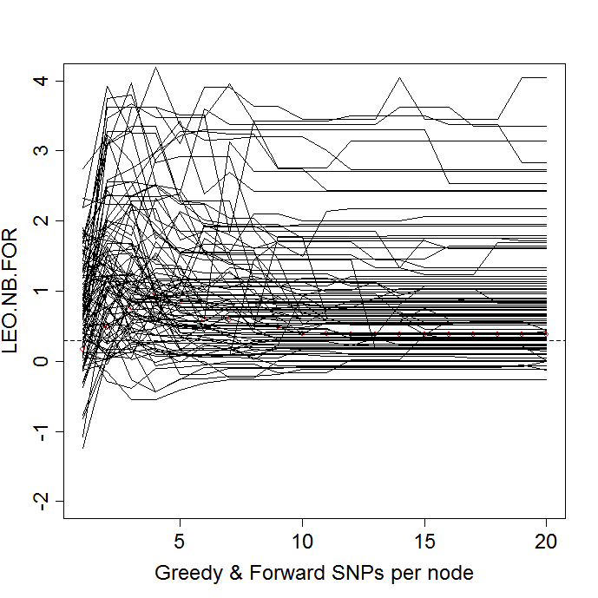

# Plot the behavior of the median differential response as number of SNPs increases.

# rbp3: previous.snp.dependency.robustness.plot
#
# We condition on prior SNP value, creating a difference matrix
# at first, since the signals do consistently drop for one signal
# SNP simulations.
#
# Median response variation, conditional upon previous SNP count score level.
#
rbp3=function(x,stat.name,th,...) {
dm=get.diff.matrix(x)
dm2=data.frame(boost.diff.matrix.by.median(dm))

colnames(dm2) = paste(1:ncol(dm2))

dv=boxplot(dm2,notch=F, ylab=stat.name, cex.lab = 1.5, cex.names =1.5, cex.axis=1.5,...)
abline(h=th, lty=2) # show our favorite LEO.NB.FOR significance threshold

invisible(dv)
}

rbp3(the.frames$my.LEO.NB.FOR.snp,”LEO.NB.FOR”,.3, xlab="Greedy SNPs per node",col=”blue”)

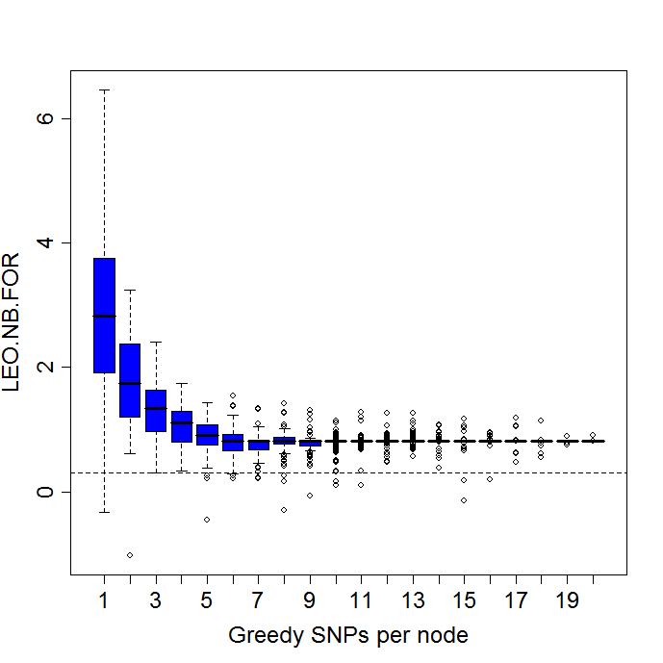

rbp3(the.frames$my.LEO.NB.MAX.snp,”LEO.NB.MAX”,.75, xlab="Greedy SNPs per node",col=”blue”)

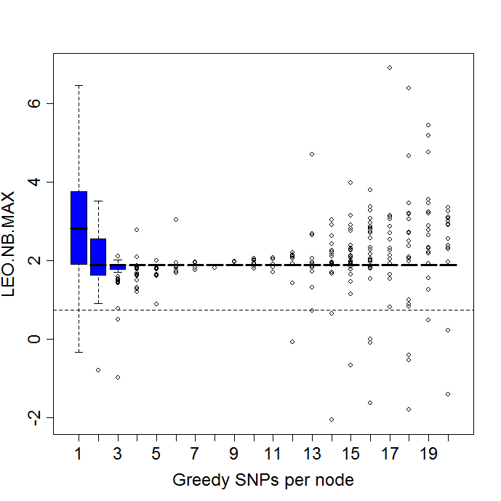

rbp3(the.frames$my.LEO.NB.ALL.snp,”LEO.NB.ALL”,.75, xlab="Greedy SNPs per node",col=”blue”)

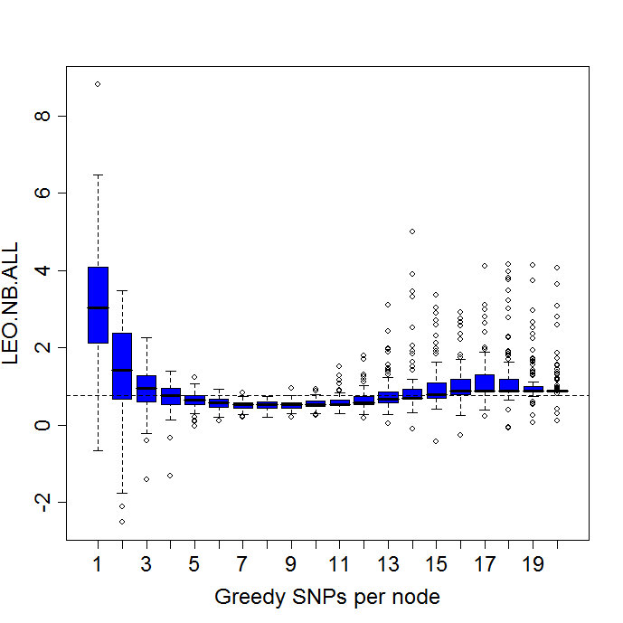

a=load(my.robust.files[2])
the.frames = get.frames(r$forward.100.causal)
rbp3(the.frames$my.LEO.NB.FOR.snp,”LEO.NB.FOR”,.3, xlab="Forward SNPs per node",col=”blue”)
rbp3(the.frames$my.LEO.NB.MAX.snp,”LEO.NB.MAX”,.75, xlab="Forward SNPs per node",col=”blue”)
rbp3(the.frames$my.LEO.NB.ALL.snp,”LEO.NB.ALL”,.75, xlab="Forward SNPs per node",col=”blue”)

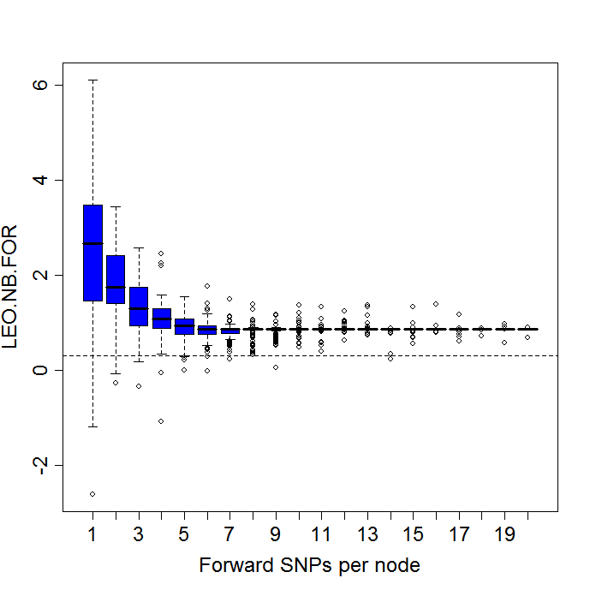

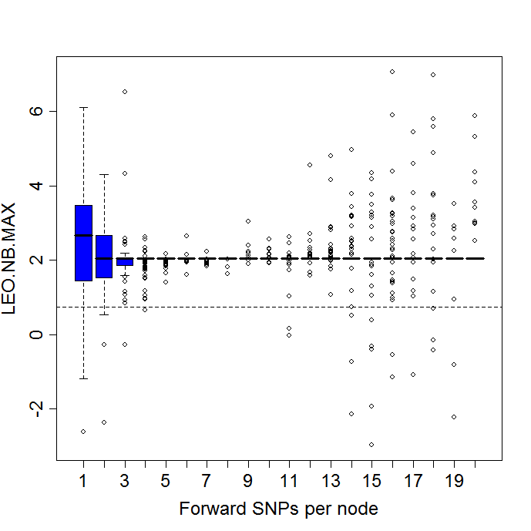

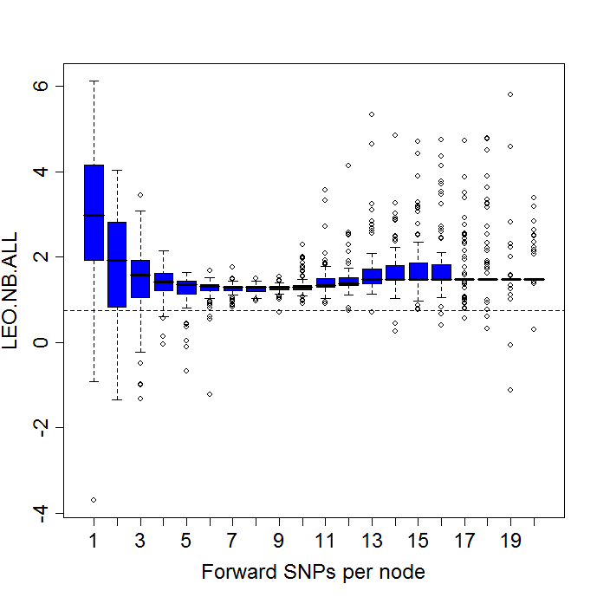

a=load(my.robust.files[3])
the.frames = get.frames(r$greedy.and.forward.100.causal)

rbp3(the.frames$my.LEO.NB.FOR.snp,”LEO.NB.FOR”,.3, xlab="Forward SNPs per node",col=”blue”)
rbp3(the.frames$my.LEO.NB.MAX.snp,”LEO.NB.MAX”,.75, xlab="Forward SNPs per node",col=”blue”)
rbp3(the.frames$my.LEO.NB.ALL.snp,”LEO.NB.ALL”,.75, xlab="Forward SNPs per node",col=”blue”)

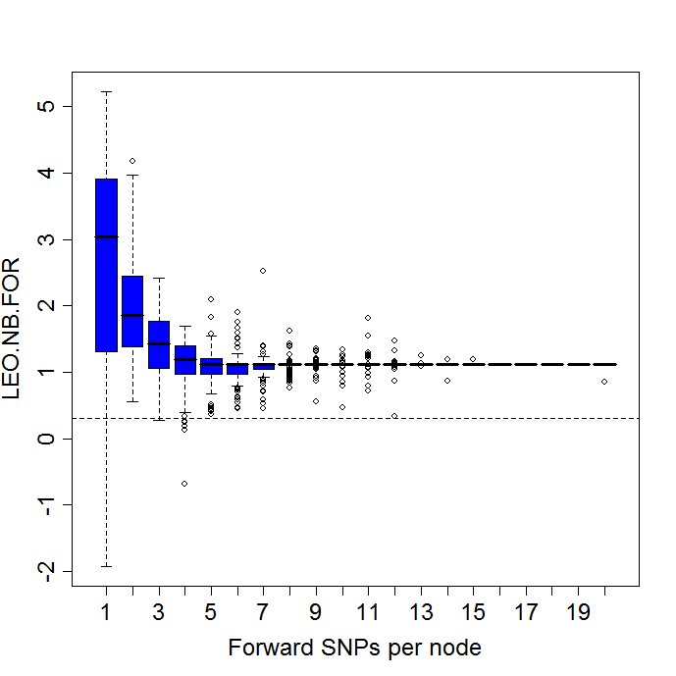

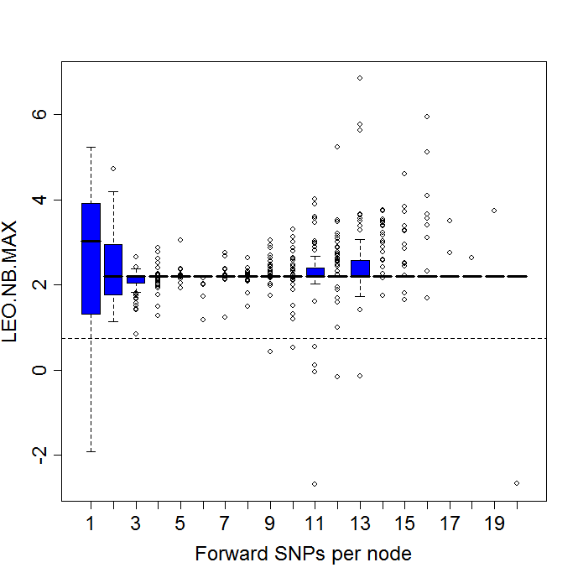
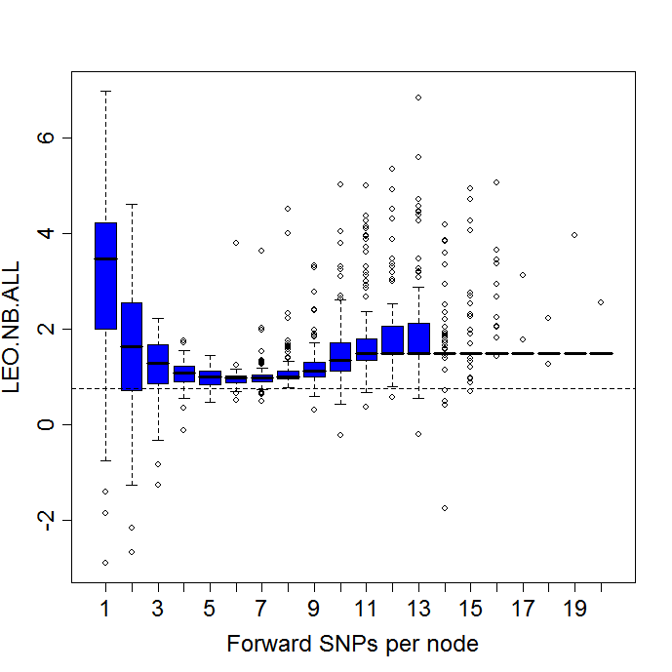

# same data, but all in one plot
par(mfrow=c(3,1))
rbp3(the.frames$my.LEO.NB.FOR.snp,”LEO.NB.FOR”,.3, xlab="Forward SNPs per node",col=”blue”)
rbp3(the.frames$my.LEO.NB.MAX.snp,”LEO.NB.MAX”,.75, xlab="Forward SNPs per node",col=”blue”)
rbp3(the.frames$my.LEO.NB.ALL.snp,”LEO.NB.ALL”,.75, xlab="Forward SNPs per node",col=”blue”)

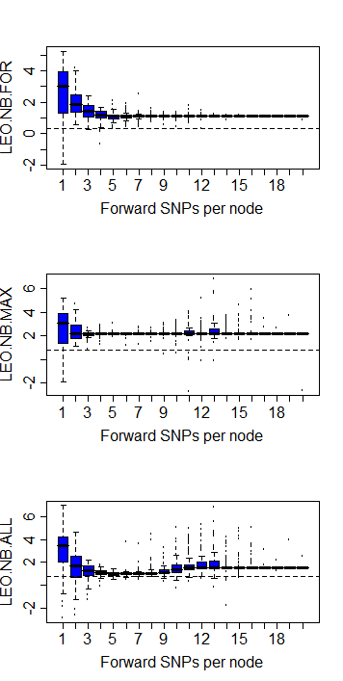

# Now compare to null hypothesis

my.robust.files[16]
# [16] "mc.robust.0a.1b.0causal/r.test.robust.task1.results.100.Mon_Aug_13_05.34.40_2007.rdat"

my.robust.files[15]
my.robust.files[17]

a=load(my.robust.files[16])
the.frames = get.frames(r$greedy.100.causal)

# the.frames = get.frames(r$forward.100.causal)
# the.frames = get.frames(r$greedy.and.forward.100.causal)

rbp3(the.frames$my.LEO.NB.FOR.snp,”LEO.NB.FOR”,.3, xlab="Greedy SNPs per node",col=”blue”)

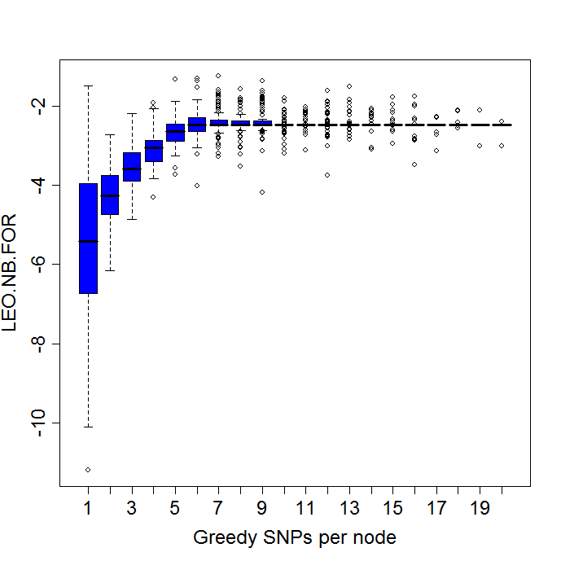

rbp3(the.frames$my.LEO.NB.MAX.snp,”LEO.NB.MAX”,.75, xlab="Greedy SNPs per node",col=”blue”)

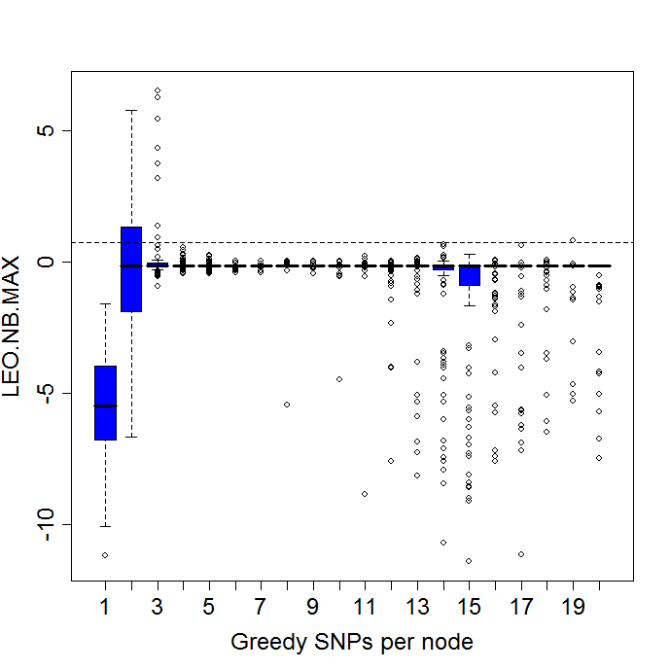

rbp3(the.frames$my.LEO.NB.ALL.snp,”LEO.NB.ALL”,.75, xlab="Greedy SNPs per node",col=”blue”)

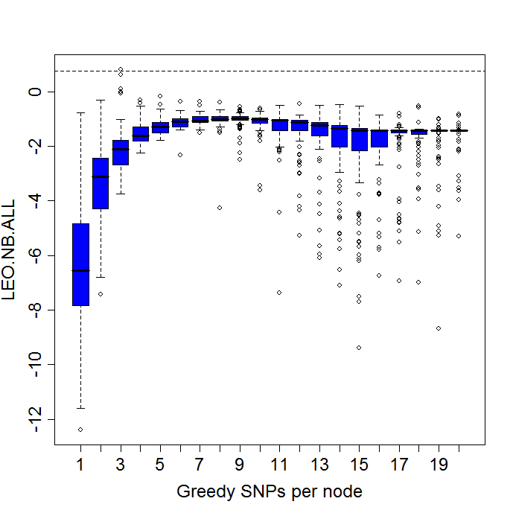

Notice that the LEO.NB.FOR score tends to have a lower median score than the LEO.NB.ALL, suggesting that it will also have a lower false positive rate.

# Adding in the A SNPs: 1 vs. 5: greedy snp selection

#[1]"mc.robust.0a.1b.no.neighbors.1causal/r.test.robust.task1.results.100.Sun_Aug_12_14.56.15_2007.rdat"
#[5] "mc.robust.1a.1b/r.test.robust.task1.results.100.Sun_Aug_12_06.02.53_2007.rdat"

a=load(my.robust.files[1])
r1.the.frames = get.frames(r$greedy.100.causal)

a=load(my.robust.files[5])
r5.the.frames = get.frames(r$greedy.100.causal)

# the.frames = get.frames(r$forward.100.causal)
# the.frames = get.frames(r$greedy.and.forward.100.causal)

par(mfrow=c(1,2))
rbp3(r1.the.frames$my.LEO.NB.FOR.snp,”LEO.NB.FOR”,.3, xlab="Greedy SNPs per node",col=”red”,ylim=c(-1,6))
rbp3(r5.the.frames$my.LEO.NB.FOR.snp,”LEO.NB.FOR”,.3, xlab="Greedy SNPs per node",col=”orange” ,ylim=c(-1,6))

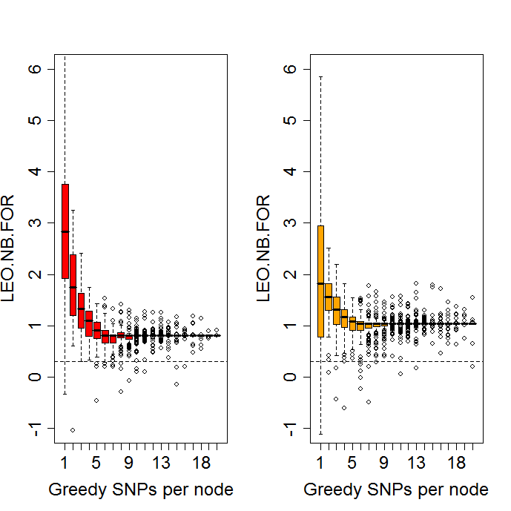

# We note that while the initial score is higher at 1 SNP when no A SNP can be found/is not supplied in the simulated data, the asymptodic score is higher on the right hand, orange box plot, indicating stronger robustness when integrating multiple SNPs.

# Also note that the downward score curve is just the median drop; those scores that start lower will fall below the significance threshold of 0.3 shown as more SNPs are added.

# ROC plotting

a=load(my.robust.files[1])
r.true.pos=r
a=load(my.robust.files[16])
r.true.neg=r

true.pos.frames = get.frames(r.true.pos$greedy.100.causal)
true.neg.frames = get.frames(r.true.neg$greedy.100.causal)

# test:
x.true.pos = true.pos.frames$my.LEO.NB.FOR.snp;
x.true.neg = true.neg.frames$my.LEO.NB.FOR.snp;
stat.name="LEO.NB.FOR"

# plot a histogram
at.snp = 1
my.pos.hist = hist(x.true.pos[,at.snp],breaks=20,xlim=c(-15,10),col="yellow",main=””,xlab=stat.name)
my.neg.hist = hist(x.true.neg[,at.snp],breaks=20,plot=FALSE)
plot(my.neg.hist,add=TRUE,col="blue")
title(paste("True negatives in blue, True positives in yellow\nDensity at SNP”,at.snp))

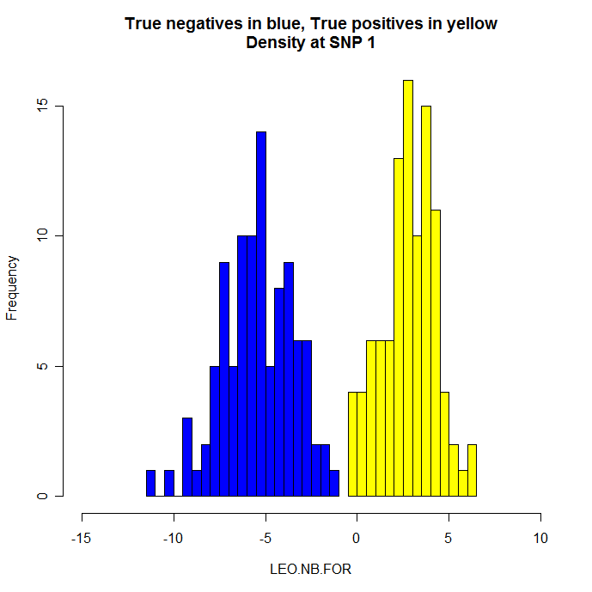

at.snp = 10
my.neg.hist = hist(x.true.neg[,at.snp],breaks=20, xlim=c(-15,10),col="blue",main=””,xlab=stat.name)
my.pos.hist = hist(x.true.pos[,at.snp],breaks=10,plot=FALSE)
plot(my.pos.hist,add=TRUE,col="yellow")
title(paste("True negatives in blue, True positives in yellow\nDensity at SNP”,at.snp))

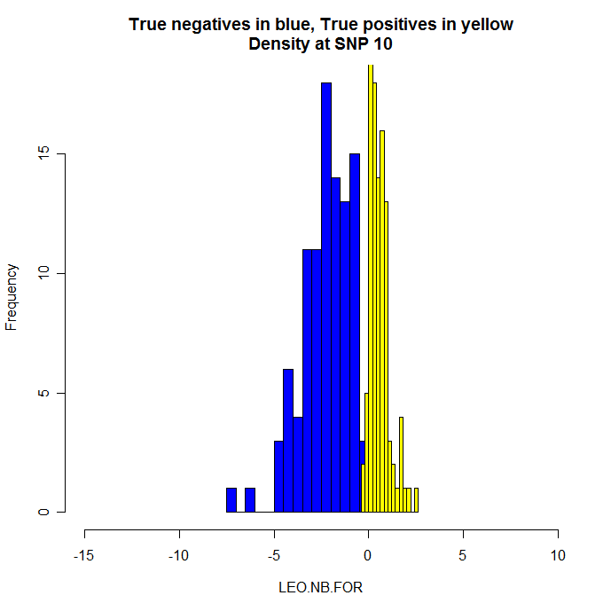

# Comment: much better separation at SNP1--as expected with just one signal SNP/at the # earlier SNP count = 1 distributions. However, the 10 SNP distributions are still fairly well separated. We quantify this separation and the amount of overlap next with the ROC curves.

# generate ROC curve

if (exists("roc.plot")) rm(roc.plot)
roc.plot=function(snp.range=1:20, x.true.pos, x.true.neg,stat.name ,...) {

lower.th.range = round(min(x.true.neg,na.rm=T),digits=1) - .2
upper.th.range = round(max(x.true.pos,na.rm=T),digits=1) + .2
th.range=signif(seq(lower.th.range,upper.th.range,.1),3)

for (i in 1:length(snp.range)) {
num.snp = snp.range[i]

fpr = rep(NA,length(th.range))
power = fpr

k=1
for (th in th.range) {
true.pos = sum(x.true.pos[,num.snp] >= th, na.rm=T)
false.neg = sum(x.true.pos[,num.snp] < th, na.rm=T)

true.neg = sum(x.true.neg[,num.snp] < th, na.rm=T)
false.pos = sum(x.true.neg[,num.snp] >= th, na.rm=T)

total.pos = sum(!is.na(x.true.pos[,num.snp]))
total.neg = sum(!is.na(x.true.neg[,num.snp]))
pwr = true.pos / total.pos

# false pos rate is (rather unintuitively) NOT found by conditioning on
# there being a positive call, but RATHER given
# that we are in the true.negative distribution, how many
# of these truely negative cases are called positive at the
# given threshold.
false.pos.rate = false.pos / (false.pos + true.neg)

fpr[k] = false.pos.rate
power[k] = pwr
k=k+1
}

# locate the lowest threshold for which fpr == 0 (or minimum fpr available)
min.fpr = min(fpr,na.rm=TRUE)
w.min.fpr = which(fpr == min.fpr)
best.fpr.point = min(w.min.fpr)

print(paste(“At SNP “,num.snp,”, Best FPR of “,min.fpr,”at th =”,th.range[best.fpr.point],”; here Power is ”,signif(power[best.fpr.point]),3))

# locate the highest threshold for which power == 1 (or maximum power available)
max.power = max(power,na.rm=TRUE)
w.max.power = which(power == max.power)
best.power.point = max(w.max.power)

print(paste(“At SNP ”,num.snp,“, Best Power of “,max.power,”at th =”,th.range[best.power.point],”; here FPR is ”,signif(fpr[best.power.point]),3))

if (i== 1) {
# pch=22 is square
dv=plot(x=fpr, y=power, ylab=paste(sep="","Power or True positive rate, TP/(TP+FN)"),xlab=paste(sep="","False positive rate, FP/(FP+TN)"), cex.lab = 1.5, cex.axis=1.5,ylim=c(0,1),xlim=c(0,1), pch=22,bg=”yellow”)
lines(x=fpr, y=power)

# show the diagonal no detection power line, for reference
lines(x=c(0,1),y=c(0,1),lty=2)
} else {
points(x=fpr, y=power, pch=21,bg=”green”)
lines(x=fpr, y=power)
}
} # end for i

#points(x.points,score.for,pch=21,bg="red",cex=1.5)

#lines(x.points,score.max)
#points(x.points,score.max,pch=23,cex=1.5,bg="blue") # diamond

#lines(x.points,score.all)
#points(x.points,score.all,pch=22,cex=1.5,bg="yellow") # square

invisible(dv)
}

roc.plot(snp.range=1:20, x.true.pos = true.pos.frames$my.LEO.NB.FOR.snp, x.true.neg = true.neg.frames$my.LEO.NB.FOR.snp, stat.name="LEO.NB.FOR")

# The SNP = 1 ROC curve, for LEO.NB.FOR from
#a=load(my.robust.files[1])
#r.true.pos=r
#a=load(my.robust.files[16])
#r.true.neg=r

At just the first SNP:
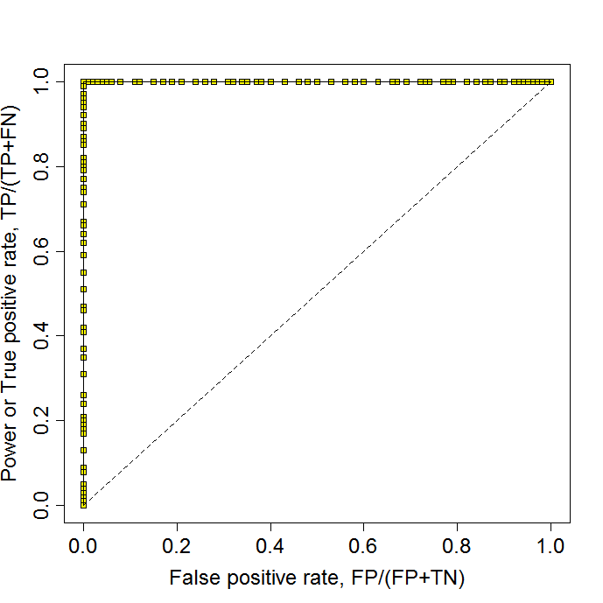

[1] "Best FPR of 0 at th = -1.4 ; here Power is 1"
[1] "Best Power of 1 at th = -0.4 ; here FPR is 0"

# Next graph shows, we don’t get a alot of discrimination between the SNP numbers by this ROC approach. As they all look too good!

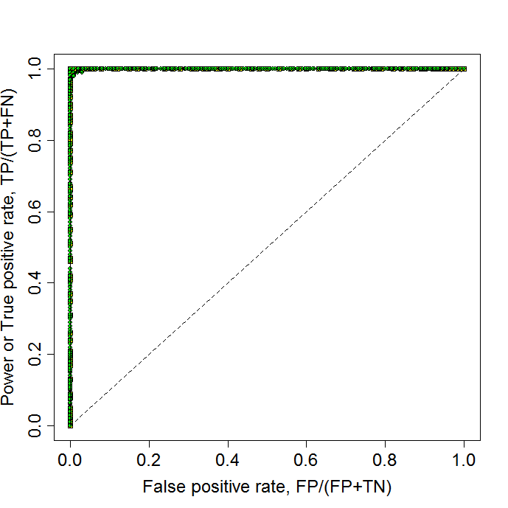

###########################

4 snp simulations

a=load(my.robust.files[21])

the.frames = get.frames(r$forward.100.causal)

# the.frames = get.frames(r$greedy.100.causal)
# the.frames = get.frames(r$greedy.and.forward.100.causal)

rbp3(the.frames$my.LEO.NB.FOR.snp,”LEO.NB.FOR”,.3, xlab="Forward SNPs per node",col=”green”)
rbp3(the.frames$my.LEO.NB.MAX.snp,”LEO.NB.MAX”,.75, xlab="Forward SNPs per node",col=”green”)
rbp3(the.frames$my.LEO.NB.ALL.snp,”LEO.NB.ALL”,.75, xlab="Forward SNPs per node",col=”green”)

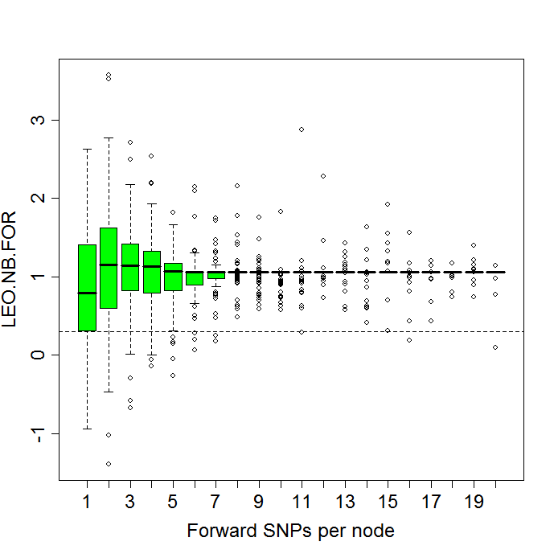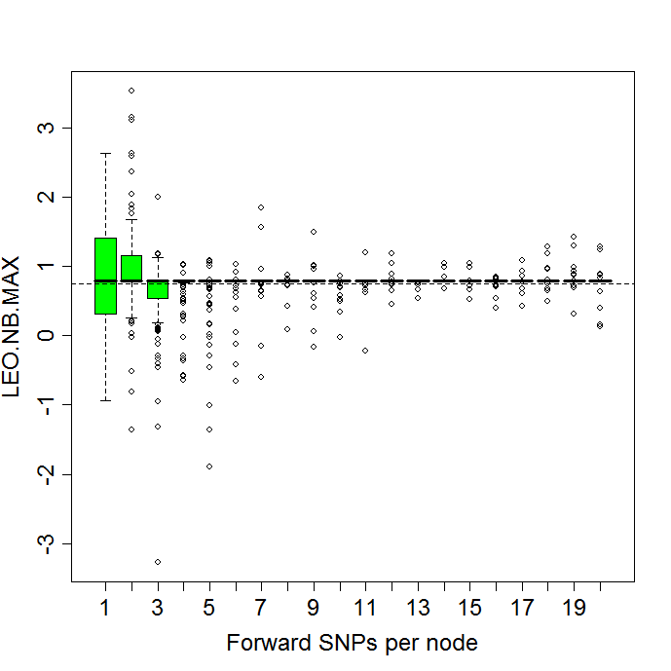

# As expected the single marker max scores are very stable after first choice when there is only one signal SNP.
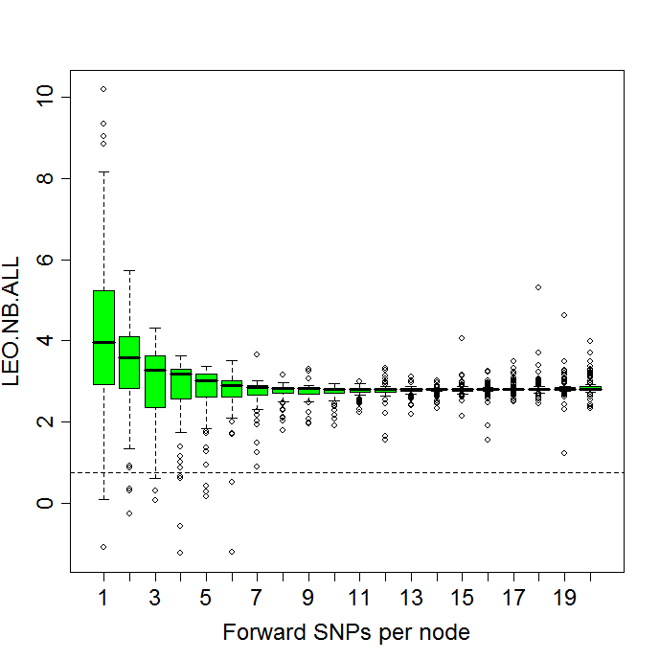

# Observe that the variance of these scores tends to shrink quickly to minimal variation once 10-12 SNPs are incorporated.

a=load(my.robust.files[22])

the.frames = get.frames(r$greedy.100.causal)

# the.frames = get.frames(r$forward.100.causal)
# the.frames = get.frames(r$greedy.and.forward.100.causal)

rbp3(the.frames$my.LEO.NB.FOR.snp,”LEO.NB.FOR”,.3, xlab="Greedy SNPs per node",col=”green”)
rbp3(the.frames$my.LEO.NB.MAX.snp,”LEO.NB.MAX”,.75, xlab="Greedy SNPs per node",col=”green”)
rbp3(the.frames$my.LEO.NB.ALL.snp,”LEO.NB.ALL”,.75, xlab="Greedy SNPs per node",col=”green”)

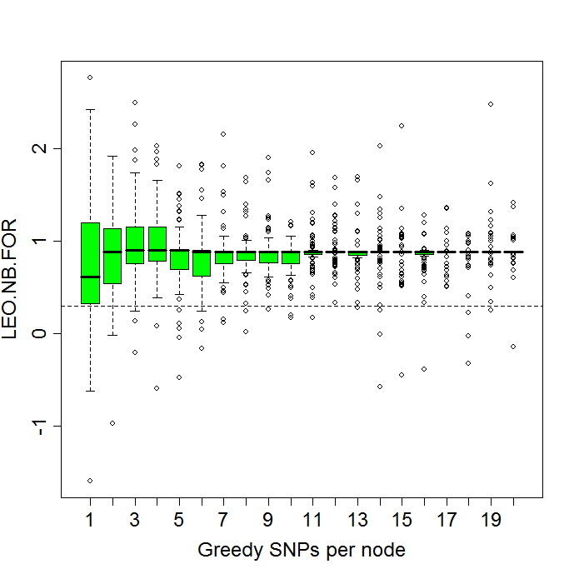

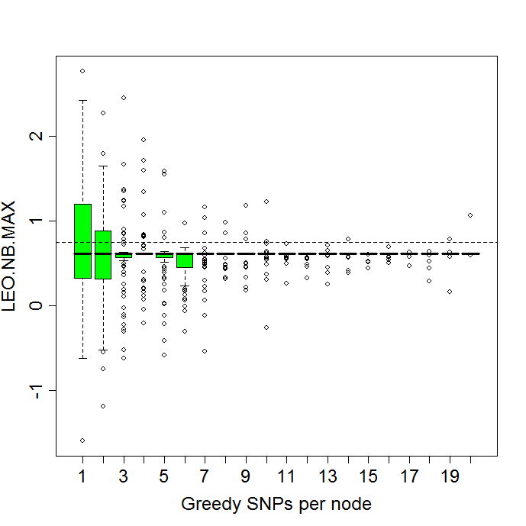

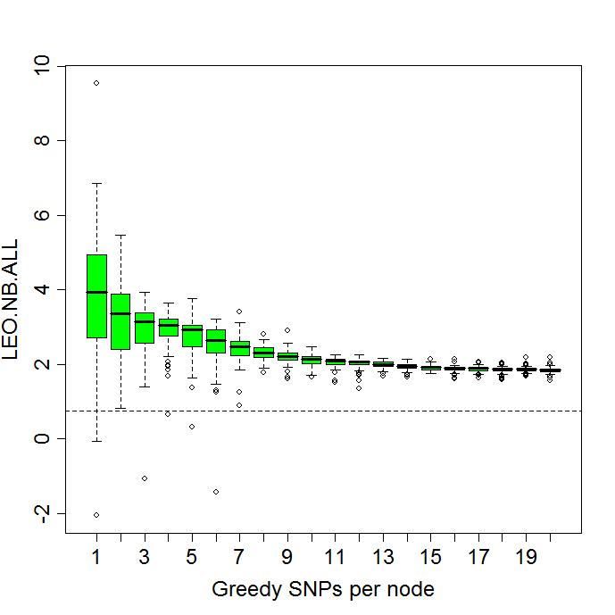

###################
# Now we have more complete files, 27 in total, since the re-done jobs completed.


# list of the directories and files contained therein, organized so task1,2, 3 are in order.

my.27robust.files = c(
"mc.robust.1a.1b/r.test.robust.task1.results.100.Sun_Aug_12_06.02.53_2007.rdat",
"mc.robust.1a.1b/r.test.robust.task2.results.100.Sun_Aug_12_14.38.15_2007.rdat",
"mc.robust.1a.1b/r.test.robust.task3.results.100.Sun_Aug_12_03.30.12_2007.rdat",

"mc.robust.0a.1b.5causal/r.test.robust.task1.results.100.Tue_Aug_14_10.58.51_2007.rdat",
"mc.robust.0a.1b.5causal/r.test.robust.task2.results.100.Sun_Aug_12_16.05.02_2007.rdat",
"mc.robust.0a.1b.5causal/r.test.robust.task3.results.100.Sun_Aug_12_13.23.41_2007.rdat",

"mc.robust.1a.1b.5causal/r.test.robust.task1.results.100.Sun_Aug_12_11.35.58_2007.rdat",
"mc.robust.1a.1b.5causal/r.test.robust.task2.results.100.Sun_Aug_12_08.03.22_2007.rdat",
"mc.robust.1a.1b.5causal/r.test.robust.task3.results.100.Sun_Aug_12_07.16.37_2007.rdat",

"mc.robust.1a.1b.0causal/r.test.robust.task1.results.100.Thu_Aug_16_03.59.40_2007.rdat",
"mc.robust.1a.1b.0causal/r.test.robust.task2.results.100.Sun_Aug_12_14.26.48_2007.rdat",
"mc.robust.1a.1b.0causal/r.test.robust.task3.results.100.Sun_Aug_12_13.12.29_2007.rdat",

"mc.robust.0a.1b.0causal/r.test.robust.task1.results.100.Mon_Aug_13_05.34.40_2007.rdat",
"mc.robust.0a.1b.0causal/r.test.robust.task2.results.100.Sun_Aug_12_11.58.00_2007.rdat",
"mc.robust.0a.1b.0causal/r.test.robust.task3.results.100.Mon_Aug_13_06.48.41_2007.rdat",

"mc.robust.1a.1b.1causal.4an.4bn/r.test.robust.task1.results.100.Mon_Aug_13_18.29.13_2007.rdat",
"mc.robust.1a.1b.1causal.4an.4bn/r.test.robust.task2.results.100.Mon_Aug_13_20.23.08_2007.rdat",
"mc.robust.1a.1b.1causal.4an.4bn/r.test.robust.task3.results.100.Mon_Aug_13_19.32.40_2007.rdat",

"mc.robust.1a.4b.4causal.4an.4bn/r.test.robust.task1.results.100.Tue_Aug_14_21.15.45_2007.rdat",
"mc.robust.1a.4b.4causal.4an.4bn/r.test.robust.task2.results.100.Tue_Aug_14_12.20.56_2007.rdat",
"mc.robust.1a.4b.4causal.4an.4bn/r.test.robust.task3.results.100.Fri_Aug_17_03.38.37_2007.rdat",

"mc.robust.0a.4b.4causal.4an.4bn/r.test.robust.task1.results.100.Tue_Aug_14_14.09.52_2007.rdat",
"mc.robust.0a.4b.4causal.4an.4bn/r.test.robust.task2.results.100.Tue_Aug_14_10.32.41_2007.rdat",
"mc.robust.0a.4b.4causal.4an.4bn/r.test.robust.task3.results.100.Thu_Aug_16_22.19.47_2007.rdat",

"mc.robust.0a.1b.no.neighbors.1causal/r.test.robust.task1.results.100.Sun_Aug_12_14.56.15_2007.rdat",
"mc.robust.0a.1b.no.neighbors.1causal/r.test.robust.task2.results.100.Sun_Aug_12_10.06.59_2007.rdat",
"mc.robust.0a.1b.no.neighbors.1causal/r.test.robust.task3.results.100.Sun_Aug_12_05.28.02_2007.rdat"
)

# Numbered file index
> my.27robust.files
[1] "mc.robust.1a.1b/r.test.robust.task1.results.100.Sun_Aug_12_06.02.53_2007.rdat"
[2] "mc.robust.1a.1b/r.test.robust.task2.results.100.Sun_Aug_12_14.38.15_2007.rdat"
[3] "mc.robust.1a.1b/r.test.robust.task3.results.100.Sun_Aug_12_03.30.12_2007.rdat"

[4] "mc.robust.0a.1b.5causal/r.test.robust.task1.results.100.Tue_Aug_14_10.58.51_2007.rdat"
[5] "mc.robust.0a.1b.5causal/r.test.robust.task2.results.100.Sun_Aug_12_16.05.02_2007.rdat"
[6] "mc.robust.0a.1b.5causal/r.test.robust.task3.results.100.Sun_Aug_12_13.23.41_2007.rdat"

[7] "mc.robust.1a.1b.5causal/r.test.robust.task1.results.100.Sun_Aug_12_11.35.58_2007.rdat"
[8] "mc.robust.1a.1b.5causal/r.test.robust.task2.results.100.Sun_Aug_12_08.03.22_2007.rdat"
[9] "mc.robust.1a.1b.5causal/r.test.robust.task3.results.100.Sun_Aug_12_07.16.37_2007.rdat"

[10] "mc.robust.1a.1b.0causal/r.test.robust.task1.results.100.Thu_Aug_16_03.59.40_2007.rdat"
[11] "mc.robust.1a.1b.0causal/r.test.robust.task2.results.100.Sun_Aug_12_14.26.48_2007.rdat"
[12] "mc.robust.1a.1b.0causal/r.test.robust.task3.results.100.Sun_Aug_12_13.12.29_2007.rdat"

[13] "mc.robust.0a.1b.0causal/r.test.robust.task1.results.100.Mon_Aug_13_05.34.40_2007.rdat"
[14] "mc.robust.0a.1b.0causal/r.test.robust.task2.results.100.Sun_Aug_12_11.58.00_2007.rdat"
[15] "mc.robust.0a.1b.0causal/r.test.robust.task3.results.100.Mon_Aug_13_06.48.41_2007.rdat"

[16] "mc.robust.1a.1b.1causal.4an.4bn/r.test.robust.task1.results.100.Mon_Aug_13_18.29.13_2007.rdat"
[17] "mc.robust.1a.1b.1causal.4an.4bn/r.test.robust.task2.results.100.Mon_Aug_13_20.23.08_2007.rdat"
[18] "mc.robust.1a.1b.1causal.4an.4bn/r.test.robust.task3.results.100.Mon_Aug_13_19.32.40_2007.rdat"

[19] "mc.robust.1a.4b.4causal.4an.4bn/r.test.robust.task1.results.100.Tue_Aug_14_21.15.45_2007.rdat"
[20] "mc.robust.1a.4b.4causal.4an.4bn/r.test.robust.task2.results.100.Tue_Aug_14_12.20.56_2007.rdat"
[21] "mc.robust.1a.4b.4causal.4an.4bn/r.test.robust.task3.results.100.Fri_Aug_17_03.38.37_2007.rdat"

[22] "mc.robust.0a.4b.4causal.4an.4bn/r.test.robust.task1.results.100.Tue_Aug_14_14.09.52_2007.rdat"
[23] "mc.robust.0a.4b.4causal.4an.4bn/r.test.robust.task2.results.100.Tue_Aug_14_10.32.41_2007.rdat"
[24] "mc.robust.0a.4b.4causal.4an.4bn/r.test.robust.task3.results.100.Thu_Aug_16_22.19.47_2007.rdat"

[25] "mc.robust.0a.1b.no.neighbors.1causal/r.test.robust.task1.results.100.Sun_Aug_12_14.56.15_2007.rdat"
[26] "mc.robust.0a.1b.no.neighbors.1causal/r.test.robust.task2.results.100.Sun_Aug_12_10.06.59_2007.rdat"
[27] "mc.robust.0a.1b.no.neighbors.1causal/r.test.robust.task3.results.100.Sun_Aug_12_05.28.02_2007.rdat"

# Key Question: Does the SNP selection methodology variation make any difference?

# If it doesn’t, we can simply combine the 4 snp simulations....
# Of course it will only matter on the 4 snp simulations, because with just one SNP
# the greedy and forward should be grabbing the same best SNP to start with
# so really we have 300 simulations of the same scenario here, which means
# our standard errors of the means will be even tighter.

# But does the SNP selection methodology make a difference in the 4 SNP selection trait,
# and confirm that our expectation above is met by inspecting the data.

# compare:
#my.27robust.files[19]
#my.27robust.files[20]
#my.27robust.files[21]

a=load(my.27robust.files[19])
greedy.frames.1a.4b.4causal.4an.4bn = get.frames(r$greedy.100.causal)

a=load(my.27robust.files[20])
forward.frames.1a.4b.4causal.4an.4bn = get.frames(r$forward.100.causal)

a=load(my.27robust.files[21])
fwd.and.gr.frames.1a.4b.4causal.4an.4bn = get.frames(r$greedy.and.forward.100.causal)

the.frames = greedy.frames.1a.4b.4causal.4an.4bn
par(mfrow=c(2,2))
rbp3(the.frames$my.LEO.NB.FOR.snp,”LEO.NB.FOR”,.3, xlab="Greedy SNPs per node",col=“pink”, ylim=c(-2,4))
rbp3(the.frames$my.LEO.NB.MAX.snp,”LEO.NB.MAX”,.75, xlab="Greedy SNPs per node",col=“pink”, ylim=c(-2,4))
rbp3(the.frames$my.LEO.NB.ALL.snp,”LEO.NB.ALL”,.75, xlab="Greedy SNPs per node",col=“pink”, ylim=c(-2,8))
rbp3(the.frames$ my.LEO.MULTIONE.NB.snp,”LEO.MULTIONE.NB”,.75, xlab="Greedy SNPs per node",col=“pink”, ylim=c(-2,4))

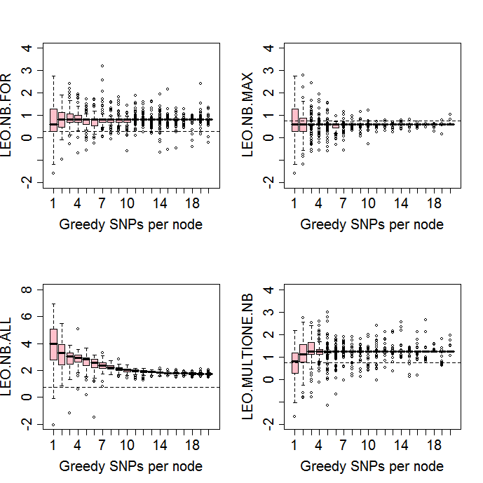

# This is with 4 causal B SNPs, with 1 A SNP, and 4 neighbors per A & B.
# Average behavior here for LEO.NB.ALL is to decline steadily.
# Average behavior here for LEO.NB.FOR is to peak at the addition of 3 or 4 SNPs per node.

the.frames = forward.frames.1a.4b.4causal.4an.4bn
par(mfrow=c(2,2))
rbp3(the.frames$my.LEO.NB.FOR.snp,”LEO.NB.FOR”,.3, xlab="Forward SNPs per node",col=“purple”, ylim=c(-2,4))
rbp3(the.frames$my.LEO.NB.MAX.snp,”LEO.NB.MAX”,.75, xlab="Forward SNPs per node",col=“purple”, ylim=c(-2,4))
rbp3(the.frames$my.LEO.NB.ALL.snp,”LEO.NB.ALL”,.75, xlab="Forward SNPs per node",col=“purple”, ylim=c(-2,8))
rbp3(the.frames$ my.LEO.MULTIONE.NB.snp,”LEO.MULTIONE.NB”,.75, xlab="Forward SNPs per node",col=“purple”, ylim=c(-2,4))

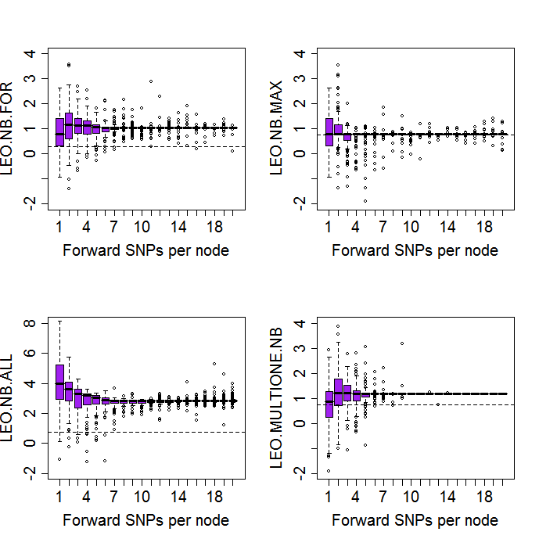

the.frames = fwd.and.gr.frames.1a.4b.4causal.4an.4bn
par(mfrow=c(2,2))
rbp3(the.frames$my.LEO.NB.FOR.snp,”LEO.NB.FOR”,.3, xlab="Greedy & Forward SNPs per node",col=“red”, ylim=c(-2,4))
rbp3(the.frames$my.LEO.NB.MAX.snp,”LEO.NB.MAX”,.75, xlab="Greedy & Forward SNPs per node",col=“red”, ylim=c(-2,4))
rbp3(the.frames$my.LEO.NB.ALL.snp,”LEO.NB.ALL”,.75, xlab="Greedy & Forward SNPs per node",col=“red”, ylim=c(-2,8))
rbp3(the.frames$ my.LEO.MULTIONE.NB.snp,”LEO.MULTIONE.NB”,.75, xlab="Greedy & Forward SNPs per node",col=“red”, ylim=c(-2,4))

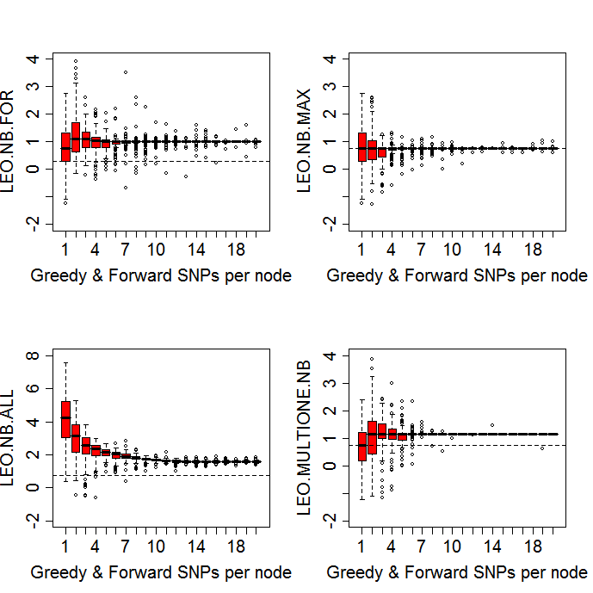

# If there is no difference at the 4 SNP trait and no difference with the single SNP
# trait in terms of Greedy, Forward, and Greedy and Forward SNP selection, then
# we should simply go with the Greedy and Forward selection method for the rest of
# the analyses. But these were not done on the exact same data, but rather different
# simulations; so we don’t know if on the same data set one method performs better
# than another; we instead know if the average performance is different.

# Within each regime, is how do the four methods compare?

# rbp.raw: show the raw stuff that rbp3 makes look pretty
#
# no conditioning on prior values done here...
#
if(exists("rbp.raw") ) rm(rbp.raw);
rbp.raw=function(x,stat.name,th,...) {

for (i in 1:nrow(x)) {
if (i==1) {
dv=plot(x[i,], ylab=stat.name, cex.lab = 1.5, cex.axis=1.5,...)
} else {
lines(x[i,])
}
}
abline(h=th, lty=2) # show our favorite LEO significance threshold

invisible(dv)
}
# for contrast, here is the raw data plotted, where it is hard to see the trend. Same data
# as the red boxes above, upper left corner plot.
the.frames = fwd.and.gr.frames.1a.4b.4causal.4an.4bn
rbp.raw(the.frames$my.LEO.NB.FOR.snp,"LEO.NB.FOR",.3, xlab="Greedy & Forward SNPs per node",col="red", ylim=c(-2,4))
# Without the conditioning on the previous value, i.e. without taking the differences
# we get the raw levels, how often do they dip below the significance threshold?

if (exists(“rbp.no.diff”)) rm(rbp.no.diff)
rbp.no.diff=function(x,stat.name,th,...) {

dv=boxplot(split(x,1:ncol(x)),notch=F,ylab=stat.name,cex.lab = 1.5, cex.names =1.5, cex.axis=1.5, ...)

abline(h=th, lty=2) # show our favorite LEO.NB.FOR significance threshold

invisible(dv)
}

the.frames = fwd.and.gr.frames.1a.4b.4causal.4an.4bn
rbp.no.diff(the.frames$my.LEO.NB.FOR.snp,"LEO.NB.FOR",.3, xlab="Greedy & Forward SNPs per node",col="turquoise", ylim=c(-2,4))

# We do note that the peak at 4 SNPs takes all of our scores above the significance threshold of 0.3.
# This corresponds to the simulation being of a 4 SNP trait.
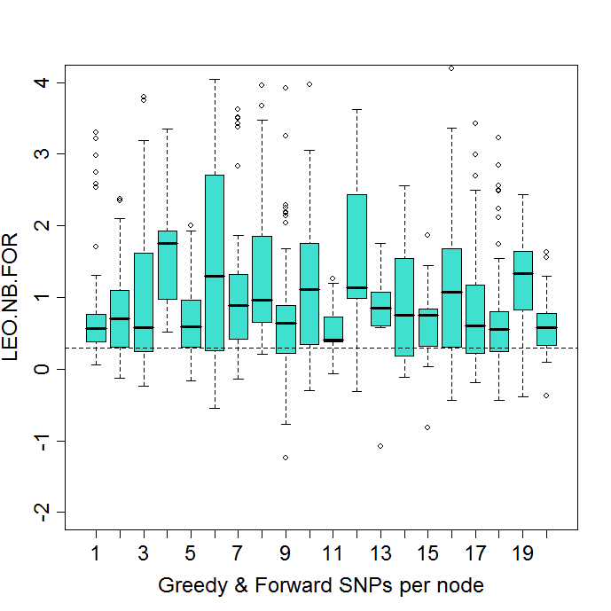

#########################
#

par(mfrow=c(2,2))
rbp.no.diff(the.frames$my.LEO.NB.FOR.snp,”LEO.NB.FOR”,.3, xlab="Greedy & Forward SNPs per node",col=“turquoise”, ylim=c(-2,4))
rbp.no.diff(the.frames$my.LEO.NB.MAX.snp,”LEO.NB.MAX”,.75, xlab="Greedy & Forward SNPs per node",col=“turquoise”, ylim=c(-2,4))
rbp.no.diff(the.frames$my.LEO.NB.ALL.snp,”LEO.NB.ALL”,.75, xlab="Greedy & Forward SNPs per node",col=“turquoise”, ylim=c(-2,8))
rbp.no.diff(the.frames$ my.LEO.MULTIONE.NB.snp,”LEO.MULTIONE.NB”,.75, xlab="Greedy & Forward SNPs per node",col=“turquoise”, ylim=c(-2,4))

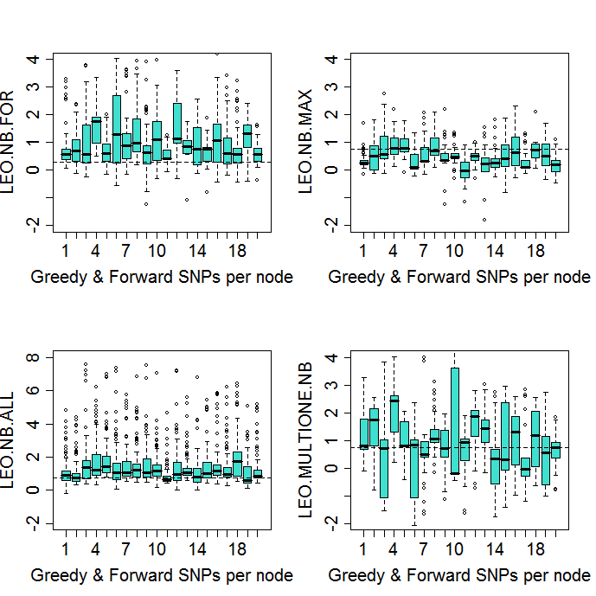

# Here the LEO.NB.MAX single-marker based scores do not obtain significance at all until 4 SNPs are allowed to be selected.

Question one: What are good significance thresholds for the

LEO.NB.FOR, LEO.NB.MAX, LEO.NB.ALL scores?

Earlier studies shown in Figure 4:

Question two: What is our statistical power to detect a given

signal at a fixed false positive rate, and what would be that

false positive rate and power at various heritabilities and SNP

distributions?

Question three: Do the Greedy/Forward/Greedy and Forward SNP

selection methods make a difference?

Question four: How does adding additional SNPs beyond the signal

SNPs affect the test conclusions? Do we overfit, and/or is one method, such as the LEO.NB.FOR method, (we suspect) may be more resistant to the addition of the extra noise SNPs than the LEO.NB.ALL method? i.e. What happens as we add SNPs after we’ve incorporated all the signal SNPs for a particular trait?

Figure 4 from the paper:

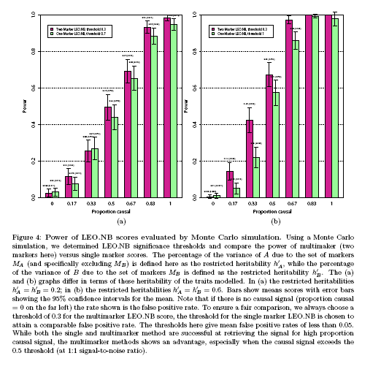

### two functions used to summarize the robustness data files: compute.leo.stats() and summarize.robust.analysis.files()

#################### compute stats

compute.leo.stats = function(LEO.NB.FOR, LEO.NB.ALL, LEO.NB.MAX, LEO.MULTIONE.NB, SIMPLE.MAX.MAX) {

LEO.NB.FOR.mean = mean(LEO.NB.FOR,na.rm=T)
LEO.NB.ALL.mean = mean(LEO.NB.ALL,na.rm=T)
LEO.NB.MAX.mean = mean(LEO.NB.MAX,na.rm=T)
LEO.MULTIONE.NB.mean = mean(LEO.MULTIONE.NB,na.rm=T)
SIMPLE.MAX.MAX.mean = mean(SIMPLE.MAX.MAX,na.rm=T)

LEO.NB.FOR.se = stderr1(LEO.NB.FOR)
LEO.NB.ALL.se = stderr1(LEO.NB.ALL)
LEO.NB.MAX.se = stderr1(LEO.NB.MAX)
LEO.MULTIONE.NB.se = stderr1(LEO.MULTIONE.NB)
SIMPLE.MAX.MAX.se = stderr1(SIMPLE.MAX.MAX)

LEO.NB.FOR.sd = sd(LEO.NB.FOR,na.rm=T)
LEO.NB.ALL.sd = sd(LEO.NB.ALL,na.rm=T)
LEO.NB.MAX.sd = sd(LEO.NB.MAX,na.rm=T)
LEO.MULTIONE.NB.sd = sd(LEO.MULTIONE.NB,na.rm=T)
SIMPLE.MAX.MAX.sd = sd(SIMPLE.MAX.MAX,na.rm=T)

####################

LEO.NB.FOR.mean = mean(LEO.NB.FOR,na.rm=T)
LEO.NB.ALL.mean = mean(LEO.NB.ALL,na.rm=T)
LEO.NB.MAX.mean = mean(LEO.NB.MAX,na.rm=T)
LEO.MULTIONE.NB.mean = mean(LEO.MULTIONE.NB,na.rm=T)
SIMPLE.MAX.MAX.mean = mean(SIMPLE.MAX.MAX,na.rm=T)

LEO.NB.FOR.se = stderr1(LEO.NB.FOR)
LEO.NB.ALL.se = stderr1(LEO.NB.ALL)
LEO.NB.MAX.se = stderr1(LEO.NB.MAX)
LEO.MULTIONE.NB.se = stderr1(LEO.MULTIONE.NB)
SIMPLE.MAX.MAX.se = stderr1(SIMPLE.MAX.MAX)

LEO.NB.FOR.sd = sd(LEO.NB.FOR,na.rm=T)
LEO.NB.ALL.sd = sd(LEO.NB.ALL,na.rm=T)
LEO.NB.MAX.sd = sd(LEO.NB.MAX,na.rm=T)
LEO.MULTIONE.NB.sd = sd(LEO.MULTIONE.NB,na.rm=T)
SIMPLE.MAX.MAX.sd = sd(SIMPLE.MAX.MAX,na.rm=T)

data.frame(LEO.NB.FOR.mean, LEO.NB.FOR.se, LEO.NB.FOR.sd, LEO.NB.ALL.mean, LEO.NB.ALL.se, LEO.NB.ALL.sd, LEO.NB.MAX.mean, LEO.NB.MAX.se, LEO.NB.MAX.sd, LEO.MULTIONE.NB.mean, LEO.MULTIONE.NB.se, LEO.MULTIONE.NB.sd, SIMPLE.MAX.MAX.mean, SIMPLE.MAX.MAX.se, SIMPLE.MAX.MAX.sd)
} # end compute.leo.stats

summarize.robust.analysis.files = function(my.27robust.files,f1,f2,f3,snp.number) {

load(my.27robust.files[f1]) # r
greedy.frames = get.frames(r$greedy.100.causal)

load(my.27robust.files[f2])
forward.frames = get.frames(r$forward.100.causal)

load(my.27robust.files[f3])
fwd.and.gr.frames = get.frames(r$greedy.and.forward.100.causal)

# get the first SNP of each.
LEO.NB.FOR = c(greedy.frames$my.LEO.NB.FOR.snp[,snp.number],forward.frames$my.LEO.NB.FOR.snp[,snp.number],fwd.and.gr.frames$my.LEO.NB.FOR.snp[,snp.number])
LEO.NB.ALL = c(greedy.frames$my.LEO.NB.ALL.snp[,snp.number],forward.frames$my.LEO.NB.ALL.snp[,snp.number],fwd.and.gr.frames$my.LEO.NB.ALL.snp[,snp.number])
LEO.NB.MAX = c(greedy.frames$my.LEO.NB.MAX.snp[,snp.number],forward.frames$my.LEO.NB.MAX.snp[,snp.number],fwd.and.gr.frames$my.LEO.NB.MAX.snp[,snp.number])
LEO.MULTIONE.NB = c(greedy.frames$my.LEO.MULTIONE.NB.snp[,snp.number],forward.frames$my.LEO.MULTIONE.NB.snp[,snp.number],fwd.and.gr.frames$my.LEO.MULTIONE.NB.snp[,snp.number])
SIMPLE.MAX.MAX = c(greedy.frames$my.SIMPLE.MAX.MAX.snp[,snp.number],forward.frames$my.SIMPLE.MAX.MAX.snp[,snp.number],fwd.and.gr.frames$my.SIMPLE.MAX.MAX.snp[,snp.number])

x = compute.leo.stats(LEO.NB.FOR, LEO.NB.ALL, LEO.NB.MAX, LEO.MULTIONE.NB, SIMPLE.MAX.MAX)
x
} # end summarize.robust.analysis.files

# Numbered file index
# > my.27robust.files
# [1] "mc.robust.1a.1b/r.test.robust.task1.results.100.Sun_Aug_12_06.02.53_2007.rdat"
# [2] "mc.robust.1a.1b/r.test.robust.task2.results.100.Sun_Aug_12_14.38.15_2007.rdat"
# [3] "mc.robust.1a.1b/r.test.robust.task3.results.100.Sun_Aug_12_03.30.12_2007.rdat"
#
# [4] "mc.robust.0a.1b.5causal/r.test.robust.task1.results.100.Tue_Aug_14_10.58.51_2007.rdat"
# [5] "mc.robust.0a.1b.5causal/r.test.robust.task2.results.100.Sun_Aug_12_16.05.02_2007.rdat"
# [6] "mc.robust.0a.1b.5causal/r.test.robust.task3.results.100.Sun_Aug_12_13.23.41_2007.rdat"
#
# [7] "mc.robust.1a.1b.5causal/r.test.robust.task1.results.100.Sun_Aug_12_11.35.58_2007.rdat"
# [8] "mc.robust.1a.1b.5causal/r.test.robust.task2.results.100.Sun_Aug_12_08.03.22_2007.rdat"
# [9] "mc.robust.1a.1b.5causal/r.test.robust.task3.results.100.Sun_Aug_12_07.16.37_2007.rdat"
#
# [10] "mc.robust.1a.1b.0causal/r.test.robust.task1.results.100.Thu_Aug_16_03.59.40_2007.rdat"
# [11] "mc.robust.1a.1b.0causal/r.test.robust.task2.results.100.Sun_Aug_12_14.26.48_2007.rdat"
# [12] "mc.robust.1a.1b.0causal/r.test.robust.task3.results.100.Sun_Aug_12_13.12.29_2007.rdat"
#
# [13] "mc.robust.0a.1b.0causal/r.test.robust.task1.results.100.Mon_Aug_13_05.34.40_2007.rdat"
# [14] "mc.robust.0a.1b.0causal/r.test.robust.task2.results.100.Sun_Aug_12_11.58.00_2007.rdat"
# [15] "mc.robust.0a.1b.0causal/r.test.robust.task3.results.100.Mon_Aug_13_06.48.41_2007.rdat"
#
# [16] "mc.robust.1a.1b.1causal.4an.4bn/r.test.robust.task1.results.100.Mon_Aug_13_18.29.13_2007.rdat"
# [17] "mc.robust.1a.1b.1causal.4an.4bn/r.test.robust.task2.results.100.Mon_Aug_13_20.23.08_2007.rdat"
# [18] "mc.robust.1a.1b.1causal.4an.4bn/r.test.robust.task3.results.100.Mon_Aug_13_19.32.40_2007.rdat"
#
# [19] "mc.robust.1a.4b.4causal.4an.4bn/r.test.robust.task1.results.100.Tue_Aug_14_21.15.45_2007.rdat"
# [20] "mc.robust.1a.4b.4causal.4an.4bn/r.test.robust.task2.results.100.Tue_Aug_14_12.20.56_2007.rdat"
# [21] "mc.robust.1a.4b.4causal.4an.4bn/r.test.robust.task3.results.100.Fri_Aug_17_03.38.37_2007.rdat"
#
# [22] "mc.robust.0a.4b.4causal.4an.4bn/r.test.robust.task1.results.100.Tue_Aug_14_14.09.52_2007.rdat"
# [23] "mc.robust.0a.4b.4causal.4an.4bn/r.test.robust.task2.results.100.Tue_Aug_14_10.32.41_2007.rdat"
# [24] "mc.robust.0a.4b.4causal.4an.4bn/r.test.robust.task3.results.100.Thu_Aug_16_22.19.47_2007.rdat"
#
# [25] "mc.robust.0a.1b.no.neighbors.1causal/r.test.robust.task1.results.100.Sun_Aug_12_14.56.15_2007.rdat"
# [26] "mc.robust.0a.1b.no.neighbors.1causal/r.test.robust.task2.results.100.Sun_Aug_12_10.06.59_2007.rdat"
# [27] "mc.robust.0a.1b.no.neighbors.1causal/r.test.robust.task3.results.100.Sun_Aug_12_05.28.02_2007.rdat"

# 1a.1b 100% causal, no neighbors,
x.1.2.3 = summarize.robust.analysis.files(my.27robust.files, 1,2,3,snp.number=1)
x.4.5.6 = summarize.robust.analysis.files(my.27robust.files,4,5,6,snp.number=1)
x.7.8.9 = summarize.robust.analysis.files(my.27robust.files,7,8,9,snp.number=1)
x.10.11.12 = summarize.robust.analysis.files(my.27robust.files,10,11,12,snp.number=1)
x.13.14.15 = summarize.robust.analysis.files(my.27robust.files,13,14,15,snp.number=1)
x.16.17.18 = summarize.robust.analysis.files(my.27robust.files,16,17,18,snp.number=1)
x.25.26.27 = summarize.robust.analysis.files(my.27robust.files, 25,26,27,snp.number=1)

df= rbind(x.1.2.3, x.4.5.6, x.7.8.9, x.10.11.12, x.13.14.15, x.16.17.18, x.25.26.27)
rownames(df) = c("1a.1b.100","0a.1b.50","1a.1b.50","1a.1b.0causal","0a.1b.0causal","1a.1b.100.4an.4bn","0a.1b.100")

# get a better row order
df2 = df[c(4,3,1,6,5,2,7),]
write.csv(df2,file="single.snp.robustness.analysis.17aug2007.csv")

# See this Excel spreadsheet for the source of the computation of the 5% False positive rate and the power.
# And the Single SNP signal and null results are summarized from the Excel sheet into the following tables in the paper.
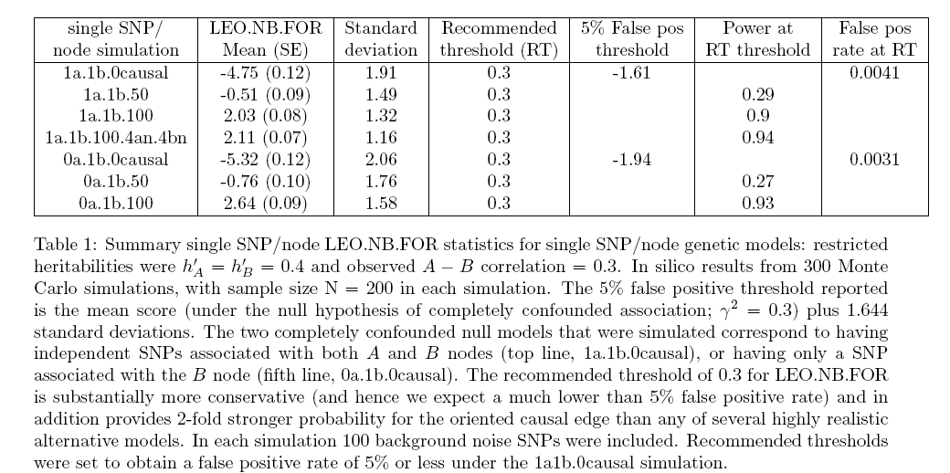

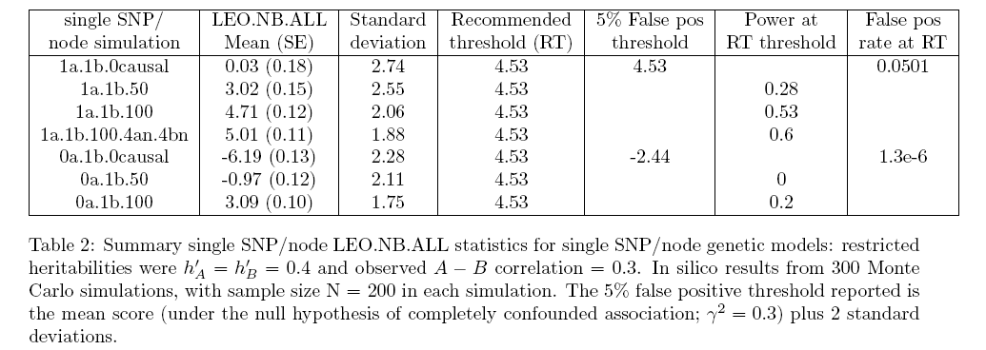

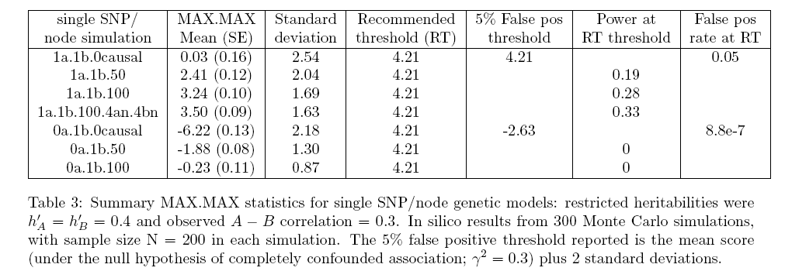

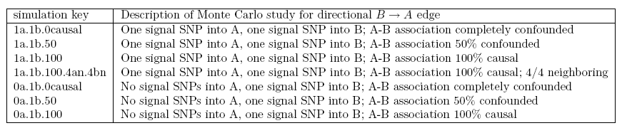
# Look at the null models more. In particular, what happens when we keep adding noise SNPs.

f1=10
f2=11
f3=12

load(my.27robust.files[f1]) # r
greedy.frames = get.frames(r$greedy.100.causal)

load(my.27robust.files[f2])
forward.frames = get.frames(r$forward.100.causal)

load(my.27robust.files[f3])
fwd.and.gr.frames = get.frames(r$greedy.and.forward.100.causal)

# make barplots with the mean score + sd, fp rate and power

rbp.barplot=function(x,stat.name,th,...) {

dv=boxplot(split(x,1:ncol(x)),notch=F,ylab=stat.name,cex.lab = 1.5, cex.names =1.5, cex.axis=1.5, ...)

abline(h=th, lty=2) # show our favorite LEO.NB.FOR significance threshold

invisible(dv)
}

rbp3(the.frames$my.LEO.NB.FOR.snp,”LEO.NB.FOR”,.3, xlab="Greedy SNPs per node",col=”blue”)

######

# null study

f1=10
f2=11
f3=12

load(my.27robust.files[f1]) # r
greedy.frames = get.frames(r$greedy.100.causal)

load(my.27robust.files[f2])
forward.frames = get.frames(r$forward.100.causal)

load(my.27robust.files[f3])
fwd.and.gr.frames = get.frames(r$greedy.and.forward.100.causal)

x=list()
for (snp.number in 1:20) {
LEO.NB.FOR = c(greedy.frames$my.LEO.NB.FOR.snp[,snp.number])
LEO.NB.ALL = c(greedy.frames$my.LEO.NB.ALL.snp[,snp.number])
LEO.NB.MAX = c(greedy.frames$my.LEO.NB.MAX.snp[,snp.number])
LEO.MULTIONE.NB = c(greedy.frames$my.LEO.MULTIONE.NB.snp[,snp.number])
SIMPLE.MAX.MAX = c(greedy.frames$my.SIMPLE.MAX.MAX.snp[,snp.number])

x[[snp.number]] = compute.leo.stats(LEO.NB.FOR, LEO.NB.ALL, LEO.NB.MAX, LEO.MULTIONE.NB, SIMPLE.MAX.MAX)
}

# plot each statistic under the null hypothesis

for.mean = sapply(x, function(x) x$LEO.NB.FOR.mean)
for.sd = sapply(x, function(x) x$LEO.NB.FOR.sd)
names(for.mean)=names(for.sd)=paste(1:20)

barplot2(for.mean,plot.ci=T, ci.l=for.mean - for.sd/10, ci.u=for.mean+for.sd/10,xlab="Greedy SNPs",ylab="LEO.NB.FOR, under Null",cex.axis=1.5,cex.names=1.5,cex.lab=1.5,ylim=c(-6,1),)
box()

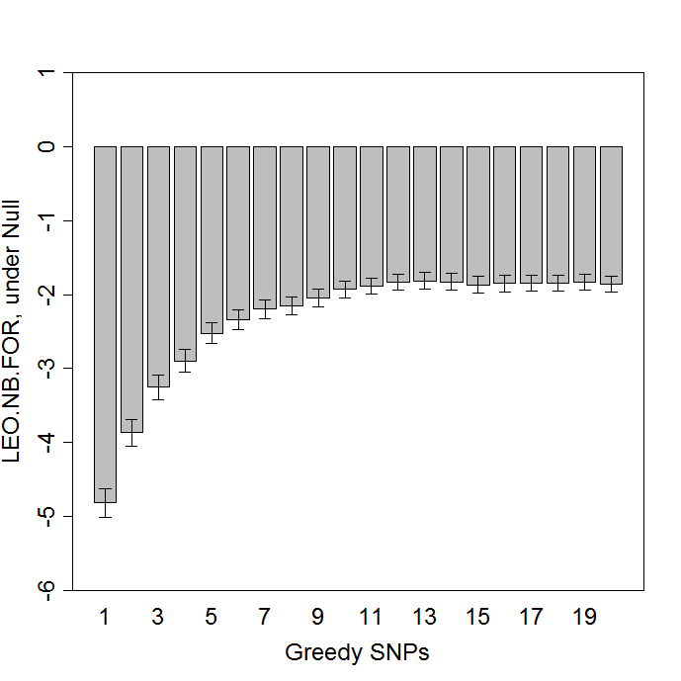

barplot2(for.sd, xlab="Greedy SNPs",ylab="StdDev of LEO.NB.FOR, under Null",cex.axis=1.5,cex.names=1.5,cex.lab=1.5,ylim=c(0,3))
box()

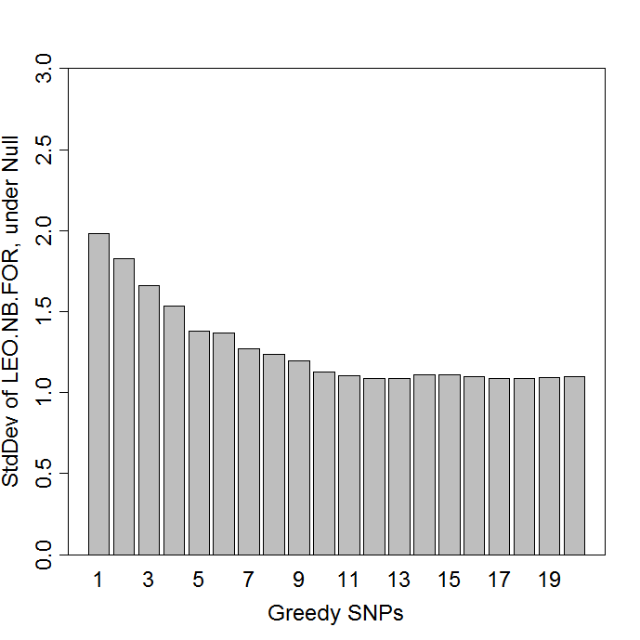

th = .3
zscore = (th - for.mean) / for.sd
for.fp = pnorm(zscore,lower.tail=FALSE)

all.mean = sapply(x, function(x) x$LEO.NB.ALL.mean)
all.sd = sapply(x, function(x) x$LEO.NB.ALL.sd)
names(all.mean)=names(all.sd)=paste(1:20)

# what choice of TH keeps the FP rate below 5% here...

th.all = 3.5
zscore.all = (th.all - all.mean) / all.sd
all.fp = pnorm(zscore.all,lower.tail=FALSE)

barplot2(all.mean,plot.ci=T, ci.l=all.mean - all.sd/10, ci.u=all.mean+all.sd/10 ,ylim=c(-.7,.5),xlab="Greedy SNPs",ylab="LEO.NB.ALL, under Null",cex.axis=1.5,cex.names=1.5,cex.lab=1.5)
box()
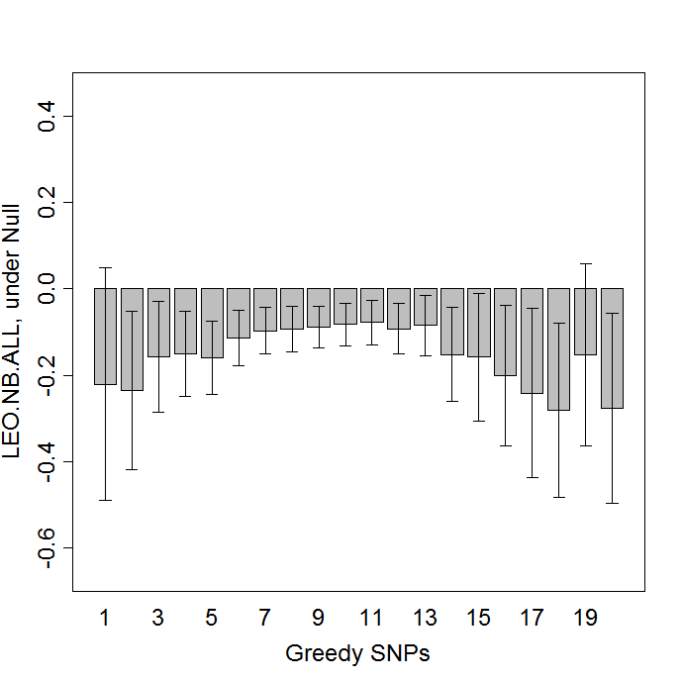

## LOOKs like about –0.1 is a reasonable conclusion for the null value of LEO.NB.ALL
## then what is its sd?

barplot2(all.sd, xlab="Greedy SNPs",ylab="StdDev of LEO.NB.ALL, under Null",cex.axis=1.5,cex.names=1.5,cex.lab=1.5,ylim=c(0,3))
box()

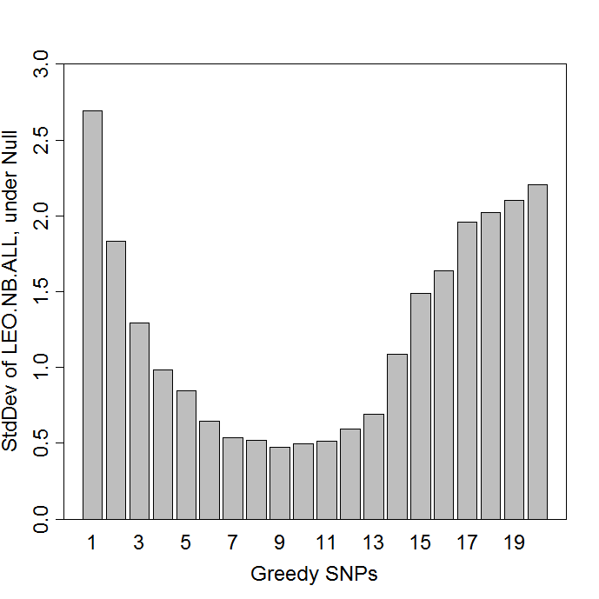

# As more and more garbage gets added, eventually the StdDev of LEO.NB.ALL starts
# to blow up again, after shrinking for a while. Odd. Is this just variance inflation?

# Remind ourselves that LEO.NB.MAX really uses a very similar strategy to LEO.NB.FOR, and
# LEO.NB.MAX at present is selecting that max from the best LEO.O score—a vestigial feature from
# the first implementation a long time ago. Let us contrast our LEO.NB.FOR and LEO.NB.ALL to the
# SIMPLE.MAX.MAX which is an understandable and readily available simple contrast.

# Analyze MAX.MAX under Single SNP NULL.

f1=10
f2=11
f3=12

load(my.27robust.files[f1]) # r
greedy.frames = get.frames(r$greedy.100.causal)

load(my.27robust.files[f2])
forward.frames = get.frames(r$forward.100.causal)

load(my.27robust.files[f3])
fwd.and.gr.frames = get.frames(r$greedy.and.forward.100.causal)

x=list()
for (snp.number in 1:20) {
LEO.NB.FOR = c(greedy.frames$my.LEO.NB.FOR.snp[,snp.number])
LEO.NB.ALL = c(greedy.frames$my.LEO.NB.ALL.snp[,snp.number])
LEO.NB.MAX = c(greedy.frames$my.LEO.NB.MAX.snp[,snp.number])
LEO.MULTIONE.NB = c(greedy.frames$my.LEO.MULTIONE.NB.snp[,snp.number])
SIMPLE.MAX.MAX = c(greedy.frames$my.SIMPLE.MAX.MAX.snp[,snp.number])

x[[snp.number]] = compute.leo.stats(LEO.NB.FOR, LEO.NB.ALL, LEO.NB.MAX, LEO.MULTIONE.NB, SIMPLE.MAX.MAX)
}

smaxmax.mean = sapply(x, function(x) x$SIMPLE.MAX.MAX.mean)
smaxmax.sd = sapply(x, function(x) x$SIMPLE.MAX.MAX.sd)
names(smaxmax.mean)=names(smaxmax.sd)=paste(1:20)

barplot2(smaxmax.mean,plot.ci=T, ci.l=smaxmax.mean - smaxmax.sd/10, ci.u=smaxmax.mean+smaxmax.sd/10 ,ylim=c(-.7,.5),xlab="Greedy SNPs",ylab="MAX.MAX, under Null",cex.axis=1.5,cex.names=1.5,cex.lab=1.5)
box()

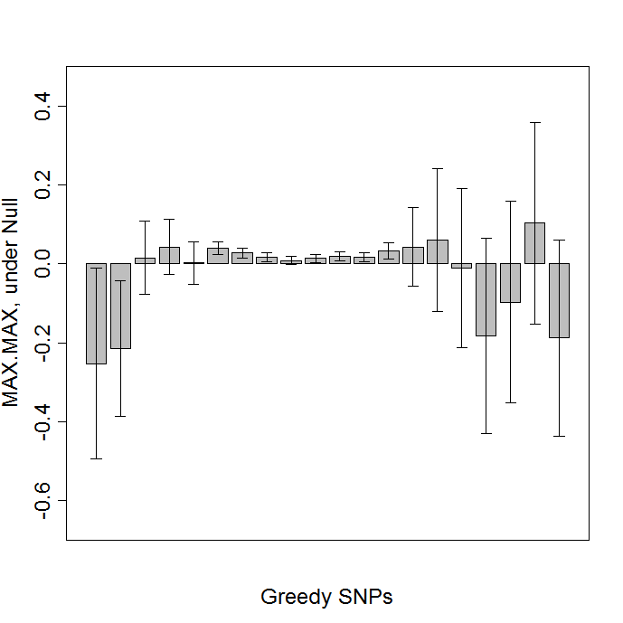

barplot2(all.sd, xlab="Greedy SNPs",ylab="StdDev of MAX.MAX, under Null",cex.axis=1.5,cex.names=1.5,cex.lab=1.5,ylim=c(0,3))
box()
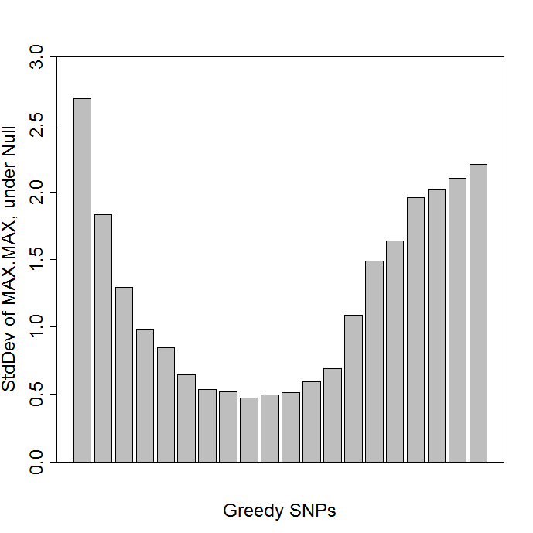

# Now analyze and compare FOR, MAX.MAX, ALL, and LEO.NB.MAX under
# the 4 SNP model as to the choice of Greedy, Forward and Greedy&Forward selection
# methodology

############################
# start new analysis of the 4 snp scenario
# [19] "mc.robust.1a.4b.4causal.4an.4bn/r.test.robust.task1.results.100.Tue_Aug_14_21.15.45_2007.rdat"
# [20] "mc.robust.1a.4b.4causal.4an.4bn/r.test.robust.task2.results.100.Tue_Aug_14_12.20.56_2007.rdat"
# [21] "mc.robust.1a.4b.4causal.4an.4bn/r.test.robust.task3.results.100.Fri_Aug_17_03.38.37_2007.rdat"
############################

f1=19
f2=20
f3=21

load(my.27robust.files[f1]) # r
greedy.frames = get.frames(r$greedy.100.causal)

load(my.27robust.files[f2])
forward.frames = get.frames(r$forward.100.causal)

load(my.27robust.files[f3])
fwd.and.gr.frames = get.frames(r$greedy.and.forward.100.causal)

x=list()
for (snp.number in 1:20) {
LEO.NB.FOR = c(greedy.frames$my.LEO.NB.FOR.snp[,snp.number])
LEO.NB.ALL = c(greedy.frames$my.LEO.NB.ALL.snp[,snp.number])
LEO.NB.MAX = c(greedy.frames$my.LEO.NB.MAX.snp[,snp.number])
LEO.MULTIONE.NB = c(greedy.frames$my.LEO.MULTIONE.NB.snp[,snp.number])
SIMPLE.MAX.MAX = c(greedy.frames$my.SIMPLE.MAX.MAX.snp[,snp.number])

x[[snp.number]] = compute.leo.stats(LEO.NB.FOR, LEO.NB.ALL, LEO.NB.MAX, LEO.MULTIONE.NB, SIMPLE.MAX.MAX)
}

gr.smaxmax.mean = sapply(x, function(x) x$SIMPLE.MAX.MAX.mean)
gr.smaxmax.sd = sapply(x, function(x) x$SIMPLE.MAX.MAX.sd)
names(gr.smaxmax.mean)=names(gr.smaxmax.sd)=paste(1:20)

gr.all.mean = sapply(x, function(x) x$LEO.NB.ALL.mean)
gr.all.sd = sapply(x, function(x) x$LEO.NB.ALL.sd)
names(gr.all.mean)=names(gr.all.sd)=paste(1:20)

gr.for.mean = sapply(x, function(x) x$LEO.NB.FOR.mean)
gr.for.sd = sapply(x, function(x) x$LEO.NB.FOR.sd)
names(gr.for.mean)=names(gr.for.sd)=paste(1:20)

gr.multione.mean = sapply(x, function(x) x$LEO.MULTIONE.NB.mean)
gr.multione.sd = sapply(x, function(x) x$LEO.MULTIONE.NB.sd)
names(gr.multione.mean)=names(gr.multione.sd)=paste(1:20)

### forward

x=list()
for (snp.number in 1:20) {
LEO.NB.FOR = c(forward.frames$my.LEO.NB.FOR.snp[,snp.number])
LEO.NB.ALL = c(forward.frames$my.LEO.NB.ALL.snp[,snp.number])
LEO.NB.MAX = c(forward.frames$my.LEO.NB.MAX.snp[,snp.number])
LEO.MULTIONE.NB = c(forward.frames$my.LEO.MULTIONE.NB.snp[,snp.number])
SIMPLE.MAX.MAX = c(forward.frames$my.SIMPLE.MAX.MAX.snp[,snp.number])

x[[snp.number]] = compute.leo.stats(LEO.NB.FOR, LEO.NB.ALL, LEO.NB.MAX, LEO.MULTIONE.NB, SIMPLE.MAX.MAX)
}

fw.smaxmax.mean = sapply(x, function(x) x$SIMPLE.MAX.MAX.mean)
fw.smaxmax.sd = sapply(x, function(x) x$SIMPLE.MAX.MAX.sd)
names(fw.smaxmax.mean)=names(fw.smaxmax.sd)=paste(1:20)

fw.all.mean = sapply(x, function(x) x$LEO.NB.ALL.mean)
fw.all.sd = sapply(x, function(x) x$LEO.NB.ALL.sd)
names(fw.all.mean)=names(fw.all.sd)=paste(1:20)

fw.for.mean = sapply(x, function(x) x$LEO.NB.FOR.mean)
fw.for.sd = sapply(x, function(x) x$LEO.NB.FOR.sd)
names(fw.for.mean)=names(fw.for.sd)=paste(1:20)

fw.multione.mean = sapply(x, function(x) x$LEO.MULTIONE.NB.mean)
fw.multione.sd = sapply(x, function(x) x$LEO.MULTIONE.NB.sd)
names(fw.multione.mean)=names(fw.multione.sd)=paste(1:20)

### forward and greedy: fwd.and.gr.frames

x=list()
for (snp.number in 1:20) {
LEO.NB.FOR = c(fwd.and.gr.frames$my.LEO.NB.FOR.snp[,snp.number])
LEO.NB.ALL = c(fwd.and.gr.frames$my.LEO.NB.ALL.snp[,snp.number])
LEO.NB.MAX = c(fwd.and.gr.frames$my.LEO.NB.MAX.snp[,snp.number])
LEO.MULTIONE.NB = c(fwd.and.gr.frames$my.LEO.MULTIONE.NB.snp[,snp.number])
SIMPLE.MAX.MAX = c(fwd.and.gr.frames$my.SIMPLE.MAX.MAX.snp[,snp.number])

x[[snp.number]] = compute.leo.stats(LEO.NB.FOR, LEO.NB.ALL, LEO.NB.MAX, LEO.MULTIONE.NB, SIMPLE.MAX.MAX)
}

fg.smaxmax.mean = sapply(x, function(x) x$SIMPLE.MAX.MAX.mean)
fg.smaxmax.sd = sapply(x, function(x) x$SIMPLE.MAX.MAX.sd)
names(fg.smaxmax.mean)=names(fg.smaxmax.sd)=paste(1:20)

fg.all.mean = sapply(x, function(x) x$LEO.NB.ALL.mean)
fg.all.sd = sapply(x, function(x) x$LEO.NB.ALL.sd)
names(fg.all.mean)=names(fg.all.sd)=paste(1:20)

fg.for.mean = sapply(x, function(x) x$LEO.NB.FOR.mean)
fg.for.sd = sapply(x, function(x) x$LEO.NB.FOR.sd)
names(fg.for.mean)=names(fg.for.sd)=paste(1:20)

fg.multione.mean = sapply(x, function(x) x$LEO.MULTIONE.NB.mean)
fg.multione.sd = sapply(x, function(x) x$LEO.MULTIONE.NB.sd)
names(fg.multione.mean)=names(fg.for.sd)=paste(1:20)

# plot LEO.NB.FOR
for.mean.3 = rbind(gr.for.mean, fw.for.mean, fg.for.mean)
for.3.ci.l = rbind(gr.for.mean - gr.for.sd/10, fw.for.mean - fw.for.sd/10, fg.for.mean - fg.for.sd/10)
for.3.ci.u = rbind(gr.for.mean + gr.for.sd/10, fw.for.mean + fw.for.sd/10, fg.for.mean + fg.for.sd/10)
rownames(for.3.ci.l) = rownames(for.mean.3)
rownames(for.3.ci.u) = rownames(for.mean.3)

barplot2(for.mean.3,plot.ci=T, ci.l=for.3.ci.l, ci.u=for.3.ci.u,xlab="Number of SNPs",ylab="LEO.NB.FOR scoring a 4 SNP trait",cex.axis=1.5,cex.names=1.5,cex.lab=1.5,beside=T,ylim=c(0,1.5),col=heat.colors(3))
box()
legend(36,1.4, c("Greedy SNP selection","Forward SNP selection", "Forward & Greedy SNP selection"), fill = heat.colors(3))
abline(h=0.3,lty=2)

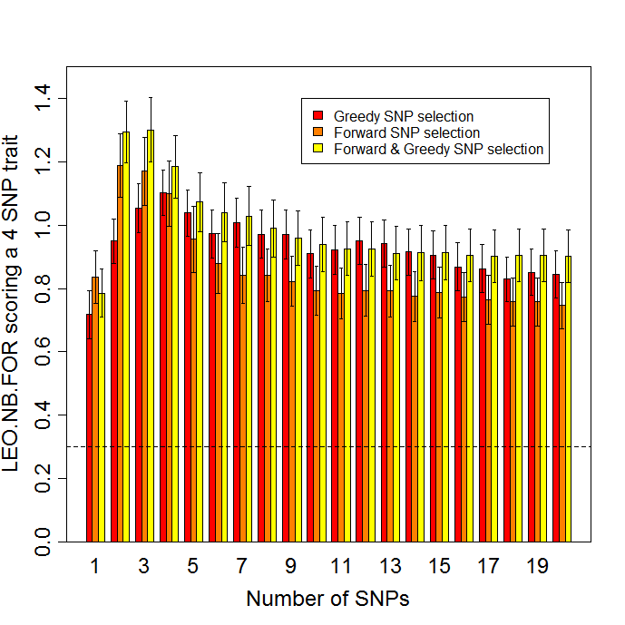
# model was: 1a.4b.4causal.4an.4bn, error bars show SE of the mean, mean of 100 simulations shown.
# Dottted line shows 0.3 significance threshold.

# Also saved as postscript file: c:/good/aggregation.titration.leo.nb.for.20aug2007.ps

# plot LEO.MULTIONE.NB

multione.mean.3 = rbind(gr.multione.mean, fw.multione.mean, fg.multione.mean)
multione.3.ci.l = rbind(gr.multione.mean - gr.multione.sd/10, fw.multione.mean - fw.multione.sd/10, fg.multione.mean - fg.multione.sd/10)
multione.3.ci.u = rbind(gr.multione.mean + gr.multione.sd/10, fw.multione.mean + fw.multione.sd/10, fg.multione.mean + fg.multione.sd/10)
rownames(multione.3.ci.l) = rownames(multione.mean.3)
rownames(multione.3.ci.u) = rownames(multione.mean.3)

barplot2(multione.mean.3,plot.ci=T, ci.l=multione.3.ci.l, ci.u=multione.3.ci.u,xlab="Number of SNPs",ylab=”CPA.FOR scoring a 4 SNP trait",cex.axis=1.5,cex.names=1.5,cex.lab=1.5,beside=T,ylim=c(0,2),col=heat.colors(3))
box()
legend(38.6,1.77, c("Greedy SNP selection","Forward SNP selection", "Forward & Greedy SNP selection"), fill = heat.colors(3))
abline(h=0.3,lty=2)

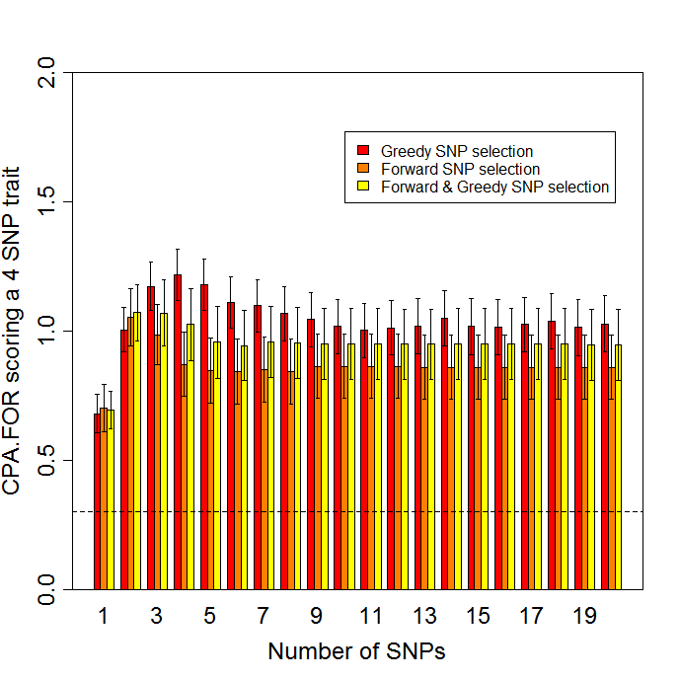
c:/good/aggregation.titration.cpa.3sept2007.ps

# plot LEO.NB.ALL

all.mean.3 = rbind(gr.all.mean, fw.all.mean, fg.all.mean)
all.3.ci.l = rbind(gr.all.mean - gr.all.sd/10, fw.all.mean - fw.all.sd/10, fg.all.mean - fg.all.sd/10)
all.3.ci.u = rbind(gr.all.mean + gr.all.sd/10, fw.all.mean + fw.all.sd/10, fg.all.mean + fg.all.sd/10)
rownames(all.3.ci.l) = rownames(all.mean.3)
rownames(all.3.ci.u) = rownames(all.mean.3)

barplot2(all.mean.3,plot.ci=T, ci.l=all.3.ci.l, ci.u=all.3.ci.u,xlab="Number of SNPs",ylab="LEO.NB.ALL scoring a 4 SNP trait",cex.axis=1.5,cex.names=1.5,cex.lab=1.5,beside=T,ylim=c(0,4.6),col=heat.colors(3))
box()
legend(33,3.6, c("Greedy SNP selection","Forward SNP selection", "Forward & Greedy SNP selection"), fill = heat.colors(3))
abline(h=4.53,lty=2)

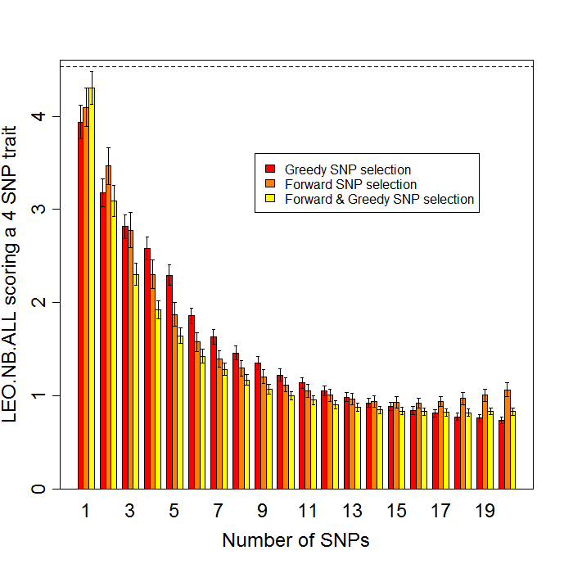
# Showing the 4.53 significance threshold.
# Also saved as postscript file: c:/good/aggregation.titration.leo.nb.all.20aug2007.ps

# plot simple MAX.MAX

smaxmax.mean.3 = rbind(gr.smaxmax.mean, fw.smaxmax.mean, fg.smaxmax.mean)
smaxmax.3.ci.l = rbind(gr.smaxmax.mean - gr.smaxmax.sd/10, fw.smaxmax.mean - fw.smaxmax.sd/10, fg.smaxmax.mean - fg.smaxmax.sd/10)
smaxmax.3.ci.u = rbind(gr.smaxmax.mean + gr.smaxmax.sd/10, fw.smaxmax.mean + fw.smaxmax.sd/10, fg.smaxmax.mean + fg.smaxmax.sd/10)
rownames(smaxmax.3.ci.l) = rownames(smaxmax.mean.3)
rownames(smaxmax.3.ci.u) = rownames(smaxmax.mean.3)

barplot2(smaxmax.mean.3,plot.ci=T, ci.l=smaxmax.3.ci.l, ci.u=smaxmax.3.ci.u,xlab="Number of SNPs",ylab="MAX.MAX scoring a 4 SNP trait",cex.axis=1.5,cex.names=1.5,cex.lab=1.5,beside=T,col=heat.colors(3),ylim=c(0,5))
box()
legend(31,3, c("Greedy SNP selection","Forward SNP selection", "Forward & Greedy SNP selection"), fill = heat.colors(3))
abline(h=4.21,lty=2)

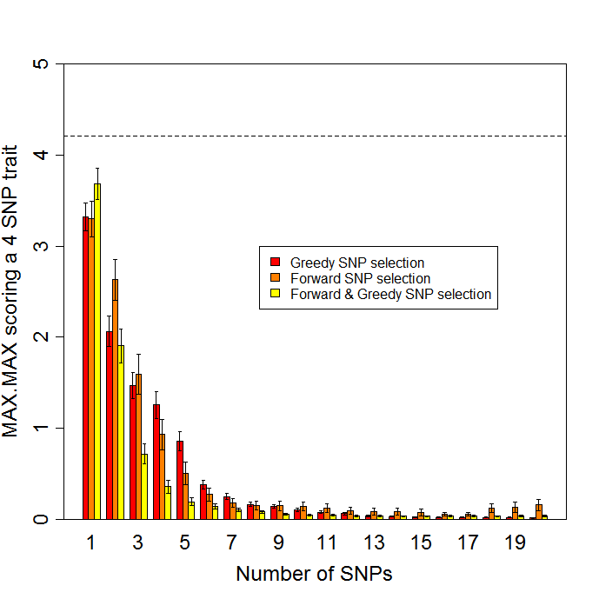
# Showing the 4.21 significance threshold.
# Also saved as postscript file: c:/good/aggregation.titration.maxmax.20aug2007.ps

# Repeat for the Null model titrations, just to visualize the Tables results.

############################
# start new analysis of the Null model 100% confounding, to show the SNP titrations...
# [10] "mc.robust.1a.1b.0causal/r.test.robust.task1.results.100.Thu_Aug_16_03.59.40_2007.rdat"
# [11] "mc.robust.1a.1b.0causal/r.test.robust.task2.results.100.Sun_Aug_12_14.26.48_2007.rdat"
# [12] "mc.robust.1a.1b.0causal/r.test.robust.task3.results.100.Sun_Aug_12_13.12.29_2007.rdat"
############################

f1=10
f2=11
f3=12

load(my.27robust.files[f1]) # r
greedy.frames = get.frames(r$greedy.100.causal)

load(my.27robust.files[f2])
forward.frames = get.frames(r$forward.100.causal)

load(my.27robust.files[f3])
fwd.and.gr.frames = get.frames(r$greedy.and.forward.100.causal)

x=list()
for (snp.number in 1:20) {
LEO.NB.FOR = c(greedy.frames$my.LEO.NB.FOR.snp[,snp.number])
LEO.NB.ALL = c(greedy.frames$my.LEO.NB.ALL.snp[,snp.number])
LEO.NB.MAX = c(greedy.frames$my.LEO.NB.MAX.snp[,snp.number])
LEO.MULTIONE.NB = c(greedy.frames$my.LEO.MULTIONE.NB.snp[,snp.number])
SIMPLE.MAX.MAX = c(greedy.frames$my.SIMPLE.MAX.MAX.snp[,snp.number])

x[[snp.number]] = compute.leo.stats(LEO.NB.FOR, LEO.NB.ALL, LEO.NB.MAX, LEO.MULTIONE.NB, SIMPLE.MAX.MAX)
}

gr.smaxmax.mean = sapply(x, function(x) x$SIMPLE.MAX.MAX.mean)
gr.smaxmax.sd = sapply(x, function(x) x$SIMPLE.MAX.MAX.sd)
names(gr.smaxmax.mean)=names(gr.smaxmax.sd)=paste(1:20)

gr.all.mean = sapply(x, function(x) x$LEO.NB.ALL.mean)
gr.all.sd = sapply(x, function(x) x$LEO.NB.ALL.sd)
names(gr.all.mean)=names(gr.all.sd)=paste(1:20)

gr.for.mean = sapply(x, function(x) x$LEO.NB.FOR.mean)
gr.for.sd = sapply(x, function(x) x$LEO.NB.FOR.sd)
names(gr.for.mean)=names(gr.for.sd)=paste(1:20)

### forward

x=list()
for (snp.number in 1:20) {
LEO.NB.FOR = c(forward.frames$my.LEO.NB.FOR.snp[,snp.number])
LEO.NB.ALL = c(forward.frames$my.LEO.NB.ALL.snp[,snp.number])
LEO.NB.MAX = c(forward.frames$my.LEO.NB.MAX.snp[,snp.number])
LEO.MULTIONE.NB = c(forward.frames$my.LEO.MULTIONE.NB.snp[,snp.number])
SIMPLE.MAX.MAX = c(forward.frames$my.SIMPLE.MAX.MAX.snp[,snp.number])

x[[snp.number]] = compute.leo.stats(LEO.NB.FOR, LEO.NB.ALL, LEO.NB.MAX, LEO.MULTIONE.NB, SIMPLE.MAX.MAX)
}

fw.smaxmax.mean = sapply(x, function(x) x$SIMPLE.MAX.MAX.mean)
fw.smaxmax.sd = sapply(x, function(x) x$SIMPLE.MAX.MAX.sd)
names(fw.smaxmax.mean)=names(fw.smaxmax.sd)=paste(1:20)

fw.all.mean = sapply(x, function(x) x$LEO.NB.ALL.mean)
fw.all.sd = sapply(x, function(x) x$LEO.NB.ALL.sd)
names(fw.all.mean)=names(fw.all.sd)=paste(1:20)

fw.for.mean = sapply(x, function(x) x$LEO.NB.FOR.mean)
fw.for.sd = sapply(x, function(x) x$LEO.NB.FOR.sd)
names(fw.for.mean)=names(fw.for.sd)=paste(1:20)

### forward and greedy: fwd.and.gr.frames

x=list()
for (snp.number in 1:20) {
LEO.NB.FOR = c(fwd.and.gr.frames$my.LEO.NB.FOR.snp[,snp.number])
LEO.NB.ALL = c(fwd.and.gr.frames$my.LEO.NB.ALL.snp[,snp.number])
LEO.NB.MAX = c(fwd.and.gr.frames$my.LEO.NB.MAX.snp[,snp.number])
LEO.MULTIONE.NB = c(fwd.and.gr.frames$my.LEO.MULTIONE.NB.snp[,snp.number])
SIMPLE.MAX.MAX = c(fwd.and.gr.frames$my.SIMPLE.MAX.MAX.snp[,snp.number])

x[[snp.number]] = compute.leo.stats(LEO.NB.FOR, LEO.NB.ALL, LEO.NB.MAX, LEO.MULTIONE.NB, SIMPLE.MAX.MAX)
}

fg.smaxmax.mean = sapply(x, function(x) x$SIMPLE.MAX.MAX.mean)
fg.smaxmax.sd = sapply(x, function(x) x$SIMPLE.MAX.MAX.sd)
names(fg.smaxmax.mean)=names(fg.smaxmax.sd)=paste(1:20)

fg.all.mean = sapply(x, function(x) x$LEO.NB.ALL.mean)
fg.all.sd = sapply(x, function(x) x$LEO.NB.ALL.sd)
names(fg.all.mean)=names(fg.all.sd)=paste(1:20)

fg.for.mean = sapply(x, function(x) x$LEO.NB.FOR.mean)
fg.for.sd = sapply(x, function(x) x$LEO.NB.FOR.sd)
names(fg.for.mean)=names(fg.for.sd)=paste(1:20)

# plot LEO.NB.FOR

for.mean.3 = rbind(gr.for.mean, fw.for.mean, fg.for.mean)
for.3.ci.l = rbind(gr.for.mean - gr.for.sd/10, fw.for.mean - fw.for.sd/10, fg.for.mean - fg.for.sd/10)
for.3.ci.u = rbind(gr.for.mean + gr.for.sd/10, fw.for.mean + fw.for.sd/10, fg.for.mean + fg.for.sd/10)
rownames(for.3.ci.l) = rownames(for.mean.3)
rownames(for.3.ci.u) = rownames(for.mean.3)

barplot2(for.mean.3,plot.ci=T, ci.l=for.3.ci.l, ci.u=for.3.ci.u,xlab="Number of SNPs",ylab="LEO.NB.FOR scoring a 100% confounded model",cex.axis=1.5,cex.names=1.5,cex.lab=1.5,beside=T,ylim=c(-5.5,1),col=heat.colors(3))
box()
legend(36,-3.6, c("Greedy SNP selection","Forward SNP selection", "Forward & Greedy SNP selection"), fill = heat.colors(3))
abline(h=0.3,lty=2)

# plot LEO.NB.ALL

all.mean.3 = rbind(gr.all.mean, fw.all.mean, fg.all.mean)
all.3.ci.l = rbind(gr.all.mean - gr.all.sd/10, fw.all.mean - fw.all.sd/10, fg.all.mean - fg.all.sd/10)
all.3.ci.u = rbind(gr.all.mean + gr.all.sd/10, fw.all.mean + fw.all.sd/10, fg.all.mean + fg.all.sd/10)
rownames(all.3.ci.l) = rownames(all.mean.3)
rownames(all.3.ci.u) = rownames(all.mean.3)

barplot2(all.mean.3,plot.ci=T, ci.l=all.3.ci.l, ci.u=all.3.ci.u,xlab="Number of SNPs",ylab="LEO.NB.ALL scoring a 100% confounded model",cex.axis=1.5,cex.names=1.5,cex.lab=1.5,beside=T,ylim=c(-1,1),col=heat.colors(3))
box()
legend(25,-.5, c("Greedy SNP selection","Forward SNP selection", "Forward & Greedy SNP selection"), fill = heat.colors(3))
abline(h=4.53,lty=2)

# simple MAX.MAX

smaxmax.mean.3 = rbind(gr.smaxmax.mean, fw.smaxmax.mean, fg.smaxmax.mean)
smaxmax.3.ci.l = rbind(gr.smaxmax.mean - gr.smaxmax.sd/10, fw.smaxmax.mean - fw.smaxmax.sd/10, fg.smaxmax.mean - fg.smaxmax.sd/10)
smaxmax.3.ci.u = rbind(gr.smaxmax.mean + gr.smaxmax.sd/10, fw.smaxmax.mean + fw.smaxmax.sd/10, fg.smaxmax.mean + fg.smaxmax.sd/10)
rownames(smaxmax.3.ci.l) = rownames(smaxmax.mean.3)
rownames(smaxmax.3.ci.u) = rownames(smaxmax.mean.3)

barplot2(smaxmax.mean.3,plot.ci=T, ci.l=smaxmax.3.ci.l, ci.u=smaxmax.3.ci.u,xlab="Number of SNPs",ylab="MAX.MAX scoring a 100% confounded model",cex.axis=1.5,cex.names=1.5,cex.lab=1.5,beside=T,ylim=c(-1,1),col=heat.colors(3))
box()
legend(26,-.6, c("Greedy SNP selection","Forward SNP selection", "Forward & Greedy SNP selection"), fill = heat.colors(3))
abline(h=4.21,lty=2)

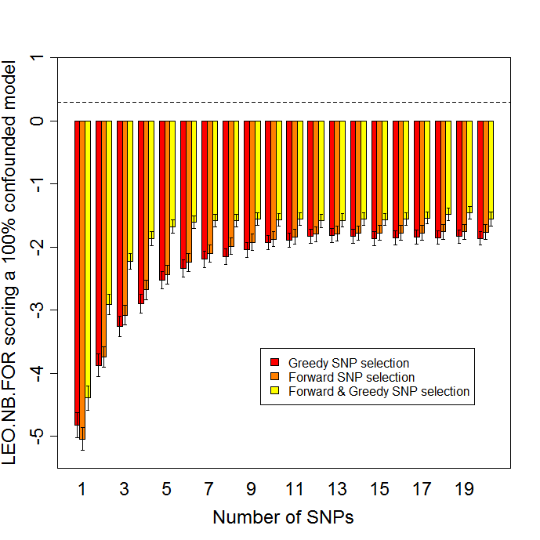
Postscript: aggregation.titration.leo.nb.for.1a1b.0causal.20aug2007.ps

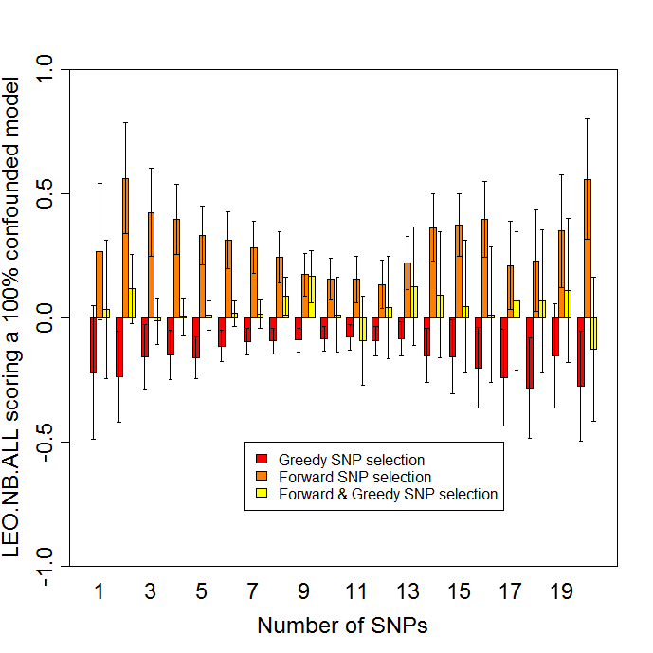
# Postscript: aggregation.titration.leo.nb.all.1a1b.0causal.20aug2007.ps

# even under the NULL model the selection criterion show group differences....odd. The means are not completely significantly different at 1st SNP, which is what counts...but the variances are much tighter around the one SNP selection method...so to give the ALL strategy the best shot it can take, we should give it the Greedy SNP selection since that shows the lowest scores under the NULL, and re-do the Single SNP spreadsheet analysis of what the Recommended Threshold should be.

# Now it is clear that the SWOOPing pattern in the ALL StdDev under the NULL is due to the Forward SNP selection pattern.

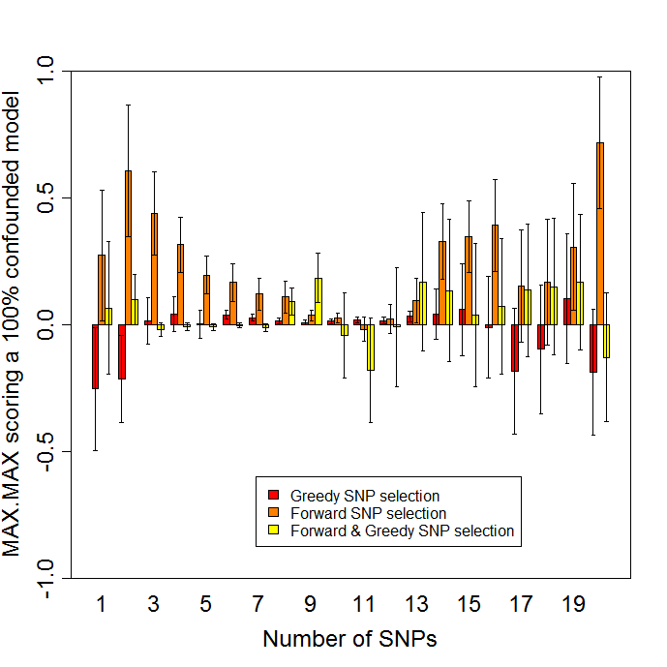

# Postscript: aggregation.titration.maxmax.1a1b.0causal.20aug2007.ps

# Perhaps we should also redo the MAX.MAX analysis, using just the Greedy SNP selection method, since it seems to be producing the lowest scores here at the first SNP...which is likely just do to sampling variation, since the Forward and Greedy and combined should be all choosing just the best SNP at the 1 SNP point.

# what is the Distribution of LEO.NB.ALL under just the Greedy—does it really have that big an SD?
# Yes:
> snp.number=1
> f1
[1] 10
> LEO.NB.ALL = c(greedy.frames$my.LEO.NB.ALL.snp[,snp.number])
> str(LEO.NB.ALL)
Named num [1:100] 2.39 2.12 -0.958 1.01 4.9 -0.706 NA -2.31 NA 0.328 ...
- attr(*, "names")= chr [1:100] "rep.1" "rep.2" "rep.3" "rep.4" ...
> LEO.NB.ALL
rep.1 rep.2 rep.3 rep.4 rep.5 rep.6 rep.7 rep.8 rep.9 rep.10
2.3900 2.1200 -0.9580 1.0100 4.9000 -0.7060 NA -2.3100 NA 0.3280
rep.11 rep.12 rep.13 rep.14 rep.15 rep.16 rep.17 rep.18 rep.19 rep.20
-4.8000 5.8000 -3.3400 -3.2500 NA 3.1800 -0.3640 -2.0600 2.8600 NA
rep.21 rep.22 rep.23 rep.24 rep.25 rep.26 rep.27 rep.28 rep.29 rep.30
NA 0.5690 -2.0900 0.7140 NA 1.7400 0.6260 NA 0.9510 -1.6800
rep.31 rep.32 rep.33 rep.34 rep.35 rep.36 rep.37 rep.38 rep.39 rep.40
3.3700 -0.6680 -1.0800 NA -1.3300 -0.3120 0.6900 -1.4900 4.1600 NA
rep.41 rep.42 rep.43 rep.44 rep.45 rep.46 rep.47 rep.48 rep.49 rep.50
NA -2.5200 -1.7000 NA -2.1600 NA -3.8700 NA -0.5440 NA
rep.51 rep.52 rep.53 rep.54 rep.55 rep.56 rep.57 rep.58 rep.59 rep.60
-4.6800 0.3420 -2.0600 -0.8160 2.4500 1.5400 -1.8700 -2.6400 2.3300 -1.0700
rep.61 rep.62 rep.63 rep.64 rep.65 rep.66 rep.67 rep.68 rep.69 rep.70
0.4940 0.9890 NA -0.5260 -4.0600 -0.2380 -1.8300 -0.8620 -2.1500 -0.9470
rep.71 rep.72 rep.73 rep.74 rep.75 rep.76 rep.77 rep.78 rep.79 rep.80
-2.5200 -1.9400 4.7500 -2.1100 -4.7900 -1.0100 -1.3200 2.1200 1.5100 0.5740
rep.81 rep.82 rep.83 rep.84 rep.85 rep.86 rep.87 rep.88 rep.89 rep.90
NA 0.0307 5.2500 NA 2.8200 0.7360 -0.5780 NA -4.7400 -5.1300
rep.91 rep.92 rep.93 rep.94 rep.95 rep.96 rep.97 rep.98 rep.99 rep.100
NA -6.1900 -3.0400 3.6900 3.0600 -1.5200 1.4200 1.8900 7.0800 -0.4840
>

hist(LEO.NB.ALL,col="blue",main="Histogram of LEO.NB.ALL under a 100% confounded model",sub="Greedy SNP selection",cex.lab=1.5,breaks=10)

# THIS IS JUST 1ST SNP TOO:
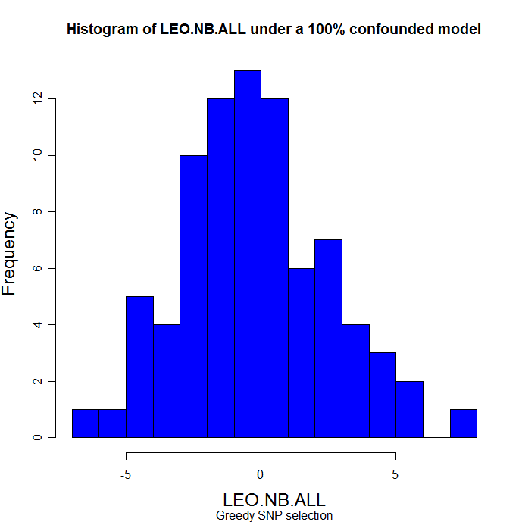

LEO.NB.ALL = c(forward.frames$my.LEO.NB.ALL.snp[,snp.number])
hist(LEO.NB.ALL,col="blue",main="Histogram of LEO.NB.ALL under a 100% confounded model",sub="Forward SNP selection",cex.lab=1.5,breaks=10)

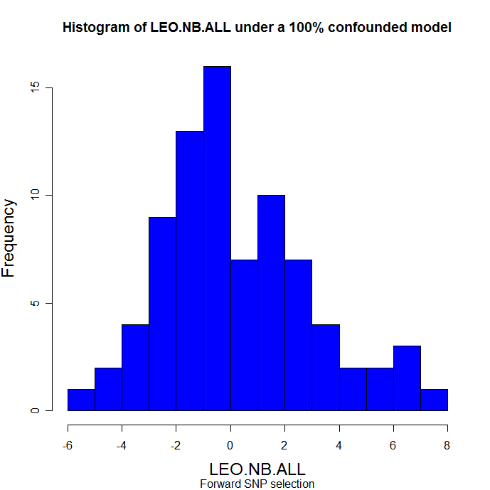

sum(is.na(LEO.NB.ALL))
[1] 19

# Obviously there really are alot of false positives -- about 23% of the distribution here is greater than 2....which means that yes at a threshold of 2.0 we would have a 23% false postive rate. Not good.

sum(LEO.NB.ALL > 2,na.rm=T)/sum(!is.na(LEO.NB.ALL))
#[1] 0.2345679
sum(LEO.NB.ALL > 2,na.rm=T)
#[1] 19
sum(LEO.NB.ALL > -20,na.rm=T)
#[1] 81
19/81
#[1] 0.2345679

# the sd is still big:
sd(LEO.NB.ALL,na.rm=T)
#[1] 2.758486

LEO.NB.ALL = c(greedy.frames$my.LEO.NB.ALL.snp[,snp.number])
sd(LEO.NB.ALL,na.rm=T)
#[1] 2.6914

LEO.NB.ALL = c(fwd.and.gr.frames$my.LEO.NB.ALL.snp[,snp.number])
#sd(LEO.NB.ALL,na.rm=T)
#[1] 2.779405

#So the Standard deviations are large in when we look within SNP aggregation strategy, implying that the spreadsheet analysis which using sd = 2.74 was fine, and certainly all three of these distributions do look centered around 0, so the 0.03 mean used in the RT analysis should be fine too.

#####

##### Repeat titation for the Single SNP models....

############################
# start new analysis of the Single marker model, to show the SNP titrations...
# [16] "mc.robust.1a.1b.1causal.4an.4bn/r.test.robust.task1.results.100.Mon_Aug_13_18.29.13_2007.rdat"
# [17] "mc.robust.1a.1b.1causal.4an.4bn/r.test.robust.task2.results.100.Mon_Aug_13_20.23.08_2007.rdat"
# [18] "mc.robust.1a.1b.1causal.4an.4bn/r.test.robust.task3.results.100.Mon_Aug_13_19.32.40_2007.rdat"
############################

f1=16
f2=17
f3=18

load(my.27robust.files[f1]) # r
greedy.frames = get.frames(r$greedy.100.causal)

load(my.27robust.files[f2])
forward.frames = get.frames(r$forward.100.causal)

load(my.27robust.files[f3])
fwd.and.gr.frames = get.frames(r$greedy.and.forward.100.causal)

x=list()
for (snp.number in 1:20) {
LEO.NB.FOR = c(greedy.frames$my.LEO.NB.FOR.snp[,snp.number])
LEO.NB.ALL = c(greedy.frames$my.LEO.NB.ALL.snp[,snp.number])
LEO.NB.MAX = c(greedy.frames$my.LEO.NB.MAX.snp[,snp.number])
LEO.MULTIONE.NB = c(greedy.frames$my.LEO.MULTIONE.NB.snp[,snp.number])
SIMPLE.MAX.MAX = c(greedy.frames$my.SIMPLE.MAX.MAX.snp[,snp.number])

x[[snp.number]] = compute.leo.stats(LEO.NB.FOR, LEO.NB.ALL, LEO.NB.MAX, LEO.MULTIONE.NB, SIMPLE.MAX.MAX)
}

gr.smaxmax.mean = sapply(x, function(x) x$SIMPLE.MAX.MAX.mean)
gr.smaxmax.sd = sapply(x, function(x) x$SIMPLE.MAX.MAX.sd)
names(gr.smaxmax.mean)=names(gr.smaxmax.sd)=paste(1:20)

gr.all.mean = sapply(x, function(x) x$LEO.NB.ALL.mean)
gr.all.sd = sapply(x, function(x) x$LEO.NB.ALL.sd)
names(gr.all.mean)=names(gr.all.sd)=paste(1:20)

gr.for.mean = sapply(x, function(x) x$LEO.NB.FOR.mean)
gr.for.sd = sapply(x, function(x) x$LEO.NB.FOR.sd)
names(gr.for.mean)=names(gr.for.sd)=paste(1:20)

gr.multione.mean = sapply(x, function(x) x$LEO.MULTIONE.NB.mean)
gr.multione.sd = sapply(x, function(x) x$LEO.MULTIONE.NB.sd)
names(gr.multione.mean)=names(gr.multione.sd)=paste(1:20)

### forward

x=list()
for (snp.number in 1:20) {
LEO.NB.FOR = c(forward.frames$my.LEO.NB.FOR.snp[,snp.number])
LEO.NB.ALL = c(forward.frames$my.LEO.NB.ALL.snp[,snp.number])
LEO.NB.MAX = c(forward.frames$my.LEO.NB.MAX.snp[,snp.number])
LEO.MULTIONE.NB = c(forward.frames$my.LEO.MULTIONE.NB.snp[,snp.number])
SIMPLE.MAX.MAX = c(forward.frames$my.SIMPLE.MAX.MAX.snp[,snp.number])

x[[snp.number]] = compute.leo.stats(LEO.NB.FOR, LEO.NB.ALL, LEO.NB.MAX, LEO.MULTIONE.NB, SIMPLE.MAX.MAX)
}

fw.smaxmax.mean = sapply(x, function(x) x$SIMPLE.MAX.MAX.mean)
fw.smaxmax.sd = sapply(x, function(x) x$SIMPLE.MAX.MAX.sd)
names(fw.smaxmax.mean)=names(fw.smaxmax.sd)=paste(1:20)

fw.all.mean = sapply(x, function(x) x$LEO.NB.ALL.mean)
fw.all.sd = sapply(x, function(x) x$LEO.NB.ALL.sd)
names(fw.all.mean)=names(fw.all.sd)=paste(1:20)

fw.for.mean = sapply(x, function(x) x$LEO.NB.FOR.mean)
fw.for.sd = sapply(x, function(x) x$LEO.NB.FOR.sd)
names(fw.for.mean)=names(fw.for.sd)=paste(1:20)

fw.multione.mean = sapply(x, function(x) x$LEO.MULTIONE.NB.mean)
fw.multione.sd = sapply(x, function(x) x$LEO.MULTIONE.NB.sd)
names(fw.multione.mean)=names(fw.multione.sd)=paste(1:20)

### forward and greedy: fwd.and.gr.frames

x=list()
for (snp.number in 1:20) {
LEO.NB.FOR = c(fwd.and.gr.frames$my.LEO.NB.FOR.snp[,snp.number])
LEO.NB.ALL = c(fwd.and.gr.frames$my.LEO.NB.ALL.snp[,snp.number])
LEO.NB.MAX = c(fwd.and.gr.frames$my.LEO.NB.MAX.snp[,snp.number])
LEO.MULTIONE.NB = c(fwd.and.gr.frames$my.LEO.MULTIONE.NB.snp[,snp.number])
SIMPLE.MAX.MAX = c(fwd.and.gr.frames$my.SIMPLE.MAX.MAX.snp[,snp.number])

x[[snp.number]] = compute.leo.stats(LEO.NB.FOR, LEO.NB.ALL, LEO.NB.MAX, LEO.MULTIONE.NB, SIMPLE.MAX.MAX)
}

fg.smaxmax.mean = sapply(x, function(x) x$SIMPLE.MAX.MAX.mean)
fg.smaxmax.sd = sapply(x, function(x) x$SIMPLE.MAX.MAX.sd)
names(fg.smaxmax.mean)=names(fg.smaxmax.sd)=paste(1:20)

fg.all.mean = sapply(x, function(x) x$LEO.NB.ALL.mean)
fg.all.sd = sapply(x, function(x) x$LEO.NB.ALL.sd)
names(fg.all.mean)=names(fg.all.sd)=paste(1:20)

fg.for.mean = sapply(x, function(x) x$LEO.NB.FOR.mean)
fg.for.sd = sapply(x, function(x) x$LEO.NB.FOR.sd)
names(fg.for.mean)=names(fg.for.sd)=paste(1:20)

fg.multione.mean = sapply(x, function(x) x$LEO.MULTIONE.NB.mean)
fg.multione.sd = sapply(x, function(x) x$LEO.MULTIONE.NB.sd)
names(fg.multione.mean)=names(fg.for.sd)=paste(1:20)

# plot LEO.NB.FOR

for.mean.3 = rbind(gr.for.mean, fw.for.mean, fg.for.mean)
for.3.ci.l = rbind(gr.for.mean - gr.for.sd/10, fw.for.mean - fw.for.sd/10, fg.for.mean - fg.for.sd/10)
for.3.ci.u = rbind(gr.for.mean + gr.for.sd/10, fw.for.mean + fw.for.sd/10, fg.for.mean + fg.for.sd/10)
rownames(for.3.ci.l) = rownames(for.mean.3)
rownames(for.3.ci.u) = rownames(for.mean.3)

barplot2(for.mean.3,plot.ci=T, ci.l=for.3.ci.l, ci.u=for.3.ci.u,xlab="Number of SNPs",ylab="LEO.NB.FOR scoring a single SNP model, 4AN/4BN",cex.axis=1.5,cex.names=1.5,cex.lab=1.5,beside=T,col=heat.colors(3),ylim=c(0,3))
box()
legend(38,1.9, c("Greedy SNP selection","Forward SNP selection", "Forward & Greedy SNP selection"), fill = heat.colors(3))
abline(h=0.3,lty=2)

# plot CPA.FOR

# plot LEO.MULTIONE.NB

multione.mean.3 = rbind(gr.multione.mean, fw.multione.mean, fg.multione.mean)
multione.3.ci.l = rbind(gr.multione.mean - gr.multione.sd/10, fw.multione.mean - fw.multione.sd/10, fg.multione.mean - fg.multione.sd/10)
multione.3.ci.u = rbind(gr.multione.mean + gr.multione.sd/10, fw.multione.mean + fw.multione.sd/10, fg.multione.mean + fg.multione.sd/10)
rownames(multione.3.ci.l) = rownames(multione.mean.3)
rownames(multione.3.ci.u) = rownames(multione.mean.3)

barplot2(multione.mean.3,plot.ci=T, ci.l=multione.3.ci.l, ci.u=multione.3.ci.u,xlab="Number of SNPs",ylab=”CPA.FOR scoring a single SNP model, 4AN/4BN",cex.axis=1.5,cex.names=1.5,cex.lab=1.5,beside=T,ylim=c(0,2),col=heat.colors(3))
box()
legend(38.6,1.77, c("Greedy SNP selection","Forward SNP selection", "Forward & Greedy SNP selection"), fill = heat.colors(3))
abline(h=0.3,lty=2)

# plot LEO.NB.ALL

all.mean.3 = rbind(gr.all.mean, fw.all.mean, fg.all.mean)
all.3.ci.l = rbind(gr.all.mean - gr.all.sd/10, fw.all.mean - fw.all.sd/10, fg.all.mean - fg.all.sd/10)
all.3.ci.u = rbind(gr.all.mean + gr.all.sd/10, fw.all.mean + fw.all.sd/10, fg.all.mean + fg.all.sd/10)
rownames(all.3.ci.l) = rownames(all.mean.3)
rownames(all.3.ci.u) = rownames(all.mean.3)

barplot2(all.mean.3,plot.ci=T, ci.l=all.3.ci.l, ci.u=all.3.ci.u,xlab="Number of SNPs",ylab="LEO.NB.ALL scoring a single SNP model, 4AN/4BN",cex.axis=1.5,cex.names=1.5,cex.lab=1.5,beside=T,col=heat.colors(3),ylim=c(0,5.5))
box()
legend(36,4.1, c("Greedy SNP selection","Forward SNP selection", "Forward & Greedy SNP selection"), fill = heat.colors(3))
abline(h=4.53,lty=2)

# simple MAX.MAX

smaxmax.mean.3 = rbind(gr.smaxmax.mean, fw.smaxmax.mean, fg.smaxmax.mean)
smaxmax.3.ci.l = rbind(gr.smaxmax.mean - gr.smaxmax.sd/10, fw.smaxmax.mean - fw.smaxmax.sd/10, fg.smaxmax.mean - fg.smaxmax.sd/10)
smaxmax.3.ci.u = rbind(gr.smaxmax.mean + gr.smaxmax.sd/10, fw.smaxmax.mean + fw.smaxmax.sd/10, fg.smaxmax.mean + fg.smaxmax.sd/10)
rownames(smaxmax.3.ci.l) = rownames(smaxmax.mean.3)
rownames(smaxmax.3.ci.u) = rownames(smaxmax.mean.3)

barplot2(smaxmax.mean.3,plot.ci=T, ci.l=smaxmax.3.ci.l, ci.u=smaxmax.3.ci.u,xlab="Number of SNPs",ylab="MAX.MAX scoring a single SNP model, 4AN/4BN",cex.axis=1.5,cex.names=1.5,cex.lab=1.5,beside=T,col=heat.colors(3),ylim=c(0,5))
box()
legend(26,2.2, c("Greedy SNP selection","Forward SNP selection", "Forward & Greedy SNP selection"), fill = heat.colors(3))
abline(h=4.21,lty=2)

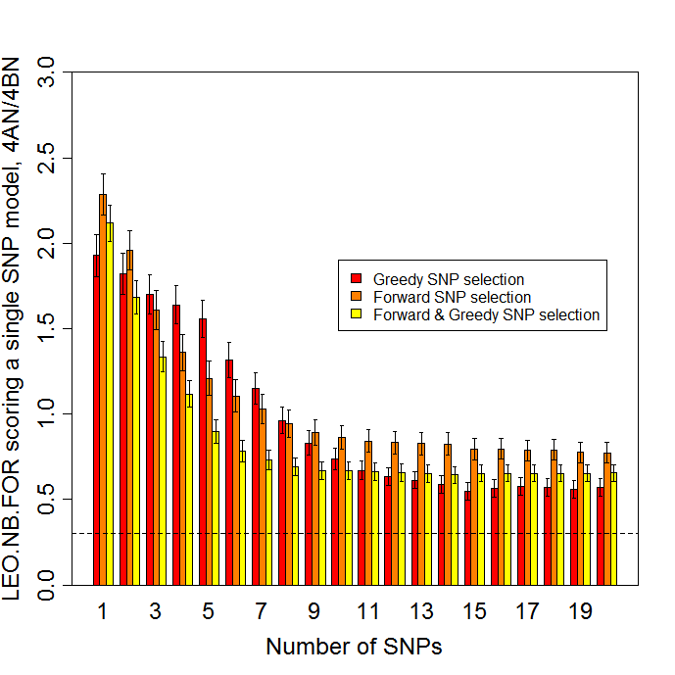

# Postscript saved under: c:/good/aggregation.titration.leo.nb.for.1a1b.100.4an.4bn.20aug2007.ps

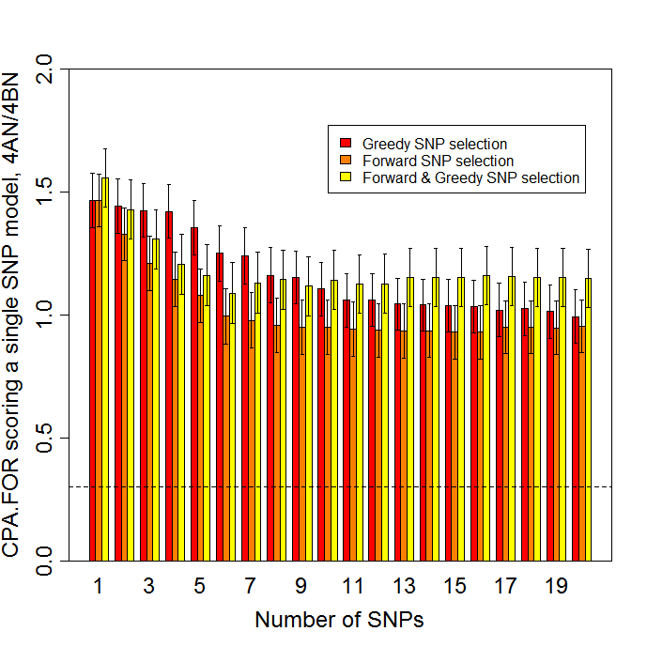

c:/good/aggregation.titration.cpa.for.1a1b.100.4an.4bn.3sept2007.ps
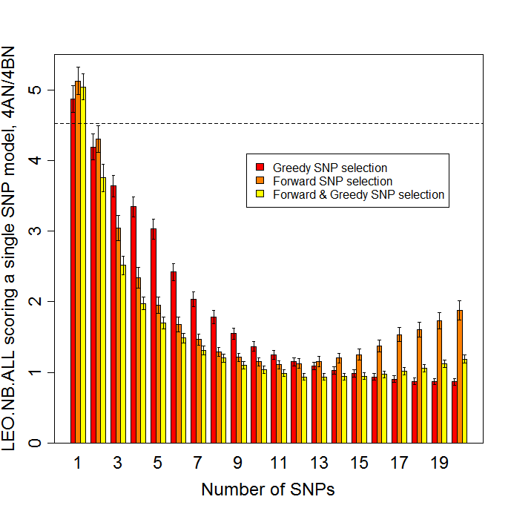
# Postscript as aggregation.titration.leo.nb.all.1a1b.100.4an.4bn.20aug2007.ps

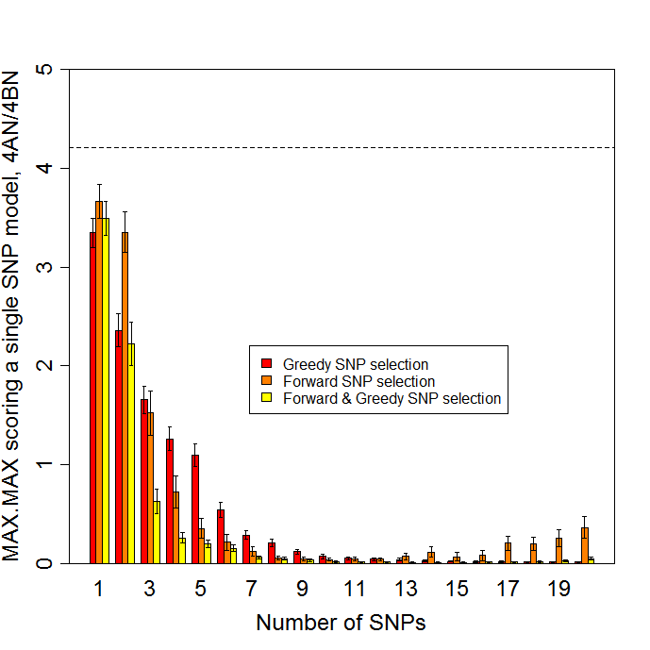

# Postscript: aggregation.titration.maxmax.1a1b.100.4an.4bn.20aug2007.ps

# neo.txt code used to produce these …. For archival purposes. Version 1.280.


# do boxplots of the null distributions:
# Use just the Forward, since the greedy looks statistically the same.

f2=11
load(my.27robust.files[f2])
forward.frames = get.frames(r$forward.100.causal)

df=data.frame(forward.frames$my.LEO.NB.FOR.snp)
colnames(df)=paste(1:20)
boxplot(df,col="yellow",ylim=c(-10,2),notch=T,xlab=”Number of SNPs”,ylab=”LEO.NB.FOR score under a 100% confounded model”, cex.axis=1.5,cex.names=1.5,cex.lab=1.5)
abline(h=.3,lty=2)

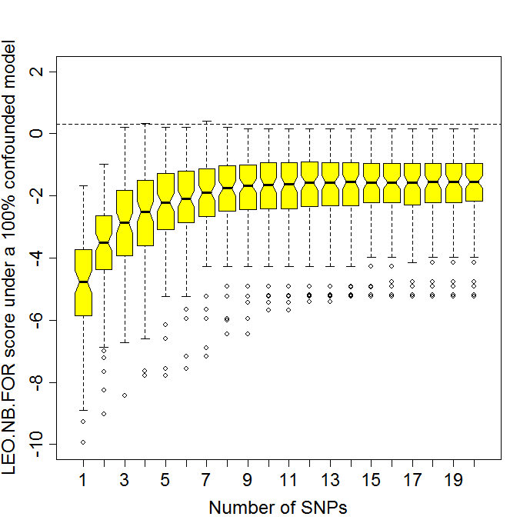

c:/good/leo.nb.for.0causal.for.snp.titration.30aug2007.ps

df=data.frame(forward.frames$my.LEO.NB.ALL.snp)
colnames(df)=paste(1:20)
boxplot(df,col="yellow",ylim=c(-6,10),notch=T,xlab=”Number of SNPs”,ylab=”LEO.NB.ALL score under a 100% confounded model”, cex.axis=1.5,cex.names=1.5,cex.lab=1.5)
abline(h=4.53,lty=2)

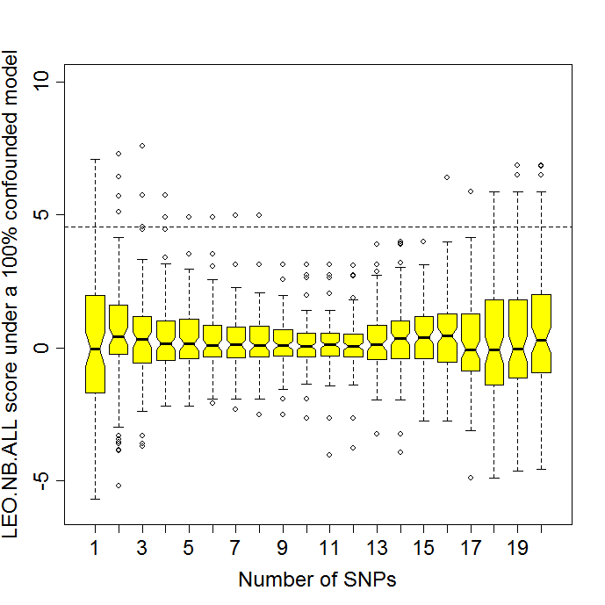
c:/good/leo.nb.all.0causal.for.snp.titration.30aug2007.ps

df=data.frame(forward.frames$ my.SIMPLE.MAX.MAX.snp)
colnames(df)=paste(1:20)
boxplot(df,col="yellow",ylim=c(-6,10),notch=T,xlab=”Number of SNPs”,ylab=”MAX.MAX score under a 100% confounded model”, cex.axis=1.5,cex.names=1.5,cex.lab=1.5)
abline(h=4.21,lty=2)

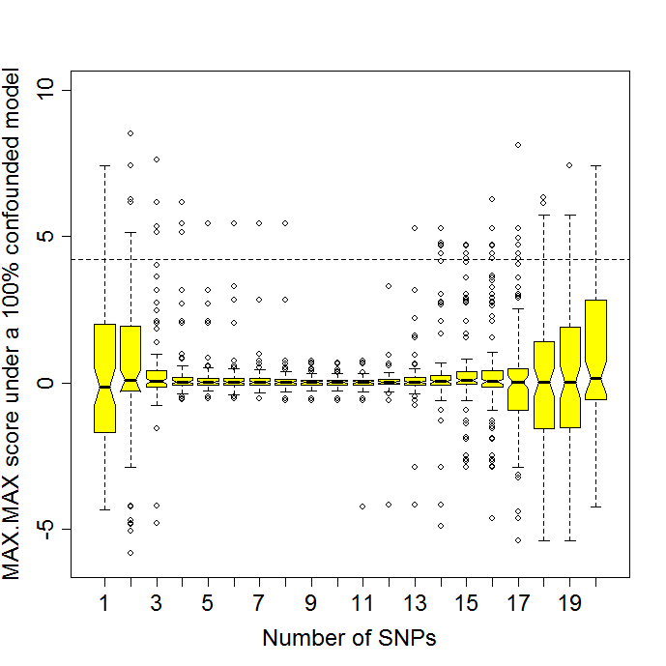

c:/good/max.max.0causal.for.snp.titration.30aug2007.ps

df=data.frame(forward.frames$my.LEO.MULTIONE.NB.snp)
colnames(df)=paste(1:20)
boxplot(df,col="yellow",notch=T,xlab=”Number of SNPs”,ylab=”CPA.FOR score under a 100% confounded model”, cex.axis=1.5,cex.names=1.5,cex.lab=1.5)
abline(h=0.3,lty=2)

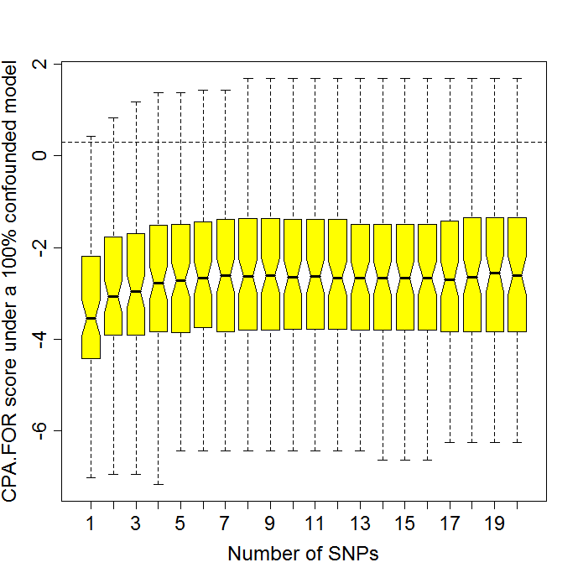

c:/good/cpa.for.0causal.for.snp.titration.30aug2007.ps

#### also compute multione null thresholds because this is Eric’s causality test….but with Forward stepwise regression SNP selection
# starting afresh, 2 Sept 2007
# also: do Shapiro-Wilks normality testing: shapiro.test() on the scores, so
# we have some notion that our 5% fp rate threshold based on the 1.644 standard deviations
# is reasonable.

source(“neo.txt”)

my.27robust.files = c(
"mc.robust.1a.1b/r.test.robust.task1.results.100.Sun_Aug_12_06.02.53_2007.rdat",
"mc.robust.1a.1b/r.test.robust.task2.results.100.Sun_Aug_12_14.38.15_2007.rdat",
"mc.robust.1a.1b/r.test.robust.task3.results.100.Sun_Aug_12_03.30.12_2007.rdat",

"mc.robust.0a.1b.5causal/r.test.robust.task1.results.100.Tue_Aug_14_10.58.51_2007.rdat",
"mc.robust.0a.1b.5causal/r.test.robust.task2.results.100.Sun_Aug_12_16.05.02_2007.rdat",
"mc.robust.0a.1b.5causal/r.test.robust.task3.results.100.Sun_Aug_12_13.23.41_2007.rdat",

"mc.robust.1a.1b.5causal/r.test.robust.task1.results.100.Sun_Aug_12_11.35.58_2007.rdat",
"mc.robust.1a.1b.5causal/r.test.robust.task2.results.100.Sun_Aug_12_08.03.22_2007.rdat",
"mc.robust.1a.1b.5causal/r.test.robust.task3.results.100.Sun_Aug_12_07.16.37_2007.rdat",

"mc.robust.1a.1b.0causal/r.test.robust.task1.results.100.Thu_Aug_16_03.59.40_2007.rdat",
"mc.robust.1a.1b.0causal/r.test.robust.task2.results.100.Sun_Aug_12_14.26.48_2007.rdat",
"mc.robust.1a.1b.0causal/r.test.robust.task3.results.100.Sun_Aug_12_13.12.29_2007.rdat",

"mc.robust.0a.1b.0causal/r.test.robust.task1.results.100.Mon_Aug_13_05.34.40_2007.rdat",
"mc.robust.0a.1b.0causal/r.test.robust.task2.results.100.Sun_Aug_12_11.58.00_2007.rdat",
"mc.robust.0a.1b.0causal/r.test.robust.task3.results.100.Mon_Aug_13_06.48.41_2007.rdat",

"mc.robust.1a.1b.1causal.4an.4bn/r.test.robust.task1.results.100.Mon_Aug_13_18.29.13_2007.rdat",
"mc.robust.1a.1b.1causal.4an.4bn/r.test.robust.task2.results.100.Mon_Aug_13_20.23.08_2007.rdat",
"mc.robust.1a.1b.1causal.4an.4bn/r.test.robust.task3.results.100.Mon_Aug_13_19.32.40_2007.rdat",

"mc.robust.1a.4b.4causal.4an.4bn/r.test.robust.task1.results.100.Tue_Aug_14_21.15.45_2007.rdat",
"mc.robust.1a.4b.4causal.4an.4bn/r.test.robust.task2.results.100.Tue_Aug_14_12.20.56_2007.rdat",
"mc.robust.1a.4b.4causal.4an.4bn/r.test.robust.task3.results.100.Fri_Aug_17_03.38.37_2007.rdat",

"mc.robust.0a.4b.4causal.4an.4bn/r.test.robust.task1.results.100.Tue_Aug_14_14.09.52_2007.rdat",
"mc.robust.0a.4b.4causal.4an.4bn/r.test.robust.task2.results.100.Tue_Aug_14_10.32.41_2007.rdat",
"mc.robust.0a.4b.4causal.4an.4bn/r.test.robust.task3.results.100.Thu_Aug_16_22.19.47_2007.rdat",

"mc.robust.0a.1b.no.neighbors.1causal/r.test.robust.task1.results.100.Sun_Aug_12_14.56.15_2007.rdat",
"mc.robust.0a.1b.no.neighbors.1causal/r.test.robust.task2.results.100.Sun_Aug_12_10.06.59_2007.rdat",
"mc.robust.0a.1b.no.neighbors.1causal/r.test.robust.task3.results.100.Sun_Aug_12_05.28.02_2007.rdat"
)

############################
# start new analysis of the Null model 100% confounding, to show the SNP titrations...
# [10] "mc.robust.1a.1b.0causal/r.test.robust.task1.results.100.Thu_Aug_16_03.59.40_2007.rdat"
# [11] "mc.robust.1a.1b.0causal/r.test.robust.task2.results.100.Sun_Aug_12_14.26.48_2007.rdat"
# [12] "mc.robust.1a.1b.0causal/r.test.robust.task3.results.100.Sun_Aug_12_13.12.29_2007.rdat"
############################

f1=10
f2=11
f3=12

load(my.27robust.files[f1]) # r
greedy.frames = get.frames(r$greedy.100.causal)

load(my.27robust.files[f2])
forward.frames = get.frames(r$forward.100.causal)

load(my.27robust.files[f3])
fwd.and.gr.frames = get.frames(r$greedy.and.forward.100.causal)

compute.leo.stats = function(LEO.NB.FOR, LEO.NB.ALL, LEO.NB.MAX, LEO.MULTIONE.NB, SIMPLE.MAX.MAX) {

LEO.NB.FOR.mean = mean(LEO.NB.FOR,na.rm=T)
LEO.NB.ALL.mean = mean(LEO.NB.ALL,na.rm=T)
LEO.NB.MAX.mean = mean(LEO.NB.MAX,na.rm=T)
LEO.MULTIONE.NB.mean = mean(LEO.MULTIONE.NB,na.rm=T)
SIMPLE.MAX.MAX.mean = mean(SIMPLE.MAX.MAX,na.rm=T)

LEO.NB.FOR.se = stderr1(LEO.NB.FOR)
LEO.NB.ALL.se = stderr1(LEO.NB.ALL)
LEO.NB.MAX.se = stderr1(LEO.NB.MAX)
LEO.MULTIONE.NB.se = stderr1(LEO.MULTIONE.NB)
SIMPLE.MAX.MAX.se = stderr1(SIMPLE.MAX.MAX)

LEO.NB.FOR.sd = sd(LEO.NB.FOR,na.rm=T)
LEO.NB.ALL.sd = sd(LEO.NB.ALL,na.rm=T)
LEO.NB.MAX.sd = sd(LEO.NB.MAX,na.rm=T)
LEO.MULTIONE.NB.sd = sd(LEO.MULTIONE.NB,na.rm=T)
SIMPLE.MAX.MAX.sd = sd(SIMPLE.MAX.MAX,na.rm=T)

####################

LEO.NB.FOR.mean = mean(LEO.NB.FOR,na.rm=T)
LEO.NB.ALL.mean = mean(LEO.NB.ALL,na.rm=T)
LEO.NB.MAX.mean = mean(LEO.NB.MAX,na.rm=T)
LEO.MULTIONE.NB.mean = mean(LEO.MULTIONE.NB,na.rm=T)
SIMPLE.MAX.MAX.mean = mean(SIMPLE.MAX.MAX,na.rm=T)

LEO.NB.FOR.se = stderr1(LEO.NB.FOR)
LEO.NB.ALL.se = stderr1(LEO.NB.ALL)
LEO.NB.MAX.se = stderr1(LEO.NB.MAX)
LEO.MULTIONE.NB.se = stderr1(LEO.MULTIONE.NB)
SIMPLE.MAX.MAX.se = stderr1(SIMPLE.MAX.MAX)

LEO.NB.FOR.sd = sd(LEO.NB.FOR,na.rm=T)
LEO.NB.ALL.sd = sd(LEO.NB.ALL,na.rm=T)
LEO.NB.MAX.sd = sd(LEO.NB.MAX,na.rm=T)
LEO.MULTIONE.NB.sd = sd(LEO.MULTIONE.NB,na.rm=T)
SIMPLE.MAX.MAX.sd = sd(SIMPLE.MAX.MAX,na.rm=T)

data.frame(LEO.NB.FOR.mean, LEO.NB.FOR.se, LEO.NB.FOR.sd, LEO.NB.ALL.mean, LEO.NB.ALL.se, LEO.NB.ALL.sd, LEO.NB.MAX.mean, LEO.NB.MAX.se, LEO.NB.MAX.sd, LEO.MULTIONE.NB.mean, LEO.MULTIONE.NB.se, LEO.MULTIONE.NB.sd, SIMPLE.MAX.MAX.mean, SIMPLE.MAX.MAX.se, SIMPLE.MAX.MAX.sd)
} # end compute.leo.stats

x=list()
for (snp.number in 1:20) {
LEO.NB.FOR = c(greedy.frames$my.LEO.NB.FOR.snp[,snp.number])
LEO.NB.ALL = c(greedy.frames$my.LEO.NB.ALL.snp[,snp.number])
LEO.NB.MAX = c(greedy.frames$my.LEO.NB.MAX.snp[,snp.number])
LEO.MULTIONE.NB = c(greedy.frames$my.LEO.MULTIONE.NB.snp[,snp.number])
SIMPLE.MAX.MAX = c(greedy.frames$my.SIMPLE.MAX.MAX.snp[,snp.number])

x[[snp.number]] = compute.leo.stats(LEO.NB.FOR, LEO.NB.ALL, LEO.NB.MAX, LEO.MULTIONE.NB, SIMPLE.MAX.MAX)
}

snp.number=1
LEO.NB.FOR = c(greedy.frames$my.LEO.NB.FOR.snp[,snp.number])
LEO.NB.ALL = c(greedy.frames$my.LEO.NB.ALL.snp[,snp.number])
LEO.NB.MAX = c(greedy.frames$my.LEO.NB.MAX.snp[,snp.number])
LEO.MULTIONE.NB = c(greedy.frames$my.LEO.MULTIONE.NB.snp[,snp.number])
SIMPLE.MAX.MAX = c(greedy.frames$my.SIMPLE.MAX.MAX.snp[,snp.number])

LEO.MULTIONE.NB.gr = LEO.MULTIONE.NB
LEO.NB.ALL.gr = LEO.NB.ALL
LEO.NB.FOR.gr = LEO.NB.FOR
LEO.MULTIONE.NB.gr = LEO.MULTIONE.NB
SIMPLE.MAX.MAX.gr = SIMPLE.MAX.MAX

gr.smaxmax.mean = sapply(x, function(x) x$SIMPLE.MAX.MAX.mean)
gr.smaxmax.sd = sapply(x, function(x) x$SIMPLE.MAX.MAX.sd)
names(gr.smaxmax.mean)=names(gr.smaxmax.sd)=paste(1:20)

gr.all.mean = sapply(x, function(x) x$LEO.NB.ALL.mean)
gr.all.sd = sapply(x, function(x) x$LEO.NB.ALL.sd)
names(gr.all.mean)=names(gr.all.sd)=paste(1:20)

gr.for.mean = sapply(x, function(x) x$LEO.NB.FOR.mean)
gr.for.sd = sapply(x, function(x) x$LEO.NB.FOR.sd)
names(gr.for.mean)=names(gr.for.sd)=paste(1:20)

gr.multione.mean = sapply(x, function(x) x$LEO.MULTIONE.NB.mean)
gr.multione.sd = sapply(x, function(x) x$LEO.MULTIONE.NB.sd)
names(gr.multione.mean)=names(gr.multione.sd)=paste(1:20)

### forward

x=list()
for (snp.number in 1:20) {
LEO.NB.FOR = c(forward.frames$my.LEO.NB.FOR.snp[,snp.number])
LEO.NB.ALL = c(forward.frames$my.LEO.NB.ALL.snp[,snp.number])
LEO.NB.MAX = c(forward.frames$my.LEO.NB.MAX.snp[,snp.number])
LEO.MULTIONE.NB = c(forward.frames$my.LEO.MULTIONE.NB.snp[,snp.number])
SIMPLE.MAX.MAX = c(forward.frames$my.SIMPLE.MAX.MAX.snp[,snp.number])

x[[snp.number]] = compute.leo.stats(LEO.NB.FOR, LEO.NB.ALL, LEO.NB.MAX, LEO.MULTIONE.NB, SIMPLE.MAX.MAX)
}

snp.number=1
LEO.NB.FOR = c(forward.frames$my.LEO.NB.FOR.snp[,snp.number])
LEO.NB.ALL = c(forward.frames$my.LEO.NB.ALL.snp[,snp.number])
LEO.NB.MAX = c(forward.frames$my.LEO.NB.MAX.snp[,snp.number])
LEO.MULTIONE.NB = c(forward.frames$my.LEO.MULTIONE.NB.snp[,snp.number])
SIMPLE.MAX.MAX = c(forward.frames$my.SIMPLE.MAX.MAX.snp[,snp.number])

LEO.MULTIONE.NB.fw = LEO.MULTIONE.NB
LEO.NB.ALL.fw = LEO.NB.ALL
LEO.NB.FOR.fw = LEO.NB.FOR
LEO.MULTIONE.NB.fw = LEO.MULTIONE.NB
SIMPLE.MAX.MAX.fw = SIMPLE.MAX.MAX

fw.smaxmax.mean = sapply(x, function(x) x$SIMPLE.MAX.MAX.mean)
fw.smaxmax.sd = sapply(x, function(x) x$SIMPLE.MAX.MAX.sd)
names(fw.smaxmax.mean)=names(fw.smaxmax.sd)=paste(1:20)

fw.all.mean = sapply(x, function(x) x$LEO.NB.ALL.mean)
fw.all.sd = sapply(x, function(x) x$LEO.NB.ALL.sd)
names(fw.all.mean)=names(fw.all.sd)=paste(1:20)

fw.for.mean = sapply(x, function(x) x$LEO.NB.FOR.mean)
fw.for.sd = sapply(x, function(x) x$LEO.NB.FOR.sd)
names(fw.for.mean)=names(fw.for.sd)=paste(1:20)

fw.multione.mean = sapply(x, function(x) x$LEO.MULTIONE.NB.mean)
fw.multione.sd = sapply(x, function(x) x$LEO.MULTIONE.NB.sd)
names(fw.multione.mean)=names(fw.multione.sd)=paste(1:20)

### forward and greedy: fwd.and.gr.frames

x=list()
for (snp.number in 1:20) {
LEO.NB.FOR = c(fwd.and.gr.frames$my.LEO.NB.FOR.snp[,snp.number])
LEO.NB.ALL = c(fwd.and.gr.frames$my.LEO.NB.ALL.snp[,snp.number])
LEO.NB.MAX = c(fwd.and.gr.frames$my.LEO.NB.MAX.snp[,snp.number])
LEO.MULTIONE.NB = c(fwd.and.gr.frames$my.LEO.MULTIONE.NB.snp[,snp.number])
SIMPLE.MAX.MAX = c(fwd.and.gr.frames$my.SIMPLE.MAX.MAX.snp[,snp.number])

x[[snp.number]] = compute.leo.stats(LEO.NB.FOR, LEO.NB.ALL, LEO.NB.MAX, LEO.MULTIONE.NB, SIMPLE.MAX.MAX)
}

snp.number=1
LEO.NB.FOR = c(fwd.and.gr.frames$my.LEO.NB.FOR.snp[,snp.number])
LEO.NB.ALL = c(fwd.and.gr.frames$my.LEO.NB.ALL.snp[,snp.number])
LEO.NB.MAX = c(fwd.and.gr.frames$my.LEO.NB.MAX.snp[,snp.number])
LEO.MULTIONE.NB = c(fwd.and.gr.frames$my.LEO.MULTIONE.NB.snp[,snp.number])
SIMPLE.MAX.MAX = c(fwd.and.gr.frames$my.SIMPLE.MAX.MAX.snp[,snp.number])

LEO.MULTIONE.NB.fg = LEO.MULTIONE.NB
LEO.NB.ALL.fg = LEO.NB.ALL
LEO.NB.FOR.fg = LEO.NB.FOR
LEO.MULTIONE.NB.fg = LEO.MULTIONE.NB
SIMPLE.MAX.MAX.fg = SIMPLE.MAX.MAX

fg.smaxmax.mean = sapply(x, function(x) x$SIMPLE.MAX.MAX.mean)
fg.smaxmax.sd = sapply(x, function(x) x$SIMPLE.MAX.MAX.sd)
names(fg.smaxmax.mean)=names(fg.smaxmax.sd)=paste(1:20)

fg.all.mean = sapply(x, function(x) x$LEO.NB.ALL.mean)
fg.all.sd = sapply(x, function(x) x$LEO.NB.ALL.sd)
names(fg.all.mean)=names(fg.all.sd)=paste(1:20)

fg.for.mean = sapply(x, function(x) x$LEO.NB.FOR.mean)
fg.for.sd = sapply(x, function(x) x$LEO.NB.FOR.sd)
names(fg.for.mean)=names(fg.for.sd)=paste(1:20)

fg.multione.mean = sapply(x, function(x) x$LEO.MULTIONE.NB.mean)
fg.multione.sd = sapply(x, function(x) x$LEO.MULTIONE.NB.sd)
names(fg.multione.mean)=names(fg.for.sd)=paste(1:20)

# plot LEO.MULTIONE.NB

multione.mean.3 = rbind(gr.multione.mean, fw.multione.mean, fg.multione.mean)
multione.3.ci.l = rbind(gr.multione.mean - gr.multione.sd/10, fw.multione.mean - fw.multione.sd/10, fg.multione.mean - fg.multione.sd/10)
multione.3.ci.u = rbind(gr.multione.mean + gr.multione.sd/10, fw.multione.mean + fw.multione.sd/10, fg.multione.mean + fg.multione.sd/10)
rownames(multione.3.ci.l) = rownames(multione.mean.3)
rownames(multione.3.ci.u) = rownames(multione.mean.3)

barplot2(multione.mean.3,plot.ci=T, ci.l=multione.3.ci.l, ci.u=multione.3.ci.u,xlab="Number of SNPs",ylab="LEO.MULTIONE.NB scoring a 100% confounded model",cex.axis=1.5,cex.names=1.5,cex.lab=1.5,beside=T,ylim=c(-5.5,1),col=heat.colors(3))
box()
legend(36,-3.6, c("Greedy SNP selection","Forward SNP selection", "Forward & Greedy SNP selection"), fill = heat.colors(3))
abline(h=0.3,lty=2)

# plot LEO.NB.FOR

for.mean.3 = rbind(gr.for.mean, fw.for.mean, fg.for.mean)
for.3.ci.l = rbind(gr.for.mean - gr.for.sd/10, fw.for.mean - fw.for.sd/10, fg.for.mean - fg.for.sd/10)
for.3.ci.u = rbind(gr.for.mean + gr.for.sd/10, fw.for.mean + fw.for.sd/10, fg.for.mean + fg.for.sd/10)
rownames(for.3.ci.l) = rownames(for.mean.3)
rownames(for.3.ci.u) = rownames(for.mean.3)

barplot2(for.mean.3,plot.ci=T, ci.l=for.3.ci.l, ci.u=for.3.ci.u,xlab="Number of SNPs",ylab="LEO.NB.FOR scoring a 100% confounded model",cex.axis=1.5,cex.names=1.5,cex.lab=1.5,beside=T,ylim=c(-5.5,1),col=heat.colors(3))
box()
legend(36,-3.6, c("Greedy SNP selection","Forward SNP selection", "Forward & Greedy SNP selection"), fill = heat.colors(3))
abline(h=0.3,lty=2)

# plot LEO.NB.ALL

all.mean.3 = rbind(gr.all.mean, fw.all.mean, fg.all.mean)
all.3.ci.l = rbind(gr.all.mean - gr.all.sd/10, fw.all.mean - fw.all.sd/10, fg.all.mean - fg.all.sd/10)
all.3.ci.u = rbind(gr.all.mean + gr.all.sd/10, fw.all.mean + fw.all.sd/10, fg.all.mean + fg.all.sd/10)
rownames(all.3.ci.l) = rownames(all.mean.3)
rownames(all.3.ci.u) = rownames(all.mean.3)

barplot2(all.mean.3,plot.ci=T, ci.l=all.3.ci.l, ci.u=all.3.ci.u,xlab="Number of SNPs",ylab="LEO.NB.ALL scoring a 100% confounded model",cex.axis=1.5,cex.names=1.5,cex.lab=1.5,beside=T,ylim=c(-1,1),col=heat.colors(3))
box()
legend(25,-.5, c("Greedy SNP selection","Forward SNP selection", "Forward & Greedy SNP selection"), fill = heat.colors(3))
abline(h=4.53,lty=2)

# simple MAX.MAX

smaxmax.mean.3 = rbind(gr.smaxmax.mean, fw.smaxmax.mean, fg.smaxmax.mean)
smaxmax.3.ci.l = rbind(gr.smaxmax.mean - gr.smaxmax.sd/10, fw.smaxmax.mean - fw.smaxmax.sd/10, fg.smaxmax.mean - fg.smaxmax.sd/10)
smaxmax.3.ci.u = rbind(gr.smaxmax.mean + gr.smaxmax.sd/10, fw.smaxmax.mean + fw.smaxmax.sd/10, fg.smaxmax.mean + fg.smaxmax.sd/10)
rownames(smaxmax.3.ci.l) = rownames(smaxmax.mean.3)
rownames(smaxmax.3.ci.u) = rownames(smaxmax.mean.3)

barplot2(smaxmax.mean.3,plot.ci=T, ci.l=smaxmax.3.ci.l, ci.u=smaxmax.3.ci.u,xlab="Number of SNPs",ylab="MAX.MAX scoring a 100% confounded model",cex.axis=1.5,cex.names=1.5,cex.lab=1.5,beside=T,ylim=c(-1,1),col=heat.colors(3))
box()
legend(26,-.6, c("Greedy SNP selection","Forward SNP selection", "Forward & Greedy SNP selection"), fill = heat.colors(3))
abline(h=4.21,lty=2)

# check for normality
x.for = c(LEO.NB.FOR.fg,LEO.NB.FOR.fw,LEO.NB.FOR.gr)
qqnorm(x.for)

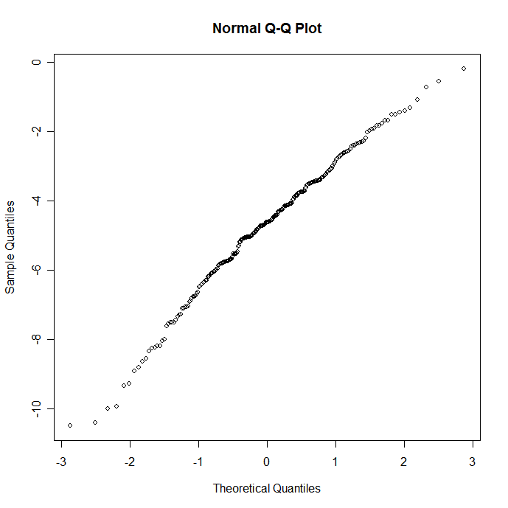

x.all = c(LEO.NB.ALL.fg,LEO.NB.ALL.fw,LEO.NB.ALL.gr)
qqnorm(x.all)

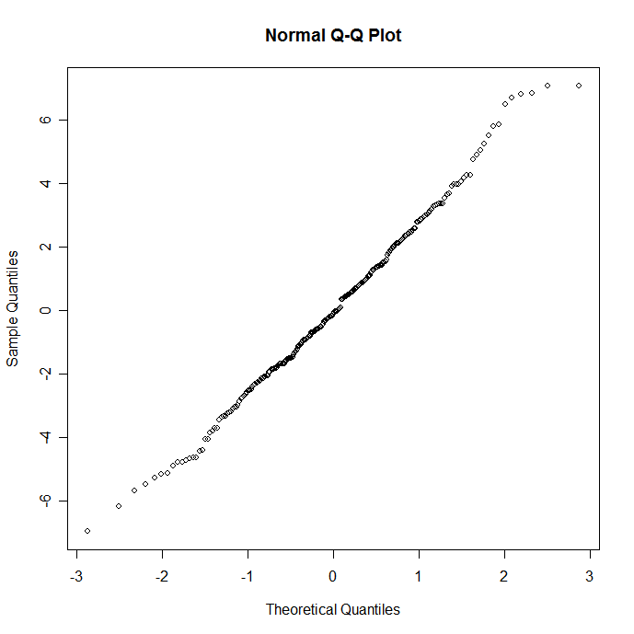

x.cpa = c(LEO.MULTIONE.NB.fg,LEO.MULTIONE.NB.fw,LEO.MULTIONE.NB.gr)
qqnorm(x.cpa)

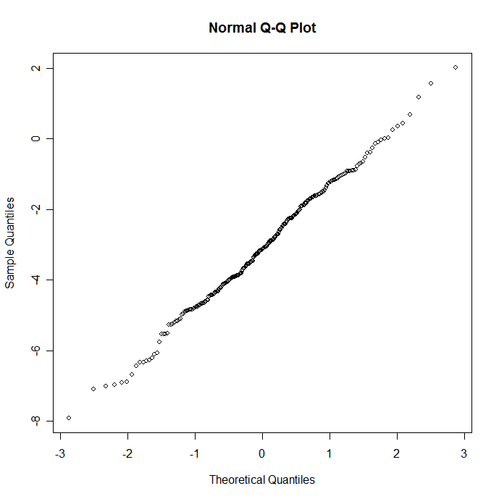

x.maxmax = c(SIMPLE.MAX.MAX.fg,SIMPLE.MAX.MAX.fw,SIMPLE.MAX.MAX.gr)
> str(x.maxmax)
Named num [1:300] NA 3.82 2.61 4.12 7.21 -0.00647 -1.8 -2.15 4.63 -1.83 ...
- attr(*, "names")= chr [1:300] "rep.1" "rep.2" "rep.3" "rep.4" ...
> qqnorm(x.maxmax)

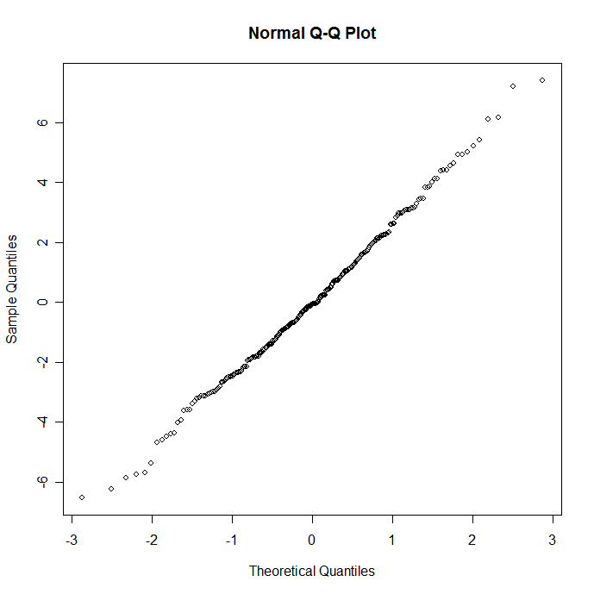

> shapiro.test(x.cpa)

Shapiro-Wilk normality test

data: x.cpa
W = 0.996, p-value = 0.7797

> shapiro.test(x.all)

Shapiro-Wilk normality test

data: x.all
W = 0.9941, p-value = 0.4526

> shapiro.test(x.for)

Shapiro-Wilk normality test

data: x.for
W = 0.9861, p-value = 0.01731

x.for.s=sort(x.for)
> shapiro.test(x.for.s[4:290])

Shapiro-Wilk normality test

data: x.for.s[4:290]
W = 0.9927, p-value = 0.2834

>

> shapiro.test(x.maxmax)

Shapiro-Wilk normality test

data: x.maxmax
W = 0.996, p-value = 0.7862

>

