SCB-7000 Series

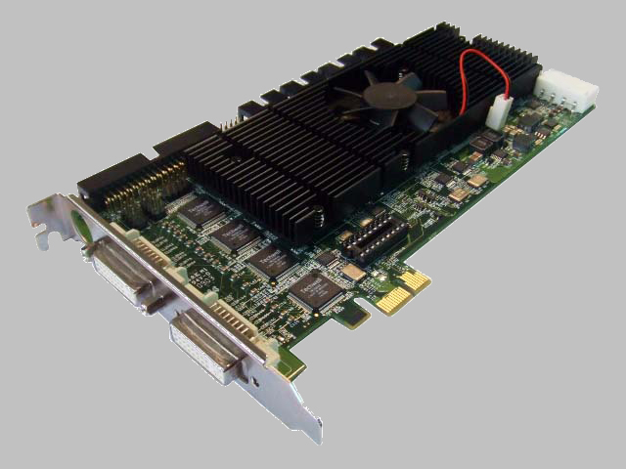
Specifications
Model | SCB-7004 | SCB-7008 | SCB-7016
Video Input | 4 Cameras | 8 Cameras | 16 Cameras
Audio Input | 4 Channels | 8 Channels | 16 Channels
Maximum Cards | 4 Cards | 4 Cards | 2 Cards
Display Rate | 120 fps (NTSC),  100 fps (PAL) | 240 fps (NTSC),  200 fps (PAL) | 480 fps (NTSC),  400 fps (PAL)
Recording Rate @D1 | 120 fps (NTSC),  100 fps (PAL) | 240 fps (NTSC),  200 fps (PAL) | 480 fps (NTSC),  400 fps (PAL)
Video Resolution | NTSC: 176x120; 352x240; 704x480
Video Resolution | PAL: 176x144; 352x288; 704x576
Compression Format | Hardware Compression H.264
Interface | PCI-e x1
Available I/O Card | 1 Card | 2 Cards | 4 Cards
Available I/O Box | Support
Hardware Watchdog | Support
Dimension | 167 (W) x 121 (H) mm | 167 (W) x 121 (H) mm | 216 (W) x 126 (H) mm
Software Version | NUUO Full D1 H.264 Hybrid System v3.2.21
System Minimum Requirements (per card)
OS Supported | Windows XP SP3/ Windows 2003/ Windows Vista SP1
CPU | Core 2 Duo E5300 | Core 2 Duo E5300 | Core 2 Quad Q9550*
RAM | 2 GB | 2 GB | 2 GB
HDD | 250 GB
Mother-board | Intel P45 or P43 or above,MB vendor ASUS,Gigabyte or MSI with Intel Chipset recommended
Display | ATI Radeon 3850/4850, nVIDIA GeForce GF-9600 or above(ATI Driver V9-2 recommended,ATI Driver V10 not support)
* For more information about the system requirements of different channels, please refer to the “System Requirements of NUUO SCB-7000 series” document.
** For stability reason, we strongly recommend to apply a desktop with a system fan when using SCB-7000 series.
SCB-6000 Series

Specifications
Model | SCB-6004 | SCB-6008 | SCB-6016
Video Input | 4 Cameras | 8 Cameras | 16 Cameras
Audio Input | 4 Channels | 8 Channels | 16 Channels
Maximum Cards | 4 Cards | 4 Cards | 2 Cards
Display Rate | 120 fps (NTSC),  100 fps (PAL) | 240 fps (NTSC),  200 fps (PAL) | 480 fps (NTSC),  400 fps (PAL)
Recording Rate @CIF | 120 fps (NTSC),  100 fps (PAL) | 240 fps (NTSC),  200 fps (PAL) | 480 fps (NTSC),  400 fps (PAL)
Recording Rate @D1 | 30 fps (NTSC),  25 fps (PAL) | 60 fps (NTSC),  50 fps (PAL) | 120 fps (NTSC),  100 fps (PAL)
Video Resolution | NTSC: 176x120; 352x240; 704x480
Video Resolution | PAL: 176x144; 352x288; 704x576
Compression Format | Hardware Compression H.264
Interface | PCI-e x1
Available I/O Card | 1 Card | 2 Cards | 4 Cards
Available I/O Box | Support
Hardware Watchdog | Support
Dimension | 167 (W) x 121 (H) mm | 167 (W) x 121 (H) mm | 216 (W) x 126 (H) mm
Software Version | NUUO Full D1 H.264 Hybrid System v3.2.21
System Minimum Requirements (per card)
OS Supported | Windows XP SP3/ Windows 2003/ Windows Vista SP1
CPU | Core 2 Duo E5300 | Core 2 Duo E5300 | Core 2 Duo E5300*
RAM | 2 GB | 2 GB | 2 GB
HDD | 250 GB
Mother-board | Intel P45 or P43 or above,MB vendor ASUS,Gigabyte or MSI with Intel Chipset recommended
Display | ATI Radeon 3850/4850, nVIDIA GeForce GF-9600 or above(ATI Driver V9-2 recommended,ATI Driver V10 not support)
* For stability reason, we strongly recommend to apply a desktop with a system fan when using SCB-6000 series.

SCB-5000 Series
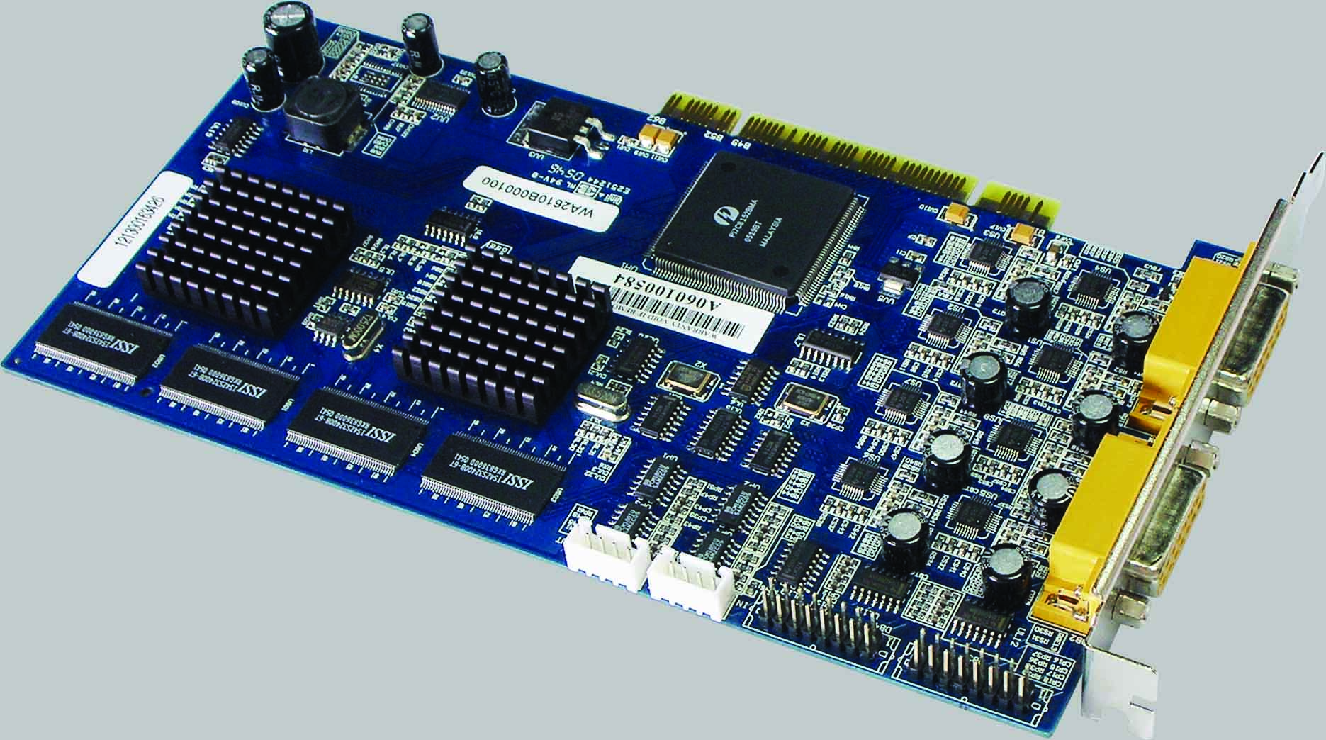
Specifications
Model | SCB-5004 | SCB-5008 | SCB-5016
Video Input | 4 Cameras | 8 Cameras | 16 Cameras
Audio Input | 4 Channels | 8 Channels | 16 Channels
Maximum Cards | 4 Cards | 4 Cards | 3 Cards
Display Rate @D1 | 120 fps (NTSC),  100 fps (PAL) | 240 fps (NTSC),  200 fps (PAL) | 480 fps (NTSC),  400 fps (PAL)
Recording Rate @CIF | 120 fps (NTSC),  100 fps (PAL) | 240 fps (NTSC),  200 fps (PAL) | 480 fps (NTSC),  400 fps (PAL)
Video Resolution | NTSC: 176x120; 352x240; 528x320; 704x480*
Video Resolution | PAL: 176x144; 352x240; 528x320; 704x480*
Compression Format | Hardware Compression H.264
Available I/O Card | N/A
Available I/O Box | Supporting
Hardware Watchdog | N/A
Dimension | 154 (W) x 95 (H) mm | 201 (W) x 109 (H) mm | 265 (W) x 125 (H) mm
Software Version | NUUO H.264 Hybrid system v3.2.0
System Minimum Requirements
OS Supported | Windows XP SP3/ Windows 2003
CPU | Core 2 Duo E5300
RAM | 2 GB | 2 GB | 2 GB
HDD | 250 GB
Mother-board | Intel P45 or P43 or above,MB vendor ASUS,Gigabyte or MSI with Intel Chipset recommended
Display | ATI Radeon 3850/4850, nVIDIA GeForce GF-9600 or above(ATI Driver V9-2 recommended,ATI Driver V10 not support)
* Support SCB-5004 to record 2ch @ D1 resolution, SCB-5008 to record 2ch @ D1 resolution, SCB-5016 to record 4ch @ D1 resolution

SCB-G3-3000 Series
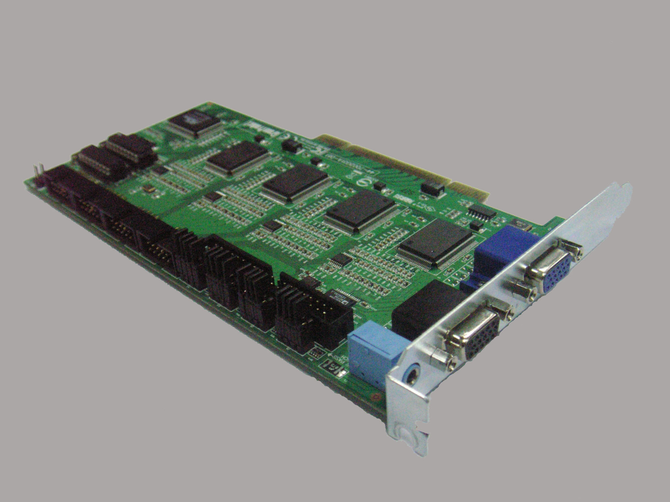
Specifications
Model | SCB-3004 | SCB-3008 | SCB-3012 | SCB-3016
Video Input | 4 Cameras | 8 Cameras | 12 Cameras | 16 Cameras
Audio Input | 4 Channels
Maximum Cards | 2 Cards*
Display Rate @D1 | 120 fps (NTSC), 100 fps (PAL)
Recording Rate @CIF | 120 fps (NTSC), 100 fps (PAL)
Recording Rate @D1 | 120 fps (NTSC), 100 fps (PAL)
Video Resolution | NTSC : 704x480 ; 640 x 480; 352x240
Video Resolution | PAL : 704x576 ; 640 x 576; 352x288
Compression Format | Software Compression MPEG-4
Available I/O Card | 4 Cards
Hardware Watchdog | Yes
Dimension | 200 (W) x 120 (H) mm
Software Version | NUUO MPEG-4 Hybrid system v3.2.21
System Minimum Requirements
OS Supported | Windows XP SP3/ Windows 2003/ Windows Vista SP1
CPU | Core 2 Duo E5300
RAM | 2 GB
HDD | 250 GB
Mother-board | Intel P45 or P43 or above,MB vendor ASUS,Gigabyte or MSI with Intel Chipset recommended
Display | ATI Radeon 4650, nVIDIA GeForce GF-9600 or above(ATI recommended)
* When installed two 3000 series card on one PC, the system can only support 352x240(NTSC), 352x288(PAL) resolution for each channels.

SCB-G3-2000 Series
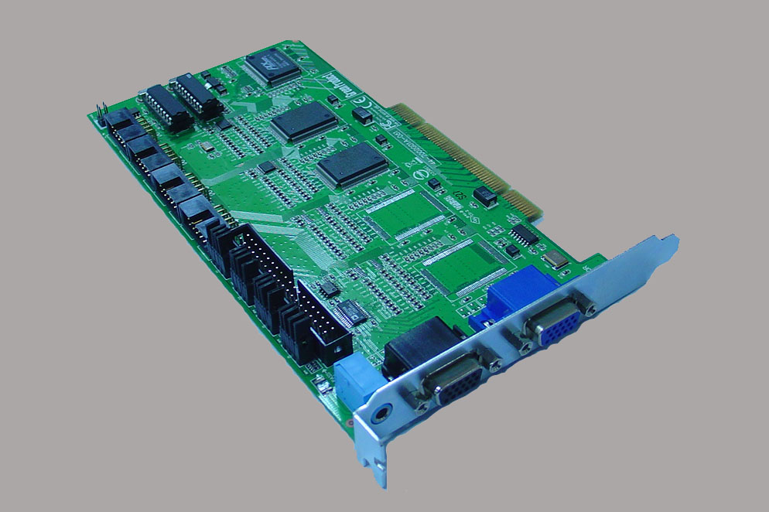
Specifications
Model | SCB-2004 | SCB-2008
Video Input | 4 Cameras | 8 Cameras
Audio Input | 2 Channels
Maximum Cards | 4 Cards*
Display Rate @D1 | 60 fps (NTSC), 50 fps (PAL)
Recording Rate @CIF | 60 fps (NTSC), 50 fps (PAL)
Video Resolution | NTSC : 704x480 ; 640 x 480; 352x240
Video Resolution | PAL : 704x576 ; 640 x 576; 352x288
Compression Format | Software Compression MPEG-4
Available I/O Card | 2 Cards
Hardware Watchdog | Yes
Dimension | 200 (W) x 120(H) mm
Software Version | NUUO MPEG-4 Hybrid system v3.2.21
System Minimum Requirements
OS Supported | Windows XP SP3/ Windows 2003/ Windows Vista SP1
CPU | Core 2 Duo E5300
RAM | 2 GB
HDD | 250 GB
Mother-board | Intel P45 or P43 or above,MB vendor ASUS,Gigabyte or MSI with Intel Chipset recommended
Display | ATI Radeon 4650, nVIDIA GeForce GF-9600 or above(ATI recommended)
* When installed four 2000 series card on one PC, the system can only support 352x240(NTSC), 352x288(PAL) resolution for each channels.

SCB-G3-1000 Series
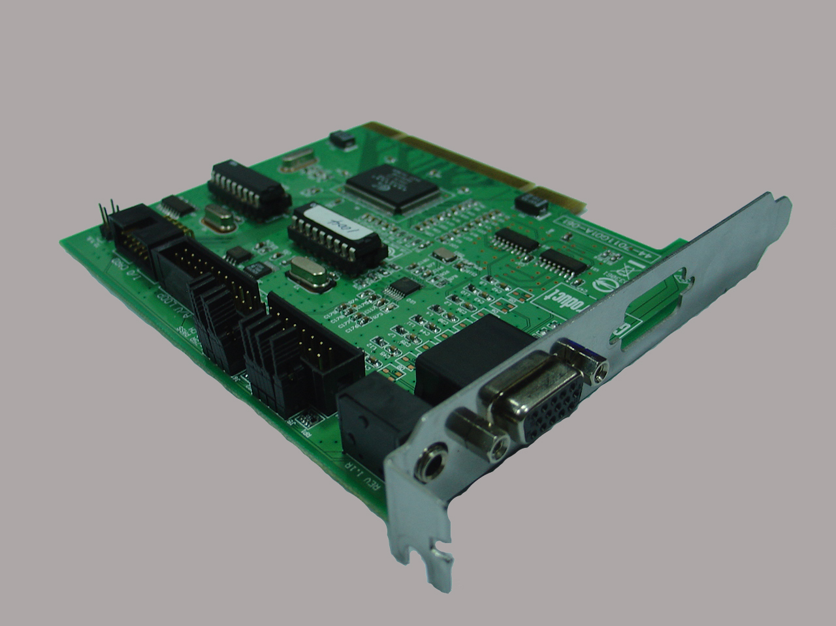
Specifications
Model | SCB-1004 | SCB-1008
Video Input | 4 Cameras | 8 Cameras
Audio Input | 1 Channel
Maximum Cards | 4 Cards
Display Rate @D1 | 30 fps (NTSC), 25 fps (PAL)
Recording Rate @CIF | 30 fps (NTSC), 25 fps (PAL)
Video Resolution | NTSC : 704x480 ; 640 x 480; 352x240
Video Resolution | PAL : 704x576 ; 640 x 576; 352x288
Compression Format | Software Compression MPEG-4
Available I/O Card | 1 Card
Hardware Watchdog | Yes
Dimension | 155 (W) x 120 (H) mm
Software Version | NUUO MPEG-4 Hybrid system v3.2.0
System Minimum Requirements
OS Supported | Windows XP SP3/ Windows 2003/ Windows Vista SP1
CPU | Core 2 Duo E5300
RAM | 2 GB
HDD | 250 GB
Mother-board | Intel P45 or P43 or above,MB vendor ASUS,Gigabyte or MSI with Intel Chipset recommended
Display | ATI Radeon 4650, nVIDIA GeForce GF-9600 or above(ATI recommended)

System Diagram
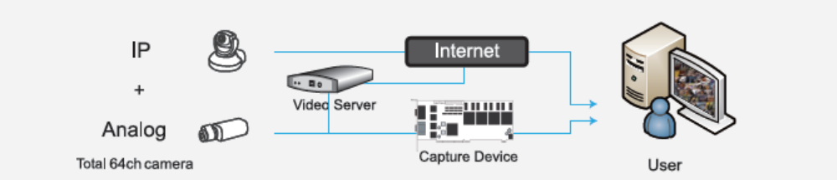

NUUO Software v3.2.21
Main Features
- Support up to 64 channels, including IP and analog cameras*
- Support Megapixel cameras (requires IP+ license)
- Triple monitor display
- Support Joystick
- E-map
- Unique GUI recording schedule
- Digital PTZ and multi-view
- User-Define presets for analog speed dome
- Smart detection of 6 events with 10 instant responses
- Counting application
- Intelligent playback system with 5 video analytics searches
- POS and I/O device integration
- Remote live viewer, remote playback, remote backup, remote I/O control and remote desktop configuration
- Supported by NUUO Central Management System
- Supports 36 brands of IP cameras and more than 560 models(requires IP+ license)
- Supports 28 languages
*The maximum number of camera connections depends on the server's hardware configuration and the total bit rate of the IP cameras. Please check NUUO Calculator on http://support.nuuo.com/calculator/
Specifications

System, setting, management and integration:
  - Hybrid system –The user can mix and match 64 IP and analog cameras per system.

  - Open Platform: Supports over 560 IP cameras, megapixel cameras and video servers from 36 brands of network camera manufacturers; supports H.264, MPEG-4, MJPEG, MxPEG video formats; integrates various systems including point of sale (POS) and I/O device, as well as provides you SDK to integrate access control.

  - Multi-site/Multi-server: Multiple NDVR hybrid servers can be managed by NUUO CMS or remote live view client at a centralized monitoring station in multi-site projects.

  - Multiple Video Clients: NUUO NDVR server can stream video to multiple Remote Live Viewers, web clients and mobile clients simultaneously.

  - Intelligent Video Analytics: NUUO IVS supports 6 types of video analytics including general motion, missing object, camera occlusion, foreign object, focus lost and signal lost. Each IVS alarm can trigger up to 10 unique instant notifications.

  - Intelligent PTZ: Joystick support on PTZ cameras and software enabled digital PTZ function are both available in NUUO NDVR. Preset points and patrol functions are also available on many camera models.

  - User-Define Preset: Analog speed domes can trigger special actions such as auto-tracking, auto-iris, camera manual…etc directly from the NDVR’s preset controller.

  - GUI Recording Schedule: Intuitive GUI recording schedule featuring continuous recording, motion recording and the 6 unique event recording modes. User can define the recording schedule for each camera on a day by day basis.

  - Triple Monitor: Up to 64 channels of live view video can be displayed per monitor. Monitor 1 and monitor 2 can both display live view video or act as alarm monitor while the 3rd monitor can be used to playback recorded video (SCB-5000 Series only supports playback system on the 2nd monitor but not live video).

  - Transcoding: Record and live display at different frame rate and resolution.

  - Advance E-Map: Freedom to import custom image file, place the cameras and I/O on the map to indicate where events are getting triggered with a convenient video preview window.

  - User-Friendly Interface: GUI recording schedule, camera drag and drop, I/O control menu and PTZ control menu.

  - Automatic Camera Model Detection: Automatically search for all of the IP cameras in the network (camera must support UPnP protocol). For cameras that don’t support UPnP, user can manually insert the IP camera. The auto detection function will help the user to find the brand and model of the camera after specifying its IP address.

  - Counting Application: intelligent 2-way (in and out) counting of object, people and traffic.

  - User Authority Management: Support unlimited number of users with detailed and fully customizable user privilege on each user.

  - Network Flow Monitor: The data streaming bandwidth of each remote client connection to the NDVR server can be monitored and blocked if flow rate is too high.

  - Auto Recycle: Automatically recycle recording files when the storage is full. Separate recycle schedule between recordings and varies log files.

  - Integration Support: Open SDK for integration with third-party systems such as access control, automation, burglar alarm, video analytics and others.

Live Display:
  - Multi-view: NUUO NDVR can duplicate the same live view video onto multiple channels and digitally zone in to see the details of different spots on cloned channels without losing the original live view video. (SCB-5000 Series do not support Multi-view from the analog cameras. All IP cameras work otherwise.)

  - Intelligent PTZ: Joystick support on PTZ cameras and software enabled digital PTZ function are both available in NUUO NDVR. Preset points and patrol functions are also available on many camera models.

  - Monitor Resolution: Supports 1024x768, 1200x900, 1280x1024, and 1600x1200 screen resolutions

  - Advanced E-Map: Freedom to import custom image file, place the cameras and I/O on the map to indicate where events are getting triggered with a convenient video preview window.

  - Bandwidth Monitor: Monitor and display the bandwidth usage of individual cameras and remote viewing clients.

  - Two-way Audio: Listen, record or even have an audio conversation through the NDVR by utilizing IP camera’s microphone and speaker.

Playback, Search, Export and Secure data:
  - Post-Recording Processing: Search for 5 types of different analytics events, digital PTZ and video enhancement tool are all available in playback.

  - Multi-Channel Playback: Play up to 16 channels of recorded video simultaneously both locally and remotely.

  - Video Enhancement: Fine tune the image’s visibility, sharpen, brightness, contrast or even grey scale.

  - Intelligent Search: Search for 5 different special events (general motion, missing object, foreign object, camera occlusion and signal lost) in recorded files with date, time and log file.

  - Video Export: Take a snapshot of the recording in JPEG/BMP format or export a section of the video in “AVI” and “ASF” format.

  - Backup: Backup the recording for archiving purposes or backup the recording with an embedded player to watch at a separate location. NDVR supports both local and remote backup to local HD, network drive and CD.

  - Log data: Unusual event, system log, counting application, POS log and export and backup can export to “xls” or “txt” file

  - Watermark: Protect for original recording from alternation with our watermark verification tool.

  - DBTool: Reconstruct, repair or relocate the recordings in local drive, external drive or network drive.

Remote operations:
  - Multiple Live View Display: Streaming live video from multiple NUUO servers (NVR, DVR, and NDVR) simultaneously. Dual monitors support with up to 128 channels per monitor (64 channels per monitor in v3.2.0).

  - Multi Playback Channels Display: Remote playback of 16 channels recording from any one of the NUUO servers (NVR, DVR, and NDVR).

  - Intelligent PTZ: Joystick support on PTZ cameras and software enabled digital PTZ function are both available in NUUO NDVR. Preset points and patrol functions are also available on many camera models.

  - I/O Event Control: Easy to use input and output control panel to remotely trigger digital outputs and monitor input status.

  - E-Map: A map view of where each camera and I/O devices are located with a convenient preview window.

  - Remote Backup: Backup the video into .DAT format with a NUUO player attached for easy achieve and viewing purposes.

  - Web-browser (client): Display up to 16 channels of live video stream or 16 channels of playback in I.E. from any single NUUO server.

  - PDA Viewer: Up to 16 channels snapshot or 1 channel live display; PTZ and I/O control.

Extension Service
  - Central Management System: Ultimate central monitoring solution for grand scale projects and projects with multiple sites. Fully compatible with all NUUO servers (NVR, DVR, NDVR and NVRmini).

  - Remote Desktop Service: Embedded remote desktop server that will host for any NUUO remote desktop clients to remotely configure the NDVR software (remote desktop client is installed separately).

  - 3GPP Service: NUUO NDVR supports mobile devices through 3G network to stream live view video.

External Device
  - Point of Sale (POS): NUUO Point of Sales system works on NUUO NDVR by overlaying the transaction text from cash register onto live video channels. All POS recordings are searchable.

  - External I/O capacity: Please refer to our I/O box section: C24/C26/C28 for more details.

Smart Guard:
  - Smart detection of 6 camera events, 14 different user-defined POS events, digital input events and 4 system events. The combination of our smart guard events is a powerful tool to combat vandalism and provide a platform for operators to monitor and respond to live events immediately.
    - Camera Events:
      - General Motion
      - Missing Object
      - Foreign Object
      - Focus Lost
      - Camera Occlusion
      - Signal Lost
    - Signal Digital Input Event
    - System Event:
      - System alarm on Disk Space Exhausted
      - System alarm on System Health Unusual (CPU temperature)
      - System alarm on Resource Depleted (CPU loading)
      - System alarm on Network Congestion

  - Instant alarm notification is the fastest and most cost efficient way to automatically respond to any smart detection event.
    - 10 automatic instant alarm responses:
      - On Screen Display
      - Play Sound
      - Send E-mail
      - Phone Call
      - PTZ Preset Go
      - Signal Digital Output
      - Send a SMS message
      - Send to Central Server
      - Send Snapshot to FTP
      - Popup E-Map on Event

Support Language
Bulgaria |  | Chinese (Simplified ) |  | Chinese (Traditional) |  |  | Czech
Danish |  | English |  | Farsi |  |  | Finnish
French |  | German |  | Greek |  |  | Hebrew
Hungarian |  | Italian |  | Japanese |  |  | Korean
Norway |  | Polish |  | Portuguese(Brazil) |  |  | Portuguese(Portugal)
Romanian |  | Russian |  | Serbia |  |  | Slovak
Spanish |  | Swedish |  | Thai |  |  | Turkey
IP Camera Brand(s) Supported
ACTi | Arecont |  | Atlantis |  | Axis | Basler |  | Cisco
Digimerge | D-Link |  | Dynacolor |  | Etrovision | EverFocus |  | Eyeview
Fine | HIKVision |  | Hitron |  | Icantek | IQinvision |  | JVC
LevelOne | Linksys |  | Lorex |  | Lumenera | Mobotix |  | Moxa
Panasonic(PCC) | Panasonic(PSS) |  | Pixord |  | Planet | Samsung |  | Sanyo
Seorim | Sony |  | Toshiba |  | Truen | Vivotek |  | Y-cam
Zavio



