

The Point of Sale Solution

Hardware & Software Installation
User Manual

Ver. 99.340.A112.001

Table of Contents

Table of Contents 1
System Introduction 2
Definition of Terms 2
Product Specification 3
Hardware Installation 4
SCB-C31A POS data capture convertor 4
Software Installation 6
SCB-C31A POS data capture convertor 6
NUUO NVR/DVR/Hybrid system installation 7
Software Setup 8
1. POS Device Management 8
1.1. Insert/Delete/Configure POS devices 8
1.2. New/Edit/Delete/Import/Export Tag Filter 10
1.3. Setup POS Display Font 14
2. Smart Guard Detection 15
2.1. POS Event 15
2.2. Instant Action on POS Event 18
3. Playback 18
4. Remote Network Service 19
Operation Tools 21
1. Live Display 21
2. Log Viewer Search 22
3. POS transaction data Search 24
4. Playback video with POS data 25
5. Backup video with POS data 26
6. Remote Access 28

System Introduction

NUUO POS, a Point of Sale Systems based on NUUO NVR/DVR/NVDR, provides financial transaction’s surveillance solution in one central system. The architecture is as below; POS transaction data flows to NVR by Ethernet. Each Cash Register with an external receipt printer is connected by DB9 cable. The transaction information delivered in R232 format can be converted to Ethernet through SCB-C31A POS data capture convertor. Alternatively, Cash Registers that support TCP/IP or COM port output can connect directly to the system without the SCB-C31A box.

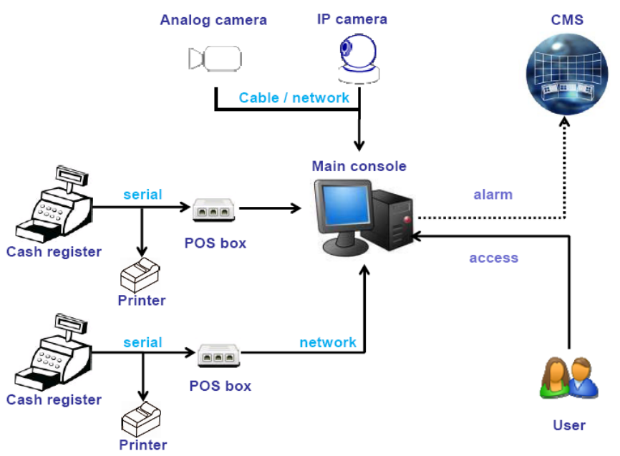

Definition of Terms

Terms | Definition
POS Original Data | Original data from POS. Usually with a lot of symbols and no line feed.
POS Transaction | Filtered result by user-defined tag-filter.
POS Event Log | Smart Guard Event Log from POS transaction. It includes Transaction start, Transaction end, Cash register open, User defined condition. Abbreviation  of POS Log.

Product Specification

NUUO Capture Box
SCB-C31A POS
Input | RS232
Output | Ethernet
DC In | DC +10V to +15V
Power consumption | 500 mA
Operating Temperature | -20 to 65℃
Operating Humidity | 0-90 % Non-Condensing
Baud Rate | 110 bps to 230.4 kbps
Data Bits | 5, 6, 7 or 8
Stop Bits | 1, 1.5 or 2
Parity | None, Even, Odd, Mark, Space
Flow Control | None, RTX/CTS, XON/XOFF, DTR/DSR

Hardware Installation

SCB-C31A POS data capture convertor

To connect Cash Register, Printer, and SCB-C31A POS data capture convertor together, please follow below steps:

Step 1: Please refer the user manual to setup Cash Register and printer.

Step 2: Using a “Y-shape” DB-9 cable, one DB-9 female connect to POS system and one DB-9 male connect to the receipt printer Y-shape (provided by Printer vendor).

Step 3: Using another DB-9 female connect to SCB-C31A POS Data Capture R232/Ethernet convertor with Null modem.
Note: There are two kinds of serial cable: Straight pass-through and Null-Modem. The connection between SCB C31A POS Data capture box and Y-cable must be null modem (in package).

Step 4: Check the system switch of the SCB-C31A POS is switch to OFF, OFF position.

Step 5: Connect power source with SCB-C31A POS.

Step 6: Connect SCB-C31A POS with internet port by RJ45 LAN cable.

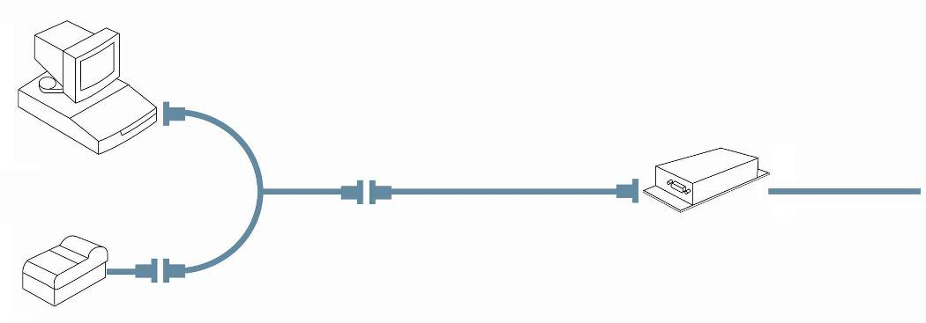
SCB-C31A POS

Cash register

Printer

Null Modem

Y-cable

Ethernet

Provided by printer

F

F

M

M

F

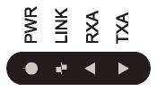
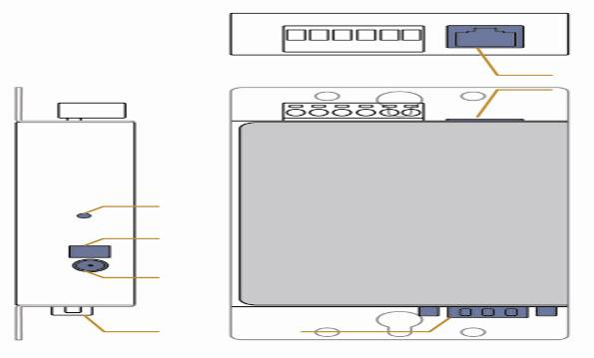
Reset

Switch

Power

RS-232

RS-232

RJ-45

The LED Indicators:
PWR LED: System is ready (Blinking).
LINK LED: Ethernet cable connection and data active.
RXA LED: Transiting/Receiving Indicator.
TXA LED: No option of SCB-C31A POS

Software Installation

SCB-C31 POS data capture convertor

Step 1: Use IE-browser to setup SCB-C31A POS, the default IP address is 192.168.1.1
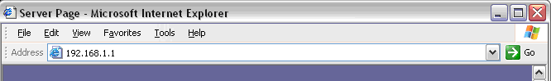

Step 2: Setup IP address and password, and then setup IP address.
Note: Each time you switch the page of the web, please click Save at first. If you leave this page without saving, all changes will be ignored.

Step 3: Setup Password if needed. Password is only using to activate a security feature on the serial server. Once a password is entered it will be required to access the menu and make change of configuration when access.
Note: Please write down the Serial number and MAC address, these two parameters are necessary when user forget your password.
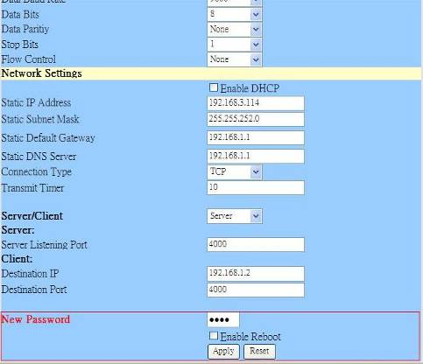

Step 4: Setup according to your POS or Cash Register. Usually all devices are default setting, you can reserve your time to pass this step.

Step 5: Please restart/reset the box after changing configurations to active setup.
To reset the unit manually apply power, insert a small plastic tool, and press lightly depressing reset located between the switch (refer page 5). Hold for 3 seconds and release. The Link and Run light will go out and turn back on. The SCB-C31A POS will revert to the last setting.

Note: Every time you change the configuration of SCB-C31A POS, please check the above settings, especially maximum connection and Remote IP address to avoid connection fail.

Connection via COM Port
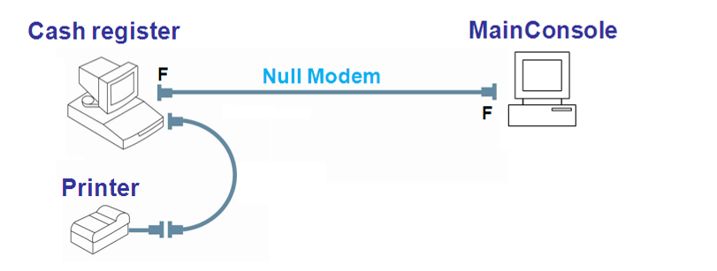
Please install system according to following diagram:

Connection via TCP Client
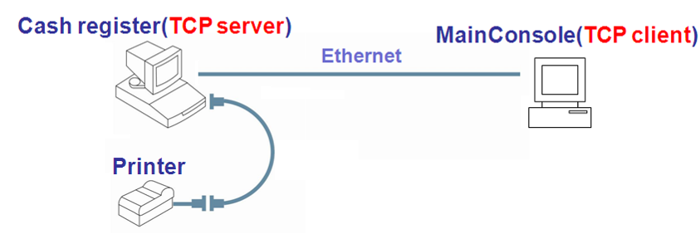
Please install system according to following diagram:

NUUO NVR/DVR/Hybrid system installation

Please refer to the Main Console user manual to complete system installation with the NVR/DVR/Hybrid systems installation CD.

Software Setup

1. POS Device Management

Each NUUO Main Console system can manage up to 64 POS cash register devices. This section will teach you how to setup config of your system.

Run Main Console and click on POS Application from the Config menu to open POS Application window.

You are able to Insert/Delete/Configure POS devices in this window. Choose devices from the POS Tree, and info will be shown in the POS Info window. Associated cameras will be shown in the preview window below.
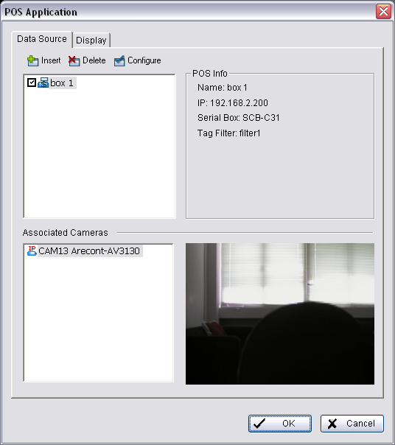
POS Tree

POS Info

Associated Camera

1.1. Insert/Delete/Configure POS devices

To Insert a POS device

- Click the Insert button to open the POS Setting window
- Configure data source info, including Name, Source Type, IP address and Port.
- After setting, click Test Connection to test POS device connection. If all the settings are correct, the system will popup “POS “name (IP)” is available” message to confirm the setting is successful.

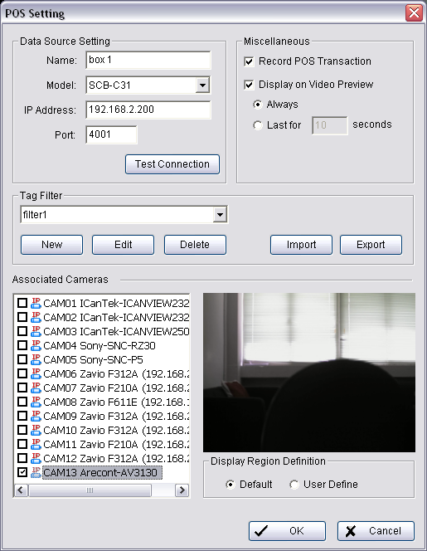
- Setup Miscellaneous options, including Record POS Transaction and Display on Videos Preview.
      - Record POS Transaction:
Select this checkbox to record POS transaction data and to transfer into MS database. The MS data will allow searching and display on associated recording video, and the MS data files can also provide third-party application to analysis.
      - Display on Video preview:
Select this checkbox to display POS transaction data overlay on associated camera live videos.
Two types of transaction data display time: Always means keep transaction data on video until receiving next transaction data. Last for 10 seconds means each transaction data only last on video for 10 seconds.
- Select Tag Filter (refer to Tag Filter section on on page 13).
- Enable checkbox to select cameras desired to be displayed with POS transaction data overlay on live video.
- In Display Region Definition option, setup display area for each camera video.
  - Default: The default display area is below the camera OSD.
  - User Define: Right-click on video preview and drag rectangle to define display area.
- Click OK to save.

To delete POS device

- Choose POS device.
- Click Delete button to remove this POS device from the system.

To configure POS device

- Choose POS device.
- Click Configure button to open POS Settings window.
- Please refer To insert POS device section (page 11 ) to modify configuration.

1.2. New/Edit/Delete/Import/Export Tag Filter

The original transaction data from POS system is hard to read. Users can define filters to make it comprehensible. NUUO also provides a simple default tag filter to help filter out same common EPSON commands. Users can edit other customized filters based on this default tag filter.

To add new Tag Filter

- Click on the New button to open the Tag Filter window.
This window includes the following sections:
- General: Setup Tag Filter name and a test connect button.
- Original Data: Show original transaction data from POS device.
- Filtered Data: Show filtered data after defined filter.
- Filtered Function buttons: Tool used to define filter type.
- Filter List: A list of all filters.
- Data tools: Includes import/export buttons to import/export original binary data, and a clear button to clear original/filtered data windows.
- Filter tools: Includes upper/down tool to arrange priority of each filter, or remove filters from list. You may also edit existing filters or add new ones.
- Encoding: Choose desired language.
- Transaction Timeout: Define a maximum time length for transactions to end when no more data is received.

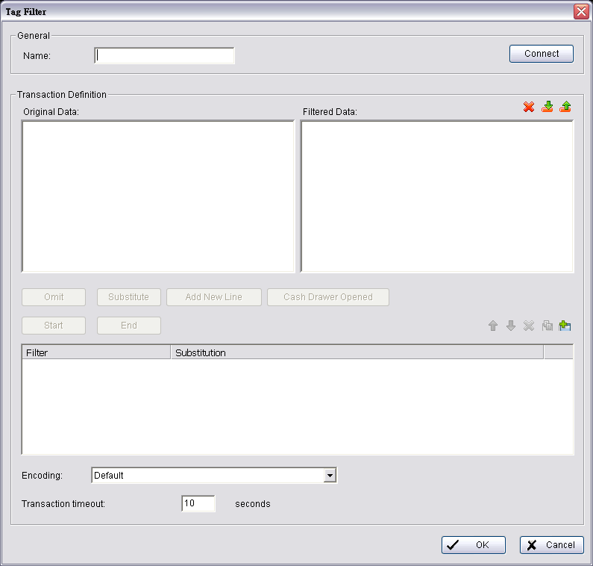
General

Original Data

Filtered Data

Filtered Function

Filter List

Data Tools

Filter Tools

Encoding

Timeout

- Enter name of tag filter.
- Click Connect button to capture POS transaction data from POS device.
- Please operate POS device to send transaction data to filter.
The original transaction data will show on the left window.
Note: If you don’t want the data to keep importing when editing filters, please click the Disconnect button to stop connection.
- Data Tools:
Export: Capture and export original Binary data
Import: Reload exported Binary data.
Clear: Remove data form Original Data and Filtered Data windows.
- Start to edit tag filters:
Click and highlight text from Original Data window, then use the six buttons below to define filters. The filtered transaction data will show on the right window.
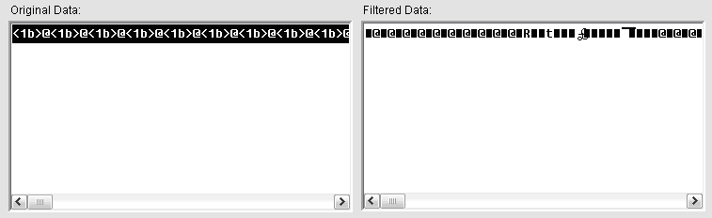

- Omit: Neglect the selected text which is meaningless or not important. The text will disappear in right filtered data window.

- Substitute: Use other words to replace the selected text. The system will popup a substitution panel for replacing desired words. The text on the filtered data window will show the result.

- Add New Line: Define the selected text as the symbol for changing to a new line. The result will show on the right filtered data table. 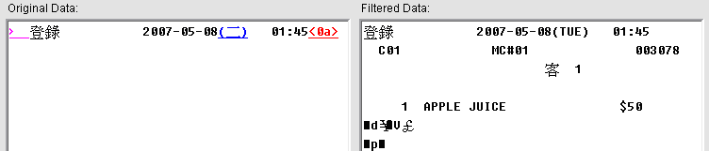

- Start: Define the selected text as the symbol for the beginning of a transaction. It will be replaced as a line as shown below.
Note: This setup is also used as detection tag for Smart Guard to detect Transaction Start event.

- End: Define the selected text as the symbol for the end of a transaction. It will be replaced as a line as shown below.
Note: No transaction end may result in error or lost info.
If you do not define this filter please be sure to define a transaction timeout. For more info please refer to p.16.
This setup is also used as detection tag for Smart Guard to detect Transaction End event.
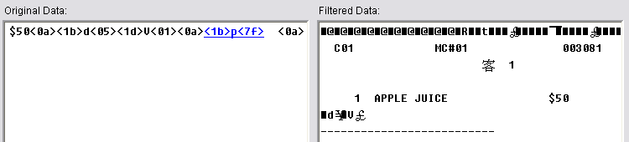

- Cash Register Opened: Define the selected text as the symbol for cash register opened. The filtered data will show the <Cash Register Open> mark as below.
Note: This setup is also used as detection tag for Smart Guard to detect Open Cash Register event.
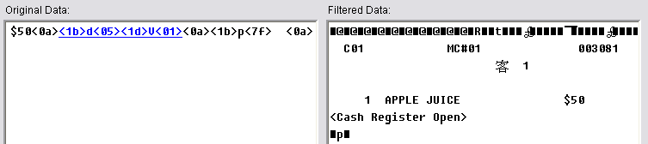

- Filter Tools:
The buttons are used to change priority of sub filter criteria. The filter will operate by order of list; the filters on top will take effect first. The button will remove the filter from this list. Click on Edit / Add to configure tag filters or add new ones.
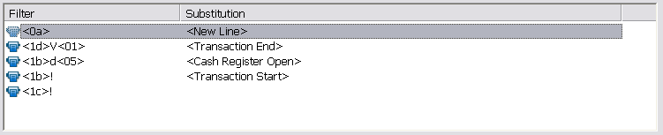

- Click on OK to save configuration.

Note: If codepage of POS printer is different with Windows OS, please correspond with POS printer to setup Encoding option.
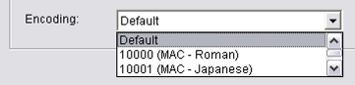

To Edit Tag Filter

- Select Tag Filter name from drop-down menu,
- Click Edit button
- Configure the Tag Filter window.
- Click OK to save configuration.

To Delete Tag Filter

- Select Tag Filter name from drop-down menu,
- Click Delete button

To Import/Export Tag Filter

- Click Import/Export button and select Import/Export URL.
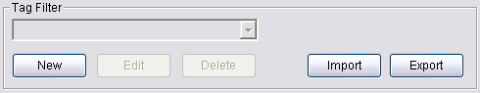
- Click Open/Save to Import/Export Tag Filter.
- After Import Tag Filters, users can simply select tag filter form drop-down menu without edit new tag filter.

1.3. Setup POS Display Font

This option allows to setup font of POS transaction data on video.

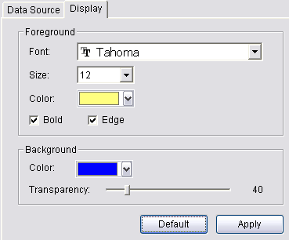
- Run Main Console, click on POS Application from Config menu to open POS Application window, and then switch to Display tab.

- For POS transaction data displayed overlay video, select the font, font size, font color and any font effects user wants.

2. Smart Guard Detection

2.1. POS Event

Each POS System has five POS Event types:

Transaction Start - Detect any transaction beginning
Transaction End - Detect any transaction ending
Open Cash Register - Detect any cash register opening
User Defined - Detect any condition which is defined by user
Connection Lost – Detect any connection abnormal event between the POS and Main Console systems.

Note: First three events require a pre-defined detection tag, please refer to Edit Tag Filter section (see page 15).

To add new POS Event

- Select POS device from device tree.
- Click on button to open Select Event Window.
- Select Event Type.
- Setup basic option of Event.
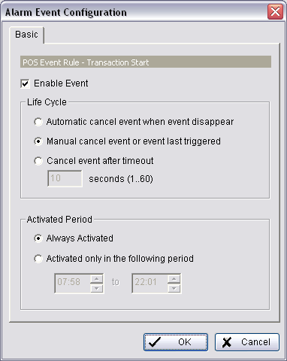

- Enable Event: Check the box to activate.
- Life Cycle:
  - Manually cancel event or event continues triggered:
The alarm/action will continue until being canceled from Main Console (Start>Open Event Report>Cancel All Events). The user currently not at the seat watching the screen will be notified by the alarm.
  - Cancel event after timeout xx seconds:
Enable checkbox and setup the timeout seconds to cancel the event after the time that you set whatever the events disappear or not.
- Activated Period:
  - Always Activated:
Enable this option, the system will react always.
  - Activated only in the following period:
Setup the system to react during a certain time period; for example, office working hours (8:58 to 18:02).

- Setup advanced option of User Defined Event.
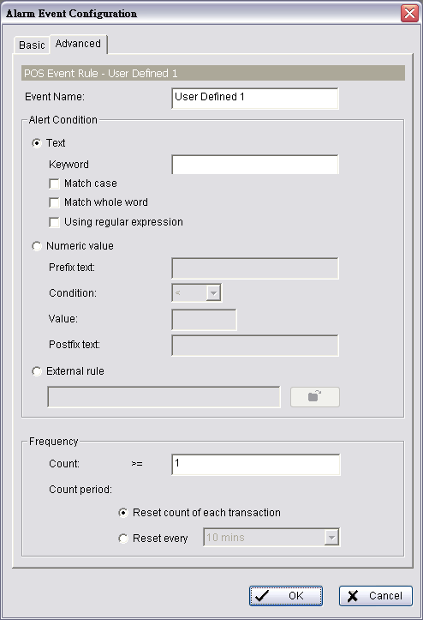
- Event name: Enter the name of user defined event.
- Alert Condition:
  - Text:
Enter the text user wants to detect in Keyword column. Enable Match case to search for names where the case matches the letters you entered. Or enable Match whole word to search for the terms you entered as a whole word.
Check Using Regular Expression to include regular expression commands in search.
  - Numeric value:
Enter a number as the condition of event and then choose one of the symbols ( ≦ ＜ ＝ ＞ ≧ ) to define the numeric value.

For advanced settings, use Prefix text/Postfix text to detect special text before/after the value’s condition.
For Example: To detect Coke > 100 US, please insert as below:
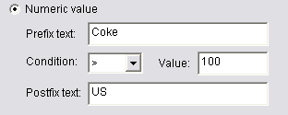
Note: The value is also case sensitive, you must key in “,” symbol to search for 10,000US.

  - External rule:
This feature allows developers to customize event rules. Main Console can send filtered transaction data to third-party applications and receive reply on whether to trigger alarm or not. Please contact service@nuuo.com for details.
- Frequency:
  - Count:
Alarm will be triggered when this event happens over specific number of times.
  - Count Period:
To reset count after each new transaction, or under specified period of time.

To Copy Event to other POS Devices

- Right-Click on POS Event which you want to copy. For example, click, and select copy.
- Switch to other POS device which you want post event: Right-click on POS device, and select post.

Note: IF you want to copy POS event to all POS devices, simply select copy to all of right-click menu on step 1.

2.2. Instant Action on POS Event

Each POS Event can be setup to trigger 9 instant response actions:

On Screen Display - A red warning message will be flashing on the screen of associated cameras.
Play Sound – Play sound warning.
Send E-mail - Send E-mail with event type, time, and snapshot of first associated camera.
Phone Call – dial pone call.
PTZ Preset Go – Control PTZ camera move to a preset point or patrol around preset points.
Signal Digital Output - Triggers traditional alarming output devices.
Send a SMS message - Send a SMS message with event type and time.
FTP – Upload snapshot of first associated camera to FTP.
Popup E-Map on Event – Auto popup E-map window to show POS device location.

Note: For detail configuration please refer to chapter 4.2 Action section of Main Console user manual.

3. Playback

To enable POS overlay option

- Click to open Setting window, and then switch to POS tab.
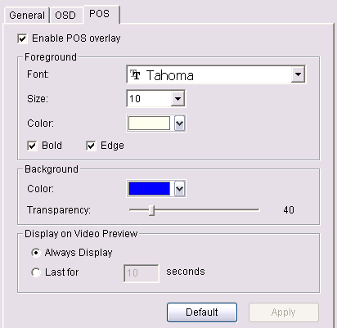
- Check the box of Enable POS overlay, the transaction data will be overlaid on associated camera’s recording video.
- Set up overlay configuration; select the font, size, font color and any font effects user wants.
- Setup option of Display on Video Preview to display POS transaction data overlay on associated camera live videos.
Always Display: To keep transaction data on video until receiving next transaction data.
Last for 10 seconds: Each transaction data is displayed last on video for 10 seconds.

4. Remote Network Service

NUUO systems allow users to access POS data on remote sites.

To Start Network Service of Main Console

- Open Config menu and click Network Service to open Network service window
- Switch to  Live Streaming tab.
- Setup the options of connection and then click start to allow remote view POS Transaction with live videos.
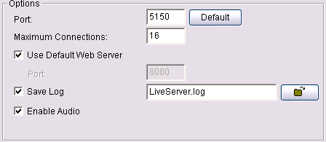

Note: Port 5150 is used when connecting via NUUO Remote Live Viewer application. Web server port 8080 is used when connecting via IE-browser. Please refer to chapter 5.14 Network Service section of Main Console user manual for details.

- Switch to Remote Playback tab.
- Setup the options of connection and then click start to allow remote access database of POS Transaction.
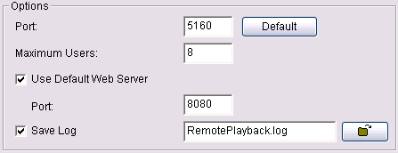
Note: Port 5160 is used when connecting via NUUO Playback application. Web server port 8080 is used when connecting via IE-browser. Please refer to chapter 5.14 Network Service section of Main Console user manual for details.

Operation Tools

1. Live Display

To Display POS Transaction Data Overlay

- Enable Display on Video Preview option.
Please go to Main Console > Config > POS Application > select POS device and Configuration window, and then check the box of this option.
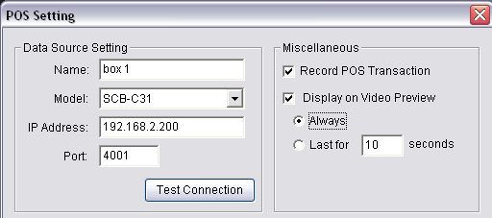
- Select Associated Cameras.
In Associated Cameras setup region, select cameras to overlay POS transaction data.
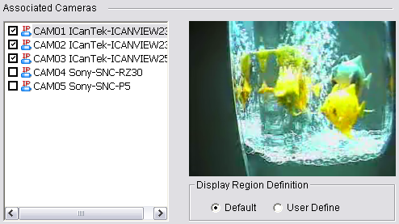
- Enable the POS device application
After setting the associated camera, click OK button back to POS Application window. Select POS device form the device list, the system default enables all POS device when inserted.
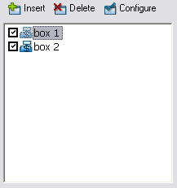

- View the Live Video with POS transaction data
After above setup, the transaction data would show on video when transactions happen.
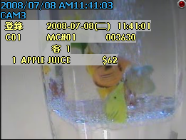

2. Log Viewer Search

Log Viewer is a tool used to search Unusual Events (Smart Guard Events), System Logs, Counting Application results, and POS Logs (POS Event Logs). For detailed description, please refer to chapter 5.12 Log Viewer section of Main Console user manual.

Note: If you want to search the transaction data, please use POS Search tool on next section 3. POS Transaction Data Search on page 31.

To Search POS Event via Main Console

- Run Main Console, click on Log Viewer from Config menu to open Log Viewer window, and then switch to POS Log tab.
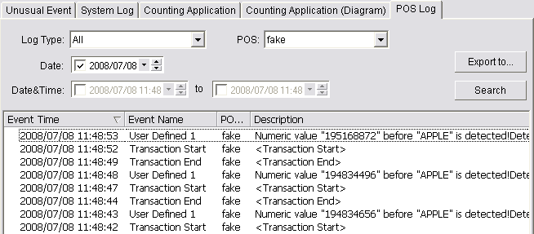
- Select Log Type and POS device from drop-down menu.
- Setup time criteria to search for special Date or a period of Date&Time.
- Click on Search, and search result will list on table.

Note: If you want to copy the search result to other application, simply click on Export to… button to save result as an excel table.
Note: A link () will appear next to each event time where video is available. By clicking on the link, an instant playback window will pop up to show recorded video.

To Search POS Event via Playback

- Run Playback, open record to select the video period, and click Log Viewer button to open Log Viewer window.
- Follow the step 2-4 on previous section to search POS Log.
- Double-click on POS log from result table, and the video will auto switch to the time of POS log.
For Example: When clicking on a specific log from the list, the video will auto switch to the time point the event happened.
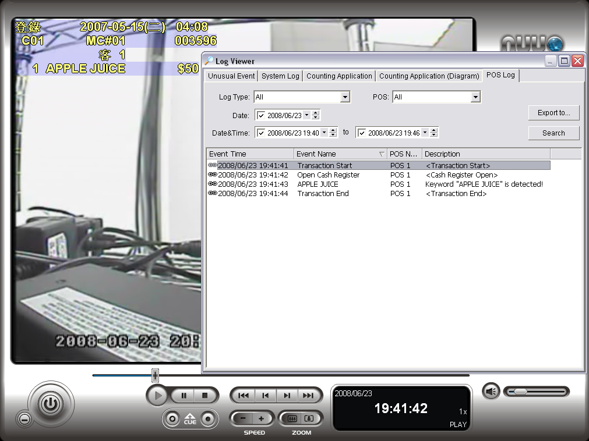

3. POS transaction data Search

POS Search tool is used to search key words of all transaction data. To open this tool, please click on Playback application to open Date Time Search Dialog, and then click on button.
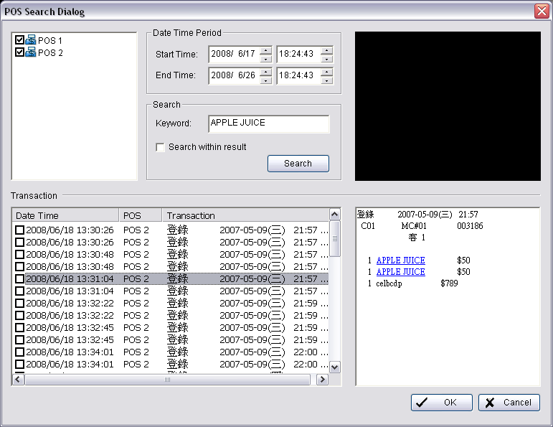

In POS Search Dialog, please follow the steps blow to search from POS devices, Date Time Period, or special keywords.

- Check the box of POS devices from the POS list.
- Setup Start Time and End Time in Data Time Period section.
- Enter keyword you want to search.
Note: This search is case sensitive, you must key in “,” symbol to search for 10,000US.
Note: Regular Expression commands are supported in search.
- Click Search button, Transaction table will show results.
- Select items from Transaction table, the whole transaction detail will show in right-down table and the record video of first associated camera will show in right upper corner.
- Check the box of Search within result and enter keyword, it will search again within the results.

4. Playback video with POS data

To view record video with POS transaction data, please check you have enable POS overlay option (refer the page 32). If you have started this option, the system will auto overlay transaction data when play recording video. Below are two modes to select video period.

To select Period by POS search
- Click on Playback application to open Date Time Search Dialog, and then click on button
- Follow above section 3 POS Transaction data search to search.
- Select the transaction data for result list, and click OK.
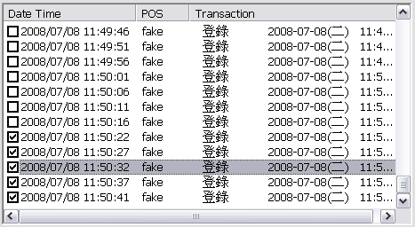
- The period you select from POS search result will be automatically selected.
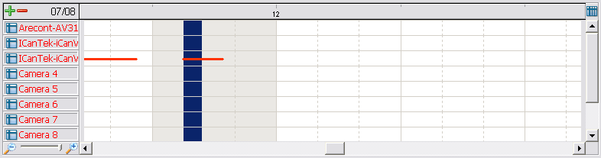
- Click OK to go back to Playback application.

To select Period by Date&Time

- Click on Playback application to open Date Time Search Dialog.
- Setup Start Time on Date Time Period setup panel, or directly left-click and drag to select period from Time Table.
- Click OK to go back to Playback application.

5. Backup video with POS data

NUUO system has three ways to backup video with POS transaction data.

To backup via Main Console

- Open Config menu and then click Backup to open backup system window (For detail, please refer capture 5.13 backup section of Main Console user manual).
- Click on 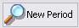 to select data time period you want to backup. The period will be listed on table after click OK. Click to open Backup option window.
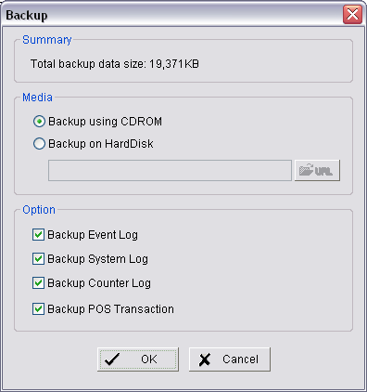
- Select the location where you want backup to.
- Select which data base you want to backup with.
- Event Log: The database of smart guide detected POS and Camera Events.
- System Log: Include recycle, start/stop/modify schedule, Network service…
- Counter Log: Database of Counting Application.
- POS Transaction: The database of POS transaction data.
- Click OK to backup.

To backup via Backup System

- Click on Start > All Programs > NUUO Surveillance System > NUUO Backup System to open NUUO Backup System window.
- Following above step 2-5 on backup on Main Console to backup video with POS transaction data.

To backup via Playback

- Start Playback Application and use Open Record tool to open video you want to backup.
- Click  Backup to open backup dialog.
- Check the period and cameras are what you want to backup.
- Setup the location where you want to backup to.
- Select which database you want to backup with.
- Click OK to start backup.

6. Remote Access

NUUO systems have three remote tools to remote access POS data: NUUO Remote Live Viewer application tool, Playback application tool, and web browser. All access functions are the same as launch on local machine (please refer 3.2 POS Transaction Data search section on page 31).
Note: Before using remote access tool, please check the network service of Main Console has been started (please refer chapter 4 Remote Network service on page 25).

Remote Access via Remote Live Viewer Application

- Click General Setting to obtain LiveView Setting dialog.
General Setting



- Select “Server” to open Server Setting window.
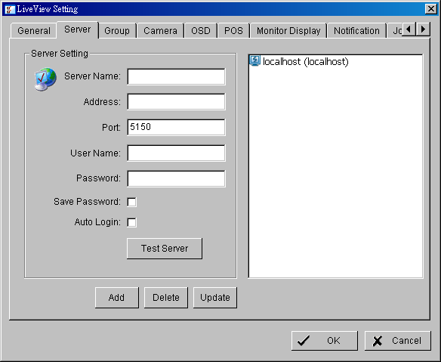

- Setup Server Name, Address, Port, User Name.
- Click on Test Server button to test the setup of server and connection is available.
- Click Add button to add new server site to list, and then, click OK to save configuration.
- Click on “POS” setting to open POS Setting window.
- Select “Enable POS overlay” option to adjust OSD settings of POS information on monitor view.
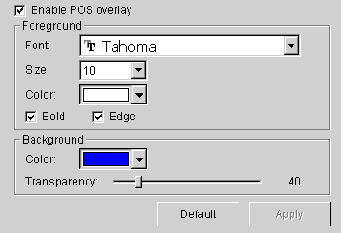

- For POS transaction data displayed overlay video, select the font, font size, font color and any font effects user wants.

Note: The status of POS overlay will be the same with the one in MainConsole. Go to Main console> Config >POS Application to check if “Display on Video Preview” is enabled first, then the POS Overlay function could be enabled.

Remote Access via Playback Application

- Go to General Setting – Setting – Server to open Remote Playback Site Management window.
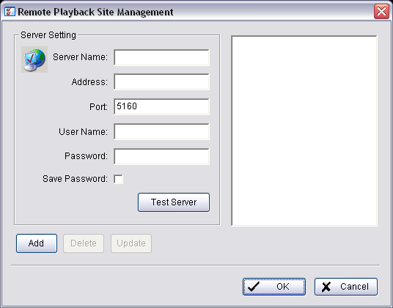
- Setup Server Name, Address, Port, User Name
- Click on Test Server button to test the setup of server and connection is available.
- Click Add button to add new server site to list, and then, click OK to save configuration.
- Click icon on the top of the Open Record window to access the Remote Playback Site.
- Follow the step on section 3.2 POS Transaction Data search section on page 31 to search POS transaction data.
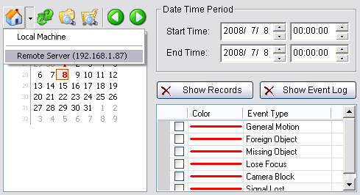

Remote Access via IE-browser

- Open an Internet Explorer browser and enter the IP address or DDNS name of the server followed by the connecting port.
Example: http://169.254.54.171:8080/
- Select Remote Live Viewer / Remote Playback to launch option.
- Follow above Remote Access section to view POS transaction data with live video(s), or play recorded video(s) with POS transaction data.

