JOIN JB TOURS TO………………………….
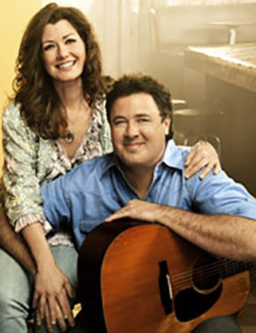


Monday - Thursday  2019 |  | per person double occupancy  Single $1409 Triple $1119 Quad $1079  Add $36 for credit card payments  cancellation insurance available
Your Tour Includes:  - 3-nights’ accommodations at the Gaylord Opryland Resort (incl. luggage handling)  - 6 meals, Including Dinner at the Aquarium Restaurant  - Guided Nashville city tour  - Admission to Johnny Cash & Patsy Cline Museums  - Visit Studio B and Country Music Hall of Fame  - Vince Gill and Amy Grant Christmas Concert  - Holiday production at the Grand Ole Opry  - Gaylord Opryland Resort’s Country Christmas show, featuring Trace Adkins  - ICE life size Winter Wonderland made entirely of ice! |  | Departures  6:30 am Fostoria Shopping Plaza  7:00 am Tiffin Wal-Mart Lot  7:30 am Findlay Wal-Mart (Tiffin Ave)  ****** Break & lunch en-route (on your own)  6:30 pm Approximate Return time
A $20 DEPOSIT WILL GUARANTEE YOUR RESERVATION
******FINAL PAYMENT IS DUE 45 DAYS PRIOR TO DEPARTURE *******
In case of cancellation all monies will be refunded, except for any expenses incurred that cannot be recovered
(NO SHOWS WILL FORFEIT ALL MONIES PAID)
JB Tours  PO Box 150  Fostoria OH 44830 | We Keep the Cost Down & the Excitement up!  419 435-8165  www.jbtours.net |  | 




Gaylord Opryland Resort

