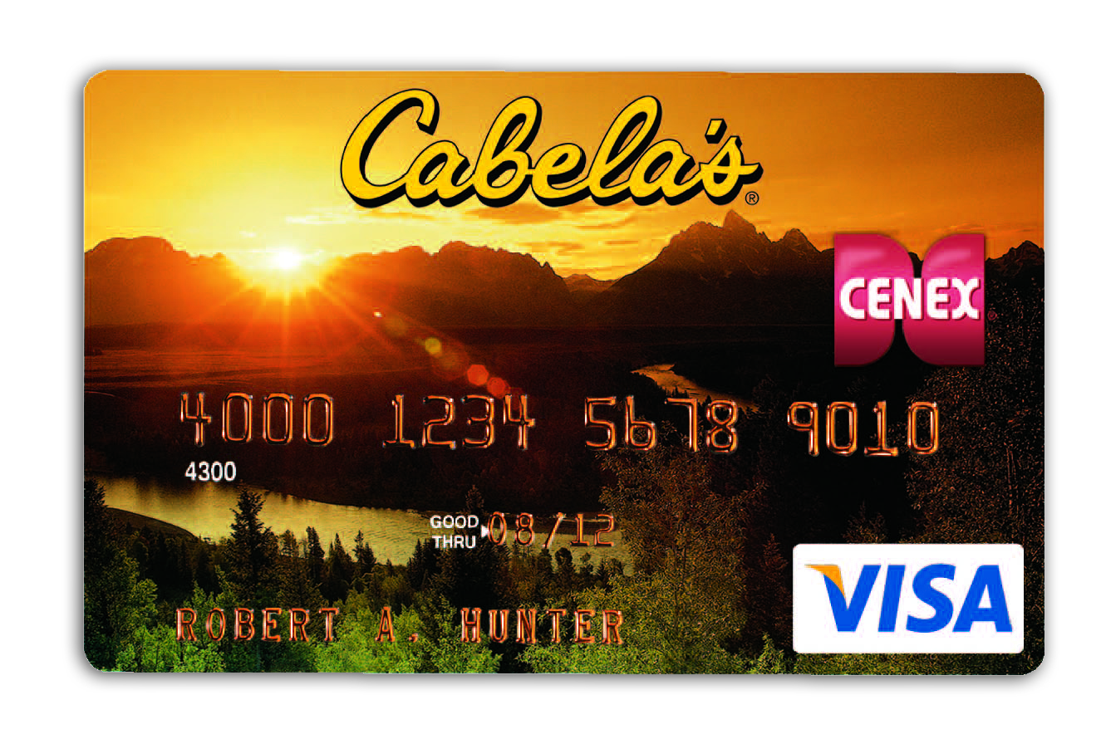
Fuel Your Adventure with Cenex® and Cabela’s®!

If you're the kind of avid outdoorsman who will pull a bass boat 650 miles to get to the perfect lake, can identify fish bait strictly by smell or regularly sweats off 7 pounds…on your ATV, we have a piece of gear just for you – the Cabela’s CLUB Visa® card, available from Cenex.
If you’re into quality, you already make Cenex your destination for fuel and snacks. But when you make the Cabela’s CLUB Visa your card of choice, you’ll earn DOUBLE points on purchases made at Cenex, toward FREE gear at Cabela’s. And more gear…. means more adventures.

Open a new Cabela’s CLUB Visa at Cenex and enjoy these benefits:

- BONUS: $15 in FREE Cabela’s gear upon approval!
- No Annual Fee
- Earn 2% in CLUB Points on every Cenex* and Cabela’s purchase
- Earn 1% in CLUB Points on every other Visa purchase
- Points can be redeemed at any Cabela’s store, catalog or at cabelas.com
- There is no limit to the number of points you can earn, and points never expire on accounts in good standing.
- Access to exclusive Cabela’s CLUB Member discounts and events

Stop by to pick up an application, or apply online at www.cenex.com.

Already carry a Cabela’s CLUB Visa? You’re automatically enrolled. As of October 1, 2009 your Cenex purchases have accrued 2% in CLUB points toward FREE gear at Cabela’s.

*A 2% rebate applies to purchases made at Cenex Retail Facilities. A 1% rebate applies everywhere else.

