
Little Shining Stars Childcare Centre
Newsletter May/June 2013

New email address: sstarschildcare@gmail.com

Director’s Report

Welcome to the new families who have joined the centre over the last month. We look forward to working closely with you to support the learning and development of your children.

Since I have begun working here, I’ve tried to meet as many parents as I can and hope to catch up with the rest of you in the coming weeks. Thank you all for being so welcoming!

We have just had our kitchen audit with the Department of Health inspector and so won’t need another for 12 months; but we still haven’t heard when we will have our NQS assessment. In the meantime, the centre has been given a ‘provisional’ rating so we can continue with business as usual.

The centre still has some entertainment books available so if you are interested please see Parveen or Singh. We also have our new website up and running. You will find it at:

Little Shining Stars Childcare Centre

I would like to acknowledge the support that I’ve received from both management and the educators at our service, and how much I appreciate the flexibility they have demonstrated with all the changes that have been implemented. Many of these changes have been procedural, but there have also been some changes in practice that will more closely meet the new quality standards.

So, until the next newsletter, keep warm.
regards,
Glenda


Sun Safety

With the nights drawing in and the weather becoming colder, it may seem like a strange time to update our SunSmart policy. We endeavour to provide a sun safe environment for the children and we use the latest research to inform our policy development.

The educators and children must wear hats all year round when in the outdoor environment.

Sunscreen is also used according to the manufacturer instructions when the UV rating is over 3. This ensures that in the winter months, the educators and children receive enough sunlight to manufacture the Vitamin D they need. We check the UV rating each day and when the rating is Extreme, we try to minimize the children’s exposure to harmful rays.

With this in mind, the centre has new hats (with the logo) that meet the required standards and these are available in two styles: bucket and legionnaire. The cost of these is $11.00 and can be added to your account. This will avoid the issue of children remembering to bring a hat from home and the centre will make sure that they are sanitized at the end of each week.

To order a hat, please fill out the slip at the end of the newsletter. Our SunSmart policy can also be found here.


Scholastic Books

In the parent pockets, you will find a catalogue for Scholastic Books. Many of you may remember these from your own time at school—I certainly do! These books are good quality and value and also age appropriate.

To order books from the catalogues, fill out the order slip, pay online (with a credit card) where possible and bring your order slip back to us. Orders arrive in about a week and the centre receives free books for the children here.

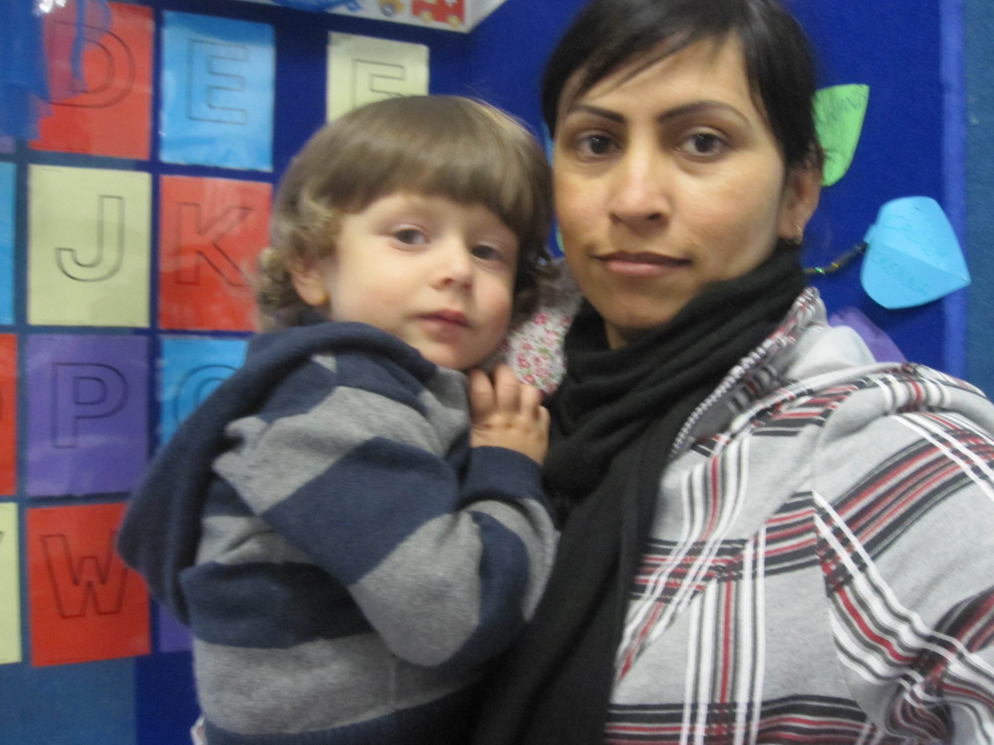
Primary Caregiving

In order to meet the requirements of the National Quality Standards, we have implemented Primary Caregiving throughout the service. This model of care is based on attachment theory: a child is more secure and has better outcomes if they have a special person who is responsive to them. This meets the national standards for Quality Area 5 and also links to the Early Years Learning Framework.

Primary care does not mean that your child will only have a relationship with one person. All the educators in all rooms will work to form relationships with all the children, so that if their key person isn’t available, then children will still have someone who is equally as responsive.

Over the next week or so, the educators in the rooms will decide who will be in their primary care groups. This is based on ‘best fit’: who has the temperament and ability to best support the child, and the relationship that child already has with the educator. The primary care-giver will plan for and document your child’s learning and will be the main contact between families and the centre, building strong and respectful partnerships.

Reminders and Updates

Signing attendance sheets

We recently had a DECD audit, and as a result of this, we would like to remind all parents and caregivers to sign your child in and out each day.
We understand that dropping your child off in the morning can be stressful, or you may be running late for work and forget to sign the attendance sheets.
When this happens, the educators can do it for you, but you must then counter-sign the educator’s signature. Signing the attendance sheet is also required when there is a public holiday or your child is absent from care.

Items in children’s bags

If your child needs prescribed medicine during the day, please fill out a medication form and give the medication to an educator so it can be correctly stored. According to OHS&W guidelines, we cannot administer eye or ear drops or cut children’s nails (so please make sure that children’s nails are clipped). All over the counter medication needs to be correctly labeled by a chemist, stating the child’s name and dosage. We do not administer Panadol to children unless you have a doctor’s letter stating the reason for use. If your child has allergies, please make sure we have a copy of their action plan and their medication such as anti-histamine syrup and/or epipen.

Any bottles or food must also be given to educators for correct storage and if your child has a communication book, please make sure this is also given to the educators.

Fruit to share

Please remember to bring a piece of fruit each day for the children to share. There is a basket outside the baby room and another outside the kindy room for this. Sharing fruit provides many opportunities for learning about reciprocity and community responsibility as citizens, linking with the Early Years Learning Framework: outcome 2.

Educator of the month

Last month Genine was voted “Educator of the Month”. Genine has shown that she is committed to supporting children and families and we appreciate your recognition of her work. You will find a new nomination form at the end of the newsletter.

Website

Privacy and confidentiality are important to us, but it is the support of families that ensures our ongoing viability. With this in mind, it would be fantastic if we could use pictures of the children on our website. We would make sure that they weren’t able to be identified and, where possible, the photos would be of the experiences they are engaged in rather than of the children themselves. There is a permission slip at the end of the newsletter if you agree to us using pictures that may include your child in newsletters, the website and other promotional material.

Excursions

In society today, there is a worrying trend to keep young children safe behind fences. This means that they miss out on many wonderful learning experiences and that communities miss out on seeing young children as people in their own right.

We strongly encourage short excursions in the neighbourhood, but need your permission to do so (again a permission slip can be found at the end of the newsletter). Excursions of this nature could involve a walk around the block or a visit to Wayville Park. For these short excursions, the children will not cross a main road.

In the future, there will be opportunities to go further afield. Small groups of children may go to the museum, or just for a trip on a tram. The ratio for these excursions is 1:4 and we will require you to sign a separate permission form in those instances.

Parent information pockets

We are in the process of moving the parent pockets from in the rooms to the hallway where they are much more visible. Please check your pocket regularly for centre information, learning stories and any other correspondence.

First Aid training

It is nearly time for the staff to update their first aid qualifications. We are inviting parents and other interested people to join us for this in June/July. The training takes about 7 hours and includes 3 nationally recognized modules (plus lunch!): first aid, anaphylaxis and asthma management. Please let us know if you are interested.

Family day

On 30th June, we will be holding an afternoon tea for families to celebrate the joy of extended family and the benefits this has for children (in some families, extended family can mean close friends). There will be more information about this soon.

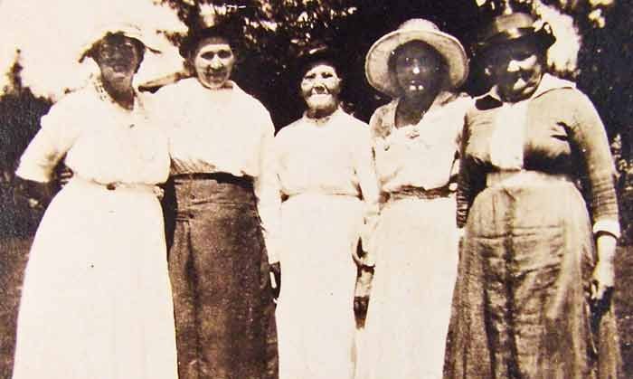

Room Reports

Junior Kindy

Wow! What a busy couple of months we have had in the Junior Kindy Room!
In May, we spent a lot of time learning our numbers and the alphabet. We celebrated ANZAC Day, looked at different community services, space and we made our own TV. In June, we will focus on the environment and also investigate colours and shapes, singing lots of songs to help us learn.
It is with great pleasure that we welcome Aardi, Cooper, Caylee and their families into the junior kindy room and hope that they enjoy their time with us. We say goodbye to Tiana who has moved into the Kindy Room.
It is amazing how much the children learn in such a short time. One of our children is from Mongolia and didn’t speak English; now he is using English to speak to others in the room.
To assist us with our curriculum planning, it would be greatly appreciated if you could complete the weekend sheets and return them to us each week along with any learning stories you may have – we need to be able to show these to the Assessor.
If you have any questions, concerns, comments or ideas, please do not hesitate to speak to us.

Narinder and Genine
Baby Room

We have been very busy in the baby room over the last couple of months. We have been focusing on the children’s interests such as animals, planes, trains, rainbows and diggers. The children love watching the dogs walking past and make ‘woof’ sounds at them.
To ensure that we are providing children with activities of value and interest to them, we ask families to please take some time to fill in a weekend sheet and jot down what your child has done over the weekend, so we can incorporate it into our curriculum. This ensures that children feel a sense of belonging and have a positive connection between the two places.
Over the coming months we will focus on encouraging children to sit down together during meal times for social interaction and giving children the opportunity to feed themselves. We will also be having a few younger babies starting in the room and there will be a focus on nurturing and building relationships with those children and families.
If you have any questions or concerns, please feel free to approach your child’s primary caregiver.

From Toni and Parveen in the baby room.

Kindy Room

We have had a busy few months here in the Kindy room. In April, we focused on all different types of animals. We read information books, went exploring in the yard to search for animals, and became more involved in taking care of Sticky – our pet stick insect. The children enjoyed having Sticky climb on them, giving her new gum leaves to eat and spraying her with water.
In May, we have been learning about space. We have had lots of books to look at, admiring the big rockets, the cool astronauts, and the beautiful planets. One morning we were lucky enough to witness an eclipse, using special glasses that let us safely see the sun.
The children have been showing great communication and listening skills in Show and Tell, practicing literacy skills by doing alphabet exercises and by working hard to write their own names.
We were sad to say goodbye to Zach and wish him and his family all the best. We have welcomed Tiana from the Junior Kindy room and had visits from our new friends, Tivona, Juliet and Tong.
Just a reminder, that we really appreciate parent input into all areas of our planning. We would love it if you could fill out weekend sheets and please return learning stories, signed and with a brief comment if possible. Thank you for your help. We will keep busy and warm over the upcoming winter months!

From Esther and Emily in the kindy room

Sun Protection Policy

Australia has the highest incidence of skin cancer in the world with two out of every three people developing some form of skin cancer before they are 70.
Skin damage, including skin cancer, is the result of cumulative exposure to the sun. Sun exposure in the first ten years of life determines, to a substantial degree, the likelihood of skin cancer developing later in life.
Cancer Council SA advises people protect their skin at times when the ultraviolet (UV) radiation level is 3 and above—this is when it is strong enough to cause damage to unprotected skin. For much of South Australia, UV radiation levels are 3 and above everyday from September to April—it is during these months that sun protection is necessary.
Cancer Council SA recommends that a skin protection policy be in place from 1 September until 30 April when UV radiation levels are 3 and above. It is highly recommended that UV radiation levels are monitored, particularly during May and August as they still may be 3 or above depending on your location. Cancer Council SA also recommends that particular care should be taken during these months between 10.00 am – 3.00 pm, when the UV radiation levels are at their highest.
It is important to balance sun protection with safe sun exposure for the production of vitamin D for bone growth and development. During May to August, at times when the UV radiation level is below 3, sun protection for most people is not necessary.
Our service aim to promote among children, staff and parents:
  - Positive attitudes towards skin protection.
  - Lifestyle practices which can help reduce the incidence of skin cancer and the number of related deaths.
- Personal responsibility for and decision making about skin protection.
  - Awareness of the need for environmental changes in our centre to reduce the level of sun exposure when the UV radiation level is 3 and above.

This policy is for implementation from 1 September to 30 April. Outside of this time care should also be taken when the ultraviolet radiation level is 3 (moderate) and above. The purpose of the policy is to ensure that all members of our Early Childhood Service are protected from skin damage caused by the harmful rays of the sun.
Babies under 12 months need special consideration—see strategy 5.

It is an expectation that all staff, students and parents of the service will use the following skin protection strategies:
1 Take care to protect the skin when the ultraviolet radiation level is 3 (moderate) and above.
Extra care should be taken between 10.00 am and 3.00 pm when UV radiation levels are highest.
1.1 The children’s lunch, rest time and indoor activities will be held between 10.00 am and 3.00 pm to minimise exposure to UV radiation in the middle of the day.
1.2 Whenever possible, all outdoor activities will be scheduled before 10.00 am and after 3.00 pm or in the shaded areas of the service.
2 Use the shade of trees, pergolas, umbrellas and tents whenever outdoors.
2.1 Tree planting will be organised at the service with priority given any open space grassed area.
2.2 The sandpit and play equipment area to be a priority for shade structure planning
2.3 The further provision of shade areas is a priority for the service.

3 Wear appropriate clothing which protects the skin.
3.1 Children, staff and parents will be expected to wear a broad brimmed hat, legionnaire style hat, or a bucket hat (bucket hat must have a deep crown and minimum 5 cm brim for children under 5 years of age and 6cms for older children and adults) whenever they are involved in outside activities. Children not wearing an appropriate hat will be expected to play in the shade.
3.2 Children will be encouraged to wear shirts with collars and at least elbow length sleeves and longer style shorts/skirts.

4 Apply a broad-spectrum, water resistant sunscreen with an SPF of 30+ to clean, dry skin, 15—20 minutes before going outdoors for lunch or activities. Sunscreen should be reapplied every two hours if outdoors for a prolonged period of time or more frequently if involved in water activities or perspiring.
4.1 Adequate time must be allowed for correct application of sunscreen on children before they go outdoors.
4.2 Parents will be encouraged to supply sunscreen for their children although there will be bulk sunscreen packs available at the service.
4.3 Sunscreen will be applied before the children’s morning outdoor activities and again before they go outside in the afternoon at times between 10.00 am and 3.00 pm or when the UV is 3 and above.

5 The special needs of babies:
5.1 Babies (under the age of 12 months) should be kept out of the direct sunlight as much as possible and always protected by shade, clothing and hats.
5.2 Sunscreen should be applied to small areas of exposed skin not protected by clothing and hats, where necessary.

6 Reinforcing the SunSmart message in all service activities and in general service procedures is an important strategy in the adoption of skin protection behaviours.
6.1 Staff will be encouraged to role model appropriate SunSmart strategies in all service activities.
6.2 Skin cancer prevention will be included in appropriate teaching activities.
6.3 Staff will be encouraged to keep up to date with new information and resources from Cancer Council SA.
6.4 Information about the centre’s SunSmart Policy will be given to all new staff, students and families.

7 The Services sun protection strategy will be evaluated on a two yearly basis.
7.1 Policy issues will be discussed at staff and parent meetings.

I wish to purchase a centre hat for my child/ren.

Family name:

Number of hats and style: Bucket

Legionnaire

Method of payment: Account EFTPOS Cash Bank Transfer

I give permission for images of my child/ren to appear in newsletters and other promotional material for Little Shining Stars Childcare Centre.

Family name:

Please circle: Yes No

I give my permission for my child/ren to take part in short excursions in the local community.

Family name:

I have read and agree to abide by the centre’s Sun Safety Policy

Family name:

