ITALPRESSE
ITALPRESSE S.p.A.
Via delle Groane, 15 - Bagnatica (BG) - 24060 - ITALIA
TEL. : (+39) - 035 - 68 11 22 FAX. : (+39) - 035 - 682 682
e-mail : sales@italpresse.com

Woodworking
machinery

DATE 10th march 2009
FROM ITALPRESSE S.P.A.

TO SCOTT AND SARGEANT
ATT. Mr. MARK GIBSON

RE. Press line mod. MARK/C 16-26/7

Dear Mr. Mark,

Following your request , please find here our offer for an automatic press line mod. MARK/C 14-26/7.

In alternative we can offer a through feed press type
MARK-C 20-30/7 with platen dimensions 2000 x 3000 mm. at

PRICE € 162.100,00

We are at your full disposal for any further information your might need.

Best regards

Antonio Locatelli

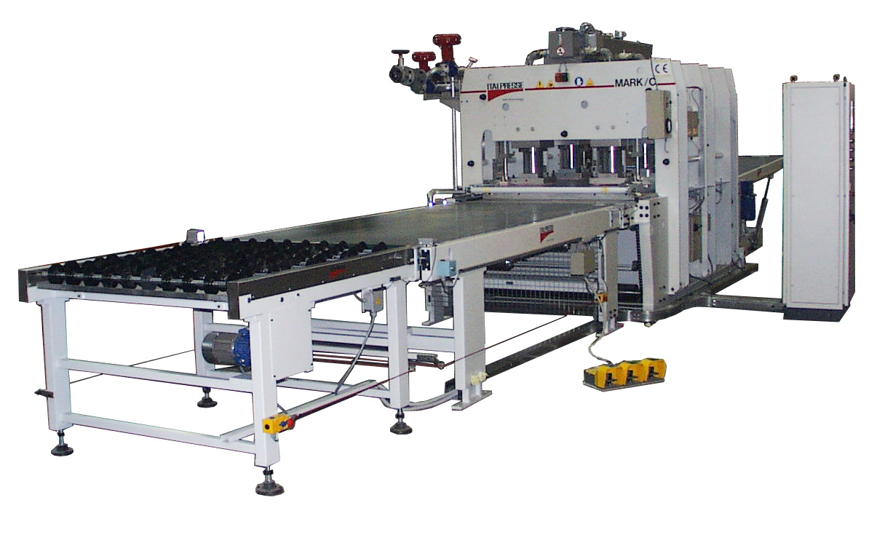

AUTOMATIC FLOW LINE MOD. MARK/C 16-26/7

composed of:

POS. 1 LOADING BELT MOD. NC 16-31
- dimensions mm. 1600X3100
- translation speed mt/1' 0-40
- panels translation synchronized with
press belt
- manual control with pedal for
advancement and reversal
- electric eyes nr. 2

POS. 2 AUTOMATIC PRESS MOD. MARK/C 16-26/7
- platens dimensions mm. 1600X2600
- daylight opening mm. 140
- loading on side of mm. 1400
- down stroking movement of the platens
- solid drilled platens - thickness mm. 90/110
- type of heating: NOT INCLUDED
customer will heat the press
with the steam
- total pressure Tons 233
- specific pressure on 80% of the
surface Kg/cm2 7
- pressure pistons dia. mm. 125 nr. 8
- mouvement pistons nr. 2
- pistons stroke mm. 140
- closing time sec. 2
- opening time sec. 3
- time to reach the pressure sec. 3
- speed of the belt inside the press mt/1' 0-40
- belt control with self braking
motor reducer group
- racks group with torsion rods

ITALPRESSE PRESS CHARACTERISTIC
RING FRAME, PLATENS, CYLINDERS and ASSEMBLED GROUP

The press structure is made of CNC machined components to assure an accurate assembling.

1. Ring frame

The solid profiled steel frames are made by S275JR steel sheet which is oxygen cut and subsequently CNC machined according the project drawings and data

2. Platens

Made by S 275 JR

Solid platens worked by deep-hole drilling machine to guarantee:

- the constant control of the bore axis in order to obtain a uniform platen temperature
- optimised bore diameter in relation to the head loss(Δp) and in relation to the required loss of temperature (Δt)
- the heating circuit is obtained with the intersection of the two perpendicular bore directions and by inserting steel blocks in order to drive the heating oil.

The number of the inlet and outlet for the heating fluid is optimised in relation with the press application.
This guarantee a temperature over every area of the platens according to the specific needs.

3. Cylinders

The cylinder liner is made of S 355 JR steel.
The stem is made of 40NiCrMo4 alloy steel

All the cylinders are produced by a robot welding centre and the face is realised in controlled atmosphere with a constant control of:
- speed rotation
- atmosphere pressure and quality
- torch temperature

The cylinders are examined with non-destructive tests using X-ray or magnetic resonance.

The cylinders pass the quality control test only if the parameters are the following:
- surface hardness of the stem Cr face: 74-78 HRC
- stem surface finish: Ra = 0.8 micron
- roundness tolerance: mm 0.04

All welded components are normalised in order to avoid internal stresses.

4. Assembled group

The RING FRAME-CYLINDERS-PLATENS group is assembled to compensate and reduce problems such as:
- thermal expansion
- synchronous and parallel movement of the platen
- stem overheating

Concerning the stem overheating effect, in our presses mod. MARK, we avoid stem-platen direct contact by inserting:
- insulating material with high specific pressure resistance
- solid drilled plates to avoid the hydraulic oil heating due to the stem heating

The stem is "mechanically anchored" to allow sliding in any direction in order to compensate thermal expansions.
All the components, which allow the platen movement, are linked so

that the platen moves perfectly parallel.

The RING FRAME-CYLINDERS-PLATENS group is assembled without welding to allow thermal expansion in any directions.

The press will be completed with the following main devices:

POS.2.1 DOWNSTROKING BRAKE to decelerate the closing speed of the
mobile platen for a soft contact with the panels

POS.2.2 FLATNESS CONTROL, which, besides the mechanical group
with racks and pinion, guarantees a constant control of
the mobile platen flatness to avoid any trouble if for
any reason the platen does not go down parallel.

POS.2.3 ELECTRO-PNEUMATIC DEVICE for top mylar belt shaking,
running at every press opening (at the end of the
pressing cycle) to guarantee the detaching of the pressed
panel

POS.2.4 COOLED PLATES for the insulation of the pressure
cylinders:
with first layer of insulating material and second of
solid steel drilled for water circulation.
The plates are connected with inlet and outlet main
pipes.

POS. 2.5 MANIFOLDS

POS. 3 UNLOADING GRAVITY ROLLERS MOD. NC 16-31

- dimensions mm. 1600X3100

POS. 4 CONTROL BOARD
- complete with all the electric and programmable
logic electronic equipments to test and control
the whole line

TOTAL PRICE EURO 119,500,00

SUPPLY CONDITIONS

DISCOUNT 25%

DELIVERY EX WORKS our factory

DELIVERY TIME About 150 days from receipt of order and down payment (August excluded)

PAYMENT 30% Down Payment at the order
70% Bank transfer before shipment

SET UP ITALPRESSE will send one technician at the cost of EURO 8,900 net (board and lodging at your charge)

OFFER VALIDITY 60 days

