BOOM CRANE
LOAD LIMITER
ОНК–160С–07

Operating Manual

ЛГФИ.408844.026-05 РЭ/Э

Contents
1 The Limiter Description and Principle of Operation 3
1.1 Purpose of the Limiter 3
1.2 Characteristics of the Limiter 4
1.3 The Limiter Composition 6
1.4 The Limiter Arrangement and Principle of Operation 7
1.5 Marking and Sealing 9
2 Description and Principle of Operation of the Limiter Components 10
2.1 Data Display Unit 10
2.2 Rotating Portion Controller 15
2.3 Boom Head Controller 16
2.4 Digital Force Trabsducer 17
2.5 Digital Pendulum Angle Transducer 17
3 Safety Precautions 18
4 The Limiter Mounting 18
4.1 General Instructions 20
4.2 The DDU Installation 19
4.3 The DFT Installation 19
4.4 The DPAT Installation 21
4.5 The RPC Installation 22
4.6 The BHC Installation 24
4.7 The Limiter Connection to the Crane Electric Circuit 25
5 Adjustment 27
5.1 General 25
5.2 Check of the Limiter Discrete Signals Connection to the Crane 27
5.3 Entering of the Date and Time, the Crane Number and the Year of Its Production 27
5.4 Reset of the Settings and the Program Adjustment 28
5.5 Adjustment of the Transducers 28
5.5.1 Mode Selection 28
5.5.2 Setting of the DFT address 29
5.5.3 The DFT Zero Adjustment 29
5.5.4 The Tilt Channel Adjustment 31
5.5.5 The Reach Channel Adjustment 29
5.5.6 Adjustment of the DFT Tightening 29
5.5.7 The Weight Channel Adjustment 30
5.6 Entering of the Parameter Recorder Date of Installation 32
5.7 Adjustment of the Audio Signal Tone Value and the DDU Temperature 31
5.8 Exit the Adjustment Mode 31
6 Complex Check 31
7 Operation 32
7.1 Operating Limitations (Safety Precautions) 32
7.2 The Limiter Preparation for Operation 33
7.3 The Limiter Operation 35
7.4 The CLL Troubleshooting 38
8 Maintenance 43
8.1 General 43
8.2 Types of Maintenance 43
8.3 Maintenance Procedure 43
9 Packing, Storage and Transportation Regulations 46
Appendix А The ОНК-160С-07 Modes of Operation on the Cranes 47
Appendix B Diagrams of the ОНК-160С-07 Connection to the Cranes 48
Appendix C List of Accepted Abbreviations and Designations 49
The present document is an operating manual for the ОНК-160C boom crane load (lifting capacity) limiter of modification OHK-160C-07 (hereinafter – the limiter or the CLL) installed on pipelayer cranes.
The Operating Manual (hereinafter – the OM or the Manual) is combined with the iinstructions of the OHK-160C-07 mointing, putting in operation and adjustment on the pipelayer cranes (hereinafter – the cranes).
The Manual contains information on the CLL design and principle of operation, instructions on the limiter components mounting on the crane and the procedure of their connection to the crane electric circuit, the limiter adjustment and serviceability testing, preparation for operation and operating procedure, instructions necessary for the CLL correct and safe operation, troubleshooting; maintenance instructions, storage, packing and transportation regulations.
The Manual is a part of the set of obligatory operating documents specified in the certificates for the cranes.

1 The Limiter Description and Principle of Operation

1.1 Purpose of the Limiter
The ОНК-160С-07 limiter is designed to be installed on the pipelayer cranes and is used to protect the crane from overloads, to limit the crane equipment operating zones determined by its design and operating conditions (when operating under restricted conditions or near the overhead transmission lines), to register the crane operation parameters as well as to display data on the crane lifting capacity, loading level, the boom head height of lift, angles of the boom elevation and the platform tilt and other crane operation parameters.
The crane models where the ОНК-160С-07 limiter can be used are given in Appendix A.
The ОНК-160С-07 limiter programming for use as a part of a particular crane model is performed by authorized specialists of the limiter manufacturer, the CLL supplier or the crane manufacturer.
At built in the limiter parameter recorder (hereinafter - PR) provides registering (recording), preprocessing and storage of official information (including information on the organization performed the limiter programming), operational and long-term storage data on the crane performance parameters (including information on its operation rate) during the CLL whole service life.
Operation with the parameter recorder (method and modes of information read-out and processing from the PR using a PC) is given in the Instructions on the Parameter Recorder Data Read-out and Presentation ЛГФИ.301412.101 И1 supplied with the telemetry data reader СТИ-1 or optionally.

1.2 Characteristics of the Limiter
1.2.1 The limiter provides:
- uninterrupted operating mode; the limiter readiness time does not exceed 5 minutes after switching the power on;
- receiving and processing of up to twenty four (depending on the CLL modification) input discrete DC signals with voltage from 10 to 30 V from the crane hoisting mechanism (CHM) electric circuit, including the signals from the transducers of the controls positions to generate corresponding control signals of the output electronic switches in accordance with the CLL operating program algorithm and to record the indications characterizing the crane equipment condition to the parameter recorder memory;
- output of up to eight relay control DC signals (12/24V, 1,5А) prohibiting (switching off) or permitting the crane equipment movements;
- limitation (by the limiter firmware) of the crane equipment operating zones (limits of approaching to the maximum and minimum reach, maximum tolerated lateral and/or longitudinal tilt) by means of switching off the crane movements at the operating zone borders (excluding movements taking the equipment to the operating zone;
- indication of the crane equipment configuration, the crane and the CLL operating modes as well as the crane operation parameters;
- the LCD illumination in darkness;
- recording (registering), storage and read-out of the telemetric data on the crane operation parameters from the parameter recorder (PR) built in the CLL;
- warning and alarm light and acoustic signaling;
- the CLL programming for the particular crane type (by the authorized specialists of the organizations mentioned in i. 1.1);
- the limiter self-diagnosis: testing of the functional assemblies of the CLL units and transducers and serviceability monitoring of the communication lines connecting the PU with the units and transducers, monitoring of the output electronic relays connection to the executive units and of their blocking by means of jumpers.

1.2.2 Degree of protection of the CLL housings:
- IР55 – for the PU;
- IР56 – for the other CLL components (units and transducers).
1.2.3 The basic technical data (not mentioned above) which the limiter provides, are given in Table 1.
Notes
1 The data displaying errors by the digital LCDs in the static mode are defined during the limiter manufacturing and after its repair by the Manufacturer.
2 Mass and dimension characteristics of the OHK-160C-07 components are given in ЛГФИ.408844.026 ПС/Э.

Table 1 - The ОНК-160С-07 Basic Technical Data
Parameter
name | value
Force range Р, N (kgf) ¹⁾ | 0-9800 (0-1000)
Reach range Rт, m | from 0 to 70
Boom head height of lift range Но, m | from 0 to 70
The boom elevation range Aс relative to the horizon | from minus 10 to +90°
The platform longitudinal Ka and lateral Kb tilt range relative to the horizon | from minus 15 to +15°
Detection range of the OTL of 50Hz AC at voltage of 0.22-1 кV, m | 1.5 min
The data displaying error on the LCDs in the static mode, min:  – on the crane loading level Мз, %  – on the actual mass of the load being lifted Qт, % ²⁾⁾  – оn the maximum lifting capacity Qм, % ³⁾  – оn the reach Rт, % ⁴⁾  – оn the boom head height of lift Но, % ⁵⁾  – on the boom elevation Ac and/or the crane platform tilt (Ka and Kb) relative to the horizon | ±5.0  ±5.0  ±1.5  ±1.5  ±3.0  ±0.2°
------------------
¹⁾ 1 N = 10,2 kgf
²⁾ Relative to the maximum lifting capacity for the given reach Rт.
When operating within the loading characteristics with lifting capacity of 3.3 tons minimum the error should not exceed ± 0.1 ton
³⁾ With the lifting capacity less than 7 ton the error does not exceed ±0.1 ton.
⁴⁾ If the boom being loaded with the rated load for the given reach
⁵⁾ With no load
The CLL protection actuation at the crane loading level, % | above 105
The CLL protection actuation error at the crane overloading, %, max | ±5.0
Number of the DC output relays (electronic switches), pce | up to 8
The DC relay (electronic switches) switching capacity, А, max | 1.5
The DC supply rated voltage (vehicle-borne circuit U_{БС}), В | 12.0 or 24.0
The DC supply voltage range relative to the rated value, V | from 10.8 to 30.0
Power consumption form the DC power source without thermostating (with thermostating), V•А, max | 30 (60)
Operating temperature range, °C | from minus 45 to +55
Storage temperature range, °C, min | from minus 50 to +60
Air relative humidity at a temperature of plus 25°C, %, max | from 45 to 100
Mean life before failure, h, min | 8800
Mean service life, years, min | 12

1.3 The Limiter Composition
Table 2 - The ОНК-160С-07 Limiter Delivery Set
Component name | Type,  marking | Designation | Q-ty,  pce
Data display unit | БОИ-03 | ЛГФИ.408843.029-03 | 1
Rotating portion controller | КПЧ-01 | ЛГФИ.484461.004-01 | 1
Boom head controller | КОС-03 | ЛГФИ.411117.003-03 | 1
Digital pendulum angle transducer | ДУГМЦ-06 | ЛГФИ.401221.017-06 | 1
Digital force transducer | ДУЦ-06 | ЛГФИ.404176.023-06 | 1
Cable | ЛГФИ.685621.273-03 |  | 1
Cable | ЛГФИ.685621.284-01 |  | 1
Cable | ЛГФИ.685621.285-01 |  | 1
Cable | ЛГФИ.685623.045-03 |  | 1

1.4 The Limiter Arrangement and Principle of Operation
Below are given the abbreviations used in the CLL operation description:
- AD converter – analog-digital converter;
- ADR – archive data reader САИ-3 (component of СТИ-3);
- BHC – boom head controller (with a built-in dangerous voltage protection module (DVPM); the BHC housing performs the antenna functions);
- CAN – serial two-wire communication channel (CAN-interface);
- DDU – data display unit (with the built-in crane operation parameter registration - PR);
- DFT – digital force transducer;
- DM – display module;
- DPAT – digital pendulum angle transducer;
- DVPM - dangerous voltage protection module;
- НА1 – ring for the audio (warning and emergency) signaling;
- HLL – crane hook lift limiter;
- IС –integrated circuit;
- IR-channel – infrared channel of the crane parameter recorder (is used while the data readout from the PR);
- IRRT – infrared receiver-transmitter of the crane parameter recorder;
- LCD – liquid crystal display;
- LSIC - large-scale integrated circuit;
- MC - microcontroller;
- MC LSIC – microcontroller LSIC;
- OTL - overhead transmission line;
- PSM – power supply module;
- PR – crane parameter recorder;
- RAM – random access memory;
- ROM – read-only memory;
- RPC – rotating portion controller (with the built-in longitudinal and lateral tilt transducer (TT));
- SCM – single-chip microcontroller;
- TDR - telemetry data reader СТИ-3;
- ТS – thermostat;
- TT – tilt transducer;
- USB – port for the PC connection when read-out data (in full) from the crane parameter recorder built in the DDU and for the DDU controller programming.

1.4.1 The ОНК-160С-07 limiter block diagram is given in Figure 1.

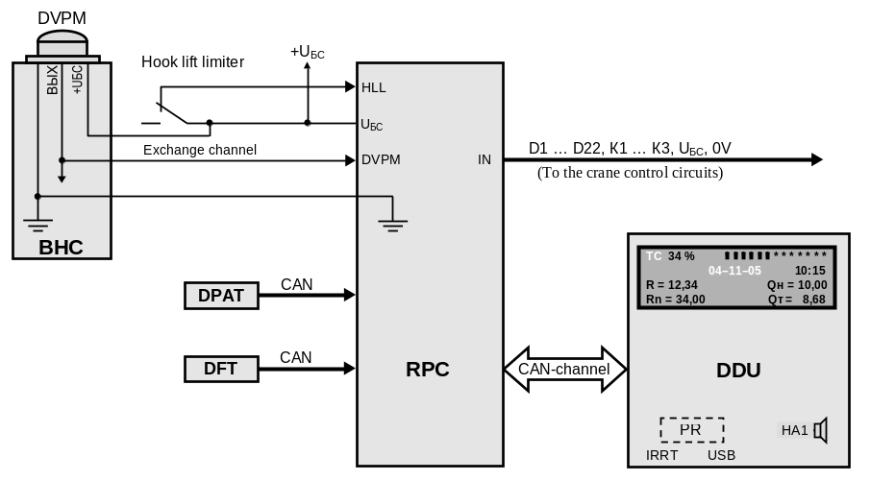

Figure 1 – The ОНК-160С-07 limiters block diagram

1.4.2 The DDU and the transducers installed on the crane rotating portion are connected to the RPC unit individual connectors.
1.4.3 The CLL principle of operation is based on the serial poll and conversion of the analog signals from the primary data transducers into digital serial code, its transmission to the DDU, detecting the boom elevation, calculation of the reach values, hight of lift (according to the preset geometric dimensions of the crane operating equipment), as well as calculation of the mass value of the load being lifted and the crane loading level with their following comparison with the maximum permissible values at the selected crane operating mode (the crane equipment configuration).
Calculation of the crane loading capacity parameters and its loading level is performed in the DDU according to the values of the data signals from the transducers measuring the boom elevation and the force (which depends on the load weight on the crane hook) of the boom stretching taking into account the signal values from the equipment position transducers (limit switches) and the crane controls.
By the calculation results, depending on the crane equipment position relative to the operating zone borders, load value and presence of OTL near the operating area, the DDU generates signals controlling switching on and off the relays (electronic switches) installed in the RPC.

1.4.4 The limiter is operated by the program stored in the DDU microcontroller (MC).
The software contains a testing subprogram, adjustment subprogram and executing program. The programs are controlled by the main menu and submenu.
The testing subprogram is started once after the CLL is energized.
The adjustment subprogram is used to adjust the limiter on the crane.
Entering the НАСТРОЙКА (ADJUSTMENT) menu is performed only by pressing the НАСТРОЙКА (ADJUSTMENT) button on the DDU front panel which is closed by a cover and sealed.
The executing program is run after the supply voltage is fed to the CLL. Having passed the testing subprogram the limiter automatically enters the РАБОТА (OPERATION) mode.
1.4.5 The limiter operation control [the crane operating mode selection, displaying of the operating modes and (or) the crane operating parameters] is performed from the DDU front panel (ref. Figure 3).

1.5 Marking and Sealing
1.5.1 The limiter marking is made on the DDU and contains the following:
- the CLL designation and its modification (on the side wall of the DDU);
- the CLL serial number according to the Manufacturer’s numeration system.
1.5.2 Marking of the CLL components is made directly on their housings or cables connected to them and contains:
- the CLL component designation according to Table 2;
- the CLL component serial number according to the Manufacturer’s numeration system.
1.5.3 Sealing of the limiter components is performed by the Manufacturer’s production control department in the places of fixation of their covers (seals of types А and B).
The DDU sealing is made in the groove for the upper cover fixing screw on the housing back side (seals of type A).
In the DDU additionally sealed is the cover providing access to the НАСТРОЙКА (ADJUSTMENT) button (a seal of type B).
In the BHC unit sealed is the upper cover (a seal of type A).
The transducers are sealed with the seal of type A in the places their covers fixation (in the special cup under the screw).

1.5.4 Sealing and removing of the seal of type B (with the following record the CLL certificate) on the limiter being in use are performed by specialists mentioned below:
- the crane manufacturer's safety device service engineers when mounting the CLL on the crane;
- the Customer's safety device service engineer (or an engineer responsible for the crane serviceability) after the limiter trimming according to the results of its testing as a part of the crane with the help of the control weights (i. 8.3.5 of the OM) during the crane seasonal maintenance.

2 Description and Principle of Operation of the Limiter Components

2.1 Data Display Unit
Data display unit (DDU) is designed to receive and process digital data, to calculate the crane operating parameters, to record them and store in the built-in parameter recorder (PR), to display the calculated values of the operating parameters (on the LCD) and the crane operating modes (LEDs), to generate control signals allowing or prohibiting operating movements, to generate commands switching off some crane mechanisms, to give a warning or emergency light or audio signals, and to enter data and the crane operating modes into the microprocessor memory, to display the CLL current state and to read out the telemetry data from the PR.
The DDU (ref. Figure 2) receives information via the serial two-wire channel (interface of the CAN type) from the RPC to which the data from the discrete inputs and the primary data transducers connected to the BHC and RPC units come.
The DDU contains a thermostat (TS) which switches on a heater under the LCD at an ambient temperature of less than minus 5ºC.
The DDU is connected with RPC by means of a cable.
To the left from the cable in the DDU lower part there is a cover for the opening providing an access to the USB connector, with the help of which the CLL is programmed and the data in full is read out from the built-in parameter recorder.
The supply voltage (+12/24V) is fed to the DDU from the RPC.
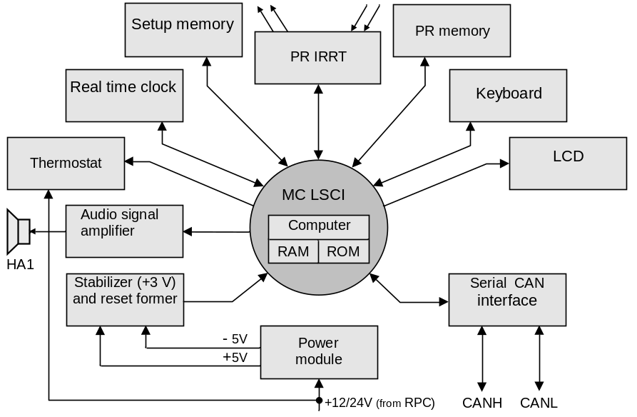

Figure 2 – The DDU block diagram

The limiter operation [entering of the crane operating modes, display of the crane operating modes and (or) operating parameters] is controlled from the DDU front panel.
Function of the indication elements and controls of the DDU front panel are shown in Figure 3 and described (when the CLL operates in the РАБОТА (OPERATION) mode) below.
Note – In Figure 3 the numeric designation of the DDU indication elements and controls are given conventionally.
The glowing green LED НОРМА (NORM) (1) indicates that the crane operates at a load safe for its design.
The green LED НОРМА (NORM) blinking (with simultaneous producing of the limiter warning interrupted audio signal) signalizes of occurrence of one of the following situations during the crane operation:
а) the crane loading is less than 90 % of the rated (certificate) loading capacity;
b) the crane has approached the operating zone borders (the non-operating zone above the cabin, maximum or minimum reach etc.).

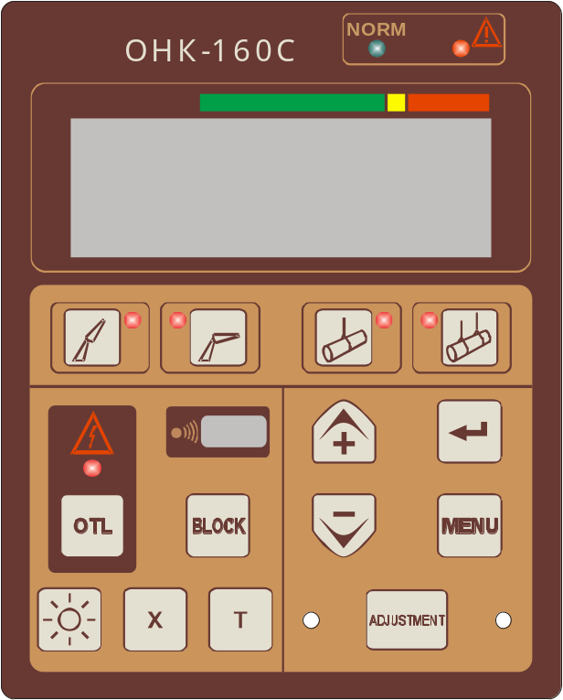

1 – LED НОРМА (NORM)  2 – LED СТОП (STOP)  3 – digital liquid crystal display (LCD)  4 … 7 – LEDs of the counterbalance position and the crane operating mode: counterbalance drawn up (4), counterbalance moved away (5), single operation (6), operation in autocade (7)  8 … 11 – buttons of the crane operating mode setting: counterbalance drawn up (8), counterbalance moved away (9), single operation (10), operation in autocade (11) |  | 12 – window for data read-out from the PR  13, 14, 18, 19 – buttons to call menu (19) and to move up and down the menu (13, 18); up (13), down (18) and to enter (14) the adjusted parameter into the CLL memory  15 – LED of the OTL protection actuation  16 – button to select the DVPM voltage range  17 – button блокировкА (BLOCK)  20 – button to switch on the LCD backlighting  21, 22 – auxiliary buttons  23 – button НАСТРОЙКА (ADJUSTMENT)

Рисунок 3 - Лицевая панель БОИ

The glowing red LED  (СТОП; 2) (STOP) (with simultaneous producing of the limiter warning interrupted audio signal and one or several crane mechanisms switching off) signalizes of occurrence of one of the following situations during the crane operation:
а) the actual crane loading is not less than 105 % of its rated (certificate) loading capacity, i.e. the load mass on the hook exceeds the maximum permissible value for the given crane equipment configuration;

b) the crane boom head is within the OTL electric field (the OTL protection actuation)); additionally the red LED  (ЛЭП) (OTL) starts blinking, the LCD displays the voltage value [in kilovolts (кB)], corresponding to the upper value of the DVPM voltage range in which the OTL has been detected;
c) reaching of the hard-coded (provided by the limiter firmware) limits of minimum reach or of maximum hook lifting height (the hook lift limiter actuation); in this situation the LCD displays the corresponding message without the green LED НОРМА (NORM) switching off;
d) failure of at least one of the limiter components; in this situation LCD displays the corresponding message (error code of the "ЕХХ" or "ЕХХХ" kind) without the green LED НОРМА (NORM) switching off .
The digital liquid crystal display (LCD; 3) is designed to display the crane and the CLL operating modes, the crane operating parameters, operating and official messages.
The counterbalance position LEDs (4 – the crane operation with the counterbalance drawn up, 5 – operation with the counterbalance moved away) glow when the corresponding operating mode is being selected.
The crane operating mode LEDs (6 – the single crane operation, 7 – the crane operation in autocade) light up when selecting the corresponding operating mode.
The blinking LED (Диапазон ЛЭП; 15) (OTL range) signalizes of the crane boom head (the BHC DVPM antenna) being within the overhead transmission line (OTL) electric field of 50 Hz frequency and 220 V AC (the OTL protection actuation).
Note – The dangerous voltage protection module (DVPM) is built in the limiter boom head controller (BHC). The BHC cover performs the functions of the DVPM antenna.
When the OTL protection actuates (the red LED blinks) the crane mechanisms are switched off, the red LED (СТОП) (STOP) lights up and the emergency interrupted audio signal is produced; LCD displays the voltage value [in kilovolts (кB)] corresponding to the upper value of the DVPM voltage range in which the OTL has been detected.
Notes
1 The upper values of the DVPM voltage ranges (кV): 1; 10; 35; 450; 750.
2 In case there is no BHC the LED glows permanently.
The window for the data read-out from the parameter recorder (12) is designed for read-out the data recorded in the parameter recorder (PR) of the crane during the operation of the latter, using the infra-red channel (IR-channel) to the САИ-3 archive data reader.
The buttons of the counterbalance position selection 8 (operation with the counterbalance drawn up) and 9 (operation with the counterbalance moved away) are designed to select the crane operating mode with a counterbalance.
The buttons of the crane operating mode selection 10 (the single crane operation) and 11 (the crane operation in autocade) are designed to select the pipelayer crane operating modes.
Buttons "+" (13) and "–" (18) are designed to correspondingly increase (13) and decrease (18) the numeric value of the adjusted parameter displayed on the LCD in the НАСТРОЙКА (ADJUSTMENT) mode, and to move up ("Ù" or "↑" when displaying on the LCD) and down ("Ú" or "↓" when displaying on the LCD) the menu items.
Button "↵" (ввод; 14) (ENTER) is designed to enter (record) the crane equipment configuration (in the РАБОТА (OPERATION) mode) or the value of the adjusted (set) parameter displayed on the LCD in the НАСТРОЙКА (ADJUSTMENT) mode to the CLL setting memory.
The Диапазон ЛЭП (OTL RANGE) button (16) provides selection of the BHC protection module voltage ranges. The upper voltage values (кV) of the DVPM ranges: 1; 10; 35; 450; 750.
The БЛК (блокировка; 17) (BLOCKING) button is used to block the built-in coordinate protection when it actuates. The pressed БЛК (BLOCKING) button gives the opportunity to move the crane to the allowed operating zone in difficult situations when the limiter itself cannot recognize dangerous and safe movements.
The МЕНЮ (MENU) button (19; "М" when displaying the menu information windows on the LCD) is designed to call the menu on the LCD.
By the button "¤" (ПОДСВЕТКА; 20) (BACKLIGHTING) the LCD backlighting is switched on and off (by the button pressing one more time) in darkness.
Buttons Х (21) and Т (22) are used as the auxiliary (usually: Х – exit the submenu; Т – call the displaying on the LCD of the current date: day - month – year). Other functions of these buttons are explained in situations described below.
The НАСТРОЙКА (ADJUSTMENT) button (23) provides entering the настройкА (ADJUSTMENT) menu.

2.2 The Rotating Portion Controller
The rotating portion controller (BHC) is designed to connect the primary data transducers (analog and digital), mounted on the crane rotating platform and the boom root section, discrete input signals from the crane controls position transducers etc., to transmit signals to the BHC via the serial two-wire communication channel (CAN interface), and to switch on and off the crane operating movements with the help of the output relays (electronic switches) К1 – К3 built in the unit.
The crane movements are allowed at the K1 relay switched on.
When the crane is loaded more than 105 % of its rated (certificate) loading capacity the К1 relay is switched on and the crane movements are blocked (prohibited).
The К2 relay is switched off when the BHC unit antenna is within the OTL electromagnetic field.
The К3 relay is switched off when the crane hook lift limiter (HLL) actuates.
In the BHC housing (ref. Figure 4) the crane platform longitudinal and lateral tilt transducer (TT) is placed.
The DDU and transducers mounted on the crane rotation portion are connected to the BHC unit individual connectors.
The BHC is connected to the crane control system by the cable.
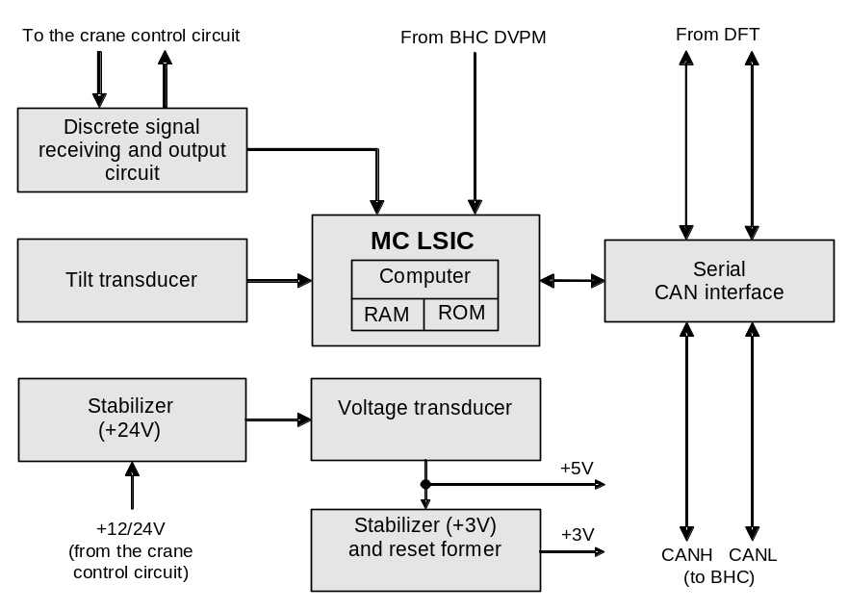

Figure 4 – The BHC block diagram

2.3 The Boom Head Controller
The boom head controller (BHC) is designed (ref. Figure 5) to collect signals from the primary data transducers (discrete, digital, frequency and analog) mounted on the boom head, to measure strength of the OTL electromagnetic field of the 50 Hz frequency and to transmit these signals from the boom head via the serial one-wire communication channel.
Note – The BHC can receive a discrete signal from the hook lift limiter transducer (limit switch).
The supply voltage (+12/24V) can be fed to the BHC from the crane circuit or from the RPC unit.
The unit housing functions as the antenna of the dangerous voltage protection module (DVPM) built in the BHC.
The DVPM measures the electromagnetic field strength and transmits its value to the RPC via the one-wire communication line.
When the DVPM actuates or fails the BHC displays code "Е101" … "Е105".
If there is a signal of approaching the OTL, the BHC unit prohibits the crane operations until the DVPM is switched to another OTL voltage measuring range (with less sensitivity) by pressing the ДИАПАЗОН ЛЭП (OTL RANGE) on the BHC front panel.

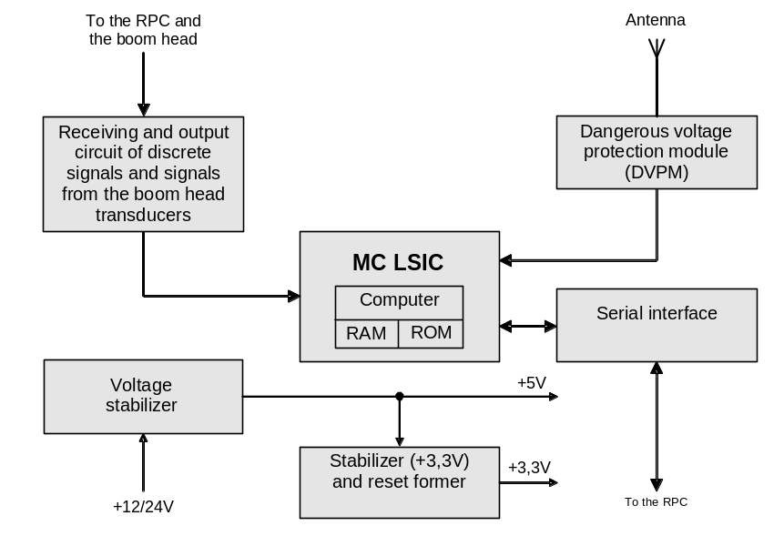

Figure 5 – The BHC block diagram

2.4 Digital Force Transducer
Digital tension force transducer (DFT) serves to measure the force produced by the load being lifted.
The DFT (ref. Figure 6) is a strain measuring bridge stuck on the steel base which distorts (stretches) under the influence of a force in a load cable produced by the mass of the load being lifted.
The output voltage from the bridge is fed to the electronic amplifier, in the MC LSIC it is transforms into the digital code and via the serial two-wire CAN interface is transmitted to the DDU.
The supply voltage (+20V) is fed to the DFT from the RPC unit.

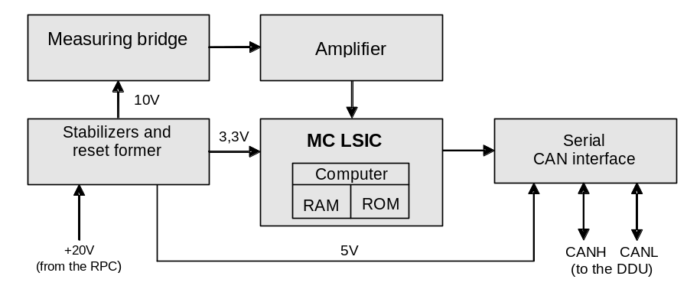
Figure 6 – The DFT block diagram

2.5 Digital Pendulum Angle Transducer
DPAT (ref. Figure 7) is designed to measure the crane boom elevation (Aс) relative to the horizon.
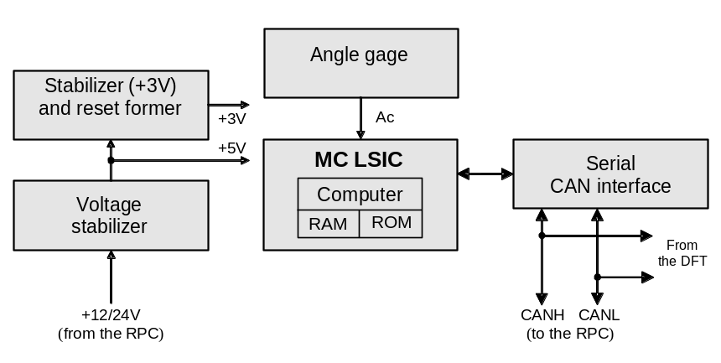

Figure 7 – The DPAT block diagram
The transducer provides measuring of the boom elevation angles within the range of minus 10 to +90°.
The DPAT output signal (ref. Figure 7), proportional to the boom elevation angle, is amplified and fed to the ADC input of the transducer microcontroller and after transformation into the digital code is transmitted (via the RPC) to the DDU.
The transducer supply voltage (+12/24V) comes from the RPC.
Напряжения питания датчика (+12/24 В) поступает из КПЧ.

3 Safety Precautions
The limiter is not hazardous to the operating staff and when commissioning and operating the CLL it is recommended to follow the current safety regulations for the pipelayer crane mounting and operation.
When performing any welding operations on the crane the CLL must be de-energized.
PERSONS WITHOUT SPECIAL TRAINING AND SPECIAL CERTIFICATES ARE NOT ALLOWED TO PERFORM THE LIMITER SETTING AND ADJUSTMENT ON THE CRANE.
DO NOT USE THE LIMITER WITH THE SEALS BROKEN.
The limiter presence on the crane does not exempt the crane operator from liability in case of the crane overturning or breaking of the crane assemblies.

4 The Limiter Mounting

4.1 General Instructions
Only qualified specialists who have studied the present document and been authorized to perform commissioning of the safety devices on the crane are allowed to accomplish the ОНК-160C-07 limiter mounting and putting in operation.
Operations involving welding should be performed by organizations which accomplish the work in full accordance with the Rules on safe operation of pipelayer cranes, effective normative documents, and have the appropriate authorization to perform the mentioned operations.
When performing operations involving welding on the crane metalware all the used materials should be in conformity with the effective normative documents.
In case the CLL is completed with assemblies and parts manufactured by several factories, the responsibility for quality of manufacturing in whole, for conformity with the Rules and other normative documents and for paper work (alterations in the CLL and crane operating documents) is imposed on the organization which accomplishes the CLL mounting, adjustment and functional check (with participation of the hoisting machine owner) on the crane.
Before putting the OНК-160С-07 in operation it is necessary to perform the limiter external examination:
- remove the limiter from the shipping container;
- check availability and integrity of the controls and displays on the data display unit (DDU) front panel;
- check the integrity of coatings, paint and seals of the CLL components.
When performing operations according to ii. 4.2-4.6 measure the distances using the retractable metal measuring ruler.
The retractable ruler should be verified.

4.2 The DDU Installation
Install the DDU, the overall and mounting dimensions of which are shown in Figure 8, on the crane cabin front wall or in the control console in such a way that the DDU front panel should face the crane operator and easy access to the DDU at minimum view should be provided.
Fix the DDU on the bracket by screws M6.
The fixing elements of the DDU and its external connecting cable should provide the possibility of the unit quick dismounting.

4.3 The DFT Installation
The tension DFT, the overall and mounting dimensions of which are shown in Figure 9, is installed in the load cable guyline in such a way that the maximum tensile load value at the maximum permissible mass of the load being lifted (taking account of overloads), influencing the transducer sensing (measuring) element by means of a clevis, should not exceed 0.7•Fmax, where Fmax – the transducer maximum operating force:
Fmax = 9800 Н (1000 kgf) for ДУЦ-06.

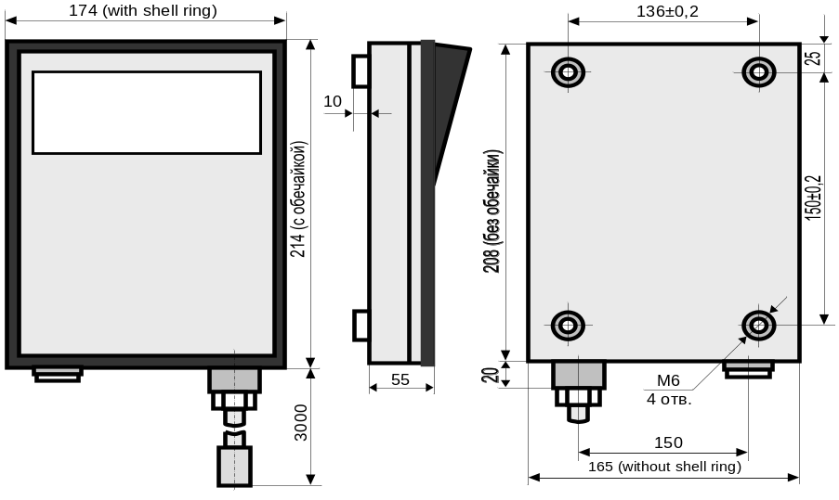
Figure 8 – The DDU overall and mounting dimensions

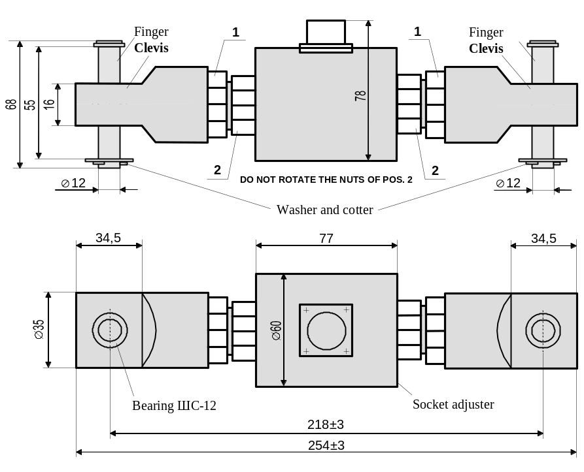
Figure 9 - The ДУЦ-06 overall and mounting dimensions
Connect the DFT by means of the CAN interface cable from the CLL complete set according to the diagram given in Appendix B to the present Manual.
To prevent the cable breaking hear the transducer connector the cable should be fixed (at a distance of 0.2-0.5 m from the DFT) to the crane structural element or to the transducer housing.
When mounting the DFT should be installed in such a way that the transducer connector should face down (to prevent moisture penetration into the transducer).
The transducer should be fixed to the eyes by means of two ∅ 12 мм fingers.
Note – The ∅12 mm fingers (ref. Figure 9) with a washer and cotter are the transducer components.
The transducer play on the fingers should be eliminated with the help of washers.
When it is required to change the angle of turn of the clevis flat portion relative to the transducer longitudinal axis, this operation should be performed (having fixed the clevis beforehand) by unscrewing and following screwing of the DFT nut (pos. 1 in Figure 9), applying force between the clevis and outer nut (1), and not allowing the torque influence on the sensing element (resilient member), placed in the transducer housing.
CAUTION
DO NOT BLOCK THE ШС-12 (ШСП-12) BEARING. At any crane boom evolutions there should be provided a gap of minimum 2 mm between the clevis and the eye of the transducer introduction assembly.
the torque appying to the transducer sensing element is not allowed. when changing THE ANGLE OF TURN OF THE CLEVIS FLAT PORTION ROTATE ONLE NUT OF POS. 1 HAVING CLAMPED THE CLEVIS IN THE VICE. DO NOT ROTATE THE TRANSDUCER INTERNAL NUTS (POS. 2).
AFTER MATING THE TRANSDUCER CONNECTOR WITH THE CABLE CONNECTOR THE CONNECTOR NUT OF THE LATTER MUST BE TIGHTENED PROPERLY.

4.4 The DPAT Installation
Install the digital pendulum angle (of the boom elevation) transducer on the boom root section at a distance of not more than 5 m from the boom attachment axis (ref. Figure 10). For this purpose on the boom side weld two bosses (with the М6 thread for fastening screws) so that the transverse axis of symmetry of the bosses located with a distance of 116 mm between them should be parallel to the boom longitudinal axis of symmetry.
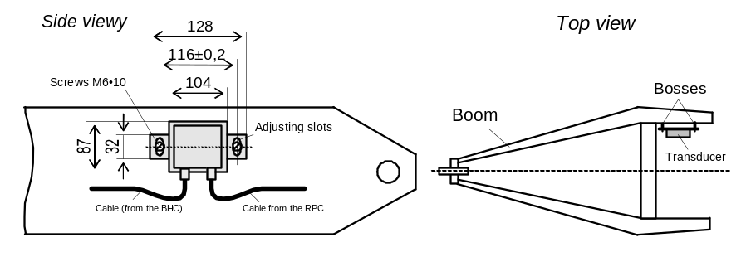

Figure 10 – The PDAT installation

Fix the transducer by means of two screws 6•10 with spring washers. Take care that the transducer side surface should be parallel to the boom axis.
Fasten (without slack) the transducer cable.
The places of mating of the transducer and cable connections a as well as the cables themselves should be protected from water direct penetration and water draining along the cables.
Note – It is recommended to place the cable into a metal tube or L-bar. It is applicable to the other limiter cables.

4.5 The RPC Installation
Fix the RPC, the overall and mounting dimensions of which are shown in Figure 11, by the М6 screws on the firmly secured crane wall so that the unit cable outputs should face vertically down (to prevent water draining along the cables into their connectors and into the unit housing), and the plane of the RPC housing mounting should be parallel to the plane of the boom vertical movement.
Open the RPC cover and mate the transducer connectors with the unit connector according to the marking on its cover.
Fit additional rubber sealing rings on the cables into the provided places on the RPC housing.
Replace the cover and tighten the fastening screws avoiding the cover distortion relative the unit housing.
CAUTION
Water penetration into the rpc housing is not allowed.
lack of at least one of the unit cover fasteniong screws is not allowed.

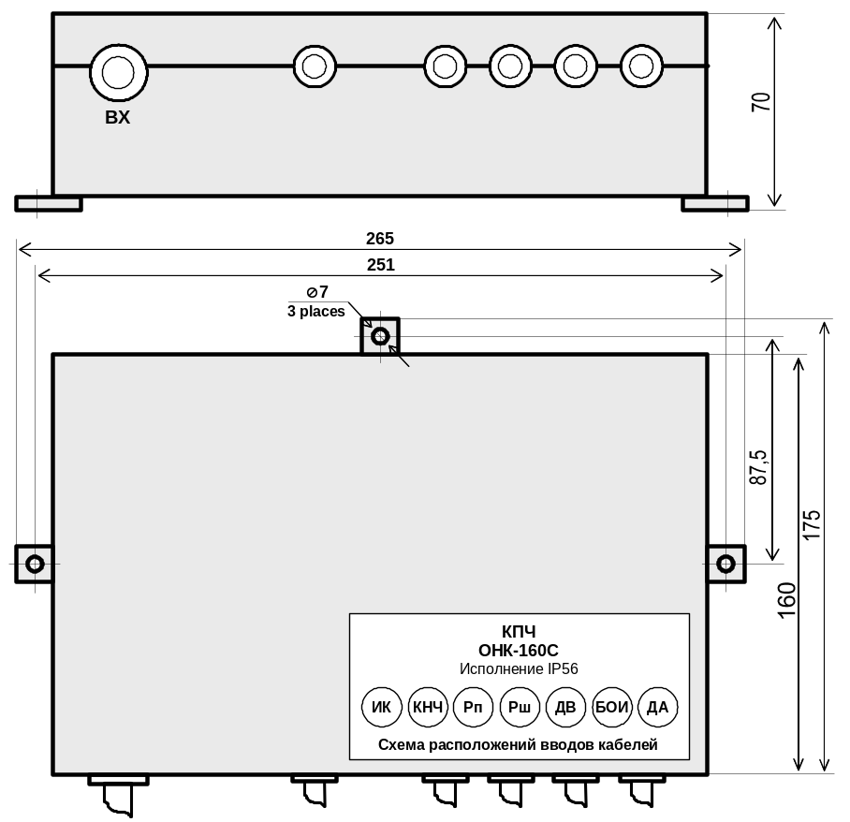
Figure 11 – The RPC overall and mounting dimensions

It is recommended to tighten the cover screws in the following order:
- screw in (not all the way) the central lower screw;
- screw in (not all the way) the central upper screw;
- screw in (not all the way) the left lower screw;
- screw in (not all the way) the right upper screw;
- screw in (not all the way) the right lower screw;
- screw in (not all the way) the left upper screw.
Repeat the above mentioned screw tighting operations several times (i.e. to avoid the cover distortion tighten the screws gradually in several steps)

4.6 The BHC Installation
Install the boom head controller (BHC) onto three bosses on the crane boom head in such a way (ref. Figure 12), that the unit longitudinal axis should be parallel to the boom axis.
Fasten the BHC by the М6 screws.
The BHC metal base should have reliable electric contact with the boom metal.
The BHC output wires should be directed downwards to prevent water penetration inside.

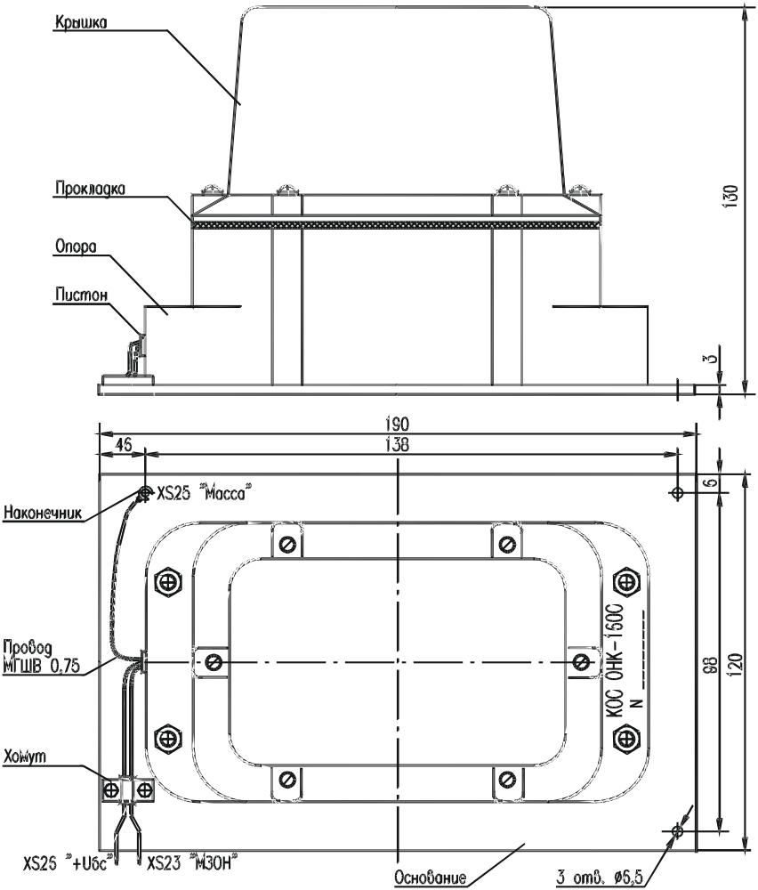

Figure 12 – The BHC overall and mounting dimensions

4.7 The Limiter Connection to the Crane Electric Circuit
When connecting the ОНК-160С-07 limiter follow the diagram of the CLL connection to the crane given in Appendix B.
Mate the connectors of the transducers and of the crane control circuit cable with the RPC connectors according to the marking on its cover.
Properly insulate the unused wires of the RPC control cable and fix to the cable with the help of the insulating tape.
All the limiter the plug and socket connections (places of joining of the transducers and units connectors with the cables) should be properly tightened (to prevent water penetration in them).

5 Adjustment
This section describes the CLL adjustment procedure at the crane manufacturing factory and also after the limiter repair.
While operating the crane follow the limiter adjustment procedure described in the section "Maintenance" (i. 8) of the present Operating Manual.
THE LIMITER ADJUSTMENT OPERATIONS DESCRIBED IN SECTION 5 SHOULD BE PERFORMED BY A TRAINED AND AUTHORIZED SAFETY DEVICE SERVICE ENGINEER.
When adjusting the limiter use a set of calibrated testing loads with mass being measured with an error of not more than ±1 %.
Measure the reach with the help of a retractable metal ruler having permissible deviation from the rated length of not more than ±0.5 см within the limiter operating temperature range.
The retractable ruler length should be not less than the reach maximum value for the given crane type.
The retractable ruler should be periodically verificated by metrological service.
5. 1 General
5.1.1 Functions of the DDU Buttons
When adjusting the following limiter data display unit buttons are used (also i. 2.1):
- МЕНЮ (MENU) (or М when displaying on the LCD) – entering the menu or selecting the required menu item;
- "Ù" and "Ú" – moving up "Ù" and down "Ú" the menu items;
- "+" и "–" - increasing ("+") and decreasing ("–") of the numeric value of the parameter being adjusted or the operating mode displayed on the LCD;
- Х – exiting (returning) from the menu (menu item) or switching (listing) of the pages displaying the crane operating parameters in the Работа (OPERATION) mode;
- Т – changing of the cursor position or of the parameter to be changed (the button other functions are given below);
- "↵" (ENTER) – recording of the value of the adjusted parameter displayed on the LCD to the limiter nonvolatile memory.

5.1.2 Safety Precautions
The CLL is adjusted in the НАСТРОЙКА (ADJUSTMENT) mode. While operating in this mode it is necessary to take care because this mode allows all the crane movements, and the signals to stop the crane at overloading are not generated.
CAUTION
TO PREVENT LOSS OF SETTINGS DO NOT FEED AND SWITCH OFF SUPPLY TO THE LIMITER IN THE НАСТРОЙКА (ADJUSTMENT) MODE.
IN CASE OF SUPPLY EMERGENCY SWITCHING OFF IT IS NECESSARY TO PERFORM THE CLL ADJUSTMENT ONCE MORE IN ACCORDANCE WITH THE OPERATING MANUAL CORRESPONDING ITEM.
5.1.3 Operating Procedure
Adjustment of the ОНК-160С-ХХ modification of the ОНК-160С limiter, where Х – an integer number from 0 to 9, is performed by serial data input in all the adjustment menu items beginning from the first (upper) menu item.
Depending on the crane type on which the ОНК-160С-ХХ is used, some menu items can miss in some limiter modifications, and for some other CLL modifications some new items can be added.
5.1.4 The Main Menu (настройка (ADJUSTMENT) menu)
To enter the main menu (in the adjustment menu) press the НАСТРОЙКА (ADJUSTMENT) button on the DDU front panel and hold it pressed for 5 s.
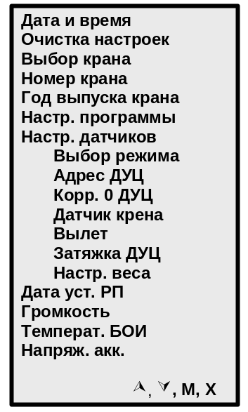The main menu view is shown in the figure to the left. In the bottom line are shown the DDU buttons which can be used in the adjustment menu:
- "Ù" и "Ú" - moving up ("Ù") and down ("Ú") the menu items;
- М (MENU) – enter the submenu or selecting of the required menu item;
- Х - exit (return) the menu (menu item).
In the adjustment menu the error messages (causes of failures) are displayed in the DDU lower left corner.
Messages of the limiter components (units and transmitters) failures have the form of "ЕХХ" or "ЕХХX" (eg. "Е63") with the corresponding to this failure short explanatory text (eg. "Линия связи" (communication line) for code "Е63").
Before starting adjustment it is necessary to eliminate all the errors described in the error messages.
To enter the menu (submenu) items press the МЕНЮ (MENU) button on the DDU.

5.2 Check of the Limiter Discrete Signals Connection to the Crane
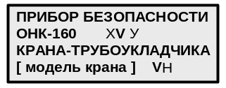5.2.1 Feed the supply voltage to the limiter.
Monitor on the LCD (ref. the figure to the left) the information on the limiter software displaying:
Х – the RPC (0, 1, 2) number (modification);
VУ – the software version;
VН – the software version.
This information is necessary to select the CLL components, to identify the software and the crane type.
Monitor the limiter self-testing passing: (from bottom to top, from the left to the right) switching on-off (lighting up – going out) of all the DDU LEDs by turn.
Having passed the self-testing the limiter will enter the operating mode.
5.2.2 Using the Меню (MENU) button enter the operating mode menu and select the "Диагностика" (Diagnostics) item, then select the "Контр.пов.части" ("Rotating portion controller") item.
5.2.3 Changing the crane mechanism positions (e.g. moving the counterbalance up and away) check the correct connection of the crane one-time signals (according to the diagram in the figure of Appendix B) to the RPC inputs monitoring displaying of digits "0" or "1" in the corresponding LCD bit in accordance with the signal function (digit "1" means the supply voltage feeding to the input).

5.3 Entering of the Date and Time, the Crane Number and the Year of Its Production
Energize the limiter.
Press the НАСТРОЙКА (ADJUSTMENT) button.
Note – In the adjustment mode on the LCD the parameters (of the crane position) to be set are marked with the "*" symbol.
To enter the main menu (submenu) items press the МЕНЮ (MENU) button.
Pressing the "Ù" и "Ú" buttons select the "Дата и время" (Date and time) submenu.
Press the МЕНЮ (MENU) button to enter the "Дата и время" (Date and time) submenu (in the same way you can enter the main menu other items).

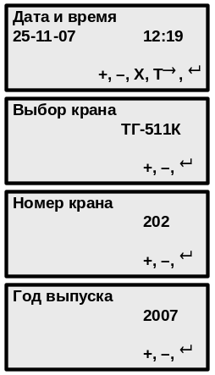In the "Дата и время" (Date and time) submenu (ref. the figure to the left) the cursor is moved to the submenu item by means of the Т button to change (correct) the set parameter values.
After pressing the "↵" button (entering the set parameter value into the CLL memory) return (exit) to the main menu will take place.
In the "Выбор крана" (Crane selection) submenu using the "+" button the required crane is set (selected) (e.g. "ТГ-511К", as it is shown in the figure to the left).
In the same way the crane number and the year of its production is set.

5.4 Reset of the Settings and the Program Adjustment
In the "Очистка настроек" (Reset of settings) submenu it is possible to reset all the entered settings and return to the factory settings.
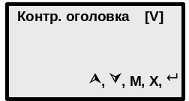In the "Настр. программы" (Program adjustment) submenu (ref. the figure to the left flags of the DDU program servicing of the units and transduces designed for the limiter additional completing are set as well as flags to switch on fine adjustment modes.
The boom head controller ["Контр. оголовка" (Head controller) in the submenu] actuates if the limiter contains the boom head controller (BHC) with the dangerous voltage protection module (DVPM). In this case the DDU program performs servicing of the BHC if the "Настр. программы"(Program adjustment) submenu sets the [V] flag in the "Контр. оголовка" (Head controller) item by means of the M button.
Cancellation of the selected modes is performed by removing the [V] flags in the corresponding item of the "Настр. программы" (Program adjustment) submenu by another pressing of the М button.

5.5 Adjustment of the Transducers

5.5.1 Mode Selection
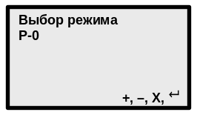In the "Выбор режима" (Mode selection) submenu the crane required mode (e.g. "Р-0" as it is shown in the figure to the left) in which the CLL adjustment will be performed is set (selected) using the "+" button.
It is recommended to make adjustment in the maximum loading capacity mode.
Each pressing of the "+" button leads to the operating mode change.
Pressings of the "+" button stop the required mode displaying (the "Р-1" mode in the above figure).

5.5.2 Setting of the DFT Address
The digital force transducer (DFT) has the address 20.
Setting of the DFT address is performed at the transducer replacement or when the "Е20" error is displayed.
Setting means following the submenu item instructions.

5.5.3 The DFT Zero Adjustment
Set the zero force on the transducer.
In the "Корр. 0 ДУЦ" (DFT zero Adjustment) submenu set the Fд = 0 value using the "+" and "–" buttons and press the "↵" button.
The Кf value shows the amount in kilograms of force (kgf) by which the transducer zero is corrected.

5.5.4 The Tilt Channel Adjustment
Place the pipelayer crane on the horizontal ground having inclination of not more than 0.5°.
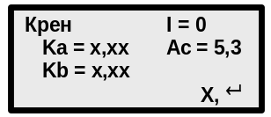Enter the "Датчик крена" (Tilt transducer) submenu (ref. the figure to the left) and press the "↵" button. After that the LCD in the "Датчик крена" (Tilt transducer) submenu will display zero values of the longitudinal (Ka) and lateral (Kb) tilt instead of values "х,хх". (The boom elevation value Ас is given for reference).

5.5.5 The Reach Channel Adjustment
Enter the "Вылет" (Reach) submenu.
To provide the load cable pulling and easiness of making the necessary measurement adjust the reach channel at a load on the hook, approximately equal to the hook assembly mass (200-500 kg).
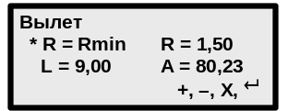Lifting and lowering the crane boom set (ref. the figure to the left) the recommended (displayed on the LCD in the line with the "*" sign) reach value monitoring the LCD indication.
Pressing the "+" and "–" buttons set the actual set and measured with the retractable ruler reach value monitoring the LCD indication.
Press the "↵" button to enter the set parameter value into the CLL memory, or the Х button if you do not want to enter the set reach value into the memory.

5.5.6 Adjustment of the DFT Tightening
Enter the "Затяжка ДУЦ" (DFT tightening) submenu.
Lifting and lowering the crane boom set (see the recommended value displayed on the LCD in the line with the "*" sign) the boom elevation equal to the "*А" value.
Changing the transducer mechanical tightening force (loosen or tighten the DFT) set (see the line with the "*" sign on the LCD) the recommended value of the tightening force "*F".
The error of the boom elevation A setting and the transducer tightening force F should not deviate for ±10 % max from the recommended values.

5.5.7 The Weight Channel Adjustment
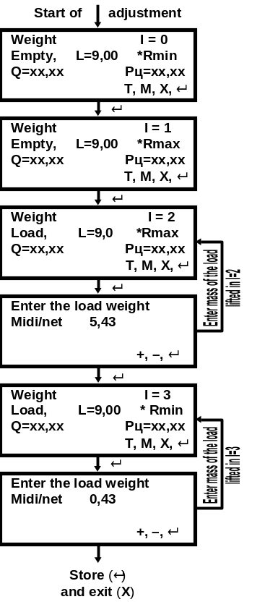It is recommended to perform the weight channel adjustment in the mode of the crane operation with maximum lifting capacity.
Enter the "Настр. веса" (Weight adjustment; ref. the figure to the right) submenu.
The weight channel adjustment consists in successive performing of operations at values
I = 0, I = 1, … I = 3 following the instructions displayed on the LCD for the next actions I.
Below is given the example how to make adjustment.
When adjusting the channel each T button pressing changes the parameter group displayed on the LCD:
"Q=хх.хх Рц=хх.хх" or
"L=хх.хх R=хх.хх",
where Рц – force of the boom elevation (monitoring is not required).
Entering of the mass values of the loads being lifted is performed taking into consideration the designation system adopted for the given crane: the midi load – the load mass on the cables together with the load-handling device; the net load – the load mass on the hook without the load-handling device.
While adjusting the channel do not monitor the displayed on the LCD mass values of the
load being lifted.
The displayed on the LCD mass values should correspond to the masses of the loads being lifted only after they have been stored in the limiter memory during the ВВОД МАССЫ ГРУЗА (Load mass enter) action at I = 3.
Reaches close to the recommended values are set in the windows with I = 0, I = 1, I = 2, I = 3 by performing the boom lifting and lowering actions.
Load masses lifted in actions I = 2, I = 3 should not be less than the half of the crane rated lifting capacity.
In case the CLL is adjusted on the crane with the MIDI lifting capacity during the executing the items of the weight channel adjustment menu in which the parameters without load being entered it is necessary to place the hook on the ground (loosening the cables) before the ВВОД (Enter) button is pressed.

In case the CLL is adjusted on the crane with the NET lifting capacity the hook should be 1-3m above the ground before the ВВОД (Enter) button is pressed.

5.6 Entering of the Parameter Recorder Date of Installation
Enter the "Дата уст. РП" (Parameter recorder date of installation on the crane) submenu.
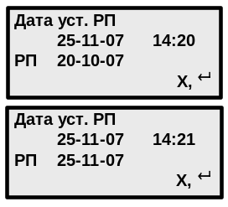In the second line of the submenu (ref. The figure to the left) the current date (day – month – year) and time stored in the CLL memory when performing operations according to i.5.3 are entered, and in the third line – the date entered into the CLL memory when it was adjusted on the limiter manufacturer or the crane manufacturer.
To enter the PR date of installation on the crane to the CLL memory press the "↵" button (storing the parameter in the CLL memory).
After pressing the "↵" button the date from the second line will be recorded into the submenu third line (ref. the second information window in the figure above) and the program will return to the main menu.

5.7 Adjustment of the Audio Signal Tone and the DDU Temperature
The audio signal tone adjustment and the DDU temperature setting is performed at the CLL manufacturer. If it is necessary to set the given parameters during operation follow the instructions displayed on the DDU LCD when performing actions of the "Громкость" (Volume) and "Температ. БОИ" (DDU temperature) submenus correspondingly.

5.8 Exit the Adjustment Mode
Having performed the adjustment operations according to ii. 5.3 - 5.7 it is necessary to return the limiter into the operating mode by pressing the X button, then close the cover of the НАСТРОЙКА (Adjustment) button and seal it.

6 Complex Check
The given check is obligatory and should be performed only after НАСТРОЙКА (Adjustment) button sealing (ref. i.5.8).
If at least one of the CLL checks mentioned below cannot be performed, it is necessary to repeat the limiter adjustment according to ii. 5.3 - 5.8, then perform the CLL check according to i. 6 again.
6.1 Check the correct receiving by the limiter of the discrete signals from the crane and serviceability and correct connection of the CLL output relays (permission of the crane moving away from the limitation zone and prohibition of moving to the zone of the hard-coded limits of the boom minimum reach and the maximum platform tilt), by performing operations according to i. 5.2.
6.2 Check the limiter determination accuracy of the values of reach, mass of the load being lifted, the boom elevation in four points of the crane loading characteristics at each certificate value of the boom length.
The parameter display error on the LCD in the static mode should not exceed the values given in i. 1.2.3.
6.3 Lowering and lifting the crane boom check the correct functioning of the hard-coded (provided by the limiter firmware) crane operating movement limit of the minimum reach.
When the hard-coded limit of the crane equipment operating zone border (of the minimum reach) the green LED НОРМА (NORM) should blink and the warning interrupted audio signal should be enabled.
6.4 Check the limiter correct functioning when the crane is overloaded performing the following operations.
Lift by turn the maximum permissible (according to the loading characteristics for the given crane type) loads at the maximum and minimum reach.
The limiter should allow lifting of these loads.
Increasing mass of the above loads by 10% try by turn to lift them.
The limiter should prohibit lifting of these loads.
6.5 Make the recording in the limiter certificate (if necessary also in the crane certificate) about the ОНК-160С-07 complex checking.

7 Operation

7.1 Operating Limitations (Safety Precautions)
The limiter is not hazardous to the operating staff and when commissioning and operating the CLL it is necessary to follow the current safety regulations for the pipelayer crane operation.
DO NOT USE THE LIMITER WITH THE SEALS BROKEN.
WHEN PERFORMING ANY WELDING OPERATIONS ON THE CRANE THE LIMITER MUST BE DE-ENERGIZED.
PERSONS WITHOUT AUTHORIZATION FOR THE SAFETY DEVICE ADJUSTMENT ARE NOT ALLOWED TO PERFORM THE LIMITER ADJUSTMENT (TRIMMING) ON THE CRANE.
DO NOT START OPERATION WITHOUT MAKING SURE THAT THE PIPELAYER CRANE OPERATING MODES ARE SET CORRECTLY.
THE CRANE CAN OPERATE NEAR THE OTL ONLY IF THERE IS AN ADMISSION OF A STANDARD FORM SPECIFYING THE SAFE OPERATING CONDITIONS.
The limiter presence on the crane does not exempt the crane operator from liability in case of the crane overturning or breaking of the crane assemblies when lifting the load.

7.2 The Limiter Preparation for Operation
Before the CLL switching on it is necessary to study the functions of the indicating elements and controls on the DDU front panel (ref. i. 2.1).
In the Работа (OPERATION) mode (i.e. when the limiter is used in accordance with its purpose) the following buttons of the data display unit (DDU) are used:
- БЛК (BLOCKING; 17) – to block actuation of the protection from approaching to the OTL;
- "¤" (BACKLIGHTING, 20) – to switch on and off (by the button pressing one more time) the LCD backlighting in darkness.
- Х (21) – to exit (return) the menu or submenu (the submenu item) and change over the pages displaying the crane operating parameters;
- Т (22) – to call the calender on the LCD. By pressing the "Т" button the current values of the date (day – month – year) and time (hours – minutes) are displayed in the second line. Three seconds after the "Т" button is pressed the limiter automatically returns to displaying of the crane current operating parameters;
- "+" (13) и "–" (18) – to increase ("+") and decrease ("–") the numeric value of the set (selected) parameter or of the operating mode displayed on the LCD;
- "Ù" (13) и "Ú" (18) – to move up "Ù" and down "Ú" the menu (submenu) items;
- МЕНЮ (MENU) (19; М when displayed on the LCD) – to enter the service menu and its submenu;
- "↵" (14, - ENTER) – to enter the set (selected) value of the crane equipment configuration displayed on the LCD to the limiter memory.
Use the МЕНЮ (MENU) button, pressing of which in the Работа (OPERATION) mode leads to displaying of the service menu items (ref. the figure below), only if it is necessary (e.g. to correct accuracy of the rate of the clock, to read-out the crane operation time data or to get the additional information on the condition of the CLL components if a fault occurs).
In the "Диагностика" (DIAGNOSTICS) submenu it is possible to control:
- the condition of the limiter discrete inputs and its output relays (ref. the "Контр.пов.части" (Rotating portion controller) submenu);

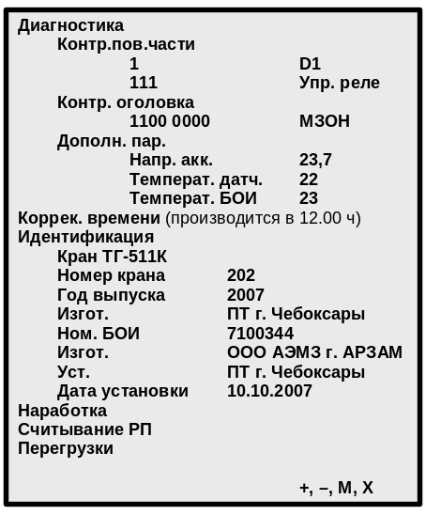- data coming from BHC (ref. the "Контр. оголовка" (Boom head controller) submenu): three left digits – the OTL voltage range, within which actuation of the protection from dangerous approaching to the OTL; the next two digits – the BHC serviceability – malfunction code; the next two digits – the condition of the BHC output switches; the right digit – the condition of the hook lift limiter input if it is connected to the BHC;
- the accumulator voltage, the temperature of the transducers and DDU (ref. the "Дополн. пар" (Additional parameters) submenu).

When using the limiter remember the following:
- if the limiter prohibited the crane operating movements, the red LED (СТОП) (STOP) glows on its panel, simultaneously the LCD displays a text message with a numerical code, explaining the reason of operation prohibition (e.g. "E83 Огр. под. крюка" (Hook lift limit) или "Е88 Вылет велик" (Reach is too large));
- when the crane boom approaches the hard-coded (provided by the limiter firmware) limits of the crane equipment operating zone border (of the boom minimum reach and the platform maximum lateral and/or longitudinal tilt) a warning interrupted audio signal is produced and the LED НОРМА (NORM) starts blinking;
- the limiter has no switch of its own to feed the supply voltage. The CLL is switched by means of the toggle switch on the crane control panel simultaneously with switching on of the instruments in the cabin. In this situation there should be a pause of not less than 30 seconds between the limiter switching on and off;
- if the limiter is switched on at a temperature of less than minus 10 °С, the DDU internal heater [thermostat (ТС)] tuns on and the data will be displayed on the LCD after warming up during 10 minutes;
- WHEN THE TRANSDUCERS FAIL THE CRANE OPERATION IS PROHIBITED (load lifting is blocked).
CAUTION
THE LIMITER IS NOT A MEASURING DEVICE AND NIT A SUBJECT TO THE METROLOGICAL VERIFICATION.
DO NOT USE THE LIMITER TO PERFORM COMMERCIAL MEASURING OF THE PHISICAL QUANTITIES.

7.3 The Limiter Operation

7.3.1 The Limiter Switching On
Switch on the toggle switch feeding the supply voltage to the crane control circuits.
Monitor the limiter self-testing passing: the liquid crystal display (LCD) displays the message (in lines)
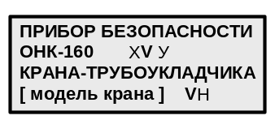
and (from bottom to top, from the left to the right) switching on-off (lighting up – going out) of all the DDU LEDs by turn.
Having passed the indication testing the limiter will enter the operating mode.
In the РАБОТА (OPERATION) mode two information windows for displaying on the LCD are provided successively. Types of the crane parameters being controlled and another additional information displayed in these windows are given in Figure 13.
Change from one information window to the other (to look up the information in the windows) is performed by pressing the Х button (button 21 in Figure 3).

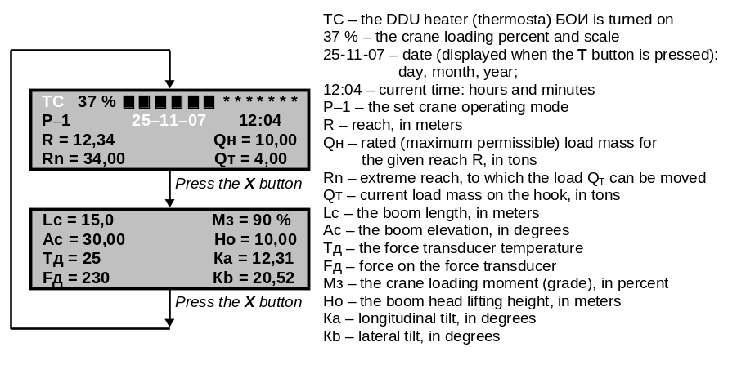
Figure 13- View of the DDU informations windows

7.3.2 The Crane Operating Mode Monitoring and Setting
Operations according to i. 7.3.2 should be performed when the crane starts operation, and when it is necessary to change the crane operating modes or when the LCD displays the corresponding message.
CAUTION
DO NOT START THE CRANE OPERATION WITHOUT MAKING SURE THAT ITS OPERATING MODES ARE SET CORRECTLY.
The pipelayer crane operating mode is determined by its loading characteristics and condition of the limiter DDU LEDs 4-7 (ref. Figure 3).
The pipelayer crane operating modes "Р-Х", provided in the ОНК-160С-07 limiter are given in Appendix A.
The crane operating mode is set by changing of the operating mode number "Р-Х" with the help of the operating mode setting buttons (8-11 in Figure 3).
Having set by means of the corresponding buttons (8-11 in Figure 3) the required operating mode with counterbalance [the counterbalance is drawn up (button 8) or moved away (button 9)] and selected the crane operating mode [single (button 10) or in autocade (button 11)], it is necessary to monitor the operating modes correct setting by switching on (glowing) of the corresponding LEDs of the crane operating modes (LEDs 4-7 in Figure 3).
The set crane operating modes are stored in the CLL memory.
The limiter automatically excludes the operating mode not provided on the given type of crane.

7.3.3 Peculiarities of Operation with the CLL
During the crane operation situations may occur when the ОНК-160С limiter prohibits the crane operation.
The messages of the "EXХ" (or "EXХХ") kind, where "Е" means "error, failure"; ХХ (or ХХХ) – message numerical code, Х – any integral number from 0 to 9, help to determine the reason of the crane halt.
Each message displayed on the LCD is accompanied by the text commentary.
Messages about the coming up to the limit in the Работа (OPERATION) mode are displayed in the second line at the top on the main (first) page of the crane operating parameter displaying and are kept on the LCD up to elimination of the reason caused the crane halt.
Kinds of the displayed messages and their short descriptions are given in Table 3.

Table 3
Kind of the message,  displayed on the LCD | Message short description
E83 Огр.под.крюка (Hook lift limit) | The limit switch of the hook lift limiter (HLL) actuated
E89 Вылет мал (Reach is too small) | Reach limit actuated
E90 Блокировка 1 (Blocking 1) | The carne operation with the БЛК button pressed
E91 Блокировка 2 (Blocking 2) | The limiter output relay blocking by means of a jumper
E92 Блокировка 3 (Blocking 3) | The CLL output relay is disconnected from the crane control circuit
Е100 Выб.реж. (Mode selection) | Incorrect setting of the operating mode
Е101 … Е105 | The OTL has been detected

7.3.4 The Crane Operation Time Data Readout
Press the МЕНЮ (MENU) button to enter the service menu.
Using the "+" and "–" buttons select the "Наработка" (Operating time) submenu.
Press the МЕНЮ (MENU) button.
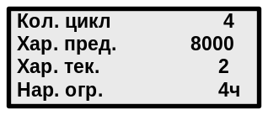The LCD will display the information window (ref. The figure to the left), where the current values of the crane loading cycles ("Кол. цикл" (Number of cycles)), the limiting Nп and current Nт characteristic number ("Хар. пред" (Characteristic limiting) and "Хар. тек." (Characteristic current)) and the limiter operating time (time of being in on state) ("Нар. огр." (Limiter operating time), in hours).
To exit the submenu press the Х button.

7.3.5 Rate of the Clock Correction
The given operation is performed when there is discrepancy between the time displayed on the limiter LCD and the local time or when change over to the summer (or winter) time takes placeя суток.
The rate of the CLL clock in the РАБОТА (OPERATION) mode is possible if the actual value of the current time differs from the value displayed on the DDU LCD by not more than 1 h 15 min. When the time deviation is more than 1 h 15 min make the time correction in the настройка (ADJUSTMENT) mode (ref. i. 5.3).
Time correction in the РАБОТА (OPERATION) mode should be performed only in case if before correction the displayed on the LCD time value is within the range from 10:45 (10 h 45 min) to 13:15 (13 h 15 min); otherwise set the time in the настройка (ADJUSTMENT) mode.
Correct the current time in the РАБОТА (OPERATION) mode at 12 h sharp.
Press the МЕНЮ (MENU) button to enter the service menu.
Using the "+" and "–" buttons select the "Коррек. времени" (Time correction) submenu.
Press the МЕНЮ (MENU) button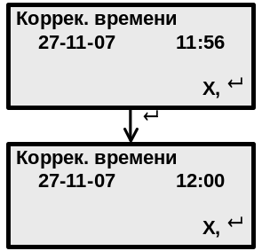. The LCD displays the information window (ref. the figure to the left), where in the second line the current values of the date and time are shown.
At 12 o'clock press the "↵" button. After pressing the "↵" button the LCD will display the required time: 12:00 (ref. the second window in the figure to the left).
To exit the submenu press the Х button.

7.4 The CLL Troubleshooting
7.4.1 The ОНК-160С-ХХ limiter firmware allows to check serviceability of its main assemblies and locate the fault by displaying its code on the DDU LCD (ref. Table 4).
7.4.2 To locate the fault in case of the limiter being unserviceable it is recommended to use the following procedure:
- check the units and the transducers for the absence of external mechanical damages;
- check correct connection of the transducers;
- check the cable interconnections, serviceability of the electric connection circuits of the transducers and units.
7.4.3 The displayed on the LCD messages are of the "EXХ" (or "EXХХ") kind, where "Е" means "error, failure"; ХХ (or ХХХ) – message numerical code, Х – any integral number from 0 to 9.
Each message displayed on the LCD is accompanied by the text commentary.
WHEN THE LIMITER ERROR MESSAGE IS DISPLAYED THE CRANE OPERATION IS NOT ALLOWED.
The error messages in the Работа (OPERATION) mode are displayed in the LCD second line on the main page displaying the crane operating parameters and kept on the LCD up to elimination of the reason caused the crane halt.
Note – The CLL error message in the настройка (ADJUSTMENT) is displayed in the lower left corner of the DDU LCD. Without eliminating the reason of trouble there is no good in futher CLL adjustment.
The messages of the transducer errors are generated when there is no interaction with the transducer or the determined parameter value exceeds its measurement range (the ADC bit grid) and can be the result of failure of the transducer itself or of its incorrect "binding" to the crane (e.g. the variable resistor slider is in the "dead zone").
When the error message appears it is recommended to switch off and on the limiter supply to correct accidental program malfunctions.
During the limiter service life sporadic appearance of the error message "E65 Сбой программы" (Program malfunction) is allowed. When this message appears repeatedly during one working shift it is necessary to check the reliable connection of the CLL components connectors (in the first place – of the DDU with RPC) and connection of the power supplying wires to the crane electrical box terminals, and check the value of the vehicle-borne circuit voltage. If after performing of the mentioned operations and eliminating of the detected malfunctions the error message "E65" appears again, it is necessary to replace the defective DDU.
7.4.4 Kinds of the displayed on the LCD error messages (codes) about failure of the limiter components, their short description as well as possible reasons of the CLLL failure and troubleshooting are given in Table 4.
the cll Troubleshooting operations, requiring opening of the units and transducers, should be performed by the authorized specialists of the repair and after-sale service centers having the corresponding certificates.
7.4.5 When eliminating some of the CLL failures given in Table 4 it is recommended to follow the diagram of the CLL components connection to the crane (ref. the figure of Appendix B). In this situation voltage and electrical resistance should be measured with the supply voltage switched on and off respectively.
7.4.6 Detection of faults connected with the communication line failure should be performed in the following order.
The fault detection should be performed using the electrical meter designed for use in the same climatic conditions, in which the fault detection is performed and which is able to measure the dc voltage up to 30 V, electrical resistance up to 1 kOhm and which has accuracy class 1,0.
The electric meter should be calibrated.

Table 4 – The Limiter Troubleshooting
Symptom |  | Remedy
Kind of message | Short description | Remedy
E15 ДУГМЦ (DPAT) | The DPAT failure | Perform i. 7.4.6.  Replace the transducer
E20 Датчик усилия (Force transducer) | DFT ot its circuits are defective | Perform i. 7.4.6.  Replace the transducer
E40 Конт.пов.ч. (Rotation portion controller) | The RPC or its circuits are defective | Perform i. 7.4.6.  Replace the RPC
Е53 (или E55)  Контр.оголовка (Boom head controller) | The BHC or its circuits are defective | Perform i. 7.4.6.  Replace the BHC
E63 Линия связи (Communication line) | Failure of the communication line (of the CANH and CANL circuits) | Perform i. 7.4.6.
E64 Сбой генератора (Generator malfunction) | Generator (crystal resonator 3,64 MHz) malfunction | Replace the DDU controller board
E65 Сбой программы (Program malfunction) | The limiter program malfunction (The processor hang) | Perform instructions of i. 7.4.  Replace the DDU controller board
E66 КС программы (Program checksum | The program checksum is wrong | Reprogram the DDU.  Replace the DDU controller board
E67 Часы молчат (No clock response) | No clock response (IC pos. D1) to the processor call (DDU) | Switch the power supply off and on.  Adjust the clock according to i. 5.3.  Replace the DDU controller board
E68 Нет прерыв.1сек (No 1s interruption) | The clock (IC pos. D1) does not operate, there is no 1s interruption (DDU)
E69 Сбой часов (Clock malfunction) | The clock (IC pos. D1) operation is wrong (DDU)
E70 Настр.память (Setting memory) | No setting memory (pos. D6) response to the processor call (DDU) | Replace the DDU controller board
E71 Память РП1 (PR1 memory) | No PR1 memory (IC pos. D7) response to the processor call (DDU) | Replace the DDU controller board
E72 Память РП2 (PR2 memory) | No PR2 memory (IC pos. D7) response to the processor call (DDU) | Replace the DDU controller board
E73 Память РП3 (PR3 memory) | No PR3 memory (IC pos. D12) response to the processor call (DDU) | Replace the DDU controller board
E74 Uбс=ХХ.Х | The supply voltage (Uбс) is out of norm (ХХ.Х – the measure voltage value) | Check the supply voltage value Uбс
E75 Термостат (Thermostat) | The thermostat is defective (DDU) | Replace the DDU controller board
E81 Крен продольн. (Longitudinal tilt)  or  E82 Крен поперечн. (Lateral tilt) | The tilt transducer is not adjusted.  The RPC in which the TT is located is installed incorrectly.  The TT is defective | Adjust the TT according to i. 5.5.4.  Correct the RPC installation (ref. i. 4.5): loosen the screws fastening the unit; smoothly moving the RPC in the longitudinal or lateral (depending on the error code) direction, make the error code disappear; fix the RPC in the new position in such a way that the displayed on the LCD values of the longitudinal and lateral tilt should be within the range from minus 3 to +3°; repeat the TT adjustment according to i. 5.5.4.  Replace the RPC
E83 Огр.под.крюка (Hook lift limit) | The limit switch of the hook lift limiter actuated | Lower the hook
E89 Вылет мал (Reach is too small) | Reach limit actuated | Increase the boom reach
E90 Блокировка 1 (Blocking 1) | The carne operation with the БЛК button pressed | Release the БЛК button
E91 Блокировка 2 (Blocking 2) | The relay blocking by means of a jumper | Remove the jumper
E92 Блокировка 3 (Blocking 3) | The relay output is disconnected from the crane control circuit | Connect the relay to the crane control circuit
Е100 Выб.реж. (Mode selection) | The incorrect operating mode is set | Set the required operating mode acc. to i. 7.3.2
E101 ЛЭП 0.22-1кВ | Operation in the OTL 0,22-1 кV zone | Pressing the "Диапазон ЛЭП" (OTL range) (16) button select another (higher) OTL voltage range
E102 ЛЭП 6.0-10кВ | Operation in the OTL 6-10 кV zone
E103 ЛЭП 20-35кВ | Operation in the OTL 20-35 кV zone
E104 ЛЭП 110-450кВ | Operation in the OTL 110-450 кV zone
E105 ЛЭП 500-750кВ | Operation in the OTL 500-750 кV zone
Open the cover of the de-energized RPC and disconnect the DPAT connector.
Make sure there is no short-circuit between the contacts of the communication line connectors, then check the resistance between contacts 6 and 7 of the DPAT connector.
Fully assembled line has the resistance of (60±5) Ohm (parallel connection of two 120 Ohm resistors placed at the beginning and in the end of the line; one of these resistors is in the DDU, the other is in DFT).
Switch on the supply and check the communication line voltage. Voltage in the CANH (contact 6) and CANL (contact 7) wires of the operable line relative to the negative wire (contact 4) should be +(2.5±0.2) V.
If the measured voltage values in the CAN lines differ from the specified values, detect the defective unit or transducer disconnecting successively (with the power supply switched off) their connectors from the RPC.
Check the +(24±8) V voltage availability on contact 3 of the units and transducers relative to contact 4.
The terminals of the DDU controller board have the following marking of the circuits:
Ж – circuit "+24 V";
C –circuit GND (ОБЩ);
Э –circuit ЭКРАН (Shield);
Б –circuit CANH;
Ф –circuit CANL.
Having detected the fault replace the defective unit (transducer).
7.4.7 If the CLL does not allow any crane movement, it is necessary to check: а) correct connecting of the crane discrete signals to the RPC (ref. i. 5.2) and make sure the CLL program allows this movement (by digit "1" availability in the corresponding output relay bit in the "Диагностика" (Diagnostics) menu); b) correct connecting of the RPC output relays.
7.4.8 If after performing the actions recommended in ii. 7.4.2 - 7.4.7 the fault cannot be eliminated, the defective component should be sent to the CLL manufacturer.
7.4.9 When describing the limiter and/or its component failure during operation it is necessary to mention in detail the nature of the defect and conditions of its appearing:
- the name and address of the enterprise raising a claim;
- the crane type on which the CLL is used;
- the CLL modification number and its serial number;
- the CLL time before failure as the crane component;
- the code of the displayed on the LCD error message;
- the data displayed in all lines of all information windows;
- the state of the limiter LEDs;
- description of the conditions of the failure appearance (loading characteristics; values of the mass of the load being lifted, actual reach, boom length and elevation, ambient temperature;
- other information which can help to detect the fault in the limiter defective component (unit or transducer).

8 Maintenance

8.1 General
The maintenance means performing actions providing the ОНК-160С-07 limiter serviceability during its service life. The maintenance provides the limiter continuous serviceability and the crane safe operation.
The specified by the present Manual the limiter maintenance periodicity should be observed under any operating conditions and in any season.
The limiter maintenance should be performed simultaneously with the crane maintenance.
During the limiter maintenance safety precautions specified for the crane maintenance should be observed.
To perform the maintenance it is necessary to prepare beforehand the required materials, instruments and tools. Place the crane in a covered space free of smoke, in winter in a heated room.

8.2 Types of Maintenance
Depending on the periodicity and volume of work the limiter maintenance is subdivided into following types:
- the shift-time maintenance (STM);
- the first periodic maintenance (PM-1);
- the second periodic maintenance (PM-2);
- the seasonal maintenance (SM).

8.3 Maintenance Procedure
8.3.1 The Shift-time Maintenance
The STM is performed by the crane-operator before work.
The STM includes the following actions:
- external examination and cleaning of the units and transducers from dust and dirt;
- the CLL functioning check: absence of damages of the LCD, LEDs, signal lights and switchpoints;
- the CLL serviceability check by lifting of the test load and comparing of the displayed on the LCD mass and reach values with the actual values of the mass of the load being lifted and of the reach set with the help of the retractable ruler. The difference between the compared values should not exceed: of the load mass ±5 %; of the reach ±1.5 %.

8.3.2 The First Periodic Maintenance (PM-1)
PM-1 is performed by the safe device service engineer not rarely than once a month.
PM-1 stipulates the limiter check by test loads (ref. i. 8.3.5) and, if necessary, the CLL trimming according the results of its check.
8.3.3 The Second Periodic Maintenance (PM-2)
PM-2 is performed by the safe device service engineer not rarely than once a quarter.
PM-2 stipulates performing of actions of STM and PM-1 and, if necessary, the rate of the clock correction (ref. i. 7.3.5).
8.3.4 The Seasonal Maintenance
The SM is performed during the crane preparation for operation in winter and summer.
The SM is performed by the crane-operator actions acc. to i. 8.3.4 a) – d)) and by the safe device service engineer ((actions acc. to i. 8.3.4 e) – i)).
The SM includes the following actions:
a) the shift-time maintenance actions;
b) condition check of the transducers, connecting cables and connectors;
c) condition check of the sealings (including the cabin) and paint coats;
d) elimination of the detected defects;
e) the limiter check with the test loads (ref. i. 8.3.5);
f) the CLL trimming according to the results of its check according to i. 8.3.5 if necessary;
g) read-out of the crane operating time data according to i. 7.3.4, if necessary;
h) read-out from the PR of the data according to the ЛГФИ.301412.101 И1 Instructions (included in the СТИ-3 reader complete set), if necessary;
i) the rate of the clock correction (ref. i. 7.3.5), if necessary.
THE DATA READ-OUT FROM THE CLL (WITH ITS SEALING FOLLOWED) SHOULD BE PERFORMED BY AN ENGINEER RESPONSIBLE FOR THE Crane SAFE OPERATION, A SPECIALIST IN PROCESSING OF THE PARAMETER RECORDER DATA OF THE AFTER-SALE SERVICE OR REPAIR CENTER ENGAGED IN THE GIVEN SAFETY DEVICES SERVICING.

8.3.5 The Limiter Check with Test Loads
THE CLL TRIMMING OPERATIONS DESCRIBED IN I. 8.3.5 SHOULD BE ACCOMPLISHED BY A SAFETY DEVICE SERVICE ENGINEER.
While performing the operations described in i. 8.3.5 use:
- a set of certified test loads the mass of which should be measured with an error of ± 1% max;
- a retractable metal ruler having permissible deviation from the rated length of not more than ±0.5 см within the limiter operating temperature range.
The retractable ruler length should be not less than the reach maximum value for the given crane type.
The retractable ruler should be periodically verificated by metrological service.
The reach should be set using the retractable ruler with an error of ±2 cm max.
Actions described in i. 8.3.5 should be performed in the maximum lifting capacity mode.
Note – The limiter can be checked according to the procedure and at reaches mentioned in the crane Operating Manual, it is also permissible to make the limiter actuate by increasing of the reach.
8.3.5.1 Perform actions according to i. 6.4.
If the limiter does not meet i. 6.4 requirements, perform the CLL adjustment according to i. 5.
8.3.5.2 Close and seal the cover of the НАСТРОЙКА (ADJUSTMENT) button.
8.3.5.3 Make a record of the actions performed in the limiter and crane certificates.

9 Packing, Storage and Transportation Regulations
9.1 Before packing preserve the CLL according to the requirements of the state standard ГОСТ 9.014-78 covering the storage conditions of article group III-1, the temporary protection variant ВЗ-10 or B3-14 with the limiting protection period without re-preservation of 6 months.
9.2 The preserved limiter and the operating documentation should be packed in boxes according to state standard ГОСТ 2991-85.
Before the CLL packing the shipping container should be lined with a asphalt-laminated paper ГОСТ 515-77 or paraffined paper ГОСТ 9569-79 in such a way that the paper ends should go beyond the container edges by the value exceeding the half of the box length and width.
Each box with the limiter should contain a packing list including:
- the Manufacturer’s name or its trade mark;
- the article name and designation (code);
- the list of the article components and their quantity;
- the date of packing;
- the packer and inspector stamp.
9.3 The storage conditions concerning the climatic factors should correspond to the storage conditions 5 (ОЖ4) of the state standard ГОСT 15150-69 for the articles of the У construction: air temperature from minus 50 to plus 60 °С, air relative humidity of up to 100% at a temperature of plus 25 °С.
Store the limiters in open storage facilities in the unpacked Manufacturer’s package.
The storage facility should be free of current-conducting dust, acids, alkali and other corrosive additives.
The limiter storage period (without re-preservation) is not more than 12 months from the date of shipping in the Manufacturer's package in the storage facilities.
9.4 The limiters can be shipped by any covered transport facility according to ГОСТ 20790-93 and regulations on transportation of goods for the given mode of transport.
The transportation conditions concerning the climatic factors should correspond to the storage conditions 5 (ОЖ4) of ГОСТ 15150-69: air temperature from minus 50 to plus 60 °С, air relative humidity of up to 100% at a temperature of plus 25 °С.
Stowage and fixing of the boxes with CLL in the transport facilities should exclude their movement, impacts, kicks and exposure to the precipitation.
9.5 While storing and shipping the boxes with the limiters can be stowed in three rows max. The boxes should be placed according to the manipulation signs.

Appendix А
(obligatory)

The ОНК-160С-07 Modes of Operation on the Cranes

А.1 The ОНК-160С-07 Modes of Operation on the ТГ-511К Crane
Code "Р-0" single operation, the counterbalance is drawn up.
Code "Р-1" single operation, the counterbalance is moved away.
Code "Р-2" operation in autocade, the counterbalance is drawn up.
Code "Р-3" operation in autocade, the counterbalance is moved away.

Appendix B
(obligatory)

Diagrams of the ОНК-160С-07 Connection to the Cranes

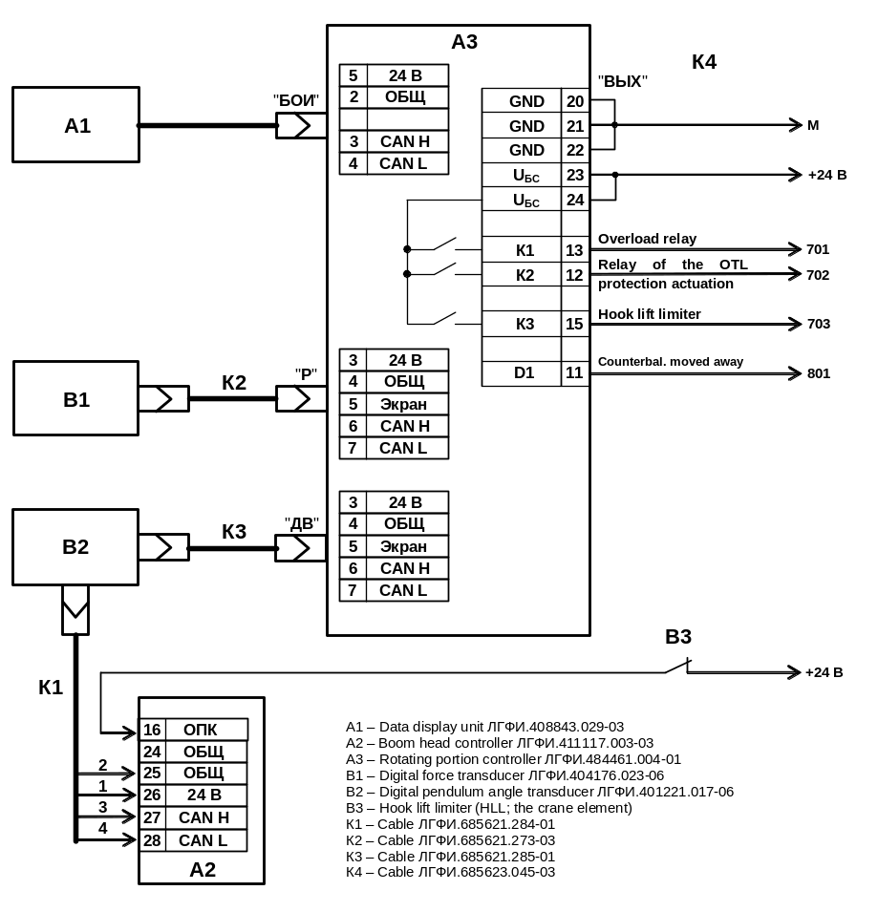
Figure Б.1 – Diagram of the ОНК-160С-07 limiter components connection to the ТГ-511К crane

Приложение C
(reference)

List of Accepted Abbreviations and Designations

AD converter – analog-digital converter
ADR – archive data reader САИ-3 (component of СТИ-3)
BHC – boom head controller (with a built-in DVPM; the BHC housing performs the antenna functions)
CAN – serial two-wire communication channel (CAN-interface)
CLL – crane load limiter OHK-160C
DDU – data display unit (with the built-in crane operation parameter registration - PR)
DFT – digital force transducer
DM – display module
DPAT – digital pendulum angle transducer
DVPM - dangerous voltage protection module (built in the BHC)
НА1 – ring for the audio (warning and emergency) signaling
HLL – crane hook lift limiter
IС –integrated circuit
IR-channel – infrared channel of the crane parameter recorder (is used while the data readout from the PR)
IRRT – infrared receiver-transmitter of the crane parameter recorder
LCD – liquid crystal display
LSIC - large-scale integrated circuit
MC - microcontroller
MC LSIC – microcontroller LSIC
OM – operating manual ЛГФИ.408844.026-05 ПС/Э
OTL - overhead transmission line
PM-1 – first periodic maintenance
PM-2 – second periodic maintenance
PSM – power supply module
PR – crane parameter recorder (built in the DDU)
RAM – random access memory
ROM – read-only memory
RPC – rotating portion controller (with the built-in TT)
SM – seasonal maintenance
SCM – single-chip microcontroller
STM – shift-time maintenance
TDR - telemetry data reader СТИ-3
ТS – thermostat
TT – longitudinal and lateral tilt transducer (built in the RPC)
USB – port for the PC connection when read-out data (in full) from the crane parameter recorder built in the DDU and for the DDU controller programming
БЛК (BLOCKING) – name of the button for hard-coded (provided by the limiter firmware) blocking of the coordinate protection when it actuates
Диапазон ЛЭП (OTL range) – name of the button to select the voltage ranges of the BHC protection module
ЕXX и ЕХХХ – the CLL error code [code of the message of the DDU functional assembly failure or of the limiter component (unit or transducer) (X – any integer number from 0 to 9)]
МЕНЮ (MENU) – name of the button to call (display) the menu to the LCD
НАСТРОЙКА (ADJUSTMENT) – name of the button to enter the настройкА (Setting) menu
НОРМА (NORM) – green LED, its glowing means the crane operation with the load safe for its design
ПОДСВЕТКА ("¤") (BACKLIGHTING) – name of the button for the LCD backlighting switching on in darkness.

Х – name of the auxiliary button usually used to exit the submenu
Т – name of the auxiliary button, its main function is to display the current date on the LCD (Other functions of this button are mentioned in the OM)
"+" – name of the button for increasing of the numeric value of the parameter being adjusted displayed on the LCD in the НАСТРОЙКА (ADJUSTMENT) mode
"–" – name of the button for decreasing of the numeric value of the parameter being adjusted displayed on the LCD in the НАСТРОЙКА (ADJUSTMENT) mode
"Ù" – name of the button for moving up the menu item
"Ú" – name of the button for moving down the menu item
"↵" (ввод) (ENTER) – name of the button for entering (recording) of the crane equipment configuration (in the РАБОТА (OPERATION) mode) or of the set parameter value displayed on the LCD in the НАСТРОЙКА (ADJUSTMENT) mode into the limiter setting memory

