



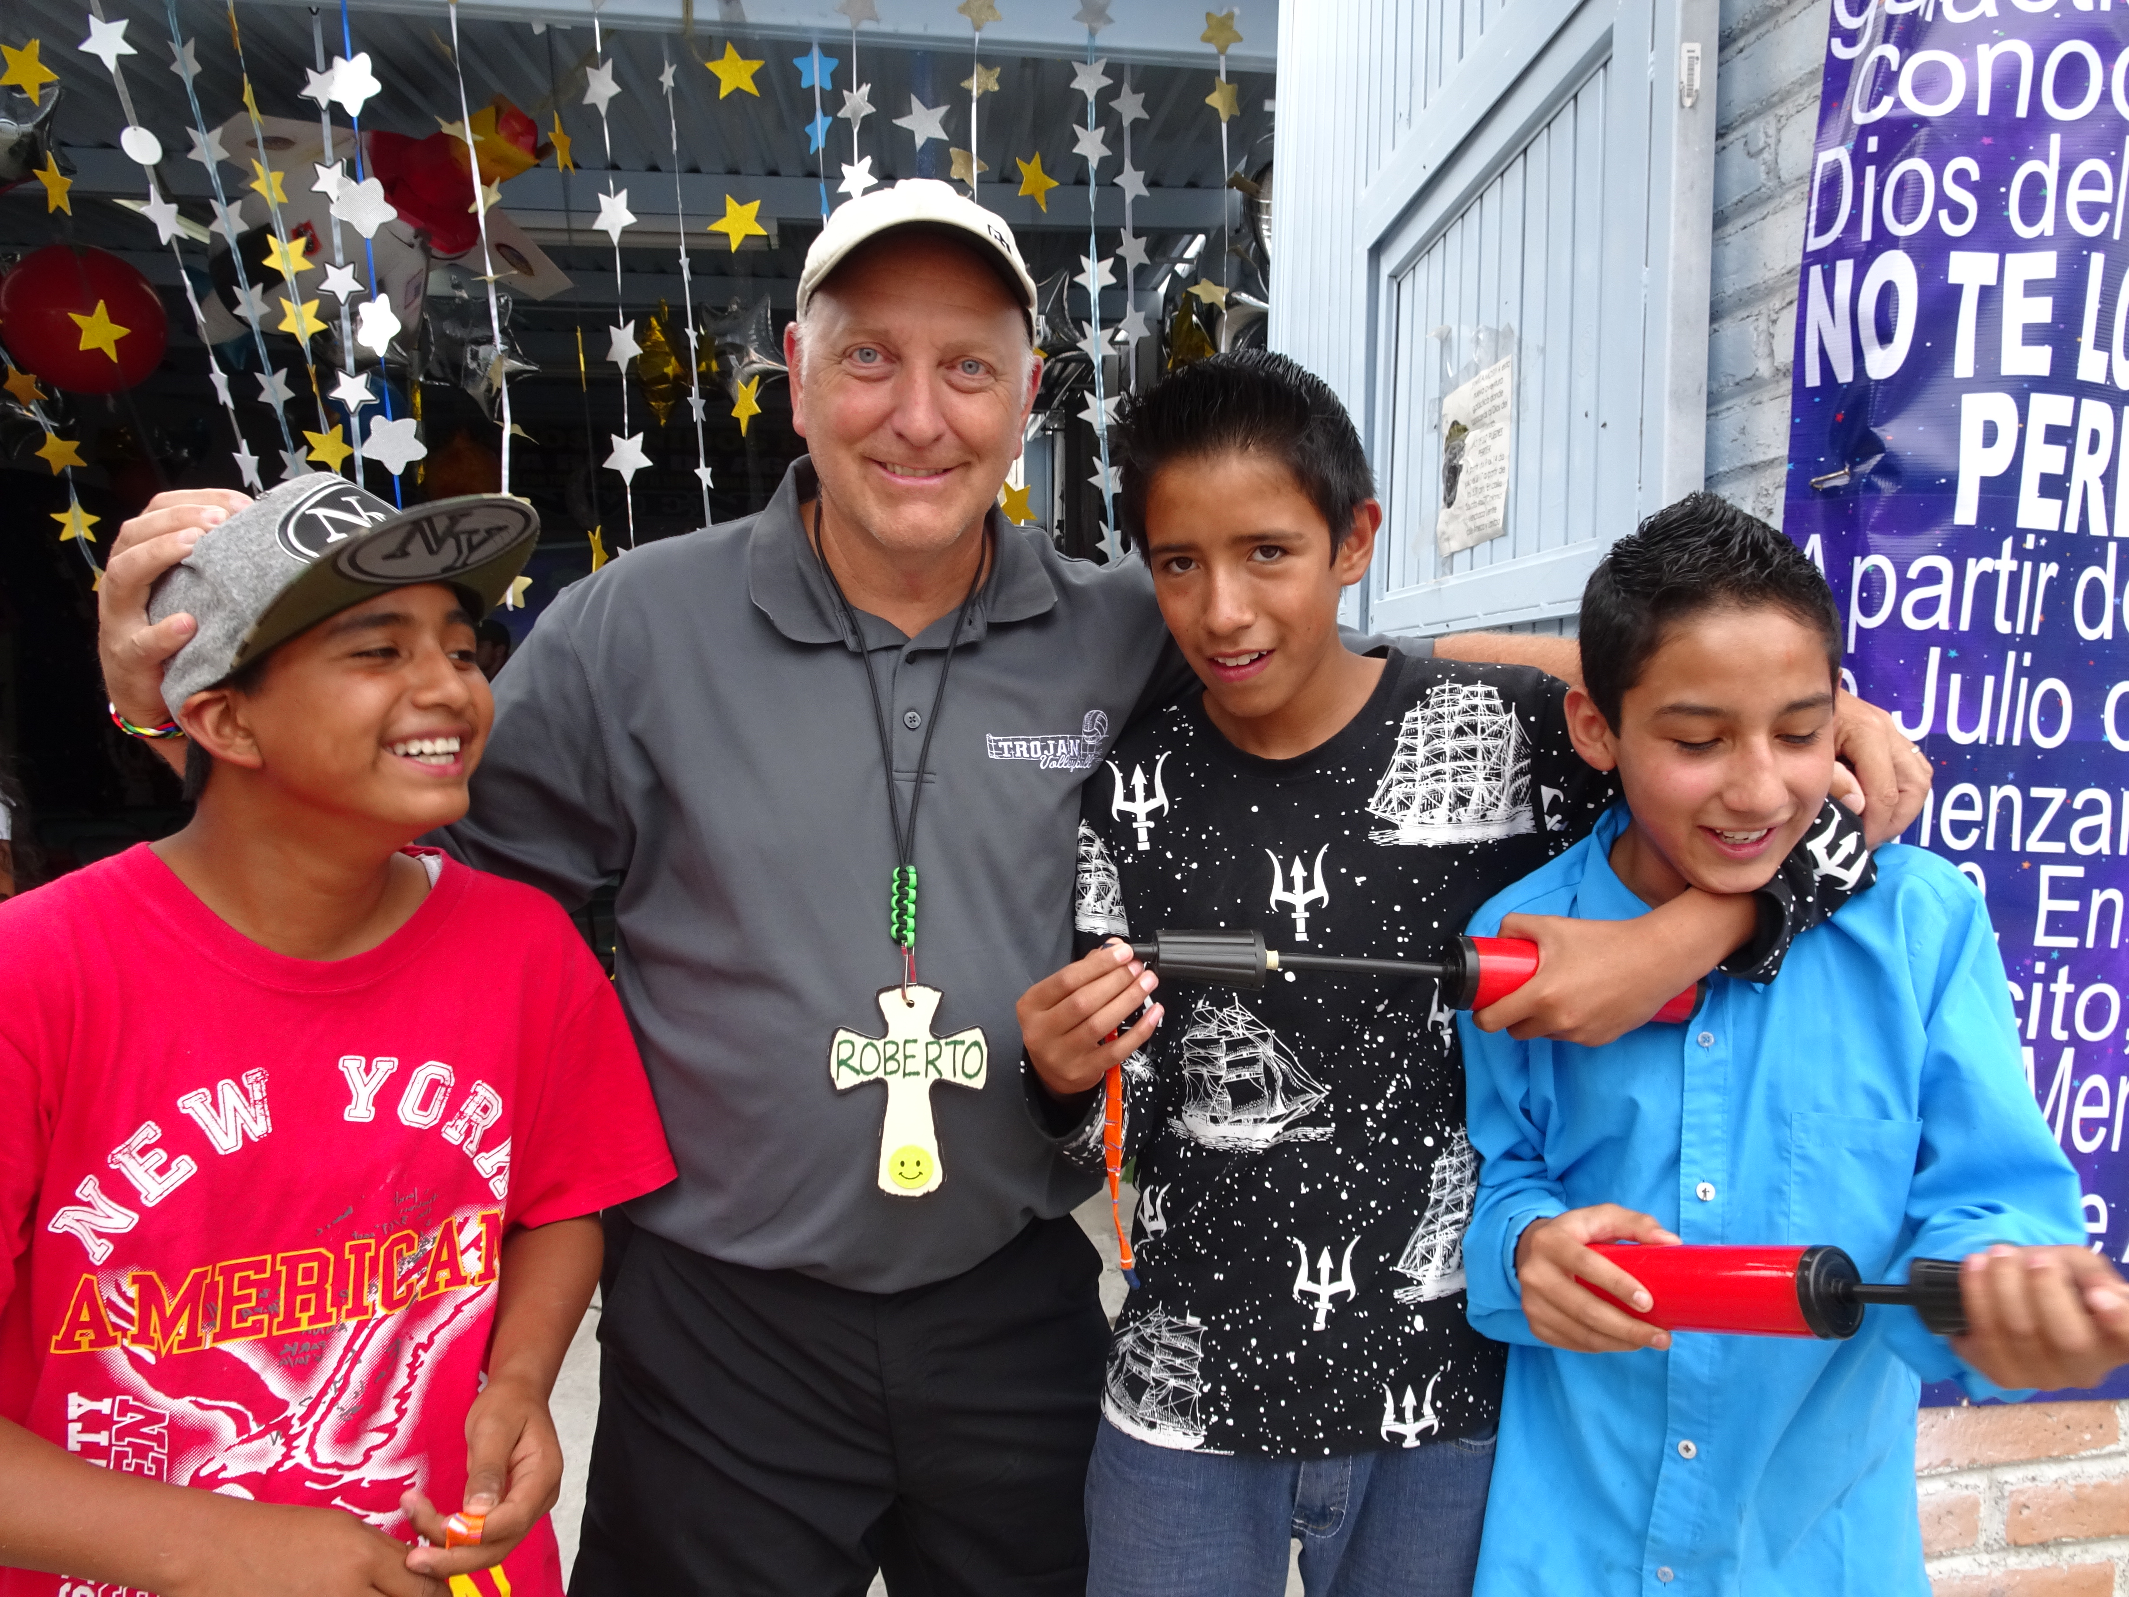

Registration Form

GENERAL INFORMATION
Full Name (as it appears
or will appear on your passport)
Full Address
Email Address
Phone Number
Name and Address of Church where you attend or are a member
Date of Birth
PASSPORT INFORMATION
Do you have a passport with a remaining validity of at least seven months past dates of trip? |  |  |  | Yes No
Passport Id Number
Passport Expiration Date
EMERGENCY CONTACT INFORMATION
Name
Full Address
Relationship |  | Email Address
Phone Numbers |  | Cell
Home |  | Work

CHURCH INVOLVEMENT
List any ministries you are involved in at your local church.

List your Pastor’s name and contact information or another person who could serve as a reference.

EDUCATION
I am currently a student in | High School College
I have graduated from | High School College
Name of college
City/state of college
Degree/major
EMPLOYMENT
Presently employed at
Occupation
SPANISH (Not required but if you speak Spanish please rate your fluency).
Beginner 1 2 3 4 5 Fluent

OTHER INFORMATION
Because this trip will include work projects, please mark any of the following that you are skilled at and have experience with. (Put a “1” for skilled / “2” for experience)
Electrical Landscaping
Masonry Plumbing
Carpentry Concrete work
Painting Roofing
Auto Mechanics Dry Wall
NOTE: Having experience in these types of labor is helpful but is NOT a requirement for being a part of this trip.
Please tell about some of your gifts, interests, hobbies, and/or talents.
Briefly explain why you would like to be a part of this trip.

What do you hope to see God do in you and through you during this trip?

Have you participated on another short-term ministry trip? Yes No
If so, what group were you with, where did you go and what type of ministry did you do?

Briefly describe your personal relationship with Jesus Christ.

List any allergies or special health conditions of which the team should be aware.

Knowing that I am representing Jesus Christ and His Church, I will submit to the instruction of the trip leaders during the pre-trip training meetings and during the time we spend on the trip itself. I will be a team player and will encourage my teammates as together we work to bring glory to God in word and deed I agree with this statement.
During a trip of this nature, I understand that there is always a risk to my personal safety. I am willing to trust that the Lord will keep us safe and I will not hold the United Brethren Church nor anyone associated with this trip liable if something does go wrong.
I agree with this statement.
If you’re 16 years or older, do you have current copies of your background clearances? No Yes
If No, are you willing to obtain them at your earliest convenience and make them available to the leaders of this trip? No Yes
Signature of Agreement
Date Signed
Signature of Parent or Guardian
(if applicant is under 18 yrs of age)

A transferrable, but non-refundable deposit of $200 completes your application.
A check can be sent to:

Global Ministries
302 Lake Street
Huntington, Indiana 46750

Please note Mexico trip and the name of the person applying with the check.

Or pay online at our secure e-giving site. You can access this through ubglobal.org. If paying online, please pay 206.35 to cover the credit card fees.

