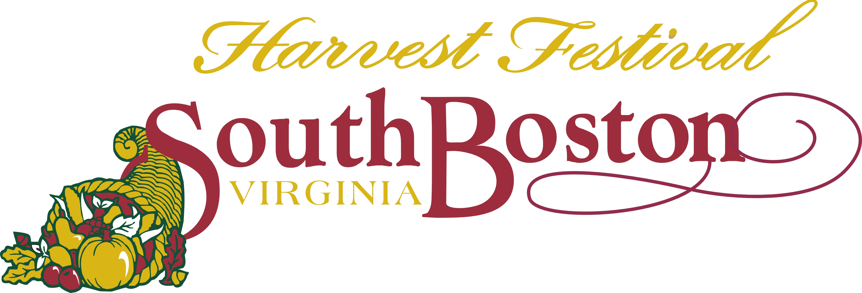
27th Annual in Downtown South Boston
432 Main Street, South Boston, VA 24592
Telephone: (434)-575-4208 Fax: (434) 575-4275
E-mail: sdavis@southbostonva.us Website: www.soboharvestfest.com

Saturday, September 29, 2018
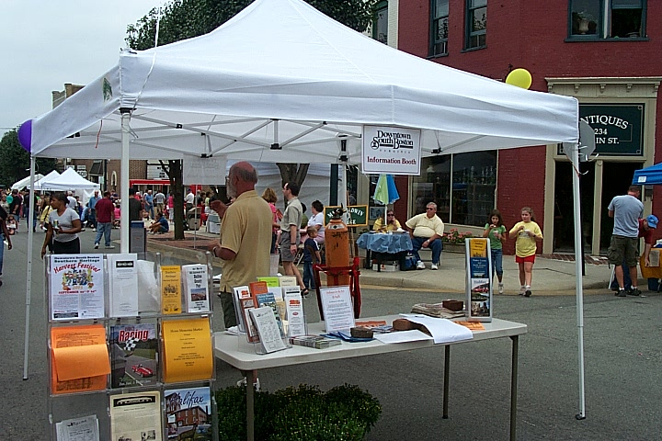

“ALL OTHER VENDORS” APPLICATION
(“All Other Vendors” are for example, non-profit groups, churches or girl/boy scouts. Call with questions)

ENTRY FEE:

$30.00 make payable to South Boston Harvest Festival (fee is non-refundable)
Send completed application and check, money order or credit card information to:
South Boston Harvest Festival 432 Main Street South Boston, VA 24592
Service Charge for all returned checks $25.00
Final Deadline ---Thursday, September 27, 2018 12:00 noon

REQUIREMENTS TO APPLY:

*Must give information as to what you will have in your booth space – food, raffle tickets, information handouts, cookbooks, etc.

INFORMATION:
*This is an outdoor festival held in the streets of downtown South Boston.
*Booth space is 10 by 10. The space may be on the street or on the sidewalk area between the trees. You may purchase two spaces if needed, $30.00 per space.
*Vendors provide their own tables, chairs, tents, shelves, racks, extension cords, etc.
*Exhibit hours are 9:00 a.m. to 5:00 p.m. Be ready to sell at 9:00 a.m. and sell until 5:00 p.m.
Vendors leaving before 5:00 pm may not be asked back. No selling is permitted after 5:00 p.m.
*Fee is non-refundable due to cancellation on your part or inclement weather. This is a “rain or shine event”--- no rain date.
*Exhibit spaces will be arranged by the Harvest Festival organizers according to the order of application received, paid application fee, and what works best for the flow of the festival.
*All vendors must sell to the street side of the festival.
*Confirmation will be sent prior to the festival, along with all check-in information.
*As the festival is a family event, all items displayed or sold must be in “good taste”. This is up to
the discretion of the Harvest Festival organizers.
*Estimated attendance of previous festivals was around 8,000.

For Office Use Only:

App#___________ Date Rec._______________ Conf. Sent__________________ Fee Paid__________

“ALL OTHER VENDORS” APPLICATION 2018
$30.00 application fee---must accompany this application

Organization Name: Phone:________________________
____________________________________
Cell Phone:____________________
Contact Person:
_______________________________________________________________________

Email: (PRINT CLEARLY, you will receive festival information by email)

________________________________________________________________________________________________

Full Mailing Address:
________________________________________________________________________

City/State/Zip____________________________________________________________

Items that will be in your booth space: (be specific) ______________________________
________________________________________________________________________

Will you be bringing a tent? Yes _______________No _________________
If yes, state size of tent (required) _____________________________________
Are you purchasing two or more spaces? Yes ____ How many? _____No, just one ____

NOTE: Please state if you are bringing a tent. Not all vendor spaces are tent friendly. Your
space cannot be altered to fit a tent if you do not indicate that you will be using one.

***Any food that will be sold to the public requires VA Department of Health paperwork and fees. Please call 434-433-3545 for more information.

Electrical Needs: (check the one that applies to you)

Option #1 none __________

Option #2 yes ___________ (120v/20amps)
If yes, state what you will be using the electricity for. Example---cash register,
lamps, etc.________________________________________________________________

Extra electricity, Option #3 yes _________(the volts/amps you require______________)

Our extra electricity is limited. If your electrical needs are above 120v/20 amps, please call and discuss this with the festival coordinator for approval, before mailing in application.
There is an additional charge for extra electricity. (434-575-4208)

Do you have handicapped needs? Yes ____________No _________________

Have you been here before as a vendor? Yes _____________ No __________

How did you hear about this festival? _________________________________

Payment Information
(Payment is due with the application to secure your spot)

Payment: Please make check or money order payable to South Boston Harvest Festival

Payment by credit card: (fill out below or call the office 434-575-4208)

Name as it appears on card: ______________________________________________________

Full Address: _________________________________________________________________

Type of Card (circle one) VISA MASTERCARD DISCOVER

Card Number: _ _ _ _ - _ _ _ _ - _ _ _ _ - _ _ _ _ Security Code: ___ ___ ___

Expiration Date: __________________ Amount to be charged: ___________________________

Signature: _____________________________________________________________________

By submitting this form, I understand that my Credit Card will be charged the fee for my
application to the South Boston Harvest Festival of 2018 upon the Festival’s receipt of this application form. Your receipt will be emailed back to you. Your statement will show a charge
made to Destination Downtown South Boston (DDSB).

Agreement Information
(signature required---this page must accompany your application)

PLEASE PRINT OUT ALL PAGES, FILL OUT COMPLETELY AND MAIL BACK TO THE FESTIVAL. KEEP COVER PAGE FOR YOUR FILES

Any questions call Sara Davis, Festival Coordinator at 434-575-4208, fax 434-575-4275,
or email sdavis@southbostonva.us .
For more information visit, www.soboharvestfest.com

By signing this application, each vendor is fully responsible for their own entries, including loss by breakage, theft, fire, rain, or any other cause of damage to inventory or self. Vendors are responsible for any insurance they deem necessary. Also, the vendor hereby expressly releases Destination Downtown South Boston and the Town of South Boston from any and all liability for damage, loss or injury to any person or goods from any cause whatsoever. Destination Downtown South Boston and the Town of South Boston assume no responsibility or liability for fire, theft, rain, or other loss or damage or for injuries to person or property.

Signature: (required) ____________________________________________________

Today’s Date: _________________________________________________________
27th Annual in Downtown South Boston
432 Main Street, South Boston, VA 24592
Telephone: (434)-575-4208 Fax: (434) 575-4275
E-mail: sdavis@southbostonva.us Website: www.soboharvestfest.com

NO SOLICITATION AGREEMENT

Organization Name ______________________________________________________

Contact Name __________________________________________________________

Address _______________________________________________________________

City, State, Zip __________________________________________________________

The South Boston Harvest Festival allows all vendors to operate their booth space within the allotted dimensions as stated on all applications, each paid space being 10 ft by 10 ft. All vendors will agree to use their 10 by 10 booth space to display their wares in that area. At no time during festival hours (9:00 am to 5:00 pm) will vendors or any of their associates be allowed to go up and down the festival streets and solicit the visitors. Any vendor or their associates who do not abide by this agreement will be asked to leave the festival immediately and will not be allowed to return to the festival in future years.

Signature of Contact Name: ____________________________________________________

Today’s Date: _______________________________________________________________

Please sign, date and return to the
South Boston Harvest Festival, with your application.

