Revised February 2003

A Framework for Research, Design and Policy Issues in
Peer-to-Peer (P2P) Application Architectures

Raymond R. Panko
University of Hawai`i
Ray@Panko.com

Abstract
Napster and file-sharing applications in general originally focused popular attention on peer-to-peer (P2P) computing. However, P2P computing is a broad spectrum of peer-to-peer applications that may require corporations and society to reappraise how applications should be delivered and managed. This revolution may be as profound as when the client/server application architecture (including Web-based application architectures) displaced terminal–host computing. To understand P2P technologies and the issues they raise, this paper looks at several important P2P applications. The paper then uses these examples and other information to develop a framework for P2P research, design, and policy issues.

Keywords
Peer-to-peer, P2P, user, file sharing, processor sharing, instant messaging, IM, grid computing, accountability, firewalls, crossloading.

I. Introduction
The purpose of this paper is to present a framework for research, design, and policy issues in peer-to-peer (P2P) application architectures. This framework is shown in Figure 1. Before we can discuss this framework, however, we first have to understand what peer-to-peer computing is (and is not). We will also need to look at a number of existing P2P application categories and the specific issues they raise. Afterward, we will look at the framework.
Figure 1: Framework for Research, Design, and Policy Issues in Peer-to-Peer (P2P) Application Architectures.

II. What is Peer-to-Peer (P2P)?
The most fundamental issue regarding P2P is what constitutes a P2P application architecture. An application architecture asks where processing power and other resources are located when an application runs. In the past, we have had terminal–host and client/server application architectures. In the former, all processing and storage resided on the host computer. In the latter, resources were used on both the client and the server.
Broadly speaking, we define a peer-to-peer (P2P) application architecture as one in which user computers—typically home or office PCs—do most or all of the processing and in which end users themselves provide services to one another. Although servers may be present, they play minor facilitating roles and do not control peer interactions. Note the dual focus on end-user computers and on user initiative. These two characteristics appear to jointly characterize P2P. Figure 2 shows that defining P2P application architectures raises a number of issues.
Figure 2: Defining Peer-to-Peer (P2P) Application Architectures
Although most definitions of P2P computing are similar to this one, there is some disagreement over what should and should not be considered a peer-to-peer application architecture. In this section, we will look at the issues involved in defining P2P computing.

Application Architectures
In typical networking, there are five layers of functionality. The bottom two, the physical and data link layers, almost always use OSI standards. The next two, the internet and transport layers, normally use TCP/IP standards but sometimes use standards from other standards architectures, such as IPX/SPX and SNA. OSI standards are rarely used above the data link layer, apart from a few application standards. The top standards layer deals with application–application interactions. (OSI further divides this layer into three layers: session, presentation, and application.)
In this context, an application architecture is a plan for distributing application processing, storage, connection speed, user presence, and management across multiple machines.
If standards layering is done properly, application architectures can be created using any lower-layer standards architecture. Only application-layer functionality needs to be created, greatly simplifying the job of developing new application architectures.
However, although P2P usually focuses on application-level concerns, peer-to-peer routing works at Layer 2 (data link) or Layer 3 (network/internet).

Facilitating Servers
Most P2P architectures use servers to facilitate some of their work, most commonly to compensate for some limitations of user computers (such as their transient presence on the Internet or the fact that they usually get a different IP address each time they are online). However, the main work is still done user-to-user, with the facilitating servers taking a secondary role. Overall, the presence of a facilitating server does not prevent an application architecture from being peer-to-peer.

In Contrast to Client/Server Architectures
P2P architectures usually are viewed as a change from traditional client/server application architectures (including Web architectures), in which large central servers do the critical work while client PCs on the desktops and in the homes of users play a supporting role. Figure 3 illustrates client/server computing.
Figure 3: Traditional Client/Server Application

Issues in Client/Server Computing
In client/server processing, the server does most of the heavy work, and there is extensive communication between the client and the server. This leads to several problems.

Inefficient Use of User Computer Resources
A first and most basic problem is client/server computing’s inefficient use of client processing and storage power. Today’s personal computers are so powerful that users rarely use the full capabilities of their machines even when they are actively working. In fact, most of the time, user PCs are not doing any processing work, including when users are away from their machines and even when users are reading information on the screen. Server processing costs and electrical power requirements have risen dramatically in recent years, and it seems reasonable to ask user machines to share more of the workload. Many clients also have large hard disk drives, making them ideal for file sharing. Clay Shirky has noted that user computers have been the “dark matter” of the Internet [O’Reilly, 2001], with enormous yet rarely recognized resources.
Although client/server processing makes some use of user computer resources, peer-to-peer computing makes far more intense use of these resources, including processing power, file storage, Internet connectivity, content, and the presence of the user. An intense dependence on user resources appears to be central to defining P2P architectures. As Shirky [2001, p. 22] put it, P2P is
“a class of applications that take advantage of resources—storage, cycles, content, human presence—available at the edge of the Internet.”
Shirky [2001, pp. 22-23] provided the following litmus test for whether an application is peer-to-peer:
“1. Does it allow for variable connectivity and temporary network addresses? 2. Does it give the nodes at the edges of the network significant autonomy? If the answer to both of these questions is yes, the application is peer-to-peer. If the answer to either question is no, it’s not peer-to-peer.”

Reliability
The second problem with client/server computing is network reliability. With centralization come single points of failure. The network connection to a server site can become overloaded or fail entirely. A single software fault can take down multiple servers simultaneously.

Administrative Control
A third “problem” with client/server processing is administrative control. Servers, and therefore processing power and data, are under the control of a central administration. Working with the central administration can be extremely frustrating for end users. While some degree of control is necessary for the security, integrity, and integration of central information resources, many proponents of P2P architectures argue that central control is unnecessary and counter-productive for much of the end-user work that takes place in organizations. Just because IT personnel work primarily with central applications does not mean that such applications dominate computer use in corporations.
Peer-to-peer architectures have a strong self-governance dimension. P2P application architectures move control away from the central IT staff to the end users themselves. As Anderson [2001, p. 76] put it, “The P2P paradigm has a human as well as a technical side—it shifts power, and therefore control, away from organizations, toward individuals.” P2P application architectures bring a degree of democratization (some would say chaos) not seen since the early days of personal computing.
Although loss of central control can be disconcerting to the central corporate staff, the reality is that most work in a corporation probably is being done by individuals and by small, rapidly changing, and largely self-organizing teams. P2P computing mirrors those realities, allowing users to work together in sophisticated ways with minimal delays in creating support resources and with more appropriateness in the governance of information management.
Governance goes beyond the mechanics of keeping a P2P application network functioning well. It also means governing the behavior of users, that is, holding them accountable for their actions. In a decentralized environment, accountability can be an enormous problem.

Low Barriers to Entry for Information Providers
Fourth, perhaps the most fundamental societal problem that may be alleviated by P2P computing (although not a prime corporate concern) is that Internet content shows signs of becoming more centralized and falling under the control of a relatively small number of organizations, such as Time Warner/AOL. Even websites, which allow very open publication, are relatively expensive to maintain, and websites seem to be growing in complexity and cost. Moore and Hebeler [2002] have noted a number of differences between P2P publishing and website publishing. They note that P2P publishing is more symmetric, without dominance by a few firms in the creation of new material, has abundant material, has low formality and control, has high availability because it is distributed and redundant, and is not limited to a single standard, such as HTTP.
Of course, the ability to provide information means little if no one listens. Napster and most other file-sharing applications have been dominated by narrow commercial content, and it remains to be seen whether other P2P applications can bring more effective diversity to the voices people hear on the Internet.

Was the Internet Originally Peer-to-Peer?
On a peripheral point, it is sometimes said that the Internet originally was peer-to-peer. However, while that was and still is true of network transmission, and while hosts can be both clients and servers, early Internet applications were almost always client/server in nature (telnet, FTP, e-mail, and so forth). It is true that several developments have tended to make user machines client-only vehicles, including transient IP addresses and asymmetric speeds for Internet access. However, nothing in TCP/IP standards below the application layer requires either symmetric or asymmetric application architectures.

Excluding Distributed Server Architectures: The Centrality of the User Computer
Some analysts would argue that the definition of P2P application architectures should include distributed server architectures, such as the domain name system (DNS) and content distribution networks. However, we will not consider these server-to-server architectures to be part of P2P application architectures. Most fundamentally, full application architectures must include user machines and not merely the server portion of applications.
In any case, distributed server architectures do not raise the type of policy issues or have the potential organizational and societal impacts that P2P application architectures do. P2P computing may change the role of user computers, change network traffic, and create new problems for governance. Most importantly, distributed server architectures miss the truly revolutionary aspect of P2P—the discovery of the user computer as a valuable resource.
At the same time, distributed server systems are likely to be important and in some cases cannot be separated from user P2P computing. For instance, in grid computing, processing power would be provided over the network by many servers, much as electrical power is provided over the electrical power grid by many power plants. Obviously, this overlaps with applications that share the processing power of user computers. “The grid” may eventually treat servers providing processing power and user computers providing processing power in the same way.

What is a User Computer?
We will use the term user computer throughout this paper. We will use the term broadly to embrace Windows PCs, Macintoshes, Linux PCs, Unix workstations, personal digital assistants (PDAs), cellphones, and all other end-user devices. All of the devices on this list have or will soon have substantial processing power, storage, and connection speed.
“User” is a shortened form of “end user.” Traditionally, there have been two types of computer users. First, there has been the core information systems staff, which uses computers to provide services to others. Second, there have been end users—managers, professionals, and other information workers who use computers to get their functional work done in marketing, finance, and other corporate areas. Home users are also end users. In any organization, end users are far more numerous than information systems staff users.
We recognize that “user computer” is an awkward term. However, “client” makes little sense because user computers are both clients and servers in P2P computing. “Peer” would be better, but servers can also operate peer-to-peer. The best term would be “personal computer,” because personal is the essence of P2P networking and because “personal” can embrace PDAs and cellphones. However, the term “personal computer” has lost the emphasis on “personal,” and when people think of the term “PC,” they merely think of desktop or notebook hardware.
Another reason we do not use the term “client” is that most P2P applications are based on client/server interactions with one party acting as a client and the other party acting as a server. Of course, in P2P computing, these roles are transaction-dependent, and a user computer may be a client one moment and a server the next [Kim, Graupner, & Sahai, 2002].

What is Peer-to-Peer Computing
Based on the discussion so far, we will give our definition for peer-to-peer computing:
Peer-to-peer (P2P) computing is computing that heavily or exclusively uses user resources—user computers, user computer connectivity, user data, and users themselves.

Types of P2P Applications
To date, five types of P2P applications have emerged or are emerging.

P2P File Sharing
In P2P file sharing, files reside on user computers. Users in P2P file-sharing networks can search for a desired file on the computers of other users. Searchers can then download (more accurately, crossload) the file from a user computer containing the file. Servers may be involved in searching or other matters, but the large file transfers are peer-to-peer. Napster is the most famous file-sharing application. Others are Gnutella and Kazaa.

P2P Processor Sharing
Most of the time, the majority of user computing processing power goes unused. In P2P processor sharing, users make their computers’ unused processing capacity available to others. This can make an enormous aggregate amount of processing power available in large user communities. SETI@home, which processes data from the Search for Extraterrestrial Intelligence (SETI) project on millions of user PCs, is the most famous processor-sharing application, but, as we will see below, processor sharing is also used in industry.

P2P Human Communication
In e-mail, servers mediate between the sender and the receiver. However, it is possible for two end users or small groups of end users to communicate directly, with little or no use of a central server. This will allow them to send instant messages and do other work, such as transferring files and working on joint documents. This is a new area, but instant messaging (IM) has been growing explosively for one-to-one (interpersonal) communication. Beyond IM, we can foresee more sophisticated P2P group communication applications, such Groove, which allows small groups of end users to work together intensively on projects.

Multiuser Interactive Applications
A category of P2P applications that is still embryonic is multiuser interactive applications, in which groups of users work interactively on the same data domain. They do not work in parallel, like simultaneous users of databases. Rather, they interact directly with one another, in the context of an application. In games, for instance, they may fight one another in a virtual city. Beyond gaming, group decision support systems, which are now server-based, may move to P2P environments in some cases. In addition, traditional single-user applications such as word processing, spreadsheet development, and architectural graphics design, may grow into multiuser environments in which people can simultaneously mark up or even edit files while talking to one another about the changes in real time. Some applications already have shared-use features.

Peer-to-Peer Routing
The final category of peer-to-peer computing is even more embryonic. This is peer-to-peer routing, which is the use of P2P networking to replace routers and switches in a network.
Figure 4 shows two radio networks. The first is a conventional cellular radio network of the type found in cellular telephony or 802.11 wireless LANs. Here, the service area is divided into cells. Each has an access point (also called a cell site). All stations within a cell communicate with the central access point. A backbone transmission infrastructure links the access points together. Although this method works, it requires a considerable investment in terms of access points and backbone transmission to link the access points.
Figure 4: Access Point versus Peer-to-Peer Routing in Wireless Networks
The figure also illustrates P2P routing. Here, the network consists entirely of wireless user computers. Each user computer has a built-in router. Messages travel from user computer to user computer in a chain. Such networks are sometimes called mesh networks or scatternets.
As noted earlier, in contrast to the other P2P systems we examine, which work at the application layer (Layer 5 or Layer 7 depending on the architecture), P2P routing works at Layer 2 or 3.

III. File-Sharing Applications

Content Pot Luck Parties
Before going further into the framework, we will look more closely at some of the applications we have just seen. Grappling with some of the intricacies of actual P2P applications and trends will give us a solid foundation for subsequent discussions of research, design, and policy issues. We will begin with the family of applications that first brought P2P computing to the world’s attention, file-sharing applications. Figure 5 shows some of the major file-sharing applications.
Figure 5: P2P File-Sharing Applications
Gene Kan [2001] has described file-sharing programs as potluck parties. All party goers (or at least enough of them) bring dishes to share. Everyone takes from the dishes brought to the party. The “food” is digital rather than physical, so sharing costs very little, and there normally is an abundance of intellectual food to share.
File-sharing applications are the most widely used P2P applications to date. They first proved popular for the illegal sharing of copyrighted music files. In 2001, after the fall of Napster, Webnoize estimated that more than three billion files were transferred during the month of August alone by the four leading file-sharing applications [CNN.com, 2001, September 6]. The vast majority of these files were music files. This volume was greater than Napster’s peak volume before its legal problems.
In July 2003, The Pew Internet and American Life Project [Madden & Lenhart] surveyed Internet users. It found that 35 million adult American Internet users downloaded files. This represented 29% of all U.S. adult Internet users. The percentage of downloaders was even higher among full-time students (35%), broadband users (41%), and users with more than three years of Internet experience (59%).
However, file sharing is not limited to music, video, and software piracy. A growing number of corporations are likely to use it in the future to share business documents. Even in home use, music is losing its dominance, although it is doing so primarily to other bootlegged material, notably movies and software [CNN.com, 2001, September 6].

Napster
To begin to explore the issues raised by peer-to-peer application architectures, we will focus ont the most famous P2P file-sharing application, Napster.

Purpose
Napster was an application for sharing music files stored in the MP3 file format. It was created by a student, Shawn Fanning, whose nickname was “Napster,” reflecting his matted hairstyle. At the time he created it, Fanning was a freshman at Northeastern University.

MP3 Files
There are many programs that will “rip” a track from an audio CD, converting it into MP3 format. MP3 format is compressed, so it is easier to transfer over communications lines than basic CD music files.
There are many ripper programs and options in these programs, so different rips of the same song will give MP3 files of different lengths. In general, the longer the file length for a given song, the higher its quality is likely to be.

Napster Technology: Index Servers
Figure 6 illustrates the technology used by Napster. Users had to download a special Napster user program. When a user turned on this Napster program, the program looked for files in specified public directories on the user PC. Then the Napster program connected to a central Napster index server and uploaded information about the user PC, including its IP address and connection speed, and about each sharable file, including the artist, the name of the song, and the size of the file.
Figure 6: Napster Technology
The index server added this information to its current database of music files available for public use on user PCs currently running the Napster program. Later, when users stopped being available, the index server flushed their information from the central database.
When a Napster user wished to get an MP3 music file, he or she sent a query to the index server specifying an artist, title, or both. The server returned a list of user PCs offering the file, as well as each user PC’s speed of connection and the size of its file in bytes.
The Napster user then selected a specific user PC—usually one offering a file with high quality (large size) on a user computer with a high-speed (broadband) connection to the Internet.
Then the index server got out of the way. The searcher’s Napster program contacted the Napster program on the selected peer computer. The two user PCs then transferred the program without any server intervention, using a simple HTTP request–response cycle. Given the large size of most music files (several megabytes), most of the traffic in the system took place between peer user PCs, with user PC–index server communication accounting for a much smaller transmission volume.

Perspective on Napster’s Use of a P2P Application Architecture
Why was a P2P application architecture used in Napster? Arguably, Napster might have operated best using a central server holding all songs. However, that was not an option because of copyright issues. There already was a long history of legal actions against server sites offering copyrighted music files.
Fanning argued that the index server would not violate copyright because it would not store the music files itself [Bricklin, 2001]. Consequently, even if users were violating copyright laws, Napster would be blameless. The legal system disagreed, as explained below.

Defeating Firewalls
Many corporate and educational users sit behind firewalls, as Figure 7 illustrates. Firewalls are designed to limit communication to and from the outside world based on filtering rules applied to certain header fields in packets. Many of these filtering rules are based on IP addresses in the packet’s IP header and on port numbers in the packet’s TCP or UDP header. IP addresses identify the source and destination hosts involved in the communication. Source and destination port numbers designate the application programs that are communicating on these hosts. Firewalls usually are very restrictive, allowing only a handful of applications to send messages through the firewall.
Figure 7: Napster and Firewalls
Port 80 is used by HTTP, which is the delivery protocol of the World Wide Web. By default, many firewalls allow any packet with source or destination port number 80 to pass through the firewall so that ordinary webservice can be provided. However, Napster also uses Port 80 for its communication, allowing it to slip through many corporate or educational firewalls. Napster’s proponents consider this to be a clever feature. In contrast, corporate security personnel are upset that Napster sneaks through their firewalls using this “malicious trick.”
Although the MP3 files delivered by Napster did not until recently contain viruses, the prospect of using Port 80 for communication outside of webservice is very disturbing to corporate security personnel. In fact, many P2P applications use Port 80, so the security implications of this practice are pervasive.
In addition, while MP3s cannot contain viruses, they can contain other undesirable content. For instance, the Barenaked Ladies band created a “Trojan download” that had the name of one of their MP3 files but was really an advertisement for the band’s new album. Although this was a harmless prank, it indicates problems that can be created by false downloads in systems that are not limited to non-executing MP3 files. In addition, just because a file has an .MP3 extension does not mean that it is an MP3 file. As of February 2002, both Windows Media Player and RealOne Player would execute files written in their native formats, even if the file had the .MP3 extension [McWilliams, 2002]. Both of these native file formats allow developers to add hyperlinks and JavaScript code to their audio or video files. Code can do damage to the computer or its data, and hyperlinks can download pages containing malicious code.

Success and Death (Sort Of)
By any measure, Napster was stunningly successful in its prime. It grew faster than any other Internet application in history, even the World Wide Web [Shirky, 2001]. Quite simply, the lure of free music by famous artists (and hard-to-find artists) was irresistible.
In addition, once users began crossloading music files, these new files were available for sharing by default on each receiving PC. In other words, freeloading—crossloading files without ripping any new ones—actually had a positive effect on application attractiveness. The bigger Napster got, the more desirable it became because of its greater base of available songs, and the faster it grew.
However, success began to hurt Napster. Naturally, crossloaders picked files on PCs that had high-speed connections to the Internet. Many of these PCs were on university networks. Soon, Napster traffic was consuming a significant fraction of all traffic in college networks. Network performance either lagged or obviously would lag in the future as Napster continued to grow. Consequently, many universities outlawed Napster use [Shirky, 2001] and often performed Napster traffic filtering to prevent its use. This reduced the usefulness of Napster, but continuing user growth more than made up for the loss of traffic at some universities.
More importantly, Napster.com soon found itself in court defending its copyright argument against the music industry in court. Although the legal system worked slowly, it eventually destroyed Napster as a bootlegging service by convicting Napster of vicarious and contributory infringement, that is, helping others infringe on copyrights [Copyright Act of 1976]. This legal concept is an old one and had been successfully applied in the past to punish copy centers that assisted professors in making unauthorized copies of copyrighted documents for their classes. The courts ruled that by providing an index server, Napster materially assisted in copyright violations. Napster was stopped temporarily in July 2000 and was virtually shut down by the appeals court in February 2001. In 2003, Roxio reestablished Napster, this time on a legitimate basis in which users pay for the music they download. Despite keeping the Napster name, the new Napster service uses a traditional client/server application architecture instead of a P2P architecture.

Gnutella
When Napster died, users turned to other file-sharing applications, including Gnutella. In 2002, eleven percent of all Internet-connected machines were running the Gnutella protocol [Duke, 2002].
We will look at Gnutella mainly because it illustrates how a file-sharing service can exist without central servers such as the index servers of Napster. It also illustrates how difficult it is to do P2P file sharing without facilitating servers. Finally, we will look at Gnutella to show why it has been difficult to repeat the explosive success of Napster.

Origins
Gnutella is not a program; rather, it is a protocol. The Gnutella protocol was developed within AOL in March 2000, but when AOL shut down the project, members of the open source software community reverse-engineered the protocol and published it [Kan, 2001].
The Gnutella protocol is implemented by many programs, including BearShare, LimeWire, and Gnotella. All of these programs can work together using the Gnutella protocol, so there is no such thing as “the BearShare network” or “the LimeWire network” distinct from the Gnutella network, which connects all Gnutella-compliant computers regardless of what software they use.
One problem with Gnutella’s loose origin is that no organization now “owns” the protocol, so there is no way to fix problems in the Gnutella protocol design or to clarify how certain tasks should be done. Kan [2001] identifies a number of problems with the protocol and with typical implementations. These considerably reduce the efficiency of Gnutella file sharing.

Goals
Like Napster, Gnutella was created as a P2P file-sharing service. However, unlike Napster, Gnutella was never intended to be limited to the sharing of MP3 files. Gnutella’s goal was to be a general file-sharing mechanism for any type of file.

Basic Gnutella Operation
Napster used central index servers, which gave the government a single point of censorship. Once Napster index servers were shut down or restricted, the user programs were rendered almost useless.
Gnutella, in contrast, was created to be completely serverless. Although the motivation of the Gnutella design team is unknown, this design choice may have been made to remove the possibility of government shutdowns.
Figure 8 shows how Gnutella works. It shows application-layer Gnutella messages, which are sent over a TCP connection between each pair of user computers.
Figure 8: Gnutella Servents with Viral Networking
When a user joins the Gnutella network, their Gnutella user program (called a servent because it is both a server and a client) connects to one or more Gnutella PCs. This creates a mesh of connectivity among the Gnutella users.
When a new user PC joins the network, it transmits an introductory “ping” message to its “direct connects,” that is, to the user PCs to which it connects directly. These direct connects pass the message on to the user PCs to which they connect, and so forth. This viral networking continues for several hops, usually five to seven. The user PCs that can be reached in these few hops constitute the Gnutella user’s horizon. In effect, each user sees a different Gnutella network. In fact, they see a somewhat different Gnutella network every time they use it.
Typically, each user can see about 10,000 hosts [Kan, 2001]. This limited horizon prevents traffic from becoming overwhelming as the number of Gnutella users grows. The traffic for each user stays within his or her Gnutella cluster.
All computers reached by a ping message send back a “pong” message giving information about themselves. Pong messages travel back the along the path by which each ping arrived. In other words, each pong is routed along a single path rather than being broadcast as pings are. This reduces traffic.
Pings and pongs allow a new host to estimate its horizon and also to identify the IP addresses of additional hosts to which it may connect [Rohr, 2001]. Connecting directly to multiple hosts improves the speed of viral networking.
Gnutella creates meshes of servents with many loops in their connections. To prevent messages from arriving multiple times by different routes, every user message has a random 128-bit ID number. Each servent only passes a message on once, discarding other copies of the message.
When a user PC searches, it broadcasts its search message using viral networking. The responses come back via the mesh to the searching user. Hopefully, the user will get several responses.
The user chooses the most attractive response in terms of content and the connection speed of the offering computer. The searcher then connects directly to the user PC offering the file instead of using a viral networking connection. The file transfer then is done peer-to-peer between the searcher and the provider.

Searching
Curiously, Gnutella does not specify how a servent that serves up files should interpret search queries. It does not even specify whether multiword queries should be ANDed or ORed. This gives great flexibility, allowing different serving hosts to interpret the same query differently and so potentially provide a broader range of file offerings than a strictly-interpreted query. However, this means that precision in query specification is impossible.

Getting Through Firewalls
Earlier, we saw that Napster uses communication Port 80 to get through firewalls in both directions. However, many firewalls have grown more restrictive and only allow communication between internal hosts and external webservers. When an internal client sends an HTTP message to an external webserver, the destination port number is 80. However, the requesting client host generates and uses an “ephemeral” port number larger than 1,024, as Figure 9 illustrates. The firewall therefore passes outgoing packets with external port number 80 and any internal ephemeral port number because access to external webservers generally is good.
Figure 9: Gnutella and Firewalls
However, a growing number of firewalls will not allow an internal webserver (listening on Port 80) to communicate with an external host (communicating on an ephemeral port number). The figure shows this situation.
To get around this limitation, Gnutella has a push mode, in which the two user PCs switch port number types. The internal user PC that will serve a file to an external user PC sends and receives on an ephemeral port (Port 12856)—the opposite of what usually occurs in HTTP. The external receiving user PC, in turn, sends and receives on Port 80. The serving PC sends an HTTP request message using the HTTP POST method; this allows the sender to attach a file to an HTTP request message. The POST method was created as a way of uploading files to a webserver. Gnutella uses it to defeat corporate firewalls.
Like Napster users, Gnutella users note how clever and useful circumventing normal firewall security is. Again as in Napster, corporations note that firewalls were put in place to implement policies about what traffic should and should not flow into and out of a corporation. Push mode was deliberately designed to thwart corporate policies. Corporate security personnel take this as proof of bad faith on the part of Gnutella developers and users.

User Accountability
Gnutella, like most P2P applications, depends heavily on the kindness of strangers. If a malcontent decides to damage Gnutella users, he or she can simply send a large number of search queries. This is very difficult to deal with because it is difficult to tell a flooding malcontent from a very fast computer that is used to pass on many queries.

A Troubled Early History
Although Gnutella is a logical replacement for Napster because it cannot be shut down easily, Gnutella has had a troubled history. In July 2000, when Napster was first shut down for a brief period of time by legal action, many users tried turning to Gnutella. Under this sudden surge of use, Gnutella failed. To users, it seemed like nobody was answering their searches.
Subsequent analysis [Clip2, 2000] showed that what really happened was that many people with slow connections and few if any files to share made it almost impossible for searches to reach Gnutella user machines containing the files that users were seeking. Clip2 estimated that a heavily-loaded Gnutella network requires a bandwidth of at least 67 kbps per machine or queries will be delayed so much that they will be discarded. This exceeds the capacity of dial-up modems [Clip2, 2000].

Gnutella Superpeers to the Rescue
Gnutella was saved by voluntary effort on the part of many users who established superpeers—PCs with high-speed connections to the Internet, many files to share, and permanent IP addresses. Each superpeer connects to several other superpeers, effectively forming a Gnutella backbone. When ordinary users connect to Gnutella today, they connect directly to one or more superpeers. Dial-up peers, in effect, are pushed to the edge of the network where traffic is low enough for their capabilities. These superpeer PCs may not be true servers, but they certainly are rather “serverish.”

Performance Issues
Hong [2001] found that Gnutella’s broadcasting sacrifices efficiency for speed and worst-case guarantees. Broadcasting uses parallel transmission to get messages out quickly, but this breadth-first approach is not efficient in terms of network bandwidth. On the positive side, broadcasting gives a high probability of rapid success, even if a rare file is being sought.
Gnutella’s broadcasting approach tends to place a heavy load on networks. To moderate the traffic load created by Gnutella broadcasting, search requests are limited to between 5 and 7 hops, so the number of broadcast messages for searching does not grow linearly with the number of Gnutella users worldwide. The initial sender sets the time-to-live field in the Gnutella message (similar to the time-to-live field in IP packets) to a small number. If the sender tries to set the field to a large number, other Gnutella programs, seeing this large value, have the option of reducing it.
The time-to-live field allows Gnutella to scale relatively well. As the number of Gnutella users grows worldwide, traffic does not explode because each user broadcast stays within its own horizon and does not reach all Gnutella users.
The lack of a formal standards body for Gnutella means that problems with the Gnutella protocol and its interpretation are difficult or impossible to correct. Kan [2001], for instance, notes a serious problem in Gnutella “push” commands. Although the destination host is known, so that the push command can be routed on a direct line to the serving host, many Gnutella user programs senselessly broadcast push commands, clogging the network with needless broadcast traffic. Kan [2001] notes that broadcast push commands sometimes make up half of all network traffic. (However, many users may have thought that “push” was simply a way to speed up transfers [Panko, J., 2003].)
Rohrs [2001] notes that pings and pongs, which make up most of the remaining traffic, could be reduced if caching were done. If a node sent a ping to another node, the pinged node would respond with a cache of hosts it knows, perhaps even limiting the cache to “good” hosts. This would still allow nodes joining a network to learn about additional hosts to which to send introductory pings, essentially linking to them. The more good direct connections a user program can make, the faster subsequent searches will be. Of course, caches have to be erased frequently to account for users joining and leaving the online community.
Kan [2001] also notes that how users first connect to the Gnutella network can create either a tight cluster of hosts, leading to network overload, or a sparsely connected web in which traffic is spread out and does not become an overload problem. Unfortunately, software developer actions have tended to push Gnutella into the former mode, resulting in needless congestion. Truelove [2001] has noted that some clients, notably LimeWire and BearShare, alter host connection preferences over time to avoid problems. In addition, LimeWire attempts to cluster people with similar interests into communities [Rohrs, 2001].
Rohrs [2001] notes that if a new protocol could be developed, it would both improve the application and get rid of the many older Gnutella clients that are very inefficient.

Funding
Although Gnutella was created as a general-purpose file-sharing system, it has been used most heavily to crossload MP3 files (and increasingly movie files). These commercial media files still provide the highest value to users.
Gnutella funding is voluntary. People just use their own PCs and Internet connectivity, as they did with Napster. Gnutella has no central servers or administration to finance. Although superpeers act like servers, they also are contributed voluntarily. Gnutella was never about making money, and there was no Gnutella Company to begin with.
Napster achieved near-monopoly status. In contrast, Gnutella has several P2P competitors for file-sharing service. Although Gnutella is heavily used, it has nothing like a monopoly market share.

FastTrack: Kazaa, Morpheus, and Grockster
In the Post-Napster world, the most widespread P2P file-sharing system has been a group of systems using the FastTrack technology created in 2000 by Dutch-based Consumer Empowerment. These systems included Kazaa by Sharman Networks, Ltd. in Australia (formerly by Kazaa based in the Netherlands and owned by Consumer Empowerment), StreamCast Network’s Morpheus, and Grockster (in the West Indies). However, contract disputes caused Morpheus to drop FastTrack technology and move to a Gnutella client. We will use the term Kazaa rather than FastTrack because Kazaa now dominates FastTrack file sharing.
According to Webnoize, 3.05 billion files were downloaded by FastTrack-based file-sharing networks in August 2001 alone. In January 2003 [INS News, 2003], Kazaa had around 3.2 million users around the world. These users offered 624 million files totaling 5 terabytes of data. In May 2003, Kazaa became the most downloaded program in the history of the Web, with 230 million downloads [CNN.com, 2003, May 23].

Mutating Technology
It is difficult to speak definitively about Kazaa technology because it has changed many times since its creation. Firms that build products to block Kazaa traffic report that the protocol changes frequently, sometimes daily, and that many of these changes are done to make Kazaa difficult to block.

On By Default
By default, Gnutella servent programs usually are only active while the user actually is searching, which may be only a fraction of the time the user is online. In contrast, early Kazaa user programs usually were turned on by default when the user booted up and tended to stay turned on the entire time the user is online [Truelove and Chasin, 2001]. In fact, even if users “disconnected” from the network, their PCs still would listen for connection attempts on Port 1214. This made the effective Kazaa network larger than the effective Gnutella network at any moment, but it placed burdens on users that users may not have understood.

Self-Organizing Network: Automatic SuperNodes
Kazaa uses “SuperNodes” similar to Gnutella superpeers. Consequently, the number of available files is not directly proportional to how many users are online at any moment but rather is proportional to content storage at SuperNodes.
In Kazaa, users become SuperNodes automatically rather than by conscious voluntary choice; in contrast, Gnutella supernode users consciously choose this role. This makes Kazaa a self-organizing network. Of course, people who have fast computers and a fast Internet connection might object to becoming SuperNodes automatically.
SuperNodes act like local search hubs, maintaining an index of media files shared by each user to which it connects (reminiscent of the index server of Napster) and proxying search requests on behalf of its users [Truelove and Chasin, 2001]. Peering reduces search time and increases efficiency.

Performance Problems
Users who become SuperNodes may experience performance problems. Their DSLs may be overloaded, or their cable modems may constantly hit their rate caps. Latency may increase in many Internet applications. In addition, their firewalls may become a constant alarm system due to large numbers of connection attempts. A study at a residence hall at the University of Texas involved loading Kazaa on a single PC and then leaving it on for four days [Resnet, 2001]. After a brief initial period, the system averaged 150 kbps out and 85 kbps in, with occasional outgoing bursts of a megabit per second. That is far more traffic than normal Internet activities generate.

Intelligent Downloading
Downloading is the most resource-consuming aspect of file-sharing systems. Kazaa has intelligent downloading, which allows users to download the same file from several other users at the same time [Miller, 2001]. Each file provider will send different parts of the file. This reduces the workload on file providers and also speeds download time overall. File download disruptions can also be handled by Kazaa’s intelligent downloading.

Metadata
Kazaa addresses searching by using metadata to describe files. However, this metadata is very limited and generally is defined well only in the case of music files [Truelove and Chasin, 2001].

Registration Server
Although Kazaa can run without a server, early users certainly logged into a registration server. This gave them a user name [Metselaar, 2001]. Users often would not deal with users without user names, so registration was critical in practice.
The registration server was also used to download upgrades for the client. In 2002, when Morpheus failed to pay its fees on time, FastTrack caused a new version of the software incompatible with the Morpheus network to be downloaded to Morpheus, and Morpheus was temporarily put out of business when its users could not connect to Morpheus registration servers. This new version centralized a number of functions [Merrill, 2002], making servers more important (and also making FastTrack vulnerable to lawsuits).
Later, as the registration server became a liability due to the possibility of active participation leading to vicarious copyright infringement suits, Kazaa apparently changed its protocols to be purely peer-to-peer, although this is uncertain because Kazaa has not disclosed details.

Adware/Altnet
Kazaa users have been rather wary of the service because the Kazaa clients that many users downloaded once included adware that constantly generated advertisements when users used the system. This was dropped only after extensive bad publicity.
Adware might have been acceptable as a way of “paying” for service, but Kazaa for a time also contained software that could be use to switch users to a different file-swapping network, Altnet. Among other things, Altnet could sell processing power on the user’s PC to pay for file downloads. This was widely viewed by users as highly inappropriate.
However, Kazaa continues to download Altnet as an alternative “premium” file-sharing service. It now does so explicitly, although users can uninstall it.
Altnet now “pays” for disk space and bandwidth with “points.” Users can use these points to purchase premium content or to enter sweepstakes for money and prizes. In a sense, Altnet applies a concept like grid computing, although it applies it to disk and bandwidth sharing, rather than to processor sharing. Kazaa has also added this approach to basic Kazaa file sharing; users who share more files of higher quality are given priority in downloads.

Legal Censorship
Kazaa’s developers hoped that FastTrack technology would be able to resist legal censorship because Kazaa and Grockster never touched the files being transmitted or provided any assistance in locating copyrighted material. However, this issue is complicated by the fact that Kazaa users, at least in the past, had to attach to registration servers for full service. As discussed below, Kazaa has faced continuous legal headaches.

Freenet
A different technical approach was taken by another file-sharing application, Freenet. First, Freenet PCs respond to queries by returning the document requested, not just a notification that the document exists. Second, Freenet does not broadcast search messages [Langley, 2001]. Instead, the sender sends the search message only to one direct connect, not to all of them. Similarly, that direct connect only sends the search message to one of its direct connects, and so forth. This “depth-first” approach avoids the heavy traffic of broadcasting, although sending the entire file removes much of this advantage and search time can be lengthy. Another interesting aspect of Freenet is that if a file is popular, it is automatically replicated to more sites in order to reduce the downloading load on users offering popular files [Miller, 2001]. Of course, this might mean that you are sent a virus in response to your search [Panko, J., 2003].

Corporate Applications
Although user-focused file-sharing services designed for copyright violations have received the most attention, there have been legitimate corporate file-sharing services as well. For example, McAfee software’s ASaP service downloads updates to a corporation, which then distributes the updates peer-to-peer among the firm’s individual PCs [Fattah 2002]. Fattah [2002] offers several other examples of corporate applications.

IV. Processor-Sharing (Grid) Applications

Introduction
File-sharing applications share the storage capacity, content, and connection speed of user computers. They generally use only modest processing power on each machine. However, processor sharing can be a goal in itself. Figure 10 shows some major considerations for processor-sharing applications.
Figure 10: P2P Processor-Sharing (Grid) Applications
Most of the time, we waste the processing power of our user computers. Often, we turn them off or are away doing other things. Even when we are actively using our computer, we rarely use its full processing power.
Processor sharing is the most difficult aspect of P2P computing to categorize because server processor sharing is an attractive proposition if this processing power can be sold or offered for free. Under the general name of grid computing, processor sharing on both user and server computers is likely to become integrated with processing power being shared regardless of what kind of machine is offering the processing power. We will focus on P2P processor sharing, however, in which the processor sharing is done primarily by PCs.

SETI@home
One example of employing P2P processing to use wasted user PC capacity is SETI@home. SETI is the Search for Extraterrestrial Intelligence project. Many volunteers download SETI@home screen savers that really are programs that process radio signal data. When the computer is idle, the screen saver awakens and asks the SETI@home server for work to do. The server sends it a data set of about 300 KB for rapid downloading [Anderson, 2001]. The user PC then processes the data, saving frequently to disk to create checkpoints. The results are returned to the SETI@home work scheduler server when the data set is processed. Processing ends when the user begins to do work, or when the computer finishes its task. Hitting a key or moving the mouse automatically turns off the screen saver.
This approach has allowed SETI to harness the processing power of millions of PCs. (In July 2003, SETI@home estimated that there were over four million PCs in the system.) In fact, it has been estimated that SETI@home’s processing power in 2003—an average of 56.2 teraflops—exceeded that of the fastest supercomputer (ASCI White) at only 1% of the hardware cost [Anderson, 2001].
Figure 11: SETI@home User PC Processor Sharing
One problem that SETI@home discovered was the need to monitor and control volunteers [Anderson, 2001]. Some volunteers tried to use nonstandard analysis programs, arguing that their programs were better. However, SETI results will be useless if SETI cannot guarantee consistency in processing. Other problems, surprisingly, are that some users sent back falsified data to make it look like they found a meaningful pattern while others returned the same data multiple times to get more “credit.” The SETI@home experience shows that even with volunteers, accountability problems must be addressed.

Other Voluntary Shared-Processing Applications
As the first major shared-processing application to excite public interest, SETI@home was able to attract millions of volunteers. A number of other voluntary shared-processing applications have also appeared to tap unused resources on personal user computers. The most famous effort other than SETI@home is Distributed.net, which has been used to crack encryption methodologies through brute-force key guessing since 1997. Quite a few large scientific problems are now being attacked with voluntary grid computing.

Corporate Systems
Some corporations also share processing, using a variety of approaches.
- First Union Corporation uses a portfolio risk application that runs on the company’s PCs [Trombly, 2001].
- Merril Lynch & Company has been using P2P processor-sharing applications for several years, using a homegrown approach [Trombly, 2001].
- Boeing and Pratt & Whitney use processor sharing to simulate the flow of wind over structures [Breidenbach, 2001].
- J. P. Morgan Chase created a homegrown processor-sharing system for risk management calculations; it found that maintenance costs were very high for this self-developed product [Breidenbach, 2001].
- Celltech Group PLC in England uses the distributed computers of Parabon Computation to do gene sequencing calculations [Gladwin, 2001].
- Over 8,000 Gateway PCs in retail stores are linked using United Devices, Inc. grid software. Gateway is selling this processing power to businesses at 15 cents per processing hour [Mitchell, 2002].

Vendor Efforts
Once an academic rarity, grid computing is now being taken seriously by major hardware and software vendors, including IBM, HP, Sun Microsystems, and Oracle. In fact, Oracle’s most recent versions of its database and application servers are called 10g, where the “g” stands for “grid. In 2003, HP announced that all of its products would be grid-enabled within 24 months.
Vendors are advertising three major benefits for grid computing. One is load sharing. When each application has its own server, there is no way to handle peak workloads without purchasing servers that are oversized and therefore expensive for the application’s normal workload. With grid computing, however, capacity is assigned dynamically. As long as all applications do not have workload peaks at the same time, this approach should reduce server investments dramatically.
Another is time shifting. Many corporations have data centers in multiple time zones. Typically, these data centers are used only lightly at night. With time shifting, the grid can shift work to underused computers in different time zones.
For clients, a major advantage of grid computing is that it can make rarely used applications available to individual users on an on-demand basis.

Globus

The Globus Project
Most vendors plan at the time of this writing to use technology from the Globus Project (http://www.globus.org), which is developing fundamental technology for grid computing. Funding from this project has come from the National Science Foundation, DARPA, NASA, the U.S. Department of Energy, and several commercial organizations.

Open Grid Services Architecture
The first focus of the Globus effort was to develop an architecture for grid computing applications that integrates Internet standards. This is the Open Grid Services Architecture (OGSA). This architecture has four layers: user applications; collective services (directory handling, diagnostics, monitoring, etc.); resource and connectivity protocols for access to servers and networks; and the fabric (computers, storage, sensors, and networks). The middle two layers provide the main new functionality in the architecture.

Globus Toolkit and Vendor Incompatibility
Next, the Globus Project created the Globus Toolkit for creating grid applications using OGSA. However, Globus Toolkit requires vendor extensions to function. Consequently, different vendors using the toolkit usually develop incompatible systems. However, several companies are using Platform Computing’s Platform Globus, a commercially supported version of the Globus Toolkit. This may provide selective interoperability.

Globus Security
Although the current version of OGSA and the Globus Toolkit are fairly well-developed, they have a number of weaknesses. Most notably, security is still nascent in both the architecture and the toolkit. Individual vendors have had to provide their own functionality in these areas.

SOAP and Web Services
One prospect for processor sharing is that it will merge at least somewhat with the emerging Web services paradigm, which offers standardized ways to transmit service requests and responses between object on different machines through the Simple Object Access Protocol (SOAP) standard.

SOAP Message Transmission
SOAP messages usually are sent within HTTP messages, which have several header lines before a SOAP envelope section that specifies what method should be activated and what parameters should be passed to the object. The SOAP envelope section is expressed in XML syntax, which is widely understood by programmers. HTTP and XML provide simplicity and familiarity, and SOAP-based Web services seem poised to become dominant delivery systems for remote calls to objects on different computers. SOAP messages can also be sent via the Simple Message Transfer Protocol (SMTP) e-mail delivery standard and other delivery mechanisms, but this has been rare to date.

Program Transfer
The potential link between grid computing/processor sharing and Web services is being formalized in the Open Grid Services Architecture (OGSA). Unfortunately, SOAP and OGSA both require the object (program) being called to be already running on the serving computer. Processor sharing also needs a way to transfer programs to the serving computer. For this and other reasons, SOAP would have to be extended to be used for processor sharing, and OGSA will have to address program distribution. However, the advantages of standardized calls and responses are strong, so an effort to extend SOAP for processor-sharing applications via OGSA or some other standard seems worthwhile.

SOAP Security and Firewall–Respectful Protocols
One attractive aspect of SOAP from a security viewpoint is the use of a SOAPaction field in the HTTP header. This header field describes the specific method being invoked on the object. Firewalls can look at the SOAPaction field to determine whether the request should be passed or not.
In addition, if the serving computer supports the m-POST HTTP method, one or more additional firewall-specific headers are included in the HTTP response message. The SOAP consortium is now developing an extensible set of headers to allow more firewall-specific information as well as security headers for encryption, authentication, and other purposes.
This type of firewall-respectful design approach shows that using HTTP on Port 80 need not be a subversive ploy on the part of P2P processor-sharing application designers.

Appropriate Applications

Multiple Identical Program Chunks
Some applications are ideally suited to shared-processor computing. These are applications that can be broken neatly into a number of identical chunks that can be processed in parallel. It is no accident that cracking encryption keys and SETI data processing were among the earliest shared processor applications. In contrast, large database applications would be extremely difficult to break up for shared processor networks. Shared processing is not a general solution to business computing.

Latency
Another issue in grid computing is latency. Although programs run very quickly, the exchanging of information among computers in the grid can take a long time, relatively speaking. This suggests that the most suitable tasks can be divided into large chunks with little or no communication during chunk processing.

Accountability

Parasitic Computing
One ominous twist on processor sharing is parasitic computing, in which the machine that does the processing is tricked into doing so without the knowledge or consent of its owner. In 2001, researchers at Notre Dame divided one problem into discrete tasks and sent individual tasks to webservers, where they were processed [Stenger, 2001]. The webserver owners were unaware of this intrusion. Although the parasitic processing exploited servers rather than clients, this perversion of processor sharing could become a serious accountability problem for peer-to-peer processing on user computers.

Trojan Horse Grid Computing
In a similarly ominous twist, Distributed.net’s clients have been distributed illicitly around the Internet as a Trojan horse (http://www1.Distributed.net/trojans.html.en). This idea of forcing users to give up their computing power without permission indicates the ethical blindness of some Internet users or at least a form of ethics that gives no respect to individuals if a greater cause is deemed worthy.

Unauthorized Service Provision
Although participating in grid computing to help worthy causes may be a worthwhile goal, employees who do unauthorized grid computing on work machines face dismissal and prosecution. It is a long-established principle that work machines are the property of the organization, not the employee [Panko and Beh, 2002]. Most corporations have a prohibition against doing personal computing on their machines. Installing software with the security issues of grid computing goes against both the letter and spirit of corporate restrictions.
In one recent case, an employee at the DeKalb Technical Institute in Georgia, David McOwen, installed the Distributed.net client on a number of the institute’s computers [Harrison, 2002]. As noted earlier, this program supports a collaborative effort to crack security algorithms. McOwen was fired and prosecuted on charges of theft (for lost bandwidth and computer time) and trespass (for entering work areas to install the software). Complicating matters, the prosecution argued that he was motivated at least in part by the prospect of prize money. Later, the publicity of the case caused McOwen to be fired from a job he took after leaving the Institute. He eventually pled guilty and was sentenced to probation, 80 hours of community service, and $2,100 to cover the cost of removing the clients. In addition, McOwen had to pay thousands of dollars in legal expenses. Although Distributed.net explicitly prohibits the use of its client programs on unauthorized machines (http://www1.distributed.net/legal/policy.html), it does not enforce this prohibition in any way.

Security: Sandboxing and Privacy
Corporations that wish to exploit the potential of processor sharing must be very concerned with security when they select technology. For instance, a program must be forced to run in a “sandbox” that does not permit the program to read unrelated information on the user PC or have any unrelated impact on the user PC.
In addition, when programs are running and creating data, users on the PCs hosting the processing should not be able to see results, which could be private or proprietary. Strong authentication will also be needed.

Performance and Scalability
As grid computing begins to move into mainstream use, performance and scalability (ability to grow without serious problems) will become important issues for organizations that use them. The mathematics of computer and network performance and scalability in grid computing has only begun to be explored. Performance and scalability will be special issues in “extragrids” that combine computer capacity from multiple organizations.

Scheduling, Bidding, and Payment
Today, scheduling between user PCs and processor-sharing applications tends to be very simple. When users are not using their computer, they turn over its capacity for processor sharing. This gives no capacity during times of user activity, total capacity during inactivity. However, even when users are using their computers, they are not using the computer’s full capacity. Highly interactive scheduling based on actual loads is needed to make maximum use of grid computing.
Similarly, most users now sign up with a single service, such as SETI@home. However, instead of there being a single grid customer and multiple allied users for that single customer, we will need to be able to support many-to-many operation in which multiple organizations that need computing power can bid for and reserve capacity on multiple user machines.
In addition, payment mechanisms will need to be created as grid computing moves from volunteerism to commercial motivation. These payment mechanisms will have to be highly secure.

Software Distribution
Currently, P2P processor-sharing logic for a specific application must be distributed via some downloading method that normally must be initiated and managed by the owner of the user computer. However, as in the case of Web services, a more automatic way of distributing software for P2P processor sharing must be developed.

Politics
One concern is a transfer of computer “ownership” during grid computing. Although organizations legally own all of their machines, a basic management principle is that an organizational units must control the resources it needs to achieve its goals. Consequently, many functional managers and individual users feel that they effectively “own” their machines, so grid computing is seen as a power grab by the central IT staff. A survey of 40 organizations that use grid computing was conducted by Collignon Research for Platform Computing in 2003. Eighty-nine percent of the respondents believe that there are nontechnical barriers to grid computing, including “server hugging,” loss of control, and loss of budget control [Shankland, 2003].

The Enslow Legacy
Although we tend to think of grid computing as something new, computer scientists have been studying it for many years. Most notably, Philip Enslow [1978] published the classic paper on "distributed computing" which envisioned a collection of independent computers that look like a single computer to the user. Although this vision of computing was infeasible when Enslow proposed it, a considerable amount of research on this type of distributed computing was done in the 1970s and 1980s and needs to be revisited in today's era. This research examined such things as network load implications, message loss and duplication, processor failure, race conditions, and other issues. Also notable is Flynn's [1972] classic taxonomy. The current set of grid computing applications is far more limited than the set of applications that Enslow proposed to support.

V. P2P Communication Applications
Machines are not the only important resources at end nodes in networks. The users themselves are valuable to other end users for communication and even business transactions. Communication applications have long connected pairs or groups of users via servers, most notably mail servers. Now, we are beginning to connect users peer-to-peer. Figure 12 shows some major issues for P2P communication applications.
Figure 12: P2P Communication Applications

Voice and Video Communication
E-mail illustrates the strong potential for communication/transaction applications. However, standard Internet E-mail does not attempt to be peer-to-peer. Internet E-mail was designed in the old terminal-host days, when it was assumed that users would rarely be online. Therefore, all Internet e-mail exchanges (SMTP) go through mail server hosts, as Figure 13 illustrates.
Figure 13: E-Mail and P2P Messaging
The figure also illustrates P2P messaging involving facilitating servers. These facilitating servers establish communication between two user peers. However, once communication is established, the facilitating servers get out of the way, and subsequent communication is simple P2P. The facilitating servers are needed at least to let the communicating users learn one another’s IP addresses.
Beyond this, facilitating servers can provide authentication to ensure a caller’s identity. As we will see later, using central servers for some functions allows for security upgrades and communication retention where retention is necessary.

H.323
The H.323 family of standards, which comes from the OSI architecture, traditionally has governed IP-based telephony and videoconferencing. One factor in favor of H.323 is that every Microsoft Windows in recent years has shipped with an H.323 client, NetMeeting.
As Figure 14 shows, two “terminals”—usually PCs—wish to communicate. If the calling party knows the called party’s IP address, it can connect to the called party directly. This is a pure peer-to-peer interaction.
Figure 14: H.323 Communication
However, such communication typically uses gatekeeper servers. The called party’s gatekeeper authenticates the caller and then facilitates the connection to the called party. If there is a gatekeeper in a terminal’s zone, the terminal is required to use the gatekeeper to communicate. (A different type of server, a gateway, connects an IP network to the Public Switched Telephone Network.)
H.323 has three options, offering a spectrum of central-versus-P2P functionality.
- In H.323, if the two terminals know one another’s IP addresses, and if there is no gatekeeper present, they can communicate using peer-to-peer interaction exclusively.
- If a gatekeeper is present, the terminals are required to use the gatekeeper in their zone to authenticate the caller and set up the communication. They may then communicate peer-to-peer.
- If all communication goes through the gatekeeper, additional services are possible, such as those provided in electronic telephone switching (call waiting and so forth).

This spectrum of capabilities illustrates the type of flexibility that would be desirable in other P2P programs to allow individual firms to select the degree of client/server versus P2P functionality that would be best for their organization.
H.323 is a method for making and to some extent managing connections between user terminals (computers or telephones). However, H.323 does not govern actual communication. Ongoing user-to-user communication after session establishment is governed by the Real Time Protocol (RTP) and is managed by the Real Time Control Protocol (RTCP).
In traditional telephone technology, RTP and RTCP are transport protocols. H.323, like the SIP protocol discussed next, is a signaling protocol for setting up, managing, and breaking down sessions.

Session Initiation Protocol (SIP)
Although H.323 is well-developed, it is a heavyweight protocol. As it often does with OSI standards, the Internet Engineering Task Force (IETF), which develops TCP/IP Internet standards, has developed a lightweight H.323 signaling counterpart, the Session Initiation Protocol (SIP).
In the marketplace, product support for H.323 is universal. However, H.323 use appears to be declining. In contrast, SIP use appears to be growing rapidly.
As its name suggests, SIP only handles the initiation (and termination) of communication. It does not handle the details of conferencing interactions in between. Like H.323, SIP relies on RTP and RTCP for ongoing interactions.
As in the case of H.323, direct communication between clients is possible in SIP if the caller knows the called party’s IP address. However, Figure 15 shows that SIP normally uses SIP proxy servers, which act much like H.323 gatekeepers. Proxy servers, however, are Internet-aware. For instance, they will allow someone to use his or her e-mail address like a telephone number for accepting incoming calls. A SIP URL for Ray@Panko.com is SIP:Ray@Panko.com.
In addition, SIP will be able to set up connections between Internet hosts and Public Switched Telephone Network telephones, serving much like H.323 gateways.
Figure 15: Session Initiation Protocol
We saw earlier that Microsoft’s NetMeeting application uses H.323 for audio and video conferencing. In turn, Microsoft’s Windows Messenger for XP instant messaging application offers SIP for communication.

MEGACO/H.248
Although the International Telecommunications Union–Telecommunications Standards Sector (ITU-T) and the IETF often are viewed as competitors, they are increasingly cooperating. One example is a jointly-developed family of standards called MEGACO by the IETF and H.248 by the ITU-T. MEGACO/H.248 is not a direct competitor of H.323 and SIP. Rather, it provides a way of managing multiple gateways (called media gateways in the standard) from a central media gateway controller computer.

Instant Messaging (IM)
Many high school and college students communicate constantly with their peers online, using instant messaging (IM) services. They type messages back and forth while doing their homework, and they frequently exchange files. Some of the major programs they use are America Online’s (AOL’s) Instant Messenger (AIM) and ICQ; Microsoft’s MSN and Windows Messenger; and Yahoo Messenger programs. However, there are quite a few other popular IM products. In 2003, 40% of all Americans between 14 and 24 used AIM alone [Vise, 2003, March 3].
ICQ introduced instant messaging in 1996, but AIM is the clear market leader today. Osterman Research estimated in early 2003 that there were 195 million AIM screen names and that these users sent 1.6 billion IM messages daily.
IM usage has begun to move outside the home and dormitory, into businesses. Ferris Research predicts that the worldwide number of business IM users will grow from 10 million in 2002 to 23 million in 2003 and 182 million in 2007 [Kontzer, 2003, April 7].
Jupiter Media Metrix estimated that there were 54 million IM home users in September 2001, while there were 13 million business IM users [Perera, 2001]. IDC [Marsan, 2002a] forecasts 229 million business IM users throughout the world in 2005. Gartner estimates that more people will use IM than e-mail as their primary communication tools at work by 2006.
In general, this “invasion of businesses” is coming from the bottom up, driven by home users who install the software on their own office PCs. Although companies have been wary of IM, they have been slow to move either to legitimize it or to ban or regulate it.

IM Services

Initial Operation
As Figure 16 illustrates, when an IM user turns on his or her computer, the IM program registers with a presence server. This facilitating server has a list of the user’s circle of friends. The presence server sends out a notification to each member of the list who is currently online that the user is now online. Often, receiving computers will beep when they receive such a notification. In all cases, there will be a visual notification in an IM presence panel of which friends are online.
Figure 16: Instant Messaging

Availability Status
Users can modify their availability status information (available, unavailable, etc.). This modified status will be displayed in their friends’ IM panels. In the physical world, someone who works in an office can close his or her door to hint that he or she does not wish to have visitors. In instant messaging, in contrast, notifications about a user’s willingness to chat are explicit and specific.

File Transfer
Another major use of IM is peer-to-peer file transfers. If two users are chatting back and forth, one can send the other any type of file. This is very useful. It also frightens corporations because these file transfers usually bypass normal antivirus filtering, although some (but not all) antivirus programs are beginning to filter file transfers for some (but not all) IM programs.

Asynchronous Messages
If someone in a user’s circle of friends is offline or online but unavailable, most IM services allow others to send this person asynchronous messages that the receiver can read later. Typically, people outside of a user’s authorized circle also can send messages, say to request to be added to the user’s circle.

Voice
A few IM systems are beginning to offer voice communication. In contrast to the general voice and video communication standards we saw earlier in this section, IM voice applications usually do not interoperate with other voice applications.

Games
A few IM systems even offer games, and a few IM systems can be used during games for side conversations.

Corporate Uses
Corporate users of IM systems typically use their instant messaging much like home users—as an extra communication channel with the advantage of immediacy and presence knowledge. In addition, IM fits nicely into certain group activities. For instance, in corporate help desk environments, a help desk expert can send an IM message to other help desk experts while talking to a user. The other analysts may find a solution while the first analyst is still talking to the user. Broadcasting for rapid response typically is used in network management centers as well. In a survey of companies using enterprise-class IM software, 80% said that accelerating troubleshooting to reduce staff costs was very important or extremely important [Osterman, 2003, June 24].

IM Architectures
What happens when two users begin sending messages back and forth? The answer is that different IM services use different P2P application architectures [Gowan, 2000; Miller, 2001].

Pure P2P IM
ICQ has the purest P2P architecture. The presence server merely gives IP addresses to callers. Actual communication between the two users takes place purely peer-to-peer.

Pure Server-Based IM
In contrast, Windows Messenger (called MSN Messenger before Windows XP) is purely server-based, passing all messages through the central server.

Partially Server-Based IM
Like Windows/MSN Messenger, AOL Instant Messenger (AIM) sends all text messages between users through the server. However, file transfers and voice conversations take place peer-to-peer.

As discussed next, these differing approaches have different security implications. They also allow updates to be sent to users without requiring users to explicitly download new software.

IM Security and Other Concerns
Many corporations are interested in using IM internally, and indeed, many already are doing so. However, several aspects of IM are major concerns for businesses.

Normally No Encryption or Authentication
IM programs offer either no cryptographic protections or only encryption for confidentiality. Encryption is not enough. There also must be strong authentication (identifying the communication partner). Authentication is far more difficult to do well than confidentiality, and strong authentication is almost entirely lacking in IM security.

Amateur Cryptography
In addition, IM developers often are amateurish in terms of even encryption, and their advanced cryptographic protections are often embarrassing. For instance, Bantu created its own encryption methodology [Marsan, 2002b]. This is a classic mistake because unflawed encryption methods are rare. Only methods that have withstood years of critical analysis are deemed suitable by security experts [Schneier, 2000].

Security Vulnerabilities
Another concern is that major IM programs have been found to have a number of serious security vulnerabilities. Several could give an attacker complete control of the user’s machine. Others permitted devastating denial-of-service attacks. Although vendors typically have introduced patches rapidly, most patches have not been automatically-installing. Given that end users do not have a good track record for installing patches, vulnerabilities are likely to persist.

Malicious Content
As noted earlier, a major IM security concern is malicious content, such as viruses. Most IM services allow users to transfer files to each other while they are chatting. These crossloads usually bypass the firm’s antivirus system set up to filter FTP for viruses or violations of policy.
In addition, asynchronous messaging can be used to send spam and social engineering attacks. For example, one early IM worm sent instant messages to everyone on a victim’s friends list [Evers, 2002, February 14]. Although the message did no damage directly, it told users to see a particular URL. The page retrieved using this URL took the reader to a website containing malicious JavaScript code that exploited a security weakness in Microsoft’s Internet Explorer. Although the worm did not have a destructive payload, it illustrated how IM can provide a very rapid way to spread malware.

Unauthorized Outgoing File Transfers
Many firms forbid the use of FTP for outgoing file transfers because of concerns that intellectual property will be sent outside their borders. Again, IM can get around these policies with direct file transfers.

Lost Productivity through Interruptions and Amount of Use
As a new communication medium to complement traditional ways of communicating, IM has the potential to improve employee productivity.
However, because everyone on your circle of friends list knows when you are using your computer, the potential for constant interruptions is enormous. The management literature has long expressed concern over the number of times that managers and professionals are interrupted for brief conversations each day [Mintzberg, 1973]. IM can produce a quantum leap in the frequency of interruptions.
Although users can signal their willingness to communicate, most take the default “always available” option. Others go the opposite direction, rarely making themselves available. This provides more peace and quiet but effectively removes the person from the community, reducing the potential benefits of IM.
In addition, some employees use IM to chat with their family and other non-business communication partners extensively. Although some personal use might not cause problems, some employees almost become addicted to non-business chatting.
Another issue is amount of use. Some employees use IM almost constantly during the day. This leaves little uninterrupted time for thinking and for tasks that require uninterrupted attention to do well.

Slow Typing Speeds and Multitasking
Even in business uses, although chatting is efficient for one or two message exchanges, it is very slow for longer conversations. Yet once two people get started chatting back and forth, they tend to continue doing so even if the conversation becomes prolonged.
Consequently, many people do multitasking, meaning that they do other things while engaging in chats [Chen, 2003, May 12]. Between messages coming from the other party, they may look up information, check their e-mail, talk on the telephone, or do other things. However, this scatters concentration. If you ever talk on the telephone with someone who is also instant messaging, it usually is obvious that the IM user really is not fully listening to you.

Interoperability

Walled Gardens
Perhaps the biggest problem with IM today is an almost complete lack of interoperability among IM programs. Historically, AOL permitted interoperability only between its AIM and ICQ programs and actively thwarted efforts by other IM vendors to interconnect. For example, when Microsoft tried to link to AIM, AOL thwarted this linking, arguing that it (AOL) wished to shield its customers from privacy concerns, spam, and other potential abuses by outsiders. Later, in August 2003, when MSN upgraded its Messenger IM product, this upgrade blocked access by Trillian IM users. As a consequence of thwarted interoperability, IM has consisted of sets of walled gardens sealed from one another. Unless a user wants to install several IM clients, he or she is limited to one service.

A Requirement for AOL to Interoperate
As part of the deal it made with the U.S. government to merge with Time Warner, AOL agreed to open AIM to other services [Marsan, 2002b] before it began offering certain advanced services. However, when the market for these advanced services became problematic, AOL stopped working actively on interoperability, although it is beginning to allow other vendors to interconnect with its customers on a vendor-by-vendor basis.

AOL–Microsoft Discussions
In May 2003, Microsoft and AOL settled a complex lawsuit. As part of the settlement, Microsoft and AOL agreed to work together to achieve interoperability. However, the settlement only promised discussions on the matter, and in any case, the agreement would not necessarily bring interoperability with other IM services.

AOL–IBM Interoperability
In addition, AOL is working directly with IBM to provide interoperability between AIM and Lotus/IBM Sametime (an enterprise IM discussed below). Sametime users, whose names are strongly controlled in organizations using Sametime, will be able to use their Sametime names as their AOL screen names.

SIMPLE
As listed in the Framework (Figure 26) section on IM standards, if interoperability among IM vendors succeeds, this may take place through the IETF’s SIMPLE instant messaging standard, which is based on the SIP standard we saw in the previous section. Both AOL Time Warner and Microsoft have committed to supporting SIMPLE for IM interoperability [Kobielus, 2001], but AOL has since dropped its commitment. Fortunately, Microsoft has made SIMPLE a core standard in its Microsoft Office Live Communications Server 2003 software. In addition, IBM/Lotus has made SIMPLE the basis for its Sametime enterprise IM product.

Gateways
A number of vendors have taken a more active approach, placing an IM gateway between the site firewall and the internal network. This allows them to do limited translation between internal and external IM systems. However, the word “limited” is the important one regarding these gateways.
Some gateway systems also require the installation of software on client PCs. This allows clients to cache outgoing messages if the gateway server goes down temporarily. However, the requirement to install software on all client PCs is unattractive because touching many clients is very expensive.

Using Multiple IM Systems
As a consequence of limited interoperability among IM systems, many users have to work with two or even three products to work with their contacts. Even in September 2001, Jupiter research fund that 29% of home users and 23% of business users used two or more IM products. These percentages probably are considerably higher today.

Retention of IM Messages
Many e-mail servers store messages on their disk drives for some time, then archive the messages onto tape. The coordinated use of online storage and backup storage for messages is referred to as retention. Few IM systems have offered retention. (Note: this section on retrieval is taken largely from Panko [2004].)

The Benefit of Retention
On the positive side, retention (keeping e-mail) allows users to go through their old mail to look for information. A great deal of a corporation’s “organizational memory” and of an individual employee’s working information is stored in online e-mail files and archives. Although most messages retrieved are recent ones, corporate projects can last a long time, and some retrievals must go back months or sometimes even years.

The Dangers of Retention
On the negative side, lawyers can use the legal discovery process in lawsuits to dredge up messages in which an employee has said something embarrassing or even obviously illegal. In the Federal Microsoft antitrust lawsuit, for instance, e-mail messages from Bill Gates and other senior managers found during the discovery process were vivid and damaging to Microsoft.

Accidental Retention
Some firms have responded to the specter of discovery by refusing to archive e-mail at all or by keeping mail for only 30 days or some other short period of time. However, mail servers are backed up routinely using magnetic tape, and information can stay on those tapes for long periods of time. Oliver North, the central figure in the Iran Contra scandal during the Reagan administration, deleted his e-mail messages, but the prosecution was able to find them on routine backup tapes.
In some cases, the e-mail messages will be very difficult to retrieve, turning the backup files into a “write-only memory.” However, courts have consistently ruled that if such archives exist, companies under discovery orders must use their own money to create programs to sort through the accidental archives.

Shredding Programs
Some firms have mandatory deletion policies. To enforce these policies, some firms are turning to “shredding tools” that make the communication unavailable beyond some period of time. However, these shredding programs normally do not work with even e-mail, much less with IM.

Legal Retention Requirements
In addition, several industries have government requirements to retain messages. In the financial services industry, for instance, companies are explicitly required to retain their communication, including e-mail. Financial services organizations are also required to establish, maintain, and enforce a supervisory system ensuring compliance with retention rules.
This is not just a theoretical requirement. In 2002, the U.S. Securities and Exchange Commission fined five financial services firms a total of $8.25 million for failing to maintain good electronic mail archives. (Under SEC rule 17a-4, all communication involved with transactions must recorded, and the SEC has other maintenance rules as well.) The SEC also requires the creating, maintenance, and enforcement of a retention management policy, so the defendants were also required to develop and enforce a supervisory system affecting all employees. In 2003, the National Association of Security Dealers (NASD), which oversees NASDAQ security dealers told these dealers to retain all IM messages for at least three years [Kotadia, 2003, June 19].
Many government agencies are also required to retain e-mail messages as public documents, thanks to “sunshine laws,” such as the U.S. Freedom of Information Act, which require openness in government. Non-substantive transient communications usually are exempt from this rule, but not all e-mail messages fit this exemption.
All industries, in fact, are legally required to retain many communication transactions whether these occur electronically or on paper. In such cases, deleting messages will not make a company immune from punishment. Examples include involuntary terminations, public information on job openings, and complaints about certain medical problems that might be caused by toxic chemicals. Different types of retention requirements require retention for everything from a few months to a few decades.
In fact, lack of record keeping is a problem in all court proceedings. In one court case, Sprint was fined in a patent lawsuit for failing to keep good e-mail records relevant to the patent [Osterman, 2000, August 4].

IM Retention in Practice
Originally, no IM system offered retention. However, in heavily regulated industries in particular, IM systems that do not offer retention are almost always outlawed. However, some of the new “business class” IM systems discussed later are beginning to offer retention.
As noted above, some firms place IM gateways between their site firewalls and their internal networks. Some of these gateways also retain copies of incoming and outgoing messages. However, this only provides retention for messaging passing through the border gateway.
Some IM gateways require software to be added to clients as well as to IM gateway servers. Whenever clients and servers send instant messages, they record these messages. Periodically, they upload these messages to the gateway server for retention.

Enterprise IM Systems

Enterprise-Class IM
The vendors of consumer IM services are beginning to offer enterprise IM services for secure corporate communication. AOL has introduced Enterprise AIM Services. Yahoo offers the Yahoo Messenger Enterprise Edition. Microsoft offers two enterprise systems. The first is MSN Messenger Connect, which allows a company to communicate securely with outside parties. For secure IM and other real-time services, including audio and videoconferencing, Microsoft offers the Microsoft Office Live Communications Server 2003 (called Greenwich during development). Microsoft hopes to capitalize on the fact that their consumer clients are already installed on corporate desktops.
However, none of these “top three” consumer IM vendors have penetrated the corporate enterprise market extensively. So far, the enterprise IM market has been dominated by Lotus/IBM’s Sametime IM system created as an extension of Notes. Sametime began its life in the enterprise IM market and has consolidated its position there, at least temporarily. IBM said that Sametime had a 73% market share of the enterprise IM market at the beginning of 2003 [Chen, 2003 May 12]. However, Sametime usage is probably small compared to the use of consumer IM services in business.
In either case, we can expect that many of the concerns that corporations have had about IM in the past will be addressed. Companies will at last have the tools to have well-managed IM systems. They also will have encryption, authentication, and filtering, plus many other advanced management features.

Communication Capabilities beyond Simple Chatting
Enterprise IM systems typically have capabilities beyond simple chatting. These may include the ability to do instant polls, distribution lists, templates and type-ahead to ameliorate the problem of low typing speeds, group chats, and the ability to serve users when they move between devices (notebooks, PDAs, etc.).

Management
Enterprise IM systems also give IT administrators the ability to manage their IM systems. Administrators can control the provisioning of individuals and groups and the assignment of IM functionality permissions in a highly granular way. They typically can also link IM identities to the corporate directory (such as Active Directory or SunONE Directory) or the corporate e-mail/groupware directory (for instance, the directories of Microsoft Exchange or Lotus Notes).
These tools have policy management modules that determine what individuals and groups can do. For instance, to prevent users from always setting their presence as unavailable, that capability can be turned off and the decision locked down. (Of course, things like this should be done carefully). These tools can also manage profiles—who each user can see and who can see each user.
Enterprise IM systems can also provide reports on usage and bandwidth analysis. Ideally, they allow multiple IM servers and gateways to be managed by a single individual.

Retention
We have already discussed the importance of message retention. Most enterprise IM systems can retain information according to Securities and Exchange Commission’s rules and can even produce required SEC reports. They also provide flexible searching through the database of stored messages.

Monitoring
Companies are also concerned with having the ability to monitor communication. Although the desire to monitor might simply be due to productivity concerns (such as reducing purely personal uses), there are strong legal reasons to monitor employee communication of all sorts. For example, monitoring for sexual harassment can help a company avoid sexual and racial harassment lawsuits [Panko & Beh, 2002].
Monitoring is also done to ensure that privacy violations are not occurring. In health care firms, HIPAA requires that identifiable patient information not be made public. Monitoring can audit compliance.

Security
Instant messaging raises a large number of security concerns. We have looked at some of these already.
- File transfers may carry dangerous viruses or may deliver Trojan horse programs.
- IM programs may have vulnerabilities that allow the take-over of a user’s computer.
- There may be inadequate authentication and encryption.
- IM programs may surreptitiously get through firewalls despite corporate prohibitions.
- Users may use IM in violation of corporate policies.

The one area that has not improved much, however, is interoperability. Sametime is based on SIMPLE, and this may start a trend. In fact, Terra Lycos and Reuters have already offered SIMPLE-based systems based on Microsoft’s Microsoft Office Live Communications Server 2003. However, at least in the short term, the more awkward solution of creating gateways with limited translation abilities is likely to be the rule.

Do Companies Care?
Although there seems to be much interest in enterprise IM systems and IM management in general, corporations in most cases are not leaping into the supervision of IM aggressively. Instead, they seem to be taking a wait-and-see approach. In April 2003, InternetWeek magazine’s website, internetweek.com, polled its readers online [Wagner, 2003, April 11]. Although this was not a scientific survey, the results were still worth noting. Sixty-four percent of the respondents said that their companies did not restrict IM at all, while 21% prohibited the use of IM, and the final 15% had policies in place. Hopefully, enterprise IM products will be reasonably mature when most corporations see the need for them.

Bots
Normally, you are communicating with another human when you use IM. However, you may be communicating with a piece of software, better known as a bot (short for robot).
Olsen [2003, January 27] presented a brief history of bots. She noted that one of the first bots was the “Smarter Child” buddy bot created by ActiveBuddy which played games and answered questions about several topics. More recently, AOL has offered ZoeOnAOL, which can answer weather questions and give stock quotes. Marketers also have used bots. For instance, the RingMessenger buddy on AOL answered questions about the Lord of the Rings.
While chatting with a bot buddy is intriguing, bots may have broader roles in the future. IM can be used as a way for one program to talk to with another program in real time. Although interactions would be limited compared to those of Web services, simplicity would be attractive.

Growing Beyond IM

Integrating with Other Real-Time Applications
IM is growing beyond plain vanilla instant messaging in other ways as well. First, as exemplified by Microsoft’s Microsoft Office Live Communications Server 2003, IM is being integrated more closely with audio conferencing, video conferencing, and other real-time services.

APIs for Other Applications
In addition, some enterprise IM systems offer application program interfaces (APIs) for application developers. These APIs allow other application writers to use the functionality of IM within their applications. For instance, programmers writing a customer support program can easily integrate real-time chatting without doing extensive programming.

The Patent Issue
One final point is worth mentioning about IM because its long-term implications could be enormous. In 2002, AOL received a U.S. Patent on instant messaging technology. AOL has so far shown no interest in enforcing this patent, but its existence raises concerns for other vendors and also for user organizations that fear that they may see their vendor choices shrinking dramatically if AOL does begin enforcing its patent.

Cellular Short Message Service (SMS)
Cellular telephone systems have long offered short message service (SMS) that allows two customers to send messages to one another. In Europe, SMS has proven popular as a way to send inexpensive text messages during the daytime, when cellular per-minute charges usually are high [personal communication with Julia Panko, 2004]. SMSs from different vendors in Europe usually are interoperable. In the United States, SMS began later and is less interoperable.
In addition, to speed voice connections, some cellular vendors now offer push-to-talk, which essentially turns cellular telephones into walkie-talkies. These instant connection features often feature buddy lists that allow users to select friends and link to them instantly.
Cellular vendors are now beginning to explore adding presence services so that SMS users will be able to tell when the person they want to reach is online. In the United States, emergency 911 service laws require cellular telephone vendors to be able to determine the location of individual subscribers. This information could be added to presence knowledge servers.
Ericsson has been promoting the Instant Messaging and Presence Services standard for cellular instant messaging and other presence services. This will standardize not only instant messaging but also group chat rooms and other services.
Today, cellular systems are centralized rather than P2P systems because cellphones traditionally have had minimal power. However, as circuitry costs fall, cellphone vendors seek to differentiate their offerings. In addition, many PDAs, which have more processing power than cellphones, are beginning to act as cellphones. Consequently, we may soon see the balance of processing and control switch increasingly to individual cellular phones.

P2P Groupware: Groove
Groove is a peer-to-peer groupware application that goes beyond peer-to-peer communication to provide a number of structured communication services for small groups. This type of software is known, generically, as groupware.
Groove has origins in Lotus/IBM Notes. This is not surprising because Ray Ozzie, the creator of Groove, also created Notes. As shown in Figure 17, Notes is not a P2P application. Rather, it is a server-centered groupware product that combines messaging with calendaring and other tools. It also allows customized applications to be created, such as a customer contact application with threaded discussions and a shared group appointment calendar.
Figure 17: Replication in Notes and Groove
As Figure 17 shows, content is stored on a Notes server. Periodically—often overnight—changes on each server are replicated to other servers. This way, no matter which Notes server a group member uses, the information will be the same, apart from replication delays.
One problem with this approach is that a central administrator has to create, modify, and delete groups on servers. This creates heavy administrative costs. It also tends to create red tape and delay for users.
Speaking rather simplistically, Groove is a P2P implementation of core Notes functionality. Group members can create their own groups and determine what tool functionality the group will use without central intervention. This allows rapid group creation with minimal bureaucracy. Tools include communication (including threaded discussions and instant messaging), shared content (document files, graphics, etc.), document version control, and shared activities (group calendars and shared-screen conferencing).
As Figure 17 shows, all of the group information is stored redundantly on each group member’s computer. When one group member changes his or her information, the change (called a delta) is replicated immediately to all other user computers in the group. To account for people being offline, it is possible to use a central relay server to store deltas until they can be retrieved.
Groove also has a presence server to match users currently online. The presence server gets out of the way after announcing presence, and subsequent interactions among online group members are peer-to-peer interactions.
Groove has minimal built-in security. For instance, strong 192-bit symmetric key encryption is mandatory during both file storage and transmission. However, beyond that, security is left to the group members. For instance, authentication is based on trust, assuming that most group members will know everyone. However, trust can be fooled rather easily. There are no digital signatures to allow identity to be checked and validated with digital certificates. Also, groups can exchange any files they wish; this makes many companies nervous because users typically are not very good at security. (Witness all of the viruses and worms being propagated by e-mail users opening attachments.)
Although Groove eliminates most central administrative chores, the central corporate administration does have the ability to restrict which tools groups may employ, to restrict which employees may have licenses, to synchronize Groove with the central personnel directory, and to set policies for several other matters. In other words, Groove attempts to balance group control with corporate control and allows firms to set the relative balance they desire. In most Groove releases, the ability to manage Groove centrally has been introduced.
Groove.net, in turn, offers services from a central site. For instance, every Groove user program checks with Groove.net at startup to ensure that the user has the most recent version of Groove components.

Presence and Circles of Contacts
Instant messaging is based heavily on two radical concepts. One is the issue of presence—the ability of others to know when you are online and available for communication. The second is communication circles—groups of people to whom you are willing to divulge presence information and with whom you are willing to communicate. Although these issues began with IM, they are of very general importance to communication.

Presence
Instant messaging first introduced most of the world to presence service. In the case of IM, presence service is essential in helping people know when they can initiate communication.

Beyond IM
However, at a broader level, it is now possible to know someone’s position almost constantly thanks to the global positioning system (GPS), the ability of a growing number of cellular systems to locate the source of transmissions, and even the possibility of using networks of 802.11 access points to locate people within a building.
Presence knowledge can be extended to other applications such as IP telephony and videoconferencing. In telephony, for instance, you might call or not call someone depending on whether they are at home or in the office.

Interruptions
One problem with presence service is that it can overwhelm people in key positions, such as managers. Mintzberg [1973] cited several studies showing that managers are constantly interrupted—to the point where their efficiency is impaired. IM would only serve to exacerbate this problem. The value of IM may depend heavily on the degree to which individuals are already overloaded in their jobs.

Differential Revelation of Presence Information
In addition, research is needed on the degree to which presence information can and should be revealed to different people and roles within a firm. Private secretaries traditionally screened callers and visitors, applying different access conditions to different people. In e-mail, the individual has the ability to decide whose messages should be answered immediately and whose messages can wait or can be ignored. In plain telephony, many people use their answering machines to screen incoming calls.
Current IM systems allow users to declare themselves to be unavailable even when they are online. Future presence-based services may have to be far more subtle.
Will future systems even attempt to provide unavailability information automatically, say when the user appears to be highly engaged in an online task?

Circles of Contact

Individual Circles of Contacts
In IM, each person has a circle of friends to whom they will reveal presence information. This generally worked well.

Circles of Contacts in Organizational Settings
In an organization, however, individuals must be available to many people and roles. How can circles of contacts be developed and maintained? Should we let individuals build their own circles? If so, they may not include essential people by accident or because of personal dislikes or politics. Also, should we allow people to determine the extent to which they will reveal presence and other information to people in their circles of contacts?

Interorganizational Systems
Problems are even more difficult in interorganizational systems. Suppose someone from another organization wishes to add you to their circle of contacts and have you add themselves to your circle. Could you trust them? Within the security world, the concept of federated identities (also called cellular trust) may be applicable. In federated identities, each company’s identity system (such as its directory system) can reveal selective information to people outside the firm. The system can also vouch for the identity of a person by sending a digital certificate giving their public key to an external individual or system. This will determine whether the message sender is a particular person. It can also reveal information about that person, such as whether they are in the purchasing department. Unfortunately, federated identities research has not focused heavily on identity management needs in interorganizational instant messaging.

Reputation Management
In P2P communities, one problem is how much to trust others. Attempting to appear trustworthy is typically called reputation management. Most reputation management systems depend on individuals behaving well over a period of time; this increases one’s reputation. However, if someone can spoof the identity of others, then reputation systems break down.

Social Networking Approaches
In human social networks, each person has a circle of people they know fairly well. Each person in that circle has a circle of their own; this circle will be only partially overlapping with the first person’s circle. In human circles, people often introduce two people in their circle who do not know each other. For many home IM users, this social networking approach is used to meet new people with whom to communicate.
One interesting tool that works on the basis of social networking is LinkedIn (linkedin.com). This project is collecting many social networks, including contact information for people in a member’s circle. If you are a member of LinkedIn and wish to contact a person, the system will determine if there is an overlapping path to that person. You will then be allowed to contact that person, although you will not know who ultimately listed the target party. This could lead to the equivalent of harassment or stalking, so people can refuse contact with people who send them messages. They can also cut off people who give too many bad referrals about them.

VI. Multiuser Interactive Applications
As discussed earlier, multiuser interactive applications, in which users interact with one another in the context of an application’s space, constitute an embryonic category of P2P applications. Figure 18 surveys some major aspects of these applications.
Figure 18: P2P Multiuser Interactive Applications

Online Multiplayer Games
There are many online multiplayer games today. For instance, in Counter-Strike, teams of good guys fight teams of bad guys in a village, hotel, airport, or some other environment [http://counter-strike.net]. Players have realistic-looking avatars that run through the environment, shooting the avatars of other players.
Counter-Strike requires a server that stores the maps (environment descriptions) and forwards data on user actions to the other players, so that their environments can be updated interactively. However, most of the processing is done on the user PC.
For smaller groups, including pairs of chess players, direct P2P gaming is easy to do because players can first “meet” though instant messaging or some other non-centralized mechanism.
With mobile phones and other mobile devices, new worlds of gaming interaction are possible, including games on mobile devices that sense when another player is physically near and invite interaction. One could envision the spatial functionality of these gaming environments being used in “virtual corporations,” without the guns, hopefully.
In 2003, a major flaw was found in games based on the GameSpy technology. This flaw allowed a player to send a heavy stream of “updates” to other players, effectively subjecting them to a denial-of-service attack.

Joint Website Visits
In the business world, we can envision joint website visits in which two or more people surf the Web together seeing the same pages. Microsoft Network 8.0 already does this, allowing typed chatting during the surfing. This could be used in training and many other areas.

Multiuser Single-User Applications
Certain personal computer applications have traditionally been viewed as single-user applications, including word processing, spreadsheet development, and graphics (including architectural drawing).

Shared-Screen Conferencing (Whiteboarding)
However, once a file is created, two or more people with their screens synchronized might both be able to mark up the file image on screen in real time, pointing to certain areas with a cursor, highlighting things, drawing circles, making annotations, and taking other drawing actions. This is called shared-screen conferencing or whiteboarding.

Shared-Application Conferencing
In fact, it is possible to go beyond shared screen conferencing by making all keyboards “live” so that anyone can give commands to the application to make changes in the file in real time. This is called shared-application conferencing. Groove supports shared-application conferencing. Like shared-screen conferencing, shared-application conferencing has long been possible but has been little-used.
Research on shared-application conferencing is very old. For instance, in the 1960s and 1970s, Doug Englebart’s Augmentation Research Center at Stanford Research Institute used NLS shared-screen-conferencing to discuss proposals being submitted to sponsors. Although shared-screen conferencing has been studied for many years, is easy to implement in a serverless environment, and has had commercial products, it has not proven popular.

Group Support Systems
Since the 1960s, various researchers have created real-time group support systems to support teams of people with brainstorming, idea consolidation, voting, mental map-building, and other tools. Computer conferencing tools evolved in distributed environments, while other tools began in dedicated electronic meeting rooms and then grew to support real-time distributed conferences. Again, one could envision shifting from server-based conferences, which have to be centrally administered, to P2P implementations that would require less administration for the company and less red tape for users. However, neither real-time computer conferencing nor tools created for electronic meeting rooms have seen much use in industry or residential computing.

VI. Peer-to-Peer Routing (Mesh Networking)
Figure 4 illustrates peer-to-peer routing (also called mesh networking), in which individual user computers act not just as end stations but also as routers to deliver frames beyond the limits of individual radio transmission links. Mesh networks are also called scatternets.
Figure 19: Issues in P2P Routing (Mesh Networks)

Are Mesh Networks New?
Some might argue that mesh networks are not really new. For example, in the University of Hawaii’s radio-based Alohanet, the individual stations decided when to transmit, using carrier sense multiple access, which was later adopted by Ethernet. However, there was no routing in Alohanet. All stations formed a single collision domain, in which every station could hear every other station. The same criticism applies to the idea that 802.11 networks operating in ad hoc mode, in which there are no access points, are examples of P2P routing. Again, there is no routing because all stations can reach one another directly, without using intermediate stations.

Potential Advantages

Cost Reduction
P2P routing could save money in cellular telephony by ending the need for expensive cell site hardware, transmission, and building facilities. For wireless LANs, which have comparatively inexpensive access points, the prospects for cost savings would be somewhat less, although enterprise-class access points now cost several hundred dollars.

Reliability
Potentially, at least, P2P routing can bring reliability. When access points are used, each serves a substantial area. If an access point fails, other access points may not be able to expand their coverage to close the gap. However, with P2P routing, stations typically “serve” a much smaller geographical area, and it is common for there to be multiple stations in every coverage area. Under these conditions, the failure of a single station should have little if any impact.

Reach
However, mesh networking may have other advantages [Blackwell, 2002]. For instance, mesh networking may solve one of the biggest problems in wireless LANs—the inability to reach stations that lack direct line-of-sight to the access point. In addition, mesh networking might allow a firm to use fewer access points to obtain the same reach. This could be important as firms move from 802.11b WLANs to 802.11a WLANs, which use higher frequencies that do not travel as far.

Concerns
Although cost reductions and other advantages are attractive, some P2P routing raises some potentially difficult problems.

Density and Coverage
An important problem for P2P routing is the density of devices. If there is a high density of devices, there will be few coverage gaps, so scatternets should be able to span wide areas. However, if the density of devices capable of doing P2P routing is low, there may not be enough devices to carry signals from a particular sending station to a particular receiving station.

Station Overload
Another potentially devastating problem is station overload. With routers, we have learned that sophisticated routing consumes a large number of CPU cycles. This could place a considerable load on all stations. More importantly, some stations may have to handle an especially large amount of traffic because their positions make them communication nexuses. These stations could be badly overloaded.

Standards and the Need to Update the Installed Base
Finally, there is the problem of compatibility. Today's wireless LAN products do not have peer-to-peer networking capabilities. By the time mesh networking becomes feasible and is standardized, most firms will have installed a large base of access points and wireless NICs. In addition, large firms are beginning to develop the ability to ability to manage their increasingly complex traditional wireless LANs. This large installed base, coupled with a reluctance to give up hard-won management capabilities, will create a great deal of inertia against implementing mesh networks—even if software-only upgrades become available.

A Lack of Standards
The concept of P2P routing is actually built into the broad design of Bluetooth. Bluetooth allows the interconnection of piconets, each built around a single master and its slaves. This approach uses a slave that is in two piconets to bridge the pair of piconets together. All told, up to 10 piconets should be connectable into a single scatternet. Unfortunately, the Bluetooth Forum has not yet specified how this portion of the Bluetooth standard should work.
The U.S. Federal Communications Commission has given one firm, MeshNetworks, permission to create mesh networks in 802.11 wireless LANs. However, this is not a standards-based technology.

Mesh Routing Protocols

Discovery Protocols
Stations joining mesh networks need discovery protocols that allow them to locate other stations in their neighborhoods. This is the first step in integrating a station into the mesh network.

Routing Protocols
There also need to be routing protocols, in which the stations communicate to exchange information about possible routes, as wired routers do. A routing protocol is needed to give each station the data it needs to build a routing table to use to decide what to do with incoming frames, based on their media access control (MAC) addresses.

Wide Variation in Routing Protocols
For IP routing, routing protocols range from simple, such as RIP, to complex, including OSPF and BGP. These different IP routing protocols vary widely in strengths and weaknesses, including scalability, which is the ability to accommodate very large networks.

Robustness and Convergence Speed
Mesh routing protocols also must be robust, meaning that if several stations enter or leave the mesh within a brief period of time, the routing tables will flush old routes and to add new valid routes.
This process, called convergence, should be very fast to avoid long disruptions in routing. Traditional IP routing protocols may take a minute or more to converge. This is sufficient for routers, which rarely fail. However, this is too slow for mesh networks, whose stations will appear and disappear frequently.

802.1w: Rapid Spanning Tree Protocol (RSTP)
One option may be to treat the individual devices as bridges (essentially switches). This would allow them to use the 802.11w Rapid Spanning Tree Protocol (RSTP), which automatically organizes bridges in a simple hierarchy. In hierarchies, routing is extremely simple. In addition, the entire hierarchy has to be reconstituted every time a station arrives or leaves. However, mesh networks may have far more stations than even large traditional networks have switches. The performance of 802.1w networks given this number of devices in the hierarchy needs further study.

P2P Routing with Mobile Devices
Wireless devices tend to be mobile, and mobile devices present a special problem for P2P routing. Adjustments need to be made constantly in signal strength, and routing tables have to be updated constantly. Consequently, routing protocols have to be applied constantly, not simply occasionally as in routers.

Management: Distributed or Centralized?
To build large scatternets, management will be necessary. In the peer-to-peer spirit, one might expect management to be distributed rather than centralized. Intelligent local decisions would add up to overall efficiency and other management goals. For example, if a new station joined the scatternet, nearby stations could negotiate power levels for efficient coverage. To give another example, if a station is turned off, nearby stations could expand their power to give good coverage in the area affected by the station’s defection.
Although distributed management may be possible, both cellular telephony and enterprise 802.11 technologies use central management to control the operation of cellsites and access points, respectively. Sending all situation data to a central management unit makes decision making very effective. It remains to be seen whether distributed management could do as good a job.
Although P2P purists might be balk at the idea of using centralized management in distributed routing, a key theme of this paper has been that pragmatism, not purity, should govern when to use central and or distributed functionality.

Security
When the 802.11 standards were first created, security was rudimentary and easily broken. Analysts soon discovered many weaknesses in 802.11 security, including the ability of attackers to impersonate access points or conduct denial-of-service attacks on access points. Both weaknesses could allow attackers to disrupt significant physical areas within the firm. With peer-to-peer networking, every station is a potential point of attack. Not only is strong authentication needed (probably using the Extensible Authentication Protocol), but peer networks must be built so that they can survive successful attacks on at least a few stations simultaneously.

Below the Application Layer
P2P routing is not an application-layer concern. Routing takes place at the internet layer between the data link layer and the transport layer. However, peer-to-peer routing uses the power or end nodes to operate, so we consider it to be a P2P concern.

VII. Issues in Designing P2P Architectures
Having looked in some detail at peer-to-peer applications, we can now begin focusing on specific research, design, and policy issues that must be faced with P2P computing. We will begin with the concept of application architecture, which can be defined as the collection of an application’s central design decisions. It is crucial to consider high-level design alternatives when designing peer-to-peer applications. Figure 20 shows some of the issues involved.
Figure 20: Issues in Designing P2P Architectures

What is Shared?
The most basic issue is what will be shared: processing power, storage capacity, content, connection speed, user presence, and so forth. Shirky [2001] noted that while processor sharing programs such as SETI@home need many CPU cycles but little storage, file-sharing programs require a great deal of storage but little CPU time. P2P applications also vary in their requirements for bandwidth and in the symmetry of bandwidth in the upstream and downstream directions. Some applications require user presence at the time of use, but others do not.

Dealing with User Limitations
A core issue for any P2P application architecture is how it solves the three main limitations of P2P computing:
- IP address transience due to the random assignment of IP addresses by autoconfiguration servers when the user connects to the Internet. This makes finding user computers difficult.
- Sporadic computer presence, Internet connection presence, application presence, and user presence.
- The connection speeds of user computers. User computers with telephone modems are poor service providers in file-sharing applications and some other applications. For some applications, such as file sharing, the symmetry of connection speed also is important.

IP Address Transience

Autoconfiguration
The transience of IP addresses is due to the way most user computers get their IP addresses. When a user computer is turned on, it does not have an IP address. Instead, it broadcasts an autoconfiguration request message to all nearby autoconfiguration servers. The dominant protocol for this is the Dynamic Host Configuration Protocol (DHCP), which is built into Windows. Multiple autoconfiguration servers may respond with offers of service. The client selects one offer, and it receives a temporary IP address from the server. It uses this IP address during its current connection to the Internet. Each time the client PC connects to the Internet, it may receive a different IP address.

IP Transience is Not a Problem for Traditional Client/Server Computing
In traditional client/server computing, user IP transience is not a problem. First, finding servers is not a fundamental problem. Servers have fixed IP addresses. (Imagine asking for directions to a store and being told that it moves every day to a new and unannounced location.) Users even can use DNS hosts to find a host’s IP address if they only know the server’s host name.
After finding a server’s IP address, a client initiates communication, sending a request message to a server. This request message includes the client’s IP address, so the server has no problem finding the client for the response. In contrast, however, two users have no simple way to find one another when both have transient IP addresses.

Protocol-Specific Name Service
IP transience was not a problem for Napster because of its use of an index server. When a Napster program on a user PC contacted the index server, the user program told the index server the user’s current IP address. In effect, the index server was similar to a DNS server but only for PCs implementing a single protocol (Napster’s protocol).
We have seen that several P2P applications use presence servers or registration servers. Shirky [2001] has noted that protocol-specific name servers are likely to proliferate as each P2P application creates its own protocol-exclusive name server.

Voluntary Superpeers with Permanent IP Addresses
Gnutella and some other “serverless” P2P applications address the problem of IP transience by depending on voluntary superpeers that receive permanent IP addresses. The user then connects to one or to several of these superpeers. However, this tends to place a heavy burden on superpeers and so may not be desirable.

Dynamic DNS
One possible general solution for user IP transience is to use something like the Dynamic DNS (DDNS) approach Microsoft uses in its Active Directory. DDNS, which is defined in RFC 2136, is turned on by default in Windows 2000 clients. Once users are given temporary IP addresses by a DHCP server, they can register with a DDNS server, so that the DDNS server will know their IP address. Anyone who searches for a user PC by name will receive the user PC’s current IP address, just as anyone who searches for a server by name on the DDNS server will receive the server’s permanent IP address.

IP Version 6 and Network Address Translation (NAT)
A new version of the Internet Protocol, Version 6 (IPv6), has been touted as another possible solution for IP transience. One reason for using NAT with IPv4 is that firms often have fewer IP addresses than they have computers, and NAT allows several computers to share one IP address. IPv6 has 128-bit source and destination address fields, providing a sufficient number of addresses to give every computer in the world (and every household appliance, for that matter) a permanent IP address.
However, autoconfiguration has general benefits. It automatically supplies the user computer with the IP addresses of a default router, a DNS server (or two), and other information. If this information were to be manually configured on the user PC, then every time a DNS server or another configured piece of information changed, all manually configured PCs would have to be manually reconfigured. So even if IP addresses were plentiful, companies probably still would use autoconfiguration on user computers.
More fundamentally, corporate user computers tend to sit behind firewalls designed to protect corporate networks from the Internet, as Figure 21 illustrates. Many firewalls do network address translation (NAT), in which they intercept each outgoing IP packet and place a stand-in IP address in the source IP address field. For instance, if a user PC having the IP address 172.20.9.6 makes a connection to an external host, the NAT firewall may change the source IP address in all packets being sent to the external host to 60.168.34.2. When the external host sends replies to 60.168.34.2, the firewall will send reply messages on to internal host 172.20.9.6. Each time a user computer connects to an external host, it is given a new false IP address.
Figure 21: Network Address Translation (NAT)
Corporations use NAT to confuse hackers. If a hacker knows the IP address of a host, he or she can use this knowledge to begin attacking it. However, if a hacker sniffs the packets going between the NAT firewall and the Internet, he or she will only see false IP addresses.
NAT is very widely used for corporate security, so even if user computers in corporations get permanent IP addresses, these are likely to be hidden from the outside world by firewalls implementing NAT. Even if IPv6 is used, then, NAT may still create IP address transience.

Computer, Internet Connectivity, User, and Application Transience

Computer and Connection Transience
In addition to IP address transience, P2P application designers must cope with computer and Internet connection transience. Quite simply, user computers are not always turned on and connected to the Internet.

Application Transience
In addition, even if computers are connected to the Internet, users may turn off their availability to others. For instance, as discussed earlier, by default, Gnutella users usually are only available for file sharing when they are actually running the Gnutella program. In contrast, early FastTrack programs by default always ran in the background, so users provided service whether or not they wish to do so. Whether to require users to always be available by default is a design issue mired in controversy. Informed user choice in setting the default would seem to be highly desirable instead of having designs that mandate always being available or being available only when the application is in use.

User Transience

A Design Issue for Communication Applications
For certain communication applications, such as instant messaging, user presence is required. Even if a user has his or her computer on, is connected to the Internet, and has instant messaging running, IM will be useless if the user is not present.
Communication applications must be able to cope with transient user presence. For example, Groove users send changes in their replicated databases to other online users in real time, but we saw earlier that Groove also uses a relay server to forward deltas (changes) to offline users the next time these users connect to the system. Other communication applications may also need to provide temporary storage.

A Benefit for Processor Sharing
Of course, a lack of user presence actually is an advantage in processor sharing. Most processor sharing applications stop working entirely when a user is active, and even processor sharing applications that continue working when the user is active run more slowly.

Connection Speed

Low-Speed Users
The problem of connection speed is growing less troublesome over time as more users get broadband connections to the Internet. However, it will still be some time before most Internet users have broadband connections, and it will be much longer before users with low-speed connections can be ignored. Telephone modem access at low kilobit speeds will remain an important design issue for several years to come.

Superpeers
Some P2P applications, including Gnutella, address the problem of connection speed by depending on users with high-speed Internet connections to provide service. Unfortunately, this places an unequal burden on users with high-speed connections.

Asymmetric Speeds
Another problem for P2P file transfers is that even where broadband connections exist, they tend to offer asymmetric speeds, with broadband speeds to the user computer but much lower speeds from the user outward [Minar and Hedlund, 2001]. This is fine for Web access, but file transfer applications and some other P2P applications obviously would work better with symmetric connections that have high speed in both directions. Both cable modem service and ADSL service have speed asymmetry. Although symmetrical DSL service is available (HDSL, SHDSL), it normally is too expensive for residential use because it comes with quality of service levels that are needed for high-value business transactions. Fortunately, most asymmetrical services provide faster-than-modem speeds upstream, and cable modem service often offers upstream speeds of 256 kbps or more.

The Use of Facilitating Servers
Perhaps the most central design decision is whether and how to use facilitating servers. Where avoiding censorship is not a crucial issue, most P2P architectures tend to use facilitating servers. These facilitating servers provide a number of important services, including (among other things):
- Admitting users to the online community (or denying them access) by authenticating them and checking if they are on admission lists,
- Providing a protocol-specific name space for currently-online users in order to solve the problem of IP transience,
- Providing a notification system for when an offline user comes online,
- Providing a central searchable database (as in Napster),
- Providing a central place from which to assign tasks in processor sharing,
- Providing ongoing service during human interactions, as H.323 makes possible if all communication passes through a gatekeeper server, and
- Providing temporary storage if a user is not online, as in Groove.

Where the possibility of censorship is an important issue, pure P2P networks that use no servers are likely to be used. The absence of facilitating servers, for instance, has made Gnutella difficult to shut down, as compared to Napster, where the courts mandated the shutdown of the index server, effectively stopping Napster. However, pure P2P networks are also desirable for other reasons, for instance to eliminate all central administration chores.
However, in the discussion of Gnutella, we also saw how difficult serverless P2P architectures are to create and use. In many cases, some peers become “more equal than others” and take on a role that, if not that of a server, is more than that of a normal peer client. This may or may not be tolerable given the heavy load that may be placed on superpeers. In corporations, where avoidance of censorship should not be a design issue, we are likely to see many more server-facilitated P2P applications.

When to Use P2P versus Centralized Computing
A key point to keep in mind about P2P is that it is not a goal but rather a tool. As Shirky [2001, p. 26] put it, “Users will not adopt peer-to-peer applications that embrace decentralization for decentralization’s sake. Instead, they will adopt those applications with just enough decentralization in just the right way, to create novel functions or to improve existing ones.”
To understand when P2P computing is desirable, we will need a body of work on application design that examines tradeoffs between different degrees of decentralization and user goals. For example, Minar and Hedlund [2001] have noted that large and relatively static databases would gain little from P2P implementation.

VIII. Service Quality Issues
Today, it is not enough that applications work on networks. They must work well. Different design architectures can have dramatic effects on the quality of service that users receive. Figure 22 shows issues for the two major elements in P2P service quality: reliability and performance.
Figure 22: P2P Service Quality Issues

Reliability

Reliability through Redundancy
Like many P2P applications, Napster achieved reliability through redundancy. If there were many users, losing some of them and the files on their computers caused few problems. Napster always had enough high-speed users and copies of music files for good crossloading. Most other file-sharing applications and, in fact, most other P2P applications also try to create reliability through user redundancy. Of course, the degree of reliability achieved this way depends on the degree of redundancy among the users. Transience can be a reliability problem for less-popular applications, and reliability has to be created some other way for less-popular applications.

Single Points of Failure or Censorship
In Napster, the central index servers did create single points of failure (and censorship), but uptime was good, and users were tolerant of occasional server downtime. Gnutella avoids single points of failure and censorship entirely by not using a server at all. In contrast, early versions of FastTrack used a server for downloading the user PC software and for registering users. That creates a single point of failure and censorship. While not an issue for most corporate P2P applications, censorship will be an issue for many public P2P applications.

Backup and Retention Policies
When content is scattered across many machines, quite a few of which will not even be turned on or connected to the network, how will backup be possible? It can be argued that the informal redundancy of file-sharing networks and the formal redundancy of replication-based systems such as Groove provide natural backup. However, the strengths and weaknesses of redundancy versus backup have not been explored in detail. For example, how can recovery be done? In addition, there are several reasons for having retention policies that explicitly remove information from systems or retain information in systems indefinitely. Peer-to-peer file sharing approaches to date do not even address backup and retention policy issues.

Performance
Napster performed well in the critical step—file transfer—because as noted earlier, there were enough people with broadband access and reasonably fast computers to give adequate performance. However, was Napster doing its work efficiently from a network or processor viewpoint?

Performance Trade-Offs
Hong [2001] has studied two other P2P applications: Freenet and Gnutella. The analysis showed that Freenet gives high scalability and efficient searches under average conditions, while Gnutella sacrifices efficiency for speed and worst-case guarantees. As P2P applications begin to move into the corporate world, trade-offs between efficiency, speed, and other desirable performance factors will be important to assess.

Scalability
Of course, scalability is a serious concern for any protocol that uses broadcasting. To limit broadcasting, Gnutella has a Time-to-Live (TTL) field in its header. The sender sets this TTL field to between 5 and 7. Each user PC that sends the message on reduces the TTL value by one. When the value gets to zero, the message goes no farther. If the sender cheats and sets a high TTL value, other user PCs can reduce the value unilaterally. This controls broadcasting but creates contact horizons that are different for each user; each user sees a different network of peers. FastTrack, in turn, limits broadcasting by having some users become search hubs that cache search results, in order to reduce the network load.
On the positive side, the use of a distributed and redundant system at least holds the promise of high scalability on the part of service-providers. While websites are difficult to scale rapidly, vast networks of peer content providers may be able to respond very rapidly to enormous sudden peaks in demand. During the 9/11 crisis, for example, CNN.com and other news websites were badly overloaded. If news had been distributed via peer-to-peer distribution instead, high availability might have been maintained during the crisis.

Predictability
Another performance concern is predictability. Telephone companies have long been able to engineer their voice networks very efficiently because of the predictability of telephone calling. Data traffic is less predictable, but companies are moving toward quality-of-service guarantees and are focusing heavily on efficiency for their costly data networks. For firms trying to provide specific levels of service quality, the wild unpredictability of P2P application bandwidth is a serious concern [Moore and Hebeler, 2002]. When trailers for popular new movies are released, for example, corporate networks sometimes suffer serious degradations in performance because of the sudden increase in traffic load.

IX. Searching
One of the most difficult set of research and design issues for P2P specialists is searching. Figure 23 shows some of these issues.
Figure 23: Research and Design Issues for P2P Searching

Issues

Difficulty of Searching
In file-sharing applications, a major problem to be addressed is how to search for particular information. For some types of information, searching is fairly easy. For other types of information, searching is very difficult.

Speed and Efficiency
Of course, searching should be fast. However, searching should also be efficient in terms of the load it places on peers and on the network.

Napster’s Charmed Life:
MP3’s Simple and Widely-Known Search Format
For Napster, searching was simple because most music files can be found with a limited and universally-understood author/title format. Even this broke down in some cases—for instance, in classical music, in which the performer of the piece is also needed to distinguish a particular recording [O’Reilly, 2001]. However, in general, the presence of a simple and natural search format for Napster made it enormously easy for users to make searches.

The Achilles’ Heel of P2P File Sharing
In general, however, searching is the Achilles’ heel of P2P file-sharing application architectures. Many collections of information require more complex searching, and how to accommodate these needs is one of the great unanswered questions in peer-to-peer file sharing. It is telling that Oram’s [2001] survey the peer-to-peer field did not have a chapter on searching.

Metadata and Namespaces
One approach to improving searching is to place metadata (data about the data in the file) in files to describe their content. For instance, a book file would begin with metadata giving its author, title, date, publisher, and other information. (Book metadata is well standardized.) XML namespaces are especially promising for expressing metadata [Dornfest and Brickley, 2001]. While using metadata is good, it will be much easier for certain types of information (e.g. music recordings) than for others.
Also, on the World Wide Web, the creators of websites often abuse content metadata tags to get more hits on their sites. One would expect the same behavior in P2P file sharing.
As noted earlier, FastTrack defines metadata for limited types of content, most notably music. More generally, the JXTA protocols (discussed later) are developing a rich metadata approach that creates search spaces similar to XML name spaces. For many types of data, a well-defined and rich set of metadata tags can be defined. This type of approach promises to make file-sharing searching much more effective in the future.

Unstructured Data
Although metadata will help somewhat, we must recognize that many P2P searches cannot be satisfied using highly structured databases such as relational databases. Consequently, even with metadata, P2P queries cannot make use of the rapid data retrieval possible in highly structured databases. Research needs to be done on how to achieve performance and relevance for unstructured or XML-structured queries. The World Wide Web, of course, also has this problem.
Gnutella uses an interesting approach. It allows each individual user computer to decide how to respond to queries. If different user computers respond to the same query in different ways, this could reduce relevance but could increase the diversity of responses.

Direct versus Server-Based and Hub-Based Searches
In Gnutella, searches are broadcast, leading to scalability issues. Napster used index servers to improve the scalability and specificity of searches. Other approaches to using servers for searching are also possible. The JXTA approach described below, for instance, makes use of search hubs. Data providers register with hubs, indicating through XML code the kinds of information they can provide. Information consumers send queries to hubs, which pass their queries on selectively. These hubs, furthermore, can be chained together and can be specialized by topics. Using hubs avoids the worst scalability problems of broadcasting, and application-specific metadata stored at the hubs is likely to make searches more relevant.

Rapid Availability for Dynamic Data
One hope of P2P searching is that it will provide fresher data to users. Traditional sources, such as databases and even Web search engines, are based on relatively static data that often are somewhat old. In contrast, most P2P search approaches allow users to reach the original source of dynamic data and so to get data that is completely up-to-date.

Persistent Searches
Gartner Consulting [2001] has noted that many searches will be persistent searches instead of one-time queries. For instance, if a researcher wishes to study peer-to-peer computing, they may have a “standing order” for information on the topic. This can be satisfied in several ways, such as periodically placing a query on the topic or having event triggers on search hubs or other servers that notify selected users when a new item fitting the query criteria appears.

Legal Discovery Requirements
When a company is sued, it often is required to provide all files relevant to the case. With distributed content in P2P applications, companies perhaps could argue that compliance would be very difficult. However, the courts do not view difficulty as a sufficient defense against producing files in response to discovery orders. Given the lack of retention management in most P2P applications (as noted earlier), legal discovery could be extremely expensive and could uncover a large number of files that would normally have been deleted.

X. Foundation Functionality
A number of functions must be provided as a foundation for any P2P application. At a core level, these include finding other users, forming groups, sending messages among group members, and managing group members who are using too much bandwidth or other forms of capacity. At the middle level, below specific applications, these functions include backup, retention, and management, as Figure 24 shows.
Figure 24: P2P Foundation Functionality

Backup and Retention
As noted earlier, backup is critical for reliability yet is ignored in almost all P2P architectures and is very difficult to implement in P2P systems. Beyond this, how can a company implement reasonable retention schedules to ensure that critical documents of varying types are maintained and that other documents are deleted appropriately?

Group Management Tools
Although P2P management seems to be an oxymoron, the need to manage communities is very real. This probably is easiest in small groups such as project teams using Groove, but even for large and diffuse communities, the presence of a few troublemakers can be disastrous. Perhaps some central control is possible. Otherwise, there must be some form of distributed community control to avoid not only accountability violations but also optimization and bottleneck-avoidance problems.

XI. Security
Security is a large and growing concern in corporate environments. Corporations have been working frantically in recent years to beef up their security against a rapidly growing number of skilled hackers and an exploding number of “script kiddies” who have modest skills but who use tools created by skilled hackers. To corporations facing vexing security problems, P2P applications often are not viewed favorably, especially because several file transfer applications have been designed to deceive firewalls and so circumvent corporate access policies. Figure 25 shows the major P2P research, design, and policy security issues.
Figure 25: P2P Research, Design, and Policy Security Issues

User Security Weaknesses
One of the biggest problems in corporate security is the firm’s end users themselves. End users typically lack training in security and often lack even the technical skills needed to install and update antivirus protection. Placing more reliance on end users is not very attractive to corporate security personnel, especially when end users are using programs such as Gnutella that aggressively attempt to get around existing corporate firewalls.
At work and often at home, end users tend to have always-on connections that allow them to be attacked at leisure. Once a home user computer is compromised, the attacker often can do anything the end user can do and can impersonate the end user. Many corporate break-ins are done from compromised user computers in homes. Beyond ignorance, many end users deliberately turn off security protections or circumvent them in other ways.
In addition, notebooks, PDAs, cellphones, and other end user computers frequently are lost and stolen, giving finders or thieves direct access to files and user access permissions. One approach is to require files on all portable devices to be encrypted, but unless a corporation has a good key escrow system that keeps a copy of the key, the loss of an encryption key will make the data unrecoverable if the encryption is strong. Would the loss of encryption keys be common? We do know that approximately one third of all calls to help desks are for forgotten passwords; one might expect key loss to be similarly common.

Vendor Ignorance
Another general security problem is that many P2P applications were created by an individual or by a small group with weak security skills and a naïve understanding of security requirements. For instance, Marc Hedlund [2001] noted that when he used AudioGalaxy (a Napster-like service with a central index server), his password was sent in the clear over the Internet. Many users use the same passwords for multiple services, so if a password is stolen, there is a good chance it can be used to break into more secure password-based systems. In other cases, vendors naïvely rely on trust models that are easily circumvented and that can be used by attackers to automate attacks.

Malicious Content
A major security concern in several P2P applications is malicious content, including viruses, worms, Trojan horses (programs that pretend to be useful software but actually are malevolent), and other nasty pieces of code. These constitute the most important and costly group of security threats for most corporations. File-sharing applications may download malicious programs directly. IM applications may include them if one IM users sends a file to another IM user directly.
The dominance of MP3 file sharing among early P2P applications may have lulled end users and corporations into a false sense of security. MP3 files cannot contain executable programs, so transferring them is generally (but not always) safe. However, now that P2P file sharing is moving to general file sharing, there is little or no protection from executable content.
One early Gnutella worm took over the Gnutella user program [Lemos, 2001]. Afterward, every time it saw a search request, it responded that it had that file. If the searcher accepted the offer, the virus transferred a copy of itself instead of sending the requested file. Fortunately, the virus had an absurdly short length for a music file (8,192 bytes), so few people selected it.
As noted earlier, the antivirus filtering programs that companies place on all clients to check e-mail and WWW downloads usually do not filter P2P applications or filter only the most popular P2P applications. In processor sharing, of course, users actually invite externally developed programs to run on their computers.

Spoofing and Pornography
In addition, the generality of file sharing has permitted the offering of pornography and other spoofed content in response to a search request, often under an innocent-seeming title. For instance, when the movie American Pie 2 came out in 2001, a widely shared pirated version spread by file-sharing applications actually turned out to be a French pornographic movie [CNN, 2001]. In 2003, Madonna posted files that were supposedly pirated copies of a song about to be released; it contained nothing but her swearing at the downloader.

Revealing IP Addresses
For searchers, Gnutella offers anonymity to intermediate nodes that pass along search queries. However, during the final crossloading process, the searcher knows the serving host’s IP address, so there is no anonymity here. Kan [2001] described a site that pretended to offer pornographic material but that instead posted the IP addresses of the searchers on a Wall of Shame. On the positive side for those desiring more anonymity, the dispersed nature of Gnutella gives no central place for monitoring equipment to be installed [Kan, 2001].
Revealing IP addresses has already lead to lawsuits by the RIAA, as noted elsewhere in this paper. A number of file traders have turned to programs that protect IP addresses during trades. One of these is Winny, which is based partly on Freenet. A survey by Japan's Association of Copyright for Computer Software estimated that there were a quarter of a million Winny users in Japan in September 2003 [Associated Press, 2003, December 8]. (However, two Winny users were arrested when they used a non-anonymous messaging function in the program [Associated Press, 2003, December 8].) Of course, for legitimate business needs, anonymity generally is not required or even desirable.

Unintended Exposure of Sensitive Information
File swapping software is especially dangerous. Research has shown that even when users only intend to share music files, they often open other directories of their computers to searching [Musil, 2002].
For example, when 443 searches were conducted via Kazaa, 61% returned one or more hits that were messages in the sharer’s e-mail folder. The study also found that file-sharing networks often reveal social security numbers, tax returns, medical records, and sensitive private communication [Gross, 2003, May 23].
One frequent file searcher reports that he recently spotted personal letters and memos [Sullivan, 2002]. Once he learned about sensitive negotiations between two companies. Good and Krekelberg [2003] surveyed actual Kazaa users. They found that most users were unable to tell what files they were sharing. In fact, some assumed that they were sharing no files when they were actually sharing their entire disk drives.

Instant Messaging Ephemerality
In contrast to e-mail, which leaves at least a temporary record on a mail host or user’s computer, instant messaging often is purely ephemeral, leaving no trace on either servers or user computers. Normally, ephemerality raises no security issues, but this is not always the case. As noted earlier, the U.S. Securities and Exchange Commission and the National Association of Securities Dealers currently require the monitoring and saving of both e-mail and IM traffic by U.S. financial services firms [Mearian, 2001]. This may change in the future (opponents of saving IM traffic note that telephone conversations are not stored and saved). However, companies with high security requirements or strong concerns over general employee monitoring or who wish to monitor the traffic of employees who are suspected of abuse may wish to store some or all IM traffic. In P2P communication, this would be extremely difficult without putting sniffers on the internal network. One company, FaceTime Communications, offers a product, IM Auditor 2.0, that audits the use of IM by employees. The software runs on a server in front of the corporate firewall, monitoring all outgoing and incoming IM traffic.

Monitoring Employee Communication
Increasingly, firewalls filter both incoming and outgoing messages based on their content. In business, the sending of inflammatory or harassing e-mail, e-mail containing content banned by securities regulation, e-mail sending trade secrets out to thieves, and the transmission of private employee or customer information can all cause problems. Pornography, in turn, can lead to expensive sexual harassment lawsuits [Panko and Beh, 2002].
In addition, to prevent their computer being used in denial-of-service attacks on other organizations, corporate firewalls also watch for floods of messages, spoofed (falsified) IP addresses, and other attack signatures. As discussed next, with the growing ability of P2P applications to circumvent corporate firewalls, security is being weakened at the very time companies are working harder to provide it.

Firewalls

Firewall Circumvention
Firewalls provide protection against undesirable content exchanged through e-mail, the World Wide Web, and other firewall-respectful applications. However, as noted earlier, many P2P applications actively work to get around firewall protections by communicating on Port 80 and by using more sophisticated approaches such as Gnutella’s push mode, leaving their users open to an increasingly hostile Internet environment.
In addition, users of AIM can change their port from its default TCP port of 20379 to any other port, allowing the user to burn through any port that the firm leaves open to the Internet [Feldman, 2002]. Many companies leave high number TCP and UDP ports open because these typically are used by clients when they open connections with external servers. Unfortunately, this leaves the company wide open to attacks from port-spoofing applications.
More generally, Akonix Systems, which sells detection technology for file sharing, IM, and other P2P applications, has found that updates are needed constantly because file sharing and IM protocols are changed frequently—sometimes more than once a day—at least partially to thwart firewall detection [personal communication with Dmitry Shapiro of Akonix Systems, June 20, 2003]. It is no longer possible to create simple rules to detect rogue P2P protocols.

Developing Firewall-Respectful Protocols
One possibility is to create new protocols that cooperate with firewalls. For instance, the SOAP standard for Web services, as discussed earlier, adds one or more new fields to HTTP headers. Standardized fields allow the firewall to recognize the message as a SOAP message and to decide whether to pass or deny this particular SOAP message based on the content of the added field or fields.
The development of firewall-respectful protocols will require a concerted and broadly-based effort. In contrast, most P2P development could be characterized as “cowboy” development, in which a single developer or small group makes all of the critical design decisions.
If firewall-respectful protocols are not used by an application, corporations must be expected to take strong unilateral action to protect the integrity of their security. Corporations are not likely simply to trust end users, who historically have been the sources of most security breaches.

Application Firewall Compliance
The type of firewall we have been discussing is a packet filter or stateful inspection firewall that looks at only a few application content fields.
Another possibility is the deployment of application firewalls, through which all P2P application traffic passes for monitoring purposes at a corporate boundary. If a packet/stateful firewall is like a guard gate, an application firewall is like a customs inspector who examines the content of arriving luggage in detail. Application firewalls are already heavily used in e-mail and other corporate applications. Companies may eventually restrict all traffic that does not pass through an application firewall as it enters or leaves the internal corporate network.
In addition, application firewalls enforce protocol adherence. An HTTP application firewall will only accept application messages arriving on Port 80 if these really are HTTP messages. Protocols that use Port 80 to transmit non-HTTP protocol-specific messages will be stopped automatically by application servers. This gets around the problem of packet filter firewalls passing on all Port 80 traffic. Newer intrusion protection systems (IPSs) provide even more control over protocols that use Port 80 inappropriately.
Even if a P2P protocol delivers its messages in HTTP bodies, application firewalls can be programmed to look deeply into the application message to filter out messages from offending protocols if these become sufficiently prevalent to be worth the effort. Not surprisingly, this is called deep inspection.

Locking the Client Desktop to Prevent Installation
Given the slippery nature of many P2P programs, many corporations will see P2P software as another reason to lock corporate user computers so that users cannot install software on their desktop or notebook computers [Feldman, 2002]. Even if the user’s computer is not fully locked, good desktop management software can single out popular P2P software to be excluded from client machines [Feldman, 2002]. Of course, most firms cannot lock down home computers that employees use for remote access, especially if these computers are owned by employees.

Authentication

The Difficulty of Authentication
Although a number of P2P applications implement encryption for confidentiality (so that interceptors cannot read messages), authentication (proving the other party’s identity) is much more difficult. Weak authentication approaches, such as passwords, are far too easy to defeat. Many P2P applications that encrypt for confidentiality do not address authentication at all or do so very poorly.

PKIs
Strong authentication almost always relies on public key infrastructures (PKIs), in which a certificate authority creates and distributes digital certificates that list a person’s public key and perhaps other information as well. If someone claims to be Party X, you must get the digital certificate for Party X and use the public key in that certificate to test authentication messages from Party X.

PKI Scalability
Although PKIs work well in closed communities such as individual corporations, they have had difficulty scaling to large public use. Certificate authorities (CAs) are not regulated, and in large systems, fraudulent applications for certificates are likely to succeed about as frequently as fraudulent applications for driver’s licenses and for other forms of identification. In large systems with diverse CAs, creating and enforcing procedures for ensuring the identity of applicants is extremely problematic.

Split Trust
One problem with certificate authorities is that there is no regulation. Kim, Graupner, and Sahai [2002] have proposed the use of open certification, in which anyone can be a certificate authority but in which users trust only the certificate authorities they choose to trust (a split trust model).

Digital Certificates versus Reputation Assessment
Also, digital certificates do not attest to a party’s integrity. They merely associate a name with a public key. Digital certificates are simply designed to tell us that the XYZ Company has public key abc; they do not tell us that XYZ is a reliable business partner. Although certificate authorities sometimes cancel certificates because of bad behavior, reputation assessment is an entirely separate issue from public key infrastructures.

Integration with Existing Corporate Authentication
For peer-to-peer applications to work well in business, of course, P2P security must be able to work with a company’s existing authentication methods, such as RADIUS, Kerberos, LDAP directory servers, PKIs, and other authentication support tools. These tools tend to be rudimentary in functionality today and immature in their standards development.

Circles of Trust
Pretty Good Privacy (PGP), which is used in e-mail and some instant messaging systems, uses public key authentication without using a public key infrastructure. Each user has a “key ring” of public keys it trusts. This trust can be transitive. If Person A trusts Person B, and if Person B trusts Public Key Z, then Person A can choose to trust Public Key Z and other keys on Person B’s key ring. This creates expanding circles of trust. Unfortunately, if one person trusts unwisely, this unwise trust tends to spread throughout the circle of trust surrounding this user. This weakness is disturbing to corporate security managers.

Other Forms of Authentication
Passwords and most other forms of authentication offer weaker authentication than public key authentication methods, such as digital signatures. Other forms of authentication do not need complex public key infrastructures. Unfortunately, they also lack a uniform way of identifying individuals and organizations and are very difficult to implement in the open communities that often characterize P2P computing.

Content Filtering and P2P
In many corporations, user PC filtering software checks every e-mail message and every World Wide Web download for objectionable content, such as viruses. It is critical to develop ways to pass P2P exchanges through this filtering system so that P2P will not be the weakest link in the corporate security system.

Privacy and Anonymity
In some cases, the identity of all group members will be well known to all other members. Industrial product teams usually work this way. However, in other cases, members will wish to protect their personal privacy. This may range from pure anonymity to guarantees that sensitive personal information will not be “leaked” outside of trusted circles. Anonymity may not be an issue in business and may not even be tolerated in business.

Trust
One way to promote security is to create webs of trust among group members. Members may trust certain other members directly, based on experience. As just noted, members also may trust other members transitively, trusting someone if a trusted fellow member trusts the third party. Trust can also be based on reputation earned in the community as a whole, although as discussed in the later section on anonymity, this is very difficult.
Although trust is somewhat attractive, it also is dangerous. As noted earlier. Identity can be hijacked easily in some systems, allowing a malefactor to impersonate someone who is trusted. In addition, most viruses today (both human and digital) probably come from trusted sources who share malware unwittingly. Depending heavily on trust is very foolish.

The Use of Servers and Security: Sometimes a Double-Edged Sword
As noted earlier, instant messaging (IM) vendors use different strategies for communication among users. AIM and Windows/MSN Messenger route all text messages through a central server. ICQ has users send messages directly to one another.
Privacy advocates have argued that sending clear (unencrypted) text through a central server (as in the cases of AIM and Windows/MSN Messenger) creates a very strong potential for privacy abuse by the IM company.
On the other hand, sending all message traffic through the server can allow some security problems to be fixed without requiring users to download security patches. In January 2002, America Online, which owns both AIM and ICQ, had to fix serious security problems in the two services. It was able to fix the problem in AIM by changing the server software only, giving every user protection immediately [Feldman, 2002]. However, because ICQ does not use a central server, all ICQ users with older versions of the software had to download a patch to be safe [Festa, 2002]. It seems unlikely that most did so given the tendency of users not to download client patches. A flaw in MSN/Windows Messenger due to weaknesses in the Microsoft Internet Explorer Browser in February 2002 similarly required users to install update patches.
Of course, encrypting user messages could solve the privacy concern. However, if encryption is done well, content filtering on an application firewall is impossible because the application firewall software will not be able to decrypt the message to read its content.
The key lesson is that servers can both help and harm security. Here, there is a clear trade-off between user privacy and the ability of the central administration to fix problems rapidly.

Comprehensive Security Systems
Too many P2P applications apply security to only part of the process they support, leaving more holes than traditional airport security. Kim, Graupner, and Sahai [2002] have proposed a comprehensive security platform for systems to allow users to advertise, discover, and interoperate with one another securely. Although this approach has not been tested extensively, it illustrates the complexity of comprehensive security. In turn, Wang, et al. [2002] found a number of complex security issues in publish-subscribe systems, in which some parties publish information and others subscribe to the information, perhaps for a fee.

XII. Standards

The Need for Interoperability
As noted above, P2P application development has been characterized as “cowboy” development in which individuals or small groups working in isolation have designed application protocols. Little thought has been given to the standardization of peer-to-peer protocols. However, standards are crucial. Without them, there can be no interoperability, and without interoperability, companies will be highly reluctant to adopt P2P technology for fear of vendors failing or charging abusive prices once a company is locked in to their proprietary product. In addition, without standards, each product’s approach to security and other matters must be assessed separately. Figure 26 shows a number of P2P standards issues.
Figure 26: P2P Standards Issues

JXTA
Although the field may still be too young for strong standardization, it would be good to have at least some standardized protocols to speed the development of future P2P applications. Sun has developed a body of standards called JXTA (pronounced “juxta,” which is short for “juxtaposition”). However, these are proprietary standards, like Java. A major research issue should be to develop an open framework for standards required in peer-to-peer networking so that standards development can begin.
Although JXTA is a captive set of standards owned by SUN and is still under development, at the very least its structure is interesting.
- At the bottom of its application layer lies a group of core services. These include tools for finding other user PCs, setting up groups, exchanging messages, implementing security, and managing nodes (if a node is using too much bandwidth, for instance, an administrative console for the group is notified, and the node can be adjusted).
- Above this come general functions, such as JXTA search, which uses hubs to direct user queries to service providers (service providers register with the hubs and use XML to describe what they offer).
- At the top layer come actual user services, such as instant messaging and P2P groupware.

If a P2P standards body can agree upon such a modular architecture design, then vendors can begin creating open products to fit the architecture’s niches.

SIMPLE for Instant Messaging
As noted earlier, interoperability between instant messaging systems has been nonexistent because of AOL’s lack of cooperation. However, AOL has agreed to open its AIM and ICQ instant messaging systems to outside IM services, including Microsoft’s Windows/MSN Messenger.
This integration is likely to be accomplished by using the Internet Engineering Task Force’s SIP (Session Initiation Protocol) for Instant Messaging and Presence Leveraging (SIMPLE) protocol [IETF, 2001]. Based on the Session Initiation Protocol discussed earlier, SIMPLE allows users on different IM platforms to communicate with one another.
Although SIMPLE is promising, however, it is not yet a standard. In addition, serious problems will have to be overcome before SIMPLE can be finalized. Most importantly, SIP and therefore SIMPLE allow UDP connections, which do not have the flow control mechanism of TCP. If many large multimedia files are sent via UDP, the Internet core will become so congested that nobody will be able to receive service [Marzan, 2002b].

Intel’s Peer-to-Peer Trusted Library
Intel has made a C++ library available as a way to standardize security across P2P applications. This is the company’s Peer-to-Peer Trusted Library. Intel is making this library available free to developers of P2P applications. The library includes code for digital certificates and general peer authentication (including digital certificates and digital signatures), secure storage, digital envelopes, and general public key encryption and symmetric key encryption. Information about the library is available at http://sourceforge.net/projects/ptptl. This site also has samples of simple P2P applications to illustrate how to use the library. This library is very much a work in progress and is expected to be expanded over time.

TCP/IP
Hopefully, P2P standards will rely on TCP/IP transport and internet standards, which now dominate in corporations. These standards also work with all physical and data link layer standards for individual networks and hide the technologies of individual networks from the application layer.
At the same time, TCP/IP standards offer a number of options that might be selected as mandatory or at least strongly recommended. For instance, in the case of security, SSL/TLS might be mandated at the transport layer, although applications must be designed to use SSL/TLS if they are to benefit from it. IPsec might be mandated at the internet layer, but it is somewhat complex to implement.

P2P Should Use Proven Application Standards Where Possible
The focus of P2P standards, of course, must be the application layer. Here, too, it would be good to use proven standards whenever possible. This is especially true in security, where “home-brewed” standards almost inevitably are found to have serious security flaws. In contrast, proven standards have been refined and tested widely, reducing the likelihood of error. For instance, when the 802.11 Working Group created the Wired Equivalent Privacy (WEP) security standards for wireless LANs, instead of using existing security standards, it did an amateurish job of selecting security standards. As a consequence, WEP was a security disaster.

P2P Standards will be Specific to Individual P2P Applications
At the highest layer of any P2P application standards architecture will come the specific functionality needed for particular P2P applications: file sharing, processor sharing, human communication, and multiuser interactive applications.

Translation versus Interoperability
Although pure interoperability is desirable, the existence of incompatible systems can be at least bridged by meta-services. For instance, in instant messaging, Jabber can link users on different instant messaging systems with different application standards. However, this is inelegant and is a stopgap approach rather than a solution. Full standards such as SIMPLE are much better for users.

Document Standards Translation
At the same time, one area where translation may always be important is in transaction-based document exchange. Kuno, Lemon, and Karp [2002] have argued that there are likely to be multiple document standards for many types of transaction documents given the nature of the Internet community. They have proposed a system of specific mechanisms for dealing with such situations that involve a fundamental reliance on document transformations.

XIII. Business Model Issues for Vendors
Many P2P systems have to run by businesses. While they may be nonprofit and even unincorporated businesses, they need to attract enough resources to keep themselves alive. It is important to understand each application’s business model, that is, its central plan for how to make profits. Figure 27 shows the major business model issues facing P2P applications.
Figure 27: P2P Business Model Issues

Competitive Advantage
Every product needs a competitive advantage—a reason for users to choose the product instead of a competing product. For file-sharing systems, this competitive advantage is simple. People, especially teenagers, often spend large amounts of money on new albums, videos, and programs. File-sharing systems offer these products for free. Few other P2P applications have anything like this degree of competitive advantage. They have to address competitive advantage very carefully to survive. They need a comparative advantages both relative to traditional delivery systems and relative to other P2P products in their category.

Competition
There were music file downloading systems before Napster. However, they were difficult to use, for instance often relying on FTP. In addition, many required users wishing to download files to first upload some files not already on the server [Panko, D., 2001]. While this addressed the free rider problem, it added to complexity and effort. When Napster burst on the scene, it offered almost automatic operation.
Napster became dominant by word of mouth. Later, when Napster was shut down, Kazaa quickly became dominant (probably because of Gnutella’s greater use difficulty). However, as P2P applications become mature, we are not likely to see overwhelming market share for individual products.

Product

Piracy and Voluntary Contributions
How do file-sharing systems get their products? Quite simply, their members pirate and transfer tracks from copyrighted music CDs, videos, and software programs. This allows them to offer a high-quality product at no cost to them beyond perhaps running a server. Many other P2P application architectures also depend on voluntary customer contributions in creating product. In general, this reliance on customers to do most of the work is a risky long-term product strategy.

Increasing Product Availability with Use
One interesting thing about file-sharing systems is that the more they are used, the more products they offer. As noted earlier, when a user crossloads a new file, this file is kept by default in a directory of files from which other users could make copies. Files that are initially available on only a few machines can soon become available on dozens or even thousands of other user PCs for file sharing.

Default for Availability
Another important consideration, as noted earlier, is whether the user program is always on by default or is on only when the user is actively uploading or downloading files. An always-on default makes more systems available for use at any moment but may overload some users.

Ease of Use
One product factor for Napster that is easy to overlook is the extreme ease of use of the Napster user program itself, as noted earlier. Complexity of operation is likely to prove fatal in the marketplace. KISS (Keep it simple, stupid) is still a critical design goal in P2P computing.

Pricing

Sunk Costs and Resources
In addition to offering a product that users valued, Napster.com offered the product for free. Although users had to contribute resources in the form of their PC and Internet connectivity, most users already had these resources and viewed them as sunk costs. However, as we will see below, companies that provide end users with transmission services take a very different view of resource usage.

Payment and Pricing
In processor sharing and other P2P applications, one could envision a shift to for-pay services in which service consumers provide service users with micropayments for providing capacity and content to be shared. In such an environment, markets to match buyer to sellers would have to emerge. One could also envision sophisticated and rapidly-changing pricing structures for capacity/content sellers that would react to rapid fluctuations in demand. This could be a very fruitful area for economics research.

Promotion

Content Promotion
Even the best idea will fail if it is not marketed well. Napster could depend on the billions of dollars that the music industry spent marketing its recordings for content marketing [O’Reilly, 2001]. File searchers knew the product being exchanged very well. Many other file-sharing applications can rely on producer-marketed content, but not all can.

System Promotion
For marketing Napster itself (as opposed to its content), the competitive advantage was so strong that word-of-mouth advertising was fervent. This has worked less well for many subsequent P2P applications.

Distribution
For tangible products, distribution costs tend to be very high. Physical distribution is expensive, and there may be several layers of wholesalers and a retailer in the distribution chain. For file sharing, of course, distribution only needs Internet connectivity. In addition, it bypasses all intermediaries, requiring direct peer-to-peer file crossloading.

Supply Chain Roles

Producers versus Publishers
In terms of the supply chain, there are two business roles for file-sharing services: producers and publishers. In music, for instance, the record companies are the producers of the product. A file-sharing system’s role, in turn, is that of a publisher. However, it would be fair to say that the millions of user PC users that store the files on their systems are the real publishers in file-sharing systems [Minar and Hedlund, 2001].
On the Internet, producers were their own publishers in the early days. People and organizations built their own websites, and users went to these websites directly. Increasingly, however, we are seeing a distinction between content producers and publishers. Content publishers need special skills that content producers do not have and may not wish to develop.

Complex and Changing Supply Chain Roles
More generally, Hagel and Bughin [2000] and Hummel and Lechner [2001] present detailed analyses of how peer-to-peer communication can change all aspects of the traditional supply chain of producers, wholesalers, and retailers. For instance, consumers can band together to increase their buying power, and they can exchange reviews that affect the reputation of products. Gone are the days when a powerful supplier, through advertising, could shape opinion about their product with only local word-of-mouth effects to counter their marketing. Hummel and Lechner [2001] note that P2P interactions are moving beyond mere communication to the exchange of economic business transactions.

Financing the Business
To stay in business, P2P companies need money. Consider the case of Napster. As with almost all P2P applications, much of the funding came from the users themselves, in the forms of donated processing power, file storage, and Internet connectivity. Napster software development also was voluntary, again as in the cases of most P2P application programs. However, we are beginning to see the commercial development of P2P applications, such as Groove.
Napster did have to fund its servers. This was possible because of the luxurious venture capital market at the time and the tendency of investors not to ask the question, “By the way, how do you expect to make any money doing this?”
Although some P2P applications designed for home users are likely to continue to rely on the voluntary offering of services, often in the form of superpeers, commercial P2P applications designed for the business community are likely to take a for-profit approach and so will require considerable funding.
The most promising approach is to sell P2P software to corporations rather than simply to provide a service directly to users. Groove in collaborative applications, Bantu in instant messaging, Consumer Empowerment in file sharing, and several other P2P vendors have adopted the business model of funding development through the sale of software to organizations.

Payment Mechanisms
Payment can be a difficult problem in distributed P2P applications. For one thing, the parties may not trust one another. This probably will require third parties to collect and distribute money. We already do this through credit card payments on the Internet, and the popularity of PayPal on e-Bay and some other websites indicates that electronic money is not dead. Wang et al. [2002] suggest that the infrastructure by which buyers and sellers find one another may be a good general place to collect and distribute money, although infrastructure trust itself can be very limited in complex multi-owner applications.

XIV. Volunteerism
Although many business-oriented P2P applications are likely to be commercially developed in the future, the continued importance of volunteerism in software development seems likely. Major open source projects such as Linux and GNU have shown that even complex development can be done successfully with voluntary efforts. Figure 28 looks at some of the major volunteerism issues facing P2P applications that rely on volunteerism.
Figure 28: Volunteerism Issues

Complex Roles for Different Types of Volunteers
It would be good to have a better understanding of volunteerism. Ginsberg and Weisband [2002] studied one volunteer community, the Internet Chess Club, which is devoted to supporting chess learning, including the holding of online tournaments. They found that the club was able to provide 24-hour service by relying on a complex and carefully selected mix of different types of volunteers, each type providing different services to users. Some of these volunteers are general helpers, who have an “h” after their names and who provide general assistance to users. These helpers tend to be younger and less skilled but more addicted members. Volunteer administrators, in turn, have the power to set up ad hoc chess tournaments, while Manager volunteers are trusted with the power to kick off misbehaving players. Titled chess masters provide a database of games for other club members to study. Software contributors create new software to enhance the Internet Chess Club experience.

Strategies for Motivating Volunteers
Even in business, collaborative applications and other applications require a certain degree of volunteerism on the parts of users. Lui, Lang, and Kwok [2002] have identified several mechanisms that promote volunteerism, including creating contribution–reward mechanisms (such as those now provided by Kazaa), giving visibility to individuals, creating subcommunities in which people are less anonymous and more connected, and peer recognition, in which users cite one another for their contributions. These mechanisms mix rewards, personal needs, the benefits of altruism, interpersonal liking, and the desire for affiliation.

XV. Accountability: Governance Issues

Application Community Accountability Issues
When P2P applications grow, their users form communities whose members must behave properly if the application is to thrive. Figure 29 shows some major accountability (governance) issues for P2P computing.
Figure 29: Accountability (Governance) Issues

Spam and Viruses
The most basic issue communities must face is accountability, that is, how to insist that people behave in a responsible way that does not harm the integrity of the application. In e-mail and USENET, spam has long been a serious accountability problem. Another accountability issue in file-sharing applications and IM is the sharing of viruses, Trojan horses, and other malware under the pretense that they are legitimate files.
Napster did not suffer a serious problem with illicit content because of the nature of its product. MP3 files normally are strict data files with no active content, although, as noted earlier, some versions of Windows Media Player and RealOne Player could be tricked into executing files with MP3 extensions. Consequently, users could crossload MP3 files with high confidence that they were not active dangers to their computers. Most other file-sharing systems do not have this immunity. Nor do most other P2P applications.

Spyware and Adware
One disturbing trend has been a tendency for P2P application developers to generate revenues by adding spyware or adware to their products. Spyware gathers data on user online behavior and sends this to advertisers without the user’s knowledge. Adware fills the user’s screen with frequent and highly persistent advertisements. In many cases, users are unaware of the spying and the source of on-screen advertisement deluges. Even deleting the original P2P application may not get rid of the offending spyware or adware.

Consumption of Bandwidth
A major accountability problem is that many P2P applications, especially movie and music file-sharing applications, can consume a great deal of network bandwidth. While users do not see this as a problem, arguing that bandwidth was “free” and would be wasted if it went unused, network managers note that networking actually is extremely expensive. If P2P applications substantially increased traffic, new capacity would have to be added. This new capacity will be far from free.
For instance, ISPs now report that as much as 60% of their traffic consists of file transfers [CNN.com, 2003, May 25]. The volume of such traffic is growing rapidly, putting a financial strain on ISPs. In fact, Cox@Home did order hundreds of users to stop using Napster because of bandwidth load [Shirky, 2001].
At the same time, ISPs know that much of the demand for broadband comes from a desire to do file sharing. Many ISPs are attempting to balance demand with escalating costs by doing traffic shaping in which the bandwidth consumed by peer-to-peer file sharing is limited. With cable modem service, for instance, the ISP can limit cable modem transmission speed. Limiting P2P traffic allows other traffic to get through. Even so, if ISPs cut back on P2P file sharing too much, they will lose broadband customers.
On the corporate side, the Promina Southern Health System hospital near Atlanta installed the Packeteer program to reduce file sharing [Borland, 2003, August 27]. The results were dramatic. For instance, a routine database information transfer that had been taking 9 hours to perform took only an hour and a half after Packeteer was installed.
Quite a few colleges, whose broadband networks make them popular upload and download sites, have responded by forbidding the use of file sharing on their networks. To help these administrators, quite a few network management programs added a detection feature for popular P2P file-sharing applications.
Heavy traffic also may be a problem for individual users who offer many files to share. Unless uploading bandwidth can be limited, the user’s Internet experience actually may be harmed by such users [Minar and Hedlund, 2001]. They may even drop out of the file-sharing network entirely.

Spoofed Content
Another accountability issue is spoofed content—offering a music file reportedly by a certain artist and containing a certain song that really contained some other MP3 file. This has been rare, but it probably will grow over time. For instance, as noted above, when the movie American Pie 2 came out in 2001, a widely shared pirated version spread by file-sharing applications actually turned out to be a French pornographic movie [CNN, 2001].
The music industry or malicious attackers could flood file-sharing networks with spoofed content, destroying confidence in the system. To give an analogy, the British flooded the American economy with counterfeit currency (Continentals) during the American Revolutionary War to undermine the new national economy.
Spoofed content can also be a way to spread viruses by attaching them to legitimate executable content.

The Free Rider Problem
One of the most important accountability issues in file-sharing networks is the free rider problem—the presence of many users who offer no files to be shared to others but who crossloaded many files from others. A great deal of free riding undoubtedly took place. (One study found that 70% of all user PCs in Gnutella shared no files, and half of all responses were returned by only 1% of the reachable hosts [Adar and Huberman, 2000].) Fortunately, enough Napster users shared files that when a user searched, there usually was an attractive list of crossload locations. The same has been true of later file-sharing networks.
In smaller communities, there may not be enough users for redundancy to be effective in the face of free riding. File trading may be a good strategy for mass media but not for specialized file content.
In addition, if file-sharing networks are established for profit, free riding may make them less profitable to their developers [Lui, Lang, and Kwok, 2002]. For commercial file-sharing networks, new incentives for users may be necessary.
Recent versions of Kazaa, for instance, provide important incentives for offering files. Download speed and priority is based upon a user’s participation level. Users who provide more files receive positive participation level ratings. Those who primarily free ride get low participation ratings. Participants who add metadata for searching to their files are given even higher participation levels.

The Lack of Tools to Enforce Accountability
Unfortunately, there is nothing in the Internet’s design that is compatible with enforcing accountability. Although efforts are now underway to make it easier to track criminals on the Internet, these efforts are encountering fierce resistance from proponents of keeping the Internet “democratic.”

Communication “Netiquette”
One long-standing concern about text communication is that context cues (such as smiles or frowns) are absent, so misinterpretations are commonplace, often leading to hard feelings. Although emoticons and acronyms provide some context, they often still are not enough to prevent misunderstandings.
In addition, proper e-mail netiquette requires many things, such as not sending long messages, not sending unexpected attachments, not forwarding messages to others without permission, and so forth. IM makes keeping messages brief even more important, raises issues such as whether users should hide online by always making themselves unavailable, and has intensified the VMLA (vague multi-letter acronym) problem.

The Need for Applications That Do Not Depend on Trust
Overall, we must design applications that do not require much dependence on good user behavior to function effectively, we must create incentives to encourage good behavior, we must audit usage so that bad behavior can be held accountable, or we must do all of these things [Minar and Hedlund, 2001].

Organizational Governance Issues
Organizations had three major concerns with Napster use by their employees. These concerns will carry over to other file server applications and to many other P2P applications.

Wasted Employee and Computer Time
The first was simply that Napster wasted employee time. It is difficult to think of many legitimate business uses for large-scale MP3 file crossloading. There is a strong legal tradition that employees must not use corporate equipment to engage in activities that are not work-related [Panko and Beh, 2002]. Many other file-sharing systems also use files that are not work-related. Processor-sharing applications may also prove problematic if corporations begin using their own processor-sharing applications. Corporations will not wish to compete on their own computers with SETI@home and other public processor-sharing tools.

Corporate Security Policy Enforcement
The second corporate concern with P2P applications is security. We have already discussed the security problems created by P2P applications. The fact that many peer-to-peer applications deliberately attempt to bypass corporate firewall security is a major reason for the hostile attitude toward P2P applications found in many corporations.

Performance
The third corporate concern is performance. With music files averaging two to four megabytes in size and with video files far larger, it is not difficult for even a moderate number of file-sharing P2P users to slow a network’s performance. More fundamentally, for P2P programs designed explicitly for business use, it is important that these applications use protocols that are reasonably efficient, so that sloppy design or the selection of an inefficient protocol (such as those that involve broadcasting) do not accidentally cause network performance problems.

Recap
Any P2P application used in business, then, must answer three key corporate questions. First, is it work-related? Second, if it is work-related and therefore acceptable, what security and performance issues will it raise? Third, how will it handle these issues?

Global and Local Management
For the server world, Minar and Hedlund [2001] have noted that management can contain both global and local governance. For instance, in USENET, there is a global mechanism for adding new newsgroups. However, each server administrator decides locally what newsgroups the local server will offer.
It might be good if different organizations could locally adapt P2P application characteristics to their own organizations. For instance, corporations might require that employees only use internal facilitating servers whose file-sharing mechanisms are under the scrutiny of the organizations. As noted earlier, Groove allows a corporation to set general policies on its use and allows even more finely grained control if desirable.

Balance of Corporate and End User Control
Groove may be a good indicator of the future because it provides strong small group management and control with an umbrella of general corporate control policies. This is how real organizations work in many aspects of their business.
Although large centralized systems are important, it is doubtful that they make up a significant fraction of the work that takes place in corporations. Small departments, project teams, and committees do a great deal of corporate work, and for them, centralized control and the red tape involved in setting up and running a group tool are very problematic. At the individual level, the need for large amounts of autonomy is even greater. For professionals, most organizations use “envelope supervision” in which managers set some boundaries but rely on individual initiative and integrity [Benveniste, 1987]. Why should IT support for professional functions go against this pattern?

Societal Issues
Peer-to-peer applications also raise a number of governance issues for society.

Intellectual Property Violations

The Problem
Obviously, the protection of intellectual property is a concern for many applications—especially file sharing. Record companies have complained that they have experienced a decline in sales in recent years that led to heavy price discounting However, this complaint is difficult to evaluate because the economy has been in recession, and because the number of new CDs offered to consumers also has gone down in recent years.
More broadly, the swapping of pirated television programs also has been on the upswing thanks to a growing number of broadband connections, the fall of video capture board prices, and a proliferation of capping (video capturing) software.
The trading of pirated software is also on the rise. This directly affects companies like Microsoft, which have been adding copy protection in recent years. It is perhaps no accident that Microsoft’s proposed Palladium security system would strongly implement intellectual property protections. In addition, Windows XP media edition, which allows users to see television onscreen and record programs, has strong limitations on how disks recorded by the software can be used.

Napster
The first legal P2P challenge attacked Napster. In its defense, Napster argued that it was not responsible if some of its users employed the service illegally for copyright violation. Napster itself was not party to these direct violations, its lawyers argued. As noted earlier, however, the courts ruled that that Napster was guilty of vicarious and contributory copyright violation in directly assisting copyright infringement with its index server. After some delays, Napster was put out of business.

Kazaa: The Netherlands
Other file-sharing networks have also faced legal sanctions, but the major focus of copyright violation suits has been Kazaa, which became the largest file-trading network after the fall of Napster. In January 2003, Kazaa had 3.2 million users [Burns, January 15, 2003].
Kazaa, headquartered in the Netherlands, was sued there for copyright violations. The initial decision against Kazaa in November 2001 was negative, forcing the company to stop downloading its client from it servers. In response, Kazaa attempted to evade jurisdiction by selling its assets to Sharman Networks, which is registered in the Island country of Vanuatu but has its corporate offices in Australia. Download facilities, furthermore, were in Denmark.
In March, 2002, however, a Netherlands appeals court threw out the lower-court verdict. The appeals court ruled that Kazaa had legitimate uses as well as file sharing for piracy and is not responsible for the actions of people using its software.
The decision in the Netherlands is now under appeal there. Even if the appeal fails, the situation may be different in the future in the Netherlands because of the European Copyright Directive and the Berne Convention of the World Trade Organization.

In the United States: Then Wilson Decision
In the United States, the Motion Picture Association of America (MPAA) and the Recording Industry Association of America (RIAA) brought suit against Kazaa in California. The judge in that case, U.S. District Court Judge Stephen Wilson, ruled that Kazaa could be sued in California because it has extensive business dealings there. The lawsuit also included the file-sharing networks Morpheus and Grokster.
The participants asked for a summary judgment in the case. Surprisingly, they got it. In April 2003, Judge Wilson completely dismissed the suit against Morpheus and Grokster. He based his decision on the 1984 U. S. Supreme Court “Betamax” decision, which ruled that videocassette recorder manufacturers could not be sued for copyright violation because their systems had “substantial noninfringing uses,” that is could be used for legal purposes as well as for copyright infringement. The judge ruled that this decision applied directly to both Morpheus and Grokster. This opinion is under appeal at the time of this writing.
In his ruling, the Judge also noted that “neither Grokster nor StreamCast provides the ‘site and facilities’ for direct infringement.” (SreamCast it the mother company for Grokster.) This meant that these services could not be found guilty of vicarious and contributory infringement, which requires substantial participation by the defendant [Smith, 2003]. Grokster and Morpheus had nothing like Napster’s index server.
However, the judge did not dismiss the lawsuit against Kazaa. He did not give a reason for failing to include Kazaa in the dismissal. One possibility is a concern that Kazaa may have more control over its clients than Morpheus or Grokster, thus raising the possibility of substantial participation. Although Kazaa has said that it has no control over users after it delivers its clients, this may not be true. For instance, Morpheus originally used FastTrack technology. However, when it failed to pay its bills, Kazaa managed to download “updates” to Morpheus clients. These updates were incompatible with the Morpheus network, so many Morpheus users switched to Kazaa. In addition, when Linux programmers determined how to create their own Kazaa clients, a “security update” locked out these clients [Borland, 2001]. In addition, Kazaa has changed its protocol many times, making it difficult to know the degree to which Kazaa currently and historically has participated actively in piracy.

Pursuing Individual Violators
In dismissing the lawsuits against the two file-sharing networks, however, the judge ruled that individual users could definitely be sued for copyright violations.
Many users have assumed that although legally liable, they could not be sued in practice. Given the huge number of users involved, they would effectively have “mob immunity.” Just as people in mobs are almost impossible to arrest because there are so many of them, file sharers have felt that they could not be sued effectively.
In addition, most downloaders feel that there is nothing morally wrong about downloading copyright material. In mid-2003, the Pew Internet and American Life Project found that two-thirds of downloaders are unconcerned that the files they download are copyrighted. Furthermore, 72% of online users aged 18 to 29 said that they did not care if the files they downloaded were copyrighted. This percentage rose to 82% among students.
However, music, video, and software providers are beginning to attempt to break through this mob immunity. The RIAA has long had an anti-piracy unit. In the past, it focused on physical piracy rings who copied and sold copyrighted albums. In 2003, this unit turned its attention to online piracy.
Even before Wilson decision, the Recording Industry Association of America. began to infiltrate file-sharing networks. It recorded the IP addresses of people who offered files for sharing.
To use this information, the RIAA had to find the identity of the people who owned the file-sharing computers. To do so, it sued ISPs to reveal the identities of computers at various addresses. In April 2003, Judge John Bates of the U.S. District Court for the District of Columbia ruled that Internet service provider Verizon had to provide information on two customers accused of violating copyright rules in file transfers. This case was brought by RIAA under the Digital Millennium Copyright Act of 1998. Under this Act, subpoenas are issued by a court clerk—not even by a judge—if a copyright holder has reasonable suspicion that someone is violating copyright. Bates explicitly said that copyright violators should have little expectation of privacy or anonymity [Gross, April 27, 2003]. In June 2003, the RIAA had sent cease-and-desist orders to several people. By August 2003, the music industry had won approval of 871 subpoenas, and this probably was just the beginning of a major campaign.
Once RIAA had the identities of attackers, it began to sue them. Although it initially only went after violators who offered a “substantial” number of files—generally more than 1,000. Among the targets was a 12-year-old girl [Associated Press, 2003, September 19] and a 71-year-old grandfather whose grandchildren had used his computer [Reuters, 2003, September 9]. (In one case, RIAA sued a 66-year old woman whose Macintosh computer could not run the Kazaa software that RIAA claimed that she used [Associated Press, 2003, September 24].
As of October 2003, the RIAA had filed 465 lawsuits [CNN.com, October 31]. Sixty percent of those sued settled with the RIAA out of court—usually for between $2,500 and 7,500. People who did not settle, probably would receive much higher fines, although probably only a fraction of the $750 to $150,000 that the law allows per copyrighted song [CNN.com, 2003, September 9]. Given the costs of litigation, RIAA probably lost money on each lawsuit. However, they probably were aiming primarily on having a psychological impact on other file sharers.
This broad attack on individual file sharers had a significant impact on users. The NPD Group [2003, November 5] found that 1.4 million households deleted all music files from their computers in August 2003. This was substantially higher than previous monthly deletion rates, which began at 606 thousand when data were first collected in May 2003. In addition, NPD measured an 11% drop in file downloading from the previous month. However, this still is a modest impact. Perhaps most tellingly, Kazaa lost more than 40% of its users between June and September, according to Nielsen/Netratings [Reuters, 2003, September 19]. However, only time will tell how effective individual litigation will be for the RIAA.

For-Fee Services
To attract people who have stopped downloading files illegally, several commercial music downloading services have begun to offer songs for about $1 apiece and about $10 for a CD. Apple’s iTunes was the first major market entrant in the wake of the RIAA consumer offensive. Ironically, another was Napster, reborn as a non-P2P service.
One impact of lawsuits may be to drive file sharing underground. Several invitation-only file-sharing networks have already been established [Fraser, 2003, July 29]. These networks use encryption to hide the nature of material being shared. However, packets still carry the IP address of the sender, so while PCs on such networks will not respond to the trolling methods used so far by the RIAA, the members of these communities are not truly anonymous.

Pursuing Corporate Violators
On the corporate front, the major record companies have sent brochures to the Fortune 1000 companies, explaining their legal exposure, including the possible criminal prosecution of the organization or its directors [CNN.com, 2003, February 14]. In at least one case, a company settled a file-sharing piracy suite for a million dollars [Borland, 2003].
Businesses certainly do seem to be at risk. A study of 560 organizations by AssetMetrix detected file sharing in 77% of the scanned companies in 2002 and the first half of 2003 [Weiss, 2003]. Of 175,765 PCs scanned, 6,764 were found to have P2P programs installed, including file-sharing programs. This means that one in every 26 employees was using at least one P2P application. Although these numbers indicate that P2P application, including file sharing, is not used by a majority of employees, this is enough presence for concern. In addition, in some companies, almost 60% of all PCs had P2P software installed.
Content vendors have also been threatening to sue universities, which are hotbeds of file offering due to their high-speed networks. This also could reduce the number of supernodes dramatically. A number of Universities have already shut down peer networks within dorms. In 2003, for example, campus police at Ohio State University shut down a file-swapping network and seized five computers that were acting as supernodes [USA TODAY, 2003, May 7]. The students were using sharing software that specifically worked to get around the campus router’s technology for limiting file-sharing bandwidth. Many other universities have policies banning file-sharing applications, and quite a few are beginning to enforce these policies stringently.

In the United States: Congressional Activities
Not surprisingly, the RIAA has been lobbying Congress for harsher laws. In an interesting tactic, the RIAA has been focusing on pornography, especially child pornography, in shared files [Greene, 2003, October 9].
Although Congress has not addressed the P2P file-sharing issue with legislation, several actions moving in that direction have been chilling. Perhaps most disturbingly, In June 2003, Senator Oran Hatch, who is chair of the Senate Judiciary Committee, expressed interest during a hearing in learning how to implement extreme remedies—even destroying violator computers. As Hatch put it, “This may be the only way you can teach someone about copyright” [McCullagh, 2003]. Hatch is a songwriter himself who receives modest royalties from his work. In August of 2003, Reps. Howard Berman and John Conyers introduced a House bill that would make it a felony to trade a single song [Levy, 2003]. This would be perhaps the lowest bar ever for a felony. In 2002, Senator Fritz Hollings introduced a bill to require PC hardware to have mandatory copyright protection. None of these bills passed, but they indicate some strong sentiments against copyright violations in Congress.
However, not everyone in Congress is so extreme in their positions. Senator John McCain, chair of the U.S. Senate Commerce, Science, and Transportation Committee, held meetings in 2003 to reappraise whether copyright holders should be able to obtain warrants without judicial intervention to identify violators, as is now the case [Gross, 2003 June 19].

WIPO
Internationally, the World Intellectual Property Organization (WIPO), a division of the United Nations, created a Copyright Treaty in 1996. This treaty would provide for the international enforcement of copyright violation judgments. However, few countries have ratified the treaty.

Confidential, Proprietary, and Other Sensitive Corporate Information
Copyright violation is not the only intellectual property issue in file sharing. Confidential, proprietary, and other sensitive corporate information may be released to the outside world accidentally or on purpose by an individual employee.

Personal Privacy
Another issue is the sharing of private customer and employee information. Privacy violations can produce personal harm and can result in lawsuits. In the next few years, we may see laws that mandate strict control over private information. In the United States, the finance and health care industries already have such laws. Europe has long had very strong privacy laws.

Anonymous Publishing
Another issue is the tension between a desire to prevent censorship and retain anonymity on the one hand and a desire to have accountability on the other hand. Many P2P applications were explicitly designed to prevent censorship and preserve anonymity. These include Publius [Waldman, Cranor and Rubin, 2001a], Free Haven [Dingledine, Freedman, and Molnar, 2001], and Freenet [Langley, 2001].
Such systems would allow whistle blowers to reveal corporate and government misconduct without fear of reprisal. They would guarantee robust free speech.
Although anonymity and the prevention of censorship have societal benefits, certain content such as child pornography and stock price manipulation fraud are outlawed even in permissive societies. It is extremely difficult to create systems that give a high degree of anonymity and still give adequate societal protection.
In addition, existing anonymous systems have demonstrated that it is extremely difficult to build an application that is perfectly anonymous. It is even more difficult to create a system that resists censorship, which may come in several forms, including legal action and vigilante denial-of-service attacks [Dingledine, Freedman, and Molnar, 2001]. As noted earlier, in 2002, a bill in Congress proposed to give intellectual property rights owners the legal right to attack pirates. Although the bill did not pass, it illustrates that anonymous systems may face a hostile attack environment.
This is a paper written primarily for business professionals and faculty members in business schools, so we focus primarily on the corporate aspects of P2P networking. However, the societal issues created by P2P networking are potentially enormous.

XVI. Impacts
It is too early to assess the impacts of peer-to-peer processing. However, Figure 30 shows that we can at least identify several areas that researchers will wish to monitor closely in the future.
Figure 30: Impacts of P2P Applications

Potential for Community Building
We have always had e-mail and other tools for building emergent communities. However, as Oram [2001, p. x] has noted when discussing e-mail and USENET, “People can exchange recommendations and ideas over these media, but they had great difficulty commenting on each other’s posting, structuring information, performing searches, or creating summaries.” Many current P2P systems have these same limitations, but there seems to be a trend toward creating applications that have more community-building functions. It will be interesting to see if there is more community development in society as a result of P2P applications.

Impacts on Commercial Publishing
Napster was a direct attack on the commercial music publishing industry. While some Napster adherents argued that the record companies should be happy to have Napster around because it stimulated interest, and while some bands supported Napster (for instance, Radiohead), all the major record companies could see were lost revenues.
Copyright avoidance through crossloading is deeply frightening to all commercial publishers, not just music publishers. Worse yet, it retards innovation. For example, one reason why textbooks are not available on CD-ROM is the concern that few students would pay for a textbook if they could get it on a free CD-ROM copy.
One often-heard argument for P2P file sharing is that music CDs should not be so expensive because compact discs (CDs) are inexpensive to produce. Shirky [2001] has argued that Napster and its successors represent an act of civil disobedience caused by the unreasonably high price of products and being as natural and inevitable as people speeding when speed limits are unreasonably low. If producers reduced their prices, he argued, the civil disobedience would stop.
However, prices can only be reduced so much. For a $13 CD sold in a store, the record company gets $8, and the remainder goes for distribution and for retail store operation [Reuters, 2001]. The record company clears $3 to $4 per CD after costs, including production costs, marketing costs, and artist royalties of $0.50 to $0.75 per CD. While these profit margins are significant, many CDs fail to sell well in the market. In any case, real costs are far higher than the cost of reproducing CDs. Even removing all profit and distribution costs would only reduce prices somewhat.
Unfortunately, consumers commonly fail to understand the total cost of business, including management, marketing, and other functions, which always are far more expensive than physical distribution. If “reasonable” means the cost of a disk plus a few cents more, then Shirky’s [2001] suggestion that people will be willing to pay such “reasonable” fees may not be meaningful.
Perhaps electronic copy protection will allow innovation in media without the prospect of widespread piracy. However, protection would be expensive. Ironically, copying electronic information is inexpensive while preventing copying is very expensive [Shirky, 2001]. Another problem is that copy protection inevitably produces problems for users. Most importantly, given the ease with which copy protection methods have been broken in recent years, the technical prospects for copy protection are not good.
Overall, there is no known way today to avoid massive wars between publishers and pirates in the years ahead. A casualty of this war may be innovation in electronic offerings due to the likelihood of piracy.

Impacts on Corporate IT Efficiency
Although P2P processor-sharing applications have attracted only modest press coverage, they represent an enormous opportunity for corporations to stretch their IT dollars considerably. Companies that build websites or client/server applications see constant growth in user requirements for server processing capacity. The growing cost of servers is a serious concern in many IT departments. With the right kind of processor sharing, a company could double its effective server processing power in a matter of weeks.
As discussed above, however, corporate processor sharing also entails considerable risk, both to the people making their computers’ processing power available and to the group whose data is being processed. Although processor sharing’s potential is enormous, at least one or two more generations of technology are likely to be needed before corporations adopt it widely. Also on the corporate horizon, P2P file sharing may be used to pass important files around the corporation without overburdening central locations or requiring the installation of faster and more expensive data pipes out of corporate computing centers.

Impacts on Work Practices
For corporations, the major issue is whether peer-to-peer applications will affect work practices. Here, there appear to be two main issues. The first is whether corporate data control will be weakened to a detrimental degree if P2P applications are used. Losing track of where critical corporate data is stored is not a pleasant prospect for corporations. In addition, most user computers are not highly secure, so a hacker trying to find copies of important pieces of proprietary data may have an easier time searching through many user computers than trying to break into a central server with strong security.
The second issue is whether P2P applications such as Groove will be successful in enabling groups to work together with P2P tools that make it faster to set up groups and easier to administer these groups, mirroring the faster and more flexible nature of groupwork today. We will need to determine whether P2P groupware can allow higher group performance and greater group cohesion, better leadership, higher satisfaction, and improvements in other important small group work pattern parameters. We will also need to understand the extent to which P2P groupware can scale to larger groups and to groups that have a mix of local and distant members and a mix of corporate employees and outside participants.
A longer-term issue is the extent to which P2P groupware and general communication tools will undermine corporate control and move control lower in the organization. As Anderson [2001, p. 76] put it, “The P2P paradigm has a human as well as a technical side—it shifts power, and therefore control, away from organizations, toward individuals.”
At a less profound level, along with a shift in where computing is done will come a shift in costs and administrative work as well [Shirky, 2001]. Empowering lower-level groups in a corporation is attractive is some ways, but if it comes, lower levels will need to take on greater administrative roles. Based on what we saw in the early days of personal computing, they may not do this very well. In addition, the added cost may prevent them from doing other important work.

XVII. Closed P2P Communities (p2p)

Intranets and Extranets
On the Internet, the universal access provided by the underlying technology often is restricted in practice. In intranets, companies use Internet transmission but limit interactions to employees of their company, providing outside links to the general Internet as needed. In extranets, groups of companies make some of their internal resources available to other group members but not to the population of the Internet as a whole. It would be surprising if such closed communities did not happen in peer-to-peer computing. Figure 31 shows some of the issues that closed peer-to-peer communities raise.
Figure 31: Closed P2P Communities (p2p)

Confidentiality and Accountability Enforcement
The idea of restricting P2P interactions is disturbing to many who see the Internet as a free and open community and see restrictions as going against the spirit of the Internet. However, some-peers-to-some-peers (p2p) networking has compelling benefits. In a business context, of course, not allowing competitors (or customers) access to certain information is crucial. In addition, as Parameswaran, Susarla, and Whinston [2001] have noted, restricting even social communities to avoid and weed out free riders and unreliable information providers can help enforce accountability among the closed group members.
Parameswaran, Susarla, and Whinston [2001] have suggested that different types of communities will have different requirements for both quality of service (speed, and so forth) and quality of content (accuracy, and so forth). Figure 32 illustrates their sample grid for these dimensions.
Figure 32: Quality of Service/Quality of Content Grid for Different Peer-to-Peer Communities

Rumor
A good example of internal p2p file sharing is Rumor, by Network Associates’ MyCIO.com subsidiary. Rumor is initially being used to distribute antivirus update files efficiently [Berinato, 2000]. The first five users in each firm that download updates become update providers to subsequent users. This reduces load on the central update server. Token controls provide security against spoofing and other attacks. Rumor is not limited to antivirus updates but is a general purpose internal file-sharing application.

XVIII. Conclusion: Toward a Positive View of P2P through Business-Class Applications

Changing the Peer-to-Peer Meme Map
Although peer-to-peer computing has a bright future in business, P2P was born primarily in the residential environment and in many cases was based on designs created to circumvent intellectual property rights and corporate security. O’Reilly [2001] created a “meme map” to indicate the structure of what people say about P2P networking. He noted that most comments about P2P have been negative. If P2P is to flourish, its developers will have to create compelling visions about how peer-to-peer networking can enhance our personal, organizational, and societal lives.
In particular, if P2P is to flourish in business, it must outgrow its background of personal piracy and corporate security circumvention. It must evolve into business-class peer-to-peer computing that fits the needs and realities of business life.
Figure 33: Developing a Positive View of P2P through Business-Class Applications

Security
Most obviously, P2P computing needs to work with corporate security instead of against it. Organizations are facing severe and rapidly growing security risks. In this environment, they will have no tolerance for applications that attempt to bypass security. In fact, they will have little tolerance for applications that fail to implement very strong security and that do not integrate well with each company’s strategic security technologies. This will require a 100% turn-around in most P2P thinking, where avoiding corporate controls often is a major factor in protocol design.
It is important to understand that security is extremely difficult to implement and that there is no room for amateurish or home-brew security. A major lesson from security history is that P2P applications must use mature and well-tested security algorithms. Simply put, it is enormously difficult to create security algorithms that are not breakable, so it is crucial to use proven methods that have been widely tested and have not been found to have known weaknesses. Recent security debacles such as the 802.11 Wired Equivalent Privacy standard for wireless LANs have shown that specialized technical competence in security is crucial. The widely touted but spotty security in Groove does not engender confidence that the enormous difficulty of security is appreciated in the P2P world.
Of course, general corporate security itself is not as good as it should be. Few corporations have public key infrastructures (PKIs), which are needed for strong authentication. Those companies that have PKIs, in turn, tend to be using proprietary products that have poor interoperability with one another. Until authentication is solved at the corporate level, it will be very difficult to solve it in P2P applications. In the meantime, P2P applications should be compatible with RADIUS, Kerberos, LDAP directory server access, and other interim tools for implementing security.

Performance

Servers
In many cases, P2P architecture design has been driven by a desire to avoid censorship and prosecution while users engaged in piracy or other illegal activities. In Gnutella, for instance, the desire not to use servers required the use of viral networking, which generates heavy broadcast. FastTrack has shown that the use of emergent search hubs can reduce broadcasting traffic in serverless systems, and there almost certainly are other ways to make serverless systems more efficient. However, both the Gnutella and FastTrack architectures generally avoided the use of servers to prevent legal shutdowns. Freed of the need to avoid prosecution, business-class P2P can use servers wherever desirable for performance, security, or other considerations. This will require new ways to think about P2P application design.

Performance Trade-Offs
As noted in the text, there may be tradeoffs between efficiency and speed, between best-case and worst-case performance, and among many other factors. We are only just beginning to understand the performance implications of various P2P designs. As P2P applications begin to use significant amounts of corporate bandwidth, however, we will need to understand the performance implications of various designs very well.

Manageability
In many ways, P2P computing in the first decade of the Twenty-First century will be analogous to personal computing in the 1980s. It will bring the agility and flexibility to dyadic and small-group work in network environments that PCs brought to stand-alone work. As PCs empowered end users, P2P will empower groups. P2P will also bring the same corporate concerns about giving too much freedom to end users. In these days of high security threats, corporate security concerns cannot be ignored.
One problem is that the central IT staff usually sees computing from its own point of view. When it looks around its own work area, it sees large servers and the development and purchasing of central applications. However, individuals and small groups do most work in corporations. If central database applications are used at all, they often are used only peripherally. Groupwork is ubiquitous in corporations, and groups and their membership change constantly. Yet most group tools such as Lotus Notes require every group and its membership to be set and changed by the central corporate staff.
Future P2P systems probably will need to implement flexible manageability. Like Groove, they probably will be able to mix local control with the ability of corporations to set policies on how local flexibility can be expressed. Like H.323, P2P applications should inherently offer a spectrum of central management control levels to fine-tune the ability of organizations to control or free individuals or small groups.

Processor Sharing
Processor sharing is somewhat different from other P2P applications because unless it is voluntary, which it probably would not be in corporate settings where the corporate ownership of desktop PCs is well established in law, it does not involve end user responsibility directly.
Also, as noted earlier, grid computing is blurring the distinction between processor sharing on desktop PCs and processor sharing on servers. However, if small-group processor sharing emerges, in which small groups can freely join their computers for processor sharing, an end-user focus may be re-injected into the picture. In any case, security will be an enormous issue in processor sharing, both to protect end users and to protect the entity whose data is being processed.

Standards
One problem with P2P applications in general is a lack of standards. Different P2P applications have very little in common above the transport layer, so corporations have to deal with each of them separately. This probably was necessary in the earliest days of P2P computing, but the standardization of basic functions will have to emerge if corporate P2P computing is to move forward. JXTA is a potential step in the right direction, but SUN’s habit of owning “open” standards and using them to fight Microsoft may doom JXTA. In security, as noted above, it is crucial to use well-developed standards.

Searching
For file sharing, searching tools are critical to both success and performance. Piracy-motivated searching, which focused on downloading music, video, or software, was fairly simple. In a corporate setting, however, searching must be able to serve a broad spectrum of searching tasks from heavily-structured databases to open-ended file searching that may not even be aided by metadata. In addition, a core issue is whether we wish all user PCs to interpret search requests in the same way or whether we wish to have the hybrid vigor offered by Gnutella’s allowing each user computer to decide how it will interpret search specifications.

A Natural Evolution
To put the recent emergence of P2P computing in perspective, we need to look at history. Initially, computers performed processing on central hosts because the microprocessors needed for smart desktop equipment had not yet been invented. As user technology processing power grew, we saw the rise of file server program access and then client/server processing, including web-enabled applications. The continuing growth of user computer processing power, combined with the maturation of networking, has allowed the emergence of today’s embryonic P2P application architectures. Quite simply, P2P is arriving today because it finally can arrive today, thanks to growing PC power.
As the cost of processing power and memory continues to decline, and as we gain more understanding of P2P architectures, we will see increasingly mature P2P application designs. More profoundly, technology will allow cellular telephones, PDAs, and other small user devices to play serious roles in user computing. Bluetooth’s idea of personal area networking with multiple overlapping piconets built around individual users probably represents the next step in the development of user-based computing.

User Vision, Business Direction
Where will this positive vision of P2P originate? It will come primarily from the end users themselves, who are developing a deep understanding of peer-to-peer applications because of their personal experience living with P2P applications. Moore and Hebeler [2002] have noted that users seem to understand P2P instinctively. However, corporations need to give P2P business direction so that user enthusiasm can be channeled to deliver services needed in corporations.

References
Adar, E. and Huberman, B. A. (2000) “Free Riding on Gnutella,” Xerox Palo Alto Research Center: Palo Alto, California.
Anderson, D. (2001) “SETI@home,” Chapter 5 (pp. 67-76) in Oram, A. (Ed.) Peer-to-Peer: Harnessing the Benefits of a Disruptive Technology, O’Reilly & Associates: Sebastopol, California.
Associated Press (2003, December 8) "Japan Police Arrest Two for File Sharing."
Associated Press (2003, September 23) “File-sharing suit against 66-year-old sculptor dropped.”
Associated Press (2003, September 9) “Who’s Targeted by Music Swapping Suits?”
Benveniste, G. (1987) Professionalizing the Organization: Reducing Bureaucracy to Enhance Effectiveness, San Francisco, Jossey-Bass.
Berinato, S. (2000, October 22) “Peer-to-Peer Moves into Enterprise,” ZDnet.com.
Borland, J (2003, August 27) "Businesses Boosting Anti-P2P Software," zdnet.com. No longer available online.
Borland, J. (2001, October 3) “Suit Hits Popular Post-Napster Network,” News.com. http://news.com.com/2100-1023-273855.html.
Breidenbach, S. (2001, July 30) “Peer-to-Peer Potential Discovered,” Network World Fusion. http://www.nwfusion.com/research/2001/0730feat.html.
Blackwell, Gerry (2002) “Mesh Networks: Disruptive Technology?” 802.11 Insights. http://www.80211-planet.com/columns/article/0,4000,1781_961951,00.html.
Borland, J. (2003, June 16) “File Swappers Put Business at Risk,” CNET News.com. http://zdnet.com.com/2100-1104-1026184.html
Bricklin, D. (2001) “The Cornucopia of the Commons,” Chapter 4 (pp. 59-63) in Oram, A. (Ed.) Peer-to-Peer: Harnessing the Benefits of a Disruptive Technology, O’Reilly & Associates: Sebastopol, California.
Burns, Glen (2003, January 15), “Kazaa to Face U.S. Courts; Future in Doubt,” INS News. http://www.insnews.org/world/focus/2003/01/kazaa.us.courts.htm.
Chen, C. Y. (2003, May 12) “The IM Invasion,” FORTUNE. http://www.fortune.com/fortune/techatwork/articles/0,15704,451059-2,00.html.
Clip2 (2001, September 8) “Bandwidth Barriers to Gnutella Network Scalability.” http://www.clip2.com/dss_barrier.html.
CNN.com (2001, August 3) “’Pie’-eyed Web Users Find French Porn Instead.” http://www.cnn.com/2001/TECH/internet/08/03/american.pie.porn.reut/index.html.
CNN.com (2001, September 6) “Study: Music Downloading Rises in August.” http://www.cnn.com/2001/TECH/internet/09/06/webnoize.music.reut/index.html.
CNN.com (2003, May 25) “Cutting the Costs of File Sharing.” http://www.cnn.com/2003/TECH/internet/05/23/isp.hog.reut/indes.html.
CNN.com (2003, October 31). “More Lawsuits Filed Against Downloaders,” http://www.cnn.com/2003/TECH/internet/10/31/downloading.suits.ap/index.html.
COPYRIGHT ACT 1976, AS AMENDED (2001) CHAPTER 12. COPYRIGHT PROTECTION AND MANAGEMENT SYSTEMS § 1201. Circumvention of copyright protection systems (c) Other Rights, Etc., Not Affected.
Dingledine, R.; Freedman, M. J.; and Molnar, D. (2001) “Accountability,” Chapter 16 (pp. 271-340) in Oram, A. (Ed.) Peer-to-Peer: Harnessing the Benefits of a Disruptive Technology, O’Reilly & Associates: Sebastopol, California.
Dornfest, R. & Brickley, D. (2001) “Metadata,” Chapter 13 (pp. 191-202) in Oram, A. (Ed.) Peer-to-Peer: Harnessing the Benefits of a Disruptive Technology, O’Reilly & Associates: Sebastopol, California.
Duke, D., “Peer-to-Peer Sharing,” Network Security, Issue 7, July 2002, p. 4.
Enslow, P. H. Jr. (1978, January) "What is a 'Distributed' Data Processing System?" Computer, 13-21, Jan. 1978.
Evers, J. (2002, January 21) “Kazaa Sells Assets to Australian Company.” www.idg.net.
Evers, J. (2002, February 14) “Worm Spreads through MSN Messenger.” http://www.idg.net.
Fattah, S. M. (2002) P2P: How Peer-to-Peer Technology is Revolutionizing the Way we do Business, Chicago: Dearborn Trade Publishing.
Feldman, J. (2002, January 10). “You’ve Got Vulnerabilities: AOL Repairs AIM, but P2P Issues Remain,” Network Computing. http://www.nwc.com/buzzcut/02bc0110.html.
Festa, P. (2002, January 14) “AOL Warns of ICQ Attack Risk,” ZDNet.com. http://zdnet.com.com/2100-1105-813806.html.
Flynn, M. J. (1972, July 29) "Some Computer Organizations and Their Effectiveness," IEEE Trans. computers, (C-21:9).
Fraser, P. (2003, July 29) “Secret Networks Protect Music Swappers,” cnn.com. http://www.cnn.com/2003/TECH/internet/07/29/private.fileshare/index.html.
Gartner Consulting, (2001, January) “The Emergence of Distributed Content Management and Peer-to-Peer Networks,” Engagement #010022501, The Gartner Group: San Jose, California.
Ginsberg, M. and Weisband, S. (2002, January 7-10) “Social Capital and Volunteerism in Virtual Communities: The Case of the Internet Chess Club,” Proceedings of the 35th Hawaii International Conference on System Sciences, Island of Hawai`i.
Gladwin, L. C. (2001, April 30) “SUN Jump-Starts Peer-to-Peer,” Computerworld. http://www.computerworld.com/rckey18/story/0,1199,NAV63_STO60102,00.html.
Gowan, M. (2000, May 25) “How It Works: Instant Messaging,” CNN.com. http://cnn.com/2000/TECH/computing/05/25/how.messaging.works.idg/index.html.
Greene, T. C. (2003, October 9). “Music Lobby Frightens Congress with P2P Kiddie-Porn Nightmares,” The Register. http://www.theregister.co.uk/content/6/32762.html.
Gross, G. (2003, April 27) “Judge Says ISP Must Name Downloaders,” IDG News Service. Available online through a search of www.idg.net.
Gross, G. (2003, May 23) “Peer-to-Peer Pondered: Do File-Sharing Services Get Too Snoopy?” http://www.pcworld.com/news/article/0,aid,110861,tk,dn052303X,00.asp.
Gross, G. (2003, June 19) “Senate Committee to Address ISP Subpoenas,” nwfusion.com. http://www.nwfusion.com/news/2003/0619senatcommi2.html.
Hagel, III, J. & Bughin, J. (2000) “The Real Value of Online Communities,” EM—Electronic Markets. The International Journal of Electronic Markets and Business Media, 10(4).
Harrison, A. (2002, January 18) “Plea Agreement in Distributed Computing Case,” Security Focus. http://www.securityfocus.com/news/311.
Hedlund, M. (2001, September 24) “AudioGalaxy Flubs Security,” The O’Reilly Network. http://www.oreillynet.com/pub/a/p2p/2001/07/24/ag_security.html.
Hong, T. (2001) “Performance,” Chapter 14 (pp. 203-241) in Oram, A. (Ed.) Peer-to-Peer: Harnessing the Benefits of a Disruptive Technology, O’Reilly & Associates: Sebastopol, California.
Hummel, J. and Lechner, U. (2001) “Communities—the Role of Technology,” European Conference on Information Systems (ECIS 2001).
INS News (2003, January 15) “Kazaa to Face U.S. Courts: Future in Doubt” http://www.insnews.org/world/focus/2003/01/kazaa.us.courts.htm.
Internet Engineering Task Force (2001) SIP for Instant Messaging and Presence Leveraging Extensions (SIMPLE). http://www.ietf.org/html.charters/simple-charter.html.
Jacobs, A. (2001, October 15) “Microsoft Puts its Muscle Behind Groove,” Network World Fusion. http://www.nwfusion.com/archive/2001/126371_10-15-2001.html.
Kan, G. (2001) “Gnutella,” Chapter 8 (pp. 94-122) in Oram, A. (Ed.) Peer-to-Peer: Harnessing the Benefits of a Disruptive Technology, O’Reilly & Associates: Sebastopol, California.
Kim, W.; Graupner, S.; and Sahai, A. (2002, January 7-10) “A Secure Platform for Peer-to-Peer Computing in the Internet,” Proceedings of the 35th Hawaii International Conference on System Sciences, Island of Hawai`i.
Kobielus, J. (2001) “SIMPLE, but more complex,” Network World Fusion. http://www.nwfusion.com/columnists/2001/1008kobielus.html.
Kontzer, T. (2003, April 7) “IM Users Will Double This Year,” InformationWeek, http://www.internetweek.com/story/showArticle.jhtml?articleID=8600178.
Kotadia, Munir (2003, June 19) "NASD: Treat IM Like E-Mail," CNETnews.com. http://zdnet.com.com/2100-1104-1018960.html.
Kuno, H.; Lemon, M.; and Karp, A. (2002, January 7-10) “Transformational Interactions for P2P E-Commerce,” Proceedings of the 35th Hawaii International Conference on System Sciences, Island of Hawaii.
Lemos, Robert (2001, February 7) “Size Matters: Gnutella Worm Leaves a Trail,” ZDNet News. http://www.zdnet.com/zdnn/stories/news/0,4586,2690291,00.html.
Langley, A. (2001) “Freenet,” Chapter 9 (pp. 123-132) in Oram, A. (Ed.) Peer-to-Peer: Harnessing the Benefits of a Disruptive Technology, O’Reilly & Associates: Sebastopol, California.
Levy, S. (2003, August 2). “Pirates of the Internet,” msnbc.com. http://msnbc.com/news/944690.asp.
Lui, S. M.; Lang, K. R.; and Kwok, S. H. (2002, January 7-10), “Participation Incentive Mechanisms in Peer-to-Peer Subscription Systems,” Proceedings of the 35th Hawaii International Conference on System Sciences, Island of Hawai`i.
Madden, M. and Lenhart, A. (2003 July). Pew Internet Project Data Memo: Music Downloading, File-Sharing, and Copyright,” Pew Internet & American Life Project, http://pewinternet.org.
Marzan, C. D. (2002a January 9) “Secure IM Proliferates,” Network World Fusion. http://www.nwfusion.com/news/2002/0109secureim.html.
Marzan, C. D. (2002b January 14) “Threat to ‘Net,” Network World Fusion. http://www.nwfusion.com/news/2002/0114instantmessaging.html.
McCullagh, D. (2003, June 18) “Senator OK with Zapping Pirates’ PCs,” CNET News.com. http://news.com.com/2100-1028-1018845.html.
McWilliams, B. (2002, February 25) “MP3 Files Not Always Safe with Top Media Players,” Newsbytes. http://www.newsbytes.com/news/02/174747.html.
Mearian, L. (2001, November 27) “Wall Street Blocks Instant Message Traffic Flow,” CNN.com. http://www.cnn.com/2001/TECH/ptech/11/27/wall.im.traffic.idg/index.html.
Merril, P. (2002, March 11) “ArtsWatch,” GRAMMY.com. http://grammy.aol.com/news/artswatch/0311fasttrack.html.
Metselaar, E. (2001, December 2) “Re: Use of Servers” personal communication with the author. Mr. Metselaar was an employee of FastTrack.
Miller, M. (2001) Discovering P2P, Sybex: San Francisco.
Minar, N. & Hedlund, M. (2001) “A Network of Peers: Peer-to-Peer Models Through the History of the Internet,” Chapter 1 (pp. 3-20) in Oram, A. (Ed.) Peer-to-Peer: Harnessing the Benefits of a Disruptive Technology, O’Reilly & Associates: Sebastopol, California.
Mintzberg, H. (1973) The Nature of Managerial Work, Englewood Cliffs, NJ: Harper & Row.
Mitchell, R. L. (2002, December 23) “Facing the Grid Reality,” Computerworld. http://computerworld.com/networkingtopics/networking/story/0,10801,76981,00.html.
Moore, D. and Hebeler, J. (2002) Peer-to-Peer: Building Secure, Scalable, and Manageable Networks, Berkeley, CA: McGraw-Hill/Osborne.
Musil, S. (2002, June 7). “File Swappers Expose Themselves,” ZDNet News, http://zdnet.com.com/2100-1105-933836.html.
NPD Group, (2003, November 5) “Consumers Delete Large Numbers of Digital Music from PC Hard Drives, the NPD Group Reports.” http://www.npd.com/press/releases/press_031105.htm.
Olsen, S. (2003, January 27) “AOL Tries Out New IM Chat Bot,” CNET News.com. http://rss.com.com/2100-1023-982247.html.
Oram, A. (2001) “Preface,” (pp. vii-xv) in Oram, A. (Ed.) Peer-to-Peer: Harnessing the Benefits of a Disruptive Technology, O’Reilly & Associates: Sebastopol, California.
O’Reilly, T. (2001) “Remaking the Peer-to-Peer Meme,” Chapter 3 (pp. 38-58) in Oram, A. (Ed.) Peer-to-Peer: Harnessing the Benefits of a Disruptive Technology, O’Reilly & Associates: Sebastopol, California.
Osterman, M. (2003, June 24) "Today's Focus: Hot Buttons for Managing IM," Network World Fusion Focus: Michael Osterman on Messaging, Electronic newsletter,
Osterman, M. (2000, August 4) “E-Mail Archiving,” Network World Fusion Focus: Michael Osterman on Messaging, Electronic newsletter.
Osterman, M. “(2000, August 8) "Today’s Focus: Archiving in Message Systems, Part 1,” Network World Fusion Focus: Michael Osterman on Messaging, Electronic newsletter.
Panko, D. (2001, September 1) Personal communication with the author.
Panko, J. (2003, March 17). Personal communication with the author.
Panko, R. (2003) Business Data Networking and Telecommunications, Prentice-Hall: Upper Saddle River, New Jersey.
Panko, R. (2004) Corporate Computer and Network Security, Prentice-Hall: Upper Saddle River, New Jersey.
Panko, R. R. & Beh, H. (2002, January) “Employee Workplace Monitoring for Pornography and Sexual Harassment,” Communications of the ACM.
Parameswaran, M.; Susarla, A.; and Whinston, A. B. (2001) "P2P Networking: An Information-Sharing Alternative, IEEE Computers (34:7) 31-38.
RESNET (2001). Fasttrack Bandwidth Usage. http://resnet.utexas.edu/trouble/p2p-fasttrack.html.
Reuters (2001, December 28) “CD Prices Cut as Napster Blues Play On.”
Reuters (2003, September 19) “File Sharers Undaunted by Crackdown”
Rohrs C. with ideas from Falco, V. (2001) “Limewire: Ping Pong Scheme.” http://www.limewire.com/index.jsp/pingpong.
Schneier, B. (2000) Secrets & Lies: Digital Security in a Networked World, John Wiley & Sons: New York.
Shankland, S. (2003, March 14) “Office Politics Grind on Grid Computing,” CNET News.com. http://zdnet.com.com/2100-1103-992561.html.
Shirky, C. (2001) “Listening to Napster,” Chapter 2 (pp. 21-37) in Oram, A. (Ed.) Peer-to-Peer: Harnessing the Benefits of a Disruptive Technology, O’Reilly & Associates: Sebastopol, California.
Perera, R. (2001, November 15) “Instant Messaging Gets Down to Business,” PCWORLD.COM. http://www.pcworld.com/news/article/0,aid,71383,00.asp.
Smith, S. (2003, March 28) “From Napster to Kazaa: The Battle Over Peer-to-Peer Filesharing Goes International,” Duke Law and Technology Review, 0008. http://www.law.duke.edu/journals/dltr/articles/2003dltr0008.html.
Smith, T. (2001, November 29) “Kazaa Ordered to Cease Infringing Copyright,” The Register. http://www.theregister.co.uk/content/6/23107.html.
Stenger, R. (2001, August 29) “Internet tapped for ‘parasitic computing,’” CNN.com. http://www.cnn.com/2001/TECH/internet/08/29/stealth.computing/index.html.
Sullivan, Bob, “Is Your Computer Inviting Voyeurs?” www.msnbc.com, January 14, 2002. http://www.msnbc.com/news/686184.asp. (No longer online.)
Trombly, M. (2001, April 30) “Peer-to-Peer Makes Inroads on Wall Street,” Computerworld. http://www.computerworld.com/rckey18/story/0,1199,NAV63_STO60103,00.html.
Truelove, K. (2001, January 25) “Gnutella: Alive, Well, and Changing Fast.” http://www.oreillynet.com/pub/a/p2p/2001/01/25/truelove0101.html.
Truelove, K. and Chasin, A. (2001, July 2) “Morpheus Out of the Underground.” http://www.oreillynet.com/pub/a/p2p/2001/07/02/morpheus.html.
USA TODAY (2003, May 7) “Campus Police Seize Computers Used for Illegal Downloads.” http://www.usatoday.com/tech/news/2003-05-07-osu-seizures_x.htm.
Vise, D. A. (2003, March 3) “AOL Aims for IM Revenue,” The Washington Post. http://www.msnbc.com/news/879797.asp (no longer online).
Wagner, M. (2003, April 11). “Instant Messaging Uncontrolled in Most Enterprises, Says Reader Poll,” internetwork.com. http://www.internetweek.com/story/showArticle.jhtml?articleID=8800028.
Waldman, M.; Cranor, L. F.; and Rubin, A. (2001a) “Free Haven,” Chapter 12 (pp. 159-187) in Oram, A. (Ed.) Peer-to-Peer: Harnessing the Benefits of a Disruptive Technology, O’Reilly & Associates: Sebastopol, California.
Waldman, M.; Cranor, L. F.; and Rubin, A. (2001b) “Trust,” Chapter 15 (pp. 242-270) in Oram, A. (Ed.) Peer-to-Peer: Harnessing the Benefits of a Disruptive Technology, O’Reilly & Associates: Sebastopol, California.
Wang, C.; Carzaniga, A; Evans, D.; and Wolf, A. (2002, January 7-10) “Security Issues and Requirements for Internet-Scale Publish-Subscribe Systems,” Proceedings of the 35th Hawaii International Conference on System Sciences, Island of Hawai`i.
Weiss, T. R. (2003, July 18) “Businesses Clamp Down on Peer-to-Peer,” PC World. http://www.pcworld.com/news/article/0,aid,111628,00.asp.

About the Author
Raymond Panko is a professor of IT management in the College of Business Administration of the University of Hawai`i. Before coming to the university, he was a project manager at Stanford Research Institute. He received his doctorate from Stanford University. Prentice-Hall has published his networking and security textbooks, which formed the basis for some of the material in this paper.
Figure 1: Framework for Research, Design, and Policy Issues in Peer-to-Peer (P2P) Application Architectures.
What is a Peer-to-Peer (P2P) Application Architecture? (Figure 2)
P2P Applications
File-Sharing Applications (Figure 5)
Processor-Sharing Applications (Figure 10)
P2P Communication Applications (Figure 12)
Multiuser Interactive Applications (Figure 18)
Peer-to-Peer Routing (Figure 19)
Architecture Issues (Figure 20)
Technical Issues
Service Quality Issues (Figure 22)
Searching (Figure 23)
Foundation Functionality (Figure 24)
Security (Figure 25)
Standards (Figure 26)
Business Issues
Business Model Issues for Vendors (Figure 27)
Volunteerism (Figure 28)
Societal Issues
Accountability: Governance Issues (Figure 29)
Impacts (Figure 30)
Closed P2P Communities (p2p) (Figure 31)
Developing a Positive View of P2P with Business-Class Applications (Figure 33)

Figure 2: Defining Peer-to-Peer (P2P) Application Architectures
Application Architectures
Application architecture: location of processing and other resources
Traditionally, terminal–host and client/server
P2P is a family of application architectures
Characterized by user computers working with user computers
Facilitating servers are part of many P2P applications
Management is decentralized as well
Traditionally client/server
User PC processing power and other capabilities are underused
Lack of reliability at server location (single point of failure)
Centralized administrative control increases complexity for users
High barriers to entry for information providers
Exclude Distributed Server Architectures (e.g., DNS)
Many server systems are distributed
Clients are not in control or have their power used extensively
No serious policy concerns to consider
Grid computing may integrate distributed clients and servers
What is a User Computer?
Desktop computers, notebook computers, PDAs, cellphones, etc.
We call peer computers user computers
Not “client” computers because user computer can act both as a client and a server
Types of P2P Applications
File sharing
Processor sharing
Human communication
Multiuser interactive applications
Peer-to-peer routing (mesh networks or scatternets)
Return to Framework (Figure 1)
Figure 3: Traditional Client/Server Application

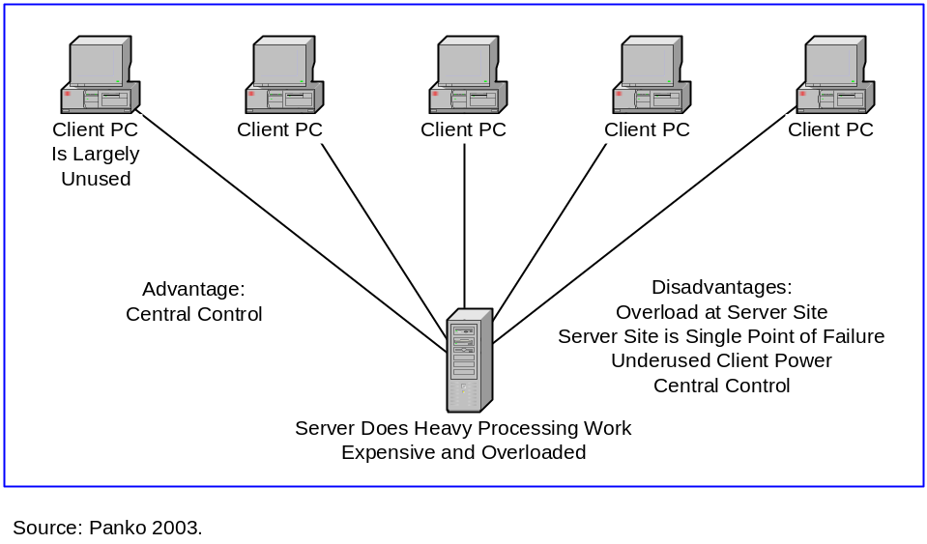

Figure 4: Access Point versus Peer-to-Peer Routing

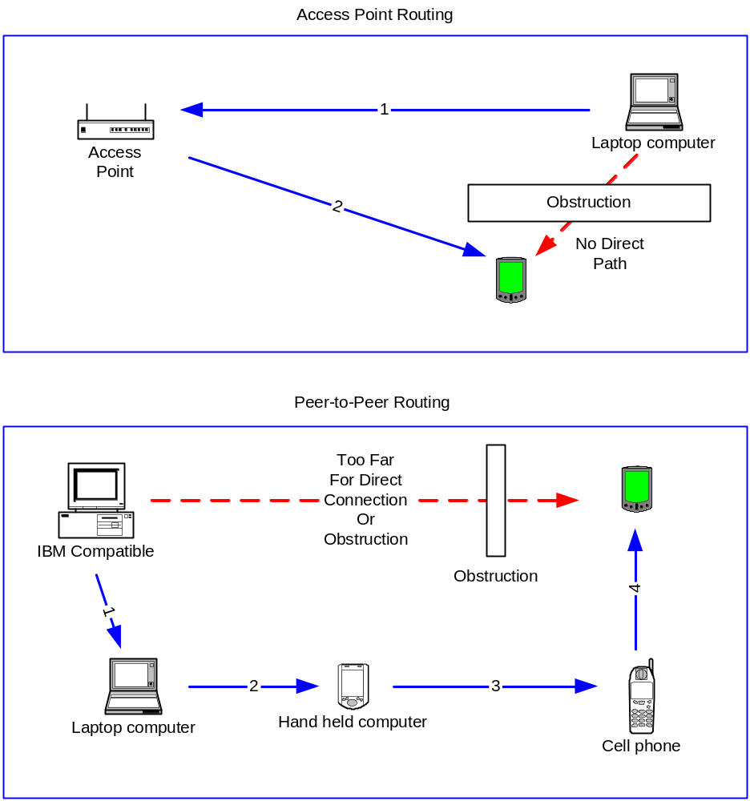

Figure 5: P2P File-Sharing Applications
Content Pot Luck Parties [Kan, 2001]
Heavily used for sharing of pirated music, video, software
Potential corporate uses as well
Napster
Purpose: to share MP3 files
Used an index server to store computer and file information
Provides a single point of legal vulnerability
But file transfers were strictly P2P
P2P transfers were intended to frustrate piracy laws
Designed to defeat firewalls by using Port 80
Destroyed legally in 2001
Resurrected in 2003 as client/server service
Gnutella
Created as a protocol, not as a product
User computers (called servents) do all the work
No servers are used at all
Viral networking for introductions and searches
Direct user–user file transfers
Limited horizon (time-to-live value limits viral hops)
User accountability
Forces itself through firewalls, including aggressive push mode
A troubled history
Needs superpeers to work effectively
Performance concerns because of flooding
FastTrack: Kazaa, Morpheus, and Grockster
Dominates consumer P2P today
Mutating technology to thwart firewalls so difficult to describe
On by default
Self-organizing network
Users automatically become SuperNodes without their knowledge
Can create content problems for them
Intelligent downloading: simultaneous downloads from multiple peers
Standardized metadata (largely for music files)
Registration server in early version
Adware/Altnet
Legal censorship
Freenet
Designed to resist censorship
Depth-first searching to reduce traffic load on network
Returns document, not notice that document exists
Automatic replication of popular files
Corporate Applications
Cross-loading antivirus updates [Fatah, 2002]
Other examples
Return to Framework (Figure 1)

Figure 6: Napster Technology

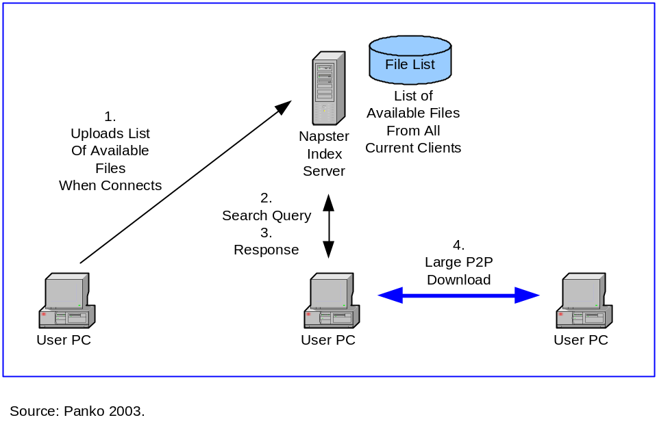

Figure 7: Napster and Firewalls

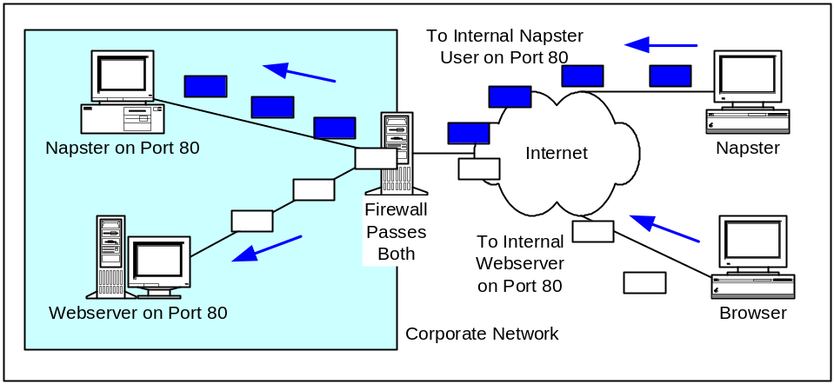

Figure 8: Gnutella Servents with Viral Networking

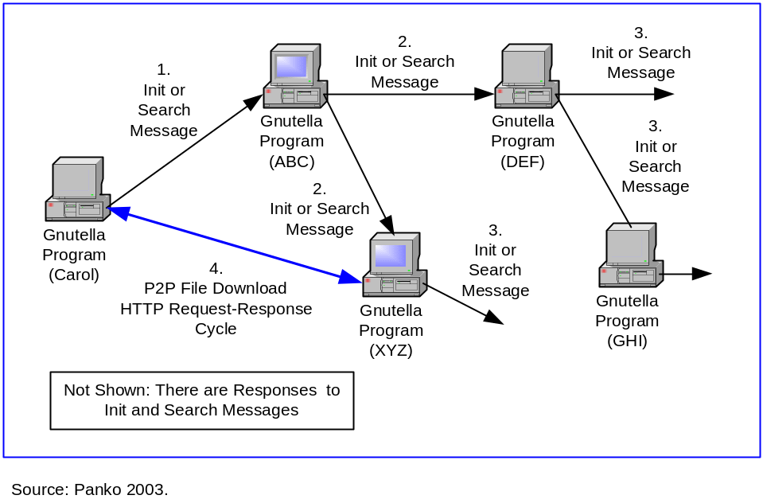

Figure 9: Gnutella and Firewalls

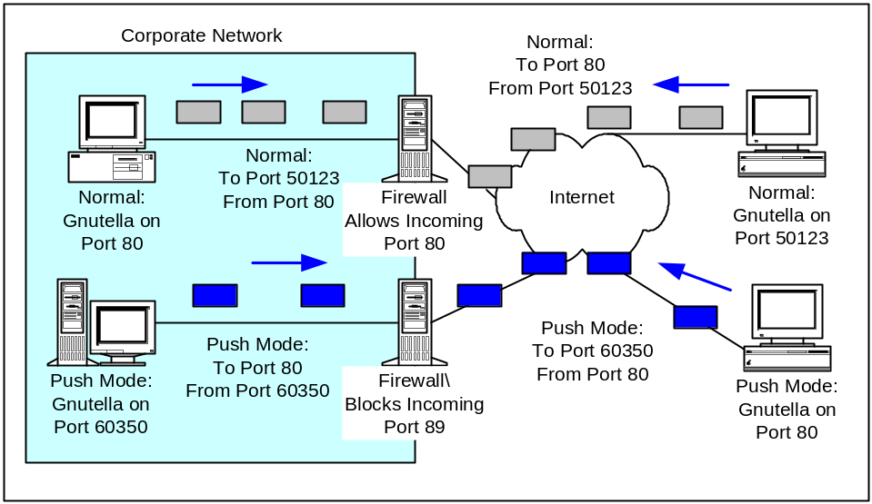

Figure 10: P2P Processor-Sharing (Grid) Applications
Linked to Grid Computing, Which Also Involves Server Grids
SETI@home
Built into screen saver for automatic starting when no other use
Downloaded small processing jobs; received responses
Problems with volunteer misbehavior
Distributed.net for Key Cracking
Corporate P2P Processor Sharing (First Union Corporation, etc.)
Vendor Efforts
IBM, HP, Oracle, and other firms are pushing grid technology
Oracle’s 10th version was called 10g for “grid”
Globus Project (Globus.org)
Open Grid Services Architecture (OGSA)
Globus Toolkit for building applications
But vendor incompatibilities
Globus Security is nascent
Likely to be Linked to Web Services
SOAP message transmission
SOAP messages in XML format
Usually carried in HTTP messages
Need to transfer programs to grid computers
SOAP is firewall-respectful; a model for other protocols?
SOAPaction field
What Applications Are Suitable?
Multiple, nearly identical program chunks
Must tolerate latency in communication
Accountability Problems
Forced grids: Parasitic computing and Trojan horse grid computing
Unauthorized service provision by employees on corporate computers
Security: Sandboxing and Privacy
Programs should not be able to take harmful action
The computer owner should not be able to read grid processing results
Performance and Scalability
Unexplored research area
Especially an issue in extragrids, which use computers outside a firm
Scheduling, Bidding, and Payment
Users will want to schedule grid use of their computers
In commercial environments, there must be bidding and payment processes
Software Distribution
Software must be distributed before processing
The Enslow Legacy
P2P, grid concepts anticipated by Phil Enslow [1978]
Much relevant work was done in the late 1970s and early 1980s
Corporate Politics
"Server hugging" and "Not on My Computer"
Return to Framework (Figure 1)

Figure 11: SETI@home User PC Processor Sharing

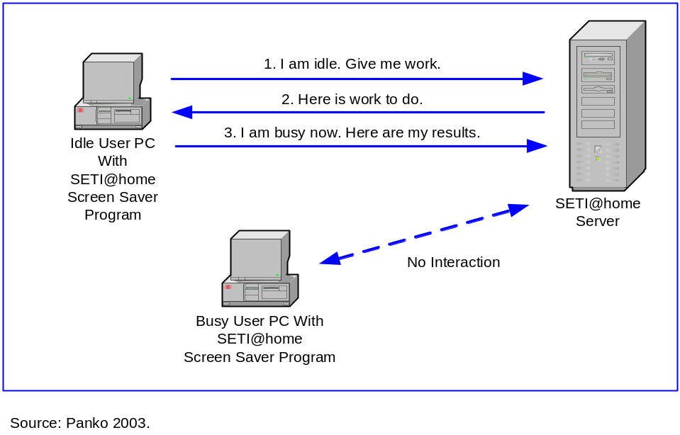

Figure 12: P2P Communication Applications
People are Distributed Resources
Voice and Video Communication
H.323 Standards for Voice and Video Communication
Terminals
Gatekeepers authenticate senders and locate receivers
Option of whether and how much to use gatekeepers
Gateways link to the public switched telephone network (PSTN)
Session Initiation Protocol (SIP)
Similar to but simpler than H.323
SIP gateways can use e-mail addresses to locate receivers
ENUM allows connection to PSTN
MEGACO/H.248 to Control Gateways Centrally
Instant messaging
IM Services
Initial operation
Presence and availability information
File transfers, asynchronous messages, and voice
IM Architectures
Pure P2P IM
Pure server-based IM
Partially server-based IM
IM Security and Other Concepts
Normally, no encryption and authentication
Amateur cryptography
Occasional security vulnerabilities that must be patched
Malicious content
Unauthorized outgoing file transfers
Lost productivity through interruptions
Lost productivity through amount of use
Slow typing speeds and multitasking
Interoperability
Walled gardens
A requirement for AOL to interoperate
AOL–Microsoft discussions
AOL–IBM interoperability
SIMPLE
Gateways
Retention of IM Messages
The benefit of retention
The dangers of retention
Accidental retention
Shredding programs
Legal retention requirements
Retention in practice
IM retention
IM gateways
Enterprise IM Systems
For use within an enterprise
Communication capabilities beyond simple chatting
Management
Retention
Monitoring
Security
Organization
Do Companies Care?
Bots
Growing Beyond IM
Integration with other real-time applications
APIs for other applications
Patent Issue
AOL has a patent. Will it enforce it
Cellular Short Message Services (SMSs)
Ordinary SMS
Push-to-talk service
P2P Groupware: Groove
Groupware tool
Similar to Notes in functionality
But projects are implemented on user computers
No red tape to create new groups
Replication: changes are propagated to other group PCs
In real time or
From relay server when the user next comes online
Presence and Circles of Contacts
Presence
Beyond IM
Interruptions
Differential revelation of presence information
Circles of Contacts
Individual circles of contacts
Circles of contacts in organizational settings
Interorganizational systems
Social networking approaches
Return to Framework (Figure 1)

Figure 13: E-Mail and P2P Messaging

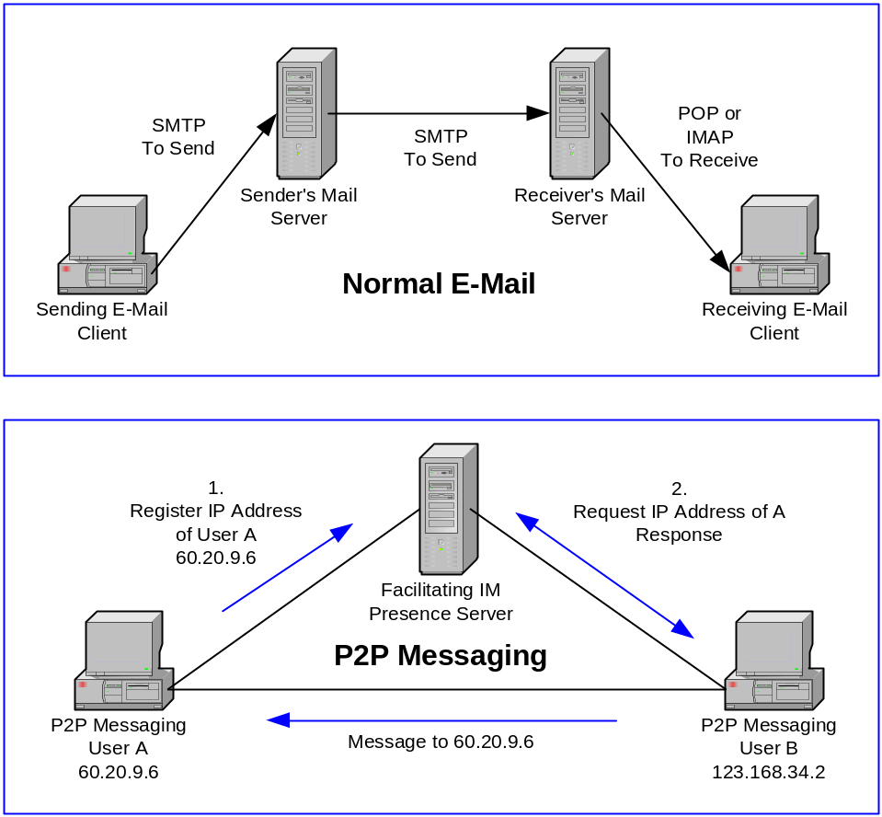

Figure 14: H.323 Communication

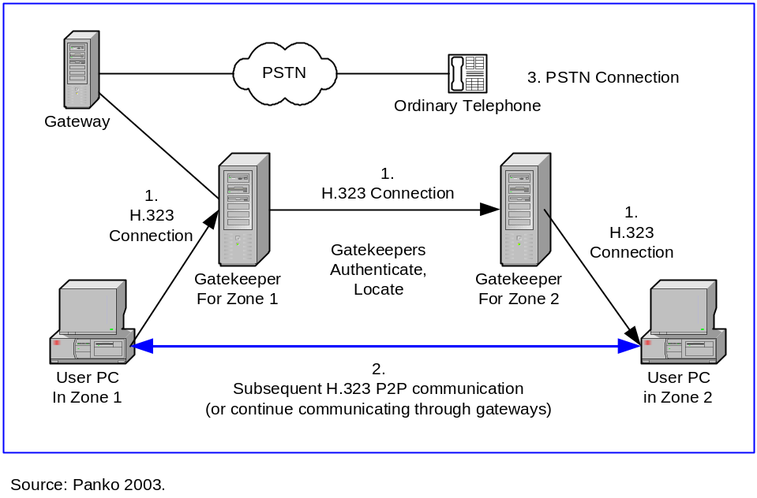

Figure 15: Session Initiation Protocol

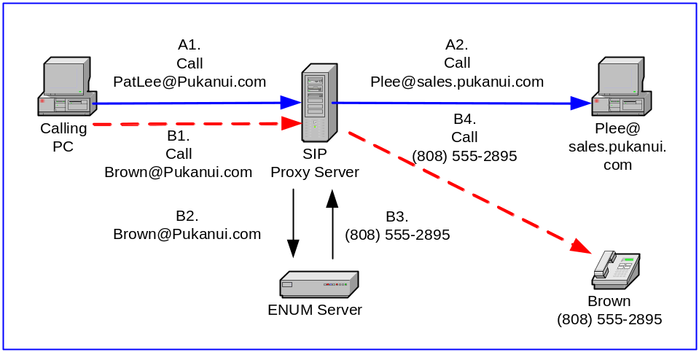

Figure 16: Instant Messaging

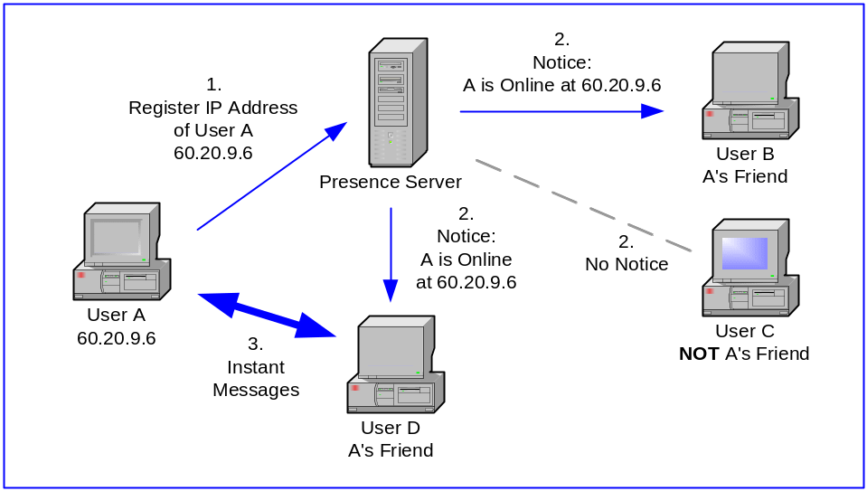

Figure 17: Replication in Notes and Groove

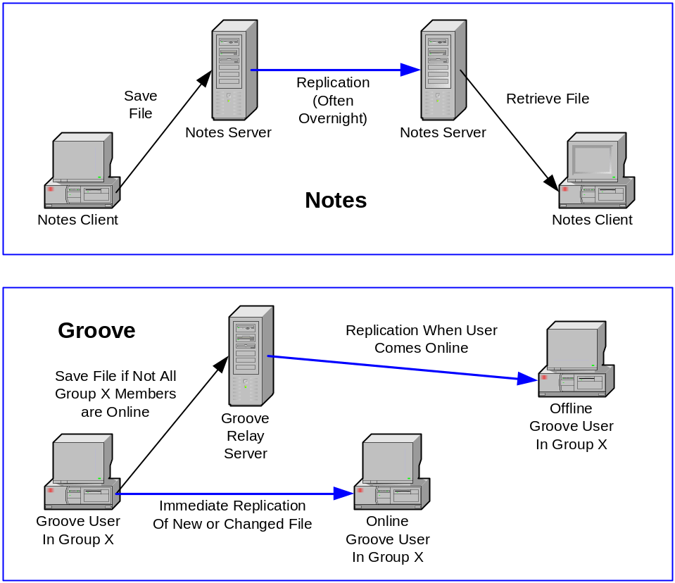

Figure 18: P2P Multiuser Interactive Applications
Online Multiuser Games
PC games such as Counter-Strike
Mobile telephones for ad hoc gaming with anyone nearby
Joint Website Visits
Multiuser Single-User Applications
Shared screen conferencing (whiteboarding)
Shared application conferencing
Group Support Systems
Brainstorming
Idea consolidation
Voting
Mental map building
Return to Framework (Figure 1)

Figure 19: Issues in P2P Routing (Mesh Networks)
Terminology
P2P routing, mesh networks, scatternets
Intermediate routing (see Figure 4)
Are Mesh Networks New?
Alohanet and ad hoc 802.11 networks do not have central concerns
However, all stations can hear all other stations
There is no intermediate routing
Potential Advantages
Cost reduction by avoiding access points and similar technologies
Reliability: losing a single station should have little effect since each serves only a small area.
Reach: the ability to reach stations with poor line-of-sight to access points
Concerns
Density and coverage
If density is sparse, there may be no route between two stations
Station overload
Especially for stations at communication nexuses
A Lack of Standards
Bluetooth has mesh networking in its design, but no standards have been developed
The FCC has permitted one company to do mesh networking in 802.11
Even if standards are created, updating the installed base would be difficult
Mesh Routing Protocols
Stations need discovery protocols to join mesh networks
Mesh networks will need routing protocols to allow stations to share routing table information.
Routing protocols may vary from simple to complex
Should have fast convergence if there are changes
The 802.1w Rapid Spanning Tree Protocol may be useful
P2P Routing with Mobile Devices
Need to adjust signal strength and routing tables constantly
Processing routing protocol updates has to be done constantly
Management
Can be centralized or distributed
Pragmatic decision, not a matter of purity
Security
Authentication must be strong
The scatternet must be able to survive successful attacks
Below the Application Layer
Layer 3 concern
Figure 1 (Framework)

Figure 20: Issues in Designing P2P Architectures
What is Shared?
User PC processing power
User PC storage capacity
User PC content
User PC connectivity
Presence of user
Method for Dealing with User Limitations
IP address transience
Autoconfiguration creates IP address transience
Not a problem for client/server systems
Protocol-specific namespace servers
Dynamic DNS
Voluntary superpeers with permanent IP addresses
IP Version 6 and Network Address Translation (NAT)
User, computer, connection, and application transience
Computer and internet connectivity transience
Application transience even if the computer is on and connected
User transience
A design issue for communication applications
Relay servers (Groove)
An advantage for processor sharing applications
Connection speed
The problem of low-speed users as service providers
Superpeer backbones (Groove)
Connection speed asymmetry
Whether or Not to Use Servers
Censorship
Corporate administrative overload, red tape
Return to Framework (Figure 1)

Figure 21: Network Address Translation

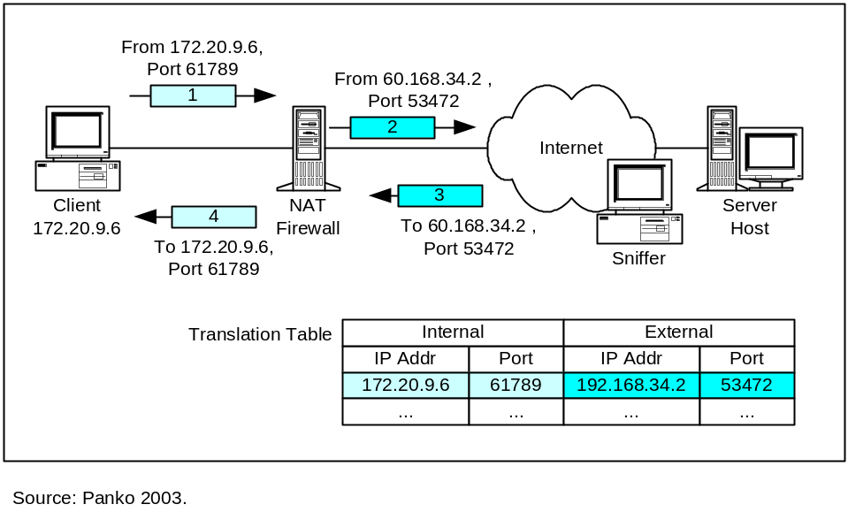

Figure 22: P2P Service Quality Issues
Need for Reliability
Reliability through redundancy
Single points of failure or censorship
Backup and retention policies
Performance
Performance trade-offs
Scalability
Predictability
Return to Framework (Figure 1)

Figure 23: Research and Design Issues for P2P Searching
Issues
Difficulty of Searching
Need for Speed and Efficiency
Napster’s Charmed Life: MP3 Files
Simple music search data
Searching: The Achilles’ heel of P2P file sharing
Search Method
Restricted namespace searching (e.g., Napster’s MP3s)
Metadata and namespaces
Unstructured data searches (Gnutella)
Performance problems on user computers
Gnutella lets the peer decide how to respond to an offer
Topology
Direct versus server-based versus hub-based searches
Depth-first (Freenet) versus breadth-first (Gnutella) searches
Caching of answers to reduce broadcasting
Voluntary or involuntary superpeers
Downloading
From a single user PC
Parallel downloads of parts of a file from multiple servers (FastTrack)
Rapid Availability of Dynamic Data
Persistent Searches
Legal Discovery Requirements

Return to Framework (Figure 1)

Figure 24: P2P Foundation Functionality
Backup and Retention
Group Management Tools

Return to Framework (Figure 1)

Figure 25: P2P Research, Design, and Policy Security Issues
User Security Weaknesses
Vendor Ignorance
Many Threats
Malicious Content
Spoofing and Pornography
Revealing IP Addresses
Exposure of Sensitive Information
Instant Messaging Ephemerality
Monitoring Employee Communication
Firewalls
Firewall circumvention
Firewall-respectful protocols (SOAPaction field)
Application firewall compliance
Locking the Client Desktop to Prevent Installation
Authentication
Difficulty
PKIs
PKI scalability
Split trust
Digital certificates versus reputation management
Integration with existing corporate authentication systems
Circles of trust
Other forms of authentication
Content Filtering and P2P Transmission
Privacy and Anonymity
Trust
The Use of Servers and Security
Sometimes a double-edged sword
Comprehensive Security Systems

Return to Framework (Figure 1)

Figure 26: P2P Standards Issues
The Need for Interoperability
Application-layer standards needed
Cowboy proprietary development to date
Lack of standards body
JXTA “Open” Proprietary Protocol
SIMPLE for Instant Messaging
Intel’s Peer-to-Peer Trusted Library
TCP/IP
Use Proven Standards Where Possible
P2P Standards will be Specific to Individual P2P Applications
Translation versus Interoperability
Document Standards Translation

Return to Framework (Figure 1)

Figure 27: P2P Business Model Issues for Vendors
Competitive Advantage
Competition
Product
Piracy and voluntary contributions
Increasing product availability with use
Default for availability
Simplicity of use
Pricing
Sunk costs and resources
Payment and pricing
Promotion
Content promotion
System promotion
Distribution
Supply chain roles
Producers versus distributors
Complex and changing roles
Financing the business
Traditionally a problem, especially after the venture capital pullout
Creating commercial P2P software
Relying on volunteers
Sales to corporations
Payment
Lack of trust
Trusted third party (such as PayPal)

Return to Framework (Figure 1)

Figure 28: Volunteerism Issues
Complex Roles for Different Types of Volunteers
Strategies for Motivating Volunteers

Return to Framework (Figure 1)

Figure 29: Accountability (Governance) Issues
Application Community Accountability Issues
Spam and viruses
Spyware and Adware
Consumption of bandwidth
Spoofed content
The free rider problem
Lack of tools to enforce accountability
Communication netiquette
Applications that do not depend on trust
Organizational Governance Issues
Wasted employee, computer, and network time
Corporate security policy enforcement
Performance
Global and local management of applications (i.e., USENET, Groove)
Balance of corporate control and end-user control
Societal Issues
Intellectual property violations
Lost revenues through piracy
Direct violations versus contributory infringement (Napster)
Netherlands: provider is not responsible for use
U.S. Wilson decision: if no participation, provider not responsible for use (Betamax)
Will property owners use their power to monopolize distribution?
RIAA now pursuing individual violators
For-fee services
Pursuing corporate violators
Potential U.S. Congressional activity
WIPO Copyright Treaty of 1996
Violation of confidential, proprietary, and sensitive information
Personal privacy
Anonymous publishing

Return to Framework (Figure 1)

Figure 30: Impacts of P2P Applications
Potential for Community Building
Interactions with Commercial Publishing
Impacts on Corporate IT efficiency
Impacts on Work Practices

Return to Framework (Figure 1)

Figure 31: Closed P2P Communities (p2p)
Intranets and Extranets
Confidentiality and Accountability Enforcement
Rumor

Return to Framework (Figure 1)

Figure 32: Quality of Service/Quality of Content Grid

 | Low  Quality of Content | High  Quality of Content
High  Quality of Service | Regular Network | Business Communities
Low  Quality of Service | No clear control, free riding | Cohesive social groups

Source: Parameswaran, Susarla, and Whinston [2001].

Figure 33: Developing a Positive View of P2P through Business-Class Applications
Must Develop a “Positive Meme Map”
Security
Performance
Servers
Performance Trade-Offs
Manageability
Processor Sharing
Standards
Searching
A Natural Evolution
User Vision, Business Direction

Return to Framework (Figure 1)

A Framework for Research, Design and Policy Issues in Peer-to-Peer (P2P) Application Architectures 1
Abstract 1
Keywords 1
I. Introduction 1
II. What is Peer-to-Peer (P2P)? 1
Application Architectures 2
Facilitating Servers 2
In Contrast to Client/Server Architectures 2
Issues in Client/Server Computing 3
Reliability 3
Inefficient Use of User Computer Resources 3
Administrative Control 3
Low Barriers to Entry for Information Providers 4
Was the Internet Originally Peer-to-Peer? 4
Excluding Distributed Server Architectures: The Centrality of the User Computer 5
What is a User Computer? 5
Types of P2P Applications 6
P2P File Sharing 6
P2P Processor Sharing 6
P2P Human Communication 6
Multiuser Interactive Applications 6
Peer-to-Peer Routing 7
III. File-Sharing Applications 7
Content Pot Luck Parties 7
Napster 8
Purpose 8
MP3 Files 8
Napster Technology: Index Servers 8
Perspective on Napster’s Use of a P2P Application Architecture 9
Defeating Firewalls 9
Success and Death (Sort Of) 10
Gnutella 11
Origins 11
Goals 11
Basic Gnutella Operation 11
Searching 12
Getting Through Firewalls 12
User Accountability 13
A Troubled Early History 13
Gnutella SuperPeers to the Rescue 14
Performance Issues 14
Funding 15
FastTrack: Kazaa, Morpheus, and Grockster 15
Mutating Technology 15
On By Default 16
Self-Organizing Network: Automatic SuperNodes 16
Performance Problems 16
Intelligent Downloading 16
Metadata 17
Registration Server 17
Adware/Altnet 17
Legal Censorship 17
Freenet 18
Corporate Applications 18
IV. Processor-Sharing (Grid) Applications 18
SETI@home 19
Other Voluntary Shared-Processing Applications 19
Corporate Systems 19
Vendor Efforts 20
Globus 20
The Globus Project 20
Open Grid Services Architecture 20
Globus Toolkit and Vendor Incompatibility 21
Globus Security 21
SOAP and Web Services 21
SOAP Message Transmission 21
Program Transfer 21
SOAP Security and Firewall–Respectful Protocols 22
Appropriate Applications 22
Multiple Nearly Identical Program Chunks 22
Latency 22
Accountability 22
Parasitic Computing 22
Trojan Horse Grid Computing 22
Unauthorized Service Provision 23
Security: Sandboxing and Privacy 23
Performance and Scalability 23
Scheduling, Bidding, and Payment 24
Software Distribution 24
Politics 24
The Enslow Legacy 24
V. P2P Communication Applications 25
Voice and Video Communication 25
H.323 25
Session Initiation Protocol (SIP) 26
MEGACO/H.248 27
Instant Messaging (IM) 27
IM Services 28
Initial Operation 28
Availability Status 28
File Transfer 28
Asynchronous Messages 28
Voice 28
IM Architectures 28
Pure P2P IM 29
Pure Server-Based IM 29
Partially Server-Based IM 29
IM Security and Other Concerns 29
Encryption and Authentication 29
Amateur Cryptography 29
Security Vulnerabilities 30
Malicious Content 30
Unauthorized Outgoing File Transfers 30
Lost Productivity through Interruptions and Amount of Use 30
Slow Typing Speeds and Multitasking 31
Interoperability 31
Walled Gardens 31
A Requirement for AOL to Interoperate 31
AOL–Microsoft Discussions 31
AOL–IBM Interoperability 32
SIMPLE 32
Gateways 32
Retention of IM Messages 32
The Benefit of Retention 32
The Dangers of Retention 33
Accidental Retention 33
Shredding Programs 33
Legal Retention Requirements 33
IM Retention 34
IM Gateways Error! Bookmark not defined.
Enterprise IM Systems 34
Into the Enterprise Error! Bookmark not defined.
Communication Capabilities beyond Simple Chatting 35
Management 35
Retention 35
Monitoring 35
Security 36
Do Companies Care? 36
Bots 36
Growing Beyond IM 37
Integrating with Other Real-Time Applications 37
APIs for Other Applications 37
The Patent Issue 37
Cellular Short Message Service (SMS) 37
P2P Groupware: Groove 38
Presence and Circles of Contacts 39
Presence 39
Beyond IM 39
Interruptions 39
Differential Revelation of Presence Information 40
Circles of Contact 40
Individual Circles of Contacts 40
Circles of Contacts in Organizational Settings 40
Interorganizational Systems 40
Social Networking Approaches 40
VI. Multiuser Interactive Applications 41
Online Multiplayer Games 41
Joint Website Visits 41
Multiuser Single-User Applications 42
Shared-Screen Conferencing (Whiteboarding) 42
Shared-Application Conferencing 42
Group Support Systems 42
VI. Peer-to-Peer Routing (Mesh Networking) 42
Are Mesh Networks New? 43
Potential Advantages 43
Cost Reduction 43
Reliability 43
Reach 43
Concerns 43
Density and Coverage 44
Station Overload 44
Compatibility Error! Bookmark not defined.
A Lack of Standards 44
Mesh Routing Protocols 44
Discovery Protocols 44
Routing Protocols 44
Wide Variation in Routing Protocols 45
Robustness and Convergence Speed 45
802.1w: Rapid Spanning Tree Protocol (RSTP) 45
P2P Routing with Mobile Devices 45
Management: Distributed or Centralized? 45
Security 46
Below the Application Layer 46
VII. Issues in Designing P2P Architectures 46
What is Shared? 46
Dealing with User Limitations 47
IP Address Transience 47
Autoconfiguration 47
IP Transience is Not a Problem for Traditional Client/Server Computing 47
Protocol-Specific Name Service 47
Voluntary Superpeers with Permanent IP Addresses 48
Dynamic DNS 48
IP Version 6 and Network Address Translation (NAT) 48
User, Computer, Internet Connectivity, and Application Transience 49
User, Computer, and Internet Connectivity Transience Error! Bookmark not defined.
Application Transience Error! Bookmark not defined.
Lack of User Presence is an Advantage for Processing Sharing 49
Connection Speed 50
Low-Speed Users 50
Superpeers 50
Asymmetric Speeds 50
The Use of Servers 50
When to Use P2P versus Centralized Computing 51
VIII. Service Quality Issues 51
Reliability 51
Reliability through Redundancy 51
Single Points of Failure or Censorship 52
Backup and Retention Policies 52
Performance 52
Performance Trade-Offs 52
Scalability 52
Predictability 53
IX. Searching 53
Issues 53
Difficulty of Searching 53
Speed and Efficiency 53
Napster’s Charmed Life: MP3’s Simple and Widely-Known Search Format 53
The Achilles’ Heel of P2P File Sharing 54
Metadata and Namespaces 54
Unstructured Data 54
Direct versus Server-Based and Hub-Based Searches 54
Rapid Availability for Dynamic Data 55
Persistent Searches 55
Legal Discovery Requirements 55
X. Foundation Functionality 55
Backup and Retention 55
Group Management Tools 56
XI. Security 56
User Security Weaknesses 56
Vendor Ignorance 57
Malicious Content 57
Spoofing and Pornography 57
Revealing IP Addresses 58
Exposure of Sensitive Information 58
Instant Messaging Ephemerality 58
Monitoring Employee Communication 59
Firewalls 59
Firewall Circumvention 59
Developing Firewall-Respectful Protocols 59
Application Firewall Compliance 60
Locking the Client Desktop to Prevent Installation 60
Authentication 61
The Difficulty of Authentication 61
PKIs 61
PKI Scalability 61
Split Trust 61
Digital Certificates Versus Reputation Assessment 61
Integration with Existing Corporate Authentication 61
Circles of Trust 62
Other Forms of Authentication 62
Content Filtering and P2P 62
Privacy and Anonymity 62
Trust 62
The Use of Servers and Security: Sometimes a Double-Edged Sword 63
Comprehensive Security Systems 63
XII. Standards 64
The Need for Interoperability 64
JXTA 64
SIMPLE for Instant Messaging 64
Intel’s Peer-to-Peer Trusted Library 65
TCP/IP 65
P2P Should Use Proven Application Standards Where Possible 65
P2P Standards Will be Specific to Individual P2P Applications 66
Translation versus Interoperability 66
Document Standards Translation 66
XIII. Business Model Issues for Vendors 66
Competitive Advantage 66
Competition 66
Product 67
Piracy and Voluntary Contributions 67
Increasing Product Availability with Use 67
Default for Availability 67
Ease of Use 67
Pricing 67
Sunk Costs and Resources 67
Payment and Pricing 68
Promotion 68
Content Promotion 68
System Promotion 68
Distribution 68
Supply Chain Roles 68
Producers versus Publishers 68
Complex and Changing Roles 69
Financing the Business 69
Payment Mechanisms 69
XIV. Volunteerism 69
Complex Roles for Different Types of Volunteers 70
Strategies for Motivating Volunteers 70
XV. Accountability: Governance Issues 70
Application Community Accountability Issues 70
Spam and Viruses 70
Spyware and Adware 71
Consumption of Bandwidth 71
Spoofed Content 72
The Free Rider Problem 72
The Lack of Tools to Enforce Accountability 73
Communication “Netiquette” 73
The Need for Applications That Do Not Depend on Trust 73
Organizational Governance Issues 73
Wasted Employee and Computer Time 73
Corporate Security Policy Enforcement 73
Performance 74
Recap 74
Global and Local Management 74
Balance of Corporate and End User Control 74
Societal Issues 75
Intellectual Property Violations 75
The Problem 75
Napster 75
Kazaa: The Netherlands 75
In the United States: Then Wilson Decision 76
Pursuing Individual Violators 76
Pursuing Corporate Violators 78
In the United States: Congressional Activities 79
WIPO 79
Confidential, Proprietary, and Other Sensitive Corporate Information 79
Personal Privacy 79
Anonymous Publishing 79
XVI. Impacts 80
Potential for Community Building 80
Impacts on Commercial Publishing 80
Impacts on Corporate IT Efficiency 81
Impacts on Work Practices 82
XVII. Closed P2P Communities (p2p) 82
Intranets and Extranets 82
Confidentiality and Accountability Enforcement 83
Rumor 83
XVIII. Conclusion: Toward a Positive View of P2P Through Business-Class Applications 83
Changing the Peer-to-Peer Meme Map 83
Security 84
Performance 84
Servers 84
Performance Trade-Offs 85
Manageability 85
Processor Sharing 85
Standards 86
Searching 86
A Natural Evolution 86
User Vision, Business Direction 86
References 88
About the Author 94

Figure 1: Framework for Research, Design, and Policy Issues in Peer-to-Peer (P2P) Application Architectures. 1
Figure 2: Defining Peer-to-Peer (P2P) Application Architectures 2
Figure 3: Traditional Client/Server Application 3
Figure 4: Access Points Versus Peer-to-Peer Routing in Wireless Networks 7
Figure 5: P2P File-Sharing Applications 7
Figure 6: Napster Technology 8
Figure 7: Napster and Firewalls 9
Figure 8: Gnutella Servents with Viral Networking 11
Figure 9: Gnutella and Firewalls 13
Figure 10: P2P Processor-Sharing (Grid) Applications 18
Figure 11: SETI@home User PC Processor Sharing 19
Figure 12: P2P Communication Applications 25
Figure 13: E-Mail and P2P Messaging 25
Figure 14: H.323 Communication 25
Figure 15: Session Initiation Protocol 27
Figure 16: Instant Messaging 28
Figure 17: Replication in Notes and Groove 38
Figure 18: P2P Multiuser Interactive Applications 41
Figure 19: Issues in P2P Routing (Mesh Networks) 43
Figure 20: Issues in Designing P2P Architectures 46
Figure 21: Network Address Translation (NAT) 48
Figure 22: P2P Service Quality Issues 51
Figure 23: Research and Design Issues for P2P Searching 53
Figure 24: P2P Foundation Functionality 55
Figure 25: P2P Research, Design, and Policy Security Issues 56
Figure 26: P2P Standards Issues 64
Figure 27: P2P Business Model Issues 66
Figure 28: Volunteerism Issues 70
Figure 29: Accountability (Governance) Issues 70
Figure 30: Impacts of P2P Applications 80
Figure 31: Closed P2P Communities (p2p) 83
Figure 32: Quality of Service/Quality of Content Grid for Different Peer-to-Peer Communities 83
Figure 33: Developing a Positive View of P2P through Business-Class Applications 84

