I N V I T A T I O N
TO THE
7th
STEERING GROUP MEETING
OF
PA4 – TO RESTORE AND MAINTAIN THE QUALITY OF WATERS – OF THE EUSDR

We are pleased to invite you to the 7th Steering Group (SG) meeting of Priority Area 4 (PA4) of the European Union Strategy for the Danube Region that will take place in Budapest, Hungary on the
28th March 2014
VENUE: Ministry of Foreign Affairs
Budapest, Bem J. tér

The objective of the meeting is to

- formulate strategic and technical recommendations for the programming of the operational programmes for the 2014-2020 period;
- discuss the opportunities to integrate common efforts on river basin management and quality of waters to the process and incorporation into Partnership agreements;
- describe the recent development on buffer zones and early warning
- discuss further process and case studies, JRC Danube Nexus relevant projects, DR-TAF etc
- discuss on the draft paper for the harmonisation of the EUSDR priority areas fourth and fifth actions and ICPDR relevant activities;

The discussion on financing, follow-up on relevant activities as well as the harmonisation of the EUSDR priority areas fourth and fifth actions and the buffer zones draft report will be the main elements of the Steering Group agenda. To facilitate the discussion background papers will be circulated to the SG members.

The proposed agenda is enclosed to this letter.

Please note that the working language of the meeting is English.
Please make your hotel booking individually. Attached please find a list of hotels in the area.
The costs related to accommodation and travel will be covered by the participants (except for non-EU countries, where related costs will be covered for one participating SG member/ non EU country by PA4).
Please note that for non EU country participants the flight and hotel reservation will be made by PA4, so please do not purchase tickets.
Members requiring VISA should confirm participation asap in order to make all arrangements prior the meeting.

Be so kind to confirm your participation until 20th of March 2014 by filling in and sending the attached Registration Form to the following e-mail addresses:

kocsiskupperzs@t-online.hu david.szilvia@ovf.hu, vranovska@vuvh.sk and kijovska@vuvh.sk

We are looking forward to meet you in Budapest.

Budapest, 7 March 2014

Yours sincerely,

Zsuzsanna Kocsis - Kupper  Co-coordinator – Hungary |  | Andrea Vranovska  Co-coordinator - Slovakia
Agenda
PA4 Steering Group – 7th Meeting
DATE: 28 March 2014
VENUE: Ministry of Foreign Affairs, Ministry of Foreign Affairs, Budapest, Bem tér
Room: BC 112

Co-Chairs: Zsuzsanna Kocsis-Kupper and Andrea Vranovska
09.30 – 10.00 | Registration
10.00 | Welcome notes (Balázs Medgyesy, Government Commissioner, NCP HU)  Introduction of delegates and new members of the Steering Group (Ms Zsuzsanna Kocsis-Kupper)
10.10 | Adaption of the Agenda (Ms Zsuzsanna Kocsis-Kupper)
10.15 | Approval of the SG6 minutes (Ms Zsuzsanna Kocsis-Kupper)
10.20 | Objectives of the SG7 meeting (Ms Zsuzsanna Kocsis-Kupper)
10. 30 | Alignment of Funding (Anna Repullo Grau DG Regional Policy, Balázs Medgyesy, Government Commissioner, NCP HU/Zsuzsanna Kocsis-Kupper)  - Addressing the issue  - Introduction of the background paper  - Discussion about the main messages  - Next steps
12.15 | Lunch
13.30 | Technical developments  - Case studies ‘to establish buffer strips along the rivers to retain nutrients and to promote alternative collection and treatment of waste in small rural settlements’ (Action 5) and (Action 7) Presentation of the draft reports (Szilvia Szilágyi, Justice and Environment)  - Feasibility study related to early warning system (Zsófia Kovács, Pannon University)  - JRC projects (TBC)  - Implementation of activities outlined in the Roadmap (SK) – discussion on selected items got from participants before the meeting (Andrea Vranovska)  - DR-TAF issues SG has to select 2 + 1 projects (deadline to submit to PA10 by April 1,2014, please send proposals for circulation ASAP and well before the SG meeting)
15.30 | Coffee break
16.00 | Harmonisation of the EUSDR priority areas fourth and fifth actions and ICPDR relevant activities (ICPDR representative TBC/Zsuzsanna Kocsis-Kupper)  - Introduction of the issue  - Introduction of the background paper  - Discussion  - Next steps
17.00 | Any Other Business
17.30 | End of the meeting

REGISTRATION FORM
FOR THE 7th STEERING GROUP MEETING OF THE EUSDR PA4

R.S.V.P

Budapest, 28. March 2014
Ministry of Foreign Affaires

Name: ……………………………………………………………….

Organisation: ………………………………………………………..

Post: …………………………………………………………………

Phone: ……………………………………………………………….

E-mail: ……………………………………………………………… (check spelling, please)

Lunch: (Please mark the boxes accordingly)

 | vegetarian |  | not vegetarian

Please return this registration form to the following e-mail addresses before 20 March 2014:

david.szilvia@ovf.hu

For further information see Practical Details!

PRACTICAL INFORMATION

Budapest, 28 March 2014
Ministry of Foreign Affairs

- Working language

The official language of the meeting is English.

- Transport

If you arrive at Liszt Ferenc International Airport

By public transport

Passengers are taken by a direct bus service, called Bus No. 200E, from the Liszt Ferenc International Airport, to Kőbánya-Kispest metro terminal (blue line). By the blue metro line (3) you can reach “Deák tér” stop in about 20 minutes. In Deák tér with the change of the metro line to the red line (2) you reach Batthyány tér (2 stops - taking the direction “Déli pu”.) From here the venue of the meeting (Ministry of Foreign Affairs) can be reached by foot in about 10 minutes along the Danube, or take the bus 86 for one stop. See detailed map. The tickets in Budapest are only valid for one ride, so if you change from bus to Metro you need to punch another ticket. A one-way ticket costs HUF 350 (450 HUF when buying on the bus from the driver).

By taxi

The official taxi company is Főtaxi. It can transfer the passengers to any part of Budapest. All cars are equipped with POS terminal, therefore passengers can pay with credit card as well. Reservations can be made in person at Főtaxi booths located at the airport. At the taxi rank in front of the stands taxis are parking continuously waiting for passengers, in case of a special request there is only a few minutes to wait for the taxi arriving from the nearby parking.
Districts | Prices HUF | Prices EUR
Pest | ∼6000 HUF | ∼30 EUR
Buda | ∼7000 HUF | ∼33 EUR

By minibus

The AirportShuttle-Minibus provides a door-to-door transfer between the Airport and any point of Budapest and its fleet operates 24 hours a day. The transfer operates as a shared-ride service, which means that passengers travelling to /from the same/ closely situated address are taken in the same vehicle. The service provides the transfer with a boarding capacity of 8 to 10, and 30 to 50 passengers. The AirportShuttle-Minibus Desks are to be found in the terminal. All Minibuses arrive to and depart from the Terminals’ Main Entrance.
Reservations can be made in person at the AirportShuttle-Minibus Desks or 24 hours before your flight departure via online reservation system www.airportshuttle.hu, through travel agencies or by calling the Call Center by dialling the number (+36-1) 296-8555.

If you arrive by train

There are three main train terminals at Budapest: Keleti pályaudvar (Eastern), Déli pályaudvar (Southern) and Nyugati pályudvar (Western). All the three terminals have their Metro stops. The first two (Keleti and Déli) are located at the stops of the red line. The third train terminal has a Metro stop on the blue line. You have to go to “Batthyány tér”, where you can follow the detailed map instructions: by foot you reach the Ministry in about 10 minutes, or take the bus 86 for one stop. The tickets in Budapest are only valid for one ride, so if you change from bus to Metro you need to punch another ticket. A one-way ticket costs HUF 350.

- About Hungary and Budapest

Currency
Hungarian Forint (HUF)

Time Zone
Central European Time Zone

Important phone numbers
Country code for Hungary: +36
European Emergency number: 112

Useful links
You can find more information about Hungary on www.hungary.com
You can find more information about Budapest on www.budapestinfo.hu

Recommended hotel: http://www.regnumresidence.hu/

Hotels in the neighbourhood:
http://www.accorhotels.com/gb/hotel-6151-novotel-budapest-danube/index.shtml
http://www.artotels.com/budapest-hotel-hu-h-1011/hunbuart?s_cid=tl.gp.abu.20110616
http://www.carltonhotel.hu/

For further details or in case of any question, please contact:
david.szilvia@ovf.hu

Maps to the seminar, overview map

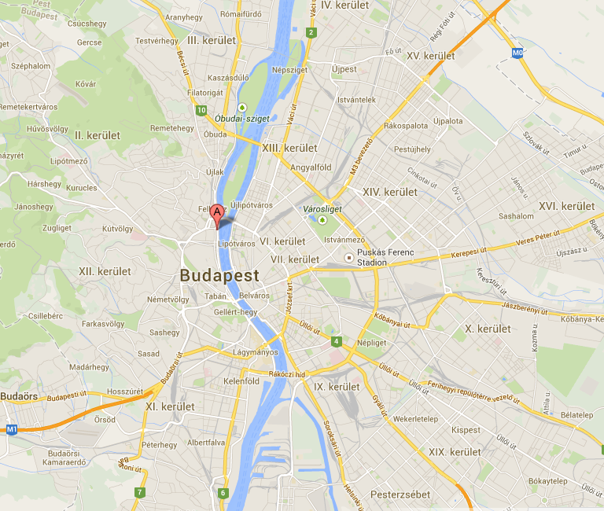

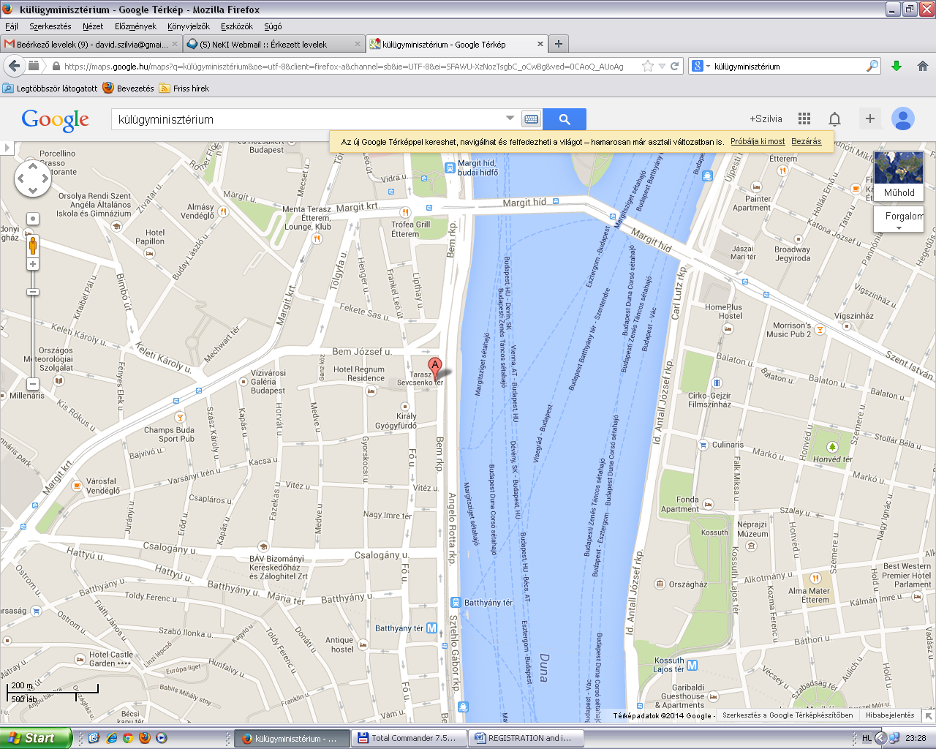
Detailed map
Bus 86
Bus 86
Tram stop 4 and 6
Ministry of Foreign Affairs

Busses 16, 105

