Minutes
of the 3rd Trans-national Meeting of Partnership
Larissa, 11th – 14th, October 2011

PRODUCING OPEN ONLINE LEARNING SYSTEMS -
for Centers of Excellence – [POOLS – CX]

LLP-LdV-TOI-2010-RO-012/2010-1-RO1-LEO05-07447

PROJECT PARTNERSHIP










P0 -UNIVERSITATEA DIN PITESTI - Facultatea de Stiinte ale Educatiei / UNIVERSITY OF PITESTI - The Faculty of Educational Sciences
P1 European Forum of Technical and Vocational Education and Training (EFVET)
P2 Syddansk Erhvervsskole / South Danish Vocational College
P3 CSCS Centro Studi Cultura Sviluppo / Research Centre for Cultural Development
P4 C.V.T. GEORGIKI ANAPTIXI - KEK Georgiki Anaptixi – GEORGIKO TECHNOLOGIKO KENTRO EREVNAS EPAGELMATIKIS KATARTISIS KAI EPIMORFOSIS
P5 ÖZEL MARMARA ANADOLU MESLEK LISESI / Marmara Private Anatolian Vocational High School
P6 Sabhal Mòr Ostaig / Scotland’s Gaelic College

During last 11th and 14th of October 2011, the third trans-national meeting of the LdV project “PRODUCING OPEN ONLINE LEARNING SYSTEMS for Centers of Excellence – [POOLS – CX]” and No LLP-LdV-TOI-2010-RO-012/2010-1-RO1-LEO05-07447 was held in Larissa, in C.V.T. Georgikis Anaptixis’ central headquarters (111 Socratous Str., Larissa).
This project is a Leonardo supported TOI (Transfer of Innovation) project based on the POOLS project (2005-2007).

Attendees

ORGANIZATION | COUNTRY | NAME
National Agency for Community Programms in the Field of Education and Vocational Training | Romania | - Mihai CARAMIHAI  - Andreea LUNGU
University of Pitesti | Romania | - Mihai BRASLASU  - Constantin TIBRIAN
South Danish Vocational College | Denmark | - Kent ANDERSEN
CSCS Centro Studi Cultura Sviluppo | Italy | - Marialuce GIUSTI
C.V.T. Georgikis Anaptixis | Greece | - Nikolaos ZACHAROULIS  - Chrysovalanto LITSIOU
Özel Marmara Anadolu Meslek Lisesi | Turkey | - Nevzat KULABEROGLU  - Burak DEMIRKAZÝK  - Yasin BAHÇECI
Scotland’s Gaelic College | United Kingdom | - Gordon WELLS

Tuesday, October 11, 2011
Morning Meeting

Attendees
1 | Mihai CARAMIHAI | ANPCDEFP
2 | Andreea LUNGU | ANPCDEFP
3 | Mihai BRASLASU | P0
4 | Constantin TIBRIAN | P0
5 | Kent ANDERSEN | P2
6 | Marialuce GIUSTI | P3
7 | Valentini Chrysovalanto LITSIOU | P4
8 | Nikolaos ZACHAROULIS | P4
9 | Nevzat KULABEROGLU | P5
10 | Burak DEMIRKAZÝK | P5
11 | Yasin BAHÇECI | P5
12 | Gordon Wells | P6

09.00 – 10.00 The meeting begins with a short welcome speech by the hosted organization held by Valentini Litsiou and Nikolaos Zacharoulis. After this, each member of each partner organization introduces the organization that they represent, projects involved in, as well as their personal background and areas of expertise to the representatives of the Romanian National Agency for Community Programms in the Field of Education and Vocational Training (ANPCDEFP), Mihai CARAMIHAI and Andreea LUNGU.

Next comes a walkthrough the workshop agenda items. Mihai Braslasu points out the main issues to be discussed during the meeting.

10.00 – 11.45 According to the agenda the consortium discusses the dissemination activities of the project that carried out up to the moment. Kent Andersen gives information about the dissemination activities he carried on during the Euro CALL Conference (31st August - 3rd September 2011, University of Nottingham, UK). The dissemination broschure attracted attention probably due to its colouring.
Mihai Braslasu gives to the partners the dissemination brochure, last version, in their National languages (GR, IT, TR – 200 copies in each language), and 20 in English for each partner.

Furthermore, the promoter presents the dissemination materials (paper and power point presentation of the project) that he used while attending the 12th EUROPEAN CONFERENCE E-COMM-LINE 2011, Bucharest, ROMANIA. September 21-22, 2011). Partners suggest that these materials should be uploaded on the project’s website also.

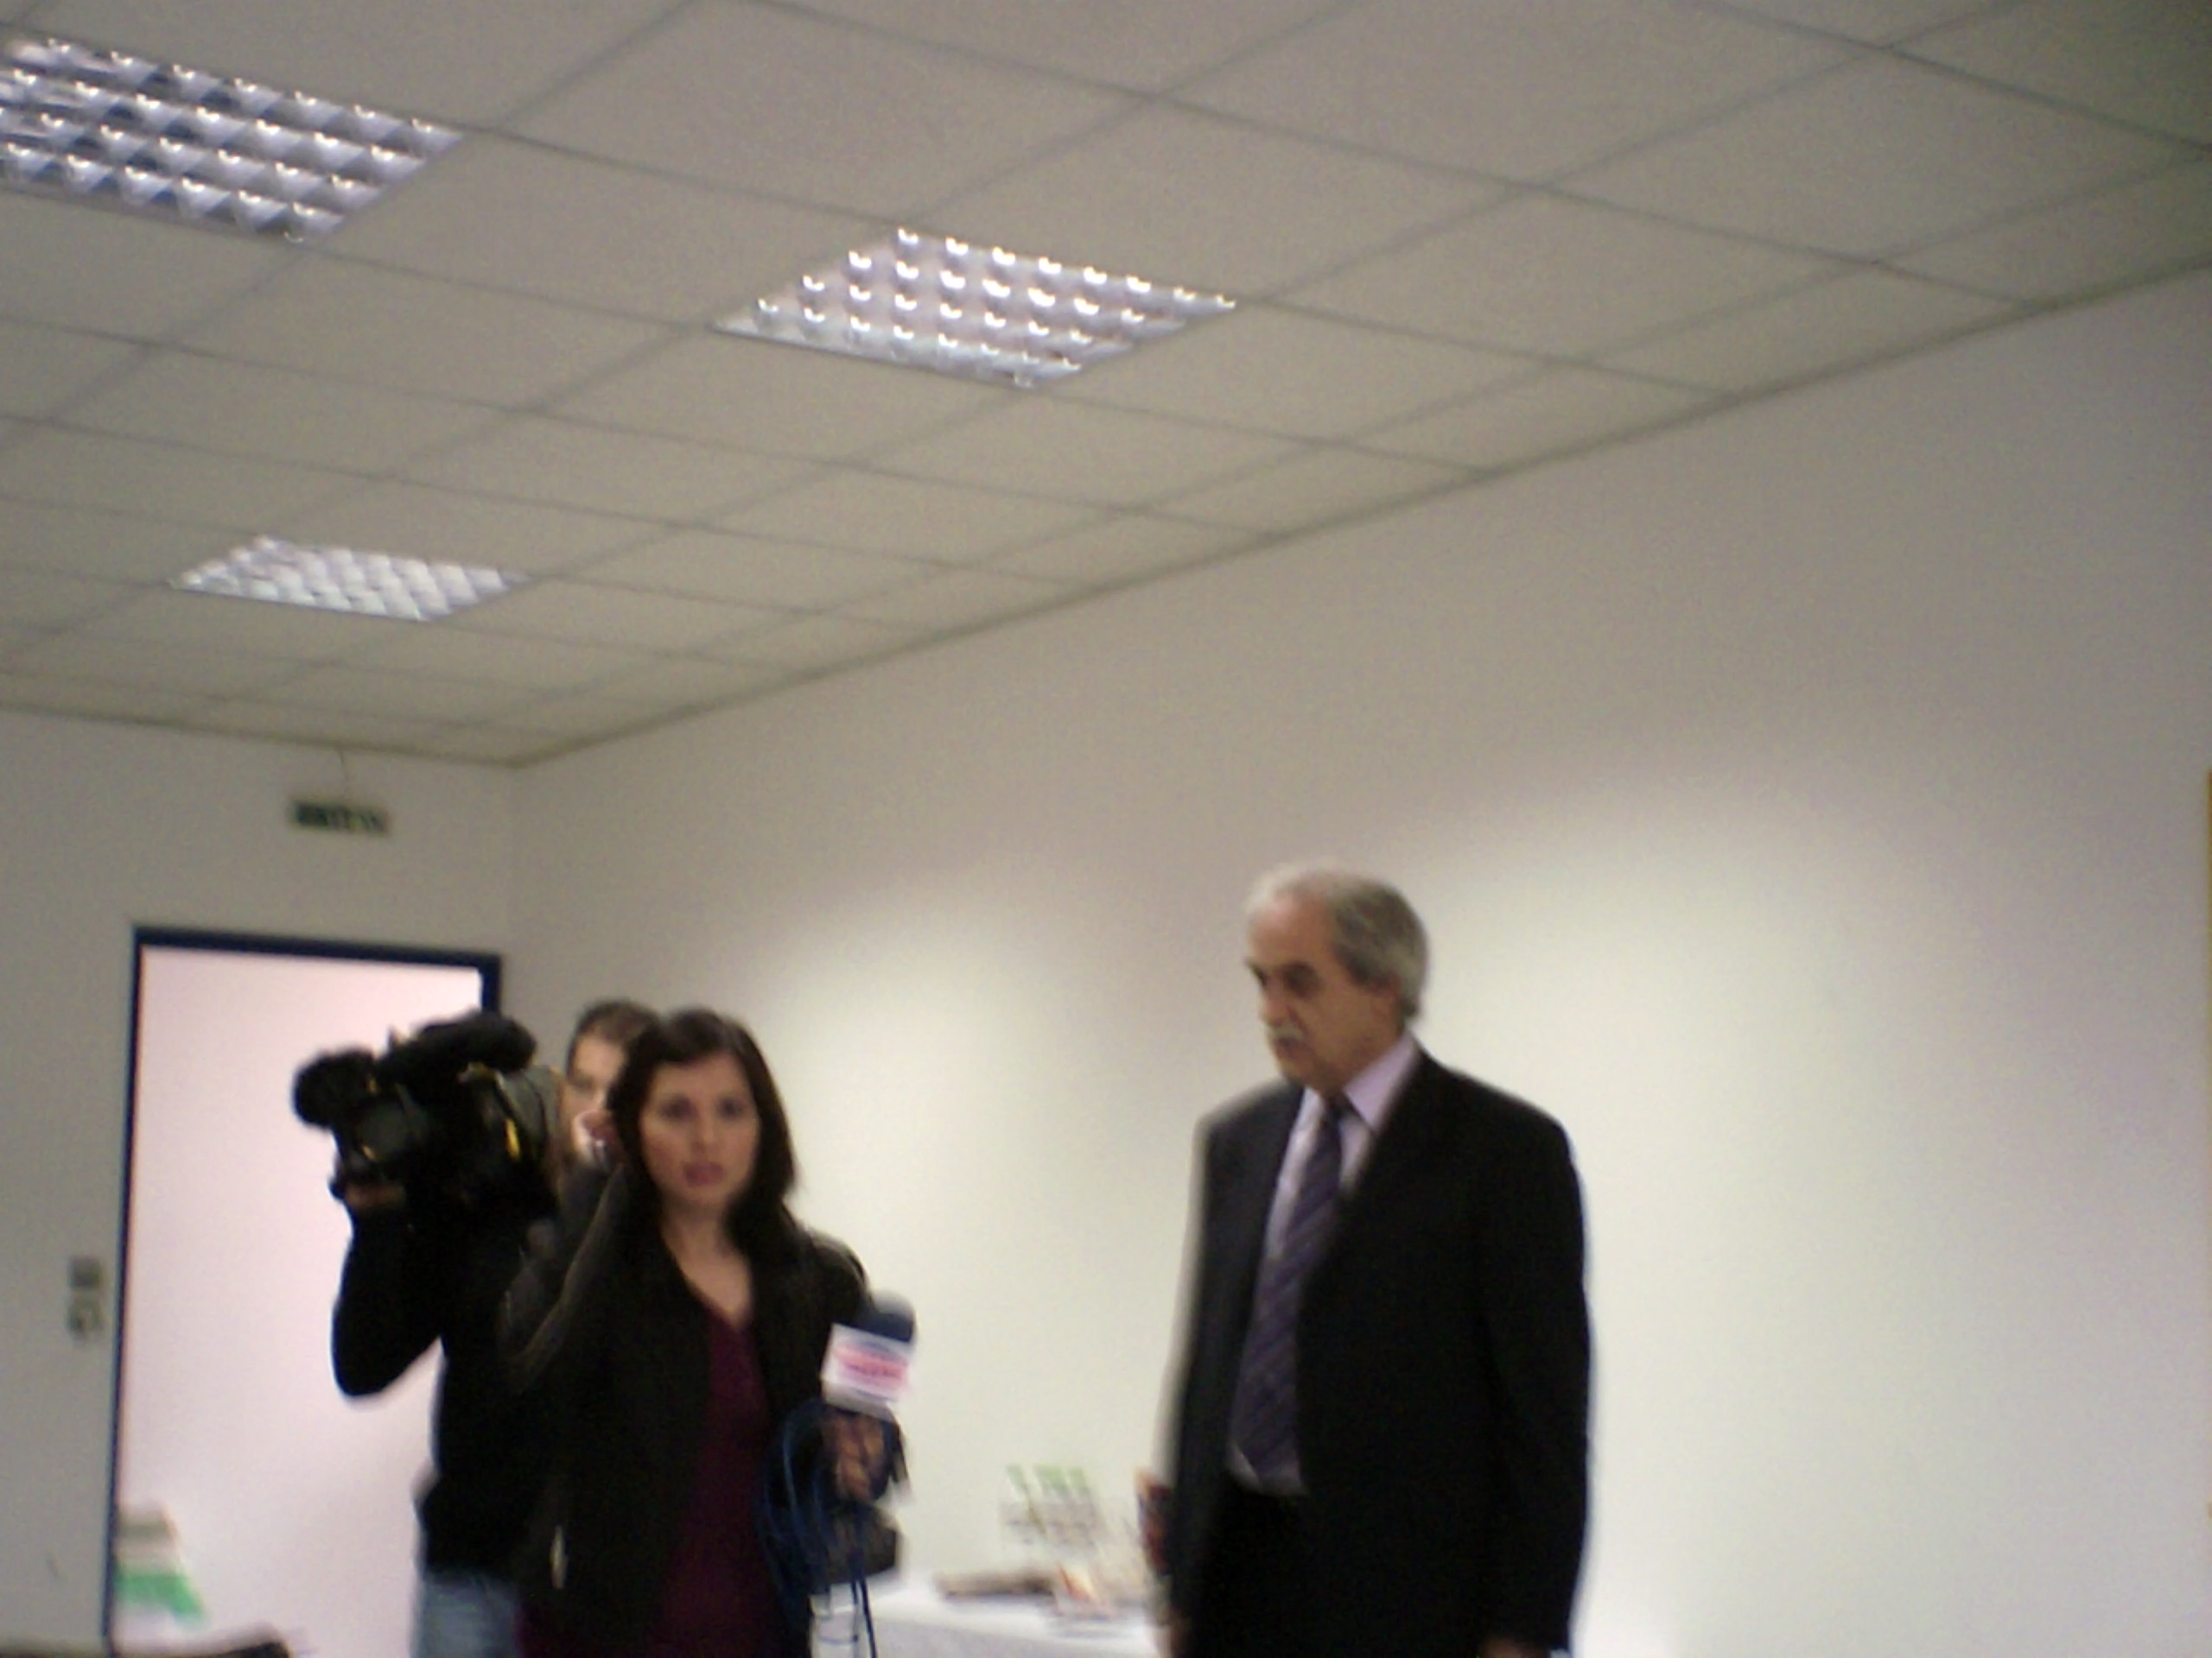

While the meeting is in progress a reporter and a cameraman from a local TV channel, invited by Mr. K. Bliatsios (President and Legal Representative of CVT GA) come to the meeting venue in order to cover the event and to take an interview from Mr. K. Bliatsios about the project and to include it on the central news broadcast. The relevant part will be given to the partners on a DVD by Valentini Litsiou.

After this, the partnership discusses about the POOLS-CX Vimeo group. Gordon Wells introduces Vimeo to the representatives of the Romanian National Agency and gives information about the videos uploaded by the partners. He appreciates the efforts made by the GR, IT, and TR partners to produce 10 videos suitable for language teaching each.

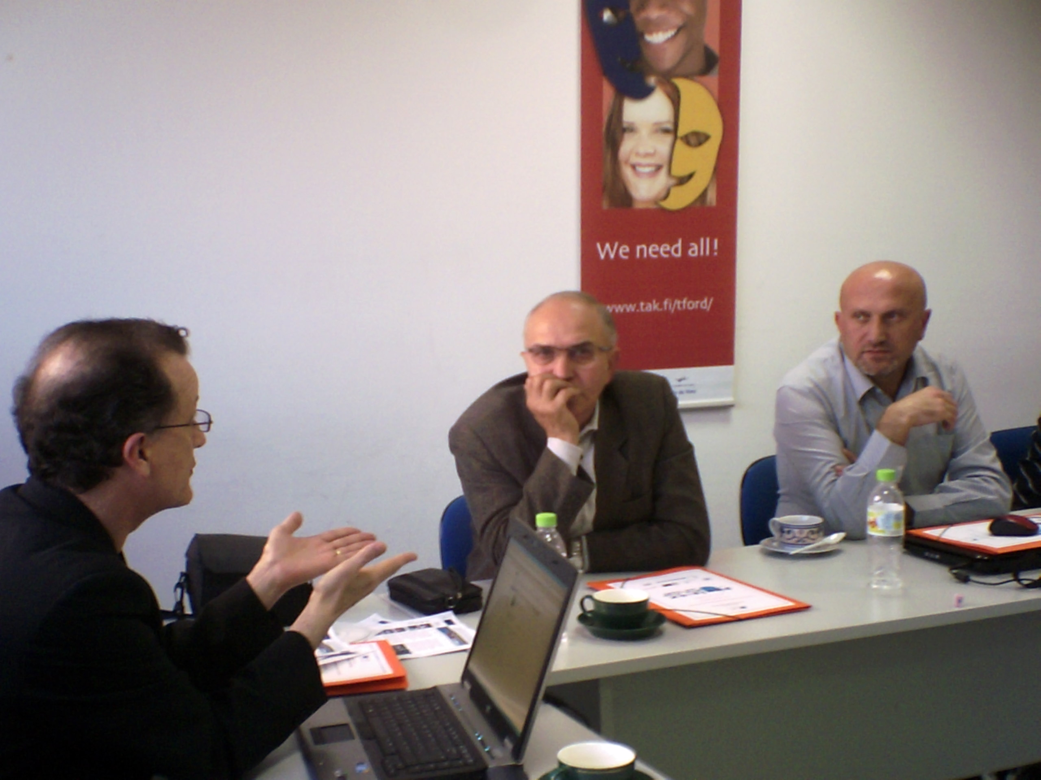

Gordon’s idea of using Vimeo as a working space for the partnership proved to be a very inspired one, and it shows its benefits now. Gordon Wells also suggests that the project coordinator should create a similar group on Utube in order to increase dissemination of the videos produced by the partnership.

In the framework of this topic, Kent Andersen thinks that this group should be open from now on. The Turkish partners suggest it to be a 2 steps process: Sending of invitations to join the group and after this to be opened. Finally, the consortium decided to make the POOLS-CX Vimeo group open to everyone in order to have better and better dissemination results.

As the group will be public, Nikos Zacharoulis notices, the partners must pay attention to the copyrights concerning the music and the images.

At the end of this topic the partnership decide that the next step regarding the dissemination activities will be the creation of POOLS-CX group on Utube.

Other dissemination activities accomplished:
- Burak Demirkazyk: Turkish team used the opportunity of the Education Board of Istambul meeting to disseminate the project and its outputs. Similar dissemination activities were brought to the attention of the 12 European experts in education that attended a meeting in Marmara High School.

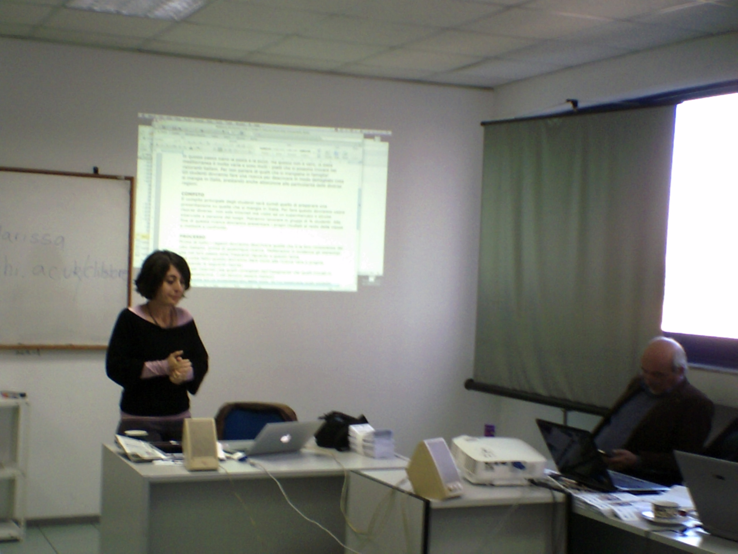

- Marialuce Giusti: Italian team took advantage of an educational event organized in their organization to disseminate POOLS-CX. Students attending courses are also informed about the project and videos produced by the Italian team are used for demonstration and teaching.

Mihai Braslasu asks the opinion of Romanian N. A. representative, Mihai Caramihai about the members of the POOLS-CX team and the way they are working together. Professor Caramihai mentioned that even if he is not a teacher of languages and does not have much expertise in the field so he is convinced that all the materials produced meet the principles set by European Commission.

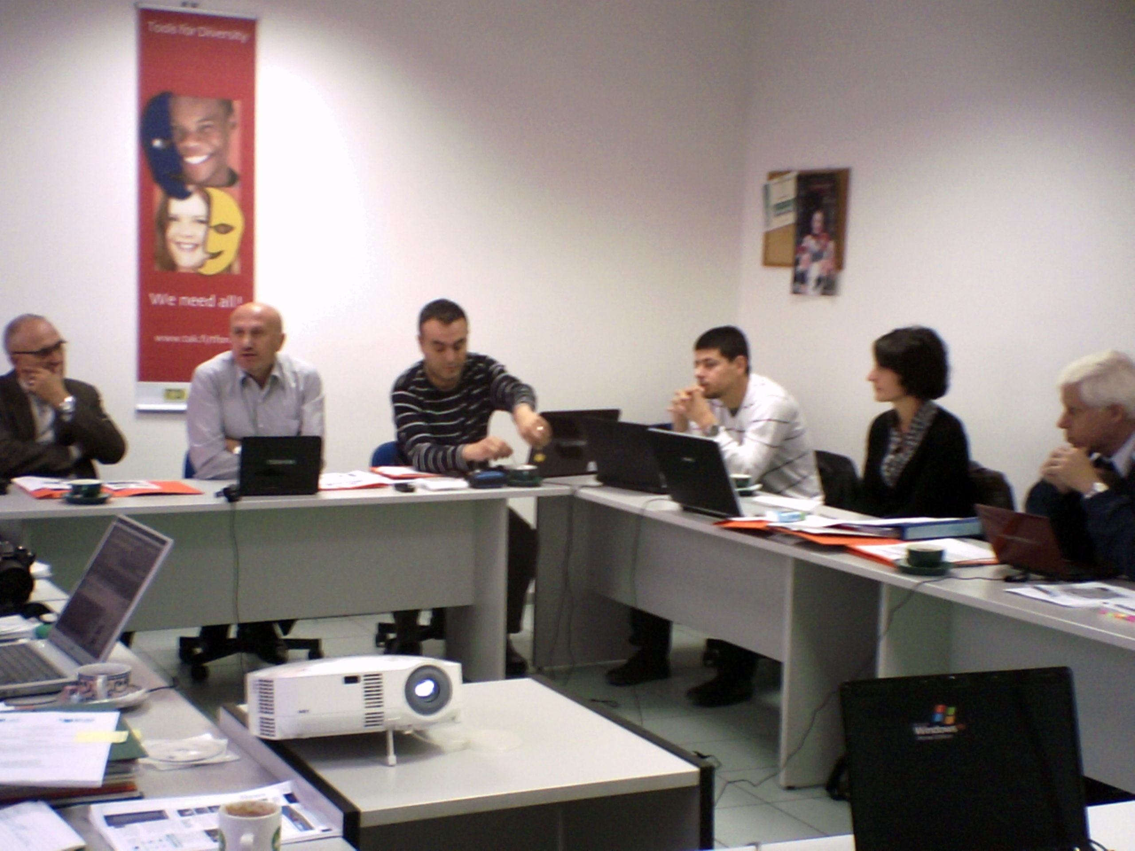

There is positive perspective for the ones that will be produced in the future. Partners should pay attention to the newest developments in the language teaching methodology. Emphasis upon innovative didactics of language teaching should be the main point of interest for the partners and project outputs must bear this mark. Products must also be market oriented.

Professor Caramihai also draws the partners’ attention that all the materials produced must be labelled as being founded by the European Commission.

Next, Mihai Caramihai discusses the process of creating Centers of Excellence in the new partner – countries. He says that the Romanian National Agency is working on the translation from Romanian into English of the procedure that must be followed for the certification of these centers of excellence. Partners can use the procedure for self evaluation. After that, the Romanian National Agency will evaluate these new centers of excellence and certify that they meet the requirements of the methodology.

Regarding POOLS-CX project website, Kent Andersen starts a new discussion topic. He makes some comments – suggestions listed below:
Home page should have more content, and the new teaching materials added, accompanied by pictures, to make the home page more appealing.
- the project website, www.poolscx.eu, must provide information about each partner (detailed description of the partner organization, contact person, email addresses).
- Power point presentations of the project and its outputs must be uploaded.
- “VIMEO” button should be removed until the Vimeo group becomes open to the public. After that, links to the videos produced and uploaded upon Vimeo should be provided from the project website and Facebook group. Friends and students invited to comment upon the content of the videos.
- All versions of the brochure (EN, RO, IT, GR, and TR) should be uploaded upon the website
- The button “FORUM” should be removed as there is the Facebook Group that takes over the discussions about project materials.
- Newsletters must have PDF format.

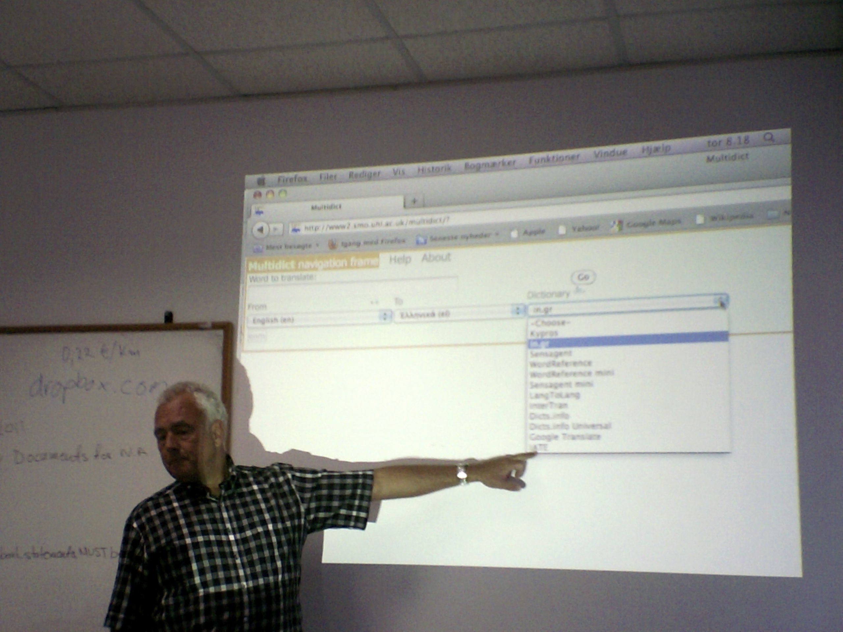

11.45 – 13.00 Quality Management and Monitoring of Project Activities. Mihai Braslasu reminds the partner that, according to tasks in WP2, internal quality management is based on monitoring activities and milestones. Based upon quarterly reports made up by each partner and assessment of products, Quality Assurance Board (Mihai Braslasu, Kent Andersen, Gordon Wells) considers that, up to this point, most of the milestones and tasks included in the Action Plan established in Pistoia were met and quality of products is according to the established standards.

Nevzat KULABEROGLU wants to know more about the kind of standards established for video production. Gordon Wells states that these standards include techniques to be used, themes related to vocational education, cultural background. Quality of image and sound is given by the equipment used. Progress in technology usually ensures the required quality of both sound and image. Consequently, all videos produced by the Greek, Italian, Turkish and Romanian partners have good quality, and they can be used for teaching purposes.

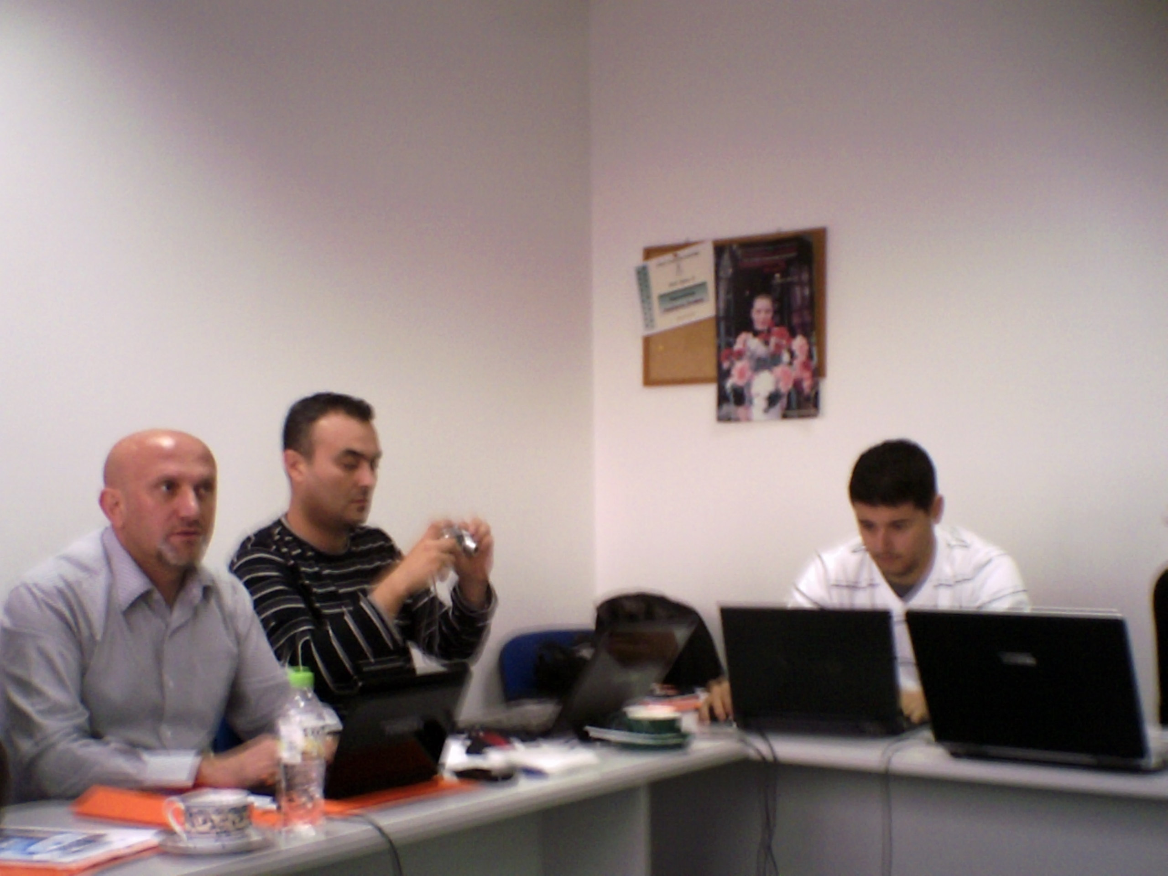

Kent Andersen considers that checking milestones and tasks one by one will give partners a clear image of the progress achieved so far. Analysis reveals the tasks that were not completed or need to be completed in the future, and partners decide upon responsibilities in bringing them to completion as follows:

Activity | Responsible partner | Deadline
Web site development: upload content; remove flags for translations; insert partner description and contact details and logos; change “Forum” into “Facebook”; videos, local brochures produced by each partner; ensure good web statistics | RO Team via project web master RADU OPRISA | 30/06/2011  End of October
Integrate plugins from Facebook to publish on project web site activities and/or friends from FB Project Group. See: http://developers.facebook.com/docs/plugins/ | RO Team via project web master RADU OPRISA | 30/06/2011  End of October
All partners: to produce translation of DIY videos produced by the Romanian team from English into own language of the subtitles.  All partners: recording voice over to be edited by Romanian partner. | All TOI partners | 20/09/2011  January 2, 2012
Romanian Team to produce 10 videos in English on technical / vocational subjects | RO Team | 5 video by 30/10/11  30/11/11  5 video by 30/01/12
To localize in EN, GR, TR, IT the videos made by Romanian Team to produce 10 videos in English on technical / vocational subjects; translations (in utf -8 .txt files) in own language and recording of voice over; send to RO Team translations and audio files (in .wav format); | All TOI partners | 5 video by 30/11/11  30/12/11  5 video by 30/02/12
RO Team to make available in EN, GR, TR, IT the videos editing translations and audio files provided by all TOI partners | RO Team in the person of Bogdan | 5 video by 30/12/11  30/01/12  5 video by 30/03/12

Tuesday, October 11, 2011
Afternoon Meeting

14.30 – 17.30
After ne necessary break for lunch, the consortium continued the meeting with presentations of the videos produced by each team in an alternate way.

The videos that presented by each team were the following:

- C.V.T Georgikis Anaptixis presented the next videos:
- School Materials
- Greek Salad Preparation
- Ordering Fast Food
- Old Stone Bridges in Greece

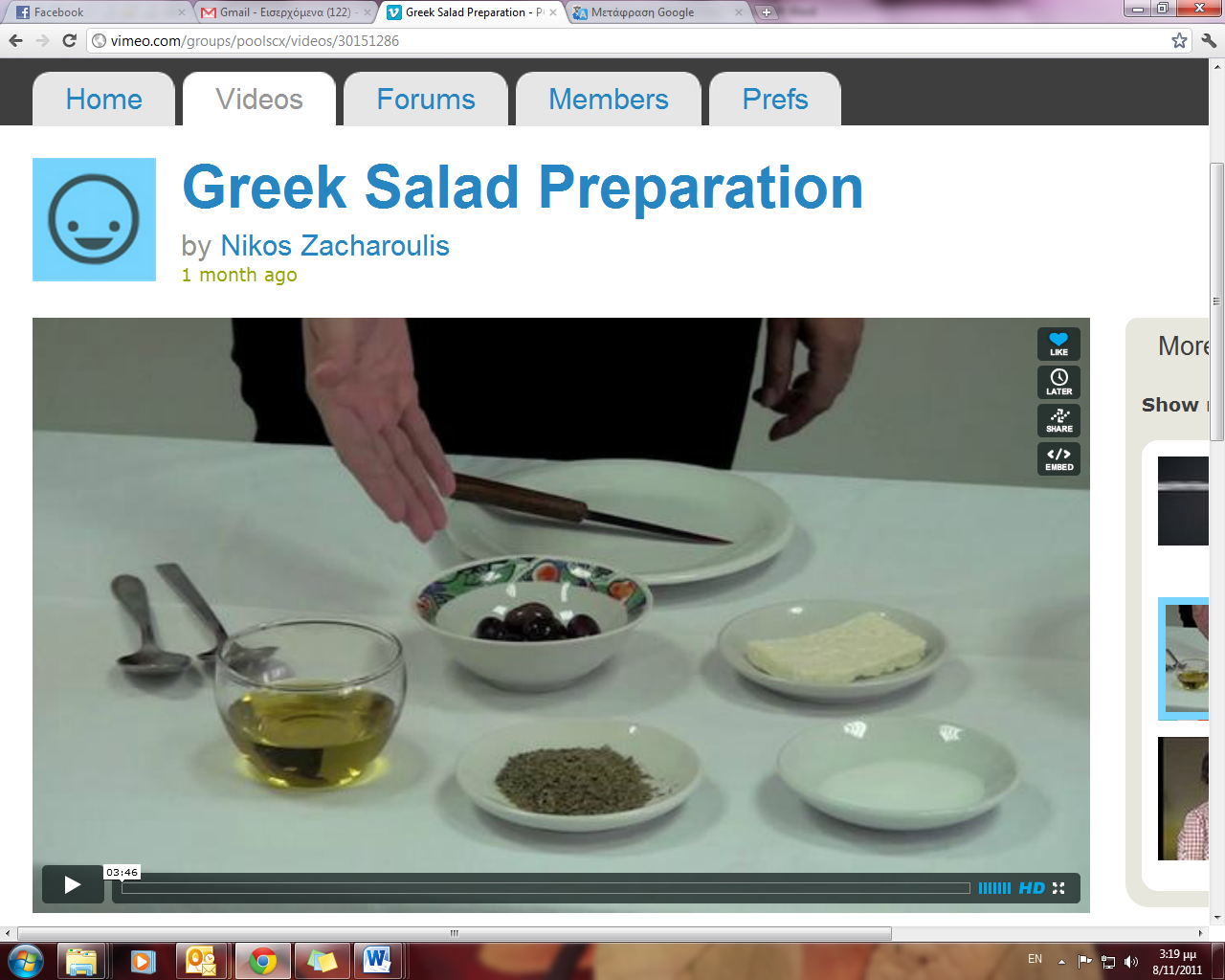

- Özel Marmara Anadolu Meslek Lisesi presented the next videos:
- Maiden’s Tower
- Istanbul and Its Inhabitants
- Why did i decide to attend Marmara Private Anatolian High School to
- If you want to live make everything live
- An Interview with Our Grad Students
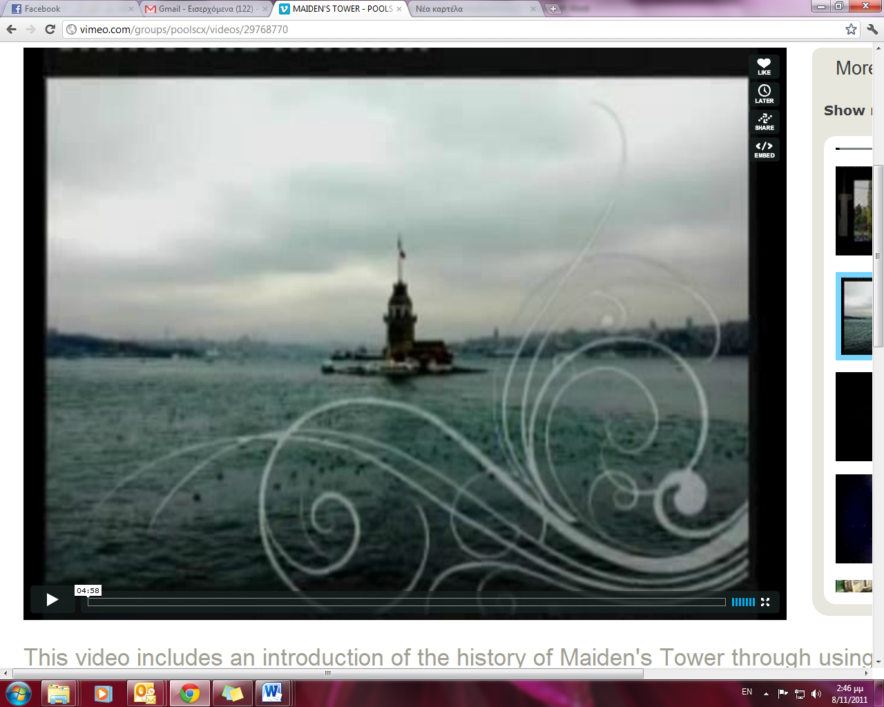
- CSCS presented the next 5 videos, even though have been produced more:
- Visita a Pistoia
- Fare Acquisti
- Andiamo a Pistoia per fare uno stage in azienda
- Primo passo: Trovare Villa Michelina
- Sono malata

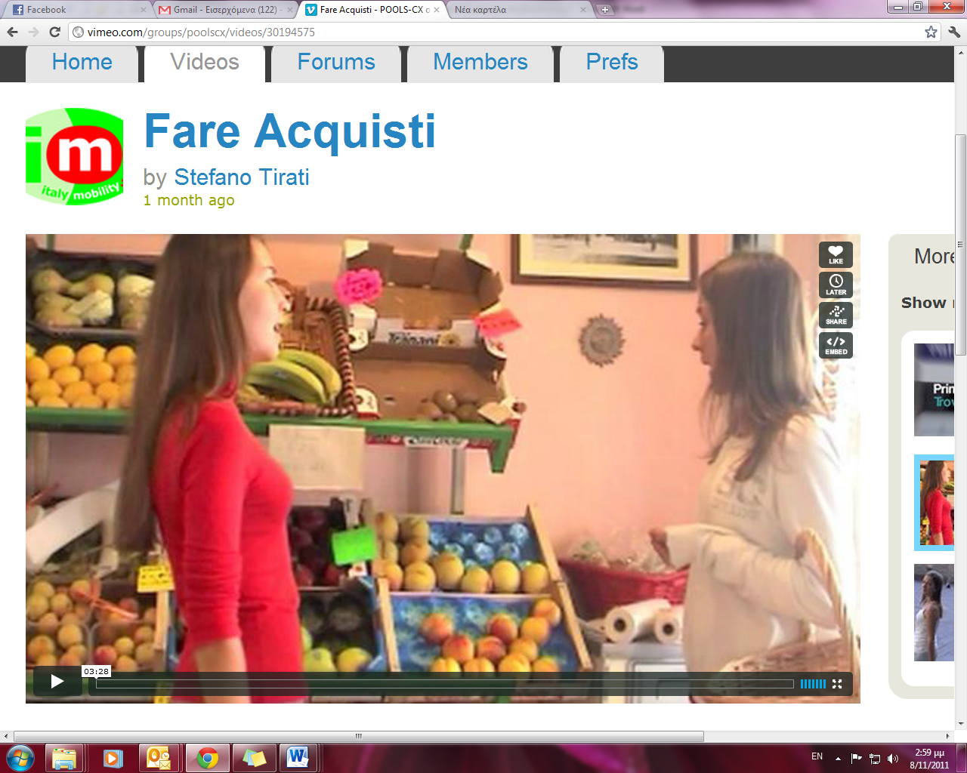

- University of Pitesti presented the videos:
- Cooperage
- Pottery

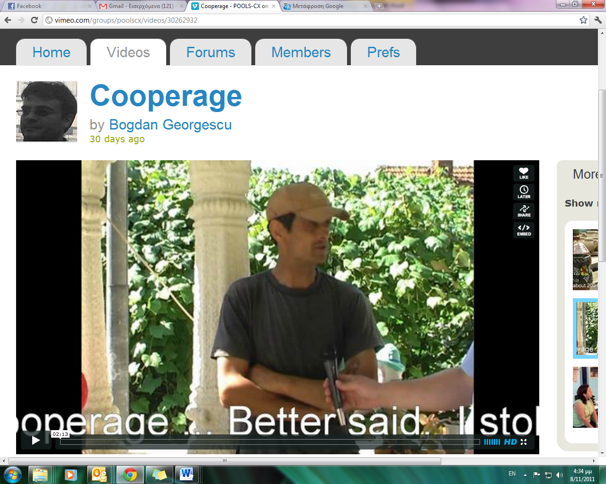
After the presentation of each video, partners, were asked to make comments. So, the summarized comments made by each partner per each team’s video are listed below:

For the Greek language videos:

- The name of objects on “School materials” video is unnecessary
- The speed and quantity of the commentary on “Old Stone Bridges in Greece” video is proper for advanced learners
- The noise of the bag on “School materials” video should be covered
- In general, all the presented videos were in good and acceptable quality

For the Turkish language videos:

- In general, all the presented videos were in good and acceptable quality
- The introduction in “Maiden’s Tower” according to Mr. K. Andersen’s point of view is very large and Mr. G. Wells suggested the music introduction should be cut
- The partnership congratulated the Turkish team for the choice of actors in their videos (actors are students) and for the music background as well, as they have the copyrights of all the music tracks
- In order to have videos with clearer picture Mr. N. Zacharoulis suggested all the videos to be uploaded in higher analysis (not to be so compressed)

For the Italian language videos:

- In general, all the presented videos were in good and acceptable quality
- The voice of people in public places should be more clear
- The noise of the external shootings shouldn’t be so loud
- The idea of having the dialogues of the actors written and spoken by Italian teachers is very helpful for the learners

For the Romanian language videos:

- The subtitles on videos are better to be in Romanian and not in English. It is better and more helpful for the learners
- The subtitles on videos shouldn’t be rolling
- On “Pottery” video the voice, the sound and the image are not synchronized
- The image and voice quality is on high levels

General comments for all language videos:

- At the end of each language video should be put a disclaimer for E.C. (POOLS - CX has been funded with support from the European Commission. This publication reflects the views only of the author, and the Commission cannot be held responsible for any use which may be made of the information contained therein.)
- As some of the partners had a kind of doubts if their videos are proper, suitable and acceptable for language purposes they wanted to know if they have to create other videos or not. After a long discussion the participants decided with the directions of Mr. G. Wells that all the language videos prepared by now are acceptable!

Wednesday, October 12, 2011
Morning Meeting

Attendees
1 | Mihai CARAMIHAI | ANPCDEFP
2 | Andreea LUNGU | ANPCDEFP
3 | Mihai BRASLASU | P0
4 | Constantin TIBRIAN | P0
5 | Kent ANDERSEN | P2
6 | Marialuce GIUSTI | P3
7 | Valentini Chrysovalanto LITSIOU | P4
8 | Nikolaos ZACHAROULIS | P4
9 | Nevzat KULABEROGLU | P5
10 | Burak DEMIRKAZÝK | P5
11 | Yasin BAHÇECI | P5
12 | Gordon Wells | P6

09.30 – 13.30
The second day starts with the presentation of the Interim Report template made by the representatives of the Romanian National Agency. Professor Mihai Caramihai presents the pdf file of the report and explains each part of it and the way it had to be filled in field by field.

Useful information and deadlines for the Interim Report:
- Covered period: 01.02.2011 – 31.01.2012
- Deadline for submission of IR by partners to project coordinator: 29.02.2012
- Deadline for submission of IR by project coordinator to the Romanian NA: 31.03.2012

All the interim report has to be filled in by the coordinator but in some parts the assistance and the contribution of the rest of partners is necessary. Professor Caramihai gives details and examples about the information and documents necessary and relevant for the IR:
a) Section F.1. Work Programme - lists of partners attending each project meeting.
Section F.3.1. Results – fields must be completed for each result.
Section F.3.2. Work Packages – description of the activities in each work package. Only completed results are taken into consideration.
b) Section G. DISSEMINATION AND EXPLOITATION OF RESULTS - partners have to fill in the dissemination activities carried out by each partner – organization on national and/or European level. After this, the coordinator has to make the compilation.
c) Section J. Annexes to the report – necessary documents must reflect and testify activities carried out by partnership, copies of tangible results, dissemination materials, etc.
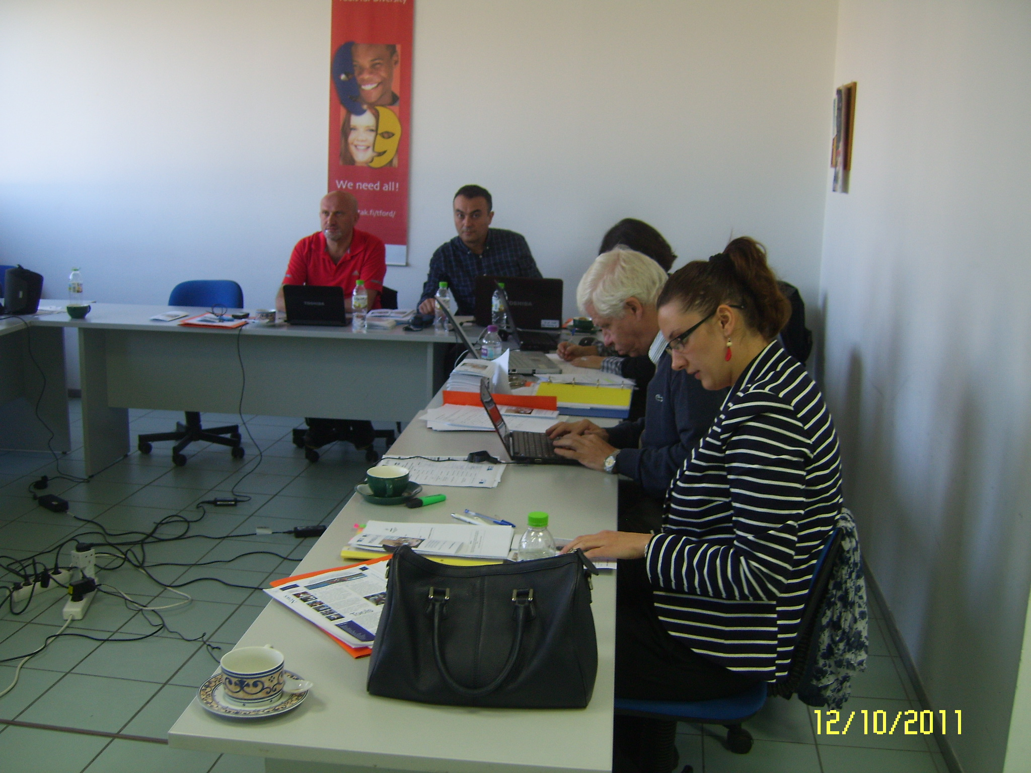
Andreea Lungu, financial officer in the Leonardo da Vinci Financial Department of the NA gives details about financial matters concerning the IR. She also answers questions addressed by partners. A description of the guidelines for financial issues of the project is presented, as well as a detailed description of all the necessary information for eligible costs:
Section K. FINANCIAL REPORT - the coordinator has to fill in the fields according to the interim financial reports and documents sent by the partners. For other currencies than Euro figures must take into consideration the exchange rate of the month project started (February 2011).
- Staff cost
- Staff costs include any salary or remuneration paid to persons employed by a partner’s organization, working permanently or temporary for the project.
- Costs relating to the following categories of staff are considered:
- Statutory staff, having either a permanent or a temporary employment contract with a partner of the consortium. To be considered in this category, staff must report to the relevant partner organization as an employee
- Temporary staff, recruited through a specialized external agency
- Needed Documents for STAFF Costs:
- a list of all personnel employed on the project, showing the exact period that they worked, plus their position
- employment contracts for both permanent and temporary staff
- payroll/salary slips for the project duration
- calculation of the related charges (e.g. pensions)
- bank statements showing payments made to the personnel
- evidence of calculation of the daily rates
- timesheets
- centralized sheet for each staff employee

- Travel and subsistence cost
- Travel and subsistence costs for staff taking part in the project are considered eligible, provided that they are in line with the partner’s usual practices
- Costs may be claimed only for journeys directly connected to specific and clearly identifiable project-related activities

- Travel
- Reimbursement of travel costs must be based on real costs, independent of the means of travel chosen (rail, bus, taxi, plane, rented car). Partners are required to use the cheapest means of travel (e.g. use Apex tickets for air travel and take advantage of reduced fares). Where this is not the case, a full explanation should be provided.
- The travel cost for a journey should include all costs and all means of travel from the point of origin to the point of destination (and vice versa) and may include visa fees, travel insurance and cancellation costs.
- The travel costs include also travel costs to airport or rail station; any other local travel is included in subsistence costs.
- Expenses for private car travel (personal or company cars), where substantiated and where the price is not excessive, will be reimbursed as follows (whichever is the cheapest):
- Either a rate per km in accordance with the internal rules of the organisation concerned up to a max of EUR 0.22 per km.
- Or price of a rail, bus or plane ticket. Only one ticket shall be reimbursed, independently of the number of people travelling in the same vehicle (use internet sites to obtain this type of document).
- For rented cars (maximum category B or equivalent) or taxis: the actual cost where this is not excessive compared with other means of travel (also taking into account any influence factors e.g. late/early hour, excessive luggage). Reimbursement will be made independently of the number of people travelling in the same vehicle.

- Subsistence
- The reported expenses must respect the maximum daily rates published on the website of the NA (the respective National Call for proposals); any surplus will be considered as ineligible. The rate to be applied is the one of the destination country i.e. where accommodation costs are incurred.
- Reimbursement must be based on the existing internal rules of the partner organisations, which may be on actual costs (reimbursement of receipts) or daily allowance basis.
- In either case, documentation evidencing the applied internal rules must be provided.
- In either case, proof of attendance and overnight accommodation (hotel invoice) will be required to substantiate declared costs.
- Subsistence rates cover accommodation, meals and all local travel costs (but not local travel costs part of the travel from point of origin to point of destination – see point a) above).
- In calculating the number of days for which to apply the daily subsistence rate, it should be noted that a full day includes an overnight stay; a full day’s allowance without an overnight stay will not be reimbursed.
- A corresponding reduction must be applied if accommodation, meals and local travel costs are provided for free, by a third party.

- Needed Documents for TRAVEL and SUBSISTENCE Costs:
- Air / train travel:
- plane / train tickets
- boarding passes
- invoice for the plane tickets (if any)
- receipt/payment order/bank statement/other similar document as proof of payment
- Private car travel: any evidence showing the price of a rail, bus or plane ticket (use internet sites to obtain this type of document).
- Rental cars or taxis: invoice, proof of payment or receipts (for taxis)
- Travel insurance: insurance policy
- the statement of expenditure, in accordance to the internal rules of the organization, signed by the persons entitled to do so within the organisation (usually the head accountant)
- if internal rules are based on actual costs: all documents concerning the amounts reimbursed ( the hotel invoice, meal, taxi receipts, etc)
- if internal rules are based on daily allowance: the internal document which mention the amount of daily allowance applied by the organisation, evidence of payment to the person and the hotel invoice to substantiate the number of overnights
- centralized sheet for travel and subsistence costs for each traveling person

- Subcontracting cost
- Staff members of project’s partners are not allowed to operate in a subcontracting capacity for the project.
- Costs are based on a verifiable estimate or, if the subcontractor is identified, on the basis of an offer. The estimate/offer will cover all costs (i.e. staff costs plus travel costs, etc.).
- The Beneficiary shall award the contract to the tender offering best value for money, that is to say, to the tender offering the best price-quality ratio, in compliance with the principles of transparency and equal treatment for potential contractors, care being taken to avoid any conflict of interests.
- Contracts with a value below EURO 12.500 can be paid simply on presentation of an invoice.
- Needed Documents for SUBCONTRACTING Costs:
- subcontracting agreement
- invoices corresponding to the carried out task,
- receipt/payment order/ bank statement/ other similar payment document

- Other costs
- Only activities which are specific and necessary for achieving the goals of the project may be considered eligible
- All costs related to the administration of the project e.g. consumables, supplies, photocopying costs, telephone costs, internet access, paper, etc., are covered by the indirect costs of the project
- Needed Documents for OTHER Costs:
- invoices
- receipt/payment order/ bank statement/ other similar payment document
- Indirect cost
- The indirect costs of the project eligible for Community funding is a flat rate amount, set at a maximum of 7% of the total amount of eligible direct costs. As these costs are a lump sum, they won’t be justified.

- GENERAL RULES

The supporting documents should be:
- clearly and well photocopied, dated (not legible documents will be considered as ineligible)
- issued by an institution other than the partner (not produced internally)
- certified by each organization’s signature (with the name of the person signing written in clear) and bearing the phrase:”True to the original, paid from the Project number LLP/LdV/TOI/RO/….”;
- briefly translated (explain the nature of expenditure/ task carried out) in English if they are issued in other language.
- The exchange rate and the amount in euro must be mentioned on the supporting financial documents issued in national currency.
- The exchange rate can be found in… and it is taking into account the month of agreement signed.

As Partner 1, European Forum of Technical and Vocational Education and Training (EfVET), is involved only in dissemination activities, IT, GR, and TR partners want to know whether parts of the budget allocated to this partner can be redistributed, the representative of the NA indicates the way it can be done: Amendment request filled in by the project coordinator and sent to the NA to be approved.
At the end of the session, representatives of the NA draw the attention of the project partners that all the photocopied documents sent to the project coordinator must bear the inscription True to the original, be signed and stamped by the legal representative of each organization.

Wednesday, October 12, 2011
(Afternoon Meeting)

14.30 – 15.30
The consortium continues the meeting procedure with the demonstration of Wordpress blogs made by Gordon Wells. Firstly, Gordon Wells presents his own page – profile – blog on Wordpress as an example (http://gordonwellsuist.wordpress.com/). He describes it as “a system whereby anybody can upload whatever he/she wants (texts, images, videos, audios, links, etc.), like a diary, and anyone can comment each post”. You can create a text and a link. If you add a picture and click on it, this may open a new link.
RECENT POSTS helps other people find the needed material easily. Other people can add comments to one of the posts. RECENT COMMENTS helps them do it. Gordon then speaks about TAGS, BLOG ROLL, e-MAIL SUBSCRIPTION and ARCHIVES as other possibilities offered by Wordpress.

After these detailed explanations given to the partners about Wordpress’ basic functions, Gordon asks them to create their personal Wordpress profile. Furthermore, all the partners create their first post on Wordpress including a video and a link (e.g. http://valentinilitsiou.wordpress.com/).
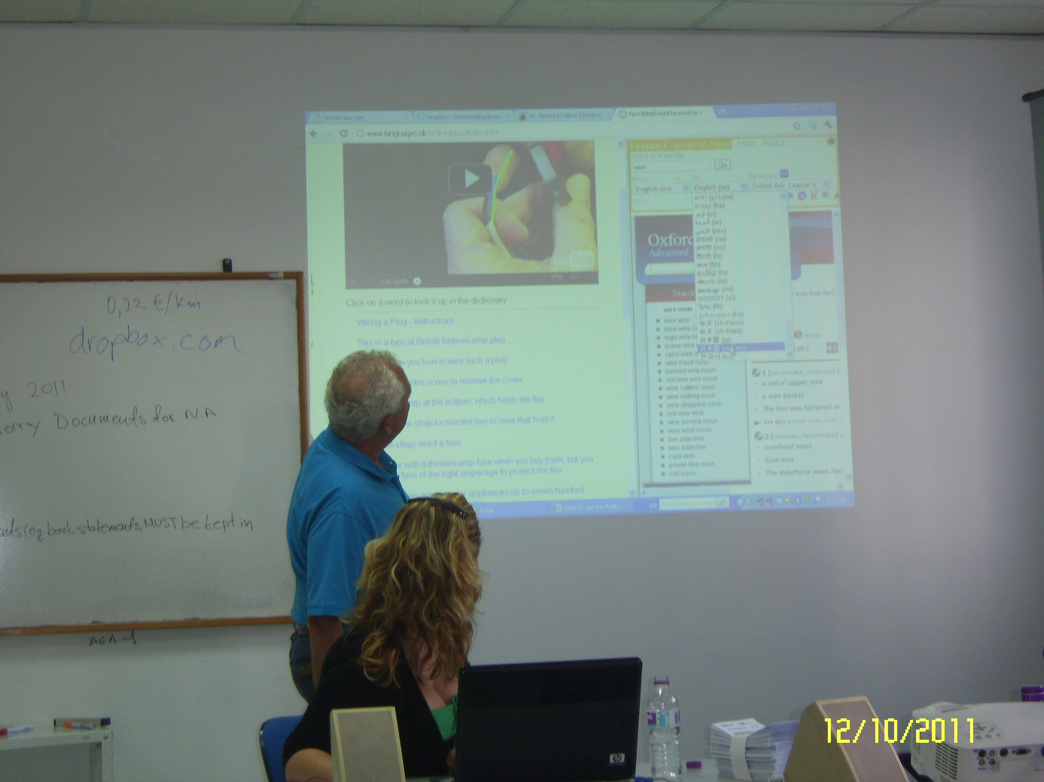
15.45 – 17.30
The second meeting day continues with Kent Andersen’s introduction to Multidict and the use of posts from Wordpress in Multidict in order to link web pages word by word to online dictionaries. The procedure is presented step by step:
- Go to: http://multidict.net/
- Choose the option: Wordlink - link web pages word by word to online dictionaries (http://www2.smo.uhi.ac.uk/wordlink/)
- Paste the preferable link from Wordpress profile or from anywhere else
- Click on: Go. Translation from source to target language appears on screen.

Following the above presentation, Kent Andersen speaks to the partnership about the useful webpage http://www.shorturl.com/ which is a free URL forwarding service allowing anyone to take any existing URL and shorten it. The procedure is very simple; just type/paste a URL in the White box to shorten it and clicking the “Create” button the short URL will appear. The important thing here is that it never expires and lasts forever.

Kent Andersen introduces practical way of storing information and using it whenever and wherever necessary to the partners: www.dropbox.com. Files and folders can be kept safely and used when necessary. Online connection is necessary and creating personal accounts. Kent makes a step by step demonstration and then asks each partner to create accounts, assisting them in the process.

At the end of the second working day and as an introduction to the next day workshops Kent Andersen takes advantage of the POOLS teaching materials stored on www.languages.dk. He will use Wiring an British Plug, one of the first step by step video presentations, to create online teaching materials the next day.

Thursday, October 13, 2011
(Morning Meeting)

Attendees

1 | Mihai BRASLASU | P0
2 | Constantin TIBRIAN | P0
3 | Kent ANDERSEN | P2
4 | Marialuce GIUSTI | P3
5 | Valentini Chrysovalanto LITSIOU | P4
6 | Nikolaos ZACHAROULIS | P4
7 | Nevzat KULABEROGLU | P5
8 | Burak DEMIRKAZÝK | P5
9 | Yasin BAHÇECI | P5
10 | Gordon Wells | P6

09.00 – 09.30
The third meeting day starts with the presentation of Kent Andersen about “Ways of language learning and innovative means of exchange”. Communicative methodologies like Computer Assisted Language Learning, Task Based Learning and Content and Language Integrated Learning are the main topics of the presentation. Links to specialized websites are provided. The slides of the above presentation can be seen in Annex 2.

09.30 – 12.00
After this, the consortium continues the meeting with an exercise using “Wiring a British Plug” as an example. Divided into 5 groups and after watching the video and some Hot Potatoes exercises, partners are asked to wire a British plug under the directions of Kent Andersen.

Thereafter, the same Mr. Kent Andersen makes an introduction to Webquests and presents some examples. Enough time was given to the participants at the meeting in order to prepare a Web quest per partner organization. After the compilation of the Webquests one representative of each partner organization presents the Web quest created:
- Marialuce Giusti from CSCS
- Nevzat Kulaberoğlu from Özel Marmara Anadolu Meslek Lisesi
- Valentini Litsiou from C.V.T. Georgikis Anaptixis

The Web quest that receives Kent Andersen’s best comments and higest appreciation is the one created by was the Turkish! It is minutely detailed, and it is accompanied by a table explaining all the steps followed, as well as an explanation of the degree of complexity according to the Common European Framework of Reference for Language Learning (CEFR).

12.30 – 13.30
Partners discuss about internal communication. Gordon Wells gives details about the Quality Assurance Board meeting held the previous evening. First issue – assessment of the deadlines and how realistic they are. Conclusion – taking into consideration outputs of the project and milestones to be met, it is important to avoid delays. Romanian team has important responsibilities in this respect. Mainly the deadlines missed in video production. It is also notified that partners have to communicate with each other mainly by e-mails. Suggestions below are given by the QAB (M. Braslasu, K. Andersen and G. Wells):
- Checking the mailing list (see whether all partners are included).
- Use of Reply to all when sending messages. Check if the sent e-mail was read by all receivers.
- Quick answers - receivers have to reply within 24 working hours, at least let know that they have received the e-mail.

The milestones and tasks that have to be carried out the partners regarding the DIY videos are discussed. They are summarized as follows:
- Production of DIY videos by the RO team
- Preparation of EN text by the RO team
- Preparation of voice – over by IT, TR and GR teams

Furthermore, in the framework of peer to peer review, all the partners are requested to comment upon the videos uploaded on Vimeo using the Forum box. In this respect, Burak Demirkazyk wants to get relevant feed back upon the quality of the videos produced by the Turkish team. Without partners’ peer reviewing it is difficult for one to know whether the quality of the videos meets the standards.
On the other hand, as Nikos Zacharoulis affirms, each partner has full responsibility for what was produced. Suggestions, criticism are necessary to increase quality. QAB decides that Gordon Wells has the final decision upon quality of these videos.

Thursday, October 13, 2011
(Afternoon Meeting)

14.30 – 15.30

Under the directions of Kent Andersen the partners create a webpage in the DropBox “Public folder” for the needs of the forthcoming exercises. The workshop continues with the next topics delivered by Kent Andersen:
- Introduction to Text Blender
- Introduction to Hot Potatoes
Kent Andersen first makes a presentation of Clilstore, the main tool in producing online exercises starting from videos suitable for language learning and their transcription: http://multidict.net/clilstore. He then makes a step by step presentation of the site and the didactic opportunities it offers.
Partners are challenged to produce their own exercises.

15.30 – 17.00
Assisted by Kent, partners follow the procedure and produce their own exercises. These exercises are then saved in DropBox. Links can be given to students afterwards and in order to learn how to use Text Blender to translate words and phrases from source language to target language (IT to TR for example)

Next session is dedicated to Hot Potatoes and exercises that can be created using this free educational software. JCross, JMatch, JCloze, JQuiz, JMix and the Masher are used by Kent Andersen to create online exercises starting from a given text.

Partners create their own exercises following the examples given by Kent.

17.00 – 17.30
In the last part of the workshop partners make a final evaluation of the Web Quests:
- Marialuce Giusti - Sai doverro come si mangiare in Italia?
- Nevzat Kulaberoglu – Subtitling a new movie
- Valentini Litsiou – Organizing a trip to Meteora.
Also, the partnership discusses the content of the questionnaire prepared by Kent Andersen for the participants to the in-service courses. After examining each topic of the questionnaire the consortium decides to make some changes. The modified questionnaire can be seen on Annex 3.

At the end of the day Kent Andersen asks each of the teams to produce a set of similar exercises based on one of the videos they produced and uploaded on Vimeo. Each team has to send the link to him until Tuesday, 18th October 2011, the latest.

Friday, October 14, 2011
(Morning Meeting)

Attendees
1 | Mihai BRASLASU | P0
2 | Constantin TIBRIAN | P0
3 | Kent ANDERSEN | P2
4 | Valentini Chrysovalanto LITSIOU | P4
5 | Nikolaos ZACHAROULIS | P4
6 | Burak DEMIRKAZÝK | P5
7 | Yasin BAHÇECI | P5
8 | Gordon Wells | P6

9.30 – 10.00
Morning workshop begins with a presentation made by Kent Andersen. He demonstrates how to make printed exercises with Hot Potatoes.

10.00 – 10.30
Presentation of the exercises produced the previous day by the teams. Difficulties encoutered during this prcess are discussed and ways to overcome them are indentified.
10.30 – 11.30
Preparing a lesson plan which leads to communicative activities based on Task Based Learning. Kent Andersen discusses the structure of a lesson plan including on line exercises. Lesson plan includes:
- Number of students
- Level of students + learning styles
- Lesson’s aims
- Lesson’s items:
- Watch video + read
- Complete exercises
- Debate or use of material

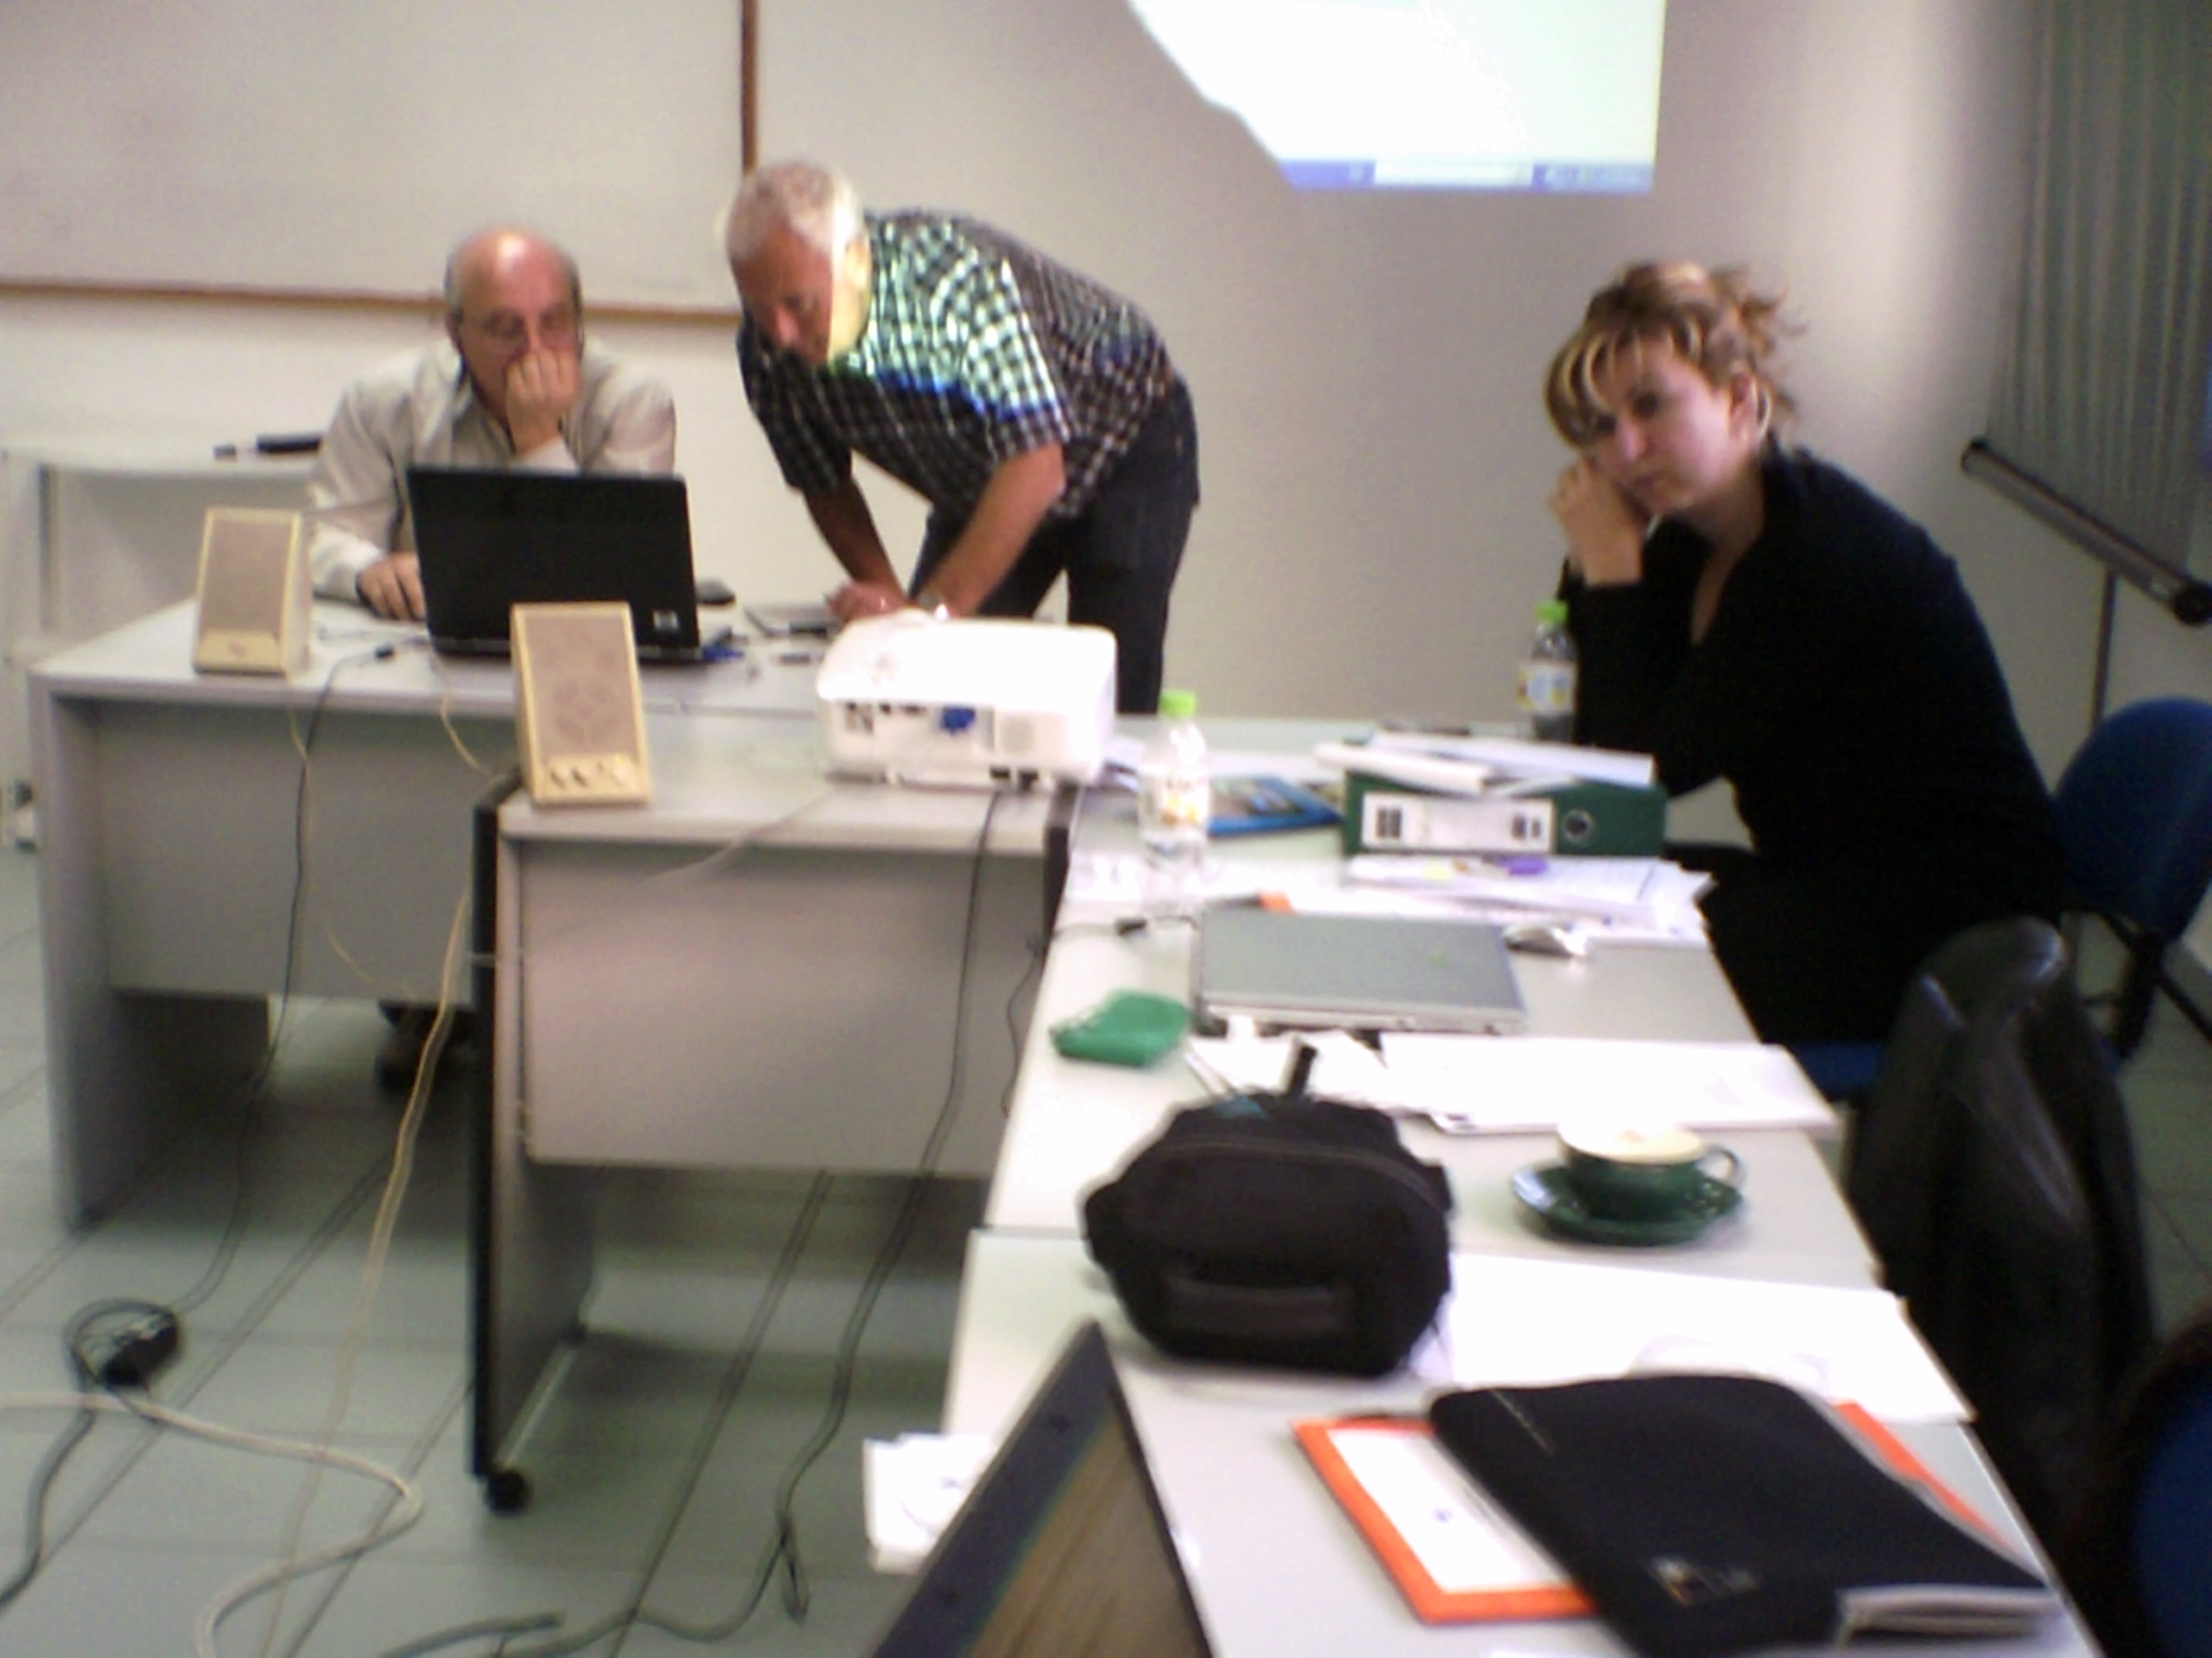

11.30 - 12.30
The main issue discussed focuses upon the structure of in service courses. Each course should walk through similar items where participants:
- prepare exercises and activities
- make a lesson plan (to be piloted in own classes)
- submit students’ evaluations and own description of experience
- get feedback from course instructor
- prepare and submit a post evaluation (value of using Computer Assisted Language Learning as seen one or two weeks after having tested the lesson plan in own classes).
- receive last feedback from course instructor.
The structure of the courses includes:
- 16 lessons delivered F2F by the trainer/instructor
- 16 lessons dedicated to individual work of the trainees
- 2 lessons during which the trainer/instructor receives on line feed back. Same feed back can be sent by mail
- 4 lessons dedicated to testing of the online exercises in classes
- 2 lessons where feed back is provided by the trainer/instructor.
A total of 40 hours during which students work according to the above structure of the couses.
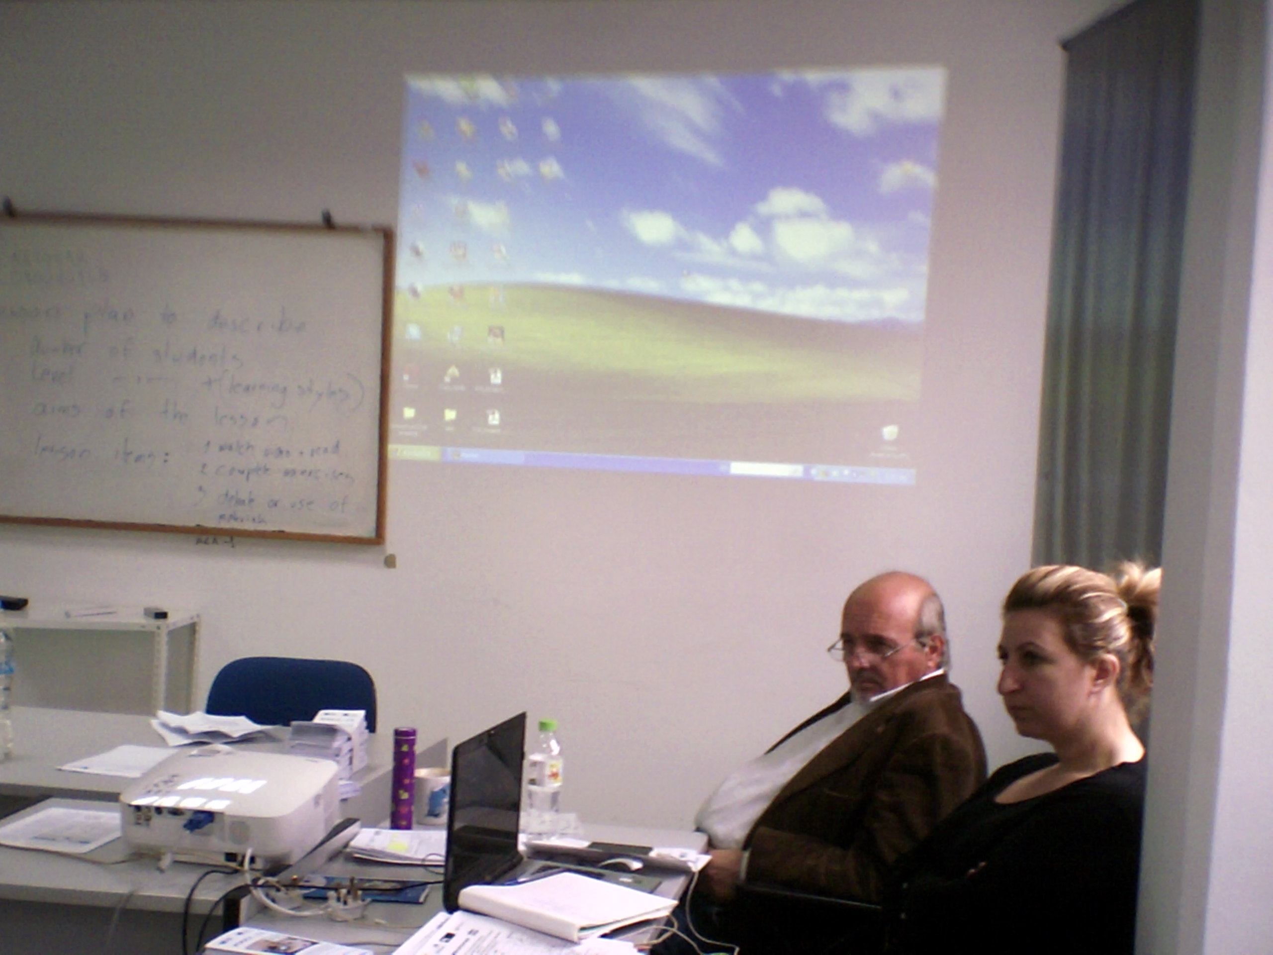
From Nikos Zacharoulis’s perspective the structure of the courses can include:
- 16 lessons (trainer and trainees working F2F)
- 20 lessons dedicated to distance learning (trainer and trainees communicate if/when necessary
- 4 lessons during which the trainer/trainees test the on line exercises in their own classes with students.
The same amount of 40 working hours results.

Discussing the alternatives, partners come to the conclusion that flexibility of the structure is necessary. Analysis of needs is also necessary. This way, each of the three teams (IT, GR, TR) find out the courses trainees are interested to attend. Trainers must cover most of the modules in the Course Description. Annex 4 includes a detailed description of the course structure.

The in service courses (two sessions) must be delivered for free. No fee for the courses. Attendance lists are necessary.
At the end of the project:
- project coordinator sends the certification according to the standards and indicators of the Romanian NA testifying that the partner organizations are certified as Centers of Excellence in the frame of POOLS – CX project, in order to avoid problems with the National legal framework of each country;
- courses can be accredited by each partner, according to the specific rules of each partner country. Whether they continue to be delivered for free or attendants pay a fee is the decision of each partner.

Friday, October 14, 2011
(Afternoon Meeting)

14.30 – 15.00
Partners take final decision on how the in service pilot courses will be described / advertised and actual lesson plan (documents are to be mailed to Kent Andersen for feedback). The same for the evaluation of pilot courses (trainer’s/instructor’s and participants’ evaluation questionnaires). Proposals to improve the courses coming from trainers/instructors and attendants/trainees must be collected and included in the final structure of the in service courses.

15.00 – 15.30
Partners discuss ammendments to the WP. Nikos Zacharoulis draws the attention to WP 3 Dissemination. He considers that dissemination of project during 2 national conferences is impossible for the Greek partner. Change suggested:
Two national conferences (80 participants at least), four presentations (approximately 30 participants per presentation), 3 seminars (20 attendants per seminar) two newspaper articles per year, and at least one TV presentation per year (5 to 10 minutes) will be used by each partner the project coordinator to advertise and disseminate the project outputs.

Other changes concern WP 7. Editing, adaptation and compilation of the project outputs:

- DIY DVDs (with subtitles, 2.000 copies, translated in the 4 languages), they have already been done, those that kent gave in larissa!!!
- Videos suitable for eLearning content (500 copies with subtitles in English, in GR, IT and TR)

The course, the manual and unit examples, translated in RO, EN, DK, EL, IT, and TR will be published on the project web site. 180 printed copies (30 in each language: RO, EN, DK, EL, IT, and TR) will be produced by the Romanian project coordinator and sent to each partner.

The 500 copies of 20 online videos suitable for eLearning content will include 20 videos for each of the new partner languages (GR, IT, and TR).

The above changes, as well as the changes in the budget discussed, are to be included in the Amendment Request form by the project coordinator and submitted to the approval of the NA before the completion of the IR.
External Evaluator, Boian Savtchev, has to be reminded by project coordinator to sent project meeting evaluation questionnaire to the attendants the week after the the end of 3rd project meeting.
At the end of discussion, evaluation of workshop is made by Mihai Braslasu.
16.00 End of workshop
The third meeting of POOLS – CX LdV project which was held in Larissa, Greece is closed with a short speech delivered by the project coordinator Mihai Braslasu. He thanks all the partners for their contribution to the progress of the meeting. Special thanks to Kent Andersen, the main actor of the workshops, and to Gordon Wells as well. Warm thanks to the Greek colleagues for their hospitality and their efforts for organizing and running in a remarkably successfully way the 3rd trans-national partnership meeting.

The President and Legal Representative of C.V.T. Georgikis Anaptixis thanks all the partners for their participation.

Sunday, October 15, 2011

Departure and travel

POOLS-CX AGENDA

Project Meeting and Workshops in Larissa, Greece

October 10 -15, 2011

Meeting place: C.V.T. GEORGIKI ANAPTIXI, Str. Socratous, no.111

Monday, October 10, 2011
Arrival of teams and check in at Park Hotel (31st August St. 1, Larissa, Greece, 41221, Telephone: +302410257071)
8.00 pm – Informal meeting – hotel lobby

Tuesday, October 11, 2011
Project Meeting
Morning Meeting
8.30 Meeting with Valentini at the hotel lobby in order to go all together to C.V.T. G.A. by bus
9.00 Welcome by Valentini Litsiou and Nikolaos Zacharoulis
9.15 Walkthrough the meeting and workshop agenda items (Mihai Braslasu)
9.30. Dissemination activities (brochure, EuroCALL conference, project website, Vimeo group, Facebook group, newsletters)
10.15 Quality management and documentation
11.15 Check on milestones and tasks - each partner presents achievements and activities
12.45 Milestones met if not how and when can we catch up?

13.15 Lunch

Afternoon Meeting
14.15 Presentation of videos produced by the RO team
14.45 Presentation of videos produced by the IT team
15.15 Presentation of videos produced by the EL team
15.45 Presentation of videos produced by the TR team
16.15 Demonstration of Wordpress blogs by Gordon Wells
17.00 All teams create a blog with text, photos, and an embedded video
Wednesday, October 12, 2011
Workshop
Exploitation of results – first piloting of the Course Book and Course Description

Morning Meeting
9.30 Administrative procedures and documentation needed for the Interim Report: Mihai Braslasu – Mihai Caramihai NA
10.30 A primer on CALL methodology with a pedagogical framework for computer assisted language learning (based on task based learning): Kent Andersen
11.30 Sample unit where the participants test the framework based on an exercise called “Wiring a British Plug”
12.30 Short introduction to Webquests* by Kent Andersen

*Call unit examples for the courses:
Each team prepares one or more Web Quests. The materials should be made online with Dropbox.com See some example Web Quests:
http://www.languages.dk/methods/call/WebQuests/LightRailQuest/index.htm
http://www.languages.dk/methods/call/WebQuests/WebQuest_EU.pdf
http://www.languages.dk/methods/call/WebQuests/Valladolid.pdf

13.30 Lunch

Afternoon Meeting
14.30 Development / adaptation of Webquests in Greek, Italian, and Turkish (and Romanian)
16.00 Presentation of questionnaires to assess impact, success and satisfaction indicators.
Parallel with the Web quest development the Quality Assurance Board has a meeting (Mihai Braslasu, Gordon Wells, and Kent Andersen). Suggested meeting items are optimization of project coordination, frequency of contacts and reminders to partners, and how to ensure the proposed project impact and future exploitation.
17.00 Decision upon the final form of the questionnaires
17.30 Financial reports – difficulties, reports, questions, etc. Mihai Braslasu – Andreea Lungu NA

Thursday, October 13, 2011
Workshop
Preparation of the in-service courses
Morning Meeting

09.30 Results from the QAB meeting by Gordon Wells
10.30 Debate on communicative methodologies like TBL and CLIL: Kent Andersen
10.45 Installing DropBox and how to make exercises online: Kent Andersen
11:15 The Webquests are placed online and the links put into the Facebook group
11:45 Introduction to Multidict, what is needed to teach the future course participants and their students?
12.15 Introduction to Wordlink features: “Compose” and “Process a webpage”
12.45 Each team creates a webpage in the DropBox “Public folder” and place the link in the Facebook page

13.30 Lunch

Afternoon Meeting
14.30 TextBlender introduction. Each team makes a webpage with the TextBlender using one of the videos that have been produced. Kent Andersen
15.30 Hot Potatoes primer Kent Andersen
16.30 Hot Potatoes primer continued, each team prepares sample exercises
Friday, October 14, 2011
Workshop
Structure of the pilot courses

Morning Meeting
9.30 How to make printed exercises with Hot Potatoes. Kent Andersen
10.00 Presentation of the exercises produced by the teams
11.30 Preparing a lesson plan which leads to communicative activities based on Task Based Learning: Kent Andersen
12.30 Proposed structure for future courses:
Each course should walk through similar items where participants:
- prepare exercises and activities
- make a lesson plan (to be piloted in own classes)
- submit students’ evaluations and own description of experience
- get feedback from course instructor
- prepare and submit a post evaluation (value of using computer assisted language learning seen one or two weeks after having tested the lesson plan in own classes).
- receive last feedback from course instructor.

13.30 Lunch

Afternoon Meeting
14.30 Decision on how the pilot courses will be described / advertised and actual lesson plan (mailed to Kent Andersen for feedback), evaluation of pilot course both experience of instructor and the participants (mailed to Kent for feedback). How to improve the courses
15.00 Evaluation of workshop
16.00 End of workshop

Saturday, October 15, 2011

Departure and travel

N.B.
- Don’t forget to bring a laptop computer
- Remember to keep your boarding passes/original travel documents and receipts
- Please note that meals, drinks etc. due to the EU regulations set out in the financial handbook have to be paid by each participant / national team (the cost is of course covered by the per diem).

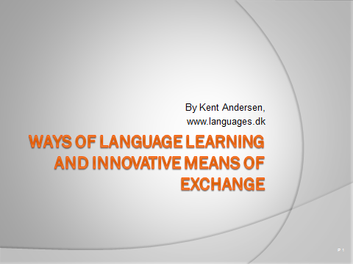

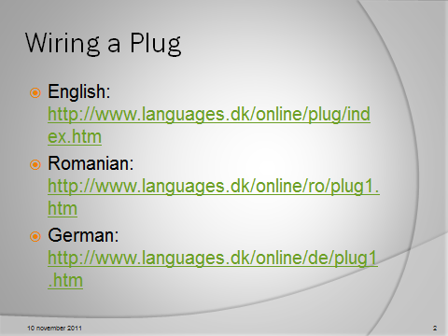

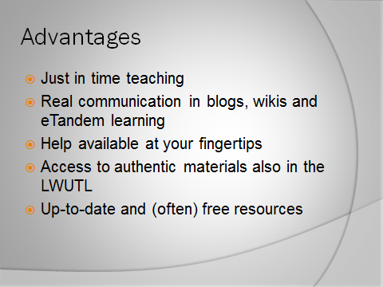

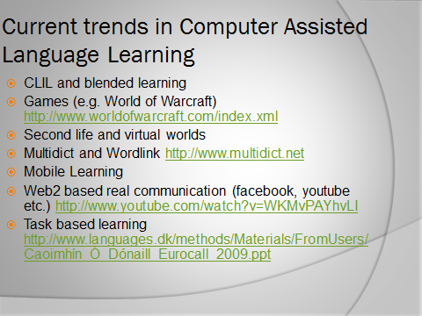

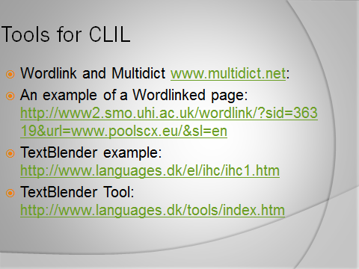

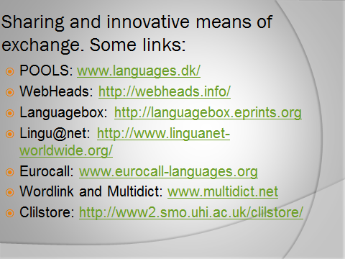

Please assist us with improving the pools-2 courses by indicating your level of agreement with the following items using the scale below:

5 ++ Excellent
4 + Very good
3 +/- Good / acceptable
2 – Weak
1 - Poor

The course venue was of sufficient quality (access to Internet, computers, etc.)? |  | 5  ++ | 4  + | 3  +/- | 2  - | 1  -- | n.a.

The course materials were of good quality |  | 5  ++ | 4  + | 3  +/- | 2  - | 1  -- | n.a.

The time for working on the course items and content has been sufficient |  | 5  ++ | 4  + | 3  +/- | 2  - | 1  -- | n.a.

There was sufficient time and possibilities for discussions? |  | 5  ++ | 4  + | 3  +/- | 2  - | 1  -- | n.a.

The presentations and demonstrations during the course had good quality were well prepared |  | 5  ++ | 4  + | 3  +/- | 2  - | 1  -- | n.a.

Your own ideas were listened to and taken into account? |  | 5  ++ | 4  + | 3  +/- | 2  - | 1  -- | n.a.

After the in-service period of the course you now have a clear vision of your next tasks to complete the course |  | 5  ++ | 4  + | 3  +/- | 2  - | 1  -- | n.a.

You now feel you have the needed competence to have a start at using computer assisted language learning with your students? |  | 5  ++ | 4  + | 3  +/- | 2  - | 1  -- | n.a.

The course was seen as a whole appropriate and productive? |  | 5  ++ | 4  + | 3  +/- | 2  - | 1  -- | n.a.

What I liked best about the course:

What I think could be improved:

What was new for me:

I would also like to take a course in: Other comments

Pools-CX pilot course on Computer Assisted Language Learning

Suggested structure: Two days course either in your institution or in our centre, two and a half days course online (individual work supported by our instructor), and a day testing and evaluating the outcome in own classes. The full value for the participants matches a five days course.

After the lessons the participants can:
- Teach their students how to make use of smart phones, tablets, and/or computers for dictionary lookups between English and 100+ languages (using the Multidict service – free)
- Link webpages, like newspapers etc. word by word to 100+ languages (using the Wordlink service- free) This is not a simple Google Translate, but a teaching tool.
- Create crossword puzzles that can work as print outs on paper or as online exercises. (Use of Hot Potatoes)
- Create “fill in the blank” exercises that can work as print outs on paper or as online exercises. (Use of Hot Potatoes)
- Create quizzes, multiple choices, and short answer exercises online. (Use of Hot Potatoes).
- Create “mixed words exercises” where the words in a sentence are mixed and the students have to drag and drop them in place. (Use of Hot Potatoes)
- Use a free service to put exercises online for students working at home or in classes (use of Dropbox public area)
- Use a free service (the Clilstore) to create online exercises / web pages where all words are linked to 100+ languages. The exercises can make use of graphics, audio, and video (e.g. from You tube and Vimeo)

The participants will have achieved ideas about how to use ICT in a pedagogically sound way (not “drill and kill”) for supporting communicative lessons.

The above represent some ambitious competences, but the evaluations from previous courses run in 2010 and 2011 in Italy, Lithuania, Cyprus, and Portugal show that it is possible even within the limited scope of lessons.

Proposed lesson structure:

Lesson block one (four lessons)
- Introduction to current communicative ideas behind CALL (Computer Assisted Language Learning)
- Use of Multidict for accessing hundreds of online free dictionaries from e.g. smart phones (students may look up words in their native languages)
- Use of Wordlink for linking webpages word by word to online dictionaries
- Hands on use of Multidict and Wordlink
- Hands on experience of online exercises, e.g a Task Based Lesson “Wiring a Plug”

Lesson Block Two (four lessons)
- Registration and downloading of the Dropbox software. The software is free and gives users free online storage of 2GB data (e.g. 1000 webpages created with Hot Potatoes), using a “public folder” in Dropbox the materials become immediately online; can thus be used by your students anywhere with e.g. smartphones and iPads
- Introduction to the Hot Potatoes software
- Download and installation of Hot Potatoes
- Walkthrough of the Hot Potatoes exercise types (Cloze, Cross Word Puzzles, Quizzes, and mixed words exercises)
- Hands on creation of Hot Potatoes exercises made online in Dropbox
- How to print out the exercises for use in classes without access to computers

Lesson Block Three
- Introduction to the Clilstore; free service, which creates online multimedia rich webpages where all words are linked to dictionaries in + one hundred languages
- Demonstration of the Clilstore workflow
- Hands on compilation of exercises with the Clilstore
- Linking exercises created with the Clilstore to Hot Potatoes exercises
- Testing the materials
- The participants each prepare a lesson plan for the next lesson with own students where the developed exercises / materials will be used

Lesson Block Four
- WebQuest examples
- Ideas behind WebQuests
- Development of WebQuest, each teacher produces a WebQuest to be used in own classes
- Preparation of a lesson plan making use of the WebQuest to be mailed to the instructor

Post f2f Lesson Work
- The participants develop online materials with exercises and email the links to these to the course instructor for feedback
- The participants prepare a lesson plan for using the developed materials with students and email the plan to the course instructor for feedback
- The participant and the students evaluate the lessons and the result is mailed to the course instructor for feedback and suggestions for future material development and lessons

