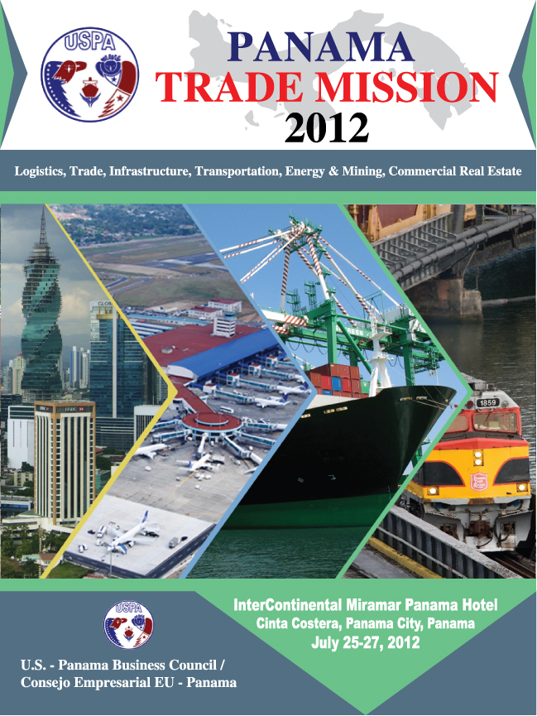

PANAMA TRADE MISSION 2012 - UPDATE #1 – 6/20/2012

Re: Field trips and Friendship Awards

The Trade Mission to Panama is taking shape. Several groups from the United States have shown interest in attending and the Supporting Organizations have been doing a great job promoting the conference.

Three weeks ago I was in Panama finalizing arrangements with the hotel and working with USPA Panama in establishing priorities and finalizing the program. First-class presentations from Government officials and leaders of the private sector are being prepared and sites that will be visited during the field trips of Thursday in the Pacific side of Panama and Friday on the Atlantic side have been selected. These include:

- Pacific side: Construction site of the expansion of the Panama Canal; Port of Balboa, the #1 container port in Latin America in the Pacific; Panama Pacific, one of the most successful conversions of a military base to industrial/commercial/housing use; Dell Computer’s headquarters for Latin America in Panama Pacific; Miraflores locks of the Panama Canal.
- Atlantic side: MIT (Manzanillo International Terminal) in Colón, the #1 container port in Latin America in the Atlantic; Colón Free Zone, the largest Free Trade Zone in the hemisphere; Colón 2000, designated as a Home Port for cruise passengers; Panama-Colón highway a pivotal asset in Panama’s Logistics Center.
The traditional “Friendship Dinner” will take place on Wednesday evening. This year’s awardees are companies and individuals who have had a long relationship and great impact in U.S.-Panama affairs. These are: Azucarera Nacional, one of the most important exporters of Panama to the U.S.; Dell Computer who has its Latin American headquarters in Panama Pacífico; and Alexander Psychoyos, President of Empresas Tagarópulos with a long business relationship with the United States.

The Forum is also shaping up. A Free Trade Agreement panel discussion has been organized with the participation of past and present government officials. Presentations are being prepared in the areas of transportation, logistics, energy, trade and infrastructure. Minister of Commerce & Industry Ricardo Quijano Jiménez will be the Keynote Speaker of the Luncheon and several networking events are being organized. It will be a great opportunity to learn and explore business opportunities in Panama, a country with the highest growth rate in Latin America and one of the highest in the world.

Please make sure to send your registration form to panamerica@msn.com and make your reservations at the host hotel InterContinental Miramar. Details are attached. Should you have any questions please contact Juan B. Sosa at (713) 426-0554. Look forward to see you in Panama!

Juan B. Sosa Walter Luchsinger
USPA USA USPA Panama

PANAMA TRADE MISSION 2012 - UPDATE #2 – 6/25/2012

Re: Forums

In the last two weeks USPA has participated in meetings and conferences in Denver, Colorado hosted by the Chamber of the Americas, Orlando, Florida at the annual American Railroad Development Association (ARDA), and more recently at a kick-off event for USPA’s new chapter USPA West at Silicon Valley, California.

There has been a common theme in all of these events and it is the enthusiasm that Panama generates especially with the expansion of the Panama Canal and the business opportunities that are being created by the growth of the economy and projects in the infrastructure, transportation, logistics, energy, mining, logistics areas and in real estate.

The recent ratification of the Free Trade Agreement between the United States and Panama has been of special interest given the opening of new markets and the lowering of tariffs in established markets that will make U.S. products much more competitive in Panama. Given this interest USPA has organized a Trade Panel during the conference with the participation of two former Ministers of Commerce and Industry of Panama -Alejandro Ferrer and Carmen Gisela Vergara- and a present government official from the Ministry of Commerce and Industry in what promises to be a highly interesting and valuable panel. Time will be reserved at the end for questions and answers in trying to accommodate the many questions that the panel surely will generate.

In addition, Panama’s Minister of Commerce & Industry Ricardo Quijano Jiménez will be the Keynote Speaker of the luncheon and will touch on issues of Trade and Logistics, especially given the progress that Panama has made in establishing a regional logistics center of first order.

Another topic that has generated interest and will be given special interest during the conference is the incentives that exist for the establishment of Corporate Regional Headquarters for multi-national companies. Since the law was established four years ago, more than seventy transnational companies have established in Panama and many others are preparing to do so. One of the field trips that have been organized is at Panama Pacifico which is host to several multinationals that have selected Panama as regional headquarters. One of these companies, Dell, will be visited during the field trip.

We remind you that the deadline for hotel reservations is July 10. After that date availability of rooms and the application of the special tariff -$175 a night plus tax- will depend on availability.

Registration form is attached. Look forward to see you in Panama.

Juan B. Sosa Walter Luchsinger
USPA USA USPA Panama

SITES TO BE VISITED DURING THE FIELD TRIPS.

Panama City
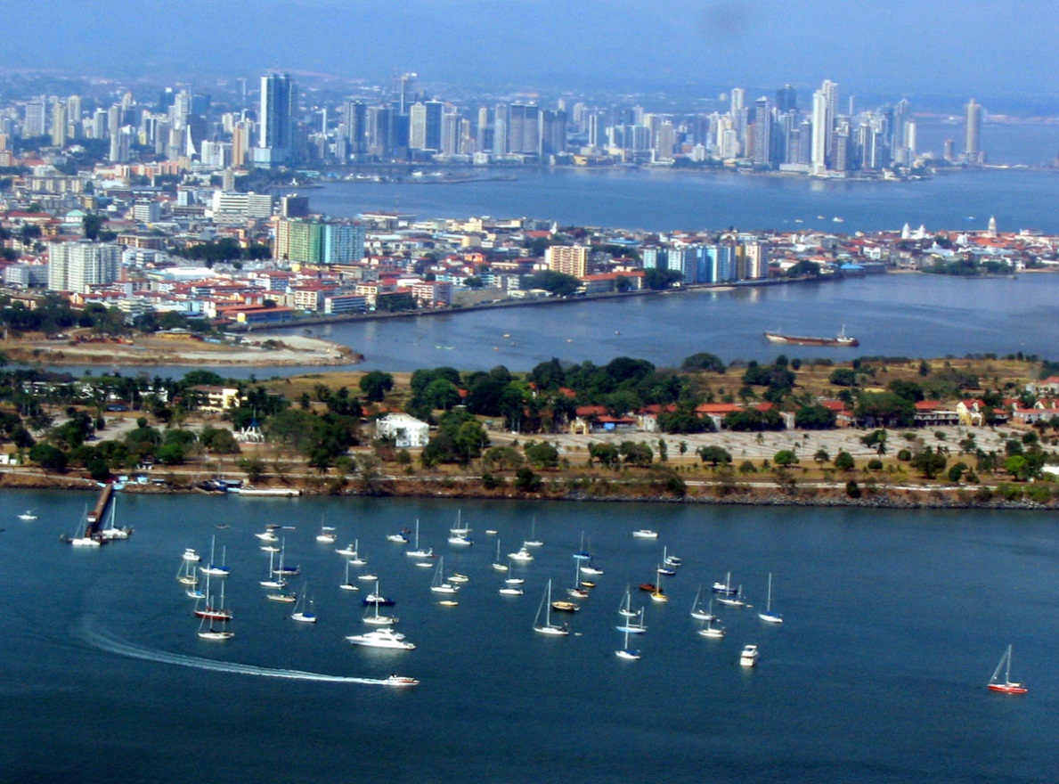
Expansion of the Panama Canal – Pacific site
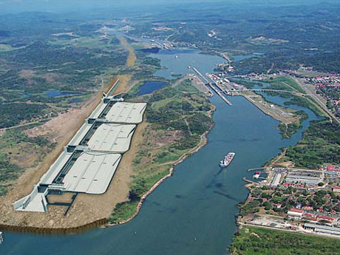
Panama Pacific
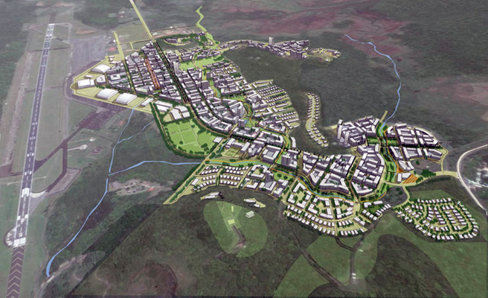

Port of Balboa - Pacific
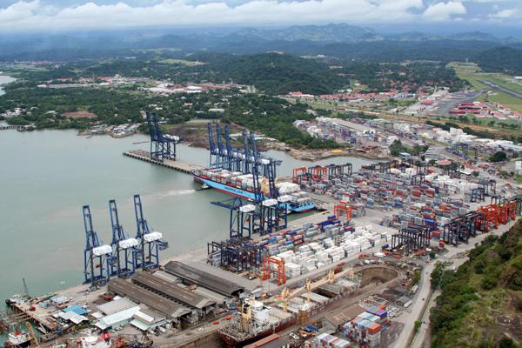

The Panama Railroad (Pacific – Atlantic)



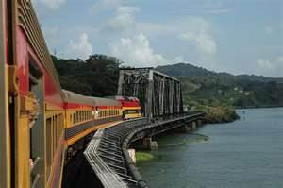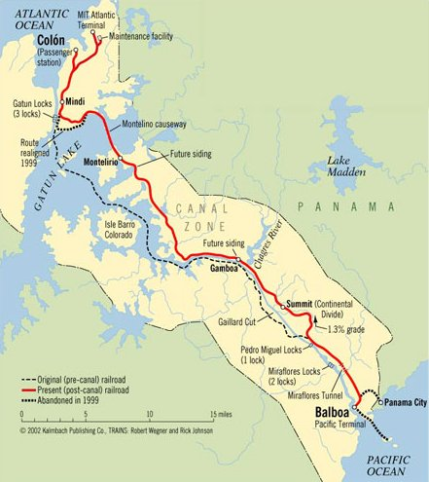

MIT Port - Atlantic
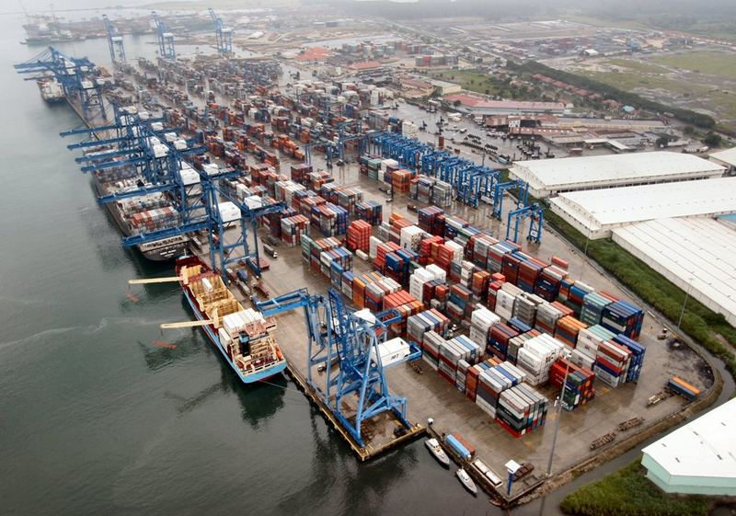

Colón Free Zone - Atlantic
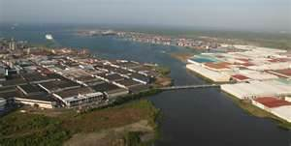

Colón 2000 - Atlantic
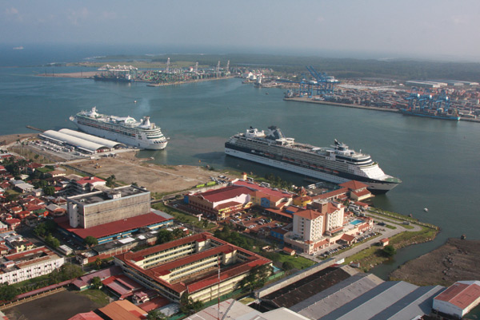
Panamá-Colón Highway
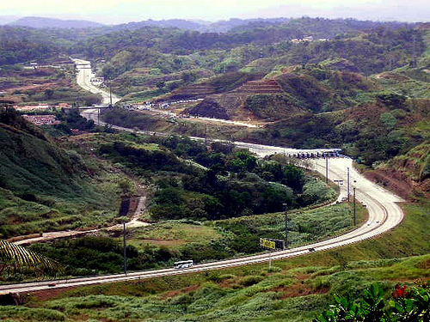


UNITED STATES-PANAMA BUSINESS COUNCIL Consejo Empresarial Eu-Panama
Memorial Drive #2061, Houston, Texas 77007 Ave. Samuel Lewis, Edif. Addison Plaza, 1er Piso Tel. (713) 426-0554/Fax: (713) 863-8781/E-mail: Panamerica@msn.con Tel. (507) 264-9024 / uspa.panama@gmail.com

A Logistics, Trade, Infrastructure, Energy & Mining, Transportation and Real Estate Conference
Supporting Organizations
USA: U.S.-Mexico Chamber of Commerce / Free Trade Alliance / TransCo / CCAA / Irving Chamber of Commerce
Chamber of the Americas / USPA National, Southwest, Southeast and West / Houston Greenspoint District / LBA
Panama: ACOBIR / AMCHAM / APEDE / AUSA Isthmian Chapter / Banking Association / CICyP / Maritime Chamber /
Colon Free Zone Association /
May 30, 2012

Dear Friends of Panama and the United States

The U.S.-Panama Business Council (USPA) was created in 1994 with the mission of strengthening relations between the United States and Panama, and promoting business opportunities between the two countries. During its eighteen years of existence the Council has organized hundreds of programs and events which have greatly contributed to expanding relations between the two countries and promoting business opportunities, which are being greatly enhanced by the expansion of the Panama Canal, the creation of the logistics hub, and the recently ratified Free Trade Agreement.

On July 25-27, 2012 USPA will have its Annual Trade Mission to Panama covering sectors that are vital to the economy of Panama and have shown dramatic growth. These are: Logistics, Trade, Infrastructure, Transportation, Energy & Mining, and Real Estate. The conference is being organized by USPA’s USA and Panama offices supported by several business organizations and government entities of both countries.

The double digit economic growth of Panama, in addition to its development as a key logistics hub for the region, the granting of investment grade, the establishment of regional headquarters for multinationals and the possibilities that are being created by the USA-Panama Free Trade Agreement have generated excitement and optimism among the business community of Panama and overseas. The conference will be a perfect opportunity to address these opportunities. In addition the Commercial Service of the U.S. Embassy in Panama will be offering its “Gold Key Service” to those companies interested. A description of the service is attached.

A program is enclosed and updates will be published in USPA’s website www.uspanana.webs.com. Several government officials and business leaders from both countries will be attending. The traditional black tie Friendship Awards Dinner will be held on the evening of Wednesday, July 25, the same day that the business forum will be held and a luncheon with Panama’s Minister of Commerce & Industry Ricardo Quijano as Keynote speaker. On Thursday, July 26 there will be a field trip to the Pacific side and on Friday, July 27 to the Atlantic.

We avail of the opportunity to thank sponsors for their generous support. Please review the website for additional information. Should you have any questions you may contact Amb. Juan B. Sosa at (713) 426-0554 in the United States or Eng. Walter Luchsinger (507) 6004-0196 in Panama. We look forward to your participation in the Panama Trade Mission 2012.

Best regards,

Amb. Juan B. Sosa Walter Luchsinger
President, USPA (USA) President, USPA (Panama)
PANAMA TRADE MISSION 2012
A Logistics, Trade, Infrastructure, Energy & Mining, Transportation and Real Estate Conference

PROGRAM

TUESDAY, JULY 24

6:30-8:00 p.m. EARLY REGISTRATION
(Venue: InterContinental Miramar Hotel)

WEDNESDAY, JULY 25 (All events at the InterContinental Miramar Hotel)

7:30-8:30 a.m. POWER BREAKFAST (Bahia Suite)

9:00-12:00 n. FORUM: TRADE & INFRASTRUCTURE (Marina Suite)
Overview of Panama
USA-Panama Free Trade Agreement Opportunities / Colon Free Zone
Expansion of the Panama Canal / Expansion of the Airport system
Energy’s market growth and expansion / Roads and Bridges
Telecommunications hub / Infrastructure projects / Innovation

12:00-2:00 p.m. LUNCH: PANAMA AS A LOGISTICS HUB (Bahia Suite)
Keynote Speaker: H.E. Ricardo Quijano Jiménez
Minister of Commerce & Industry

2:00-5:00 p.m. FORUM: TRANSPORTATION & LOGISTICS (Marina Suite)
Sea Transportation: Port Development / International Corridors of Trade
Land Transportation: Trans-isthmian railroad / North Corridor / South Corridor
Air Transportation: Airlines / Cargo hub / Express packages

7:00-10:00 p.m. RECEPTION & FRIENDSHIP AWARDS GALA DINNER (Marina Suite)
Recognition to Alberto Alemán Zubieta, administrator of the PCA (invited)
Friendship Awards: Dell / Azucarera Nacional / Alexander Psychoyos

THURSDAY, JULY 26

8:00-5:00 p.m. FIELD TRIP TO THE PACIFIC SIDE WITH LUNCH
Canal expansion / Balboa Port / Panama Pacific / City of Knowledge / Miraflores
Lunch at Panama Pacific
7:00-9:00 pm RECEPTION (TBD)

FRIDAY, JULY 27

6:00-5:00 p.m. FIELD TRIP TO THE ATLANTIC SIDE WITH LUNCH
Panama Canal Railroad / Cristobal Port / MIT Port / Colón Free Zone Logistics area / Colón 2000

Evening OPEN
PANAMA TRADE MISSION 2012
SPONSORSHIP LEVELS AND BENEFITS

Platinum - $15,000
- Recognition as platinum sponsor in all promotional material, program & website
- Unlimited access to forum
- Opportunity to make a presentation or deliver short remarks at one of the events
- Assistance with arranging private appointments
- Two Corporate tables of eight at lunch
- Two places at head table at lunch
- Four invitations to special events: Power Breakfast, Reception and field trips
- Two Corporate tables of eight at Friendship Awards Dinner
- Two places at head table at Friendship Awards Dinner
- Corporate Banner -supplied by corporation- to be displayed at Conference

Gold - $10,000
- Recognition as gold sponsor in all promotional material, program & website
- Unlimited access to forum
- Opportunity to make a presentation at one of the events
- Assistance with arranging private appointments
- One Corporate table of eight at lunch
- One place at head table at lunch
- Two invitations to special events: Power Breakfast, Reception and field trip
- One Corporate table of eight at Friendship Awards Dinner
- Corporate Banner –to be supplied by the corporation- to be displayed at Conference

Silver - $5,000
- Recognition as silver sponsor in all promotional material, program & website
- Unlimited access to forum
- Assistance with arranging private appointments
- Four invitations to lunch
- One invitation to each special event: Power Breakfast, Reception and field trips
- Four seats at Friendship Awards Dinner
- Corporate Banner -supplied by the corporation- to be displayed at Conference

Bronze - Table at the Luncheon $2,500 (eight seats) (7/25) Bronze - Table at Friendship Dinner $3,000 (eight seats) (7/25)

Individual Participation Individual - $800
- Access to forum (7/25) / One invitation to Lunch (7/25)
- One invitation to Power Breakfast (7/25) and Reception (7/26)
- One invitation to Friendship Awards Dinner (7/25)
- One invitation to Pacific and Atlantic field trip (7/26) and (7/27)
Couple - $1,200
- Access to forum (7/25) / Two invitations to lunch (7/25)
- Two invitations to Power Breakfast (7/25) and Reception (7/26)
- Two invitations to Friendship Awards Dinner (7/25)
Others
- Forum (7/25) & Lunch (7/25) - $200
- Individual Friendship Award Dinner ONLY (7/25) - $250
- Couple Friendship Award Dinner ONLY (7/25) - $400

Panama Trade Mission 2012 - Registration Form
Please complete the registration form and e-mail it to panamerica@msn.com, fax to (713) 863-8781, or mail to US-Panama Business Council, 5353 Memorial Drive #2061, Houston, Texas 77007.
Name_____________________________________________________________________________________
Title_______________________________________________________________________________________
Company__________________________________________________________________________________
Address____________________________________________________________________________________
City_________________________________________ State: ____________________Zip:________________
Telephone_________________Fax_________________E-mail_______________________________________
Check Level of Participation (See Sponsor Benefits at website www.uspanama.webs.com)
SPONSORSHIP: ___ Platinum - $15,000 ___ Gold - $10,000 ___ Silver - $5,000
___Table Friendship Dinner - $3,000 ___ Table lunch - $2,500
INDIVIDUAL PARTICIPATION: ___ Single - $800 ___ Couple - $1,200 (All events)
Fee covers registration to the conference, breakfasts, lunches, receptions, dinners and field trips.
OTHERS: ___ Forum (7/25) and Lunch (7/25) / - $250
___ Individual Friendship Awards Dinner - $250 ___Couple Friendship Dinner - $400 (7/25)
$___________ TOTAL AMOUNT TO BE PAID.

PLEASE INDICATE THE ORGANIZATION THAT REFERRED THE PROGRAM TO YOU:
U.S.-Mexico Chamber of Commerce _____ / Free Trade Alliance _____ / TransCo _____ / CCAA _____ /
Chamber of the Americas ____ / Houston Greenspoint District _____ / Irving Chamber of Commerce _____
USPA National _____ / USPA Southwest _____ / USPA Southeast _____ / USPA West _____ / LBA______

Check which events you will attend (See program & updates at website www.uspanama.webs.com)

Wednesday, July 25
___ Power Breakfast ___ Forum (Morning and Afternoon)
___ Luncheon ___ Friendship Awards Reception and Gala Dinner

Thursday, July 26
___ Field trip Pacific ___ Reception (TBD)

Friday, July 27
___ Field trip Atlantic
Method of Payment for Participation:
___ Please charge my CREDIT CARD: American Express_____ / Visa_____ / Mastercard_____ (check one)
CC #____________________________________________________________________Exp: ______________
Signature:__________________________________________________________________________________
___ CHECK. If mailed make payable to U.S.-Panama Business Council in the amount of $ ________________
Please send payment to USPA, 5353 Memorial Drive #2061, Houston, Texas 77007
Hotel Accommodation & Reservations (deadline July 10 and thereafter depends on availability)
Hotel InterContinental Miramar, Panama City, Panama Tel. (507) 206-8888 / Fax (507) 223-4891 To reserve a room in USPA block guests must be registered in the conference. To reserve rooms fax attached reservation form to (507) 214-1002 or e-mail to groups@bernhotelspanama.com. If you have any questions contact the reservation department at telephone (507) 206-8880.
Rate: $175/Double $185 plus 10.0% tax – Add. person $20 a night / Date of Arrival ____ Date of Departure ____ When making reservation specify: Dbl. Occupancy____ Single Occupancy____ Smoking___ Non-Smoking___ Number of rooms available are limited. Requests will be accommodated on a first-come-first-served basis.
Fax registration to (713) 863-8781 or e-mail it to Panamerica@msn.com
For updates please check website: www.uspanama.webs.com
For additional information please call USA (713) 426-0554 / PANAMA (507) 264-9024


RESERVATION FORM Panama Trade Mission – July 24th – 28th, 2012
Room Special Rates for Group:
Deluxe Accommodation –Single Occupancy USD$175.00 / Deluxe Accommodation – Double Occupancy USD$185.00

All rates are subject to 10% occupancy tax Additional Person USD$20.00

Rate includes buffet breakfast at Bay View Restaurant
Rates per room / per night in USD. Please note that check-in is possible as of 3:00 p.m. and check-out is required by 12:00 hrs noon. Arrange directly with the Hotel should your requirements differ.
U.S. Panama Business Council has secured accommodation on your behalf. This rate will be available until Tuesday, July 3rd, 2012. After this date all rooms and rates will be subject to the hotel’s room and rates availability at the moment of request. Hotel will honor the rate for those guests who arrive 3 days prior the meeting and stays 3 days before de period established for the meeting.
How to Book:
Complete this hotel booking form and send it by fax to our Reservations Department of INTERCONTINENTAL MIRAMAR PANAMA to (507) 214-1002 or by email to groups@bernhotelspanama.com. If you have any question please contact our reservations department at (507) 206- 8880

Group Block Code: P24
How to pay & guarantee your accommodation:
First night will be charged at the moment the reservation is requested. Guest must complete credit card information.
Changes, modifications or cancellations (including anticipated departures or late arrivals) will be allowed until Monday, July 9th, 2012 with a penalty charge equivalent to one night plus night, after this date or once the client has checked in, 100% of the original booking will be charged, plus any other additional dates in the event of early arrivals or extended departures.

PLEASE FILL IN THE FOLLOWING INFORMATION:

First Name: _______________________________________ Last Name: _____________________________________

Accompanying person: ___________________________________________________________________________

Address:_______________________________________________________________________________________

Telephone: __________________________Fax: _________________________Email:___________________________

Deluxe Single Deluxe Double Suite Master Suite

Arrival Date: _____________________________ Departure Date: ___________________________

Type of Credit Card: Mastercard Visa Amex Diners

Card Number: ______________________________________ Expiry Date: ________________

Name shown on card: __________________________________________________________________________

Card’s holder billing address: _________________________________________________________________________

Priority Club Rewards No: __________________________________________________________________________

Declaration of Consent:
I understand and accept the cancellation clause explained above and authorize the Hotel to charge my credit card if I may incur in penalty.

Signed: _________________________________________ Date: ____________________________________
U.S. Commercial Service – Embassy of the United States

GOLD KEY SERVICE- PANAMA

We are ready to provide the Gold Key Service to your company. Cost of the service for Small Medium (SMEs) companies (less than 500 employees) is $700.00 per day and $300 per each additional day. Cost for large companies (more than 500 employees) is $2,300 per day and $1,000 for each additional day. SMEs that have never exported may qualify for a one-time special fee.

The Gold Key Service includes: 4-7 appointments with pre-screened prospects in your area of interest. The first appointment is normally held at our office and includes counseling on the situation of the local economy. The other appointments are usually held at the prospect's premises.

An advanced notice of three weeks is required in order to prepare the appointment program. Please send us, preferably by courier ten sets of brochures and a description of your company and products as well as a profile of the Panamanian companies you expect to meet with. Payment has to be received in advance. Payment can be made through credit card. Please provide credit card name, number, and expiration date. If paying with check it must be payable to: Department of Commerce and mailed, along with the brochures,to the following courier address):

U.S. Embassy Panama
The Commercial Service
Avenida Demetrio Basilio Lakas, Edificio #783,Clayton
Panama City, Panama
Phone: 507-317-5080
Attention: Enrique Tellez

