The 23rd Conference on Priorities in Perinatal Care in South Africa was held under the auspices of the Priorities in Perinatal Care Association and sponsored by Abbott Laboratories SA (Pty) Ltd
Editor’s Note:

The articles included in these Proceedings were received electronically and have been included as submitted by the presenter/author. Some articles have been shortened. Abstracts were included where articles were not submitted. References are available from the authors.

INDEX

EVALUATION OF MATERNITY SERVICES IN A REGION OF GAUTENG. R Jina 1

WHAT IS THE BEST MIDWIFE OBSTETRIC UNIT (MOU) MODEL FOR METROPOLITAN AREAS? T Mabale 4

DECENTRALISATION OF HEALTH SERVICES AND REPRODUCTIVE HEALTH – SEEKING THE LINK. W Hall 8

TRAINING OF ADVANCED MIDWIVES IN BASIC OBSTETRIC ULTRASOUND.
TS Monokoane 14

THE MATERNAL CARE MANUAL OF THE PERINATAL EDUCATION PROGRAMME – IS THE RESULT ACHIEVED WITH THE NEW CURRICULUM FOR MEDICAL STUDENTS SUSTAINABLE? GB Theron 18

BETTER BIRTHS INITIATIVE (BBI) EVALUATION IN THE EASTERN CAPE (abstract).
N Makinana 21

MODIFICATION OF THE CENTERING PREGNANCY PROGRAM FOR USE IN THE SOUTH AFRICAN CONTEXT (abstract). E de Gouveia 23

LINKWOOD CLINIC - A MODEL MOU FOR THE PRIVATE SECTOR (abstract).
B Hanrahan 24

THE IMPACT OF KANGAROO MOTHER CARE AND BREAST MILK FEEDING ON THE INCIDENCE OF BLOOD PRODUCT TRANSFUSION IN INFANTS <1800 GRAMS.
GF Kirsten 25

EFFECT OF KNOWING INFANT’S HIV STATUS ON FEEDING PRACTICES.
MPB Mawela 28

THE CHOICE OF BABY FEEDING MODE WITHIN THE REALITY OF THE HIV/AIDS EPIDEMIC: HEALTH EDUCATION IMPLICATIONS. CS Minnie 31

CONTAMINATION AND NUTRIENT CONCENTRATION OF INFANT FORMULA FEEDS IN AN URBAN TOWNSHIP: A SUB-STUDY OF THE NATIONAL PMTCT COHORT STUDY.
D Jackson 38

ARE PATIENTS REFERRED FROM PERIPHERAL HOSPITALS AT HIGHER RISK OF COMPLICATIONS IN LABOUR? WJ Steinberg 42

A REVIEW OF FETAL OUTCOME IN CASES OF ABRUPTIO PLACENTA IN DR GEORGE MUKHARI HOSPITAL (GA-RANKUWA). TJ Mashamba 46

A CRITICAL EVALUATION OF THE MANAGEMENT OF NEONATAL JAUNDICE BY THE MIDWIFE OBSTETRIC UNITS. GF Kirsten 51

DEVELOPMENTALLY SUPPORTIVE CARE: THE EFFECTS OF POSITIONING ON STRESS LEVELS IN THE PRETERM INFANT. A Hennessy 53

CONGENITAL ABNORMALITIES AS THE SECOND CAUSE OF NEONATAL DEATHS (abstract). MRC Mabusela 58

FOLLOW UP OF THE PREVENTION OF MOTHER TO CHILD TRANSMISSION OF HIV (PMTCT) PROGRAMME IN THE EASTERN CAPE. M Singata 59

DISEASE PROFILE OF PATIENTS AT ANTENATAL CARE REFERRAL CENTER AT EMPANGENI HOSPITAL, KWAZULU-NATAL, SOUTH AFRICA - 2003. M Hoque 62

SERVICE DELIVERY ISSUES IN THE PROVISION OF ANTENATAL CARE IN SOUTH AFRICA. B Kunene 69

STRATEGIES FOR EFFECTIVE FOLLOW-UP OF RESEARCH PARTICIPANTS.
KR Mokhondo 73

NON-CLOSURE OF PERITONEAL SURFACES AT CAESAREAN SECTION – A SYSTEMATIC REVIEW (abstract). AA Bamigboye 78

LATERAL TILT VS SUPINE POSITION TO PREVENT SUPINE HYPOTENSION DURING CAESARIAN SECTION. Z Jafta 79

CAN ECHOCARDIOGRAPHY REPLACE INVASIVE MONITORING IN SEVERE PREECLAMPSIA? (abstract) S Laker 83

THE LEADING CAUSES OF MATERNAL DEATHS AT THE DR GEORGE MUKHARI HOSPITAL (GA-RANKUWA). GM Mothupi 84

DIFFERENCE IN THE SUTURE AND NON-SUTURE OF PERITONEUM IN REGARDS TO THE FORMATION OF ADHESIONS IN RABBITS (abstract). J Markram 87

THE PROMISE OF WIND-UP TECHNOLOGY IN PERINATAL CARE. DL Woods 88

TRAINING WORKSHOPS IN PERINATAL MENTAL HEALTH. S Honikman 91

A 30-YEAR ADVENTURE WITH IUGR. DL Woods 94

LIFESTYLE RISK FACTORS FOR LOW BIRTH WEIGHT IN THE WESTERN CAPE.
D Jackson 98

THE BABY FRIENDLY HOSPITAL INITIATIVE (BFHI) WAS ESTABLISHED TO CHANGE HEALTH CARE PRACTICE, TO ENABLE HEALTH WORKERS TO PROTECT, PROMOTE AND SUPPORT BREASTFEEDING (abstract). P Baxen 102

A COST COMPARISON OF KANGAROO CARE AT KALAFONG HOSPITAL VERSUS REGULAR CARE NEONATAL CARE AT PRETORIA ACADEMIC HOSPITAL (abstract). E Buch 103

THE CONTRIBUTION OF TRAINING WORKSHOPS TO THE IMPLEMENTATION OF KANGAROO MOTHER CARE. E van Rooyen 104

FARA NGWANA: FIRST STEPS IN THE SYSTEMATIC IMPLEMENTATION OF KANGAROO MOTHER CARE IN GAUTENG. R van der Walt 108

EARLIER DISCHARGE OF PREMATURE BABIES USING KANGAROO MOTHER CARE INTERVENTION- A PILOT STUDY. LP Mokgosi 111

THE NEURODEVELOPMENTAL OUTCOME AND ANTHROPOMETRIC DATA AT TWELVE MONTHS CORRECTED AGE OF VERY LOW BIRTH WEIGHT INFANTS TREATED WITH KANGAROO MOTHER CARE AND BREAST MILK. GF Kirsten 114

OUT OF THE MOUTHS OF BABES ….. INNOCENT REPORTING OF HARMFUL LABOUR WARD PRACTICES. E Farrell 117

IS INTRAPARTUM PAIN RELIEF USING PETHIDINE AND ATERAX SAFE FOR MOTHER AND BABY? R Pfau 122

A RANDOMIZED CONTROLLED TRIAL COMPARING MISOPROSTOL VAGINAL GEL VERSUS ORAL AND VAGINAL TABLETS FOR THE INDUCTION OF LABOUR. E Thomas 126

MISOPROSTOL FOR TREATING POSTPARTUM HAEMORRHAGE: A RANDOMIZED PILOT STUDY. GJ Hofmeyr 131

ASSESSING THE EFFECTIVENESS OF A WINDUP DOPTONE AS A FETAL MONITOR IN LABOUR. L Mangesi 137

OBSTETRIC RISK FACTORS FOR NEONATAL ENCEPHALOPATHY. SR Fawcus 141

PERINATAL HYPOXIA AND NEONATAL ENCEPHALOPATHY IN THE PMNS.

L Linley 144

PERINATAL ASPHYXIA – ARE THERE EARLY PREDICTORS FOR AN UNFAVOURABLE OUTCOME WHICH MAY DISQUALIFY INFANTS FROM ADMISSION TO A NEONATAL INTENSIVE CARE UNIT WITH LIMITED RESOURCES. GF Kirsten. 147

FETAL ALCOHOL SYNDROME IN THREE SOUTH AFRICAN PROVINCES.
DL Viljoen 150

THE MANAGEMENT OF HYALINE MEMBRANE DISEASE WITH A CHEST BRACE (abstract). D Ballot 154

PROGRESS IN NEWBORN SCREENING FOR INBORN ERRORS OF METABOLISM IN SOUTH AFRICA. (abstract) JD Cartwright 155

EVALUATION OF COUNSELLING ON PREVENTION OF MOTHER-TO-CHILD-TRANSMISSION OF HIV (PMTCT) AND INFANT FEEDING IN THREE NATIONAL PMTCT PILOT SITES.
D Jackson 157

INTEGRATING HIV PREVENTION INFORMATION AND REFERRAL SERVICES INTO ROUTINE ANTENATAL CARE SERVICES: IMPACT ON CLIENTS’ ATTITUDE TOWARDS AND ACCESS TO VCT FOR HIV. J Chege 162

THE KNOWLEDGE ABOUT HIV/AIDS AND BEHAVIOUR AMONG WOMEN WHO HAD RECENTLY GIVEN BIRTH IN THE TYGERBERG HOSPITAL (abstract).
CH Pieper 167

POSSIBLE REASONS BEHIND DECLINING HIV TESTING DURING ANTENATAL CARE AT A DISTRICT HOSPITAL IN KWAZULU NATAL (abstract). E Buch 168

THE STIGMA EXPERIENCED BY HIV POSITIVE PREGNANT WOMEN.

MJ Visser 169

STIGMATISING ATTITUDES OF THE COMMUNITY TOWARDS PEOPLE LIVING WITH HIV/AIDS. K Lehobye 177

MOTHERS 2 MOTHERS 2 BE: EDUCATION, EMOTIONAL SUPPORT, ECONOMIC OPPORTUNITY AND EMPOWERMENT FOR PREGNANT WOMEN AND MOTHERS LIVING WITH HIV (abstract). MJ Besser 183

MATERNAL MORTALITY RELATED TO AIDS AND NON-PREGNANCY RELATED INFECTIONS IN SOUTH AFRICA, 1999-2001. NCCEMD 185

MATERNAL DEATHS: AN AUDIT OF FREE STATE HOSPITALS AND DOCTORS REGARDING OBSTETRIC SERVICES. JBF Cilliers 188

MATERNAL MORTALITY AND MORBIDITY AUDITS: TO DO OR NOT TO DO? (Abstract). M Kleynhans 191

TRENDS IN PERINATAL MORTALITY AT LOCAL CLINICS FOLLOWING THE OPENING OF A NEW REGIONAL MATERNITY UNIT IN THE NORTH OF DURBAN. NF Moran 193

TWO STEPS FORWARD, ONE STEP BACK: A DECADE OF PERINATAL CARE IN ATTERIDGEVILLE (abstract). RC Pattinson 199

THE EFFECTIVENESS OF AN INTERVENTION TO IMPROVE THE QUALITY OF ANTENATAL CARE SERVICES IN RURAL PUBLIC CLINICS IN KZN. J Chege 200

SYPHILIS IN PREGNANCY - A REVIEW OF PREVALANCE AT DISTRICT LEVEL CARE.
J Devjee 205

PREVALENCE OF POSITIVE RPR TESTS IN PREGNANT WOMEN: A REAL OR ASSUMED DECREASE? (abstract). S Moodley 209

BACTERIAL COLONIZATION OF THE GASTROINTESTINAL TRACT OF INFANTS ADMITTED TO THE NEONATAL UNIT. S Velaphi 210

THE ACCURACY OF THE PCR DNA TEST FOR DIAGNOSIS OF HIV INFECTION AT AGE SIX WEEKS IN FORMULA FED INFANTS. PA Cooper 213

LOWER ABDOMINAL PAIN, UTERINE TENDERNESS AND NOT IN LABOUR OR PYREXIAL: THE LOWER GENITAL TRACT INFECTION SYNDROME OF PREGNANCY? (abstract).
E Bolton 216

DOES HIV STATUS EFFECT THE PREVALANCE OF ASYMPTOMATIC BACTERIURIA IN PREGNANCY? (abstract). SC Laker 217

A PROVINCE-WIDE 2-YEAR INITIATIVE TO IMPROVE THE QUALITY OF CARE IN MATERNAL HEALTH SERVICES: AN ANALYSIS OF FACILITATING AND HINDERING FACTORS (abstract). A Voce 219

THE IMPLEMENTATION OF “THE LIMPOPO INITIATIVE FOR NEWBORN CARE” (LINC).
NC Mzolo 220

LIMPOPO INITIATIVE FOR NEWBORN CARE (LINC): SITUATION ASSESSMENT OF NEWBORN CARE IN LIMPOPO HOSPITALS. PL Mashao 225

NATIONAL HEALTH STRATEGIES TO IMPROVE NEONATAL CARE. S Ngake 230

PLANNING FOR TERTIARY NEONATAL BEDS. DH Greenfield 234

DO CAESAREAN SECTION RATES DEPEND ON WHO MANAGES THE PRENATAL CARE? AD Rothberg 236

THE EFFECT OF RESTRUCTURING OF HEALTH CARE SERVICES ON CAESAREAN SECTION RATES. J Devjee 241

NON-ELECTIVE CAESAREAN SECTION: HOW LONG DO WE TAKE TO DELIVER?

HR le Riche 246

PUEPERAL PYREXIA IN HIV MOTHER. IS CAESAREAN DELIVERY MORE RISKY?

EJ Coetzee 250

PERINATAL MENTAL HEALTH PROJECT: A YEAR’S REVIEW. S Honikman 254

EVALUATION OF MATERNITY SERVICES IN A REGION OF GAUTENG

R Jina: Registrar, School of Public Health: University of the Witwatersrand
KS Tint: Senior researcher: Women’s Health Project

Background/Introduction
These are the South African findings of a multi-country study. The apartheid system in South Africa has left large discrepancies and inequities in health care access. Since 1994 there have been many initiatives to improve maternity care yet there has been little progress in health care.

Objectives
The general objective was to strengthen the capacity of health systems to provide appropriate and equitable care in pregnancy and childbirth with special emphasis on locally adapted and tested strategies and interventions.

Methodology
We assessed the quality of a health system by using input-, process- and outcome indicators. The study site was Ekurhuleni because it is disadvantaged in terms of health services, was traditionally a poor white mining area and now has a large number of informal settlements, it is a relatively rural/peri-urban area in Gauteng and there was little other donor-funded research in the area.

Six antenatal clinics (9.8%), four midwife-obstetric units (100%) and four hospitals (66.7%) were included in the study. The data was collected by using checklists, register and document reviews, client and health worker interviews. The analysis was done using EPI-Info 2002.

Findings
The first prominent finding was the poor utilization rates of midwife-obstetric units. This was initially discovered when field workers had to visit the midwife-obstetric units many times to find participants for the study. In the antenatal exit interview 27.6% of the interviewees said that they prefer to deliver in a health centre and 17.5% of the interviewees were referred in a health centre.

Unstructured supervision of facilities in Ekurhuleni leads to a poor quality of care. During interviews with health workers in charge of facilities, it was found that 55.6% of facilities had a supervisory visit related to maternity care. In the interviews with the general health workers, 33.3% had a supervisory visit in the last year but only 24.4% had had a visit related to maternity care. Basic services were lacking. Antenatal cards that were reviewed in the antenatal clinic and postnatal ward were incomplete. There were also inadequate labour records.
Antenatal card review | ANC exit interview | Postnatal interview
Syphilis recorded | 69.4% | 77.2%
Received at least 1 tetanus injection | 37.2% | 62.9%
Complete antenatal care and delivery plan | 15.6% | 22.8%

Government facilities should have good records because of the minimum data set, yet there was still poor record keeping. When reviewing the antenatal and birth registers we found many missing variables. These inconsistencies made comparisons between facilities and levels of services impossible. We compared this to the minimum data set obtained from the regional office of the Department of Health and found similar flaws.

Finally, we need to improve the knowledge and practice of health care workers. During interviews with health workers, we found that only 3.8% attended a midwifery skills update and 5.1% attended the perinatal education programme. It was noticed that some health professionals lacked confidence to answer knowledge-based questions. The knowledge in general was fair but some areas require attention e.g. neonatal resuscitation.

Recommendations
The first issue to highlight is the evident discrepancy between utilization of hospitals and midwife-obstetric units. Government should top-up resources at midwife-obstetric units to motivate the staff at the facility, and the community to access these facilities. There is a need to educate the community on levels of service and motivate for the use of first-line health facilities. We also need to reinforce recommended referral pathways to health workers.

An effective method to address quality of care would be to use the current quality assurance teams and/or supervisors. This, however, should not be a crises response but an ongoing, sustainable process. Supervision should be supportive and should include self-assessment, peer assessment and community input. The Department of Health needs to encourage in-service training by supervisors.

The use and collection of data can be improved by educating health workers in health facilities. There was little analysis of data and it was not available to the necessary people. The health information team should collaborate with the maternal and child health coordinator to share information and reports. This will improve performance and decision-making.

The final issue that needs to be addressed is health worker attitudes. Health Workers for Change is a workshop run by the Women’s Health Project that consists of six sessions. The workshop addresses issues around attitudes, problem-solving skills and teamwork.

WHAT IS THE BEST MIDWIFE OBSTETRIC UNIT (MOU) MODEL FOR METROPOLITAN AREAS?

T Mabale, RC Pattinson, C van der Walt

MRC Maternal and Infant Health Care Strategies Research Unit

Introduction
Four MOUs in the Pretoria Region were analysed. They represent the “Peninsular Maternal and Neonatal Service (PMNS)” model of having a stand alone MOU with the midwives having responsibility for referral of patients. There may or may not be a doctor on-site in casualty. The primary level hospital which does not perform caesarean section with the doctor being responsible and the midwives report to the doctor who refers the patients as need be. The final model is the traditional model with a MOU within a large labour ward where doctors are available, but who only see the patients if asked to by the midwives.

Aim:
To assess four model of Midwife Obstetric Units (MOUs) to determine which model is best for metropolitan areas.

Methodology:
The method used was quantitative using auditing of patient files and wards monthly statistics. Questionnaires consisting of Likert scales were administered to patients in order to assess their perception of quality of care.

Method of evaluation:
To assess safety the following variables were looked at:
- Fresh Stillbirth (FSB) rate >2.5kg (/1000 births)
- 5 min Apgar score <8
- Neonatal referral out
- Retained placenta
- Reported PPH
- Other maternal trauma

To assess cost effectiveness the following variables were looked at:
- Staff/births/day ratio
- % transfers of mothers in labour
- % patients bypassing MOU (September)
- Admissions in labour/year
- Low birth weight rate

To assess quality of care the following variables were looked at:
- Patients perceptions
- Partogram score
- Problems identified
- Action taken on problems
- Episiotomy rate

Results:

Assessment of Safety of MOU
 | MOU 1 | MOU 2 | MOU 3 | MOU 4
FSB Rate >2.5kg | 9.8 | 14.1 | 39.1 | 4.8
5 min Apgar <8 (%) | 3.0 | 11.8 | 22.4 | 11.3
Neonatal referral out (%) | 2.3 | 1.6 | 2.2 | 1.1
Retained placenta (%) | 0.4 | 0.2 | 0.7 | 0.6
Reported PPH (%) | 7.6 | 0.7 | 0.8 | 2.1
Other maternal trauma (%) | 1.1 | 1.7 | 3.2 | 1.8

Assessment of Cost-effectiveness of MOUs
 | MOU 1 | MOU 2 | MOU 3 | MOU 4
Staff/births/day Ratio | 6.54 | 1.53 | 2.06 | 0.51
% Transfer of mothers in labour | 8.7 | 31.0 | 33.9 | 24.9
% of patients bypassing MOU | 12 | 17.6 | 20 | 2.6
Admissions in labour /year | 1166 | 3378 | 3310 | 3690
Low birth weight rate (%) | 3 | 10 | 11 | 3

Quality of Care of MOUs
 | MOU 1 | MOU 2 | MOU 3 | MOU 4
Patients’ perceptions | Highest | Second | Lowest | Third
Partogram score (%) | 82.3 | 86.8 | 61.8 | 81.5
Problems identified (%) | 36 | 32 | 4 | 28
Action taken on problem (%) | 61 | 63 | 50 | 64
Episiotomy rate (%) | 29.7 | 11.8 | 22.7 | 20.1

Patient perceptions of quality of care
 | MOU 1 | MOU 2 | MOU 3 | MOU 4
Satisfied with intrapartum care
Waiting time
Reception by staff
Treated with respect
Trust of midwives
Reassurance of patients in labour
Spending time with patients in labour
Listening to patients in labour
Explanation of process
Explanation of tests
Examination of patients in labour
Unnecessary examinations in labour
Competency of midwives

Key
Highest satisfaction rate (Blue)
Second highest satisfaction rate (Red)
Third highest satisfaction rate (Green)
Lowest (Yellow)

Partogram Audit (50 cases)
 | MOU 1 | MOU 2 | MOU 3 | MOU 4
FHR monitoring | 1.92 | 1.9 | 1.88 | 1.9
Liquor | 1.82 | 1.04 | 0.82 | 1.8
Moulding | 1.9 | 1.9 | 0.94 | 1.8
Position | 1.76 | 1.96 | 1.48 | 1.7
Cervical dilation | 1.84 | 1.82 | 1.52 | 1.8
Level of head | 0.57 | 1.82 | 0.74 | 0.6
Contractions | 1.86 | 1.86 | 1.4 | 1.9
Pulse | 1.55 | 1.78 | 1.22 | 1.6
Blood pressure | 1.84 | 1.8 | 1.3 | 1.8
Urine tested | 1.37 | 1.84 | 1.06 | 1.4
Score % | 82.3 | 86.8 | 61.8 | 81.5

Conclusions
- MOU 4 (Traditional Model) safest, most cost-effective, moderate quality of care.
- MOU 3 (Primary level hospital not doing C/S) least safe, not cost-effective, poor quality of care.
- MOUs 1 and 2 (PMNS Model) safe, good quality of care, moderate cost-effectiveness.
- Obstetrics must be run by professionals, either midwives with responsibility to refer, or by dedicated doctors.
- Obstetrics is NOT for occasional operators!!!

DECENTRALISATION OF HEALTH SERVICES AND REPRODUCTIVE HEALTH – SEEKING THE LINK

Wendy Hall, Health Systems Trust
Susannah Mayhew, Nuffield Institute for Health, University of Leeds

Introduction/Background
International experience has shown that there is insufficient linkage between health system reforms and development of policy for, and implementation of, health programmes, such as reproductive health. No easy solution is offered, but the need for communication between policy makers in health system reforms and policy makers in health programmes is stressed.

“There has been a marked lack of dialogue on policy making between the areas of reproductive health and reform of the health sector. Policies in each area have been developed by different actors, pursuing different objectives, through decision-making processes that have rarely coincided”

“……poor health system performance is one of the reasons for poor reproductive health outcomes.”

This paper highlights the need to link health system development, in particular decentralisation and establishment of the district health system, and reproductive health services. It draws on some initial findings of current research on the impact of decentralisation on reproductive health services.

Policy development in South Africa
Since 1994 the health sector in South Africa has been undergoing a process of transformation. This includes restructuring the development of a single national health system and development of new policies and strategies for improved quality of health care.

The main emphasis in the transformation of the health services is on decentralised management, with emphasis on primary health care and establishing a district health system (DHS). A DHS is designed to bring the services closer to the people and to improve the efficiency and effectiveness of delivery. Hospital management, laboratory services and ambulances services have also been restructured.

Reproductive health policies in SA are based on the principles of the International Conference for Population Development of 1994. Policies and guidelines for implementation have been developed for maternal care, contraception, adolescent health, cervical cancer and choice on termination of pregnancy, among others.

The Confidential Enquiries into Maternal Deaths and the Saving Babies reports have provided evidence for developing policies and guidelines for decreasing maternal and perinatal mortality.

All these policies for systems development and reproductive health have an impact on the community and are interdependent for achieving quality of care in the communities they are designed to serve. Yet there appears to be no real interaction at national or provincial levels between health systems development and implementing reproductive health policies. A health system that is not fully established and functioning optimally will impact adversely on all health service delivery.

The 2002 Saving Babies Report showed “administrative problems” as being avoidable factors in 10,1% (metropolitan areas) and 31,1% (rural areas) of peri-natal deaths. These administrative factors include transport (pre- and inter-hospital), lack of serology results, lack of adequately trained staff, lack of equipment and poor facilities. These result in a lack of accessibility to services, ostensibly one of the pillars of primary health care and the district health system. When these services are not available there is system failure.

Relationship between Strategies for Improved Perinatal Care and Health Systems
The following diagram shows some of the determinants for improving perinatal health services. Clinical improvement is possible through strategies developed from the findings of the Saving Babies Reports. However, the role of the health systems must be considered if these strategies are to be sustainable.

Perinatal Health Services
Improved Clinical Services

Improved intrapartum management
Prevent asphyxia of newborn
Improve care of premature baby
Improved referral system
Improve ANC attendance

QUALITY PERINATAL HEALTH SERVICES
Human Resource Management
Decentralisation / DHS
Emergency Medical Services
National Health Laboratory Services

Reproductive Health Policies

Hospital Services
Drugs and Equipment

Multiple management systems have been developed. These are generally centrally driven as vertical programmes. An operational DHS, supportive of health programmes, require these management systems be integrated at the local level. The complexity of these processes and some of the challenges are illustrated in the following three examples.

- Emergency Medical Services – Ambulances
Emergency Medical Services (EMS) provides ambulances for emergency transfer of patients from the community to a clinic or hospital and between hospitals. Ambulance services are designated as a provincial responsibility in the Constitution (Schedule 5, part A) and the National Health Bill of 2004 (Section 25 (2) (m)).

All those ambulances services previously run by local authorities have been centralised to the province. The service is delivered through regionalisation, parallel to the other services. The local level health district, and the hospitals, has no direct control over the services. Shortages of ambulances and slow response times to emergency calls, especially in the rural areas, have been identified by all health workers and community members as a major problem. Insufficient ambulances, together with slow response times, will clearly impact adversely on reproductive health services.

If the systems are working well, with good co-ordination between the services and sufficient vehicles available, then theoretically there will be no problem. But problems arise, such as: -
- Conflicts between clinic nurses and ambulance drivers can not be resolved at the local level, but must be referred up the parallel management lines to be resolved at a higher level. This takes time and energy and has the potential to lead to further delays.
- Ambulances are at high-risk for hijacking and theft. The services are often short of vehicles for all emergencies and it is reported that at times maternity cases are not given priority in being treated as an emergency. Pregnant women are encouraged to find their own transport to hospital and not to rely on the emergency services.
- There is provision made for hiring a private ambulance in an emergency. However, permission has to be given from the provincial Emergency Medical Services (EMS) offices and the number of such requests per month is limited. Delays in obtaining such permission are possible and the final decision is made by someone removed from the situation on the ground. This will potentially impact adversely on health of the mother and/or child to be transferred to hospital.

- Laboratory services
According to the Savings Babies report (2002), in some areas in up to 80% of perinatal deaths there was no syphilis serology result available.
The National Health Laboratory Services (NHLS) is responsible for providing all laboratory services for the public sector. It was established as a para-statal organisation in 2001 according to Act 37 of 2000. The objective of the service is to provide “….. cost-effective and efficient health laboratory services to all public sector health care providers”
The service is run on business lines, with a centralised hierarchical structure. The health districts and the hospitals do not have direct control over the services.
In urban areas, few problems are reported with bloods specimens being collected and results disseminated timeously back to the primary level. In rural areas, there are problems. In one such area, the laboratory at the hospital operates on a 5 day week basis, with no after hours or weekend service. This arrangement may be sufficient for routine tests from ante-natal clinics, but is far from satisfactory for those emergency cases that require close monitoring. The patient is then transferred to a referral hospital that may be up to 300 kms away. This has a potentially adverse impact on quality of care.

- Hospital services
The White Paper for transformation of Health states that “Decentralised hospital management will be introduced to promote efficiency and cost-effectiveness.”
“The PHC system cannot function efficiently without the support of the hospitals to which they refer patients. Therefore, substantial improvements to the PHC system are intimately connected with the functional efficiency of hospitals.”

District level hospitals, however, are a provincial responsibility and are managed separately to the district health system. This potentially can, and has been reported to do so, lead to poor coordination of services. For example: -
- Perinatal Mortality Meetings: These are held in many districts, often co-ordinated by the district or regional hospital where most of the deliveries are done. Clinic staff, who are under the district health team and are responsible for most of the ante-natal and post-natal care of the patients, are invited. In certain places this works well. Elsewhere, however, there is friction between the two arms of the service and good attendance at these meetings only occurs when there are particular “issues”, often related to a specific referral, to deal with. Situations arise where one service blames the other for the problems. This is difficult to resolve when they are not under the same management structure.
- Supplies to clinics, such as drugs and surgical sundries: These are frequently supplied by the hospital pharmacy and stores as per orders received from the clinics. Their delivery, however, to the clinics is dependent on availability of transport. At one hospital, this transport is supplied by the district while the driver is supplied by the hospital. A state of confusion can arise, and the result can be non delivery of the goods.

Conclusion
The current health system, or systems, in South Africa are complex. The stated health policy for the country is the PHC approach through a decentralised DHS. To attain that requires integration of many systems. Health programmes are required to deliver a quality service within these systems.
The challenge is for policy makers and implementers of the services to seek ways of linking with the ‘developers’ of health systems, health sector reforms and development. The needs of front line health workers for the requisite support from the health system to ensure delivery of quality health care is central to a functional DHS health system that is efficient, effective and responsive to the needs of the community.

TRAINING OF ADVANCED MIDWIVES IN BASIC OBSTETRIC ULTRASOUND

TS Monokoane
Department of Obstetrics and Gynaecology, MEDUNSA

Introduction
In a third world setting, such as we have at the Dr George Mukhari Hospital (Ga-Rankuwa), skilled personnel such as medical officers, specialists and ultrasonographers for ultrasound scanning, are difficult to come by. Even when they are available, they usually do not like to work in the public sector or are not inclined to work in rural areas. Therefore, there is the dire need for incorporating ultrasound training for advanced midwives, so as to fill these gaps. This paper presents a report of a feasibility study of how such training can achieve the desired goal of allowing advanced midwives to fulfil the role for basic ultrasound.

Objective
The objective of the study was to appraise the feasibility of incorporating ultrasound training into Advanced Midwifery curriculum/programme.

Setting
Dr George Mukhari Hospital, where the study was conducted is a teaching hospital for the Medical University of Southern Africa.

Methodology
The training, which started in September 2002 is still ongoing and consists mainly of practical hands-on approach. Selection for training was based on the midwife being in advanced midwifery training; he/she must show a keen interest in undertaking ultrasound training and must have an understanding of basic anatomy. Training was conducted in groups of five midwives on a rotational basis during ANC and in the labour ward. After an initial demonstration by a specialist sonographer, the participants were each introduced to scanning through a hand-held session. Thereafter each midwife had an average of 5 patients per session, attended 2 sessions per week and one month each in labour ward and ANC. Patients used for the training had gestational age, ranging from 12-32 weeks.

Machine used
The machines used for the training consisted of:
- Scanning machines - Aloka (Labour ward)
GE (Antenatal ward)
- Probe – Transabdominal Probe – 3.5mHz

Outcome Measure
Post-training assessment of each participant in the training was conducted. Each trainee had to show an ability to do basic ultrasound scanning and demonstrable competence was based on the participant being able to – (1) diagnose intrauterine pregnancy; (2) determine number of fetuses; (3) confirm whether cephalic or breech presentation; (4) establish the viability of the fetus (fetal heart beats and fetal movements); and (5) determine the placenta location. Each midwife also had to demonstrate competence in biometry measurements i.e. BPD, Fl, AC, EFW and liquor volume.

Results
A total of 120 patients, all identified with singleton pregnancy, were scanned during the post training assessment of the participants. Table 1 illustrates the patients’ demographics in terms of age, parity and gestational age at the time of the assessment.

Table 1 Patient Demographics
Women with singleton pregnancy  Age range  Parity (range) | 120  15-40 years  0-5
Gestation at the time of scanning (Range) 12-32 weeks  <13 wks  14-24 wks  25-32 wks | 18  54  48

Figures 1 and 3 are examples of the training materials, which were used to train participants to recognise basic anatomical parts, necessary for the biometric measurements.

Fig 1 Measurement of the biparietal diameter.

Fig 2 The estimation of abdominal circumference requires a true cross-section view

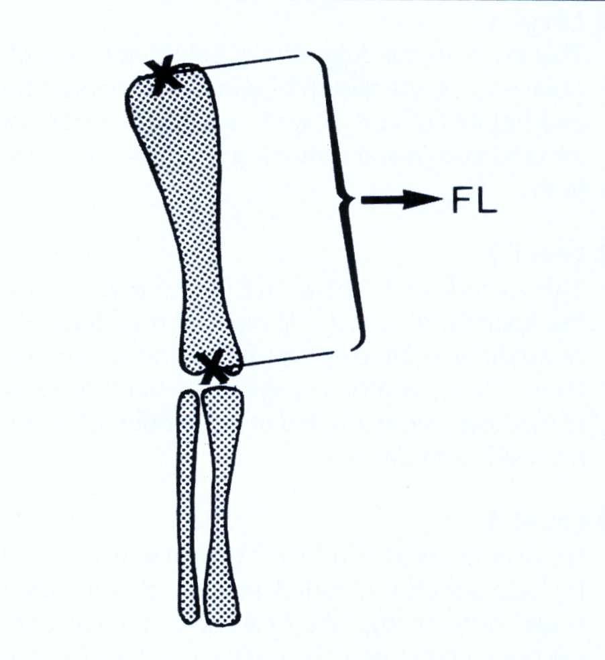

Fig: 3 Measurement of the femoral diaphysis

Table 2 Assessment of advanced midwives for basic obstetric ultrasound (120 pregnant women scanned)

BASIC ULTRASOUND SCAN (N=120) | NUMBER | PERCENT
Is the fetus intrauterine? | 120 | 100
Is the fetal heart beat present? | 120 | 100
Are movements observed? | 120 | 100
COMPETENCE IN BIOMETRY
BPD | 98 | 82
FL | 90 | 75
Liquor volume | 104 | 87
AC | 46 | 38
EFW | 46 | 38
The overall accuracy for biometry |  | 70%

Problems/Recommendations
- Continuity in training was found to be essential for the midwives to thoroughly grasp the scanning technique. Daily rather than 2 sessions per week, is therefore, advocated.
- Full-time ultrasonographer or specialist is needed for such a programme.
- Lack of competency in AC and EFW measurements calls for more intensification of training in this regard.

Conclusion
This training is still on-going and an improved competency could still be achieved with time. This report, however, highlights the feasibility of training advanced midwives in basic obstetric ultrasound. If this empowerment of midwives in basic skills, such as ultrasound scanning and instrument deliveries becomes a policy, much improved antenatal care can then be achieved. Once the competence of midwives for basic obstetric ultrasound has been achieved, training can then move to higher levels of fetal anomalies screening.

THE MATERNAL CARE MANUAL OF THE PERINATAL EDUCATION PROGRAMME – IS THE RESULT ACHIEVED WITH THE NEW CURRICULUM FOR MEDICAL STUDENTS SUSTAINABLE?

GB Theron, D Grové.
Department of Obstetrics and Gynaecology, Faculty of Health Sciences, Stellenbosch University, Tygerberg.

Introduction
A new curriculum for medical students was introduced 1999. The Maternal Care Manual was of great value as a study manual, enabling students with little theoretical knowledge to complete a clinical rotation. The problem-based new curriculum resulted in an improved performance in spite of less theoretical training. It is, however, of interest to investigate whether this is sustainable once the novelty of the new curriculum has worn off.

Methods
An introduction to clinical obstetrics is provided for the third years with hands on skills training in a skills laboratory and educational videos. The Maternal Care Manual of the Perinatal Education Programme is the study material for the new curriculum students during the clinical rotation. A questionnaire was completed by each student at the end of the rotation consisting of questions using a Likert response format (0=very poor and 10=excellent) and open ended questions for qualitative evaluation. The results of the questionnaire and end of block evaluation of third year students in the first new curriculum class (2001) were compared to students in the third year (2003) following the introduction of the new curriculum.

Results
Questionnaires were received from 152 (96.8%) of the 157 students in the first new curriculum class (2001) and 172 (97.7%) of the 176 students in the 2003 class. The evaluation of the prior information, organisation, rotation at the teaching hospital, study manual and number of deliveries conducted did not change significantly (Table I). The 2003 students rated the study guide significantly better (p=0.001) and the skills laboratory, educational videos and the regional hospital rotation significantly poorer (p=0.04, 0.0005 and 0.002 respectively). The marks of the 2001 students were significantly better in 3 clinical questions (total marks = 45) during the end of block evaluation (Table II, mean: 33.7 vs 31.7, p=0.005). The ability of the 2001 students to interpret partograms were significantly better (mean 10.5 vs 9.3, p=0.00006) with no change regarding the antenatal card. The mean end of block marks (total marks = 75) of the 2001 students was significantly better than the 2003 students (53.3 vs 50.1; p<0.001). During 2003, more students achieved lower marks (<65%) and less students higher marks (>70%) compared to 2001 (Figure 1).

Conclusions
Although a significant deterioration was detected, the changes were small. However, efforts required to sustain enthusiasm amongst lecturers need to be investigated. An increased total number of students in the 2003 class may have resulted in more students achieving poor results.

Table I Results
Comparing means | 2001 | 2003 | p-value
Prior information | 6.7 | 6.8 | 0.8
Study guide | 6.9 | 7.7 | 0.001
Organization | 6.9 | 6.8 | 0.4
VALAB | 8.3 | 7.9 | 0.04
Videos | 6.6 | 5.6 | 0.0005
TBH rotation | 6.1 | 6.4 | 0.2
Reg hospital rotation | 8.8 (4-10) | 8.3 (0-10) | 0.002
Study manual | 8.5 | 8.5
Number of deliveries | 9.4 (2-17) | 9.9 (3-22) | 0.2
Likert scale 0=very poor 10=excellent

Table II Results
Comparing means | 2001 | 2003 | p-value
Clinical questions  (45) | 33.7 (17-45) | 31.7 (10-43) | 0.005
Antenatal card  (15) | 9.1 (0-15) | 9.1 (0-15) | 0.9
Partogram  (15) | 10.5 (3-15) | 9.3 (1-15) | 0.00006
Grand Total  (75) | 53.3 (34-71) | 50.1 (24-71) | 0.001

Figure 1 Distribution of marks
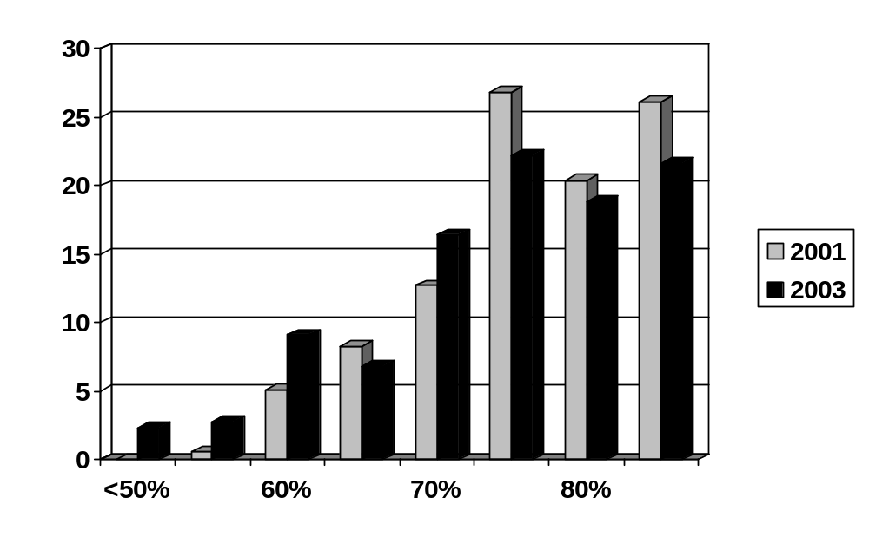

BETTER BIRTHS INITIATIVE (BBI) EVALUATION IN THE EASTERN CAPE

Makinana N, Hofmeyr GJ, Singata M, Mangesi L, Jafta Z, Masilela S*. Effective Care Research Unit, University of Witwatersrand and Fort Hare; *Eastern Cape Dept. of Health

Introduction
The Better Births Initiative (BBI) is a new strategy developed by health professionals in South Africa and internationally, to help provide a better quality of childbirth care for women and improve maternal outcomes in low-income countries. The standards are based on the best available evidence, and can be implemented using existing resources. The following principles form the basis of BBI:
HUMANITY: women treated with respect.
EVIDENCE: care that is based on the best available evidence.
COMMITMENT: health professionals committed to improving care.
ACTION: effective strategies to change current practices.
BBI has been implemented in the Eastern Cape since January 2002 in the form of workshops conducted in 24 districts. Participants were maternity health care providers. The aims of the workshops were to:
- Discuss the benefits and harms of the procedures used during labour.
- To examine research evidence on the benefits and harms of procedures.
- To discuss ways of changing practice towards BETTER BIRTHS.
- To provide information on how to implement the four steps to ‘Better Births’, and set realistic goals for reducing harmful or unnecessary procedures.
After six months follow up was done to see if Better Births was implemented and to find out if there were any obstacles encountered and share experiences.
After a year since implementation, an evaluation was done. Seven municipality districts were visited.

Objectives
- To find out how much the maternity staff know about BBI.
- To evaluate the effects of BBI in an institution.
- To reinforce the principles of BBI to the maternity staff and management.

Methods
- One hospital and clinic in each of the 7 municipal districts were selected by random sampling, as well as the referrel hospital.
- Three groups of people were evaluated in each institution: the labour ward staff, post-natal ward patients and the management.
- Data was collected in the form of questionnaires and focus group interviews with tape recorder.
- Labour ward registers were studied for the columns that are added for new changes and the month before the implementation of the BBI was used as the baseline.
- Audit charts that were distributed during implementation were studied.
- Three changes that were most commonly evaluated were, stopping routine episiotomies in primigravidae, number of women who had a companion in labour and number of women who received oral fluids during labour.
- Data were analysed and the results will be made available for all interested, particularly those who participated.
The BBI materials are available free of charge on the WHO Reproductive Health Library, from rhl@who.int
and on the BBI website: http://www.liv.ac.uk/lstm/EHCP.html

MODIFICATION OF THE CENTERING PREGNANCY PROGRAM FOR USE IN THE SOUTH AFRICAN CONTEXT

De Gouveia E, Makin JD
Department of Obstetrics & Gynaecology University of Pretoria

The Centering Pregnancy Program is an innovative model for group antenatal care that has been successfully implemented at more than 50 antenatal care sites around the United States and Canada. In a group setting, women receive their basic antenatal risk assessment, can share and gain support from other women, improve their sexual risk reduction skills and gain knowledge and skills related to their pregnancy, condom use, STDs /HIV, childbirth and parenting. Groups of 8-12 women of the same approximate gestational age are led by a midwife and an assistant. The Centering Pregnancy Program has structured 2-hour sessions that are implemented from the 2nd trimester of pregnancy (after initial individualized assessments have been conducted) through to the end of pregnancy. There are 12 main content areas. The program was developed and modified for young urban US women. For the program to be effective, it needs to focus on cultural and content issues important to South African pregnant women.

Aim
The primary objective of the proposed project is to modify an innovative group antenatal care program (Centering Pregnancy Program). This study will serve as the pilot study for a much larger randomised control trial investigating the effectiveness of the group prenatal care.

Methods
A total of 34 women in 5 groups volunteered to participate in the focus groups. They were recruited from the Kalafong antenatal clinic while waiting for their routine check up. A further focus group has yet to be done with the partners of these volunteers. The health care workers at the Kalafong antenatal clinic also participated in separate groups. Volunteers were asked to give their opinion on the current method of antenatal care and on the proposed program in an informal setting. The sessions were recorded and notes were taken.

Results
The transcribing and analysis of the data is currently in progress. Preliminary results suggest that women and health care workers would welcome the Centering programme.

LINKWOOD CLINIC - A MODEL MOU FOR THE PRIVATE SECTOR

Barbara Hanrahan, Linkwood Clinic, Marilyn Sher, Independent midwives

Linkwood Clinic's birth unit could be viewed as a model for MOU's in the private sector.

The clinic has been open since June 2001 and over 1500 women will have given birth in the unit by June 2004: the clinic's third birthday.

The unit has been able to contain the ceasarean section rate to between 20 and 25 %. This rate is very favorable when compared to the high caesarean rate in the private sector in Johannesburg.

Eleven (11) independent midwives and three (3) obstetricians client's utilise the unit on a regular basis.

The staff midwives, private midwives and obstetricians have an excellent working relationship. This includes back up, referalls, peer review, continuing education, joint development of policies and procedures.

We wish to present the Unit's birth and related statistics for 2002 and 2003.
THE IMPACT OF KANGAROO MOTHER CARE AND BREAST MILK FEEDING ON THE INCIDENCE OF BLOOD PRODUCT TRANSFUSION IN INFANTS <1800 GRAMS

Weyers HH, Kirsten GF. Department of Paediatrics and Child Health, Tygerberg Children’s Hospital and the University of Stellenbosch.

Blood product transfusions form an integral part of the management of very low birth weight (VLBW) infants. These infants are amongst the most heavily transfused of all patients. At our own institution, Kangaroo Mother Care (KMC) and breast milk feeding resulted in a significant decrease in the incidence of necrotising enterocolitis. KMC and breast milk feeding have the potential to reduce the incidence of nosocomial infections and necrotising enterocolitis and therefore the need for blood transfusions in VLBW infants.

Objective
To determine the prevalence of blood product transfusions in infants weighing less than 1800g admitted to a level 2 neonatal ward and nursed with intermittent KMC and breast milk feeding, compared to infants <1800g nursed with conventional incubator care and formula feeds.

Study design: A retrospective, descriptive, cohort analytical study.
Study setting: Level 2 neonatal ward, Tygerberg Children’s Hospital, Western Cape.

Study population
Study Group A consisted of an historical control group of 334 infants with birth weights <1800g admitted between 01/04/1997 and 31/03/1998 to a level 2 neonatal ward and managed with conventional incubator care and formula milk feeding. Group B consisted of 410 infants with birth weights <1800g between 1/4/99 and 31/3/00 admitted to the same level 2 neonatal ward one year after the establishment of a KMC unit and who were treated with intermittent KMC and breast milk feeding

Measurements
Information on birth weight, gestation, sex, day of birth and discharge were obtained from babies’ folders. Information on number and types of blood product transfusions, cost of consumables, cross match and actual cost of blood products was obtained from the database of the Western Province Blood Transfusion Services.

Results
There were no differences (p=0.4) regarding mean birth weights between the 2 groups but the mean gestational age of the infants in Group B was significantly lower (p=0.02). Twenty three and thirteen percent of the infants in Groups A and B respectively received a blood transfusion (p=0.0006). The mean number of packed red cell transfusions for all infants in Groups A and B was 1.03 and 0.47 (p=0.0001) respectively. The infants with birth weights >1000g (p=0.0001) and gestational ages >30 weeks (p=0.009) in Group B had significantly fewer blood transfusions compared to those infants with similar birth weights and gestational ages in Group A. The infants in Group B received significantly fewer fresh frozen plasma (FFP) transfusions (p=0.0003) with a trend (p=0.05) for fewer platelet transfusions compared to the infants in Group A.

Table 1 Anthropometric measurements of the infants (mean, SD)
 | Group A  n=344 | Group B  n=410 | p
Birth weight (grams) | 1383 (287) | 1362 (303) | 0.4
Gestational age (weeks) | 31.3 (3.0) | 30.8 (2.7) | 0.02

Table 2 Percentage of infants that survived in the two study groups according to birth weight and gestational age categories
 | Group A  n=344 | Group B  n=410 | p
Overall survival | 93.6% | 95.4% | 0.3
Survival of infants >30w | 97.6% | 98.9% | 0.3
Survival of infants <30w | 83.8% | 88.1% | 0.3
Survival of infants <28w | 51.7% | 78.5% | 0.02
Survival of infants >1000g | 97.7% | 99.1% | 0.2
Survival of infants <1000g | 61% | 75.4% | 0.1
Survival of infants <800g | 28.5% | 70.6% | 0.08

Table 3 Percentage of the different number of packed red cell transfusions administered to the infants in the two study groups
Number of packed cell transfusions | Group A  n=344 | Group B  n=410 | P
0 | 77% | 87% | 0.0006
1-3 | 17% | 8.5%
>3 | 6.4% | 4.4%

Conclusions
KMC and breast milk feeding in infants <1800g resulted in a significant decrease in blood product transfusions compared to a similar group of infants who received conventional incubator care and preterm formula feeding. KMC also resulted in an improved survival of the infants with gestational ages <28 weeks. This study confirmed the beneficial effect of KMC to VLBW infants. KMC should be the preferred form of treatment for VLBW infants.

EFFECT OF KNOWING INFANT’S HIV STATUS ON FEEDING PRACTICES

C Mutanda, UE MacIntyre, P Baloyi, MPB Mawela
Department of Paediatrics and Child Health, MEDUNSA

Background
The risk of transmission of the human immunodeficiency virus (HIV) from an infected mother to her infant through breast milk means that recommendations for breastfeeding of all infants can no longer be made. The World Health Organisation guideline that HIV infected mothers should not breastfeed applies only when the mother is HIV-positive and the infant HIV-negative or HIV status unknown with consideration of the mother’s socio-economic status, informed choice and the infant’s best interests. However, when an infant is already HIV-infected, it is advisable for the mother to continue breastfeeding as the advantages of breastfeeding outweigh the risks.

Objective
To determine whether a mother’s knowledge of her infant’s HIV infection influenced her breastfeeding and other infant feeding practices.

Methods
Mother-infant pairs (infants younger than 6 months) admitted to the Medical Paediatric wards of Ga-Rankuwa Hospital between July 2001 and April 2002 were enrolled after giving informed consent. Two questionnaires on infant feeding practices were administered. The first questionnaire was administered on enrolment before HIV testing and the second after HIV post-test counselling of those tested, about one month after discharge. HIV testing was done on medical grounds at an individual paediatrician’s discretion.

Results
Of 152 mother-infant pairs enrolled, 70 completed the study: 20 pairs with an HIV infected infant became the study group and 50 pairs with the infants’ HIV status negative (12) or unknown (38) became the control group. Mean age of the whole sample was 78 (sd=45) days; 94 (sd=39) days for the study group and 74 (sd=46) days for the control group. There were no significant differences between the study and control groups for mean age at the start and end of the study, mean study period or gender distribution (p>0.05)

Prevalence of breastfeeding was 90% on enrolment in both the study and control groups and dropped to 80% in the study group and 86% in the control group after a mean 41 (sd=19) days of follow-up. The difference in prevalence between entry and exit was not statistically significant (p>0.05) for either group.

At enrolment, 91% of all mothers were giving their infants water, 100% in the study group and 88% in the control group. Of these, 40% had started doing so within the first week of life and all by the time the infant was 16 weeks old. On exit from the study, the percentage of mothers giving water in the control group had increased to 94%. None of the differences in percentages of mothers giving water was statistically significant (p>0.05).

Infant formula was given by 40% and 42% of mothers in the study and control groups respectively at enrolment. Of these mothers, 83% had started the formula by one month of the infant’s age. On exit from the study, 47% of all mothers were giving formula, 55% in the study group and 44% in the control group. The increase was not significant (p = 0.50).

At enrolment, 65% of mothers in the study group were giving complementary foods and 54% in the control group. The difference between the two groups in use of complementary foods was not significant (p = 0.40). On exit from the study 73% of all mothers were giving complementary foods, 95% in the study group and 64% in the control group. The difference between the use of complementary foods at enrolment between the groups was not significant (p>0.05). The proportion of infants receiving complementary foods in the study group increased significantly by exit (p=0.048) resulting in a significant difference between study and control groups on exit from the study (p=0.01).
The mothers’ knowledge of HIV transmission through breast milk and their recommendations regarding the breastfeeding of HIV positive infants are shown in Tables 1 and 2.

Table 1 Mothers’ knowledge of HIV transmission through breast milk
Mothers’ response | Number (percentage) of mothers  Study group Control group |  | * p-value
Breast milk transmits HIV | 11 (55) | 19 (38) | 0.19
Breast milk does not transmit HIV | 3 (15) | 11 (22) | 0.74
Did not know if breast milk transmits HIV or not | 6 (30) | 20 (40) | 0.43
Total | 20 (100) | 50 (100) | -
* p-value for difference between study and control group

Table 2 Mothers’ breastfeeding recommendations for HIV infected infant
Mothers’ recommendation | Number (percentage) of mothers  Study group Control group |  | * p-value
Stop breastfeeding | 6 (30) | 21 (42) | 0.35
Continue breastfeeding | 10 (50) | 20 (40) | 0.45
Did not know what to recommend | 4 (20) | 9 (18) | 0.88
Total | 20 (100) | 50 (100) | -
* p-value for difference between study and control group.

Conclusion
There were no significant differences in breastfeeding practices between mothers of newly diagnosed HIV infected infants and those whose infants’ HIV status was negative or unknown after one month of follow-up. A significantly higher proportion of mothers of newly diagnosed HIV infected infants, however, were giving complementary foods by the end of the study period.
Approximately one third of all mothers recommended that mothers of HIV infected infants should stop breastfeeding. The discrepancy between the mothers’ recommendations and their practices suggests other factors apart from their choices play a role in infant feeding practices.
The current recommendations on HIV and breastfeeding are intended to reduce mother-to-child transmission of HIV. Mothers of HIV infected children should be encouraged to continue breastfeeding. It should be explained that they need no longer worry about the risk of HIV transmission through breast milk and that breastfeeding is the best option for their infant.
THE CHOICE OF BABY FEEDING MODE WITHIN THE REALITY OF THE HIV/AIDS EPIDEMIC: HEALTH EDUCATION IMPLICATIONS

CS Minnie, M Greeff
Northwest University (Potchefstroom Campus)

Introduction
Health education regarding is no longer a simple matter in developing countries with a high HIV infection rate. Before the HIV and AIDS epidemic, breastfeeding was the best choice for almost all babies. Approximately one third of women who visit the antenatal clinics in the North West Province of South Africa are HIV positive. The reality of the high prevalence of HIV infection must now be considered in the choice of baby-feeding mode.

Aim of the study
The aim of the study was to explore and describe the factors that should be considered by midwives in their health education of pregnant women on HIV and baby feeding, as well as the perceptions and the levels of knowledge of midwives and pregnant women regarding these factors. The final aim was to compile guidelines for health education by midwives to pregnant women in order to empower them to make a choice pertaining to the most appropriate baby-feeding mode.

Factors that must be considered in the health education to pregnant women regarding HIV and baby feeding
Although total avoidance of breast-feeding rules out the risk of HIV-transmission, it is not necessarily the best choice for all women.

Breastfeeding can be seen as a safety net against poverty and the risk of not breastfeeding, must be measured against the risk of HIV-infection (Coutsoudis et al., 2001:6). The infant mortality resulting from dehydration and infections because of the lack of protective factors in breast milk (especially in poor living conditions) may be more than the mortality resulting from HIV/AIDS infection (Yamey, 2001:1). An important factor that must be considered in health education is the risk of the spill-over effect if also those mothers who cannot do it safely, feed their babies with a breast milk substitute. According to McCoy et al (2002:29) cultural diffusion can cause a general loss in confidence in the benefits of breast-feeding. If health workers advise the use of breast milk substitutes on occasion, they can be seen as supporting the general use of it.

Even those HIV-positive mothers that live in favourable living conditions may use unsafe practices when using a breast milk substitute (Bergström, 2003:8). A mother may also be afraid that she can, should she act contrary to the cultural norm of breast-feeding, be identified as HIV positive and then be stigmatised (Semba et al, 1999a:93).

Before a woman can compare the risk of not breastfeeding with the possible risk of HIV-infection, her own HIV-status must be known. This is one of the reasons why all pregnant women must get the opportunity and be encouraged to be tested for the HI virus (Moodley, 1999:684). Pregnant women must also be knowledgeable about the factors that influence the risk of HIV mother-to-child transmission through breast milk.

The risk of HIV-transmission through breast milk
In the absence of any interventions, the total risk of mother-to-child transmission of HIV during pregnancy and during birth and through breastmilk is about 30% (Wilkinson & McIntyre, 1998:1304). Although it is generally accepted that the risk of infection that can be contributed to infection through breast milk is about 14% (Dunn et al., 1992:587; Leroy et al., 1998:600), various factors have an influence on the risk of mother-to-child transmission through breast milk.

The viral load in the mother’s blood
The viral load increases shortly after sero-conversion because of primary infection or reinfection (Dunn et al, 1992:586, Newell & Peckham, 1994:43). The use of safe sexual practices is therefore especially important for all pregnant and breastfeeding women.

The viral load is also increased during the final stages of the disease. Because of the increased risk of mother-to child transmission added to the risk of the deterioration of the mother’s condition if she is already ill, breastfeeding is not advised for women with advanced AIDS (Nduati et al.2000: 101; UNAIDS, 1999:1).

Anti-retroviral drugs have the ability to decrease the plasma viral load. The regimen that is currently used in South Africa, a single dose of 200 mg Nevirapine during labour followed with a single dose (2 mg/kg) for the baby within 72 hours after birth, decreases the risk of vertical transmission during labour from 16% to 6% (McCoy et al., 2002:26). Chen et al (2000:1620) found that the risk of infection through breast milk is decreased for babies whose mothers received anti-retroviral medication, although the protective value of the single dosages-regime is not yet determined.

The viral load in the mother’s milk
Semba et al. (1999b: 305) found that as only one third of milk specimens of patients with confirmed HIV-infection contained detectable levels of HIV, the intrinsic protective properties of breast milk that usually act against infections like gastro-enteritis apparently also provide protection against the free cell HIV component.

Heat treatment (pasteurisation or boiling) is necessary to disable the cell associated HI viruses. Both free cell and cell associated HI viruses are destroyed in human milk if heated for 30 minutes to 56°C (Orloff et al., 1993:16). It was found that when the milk of a HIV-infected mother is placed in a glass bottle in an aluminium pot with boiling water and left for 20-30 minutes, all the HI viruses were destroyed (Jeffery et al., 2001:346). This method can be very valuable in circumstances when the milk may be more than usually infectious.

One of these circumstances is when mastitis is present. HIV-positive women with signs associated with mastitis, had almost twice the rate of mother to child transmission, compared to other HIV-positive women (Semba, 1999a;97). If mastitis is present, pasteurisation can be used as a temporary measure.

Integrity of the mother's and baby's skin and mucus membranes
The risk of mother to child transmission of HIV is increased if the nipple of the mother’s breasts is damaged (Coutsoudis et al, 74). Sore or cracked nipples must be prevented (Smith & Kuhn, 2000:336), and when present the mother should not breastfeed her baby directly (Coutsoudis et al, 2001:24), but rather pasteurise her expressed milk until her nipples are treated and healed.

Ruff et al. (1992:326) came to the conclusion that the risk of transmission through breast milk would be increased if the oral mucous membranes of the baby are not intact e.g. when conditions like candida, stomatitis of farangitis are present. Coutsoudis et al. (2001:24) recommends that candida infection should be treated as soon as it is diagnosed. It can also be advised that a mother rather give pasteurised breastmilk during the period the infection is present.

The permeability of the mucus membrane of the baby’s intestines can be affected during infections like gastro-enteritis (Evian, 2000:221) and when the baby is born prematurely (Briggs, 1999).

The other main factor causing the integrity of the intestinal mucus membranes to be disturbed is when mixed feeding is practised too early (Smith & Kuhn, 2000:334-336; Coutsoudis et al, 1999;474; 2001b:18). The importance and practical aspects of exclusive breastfeeding must be included in the health education to pregnant women.

Adaptations in breast-feeding technique to limit the risk of HIV-transmission
The research of Coutsoudis et al. (1999:474) has proven that the risk of HIV-transmission through breast milk is largely determined by the mode of breastfeeding being practiced. The risk of mother to child transmission is less when exclusive breastfeeding (with no other liquids or solids except medication (WHO, 1998:1; Labbok, 2000:20)) is practised compared to the practise of mixed feeding (Coutsoudis et al, 1999:472; 2000:102; Taren et al, 2000:72).

Although exclusive breastfeeding is recommended for all babies under the age of six months after which breast milk alone can no longer meet all the nutritional demands (WHO & UNICEF, 1992:1), the practice of mixed feeding before this age is very common. According to Smith and Kuhn (2000:334), most babies under the age of four months do not receive exclusive breastfeeding as feeding with other types of milk or solids starts before this age. The practice where a baby that mainly receives formula milk, also occasionally breastfeed can also be considered as mixed feeding.

An HIV-positive mother that has chosen to breastfeed must abruptly wean her baby as soon as she starts to introduce other fluids or solids to her baby’s diet (Coutsoudis et al., 1999:475; 2001b: 24). Gradual weaning is not recommended, as there will be a period of mixed feeding when the risk of HIV transmission is increased.

Results of the study
The overall knowledge of the midwives was better than the knowledge of the pregnant women. This indicates that the knowledge of the midwives is not efficiently transferred to the pregnant women.

Comparison of the percentage of correct answers by the midwives and pregnant women
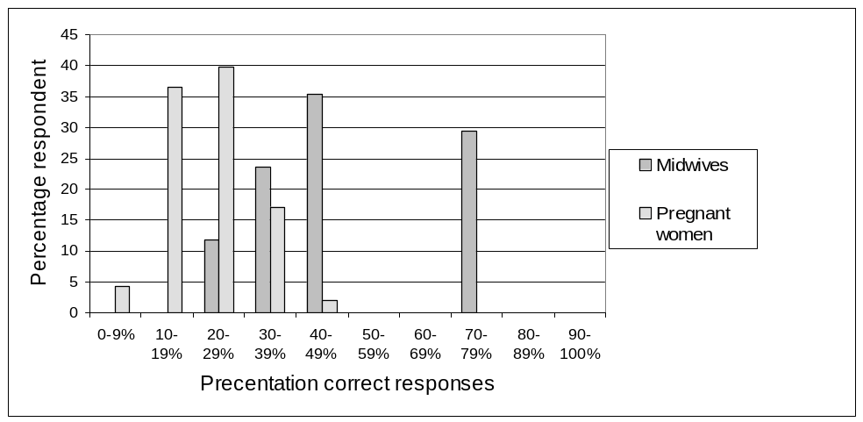
Perceptions of the midwives regarding antenatal education about the choice of baby-feeding mode

The midwives admit that the health education presented to the pregnant women is deficient. They experience the following stumbling blocks in the presentation of health education:
- The midwives have the perception that giving health education is not worthwhile as the women are not free to make a choice because of factors like their financial status and their fear for victimisation and stigmatisation if their family would detect their positive HIV status.
- The midwives experience communication problems because of language/culture difference between the midwives and the pregnant women, the denial of the reality of HIV as well as the level of ignorance of some of the pregnant women.
- The midwives experience a lack of time, sufficient staff and educational material like posters and pamphlets.

It was found that of all the factors influencing pregnant women in their decision of baby-feeding mode, the health education that they receive from midwives at the antenatal clinic plays the most significant role.

Formal and informal training
Pregnant woman in her circumstances
Domestic circumstances, sanitation, method how water is heated
Previous experience with baby feeding
Knowledge of HIV transmission and baby feeding
Media
Most appropriate baby feeding mode
Ante Natal Education
Pregnant woman
Informed decision
HIV status
Midwife

Advice from family and friends
Culture
Perception of Stigma regarding HIV status in community
Financial status
Educational level
Support
Age
Privacy

Schematic representation of the process of antenatal education by the midwife to the pregnant woman to enable her to make an informed decision regarding the most appropriate baby feeding mode
Previous infant death because of gastro-enteritis or malnutrition
The final conclusion was made according to the perceptions of the midwives and the pregnant women, that the women aren’t sufficiently empowered by the health education to be able to make an informed decision regarding the most appropriate baby feeding mode.

References available on request from Mrs. Minnie (vpkcsm@puk.ac.za)

CONTAMINATION AND NUTRIENT CONCENTRATION OF INFANT FORMULA FEEDS IN AN URBAN TOWNSHIP: A SUB-STUDY OF THE NATIONAL PMTCT COHORT STUDY

Erika Bergstrom, Ted Greiner, University of Uppsala; Nigel Rollins, Wim Sturm, University of Natal; Debra Jackson, Mickey Chopra, Juana Willumsen, University of the Western Cape; Tanya Doherty, Health Systems Trust; Mark Colvin, Medical Research Council

Aim:
Assess how mothers prepare and feed commercial infant milk and to assess the safety of these feeds

Objectives
# Describe methods of preparation
# Measure bacterial contamination
# Measure nutrient concentration

Material & Methods

Clinic Visit Assessments
# 94 mothers at the PMTCT clinic
# Pre-testing x 2
# Structured interviews
# Collection of milk samples from feeding utensils

Home Visit Assessments
# Sub-sample of 22 mothers
- Collection of available milk feeds
- Collection of demonstration feeds
- Observations

Analysis of the milk:
# Bacterial contamination:
- E-coli
- Enterococci
- Shigella
- Salmonella

# Nutrient concentration
- Protein

Reference values - Bacteria
# No pathogenic micro-organisms
# Human milk bank in Finland; breast milk fed to all newborn infants: <1000cfu/ml (potential pathogens) before pasteurisation
>1000cfu/ml = discarded

Protein; Infant formula
# 0-12 months; =/> 1.8g/100kcal
</= 4.0g/100kcal

Protein; Follow up formula
# 6months – 3 years; =/> 3.3g/100kcal
</= 5.5g/100kcal

Infant feeding counselling and recommendations
•Each mother was to have been counselled both antenatally and postnatally to:
•Wash hands, used boiled water
•Use sterilizing solution or boil bottle
•Use feed within one hour, do not save left-overs
•Use cup instead of bottle

Results, Infant feeding behaviours:
•32% washed hands sometimes or never
•41% owned a cup but only 3% used it for infant feeding
•100% used boiled water
•50% made up feed when child wanted it and 50% made it up in advance (more for night feeds)
•The majority left feeds with child too long or used left-overs
•Mothers scrubbed bottle with brush and water
•Only 34% used hot water
•76% used a sterilizing method
•13% washed or rinsed the bottle AFTER sterilizing it
•70% of feeds prepared more than an hour before feeding

Microbiological results, fecal bacteria

Contamination with E-coli:
At clinic: 64% 44% >1000cfu/ml
At home 63%
Demonstration feeds 33%

Contamination with Enterococci:
At clinic 26% 17% >1000cfu/ml
At home 54%
Demonstration feeds 14%

Factors significantly associated with contamination:
•Boiled water stored to be used later
•Bottle versus cup
•Possession of fewer bottles
•Fewer feeds/night
•No sterilising method
•No free formula from clinic
•Living outside Durban

Protein results:
Infants 0-12 months of age: (N=85)
Over-diluted feeds: 22%
Too concentrated feeds: 1%

Infants >12 months of age (N=9)
Over-diluted feeds: 78%
Too concentrated feeds: 0%

Home visits:
Already prepared feeds: 44% over-diluted
Demonstration feeds: 10% over-diluted

Factors significantly associated with over-dilution of the feeds:
•Age of infant > 6months old
•Larger quantity of formula prepared: 175-1000ml
•No running water inside house

Summary:
•Difficulties in safe practice of replacement feeding
•Contaminated milk feeds
•Over-diluted milk feeds
•No significant associations with socio-economic factors

Further studies needed:
•Development of an algorithm to identify babies for whom replacement feeding is likely to be safe/not safe
•Follow up of babies to determine health outcomes by feeding method.
ARE PATIENTS REFERRED FROM PERIPHERAL HOSPITALS AT HIGHER RISK OF COMPLICATIONS IN LABOUR?

OY Egbeyemi*; WJ Steinberg*, G Joubert#
* Department of Family Medicine, # Department of Biostatistics; University of the Free State, Bloemfontein

Aim of Study
To determine whether patients referred to Cecilia Makewane Hospital, Eastern Cape, by peripheral hospitals are at greater risk of developing complications in labour.

Method
A prospective analytical study was designed to analyse women presenting to the labour ward at Cecilia Makewane Hospital for the period 1 April to 30 June 2001. The study group was stratified according to their source of origin: home, outlying clinics, peripheral hospitals, antenatal ward and private sector. The following outcomes were measured: mode of delivery, pregnancy outcome wrt abortion, stillbirth, and admission to the neonatal ward.

Results
A total of 863 patients were included into the study. Their source of origin is reflected in Table 1. Only one patient came from the private sector in this period.
There were 298 caesarean sections in this study population. Sixty eight percent of those referred from peripheral hospitals needed a caesarean section compared to less than 40% in all other groups (Table 2).
Of all the patients, 164 babies (19%) were admitted to the neonatal unit. 28% of the clinic referred patients, 30% of the hospital referred patients, 13% of those from home, 22% of those from the ante-natal ward at Cecilia Makewane Hospital (Table 3).
There was a significantly higher stillbirth rate amongst those referred from the peripheral hospitals. Sixteen babies were stillborn, of which 7 were hospital referred patients and 4 could be directly related to intra-partum events (Table 4).

Confounders
Adjusting for the three possible confounders namely age, parity and booking status, patients from peripheral hospital were more likely to have caesarean sections than patients from all other sources. Increasing age (p=0.0024) and decreasing parity (p=0.0055) were independent predictors of caesarean section, but booking status (p=0.9860) was not significantly associated with caesarean delivery (Table 5).
Adjusting for confounders age, parity and booking status, women referred from peripheral hospital did differ significantly from women referring themselves regarding stillbirths (odds ratio 4.76; 95% CI 1.34 -17.06) and admission to the neonatal ward (odds ratio2.79; 95% CI 1.78 - 4.37). The patients from peripheral hospitals did not differ significantly from the patients from the clinics and antenatal ward regarding the above outcomes, although the odds ratios were generally larger than one.

Conclusion
This study confirms the hypothesis that patients referred to Cecilia Makewane Hospital in active labour should be regarded as high-risk patients.

Table 1 Origin of patients

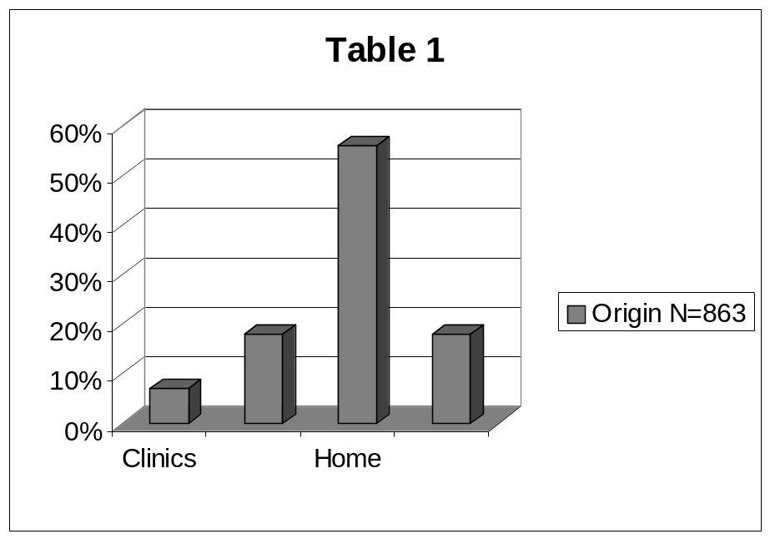

Table 2 Caeserean Sections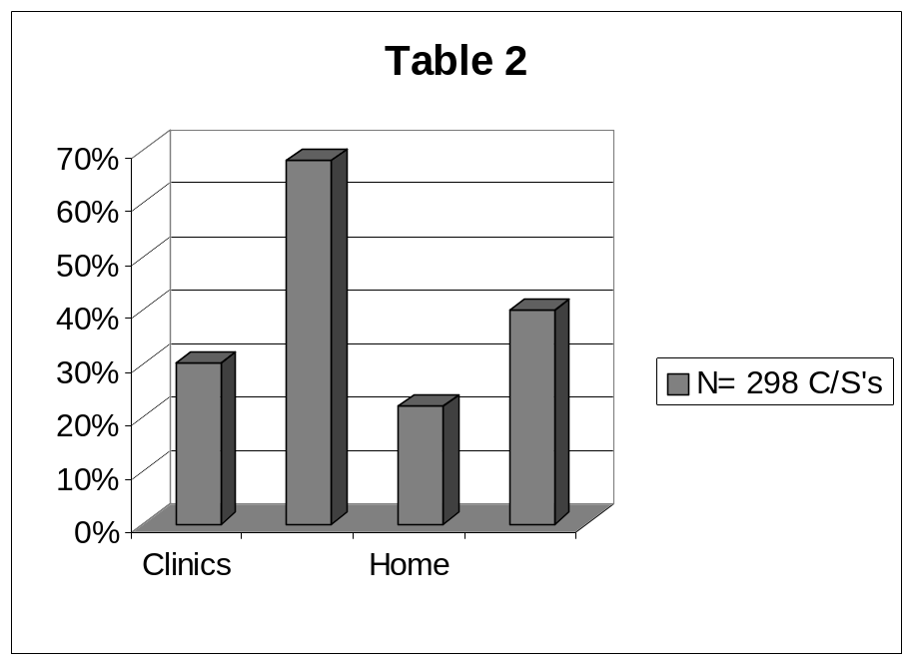

Table 3 Neonatal admissions
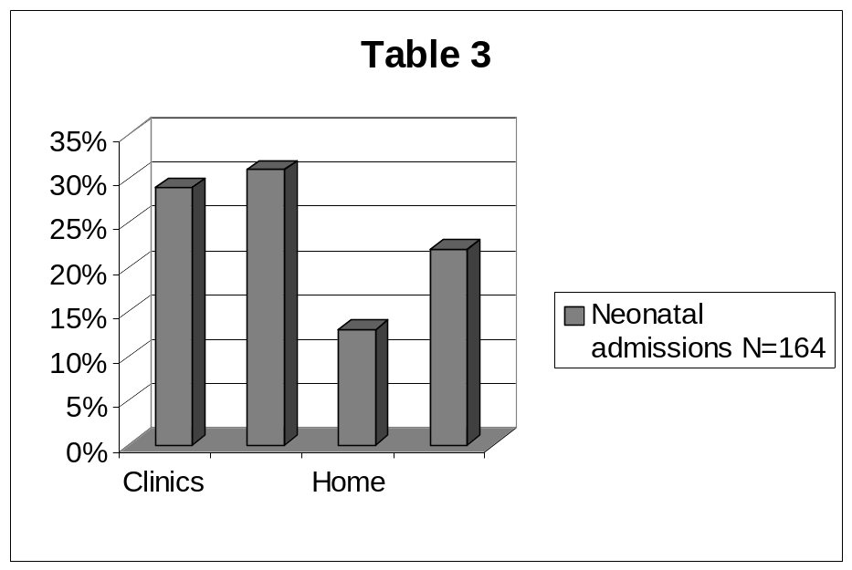

Table 4 Stillbirths
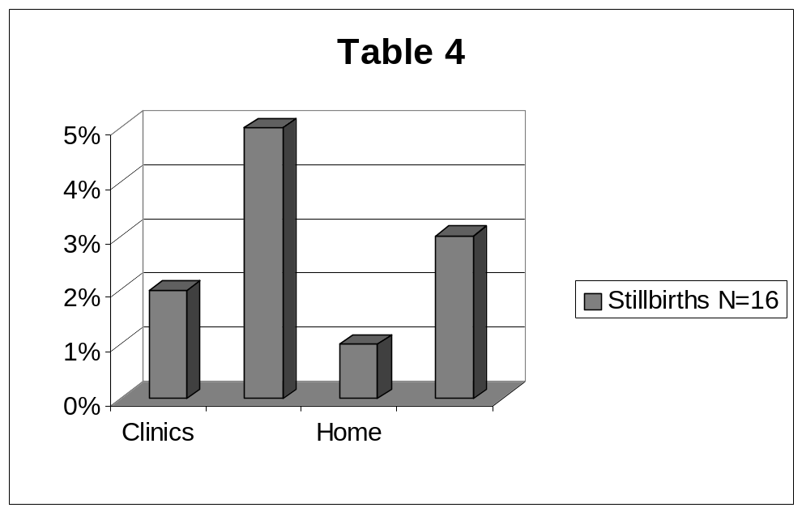

Table 5 Confounders
 | OR | 95% CI
Hosp vs clinic | 4.90 | 2.60-9.26
Hosp vs ward | 3.31 | 2.07-5.29
Hosp vs self | 7.53 | 5.00-11.36

A REVIEW OF FETAL OUTCOME IN CASES OF ABRUPTIO PLACENTA IN DR GEORGE MUKHARI HOSPITAL (GA-RANKUWA)

TJ Mashamba, M Maitin, OA Towobola
Department of Obstetrics and Gynaecology, MEDUNSA

Introduction
Abruptio placenta is the premature separation (before delivery of the fetus) of a normally situated placenta. It is a life threatening complication to both the mother and the fetus. It remains a major cause of both maternal and perinatal morbidity and mortality. The frequency of perinatal deaths associated with abruptio placenta ranges from 30-87%.

Prediction and prevention of abruptio placenta are made difficult by the fact that the aetiology is unknown even though a variety of maternal and fetal conditions have been associated. The diagnosis of abruptio placenta is usually easy but it becomes difficult in some patients with painless features. It requires prompt and active management because delay may compromise the patient with serious morbidity and even death.

Objective
The objectives of our study were to review perinatal outcome in babies born to mothers complicated by abruptio placenta

Setting
The study was conducted at the Dr George Mukhari Hospital: a tertiary centre, which is a referral hospital for numerous rural hospitals in the immediate areas of Ga-Rankuwa and the three other provinces. The patient population is mainly of low socio-economic background.

Methodology
Following approval by the Ethics Committee of Medunsa, the files of patients who delivered at the hospital between the period 1 January 1998 – 31 December 1999, were retrieved. The relevant material information and perinatal data were collected using data collection forms, encoded for statistical analysis.

The inclusion criteria entailed all patients who had clinical symptoms and signs of abruptio placenta. Patients who were at least 28 weeks gestation – calculated from the first day of the last normal menstrual period, were included. Retrospective diagnosis was used for those cases, who could not be confirmed by their clinical presentations. Abruptio placenta was confirmed post-delivery by the presence of retro-placeta clot.

Outcome Measures
All delivery files for the two-year period were retrieved and those with abruptio placenta were evaluated. Focus on perinatal outcome included: perinatal or neonatal deaths, significance of mode of delivery on perinatal outcome, weight differential among babies who survived compared with those of perinatal deaths and the overall mortality rate.

Results
During the period of this review, there were 13 577 deliveries at the Dr George Mukhari Hospital, of which 124 cases were complicated by abruptio placenta, giving an incidence of 0.9%.

Table 1 Clinical and Demographic Data of Patients (N=124)

Age (yrs) (Mean; Range) | 28 (16-40)
Parity (Mean; Range) | 3 (0-7)
Previous history of hypertension | 80 (64.5%)
History of cigarette smoking | 17 (13.7%)
Previous history of abruptio placenta | 10 (8.1%)
Prenatal Care attended | 41 (33%)
10 patients (8.1%) were of parity >5
5 patients (4%) were 35 years or older

A large proportion of the women (67%) in this review, were unbooked for antenatal care.
Table 2 Fetal Outcome

FETAL OUTCOME | N=124 | PERCENT
Live Births  - Survivors  - ENND | 69  63  6 | 55.6  91.3  8.7
Stillbirths  - FSB  - MSB | 55  51  4 | 44.4  92.7  7.3
ENND – Early Neonatal Death
FSB – Fresh Stillbirth
MSB – Macerated Stillbirth

Table 2 illustrates fetal outcome in this series. Sixty-nine babies were born alive of which 6 died in the early neonatal period and 63 survived. There were 55 stillbirths and the perinatal mortality from these figures was 49.2%.

In Table 3 below, there were significantly more survivors in the caesarean section group than in the vaginal group (88.8% vs 13.2%). Seventy seven percent of all the deaths (neonatal and stillbirths) weighed <1.5kg when both vaginal and caesarean section deliveries were combined. From the babies who survived, 92.2% weighed more than 2.5kg for both groups. The mortality rate was significantly higher in the very low birth weight babies (<1.5kg, with a p value of <0.002).

Table 3 Relationship of birth weight, mode of delivery and fetal outcome

 | Vaginal deliveries (N=61) |  |  | C/s deliveries (N=63)
Births weights (kg) | SB | NND | Alive | SB | NND | Alive
1.5 | 40 | 2 | 0 | 0 | 4 | 0
1.6-2.4 | 8 | 0 | 5 | 3 | 0 | 0
> 2.5 | 3 | 0 | 3 | 0 | 0 | 56
NND = Neonatal death | SB = stillbirth

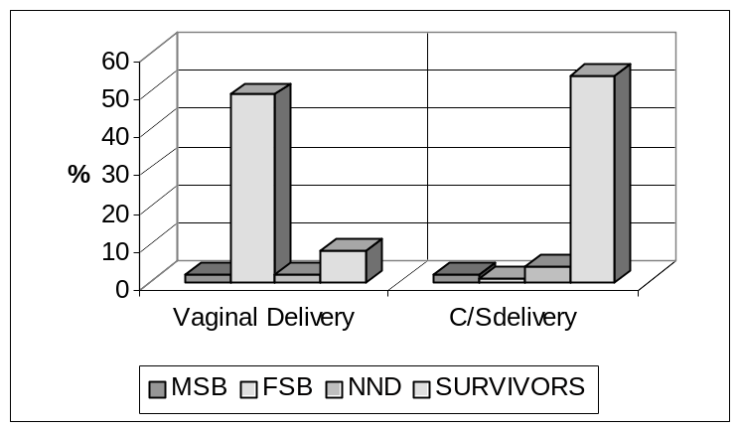Figure 1 Relationship of mode of delivery and fetal outcome

Figure 1 shows the relationship between mode of delivery and fetal outcome. In the C/s group, 88.8% of the babies survived while only 13% of those delivered vaginally survived. There was also a disproportionately higher number of fresh stillbirths among babies delivered vaginally.

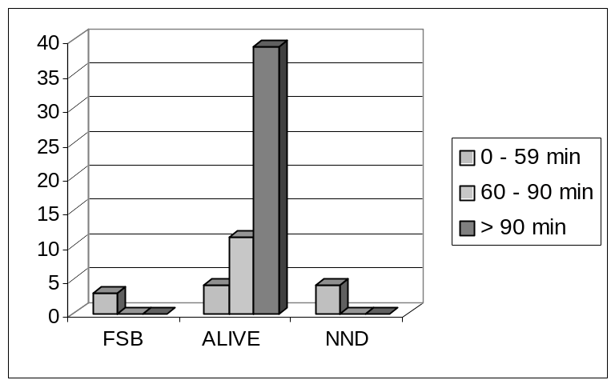Figure 2 Relationship of admission-delivery time and fetal outcome in patients delivered by c/s (n=61)

The average admission-delivery-time was 2 hours, although the majority of the patients were delivered after 1.5 hours. There were 4 neonatal deaths, all weighing <1.5kg. Two dead babies, whose mothers reported loss of fetal movements for more than 24hrs prior to admission, were delivered by C/s.

Conclusion
The primary cause of abruptio placenta is unclear, but the following factors have been implicated as risk factors: cigarette smoking, intrapartum hypertension, coitus within 48 hours preceding delivery and lack of antenatal care. The incidence and perinatal mortality reported in this review, for Dr George Mukhari Hospital (0.91% and 49.2%) compare very well with the reported incidence of 1.2% and perinatal mortality of 61% from the King Edward VIII hospital in Durban.

A CRITICAL EVALUATION OF THE MANAGEMENT OF NEONATAL JAUNDICE BY THE MIDWIFE OBSTETRIC UNITS

Van Leeve K, Kirsten GF, Samuels A. Department of Paediatrics and Child Health, Tygerberg Hospital and Bishop Lavis Day Hospital.

With the current policy of discharge within 24 hours after birth of well term and near term infants, it is the mother’s responsibility to identify jaundice in her infant and to decide whether it warrants an assessment at a hospital or clinic outside the days of the clinic visits. Very few state hospitals in South Africa have the facilities to admit mothers with their jaundiced infants so that breastfeeding is often interrupted and replaced with formula feeding. Although the screening of jaundiced infants may be performed at clinics, phototherapy is traditionally managed in a hospital under the supervision of a doctor. Neonatal jaundice is therefore a relatively expensive condition to manage. In the Tygerberg Hospital drainage area, infants are screened for neonatal jaundice (NNJ) at Midwife Obstetric Units (MOU) and treated with phototherapy at Bishop Lavis MOU. No information is available on the efficacy of the system.

Objective
To determine the effectiveness of the current NNJ screening, treatment by phototherapy and referral system at the MOUs.

Methods
Neonates whose total serum bilirubins (TSBs) were screened between 1 August 1999 and 31 July 2001 at Elsies River and Bishop Lavis MOU, or who were admitted to Bishop Lavis MOU for phototherapy, or who were referred to TBH for further management were studied retrospectively. The duration of admission, number and location of those transferred, processing time of blood samples as well as indication for transfer, were recorded.

Results
A total of 3962 infants were screened of whom 381 (Table 1) were admitted to Bishop Lavis MOU for phototherapy and 40 who were transferred to TBH for a possible exchange transfusion (Table 3). The mean processing time of the blood samples was 6.37 hours (range 1.18 – 18.38) (Table 2). Serious deficiencies were identified in the TSB screening system as reflected by the long blood sample to laboratory processing time (BSLPT).

Table 1 Clinical characteristics, total serum bilirubin levels (mmol/l) and duration of admission to Bishop Lavis of the 381 infants who required phototherapy (mean, SD)
 | Age on admission (days) | Gestation (weeks) | Birth weight  (grams) | TSB* on admission | Duration of admission (days)
Mean (SD) | 5.2(1.9) | 37.1(2.2) | 2607(532) | 277(42) | 1.5(1.9)
Median | 5 | 37 | 2540 | 280.5 | 1
Range | 2 - 20 | 31 - 44 | 1700 - 4280 | 167 - 384 | 1-5
*TSB = Total serum bilirubin

Table 2 Time taken between blood sampling and laboratory processing (hours)
 | Bishop Lavis | Elsies River
Number of samples | 1414 | 1209
Mean time (SD) between sampling and processing | 6.45(2.05) | 6.28(1.76)
Range | 1.18-18.38 | 1.08-14.98
Number of samples with sampling and laboratory time of >6 hours | 771 (55%) | 720 (60%)

Table 3 Clinical informations and TSB levels of the fourty infants tranferred to Tygerberg Hospital for possible exchange transfusion
 | Gestational  Age(wks) | Weight  (grams) | Age(days)  At transfer To TBH** | 1st TSB*  (mmol/l) | TSB (mmol/l)  Before transfer | TSB (mmol/l)  at TBH**
Mean (SD) | 37.5 (2.3) | 2655(499) | 1.3(0.7) | 283(47) | 339(77) | 303(73)
Range | 32-42 | 1896-3584 | 0-3 | 201-384 | 193-519 | 191-494
TSB = Total serum bilirubin level; TBH* = Tygerberg Hospital

Conclusion
The current screening and treatment system is effective as reflected by the number of patients screened and treated at the MOU. Only 10.4% of neonates admitted to Bishop Lavis for phototherapy were transferred to TBH. The long BSLPT should be reduced.

Recommendations
More phototherapy units should be set up at the MOUs. Blood processing time would be shortened by contracting a laboratory closer to the MOU.
DEVELOPMENTALLY SUPPORTIVE CARE: THE EFFECTS OF POSITIONING ON STRESS LEVELS IN THE PRETERM INFANT

Angie Hennessy, Carin Maree (UP – Department of Nursing Science) & Prof Piet Becker (MRC – Biostatistics Unit)

Background
This study investigates aspects of developmentally supportive positioning (DSP) because there is little extant literature available. In the neonatal intensive care unit (NICU) under study, it was observed that when external environmental factors (light, touch and sound) were optimally modified, the preterm infant was still prone to physiological instability or stress. This provided the impetus for this study. Thus, more than just environmental adaptation is needed for reduction of negative sequelae. When the infants were positioned according to DSP principles, they appeared to have lower stress levels, including increased stability of vital data and reduced irritability. It appears that infants in these positions experience increased sleeping time and quiet-alert states.

Problem statement
The absence or inadequate implementation of DSP has a negative effect on the stress levels of the preterm infant.

Research question
What effect would DSP have on the stress levels of the preterm infant?

Purpose
Investigating DSP’s effects on preterm infant stress levels.

Objectives
The first objective was to find an appropriate stress scale to assess the stress levels of the preterm infant, and the second objective was to determine the effects of DSP on the stress levels of the preterm infant using this stress scale. As an appropriate scale could not be found, the first objective became to develop and validate such a scale. Objectives one and two formed phase one and phase two of the research process respectively, where phase one addressed stress scale development and validation, and phase two, data collection using the validated stress scale.

Setting
A private hospital’s neonatal intensive care unit (NICU).

Target population, sample
Preterm infants of gestational age < 37 weeks admitted to the NICU and not sedated; non-probability sampling techniques drew a convenience sample of 22 infants.

Research method, results – Phase one
Development of the Hennessy Stress Scale for the Preterm Infant. Observed qualitative data quantified as a percentage reflects the infant’s stress levels. An expert panel analysed content and validated the instrument using human judgement modelling to assign weights to items on the stress scale. These weights provide an accurate method of calculating preterm infant stress levels, producing a valid, reliable scale.


Research methods, results – Phase two
Within-subject design (quantitative empirical research) following a quasi-experimental approach used Hennessy Scale to investigate the relationship between DSP (independent variable) and preterm infants’ stress levels (dependent variable); observable behaviour, the preterm infants’ stress levels, was repeatedly measured throughout one baseline evaluation (pre-test) and intervention phase (post-test). Before data was collected, a compulsory education session on Developmentally Supportive Care (DSC) was presented to all NICU staff. The pre-test was done before routine care was delivered and the post-test was conducted three hours after the pre-test. All positions were used except supine positioning. During this time period, DSC principles were implemented as far as possible. Observation of the physiological stability and behaviour of the sample population indicated the effect of DSP on the stress levels of preterm infants.

Data was analysed by the use of a one-sided Student’s paired t-test, which compared the mean stress scores from pre-test and post-test data-collection results. Pre- and post-test mean stress level scores, 29.35% vs. 16.61% (shift of 12.74%), are significantly different (p < 0.0001; Student’s Paired t-test) and the 95% confidence interval for the difference in mean stress level scores is (10.93%; 14.54%).

Table 1: One-sided Student’s Paired t-Test Results
 | Pre-test | Post-test
Sample Size | n = 22 | n = 22
Mean Stress Score | 29.35% | 16.61%
Standard Deviation | 9.57% | 8.69%
95% confidence interval for the difference (10.93%; 14.54%)

Discussion
The expert panel agreed that a shift of 20% in the mean stress score as a result of DSP was required to be clinically significant. This means that a reduction of not less than 4.9% in the reduction of stress levels due to DSP is necessary. The results of this study surpassed the improvement required by the expert panel, as the shift between pre- and post-test mean stress scores was 12.74%.

The intervention, DSP, was seen to have dramatically improved the stress levels of the preterm infant, providing convincing evidence of the cause-effect relationship between DSP and preterm infant stress-level reduction.

Limitations
The Hennessy Scale is expert group specific. Due to the nature of a within-subject research design, which requires a small sample size, with consequent reduction of potential for generalisation of results, repeating the same study to confirm these findings would be recommended. The study should be conducted over a 24-hour period, which the expert panel recommended. Sample stratification of research participants according to gestational age could also be included.

Conclusion
DSP significantly decreases infant stress levels.

Acknowledgment
To Children’s Medical Ventures, a Restironics company and NeoCare Medical, for generously donating developmentally supportive positioning aids to the University of Pretoria for the use in this study.
CONGENITAL ABNORMALITIES AS THE SECOND CAUSE OF NEONATAL DEATHS

MRC Mabusela¹, RC Pattinson²
¹National Department of Health: Human Genetics, ² MRC Unit, Kalafong Hospital

Introduction
According to the World Health Organisation, causes of infantile death due to congenital abnormalities start to appear in the statistics when the infant mortality rate is lower than 40/1000. Congenital abnormalities reach the status of first cause when the infant mortality rate falls below 20/1000. The South African infant mortality rate for the calendar period 1993 – 1998 is 45/1000 live births and it was 40.7/1000 live births in the calendar period 1983 – 1987.

Method
At the 2001 Perinatal Care Survey Workshop (PPIP), the National Department of Health: Human Genetics requested PPIP users to start collecting data and breaking down data on congenital abnormalities. Data on this has thus been collected from October 2001 to date. The objectives for this were the following:
- To determine the ranking for congenital abnormalities as the cause
of perinatal and neonatal deaths;
- To determine the extent of congenital abnormalities, in particular, Neural Tube Defects.

Results
The PPIP data from October 2001 to September 2003 indicates that congenital abnormalities rank second as the cause of neonatal deaths among deliveries of weight category of 2500g+. Congenital abnormalities are the cause of more neonatal deaths than infections including HIV/AIDS.

Conclusion
The data proves that congenital abnormalities are more of a challenge than previously expected. The paper will discuss the following questions: “How prepared is the basic primary healthcare system to deal with such conditions?” and “What more can be done for these children in accordance with the National Policy Guidelines for the Management and Prevention of Genetic Disorders, Birth Defects and Disabilities?”

FOLLOW UP OF THE PREVENTION OF MOTHER TO CHILD TRANSMISSION OF HIV (PMTCT) PROGRAMME IN THE EASTERN CAPE

M Singata, Z Jafta, S Masilela*, GJ Hofmeyr
Effective Care Research Unit, University of Witwatersrand and Fort Hare;
*HIV Directorate, Eastern Cape

Introduction
The PMTCT programme in the Eastern Cape was launched in July 2001.
A pilot program was started in 2 district Municipalities, 3 hospitals and 53 clinics: Frere, Cecilia Makiwane and Reitvlei hospital and their feeder clinics.
Expansion of the program started in May 2002. The implementation strategy has 3 phases:
1. Integration of PMTCT into the Maternal, Child and Woman’s Health programme
2. Establishment of management mechanisms
3. Monitoring and Evaluation
The Effective Care Research Unit is an implementing agent tasked by the HIV Directorate (Eastern Cape) to conduct monitoring and evaluation.

Objectives
To evaluate if the programme has been implemented since training of health care workers in their health facilities.
To monitor whether policies and protocols are being used properly.
To assess the understanding of the programme by the clients

Methods
Please note the ‘method’ section on the abstract book is incorrect.
We visited all district municipalities in the Eastern Cape.
We randomly selected two Hospitals and the feeder clinic to evaluate in each District.
Six hospitals were evaluated and 5 clinics.
Questionaires where used to collect data from Health Care workers involved in the PMTCT programme.

Hospitals | N | %
Is HIV testing and counselling available/offered ?  Is voluntary Testing and counselling available ?  Are lay counsellors used ?  Is HIV Rapid testing available ?  Are all pregnant women counselled for HIV testing during ANC ?  Are babies born to HIV positive mothers who received Nevarapine followed up? | 6  5  3  6  4  4 | 100%  83%  50%  100%  66%  66%

Clinics | N | %
Is HIV testing and counselling available/offered ?  Is voluntary Testing and counselling available ?  Are lay counsellors used ?  Is HIV Rapid testing available ?  Are all pregnant women counselled for HIV testing during ANC ?  Are babies born to HIV positive mothers who received Nevarapine followed up? | 4  4  3  3  4  4 | 80%  80%  60%  60%  80%  80%

Data from Eastern Cape Department of Health
We were not able to get data for the whole year. Some data were available for October – December 2003.
Calculations for October-December 2003:
Estimated deliveries in Eastern Cape: 16, 680
Expected HIV+ve (+25%): 4,170*
Data from HIV Directorate (Eastern Cape):
ANC Attendance 6,560
Counseled 3,465 53% of attendees
Tested 2,230 33% of those counselled
HIV Positive 937 42% of those tested
NVP Dispenced 445* 47% of those positive
*Number who received Nevirapine approximately 12% of expected HIV positive women

Possible Reasons for unmet Needs
Inadequate counselling.
Staff shortage and lack of skills
Lack of ante-natal care
Unwillingness to be tested (stigma)
Failure to do test or to get results
Not all clinics & Hospitals offer PMTCT

Recommendations.
Lay Counsellors to be employed by the department.
All health care centers to include PMTCT in their antenatal clinics.
Addition of staff.
Paediatric Department to establish follow up clinics for the babies in hospital and clinics.

DISEASE PROFILE OF PATIENTS AT ANTENATAL CARE REFERRAL CENTER AT EMPANGENI HOSPITAL, KWAZULU-NATAL, SOUTH AFRICA - 2003.

Monjurul Hoque, Wolfe Edelstein, FCOG
Empangeni Hospital, KwaZulu-Natal

Timely antenatal care opens a window of opportunity to combat avoidable causes of maternal and perinatal mortality and morbidity. In spite of efforts taken nationally, provincially and locally (developing policies, allocating resources, setting norms and standard etc.) high rates of maternal mortality (MMR of between 175-200 and 144/100000 live births for South Africa and KwaZulu-Natal respectively for the years 2000 and/or 2001) and perinatal mortality (PNMR of 43/1000 live births for KZN during 2002 and 40/1000 live births for SA during 2000) are observed. The actual prevalence- and incidence of pregnancy-related conditions in South African population are not yet known. This study estimates the prevalence of diseases and risk factors of pregnant mothers attending the antenatal care referral center at Lower Umfolozi District War Memorial Hospital (LUDWMH) High Risk Clinic (HRC).

Definition of conditions
Anaemia: Any pregnant women with a Haemoglobin (Hb.) level < 10 gm/dl.
Hypertension in Pregnancy (Gestational, onset after 20 weeks): A diastolic blood pressure (BP) of 90 mmHg or more, on 2 occasions and at least 4 hours apart or a rise of 30 mmHg or more in systolic BP or a rise of 15 mmHg or more in diastolic BP above baseline levels in a previously normotensive woman. Diabetes Mellitus (DM): All pre-gestational DM and gestational diabetic are grouped as Diabetic in this study.
Cardiac Disease: Pregnant women with known cardiac diseases (Essential hypertension, CCF etc) and present with signs and symptoms of cardiac conditions are defined as being cardiac.
Asthma: The diagnosis of asthma is same as non-pregnant women.

IUGR: It refers to the failure of a fetus to achieve its growth potential (head and body or body alone). Ultrasound scanning (U/S) is used to confirm the diagnosis.

IUD: Typical clinical findings include: absence of fetal movement, disappearance of symptoms of pregnancy, absent fetal heart rate and confirmed by U/S assessment at or above 28 weeks of pregnancy or the fetal weight over 1000 gm.
Bad Obstetric History (BOH): This is defined as poor performance in the absence of a demonstrable cause. This includes: previous unexplained stillbirth in the 3rd trimester, two or more previous 2nd trimester miscarriages and previous preterm delivery.

Methods and Materials
LUDWMH is situated at Empangeni in Uthungulu Health district (DC 28), provides all levels (District, Regional and Tertiary) of Maternity and Neonatal services. It is a referral center for all levels of services for 13 surrounding fixed clinics, one community health center (catchments population of approximately 400 000), and for regional and tertiary level of services for the 12 district hospitals of northern part of KwaZulu-Natal (catchments population of approximately 2 million). The population it serves is mainly rural and poor.

High Risk Clinic (HRC) at LUDWMH
Patients are accepted and seen on appointment basis at the HRC. A medical officer or a specialist makes the final diagnosis based on the history, examination and investigation results. The patient’s final diagnosis is recorded in the antenatal register book together with the patient’s name, hospital number, age, address, name of referring health facility, gestational age, parity, numbers of visits, diagnosis or risk factor by the midwives.

Study design and study population
Cross-sectional facility-based descriptive study of pregnant women attending over a 3-month period (April to June 2003) at HRC.

Data analysis and statistical tests:
The antenatal register is used to collect data on MS Access computer software and thereafter imported to SPSS 11.5 (Windows version) for analysis. Frequency tables, cross tabulations with Pearson chi-square tests were performed to measure the level of significance.

Limitations
Facility data limits the actual population level estimation.

Results
A total of 4200 antenatal (first and repeat) visits were recorded during the data collection period. At the first and second visits 1157 and 1168 (28%) attendees are recorded. Age profiles of the first attendees are shown in Table 1. Teenage (age <18 years) attendees are 14.1% and over 50% attendees are below the age of 25 years.

Table 1: Age profile of HRC attendee.
Age group (age in years) | Percentage
Age <20 years  <13 years – 0.1%  13-16 years- 3.4%  17-19 years – 17.2% | 20.7
20-24 years | 33.8
25-29 | 21.9
30-34 | 14.1
35-39 | 6.3
40-44 | 2.6
>45 | 0.6

Most of these attendees were primigravida (38%) and gravida two (32%). gravida three and four were 15% and 6% respectively. Others were gravida five and above.

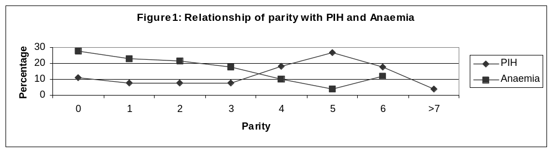
The diseases and risk profiles are shown in table 2.

Table 2: Disease Profile of HRC attendees
Diseases and  Risk Factors | % of Conditions at First visit  n=1157 | Significance level (p- value) | %of conditions at Second visit  n=1168 | (p- value)
Anaemia  (Helminthiasis  Bilharzia  n=456) | 30.3  (19)  (8) | 0.000 | 32.2 | 0.000
PIH | 9.9 | 0.000 | 16.6 | 0.000
Grandmultiparity | 8.0 | 0.003 | 7.8 | 0.003
Previous C/S | 6.8 | 0.001 | 7.3 | 0.001
Bad Obstetric History | 5.8 | 0.033 | 6.6 | 0.029
UTI | 5.0 | 0.000 | 1.9 | 0.009
Vaginitis | 11 | 0.000 | 5.6 | 0.006
Post dates | 1.6 | 0.506 | 6.0 | 0.004
Diabetes | 1.0 | 0.057 | 1.4 | 0.037
Asthma | 1.0 | 0.12 | 0.2 | 0.22
Twin Pregnancy | 0.9 | 0.000 | 0.5 | 0.038
Breech Presentation | 0.7 | 0.24 | 0.5 | 0.34
Cardiac | 0.6 | 0.304 | 2.2 | 0.053
IUGR | 0.4 | 0.31 | 1.4 | 0.057
PTB | 0.3 | 0.216 | 0.4 | 0.121
IUD | 1.5 | 0.000 | 0.5 | 0.07
Normal (No risk factor detected) | 9.0 | 0.016 | 4.4 | 0.046
Others conditions | 6.2 |  | 4.5
Admission | 2.2 | 0.040 | 2.8 | 0.040
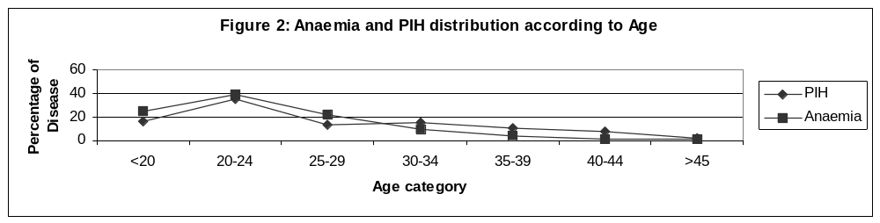
Discussion
The findings of this study are unique for this institution. The teenagers are higher (14.1%) than the provincial average of 10%. It could be due to referral patterns by the primary health care facilities and teenagers are considered at higher risk in pregnancy thus over represented. A total of 76.4% attendees are under the age of 30 years. It indicates that pregnancy in earlier age groups are at higher risk of developing health conditions is evidenced as 60% and 62% maternal deaths are seen to occur among these same age group in SA. The peak incidence of maternal deaths is observed in the 25-29 years age group. Pregnant women of low parity have also shown a trend of higher risk of developing health conditions. The highest group is null parity (37.6%) followed by 31.6% in gravida two and gradually decreasing trend with increased parity. As these conditions are associated with higher maternal and perinatal mortality thus similar trend is observed in maternal mortality. (Lower the parity higher is the maternal mortality, para nil -35%, para one -23%). Anaemia has the highest prevalence (30.3%). Among these anaemic mothers, 19% had Helminthiasis and 8% had Bilharzia (co-morbidity). The prevalence of anaemia between first and second visit is minimum. The overall leading two causes of maternal morbidity (anaemia and PIH) are seen to occur at a similar trend with age of mothers (graph 1). Anaemia appears to lead PIH at earlier age and low parity (Figure 1 and 2) and PIH seen to occur at a higher rate with older age and higher parity similar to a study in Malawi and other parts of Africa for low parity and earlier age. But PIH is seen superseding anaemia at the later age (30 years and above) and with higher parity. The prevalence of PIH was 9.9% among the first time attendees. At the second visit at HRC, the prevalence of PIH is found at an increased rate of 16.6%. PIH with any other co-morbid factors are not considered in this study. As the pregnancy advances the incidence of PIH increases. This finding is similar to a study conducted in the same province (In Durban, King Edward Viii Hospital, 18% of pregnant women were found affected with these conditions at labour). It is known that the incidence and prevalence of PIH varies among countries, populations and health centers due to some genetic predisposition. The definition of PIH also varies place to place.
Grandmultiparity of 8% appears to be higher compared to a facility based study at Lagos University Teaching hospital (4.11%) in Nigeria. Attendance due to previous C/S (previous c/s x1, x2 or more) of 6.8% is lower considering the risk group and the c/s rate of 11.7% observed for rural population of SA during 2000-2002. This lower rate could be due to low booking rate and or delay in referrals and all previous C/S (e.g. previous C/S x 1) are not necessarily at higher risk. Pregnancy with BOH of 5.8% and 6.6% at the first and second visit respectively appears to be lower considering a study conducted in India (between 10-12%). This could be due to differences in definition (The Indian study included early neonatal death, congenital abnormality and IUGR) and low rate of booking and referrals from PHC clinics.
The prevalence of symptomatic UTI was 5% at the first visit and 1.9% at the second visit are similar to other study as it reports that the incidence of asymptomatic bacteriuria between 2% and 10% but lower compare to the finding a local study conducted in Pretoria region SA.
Vaginitis is seen to occur at higher rate (11% and 6% at first and second visits) in this study as the study population are rural, poor, less educated thus may practice unhygienic practices which led to than UTI in this population.
The prevalence of bilharzia was 8% could be considered higher. UTI, vaginitis, bilharzia, helminthiasis are the conditions related to poor hygienic practices, low socio-economic and poor environmental factors these people are living in.
The prevalence of twin pregnancy 0.9% (p<0.05) at this risk group is similar to other finding. Although generally 3% mothers are considered diabetic during pregnancy, we found 1% at the first visit and 1.4% at the second visit (gestational and known diabetes). As the GA increases the incidence of gestational diabetes also increases. Low prevalence of diabetes could be explained, as the populations we serve are poor, lifestyle (food consumption) is not favourable for developing diabetes.
The post-dates (pregnancy beyond the expected date of delivery) are 1.6% (p>0.05) and 6% (p<0.05) at the first and second visit (respectively). As it is a cross sectional study, the higher prevalence of post-dates are likely at the second visit and the clinical practices here is to intervene as soon as pregnancy passed 42 weeks. Confirmation of post-dates is done following a set of criteria (history, clinical and ultrasound).
At the first visit, 1.5% of the attendees were found with IUD. The IUD at the second visit was at a lower rate of 0.2. This could be the effect of better management at HRC. Nine percent of all referrals were found to be normal as most of them came from clinics and nurses run the clinics, thus there diagnosis were changed by the medical officer or consultant at HRC. This proportion is still at low level. The admission to hospital from first (2.2%) and second visit (2.8%) is similar. The admission to hospital depends on the severity of condition. Thus it appeared that referral was at appropriate time thus did not require higher admission rate.
Further studies are needed to estimate the prevalence and incidence of pregnancy related conditions, the causes and outcome of such conditions on a population based study for the development of maternal and child health.

Acknowledgement
The authors wish to acknowledge the contributions made by the HRC Nursing staff who kept the record of all attendees. The Hospital Manager and the Management team for allowing conducting the study.

SERVICE DELIVERY ISSUES IN THE PROVISION OF ANTENATAL CARE IN SOUTH AFRICA

B Kunene*, M. Beksinska*, S Mullick ±, B Janowitz, C Cuthbertson,
L Johnson, S Cummings
(Family Health International, North Carolina; *Reproductive Health Research Unit, Durban; ± Frontiers, Population Council)

Introduction
As part of an operations research project to assess the impact of involving men in the provision of antenatal and postnatal care, we evaluate the current provision of services to new and repeat antenatal clients. The aim was to ascertain what services each women received during her antenatal care visit, and to determine what health providers do, how long does each services given to the women take; and whether there were particular times during the day when providers would have time to give couple counselling

Methodology
Client flow analysis (CFA) and activity sampling methods were used. Each segment of the study was conducted for two days each at twelve clinics in Durban January/February 2001 and repeated in 2002. We selected days in which we expected to find either a large number of first time or repeat antenatal clients.

For the CFA, a form was given to each client as they arrived at the clinic and the client then gave the form to each consecutive provider, and the provider then noted the start and end times of the contact. The provider was also asked to provide information on specific services she provided during that contact. One entry point and one exit point were used on the days of doing CFA. Synchronized digital watches were given to providers

Activity sampling is a technique for determining how providers spend their time. An observer was assigned to each provider and given a watch and beeper. There were a total of 69 observation days in the pre-test and 67 in the post-test. (Box for activities is attached as annexure)
Results
The results showed that most antenatal clients are being seen from 07h30 and 13h30, while clients coming for other services are being seen later than antenatal clients.

Figure 1: Time when antenatal care are being seen at the clinics

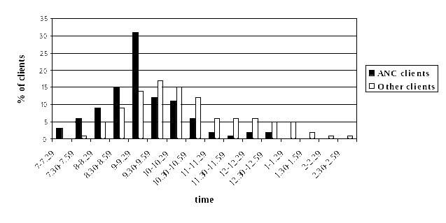

Time spent by the clients at the clinic was assessed. The result showed that although client spent a lot of time at the clinic (4.27 hours) they spent very little time (0.28 hours first visit and 0.14 hours repeat clients) in contact with nurses (Table 1).

Table 1 Time spend at clinic by antenatal care clinic
Type of Visit | Contact time with a provider | Waiting time while in clinic | Total time spent at the clinic
Antenatal first visit  N=205 | 0:28 | 3:59 | 4:27
Antenatal repeat visit  N=342 | 0:14 | 2:46 | 2:59
Note-excludes 17 cases due to incomplete information

Services received by the clients were documented. Table 2 showed that not all clients received all services scheduled to be received per visit. This includes those services that are to be done to detect high risk clients such as blood pressure which was received by only 70% of the first visit clients.

Table 2: Services received by antenatal clients
Type of service | ANC first visit  N=212  % | ANC repeat visit  N=352  %
Blood pressure | 70 | 78
History | 91 | 15
Exam | 78 | 71
Blood drawn* | 71 | 5
Weight | 61 | 62
Urine | 60 | 52
Treatment | 50 | 15
Consult | 17 | 10
*excludes clients who had blood drawn at a different facility

Providers spent an average of 37% of their day in direct contact with clients, 33% carrying out administrative activities, and the remainder carrying out personal activities, not engaged in work related activities, or not at the clinic during work hours.

Table 4 Number of minutes and percentage distribution of provider time across different activities
Category | Minute | Percentage
Contact with clients | 194 | 37
Administration | 174 | 33
Personal | 67 | 13
Non-working related activities | 48 | 19
Not at work | 31 | 6

Conclusion
Our results show that antenatal clients spend far more time waiting for services than they do getting services. Waiting times are long. Not all new ANC clients received the minimum package of services. This finding highlights the need for providers to increase their efforts to expand access to that package. There is need for interventions that strengthen antenatal services including counselling.

Annexure
The box below explains how services were grouped for analysis of time spend by the health providers.

Box 1. Components of time use categories
Contact | Interaction with client
Administrative
Activities directly supporting contacts | Preparing work space, Collecting equipment and supplies, Material preparation for the day, Filling out client card/register, Washing hands, Allocation of provider duties, Accompanying client to ambulance
Other administrative activities | Beginning of day meeting, Chatting with staff and doing paperwork, Provide support to another nurse, Work related meeting/in-service, Work related telephone call, Gathering things at end of day, Walking for work related task, General administrative task/paper work/mail, Waiting for equipment, Discussion with staff about general clinic matters, dispensing stock take
Personal | Prayer, tea break, In bathroom
Non-work related activities | Personal call, Meeting with personal visitors, Chatting with staff about non-work matters, Walking for non-work related task, Reading magazines/newspaper, Talking with other clients, Waiting for client, Playing board games
Not at clinic | Was not present when shift began, Absent from clinic for personal reason, Left shift early
Unknown | Observer not at clinic, observer orientation of clinic

STRATEGIES FOR EFFECTIVE FOLLOW-UP OF RESEARCH PARTICIPANTS

KR Mokhondo, M Zondo, RC Pattinson
MRC Research Unit for Maternal and Infant Health Care Strategies, University of Pretoria

Aim
To evaluate the effectiveness of the follow-up protocol of research participants based on telephonic contact.

Protocol used for follow-up
- Two hospitals in the Tshwane Metropolitan area were chosen: Kalafong Hospital and Pretoria Academic Hospital.
- Collected correct contact details of research participants at the time of entry to the trial.
- Identified the eligible patients for follow-up; that is participants from the Tshwane area.
- At follow-up times (which were done two monthly), participants were telephoned. If contact was established, a questionnaire was administered and arrangements made for the next call. If contact was not made, two further attempts to contact the patients telephonically were made at different times of the day. These attempts were made to check the correctness of the telephone numbers using the Tshwane telephone directory according to the addresses the patients provided. If the patient had moved or the telephone was that of the employer, contact details were sought from the person who answered the phone. The fourth and last telephone attempt was made for the non- responded participants, if no response the participants were taken off the study and regarded as lost to follow-up.

This project started in August 2001 and finished December 2003.

Geographical Areas:
Atteridgeville
Saulsville

Centurion

Pretoria central
Pretoria East

Pretoria North

Pretoria West
Mamelodi

Mabopane
Soshanguve
Lotus Garden

Laudium

How we got some of the phone numbers that we did not have from the beginning of the study. (The participants who did not have the contact details on admission to the trial).
A search for more contact details was done from the following records:
- High Care and Intensive Care Unit follow up statistics.
- Kangaroo Mother Care Unit.
- Previous research records, for example: Pretoria Pasteurisation study, the attitudes of mothers towards pasteurising their own expressed breast milk and giving it to their babies and the viral load study done on the blood and the expressed breast milk.
4. Tshwane Metropolitan telephone directory
All these records assisted the researchers in obtaining most of the phone numbers for follow up.

THE PROCESS USED

Kalafong Hospital 001
- 113 Participants had telephone numbers;
- 89 Mothers responded to calls;
- 24 Participants did not respond to telephone calls.
Reasons for no response:
- Wrong numbers;
- Client unknown;
- Not employed any longer at given telephone number;
- Lost or stolen cell phones;
- Long, continuous beep;
- The number does not exist;
- Ringing continuously with no answer day or night as we tried some numbers at home;
- No sound, query dead line;
- Moved to another Province with the child;
10. The subscriber is not available.

Pretoria Academic 009
- 82 Participants had telephone numbers;
- 23 Participants responded to calls;
- 23 Woman’s questionnaire done;
- 59 Participants did not respond to telephone calls.
Reasons for no response:
1. Wrong numbers;
- Client unknown;
- Not employed any longer;
4. Lost or stolen cell phones;
5. Long, continuous beep;
6. The number does not exist;
7. Ringing continuously with no answer, day or night as we tried some numbers at home;
8. No sound query dead line;
9. Moved to another Province with the child;
10. The subscriber is not available.
All these participants phone numbers were tried three times with no response and the fourth time, if there was no response they were taken out /off the study.

How we got some of the phone numbers that we did not have from the beginning of the study. (The participants who did not have the contact details on admission to the trial).
A search for more contact details was done from the following records:
1. Paediatric follow up records at paediatric follow-up clinic;
2. Some of the ward files;
3. Tshwane Metropolitan telephone directory.
All the mentioned records assisted the researchers in obtaining the phone numbers for follow up.

Results
Hospitals | Kalafong | Pretoria Academic
Number of participants identified for follow-up | 113 | 82
 | (%) | (%)
Number of participants contacted | 78.76 | 28.05
Reasons for failed contact:
1.Incorrect details provided | 3.54 | 12.20
2.No longer employed at contact number | 1.77 | 2.43
3.Lost or stolen mobile numbers | 1.77 | 2.43
4.No answer at numbers provided | 14.16 | 54.89
5.Relocated to other provinces during the follow-up study | 3.54 | 0

Conclusion
A follow-up strategy based on telephonic contacts is both feasible and effective in the metropolitan area of Tshwane. It is very cost effective. However, to ensure a high proportion of participants being contacted the following points need to be followed:

1. Building a good interpersonal and trust relationship from the onset of the research is imperative for successful follow-up of research participants.
2. On admission to the research, elicit at least three telephonic contact numbers and addresses where research participants can be reached.
3. Keep continuous contact with research participants.
4. Provide contact details where participants can contact researchers, if change in contact details occurs.

NON-CLOSURE OF PERITONEAL SURFACES AT CAESAREAN SECTION – A SYSTEMATIC REVIEW

AA Bamigboye, GJ Hofmeyr

Background
Caesarean section is a very common surgical procedure world-wide. Suturing the peritoneal layers at caesarean section may or may not confer benefit, hence the need to evaluate whether this step should be omitted or not.

Objectives
The objective of this review was to assess the effects of non-closure as an alternative to closure of the peritoneum at caesarean section on intra-operative, immediate and long-term postoperative and long-term outcome.

Search Strategy
We searched the Cochrane Pregnancy and Childbirth Group trials register (November 2002).

Selection Criteria
Controlled trials comparing leaving the visceral and/or parietal peritoneum unsutured at caesarean section with a technique which involves suturing the peritoneum in women undergoing elective or emergency caesarean section.

Data collection & analysis
Trial quality was assessed and data were extracted by two reviewers.

Main results
Nine trials involving 1811 women were included and analysed. The methodological quality of the trails was variable. Non-closure of the peritoneum reduced operating time whether both or either layer was not sutured. For both layers, the operating time was reduced by 7.33 minutes, 95% confidence interval (CI) –8.43—6.24. There was significantly less postoperative fever and reduced postoperative stay in hospital for visceral peritoneum and for both layer non-closure. There were no other statistically significant differences. The trend for analgesia requirement and wound infection tended to favour non-closure, while endometritis results were variable. Long-term follow-up in one trail showed no significant differences. The power of the study to show differences was low.

Conclusions
There was improved short-term postoperative outcome if the peritoneum was not closed. Long-term studies following caesarean section are limited, but data from other surgical procedures are reassuring. There is at present no evidence to justify the time taken and cost of peritoneal closure.

LATERAL TILT VS SUPINE POSITION TO PREVENT SUPINE HYPOTENSION DURING CAESARIAN SECTION

Jafta Z, Hofmeyr G.J.
Effective Care Research Unit, East London Hospital Complex, University of Fort Hare/ University of Witwatersrand.

Introduction
Caesarean section is the commonest major operation performed on women. Ways of performing a caesarean section operation, and operative techniques vary widely.

The position of the patient at caesarean section can either be supine or table tilted to the left. For many years, it has been well shown that when pregnant women near term lie in the supine position the uterus can compress the inferior vena cava, interfering with venous return to the heart and thus reducing cardiac output and the arterial blood pressure. This syndrome is known as the supine hypotension syndrome.

Inferior vena-caval compression by the gravid uterus has been shown to have deleterious effects on maternal haemodynamics. The resultant decrease in cardiac output may constitute a threat to both mother and fetus. Aortic compression may also impair uterine blood flow. The problems may be alleviated by the lateral displacement of the uterus by left lateral table tilt.

Some attention has been focused on the proposition that this disturbance might be one of the causes of neonatal asphyxia at caesarean section (Ansari et al.1970; Colon – Morales, 1970). There has been very limited work done on the subject, but a few randomised controlled trials were done which had varying results.
Kerr, Scott and Samuel, 1964 showed that compression of the vena cava and a considerable reduction of cardiac output occurred in the majority of pregnant women at term when lying supine if the fetal head is not engaged. A 25% increase of cardiac output was shown in the left lateral position. There has been a need to determine whether slightly tilting the table at caesarean section to the lateral position, thus trying to ease the pressure off the inferior vena cava, would produce any significant changes to the maternal and/or fetal outcome.

Objectives
To compare, using the best available evidence, the effects of left lateral tilting versus supine position at caesarean section on maternal and/or infant health.

Method
This review draws on the search strategy developed for the Pregnancy and Childbirth Group of the Cochrane Collaboration. Relevant trials are identified in the Group's Specialised Register of Controlled Trials. Trials under consideration were evaluated for appropriateness for inclusion and methodological quality without consideration of their results. Sub-groups are regional analgesia, general anaesthesia, both or undefined.

Data Collection And Analysis
Data extraction is done on all studies that meet the selection criteria. Data extraction forms are used and Revman software used for the analysis.

Main Results
These are presented using the relative risk (RR) or weighted mean difference (WMD), and the 95% Confidence interval (CI). There was no difference between groups in the induction-delivery interval and umbilical cord base deficit. With lateral tilting, there was a trend to reduction of low Apgar scores, and a significant increase in umbilical cord pH values.

Results (1) Induction-delivery interval


Results (2) Low Apgar Score

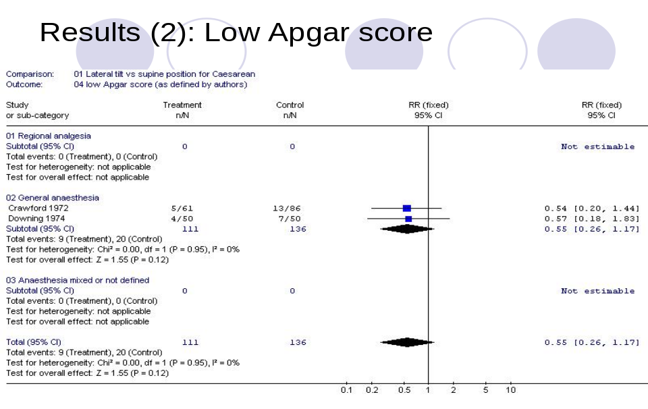

Results (3) Umbilical cord blood pH
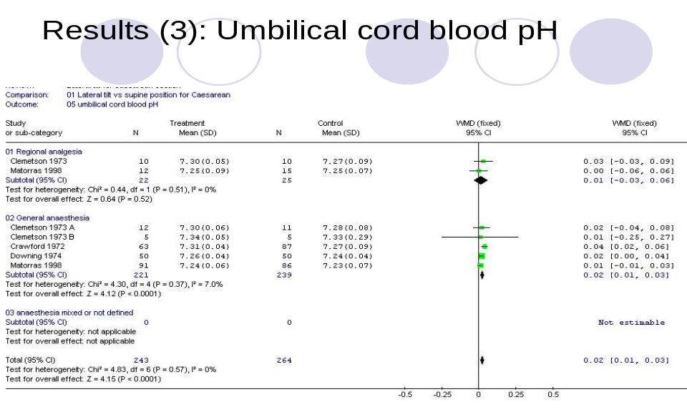

Results (4) Umbilical cord base deficit

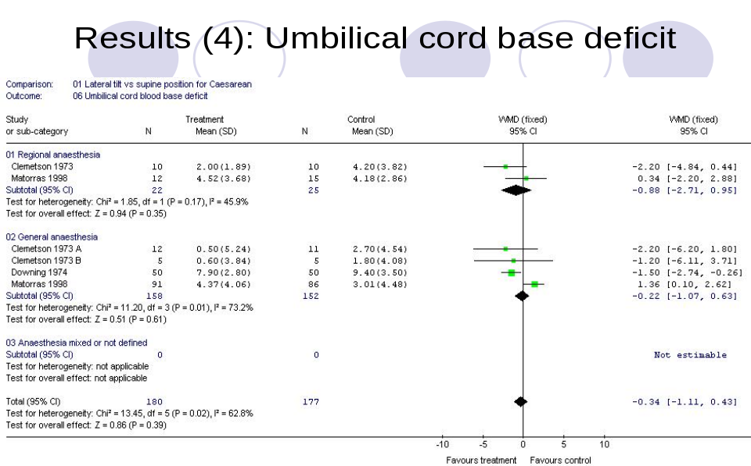

Conclusion
There are very few randomised control trials done on this topic. Therefore, there is not enough clinical evidence from the randomised trials to evaluate the use of lateral tilt adequately. There was a small but statistically significant increase in umbilical cord pH values. Lateral tilt until the baby is born appears to be the safest option until more evidence is available.

CAN ECHOCARDIOGRAPHY REPLACE INVASIVE MONITORING IN SEVERE PREECLAMPSIA?

Cornette J, Pattinson RC, Laker S.
MRC Unit for Maternal and Infant Health Care Strategies.
Department of Obstetrics and Gynaecology, Kalafong Hospital, University of Pretoria.

Objective
To investigate whether echocardiographic measurements correlate with pulmonary artery catheterisation measurements in severe pre-eclamptics patients requiring invasive monitoring.

Methods
In a descriptive study 7 severe pre-eclamptic patients were managed with pulmonary artery catheterisation. 2-D and Doppler ultrasound echocardiography was performed simultaneous with the invasive measurements. Equivalent values were correlated.

Results
There was a good to excellent correlation for all measurements except for Pulmonary Capillary Wedge Pressure Table 1.

Type of haemodynamic measurement | Correlation coefficient
Central Venous Pressure | R = 0.90
Cardiac Output | r = 0.88
Stroke Volume | r = 0.75
Systemic Vascular Resistance | r = 0.73
Systolic Pulmonary Artery Pressure | r = 0.81
Pulmonary Capillary Wedge Pressure | r = 0.46 – 0.60

Conclusion
Cardiac Ultrasound has the potential to be of great value in the management of severe pre-eclampsia. It is also promising as a non-invasive alternative in the further study of the central haemodynamics of pre-eclampsia.
THE LEADING CAUSES OF MATERNAL DEATHS AT THE DR GEORGE MUKHARI HOSPITAL (GA-RANKUWA)

GM Mothupi, TJ Mashamba, TS Monokoane, OA Towobola
Department of Obstetrics and Gynaecology, Medunsa

Introduction
Periodic review of maternal deaths in this hospital is an essential audit exercise, in order to establish the magnitude, as well as to identify prevailing causes of maternal deaths. Findings from this review should help in developing strategies for decreasing maternal mortality rates. This exercise is even more necessary as a way of monitoring the impact of the HIV/AIDS pandemic, as a single contributing factor for maternal mortality.

Objective
The objectives of this review are three fold:
- Determine the number of maternal deaths over a two-year period.
- Establish a pattern of disease causing maternal deaths.
- Determine the impact of HIV/AIDS on the reported cases of maternal deaths.

Setting for this Review
The review was undertaken at the Dr George Mukhari Hospital – a tertiary, teaching hospital affiliated to the Medical University of Southern Africa (Medunsa). The hospital is situated approximately 35km north of Pretoria in the Gauteng Province.

Methods
All cases of maternal deaths reported between 1 Janaury 2002 and 31 December 2003 were retrospectively reviewed. Information was extracted from both the patients’ bedletters and from the Maternal Death Notification forms. Each case was reviewed by extracting details from the relevant documents into a computer-recording format.

Quite apart from determining the demographic profile of the cases of maternal deaths, our main focus was to establish the number of deaths, causes of deaths and to determine those cases in which HIV/AIDS was a contributing factor.

Results

Table 1 Deliveries, Deaths & Mortality Rates

Total number of deliveries 15 298
Total number of maternal deaths 44
Maternal mortality ratio: 288 deaths/100 000 women
Annual maternal mortality ratio: 144 deaths/100 000 women

Table 2 Age profile of the women

Age range: 14-41 years
Mean age: 27.8 years
Standard deviation: 3.3 years

Table 3 Parity Distribution

Parity 0 8 (18.2%)
  - 33 (75.0%)
> 5 3 (6.8%)

Three quarters of all maternal deaths occurred among women of parity 1-4 while nulliparous women accounted for 18.2%. The mean age for the 44 women in this review was 27.8 years and a range of 14-44 years.

Table 4A&B Primary Obstetric Causes of Deaths (n=44)

A DIRECT CAUSES | N | %
- Haemorrhage  - Pregnancy related sepsis  - Hypertension  - Anaesthesia  - Pulmonary embolism | 18  4  3  2  1 | 40.9  9.1  6.8  4.5  2.3

B INDIRECT CAUSES | N | %
1. Non-pregnancy related infections  - HIV/AIDS (6)  - TB/Sepsis (2)  - Meningitis (2)  - Pneumonia (1)  - Malaria (1) | 12 | 27.3
- Pre-existing medical diseases  - Cardiacs | 3 | 6.8
- Coincidental death  - Gunshot wound | 1 | 2.3

Direct causes of deaths accounted for 63.6% of all deaths, with the two predominant ones being haemorrhage (APH & PPH) and sepsis. Indirect causes of deaths accounted for 36.4%, with non-pregnancy related infections alone accounting for 27.3%.

Table 5 illustrates the impact of HIV/AIDS on maternal deaths. In the two years of this review, there was an increase in the number of cases in which HIV/AIDS was a direct contributing factor. The number of cases of positive HIV test and/or AIDS defining conditions was 13 out of 44 deaths (29.5%). This makes HIV/AIDs the second most prominent cause of death.

Table 5 Impact of HIV/AIDS on maternal deaths

YEAR 2002 | YEAR 2003
Total deaths 27  HIV/AIDS 5 (18.5%) | Total deaths 17  HIV/AIDS 4 (23.5%)
Deaths from sepsis 7  HIV/AIDS 3 (42.9%) | Deaths from sepsis 3  HIV/AIDS 1 (33.3%)

Conclusion
The overall annual maternal mortality ratio of 144/100 000 women, though similar to the South African national average, still remains unacceptably high. So also is the increasing proportion of maternal deaths due to sepsis, in association with HIV/AIDs. There is, however, an urgent need to focus attention on the problem of deaths due to haemorrhage, as some of these deaths are preventable.

DIFFERENCE IN THE SUTURE AND NON-SUTURE OF PERITONEUM IN REGARDS TO THE FORMATION OF ADHESIONS IN RABBITS

J Markram, MS Pretorius, HS Cronje, G Joubert, CH Janse van Rensburg, BD Meddlecote
Department Obstetrics and Gynaecology, University of the Free State, Bloemfontein

Introduction
There is controversy whether peritoneum should be closed or not. Many authors state that the suturing of peritoneum causes more adhesions than non-closure. Adhesions are associated with bowel obstruction. Up to 56% of women with bowel obstruction had previous gynaecological surgery. Adhesions also cause infertility and chronic pelvic pain. The suturing of peritoneum has never been proven to cause less adhesions. Adhesions are sometimes distant to the site of peritoneal injury. Re-epithelialization of peritoneal surfaces occurs quickly and small and large defects recover at the same rate. The peritoneum’s first response to injury is increased vascular permeability and the formation of an exudates. Fibrin is deposited and fibrinolysis follow. Ischaemia adversely affects fibrinolysis. Suturing materials illicit an inflammatory response. To reduce morbidity and mortality, surgical techniques that limit adhesion formation should be applied. The aim of this study is to evaluate whether suturing or non-suturing of the peritoneum causes the least adhesions.

Method
This is blind, randomized, experimental study. 22 Rabbits were used. Under anaesthesia they were prepared for surgery. With induction of anaesthesia all the rabbits received prophylactic antibiotics. Sharp injury to the parietal peritoneum was made. According to randomization the peritoneum was either sutured with Prolene® or not. After 2 weeks, a re-laparotomy was done on all rabbits, photos taken, biopsies taken and adhesions, if any, described. Specimens were evaluated by pathologists for inflammatory response. The more severe the response, the more likely it will be that adhesions will form.

Results and conclusions to be presented at the 23rd Conference on Priorities in Perinatal Care in Southern Africa as the study is nearing completion.

THE PROMISE OF WIND-UP TECHNOLOGY IN PERINATAL CARE

Dave Woods
Neonatal Medicine, University of Cape Town

Most maternal and perinatal deaths occur in poorly resourced countries where skilled care, adequate facilities and appropriate equipment for mothers and infants are often absent. Essential working technology is needed to provide a high standard of primary care to mothers and infants. Basic equipment is often too complicated and sophisticated, frequently broken and cannot be repaired, or lacks a source of power. As a result, much of the available equipment is not used or is abandoned.

Batteries are often used as a source of power for medical equipment in Africa where electricity supplies are frequently intermittent or unreliable. However, batteries are often not available or are stolen. Wind-up technology offers a simple solution to this energy need and has successfully addressed the energy supply in radios and torches. The challenge is to use this innovation to solve some of the difficulties of providing cheap, efficient and robust medical equipment that is independent of conventional power sources.

A consortium of clinicians, engineers and programme advisors in South Africa and the United Kingdom is currently developing and evaluating a range of wind-up medical technology needed for maternal and newborn care in under-resourced communities. Prototypes include a foot and solar powered central energy unit, a fetal heart rate monitor, a oxygen saturation monitor (pulse oximeter), a microcentrifuge, a bilirubinometer and a syringe driver (infusion pump).

Operational instructions to use the wind-up equipment, and appropriate training material needed to recognize clinical indications, interpret results and provide clinical management, will also be developed, using the successful distance learning model of the Perinatal Education Programme (PEP).

Early field trials are documenting that wind-up medical equipment is accurate and acceptable to nursing staff. The wind-up oxygen saturation monitor gives accurate results when compared to standard models.
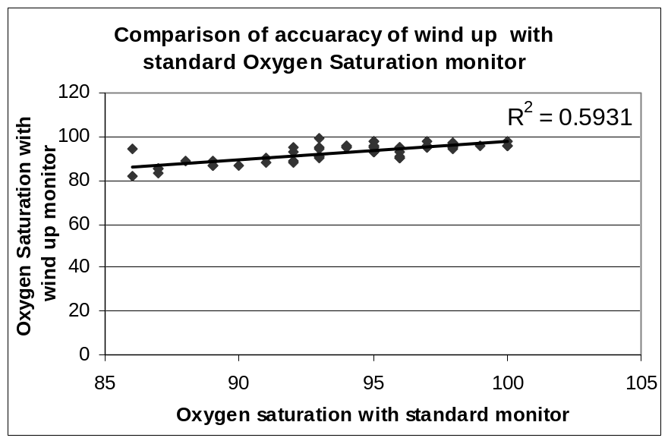
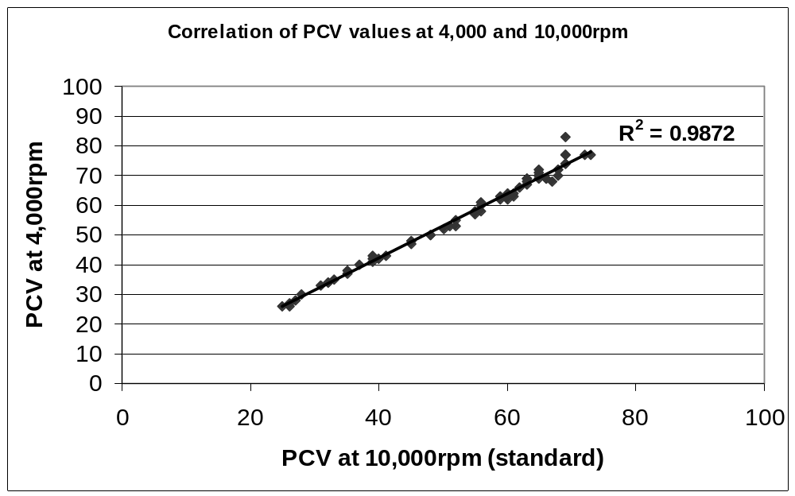The wind-up microcentrifuge gives reliable, consistent packed cell volume (PPCV) results at 4000 rpm and uses less power than the standard models which function at 10 000 rpm. The results with the wind-up model can easily be converted to those obtained with a standard model.

It is planned to assess the range of wind-up technology being produced in many perinatal services in South Africa. Provisional results promise that the present project will lead to the production of cheap, effective, maintenance-free and power-independent medical equipment suited to the needs of medical care, especially perinatal care, in developing countries.

TRAINING WORKSHOPS IN PERINATAL MENTAL HEALTH

Simone Honikmanª, Liz Mills^{b}, Cathy Aaron^{c}, Sue Fawcus^{d}
ªMowbray Maternity Hospital; ^{b}Postnatal Depression Support Association of South Africa; ^{c}Community Mental Health Services; ^{d}Department of Obstetrics and Gynaecology, Faculty of Health Sciences, University of Cape Town

Introduction
- Research from the Thula Sana Project has shown a prevalence of postnatal depression in Khayelitsha, Cape Town of 34,7%¹. This value is almost three times that of developed countries².
- Health workers in maternal care are inadequately equipped to identify those women at risk, or suffering with emotional distress in the perinatal period. Few are trained in counselling techniques. Competing health needs leave little time for engagement with women on emotional issues. Staff are not familiar with appropriate resources for referral.
- The Better Births Initiative³ was formally introduced in the Peninsula Maternal and Neonatal Service (PMNS) in 2002. The key principles cohere with the development of a strategy to support staff in their care of clients’ mental health.
- A multidisciplinary team developed a series of workshops for nursing staff in perinatal mental health. They were run at all the obstetric facilities in the PMNS in Cape Town, in 2003. A maximum of 20 participants (all grades of nursing staff and counsellors) at each obstetric unit, attended 4 hours of training. The workshops were presented by two facilitators.
- The Perinatal Mental Health Handbook was developed to complement the workshop training and to act as a permanent resource for each unit.

Objectives
The aim of the workshops was to improve the quality of service delivery to women accessing health care in the PMNS. It was felt that this could be achieved by raising the awareness of nursing staff and by developing their understanding of perinatal mental health problems.

Workshop outline
Introduction: Exploration of personal or professional experiences of the perinatal period. Reflection on how these experiences affect the participants’ interactions with clients.
Common perinatal mental illnesses: Didactic training on risk factors, signs, symptoms, management, prognosis, cultural issues etc.
Listening and basic counselling skills: Case-study, narrative and role-play techniques were used.
Referral resources: Introduction to the Perinatal Mental Health Handbook with its referral directory and screening tools. Discussion of local resources. Important points for referring. A proposed management protocol.

Follow-up
Anonymous feedback questionnaires were distributed to the participants after the workshops and two to four months later. The latter assessed the impact of the workshop on clinical practice and the use of the handbook.

Analysis of the feedback forms
- The workshops were appreciated and felt to be relevant to nursing practice.
- Almost all participants requested more comprehensive follow-up workshops.
- Most participants felt better equipped in terms of listening and counselling skills. Many reported how they had used these during the months after the workshop.
- Many participants expressed relief at being provided with details of referral options.
- Many participants reported using the handbook as an on-going resource, although many others had not had the time to use it.
- Several participants mentioned how the qualities of their interactions with women and their families had changed positively.
“It [the workshop] has helped one to be introspective…”
“Through exploring my own labour, I can reflect on what the patient is going through.”
“I realised the importance of listening to identify those patients at risk.”
“No more yelling for the client to push, instead speaking words of encouragement, engaging client participation and trust – takes a lot of practice.”

Conclusions
There is a significant need for staff to be trained in perinatal mental health issues. By providing an opportunity for staff to explore their personal experiences of mothering, they may gain a degree of insight into the quality aspects of their professional practice. This may have the effect of increasing staff’s abilities to empathise and support their clients.

Acknowledgements
The following people participated in the development of the workshops;
Liesl Abrahams, Bonnita Williams, Jackie Pienaar, Julia Chesselet, Tracey Parsons and the Mowbray Maternity Hospital Education Department.
The nursing and counselling staff of the PMNS are thanked for their enthusiastic and inspiring participation in the workshops.
A 30-YEAR ADVENTURE WITH IUGR

Dave Woods
Neonatal Medicine, School of Child and Adolescent Health,
University of Cape Town

For many years it has been recognised that all infants are not the same size at birth. Some infants are small because they are born too soon but others are small because they have been growing too slowly or have lost weight in the last weeks of pregnancy.

Thirty years back, we documented that infants born to mixed race mothers were significantly smaller than infants described in most local and international publications, even after correcting for gestational age (Woods et al 1981). This finding was usually attributed to genetic differences. We questioned this simplistic explanation and favoured maternal life history and nutrition as a more probably cause of intra-uterine growth restriction (IUGR) in under resourced communities. Our challenge was to document and explain the relationship between maternal and infants size at birth.

We started by showing that primigravid women who delivered in the public service in Cape Town were significantly smaller than control mothers in the private service, when their size was measured on the day after delivery (Woods et al 1978). The study mothers who could not afford private care were shorter, lighter and thinner than the control mothers in the private sector. The size of their infants at term showed similar differences, with infants born in the public sector also being shorter, lighter and thinner (Woods et al 1978a).

The next step was to correlate the size of study mothers and their infants at birth. After correcting for gestational age and gender, it was found that birth weight, length and head circumference correlated best with maternal post delivery weight and least with maternal height (Woods et al 1979).

We then explored this size relationship further by dividing the mothers into three height categories and three post delivery weight categories, and then calculating the mean birth weight in each category. Again, gender and gestational age was corrected for. There was a relative small change in birth weight between short and tall mothers but a 10 times greater weight difference between infants born to heavy and light mothers. The infants with the highest birth weight for their gestational age were born to the heaviest and not the tallest women (Woods et al 1979). This pattern was also found for infant length and head circumference as well as placenta weight, and suggests that nutritional rather than genetic factors was lowering the growth trajectory of these individuals (Woods et al 1989).

When the infants, born underweight for gestational age, were examined, two thirds had a normal ponderal index and only one third were thin (Woods et al 1979a). The ponderal index is determined by dividing birth weight by length cubed and is an objective method of recognising thin and fat infants. Many of these infants also had quantitative placental inadequacy (Woods et al 1986). In addition, maternal weight rather than placental weight was the significant predictor of birth weight suggesting that maternal weight affects both fetal and placental growth rate (Woods 2001).

At this first step of the investigation into maternal and infant size relationships, we concluded that underweight rather than short mothers had growth restricted infants in our Cape Town study community. Further, most infants of underweight mothers had symmetrical growth restriction as their ponderal index was normal. This finding suggests that most underweight for gestational age infants had been growing slowly from early in pregnancy rather than simply losing weight in the last few weeks before delivery.

As the nutritional needs of a fetus in early pregnancy are small, it is unlikely that these fetuses were growing slowly because they could not get enough nutrition. Rather, they seemed to be growing slowly in order to avoid a nutritional crisis towards term when fast growing individuals might outgrow the mother’s nutritional supply line.

A cohort of infants born underweight for gestational age at term were followed to 5 years of age and compared to control infants, born appropriate for gestational age. The previously underweight for gestational age infants were found to be lighter and shorter with relatively smaller heads and a lower body mass index (Molteno et al 1995). This restricted postnatal growth, in the infants born underweight for gestational age, could not be attributed simply to a lower family income at 5 years as grades of income were equally distributed in both groups of infants.

On completing this second step of the investigation we concluded that infants born underweight for gestational age in our study sample remained both short and light at 5 years and many were thin. In addition, the size of infants at 5 years of age is not associated with the amount of the family income. Therefore, their growth during childhood may be determined by their weight for gestational age at birth rather than their home environment. This is an important observation as size for age at school entry is often taken as a reliable marker of childhood undernutrition in South Africa.

At 20 years, the underweight for gestational age cohort remained lighter, shorter and thinner than the controls who were born with an appropriate weight for gestational age (Levitt et al 2000). The underweight for gestational age cohort had higher mean systolic and diastolic blood pressures at 20 years and had a trend towards more hypertension. The underweight for gestational age group also had a higher mean fasting blood glucose and more had an impaired glucose tolerance test than the controls. The impaired glucose tolerance could be partially explained by the observation that the underweight for gestational age group had a higher mean plasma cortisol level at 20 years causing insulin resistance.

Finally, if the study infants are divided by weight for gestational age at birth and body mass index at 20 years, it is noticed that the underweight for gestational age infants with a high body mass index as adults were at greatest risk of becoming hypertensive. Similarly, the underweight for gestational age infants who become relatively fat adults are the individuals with a raised 2-hour plasma insulin suggesting they have developed insulin resistance (Levitt et al 2004).

In conclusion, this study supports the “thrify phenotype hypothesis” where slow growth, both before and after birth, may be programmed to protect against unsustainable nutritional needs. A smaller individual requires less nutrition than a larger individual. Fetal growth restriction, starting early in gestation, may be an appropriate physiological adaptation to a nutritionally poor environment rather than simple starvation while dietary affluence and obesity in adulthood, in those individuals who experienced fetal growth restriction, may result in chronic illnesses such as hypertension and diabetes.

If symmetrical growth restriction at birth and during childhood in poor communities is a way of avoiding starvation in an under-resourced environment, then adult obesity should be avoided as it carries many of the health risk found in today’s affluent societies. Or put simply, if you buy a motor car with an engine designed for 92 octane petrol, don’t risk tanking up with 98 octane fuel.

I would like to thank Professors Atties Malan, Chris Molteno and Dinkie Levitt for sharing this adventure with me.

LIFESTYLE RISK FACTORS FOR LOW BIRTH WEIGHT IN THE WESTERN CAPE

Elize Batiste, Debra Jackson, Kirstie Rendall-Mkosi, School of Public Health, University of the Western Cape; Lana Maart, Western Cape Nursing College; Joy Miles, Western Cape Province Department of Health

Study Aims
To determine the epidemiology of low birth weight (LBW) related to lifestyle behaviours in pregnant women and women of childbearing age, along with knowledge, attitudes and practice related to these lifestyle factors among women and health service providers in the West Coast/Winelands Region in the Western Cape, with particular attention to lifestyle factors such as alcohol, smoking and nutrition and available resources and programmes to promote healthy lifestyles in women.

Methods
Study Design: Quantitative Case-Control Study
Study Setting: Paarl Hospital
Population/Sampling:
Cases = (200) infants born in Paarl Hospital with birthweight <2500 gms (LBW) Controls (unmatched) = (200) normal weight infant(s) born in Paarl Hospital
Cases and Controls were identified using hospital delivery register. OR and 95% CI were the measure of association. Fishers exact tests were used to test for associations between variables of interest.

Data Collection Methods:
* Antepartum and Intrapartum Medical/Case Record Review
* Hospital postpartum mother’s structured interview using established tools and investigator-designed instruments.

Results

Contribution Of Pre-Term & IUGR To LBW
•47.5% of cases were born prematurely
•52.5% of cases were term infants with LBW reflecting a substantial IUGR component in this population.

Demographic Data
Variable Case% Control% OR 95%CI
•Teenagers 21.0 19.5 1.09 0.67-1.78
•Older Moms>35yrs 11.0 7.5 1.52 0.76-3.03
•Education<6yrs* 36.5 20.0 2.29 1.46-3.60
•Employed 22.9 25.5 0.86 0.54-1.38
•Reside on farm 36.5 30.0 1.34 0.88-2.03
•Reside in township 59.0 60.5 0.93 0.63-1.40
•Living in shack * 16.5 6.0 3.09 1.55-6.19
•Single 24.5 24.5 1.0 0.63-1.57

The demographic data suggest a primarily low income, disadvantaged population as would be expected in a public hospital. Of the demographic variables, only low education and living in a shack were significant predictors of low birth weight – possibly representing the poorest of the poor?

Risk factors as recorded in record review significantly associated with LBW
Variable Case% Control % OR 95%CI
Multipara 65.5 50.5 1.89 1.25-2.86
Multiple pregnancy 7.5 0.5 16.13 2.11-123.45
Previous LBW 13.9 4.0 3.85 1.69-8.75
Previous pre-term 12.3 5.0 2.65 1.22-5.73
Attendance at ANC 81.0 90.0 0.47 0.26-0.84

All medical related risk factors for low birth weight were as expected, except parity. In the literature, primiparas generally are found to be at higher risk than multiparas. In this population, multiparas were found to be of higher risk, possibly suggesting a cumulative effect of poverty and lifestyle?

Means of Possible Risk Factors in Sample
Variable Case Control P-Value
Weeks gestation @1st ANC 22.6 22.1 0.47
Maternal Height 160 162 0.01
Pre-pregnant Wt 62 54 0.17
Wt @ 1st ANC 60 70 0.00
Number of ANC Visits 4.7 6.1 0.00

Maternal height, weight at 1st ANC visit and number of ANC visits were all predictive of low birth weight. Pre-pregnant weight had to few women with known values to be meaningful. The number of ANC visits remained significantly different even when examining only those who delivered at term.

Smoking Status in Sample
Variable Cases Controls OR 95% CI
•Current smokers 61% 34% 3.04 2.02-4.57
•Passive smokers 63.9% 53.4% 1.54 0.67-3.50

Of all possible risk factors smoking showed the highest odds ratio.

Alcohol Ingestion in Sample
Alcohol ingestion Case Control OR 95% CI
Drinkers 35.0% 20.0% 2.15 1.37-3.38
Cage Score>2 52.9% 47.5% 1.24 0.57-2.70

Mean Mean - P-Value
Num of Bottles/person(750ml) 2.08 2.06 - 0.94
Avg. CAGE Score 3.0 2.0 - 0.18

Drinking alcohol was significantly associated with low birth weight, but not the amount of alcohol consumed as measured by either the CAGE score or number of bottles. This may have been due to measurement error or to the fact that the weekend binge drinking pattern does not vary substantially between drinkers.

Social Factors and Stress
•Neither individual Score items, nor
•High stress score (OR 1.26; 95% CI 0.84-1.88)
showed any relation to LBW.

Risk Factors For Term LBW & Pre-Term Delivery
The results showed similar results to the overall LBW analysis for all variables except that:
•age>35 years was an additional risk factor term LBW (OR 2.19; 95% CI 1.04-4.64).
•alcohol drinking was not associated with pre-term delivery (OR 1.50; 95% CI 0.83-2.66).

Confounding Analysis
Maternal height was the only variable to be confounding the association between:
•smoking and LBW(3.88; 95% CI 1.48-10.1)
•alcohol and LBW(2.78; 95% CI 0.92-8.47)
In both cases adjusted OR was larger than the Crude OR
•Smoking confounded the alcohol and LBW relationship
(OR 1.34, 95% CI 0.80 – 2.23)
•However, alcohol and smoking together interacted to increase risk of LBW more than either smoking or drinking alone (OR 3.92; 95% CI 2.29 – 6.7), suggesting that reducing drinking will still have an effect to reduce low birth weight.

Conclusions
Results suggest a need for a comprehensive health programme to address:
•Family planning to reduce number of pregnancies.
•Community Outreach to increase ANC attendance.
•Reduce smoking and alcohol use during pregnancy
•Screening of high-risk women.
•Follow-up protocols and monitor progress of high-risk women.
•Close collaboration with ANC & family planning.

THE BABY FRIENDLY HOSPITAL INITIATIVE (BFHI) WAS ESTABLISHED TO CHANGE HEALTH CARE PRACTICE, TO ENABLE HEALTH WORKERS TO PROTECT, PROMOTE AND SUPPORT BREASTFEEDING

P Baxen

However, a study has found that exclusive breastfeeding levels are still very low at St Monica’s. Several possible reasons for this has been suggested, namely:
- Social economic factors such as low/poor maternal education and the need to return to employment
- Inadequate breastfeeding promotion programmes.
- Psychosocial factors
- The promotion and availability of formula and free samples

A possible explanation for the low breastfeeding frequency then could be that the breastfeeding promotion programme (BFHI) was inadequate. Given this possibility this study was devised to evaluate the key components of the baby-friendly hospital initiative at St Monica’s.
An important potential result is that the health workers don’t educate and support or do not sufficiently educate and support expectant and new mothers.

Aim
The study examined the training, knowledge and practices of health workers and examined the extent to which health workers advised, educated and prepared expectant women for breastfeeding.

Methodology
This was a quantitative descriptive study.

Key findings
This study reveals that all enrolled nursing assistants and midwives are aware of the breastfeeding policies and that most are appropriately trained to prepare expectant and new mothers for breastfeeding.
Preparation given to expectant women on key messages regarding breastfeeding is insufficient. However, there is a high initiation of breastfeeding within the first six hours after birth of the baby.
However, their practice, immediate postnatal care of the mothers and babies seems to have become routine and does not sufficiently train new mothers in practical skills to manage breastfeeding
The study reveals that the lack of support group structures outside the MOU has implications for sustainable exclusive breastfeeding practices.
There is an alarming increase in the early introduction of other feeds, within 12 hours in this study. It is also clear that new mothers did not have an understanding of the concepts “demand feed” and “exclusive feeding”.

A COST COMPARISON OF KANGAROO CARE AT KALAFONG HOSPITAL VERSUS REGULAR CARE NEONATAL CARE AT PRETORIA ACADEMIC HOSPITAL

Buch E¹, Lorio P², Pletz A², Delport S³, Naude F³, Avenant T³, de Witt W³
¹School of Health Systems and Public Health, University of Pretoria; ² Department of Economics, University of Pretoria; ³Department of Paediatrics, University of Pretoria

The aim of the study was to develop a costing model for the care provided to low birth weight neonates in a public hospital setting and then to compare whether the incorporation of Kangaroo Care at Kalafong Hospital results in a lower cost, using Pretoria Academic Hospital (PAH) as the comparison. The cost of care of all neonates born at the hospital over a 90-day period who met the inclusion criteria was determined. 31 neonates at Kalafong and 28 at Pretoria Academic with birth weights between 1000g and 1500g were followed until the infant was discharged or reached discharge weight. The number of infants requiring artificial respiration and the average birth weights were similar in the two groups.

A costing model covering fixed, variable and opportunity costs was developed suitable for use in a public hospital situation where individualised billing for consultations, medicines and consumables and procedures is not routinely determined. Meticulous fieldwork was required to ensure that expenses were not missed. Certain costs that were not pertinent to the cost comparison e.g. overall administrative costs of the hospital were not calculated. Total costs and cost of intensive, high and kangaroo (Kalafong) or crib (PAH) care per neonate and per day were calculated per variable (eg doctors time, laboratory tests) and for the total of all costs.

Average length of stay at Kalafong was 38 days compared to 34 at PAH, with neonates requiring 17 days longer in HCU at PAH than at Kalafong. In spite of this and the discharge weight being significantly higher at PAH, cost of care at Kalafong was higher R 18 390 versus R16 305), albeit not significantly so. The main cost driver of the difference was the higher ratio and ranks of nurses at Kalafong, as well as the inherent cost of food for lodger mothers in KMC. However, when the staffing intensity is adjusted to be equal for each level of care at the hospitals and overcrowding at PAH corrected for, KMC becomes the cheaper option at R 10 569 per admission, compared to R14 609 at PAH. The main saving is the reduction of costs of high care through cheaper Kangaroo Care. Analysis of individual costs adds further information that can be used to improve efficiency of care and service management.

THE CONTRIBUTION OF TRAINING WORKSHOPS TO THE IMPLEMENTATION OF KANGAROO MOTHER CARE

Elise van Rooyen1, Anne-Marie Bergh1, Ria van der Walt2 , RC Pattinson1
¹ MRC Unit for Maternal and Infant Health Care Strategies and the University of Pretoria
² Directorate: Public Health, Gauteng Department of Health

Background
Training seminars and workshops are a popular form of introducing health workers to new health care interventions targeted for implementation. The effectiveness of one-off training seminars as instruments of training that may lead to successful implementation of a new intervention is, however, questionable.

Following the implementation of kangaroo mother care (KMC) at Kalafong Hospital in 1999, a need was identified for health workers to be informed about the concepts and benefits of KMC, as well as how it could be implemented. An open invitation was sent to several hospitals in Gauteng Province to participate in one-day KMC training seminars at Kalafong Hospital.

Health workers attending the first couple of seminars came out of curiosity about a new intervention rather than seriously considering implementation of KMC. At the seminars, they were all challenged to implement KMC in their health care facility, but many lower ranking health care workers were uncertain that they would be able to convince and influence senior staff to implement KMC.

During 2002, the Gauteng Department of Health prioritised the implementation of KMC in all their health care facilities. It was arranged that health care workers representing many facilities throughout Gauteng should attend the one-day seminars on KMC and its implementation at Kalafong Hospital (the format remained the same as before). Health workers who attended these seminars were, however, selected in a random, haphazard manner.

Aim of the study
In order to confirm the assumption that one-off seminars are not very effective training tools for the successful implementation of a new intervention, a retrospective review of the training seminars was performed and the Gauteng hospitals represented at the seminars were visited to establish whether KMC was successfully implemented.

Methods
(1) Detailed attendance registers were kept for all the seminars held between 2000 and 2002. The attendance patterns of delegates from Gauteng hospitals were analysed by means of the following questions:
- Which hospitals sent staff for training?
- Which hospitals had implemented KMC by October 2003?
- What was the time span between training and implementation?
- What categories of staff attended the training seminars?
(2) Hospitals that had implemented KMC by October 2003 were visited and scored on the standardised progress-monitoring instrument that had been developed for this purpose.¹

Results

Hospitals sending staff for training
There were two types of invitations for attending the training seminars:
- During 2000 to 2002, delegates from 7 hospitals attended the KMC seminars by invitation from Kalafong Hospital or by word of mouth.
- During 2002, delegates from 6 hospitals attended by invitation from Gauteng head and regional offices as part of the priority budget.
- Two hospitals attended via both forms of invitations.
Thus, in total, delegates from 15 Gauteng hospitals attended the seminars.

KMC implementation by October 2003
Of the 7 hospitals that had responded to Kalafong invitations, 4 hospitals implemented KMC. One hospital that had responded to both types of invitation also implemented. Of the 6 hospitals that had responded to the Gauteng Health priority drive, only 1 hospital implemented KMC. Thus, out of the 15 hospitals that had sent delegates to the seminars, 6 hospitals (40%) had implemented KMC by October 2003. In at least 5 of the hospitals that had implemented KMC, there was a suggestion of some medical interest or involvement in the process.

The 6 hospitals already implementing KMC were scored to evaluate their progress with implementation. The score was calculated out of 30. A score of 10 and more reflects evidence of practice. A score of 17 and more reflects evidence of routine practice and integration and a score of 24 and more reflects sustainable practice.

The scores for these 6 hospitals ranged between 11.3 and 26.2 out of 30:
- Two hospitals were on the level of “evidence of practice” (10 > < 17/30)
- Three hospitals were on the level of “routine and integration” (17 > < 24/30)
- One hospital was on the level of “sustainable practice” (> 24/30)

Time span between training and implementation
Trainees in November 2000:
- One hospital implemented immediately (and continued to send trainees each year).
- Two hospitals implemented ± 1 year later.
- One hospital implemented ± 2 years later.

Trainees in 2001:
- One hospital implemented after ± 7 months.

Trainees in 2002 (Gauteng priority budget):
- One hospital implemented just prior to the training in July 2003.

Seminar attendance and categories of staff

Total number of attendees: 89
(excluding Kalafong Hospital 19)
Chief professional nurses 7
Senior professional nurses 4
Professional nurses 63
Enrolled & auxiliary nurses 7
Student nurses 2
Occupational therapists 2
Medical officers
(including community service doctors) 4
12 attendees indicated they were in management positions.

Conclusion
Sending delegates in a random, haphazard manner to one-off training workshops is not an effective way of implementing a new health care intervention, especially where juniors are sent without key staff accompanying them. Introductory training workshops and seminars can assist in awareness-making processes for changing practice, but more continuous support and guidance is needed for practices to become sustainable. Assistance with implementation should take on two forms:
- Assistance with the management of the intervention;
- Provision of content material related to the intervention.

Recommendations
- It will be helpful to investigate other forms of facilitation to assist hospitals in the management of implementation of new health care interventions.
- Two forms of staff development with regards to the content of the intervention are advised:
  - Short, general awareness-making sessions for staff;
  - More intensive training of a multi-professional group of carefully selected staff members at the immediate point when the change in practice is made.
- Further investigation of the interaction between training and other enablers and/or barriers to successful implementation, particularly the role of leadership, is needed.

FARA NGWANA: FIRST STEPS IN THE SYSTEMATIC IMPLEMENTATION OF KANGAROO MOTHER CARE IN GAUTENG

Anne-Marie Bergh¹, Ria van der Walt², Elise van Rooyen¹, RC Pattinson¹
¹ MRC Unit for Maternal and Infant Health Care Strategies and the University of Pretoria
² Directorate: Public Health, Gauteng Department of Health

Introduction
The implementation of kangaroo mother care (KMC) was declared a provincial priority by the Gauteng Department of Health for the financial year of 2002/2003. Fara Ngwana (“hold the baby”) is the formal name of this outreach, which also comprises an investigation into the question how to ensure sustainable implementation. This is being done by means of a staged process, targeting a group of six to seven hospitals each year. The aim of this paper is to describe the facilitation and implementation process of the first seven of the targeted hospitals, which was informed by the following two research questions:
• How effective are two different outreach strategies in the implementation of a new health care intervention?
• How does one ensure sustainable implementation?

Methods
In conjunction with the implementation, the effect of two different forms of facilitation to assist hospitals in the implementation process was also investigated. CEOs of these hospitals gave written permission for their hospital to be part of the study.

All hospitals targeted for implementation in 2003 received a pre-intervention assessment visit by the three facilitators-cum-researchers (RvdW, A-MB, EvR) to assess their conditions. Four to six delegates from each hospital then attended the launch of Fara Ngwana, which coincided with a workshop to introduce KMC. Each hospital also received the basic implementation package developed by the MRC Unit for Maternal and Infant Health Care Strategies and was informed on which type of facilitation they would receive.

The hospitals targeted for implementation in 2003 and 2004 were paired and randomised to one of two facilitation approaches. Four hospitals were allocated to “on-site” facilitation and received two visits at two-month intervals from the three facilitators, starting 2½ months after the launch. The other three hospitals attended a two-day, hands-on training session at Kalafong Hospital (“off-site” facilitation), 2½ months after the launch.

In February 2004, all seven hospitals were scored on the standardised progress-monitoring instrument that had been developed for this purpose.

Results
Progress of hospitals were measured against a maximum score of 30. The progress should be interpreted as follows:
> 10: Evidence of practice
> 17: Evidence of routine and integration
> 24: Evidence of sustainable practice

Table 1 Scores Figure 1 Graphic representation of scores

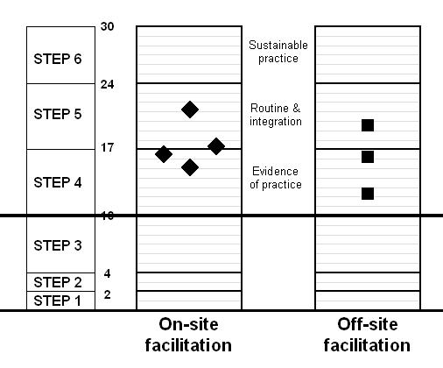
On-site facilitation |  |  | Off-site facilitation
Hospital A | 16.52 | paired with | Hospital E | 19.23
Hospital B | 20.58 | paired with | Hospital F | 12.19
Hospital C | 17.08 | paired with | Hospital G | 16.53
Hospital D | 14.90
Mean | 17.27 |  | Mean | 15.98

Qualitative evidence suggests that imperatives for successful implementation include the formation of a structured committee to drive implementation, the identification of the right individuals to drive the process, and a symbiotic relationship between nursing and medical staff regarding decision-making and caring roles.

Other observations of importance were that the keeper of the implementation package had a lot of power in terms of the communication and dissemination of information. Hospitals also reacted differently to the demands of implementation related to resources. Some hospitals were willing to implement without additional allocations, whereas others preferred to wait for the “ship to arrive”. Reactions from senior management ranged from active resistance, to a laissez-faire attitude, to active support. Where management was laissez-faire in their approach, but a relationships of trust existed, individuals had scope to implement KMC creatively without additional resources.

Conclusions
• All seven targeted hospitals reached at least the level of “evidence of practice”.
• Too few hospitals were covered to make conclusive statements regarding the effectiveness of different outreach strategies in the implementation of a new health care intervention.
• Implementation progress in all hospitals should be monitored periodically until KMC has been well institutionalised.
• Hospitals need continued support for about 1 to 2 years in order to be able to maintain a level of sustainable practice.
• After having reached the potential of sustainable practice, continued monitoring of KMC should be part of comprehensive quality assurance programmes aimed at monitoring quality of care.

EARLIER DISCHARGE OF PREMATURE BABIES USING KANGAROO MOTHER CARE INTERVENTION - A PILOT STUDY

M Mokhachane, LP Mokgosi, RM Mphahlele, E Beckh-Arnold, S Velaphi.

Introduction
Overcrowding at Chris Hani Baragwanath Hospital (CHBH) is a major problem. In 2001 there were 18 959 deliveries in the hospital of which 3 221(29%) were admitted to the neonatal unit. Of these, 48% weighed less than 2000g and 49% premature (<37 weeks gestation). As a result, the bed occupancy in medium and high care wards is usually more than 150%. Full time Kangaroo Mother Care (KMC) was introduced to the unit in 2002. But KMC without earlier discharge would not solve the problem of overcrowding.

Objectives
- To establish the safety of discharging infants weighing between 1500g to 1649g using KMC.
- To assess the feasibility of ambulatory KMC in our setting.

Methods
This was a pilot study. Routinely, infants in the unit are discharged at a weight of 1650g. Infants who were admitted to the KMC unit and weighed between 1500 and 1649g were eligible for early discharge. Their home and social circumstances were assessed. Thirty infants were enrolled. They were compared to 30 similar infants also admitted to the ward during the study period and discharged at the routine weight of 1650g. They were followed up weekly till term or 4–6 weeks. At follow-up weight, head circumference and length were recorded. Also noted was the length of time that KMC was practised at home. Morbidity and mortality were recorded. The primary outcome of the study was to look at weight gain, mortality and morbidity if babies are discharged weighing less than 1650g. Other parameters looked at were to see the percentage of patients that completed follow-up and to see the rates of exclusive breastfeeding by the end of the study.

Results
Thirty mother infant pairs were enrolled into the study and completed follow up. Seventy-six percent of mothers had attended antenatal clinic with 33% testing HIV positive. The average age of mothers was 26.6 years and parity 1.9 (±1.9). The 30 infants in the study had a mean gestational age of 31 wks and birth weight of 1255g. The mean discharge weight was 1574g. The babies discharged early had a significantly shorter stay in hospital as compared with controls (Table 1). Twenty-two of the babies were discharged on breast-milk with 60% still breast-feeding at follow up (Table 2). The length of time KMC was practised reduced as the babies approached 40 weeks gestational age (Table 4). Two infants died both weighing more than 2kg at the time of demise. One with hydrocephalus died at 5 months. The second patient died from septicaemia at 3 months of life. Four readmissions were recorded with the study patients. One patient had 2 admissions (one for laser therapy for retinopathy of prematurity and the other for sepsis, patient died at 3months). One patient was admitted with HIV related problems (HIV PCR positive) and the other patient for a ventricular peritoneal shunt insertion (died at 5 months age).

Table 1 Comparison between babies discharged early (less than 1650g) and babies discharged weighing 1650g
 | KMC early discharge  n= 30 | KMC controls  n= 30 | P-value
Birth-weight | 1255 (±199)* | 1236 (±179) | 0.7
Discharge weight | 1574 (±36) | 1675 (±32) | <0.01
Hospital days | 29.5 (±9) | 38.8 (±15) | <0.01
* - Mean (SD)

Table 2 Type of feeds used by study patients
FEED | Breast-milk | Formula | Both
Discharge | 22 (73)# | 8 (26) | 0
Last visit  (4-6 weeks after discharge | 18 (60) | 11 (36) | 1 (3.3)
# - Numbers in parenthesis are percentages
Table 3 Amount of time that KMC was performed at home.
Gestational age (weeks) | Length of KMC Hours
36 | 22 (±2)$
37 | 20 (± 4)
38 | 20 (±3)
39 | 18 (±8)
40 | 14 (±9)
$ - Mean (SD)

Discussion
The study demonstrated that the babies discharged early had normal growth. There was a significant increase in the number of mothers breastfeeding their babies. The four hospital admissions were unlikely to be related to early discharge. It has also shown that early discharge with ambulatory KMC is safe in Soweto. The mothers and family were empowered to look after these premature infants too. Other family members helped with KMC at home. Grandmothers needed continuous education.
Other implications from the study are that, as a result of a shortened hospital admission, there are reduced costs for the hospital. These infants are integrated into the family early hence there is better bonding. If discharged early, there is also a reduction in the exposure to hospital infections.
THE NEURODEVELOPMENTAL OUTCOME AND ANTHROPOMETRIC DATA AT TWELVE MONTHS CORRECTED AGE OF VERY LOW BIRTH WEIGHT INFANTS TREATED WITH KANGAROO MOTHER CARE AND BREAST MILK.

G Kirsten, J van Zyl, C Kirsten and E Thompson
Deptartment of Paediatrics, Tygerberg Children’s Hospital and the University of Stellenbosch.

At Tygerberg Hospital, non-ventilated very low birth weight infants receive intermittent Kangaroo Mother Care (KMC) and breast milk feeding and are discharged once they have reached a weight of 1800 grams. No information exists regarding the post-discharge outcome during the first year of life of these infants.

Aim
To determine the post-natal growth and neurodevelopmental outcome during the first year of life of infants <1600g who received intermittent KMC and breast milk feeding.

Study design: Prospective, cohort analytical.

Methods
127 infants with birth weights <1600g were recruited upon admission to the KMC Unit. Intermittent KMC and breast milk feeding were commenced once the infants were stable. Those with respiratory distress were treated with nCPAP and later weaned to nasal cannula oxygen. A Griffiths neurodevelopmental assessment was conducted at 12 months corrected age.

Results
24 infants were excluded from the study. One hundred and three infants attended follow-up at 12 months corrected age. Thirty seven percent of the infants required re-admission to hospital while 4% died (Tables 1 and 2). The mean weight at 12 months corrected age of the infants with gestational ages <28 weeks (7726g , SD 1089) or birth weights <1000g (7948g, SD 1141) was significantly lower compared to the infants with gestational ages >28 weeks (8650g, SD 1269) and birth weights >1000g (8728g, SD 1273). The mean General Developmental Quotient (GDQ) of the infants with birth weights <28 weeks (93, SD 6.6) and the mean subscale quotient for eye-hand coordination (98, SD 5) were significantly lower (p=0.04) compared to the infants with gestational ages >28 weeks (99, SD 9, and 104, SD 9.6) (Table 3).

Table 1 Hospital admissions and deaths during the first year of life (%)
 | Hospital admissions | Deaths | Total
Bronchiolitis/pneumonia | 19 (19%) |  | 19
Hernia repair | 7 (7%) |  | 7
Gastro-enteritis | 6 (6%) |  | 6
Meningitis | 3 | 1 | 3
Other | 3 |  | 3
SIDS  Cardiomyopathy |  | 2  1 | 3
Total | 38 (37%) | 4 (4%)

Table 2 Re-admission and death (post-discharge) according to birth weight and gestational age (%)
 | <28 weeks  N=9 | >28 weeks  N=94 | <1000g  N=21 | >1000g  N=82
Bronchiolitis/pneumonia | 5 (56%) | 15 (16%) | 7 (33%) | 13 (16%)
Hernia repair |  | 7 (7%) | 1 | 6 (7%)
Gastroenteritis |  | 6 (6%) |  | 6 (7%)
Meningitis |  | 3 | 1 | 2
Other | 1 | 2 | 1 | 2
Death | 2 | 2 | 2 | 2

Table 3 Neurodevelopmental outcome at 12 months corrected age according to gestational age (mean, + SD)

 | Locomotor | Social | Speech | Eye/hand coordination | Performance | General DQ
All infants  N=103 | 93 (12) | 96 (11) | 102 (10) | 104 (9) | 97 (10) | 98 (9)
<28 weeks  N=9 | 84 (8)* | 91 (12) | 98 (10) | 98 (5)** | 93 (6) | 93 (7)***
>28 weeks  n=94 | 94 (12)* | 97 (11) | 102 (10) | 105 (10)** | 97 (10) | 99 (9)***

Conclusions
This study confirmed the lower mean weight at 12 months for extremely low birth weight infants compared to infants with birth weights >1000g. It also confirmed the lower mean GDQ as well as poor eye-hand coordination scores in these smaller infants.

Recommendations
KMC and breast milk feeding improve the survival of the VLBW and extremely low birth weight infant (ELBW). Long-term follow up should form an integral part of their treatment as weight gain and neuro-development could be suboptimal especially in the ELBW infant.

OUT OF THE MOUTHS OF BABES ….. INNOCENT REPORTING OF HARMFUL LABOUR WARD PRACTICES.

RC Pattinson, E Farrell
MRC Unit for Maternal and Infant Health Care Strategies
Dept of Obstetrics and Gynaecology, Kalafong Hospital and University of Pretoria

Both maternal and perinatal mortality in South Africa is far too high for such a wealthy country as South Africa. The confidential enquiries into maternal deaths reported in the Saving Mothers reports and the perinatal care surveys reported in the Saving Babies reports have clearly identified where the challenges in preventing deaths of mothers and babies lie. However, death is only the tip of the iceberg. What is happening in routine management of labour in public institutions throughout the country?

In the new curriculum of the Faculty of Health Sciences at the University of Pretoria, medical students are obliged to go to University-approved public institutions outside of the academic institutions for their community obstetric rotation, which includes conducting births. This rotation is coupled with community-based education and is regarded as an essential part of the training as the student is exposed to medical practice outside of academic institutions. During this exercise, the students are required to keep a logbook and portfolio in which the student has to record at least 15 cases and in each case analyses what they have learnt. The logbooks and portfolio are handed in for evaluation at the end of the rotation. The student is then required to defend the portfolio during an oral examination conducted by one of the authors. The authors have evaluated over 5000 cases recorded by the students from over 15 non-academic hospitals in the past 24 months. The authors recorded misconceptions, harmful practices and potential malpractice reported by the students in preparation for a feedback meeting with the students. Problems recorded by more than one student were discussed in the meeting to save the authors from having to repeat themselves repeatedly during the student’s defence of their portfolios. The authors have analysed the lists of misconceptions and harmful practice and report on only those items recorded in more than three report-back meetings. The assumption being this would identify widespread harmful practice, rather than isolated incidents. This data forms the background for this comment. The students are all in their student internship year and have had a basic course in obstetrics in their third year. Their knowledge of the subject is not extensive and there is no reason to believe that the students would make-up or be able to make up the case histories of the patients. Some students found some problems so common that they were recorded as a general comment in front of their reports. Each student had to complete a partogram for each of their patients so the use of the partogram by the institution could not be evaluated.

The harmful practices raised are listed below in order of danger to patients.
- Augmentation of labour with vaginal prostaglandin tablets, and hopefully erroneously recorded the use of 5 tablets of misoprostol for this use as well. Vaginal prostaglandin tablets are indicated for ripening the uterine cervix before induction of labour but are extremely dangerous when used in patients who are in active labour and already having uterine contractions. The risk of uterine rupture is a real concern in this scenario.
- Delay in doctors attending. It seems that the reasons for this problem vary between institutions. In some places, the midwives are reluctant to call out the doctors because they think they know what is best, in others they do not call because of opposition from the doctors after being called “unnecessarily” and in some instances the doctor is called in time, but does not attend to the patient until hours later, even in cases of dire emergency. The result is unfortunately almost always the same: poor outcome for mother and/or fetus.
- Intravenous buscopan given for poor progress in labour, often without a prescription. Buscopan is a muscle relaxant whose use is specifically contra-indicated in pregnancy and we are aware of no clinical trials proving its safety or efficacy in pregnancy. Despite this fact, there is a belief amongst some midwives that this drug can alleviate the uterine “spasm” which causes prolonged labour and therefore the drug is dished out to women with poor progress of labour, often without prescription and without even recording it in the patient’s prescription chart.
- Physical abuse of patients by midwives. This is extremely wide-spread and whilst most of our students are appropriately upset by witnessing this, it does not maker it easier for the patients. Students have reported midwives calling abuse “verbal pitocin”, aimed at making patients behave and perform better in labour.
- The cutting of episiotomies without local anaesthetic and lack of pain relief during labour. These go together and are accommodated in the belief that most midwives have that labour should be a painful process and that the patient is only “getting what she deserves”. The inhumanity of these practices needs no further discussion.
- Fundal pressure in the second stage. The dangers of fundal pressure are widely known, but what is also evident is that this is routine practice in most instances, and often goes hand in hand with verbal and other abuse from the midwives. It is then sold to the students as the “ideal way to manage non-cooperative patients in the second stage of labour”.
- Patients left alone and unattended for extended periods of time and single attendants during delivery. Although lack of staff does play a role here, patients are unfortunately sometimes left alone at critical stages, when tea or lunch should have been postponed temporarily until the problem had been sorted out.
- The use of 50% dextrose water IV, for neonatal and maternal resuscitation. The use of dextrose water in labour is extremely dangerous, since high maternal glucose leads directly to high fetal glucose (via active placental transport) and therefore reactive hyperinsulinaemia in the fetus, which can lead to severe neonatal hypoglycaemia when the baby is suddenly deprived of the maternal glucose supply after delivery. Fetusses with a high blood glucose content are also much more prone to intra-uterine academia during periods of stress, via anaerobic metabolic pathways.
- No estimation of the haemoglobin level during labour. This is very rarely done, even for patients who are clinically anaemic. The risk to an anaemic patient having a sever intra- or postpartum bleeding is obvious.
- Routine rectal enemas on admission. Despite the fact that no benefit has ever been proven from giving patients enemas in labour, it is common practice and can be very dangerous, as some case reports have shown.
- Lack of nutrition during labour. Patients are starved with the excuse that they might need urgent caesarean sections. It has been clearly shown this is not necessary and may be harmful. Students have reported that food is still ordered for every patient in labour and then consumed by the nursing staff.
- Lack of privacy. This is contrary to the “Patient’s Charter”. On occasion it cannot be helped by the physical structure of the labour ward, but on other occasions, there are ways to try and ensure privacy.
- Passive management of the third stage of labour. This increases the risk of postpartum haemorrhage significantly. Postpartum haemorrhage is one of the leading causes of maternal death and is the most preventable. The national guidelines recommend the active management of the third stage of labour.
- No counselling for HIV testing or testing. This despite the court order for the implementation of the Prevention of Mother to Child Transmission Programme using nevirapine.

Many of these harmful practices are not new and have been reported before notably by Fonn and Jewkes. Feedback has been given in an informal way to the relevant hospitals. However, the practices continue unabated.
This brings into question the current emphasis of training medical students in non-academic institutions. In this small sub-set of medical practice, there is considerable harmful practice, what is it like for other fields? Clearly the medical students are learning bad habits from outside hospitals. The message we are sending out to our students is:
“Do as we say, not as we do”
What sort of example are we setting? Clearly, we are perpetuating harmful practice from the very method we are using to teach our students. This should not be allowed to continue.

There are a number of potential solutions, each requires varying amounts of resources be allocated to it. The first solution is the most inexpensive and that is to remove the students from these harmful environments and bring them back to academic institutions. This will defeat the object of exposing students to different environments and preparing them to function as independent practitioners in these environments.

Another solution is to ensure outreach to all the new teaching sites to ensure these harmful practices are eradicated. This is probably the ideal solution, but will require enormous resources to implement. To be successful, the outreach agent will have to have a form of authority so that changes will be implemented. The institution of senior medical posts specifically for this purpose would be required. These posts would have to be joint appointees between the university and the province involved.

Between these two extremes are a spectrum of less ideal alternatives, some of which are enjoying attention, such as quality assurance programmes, licensing of hospitals and compulsory continuing professional development for nurses.

For the current situation, there should be no training in non-academic sites without some form of report from the students and an extensive debriefing of the students on their return to dissuade them from using harmful practices. Specifically related to labour ward practice, every institution conducting births should be strongly encouraged to institute the Better Births Initiative, a programme specifically designed to introduce best practice to the country’s labour wards. We feel this should become a national programme and resources are put into it by the National Department of Health to ensure its success.

IS INTRAPARTUM PAIN RELIEF USING PETHIDINE AND ATERAX SAFE FOR MOTHER AND BABY?

Ruth Pfau, Bamalete Lutheran Hospital, Ramotswa / Botswana
Sharon Fonn, University of the Witwatersrand, Johannesburg
Jonathan Levin, Medical Research Council, Pretoria

Introduction
Epidural anaesthesia is currently regarded as the gold standard for intra-partum pain relief. In the set-up of a third world district hospital, epidural anaesthesia for intrapartum pain relief is not feasible. There are usually inappropriate maternal resuscitation facilities in the labour ward and a chronic shortage of skilled manpower to administer and supervise epidural anaesthesia. Alternatively parenteral Pethidine is simple to administer but has limited efficacy. Pethidine crosses the placenta virtually unhindered and can affect the neonate. Concerns have been raised about respiratory depression in newborns. There is a suggestion that Pethidine is associated with a lengthening of labour and that this association is dose related. This study aimed to assess the safety of intrapartum pain relief using Pethidine and Aterax.

Methods
Since 1999, a maternity discharge form is filled for all patients admitted to the maternity ward. The form collects essential data concerning the antenatal, intrapartum and postpartum care. For the study period from 1.April 1999 to 31. December 2002, 3627 maternity discharge forms from patients who had delivered were available for analysis. All data was entered on computer and analysed using Stata.

Results
The mean maternal age was 26,7 years. The mean gravidity was 2,4, the mean parity 1,3. The mean gestational age at booking for antenatal care was 20,4 weeks and the mean number of antenatal visits was 8,4 visits. The mean birthweight was 3076 gram (Table 1).
The mean 1-min APGAR score without pain relief was 8,1 compared to 7,8 with Pethidine. The mean 5-min APGAR score was 9,2 without pain relief and 9,1 with Pethidine. Both differences were statistically significant (p<0,001). The mean 10-min APGAR score was 9,6 without and 9,7 with Pethidine. This difference was no longer significant (p=0,29) (Table 2). A regression analysis for the APGAR scores was done. For the 1-min and 5-min APGAR score all predictors were highly significant (p<0,01)(Table 3). For the 10-min APGAR score augmentation and pain relief were no longer significant.
The mode of delivery was analysed. A significant positive correlation (p<0,01) between pain relief and surgical delivery (C/S or VE) was found. A logistic model of risk factors for surgical delivery was then calculated. The Odds Ratio for Pethidine and Aterax associated with a surgical delivery was 1,3 (CI 1,0 ; 1,6) (Table 4).
The need for neonatal admission was analysed. A significant negative correlation (p=0,001) between pain relief and neonatal admission was found. A logistic model of risk factors for neonatal admission was calculated. Only birthweight (p=0,08) and pain relief (p=0,003) were significant. Both factors were protective against neonatal admissions. For pain relief the Odds Ratio was 0,5 (CI 0,3 ;0,7) (Table 5).

Discussion
The data analysed confirmed that Pethidine has an influence on the neonatal parameters. The 1-min and 5-min APGAR scores were lower in the group having received Pethidine. Despite the statistical significance, a difference of 0,1 or 0,3 points does not make a biological difference. The analysis of the predictors of the APGAR score revealed the well known factors of pre-eclampsia, birthweight, meconium stained liquor and maternal age. Administration of Pethidine and Aterax was associated with a significantly higher rate of surgical deliveries (VE, C/S). The Odds Ratio was however only 1,3 meaning that the risk was only slightly increased. The data did not allow a further investigation of the relationship between Pethidine and surgical delivery. Analysing the risk of neonatal admission, it was found that pain relief was significantly protective against admission. This confirms the previous statement that Pethidine does not have a biologically significant impact on APGAR scores.
Conclusion
It was found that the 1-min and 5-min APGAR score were significantly lower in babies delivered by mothers who got pain relief compared to those who did not. However, the difference was so small that it was of no biological concern. The study revealed that mothers who got pain relief had a slightly higher risk to end up with a surgical delivery. The risk to have a neonatal admission was smaller in the group of babies whose mothers got pain relief. All in all, the study showed that the Bamalete Lutheran Hospital pain relief policy is safe for mother and baby.

Table 1 Demographic data
 | N | Mean | Std. dev.
Maternal age | 3456 | 26,7 y | 6,5 y
Gravidity | 3613 | 2,4 | 1,6
Gestational age at booking | 3453 | 20,4 wks | 6,3 wks
Antenatal visits | 3475 | 8,4 visits | 3,5 visits

Table 2 APGAR scores
APGAR | Without Pethidine | With Pethidine | Difference | p-value
1 min | 8,1 | 7,8 | 0,3 | P<0,001
5 min | 9,2 | 9,1 | 0,1 | P=0,001
10 min | 9,6 | 9,7 | 0,1 | P=0.29

Table 3 5-min APGAR regression analysis
 | Coeffic. | p-value | 95% conf. interval
Augment. | -0,15 | 0,019 | -0,27 | -0,02
Preeclamp | -0,71 | <0,001 | -1,04 | -0,39
Meconium | -0,45 | <0,001 | -0,59 | -0,30
Btwt (kg) | 0,96 | <0,001 | -0,35 | 1,06
Mat. age | -0,22 | 0,001 | 0,23 | 0,00
Parity | 0,80 | 0,006 | 0,23 | 0,13
Pethidine | -0,23 | <0,001 | -0,35 | -0,11

Table 4 Risk factors for surgical delivery
Risk factors | Odds Ratio | p-value | 95% conf. Interval
Augmentation | 1,62 | <0,001 | 1,31 | 2,00
Preeclampsia | 3,00 | <0,001 | 1,84 | 4,88
Btwt (kg) | 1,61 | <0,001 | 1,33 | 1,94
Maternal age | 1,06 | <0,001 | 1,04 | 1,09
Parity | 0,71 | <0,001 | 0,63 | 0,79
Pethidine | 1,31 | 0,001 | 1,06 | 1,62

Table 5 Risk factors for neonatal admission
Risk factors | Odds Ratio | p-value | 95% Conf. Interval
Btwt (kg) | 0,69 | 0,008 | 0,53 | 0,91
Pethidine | 0,52 | 0,003 | 0,34 | 0,79
Augmentation | 1,35 | 0,133 | 0,91 | 2,03
Preeclampsia | 1,85 | 0,104 | 0,88 | 3,92
Maternal age | 1,03 | 0,111 | 0,99 | 1,07
Parity | 0,83 | 0,065 | 0,69 | 1,01

A RANDOMIZED CONTROLLED TRIAL COMPARING MISOPROSTOL VAGINAL GEL VERSUS ORAL AND VAGINAL TABLETS FOR THE INDUCTION OF LABOUR

JBF Cilliers, E Thomas, O Westenburg, HS Cronje. Department of Obstetrics and Gynecology, University of the Free State, Bloemfontein.

The purpose of the study was to determine to most effective dose and method of induction using misoprostol in three different dosages and routes/methods of administration.
Study population included all pregnant women in the Universitas/Pelonomi labour wards qualifying for induction of labour.
After inclusion into the study each case was randomized to be included into one of three groups:
- A Misoprostol 50ug tablet administered vaginally every 6 hours;
- A Misoprostol 20ug solution administered every 2 hours orally for 12 hours;
- A Misoprostol 25ug gel administered vaginally every 6 hours.
Misoprostol was administered at the intervals prescribed per group until the patient was in the active phase of the first stage of labour.

Introduction
Induction of labor is a common procedure in labor wards with many indications. In the public sector in South Africa the cost of medications used for induction are very expensive.
Misoprostol has been proven to be as effective and much less expensive than prostaglandin E2 gel. The most effective dose of Misoprostol used vaginally has been shown to be 25 micrograms (ug) every 6 hours.

In South Africa, misoprostol has not been registered for the induction of labour and is only available in 200ug tablets. This means to prepare the correct dose the tablet has to be broken into eight pieces of the same size, which is not possible with the 200ug tablet available.
Currently the tablet is broken into 4 pieces of roughly 50ug each. This dose has been shown to be associated with the risk of over stimulation with the danger of fetal distress. Subsequently, other forms of application have been investigated. One involved the suspension of one tablet in water of which the patient will drink a tenth of the volume (20ug).

The purpose of the study was to determine to most effective dose and method of induction using misoprostol in three different dosages and routes/methods of administration.
All pregnant women in the Universitas/Pelonomi labor wards qualifying for induction of labour were included and were randomized to be included into one of three groups:
- A Misoprostol 50ug tablet administered vaginally every 6 hours for 24 hours;
- A Misoprostol 20ug solution administered every 2 hours orally for 12 hours;
- A Misoprostol 25ug gel administered vaginally every 6 hours for 24 hours.

The gel was prepared by drawing up 8cc water into a syringe and squirting this into an empty specimen bottle. The 200ug tablet was now dissolved into the solution. Two bags of KY-jelly were squeezed into a 10cc syringe. 1ml of the solution was added to 3ml of the gel and shaken. This would give a solution of 25ug in 4ml solution.

The oral solution was prepared by dissolving 1x 200ug tablet in 200ml water and giving the patient 20ml to drink. A new solution was prepared just prior to administration as it is unsure if the solutions will lose its effectiveness in a solution or gel form.

Misoprostol was administered at the intervals prescribed per group until the patient was in the active phase of the first stage of labor.

Results: (Slides read from left to right)
A few variables were taken into consideration in the different groups. Age, Parity and Gravity was mostly evenly distributed

Fetal welbeing was evaluated before and after every dose of misoprostol. The graph on the left represents the fetal wellbeing before induction was started

This showed that misoprostol orally took by far more doses to reach active labour followed by the gel and then the tablet group.

The gel group also took the longest time to reach delivery followed by the oral group.

This, in turn, could have led to more caesarean sections in the oral tablet and vaginal tablet groups. These two groups had almost the same caesarean section rate with the vaginal gel having the most vaginal deliveries.

Hypertension with proteinuria was by far the biggest reason for elective induction during the trial. This was followed by post maturity and other causes.

The Bishop score showed the misoprostol gel group had much more patients with a more favourable score. One would expect that this would have favoured this group to a speedier induction active labour stage. But as well see later is wasn’t the case.

The vaginal gel group took the longest time to reach active labour. This is contradictory than what was expected considering the favourable Bishop score.

The most failed inductions were noted in the oral group followed by the vaginal tabled group.

Considering the reasons for the caesars, it would appear as if there was a trend that the vaginal gel gave less uterine over stimulation and in return a lower incidence of fetal distress. On the other hand, more C/S was done in the gel group for poor progress.

Conclusion
Although the study is small it appears as if there is a trend that misoprostol gel PV takes longer to reach active labour and to deliver but has less over stimulation and has a better vaginal delivery rate.
There must most certainly be more patients enrolled into this trial to make any scientific significant recommendations.

MISOPROSTOL FOR TREATING POSTPARTUM HAEMORRHAGE: A RANDOMIZED PILOT STUDY

Hofmeyr GJ, Ferreira S, Nikodem VC*, Mangesi L, Singata M, Jafta Z, Maholwana B, Mlokoti Z**, Pirani N***, Walraven G****, Gulmezoglu AM*****.
Effective Care Research Unit, University of Witwatersrand and Fort Hare, and East London Hospital Complex, South Africa, *University of the Western Cape, **Tembisa Hospital Effective Care Research Unit, ***Chris Hani Baragwanath Hospital and University of the Witwatersrand, **** Aga Khan Health Services, France, *****HRP/RHR, World Health Organisation, Geneva, Switzerland.

Background
Postpartum haemorrhage (PPH) is the major cause of maternal deaths in many low-income countries. In South Africa, 240 of 2445 maternal deaths reported between 1999 and 2001 were due to postpartum haemorrhage, the third most common cause. In the United Kingdom, the risk of maternal death from haemorrhage is about 1 in 100 000 births. The potential to save mothers’ lives with medical interventions for haemorrhage is thus considerable.
There is good evidence that a policy of active management of the third stage of labour is effective in reducing the risk of postpartum haemorrhage.
When postpartum haemorrhage occurs, a number of medical and surgical interventions are used to control the bleeding. A crucial aspect of both prevention and treatment of postpartum haemorrhage is uterotonic therapy. The most commonly used agents are injectable oxytocin and/or ergometrine.
Misoprostol is a methyl ester of natural prostaglandin E1. Oral and rectal misoprostol have been used for routine management of the third stage of labour. The main side-effects have been shivering and pyrexia, which are dose-dependent. In a systematic review of the topic, blood loss >1000ml and use of additional oxytocics were more frequent with misoprostol than with injectable oxytocics, indicating that injectable oxytocics should remain the drug of choice for routine prophylaxis.
The therapeutic use of misoprostol for the treatment of postpartum haemorrhage has been promoted on the basis of unblinded studies. In a systematic review, we located 6 uncontrolled reports and one small, unblinded randomised trial. In the 6 observational studies, 41 women with postpartum haemorrhage were treated with misoprostol 1000μg rectally (32 women), 200µg rectally (5 women), 200μg orally 2-hourly (2 women) or 800μg intrauterine (2 women). In all but 2 of the women (who received 1000μg rectally), a prompt response to the treatment was reported. In the single blind randomised trial, subjective prompt cessation of bleeding was reported in 30/32 women who received misoprostol 800μg rectally compared with only 21/32 who received oxytocin 5 units plus ergometrine 0.5mg intramuscularly.
The urgent need for randomised trials of this new intervention has been emphasised. If effective, it could have a major impact on maternal mortality, particularly in under-resourced countries. If not, it’s use should be discouraged because of the dangers of side-effects, and the risks associated with widespread introduction of misoprostol into health systems in which it might be used for labour induction in inappropriate doses, with the risk of fetal compromise and uterine rupture.
We reviewed the literature on the pharmacokinetics of misoprostol administered by various routes. The oral route has the most rapid uptake, but the shortest duration. The rectal route has slow uptake but prolonged duration. The buccal or sublingual route has rapid uptake, prolonged duration and greatest total bioavailability. In order to improve the rapidity of onset of action and the overall bioavailability, we modified the reported practice of using 800-1000 μg rectally for treatment of PPH, by administering 200μg orally, 400 μg sublingually and 400 μg rectally.
The objective of this study was to determine the side-effects and effectiveness of high-dose misoprostol for the treatment of postpartum haemorrhage by means of a double-blind, placebo-controlled, randomised clinical trial.

Methods
The study was conducted at the East London Hospital Complex (Frere Maternity and Cecilia Makiwane Hospitals, Eastern Cape) and Tembisa and Chris Hani Baragwanath Hospitals, Gauteng, South Africa.
Treatment packs were prepared independently, ordered in computer-generated random sequence and numbered consecutively. The packs contained either misoprostol 5 x 200μg or placebo. The treatment sequence was kept sealed, and the code broken only after complete entry and checking of all trial data. A confidential interim analysis was performed by AMG after the first 100 enrolments, and clearance given to continue with the trial.
Women in labour were given information about the trial in the form of notices in the labour rooms. Management of labour 3rd stage was routine active management with oxytocin 10units or syntometrine one ampoule soon after the birth. Women aged 18 or more with bleeding more than expected at least 10 minutes after delivery, thought to be due to uterine atony and requiring additional uterotonic therapy, were given all the routine treatment for PPH (drip, oxytocics, etc) from a special ‘PPH Trolley’ kept in the labour ward. In addition, they were asked to participate in the trial. Information about the trial was given verbally and in writing in an appropriate language. Those who gave written consent were enrolled in the trial. Baseline data were documented. The next treatment pack containing either misoprostol 5 x 200μg or placebo was drawn and the number recorded. In addition to routine management, misoprostol or placebo were given, 1 orally, 2 sublingually and 2 rectally, and the time recorded.
A low-profile plastic ‘fracture bedpan’ was placed under the woman’s buttocks. After 1 hour, the blood collected in the bedpan was measured in a graduated measuring jug, the temperature was measured with a mercury thermometer, and any shivering was recorded as ‘mild’, ‘moderate’ or ‘severe’. All other management was by hospital staff according to the hospital routine for the management of postpartum haemorrhage.
After 24 hours, blood was collected for haemoglobin estimation and the hospital records checked for use of additional uterotonics and any other complications such as blood transfusion.
The primary outcome measures were: (1) measured blood loss >500ml in 1 hour after enrolment; (2) mean measured blood loss in 1 hour; (3) haemoglobin level day 1 after birth <6g/dl or blood transfusion; (4) Side-effects (pyrexia 38.5 C or more, moderate or severe shivering 1 hour after enrolment).
Sample size calculation: To reduce blood loss >500ml after enrolment from 25% to 10%, would require 112 per group (α=95%, β=80%).
Data were collected on a data form, entered onto an excel spreadsheet, checked for accuracy, then analysed using Epi-info 2002 and Revman 4.2 software. Results were expressed as relative risks or mean difference with 95% confidence intervals.
Ethical approval was given by the Committee for Research on Human Subjects, University of the Witwatersrand, and the Ethics Committee, East London Hospital Complex.

Results
Altogether 244 women were enrolled in the trial. The pack numbers for 6 women were incompletely filled in on the data sheets, and they could not be included in the analysis. There was no reason to expect that these exclusions occurred in any selective way which would introduce bias into the final samples, nor could their results have materially altered the conclusions of the study.
The outcomes are shown in the table. Measured blood loss within 1 hour of enrolment of 500ml or more in the placebo group was less frequent (9.2%) than the 25% prediction on which the sample size calculation was based. This may have been because the criteria for enrolment were loosely defined as ‘more than expected blood loss’, resulting in the enrolment of women with less severe blood loss than anticipated. The study was therefore underpowered to detect a statistically significant reduction in this outcome. With misoprostol, there was a trend to reduced blood loss >500ml in 1 hour after enrolment (6/117 vs 11/120, relative risk 0.56; 95% confidence interval 0.21 to 1.46).
Other proxy estimations of blood loss showed no significant differences between the groups. Pyrexia and shivering, were significantly more frequent in the misoprostol than the placebo group.
Serious morbidity or mortality occurred in 5 women, all from the misoprostol group, including 3 maternal deaths.

Discussion
Three women, all in the misoprostol group had severe pyrexia >40°C. These side-effects may be related to the rapid absorption of misoprostol given orally, and the rapid absorption and high bioavailability when given sublingually. We would recommend that for future trials the dose be reduced to 200μg orally and 200-400μg sublingually.
In our double blind trial, we have been unable to confirm the dramatic effects of misoprostol reported previously in unblinded studies. Our results, however, are consistent with a clinically important beneficial effect. It is important that this possible effect be substantiated by sufficiently powered randomised trials before the treatment enters routine clinical use.

Table Comparison of outcomes between women who received misoprostol or placebo, expressed as proportions (percent) or mean values [standard deviation]. Differences are expressed as relative risks or mean differences, with 95% confidence intervals.
Outcomes | Misoprostol (117) |  | Placebo (121) |  | RR/ MD | 95% Conf. interval
Primary: | n |  | n |  | RR/ MD | 95% Conf. interval
Blood loss >500ml* | 117 | 6 (5.1%) | 120 | 11 (9.2%) | 0.56 | 0.21 to 1.46
Mean blood loss* [SD] (ml) | 117 | 168 [163] | 120 | 176 [173] | -8 | -51 to 35
24 hour Haemoglobin <6g/dL or blood transfusion | 110 | 20 (18.2%) | 116 | 17 (14.7%) | 1.24 | 0.69 to 2.24
Pyrexia at 1 hour >38,5°C | 114 | 11 (9.6%) | 118 | 2 (1.7%) | 5.69 | 1.29 to 25
Shivering at 1 hour > moderate | 116 | 63 (54%) | 118 | 30 (25%) | 2.14 | 1.50 to 3.04
Seconday:
Blood loss > 1000ml* | 117 | 1 (0.85%) | 120 | 0 (0%)
Blood transfusion | 115 | 19 (17%) | 119 | 15 (13%) | 1.31 | 0.70 to 2.45
24 hour haemoglobin <8g/dL or blood transfusion | 110 | 43 (39%) | 116 | 37 (32%) | 1.23 | 0.86 to 1.75
Additional uterotonic after enrolment | 111 | 63 (57%) | 112 | 63 (56%) | 1.01 | 0.80 to 1.27
Manual removal of the placenta | 117 | 1 (0.85%) | 121 | 4 (3.3%) | 0.26 | 0.03 to 2.28
Evacuation of retained products of conception | 117 | 2 (1.7%) | 121 | 0 (0%)
Hysterectomy** | 117 | 3 (2.6%) | 121 | 0 (0%)
Maternal death** | 117 | 3 (2.6%) | 121 | 0 (0%)
RR = relative risk; MD = mean difference; Conf = confidence; SD = standard deviation. *Measured, within 1 hour after enrolment

** One woman died after hysterectomy and is counted in both outcomes
ASSESSING THE EFFECTIVENESS OF A WIND-UP DOPTONE AS A FETAL MONITOR IN LABOUR

L Mangesi, GJ Hofmeyr
Effective Care Research Unit, East London Hospital Complex, University of Fort Hare, University of Witwatersrand

Introduction
Fetal surveillance is of great importance in labour for early detection of fetal distress. The goal for care during pregnancy is a healthy baby, and a satisfied mother. There are many ways of monitoring the baby's condition during pregnancy, but they differ in their levels of accuracy and reliability. Examples of these are intermittent auscultation with the fetal stethoscope, electronic cardiotocography, battery operated doptone, etc. Other methods such as ultrasound are very expensive, need a skilled attendant and are not convenient in labour. The cardiotocograph is an expensive instrument and if available, it may have to be shared among many patients. It is important that for the purpose of patient’s comfort, fetal monitoring should be done with a minimum of interference. Methods of fetal monitoring should be able to pick up late decelerations, fetal bradycardia and fetal tachycardia.

In monitoring the fetal heart rate with a fetal stethoscope, a baseline fetal heart can be measured after one minute of listening. Late decelerations may be picked up when listening after contractions. A fetal stethoscope does not allow the clinician to quantify the decelerations. The decelerations are therefore a subjective judgement of the clinician at that particular time. Baseline variabilty and minor accelerations cannot be detected by auscultation. Some abnormalities can nevertheless be detected by auscultation. According to Wood (2003), electronic fetal monitoring did not prove to have benefits compared to intermittent auscultation of fetal heart rate in low-risk women.

A doptone is a portable device, usually battery operated that works like a fetoscope, but is more sensitive than a human ear in picking up the fetal heart rate. In a study by Mahomed (1994), a hand-held doptone was found to be advantageous compared to auscultation with a fetal stethoscope.

A wind-up doptone is a doptone that can be used in the absence of batteries or electricity. This method can be of great help in low resource areas where availability of batteries may be a problem. It is not known how accurately this device can pick up the baseline, decelerations and other fetal heart rate abnormalities compared with electronic cardiotocography. This study is therefore necessary to determine the sensitivity and the specificity of a wind-up doptone.

Objectives
♦To evaluate the effectiveness of a wind-up doptone in picking up late fetal heart rate decelerations and other fetal heart rate abnormalities compared to auscultation
♦To assess the effectiveness of the wind-up doptone in predicting neonatal asphyxia compared with cardiotocography
♦To compare the acceptability of different methods for the mother

Method
This was a prospective pilot study of unselected women with singleton pregnancy in the active phase of labour at Cecilia Makiwane Hospital. Each woman was assessed with three methods. For auscultation and the wind-up doptone, the heart rate is measured for one minute between contractions, during contractions and 30 seconds after the contraction. The baseline heart rate, the lowest rate during a contraction and the rate 30 seconds after the contraction are recorded. The heart rate is then classified as normal, baseline bradycardia or tachycardia, and early or late fetal heart rate decelerations. The clinical assessment is followed by a 10-minute cardiotocograph tracing and the subjects are interviewed for their preferred method. The cardiotocograph tracing is then evaluated after the study, blind to the clinical findings.

Results
Out of 25 women who took part in the pilot study, there was one participant where a deceleration was picked up on auscultation and by the CTG. There were 22 cases where no decelerations were picked up by a fetoscope and a CTG. There were 2 cases where a CTG picked up decelerations that the fetoscope did not. This means that there were 2 false negatives on auscultation when using the CTG as a ‘gold standard’.

When a doptone was compared to a CTG, there was one incidence where both the CTG and the doptone picked up a late deceleration. In 19 cases, both the doptone and the CTG did not pick up any decelerations. There were three false positives and two false negatives that were picked up by the doptone when using the CTG as a ‘gold standard’.

Conclusion
There were too few cases to comment on the efficacy of a wind-up doptone. It was not possible to quantify the decelerations that were picked up on auscultation. In 14/25 cases, one or more doptone readings counted only every 2nd beat. It would be useful if the doptone could be improved technically. Facilities for measuring variability would also be useful. In view of the striking results of the Harari study in which perinatal outcome was significantly better with the doptone than with auscultation, a robust doptone appears to be worth developing.

Women prefer a doptone for having their babies monitored.
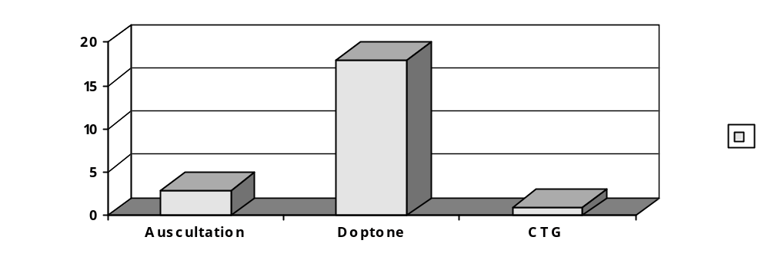Figure 1 Mothers’ preference for method of fetal monitoring

Tables Diagnosis of late decelerations by auscultation and doppler, vs CTG as ‘gold standard’
Auscultation: Sensitivity 1/3
False positive 0/1

25
22
3
24
22
2
-
1
0
1
+
AUSC
-
+
CTG

Doppler: Sensitivity 1/3
False positive 3/4

25
22
3
21
19
2
-
4
3
1
+
D
O
P
P
-
+
CTG

OBSTETRIC RISK FACTORS FOR NEONATAL ENCEPHALOPATHY

SR Fawcus, H van Zyl. Dept OBS & Gynae UCT
L Linley, C Thompson, D Greenfield. Dept. Neonatology UCT

Background
● Perinatal audits evaluating causes and avoidable factors are descriptive.
● Identification of risk factors for neonatal encephalopathy requires comparison with a control group.

Aims of the Study
● To identify antepartum and intrapartum risk factors which are associated with the subsequent development of neonatal encephalopathy.

Methods
● Case – control study design (Jul 01 –Jun 02).
● Cases: mothers of term infants with diagnosis of neonatal encephalopathy delivered at MMH or satellite MOUs.
● Controls: mothers of term infants born without ne matched to cases by level of delivery, mode of delivery, neonatal sex.
● Neonatal birth weight± 500gm

Matching
CASES CONTROLS
(N=46) (N=44)
Mean Birthwt (gms) 3169 3220
Assisted delivery 31(67%) 31(70%)
Sex = male 34(74%) 33(75%)
Delivery at level 2 39 (85%) 38(86%)

Results
Maternal Characteristics
NE CONTR OR CI
Age < 20yrs 15(33%) 7(16%) 2.56 (0.84-8.02)
Parity = 0 31(67%) 21(48%) 2.26 (0.89-5.84)
Height <155cms 18(41%) 10(29%) 2.22 (0.8-6.25)
Smoking 1(2.2%) 4(9%) 0.22 (0.01-2.21)
Mean GA at booking 24.5wk 21.2wk
Mean No.ANCvisits 4.6(45) 5.3(42)
Prior abn.Obs history 6 (13%) 6(13%) 0.97 (0.24-3.82)
Current AN complics 8(17%) 8(18%) 1 (0.3-3.34)

Onset Of Labour
• NE CONTR OR CI
GA >41 wks 20(44%) 8(19%) 3.5 (1.21-10.37)
Multiple admissions 6(13%) 8(18%) 0.69 (0.19-2.44)
Attended MOU 32(71%) 26(59%) 1.7 (0.65-4.53)
Labour induced 1(2%) 6(14%) 0.14 (0.01-1.31)
Augmentation=yes 14(31%) 13(30%) 1.08 (0.4-2.93)
Cx dilation >6cms 11(25%) 4(10%) 3 (0.77-12.53)
Referral = Yes 26(58%) 25(57%) 1.04 (0.41-2.62)
mean Transfer time 3hr3m 2hr13m

Labour Characteristics
NE CONTR OR CI
Prol. latent phase 8(18%) 6(14%) 1.37 (0.38-5.01)
Prol. active phase 16(35%) 12(27%) 1.47 (0.54-4.0)
Prol. second stage 21(47%) 3(7%) 11.96 (2.93-56.4)
● Duration ROM 8.2hr 7.5hr
Pyrexia 4(9%) 2(5%) 2.05 (0.3-17.17)

Fetal Monitoring
NE CONTR OR CI
Meconium liquor 18(40%) 15(34%) 1.29 (0.5-3.34)
No / incomplete
FH monitoring 23(51%) 16(36%) 1.75 (0.69-4.45)
Abnormal FH pattern 18(40%) 11(25%) 2 (0.74-5.48)

Causes Of Hypoxia [NE]
* Abnormal labour -29
* Shoulder dystocia – 1
* Breech / stuck head – 1
* IUGR - 1
* Post term - 5
* Abr. placenta -1
* Unexplained labour hypoxia -7

Assessment Substandard Care
NE CONTR OR CI
NIL SUBSTANDARD 6(13%) 21(48%) 0.17 (0.05-0.53)
PATIENT: delay 6(13%) 3(7%)
ADMIN:
transport delay 12(27%) 6(19%) 2.3 (0.7-7.85)
anaesthetic delay 1 0
MEDICAL:
delay referral 9(20%) 7(16%)
inadeq monitoring 8(18%) 8(18%)
delay action 18(40%) 9 (21%) 2.59 (0.92-7.45)
incorrect action 5(11%) 1(2%)

Conclusions
1. Post term pregnancy and prolonged second stage are significant risk factors for NE.
2. Larger sample size may show other factors to be significant. (?? appropriate controls?).
3. Substandard care more common in NE mothers.
4. Challenges: improved Mx Second stage.
?? Warning signs indicating referral earlier in labour/before the second stage.
Reducing delays in definitive action
Postdatism ??

Concern
● Strategies to reduce intrapartum asphyxia may require more women labouring and delivering in secondary care.
● There is already a shift to secondary care of sick HIV pos women.

–Can the services cope?

PERINATAL HYPOXIA AND NEONATAL ENCEPHALOPATHY IN THE PMNS

L Linley*, C Thompson*, D Greenfield*, G Moller*, S Fawcus#
*Division. of Neonatal Medicine, SCAH, UCT #Dept. of Obstetrics and Gynaecology, UCT

Introduction
Perinatal hypoxia associated with neonatal encephalopathy (apparent hypoxic ischemic encephalopathy or HIE) is a problem world-wide. It is associated with significant morbidity and mortality, and is potentially avoidable. The incidence in the PMNS was previously unknown.

Aims
To establish the incidence of apparent HIE in the PMNS.
To establish the incidence of apparent HIE by grade of severity.
To evaluate the contribution of intrapartum hypoxia as a cause of fresh term stillbirths in the PMNS.

Method
A retrospective folder review was conducted of the folders of infants of birthweight >2500g, who were liveborn with apparent HIE, or stillborn, in the PMNS from 01/07/2001-30/06/2002. Incidence, morbidity and mortality due to apparent perinatal hypoxia were assessed on this population studied.

Results: HIE

Incidence
Live births PMNS 01/07/01-30/06/02: n=27500
Diagnosis HIE PMNS for the same time period: n=100
Incidence HIE: 3,6/1000 live births

Place of Delivery (outborn n = 32)
Of the 68 inborn infants, 46 were born at Mowbray Maternity Hospital, which is a referral center for the MOUs at Khayelitsha, Guguletu and Mitchells Plain, 14 were born at New Somerset Hospital, which takes referrals from the MOUs at Hanover Park, Vanguard and the West Coast, 8 at Groote Schuur Hospital (referral center for Retreat MOU and False Bay Hospital), and 27 were MOU deliveries.

Gender[100] Mode of delivery
Male [61] 61% C/S [35] 35%
Female [39] 39% Vacuum [6] 6%
NVD [57] 57%
Face [2] 2%

Ethnicity [83]
‘Coloured’ [12] 12%
Black [88] 88%

Morbidity: HIE score [100]
<11 Mild [53] 53%
11-15 Moderate [31] 31%
>15 Severe [16] 16%

Morbidity: Sucking D7: 91 recorded
64 (70%) sucking well
26 (28%) not sucking (poor long term prognosis)
HIE score D7: 60 normal (60%)

Condition on discharge
[53] 53% normal
[37] 37% abnormal
Of the abnormal: [18] 49% ‘clinically significant’ abnormality

Mortality
Neonatal Deaths: 10 of 100 = 10%
Of the babies who died: Mode of Delivery: NVD: 5
C/S 4
Vacuum 1
Max. HIE score: >15 9
10-15 1

Results: Stillbirths
Hypoxia (Total) % Hypoxia
Total: 70 (127) 5%
GSH 16 (43) 37%
NSH 6 (14) 3%
MMH 25 (45) 56%
MOU’s 23 (25) 92%

Results Overall
Stillbirth Rate >2500g: 4,35/1000
Acute hypoxia SBR in babies >2500g: 2,7/1000 TB’s
Birth incidence of neonatal encephalopathy: 3,6/1000 LB’s
Burden of disease due to perinatal hypoxia: 6,3/1000 TB’s

Limitations
Undercounting was minimal. Stillbirths under 2500g were not assessed. There was limited brain imaging, although all the most severely affected infants did have ultrasound scans of their brains.

Conclusions
The incidence of HIE in the PMNS over a one year period has been established, is relatively high, and the morbidity and mortality for HIE in our population is high. The contribution of perinatal hypoxia as a cause of fresh stillbirths is notable. It is essential to address the preventability of this condition: See the “Obstetric Risk Factors” presentation as the second part of this study.
PERINATAL ASPHYXIA – ARE THERE EARLY PREDICTORS FOR AN UNFAVOURABLE OUTCOME WHICH MAY DISQUALIFY INFANTS FROM ADMISSION TO A NEONATAL INTENSIVE CARE UNIT WITH LIMITED RESOURCES.

EJ Smith, GF Kirsten. Department of Paediatrics and Child Health, Tygerberg Children’s Hospital and the University of Stellenbosch.

HIE is a major cause of acute mortality and chronic neurological disability. Infants with severe HIE either die or exhibit neurological sequelae. Standard neonatal intensive care does not alter the high mortality rate and poor developmental outcome of these infants. The outcome of infants with moderate HIE is variable and those in the mild group good. No studies have been done to evaluate the use of predictors as admission criteria to an intensive care unit in a resource limited setting.

Objectives
To audit the outcome of term infants with severe hypoxic ischaemic encephalopathy (HIE) admitted to the neonatal intensive care unit (NICU) at Tygerberg Hospital and to identify early prognostic indicators for an unfavourable outcome before transfer to the NICU.

Study Design: Retrospective chart review.

Setting: NICU, Tygerberg Children’s Hospital.

Subjects
Forty-four term infants with a gestational age ≥ 37 weeks and HIE Sarnat stage 2 or 3 were studied. Infants were excluded if they had congenital abnormalities, central nervous system abnormalities, metabolic diseases, primary hypoglycaemia, neonatal sepsis or were affected by maternal sedation.

Main outcome measures
An abnormal neurological examination which was present on day 7 or at discharge from hospital or demise. The following data was obtained from the records: place of delivery (in- or outborn), weight, method of delivery, presence of meconium stained liquor, Apgar scores, time of onset of regular breathing, first arterial pH, first base deficit, early onset seizures, duration of seizures, need for a second anti-epileptic drug and severity of encephalopathy.

Results
Twenty two (50%) infants died during the neonatal period. Of the 22 survivors, 20/22 were studied (two infants had incomplete data) of whom 16/20 had abnormal neurological findings on day 7.
The remaining four infants had a normal neurological assessment on day 7 of whom 2/4 remained normal at follow-up and 1/4 had diplegia. The remaining infant was lost to follow up. This equates to an adverse outcome (death or disability) in 86% of infants with stage 2 or 3 HIE admitted to the NICU. Although no statistically significant early predictors of outcome could be identified, a 5 minute Apgar score <4, initial pH ≤ 7.1, HCO3 ≤ 15 mmol/l, onset of breathing after fifteen minutes and need for a second anti-epileptic drug to control seizures, pointed to a high probability of mortality. Predictors of morbidity in the survivors could not be determined because of the small sample size.

Table 1 Clinical characteristics of the in- and outborn infants (mean, SD)
 | Inborn n=12 (27%) | Outborn N=32 (73%) | All infants N=44 | p-value
Gestation (weeks) | 39.9 (1.7) | 39.6 (1.0) | 40 (0.8) | 0.73
Birth weight (g) | 3072 (746) | 3088 (388) | 3083 (374) | 0.23
Total NICU days | 4.4 (2.5) | 4.0 (1.8) | 4.3 (1.9) | 0.69

Table 2 The clinical characteristics of the survivors and non-survivors (mean, SD)
 | Survivors (n=22) | Non-survivors (n=22) | p-value
Gestation (weeks) | 40 (0.8) | 39 (1.5) | 0.09
Birth weight (g) | 3082 (374) | 3085 (566) | 0.59
Admission age to NICU (hours) | 10.0 (7.1) | 7.3 (9.9) | 0.07
Total NICU days | 4.5 (1.7) | 3.8 (2.2) | 0.18

Table 3 The early blood gas results of the survivors and non-survivors (mean, SD)

 | Survivors (n=22) | Non-survivors (n=22) | p-value
PH | 7.18 (0.1) | 7.0 (0.1) | 0.02
Base deficit (mmol/L) | -13.2 (6.4) | -17.9 (6.6) | 0.01
PCO₂ (kPa) | 4.1 (2.3 | 5.2 (3.5) | 0.12
HCO₃ – (mmol/l) | 14.2 (5.0) | 10.7 (3.6) | 0.03

Table 4 The outcome according to the severity of HIE of infants admitted to the NICU with HIE

Outcome | Normal (n=3) | Neurological sequelae (n=17) | Died (n=22) | Total (n=42)
Stage of HIE  II  III  Unknown | 2 (66%)  0  1 | 9 (53%)  6 (35%)  2 | 8 (36%)  13 (59%)  1 | 19  19  4

Conclusions
Term infants with HIE who require intubation and admission to the NICU, have a grave outcome. Specific and sensitive early predictors of outcome that could aid with selection criteria to the NICU are elusive although some markers of an adverse outcome were identified. The question still remains how to balance the ethical, emotional, financial and medico-legal aspects of the management infants with severe HIE in a resource limited setting. Allocating the available limited resources to the prevention of intrapartum asphyxia may benefit a larger number of patients.

FETAL ALCOHOL SYNDROME IN THREE SOUTH AFRICAN PROVINCES

Denis Lowe Viljoen
Human Genetics Department, National Health Laboratory Service & Faculty of Health Sciences, University of the Witwatersrand

Introduction
Fetal alcohol syndrome (FAS) in South African populations represents by far the most frequently recorded serious birth defect. FAS is endemic in very poor communities in which the family unit has become dysfunctional and where maternal education, nutrition and social and health services are poorest.

Methods
The communities under study were invited to participate in the various projects and evaluated by clinicians, neuropsychometrists and persons trained in interview techniques and who were culturally sensitive to the populations being evaluated. Ethics and Review Committee approval from either the University of the Witwatersrand or Cape Town were obtained for each project as were I.R.B. approvals from collaborating institutions in the USA. (University of New Mexico, Wayne State University, UCSD, National Institutes for Health and Centres for Disease Control and Prevention). School-entry children were evaluated in high-risk populations from the three provinces by means of:

1) Screening:
Using data obtained from the original study undertaken in the Western Cape, it was ascertained that “cut-points” for height, weight and head circumference on or below the 10th centile were extremely accurate in screening the population at risk for FAS (only 1 child of 48 ascertained with FAS escaped the screening criteria). The screen positive children were then further evaluated by:

2) Dysmorphic evaluation
This was undertaken separately by two clinicians previously trained in the recognition of FAS. The children evaluated were then categorized as:
- having FAS
- not having FAS
- deferred
The “deferred” children were those with multiple clinical stigmata but insufficient for a full, confident diagnosis of FAS. Using the latest Institute of Medicine criteria, these individuals would now be designated as “partial fetal alcohol syndrome”. Notes were compared between the clinicians if any discrepancy greater than 2mm in the facial measurements occurred, or if one clinician made a diagnosis different from the other. After consultation, the child would then be categorised into one of the above 3 diagnoses.

3) Neurodevelopmental Assessments
The FAS and “deferred” groups would then undergo neurodevelopmental assessment using a panel of tests administered by a trained psychometrist. The list of tests administered is shown in Table 1.

Table 1
All deferred or FAS-affected children and a normal control selected for each with the same sex and ethnic group and from the same class, were then evaluated by trained psychometrists using the following panel of tests:
1) Draw A Person (Good enough Version).
2) Raven Coloured Progressive Matrices.
3) Visual-Motor Integration Test.
4) Visual Perception Test.
5) Motor Coordination Test.
6) Test for Reception of Grammar (TROG).
7) Subtests of the Junior South African Individual Scale (below 7 years).
8) Subtests of the Senior South African Individual Scale (7-18 years).

4) Maternal Interviews
Each mother of a child previously designated as “FAS” or “deferred” was then interviewed by a skilled, trained interviewer in her first language using a standardized questionnaire which had been previously piloted in the community under study. Demographic details and substance abuses of any kind were recorded and analysed.

5) Control Children
Controls were randomly selected for each of the “FAS” or “deferred” children and matched for age, ethnicity and sex. These children also underwent physical examination, neurodevelopmental testing and maternal interview. Their data formed the normal values for that population against which the “FAS” and “deferred” children were compared during the Case Conference.

6) Case Conference
All the data for the above children was presented at a case conference and children were finally re-allocated to the categories: FAS, not-FAS, or remained deferred. Approximately 60-70% of the original “deferred” cases qualified for the category of full FAS.

Results
These are summarised in Table 2 for more than 5000 children (and their controls) evaluated in the 3 provinces.

Table 2
Province | Center | Children Screened | Screen Positive | FAS | “Deferred” | Prevalence  Per 1000
W. Cape | Wellington 1997  Wellington 1999  Wellington 2002 | 992  857  818 | 405  305  309 | 46  64  54 | 7  5  18 | 53.4  76.0  88.0
N. Cape | De Aar  Upington | 534  1354 | 281  755 | 55  71 | 10  29 | 121.00  73.8
Gauteng | Johannesburg | 831 | 306 | 16 | 61 | 26.5
TOTALS |  | 5386 | 2055 (38.2) | 306 | 130 | 81

As can be seen, the mean of screen positive children in the Northern Cape (NCP) amounted to approximately 55% of the evaluated population whereas only a third of children in the Western Cape and Gauteng Provinces were stunted or undergrown. This reflects the poor nutritional status of children in the NCP and, perhaps, their propensity to demonstrate signs of FAS if their mothers abused alcohol.

Conclusions
The school-entry children of all three provinces demonstrate very high prevalence for FAS. These are greater than for any other population groups reported elsewhere in the world. The public health implications for South Africa are, therefore, immense as the frequency of FAS exceeds the burden of disease for all other birth defects and genetic disorders combined. It is strongly urged that prevention and intervention modalities should be introduced as an emergency in all at risk communities in this country.
Finally, the 3 studies in the WCP were all undertaken by the same research personnel, amongst the same communities using the same methodologies. Alarmingly, the prevalence of FAS has increased steadily from 53.4/1000 in 1997 to 76/1000 in 1999 and an estimated 88/1000 in 2002 suggesting an increasing prevalence of alcohol related birth defects in this single population. Health planners should be aware of this catastrophic situation.

Summary
• Poor, rural populations are at special risk for FAS.
• FAS prevalence appear to be increasing.
• Rural populations not associated with viticulture are also at risk.
• FAS is the most frequent birth defect in South Africa.

THE MANAGEMENT OF HYALINE MEMBRANE DISEASE WITH A CHEST BRACE

Daynia Ballot
Department of Paediatrics
University of the Witwatersrand

Background
Hyaline membrane disease (HMD) occurs in preterm infants due to lack of endogenous surfactant. Deficiency of surfactant results in progressive atelectasis of the lung, decreased pulmonary compliance, increased work of breathing and respiratory failure.

The key to supporting spontaneous respiration in infants with HDM is to maintain an adequate functional residual capacity (FRC). In preterm infants, the chest wall is 6 times more compliant than the lung. The chest wall is unable to withstand excessive negative intrapleural pressure. Thus the diaphragm and muscles of respiration distort the chest wall and ribcage, rather than expand the lung. The chest wall tends to recoil inwards as the lung collapses (sternal recession). All these factors increase the work of breathing for the preterm infant with HMD and may result in the need for mechanical ventilation.

Chest splint
The neonatal chest splint (Hug n Snug – Respironics) was designed to overcome collapse of the chest wall, provide stability to the chest wall and to maintain adequate lung volumes, especially FRC, without the application of positive pressure to the airway or lungs.

A randomised controlled trial is underway to evaluate the effect of the chest splint on the need for mechanical ventilation in preterm babies. The chest splint will be demonstrated and preliminary results of the trial will be presented.

PROGRESS IN NEWBORN SCREENING FOR INBORN ERRORS OF METABOLISM IN SOUTH AFRICA

Cartwright JD*,University of the Witwatersrand and Johannesburg Hospital, Knoll DP, Dept of Biochemistry, University of Potchefstroom and Venter PA Dept of Genetics University of the North.

Introduction
The ability to screen and treat newborns for inborn errors of metabolism (IEM) associated with severe mental retardation, serious disability and death has been a major advance in paediatrics. It is now possible to screen for over 30 disorders on one small blood spot taken from the infant’s heel soon after birth.
While most infants are normal, between 1:1000 and 1:2000 may have one of these disorders without any signs or symptoms until days, weeks or even months after birth. Discovery at this time, for example, after a viral illness has precipitated a metabolic crisis associated with hypoglycemia, is often too late to prevent brain damage and he/she is then permanently affected. Identification at birth and early treatment prevents this in many cases. Most of these disorders are autosomal recessive, so siblings and parents, in milder form, may also be affected.

Objectives
Test as many newborns as possible for these disorders, to gather prevalence figures. Confirm diagnosis and start treatment to keep them well and avoid complications.
Design and test a module for newborn screening that could be introduced into other parts of South Africa, as the first stage in bringing universal screening to all our infants

Methods
Mothers were informed about screening at antenatal clinic and gave written consent The consent form was approved by the ethics committee of all 3 universities. A heel prick spot was taken just before discharge and placed on a dried blood spot card and analysed at the department of Biochemistry. Positive (abnormal) results were checked and the paediatrician in charge notified to call back those affected. Cards were stored at Potchefstroom. Normal results were sent to the relevant hospital and paediatrician on a monthly basis. Call backs were re tested and started on treatment if necessary.

Results:
Since inception in 1999, we have tested 31,601 infants at JHB Hospital and another 10,000 in Limpopo province, from the rural areas .All were tested for Congenital Hypothyroidism,(CH) Additionally, 22,800 (approximately) of these were tested for amino acid disorders, organic acid disorders, and 14 acyl carnitine disorders associated with disorders of fatty acid metabolism, which can present as hypotonia, seizures, cardiomyopathy and developmental delay. All of these disorders are associated with severe mental retardation if untreated. Recently we have added a spot test for galactosemia.
Only 3 infants were found with CH (prevalence 1:3,500), and 2 of these had septo optic dysplasia. Three had biotinidase deficiency (1:48,000), three had galactosemia (1:150,000), two had tyrosinemia (1:100,000), and one case each had methylmalonic academia (1:48,000) propionic acidemia (1:10,000) and glutaric aciduria type 1 (1:15,000). Two cases had an acyl carnitine deficiency (prevalence unknown)
Outcome: of these 16 affected infants, 7 were normal or improved, 5 unknown, 2 died before treatment could be started, 2 were transitory. Prevalence of all disorders 1:2003, of CH, 1:14,000. Callbacks: 1: 200, cases found:1: 2003.

Conclusion
We achieved our objectives. Difficulties encountered further discussed if time.

EVALUATION OF COUNSELLING ON PREVENTION OF MOTHER-TO-CHILD-TRANSMISSION OF HIV (PMTCT) AND INFANT FEEDING IN THREE NATIONAL PMTCT PILOT SITES

Debra Jackson, Mickey Chopra, University of the Western Cape; Tanya Doherty, Health Systems Trust; Ann Hill, London School of Hygiene and Tropical Medicine

Background

• PMTCT pilot sites started in 2001
• Aim was to assess the feasibility of implementing a national programme.
• National evaluations conducted by HST to assess operational effectiveness.

Good Start PMTCT Cohort Study

• National research framework made provision for a prospective cohort study
• Aim to track mothers and infants to assess infant feeding practices and HIV transmission.
• Three sites: Paarl, Rietvlei and Umlazi.
• Recruitment started in September 2002.
• Cohort provides an opportunity to explore specific issues in greater depth through sub-studies that help to understand mothers behaviours and study outcomes better.
– VCT study
– Formula Study
– Qualitative study

Observational Study Of PMTCT Counselling

Aim

• To assess the quality of infant feeding counselling offered as part of the standard package of care to mothers in a national PMTCT programme;
• To assess the knowledge of mothers of infant feeding options after being counselled.

Study Methods & Data Collection

• Study Design – Descriptive, cross-sectional
• Study Sites – Rietvlei, Eastern Cape; Paarl, Western Cape and Umlazi, KwaZulu-Natal
• Sample – 4-5 counsellors per site, 12 random counselling sessions per counselor
• Data Collection-
- Structured observations
- Post-counselling client interviews
- Report back & discussion sessions with sites

Results – Structured Observations

Due to 3 different counselling periods during observation coverage of item in less than <30% of sessions considered inadequate.

Completed Observations

DURBAN

PAARL

RIETVLEI

Type of consultation

Pre-Test
Post-test
Routine ANC

6 (25%)

3 (19%)

5 (25%)

8 (33%)

5 (31%)

3 (15%)

10 (42%)

8 (50%)

12 (60%)

Length of Session

Avg minutes

21

12

21

Mother’s HIV status

Pos

Neg

Unknown

13

7

14

5

6

1

6

3

5

Gestational age

Mean in weeks

31

27

34

Communication Skills
% Yes for each item below

Durban

Paarl

Rietvlei

Greets the mother warmly at the beginning

83

69

65

Looks at and pays attention to the mother

100

81

100

Encourages the mother to talk

96

50

90

Allows time for mother to respond

100

63

90

Corrects inaccurate beliefs/practices of mother
33

31

25

Gives the mother the opportunity to ask questions

100

69

90

Uses a friendly tone of voice

100

100

95

Uses positive non-verbal communication and body language

96

100

95

Uses language that the mother understands

96

100

100

Disclosure
% YES for each item below: Durban Paarl Rietvlei
Asks if knows partners status 54 43 29
Asks if partner knows her status 77 43 29
Explains advantages of disclosure 46 43 50

Asks if family members know status 39 14 29
Explains advantages of disclosure 15 29 36

Gets agreement as to will/will not tell 39 14 29
Offers to assist with disclosure 0 0 7

Feeding Counseling for Informed Choice
% YES for each item set (#items): Durban Paarl Rietvlei
Risks of HIV transmission (6) 46-62 14-43 7-29
Risk of Breastmilk transmission(4) 0-31 0 0-7
Exclusive Breastfeeding (4) 15-46 0 0-21
Breastfeeding issues (5) 0-23 0-14 0-7
Weaning (3) 23-39 0 0-21
Socio-economic resources(5) 23-39 0 0-7
Risks of formula (5) 0-23 0-14 0-14
Stigma of exclusive formula(3) 8-31 0-14 0-7
Agreement on feeding choice (3) 0-85 29-86 14-71

Offers on-going support (1) 39 29 14

Decision achieved by:
–Told which option to take 0 0 0
–Mother own decision 100 67 75
–Mother informed decision 0 0 8

Formula Feeding Instructions: for those Choosing Formula
%YES for each item (#items): Durban Paarl Rietvlei
•Experience with formula (2) 33 0-17 17
•Cup vs Bottle (1) 67 0 67
•Make fresh & discard leftover (1) 67 0 0
•How to safely prepare (1) 67 17 33
•Demonstrates safe prep (3) 0 0 0-17
•Important NOT breast at night (1) 33 33 67
•Formula supply issues (4) 33-67 17-33 67
•Complementary foods (1) 50 33 50

Breastfeeding Instructions: for those Choosing Breastfeeding
%YES for each item (#items): Durban Paarl* Rietvlei
•Experience (1) 38 0
•Position & Attachment (1) 0 0
•Exclusive Breastfeeding (4) 25-88 0
•Feasibility of EBF (3) 0-50 0
•Cessation of Breastfeeding (7) 0-88 0-50
*No clients chose breastfeeding in Paarl

Exit Interviews
Durban Paarl Rietvlei
•# times discussed feeding options 2 2 2
•Decided how will feed infant 78 81 67
•Plan
–EBF 48 0 17
–Mixed feeding 17 38 0
–Exclusive formula 13 50 44
•Discuss with others 48 31 28
•What is EBF
–Correct Answer 30 6 11
–Don’t know 70 88 89

Perceived risk of transmitting HIV to child
EXCLUSIVE BREAST
FEED
High 4 31 17
Medium/Low 9 19 0
None 9 0 28
DK 78 50 56

FORMULA FEEDING
High/Medium 4 31 0
Low/None 57 56 72
DK 39 13 28

MIXED FEEDING
High/Medium 43 83 67
Low/None 13 0 0
DK 44 19 33

Perceived risk of getting diarrhoea or chest infection
EXCLUSIVE BREAST FEED
High/
Medium 13 37 22
Low/
None 26 12 38
DK 61 50 38

FORMULA FEEDING
High/Medium 39 50 23
Low/None 22 19 22
DK 39 31 56

MIXED FEEDING
High/Medium 48 57 53
Low/None 4 19 12
DK 48 25 35

Conclusions
- Communication skills are very good.
- Disclosure issues are discussed.
- Full information on feeding issues not provided prior to mom making decision.
- Majority of mothers supported to make own decision.
- Education on formula feeding reasonable for supply & exclusivity, but not preparation.
- Education on exclusive breastfeeding good in Durban, poor in Rietvlei.
- Most women don’t understand risks of transmission and illness for the 3 types of feeding (EBF, formula & mixed) – Difficult to make informed choices!

Challenges (from Focus Group Feedback Sessions)

• Stigma & Disclosure
• Workloads
• Training
• Staffing – level/skill, employment, compensation
• Supervision & Support
• Coordination across programmes – BFHI

INTEGRATING HIV PREVENTION INFORMATION AND REFERRAL SERVICES INTO ROUTINE ANTENATAL CARE SERVICES: IMPACT ON CLIENTS’ ATTITUDE TOWARDS AND ACCESS TO VCT FOR HIV

Jane Chege (Population Council), Mags Beksinska, Mosery Nzwakie, Mbali Dube-Nxumalo, and Busi Kunene (RHRU)

Background and Objectives
Between April 2002 and May 2003, Frontiers Program of Population Council in collaboration with the KwaZulu-Natal (KZN) Department of Health Maternal and Child Health Unit, Reproductive Health Research Unit (RHRU), and the Department of Medical Microbiology and Infectious Diseases of University of Natal, implemented an intervention study to assess the feasibility and impact of introducing a comprehensive integrated antenatal care (ANC) package. The interventions aimed to, among other things, introduce HIV prevention information and referral services in rural public health clinics in KZN Province. KZN DOH provided in-service training to antenatal care service providers in the intervention clinics aimed at improving their knowledge and skills in implementing a new schedule of visits (5 antenatal & 2 post-natal) that integrated HIV and STI counselling, management and referral into the routine antenatal care service provision. This paper will present findings on the effectiveness of the intervention in introducing HIV voluntary counselling and testing (VCT) information and referral services and the impact this had on reported VCT uptake and attitude towards HIV testing among clients accessing antenatal services.

Method
This was a quasi-experimental pre and post control group design study. Two hospitals providing VCT services in each study Health District were randomly sampled. In each sample, we randomly selected three clinics to represent clinics of varying client loads linked to the hospital for referral purposes. To collect the data presented in this paper, researchers observed client-provider interactions with all first and repeat visit clients accessing antenatal care services on the date of the visit to the clinic and had exit interviews with the observed clients. The study achieved a sample size of 241 (115 intervention and 126 comparison) clients at baseline and 253 (119 intervention and 134 comparison) clients at endline. Using bivariate analysis, we compared pre- and post-intervention measures of key variables and magnitude of change between the intervention and comparison clinics. We used multiple logistic regression analysis to identify factors that are significantly associated with uptake of VCT.

Results
The intervention was effective in increasing the proportion of clients receiving various VCT related services. However, this did not lead to a significant increase in the proportion of clients accessing VCT in the intervention clinics. To assess integration of HIV prevention and referral services, we observed if the provider discussed with the client or provided the following services:
- Discussed prevention of mother-to-child transmission (PMTC) of HIV;
- Discussed advantages of voluntary counselling and testing (VCT) for HIV;
- Discussed where to go for VCT;
- Provider enquired about client’s VCT interest;
- Provider referred client for VCT.

In addition, during the exit interviews, we asked the clients if they had received the following services during their visit on that day or any other visit to the clinic:
- Information on PMTCT;
- VCT information or counselling;
- Referral for VCT;
- Ever had HIV test.
As demonstrated in Table 1, observation of client provider interaction indicated a significant increase in the proportion of clients who received HIV related information and services. The intervention clinics had significantly higher levels of change than the comparison clinics. Although we observed an increase in the proportion of clients who reported that they had ever had an HIV test during the endline survey, this increase was significant only in the comparison clinics. As Table 2 indicates, the results from observation of client-provider interaction are confirmed by the exit interview results, although the proportion of clients who reported ever having received VCT related services was higher.

Table 1 Percent of clients receiving VCT related services
 | Intervention |  | Comparison |  |  | % Change
Discussed | Base  (N=115) | End  (N=119) | Base  (N=126) | End  (N=134 |  | Inter | Comp
PMTC | 11 | 31*** | 12 |  | 27** | +182 | +125
VCT advantage | 10 | 26** | 14 |  | 15 | +160 | +7
VCT Source | 6 | 28*** | 17 |  | 14 | +367 | -18
VCT Interest | 4 | 16** | 6 |  | 15* | +300 | +150
Referred VCT | 3 | 11* | 5 |  | 6 | +267 | +20
Any service | 12 | 29*** | 19 |  | 16 | +142 | -16
Note: * P<. 05; **P<. 01; ***P<. 001

Table 2 Increase in percentage of clients reporting receiving VCT services
 | Intervention |  | Comparison |  |  | % Change
Discussed | Base  (N=115) | End  (N=119) | Base  (N=126) | End  (N=134 |  | Inter | Comp
PMTC | 37 | 71*** | 48 |  | 61* | +92 | +27
VCT advantage | 31 | 71*** | 41 |  | 63*** | +129 | +54
Offer to refer VCT | 9 | 33*** | 36 |  | 47 | +267 | +31
Any service | 38 | 78*** | 52 |  | 69 | +105 | +33

As Figure 1 indicates, the attitude in support of HIV testing among clients accessing antenatal care services was high both in the intervention and comparison clinics. There was a slight increase in proportion of clients in favour of HIV testing in the intervention clinics. However, as Figure 2 shows, this high support for HIV testing did not translate into significant increases in the proportion of clients accessing HIV in the intervention clinics. The increase in the proportion of clients accessing HIV testing was higher in the comparison (127%) than the intervention (71%) clinics.
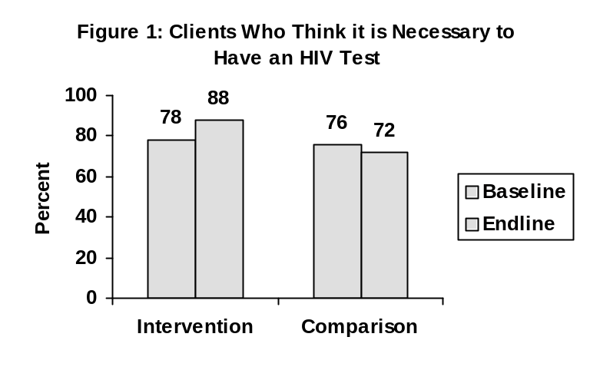

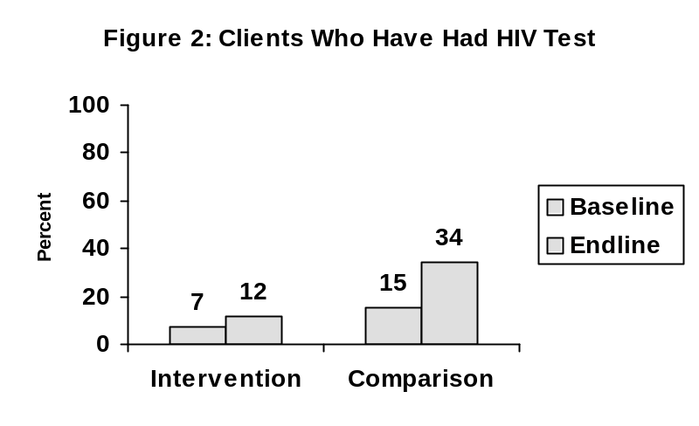
A regression analysis model indicated that age; marital status, education and client receiving VCT related services on the day of visit to the clinic were not significantly associated with uptake of VCT. The only variables in the model that were significant were attitude towards HIV testing, facility type and clients’ report of ever having received VCT related services at the clinic. Clients who think it is important to have an HIV test, clients from the comparison clinics and clients who reported ever having received VCT related services were more likely than their counterparts to have accessed VCT.

Table 3: Predicting characteristics of clients who have had HIV Test
 | % | Odds ratio | 95 % CI
Intervention (n=234)  Comparison (n=260) | 9  25 | 3.635***  Ref | 2.119-6.234
First Visit (n=223) | 12 | 2.145** | 1.274-3.614
Repeat visit (n=271) | 23 | Ref
Talked to about VCT (n=298) | 23 | Ref
Not talked to about (n=196) | 10 | 2.429** | 1.375-4.290
Think need for HIV test (n=384) | 20 | .378* | .177-.807
Think no need (n=103) | 9 | Ref

Conclusions
The findings of this study indicate that it is feasible and effective to integrate VCT information and referral services into routine antenatal care service provision in rural clinics. This has the impact of increasing the proportion of clients accessing VCT services. Clients provided PMTCT/VCT information are more likely to have had HIV testing. However, in absolute terms, the proportions of clients receiving any VCT related services and accessing VCT is still low. The study identified high professional nursing staff turnover in rural public clinics and inadequate supervision as some of the factors that hindered effective implementation of the interventions.

THE KNOWLEDGE ABOUT HIV/AIDS AND BEHAVIOUR AMONG WOMEN WHO HAD RECENTLY GIVEN BIRTH IN THE TYGERBERG HOSPITAL

CH Pieper*, Watanabe E#, Harris B#
*University if Stellenbosch, #University of Oregon

Introduction
HIV is the leading cause of death in South Africa. In 2001, 9.8% of female deaths were because of HIV. In the period of 1999-2001, between 16 and 35.6% of all maternal deaths due to non-pregnancy related infections were caused by HIV. Therefore, the knowledge and attitudes of pregnant women is important to assess.

Aim
The aim of this study was to evaluate the knowledge and beliefs concerning HIV in a group of mothers directly after giving birth in Tygerberg Hospital.

Method
All mothers who were 18 years or older and who had delivered at Tygerberg Hospital were approached for consent to an interview. A questionnaire was filled in by one of two researchers by means of a personal confidential interview. Translators were used if the patients were not English. Consent was obtained from both universities ethical councils.

Results
127 patients were evaluated. The mean (and median) age was 27 years (18-42). 28% had permanent work, 34% temporary and 21% temporary work. 88% lived in formal housing with 78% having a refrigerator, 85% running water and 75% an in-house toilet. 54% had more than 9 years of schooling.
87% had stable relationships, but only 62% were living with this person. 10% of the men had multiple partners compared to 3% of women. 99% knew what a condom was, even though only 48% had ever used one, 92% of whom had requested the usage. 97% had heard about HIV. 95% thought it was a major problem in RSA.
Reasons for getting HIV | Yes (%) | No (%)
Kissing | 32 | 56
Oral sex | 68 | 15
Breastfeeding | 70 | 17

96% thought treatment should be given to HIV positive children, but 59% thought treatment was freely available and 61% thought it could be cured.
95% of those tested knew the result, and 61% had discussed the result with someone. 94% were comfortable enough with the team to divulge their status, and of them 9% tested positive.

Conclusion
It is clear that there are many misconceptions about HIV in the reproductively active population. A clear information campaign is needed on South Africa.

POSSIBLE REASONS BEHIND DECLINING HIV TESTING DURING ANTENATAL CARE AT A DISTRICT HOSPITAL IN KWAZULU NATAL

Buch E¹, Mathambo V², Ferrinho P³, Kolsteren P⁴
¹School of Health Systems and Public Health, University of Pretoria, ²Health Systems Trust, ³Associação para o Desenvolvimento e Cooperação Garcia de Orta, ⁴Institue of Tropical Medicine, Antwerp.

With Nevirapine freely available for the prevention of mother to child transmission of HIV, the critical step is mothers wanting to determine their status. A retrospective cohort study was undertaken at a district hospital in KwaZulu Natal to determine under field conditions the number of women being offered and accepting HIV testing during antenatal care. To avoid the Hawthorne effect (i.e. measuring a situation that has changed because it is being observed), we needed to assess care that had happened prior to the start of fieldwork. 382 women were interviewed in the maternity ward post delivery to obtain information on their antenatal care 97.9% had attended antenatal care.

90% of respondents had been offered an HIV test, most at their first antenatal visit. 72% accepted, but 28% (92) did not. Those who chose not to test constitute a significant loss to care. There are many possible reasons for this choice, which this study begins to unravel.
Factors that did not seem to play a part are the need to decide instantaneously during an antenatal visit, the general experience of antenatal care, being offered the test or the attitude of counsellors (they were found to be caring). Factors that may have contributed to the mothers not taking the test were the number of women who did not know that a mother sick with AIDS could transmit HIV to her baby or of “medicine” to prevent it, the perceived lack of privacy and confidentiality, unresolved fear of the result and possibly the reliance on exclusive group counselling.

The findings are a compliment to the hospital staff for what they have achieved under field conditions. However, if the full benefits of PMTCT are to be achieved factors influencing mothers declining testing need to be addressed. It is recommended that further research, including the use of in-depth focus groups and testing of alternative models of counselling, is undertaken. It is essential to better understand the sub-group of pregnant women who choose to decline testing for HIV, lest 1 in 4 children who could benefit from Nevirapine continue not to receive it.

THE STIGMA EXPERIENCED BY HIV POSITIVE PREGNANT WOMEN

Visser MJ, Gcabo R, Makin J., De Villiers A
Department of Psychology, University of Pretoria
Serithi project, Unit for, Medical Research Council

Introduction
The stigma related to HIV is a major barrier to curbing the HIV/AIDS pandemic because it negatively affects all aspects of the prevention, diagnosis, treatment and care. Jonathan Mann spoke about a third epidemic of discrimination that would follow the HIV and then the AIDS epidemic. He asserted that this third epidemic was as central to the global AIDS challenge as the disease itself (Parker, Aggleton, Attawell, Pulerwits & Brown, 2002).

There is an insufficient documented research that investigates the nature and level of stigma HIV+ people experience. Therefore, the premise of this research is to investigate HIV+ pregnant women experiences of stigma and the impact of the experience of stigma on their choices. The objectives of this research is to: Outline different forms of stigma, to develop an instrument to assess the level of HIV/AIDS stigma experienced by these women, to compare different forms of stigma, to determine the impact of the experience of stigma on their decision to disclose their status to other people and to investigate the impact of the experience of stigma on their decision-making.

HIV related stigma
Stigma is a broad and multidimensional concept. It focuses on deviation from an ideal or expectation and therefore, it contributes to a powerful discrediting social label that radically changes the way individuals see them and are viewed as persons (Goffman, 1963). Discrimination on the other hand is the immediate process of applying the stigma at a behavioral or community level.

“AIDS-related stigma is defined as prejudice, discounting, discrediting and discrimination directed at people perceived to have AIDS or HIV and individuals, groups and communities with which they are associated” (Herek, 1999). Stigmatization related to HIV/AIDS ranges from subtle actions and discriminatory practices to the most extreme degradation, rejection and abandonment as well as physical violence (Bond et al., 2002; Jackson, 1992; Jackson & Hunter, 1992; National Association of People with AIDS, 1992). Here are some of the main reasons why stigma is attached to HIV/AIDS (Alonzo & Reynolds, 1995; De Bruyn, 1999; Parker, Aggleton, Attawell, Pulerwits & Brown, 2002):
- People are afraid of contracting HIV through casual contact due to lack of information and misconceptions.
- HIV/AIDS is associated with behavior that is already stigmatized, deviant, sanctioned by religious and moral beliefs such as sexual promiscuity and drug use.
- People living with HIV are often seen as being responsible for having contracted the disease, which increases the attribution of stigma.
From this literature it appears that stigma is born especially from fear, ignorance, lack of knowledge and social judgment, therefore it is important to distinguish and describe different forms of stigma:
- Experienced or felt stigma is the stigmatized person’s experience of or fear of being stigmatized and it represents the stigma internalised by the affected person.
- Perceived community stigma is the perception a person has of the community’s stigmatising attitudes.
- Enacted stigma refers to the actual experiences, incidences of stigmatisation experienced by the affected person. (Goffman, 1963)

In this research, different forms of stigma experienced by HIV positive pregnant women in South Africa where investigated as well as the impact it had on health related decisions.

Method
As part of the Serithi project, 100 HIV+ pregnant women participated in structured and voluntary interviews from two sites (Mamelodi and Attridgeville). As part of a structured interview, 4 scales were used to assess HIV knowledge, experienced stigma, perceived community stigma and enacted stigma. The scales were developed using and adapting items from existing questionnaires used in international research (Berger, Ferrans & Lashley, 2001; Green, 1995; Herek, 1999; Westbrook & Bauman, 1996). The experienced stigma and perceived community scales were similar and consisted of 20 questions each focusing on interpersonal relationships, tendency to blame and judgment and human rights issues. These scales scores were statistically compared and related to disclosure of HIV status. The results are presented below:

Results

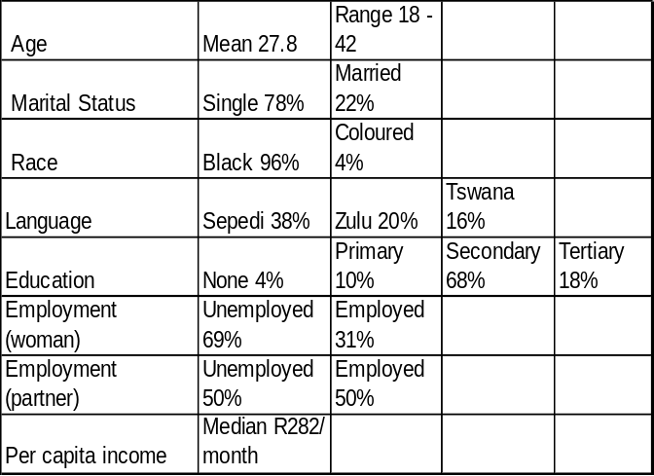Table 1 Demographic data of 100 pregnant women interviewed:
- HIV related responses
Most of the women (90%) tested for HIV in their current pregnancy and knew their HIV-status for less than one month to two months at the time of the interview. The other 10 women were previously tested and knew their status for an average of 3 years.

Almost half of the women (55%) disclosed their HIV status to at least one person, while 45% did not tell anyone at the time of the interview. They disclosed mostly to their partners (41%) and parents (16%); 9% disclosed to other family members, 15% to friends and 1% to people at her work.

At about 28 weeks of pregnancy 72% intended to bottle-feed and 22% to breastfeed their babies, while 6% suggested other methods.

Women were asked 15 questions to assess their knowledge about HIV. These women were HIV tested and had pre- and post counseling which include information about HIV and the protection of their unborn babies.

- Knowledge about HIV
The result shows that HIV+ pregnant women have basic information about the transmission of HIV and know about the incubation period (84%) and that a healthy lifestyle can help them staying healthy (92%). They were unsure about transmission through mosquito’s (52%) and the window period when testing (36%). Women did not have efficient knowledge about the transmission of HIV from mother to baby: 50% of them believed that all babies of HIV+ mothers will get HIV and very few understood the risk of transmission through breast milk. They also did not understand the effect of AIDS medication (Nevirapine) on the baby’s risk to get HIV.

- Personal and perceived community stigma responses
The women completed two scales assessing the personal stigma they experience being HIV+ and the stigma they perceive the community to have towards people with HIV. The mean and the standard deviations of the two scales were calculated. Table 3 below indicates the difference between the two scales

Table 3 Difference between experienced and perceived community stigma
Personal experience of stigma |  | Perceived community stigma |  | N | T value | P value
Mean | Standard deviation | Mean | Standard deviation
43,8 | 6,0 | 56,9 | 6,2 | 100 | -14,57 | 0,0000

The perceived community stigma is significantly more negative (p<0.00) than the personal experience of the stigma by HIV+ pregnant women. This means that the perception of the community stigma is very negative towards HIV+ pregnant women and that may contribute to a high level of internalized stigma in the group of HIV positive women.

HIV+ pregnant women also indicated the enacted stigma they experienced in their interaction with others. This refers to the stigmatizing behaviors and discriminatory actions experienced in interpersonal contact because of HIV. Of the 55 women who disclosed their status 14 (25%) experienced some kind of enacted stigma.

Table 4 Knowledge of HIV and stigma

 | Stigma  (mean) | Knowledge  (mean) | R(XY) | p
Personal | 43.8 |  | -0.3 | 0.001
Community | 56.9 |  | 0.13 | 0.2

There was a significant negative relationship between level of knowledge and the personal stigma they attach to HIV/AIDS (p<0,01). That means that women with more knowledge did not attach such a negative stigma to HIV and not internalize the community stigma as much as women with lower knowledge levels do. The same was not found for the perceived community stigma. Even women with high knowledge levels perceived the community stigma to be very negative.

Stigma and disclosure
The expectation was that women who experienced high levels of personal stigma and perceived community stigma would have lower levels of disclosure of their HIV status. The scale scores of women who disclosed their status were compared to those who did not disclosed using t-tests. There were no significant relationships.

Stigma and personal variables
In investigating the relationship between personal variables of the respondents and their experience of stigma, it was found that there were no significant relationships between personal and perceived community stigma and the following variables:
- Age of the respondent.
- Level of education (there was a non-significant but notable negative relationship between level of education and personal stigma – the higher the level of education, the lower the personal stigma).
- Marital status
- Per capita income. It can be noted that the majority of women come from a low socio-economic status.
- Language.
- Employment status
- Respondents who knew someone with HIV

Discussion
The HIV positive pregnant women experienced high levels of personal stigma in the form of guilt feelings and internalized stigma. Their perception of the community stigma was even higher. Their experience of personal and perceived community stigma did not significantly relate to the enacted stigma they experienced. It is therefore not the enacted stigma that result in personal and perceived community stigma.

Scambler and Hopkins’ (1986) finding in research on epilepsy that perceived stigma might precede enacted stigma, may also be relevant here. The perceived community stigma that exist in the community, possibly impacts on people’s beliefs about HIV and themselves having HIV. Because of their fear of being stigmatized, people with HIV protect themselves by not disclosing their status or very selectively disclosing their status only to people whom they know will understand the problem and not reject them. They also educated the people they want to disclose to before they tell them about their status. Therefore, they defuse the community’s stigmatizing reaction towards them and avoid possible discriminatory actions. The measure of enacted stigma can therefore not be used as an accurate indication of the level of stigmatizing attitudes in the community.

The experience of personal stigma correlated negatively with their level of knowledge of HIV, indicating that women with higher levels of knowledge about HIV do not internalize the negative stigma of the community to the same extent as women with lower levels of knowledge. Both groups perceived the community stigma to be negative.

The experience of stigma by HIV+ pregnant women was not related to any of the personal variables measured in this study. An intervening variable that could play an important role in the data may be the relatively short time period pregnant women knew about their HIV status. Some of them knew their status for two weeks to two months. Receiving the diagnosis is an intense crisis for the majority of women and they need to come to terms with the implications of the diagnosis in their lives and in their interpersonal relationships. A pattern might realize when these women know their HIV status for a longer period. This research stressed the importance of providing HIV+ women with relevant information and to support them in coming to terms with their diagnosis.

Conclusion
HIV/AIDS stigma is a complex and multidimensional issue with deep roots in the personal, interpersonal and community contexts. This research indicated that the experience of stigma by HIV+ pregnant women was not related to any of the personal variables measured in this study. There are also high levels of personal stigma in the form of guilt feelings and internalised stigma, which may impact on how HIV+ pregnant women interact and relate to people around them and how they perceive community stigma that exists. The experience of personal stigma correlated negatively with their level of knowledge of HIV. Although it is difficult to understand the process of developing or changing stigma on a community level, there is a clear need to establish stigma related interventions in the South African community

STIGMATISING ATTITUDES OF THE COMMUNITY TOWARDS PEOPLE LIVING WITH HIV/AIDS

K Lehobye
Serithi Project, MRC Unit for Maternal and Infant Health Care Strategies, University of Pretoria

Introduction
HIV-related stigma can be defined as prejudice, discrediting and discrimination directed at people perceived to have HIV/AIDS and individuals, groups or communities with which they are associated. Stigma is a negative social label that entirely alters the way people see themselves and the way they are seen by others.

HIV/AIDS-related stigma is a great barrier to eradicating the HIV/AIDS pandemic. This stigma is one of the main reasons that people do not wish to know their HIV status, do not wish to protect themselves and others from the virus, do not go for treatment and also the reason people do not care for and support people living with HIV/AIDS. HIVAIDS-related stigma negatively affects all aspects of HIV prevention, diagnosis, treatment and care.

Aim
The study was conducted to investigate what perceptions of HIV/AIDS people have and to assess the levels of HIV-related stigma in a sample of the community.

Methodology
A questionnaire was administered on a convenience sample of 901 respondents of different age, gender and race and they were from both urban and rural areas. The questionnaire was developed from existing questionnaires used in international research and it was adapted to suit the local situation. The questionnaire consisted of two sections, a qualitative section and a quantitative section.

Qualitative section
In the qualitative section the respondents were asked two open questions.
- What are the first thoughts that come to your mind if I say “HIV/AIDS?”
- Could you identify people whom you think have HIV and why you have picked those particular people?
The second open question was accompanied by showing the respondents a picture of people of different age, race and gender.

Quantitative section
This section consisted of two similar quantitative scales. The scales have statements to which the respondent had to answer with “agree, strongly agree, disagree or strongly disagree”.

Personal Stigma scale:
The first scale was to assess an individual’s own perceptions, thoughts and reactions towards people living with HIV/AIDS, this reflected individuals personal stigma towards HIV/AIDS. An example of the statements: “I feel uncomfortable around someone with HV.”

Perceived Community Stigma scale:
The second scale was to assess what an individual thought were the community’s perceptions, thoughts and reactions towards people living with HIV/AIDS, thus reflecting perceived community stigma towards people with HIV/AIDS. An example of the statements: “Most people think people with HIV have only themselves to blame.”

Sample Distribution
The questionnaire was administered on respondents in the community around the Tshwane Metropolitan Area. 3rd year psychology students from the University of Pretoria who were trained to administer the questionnaire interviewed the respondents. The students were predominantly white and not older than 25 years of age, thus the sample population had an over representation of the white racial group and the younger age group.
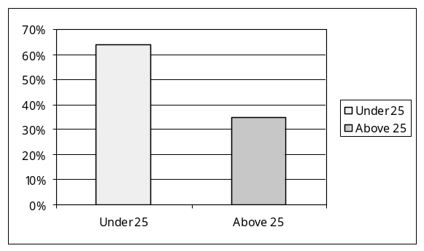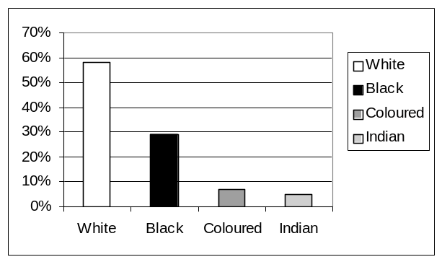
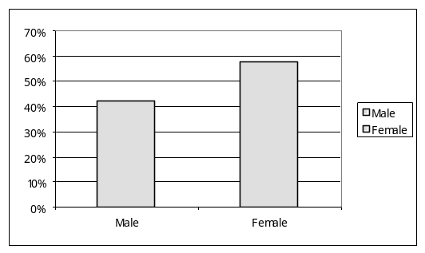

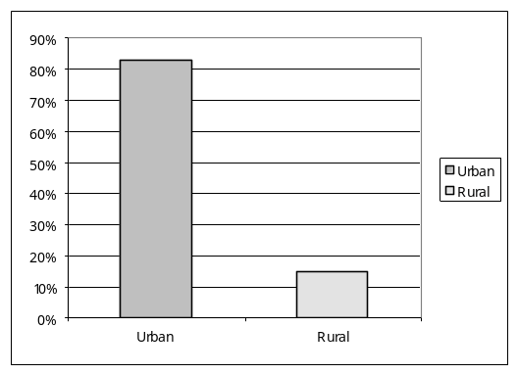

Results 1: Qualitative
Figure 1 reflects associations respondents had with HIV/AIDS. The majority associated HIV/AIDS with a deadly disease (50.8%), 20.5% attached feelings (emotions) of hopelessness, pity, pain and suffering. Other associations made included loose/low morals, modes of transmission and certain risk groups.

Figure 2 shows why respondents think certain individuals have HIV. 36.8% indicated that anyone could get HIV and that one could not tell by just looking at an individual. Though there was still a large percentage that suggested that one could identify HIV infected people by certain physical and /or behavioural attributes, for example: weight loss, blacks, women and so on.
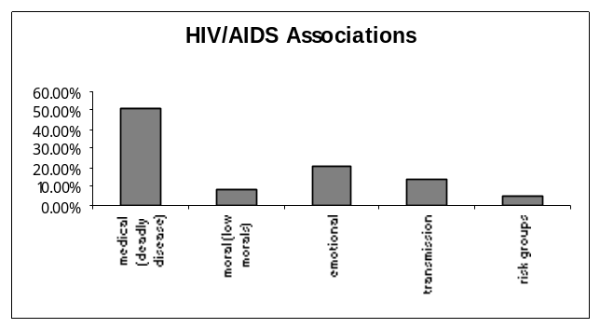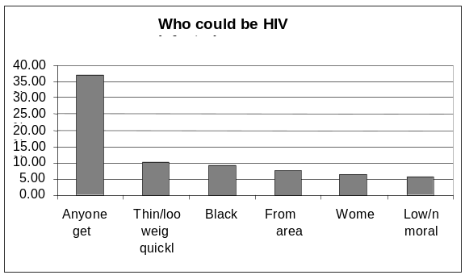 Figure: 1 Figure: 2
Results 2: Quantitative
Table 1 Comparing personal and perceived community stigma
Personal perception |  | Perceived community perception |  | N | P value
Mean | SD | Mean | SD
Total score |  | Total score
46.2 | 10.69 | 57.5 | 8.66 | 771 | .0000

Table 1 is a comparison of personal stigma and perceived community stigma. The perceived community stigma is greater than personal stigma; this means that respondents viewed the community to be more stigmatising towards people living with HIV/AIDS than themselves. The reason for this view can only be speculated. People often compare themselves to others and in doing so there is a tendency to see oneself as more positive, nicer and better than the average person. Furthermore, the community stigma may be perceived to be more negative since media usually reports emphasized discriminatory practices.

Table 2 Personal stigma among subgroups
Male |  |  |  |  |  |  | Female |  |  |  |  |  |  |  | P value
Mean |  | SD |  |  |  | N | Mean |  |  | SD |  |  | N
47.76 |  | 10.92 |  |  |  | 325 | 44.96 |  |  | 10.34 |  |  | 442 |  | 0.00032
Age <25 years |  |  |  |  |  |  | Age >25 years |  |  |  |  |  |  |  | P value
Mean |  | SD |  |  |  | N | Mean |  |  | SD |  |  | N
45.35 |  | 10.15 |  |  |  | 496 | 47.68 |  |  | 11.46 |  |  | 269 |  | 0.004
Urban area |  |  |  |  |  |  | Rural area |  |  |  |  |  |  |  | P value
Mean |  | SD |  |  |  | N | Mean |  |  | SD |  |  | N
45.74 |  | 10.72 |  |  |  | 643 | 48.8 |  |  | 10.29 |  |  | 111 |  | 0.0053
Know someone with HIV |  |  |  |  |  |  | Don’t know someone |  |  |  |  |  |  |  | P value
Mean |  | SD |  |  |  | N | Mean |  |  | SD |  |  | N
42.75 |  | 11.18 |  |  |  | 240 | 47.81 |  |  | 10.07 |  |  | 521 |  | 0.0000
White |  |  |  | Black |  |  |  |  |  |  | Coloured |  |  |  |  |  | Indian |  |  |  |  | P value
Mean | SD |  | N |  | Mean |  |  | SD | N |  |  | Mean |  | SD |  | N |  | Mean |  | SD | N
49.33 | 10.4 |  | 448 |  | 40.96 |  |  | 9.5 | 230 |  |  | 43.67 |  | 8.4 |  | 53 |  | 43.73 |  | 9.8 | 36 |  | 0.000

Table 2 shows the difference in personal stigma within subgroups. The data indicated that there was a significant difference in the personal stigma between respondents who knew someone with HIV and those who did not. The personal contact probably contributes to a more understanding and less stereotyped reaction. The results also revealed that white respondents had significantly more
stigmatising attitudes towards people with HIV/AIDS than other population groups.
Table 3: Perceived community stigma according to subgroups
Male |  |  |  | Female |  |  |  |  |  | P value
Mean | SD |  | N |  | Mean |  | SD |  | N
57.68 |  |  | 325 |  | 57.32 |  | 10.34 |  | 442 |  | 0.576
Age <25 years |  |  |  | Age >25 years |  |  |  |  |  | P value
Mean | SD |  | N |  | Mean |  | SD |  | N
58.23 | 8.49 |  | 496 |  | 55.89 |  | 8.59 |  | 269 |  | 0.00031
Urban area |  |  |  | Rural area |  |  |  |  |  | P value
Mean | SD |  | N |  | Mean |  | SD |  | N
57.47 | 8.65 |  | 643 |  | 57.55 |  | 8.87 |  | 111 |  | 0.98
Know someone with HIV |  |  |  | Don’t know someone |  |  |  |  |  | P value
Mean | SD |  | N |  | Mean |  | SD |  | N
57.30 | 9.45 |  | 240 |  | 57.55 |  | 8.24 |  | 521 |  | 0.718
White |  |  |  | Black |  |  |  |  |  | Coloured |  |  |  | Indian |  |  |  | P value
Mean | SD | N |  |  | Mean | SD |  | N |  |  | Mean | SD | N |  | Mean | SD | N
57.35 | 7.94 | 448 |  |  | 56.43 | 10.06 |  | 230 |  |  | 56.43 | 7.24 | 53 |  | 56.28 | 9.44 | 36 |  | 0.433
In terms of perceived community stigma, table 3 shows that the difference was found between the respondents under the age of 25 years and those older. The younger age group perceived the community to be more negative than the older age group. All the other groups had similar views on the stigma attached to HIV/AIDS in the community.

Conclusion
In the groups studied, there is still a fairly high level of stigma surrounding HIV/AIDS, especially perceived community stigma. The community stigma is only perceived; therefore it is not necessarily a true reflection of the community’s attitude. People see the community as significantly more stigmatising than themselves. One way to establish what the actual level of community stigma is, would be to assess the experiences of HIV positive people and see whether these stigma related experiences correspond with the perceived community stigma.

It has been established that stigma varies from subgroup to subgroup, with some subgroups appearing to be more stigmatising than others. Multivariate analysis needs to be performed to establish whether they are all significant.

There are still certain misperceptions surrounding HIV/AIDS, for example: that HIV is a woman’s disease, that it affects blacks and also people who are thin or who lose weight very quickly. These misperceptions are issues that need to be addressed in the development of any intervention programmes.

MOTHERS 2 MOTHERS 2 BE: EDUCATION, EMOTIONAL SUPPORT, ECONOMIC OPPORTUNITY AND EMPOWERMENT FOR PREGNANT WOMEN AND MOTHERS LIVING WITH HIV

Mitchell J. Besser; Department of Obstetrics and Gynecology, University of Cape Town

Description
Introduction
Women diagnosed with HIV infection during pregnancy need education and emotional support. Education improves adherence to peripartum antiretroviral treatment regimens and infant feeding practices. Emotional support improves quality of life. Most women, when diagnosed with HIV during pregnancy, are unable or unwilling to tell partner, family or friends resulting in emotional isolation. In South Africa's publicly funded mother to child transmission prevention (PMTCT) programs education and counselling are frequently limited to pre and post-HIV testing. Most programs lack capacity to provide on-going education and support. HIV counsellors are busy providing service to women undergoing testing and do not have time to meet the needs of previously diagnosed HIV-infected women returning to antenatal clinic with questions and concerns. After delivery women return to their communities and are expected to care for their own and their babies’ medical and social needs, frequently without adequate support. As comprehensive anti-retroviral treatment (ARV) programs expand, women eligible for continued, life-sustaining ARV’s also need special services to promote treatment adherence.

Mothers 2 Mothers 2 Be (M2M2B) is a mentorship program for HIV infected pregnant women and mothers. Recently delivered HIV infected mothers return to antenatal clinic as mother-mentors to educate and support HIV infected pregnant women. In antenatal clinic, mother-mentors engage pregnant women sharing personal experiences, discussing issues related to disclosure and encouraging adherence to treatment plans. Each day a nutritious meal is prepared and served to all attendees. Mother-mentors also receive continued education and support. Mother-mentors are paid a stipend for their service. Mothers 2 Mothers (M2M), delivered in the primary care clinic, provides on-going education and support to new mothers and their children. With the support of mother-mentors, new mothers are encouraged to continue with the exclusive feeding method chosen during pregnancy, to adhere to prescribed medical therapy and to take the infant for scheduled medical appointments. Mothers Creations (MC) compliments the M2M program by offering skills training and income generation projects.
Results
The first M2M2B program was started at one tertiary care hospital in 2001. There are now 13 M2M2B and M2M sites in three provinces serving primary, secondary and tertiary care centers. The programs reach approximately 2500 women per month. In the coming year there are plans to extend service to two additional provinces and the United States. In 2003, mothers in the MC program earned over R300, 000 making crafts sold in South Africa, Europe and the United States. In the coming year mothers’ programs will be integrated into several ARV programs as a means to encourage and increase adherence to treatment.

Conclusions
Pregnant women enrolling in M2M2B have a better understanding and greater acceptance of PMTCT interventions. Mothers supported after delivery will provide better care to their infants and will be more adherent to the planned feeding method and treatment regimens. Offering women opportunities to generate income contributes to empowerment and the reduction of stigma associated with HIV. Mothers 2 Mothers 2 Be programs should be incorporated into all PMTCT programs and integrated into health centers caring for women and families living with HIV.

MATERNAL MORTALITY RELATED TO AIDS AND NON-PREGNANCY RELATED INFECTIONS IN SOUTH AFRICA, 1999-2001

NCCEMD

Objective
To document the prevalence and causes of maternal deaths due to non-pregnancy related infections (NPRI) and identify avoidable factors, missed opportunities and substandard care in these deaths.

Method
Maternal deaths became notifiable events since 1997 in South Africa. When a maternal death occurs, a maternal death notification form is completed by the health facility where the death occurred. The Provincial assessor assesses the death for cause of death and avoidable factors. The report is send to the National Committee on Confidential Enquiries into Maternal Deaths (NCCEMD), which collates and analyses the data. The NCCEMD provides a report on the causes of maternal deaths in South Africa, avoidable factors, missed opportunities and substandard care associated with the deaths.

Results
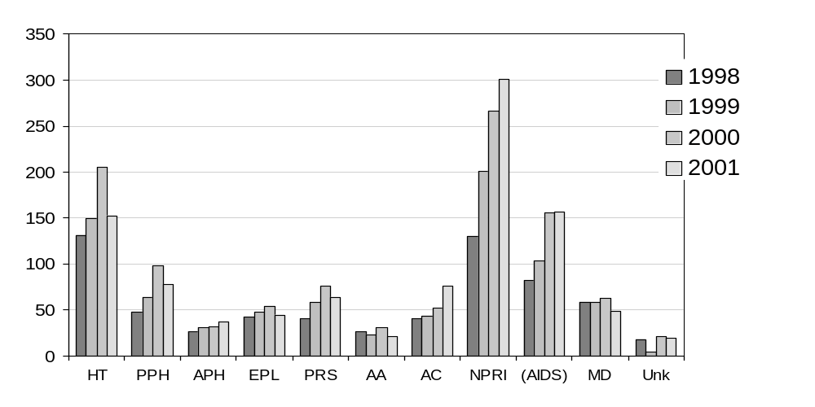Primary obstetric cause of reported maternal deaths: 1998-2001 numbers.
There were a total of 768 deaths (out of a total of 2445 deaths) due to non-pregnancy related infections (NPRIs) over the three-year period. AIDS contributed 54.2% of cases in the NPRI group. AIDS was diagnosed if a woman had a positive HIV test plus either an AIDS defining condition or a CD4+ count of less than 200/μl. HIV testing was infrequent in the all cases with only 37.6% of maternal deaths having been tested countrywide. This indicates that there was probably considerable underreporting of women dying due to AIDS.

Comparison of primary causes of death in the NPRI category
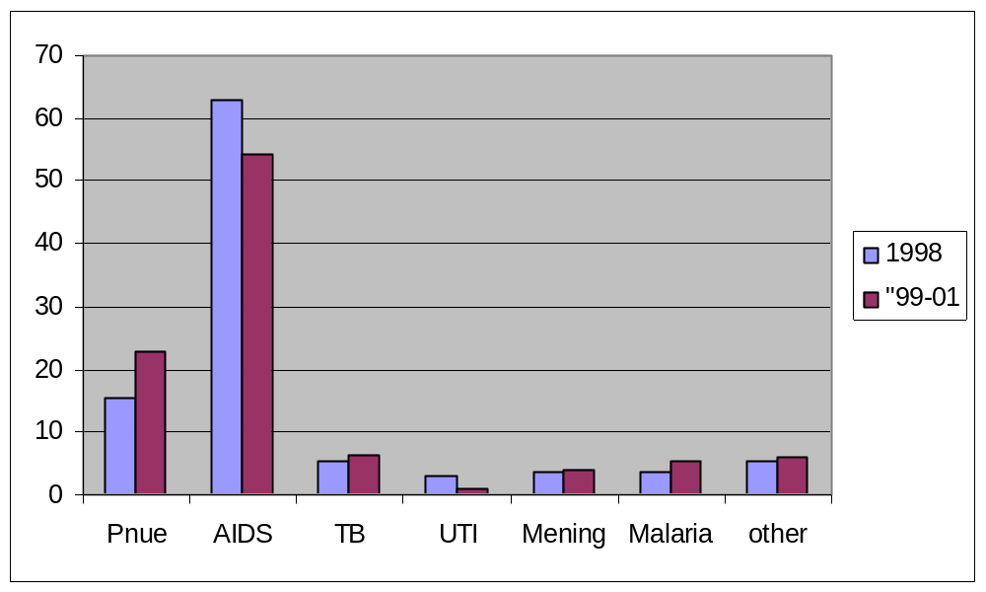

Other conditions contributing to the NPRI deaths included pneumonia contributing 22.9%, tuberculosis 6.5%, malaria 5.3% and meningitis 4.2%.

The majority of AIDS deaths occurred in women aged 25 – 29 years old with less than three deliveries.

Most of the deaths occurred in level 2 health institutions. The common final causes of death were respiratory failure (58.5%) and immune system failure (54.2%).

Timing of emergency event
Timing of emergency event | % avoidable factors  1999 - 2002
Problems in early pregnancy | 9.1
Problems in antenatal period | 27.1
Problems in intrapartum period | 1.2
Problems in postpartum period | 59.0
Others | 4.3
The majority of women were admitted with the emergency event in the postpartum period and subsequently died in the postpartum period making the postpartum period the most vulnerable time for mothers.

Category | % of avoidable factors
 | 1999 – 2000 | 1998
Patient oriented factors | 65.7 (54.1) | 50.0
Administrative factors | 23.6 (41.5) | 20.0
Health care provider factors Primary Secondary  Tertiary | 23.7 (73.3)  19.6 (67.0)  9.5 (46.7) | 36
Resuscitation factors | 10 (27.4) | 16

The most common category of avoidable factors was patient-related factors involved in 65.7% of cases. Health care provider oriented avoidable factors were identified highest at primary level contributing in 23.7% of cases. Under the category of resuscitation, avoidable factors were present in only 10% of cases.

Conclusion
NPRIs have now become the commonest cause of maternal deaths at all levels of care, surpassing hypertensive disorders of pregnancy, which was the leading cause of death in 1998. AIDS is the main contributor to these deaths.

MATERNAL DEATHS: AN AUDIT OF FREE STATE HOSPITALS AND DOCTORS REGARDING OBSTETRIC SERVICES

JBF Cilliers, JD Nortje, MG Schoon.
Department Obstetrics and Gynaecology, University of the Free State, Bloemfontein

Introduction
Due to the high number of maternal deaths in the Free State the Maternal Child and Women’s Health (MCWH) Directorate decided to do an audit of Free State hospitals and doctors. By identifying deficiencies in the hospitals equipment and the doctors training we could try to correct these deficiencies and save mothers lives.

Method
During January and February 2003, most of the hospitals in the Free State were visited by a consultant from the department Obstetrics and Gynaecology, University of the Free State. The labour wards were visited and the equipment and stock checked according to a checklist. Other data were collected like the last months labour statistics. An envelope with questionnaires for the doctors delivering an obstetric service in the hospital was left in the labour ward. These questionnaires were filled out by the doctors and send back to us by post.

Results
A total of 26 hospitals were visited during the audit. From the hospitals visited only 16 (62%) responded by returning the doctors questionnaire. From these hospitals 88 doctors filled out the questionnaire.

From the 26 hospitals that were visited the following information were obtained:
Questions regarding policies in the labour ward | Number of Hosp | % of Hosp
Policies
Referral criteria available? | 13 | 50
Telephone number of referral hospital available? | 26 | 100
Protocol for obstetric emergencies? | 18 | 69
Call list for doctors with telephone numbers? | 26 | 100
Mortality/ morbidity meetings? | 12 | 46
Cesarean sections done at the hospital? | 23 | 88
Maternity case records used in hospital? | 26 | 100
Partogram used in labour ward? | 23 | 88
Partogram correctly used on spot-check? | 17 | 65

Questions regarding availability of equipment | Number of Hosp | % of Hosp
Ultrasound | 11 | 42
Labour theatres | 26 | 100
First stage rooms | 14 | 54
Functional vantouse | 22 | 85
Forceps | 23 | 88
Manual vacuum aspiration apparatus | 8 | 31
Defibrillator | 21 | 81
Blood pressure apparatus | 25 | 96
Drip sets | 26 | 100
Resuscitation fluids | 25 | 96
CVP sets | 9 | 35
14 G drip needles | 11 | 42
Resuscitation trolly | 25 | 96
Cardiotocograph | 18 | 69

Questions regarding medication | Number of Hosp | % of Hosp
Dried plasma | 2 | 8
Oxytocin | 26 | 100
Syntometrine | 11 | 42
Cytotec | 16 | 62
Magnesium sulphate | 26 | 100
Urine dipstix | 26 | 100
Bloodbank | 6 | 23
Emergency blood | 16 | 62
Fresh Frozen Plasma | 7 | 27
Hospitals where c/s are done without availability of blood | 5 | 19

Other information acquired at the visits was a general shortage of staff, transport problems at most hospitals and no ultrasound screening for fetal abnormalities outside of Bloemfontein.
In regards to the doctors questionnaire the following information were aquired from the 88 doctors forms:
Question asked on questionnaire | Number  Of Dr’s | % of  Dr’s
Community service doctor? | 25 | 28
Backup available in emergencies? | 38 | 43
Feel comfortable to do cesarean sections | 76 | 86
Assistant available for cesarean sections? | 43 | 49
Wanted more training in obstetrics? | 62 | 70
Referral criteria not available? | 10 | 11
Having problems to refer patients to higher level? | 36 | 41
Protocols available for emergencies? | 38 | 43
Equipment in obstetrics adequate? | 29 | 33
Have any training in ultrasound? | 30 | 34
Have CPR training | 63 | 72

Problems identified from the results of the hospital audit were the following:
- Referral criteria and protocols not readily available;
- Morbidity/mortality meetings not held;
- Incorrect use of partograms;
- Vantouse not functional;
- MVA apparatus for evacuation not available;
- 19% of hospitals doing cesarean sections without blood being available;
- Transport problems at most hospitals.

Problems identified from the results of the doctors’ questionnaire were the following:
- No backup available for inexperienced doctors;
- Doctors experience problems to refer patients to a higher level;
- Transport problems;
- Some of the doctors do not have CPR training;
- Ultrasound training needed.

Conclusion
Although a lot of deficiencies were identified the challenge lay in the rectification of these deficiencies. The Maternal Child and Woman’s Health directorate are currently in the process to rectify these deficiencies.
MATERNAL MORTALITY AND MORBIDITY AUDITS: TO DO OR NOT TO DO?

M Kleynhans, AP Macdonald, F Backer, RC Pattinson
MRC Maternal and Infant Health Care Strategies Research Unit and Department of Obstetrics and Gynaecology, University of Pretoria

Aim
To ascertain whether there has been an improvement in managing severely ill pregnant women after the introduction of a maternal mortality and morbidity audit.

Setting: Public patients from the Pretoria Academic Complex region.

Method
A comparison of the rates and patterns of disease and organ dysfunction of Severe Acute Maternal Morbidity (SAMM) and Maternal Deaths (severely ill pregnant women) between 1997/8 and 2002/3 was performed. The audit system was introduced in 1997 and has been in operation unchanged ever since in the Pretoria Academic Complex.

Results
There has been a significant increase in severely ill pregnant women between 1997/8 (681/100000 births) and 2002/3 (1085/100000 births (p<0.0000). However, there has been a significant reduction in the mortality index for them during the same period (17.4% in 1997/8 and 10.7% in 2002/3, p<0.039).

The primary obstetric causes of SAMM and maternal death has remained unchanged during the study period with the most common problems being ranked in the same order in each period, namely (in descending order) complications of abortion, postpartum haemorrhage, complications of hypertension, antepartum haemorrhage and pre-existing maternal disease.

The average number of organ system dysfunctioning per patient declined from 1.48 in 1997/8 to 1.17 in 2002/3. However, as expected the number of organ systems that failed in women who subsequently died did not differ significantly (1.9 in 1997/8 and 1.7 in 2002/3). There were significant reductions in the number of severely ill pregnant women with septic shock, renal dysfunction, metabolic dysfunction and cerebral dysfunction. The rate of pulmonary oedema in women with complications of hypertension in pregnancy also significantly declined. All these indicate better management of severely ill pregnant women. However, there was a significant increase in the number of patients with immune system failure. This is related to patients with AIDS.

Conclusion
There has been a reduction in the number of preventable and manageable complications that severely ill pregnant women experienced over the past 5 years. If the mortality index of 1997/8 were extrapolated to 2002/3 there would have been a 57% increase in maternal deaths for the area, (a total of 23 women). Maternal Morbidity and Mortality Audits have been associated with this decline.
TRENDS IN PERINATAL MORTALITY AT LOCAL CLINICS FOLLOWING THE OPENING OF A NEW REGIONAL MATERNITY UNIT IN THE NORTH OF DURBAN

Neil F Moran, Department of Obstetrics and Gynaecology, Mahatma Gandhi Memorial Hospital, Durban, and Nelson R Mandela School of Medicine.

Introduction
In July 2001, a regional maternity and neonatal service for the state sector was opened at Mahatma Gandhi Memorial Hospital (MGMH) in the North of Durban. At this time, there were already a number of well-established midwife-run clinics conducting low-risk deliveries in the vicinity. Almost all the clinic deliveries took place at one of four clinics (KwaMashu Polyclinic, Ntuzuma Clinic, Phoenix Community Health Centre, and Inanda C Clinic) as these were the only four which ran a 24-hour delivery service. With the opening of the new unit at MGMH, referral patterns were changed so that these clinics now referred problem cases to MGMH instead of to more distant hospitals as had been the practice previously. With the opening of the new unit at MGMH, it was seen as important to audit perinatal data, including mortality, at these local clinics as well as at MGMH itself, so as to identify problems in perinatal care throughout the community, particularly in the light of the abrupt change in the referral patterns.
This paper presents the trends that have been seen in perinatal data at the local clinics over the two and a half year period since the opening of the new unit. These data are reviewed in conjunction with the trends in hospital perinatal data over the corresponding period, so that a population-based view of perinatal care is obtained. The implications of these trends are discussed.
In order for the hospital to provide an efficient regional service, it was considered essential that the clinics be given support and encouragement in providing a high quality primary level service. Hence, several hospital-based initiatives were implemented with the aim of providing greater support for the service in the local clinics. These initiatives included the following:
- Monthly two-hour long perinatal review meetings with representation from the clinics, including presentation and discussion of statistics from the local clinics, as well as discussion of cases referred by the clinics.
- An expanded programme of clinic visits by a community obstetrics registrar from the medical school, under supervision of a consultant at the hospital. Each of the four clinics mentioned above was visited at least once a week, in order to review potentially high-risk patients, provide in-service education, and to act as a liaison between the clinics and the hospital, so that problems at the clinic could be reported to the hospital and feedback from the hospital could be given to the clinics.
- Strict departmental policy was put in place to ensure that patients from the clinics were always accepted at the hospital when being referred appropriately according to the new referral pattern and according to existing protocols for referral.
- Direct telephonic access for the clinic sisters to the consultant on duty at the hospital.
- In-service training activities at the hospital for the sisters at the clinics, including the Perinatal Education Programme.

It was hoped that these initiatives might improve skills and morale at the clinics, and have a positive influence on the perinatal statistics at the clinics.

Methods
- Statistics on deliveries at all clinics referring directly to MGMH were compiled by the clinic staff and forwarded on a monthly basis to MGMH where they were incorporated into the monthly perinatal review meeting. Data included total number of deliveries ≥500g and number of stillbirths and neonatal deaths.
- Hospital statistics, including number of deliveries (≥500g), perinatal deaths, and number of caesarean sections, were documented daily.
- Calculation of perinatal mortality rate included all births ≥500g, and calculation of neonatal mortality rate included all live births ≥500g.
- Data on babies born outside a health facility (BBAs) were not included in the analysis for this paper.
- Babies born in a health facility outside MGMH’s direct referral area (e.g. in another hospital), but then referred to MGMH post-delivery were also not included.
- Babies born at a local clinic transferred and later died at hospital were included in the clinic’s and not the hospital’s neonatal mortality statistics.
- Data was analysed in six-month blocks, starting from July 2001, and ending in December 2003, so as to look for trends over the two and a half year period.

Results
Over the first six months (July-Dec 2001), there were 5137 deliveries within the service, of which 2788 (54%) were in hospital, and 2349 (46%) were at clinics. The perinatal mortality rate (PNMR) and neonatal mortality rate (NNMR) for the hospital were 47 and 17 per 1000 respectively, while for the clinics, the equivalent figures were 21 and 7. The overall PNMR was 35 per 1000. The caesarean section rate was 15.4%.
The following graphs show the trends in these statistics over the two and a half year period of the analysis:

Graph 1 Birth Numbers at Hospital and Local Clinics.
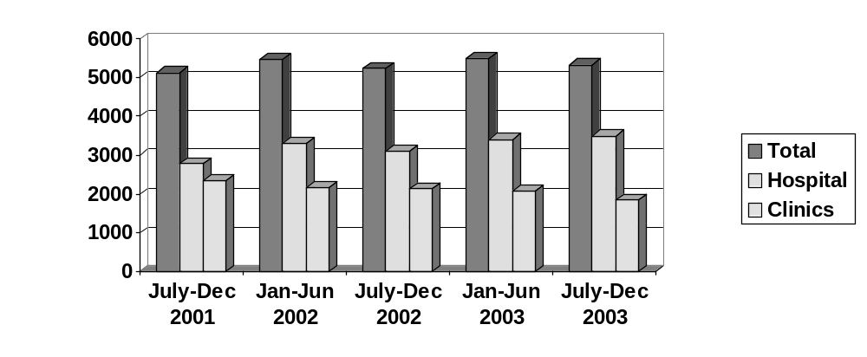

Graph 2 Clinic Perinatal Mortality Rate per 1000 Births ≥500g.
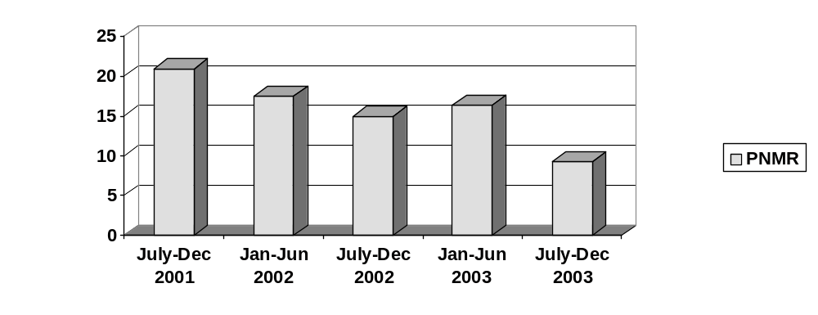
Graph 3 Hospital Perinatal Mortality Rate per 1000 Births ≥500g.
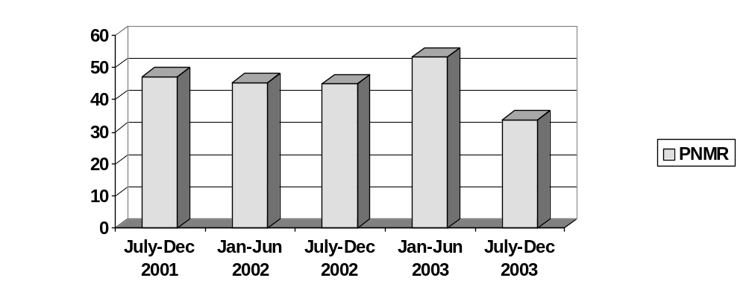
Graph 4 Total PNMR per 1000 Births ≥500g (Hospital and Clinics)
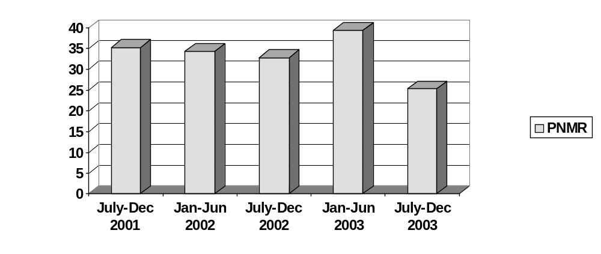

Graph 5 Neonatal Mortality Rate per 1000 live births ≥500g.
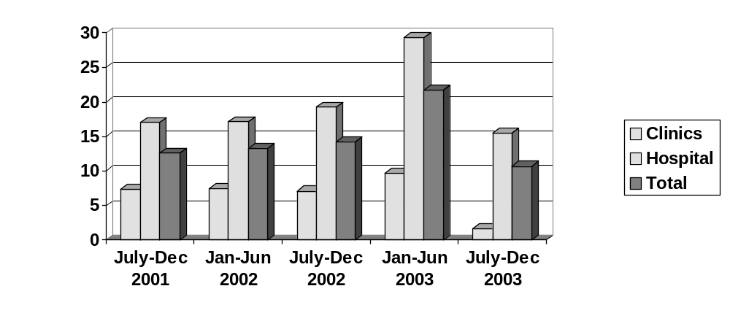
Graph 6 Population-based Caesarean Section Rate.
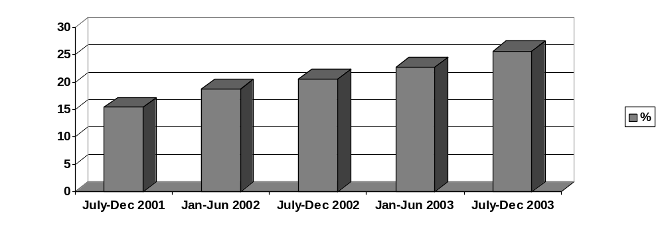
Over the last six months (July-December 2003), there were 5343 deliveries: 3496 (65%) in hospital, and 1847 (35%) at clinics. Hospital PNMR and NNMR were 33.7 and 15.5 respectively; for clinics the figures were 9.2 and 1.6. Overall PNMR was 25 per 1000. The caesarean section rate was 25.7%.

Discussion
Over the period of the analysis, there was a gradual decline in the perinatal mortality at the clinics, from an initial level of 21 per 1000, which appeared too high for clinics, which are supposed to deliver only uncomplicated pregnancies, to a more acceptable level of 9.2 per 1000 (see Graph 2). This decrease was achieved without any improvement in the facilities or staffing at the clinics. However, the decrease corresponded to a decrease in the number of deliveries at the clinics, and an increase in the number of deliveries at the hospital, although the total number of deliveries remained fairly stable (see Graph 1). Reassuringly, the hospital perinatal mortality rate did not show an increase, despite this increased workload of patients, with a higher caesarean section rate (see Graph 6). Indeed there was also a decrease in the hospital PNMR, particularly during the last six-month period, so that overall the population-based PNMR also decreased.
There was one six month period (January to June 2003), during which there was a increase in the perinatal mortality rates which could mainly be attributed to a large increase in the neonatal mortality rate (see Graphs 2-5). This increase was directly caused by two separate outbreaks of sepsis, which occurred in the neonatal ICU during this six month period, resulting in many neonatal deaths.

Conclusions
The audit emphasized the importance of conducting population-based audit, not just hospital-based. Initial figures demonstrated an unacceptably high perinatal mortality rate at the clinics. The measures taken to lend greater support to the service at the clinics were associated with a gradual decrease in PNMR and NNMR at the clinics. Over the two and a half year period studied, there was a halving of the PNMR at the clinics, without any corresponding increase in the hospital’s PNMR. In fact, the latter also decreased. This is a success story.
The 20% decrease in the number of deliveries conducted at the clinics, with a corresponding increase in hospital deliveries could be interpreted in a positive light as the overall perinatal mortality has decreased. It may be that the 65% to 35% split between hospital and clinic deliveries respectively, seen at the end of 2003, represents a more appropriate split than the original 54% to 46% split seen in 2001, given the risk factors in the local population. Similarly, the rise in caesarean section rate may represent appropriate care, which has contributed to the decrease in perinatal mortality rate.
TWO STEPS FORWARD, ONE STEP BACK: A DECADE OF PERINATAL CARE IN ATTERIDGEVILLE

RC Pattinson, SD Delport
MRC Maternal and Infant Health Care Strategies Research Unit

Objective
To determine trends in perinatal care indices and causes of perinatal deaths over 10 years in a clearly defined black urban population
Setting: Atteridgeville, Pretoria, a clearly defined mainly black urban population.
Method
Data collected from 1994 to 2003 for Atteridgeville using the Perinatal Problem Identification Programme (PPIP) was analysed.

Results
The Perinatal Mortality Rate (PNMR) has shown a significant decline over the decade (47/1000 in 1994 to 30/1000 births in 2003 for babies >500g and 20/1000 births to 15/1000 births for babies >1000g). The decline was not associated with improved socio-economic status of the patients, as the low birth rate has significantly increased over the decade from 15.5% to 17.5%. The decline is almost entirely due to a decline in the Neonatal Death Rate (NNDR) (500g or more) from 18.8/1000 live born babies in 1994 to 10.0/1000 live born babies for 2003, (and 6.1/1000 to 4.3/1000 for babies >1000g respectively). The Stillbirth Rate (SBR) has remained constant throughout the decade.
The major primary obstetric cause of death was classified as unexplained stillbirths, followed by spontaneous preterm labour, hypertension, antepartum haemorrhage, fetal abnormalities and infections. The mortality rate, during the decade, dropped significantly for spontaneous preterm labour and infections, but did not change significantly for unexplained intrauterine deaths, hypertension and antepartum haemorrhage.
The decline in the NNDR was not related to an expansion in the neonatal intensive care facilities, as this has remained the same over the decade. The decline has been associated with the introduction of a Kangaroo Mother Care Unit, almost exclusive use of expressed breast milk for infant feeding, and improved intrapartum and in-patient antenatal care (e.g. the aggressive use of corticosteroids).

Conclusion
The standard of care given in hospitals, by the staff either in the neonatal wards, the labour ward or antenatal ward has significantly improved. However, the static nature of the SBR over the decade indicates the standard of care in clinics providing antenatal care in Atteridgeville has not improved. Furthermore, primary diseases of the placenta such as hypertension and antepartum haemorrhage have remained unchanged.
Methods of improving the quality of antenatal care in the clinics (for example having specially trained antenatal care personnel in each clinic and using quality assurance audits) and primary prevention of hypertension by introducing calcium supplementation for pregnant women should be considered.

THE EFFECTIVENESS OF AN INTERVENTION TO IMPROVE THE QUALITY OF ANTENATAL CARE SERVICES IN RURAL PUBLIC CLINICS IN KZN

Jane Chege (Population Council), Mags Beksinska, Mosery Nzwakie, Mbali Dube-Nxumalo, and Busi Kunene (RHRU)

Background and Objectives
Between April 2002 and May 2003, Frontiers Program of Population Council in collaboration with the KwaZulu-Natal (KZN) Department of Health Maternal and Child Health Unit, Reproductive Health Research Unit (RHRU), and the Department of Medical Microbiology and Infectious Diseases, University of Natal, implemented an intervention study to assess the feasibility and impact of introducing a comprehensive integrated antenatal care package in rural clinics. The interventions aimed to improve the existing routine antenatal care (ANC) service provision and integrate STI and HIV information, counselling, screening and management into routine ANC service provision; introduce on-site syphilis screening using rapid plasma reagin (RPR) test, and a new goal directed schedule of visits. In addition, to providing in-service training to ANC service providers, the interventions were designed to improve existing antenatal services through improving availability of the following:
- Essential equipment, drugs and supplies;
- Information Education and Counselling (IEC) materials;
- Relevant guidelines and protocols.

Staff received refresher training on routine antenatal service provision.
In this paper, we will present findings on the effectiveness of the interventions in improving the quality of ANC services through increasing availability of essential equipment and supplies, routine ANC service provision, STI and HIV integration, and introducing onsite syphilis screening in rural clinics in KwaZulu-Natal Province.

Method
This was a quasi-experimental pre and post control group study design. We randomly sampled two hospitals providing voluntary counselling and testing (VCT) services in each study Health District and in each hospital, we randomly selected three clinics linked to the hospital for referral purposes. These clinics were matched according to volume of clients. We collected data through observation of client-provider interaction, exit interviews with observed clients, and taking inventory of clinic infrastructure, equipment and supplies. Using bivariate analysis, we compared pre- and post-intervention measures of key variables and magnitude of change between the intervention and comparison clinics.

Results
The intervention was effective in increasing STI and HIV integration, introducing onsite syphilis screening, and improving some aspects of clinic quality of care. For the STI services assessed, during provider and client interactions, we observed if the provider:
- Discussed STI symptoms and risk factors;
- Enquired about the presence of STI symptoms and client’s STI risks;
- Discussed how to prevent STIs and the role of condoms;
- Discussed condom use during pregnancy.

And for the HIV services we assessed if the provider:
- Discussed prevention of mother-to-child transmission (PMTC) of HIV;
- Discussed the advantages of and where to go for VCT;
- Enquired about client’s VCT interest;
- Referred client for VCT.

As the Table 1 below indicates, the intervention was effective in increasing integration of STI and HIV services into routine ANC service provision. The increase in proportions of first visit clients who received at least one STI and one HIV related service was greater in the intervention than in the comparison clinics. In addition, five out of the six intervention clinics were providing onsite syphilis screening at the post-intervention survey, and 58 percent of all first visit clients had their blood screened at the clinic on the days the researchers visited the clinics.

Table 1 Percent of First Visit Clients Who Received STI and HIV Related Services
 | Intervention |  |  | Comparison
Services | Base  (n=58) | End (n=52) | % change | Base  (n=64) | End  (n=50) | % change
At least 1 STI  At least 1 HIV | 31  21 | 58**  40* | +87  +91 | 33  27 | 36  38 | +9  +41
Note *P<.05; ** P<.01

Availability of staff qualified to provide family planning and antenatal care and STI services was not a problem in both intervention and comparison clinics. However during the endline survey, we observed that one intervention clinic had no midwife and the average number of registered nurses with midwifery decreased in the intervention clinics but increased slightly in the comparison clinics. There was high staff turnover in both the intervention and comparison clinics: the proportion of staff interviewed who had worked in the clinic for less than one year increased from 23 percent to 47 percent in the intervention clinics and from 45 percent to 57percent in the control clinics. The level of staff supervision declined in the intervention clinics while it improved in the comparison clinics: the proportion of providers who had received a supervisory visit in the past six months prior to the interview date reduced from 57 percent to 21 percent in the intervention clinics and increased from 38 percent to 80 percent in the comparison clinics.

The quality of routine ANC service provision was assessed through observing all antenatal client/provider interactions at the clinic. A high proportion (87% -98%) of the clients we observed received the following routine services both during the baseline and endline surveys, and in intervention and control clinics:
- Weight and height;
- BP and urine test;
- Palpation for foetal presentation;
- Drawing blood for syphilis;
- Drawing blood for HB testing;
- Providing iron/folic acid supplement.

However, the study findings show inadequate service provision and little or no improvement in the following areas:
- Assessing need for anti tetanus toxoid (ATT) (ranged between 48% - 72%);
- Counselling on nutrition during pregnancy (range between 28%-64%);
- Discussing delivery plan (ranged between 14%-79%);
- Assessing current pregnancy danger signs;
- Counselling on pregnancy danger signs.

As indicated in Table 2, the findings of the study indicated that there were small increases in the proportion of clients who were assessed for at least one pregnancy danger sign. The study observed a slight reduction in the proportion of clients provided counselling on pregnancy risks.

Table 2 Percent of First Visit Clients Assessed for and Who Received Counselling in at Least one Pregnancy Danger Sign
 | Intervention |  |  | Comparison
 | Base  (n=58) | End  (n=52) | % change | Base  (n=64) | End  (n=50) | % change
Assessed for at least 1  Counselling on at least 1 | 76  57 | 85  46 | +12  -19 | 92  64 | 98  46 | +7  -28

Availability of essential equipment and supplies as well as guidelines and protocols improved significantly in the intervention compared to the comparison clinics. Stock-outs in essential equipment reduced in intervention clinics from 22 items at baseline to 9 items at endline and there was no change in the comparison (16) clinics. In addition, there was a larger reduction in stock-outs in essential supplies in intervention clinics from 47 items at baseline to 15 items at endline and smaller change in comparison clinics from 27 items to 23 items. Stock-outs in STI drugs and contraceptives was very minimal both in intervention and comparison clinics. The number of guidelines and protocols available in ANC consulting rooms increased from 30 to 50 in intervention clinics and from 40 to 43 in the comparison clinics. However, the number of IEC materials available in the intervention clinics reduced from 46 to 34 while the comparison clinics increased from 26 to 51.

Conclusions
The findings of this study indicate that it is feasible and effective to integrate STI and HIV service provision into ANC services and introduce onsite syphilis screening in rural clinics. The intervention was successful in increasing the level of STI and HIV integration and introducing on-site syphilis screening. However, the intervention did not take place effectively due to challenges in staff turnover, the training strategy adopted and poor supervision. At the endline survey, only 2 of the six intervention clinics had at least 1 provider who had received training in all 6 of the modules of the comprehensive ANC package course. The level of staff supervision in the intervention clinics had deteriorated at the endline while the comparison clinics had made improvements. The current high professional nursing staff turnover has serious implications for quality of services and sustainability of new interventions.
SYPHILIS IN PREGNANCY - A REVIEW OF PREVALANCE AT DISTRICT LEVEL CARE

J Devjee, Jack Moodley
MRC/UN Pregnancy Hypertension Research Unit and Department of Obstetrics and Gynaecology, Nelson R Mandela School of Medicine, University of KwaZulu-Natal, Durban.

Introduction
Syphilis in pregnancy is a well known and it is a significant cause of perinatal mortality and morbidity in South Africa. Despite universal screening at all antenatal clinics, syphilis has been reported to be endemic in Kwazulu Natal. In a recent study from King Edward hospital reported a prevalence of 9%. Such reports are mainly based on figures from regional and tertiary hospitals and therefore may not be a true reflection of the problem.

Aim
To establish the prevalence of syphilis at different levels of care – (this analysis involves the district level Addington hospital) and its association with human immunodeficiency virus (HIV) disease.

Hypothesis
The high prevalence of syphilis exists at all levels of health care

Method
The following sites representing different levels of health care were chosen: Kwamashu Polyclinic (KMPC) (CLINIC), Addington hospital, (DISTRICT LEVEL) King Edward (TERTIARY LEVEL).

The demographic details of 500 antenatal patients including, their age and parity were taken into consideration. All the patients were screened for syphilis using the (RPR) Rapid plasma reagent test. In addition, HIV serology was performed with pre-test and post test counselling.

The RPR is a standard screening test for Trepenoma Palladium. It is an antigen antibody test used to screen all antenatal patients. A result of greater than 1:8 titers was regarded as an index of recent infection.

The HIV testing was done by the antibody test (Oraquick), it is done by using the saliva. An antigen antibody test if positive then the abbot or smart test is done if there is any doubt then blood is sent to the Laboratory for the ELISA testing.

Results
For the purpose of this study the results of the four hospitals are illustrated in Table 1.
The demographic data analyses of the 500 patients. The mean age of the patients recruited was 26 years; range from 14—43 yrs .The parity of the patients was P0 to P5.
The prevalence of syphilis was only 3% at Addington Hospital. There were 15 patients who were tested to be RPR Positive. The mean age 27 yrs, between the 21-27 yrs they’re 10 cases and 28-33 yrs there were 5 (Table 2).
The parity P0--2, P1--8, P2--4, P3 -- 1. The mean parity P1 (Table 3).
The incidence of HIV was 22% in the study. The mean age of the positive patients was 28 yrs and the range was 14-43yrs as illustrated in Table 4.
The parity of the HIV positive patients varied from P0- P3 and above (Table 3). The total number of patients tested positive were 109 (22%) and the 188(37%) patients did not want to be tested and the results of 203 (40 %) were negative.
The incidence of both the sexually transmitted diseases: 1.6%.

Discussion
The sites in our study were chosen to reflect both a high risk and a low risk pregnant population. This approach is seen to be open for criticism as most stillbirth and perinatal losses (out of which some could be because of syphilis) are at the tertiary level for antenatal care.

Our study shows that the prevalence of syphilis was 3% at the district level. This figure is surprising because recent studies from Durban within the last 10 yrs showed a prevalence of between 9-15%.

The dramatic fall in the incidence in a short period of time may reflect that the programme for universal testing for syphilis is now beginning to have an effect. There is however, no place to be complacent as our study did not follow up the obstetric or neonatal outcome and no contact tracing and treatment of the partner was done. From the public health point of view, it is important to trace and treat all contacts to eradicate an endemic condition.

Furthermore, complacency may lead to a change in the attitude of the health care profession towards the non-seriousness of this condition. There are already anecdotal reports of patients not being screened in the antenatal period. In our study, 9 patients had no RPR results.

The fall in the prevalence rate maybe also due to population based advertising campaign by the National Department of Health on the dangers of sexually transmitted infections, safe sexual practice and the use of condoms. Our study shows low prevalence rates at all levels of care and in different parts of the Durban Metropolitan area. However, HIV infections rates remain high and syphilis is on the decline. In our study, the incidence of HIV was 22% at Addington Hospital, a district level hospital. The syphilis rate was 3% positive and only 1.6% had both the sexually transmitted disease.

Reasons for this disparity are difficult to explain and there is a need for more in-depth research regarding the laboratory technique of testing for syphilis, as the immune suppressed state may have a “prozone effect “ on serology and result in false positive tests.

Table 1 Syphilis in pregnancy
Site | Addington | KEH VIII | KMPC
Total # recruited per site | 500 | 500 | 500
Mean age of | 26.11 | 26 | 25
Mean parity | 0.94 | 1.3 | 0.98
Mean POG (period of gestation) | 22.2 | 24 | not recorded
HIV
# women HIV (pos) | 109 (21.8%) | 140 (28%) | 137 (27.4%)
# women HIV (neg) | 203 (40.6%) | 205 (41.0%) | 186 (37.2%)
# women HIV (unknown) | 188 (37.6%) | 155 (31.0%) | 177 (35.4%)
RPR
# women RPR (reactive) | 15 (3%) | 10 (2%) | 26 (5.2%)
# women RPR (non-reactive) | 476 (95.2%) | 476 (95.2%) | 473 (94.6%)
# women RPR (unknown) | 9 (1.8%) | 14 (2.8%) | 1 (0.2%)
TPHA
# women TPHA (reactive) | 6 (1.2%) | 2 (0.4%) | 5 (1%)
# women TPHA (non-reactive) | not recorded | not recorded | not recorded
# women TPHA (unknown) | not recorded | not recorded | not recorded
TREATMENT
Treated before delivery | 14 (93.3%) | 10 (100%) | 21 (80.7%)
3 doses after delivery | 1 | 10 | 6

Table 2 RPR Positive Patients
AGE | NUMBER OF PATIENTS
20-27 | 10
28-35 | 5
TOTAL | 15

Table 3 Parity of the RPR and HIV positive patients
PARITY | RPR | HIV
P0 | 2 | 40
P1 | 8 | 37
P2 | 4 | 23
P3 and above | 1 | 9
TOTAL | 15 | 109

Table 4 HIV positive patients
AGE | NUMBER OF PATIENTS
13-20 | 13
21-27 | 53
28-35 | 28
36-43 | 15
TOTAL | 109

PREVALENCE OF POSITIVE RPR TESTS IN PREGNANT WOMEN: A REAL OR ASSUMED DECREASE?

S Moodley
University of the Witwatersrand

Introduction
Recently the observed number of RPR positive patients at the Johannesburg Hospital seems to have decreased. The aim of this study was hence to determine the current RPR positive prevalence rate at the Johannesburg Hospital labour ward (area 166) and to determine whether there has been a significant decrease in the prevalence rate of RPR positive tests.

Patients and Methods
A retrospective analysis of all charted RPR results within labour ward registers was performed. A six-month period sample from 01/08/02 to 31/01/03 was used to determine the current RPR positive prevalence rate. To verify these results, laboratory results of all patients attending antenatal clinic (area 159) for 02, and up until April 03 was obtained. The results from the current period were then compared to the results from 95,96 as obtained by Dr G.W Stewart-Smythe in a similar study. Results of two months, six months apart, of each year between these periods were also analyzed, as far back as record keeping would allow, in order to determine the trend of RPR positive prevalence rates. Congenital syphilis rates from Johannesburg Hospital for 95,96 and 00-02 were also obtained from the department of pediatrics and analyzed.

Results
The current RPR prevalence rate was determined at 4.41%. When compared to those from the G.W Stewart-Smythe study from 95,96 of 19.54% an OR of 0.19[0.16-0.23] was determined and a p-value of <0.0001 proved a statistically significant decrease. Also, the prevalence rate of congenital ‘syphilis’ decreased from 12.64% to 3.30%(OR 0.24[0.21-0.33], p < 0.0001). Laboratory result verification gave a similar prevalence rate of 4.49%. Results obtained from the years between initially showed a statistically significant decrease followed by stabilization of the RPR positive prevalence rate.

Conclusion
RPR positive prevalence rates at The Johannesburg Hospital have definitely decreased. The concurrent drop in congenital ‘syphilis’ suggests that this is a true rather than an assumed (due to false negatives) decrease. The prevalence seems to have stabilized over the last few years. The implications of this lower RPR prevalence rate and the causes thereof are numerous and beg further investigation.
BACTERIAL COLONIZATION OF THE GASTROINTESTINAL TRACT OF INFANTS ADMITTED TO THE NEONATAL UNIT

S Velaphi, J Wadula, X Poswa

Introduction
Infection with resistant gram-negative bacteria is a growing threat to hospitalized patients especially in intensive care setting. Klebsiella species that produce extended spectrum ß-lactamases have been reported to be responsible for a number of outbreaks of nosocomial sepsis in neonatal intensive care units (NICU). Colonization is a risk factor for development of bacteraemia. Though most common mode of transmission of nosocomial pathogens is via hands of nursery personnel, patient’s endogenous flora can become an important source of nosocomial pathogens causing nosocomial infection. After an outbreak of nosocomial sepsis due to extended spectrum beta-lactamase producing Klebsiella species (Klebs-ESBL) in the neonatal unit (high care and level 2 nursery), a decision was taken to determine the prevalence of GIT colonization by Klebs-ESBL in infants admitted to our neonatal unit.

Methods
All infants who were admitted in the high care unit and level 2 nursery, where there was an outbreak had rectal swabs done. Samples were cultured on a selective medium for gram-negative bacilli. They were routinely cultured, and standardized methods for detection for enterobacteriaceae were used. Klebs-ESBL was identified with the use of the disk diffusion method. Maternal and neonatal demographics, and use of antibiotics in all the infants who had rectal swabs done were collected and analyzed. Comparisons were made between infants colonized with Klebs-ESBL and those who were non-colonized or colonized with sensitive gram negative bacteria.

Results
Ninety infants had rectal swabs done. Hospital charts were recovered and reviewed for eighty one (90%). Sixty two percent of their rectal swabs were positive. Among those who were positive the predominant organism was Klebs-ESBL (Table 1).

Table 1 Organism cultured from the rectal swabs (n=50)
Organism | Number (%)
Klebs-ESBL | 29 (58)
E. coli | 12 (24)
Enterococcus | 4 (8)
Sensitive Klebsiella species | 4 (8)
Pseudomonas | 1 (2)

There were no differences in maternal age, parity, positive human immunodeficiency virus test, mode of delivery and place of birth. The birth weights of infants who were colonized were smaller than the colonized infants (Table 2). The infants who were colonized with Klebs-ESBL were older than those who were not colonized or colonized with sensitive organisms (median age 17d vs. 7d, p= 0.029) and no infants were younger than 3 days in the Klebs-ESBL group. The episodes of sepsis post rectal swabbing were more in the non-colonized group than the colonized group, though the difference was not statistically significant. Among those who developed sepsis post swabbing only one had positive culture due to Klebs-ESBL and this infant was from the non-colonized group. Infants colonized with Klebs-ESBL were more likely to have received antibiotics other than penicillin G and/ or gentamicin.

Table 2 Demographics of infants, age at swabbing and episodes of sepsis post swabbing
 | Non-colonized  (n = 31) | Colonized with non Klebs-ESBL  (n = 21) | Colonized with Klebs-ESBL  (n = 29) | Differences
Birth weight | 730-3000 (1220)* | 1040-3210  (1760) | 900-4430 (1730) | 0.012
Gestational age | 24-40 (32) | 24-42 (32) | 28-40 (34) | NS
5 minute Apgar score | 4-10 (9) | 4-10 (9) | 3-10 (9) | NS
Gender: Male | 29% | 43% | 41% | NS
Age swab done | 1-44 (7) | 1-43 (7) | 1-152 (17) | 0.029
Episodes of sepsis  - None  - 1 episode  - 2 episodes | 15  10  6 | 17  2  2 | 20  8  1 | 0.076
* - Range (Median)

Table 3 Use of antibiotics before rectal swabs were done
 | Non-colonized or colonized with Sensitive organisms  n=52 | Colonized with Klebs-ESBL  n=29
Penicillin and/or Gentamicin | 34 (65) | 10 (34)
Above plus Tazocin and Amikacin or Meropenem | 18 (35) | 19 (66)
p = 0.015 * - numbers in parenthesis are percentages

Discussion
Colonization with antibiotic resistant bacteria may precede infection with the same strain. The finding of Klebs-ESBL as a common organism colonizing the GIT could possibly explain the outbreak of nosocomial sepsis due to this organism in our unit. Since none of the infants who were colonized with Klebs-ESBL were younger than 3 days, this suggests that this was acquired in hospital rather than from the mother. This is also supported the finding that these infants were older and had more than one course of antibiotics. The association of this high colonization rate and outbreak of sepsis due to Klebs-ESBL is most likely due to endogenous (colonizing) flora becoming invasive, or poor observation of infection control measures namely washing of hands or use of antiseptic hand rub. However, the lack of significant difference in episodes of sepsis due to Klebs-ESBL between colonized and non-colonized infants makes the route of endogenous flora becoming invasive unlikely. It is of utmost importance that infection control measures are observed all the time to reduce the chances of sepsis in infants.
THE ACCURACY OF THE PCR DNA TEST FOR DIAGNOSIS OF HIV INFECTION AT AGE SIX WEEKS IN FORMULA FED INFANTS

Peter A Cooper, Keith D Bolton, Mantoa Mokhachane, Barbara J Cory and Adrian Purin*
Department of Paediatrics, University of the Witwatersrand and Johannesburg, Coronation and Chris Hani Baragwanath Hospitals and *National Institute for Communicable Diseases.

Introduction
Positive antibody tests for HIV, such as the ELISA test, are not reliable for 12-18 months after birth in infants due to the potential for transplacentally acquired antibodies to cause false positive tests. Current recommendations in the public sector for the follow up of infants born to HIV positive mothers include the commencement of co-trimoxazole at the age of six weeks and follow up to 12-18 months for definitive ELISA testing. Diagnosis at a much earlier age would allow 90% of such infants who are not breastfed and expected to test negative (if nevirapine prophylaxis has been given) to be discharged immediately from follow up, thus relieving the follow up clinics of a major clinical load.

Methods
The teaching hospitals attached to the Department of Paediatrics, University of the Witwatersrand, were involved in three feeding studies starting in 2000 whereby infants of HIV positive mothers who had elected not to breastfeed were enrolled into controlled feeding studies. Infants were randomised to various milks including standard starter formulas, formulas that were acidified by different methods and, in addition, may have had probiotics, prebiotics, and/or nucleotides added. The main outcomes of these studies related to growth and tolerance of the formulas up to the age of 6 months. Nevirapine was given during labour and delivery to some infants in the first study, but was routine in the subsequent two studies. According to the protocols, all infants had a PCR DNA test for HIV at the age of 6 weeks and a follow up confirmatory test at 4-6 months. If there was a discrepancy between the two tests, a third test was performed including a PCR RNA test for viral load and this test was regarded as definitive. Results from the three studies were analysed to assess the reliability of the PCR at 6 weeks of age in non-breastfed infants.

Results
A total of about 450 infants were enrolled in the three studies. However, a number of infants did not complete the six-month follow up period, usually due to failure to return to follow up. A total of 326 infants who had two or more PCR results were thus available for analysis.

Results of the PCR results at the two time periods can be seen in the table.

Table Results of PCR tests done at 6 weeks and 4-6 months of age
Number %
Negative at 6 weeks  Negative at 4-6 months | 287 | 88.0%
Positive at 6 weeks  Positive at 4-6 months | 31 | 9.5%
Negative at 6 weeks  Positive at 4-6 months | 5 | 1.5%
Positive at 6 weeks  Negative at 4-6 months | 3 | 0.9%

From the table it can be seen that there was a discrepancy in the results of the PCR tests done at the two time periods in only 2.4% of all subjects. Of the five infants with a negative initial test at 6 weeks and a subsequent positive test, only one of these was positive on the third definitive test. Of the three who had a positive test at 6 weeks and a subsequent negative test, all were negative on the third definitive test.

The sensitivity, specificity, and predictive values of the PCR done at 6 weeks was as follows:
Sensitivity 0.97
Specificity 0.99
Positive predictive value 0.91
Negative predictive value 0.997

Discussion
The DNA PCR test for HIV at 6 weeks of age in non-breastfed infants has been shown in this study to be extremely reliable. Where there has been a discrepancy between results at the two time periods, in seven of the eight cases a negative test was confirmed and, in only one case did an infant with a negative PCR at 6 weeks turn out to be positive on later testing. The negative predictive value of a PCR at 6 weeks in non-breast fed infants is thus extremely high.

On the basis of this study, it is recommended that all infants born to HIV positive mothers who are not breastfed should have a PCR test at 6 weeks of age. Those with a negative result should be discharged from follow up without the need for ongoing prophylaxis against pneumocystis infection in the form of co-trimoxazole, allowing clinics to concentrate on managing the much smaller group of HIV positive infants, especially now that widespread antiretroviral therapy is becoming available. As an additional precaution, parents and health care personnel should be advised that, if symptoms suggestive of HIV develop later in an infant with a negative PCR at 6 weeks, a repeat test should be done. On the other hand, on the basis of this study, a positive PCR at 6 weeks should be repeated at 4-6 months of age, especially if the infant has not yet developed symptoms of HIV at that stage.

LOWER ABDOMINAL PAIN, UTERINE TENDERNESS AND NOT IN LABOUR OR PYREXIAL: THE LOWER GENITAL TRACT INFECTION SYNDROME OF PREGNANCY?

E Bolton, RC Pattinson
MRC Maternal and Infant Health Care Strategies Research Unit, and the Obstetrics and Gynaecology Department of the University of Pretoria

Aim: To investigate the pathology behind pregnant women presenting with lower abdominal pain and a tender uterus, who are not in labour or pyrexial and do not have symphysis pubis diastasia.

Setting: Indigent urban population in Pretoria.

Method: A descriptive study with women presenting with lower abdominal pain and who were not in labour or pyrexial. Various investigations were performed, which included mid stream urine culture, vaginal smears, amniocentesis for amniotic fluid glucose, gram stain and culture, and biophysical profile. Where possible, placental histology was also obtained.

Results: Twenty-four patients were included in this preliminary study over a 2 month period. The table below shows the numbers of patients with cystitis, vaginal infection and sub-clinical chorioanmionitis. Three patients had both cystitis and sub-clinical chorioamionitis.

Pathology | Number | %
Cystitis | 11 | 46
Vaginitis | 11 | 46
Sub-clinical chorioamnionits | 8 | 33
Cystitis and sub-clinical chorioamnionitis | 3 | 13

Conclusion: Ascending infection of the lower genital tract can result in cystitis, sub-clinical chorioamnionitis, or a combination of the two where initially the mother presents with a clinical syndrome of lower abdominal pain, uterine tenderness in the absence of labour or pyrexia. Other clinical features that are often present are decreased fetal movements and vaginal discharge. This ascending infection can further result in pyelonephritis, preterm labour, preterm premature rupture of membranes, and puerperal sepsis in the mother and the fetal immune response syndrome (FIRS), congenital neonatal infections and ultimately in intrauterine death or neonatal death.

Lower genital tract infection syndrome of pregnancy is not uncommon and can result in severe maternal and feta/neonatal morbidity. Investigation of patients with this syndrome should include urine culture, wet preparation of a vaginal smear, a biophysical profile to detect the FIRS and consideration should be given to an amniocentesis to diagnose amniotic fluid infection. The best further management of these patients is unknown.
DOES HIV STATUS EFFECT THE PREVALANCE OF ASYMPTOMATIC BACTERIURIA IN PREGNANCY?

SC Laker, RC Pattinson, H Lombaard
MRC Maternal & Infant Health Care Strategies Research Unit, Department of Obstetrics & Gynaecology, University of Pretoria

Objectives
To compare the incidence of bacteriuria in pregnancy between HIV positive and HIV negative woman at any gestational age and to investigate pregnancy outcomes.

Setting: Indigent urban population in Pretoria.

Method
Three hundred pregnant women were asked to join the trial, irrespective of the presence or absence of urinary tract infection symptoms. For each candidate a short questionnaire was completed and a mid-stream urine sample was taken to be tested for MCS (microscopy, culture and sensitivity).

Results
HIV (of 300): negative 202 67.33%
Positive 98 32.67%
CD4 (of 98): < 50 2 2.04%
50 – 200 20 20.41%
> 200 43 43.88%
> 500 33 33.67%
Symptomatic: 67 22.33%
Asymptomatic: 233 77.67%
Colony counts: found in 116 out of 168 HIV negative patients 9.05%
found in 65 out of 85 HIV positive patients 6.47%
(47 unknown or contaminated samples disregarded)
Positive cultures with colony counts > 100^3:
found in 29 out of 168 HIV negative patients 7.26%
found in 20 out of 85 HIV positive patients 3.53%
(47 unknown or contaminated samples disregarded)
Most commonly found organism was e.coli
Most organisms were sensitive to nitrofurantoin.

Asymptomatic
Positive culture (100^3) Negative culture
(100^3)
HIV negative - total 163 21 (12.88%) 111 (68.10%)
HIV positive - total 70 13 (18.57%) 45 (64.29%)
CD4 <50 0
CD4 50 – 200 4 (30.77%)
CD4 >200 4 (30.77%)
CD4 >500 5 (38.46%)

Conclusion
The incidence of asymptomatic bacteriuria in HIV positive pregnant women is 18.57%. This is significantly higher than the percentages proved in earlier studies. (Pregnancy outcomes to follow.)

A PROVINCE-WIDE 2-YEAR INITIATIVE TO IMPROVE THE QUALITY OF CARE IN MATERNAL HEALTH SERVICES: AN ANALYSIS OF FACILITATING AND HINDERING FACTORS.

Anna Voce, Hugh Philpott, Centre For Rural Health, School of Family and Public Health Medicine, Nelson R Mandela School of Medicine, University of KwaZulu-Natal.

Introduction:
National and provincial directorates responsible for maternal health services are concerned about the inadequate quality of care provided in clinics, health centres and Level 1 Hospitals, as evidenced by high proportions of avoidable maternal and perinatal deaths. The overall aim of this research project has been to develop and implement a province-wide district-based model of intervention, in collaboration with Reproductive Health Management Teams (RHMTs), that will lead to improvements in the quality of maternal health care at primary level. The research objectives have been to: identify the indicators and method for a baseline assessment of the quality of maternal health care at primary level; Develop indicators to analyse factors that influence the key issues emerging from the baseline assessment; design and implement a programme of intervention, with monitoring and evaluation processes; design a strategy for replicating the training and facilitation of RHMTs. This paper presents the method, results, reflections and conclusions pertaining to Objective 3. Presentations at the previous Perinatal Priorities Conference have dealt with the concept of the Reproductive Health Management Team and the results of Objective 1.

Method
The study location has been Limpopo Province. The overall study period was from January 2002 to March 2004. A co-operative, action-research design, including a series of cyclical action-reflection steps, has been implemented in collaboration with municipal level RHMTs in the province. Both quantitative and qualitative data collection methods have been utilised in order to identify, and then monitor, interventions aimed at improving the quality of antenatal and intrapartum care.

Results
The results will present: a description of the interventions identified; an account of the extent of implementation of each intervention; an analysis of the factors that have facilitated and hindered implementation, at institutional, district and provincial level.

Conclusions:
Some of the conclusions arising from this study objective include: the interventions developed directly address the problems of current maternal health care identified in the baseline assessment; where implemented, these interventions have resulted in improvements in the quality of maternal health care. Maternal health care services must be supported by integrated management, and co-ordinated at district level by a Reproductive Health Co-ordinator, working in partnership with the municipal level RHMTs.
THE IMPLEMENTATION OF “THE LIMPOPO INITIATIVE FOR NEWBORN CARE” (LINC)

NC Mzolo¹, L Mashao¹, AF Malan ², BA Robertson ³
Centre for Rural Health, University of KwaZulu-Natal ¹, Neonatal Medicine, University of Cape Town ², Department of Paediatrics MEDUNSA, Polokwane Campus³

Background
An intervention for improving antenatal and intrapartum care in Limpopo was started in 2002 by the Maternal Child and Women’s Health (MCWH) sub-directorate in partnership with the Centre for Rural Health (CRH) from the University of KwaZulu-Natal (UKZN). This programme was called “Towards Unity in Reproductive Care (TURC). The Perinatal Review Meetings (PRM) conducted in the TURC workshops and the perceptions of the paediatricians in the province also raised concerns about the standard of newborn care in Limpopo. In addition, the PPIP data in Saving Babies Report 2002 revealed that the major causes of neonatal deaths in Limpopo were: immaturity (39.6%), hypoxia (34.6%), infection (9%) and congenital abnormalities (7,2%). The avoidable factors were identified as follows: patient related (39.9%), medical personnel related (24.5%), insufficient notes (19,2%) and administrative problems related (16,4%).

The need to improve newborn care as a separate priority became of great importance; hence the funding for and establishment of the Limpopo Initiative for Newborn care (LINC). The key stakeholders in the establishment of LINC were the Department of Paediatrics and Child Health, Medunsa; Polokwane/Mankweng Complex; the Limpopo MCWH directorate and the CRH in the University of KwaZulu-Natal.

The challenge for the LINC team was to improve newborn care in a geographically large province with six (6) districts and many facilities based in rural areas. There was a great need to raise awareness of needs of newborns, ascertain what resources were in place and develop plans to abolish and/ or improve deficits.

Process
The initiative followed series of planned activities and some have been completed and others in process.

Group Work in Workshops
Personnel from hospitals in each of the 6 districts were invited to attend regional workshops. Each group was seen three times at 2 monthly intervals from March to August 2003.

Workshop 1:
An overview and background to neonatal care was discussed. Participants were then asked to
- Discuss and identify priority problems in providing good neonatal care
- A self-evaluation situation assessment tool was discussed and readjusted as recommended by participants to be administered in the interim period between workshops.
- A coordinator from each facility was appointed to collect data.
- Participants’ knowledge of Kangaroo Mother Care (KMC) was evaluated

Workshop 2

The content consisted of feedback on the situation assessment in which participants gave their reflections on the process as well as their findings. Participants were further facilitated in prioritisation of their problems and development of the action plans to address problems in their own institutions

Workshop 3

Feedback on the progress with action plans which included successes and challenges experienced by participants in the implementation of action plans. Many practical barriers to the action plans were documented. The participants were encouraged to persist in their efforts

Hospital Visits
Site visits were conducted in all the level 2 and 3 institutions (8 facilties) and also a selected few of the level 1 institutions (5) as part of the early initiative. The visits proved to be valuable in providing support and encouragement to health personnel. The visits were aimed at facilitators gaining their own understanding of the facilities available for newborn care, and confirm findings from the situation assessment. The visits also included teaching rounds, appraisal of equipment and reviewing KMC practices

Training
The next phase of activities was to provide training for health personnel. The aim of training was to improve knowledge and clinical skills of neonatal staff with emphasis on hands-on clinical sessions. Four training courses for 5 days were held one per month from September 2003 through January 2004. A total of 96 Professional nurses from different facilities were trained in groups of 24 per group. Doctors were also invited to participate in two day training courses in October -November and January running concurrently with the nurse training.
The major content and structure of the training programme included the following:
- A one day orientation and assessment of knowledge and skills of participants using Multiple choice questions(MCQ) and Objective Structured Clinical Assessment (OSCA). Theoretical input and clinical demonstrations on the basic and common neonatal conditions, use of essential equipment and introducing examples of suitable protocols.
- Introducing of a draft Limpopo Newborn Admission Record for piloting in institutions, which would serve as an appropriate tool to measure quality of care and later adopted for use by the province.

Managers Workshops
The managers from all facilities were called for a LINC workshop to outline activities, progress of LINC thus far, their role in supporting the programme e.g. facilitating use of the Limpopo Newborn Admission record, use of protocols, implementation of action plans and dealing with staff issues to sustain this initiative. The LINC team also presented norms and standards for newborn care to be used towards improvement of newborn care

Achievements
The awareness created by the situation assessment on the appropriate environment needed for newborn care enabled the majority of the institutions embark on improvements with less or no budgetary implications; e.g. reorganizing the newborn care unit according to levels of care, establishing KMC units, motivation for new equipment and also using new equipment that has been discovered, reviewing and developing appropriate policies and protocols.

Challenges
Some improvements on the facilities require architectural interventions e.g. improving air conditioning, installing hand- washing basins and demolishing a dividing wall to create adequate space for newborn care.

Future Activities
Hospital Visits
Hospitals will be visited following the training programme to support the staff, assess progress, and consult with management. The visits will be structured using a standardized evaluation form and a report back to the institutions after the visits.

Training
Training of facilitators who will in turn, train for their districts. Provide an advanced 5-day training programme for specific institutions in which advanced neonatal skills are required.

Accreditation and certification from January – March 2005
The accreditation process has been planned and will be formalized which will among other things, take the form of site visits, evaluation of all items in the situation assessment, staff training, the use of the Limpopo Newborn Admission Record as well as the quality of care. A successful hospital will receive a certificate of Excellence in Neonatal Care.

Conclusion
The LINC programme has created tremendous enthusiasm among health personnel and some changes have already been implemented. Other provinces can take up this model. Taking care of the newborns is taking care of the nation.

LIMPOPO INITIATIVE FOR NEWBORN CARE (LINC): SITUATION ASSESSMENT OF NEWBORN CARE IN LIMPOPO HOSPITALS

PL Mashao, Z Mzolo, A Robertson, A Malan.
Centre for Rural Health, university of Kwa-Zulu -Natal

Executive Summary
The Limpopo Initiative for Newborn Care has worked with all districts and hospitals in Limpopo to assess the environment for newborn care. A situation assessment was done between April and July 2003 in 36 hospitals. Many facets of newborn care were found to be less than optimal. Steps have begun to improve facilities, equipment and staff competency. A neonatal record, protocols, policies and minimum standards of care have been developed to facilitate hospitals in improving neonatal care.

Introduction
In order to improve newborn care in Limpopo Province, it was important for us to ascertain the environment for and care of neonates at each hospital. A situation assessment tool was developed and piloted by the facilitators. The tool was discussed with the LINC representatives at a LINC workshop for clarification, corrections and input. The health care givers who attended the workshop and colleagues in the neonatal section administered the tool. The situation assessment was conducted in all 36 public hospitals in the province.

Aim of the Situation Assessment
The aim of the situational assessment was to establish the environment for newborn care in all hospitals in Limpopo providing newborn care by looking at the following parameters:
- Facilities;
- Equipment;
- Staffing;
- Policies & Protocols;
- Records;
- Support services.
The situation assessment was also done for the LINC team and managers to know the situation of newborn care in their hospitals and for hospitals to assess their situation and develop action plans on priority areas

The main focus was to establish a baseline from which too measures improvement. To provide additional qualitative information on the services and to support hospitals in finding solutions to problems, the LINC team visited 13 hospitals in the province.

Method
A questionnaire was developed by the Limpopo initiative for newborn care (LINC) team. It was piloted at Mankweng hospital. During LINC workshop members of the reproductive health management teams from all districts were trained on its use and they administered it at each hospital.

The participating hospitals were 36 out of 37 hospital that provide maternal and child health services in the province. 28 hospitals were level 1 and 7 designated level 2 and only 1 level 3 hospitals, which is Mankweng. In order for the LINC team to get more qualitative information, they also visited 13 hospitals which consists of 1 level three, 7 level 2 and 5level 1.

Findings from facilities were as follows:
Most hospitals have many small areas for providing newborn care:
- Post - natal ward and/or;
- Labour ward and/or;
- Paediatric ward (separating out-born babies still practised); and
- Often a separate KMC unit - anywhere.

Many hospitals had one or two units dedicated for newborns attached in either of the above-mentioned wards.

The heating was reported to be inadequate by 13 (33%) facilities and Infection control was reported as adequate by 33 facilities.

Kangaroo Mother Care units
Kangaroo mother care has been commenced in 56% of hospitals.

Neonatal ICU facilities
However, only one hospital in the province has a neonatal ICU facilit

Resuscitation Area

All hospitals had resuscitation areas in labour ward but only 24 (67%) in the nursery and 31 (86%) in theatre. Another area of concern was staff allocation in neonatal areas. In order to ensure continuity of care, staff allocation plays a major role. Permanent allocation of staff was our main concern. Nurses were permanently allocated to the nursery in 2 of 36 hospitals. 14 (39%) hospitals rotate the advanced midwives and 30 (83%)hospitals rotate the professional and enrolled nurses. Mankweng hospital is the only hospital with a nurse who is trained in Neonatal Intensive Care.

Rotation of staff

31 hospitals rotate their doctors and in 28 (78%) hospitals a doctor other than the doctor in charge of paediatrics is responsible for the nursery. All hospitals reported a need for additional skills to all nurses and doctors looking after newborns.

Staff skills

Doctors
Level 3 hospitals – 1 paediatrician in charge of nursery (no neonatologist);
Level 2 hospitals – 4 of 6 hospitals have one paediatrician for the whole hospital;
Level 1 hospitals – mostly community service doctors rotating.

Nurses
One Neonatal ICU trained nurse in the province. Few Paediatric trained nurses in the nursery. More Advanced midwives – but rotate in maternity section.

Equipment

Incubators were present in all hospitals, but many were reported as non-functional or broken. 28 (78%) hospitals had transport incubators. 30 (83%) hospitals reported functional phototherapy units. Only one (1) hospital with a microcentrifuge and bilirubinometer and NO hospitals had a side room for neonatal tests such as bilirubin, heamatocrit, Gram stain and shake test.

Equipment for Administering Oxygen
Resuscitation equipment was considered adequate by 31 hospitals and only 21 hospitals have head boxes. This was defined as the availability of a good oxygen supply, a ventilation mask, functional suction apparatus, and laryngoscope with blades and endotracheal tubes. Facilities for neonatal ventilation are only available in level 3 hospitals. With regard to equipment for monitoring, only 22 hospitals have pulse oximeter.

Support Services
An onsite laboratory is present in 25(70%) hospitals and 23 (64%) hospitals have mobile X-ray facilities. 18 (50%) hospitals reported problems with referring patients to a higher level. But of concern is that about 50% of hospitals has difficulties in referring sick neonates.

Perinatal Review Meeting
Regular staff meetings are held in 30(84%) hospitals; with 12(33%) hospitals conducting immediate review of neonatal deaths and 13(36%) have monthly review of neonatal deaths.

10 Other Parameters
25 (71%) of hospitals are baby friendly. Transport is a problem with only 10 hospitals reporting emergency transport available within 2 hours. Reference material such as PEP was available in 23 (64%) hospitals. Few hospitals had a neonatal record and protocols and most reported a need for records and protocols.

Conclusion
Many facets of newborn care are less than optimal. Steps have been taken by hospitals to improve facilities, equipment and staff competency. Self-administered questionnaire was a limitation to some staff members as most of those administering the tool did have much knowledge of neonatal care. Visits planned to all 37 hospitals in 2004 will provide more accurate information on the environment for newborn care as well as the quality of care.
NATIONAL HEALTH STRATEGIES TO IMPROVE NEONATAL CARE

S Ngake
National Dept of Health

Introduction
Neonatal mortality is an increasing contributor to infant mortality. In order to address this challenge, the National Department of Health (NDoH) has developed several strategies, policies, guidelines and programmes towards the improvement of neonatal care. The presentation highlighted:

Draft Maternal and Neonatal Health Strategy
During March 2003, the NDoH hosted a national summit on Saving Mothers and Babies, to disseminate information contained in the Saving Mothers 1999–2001 and Saving Babies 2001 reports and to discuss with relevant stakeholders. Following the summit, a task team was establishment to assist the National Department of Health in finalizing the strategy for the implementation of the recommendations from Saving Mothers and Babies reports.

The strategy covers essential roles and activities to be performed by politicians and managers at national, provincial and district levels, Managers at facility level, health care providers, women and their partners, the family and community. The strategy also identifies common and priority areas in implementation of the recommendations from Saving Mothers and Saving Babies reports.

The aim of the strategy is to give guidance to key role players to ensure reduction in maternal and perinatal morbidity and mortality.

Draft Neonatal Care Guidelines
The guidelines aim to improve quality of neonatal care at health facilities, as well as the norms, standards and protocols. Included in these guidelines are sections on neonatal health care plan, the care of low birth weight infants, specific protocols, neonatal resuscitation, referring neonates and neonatal transport, neonatal audit and documentation of neonatal deaths.

Draft Child Health Policy
This is a final draft, which provides protocols for Kangaroo Mother Care as well as measures to improve neonatal care within the context of maternal and neonatal strategy.

Draft Child Abuse Policy and Management Guidelines for Health Workers
This is also a final draft. It provides step-by-step management plan for suspected child abuse, which include physical assessment of boys and girls, counselling of the caregiver, and medical management and referral to second level of care or to other relevant services.

Policy Guidelines for Management and Prevention of Genetic Disorders, Birth Defects and Disabilities.
These policy guidelines indicate the services to be provided to child bearing individuals and partners prior conception, pregnancy and at birth
The Prenatal Problem Identification Problem (PPIP) data from October 2001 and September 2003 indicate that congenital abnormalities rank second as the cause of neonatal deaths among deliveries of weight category of 2500g.
These policy guidelines are available at the National Directorate; Women’s Health and Genetics.

Integrated Management of Childhood Illness (IMCI)
The IMCI strategy was developed by World Health Organisation (WHO) and United Nation Children’s Funds (UNICEF) in the early 90’s to reduce morbidity and mortality rate attributed to common preventable illnesses in children aged one week to five years.

South Africa adopted IMCI as a child survival strategy in 1996. The first case management course was conducted in Mpumalanga in 1998. It gained political support in 1999, and it was resolved that the strategy is to be implemented in every district in every province by the end of 2003. In 2003, part of the norms and standard of this strategy were included in the Primary Health Care package.

Prevention of mother to child HIV and AIDS transmission
This is an intervention strategy to prevent the transmission of HIV infection from a pregnant mother to her unborn child. It aims at integrating
- Nevaripine intervention
- Infant feeding and counselling
- IMCI into existing routine of mother and child health services
To date, 2800 health care providers have been trained in PMTCT and infant feeding. In addition, there are about 1055 clinics and community health centres as well as 205 public health hospitals, which are providing PMTCT countrywide. Since the implementation of this programme, mother to child transmission rates amongst the infants followed up to one year of age is 18%.

The Baby Friendly Hospital Initiative (BFHI)
This initiative aims to promote and protect appropriate infant feeding, taking into account the needs of HIV positive women.

The Expanded Programme on Immunisation (EPI).
Pregnant women are given anti tetanus toxoid to prevent neonatal tetanus in tetanus risk areas. In addition, neonates are also immunised with BCG and Polio to prevent morbidity and mortality from vaccine preventable diseases.

Progress/Results
These strategies, policies, guidelines and programmes were developed in a way that they carry consistent messages to avoid confusing health care providers. They are almost all in final drafts, and are awaiting departmental process for acceptance.

Challenges
- Training on the above-discussed strategies, policies, guidelines and programmes is not well coordinated. Linking of programmes is overlooked which then affect service delivery at service points.
- Shortage of human, material and financial resources remains a problem countrywide
- Follow up and supervision is not coordinated.

Conclusion
Proper implementation of the maternal and neonatal strategy will help to reduce the unnecessary delays contributing to maternal and perinatal deaths; this applies to the programmes, policies and guidelines. In the next few years, the implementation of these strategies, policies, guidelines and programmes will have to be monitored to determined their effect on Neonatal morbidity and mortality.

PLANNING FOR TERTIARY NEONATAL BEDS

DH Greenfield

Sub-Directorate, MCWH, West Cape

Introduction
There is no standard for the number of beds required for neonatal intensive care in South Africa. However, it is necessary for the planning of perinatal care to know what the bed expectancy for neonatal care will be. Especially when services are being “rationed”. The provision of services needs to be made for both place and site.

Methods
Data for the three neonatal units in the Peninsula Maternal and Neonatal Service for the year 2002 were used. Data for deliveries, low birth weight infants, ICU admissions and ventilated infants were collected.

Results
No of deliveries (infants) 28 158

Low birth weight
No 2 554
LBW rate 17.2%
% of LBW < 1500g 25%

ICU beds available
Groote Schuur Hospital 10
Mowbray Maternity Hospital 12
Somerset Hospital 8

Reason for admission
Respiratory distress
Preterm
Hypoxia
Extremely Low birth weight
These make up +/- 85% of all admissions

No of admissions 951
Percent of admissions needing ventilation 65.8%
Ventilators available 20
ICU patient Days 12 175
ICU patients / day 33.4
Patients/day requiring respiratory support 8.2
Bed Occupancy: Total 111.2%
Ventilated infants 27.3%
ICU beds available (Current) 0.94/1000 deliveries
ICU bed requirement at mean 85% bed occupancy 1.4/1000 deliveries

Conclusion
The implications for the West Cape (working on a bed occupancy of 85%) are:
PMNS 39.1 neonatal ICU beds / 1000 deliveries (excluding surgical beds);
Tygerberg 29.4 neonatal ICU beds / 1000 deliveries (excluding surgical patients and referrals from the rural areas);
Rural Regions 33.6 neonatal ICU beds / 1000 deliveries.

Discussion Points
- The use of ICU beds
- Are all the patients occupying ICU beds actually needing that level of care?
- If not, is it necessary to provide more level 1 and level 2 beds to free up ICU space?
- What is the extent of the problem of non-ICU patients being treated in an ICU?
- Can these figures be used in other areas?
- A lower low birth weight rate should result in fewer infants needing ICU care.
- In rural areas many infants needing ICU care may never reach a facility providing it.
- Different centres may have differing criteria for admission for ICU care.
3. The figures presented above seem to be very high. Because of the difficulties in obtaining, and inaccuracies in recording, ICU data in the hospitals studied, there is a need to reassess carefully ICU admissions in order to determine more accurately the bed requirements for neonatal ICU care.

DO CAESAREAN SECTION RATES DEPEND ON WHO MANAGES THE PRENATAL CARE?

Alan Rothberg, Chris Cockett, Leslie Pels, Erika Pauer
Medscheme Integrated Care Division

Introduction
As discussed by delegates at the Conference, there is probably a relationship between the caesarean section rate (CSR) and pregnancy outcome, but this relationship is not linear. A very low CSR is probably indicative of an inadequate healthcare system, while above an optimal rate the measures of outcome will follow a relatively straight line. This concept is shown graphically in Figure 1 below.

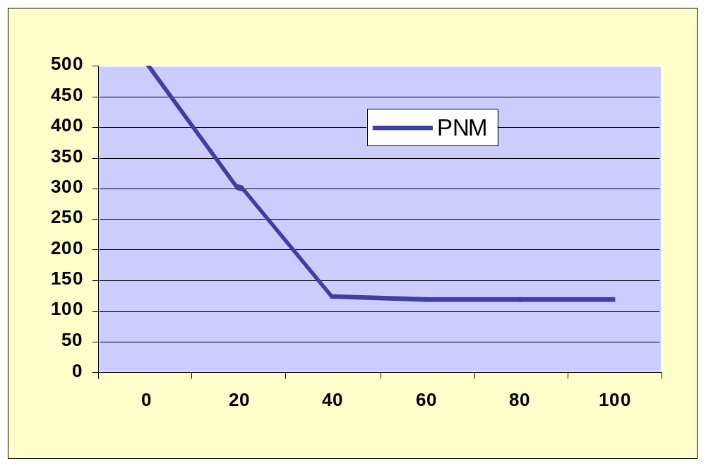
(per 1000 live births)
(%)

The question is therefore one of determining the appropriate/optimal CSR for a given population.

In addressing this question within the medical schemes environment and more specifically within the environment of medical schemes administered by Medscheme, it is necessary to first explain the nature of the medical schemes and the ‘clustering’ of schemes into High, Medium and Low groups. As shown in Figure 2, high cluster schemes are typically those catering for the more affluent members of society, while low cluster schemes cover the younger, less affluent, predominantly black, employed South Africans.

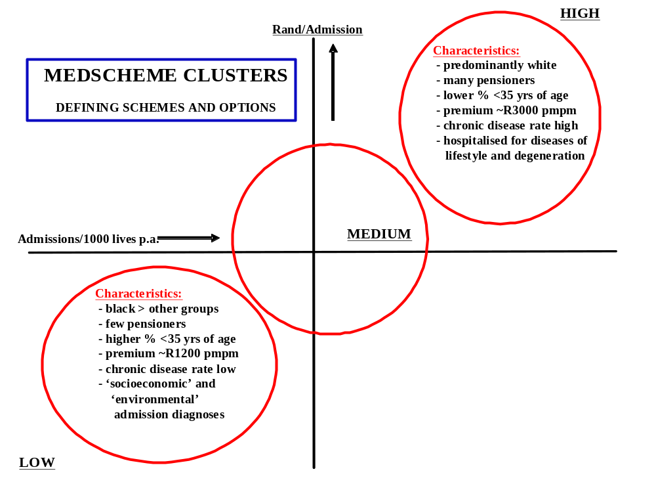

Within these clusters CSRs differ, ranging from 51% in the Low cluster to almost 60% in the high cluster. However, as pressure has been applied to trustees of low cluster schemes to ensure that the medical aid products are affordable, we have seen the emergence of new models of healthcare delivery. One of these models involves ‘capitated’ services that are prepaid and subsequently delivered via primary care centres (PCCs), and with onward referral to specialists and hospital by PCC ‘gatekeepers’. Within these schemes we have also observed CSRs that are no lower than in the high cluster, in fact some CSRs are even higher. Our concern has therefore been that, in the current legislative environment where there is no compulsory employee membership of a medical scheme, there is a chance that low-earning members will join and leave a medical scheme according to affordability and perceived need for healthcare. A woman who has had a caesarean section with one pregnancy and who might not be able to afford medical scheme membership during a subsequent pregnancy may therefore run the risk of an unmonitored and unmanaged high-risk situation in the future.

The present study was designed to test the hypothesis that GP and midwife ‘gatekeepers’ in PCCs tend not to deliver women they have seen during the pregnancy. Instead they refer to specialists for delivery because:
    - there are no delivery facilities within the PCCs;
    - the gatekeepers are too busy within the PCCs;
    - the patients usually have maternity benefits;
    - Specialists who are denied a full antenatal history will tend to deliver such patients by caesarean section.

Study
The study involved all Medscheme deliveries for the period January 2002 until June 2003. Delivering practitioners were identified by their BHF practice code numbers (specialist vs GP) and a correlation was sought between the antenatal caregiver and the delivering practitioner. Deliveries were categorised into groups according to the antenatal caregiver, delivery by GP vs Specialist, and the mode of delivery. HIV was not taken into consideration as an indication for caesarean section because HIV/AIDS registration rates are still very low in the medical schemes environment, with most registrations taking place in members hospitalized for overt disease.

Results
Data were available for 22 764 deliveries in four broad categories:
    - restricted access schemes (capitated primary care at PCCs);
    - GP-serviced schemes (often geographically-determined);
    - partial GP gatekeeping (a subset of GP-serviced members who needed onward referral to Specialists for higher-level care);
    - free access to Specialists.
There was a definite trend towards GP-orientated service delivery in the low cluster schemes (65% of schemes using the restricted access model were from the low cluster vs only 43% of schemes with free access to Specialists). Data are summarized in the following Table:

 | Restricted Access | GP-serviced | Partial GP gatekeeping | Free Access to O&G
No. of deliveries (%) | 2635 (12%) | 1842 (8%) | 1443 (6%) | 16844 (74%)
Deliveries by GPs | 44% | 90% | 19% | 2%
CSR (%) | 46% | 49% | 59% | 57%

Caesarean Section Rates are shown graphically in Figure 3
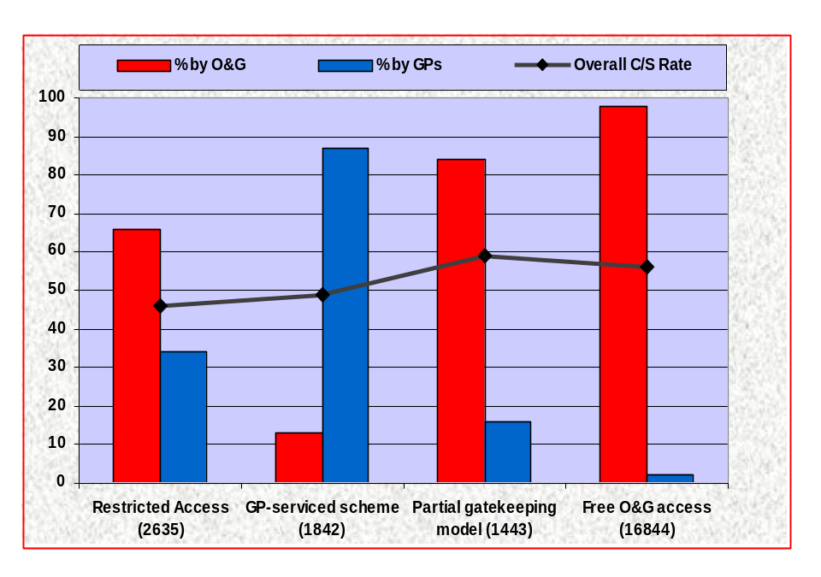

Conclusions
- There is a correlation between access to Specialists and the CSR.
- Conversely, CSRs are lower in GP-dominated schemes.
- Lower cluster schemes favour GP-directed care.
- There are differences between GP-serviced schemes and schemes that make use of capitated PCCs. These differences most likely reflect the stronger relationship between patients and providers in the GP-serviced schemes in which patients select their GPs.
- Women in restricted access schemes have a 46% risk of delivery by caesarean section and may well be at risk for unmonitored scars in future.
- The PCC model requires review in terms of best obstetric practice.

THE EFFECT OF RESTRUCTURING OF HEALTH CARE SERVICES ON CAESAREAN SECTION RATES

Fathima Paruk, Jaymala Devjee, Jack Moodley
MRC/UN Pregnancy Hypertension Research Unit and Department of Obstetrics and Gynaecology, Nelson R Mandela School of Medicine, University of KwaZulu-Natal, Durban.

Introduction
A caesarean section (CS) is often regarded as a simple, routine and common procedure in obstetric practice. However, it does constitute a major surgical procedure. The performance of the procedure has the potential to adversely impact not only at an individual level (serious morbidity and mortality) but also more widely on social cultural and economic issues. The rise in incidence of CS is therefore a cause for concern for both affluent, as well as under resourced countries. There, therefore, exists a strong body of opinion that CS should only be performed for stringent obstetrical indications, in order to prevent the spiralling rise in CS rates, without a concurrent reduction in perinatal mortality figures.
It is important to recognize that CS rates are influenced by a multitude of factors, including patient profile, available resources, experience/skill of the health care provider, as well as the level of health care provided by an institution. One would expect lower levels of health care to have a low CS rate compared to that at a higher level of health care. To our knowledge, such data is not available for the Durban Functional Region (DFR), which would be of use to health care planners as well as health care providers. The recent reorganization of maternity services in the DFR afforded us an opportunity to investigate CS rates at two levels of care viz. district and regional. The purpose of this study was to review the anticipated changes in CS rates following the introduction of a change in health care services in a maternity unit from a regional one to that of a district level.

Method
This study was conducted at Addington Hospital in Durban, which prior to 1 July 2001 provided a regional health level of maternity service to central Durban. The hospital also provided neonatal and maternal intensive care facilities, and was staffed by advanced midwifes, medical officers and specialist obstetricians. The facility was restructured to provide care at a district level. District hospitals usually provide obstetric services for patients with uncomplicated pregnancies and minor obstetric disorders. The maternity service is provided by advanced midwives and medical officers. Specialist opinion or assistance is available in emergency situations and in addition, a specialist may visit the hospital on a regular basis. In regional hospitals, the maternity service is provided by advanced midwives, medical officers and specialist obstetricians.
The prospective study was performed over two time intervals. The first interval spanned the period 1 April 2001 to 30 June 2001. During this period, the health care services were reflective of a regional level of care. The second time interval (which reflects a district level of health care) included the period 1 August 2001 to 31 October 2001. The transition from regional to district hospital was effected on 1 July 2001. The month of July 2001 was omitted for the study as it represented a transition period. The time periods representing regional and district levels of health care are referred to as interval 1 and interval 2 respectively.
Data collected included total number of deliveries, booking status of patient, mode of delivery, indication for CS and perinatal outcome. As the maternity service is midwife and medical officer ‘driven’, additional data related to decision-making with respect to the performance of CS (level of experience of health care worker and appropriateness of decision) were recorded for the month of October 2001. The indication for each CS was reviewed by one of the authors (FP). Each CS was subsequently classified as being appropriately or inappropriately indicated.

Results
The total number of deliveries during intervals 1 and 2 was 2070 and 1409, respectively. This represents a 32% reduction in the number of deliveries following the restructuring of services. For the 2 intervals, the vaginal delivery rate (74.5% and 76.3%) and the assisted vaginal delivery rate (0.9 % and 0.8%) remained essentially unchanged. The overall CS rate for intervals 1 and 2 was 24.6% and 22.9%, respectively. The proportion of elective and emergency CS was similar for both intervals (25.7% vs. 24%; and 74.3% vs. 76%, respectively).
The proportion of very low birth weight babies has declined from 4.1% to 2.6% and the proportion of extremely low birth weight babies has decreased from 1.6% to 0.9% (table 1). The booking status of all patients is similar from both intervals. In essence, >70% of patients had received some form of antenatal care on at least 3 occasions.
The indications for CS are compared for the 2 intervals in Table 2. The perinatal mortality rate has decreased from 84.5/1200 to 59.4/1000 deliveries whilst the low birth weight rate has declined from 46.8% to 35.3%.
Appropriate decisions were made in 66.7% of cases. Medical Officers with more than 2 years experience made an appropriate decision in 83.9% of situations. The overall data for the period shows that irrespective of the level of skill, an inappropriate decision for a CS was made in a third of the cases (33.3%).
Table 3 reflects data on the subset of patients who had a CS performed for poor progress in labour. Inappropriate decisions for CS were made in 45.5 % of cases. Medical officers with 2 or more years of obstetric experience made an appropriate decision in 85.7% of the situations.

Discussion
The 32% decline in the total deliveries was not unexpected as high-risk patients are now referred to appropriate levels of care. Similarly, the decline in the proportion of low birth weight babies and the concomitant improvement in the perinatal mortality rate were anticipated, and have been borne out by the data of this study. The anticipated decline in the CS rate however, has not been demonstrated by the data. The CS rates have essentially remained static. This is also true for the subsets of emergency and elective CS. The current CS rate figure of 22.9% is similar to the 20% CS rate at Northdale Hospital (personal communication), which is a district hospital in KwaZulu-Natal. Nonetheless, it is lower than the 45% CS rate at the tertiary and academic King Edward VIII Hospital obstetric unit (departmental statistics). The high CS rate at King Edward VIII Hospital is probably a reflection of the unit’s status as a referral centre for complicated cases.
The decline in CS performed for high-risk cases is considerable (9.62% to 4%). However the ultimate aim should be that no high-risk CS be performed at district level of care. Although an increase in the proportion of CS performed for indications other than high-risk cases is necessary (to compensate for the decline in CS for high risks cases), there appears to be a disproportionate increase in the group of CS performed for poor progress (16 to 24.5 %).
In this study, the profile of the patient population has changed with respect to a single factor (i.e. the proportion of high risk patients has declined). The restructuring of the health service and the decline in high-risk patients should therefore result in a decline in the CS rate. The lack of change thereof thus suggests a possible influence of the skill of the health care providers at the institution.
The analysis of data (for a 1 month period following the introduction of a restructured health service) appears to provide some explanation for the unexpected results.
It is evident from the data that approximately one third of the CS was not indicated at the point in time that they were performed. Furthermore it is also evident that CS decision-making is influenced by experience in obstetric practice. The least number of inappropriate decisions, being made by medical officers with at least 2 years of obstetric service. This issue is reinforced in the subset of patients who underwent a CS for poor progress. In this group of patients, inappropriate decisions for a CS were made in 45.5 % of cases. This information is not surprising. Decisions for CS often require a risk- benefit assessment. In addition, the diagnoses of “poor progress” and “fetal distress” are observer dependent. Thus skill and level of experience in obstetric care have the potential to influence CS decision-making.
Although the results of the study do not show the anticipated decline in the CS rate, it nevertheless provides important information – which may be utilized to effect further improvements in the quality of the obstetric services that is being provided.
It is vital that decisions related to the need for a CS is delegated to appropriately trained medical officers. There exists obviously a need at the institution for evaluation of staffing norms (and correction thereof if necessary) as well as the institution of CME programmes related to appropriate decision making on CS. A subsequent audit of the CS and perinatal mortality rate would be quite valuable.

Table 1 Birth Weight
BIRTH WEIGHT IN GRAMS | INTERVAL 1 n = 2070 (%) | INTERVAL 2 n = 1409 (%)
500 – 999 | 21 (0.1) | 9 (0.6)
1000 – 1499 | 36 (1.6) | 12 (0.9)
1500 – 1999 | 84 (4.1) | 37 (2.6)
2000 – 2499 | 191(9.2) | 107 (7.6)
>2500 | 1738 (84) | 1244 (88.3)

Table 2 Indication for Caesarean Sections (Emergency & Elective)
INDICATION | INTERVAL 1 (n = 509) % | INTERVAL 2 (n = 323) %
Poor progress | 16 | 24.5
Fetal Distress | 44 | 40.3
Cord prolapse | 0.7 | 0.6
Failed VBAC | 12 | 11
Two or more previous caesarean sections ** | 10 | 15
* High risk plus (complications) | 9.62 | 4
Multiple pregnancy | 1 | 0.92
Major malpresentation | 6.7 | 3.7
* Uncontrollable hypertension, abruptio placenta, diabetes mellitus, eclampsia.

Table 3 Sub-analysis of caesarean sections performed for poor progress with/without CPD or fetal distress (n =22)
Level of skill | No. of decisions | Appropriate decision | Inappropriate decision
Nursing sister | 4 | 50% | 50%
Intern | 2 |  | 100%
MO - < 2 years | 9 | 44.4 % | 55.6%
MO - > 2 years | 7 | 85.7 % | 14.3%
Total | 22 | 54.5% | 45.5%

NON-ELECTIVE CAESAREAN SECTION: HOW LONG DO WE TAKE TO DELIVER?

HR le Riche, DR Hall.
Department of Obstetrics and Gynaecology, Tygerberg Hospital and Stellenbosch University, Tygerberg, South Africa.

It has been widely advocated that the interval between the decision to do an emergency caesarean section and delivery of the baby not exceed 30 minutes. Failure to comply with this recommendation could have medicolegal repercussions. This is especially so should the mother or baby come to harm.

Methods
This study was undertaken to assess whether non- elective caesarean sections at Tygerberg Hospital (a tertiary referral centre) are being performed within 30 minutes and to identify any reasons for delay. The effects of delay on the early neonatal outcome were also evaluated.
A three-month prospective evaluation of all (n = 178) non-elective caesarean sections was performed, using a structured time and data sheet.

Results
During the three months of the study, 1141 women were delivered in the labour ward. Of these, 269 (23.6%) were by caesarean section. 178 (66.2%) patients had non-elective surgery and were divided into two groups according to the urgency of surgery. One hundred patients (56.2%) were classified as emergency and the remaining 78 (43.8%) as urgent.
Most caesarean sections were not done within the proposed interval of 30 minutes. Only 28 (15.7%) babies were delivered within 30 minutes, while 117 (65.7%) were delivered within one hour after the decision to operate was made. The time intervals for the two groups of non- elective caesarean sections, urgent and emergency, are shown in Table 1.
The data were further divided according to the different indications for surgery (Table 2). Both the mean and median intervals of fetal distress and abruptio placentae were significantly shorter than for poor progress (p < 0.01). Further statistical comparisons were inappropriate due to small numbers.
The effect of work within or after-hours on the decision- delivery interval was also examined. The “working hours” group (n = 46) contained all data from 08h00 – 16h00 on Mondays to Fridays. The median interval for this group was 52.5 (10-180) minutes. The remainder fell into the “after hours” group (n = 132) with an interval of 52.5 (17-169) minutes. These intervals were clearly comparable. In the same manner, decision-delivery intervals around change-over times (median 55, range 10-169 minutes), were compared to those of the rest of the day (median 52, range 17-180 minutes). Again the difference was not statistically significant (p=0.85).
Our data sheet requested the obstetrician on call to identify any reason for a decision-delivery interval of more than 30 minutes. These reasons are listed in Table 3.

With regard to the perinatal outcome, 22 babies (12.6%) had Apgar scores of 6 or less at five minutes. These babies are shown according to decision-delivery intervals in Table 4. Intra-uterine resuscitation was performed in 81 (81%) of women in the emergency group and only 12 (15.4%) in the urgent group. The number of babies needing neonatal resuscitation was 33 (33%) in the emergency group and 13 (16.6%) in the urgent group.

Discussion
Most (84.3%) non-elective caesarean sections at Tygerberg Hospital were not performed within the suggested 30-minute time frame. The motivation behind the 30-minute decision-delivery interval is concern for fetal wellbeing. In our study, most low Apgar scores were found in the <30 minutes decision-delivery interval category. This may be due to one of two reasons. Firstly, labour ward personnel are competent to recognise severe emergencies and react appropriately. On the other hand, it could be that the fetus benefits from intra-uterine resuscitation before delivery. However, when indicated, a rapid response may prevent intra-uterine death in a severely compromised fetus.
In conclusion, most of our decision to delivery intervals exceeded 30 minutes. Although we need to improve, it may be more productive to train labour ward personnel to recognise and appropriately manage specific obstetric emergencies, than to insist on rigid decision to delivery intervals.

Table 1 Decision to delivery interval (in minutes) for emergency and urgent caesarean sections
 | All  n = 178 | Emergency  n = 100 | Urgent  n = 78 | P value
Median (range) | 52 (10-180) | 48 (10-179) | 59 (25-180) | <0.01
Mean (SD) | 59.8 (31.6) | 52.9 (29.6) | 68.7 (32.1) | <0.01

Table 2 Decision-delivery intervals (in minutes) according to indications for surgery
Indication | N | Median (range) | Mean (SD)
Fetal distress | 88 | 50 (20-179) | 55.7 (30)
Poor progress | 51 | 64 (25-180) | 73.2 (33.9)
Breech | 11 | 50 (26-95) | 53.3 (20.3)
Placental abruption | 10 | 31 (17-65) | 35.2 (14.9)
Placenta praevia | 6 | 44 (26-55) | 43.2 (11.5)
Two previous C/S in labour | 4 | 61 (38-87) | 61.8 (23.1)
Other | 8
All indications | 178 | 52.5 (10-180) | 59.8 (31.6)
C/S = caesarean section. Other includes one operation for each of the following:
Fetal abnormalities, cord prolapse, face presentation, brow presentation, antepartum haemorrhage of unknown origin, vaginal septum in labour, recurrent eclampsia, failed ventouse delivery.

Table 3 Reasons given for delayed decision- delivery intervals (in minutes)
Reason for delay | Number | Median (range)
None given | 90 | 52 (33-180)
Not applicable | 28 | 27 (10-30)
Theatre busy | 23 | 104 (35-179)
Delay in regional anaesthesia | 9 | 55 (44-169)
Theatre staff delayed | 6 | 68 (40-105)
Anaesthetist unavailable | 6 | 65.5 (55-105)
Transport to theatre delayed | 4 | 63.5 (44-95)
Obstetrician engaged | 3 | 55 (38-75)
Paediatrician unavailable | 2 | 53 (50-57)
Delay preparing patient | 2 | 43 (37-49)
Other | 4
All groups | 178 | 52.5 (10-180)
Other includes one delay for the following: awaiting platelets, arterial and venous monitoring lines, waiting for foreign interpreter, waiting for consent from guardian.

Table 4 Decision-delivery intervals for babies with Apgar scores ≤ 6 at five minutes
Time (minutes) | N
< 30 | 8
30 – 45 | 4
46-60 | 4
61 – 75 | 2
76 – 90 | 3
91 or more | 1
All | 22

PUEPERAL PYREXIA IN HIV MOTHER. IS CAESAREAN DELIVERY MORE RISKY?

EJ Coetzee, E Simmonds, S Isaacs

Background & Objectives
At the 22nd Conference on Priorities in Perinatal Medicine held in Aventura during March 2003, we presented preliminary data on puerperal pyrexia in 70 patients who were infected with Human Immune Deficiency Virus (HIV). There had been sufficient evidence to persuade the American College and now the Royal College of Obstetricians and Gynaecologists to advise that all patients with HIV should have an elective caesarean section. In an European study, there had been NO increase in puerperal morbidity or mortality after elective caesarean section. We however cautioned that in South Africa, where our patients are hitherto untreated with Highly active Antiretroviral treatment (HAART) (and therefore have a high viral load and a low CD4 count) that puerperal infection may be more aggressive.
In addition, poor nutrition and social conditions may further contribute to the burden of infection.

Methods
As the Ethics Committee at the University of Cape Town had ruled that a prospective randomised trial between intention to have a vaginal birth and intention to have an elective caesarean section was unethical, we did a retrospective study of all HIV positive women who had delivered in the Groote Schuur Hospital, Maternity Centre. We did not know how many patients we were delivering with HIV infection and we therefore elected to interrogate a 6-month window from October 2002 to March 2003. Groote Schuur Hospital Maternity Centre is a Level 3, referral centre for the Maternity Services in the Cape Peninsula. Patients were identified from the delivery book in the labour ward and the folders were then requested to extract the necessary data.

Results
Two hundred and two HIV positive patients were identified. This represents 11% of all deliveries done in the Groote Schuur Hospital Maternity Centre. During that time frame, patients with HIV infection did not automatically have a CD4 count. However, 88 patients did have a CD4 count for a variety of reasons (mainly suspected infections). Of these 24 (27%) were <200. Nineteen patients had respiratory infections mainly tuberculosis and a further 8 had non-respiratory infections. Most of the respiratory tract infections were due to tuberculosis although this was often difficult to prove. However, patients often responded well to anti-tuberculosis treatment even though no mycobacteria could be found. In keeping with a tertiary referral centre, many patients (n=49) had pre-eclampsia or hypertension and 46 had severe anaemia (Hb < 8.0g/dl).

Table 1

Type of Delivery
Normal vaginal delivery | Caesarean section in labour | Elective caesarean section | Total
79 (39.1%) | 62 (30.7%) | 61 (30.2%) | 202

As can be seen in Table 1, 123 (60.9%) of patients were delivered by caesarean section. Of these half were caesarean sections in labour (emergency) and half were elective caesarean sections. The elective caesarean sections were mainly done for obstetric reasons and not because the patient was HIV positive. Virtually all caesarean sections were done under spinal anaesthesia [107 (87%) vs 16 (13%)].
The protocol during this time was that all patients who had a caesarean section who were HIV positive received at least 3 days of therapeutic antibiotics (Ceftriaxone and metronidazole) and then were discontinued if they were apyrexial for the last 24 hours. Initially it was planned to only look at puerperal pyrexia that fulfilled the criteria for puerperal fever i.e. 2 temperatures of over 38ºC taken 24 hours apart following the first 24 hours after delivery. However, HIV positive patients frequently ran a grumbling low grade temperature for many days between 37.3ºC and 37.9ºC and it was decided to include these as well.

Table 2

Puerperal Pyrexia
 | Vaginal delivery  % | Elective caesarean section  % | Emergency caesarean section  %
Low Grade Pyrexia | 10.1 | 16.4 | 22.6
Puerperal fever | 10.1 | 13.1 | 16
Total Pyrexial morbidity | 20.5 | 29.5 | 38.7

Looking at Puerperal fever (Table 2) there was a tendency to increasing prevalence from vaginal delivery (10.1%) to elective caesarean section (13.1%) emergency caesarean section (16%). This same trend was seen in low grade pyrexial morbidity and in the total cases with pyrexial morbidity (Table 2). As was expected vaginal delivery patients had the shortest ward stay with 77% being discharged within the first 3 days. However, 5% had ward stays of longer than 6 days. Fifty one percent of elective caesarean sections could be sent home by day 3 whereas only 34% of emergency caesarean sections could be sent home. Ward stays over 7 days were 11.5% for elective caesarean sections and 18% for emergency caesarean sections. There was only one maternal death in this series, which occurred in the vaginal delivery group. Three patients had total abdominal hysterectomies while 8 patients self discharged themselves despite a low grade pyrexia.

Conclusion
In a tertiary setting, where patients often have multiple pathology only 39.1% of patients achieved a vaginal delivery, whereas 30.2% had an elective caesarean section and 30.7% had a caesarean section in labour. Only 56% of those who were allowed to labour achieved a vaginal delivery. There might be a difference between patients who were in spontaneous labour vs patients who were induced, but this was not looked at. The current teaching of not rupturing the membranes in HIV positive patients may well play an important role in the decreased success in achieving a vaginal delivery. In addition, long labours with numerous vaginal examinations are discouraged in HIV positive patient. In this small study, pyrexial morbidity and short duration of ward stay was better for elective caesarean section than for emergency caesarean sections and was only slightly worse than for patients who had a vaginal delivery. In a tertiary setting, where there is a high emergency caesarean section rate it could therefore be affordable and even advisable to offer elective caesarean section to ALL HIV mothers who are not on HAART therapy.

PERINATAL MENTAL HEALTH PROJECT: A YEAR’S REVIEW

Simone Honikmanª, Hilary Rosenthal^{b}, Sheila Faure^{c}, Bea Wirz^{d}, Marianne Littlejohn^{e}, Shelsley van Zijl^{f}, Nils Bergman^{g}, Sue Fawcus^{h}

^{a-g}Mowbray Maternity Hospital; ^{h}Department of Obstetrics and Gynaecology, Faculty of Health Sciences, University of Cape Town

Introduction
A perinatal mental health project is proposed for obstetric clients in the public sector in Cape Town. This is against a backdrop of overburdened health resources and an enormous unmet need for women’s mental health care.

Background
The prevalence of postnatal depression (PND) in Khayelitsha is 34,7% while the prevalence in developed countries is 10-15%. In part, this may be due the preponderance of risk factors associated with living in impoverished communities. These include, among others, adolescent pregnancy (one sixth of Black African pregnancies), domestic violence and abuse (35% of women suffer domestic abuse during pregnancy in Durban) and HIV. The long-term effects of maternal PND for the infant are well documented. They may be persistent and severe and include the risk of child abuse.

Anxiety, particularly in the antenatal period, has separate and additional effects to those of PND. These effects are more significant than depression on child development and include organ malformation, premature delivery, low birth weight, lower neurological scores in infants and hyperactivity, inattention and emotional problems in 6-year old children at follow-up.

The most recent Confidential Enquiries into Maternal Deaths in the UK states suicide as a leading cause of maternal mortality. It was shown that in the vast majority of these deaths, there were signs of the mothers’ emotional distress in the antenatal period. This highlights the importance of screening for mental illness in the antenatally.

Within the Peninsula Maternal and Neonatal Service (PMNS), there is an extremely limited postnatal service for most women. There is no 6-week postnatal check. There is no screening or management protocol for mental health problems. Referral criteria and resources are poorly established. Midwives feel underpaid, overworked, and levels of morale are frequently low.

The Perinatal Mental Health Project
In response to the need for a perinatal mental health service, a project was developed by a multidisciplinary group of health workers. It has been operating as a pilot at the Liesbeeck Midwife Obstetric Unit (LMOU) since September 2002. This development coheres with the philosophies of the Better Births Initiative, which was launched in the PMNS earlier in the same year.

Aims and Objectives
The project aims to provide a holistic mental health service to women at the LMOU. To achieve this it hopes to identify women at risk of, or currently suffering from perinatal mental distress. These women are offered professional counselling. The objective is to prevent or alleviate symptoms and to ameliorate the sequelae of perinatal mental health disturbances for women, their infants and communities.

Design
At the second antenatal visit, midwives at the LMOU obtain informed consent from all clients to perform mental health screening. The two self-administered questionnaires used are:
- the internationally and nationally-validated Edinburgh Postnatal Depression Scale (EPDS);
- a Risk Factor Assessment (RFA) tick-form designed specifically for this project.
Based on the scores of these two forms (EPDS≥13 or RFA ≥3), women are offered counselling with one of the professional volunteer counsellors who attend weekly. The counsellors may in turn, make referrals to a psychiatrist who offers a weekly clinic.

Results

Antenatal Screening
- In the first 16 months, 830 antenatal clients were screened, representing a coverage of 52%. This gives an average of 2.4 women screened per working day at the unit.
- Approximately, one quarter (24%) scored ≥13 on the EPDS and one fifth (21%) scored ≥3 on the RFA. The median EPDS score was 8 and the median RFA score was 1.

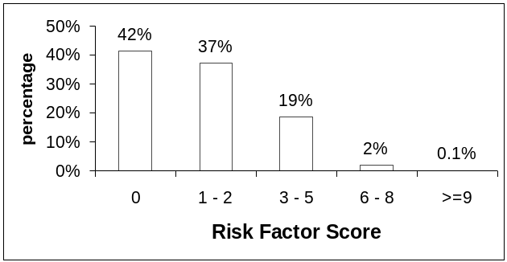EPDS Score Range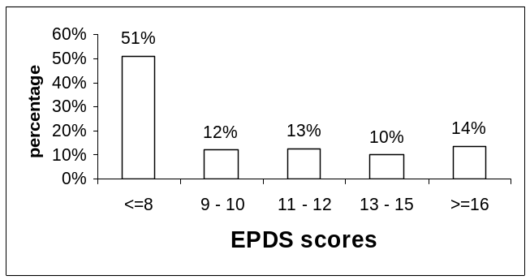 Risk Factor Score Range

Postnatal Screening

Screening in the postnatal clinic was highly selective and occurred on an ad hoc basis. This half-day clinic serves women who have delivered at Mowbray Maternity hospital as well as LMOU and is staffed by one nursing sister. All the women are within 14 days post delivery.

The number of antenatal clients screened was 72. Of these, 42% scored ≥13 on the EPDS and 19% scored ≥3 on the RFA.

Counselling
- The counselling consisted of brief psychotherapeutic interventions in mainly single sessions. The focus was more prophylactic than crisis-driven. The counsellors adopted objectives and therapeutic techniques that varied according to the needs of individual clients.
- 382 antenatal clients were referred for counselling, and 240 sessions took place at 15 sessions per month. There was a default rate for counselling of 38%.
- The counselling sessions revealed the following problems contributing to emotional distress; traumatic bereavements, tenuous/ conflictual relationships with partners, teenage pregnancy, previous history of depression, previous pregnancy loss, HIV positive status, traumatic birth syndrome and social environment problems.

Psychiatry
- The psychiatrists saw 31 clients. This represented an average of 4 sessions per month. Most were seen at least four times.
- In the majority of cases a major depressive episode was diagnosed. Other diagnoses included co-morbid personality disorders, anxiety disorders, Post Traumatic Stress Disorder, drug and alcohol abuse.
- Most women (25) were commenced on medication (20mg Fluoxetine). Some were referred for on-going counselling at LMOU or with specialist organisations for Cognitive Behavioural Therapy, marital therapy, drug dependency therapy etc.
- 4 women were admitted, two to the emergency psychiatric unit at Groote Schuur Hospital and two to in-patient wards at Valkenberg Psychiatric Hospital. The latter two were diagnosed with schizophrenia; one woman had been previously diagnosed and had lapsed her treatment, the other women was previously undiagnosed.
- The majority of women stabilised well with no relapses in the postpartum period.

Outreach Activities
- Training Workshops in Perinatal Mental Health were run at each of the other obstetric units in the PMNS. These were 4-hour interactive seminars with a focus on professional self-awareness, the risk factors, symptoms and consequences of perinatal mental illness, basic counselling skills and referral strategies and resources.
- A written manual, the Perinatal Mental Health Handbook – a resource for health workers in maternal care was developed by Simone Honikman and Liz Mills of the Post Natal Support Association of South Africa. The manual was designed to complement the workshops and to act as an ongoing resource for PMNS staff.

Conclusions
- There is a significant unmet need for a mental health service for pregnant women.
- Even well-resourced obstetric units, such as the LMOU, have difficulties with screening adequate numbers of women.
- Defaulting of counselling appointments is a significant problem. Attention must be made to referral technique to minimise this problem.
- Qualitative research and anecdotal reports from counselling and midwifery staff indicate that the counselling and sensitivity of staff contribute significantly to the emotional well-being of the clients. There is a need for quantitative research to confirm this.

The Way Forward
The following are steps currently underway or are to be taken in the future;

Funding
- Establish a source of funding. This may occur through collaboration with non-governmental organisations involved in parenting.
- Ensure greater opportunity for counselling by employing paid and trained lay counsellors.

Operational Improvements
- Increase the screening coverage of the obstetric population by motivating and reminding staff.
- Decrease the default rate for counselling by booking a clinical appointment at the same time as the counselling session and by ensuring the client is motivated to attend.
- Ensure better follow-up of women in the postnatal period.
- Rollout a version of the Project to provide a service programme for the rest of the PMNS.

Training
- Provide ongoing training for PMNS nursing staff in perinatal mental health issues.
- Train other health professionals in perinatal mental health, including day hospital personnel, obstetric doctors, medical students and baby clinic staff.

Research
- Collate and publish data generated from the Project.
- Quantitatively evaluate the efficacy of the screening and counselling interventions.
- Two psychology students are using qualitative methods to evaluate the project.
- Offer and evaluate other intervention options e.g. massage, Kangaroo Mother Care, yoga.

