The 28th Conference on Priorities in Perinatal Care in South Africa was held under the auspices of the Priorities in Perinatal Care Association and sponsored by Abbott Laboratories SA (Pty) Ltd.

Editor’s Note:

The articles included in these Proceedings were, mostly, received electronically and have been included as submitted by the presenter/author. Faxed articles have been retyped.
Some articles have been shortened.
Abstracts were included where articles were not submitted.
References are available from the authors.
Articles have not been included for presentations, which were withdrawn and not presented at Priorities.
Late submissions received after the Proceedings had been compiled and passwords allocated are included at the end of the Proceedings.
INDEX

“NO RESPONSE TO POOR FETAL MOVEMENTS”: THE POTENTIAL FOR PREVENTING PERINATAL DEATHS IN SOUTH AFRICA. JS Snyman | 1
UNEXPLAINED STILLBIRTHS: DOES THE PLACENTA HOLD THE ANSWER? (ABSTRACT). Van Greunen JP | 3
CORRELATION BETWEEN CLINICAL RISK FACTORS AND STREPTOCOCCUS AGALACTIAE COLONISATION IN WOMEN PRESENTING IN LABOUR AT CH BARAGWANATH HOSPITAL (ABSTRACT). CL Cutland | 4
EARLY DISCHARGE FROM HOSPITAL AFTER CAESAREAN SECTION AT A LARGE SOUTH AFRICAN PUBLIC HOSPITAL. N Pillay | 5
EFFECTIVENESS OF THE ESSENTIAL POSTNATAL CARD IN SOUTH WEST TSHWANE (ABSTRACT). E Etsane | 9
A GAP SURVEY ON PMTCT. Anne-Marie Bergh | 10
THE IMPACT OF QUALITY OF ANTENATAL INFANT FEEDING COUNSELLING ON OVERALL INFANT HIV-FREE SURVIVAL. S Woldesenbet | 14
EXPLOITING THE GAPS IN PMTCT QUALITY AND EQUITY IN SOUTH AFRICA. Courtenay Sprague | 19
EVALUATION OF PATIENT-HEALTHCARE PROVIDER RELATIONSHIP AND ITS ASSOCIATION WITH ADHERENCE TO ANTENATAL CARE (ABSTRACT).  A-M Bergh | 24
BIRTH DEFECTS AND PERINATAL OUTCOMES FROM 748 PREGNANT WOMEN WHO TOOK EFAVIRENZ AS PART OF LIFELONG ANTIRETROVIRAL THERAPY. A PROSPECTIVE STUDY AT A TERTIARY HOSPITAL IN SOUTH AFRICA.  Ebrahim Bera | 25
HIV TRANSMISSION FROM MOTHER TO CHILD - HAART COMPARED TO DUAL THERAPY. Gerhard Theron | 34
THE MATERNAL MORTALITY RATIO AND PERINATAL MORTALITY RATE OF ZIMBABWE IN 2007 (ABSTRACT). Munjanja SP – full article at end of these Proceedings – late submission | 38
RISK FACTORS FOR PERINATAL DEATHS AT NSAMBYA HOSPITAL, UGANDA: RETROSPECTIVE CASE -CONTROL STUDY (ABSTRACT). Victoria Nakibuuka | 39
OVERVIEW OF THE FOURTH SAVING MOTHERS REPORT: 2005-2007 (ABSTRACT). N Khaole | 40
NEONATAL DEATHS IN SOUTH AFRICA: CAUSES AND AVOIDABLE FACTORS.  S Velaphi | 41
NEONATAL CARE IN PRIVATE PRACTICE: A BRIEF OVERVIEW. HC Schuman | 45
IS CHILD HEALTHCARE IMPROVING IN SA? A THREE YEAR REVIEW OF CHILD PIP DATA (2005-2007) (ABSTRACT). K Harper | 54
HELLP SYNDROME: DOES DEXAMETHASONE IMPROVE MATERNAL MORBIDITY AND MORTALITY? Van Soest ZJWE | 55

ASSESSMENT OF THE QUALITY OF INTRAPARTUM CARE USING THE STANDARD PRIMIPARA (ABSTRACT). Guzha BT | 63
MATERNAL DEATHS FROM OBSTETRIC HAEMORRHAGE ASSOCIATED WITH CAESAREAN SECTION IN SOUTH AFRICA. 2005-2007. S Fawcus | 64
LESSONS TO LEARN FROM CASE SERIES: CONSIDERATION OF RUPTURED UTERI IN SUSPECTED ADVANCED EXTRA-UTERINE PREGNANCIES IN PREVIOUS CAESAREAN SECTIONS. (ABSTRACT) S Ramphal | 67
AUDIT OF SECOND STAGE CAESAREAN SECTIONS AT A TERTIARY DURBAN HOSPITAL. Dr V Govender | 68
MISOPROSTOL TO PREVENT POST PARTUM HAEMORRHAGE. N Mshweshwe | 75
ON THE IMPOSSIBILITY OF INFANT FEEDING COUNSELLING. Anne-Marie Bergh | 79
KANGAROO MOTHER CARE (KMC) FOLLOW-UP AT CHRIS HANI BARAGWANATH HOSPITAL. M Mokhachane | 83
SCALING UP KANGAROO MOTHER CARE IN GHANA. Anne-Marie Bergh | 88
HIV DISCLOSURE- AN ETHICAL DILEMMA IN THE KANGAROO MOTHER CARE (KMC) UNIT AT CHRIS HANI BARAGWANATH HOSPITAL. M Mokhachane | 91
HIV IMPACT ON INFANTS AND FAMILIES IN THE KANGAROO MOTHER CARE (KMC) FOLLOW-UP AT CHRIS HANI BARAGWANATH HOSPITAL. L Mokgosi | 94
THE EFFECT OF MATERNAL HIV INFECTION ON MATERNAL DISEASE AND PERINATAL DEATHS IN SOUTH-WEST TSHWANE. MH Hulsbergen | 95
TUBERCULOSIS-EXPOSED NEWBORN INFANTS: CLINICAL FEATURES AND SHORT TERM OUTCOME (ABSTRACT). A Eerdekens | 97
LONGITUDINAL PERINATAL MORTALITY RATES AND PERINATAL CARE INDEX’S IN SOUTH AFRICA. RC Pattinson | 98
FORMATIVE RESEARCH TO ASSESS CURRENT CARE PRACTICES IN SELECTED DISTRICTS IN KWAZULU NATAL. Susheela M. Engelbrecht | 100
A DISTRICT LEVEL STUDY OF THE CAUSES OF THE ‘THIRD DELAY’ IN ZIMBABWE (ABSTRACT). Manyame S | 110
ARE WE WINNING? THREE YEARS OF EFFORT TO IMPROVE PERINATAL OUTCOMES AT A DEEPLY RURAL DISTRICT HOSPITAL IN SOUTH AFRICA. Dr CB Gaunt | 111
IMPACT OF AN INTEGRATED ANTIRETROVIRAL ANTENATAL CLINIC ON MATERNAL MORTALITY AT CHARLOTTE MAXEKE JOHANNESBURG ACADEMIC HOSPITAL. V Black | 120
THE IMPACT OF THE HIV EPIDEMIC ON MATERNAL DEATHS (ABSTRACT).  RC Pattinson | 123
THE UCT FETAL CARDIAC ANOMALY STUDY – TUFCAS (ABSTRACT). TA Horak | 124
FETAL DISTRESS: DOES MATERNAL OXYGEN ADMINISTRATION INFLUENCE THE STATUS OF THE NEWBORN BABY? A randomized controlled trail (abstract). MA du Toit | 125
RESPIRATORY DISTRESS ASSOCIATED WITH ELECTIVE CAESAREAN SECTION IN TERM AND NEAR-TERM INFANTS MANAGED IN A PRIVATE HOSPITAL. Kirsten GF | 126
IS NCPAP A FEASIBLE TREATMENT MODALITY IN A RURAL DISTRICT HOSPITAL FOR VLBW INFANTS WITH RDS? (ABSTRACT). Hendriks H | 129
NECROTISING ENTEROCOLITIS AT KALAFONG HOSPITAL BETWEEN 2000 AND 2008 (ABSTRACT). S Delport | 130
INCIDENCE OF HEALTHCARE-ASSOCIATED BLOODSTREAM INFECTIONS IN VERY LOW BIRTH WEIGHT INFANTS AT KALAFONG HOSPITAL. C Kock | 131
FETAL ALCOHOL SPECTRUM DISORDER (FASD) PREVENTION PROJECT: SCREENING AND BRIEF INTERVENTIONS DURING THE ANTENATAL PERIOD – A PARTNERSHIP BETWEEN THE DEPARTMENTS OF SOCIAL DEVELOPMENT, HEALTH, A NON-PROFIT ORGANIZATION (NPO) AND THE MEDICAL RESEARCH COUNCIL (MRC) (ABSTRACT). L Olivier | 132
INTRODUCING THE MACH PROJECT, NEONATAL CARE TRAINING AND NEONATAL OUTCOMES IN MPUMALANGA PROVINCE. Janse van Rensburg SC | 133
NEONATAL SERVICES IN KWA-ZULU NATAL. M Adhikari | 134
IMPROVING NEWBORN CARE IN ZULULAND DISTRICT, KWAZULU–NATAL.  DH Greenfield | 137
THE CAUSES OF THE 3 DELAYS IN NEONATAL CARE AT DISTRICT LEVEL IN ZIMBABWE. Dondo V | 143
PROFILE OF NEONATES ADMITTED WITH HYPOXIC-ISCHEMIC ENCEPHALOPATHY TO THE NEONATAL HIGH CARE UNIT AT PELONOMI HOSPITAL. AE vd Vyver | 150
AVOIDABLE FACTORS IN BIRTHS ASSOCIATED WITH PERINATAL ASPHYXIA AT CHRIS HANI BARAGWANATH HOSPITAL. F Ismail | 156
“AS SAFE AS HOUSES”: ADOPTION OF SMART PUMP TECHNOLOGY.  Ruth Davidge | 160
DISTRICT HOSPITALS: THE CORE OF MATERNITY SERVICES, BUT SADLY NEGLECTED. RC Pattinson | 169
A COMPARISON OF TWO TRAINING METHODS FOR BASIC ANTENATAL CARE: “FACE TO FACE” AND “TRAIN THE TRAINERS”. Surina J Groenewald-Neethling | 171
TRAINING IN KANGAROO MOTHER CARE – IDEAL AND REALITY (ABSTRACT). Anne-Marie Bergh | 176
COMPARATIVE STUDY OF THE FUNCTIONALITY AND ACCEPTABILITY OF VARIOUS LOW COST NEONATAL RESUSCITATION DEVICES. D Nyasulu | 177
IMPROVING ESSENTIAL OBSTETRIC AND NEONATAL SKILLS USING THE ESMOE PACKAGE: THE RESULTS OF THE PILOT STUDY. S Velaphi | 181
NEONATAL DEATH DUE TO CONGENITAL ABNORMALITIES (ABSTRACT). Mmuso Barbara Monyemore | 184
A NEW RANGE OF PEP BOOKS: A LEARNING PROGRAMME FOR PROFESSIONALS. Prof David Woods | 185

SAVING MOTHERS & BABIES – A JOINT INITIATIVE (ABSTRACT). Mitchell, RW | 187
RISK FACTORS FOR PERINATAL HIV-1 TRANSMISSION IN PREGNANT WOMEN ON LIFELONG ANTIRETROVIRAL THERAPY. A PROSPECTIVE STUDY AT FRERE HOSPITAL, EAST LONDON, SOUTH AFRICA. Ebrahim Bera | 188
AN ONGOING AUDIT OF THE KANGAROO MOTHER CARE UNIT AT KALAFONG HOSPITAL. Elise van Rooyen | 197
IMPLEMENTING KANGAROO MOTHER CARE IN KUMASI, GHANA. Karen Davy | 206
GROWTH PATTERNS IN A COHORT OF VERY LOW BIRTH WEIGHT INFANTS IN JOHANNESBURG: A RETROSPECTIVE REVIEW. Cheryl Mackay | 212
FLASH PASTEURISATION METHOD. Louise Goosen | 216
BREASTFEEDING PREMATURE INFANTS. Louise Goosen | 217
WANTING TO SET UP A DONOR BREASTMILK BANK IN YOUR HOSPITAL? GREAT! COME AND GET THE ‘DO-IT-YOURSELF –MANUAL’ WITH GUIDELINES THAT WILL HELP YOU ON YOUR JOURNEY, ENSURING A MUCH MORE SMOOTHER RIDE TO DONOR BREAST MILK BANKING IN SOUTHERN AFRICA. Vanessa Booysen | 219
FACTORS INFLUENCING HIV-POSITIVE MOTHERS’ DECISION MAKING ABILITY. Carolé Cilliers | 225
MISOPROSTOL TO TREAT POSTPARTUM HAEMORRHAGE: A MULTICENTRE RANDOMIZED CONTROLLED TRIAL (ABSTRACT). M Singata | 230
AN EXPLORATORY STUDY PROBING THE FEELINGS AND ATTITUDES OF SENIOR MIDWIVES TOWARDS THE IMPLEMENTATION OF LABOUR COMPANIONS IN MATERNITY UNITS IN GAUTENG (ABSTRACT). Barbara Hanrahan | 231
EVALUATION OF THE USE OF THE PARTOGRAM & AN ASSESSMENT OF NEONATAL RESUSCITATION TECHNIQUES IN PRACTICE (ABSTRACT).  Mitchell, RW | 232
CLIENT REPORTS ON ANTENATAL SERVICES IN TSHWANE (ABSTRACT).  Anne-Marie Bergh | 233
A RETROSPECTIVE REVIEW OF CERVICAL SMEARS IN HUMAN IMMUNODEFICIENCY VIRUS INFECTED POSTNATAL WOMEN AT JOHANNESBURG HOSPITAL. A Wise | 234
SUPPORT FOR IMPROVEMENTS IN ANC AND PMTCT IN ZULULAND. NC Mzolo | 240
VALIDATION OF PERINATAL CARE INDICATORS. Robert Pattinson | 245
THE USE OF CELL PHONES IN POSTNATAL CARE (ABSTRACT). Mokaya K | 248
PERINATAL AUDITS AT NSAMBYA HOSPITAL (ABSTRACT). Victoria Nakibuuka | 249
INTERPRETATION OF FINDINGS FROM PPIP IMPLEMENTATION IN EMFULENI SUB-DISTRICT (ABSTRACT). Mitchell, RW | 250
IMPLEMENTATION OF THE PPIP DATABASE IN EMFULENI (ABSTRACT).  Chaane T | 251
USING MENTORS FOR IMPROVING ESSENTIAL CARE FOR WOMEN AND NEWBORNS. E. Moosa | 252
LATE SUBMISSION
THE MATERNAL AND PERINATAL MORTALITY OF ZIMBABWE IN 2007.  Munjanja SP | 256
HIV IMPACT ON INFANTS AND FAMILIES IN THE KANGAROO MOTHER CARE (KMC) FOLLOW-UP AT CHRIS HANI BARAGWANATH HOSPITAL. M Mokhachane | 262

“NO RESPONSE TO POOR FETAL MOVEMENTS”: THE POTENTIAL FOR PREVENTING PERINATAL DEATHS IN SOUTH AFRICA

Kobie Snyman for the PPIP Technical Task Team

Introduction
The relationship between poor fetal movement and perinatal deaths has been established by various reports. “No response to poor fetal movements” is one of the options of avoidable factors in PPIP. The aim of this study was to look at this avoidable factor in relation to perinatal deaths recorded from 2006-2007 in the nation PPIP database.

Methods and Results
The avoidable factor “inappropriate response to poor fetal movements” was analysed on the PPIP national database with respect to the number of cases in which it was recorded and the cause of the perinatal death associated with it. The number of deaths associated with poor fetal movements was calculated by extrapolating the data from the national PPIP database to the number of deaths per level of care for South Africa.

A total of 3097 perinatal deaths were associated with poor fetal movements. This represents 4.9% of all perinatal deaths. The majority were related to unexplained stillbirths (62.8%) followed by hypertension (13.6%), antepartum haemorrhage (5.1%) and infection (4.9%), see Table 1.26. 12.7% of all unexplained stillbirths had poor fetal movements recorded as an avoidable factor, intrauterine growth restriction had 7.8%, hypertension had 5.4% and infections had 4.6% recorded as avoidable factors.

Table 1.26 Association of poor fetal movements and primary obstetric cause of death

Description | Number | % of deaths associated with no response poor fetal movements
Unexplained stillbirth | 1944 | 62.8
Hypertensive disorders | 422 | 13.6
Antepartum haemorrhage | 159 | 5.1
Infections | 153 | 5.0
Spontaneous preterm labour | 140 | 4.5
Intrauterine growth retardation | 96 | 3.1
Intrapartum asphyxia | 90 | 2.9
Maternal disease | 38 | 1.2
Fetal abnormality | 19 | 0.6
Other | 36 | 1.1
Total | 3097 | 100.0

Conclusion
If the association of poor fetal movements was directly related to the death and if by acting on the information resulted in all perinatal deaths being prevented, then the perinatal mortality could be reduced by 12.4%. The monitoring of fetal movements by pregnant women has the potential to significantly reduce perinatal deaths. This should be tested in a large randomised trial to see if this inexpensive intervention is warranted.

For additional information, please refer to the Saving Babies Report on this CD.

UNEXPLAINED STILLBIRTHS: DOES THE PLACENTA HOLD THE ANSWER? (ABSTRACT)

Van Greunen JP*, Fawcus S†
*Department Obstetrics and Gynaecology, Groote Schuur Hospital, University of Cape Town
†Department of Obstetrics and Gynaecology, Mowbray Maternity Hospital, University of Cape Town

Introduction
In 2005 the World Health Organization estimated that approximately 4 million stillbirths occur worldwide. In South Africa 37.7% of stillbirths were classified as unexplained in the triennium 2003-2006, the largest single category. The value of comprehensive stillbirth assessment has long been recognised in developed countries, but these investigations are usually unaffordable in resource poor settings.

Aim
The overall aim of this study is to evaluate the contribution of placental histological examination in elucidation of the cause of stillbirth in those cases categorized as “unexplained” with routine investigations.

Methods
A retrospective observational study was conducted within the Peninsula Maternal and Neonatal Service (PMNS), looking at stillbirths that occurred at Groote Schuur Hospital, Mowbray Maternity Hospital as well as Mitchell’s Plain, Khayalitsha and Gugulethu Midwife Obstetric units from 01.01.2006-31.12.2006. An analysis of placental histology requested on unexplained stillbirths was done to see whether it could contribute to finding a cause of death.

Results
Five hundred and sixty six stillbirths were identified in this period. In 319(56.4%) cases a cause of death could be assigned using routine investigations alone. Of the 247(43.6%) unexplained cases 159 underwent further investigation by placental histology. Forty four (27.7%) cases of chorioamnionitis, 21(13.2%) placental haemorrhage, 26(16.4%) underlying maternal hypertension, 13(8.2%) fetal thrombotic vasculopathy, 7(4.4%) chorangiosis, 3(1.9%) structural abnormalities, 12(7.5%) hypoxia and 1(0.6%) metastatic carcinoma were identified. In 14(8.8%) cases placental histology remained inconclusive. Placental histology was able to assist in finding an underlying cause of death in a further 107(18.9%) cases.

Conclusion
Placental histological examination adds value to assessing the causes, reducing the unexplained stillbirths from 43.6% to 24.7%. In particular deaths from chorioamnionitis, retroplacental haemorrhage and hypertension were identified by placental histology in cases where “routine” investigations had classified them as unexplained.

CORRELATION BETWEEN CLINICAL RISK FACTORS AND STREPTOCOCCUS AGALACTIAE COLONISATION IN WOMEN PRESENTING IN LABOUR AT CH BARAGWANATH HOSPITAL (ABSTRACT)

¹DST/ NRF: Vaccine Preventable Diseases/ Respiratory and Meningeal Pathogens Research Unit, Chris Hani Baragwanath Hospital; ²Centres for Disease Control and Prevention, Atlanta, USA
CL Cutland¹, M. Locadiah Kuwanda¹, Elizabeth R. Zell², Stephanie Schrag², Shabir A. Madhi¹

Introduction
Maternal colonization with Streptococcus agalactiae is a significant risk factor for early neonatal sepsis and mortality. Foetus/neonate can be exposed to S. agalactiae by aspiration of contaminated amniotic fluid, perinatal transmission through intact membranes, or during passage through birth canal.
Ten to 30% of women are colonised with S. agalactiae during the third trimester of pregnancy, and vertical transmission has been reported to range between 50 and 68%, with 2-3% of colonised infants developing early onset Streptococcus agalactiae sepsis. Although maternal fever, prolonged rupture of membranes and preterm delivery have been considered the main risk factors associated with S. agalactiae sepsis in newborn infants, poor correlation between these risk factors and maternal colonisation has been reported.

Methods
A randomised, controlled trial of chlorhexidine maternal vaginal and neonatal skin disinfection was conducted at Chris Hani Baragwanath Hospital between April 2004 and October 2007. Vaginal swabs were performed on 5144 maternal participants during labour to determine carriage of S. agalactiae and other pathogenic bacteria. Data, including maternal demographics and risk factors were collected from medical records.

Results
20.7% (1063/5144) women were colonised vaginally with S. agalactiae at presentation in labour. Only 23% of colonised women had one or more clinical risk factors present during labour. 159 (15%) women had meconium stained liquor; 64 (6%) had prolonged rupture of membranes; 18 (1.7%) delivered preterm infants; 10 (0.9%) had offensive liquor or discharge; 4 (0.4%) had fever; 4 (0.4%) had foetal tachycardia and 3 (0.3%) had maternal tachycardia.

Four percent (47/1063) of the women with S. agalactiae colonisation at onset of labour received at least one dose of intrapartum antibiotics at least 2 hours prior to delivery of their infant.

Conclusion
There is poor correlation between maternal S. agalactiae colonisation at onset of labour and presence of clinical features considered to be risk factors for neonatal sepsis.
EARLY DISCHARGE FROM HOSPITAL AFTER CAESAREAN SECTION AT A LARGE SOUTH AFRICAN PUBLIC HOSPITAL.

N Pillay, E Buchmann
Department of Obstetrics and Gynaecology, Chris Hani Baragwanath Hospital and University of the Witwatersrand

Introduction
The aim of this study was to determine if discharge on the second postoperative day after uncomplicated caesarean section was acceptable to women and to what extent it was followed by adverse clinical outcomes. The primary objectives were to determine satisfaction rates, rates of wound infection, rates of maternal and infant readmission and rates of early postnatal depression. A secondary objective was to show an association, if any exists, between HIV infection and rates of postnatal complications following early discharge.

Methods
This was a cohort study of women discharged on the second postoperative day after caesarean section at Chris Hani Baragwanath Hospital. Permission to undertake this study was given by the University of the Witwatersrand’s Human Research and Ethics Committee. The second post-operative day was defined as ‘day 2’ on the postnatal morning round, from the date of delivery. The following categories of women were excluded from the study: 1) age < 18 or >45 years; 2) hypertension, cardiac disease, diabetes mellitus, or antenatal anaemia (haemoglobin <10 g/dL); 3) high risk of postoperative infection (rupture of membranes ≥24 hours, cephalopelvic disproportion, labour duration ≥20 hours, pyrexia in labour; 4) surgical difficulties such as vertical or upper segment uterine incision or suspected bladder injury, or excessive intraoperative or peripartum bleeding requiring packing, draining or blood transfusion; 5) stillbirth; 6) evidence of infection after 24 hours post-operatively (heart rate ≥110 beats/minute, temperature ≥37.5 degrees C); 7) poor clinical condition on the second postoperative day, such as not getting up, not eating, vomiting, evidence of ileus, purulent wound discharge or dehiscence; 8) infant not yet discharged from the hospital; 9) unwillingness to be discharged; and 10) no telephone contact number for follow-up.

A consecutive sampling method was used where the researcher (N.P.) identified eligible women in the postnatal wards. The researcher collected data from the case-notes and conducted a short interview. The researcher then arranged a follow-up telephonic interview, 14 days after discharge. Data collected from the case-notes in the postnatal ward included the woman’s age, indication for caesarean section, type of skin incision, pre-operative haemoglobin level, HIV serostatus and CD4 count, and birth weight. At the follow-up telephonic interview, assisted by a translator if needed, the researcher asked the woman her experience of early discharge. He also asked about evidence of wound dehiscence or purulent discharge, bleeding from the wound, pain associated with the wound (mild, moderate or severe), and readmission of the woman or her infant. Postnatal depression was assessed using a simple early postnatal depression tool described by Whooley et al.¹ Two questions were used as markers of postnatal depression. These were: ‘since the birth, how often have you been down, depressed, or hopeless?’; and ‘since the birth, how often did you have little interest or pleasure in doing things?’ If the responses to either question were ‘often’ or ‘always’, the woman was classified as having self-reported postnatal depression.

Data analysis was done using Epi-Info software. Statements of descriptive statistics included frequencies and percentages, means with standard deviations (SDs), medians with ranges. Comparisons of frequencies, where necessary, were made using Fisher’s exact test. A P value <0.05 was considered to indicate statistical significance.

Results
One hundred and seven eligible women were recruited. Nine (8.4%) were lost to follow-up, with no reply at the given telephone numbers, despite repeated efforts to contact them. The women lost to follow-up did not differ significantly in age, parity, HIV seropositivity rate (1/9; 11.1%), frequency of incision type and mean birth weight, from the 98 who were followed up. Among the 98, their ages ranged from 18 to 43 years with a mean of 26.5 years. HIV results were available for all, and 26 (26.5%) were HIV infected. Most women (70.4%) underwent emergency caesarean sections. Seventy-eight (79.6%) had transverse abdominal incisions and the remainder had vertical midline incisions. The mean birth weight was 3164 g. Table 1 shows the primary indication for caesarean section for each of the women.

Table 1 Primary indication for caesarean section for women discharged on the second postoperative day; n (%) (n=98).
Fetal distress | 48 (48.0%)
Previous caesarean section (elective) | 20 (20.4%)
Multiple pregnancy | 7 (7.1%)
Breech presentation | 6 (6.1%)
Poor progress in labour | 6 (6.1%)
Previous caesarean section (emergency) | 5 (5.1%)
Other | 6 (6.1%)

Table 2 Women’s answers at the two-week follow-up telephone call; n (%) (n=98).
Would choose early discharge again | 88 (89.8%)
Wound open | 9 (9.2%)
Wound draining pus | 8 (8.2%)
Wound bleeding | 4 (4.1%)
Pain associated with the wound | 13 (13.2%)
Early postnatal depression | 7 (7.1%)
Maternal readmission | 3 (3.1%)
Infant readmission | 0 (0.0%)
No problems reported | 57 (58.2%)

The results of the two-week follow-up telephonic interview are shown in Table 3.
Of the three women readmitted, one was a 21 year old primipara who sustained a sprained ankle on the seventh postoperative day and stayed in an orthopaedic ward. A second woman was 24 years old, primiparous and HIV infected with a CD4 count of 417/mm³. She was readmitted with endometritis on the twelfth postoperative day. This was successfully treated with intravenous antibiotics. The third woman was a 21 year old primipara who was readmitted on the fourth postoperative day to a private hospital with eclampsia. She had no evidence of a hypertensive disorder during her confinement at Chris Hani Baragwanath Hospital. Following treatment for eclampsia, she had a good and unremarkable clinical outcome.
Comparison of HIV positive and HIV negative women showed no statistically significant differences in terms of wound dehiscence, bleeding, or pain, postnatal depression, and readmission. There was however a trend to lower rates of wounds being open and draining pus in the HIV infected women. There was a trend to higher rates of early postnatal depression in HIV infected women (Table 3).

Table 3 Comparison of postoperative complications reported on the fourteenth day after discharge from hospital, by HIV serostatus (P>0.05 for all differences shown).
Complication | HIV uninfected (n =72) | HIV infected  (n =26)
Wound open | 8 (11%) | 1 (3.9%)
Wound draining pus | 7 (9.7%) | 1 (3.9%)
Wound bleeding | 3 (4.1%) | 1 (3.9%)
Pain associated with the wound | 10(13.8%) | 3 (11.5%)
Early postnatal depression | 4 (5.6%) | 3 (11.5%)
Maternal readmission | 2 (2.7%) | 1 (3.9%)
Infant readmission | 0 (0.0%) | 0 (0.0%)

Conclusion
Discharge from hospital on the second postoperative day after caesarean section was found to be safe, and to be acceptable to the majority of women. The results therefore support the practice of discharging patients on the second postoperative day after caesarean section in similar settings.
EFFECTIVENESS OF THE ESSENTIAL POSTNATAL CARD IN SOUTH WEST TSHWANE (ABSTRACT)

E Etsane, JD Makin, RC Pattinson, E Richardson, K Mokaya, AP Bergh
MRC Maternal and Infant Health Care Strategies Research Unit, Obstetrics and Gynaecology Department, University of Pretoria

Introduction
One of the key goals of the MDG is to reduce maternal and neonatal mortality.
To strive towards attainment of the goal, the need to reduce postpartum complications attributed to maternal and neonatal mortality in South Africa is a component of the strategies aimed at improving maternal and neonatal health.
Nevertheless, the attendance rate at postnatal health care facilities in South Africa is low.

Aim
To assess the effectiveness of the postnatal card as a communication tool

Method
Cards issued at postnatal wards of Califon hospital; Pretoria West hospital and Laudium clinic; filled in after examination of infant and mother, clipped to Road to Health card. Mothers were given information about postnatal visits.
At 6 weeks cards collected and audited for completeness and whether appropriate action taken if problems detected or need for PCR identified

Preliminary results:
- 38% of women do not live in the South West Tshwane area
- 75% come for 6 weeks postnatal visit
- 50% of these come for postnatal visit at 1 week
- Cards completely filled in
- PCR done; Bactrim and Vitamin A given
- Conditions identified – jaundice; septic cord; cd4 not recorded, mixed feeding; psychiatric conditions.

Conclusion
- Because a large number of mothers not attending postnatal care in South West Tshwane; card could be used to communicate if rolled out to the rest of the country
- Cards are properly filled out and health workers appear to be referring adequately and reacting by performing PCR at 6 weeks
- Postnatal visit during the first week remains a problem
A GAP SURVEY ON PMTCT

Anne-Marie Bergh,¹ Carolé Cilliers,¹ Robert Pattinson,¹ Jannie Hugo,² Gladness Mathebula², UP medical students and mentors²
¹ MRC Unit for Maternal and Infant Health Care Strategies and University of Pretoria
² Department of Family Medicine, University of Pretoria

Background
Service delivery for mothers, infants and children continues to be fragmented in many areas in the health system. The Mpumalanga Maternal and Child Health Integration Project (MACH1) is a UNICEF-funded project focussing on the development of strategies to improve the integration of services. As part of the situational analysis a survey was conducted to identify gaps in the provision of PMTCT.

Aim
The question that had to be answered was: From the perspective of health care providers and health care users, what are the barriers to the integration of PMTCT in maternal, infant and child health services?

Method
Semi-structured interview schedules with closed and open-ended questions were administered to health care providers and health care users in nine of the sub-districts with rural campuses of University of Pretoria. Final-year medical students conducted the interviews during their District Health rotation as part of their quality improvement project.

The convenience sample was constituted as follows:
 |  | Group 1 | Group 2 | Group 3 | Subtotal | TOTAL
Health care users | Antenatal | - | 32 | - | 32 | 314
Health care users | After delivery | 85 | - | 61 | 146 | 314
Health care users | 6 weeks postnatal | 10 | 34 | 60 | 136 | 314
Health care users | 3-18 months | 10 | 32 | 60 | 136 | 314
Health care providers |  | 21 | 25 |  | 46 | 46
A total of 46 health care providers were interviewed, 21 working in hospitals and 25 in primary health care clinics. The 314 health care users interviewed were in the following categories: pregnant women (n=32), women in the postnatal wards before discharge (n = 146), and women visiting primary health care clinics with babies 0-18 months old (n = 136), of whom the majority had infants of < 3 months. 35% of the women interviewed reported that they were HIV positive.

At the end of each rotation each medical student had a 6-minute interview on his or her experience as part of their OSCE. These interviews were audio-taped where written consent was given.

Findings
A matrix was developed to get an overall understanding of all the contact points an HIV-infected woman and her child have with the health system (see Figure 1). The following ‘milestones’ were used as conceptual framework: decision to test (VCT), staging, decisions about disclosure, taking prophylaxis (mother and baby), choice of infant feeding method and subsequent practice, decisions around reproductive health and use of contraception, postnatal follow-up at 1 and 6 weeks, PCR testing, long-term participation in HIV care (mother and baby).

Specific milestones identified as particularly problematic were poor infant feeding counselling and practices, poor counselling in contraception, lack of postnatal follow-up in the 0-6 weeks period and a poor understanding by mothers of the reasons for immunisation.

The overarching theme that emerged from the study was the disconnectedness between different levels of and activities in the health system and disconnectedness between the different role-players in the health system (lack of communication and team functioning). This disconnectedness leads to a paralysis of the system, the inability of individual health care workers to make a difference and the disempowerment of health care users to participate meaningfully in their own health care, as they are relegated to mere receptacles of substandard health care - “Mothers don’t know they are getting poor service”.

The two areas in which the disconnectedness manifested prominently were, on the one hand, knowledge and communication and, on the other, participation and collaboration.

Figure 1. Overview of barriers as they relate to the various millstones of the journey of an HIV+ mother in the health system
MILESTONES  BARRIERS |  | 1 VCT | 2 Disclosure | 3 AZT/Nev | 4 Infant feeding | 5 PCR | 6 Family planning | 7 Mother HIV care | 8 Child HIV care
LACK OF PATIENT PARTICIPATION IN DECISION MAKING PROCESSES | HEALTH SYSTEM related issues
LACK OF PATIENT PARTICIPATION IN DECISION MAKING PROCESSES | Staff shortages | X | X | X | X | X | X | X | X
LACK OF PATIENT PARTICIPATION IN DECISION MAKING PROCESSES | Poor quality of counselling | X | X | X | XX | X | X | X | X
LACK OF PATIENT PARTICIPATION IN DECISION MAKING PROCESSES | Health education/promotion | X | X | X | X | X | X | X | X
LACK OF PATIENT PARTICIPATION IN DECISION MAKING PROCESSES | Staff attitudes | X | X | X | X | X | X | X | X
LACK OF PATIENT PARTICIPATION IN DECISION MAKING PROCESSES | Staff knowledge | X | X | X | XX | X | X | X | X
LACK OF PATIENT PARTICIPATION IN DECISION MAKING PROCESSES | Logistical issues – general | X |  | X | XX | X | X | X | X
LACK OF PATIENT PARTICIPATION IN DECISION MAKING PROCESSES | Poor postnatal follow-up |  |  |  | XX | XX | X | XX | XX
LACK OF PATIENT PARTICIPATION IN DECISION MAKING PROCESSES | Communication and team functioning |  |  | X | XX | X | X | X | X
LACK OF PATIENT PARTICIPATION IN DECISION MAKING PROCESSES | Monitoring | X | X | X | X | X | X | X | X
 | COMMUNITY and social issues
 | Stigma | X | X |  | X |  | X | X | X
 | Support | X | X | X | X | X | X | X | X
 | Infant feeding practices |  | X |  | X |  | X |  | X
 | Socio-economic difficulties | X | X | X | X | X | X | X | X
 | Gender relations | X | X |  | X | X | X | X | X
Key: X = barrier exists Grey shaded areas = crucial structural-functional
XX = barrier particularly prominent barriers

Conclusion
The gaps in the provision of PMTCT are so many that piecemeal interventions will have little effect. When developing any strategy to improve connectedness, the HIV-infected mother and her child should form the bridge between the health system (health care providers and health managers) and the community (the woman’s ‘significant others’).

Strategies to enhance connectivity between health care providers and health care users could include patient-carried health records, constant health messages repeated over time and a participatory interactive care approach to consultations. Connectivity within the health care system could focus on the establishment of integration teams.

THE IMPACT OF QUALITY OF ANTENATAL INFANT FEEDING COUNSELLING ON OVERALL INFANT HIV-FREE SURVIVAL

S Woldesenbet & Debra Jackson
Health Systems Research Unit, Medical Research Council & School of Public Health, University of the Western Cape

Background & study objectives: Several research has shown that provision of good quality counselling service during ANC and obstetrics periods promote appropriate decision making, compliance to exclusive feeding pattern, and increase in uptake rate of ARV prophylaxis. Reports from developing countries indicate that mother to child transmission rates and infant mortality are higher during late postnatal period compared to early neonatal period.

This study aims to extend the current knowledge on the impact of ANC counselling by examining whether the differences in HIV-free survival rate among HIV exposed infants can be explained by the quality of counselling service.

Methods
Study Sites: This study uses the Good Start Study data collected from a cohort of women and infants participating in three of the 18 South African National PMTCT programme pilot sites, Paarl (Western Cape Province), Umlazi (Kwa-Zulu Natal Province), and Rietvlei (Eastern Cape Province). These sites were purposively selected to reflect different socioeconomic regions, health infrastructure, rural-urban locations and HIV prevalence.
Sample size: The total sample size of the Good Start study participants were 665 mother–infant pairs which were divided among the three sites as follows: Paarl - 149, Rietvlei - 192 and Umlazi - 324.
Data collection: Data were collected during the period October 2002 to November 2004 by trained field researchers postpartum, in the delivery facility, and in the home at 3weeks to measure early feeding and HIV transmission; at 24 weeks as the age by which breast feeding should have been discontinued; and at 36 weeks, which was the original PMTCT programme exit point. Data on infant feeding practices, infant and maternal health status, disclosure of HIV status, basic knowledge of HIV/AIDS and MTCT, socio-demographic and other relevant information are collected using the semi-structured interview method.
Data management & analysis: Data from all questionnaires were coded, double data entered in EpiData, and exported to STATA version 10 for data cleaning and analysis. A measure of the quality of infant feeding counseling was developed based on the WHO criteria/guideline for quality of counseling. A series of questions was asked in the recruitment interview. Answers to the questions were given values ranging from -4 to +12 (Table 1). This score was then dichotomised as below average (less than 19.14) and average or above average (greater than or equal to 19.14) quality of counseling for the purpose of this analysis. The primary outcome assessed in this study is HIV free survival, which is defined as the absence of both HIV transmission and death in infants born from HIV positive mothers followed from birth to 36 weeks.

Table 1 Questions used for calculating Counselling score
Reported/recalled information about antenatal infant feeding counselling | Score
During your pregnancy did you ever discuss with anyone at the clinic what is the best way for you to feed your baby? | +4 (if Yes)  -4 (if No)  0 (if don’t know)
How many times did they discuss it with you?  >3 times discussed infant feeding  2-3 times discussed infant feeding  Don’t know but definitely >1  Once only  Never *only | +4  +3  +2  +1  0
Which of the following topics were mentioned by midwife/nurse/counsellor during your pregnancy  Discussed the risk of MTCT and breastfeeding  Yes  No | +4  0
Discussed the risk of giving formula feeds (FF)  Yes  No | +4  0
Discussed different feeding options  Yes  No | +4  0
Discussed how you can make the best choice  Yes  No | +4  0
How did the health staff counsel you?  The health staff discussed advantages/disadvantages of feeding options then helped to make a suitable choice  Discussed disadvantages/advantages of feeding options then nurse recommended a suitable choice.  The health staff gave options and told the mother to choose  Simply told to Formula feed  Simply told to breastfeed | +12  +8  +4  -4  -4
If the mother intends to breastfeed, provider discussed:  - avoiding mixed feeding  - Stopping breastfeeding as early as possible  If the mother intends to formula feed: she has been told  - how to safely prepare milk  - avoiding breastfeeding at night | +4  +4  +4  +4
Maximum score | 44
Minimum score | -8

Data analysis was done using Cox-proportional hazards and adjusted Kaplan Meier survival curves. The independent influence of quality of counselling is reported after adjusting for major infant, maternal, socioeconomic, & health system factors.

Summary of Results
According to the study findings, mothers who received poor quality counselling had 72% higher transmission &/ or infant mortality risk compared to those who received better quality counselling (see table 2).

Table 2 Results of Cox – PH analysis on MTCT/IMR effect of poor quality ANC counselling service

 | Hazard Ratio | p-value | 95% Confidence interval
Counselling score below average | 1.72 | 0.024 | 1.07 - 2.75
Site (geographical location) | 1.12 | 0.491 | 0.82 - 1.53
Birth weight | 0.64 | 0.040 | 0.42 - 0.98
Log viral load | 1.51 | 0.009 | 1.12 - 2.06
Socioeconomic score | 0.99 | 0.928 | 0.86 - 1.15
Mother main income provider of the family | 0.55 | 0.038 | 0.31 - 0 .97
Disclosure of status | 1.39 | 0.148 | 0.89 – 2.16
Immunization | 0.46 | 0.001 | 0.29 -0.73
LR chi2(13) = 34.99
Prob > chi2 = 0.0000

Analysis using the continuous form of counselling score indicated that a one unit increase in counseling score is associated with 2% decrease in the risk of transmission &/or mortality (p-value 0.010 ).

Further analysis using Kaplan Meier survival curve confirms the finding from the Cox-PH models (see the graph below).

Graph 1 The impact of quality of counseling on HIV-free survival
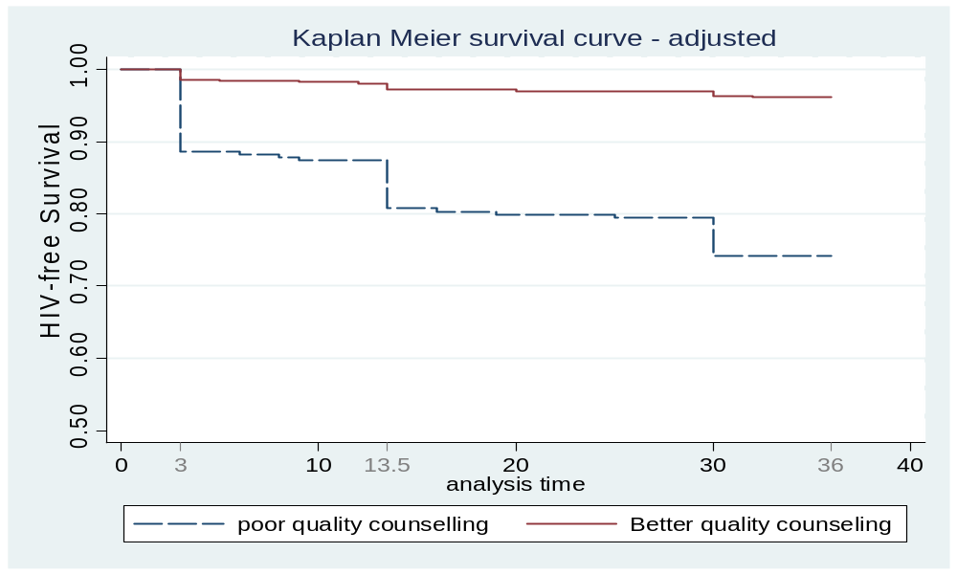

Discussion
This study suggests quality of antenatal HIV counselling significantly influences transmission of HIV and/or IMR during postnatal period at 36 weeks.

Potential causal pathways
(1) Quality of ANC counselling influences Intention of feeding & promotes appropriate feeding choice - analysis of the data using the appropriateness of feeding as an indicator shows that mothers with higher counseling score were more likely to appropriately choose formula feeding & less likely to inappropriately choose to formula feed.
(2) Quality of ANC counselling promotes adherence to feeding choice - preparing mothers ahead of time (with frequent counselling) could increase compliance to appropriate feeding postnatally. A study by Bland et. al, 2007 reports 10 times higher rate of adherence among those who were counselled > = 4 times antenatally compared to those who were counselled just once. (3) Antenatal counselling can be used to establish good relationship between mothers and health professionals which can be used to improve follow-up & support during postnatal period

Limitations of the study
The calculation of counselling score was based on reported/recalled information
Other indicators for quality of counselling such as interpersonal relationship; duration of counselling; counsellor’s skills; counsellor readiness and fluency was not appraised.
The effect of transmission at delivery & labour was not excluded – but stratified analysis shows the difference in prenatal transmission was not significant. Also, due to large number of missing values of the variable frequency of postnatal visits, the analysis was not adjusted for the effect of postnatal support/care given. Analysis by including postnatal visit after imputing the mean of postnatal visit in place of the missing values didn’t significantly change the observed association.

Conclusion & recommendation of the study
Antenatal infant feeding counselling is a feasible & acceptable service & should be used efficiently in order to reduce the MTCT & infant mortality rate.
Future research could explore the potential causal pathways (mentioned above) in the observed association.

EXPLOITING THE GAPS IN PMTCT QUALITY AND EQUITY IN SOUTH AFRICA

Courtenay Sprague and Vivian Black

Background A review of the health status of South Africans reveals a large burden of HIV infection against a context in which HIV is fully preventable and treatable. Moreover, the burden of HIV disease is not distributed evenly across race, class and sex. Rather, disaggregated data demonstrate that black South African women of reproductive age and their infants are bearing the brunt of morbidity and mortality due to HIV-related diseases. HIV prevalence in pregnant women is estimated at 30% with one in three pregnant women in South Africa living with HIV. At the same time, the overwhelming source of HIV infection in young South African children is mother to child transmission. As indicated in a recent study, 75,000 children under age five are dying each year. Significantly, more than half of these deaths — 40,000 — are preventable.

Impact Unless access to ARVs is achieved, the vast majority of children infected with HIV will die before they reach the age of two. The HIV epidemic is reversing gains in child survival in South Africa. While there is uncertainty surrounding current levels of child mortality, MRC data show that by the early 1990s the previous decline in child mortality rates has reversed. South Africa is one of 12 countries in the world falling behind in child mortality since 1990, rather than moving ahead.

Despite problems with data collection and variation among an estimated six data sources, the trend in maternal deaths in South Africa is clearly an upward one. At this rate, South Africa will not achieve the international health-related Millennium Development Goals (Goals 4 and 5 pertain to maternal and newborn health, child survival, reproductive health and HIV/AIDS). Nor will we achieve national HIV/AIDS targets identified in the HIV & AIDS and STI Strategic Plan for South Africa (2007-2011) (NSP). The NSP aims to: a) reduce the rate of new HIV infections by 50% by 2011; and b) to reduce the impact of HIV/AIDS on individuals, families, communities and society by expanding access to appropriate treatment, care and support to 80% of all HIV-positive people and their families by 2011.

The programme to prevent mother to child transmission (PMTCT), first introduced in 18 pilot sites in 2001, has since been implemented country-wide in 3,300 public health facilities. The principal aim of the programme is to “decrease the number of HIV infected babies born to HIV positive mothers”. But the Department of Health states: “The effectiveness and impact of this programme is unknown”. While PMTCT coverage is expanding, increasing both the quality and equity of services is essential to address premature morbidity and mortality in children and pregnant women.

Study Objective The study considered the primary set of barriers to pregnant women’s access to and uptake of antiretroviral medicines for their own health; and to their enrolment in and uptake of the prevention of mother to child transmission programme in two public health settings - one rural and one urban.

Methods 83 HIV positive pregnant or postnatal women indicated for PMTCT were interviewed at two public health sites: Eastern Cape and Gauteng. A qualitative, semi-structured questionnaire with a focus on in-depth, information-rich interviews was utilised. Interviews were also conducted with key health personnel employed at the sites and with key informants (academics and practitioners) with expertise in PMTCT, maternal and child health and mortality. Patient files were also reviewed. Medical ethics approval and clearance by the University of the Witwatersrand Human Research Ethics Committee (Medical) (protocol number M080119). All interviews were conducted over the one year period from March 2008 through February 2009.

Sites Two study sites were selected based on their differing rural and urban locations, different socio-economic contexts but similar HIV prevalence. The Eastern Cape is primarily a rural province. Of a population of 6.4 million, 70% are classified as poor and 30% of residents are unemployed; 93.6% of the population depends on the public health care system. In terms of racial composition, 87.5% of the Eastern Cape population is black (of African descent); 7.4% is coloured (of mixed race); 4.8% is white (of European descent); and 0.3% is Indian (of Asian descent). The population in Gauteng is estimated at 9.8 million; it is a highly urban and densely-populated province, capturing 20% of the total South African population, with an estimated 22.6% unemployment rate. Gauteng is the richest province in South Africa with an HIV prevalence estimated at 29.6%. The composition of inhabitants by race is as follows: 75.3% black; 19.9% white; 4.1% coloured; and 2.5% Indian.

Primary barriers to effective PMTCT/ART uptake and administration included the following.

Summary Results
Individual Economic: lack of money for transport (which delays or prevents visits).
Individual Psycho-social: fear of test results, denial of HIV status, fear of having to disclose to partner if HIV positive; delayed collection of timely CD4 count test results and HIV test refused (resulting in delays in initiating ART/PMTCT or missing it completely).

Health systems and health personnel: incorrect and unclear coding of woman’s HIV status in labour (leading to missed PMTCT); late initiation of the patient onto ARVs (after delivery) even though CD4 cell count test results indicated treatment; patient refused at booking (e.g., clerk turns patient away); poor or no HIV counselling received from healthcare worker (HCW) or lay counsellor; HIV testing not done by HCW in the labour ward; poor or no counselling received in labour ward; health personnel failed to administer nevirapine in labour ward (although sero-positive status was indicated); and poor or no counselling received on infant feeding (leading to mixed feeding and increasing the risk of transmission).

The Weakest Links in the PMTCT Programme in these sites:
- Quality of PMTCT coverage is highly variable
- Poorer, rural province lagging in implementation of dual therapy, raising issues around the equity of coverage for rural populations
- Poor HIV testing coverage (and poor follow up for patients who refuse testing)
- Poor HIV counseling (adherence, disclosure, support, nutrition)
- Very poor or no counseling on infant feeding
- Maldistribution of health personnel (e.g., insufficient number of healthcare workers) dedicated specifically to HIV service delivery, including ART and PMTCT interventions
- Inadequate knowledge of PMTCT on part of HCWs and lay counsellors
- Lack of clarity and consensus on monitoring and measuring PMTCT programme effectiveness nationally and within facilities studied
- Weak management, supervision, accountability and oversight within these facilities
- Weak monitoring and evaluation framework
- Poor systems for data capturing and dissemination to track progress against NSP indicators
- Poor referral networks between feeder clinics and hospitals and between units or wards within the same facility (e.g., paediatric, postnatal and adult ARV clinics)

Recommendations for the facilities in these sites are as follows.

Systems (including health personnel): addressing and improving distribution of HCWs dedicated to HIV counselling – with attention to rural, less-resourced areas - and with proper payment and performance management; support groups for women and families; routine and more frequent testing for people who have refused; earlier and more frequent ANC visits; earlier and better routine identification of women with HIV: starting HAART and initiating PMTCT earlier; plugging the gap in the delayed retrieval of CD4 cell count test results through individual calls and follow up (based on informed consent); better referral networks between postnatal wards and paediatric wards to test infants early for HIV, and to initiate ART for women and children; improved knowledge and training in key aspects of PMTCT to allow for more frequent and improved HIV counselling, including family counselling; and, improved counselling on infant feeding options is urgently needed.
Conclusions The cornerstone of PMTCT is effective counselling and testing. Attention is being paid to increasing coverage and scale, i.e., quantitative indicators. However, the quality of services, and effective ways of improving quality and equity, is receiving insufficient attention. There is an under-investment in health systems, and particularly health personnel, which is negatively impacting on the PMTCT and ART programmes for women and children. This study reveals that health personnel – the numbers of staff tasked to HIV service delivery in facilities, their skill level and competence - are a major limiting factor to prevention, care and treatment for pregnant women and children with HIV. This phenomenon is attributed to poor management, supervision, payment and conditions of HCWs, and an inappropriate distribution of health personnel in facilities. With the limited number of professional healthcare workers employed within the public sector, continued reliance on lay counsellors as bulwarks of the PMTCT programme in provinces like Gauteng; and, insufficient staff to provide testing and counseling in other provinces may be inevitable. This situation is changeable. However, if it continues as is, health outcomes are not expected to improve for those pregnant women and children with HIV who seek timely prevention and treatment from the public health system. Good health is a precondition for development. Health remains a human right in this country. So long as the stewards of our public health are neglected, this right will not be realised, and further inequity and poor health outcomes for South African women and children will result.
EVALUATION OF PATIENT-HEALTHCARE PROVIDER RELATIONSHIP AND ITS ASSOCIATION WITH ADHERENCE TO ANTENATAL CARE (ABSTRACT)

Oliver M. Barry,¹ Anne-Marie Bergh,² Elsie Etsane,² Brian Forsyth,¹ Trace S Kershaw,¹ Jennifer Makin²
¹ Center for Interdisciplinary Research on AIDS, Yale University
² MRC Unit for Maternal and Infant Health Care Strategies and University of Pretoria

Background: The prevalence of HIV among pregnant women in Pretoria, South Africa is approximately 25%. As of 2008, it is estimated that, nationally, only 60% of pregnant women are reported to receive antiretroviral drugs for the prevention of mother-to-child HIV transmission (PMTCT). Despite substantial efforts and interventions in Pretoria, a recent study has found the mother-to-child HIV transmission rate to be a disappointing 15.1%.
Previous studies in the US have demonstrated the importance of the patient-clinician relationship on antiretroviral adherence and we hypothesize that this may be an important factor contributing to adherence to PMTCT regimens and antenatal care. The purpose of this study was to develop a statistically reliable tool to evaluate the quality of the relationship between the healthcare provider and the patient, as well as to assess the potential association with attendance at antenatal care and adherence to PMTCT.
Method: Research was conducted in three phases:
(1) Development of a 19-item patient-healthcare provider relationship scale through the adaptation of previously constructed scales, addition of items appropriate for the local context, and the formulation of items into one scale
(2) Implementation of the scale in a study sample of 192 women on discharge in the post-natal wards of two hospitals in the South West Tshwane sub-district over a period of nine weeks
(3) Analysis and assessment of the reliability and demonstration of supporting evidence of the validity of the scale
Results: The average age of the study sample was 26.1 years, with 25% (48 women) being HIV positive. All women had visited government clinics for antenatal care at least one time in pregnancy (range 1-13 visits), with an average of 4.6 antenatal visits.
The draft scale was modified following reliability analysis, calculating item-total correlation, and conducting a factor analysis. The final items were chosen based on item-total correlations over 0.5, which resulted in a 14-item scale. The final scale had a high reliability (α=.91) and was demonstrated to contain only one factor. The total patient-healthcare provider relationship score determined by the scale was significantly correlated with the patient’s global rating of their relationship with the clinic (p<.001, R = .75).
Individual items from the scale provide examples of the extent of dissatisfaction with the patient-healthcare provider relationship. 30.6% of all women (n=60) reported that most often staff at the clinic did not care about them. 30.1% (n=59) reported that clinic staff never spent enough time with them, and 31.1% (n=61) reported that the clinic staff never explained to them what choices they had.
Of the 48 women who were HIV-positive, 89.1% had a CD4 count done in pregnancy, 50.0% were eligible for HAART, and 80.9% of eligible women received HAART therapy. This data provided evidence of greater adherence to PMTCT than was expected. However, there was a significant association between low scores of patient-healthcare provider relationships for HIV women and substantially inadequate antenatal care (only 1-2 visits) (p=.047).
Conclusion: The development of this scale and the demonstration of its reliability and validity in the African context allows for its use in further studies focused on adherence to treatment. The scale will now be used in a larger study designed to improve adherence to PMTCT.

BIRTH DEFECTS AND PERINATAL OUTCOMES FROM 748 PREGNANT WOMEN WHO TOOK EFAVIRENZ AS PART OF LIFELONG ANTIRETROVIRAL THERAPY. A PROSPECTIVE STUDY AT A TERTIARY HOSPITAL IN SOUTH AFRICA.

Ebrahim Bera*†; Roxaan Nonkwelo*; Batembu Mgudlwa*; Katrin McCausland*; Saji Chacko*; Busiwe Majeke*
Walter Sisulu University*; University of the Witwatersrand†

Background
Efavirenz (EFV) was reclassified in 2005 from a category C to a category D drug. This occurred following 4 retrospective case reports of birth defects in pregnant women who took EFV during the first trimester of their pregnancies.
Prospective data on women who either conceive whilst taking EFV-based antiretroviral therapy (EFV-based ART), or who are given EFV-based ART as treatment during pregnancy, are limited.

Objectives
- to determine the prevalence and type of birth defects following EFV-based ART exposure during pregnancy
- to evaluate perinatal mortality following EFV-based ART exposure during pregnancy

Methods
A local Efavirenz in Pregnancy Registry was established in January 2006 at Frere Hospital, to enable longitudinal follow-up of pregnant women within the region taking EFV-based ART. The Registry is ongoing.

For pregnant women with indications for lifelong ART, EFV-based ART was commenced with the following provisions:
- CD4 < 250 cells/mm³ or WHO stage 4 disease
- the pregnancy had progressed beyond 14 weeks of gestation
- the woman had to give written undertaking to use contraception postpartum
- a detailed fetal anatomy ultrasound examination was done prior to commencing ART
- a major psychiatric illness in the woman was excluded
Women who had conceived on EFV-based ART were given the choice of termination of pregnancy (TOP) up to 20 weeks of gestation.
For the women who elected to continue with their pregnancies, EFV was substituted in the first trimester for nevirapine (NVP) or for lopinavir/ritonavir (LPV/r). Since January 2007 all women in the first trimester were switched from EFV to NVP regardless of CD4 count. Women who presented at 14 weeks or beyond remained on EFV-based ART.
Women who had taken EFV-based ART during the entire first trimester were classified as “complete first trimester EFV exposure”. Women in whom EFV was substituted for another drug in the first trimester were classified as “partial first trimester EFV exposure”. The first trimester ended at 13 weeks and 6 days.
The primary outcomes measured were the prevalence and type of birth defects.
The prevalence of birth defects was calculated as the ratio of the number of birth defects observed in all pregnancies beyond 24 weeks of gestation, over the total number of live births. Birth defects in twins were counted separately. More than one defect in a singleton was counted as one event. A cohort of at least 200 live births exposed to EFV-based ART was deemed sufficient to detect a two-fold increase in the overall risk of birth defects compared to those observed internationally.
Secondary outcomes were perinatal mortality (PNMR) and risk factors for birth defects. Risk factors evaluated included maternal age ≥ 35 years, family history of birth defects, duration of EFV use prior to conception, concurrent co-trimoxazole (CTX) use, complete first trimester EFV exposure, and VL < 50 copies/ml at confirmation of pregnancy.
Study approval was obtained from the local research and ethics committee.

Results
Study period 01 January 2006 until 31 October 2008

Women commenced on EFV-based ART from the 2nd trimester onwards (N = 568)
Total number of pregnancies 682
Ongoing pregnancies 86
Lost to follow up (%) 28 (4.7%)
Women with pregnancy outcomes 568
Median age: in years 29 (IQR 25 - 32)
Primigravida (%) 203/567 (36%)
Median CD4 count: in cells/mm³ 172 (IQR 108 - 221)
CD4 < 250 cells/mm³ (%) 509/568 (90%)
Median plasma VL: in log₁₀ copies/ml 4.45 (IQR 3.81 – 5.04)
WHO stage 4 disease (%) 25/568 (4%)
Concurrent ART & TB treatment (%) 38/568 (7%)
Median gestation at ART initiation: in weeks 30 (IQR 25 - 34)
Median duration of ART: in weeks 8 (IQR 4 – 13)
Median gestation at delivery: in weeks 39 (IQR 37 - 40)
Median birth weight: in kg 3.00 (IQR 2.60 - 3.22)

Fourteen women (2.5%) had twin pregnancies.
One woman had a set of triplets.
Five miscarriages (includes a set of triplets), 7 stillbirths, and 9 early neonatal deaths – PNMR of 27.7 per 1000 births.
Of the 570 live births, 290 (50.9%) were male.

Birth defects were observed in 14 out of 570 live births.
The prevalence of birth defects was 2.5% (95% CI 1.4 – 4.2).

N = number of women with pregnancy outcomes; VL = viral load; WHO = World Health Organization; TB = tuberculosis; IQR = interquartile range; CI = confidence interval; PNMR = perinatal mortality rate

Type of Birth defects following second trimester EFV exposure

 | AGE | CD4 | Gestation  of ART | Duration  of ART | VL at  delivery | Type of  Defect | Outcome
#1 | 27 yrs | 248 | 26 wks | 12 wks | < 50 | Arachnoid Cyst | Conservative  Management
#2 | 27 yrs | 15 | 15 wks | 25 wks | < 50 | Suspected  Pulmonary  Stenosis | ENND  Intrapartum  asphyxia
#3 | 21 yrs | 53 | 29 wks | 9 wks | < 50 | Bilateral  Clubfeet | above-knee  POP
#4 | 35 yrs | 209 | 32 wks | 6 wks | 310 | Polydactyly  fleshy digits | Tied off
#5 | 36 yrs | 131 | 37 wks | 2 wks | No  result | Left hand  Extra digit | No  intervention
#6 | 26 yrs | 172 | 33 wks | 9 wks | < 50 | Polydactyly  fleshy digits | Tied off
#7 | 35 yrs | 13 | 35 wks | 6 wks | No result | Polydactyly fleshy digits | No intervention
#8 | 32 yrs | 93 | (twins)  31 wks | 2 wks | < 50 | Left hand Extra digit | Tied off
#9 | 30 yrs | 218 | 34 wks | 7 wks | < 50 | Right hand Extra digit | No intervention
#10 | 37yrs | 181 | 36 wks | 2 wks | 88 | Congenital naevus | No intervention
#11 | 27 yrs | 150 | 23 wks | 18 wks | < 50 | Umbilical hernia | No intervention
#12 | 34 yrs | 107 | 33 wks | 5 wks | 260 | Umbilical hernia | No intervention
#13 | 30 yrs | 194 | 29 wks | 9 wks | No result | Umbilical hernia | No intervention
#14 | 21 yrs | 157 | 36 wks | 2 wks | 59 | Overlapping fingers, facial asymmetry | “Resolution”

yrs = years; wks = weeks; gestation of ART = gestation at initiation of ART; VL = viral load in copies/ml; ENND = early neonatal death; POP = plaster of paris
Arachnoid cyst: a posterior fossa cyst was identified in the fetus on ultrasound examination at the time of ART initiation. Computer tomography (CT) scan done on the neonate showed an arachnoid cyst.
Pulmonary stenosis: the neonate died following severe intrapartum asphyxia prior to confirmation of defect.
Polydactyly: all cases were postaxial polydactyly involving hands; no bone, bony fragments or nails were identified on the extra digit/s.
Congenital naevus: 2.5 cm naevus present over anterior abdominal wall.

Women with 1st trimester EFV-based ART exposure (N = 180)

Total number of pregnancies 205
Ongoing pregnancies 18
Lost to follow up (%) 7 (3.7%)
Women with pregnancy outcomes 180

Median age: in years 30 (IQR 27 - 34)
≥ 35 years (%) 39/180 (22%)
Primigravida (%) 41/180 (23%)
EFV-based ART > 1 month prior to conception (%) 166/180 (92%)
Concurrent CTX prophylaxis (%) 60/180 (33%)
Median CD4 count at presentation: in cells/mm³ 276 (IQR 194 - 375)
VL < 50 copies/ml at presentation (%) 127/174 (73%)

Median gestational age at presentation: in weeks 19 (IQR 12 - 25)
Prior to 6 weeks (%) 9/180 (5%)
Between 6 and 13 weeks (%) 41/180 (23%)
At or beyond 14 weeks (%) 130/180 (72%)

All pregnancies were unintended
3 women accepted TOP
2 women had ectopic pregnancies
3 women (1.7%) had twin pregnancies

EFV was substituted for NVP in 51 women (28%) and for LPV/r in 8 women
123 women (68%) had complete first trimester EFV exposure

Median gestation at delivery: in weeks 39 (IQR 37 - 40)
Median birth weight: in kg 3.00 (IQR 2.60 - 3.30)

Six miscarriages (includes a set of twins), 4 stillbirths, and 2 early neonatal deaths – PNMR of 35.1 per 1000 births
Of the 167 live births, 83 (49.7%) were male

Birth defects were observed in 5 out of 167 live births and 1 out of 4 stillbirths
The prevalence of birth defects was 3.6% (95% CI 1.3 – 7.7)

N = number of women with pregnancy outcomes; CTX = co-trimoxazole; VL = viral load; TOP = termination of pregnancy; NVP = nevirapine; LPV/r = lopinavir/ritonavir; IQR = interquartile range; CI = confidence interval; PNMR = perinatal mortality rate

Type of Birth defects following first trimester EFV exposure

 | MAT  AGE | VL | CTX  USE | Gest Age  Presenting | Complete 1ST Trim EFV | B/W  (kg) | BIRTH  DEFECT | OUT  COME
#1 | 43 yrs | < 50 | No | 26 weeks | Yes | 1.1 | Enlarged  cisterna magna.  †Trisomy 18 | TOP  SB
#2 | 36 yrs | < 50 | No | 18 weeks | Yes | 3.2 | ‡AMC: Joint  contractures,  webbed limbs,  cleft palate,  absent sacrum | ENND
#3 | 37 yrs | 6400 | No | 09 weeks | No. Until 9 weeks | 1.8 | Oesophageal atresia | Surgical  Repair
#4 | 28 yrs | 15000 | Yes | 14 weeks | No.  From 13 weeks onwards | 2.8 | Postaxial polydactyly fingers*.  Pre-axial polydactyly, syndactyly toes** | No intervention
#5 | 33 yrs | < 50 | Yes | 17 weeks | Yes | 2.8 | Postaxial polydactyly | Tied off
#6 | 31 yrs | < 50 | No | 31 weeks | Yes | 3.8 | Central lower incisor tooth | Extraction

MAT = maternal; VL = viral load at presentation (in copies/ml); CTX = co-trimoxazole; Gest Age = gestational age at presentation; Trim = trimester; B/W = birth weight; AMC = arthrogryposis multiplex congenita; TOP = termination of pregnancy; SB = stillbirth; ENND = early neonatal death
†Trisomy 18 was confirmed antenatally following analysis of amniotic fluid
‡AMC: Fetal akinesia and polyhydramnios were the pre-eminent findings on ultrasound examination. Chromosomal studies done on amniotic fluid obtained antenatally were normal.
*extra digits fully formed with phalanges and a nail
**extra digits fully formed with phalanges and nail, fused with big toe

Pregnancy outcomes and a summary of birth defects by organ system of all pregnancies exposed to EFV-based ART, utilizing the Antiretroviral Pregnancy Registry (APR) system of classification of birth defects.

First trimester EFV Second/third trimester
Exposure EFV Exposure
Number of Pregnancies 180 568
Number of Twins 3 14
Number of Triplets 0 1
Number of TOP / Ectopic 5 0
Number of Miscarriages 6 5
Number of Stillbirths 4 7
Number of Live births 167 570
Number of Birth Defects 6 14
Prevalence of Birth Defects 3.6% 2.5%
Birth Defect 1st trimester EFV 2nd / 3rd trimester EFV
Nervous system 0 1
Face and neck 1 1
Cleft lip and/or palate 0 0
Heart 0 1
Respiratory system 0 0
Musculoskeletal system 0 2
Skin and skin derivatives 0 1
Limb reduction/addition defects 2 6
Digestive system 1 3
Renal and urinary system 0 0
Genitalia 0 0
Chromosomal abnormality 1 0
Specified syndromes 1 0
Note: for each organ system, counts represent the number of outcomes with at least one defect occurring in that organ system. For each defect, counts represent the number of outcomes manifesting at least one occurrence of the defect. Hence, counts are not mutually exclusive across organ systems.

Multivariate logistic regression analysis of risk factors for birth defects following first trimester EFV use

VARIABLE | AOR | 95% CI | P - VALUE
Age ≥ 35 years | 3.89 | 0.73 – 20.82 | 0.112
EFV > 1 month  prior to conception | 0.30 | 0.02 – 4.48 | 0.379
CTX use | 0.75 | 0.10 – 5.74 | 0.783
VL < 50 copies/ml  at presentation | 0.71 | 0.11 – 4.51 | 0.720
Complete first  trimester EFV use | 0.81 | 0.12 – 5.48 | 0.825
Results from multivariate logistic regression analysis of risk variables for the occurrence of birth defects, with birth defects as the dependant variable. VL = viral load;
AOR = adjusted odds ratio; CI = confidence interval; CTX = co-trimoxazole

Discussion
- Largest study to-date on EFV-based ART exposure from the second trimester of pregnancy onwards
- Prevalence of birth defects was 2.5% (95% CI 1.4 – 4.2) following 2nd trimester EFV use, and 3.6% (95% CI 1.3 – 7.7) following 1st trimester EFV exposure
- This rate is consistent with rates from published data on other classes of commonly used antiretroviral drugs internationally
- The observed birth defects were in some cases of questionable relation to EFV, and in one case unrelated to EFV exposure. The infant with posterior fossa arachnoid cyst benefited from ultrasound diagnosis at the time of ART initiation
- The results are reassuring, although the number of women in this cohort is still relatively small
- The only signal detected was postaxial polydactyly, a relatively common condition in South Africa with a reported prevalence of 15.49 per 1000 live births
- There were no cases of anophthalmia, neural tube defects or Dandy-Walker malformation following first trimester EFV-based ART exposure
- Although no specific pattern of birth defects was found, the number of exposed women does not permit any definitive conclusions to be made on EFV teratogenicity in the first trimester
- In resource-poor countries where ART options are limited, and coupled with it the high burden of HIV and TB, it is likely that EFV will remain an important component of ART
- The declining international use of EFV-based ART in pregnancy has made the establishment of a national South African registry become necessary.
HIV TRANSMISSION FROM MOTHER TO CHILD - HAART COMPARED TO DUAL THERAPY

Gerhard Theron¹, Myrthe Nellensteijn², Anneke Theron¹ and Jeanne Louw¹.
Department of Obstetrics and Gynaecology, Faculty of Health Sciences, Stellenbosch University and Tygerberg Hospital.¹ Academisch Medisch Centrum/Medical School, University of Amsterdam, The Netherlands.²

Introduction
Recently increasingly voices are calling for the use of highly active antiretroviral therapy (HAART) for the prevention of perinatal mother to child transmission of HIV (PMTCT). This approach does not recognize the weaknesses in health systems to implement complex treatment protocols. In addition the safety of HAART during pregnancy is uncertain and the consequences of stopping HAART if not required outside pregnancy unknown. If the same PMTCT of HIV could be reached with a simple regimen with proven safety and known adverse drug effects, this will be the better option in most under resourced countries. The superiority of HAART compared to dual therapy according to WHO recommendations for immune competent women to reduce PMTCT has not been proven.
The aim of the present study was to determine whether there is a difference in perinatal HIV transmission on HAART therapy compared to the national dual therapy regimen. In addition, the relation between CD4 counts and transmission in the dual therapy group was investigated.

Method
A retrospective case control study was conducted. Files of all HIV positive women who delivered at Tygerberg Hospital (TBH) between January 2007 and April 2008 with Delft and Mfuleni addresses were obtained after discharge. The antiretroviral treatment, which could be either HAART or dual therapy, received during pregnancy was recorded, along with the date dual therapy was commenced. HAART was only commenced if the CD4 count was <250 cells/mm³ and the gestational age less than 34 weeks according to the provincial PMTCT guideline used during the study period. The first line HAART regimen consists of stavudine (d4T), lamivudine (3TC) and nevirapine (NVP).^{4,5} Adequate dual therapy was at least 2 weeks of antenatal zidovudine (AZT), intrapartum single dose (sd) NVP and AZT (300mg 3 hourly per mouth) as well sd NVP and AZT for one week for the newborn baby. The first CD4 count available was recorded and broken down into <250 and >250 cells/mm³. Information regarding the type of delivery and the mother’s infant feeding choice were also recorded. Babies of HIV+ mothers were tested for HIV with DNA PCR’s at 14 weeks of age. Fisher’s exact test was done to determine whether the difference in transmission between the 2 groups are significant.

Results
A total of 581 HIV positive women from the confined geographic area delivered babies during the study period. The study group included 73 women on HAART. 508 women received dual therapy, of these 257 (50.6%) were eligible because their dual therapy were regarded as adequate, and 146 were selected randomly for inclusion in the control group. Of the study group, 62 babies were available for follow-up and 58 (80.8%) had PCR’s, 4 mothers declined PCR’s and 11 (15.1%) babies could not be traced. In the control group 124 newborn babies were available for follow-up and 119 (81.1%) had PCR’s, 5 mothers declined PCR’s and 22 (15.1%) babies could not be traced.

The difference in transmission rates in the study 2/58 (3.4%) and control group 12/119 (10.1%) is not significant (p=0.15). The CD4 count in the study group was <250 cells/mm³ in 56 (76.7%) and >250 cells/mm³ in 17 women. Both women that transmitted HIV to their babies were in the <250 cells/mm³ group. In the control group the CD4 count distribution is shown on Table I. Transmission rate of women (Table I) with a CD4 count >250 cells/mm³ was 6/98 (6.1%) and if the CD4 count was <250 cells/mm³ the transmission rate was 6/21 (28.6%). The transmission rates in the control group according to three CD4 count cut off values are shown in Table I. The caesarean section rate in the study group was 32.9% (31/73), with 7 elective caesarean sections. In the control group the rate was 33.3% (56/146) with 8 elective caesarean sections. There was no significant difference regarding elective caesarean sections between the two groups (p=0.3). There was one mother that chose exclusive breast feeding in the in the study group and 3 mothers in the control group. No information about infant feeding was available about 2 mothers in the study group and one in the control group. All the other mothers went home formula feeding their babies.

Discussion
The study was confined to two high prevalence geographic areas whose clinics send their PCR tests on babies to the virology laboratory at the Faculty of Health Sciences at TBH. The numbers are small and the results need to be interpreted with the necessary caution. The provincial protocol used a CD4 cut off for HAART of <200 cells/mm³. This was changed <250 cells/mm³ in October 2006 by clinicians working in TBH. The proportion of women in the dual therapy group with adequate therapy (50.6%) compares favourably to what was achieved with the PMTCT programme in the public health sector in Thailand (61.7%). More strict criteria were applied for adequate dual therapy (at least 2 weeks of antenatal AZT) in the index study. The proportion of babies whose information was available for transmission rates to be determined (80.8 and 81.1% in the study and control group respectively) is also in accordance with what was found in Thailand (75.8%). Invariably a proportion of women with CD4 counts of <250 cells/mm³ will be on dual therapy. The most common reasons being CD4 counts results available with a gestational age >34 weeks (too late to commence HAART according the 2003 provincial PMTCT protocol), missing appointments at the ARV clinic, defaulting antenatal visits, first contact with health care when in labour and failing the adherence program.

The high transmission rate (10.1%) in the adequate dual therapy group is due to a very high transmission rate in the group with a CD4 count <250 cells/mm³ (28.6%). A CD4 count of <250 cells/mm³ seems to be a reasonable cut off for initiation of HAART as the transmission rates at higher counts do not improve markedly (Table I). The proportion of women that will require HAART with a CD4 cut off of <350 cells/mm³, will be more than doubled in the adequate dual therapy group (14.6 to 36.1%). Early first attendance of antenatal clinics is very important. CD4 counts of HIV positive women need to be available within one week. Every effort should be made to initiate HAART if the CD4 count is <250 cells/mm³. A larger study is required to compare whether HAART and dual therapy have an equivalent transmission rate at a higher CD4 count cut off than 250 cells/mm³.

Table I. The transmission rate in the dual therapy group according to various CD4 count (cells/mm³) cut off values.

CD4 Group* | N (%) | Tested  PCR yes (%) | Positives | Transmission  rates (%)
<250 | 21 (14.6) | 21 (100) | 6 | 28.6
≥250 | 123 | 98 (78) | 6 | 6.1
<350 | 52 (36.1) | 45 (87) | 8 | 17.8
≥350 | 92 | 74 (80) | 4 | 5.4
<500 | 93 (64.6) | 77 (83) | 10 | 13.0
≥500 | 51 | 42 (82) | 2 | 4.8
* 2 of the 146 CD4 counts could not be traced

THE MATERNAL MORTALITY RATIO AND PERINATAL MORTALITY RATE OF ZIMBABWE IN 2007 (ABSTRACT)

Munjanja SP¹, Nyandoro M², Magwali T¹, Mushangwe V¹, Magure T, Chirehwa M¹, Nystrom L³. University of Zimbabwe¹, Ministry of Health and Child Welfare, Zimbabwe², University of Umea, Sweden³

Introduction
The national maternal mortality ratio (MMR) for Zimbabwe has been previously reported to be between 300 and 2000 per 100,000 live births from studies using sisterhood methods, the census and statistical modelling. These methods are not precise enough to allow monitoring of the national MMR to be done at intervals of less than 15 years. This means the impact of the safe motherhood program cannot be assessed in the medium term. It was decided to establish the MMR of Zimbabwe using direct estimation with enough precision to monitor trends every 10 years.

Methodology
The design was a population-based cross-sectional study of maternal deaths. It was a combination of a population-based survey of births and a reproductive age mortality study (RAMOS) in women. Cluster sampling was applied to select 11 districts randomly out of the 61 in Zimbabwe. The sample size was based on an estimate of the MMR of 700 per 100,000 live births. Taking into account the cluster design, a sample size of 45,000 was needed to obtain an estimate with a 95% confidence interval of +-15%. Fieldwork started on the 1st May 2007 and ended on the 21st April 2008. Multiple sources of information were used to obtain information on births and maternal deaths. These included the women themselves, health facilities, ward and village councillors, traditional birth attendants, police and family members. Birth and death registers were distributed in all wards and villages of the study. The death of every woman of reproductive age (12-49) was recorded at community level, and maternal verbal autopsy was conducted if the cause of death was unknown. Verification of maternal deaths was carried out at household level in a quarter of the wards in the districts to determine a correction factor for the maternal mortality ratio (MMR).

Results
There were 45222 births recruited into the study, out of which there were 236 maternal deaths and 1256 perinatal deaths. After applying a correction factor for maternal deaths of 1.29, the national MMR for Zimbabwe was 694 per 100,000 live births. The 95% confidence limits of the MMR are 591-797. The leading causes of deaths were HIV/AIDS(26%), postpartum haemorrhage (16%), eclampsia (11%), puerperal sepsis (7.4%), abortion complications (6.1%), malaria (5.6%), obstructed labour (2.6%). 87% of deaths were due to delays 1,2, 3 or a combination of them and were thus avoidable. 65% of deaths occurred in the postpartum period and 49% occurred at home or in transit to the facility. The were 763 stillbirths and 483 early neonatal deaths giving a perinatal mortality rate of 28 per 1000. The main causes of perinatal deaths were stillbirth ,unknown cause (38%), prematurity (22%), birth asphyxia (21%) and neonatal sepsis (6%).

Conclusion
The population based survey succeeded in establishing the national MMR and PNMR with acceptable precision. The MMR has risen since the 1992 estimate, and HIV/AIDS is now the leading cause of maternal deaths. The vast majority of deaths are avoidable.

RISK FACTORS FOR PERINATAL DEATHS AT NSAMBYA HOSPITAL , UGANDA: RETROSPECTIVE CASE -CONTROL STUDY (ABSTRACT)

Victoria Nakibuuka, Romano Byaruhaga , Puis Okong , Waiswa Peter
Department of Paediatrics, Nsambya Hospital

Reducing perinatal deaths in developing countries remains a hindrance to achieving the millennium targets for child survival. Globally, more than 760,000 perinatal deaths occur, 98% of these in developing countries. This reflects the vicious cycle of adverse social and environmental factors that are indicators of the quality of obstetric and newborn care. Understanding risk factors for perinatal deaths is crucial for designing effective interventions in developing countries.

Objective
To determine the risk factors for perinatal deaths at a large mission urban referral hospital in Uganda.

Methods
Data was obtained from 100 cases and 200 controls among births that occurred in the year 2007. Cases included babies of gestation age 28 weeks and above who were born dead or died in the first week of delivery; while controls included all babies( 28 weeks and above) less than one week who were discharged alive. Univariate and multiple logistic regression analysis were conducted to compute odds ratios and their confidence intervals at p < 0.05.

Results
A total of 6861 deliveries were registered in 2007, giving a PMR of 63 per 1000 live births. Out of the 100 cases: Macerated still births comprised 31 (31%), Fresh Still births 41 (41%), Early neonatal deaths 29(29%). Independent predictors of perinatal deaths included: Malaria OR 4.425, (95% CI 1.028 – 19.056) , Abruptio Placenta OR 11.349,( 95% CI 1.086 – 118 ), Referral from other centres OR 17.6 (95% CI 5.29 – 58.91) and birth weight less than 2.5 kg , OR 11.943 ( 95% CI 5.418 – 26.328)

Conclusion
The risk factors for perinatal deaths were: Malaria, abruption placenta, referral from other centres and low birth weight.

Recommendation
Proper ANC attendance with emphasis on three DOTs for Intermittent presumptive treatment and early recognition of referrals followed by prompt and appropriate timely management may reduce perinatal deaths at Nsambya Hospital.
OVERVIEW OF THE FOURTH SAVING MOTHERS REPORT: 2005-2007 (ABSTRACT)

N Khaole
Director Maternal Health, National Department of Health

During 2005-2007, 4077 maternal deaths were reported to the NCCEMD. The main findings are given below:
- In this triennium there has been a 20.1% increase in the number of deaths reported compared with the previous triennium (2002-2004).
- The “big five” causes of maternal death have remained the same, namely non-pregnancy related infections – mainly AIDS (43.7%), complications of hypertension (15.7%), obstetric haemorrhage (antepartum and postpartum haemorrhage; 12.4%), pregnancy-related sepsis (9.0%) and pre-existing maternal disease (6.0%).
- There has been a significant decrease (14%) in the institutional Maternal Mortality Ratio (MMR) for complications of hypertension. There was a significant increase (21%) in deaths due to non-pregnancy related infections. There were no other significant changes in the disease pattern.
- Women less than 20 years of age were at greater risk of dying due to complications of hypertension whereas women 35 years and older were at greater risk of dying of obstetric haemorrhage, ectopic pregnancies, embolism, acute collapse and pre-existing medical disease.
- Non-attendance and delayed attendance at the health institutions were the most common patient orientated problems.
- Poor transport facilities, lack of health care facilities and lack of appropriately trained staff were the major administrative problems.
- The most frequent health care provider avoidable factors were failure to follow standard protocols, poor problem recognition and initial assessment.
- Assessors thought 38.4% of the deaths were clearly avoidable within the health care system (patient orientated factors being excluded). Complications of hypertension, obstetric haemorrhage, pregnancy related sepsis and non-pregnancy related infections were responsible for 4 out of 5 of avoidable deaths.
- Recommendations concern four main areas (knowledge development, quality of care and coverage of reproductive health services, establishing norms and standards and community involvements):
  - Improving health care provider knowledge and skills in providing emergency care and ensuring adequate screening and treatment of the major causes of maternal death.
  - Improving quality and coverage of reproductive health services, namely contraceptive and termination of pregnancy services.
  - Management provision of staffing and equipment norms, transport and availability of blood for transfusion.
  - Community involvement and empowerment regarding maternal, neonatal and reproductive health in general.
NEONATAL DEATHS IN SOUTH AFRICA: CAUSES AND AVOIDABLE FACTORS

S Velaphi, RC Pattinson, N Rhoda

Background
The Millenium development goal number four aims to reduce number of deaths of children under five years old by two thirds. Neonatal deaths account for 30 to 40 percent of deaths of children under the age of five years. Most neonatal deaths occur in the first week of life. Therefore it is important to reduce early neonatal mortality rates as part of the goal to reduce the under five mortality rate by two thirds. As part of reducing the early neonatal mortality rate one needs to know the current number of early neonatal deaths, causes of neonatal deaths and avoidable factors contributing to these deaths. Currently in the country there are a number of health care facilities that conduct perinatal mortality audits using the Perinatal Problem Identification Program (PPIP). This program collects information on number of deaths, pathological causes of deaths and avoidable factors associated with these deaths. In this paper we report on causes of early neonatal deaths and avoidable factors associated with these deaths from health care facilities using PPIP in South Africa.

Methods
This was a retrospective review of data collected over a two year period from January 2006 to December 2007 by health care facilities using PPIP. These facilities conducted reviews of all neonatal deaths monthly. Data which included maternal and infant details were collected on all births, stillbirths and neonatal deaths using PPIP. Data from all these facilities were collated and analyzed focussing on number of deaths, causes of neonatal deaths and avoidable factors. Facilities were grouped into community health centres, district hospitals, regional hospitals, provincial tertiary hospitals and national central hospitals.

Results
There were 244 health care facilities that used PPIP from January 2006 to December 2007. These accounted for 37% of all health care facilities conducting births in South Africa (Table 1). These PPIP sites conducted 659 809 births, with most of the births conducted in district and regional hospitals (Table 2). The number of births conducted in the PPIP sites accounted for 40% of all deaths conducted in South Africa according to District Health Information System (DHIS).

Table 1 The number of health facilities conducting births in South Africa and the facilities using PPIP.
Sites | South Africa | PPIP Sites | PPIP Sites as % of South Africa
Community Health Centers | 327 | 51 | 17%
District Hospitals | 257 | 137 | 53%
Regional Hospitals | 65 | 46 | 71%
Provincial Tertiary Hospitals | 6 | 5 | 83%
National Central Hospitals | 9 | 5 | 56%
Total | 664 | 244 | 37%

Table 2 The number of births conducted in all health care facilities in South Africa and in facilities using PPIP.
Sites | South Africa | PPIP Sites | PPIP Sites as % of South Africa
Community Health Centers | 262 570 | 73 546 | 28%
District Hospitals | 719 508 | 288 549 | 40%
Regional Hospitals | 494 614 | 235 999 | 48%
Provincial Tertiary Hospitals | 32 000 | 93 401 | 34%
National Central Hospitals | 101 298 | 29 715 | 29%
Total | 1 671 371 | 659 809 | 40%

There were 9367 deaths from PPIP sites over this two year period, with an overall neonatal mortality rate of 14.2/ 1000 live births. Most of the deaths in the PPIP sites occurred in district and regional hospitals (Table 3).

Table 3 Neonatal deaths according to the different health care facility groups.
Sites | Early Neonatal Deaths | Late Neonatal Deaths | All Neonatal Deaths (%)
Community Health Centers | 219 | 23 | 242 (2.6)
District Hospitals | 3533 | 601 | 4134 (44.1)
Regional Hospitals | 2962 | 835 | 3797 (40.5)
Provincial Tertiary Hospitals | 475 | 128 | 603 (6.4)
National Central Hospitals | 500 | 91 | 591 (6.3)
Total | 7689 | 1678 | 9367

The number one cause of neonatal deaths was prematurity or immaturity related conditions followed by hypoxia related conditions due to intrapartum asphyxia. Immaturity or prematurity related conditions were the common causes of deaths in all facilities (Figure). Hypoxia-related conditions were the second group of conditions causing death except in provincial tertiary and national central hospitals where congenital abnormalities were the second cause.

Figure 1 The causes of neonatal deaths according to the different health care facility groups.
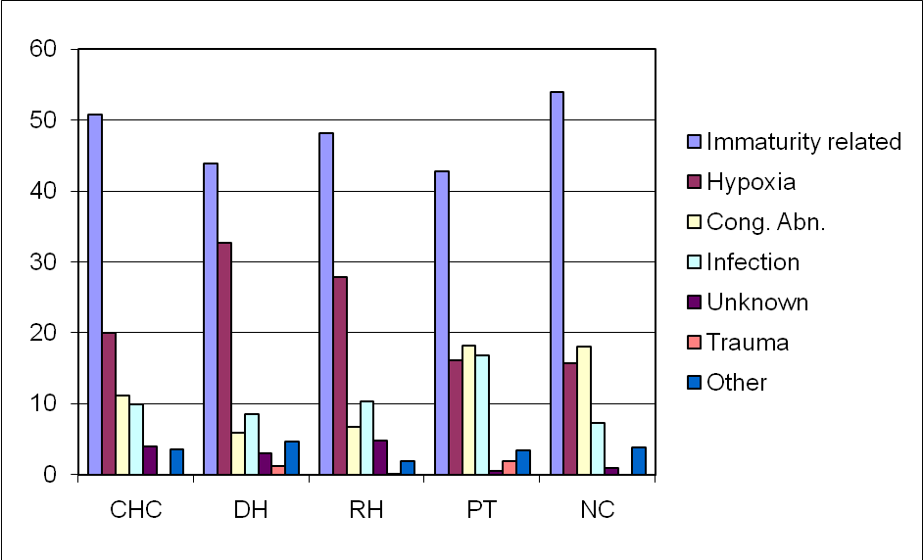

In 43% of the neonatal deaths there were factors that were identified that if they were corrected these deaths could have been prevented. These avoidable factors were almost equally distributed amongst the health care workers, administrators and patients. The common avoidable factors in the health system (health care worker and administrator) are inadequate facilities/ equipment required to take care of ill neonates and inadequate monitoring of women during labour and inadequate management plan of their infants post delivery. The common patient associated avoidable factors are delays in seeking medical attention and never initiating antenatal care.

Table 4 Avoidable factors according to the health care worker, patient and administrator
Health Care Worker Related  - Neonatal care- inadequate management plan  - Foetal distress not detected: monitored  - Prolonged second stage with no monitoring | 1449  - 169  - 166  - 97 | 16%  - 11.7%  - 11.5%  - 6.7%
Patient Associated  - Delay in seeking medical attention during labour  - Never initiated care  - Booked late in pregnancy | 1368  - 480  - 346  - 190 | 15%  - 35.1%  - 25.2%  - 13.9%
Administrator related  - Inadequate facilities/ equipment in neonatal unit  - Inadequate resuscitation equipment  - Lack of transport: home to institution | 1103  - 417  - 121  - 96 | 12%  - 37.8%  - 11.0%  - 8.7%
Missing data | 120 | 1%

Conclusion
Most of the deaths occur in district and regional hospitals, and most of the deaths are due to preterm births and due to conditions related to intrapartum hypoxia. Looking at the avoidable factors it is clear that about 40% of these deaths can be prevented. To achieve this there needs to be more focus in neonatal care in district and regional hospitals. The administrators (departments of health and managers of health care facilities) need to ensure that appropriate equipment is provided to the health care workers. Health care workers need to adhere to protocols and use the national guidelines in maternal and neonatal care.
NEONATAL CARE IN PRIVATE PRACTICE: A BRIEF OVERVIEW

HC Schuman

Introduction

Most neonatal units in South Africa, associated with both the Netcare and Mediclinic Hospital groups, are participants in the Vermont Oxford Neonatal Network. Established in 1988, the Vermont Oxford Network is a non-profit, voluntary collaboration of health care professionals, dedicated to improving the quality and safety of medical care for newborn infants and their families. The Network maintains a database on both very low birth weight infants, as well as other high-risk newborns, admitted to the neonatal unit for care. (Expanded database).

The VLBW database includes information concerning the outcomes and interventions for infants with birth weights between 501 and 1500 grams, or gestational age between 22 and 29 weeks. Centre specific data for these infants are presented and compared to data collected at all neonatal intensive care units (NICUs) participating in the Vermont Oxford Network VLBW Database, for a given time period. The data in this report should be used to target specific clinical practices and patient outcomes for further in-depth analysis, with the goal of identifying potential quality improvement opportunities. It is also used to monitor the impact of new treatment strategies over time and to use the VON results as a benchmark reference.
The pooled data of the participating neonatal units in 2007 of Netcare (14 hospitals) and Mediclinic (8 hospitals), are compared to the data of all the participating centers of the Vermont Oxford Network. The data represented here is for the period, January 1 to December 31, 2007.

Results
The numbers of admissions in the various hospitals are as follows: (The numbers are small though if compared to the international level.)

Netcare Medi-clinic Network
VLBW 456 264 56457

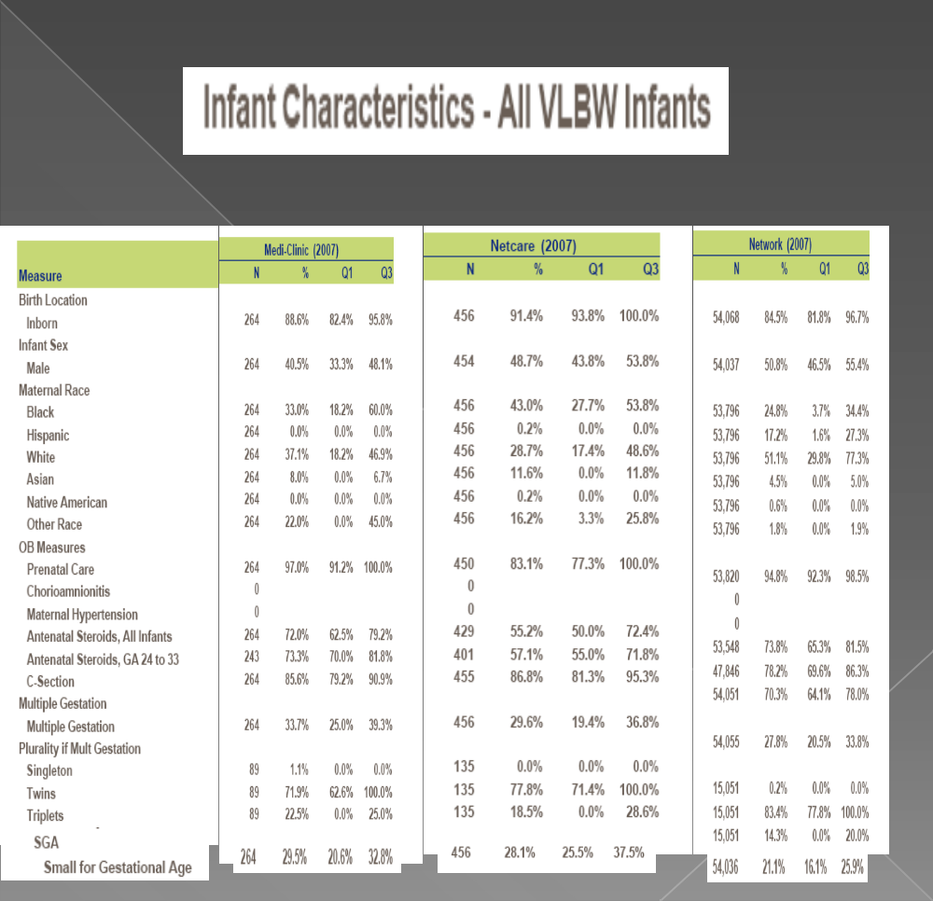

Infant characteristics.
Infant characteristics are shown in table 1. It is important to note that the small for gestational age rate in the Netcare and Mediclinic Hospitals are higher than the international norm.
The percentage of C-sections as means of delivery is higher in our setting as is seen internationally. [Graph 1]
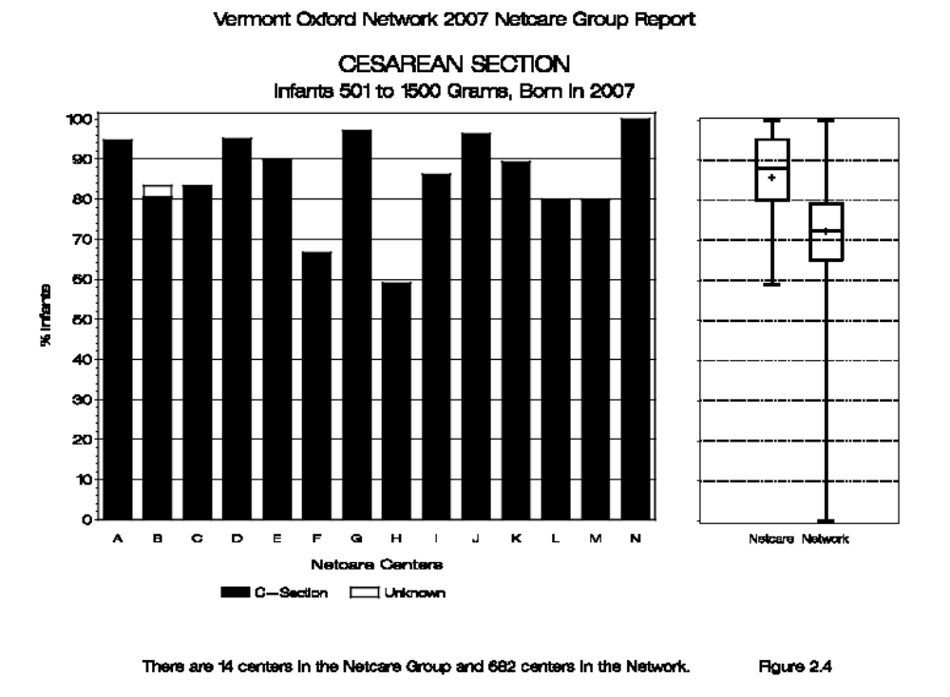
Graph 1.

The use of antenatal steroids can be seen in graph 2. Although the Mediclinic Hospitals compare well to the international usage, the Netcare Hospitals can do better. Graph 3 shows the antenatal steroid use in the different weight categories. Again it is shown that antenatal steroids is not being used optimally.
Chronic Lung disease as a complication of prematurity is a good marker of neonatal care. As can be seen in graph 4 our centres are doing very well with preventing chronic lung disease. It is important though to acknowledge that our private hospitals have a higher SGA rate than that of the VON network.
Another important complication of prematurity is severe Intraventricular Haemorrhage (Gr 3-4) (IVH). [Graph 5] It can be seen that both our Private sectors are doing well compared to the international data. However, the incidence of IVH could be higher, as reflected in Graph 6, if more ultrasound examinations are done at the level of the international participants in VON.
Retinopathy of Prematurity (ROP) is another important complication of Prematurity. Data from our hospitals are below that of the international norm. [Graph 7] Again the data can be compromised, as a result of the fact that certain hospitals do not conduct enough eye exams for ROP. Graph 8
On average the mortality in the babies <1500g are the same as the network, But looking at mortality in the different weight categories, it can be seen that we can try and do better with the smallest babies. Graph 9.Graph 10 clearly shows that according to the adjusted average total hospital stay days, the Netcare Hospitals fall within the international average.

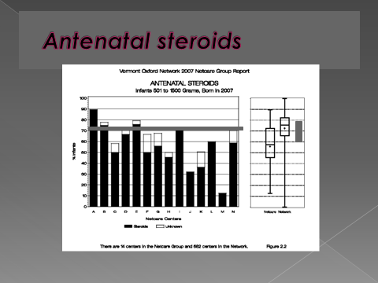
Graph 2
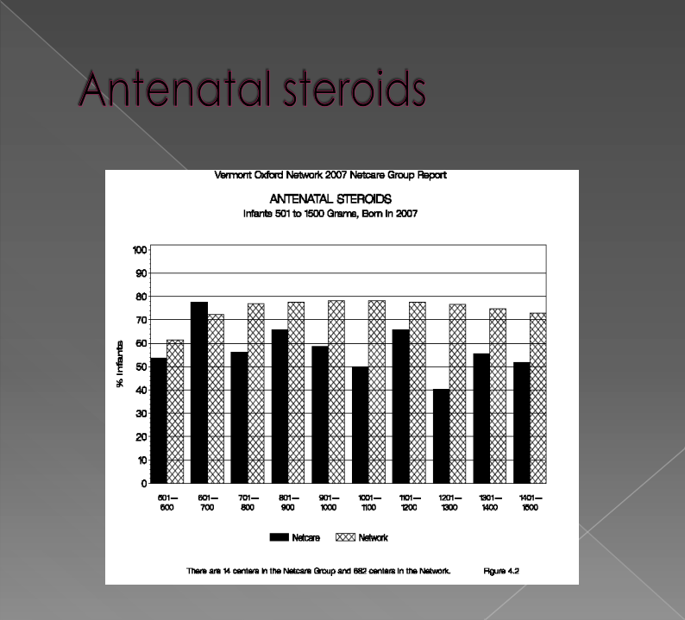
Graph 3.

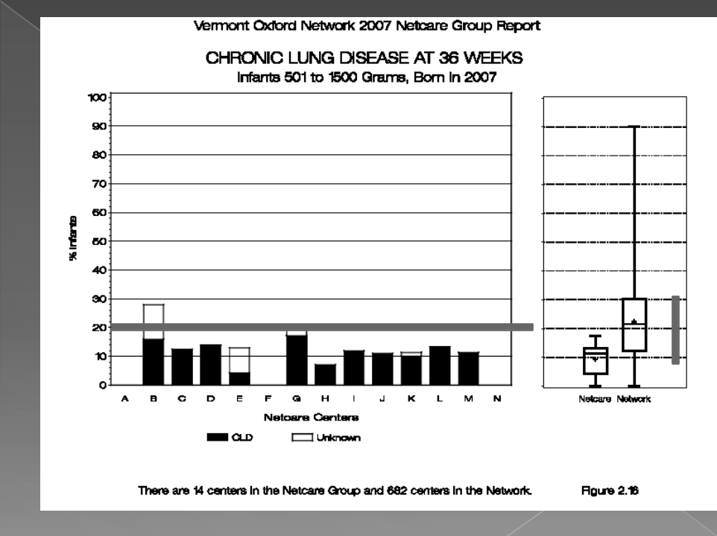
Graph 4
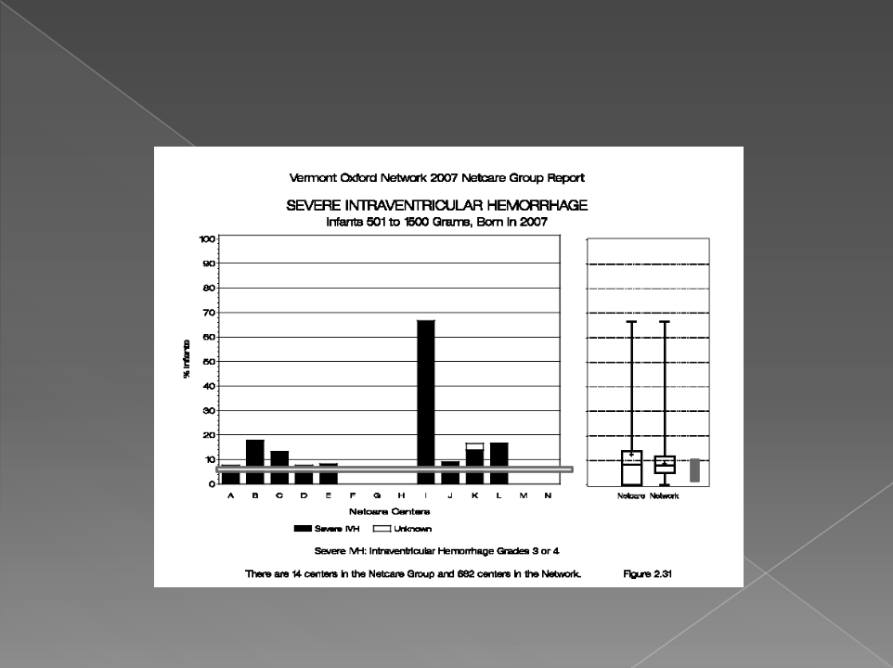
Graph 5

Graph 6

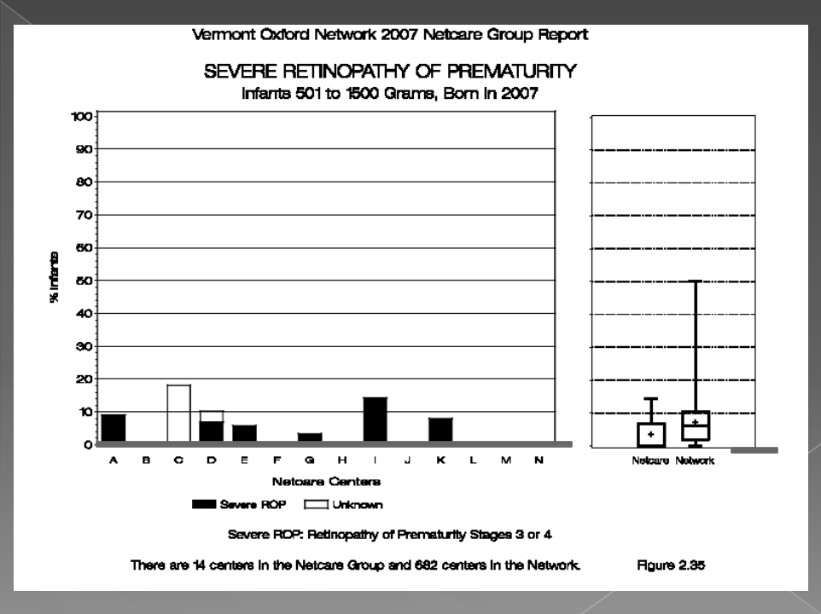
Graph 7
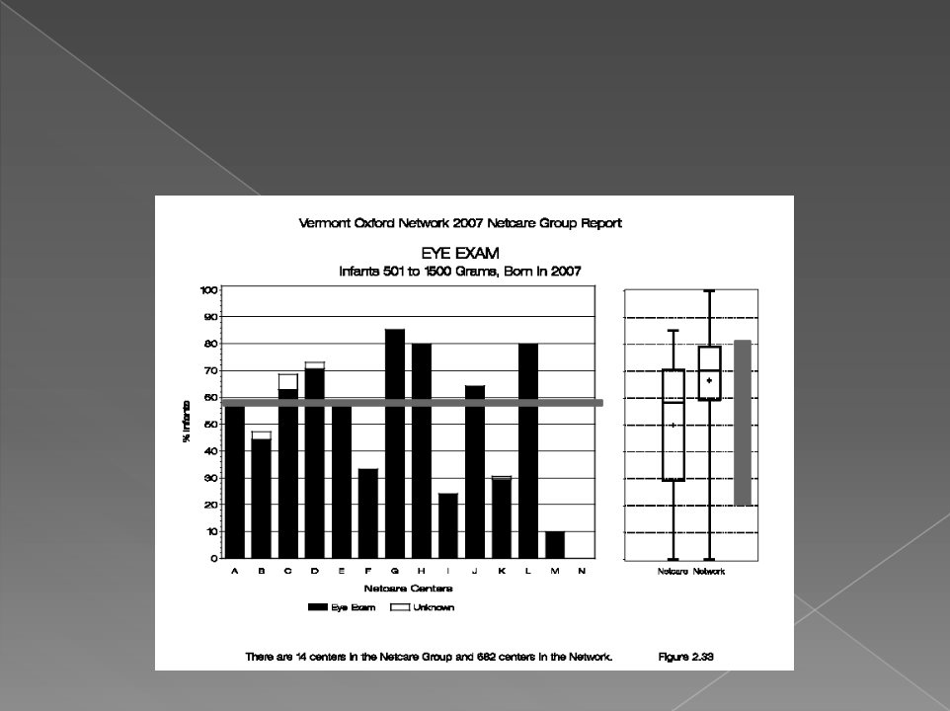
Graph 8
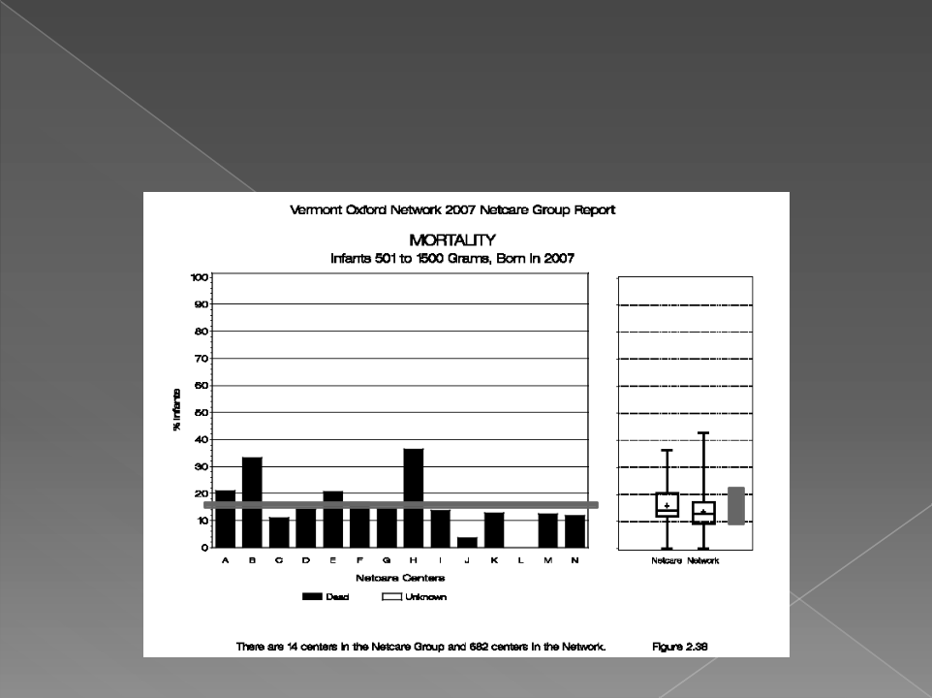
Graph 9

Graph 10

Conclusion
It appears that private neonatal care in South Africa compare well with the trends reported in the VON Network. There are, however, aspects that need to be improved on namely:
- The usage of Antenatal steroids,
- More ultra sound exams to screen for IVH
- More Retinal exams for ROP.
A concerted effort should be galvanised by all Neonatal Units to improve on mortality in the small babies without increase in morbidity. The data, however, should be used to target specific clinical practices and patient outcomes for further in-depth analysis with the objective of identifying potential quality improvement opportunities. NICUs must critically evaluate their own VON results.
VON data should regularly be compared with previous years, to determine the impact of changes in treatment strategies.

IS CHILD HEALTHCARE IMPROVING IN SA? A THREE YEAR REVIEW OF CHILD PIP DATA (2005-2007) (ABSTRACT)

Harper K, Stephen CR, Patrick ME and Child PIP Users
Department of Paediatrics, Pietermaritzburg Hospitals Complex; MRC Maternal and Infant Health Care Strategies Research Unit, University of Pretoria

Introduction
The quality of care children receive in the South African health system has been described by providers and receivers as suboptimal. A mortality review process for children who die in hospital, the Child Healthcare Problem Identification Programme (Child PIP), provides structure for the assessment of the health profile of children who die and the quality of care they received. From 2004, Child PIP has been used increasingly by health facilities throughout South Africa. This paper reports on Child PIP findings for three years, viz. 2005-2007, and begins to examine possible improvements in the quality of child healthcare in South Africa.

Methods: Since 2005, over 65 hospitals in South Africa have used Child PIP, and 47 submitted data to the national database during 2007. At each site the study population included all admissions (0-18 yrs), and detailed data were collected on each death. All neonates admitted to children’s wards were included in Child PIP data. Health profile information was gathered for each child (social, nutritional and HIV context, and cause of death). Quality of care information was obtained by determining modifiable factors. Data were analysed using Child PIP software v2.0.

Results: During 2005-2007, monthly tally data recorded 6 400 deaths from 115 219 admissions. There were 7 153 deaths reviewed in detail. Over the three years, the in-hospital mortality rate dropped from 6.8 to 4.9 deaths per 100 admissions. For each death there was an average of 2.2 modifiable factors. The majority of deaths occurred in infants (63%), with neonates making up approximately 8% of the total audited deaths. As a proportion of all deaths 63% were UWFA (53% of whom were severely malnourished) and 53% were HIV exposed or infected (36% of deaths were not tested). The proportion of children being tested for HIV increased over the three years from 53% to 70%. Despite better data collection, PMTCT data from 2005-2007 consistently showed that only one in two eligible infants received nevirapine, and only one in two received cotrimoxazole. The most frequently recorded diagnoses in children who died from 2005-2007 were ARI (17%), septicaemia (15%), diarrhoeal disease (12%), TB (pulmonary and extra-pulmonary 9%) and PCP (8%), with TB showing a relative increase over the three years. Almost half of the children dying (52%) had HIV disease Stage III and IV. Two thirds of the modifiable factors occurred in the health system (14% in clinics, 22% at admission, and 29% in children’s wards) and 34% at home. For each death, clinical personnel were responsible for 1.0 modifiable factor, administrators for 0.4 and caregivers for 0.7.

Conclusion: The Child PIP audit from 2005-2007 has shown a marked drop in the IHMR at some sites, as well as improved record keeping and a decreasing frequency of “unknowns”. As complete information is essential for the proper care of sick children this trend may suggest improving quality of care. Individual Child PIP sites have described local improvements in care as a result of implementing the mortality review process. Thus Child PIP continues to provide information showing the health profile of a paediatric population and the quality of care they receive throughout the health system.
HELLP SYNDROME: DOES DEXAMETHASONE IMPROVE MATERNAL MORBIDITY AND MORTALITY?

Du Plessis JM, van Soest ZWJE, Joubert G*
Department of Obstetrics and Gynecology, Faculty of Health Science, University of Free State, Bloemfontein, South Africa
*Department of Biostatistics, Faculty of Health Science, University of Free State, Bloemfontein, South Africa

Introduction
HELLP syndrome (H = hemolysis, EL = elevated liver enzymes and LP = low platelets) complicates preeclampsia in 9.7 to 13.6% of cases. Since Weinstein’s first report on HELLP syndrome, there have been a plethora of publications on this condition. HELLP syndrome poses a significant morbidity and mortality, for both mother and child. The management of HELLP syndrome is difficult and most experts agree that delivery is the only definite treatment, to reverse this condition. Most of the focus in recent literature has been on the use of corticosteroids, in patients with HELLP syndrome. Tomkins and Thiagarajah demonstrated a temporary arrest in biochemical abnormalities, with the antenatal use of betamethasone, in patients with HELLP syndrome. Several studies demonstrated that postpartum corticosteroids improve the outcome of HELLP syndrome. Conversely, quite a number of studies have also shown that corticosteroids do not improve the outcome of HELLP syndrome.
The Cochrane review concludes that there is insufficient evidence to determine if steroid use improves maternal and perinatal outcomes.
In light of the conflicting evidence, we did a randomized, controlled trial to determine the effect of dexamethasone on the outcome of HELLP syndrome.

Material and methods
The objective of the study was to determine if postpartum dexamethasone improves maternal morbidity and mortality. The study was conducted at the Universitas- and Pelonomi Hospitals, Bloemfontein, South Africa, between October 2007 and November 2008. The study was a randomized, controlled, unblinded trial.
Inclusion criteria were: gestation greater than 20 weeks and maternal age more than 18 years. Gestation was determined by sure dates and/or first trimester ultrasound. HELLP syndrome was defined by the Tennessee criteria (Platelet count < 100,000/μL, AST and ALT > 70 IU/L, LDH > 600IU/L). Hemolysis was confirmed by haptoglobin-levels in all patients.
Exclusion criteria were: gestation of less than 20 weeks, age less than 18 years, partial HELLP syndrome, congenital spherocytosis, pyelonephritis, idiopathic trompocytopenia (ITP), trombotic thrombocytopenic purpura (TTP), hemolytic uremic syndrome, acute fatty liver of pregnancy and cholestasis of pregnancy.
All antenatal patients received betamethasone 12 mg intramuscular, 24 hours apart (2 doses), to promote lung maturity, if the fetus was viable. Viability was defined as 28 weeks gestation or an estimated fetal weight of 1000g. In gestations larger than 34 weeks betamethasone was not given. All patients were managed according to standard local protocol for preeclampsia/eclampsia. The use of MgSO4 was left to the discretion of the attending obstetrician. All antenatal patients were delivered 48 hours after the first dose of betamethasone, unless there was an indication for earlier delivery (fetal distress). Caesarean section was only indicated for obstetric reasons; otherwise labor was induced with Misoprostil, as per local protocol. At study entry all patients were then randomized to receive dexamethasone or no dexamethasone, after delivery. If a patient only developed HELLP syndrome in the postpartum period, they were also randomized for dexamethasone or no dexamethasone.
Randomization was done by a closed envelope system and a randomization list provided by the department of Biostatistics. The following dexamethasone regime was used: 8 mg 8 hourly intravenously (IV) for the first 24 hours, then 8 mg 12 hourly IV for 24 hours and then 4 mg 12 hourly IV for 24 hours. Daily full blood count and liver function tests were done, until discharge from hospital. Primary outcome criteria were: biochemical improvement (LDH < 600IU/L, AST/ALT < 70IU/L and platelets > 100,000/μL), days in hospital, intensive care admissions, maternal morbidity and mortality. Follow-up was until discharge from hospital.
Secondary outcome criteria were: neonatal outcome and complications.
All patients were counseled and signed informed consent, before entry into the study. The study was approved by the local ethics review board.
Statistical analysis was done by the department of Biostatistics.
Analysis was done by 95% confidence intervals for percentages, means and medians. A p value < 0.05 was considered statistically significant.

Results
A total of 68 patients were randomized for the trial, of which 38 received dexamethasone and 30 received no dexamethasone. A total of 45 patients had viable fetuses and received betamethasone (23 in dexamethasone group and 22 in the no dexamethasone group), prior to delivery (66.2%). Twenty three patients had terminations for non-viable fetuses and or intra-uterine deaths (15 in dexamethasone and 8 in no dexamethasone group).
The demographic characteristics are shown in table 1. The mean gestation in the dexamethasone group was significantly less in the no dexamethasone group (p = 0.033). There were no other differences between the two groups.
Table 2 shows the biochemical parameters of the two groups at study entry. There were no differences between the two groups, regarding biochemical parameters at study entry.
Table 3 shows the birth data and neonatal outcome in patients with viable fetuses. Babies in the dexamethasone group weighed significantly less at birth (p = 0.033). An interesting observation was that 44 of the 68 fetuses (64.7%), in the study, were female. This however was not significant (95% CI, 52-76%). Thirty seven patients were delivered by caesarean section. Of those, twenty three (62.2%) had an emergency caesarean section for fetal distress. There were five neonatal deaths in the dexamethasone group and one in the no dexamethasone group. All deaths were due to complications of prematurity and hyaline membrane disease.
Table 4 shows the biochemical parameters at discharge from hospital. LDH levels were significantly higher in the dexamethasone group (p = 0.047), but no other differences were noted between the two groups.
Table 5 shows the causes of maternal morbidity and mortality. Almost double the amount of patients in the no dexamethasone group developed eclampsia (7 versus 4), but this was not significant (p = 0.194). A total of 13 patients required platelet transfusion (19.1%). The indication for platelet transfusion was a platelet count of less than 30.000/μL, when the fetus was delivered by caesarean section. There were two maternal deaths in the study, one in each group. The maternal death in the dexamethasone group was due to massive intra-cerebral bleeding. This patient’s blood pressure could not be controlled on three anti-hypertensive agents and she had a brain herniation secondary to an intra-cerebral bleed. She died on day one postpartum. The maternal death in the no dexamethasone group was due to acute renal failure and pulmonary edema. Her blood pressure could not be controlled on three anti-hypertensive agents and her pulmonary edema did not respond to medical therapy. She required dialysis to for acute renal failure and her unresponsive pulmonary edema. She also developed severe ascites, despite dialysis and died on day 13 postpartum.
A sub-analysis was done, regarding outcome in patients, who had an initial platelet count of less than 50.000/μL. Table 6 shows the biochemical parameters of these patients at study entry. The AST levels were significantly higher in the dexamethasone group at study entry (p = 0.028), otherwise there were no significant differences between the two groups.
Table 7 shows the biochemical parameters at discharge and hospital stay in this sub-analysis. There were no significant differences between the two groups.

Discussion
Our study does not support the routine use of dexamethasone, in patients with HELLP syndrome. We only included patients with true HELLP syndrome according to the Tennessee criteria and confirmed hemolysis in all cases with a haptoglobin level. Wilke et al and Paternoster et al have confirmed, in previous studies, that haptoglobin is the most sensitive marker of hemolysis. To our knowledge this is the second largest randomized trial on the effect of dexamethasone in HELLP syndrome. Most studies on HELLP syndrome were small and the same diagnostic criteria were not uniformly used in all studies.
Mould et al randomized 30 postpartum patients for dexamethasone or standard management. They concluded that dexamethasone did not have any benefit in patients with postpartum HELLP syndrome. Francois et al randomized 32 antenatal patients to investigate the effect of antenatal dexamethasone rescue therapy on class 1-3 HELLP syndrome, according to the Mississippi criteria. They found no differences among the three disease classes with respect to maternal and obstetric morbidity. In the largest study to date, Fonseca et al randomized 132 patients with HELLP syndrome for dexamethasone or placebo. There was no difference in hospital stay or complications between the two groups and they concluded that dexamethasone is not more effective than placebo in treating HELLP syndrome.
In a retrospective study, Varol et al, found a marked improvement in laboratory abnormalities and a shorter hospital stay, with the use of postpartum dexamethasone. In a study with 30 patients, Yalcin et al, found a more rapid resolution of disease and earlier clinical improvement with the use of dexamethasone. Vigil-De Gracia et al randomized 34 postpartum patients with HELLP syndrome for dexamethasone or no dexamethasone. They concluded that dexamethasone assist in quicker recovery of platelet count, but not of other biochemical parameters.
Isler et al compared the use of dexamethasone and betamethasone in postpartum HELLP syndrome in 36 patients. They found a marked improvement in mean arterial pressure with dexamethasone and concluded that dexamethasone is superior to betamethasone in the management of postpartum HELLP syndrome. Van Runnard Heimel et al randomized 31 patients, remote from term, with HELLP syndrome for high-dose prednisolone or placebo. They concluded that prednisolone reduces the risk of recurrent HELLP syndrome. Martin et al showed significant improvement in laboratory parameters, less frequent use of anti-hypertensive treatment, less transfusions, lower maternal morbidity and shortened platelet recovery with the use of dexamethasone.
In the light of the above mentioned evidence, it is not surprising that the Cochrane review concludes that more research is needed to clarify the potential advantages/disadvantages of dexamethasone in patients with HELLP syndrome. As mentioned our study does not support the use of dexamethasone in cases of HELLP syndrome. Even in our sub-analysis of patients with a platelet count of less than 50.000/μL at study entry, there was no difference in outcome.
The fact that 64% of fetuses in our study were female begs the question of a possible genetic cause of HELLP syndrome. We plan to explore this in future research.
In conclusion our study did not support the use of dexamethasone in HELLP syndrome. We would like to plea for more consistent criteria, for the diagnosis of HELLP syndrome, in future studies.

Table 1 Maternal demographic characteristics
Characteristics | Dexamethasone  (n = 38) | No dexamethasone  (n = 30) | p-value
Maternal age (years) | 27.4 | 28.2 | 0.607
Gestational age (weeks) | 28.07 | 30.7 | 0.033
Primigravida | 11 | 9
Previous preeclampsia | 5 | 2 | 0.876
Chronic hypertension | 4 | 4 | 0.876
Antenatal betamethasone (%) | 23 (60.5) | 22 (73.3)
Results expressed as means unless otherwise specified

Table 2 Biochemical parameters at study entry
 | Dexamethasone (n = 38) | No dexamethasone (n = 30) | p-value
Platelets (μL) | 54.500 | 52.800 | 0.970
AST (IU/L) | 398 | 301 | 0.196
ALT (IU/L) | 209 | 194 | 0.970
LDH (IU/L) | 1368 | 1163 | 0.126
Results expressed as means unless otherwise specified

Table 3 Birth data and neonatal outcome
 | Dexamethasone  (n = 38) | No dexamethasone  (n = 30) | p-value
Live births | 23 | 22
Terminations | 15 | 8
Birth weight*  (grams) | 1191.1 | 1548.7 | 0.033
Male fetuses (%) | 17 (25) | 7 (10)
Female fetuses (%) | 21 (31) | 23 (34)
Caesarean section (%)* | 19 (82.6) | 18 (81.8)
5 min Apgar* (median) | 8 | 8 | 0.249
Days ventilated* | 3 | 4.6 | 0.46
Days in hospital* | 14.2 | 14.7 | 0.826
Neonatal deaths* | 5 | 1 | 0.35
Results expressed as means unless otherwise specified
*Include only live births

Table 4 Biochemical parameters at discharge
 | Dexamethasone (n = 38) | No dexamethasone (n = 30) | p-value
Platelet count (μL) | 159.000 | 152.000 | 0.544
AST (IU/L) | 53 | 47 | 0.307
ALT (IU/L) | 70 | 58 | 0.275
LDH (IU/L) | 539 | 458 | 0.047
Days before platelets > 100000/μL | 4.1 | 3.6 | 0.359
Days before LFT normal | 4.0 | 4.1 | 0.551
Results expressed as means unless otherwise specified
LFT = liver function tests

Table 5 Causes of maternal morbidity and mortality
 | Dexamethasone (n = 38) | No dexamethasone (n = 30) | p-value
Hospital stay (days) | 6.0 | 6.9 | 0.510
Oliguria (%) | 7 (18) | 5 (16) | 0.861
Eclampsia (%) | 4 (11) | 7 (23) | 0.194
Dialysis (%) | 1 (2.6) | 0 | 0.100
Blindness (%) | 8 (21) | 5 (17) | 0.648
Pulmonary edema (%) | 1 (2.6) | 0 | 0.100
Platelet transfusion (%) | 7 (18) | 6 (20) | 0.911
Maternal deaths | 1 | 1
Results expressed as means unless otherwise specified

Table 6 Biochemical parameters in patient with platelets < 50.000/μL at study entry
 | Dexamethasone (n = 21) | No dexamethasone (n = 15) | p-value
Platelets (μL) | 38.000 | 37.000 | 0.585
AST (IU/L) | 511 | 258 | 0.028
ALT (IU/L) | 244 | 159 | 0.386
LDH (IU/L) | 1613 | 1168 | 0.092
Results expressed as means unless otherwise specified

Table 7 Biochemical parameters at discharge in patients with platelets less than 50.000/μL at study entry
 | Dexamethasone (n = 21) | No dexamethasone (n = 15) | p-value
Platelets (μL) | 137.000 | 149.000 | 0.648
AST (IU/L) | 63 | 40 | 0.071
ALT (IU/L) | 73 | 48 | 0.080
LDH (IU/L) | 569 | 447 | 0.054
Days before platelets > 100.000/μL | 4.25 | 4.57 | 0.620
Days before LFT normal | 4.75 | 4.42 | 0.804
Hospital stay (days) | 6.75 | 7.4 | 0.711
Results expressed as means unless otherwise specified

ASSESSMENT OF THE QUALITY OF INTRAPARTUM CARE USING THE STANDARD PRIMIPARA (ABSTRACT)

Guzha BT¹, Munjanja SP¹, Nyandoro M²,Chirehwa M³
1 Department of Obstetrics and Gynaecology University of Zimbabwe
2 Ministry of health
3Department of biostatistics

Introduction: Comparisons of quality of obstetric care between facilities and districts are difficult because population characteristics among different districts are heterogeneous and also the prevalence of complications varies. The concept of the standard primipara was introduced to control for the substantial differences in the case mix between institutions. The definition of the standard primipara used in the study was; a woman in her first pregnancy( no spontaneous abortion or termination of pregnancy),singleton foetus in cephalic presentation at term, spontaneous onset of labour between 37 and 42 weeks, no maternal disease, no antenatal complications or admission during pregnancy for >24hours
Objectives: The main objective was to compare the quality of care between districts and between urban and rural districts in Zimbabwe
Methodology: The study was a part of the Zimbabwe Maternal and Perinatal Mortality Study which is a population based descriptive and cross sectional study of deaths of women in pregnancy and perinatal deaths. A total of 45 222 deliveries were captured in 11 districts: Bindura, Chivi, Matobo, Mutoko, Tsholotsho (rural) and Nkulumane, South Eastern and Western districts of Harare (urban). Kwekwe and Mutare had both urban and rural populations. Data was entered using the Microsoft Access data entry package and analysed using Stata Version 9.0 to select women who met the definition of the standard primipara and to compare the following maternal outcomes: initial place of labour, referrals in labour, place of delivery, mode of delivery, intrapartum and postpartum complications, postpartum referrals and maternal deaths or morbidity and the following neonatal outcomes; stillbirth rate, perinatal mortality rate, neonatal death rate and neonatal complications. The outcomes were used to compare the quality of intrapartum care between the districts and rural and urban districts.
Results: These results are based on 10 947 standard primipara in the 11 districts. Rural vs urban districts: More women in the rural districts went into labour at an institution (30.6% vs 5.6%, p<0.001). In urban districts more intrapartum complications were detected (18.3% vs 7.4%, p<0.001). The caesarean section rate was higher in urban districts (6.5% vs 2.2%, p<0.001). There were significantly better perinatal outcomes in urban districts: perinatal mortality rate (1.1% vs 1.9%, p=0.001), still birth rate (0.7% vs 1.1%, p=0.013), neonatal mortality rate ( 0.5% vs 1.0%, p=0.012) and intrapartum asyphyxia rates( 19.4% vs 34.0%, p=0.001). Comparison of rural districts: There were significant differences between the highest and lowest rates in the following outcomes: usage of maternity waiting shelters, institutional deliveries and detection of intrapartum complications. The caesarean section rate was not significantly different. Comparison of urban districts: There were significant differences between the highest and lowest rates in the following outcomes: intrapartum and post partum complication detection rates and caesarean section rates. There were no significant differences in the perinatal mortality rates.
Conclusion: Quality of care in urban districts was better resulting in better perinatal outcomes. Between urban districts and also between rural districts there were some differences in quality of care but this did not significantly change the perinatal outcomes.
MATERNAL DEATHS FROM OBSTETRIC HAEMORRHAGE ASSOCIATED WITH CAESAREAN SECTION IN SOUTH AFRICA. 2005-2007

S.Fawcus, N.Mbombo.
NCCEMD, Department of Health, South Africa

Background
Obstetric haemorrhage was the third most common cause of maternal death in South Africa for the triennium 2005 to 2007, accounting for 491 deaths or 12.4% of the total. Antepartum haemorrhage accounted for 108, and postpartum haemorrhage for 383 of the deaths. The most common causal subcategory was ‘other uterine trauma’, predominantly bleeding during and after caesarean section, which accounted for 141(20.4%) of total haemorrhage deaths and has increased markedly compared to 78(17.6%) in the previous triennium.

Aims
To describe the factors associated with maternal deaths from haemorrhage related to caesarean section, to investigate avoidable factors, and to make feasible recommendations.

Methods
Descriptive audit of maternal deaths performed as part of the National Committee for the Confidential Enquiry into Maternal Deaths (NCCEMD) ongoing data collection for South Africa. Data collected from maternal death notification and assessors’ forms for haemorrhage deaths associated with caesarean section (CS) for the 2005-2007 triennium were analysed.

Results
103 cases were reviewed. 95 (92.2%) were emergency CS compared to 8 (7.8%) elective operations.
Thirty-nine (37.9%) CS were performed at level one hospitals, 43(41.7%) at level two, and 21(20.4%) at level 3 hospitals.
The most common indications for CS in the 103 cases were: obstructed labour (31.1%), previous CS in labour or elective (15.5%), abruptio placentae (13.6%), placenta praevia (13.6%), twins and malpresentations (10.7%), and fetal distress (8.7%),
In many cases, post-operative bleeding followed intra-operative problems with haemostasis, frequently due to an atonic uterus or uterine tears from a distended lower segment after difficult delivery of an impacted head. In several women, the bleeding originated from the placental bed such as in women with placenta praevia or previous CS and in some surgery was difficult due to multiple adhesions. Coagulopathy complicated the CS performed for abruptio placentae.
Twenty-eight women (27.2%) had a hysterectomy, 10 at the initial CS, and 18 at re-laparotomy. Five women had a re-laparotomy without hysterectomy, and 70 women (68%) had neither re-look laparotomy, nor hysterectomy. There was no mention of B-Lynch compression sutures or uterine tamponade procedures for any of the women.
Blood was transfused in 71 (68.9%) of cases.
The deaths were assessed to have been ‘clearly avoidable’ for 88 (85.4%) of cases.
Lack of, and insufficient blood was identified as a problem in 28 women (27.2%), and staff shortages particularly for postoperative monitoring occurred in 16 women (15.5%).
Non-availability of theatre was a problem for 9 women (8.7%); this included non-functional theatres at level one hospitals and delayed access to theatre due to heavy occupancy by other emergencies at level 2 and 3 hospitals.
Deficiencies in clinical care were identified in the majority of patients and included poor monitoring in the postoperative period leading to serious delays in the detection of haemorrhagic shock (n=36, 35%), poor resuscitation (n=18, 17.5%), and incorrect management in 8 women who had a CS for abruptio placentae with intrauterine fetal death.
There was substandard care in 62 women (60.2%); this included delay in definitive management such as hysterectomy and non-use of potentially effective treatment modalities such as parenteral ergometrine, B-Lynch compression suture and balloon tamponade.

Conclusions
There has been no improvement in maternal mortality from obstetric haemorrhage in the recent triennium. The large number of deaths due to caesarean section associated bleeding raises concern about technical skills for complicated CS. More aggressive attempts to secure haemostasis at initial CS and improved postoperative monitoring in a high care area would be important interventions for all levels of care. Recommendations for reducing haemorrhage related maternal deaths must include improving administrative support, supply of blood, and skills training for all doctors who perform caesarean sections.

LESSONS TO LEARN FROM CASE SERIES : CONSIDERATION OF RUPTURED UTERI IN SUSPECTED ADVANCED EXTRA-UTERINE PREGNANCIES IN PREVIOUS CAESAREAN SECTIONS (ABTRACT)

S Ramphal, *J Moodley
Department of Obstetrics and Gynaecology, and *Women’s Health and HIV Research Group, Nelson R Mandela School of Medicine, University of KwaZulu-Natal, Durban.

Introduction
In present day obstetric practice, ruptured uteri in a previous scarred uterus should be uncommon. It occurs in less than 1% of previous caesarean sections (C/S) and most of these cases occur during labour and have evidence of vaginal bleeding and continuous abdominal pain. Clinicians are alert to these symptoms and signs, therefore immediate action is taken to prevent further maternal morbidity and mortality. However, patients with an initial diagnosis of advanced extra-uterine pregnancy (AEUP) who have had previous C/S, occasionally present with minimal signs and symptoms such as vague abdominal pain and absent fetal movements in the antepartum period. These patients are usually in a haemodynamically stable state and are treated expectantly for a period of time.

Case series
We present a series of 7 cases, all of whom had a previous C/S, were haemodynamically stable and were being managed expectantly, to illustrate the fact that ruptured uteri should be strongly considered in the differential diagnosis, even when the clinical signs and sonography suggest an AEUP. Clinical data including age, parity, gestational age at presentation, presenting symptoms, initial diagnosis and imaging techniques will be presented.

Discussion
The lessons to be learnt in these cases fall into the following categories:
- That ruptured uteri can occur in non-labouring, haemodynamically stable women with a previous C/S
- There is an absence of signs of peritonism, possibly due to the fact that the pregnancy is extruded through the uterine scar with the amniotic sac being intact. In addition, there is little or no bleeding into the abdominal cavity or vaginally.
- Imaging techniques (sonography and MRI) should focus on the size of the uterus, as an enlarged uterus in the background of an AEUP in previously scarred uterus is highly suggestive of uterine rupture.

Conclusion
Clinicians must strongly consider ruptured uteri in women with a previous C/S presenting with vague abdominal pain and sonar suggestive of AEUP, even if they are haemodynamically stable. This will lead to earlier surgical treatment and appropriate information being provided to patients.

AUDIT OF SECOND STAGE CAESAREAN SECTIONS AT A TERTIARY DURBAN HOSPITAL

Dr V Govender, Prof J Moodley, Dr M Panday

Introduction
Caesarean sections (C/S) are increasing worldwide, even in resource-constrained countries such as South Africa'. Rates of approximately 30% have been reported from a tertiary hospital in Durban, South Africa`. This, despite suggestions by the WHO that an acceptable C/S rate is between 10-15%.
Emergency C/S in particular, are known to be associated with high levels of maternal complications and in resource-constrained countries, increasing C/S rates have negative effects on the health budget, operating theatre facilities, and the need for well-trained health professionals.
The rising C/S rates worldwide, are also due to ever widening indications for abdominal delivery, including maternal request for C/S (for a variety of reasons such as prevention of pelvic floor dysfunction) and for the prevention of mother to child transmission of HIV, and the fear of litigation'. In addition, we have observed a decreasing trend in the rate of assisted vaginal deliveries with forceps and vacuum extraction and a concomitant increase in the numbers of second stage C/S in some hospitals in South Africa. Caesarean sections in the second stage of labour have been reported to have higher maternal and neonatal complications than first stage C/S.

Methods
The study was a prospective audit of all emergency C/S performed over a 7 month period in 2008 at a teaching hospital in Durban, South Africa. We visited the postnatal wards each day of the 7 month period and identified all patients who had emergency C/S/ All relevant data, viz. maternal, neonatal, decision for C/S, intra-operative, post-operative data and duration of hospital stay of mother and baby was captured onto a structured form.
For the purpose of the study, second stage C/S was defined as one which was performed following full cervical dilatation. A prolonged second stage of labour was defined as one which had lasted over 2 hours from full cervical dilatation.
The majority of the C/S were performed by registrars who were grouped as junior or senior registrars. A junior registrar was in the first 2 years of a 4 year training period. A standard method of C/S described elsewhere was done at the study site and all women having an abdominal delivery are given intravenous prophylactic antibiotics following clamping of the umbilical cord at delivery of the baby`.

Statistics
Descriptive statistics were used and results are presented as frequencies, means and range. For comparative statistics, the t-test was used for normally distributed data while Mann Whitney U test was used for non-parametric data.

Results
There were 1961 C/S and numbers of emergency first and second stage C/S are shown in figure 1. There were 116 second stage C/S giving a rate of 10.6%. The demographic data is shown in table 1. There were significant differences in birth weights (2.9 vs. 3.3kg); operative time (35.5 vs. 41.6 minutes) and gestational age (374 vs. 38.4 weeks) between the first stage and second stage C/S (table 1). There were no differences in perinatal complications between the groups.
There were 12 stillbirths in the first stage C/S group and 2 in the second stage group. The latter were due to firstly, a 19 year old primigravid being referred, fully dilated and with the presence of fetal heart rate abnormalities from a community clinic. A C/S was decided upon, but the only operating theatre facility was busy at the time and despite the initiation of intrapartum resuscitation, a 3.3kg stillbirth fetus was delivered at C/S.
The second stillbirth was in a patient with a breech presentation. The cervix was fully dilated and the patient had had a previous C/S. A 3.0kg stillbirth was delivered. There were no neonatal deaths in the second stage C/S. Three percent of neonates delivered at first stage C/S had five minute Apgar scores of 6 or less, while 4,3% neonates delivered at second stage C/S also had Apgars scores of 6 or less at five minutes. This was not a statistically significant finding (P= 0,277).
Babies delivered at second stage c/s did not spend a significantly longer time in nursery (P = 0,96), with the duration of stay in hospital of significance, P = 0,046.
Babies delivered at second stage C/S were significantly larger than those at first stage C/S (3,2kg versus 2,9kg) - P = 0.000 (table 2).

Decision making at the time of C/S
The majority of decision-making was performed by the registrars. Junior registrars made the decision in 30,6% of cases. 295 of these cases were for first stage C/S and 38 cases of second stage C/S. Senior registrars made the decision for C/S in 45,1% of cases. Consultants decided on 20, 2% of cases that went for C/S. Consultants and registrars only made 3,7% joint decisions, all of which were for first stage C/S. Medical officers made 0,37% of total decisions, all regarding first stage C/S ( Table 3).
Consultants were only involved in performing 2 of the 511 first stage and 2 of the 116 second stage C/S. Senior registrars performed 63 and junior registrars 51 (44%) of 116 second stage C/S.

Duration of procedure
The T-test was used to determine duration of the operation. Second stage C/S took a mean time of 35.5 minutes (13-240 mins). First stage C/S took an average time of 41.6 minutes (15-180 mins) to perform (p value = 0. 0010).

Complications
Maternal complications are shown in table 3. The need to push the fetal head up prior to delivery at second stage C/S occurred in 86 cases in second stage CIS and in 7 cases of first stage C/S (p = 0.00).
Extension tears to the uterine angles occurred in 18 cases of first stage C/S and 26 cases of second stage C/S. (p = 0.000).
The 11 cases of lower segment tears at second stage C/S was also statistically significant (p = 0.00).
There were 4 cases of bladder injury in first stage C/S and 4 bladder injuries in second stage C/S. They all required a combination of surgical procedures prior to hysterectomy.
Cases included a patient who was referred at full cervical dilatation with the diagnosis of fetal distress. There was some delay in performing the C/S immediately and a stillbirth was delivered by second stage C/S 45 minutes later. It was not clear from the documentation whether consideration was given to operative vaginal delivery (forceps, ventouse or symphysiotomy). The second case was a previous C/S x 1 admitted with a breech presentation at full cervical dilatation. Again, it was not clear from the documentation whether she had had antenatal care in this pregnancy and whether a C/S was planned.
Although we did not find an increase in perinatal complications, there were 5 cases with 5 minute Apgar scores of < 5. We did not follow up these neonates but all were well at the time of discharge from hospital. No other studies report on intermediate and long term outcome of the babies born to mothers who have had second stage C/S. This obviously needs further research.
In our study, there was only one attempt at vaginal delivery in a patient who had fetal distress and who was near full cervical dilatation. Studies in the UK' and the USA"' report that the rate of operative vaginal delivery is between 10 and 15% with a preference shown for use of ventouse. Bonfill et al (1996) reported that fellows of the American College of Obstetricians and Gynaecologists were more likely to use the ventouse with a high use of soft cups'''.
Cebekulu and Buchmann (2006), working at Baragwanath Hospital, Johannesburg report an operative vaginal delivery rate of 1.1%8. These low rates of operative delivery in South Africa are of obvious concern. They indicate that training in operative vaginal delivery is1acking and that cephalopelvic disproportion rates are high in our population. The fact that a sizeable proportion of those who had second stage C/S were primigravidae, who had obviously not experienced delivery previously, have rigid perineum and if unprepared for labour tend to be uncooperative in labour, particularly in the second stage of labour. Furthermore, it is known that the women in Southern Africa have a gynaecoid pelvic shape, a 25% smaller than their Caucasian counterparts'', However, other factors are also important.
The American College of Obstetricians and Gynaecologists suggest that training on operative deliveries if the appropriate criteria are fulfilled needs to be promoted to curb the rising C/S rates'''. This recommendation should also apply to South Africa, not only to reduce rising C/S rates, but also to prevent maternal complications associated with second stage labour C/S.
In our study, maternal complications associated with second stage C/S were much higher than that of the first stage C/S. We found 84 intra- and post-operative adverse events in the second stage C/S group, compared 37 in the first stage group (p = 0.00). The complications included 4 cases of bladder injury, extension of the uterine incision and tears in lower uterine segments. These complications were mainly associated with delivery of the fetal head impacted deep in the pelvis. Different methods are used to deliver the fetal head in such situations. In our setting, the "push method" is used to disimpact the head and was used in 86 cases of the second stage C/S.
The great majority of the decisions taken for the second stage C/S was made by registrars. It is likely that some of the decisions taken may have been reversed if a consultant was present to examine the patient and make the decision. It is therefore not surprising that the Royal College of Obstetricians and Gynaecologists, London, UK, recommends that a consultant be present both at the time of decision making for a second stage C/S and at the C/S so as to reduce complications associated with C/S and possible reversal of the decision for second stage C/S if the criteria for operative vaginal delivery are present. It is reported that senior obstetricians are more likely to reverse decisions of the registrars'.
As stated earlier, maternal complications are increased in 2nd stage C/S. Allen et al (2005) from Canada, found women who had a 2nd stage C/S were 26 times more likely to have maternal complications associated with intra-operative trauma. In our study, there were 4 cases of bladder injury in the 2nd stage C/S group. Neilsen and Hokegard (1984) who reviewed surgical complications in 1319 abdominal deliveries, stated that bladder injuries were usually associated with the station of the fetal head immediately prior to surgery, emergency C/S, a gestational age < 32 weeks, rupture of membranes prior to surgery, the presence of a previous C/S or lower abdominal surgery and the experience and skill of the operator-12.
In conclusion, stage C/S are associated with significant maternal complications. Clinical teaching should focus on clinical decision making in the 2nd stage of labour, the place of operative vaginal delivery and obviously the use of the ventouse and forceps, and finally, sound surgical techniques to prevent maternal complications associated with 2nd stage C/S.

Table 1 Demographic data of all caesarean sections
Demographics | C/S 1st stage  (n = 975) |  |  | C/S 2" stage  (n = 116) | p-value
Maternal age (yrs) | 25.7 | (13-44) | 25.2 | (13-48) | 0.2940
Parity | 1 | (0-10) | 0 | ( 0-6) | 0.0217
Gestational age (weeks) | 37.5 | (31-42) | 38.4 | (24-43) | 0.003*
Gravidity | 2 | (1-7) | 1 | ( 0- 8) | 0.1799
HIV Serostatus
Positive | 328 |  | 35 |  | 0.456
Negative | 536 |  | 72
Unknown | 2 |  | 9
ARVs | 51 |  | 5 |  | 0.839
Operative time (minutes) | 35.5 | (13-240) | 41.6 | (15-180) | 0.001*
Length of stay in hospital (days) | 3.7 | (2-32) | 3.6 | ( 2- 32)
Neonatal
Birth weight (kgs) | 2.9 | (2-5) | 3.3 | (1-5) | 0.000*
Length of stay in hospital (days) | 2.2 | (1-8) | 2.3 | (0-21) | 0.046"
Length of stay in nursery | 1.6 | (0-12) | 1.4 | (0-31) | 0.96
Neonatal outcome
Alive | 947 |  | 114
Stillbirths | 12 |  | 2
Perinatal deaths | 2 |  | 0 |  | 0.795
Neonatal deaths | 5 |  | 0
ARVs = antiretroviral therapy statistical significance p < 0.05

Table 2 Baby outcomes
OBSTETRIC OUTCOMES | 'FIRST STAGE  C'S |  | SECOND STAGE CIS |  |  | P VALUE
Birth weight (kgs) | 2.9 ( 1.78 — 5.15 ) |  | 3.3 ( .550 — 5.10 ) |  |  | 0.000
Length of stay in hospital 1 2.2(days)( 1 — 8) |  |  | 2.3(days)( 0 — 21 ) |  |  | 0.046
Length of stay in nursery | I 1.6(days) ( 0 — 12 | ) | 1.4(days) ( 0 — 31 ) |  |  | 0.96
Alive | 947 |  | 114
Stillbirth 1 | 12 |  | 2 |  |  | .2v0.795
Perinatal death 1 | 2 |  | 0
1
Neonatal death 1 | 5 |  | 0
1

Table 3
MATERNAL COMPLICATION | TOTAL NO. OF EVENTS | C/S 15t STAGE | C/S em STAGE | P-  VALUE | ODDS RATIO | C.I.  95%
Postpartum haemorrhage | 12 | 7 | 5 0,000 |  | 6,22 | 19,95
Wound sepsis | 31 | 27 | 4 0,677 |  | 1,25 | 3,64
Blood transfusion | 19 | 13 | 6 0,003 |  | 4,74 | 11,43
 |  |  |  | -
Blood loss | 39 | 22 | 17 | 0,000 | 7,43 | 14,47 _
Postoperative fever | 113 |  | 79 ----34-------0,000----  40,000 |  | 4.70 | 7,45
Hysterectomy | 7 | 5 | 2 0,122 |  | 5.4O | 17,74
-S-tep-W-iie de-Vascularisation | 3 | 2 | 1 —0,201 |  | 4.23 | 47,01
Compression sutures | 6 | 3 | 3 | 0,002 | 8,60 | 43,12
Internal iliac artery ligation | 1 | 1 | 0 | 0,730
Extension tear on uterus | 44 | 18 | 26 | 0,000* | 15,35 | 29
Lower segment tear | 21 | 10 | 11 | 0,000" | 10,10 | 24,36
Bladder injury | 8 | 4 | 4 | 0,000* | 8,66 | 35,14
Fetal head pushed up | 93 | 7 | 86 | 0,000" | 396 | 929
Relaparotomy | 7 | 5 | 2 | 0,122 | 3,40 | 17,74
Pueperal infection | 11 | 9 | 2 | 0,414 | 1.88 | 8.82

Table 4 Decision for caesarean section : level of medical personnel
DECISION | C/S 1 ST STAGE | C/S 2ND STAGE |  |  | P-VALUE
Medical Officer
Junior Registrar | 495 | 38 |  | }
Senior Registrar | 425 | 66 | } |  | P = 0.003
Consultant | 208 | 12 | }
Consultant & Registrar | .  40 | 0 | -I)

MISOPROSTOL TO PREVENT POST PARTUM HAEMORRHAGE

GJ Hofmeyr, J Blum, B Fawole, K Mugerwa, NP Godi, Q Blignaut, L Mangesi, M Singata, B Winikoff, N Mshweshwe, X Williams, L Brady
Effective Care Research Unit, Eastern Cape Department of Health, University of Witwatersrand and Fort Hare

Background
Postpartum haemorrhage (PPH) remains a leading cause of maternal mortality, despite treatment with conventional methods. Misoprostol has been suggested as prophylaxis in the routine management of the third stage of labour. There is to date inadequate evidence of its efficacy, and there is concern that this method will be used widely without systematic research to document the optimal dosage, effectiveness or risks of this method. Systematic reviews have shown that the addition of ergometrine to syntocinon in the active management of the third stage increases effectiveness, but with considerable side-effects. There is a sound biological basis to expect that misoprostol may similarly augment the effectiveness of oxytocin, but with fewer dangerous side-effects.
Objective To assess the effects of misoprostol as part of the active management of the third stage of labour, on outcomes such as blood loss, complications and side-effects.
Methods This was a hospital-based, multicentre randomized controlled trial in several low-income countries where postpartum haemorrhage is a major problem (e.g. South Africa, Uganda, Nigeria). Management of third stage of labour in the participating centres was routine active management, usually with oxytocin 5-10 IU intramuscularly or by slow intravenous injection. The routine methods of third stage management in the various countries will be surveyed. This was a decentralised study and the comparison was misoprostol versus placebo. Women who gave consent, were enrolled by drawing the next in a series of randomised treatment packs containing two tablets of misoprostol 200μg or placebo. Two tablets were administered sublingually in addition to the routine active management of the third stage. The primary outcome measures were measured blood loss of 500mls or more within 1 hour after enrolment. Additional outcome measures were side-effects, blood loss ≥1000 mls after enrolment, average blood loss after enrolment, blood transfusion, and maternal morbidity and mortality. The sample size for the centres supported by gynuity with misoprostol and identical placebo were 1,200 and is based on the ability to show a reduction of blood loss ≥ 500 mls after enrolment from 13.8% to 8.5% (80% power). Gynuity funded centres enrolled a total of 240 participants each. The MRC-funded sites will also enrol 240 women per site. .A total of 3 360 participants was to be enrolled in the entire trial, giving added power to demonstrate a smaller reduction from 13.8% to 10.5%. This report is for only the gynuity funded sites.
Management The trial was co-ordinated from the Effective Care Research Unit, East London, South Africa. Several centres participated. All centres followed the same protocol and data collection techniques. Data entry and primary analysis was conducted at the individual centres. Sub-study results were reported by the individual centres. Quality control and meta-analysis of the overall results is located in South Africa. Sub group analysis is done for centres using different regimens of routine 3rd stage oxytocics.
Results
Baseline: Maternal mean age (years)
 | Uganda 1 | Uganda 2 | S.A.1 | S.A. 2 | Nigeria
Misoprostol | 25.16 | 25.35 | 29.11 | 28.92 | 31.93
Placebo | 24.53 | 23.84 | 28.1 | 28.99 | 31.97

Baseline: Mean fatal birth weight (grams)
 | Uganda 1 | Uganda 2 | S.A. 1 | S.A. 2 | Nigeria
Misoprostol | 3118 | 3126 | 3008 | 3088 | 3227
Placebo | 3256 | 3131 | 3024 | 3120 | 3119

Blood loss =/> 500 mls

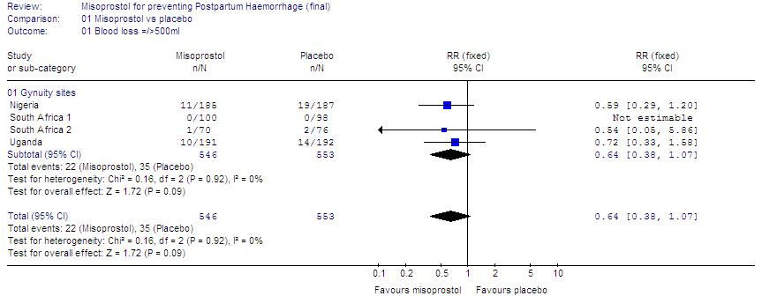

Blood loss =/> 1000mls
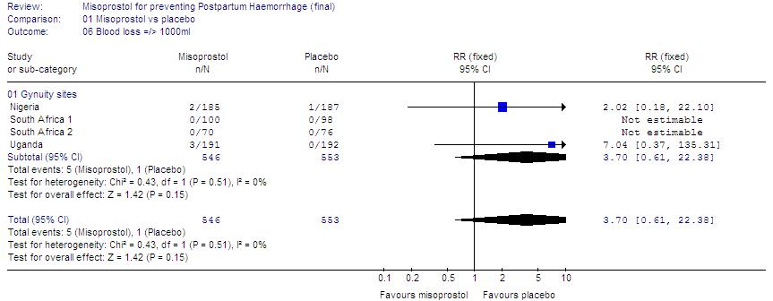
Pyrexia =/> 39 deg.C
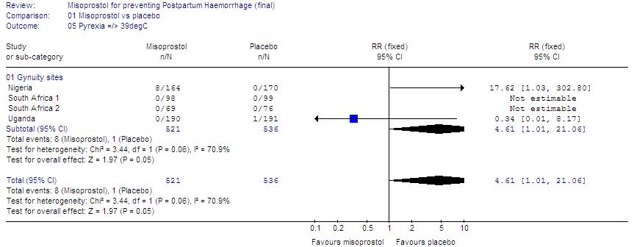

Shivering

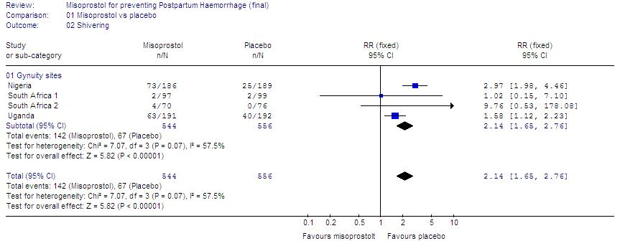

Discussion
This is the largest study to date of 400mcg misoprostol vs. placebo. The results show a trend to reduction in the primary outcome: Blood loss =/> 500ml. This is consistent with previous studies showing variable effectiveness at 400 or 600mcg. This confirms a doubling in the incidence of pyrexia (12% vs. 5%) and shivering (26% vs. 12%). Severe pyrexia =/> 39degC occurred in 8/521 women with misoprostol (vs. 1/536 with placebo). There were no cases of pyrexia >40degC. Side-effects were less with 400 than 600mcg.

Conclusion
Overall, randomized trials of misoprostol vs. placebo for preventing PPH have been disappointing. Side-effects are considerable, and dose-related. First priority is to make oxytocin widely available (much more effective than misoprostol). If misoprostol is used, there is no evidence to support dosage >400mcg.

ON THE IMPOSSIBILITY OF INFANT FEEDING COUNSELLING

Carolé Cilliers,¹ Anne-Marie Bergh,¹ Robert Pattinson,¹ Jannie Hugo,² Gladness Mathebula², UP medical students and mentors²
¹ MRC Unit for Maternal and Infant Health Care Strategies and University of Pretoria
² Department of Family Medicine, University of Pretoria

Background
We often hear complaints about the fragmentation of service delivery due to vertical programmes or poor communication in the health system. This is a general comment across the South African health service. We are all aware of clients having to come back to facilities on different days for different services.
The Mpumalanga Maternal and Child Health Integration Project – or MACH1 as it is known - is an attempt to address fragmentation in the field of maternal, infant and child health care. As part of the project, a survey was conducted to identify the gaps in the provision of services to mothers and infants.
The research was conducted in 9 sub-districts of Mpumalanga on rural campuses of the University of Pretoria where medical students do their district health rotation. As in many other studies, infant feeding emerged as one of the main problem areas.

Research questions
To gain a better understanding on infant feeding practices in these sites, we asked the following research questions:

From the perspective of health care providers and mothers:
- What are the main trends in infant feeding practices in selected areas in Mpumalanga?
- What is the effect of infant feeding counselling on feeding practices in these areas?

Method
A convenience sample was used to conduct interviews with 47 health care workers and 361 pregnant women and mothers. Semi-structured interview schedules guided the interviews and interviews were conducted by final-year medical students. Short individual feedback interviews were also conducted with each medical student on his/her experience of the research.
The study was conducted in three stages coinciding with the 3 student rotations during the second semester in 2008. Interviews were first focused on the hospitals. The results of these were then used to refine questionnaires for use in primary health care clinics. In the final stage more detailed questionnaires focussing specifically on infant feeding were developed for women in the postnatal ward and for those visiting the clinic with babies between 6 weeks and 18 months old.

Interviews conducted by medical students |  | The ‘journey’ through the health system |  | Infant feeding
 |  | Group 1 | Group 2 | Group 3
CLIENTS  (n = 314) | Antenatal | - | 32 | -
CLIENTS  (n = 314) | After delivery | 80 | - | 61
CLIENTS  (n = 314) | 6 weeks postnatal | 15 | 34 | 60
CLIENTS  (n = 314) | 3-18 months | 15 | 32 | 60
STAFF (n = 41) |  | 21 | 25

Findings
This study found that a large percentage of mothers practised poor infant feeding practices. These included poor breastfeeding practices, poor formula feeding practices and widespread mixed feeding (non-exclusive breast or formula feeding). This confirms findings of similar studies in other geographical areas (Doherty et al 2006; Bland et al 2007; Chopra et al 2005).

Difficulties with performing and maintaining good formula feeding practices included:
- Erratic and insufficient formula supplies:
  - 80% of health workers acknowledged running out of formula from time to time
  - 30% of formula feeders did not have enough money for formula
- Mixing of formula:
  - Only 50% of women doing formula or mixed feeding had been shown how to mix formula
- Cleaning and sterilising of utensils:
  - Only 25% of women doing formula or mixed feeding had been instructed on the cleaning and sterilising of utensils
- Home facilities of mothers:
  - Only 62% of all women had electricity
  - Only 42% of women had a flush toilet
  - 46% of formula feeders did not have a tap inside the house

The roots of poor infant feeding practises were located within systems and with different actors. Mothers were dependent on individual health care providers’ knowledge, skills and attitudes to provide appropriate counselling and postnatal support. Health care providers were however embedded in the health system, where lack of human resources or difficulties in, for example, providing a constant formula supply restricted their ability to provide a good health service. Mothers are individual actors, each with a unique understanding of infant feeding messages and each making individual choices (or non-choices). A mother is also set within a social system and is influenced by social actors, such as a mother-in-law. Making infant feeding choices is therefore a complex process, dependent on the dynamic between different individuals and systems. For the purpose of the study, this process was conceptualised in the following diagram:
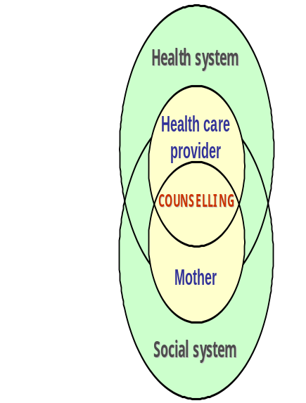
Counselling was the place where these different systems and actors met. However, much was lacking in the counselling process. It was found that 53% of mothers had received no support with breastfeeding in the postnatal ward. Confusing and mixed messages were also presented to mothers. One clinic might therefore report to being more biased to breastfeeding as a result of erratic formula supplies. Another clinic might however report to promoting formula feeding, as staff felt that this was a safer choice because mothers were mostly doing mixed feeding. Many clinics seemed to use the immediate availability of formula supplies as a guideline when counselling the women. Counselling was further influenced by a mother’s understanding of the messages and who she used as sources for information and support (e.g. what her mother-in-law had advised).

Pockets of excellence with appropriate counselling were however evident in the responses from pregnant women and mothers from certain clinics or counselled by particular individuals.

In conclusion
We raise the following the following questions:
- Is the infant’s human right to nutrition and basic health care being grossly violated?
- Are any ventures to provide adequate infant feeding counselling sustainable without an infinite stream of donor money?
- What makes for pockets of excellence and can those be reproduced throughout the health system?
- What is the spill-over effect of the indiscriminate recommendation of infant formula to HIV positive women on feeding practices of HIV negative women?
- Are more staff and more counselling the answer? We think not.
- What is the risk of putting all breastfeeding HIV positive women on ART up to breastfeeding cessation? Will we ever know, and when?
- Are we ever going to get infant feeding right?

KANGAROO MOTHER CARE (KMC) FOLLOW-UP AT CHRIS HANI BARAGWANATH HOSPITAL

M Mokhachane, L Mokgosi, K Mathiva, F Nakwa, H Diar, R Thomas, A Van Kwawegen, F Ismail and S Velaphi and KMC Unit Staff.

Introduction
Kangaroo Mother Care is a method that was started in Bogota, Colombia in 1979 by Rey Martinez. The mother (or father/family member) caries her baby in skin to skin contact between her breasts all the time. The baby only wears a nappy (plus a cap or booties in winter). This method can be practised either continuously or intermittently. Dr Martinez started this method in response to overcrowding, lack of incubators, shortage of staff and an increasing number of abandoned babies. In various studies KMC has been shown to improve weight gain and rates of breastfeeding.

In this unit there are similar challenges as was seen in Bogota, hence the decision to start Kangaroo Mother Care in 2002. All infants were followed up at a general neonatal follow-up before KMC was started. There were too many babies at the clinic and it became impossible to manage. It was also realised that the unit does not have adequate information on the LBW babies that have been discharged. In response to this a KMC follow-up was initiated with the aim of monitoring growth, feeding practices, morbidity, mortality and loss to follow-up.

Methods
The study was conducted at CH Baragwanath Hospital in Soweto. Three hundred and seventy eight infants were followed up from March 2005 to February 2008. The routine discharge weight in this unit is 1650g but some infants were discharged earlier as part of another study. For all infants KMC readiness score was used to determine if the mother infant pair is ready for discharge. Follow-up clinic is conducted three times per week. Infants were followed up weekly if discharged below 40 weeks corrected age, then at term, 3 months, 6 months, 9 months and 12 months corrected age. Those that have major problems were followed up for longer than the prescribed period.
At follow-up, infants’ growth parameters are measured, a feeding history is taken, enquiries about previous history of OPD/clinic visits or admissions is made. A full clinical examination of the infant is performed and appropriate referrals are made where indicated. In the first three to four months, the mothers are also asked whether they still practice skin to skin contact with their infants, if so for how long and if not, at what age the child started refusing KMC.
Infants with developmental problems were referred to the neuro-developmental team for assessment and management. All infants were screened for hearing before discharge or at follow-up. All infants with a birth-weight below 1500g had retinopathy of prematurity screen before discharge or at follow-up.

Statistics
Statistica 7 program was used.

Results
Three hundred and seventy eight infants were followed up during this period. Ten percent of the infants did not attend follow-up at all post discharge. Out of the 131 infants that were lost to follow-up 8 were transferred to other areas on discharge. Mothers were traced telephonically to find out what happened to the infants, whether they had, demised during this period or not. In the infants who died, all deaths were early deaths, that is less than 3months corrected age. There was a total loss to follow-up of 32%. See Table 1.

Table 1 Lost to follow-up

Age corrected for gestational age | Term | 3 months | 6 months | 9 months | 12 months | Cumulative loss
No. Lost to follow-up  (N=378) (%) | 30 (8) | 32 (8) | 19 (5) | 18 (5) | 24 (6) | 123 (32)

Mothers were relatively young with an average of 1 live child. The majority of them delivered at Chris Hani Baragwanth Hospital and were single. A third of them were HIV positive. The caesarean section rate was high as this was a very high risk group. In the neonatal period the main diagnoses were respiratory disorders and neonatal jaundice as is shown in the tables below. See Tables 2 and 3.

Table 2 Maternal demographics
Total | 349
Age | 27±6 (Range 14-43)
Parity | 1 ±1
Gravidity | 2± 1 (Range 1-8)
Place of delivery | 87% Chris Hani Baragwanath Hospital  4.5% Soweto Clinics  2.1% Home  3.6% Born before arrival  .5% Other
Antenatal clinic attendance | Yes 60%  No 7%
Place of residence | Soweto 69%  Outside Soweto 23%
Marital Status | Single 71%  Married 19%
Education | High School 63%  Tertiary 17%
HIV Status | HIV positive 29%  On HAART 2%

Table 3 Infants
Total | 378
Mean Gestational Age | 30 (±2) {Range 25-38}
Gender | Male 43%  Female 55%  Not recorded 2%
Mode of delivery | C Section 46%  NVD
Diagnosis (First 28 days of life) | Respiratory 60%  Neonatal Jaundice 57%  NEC 10%  Sepsis 18.7%
Ventilation | IPPV 10%  NCPAP 3%
Length of stay in KMC Unit (days) | 11.6 (±5.5)
RVD Exposed | 28%

Growth

Graph 1 Weight gain Graph 2 Head Growth

Mean head circumference showed normal growth being on the 50th centile from birth to 12 months corrected age. The main birth weights on the Babson and Brenda growth charts were below the 50th centile but never dropped below the third centile.

Feeding Practices
Sixty three percent of the infants (Exclusive breast and mixed) were exposed to breast milk in the KMC unit. This declined to 52%, 40% and 30% at term, 3 months and 6 months corrected ages respectively.

Table 4 Feeding practices
Type of feed | (N=378)
@ KMC  Breast  Formula  Mixed | 55%  30%  8%
@ Term corrected age  Breast  Formula  Mixed | 34%  34%  18%
@ 3 months corrected age  Breast  Formula  Mixed | 24%  37%  16%
@ 6 months corrected age  Breast  Formula  Mixed | 21%  40%  9%

Mortality and Morbidity
Forty seven infants were readmitted to hospital. The major reasons for readmission were respiratory problems (25 infants), 5 for gastro-intestinal problems, 8 for infection and 2 infants for malnutrition. Seventeen infants died during this period. The cause of death was unknown in 5 infants, 2 were sudden infant deaths syndrome, 2 from bronchopneumonia, 2 from HIV related complications, 1 from gastroenteritis and post vaccination.

Conclusion
Seventy nine percent of the infants attended follow-up until 6 months corrected age and we can confidently discharge babies using KMC in this setting. Breast feeding rates were not optimal. The unit is now working on making the hospital baby-friendly. Head growth was appropriate for gestational age although weight was less but within normal limits. Respiratory complications contribute immensely to morbidity and mortality of low birth weight infants and this need to be taken into account when discharging them early.

SCALING UP KANGAROO MOTHER CARE IN GHANA

Anne-Marie Bergh,¹ Karen Davy, ¹ Elise van Rooyen¹
Rhoda Manu,² Joanne Greenfield² and participants from Ghana Health Service
¹ MRC Unit for Maternal and Infant Health Care Strategies and University of Pretoria
² UNICEF Ghana

Background
The benefits of kangaroo mother care (KMC) in low-resource settings are well documented. Until recently very few African countries had embarked on a systematic scale-up process of KMC. Ghana is one of the countries that saw the potential of addressing the Millennium Development Goal 4 by introducing KMC to district hospitals and health centres in four of the ten regions. This was done in partnership between Ghana Health Service, UNICEF Ghana, the MRC Unit for Maternal and Infant Health Care Strategies and the University of Pretoria. The regions that were included in the scale-up project are the Northern (18 districts), Upper East (8 districts), Upper West (8 districts) and Central (17 districts) Regions.
In 2006 36% of all child deaths in Ghana were newborn deaths (29,200) and the neonatal mortality rate was 43 per 1,000 live births.¹ The current LBW rate is estimated at 9.1% of all live births.² Figures for the targeted regions are summarised in Table 1 below.

^{Table 1} Mortality rates in the four targeted regions2
Region | Neonatal mortality rate | Infant mortality rate | Under-5 mortality rate | Low birth weight
Central | 29 | 55 | 83 | 7.9%
Northern | 29 | 64 | 120 | 9.0%
Upper East | 29 | 57 | 93 | 9.9%
Upper West | 32 | 62 | 113 | 8.8%
Ghana | 43 | 71 | 111 | 9.1%

The aim of this presentation was to describe the KMC Ghana project and to report on the work in progress.

From research to policy to practice
The conceptualisation of the KMC Ghana project was based on the results from previous experience in and research on the scaling up of KMC.³⁻⁶ If was important not to create a vertical structure for implementing KMC, but rather to lift KMC out for special attention for two to three years until it was well established and the necessary paradigm shift among health workers had taken place. Furthermore, the process was driven by the regional health services by means of a KMC Steering Committee (SC) for each region and each district (see Figure 1). Each district had one representative on the Regional Steering Committee, which met 3-4 times during the year to discuss progress and plan further actions. The development of health centres of excellence was considered important for any future plans to introduce community KMC.

Figure 1 Organisation of KMC steering committees

Method
A three-phased process taking place over the course of one year was designed to make the implementation more manageable and to enhance sustainability (see Table 2). The design made provision for immediate implementation, without waiting for all training in newborn care to be in place before implementation.
Successful implementation depends not only on clinical skills, but also on transferable implementation management skills, with different skills needed at different levels in the health system. This differentiation was also built into the face-to-face facilitation programme.

Table 2 The three phases of the Ghana KMC project
Month | Phase | Date | Activities per region
0 | I | May/June 2008 | (a) Introductory workshop – 3 delegates per district  (b) Steering Committee workshop (management of implementation) – 1 delegate per district
6 | II | Nov 2008 | Advanced Steering Committee workshop
12 | III | May 2009 | Progress monitoring and evaluation of implementation of KMC

Results
The workshops were generally received very positively by participants and were associated with an increase in knowledge.
Two patterns of implementation emerged in the districts and were linked to the designation of the Regional Steering Committee member. In those districts where the Steering Committee member was a public health nurse, there was a stronger focus on public health activities and broad sensitisation and training. In districts where the Steering Committee member was a midwife attached to a health care facility, the development of facility-based KMC centres of excellence took precedence.
Some of the major challenges are lack of resources and space, lack of support from management at different levels, distances to travel, key role-players with too many other responsibilities, cultural beliefs in the community.
Evidence of the impact on neonatal morbidity and mortality will only be available in a few years’ time. Midway feedback from participants included anecdotal reports of a reduction in LBW mortality and fewer referrals to regional and teaching hospitals.

Conclusion
KMC appears to have been well accepted by both health care workers and mothers and their families in the four regions in this study. There is already evidence of KMC practice in the four regions. The effectiveness of the scaling-up process should still be evaluated.

HIV DISCLOSURE- AN ETHICAL DILEMMA IN THE KANGAROO MOTHER CARE (KMC) UNIT AT CHRIS HANI BARAGWANATH HOSPITAL

M Mokhachane, L Mokgosi, K Mathiva, F Nakwa, H Diar, R Thomas, A Van Kwawegen, F Ismail and SVelaphi and KMC Unit Staff.

Introduction:
In this unit mothers get one on one counselling session with the team members. During these sessions major social problems are unearthed. Some of these social problems create ethical dilemmas to the team. Lack of disclosure of HIV status to families/partner is a major problem not only in this unit but in the country as a whole. A lot of people are afraid to disclose because of the stigma associated with HIV. This case highlights the socio-economic dynamics that are associated with HIV and AIDS.
.
Aims
1. To share the experience KMC unit team encountered when faced with a mother who was refusing to disclose her HIV status to her partner.
2. To look at the SA guidelines when faced with disclosure to the third party at risk.

The infected mother of a premature infant (Miss M):
She was a foreigner from a neighbouring country. She came to South Africa to look for employment. She fell pregnant and lost her job as a domestic worker. She tested HIV positive during pregnancy. The partner left her when she disclosed her status. She was left pregnant and destitute. She then met the current partner(Mr T) who took her in and looked after her. She went into premature labour and delivered an extremely low birth weight baby. Mr T was very supportive and visited her frequently.

She disclosed to the staff members while in the KMC unit that Mr T is not the father of her child but she refused to disclose her status to him. Her reasons for refusing to disclose were that she’ll be abandoned. She was not a South African citizen, had no SA identification document and therefore would not qualify for a social grant. This man was supporting her financially and giving her a shelter. She was not willing to part with that. At each clinic visit she was encouraged to disclose with no success.

She was also offered retesting and work-up for anti-retrovirals but she refused stating that the ARV’s will expose her status to her partner.

The supportive partner and his family:
Mr T brought Miss M and infant to clinic for follow-up but Miss M did not want him to join while consulting with the doctor. During this time she deteriorated and was admitted to hospital. The partner took the infant to his mother in the rural areas as he was employed and not able to look after the child alone. When the mother of the infant was discharged from hospital she was too weak to look after her child. Therefore the “grandmother” continued to look after the infant.

The infant attended well baby clinic for vaccination in the rural areas. Somehow the nurses at the clinic decided to do HIV PCR because of what was written in the RTH Card. The nurses then discussed the HIV testing with the family (the mother of Mr T and his sister) without discussing with Miss M who was in Johannesburg. The sister then divulged the information to her brother. He then asked Miss M who flatly denied knowing about HIV.
The infant was brought for follow-up at the KMC clinic. Miss M then told the doctor about what happened in the rural areas. The doctor then encouraged her once more to disclose. She refused but said that it is better if they are both tested and that the doctor should not mention that her status is known.

The outcome:
They were counselled and tested. She tested positive with a CD 4 count of 1 and her partner tested negative. She was referred for treatment and adoption of the infant by the partner was discussed. She died a month later.

Mr T then went to ask the doctor whether his deceased partner knew about her status when they were tested. The doctor refused to divulge that information. He is in the process of adopting the child.
Comment:
The team had difficulty in finding clear cut guidelines that deals with disclosing to the third party at risk. Health workers need to be trained to deal with such ethical dilemmas and the countries’ guidelines need to be made accessible to all. Different guidelines also need to send the same message instead of conflicting messages.

HIV IMPACT ON INFANTS AND FAMILIES IN THE KANGAROO MOTHER CARE (KMC) FOLLOW-UP AT CHRIS HANI BARAGWANATH HOSPITAL (ABSTRACT)

M Mokhachane, L Mokgosi, K Mathiva, F Nakwa, H Diar, R Thomas, A Van Kwawegen, F Ismail and SVelaphi and KMC Unit Staff.

Introduction: A third of the infants admitted into the KMC unit were exposed to HIV. The majority of these families have major socio-economic problems. Some of them come from outside Soweto and Gauteng area with no relatives in the vicinity. There was a concern that the infants of HIV positive mothers will not grow as well as those that are not HIV exposed. Another concern was that the mothers were not disclosing to their partners.

Aims: 1. To compare the growth parameters of the HIV exposed infants to those that are not exposed.
2. To find out what the outcome of these infants is after discharge.
3. To find out how many mothers disclosed to their partners
4. To assist mothers with disclosure and testing of their partners irrespective of whether they are HIV positive or negative.

Methods: Clinic runs 3 days per week. Infants followed up weekly if discharged below 40 weeks corrected age, then at term, 3 months, 6 months, 9 months and 12 months corrected age. All infants’ growth parameters are noted at each visit as well as a general examination. At the clinic, the mothers are asked about their HIV status, the status of their partners and if HIV positive, about disclosure. All mothers were encouraged to disclose to their partners and ask them about HIV testing. The clinic team facilitated disclosure where the mother would like to disclose but is afraid to do it alone. If the partner comes to the clinic, the doctor offered counselling and testing. All the HIV exposed infants are referred for HIV PCR testing at 6 weeks and 1 year of age. All the infants with developmental problems are referred to the appropriate team.

Results:
Infants: Twenty eight percent of the infants were exposed to HIV. Nevirapine was only received by 56% of all exposed infants and 8% had a positive PCR. There was no difference in growth between HIV exposed and unexposed infants. The outcome of the infants after discharge is summarised in the table below.

OUTCOME
 | RVD Exposed  (n=105) | Unexposed  (n=273 ) | p-value
KMC @ term corrected age | 61% | 67% | 0.58
Admission | 14% | 11.5% | 0.5
Abnormal development | 10.5% | 11.1% | 0.87
Loss to follow-up | 44% | 16% | <0.01
Death | 4.8% | 4.2% | 0.87

Adults: Fifteen couples were discordant. Thirteen partners of HIV positive women were negative. Two partners of HIV negative women were positive. This did not seem to affect their relationship except with one couple.

Conclusion: Growth of HIV exposed (mainly HIV PCR negative) infants was similar to that of unexposed infants. There was a high loss to follow-up in HIV exposed infants which may due to death of the mother, relocating back to their province or death of the infant. Facilitated disclosure had a positive impact on the family.

THE EFFECT OF MATERNAL HIV INFECTION ON MATERNAL DISEASE AND PERINATAL DEATHS IN SOUTH-WEST TSHWANE

MH Hulsbergen, L Van Hoorick, HL Chauke, RC Pattinson
MRC Maternal and Infant Health Care Strategies Research Unit, Department of Obstetrics and Gynaecology, University of Pretoria

Introduction:
This article describes the effect of maternal HIV infection on maternal and perinatal disease in Southwest Tshwane. Southwest Tshwane has a low to middle-income urban population. Two midwife obstetric units (MOUs) are serving the patients with a referral system towards Kalafong Hospital, where the study was conducted. Fourteen primary care institutions have the MOUs as their referring centres.

Methods:

Southwest Tshwane has a low to middle income urban population and is served by Pretoria West and Laudium Midwife-Obstetric Units (MOUs) and Kalafong Hospital. Fourteen primary care clinics refer to those institutions. Only data from women from southwest Tshwane between 1 January 2006 and 30 September 2008 were used in the study. As part of routine audit, the maternal HIV status was recorded as HIV negative, infected or unknown in all women who gave birth from the area. The major maternal antenatal and intrapartum complication were recorded. All perinatal deaths were recorded in the Perinatal Problem Identification Programme (PPIP) and the primary obstetric cause and HIV status was allocated to each death. The causes of perinatal deaths from HIV infected, negative and unknown were analysed.

Results:
Of the 17251 births in southwest Tshwane in the time period analysed, 86.1% of the mothers were counselled which resulted in an 81.9% testing percentage. Of these women, 21.5% were HIV infected. The incidence of hypertension in the HIV tested group was 4.6%. Significantly less HIV infected women had hypertension during their pregnancy (OR 0.62, 95% CI 0.50, 0.78). Postpartum haemorrhage (defined as the need for intervention) was seen in 4.3%. Significantly more HIV infected women had a PPH (OR 1.21, 95% CI 1.0, 1.47). The caesarean section rate was 28.3% with significantly more HIV infected women having both elective and emergency caesarean sections (OR 1.21, 95% CI 1.11, 1.32).

The Perinatal Mortality rate was 34.8/1000 births in the HIV infected group and 26.4/1000 births in the HIV negative group (OR 1.33, 95% CI 1.06, 1.67). The Stillbirth rate did not differ between HIV infected and HIV negative groups, but the Neonatal Death rate did differ significantly (HIV infected 11.3/1000 live births, HIV negative 4.9/1000 live births, OR 2.28, 95% CI 1.48, 3.50). The low birth weight was significantly more in the HIV infected group (20.2%) compared with 14.6% in the HIV negative group (OR 1.48, 95% CI 1.34, 1.64). The primary obstetric cause of perinatal death was significant in spontaneous preterm labour (OR 1.9), intrapartum asfyxia (OR 4.3) and infections (OR 7.3). Final cause of neonatal death gave immaturity related reasons as the only significant reason of death (OR 2.7). See Table 1.

Table 1 Cause of perinatal death in HIV infected, negative and unknown pregnant women
Prim Obst Cause Death | HIV + | HIV -) | Unknown
Unexpl SB | 23 (7.6/1000) | 70 (6.3/1000) | 24 (7.7/1000)
Spont Preterm Labour | 22 (7.3/1000) | 42 (3.8/1000) | 28 (8.9/1000)
Intrapartum Asfyxia | 7 (2.3/1000) | 6 (0.5/1000) | 2 (0.6/1000)
Trauma | 2 (0.7/1000) | 4 (0.4/1000) | 2 (0.6/1000)
Hypertension | 9 (3.0/1000) | 34 (3.1/1000) | 7 (2.2/1000)
Antep. Haemorrhage | 7 (2.3/1000) | 28 (2.5/1000) | 11 (3.5/1000)
Infections | 10 (3.3/1000) | 5 (0.5/1000) | 4 (1.3/1000)
Fetal abnormality | 3 (1.0/1000) | 15 (1.4/1000) | 2 (0.6/1000)
Maternal Disease | 3 (1.0/1000) | 8 (0.7/1000) | 2 (0.6/1000)
IUGR | 1 (0.3/1000) | 3 (0.3/1000) | 2 (0.6/1000)
Other | 15 (5.0/1000) | 53 (4.8/1000) | 27 (8.6/1000)

Conclusion:
In southwest Tshwane a HIV positive mother has an a 33 percent increased risk of having a perinatal death compared to a HIV negative mother. This is due mainly to neonatal deaths due to prematurity, intrapartum asphyxia and infections. HIV infected women have a lower incidence of hypertensive diseases in pregnancy, but an increased risk of PPH and cesarean section. Therefore pregnancies of HIV positive women need to be monitored as high-risk pregnancies.

TUBERCULOSIS-EXPOSED NEWBORN INFANTS: CLINICAL FEATURES AND SHORT TERM OUTCOME (ABSTRACT)

A Eerdekens, S Delport
Dept of Paediatrics, Kalafong Hospital and the University of Pretoria

Introduction
Tuberculosis (TB) is increasingly being diagnosed during pregnancy and the post-partum period. Newborn infants are at risk of having acquired the disease ante- or perinatally, which if untreated, may be fatal.

Aim
To audit the clinical features and short term outcome of infants delivered to mothers with TB.

Patients and Methods
Infants of mothers with TB diagnosed during pregnancy or during the post-partum period and admitted to the neonatal service after birth to diagnose/exclude TB were audited.
Standard of care for these infants includes documentation of clinical features, M. tuberculosis microscopy and culture of gastric aspirates obtained shortly after birth, a chest radiograph and initiation of primary TB treatment. Their mothers’ HIV status, CD4-count, chest radiograph and placental histology are also documented.

Results
Over an 11-month period (1/2/2008 - 31/12/2008), 19 consecutive infants were audited. TB and HIV infection were diagnosed in 18/19 mothers (mean CD4: 124 cells x 10⁶ / L). The remaining mother had a TB contact during pregnancy and was HIV negative. At delivery 11/18 mothers were receiving TB treatment for a median period of 1 month (1 day - 9 months). 3 placentas were sent for histological examination and 1 showed histological features of placental TB. The median birth weight of the infants was 2050 g (920 g - 3600 g). No infants had clinical or radiological features suggestive of TB. 2 infants had a positive TB culture on gastric aspirate.

Conclusion
The diagnosis of TB in exposed newborn infants should be actively pursued followed by empiric TB treatment and part of the PreventionMotherToChildTransmission (PMTCT)-programme.

LONGITUDINAL PERINATAL MORTALITY RATES AND PERINATAL CARE INDEX’S IN SOUTH AFRICA

RC Pattinson, RV Prinsloo for Synergy Group
MRC Maternal and Infant Health Care Strategies Research Unit, University of Pretoria

Introduction:
Perinatal death review meetings are widely used as a method of auditing perinatal deaths. It is assumed that once the problems in perinatal care have been identified in the review meetings, there will be action taken by the members of the meetings to correct the errors and address the problems. It is thought that by identifying the problems and discussing them, the self correction that is assumed to follow will result in a reduction in perinatal deaths.

The Perinatal Problem Identification Programme (PPIP) has been used as a perinatal audit system for a number of years at various sites in South Africa and there is serial data from a wide range of hospitals. If the above assumption is correct then there should be a reduction in the number perinatal mortality and an improvement in the quality of care.

Aim:
To assess trends in perinatal mortality rates (PNMR) and perinatal care index’s (PCI) in South Africa.

Method:
Sites that have run the Perinatal Problem Identification Programme (PPIP) for 5 years or more were identified. The trends in the PNMR and PCI were analysed. The PNMR and the PCI were chosen as both have been independently significantly associated with quality of care.

Results:
There were 35 sites with 5 or more years of PPIP data. There were 6 Midwife Obstetric Units, 24 District Hospital and 5 Regional Hospital. The PNMR (>500g) and PCI are shown in Table 1.

Year | Total | Total deaths | PNMR | PCI
2003 | 71991 | 1939 | 26.9 | 2.18
2004 | 91174 | 2619 | 28.7 | 2.32
2005 | 87424 | 2117 | 24.2 | 2.38
2006 | 93012 | 2336 | 25.1 | 2.47
2007 | 91500 | 2424 | 26.5 | 2.45

There was a non significant trend to a reduced neonatal death rate in the regional hospitals and district hospitals. The PCI did not change in the various levels of care. Three institutions had a significant decreasing trend in the PNMR and PCI and 5 had a significant increasing trend in PNMR and 3 a significant increasing trend in the PCI (Chi square test for trend.).

Conclusion:
There has been no significant change in the trend of the PNMR or PCI in health institutions with PPIP data for 5 or more years. The assumption that identification of the problems resulting in perinatal deaths will lead to a self correction of these errors appears to be false. Further investigation is needed in identifying the factors related to reducing the PNMR and PCI. This is the basis of further research.
FORMATIVE RESEARCH TO ASSESS CURRENT CARE PRACTICES IN SELECTED DISTRICTS IN KWAZULU NATAL

Susheela M. Engelbrecht
Senior Programme Officer, PATH
Introduction
KwaZulu Natal (KZN) province serves a population of 9,924,000, and is the largest province in South Africa. The average annual births are estimated to be 172,710 (DHS 2007). In KwaZulu Natal there are fifty-two hospitals and more than 500 primary health clinics (PHC) and 13 Community Health Centres (CHC) providing maternal care services.
Most women prefer to deliver in hospital, and attend PHC clinics for antenatal care, postnatal care and well baby clinics. This is partly because many PHC clinics do not open at night and staffing and transport issues have been cited as some of the reasons women prefer hospitals to clinic. High risk cases identified at the CHC and PHC clinics are referred to the district hospital for management. CHC and PHC clinics do not have permanent doctors, there may be a visiting doctor from the district hospital, but this service is lacking in the three MNTI districts. District PHC Supervisors, who are based at the district or at the sub district, provide support to PHC facilities.
Maternal and newborn deaths are far too common in KZN, as in much of South Africa, and most are preventable with appropriate care and action. Maternal and Newborn Technology Initiative (MNTI) is a three year project whose aim is to reduce maternal and newborn deaths in three (3) selected districts, namely iLembe, Sisonke and uMzinyathi, through the introduction of innovative lifesaving technologies and techniques.
The project aims to assist the KZN provincial government efforts to reduce maternal and newborn deaths by introducing innovative lifesaving technologies that can reduce maternal and newborn morbidity and mortality. With these specific goals in mind, PATH has broken these goals into measurable objectives that work together towards the goal set forth above. These four objectives are as follows:
- Expand accessibility, availability, and use of appropriate and effective neonatal resuscitator devices to populations in need;
- Expand lifesaving training for birth attendants (focused on nurses/midwives and physicians) to include partograms, AMTSL, immediate postpartum maternal and newborn care, and neonatal resuscitation;
- Increase accurate reporting of cause-specific maternal and neonatal mortality through the use of a participatory assessment process designed to identify feasible methods of capturing data in an appropriate manner for the intervention evaluation and programme monitoring;
- Develop an evidence base in South Africa for the coverage, occupational safety, relative cost and cost savings, feasibility, and acceptability of AMTSL using Oxytocin-filled Uniject devises for preventing PPH across a range of service delivery settings.
The formative assessment was conducted to assist with development of project interventions and strategies.
Formative research to assess current care practices
This presentation describes the formative assessment carried out as part of the three-year initiative being pursued by the South African government with PATH t o curb maternal and newborn deaths in selected districts of KwaZulu-Natal, South Africa.
Formative research was carried out by Development Research Africa (DRA) researchers. The quantitative data were then entered and analysed descriptively in SPSS by DRA researchers. A participatory workshop with key stakeholders in KZN (Durban) was held to agree upon key findings and jointly develop a list of recommendations and an implementation plan for agreed upon recommendations.
A total of 13 facilities were assessed, 243 records reviewed, 26 providers interviewed, 14 key informants interviewed, 28 deliveries observed, and 9 newborn resuscitative efforts observed.
Major findings on current care practices
Major findings provided by the formative assessment on current care practices are:
There are many practices that are performed well by South African midwives but in this report we will focus on those findings that could benefit from targeted interventions.
- Not all key informants were aware of national, provincial, and hospital guidelines.
- The following cross-cutting practices were performed less than satisfactorily when providers were observed giving care during pregnancy, labour and childbirth, the postpartum, and for the newborn:
- Communication with clients and their support persons.
- Communication with parents and family members.
- Counseling and advice to the woman about self-care or to the mother/parents about care of the newborn.
- Infection prevention practices, most particularly handwashing, wearing protective gear, and decontamination of aprons, beds, and instruments.
- When provider practice during observation was compared with documentation in the maternal record, it appears that providers are not consistently documenting the care being provided.
- PMTCT interventions and HIV care were not systematically integrated into routine care provision during pregnancy, labour and childbirth, newborn care, and postpartum care for the woman.
- Screening tests were not consistently carried out for antenatal clients (Figure 1).
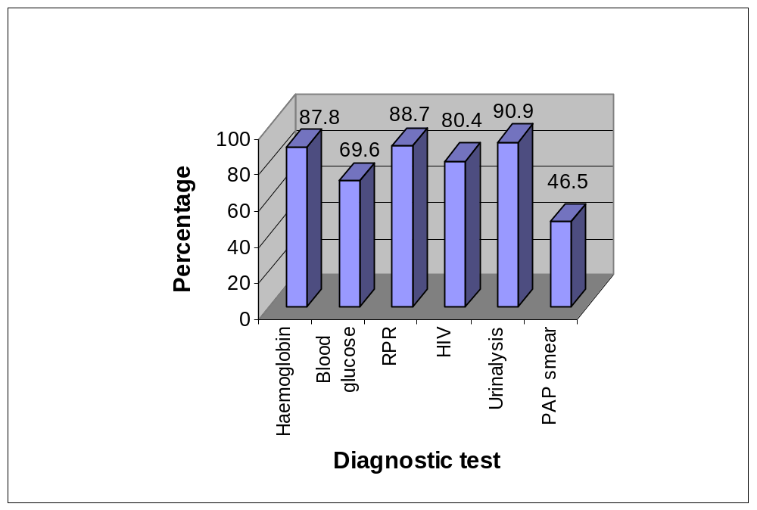
Figure 1. Percentage of antenatal records with selected diagnostic tests recorded
- Screening for cervical and breast cancer was not done systematically during antenatal and postnatal care.
- Of all of the maternal case records reviewed, only 62.1-83.1% had information recorded about the initial examination of the woman when she was admitted in labour. Of all the records reviewed, only 80.2% (195) had assessment and management interventions documented, 77% (187) had the labour record comprehensively documented, 80.2% (195) had the time recorded, and 74.1% (180) were signed. (see Figure 2.)

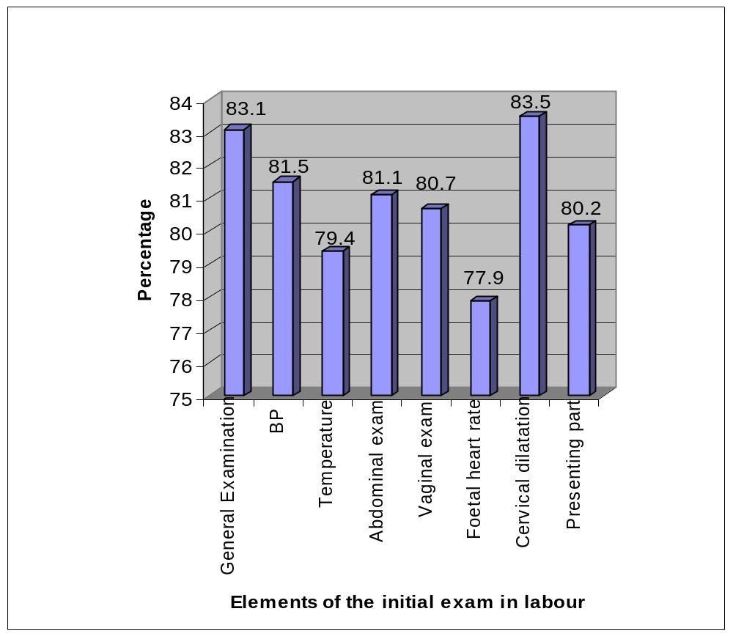
Figure 2. Percentage of maternal records with selected elements recorded of the initial exam in labour

- While 82% of women in labour had a partogram filled in, many of the partograms reviewed were not completely filled in, did not have findings consistently recorded, did not have assessments and plans of care recorded, and were not signed.
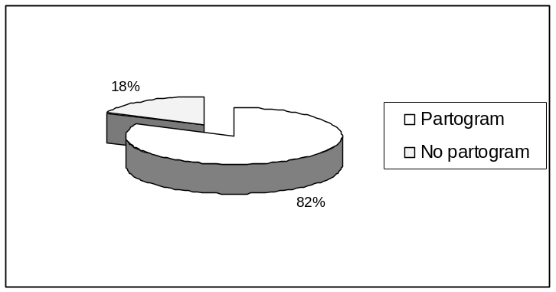
Figure 3. Percentage of maternal records with a partogram filled in
- The following practices during labour and childbirth were considered to be of particular concern:
- While 62.6% of women whose cases were reviewed had active labours longer than 6 hours, 88.4% of women had their labour augmented with oxytocin. (see Figure 4.) Although the SA national protocols state that active phase begins at 4cm, most partograms have active phase starting at 3 cm, which could explain why so many labours were augmented.
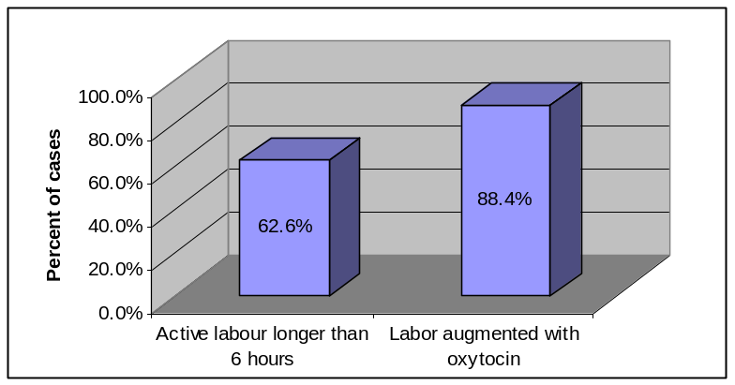
Figure 4. Number of women who had active labour longer than 6 hours and who received oxytocin during the first stage of labour
- 85.7% of the midwives observed provided some kind of emotional support to the woman in labour; only 42.9% provided information to the woman and 46.4% listened to what the woman had to say. (see Figure 5.)
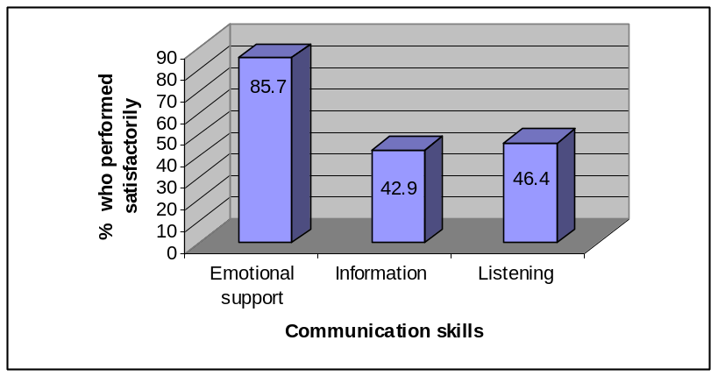
Figure 5. Percentage of observed providers who satisfactorily provided support and information to women in labour (n=28)
- During observations of provider practice, 67.9% of the women had an episiotomy and review of maternal records showed that 42.8% of the women had had an episiotomy. (see Figure 6.)
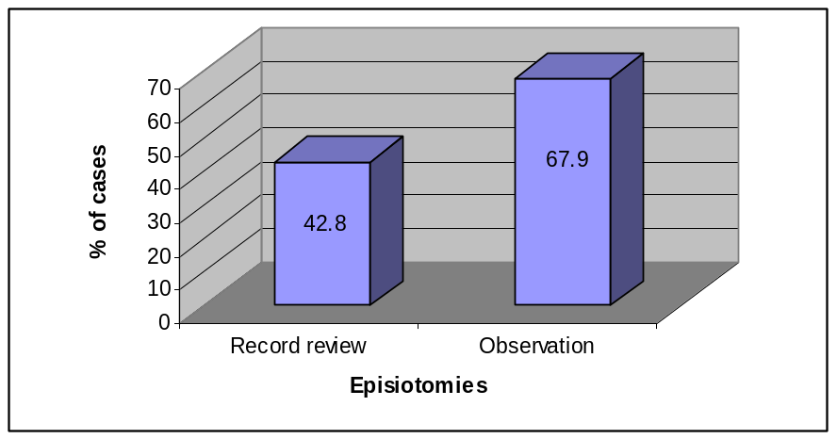
Figure 6. Episiotomy rates from record reviews and during provider observations
- The third stage of labour was not managed consistently. (see Figure 7.)
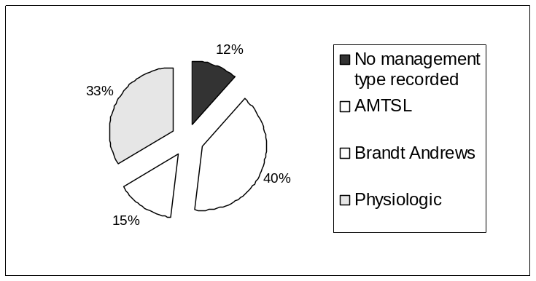
Figure 7. Type of third stage management recorded in maternal records
- Controlled cord traction and/or an uterotonic drug (Syntometrine is the uterotonic that was most used) were provided to the majority of women. (see Figure 8).
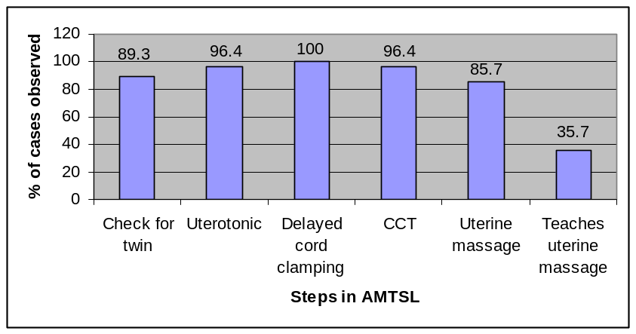
Figure 8. Percentage of observed providers who satisfactorily performed selected steps when managing the third stage of labour
- Routine care after delivery of the placenta was not consistently provided, including uterine massage, teaching the woman to massage and monitor her own uterus, careful inspection of the placenta and birth canal, and assisting and encouraging the woman to void after delivery. (see Figure 8.)
- The majority of women and newborns were only monitored between 1-3 times during the immediate postpartum period (0-6 hours after delivery of the placenta). (see Figure 9.)
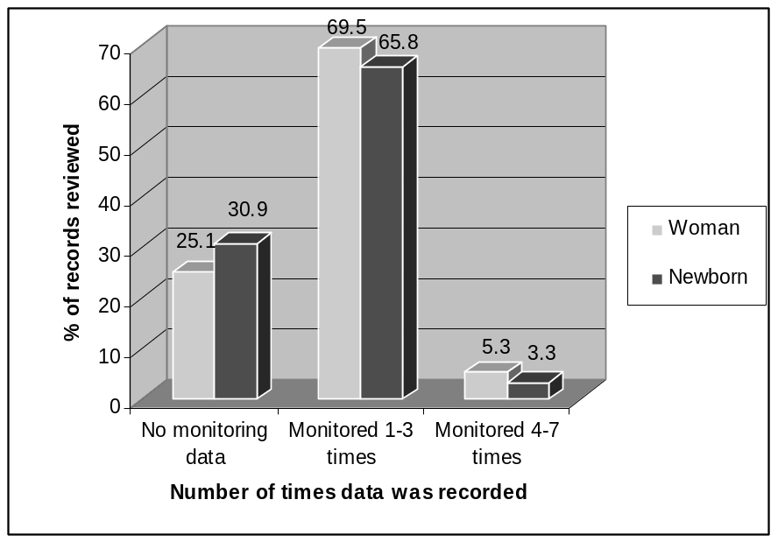
Figure 9. Percentage of maternal records with monitoring data during the immediate postpartum recorded (Recommended number of monitoring events = 16).
- Observation of providers shows that all of the recommended steps to prevent and detect PPH in the immediate postpartum period were performed satisfactorily by less than 90% of providers. (see Figure 10.)
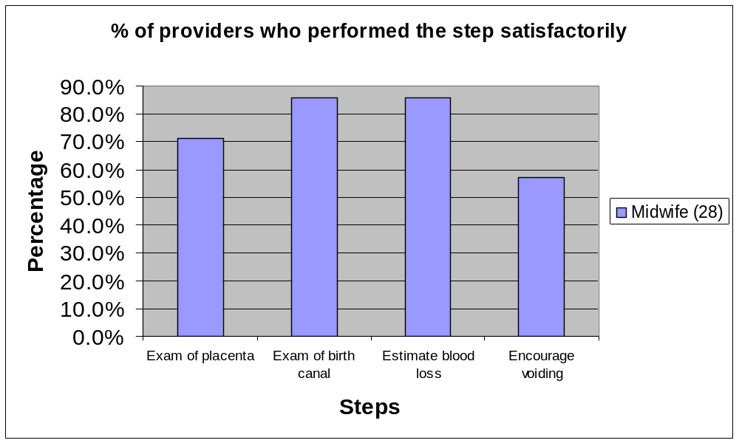
Figure 10. Percentage of observed providers who satisfactorily performed selected steps of immediate postpartum care (n=28).
- Care in the postpartum was provided to a minority of women and newborns, and then was neither comprehensive nor consistent.
- Newborn care was inconsistently provided:
- The majority of providers observed satisfactorily performed immediate care of the newborn. (see Figure 11.)
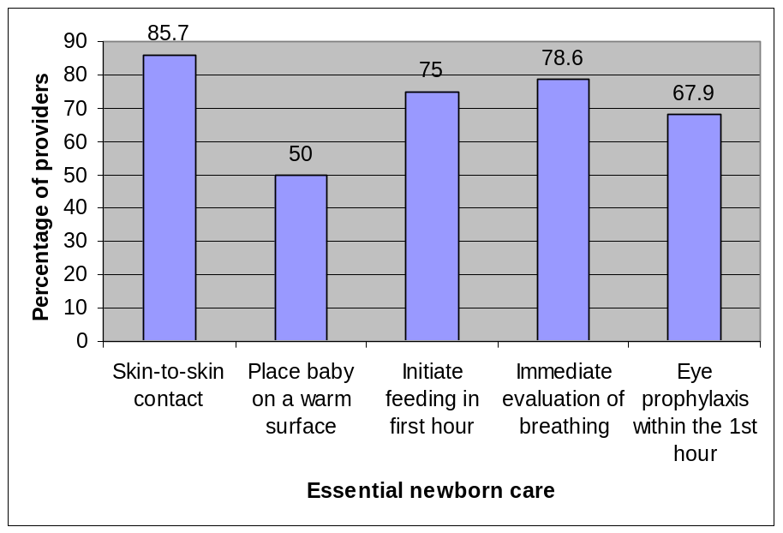
Figure 11. Percentage of observed providers who satisfactorily performed selected elements of newborn care (n=28).
- The majority of providers observed did not satisfactorily perform any of the steps of the newborn examination.
- While 100% of the providers checked the mother’s and baby’s history of ARV drug administration for newborns exposed to HIV, only 4 providers (50%) actually followed through with either provision of ARV drugs or counselling about need for completing the full dose of ARV prophylaxis for the baby. Of the 8 women infected with HIV, only 1 (12.5%) received information about support groups for women with babies who are infected with HIV and only 6 (75%) were provided counselling about signs and symptoms suggestive of HIV-related illness in infants. (see Figure 12.)
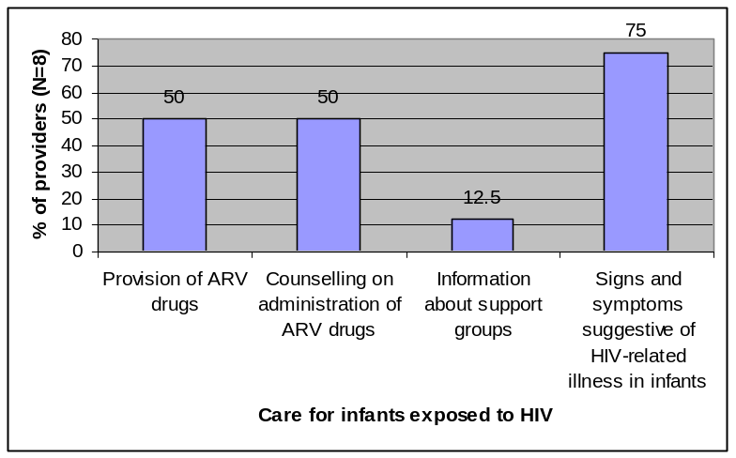
Figure 12. Percentage of observed providers who satisfactorily performed selected elements of care for newborns exposed to HIV (n=8).
- Of the 28 providers observed, very few provided counselling to parents on care for the newborn. (see Figure 12.)
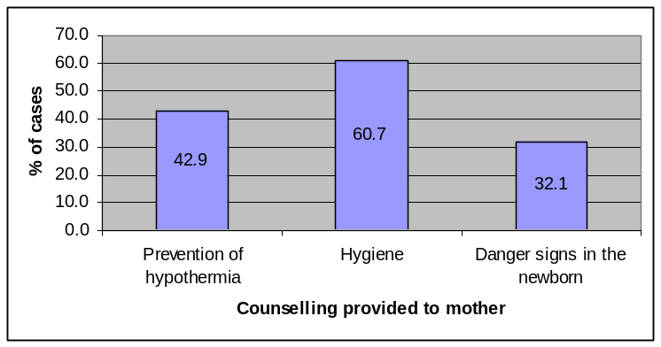
Figure 12. Percentage of observed providers who satisfactorily provided selected counselling to new mothers (n=28).
Recommendations to improve practice
- Work with DOH managers to ensure that national, provincial, and hospital guidelines are available at all of the facilities.
- Define clear expectations for infection prevention (IP) practices and care during pregnancy, labour and childbirth, for the newborn, and in the postpartum period by disseminating and reinforcing policies, guidelines, job descriptions, and protocols.
- Work with DOH personnel to develop job aids or other user-friendly means of ensuring that all midwives are aware of guidelines.
- Integrate the following subjects into learning materials developed for care during pregnancy, labour and childbirth, for the newborn, and in the postpartum:
- Infection prevention practices.
- PMTCT interventions.
- Counselling the woman about self-care and counseling mothers/parents about care of the newborn.
- Provide refresher courses for all perinatal providers on:
- Initial assessment of a woman in labour.
- Partogram.
- AMTSL.
- Monitoring and care in the immediate postpartum period.
- Essential newborn care, including prevention of hypothermia and newborn examination.
- Essential postpartum care for the woman.
- Newborn resuscitation.
- Work with facility managers to ensure that providers are working in an enabling environment by:
- Ensuring that all of the equipment, supplies, and consumables are available for the recommended maternal and newborn care.
- Ensuring adequate staffing.
- Ensuring that providers have the space and time they need to counsel clients effectively.
- Limiting rotation of staff.
- Ensuring ongoing training of personnel being transferred into the maternity ward.

- Develop indicators for the following practices at each facility:
- Infection prevention.
- PMTCT interventions.
- AMTSL.
- Integrate evaluation of infection prevention practices, client-provider interaction (CPI), counselling, and integration of PMTCT interventions into supervisory tools.
- Address the many factors that affect providers’ ability to interact with clients by:
- Defining clear expectations for good client-provider interaction (CPI).
- Ensuring adequate staffing and an enabling work environment.
- Giving providers feedback on their performance by focusing supervision on CPI and by encouraging co-workers, clients, and the community to help.
- Motivating providers by recognizing and rewarding superior performance.
- Matching workers with jobs to ensure that providers have the knowledge, attitudes, and skills essential for good CPI.
- Provide training and non-training interventions to improve counselling skills, including but not limited to:
- Ensuring the availability of client educational materials.
- If educational materials don’t already exist, developing materials that are appropriate for the intended audience.
- Work with providers to (1) evaluate why providers are not consistently documenting the care being provided and (2) develop interventions to improve documentation that are targeted to the causes.
- Work with providers to (1) evaluate why providers are not consistently screening for breast and cervical cancer and (2) develop interventions to improve screening that are targeted to the causes.
- To address incomplete partograms:
- Review the partogram to evaluate if it can by streamlined by removing certain parameters.
- Standardise recommendations for recording on the partogram for the midwife and the doctor.
- Work with doctors and midwives to (1) evaluate why providers are not consistently documenting care provided on the partogram and (2) develop interventions to improve documentation that are targeted to the causes.
- Promote peer review of partograms.
- To address high episiotomy rates:
- Disseminate and reinforce PMTCT protocols.
- Review and disseminate indications for episiotomy.
- Work with the FIO to promote giving feedback on episiotomy rates to perinatal providers.
- To address high augmentation rates:
- Update the national partogram to have active phase starting at 4 cm.
- Review and disseminate indications for augmentation of labour.
- Promote review of cases of women whose labours were augmented to evaluate if the augmentation met indications.
- Promote oxytocin as the uterotonic of choice for active management of the third stage of labour.
- To improve monitoring during at least the first 6 hours postpartum:
- Designate a person to care for women and newborns in the postnatal ward.
A DISTRICT LEVEL STUDY OF THE CAUSES OF THE ‘THIRD DELAY’ IN ZIMBABWE (ABSTRACT)

Manyame S¹, Munjanja S P², Mhloyi M³
Department of Obstetrics and Gynaecology (1,2), Department of Social Sciences (3), University of Zimbabwe.

Introduction
The ‘three delays’ model proposes that pregnancy related mortality is overwhelmingly due to delays in; deciding to seek appropriate medical help for an obstetric emergency, reaching an appropriate health facility, receiving appropriate and adequate care when the health facility is reached. Zimbabwe is one of the developing countries with a high maternal mortality ratio (880/100000 in 2007-WHO). This study analyses the deficiencies in maternal care which affect women who have reached a health facility.

Methodology
A district based cross sectional study with both a qualitative and quantitative aspect was carried out in ten randomly selected districts of Zimbabwe, during 2007-8. Questionnaires were administered to postnatal mothers who had had obstetric complications, as well as the staff attending to them. Drug and equipment checklists were filled in by investigators and their assistants at each rural health centre and district hospital. Tape recorded focus group discussions were carried out at community level for both men and women.

Results
Results for district hospitals and five rural health centres will be presented in this abstract. Total respondents were 101 postnatal women as well as staff attending to these women. 96% of the women were booked and the earliest booking gestation was 8 weeks. 72% of the women had normal vaginal delivery, 20% had emergency caesarean section and 8% had elective caesarean section. 22% of the women had an unfavourable outcome including still birth (9%), and early neonatal death (12%). Sixty two percent (62%) of the women were attended to within 10 minutes upon arrival at the health facility. Despite this however, 20% thought there was a delay in receiving treatment and the longest delay was 192 hours. The women thought the delays were caused by shortages of staff, poor referral facilities as well as poor patient care by the health providers. Most patients were able to make independent decisions concerning referral, receiving treatment including blood transfusion, and consent for surgical procedures e.g. caesarean section but 21% required permission from their husbands. 92% thought that there was no delay caused by failure to pay hospital fees. Religion had no influence on decision making within the health facility.
The equipment checklists and drug inventories showed that 50% of rural clinics in Matabeleland North did not have oxytocic drugs, intravenous fluids, intravenous antibiotics nor intravenous sedatives. All rural health centres never had oxygen cylinders thus transfer of critical patients is without oxygen support. Thus, significant third delay occurred at the primary care clinics. The district hospitals were at the time well equipped in both basic instruments and drugs for EmOC. Laboratory backing is however poor and this was attributed to lack of reagents. Most clinics are manned by primary care nurses who are not qualified or trained in EmOC which compounds the third delay.
All heath providers reported that a shortage of staff and resources, and an inadequate referral system contribute to the third delay profoundly.

Conclusion
Delays in treatment at the rural health centres were caused by the shortage of health providers, unavailability of drugs and supplies, lack of training in EmOC among nurses and a poor referral system. Patient and family factors did not contribute greatly to the third delay.
ARE WE WINNING? THREE YEARS OF EFFORT TO IMPROVE PERINATAL OUTCOMES AT A DEEPLY RURAL DISTRICT HOSPITAL IN SOUTH AFRICA

Dr C. Benjamin Gaunt
Zithulele Hospital, Eastern Cape

Abstract
Zithulele Hospital is a deeply rural district hospital in the Eastern Cape province of South Africa. Beset by staffing, procurement and infrastructure problems, the maternity service in 2005 was poorly organised and offered an inadequate standard of care. By our estimates nearly 50% of women were still delivering at home. Three years of effort focussed on regular audit to identify problems and improve our service started to bear fruit in 2008, as reflected in significantly increased deliveries and a sharp drop in the perinatal mortality rate. This presentation reflects on some of the successes, which factors have contributed to them, and some of the challenges that remain.

Introduction
Zithulele Hospital is a deeply rural district hospital in the Eastern Cape province of South Africa. It receives referrals from the surrounding primary health care clinics and provides non-specialist hospital services to a population of 130 000 people living in an area of nearly 1000km². The area is one of the poorest in the country, with low education levels and very high rates of unemployment. Access to the hospital is by means of a dirt road not reflected on standard maps.

Founded in 1956 by missionaries and now run by the provincial department of health, the hospital has, for much of its history, struggled to attract health professionals. This situation has improved markedly since the arrival of new senior staff in July 2005 and 2006; the multi-disciplinary clinical team now totals 22 professionals.

District hospitals in South Africa are historically under-resourced. Many occur in rural areas. The ratio of doctors is below 18.5 per 100 000 population in the four most rural provinces. The standard of maternity care varies widely across the country, but district hospitals typically fair worse in analyses of perinatal and maternal mortality. However, with 42% of deliveries conducted at district hospitals, the improvement of care at these institutions is an urgent priority.

In the Eastern Cape province, data suggests that 73% of women have a skilled attendant at delivery. In 2005 we estimated, based on national fertility rates, the population we serve and deliveries at our hospital, that up to 50% of women delivered at home in our area.

In addition, the Zithulele maternity service in 2005 was fragmented and disorganised. Lack of space meant the labour room consisted of two beds nearly touching each other. Lack of resources meant there were only two delivery packs in the hospital, preventing steam sterilisation between cases. There was only one laryngoscope for the whole hospital and other resuscitation equipment was hopelessly inadequate. Poor practices included inadequate monitoring during labour with no routine use of the partogram and the use of unrefrigerated ergometrine in the third stage of labour.

While much of our initial attention was taken up running day to day services, our strategy to make improvements focussed on the four areas causing the majority of morbidity and mortality, namely HIV, TB, maternal and child health.

PPIP audits
With respect to maternal health, the prospectively collected data regarding women who deliver in our maternity service was emphasised as extremely important, with attention given to accuracy and detail. In addition, each perinatal death had a data sheet completed at the time of delivery or as soon as possible thereafter. This data was then entered into the Perinatal Problem Identification Programme (PPIP) version 2.2.3, an audit tool which is used by 254 institutions in South Africa and managed by the Medical Research Council. The programme allows the user to analyse basic data and identify avoidable factors associated with each perinatal death.
The use of PPIP was supplemented with monthly perinatal mortality meetings at which each month’s data is presented and every perinatal death discussed. Each meeting usually has a short period of discussion about a clinical topic related to obstetrics, in addition to a discussion about the avoidable factors that may have been present.

A number of other significant changes have been implemented over the past three and a half years. Training and audit activities were extended. We were the first district hospital in the province to implement the Child Health Problem Identification Programme – a tool that helps us audit care in the paediatric ward. Significantly, this has helped to draw attention to the importance of the proper implementation of prevention of mother to child transmission (PMTCT) strategies for HIV. We also have an accredited journal club for doctors to stay up to date and review practice issues including obstetric care. A system of outreach to four of our feeder clinics has allowed input into antenatal care at a primary care level.

Insistence on safe practice was a key intervention. Midwives were instructed to use the partogram for every labour case and taught how to do this accurately. Use of a cardiotocograph has become routine in all high risk cases. Protocols were developed for the safe augmentation and induction of labour. Perhaps most importantly, the midwives were encouraged to call for help early, especially in the second stage of labour – allowing problems to be dealt with pro-actively. Calling early results in more normal labours being seen by the doctor, but this willingness to come is important in encouraging midwives to ask for assistance.

Results & comments
A 53.4% increase in the number of deliveries occurred between 2005 and 2008, from 745 deliveries in 2005 to 1143 in 2008. The ability of women to access care has changed little during this time. We have therefore ascribed the increase to an improved reputation of the hospital within the community, due to better quality care. A 24-hour caesarean section service was re-instituted in July 2005 resulting in much fewer referrals to the tertiary hospital 100km away. This is strongly appreciated by the women.

Despite the rise in deliveries we have been able to achieve a reduction in the 6-monthly perinatal mortality rate. Figure 1 shows corrected perinatal mortality rate, but the uncorrected rate for 2008 was also only 27.1 per 1000. The perinatal care index (PCI), which is a marker of the quality of care of newborns and corrects for low birth weight infants, has declined from a very high 3.7 during 2006 and 2007 to 2.4 in 2008. The national average for rural institutions contributing to the PPIP database in 2003-5 was 2.3. ⁸ Our PCI remains relatively high despite the improved perinatal mortality rate, partly due to a low birth weight rate of only 10.7% (compared to a national rural average of 13.3%).
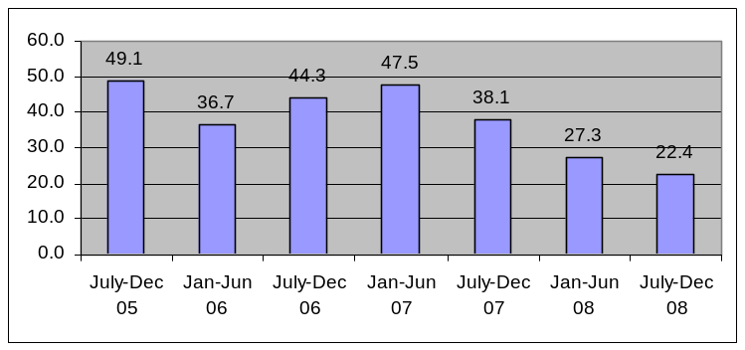

Figure 1 Corrected perinatal mortality rate over time

There has also been a change in the perinatal death profile. (See table 1.) While intrapartum asphyxia remains the predominant cause of death, and the order of causes remains almost the same, the proportion of deaths due to hypertension, antepartum haemorrhage and infection has reduced. The high number of cases of intrapartum asphyxia reflects the poor infrastructure in the area combined with extreme poverty. It also represents an opportunity for continued improvement and the need for heightened vigilance among attending staff.
 | Number (%)
 | July 05 - Dec 06 | Jan 07 - Dec 08
Intrapartum asphyxia | 21 (32.8) | 32 (40)
Unexplained IUD | 10 (15.6) | 12 (15)
Spontaneous preterm labour | 8 (12.5) | 10 (12.5)
APH | 8 (12.5) | 6 (7.5)
Hypertension | 7 (10.9) | 5 (6.25)
Infection | 5 (7.8) | 4 (5)
Fetal abnormality | 0 (0) | 4 (5)
No obstetric cause | 3 (4.7) | 3 (3.75)
IUGR | 1 (1.6) | 2 (2.5)
Trauma | 1 (1.6) | 1 (1.25)
Other | 0 (0) | 1 (1.25)
Total | 64 (100) | 80 (100)
Table 1 Causes of perinatal death

An analysis of the top eight avoidable factors associated with perinatal death over this period shows clearly that accessing care timeously is a major problem. (See figures 2 and 3.) Lack of transport from home to hospital and delay in arriving during labour are both likely due to the challenges of income and infrastructure described above. For some women a trip to hospital over the weekend can cost up to two thirds of monthly household income. Problems with antenatal care are the other major issues apparent in this analysis. This may be due to a combination of the problems of access and a lack of appreciation within the community of the importance of antenatal care, particularly within the context of historically poor service delivery. The small improvement over the past two years is hopefully a sign that things are changing as the clinics become better staffed and the hospital offers a better service.

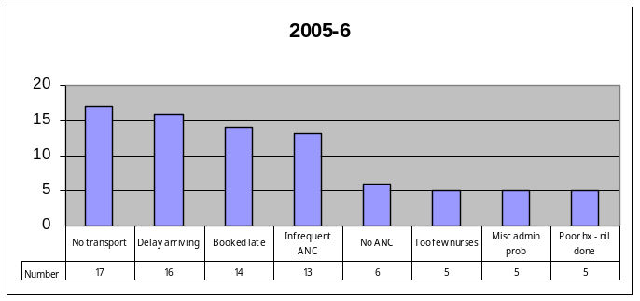
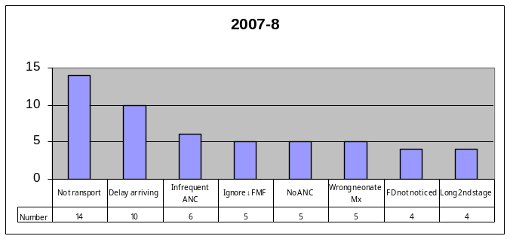

Figure 2: Top 8 avoidable factors in Figure 3: Top 8 avoidable
factors in deaths from July ‘05 to December ‘06 deaths from January ‘07
to December ‘08

Delivery methods have remained relatively similar over time. The caesarean section rate is comfortably within the 5-15% range recommended by the World Health Organisation and considered appropriate in our setting. It rose slightly from 10.5% in 2005/6 to 12.3% in 2007/8. Assisted vaginal deliveries, all ventouse deliveries, rose marginally from 5.4% to 5.8% during the same period. 1% of babies are born as vaginal breech deliveries.

A major area of success has been in encouraging pregnant women to test for HIV. (See figure 4.) This achievement has gone through a number of phases, from ensuring that women who deliver in our unit are offered testing, to encouraging the clinics to test women antenatally, to introducing “dual PMTCT” (AZT from 28 weeks and single dose Nevirapine in labour) ahead of the provincial roll-out, having obtained permission to do so from the authorities. In 2008, 99.8% of women who delivered at Zithulele knew their HIV status at delivery.

The seroprevalence rate of HIV has remained at 21% since sufficient data has been collected. This compares favourably to the 2007 rate of 27.3% in antenatal surveys from the OR Tambo District as a whole. A dedicated weekly ARV clinic for pregnant women and children has improved the uptake of PMTCT and HAART in pregnancy; a recent slight rise in the HIV positivity rate is probably due to us encouraging clinics to refer HIV positive women to us, as we are the only local site able to offer these services.
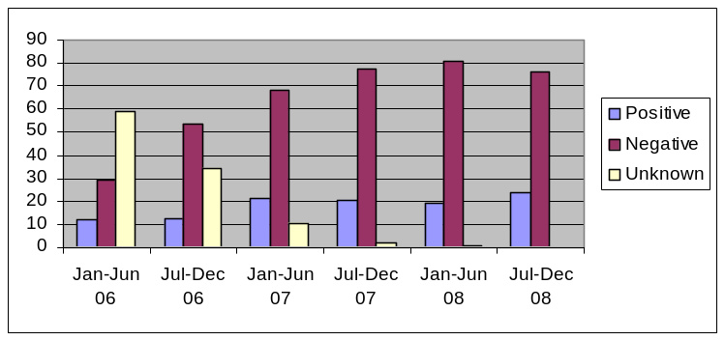

Figure 4 HIV status at delivery

Discussion & reflection
It is worth reflecting on the possible reasons for our success, in addition to the measures we implemented as described above. Such reflection assists the identification of factors worthy of continued effort, may encourage other hospitals in similar positions to make positive changes and can assist policy makers seeking to improve district health services across the board. This is especially relevant in the light of evidence that the use of an audit tool such as PPIP does not automatically result in improved perinatal outcomes.

A core of suitably skilled staff with a long term commitment to the hospital has undoubtedly provided a foundation on which improvements can be built. The four senior staff each have two post-graduate diplomas in different disciplines: two diplomas in obstetrics, two in child health, three in anaesthetics and one in HIV management. They have been supplemented by enthusiastic community service doctors and others, which has allowed an expansion in services and the improvements to be sustained. This is in line with the government’s intentions for community service; our experience suggests that the attraction and retention of long term staff in rural areas should be more actively prioritised as a way of improving both services and in order to provide a better experience for community service doctors.

The cultural theory of organisational change, articulated by Scott and colleagues, makes three assumptions, namely that such a thing as organisational culture exists, that culture is related to performance and that culture can be changed to impact performance. We are fortunate in that much of the ethos of the missionaries has been maintained. We could therefore affirm the dedicated nursing staff in their genuine care for their patients and are fortunate to have an enthusiastic management team. We have been able to build on this by promoting a culture of excellent, continuously improving standards within the hospital. Our commitment to going the extra mile is evident in our 24 hour caesarean section service which in 2006 was continued despite there being only two doctors at the hospital for a total of 12 weeks in two separate periods.

The introduction of simple protocols, ranging from blood tests required on admission to the management of eclampsia, allowed us to standardise the management of conditions commonly encountered, without having to rewrite the textbook or the many other more comprehensive protocol books available. These protocols have recently been expanded into a handbook which includes orientation information designed to make it easier for staff to get things done despite obstacles remaining in the system. Similarly, a number of proformas, including a prescription chart for PMTCT and a new discharge form, make completing these tasks quicker and easier and less prone to errors or omissions.

When it comes to facilities, our hospital has been part of the government’s hospital revitalisation programme; brand new acute wards were opened in December 2005. Good facilities lend themselves to being kept clean. In addition, the provincial Saving Mothers Saving Babies programme has provided support for obtaining curtains, linen and patient clothing, in addition to medical equipment, computers and extra staff. The result was summed up by an opposition parliamentarian who described it as a “little piece of heaven” during a portfolio committee visit.

New equipment, some of it donated by the People of Japan, has included an ultrasound machine, proper resuscitation stations, incubators and laryngoscopes. The presence of these items makes it possible to aspire to a higher level of care. Policy makers should not underestimate the role of up to date equipment in staff morale and the provision of good quality care. Similarly, the role of pharmacy, staffed with a pharmacist for the first time in the hospital’s history, has been significant in ensuring that drugs and supplies are well stocked.

Remaining challenges
There are, naturally, a number of remaining challenges. These are considered briefly, together with our nascent efforts to address them.

Access in labour has been shown to be a major issue. We have partnered with a local NGO, the Jabulani Rural Health Foundation, to build a recently opened Waiting Mothers Centre to accommodate women in advanced pregnancy who live far from the hospital. This approach to reducing maternal and neonatal mortality and morbidity is well established around the world.

Neonatal care is another challenge needing to be addressed. Well established rural institutions in other provinces have found that long-distance transfers, combined with staff and equipment shortages at referral institutions often resulted in neonatal outcomes not much better than what they were able to provide at district level. (J Nash – personal communication) To develop our own service we need to emphasise timeously identifying sick newborns as well as caring for premature infants. Gaining acceptance of Kangaroo Mother Care is an important component of this. Efforts to address this to date have been hampered by a lack of staff, but the appointment of a neonatal nurse brings hope.

South Africa has the eighth lowest rate of exclusive breast feeding at 6 months out of 134 countries. This is partly as a result of continued mixed messages regarding the role of breastfeeding in the HIV epidemic. In our area, where extreme poverty is combined with the fact that 80% of households obtain their water from the rivers and testing of our rivers has demonstrated that all are contaminated with E.Coli at levels unfit for human consumption, we advise breastfeeding to mothers regardless of HIV status (with the exception of the occasional home where the WHO’s AFASS criteria are met). Unfortunately feeding practices continue to include mixed feeding, the addition of Nestum® to milk from very early and even the use of flour instead of milk powder when money runs out!

Another problem faced is that of ongoing significant maternal mortality. The maternal mortality ratio in our unit since July 2005 has been 354/100000 births. This equates to twelve deaths. Two thirds of the total deaths have been related to AIDS. We hope that a better PMTCT programme and earlier identification of women requiring HAART will reduce this, though experience elsewhere in South Africa has shown this not necessarily to be true, despite the extra lives saved.

Conclusion
The staff at Zithulele Hospital are working hard to improve maternity services in our deeply rural location. We have some significant achievements to celebrate, including a large increase in deliveries, a decrease in the perinatal mortality rate, an improving profile of causes of perinatal death and vastly better PMTCT services. We are aware that our numbers may yet fluctuate due to a variety of factors and that there is still a long way to go, but we hope that by sharing some of our successes and challenges we can inspire others in rural settings to make maternal health one of their priorities and improve perinatal care in their areas. We hope our urban colleagues will benefit too, by gaining insight into the challenges faced by their referring district hospitals.
IMPACT OF AN INTEGRATED ANTIRETROVIRAL ANTENATAL CLINIC ON MATERNAL MORTALITY AT CHARLOTTE MAXEKE JOHANNESBURG ACADEMIC HOSPITAL

V. Black¹, S. Brooke ¹ and MF Chersich^{1, 2, 3}
1 Reproductive Health and HIV Research Unit, University of the Witwatersrand, South Africa
2 International Centre for Reproductive Health, Mombasa,
3. Kenya, University of Ghent

Introduction
HIV is a leading cause of maternal mortality. To reduce this mortality, a dedicated antenatal antiretroviral clinic was established at Charlotte Maxeke Johannesburg Academic Hospital. The purpose of this clinic is to identify women with advanced HIV disease and rapidly initiated them onto highly active antriretroviral therapy (HAART). Women are managed within the antenatal clinic environment. Following the success of the clinic, the programme was expanded to two surrounding primary health clinics and one district level hospital.

Objective
To review facility-based maternal deaths at this tertiary-level centre in Johannesburg, South Africa over a five-year period (2003 to 2007). The study investigates the proportion of deaths attributable to HIV, etiology of deaths and to determine the effects of antiretroviral treatment (ART) introduced in late 2004 on maternal mortality.

Methods
Patient case files, birth registers, death certificates and mortality summaries were reviewed. HIV status was recorded as positive, negative or unknown. Cause of death was assigned through clinical case discussion performed by the Department of Obstetrics and Gynaecology. Subsequently, two infectious disease specialists determined whether the disease was HIV related. Annual maternal mortality ratios (MMR) were calculated and disaggregated by HIV status. Analysis was done using Intercooled Stata and chi-square test. Approval for the study was given by the Human Research Ethics Committee of the University of the Witwatersrand, protocol number M070926.

Results
In the five years 106 maternal deaths occurred, with 36 709 births (facility-based MMR= 289/100 000 live births; 95% CI=236.5–349.2/100 000). The mean age women who died was 28.7 (standard deviation=5.5; range 17–42 years). Among 76 (72%) women tested, 78% were HIV infected.

In 72% of cases HIV status was known (76/106), with the majority HIV infected (78%, 59/76). Among HIV-infected women who died, the median CD4 cell count was 72cells/mm3 (IQR=29-194 cells/mm3and 87% had WHO stage 3 or 4 clinical disease. Only two women had initiated HAART. Of the deaths 70% were HIV-related (41/59), mainly tuberculosis (21) and pneumonia (12). Direct obstetric causes of death such as hypertension and pregnancy-related sepsis predominate in women HIV-negative or of unknown status (62%, 29/47). MMR in HIV-infected women was 776/100 000 (95%CI=591–1000/100 000), 6.2 fold higher (95%CI=3.6-11.4) than in HIV-negative women (124/100 000; 95%CI=72–199/100 000).

Changes in mortality over time were not detected. Though HIV testing increased 1.4 fold each year (95%CI=1.3-1.4) (figure 1), and estimated coverage of ART for pregnant women reached 59.6% in 2007, levels remain suboptimal.
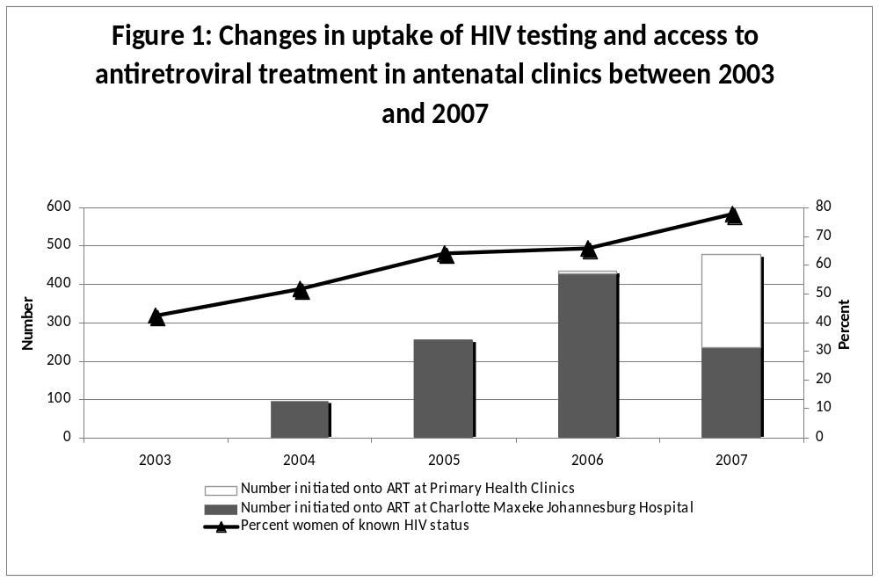
Conclusion
Though it was not possible to demonstrate that integration of ART within prenatal care services has reduced maternal deaths, provision of ART in prenatal care remains an important strategy for reducing maternal deaths in high-HIV burden countries. Thus, if maternal mortality is to be reduced in South Africa, interventions are required to target weaknesses in HIV treatment and care within maternal health services.
THE IMPACT OF THE HIV EPIDEMIC ON MATERNAL DEATHS (ABSTRACT)

RC Pattinson for NCCEMD
Director MRC Maternal and Infant Health Care Strategies research unit, University of Pretoria

In 2005-2007, 2374 (60.0%) maternal deaths were tested for HIV infection and of these 1872 (78.9%) tested positive. When comparing the pattern of disease in maternal deaths that were HIV infected, proportionally more women died of non-pregnancy related infections than the non-HIV infected group.

Two hundred and fifty five of the maternal deaths that were classified as having AIDS also had concomitant diseases which were directly related to the pregnancy. If these cases are reclassified under the direct causes of death, then there is a slight increase in deaths due to post partum haemorrhage (6%), an increase of 44% in deaths due to abortion and an 82% increase in death due to pregnancy related sepsis.

If the data is extrapolated to the number of institutional births, the MMR for HIV infected women was 327.7/100000 live births and for non HIV infected women was 34.4/100000 live births. HIV infection was associated with almost a 10 times increase in risk of maternal death.

The role of sepsis as a cause of death has probably been underestimated in previous reports, due to these deaths being hidden in the deaths due to AIDS.

THE UCT FETAL CARDIAC ANOMALY STUDY – TUFCAS (ABSTRACT)

Tracey Anne Horak*, Chantal Stewart
University of Cape Town

Introduction: Congenital heart disease complicates 0,8% of live births. Most cardiac defects are relatively well tolerated during intrauterine life, and it is only with the elimination of maternal circulation and the closure of the 3 shunts that permit fetal blood to bypass the lungs and liver, that a defect may become apparent. Whereas some cardiac anomalies cause very little disability, others are incompatible with extra-uterine life. Prenatal diagnosis of fetal cardiac anomalies is of great value in that it provides an opportunity for parental counselling, genetic testing, and adequate planning for further management of the pregnancy. Effective counselling depends largely on the security of diagnosis and the prognosis of the malformation, both locally and elsewhere.
Objective: The object of our study was to determine the accuracy and prognostic implications of the prenatal diagnosis of fetal cardiac abnormalities in patients presenting to the Maternity Unit at Groote Schuur Hospital
Method: We conducted a retrospective study of the fetal cardiac anomalies detected on two dimensional ultrasound at Groote Schuur Hospital from January 2001 to April 2005. Information was obtained from maternal, neonatal and paediatric records, and comparison drawn between cardiac findings on prenatal ultrasound versus postnatal echocardiogram or postmortem report.
Results: In total, 77 cases of fetal cardiac anomalies were identified on prenatal ultrasound scan between January 2001 and April 2005. The distribution of the cardiac anomalies was as follows: conotruncal anomalies (16), hypoplastic left heart syndrome (12), atrioventricular septal defects (16), atrial septal defects (2), ventricular septal defects (7), and the other anomalies (17). Of the 77 cases of congenital heart disease, 50 (65%) were associated with chromosomal and extracardiac anomalies. When evaluating the accuracy of ultrasound diagnosis, 27 cases (35%) were correctly identified in entirety, 14 cases(18%) were partially correct, and 9 cases (12%) were incorrectly identified. There were a further 25 cases in which the prenatal diagnosis could not be confirmed, as no cardiac echo or post mortem was performed. There was frequent misinterpretation of the cardiac defects within the conotruncal anomaly group – most often involving double outlet right ventricle and transposition of the great arteries. The diagnostic accuracy of hypoplastic left heart syndrome and atrioventricular septal defects was good. The outcome of infants with congenital heart disease was dismal, with only 43 live births (56%), and the remaining 34 infants being stillborn (44%). Of the 43 live births, there 17 neonatal deaths – 8 of these were despite active management at Groote Schuur Hospital. A further 11 patients were referred to Red Cross Children’s Hospital for surgery within the first few days of life. 4 of these patients subsequently demised, and all remaining 7 were subject to repeated cardiac procedures and repeated hospital admissions with lower respiratory tract infections and cardiac failure. Ten patients were discharged in a satisfactory condition, with plans made for cardiology follow up. The outcome of the remaining 5 patients is unknown.
Conclusion: In this study, the diagnostic accuracy of fetal cardiac abnormalities by prenatal ultrasound is good. Furthermore, the more severe cardiac anomalies are almost invariably associated with complex extracardiac anomalies and various chromosomal abnormalities. The prognosis of these patients is generally poor. Although other reported studies have quoted better prognoses in certain cases, in our experience, the prenatal detection of fetal cardiac anomalies – especially in the presence of chromosomal or extracardiac anomalies, is associated with a poor prognosis. This knowledge will be useful in guiding patient counselling in our setting.
FETAL DISTRESS: DOES MATERNAL OXYGEN ADMINISTRATION INFLUENCE THE STATUS OF THE NEWBORN BABY? A randomized controlled trail (abstract)

MA du Toit, JM du Plessis, G Joubert*
Department of Obstetrics and Gynaecology, University of Free State, Bloemfontein, South Africa.
*Department of Biostatistics, University of Free State, Bloemfontein, South Africa.

Introduction
Oxygen has been used for years, as part of intra-uterine resuscitation (IUR). No randomized trails on the use of oxygen have been published according to a Cochrane review. Current recommendations on neonatal resuscitation state that, only room air should be used and that oxygen should be used, only if the neonate does not respond to room air.
To evaluate the effects of maternal oxygen administration, as part of intra-uterine resuscitation, on the compromised fetus, we conducted a randomized controlled trail.

Method
Pregnant women in Pelonomi and Universitas Hospital, Bloemfontein. Inclusion criteria were: gestation > 32 weeks, vertex presentation, maternal age > 18 years and fetal distress diagnosed on CTG. Patients were randomized by closed envelope system to receive oxygen or not. At delivery an umbilical artery blood sample was taken for pH, base excess and lactate level analysis. Primary end points were: need for neonatal resuscitation, cord pH, base excess, lactate and 5 minute Apgar. Secondary end points were: onset of encephalopathy (HIE), NICU admission, ventilation and cerebral palsy. Statistical analysis was done by 95% CI for differences in percentages, means and medians. The study was approved by the local ethics review board.

Results
A total of 139 patients were randomized, of which 73 received oxygen and 66 received no oxygen. Maternal demographics were the same for both groups. There were no differences in delivery and neonatal data between the two groups. The lactate levels at birth were significantly higher in the oxygen group (p = 0.034). The incidence of HIE were 3 times higher in the oxygen group (8.2 vs 3.0%).

Conclusion
The practice of routine oxygen administration as part if intra-uterine resuscitation should be seriously questioned. To confirm the trend of HIE, a multicentre study of 500 patients in each arm is needed.
RESPIRATORY DISTRESS ASSOCIATED WITH ELECTIVE CAESAREAN SECTION IN TERM AND NEAR-TERM INFANTS MANAGED IN A PRIVATE HOSPITAL

Kirsten GF*, Kirsten CL*, Alexander R**
Division of Neonatology, Department of Paediatrics and Child Health, Tygerberg Children’s Hospital and the University of Stellenbosch*. Panorama Medi-clinic Hospital, Parow**

The rate of elective Caesarean section (ECS) delivery has increased over the last 30 years due to changes in the management of breech deliveries, a previous Caesarean section (CS), maternal medical illness, fetal diseases and CS on “maternal request”, etc. A high proportion of ECS deliveries in the United States are performed before 39 weeks. This may be driven by factors such as a woman’s desire to give birth once term is attained or an obstetrician’s desire to schedule the procedure at a convenient time. Delivery by CS at <39 weeks of gestation is common and is associated with an increased risk of admission to the NICU due to respiratory complications such Transient Tachypnoea of the Neonate (TTN), Respiratory Distress Syndrome (RDS) and Persistent Pulmonary Hypertension of the Neonate (PPHN) which may be associated with a poor neurodevelopmental outcome, chronic lung disease or death. Despite these serious complications, many obstetricians still use 38 weeks gestation as the gold standard for performing an elective CS (ECS) for non-medical or obstetrical indications. No information exists on the respiratory morbidity in term and near term infants delivered by ECS in private hospitals in South Africa.
Aim of study: To determine the incidence of respiratory morbidity in term and near term infants delivered by ECS in a private hospital.
Study design: Retrospective cohort analytical.
Study setting: NICU, Panorama Medi-Clinic Hospital (PMCH), Parow, Western Cape.
Patients and methods: All infants ≥36 weeks gestation delivered vaginally and by ECS and admitted to the NICU at PMCH from 1st January 2002 to 31st December 2005 were studied. ECS was defined as Caesarean delivery performed in the absence of labour and without a recognised medical or obstetrical indication for delivery of a viable infant at 37 weeks of gestation or later. The infant data were obtained from the Vermont-Oxford Network Database for all inborn infants ≥36 weeks gestation admitted for respiratory distress to the NICU at PMCH. Infants with serious congenital abnormalities or congenital infections were excluded. Respiratory morbidity was defined as respiratory distress requiring any form of ventilatory support. Prolonged infant hospitalisation was defined as hospitalization for ≥5 days.
Results: A total of 5229 infants were delivered over the study period of which 3573 (68.3%) were delivered by CS at ≥36 weeks gestation. 891 (17%) were ECS. A total of 5229 infants were delivered over the study period of which 3573 (68.3%) were delivered by CS at ≥36 weeks gestation. 891 (17%) were ECS. 22 (2.5%) of these infants required admission to the NICU for respiratory distress compared to 9/1656 (0.54%) of the infants delivered vaginally (p= 0.00002). None of the infants died.

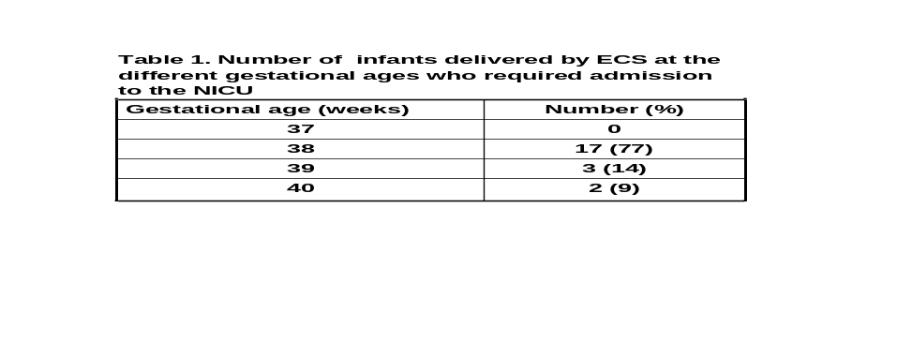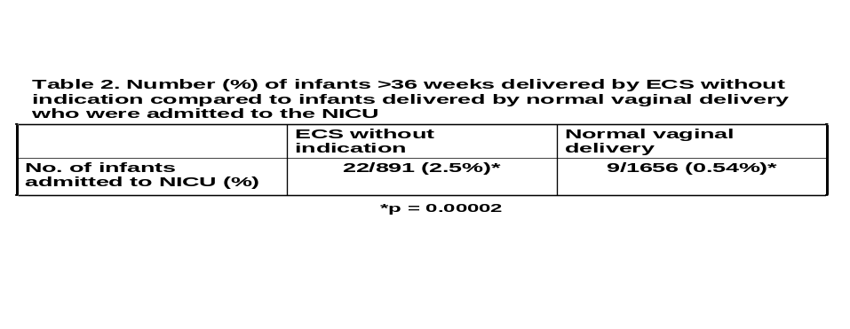
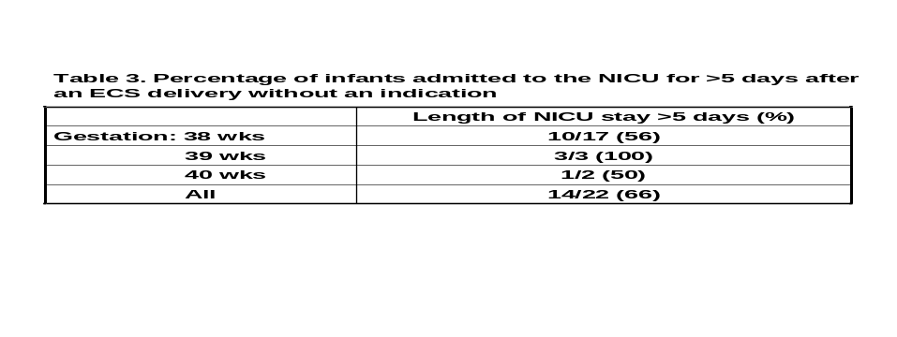
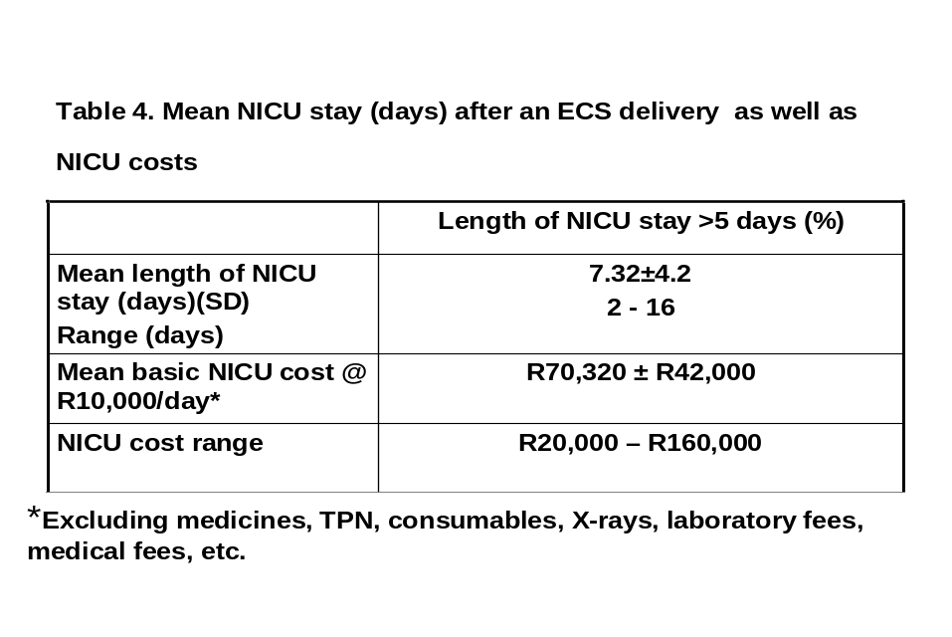
Conclusions
The majority (77%) of ECS deliveries at Panorama MediClinic where there was no medical or obstetrical indication occurred at 38 weeks gestation.
Significantly more infants delivered by ECS without indication required admission to the NICU for respiratory morbidity compared to the infants delivered by normal vaginal delivery (p=0.00002). This was probably related to the fact that the majority were delivered at ≤38 weeks gestation. This study confirmed that ECSs should be done at ≥39 weeks gestation. Parents should be informed about the high incidence of serious risks associated with infants delivered by ECS <39 weeks gestation.
IS NCPAP A FEASIBLE TREATMENT MODALITY IN A RURAL DISTRICT HOSPITAL FOR VLBW INFANTS WITH RDS? (ABSTRACT)

Hendriks H*, Kirsten GF**, Holgate S**, Post A**, Conradie H*** *Ceres District Hospital, **Division of Neonatology, Department of Paediatrics, Tygerberg Hospital, ***Department of Family Medicine, Faculty of Health Sciences, University of Stellenbosch

Introduction: Because there is a perception that nCPAP should only be practiced at secondary and tertiary hospitals, very low birth weight (VLBW) infants born at district hospitals in South Africa who develop respiratory distress syndrome (RDS), are managed with head box oxygen. As transfer is often delayed, infants may require prolonged periods of ventilation and hospitalisation after transfer to the tertiary NICU. High costs of transfer and neonatal intensive care put a strain on limited facilities and health care budgets.
Aim: To determine whether the use of nCPAP in a district hospital is feasible, whether there is acceptance by medical and nursing staff, whether survival will improve and whether fewer infants <1800g with RDS will need to be transferred to a secondary or tertiary institution.
Study setting: Nursery at Ceres District Hospital
Study design: Prospective cohort analytical study with an historic control group (HCG).

Patients and methods: All infants <1800g born between 1/1/2008 and 30/11/2008 (Study Group, SG) and between 1/1/2007 and 31/12/2007 (HCG) were studied. Infants with RDS in the SG were resuscitated with the Neopuff® and then treated with nCPAP while infants with RDS in the HCG were resuscitated with a resuscitation bag and then treated with head box oxygen. Prior to the introduction of nCPAP, a one day workshop was conducted by 2 neonatologists and a Neonatal Nurse Mentor to train the medical and nursing personnel involved with neonatal care at Ceres Hospital. The workshop included the theoretical and practical aspects of nCPAP. Data on all babies treated with nCPAP was collected prospectively. The information of the HCG was obtained from the ward records. Oxygen saturation levels in the SG were kept between 86% and 92% during oxygen administration.

Results: 57 infants were admitted in the SG and 87 in the HCG. 92% of the mothers in the SG were booked, 42% received antenatal steroids and 8% of the infants were delivered by Caesarean section. 23% of the infants in the SG required nCPAP. The mean duration of nCPAP was 26 hours (range 4 – 75 hours). 25% of the infants <1000g, 83% of the infants between 1000g and 1499g and 100% of the infants between 1500g and 1800g in the SG compared to 17%, 81% and 100% in the HCG respectively, survived. Two (3.5%) infants with RDS in the SG versus 7 (8%) (p=0.4) in the HCG required transfer to a secondary or tertiary hospital. No complications related to nCPAP treatment such as pneumothorax were noted. The nursing and medical staff quickly became proficient and confident in applying nCPAP.

Conclusions: nCPAP as a treatment modality was well received by Ceres Hospital personnel. The nursing staff experienced no problems in initiating the treatment and handling babies on nCPAP. There were no complications associated with nCPAP. This pilot study showed that although nCPAP at a district hospital did not significantly improve the outcome of infants <1800g with RDS or significantly reduce the number of transfers the separation of the mother and her infant was limited. The study showed that with appropriate training nCPAP can be safely practiced in a district hospital.

Recommendations: A long term study should be conducted to determine the impact of nCPAP in a district hospital on the incidence of ventilatory associated complications of the transferred infants, as well as to determine the cost savings.
NECROTISING ENTEROCOLITIS AT KALAFONG HOSPITAL BETWEEN 2000 AND 2008 (ABSTRACT)

S Delport
Dept. of Paediatrics, Kalafong Hospital and the University of Pretoria

Introduction
Necrotising enterocolitis (NEC) remains a major cause of morbidity and mortality in very low birth weight (VLBW) infants. Although the mechanisms of prevention are not completely understood, evidence supports the beneficial effects of human milk (HM) to reduce the risk in VLBW infants. The incidence of NEC in 2000 at Kalafong Hospital was 10% and concerted efforts were then initiated, continually renewed and perpetuated to prevent the disease in vulnerable infants.

Aims
To review the preventative measures instituted over six years (2000-2006) and to determine incidence of NEC at the end of 2007 and 2008 by retrospective audit.

Patients and Methods
Preventative methods implemented in a stepwise manner were based on:
Efforts to minimise hospital acquired infections by improvement of ward hygiene, emphasis on hand washing, intermittent kangaroo mother care and prevention of overcrowding.
Safe feeding namely no reconstitution of feeds, use of HM (Pretoria pasteurised if indicated), trophic feeds and reliable cold storage
Exclusive HM feeds facilitated by the availability of donor breast milk
Empowering mothers by recognising them as major role players in handling feeds
Provision of maternal lodger facilities
The study population comprised viable VLBW infants admitted to the neonatal unit without life-threatening congenital abnormalities and who survived for 7 days or longer. The primary outcome was NEC, defined as Bell’s stage IIb or III

Results
During 2000, 20/194 (10.3%) VLBW infants developed NEC before the institution of any preventative measures. At the end of 2006 all possible preventative measures were in place with the most important being exclusive HM intake for at least 14 days after birth in all infants. The incidence of NEC during 2007 was 1.6% (2/129) and 2.5% (5/199) during 2008.

Conclusion
A declining incidence of NEC at Kalafong Hospital has been documented and is most likely the result of a stringent policy of feeding only HM to VLBW infants during the most vulnerable time of their lives.
INCIDENCE OF HEALTHCARE-ASSOCIATED BLOODSTREAM INFECTIONS IN VERY LOW BIRTH WEIGHT INFANTS AT KALAFONG HOSPITAL (ABSTRACT)

C Kock, S Delport
Dept of Paediatrics, Kalafong Hospital and the University of Pretoria

Introduction
Very low birth weight (VLBW) infants (≤1500g) have an increased risk of healthcare-associated infections which lead to morbidity and mortality. Surveillance is an essential preventive strategy.

Aim
To determine the incidence and etiology of healthcare-associated bloodstream infection by means of a retrospective audit.

Patients and Methods
Viable VLBW infants admitted for longer than 72 hours were audited over a period of two years. A healthcare-associated bloodstream infection was documented if a recognized pathogen was cultured from blood in the presence of clinical signs, a rising
C-reactive protein and the institution of antibiotic therapy.

Results
Of 261 VLBW infants admitted over two years (1/1/2006-31/12/2007) 38/261 (14.6%) infants developed at least one bloodstream infection. The incidence was 24% (32/133 infants) during 2006 and 4.7% (6/128) during 2007 (p < 0.001). Of the organisms identified during 2006, methicillin resistant S. aureus (MRSA) predominated (11/32), followed by coagulase-negative staphylococcus (8/32), S,marcescens (3/32) and P.aeruginosa (3/32). No bloodstream infection due to MRSA occurred in 2007 and no organism predominated.

Conclusion
The incidence of bloodstream infections in VLBW infants decreased during 2007 to 4.7%. A possible explanation is that during 2007 only breast milk was used due to the availability of donor breast milk.

FETAL ALCOHOL SPECTRUM DISORDER (FASD) PREVENTION PROJECT: SCREENING AND BRIEF INTERVENTIONS DURING THE ANTENATAL PERIOD – A PARTNERSHIP BETWEEN THE DEPARTMENTS OF SOCIAL DEVELOPMENT, HEALTH, A NON-PROFIT ORGANIZATION (NPO) AND THE MEDICAL RESEARCH COUNCIL (MRC) (ABSTRACT)

D Viljoen¹; S Marais², L Olivier¹; E Jordaan², A Swart¹
¹Foundation for Alcohol Related Research (FARR)
²Medical Research Council (MRC)

Introduction
Fetal Alcohol Syndrome (FAS), the most severe form of FASD, is the most common cause of preventable mental retardation in the world. South Africa has the highest reported FASD rate in the world.
FASD Prevention Programmes should ideally target women of childbearing age before they fall pregnant, for this reason clients attending reproductive health or family planning clinics should be targeted. Unfortunately the attendance rates have decreased over the last couple of years and high risk clients often do not even attend these clinics. Alternative, cost-effective and effective contacts with clients therefore have to be explored.
As part of the National Drug Master Plan, the Department of Social Development strives to strengthen awareness and prevention programmes in communities. With the high FASD prevalence rate in the Western Cape Province, the Departments of Social Development and Health, the Foundation for Alcohol Related Research (FARR) and the Medical Research Council (MRC) secured a partnership in order to develop a model that could be implemented by both departments within their current service delivery programmes to address the challenges pertaining to FASD prevention in high-risk communities. The Witzenberg District in the Western Cape Province was selected as the pilot site for the development and implementation of this FASD Prevention Project.

Prevention Programme
A screening and brief intervention model targeting pregnant women was developed and piloted in the Witzenberg District. The project is currently in its third year (2007 – 2009). Eight ante-natal clinics and 192 women and their babies are involved.
The presentation will outline and describe the partnership between the various organizations, the screening and intervention tools and the prevention model that was developed.

Conclusion
Pre-natal screening for alcohol consumption and support to pregnant women to reduce their alcohol consumption are of crucial importance in preventing FASD. Although the majority of pregnant women in the public health sector do attend antenatal services at some stage during their pregnancies there are many missed opportunities for sharing this vital information. Given the human resource and time constrains at health care and social services facilities short, high-impact and cost-effective methods need to be implemented.
This project demonstrated that most women attending clinics would benefit by the introduction of screening and brief interventions as part of their routine care at these facilities.

INTRODUCING THE MACH PROJECT, NEONATAL CARE TRAINING AND NEONATAL OUTCOMES IN MPUMALANGA PROVINCE

Janse van Rensburg SC. Dept of Pediatrics Witbank Hospital

Introduction
The Maternal and Child Health Care (MACH) project is a collaborative effort between the University of Pretoria, the MRC unit for Maternal and Infant Health Care strategies and the department of Health and Social services of Mpumalanga and is funded by UNICEF.
The aim of this 3 year project is to integrate and improve the Maternal and Child health care system in Mpumalanga. To this effect, integration teams headed by Family Medicine and including all role-players, has been established at 10 sites in the province. Various programmes were instituted at these sites.
The department of Paediatrics at Witbank hospital was tasked with developing and implementing a training program on Neonatal resuscitation and care in order to decrease the neonatal mortality rate in the province. Training workshops was started in August 2008.

Methods
Baseline data for all participating sites was collected using mainly the PPIP program which is well established in the province. The main indicators being used is the neonatal mortality rates for each weight category at each site.
The Pediatric department at Witbank hospital developed a modular training program divided into 4 parts. These consists of training in Neonatal Resuscitation, care of the sick or low birth-weight newborn, Routine care of the healthy newborn and the PMTCT program.
A training workbook as well as a comprehensive neonatal guideline was published and distributed to all trainees.
Training workshops was started on-site in August 2008, focusing initially on neonatal resuscitation. A total of 7 sites and 200 persons were trained by end of December 2008.
These workshops will continue and be expanded for the next 2 years.

Results and Conclusion
Neonatal mortality rates at the sites up to end of February 2009 will be collected and presented at the conference. These will be compared with previous baseline data to see if any significant improvement can be demonstrated. Although it is very early in the project we believe it will be interesting to present data which measures whether any impact has been made so far. Conclusions will be based on our data and will be presented at the conference.

NEONATAL SERVICES IN KWA-ZULU NATAL

M Adhikari
Department of Paediatrics, Nelson R Mandela School Medicine, University of KwaZulu-Natal.

Background
The Saving Babies Report 2006-2007 presents data from PIPP. Some of the findings were that the highest perinatal mortality occurred in district facilities. About 60% of births were at district level (CHCs & district hospitals), 30% in level 2 institutions (regional) and 10% in level 3 institutions (tertiary & national hospitals). Most deaths were preventable. With respect to causes of death, hypoxia-related deaths were hypoxic ischaemic encephalopathy 50.7%, meconium aspiration syndrome 28.3% and persistent fetal circulation 1.8%. Almost half of deaths (term) were due to intrapartum asphyxia and trauma and were most probably avoidable.
Avoidable mortality for this group was for both health care provider & administrative problems in the facilities.
With respect to immaturity related deaths; extreme immaturity accounted for 44.9%, HMD 35.6% and other causes such as necrotizing enterocolitis, intraventricular haemorrhage and pulmonary haemorrhage less than 3%.
Recommendations included staffing norms, recommendations to be included in KPA’s of health care managers, outreach and improvement in postnatal care.
The level at which implementation has to occur included policy, administration, clinical practice, education. Quality of care issues looked at drugs, equipment,
skills, attitude, responsibility, accountability.
The aim of this study was to examine the state of the services with respect to LBWI in KZN.

Methods
Information was obtained from PIPP data, a questionnaire was sent to chief specialists in the three areas and discussed to include deliveries, neonatal admissions, high care and intensive care beds (including number of ventilators and CPAP machines), medical staff numbers, nursing staff numbers.
level of training of staff.

Results
Population of KZN according to the SA National Census 2001 was10,139,987 million, 3.7 million (35%) children < 14 yrs. Of this total of 10,139,987m
Area 1 (Durban) has 4,625,533m in 3 health districts and this is 45.6% of the population of KZN, Area 2 (PMB) 3,036,093m in 5 health districts and is 30% of the KZN population and Area 3 (Empangeni) has 2,478,380m in 3 health districts with 24.4% of the population.
PIPP Sites There are 50 PIPP sites registered & trained, 28 send data sometime and 18 more regular data, there are 11 district offices in the three areas.
The total number of hospitals in KZN is 72,
There are 3 tertiary hospitals- Durban Inkosi Albert Luthuli, PMB Greys Hospital and Empangeni Hopsital in Ngwelezane.
Regional Hospitals are 9
District Hospitals ±52 (some psychiatric,TB dental)
Total deliveries were 170,513 - Durban 71,249 (42%)
PMB 57,823 (34%) Ngwelezane 41,772 (24%)
The PNM across the 3 areas was 31-36 (Reg hosp 40-45)
The NNDR was 9-14

Deliveries
47,200 (28%) deliveries occurred in 9 regional hospitals, 4000 (2.5%) were admitted to tertiary centres (majority referred from regional). The majority of deliveries not regional & tertiary centres.

LBWI
LBWI at Hospitals is15-20%, the number being 7080-9440 of the total number of deliveries
LBWI (PIPP) – 12% = 20462
In South Africa suggest that 10% is high risk.
Estimated that 10% require some form of respiratory support and special care and that is 17051.

High Care and ICU beds
 | Tertiary | Regional | Total
ICU | 32 | 21 | 53
HC | 52 | 25 | 77
Low Care | 42 | 52 | 94
KMC | 20 | 26 | 46*
33 nCPAP machines + 53 ventilators
86 machines for 17051 babies

Medical Staff
Tertiary Hospitals (3) :2 units – neonatologists, 1 unit - paediatrician
Regional (9) 3 – neonatologists, 3 – paediatricians 3 – medical officers

Nursing Staff
In the tertiary hospitals nurses have good training, in other units the number of trained staff is variable and may not meet patient needs. Only one third of nurses trained and inn some no trained nurses at all
The majority of units have two thirds or less of the required number of nurses

Discussion
In the USA/Canada 1-10% of LBWI are high risk. One neonatologist is suggested for every 2500 deliveries. We need to be working with the District facilities. It is crucial for trained staff in LW to deliver LBWI optimally, trained staff in nurseries to recognize and monitor the sick NB–IMCI PEP, provide basic equipment for care of small baby. Nasal CPAP for units with staff and equipment. This needs to be undertaken now, it is urgent and the way forward is outreach. The issue is how to undertake the outreach, it is a skill that has to be acquired. It is important for the institutions to see the need and be interested or the process fails. Those visiting must be sensitive and aware of possible problems. The outreach must be seen as team work with the facility. An initial evaluation is required and a slow process to deal with a number of varying issues. It is very important to give positive input and encouragement where necessary on follow-on visits. The aim is foster communication between tertiary and community facilities.

IMPROVING NEWBORN CARE IN ZULULAND DISTRICT, KWAZULU – NATAL

DH Greenfield, NC Mzolo,
Centre for Rural Health, University of KwaZulu - Natal

Background
Zululand district is one of three health districts in Area 3 in the north / north-east of KwaZulu-Natal. There are 5 hospitals, and the level 2 referral hospital for obstetric and newborn patients is the Lower Umfolozi War Memorial Hospital in Empangeni. This outreach was a cooperative approach between the Centre for Rural Health (CRH) at the University of KwaZulu – Natal, the Paediatric staff at Lower Umfolozi Hospital and The District Maternal, Child and Womens’ Health (MCWH) Directorate. It was funded for a period of 18 months by Johnson and Johnson Paediatric Institute (JJPI).

Aim
The aim was to improve the quality of care provided to newborns in the hospitals in the District.

Methods
The approach was that used in the Limpopo Initiative for Newborn Care (LINC), which was to visit and assess hospitals, and advise on how the service could be improved. An initial assessment was done by the CRH and external specialists with financial and material assistance from JJPI.
The implementation team consisted of an advanced midwife trainer and experienced neonatal doctor. A standard tool was used to record the findings of the visit, and a written report, based on this document, was sent to the hospital management, District MCWH Management and the CRH. At the time of the visit, discussions were held with the staff on clinical problems, as well as the need for specific equipment and the use of that equipment. Advice was given on policies and basic protocols for the newborn care given.
Support was given for the periantal care audit process, specifically the use of the Perinatal Problem Identification Programme (PPIP). Delivery and mortality data was collected from the hospitals.
Formal basic training in newborn care for staff working with the infants was planned.

Results

Table 1 Beds for newborns (November 2008)

Hospital Deliveries Deliveries Beds available Beds needed
/ year /month HC LC HC LC
Benedictine 4088 341 9 13 16 16
Ceza 1008 84 3 2 4 4
Itshelejuba 2517 210 3 3 6 6
Nkonjeni 2707 225 11 6 10 10
Vryheid 4739 395 12 8 20 20
Total 15059 1255 38 29 56 56

The delivery numbers is an average of the deliveries over the last 4 years.
There was an increase of 16 KMC beds during the intervention.
There are too few beds for newborn infants in the District.

Table 2 Neonatal Nursing Staff (November 2008)

Hospital Deliveries Nurses needed Needed on Currently % of
/ year on duty establishment allocated need
HC/LC/total

Benedictine 4088 5/3/8 40 9 23
Ceza 1008 1/1/2 10 3 30
Itshelejuba 2517 2/1/3 15 2 13
Nkonjeni 2707 3/2/5 25 8 32
Vryheid 4739 7/3/10 50 6 12
Total 15059 18/10/28 140 28 20
HC: High care
LC: Low care

There has been an increase in 10 nurses allocated to newborn care – mainly EN/ENAs.
There has been a decrease in the rotation of staff for newborn care.
There is a serious shortage of nursing staff to provide care for newborn infants.

Table 3 Labour and Postnatal Ward Staffing

Hospital Deliveries Deliveries Midwives Midwives % of
/ year /month on staff needed staff
needed
Benedictine 4088 341 30 55 55
Ceza 1008 84 11 14 79
Itshelejuba 2517 210 11 34 32
Nkonjeni 2707 225 18 36 50
Vryheid 4739 395 30 63 48
Total 15059 1255 100 201 50

The labour wards in the District have only 50% of the recommended number of staff for labour and postnatal wards. There are 2 implications of this for newborn care:
- If labour ward is understaffed, adequate observations on the mother during labour are unlikely to be done. This increases the risk for intrapartum hypoxia.
- When the labour ward is busy and more staff are needed, they are withdrawn from other areas, and one of the areas to suffer from this is the newborn care nursery, resulting in inadequate observations / care being given to the infants.

Nursery facilities
The nurseries were overcrowded, often with babies who did not need to be there.
There is now much better use of the space:
- There are more Kangaroo Mother Care (KMC) beds available, so that the smaller babies can be with their mothers.
- There are fewer admissions of normal babies who should not be there.

Two Hospitals do no have a source of medical air.
There are far too few electric plug points.
The rooms are usually overheated – mostly more than 30⁰C. Air conditioning units are either not available or not working.

Resuscitation areas
- The areas were poorly organized
- The equipment was not ready for use
- In 3 hospitals there is no separate resuscitation equipment for the theatre.
- The organisation of these areas has markedly improved.

Nursery Equipment
- It is not possible to control or monitor oxygen therapy.
- One hospital has no glucometer
- Two hospitals have no infusion controllers
- Only one hospital has an infant scale capable of measuring weights in less than 50g intervals. This means that daily weights cannot be used to assess weight gain in very small infants.
There was practically a Provincial moratorium on the purchase of equipment in 2008.

Policies and Protocols
- Basic protocols were scanty in all hospitals, and mostly not readily available for the staff.
- Some unhelpful policies have been changed, eg:
  - Routine bathing of babies
  - Admission of normal post caesarean section babies for “observation”.
- A standard newborn admission chart is now being used in all hospitals. This is a chart which is approved by the level 2 referral hospital.
- Suitable observation charts are now being used.

Transport
- The ambulance service for newborns in the district is very poor generally.
- An ambulance is seldom available to transfer a baby within 2 hours of being requested.
- At times the ambulance personnel first assess whether the baby is sick enough to be transferred!!
- This is a district problem and needs to addressed at District or Provincial level.

Staff training
- One group of midwives was trained in basic newborn care
- One group of Enrolled Nurses / Enrolled Nursing Assistants was trained.
- One group of supervisors was trained – mainly management issues
- No doctors were trained.
There was a problem with capacity at Lower Umfolozi Hospital where the midwife and Doctor training was to be done.
More staff need to be trained.

Perinatal audit
- PPIP is on a computer at all the hospitals,
- At three of the hospitals the data derived from PPIP is used in the Perinatal Review Meetings to assess the problems and identify action which needs to be taken.
- At two of the hospitals the data is only in a paper form and is not being entered on the computer.

Table 4 Early Neonatal Mortality (per 1000 live births)

2005 2006 2007 2008
Benedictine 12.9 2.7 10.1 16.7
Ceza 10.2 16.3 11.0 9.3
Itshelejuba 15.0 12.4 6.3 8.3
Nkonjeni 14.5 18.7 9.4 21.1
Vryheid 16.9 21.9 12.2 10.8
Total 14.6 16.8 11.7 13.9

Overall there has not been much change in the mortality rates over the time period documented.

At Ceza and Itshelejuba Hospitals the mortality rates are less than 10 / 1000, which is quite good. The rates at Vryheid Hospital have been coming down over the last 2 years. It is not certain what influence the outreach has had on these rates, however, as it only really started in June 2007!

Conclusions
There have been improvements in the facilities, and staffing.

Challenges
- Equipment Oxygen therapy and resuscitation
- Transport
- Staff training
- Support from the regional hospital

There has been some rather slow progress. Most of what needs to be done can be achieved by implementing the recommendations of the Saving Babies Reports!
THE CAUSES OF THE 3 DELAYS IN NEONATAL CARE AT DISTRICT LEVEL IN ZIMBABWE

Dondo V¹, Pazvakavambwa IE², Munjanja SP³ Mhloyi M⁴ Chirehwa M⁵ , Nyandoro M⁶; Department of Paediatrics(1,2), Department of Obstetric and Gynaecology (3), Department of Social Sciences (4) Dept of Biostatistics (5), University of Zimbabwe, Ministry of Health and Child Welfare (6)

List of abbreviations
EDLIZ Essential Drug List for Zimbabwe
KMC Kangaroo Mother Care
NMR neonatal mortality rate
PNMR perinatal mortality rate
WHO World Health Organisation
ZDHS Zimbabwe Demographic Health Survey
ZMPMS Zimbabwe Maternal and Perinatal Mortality Study

Introduction
The concept of the 3 delays was introduced by Thaddeus and Maine in 1994 as it relates the danger to life in a pregnant mother. The first delay is delay in seeking care. The second delay is delay in reaching the facility once the decision has been made to seek care. The third delay is delay in receiving adequate and appropriate care once a facility has been reached. This comes to factors that are patient related (first delay), transport (second delay) and health worker and administrative related (third delay). This concept was used to assess neonatal care at district level in Zimbabwe. As time goes the danger to the life of the neonate will be increasing until treatment begins. The NMR for the African region is 44 deaths/1000 live births with a range from 9-70 deaths /1 000 live births¹. The NMR for Zimbabwe is 22(rural), 20(urban), 23(males) and 19(females) deaths/1000 live births according to the Zimbabwe Demographic Health Survey 2005-6. In the western countries where neonatal mortality is low, there are well documented studies and any deaths are the subjects of confidential enquiries. In developing countries, Egypt and South Africa have done well documented studies on perinatal and neonatal care. In Zimbabwe the studies are mainly at local and institutional level. These studies have shown high NMR and highlighted the need to find the quality of health care offered at the health care facilities. It is important to reduce neonatal deaths in order to address Millennium Development Goal 4. It is also important to note that most causes of neonatal mortality are easily preventable. It is against this background that we set out to find out the causes of the 3 delays in neonatal care at district in Zimbabwe.

Aim
The aim of the study was to assess the causes of the 3 delays in neonatal care from the community to the district level in Zimbabwe.

Specific objectives
To identify any cultural and socio-economic factors which affect neonatal health.
To identify at community level knowledge relating neonatal health and factors which cause delay from the community to the health facilities.
To identify factors which cause delay at healthcare facility level.
To make recommendations for local remedial action.

Methodology
This was a descriptive cross sectional study which was done in 10 districts randomly chosen from the provinces. 4 tools were used to collect the data; in depth questionnaire for mothers who delivered during the study period. The questions were directed at the demographic history, obstetric history, current pregnancy and delivery, the health of the neonate from delivery to 28 days of life, knowledge of danger signs in the sick neonate and taboos or traditional practices relating to the neonate. The second tool used was a structured questionnaire for the staff caring for the neonates at the local clinics and districts. The questions asked were about common neonatal conditions seen and also their management of the most common causes of neonatal mortality and availability of resources which are needed in the care of the neonates. The third tool used was a check list of resources using the WHO Mother and Baby package and EDLIZ. Finally, Focus Group Discussions were done in selected districts and questions which related to maternal health, childbirth and traditional practices were asked in these discussions. They were done at a neutral place (shopping centre) away from the health care workers so that people were free to air their views. They consisted of about 15-20 males or females separately and were tape recorded.

Data management
Data was entered into the Zimbabwe Maternal and Perinatal Mortality Study (ZMPMS) database and stored using EpiInfo and analysed using Stata Version 8. Data from the tapes was transcribed.

Results
Demographic details
Total number of respondent mothers was 126.
52% were from the rural areas and 48% were from the urban areas.
Median age was 24years (Q1=20, Q3=29)
93% booked their pregnancies and the mean number of antenatal care visits was 4 (s. d=2, 1).
36% of the mothers had sick babies in the neonatal period.
7% of the mothers had babies who died in the neonatal period
Median age of babies at interview was 9days (Q1=1, Q3=42)
Median age at onset of illness 4days (Q1=1, Q3=14)
63% were in monogamous marriages, 11% were single, 2% were widowed and <1% were in a polygamous marriage.
44% first sought help from level 1 clinics, 31% from level 2 facilities, 10% from the faith healer and equal number (7%) from level 3 and 4 facilities.

First delay
The median time taken so seek care was 1 day. 63% of all the mothers said it was a taboo to go outdoors with a neonate before one month of age and in the western province they said this was regardless of illness. 20% of the mothers used traditional herbs to treat the fontanelle or put the baby under smoke of burning herbs. This practice was common in the western provinces which contributed 53% of this practice. The staff in the respective provinces also cited this as a cause of first delay because most babies would present with inhalational smoke injury. 17% used holy water and applied cooking oil with salt to treat the anterior fontanelle. A few also applied pieces of earthenware or cow dung to the umbilicus. 25% of the mothers said the reason for this was to cast away evil spirits although the majority were just following what their ancestors used to do. 31% attributed a sunken fontanelle to insufficient treatment with herbs or being in contact with a baby treated with different or stronger herbs. 31% of the mothers who had sick babies delayed taking the baby to the clinic because they misjudged the gravity of the illness because they did not consider the signs and symptoms as danger signs. 82% of the mothers said would bring their children if they had delivered at home, and majority of those who delivered at home actually took the child for examination and weighing. However, when faced with an ill neonate, the community said had no faith in the formal health system. This was highlighted in the FGDs where they felt the formal health system was collapsing.

Second delay
There was no delay due to transport as majority walked or used a scorch cart to go to the clinic and the median time taken to reach the facility was 1hour. Median distance to the nearest clinic was 4, 5km which is within our Ministry of Health recommendation of 10km. However, transport would adversely affect the outcome of a neonate when it was difficult to transport a woman in labour to the clinic.

Third delay
Of the mothers who were booked, 18% did not receive health education at all regarding pregnancy, delivery, care of the newborn and signs and symptoms of a sick newborn. When faced with a sick newborn, all facilities visited said considered a sick neonate as an emergency and saw them without delay. This was also confirmed by the mothers. Median time taken to be seen was 30 minutes. There was no delay due to cost for all who went to the public facilities because neonates were not charged.

Staff interviews n=16
Majority were confident to manage neonatal sepsis and resuscitate the newborn though at times limited by resources. Most were limited in their management of prematurity due to absent heaters and inadequate linen and space for Kangaroo Mother Care (KMC). There was a shortage of skilled staff and high attrition rates which was highlighted in all the districts. The graph below shows availability of refresher course in neonatal care in the previous 2 years, availability of neonatal care protocols and an auditing system regarding neonates in the facilities visited.
Drugs and equipment
Of the 11 facilities visited none had everything on the WHO Mother and Baby Package and of note was unavailability of neonatal suction catheters, endotracheal tubes, laryngoscope, resuscitation drugs and intravenous period, drugs to cover neonatal sepsis and supplements for preterm babies.

 | No of facilities available | No of facilities not available
Heat source | 0 | 5
Cannula | 2 | 3
Blunt ended scissors | 3 | 2
Gloves | 2 | 3
Mucus extractors | 2 | 3
Infant masks | 3 | 2
Cord ties | 4 | 1

Referral system
Ambulances, radios and telephone services were non functional in the majority yet 89% of the mothers said were unable to pay for transport if referred to the next level of care. It was expensive to hire a car (price of a cow) or to phone (price of a chicken).

Discussion
The first delay constitutes patient related factors and these include harmful and traditional practices. Mothers delayed coming to the hospital if they attributed the cause of the illness to be supernatural. Inability to appreciate the gravity of the illness due to inadequate knowledge of the danger signs is also important in delay at home. The facility related factors which were important as causes of delay include lack of resources (material and manpower) lack of essential dugs and equipment and a poorly functioning referral system. These administrative issues of a poor referral system were also cited by the mothers as the majority said were unable to pay for transport if referred to the next level of care. User fees indirectly affected neonatal care when mothers were unable to book their pregnancies and would end up with home delivery and sometimes in the hands of an inexperienced person. Although the second delay did not contribute to delay in neonatal care it indirectly adversely affected neonatal care when relatives are unable to carry a woman in labour to the clinic or hospital.

Conclusions and recommendations
The first and the third delay contribute significantly to delay in neonatal care. Health education should be emphasised at antenatal care visits. They should incorporate the care of the newborn, including signs and symptoms of the sick neonate. They should also address the traditional practices and cultural beliefs and discourage dangerous practices. Facilities should be well equipped so as to optimise the care that patients receive once they reach a health care facility.

PROFILE OF NEONATES ADMITTED WITH HYPOXIC-ISCHEMIC ENCEPHALOPATHY TO THE NEONATAL HIGH CARE UNIT AT PELONOMI HOSPITAL.

AE vd Vyver, Y Goosen, J Raubenheimer

Introduction
Hypoxic-Ischemic Encephalopathy (HIE) is characterized by clinical and laboratory evidence of injury due to asphyxia leading to central nervous system dysfunction (Butt, Farooqui and Khan, 2008:428). The severity of HIE is classified as grade 1, 2 or 3 according to criteria by the Modified Sarnat-Sarnat Score, or alternatively mild, moderate or severe. The grading is based on the responses of the infants to handling, level of consciousness, changes in tone of reflexes and the presence of seizures within days after birth (Pin, Eldridge and Galea, 2009:225).
According to previous research studies 15% to 20% of the newborns who have been diagnosed with HIE, died during the neonatal period, whilst about 25% of the survivors will show neurological handicaps such as cerebral palsy, mental delay and epilepsy. The complications of HIE vary from no ill effects to multi-organ complications and death. Neuro-developmental complications include cerebral palsy, mental retardation and learning disabilities (Lee, Mullany, Tielsch, et al. 2008:e1382). The huge diversity in the outcome varies with the severity and duration of HIE (Haider and Bhuttta, 2006: 184). Severe HIE is associated with a mortality rate of 50-75% and of the infants who survive severe HIE, 80% will develop serious complications (Butt, Farooqui and Khan, 2008:428). According to Ivanov and Neshterova (1998:8) a grade I HIE diagnosis does not predict future neurological handicaps, whilst HIE grade II is the most common condition and the prognosis of neonates with this grade is still uncertain. It varies from no handicap to severe impairment.
HIE can be caused respectively by events in the ante-partum, the intra-partum and the post-partum periods or combinations thereof. Some of these risk factors are unavoidable and some are avoidable. The Perinatal Problem Identification Programme (PPIP) is a well developed audit tool for assessing perinatal quality of care through auditing perinatal deaths. According to the PPIP-guidelines avoidable risk factors contributing to perinatal mortality can be categorized as patient associated factors, medical personnel associated factors and administrative problems.
With the financial aid of the Healing Kids project from the Fuchs Foundation Hospital Fund an intensive resuscitation training programme for the personnel of the Pelonomi Hospital, as well as for the staff at the referral hospitals, is being planned. In order to evaluate both the effectiveness of this training program, and the upgrading of this specific unit, baseline information is required with which the post-intervention data can be compared.
The objectives of this study were to collect baseline data on HIE as well as to calculate the burden of HIE by patient days spent in the high care unit at this hospital. Another aim was to identify the medical and non-medical attributing risk factors of HIE. The researchers also evaluated the correlation between the clinical classification and the outcome of subjects with HIE. As some of these children were referred to Pelonomi Hospital, the final objective of this study was to distinguish the outcome of newborns born at Pelonomi Hospital from those referred to the hospital after birth.

Method
This retrospective study was performed in the Neonatal High Care Unit at Pelonomi Hospital. All neonates born during 2007 were screened for this study. The inclusion criteria were a gestational age of ≥ 36 weeks, clinical diagnosis of HIE and the availability of the patient file. Those infants born with congenital and/or chromosomal abnormalities were excluded.
Data was collected on custom-made forms from the subject’s records by a pediatrician working in the Neonatal High Care Unit at Pelonomi Hospital. The degree of HIE was based on the Modified Sarnat-Sarnat Score for diagnosis for Hypoxic Ischemic Encephalopathy. Data related to maternal, antenatal and neonatal course and the outcome thereof was recorded.
The data was analyzed by the Department of Biostatistics of the University of the Free State. Descriptive statistics, namely means and standard deviations or medians and percentiles for continuous data and frequencies and percentages for categorical data were calculated.

Results
During 2007, 1094 babies were admitted to the Pelonomi High Care Unit. A total of 175 files were found to contain cases potentially useful to this study. Of these, 39 infants were excluded from the study due to prematurity, wrongly diagnosed or congenital abnormalities. Of the remaining 136 newborns who met the inclusion criteria, four more files were missing. Thus a total of 132 infants’ files were available for collecting data, representing 97% of the possible data. Confirmed HIE (n=136) cases thus represented 12.5% of the total admissions.

Demographics
The majority of the babies (n=122, 92.4%) were from the referring districts, DC16 or DC17, and only 7.6% came from other places. More than three quarters (n=101, 76.5%) of the infants were born in Pelonomi Hospital, and of those, 50 (51%) of the 101 were referred to this hospital during labor. Regarding the infants who were not born in this hospital (n=31), two were born at home or in transit and the rest were all born in a clinic or another hospital.
Infants’ mothers older than 20 years of age were at lower risk for HIE compared to teenage mothers (<20 years), 24% of all the infants in this study were born to teenage mothers. The overall teenage pregnancy rate for the Southern Free State is only 17%. This was also found in other studies ¹.
Primigravidas represented a total of 56.9% of the mothers.
More male infants (n=90, 68.2%) were diagnosed with HIE.
Caesarian sections accounted for the largest proportion of deliveries (n=78, 59.1%), 10 (7.6%) were assisted vaginal deliveries, and only 44 (33.3%) were normal vaginal births.
More than half of the infants (n=72, 54.5%) were classified as HIE grade I, a third (n=44, 33.3%), as grade II and 16 (12.1%) as grade III (see Table 2).
Neurological outcomes at the time of discharge from the hospital were divided into normal, abnormal and death. Most of the infants showed a normal neurological outcome (n=106, 80.3%), 11 (8.3%) had some neurological abnormality and 15 (11.4%) of the infants died. The outcome of the newborns according to HIE grades can be seen in table 2.
Most of the infants born in Pelonomi Hospital were grade I HIE (63.4%), whilst most of the infants referred to Pelonomi were classified as grade II HIE (54.8%), table 2.
59.9% of the mothers of the infants with HIE were HIV positive; only 22.7% were negative and 17.4% of these mothers’ HIV status was unknown. The HIV status of 19 (61.3%) of the mothers of the 31 newborns born outside Pelonomi was unknown. See table 3 for HIV status.
The medical risk factors that had the most responses can be seen in table 1. According to this HIV, primiparity and meconium stained amniotic fluid were the most contributing risk factors.
Only 29.6% (n=39) of the infants had fetal distress before birth. In this study, almost half of the infants (n=17, 43.6%) who developed fetal distress had a duration of more than 2 hours before the delivery took place and a further 10 (25.6%) waited between 1 and 2 hours. It took less than 1 hour for the delivery of only 9 (23.1%) of the infants who developed fetal distress and the duration from fetal distress to delivery for the remaining 3 (7.7%) cases was unknown. There was an even spread between the grading of HIE and fetal distress (i.e., no linear relationship appeared to exist between fetal distress and HIE).
Neonatal resuscitation was performed in 110 (83.3%) of the cases. Resuscitation was mainly performed by the registrar pediatrics (n=49, 43.8%), midwives (n=31, 27.7%) and interns (20, 17.9%). The infants who were resuscitated by the registrar pediatrics and the interns had an equal normal outcome of respectively 85% and 86%. The outcome of the infants who were resuscitated by midwifes had a 68% normal outcome, 16% were abnormal and 16% had died. Table 4.
The avoidable risk factors with the most responses can be seen in Table 5. In a total of 41 patients (31.1%) the files were complete and those mothers did not have early ante-natal visits. With the factors associated with medical personnel the most responses were a delay in referring patient for secondary/tertiary treatment (n=17, 12.93%). Inadequate theatre facilities accounted for the most responses (n=32, 24.2%) according to the avoidable administrative associated factors.
The infants’ stay in the Neonatal High Care Unit was from 1 day to 55 days, with a median of 6 days. Table 6

Discussion
This study, to determine the most important attributing factors for HIE, examined data from 2007. The outcome was that HIE could be caused by events during any stage of pregnancy or during delivery itself, with HIV status of the mother as the highest contributing factor (59.9%). The incidence of HIV in the Pelonomi Hospital’s labor ward is only 19.7%. Although no statistical significance can be calculated, as the data is not comparative, the broad 90% confidence interval for 79 of 132 HIV positive mothers ranges from .53 to .67, still well above the 19.7% recorded in the general group. A concerning fact remained that the HIV status of 19 (61.3%) of the mothers of the 31 newborns born outside Pelonomi was unknown. The reason for this, according to the researchers, could be that it was not reported on the referral letter, or that it had not been established at all. Both of these scenarios have to be addressed. No literature could be found to correlate this figure.
Primigravidas represented 74 (56.9%) of the HIE cases. According to the literature available, infants of primiparous mothers had a 49% increased risk for HIE mortality compared to multiparous mothers. This data was confirmed by a prior study by A.C.C. Lee in Southern Nepal.
In this study a very high proportion of males was found in the HIE cases (n=90, 68.2%, with a 90% CI ranging from .61 to .74). Again, while this cannot be statistically tested with the current data, this is well above the proportion of males for the general population of infants born at Pelonomi in 2007. This correlated with previous studies which stated that the male gender was also a risk factor for HIE.
The duration from the diagnosis of fetal distress to the delivery can be crucial for the outcome of the infant.
The researchers used the Sarnat classification system to grade HIE amongst the infants. The grading was based on the responses of the infants to handling, level of consciousness, changes in tone or reflexes, presence of seizures and the duration of the symptoms. This study revealed that 54.5% of infants were grade I, 33.3% were grade II, and 12.1% were classified as grade III HIE. (See table 3) This correlates with a study done by Majeed et al where 56% were grade I, 31% were grade II and 13% were classified as grade III. This indicated that the classification system in Pelonomi Hospital had been done correctly.
It was established that improper antenatal care also was a factor associated with HIE. Patients who came for their first ante-natal visit after 20 weeks gestation were seen as booked late in pregnancy; this was seen in 31% of cases. A total of 6% of the mothers never attended antenatal clinics. This figure is high, but if compared to a study in Thailand (a developed country) where 22.6% of the mothers whose infants had HIE, had no regular antenatal care, or to Pakistan (a developing country) where 40% of the infants with HIE were born to mothers who did not attend any antenatal clinics at all, the proportion obtained in this study is markedly lower.
With the financial aid of the Healing Kids project from the Fuchs Foundation Hospital Fund an intensive resuscitation training program for the personnel in Pelonomi, as well as for the staff at the referral hospitals, is being planned. Neonatal care provided within the first few minutes of a newborn’s life, plays a vital role in the reduction of neonatal morbidity and mortality rates (Duran, Aladağ, Vatansever, et al. 2008:43). In a study done in Turkey during 2003 and 2004 researchers evaluated the impact of a neonatal resuscitation program on perinatal asphyxiated newborns. The number of children resuscitated decreased significantly. One reason might be the increased knowledge and skills of the personnel. At the same time, the duration of hospitalization decreased significantly (Duran, Aladağ, Vatansever, et al. 2008:46).
The total number of patient days were 860 which added up to a cost of R 1 032 000 for the year 2007. This created a significant financial burden to the neonatal unit.

Conclusions:
>10% of admissions to NHCU are for HIE
16% of neonatal deaths are due to HIE
HIV poses a serious risk for HIE
MSL(Meconium stained liquor) should be regarded as a danger sign
Resuscitation skills/equipment could save lives
Training is being planned to address the medical personnel associated factors, especially for personnel from rural clinics, so that they can refer a patient in time where the maternal risk factors indicate a possibility of HIE. Personnel also need continuous training in proper neonatal resuscitation. The study will be repeated during 2010 to evaluate the impact of resuscitation training of midwives.
AVOIDABLE FACTORS IN BIRTHS ASSOCIATED WITH PERINATAL ASPHYXIA AT CHRIS HANI BARAGWANATH HOSPITAL

F Ismail

Introduction
Perinatal asphyxia is one of the commonest causes of perinatal deaths accounting for 23% of neonatal deaths. The first review of Perinatal Problem Identification Programme (PPIP) found that the perinatal mortality from intrapartum related birth asphyxia was 4.8 per 1000 live births. The most frequent avoidable factors found to be associated with these deaths included a delay in seeking medical attention during labour, inadequate foetal monitoring and no response to poor progress during. PIPP reports on the national data, hence we wanted to know what the local experience was. It is important to conduct a clinical audit at a one’s local facility so that we can identify the areas that need improvement. The aim of this study was to identify avoidable factors amongst neonates with a diagnosis of asphyxia or hypoxic ischaemic encephalopathy and needed resuscitation at time of delivery.

Methods
This was a retrospective review of the minutes of the morbidity and mortality meetings held from February to December 2008. These meetings were held between the obstetricians and neonatologists. Babies with a diagnosis of asphyxia or who died in labour ward nursery (LWN) were presented for discussion. The review and comments on obstetric care and neonatal resuscitation were made by both obstetricians and neonatologists. The minutes of these meetings were recorded. Asphyxia was defined as any newborn who required resuscitation. The Sarnat classification was used to stage the patients with hypoxic ischaemic encephalopathy (HIE). Avoidable factors that were identified were divided into health worker related, administrator related and patient related.

Results
Three hundred and seventy eight neonates had a diagnosis of asphyxia. Of the 378, 62% were staged as HIE I, 22% and 16% as HIE II and HIE III respectively. Hundred and twenty cases were reviewed at the mortality and morbidity meetings. Eighty five patients were resuscitated and admitted to the unit; 22 were born with no heart rate and resuscitated unsuccessfully and were classified as fresh stillbirths (FSB) and 13 were resuscitated but not deemed candidates for admission to the neonatal intensive care unit (NICU) and demised in the LWN. Amongst the patients reviewed 56% were self-referrals, 35% were clinic referrals, and 4% were referred by another hospital.

Table 1 Characteristics of study patients
 | Median (Range)
Gestation (weeks) | 38 (26-43)
Birth weight (grams) | 2892 (1150-4680)
Apgar 1 minute | 5 (0-9)
Apgar 5 minute | 5 (0-10)
 | Number (Percent)
Booked | 106 (88)
HIV pos | 28 (23)
MSL | 36 (30)
First CTG ordered and done | 90 (75)
Continuous CTG monitoring ordered and done | 45 (38)

The characteristics of patients reviewed are shown in Table 1. The median birth weight was 2892 grams, 5 minute Apgar score was 5 and 30% had meconium stained amniotic fluid. With regard to monitoring 75% of the patients had a first cardiotocography (CTG) ordered and done but among those in which continuous CTG monitoring was ordered only 38% had it done. Caesarian section was performed in 35% of the patients reviewed and vacuum delivery in 9%. Of the 85 patients admitted to the unit, 64(75%) survived. Of the survivors 25% had severe encephalopathy (HIE III) according to the Sarnat staging and 38% and 35% had HIE II and HIE I respectively.

Table 2 Common avoidable factors (n=246)
 | n (%)
Inadequate theatre facilities  Foetal distress not detected intrapartum; foetus not monitored  Inadequate management of patient  Delay in seeking medical attention during labour  Delay in medical personnel calling for expert assistance  Inadequate monitoring  Incorrect assessment of patient  Inadequate beds/ facilities in labour ward  Lack of transport institution to institution  Neonatal resuscitation inadequate  Foetal distress not detected intrapartum; foetus monitored | 35 (14)  33 (13)  17 ( 7)  16 ( 7)  16 ( 7)  14 ( 6)  12 ( 5)  9 ( 4)  8 ( 3)  8 ( 3)  8 ( 3)

Avoidable factors were found in 112 cases, 246 avoidable factors were identified in total, an average of two factors per patient. The most common avoidable factor was health care worker related accounting for 55% of the avoidable factors, 32% were administrator related and 13% were patient related. The top three common avoidable factors were inadequate theatre facilities (14%), followed by foetal distress not detected (13%) and inadequate management of the patient (7%) (Table 3).
The common avoidable factors according to the different categories are listed in Table 4. Among the health worker related factors the most common factor was foetal distress not detected intrapartum, foetus not monitored (24%). Administrator related factors were topped by inadequate theatre facilities. Delay in seeking medical attention during labour was top of the list in patient related factors.

Table 3 Common avoidable factors according to the different categories (n=136)
 | n (%)
Health worker related (n = 136)  Foetal distress not detected intrapartum; foetus not monitored  Inadequate management of patient  Delay in medical personnel calling for expert assistance  Inadequate monitoring  Incorrect assessment of patient  Neonatal resuscitation inadequate  Foetal distress not detected intrapartum; foetus monitored  Poor progress in labour but partogram not used correctly  2nd stage prolonged; no intervention  Inadequate interpretation of NST | 33 (24)  17 (13)  16 (12)  14 (10)  12 ( 9)  8 (6)  8 (6)  7 (5)  4 (3)  3 (2)
Administrator related (n=78)  Inadequate theatre facilities  Inadequate beds/ facilities in labour ward  Lack of transport institution to institution  Personnel too junior to manage patient  Insufficient staff  Anaesthetic delay  Lab delay/ blood bank delay  Personnel not sufficiently trained to manage patient  No accessible neonatal ICU with ventilator  Inadequate monitoring equipment  Delay in transfer of patient | 35 (45)  9 (12)  8 (10)  6 (7)  4 (5)  3 (4)  3 (4)  2 (3)  2 (3)  2 (3)  2 (3)
Patient related factors (n = 32)  Delay in seeking medical attention during labour  Booked late in pregnancy  Never initiated antenatal care  Failed to return on prescribed date  Inappropriate response to poor foetal movement  Other: non compliant patient | 16 (50)  7 (22)  5 (16)  2 (6)  1 (3)  1 (3)

Conclusion
The findings in this study were similar to those reported in PPIP; the common avoidable factors being health system related. In achieving Millineum Development Goal four (MDG4) we thus need to provide appropriate facilities, adequate staff numbers with proper training to significantly reduce the number of neonates with asphyxia. This will also in turn reduce the number of patients with cerebral palsy.
“AS SAFE AS HOUSES”: ADOPTION OF SMART PUMP TECHNOLOGY

S. Whittaker: COHSASA (Council of Health services accreditation of South Africa)
Graham Ducasse: Principal Neonatologist Greys Hospital
Andrew L Gray: Senior Lecturer Department of Experimental and Clinical Pharmacology Nelson R Mandela School of Medicine UKZN
Ruth Davidge: Unit manager Greys NICU

Objectives:
- To investigate the impact of the Guardrails® Safety Software on the prevention of medication errors by determining the number of near misses and trends (if these exist) over 3-6 month period, as a result of intravenous infusions classified by drug, and according to it’s risk of causing potential harm if improperly administered.
- Determine the potential harm that could have been resulted had the error not been averted.
- Determine retrospectively the number of medication errors and their impact over a three to six month period to the study and compare them with the study results.
- Determine the causes of near misses.
- Identify cases, if any, where Guardrails® Safety Software changed clinical practice and the reason’s for such changes.
- Identify changes in patient outcomes, if, any, that occurred during the study period

Background: Research data continues to indicate that medication errors occur frequently and that adverse drug events (ADE`s) occur more often than suspected.
(Leape, L A systems analysis approach to medical error. Journal of evaluation in clinical practice, 3, and 3,213-22)
The Guardrails® Safety Software is a solution that has been designed to reduce the number of medication errors that may cause harm to the patient.
The Alaris® Asena® CC Syringe Pump with Guardrails® Safety Software can help reduce Intravenous medication errors by incorporating recommended standard dosing limits established by the hospital. The use of Guardrails® Continuous Quality Improvement (CQI) Event Tracker tracks not only Guardrails® alerts, but captures any pump event; the clinician can obtain actual drug usage in the Hospital.
During the process of collecting data and doing the CQI analysis, several common practices influencing medication errors were observed and eliminated from common practice in the unit.
The “rule of six” is a calculation aid that was developed to facilitate rapid dose calculation in emergency situations. The rule states that the dose (ug/kg/min) equals the rate (ml/hr) when the concentration is prepared according to the following formula: 6 x patient weight = amount of drug (mg/100ml) The conversion to the use of standard drug concentration for the 3 weight profiles specified in the data set eliminates the use of the rule and helps to prevent fluid and medication overload.

The prescribing of a drug by the clinician using weight based dosing eliminates the unnecessary calculation of flow rate for the infusion. This also eliminates rounding of the flow rate for the administration e.g. If the prescribed infusion rate was 2.4ml/hr, the rates would either have been selected at 3ml/hr or 2ml/hr.With the use of the Safety software dosing can be done at the exact required dose for a specified patient. Another point that requires addressing is the administrating of IV drugs by nursing staff. This can be helped by training and the use of the safety software. The ongoing use of the CQI reports will enable the hospital management to identify areas of concern. They can then focus on these areas and monitor the progress. 5Smart infusion pumps using Safety software like the Guardrails® Safety Software have reduced medication errors as shown in many publications they have also allowed the use of more complex i.v. drug delivery possible. The use of the software in the delivering of long acting antibiotics over a long period (e.g. over 12 – 24 hour period) is still under discussion.

Methods: The setting for this study , as part of a clinical trial evaluating the Guardrails® Safety Software and to explore the clinical acceptance of the software, imbedded applications and the CQI (continuous quality improvement) was done exclusively at Greys Hospital ( SA , Kwazulu Natal )in the Neonatal Intensive Care Unit.
Before intervention the following steps were established:

Table 1
NICU < 1KG | NICU 1 To 2.49 KG | NICU 2.5 To 5 KG
Dobutamine | Dobutamine | Dobutamine
30 mg/50 ml  (0.6 mg/ml) | 60 mg/50 ml  (1.2 mg/ml) | 120 mg/50 ml  (2.4 mg/ml)
Dopamine | Dopamine | Dopamine
30 mg/50 ml  (0.6 mg/ml) | 60 mg/50 ml  (1.2 mg/ml) | 120 mg/50 ml  (2.4 mg/ml)
Doxapram Loading | Doxapram Loading | Doxapram Loading
50 mg/10 ml  (5 mg/ml) | 50 mg/10 ml  (5 mg/ml) | 50 mg/10 ml  (5 mg/ml)
Doxapram Maintenance | Doxapram Maintenance | Doxapram Maintenance
50 mg/10 ml  (5 mg/ml) | 50 mg/10 ml  (5 mg/ml) | 50 mg/10 ml  (5 mg/ml)
Insulin | Insulin | Insulin
5 U/50 ml  (0.1 U/ml) | 5 U/50 ml  (0.1 U/ml) | 5 U/50 ml  (0.1 U/ml)
MagSulphate Main | MagSulphate Main | MagSulphate Main
800 mg/10 ml  (80 mg/ml) | 800 mg/10 ml  (80 mg/ml) | 800 mg/10 m  (80 mg/ml)
Midazolam | Midazolam | Midazolam
5 mg/50 ml  (0.1 mg/ml) | 10 mg/50 ml  (0.2 mg/ml) | 15 mg/50 ml  (0.3 mg/ml)
Morphine | Morphine | Morphine
5 mg/50 ml  (0.1 mg/ml) | 5 mg/50 ml  (0.1 mg/ml) | 5 mg/50 ml  (0.1 mg/ml)

Permission at the Department of Health was obtained from Prof R.W. Green-Thompson (2) Workflow observation study were conducted in the unit to establish work protocols and processes involved in the delivery of iv medication (3) Installation of pumps and training of staff prior to loading safety software (4) Completion of data set (5) Loading of completed and signed off data set (6) Training of staff (7) CQI download and report (8) Adjustments to current data set and the implementation of weight based dosing and standard drug concentrations (9) Loading of new data set (10) Training to all staff (11) Intended dose installation (12) Final CQI download and report for the purpose of this study result.

The process: consisted of 3 stages. Firstly after the workflow observation, clinicians started to prescribe weight based dosing as the prescription (Previously dosing was done in ml/hr). Secondly after the first CQI download all the drugs used in the units were included in the data set with the weight profiling and weight based dosing. The shift to standard drug concentrations was introduced at this point Thirdly with the introduction of Intended dose we were able to identify what the actual dosages would have been if the safety software were not in place.
Table 1shows a portion of the completed drug list after the first CQI download on the difference between the 3 different weights profiles. Intended dose was introduced by Cardinal Health to help facilitate the analyzing of the CQI data collected. Intended dose allows for the interpretation of an event to be able to see what the actual dosage would have been. (E.g. The pump will allow the user to select the flow rate or concentration of choice, but will only intervene if this selection falls out of the limits set in the data set when the user selects to start the infusion. The infusion pumps will then indicate what the limit for this particular drug is).

Results: at the end of the trial as per Figure 1, over a period of 134 patient days a total of 92 Hard Max events occurred in the unit. This represents 1% of all the infusion starts (7281) for the same period of time. When classifying the Hard Max Events using a harm index (Figure 2), the severe cases that could have caused severe harm are broken down to 30 events, representing 33% of the total Hard Max Events. Moderate events classified represents 22 events and is 24% of the total hard Max events. Minimal events classified represents 40 events and is 43% of the total hard Max events. During the first sample period of 119 days a total of 66 Hard Max events were recorded. The infusion starts associated with these Hard Max events were 1721 infusion starts. This represents a total of 4% of all the infusion starts for the 119 patient days.


Total Hard Max Events (92)
1%
Total Infusion Starts (7281)
99%
*Total Hard Events over period of 134 patient days vs. total
amount of infusion for the same period of time

Figure 1


Severe
(30 events)
33%
Minimal
(40 events)
43 %
Moderate
(22 events)
24%
*Hard Max Events classified using a Harm index.

Figure 2

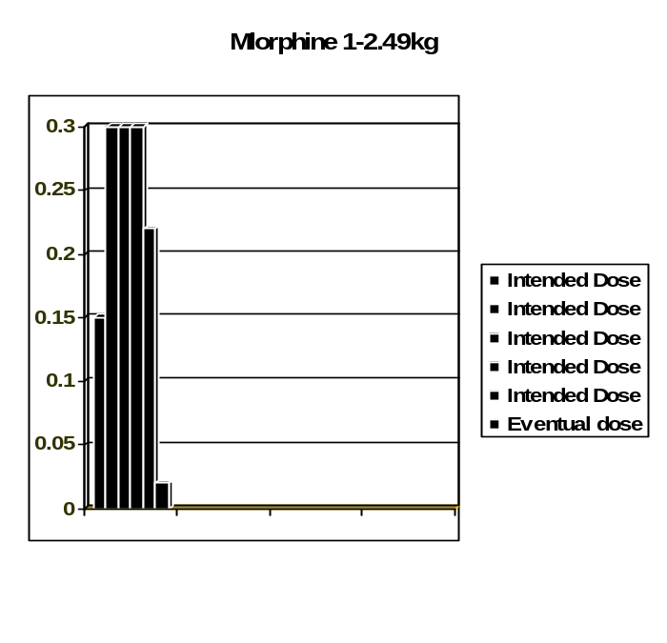

During the last sample period of 134 days a total of 92 Hard Max events were recorded. The infusion starts associated with these hard max events were 7281 infusion starts. This represents a total of 2% of all the infusion starts for the 134 patient days.

Case Examples: The following case examples are extracts from the last 134 patient day sample period.
Case A Patient Profile – Below 1 KG.
Drug: Morphine (0.1mg/ml)
On selecting Morphine as drug to be used, the user selected to infuse the drug at a rate of 0.1mg/kg/hr. The Hard Max limit for this drug was programmed at 0.05mg/kg/hr. The user then titrated down to 0.09mg/kg/hr. After both these infusion were disallowed by the pump the user selected 0.01mg/kg/hr and started the infusion. The potential overdose was 2 x higher than the hard max limit and 10 x higher than the eventual dose of 0.01mg/kg/hr.

Case B (Figure 3) Patient Profile – Between 1- 2.49 KG. Drug: Morphine (0.1mg/ml)
On selecting Morphine as drug to be used, the user selected to infuse the drug at a rate of 0.15mg/kg/hr. The Hard Max limit for this drug was programmed at 0.15mg/kg/hr. This infusion would have still been within the limits set out in the data set had the user confirmed that they wanted to infuse the drug at this higher rate. The user opted to titrate to 0.3mg/kg/hr. This is double the strength of the hard max limit. They tried another two infusion starts at his high level before the infusion was titrated down to 0.23mg/kg/hr. The infusion was again disallowed because of the hard max limit set at 0.15mg/kg/hr.The user then selected to titrate down and start the infusion at a rate of 0.02mg/kg/hr. The potential overdose was
double the amount of the hard Max limit and 15 x higher than the eventual dose of 0.02mg/kg/hr.

Case C Patient Profile – Between 1-2.49 KG.
Drug: Dobutamine (0.6mg/ml)
On selecting Dobutamine as drug to be used, the user selected to infuse the drug at a rate of 100µg/kg/hr. The Hard Max limit for this drug was programmed at 40µg/kg/hr.The user titrated down to 40µg/kg/hr and after confirming a higher dose infusion started the infusion. The potential overdose was 2.5 x higher than the hard max limit and 2.5 x higher than the eventual dose of 40µg/kg/hr.

Case D Patient Profile – Between 2.5 - 5 KG.
Drug: Midazolam (0.3mg/ml)
On selecting Midazolam as drug to be used, the user selected to infuse the drug at a rate of 1.3mg/kg/hr. The Hard Max limit for this drug was programmed at 0.3mg/kg/hr.The user titrated down to 0.3mg/kg/hr and after confirming a higher dose infusion started the infusion. The potential overdose was 4.33 x higher than the hard max limit and 4.33 x higher than the eventual dose of 0.3mg/kg/hr.

Conclusions:
1. This technology definitely decreases the risk of medication errors. While we couldn’t identify exactly which patient or nurse was directly involved with near misses identified in the CQI data it did alert us to problem areas and the number of medication errors that were occurring.
2. Near misses were mainly due to the “the human factor” when staff input the incorrect settings or overrode the safety features
3. The ease of use and applicability of this technology in lower functioning units would depend on ongoing support and in-service training from the company and a standardized drug library. Primary level units would mainly require the software for admin. of antibiotics which at present cannot be administered using safety limits.
4. Practice changes include the use of standard concentrations and dose rather than rate prescriptions. Should the correct dosing units for antibiotics become available the medication would need to be prescribed as mg/kg/time. Nurses would then become more familiar with the doses. A standard concentration would then be drawn up and a specific volume administered by the pump. This could be drawn up daily or at each medicine round, depending on the stability of the solution. Accurate programming and checking of the pump at the bedside would be required to ensure the correct dose is administered. Potentially standard medication syringes could be prepared in the pharmacy.
5. The first couple of weeks following the introduction of the technology were difficult and frustrating for staff mainly due to fiddly keying in of values, multiple alarms and new processes, some omissions in the drug library and ongoing orientation for new and on call staff. However once these difficulties were overcome staff became confidant in and reliant upon the new pumps.

Discussion:
1. Unfortunately downloading and analysis of CQI data is dependant on the company and needs to be on a regular ongoing basis on order to be effective in promoting change.
2. As people become more aware of errors will more be reported?
3. Ongoing monitoring is required to see if the CQI data reflects improved compliance and fewer errors. This is difficult to judge due to high turnover of staff.
4. Feed back needs to be given to the companies with regard software changes required for neonatal patients e.g.
•On screen display of weight and adjustments without losing infused volumes
•Greater selection of dosing units e.g. mg/kg/30min, MU
•Use of 1ml syringes would be wonderful!
•Neonatal limits on pressure that cannot be overruled
5. A standardized neonatal drug library would decrease the need for specialized knowledgeable staff to be available to laboriously compile new data sets for each unit.
6. Further study is required comparing the various pumps and software available on the market- particularly for an NICU setting
7. As we become more and more dependant on technology so our functions change…
•Pharmacists drawing up our medications and labeling with bar codes
•Computers scanning and checking the codes
•Smart pumps delivering the medication.
What are the nurses and doctors role in this equation? How will this affect our knowledge of medications, concentrations, dosing etc? Who will be accountable? Is this change for the good?

Table 2 Software analysis

ADVANTAGES | DISADVANTAGES
Easy to use software warns of  and prevents errors | Weight not displayed on screen
Easy adjustment of doses and rates | Inability to program antibiotics  over½ hr
Accurate measurement of  infused volume | Arrow keys fiddly to use
Use of drug library as a reference | Initial set up very time  consuming. Any modifications  dependant on laptop and  company
Detailed CQI data | Dependant on company for  regular downloads
Weight banding ensures weight  applicable limits | Cannot adjust weight without  loosing current infusion history
Standard concentrations
Dose not rate dependant
prescriptions

Table 3 Hardware analysis

ADVANTAGES | DISADVANTAGES
Large, clear display | Large and heavy in NICU  setting
Accurate administration down to  0.01ml/hr | Keying in of values is fiddly
Robust and well engineered | Syringe holder – weak spot
Accurate monitoring and display  of pressure (including in vivo) | Ordering of pressure  sensing ext. sets
 | Not stackable
 | Individual power cables

DISTRICT HOSPITALS: THE CORE OF MATERNITY SERVICES, BUT SADLY NEGLECTED

RC Pattinson for Saving Babies Technical Task Team
MRC Maternal and Infant Health Care Strategies research unit, University of Pretoria
(See Saving Babies 2006-2007: Sixth report on Perinatal Care in South Africa. www.ppip.co.za for details)

During the period 1st January 2006 to 31st December 2008, 659,809 births and 25060 perinatal deaths were recorded on the national Perinatal Problem Identification Programme (PPIP) database from 244 PPIP sites. This represents 39.5% of all births in institutions using the District Health Information System (DHIS) for the denominator.

The major findings are given below:
- Nationally about 17% births occur in Community Health Centres, 42% in District hospitals, 30% in regional hospitals and 11% in tertiary hospitals.
- The top 5 categories of perinatal deaths were unexplained stillbirths (24%), spontaneous preterm birth (23%), intrapartum asphyxia and birth trauma (17%), complications of hypertension in pregnancy (13%) and antepartum haemorrhage (10%). These 5 causes account for 89% of perinatal deaths.
- Perinatal mortality rates for intrapartum asphyxia and birth trauma were highest in district hospitals at 8.29/1000 births, followed by regional hospitals at 5.65/1000 births. This was 46.7% higher than regional hospitals.
- Intrapartum asphyxia and birth trauma were the most common health care provider probably avoidable deaths (43%) and administrative probably avoidable deaths (18%).
- Most health care provider probably avoidable deaths occur in district hospitals (57%) and most were due to intrapartum asphyxia and birth trauma (47% of 57%).
- The avoidable mortality rate for health care providers is highest in district hospitals (7.04/1000 births) and intrapartum asphyxia and birth trauma is the most common cause.
- The avoidable mortality rate of administrative problems is highest in district hospitals (4.29/1000 births) and relate mostly to intrapartum asphyxia and birth trauma and spontaneous preterm birth.
- Regional hospitals are the second worst in relation to quality of care and the pattern of disease is similar to district hospitals.

Community service doctors provide the main medical human resource for district hospitals. This group needs to have sufficient obstetric and neonatal skills before taking up positions in district hospitals. To ensure this, interns need to be taught the relevant skills before starting their community service.

Skills of midwives in district hospitals also needs improving and this can only effectively occur at their district hospitals.

Making completion of the ESMOE course compulsory for all interns and introducing mandatory obstetric and neonatal fire-drills in district hospitals will improve skills of both community service doctors and midwives.
A COMPARISON OF TWO TRAINING METHODS FOR BASIC ANTENATAL CARE: “FACE TO FACE” AND “TRAIN THE TRAINERS”

Surina J Groenewald-Neethling, MCWH Boland/Overberg Region
Prof Sheila Clow, UCT; Prof RC Pattinson, Univ Pretoria.

Introduction:
The BANC (basic antenatal care) programme, a “Quality Improvement Programme”, was adapted by Prof Bob Pattinson for the South African circumstances. To deal with some of the shortcomings of the Training of Trainers (TOT) approach, another approach, “face to face” (FTF) training was proposed for the Boland/Overberg region (BOR), a rural region of the Western Cape province of South Africa. The study compares the two training methods. One training level was eliminated (shown in graph below) in the FTF training method which decreased the possibility of diluting information. In this method all the professional nurses were trained by the Expert trainer.

Graph 1: Cascade of training in BANC

‘Train the trainers’ ‘Face to face’ training
Level 1
Panel of experts

Level 2
(Facilitator from District level)
Expert trainer

Level 3
Trainer
(Trainer from the clinic for train the trainers)

Level 4
Clinic trainees

Aim and Objectives:
To assess if the two training approaches (TOT vs. FTF) are equally effective in implementing BANC. This was measured by two parameters:
- examining the improvement if any in the standard of antenatal care given, using the documentation of antenatal care on the antenatal card
- assessing the effect of training on the gestational age (GA) at booking.

Method:
A Restricted Randomised Cluster Comparative Trial was used in this study. Clinics that refer their births to primary maternity facilities formed a cluster. Matched pairs (from six subdistricts) were randomly assigned to one of the two intervention groups. There were 3 clusters in each arm with 3-6 clinics in each cluster. Data collection took place through audits of antenatal cards prior to and three months after implementation of BANC. Twenty antenatal records per clinic were randomly selected before and after the training. In total, 960 cards were scored. The effect of the two different training approaches was compared in each pair as well as across the three pairs, and analysed statistically.

With the intra observer variability test, 31 cards for the before and after training were randomly selected by a 3rd person who blinded it and gave it back for the rescore.

Results:
When one compares the pre-training gestational age (GA) at the booking < 20 weeks, one can see that the clusters are not balanced. The TOT group started off with a better GA at booking (graph 2).

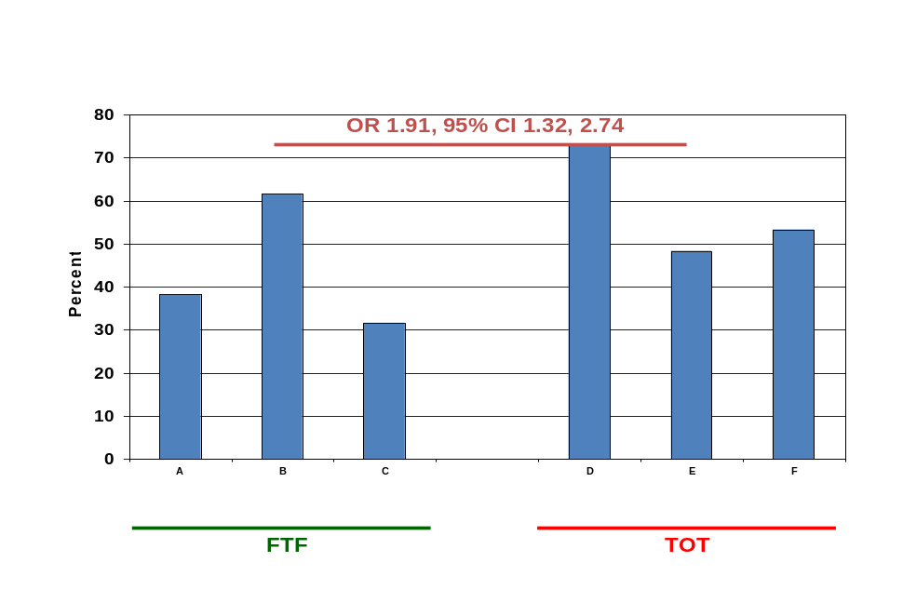

Graph 2: Comparison of Pre training gestational age at booking less 20 weeks gestation per sub-district

In the pre- and post training gestational age analysis, both groups, the Face to Face and Training of trainers show a significant improvement in the booking gestational age. When one compares the FTF and TOT post training results, there is no significant difference between the two groups as shown in graph 3.
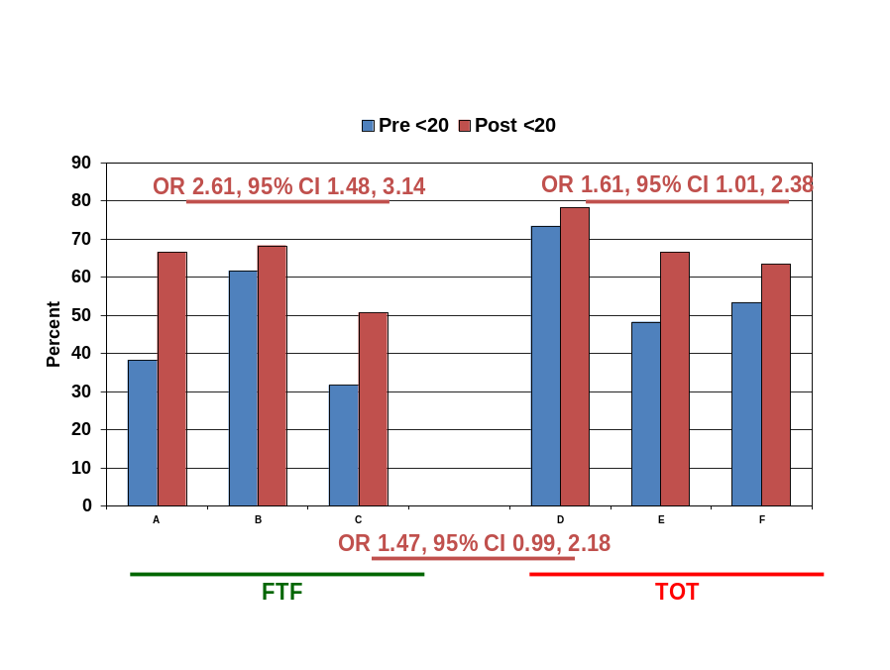

Graph 3: Comparison of Pre and Post training gestational age at booking per sub-district

In the comparison of the pre- and post mean scores, the FTF group showed highly significant post training scores compared with the TOT group as seen in Graph 4.

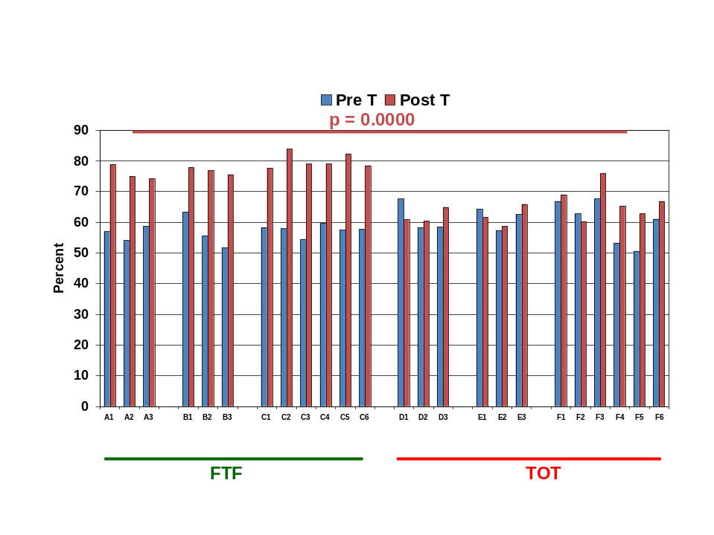

Graph4: Comparison of Pre and Post training mean scores

A comparison of the pre- and post scores in Graph 5, the Face to face group shows a massive increase in knowledge and skills, 45 x better than in the pre-training scores. The Training of trainers method showed no significant increase in knowledge and skills. When comparing the post scores, the meta-analysis of the grouped subdistricts confirmed these findings, with FTF being more than 8 x better than TOT as a method of improving the standard of care.

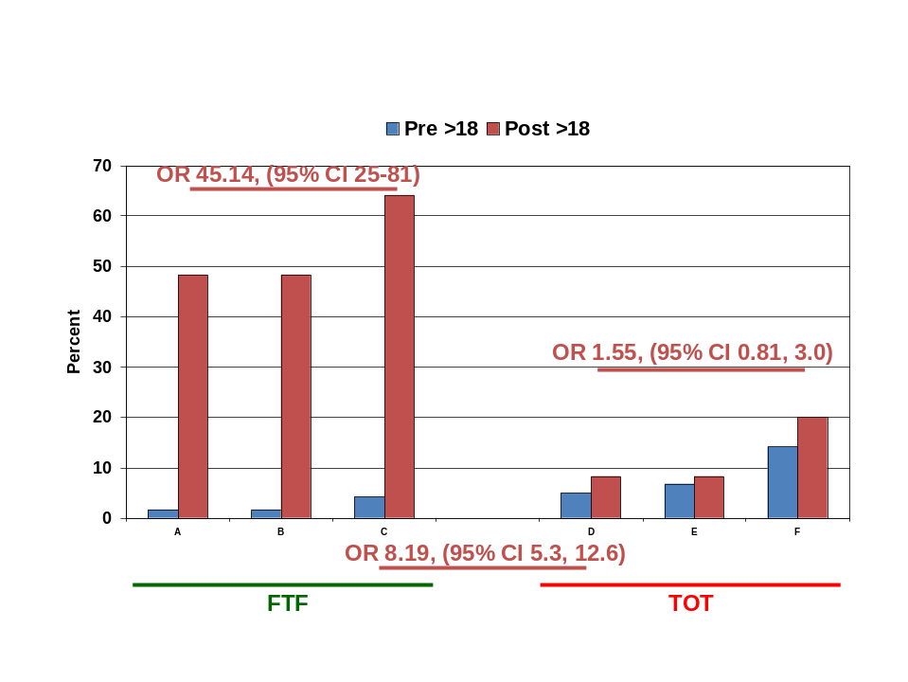

Graph5: Comparison of Pre and Post training scores in sub-districts
(adequate antenatal care: score >18, i.e. >75%)

For the intra observer variability, in both Training of trainers and Face to face groups, the correlation was 0.9.

Conclusion:
Overall, Face to Face training was substantially better than Training of Trainers in implementing BANC. Based on this study, future training would have a better success rate if the FTF method is used. By cutting out the middle level, one reduces dilution of enthusiasm and competence (“broken telephone problem”). The implications of these results have great relevance on the roll-out of training for this and any other national initiatives and should thus influence future decisions.

TRAINING IN KANGAROO MOTHER CARE – IDEAL AND REALITY (ABSTRACT)

Anne-Marie Bergh, Elise van Rooyen, Robert Pattinson
MRC Unit for Maternal and Infant Health Care Strategies and University of Pretoria

Background
The MRC Unit for Maternal and Infant Health Care Strategies has a research programme on the implementation of kangaroo mother care (KMC). One of the aspects investigated are outreach strategies associated with education and training in the scaling up of a new health care intervention.

Aim
To provide an overview of
- different assumptions about the effect of training in KMC
- outreach and educational strategies and their effect on implementation of KMC

Methods
- Two randomised trials testing the effect of different outreach strategies, namely (a) an implementation package only versus face-to-face facilitation (34 hospitals) and (b) face-to-face facilitation, ‘on site’ versus ‘off site’ at a centre of excellence (36 hospitals)
- A pilot in the use of telemedicine for training in KMC (3 hospitals)
- Measuring the effect of one-day training workshops on KMC implementation (24 hospitals)
- Piloting an implementation workbook as training tool (4 hospitals)

Results
- (a) Hospitals receiving face-to-face facilitation scored significantly better on the implementation progress scale than hospitals receiving an implementation package only.
(b) There was no significant difference in the implementation scores of hospitals receiving on-site or off-site facilitation.
- Only 13 of the 21 scheduled telemedicine broadcasts took place as a result of broadcast failures (connection, sound, vision). All three hospitals implemented KMC successfully.
- Only 9 of 24 hospitals whose delegates attended a one-off workshop implemented KMC.
- A workbook on its own is not sufficient for KMC implementation and a multimedia package is needed.

Conclusion
  - The way in which education and training is included in programmes aimed at implementing KMC at a particular health care facility or aimed at scaling up KMC to a group of hospitals requires careful consideration to ensure sustainable practice.
  - Outreach strategies including personal support over a longer period of time are more effective in implementing KMC than one-off workshops. In this process the support from management at all levels is crucial for success.
  - Face-to-face outreach strategies are more effective than an implementation package on its own. The site of face-to-face facilitation, either on-site or off-site at a centre of excellence, does not make a difference in implementation progress. The choice of outreach strategy should be guided by local circumstances, cost and the availability of skilled facilitators.
COMPARATIVE STUDY OF THE FUNCTIONALITY AND ACCEPTABILITY OF VARIOUS LOW COST NEONATAL RESUSCITATION DEVICES.

D Nyasulu, Dr C Kelly, E Moosa, S Engelbrecht, M Folsom, P Coffey, J Litch, C Markham, A Greene KZN Department of DOH
Maternal and Newborn Technology Initiative
(MNTI) Project
PATH, Durban, South Africa

Introduction/Background information
Causes of neonatal mortality in under resourced countries include prematurity, birth asphyxia (hypoxia), sepsis and congenital abnormalities. An estimated five million babies sustain birth asphyxia in under resourced countries each year, of whom one million die and another million live with mental and physical sequelae.
Ensuring that appropriate neonatal resuscitators are available at every birth and used correctly, as stated in current policy, is critically important in the management of birth asphyxia and in minimizing its associated sequelae. The lack of adequate neonatal resuscitation equipment and poor neonatal resuscitation skills, amongst health care providers have been identified as contributing factors in these often-avoidable neonatal deaths.

Research Goal and Objective
The Goal: To reduce neonatal mortality and childhood disability in South Africa by ensuring that health care providers have access to affordable, high-quality neonatal resuscitation devices and have appropriate skills in neonatal resuscitation.
Objective: Assessment and identification by local stakeholders of appropriate and cost-effective neonatal resuscitators for use by South African health care providers.
Assessment Design
The study used a participatory methodology to engage users and potential users within the health system in the evaluation of the functionality and acceptability of a select group of resuscitators and to gather input from a focus group discussion about the relative merits of each device.The study was conducted in collaboration with the local Department of Health (DOH) in KwaZulu-Natal.
Methodology
Participant Recruitment
Participants were recruited from among existing health facility staff in each of the four sites in line with the criteria described above. Non-monetary inducements were offered to the participants in terms of refreshments/snacks during the workshop. All participants signed a standard written informed consent.

Sample size
Four neonatal resuscitation devices, Laerdal silicone bag and mask; Besmed silicone bag and mask; Headstar Medical Products silicone bag and mask and HI-Care silicone bag and mask, were evaluated with respect to ease of use, including disassembly, reassembly, cleaning, and functionality were evaluated after which information on the minimum requirements for appropriate and affordable neonatal resuscitation devices to be used at all levels of the health system was generated and agreed upon.
Four one day workshops which included a refresher course on neonatal resuscitation and device evaluation were conducted. Forty health care providers including midwives and doctors participated in the study.

Data collection procedures
- Resuscitation Skills Refresher Training
Collaborating partners from the DOH were responsible for conducting a refresher course in neonatal resuscitation skills. This was based on the South African Pediatric Association Manual of Resuscitation of the Newborn and served to standardize the resuscitation techniques used in the simulation exercise to evaluate the resuscitation devices. Participants were instructed in the correct use of and the differences between the types of resuscitators (bag and mask, mouth to mask) during the neonatal resuscitation refresher course.
- Simulated use evaluation of functionality and acceptability of resuscittaors
a. Four designated device stations were created (one for each device); they were labeled with the device name, manufacturer, cost, and information related to projected availability in South Africa. Three devices were placed at the designated device station.
b. Participants were divided into groups of three to four people. Each group went to a device station and participants took turns using the designated device for 2 and 5 minutes. Other members in their group timed their simulated use session and assess the respiration rate during each session using a stopwatch.
c. .Participants went to all four designated device stations and interacted with each device as described above. Thereafter participants recorded observations about each device on data collection sheets utilizing a five-point Likert-type scale to assess variables related to device usability.
d. With no instruction, participants disassembled resuscitators to their primary components. After disassembly, participants reassembled resuscitators.
- Nominal group process to identify preferred devices
a. Participants were asked to choose their three most preferred devices. To do this, newsprint with the name of each device written on it were taped to the wall of the meeting room. Each participant received three round self-adhesive dots. These dots were votes to indicate their priorities. Participants put the dots on the newsprint next to the devices they want to vote for. One to three dots could be used on a device. The votes were then tallied to identify the top three devices preferred by the group.
- Focus group discussion
During the focus group discussion participants to discuss participants’ experience with the resuscitators, highlighting differences between the two main types, issues with assembly/disassembly, ergonomics, and correct use
- Consensus decision-making on minimum standards.
Participants broke into two small groups to develop a set of minimum standards for neonatal resuscitation devices for each level of service delivery. Each small group presented their list to the larger group. Project staff encouraged discussion and then facilitated the compilation of one list of minimum standards.

Data Analysis
Data about socio-demographic information was entered into SPSS 12.0 and descriptive statistics were generated in order to provide statistical background on each study participant.
User evaluation data were entered into SPSS 12.0. Device usability was measured as the mean of scores generated from a five-point Likert-type scale for human factors variables related to ease of use, comfort, and ergonomics. A similar set of scores was generated for variables related to disassembly/reassembly. A summary device usability score was measured as the mean of all scores on the device usability index.
Statistical tests were carried out to explore differences in quantitative variables related to position, gender and district. For ordinal data, appropriate non-parametric tests such as the Mann-Whitney test and the Kruskal-Wallis test was used. Qualitative data from the focus group discussions were cleaned and coded following transcription of the data. A set of codes was developed and data were manually sorted into like-coded blocks of text.. For central themes, data matrices were used to examine differences by position, gender, and district.
The primary outcome indicator for device preference was be the proportion of users who ranked each device as their top choice (individual level) and the proportion of groups that selected each device as their top choice (group level).

Results
Laerdal device consistently rated highest in all aspects. Materials were assessed by two questions: 1) apparent durability of the device and 2) feel of device/bag material. In both aspects Laerdal was rated as the most favourable, whilst one participant felt the Besmed bag material to be too hard.
Affordability was the one category where the Laerdal device was rated lower than the other devices. This is likely due to the relatively high cost of the Laerdal device.
Mask size was rated similarly for the Laerdal, Besmed and Headstar devices although the median was highest for the Laerdal device. There was more variation in the range of responses related to mask shape. Headstar device was rated favorably for mask shape.
IMPROVING ESSENTIAL OBSTETRIC AND NEONATAL SKILLS USING THE ESMOE PACKAGE: THE RESULTS OF THE PILOT STUDY.

S Velaphi, RC Pattinson and ESMOE working group

Introduction
Saving mothers 2004-2006 recommended that protocols on the management of conditions causing maternal deaths must be available and utilised appropriately in all institutions where women deliver; and that all midwives and doctors must be trained on the use of these protocols. The indicators that were set to check if this recommendation is being implemented included the availability of a functioning training programme for all institutions at district level. In order to address the above recommendation obstetricians from different universities and hospitals in the country came together and developed a package that will be used to train doctors and midwives on management of medical and obstetric emergencies. This package is called Essential Steps in Medical and Obstetric Emergencies (ESMOE). This package is based on two guidelines titled 1. Essential steps in the management of common conditions associated with maternal and neonatal mortality, 2. Guidelines for Maternity Care in South Africa- second edition; and also based on “Life Saving Skills Manual and Facilitators guide” both from the Royal College of Obstetricians. These were adapted to suit our local situations. Different tools that include slides, CD/ DVDs, and mannequins are used during training. To assess the impact of training using the ESMOE package on knowledge and skill we conducted a pilot study among interns who were rotating through the department of obstetrics in different hospitals from different provinces.

Methods
Sixty nine interns completing their department of obstetrics and gynaecology four month rotation in April 2008 were requested to write a multiple choice question (MCQ) paper. Twenty of these of these were randomly chosen to do the skills test. This group served as the control for the study group that underwent the training in ESMOE. The study group consisted of seventy-eight interns who were starting their department of obstetrics and gynaecology four month rotation starting in May 2008. The study group wrote the MCQ paper as a pre-test before going through ESMOE training. Twenty one were randomly chosen to do the skills test. The ESMOE training was then conducted. In August the study group re-wrote the MCQ paper as a post-test and 24 were randomly selected to do the skills test. The study group also completed a participant satisfaction questionnaire at the end of their training to evaluate the course. The satisfaction questionnaire was designed to give a score from 1 to 10 with 1 being definitely not agree to 10 being extremely happy.

Results
There were 8 hospitals who were involved in this pilot. The participating hospitals with the number of interns enrolled per institution are shown in Table 1.

Table 1 Participating hospitals and number of interns enrolled

Hospital | Controls | Study (pretest) | Study (posttest)
Chris Hani Baragwanath | 16 | 22 | 15
Kalafong | 6 | 7 | 7
Mowbray Maternity | 6 | 6 | 8
Nelson Mandela | 8 | 8 | 8
Pelonomi / Universitas | 13 | 15 | 12
Pretoria Academic | 10 | 10 | 9
Tygerberg | 10 | 10 | 10
Total | 69 | 78 | 69

There was no significant difference in pre-test MCQ scores and post-test MCQ scores in the study group. There was also no significant differences between the MCQ scores of interns who were finishing their obstetric and gynaecology block with no ESMOE training and those who were finishing their block with training in ESMOE (post-test MCQ scores in study group). There were significant differences in skills of those who were trained in ESMOE compared to their skills before training and the controls who were not trained in ESMOE at all.

The scores on questions on course satisfaction were higher than 8 as shown on Table 2.

Question | Mean mark
Was the course enjoyable? | 8.6
Was it easy to make the most of the course? | 7.8
Was it easy to join in the interactive sessions? | 8.2
Did you feel comfortable and at ease during the course? | 8.6
Was the course a good use of your time? | 8.5
How good was the venue? | 8.5
How good was the equipment provided for learning? | 8.3
Assessment of modules
Lecture on ABCDs and the systemic approach | 8.4
Module on Resuscitation of mother | 8.3
Module on Resuscitation of the newborn | 8.2
Module on Shock | 8.3
Module on pre-eclampsia and eclampsia | 8.4
Module on Haemorrhage | 8.4
Module on obstetric complications | 8.5
Module on obstetric labour | 8.0
Module on assisted delivery | 8.3
Module on Sepsis | 8.1
Module on HIV/AIDS | 8.0
Module on complication of abortion | 8.0
Module on surgical skills | 8.2

Discussion
The pilot study shows that the knowledge increased slightly, suggesting that interns had a decent theoretical knowledge when they started the block. The significant improvement in skills after being trained in ESMOE emphasizes the need of a course like ESMOE where to teach skills to all interns. To have clinical skills in management of medical and obstetric emergencies is critical in saving mothers and babies during the perinatal period. The findings of this pilot emphasizes the need of implementing training clinical skills in managing medical and obstetric emergencies. This will result in reduction in maternal mortality as it has been suggested by the Saving Mothers Report. The first phase of improving emergency obstetric care in South Africa is now complete; namely an effective training programme has been developed that both increases knowledge and more importantly skills. The next phases of scaling-up to all interns and to introducing fire-drills to all institution performing deliveries must now be tackled.
NEONATAL DEATH DUE TO CONGENITAL ABNORMALITIES (ABSTRACT)

Mmuso Barbara Monyemore
Directorate: Women’s Health and Genetics, National Department of Health

Introduction
There is a need to emphasise the extent and seriousness of neonatal death due to congenital abnormalities/birth defects. More often, congenital abnormalities are perceived as an unappreciated public health problem. However, the Saving Babies: Fourth Perinatal Care Survey of South Africa (2003), reports congenital abnormalities as the second most important cause of neonatal deaths above 2kg (15%) in South Africa. Furthermore, the Saving Babies: Fifth Perinatal Care Survey of South Africa (2003 – 2005), reports congenital abnormalities within the first ten primary causes of perinatal and neonatal death, and stillbirths in South Africa.

Discussion
The focus of this paper is to sensitise the health professionals of the preventive/screening programmes to reduce neonatal death due to congenital abnormalities. Screening for congenital abnormalities should be seen as an integral part of the Maternal, Newborn and Child Health programmes. These screening programmes include pre-conception screening, antenatal screening and newborn screening.

It is also fundamental that health professionals be trained to be able to recognise congenital abnormalities, data collection programmes be supported, and available high technology in this country be used equitably. Most importantly, ethical and legal principles should be considered throughout the implementation of these preventive programmes.

Conclusion
Prevention of neonatal death due to congenital abnormalities should not be underestimated, and should add to the ongoing and extensive worldwide efforts to reduce under-five mortality (Millennium Development Goal 4).

A NEW RANGE OF PEP BOOKS: A LEARNING PROGRAMME FOR PROFESSIONALS

Prof David Woods, Perinatal Education Trust

Introduction:
Over the past 12 years the Perinatal Education Programme (PEP), consisting of 7 self-directed learning manuals, has been successfully used by more than 50 000 nurses, doctors and students in South Africa. Published studies show that PEP can be used by nurses in study groups to improve cognitive knowledge, clinical skills, caring attitudes and patient care practices. Furthermore, PEP manuals have been widely used by doctors and medical students. The development and evaluation of the PEP courses has been documented in a number of presentations at Priorities conferences.

Methods:
Recent funding by Eduhealthcare has allowed the PEP manuals to be updated and printed as attractive self-learning books. These promise to make continued perinatal education available to a wider audience of health professionals, not only in South Africa but in other developing countries.

Results:
The two long courses (Maternal Care, and Newborn Care) and the five shorter courses (Primary Newborn Care; Mother and Baby Friendly Care; Saving Mothers and Babies; Perinatal HIV, and Birth Defects) have been published as books by Electric Book Works. An additional two short courses on Primary Maternal Care (antenatal and postnatal care for primary care clinics) and Intrapartum Care have been added.
The learning material (minus the MCQs) has been made available on an open website (www.EBWhealthcare.com). Copies can be printed out in PDF format. The complete books can also be accessed electronically as an interactive learning course on the website. For a small fee, the final examinations can be written on the website.
Other books in the Electric Book Works series include Adult HIV, Childhood HIV and Child Health Care. Books on further health care topics (Childhood TB, Adolescent HIV, Childhood Palliative Care, and Childhood Developmental Disabilities) are being developed.

Conclusion:
The well known PEP manuals, now updated and presented as books in a new attractive format promise to offer self-directed learning opportunities to all doctors and midwives caring for pregnant women and their newborn infants in South Africa.
What is required on a provincial basis is a formal structure of continuing education facilitators to enable all health care professionals access to educational opportunities. When linked to national management protocols, the PEP books will provide a cost-effective training tool to improve the care of patients, especially in under-resourced rural and periurban areas.
SAVING MOTHERS & BABIES – A JOINT INITIATIVE (ABSTRACT)

Mitchell, RW¹, Cooper, P², Chaane T³, Parsley, SM⁴, Hlongwane, M⁴, Mtshali, E⁴.
¹ Obstetrician Gynaecologist, Gauteng Department of Health,
²Professor and Head Department of Paediatrics Charlotte Mexeke Hospital, University of Witwatersrand Faculty of Health Sciences,
³ Chief Director, Health Programmes, Gauteng Department of Health,
⁴ Wits Health Consortium (Johnson & Johnson Paediatric Institute)

Introduction:
The “Saving Mothers” and the “Saving Babies” reports identified a number of interventions to reduce maternal and neonatal morbidity and mortality. At a prior Priorities Conference Andi Kennedy (JJPI), Dr R Mitchell and Ms T Chaane (GDoH) discussed a joint initiative whereby an impact on maternal and neonatal care could be achieved. After numerous meetings and discussions it was decided to establish a Project Team consisting of three persons to implement this program. It was agreed that JJPI (Ms Bonnie Petrauskas) would fund the project via the Wits Health Consortium. The Department of Paediatrics, University of Witwatersrand (Prof P Cooper) and the GDoH (Dr R Mitchell, Ms T Chaane) would coordinate and facilitate the project.
Method:
Initially the project was be in the form of 2 obstetric interventions and 1 neonatal intervention.
Obstetric intervention: The obstetric module has been re-assessed and now consists of three (3) lectures / talks (interactive) addressing the Use and Interpretation of the CTG, Use and Interpretation of the Partogram and the Management of PPH. Each of these lectures lasts about 1.5hrs, using examples to demonstrate various scenarios.
Neonatal intervention: This module is a combination of theory and practical (hands on) stations addressing Neonatal Resuscitation. The course is based on the SAPA guidelines. The course has 3 or 4 workstations following the theory part. The course is run over a full day. The work stations are; i) chest compression, ii) bag and mask, iii) intubation and iv) umbilical vein catheterization. The course is a certificate course with a pre and post course evaluation.
Results:
A total of 943 persons (medical practitioners and midwives) have attended the Obstetric Modules and 910 persons (medical practitioners and midwives) have attended the Neonatal Course. The follow-up visits by the 2 midwives have tutored 1182 health workers at their places of work. A major problem has been how to measure the effectiveness of the interventions as each of the outcomes has multiple inputs, any of which could and would impact on outcome. We have had anecdotal reports of babies being saved directly as a result of what has been learned on the Obstetric and Neonatal Modules.
Conclusions:
Although it is difficult to quantify the effects of the Course it is commonly accepted that any up-skilling will have a positive effect on outcomes especially if the interventions are appropriate. The Course is followed up with refresher re-enforcing visits to the institutions. It is our intention to expand the scope of the interventions.
In conclusion the project has been and still is continuing to have a positive impact on the management of pregnant women and on neonatal care.
RISK FACTORS FOR PERINATAL HIV-1 TRANSMISSION IN PREGNANT WOMEN ON LIFELONG ANTIRETROVIRAL THERAPY. A PROSPECTIVE STUDY AT FRERE HOSPITAL, EAST LONDON, SOUTH AFRICA.

Ebrahim Bera,*‡; Nkosazana Jwacu*; Freda Pauls*; Thozeka Mancotywa*; Ndileka Ngcelwane*; Yoliswa Hlati*
Walter Sisulu University‡; University of the Witwatersrand‡; Department of Obstetrics & Gynaecology, Frere Hospital*, East London

Background
Factors influencing perinatal HIV-1 transmission at delivery include: mode of delivery, preterm birth, CD4 count and maternal plasma HIV-1 RNA viral load (VL).
Elective Caesarean section (ELCS) is currently recommended for women on antiretroviral therapy (ART) with VL > 1000 copies/ml at delivery.

Objectives
- to estimate the rate of HIV-1 transmission in the infants of pregnant women taking lifelong antiretroviral therapy (ART)
- to evaluate risk factors for perinatal HIV-1 transmission

Methods
- Requirements for lifelong ART at Frere Hospital included pregnant women with World Health Organization (WHO) stage 4 disease, or women with CD4 < 250 cells/mm³. An ultrasound scan was routinely done to confirm gestational age.
- Women initiated on lifelong ART as well as women who conceived on ART were followed up until 6 weeks postpartum.
- Details on age, parity, CD4 count, viral load (VL), gestation of ART commencement, duration of ART, VL at delivery, gestation at delivery, mode of delivery & infant outcomes were obtained.
- For women who conceived on ART, CD4 count & VL at confirmation of pregnancy were additionally obtained.
- VL assays were repeated prior to Elective Caesarean section (ELCS), at the onset of labour or induction of labour, or within a week following delivery.
- VL results were not known until 2 weeks after delivery.
- ELCS were performed for obstetric indications.
- ELCS was defined as Caesarean section prior to the onset of labour and prior to rupture of membranes.
- From 6 weeks onward, a heel-prick dried blood spot (DBS) was collected from infant for HIV DNA polymerase chain reaction (PCR).
- An infant was classified as HIV-1 infected if PCR specimen confirmed HIV-1 sero-conversion, or the infant died from HIV-related illness.
- HIV-1 infected infants received priority referral to paediatric ART unit.

Statistical Analysis

- Statistical analysis Epi-info 2005.
- Continuous data = medians with interquartile ranges (IQR) or means with standard deviations (SD).
- Categorical data = proportions with 95% confidence intervals (CI).
- Dichotomous data comparisons with χ² or Fisher exact test.
- Variables studied as risk factors for transmission included: CD4 < 250 cells/mm³; ART-naïve; duration of ART; ELCS; Emergency Caesarean section (EMCS); normal vaginal delivery (NVD); assisted vaginal delivery (AVD); type of ART; preterm birth (<34 weeks); maternal plasma VL at delivery; gender; neonatal birth weight & infant prophylaxis.
- Univariate logistic regression for all possible risk factors.
- Multivariate logistic regression model with adjusted odds ratios (AOR) & 95% confidence intervals (CI).
- Study approval from local research & ethics committee.

RESULTS

Study period: 01 January 2006 until 31 October 2008

Women initiated on lifelong ART
Total number of pregnancies 711
Ongoing pregnancies 97
Lost to follow up (%) 30 (4.9%)
Pregnancies with outcomes 584
Miscarriages 5
Stillbirths 7
Twins 14
Women with live births 572
Live births (including twins) 586

Women who conceived on lifelong ART
Total number of pregnancies 239
Ongoing pregnancies 22
Lost to follow up (%) 9 (4.1%)
Pregnancies with outcomes 208
Termination of pregnancy (TOP) 3
Ectopic pregnancy 2
Miscarriages 8
Stillbirths 5
Twins 5
Women with live births 193
Live births (including twins) 195

Baseline demographic characteristics of the combined cohort of pregnant women on lifelong ART with live births (N = 765)
Median age in years [IQR] 29 [25 – 33]
Primigravida (%) 254/764 (33%)
Median CD4 count in cells/mm³ [IQR] 192 [127 – 245]
CD4 < 250 cells/mm³ (%) 594/765 (78%)
Type of ART
d4T/ 3TC/ EFV† (%) 673/765 (88%)
d4T/ 3TC/ NVP* (%) 77/765 (10%)
AZT**/ 3TC/ EFV (%) 51/765 (7%)
AZT/ 3TC/ NVP (%) 8/765 (1%)
d4T/ 3TC/ LPV/r*** 6/765
EFV/ LPV/r 2/765
TDF/ 3TC/ LPV/r*** 1/765
AZT/ ddI/ LPV/r 1/765
Median duration of ART in weeks [IQR] 11 [6 – 29]
Duration of ART < 10 weeks (%) 315/765 (41%)
Mean¶ VL at delivery in copies/ml 7885 (SD: 68 880)
VL < 1000 copies/ml at delivery (%) 508/567 (90%)
VL < 50 copies/ml at delivery (%) 407/567 (72%)

d4T = stavudine; AZT = zidovudine; 3TC = lamivudine; EFV = efavirenz; NVP = nevirapine; ddI = didanosine; TDF = tenofovir; LPV/r = lopinavir/ritonavir IQR = interquartile range; VL = viral load; SD = standard deviation
Type of ART
† 3 women were switched from NVP to EFV in the 2nd/3rd trimester
* 44 women were switched from EFV to NVP in the first trimester
** 3 women were switched from d4T to AZT in the 3rd trimester
*** 7 women were switched from EFV to LPV/r in the first trimester
¶ VL < 50 copies/ml at delivery was assigned a value of 20 copies/ml
Results for VL assays at delivery were available for 567 (74%) out of 765 women

Delivery Outcomes
Planned vaginal birth (%) 686/765 (90%)
Planned ELCS (%) 78/765 (10%)
Median gestation at delivery in weeks [IQR] 39 [38 – 40]
Delivery < 34 weeks (%) 48/765 (6%)
Mode of delivery
ELCS (%) 74/765 (9.7%)
EMCS (%) 144/765 (18.8%)
NVD (%) 527/765 (68.9%)
AVD (%) 19/765 (2.5%)
Laparotomy for extra-uterine pregnancy 1/765
Delivery outside hospital¶ (%) 91/765 (12%)

ELCS = elective caesarean section; EMCS = emergency caesarean section; NVD = normal vaginal delivery; AVD = assisted vaginal delivery
¶ Includes deliveries at home, midwifery obstetric unit, primary care centre, and en-route to hospital.

Infant Outcomes
Live births 781
Male: female ratio (%) 106/100 (male = 51.4%)
Median birth weight in kg [IQR] 3.00 [2.60 – 3.29]
Low birth weight (< 2500g) (%) 162/781 (21%)
Preterm birth (< 34 weeks) (%) 54/781 (7%)
Early neonatal deaths (%) 12/781 (1.5%)
Perinatal mortality rate (per 1000 births) 30.3
Number of birth defects (%) 23/781 (2.95%)
sd-NVP + AZT prophylaxis (%) 632/772 (82%)
Exclusive breast feeding (%) 40/768 (5%)
Infant deaths* prior to HIV PCR testing 13/769 (1.7%)
Infants tested positive for HIV DNA PCR 14/589**
Overall HIV-1 transmission rate (%) 16/591 (2.7%)
95% Confidence Interval 1.6 - 4.5

sd-NVP = single dose nevirapine; AZT = zidovudine; PCR = polymerase chain reaction
*2 infants died from HIV-related illnesses prior to PCR testing
**589 out of 756 infants (78%) were tested from 6 weeks onwards

HIV-1 transmission following lifelong ART: Univariate analysis

N n % P

Total 591 16 2.7%
Timing of ART
Antenatal ART 444 14 3.2% 0.197
Conception on ART 147 2 1.4%
CD4 count
CD4 < 250 462 12 2.6% 0.476
CD4 > 250 129 4 3.1%
Type of ART
NVP-based ART 68 1 1.5% 0.433
EFV-based ART 523 15 2.9%
Duration of ART
< 10 weeks 241 11 4.6% 0.013
> 10 weeks 350 5 1.4%
VL at delivery
VL > 1000 copies/ml 45 4 8.9% 0.017
VL < 1000 copies/ml 408 7 1.7%
Preterm birth
< 34 weeks 33 3 9.1% 0.054
> 34 weeks 558 13 2.3%
Planned mode of delivery
Planned vaginal birth 523 15 2.9% 0.433
Planned ELCS 67 1 1.5%
Mode of delivery
NVD 389 13 3.3% 0.097
AVD 19 0 0%
EMCS 117 3 2.6%
ELCS 65 0 0%
Place of Delivery
Delivery outside hospital 72 3 4.2% 0.308
Delivery within hospital 519 13 2.5%
Gender of neonate
Male 295 10 3.4% 0.161
Female 296 6 2.0%
Birth weight
< 2500g 116 6 5.2% 0.073
> 2500g 475 10 2.1%
Neonatal Prophylaxis
sd-NVP + AZT 496 13 2.6% 0.489
sd-NVP only 95 3 3.2%

n = number of infected infants. Twins were counted separately.
N = number of mother-infant pairs. Twins were counted as separate mother-infant pairs.
P was obtained by χ² test for duration of ART, mode of delivery and gender. For all other variables the value of P was obtained from Fisher exact test.

Univariate Logistic Regression Analysis of risk factors for perinatal HIV-1 transmission in women on lifelong ART

OR (95% CI) p-value

Timing of ART
Antenatal ART 2.36 (0.53 – 10.51) 0.260
Conception on ART 1.00
CD4 count
CD4 < 250 0.83 (0.26 – 2.63) 0.756
CD4 > 250 1.00
Type of ART
NVP-based ART 0.51 (0.07 – 3.89) 0.512
EFV-based ART 1.00
Duration of ART
< 10 weeks 3.30 (1.13 – 9.62) 0.029
> 10 weeks 1.00
VL at delivery
VL > 1000 copies/ml 20.65 (2.79 – 152.58) 0.003
VL < 1000 copies/ml 1.00
Preterm birth
< 34 weeks 13.03 (1.50 – 113.34) 0.020
> 34 weeks 1.00
Planned mode of delivery
Planned vaginal birth 1.98 (0.26 – 15.22) 0.512
Planned ELCS 1.00
Place of Delivery
Delivery outside hospital 1.69 (0.47 – 6.09) 0.421
Delivery within hospital 1.00
Gender of neonate
Male 1.70 (0.61 – 4.73) 0.313
Female 1.00
Birth weight
< 2500g 2.54 (0.90 – 7.13) 0.077
> 2500g 1.00
Neonatal Prophylaxis
sd-NVP + AZT 0.83 (0.23 – 2.95) 0.768
sd-NVP only 1.00

Results from univariate logistic regression analysis of risk factors for perinatal HIV-1 transmission
OR = unadjusted odds ratio; CI = confidence interval; ELCS = elective caesarean section; ART = antiretroviral therapy; sd-NVP = single-dose nevirapine; AZT = zidovudine

Multivariate Logistic Regression Analysis of risk factors for HIV-1 transmission in women on lifelong ART (N = 453)

VARIABLE | AOR | 95% CI | P-value
VL > 1000 copies/ml | 12.87 | 1.69 – 98.02 | 0.014
ART < 10 weeks | 4.42 | 1.26– 15.48 | 0.020
Preterm birth | 13.18 | 0.63 – 276.30 | 0.097
LBW | 0.68 | 0.12 – 3.93 | 0.669
Vaginal delivery | 1.99 | 0.57 - 6.96 | 0.281

Results from multivariate logistic regression analysis of risk variables for HIV-1 transmission found to be significant on univariate analysis.
AOR = adjusted odds ratio; CI = confidence interval; VL = viral load; ART = antiretroviral therapy; LBW = low birth weight (< 2500g)

Discussion
This study examined perinatal HIV-1 transmission and its associated risk factors in women who exclusively required lifelong ART for their own health. The overall HIV-1 transmission rate of 2.7% is comparable to rates observed elsewhere in South Africa following combination ART use in pregnancy, but slightly higher than the rate of < 2% observed internationally.

The main determinants of HIV-1 transmission were maternal plasma VL at delivery and duration of ART. ART duration of less than 10 weeks increased the rate of HIV-1 transmission more than 4-fold, and VL > 1000 copies/ml was associated with a nearly 13-fold higher rate of transmission.
Transmission rate was 0.4% (95% CI 0.0 – 2.1) in the infants of women with VL < 1000 copies/ml at delivery and who received > 10 weeks of ART during pregnancy.
Preterm birth and low birth weight (LBW) were associated with higher transmission rates, but the relatively small number of infants that were followed up precludes definitive conclusions on the association between preterm birth or LBW and HIV-1 transmission.

Four out of 323 women (1.2%) with undetectable plasma VL (< 50 copies/ml) at delivery infected their infants. These women were all ART-naïve and had a mean pre-therapy VL of 4.83 log₁₀ copies/ml, compared to a pre-therapy VL of 4.09 log₁₀ copies/ml in the group of women who had uninfected infants.
Also, the mean duration of ART was only 9 weeks (range 6 – 13 weeks) in the 4 women who infected their infants, compared to a mean period of 19 weeks (range 1 – 43 weeks) in the 319 women with uninfected infants.
We have observed complete plasma VL suppression at delivery in a patient from a pre-therapy value of 5.23 log₁₀ copies/ml, following 6 weeks of ART – with subsequent infant HIV-1 sero-conversion. This treatment period may not be sufficient to suppress genital tract VL to undetectable levels. Compartmentalization of the genital tract is known to occur, with a delayed response to ART compared to plasma VL.
Cell-associated genital tract shedding of HIV-1 has been demonstrated as a risk factor for transmission. This may account for the observed HIV-1 transmission despite undetectable plasma VL at delivery.

Current trends of performing ELCS based on the presence of maternal HIV-1 infection or the result of pre-delivery VL were not followed for this cohort. Vaginal birth was planned for 90% of women. ELCS were done for obstetric indications. The rate of ELCS was low (10%), consistent with ELCS rates in the overall obstetric population at our institution. No association between mode of delivery and transmission rate was found. However, the lack of association may be due to the limited number of women who had ELCS. Whether ELCS provides further protection against HIV-1 transmission seems plausible but presently unclear. A randomized study on the additional benefit of ELCS in women on ART may provide clarity on its role.

Intrapartum risk factors including duration of membrane rupture and episiotomy were not evaluated, since universal intrapartum precautions were the norm for this cohort. Delivery outside the labour ward suite was evaluated as a surrogate marker for suboptimal intrapartum precautions. No statistically significant differences in HIV-1 transmission rates were however observed with respect to place of delivery.
Infant gender was not a risk factor for transmission in this cohort.

Conclusions
The overall rate of infant HIV-1 transmission in this cohort was low, notwithstanding a policy of planned ELCS for obstetric reasons.
Pregnant women with indications for lifelong treatment should be targeted for access to ART prior to 30 weeks of gestation.
Undetectable plasma VL at delivery does not eliminate the risk of perinatal HIV-1 transmission. The optimal route for delivery of the HIV-exposed fetus remains unclear.
AN ONGOING AUDIT OF THE KANGAROO MOTHER CARE UNIT AT KALAFONG HOSPITAL

Elise van Rooyen
Department of Paediatrics, Kalafong Hospital
MRC Research Unit for Maternal and Infant Health Care Strategies
University of Pretoria

Background
A 20-bed kangaroo mother care (KMC) unit was established at Kalafong Hospital, Pretoria, Gauteng Province, South Africa, where continuous and intermittent KMC is practiced. The unit was opened on 6 July 1999. All infants discharged from the unit were followed up at a clinic, which is held in the unit weekly. A special audit capturing form was developed in order to keep accurate records of the patients admitted to the unit.

Objective
The objective of the poster was to present the data of the audit results collected over a 9-year period in the KMC unit at Kalafong hospital from 1 August 1999 to 31 July 2008.

Method
All patients admitted to the KMC unit from 1 August 1999 to 31 July 2008 were included. A data sheet was completed for each admission. The same form was used to record follow-up clinic attendances. Data captured on the sheet included the following: birth, admission and discharge dates, birth, admission and discharge weights, gestational age of the infants, transfer dates out of the unit due to apnoea or infection, feeding practices, number of infants on oxygen and time period, number of deaths, follow-up clinic attendances. The data was captured on the computer in Excel and analysed each year.

Results
During the study period 3498 infants were admitted to the KMC unit. Details of the total admissions, admissions per month, average length of stay in days and the bed occupancy in the unit are summarised in Table 1. When looking at the length of stay the longest period that a patient stayed in the unit was 165 days. The reason for the long stay was because the infant was oxygen dependent and could not be discharged on oxygen.

Table 1
Year | 1 | 2 | 3 | 4 | 5 | 6 | 7 | 8 | 9 | Total
Number of infants admitted | 319 | 361 | 369 | 428 | 408 | 409 | 457 | 378 | 369 | 2294
Average admissions/month | 27 | 30 | 31 | 36 | 34 | 34 | 38 | 32 | 31 | 32
Bed occupancy rate in unit | 58% | 68% | 72% | 75% | 68% | 71% | 87% | 69% | 68% | 69%
Average length of stay (days) | 13 | 14 | 14 | 13 | 12 | 13 | 14 | 13 | 13 | 13

Gestational age data of the infants admitted to the unit has only been collected for the past 5 years. Many of the mothers do not know the date of their last menstrual period and is therefore unsure of their expected dates of delivery and the gestational age of their infants. The infants’ gestational ages are mostly calculated by using the Ballard Scoring system. The admitting doctor calculates these scores soon after birth. Twenty six percent of infants admitted to the KMC unit had a gestational age of less than 30 weeks at birth. The average gestational age of infants on admission to the KMC unit was 34-35 weeks. Eighteen percent of infants had gestational ages of 32 weeks or less on admission to the KMC unit and 20% infants were discharged with a gestational age of 34 weeks or less.

The infants admitted to the unit were allocated to different weight categories according to their birth and admission weights. The results are summarised in Table 2 and 3. Forty nine percent (1708) infants had a birth weight less than1500 grams. Eight percent (284) infants weighed less than 1000 grams at birth. Forty three percent (1708) infants were admitted to the unit weighing less than 1500 grams.

Table 2
Birthweight Categories | Aug99-Jul00 | Aug00-Jul01 | Aug01-Jul02 | Aug02-Jul03 | Aug03-Jul04 | Aug04-Jul05 | Aug05-Jul06 | Aug06-Jul07 | Aug07-Jul08 | Total | %
< 749g | 1 | 2 | 4 | 4 | 1 | 0 | 3 | 6 | 5 | 26 | 0.74%
< 999g | 16 | 19 | 30 | 40 | 31 | 41 | 32 | 27 | 22 | 258 | 7.38%
< 1249g | 53 | 77 | 63 | 80 | 65 | 83 | 92 | 65 | 74 | 652 | 18.64%
< 1499g | 80 | 82 | 72 | 86 | 91 | 89 | 110 | 90 | 72 | 772 | 22.07%
< 1749g | 93 | 86 | 85 | 110 | 130 | 110 | 113 | 90 | 101 | 918 | 26.24%
< 1999 | 49 | 54 | 77 | 69 | 67 | 55 | 80 | 75 | 70 | 596 | 17.04%
>1999 | 7 | 11 | 25 | 22 | 19 | 30 | 27 | 23 | 25 | 189 | 5.40%
Unknown | 20 | 30 | 13 | 17 | 4 | 1 | 0 | 2 | 0 | 87 | 2.49%
 | 319 | 361 | 369 | 428 | 408 | 409 | 457 | 378 | 369 | 3498 | 100.00%

Table 3
KMC Admission Weight Categories | Aug99-Jul00 | Au 00-Jul01 | Aug01-Jul02 | Aug02-Jul03 | Aug03-Jul04 | Aug04-Jul05 | Aug05-Jul06 | Aug06-Jul07 | Aug07-Jul08 | Total | %
< 999g | 6 | 4 | 14 | 3 | 1 | 2 | 3 | 1 | 0 | 34 | 0.97%
< 1249g | 42 | 41 | 63 | 63 | 52 | 52 | 49 | 29 | 26 | 417 | 11.92%
< 1499g | 75 | 115 | 98 | 129 | 127 | 135 | 159 | 105 | 123 | 1066 | 30.47%
< 1749g | 137 | 138 | 114 | 161 | 164 | 131 | 150 | 129 | 132 | 1256 | 35.91%
< 1999 | 52 | 44 | 58 | 55 | 52 | 70 | 71 | 75 | 67 | 544 | 15.55%
>1999 | 7 | 19 | 22 | 17 | 12 | 19 | 25 | 39 | 21 | 181 | 5.17%
 | 319 | 361 | 369 | 428 | 408 | 409 | 457 | 378 | 369 | 3498 | 100.00%

Before implementation of KMC at Kalafong hospital infants were discharged at a weight of 1750 grams or more. (Figure 1).

Figure 1 Discharge Weight Categories after KMC implementation
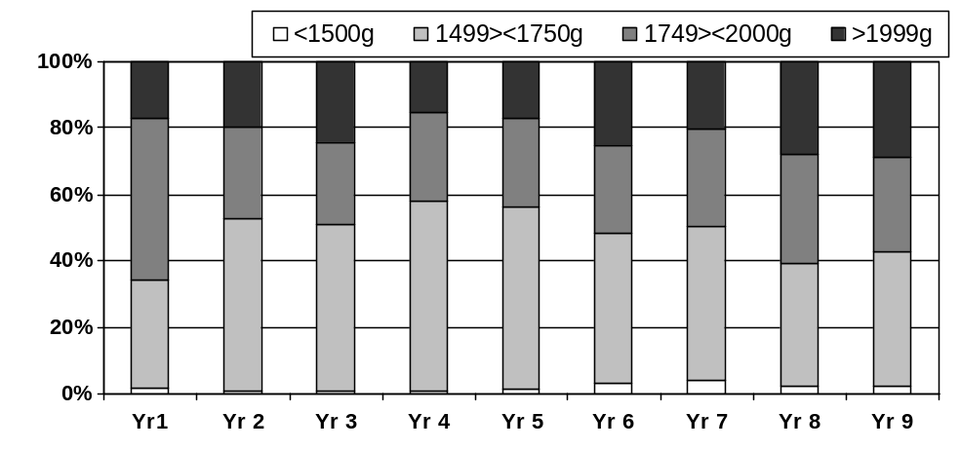

Table 4

Discharge weight Categories | Aug99-Jul00 | Au 00-Jul01 | Aug01-Jul02 | Aug02-Jul03 | Aug03-Jul04 | Aug04-Jul05 | Aug05-Jul06 | Aug06-Jul07 | Aug07-Jul08 | Total | %
< 1499g | 6 | 4 | 4 | 3 | 6 | 13 | 18 | 9 | 8 | 63 | 1.80%
< 1749g | 103 | 186 | 190 | 245 | 223 | 185 | 210 | 139 | 150 | 1481 | 42.34%
< 1999 | 152 | 100 | 95 | 113 | 110 | 108 | 130 | 123 | 105 | 931 | 26.62%
< 2249g | 38 | 30 | 50 | 32 | 42 | 59 | 46 | 53 | 56 | 350 | 10.01%
< 2499 | 10 | 12 | 5 | 16 | 14 | 18 | 18 | 15 | 20 | 108 | 3.09%
< 2999g | 5 | 18 | 11 | 9 | 11 | 16 | 12 | 16 | 24 | 98 | 2.80%
>2999g | 5 | 11 | 14 | 10 | 2 | 10 | 23 | 23 | 6 | 104 | 2.97%
 | 319 | 361 | 369 | 428 | 408 | 409 | 457 | 378 | 369 | 3498 | 100.00%
Of the 3498 infants admitted to the KMC unit, 32 (0,9%) infants died in the unit or within 24 hours of being transferred back to the intensive care unit (ICU) (Table 5). One hundred and sixteen (6%) infants were sent back to the high care unit (HCU) due to apnoea or possible infection. Sixty infants had to be readmitted from home because they did not have satisfactory weight gain or because they had lost weight.

Table 5

Deaths, Transfers and Readmissions
Year | 1 | 2 | 3 | 4 | 5 | 6 | 7 | 8 | 9 | Total
Number of patients admitted | 319 | 351 | 369 | 428 | 408 | 409 | 457 | 378 | 369 | 3498
Infants that died in the unit | 0 | 3 | 5 | 4 | 4 | 1 | 8 | 3 | 4 | 32 (0,7%)
Infants T/F back to HCU with apnoea / possible infection | 25 | 24 | 17 | 22 | 29 | 34 | 38 | 21 | 25 | 235 (6.7%)
Infants readmitted from home | 5 | 18 | 12 | 19 | 6 | 14 | 13 | 23 | 9 | 118 (3%)
*10 expected deaths - (trisomy 18, spina bifuda, microcephaly, AIDS, prune belly, PDA, hydrocephalis, Congenital CM, intra cranial bleed))
*2 deaths during RSV outbreak
*10 unexpected deaths
*1 death associated with maternal depression
#47% infants readmitted from home during winter months

The analysis of deaths that occurred revealed that there had been 10 expected deaths and 10 unexpected deaths (Table 5). One of the unexpected deaths occurred in a mother and infant pair where the mother was severely depressed. Due to her depression and poor response to communication it was only in retrospect that it was realised that the mother also had psychiatric problems. From this incident we realised that it is very risky to expect a mother to be the primary care taker of her premature infant if she has a severe depression or suffers from a psychological problem. Mothers who show signs of mental health problems are therefore excluded from the KMC unit and their infants receive conventional neonatal care.
Characteristics of infants that died are summarised in Table 5. In order to establish whether there had been a seasonal variation in infant deaths, the data was also analysed according to the months of the year in which the deaths had occurred to see whether winter played a roll.

Table 6

Characteristics of Infants that Died
Birth weight < 1250 grams | 59.4%
Weight at death < 1500 grams | 46.9%
< 7 days in KMC | 46.9%
Receiving oxygen | 47.1%
HIV exposed | 23.5%
Died in April – September (Winter) | 46.9%
Died in April – May (staff change) | 22.2%

Forty seven percent of infant deaths occurred during the winter months, April to September and 22% deaths occurred during the months April and May. Each year 60% of the nursing staff in the wards change and this staff change occurs at the beginning of April each year.
Infants were discharged much sooner and at a lower weight than in the past and it was therefore important to see how many infants did not have satisfactory weight gain of at least 10 grams per day. Infants who lost weight or did not gain weight were readmitted to the unit. Only 118 infants (3%) had to be readmitted during the 9-year period (Table 5). In order to see whether the readmissions had a seasonal pattern, the data was analysed and it was found that 45% infants were readmitted during the winter months, April to September. Therefore, readmissions did not increase during the colder months compared to the warmer months. The main factors that played a roll in infants’ readmissions were mothers failing to practice KMC continuously or she did not feed the infant at regular intervals.
Characteristics of infants transferred back to the HCU are summarised in Table 7. From the data it is clear that the smaller infants were more prone to complications, which necessitated them to be transferred back to the HCU (68% of infants transferred weighed less than 1501 grams). Nearly half of all the transfers (48%) occurred during the first week after admission to the KMC unit.
The most common reason for transferring infants back to the HCU was apnoea-like incidents or aspiration of feeds during or shortly after feeds. Nearly all the infants that were transferred to the KMC unit were on tube feeds and the transition of tube to cup and breastfeeding occurred in the unit. During the transition period the mothers need a lot of support from the nursing staff in order to acquire the skill to feed their premature infants and to learn the correct feeding techniques, which would prevent complications. This support may be lacking. One third of infants that had to be transferred back to the HCU were oxygen dependent.

Table 7

Characteristics of Infants Transferred back to HCU
Total t/f out in past 9 years |  | 235 | 3498 | 6.72%
HIV pos |  | 63 |  | 26.81%
Died |  | 8 |  | 3.40%
O2 dependant |  | 83 |  | 35.32%
pts BW<1250g |  | 136 |  | 57.87%
pts Admission weight<1500g |  | 161 |  | 68.51%
T/F in < 7 days |  | 114 |  | 48.51%
One of twins or triplets |  | 23 |  | 9.79%
Average days in hospital |  | 50 days

One of the components of KMC is exclusive breastfeeding. The infants at Kalafong hospital are fed breast milk. Initially they receive expressed breast milk via oro- or nasogastric tube, then via syringe or cup until feeding at the breast is established. Infants that were HIV exposed received pasteurised breast milk via tube or cup.
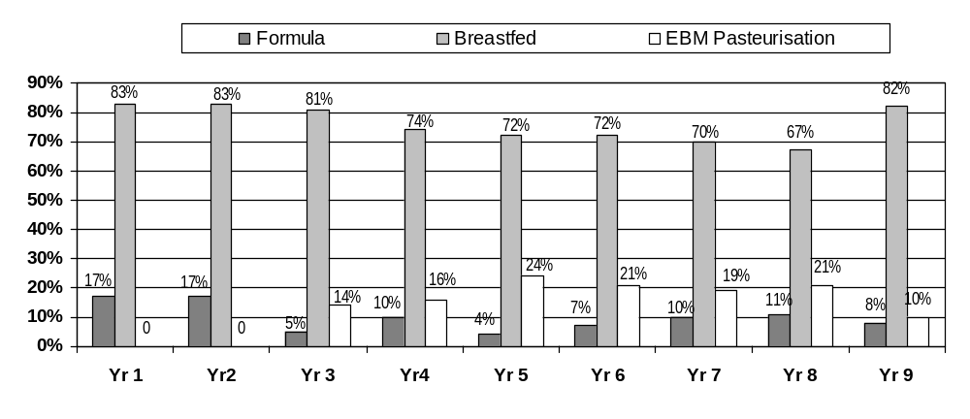Figure 2 KMC Unit Infant Feeding Methods

Breastfeeding has important anti-infective properties, which play an important role in the prevention of infections and necrotising enterocolitis. This may be one of the reasons why so few infants (6%) developed hospital acquired infections.
The feeding methods of infants in the KMC unit are summarised in Figure 2. Only 10% of infants received formula feeds. The average weight gain of the infants in the KMC unit was 24 grams per day.
It was important to follow-up the infants that had been discharged from the unit to see whether the infants who were discharged at a lower weight were thriving at home. A follow-up clinic was established and Figure 3 summarises the attendance rate. Only two infants were abandoned during the period of the audit.

Figure 4 KMC Follow-up Clinic Attendance Rate
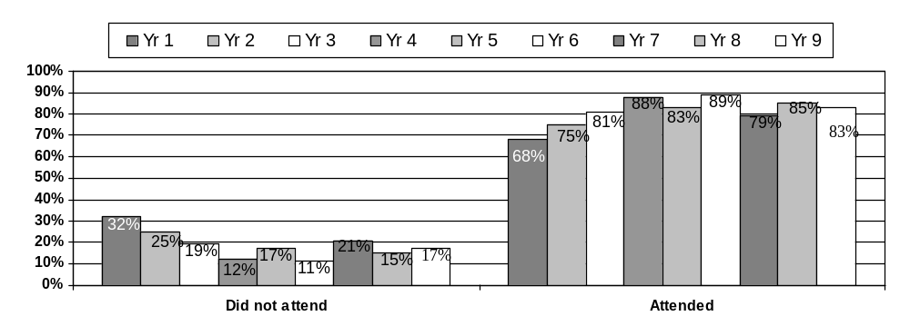

Conclusion
The KMC unit has resulted in an increased capacity of Kalafong Hospital to deal with its increasing number of high-risk low birth weight infants by creating a cost-effective and safe step-down facility for the infants from the neonatal intensive and high care units. With information gathered from the continuous audit, changes in clinical practice were made to improve the care in the KMC unit.
IMPLEMENTING KANGAROO MOTHER CARE IN KUMASI, GHANA

Abenaa Akuamoa-Boateng,ª Priscilla Wobil,^{b} Regina Obeng,^{b} Mary Sagoe^{c}
Karen Davy,^{d} Anne-Marie Bergh,^{d} Elise van Rooyen^{d}
Eilon Shany,^{e} Rina Marco,^{e} Miki Karplus^{f}

ª Millennium Cities Initiative, Kumasi, Ghana
^{b} Komfo Anokye Teaching Hospital, Kumasi, Ghana
^{c} Kumasi Metropolitan Assembly, Kumasi, Ghana
^{d} MRC Unit for Maternal and Infant Health Care Strategies and University of Pretoria, South Africa
^{e} Soroka Medical Centre, Beer Sheva, Israel
^{f} Medical School for International Health, Faculty of Health Sciences, Ben Gurion University, Beer Sheva, Israel.

Population figures pertinent to Kumasi
Country population: 24,3 million
Ashanti Region: 4,0 million
Kumasi Metropolitan District: 2,5 million²
Kumasi City: 1,5 million

Introduction
The city of Kumasi is the capital of the Ashanti region and the centre of the Kumasi Metropolitan District in Ghana. It is a bustling trading and transport metropolis facing the same challenges as other cities in Africa in reducing its infant mortality rates. It is estimated that the under-5 mortality rate (U5MR) in Ghana is between 111 and 115 per 1000 and the infant mortality between 71 and 73 per 1000 live births. The neonatal mortality rate (NNMR) of 43 per 1000 live births comprises 39% of the U5MR. The NNMR has not improved over the past 15 years,¹ thus the number of deaths during the first month of life remains high. The low birth weight (LBW) rate in Ghana is 16%, and 26% of neonatal deaths can be attributed to prematurity.
One of the strategies recommended for developing countries to reach their Millennium Development Goal (MDG) 4 is the systematic introduction of kangaroo mother care (KMC) for LBW and preterm infants. However, until 2007 skin-to-skin care was not practised in the neonatal hospital environment in Ghana and the health services in Kumasi were the first to introduce KMC on a systematic scale. Previously all infants less than 2.2 kg born in sub-metro, primary level hospitals had been transferred to the Komfo Anokye Teaching Hospital (KATH). Many were hypothermic and requiring stabilisation on arrival to an overpopulated and understaffed neonatal unit. Therefore, in addition to developing the skills for managing neonates effectively, there was a need for establishing systematically practiced KMC to specifically address the morbidity and mortality associated with preterm and LBW babies in the Kumasi context. To implement KMC to meet these needs a unique programme to suit Kumasi was developed and executed.
The first training in KMC in Kumasi was hosted by the Millennium Cities Initiative (MCI) in February 2007 and funded by the Centre for International Cooperation of the Ministry of Foreign Affairs of Israel (MASHAV). Initial KMC expertise was provided by the South African MRC Unit for Maternal and Infant Health Care Strategies, South Africa.
AIM
To describe the process of introducing kangaroo mother care in hospitals in the Kumasi Metropolis.

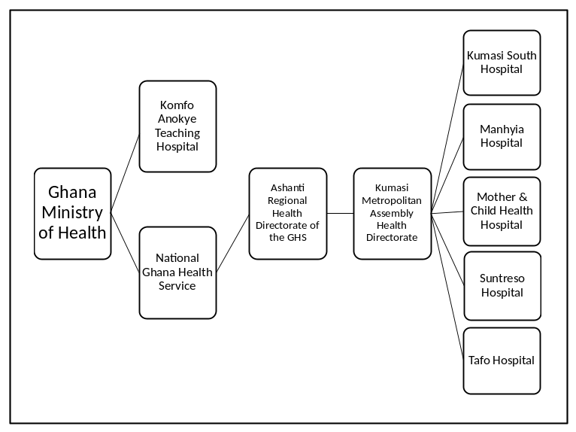

Kumasi Metropolitan health network in the Ghana health system

Method
- A two-pronged approach was followed with regard to the introduction and implementation of KMC:
Basis activities | Nature of training and preparation | Number of people trained | Designations | Number of hospitals represented | Evaluation of training by participants
(1) Establishment of a 7-member Steering Committee to drive the implementation process | - One-day workshop in management and facilitation skills  - Participants prepared for:  - assisting with KMC training  - driving KMC implementation | 10  + 2 observers | Participants:  - 9 midwives / nurses  - 1 nutritionist  Observers:  - MCI facilitator  - Director KMA Health Directorate | 6 | - Good to excellent  - Very useful  - High rating for the topic of KMC and active participation
(2) Training of health workers in the practice and implementation of KMC | - One-day workshop in an 8-day course in neonatal care, following the topics hypothermia and preterm and LBW infant care.  - Focus:  - KMC components, practice and implementation  - Context focused  - Addressing weaknesses and threats | 30  + 10 observers | - 23 nurse/ midwives  - 6 doctors  - 1 nutritionist | 6 | - KMC highest rated topic*  - Participants enjoyed:  - lectures  - presentations  - group discussions  - effects of KMC  - practicing KMC
At the culmination of both workshops, challenges were posed with regard to planning, communication, the development of guidelines, standards and policies, administration, education, budgeting and monitoring and evaluation.
* KMC and resuscitation rated 4.5 out of a possible 5

- An evaluation of KMC implementation was carried out in four of the six facilities eight weeks after the initial training.
- Qualitative data was collected on the experiences of key role-players.

OUTCOMES
KMC implementation
- Initial evaluation of implementation progress (May 2007): all four hospitals visited showed “evidence of KMC practice”, with scores between 11.52 and 14.31 out of 30 on a validated progress-monitoring scale.⁶
- Intermittent KMC is being practised at the teaching hospital (KATH). In the first year between April 2007 and April 2008, 257 LBW babies received KMC. In the second year an average of 12.5 infants per month received KMC. Four deaths occurred, most likely due to aspiration because of wrong feeding techniques. Parent and staff satisfaction levels were high.
- Currently 4 of the 5 sub-metro hospitals practise continuous KMC.

Infants in continuous KMC in Kumasi sub-metro hospitals in 2008*
 | Facility A | Facility B | Facility C | Facility D | Facility E | Total
KMC | 0 | 6 | 16 | 5 | 47 | 74
Deaths in KMC | N/A | 0 | 0 | 0 | 1 | 1
* Average hospital stay: 5 days

Subsequent education and training

Theme | By whom? | Where? | Number of participants | For whom? | Time period
Introduction to KMC | KATH neonatologist and neonatal nurse in Kumasi | Kumasi | 162 | - 46 doctors  - 90 nurses  - 26 other health personnel | Over a period of 18 months
Practical training in neonatal care | Soroka Medical Centre, Beer Sheva | Israel | 4 | - 2 doctors  - 2 nurses | Oct 2007 – Jan 2008  (3 months)
KMC-focused benchmarking, networking and educational programme | MRC Unit for Maternal and Infant Health Care Strategies | South Africa | 2 | - 1 neonatologist  - 1 neonatal nurse | June 2008  (5 days)

- The KATH Mother and Baby Unit (MBU) has become known beyond the Ashanti Region as a KMC capacity-building centre of excellence. Other maternity and neonatal units in Ghana are now sending nursing personnel to KATH for on-site, practical training.
- KMC experiences and expertise have been shared with other West African countries.
- KATH developed or adapted educational and health promotion materials more suitable to the Ghanaian context.

Policy developments
- A KMC policy specific to the Kumasi context was written and distributed. These were implemented and adhered to in three facilities. According to key role-players, KMC has been practiced better in these institutions than those where no policy had been implemented. These three institutions are the teaching hospital and the two of the sub-metro hospitals that had the most infants in KMC in 2008.
- Changes were instituted in the referral system between hospitals as a result of the workshops. According to KATH staff, there has been a reduction in LBW and preterm transfers from sub-metro hospitals to KATH. There is the perception that since the introduction of KMC in the facilities, fewer infants require warming and treatment for hypothermia.

Upgrading of facilities
The sponsorship by MCI and MASHAV for the following facilities will improve the practice of KMC:
- Kumasi South Hospital’s neonatal care and KMC unit was completed, equipped and commenced trial runs in August 2008.
- Suntreso Hospital’s neonatal care facility and KMC ward were upgraded, refurbished, equipped and planned to be operational by April 2009.

Impact of the ‘Kumasi model’
- This model has provided the basis for at least one subsequent KMC project.

Conclusion
- Kumasi was the first health network to successfully implement KMC in Ghana.
- The approach used to introduce KMC was effective, especially where committed individuals and a nurse-doctor team were involved in the implementation process. Change is a long process and reality is not always close to the ideal. The perseverance and dedication of key health personnel have contributed to the changes.
- Additional training in South Africa of key staff members from KATH enhanced the continued practice and training of KMC in KATH and the Kumasi health network.
- The training and development of a Steering Committee to drive the implementation process seems to have been fruitful at the outset. The Steering Committee requires support and continued leadership to function optimally in order to maintain momentum for the duration of the entire change process.
- The ‘Kumasi model’ is suitable for larger regional and possibly national KMC implementation approaches.
- The ultimate impact of KMC on neonatal mortality in Kumasi is not yet known.

GROWTH PATTERNS IN A COHORT OF VERY LOW BIRTH WEIGHT INFANTS IN JOHANNESBURG: A RETROSPECTIVE REVIEW

Cheryl Mackay and Daynia Ballot
Department of Paediatrics and Child Health, University of the Witwatersrand and Charlotte Maxeke Johannesburg Academic Hospital

Background
The problem of very low birth weight (<1500 grams) (VLBW) infants, with their attendant complications, is a significant one. A VLBW rate of 3% has been reported at Chris Hani Baragwanath Hospital, Soweto, for the years 2000-2002. With the advent of modern neonatal intensive care the outcome of VLBW infants has improved steadily over the last 50 years. Improvement in long term survival of VLBW infants raises various management issues, one of these being the issue of growth and growth monitoring.
Growth monitoring is an essential component of child health care, and especially so in the VLBW infant. Currently intrauterine growth charts, for example those of Usher and McLean, are widely used for assessing growth up to term corrected for gestational age. Standard growth charts, for example those published by the World Health Organisation (WHO), are commonly used thereafter, in particular at the well baby clinics and on the “Road to Health” card.

Objective
To review the growth patterns (weight, length and head circumference) of a cohort of VLBW infants from birth to 20 months corrected for gestational age and to compare the information obtained with WHO Child Growth Standards.

Methods
177 VLBW infants, born between 1 July 2006 and 28 February 2007, were enrolled as part of the “Outcome review of very low birth weight infants in Johannesburg” study. Of these patients, 139 attended at least one follow up visit at a neonatal clinic at Johannesburg Hospital post discharge and 96 were followed up to at least 12 months corrected for gestational age. A retrospective chart review was conducted on this cohort of patients. Growth parameters (weight, length and head circumference) at each follow up visit were recorded and entered into the WHO Anthro software package (version 2) and age and sex appropriate z-scores determined for each patient at each visit (4).

Results
The clinical and demographic data are shown in Table 1 and the weight for age, length for age, weight for length and head circumference for age z scores are shown in graphs 1 to 4 respectively.

Table 1: Clinical and Demographic Features of the Study Sample
Variable | Number (%)
Birth weight: Mean  <1000g  1000 - 1500g | 1199.6g (1166.0;1233.2))  18 (13%)  121 (87%)
Mean Gestational Age | 31 weeks (30.5;31.5)
Sex: Male  Female | 50 (35.96%)  89 (64.03%)
Race: African  Mixed  Asiatic  White | 129 (92.8%)  7 (5%)  2 (1.5%)  1 (0.7%)
No. of babies: Singleton  Twins  Triplets | 119 (85.6%)  18 (12.9%)  2 (1.5%)
Size appropriate for gestation: AGA  SGA | 107 (77%)  32 (23%)
HIV exposure: Negative  Positive  Unknown  Refused testing | 78 (56.1%)  30 (21.6%)  20 (14.4%)  11 (7.9%)
ICU admission: Yes  No | 31 (22.3%)  108 (77.7%)

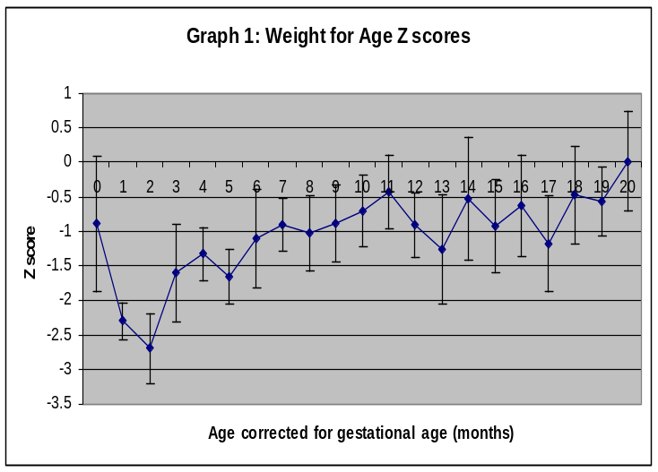

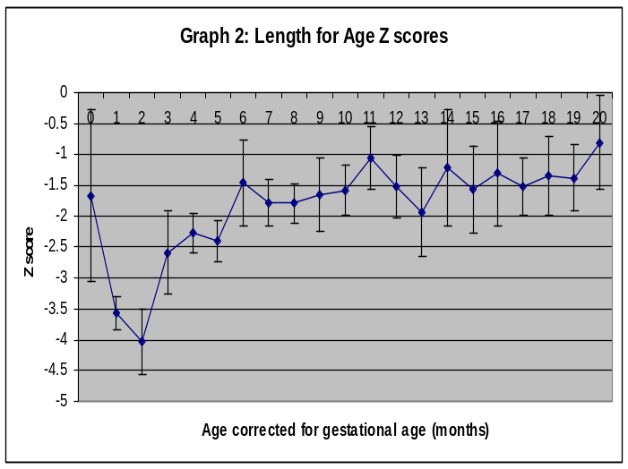

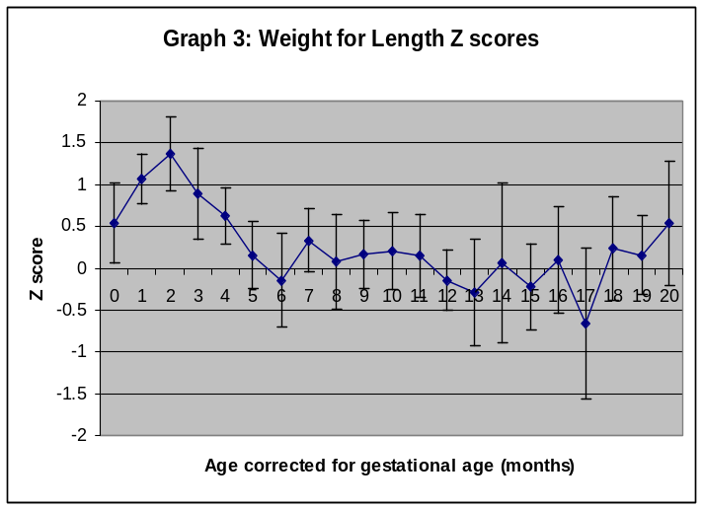

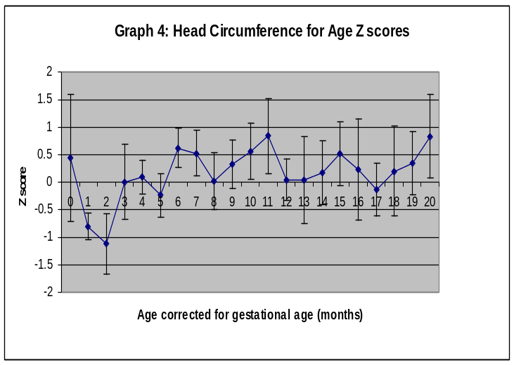

Discussion
The mean weight for age and length for age z scores for this sample of VLBW infants are below zero for most of the study period, indicating suboptimal growth as per the standard WHO charts. There is an initial decline in z scores between 0 and 3 months corrected for gestational age followed by an upward trend in keeping with catch up growth. Head circumference for age z scores show a similar pattern. This suggests that there is an initial period, between 0 and 3 months corrected for gestational age, of growth impairment relative to the WHO reference standard. Impairment in postnatal growth in VLBW infants has been reported in other studies and multiple factors play a role (5, 6). These may include nutritional deficiencies, medical complications / illnesses, oxygen dependency, the use of corticosteroids and feeding difficulties (5, 6).
The weight for length z scores, however, show an initial peak followed by a downward trend towards 0. This suggests that initial weight gain relative to length in this sample is in excess of the WHO reference population. Reasons for this may include feeding practices (such as the use of calorie dense feeds), the notion that “a big baby is a healthy baby” leading to overfeeding or a lag in increase in length relative to increase in weight (7). This initial peak is followed by a tapering of weight gain relative to length such that weight for length z scores approach 0 at 20 months corrected for gestational age.

Conclusion:
Growth of VLBW infants is not the same as that of term infants, even when adjusted for gestational age. The use of WHO growth standards or other growth references based on normal term infants may therefore not be appropriate, especially in the early neonatal period. Although growth references are available for premature and LBW infants, such as those of Casey et al (Infant Health and Development Program) and more recently those of Niklasson et al, a number of factors make them less than ideal as a universal growth reference (8, 9). These include, amongst other things, the data being outdated, analysis being predominantly cross-sectional as opposed to longitudinal and the study sample consisting of only a single nationality or population group (10). An appropriate growth reference for preterm and LBW infants needs to be developed.
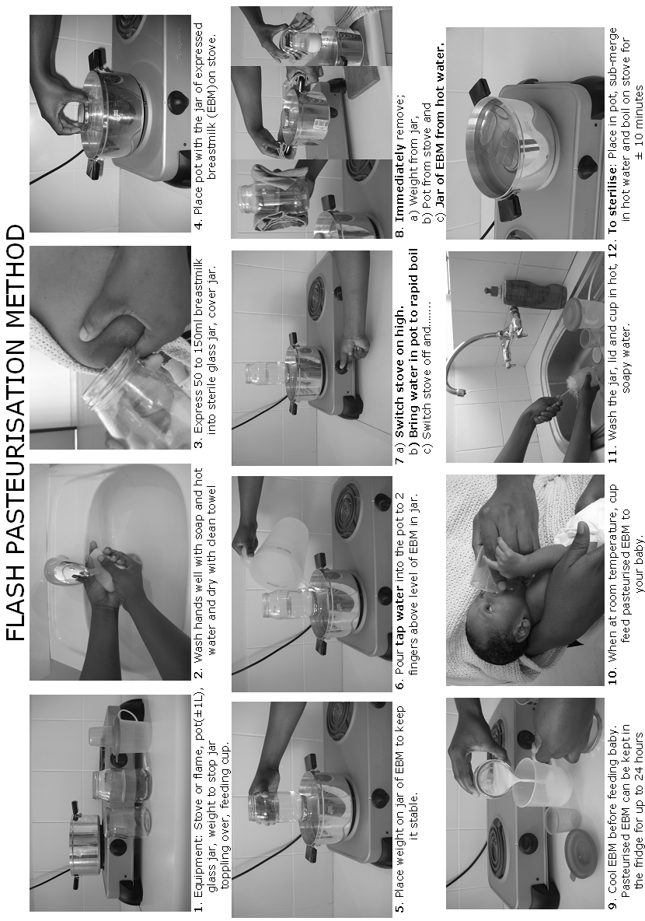
BREASTFEEDING PREMATURE INFANTS

Louise Goosen (IBCLC)
Mowbray Maternity Hospital

Expressing and Skin to skin care
Skin to skin care and breastmilk are essential in any NICU who offers ‘care of excellence’ to the neonates in their care. It comes at no extra cost in terms of rands and cents, just education and by-in from the NICU staff and in turn of parents.

Ideally skin to skin care should commence as soon and as for as prolonged a period as is possible.
Commencing the early expression of colostrum is always essential.
Expressing is made easier when doing skin to skin care and more especially with some baby/nipple contact.
No colostrum should ever be wasted. Small amount can be put directly into the baby’s mouth via 1ml syringe.
Mothers need to be shown how to express and be encouraged and praised for their efforts.
Expressing needs to be done often e.g. 2 hourly and not necessarily for prolonged periods.
Hand expressing is preferable to using a pump, especially in the first few days.

HIV and colostrum
There has been much debate about how to pasteurising small amounts of colostrum
We think we can offer a solution:
Add enough defrosted pasteurised donor milk to mother’s EBM to make up the necessary 50ml and re-pasteurise using the Flash or Pretoria methods. A huge morale booster for the moms concerned.

When is baby ready to breastfeed
Allow baby to spend plenty of time at the breast, exploring, smelling, licking.
When baby attempts to latch or tries to suckle at the breast he or she is probably ready to start breastfeeding in earnest.
Positioning is of the utmost importance – the two positions most often recommended:
Underarm or rugby ball and cross-hold
Most infants show some interest in breastfeeding by 34/35 weeks gestation, some much earlier.
Breastfeeds usually commence before tube feeds are stopped
Tube feeds are usually replaced by EBM cup feeds after breastfeeds

The slow feeder
Do not expect instant success.
A premature baby can take many weeks to learn what a full term baby learns within an hour or two.
Suck training and finger feeding can be useful methods to help babies who are making slow progress. These techniques should be used by skilled personnel only, although mothers can be taught to use this method.

General
Small regular feeds are always preferable to larger feeds over longer periods.
Babies need regular weight checks and growth monitoring after discharge.
Moms with twins or triplets need to be shown how to feed 2 babies at the same time.

WANTING TO SET UP A DONOR BREASTMILK BANK IN YOUR HOSPITAL? GREAT! COME AND GET THE ‘DO-IT-YOURSELF –MANUAL’ WITH GUIDELINES THAT WILL HELP YOU ON YOUR JOURNEY, ENSURING A MUCH MORE SMOOTHER RIDE TO DONOR BREAST MILK BANKING IN SOUTHERN AFRICA

VANESSA BOOYSEN. NICU TRAINING OFFICER, DONOR BREASTMILK BANK CO ORDINATOR UNIVERSITAS ACCADEMICAL HOSPITAL, AS WELL AS NEONATAL LECTURER UNIV OF FREE STATE, BLOEMFONTEIN.

Introduction
There are only six years left to meet the MDG 4. So far there has been limited progress in reducing neonatal deaths, especially during the first week of life. Therefore more attention, AND ACTION, has to be made in reaching these goals. HIV and AIDS have also aggravated the whole situation.
If one looks at the CAUSES OF NEONATAL DEATHS, (OPPORTUNITIES FOR Africa’s Newborns), Sepsis accounts for 28%, and Prematurity for 29%, of these deaths. Combined +- 60% of neonatal deaths.
Breast milk no longer has to prove itself superior to formula milk, and many studies show that infants who are EXCLUSIVELY BREASTFED, just do so much better overall than those fed formula milk.
In the context of premature feeding it is even more imperative that these very small, immune compromised (and these days exposed to HIV), infants, deserve the best feeding option. Breast milk. This will ensure that sepsis and NEC rates are reduced, improving their overall chances of survival.
It was while attending last years 2008 Priorities that I was inspired and motivated to set up THE VERY FIRST DONOR BREASTMILK BANK IN THE FREE STATE PROVINCE.
My euphoria and ‘pie in the sky -dream’, became a harsh reality when I started encountering numerous hiccups and pitfalls on my way.
Due to a)stringency measures from the Dept Of Health, and the in sustainability of replacement feeding formulas on the one side, and b)child survival on the other, I FORESEE THAT MORE AND MORE HOSPITALS WILL BE GOING THE EXCLUSIVE BREASTMILK OR DONOR BREASTMILK FEEDING OPTION WAY.
Therefore, keeping the relaxed, informal ‘vibe’ at priorities, I would like to address the audience concerning THE ABOVE MENTIONED TITLE.
METHOD: My own lessons learnt from trial and error, as well as a ‘PERSONAL EXPERIENCE COMMENT FORM’ that was distributed to Registrars, Clinical assistants, nurses, dieticians, Head of Dept’s etc, concerning their own experiences during the growing pains of Donor Breast milk banking.
RESULTS: 1)Comments received from above mentioned staff members will be discussed at Priorities, as well as the
2)BENEFITS of using donor breast milk as feeding choice for all premature babies weighing less than 1.8 kg, younger than 14 days old, in our own very busy unit. Keeping in mind that we treat exceptionally high risk neonates, being the only Tertiary Hospital in the Free State and Northern Cape area;
3)Experiencing emotional and work satisfaction from staff members in the context of donor breast milk banking

CONCLUSION: Donor breast milk banking, especially for the LBW and ELBW premature baby is the best, or ONLY, (my emphasis), way forward in reducing early neonatal mortality and morbidity, especially sepsis and NEC. Keeping in mind that these combined causes represent 60% of early neonatal deaths. An ACTIVE WAY WE CAN ENCOURAGE ALL HOSPITALS TO DO AND follow. By doing this, as a country as whole, we can get much closer to MDG 4 by 2015.
Therefore, If the Donor Breast milk Journey to improving neonatal health is made ‘USER FRIENDLY, and directive, many more hospitals will climb aboard and enjoy the ride.

THE INSIDE OF DBM BANKING:
Before one can start a breastmilk bank, there are important things that have to be in place.
- WHAT DOES YOUR INFRASTRUCTURE LOOK LIKE?
Its of utmost importance to have a Wide Burocratic involvement.
Prior to starting bank, inform and involve ALL Heads of Departments, from the Matron in your NICU right up to the CEO / Head of Hospital / HOD / Mother and Child Health, PMTCT, etc etc.
Contractual commitment between various parties eg. SABR/HOSPITAL/ UNIVERSITY. Each party has his own regulations. One needs to come to a mutual agreement.
After 2 yr contract, what then….plan ahead to ensure sustainability of the Donor Bank.

- POLICIES
Are all your policies in place BEFORE you start the donor breastmilk bank? Does your staff know the content of the policies and guidelines and do they adhere to them?

- STAFF
This is the MOST NB ASPECT for successful DBM (Donor Breast Milk) banking EVERYONE must buy into concept. Nurses, Doctors, Dieticians, Cleaners etc. COMMUNICATION between Different Departments and the Donorbank. EVERYONE must be involved and take dual responsibility and ownership for bank. Weekends/Holidays/Leave periods = SUSTAINABILITY
Must not be ONE PERSON DRIVEN
Who will be working in the bank doing the daily measuring, decanting and distribution of Pasteurized Donor Breast Milk (PDBM), to the NICU.(Staff nurse)

The coordinator of the donor bank, has to be A BFHI TRAINED, ENTHUSIASTIC/MOTIVATED AND PASSIONATE STAFF MEMBER WHO OVERSEES KMC MOTHERS AND IN HOUSE DONORS.
She also:
Checks up on Guideline adherence.
Keeps statistics of DBM Recipients and Donors
TRAINS ALL persons involved…BEFORE the opening of the donor bank AND ensures CONTINUOUS training.
Checks to see if Guideline adherence is practiced by rotating Registrars.
Facilitates compulsory BFHI Training for ALL Staff members. From the Profs right through to the cleaners.
TRAINS staff members at ALL ANTE NATAL CLINICS IN the HOSPITAL FEEDING AREA, concerning the possibility of using donor breastmilk and Donor awareness.
Checks the condition of the mother’s breasts.
Sees to adherence and early initiation of expressing.
Demonstrates the correct expressing technique to all staff and mothers.
Collaborates and communicates between NICU STAFF/MOTHERS AND BABIES
Checks for DAILY Discarding of expired DBM from unit fridge.

- PREMATURE BABIES
Have COLOSTRUM CHASERS! Nurses that express small volumes of colostrum from a mother, in a syringe so as to make very sure that the very first fluid to enter the gut of the infant, IS COLOSTRUM.
Strict guidelines for using DBM
Mother of infant must give written consent for DBM before you are allowed to give the DBM.
This consent must be given prior to birth of baby. NB, because this can unnecessarily delay the timely giving of DBM.

5. DONORS
INHOUSE, OTHER HOSPITALS, STAFF MEMBERS AND PUBLIC
Does your hospital have KMC Lodger Mother facilities?
Create Donor awareness through: 1) Education at ANC Clinics,
          - 2) In house identifying of donors from Lodger moms, lactating moms, staff members who are breastfeeding.
          - 3) Constant reminding to Private Hospitals to please identify donors and collect Breastmilk for the donor bank.
          - 4) Public awareness through Media, Radio Chats, Newspaper,
          - 5) Distributing of Pamphlets in waiting areas, at pumpathons, in Post Natal gift packs, Doctors Rooms etc.
          - 6) Pumpathons in Shopping Malls,
          - 7)TALK,TALK,TALK DBM

  - Strict screening of donors and HIV Testing as well as 3 monthly HIV testing for longstanding donors.
  - Motivate donors to donate for a longer period of time
  - Adherence to correct Pasteurization Guidelines of DBM.
  - Fetching of Donor Milk and supplying bottles to Hospitals and Donor Mothers…You must have a dedicated person who will do this.
  - Telephonic follow-ups with Donor Mothers and Hospitals…..WHO?
  - Supply of bottles/caps/rapid HIV tests and all the necessary forms to ensure safe DBM Banking. WHO WILL SUPPLY THIS?

6. IDENTIFIED AREA FOR PASTURIZATION AND STORAGE OF DBM

Do you have a suited area for the donor bank, located close to NICU?
Can the door lock?
Does the area have Electricity supply?
Is there running water, pipes, basin?
Is the area big enough to furnish two chest freezers, small fridge and pasteurizer?
Do you have files for documentation?
Can the area be kept clean?

THE OUTSIDE OF DBM BANKING:
Is there Burocratic involvement or interference from the heads of Hospital departments,CEO, Dept of HEALTH etc.
Financial support. Donations, Foundations, NGO’s….where will the money come from?
Ongoing Public awareness, Media Involvement.
Educated ANC Clinics.
Are there Other Hospitals in area for supply of Breastmilk?
Health Profile of Mothers?

BENEFITS AND POSITIVE OUTCOMES OF DONOR BREASTMILK BANKING
Healthy babies. Reaching MDGs
Reduction of NEC .Biggest killer in Premature infants (ESPECIALLY DURING UNCONTROLLABLE FINANCIAL STRINGENCY MEASURES AND LACK OF STOCK, OVERCROWDING IN NICU’s ETC)

Total change in feeding culture:
Staff encourages exclusive breastfeeding
Increased usage of Mothers Own Milk
Lodger mothers motivate each other to breastfeed or even become a Donor
Reduces the ‘performance pressure’ from the critically ill Mother to supply breastmilk.
Satisfied Doctors and Nurses.
Saving Hospital Costs(antibiotics/TPN)
Babies are discharged sooner

STAY FOCUSSED ON YOUR GOAL/DREAM/VISION.
CHANGE IS NOT ALWAYS EASY AND THERE WILL ALWAYS BE RESISTANCE FROM SOMEONE.
PERSEVERE… AND ENJOY THE JOYS OF DONOR BREASTMILK BANKING
FACTORS INFLUENCING HIV-POSITIVE MOTHERS’ DECISION MAKING ABILITY

Carolé Cilliers,1 Anne-Marie Bergh,² Elsie Etsane,² Robert Pattinson²
¹ Department of Sociology
² MRC Unit for Maternal and Infant Health Care Strategies and Department of Obstetrics and Gynaecology, University of Pretoria

BACKGROUND
Women continue to bear the brunt of the HIV epidemic in numerous ways. They are physically more vulnerable to HIV, but are also victimized as a result of their economic conditions, the promiscuity of male partners and their dependency on and domination by male partners. Women of childbearing age are particularly at risk and it is estimated that women in the age group 15 to 24 years are up to 2.5 times more likely to be infected than their male
counterparts.
Women are further affected by the risk of transmitting the HI-virus to their infants. The chance of transmission can be significantly reduced by relatively simple and inexpensive interventions, but despite mother-to-child transmission (MTCT) being almost entirely preventable, 1500 infants continue to be infected every day, most of them in sub-Saharan Africa.³
Primary healthcare clinics are an important point of access for women to services such as preventing mother-to-child-transmission (PMTCT). When accessing these services, women require adequate information and support in order to make informed decisions concerning their own health and the health of their children.

AIM
The aim fo this study was to determine the factors that influence women’s decision making abilities with regard to their own helath care and that of their children, as seen from the perspective of HIV-positive mothers.

METHODOLOGY
A qualitative research methodology was followed to conduct in-depth interviews with 22 HIV-positive mothers. Purposive sampling was used and four clinics in the Tshwane Metropolitan area were visited. All participants had children younger than three years and all had participated in a PMTCT programme. Interviews were conducted between May 2008 and November 2008.

FINDINGS
An HIV-positive pregnant woman faces numerous decisions during her “journey” through the health system. These decisions are often complex and require adequate information and support from health workers and other role-players. Some of these decisions include:
During pregnancy - decision to test: When a woman tests positive decisions need to be made about: disclosure; participating in PMTCT and taking prophylactic antiretroviral therapy (ART) to prevent transmission; choice of infant feeding method.
In the period after the birth: confirmation of feeding choice; adherence to infant feeding method; HIV PCR testing of the child at six weeks; decisions around reproductive health (including contraception and family planning).
Long-term follow-up: early participation in HIV care, initiation of ART when required, ongoing adherence to medications; continuation of contraception. For the HIV-infected child decision relate to: participation in HIV care, initiation of ART when required, adherence to medications.
This study found that there were numerous factors that adversely influence a woman’s ability to make decisions regarding her health and the health of her children. For the purpose of this study, the identified factors were organised according to three different levels, namely individual and household level, community level and institutional level:

- Individual and household level:

Dealing with an HIV positive diagnosis. Many women were still struggling to come to terms with a positive diagnosis. They were often expected to make important decisions immediately after learning their positive HIV-status.

Poverty. Limited financial resources resulted in many of these women being dependant on male partners. They often found it difficult to pay for transport to health facilities and supplement formula supply. Foreign nationals had no access to child support or other grants and experienced an even greater financial burden.

Poor literacy. Some mothers were unable to read appointments on antenatal and other cards. This also resulted in them being unable to access any written information (e.g. leaflets at clinic or internet)

Language barriers. Women who were not fluent in English or local language struggled to formulate questions and understand answers.

Gender relations. Abuse, abandonment and lack of involvement and support by male partners were widespread. Partners were reportedly often reluctant to get tested or use condoms.

Family relations. Women were often in fear of disclosing their status to family members. Many experienced lack of support and rejection by family.

- Community level:

Stigma. Mothers were selective in disclosing their HIV-positive status. This was seemingly in fear of community ‘gossip’. The community perception still exists that HIV-positive people are to be blamed for their diagnosis.

Lack of support. The fact that women were not disclosing their status to the community, resulted in them being unable to access support at this level. Most of the women expressed the need for a support group, but voiced concerns of having to disclose their HIV status. Few women had knowledge of available support groups in their community.

- Institutional level:

Long queues. Having been at the clinic since early, both mothers and health workers were often in a hurry to finish. This resulted in rushed consultations.

Fragmentation of services. Despite an official ‘supermarket’ approach, women still visited facilities up to three times a week for different services.

Stigma at clinic. Some clinics had designated PMTCT consultation rooms. Mothers were often reluctant to access these services as other health users were aware that a positive HIV diagnosis was associated with these rooms.

Supplies. Clinics often had a shortage of formula or ARVs. Despite official policy, PCR tests were not offered at some clinics.

Counselling was often inadequate or not done at all, reportedly due to time constraints. The counselling process was influenced by the training and poor attitudes of nurses.

Attitude of health workers. Mothers reported often on health workers being rude. In some cases HIV-positive mothers were victimised, resulting in a reluctance to ask questions or seek advice.
Nurses as gatekeepers. Nurses often decided which mothers would have access to what information.
Lack of support, Often little support was given by health workers. Few support groups were available at clinics.

CONCLUSIONS
Health workers often are the primary source of health information and support. Relationships with health worker are therefore critical.
Health workers are often able to help mothers contend with problems on other levels such as:
  - assistance mothers to access child support grants or shelters;
  - advice and support in the choice of strategies if the mother afraid to disclose her status, for example by means of couple counselling;
  - helping mother to access information by means of verbal explanations, diagrams and repeated counselling.
Strategies to empower women in their decision making abilities could include:
  - improving both the quantity and quality of counselling given to women;
  - a participatory interactive care approach to consultations;
  - constant and repeated health messages in clinic settings, both written and verbal;
  - strengthening access to social services, for example child support grants or referral to shelters;
  - implementing and strengthening availability of support groups;

MISOPROSTOL TO TREAT POSTPARTUM HAEMORRHAGE: A MULTICENTRE RANDOMIZED CONTROLLED TRIAL (ABSTRACT)

M Singata, Effective Care Research Unit, Univ Fort Hare, Univ of Witwaterand, Eastern Cape Department of Health(SMSB), on behalf of the WHO Misoprostol for treatment of PPH study group.

Introduction
Postpartum haemorrhage (PPH) remains a leading cause of maternal mortality, despite treatment with conventional methods. Uncontrolled reports and one small randomised controlled trial have suggested that misoprostol may have an additive effect to routine treatment, and there is a serious danger that this method will be used widely without systematic research to document the optimal dosage, effectiveness and risks of this method.
The objective of this trial was to assess the effects of misoprostol adjunct to the use of injectable oxytocics in women requiring additional uterotonics following active management of the third stage of labour, on outcomes such as blood loss, and side-effects.

Methods
This was a hospital-based, multicentre, double blind, randomized controlled trial. Management of labour in the participating centres was routine active management of the 3rd stage with oxytocin 10 IU intramuscularly or by slow intravenous injection. Women clinically diagnosed with postpartum haemorrhage requiring additional injectable uterotonics, who gave consent, were given routine treatment for PPH. In addition they were enrolled by drawing the next in a series of randomised treatment packs containing 3 tablets of misoprostol 200μg or placebo. The three tablets were administered sublingually. The primary outcome was incidence of measured blood loss of 500mls or more at 60 minutes after enrolment. Secondary outcome measures were side-effects at 60 and 90 minutes after enrolment, blood transfusion and/or haemoglobin level 24 hours after birth, blood loss ≥1000 ml at 60 and 90 minutes after enrolment, mean blood loss at 60 and at 90 minutes after enrolment, any uterotonics administered after randomization, maternal death or severe morbidity (laparotomy, hysterectomy, ICU admission, organ failure). The sample size was 1,400 women and was based on the ability to show a reduction of blood loss ≥ 500 ml after enrolment by 35%, and a reduction in blood transfusion by 25%.

Results
Some preliminary results will be presented at the conference

Conclusion:
Use of potentially harmful drugs should be based on sound evidence of effectiveness from randomized trials. Data from this large trial will help to guide clinical practice.
Acknowledgements: WHO HRP: Gynuity Projects, Saving Mothers Saving Babies Project, Eastern Cape Department of Health.
AN EXPLORATORY STUDY PROBING THE FEELINGS AND ATTITUDES OF SENIOR MIDWIVES TOWARDS THE IMPLEMENTATION OF LABOUR COMPANIONS IN MATERNITY UNITS IN GAUTENG (ABSTRACT)

Barbara Hanrahan, Cheryl Nicodem
University of the Western Cape

There is conclusive evidence from research that women supported throughout labour enjoy a number of benefits which impact on the process of labour and the woman's emotional experience. Where women are not supported by their partners or family, a lay companion is encouraged. As many maternity units in Gauteng have not implemented the use of a lay labour companion this research seeks to explore the feelings and attitudes of senior midwives towards the implementation of the lay labour companions in maternity units in Gauteng. Qualitative research was conducted using semistructured interviews with probe questions within the private and governmental sectors. As the role of a highly active sister in charge and labour midwives has been identified in the past - the participants were labour ward management and senior labour ward midwives. Themes were identified and reported on.

EVALUATION OF THE USE OF THE PARTOGRAM & AN ASSESSMENT OF NEONATAL RESUSCITATION TECHNIQUES IN PRACTICE (ABSTRACT)

Mitchell, RW¹, Cooper, P², Chaane T³, Parsley, SM⁴, Hlongwane, M⁴, Mtshali, E⁴.
¹ Obstetrician Gynaecologist, Gauteng Department of Health,
²Professor and Head Department of Paediatrics Charlotte Mexeke Hospital, University of Witwatersrand Faculty of Health Sciences,
³ Chief Director, Health Programmes, Gauteng Department of Health,
⁴ Wits Health Consortium (Johnson & Johnson Paediatric Institute)

Introduction:
In order to assist in understanding the practices around the Use of the Partogram and Neonatal Resuscitation two separate assessments were performed. A retrospective study on the use of the Partogram was performed. The second study was a prospective questionnaire on Neonatal Resuscitation Practices.
Both of these practices have been identified in the “Saving Mothers” and the “Saving Babies” reports as vital in the reduction of morbidity and mortality in mothers and babies.

Method:
The Partogram usage was assessed retrospectively on a sample of bedletters drawn in a random method from the labour ward records. The Philpot 25 point assessment form was used for this study.
The Neonatal Resuscitation study was a prospective study on resuscitation practices currently being performed in our institutions. The aim is to inform us on the scope and type of technique commonly used.

Results:
The results of both these studies / surveys will be presented.

Conclusions:
Based on the results of the analysis of the outcomes recommendations for the improvement in use of the Partogram will be made and recommendations with regard to the skills and course content for Neonatal Resuscitation will be made.

CLIENT REPORTS ON ANTENATAL SERVICES IN TSHWANE (ABSTRACT)

Oliver M. Barry,¹ Anne-Marie Bergh,² Elsie Etsane,² Brian Forsyth,¹ Jennifer Makin²
¹ Center for Interdisciplinary Research on AIDS, Yale University
² MRC Unit for Maternal and Infant Health Care Strategies and University of Pretoria

Background:
Studies, especially in the area of HIV, demonstrate associations between adherence to treatment in pregnancy and patients’ perceptions of being valued and respected by their healthcare providers and having a sense of empowerment. As part of a study developing a scale for measuring the relationship between patients and healthcare providers, information was also collected on clients’ reports and perceptions on particular aspects of the antenatal services they had received. The aim of this presentation is to report on some of the major issues that health authorities could probe in audits and quality improvement projects.

Method:
A structured interview with both closed and open-ended questions was conducted with a convenience sample of 192 women on discharge in the post-natal wards of two hospitals over a period of nine weeks in June to August 2008. The questionnaire included, amongst others, sections pertaining to socio-demographic details, antenatal care, continuity of care, and clinic services and operations.

Results:
The average age of the study sample was 26.1 years, with 159 (83%) having completed at least 10 years of schooling. 48 women (25%) were HIV positive. All women had visited government clinics for antenatal care at least once during pregnancy (range 1-13 visits), with an average of 4.6 antenatal visits.
Some of the more pertinent results that may need further attention are the following:
 | n | %
Instructed to come for antenatal visits on a specific day of the week only | 154 | 80%
Given a specific appointment time for visits | 98 | 51%
Turned away when clinic was open | 34 | 18%
Clinic hours not convenient | 32 | 17%
Not told about baby’s immunisations | 102 | 53%
Not given information on family planning | 67 | 35%
Problems understanding staff speaking different languages | 9 | 7%

Qualitative data from the open-ended questions, providing an understanding of the above issues, will also be presented.

Conclusion:
- Comprehensive primary health care available to all at all times was not reflected in the self-reports of antenatal care by women in a postnatal ward.
- The substantial number of women who reported not getting sufficient information on immunisations and family planning warrants further investigations into the way in which health messages are conveyed and why so many clients report on not receiving the messages.
- Getting feedback on client perceptions of antenatal services could provide useful information for reflection on the improvement of quality in a health district.
A RETROSPECTIVE REVIEW OF CERVICAL SMEARS IN HUMAN IMMUNODEFICIENCY VIRUS INFECTED POSTNATAL WOMEN AT JOHANNESBURG HOSPITAL

A. Wise¹, V Black²,M Dowdswell³
Department of Obstetrics and Gynaecology, WITS¹; Reproductive Health Resarch Unit²; Department of statistics, WITS³

Introduction
Against the high background rate of HIV among our antenatal clinic attendees, 30.3% in Gauteng in 2007, and the importance of cancer of the cervix as a health issue; this study was undertaken to determine the rate of abnormality found in cervical smears done on HIV positive women attending the postnatal clinic at Johannesburg Hospital. The degree of abnormality and where possible its management was reviewed. Secondly it was determined whether the WHO stage, CD4 cell count and viral load, correlated with the patients’ Pap smear results. Lastly patients were analyzed according to the treatment received for HIV and their Pap smear results.

Patients and Methods
The study is a retrospective record review. Records of all the patients who attended the postnatal clinic (PNC) between October 2005 and the end of July 2006, who had a Pap smear performed, were included. Follow-up test results, namely serology, cytology and histology, for this group were collected to the end of June 2007. A total of 324 patients attended the clinic in the study time period, of these 248 (76.5%) had a Pap smear done and 76 (23.5%) did not.

Results
- The mean age was 29.47y, mean parity 2.34 and gravidity 2.56. WHO Stage1 accounted for the majority of the patients 30.6%, Stage 2 was 8.9%, Stage 3 was 9.3% and Stage 4 was 6.0%. WHO stage was unknown in 45.2%. Smoking was found in 2.4% of the sample.
- Every patient had an initial CD4 cell count. The range was 3- 1193 cells/µL, with a mean of 257cells/µL and a median of 190cells/µL. For the last CD4 cell count prior to the Pap smear the range is 4-1193cells/µL, with a mean of 306cells/µL and a median of 267cells/µL.
- The viral load range was from undetectable to 4000000copies/ml. The mean initial viral load was 122698copies/ml and the median was 28000copies/ml. The viral load before the Pap smear had a range from undetectable to 4000000copies/ml. The mean viral load was 41504copies/ml and the median was 400copies/ml.
- Prior to the first Pap smear being performed 139 women (56.0%) had been initiated on ART. By the end of the study time period a total of 152 women (61.3%) had been initiated. One hundred and forty-eight were on HAART and four on individualized regimens.
- 131(52.8%) normal Pap smears, 64(25.8%) LGSIL, 32 (12.9%) HGSIL, 10 (4.0%) with ASCUS and 11 (4, 4%) that could not be classified. Hence 47, 2% of the Pap smears were abnormal. There was one case of malignancy developing after an abnormal Pap smear.

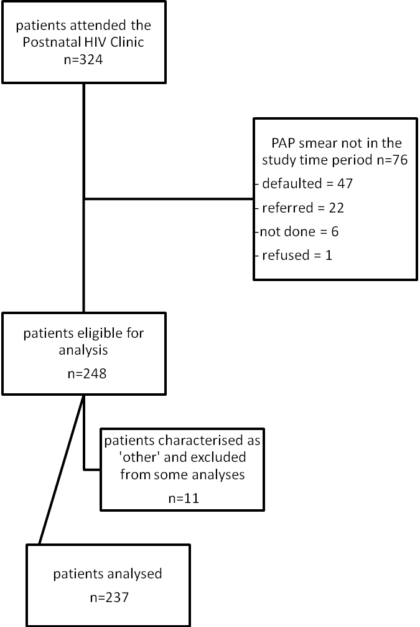
- A total of 52 patients had follow-up investigations and/or treatment, which is 21.0% of the sample. Thirty-six were on ART at the time of the final intervention – three for less than 12 weeks and 33 for longer. Thirty (83.3%) patients had full virological suppression at the time of their last intervention. A rate of 34.1% for regression, 50.0% for persistence and 15.9% for progression was demonstrated in the subgroup.

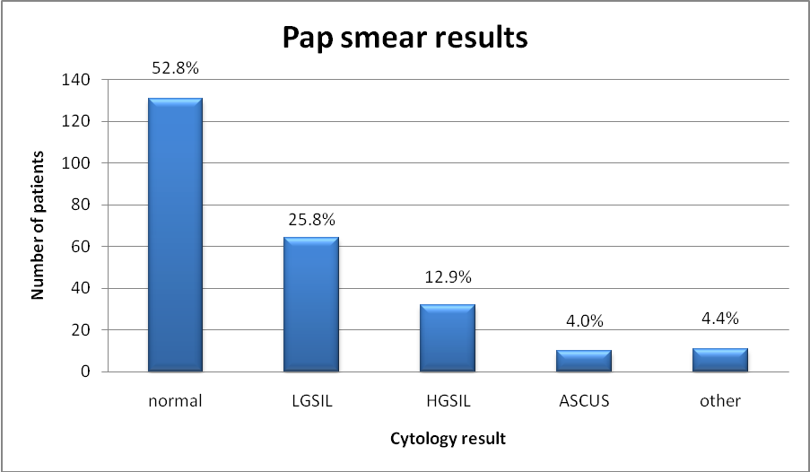
- Age did not show a statistically significant relationship (P=0.1526) with the Pap smear results. Neither did parity, gravidity, WHO Staging or smoking.
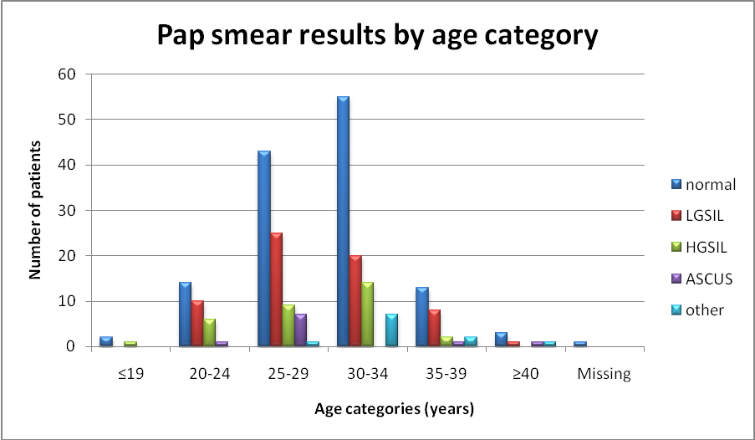
- When the initial CD4 cell counts are cross-tabulated against the Pap smear findings, the abnormal smears were associated with lower CD4 cell counts ( p-value is 0.029). Once initiated on ART and theCD4 cell counts had improved , the p-value is no longer significant p=0.063.
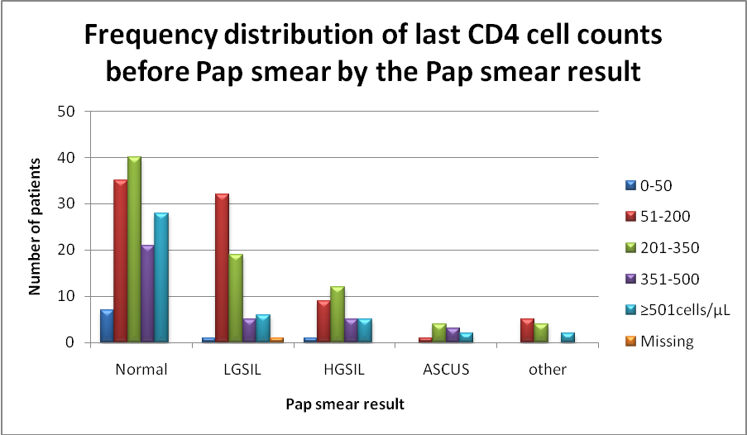
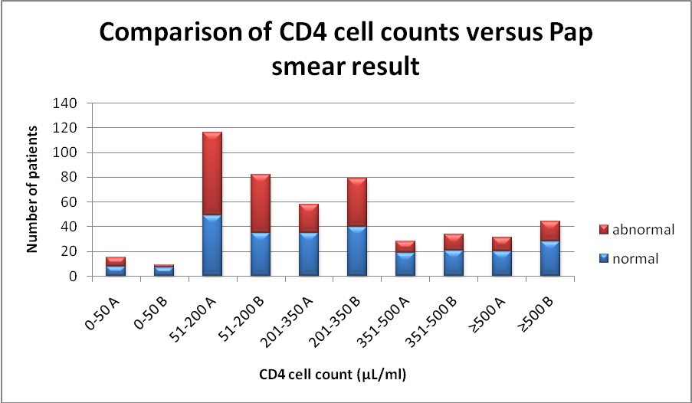
A = initial CD4 cell count B= last CD4 cell count before Pap smear

- There is no statistically significant relationship between either the initial viral load (p=0.6191) or viral load before Pap smear (p=0.841) and the Pap smear results.
- The use of ART and Pap smear result analyses yielded both significant and non-significant p-values and thus ART is likely a surrogate marker for impaired immunity with similar results to those for the initial CD4 cell count.
- Twenty-eight of the 45 patients whose follow-up results were looked at were on ART or for more than 12 weeks; 11/28 (39.2%) regressed, 13/28 (46.4%) persisted and 4/28 (14.3%) progressed. Seventeen of the 45 were not on ART or had been on for less than 12 weeks; 4/17 (23.5%) regressed, 9/17 (52.9%) persisted and 4/17 (23.5%) progressed.

Conclusion
The rates of cervical abnormality in HIV sero-positive patients attending the Johannesburg Hospital postnatal clinic are much higher (47, 2%) than would be expected in the general population, with a significant portion requiring follow-up investigation and management.
The findings are in keeping with the majority of the literature as regards rates of abnormality. The relationship of the CD4 cell count confirms the results of other work however this study did not find a relationship between the viral load and Pap smear results. Although the numbers were small a positive effect in terms of increased regression and decreased persistence was found with the use of ART’s.
As a public health issue this study underlines the importance of screening this vulnerable population earlier, given that the mean age is 29 years at which time nearly 50% of patients have an abnormality. It would be preferable to deal with the problem comprehensively during the screening phase rather than trying to manage a potential increase in cervical cancer cases.

SUPPORT FOR IMPROVEMENTS IN ANC AND PMTCT IN ZULULAND

NC Mzolo, M Ross
Centre for Rural Health, Nelson R. Mandela School of Medicine University of KwaZulu-Natal

Overview
The project was a 2-year initiative (2007-2008) of the Centre for Rural Health (CRH) in partnership with Johnson and Johnson Pediatric Institute (JJPI) and Zululand District to improve antenatal care and PMTCT in an isolated poorly resourced rural district.

Background -Zululand 2006 (District Health Barometer Health Systems Trust 2007)

Perinatal mortality rate (PNMR) | 69
District ranking of PNMR | 51st
Stillbirth rate (SBR) | 54.1
District ranking of SBR | 52nd
Proportion of ANC clients tested for HIV | 42.4
District ranking of proportion of ANC clients tested | 40th
HIV prevalence at ANC | 30.9
District ranking of ANC prevalence | 34th

Zululand District
This district is bordered by Mpumalanga district in the north west, Swaziland in the north east, and uMkhanyakude district in the north-west, uThungulu district in the south and Umzinyathi district in the south-west. It has a population of 832 786 and is served by 5 district hospitals, 53 clinics, 1 community health centre (CHC) and 12 mobile teams.

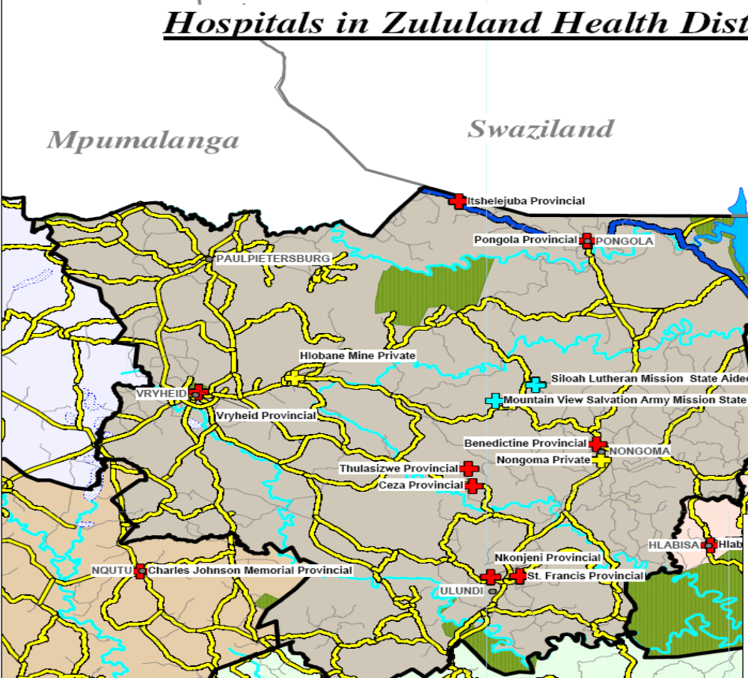
Figure 1 Map showing Zululand district hospitals: Benedictine, Ceza, Itshelejuba, Nkonjeni and Vryheid.

Intervention strategies
The following activities were done
1. Establish (re-establish) relationships within partnership
2. Baseline studies re antenatal care and prevention of mother to child transmission of HIV (PMTCT)
3. On site visits to establish and support teams within each sub-district
4. Attendance at monthly perinatal review meetings
5. Conduct basic antenatal care (BANC) training for: clinic managers, PHC supervisors,
midwives, local and district MCWH coordinators from each collaborating sub-district
6. Integrate PMTCT into BANC training sessions
7. Facilitate quarterly PMTCT district learning sessions
8. Support Perinatal Problem Identification Programme (PPIP)

Evaluation strategies
1.Focus group discussions with clinic midwives re implementation of BANC
2.Review of randomly selected maternity records from September 2008 deliveries to evaluate quality of AN care, use of SFH graphs and implementation of PMTCT and where relevant, make comparisons with findings in 2006.

Results
- Correct use of the symphysis fundal height (SFH) graph in five sub districts??
Number of antenatal records examined | 408 (100%)
Number of antenatal records with graph present | 159 (39%)
Number of antenatal records with graph present but unused | 23 (5.6%)
Number of antenatal records with graph partly used | 104 (25%)
Number of antenatal records with graph used correctly | 122 (30%)
Range of correct use in the five sub-districts studied 17-44%

2. Quality of antenatal care mx by the antenatal care audit tool (Max for each item = 500
Item studied | 2006 score | 2008 score | % Improvement
Identification of risk factors | 298 | 324 | 5
Satisfactory action plan recorded | 69 | 184 | 23
Plans for delivery discussed and recorded | 184 | 184 | 0
Arrangements for transport discussed and recorded | 71 | 272 | 40
Family planning discussed and recorded | 185 | 364 | 36
RPR checked and recorded | 360 | 392 | 6
HIV counseling carried out | 445 | 484 | 8

3. Implementation of PMTCT in September 2008. (No. of ANC records examined 511)
Item studies |  | % Implementation
Clients counseled | 509 | 99
Clients tested for HIV | 483 | 95
Clients HIV positive | 142 | 29
CD4 taken | 75 | 53% of those positive
CD4 recorded on maternity record | 29 | 20% of those positive

Perceptions of BANC by clinic midwives (Respondents from focus groups)
1. ”It helps us a lot to pick out high risk patients and manage them as soon as possible”
2. ”After the BANC training we said’ WOW, we did not know very well – with the graph you are able to identify at a glance whether you need to refer –the BANC did help us a lot’ ”

Challenges arising from BANC training
1. Participants need active on-going support if change (to BANC) is to be maintained.
2. A designated person with time and enthusiasm essential for BANC follow up support
3. Supply of essential resources must be ensured (e.g. graphs & obstetric calculators)
4. Clinic midwives need to attend PNRM for follow up of BANC implementation by reviewing records of the perinatal deaths

Factors enhancing success of BANC
1. Support from district office staff and area consultants
2. Including MCWH coordinator and PHC supervisors on BANC training courses.
3. Supervised practice in using graph and clinic record auditing tool
4. Sharing on site successes in identifying IUGR and post dates
5. Ready availability of essential tools.
6. Recognition of BANC as an enabling factor in PMTCT integration into ANC

Factors enhancing integration of PMTCT into ANC
1. The establishment of multi-professional PMTCT teams to review and interpret stats and make decisions based on information available.
2. Use of process maps by midwives and counselors to identify (and fill) gaps (using a quality improvement tool from the Institute for Health in Quality Improvement ).
3. Running district learning sessions to share best practices, compare progress and develop action plans
4. Presentation and discussion of selected PMTCT stats at PNRM

Conclusions
1. BANC is a good programme for training and re-skilling all involved in ANC
2. BANC and PMTCT are complementary and enhance uptake of PMTCT

Recommendations
1. BANC should be introduced into all basic midwifery training
2. All practicing midwives should learn and introduce BANC into their practice
3. Use of BANC and PMTCT should be an integral part of the PNRM
4. District learning sessions should be continued to share best practices in ANC).

VALIDATION OF PERINATAL CARE INDICATORS

Robert Pattinson*, Stuart Whittaker**
* MRC Maternal and Infant Health Care Strategies research Unit, Dept. O&G University of Pretoria, RSA
**COHSASA, Cape Town, RSA

Introduction
Very few of the perinatal care indicators have been validated by independent means of assessing quality of care.

Objective
To validate perinatal care indicators by an independent means of assessing the quality of care

Methods
The Council for Health Service Accreditation of Southern Africa (COHSASA) is an non-governmental organisation that scores hospitals on their quality of care for accreditation purposes and is recognised by the International Society for Quality in Health Care. The Perinatal Problem Identification Programme (PPIP) is an audit system aimed at improving the quality of care. Health institutions audit every perinatal death and enter each death and the monthly births in weight categories in the programme. The programme calculates various perinatal care indices to measure the quality of care over time. Approximately 150 hospitals have been accredited by COHSASA in South Africa and PPIP is used by 180 hospitals. There is an overlap of 61 hospitals. The COHSASA score for overall performance of the hospital and that of the maternity section was compared with the PPIP perinatal care indicators, namely perinatal mortality rate (PNMR); neonatal deaths (NNDR) between 1-2 kg; the perinatal care index (PNMR/Low birth weight rate); and the fresh stillbirths and early neonatal deaths >2500g/births rate (a proposed measure of the quality of intrapartum care) were correlated. The 61 hospitals were divided into those that did not receive referrals from outside their sub-district (Group 1) and those that received referrals from outside their sub-districts (Group 2).

Results
For the hospitals that did not receive referrals from outside their sub-districts, there was a negative significant correlation between the COHSASA scores overall and PNMR (r= - 0.527, p<0.000, Figure 1), NNDR (1-2kg) (r=-0.421, p=.0.01, Table 1), perinatal care index (r= 0.610, p=0.000, Figure 2) but not with the intrapartum care indicator. This was true also for the COHSASA maternity scores. There was no correlation with the hospitals receiving referrals from outside their sub-districts.

Table 1 Neonatal Death Rate (1-2kg) versus COHSASA score
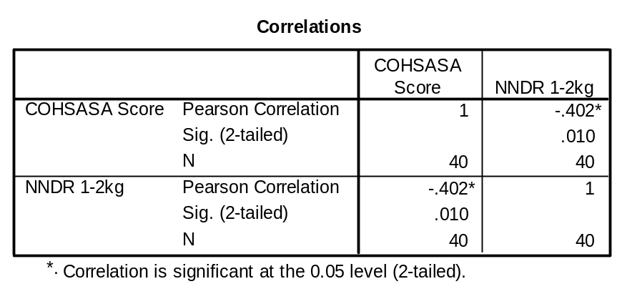
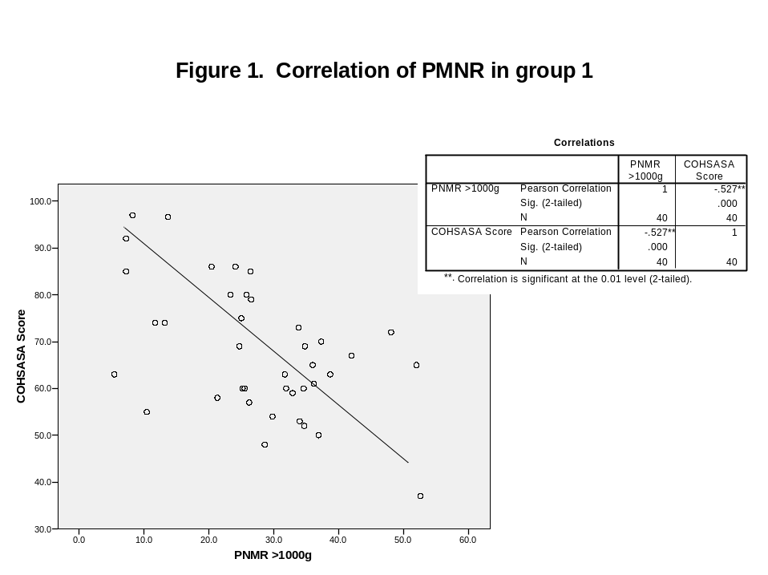
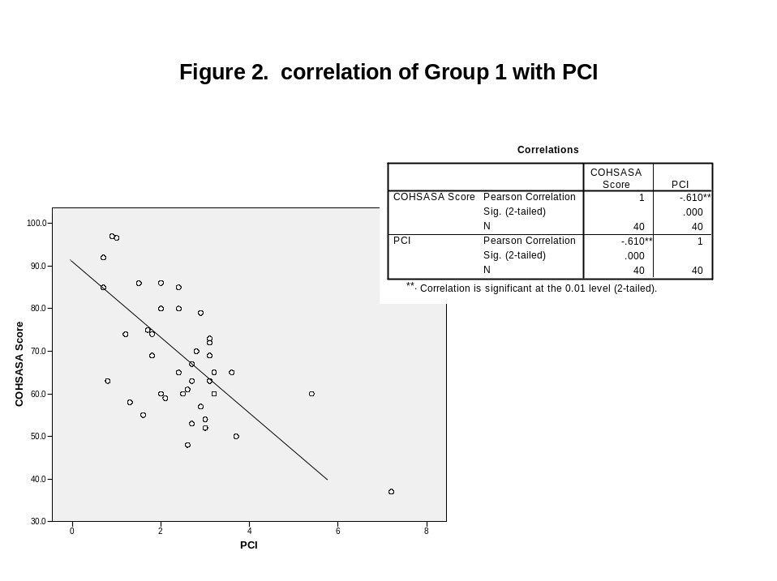

Conclusion
The PNMR, NNDR (1-2kg) and the perinatal care index can be used as a measure of quality of perinatal care.

THE USE OF CELL PHONES IN POSTNATAL CARE (ABSTRACT)

Mokaya K, Hugo J, Makin J, Pattinson R, Forsyth B, Bergh A
MRC Unit for Maternal and Infant Healthcare Strategies, University of Pretoria; Yale University School of Medicine

Introduction
Postpartum complications are a major cause of the morbidity and mortality associated with childbirth in South Africa. Several deficiencies exist in postnatal care in South Africa, such as poor rates of follow up of mothers and infants within a week of delivery, and poor communication between healthcare staff and patients. An intervention that can be used to improve postnatal care in South Africa is the incorporation of mobile technology. Cell phones have been used successfully in other settings in healthcare for education/awareness, preventive care, chronic disease management, monitoring and medication compliance, data collection, health record access and so on. They are advantageous to use because of their ubiquity, wide reach and simplicity of use.

Objectives
The goal of this study is to determine the feasibility and effectiveness of incorporating cell phone technology in postnatal care. The specific objectives are: to determine patterns and preferences of cell phone use among mothers in Tshwane district; to determine whether a cell phone intervention using SMS and phone call reminders will increase rates of attendance in postnatal clinics; to determine the cost-effectiveness of this intervention; and to determine healthcare staff attitudes towards the use of cell phone technology in postnatal care.

Methods
This study uses mixed methods as follows. Cross-sectional questionnaires and qualititative interviews to determine patterns, preferences, and attitudes of mothers and healthcare staff towards cell phone use in postnatal care.

Results
200 mothers were surveyed to determine their cell phone use, patterns and preferences. 98% of the mothers in had access to a cell phone, and 80% of them owned personal cell phones. Over 90% of them used cell phones for making/receiving calls, while about 80% of mothers used it for SMS’s. 95% of them felt positive towards communicating with healthcare facilities using cell phones: 51% of these preferred phone calls while 41% preferred SMS’s. Types of information they prefer to receive from healthcare providers include: education/health promotion messages, appointment reminders, medication reminders, and laboratory/test results.

Discussion/Conclusion
Cell phone technology can be effectively used to enhance postnatal care in South Africa. The study shows that they can be feasibly used to improve communication between healthcare provides and patients due to high availability and levels of cell phone use among patients and their positive attitude towards receiving communication from healthcare providers on their cell phones. Studies on staff attitudes towards it, the clinical impact of the technology on postnatal care and the cost-effectiveness and overall feasibility of technology are ongoing. A randomized controlled trial to determine the impact of cell phone communication on rates of postnatal clinic attendance is in progress currently.
PERINATAL AUDITS AT NSAMBYA HOSPITAL (ABSTRACT)

Victoria Nakibuuka, Byaruhanga Romano, Puis Okong , Gilbert Tumwine , Peter Waiswa
Department of Obstetrics and Gynaecology, Nsambya Hospital

Introduction
Maternal and neonatal conditions in Uganda contribute 20.4% of the total burden of ill health and avoidable deaths. It is estimated that about 18–37% of these deaths could be prevented by improved services delivery strategies combined with outreach and family community care. Perinatal audit significantly reduce neonatal and maternal mortality. Therefore the aim of this study was to assess if perinatal audits would improve quality of maternal and newborn care at Nsambya Hospital

Study Design: Cross sectional descriptive study

Methods
Over six months period (March – November 2008), weekly perinatal death reviews were conducted by a team consisting of midwives, pediatricians, administrators and obstetricians. Each case was discussed in detail, identifying gaps, mistakes and cause of death. The quality offered to the mother was further classified into four categories namely: 1.Optimum 2. Probably Acceptable 3. Probably suboptimal 4. Suboptimal. The perinatal deaths were also further classified as follows: 1. Not Avoidable 2. Partially avoidable 3. Completely avoidable.
All information was further transferred on to an audit form and later analyzed with SPSS version 12.

Results
The prevalence of perinatal deaths was 5.8%. A total of 120 perinatal deaths were audited, 34.5% were macerated still births, FSB (28.6 %,), Neonatal deaths 34.5%. A total of 12 (7.2 %) of the mothers had received suboptimal care, 12 (10.1%) probably suboptimal, probably acceptable 33 (27.7%), Optimum 61 (51.3%). 7.6% of these deaths were completely avoidable and 36.1% were partially avoidable. The major causes of death included: birth asphyxia 35 (29.4%) Respiratory distress sydromme 11 (9.2%), Haemorrhagic disease of the newborn (7.6%), Meconium aspiration pneumonia 3(2.5%). Perinatal mortality rate was 42.5 per 1000 lives in 2008 after introduction of the audits compared to 62.5 per 1000 live births in 2007 (P = 0.00002).

Conclusion
Perinatal audit if probably conducted may reduce perinatal mortality at Nsambya Hospital.
INTERPRETATION OF FINDINGS FROM PPIP IMPLEMENTATION IN EMFULENI SUB-DISTRICT (ABSTRACT)

Mitchell, RW¹, Chaane T².
¹ Obstetrician Gynaecologist, Gauteng Department of Health,
² Chief Director, Health Programmes, Gauteng Department of Health

Introduction:
The PPIP Database was implemented in the Emfuleni Sub-District of Gauteng. The study documented the conditions contributing to perinatal deaths in the sub-district. The findings of the study will be presented.

Method:
The findings over the assessment period will be presented and analyzed. Key findings will be identified and their impact on peri-natal mortality will be discussed. The findings will be interpreted on the basis of the prevailing conditions in the sub-district.

Results:
The results of the PPIP study will be presented with reference to the contributing causes to peri-natal mortality. The interpretation will enable conclusions and recommendations for the improvement of peri-natal survival to be made.

Conclusions:
There are definitely interventions that can be implemented that will impact positively on peri-natal survival rates that this study has identified. The recommendations are cost effective and probably apply to the general management of peri-natal cases across the province. The PPIP Database has established itself as a major contributor to the identification and management of peri-natal problems over a wide implementation base. This is a report / analysis of just one area of implementation and it demonstrates the worth of the PPIP database.

IMPLEMENTATION OF THE PPIP DATABASE IN EMFULENI (ABSTRACT)

Chaane T¹, Mitchell, RW²
¹ Chief Director, Health Programmes, Gauteng Department of Health,
² Obstetrician Gynaecologist, Gauteng Department of Health.

Introduction
A report on the implementation of the PPIP (Perinatal Problem Identification Programme) in the Emfuleni Sub District (Sedibeng) in Gauteng. The aim of the project was to document the conditions contributing to perinatal deaths in the sub-district and to make recommendations.

Method
All perinatal deaths in the sub-district (provincial hospitals and MOUs) were classified using the Perinatal Death Audit form (from the PPIP). Using the standard coding/classification system the factors related to primary obstetric cause of death, the final neonatal cause of death, and any avoidable factors, any missed opportunities and/or substandard care that contributed to the death were identified.

Results
Primary Obstetric causes of death identified (top 5)
Intrapartum asphyxia 24.4%
Spontaneous Preterm Labour 18.8%
Hypertensive disorders 17.5%
Ante-Partum Haemorrhage 13.2%
Unexplained IUFD 12.9%
PNMR for the Hospitals was calculated
The NNMR was also determined for the Hospitals

Conclusions
Identification of the Avoidable factors was achieved. Recommendations with regard to improving the care of neonates in the sub-district are made. These are probably applicable to the wider population as a whole.

USING MENTORS FOR IMPROVING ESSENTIAL CARE FOR WOMEN AND NEWBORNS

D. Nyasulu: MNTI Project Director, PATH South Africa
E. Moosa: MNTI Training Advisor, PATH South Africa
S. Engelbrecht: Senior Program Officer, PATH South Africa
Dr. J. Litch: Senior Newborn, Child, Maternal and Nutrition Specialist for PATH’s Global Programs

M. Folsom: Country Director, PATH South Africa

Background
The MNTI training strategy aims to improve the standard and quality of care provided to mothers and newborns through strengthening of skills and knowledge of the health care providers. The training materials focus on updating midwives’ knowledge and skill base and standardizing practices to reflect evidence-based care and SA national standards, and will require that all participants demonstrate competency in the clinical area for skills being taught.
The key result areas include improved skills of health care providers in the areas of admission of women in labour, correct use of the partogram, prevention of postpartum haemorrhage including application of active management of the third stage of labour, neonatal resuscitation, immediate post natal care for mother and neonate, infection prevention, client-provider interaction, quality assurance, and use of Perinatal Problem Identification Programme (PPIP) surveillance data to improve service delivery. All learning material is consistent with current South African policy and clinical guidelines.

MNTI training objectives
- Develop a model maternal and newborn health refresher training program that incorporates the highest standard and evidence based best midwifery practices and integrates PMTCT care into the practice of routine maternal and newborn care.
- Foster an environment of learning in the clinical area whilst at the same time updating knowledge and skills on a continuous basis.
- Foster an environment of self-evaluation and provider-driven initiatives to improve and maintain quality of care.
- Develop mentors and clinical training sites that will be available for other learning activities.
- Support and strengthen the existing M & E programs specifically PPIP to inform providers and managers to guide improvements in quality of care services.

Description of project intervention zone
MNTI training is directed at registered midwives and doctors involved in maternity and newborn care at level 1 hospitals, CHC and PHC clinics. Currently thirteen facilities in the three project districts have been selected as training sites. Training is conducted at all District (level 1) hospitals and 2 CHCs located in the project area. The estimated population for the three districts is 1,645,527. This represents 16.43% of the total population of KwaZulu-Natal Province.




MNTI Training Sites by District

MNTI Training Strategy
To ensure that health workers receive training that standardizes and continuously updates their lifesaving skills, PATH’s Maternal and Newborn Health Technology (MNTI) has developed an innovative training approach /strategy that integrates maternal and newborn elements through a series of training modules focusing on:
- Utilization of partogram for early identification of complications
- Active management of the third stage of labour to prevent haemorrhage
- Newborn resuscitation
- Immediate postpartum and essential newborn care
- Quality assurance informed by data from the Perinatal Problem Identification Program
The training approach incorporates a revolving mixed learning model implemented onsite and supported by well trained site mentors, supervisors and facility managers that optimizes efficiency and learning for inservice health care providers. To support this innovation PATH has produced an essential training program, including a supporting video and job aides that present, review and reinforce the knowledge, skills and practices needed to perform these life saving procedures.
This paper presents the design and methodology for implementation of this innovative training model and shares learning from initial pilot implementation at clinical facilities in KwaZulu-Natal.

Phased implementation of project training activities
- Selection of clinical training sites – Review of facilities, discussions with training site staff, agreement for becoming a clinical site
- Formative research– Utilize the findings to develop an action plan, and agreement for criteria to meet to be accredited as a training site

Phase I

- Preparation of equipment and supplies for performing selected maternal and newborn activities – Advocacy and motivation of facility managers for procurement of necessary equipment and supplies
- Development of a training strategy
Phase II

- Development of first draft of learning materials using the Performance Learning Approach – Identification of essential skills and knowledge for selected subjects, adaptation of existing materials for self-paced learning and to the South African context
- Development of a maternal and newborn health committee (MNHC) made up of personnel at each facility (the District MCWH and the Provincial manger are automatically members) - these committees worked with MNTI to agree on indicators, adapt supervisory tools and select 2 mentors in each facility
- Validation, pre-test, and finalization of learning materials
Phase III

- Agree upon indicators for following progress of project activities – MNTI staff met with representatives of the DOH and districts to agree upon indicators and ways to follow progress
- Adapt supervisory tools – MNTI staff and representatives of the DOH and districts reviewed existing supervisory tools and adapted them to include project indicators
- Develop job aids – MNTI staff and the MNHC developed job aids, pre-tested them, and then printed them for use in facilities in the intervention zone

Phase IV

- Selection of 2 mentors per clinical training site
- Training of mentors at the clinical training site to support learners using the mixed learning approach
- Training of perinatal personnel in the clinical training sites
- Providing post-course follow-up – DOH and MNTI trainers provide supportive supervision to facilitate transfer of training to the work site and evaluate effect of training activities
- Evaluation of clinical training sites - DOH representatives and MNTI staff will visit the facilities and judge if facilities meet up to agreed upon standards and award the “Izandla eziphephile” (“safe hands”) status to sites found to meet criteria for serving as clinical training sites

Phase V

Phase VI
- Post-course follow-up
- Monitoring and supervisory activities

Conclusion
PATH believes that combining life saving skills training and health care facility strengthening will lead to substantial improvements in quality of care and ensure lasting gains for maternal and newborn health in South Africa.

THE MATERNAL AND PERINATAL MORTALITY OF ZIMBABWE IN 2007

Munjanja SP¹, Nyandoro M², Magwali T¹, Mushangwe V¹, Mataya R³, MagureT¹, Chirehwa M¹, Nystrom L⁴
¹College of Health Sciences, University of Zimbabwe
²Ministry of Health and Child Welfare, Zimbabwe
³Department of Public Health, Loma Linda University, California USA
⁴Department of Epidemiology and Public Health, Umea University, Sweden

Introduction
The national maternal mortality ratio (MMR) and perinatal mortality rate (PMR) of Zimbabwe have never been properly established. Estimates for Zimbabwe reported by the World Health Organisation have been established using statistical modelling and those from Demographic and Health Surveys (DHS) using the sisterhood method. Both methods produce imprecise estimates with wide confidence limits, which are not reliable enough for monitoring. With those estimates it will be very difficult to monitor progress towards the Millennium Development Goal (MDG) 5, or any other targets set in the future. The same challenge of precision is faced with the perinatal mortality rates from the DHS quoted above, which report the estimates without confidence intervals. There is also concern that the methodology employed under-estimates the number of stillbirths.
The methods available for estimating these indicators include: vital registration, population-based surveys, census, reproductive age mortality studies (RAMOS), direct and indirect sisterhood methods and statistical modelling. The only previous population-based study done in Zimbabwe described the results in two provinces of the country. It reported an MMR in urban Harare and rural Masvingo of 85 and 168 per 100,000 live births respectively. In 2006 the Ministry of Health and Child Welfare (MoHCW) recommended that a study should be conducted in order to obtain estimates precise enough to observe medium term changes (every 10-20 years). Out of the above mentioned methodologies it was obvious that a national population-based study was the most feasible, and it was decided to combine this with a reproductive age mortality study.

Study design and methodology
This was a population-based descriptive and cross-sectional study of maternal and perinatal deaths. It was a combination of a survey of consecutive births and a RAMOS. The aim of this combined approach was to collect accurate information on the denominator (live births) and nominators (number of maternal and perinatal deaths).
A sample size of 45.000 live births was required to achieve the required precision using an assumed MMR estimate of 700 per 100,000, and the need to reach 95% confidence of +-15% around the estimate. Using the province a cluster, 11 districts were selected from among the 62 in the country for the study. The live births expected from each district were calculated as a proportion of the district’s population compared to the total population of the 11 districts. The distribution of the districts around the country is shown in Figure 1.
Women were registered into the database upon delivery or miscarriage and followed up for 6 weeks, or at death if they were between the ages of 12 and 49 years (RAMOS). Stillbirths, neonates and neonatal deaths were registered at delivery or by following up community reports entered into the village death and birth registers. Maternal and neonatal verbal autopsies were conducted for deaths occurring at home. The sources of information were the following in order of frequency: the women themselves, medical records, nurses/midwives, village health workers, female relatives, husbands/partners, neighbours, police officers and district registry offices.
The field work was conducted by 69 full time enumerators who were all experienced midwives, and it lasted from the 1st May 2007 to 30th April 2008.

Results
Process outcomes
A total of 45,240 women were recruited into the study in the 11 districts. Among these were 45,052 births, the remainder were 58 women who died without delivering and 129 women who miscarried before 22 completed weeks of gestation. Table 1 shows some important process outcomes, which show the differences in the quality of care offered to rural compared to urban women.

Maternal mortality
The population-based survey showed that there had been 243 maternal deaths. The verification exercise showed that a correction factor of 1.3 should be applied to this figure, giving a total of 313 deaths. The RAMOS had identified 253 deaths. By cross checking the names it was found that the final list of maternal deaths was 316. This gave an MMR of 725/100,000 live births (95% CI 648-810), or one death for every 138 live births.
Causes of maternal mortality
The main causes of maternal deaths were, in order of decreasing frequency; HIV/AIDS (25.5%), postpartum haemorrhage (14.4%), hypertension/eclampsia (13.1%), puerperal sepsis (7.8%), abortion complications (5.8%), malaria (5.8 %) and obstructed labour (3.3%). A comparison of the distribution of these causes between 1990 and 2007 is shown in Table 2. This shows that maternal deaths from HIV/AIDS have multiplied 5 fold since 1990.

Characteristics of maternal deaths
The deaths occurred in the postpartum, antenatal and intrapartum period in 63%, 24% and 6.6% respectively. Nearly half (49.3%) occurred outside institutions. The three delays in care contributed to deaths in 72.8% of women. The risk of death was significantly increased by delivering outside institutions, being delivered by an unskilled attendant and belonging to the Apostolic faith sect.

Perinatal mortality
There were 44,378 singleton births, 303 sets of twins and 5 sets of triplets in which the gestation was more than 22 weeks or the fetus weighed more than 500 grams. There were 1296 perinatal deaths out of 45,023 births. The stillbirth rate was 17/1000 total births and the early neonatal death rate was 11/1000 live births. The PMR was 29/1000 total births (95% CI 27.3-30.4). The neonatal death rate was 13/1000 live births.

Causes of perinatal death
The leading causes of perinatal deaths were, in order of decreasing frequency; preterm birth (33.6%), intrapartum asphyxia and birth trauma (26%), unexplained intrauterine death (17.4%), multiple pregnancy (4.65), maternal hypertension (3.6%) and infection (3.3%).

Characteristics of perinatal deaths
The place of delivery and the attendant present did not affect the risk of perinatal death, but this was significantly increased if the mother belonged to the Apostolic Faith sect. Perinatal mortality decreased to the lowest level at 38-41 weeks, then rose again at 42 weeks. The same pattern was seen with birth weight (BW); there was a decrease in risk with increasing BW to the lowest level at 4000-4499 grams, above which the risk rose again. Nearly half (49.4%) of neonates died in the first 24 hours of life and 68.6% in the first 72 hours.

Discussion
There were great logistical challenges but most were overcome, and this proves that other sub-Saharan African countries will be able to attempt a similar exercise. The cost of the study was USD 0.70 per woman of reproductive age per year if it is done every 10 years, making it affordable.
Completeness of data collection was judged to be good using various independently verifiable indicators. However there are certain limitations of the methodology and field work which need to be improved in future studies. Some of these are described in the short report of the study.⁹
The estimates obtained for MMR and PMR have narrow confidence intervals. This means that national monitoring is possible if the same methodology and precision are used in future studies. In the case of the MMR, if there is an annual decrease of 3%, it will be possible to detect this change in 10 years. An annual change of 2% per annum can be detected in 15 years.
There are no previous comparable studies in Zimbabwe or surrounding countries to make a comparison with both for the MMR and PMR. The national trends can only be established in 10-20 years when a repeat study is conducted. It will not be possible to know in 2015 if the MDGs 4 and 5 have been achieved in Zimbabwe since precise estimates of the MMR and PMR for 1990 are not available.
Figure 1. Districts selected for the maternal and perinatal mortality study in Zimbabwe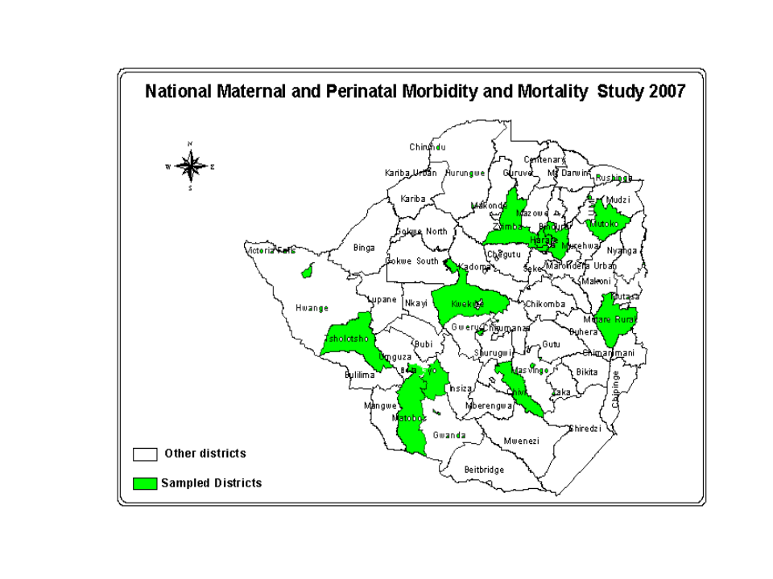
Table 1 Distribution of important process outcomes by period of pregnancy and place of abode
__________________________________________________________________________________
Process Rural Urban p-value National
___________________________________________________________________________________
Antenatal period
Antenatal booking (%) 91.5 91.2 0.24 91.4
HIV test during pregnancy (%) 26 47 <0.001 34
Median gestation at booking (weeks) 24 27 <0.001 24

Intrapartum period
Delivery at facilities (%) 51.7 94.3 <0.001 68.7
Assisted vaginal delivery (%) 0.2 2.0 <0.001 0.9
Caesarean section (%) 1.5 7.5 <0.001 4.4
Postpartum period
Attended 10 day postnatal visit (%) 67.5 84.4 <0.001 73.9
Attended 6 week postnatal visit (%) 75.5 88.8 <0.001 80.6

Table 2 Zimbabwe: Causes of maternal deaths in this study (2007) compared to a previous study⁸
Cause | 1990⁸ | 2007
Cause | (%) | (%)
Haemorrhage | 18 | 19
Abortion complications | 17 | 6
Puerperal sepsis | 13 | 8
Hypertension/ eclampsia | 12 | 13
Obstructed Labour | 3 | 3
HIV/AIDS | 5 | 26
Malaria | 5 | 6
Unknown | 9 | 10

HIV IMPACT ON INFANTS AND FAMILIES IN THE KANGAROO MOTHER CARE (KMC) FOLLOW-UP AT CHRIS HANI BARAGWANATH HOSPITAL

M Mokhachane, L Mokgosi, K Mathiva, F Nakwa, H Diar, R Thomas, A Van Kwawegen, F Ismail and S Velaphi and KMC Unit Staff

Introduction
A third of the infants admitted into the KMC unit were exposed to HIV. The majority of these families have major socio-economic problems. Some of them come from outside Soweto and Gauteng area with no relatives in the vicinity. On discharge the mother-infant pair is collected by a family member. Those that have chosen to formula feed because of their HIV status are given a tin of formula on discharge. The majority of these mothers insist that nursing staff should hide the formula from their families. At the clinic, some HIV positive mothers do not want their partners to be present when consulting with the doctor. There was also an impression that HIV exposed infants have a stormy course after birth. There was therefore, a concern that the mothers were not disclosing to their partners/families and that the infants of HIV positive mothers will not grow as well as those that are not HIV exposed.

Objectives
1. To compare the growth parameters of the HIV exposed infants to those that are not exposed.
2. To find out what the outcome of these infants is after discharge.
3. To find out how many mothers disclosed to their partners
4. To assist mothers with disclosure and testing of their partners irrespective of whether they are HIV positive or negative.

Methods
Kangaroo Mother Care clinic runs 3 days per week. Infants were followed up weekly if discharged below 40 weeks corrected age, then at term, 3 months, 6 months, 9 months and 12 months corrected age. All infants’ growth parameters were noted at each visit as well as a general examination. At the clinic, the mothers were asked about their HIV status, the status of their partners and if HIV positive, about disclosure. All mothers were encouraged to disclose to their partners and ask them about HIV testing. The clinic team facilitated disclosure where the mother would like to disclose but is afraid to do it alone. If the partner comes to the clinic, the doctor offered counselling and testing. All the HIV exposed infants were referred for HIV PCR testing at 6 weeks and 1 year of age. All the infants with developmental problems are referred to the appropriate team.

Results

Infants
- HIV exposure
Three hundred infants were followed-up at the clinic. Twenty eight percent (105) were HIV exposed (28%). Only 59 infants (56%) received Nevirapine at birth. Nine(9%) of the HIV exposed infants had a positive HIV PCR at 6 weeks and only 2 of them were on anti-retrovirals.

- Growth
Table 1 Weight of HIV exposed vs non exposed infants

Corrected Age | HIV exposed  (n=105)  Weight in grams | Non-exposed  (n=260)  Weight in grams | p-value
Birth | 1306 ± 216 | 1303 ± 220 | 0.9
Discharge | 1683 ± 53 | 1673 ± 68 | 0.2
Term | 2819 ± 590 | 2913 ± 602 | 0.2
3 months | 5462 ± 895 | 5314 ± 881 | 0.2
6 months | 6946 ± 1091 | 6754 ± 1157 | 0.6
9 months | 7975 ± 1213 | 7773 ± 1189 | 0.3
12 months | 8470 ± 1943 | 8420 ± 1577 | 0.9

Table 2 Head growth of HIV exposed vs unexposed infants

Corrected Age | HIV exposed  (n=105)  Head circumference in cm | Non-exposed  (n=260)  Head circumference in cm | p-Value
Term | 34.7 ± 1.7 | 35.5 ± 1.9 | 0.003
3 Months | 40.7 ± 1.9 | 40.4 ± 1.7 | 0.29
6 Months | 43 ± 2.1 | 42.9 ± 1.7 | 0.18
9 Months | 45 ± 1.9 | 44.7± 2.2 | 0.23
12 Months | 46 ± 1.5 | 45.9 ± 2.7 | 0.58

There was no difference in growth between HIV exposed and unexposed infants except head circumference at term corrected age. Head circumference at birth was not well documented and it was therefore difficult to compare. The outcome of the infants after discharge is summarised in the table below.

- Outcome of the infants

Table 3 Outcome of infants after discharge

OUTCOME
 | RVD Exposed  (n=105) | Unexposed  (n=273 ) | p-value
Practicing KMC @ term corrected age | 61% | 67% | 0.58
Admission | 14% | 11.5% | 0.5
Abnormal development | 10.5% | 11.1% | 0.87
Loss to follow-up | 44% | 16% | <0.01
Death | 4.8% | 4.2% | 0.87

There was a significant loss to follow-up in the RVD exposed group. It was not easy to establish what the cause of this loss is as it was difficult to contact some of them. The assumption is either moving to another province, illness or death of the mother.

- Adults
Fifteen couples were discordant. Thirteen partners of HIV positive women were negative. Two partners of HIV negative women were positive. This did not seem to affect their relationship except with one couple. The majority of the mothers found easier to disclose with the assistance of a health care worker.

Conclusion:
Growth of HIV exposed (mainly HIV PCR negative) infants was similar to that of unexposed infants. There was a high loss to follow-up in HIV exposed infants which may due to death of the mother, relocating back to their province or death of the infant. Facilitated disclosure had a positive impact on the family.

