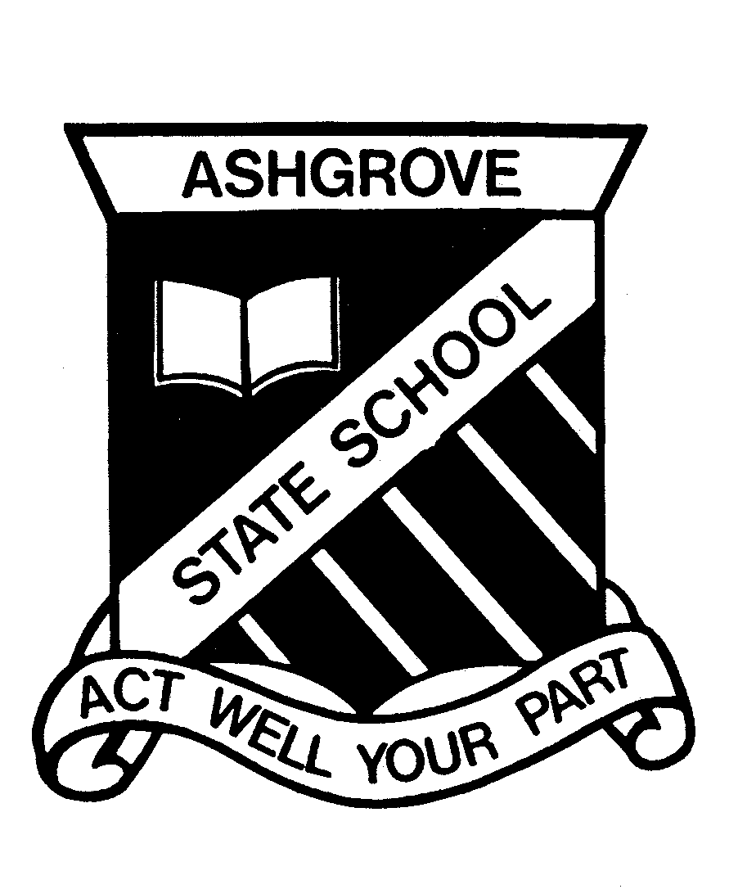

CONTENTS

Foreword |  | 3
 | School Vision, Our Purpose, Values and Beliefs
P&C Welcome |  | 4
Staff List |  | 5
School Directory |  | 7
School Term Calendar |  | 7
School Routine |  | 8
Enrolment Policy & Map |  | 9
School Organisation |  | 13
 | Ancillary Staff
 | Chaplain
 | Composite Classes
 | Enrolment
 | Houses
 | Leadership Program
 | Parent Network
 | Prep
 | Religious Education
 | Special Education Staff
 | Specialist Subject Teachers
 | Staff Identification
 | Student Council
 | Support Staff
 | Teaching Staff
Ashgrove State School Curriculum Framework |  | 15
Ashgrove Approach |  | 17
Academic Achievement Data |  | 18
Curriculum Enhancement |  | 19
 | Advanced Learning
 | English
 | ICAS
 | Maths Tournament
 | Music
 | Resource Hire Scheme
 | Physical Education
 | The Gap State High School Art & Maths Extension
 | Writers Festival
 | YCDI – Social Skills Program
Extra Curricular Activities |  | 21
 | Book Club
 | Camps – Years 4, 5, 6 & 7
 | Collection of Money for Student Activities
 | Debating
 | Excursions
 | Opti-Minds
 | Stephanie Alexander Kitchen Garden Program
Communication |  | 22
 | Appointments with Staff
 | Class Requirements
 | Communication to/from School
 | Mobile Phones
 | Parent Teacher Interviews
 | Telephone Calls

Student Health and Safety |  | 23
 | Absence from School
 | Accidents and Illness
 | Active School Travel
 | Arrival at School
 | Assembly
 | Critical Incident Management
 | Current Emergency Information
 | Departing School
 | Leaving School during the Day
 | Medication at School
 | Responsible Behaviour Plan for Students
 | School Dental Services
 | Sickness – Infectious Diseases
 | Sun Safety
 | Supervision of Children
 | Wet Days
Facilities |  | 25
 | Computers
 | Grounds
 | J.B. Stephens Centre
 | Library – Resource Centre
 | Outside School Hours Care
 | School Hall
 | Sporting Facilities
Road Safety |  | 26
 | Bicycles
 | Skateboards/Scooters
 | Traffic in grounds
Miscellaneous Matters |  | 26
 | Crossing Supervisor & Stop Drop Go
 | Homework
 | Lost Property
 | School Photos
 | Toys & Personal Belongings
Parents as Partners |  | 27
 | Excellence Fund
 | Parents’ and Citizens’ Association
 | School Council
 | Swimming Club
 | Swimming Lessons
 | Tuckshop
 | Uniform Shop
Uniform Policy |  | 29
 | Dress and Grooming
 | Uniforms – Girls
 | Uniforms – Boys
YMCA |  | 30
 | Outside School Hours Care

FOREWORD

Welcome to Ashgrove State School. The information in this booklet is presented to outline to you our school, some of the ways we operate and our vision for education. We trust that the information will be beneficial to you in assisting you understand Ashgrove State School.

For over 135 years Ashgrove State School has enjoyed a reputation of providing excellent academic outcomes for the students of the Ashgrove Community. This year the school entered an exciting new phase on being selected as one of 26 state schools to be an Independent Public School. Ashgrove is one of only eight primary schools in the state to be selected for this program. Being an Independent Public School provides the school with the opportunity to shape and tailor the workforce and develop programs that meet the needs of the student body through increased autonomy and flexibility.

The teaching/learning program at Ashgrove State School is planned to cater for the individual, their needs, learning styles and interests. Ashgrove State School prides itself on ‘putting students first’ and providing a futures orientated education. This philosophy is the foundation of all decision making in the school. Resources, policies and programs are a reflection of this approach.

The curriculum is enhanced by a range of opportunities offered to children to extend their learning and to participate in additional activities and competitions. Information and Communication Technology skills have been recognised as being paramount to the successful implementation of the curriculum at the school. The expansion of resources in this area is a strategic priority.

The success of the school mirrors the great support given by the parents and the community. The school community is young, dynamic, enthusiastic and caring. Every effort is made to welcome all families and to encourage their participation in many facets of school life. We hope that you will feel welcome in our community and assist in whatever capacity to continue to move our school forward.

Ashgrove State School is proud of the achievements and successes of its students and the efforts of all members of the school community who contribute to this success.

Patrick Murphy – PRINCIPAL

SCHOOL VISION

To create a School that is the pride of its community and recognised nationally.

OUR PURPOSE

To achieve optimum quality educational outcomes for all students.

OUR VISION FOR STUDENTS

To prepare every student to contribute to and thrive in the future by providing enriching educational experiences within a safe, supportive, challenging environment.

OUR VALUES AND BELIEFS

At Ashgrove State School we believe in and value:
- Strong partnerships through open communication in a supportive environment.
- Commitment to excellence everywhere for everyone.
- Working together to meet current and future needs and challenges.
- Respect for and pride in self, others, school and the community.
- Educating each child to unlock his/her potential and foster a lifelong love of learning.

P&C WELCOME

On behalf of the Ashgrove State School Parents’ and Citizens’ Association I would like to extend a warm welcome to the Ashgrove State School Community.

Ashgrove State School is fortunate to have a strong and active school community. The Parents’ and Citizens’ Association works with the principal, staff and broader school community to provide a range of benefits to our children including:

- fundraising activities to supplement school facilities and resources;
- planning future improvements;
- regular forum for the collaborative resolution of issues;
- provision of a quality tuckshop service; and
- providing social functions that help to foster community spirit.

There are a number of sub-committees of the P & C that assist in specific areas. These sub-committees are:

- Swimming Club: this group coordinates the Ashgrove Aces and conducts regular social and competitive meetings;
- Uniform Shop: this facility provides parents with the opportunity to conveniently access all of their children’s uniform requirements.

Together and with the support of many other members within the school community, these groups have achieved a number of significant improvements for the school including:

- planning and running an extremely successful annual fete;
- modifications to classrooms to reduce traffic noise;
- air conditioning for all classrooms;
- construction of the JB Stephens Centre;
- widening of the school pool;
- improved tuckshop facilities and services;
- construction of a new playgrounds;
- computer laboratories;
- construction of Before and After School Care facility;
- the creation of a Stephanie Alexander Kitchen Garden;
- construction of artificial turf and shade areas;
- rubber surfaces installed in all playgrounds;
- new surface on tennis court;
- fully equipped air-conditioned school hall.

I would strongly encourage you to join the P&C to work towards providing the school with improved facilities for our children’s education and to also meet other parents and become part of the Ashgrove State School community.

Kyra Williams
President Ashgrove State School Parents’ and Citizens’ Association

STAFF LIST – 2013

PRINCIPAL Pat Murphy
DEPUTY PRINCIPAL (P-3) Helen Lynch
DEPUTY PRINCIPAL (4-7) Graeme Chamberlain
HEAD OF CURRICULUM Robyn Burke
BUSINESS SERVICES MANAGER Joy Sinclair
PERSONAL ASSISTANT Heather Marshall
ADMINISTRATION OFFICERS Janice Midgley, Desiree Murray

CLASSROOM TEACHERS
Prep Melissa Adams
Prep Sandy Gardner
Prep Jane McConaghy
Prep Kelli Webb
Year One Christine Thomas
Year One Karen Harvey
Year One Connie Barbera/ Lisa Pengelly
Year One Sharni Manderson
Year Two Gillian Tanks
Year Two Liane Murphy
Year Two Venny Sarmiento/Louise Stark
Year Two Lynda Hurst
Year Three Jody Blee/Jo Sprenger
Year Three Karen Hayward
Year Three Sophia Davies
Year Three Cathy Mewburn
Year Four Kathryn Ash
Year Four Victoria Stoddart
Year Four Kristine Barbarossa
Year Four Leanne Holland/Amanda Stay
Year Five Janet Price
Year Five Emma Curry
Year Five Claire Goss
Year Five Claire Aitken
Year Six Damien Green
Year Six Jenny Warwick
Year Seven Christina Maxwell
Year Seven Mark Weibgen
Year Seven Elizabeth Somerville/Lynette Lynch

CHOIR Anne Pook
CLEANERS Bob Gillam, Jim Frainey,
Janette Boulton, Deb Lumer
GUIDANCE OFFICER Sharon Edwards
INFORMATION TECHNOLOGY Kristy Whitham, Simone Gately
JANITOR GROUNDSMAN Brad Ross
LIBRARIAN Julie Gwynne-Jones
LIBRARY AIDE Stella Nicholas
LOTE Rosie Robinson
MUSIC - CLASSROOM Rosemary Clark, Rachel Lathwell
MUSIC – STRINGS Keith Sharp
MUSIC – WWB Fons Hartog, Jeff Jarrott
PHYSICAL EDUCATION Danny McDonald
SPECIAL EDUCATION TEACHER Helen Wade, Kristy Whitham
SUPPORT TEACHER Gerry Healy
TEACHER AIDE Kylie Tolhurst
TEACHER AIDE Tracey Spencer
TEACHER AIDE Kay Toy
TEACHER AIDE Janet Munro
TEACHER AIDE Christine Costello
TEACHER AIDE Kate Williamson
TEACHER AIDE Debbie Ryan
TEACHER AIDE Simone Gately
TEACHER AIDE Jo Waite
TEACHER AIDE Cheri Payne
TEACHER AIDE Kristine Evans
TEACHER AIDE Michelle McLean
ASHGROVE STATE SCHOOL DIRECTORY

ADDRESS: Ashgrove State School
31 Glory Street
Ashgrove Q 4060

POSTAL ADDRESS: Ashgrove State School
P O Box 2077
Ashgrove West Q 4060

WEB ADDRESS: www.ashgrovess.eq.edu.au
EMAIL admin@ashgrovess.eq.edu.au
absences@ashgrovess.eq.edu.au

TELEPHONE NUMBER: 3858 4777

FAX: 3858 4700

TUCKSHOP: 3858 4718

CLOTHING STORE: 3858 4721

AFTER SCHOOL CARE: 3366 1523
0417 706 789

SCHOOL CALENDAR

2013 School Term Dates
Term 1 Tuesday 29 January 2013 Thursday 28 March 2013
Term 2 Monday 15 April 2013 Friday 21 June 2013
Term 3 Monday 08 July 2013 Friday 20 September 2013
Term 4 Tuesday 08 October 2013 Friday 13 December 2013
Public Holidays
28 January (Australia Day) 29 March (Good Friday) 01 April (Easter Monday)
25 April (ANZAC Day) 10 June (Queen’s Birthday)
14 August (Exhibition) 07 October (Labour Day)
Pupil Free Days
23, 24 & 25 January 21 October

2014 School Term Dates
Term 1 Monday 28 January 2014 Friday 04 April 2014
Term 2 Tuesday 22 April 2014 Friday 27 June 2014
Term 3 Monday 14 July 2014 Friday 19 September 2014
Term 4 Monday 07 October 2014 Friday 12 December 2014
Public Holidays
27 January (Australia Day) 18 April (Good Friday) 21 April (Easter Monday)
25 April (ANZAC Day) 09 June (Queen’s Birthday)
13 August (Exhibition) 06 October (Labour Day
Pupil Free Days
22, 24, 25 January 20 October
SCHOOL ROUTINE

BELL TIMES
8:45am Bell Students prepare for school
8:55am Bell School commences
10:55-11:30am Bell Morning Recess*
1:00-1:45pm Bell Lunch*
2:55pm Bell General dismissal
3:30pm Bell Students who have not been collected to report to the 0ffice.
*The first fifteen minutes of each break is supervised eating time, where children must sit to eat their food in designated year level areas.

FRIDAY INTERSCHOOL SPORT
10:30-11:00am Bell Morning Recess* Upper & Lower grades
12:00-12:15pm Bell Sport Lunch* Upper grades
12:45-1:30pm Bell Lunch* Lower grades
FRIDAY SPORT – No Interschool sport
10:30-11:00am Bell Morning Recess* Upper & Lower grades
12:45-1:30pm Bell Lunch* Upper & Lower grades

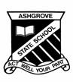
ENROLMENT MANAGEMENT PLAN

Rationale
Ashgrove State School recognises as its prime obligation the provision of access to an appropriate educational service for students resident within this community as defined by its local catchment area.

Because of enrolment capacity and growth Ashgrove State School may be unable to meet this obligation in future, unless action is taken now to manage enrolment.

This plan sets out the conditions under which students may be enrolled into Ashgrove State School.

Enrolment capacity of school
The school currently has the capacity to enrol up to 725 students in 29 classrooms. The number of students entering the Prep year in any given year is not to exceed 100 students in 4 classrooms unless there are more than 100 students enrolling from within the catchment area.

Local catchment area
The school’s enrolment capacity for students who live outside the local catchment is dependent upon:
  - the school’s enrolment capacity
  - catering for in-catchment enrolments
  - allowing for in-catchment growth during the year
  - ensuring an even spread of students across all year levels while maintaining class size targets
The local catchment area is based on equidistance boundaries with other schools. The attached map defines the boundary area for which Ashgrove State School is the closest school by vehicular trafficable route. Should this capacity change because of changes to road networks, this will be formally notified through the registration and gazettal of an amended plan including the operative date for the new catchment area.

Enrolment Policy
All students who reside within the local catchment area and are eligible for enrolment in the educational program offered by the school have a right to enrolment at the school. The Principal will hold places for students who relocate to within the catchment boundary throughout the school year.

Enrolment of students from outside the local catchment area will be managed to ensure that the total current and forecast enrolments do not exceed the school’s current built capacity and where applicable will ensure there is an even spread of students across year levels or class groupings.

The school's enrolment management plan does not replace other departmental policy; for example Safe, Supportive and Disciplined School Environment, nor does it overrides subsequent determinations regarding built school capacity.

Enrolment Criteria
Students who reside outside the school's local catchment boundary who apply for enrolment at the school will be put on a waiting list in order of receipt of application. Where there is spare capacity, students will be enrolled from the waiting list based on the following criteria and order of priority:
- Siblings of students already enrolled
- Children and young people who are subject to child protection orders that grant guardianship or custody to the Chief Executive Officer of the Department of Child Safety.
- Students whose parent or legal guardian is employed by the school.
- Siblings of students who have left the school and reside outside of the local catchment boundary.
- Students who reside outside the catchment area and who officially leave the school will be considered for re-admission in accordance with the enrolment criteria.
- Any remaining students residing outside the catchment area.

Proof of Residency
Parents who wish to enrol their child/ren at Ashgrove State School under the Enrolment Management Plan will need to demonstrate that the child/ren to be enrolled, reside within the catchment area. Current proof of residency at the address indicated can be provided by way of one of each of the following:
- One primary source – a current lease agreement, rates notice or driver’s license, or unconditional sale agreement and
- One secondary source – a utility bill (e.g. electricity or gas) showing the same address.
If unable to provide this proof of residence, a Statutory Declaration confirming that an officer authorised to endorse statutory declarations has sighted sufficient evidence that in their opinion the student is a resident within the catchment area, must be provided.

Acceptance and notification processes
Applications for admission into Years Prep to Year 7 will be accepted each year from the 1st April for enrolment to commence from the beginning of Term 1 the following year.

Applications will be recorded in order of receipt.

Applications will remain current only for the year of submission.

The school will offer places for Prep the following year on or before September 1st each year.

Review
All enrolment applications will be considered on merit in accordance with the enrolment criteria.

Parents wishing to have an unsuccessful enrolment application reviewed may seek clarification from the principal. Parents should provide a written submission seeking a review of an unsuccessful enrolment application. This submission should present evidence to substantiate a claim that the stated criteria have not been applied fairly and equitably.

The Enrolment Management Committee will review written submissions and the reply should be in writing within 14 days of submission.

Enrolment Management Committee
The enrolment management committee consists of Principal (Chair), School Council Representative, Representative of Regional Director, Staff Representative.

Further appeal should be directed to the Assistant Regional Director on behalf of the Regional Director whose decision will be final.

Review Date
Reviewed annually at Term 4 meeting of the School Council.
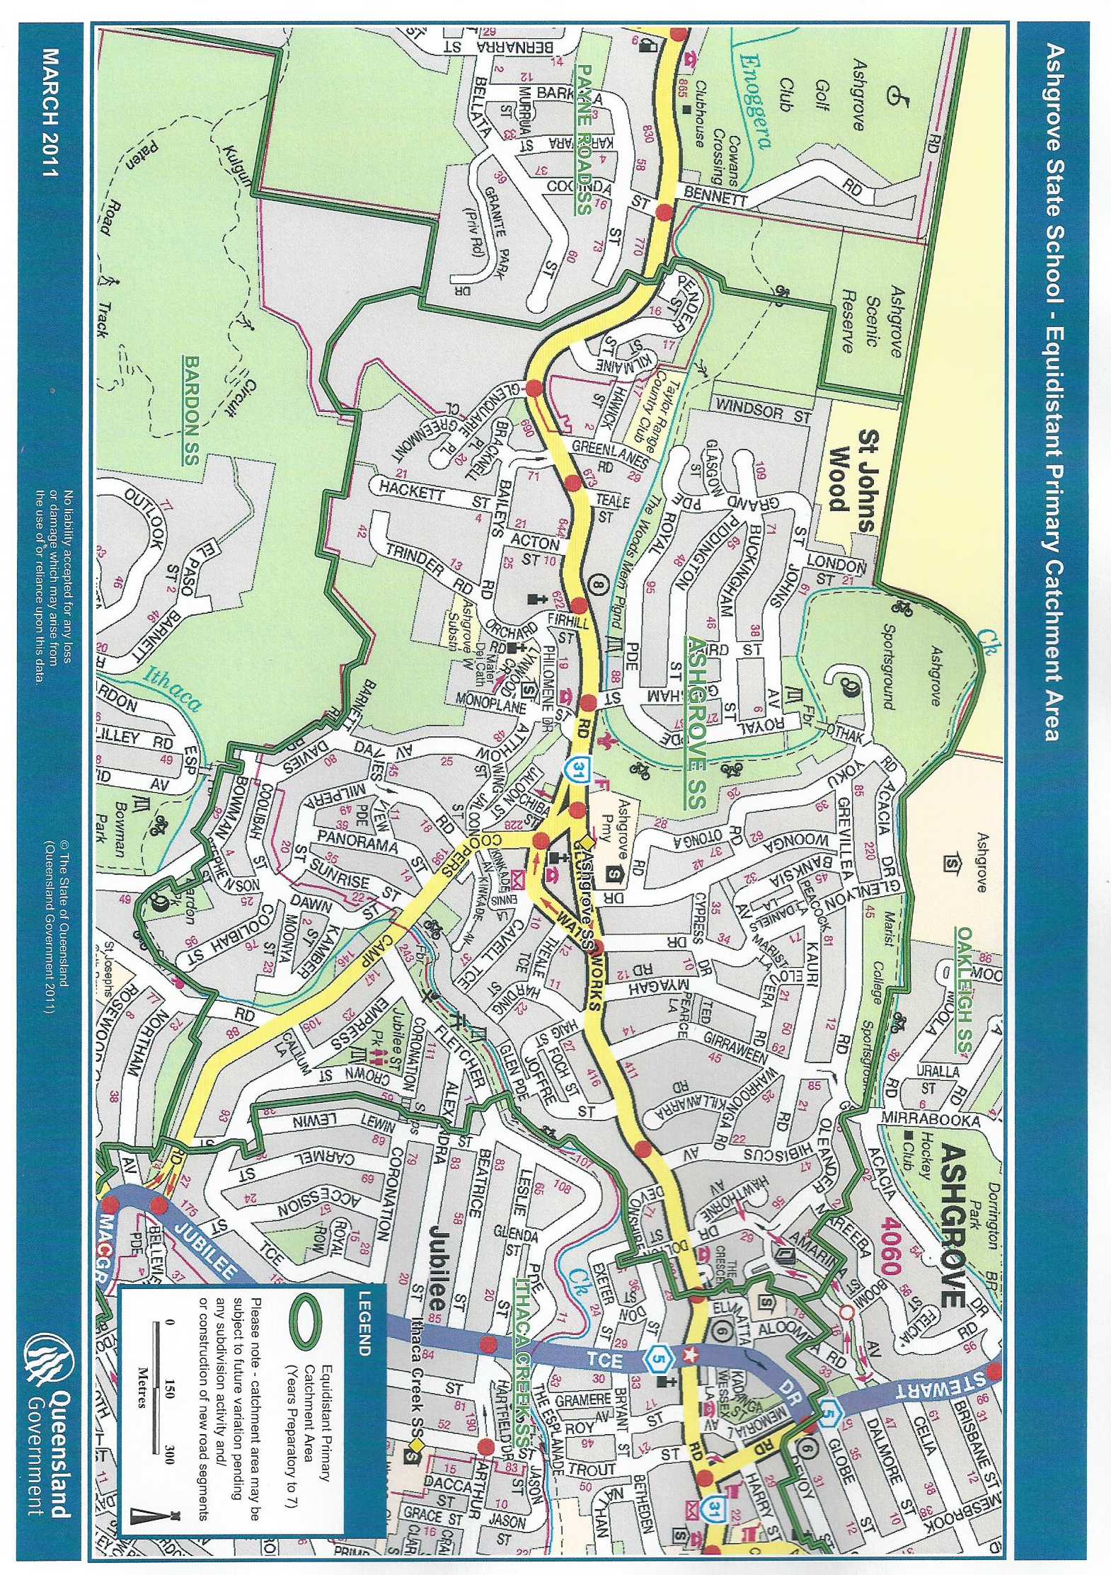
ENROLMENT POLICY – CATCHMENT ZONE

Acacia Drive*Nos 212-244 | Harding Street
Acton Street | Hawick Street
Alexandra Street* Nos 92-114 | Hawthorne Avenue
Amarina Avenue*Nos 46-97 | Hibiscus Street
Atthow Avenue | Jaloon Street
Baileys Road | Joffre Street
Banksia Avenue | Kamber Street
Barnett Road | Kauri Road
Bowman Parade*Nos 80-109 | Killiwarra Road
Bracknell Place | Kilmaine Street
Buckingham Street | Kinkade Avenue
Cavell Terrace | Laird Street
Chiba Street | London Street
Coolibah Street | Lynwood Crescent
Coopers Camp Road* | Milpera Street
Coronation Street*Nos 93A-115 | Monoplane Street
Crown Street | Moonya Street
Cypress Drive | Myagah Road
Davies Road | Oleander Drive
Dawn Street | Orchard Road
Devonshire Street* 53-79 | Othaki Road
Dolton Street | Otonga Road
Elouera Road | Panorama Street
Empress Terrace* 1-99 | Pender Street
Ennis Lane | Philomene Drive
Firhill Street | Piddington Street
Fletcher Parade*Nos 160-249 | Royal Parade
Foch Street | St Johns Avenue
Girraween Grove | Stephenson Street
Glasgow Street | Sunrise Street
Glenquarie Place | Teale Street
Glen Parade | Theale Street
Glenlyon Drive | The Crescent
Glory Street | Trinder Road
Grande Parade | View Parade
Greenlanes Road | Wahroonga Road
Greenmont Close | Waterworks Road*Nos 346-796
Gresham Street | Windsor Street
Grevillea Road | Wing Street
Hackett Street | Woonga Drive
Haig Street | Yoku Road

* Denotes section of street in Catchment Zone – refer to detailed street map.

SCHOOL ORGANISATION

ANCILLARY STAFF
The school office is staffed by a Business Services Manager and two full time and one part time Administration Officers. The primary school has several Teacher Aides, two of whom works primarily in the library and special education. The school has a Schools’ Officer Facilities and five cleaners.

CHAPLAIN
A chaplain was appointed to the school in late 2007 and works two days per week. She provides pastoral care if needed, assists with the development of social skills in our children, provides one on one counselling with regard to behavioural or social issues, organizes lunch time clubs and generally assists with the well being of our children and staff. She also attends school functions and/or excursions, camps and class activities whenever possible.

COMPOSITE CLASSES
As the enrolment varies from year to year, composite or multi-age classes comprising children from more than one-year level may be formed. Research indicates that learning outcomes from a composite class are identical to straight year level classes.

ENROLMENT
Ashgrove State School has an Enrolment Management Plan, which endeavours to maintain enrolment numbers at a level which can be accommodated within the school grounds. This allows children, including siblings, residing permanently within our catchment zone enrolment as a right of entry. Students residing outside of our catchment zone may be offered enrolment subject to vacancies.

HOUSES
The school has three sporting team houses: Binda which is Blue, Munda Green and Warroo Yellow. Houses are named after the Aboriginal names for Water, Earth and Fire.
On enrolment every student is allocated to a house. All members of the same family are allocated to that same house.
Houses compete in the Annual Athletics, Swimming and Cross Country carnivals. A house system has recently also been introduced to focus on other academic and social pursuits.

LEADERSHIP PROGRAM
At the end of 2013 Year 6 children are given the opportunity to become school leaders for their final year of primary school.
Those children wishing to participate are given an accreditation sheet which can be completed during the last term of year 6 or may be ongoing during their year in year 7. Upon completion of the sheet the children are presented with a Senior Leaders badge.
Those children wishing to nominate for a formal leadership position in Year 7 e.g. School Captain, House Captain, or Music Captain, must complete their accreditation sheet by early in term 4. After this date badges can be earned at any time during the following year, but students will not be eligible for a formal leadership position in their final year of school.
To complete their accreditation sheet, students must get all criteria signed by various staff and community members. Parents and family members are not eligible to sign for the students. Some of the criteria for accreditation are:-
- high level leadership skills;
- consistent adherence to school rules and values;
- high level of reliability, responsibility, initiative;
- well developed communication and people skills;
- high level of personal presentation;
- regular attendance at school;
- community service involvement;
- willingness to commit to and participate in school activities.
Those unsuccessful in gaining a formal leadership position are still given some leadership responsibilities.

In 2014 Year 6 students, in preparation for year 7 moving to high school, will be offered the chance to undertake these leadership roles. From 2015 Year 6 children will assume leadership of the school.
PARENT NETWORK
Each class in the school has a Parent Network representative. This person attends a meeting each term with the Principal and Deputy Principals. This meeting serves as an ideas sharing session and the parent representatives are given factual information regarding school procedures and curriculum to pass on to other parents in the class These parent representatives also organize morning teas etc to enable parents to get to know each other and these meetings also serve as a welcome to any new families that may have come to the school.

PREP
The non-compulsory, full-time preparatory year is offered in all Queensland State Primary Schools. Children born between 01 July 2008 and 30 June 2009 will be eligible for Prep in 2014.

RELIGIOUS EDUCATION
Religious Education at Ashgrove State School is delivered in a non-denominational format to children in Year 1 to Year 5 depending on the number of volunteers available.
Most of the children enrolled at the school attend these classes which are taught by volunteers from local churches for one half hour per week. All volunteers work from a pre prepared program and supply the children with a booklet in which to complete each week’s work. The program is Christian based but non denominational and has the support and approval of all Christian churches. If you do not wish your child/children to attend these classes you will be required to inform the class teacher(s) in writing at the beginning of each year.
No alternative curriculum work will be provided to children not attending Religious Education classes. They will be required to do ‘catch up’ work at this time.

SPECIAL EDUCATION STAFF
The school has a Support Teacher Learning Difficulties and Special Education Staff who support students with diagnosed disabilities. and accesses various special education staff according to children’s needs. The school also has three teacher aides who assist children with special needs.
Access to special education staff requires a process of referral to the school’s Support Services Committee.

SPECIALIST SUBJECT TEACHERS
The staff includes a teacher-librarian, two technology teachers, a LOTE teacher (Chinese),
two classroom music teachers, a physical education teacher, three instrumental music teachers, an advanced learning coach, data coach and writing coach.

STAFF IDENTIFICATION
Staff at the school, both teaching and ancillary, wear readily recognisable name badges. Children have been informed that if required they can seek help from an adult with such a badge.
All relief teaching staff and authorised visitors wear a visitor’s badge which identifies them as being authorised to be on the school premises. Staff on playground duty wear a fluoro vest and carry Epi-pens and emergency cards.

STUDENT COUNCIL
The Student Council consists of class representatives of Years 5, 6 and 7. The members of the Student Council are a representative voice for matters and activities within the school. The membership changes every semester to give more children the opportunity to display leadership qualities. The Student Council also supports charitable causes in the community.

SUPPORT STAFF
The school has a Guidance Officer one day per week, a Speech Pathologist one day per fortnight and can access Advisory Visiting Teachers and English as a Second Language (ESL) support staff when necessary.

TEACHING STAFF
In 2013 there are twenty nine classes form Prep to Year 7.

ASHGROVE STATE SCHOOL
CURRICULUM FRAMEWORK

RATIONALE
Ashgrove State School services the community of Ashgrove and surrounding suburbs from Prep to Year Seven. The School has a tradition and reputation for excellence in student achievement in academic, cultural and sporting activities. The school community places particular importance on the productive partnership that is developed between home and school and the positive impact this has on each child’s learning.
The school community believes that curriculum is defined as all planned or related learning activities which take place inside the boundaries of the school.

The community and staff of Ashgrove State School recognise that the fundamental goal of teaching is to facilitate the development of literate and numerate students who possess the valued attributes of lifelong learners. We aim for students to become:

Collaborative Workers

Complex Thinkers

Quality Producers

Active Investigators

Reflective and Self-directed Learners

Responsive Creators

Effective Communicators

CORE LEARNINGS

At Ashgrove State School we follow the Australian Curriculum. Currently those subjects which have been introduced are are English, Maths, Science and History. The other four Key Learning Areas are Health and Physical Education (HPE), The Arts, Technology and Languages Other Than English (LOTE) which are part of the Queensland Curriculum.

From the Australian Curriculum, Education Queensland has developed a comprehensive curriculum program known as C2C for teachers to cover the recommended amount of time for each subject area using innovative technologies. The work is aimed at the middle range of students in a class, with teachers being expected to differentiate the lessons to cater for the needs of all students in the class. In Prep, our teachers follow the Australian Curriculum and also the Qld Early Years Curriculum Guidelines.

A Head of Curriculum is employed to guide the development of a whole-school approach to pedagogy (teaching). Teachers each year are provided with an overview of data for the children in their class. This data is collected from NAPLAN results, previous report cards, diagnostic tests, reading records and anecdotal evidence. Teachers use this information and that gained from their daily work in class, to set three clear learning goals for each child in the class for each term. The children know what their goals are and are given regular feedback on their progress towards each goal.

Core learnings for the Qld Studies Authority (QSA) Languages Other than English (Chinese) Syllabus will be Level 1 to 3 Outcomes for our Year Five, Six and Seven students. The development of knowledge in Chinese is outlined in the school-developed LOTE program.

The teaching and development of skills and processes across all subject areas, is seen by our school community as being just as important as the imparting of knowledge. The school’s programs place particular importance on the development of leadership skills with a major emphasis on personal development, life skills, communication and leading peers.

The integration of Gifted & Talented principles and teachings into all K.L.A. areas is fundamental to the school’s philosophy of catering for the individual needs of every child. The Gifted and Talented Policy is available on the school website.

Today’s society demands that all students have diverse skills in Information and Communication Technology. High level computer skills are taught separate from the classroom and then integrated into classroom practice. In our school community Music and Sport are well-supported learning experiences that play an important part in the development of each child in the school.

TEACHING STRATEGIES

Cooperative Planning, Staff Meetings, Sector and Year Level Meetings allow teachers to critically reflect on their own practices and share best practices with their colleagues. This ensures that planning and moderation is consistent across year levels. However, each class will reflect the character and individual features of the students in each class.

ASSESSMENT

The purposes of assessment are to:
- determine the success of the planning, teaching and learning.
- inform future programs for teaching and learning.
- promote, assist and improve student learning.
- provide data that can be communicated to a range of people about the progress and achievements of individual students or groups of students.
Assessment activities developed cooperatively by the teachers during the development of the units will assist in helping guide teachers’ professional judgement.

In the collaborative planning process, teachers work together to determine appropriate assessment tools for the unit of work planned. Assessment is currently moderated by a school moderation process developed in staff year level meetings to create alignment across year levels. Meetings where teachers can see the work of others, discuss planning and witness student achievement allow individuals the opportunity to learn best practice. This moderation process assists the school to ensure consistency of marks and reflect on teaching strategies.

REPORTING

A report card for children in Prep to Year 7 will be sent home at the end of each semester. The report card template is used throughout Queensland and reports in the key learning areas of the Australian Curriculum, Australian Curriculum and the Early Years Curriculum Guidelines. The audience of the report card is the parents of the child. All parents are encouraged to attend a parent/teacher interview during Semester One. Parents are able to organise a parent teacher interview at any time throughout the year. To gain the most from the interviews it is often best to make a prior appointment to allow the teacher time to organise data to give you the best possible information about your child.

Teachers and parents are encouraged to talk to children about their report cards and utilise them for continued improvement and future goal setting. Each student’s report will contain achievement information about each learning area studied.
A five-level achievement code describes the student’s overall achievement against what is expected at the time of reporting. A full explanation of the achievement codes are detailed on the front cover of all students’ report cards. Written comments outline what a student has achieved and provide advice on areas for improvement. Children in Years 3, 5, and 7 will also receive a report on the achievement of their children following the National Assessment Program for Literacy and Numeracy.
THE ASHGROVE APPROACH
The Ashgrove Approach is a Pedagogical Framework around which staff are expected to base their teaching.
High Expectations  - Quality work presentation  - Correction of student work  - High expectations of behaviour  - Classroom displays to highlight curriculum  - Harmonious classroom tone – no working noise, good listening, focussed learning and effective group work  - Constant movement around the room /proximity to students  - A Visible Timetable | Individual Goal Setting  - Teachers to set three individual learning goals for each child each term.  - Students to be aware of goals and steps needed to achieve the goal.  - Parents to be aware of their child’s learning goals  - Students to be celebrated on achievement of goal. | Knowledge from Short Term to Long Term Memory  - Most students require repetition of work covered in Literacy and Numeracy.  - This will occur in form of warm ups, drills and practise, games, homework and utilising ICTs. | Differentiation  - Teachers differentiate the standard of work taught and expected of students.  - Teachers understand that every child is different and will examine individual data and determine the appropriate pathway for the child.
Explicit Instruction  - Students aware of lesson intent  - Success criteria provided for students  - Teacher Directed Learning – I Do, We Do, You Do  - Literacy Blocks – Occur in every classroom at least 3 times per week.  - Regular assessment including diagnostic tests  - Regular feedback to students on their progress | Parents as Partners  - Parents to receive a letter from the teacher in week 1 of school year, detailing who they are, how classroom will operate and curriculum for the year.  - Regular newsletters to go home to parents informing them of class happenings.  - Formal parent interviews Term 1 and Term 3.  - Regular information sessions for parents to enable them to assist their children at home. | Quality Relationships  - Every student matters every day  - Every student to have a good relationship with the teacher.  - Teachers to be interested in the learning of every child and also care about them.  - Learning to be engaging, interesting and fun.  - Students to know intent of each lesson and its purpose. | Essential Skills Classroom Management  - Establishing Expectations  - Giving Instructions  - Waiting and Scanning  - Cueing with parallel acknowledgement  - Body Language encouraging  - Descriptive encouraging  - Selective Attending  - Redirecting to the learning  - Giving a choice  - Following Through

ACADEMIC ACHIEVEMENT DATA

Student Results
Ashgrove State School has long held a reputation in the wider community as a school of academic excellence. I am delighted to say that the school continues to enhance this reputation. Below I have outlined the results from the year three, five and seven NAPLAN testing which gives comparative data as to how the school is travelling compared with all schools in Australia. Additional Data is also available on the My School Website.

2012 Year 3, 5 & 7 NAPLAN Testing Results
for Ashgrove Sate School

 | Ashgrove Mean 2012 | Like Schools 2012 | State Mean 2012 | National Mean 2012
Year 3
Reading | 500 | 495 | 403 | 419
Writing | 453 | 423 | 399 | 415
Spelling | 464 | 418 | 394 | 414
Grammar & Punctuation | 509 | 437 | 404 | 424
Numeracy | 465 | 402 | 376 | 395
Year 5
Reading | 549 | 495 | 470 | 493
Writing | 505 | 471 | 450 | 477
Spelling | 518 | 492 | 472 | 494
Grammar & Punctuation | 552 | 498 | 468 | 491
Numeracy | 550 | 493 | 469 | 488
Year 7
Reading | 587 | 547 | 524 | 541
Writing | 554 | 529 | 504 | 518
Spelling | 570 | 547 | 527 | 543
Grammar & Punctuation | 577 | 556 | 532 | 546
Numeracy | 592 | 552 | 526 | 538

CURRICULUM ENHANCEMENT

ADVANCED LEARNING PROGRAM
The school Gifted and Talented policy is available on our school website. As well as programs for talented children which are run outside the school, we offer in school activities such as maths extension classes, writer workshops, art activities and science challenges. Teachers differentiate lessons within class to cope with all levels of ability.

ENGLISH
Students in Year 7 identified as having special abilities in writing are selected to participate in a Writers’ Camp involving schools in the Gap Cluster. During the course of this camp the students work with professional writers with expertise in a variety of genres.
Children from Years 2 – 7 have the opportunity to take part the School Spelling Bee Competition. The library staff encourages students to participate in writing and poetry competitions and in the annual Queensland Readers’ Cup.
Each year the B.M.J. Shepherd Award for Literature is presented to the most outstanding student in Year 7 in English.

ICAS COMPETITIONS
Students from Year 3 to Year 7 are encouraged to take part in the ICAS University of New South Wales English, Maths, Science, Computer and Spelling Competitions. This challenges these students and allows them comparisons with state and national benchmarks.

RESOURCE HIRE SCHEME
In 2013 the school will invoice families $20 per year per child to finance top quality resources for the children and teachers. This will enable the school to continually update home treaders to ensure these are up to date and worthwhile. It will also give the school the opportunity to continue to purchase and update the many excellent resources suggested within the National Curriculum. This will ensure our vision to prepare every student to thrive in the future by providing enriching educational experiences.

MATHS TOURNAMENT
Deputy Principals from our District organise a Maths Tournament for Year 6 and 7 students during Education Week each year. This Tournament takes place in several venues across Brisbane Central and West and involves students working in teams of 5 to solve Mathematics problems. Points are counted during the morning and the three top teams from each venue are presented with medals at the end of the competition.

MUSIC
Instrumental Music is a wonderful feature of the school with the String Ensemble and Concert Band drawing much acclaim. Instruction is offered in the areas of woodwind, brass, percussion and strings. Specialist Teachers take students selected for these programs during normal school hours. Selection into the Strings program begins in year 3, while students in percussion, brass and woodwind are selected from Year 4. Opportunities to play in concert bands, ensembles and individual performances are also given to these students out of school hours. Students who display and develop outstanding ability are given the opportunity to attend music camps where they can further develop their talents.
All students, as part of their music education, learn the basics of recorder playing.
The school currently has a Choir. Students are welcome to audition for inclusion in the choir at any time. The choir take part in non-competitive musical evenings such the biennial Ringbalin.

PHYSICAL EDUCATION
All students participate in the School’s Track and Field, Cross Country and Carnival and Swimming Carnivals. Students who display advanced skills in these areas are selected for representative opportunities at district, regional and state levels.
Students in Years 4 to 7 are selected to represent Ashgrove State School in interschool sporting competitions. Presently we participate in soccer, cricket, softball, netball, touch football and rugby league.

THE GAP STATE HIGH SCHOOL ART AND MATHS EXTENSION
Each year The Gap State High School offers several of our Year 7 students the opportunity to participate in Art or Mathematics extension programs. These programs require that the selected students attend the High School one afternoon per week to work with other students from local schools and the High School teachers. They participate in extension Art Activities which result in a display in our school foyer at the end of the year. The Maths students work on extension Problem Solving activities and are assessed by their teachers at the conclusion of the program.

YOU CAN DO IT - SOCIAL SKILLS PROGRAM
Children in all classes are taught from a Social Skills program called “You Can Do It”. This program aims to provide all children with the foundations for achievement and social well being. It gives children the positive mindset necessary for them to develop the five foundations of Confidence, Persistence, Organisation, Getting Along and Emotional Resilience to achieve academic and lifelong success. Helping children to recognise and overcome the barriers locking their ability to adopt positive mind-habits is a key part of the program.
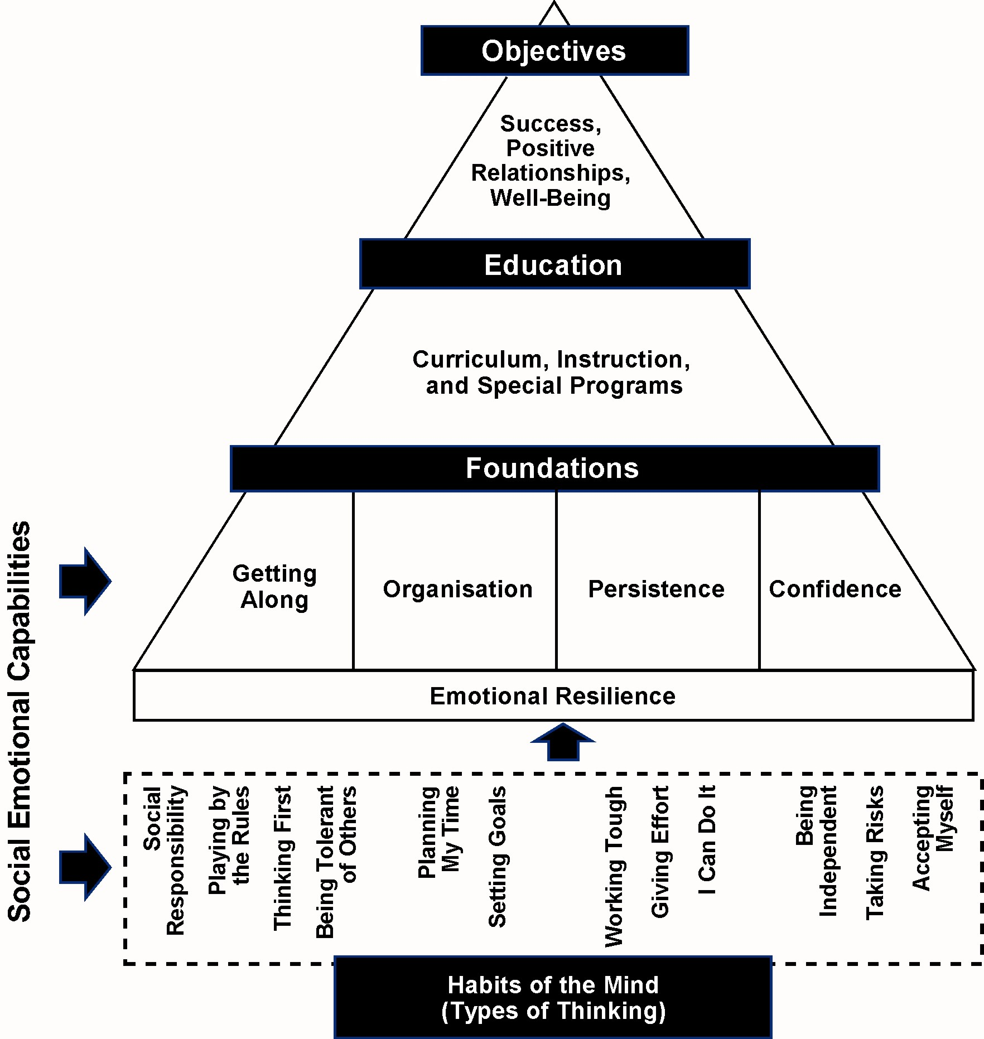

EXTRA CURRICULAR ACTIVITIES

BOOK CLUB
The school participates in the Scholastic Book Club. Parent helpers ensure the continuation of Book club. At regular intervals children may order books at reasonable prices through the Book Club. Participation by individual families is optional and children are asked to return money with their orders to the front office foyer by the date on the order form.

CAMPS
Students in Year 4, 5, 6 and 7 are involved in the schools camping program. The objectives of the camp are social and educational and form a vital part of the curriculum program offered by the school. Information is sent home to parents well in advance of the actual dates of the camp.
Year 4 students attend for 1 night – 2 days
Year 5 students attend for 2 nights – 3 days
Year 6 students attend for 4 nights – 5 days
Year 7 visit Canberra for 5 days.

CHESS
Children from Year 2 and older are welcome to join our school chess club. Chess coaching is conducted before school on Tuesday morning by Gardiner Chess. Students in our chess club have the opportunity to play in inter-school competitions.

CHOIR
The Ashgrove choir caters for students from Year 5,6 and 7. The choir meets once a week for rehearsal on Wednesday mornings before school; this is a vital part of developing a great sounding choir. Attendance at rehearsal also ensures that we are able to attend more performances/ competitions/ concerts as the whole group is prepared for performance.

COLLECTION OF MONEY FOR STUDENT ACTIVITIES
Invoices/statements for school activities/excursions are sent home once per term. Payments can be made by cheque, cash, and credit card. Please make cheques payable to ‘Ashgrove State School’. If paying by cash, it would be appreciated if correct money were enclosed, as the school does not have the facility to give change. Cash will only be processed on Tuesday, Wednesday and Thursday. Please note that cash and cheque payments should be placed in an envelope clearly marked with child’s name and class. If paying by credit card please complete the details on the reverse side of the invoice. All payments need to be placed in the Cash Collection Box located in the office foyer. Permission notes to enable students to attend any excursions or activities must be given to your child’s teacher.

DEBATING
Students from the upper school have teams that undertake debating in the Queensland Debating Union for interschool competition. These teams are now being coached by two parents who are very experienced debating coaches.

EXCURSIONS
Regularly throughout the year various excursions are organised by teachers to support and enhance the curriculum. All excursions are part of the school curriculum and all students should participate. Notices informing parents of these excursions will be sent home in advance of the day of the excursion. Signed parental permission must be provided for all excursions.

OPTIMINDS
The school also participates in the Opti-Minds Challenge. Opti-Minds is an interschool problem-solving event for students. Teams of 7 students per team across 2 grade levels are asked to find solutions to challenging problems which require experimentation and reward divergent thinking.

STEPHANIE ALEXANDER KITCHEN GARDEN PROGRAM
In 2011 the school become part of the Stephanie Alexander Kitchen Garden Program. The school has employed a gardener and a cook and they currently work with each year 3, 4, 5 & 6 class once a month. The children spend 30 minutes in the edible garden and 90 minutes cooking and then sharing what they have cooked at the class table. A purpose built kitchen will be built in 2014.
COMMUNICATION

APPOINTMENTS WITH STAFF
If you wish to discuss any matters concerning your child, please contact your child’s teacher in the first instance as they are in the best position to inform you of your child’s issues. To gain the most from the interviews it is often best to make a prior appointment to allow the teacher time to organise data to give you the best possible information about your child.

CLASS REQUIREMENTS

A booklist containing the class requirements is sent out to every child in October for the following year. The P & C Association have an arrangement with Enoggera Newsagency to supply the items on the booklist. Orders returned by the due date will be available for collection from the school before the end of each year. Included in the booklist are details of the P&C contribution scheme.

COMMUNICATION FROM SCHOOL
Parent Information Evenings
These are held early in the year for every class. They provide general information on the operation of the classroom and the curriculum.
Newsletter.
The school newsletter is sent home fortnightly via email. Parents are urged to read this carefully as it is the main means of communication between the school and parents. The newsletter contains school information, school news, news from the School Council and P & C Association, examples of student work and other items of interest.
Notices etc.
Other notices and information are forwarded home with the children concerned as required.
Communication Handbook and Diary.
Teachers in year 5 to 7 can use the Communication Handbook and Diary issued to each child to communicate with parents about your child.
Parent Network
Important information is often circulated via email through the Parent Network.
SMS System
The school uses an SMS system to inform parents of emergency situations. We will send an SMS to those parents who have chosen to be a part of this service in the event of an event cancellation, storm or flood warnings etc.

COMMUNICATION TO SCHOOL
If parents need to communicate a brief message to the teacher, parents generally find writing a note or using the student’s diary effective for this purpose. If parents require an interview with a teacher a letter should be addressed to the teacher requesting an appointment. Many teachers also provide email addresses in order to communicate with parents.

MOBILE PHONES
Students may bring mobile phones to school as some students travel via public transport or walk unsupervised and parents like to ensure their safety. Once at school students are required to bring their mobile phones to the office where they will be held for the day. Students may collect mobile phones at the end of the day at 2:55pm.

PARENT TEACHER INTERVIEWS
The school has two formal periods for parent teacher interviews. These are at the end of term one and term three. Parents may at anytime request an interview with the teacher to discuss students’ progress.

TELEPHONE CALLS
Messages will be given to children during the day if they are of an urgent nature or concern changes to how children are to go home at the end of the day. However we cannot always guarantee students will receive messages that are received after 1:00pm as children often move classes or are involved in extra curricula activities. Children do not, as a rule, have access to the telephone. Should the need arise, parents may be contacted on behalf of the students.
STUDENT HEALTH and SAFETY

ABSENCE FROM SCHOOL
The school provides an email address absences@ashgrovess.eq.edu.au for parents to report student absences. One day absences can also be recorded in the Communication Handbook Diary.

ACCIDENTS and ILLNESS
Minor injuries are treated at school. Where the injury is more serious but not urgent, parents will be contacted and their advice sought. In cases where the injury is considered serious and /or the child appears seriously ill an Ambulance will be called and parents contacted.
Children with a minor illness at school are given the chance to lie down for a short time before returning to class. If a child is not well enough to return to class, parents will be called and they will be asked to take the child home. It is important that parents keep their emergency contact details up to date so that we can advise you promptly should your child require attention.

ACTIVE SCHOOL TRAVEL
The school was part of a Brisbane City Council program called Active School Travel in 2008. This program aims to reduce vehicular traffic around our school by encouraging children to walk, ride, catch a bus or car pool to get to school. Whilst we no longer have monetary support from BCC in 2013, we will continue to encourage this activity.

ARRIVAL AT SCHOOL
The first bell rings at 8:45am. At this time children are able to enter the classroom. There is no formal staff supervision of students before the 8:45am bell and after the 2:55pm bell. YMCA offers before school care from 6:30am-9:00am and after school care from 2:55pm-6:00pm.

ASSEMBLY

An assembly is held every Tuesday morning at 9.00am in the Covered Play Area. This is a time for presentations by students, recognition of achievement and emphasising matters relating to the operation of the school. Parents are most welcome to attend.

CRITICAL INCIDENT MANAGEMENT
The school has an extensive Critical Incident Policy which covers items such as fire evacuation and lockdown, storm, bomb threat, suspicious package procedures and medical emergencies including Anaphylaxis, Asthma, Diabetes and Epilepsy. These policies are available on the school website.

CURRENT EMERGENCY INFORMATION
Should you change address, telephone numbers, your place of work or if your emergency contacts change, please notify the school immediately.

DEPARTING SCHOOL
At the end of the school day children should leave the school grounds as soon as is practicable. The school playground is not supervised by school staff at the conclusion of the school day. Parents are asked to ensure children know how they are going home each day and to inform their child’s teacher if this routine changes. Parents are asked to ensure that their child is not left to wait unsupervised after school. If your child is in the school grounds after 3:30pm they are expected to come to the office when the bell rings. Parents will then be contacted.

LEAVING SCHOOL DURING THE DAY
Once children are at school they will not be allowed to leave the school grounds until dismissal time. For children who are required to leave school during the day, parents are asked to report to the office and sign their child out in the register. Parents must then take a leaving early slip to the class teacher to verify that the child has been signed out.
MEDICATION AT SCHOOL
Parents need to be aware that Education Queensland provides strict guidelines for schools to follow regarding administration of medicine to students. It is unwise for children to carry medication. Parents are asked to adhere to the guidelines set out below for student prescribed medication to be administered when necessary. The only exception may be asthma medication.
- With any medication parents must provide a written request to the Principal using the Request to Administer Medication form available from the office.
- Written Instructions by the pharmacist at the doctor’s direction, should appear on the label of the medication.
- Specific times as well as quantity to be administered must be indicated. School staff can not supply nor do they administer non-prescribed oral medication (such as analgesics and over the counter medication) even if parents request this in writing.

RESPONSIBLE BEHAVIOUR PLAN FOR STUDENTS

The school’s Responsible plan for Students policy, based on The Code of Conduct Behaviour, is available on the school website www.ashgrovess.eq.edu.au

A copy of this policy is given to all families upon enrolment

SCHOOL DENTAL SERVICES

The School Dental Service provides regular dental care to all primary school children. The treatment is provided by Dentists and School Dental Therapists. Specialist services are not available but parents will be informed if any such treatment is considered advisable.

SICKNESS – INFECTIOUS DISEASES
Some infectious diseases require children who are suffering from the disease and children who are in contact with the diseases to be excluded from school for a time. Parents should contact the school for advice on the required time away from school for the following.

Chicken pox and Shingles; Conjunctivitis; Diarrhoea; Hand, Foot and Mouth Disease; Haemophilias Influenza; Headlice; Hepatitis A; Herpes (cold sores); Impetigo (school sores); Influenza; Measles; Meningitis; Meningococcal Infection; Mumps; Pediculosis (Head Lice); Ringworm, Rubella; Scabies; Streptococcal Infection; Typhoid Fever; Whooping Cough.

SUN SAFETY
The school has a Sun Safety Policy. The school has a ‘No hat-no play’ rule. All children in the school are encouraged to wear sunscreen and have sun safe clothing. The school tries to, where possible, conduct lessons that minimise children’s exposure to the sun.

SUPERVISION OF CHILDREN
The School provides no formal supervision for children outside school hours. Children are therefore the responsibility of parents before the first bell at 8:45am and after the 2:55pm bell. YMCA offers before school care from 6:30am – 9:00am and after school care from 2:55pm – 6:00pm. We ask that parents insist that their children follow school rules whilst in school grounds. At morning recess and lunch, staff members are rostered to supervise the children in the playground.

WET DAYS

Normal school hours operate on wet days or when storms are forecast. The school has a wet weather policy, which provides supervision and protection for children in the event of wet weather and storms.

FACILITIES

COMPUTERS
The development and use of computer technology has been a feature of Ashgrove State School over many years. Our students have access to the following technological resources:-
- A local school network connecting every classroom to Education Queensland’s wide area network and the Internet;
- A computerised library access system and library mini-lab connected to the Internet;
- A computer lab of 30 computers connected to the Internet and network printer;
- Digital cameras/scanners/video cameras/data projector/overhead projectors/video players;
- A wide range of curriculum software that is an integral part of classroom teaching and learning;
- Multimedia software to produce video editing.
- Interactive whiteboards in every classroom.
All of the staff have a Level 1 technology competency achievement certificate. Information Technology teachers deliver weekly lessons using computer technology.
- 30 Laptops housed in mobile trolleys.
- At least 2 computers in every classroom.
- Wireless hubs in each section provides additional computers for children in years 3-7.

GROUNDS
The grounds at Ashgrove State School well maintained and have been developed to enhance both their practical and aesthetic value. Attention has been given to providing shade both through tree planting and shade structures.
The junior school is well catered for with planned playground areas which provide fun play areas and outdoor learning environments.

JB STEPHENS CENTRE
This building was provided through fundraising of the school’s P & C Association and financial assistance from the State Government. It provides an excellent multipurpose facility to host instrumental music activities, class presentations, professional development and other presentations. The JB Stephens Centre has recently been refurbished to allow for a second music teaching space and a teaching/learning space which houses 30 laptops and other technological devices.

LIBRARY - RESOURCE CENTRE
An extensive collection of fiction and non-fiction books as well as other resource and recreational material is housed in the school’s Resource Centre. The library management system is fully computerised and is connected through the school network to the internet. Materials are available for borrowing by students, teachers, staff and parents.

OUTSIDE SCHOOL HOURS CARE
Outside School Hours Care now has a building on the school oval. This enables OHSC staff to create a more homely environment for the children. This building will also be available during the day for school use.

SCHOOL HALL
The school hall was built in 2011 as part of the Federal Government BER initiative (Building Education Revolution). This facility has multi-purpose flooring which allows it to be used as a teaching venue for PE lessons. It is also equipped with a sound system and drop down screen and projector. The venue is used for school assemblies, presentations, performances and other school functions. It is available to be hired for outside school functions.

SPORTING FACILITIES
These facilities include tennis courts, netball courts, cricket pitch, cricket practice wickets and the oval. When not being used by the school these facilities are available for community use. The tennis courts can be hired by community members on weekends. Tennis coaching is available before and after school for students. Junior Cricket teams use the school oval for practice and week-end competition.

SWIMMING POOL
This facility, being on site, ensures all students from Prep to Year 7 receive basic swimming instruction from our Specialist Physical Education Teacher. As the school has a pool on site, our children have the advantage of receiving more tuition time. The pool is solar and gas heated, making the water temperature comfortable throughout the year.
ROAD SAFETY

STOP DROP GO & CROSSING SUPERVISOR
The school has a Crossing Supervisor at the back of the school in Otonga Road to assist children and parents needing to cross the road before and after school. The crossing supervisor is present from 8.00am to 9.00am in the morning and after school from 2.50pm to 3.20pm.
The school also has a Stop Drop Go Zone in the parent car park behind the fire station. Parent volunteers man this area after school each day and assist with getting children and their bags into the car so that parents have no need to leave the car. Parents register to be part of this service and place a name visor in their car for easy identification. Extra volunteers are always very welcome.

BICYCLES
Bicycles may be ridden to school and bicycle riders must wear protective helmets. For the safety of other pedestrians, students must walk their bikes in the school grounds at all times. All bicycles are to be placed in the bike cage provided, which is located between the JB Stephens and sports shed buildings on the school oval nearest to Otonga Road. It is advisable that bicycles are chained and locked to the bike racks and that bicycle helmets are not left with the bicycles.

SKATEBOARDS/SCOOTERS
Scooters and skateboards can be ridden to school, but must be placed in a safe location in the classroom. They must not be ridden on the school grounds.

TRAFFIC IN GROUNDS
The car park in front of the main building is reserved for staff, commercial deliveries to the school, service and emergency vehicles. Vehicles should not be driven into the staff car park to deliver or collect children from school. The only exception to this procedure is when you collect a sick or injured child from the school. In this case permission to use the front car park is given. Car parking is available in the car park situated behind the fire station in Otonga Road or Woonga Drive.

MISCELLANEOUS MATTERS

HOMEWORK
Homework assists students to develop independent study habits. Homework also enables students to involve their parents in their education.
In primary school the amount of homework will vary with the age of the children and the work currently being done at school. Parents can best assist by ensuring children have a set time to do their homework and by assisting their children to keep ‘on task’. If homework cannot be completed, parents are asked to write an explanatory note in the Communication Handbook and Diary. Homework should not be an issue that causes distress to an individual or family. If you believe that your child has made a reasonable attempt then please sign where they are up to and this will meet staff and school requirements. No child should average more than 30 minutes homework per night, including reading.

LOST PROPERTY
It is inevitable that children ‘lose’ things at school. Parents are asked to ensure ALL items of property are identified with their child’s name.

All lost property is gathered and placed in large plastic containers, which are located inside the western stairwell. We encourage parents to check this area regularly.

SCHOOL PHOTOS
Each year a commercial photographer is invited to the school to take photographs of class, individual portraits, music and sporting groups. Class, individual and group photos can be ordered at the parent’s discretion.

TOYS and PERSONAL BELONGINGS
Children should not bring toys, games, collectables and personal belongings of value to school. The school has no avenue to replace lost or damaged items and will not be held responsible for their loss.
PARENTS AS PARTNERS

EXCELLENCE FUND
The school P & C Association supports an Excellence Fund to assist parents with sport costs when students are selected to compete in their chosen field at a Regional level or equivalent. The intention is to provide recognition for significant achievement and assist in offsetting some of the costs incurred particularly where travel is involved. This monetary amount is dependent on the destination of the student’s activity and is available by application to the P & C. (See application form in the student school diary). Applications will only be considered for those students whose parents have paid the P & C contribution and/or those parents who contribute to the school community through working voluntarily throughout the school.

PARENTS’ AND CITIZENS’ ASSOCIATION
Meetings of the Ashgrove State School Parents’ and Citizens’ Association are held in the school staffroom at 7.30pm on the second Tuesday of every month unless otherwise advised through the school newsletter. All parents are invited to become members of the P and C and are warmly welcomed at the meetings and encouraged to become actively involved in the school.

Meetings provide a forum for discussion on a variety of issues related to the school, its students and curriculum.

The P and C Association fulfil a major role in the school through fundraising activities which are also important social events. The annual fete is our major fundraising event and other smaller fundraising activities are also organised for the benefit of the school and the school community. The P and C Association also provide services such as the tuckshop and uniform shop.

SCHOOL COUNCIL
Ashgrove State School has an elected School Council of 12 members with equal representation of staff and parents. The School Council is closely involved in developing the strategic direction of the school, advising on matters of policy, monitoring progress towards agreed goals and reporting these to the school community and Education Queensland.

Appointed members retain their position for 3 consecutive years to ensure the continuity of the School Council. In any year where new nominations are required a returning officer is appointed. Notice of election is given via the school newsletter and elections are held over several days.

The School Council is responsible for approving the school’s strategic direction as set out in the Annual Operation Plan and Budget.

SWIMMING CLUB
Ashgrove State School has an Amateur Swimming Club, known as the ‘Ashgrove Aces’. Club nights are held each Monday night, commencing at 6.15pm for Terms 4 and 1, excluding Christmas Holidays. Club night is a fantastic opportunity for children to develop their swimming and competition skills in a relaxed, non-threatening environment. All strokes are offered each night and children are able to elect which events they would like to participate in. The Club is strongly involved in inter-club Carnivals, Brisbane Swimming Association and Queensland Swimming Association meets.

"Ashgrove Aces" has an excellent tradition in competition and achievements and it is continually producing members who achieve at State Level.

Come along and join the activities of the Club. All enquires are to be directed to ‘Ashgrove Aces’ email ashgrove.aces@gmail.com or phone 0455 820 706. The pool offers the School community an excellent facility for both the School and the Club. Our 25m pool is heated to optimum temperature in order to maximise its potential as a teaching facility all year round.
SWIMMING LESSONS
The swimming pool is leased to Swim & Co, a professional, accredited coaching team, who conduct Learn to Swim and Squad Coaching lessons. The Swimming Lessons are organised for all levels from Learn to Swim, Stroke Correction, Encouragement, Development, Improvement, Competitive, Fitness and Adult lessons.

All enquires are to be directed to, Swim & Co, 3366 2612 or 0417 003 977
Email:- swimandco.ashgrovess@hotmail.com

TUCKSHOP
The school tuckshop provides a healthy, well-balanced menu at affordable prices. A paid convenor and volunteers run the tuckshop. It is open 8.00am to 2:00pm daily. A Tuckshop Committee manages decision-making under the direction of the school P&C.

Volunteers are an important and integral part of tuckshop operations. Assistance with the preparation and service of food means that costs and prices are minimised. No experience is necessary, just a willingness to help as part of a small team. The roster of available days is kept at the tuckshop. Volunteers are asked to assist on a monthly basis.

Families who are unable to help on roster but wish to support the tuckshop can make donations of food items, consumables or cash. The donation roster is coordinated at the tuckshop by the convenor.

Children ordering tuckshop need separate bags for morning tea and lunch. Enclosing the correct money amount is always appreciated! Details of how to write the order on the bag are listed on the reverse side of the menu. Menus are sent home with every child at the beginning of each year. They are also available at the tuckshop anytime.

The P&C is hopeful that by semester two in 2013 a Flexi-Schools online ordering system will be available to parents.

On Friday from 2:30pm-3:30pm the tuckshop also operates what is known as the Ashgrove Café. The Convenor manages the Café with help from a rostered class each week. Assistance is sought from the parents of the rostered class to serve. Every class is rostered twice a year. The Café provides a great end of week opportunity for parents and children to relax and socialise. An espresso machine in the Tuckshop ensures that parents get a great cup of coffee either on parade mornings, sports days or at Friday afternoon café.

To obtain further information or offer assistance in any way please call into the tuckshop or phone the convenor on 3858 4718.

UNIFORM SHOP
The uniform shop operated by the Parents’ and Citizens’ Association sells new shirts, shorts, hats, jumpers, track and bootleg pants as well as second-hand dresses, shirts, shorts and jumpers.
It also sells the school’s backpack, swimming caps, swimming, library, homework and chair bags.

Hours of operation
The Uniform Shop is open: -
First week of school every day 8.15am - 10.00am
Normal hours of operation Monday/Tuesday only 8.15am - 9.15am

Two additional days during the week prior to the start of each school year.

Phone: 3858 4721

UNIFORM POLICY

UNIFORM AND EXPECTATIONS

The school has a uniform, the wearing of which is encouraged for reasons of identification and suitability for participation in school activities.

Hairstyles should be neat and tidy. It is recommended that hair, which is longer than collar length, be tied back. Nail polish and jewellery should not be worn to school.

All items (excluding footwear and dresses) are available from the Ashgrove State School Uniform
Shop. The Uniform Shop sells second hand dresses. The Ashgrove West Drapery sells new cotton
dresses and other uniform items.

GIRLS: Dress or skort/shorts/skirt and polo shirt.
Dress ……… A dress in maroon and white check material with short sleeves and zip front.
Shorts……... Maroon jersey shorts with full elastic waist and a pocket on each side
Shirts ……… Polyester/cotton or cotton knit maroon shirt with button tab; a contrast knit collar and school logo.
Skort……….. Maroon poly/viscose shorts with a skirt covering.
Hat …………. Maroon wide-brimmed hat with school badge screen-printed on front.
The school has a ‘No hat-no play’ rule.

Shoes ……… Sports shoes (predominately white) or black school shoes, with white socks. All footwear must cover the toes and have fastenings (e.g. laces, velcro).

BOYS Polo shirt and grey shorts.
Shorts Grey longer leg style school short.
Shirts Polyester/cotton or cotton knit maroon shirt with tab, a contrast knit collar and school logo.
Hat Maroon wide-brimmed hat with school badge screen-printed on front.
The school has a ‘No hat-no play’ rule.

Shoes Sports shoes (predominately white) or black school shoes, with white socks. All footwear must cover the toes and have fastenings (e.g. laces, velcro).

WINTER WEAR - BOYS AND GIRLS
Maroon surf jacket with grey collar and school logo or maroon zip jacket with school logo.
Maroon tracksuit pants (unisex), maroon bootleg pant (girls).

MUSIC PERFORMANCE UNIFORM
Music polo shirt, with black pants and black shoes.

YEAR 7 SHIRTS – BOYS AND GIRLS
Each Year 7 class elects a committee to develop a Year 7 polo shirt that can be worn as part of the school uniform and at graduation.

YEAR 4-7 SPORTS SHIRTS – BOYS AND GIRLS
A sports polo shirt is to be worn on Fridays only for Interschool Sport
Canterbury type shorts (Maroon or Black) may only be worn on Fridays or designated sports days.

Please clearly label all hats, shoes, socks, and clothing with child’s name.

YMCA OUTSIDE SCHOOL HOURS CARE

WHAT IS OUTSIDE SCHOOL HOURS CARE
An Outside School Hours Care service is a place where children attending prep or school can go before or after school and during the school holidays, to play and relax in a safe and stimulating environment. Staff aim to provide a caring environment incorporating a fun program of activities for the children.

PROGRAMS
At YMCA Outside School Hours Care services we strive to create a homely atmosphere; where your needs as a parent/guardian are respected, and where you can feel that your child is well cared for. The staff are trained to provide interesting programs for your child. The program covers both indoor and outdoor activities and usually includes craft, cooking, sports and games. Please share your ideas and contribute at any time. Your suggestions are welcome. We provide an area for homework, however the ultimate responsibility lies with the child and parent/guardian.

HOURS
YMCA Outside School Hours Care operates Monday to Friday.
Before School Care 6:30am to 8:45am.
After School Care 2:30pm to 6:00pm. Vacation Care 6:30am to 6:00pm.

BOOKING PROCEDURE AND PAYMENT OF FEES
Bookings and cancellations are essential. Staff: Child ratios are a priority. Afternoon tea preparations and craft activities are organised according to bookings. Please see our Fees Structure notice for charges that apply.

PAYMENT OF FEES
Regular Users of Service
Accounts are issued weekly on Mondays and payment is required by the Friday. Family statement of fees will be emailed or if no nominated email address has been provided, will be made available at the service.
Parents/Guardians are responsible to ensure that your account is opened and collected. Casual attendance must be paid for on the day of usage.

Family accounts will include fees for care for the current week to Friday and have an estimate of the CCB (Child Care Benefit); this estimate is seen as a bold, underlined entry under the CCB column on the statement. Once the CCB is reconciled the bold, underline will be removed. There may be small changes from week to week once information regarding attendances of other siblings, CCB percentage changes and CCTR (Child Care Tax Rebate) contributions have been reconciled with the DEEWR and these changes may alter the account slightly. These changes are beyond our control. It is a requirement of DEEWR that a statement of account is provided to all customers for all sessions of care so families may at times receive a statement where nothing is owing or shows a credit. If there is an outstanding amount the due date will be clearly indicated on the account.
If fees are overdue by more than 14days and payment is not received within 7 days following formal notice, family enrolment will be suspended and no attendance will be possible until the account is paid in full. Fees are to be paid preferably by
B Pay: We request that parents make arrangements to utilise this method. All required details for payment by B Pay are located on service statements. B Pay payments must be made by the Friday following the issuing of the account. The due date is indicated on the account. Receipts are issued with payment by bank/financial institution.
Ezidebit: Direct debit payment facilities are available at all OSHC services.
If a family is experiencing any difficulties in paying fees on time they are required to discuss this in confidence with the Coordinator and agree on a payment plan.

CHILD CARE BENEFIT
Eligible families can receive a discount on their fees. To receive Childcare Benefit please call the Family Assistance Office on 13 61 50

LATE FEE
Although situations may arise where the parent/guardian cannot collect their child/ren before closing time, it remains the parents/guardians responsibility to arrange for an authorised person to collect the child/ren before 6:00pm. Children must be collected by 6:00pm or a late fee will apply.

Emergency numbers will be attempted if the parent has not advised of late collection of children. In the event that no emergency contact answers, the child/ren will be sent to the local Police station. (These are Policy requirements used by Outside School Hours Care Services).

For more OSHC Information Phone 3366 1523 or Email: ash@ymca.org.au

