R.A.S.C.A.L.S
AFTER SCHOOL & HOLIDAY CLUB

Based at
Horns Drove Community Pre-School & RASCALS

Bakers Drove
Rownhams
Southampton
SO16 8AD

Telephone: 023 80737207

e-mail: enquiries@hornsdrove.uk

www.hornsdrove.uk

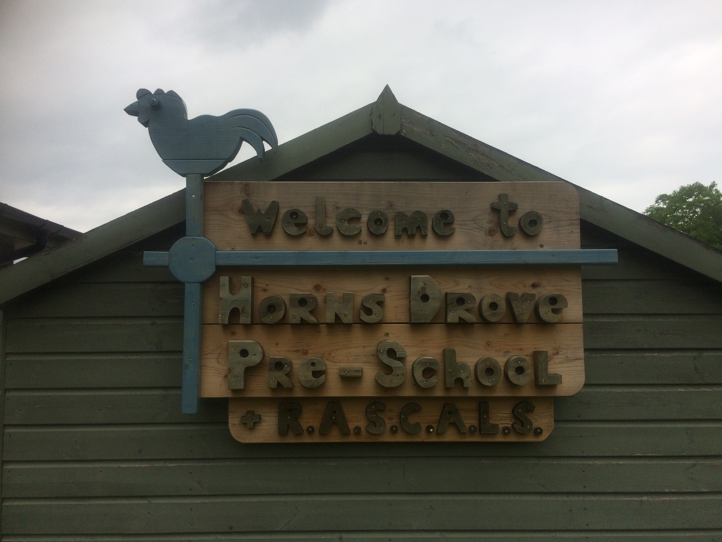

We are a long established After School and Holiday Club based in the grounds of Rownhams St Johns School.

Our friendly staff (all Enhanced CRB Checked) will make sure that the children enjoy their time spent at our clubs with lots of fun activities relevant to their ages. The staff will involve the children at all times in choosing activities that they enjoy. There will be a wide choice and we will have access to both indoor and outdoor play areas at all times and we do have a quiet area for resting. Activities to include: art and crafts, clay modelling, junk modelling, cooking, football, cricket, outdoor and indoor games, wii, table tennis, table football, construction, computer and lots of other things.

Our Manager and Playworkers are qualified and/or experienced and regularly undertake training to update their skills. Volunteers and college placements will sometimes assist them. Volunteers and college placements will be supervised at all times by existing staff members.

Security checks will be carried out to ensure persons selected meet the criteria to work with children. The club encourages volunteers to participate from the local area who are interested in childcare as a career.

After School Club

We cater for children attending Rownhams St Johns and Nursling Primary schools. We collect the children after school, two staff members collect the Rownhams Children on foot and 2 staff collect the Nursling children in our own van.

Once they have arrived in the setting, they can help themselves to a healthy snack and we provide sugar free squash and water. They can then choose from a variety of activities which we change on a regular basis. Our craft table always has something interesting to keep them occupied and our large outside area is always popular for outdoor games.

Snacks & Drinks: We will provide a light afternoon snack, for example fruit, crackers toast, bread, cheese and
biscuits and yoghurts. Water and sugar free squash to drink. We operate a nut free setting this includes all tree
nuts.

Fees: £13 per session. Sibling discount for additional children £12:50

Waiting List: We operate a waiting list on a first come first serve basis. You can get a waiting list form off our website or pick one up from the setting.

Mobile Phones: These need to be handed in to staff on arrival and collected before they leave. If they need the phone for a specific reason they need to ask a member of staff. They are not permitted to take pictures whist in the setting.

Ad Hoc Bookings: We occasionally have a few open slots so if you need a space give us a call.

Not attending on the day: If your child is not attending the After School Club please notify us that morning or in advance. You also need to inform the relevant School as if we are not notified then our staff will wait at the school while trying to contact you and this delays everyone.

Payment: Invoices are raised on or as close to the 1st of each month as possible, payment is due within 7 working days of the issue date. If payment is not received you are at risk of losing your child/s place. If payment is not received within 14 days then your place may be withdrawn.

Payments can be made by Direct Debit, BACS (direct transfer) and childcare vouchers.

We will be operating a cash and cheque free setting in the future so please can you start making alternative arrangements if this is how you currently pay us.

Opening Times: 3pm – 6pm

Absence/illness/holidays: Full fees are payable.

Unforseen closure: If due to unforeseen circumstances we are unable to operate the setting for a period longer than 3 days we will refund your fees.

Closures due to weather: These are still payable unless the closure continues for longer than 3 days.

School inset days: Full Fees are still payable. You child is still able to attend After School Club that day but please let us know in advance so we can add them to the register.

Medication & Care Plans: Please ensure this section is filled out correctly on their registration form and if they are an existing child that our information is up to date and that any changes to your child’s health are communicated to us immediately

Lost Property: Please make sure all items are clearly labelled, if you lose anything please ask the staff. We cannot take responsibility for any toys or valuables brought into the setting. At the end of each term we donate any unclaimed lost property to charity.

Wipes: If you send your child in with any wipes / toilet / flushable wipes please notify us as we need to ensure these are not disposed of in the toilets as our drainage systems cannot cope with any type of wipes, including the ones advertised as flushable.

Malicious Damage: If any child is found to have deliberately damaged the building, resources, toys or put items (including wipes and bulk toilet paper) down the toilets / drains then we will recover the repair / replacement costs from yourselves.

Collections: All children must be collected by the parent/carer or nominated person by 6pm and signed out by staff. The person nominated to collect your child/children must be at least 16 years of age. Please ensure that we are informed of the nominated person who will be collecting your child. They will be required to provide a password.

PLEASE NOTE: that an initial late collection fee of £10 will be charged at 6.15pm and then £5 per additional quarter hour (or part thereof).

Notice Period / Termination of contract or cancellation of specific days: We require 4 working weeks notice in all instances unless we can fill the space immediately, please speak to the Business Manager and we will see what we can work out.

Policies/Procedures: We have a full set of policies available for viewing at the office.

Staff: A ratio of 1:8 will be strictly adhered to for children under 8 when inside and outside.

Holiday Club

We cater for up to 25 children on a daily basis aged 4 – 11, with limited spaces for 4 years olds each day.

Whilst we do have sporting activities available (cricket, football etc) for the children to take part in we focus more
on providing a broad range of activities for them to choose from. We always have an exciting craft / activity area
set up and often there is a theme depending on the time of year. We have ping pong, table football, an
electronic keyboard, lots of games and books, large scooters and water play. Our lovely outside area has a large
climbing frame, sandpit and other areas of interest and we utilise the school field every day too weather
permitting.

Snacks & Drinks: We will provide a light morning and afternoon snack, for example fruit, crackers, toast,
bread, cheese, biscuits and yoghurts. Water and sugar free squash to drink. We operate a nut free setting this
includes all tree nuts. We occasionally give children a small sweet to take home as a reward for good or helpful
behaviour. We sometimes bake and will involve the children in this and they can then eat what they make or
take it home.

Fees:
All day £24 – sibling discount £23
Half Day £12 – sibling discount £11.50

Mobile Phones: These need to be handed in to staff on arrival and collected before they leave. If they need the phone for a specific reason, they need to ask a member of staff. They are not permitted to take pictures whist in the setting.

Tablets: They are allowed to bring tablets in with them but they are limited to half an hour while here. They are not permitted to take pictures whilst in the setting.

Ad Hoc Bookings: You are welcome to call on the day or pop in as we may have spaces available.

Not attending on the day: If your child is not attending please notify us that morning or in advance. We require 2 weeks notice for any cancellations / changes.

Payment: Payment is upon receipt of invoice and will be issued in advance of the actual booking wherever possible.

Payments can be made by Direct Debit, BACS (direct transfer) and childcare vouchers.

We will be operating a cash and cheque free setting in the future so please can you start making alternative arrangements if this is how you currently pay us.

Opening Times:
All Day 8:30 – 6pm
Morning session 8:30 – 1pm
Afternoon session 1:30pm – 6pm

Absence/illness/holidays: Full fees are payable unless we have received two full weeks notice.

Unforeseen closure: If due to unforeseen circumstances we are unable to operate the setting for a period longer than 3 days we will refund your fees.

Closures due to weather: These are still payable unless the closure continues for longer than 3 days.

Medication & Care Plans: Please ensure this section is filled out correctly on their registration form and if they are an existing child that our information is up to date and that any changes to your child’s health are communicated to us immediately

Lost Property: Please make sure all items are clearly labelled, if you lose anything please ask the staff. We cannot take responsibility for any toys or valuables brought into the setting. At the end of each term we donate any unclaimed lost property to charity.

Wipes: If you send your child in with any wipes / toilet / flushable wipes please notify us as we need to ensure these are not disposed of in the toilets as our drainage systems cannot cope with any type of wipes, including the ones advertised as flushable.

Malicious Damage: If any child is found to have deliberately damaged the building, resources, toys or put items (including wipes and bulk toilet paper) down the toilets / drains then we will recover the repair / replacement costs from yourselves.

Collections: All children must be collected by the parent/carer or nominated person by 1pm or 6pm and signed out by staff. The person nominated to collect your child/children must be at least 16 years of age. Please ensure that we are informed of the nominated person who will be collecting your child. They will be required to provide a .

PLEASE NOTE: that an initial late collection fee of £10 will be charged at 6.15pm and then £5 per additional quarter hour (or part thereof).

Policies/Procedures: We have a full set available for viewing at the office.

Staff: A ratio of 1:8 will be strictly adhered to for children under 8 when inside and outside.

ADDITIONAL INFORMATION

The Government provides a range of ‘Credits’ in order for families to be supported financially and enabling high quality childcare and early education services to be accessed.

Child Tax Credit
It provides support for families who are responsible for children under 16 (under 19 where the child is studying full time up to A-level, NVQ Level 3 or equivalent).
The amount you get is based on your household income. You can claim whether or not you are in work.

Working Tax Credit
Working Tax Credit supports working households on low incomes by topping up earnings. It is made up of a number of elements depending on your circumstances. For example, extra amounts are available to those who work at least 30 hours a week and to those who are working and have a disability. It also includes an element to help with the costs of Ofsted registered or approved childcare, known as the childcare element.

Universal Credit
Parents who have been claiming Tax Credits will be transferred to Universal Credit over time.
New from 2017

30 hours free childcare
  - For working families in England
  - With 3 and 4-year-old children
  - An extra 15 hours a week of free childcare - so 30 in all
Tax free childcare
  - For working families, including the self-employed, in the UK
  - With children under 12 (or under 17 if disabled)
For every £8 you pay in, the government will add an extra £2, up to £2,000 per child - that's up to £500 every three months

Childcare Choices brings together all the government childcare offers in one place, making it easier for parents to find out what works for them, please visit childcarechoices.gov.uk for full information

EXAMPLE: CONFIRMATION OF THE ISSUE OF A RED/YELLOW CARD

Date…………………………………………………

To the parents of………………………………….

Your child has today been issued with a RED/YELLOW Card for

BEHAVIOUR

Unwanted and challenging behaviour will first be dealt with by the member of staff present. The child will first be given a warning (and a card if appropriate) but if the behaviour continues the child will be removed from the activity/area and the reason for this happening will be given to the child.

We operate a card system and parents will be told if their child is given a card. If this behaviour, or other similar behaviour continues the adult responsible for the child will be informed and the child’s placement will be reviewed.

The Manager reserves the right to immediately exclude or refuse a child’s attendance at RASCALS Club if they feel it is having a negative impact on the other children’s enjoyment regardless of whether they have been issued with any cards. In this case the parent or Carer will be required to collect their child immediately and the child may no longer attend the setting.

Inappropriate language, aggressive behaviour and bullying will not be tolerated. The responsible adult will always be informed if their child displays unwanted and challenging behaviour during their time at Rascals Club.

Carding system:

A YELLOW Card will be issued for unwanted behaviour or for not following instructions when requested. Two Yellow cards during a session will be converted to a RED card.

A RED Card will be issued as a result of any intentional physical violence, aggression towards another child or member of staff and any severe and unacceptable behaviour.

The issue of these cards is noted by us and to you and will be monitored.

If a child is in receipt of 3 red cards, within a term or during Holiday club there will be an immediate ban for 1 school week and after receiving the 2nd red card a meeting will be sought with the parent/carer.to discuss the way forward, which may result in a permanent ban.

I understand and acknowledge receipt of this notice.

Parent/carer signature………………………………………………………………………………………
R.A.S.C.A.L.S Registration Form
Please complete all parts of this form, sign and date where indicated and return to the attention of Karen Terzer
At Horns Drove Community Pre-School & RASCALS, Bakers Drove, Rownhams, Southampton SO16 8AD or
e-mail to enquiries@hornsdrove.uk Today’s Date: ______________________

Name of Child |  |  | Date of Birth |  | Age
1st Child:

2nd Child:

3rd Child:
Address |  |  | Home Telephone No:
 |  |  | Religious/Cultural Beliefs:
Post Code |  |  | Dietary Requirements:
E-Mail address which we can send Newsletters to etc
Name of Parent/Carer 1. |  |  |  | Relationship to Child
Mobile Telephone No: : Email address |  |  |  | Work Telephone No: and Name of Organisation
Name of Parent/Carer 2. |  |  |  | Relationship to Child
Mobile Telephone No: : Email address |  |  |  | Work Telephone No: and Name of Organisation
If you are not available to collect your child during an emergency, whom else could we contact? | Name |  |  | Address | Telephone Numbers
 | Relationship
Please nominate a PASSWORD here.
Are there any orders excluding any adults who should not collect your child/children? please give details below:
Name and Address of School |  | Name of Class Teacher
 |  | School Telephone Number

Doctor’s Name | Doctor’s Telephone No:
Doctor’s Address | Has your child had all the childhood immunisations?
 | Please give dates of Tetanus immunisations.
Medical History including childhood illnesses which influence daily care (allergies, asthma, any other medical conditions)
Please provide here any additional comments you would like to give us about your child (e.g. child’s preferred name, name of school and class teacher, etc.).
I consent to any emergency medical treatment necessary during the running of the play scheme. I authorise the play scheme staff to sign any written form of consent required by the hospital authorities if the delay in getting my signature is considered by the doctor to endanger my child’s health and safety.

Yes No
Signed………………………………………………………… Date………………………………

I also consent to my child being photographed by Club staff for publicity and/or display. Images will not be used on the internet.

Yes No
Signed………………………………………………………… Date………………………………

On certain occasions (i.e. parties and special occasions etc.) we may choose to provide the children with food that has a high sugar content, i.e. sweets and ice cream. If you have any objections or comments to make regarding giving your child high sugar content foods please indicate below:

I consent to my child being given high sugar content foods.

Yes No

Signed………………………………………………………… Date………………………………

Further comments:

PLEASE TICK THE DAYS THAT YOU WOULD LIKE YOUR CHILD/CHILDREN TO COME TO RASCALS AND WHEN YOU WOULD LIKE THEM TO START. DATE TO COMMENCE:
MONDAY | TUESDAY | WEDNESDAY | THURSDAY | FRIDAY

R.A.S.C.A.L.S

AGREEMENT

I have read and understood the contents of the Welcome Pack and agree to the partnership agreement contained within the pack.

Further more I/we agree to:

- Give up-to-date information about my child/children including any change of emergency contact details.

- Payment within 7 days of receipt of invoice

- Pay fees for booked/dates – please note that fees are still due if your child is absent for any reason. 2 weeks notice is required for any changes

- Pay for trips – this includes entrance fees if you have booked a place but your child is absent for any reason on the day.

- Collect my/our child/children by 1pm or 6pm

(Please note that Club staff has to leave the building promptly at the end of the session. If any children still remain, Club staff may have to inform Childrens Services as our registered hours are to 6:00pm only. Therefore, prompt collection is advisable)

- Notify the staff in advance if any adult other than myself is to bring or collect my child

- Inform the Club if my/our child/children are to be absent from the Club and inform the school if it relates to After School Club

Parent/Carer
Signed ………………………………………….…… Date…………………………………….….…

Print Name………………………………………… Relationship to Child ………………………

I have explained that policies and procedures are available in the office on request.

Club Staff
Signed ………………………………………….…… Date…………………………………….….…

Print Name………………………………………… Position……………...………………….……

R.A.S.C.A.L.S
AFTER SCHOOL & HOLIDAY CLUB

PARTNERSHIP AGREEMENT

To make the Club a centre of quality and excellence, we will need to have the support of everybody that is involved in it.

We value the partnership we will all have and will respect and value all adults and children.

Therefore, we would like you to read the following statements, before registering your child/children.

Children’s contract:

Follow the Ground Rules decided by the children
- Be on time at the meeting point for collection
- Be helpful to peers as and when necessary
- Strive to become a better person within your own right
- Treat people as you would expect to be treated
Treat all toys, equipment and the building with respect

Parent/Carer’s contract

- Communicate with ourselves about any information appertaining to your child/children that is relevant to the Club
- Support our Agreement, Card System, Ground Rules and Behaviour Management Policy
- Support our policies and work with us to provide a harmonious and quality Club
- Endeavour to attend Parents/Carers meetings and other social events
- Ensure that fees are paid as requested and that you will collect your child/children on time.
- Ensure that any information or concerns regarding your child/children including any Child Protection Issues are given to the Play Leader
Ensure that your child/children are fully aware of the Club Ground Rules and their importance

We will:
- Endeavour to provide a safe, secure and happy environment
- Strive to ensure that regular communication between the staff and yourself/selves on all aspects of your child/children’s life at the Club
- Strive to ensure that regular communication takes place between the staff and yourself/selves on all aspects of your child/children’s life at the Club
- Ensure that all information given to the Club will remain confidential and on a need to know basis at all times
- Update our Ground Rules (written by the children) and reviewed on an annual basis

SIGNED BY PARENT/CARER …………………………………………………………………..

SIGNED BY YOUNG PERSON/S: …………………………….…………………………………….

APPENDIX D
Horns Drove Community Preschool
and RASCALS

MINIVAN PERMISSION FORM

Horns Drove Community Preschool and RASCALS have a minivan which is used to transport children on educational visits and to RASCALS from Nursling Primary School. If you give permission for your child to be transported in the minivan, then please could you sign and return this consent form.

We also require some information about your child in order to ensure they are provided with the correct child car seat / booster seat for their age, weight and height. Information will only be used in relation to using the correct child car seat and processed in accordance with GDPR regulations.

Current Child seat law states:
- Children must be transported in an appropriate child restraint from birth until either they are 135cm (4’ 5”) tall or 12 years old, whichever comes first.
- Children over 12 or more than 135cm tall must wear a seat belt.
- Unexpected Journeys – If the correct child car seat isn’t available, a child aged 3 or older can use an adult seat belt if the journey is all of the following: unexpected, necessary and over a short distance.

I give permission for ______________________________________ to be transported in the minivan for educational visits and / or transportation to RASCALS. I will inform the setting if the requirement for a child seat changes.

Date: ___________________________________________

Current height: ________________________________

Current weight: ________________________________

Current age: ________________________________

Parent Name:_____________________________________

Parent / Carer Signature: _____________________________

Current Child seat / Booster seat Group: Group 2 Group 3

